

Education Learning and Development Module

**education sector workforce planning**

Practitioner Level

2019

CONTENTS

Acronyms 3

1 Introduction 4

2 Education workforce planning – data and analysis 4

3 The workforce planning cycle 6

4 Managing supply and demand 9

5 Improving workforce quality 20

6 Capacity development approaches for the workforce 25

7 Responding to context 28

8 Test your knowledge 29

References and links 33

# Acronyms

DFAT Australian Government Department of Foreign Affairs and Trade

EMIS Education Management Information System

EQAIS Education Quality Assurance and Improvement System

OECD Organization for Economic Cooperation and Development

UNDP United Nations Development Programme

# Introduction

This Practitioner level module is designed to ensure that Department of Foreign Affairs and Trade (DFAT) staff members who engage with and lead policy dialogue with international and domestic partners are informed about education workforce planning cycles, key challenges related to managing workforce supply and demand, as well as initiatives that can improve workforce quality.

It is recommended that staff complete the *Education Sector Workforce Planning: Foundation level* module as background information to this *Practitioner level* module.

# Education workforce planning – data and analysis

## The scope of the education workforce

The education workforce comprises a range of key roles at school, district, regional and national levels. The responsibilities of each of these roles, and their contributions to education outcomes, must be understood for effective workforce systems and planning.

Each country situation is different depending on the policy framework. Some of the key roles commonly found in education systems, also discussed in the *Education Sector Workforce Planning: Foundation level* module*,* are outlined below.

### Teachers

**Teachers** provide direct education services to students. Teachers assist students to learn. To do this, teachers must know how to inspire, motivate and challenge pupils and promote good progress on learning outcomes. If this is to be done well, teachers must have: good subject and curriculum knowledge; be able to plan and teach well-structured lessons; assess students’ learning; and provide a constructive learning environment.

The conditions of teacher employment are highly variable across countries, and can also vary within countries. In some developing countries, private school teachers may be better qualified than public school teachers and may have better remuneration and conditions. In other countries the opposite is true, and public teachers are better qualified and remunerated than private teachers. This can put pressure on governments to take responsibility for up-grading teachers in the private systems and paying their salaries in order to provide equitable quality of education for all girls and boys. Teachers employed by independent faith-based schools, in Indonesia for example, may have a qualification in religious education but not general education.

### Principals

**Principals** provide the day-to-day leadership and management of education institutions. Principals are usually responsible for student discipline, teacher performance, implementation of administrative policies and procedures and supervision of curriculum programs; they gather and report data and communicate with the school community. Principals also report to their school councils (or boards) so that they in turn can provide effective governance of the school.

### Quality of teaching

Within schools, teachers and principals facilitate and coordinate learning programs and resources. The quality of teaching is widely recognised as the single most important factor influencing learning quality in pre-schools, schools and colleges. Principals ideally provide leadership to the provision of sound educational, administrative and teacher development outcomes. Planning for the right number of teachers and principals, in the right places at the right times, is critical to effective education workforce planning and development.

### Administrative staff

**Administrative staff** regulate and support the education system at school, district, province, state and national levels.Administrative staff at school level are often locally hired. Administrative staff at district level and above are usually public servants. They perform a range of services, such as implementing school financial procedures including school accounts and the collection of school fees; coordination of school record keeping, property repairs and maintenance; liaising with the public and school related bodies; and providing support to schools and principals. The scope of duties for administrative staff may vary, depending on whether administrative functions are centralised in the Ministry of Education, or are more decentralised.

### Teacher educators

**Teacher educators** provide pre-service and in-service training for teachers.Teacher educators may be employed by Teachers Colleges, universities, education ministries, faith-based organisations and/or private institutions. The key role is to facilitate teacher training and development. Teacher educators help to develop teaching skills and understandings: (a) in trainee teachers prior to their employment in schools (pre-service); and (b) to existing teachers to refresh or enhance their skills and knowledge (in-service).

Teacher educators are ideally experts in particular levels of schooling (e.g. early childhood, primary, or secondary) or in particular subject areas (e.g. mathematics, sciences). Predicting new and changing teacher education needs and employing suitable and sufficient teacher educators is a critical component of effective education workforce planning and development.

# The workforce planning cycle

The workforce planning cycle was introduced in the *Education Sector Workforce Planning: Foundation level* module. This module will build upon planning concepts to provide an operational understanding of workforce planning for education sub-sectors.

The following diagram outlines each of the six stages of the workforce planning cycle.

Figure 1: Stages in the workforce planning cycle

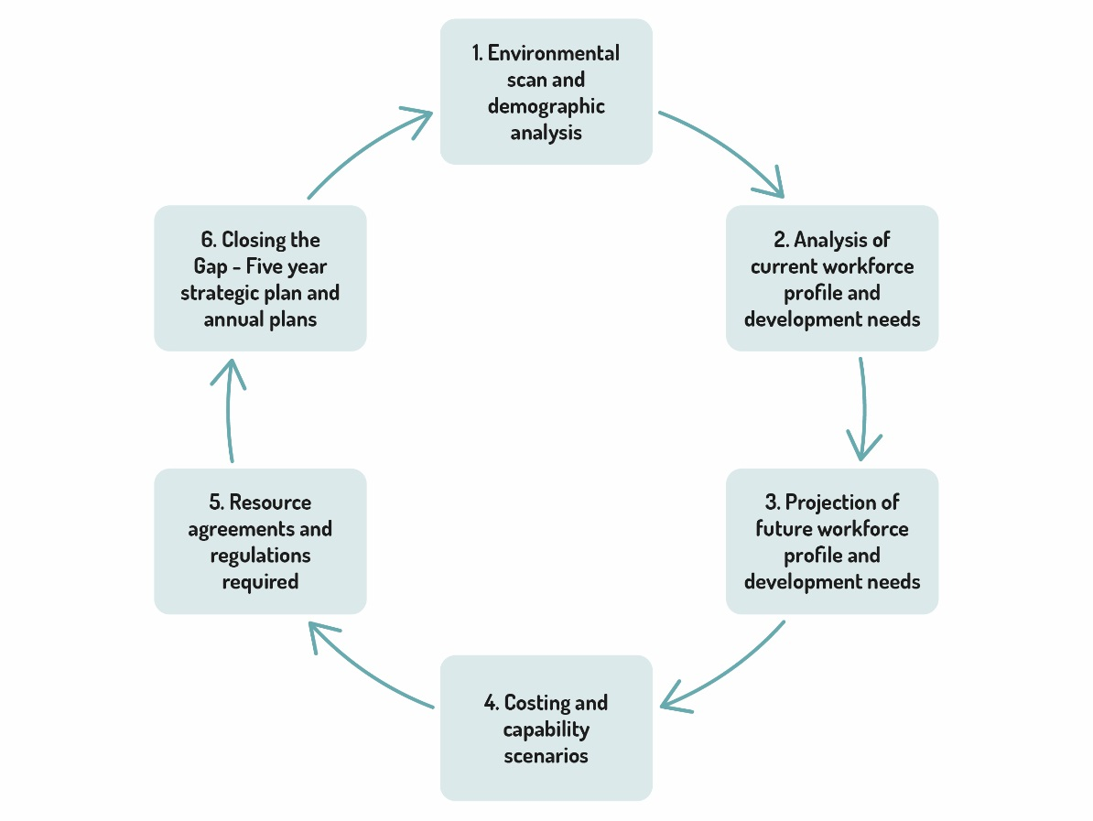

At each stage of the workforce planning cycle, planners need reliable and up-to-date data and analytical tools (*see the Education Sector Workforce Planning: Foundation level* module).

## Stage 1: Environmental scan and demographic analysis

An ‘environmental scan’ is a process which provides information about the current situation based on a review of internal and external data sources. Environmental scans often include an analysis of the strengths, weaknesses, opportunities and threats to an education workforce. They require access to and analysis of demographic data, primarily relating to students and teachers.

|  |  |
| --- | --- |
| **Examples of data required** | **Analysis** |
| Population dispersal; growth rates; profile of the school-age population; enrolment, retention, drop-out and repetition rates; transition rates; number, type and location of schools, their condition and plans for new schools; location and capacity of teacher training institutes; relevant government policies and laws; stakeholder concerns and issues, gender and disability-disaggregated data. | Examples of data analysis include: national level monitoring of the quality of data from local level; identify disadvantaged areas; private/public split and implications; impacts of in and out migration, itinerant workers, or nomadic groups; industrial or mining developments impacting on population centres; gender inequities. |

## Stage 2: Analysis of current workforce – profile and development needs

Knowing the profile of an existing education workforce is (its age structure, numbers, relevant qualifications, years of experience, location of personnel, employment status, etc.) is critical to understanding workforce capacity to meet current and future education needs and demands.

|  |  |
| --- | --- |
| **Examples of data required** | **Analysis** |
| Numbers of teachers in each sub-sector and specialisation; qualifications; age and gender profile; location; exit rates from retirement and other factors; access to training opportunities; supervision and management; current vacancies; permanent versus contract employees; entitlements. | Identify: compliance with staff:student ratio regulations; compliance with staffing quotas per school; hard-to-staff areas; strategies for deployment to manage over and under-supply; specialists needed to meet curriculum requirements. From the age profile, estimate the losses from the teaching service; recruitment and retention targets; identify need for affirmative actions for gender, disability, ethnicity or location. |

## Stage 3: Projection of future workforce profile and development needs

Future workforce profiling demands an understanding of the current situation and a capacity to compare that with projections for future workforce demands. Together they start to give a clear indication of where the gaps are and what the supply and development needs of the education sector will be.

|  |  |
| --- | --- |
| **Examples of data required** | **Analysis** |
| Estimates of student population by grade and by locations for next 5-10 years together with number of teachers required; gender, ethnic minorities, people with disabilities-disaggregated data | Number of new teachers required and where; compliance with staff:student ratio regulations; compliance with staffing quotas per school; % of current workforce needing qualification upgrading and/or retraining; identify impact of any changes in regulations, additional supervision, management and training staff required at local and provincial or national levels; gender inequalities. |

## Stage 4: Costing and capabilities scenarios

Once future workforce projections are made and any gaps in personnel or capacity are defined, it is possible to estimate the costs of meeting future needs.

|  |  |
| --- | --- |
| **Examples of data required** | **Analysis** |
| Unit costs – e.g. high, low and average salary cost; training costs for different kinds of teachers in various locations; teacher qualification up-grading costs for different modalities; in-service costs for various circumstances (e.g. travel costs for cluster in-service in remote areas). | Recruitment, pre-service training, deployment costs; recurrent budget requirements; development budget requirements; significant policy reform costs (e.g. curriculum reform and related re-training costs); in-service training costs per year, including retraining costs, allowances, supervision and management. Capacity of national and local training institutions to meet their needs and address gender inequalities. |

## Stage 5: Resource agreements and regulations required

When the future workforce projections and costings are made, it is then important to secure the resources to fund education workforce development initiatives. It is also important that the relevant regulations and policies support any proposed changes.

|  |  |
| --- | --- |
| **Examples of data required** | **Analysis** |
| Budget estimates per year; sources of funds; alignment with overall national priorities including gender equality priorities; develop compensatory strategies for disadvantaged areas; development partner priorities. | Industrial negotiations and stakeholder consultations; any revision of laws and regulations required – national and local? Public-private partnerships? |

## Stage 6: Closing the gap – five-year strategic plan and annual plans

Because implementing workforce changes takes time, it is important to adopt a medium to long-term strategic approach to workforce development. Shorter term (annual) objectives, strategies and targets that require regular monitoring, management, evaluation and reporting are also critical.

|  |  |
| --- | --- |
| **Examples of data required** | **Analysis** |
| Establish targets and agreed strategies at each level of government. Establish monitoring tools and procedures. | Effective data collection and analysis systems to track performance on an annual and multi-year basis. Use analytics to anticipate risks and problems to be addressed. Identify gender gaps or imbalances that exist in the workforce and that need to be addressed in the medium-term workforce plans. |

# Managing supply and demand

Workforce planning requires the matching of staff supply with real and anticipated demand, over time in ways that are affordable and sustainable. Predicting future teacher numbers requires an understanding and comparison of the current and future student population and teacher demographics (age, numbers, and locations).

## Growth in students vs. attrition in teachers

Growth rates in student numbers and attrition rates of teachers need to be considered in making estimates of future workforce needs. Due to the lack of specific and reliable data in many developing country contexts, coupled with sometimes unpredictable changes in circumstances, there is often some margin of error. In some cases, even a small margin of error can relate to a significant misallocation. For example, in Indonesia, a margin of error or buffer for flexibility of three per cent applied to a large teaching workforce of three million teachers, amounts to 90,000 teachers (that is, 90,000 too many – or too few – teachers).

## Teacher:student ratios

The teacher-student ratio is a key statistic for workforce planning as it captures the desirable provision of teachers to students. There are usually different ratio values specified for primary, junior and senior secondary and disability inclusive education services, in recognition of the different types of learning and teaching that take place in those settings. Early childhood classes are generally smaller than senior secondary. Many years of research on class sizes, however, have failed to identify an ‘ideal ratio’ that is both efficient and effective for learning.

|  |
| --- |
| Calculating teacher:student ratios  **Teacher: student ratios vary widely among developed and developing countries.**  **Pre-primary** teacher: student ratios for Organization for Economic Cooperation and Development (OECD) members averaged 13:1 in 2015. The lowest ratio of 5:1 was reported for Iceland, and the highest in Chile at 15:1.  In **primary** education, the average teacher ratio among OECD members in 2015 was 15:1, but ranges from 27 in Mexico to 10 in Norway.  Average OECD **lower secondary** education teacher ratios in 2015 were 13:1, with the highest being 34:1 in Mexico, and the lowest being 8:1 in Latvia.  **Upper secondary** ratios for 2015 also averaged 13:1 in 2015. The lowest ratio of 10:1 for Latvia and Portugal, and the highest in Chile at 23:1.  Source: [OECD Stat](https://stats.oecd.org/Index.aspx?DataSetCode=EAG_PERS_RATIO) |

The teacher:student ratios adopted by a country reflect what is affordable and what seems manageable for teachers. Schools and districts (or provinces) can be compared based on teacher:student ratios to determine priorities for teacher training, deployment and re-deployments. By adding additional variables such as rural/urban, gender equality, socio-economic bands or types of schools to the analyses, education workforce planners are able to target their interventions.

Consider the following historical series of graphs that show the ratio of students to teachers in different Indonesian provinces.

**Graph 1** compares the primary teacher:student ratio of Aceh Province (11 students per teacher on average for the province) with four other provinces and the national ratio (17 students per teacher). In general, lower student:teacher ratios can result in better opportunities for teachers to provide more individual student-centred instruction than higher student:teacher ratios. However, very low student:teacher ratios have associated recurrent costs (salaries) that need to be factored into budgeting.

The graph shows that Aceh Province is well below the national average and its ratio is about half that of the most densely populated and least densely populated provinces (Jakarta and Papua). It is important to note that the ratio of students to teachers is not the only factor determining the quality of education in schools, but it is a very important workforce planning measure.

Graph 1: Ratio of students to teachers in Indonesian provinces 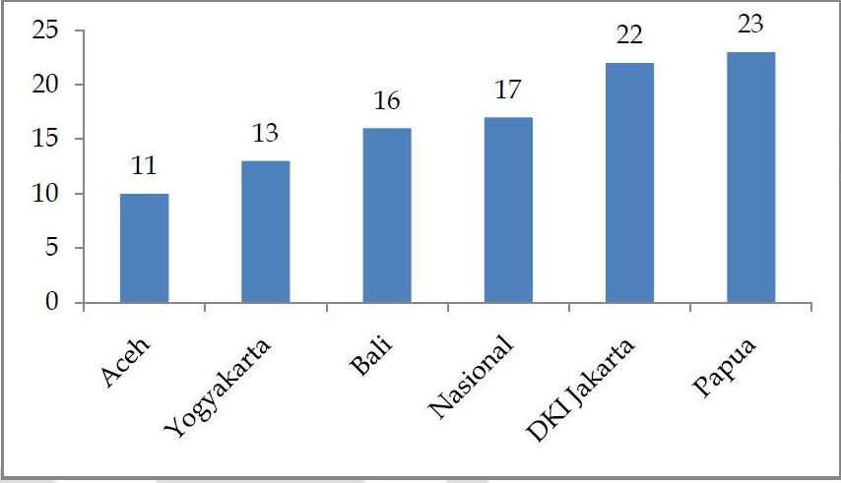

Source: Indonesian Ministry of National Education Padati Web, 2010 (ratios rounded)

**Graph 2** compares all the districts in the Province of Aceh on primary school teacher:student ratios. The highest ratio is almost double the lowest, and yet it is still not very high compared with other countries’ ratios. There are many possible reasons for these variances including local, demographic and historical factors, the greater attractiveness of some provinces to teachers than others, their locations, comparative teacher remuneration, local hiring practices and teacher qualification requirements.

Graph 2: Teacher:student ratios in districts of Aceh province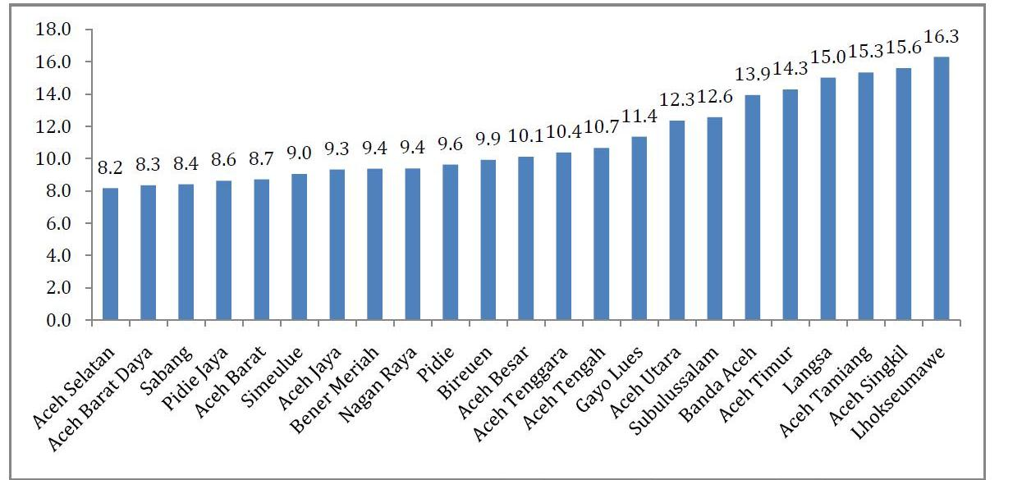

Source of data: 2010 Aceh Province Education Annual Education Report (LPPA).

**Graph 3** provides national level data showing trends through time and the differences in primary and secondary teacher provision in districts classified as lower middle income. This can be compared with the international averages (straight line) for primary and secondary. What it suggests is that, over the last decade in particular, the student teacher ratio has declined*.* This is largely attributed to the teacher workforce growing more quickly than student enrolments and potentially deliberate policy and budget choices to lower the ratio (although at the time there had not been a strong emphasis on data for decision-making, implying that budget and policy interventions incidentally affected rations).

Graph 3: Student:teacher ratios over time in lower middle income districts

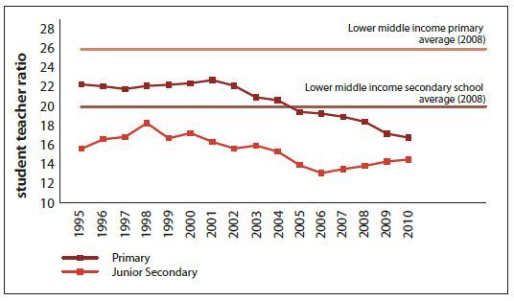

Source: Samarrai S, Syukriyah D, Setiawan I 2012, [Making Better Use of Teachers – Strengthening Teacher Management to Improve the Efficiency and Equity of Public Spending.](http://documents.worldbank.org/curated/en/602311468038719842/pdf/741550BRI0Teac0eft0112900Box371978B.pdf)

|  |
| --- |
| An activity for you  **Consider the data from the graphs above and answer the following questions.**  Question 1: What scenarios or factors would you hypothesise to account for the different trend lines?  Question 2: Why would the primary ratios be getting even lower? Could it be due to a lower student population, over-supply or local hiring practices?  Question 3: How well is this kind of data communicated in your context, and what difference could it make to policy-making? How would it improve planning if data was disaggregated by gender, ethnic minorities, people with disabilities and urban/rural/remote?  **Check your answers to Question 2.**  Why would the primary ratios be getting even lower?   * Lower student population? (answer – no) * Over-supply? (answer – probably yes) * Local hiring practices? (answer – most probably yes) |

## Balancing demand and supply of education staff

Over-supply and under-supply of education workforce personnel are equally problematic and require agreement between levels of government to be effectively managed. Over and under-supply of teachers, for example, influence teacher:student ratios and therefore the level of individual attention a student receives.

A further consideration of supply relates to the level of personnel available to substitute for one another. Primary schools, for example, tend to have different issues and problems to secondary schools where more subject specialist teachers are required; secondary schools often require teachers with different and higher levels of teacher training than do primary schools.

### Teacher over supply

There are several ways that education systems can seek to manage the problem of matching supply and demand and responding to unforeseen circumstances. One is to push the planning function to the local level, with stringent accountability. Another is to maintain a proportion of the workforce as temporary or contract teachers and this makes it easier to shed or hire teachers.

These approaches may however affect the job and income security of women disproportionately as they are more likely to be in temporary or contract employment. Whilst not a popular scenario with teachers and teacher unions, temporary or contract teachers provides government with some flexibility to avoid high over-supply, and to respond rapidly to under-supply.

### Effective procedures for addressing over and under supply

Another strategy to respond to the over-supply of teachers is to have deployment and re-deployment procedures nationally, as well as local level agreements to transfer teachers between schools, within defined areas, such as a district. Sometimes education ministries and regional authorities are able to offer financial and other incentives (professional development assistance or permanent employment and promotion fast tracking strategies) to attract teachers to areas of inadequate teacher supply. Since each of these actions can impact on the welfare of teachers and their families, local governments are often reluctant to act on redeployment measures unless they are accountable for the budget.

|  |
| --- |
| Case study: Excess teachers in Indonesia  The World Bank Education Indonesia Public Expenditure Review 2011 identified the number of primary and junior secondary teachers, both public service and contract, that could be re-deployed in accord with the standards outlined by government.  The following graph shows the scale of redistribution necessary to comply with staffing standards in primary and junior secondary schools. It shows how many teachers in Indonesia would need to be moved to achieve a more equitable distribution of primary and junior primary teachers across the country and how far they would need to move to achieve that objective.  **Graph 4: Numbers of teachers to be moved to achieve equity, Indonesia**  D:\ERF\2013 tasks\Modules\workforce planning\graphs\oversupply graph from PER.jpg  Source: World Bank 2011, Indonesian Education Public Expenditure Review. |

|  |
| --- |
| Case study: Merging small schools in Indonesia  In 2000, the local district education office in Bantul, Yogyakarta realised that many of its schools had very few students. In some schools it was not uncommon to have only five students in each class.  Faced with growing budget pressures and the high cost of maintaining a large number of small schools, the district began to explore ways in which the number of schools could be reduced. It set a number of criteria for identifying primary schools that could potentially be merged:   * enrolment levels below 150 students * distance between schools to be merged to be less than 1.5 kilometres * no geographical obstacles such as rivers, railway lines, highways, or mountains separating the schools.   **What happened?**  The success of the school merging program can be ascribed to the local government’s responsiveness to the concerns of all stakeholders. For example, teachers and school principals of merged schools were concerned about being transferred to schools far away from their homes. The local government ensured that teachers were transferred to schools close to their homes and promoted well-performing principals to become school supervisors. The local government worked with affected communities to socialise the importance of the proposed merger. It also supported the conversion of old school buildings for other uses such as training centres for early childhood education.  **Was it successful?**  The program of merging schools has been regarded as successful. According to district records the number of primary schools has fallen from 578 in 2002/03 to 356 in 2011. The primary school student:teacher ratio in Bantul district was 20:1 in 2010, well within levels of teacher provision necessary for quality education, and despite the merging of schools, Bantul district continues to perform well on the annual national examinations.  Source: Samarrai S, Syukriyah D, Setiawan I 2012, [Making Better Use of Teachers – Strengthening Teacher Management to Improve the Efficiency and Equity of Public Spending.](http://documents.worldbank.org/curated/en/602311468038719842/pdf/741550BRI0Teac0eft0112900Box371978B.pdfhttp:/documents.worldbank.org/curated/en/602311468038719842/pdf/741550BRI0Teac0eft0112900Box371978B.pdf) |

### Teacher under-supply

Under-supply of teachers is an ongoing problem in most developing countries, primarily because of efforts to expand access to universal education for the first six years, then nine years and then 12 years. In many developing countries there is a high birth-rate, with an associated growth in the school-aged population.

There are also teacher supply lag time issues, particularly if demographic change is not well understood (for example: baby boom; rural to urban drift; population movements due to conflict, natural disaster or economic change). Often, a ‘trained’ teacher is a secondary school graduate with 1-4 years of tertiary level pre-service training.

When there is population growth – either in real numbers or in enrolment numbers (e.g. more children enrolling due to the abolition of school fees) – the system cannot instantly respond with more fully trained teachers. Teacher attrition may also be an issue if more teachers are leaving the system than are being replaced by new teachers. An added difficulty is that the higher education and teacher training sectors which prepare teachers face capacity constraints in many countries.

There are several consequences in these under-supply scenarios:

* Student numbers increase while teacher numbers stay the same (or reduce). The result is larger class sizes, and larger staff:student ratios.
* Under-qualified or under-trained teachers are hired. Such teachers may not have finished school themselves, and may have little or no pre-service training.
* Auxiliary teachers are sought, such as retired teachers, foreign teachers or international volunteers.

### Chronic under-supply

Countries that have an over-supply in some areas or an over-supply in total, can still suffer from a critical under-supply in some geographic areas and in some subject areas. The problem of under-supply is frequently more serious in remote or difficult-to-access areas.

Actions to redress this include incentives such as allowances, teacher housing or other benefits for remote area appointments. Where such provisions are not affordable, or are available but are not effective, positions are left vacant and classes combined in some way, or positions are filled by untrained teachers or volunteers. Small schools are particularly vulnerable to insufficient and intermittent staffing.

The key lesson here is the critical role good Education Management Information System (EMIS) and workforce data can play in planning the sector workforce over time. Good data cannot cover every contingency, but good data analysed well can be instrumental in planning budgets, managing change, and improving education quality over the medium term.

|  |
| --- |
| Case study: Laos teacher under-supply  Throughout the basic education sub-sector in Laos there are significant challenges to teacher supply, training, deployment and professional support. While there is a surplus of teachers nationally, difficulties in attracting and maintaining qualified teachers in remote areas is a major constraint, and contributes to the large number of one- and two-teacher or ‘incomplete’ schools throughout the country (‘incomplete’ schools offer less than the full five grades of primary school.)  Disincentives to working in remote environments include a lack of resources and support, extra workloads associated with teaching in what are often multigrade environments, and, for non-local teachers, language and cultural barriers. Non-local female teachers face additional challenges of working and living in these communities - including safety and security issues and gender-related cultural barriers, which make it difficult for married females to relocate their families for professional reasons.  Source: Department of Foreign Affairs and Trade 2014, [Australia-Laos Education Delivery Strategy 2013-18](https://dfat.gov.au/about-us/publications/Pages/australia-laos-education-delivery-strategy-2013-18.aspx) |

## The challenge of deployment

In some countries the deployment of teachers may result in an over-supply in urban areas and an under-supply in rural areas. For example, in Australia rural, regional and remote schools can be hard to staff. Teachers often experience isolation from friends and family, find the physical environment unfamiliar, perceive the lack of access to services and shops as a limitation and the sheer distance to the city as a challenge. As a result, ongoing staffing vacancies are common in rural areas.

## Entry to the teaching workforce

One of the key challenges in improving children’s access to quality education is to ensure that all teachers have the minimum qualifications considered essential for effective teaching. In developing countries this minimum has been increasing steadily over the decades from less than six months of dedicated pre-service teacher training to the now typical two to three years teacher education qualification.

Raising the qualifications of new entrants to the profession can be phased in according to demand, available budget and the capacity of higher education institutions. Compared with teachers in OECD countries, many teachers in developing countries are under-educated and under-trained. Raising teaching standards through improved pre-service programs is a challenge - particularly where teachers have been appointed by their communities and in non-government organisation schools.

## Raising qualifications of the existing workforce

Raising the qualifications of existing teachers is a challenging task because:

* teachers will be at many different starting points, including some with high school education, or less
* teachers usually cannot be released from their classes, requiring intensive training during school holidays when teachers may have competing priorities on their time (e.g. agricultural work)
* part-time training may not be in reach of teachers in small and remote schools
* the lack of connectivity and infrastructure limit the opportunities for distance learning
* supervisors and trainers may be unable to travel the distances required to bring training to remote areas
* family commitments, particularly for women, reduce the range of options.

Innovative approaches for mixed-mode training are being developed which involve teachers in a cycle of multiple, short periods of attendance at a local training hub followed by return to teaching and supervisory visits. Mixed mode training is especially important in countries with a difficult terrain, such as Papua New Guinea.

## Small schools

Whilst it is typical to think of education in terms of **mono-grade classes**,where all the students are enrolled in the same grade, multi-grade teaching is a necessity in many small or remote schools where there may be fewer teachers than grades. It is also common in some urban areas that are subject to fluctuations in enrolments.

A **multi-grade class** is a single class where students from more than one grade are enrolled and where there will be a range of ability and ages. Multi-grade teaching requires the same skills of assessment and adaptation as good mono-grade teaching, but with a focus on differing content and grade standards. There are many benefits in having older and younger students learning together, and can be supportive of different learners, repeaters, and returning drop-outs.

|  |
| --- |
| Case study: Indonesia multigrade teaching  In an analysis of student learning outcomes, it was reported that teachers in the Indonesian rural areas of Pacitan district found that “teachers who were previously overworked by attempting to teach each grade in separate shifts were now able to use their time more effectively. A comparison of test scores showed greater improvement in the multi-grade than the mono-grade schools in the district.”  Source: World Bank 2013, [Indonesia - Spending More or Spending Better: Improving Education Financing in Indonesia](https://openknowledge.worldbank.org/handle/10986/13210https:/openknowledge.worldbank.org/handle/10986/13210) |

### Other approaches for small schools

Other approaches to optimise learning outcomes in small schools include various forms of peer tutoring and class monitors who stand-in for the teacher, the use of volunteers and timetabling the grades into separate shifts.

The percentage of small schools is often an important indicator in education workforce planning or where improvements in the quality of the teaching workforce will be needed. Whether mono-grade or multigrade classes are in operation, teachers in small rural schools are frequently disadvantaged by:

* a lack of contact with other teachers and professionals
* distance from support services
* poor connectivity and communication
* difficulty getting resources and supplies.

## Teaching in remote areas

In remote areas, teachers are often out of touch with the district office for long periods and unaware of basic reporting and management procedures which may be taken for granted in other locations.

Teaching in remote areas requires teachers who are resilient, creative and independent as well as highly skilled professionals. Attracting and retaining high quality teachers to remote areas is difficult, even where incentives are provided to attract teachers or to compensate them for the challenging conditions. In Laos for example, a mobile teacher model has been introduced to assist with these shortages and issues (see earlier example of the Laos teacher under-supply, and research findings in the references attached).

|  |
| --- |
| An activity for you  **For your country program or a developing country known to you, what strategies are used to balance teacher supply and demand?**   1. How is supply and demand affected by gender? 2. Are there specific strategies for this? 3. What incentives are provided for teachers to serve in remote areas? 4. How successful are these incentives? |

# Improving workforce quality

## Private schools and teachers

In many developing countries education has traditionally been provided by religious groups (churches, missionary societies, Islamic foundations and charitable organisations). Often the teachers in these non-government schools have been lowly paid (if at all) and usually, but not always, have had low levels of qualifications. Today most developing countries have a mix of public and private (non-government) education.

The following discussion provides some insight into selected elements that can support improved management of the teacher workforce.

### Introduction of policies to close the public/private gap

Teachers in non-government schools are generally accountable to the principal and the foundation or organisation which owns the school. However, where there are gaps in quality between the public and non-government school workforce, governments might look to introduce policies such as:

* mandatory minimum qualifications for employment as a teacher (e.g. a three year bachelor’s degree) in any school
* opportunities to upgrade qualifications while still being paid (e.g. through a conversion course)
* regulation of teaching standards which may be used to assess the competence of teachers (e.g. performance assessment guidelines to be used by principals and supervisors to assess teacher performance)
* registration and certification procedures to ensure teachers are up-to-date and engage in continuous professional development, including specified mandatory hours of in-service training.

## Certification and registration processes

Certification and registration refer to the processes by which teachers with academic qualifications can be shown to possess the professional competencies for teaching. These processes can involve one or a combination of the following – a written test, interview, evidence of participation in professional development, submission of a portfolio, report from a supervisory teacher or principal, observation of a lesson and feedback from a supervisor or district official.

The benefits of certification for individual teachers may include an increase in salary, change in status from temporary to permanent, different status and responsibilities within the school, promotion on ladder of career progression, qualification and accreditation to teach in other jurisdictions. The benefits of certification for the system include the opportunity to monitor and continually improve the professionalism and competence of the workforce.

|  |
| --- |
| Case study: Read-up – teacher certification in Indonesia  The foundation module included a case study of the 2005 Government of Indonesia Teacher Law (No 14/2005). A key element of the reform was the certification of teachers who met the minimum academic qualifications requirements and were teaching the equivalent of a full-time load.  Monitoring by the World Bank is reported in [Policy brief 73264: Teacher Certification in Indonesia – a Doubling of Pay or a Way to Improve Learning?](http://documents.worldbank.org/curated/en/422651468285048834/pdf/732640BRI0Teac00disclosed0100170120.pdf) The evaluation found: The certification process did not lead to improvements in the subject knowledge of teachers or their membership of a teacher working group, nor did lead to improved scores on the student learning assessment.  Read the [evaluation](http://econweb.ucsd.edu/~kamurali/papers/Published%20Articles/Double%20for%20Nothing%20(QJE_Forthcoming).pdf) conducted by De Ree; Muralidharan; Pradhan; and Rogers (2017) and consider why the reform was not successful in improving student outcomes  Sources: World Bank 2012, [Policy Brief 73264: Teacher Certification in Indonesia: a Doubling of Pay, or a Way to Improve Learning?](https://econweb.ucsd.edu/~kamurali/papers/Published%20Articles/Double%20for%20Nothing%20(QJE_Forthcoming).pdfhttp:/documents.worldbank.org/curated/en/422651468285048834/pdf/732640BRI0Teac00disclosed0100170120.pdf); De Ree J, Muralidharan K, Pradhan M, Rogers H 2017, [Double for nothing? Experimental evidence on an unconditional teacher salary increase in Indonesia](https://econweb.ucsd.edu/~kamurali/papers/Published%20Articles/Double%20for%20Nothing%20(QJE_Forthcoming).pdfhttps:/econweb.ucsd.edu/~kamurali/papers/Published%20Articles/Double%20for%20Nothing%20(QJE_Forthcoming).pdf) |

## Affirmative action

Women are underrepresented in decision-making and senior staff positions in most education systems, often due to explicit or implicit bias in hiring, training and progression. Institutional structures, including qualifications and required work experience, promotion procedures and job descriptions may help or hinder women’s progress to leadership. In addition, informal attitudes and practices exist that may also support or discriminate against women.

Affirmative action policies are one means of remedying cultural or institutional biases. In 1996, Uganda revised its Constitution to be more responsive to gender equality issues. It acknowledged the importance of affirmative action to “redress the imbalances created by history, tradition or custom.” This included a policy that 30 per cent of applicants hired for all school positions, including leadership roles, should be women.

In the interests of equality, scoring for applicant shortlisting and interviews were adjusted to counter the disadvantage women faced due to such requirements as years of service or experience in decision making (requirements which favoured their male counterparts). This, however, is a long-term process and Uganda is still working to resolve the under-representation of women in their education sector.

|  |
| --- |
| An activity for you  **Supporting affirmative-action**  The Director of Human Resources in the Ministry of Education has requested your assistance in developing an affirmative action policy for the education sector. You have a flexible facility so you can provide a consultant to help with this but you need to develop a set of Terms of Reference and tasking note. Before you discuss this further with the Director you need to understand more about why affirmative action is desired.  **Consider the following questions:**   1. What are possible causes of gender imbalance in the education workforce? 2. What statistics would be useful to present in the rationale? Are these available? 3. What are the global lessons learned in affirmative action policy? |

## Quality assurance systems

All developing countries want to ensure that the education that is provided meets quality standards. The first key task is to develop policies and standards that are inclusive, are learner focused and are at the same time achievable and affordable.

The system must then develop strategies and instruments to measure and hold individuals and institutions accountable for how well teachers perform and how well students learn. School supervisors or inspectors are the first line in education quality assurance but in poor countries there is little funding available for their training and resourcing (e.g. for travel, to conduct workshops).

The following diagram illustrates that at the school level, quality assurance usually includes activities such as school self-evaluation and school improvement planning. At a district level, quality assurance is more likely to include activities to monitor school inputs and outputs and district processes.

Figure 2: Quality assurance systems

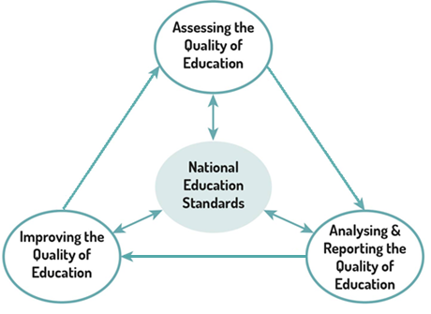

Source: Indonesia National Ministry of Education & Culture 2010, Education Quality Assurance and Improvement System (EQAIS)

An education quality assurance framework is the broader system which supports the processes presented in Figure 2 at school and district level. For example, a quality assurance framework would include the following key elements:

* performance standards included in minimum service standards or other policy statements
* targets and ways of measuring performance including gender measurements and goals
* requirements and templates for annual reporting
* regular schedule of program and policy evaluation by the national level
* resource allocation which takes account data from all levels
* clear roles and responsibilities for managers at all levels and sufficient autonomy intervention, and support for improvement to take place
* clear accountability and consequences for poor performance.

Have developing countries made progress on quality assurance requirements?

Developing countries have made considerable progress on the requirements in the first half of this list and little progress in areas such as intervention systems and sanctions for poor performance.

Quality assurance at school level usually includes some form of school self-evaluation followed by reporting to district and community. Often, evaluation includes establishing plans and prioritising for the following year. These could include gender equality goals if there is imbalance in male and female teaching staff or different enrolments or performance for girls and boys. The school development plan may be a condition for ongoing school grants.

A fully-fledged quality assurance system at school level should include a degree of external monitoring and the tracking of student outcomes.

## Teacher remuneration

Increasing teachers’ remuneration is generally agreed to be effective in raising the status of teaching and thereby attracting and retaining better quality graduates in teaching. However, research findings on the impact of salary on teacher performance in the classroom is very mixed, a reminder that there are many factors which impact on teacher behaviour – personal factors such as knowledge, skills, attitudes, intrinsic motivation and gender awareness – and school level factors such as organisation climate, leadership, clarity of roles, support and feedback. Teacher remuneration varies for several reasons, including the:

* capacity of a country or province to pay
* number of teachers to be paid
* qualification requirements for their employment
* demographics of the teaching workforce
* level of unionisation of education employees
* nature and value of other employment conditions provided.

Increases in teacher remuneration need to be considered in light of the quality assurance and accountability measures put in place, improvements in qualifications, years of service etc. In turn, these factors often determine the status of teacher employment (contract vs. permanent).

## Teacher housing

The provision of teacher housing is often one of the key elements of a teacher welfare system in rural and remote areas. Often this is a district or local village responsibility but can be supplemented by national subsidies and allowances. Other adjustments are also made locally, e.g. allowing teachers time off to undertake harvesting or planting at key periods of the agricultural cycle, donating food to the teacher’s family and allowing time away for child birth and carer responsibilities. Teachers in very isolated locations are often not able to receive their salary for long periods and may have to walk long distances to get to a transport access point, necessitating long absences from school. Mobile money approaches are helping in this regard, but are far from universal.

# Capacity development approaches for the workforce

|  |
| --- |
| Capacity development  The term capacity development is used to describe “capacity development as the process through which individuals, organizations and societies obtain, strengthen and maintain the capabilities to set and achieve their own development objectives over time.”  Source: United Nations Development Programme (UNDP) 2009, [Capacity Development: A UNDP Primer](https://www.undp.org/content/dam/aplaws/publication/en/publications/capacity-development/capacity-development-a-undp-primer/CDG_PrimerReport_final_web.pdf) |

## Capacity development strategies for all levels

Capacity enhancement occurs at various levels and a comprehensive approach should address each level. Each of the following approaches for developing capacity are critically important for building and maintaining a quality work force and providing the opportunity for quality teaching and learning to occur.

### In-school support

Designated teachers and principals can provide mentoring, coaching, supervision and support in formal and informal ways. Support should be sensitive to gender including female role models where feasible. In an ideal school, the principal nurtures the development of a learning community in which all members support each other in continuous improvement. Unfortunately in many schools there is a closed-door culture caused by low levels of training and low levels of confidence. Even when teachers are required to undertake local lesson planning there is little evidence of teachers collaborating until some external stimulus is introduced.

A [Minimum Service Standards Baseline Survey in Indonesia](https://www.adb.org/sites/default/files/project-document/176596/43273-012-dpta.pdf) showed that in two thirds of national schools and almost half the madrasah, principals regularly supervised teachers through classroom visits and discussions.

Source: PT. Trans Intra Asia, Indonesia and The Institute of Public Administration of Canada, Canada 2014, Support to Basic Education Minimum Service Standards Planning and Monitoring

### Induction programs

Induction programs are usually formal processes which assist new teachers to adapt to general school routines and local expectations as well as their specific teaching responsibilities (including gender sensitive teaching practices). Such programs are especially important for new graduates who have not had a professional (pedagogical) stream in their training program. At a minimum level it would include introductions to school personnel, explanation of roles, rules and expectations and handover of any resources and materials.

### Performance management

Performance management is the process by which supervisors engage with their staff to monitor and improve their performance. At a minimum, it needs a clear statement of roles and responsibilities against which achievements can be discussed. The next step is for goals to be mutually agreed and the required assistance provided. In many developing countries this function is not strong. A base good practice is to encourage principals to visit classrooms and to give constructive feedback to teachers.

### In-service training and networks

In-service training occurs in many different ways – short meetings after school, whole day workshops, cluster meetings, visits to other schools or short training courses on particular teaching topics (such as multi-grade teaching, gender sensitivity) and management issues (for example: timeline for introducing a new curriculum). Schools are often given a budget allocation to fund teachers’ meeting and travel costs; districts also provide funds and advisors for activities. National policy initiatives are often accompanied by resources and funding to support implementation: for example training modules, resource materials and “train the trainer”.

### Visiting specialists

Education systems usually have some curriculum advisors but the extent to which they can visit schools or cluster meetings is often very limited because of transport costs. New areas of curriculum or school management are usually targeted for assistance through visiting specialists such as curriculum advisors.

### Formal studies/higher education

Teachers who are within travel distance of higher education institutions are sometimes assisted financially, or with release time, to attend courses which contribute to their professional development.

Online learning is becoming increasingly popular as more teachers are able to access technology and the internet. Open learning institutions provide a more flexible pathway for teachers and civil servants who are not within easy reach of universities and training colleges or whose other obligations prevent physical attendance. Government and development partners provide scholarships for teachers and civil servants to upgrade their qualifications.

### Continuous professional development

The notion of self-directed continuous learning incorporating some of the above activities is at the pinnacle of capacity enhancement. This recognises that professionals take responsibility for their own professional development, with learning intrinsically motivated, individualised, contextualised and ongoing.

### Succession planning

At system and school levels, succession planning seeks to identify future leaders and to provide the experiences they will need to be ready for leadership roles. Ideally this is part of systematic performance management but is more often ad hoc. One of the ways that principals can contribute to succession planning is to delegate roles to staff, ensuring that such opportunities are available to both female and male teachers.

### Gender equality strategies

While most education workforces are working towards gender equality in the teaching ranks, many lag behind in promotions to principal and district official or school supervisor. Policies which are made at the national level can take some time to be operationalised at district and school level. The Australian aid program supports gender awareness, planning and budgeting in all of its education programs.

### Career pathways

Active performance management provides attractive pathways to motivate high performing teachers to remain in the education system. For teaching to attract the most able female and male graduates, there needs to be an attractive remuneration and career path. A teacher appraisal system assists in recognising and encouraging good performance, identifying areas for development, and improving overall performance of teachers, and ideally links this performance to remuneration and non-financial incentive structures.

### Leadership development

Leadership development is often focussed on principals and district officials but may also target middle levels of management and high performing teachers. It can use many of the strategies outlined above as well as tailored short courses, diplomas and higher degree scholarships. Women are often absent from decision making positions in the education sector and specific steps need to be taken to address this imbalance.

### Supporting school-based management

School-based management aims to decentralise decision-making from central education and field offices (departments of education) to individual schools to enable them to better respond to their specific education needs. Supporting school-based management requires training courses for principals, school staff and school committee members in school development planning, decision-making, financial planning and management (including gender sensitive budgeting), monitoring and reporting; school improvement and accountability.

### Supporting district management, provincial and national management

A number of actions can support the development of district managers, provincial administrators and national coordinators including:

* strategic and annual planning
* data collection, management and analysis (including gender, ethnic minorities, people with disabilities-disaggregated data)
* education workforce analysis and planning
* human resource development
* community engagement that ensures different categories of men and women are represented; financial management (including gender sensitive budgeting), planning and reporting; procurement; meeting minimum service standards
* quality assurance
* governance and regulation
* anti-corruption strategies.

# Responding to context

The preceding information provides useful approaches to education sector workforce planning. Whilst useful, these approaches must always be mindful of context. Key considerations for contextualising workforce planning include:

* The impact of decentralisation on governance and financing – Who pays for what? Who is accountable and to whom?
* The importance of reliable and timely data and skills for analysis including gender-disaggregated data and gender analysis.
* Special issues faced in rural and remote areas.
* Ways of empowering local communities (including women and women’s groups).
* Efficiency issues e.g. amalgamation of schools; class sizes; student-teacher ratios; female-male teacher ratios.
* How government and development partners are addressing persistent disparities in education inputs and outcomes associated with poverty, disability, gender and isolation.
* The occurrence of gender imbalance in the education sector workforce – In what parts of the sector? Are imbalances being addressed? In what way?
* Training teachers to support children with disabilities.
* Industrial relations laws and regulations (that affect women).
* The occurrence of gender sensitive budgeting and planning.
* Cultural practices and beliefs that impact on an equitable workforce plan for the education sector.



# Test your knowledge

## Assessment questions

Answer the following questions by ticking ‘True’ or ‘False’. Once you have selected your answers to all the questions, turn the page to ‘The correct answers are...’ to check the accuracy of your answers.

Question 1

Education systems can never have enough teachers.

Is this statement true or false? □ True □ False

Question 2

All countries should aim for the ideal teacher:student ratio.

Is this statement true or false? □ True □ False

Question 3

There are both advantages and disadvantages of having casual or contract teachers in the workforce.

Is this statement true or false? □ True □ False

Question 4

Multigrade teaching is not a bad thing.

Is this statement true or false? □ True □ False

Question 5

Quality assurance of education is mainly about having a rigorous external review process.

Is this statement true or false? □ True □ False

Question 6

The following are all types of capacity development approaches for the education workforce:

* in-school support
* induction programs
* performance management
* in-service training
* visiting specialists
* formal higher education, including scholarships
* continuous professional development programs.

Is this statement true or false? □ True □ False



## The correct answers are...

Question 1

Education systems can never have enough teachers.

**This statement is false.** An over-supply of teachers raises problems of sustainability and efficiency and may impact negatively on other education sector priorities.

Question 2

All countries should aim for the ideal teacher:student ratio.

**This statement is false.** There is no ideal ratio. The ratio will be specific to the policy context of location (country or region) and level in the education system.

Question 3

There are both advantages and disadvantages of having casual or contract teachers in the workforce.

**This statement is true.** The advantage is the flexibility it creates within a workforce. The disadvantage is the potential for negative impacts on teacher welfare.

Question 4

Multigrade teaching is not a bad thing.

**This statement is true/false.** Multigrade teaching is often a necessity in small schools, and multigrade teaching occurs in many so-called mono-grade classes where there is a wide range of ages and ability levels. The most important issues are appropriate teacher preparation and support to meet the needs of all children in a classroom.

Question 5

Quality assurance of education is mainly about having a rigorous external review process.

**This statement is false.** Quality assurance should include both in-school and external processes of review.

Question 6

The following are all types of capacity development approaches for the education workforce:

* in-school support
* induction programs
* performance management
* in-service training
* visiting specialists
* formal higher education, including scholarships
* continuous professional development programs.

**This statement is true.**

# References and links

**All links retrieved August 2019.**

2010 Aceh Province Education Annual Education Report

De Ree J, Muralidharan K, Pradhan M, Rogers H 2017, Double for nothing? Experimental evidence on an unconditional teacher salary increase in Indonesia. Quarterly Journal of Economics, United Kingdom, <https://econweb.ucsd.edu/~kamurali/papers/Published%20Articles/Double%20for%20Nothing%20(QJE_Forthcoming).pdf>

DFAT 2014, Australia-Laos Education Delivery Strategy 2013-18. Canberra, <https://dfat.gov.au/about-us/publications/Pages/australia-laos-education-delivery-strategy-2013-18.aspx>

Indonesia Ministry of National Education 2010, Padati Web

Indonesia National Ministry of Education and Culture 2010, Education Quality Assurance and Improvement System (EQAIS)

OECD n.d, Student-teacher ratios and average class size, OECD Stat, <https://stats.oecd.org/Index.aspx?DataSetCode=EAG_PERS_RATIO>

PT. Trans Intra Asia, Indonesia and The Institute of Public Administration of Canada, Canada 2014, Support to Basic Education Minimum Service Standards Planning and Monitoring. Jakarta, <https://www.adb.org/sites/default/files/project-document/176596/43273-012-dpta.pdf>

Samarrai S, Syukriyah D, Setiawan I 2012, Making better use of teachers: strengthening teacher management to improve the efficiency and equity of public spending. Indonesia – World Bank, <http://documents.worldbank.org/curated/en/602311468038719842/pdf/741550BRI0Teac0eft0112900Box371978B.pdf>

UNDP 2009, Capacity Development: A UNDP Primer. New York, <http://www.undp.org/content/dam/aplaws/publication/en/publications/capacity-development/capacity-development-a-undp-primer/CDG_PrimerReport_final_web.pdf>

World Bank 2011, Indonesian Education Public Expenditure Review

2012, Teacher Certification in Indonesia: A Doubling of Pay, or a Way to Improve Learning? Washington, <http://documents.worldbank.org/curated/en/422651468285048834/pdf/732640BRI0Teac00disclosed0100170120.pdf>

2013, Indonesia – Spending More or Spending Better: Improving Education Financing in Indonesia.Jakarta, <https://openknowledge.worldbank.org/handle/10986/13210>

Learn more about…

* *Workforce Development in Developing Countries, World Bank Group, 2010, found at*, <http://siteresources.worldbank.org/EDUCATION/Resources/278200-1290520949227/WfD_Benchmarking_Framework.pdf>
* *The World Bank (SABER) ‘What Maters for Workforce Development. A Framework and Tool for Analysis, found at,* <http://documents.worldbank.org/curated/en/608191468326178977/What-matters-for-workforce-development-a-framework-and-tool-for-analysis>
* *Multi-grade approaches to learning and teaching, found at,* <http://multigrade.ioe.ac.uk/> and <http://multigrade.ioe.ac.uk/fulltext/fulltextLittle.pdf>
* *DFAT’s Investing in Teachers ODE Brief, found at,* <http://dfat.gov.au/aid/how-we-measure-performance/ode/Documents/teacher-development-evaluation.pdf>
* *UNESCO’s discussion on ‘The challenge of teacher shortage and quality: Have we succeeded in getting enough quality teachers into classrooms?’, found at,* <http://unesdoc.unesco.org/images/0023/002327/232721E.pdf>