|  |
| --- |
| AusAID |
| An Effective Aid Program for Australia |
| Making a real difference-Delivering real results |
|  |
| **6/1/2012** |

|  |
| --- |
| © Commonwealth of Australia 2012 This work is copyright. Apart from any use as permitted under the Copyright Act 1968, no part may be reproduced by any process without prior written permission from the Commonwealth. Requests and inquiries concerning reproduction and rights should be addressed to the Commonwealth Copyright Administration, Attorney General’s Department, Robert Garran Offices, National Circuit, Barton ACT 2600 or posted at http://www.ag.gov.au/ccaFor further information, contact:Communications Section AusAIDGPO Box 887Canberra ACT 2601Phone: +61 2 6206 4000Internet: www.ausaid.gov.auThis document is available online at www.ausaid.gov.au/publications |

## Contents

Executive Summary 3

1. Introduction 7

1.1 Why we provide aid 7

1.2 The state of global poverty 9

1.3 Australia’s aid program 12

1.4 A record of achievement 14

1.5 Recognising the wider development context 15

2. The Independent Review 17

3. Purpose of Australia’s aid program 18

4. Making Australian aid more effective 19

4.1 A clear strategy 19

4.2 Value for money 19

4.3 The importance of consolidation 20

4.4 Focusing on risk management and performance oversight 21

4.5 A transparent aid program focused on results 23

4.6 Involving the Australian community 24

4.7 Effective aid management—the role of AusAID 25

5. What Australian aid will focus on 26

5.1 Saving lives 27

5.2 Promoting opportunities for all 29

5.3 Investing in food security, sustainable economic growth and private sector development 32

5.4 Supporting security, improving the quality of governance, and strengthening civil society 35

5.5 Preparing for and responding to disasters and humanitarian crises 36

6. Where Australia will provide aid 39

7. The way we will deliver our aid 49

Abbreviations 52

Annex A. Response to Independent Review recommendations 53

## Executive Summary

Successive Australian Governments have recognised the Australian aid program as an integral part of Australia’s international effort. There is bipartisan commitment to the Millennium Development Goals (MDGs), and to scaling up our aid effort so that it reaches 0.5 per cent of Gross National Income (GNI). The Government has committed to reach this target by 2016-17.

As economic and fiscal conditions permit, Australia has an aspirational goal of raising aid to 0.7 per cent of GNI. This is a long-standing policy adopted by Australian governments since 1970.

We are also committed to the most effective aid program possible—to get the best value for money and to make a real difference in reducing poverty on the ground. We are using taxpayer dollars for our aid program, so we have a responsibility to Australian taxpayers to make sure that programs they fund are effective.

That’s why in late 2010, the Government commissioned the first independent review of the aid program in 15 years—a review specifically designed to assess the effectiveness of our current program and recommend where we could make it even better for the future.

The Independent Review found that Australia has a good aid program and is an effective performer by global donor standards. It made 39 recommendations to further improve the program. The Independent Review identified ways to make Australia’s aid program more transparent, more accountable, more focused on results and on real, measurable value for money.

The Independent Review analysed the overall purpose of Australia’s aid program and made recommendations on the appropriate geographic and sectoral focus of Australian aid, and the importance of effective partnerships in delivering Australian aid on the ground. The Independent Review also identified ways to give Australia’s aid program greater, longer-term strategic direction, including through reformed planning and budget measures.

The Government welcomes the Independent Review’s outcomes and agrees (or agrees in principle) with 38 of the 39 recommendations. (The Government notes one further recommendation, on the name of the Ministerial portfolio covering the aid program, and will respond to this later.) Based on the Independent Review’s findings, this statement outlines a new framework for Australia’s aid program centred on delivering real results for poor people by maximising aid effectiveness.

We want a program of which all Australians can be proud—a program where young Australians will want to volunteer, where we will hold our heads up high because of the difference we are making to others in the world.

### The purpose of the aid program

The fundamental purpose of Australian aid is to help people overcome poverty. This also serves Australia’s national interests by promoting stability and prosperity both in our region and beyond. We focus our effort in areas where Australia can make a difference and where our resources can most effectively and efficiently be deployed.

### Making Australian aid more effective

Enhanced effectiveness will be the cornerstone of Australia’s aid program. Consistent with the Independent Review’s recommendations we will:

* drive value for money in our aid program, building on the commitment to reduce the number of technical advisers by 25 per cent over the next two years, and reduce any unreasonable remuneration levels of remaining advisers to maximise the return on our aid dollars
* develop a rolling four-year whole-of-aid budget strategy, covering for the first time, the aid efforts of all relevant Australian Government agencies under one coherent plan that outlines the results we aim to achieve
* analyse annually our progress against the results outlined in the four-year budget strategy to make clear what is working and what is not
* abolish any programs that are not delivering on their objectives or undertake immediate changes to make sure they are
* by the end of 2011, issue a Transparency Charter to provide more accessible information on what we fund and the results we achieve
* further strengthen our existing robust fraud and risk management systems and capabilities
* involve more Australians in the aid program including by increasing volunteer numbers and improving links with Australian business.

### What Australian aid will focus on

Consistent with the MDGs, what we do will be guided by five core strategic goals, reinforced by 10 individual development objectives. The goals are:

* Saving lives
* Promoting opportunities for all
* Sustainable economic development
* effective governance, and
* humanitarian and disaster response.

Consistent with the strategic goals, the Australian aid program will also focus on 10 individual development objectives. These are:

• improving public health by increasing access to safe water and sanitation

• saving the lives of poor women and children through greater access to quality maternal and child health services (for example, skilled birth attendants and midwives) and supporting large scale disease prevention, vaccination and treatment

• enabling more children, particularly girls, to attend school for a longer and better education so they have the skills to build their own futures and, in time, escape poverty

• empowering women to participate in the economy, leadership and education because of the critical untapped role of women in supporting development

• enhancing the lives of people with disabilities

• improving food security by investing in agricultural productivity, infrastructure, social protection and the opening of markets

• improving incomes, employment and enterprise opportunities for poor people in both rural and urban areas, including the development of sustainable mining industries to boost overall economic development

• reducing the negative impacts of climate change and other environmental factors on poor people

• improving governance in developing countries to deliver services, improve security, and enhance justice and human rights for poor people; and to improve overall effectiveness in aid delivery in partnerships between host governments and agencies, and

• enhancing disaster preparedness and delivering faster, more effective responses to humanitarian crises, given the increased frequency and impact of natural disasters in recent decades.

### Where Australia will provide aid

As recommended in the Independent Review, the Asia–Pacific region, including our nearest neighbours, Indonesia, Papua New Guinea and East Timor, will remain the primary focus of our efforts. This is where we have strong ties and experience, and where the international community expects us to play a lead role. It is also where our own economic and security interests are most closely engaged.

At the same time, we will implement the Independent Review’s recommendation to increase aid to South Asia and Africa—as a growing middle power, we cannot pretend to be tackling global poverty without increasing our investment in the world’s two most impoverished regions. The aid program will continue to play its part in international efforts to bring development to Afghanistan and Pakistan. We will also provide targeted support elsewhere.

Support for global programs extends the reach and impact of Australia’s aid—both within our region and beyond. We will increase support for multilateral organisations such as the World Bank and the Global Alliance on Vaccines and Immunisations (GAVI), and United Nations development agencies that we assess as being efficient and effective, that are consistent with Australian priorities, and that deliver value for money. AusAID will also develop a global ratings system, as the British have done, that assesses the relative effectiveness of all multilateral agencies.

### How Australia will deliver our aid

We will deliver our aid using systems, methods and partners that are effective in achieving results and efficient in delivering value for money. This will not mean a ‘one size fits all’ approach. It means we will tailor our delivery systems to individual country circumstances and concrete evidence of what works best on the ground to produce results.

We will also provide more assistance through the systems and processes of our partner governments where we assess these as robust. If these systems are robust, we can drive the Australian aid dollar further by actively reinforcing partner government priorities.

We will also make greater use of multilateral partners, civil society, and Australian non-government organisations to deliver our assistance, particularly in regions where they have a greater capacity to deliver results for poor people than we do.

Whatever form of aid delivery we use, within every country we work, the Government will also, in the future, insist on visible branding of Australian aid—or co-branding if we partner with others. It is important that the world recognises that Australian aid **is** Australian aid. This has not been done effectively in the past.

The Government’s effort to drive aid effectiveness represents a significant reform. It will require far-reaching changes to the aid program. And it will take persistence and enduring effort. But it is an essential task to get the most out of our aid program, and to ensure it maintains the support of the Australian community.

Diagram 1 Framework for the Australian aid program

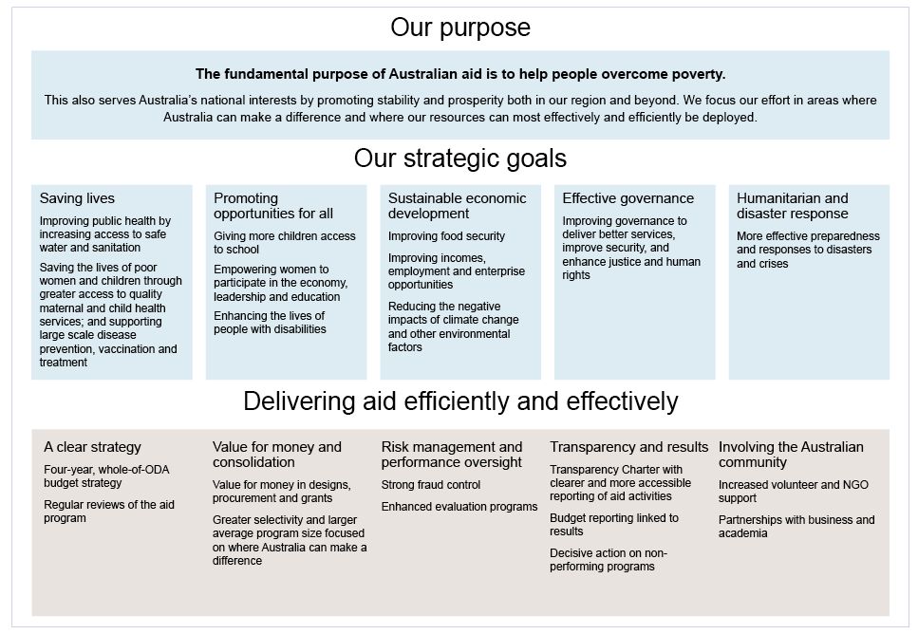

## 1. Introduction

Our aid program improves the lives of people living in poverty. At the same time, it advances our own national interests—our economic and security interests.

To ensure we were achieving the best possible return on our aid investment the Australian Government commissioned an *Independent Review of Aid Effectiveness* in November 2010. The Independent Review, led by Mr Sandy Hollway AO, was commissioned to critically assess our current program and identify where we could make it better.

The purpose of this statement is both to outline the Government’s response to the Independent Review and to set out the future directions for the Australian aid program for the period to 2015.

### 1.1 Why we provide aid

#### Australian values

We provide aid because a fair go for all is part of our national character—and that fair go extends to the 1.4 billion members of the human family who still live in grinding poverty.

We provide aid because Australians believe deeply in helping others in difficulty and distress no matter where they live. The idea of giving everyone a fair go is ingrained in all Australians, and Australians are, by instinct, a compassionate people.

Our aid also advances our national interests—it promotes security and it builds our economic interests through regional and global prosperity.

We are committed to the Millennium Development Goals (MDGs), agreed by world leaders in 2000, because it is unacceptable for 1.4 billion people to be living on less than US$1.25 a day.[[1]](#footnote-1)

It is unacceptable that:

• 22 000 children die every day, the majority from preventable causes[[2]](#footnote-2)

• almost 1000 mothers die every day as a result of pregnancy or childbirth[[3]](#footnote-3)

• 1145 people die every day from malnutrition or starvation[[4]](#footnote-4)

• 500 people die every day from war or civil conflict[[5]](#footnote-5)

• 640 000 women and children are the victims of human trafficking every year[[6]](#footnote-6)

• 915 million poor people have unclean water, and 2.6 billion have inadequate sanitation[[7]](#footnote-7)

• 67 million children, including 35 million girls, do not receive basic primary-level education.[[8]](#footnote-8)

Australia recognises we are not capable of changing this alone. But, in partnership with others, we believe we can make a difference. And Australians are the sort of people that want to make a difference.

Our approach to aid is also an expression of the Australian way of doing things. We work to give people and communities a hand up, not just a hand out, to the point where aid is ultimately no longer needed. We do this through an innovative, practical and hands-on approach based on concrete evidence of what works. And we do this in the spirit of partnership and friendship, respecting the cultures, aspirations, and the ways of working of the people we are helping.

#### Australia’s national interests

Helping poor people out of poverty in areas of strategic importance for Australia is also good for our own peace and stability. Of Australia’s 24 nearest neighbours, 22 are developing countries with some of them particularly fragile and vulnerable.

Two of our closest neighbours—East Timor and Papua New Guinea—have growing, young populations, which need to share in the benefits of resource-led growth if their stability and prosperity are to be assured. Indonesia shares a maritime border with Australia and is managing a challenging reform process aimed at improving the livelihoods of the 100 million of its people still living on $2 a day or less.[[9]](#footnote-9) Helping Indonesia to manage this transition will be important for Australia’s economy and security.

It is not in our interest for our neighbours to have a high proportion of poor people with few opportunities to improve their lives. Not only will a region like this have less economic growth and less trade, it will also be unstable, prone to radicalisation, and susceptible to the influence of countries and ideas at odds with Australia’s interests.

By lifting people out of poverty, we also grow the global economy and that is good for Australian business. We export almost $90 billion of goods and services annually to countries where Australian bilateral and regional aid is currently delivered. Prosperity in developing countries therefore contributes to jobs and improved living standards for Australians at home. Countries such as Thailand and South Korea were once aid recipients and are now among Australia’s 10 largest trade partners.

Unless we create opportunities for people to lift themselves out of grinding poverty, instability will grow and people will continue to seek refuge from violence and economic hardship on our shores. As the UK Secretary of State for International Development, Andrew Mitchell, highlighted when outlining the future of Britain’s aid program in March 2011:

*These results are not only delivered from the British people; they are also for the British people. They contribute to building a safer, more stable and prosperous world which, in turn, helps keep our country safe from instability, infectious disease and organised crime.*

#### Australia as a good international citizen

Australia is also a middle power with both global and regional interests. We are a founding member of the United Nations. We are a member of the G20—a grouping of the 20 major and emerging economies of the world. We are the fourth-largest economy in Asia after China, Japan and India. As a middle power, we also must bear our fair share of global responsibility within the overall international system.

Australia has a strong interest in enhancing a global and regional rules-based order that promotes cooperation and partnership between countries. A successful global system brings with it benefits for all countries including Australia by:

• strengthening the global economic order (through the G20, the International Monetary Fund (IMF), World Trade Organization (WTO) and International Labour Organization)

• improving the global security order (through the United Nations Security Council) together with Australia’s bilateral security treaties

• improving the global environmental order (through the United Nations Framework Convention on Climate Change)

• promoting a global human rights order (through the United Nations Human Rights Council, United Nations Convention on the Rights of the Child, and the United Nations Convention on the Rights of Persons with Disabilities)

• coordinating development assistance (through the World Bank, the Organisation for Economic Cooperation and Development, and the United Nations Development Programme)

• delivering humanitarian assistance (through a range of global governmental and non-governmental agencies including the United Nations High Commissioner for Refugees).

Therefore, beyond the direct national security and national economic interests at stake within our immediate region, we also have broader interests and values in enhancing the stability and fairness of a global rules-based order. This is the principle we call good international citizenship, where we obtain national interest benefits by building the stability and fairness of the global system, in addition to the direct benefits that flow to developing countries themselves.

Australia’s interests are not served by the fragmentation of the global order. For example, the impact on global people movements, arising from a collapse in the global system to responding to humanitarian and refugee crises, would be profoundly destabilising for Australia and other countries both in the region and beyond. We therefore have deep values and interests at stake in ensuring that the global order is preserved and enhanced. And to do that, all countries must play their part, including Australia.

Therefore, our development assistance policy, together with our foreign policy, security policy, and our international economic and environmental policies, all have an impact in supporting a stable and humane order that benefits all countries in the world.

### 1.2 The state of global poverty

The Australian Government is committed to the implementation of the MDGs—targets agreed by the world’s nations to reduce poverty by 2015. The MDGs represent an unprecedented global unifying force for reducing poverty and improving human development (see Diagram 2).

Diagram 2: The Millennium Development Goals

|  |  |  |
| --- | --- | --- |
| [Description: MDG 1 logo - plate of food](http://www.mdgmonitor.org/goal1.cfm) | End poverty and hunger | • Halve, between 1990 and 2015, the proportion of people whose income is less than $1 a day.  • Achieve full and productive employment and decent work for all, including women and young people.  • Halve, between 1990 and 2015, the proportion of people who suffer from hunger. |
| Description: MDG 2 logo - pencil | Universal education | • Ensure that, by 2015, children everywhere, boys and girls alike, will be able to complete a full course of primary schooling. |
| Description: MDG 3 logo - symbol of venus (women) | Gender equality | • Eliminate gender disparity in primary and secondary education, preferably by 2005, and in all levels of education no later than 2015. |
| Description: MDG 4 logo - teddy bear | Child health | • Reduce by two thirds, between 1990 and 2015, the under-five mortality rate. |
| Description: MDG 5 logo - pregnant woman | Maternal health | • Reduce by three quarters the maternal mortality ratio.  • Achieve universal access to reproductive health. |
| Description: MDG 6 logo - medicine bottle | Combat HIV/AIDS | • Have halted by 2015 and begun to reverse the spread of HIV/AIDS.  • Achieve, by 2010, universal access to treatment for HIV/AIDS for all those who need it.  • Have halted by 2015 and begun to reverse the incidence of malaria and other major diseases. |
| Description: MDG 7 logo - four leaf clover | Environmental sustainability | • Integrate the principles of sustainable development into country policies and programs, and reverse the loss of environmental resources.  • Reduce biodiversity loss, achieving, by 2010, a significant reduction in the rate of loss.  • Halve, by 2015, the proportion of the population without sustainable access to safe drinking water and basic sanitation.  • By 2020, to have achieved a significant improvement in the lives of at least 100 million slum dwellers. |
| **Description: goal8_sm** | Global partnership | • Targets cover: trading and financial systems, the special development needs of disadvantaged states, debt sustainability, affordable access to essential drugs, and access to information and communications technologies. |

#### Global progress

There has been unprecedented progress in reducing poverty and improving the health and livelihoods of poor people around the world.

• The developing world as a whole is on track to halve the number of people living in poverty by 2015.[[10]](#footnote-10)

• Major advances have been made in getting children into school.[[11]](#footnote-11)

• Since 1990, annual deaths of children under five have dropped from 12 million to 8 million.[[12]](#footnote-12)

• There are signs of progress in reducing maternal mortality, but not fast enough to meet the MDG target by 2015.[[13]](#footnote-13)

• On currents trends, 86 per cent of people in developing regions will have access to improved sources of drinking water by 2015.[[14]](#footnote-14)

Despite the progress that has been made, continuing global poverty remains one of the international community’s greatest challenges. Furthermore, poor countries are facing new and emerging challenges to their development. These include dealing with the impacts of the global financial crisis, rising food and energy prices and climate change.

The World Bank’s 2011 *World Development Report* has highlighted that low-income countries, and in particular fragile states, are at risk of falling into an ongoing cycle of poverty. Without sustained effort and assistance this cycle will be very difficult to overcome. The report estimates that 1.5 billion people live in countries affected by the repeated cycles of political and criminal violence that pose a constant threat to long term development. Long term engagement and assistance from the international community in these countries is essential to build confidence amongst citizens that change is possible. It is also necessary to help build the institutions and deliver improvements in governance that will enable countries to break free from this cycle of conflict and poverty.

#### Performance by region

Gains over the past decades have not been even between countries and regions (see Graph 1 below).

**Graph 1: Numbers of people living in poverty by region**

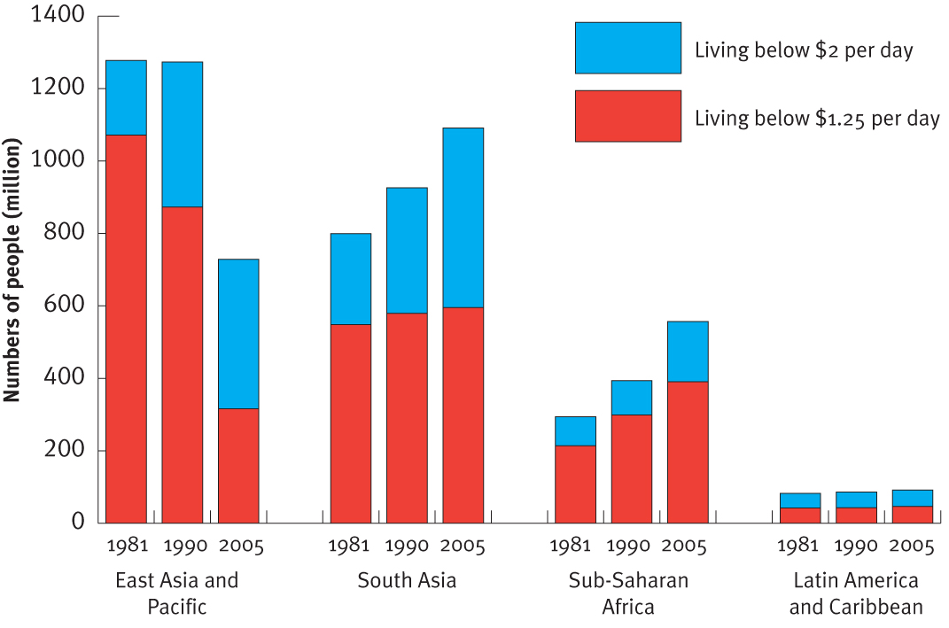

Source: Chen and Ravallion, 2008

The number of people living in extreme poverty (less than US$1.25 a day) dropped significantly in East Asia between 1981 and 2005 in both absolute terms and as a proportion of the population. It has remained reasonably static in South Asia in terms of numbers, but declined markedly in proportional terms. Sub-Saharan Africa, while making some recent gains, lags behind the other regions. In Latin

America and the Caribbean, while the numbers are much smaller, children in rural areas are more than twice as likely to be underweight as children in urban areas.[[15]](#footnote-15)

Since 1990, child mortality rates have more than halved in East Asia, Latin America, and the Caribbean. By contrast, many countries with unacceptably high rates of child mortality, most notably in Sub-Saharan Africa, have made little or no progress in recent years.[[16]](#footnote-16)

Closer to home, the Pacific faces major challenges in achieving the MDGs. While some island countries in the Pacific have made good progress against MDG targets, and some in fact are achieving them, the same cannot be said of the entire region. More than 1.5 million people in the Pacific are living in poverty and do not have the income to satisfy their basic human needs.[[17]](#footnote-17)

Overall, there is much to be done by 2015. A greater and more effective effort is required by developed and developing countries alike to help the 1.4 billion people still living in grinding poverty to live a better life.

Australia must and will play its part in this effort.

### 1.3 Australia’s aid program

Since world leaders agreed in 2000 to pursue a global partnership to achieve the MDGs, the Australian aid program has risen to 0.35 per cent of GNI (see Graph 2). Our aid program has grown to around $5.2 billion in 2012–13.

**Graph 2: Growth of Australian aid budget (as a proportion of GNI) over time—from 1971–72 to   
2012–13**

**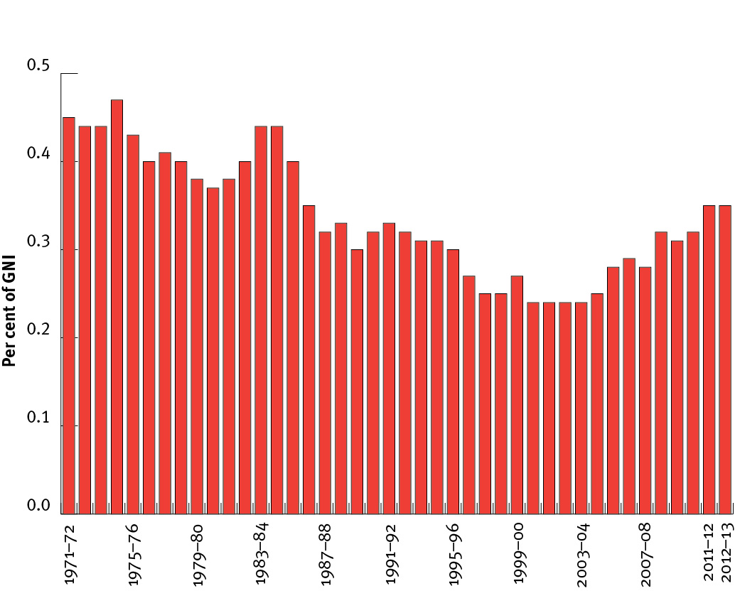**

Source: AusAID

However, we are still below the average OECD’s Development Assistance Committee (DAC) donor country effort. In 2011, this was around 0.46 per cent of GNI; our net ODA/GNI was just 0.35 per cent (see Graph 3).

On current projections, by 2015, we expect to rank around the OECD average in terms of how much aid we provide as a proportion of GNI.

**Graph 3: ODA/GNI for all DAC countries for 2011**

**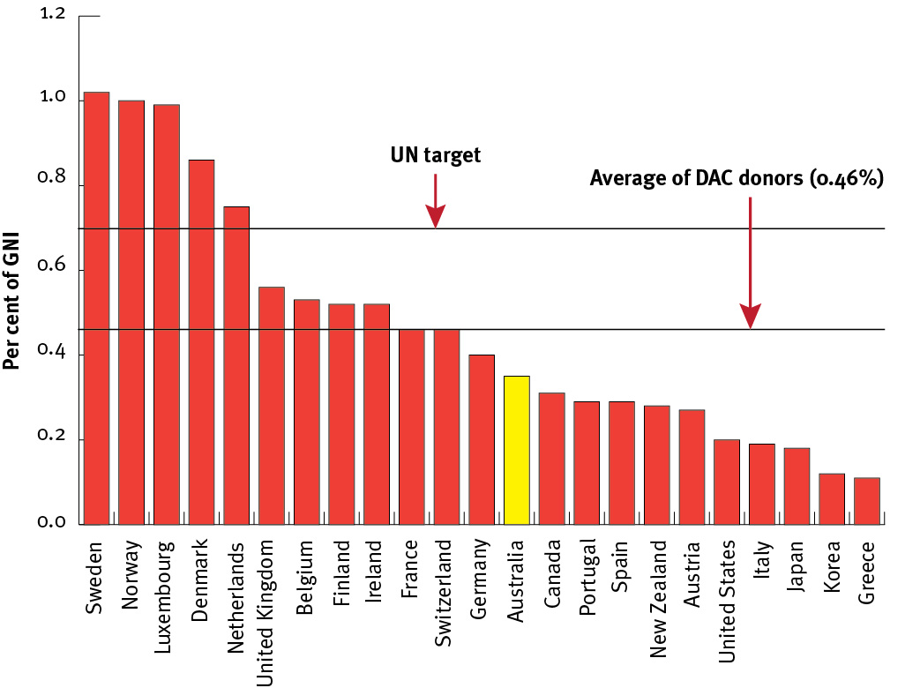**

Source: OECD DAC

Another major donor that has significantly increased its aid program over the period 2000–2010 is the United Kingdom, which went from a ranking of fourth in 2000 (with net ODA of US$4.5 billion and an ODA/GNI ratio of 0.32 per cent) to a ranking of second in 2010 (with net ODA of US$13.8 billion and an ODA/GNI ratio of 0.56 per cent—see Graph 4).[[18]](#footnote-18)

In absolute dollar terms Australia, in 2011, is estimated, for the first time, to be among the top ten aid donors in the world—coming in at number ten (see Graph 4).

**Graph 4: Aid volumes—comparison of OECD DAC donors for 2011**

**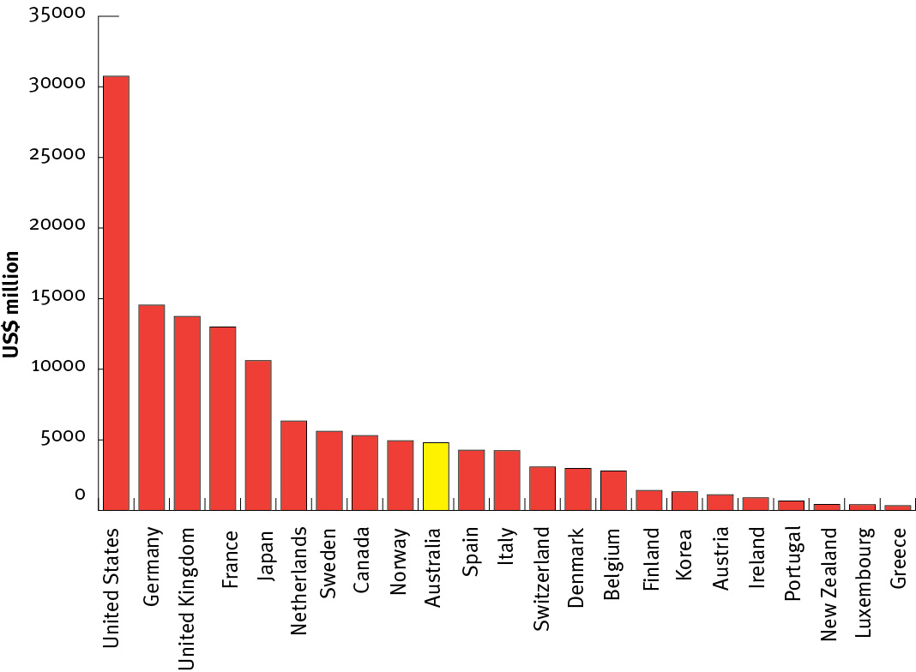**

Source: OECD DAC and AusAID[[19]](#footnote-19)

### 1.4 A record of achievement

The Independent Review noted that our ability to assess performance is rated by the Australian National Audit Office (ANAO) as robust. It is also rated among world’s best by the OECD. The incidence of fraud is small (0.021 per cent of AusAID’s appropriated funds[[20]](#footnote-20))and dealt with swiftly. Moreover, the Office of Development Effectiveness (ODE) produces an annual report that critically assesses what Australia has achieved and what we can do better.

Australia is valued as an effective partner and donor of choice by many of our partner countries. Our partners value Australian know-how, they prioritise scholarships to Australia for their best and brightest, and seek Australian expertise in areas such as economic reform, health, education, law and justice, and governance.

The Australian aid program can point to many successes over the past decade.

• Since 2003, we have helped reduce malaria cases by 80 per cent in Vanuatu and by more than half in Solomon Islands.

• In Papua New Guinea, we have helped immunise 900 000 children against measles and other diseases since 2009.

• Also in Papua New Guinea, we have helped abolish school fees for the first three grades of primary school with the aim of supporting Papua New Guinea to abolish school fees for the first nine years of schooling by 2016. This has already led to an extra 300 000 students enrolled in schools compared to 2006. Similar programs are underway in Solomon Islands, Vanuatu and Samoa, which will help an additional 200 000 children attend school.

• Since 2009, we have helped 600 000 people obtain access to safe water and 400 000 people obtain access to basic sanitation in East Timor, Solomon Islands, the Philippines and Vietnam.

• In Pakistan, we have helped fund the training of 10 000 midwives.

• In Afghanistan, we have helped expand access to essential basic health services from less than 10 per cent of the population in 2001 to around 85 per cent today.

• Also in Afghanistan, we have helped provide education to 6 million Afghan children including 2 million girls.

• In Indonesia, we have helped 330 000 poor children attend school by constructing or extending more than 2000 schools across Indonesia over five years.

• We have restored peace and stability in Solomon Islands by leading regional efforts to restore law and order, and re-establishing essential public services.

• In 2010, we responded to more than 30 rapid-onset emergencies and conflicts, including the earthquake in Haiti and the July 2010 Pakistan floods, benefiting more than 1 million people.

• Through the scholarship program over the past decade, we have educated and trained more than 12 000 people capable of being the leaders of tomorrow to advocate reform and development in their own countries. At least 85 per cent of these scholars remain in their home countries for more than two years after their return, applying their new skills and knowledge.

### 1.5 Recognising the wider development context

As noted in the Independent Review, aid plays only one part, and in most instances, a small one in advancing development and reducing poverty.

For the vast majority of countries, trade, investment and economic reform are far more important drivers of economic development than aid. Countries that have engaged with the global economy have grown more quickly than those that have not. This is evidenced by the remarkable growth of China, other East Asian economies, and India, which together accounted for more than 29 per cent of the world’s total merchandise exports in 2009, compared to 13 per cent in 1973.[[21]](#footnote-21)

Despite record levels of aid, aid volumes are small and shrinking compared to the size of developing country economies. For example, at the time of independence in 1975, Australian aid was equivalent to 20 per cent of Papua New Guinea’s Gross Domestic Product (GDP). Now, it is less than five per cent.

In some countries, such as the Philippines, Samoa and Tonga, remittances from overseas workers also play an important role. Globally, remittances more than tripled between 2001 and 2009.[[22]](#footnote-22) Some 77 per cent of Tongan families rely on remittances from those working overseas. Graph 5 shows the size of global equity flows (foreign direct investment and portfolio equity investment) compared with official aid grants and worker remittances from 2001 to 2009.

**Graph 5: Net inflows, worker remittances and official grants 2001–2009**

[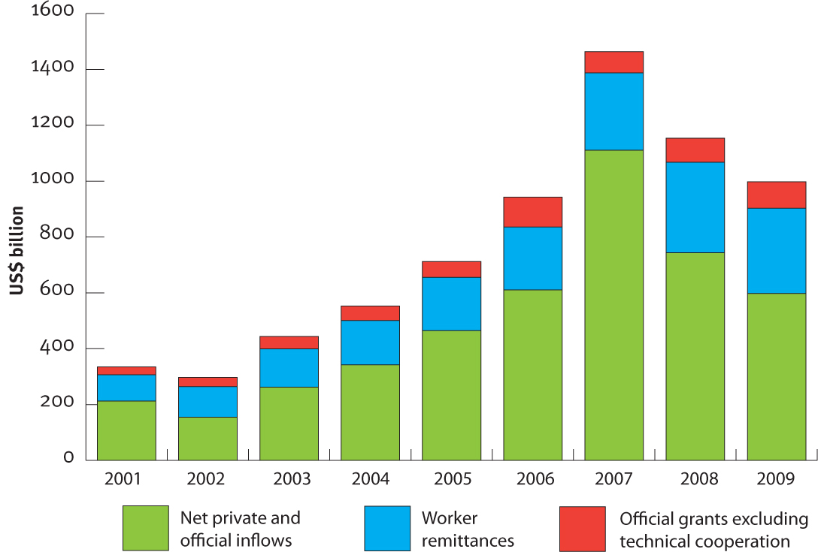](http://www.ausaid.gov.au/about/pages/contact.aspx)

Source: World Bank, *Global Development Finance* 2011.

Much more important, therefore, are a country’s own policies and actions. Countries that have been stable, adopted trade-enabling policies, and invested in the health and education of their people have been more successful than countries that have not. Of course, aid can play an important role in supporting reform and programs that help developing countries seize the opportunities afforded by greater trade and investment. This includes support for liberalisation and competition policies, appropriate investments in critical infrastructure, and building the productive capacity of the workforce.

The adoption of more open and freer trade and investment by developed countries would allow developing countries greater access to markets, knowledge and technologies. An open and predictable rules-based multilateral trading system is critical.

Agricultural subsidies in developed countries, for example, exacerbate the current food security problem by insulating their producers from world price changes, shifting the adjustment burden to farmers in developing countries, and taking market share away from them. In 2009, support to agricultural producers in OECD countries was estimated at US$253 billion. This figure stands in stark contrast to total annual official aid flows from OECD countries in 2009 of US$120 billion.[[23]](#footnote-23) Aid can only achieve so much when set against the harmful long term impacts that such restrictive trade practices have on poor countries.

Developed countries have a responsibility through their membership and engagement in institutions such as the International Monetary Fund, the World Bank, the World Trade Organization’s Doha Development Round and the G20 to meet commitments and pursue a fair and competitive environment that encourages global economic growth for all—including both developed and developing economies.

Therefore, Australia’s future development policy must be fully integrated: fully mindful of the role played by ODA but equally mindful of incorporating global economic policies that impact on poverty reduction.

## 2. The Independent Review

The Government commissioned the *Independent Review of Aid Effectiveness* in November 2010 with the aim of making a good aid program even better. The terms of reference for the Independent Review were to examine the effectiveness and efficiency of the Australian aid program, and make recommendations to improve its structure and delivery.

This was the first independent review of the aid program in 15 years. The Independent Review was conducted by a panel of eminent Australians chaired by Mr Sandy Hollway AO. Other members of the panel included Ms Margaret Reid AO, Mr Bill Farmer AO, Dr Stephen Howes, and Mr John Denton.

The panel consulted extensively, both domestically and internationally, including with governments in Asia, the Pacific, and Africa; non-government organisations; think tanks; bilateral and multilateral donors; Australian business and private sector representatives; as well as a range of Australian Government departments. The panel also received almost 300 public submissions from a wide cross-section of the Australian and international community.

The Independent Review found that Australia has a good aid program and is an effective performer by global donor standards. It made 39 recommendations to further improve the program as it grows. The recommendations covered:

• the overall purpose of Australia’s aid program

• the geographic and sectoral focus of Australian aid and future aid allocations

• the importance of partnerships in delivering Australian aid

• ways to make Australia’s aid program more transparent, more accountable, and more focused on results and value for money

• ways to give Australia’s aid program greater strategic direction, including through reformed planning and budget measures.

The Independent Review also found that the incidence of fraud in the aid program was very low and that AusAID has strong systems for the prevention and detection of fraud. It confirmed assessments by the ANAO and the OECD that AusAID’s self-rated project and program management system is at the forefront of bilateral donors globally. It also noted findings by the Center for Global Development that Australia ranks as the best bilateral donor in terms of its commitment to transparency and learning.

The Government has welcomed the Independent Review’s outcomes and agreed (or agreed in principle) to 38 of the recommendations (see detailed responses at Annex A). The Government has noted recommendation 29 on the name of the Ministerial portfolio covering the aid program, and will respond to this later.

The Independent Review’s recommendations build on reforms that are already well underway. These reforms include the consolidation of our largest programs in Indonesia, Papua New Guinea, East Timor, and the Pacific around key sectors aligned with these countries’ national development priorities. They also include the 2010 adviser remuneration review that has helped reduce the reliance on advisers throughout the aid program, freeing up funds for vital health and education supplies; and a 2011 procurement review that will allow AusAID to keep pace with changes in the aid market and maximise value for money.

The Government’s efforts to strengthen the effectiveness of the aid program, including its response to this Independent Review, represent some of the most far-reaching changes to the aid program in more than a decade. This will be an enduring effort. Increasing aid effectiveness is a major objective and will require rigorous persistence.

## 3. Purpose of Australia’s aid program

As a result of the Independent Review, the Government has agreed on the following statement of purpose for Australia’s aid program.

|  |
| --- |
| **The fundamental purpose of Australian aid is to help people overcome poverty.**  This also serves Australia’s national interests by promoting stability and prosperity both in our region and beyond. We focus our effort in areas where Australia can make a difference and where our resources can most effectively and efficiently be deployed. |

It is important to be clear about the fundamental purpose of the aid program because it is this statement of purpose that directs Australia’s aid resources.

The Australian aid program places helping **people** overcome poverty at the core of our efforts. This statement of purpose reminds us that our aid must address the fundamental constraints that prevent **people** from breaking out of poverty.

We need an integrated framework to overcome poverty that keeps mothers and children alive and healthy; provides education for all; builds agricultural and broader economic resilience; boosts employment; improves governance of communities and nations; and addresses systemic environmental threats capable of undermining all of the above.

The second part of our statement of purpose focuses our efforts on countries and sectors of national interest where we believe we can make a real difference to poor people’s lives. The national interest dictates that we should focus the bulk of our efforts in our own region. This is where we have long-standing ties, where our knowledge is most developed, and where other donors expect Australia to play a leading role. These are countries whose peace and prosperity are most closely linked to our own.

At the same time though, our global interests dictate that we should also contribute to international efforts to reduce poverty outside our most immediate region—in Africa and South Asia and, where appropriate, beyond.

Decisions on what we do will be informed by evidence of where Australian aid can make a difference to poor people’s lives. This will include an assessment of Australia’s comparative advantage, the effectiveness of our current programs, and whether our partner countries would benefit from increased assistance.

The final part of our statement of purpose stresses the importance we place on maximising the effectiveness of the Australian aid dollar. This ranges from better planning and carrying out better evaluations of program performance to informing the Australian community of the impact we are having on the lives of poor people.

## 4. Making Australian aid more effective

The Independent Review found that Australia has a good aid program and is an effective performer by global donor standards. However, the Government is determined to make the program even better. Enhanced effectiveness will be the cornerstone of Australia’s aid program.

### 4.1 A clear strategy

Effective aid requires clarity of purpose and a clear strategy for implementing concrete programs consistent with that purpose.

As recommended in the Independent Review, the Government will enhance its forward strategic planning by preparing a four-year, whole-of-ODA budget strategy, which will be considered as part of the 2012 Budget. In 2011–12, non-AusAID ODA will account for around 11 per cent of our total aid program.

This will bring together the aid plans of AusAID and other key partners under a single, integrated strategy that outlines the key results we aim to achieve and the way these will be reported.

Longer term, more predictable funding will also help poor people by providing AusAID and partner countries with greater certainty to plan ahead.

In return, AusAID and the aid delivery agencies with which it works will be made more accountable for results. This includes consideration by the Government of progress against the four-year plan as part of the annual budget process.

As part of this effort, we will work to adopt consistent approaches to performance reporting and evaluation of ODA spending across all Government agencies.

This work will build on reforms made in recent years to strengthen coordination across Government in the strategic planning and delivery of our aid. Such reforms include the strengthening of the cross-agency Development Effectiveness Steering Committee (DESC) to advise the Government on major aid policy and aid budget priorities and concerns. This committee includes deputy secretaries from the Treasury, and the Department of the Prime Minister and Cabinet, Finance and Deregulation, and Foreign Affairs and Trade, and is chaired by the Director General of AusAID.

It has been 15 years since the last independent review of the aid program. That is too long. The Government is committed to more frequent external reviews of the aid program. Such external reviews would be more extensive than the Government’s own annual review of the aid program and would include, as part of their terms of reference, consultation with domestic and international stakeholders, as well as independent research to guide the future strategic direction of the aid program. Consistent with the thrust of the Independent Review Panel’s recommendation, the Government supports a regular, five-yearly external review—particularly given the projected expansion of the aid budget in the years ahead.

### 4.2 Value for money

A ‘value for money’ perspective—one that balances effectiveness, efficiency and economy in decision-making—will drive improvements across the aid program. This focuses on results and returns for poor people, rather than just input costs.

We have already made a start.

In February 2011, the Government released the Joint Adviser Review, which identified 257 positions—a quarter of all advisers—to be phased out over the next two years. Phasing out these positions will free-up an estimated $62 million by 2012. These funds will be reinvested in other high-priority development activities, such as basic health and education service delivery, or other forms of skills development such as training, scholarships, volunteers and twinning arrangements.

The Adviser Review also informed the introduction of an Adviser Remuneration Framework, which caps the salaries and allowances payable for all commercially-contracted advisers. Since the Framework was introduced in February 2011, it has already resulted in savings of between 10 to 40 per cent on advisers.

A procurement review, being conducted by AusAID in 2011, will further ensure that the aid program is able to keep pace with the changing aid market and maximise value for money. The review will ensure that our tender and grant selection processes are fully transparent and effective and represent world’s best practice.

### 4.3 The importance of consolidation

The ability to be responsive and flexible is a key strength of Australia’s aid program. At the same time, this needs to be balanced against the risk of fragmentation, or working in too many countries and too many sectors with too many small activities. Fragmentation can impact on results and impose significant transaction costs on both AusAID and partner governments.

This trend towards consolidation of development assistance is also reflected in many recent international reviews of aid effectiveness—including the 2010 review of the United Kingdom’s bilateral aid program.

Accordingly, Australia will continue to consolidate the aid program with fewer, larger programs in fewer sectors. The trend in increased average aid initiative size shown in Graph 6 will continue and intensify as we increase assistance to 2015–16.

**Graph 6: Number and average size of AusAID initiatives 1995–96 to 2010–11**

**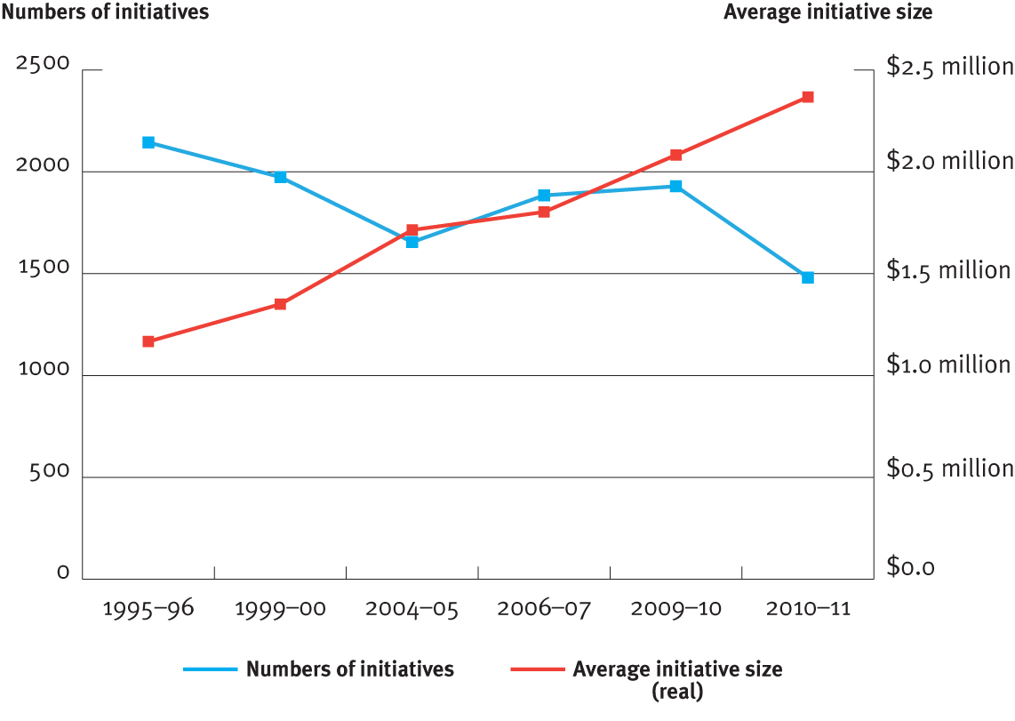**

Source: AusAID

### 4.4 Focusing on risk management and performance oversight

The aid program works in many difficult environments where corruption can be rife—a fact acknowledged by the ANAO. Many of our partner countries have weak probity systems and rate poorly on international corruption indicators. Seven of our top 10 partner countries rank in the bottom third of Transparency International’s Perceptions of Corruption Index, with the other three slightly above it.[[24]](#footnote-24) A sensible approach to risk management is required to guard against risk and fraud while delivering programs and assistance to those poor people who need it.

#### Fraud control

The *Independent Review of Aid Effectiveness* states that there is a “serious and systematic approach within AusAID to fraud management”. AusAID maintains zero tolerance of any fraud in the aid program and has a range of systems in place to ensure that fraud is minimised.

These control systems have helped the aid program to keep fraud at a minimum. In the 2010–11 year (up to 30 April 2011), the estimated potential loss due to fraud was 0.021 per cent of AusAID’s appropriated funds. In dollar terms, this is 21 cents for every $1,000 spent. This is much lower than the rates of fraud recorded by many other government agencies, private sector companies, and other donors.

|  |
| --- |
| Box 1: AusAID’s Seven-Point Program for Fraud Management   1. AusAID maintains a portfolio-wide fraud control plan, which complies with the Australian Government’s mandatory fraud control guidelines. 2. Country posts also maintain fraud and risk management control plans, which are updated annually. 3. Any company or non-government organisation appearing on fraud blacklists is automatically excluded from bidding for contracts. 4. AusAID’s internal audit section reviews the specific fraud control mechanisms of partners such as non-government organisations, contractor firms and tertiary institutions, to ensure they comply with its fraud reporting and risk management requirements. 5. Partner government systems are also assessed in detail, and assistance provided, to improve identified weaknesses before any Australian funds begin to flow. 6. The ANAO also conducts external audits of AusAID’s financial statements and undertakes targeted performance audits. 7. In 2011, a senior executive position of Chief Auditor was created and filled. AusAID’s Audit Committee has been strengthened with the appointment of highly experienced external members, including an independent Chair (a former Deputy Commonwealth Ombudsman and Deputy Auditor-General). |

Further investments in fraud control will be needed as the aid program grows. This will include the use of specialised fraud control experts for countries with the highest incidences of fraud.

#### Performance management

The aid program is subject to a number of internal and external oversight mechanisms covering financial and program accountability, including by the ANAO. These mechanisms are outlined in Box 2.

AusAID’s internal system of program performance management has been rated as robust by the ANAO and among donor best practice by the OECD.

|  |
| --- |
| Box 2: AusAID’s Four-Point Program Performance Management System  The aid program is subject to regular external oversight by several bodies, both domestic and international, that evaluate performance and quality against Australian and global standards.  1. AusAID’s internal quality reporting system  AusAID undertakes three types of performance reports—annual performance reports at the country/regional level, quality reports on individual aid activities, and independent evaluations.  Annual performance reports assess the performance of a country or regional program against three tiers—progress against the country or region’s development goals, the contribution of Australian aid, and aid management. A ‘traffic light’ system is used to rate performance, and identify actions needed to improve effectiveness of the aid program.  Quality reports are mandatory at the design and implementation stages for all significant aid activities. These reports assess how individual aid activities contribute to achieving overall program objectives and ensure AusAID is able to identify and manage any issues that emerge. |
| Independent evaluations of significant activities are commissioned at least once every four years. Each year AusAID also commissions a number of cross-program evaluations at the sectoral and country strategy level.  2. Office of Development Effectiveness  The ODE was established in 2006 to monitor the quality and evaluate the impact of the Australian aid program. ODE is a unit within AusAID that is separate from those areas responsible for managing our overseas programs.  ODE answers directly to the Director General of AusAID and is guided by the cross-agency DESC, chaired by the Director General. ODE has produced three annual reviews of development effectiveness and a series of influential evaluations, including on service delivery in fragile states. ODE also independently checks the robustness of AusAID’s Quality Reporting System, the main internal assessment mechanism for aid programs.  3. Australian National Audit Office  Since 2009, AusAID has been included in the ANAO’s annual work plan of performance audits. Recent performance audits conducted by the ANAO include an audit of AusAID’s management of the expanding aid program (2009–10) as well as AusAID’s support for tertiary training assistance, including scholarships (2010–11).  In its 2009 review, the ANAO concluded that “AusAID has managed the expansion of the aid program in a way that supports delivery of effective aid”.  4. OECD DAC Peer Review  As a member of the OECD DAC, Australia is subject to regular peer reviews by other bilateral donors. The last OECD DAC Peer Review, in 2008, commended Australia for its “reinforced strategic focus on poverty reduction and the MDGs and its continuous engagement in states in fragile situations”. It also found that Australia is strongly committed to making its aid program more effective. |

Australia will continue to refine and strengthen our internal oversight mechanisms. Consistent with the findings of the Independent Review, we will undertake a smaller number of high quality independent evaluations and draw on external advice, targeting areas where effectiveness can be improved.

#### Acting when aid programs are not delivering

The aid program works in difficult environments. It is inevitable that some of our investments, no matter how well planned, will not achieve the improvements in poor people’s lives that we had expected.

We will act swiftly when expected results are not being achieved. We will utilise more rigorously the traffic light system in our performance management framework—which rates activity performance according to a red, amber and green scale—to help identify when programs are beginning to go off track. Where programs are found to be failing to deliver, our response will be rapid, either to cancel programs altogether or radically revise them.

We have already shown our determination to change course and cease programs on the basis of poor progress. This year, we stopped an initiative seeking to improve land reform in the Pacific when the approach we were taking was not gaining the results we had expected.

### 4.5 A transparent aid program focused on results

#### Transparency

We are committed to increasing the amount of information available on the aid program in a timely and user-friendly form for the Australian public.

Australia is rated by the highly-regarded Brookings Institution and the Center for Global Development as the best bilateral donor in terms of our commitment to transparency. But we can and will do better.

As recommended by the Independent Review, we will issue a Transparency Charter committing AusAID to provide more information on what we fund and the results we achieve. The Charter will be released by the end of 2011 following consultation with the Australian community and our international partners.

The charter will promote a ‘warts and all’ approach to reporting to ensure that we are as frank about our failures as we are about our achievements. We will use this to encourage debate and contestability and, in turn, improve our effectiveness.

We have already started. The 2011–12 Aid Budget Statement includes more results, greater country information and, for the first time, details of aid spending by Australian Government agencies aside from AusAID.

We have also joined international efforts to make more information available on aid programs through our membership of the International Aid Transparency Initiative (IATI). Through IATI, we will make available information on our policies, programs and evaluations in a format consistent with other donors.

The whole point of this transparency initiative is to ensure maximum value for money and, based on this principle, to continue to build the confidence of the Australian community in the effectiveness of our overall program. This includes frank admissions when program failures inevitably occur (and the reasons for them) rather than trying to sweep them under the carpet.

#### Focus on results

Effective aid is more than just how much money we are spending. It is about the results we want to achieve and our ability to measure and report on the impact of our aid on the lives of poor people.

AusAID will continue its transition to a results-based organisation. Reflecting significant work over recent years, we are now able to better articulate what we want to achieve with our aid and how to measure results from the programs we invest in. For instance, annual reports on the performance of our major country and sectoral programs have been produced and made publicly available for the past five years. The 2011–12 Aid Budget Statement contains 208 quantified results—92 past achievements and 116 projected results. This compares with a total of only 17 results in the previous year’s budget statement.

We have introduced a stronger focus on results in our bilateral agreements with partner governments. Since 2008, the Government has signed Partnerships for Development with 11 Pacific island countries. These agreements commit Australia and relevant Pacific countries to jointly achieve defined results, including increased places for kids to go to school and extra midwives to help women have safer pregnancies and deliveries.

We will continue to strengthen our ability to measure and report on the results of our aid. This includes the development of a high-level results framework as part of the whole-of-ODA budget strategy, which is discussed in Section 4.1.

## 4.6 Involving the Australian community

Australians have a reputation for ingenuity, know-how and drive. In line with the recommendations of the Independent Review, we will make greater use of the talents available in Australia’s non-government sectors, academic and research institutions and business, as well as members of the wider Australian community.

We will increase the number of Australian volunteers to 1000 a year under the new, integrated Australian Volunteers for International Development program (Box 3).

|  |
| --- |
| Box 3: Australian Volunteers for International Development  The Australian Volunteers for International Development program, launched in May 2011, will make it easier for more Australians to volunteer their services in developing countries.  Volunteers are an important part of Australia’s aid program. By contributing their time and skills to local organisations and the communities in which they work, volunteers make a substantial contribution to development in partner countries. Just as importantly, these dedicated Australians return richer for the experience, contributing new ideas and perspectives to Australian life.  The new Australian Volunteers for International Development program combines four existing programs into a single program to streamline administration, align more closely with the aid program’s overall country strategies, and to develop a common program identity.  Currently, volunteers are deployed to 33 developing countries around the world. |

We will double the AusAID-NGO Cooperation Program (ANCP), which will support more Australian non-government organisations to participate in our aid program. With the help of funding received through the ANCP, Australian non-government organisations are working to improve the lives of millions of people in almost 50 countries across Asia, the Pacific, Africa, the Middle East and Latin America.

|  |
| --- |
| Box 4: Increased funding and partnerships with NGOs  In addition to significantly increased funding, recent reforms to our NGO program include high-level strategic partnerships between AusAID and some of Australia’s largest NGOs, including World Vision Australia, Oxfam Australia, Caritas Australia, Plan International Australia, and ChildFund Australia.  These partnerships enhance the reach of Australian aid, and enable the Australian Government and Australian NGOs to share lessons and experiences, jointly identifying the most effective ways to help people overcome poverty and make progress towards the MDGs.  Expansion of the ANCP enables more Australian NGOs to receive financial support, and to work in a direct partnership with the Australian Government. Increased funding to a more diverse range of Australian NGOs will provide even greater opportunities to extend the reach and effectiveness of Australian aid to benefit the most vulnerable people in the poorest communities in the world. |

We will draw on the expertise of Australian people to help communities suffering from disasters, through the Australian Civilian Corps (ACC). The ACC is a body of highly-skilled Australian professionals who can be deployed to assist during the transition from immediate disaster relief to long term development (Box 5).

|  |
| --- |
| **Box 5: The Australian Civilian Corps**  The Government has established the Australian Civilian Corps (ACC) to enable the rapid deployment of civilian specialists to countries experiencing or emerging from natural disaster or conflict. The ACC will assist these countries to restore essential services, rebuild government institutions, and re-establish economic and social stability. The ACC will provide a bridge between emergency response measures and long term development programs.  Recruitment of civilian specialists commenced in early 2010 and will continue throughout 2011. The ACC register is expected to reach 500 screened and trained personnel by June 2014.  The first ACC deployment took place in April 2011 when an ACC member was deployed as a donor-liaison officer within the Interim Haiti Recovery Commission. Further deployments are expected during 2011. |

We will develop deeper research partnerships with Australian universities and research institutions, and will look to support the development of centres of excellence in key areas. In line with the Independent Review, we will look to enhance our investment in agricultural and medical research. We will allocate research funding, where appropriate, on a competitive basis to ensure we are receiving value for money.

We will also develop stronger links with Australian business, including through an annual dialogue with peak industry groups on aid and development, and active collaboration, where appropriate, in the joint delivery of programs with Australian business.

### 4.7 Effective aid management—the role of AusAID

AusAID will remain the lead agency responsible for the Government’s fight against global poverty.

The Independent Review found that AusAID is well-led and that AusAID staff are generally highly motivated and capable. The ANAO and the OECD DAC have also found that the aid program has been well-managed as it has grown.

AusAID is changing. In 2010, AusAID became an Executive Agency reflecting its expanding role and growing links across government. As the aid budget grows and becomes a more important part of the Government’s international engagement, strategic policy advice on development issues will become an increasingly fundamental part of AusAID’s mandate.

AusAID will be increasingly recognised as one of the world’s leading development agencies.

We are well-placed to achieve this. AusAID, headquartered in Canberra, is represented at 41 posts overseas where it monitors the effectiveness of our aid on the ground and advances our interests. AusAID has strong links with other government agencies. Cadres of specialist staff have been developed in a range of sectors and will be developed further. There have also been strong investments in AusAID’s leadership and strategic management, as well as in operational and performance capabilities.

AusAID is committed to attracting, retaining, and developing its workforce as one that provides leadership on development issues across government and internationally, and one that is responsive and professional in serving the Government. A new workforce plan, including the creation of specialist sectoral and technical streams, is being implemented along with a revised learning and development strategy. We will target aid management and public policy skills, and increase staff diversity. We will also work to streamline our systems and processes to make them more responsive and efficient, and eliminate any unnecessary administrative burdens that we place on our partners.

AusAID will have aid effectiveness as a core value, and will work to ensure it delivers measurable results and good value for money in its administration of the aid program.

## 5. What Australian aid will focus on

Consistent with the Independent Review’s recommendations the Government will make its aid decisions based on three sets of criteria:

• Three allocative criteria that define poverty-related need; effectiveness and the national interest.

• Five strategic goals for the overall aid program

– saving lives

– promoting opportunities for all

– investing in food security, sustainable economic growth and private sector development

– supporting security, improving the quality of governance, and strengthening civil society, and

– preparing for and responding to disasters and humanitarian crises.

• Ten individual development objectives that gives effect to these goals.

#### Aid allocation criteria

Australia will allocate aid to countries, regions and sectors based on assessments of poverty, capacity to make a real and measurable difference, and national interest. These criteria are explained in Box 6.

|  |
| --- |
| **Box 6: Aid allocation criteria**  Decisions on country allocations will be based on the following criteria.  **• Poverty and need**—countries and regions where there are large numbers of people living in poverty and where progress against the MDGs is lagging.  **• Effectiveness and capacity for Australian aid to make a real difference**—countries where the aid program is effective and where Australia has recognised experience, expertise, and a good working relationship with partner governments.  **• Our national interest**—effort will be focused on countries and regions whose security and prosperity are directly linked to Australia’s (while recognising that any consideration of Australia’s wider national interests necessarily takes us beyond our immediate region, these interests will always remain subordinate to those of our geographical neighbours). |

Aid allocation decisions will also be driven by the need to focus on key sectors to maximise the impact of our aid.

Where Australia is the lead or a major donor, and particularly where aid represents a large proportion of partner government revenues (i.e. the Pacific island countries), we will pursue results across a broader range of sectors. Selectivity here is still important. In this respect, the Pacific Partnerships for Development we have signed with Papua New Guinea and 10 other Pacific island countries help us focus on a defined number of mutually-agreed sectors.

Where Australia is a relatively small donor, or where aid represents only a small proportion of partner government resources, our focus will be even more selective and our effort combined with that of other partners to achieve impact.

#### Core strategic goals and individual development objectives

Consistent with the thrust of the Independent Review, we will organise our work around five core strategic goals. From these strategic goals flow 10 specific development objectives as follows.

### 5.1 Saving lives

|  |
| --- |
| **Our key development objectives**  1. Improving public health by increasing access to safe water and sanitation.  2. Saving the lives of poor women and children through greater access to quality maternal and child health services (for example, skilled birth attendants and midwives), and supporting large scale disease prevention, vaccination and treatment. |

#### Water and sanitation

Around 900 million people do not have access to clean water and 2.6 billion do not have access to adequate sanitation and hygiene.[[25]](#footnote-25) Many diseases such as diarrhoea, cholera, typhoid, hepatitis, and dysentery are spread by contaminated water. More than 1.5 million children around the world die each year as a result of diarrhoea.[[26]](#footnote-26) It is the second biggest cause of deaths for children.

We will invest significant resources to improve health outcomes through better access to safe water and increased sanitation and hygiene. This is because it is a proven way of achieving results. Graph 7 shows the high relative benefit for child survival of investments in sanitation and hygiene when compared to other interventions.

**Graph 7: Relative benefits to child health of specific interventions**

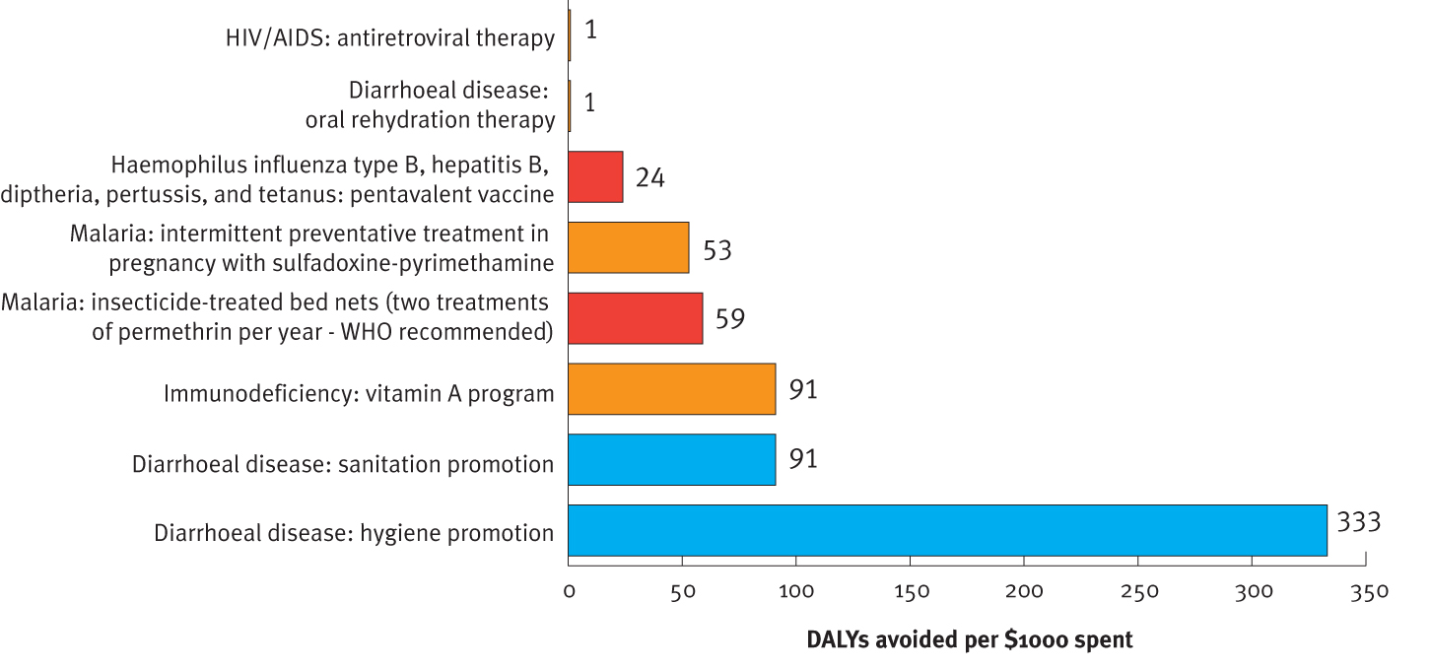

Note: The **disability-adjusted life year (DALY)** is a measure of overall disease burden expressed as the number of years lost due to ill health, disability or early death. Source: World Bank

#### Mothers and children

Despite good progress in many regions of the world, 350 000 women still die each year in pregnancy or from complications due to childbirth.[[27]](#footnote-27) Most of these women are from the poorest and most vulnerable communities in the developing world. Countries that have succeeded in reducing maternal and infant deaths have demonstrated long term commitment and funding over decades to address the causes of poor health (for example, girls’ education) while increasing access to quality health services.

We will focus on proven value for money interventions to reduce maternal and child deaths, particularly in high burden countries such as Papua New Guinea and East Timor which have some of the highest rates of maternal deaths in the Asia–Pacific region after Afghanistan.

#### Combating disease

Every year, about 8 million children never make it to their fifth birthday because they are struck down by diseases that we have the means to prevent. Childhood immunisation has contributed significantly to improved child survival and continues to be an important part of Australia’s aid investments (Box 7).

|  |
| --- |
| **Box 7: Australia’s partnership with the GAVI Alliance**  Australia has supported the critical work of the GAVI Alliance (formerly known as the Global Alliance for Vaccines and Immunisation) by providing $34 million in core contribution to GAVI since 2006. At the June 2011 *Saving Children’s Lives* pledging conference, the Government announced a commitment to GAVI of $200 million between 2011 and 2013, more than ten times Australia’s previous three-year contribution.  Our contribution will fund an estimated 7.1 million life-saving vaccines for children and prevent an estimated 167 000 future deaths through routine immunisation over the next three years. This will form part of GAVI’s plans to fund more than 250 million vaccines over this same period. Our support to GAVI will assist in combating pneumonia and diarrhoea, two of the biggest childhood killers in the developing world.  In addition to this commitment, Australia will provide $250 million over 20 years to GAVI’s International Finance Facility for Immunisation to help low-income countries build their health systems to deliver better immunisation services to their people. |

We will also work to halt and reverse infectious disease transmission, including HIV/AIDS, tuberculosis and malaria, and address the growing problem of non-communicable diseases, particularly in the Pacific. We will invest in strengthening the overall health systems in partner countries to deliver services that benefit poor people—for instance, training doctors, nurses and midwives, and improving drug procurement and distribution. We will empower poor communities to improve their health through direct support to reduce the economic and social barriers that prevent the poor accessing critical health services and interventions. We will also help combat avoidable blindness through support for better screening and treatment.

### 5.2 Promoting opportunities for all

We will also expand opportunities for people in developing countries to lift themselves out of poverty through our work in education, gender equality and disability.

|  |
| --- |
| **Our key development objectives**   1. Enabling more children, particularly girls, to attend school for a longer and better education so they have the skills to build their own futures and, in time, escape poverty. 2. Empowering women to participate in the economy, leadership and education because of the critical untapped role of women in development. 3. Enhancing the lives of people with disabilities. |

#### Education

There have been impressive gains in getting more children into school, particularly girls, with the number of children not in primary school falling from 100 million in 1999 to 67 million today. The quality of education is a challenge across all regions. Too many young people are leaving school without the necessary literacy and numeracy skills to be fully productive members of society. The link between school and work is also a growing challenge, particularly in countries with high population growth rates and large youth bulges, for example, Solomon Islands, East Timor, and Papua New Guinea.

Education will become the flagship of our aid program. Our primary focus will be to increase the number of children in school, keep them there for longer, and help them to learn more while they are there. In our immediate region, we will support the whole sector, from early childhood to vocational training and higher education.

We will particularly focus on addressing the financial and social barriers to girls’ education, including in Afghanistan (Box 8).

|  |
| --- |
| **Box 8: Australian support for education in Afghanistan**  Education has been one of the success stories of Afghanistan over the past 10 years. With support from Australia and other donors, more Afghans now attend school or receive some sort of education than ever before in its modern history. There has been an increase in school enrolments from less than 1 million in 2001 to more than 6 million today, more than 2 million of whom are girls. The number of schools has trebled to meet this growth.  However, real challenges remain. There is a shortage of qualified teachers to meet the increasing demand for education, many schools lack adequate facilities and strong efforts are required to increase the participation of girls. The challenges are particularly severe in Uruzgan Province, where Australia leads the multinational Provincial Reconstruction Team. Literacy rates in Uruzgan are extremely low, even by Afghan standards, at eight per cent for men and less than one per cent for women. These rates are among the worst of all provinces in Afghanistan.  In Uruzgan, Australia is working with Save the Children to enhance the quality of, access to, and demand for education, with a focus on women and girls. Our funding will build schools, train women as teachers and community educators, establish literacy groups, and educate women and children about health, nutrition and sanitation. |

We will provide more assistance to young people in the Pacific, Papua New Guinea, and East Timor to prepare them for work, including through training and internationally-recognised technical qualifications. This will help these young people to be competitive in the job market, earn a living, and contribute to economic growth.

We have provided scholarships for study in Australia dating back to the start of the Colombo Plan in the 1950s. These scholarships have contributed to the development of exceptional students from developing countries in the Asia–Pacific region and beyond. Thousands of students were trained under this scheme. Many of these scholars have gone on to hold senior leadership roles in their countries.

We will build on this proud tradition by providing short and long term scholarships under the Australia Awards to address critical human resource needs in developing countries and build people-to-people links. We will provide additional tailored support to improve the leadership skills of the best and brightest scholars by supporting strong alumni networks. At present, 2400 Australia Awards are offered annually. These will increase to around 3800 by 2015 and will support young leaders from East Asia and the Pacific, South Asia, Africa, Latin America, and the Caribbean.

#### Women and girls

The majority of the world’s poor are women and children. Of the 1 billion people in the world who lack basic literacy skills, women and girls comprise about two-thirds.[[28]](#footnote-28) One in three women experience physical or sexual violence.[[29]](#footnote-29) Research by the United Nations Office of Drugs and Crime, the International Labour Organization and others indicates that women and girls make up the vast majority of human trafficking victims.

Equal opportunity for men and women is central to economic and human development. In the economy, equal opportunity for men and women supports economic growth and helps to reduce poverty. Involving both women and men in decision-making improves how resources are allocated. Yet there is no country in the world where gender inequality does not exist, and where women and girls do not suffer disadvantage. The International Labour Organization estimates that unequal access to education and employment opportunities for women cost Asia around US$70 billion per year.[[30]](#footnote-30)

Promoting gender equality and empowering women will continue to be an overarching goal of Australia’s aid program. We will increase our efforts to meet gender equality goals and targets, first by ensuring equitable access to health and education services, particularly for adolescent girls. We will work with development partners to help improve the sexual and reproductive health of women and girls. We will also increase our efforts where progress has been slowest—by encouraging the participation of women in politics, decision-making and peace-building, and by supporting their economic empowerment. We will also continue to work to enhance the safety and security of women and girls in their homes, their communities, and in disaster and conflict situations. We will support effective international efforts to promote gender equality, particularly through the newly-established agency, UN Women (Box 9).

|  |
| --- |
| **Box 9: Examples of Australian assistance to promote women and girls**  Australia supports UN Security Council Resolution 1325, which concerns the impact of war on women, and the contributions that women can make to end conflict and promote peace.  In Bangladesh, Australia has helped thousands of women in extreme poverty to develop sustainable income-generating enterprises. In 2010 in Bangladesh we supported civil society to provide a comprehensive support package that included productive assets, for example, a cow or goats, stipend and training, to 21 675 women in extreme poverty to develop sustainable income-generating enterprises.  In Northern Iraq, Australia’s aid program supports services for victims of gender-based violence and the capacity of local government to respond to violence against women. In Mindanao in the Philippines, Australia is supporting the role of women as peace-builders and peacemakers through the ‘Another Mindanao is Possible’ project.  Across the Pacific, Australian aid has assisted thousands of women who have been subjected to violence. For example, in 2010, the Fiji Women’s Crisis Centre—supported with Australian funding—assisted 3784 clients with counselling and other practical services, and provided training and support to crisis centres in other Pacific countries.  Australia has been working with partners to prevent the needless deaths of women from problems arising during pregnancy and childbirth. For example, in Cambodia Australian aid has contributed to the number of babies delivered by trained staff climbing from 44 per cent in 2005 to 71 per cent in 2010. |

#### Disability

Around 15 per cent of the world’s population—about a billion people—live with a disability and the great majority of these people live in developing countries.

In recent years, Australia has shown international leadership in improving the lives of people with disabilities. Australia released an internationally-recognised disability strategy, *Development for All,* in late 2008.

We will continue to be an advocate and supporter of people with disabilities, who are among the poorest and most marginalised in all the countries where Australian aid is delivered (Box 10).

|  |
| --- |
| **Box 10: Australian assistance is promoting disability-inclusive development**  Australia’s achievements in disability-inclusive development were recently highlighted as a best-practice model in the 2011 *World Report on Disability* by the World Health Organization and the World Bank. The report particularly commended our *Development for All* strategy—the aid program’s first comprehensive disability strategy.  Key achievements in recent years include:  • In Indonesia, Australian assistance has built around 1000 junior secondary schools with ramps and accessible toilets, improving access to education for students with disability.  • In East Timor, Australia has helped the Ministry of Social Solidarity to develop a disability policy to ensure that citizens with disability can participate in, contribute to, and benefit from national development.  • In Papua New Guinea, Australia has supported disability-inclusive training for 50 Special Education Resource Centre staff, 25 teacher education lecturers and around 300 school-based counsellors. |

### 5.3 Investing in food security, sustainable economic growth and private sector development

The best way to help people out of poverty is by generating sustainable economic growth and providing them with the opportunity to earn a living. Jobs increase people’s incomes and generate revenue for governments to reinvest in services such as education and health.

|  |
| --- |
| **Our key development objectives**  6. Improving food security by investing in agricultural productivity, infrastructure, social protection and the opening of markets.  7. Improving incomes, employment and enterprise opportunities for poor people in both rural and urban areas, including the development of sustainable mining industries to boost overall economic development.  8. Reducing the negative impacts of climate change and other environmental factors on poor people. |

#### Food security, rural development and social protection

Three quarters of the world’s poor live in rural areas and rely on agriculture to survive.[[31]](#footnote-31) We will target rural poverty, particularly in the least developed countries. However, as countries develop, urbanisation increases. As a result, the numbers of poor living in urban areas rises. This highlights the importance of ensuring that our approach is shaped by the individual circumstances of each country and its stage of development.

A key cause of ongoing high food prices has been a slowdown in the growth of agricultural productivity. Two-thirds of the world’s 1 billion people who go hungry each day live in Asia.[[32]](#footnote-32) The poor have been

hardest hit by rising food prices, as they spend most of their income on food. The urban poor are particularly vulnerable as they cannot grow their own food.

In line with the Independent Review, we will work to improve agricultural productivity with a particular focus on countries and regions with food security problems. Agricultural research remains an important driver of agricultural productivity. We will increase support for the Australian Centre for International Agricultural Research (ACIAR), which has achieved impressive results, confirmed by independent evaluations. We will work to improve financial services, including through microfinance services and the way agricultural markets work for poor people (Box 11).

|  |
| --- |
| **Box 11: Australia’s leadership role in food security**  Australia has an international reputation for agricultural research. To ensure this expertise benefits the world’s poor, we have increased the size and capability of ACIAR and we are one of the fastest-growing contributors to the Consultative Group on International Agricultural Research (CGIAR).  ACIAR funds research projects that reflect the priorities of Australia’s aid program and our national research strengths, and works in partnership with agricultural research and development bodies in developing countries. ACIAR works in around 30 countries across five regions: Papua New Guinea and the Pacific islands, Southeast Asia, North Asia, South Asia and Southern Africa. ACIAR also supports the work of important global research bodies such as the International Rice Research Institute.  Australia has been a leader in responding to the impact of rising global food prices on poor people, including through our active contribution to the work of the G20 on food security. We contributed $50 million to the World Bank’s Global Food Crisis Response Fund at the peak of the crisis in 2008, and we were an early and major supporter of the Global Agriculture and Food Security Program ($50 million). These programs provide safety nets for the poor, such as supplying food for work and helping to support agricultural production. We have built on these investments with a further commitment of $464 million for food security over four years, announced in the 2009 Budget.  Australia is a persistent and credible voice in support of free trade in grains as a key route to improved global food security. We have also been effective in partnering with private sector actors in agriculture to help achieve food security. |

Social protection measures, such as cash transfers and subsidies for health and education, can alleviate short term suffering, build community resilience to crises, and help vulnerable families avoid choices that push them further into poverty. We will increase support for social protection programs, which improve the capacity of poor people to cope with economic shocks.

#### Private sector development and trade

Governments have a critical role in encouraging economic growth as they set rules governing private businesses, including on employment, environmental standards, investment and trade, and other safeguards. Countries that make it easier for the private sector to set up businesses, grow, and employ people generally have higher incomes and fewer poor people.

No country has achieved sustained economic growth and poverty reduction without participating in international trade. We will work with partner governments to improve the policy environment for sustainable growth, trade, and private sector development by providing advice and support. This will include sharing our expertise to help our partners better manage the development of natural resources, particularly in the mining sector.

#### Transport, energy, and communications

Good transport links reduce the cost of doing business and improve access for people to markets and social services. We will work to improve transport networks, including access to reliable roads. Our support will include investment in infrastructure as well as improved transport policy and planning.

The vast majority of the world’s 1.4 billion extremely poor people, and many others living close to the poverty line, do not have access to basic infrastructure services. United Nations estimates suggest that developing countries in the Asia–Pacific region will need $200 billion to be invested every year over the next 10 years to meet their people’s basic needs. Historically, less than 25 per cent of this has been mobilised through public and private sources.[[33]](#footnote-33)

Many rural areas do not have access to electricity; coverage is only seven per cent in Papua New Guinea,[[34]](#footnote-34) 16 per cent in Afghanistan, and 24 per cent in Cambodia.[[35]](#footnote-35) More than 1 billion people in East Asia and the Pacific still cook with wood, charcoal or coal, which has serious consequences for their health and the environment. It is estimated that smoke from cooking fuels accounts for nearly 2 million premature deaths annually worldwide—more than deaths from malaria and tuberculosis combined.[[36]](#footnote-36) We will work to improve access to electricity, to improve the lives of the world’s poorest people, and to expand their opportunities for income generation. We will also work to improve communications, which can have a major impact on people’s income earning opportunities as shown through Australia’s experience in Vanuatu (Box 12). [[37]](#footnote-37)

|  |
| --- |
| **Box 12: Telecommunication reform in Vanuatu**  Since the telecommunication sector in Vanuatu was opened to competition in 2007, the number of people owning and using mobile phones has grown fast. Mobile phone coverage increased from 20 per cent in 2007 to more than 92 per cent today.37  Businesses have come up with innovative and creative ways of using their mobile phones. From arranging transport, to checking their supply before delivering goods, to contacting potential and existing customers to sell produce, mobile technology has brought about opportunities for growth not possible before.  Australia’s aid program supported the introduction of competition in Vanuatu’s telecommunications sector. This has added an estimated one per cent to GDP, created new opportunities for social and family relationships, increased profitability for small and medium businesses, and enhanced rural productivity. |

#### Climate change

Climate change is a major development challenge. It will impact poor people first and worst. It will exacerbate food shortages, reduce household incomes, and increase rates of illness for poor people and communities who are least able to cope with the impacts. We will continue to support action on climate change in developing countries, focusing on those least able to adapt, especially least developed countries and small island developing states.

We will also assist developing countries with high greenhouse gas emissions to pursue cleaner development. The integration of environment, climate change and disaster risk reduction into the aid program will be strengthened.

We will continue to contribute to multilateral and global environment and climate change funds to deliver cost-effective, innovative, and geographically broad climate change financing approaches.

For example, Australia is an active investor in fast-start financing to help developing countries with climate change mitigation and adaptation (Box 13).

|  |
| --- |
| **Box 13: Fast-start financing to address climate change**  Climate change is a fundamental development challenge and Australia is committed to achieving a global solution. To this end, Australia has committed around $600 million in funding to assist developing countries address climate change over the 2010 to 2012 fast‑start period.  Around half of Australia’s fast-start package is for mitigation—to help developing countries reduce their emissions and lay the foundation for driving the strong mitigation action needed to meet the goal of limiting global temperature change to two degrees or below.  Our assistance is supporting the Australia–Indonesia Kalimantan Forests and Climate Partnership, one of the most advanced large-scale demonstration activities in Indonesia that is reducing deforestation and forest degradation (REDD+). Through our partnership, Indonesia and Australia are working in Central Kalimantan to rehabilitate peatland and reduce deforestation and peatland degradation, which is one of the largest sources of greenhouse gas emissions in Indonesia.  The other half of Australia’s fast‑start package is for adaptation to assist developing countries to plan for and respond to the unavoidable impacts of climate change, focusing on the poorest and most vulnerable countries.  In the Pacific, our assistance is already helping to develop a better understanding of likely climate change impacts and integrate climate risk into vulnerable sectors. This support includes upgrading transport infrastructure in Solomon Islands to reduce risks from extreme weather events and coastal erosion and, in Kiribati, supporting improved water security, increasing coastal resilience and strengthening government capacity to plan for and adapt to the impacts of climate change. |

### 5.4 Supporting security, improving the quality of governance, and strengthening civil society

Social stability, the quality of government, and an engaged civil society all contribute to an environment where jobs can be created and services delivered to poor people.

|  |
| --- |
| **Our key development objective**  9. Improving governance in developing countries to deliver services, improve security, and enhance justice and human rights for poor people; and to improve overall effectiveness in aid delivery in partnerships between host governments and aid agencies. |

#### Economic and public sector reform

A strong public sector and sound public financial management contributes to better service delivery. Health workers cannot attend births in villages if funds do not flow from provincial treasuries to pay for transport. Poor farmers will find it difficult or more expensive to get their produce to markets if infrastructure is not properly maintained.

We will focus on improving public financial management and the performance of the public service. This will support partner agencies to strengthen their delivery of services to help them be more responsive and accountable to poor people.

#### Law and justice

A safe environment is a fundamental prerequisite for development and poverty reduction to occur. Access to justice is vital for promoting human rights.

Girls cannot attend school if they fear violence or intimidation. Businesses will not invest if they do not have confidence in the enforceability of contracts or if the costs of security are too high.

We will support safer and more stable communities, and promote equitable access to law and justice services for poor people. Our law and justice programs will highlight important Australian priorities, including addressing violence against women, particularly in the Pacific, and promoting access to justice.

Corruption undermines efforts to lift people out of poverty. It diverts funds from services and undermines investor confidence, which is critical for creating jobs. We will work with our partners to support their efforts to tackle corruption, improve transparency and accountability, and advance human rights (Box 14).

|  |
| --- |
| **Box 14: Australia’s Human Rights Grants Scheme**  The Human Rights Grants Scheme provides grants to non-government organisations and human rights institutions based or operating in developing countries to support activities that promote and protect human rights.  In 2010 AusAID provided $3.3 million for grants that support organisations to address local human rights issues. The Scheme has been operating since 1997 and has provided support to human rights activities across the world.  For example, the Scheme is supporting the *Protect the Next Generation* project in the district of Kayes, Mali, to help end female genital mutilation in an area with a 98 per cent prevalence rate of mutilation. The project has provided education on women’s rights and health issues in 40 villages, and has trained five local doctors and 20 healthcare service providers to identify and treat genital mutilation complications. |

#### Leadership, civil society, and democracy

Support for improved administrative practices alone is unlikely to lead to sustained improvements in services for poor people. The quality of leadership and the ability of citizens to effectively engage with their government are also critical.

We will work with democratic and political structures to support more inclusive and transparent decision-making and involvement by poor people. In doing, so we will engage with and support civil society groups.

We will build enduring ties with future leaders to help them develop solutions to development challenges, and we will support local leaders.

### 5.5 Preparing for and responding to disasters and humanitarian crises

In 2010, 373 natural disasters killed nearly 297 000 people worldwide, affected more than 208 million others, and caused US$100 billion of economic damage.[[38]](#footnote-38)In the Asia–Pacific region alone, the recorded number of disasters increased by around 125 per cent between 1981 and 1990.[[39]](#footnote-39) Over the last three decades, the Asia–Pacific region has accounted for 85 per cent of deaths and 38 per cent of global economic losses due to natural disasters.[[40]](#footnote-40)

Natural disasters are increasing in frequency, scale and impact, throwing more communities into crisis across the globe. Demand for disaster relief and humanitarian assistance is likely to grow given population growth, especially in zones of high vulnerability and more frequent extreme weather events associated with climate change. These disasters threaten to reverse decades of hard-won development gains and will impact disproportionately on poor people who live in vulnerable regions and have the least resilience to withstand these disasters.

Human-induced disasters include conflict and violence. The combination of armed conflict, natural disasters, and human rights violations forced 43 million people to flee their homes in 2009, the highest number since the mid-1990s.[[41]](#footnote-41) This includes 27 million internally displaced persons—people who have fled their homes yet remain in their own country.[[42]](#footnote-42)

|  |
| --- |
| **Our key development objective**  10. Enhancing disaster preparedness and delivering faster, more effective responses to humanitarian crises, given the increased frequency and impact of natural disasters in recent decades. |

Consistent with the recommendation of the Independent Review, we will increase our focus on humanitarian assistance and disaster risk reduction and relief.

We will reduce vulnerability and enhance the resilience of countries and communities to the impact of disasters, including by investing in science and technology to improve anticipation of natural disasters.

Our goal for humanitarian action is to save lives, alleviate suffering, and maintain human dignity during and in the aftermath of conflict, natural disasters, and other humanitarian crises. We will strengthen our responses to humanitarian crises by supporting effective partners who have local capabilities and specialist knowledge, including governments, non-government organisations, United Nations agencies and the Red Cross and Red Crescent Movement.

Further, we will work to strengthen the international system’s capacity to prepare for and respond to crises, and we will contribute to international peace-building initiatives. We will do this through the East Asia Summit, the Association of Southeast Asian Nations (ASEAN) Regional Forum and other regional institutions.

We will deploy experts with required skills, for example engineers who can provide life-saving infrastructure such as safe water systems, or advisers who focus on the rights and safety of affected populations. We will also deploy experts in the transition period between immediate disaster relief and long term development (see Box 5 on Australian Civilian Corps on page 26).

**Graph 8: Estimated breakdown of Australian ODA by sector in 2011–12**

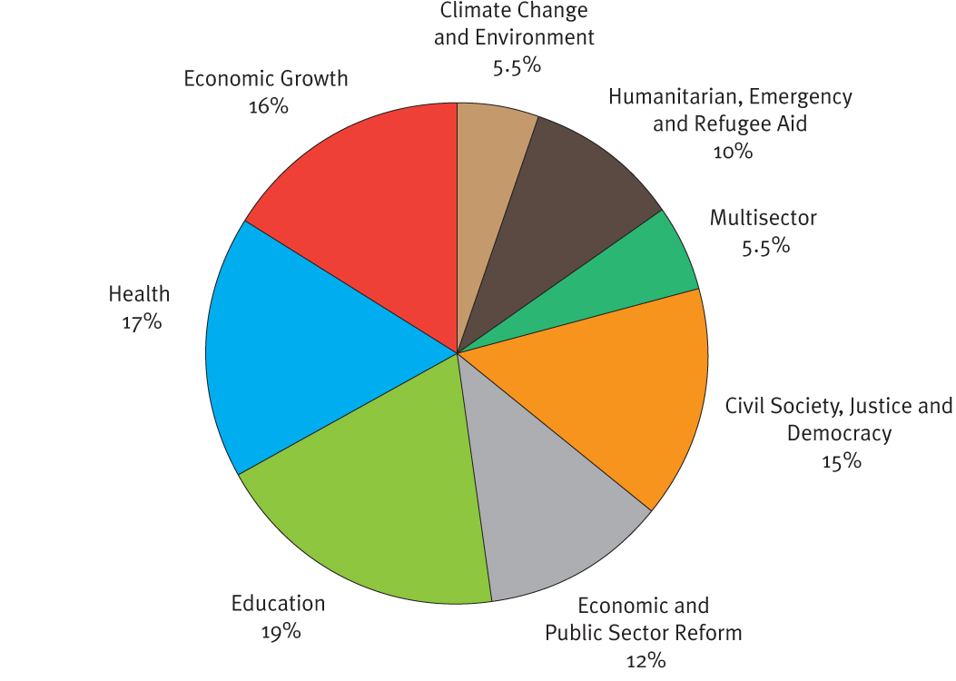

Source: AusAID

A focus on these areas—promoting health, ensuring access to education, promoting opportunities for women and girls and the disabled, boosting economic growth and food security, supporting effective governments and the rule of law, and enhancing preparedness and responses to natural disasters—represents a comprehensive development approach and is reflected in Australia’s budget for 2011–12 (see Graph 8). It will ensure that we are playing our part to meet internationally-agreed development targets, and that our aid investments are making a difference to people’s lives.

## 6. Where Australia will provide aid

The first priority for Australian aid will be those regions and countries where Australia is able to make a real difference in improving the lives of the poor and where our aid is of the greatest direct relevance to Australia’s national interests.

Our near neighbours will continue to receive the highest levels of Australian assistance. Our region has high numbers of poor people and is where Australia can make the most difference.

Australia is the largest bilateral donor to the Pacific island countries and a major donor in East Asia. Australia has vital national interests at stake throughout the region. We have an established field presence throughout this region and bilateral assistance will remain our primary vehicle of assistance. In these countries, Australia will continue to take a donor leadership role, particularly in the Pacific where Australia provides around half of all ODA. Graph 9 shows AusAID’s estimated country aid by region in 2011–12. East Asia and the Pacific comprise more than 70 per cent of our bilateral aid.

**Graph 9: AusAID country aid by region, 2011–12**

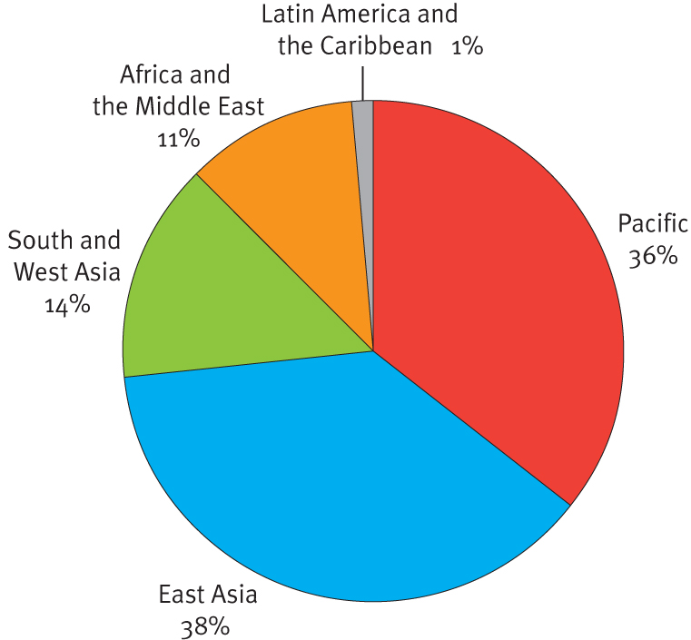

Source: AusAID

At the same time, as a growing middle power with global interests, Australia has a clear rationale for providing aid beyond East Asia and the Pacific to those countries in need. Australia cannot claim to be tackling global poverty without contributing to efforts in South Asia and Africa, where more than 70 per cent of the world’s extreme poor live.[[43]](#footnote-43)

Disasters and humanitarian crises can strike anywhere in the world. As a good international citizen, Australia will provide humanitarian assistance to help people affected by crises where we assess we can make a difference to their lives.

As recommended by the Independent Review, Australia will allocate aid to countries and regions based on assessments of poverty, national interest, effectiveness, and capacity to make a real difference, in line with the criteria set out in Box 6 (page 27).

#### Indonesia

Around 30 million Indonesians live on less than US$1.25 a day and more than 100 million live on $2 a day or less.[[44]](#footnote-44) Many poor Indonesians do not have access to basic food, education or health services. Indonesia’s maternal mortality rate is among the worst in the region.

Indonesia is the fourth most populous country in the world and shares a maritime border with Australia. Australia has a strong interest in supporting a prosperous and stable Indonesia with educated and healthy people.

Australia is the largest grant donor to Indonesia. The Independent Review found that Australia’s aid program is delivering results and is highly valued by Indonesia. The existing program to Indonesia is creating jobs and livelihoods, improving access to basic education and health services, and helping local communities prepare for and respond to natural disasters.

Australia will increase its aid to Indonesia, delivered largely through bilateral mechanisms. More aid will be directed at sectors where Australia is having the largest impact.

|  |
| --- |
| **Box 15: Major Australian aid programs in Indonesia**  The Indonesia program is Australia’s largest. It funds major education, infrastructure, health, poverty reduction and disaster management initiatives that are improving the lives of millions of poor people.  **Education** is the flagship of the aid partnership. Australia has helped build more than 2000 schools and is helping Indonesia to build 2000 more. This has created 330 000 new school places for Indonesia’s children who otherwise would not have access to an education and will create places for a further 300 000. Australia is also promoting tolerance by assisting both secular and Islamic schools and ensuring more children are taught the approved Indonesian curriculum.  Australian-funded projects are providing Indonesia’s poor with access to clean **water and sanitation** for the first time. In less than a year, Australia’s aid has connected more than 339 000 people in urban areas to essential water and sanitation.  In **health**, Australia has helped renovate birthing wards and trained 5000 health officers. Australia is also helping to save lives by reducing HIV transmission through needle exchange, methadone and safe sex programs.  Australia is also supporting Indonesia’s **poverty reduction** program. Australia’s assistance through this program reaches around 80 000 villages each year, funding community-driven activities to improve welfare, build basic infrastructure and create employment for the poor.  Australia is supporting Indonesia’s goal to strengthen **disaster management** through the Australia Indonesia Facility for Disaster Reduction in Jakarta. The facility is working to save lives, protect livelihoods, safeguard development gains and reduce the cost of disasters in the region. |

#### Papua New Guinea

Despite strong recent economic growth and the growth of its resource sector, Papua New Guinea is struggling to meet the MDGs. Around a million people live in extreme poverty in Papua New Guinea,[[45]](#footnote-45) more than a third of all children do not complete primary school, and violence against women undermines the safety and livelihoods of families.

Papua New Guinea is our nearest neighbour. Improving the lives of poor people and promoting stability are central to Australia’s interests.

Australia is the largest donor to Papua New Guinea. Australian aid is having an impact on the lives of poor Papua New Guineans (see Box 16). Our aid agreement with Papua New Guinea was reviewed in 2010 and, as a result, our program is now better focused on four key sectors (education, health, law and justice, and infrastructure). Internationally, Australia has a depth of knowledge about Papua New Guinea’s development challenges.

Australia will increase its aid to Papua New Guinea to help meet its critical development needs, particularly in education and health. We will continue to use bilateral mechanisms to deliver this support.

|  |
| --- |
| **Box 16: Major Australian aid programs in Papua New Guinea**  Australia is strengthening its aid to Papua New Guinea by repositioning the program around four sectors—health (including HIV/AIDS), education, infrastructure, and law and justice. Health and education will be the key priorities, reflecting the importance of progress in these areas for Papua New Guinea’s development.  Australia’s **education** program supports Papua New Guinea’s *Universal Basic Education Plan* to increase enrolment in primary and elementary school. In 2009, 300 000 more children were enrolled in elementary and primary schools in Papua New Guinea compared to 2006.  Australia also supports Papua New Guinea to strengthen its primary **health** care system. Our aid has helped immunise 900 000 children against infectious diseases since 2009. Australia is also helping to reduce disease, such as malaria and tuberculosis, and to respond to outbreaks of cholera. We are improving maternal health by increasing skilled birth attendants through better midwifery schools and distributing maternal health emergency equipment across the country. Australia also supports Papua New Guinea to deliver a coordinated and effective response to **HIV**, including increasing testing and counselling facilities. In 2010, HIV testing sites increased to 266, up from 250 in 2009.  Australia is helping to improve and maintain **infrastructure**, including more than 2000 kilometres of national roads and highways, increasing access to markets and services.  Australia supports Papua New Guinea’s **law and justice** agencies to deliver services in crime prevention, prosecutions, policing, legal aid, prisons, the Ombudsman and courts. |

#### East Timor and Solomon Islands

East Timor and Solomon Islands have both experienced violent conflict over the past decade and are still rebuilding their societies to provide people with security and access to basic services. In East Timor, 41 per cent of people are living in poverty.[[46]](#footnote-46) In Solomon Islands, around 22 per cent of people live below the poverty line.[[47]](#footnote-47)

Australia has a deep interest in the future prospects of East Timor and Solomon Islands. The international community expects that Australia will play a leadership role in fostering stability and development of our neighbours.

Australia is the largest donor in both countries and is having an impact on the lives of the poor. In East Timor, the Australian Government reviewed the program in 2009 and consolidated the program around four key sectors. Australia has helped to maintain 4800 kilometres of rural roads in East Timor, which has enabled people to get their produce to markets and sick children to health care. In Solomon Islands, Australia has helped 140 000 children attend school.

Australia will increase aid to both countries in sectors where we assess the development benefits are highest. In Solomon Islands, as the Regional Assistance Mission to Solomon Islands winds down, Australia will maintain support through its bilateral aid program.

|  |
| --- |
| **Box 17: Major Australian aid programs in East Timor**  Although still one of the poorest countries in the region, East Timor is turning the corner with the help of development partners like Australia. East Timor’s economy has been growing steadily since 2007, and the number of people living below the poverty line has fallen to 41 per cent—down from almost 50 per cent in 2007. Nonetheless, East Timor still has significant development challenges. The Australian aid program is making a difference in East Timor by focusing on key sectors—health, education, agricultural productivity and creating employment opportunities.  In **health** we have restored the eyesight of more than 4800 people through cataract surgery, delivered family planning education to more than 140 000 women in the past year, and raised the proportion of safe births by two-thirds since 2003. In **education** Australia is supporting the development of up to 250 ‘cluster schools’, which will act as educational hubs for surrounding schools and improve access to quality education.  Australia has improved the **food security** of 25 000 East Timorese families by helping farmers increase yields of rice, maize, sweet potato, cassava and peanut crops.  We have created short-term **jobs** for 99 000 women and men by supporting the rehabilitation and maintenance of more than 4800 kilometres of rural roads, which has increased access to markets and services. More than 100 000 people also now have access to clean water and sanitation as a result of our support for ruralinfrastructure.  Australia is also helping the East Timorese Government to better manage its budget so it can spend its own money for the benefit of its people. |

#### Other Pacific island countries

Due to their small size and remoteness from international markets, poor Pacific island countries have limited opportunities to improve the lives of their people. People are also highly vulnerable to natural disasters and climate change.

Australia has an abiding interest in the stability and prosperity of the Pacific region.

Australia is the largest donor in the Pacific region and our aid is delivering results. We have deep knowledge of the development challenges in the region and we take a leadership role in promoting development.

Australian aid will increase where we assess it can make the most difference.

Through the Pacific Partnerships for Development, we will work with partner countries to support stronger economic growth, better education and health outcomes, and safer communities.

|  |
| --- |
| **Box 18: Pacific Partnerships for Development**  Australia is committed to a strengthened engagement with our Pacific island neighbours through the **Pacific Partnerships for Development**.These partnerships focus on mutual commitments with Pacific countries to achieve concrete development results. These commitments include reforms to boost the delivery of basic health and education services and enhance economic growth.  Eleven bilateral Partnerships for Development have been signed. Australia entered into Partnerships with the leaders of Papua New Guinea, Samoa, Solomon Islands, Vanuatu and Kiribati in 2008–09; Nauru, Tonga and Tuvalu in 2009–10; and the Marshall Islands, Federated States of Micronesia and Palau in 2010–11.  Real progress is being made under these Partnerships, especially in getting more children into school. For example, Australia has worked with governments in Papua New Guinea, Solomon Islands, Vanuatu and Samoa to eliminate school fees, leading to rapid increases in school enrolments. In Vanuatu, 3000 more children enrolled in school in 2010 with the help of an Australian supported initiative. In Samoa, we have helped 160 disabled children access schooling and support services. |

#### Other East Asian countries

More than 315 million East Asians live under the poverty line of US$1.25 a day or less, and do not have access to basic services.

Australia has a vital national interest in the prosperity and stability of the East Asia region.

The Independent Review has assessed Australian aid to East Asia as effective and delivering results.

Australia will increase aid to East Asian developing countries, in countries and sectors where we assess it can make the most difference.

In view of China’s rapidly evolving stage of development, and its large overseas aid program, Australia’s bilateral assistance to China will be phased out. Australia will continue to provide targeted assistance through multilateral organisations and regional programs where we can make a difference to poor people.

|  |
| --- |
| **Box 19: Major Australian aid programs in East Asia**  East Asia is an economic success story but also very much a work in progress. The region is home to some of the world’s fastest growing economies but also contains some of the world’s poorest countries, poorest areas within countries and increasing poverty within major cities.  Australia helps poorer countries and regions accelerate and broaden the benefits of growth and tackle new policy challenges such as urbanisation, climate change and the need for social safety nets.  An estimated one-quarter of Burma’s population of 50 million people live in poverty.[[48]](#footnote-48) Burma’s development remains constrained by poor progress towards democracy and reform. In 2011, Australia expanded its humanitarian assistance to focus on basic health, education, food security and livelihoods. With Australian support, a United Nations-managed program in Burma has re-treated 430 000 bed nets to protect families from malaria.  While the Philippines has experienced steady economic growth since 2007, more than 40 million Filipinos live on less than US$2 a day.[[49]](#footnote-49)Australia is now the largest grant donor to the Philippines. Australian aid in education helped around 2 million Filipino children access education and better quality schooling over the past five years.  Vietnam continues to make good progress against most of the MDGs. Despite this, significant challenges remain. Poor infrastructure, inadequate human resources and institutional weaknesses are the key constraints to maintaining strong growth. In 2009 and 2010 Australia helped provide more than 1.1 million rural households in Vietnam with hygienic sanitation facilities.  Cambodia remains a least-developed country with one-third of Cambodians living in poverty.[[50]](#footnote-50) With Australian support, Cambodia has increased the proportion of births attended by skilled attendants in target areas from four in ten to seven in ten, reducing the chances of complications or death for mothers and babies.  Laos is one of the poorest countries in Southeast Asia, with an estimated 34 per cent of the population living below the international poverty line of US$1.25 per day.[[51]](#footnote-51) In 2011–12, Australia will support the construction of 400 primary and pre-primary schools and provide improved road access for more than 60 000 people. |

#### South Asia

South Asia has the largest number of poor people in the world and receives less aid per poor person than other regions in the world. In South Asia, 1.3 billion people do not have access to clean water and 20 million children do not have access to education.[[52]](#footnote-52)

As an Indian Ocean state, Australia has a clear and vital interest in the prosperity and stability of this region.

The Independent Review assessed that Australia’s aid program to this region has been effective and that more aid would lead to strong development results.

We will increase aid to this region. The bulk of Australia’s assistance will be delivered through partnerships, including with multilateral and non-government organisations that we assess as effective, and by investing in sectors where we can make the biggest difference.

Consistent with the Independent Review and reflecting the Government of India’s views about external aid, Australia’s bilateral assistance to India will be phased out. Australia will continue to provide targeted assistance through multilateral organisations and regional programs where we can make a difference to poor people.

|  |
| --- |
| **Box 20: Major Australian aid programs in South Asia**  Australia’s aid program to South Asia is directly targeting the needs of the poor through better health, education, water and sanitation, and income opportunities.  In Bangladesh, Australia supports maternal, neonatal and child health services for more than 27 million people across 18 districts. This has contributed to a 40 per cent reduction in maternal deaths nationwide over the past decade. More than 9 million Bangladeshi children now have access to quality primary education from Australia’s support for 40 000 schools and training for more than 190 000 teachers. Australia is assisting 462 000 of the very poorest Bangladeshi families through skills training, income support and basic health care.  In Sri Lanka, we are helping to rehabilitate communities, build peace and respond to humanitarian concerns in the wake of the civil conflict. Australia has repaired or rebuilt more than 3750 houses and three schools in northern Sri Lanka, and provided more than 135 000 disadvantaged rural children with access to quality education. Australia is supporting demining and providing seeds and farming tools to more than 30 000 families to help communities resettle and become self-sufficient.  In the Himalayan region, Australia has started helping countries adapt to climate change. A strategic assessment of the Ganges River Basin has brought together governments, communities, civil society and regional organisations to plan for better water resource management across the region. Australia is also strengthening regional responses to cross-border problems and challenges in infrastructure, water and sanitation, climate change, health and HIV-AIDS. |

#### Afghanistan and Pakistan

Afghanistan is among the least developed countries in the world, with 42 per cent of people living in poverty.[[53]](#footnote-53) It suffers from some of the worst maternal mortality and literacy rates in the world. There are significant populations without access to basic services or the means to earn a living.

The aid program will continue to play its part in Afghanistan, which is affected by a long running conflict. The aid program is working in uniquely challenging circumstances, as part of a whole-of-government effort to bring about stability and development in Afghanistan.

A third of Pakistan’s population live in poverty[[54]](#footnote-54) and almost a quarter of the population is malnourished.[[55]](#footnote-55) Only two-thirds of primary school-aged children attend school and, of those, one-third will drop out.

Australia has a long term national interest in contributing to development in Pakistan and will continue to do so. Our efforts in both countries will be targeted. We will focus our aid in a limited number of sectors where we can make the biggest difference. We will deliver our aid primarily through multilateral and non-government organisations that have a solid track record on the ground.

|  |
| --- |
| **Box 21: Major Australian aid programs in Afghanistan and Pakistan**  In Afghanistan, through the Afghanistan Reconstruction Trust Fund, Australia supports national health and education programs that build schools and health clinics, and train and fund teachers and medical staff. These programs have led to substantial development in Afghanistan over the past 10 years, including an increase in school enrolments from less than 1 million in 2001 to more than 7 million today. Australia also provides training and capacity‑building assistance, including scholarships, to the Afghan Ministries of Public Health and Education.  In Uruzgan, Australia is supporting a four-year, $36 million program through Save the Children. This program will help deliver school places for more than 20 000 children. It will also provide immunisations that will help protect around 6000 children under two from preventable diseases.  In Pakistan, in response to the 2010 floods, Australia helped provide emergency medical supplies to more than 11 million people through the World Health Organization. Australia is also helping to improve nutrition for 4.5 million children, pregnant women and mothers in Balochistan and Khyber-Pakhtunkhwa. In 2010, Australia also helped 22 000 flood-affected Pakistani children return to school by supporting temporary learning spaces and providing educational supplies. |

#### Africa and the Middle East

Africa has the highest proportion of people living in extreme poverty in the world and is expected to make up 40 per cent of the world’s extreme poor by 2015.[[56]](#footnote-56) Around 11.1 million people are affected by conflict[[57]](#footnote-57) and 30 million children go hungry every day in Africa.[[58]](#footnote-58)

|  |
| --- |
| **Box 22: Major Australian aid programs in Africa**  Australia’s aid supports Africa’s progress towards the MDGs in **food security, maternal and child health, and water and sanitation.** Examples of Australian assistance to Africa include: increasing crop productivity on 500 000 small African farms within 10 years; improving obstetric and newborn care in East Africa by training 300 new midwives; and providing safe water and sanitation to 1.2 million people in Southern Africa.  Australia is also building Africa’s **human resource capacity** through Australia Awards (scholarships) and technical expertise. Australia will offer 1000 Australia Awards each year to African students by 2013. We will also support short-term agricultural training, training in diplomacy and public financial management for African public officials.  Australia is working closely with international partners, Australian non-government organisations and regional partners to respond to **humanitarian emergencies** and ongoing crises in Africa, particularly in Sudan, South Sudan, the Democratic Republic of Congo and the Horn of Africa. In 2010–11 we delivered, in partnership with the World Food Programme, 45 693 tonnes of food to help address food insecurity across Africa. Australia is also assisting African countries **adapt to climate change**;supporting international **peace-building** initiatives; and ensuring African governments maximise the **economic and social benefits** of natural resource development, particularly mining.  In **Zimbabwe**, we continue to provide support to address the needs of the most vulnerable and promote stability and economic growth through water and sanitation, food security, and agriculture initiatives. In partnership with UNICEF, Australia is improving vital water supply and sanitation for more than 2 million Zimbabweans.  In **North Africa**, Australia is supporting the transition to democracy. Australia aims to improve food security and agricultural productivity for 77 000 Egyptians and Tunisians, create 6500 jobs for young Egyptians, clear landmines, support Tunisia’s elections and build human capacity through scholarships. Australia is also supporting the response to the ongoing humanitarian crisis in Libya, where more than 1 million people have been displaced by conflict. |

The Middle East is undergoing political and social upheaval with major humanitarian consequences. Almost 4 million internally‑displaced people are without security and livelihoods.[[59]](#footnote-59)

|  |
| --- |
| **Box 23: Major Australian aid programs in the Middle East**  In the **Palestinian Territories**, Australia focuses on humanitarian assistance to vulnerable groups and supports the peace process by strengthening stable and effective Palestinian institutions. Australia supports the Palestinian Authority to deliver basic services, including improved water and sanitation for 105 Palestinian schools.  In **West Bank, Gaza, Jordan, Lebanon and Syria**, Australia’s assistance is improving health, education, housing, and water and sanitation services for more than 500 000 refugees and vulnerable groups.  In **Iraq**, Australia provides aid to help the country rebuild. Australia is improving Iraq’s agriculture sector, supporting microfinance, research, scholarships and training. Australia is also upgrading classrooms and supporting remedial education for 100 000 children, empowering women and girls, and training more than 1000 officials in public sector management to help Iraq manage its own future. |

As an Indian Ocean state with rapidly increasing links through trade, investment and migration, Australia has an interest in the prosperity and stability of both Africa and the Middle East.

Australia is a relatively small donor to both regions. Our aid is most effective when we partner with larger organisations that have a solid track record and by focusing on a small number of sectors where we can make the biggest difference.

We will increase our assistance to Africa and the Middle East. This will be delivered in partnership with effective multilateral and non-government organisations, and other partners. We will provide bilateral assistance in sectors where Australia can make a real difference.

#### Latin America and the Caribbean

Poor people in this region suffer from widespread inequality and are vulnerable to natural disasters and climate change. Around 17 per cent of people live on $2 a day or less.[[60]](#footnote-60) In a globalised world, it is in Australia’s interests to provide assistance to regions that are not our closest neighbours, but where entrenched poverty and inequalities remain.

Australia’s aid to this region is most effective when it is delivered through partners that have established programs on the ground and where we focus on a small number of sectors.

Consistent with the Independent Review, we will continue to deliver the bulk of this assistance through partnerships with regional, multilateral, and non-government organisations that we assess can make the biggest difference to the poorest.

We will also maintain the flexibility to deliver some of our aid bilaterally so that, for instance, we can continue scholarship programs for Caribbean countries.

|  |
| --- |
| **Box 24: Major Australian aid programs in Latin America and the Caribbean**  In **Latin America**, Australia is providing around $25 million annually in development assistance from 2010–2014 targeting poor countries and regions. This assistance focuses on: sustainable rural livelihoods (improved agriculture and access to financial services); human resource development (scholarships, fellowships and public sector linkages); natural resources management; and preparing for and responding to natural disasters. Our support for microfinance in Peru will provide financial training, networking and mentoring for up to 100 000 women entrepreneurs and their families.  In the **Caribbean**, Australia works closely with Caribbean partners and other regional donors to address climate change, support economic development, and strengthen human and institutional capacity. Through our support for employment and training programs we will provide more than 1200 disadvantaged Jamaican youth with better skills to help them get jobs. |

## 7. The way we will deliver our aid

Australia will use delivery mechanisms and partnerships that are effective and achieve results.

Direct country-to-country delivery will remain our primary vehicle of assistance in East Asia and the Pacific, where Australia is a major donor and where we have a well‑established field presence. In these countries, Australia will take a donor leadership role, particularly in the Pacific where Australia provides around half of all ODA.

In Africa, South and West Asia, as well as Latin America and the Caribbean, we will make greater use of multilateral partners and our partnerships with other donors, including emerging donors. In these regions, we can tap into these organisations’ greater field presence and experience to increase results for poor people.

In view of our global interests, we will increase the support we provide to global initiatives and multilateral organisations with proven records of effectiveness. In doing so, Australia will strengthen its engagement in the strategic direction and governance of these organisations.

Australia will increase assistance to civil society organisations, including Australian non-government organisations where they are effective and provide the best delivery mechanism to achieve results.

Over recent years, Australia has been changing the way it delivers assistance with partners based on evidence of effectiveness (see Graph 10).

**Graph 10: Use of partners in the Australian aid program 2005–06 to 2009–10: per cent of AusAID expenditure**

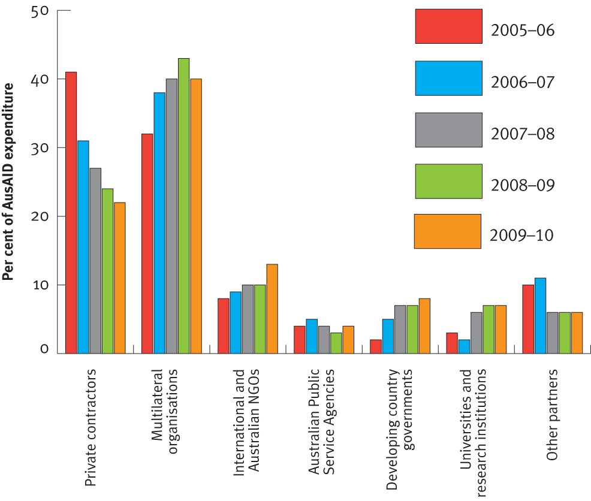

Source: AusAID

### Direct country-to-country delivery

#### Private sector

The private sector, particularly private contractors, is well-placed to deliver services related to high-level management support, logistics, and technical areas such as infrastructure. Contractors also have the ability to quickly mobilise advisers, have structures in place to provide technical backstopping, and can replace personnel quickly when needed. That said, the use of private contractors to deliver aid can mean that development gains are more difficult to maintain after Australian funding has finished. For that reason, the proportion of the program delivered through contractors has declined from 41 per cent to 23 per cent over the past five years.

Consistent with the Independent Review’s findings, we will continue to use private sector contractors in circumstances where the necessary expertise does not exist in-house and where contractors represent the most reasonable and cost-effective choice. We will also make better use of private sector expertise in the early stages of policy development and program design.

#### Developing country government systems — national delivery

Experience dictates that the best way to improve and strengthen government systems and processes, such as planning, financial, procurement and audit, is to work within partner governments rather than work outside them through a parallel system or on a stand-alone project.

Delivering through government systems reduces the administrative burden upon partner governments, particularly when part of a broader multi-donor or sector program. It also enables greater ownership by partner countries, leverages national resources, and facilitates greater alignment with partner government priorities.

To guard against the risk that aid funds will be poorly managed, we will only use partner government systems where we assess these as being robust. Where they are not, we will work to strengthen these before any Australian funds are provided.

#### Australian universities and other government agencies

The use of Australian universities to provide tertiary qualifications and training has been a cornerstone of Australian aid delivery for decades. Australian Government agencies have also been an important feature of Australia’s aid program. These agencies can provide their counterparts with valuable firsthand experience to help design and implement important public policy reforms through capacity building and training.

Consistent with the Independent Review, we will continue to use the aid program to build stronger linkages between Australian institutions and their counterparts where this is the most effective way of achieving development results.

### Multilateral organisations

Delivering aid through multilateral organisations allows us to benefit from these organisations’ specialist expertise and extends our reach and impact, particularly in geographic areas where we have no presence on the ground. As the aid program grows, providing more funds through global programs is an effective and efficient use of Australian funds.

The Australian aid program engages with three main types of multilateral delivery partners:

• international financial institutions (for example, the World Bank and the Asian Development Bank)

• UN organisations (for example, the United Nations Children’s Fund, World Food Programme and the United Nations Development Programme)

• other global funds (for example, GAVI Alliance and the Education for All—Fast Track Initiative).

In 2011, Australia will undertake an assessment of the effectiveness of our key multilateral partners, which we will publish, to ensure that our objectives are aligned and that we are working together as best we can to achieve results on the ground. Following this assessment, and in line with the recommendations of the Independent Review, Australia will increase its support for multilateral and non-government organisations that we evaluate to be:

• effective and achieving results for the poorest people

• in line with Australia’s objectives and priorities

• value for money.

Australia will provide this support as a mix of core support for general programs and earmarked aid. Core contributions can be used for any purpose within an organisation’s mandate. The advantages of core contributions are ease of management for the agency we are supporting, and the ability for Australia to exercise influence over the policies of sometimes very large multilateral organisations. Earmarked contributions are directed towards a specific region, country, sector or activity and allow us to target our funds. Earmarked funding can provide greater visibility to Australia’s contribution.

Australia will have a stronger voice in multilateral organisations through our increased contributions.   
We will use this to champion effectiveness and value for money as well as to encourage increased engagement by multilateral organisations in our region, and with fragile and vulnerable states.

We will fund only those organisations capable of delivering results and demonstrating effective and efficient use of their resources.

We will work with multilateral organisations to ensure appropriate recognition and visibility for Australia’s core and earmarked contributions.

### Civil society organisations

Civil society organisations include non-government organisations, community groups and citizens’ associations. Delivering aid through civil society organisations enables us to benefit from these organisations’ grass roots networks, niche areas of specialisation, and presence on the ground. These organisations are connected with local communities, and are able to engage on policy issues and deliver assistance directly to those people who need it most.

The differences in size and areas of specialisation mean that civil society organisations can be more flexible and dynamic than other partners. It can also mean that there is variability in management capacity and quality assurance processes, which need to be assessed and, in some cases, improved before aid funds can be provided. Not all civil society organisations are capable of taking small and successful activities to a larger scale; this can limit their ability to effectively absorb additional funds.

The Government will develop, in consultation with the Australian Council for International Development, a new *Civil Society Engagement Framework*. This will set out how Australia will work more effectively with civil society organisations, in Australia and overseas, to increase the impact of aid for the world’s poorest.

## Abbreviations

ACC Australian Civilian Corps

ANAO Australian National Audit Office

AusAID Australian Agency for International Development

DAC Development Assistance Committee

DESC Development Effectiveness Steering Committee

GAVI Alliance Global Alliance for Vaccines and Immunisation

GDP Gross Domestic Product

GNI Gross National Income

IATI International Aid Transparency Initiative

MDGs Millennium Development Goals

NGO Non-Government Organisation

ODA Official Development Assistance

ODE Office of Development Effectiveness

OECD Organisation for Economic Cooperation and Development

RAMSI Regional Assistance Mission to Solomon Islands

UN United Nations

UNDP United Nations Development Programme

WHO World Health Organization

## Annex A. Response to Independent Review recommendations

| **Review recommendation** | **Government’s response** |
| --- | --- |
| 1. The objective of the Australian aid program should be cast as follows:  ***The fundamental objective of Australian aid is to help people overcome poverty.***  *We work to improve the lives of those living in conditions far below what Australians find acceptable. We focus our resources and effort on areas of national interest, and where Australia can make a real difference.* | Agree, with the following refinement:  ***The fundamental purpose of Australian aid is to help people overcome poverty.***  *This also serves Australia’s national interests by promoting stability and prosperity both in our region and beyond. We focus our effort in areas where Australia can make a difference and where our resources can most effectively and efficiently be deployed.* |
| 2. Aid allocations to countries and regions should be defined to include the geographic distribution of global programs supported by Australia, as well as country program aid. | Agree. |
| 3. Decisions about country allocations should be based on poverty, national interest, capacity to make a difference, and current scale and effectiveness. Decisions about country programs should also reflect the need to consolidate the aid program. | Agree. These will form the criteria in the comprehensive aid policy framework to guide allocations by country/region, sector and program. |
| 4. In scaling up the aid program, country allocations and programs should be adjusted in line with the Review Panel’s specific recommendations based on these criteria. | Agree in principle and that specific geographic allocations will be decided by the Government in the 2012–13 budget process. Geographic allocations will be based on an assessment of poverty, national interest, capacity to make a difference, and current scale and effectiveness.  In line with the Government’s commitment to deliver 0.5 of GNI on overseas aid by 2015–16,[[61]](#footnote-61) agree in principle that:  • aid to Pacific island countries, South East Asia, Afghanistan and Pakistan, and Africa and the Middle East be increased  • bilateral aid to China and India be phased out with future assistance to be delivered through regional and global programs  • any future increase in aid to Latin America and the Caribbean be modest, with any increases to be delivered through regional and global programs. |
| 5. Australia should join the African Development Bank. | Agree in principle, subject to the outcome of a detailed assessment. |
| 6. The Direct Aid Program should at least double, with the highest increases in countries with no country program. | Agree in principle, with the details to be determined by the Government through the 2012–13 budget process. |
| 7. The aid program should be driven by country programs, rather than by predetermined sectoral targets. | Agree. |
| 8. Sectoral selectivity should be increased at the country level. Sectoral spread in country programs should be low, outside of Indonesia, East Timor, Papua New Guinea and the Pacific island region. | Agree. |
| 9. An organising framework should be adopted to enhance the aid program’s strategic clarity and facilitate communication of results. This should be built around the following four themes:  • investing in pro-poor, sustainable economic growth and private sector development  • promoting opportunities for all  • supporting social stability, improving the quality of government, and strengthening civil society  • preparing for and responding to crises. | Agree, with one addition.  This should be build around five strategic goals for the overall aid program:  • saving lives  • promoting opportunities for all  • investing in food security, sustainable economic growth and private sector development  • supporting security, improving the quality of governance, and strengthening civil society  • preparing for and responding to disasters and humanitarian crises. |
| 10. The aid program should increase its emphasis on private sector development and strengthening civil society. Policy statements in relation to each should be developed. | Agree. |
| 11. Promoting gender equality should be a critical cross-cutting objective for the aid program. Australia should be a firm and persistent advocate and practical supporter of gender equality, especially in the Pacific. | Agree. |
| 12. Humanitarian and emergency assistance should be increased as a share of the program. | Agree in principle, with the details to be determined by the Government through the 2012–13 budget process. Decisions on allocations will be based on an assessment of poverty, national interest, capacity to make a difference, and current scale and effectiveness. |
| 13. A small number of flagships should be identified where Australia should exercise leadership and be recognised for its efforts. | Agree. |
| 14. Reliance on bilateral modes of aid delivery should largely be restricted to East Asia, the Pacific, Afghanistan and Pakistan. Aid delivered to other regions should be mainly through partners. | Agree. |
| 15. Core funding to multilateral organisations and NGOs should be significantly increased as a share of total spending. Core funding increases should be made on a case-by-case basis, linked to effectiveness, capacity, and relevance. | Agree in principle, with the details to be determined by the Government through the 2012–13 budget process. Decisions on allocations will be based on an assessment of poverty, national interest, capacity to make a difference, and current scale and effectiveness in line with their mandate. |
| 16. AusAID should devote greater senior management resources to developing and managing relationships with key partners. Predictable, multi-year funding of partners should be provided and micromanagement avoided. | Agree. |
| 17. Core funding to multilateral organisations should be linked to performance and relevance to Australia through the introduction of a multilateral rating system. | Agree. |
| 18. In relation to multilateral organisations, Australia should use its more prominent ‘seat at the table’ to seek greater influence over policy and program directions, better recognition for contributions, and better monitoring of effectiveness. | Agree. |
| 19. AusAID’s existing accreditation system should be used as a basis for Australian NGOs to access increased funding. AusAID should consider further means to improve the accreditation process for small NGOs. | Agree. |
| 20. The share of aid being disbursed through government systems should be expanded. | Agree. |
| 21. The power of business should be harnessed and business innovation should be encouraged, including through an annual consultative forum. | Agree. |
| 22. There should be increased use of partnership arrangements with other bilateral donors, both traditional and non-traditional. | Agree. |
| 23. There should be more aid funding for research by Australian and international institutions, particularly in agriculture and medicine. | Agree in principle, with the details to be determined by the Government through the 2012–13 budget process. Allocations will be based on an assessment of poverty, national interest, capacity to make a difference, and current scale and effectiveness. AusAID will consult with the Australian Research Council and the National Health and Medical Research Council on relevant research. |
| 24. The government should develop and implement a Cabinet-endorsed four-year strategy for the entire aid program, for policy and funding clarity. | Agree. The Government will develop a comprehensive aid policy framework, linked to a four-year budget strategy, which would be a rolling strategy. |
| 25. There should be a Cabinet discussion of an annual review of progress against the four-year strategy and predetermined hurdles, with consequences if hurdles are not met. | Agree, with the following comments:  • An annual review of effectiveness will be presented to Cabinet before the end of each calendar year that will report on:  i. whether ODA is being delivered in line with the comprehensive aid policy framework  ii. whether ODA is achieving development results.  • This will give Cabinet an annual opportunity to respond to changes in priorities, including consequential changes to the comprehensive aid policy framework. This would then feed into the budget process each year through the whole-of-ODA budget submission.  • The annual review will be developed by AusAID in consultation with other agencies. |
| 26. The budget process should be reformed to provide greater funding certainty, including allocating funds on the basis of the four-year strategy and its annual updates, not through New Policy Proposals as at present. | Agree, with the following comments:  • A comprehensive aid policy framework, which includes a four-year budget strategy, will be developed by Government.  • This framework will form the basis of future new policy proposals, which will be brought forward annually in the whole-of-ODA budget submission consistent with whole-of-government budgetary processes.  • Improvements to the operation of the ODA Contingency Reserve will be considered before the 2012–13 Budget. |
| 27. Four-yearly independent reviews of the aid program should be instituted to inform each new four-year strategy. | Agree to regular five-yearly reviews of the aid program. |
| 28. Ministers should continue to provide leadership to the aid program, and particularly the strengthening of the program for the crucial and challenging period of scaling up over the next five years. An effectiveness culture focused on results, rather than an announcement culture leading to fragmentation, should drive the program. | Agree. |
| 29. The words ‘International Development’ should be added to the title of the Minister for Foreign Affairs. | Noted for further consideration by the Government. |
| 30. A ‘whole-of-ODA’ approach should be strengthened by creating uniform standards across government departments to planning, delivery, monitoring and reporting, overseen by the Development Effectiveness Steering Committee (DESC). | Agree. |
| 31. Corporate reform efforts within AusAID should be accelerated to promote a culture geared towards delivering results and enhancing productivity, especially by reducing staff turnover, building the workforce with the requisite skills, streamlining business processes, and reducing paperwork. | Agree. |
| 32. AusAID should be provided with increased resources to manage effectively the increasing program. | Agree in principle, with the details to be determined by the Government through the 2012–13 budget process. |
| 33. The aid program should foster a culture of risk management rather than risk aversion by balancing various forms of risk and ensuring they are well understood across AusAID as the program grows. It should increase the relative importance of risks to development effectiveness as compared to other risks. There should be a greater focus on results and reward for innovation, and acceptance that in a big program some activities will fail. | Agree. |
| 34. A three-tiered reporting system should be adopted by all Australian government departments and agencies in relation to their use of ODA funds. | Agree. The three tiers for reporting will be:  • Tier 1—progress against development goals  • Tier 2—the contribution of Australian aid  • Tier 3—operational and organisational effectiveness. |
| 35. An annual assessment of aid effectiveness of all of ODA should be prepared using the three-tier system. This should inform the annual reviews of the four-year strategy provided to Cabinet. | Agree. |
| 36. A small number of high quality evaluations and an annual synthesis and quality assurance report should be produced annually, overseen by an Independent Evaluation Committee. | Agree. |
| 37. A Transparency Charter should be developed, committing the aid program to publishing documents and data in a way that is comprehensive, accessible and timely. | Agree. |
| 38. Public engagement should be improved through a new community grants scheme, embracing new media technologies and promoting development education. | Agree. The Government will pilot a new community grants scheme that will be delivered through Australian community groups to benefit people in developing countries. |
| 39. The scale-up of the aid program to 0.5 per cent of GNI should be subject to the progressive achievement of predetermined hurdles. | Agree in principle, with program performance to be assessed through the annual review of the aid program noting that development is a long term process and results will be incremental. |

1. Chen, Shaohua and Ravallion, Martin, 2008, *The developing world is poorer than we thought, but no less successful in the fight against poverty*, Policy Research Working Paper 4703, World Bank [↑](#footnote-ref-1)
2. UNICEF et al, 2010, *Levels and Trends in Child Mortality* [↑](#footnote-ref-2)
3. World Health Organization (WHO), 2010, *Trends in Maternal Mortality: 1990 to 2008* [↑](#footnote-ref-3)
4. FAO and WFP, 2010, *The State of Food Insecurity in the World*, Rome [↑](#footnote-ref-4)
5. WHO, 2011, *WHO Database* – 2008 Data [↑](#footnote-ref-5)
6. US Department of State, 2007, *Trafficking in Persons Report* [↑](#footnote-ref-6)
7. WHO/ UNICEF Joint Monitoring Program for Water Supply and Sanitation, 2010, *Progress on Sanitation and Drinking Water: 2010 Update*, Geneva [↑](#footnote-ref-7)
8. UNESCO, 2011, *Education for All Global Monitoring Report 2011* [↑](#footnote-ref-8)
9. World Bank, 2011, *World Development Indicators* (data.worldbank.org/indicator) [↑](#footnote-ref-9)
10. United Nations, 2010, *Millennium Development Goals Report 2010*, New York [↑](#footnote-ref-10)
11. Ibid. [↑](#footnote-ref-11)
12. WHO, 2010, *Fact Sheet 290*, Geneva [↑](#footnote-ref-12)
13. United Nations, 2010, *Millennium Development Goals Report 2010*, New York [↑](#footnote-ref-13)
14. Ibid. [↑](#footnote-ref-14)
15. United Nations, 2010*, Millennium Development Goals Report 2010*, New York [↑](#footnote-ref-15)
16. Ibid. [↑](#footnote-ref-16)
17. AusAID estimate [↑](#footnote-ref-17)
18. OECD, 2011, *Member Countries’ Budget Contributions for 2011*, http://www.oecd.org/document/14/0,3746,en\_2649\_201185\_31420750\_1\_1\_1\_1,00.html [↑](#footnote-ref-18)
19. Based on preliminary data issued by the OECD DAC [↑](#footnote-ref-19)
20. Calculated to 30 April 2011 and expressed as a proportion of total appropriation for 2010–11 [↑](#footnote-ref-20)
21. World Trade Organization, 2011, *International Trade Statistics Database* [↑](#footnote-ref-21)
22. World Bank, 2011, *Global Development Finance 2011* [↑](#footnote-ref-22)
23. OECD, 2010, Agricultural Policies in OECD Countries [↑](#footnote-ref-23)
24. Transparency Inernational, 2010, Perceptions of Corruption Index [↑](#footnote-ref-24)
25. WHO/ UNICEF Joint Monitoring Program for Water Supply and Sanitation, 2010, *Progress on Sanitation and Drinking Water: 2010 Update*, Geneva [↑](#footnote-ref-25)
26. WHO/UNICEF, 2009, *Diarrhoea: Why children are still dying and what can be done*, Geneva [↑](#footnote-ref-26)
27. UNDP, 2010, *Millennium Development Goal 5: Where do we stand?*, http://www.beta.undp.org/undp/en/home/mdgoverview/mdg\_goals/mdg5/where\_do\_we\_stand.html [↑](#footnote-ref-27)
28. UN Women, *Education for Women and Girls*, http://www.unwomen.org.au/GEO/Resources/education-for-women-and-girls [↑](#footnote-ref-28)
29. UN Women, *Violence against Women,* http://www.unwomen.org.au/GEO/Resources/violence-against-women [↑](#footnote-ref-29)
30. International Labour Organization, 2010, *Women and Labour Markets in Asia, Rebalancing for Gender Equality* [↑](#footnote-ref-30)
31. World Bank, 2008, *World Development Report 2008* [↑](#footnote-ref-31)
32. Food and Agriculture Organisation of the United Nations, http://www.fao.org/hunger/en/ [↑](#footnote-ref-32)
33. McCawley, P, 2010, *Infrastructure Policy in Asian Developing Countries*, Asian–Pacific Economic Literature, Vol. 24, Issue 1, pp. 9–25 [↑](#footnote-ref-33)
34. World Bank, 2011, *PNG Country Brief* [↑](#footnote-ref-34)
35. International Energy Agency, 2011, *World Energy Outlook* [↑](#footnote-ref-35)
36. World Bank, 2011, *One Goal, Two Paths: Achieving Universal Access to Modern Energy in East Asia and Pacific* [↑](#footnote-ref-36)
37. Pacific Institute of Public Policy, 2009**,** *Social and Economic Impact of Introducing Telecommunications throughout Vanuatu* [↑](#footnote-ref-37)
38. The Centre for Research on the Epidemiology of Disasters (CRED), EM-DAT: *The OFDA/CRED - International Disaster Database*  [↑](#footnote-ref-38)
39. Ibid. Statistic has been calculated as a three year moving average to reduce annual variation [↑](#footnote-ref-39)
40. UNESCAP and UNISDR, 2010, *The Asia Pacific Disaster Report, 2010* [↑](#footnote-ref-40)
41. United Nations High Commissioner for Refugees, 2009 *Global Trends Report* <http://www.unhcr.org/4c11f0be9.html> [↑](#footnote-ref-41)
42. Internal Displacement Monitoring Centre, 2010, *Internal Displacement: Global Overview of Trends and Developments in 2010* [↑](#footnote-ref-42)
43. Chen, Shaohua and Ravallion, Martin, 2008, The World Bank, *Policy Research Working Paper 4703: The Developing World is Poorer than We Thought, But No Less Successful in the Fight against Poverty* [↑](#footnote-ref-43)
44. World Bank, 2011, *World Development Indicators* (data.worldbank.org/indicator) [↑](#footnote-ref-44)
45. Allen, B., Bourke. R. M. and Gibson, J., 2005, *Poor rural places in Papua New Guinea, Asia Pacific Viewpoint*, Vol. 46, No. 2, August 2005 [↑](#footnote-ref-45)
46. World Bank, 2011, *World Development Indicators Database* (data.worldbank.org/indicator)*.* Statistic refers to national poverty line [↑](#footnote-ref-46)
47. UNDP Pacific Centre, 2008, *Solomon Islands—Analysis of the 2005–06 Household Income and Expenditure Survey.* Statistic refers to national poverty line [↑](#footnote-ref-47)
48. CIA, 2011, *World Factbook.* Statistic refers to national poverty line [↑](#footnote-ref-48)
49. World Bank, 2011, *World Bank Open Data Database* [↑](#footnote-ref-49)
50. World Bank, 2011, *World Development Indicators* (data.worldbank.org/indicator). Statistic refers to national poverty line [↑](#footnote-ref-50)
51. World Bank, 2011, *World Development Indicators* (data.worldbank.org/indicator) [↑](#footnote-ref-51)
52. Ibid. [↑](#footnote-ref-52)
53. UNDP, 2008, *Human Development Report.* Statistic refers to national poverty line [↑](#footnote-ref-53)
54. UNDP, 2009, *Human Development Report.* Statistic refers to national poverty line [↑](#footnote-ref-54)
55. UNDP, 2010, *Human Development Report*  [↑](#footnote-ref-55)
56. World Bank, 2011, *Global Monitoring Report 2011* [↑](#footnote-ref-56)
57. Internal Displacement Monitoring Centre, 2011, *Internal Displacement in Africa* [↑](#footnote-ref-57)
58. World Bank, 2011, *World Development Indicators* (data.worldbank.org/indicator) [↑](#footnote-ref-58)
59. Internal Displacement Monitoring Centre, 2011, *Internal Displacement in the Middle East* [↑](#footnote-ref-59)
60. Chen, Shaohua and Ravallion, Martin, 2008, The World Bank, *Policy Research Working Paper 4703: The Developing World is Poorer than We Thought, But No Less Successful in the Fight against Poverty* [↑](#footnote-ref-60)
61. As announced by the Government in the 2012–13 Budget, Australia will now deliver this commitment by 2016–17 [↑](#footnote-ref-61)