Electoral Support Program
Phase 3

DRAFT Strategic Plan

Table of Contents
1. Summary 2
2. Preface 2
3. Background 2
3.1. Australian Government support aligns with PNG Government Priorities 2
3.2. The PNG Electoral System 2
3.3. Australian Government support to the Electoral System in PNG 2
3.4. Analysis of the current PNG context 2
4. Design of Electoral Support Program Phase 3 2
4.1. Lessons learned from Electoral Support Program Phase 2 2
4.2. Priorities of the PNG Electoral Commission 2
4.3. Goal, Aim, and Objectives of Electoral Support Program Phase 3 2
4.4. A Strategic and Value for Money Approach 2
4.5. Development of Strategic Focus Areas 2
4.6. Principles of the Electoral Support Program Phase 3 2

Abbreviations and Acronyms

AEC Australian Electoral Commission
CSO Civil Society Organisation
GoPNG Government of PNG
IDEC Interdepartmental Elections Committee
LPV Limited Preferential Voting
MTDP Medium Term Development Plan
NGO Non Government Organisation
PNG Papua New Guinea
PNGEC PNG Electoral Commission

Summary
- Free and fair elections are critical to democracy, good governance and stability in PNG. These are, in turn, essential for PNG’s development. Providing electoral support helps further Australia’s goal of improving development outcomes for PNG. Strengthening democracy and stability in PNG also aligns with Australia’s national interest.
- The Electoral Support Program is designed to align with the priorities of the Government of PNG and the Government of Australia - specifically, the PNG Electoral Commission (PNGEC) and AusAID.
- The PNG electoral system is complex due to a number of systemic and contemporary issues, including: an inaccurate electoral roll, delays in electoral reform, lack of financial resources and challenging logistical considerations. There is growing evidence that the 2012 General Election will be extremely difficult, corrupt and violent due to the various interests at stake. Candidates are becoming increasingly bold in their attempts to secure seats and their actions are only likely to become more daring. The ability of the PNGEC to provide adequate levels of security and safety for its officials and for the voting public is a major challenge, even when working closely with the Police and Defence Forces.
- Australian assistance takes a long-term capacity building approach. The current phase of the Electoral Support Program builds on previous assistance,with its primary focus being to support the 2012 General Election and post-election review and learning.
- The current Program modality is supportive, responsive, and based on a capacity building approach. As such, the program provides advice and guidance to the PNGEC and other stakeholders. It does not direct and it does not implement.
- The Program is small in comparison to total GoPNG funding for elections and so strategic choices were made based on: analysis of lessons learned from previous phases, the priorities of the PNGEC and AusAID, value for money and appropriateness – where could the Program make the greatest difference given its small and strategic inputs.
- The strategic focus of the Program is based on a consultative process including AusAID, PNGEC, Cardno and project stakeholders. A total of eleven strategic focus areas were defined to ensure the program was targeted and value for money.
- Based on the above process and parameters, there are a number of areas which the Program explicitly and intentionally does not provide support to as it is considered inappropriate and/or outside the scope of the Program. This includes electronic voter identification.
- Australian support can assist the PNG Electoral Commission and GoPNG to improve electoral administration. However, it cannot effect a free,fair, and violence-free election. This responsibility rests with the Government of PNG and its citizens

Preface
This Strategic Plan is the overarching framework that sets out the development context and direction of the Electoral Support Program Phase 3 (the Program), including its strategic focus areas for funding over the next two years. A strategic plan by its nature is meant to be long term: a high level document around which all stakeholders can coordinate their activities in order to achieve agreed goals and objectives. This Strategic Plan sets the parameters of the Program and guides the decision-making processes of the Program Board.

Background

Australian Government support aligns with PNG Government Priorities
Support to the PNG electoral system is important for the Governments of PNG and Australia. The Program therefore aligns with the long-term objectives of both Governments.
The PNG Government has developed Vision 2050 that maps out PNG’s development initiatives for the next 40 years and identifies seven strategic pillars that underpin its growth and development. To implement Vision 2050, a Medium Term Development Plan (MTDP) 2011- 2015 is in place to guide the development of sector policies, plans and strategies and the monitoring of progress.The role of political leadership and citizens’ choice of good leaders is considered critical to this process.
‘...To achieve transformational and systemic change, as envisioned under Vision 2050, political leadership is critical. First, the success of Vision 2050 depends significantly on the cadre of political leadership and its commitment to implementation. Second, it will be incumbent upon all citizens to elect good leaders to public office.’
The Electoral Commission’s role, to build electoral awareness of citizens and candidates as well as conducting free and fair elections, is central to the creation of this enabling environment.
Diagram 1: The link between GoPNG’s long-term priorities and the PNGEC’s outputs
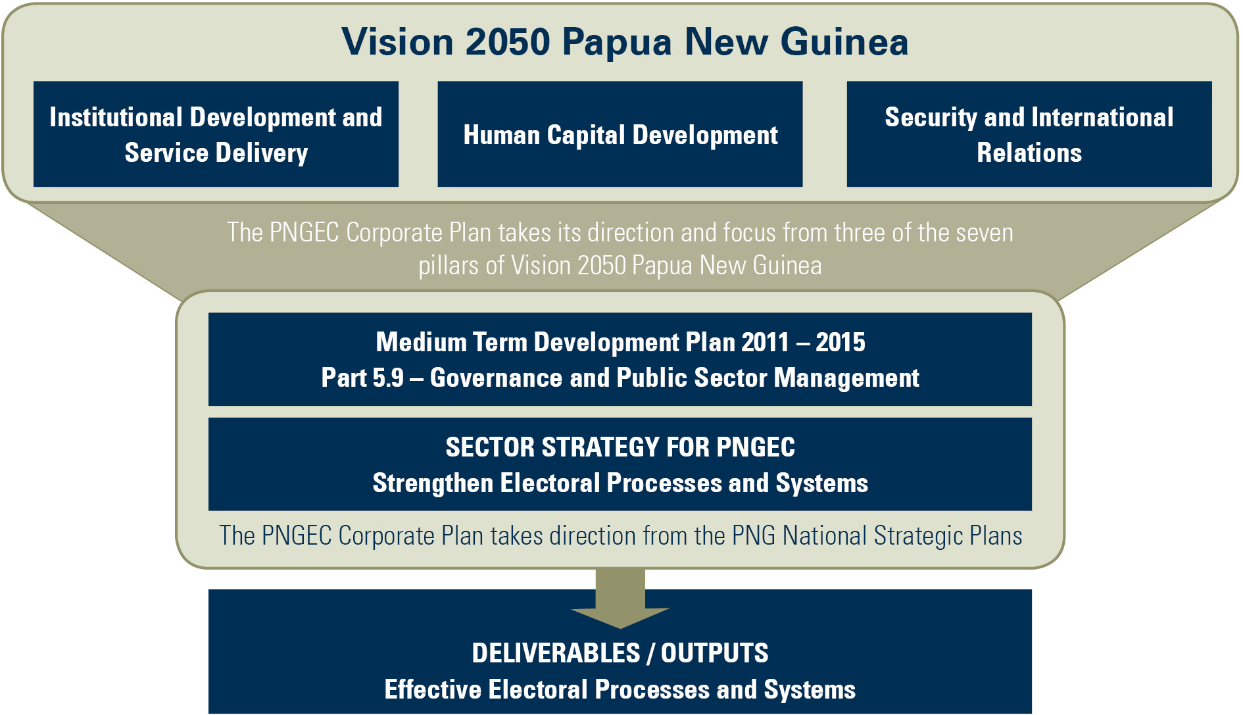
Specifically, PNGEC takes it direction and focus from three of the seven pillars of Vision 2050: institutional development and service delivery; human capital development; and security and international relations. The PNGEC also draws upon Part 5.9 of the MTDP (governance and public sector management) as outlined in Diagram 1, above.
The PNGEC has a five year Corporate Plan (2008 – 2012) which is consistent with Vision 2050 and the MTDP. The Plan sets out a detailed and coordinated plan of action that will be progressively implemented in readiness for local level and national government elections in 2012. Given the complexity, scale and resources required to conduct elections in PNG ‘elections are not just the responsibility of the Electoral Commission. They are a ‘whole-of-government’ responsibility’ and are a key part of the enabling environment necessary for development in PNG.
A key principle of Australian Government development assistance is alignment with the bilateral partner priorities. This is clearly set out in a Partnership for the Development agreement between the PNG and Australian governments. Through this partnership the Australian Government is supporting PNG’s priorities by focusing in four key areas: health (including HIV), education, transport infrastructure and law and justice. The Partnership also focuses more on working with provincial and district levels of government, in recognition of the important role local levels of government play in direct service delivery.
The strengthening of democratic institutions and building civil society are considered essential to ensuring the achievement of these joint priorities. Free and fair elections are essential for stability and good governance in PNG. As a result a democratic governance program, which includes support to the PNG electoral system, is an enabling and important element in the Australian Government’s PNG program.

The PNG Electoral System
The management of elections in PNG presents unique challenges because of:
- Broad issues relating to the geography and culture of PNG, including issues of security,logistics of reaching remote areas, lack of women’s participation, localised political corruption, violence and intimidation. These problems are particularly acute in the Highlands.
- Specific election-related issues such as recruitment and training of a large temporaryworkforce of returning officers and polling officials, uncertainty over electoral boundaries, electoral fraud, mobile polling, voter literacy and education, disabled access and the lack of accuracy and integrity of the electoral roll.
Papua New Guinea is an independent state with a modified Westminster system of government and universal suffrage for all citizens over 18. There are 19 provinces, each with a number of districts, which are also the electorates for the single chamber national parliament. In total there are 89 districts / electorates.
Political allegiances are largely based on the local and personal ties of men, including family ties, rather than on ideology or party. Consequently the majority of MPs have localised and small support bases within their electorates. There is only one woman in the National Parliament. Despite the introduction of the Organic Law on the Integrity of Political Parties and Candidates 2000, which was designed to strengthen the role of political parties, the party system remains relatively weak.
National and local government elections are the biggest public event held (every five years) in PNG. An independent Electoral Commission is charged with the responsibility under the Constitution to conduct elections and the Electoral Commissioner is an independent constitutional office holder. The major operational law is the Organic Law on National and Local-Level Government Elections (No.3 / 1997) (the Election Law).Since 2007, national elections have been conducted under a limited preferential voting (LPV) system. Given the size and complexity of PNG elections, all relevant departments of the PNG Government play a critical role in their conduct and management. The Interdepartmental Electoral Committee (IDEC) is the national body responsible for coordination of whole of government involvement in elections, including provision of security, adequate and timely financial resources, infrastructure and personnel. At the provincial level, Provincial Electoral Steering Committees undertake the role.

Australian Government support to the Electoral System in PNG
Phase 3 of the Program is the latest phase of Australian Government to support the PNGEC to manage and conduct elections.
Free,fair, and credibly run elections are critical to strengthening democracy, governance and stability in PNG which are, in turn, essential for PNG’s development. Providing electoral support and building democratic institutions and civil society are important elements of support to improve development outcomes for PNG.
Australian Government-funded support to the PNG Electoral Commission (PNGEC) started in April 2000. That phase, managed by the Australian Electoral Commission (AEC), involved supporting the update of the electoral roll and strengthening the capacity of the PNGEC to plan and conduct the June – July 2002 General Election.
In November 2002, AusAID reviewed the on-going relevance and possible future shape of Australia’s electoral support program to PNG. The review recommended that future AusAID assistance should focus on improving the broader electoral system requiring the involvement of a wide community of stakeholders in the assistance program, including national, provincial and district governments, non-government organisations (NGOs) and civil society organisations (CSOs).
The Electoral Support Program Phase 2 (ESP2) commenced in August 2005 and concluded in February 2011. ESP2 was managed by Cardno (then Cardno Acil). A final independent evaluation in 2010 concluded that:
‘the program has achieved tangible successes against its Component objectives. In particular the organisational capacity, transparency, human-resource management and self-confidence of the PNGEC, in relation to its central election responsibilities, but also its wider relationship to, and with, both society and government, have undergone a fundamental change. This is reflected in its successes, with ESP2, especially during the preparations of 2007, taking a lead in supporting policy issues relating to LPV and its user friendly delivery to the voters. ESP2’s promotion and the PNGEC’s adoption of a policy of increased openness to, and involvement with, the CSOs has been another important step forward. On the technical level, the Commission’s improved capacity to plan, to train, to meet logistic demands and to deliver a well prepared election service to voters is clear’.
The independent review team identified some areas for strengthening and recommended continued support for a Phase 3 of the program.

Analysis of the current PNG context
The focus for the Program is the 2012 General Election. The achievement of safe, free and fair elections will be a major challenge for the PNGEC and its whole of government partners given the high stakes on offer for those who are successful.
PNG is experiencing sustained growth across its economy due to high international commodity prices that have fuelled rapid output and revenue growth across a number of regions and a variety of sectors. Real per capita incomes have begun to increase after a 30-year period of stagnation and formal sector employment across all industries is now at record levels. The LNG project which comes online in 2014 is expected to increase real GDP by 25 per cent. Similarly, the 2011 GoPNG Budget is set to be the highest ever recorded, contributing to the goals of the Government’s long-term development plans, especially in the areas of health, education, infrastructure and law and order. However, this increase comes after many decades of decline with basic service delivery still unable to reach large parts of the population. For example, education expenditure per capita is currently only half of what it was before significant cuts in the late 1990s. Given the increased resourcing by the Government of PNG in 2011 for elections preparation, the Australian allocation is strategic and targeted to support the PNGEC and other stakeholders’ priorities.
The recent election of a new Prime Minister after Parliament declared the office vacant due to serious illness of the long serving incumbent, Sir Michael Somare, has not settled the political unrest in PNG. Supporters of Somare have launched a constitutional challenge into whether the Prime Ministership should have legally been declared vacant. Furthermore the Somare family are embroiled in Leadership Code cases initiated by the Ombudsman since late 2010.
This sets the scene for considerable political instability as PNG politicians are gearing up for the mid-2012 elections and building up political and financial credit for themselves and their parties.
‘The situation has been quite fluid since a Supreme Court decision in July 2010 allowed MPs to swap parties, and several parties in government have grown as MPs hopped around the floor, some more than once.’
Government has been in a state of policy paralysis this year and state services continue to decline. Angry landowners are blocking some of the construction at the LNG sites in the Southern Highlands and Gulf provinces, and resource projects in Madang province are under court challenge. The new Police Commissioner Tony Wagambie admits major problems of police indiscipline; brutality by members of the under-resourced and trained force is a major public concern.
It is in this context that the 2012 General Election will be held.

Design of Electoral Support Program Phase 3
The Program is small in comparison to total GoPNG funding for elections and so strategic choices were made based on: analysis of lessons learned from previous phases, the priorities of the PNGEC and AusAID, value for money and appropriateness – where could the Program make the greatest difference given its small and strategic inputs.

Lessons learned from Electoral Support Program Phase 2
The McGovern independent evaluation report of ESP2 in 2010 identified a number of lessons learned from ESP2. In particular:
- the need to ensure that staffing levels, skill sets, and the focus of electoral programs are sufficiently responsive to electoral issues by partner governments and donors in election off years;
- a stronger strategic focus on electoral environmental factors, such as civics education, during such off years will complement technical responses and election event related support;
- stronger link between research, evidence and Program activities is required for electoral programs to successfully address key electoral challenges;
- improving technical competence of election administration bodies is key as well as addressing factors that influence the integrity of elections, requiring research-driven solutions, including baseline data on broader societal electoral knowledge, attitudes and practices; and
- given the multi-agency nature of elections, donor innovation is needed to ensure that elections-related issues are included in country program strategic planning and filter down into cross programmatic planning (outside of electoral programs).
Given the value of ESP2 and a request from the PNGEC Commissioner for continuing assistance until the conclusion of the 2012 elections, AusAID tendered Phase 3 with an additional strategic focus on:
- linkages between election-related support and strategic analysis of election-related environment factors;
- support to sub-national election administration needs;
- further Program support to a variety of context-specific approaches to increasing the accuracy of the Electoral Roll;
- support for civil society engagement;
- strengthening GoPNG election coordination;
- emphasis on linkages between research, evidence and Program activities for the Program to successfully address key electoral challenges; and
- more explicit treatment of cross-cutting issues such as gender and HIV and AIDS.
Cardno was appointed as Managing Contractor for Phase 3 of the Electoral Support Program, which runs from February 2011 – February 2013.

Priorities of the PNG Electoral Commission
The mission of the PNGEC is to organise elections for the people of PNG that enable voters to fulfil their basic human right to freely and fairly elect their members of government.The PNGEC Corporate Plan 2008 – 2012 clearly sets out eight strategic goals and priorities:
- Election Administration  - Financial Management  - Information and Community Awareness  - Information and Communication Technology | - Policy Development  - Audit and Risk Management  - Human Resource Development  - Organisational Capability
For 2011 –13, the Commissioner defined PNGEC’s priorities as preparation for and the conduct of the national and local level government elections. In particular, a focus on: whole-of-government coordination, especially at the provincial level; strengthening the accuracy of the electoral roll; planning and administrating the election; and provision of electoral awareness.

Goal, Aim, and Objectives of Electoral Support Program Phase 3
Electoral support changes over the life of the electoral cycle. Phase 3 builds on the support provided under previous phases for long-term institutional strengthening. Phase 3 focuses on the planning, management and review of the 2012 General Election.
The goal of the PNG Electoral Support Program Phase 3 is to contribute to strengthened Papua New Guinea electoral systems.
The aim of the Program is to build on past phases of AusAID funded activities of electoral support to PNG and support the current efforts of the Government of Papua New Guinea (GoPNG) through the PNGEC to plan for, and administer, elections.
The Program has four component objectives:
- Component Objective 1: To strengthen electoral governance
This component relates to matters of electoral governance, policy, legislation and electoral management, and will seek to address some of the broader, fundamental issues that lead to electoral problems. E.g. Whole-of-government coordination, IDEC and PESCs
- Component Objective 2: To strengthen PNGEC capacity to manage elections
This component relates to the specific assistance for planning and conducting any by-elections and recounts; assistance to the PNGEC in preparing for the 2012 national election or any other electoral events; and continuation of the PNGEC organisational capacity work so that the competency of the PNGEC to organise, plan and conduct elections is realised and sustained.
- Component Objective 3: To increase the PNG electoral system and civics awareness
This component relates to the funding relationships between the PNGEC and CSOs to promote the sharing of electoral awareness content and in the monitoring of awareness activities.
- Component Objective 4: To improve research, analysis, program management and coordination
This component relates to monitoring and evaluation activities and research to support the mainstreaming of key development issues, funding to conduct evidence-based research, PNG electoral coordination mechanisms, and provision of technical advice to these bodies.

A Strategic and Value for Money Approach
The Program has a total budget of AUD11.5 million over two years, of which AUD5.5 million is earmarked for Program activities. This compares with approximately AUD156.2 million which the PNGEC will receive from the Government of PNG over the same period.The PNGEC has three funding streams for the planning and management of the 2012 general election: a development budget, a recurrent budget (including special funding for the 2012 general election) and funding from the Program.
For 2011, the recurrent budget is PGK24.8 million with a prediction for 2012 of PGK266 (PGK240m for the elections). The 2011 development budget is PGK25m with a prediction for 2012 of PGK28m. In addition, further funds will be provided through GoPNG budget processes to police, defence and other government services for theirsupport roles in election management.
Diagram 2: PNG Electoral Systems Mechanisms and Funding Sources
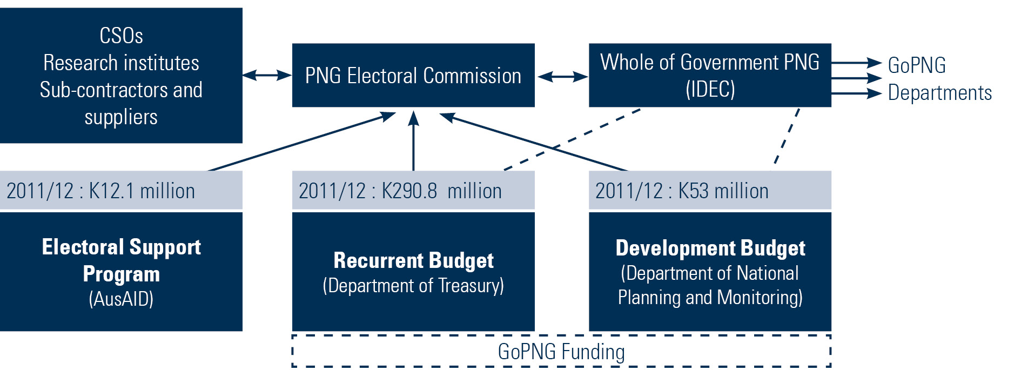
NB: Funding amounts are estimates based on actual and forecasted commitments.
The contribution the Program can make to the overall development of the electoral system in PNG is relatively small, reflecting the supporting nature of the program. For maximum impact the Program needs to be well targeted to ensure value of money. The aim of the Program clearly defines its parameters as providing supportthrough the PNGEC to plan for, and administer, elections.Therefore it was critical to define the priority areas of PNGEC in order to determine the strategic focus areas of the Program.

Development of Strategic Focus Areas
The strategic focus areas provide direction and structure to the Program’s broad objectives. They define what is appropriate for the Program to fund and what is not.
The Program has a flexible funding mechanism that provides funds to approved activities. The value of this type of aid modality is that it is responsive and current rather than being predetermined. The limitation of such an approach is that it can become opportunistic and lack direction – unless it is underpinned by a strategic framework.
The purpose of developing strategic focus areas for each of the four component objectives for the Program was to provide targeting focus for the funding. As a result each of the Program-funded activities will need to clearly relate to one of the focus areas as well as comply with the good practice selection criteria for activities.
Participatory workshops were held with Program Board members, Electoral Commission, Program Staff and Cardno personnel to determine these focus areas. A total of eleven Strategic Focus Areas are identified for the Program. The comparative size of the Program means it can only make a small contribution to the electoral system of PNG. These focus areas define a targeted, strategic and value for money approach to allocating this money.
Table 1: Development of Strategic Focus Areas for each Component Objective
Program Component Objective | Strategic Focus Areas
- To strengthen electoral governance | 1. Support the work of the IDEC  2. Increased focus at the provincial level
- To strengthen PNGEC capacity to manage elections | 1. Electoral roll improvement plan  2. Build provincial electoral management capacity  3. Election logistics and coordination support  4. Strengthen corporate services
- To increase the PNG electoral system and civics awareness | 1. Support to development of awareness materials  2. Support PNGEC’s work with CSOs
- To improve research, analysis, program management and coordination | 1. Integration of cross cutting strategies into program activities (e.g. gender, HIV and AIDS, fraud and anti-corruption)  2. Research and analysis  3. Coordination with key AusAID program partners
Based on these 11 areas, project stakeholders develop activity proposals which are submitted for review and approval by the Program Board. From these submissions, an Annual Plan of activities is developed. Each Annual Plan therefore reflects the priorities of both the Governments of PNG and Australia, the PNG Electoral Commission, as well as the Program’s capacity building approach.
Due to the nature of the Program and the processes established, not everything can, nor should be, funded. Activities must be:
- demand-driven and led by project stakeholders such as the PNGEC or CSOs;
- appropriate for funding by the Australian Government; and
- achieve a capacity building outcome.
The Program Component Objectives, and the strategic focus areas, form the basis of the outcomes articulated in the Program’s Monitoring and Evaluation Framework. This Framework is used to monitor and report on activity progress over the life of the Program.

Annex 1 – Principles of the Electoral Support Program Phase 3
The Program will be governed by the following principles:
Whole of government coordination: effective operation of the PNG Inter-Departmental Electoral Committee (IDEC) and support of GoPNG ownership of the reforms initiated by the Program.
Ownership: support of initiatives by both government and civil society organisations (CSOs) to improve the PNG electoral systems. The PNGEC is responsible for all key decisions on electoral management with the Program supporting the use of PNG systems wherever possible.
Performance-based activities: inputs that are clearly linked to specific, measurable objectives or reforms and tied to achievement of results or progress against objectives.
Flexibility: flexible approach to implementation based on an agreed annual budget ceiling and regular reviews of Program priorities and activities funded under the Program.
Consultation: implementation of consultative management arrangements through the Electoral Support Program Board (the ‘Program Board’).
Additional services: support will add to the overall resources available to the governance sector in PNG and will not replace or fund core recurrent GoPNG costs associated with elections management.
Appropriateness: activities will be tailored to the PNG context.
Affordability: activities will support service delivery that is affordable and sustainable.
Training and support: provision of appropriate training for the PNGEC.
Systems development: strengthen the development of systems for strategic management, election planning management and evaluation, and corporate planning and management.
Continuous improvement: through an effective monitoring and evaluation system of Program outputs, outcomes and sharing examples of best practice and lessons learnt with AusAID, GoPNG and other stakeholders.

PNG National Strategic Planning Taskforce, Papua New Guinea Vision 2050, July 2010
Ibid pg 12
PNG Electoral Commission Corporate Plan, 2008-2012, Hon. Philemon Embel, LLB, OBE, MP, Minister for State and Minister assisting the Prime Minister, pg 2
Partnership for Development between the Government of Australia and the Government of Papua New Guinea, 2008
http://www.ausaid.gov.au/country/papua.cfm
Partnership for Development between the Government of Australia and the Government of Papua New Guinea, 2008 pg 9
McGovern, J ESP2 Independent Completion Report , May 2010, pg 5
ibid
Batten, A, 2011 PNG’s bumpy road to high growth, East Asia Forum, January 5 2011,
http://www.eastasiaforum.org/2011/01/05/pngs-bumpy-road-to-high-growth/
Ibid
AAP, PNG’s Somareout of hospital, 23 August 2011.
Standish, B, 27 July 2011, When the Grand Chief is away: PNG’s bigman politics, East Asian Forum
http://www.eastasiaforum.org/2011/06/27/when-the-grand-chief-is-away-papua-new-guinea-s-big-man-politics/
McGovern, J ESP2 Independent Completion Report , May 2010, pg 27
AusAID, November 2010 Electoral Support Program Phase 3 Scope of Services pg 2-4
Ibid pg 4
AusAID, November 2010 Electoral Support Program Phase 3 Scope of Services pg 2-4

