

Empowering Migrants through Pacific Remittances (EMPR)

Independent Mid-term Review

June 2023

**Prepared by:**

**Glenn Cummings**

**Erin Corvisy**

**Acknowledgements**

The review team are grateful to CulturalPulse for support and guidance throughout this assignment. We also thank all those informants who kindly made time to talk with us and provide information and insights.

**Disclaimer**

The opinions expressed are those of the review team, and do not necessarily reflect those of CulturalPulse. Responsibility for the opinions expressed in this report rests solely with the authors.

Table of Contents

Executive Summary 4

Introduction 6

Key Findings 10

Relevance 10

Effectiveness 12

Efficiency 19

Coherence 20

Gender, Disability and Social Inclusion 21

Sustainability 23

Program Management and Reporting 23

Conclusions and Recommendations 24

Overall Conclusions 24

Recommendations 25

Annex 1: List of Key Organisations Consulted 26

# Executive Summary

**Empowering Pacific Migrants through Remittances (EMPR) is a four-year, AU$3 million program jointly funded by the New Zealand Ministry of Foreign Affairs and Trade (MFAT) and Australia’s Department of Foreign Affairs and Trade (DFAT).** The current iteration of EMPR runs from 2021-2025 and builds on a previous 4-year program which saw the initial development of the Send Money Pacific (SMP) website, the main tool of EMPR. CulturalPulse, a Sydney-based company that specialises in communication services to large and diverse audiences, is the managing contractor of EMPR.

**The value of remittances sent into the Pacific has been growing steadily in the past 20 years.** Pacific Island small states[1] received over US$1.16 billion in 2022. Remittances make up a significant portion of the national economy in some Pacific Island Countries, averaging 12.5per cent of GDP in 2021 across small states, with rates as high as 46.5per cent of GDP noted in Tonga.

**The Pacific remains one of the most expensive remittance corridors in the world despite significant decreases in the cost of sending money in the past decade** – the cost to Fiji has decreased by 43per cent since 2011, the cost of sending money to Vanuatu, Samoa and Tonga has decreased by between 17-21per cent over the 10-year period.

**The goal of EMPR is ‘to enable all people in Australia and New Zealand remitting to Pacific Island countries to 1) meaningfully engage with the market of remittance service providers, 2) select providers that best suit their needs, and 3) maximise the value of remittances sent to Pacific households’**.

**This review covers the period from April 2021 to May 2023**. The review used a mixed methods approach that included a detailed document review and independent research of the remittance sector in the Pacific and globally, significant data analysis from the Send Money Pacific website and data from app usage, key stakeholder interviews both in Australia and in New Zealand, with people involved in implementing the program and others with an interest in the program, and one focus group discussion with Australia-based diaspora community members.

**The Send Money Pacific (SMP) website has been revamped and is easier to use than the previous iteration and the SMP app has been developed and released. CulturalPulse has done an effective job of producing content in language for targeted countries; content in Pacific languages is highly appreciated.** They have developed an effective network of community coaches from different Pasifika communities and have established a brand ambassador. However, these groups have not been supported and used as effectively as they could have been. There have been limited people-to-people links made through the program. These links are important as trust is a key element in whether people will use the SMP website or app.

**Despite the increases in remittances and decreasing cost of sending money overseas noted, the ongoing relevance of the EMPR program is difficult to ascertain.** There has been relatively little change in usage of the website over the first two years of the program. **Only 21 per cent of visitors to the SMP website are return users[2].** **Less than 1 in 3 visits to the SMP website result in the user comparing the price of remitting money**. These low rates raise questions about the value people place on having a comparison site for remittances.

**Conversely, the growth in app usage is promising, with a much higher proportion of return users - 65 per cent.** This may be attributable to several factors including higher levels of satisfaction amongst users, ease of access to a mobile device or relative confidence in using a phone compared to a computer.

**The app also has a much higher third-party link click-through rate than the website with 62 per cent of sessions resulting in a click on an external link on the app compared with only 5 per cent on the website.** This is an indicator of familiarity, confidence, and skill in using the SMP app.

**EMPR is an expensive program to run. Despite CulturalPulse allocating a significantly higher proportion of resources to program activities when compared to the previous managing contractor, each web page view still costs AU$14.94, and with relatively low rates of people actually visiting a comparison page once on SMP, this rises to AU$47.39 per comparison page view.** Drilling down further, with fewer than 1 in 10 users of the app or website clicking on an external remittance provider link, each click currently costs EMPR AU$603.61. Each return website user costs the program AU$152.14.

Despite the efforts of CulturalPulse, the EMPR program has very little connection with the Pacific Australia Labour Mobility (PALM) program which is one of the primary target audiences of the program. There is a greater connection in New Zealand, with the SMP website and app included in training programs that are centrally coordinated and undertaken by approximately 75 per cent of seasonal workers. **In Australia, users of the SMP website are much more likely to be city-based with 87 per cent based in capital cities. In New Zealand, 68 per cent of users are based in the three largest urban centres, indicating more even usage between diaspora and labour scheme workers.** Data on app usage suggests an even higher take-up among seasonal workers while in Australia, there is little difference with the vast majority of users still based in the capital cities.

**The location of users is important as diaspora and seasonal workers may use remittances differently.** It was noted by some diaspora consulted that they may pay bills directly to an educational institution, health care provider or even a supermarket. In these instances, a fixed amount is to be received in the Pacific country. **Where the benefit accrues is relevant for an ODA-funded program with the underpinning assumption that lower cost of remittances will result in economic benefits for Pacific countries as more money will be received in-country.** Further research into how remittance services are being used by different groups of remitters is required to better understand this issue.

**The SMP website and app have increased transparency around remittance prices when sending money from Australia and New Zealand to a range of Pacific countries.** However, its effectiveness in improving remittance literacy and increasing the confidence and skill of remittance users remains unclear. The rollout of more educational modules in the coming months may help in this regard.

**In order to better understand the demand for the SMP website and app, a more focused, people-to-people-based approach should be adopted in the remaining years of the program.** This will require program indicators and targets to be reconsidered to reflect a potential narrowing of scope.

**The following recommendations are made to refocus the efforts of EMPR and guide the program for the remaining two years:**

1. EMPR should focus its efforts on the seasonal worker populations in Australia and New Zealand in order to effectively use scarce resources.
2. EMPR should reallocate its budget to allow community coaches to work much more closely with DFAT and MFAT seasonal labour program staff, accompanying them on field visits to attend pre-arranged meetings with workers to personally introduce the SMP app to workers, leveraging the trusted relationships that exist between them and workers.
3. While both the SMP website and app should be maintained, the app should be prioritised with an increase in budget allocated, if necessary, as it is showing more promising signs in terms of achieving the program objectives than the website.
4. The SMP website (and app if necessary) should be updated to ensure ease of use in New Zealand by ensuring it defaults to New Zealand settings for New Zealand-based users and wherever possible that third-party landing pages also default to New Zealand web pages.
5. DFAT, MFAT, and CulturalPulse should agree on a reporting template that ensures that reporting is focused on program outcomes, including GEDSI outcomes, and includes in-depth trend analysis to identify issues and opportunities as soon as possible.
6. CulturalPulse should work with DFAT and MFAT’s seasonal worker program training providers to develop a stand-alone ‘How to Send Money Home’ training module that brings together information on the SMP app and website and the real cost of remittances. The module should be translated into language for online purposes and also developed into a half-day (maximum) in-person course that can be delivered during field trips to visit workers.

# Introduction

Remittances are an important source of income for many people across the Pacific who use money received to help cover basic needs such as health and education, and to cushion the effects of shocks such as natural disasters and economic downturns.

Empowering Pacific Migrants through Remittances (EMPR) is a four-year, AU$3 million program jointly funded by the New Zealand Ministry of Foreign Affairs and Trade (MFAT) and Australia’s Department of Foreign Affairs and Trade (DFAT). The current iteration of EMPR runs from 2021-2025 and builds on a previous 4-year program. CulturalPulse, a Sydney-based company that specialises in communication services to large and diverse audiences, is the managing contractor of EMPR.

**The goal of EMPR is ‘to enable all people in Australia and New Zealand remitting to Pacific Island countries to 1) meaningfully engage with the market of remittance service providers, 2) select providers that best suit their needs, and 3) maximise the value of remittances sent to Pacific households’**.

EMPR is part of a broader suite of activities undertaken by the Australian Government, collectively known as PAC-REMIT that are aimed at supporting ‘more open, competitive, and safe financial channels that enable lower cost remittances services from Australia to Pacific Island Countries’[3]. PAC-REMIT has five objectives; EMPR supports the fifth end-of-program objective of PAC-REMIT which is that ‘remitters skilfully use remittance service providers’ products.’ EMPR is not part of any broader remittance program in New Zealand.

The main tool used in implementing the program is the Send Money Pacific (SMP) comparison website[4]. Established under a previous version of the program, CulturalPulse undertook a significant overhaul of SMP when they took over the program in April 2021 with the revamped site coming online in August 2021. SMP allows users to select where they want to send money from (Australia or New Zealand), where they want to send money to, how much they want to send ($200 or $500 are the international standard comparison amounts used), and whether they would like the results sorted by cost or speed of transfer.

SMP returns the three best results initially with the user able to reveal additional results if they wish to compare more providers. SMP is not a money transfer operator in its own right. The results provide links to the best providers based on the criteria selected by the user; clicking on these takes the user to that company’s external website.

*Figure 1: Screenshot of SMP homepage*

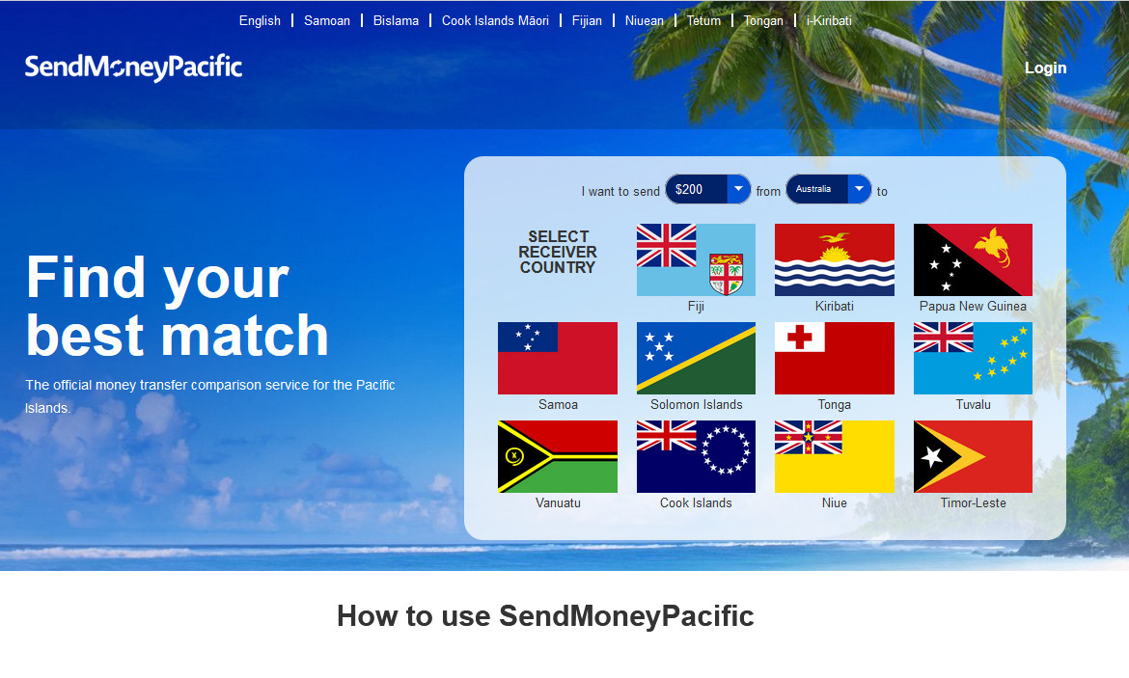

**Helping to promote awareness around SMP and train communities in the use of the website and app, EMPR has established a network of community coaches** drawn from the diaspora and holds regular Talanoa discussion sessions with this group to support and encourage their work and provide feedback from the community to CulturalPulse. EMPR also has some high-profile Ambassadors who help in promoting SMP. However, the program implementation plans, strongly encouraged and supported by DFAT and MFAT, have focused mostly on digital amplification strategies with only a very small proportion of the budget available to coaches to support community events or undertake meaningful, regular outreach beyond their local area. Some coaches based in regional areas have some interaction with seasonal workers, but broadly speaking the coaches work through regular community structures such as diaspora associations or church groups.

Overview of remittances in the Pacific

The value of remittances sent into the Pacific has been growing steadily in the past 20 years. Figure 2 shows that Pacific Island small states[5] received US$1.16 billion in 2022. Growth in remittances is also noted in all major countries targeted by EMPR.

*Figure 2: Personal remittances received for selected Pacific countries (2000 – 2022)*

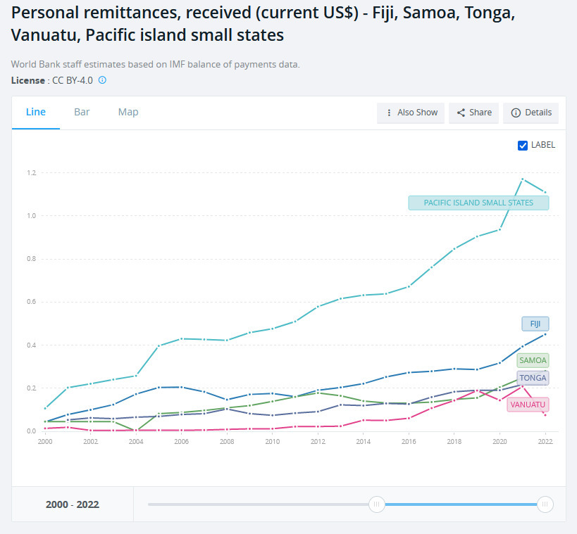

Source: <https://data.worldbank.org/indicator/BX.TRF.PWKR.CD.DT?locations=S2>

Remittances make up a significant portion of the national economy in some Pacific Island Countries, averaging 10.1 per cent of GDP in 2022 across small states, a decrease from 12.5per cent in 2021. Figure 3 shows that for most small island countries across the Pacific reliance on remittances is increasing. For example, in Tonga remittances constituted 46.5 of the country’s GDP in 2021 (2022 data currently not available) a very large increase from only 19per cent of GDP a decade earlier. In Samoa, remittances make up 33.6per cent of GDP in 2022 up from 29.4per cent in the previous year and more than double the 15per cent noted in 2017. In Vanuatu and Kiribati, the proportion of remittances to GDP have both decreased over the past year – Vanuatu significantly from 21.4per cent in 2021 to only 7.6per cent in 2022 and Kiribati to 6.7per cent in 2022 down from a recent high of 11.5per cent in 2019. Fiji which receives the most remittances in dollar terms annually (US$459m in 2022) has also seen an increase in remittances as a percentage of GDP in the past five years, increasing from 5.2per cent in 2017 to 9.3per cent in 2022.

*Figure 3: Personal remittances as a percentage of GDP for selected Pacific countries*

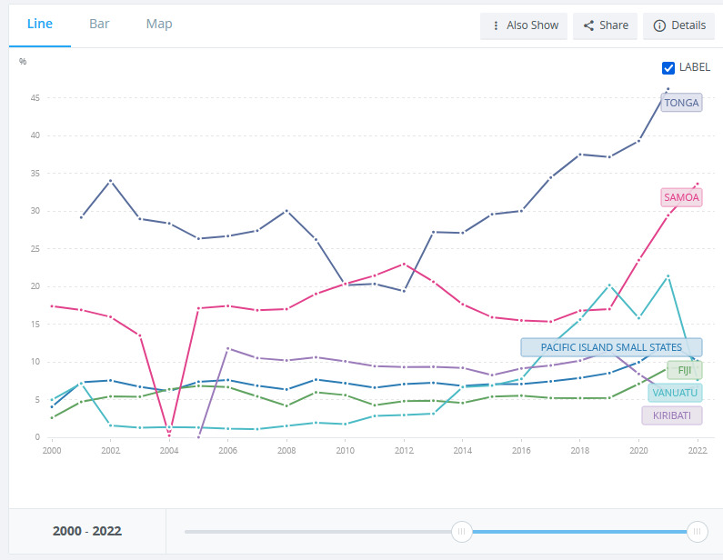

Source: <https://data.worldbank.org/indicator/BX.TRF.PWKR.DT.GD.ZS?end=2022&locations=S2-FJ-TO-WS-VU-KI&start=2000>

The Pacific remains one of the most expensive remittance corridors in the world. The average cost of sending money to the Pacific is 8.6 per cent[6]. This is still higher than the global average cost of remitting of 6.25per cent[7] despite significant decreases in the cost of sending money to the Pacific noted in the past decade – the cost to Fiji has decreased by 43per cent since 2011, the cost of sending money to Vanuatu, Samoa and Tonga has decreased by between 17-21per cent over the 10-year period.

The costs of sending money from Australia and New Zealand are likely the main drivers in the reduced prices of sending money to the Pacific. In the same 10-year period (2011-2020), the cost of sending money overseas from Australia decreased 47per cent to 7.21per cent[8]. The cost of sending money from New Zealand decreased by 35per cent to 7.83per cent. The most recent data for Australia, from March 2023, reports an even further decrease in the cost of sending money from Australia to 5.77per cent[9].

Figure 4 shows the relative cost of remitting money from G20 countries. Whilst this grouping does not include New Zealand, it does include Australia and provides a useful comparison for similar countries. It can be seen that the cost of remitting from Australia is below the G20 and is the fifth cheapest place to remit money from. This may be skewed by Australia having a significant Indian population; India is the second cheapest G20 country to send remittances to (4.72per cent)[10]. Figure 4 shows that it is cheaper to send money overseas from Australia than it is to send money overseas from Canada, the United Kingdom, France, or Germany, but it is more expensive than sending money overseas from the United States of America or Italy.

*Figure 4: Average cost of remitting from G20 countries (March 2023)*

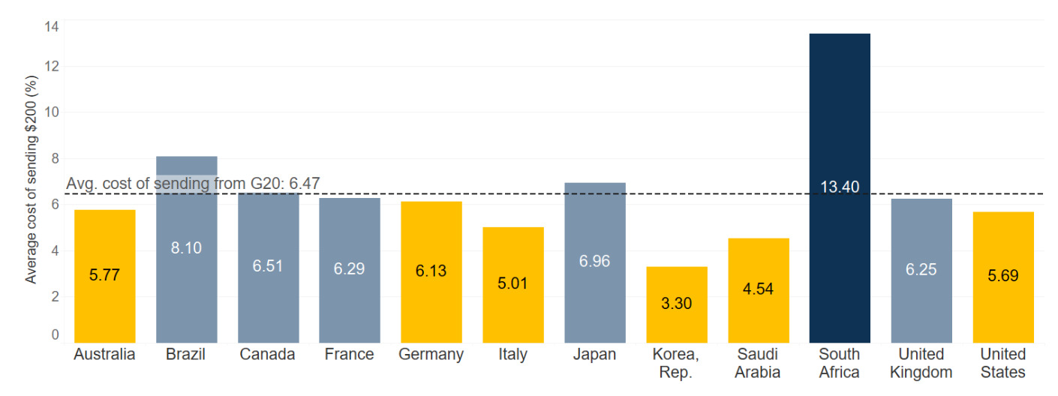

Source: <https://remittanceprices.worldbank.org/sites/default/files/rpw_main_report_and_annex_q123_final.pdf>

Whilst there have been marked reductions in the cost of remitting money into the Pacific since 2010, the cost remains significantly above the Sustainable Development Goal target of reducing the global cost of remittances to less than 3per cent and eliminating any remittance corridors with costs of higher than 5per cent[11].

Program objectives

EMPR has four end-of-program objectives:

1. Increased awareness of remittance service options
2. Improved ‘remittance literacy’
3. Enhanced familiarity, confidence, and skill in using a range of remittance services and channels
4. Increased transparency of remittance prices

The review will measure progress against these objectives when addressing the effectiveness of the program to date.

It should be noted that for the purposes of the program, ‘remittance literacy’ includes relevant aspects of financial and digital literacy. It includes the ability to identify the best option that minimises cost and increases the efficiency of remitting and an understanding of remittance fees and the effect of exchange rates[12].

Program elements

The program has four main elements:

* SMP website
* Learning modules
  + Short YouTube videos educating people about the SMP website and how to download the app
    - Videos translated into languages of target countries
  + Future modules planned on understanding the cost of remitting and use of features of the SMP website and app
* Amplification activities
  + Digital engagement through social media channels – predominantly Facebook
  + Face-to-face engagement through community coaches and Talanoa sessions

Review Features

The task

The review covers the period from April 2021 to May 2023, the second phase of the program.

The review will broadly follow the OECD-DAC evaluation criteria. As this is a mid-term review, program impact has not been assessed, but progress against the end-of-program outcomes is assessed under the effectiveness criteria. Program relevance, efficiency, coherence, and sustainability have all been considered. An assessment of the program’s efforts around social inclusion, including gender and disability inclusion, will also be made.

Recommendations as to how the program can be improved for the remaining two years it is scheduled to run are made at the end of the report.

Our approach

The review used a mixed methods approach that included a detailed document review and independent research of the remittance sector in the Pacific and globally, significant data analysis from the Send Money Pacific website and data from app usage, key stakeholder interviews both in Australia and in New Zealand, with people involved in implementing the program and others with an interest in the program, and one focus group discussion with Australia-based diaspora community members.

A list of stakeholders consulted is included in Annex 1.

# Key Findings

## Relevance

As noted earlier, **remittances are an important, and often growing, part of many Pacific countries’ economies. At the same time, the Pacific corridor remains one of the most expensive in the world.** While lowering the cost of remittances is beyond the control of EMPR, its objectives of educating and supporting users to make informed choices of available remittance options on any given day, remains highly relevant.

**The baseline survey conducted at the start of this iteration of EMPR highlights the fact that remittance literacy levels are low among Pacific diaspora and seasonal workers in Australia and New Zealand**. Only 16per cent of respondents could correctly identify the cost of sending a remittance[13]. Increasing levels of financial literacy is important if remitters are to maximise the amount of money they are seeking to send to their home countries.

This is particularly important as the cap on the number of seasonal workers in New Zealand continues to rise with one political party proposing to double the number to 38,000 by 2028[14]. In its most recent budget, the Australian Government included funding to expand the Pacific Australia Labour Mobility (PALM) scheme[15]. With relatively little financial literacy training included in pre-departure briefings for seasonal workers, and many workers participating in the scheme with the aim of sending as much money home as possible during their time away, having a program in Australia and New Zealand that specifically helps them to achieve this aim is highly relevant.

**The ongoing relevance of the SMP website and app is more difficult to ascertain.** The effectiveness section below highlights relatively little change in usage of the website over the first two years of the program, with a very slight upward trend in page views per day during the period under review. The growth in app usage is more promising, although its introduction coincides with a downward trend in website use. A higher proportion of app users are based in New Zealand and Australia (60 per cent) than the proportion of website sessions by users located in Australia and New Zealand (34 per cent). The highest number of website sessions are undertaken in Fiji, which may speak to remittance receivers driving remittance decisions, at least in that one country.

It must be remembered that strictly speaking it is not the goal of the program to lower the cost of remittances – that is far beyond the control of EMPR – but rather to ensure that users are choosing the best option available to them on any given day. The website and app are only integral to the fourth program outcome around increased transparency of remittance services. They help with the education and confidence outcomes as well, but it is feasible that these could be successfully achieved without the SMP website or app.

That raises the question of whether there are alternatives in the market that remitters could be pointed towards that provide transparent information about the full cost of remitting money with different service providers. There is one other comparison site – www.saverpacific.com – that is run by the company that implemented the first iteration of the program.

**Program literature does not distinguish between different remitters - labour scheme workers and diaspora**. Most discussions undertaken during the review defaulted to labour scheme workers, primarily because one of the stated objectives of most workers is to send as much money home as possible. Absent any hard data, considering the location of SMP web and app users may give some indication of whether the program is accessed more by diaspora or Pacific labour scheme workers.

Based on census data[16] and the most recent estimate of the number of workers in Australia under the Pacific Australia Labour Mobility (PALM) scheme[17], it is estimated that labour scheme workers make up approximately 13 per cent of people from the Pacific in Australia. Given the census data includes children, and the fact that not all people who identify as being from the Pacific would remit money regularly and a proportion of those that do would remit as part of a family group not individually, it is expected that if both labour scheme workers and diaspora were using the service equally then considerably more than 13 per cent of users would be regionally-based labour scheme workers and be based in regional areas.

In New Zealand, better location data is available in the most recent census[18]. It shows that approximately 80 per cent of people who identify as being from the Pacific Peoples ethnic group live in the three largest cities – Wellington, Auckland, and Christchurch. As with Australian census data, this includes children, and those who don’t remit regularly or remit as part of a family group, meaning that the percentage of remitters expected from the cities would be lower than 80 per cent if remittance services were being utilised equally by diaspora and labour scheme workers.

Figure 5 below shows the proportion of SMP users by location for Australia and New Zealand. **It indicates that in Australia, the SMP website is more likely to be used by city-based diaspora rather than regional-based workers with** **87 per cent of Australian users based in capital cities. In contrast in New Zealand, only 68 per cent of users were based in the three largest urban centres**. The higher regional proportion of non-city users in New Zealand potentially indicates a higher take up by Pacific labour workers, or at a minimum more equal take up between diaspora and labour scheme workers.

*Figure 5: Location of SMP website users in Australia and New Zealand*

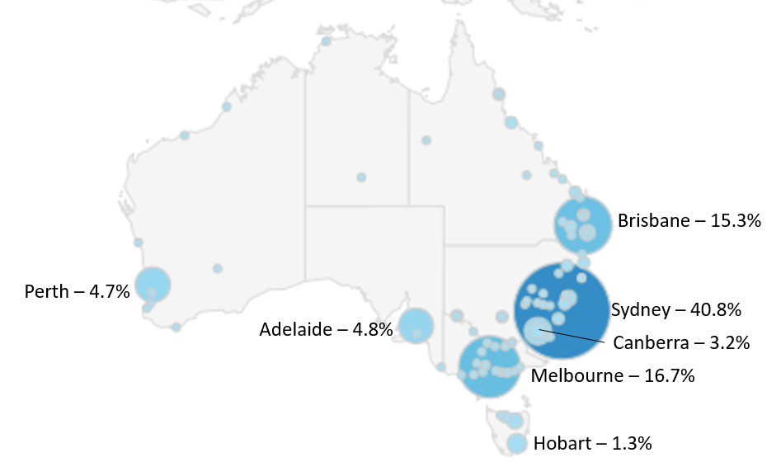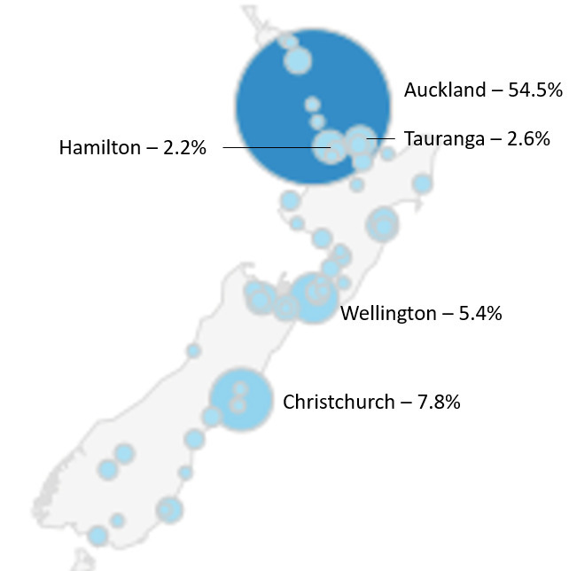

*Source: CulturalPulse, from Google Analytics data July 2021 – 2023*

The data set for users of the app is much smaller (NZ: 815 users, Australia: 1,525 users) and with a significant number of users' locations unknown in both Australia (7per cent) and New Zealand (14per cent). Even with these limitations the patterns of use strongly align in both locations. In Australia 84 per cent of SMP app users are based in the capital cities which given the number of unknown user locations is practically the same as the 87 per cent noted for SMP web users in Australia. In New Zealand, the number of SMP app users based in the three largest urban centres – 55 per cent - is lower than the website equivalent (68 per cent) with some larger seasonal labour centres such as Hamilton, Hastings and Tauranga noting increased users of the app.

**The location of users is important as diaspora and seasonal workers may use remittances differently.** It was noted by different respondents during three separate consultations that diaspora particularly may pay bills directly to an educational institution, health care provider or even a supermarket. In these instances, a fixed amount is to be received in the Pacific country. Any gains made by using SMP through lower fees and charges remain in the sending country – Australia or New Zealand. The opposite is true when a fixed amount is being sent, for example, $200 every month from Australia or New Zealand from a seasonal worker’s wage. The benefit is received in the Pacific country as they receive more local currency due to lower fees or a better exchange rate.

**Where the benefit accrues is relevant for an ODA-funded program with the underpinning assumption that lower cost of remittances will result in economic benefits for Pacific countries as more money will be received in-country.** Further research into how remittance services are being used by different groups of remitters is required to better understand this issue.

## Effectiveness

Evidence has been gathered by the review team to assess whether EMPR has made progress towards achieving the end-of-program outcomes.

Increased awareness of remittance service options

**Awareness of remittance service options was low at the start of the program. The baseline survey reported that only 17 per cent of respondents had heard of SMP, and only three per cent reported having used it.** The survey was not replicated for this review, but a follow-up survey is planned for the final evaluation.

EMPR’s monitoring, evaluation and learning plan contains indicators and targets around the number of views and audience reach for each of its social media platforms. Table 1 summarises the targets and performance to date by channel.

*Table 1: Clicks and reach by platform (1 July 2021 – 26 May 2023[19])*

|  |  |  |  |
| --- | --- | --- | --- |
| Platform | Program target views/reach  (by 30 June 2025) | Actual views/reach | % target achieved |
| SMP website | 350,000 page views | 105,509 page views | 30% |
| Facebook | 18 million reach | 7.074 million reach | 39% |
| YouTube | 450,000 views | 175,770 views[20] | 39% |
|  |  |  |  |
| App users | No target[21] | 3,973 | - |

**Whilst reach and view numbers are not linear and the targets may still be reached, they are currently below expectations.** However, only two of the six planned education modules have been rolled out on social media. These are expected to increase reach and drive traffic to the website.

It is of note that both Facebook and YouTube channels are closer to achieving their targets than page views on the SMP website. This suggests that whilst the content being produced is engaging audiences, it is not necessarily driving people to the SMP website.

Whilst social media content raises awareness about SMP and the value of a comparison website, an argument exists that increased awareness of remittance service options is better gained through using SMP itself. Figure 6 below shows that in the early stages of EMPR, from July 2021 to around November 2022, Facebook reach (where just under half of all website referrals came from during the period) and website views were reasonably well aligned, indicating that Facebook was driving traffic to the website. Since December 2022 that connection is noticeably weaker as evidenced by the spaces under the orange line in Figure 6 not being as filled by grey columns since December 2002. This coincides with the launch of the SMP app and associated videos in language informing people of how to download the app.

*Figure 6: Web page views (left-hand axis) versus Facebook reach (right-hand axis)*

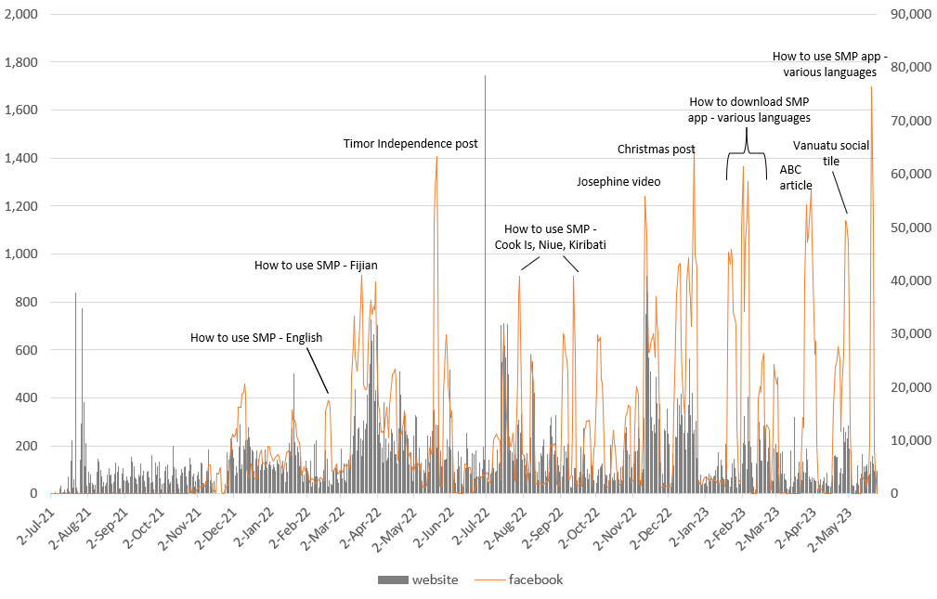

Figure 7 further highlights this change in behaviour since the launch of the app, with a general downward trend in the use of the SMP website coinciding with a steady rise in the use of the app.

*Figure 7: Daily SMP web page views and app users since September 2022 (app launch)*

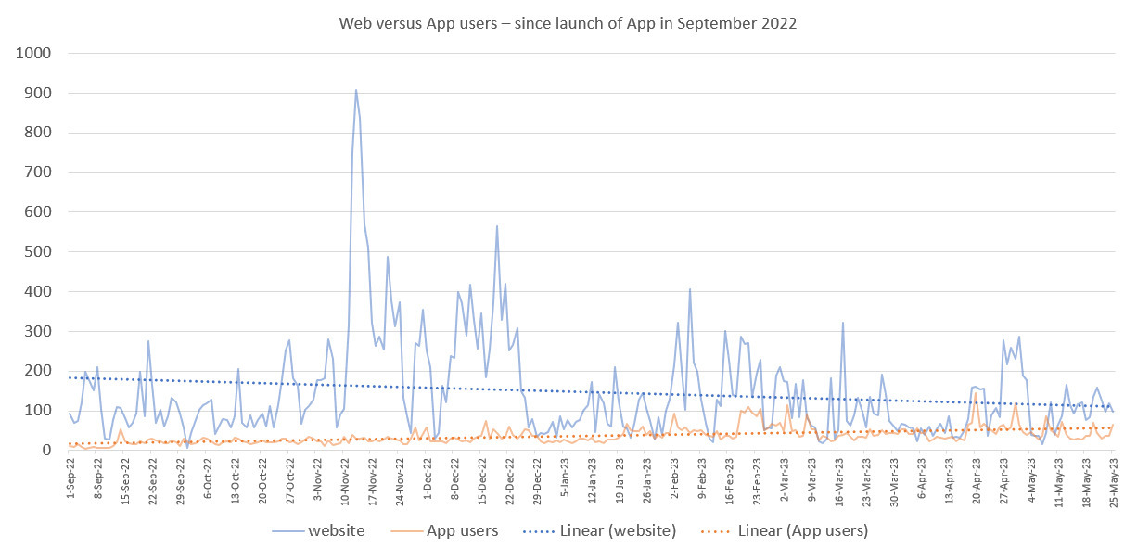

**The increase in app users approximates the decrease in web page views**, indicating that either people who previously used the website have shifted to using the app since it became available, or that people who previously used the website are no longer using the service and a new group of users have been found who prefer the app. Which of these propositions is true can only be confirmed by a survey of app users to gauge how many have migrated from the website to using the app since its launch. Providing some evidence that the former is true – people migrated to the app from the website – is the fact that the trend line for website page views was positive from the start of the program until 1 September 2022 indicating growth in the number of views over that period.

Improved ‘remittance literacy’

**Remittance literacy is defined by EMPR to include elements of both digital literacy and financial literacy.** EMPR has predominantly focused on the digital literacy elements to date. The education modules that have been developed and translated into Pacific languages have focused on how to use the SMP website and how to download the SMP app.

**The reach of the first two modules has been impressive with the 18 videos loaded to YouTube being viewed 177,000 times as at 26 May 2023.** Facebookposts which include the videos have also reached over 1.2 million people[22]. The most popular video is a generic promotional video featuring EMPR Ambassador Josephine Maejiirs, captain of the Fijian rugby team. This has been viewed more than 33,000 times since its launch 6 months ago. Table 2 provides a breakdown of other videos posted to the SMP YouTube channel.

*Table 2: Views of videos posted to the SMP YouTube channel*

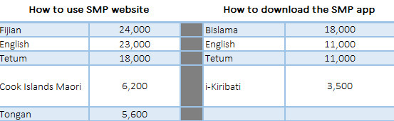

**The third module is currently under development and focuses on understanding the total cost of sending money overseas.** With only 16 per cent of respondents in the baseline survey able to correctly identify the total cost of sending money overseas this module is the critical financial literacy piece of the program. The module attempts to explain to people why a ‘zero fee’ option may not be the cheapest if the provider is taking a higher exchange rate margin (and therefore offering a lower exchange rate) which results in a lower final amount being received in-country.

**Whilst this is an important education piece, in some ways understanding how that amount is arrived at is irrelevant for many users**. The revamped SMP website provides users with clear results for any search with the first column being the total amount received in-country. Someone wants to send $200 home and they want to know which provider will result in the most money being received by their family. Whether that provider offers no or low fees, or gives the best exchange rate, is not that important to them, it’s the amount that will be received that will influence the decision. Of course, outside of the SMP context, understanding the total cost of remitting money is important if someone is independently comparing prices.

**Another measure of remittance literacy included in EMPR’s monitoring, evaluation and learning framework is the number of users investigating more cost-effective remittance options**. The end-of-program target for this measure is 112,000 SMP users and 7,000 app users. As at 26 May 2023, the website has 37,832 users and the app has 3,973 users. Given the trends noted earlier it is likely the app will reach its target, but the website will fall short.

**It is not clear to the review team that the number of users of the website or the app is the most effective way to gauge remittance literacy.** Since August 2021 (when data is available), less than 1 in 3 page views on SMP have been on a comparison page (32,212 visits to a comparison page). Considering the number of views for comparison pages on the site or the app may be a better measure of remittance literacy.

Figure 8 highlights the huge volatility that exists between the number of page views on the SMP website (represented as columns - left-hand axis) and the percentage of those views that are visiting a comparison page (line graph - right-hand axis). There is considerable variation, some days more than 70 per cent of page views are on comparison pages and other days less than 10 per cent. Some of this variation correlates with significant holidays and events in receiving countries. For example, in early March 2023, 68 per cent of visitors went to a comparison page. This spike was driven by a large number of visits to the NZ-Vanuatu comparison page as people were sending money home in the aftermath of a major cyclone that hit the country. The most visited comparison corridors are Australia – Fiji (21 per cent of comparison page views), NZ – Samoa (13per cent), Australia – Samoa (11per cent), Australia – Vanuatu (10per cent) and NZ – Tonga (7per cent). On only 123 out of 653 days (19per cent) since August 2021 have more than half of the visitors to SMP gone to a comparison page.

This suggests that while people are engaging with the digital literacy content on social media platforms and, as noted earlier especially until December 2022, were then visiting the SMP website, a minority of people then feel confident enough to explore a comparison page. The trend line suggests that levels of engagement with comparison pages on the SMP website are also decreasing.

*Figure 8: SMP web page views vs percentage of comparison page views*

**Whilst EMPR has done an effective job of producing content in language for targeted countries, it is difficult to see evidence of how this is translating into improved remittance literacy at this stage of the program.** This may become clearer through self-reporting around digital literacy and perceptions towards using mobile apps and websites for remittance comparisons that will be conducted as part of the final program evaluation.

Enhanced familiarity, confidence, and skill in using a range of remittance services and channels

Two quantitative measures are included in the monitoring, evaluation and learning framework for EMPR to indicate whether people are more confident and skilled in using remittance services: the number of return users and the number of people clicking on links to external money transfer providers from the SMP website or app.

Different data is available for the app and website for both of these measures. Figure 9 highlights the percentage of return users for the website only. Data is aggregated for previous years, and monthly for 2023 only. It highlights the fact that until December 2022, approximately 1 in 5 visitors to the site were return users. Despite an increase in the proportion of return users in January, the trend across 2023 is negative, indicating fewer people are visiting the site more than once.

**Across the life of the program, the SMP website has attracted 37,954 users of which only 21per cent visit more than once.** The downward trend makes the end-of-program target of 35per cent for return users appear difficult to achieve.

*Figure 9: New and returning SMP website users*

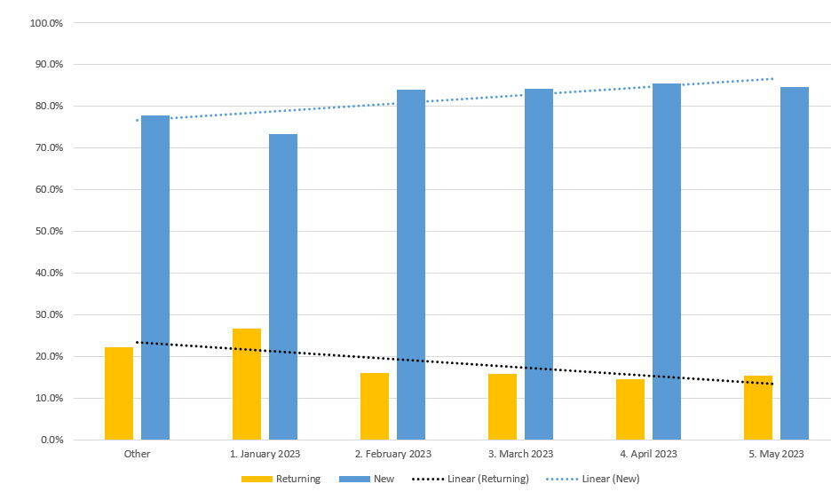

**The low rate of return users for the website raises questions about the value people place on having a comparison site for remittances.** Attracting people to a new website is difficult, retaining people who have discovered the site should be relatively easier provided people see value in using the service. However, return user rates for the SMP app indicate that other issues, such as access to a computer or relative ease of use may also be contributing to low return user rates for the website.

Since the SMP app launched in September 2022 until 26 May 2023, it has attracted 3,973 users of which 1,657 (42per cent) are based in Australia and 846 (21per cent) are based in New Zealand. **Users of the SMP app are much more likely to use it multiple times than users of the website**. Figure 10 shows the daily return user rate for the app since it launched. The app has been used just under 10,000 times since launching of which 65 per cent of sessions were return users.

*Figure 10: New and returning SMP app users*

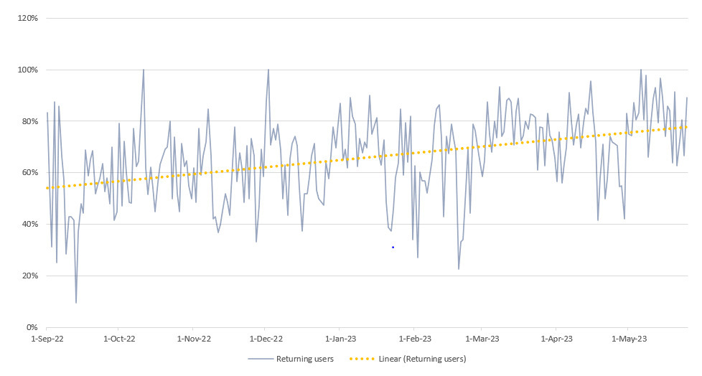

The second quantitative indicator measuring confidence and skill of users is the number of people clicking on links to external money transfer providers from the SMP website or app. This indicates that not only are people comfortable using the SMP site to compare options, but that they are also comfortable enough to click on a link that will take them to a third-party website. EMPR is unable to track what people do once they leave the SMP website, so it is not known whether people then use that provider or decide to return to whichever provider they have used in the past.

Table 3 provides a monthly summary of the number of clicks made on external remittance provider links on both the SMP website and app. As noted above with the proportion of return users, the proportion of sessions where the user clicks on an external service provider's link is significantly higher for the app. It should be noted that data for the app is only available from 19 April 2023, so it is a much smaller sample size than the website which has data available from August 2022.

*Table 3: Clicks to external remittance provider links from the SMP website and app*

|  |  |  |  |  |  |
| --- | --- | --- | --- | --- | --- |
| Month | Web links clicked | % of sessions |  | App links clicked | % of sessions |
| Aug -22 | 325 | 6.3% |  |  |  |
| Sept-22 | 219 | 6.6% |  |  |  |
| Oct-22 | 193 | 6.0% |  |  |  |
| Nov-22 | 181 | 2.0% |  |  |  |
| Dec-22 | 153 | 2.1% |  |  |  |
| Jan-23 | 194 | 7.3% |  |  |  |
| Feb-23 | 281 | 5.8% |  |  |  |
| Mar-23 | 173 | 5.3% |  |  |  |
| Apr-23 | 104 | 3.6% |  | 218 | 48.4% |
| May-23 | 94 | 3.3% |  | 476 | 71.6% |
| Total | **1,917** | **5.2%** |  | **694** | **67.2%** |

**Whilst the click-through rate on the app is impressive, fewer than 1 in 10 app users are clicking on an external remittance provider link.** Of the 2,503 SMP app users in Australia and New Zealand in April and May 2023, only 225 have clicked on a link (averaging 3.08 per user). This suggests a relatively small number of highly confident users of the SMP app. It is also possible that other users have downloaded apps for the individual remittance providers and use the SMP app only to see which is the best for them to use this week and go directly to the service providers app where they may already be logged in and can easily send money directly from that app rather than being directed to a website.

The number of individual users who clicked on a link from the website is not available so a similar comparison to the above cannot be made. However, the total number of website users between August 2022 and May 2023 was 17,756. Assuming that each click on an external link was made by a unique user (this is a very conservative assumption given each user clicked on 3.08 links on the app) only 10.8 per cent of website users clicked an external link.

**The two largest remittance providers, Money Gram and Western Union remain the two most clicked external links from both the app and the website, however, a greater spread of providers is being considered.** One-third of clicks on external provider links were to Western Union or Money Gram, this is considerably lower than the 71 per cent of respondents in the baseline survey who said they have used one of both providers in the past. Whilst historic data was not available to compare the external links clicked in any given week to the cheapest or fastest providers for the week for a given segment, there appears to be a willingness to explore different providers, although as noted above, the number of users exploring options is still very small.

**Whilst there are some signs that users are willing to explore other remittance providers it is difficult to see evidence that users of SMP are displaying enhanced familiarity, confidence, and skill in using remittance services and channels.** Users of the app show more confidence in exploring options than users of the website.

Increased transparency of remittance prices

**SMP is the most significant comparison site for remittance services into the Pacific in the market at the moment.** SMPcurrently lists 25 money transfer operators on the site and app. This is a significant number and increases transparency in the market.The end-of-program target is for 28 providers to be listed; EMPR has made good progress towards this goal.

**Another comparison website does exist, run by the company that implemented the first phase of EMPR**[23]. It is not clear how the website is funded or whether it is attempting to run on a commercial basis. The website is one of several remittance comparison websites run by the company around the world, at least one of which is partly funded by DFAT via the ASEAN Triangle program implemented by the International Labour Organisation. Based on social media metrics, their Pacific comparison site is significantly smaller than SMP. It is not possible to know how many people use their website, but EMPR appears to be having a greater positive impact on transparency.

**SMP only updates rates and prices once a week, this limits the ability of users to effectively compare providers.** The review team understands that the previous iteration of the program updated the rates monthly, and weekly updates represent an improvement on this. As real-time rates are not available for all providers at a reasonable price, CulturalPulse has decided not to include real-time rates for any providers.This means that rates and prices could be as much as six days out of date when someone visits the website. The top three options for both price and speed may be wrong at this point as exchange rates will have moved and providers may have changed their fees or introduced new offers. It is noted that the competitor's website uses a mix of real-time and weekly updated rates on its site. The review team makes no judgment on which approach is more equitable or transparent.

Website issues

Some issues were noted during the review around the functionality of the SMP website. These issues in large part reflect the fact that all development and testing is performed in Australia, leading to some anomalies existing for New Zealand users. Issues raised during the review include:

* SMP automatically defaults to sending money from Australia on the landing page even when a user is New Zealand and could be identified as so by their IP address
  + This requires users to make an additional click to change the sending location and gives the sense that this isn’t a service developed for them.
* When clicking an external service provider link from SMP, most third-party websites default back to sending money from Australia
  + This adds complexity for users who may have relatively low levels of digital literacy as not only are they on a third-party site, but they have to navigate back to the New Zealand page on that site.

It is understood that both of these issues can be easily rectified, and CulturalPulse has undertaken to do so as quickly as possible. Ensuring that the path to remitting money is as simple as possible is critical for a service such as SMP where people may have relatively low levels of digital literacy and therefore even the smallest barriers become major obstacles.

## Efficiency

**EMPR has a budget of AU$3 million over four years, jointly funded by DFAT and MFAT.** To the end of March 2023, the project has incurred costs of AU$1.58 million, evenly split between DFAT and MFAT money. The expenditure rate is in line with the budget.

Measuring the efficiency of EMPR is difficult. Management fees are significantly lower than the previous iteration of the program and the majority of program spending is around the website and amplification activities promoting the website and the app, including translating educational modules into multiple languages. However, it is possible that three of the four objectives could be achieved without the website and taking a different approach altogether. This may have included a significantly scaled-up financial literacy training program targeting seasonal workers, or increased engagement with grassroots activities at community events.

As the social media and web activities are inextricably linked, it is practically impossible to allocate expenditure to different elements. Table 4 takes a simple approach to calculating the efficiency of program spend by dividing the program spend to date by various website and app metrics to calculate a cost per unit for different measures.

Each figure calculated below is a discrete value and should not be read in conjunction with any other number calculated. For example, the total program cost of AU$1.58 million is divided by the number of web page views to arrive at $14.94 per view. The same total program cost (AU$1.58 million) is divided by the number of YouTube views to arrive at $8.97 per view.

*Table 4: Cost per unit for selected metrics*

|  |  |  |  |  |  |  |
| --- | --- | --- | --- | --- | --- | --- |
| Description | Units | AU$/unit |  | Description | Units | AU$/unit |
| Web page views | 105,509 | 14.94 |  | MTO clicks (web and app) | 2,611 | 603.61 |
| Unique web page views | 70,848 | 22.25 |  | Facebook reach (includes 1.2m video posts) | 7,073,795 | 0.22 |
| Website user | 37,382 | 41.66 |  | Facebook page views | 26,761 | 42.87 |
| Return website users | 10,359 | 152.14 |  | Facebook likes | 2,336 | 674.67 |
| Segment page views | 23,259 | 47.39 |  | YouTube views | 175,770 | 8.97 |

**Based on the above measures, EMPR is an expensive program to run**[24]. A cost of AU$47.39 per segment page view is difficult to justify.

## Coherence

**EMPR is part of a broader suite of activities undertaken by the Australian Government, collectively known as PAC-REMIT.** These activities are aimed at supporting ‘more open, competitive, and safe financial channels that enable lower cost remittance services from Australia to Pacific Island Countries’[25]. EMPR supports the fifth of PAC-REMIT’s five objectives **-** that ‘remitters skilfully use remittance service providers’ products’. There was some collaboration with PAC-REMIT during the inception phase of the program and in developing EMPR’s GEDSI strategy, but there has been limited ongoing contact throughout. This is primarily due to PAC-REMIT’s portfolio not growing as expected and therefore little need for ongoing reviews to ensure that EMPR remains aligned with new initiatives.

**There are low levels of engagement with the Pacific Australia Labour Mobility (PALM) scheme.** SMP is briefly mentioned in one of the PALM scheme’s online pre-departure briefing videos.One of the main barriers to specific SMP content being included in the core pre-departure training course is simply the amount of information already included in the course. Workers are perceived to be more interested in information that they need immediately – around travel details, where they will live, and what to expect in the first week of arrival. EMPR has been unable to persuade the PALM program that remittance literacy is critical information for trainees to have before departure. The fact that CulturalPulse is still rolling out its education modules means that training providers are less inclined to include available content in their already-full training schedules.

**Voluntary training programs under the PALM scheme are generally employer driven.** Figure 11 which shows the number of PALM workers completing various courses offered between September 2021 – April 2023, highlights this fact. Employers have legal obligations to ensure a specified number of workers have First Aid training; 44 per cent of voluntary courses completed during the period were First Aid. The next most popular courses were Chemical Safety (74 workers; 9per cent of completions), Forklift Licence (67; 8per cent of completions), and Wellness for Staff (61; 8per cent of completions). The Budgeting courses offered were the next most popular (60 people), equal to the driving lessons/licence courses. The exact curriculum of the Budgeting course has not been reviewed, but SMP is not mentioned in the corresponding PALM Budgeting and Setting Goals pre-departure briefing module. SMP is acknowledged in the Tips for Saving Money pre-departure briefing module, but no detail is provided around the service it offers or how it works.

*Figure 11: Voluntary training courses completed by PAM workers: Sept 2021 – April 2023*

*Source: provided by the Pacific Australia Labour Mobility Scheme*

**Australian-based community coaches have had little direct engagement with seasonal workers or the PALM program.** Some regionally based coaches may interact with workers through community associations or church groups, but there is no organised effort to engage with this group of prominent remitters. PALM program community liaison officers (CLO) have expressed an openness to having community coaches accompany them on regular field trips to visit with regionally based workers from their country. During these visits, the CLOs hold meetings for all the workers to support them while in Australia. There is an opportunity for EMPR coaches to use these gatherings to promote SMP and run short face-to-face training sessions for the workers present. Strengthening ties with the PALM program should be a priority for EMPR in Australia.

**EMPR is not part of any broader remittance program in New Zealand,** however,EMPR has stronger ties with MFAT’s Recognised Seasonal Employer (RSE) scheme, through the Vakameasina training program. The core course in this program, which is completed by approximately 75 per cent of workers, includes financial literacy training with specific mentions of SMP. Where connectivity allows, trainers assist workers to download the SMP app to their phones. A separate financial literacy training course is also available through Vakameasina which includes more information on SMP and remittance literacy. It is estimated that less than 10 per cent of RSE workers undertake this course.

## Gender, Disability and Social Inclusion

**EMPR developed a GEDSI strategy after the program had started.** This required additional research and resources that were not factored into the original program budget. Despite this, the program has recorded some solid achievements in both gender and social inclusion. Efforts around disability inclusion could be strengthened.

**Content in different languages is a significant social inclusion achievement** and meets EMPR’s third GEDSI Strategy target to ‘Enable those that do not speak English to access information’[26]. The SMP website, app, videos, and social media content have been translated into different languages, increasing accessibility to, and visibility of, information for the target audiences. **Subtitles are included on all video content.** Throughout consultations, there was significant feedback to suggest that having the website and communications content available in-language was a successful strategy in maximising exposure, and created the perception that SMP was an inclusive, accessible, brand.

**The use of female Ambassadors in SMP videos is positive** and supports EMPR’s second GEDSI Strategy target to ‘Increase remittance literacy amongst females’26. The most popular video across SMP’s Facebook and YouTube channels is a generic promotional video featuring EMPR Ambassador Josephine Maejiirs, captain of the Fijian rugby team. This has been viewed more than 33,000 times on YouTube and 405,000 times on Facebook since its launch 6 months ago. Josephine Maejiirs is a well-known and respected public figure in Fiji and among diaspora in Australia. As a female ambassador, she has the power to influence other women and increase remittance literacy by promoting the benefits of using SMP.

**There is equal representation of women in Talanoa sessions and among Community Ambassadors.** EMPR’s first GEDSI Strategy Target is to ‘Ensure female participation in *Talanoa* sessions’26 and this has been achieved with 50per cent of participants in the Talanoa sessions being female. There is a strong female representation among the Community Ambassadors, ensuring that the EMPR message is being shared equally across genders, and supports EMPR’s GEDSI Strategy Targets to 1) ‘Increase the number of women engaging in remittance comparisons’; 2) ‘Reinforce and promote women in influential roles’; and 3) ‘Promote voices of women and those with disabilities back to communities through Stories’26.

**SMP website and app are built with DFAT disability inclusion standards in mind.** The project team made efforts to adhere to DFAT’s accessibility standards when designing the website and app, although they indicated that adhering strictly to the standards and meeting all the requirements was beyond the scope and cost of the project. CulturalPulse inherited an existing SMP website. Whilst significant upgrades have been made to make the site more user-friendly, making the site gold standard in terms of accessibility would require a complete rebuild, which would have consumed a large part of the program budget and was not considered feasible.

**The EMPR project team is gender and culturally diverse**, bringing a range of voices, perspectives, and backgrounds to the project.

**More work is needed to reach out to organisations of persons with disabilities (OPDs), to represent people with disabilities in the content that is produced, and to engage with people with disabilities among diasporas.** Efforts were made by the project team to connect with Pacific Disability Forum, but they have not succeeded in getting any traction with them. They also reported that because no such body exists within Australia, reaching people with disabilities among Pacific diaspora in Australia had proven difficult. Efforts were made by asking Community Ambassadors and Talanoa session participants to assist the team to connect with Pacific migrants with disabilities, but this too has not worked to date. EMPR’s sixth GEDSI Strategy Target is to ‘Promote voices of women and those with disabilities back to communities through Stories’26, with a specific target of publishing the story of one person with a disability per year. This target has not been met.

**Reporting on the program’s GEDSI strategy could be strengthened.** As noted, the program has made progress towards a number of the objectives set out in the strategy, although reporting on this progress has been patchy. Greater emphasis on including progress, particularly around disability inclusion, as well as ongoing efforts to maintain and strengthen gender and social inclusion efforts, should be documented in regular reports.

## Sustainability

**EMPR is not sustainable in its current form;** the SMP website and app cost considerable amounts to maintain. Market penetration is not sufficient to attract advertisers to the website and it is unlikely that SMP YouTube videos will attract advertising either. Unlike many other development programs, there is no local partner to hand operations over to, or an obvious exit strategy.

The intellectual property developed under the program could be gifted or sold to a third party. As more providers enter the market, the service may become more attractive to a potential operator.

## Program Management and Reporting

Program Management

**CulturalPulse appears to be doing a good job managing the EMPR project.** The products they are producing are of a high quality and are well received by all who engage with them. They have been responsive to requests to change or adapt the program during implementation. For example, it was noted that results for price comparisons in Niue were listing a number of remittance services as the cheapest options for people, when in fact Niue operates under a common banking system with New Zealand and people could access free transfers between the two countries via their regular banking system. Once alerted to this issue, CulturalPulse updated SMP’s search functions to reflect this.

Program Reporting

**Program reporting could be improved by taking a longer-term view.** Reporting is strong around individual activities, noting changes in website users, engagement with Facebook and other social media and similar measures. Some of these are program indicators and are useful to report. But reporting them only for a discrete period and not the entire program length can miss trends. Considering indicators over the length of the program also provides more data for in-depth analysis. For example, it is only after looking at website traffic in a pre-and post-app launch context that a drop off in web users can be clearly seen. Likewise, considering returning users over the life of the project reveals an apparent decrease since the development of the app.

As noted earlier, project reporting should also contain strengthened GEDSI reporting, monitoring progress against objectives outlined in the GEDSI strategy.

# Conclusions and Recommendations

## Overall Conclusions

**The cost of sending money from Australia and New Zealand to anywhere in the world has on average decreased markedly in the past decade** (47per cent and 35per cent respectively). The cost of receiving money in Pacific countries has also decreased significantly over the same period – around 20 per cent in Vanuatu, Samoa, and Tonga, and 43 per cent in Fiji. Market forces, most likely under pressure from new technology, are reducing the cost of remittances globally

**CulturalPulse communicates well with Pasifika communities, translating good content into Pacific languages.** This has been well received by Pasifika communities, although it is not clear that it has translated into a significant increase in the use of the SMP website.

**EMPR has two years remaining to run under its current contract. It is difficult to discern how much progress the program has made to date towards achieving its objectives.** The importance of remittances to Pacific countries’ economies has increased in the past 20 years, and while the cost has reduced significantly over the same period it remains higher than the global average and is not on track to meet the targets set out in the Sustainable Development Goals.

**With only two of the planned six learning modules rolled out to date it is difficult to assess the effectiveness of EMPR to date.** There is great appreciation amongst Pacific communities for having videos and promotional materials in different languages. The popularity of the YouTube videos is a testament to this.

**EMPR is an expensive program to run.** Whilst it is not possible to know how many people have changed their remitting behaviour as a result of comparing prices on the SMP website or app, even if everyone who viewed a segment page (comparison page) changed their behaviour, the cost per person would be just under $50 each. That is a very expensive conversion rate.

**The number of users viewing website pages has been on a downward trend since the SMP app was launched; the SMP app is showing more promise than the website in terms of repeat users and click-through rates to third-party websites.** It also appears the app is being used by more seasonal workers in New Zealand, although there is no discernible difference in user location in Australia. While both tools should be maintained, where resources are scarce, the app should be prioritised.

**Whilst the digital campaigns are getting some traction, for example, YouTube views and Facebook reach, the value of face-to-face interactions cannot be underestimated in the Pacific context where trust was regularly raised as an issue.** The level of resources available for in-person engagement, leveraging the work of community liaison officers of the Australian labour scheme and corresponding efforts under the New Zealand seasonal worker program, should be increased. This represents a significant shift in the way the program is being delivered, with a significantly increased role for community coaches who it is envisaged will undertake the majority of the engagement and training activities.

**EMPR has all the building blocks of the program – digital and community infrastructure - in place.** Whilst EMPR is struggling to meet its objectives, the final two years of the program should be viewed as an opportunity to test demand, and a modified delivery approach, for the program by focusing on a smaller, targeted group and incorporating a much stronger in-person element.

## Recommendations

Strategic

**Focus on a smaller, discrete target group**

1. EMPR should focus its efforts on the seasonal worker populations in Australia and New Zealand in order to effectively use scarce resources.

**Increase face-to-face engagement**

1. EMPR should reallocate its budget to allow community coaches to work much more closely with DFAT and MFAT seasonal labour program staff, accompanying them on field visits to attend pre-arranged meetings with workers to personally introduce the SMP app to workers, leveraging the trusted relationships that exist between them and workers.

**Prioritise the app over the website**

1. While both the SMP website and app should be maintained, the app should be prioritised with an increase in budget allocated, if necessary, as it is showing more promising signs in terms of achieving the program objectives than the website.

Operational

**Ensure ease of use of website and app in all locations**

1. The SMP website (and app if necessary) should be updated to ensure ease of use in New Zealand by ensuring it defaults to New Zealand settings for New Zealand-based users and wherever possible that third-party landing pages also default to New Zealand web pages.

**Work together to develop a fit-for-purpose reporting template**

1. DFAT, MFAT, and CulturalPulse should agree on a reporting template that ensures that reporting is focused on program outcomes, including GEDSI outcomes, and includes in-depth trend analysis to identify issues and opportunities as soon as possible.

**Develop a stand-alone SMP training module**

1. CulturalPulse should work with DFAT and MFAT’s seasonal worker program training providers to develop a stand-alone ‘How to Send Money Home’ training module that brings together information on the SMP app and website and the real cost of remittances. The module should be translated into language for online purposes and also developed into a half-day (maximum) in-person course that can be delivered during field trips to visit workers.

# Annex 1: List of Key Organisations Consulted

**CulturalPulse:**

* Monitoring, Evaluation and Learning Lead
* Program Director
* CEO
* Senior Manager, Engagement Marketing
* General Manager - Client Operations
* Project Coordinator
* Project Coordinator

**Focus group:**

* Fiji-based community leader and EMPR advisor
* Fijian brand ambassador
* Australia-based Samoan community leader
* Australia-based East Timorese community leader
* New Zealand-based Niuean community leader
* New Zealand-based Tongan community leader
* Australia-based Vanuatuan community leader

**Australian Department of Foreign Affairs and Trade:**

* Assistant Director - Pacific Regional Trade Integration & Private Sector Growth
* Advisor to DFAT

**NZ Ministry of Foreign Affairs and Trade:**

* Adviser, Economics and Trade - Development Economy and Prosperity Division
* RSE Worker Training Program (Vakameasina) Lead - Pacific Regional Division
* RSE Worker Training Program (Vakameasina) Officer - Pacific Regional Division

**Fruition Horticulture New Zealand (RSE training provider):**

* Program Manager - RSE Worker Training Program Stakeholder Liaison Group (Vakameasina)
* Vakameasina Regional Coordinator

**The Pacific Australia Labour Mobility (PALM) Scheme:**

* Australia-based Samoan Community Liaison Officer

**Pacific Labour Facility Australia:**

* Stakeholder Engagement Manager

1. [https://data.worldbank.org](https://data.worldbank.org/); ‘Pacific Island (small states) is defined by the World Bank to include Fiji, Kiribati, Marshal Islands, Federated States of Micronesia, Nauru, Palau, Samoa, Solomon Islands, Tonga, Tuvalu, and Vanuatu.
2. Figures based on SMP dashboard data for period 1 July 2021 to 26 May 2023 when data scraped. CulturalPulse note that google data may understate the rate of return users due to users’ cookie preferences. Users without a tracking cookie are recorded as new users by default.
3. DFAT, Pacific Remittances Implementation Strategy and Workplan 2021-2022.
4. [www.sendmoneypacific.org](http://www.sendmoneypacific.org)
5. [https://data.worldbank.org](https://data.worldbank.org/); ‘Pacific Island (small states) is defined by the World Bank to include Fiji, Kiribati, Marshall Islands, Federated States of Micronesia, Nauru, Palau, Samoa, Solomon Islands, Tonga, Tuvalu, and Vanuatu.
6. Review team calculation based on World Bank data – [www.data.worldbank.org](http://www.data.worldbank.org). Calculated as weighted cost of remittances from four Pacific countries with cost data available – Fiji, Samoa, Tonga, and Vanuatu (representing approximately 90% by volume for Small Island Pacific States).
7. World Bank, ‘Remittance Prices Worldwide Quarterly,’ Issue 45, March 2023.
8. [https://data.worldbank.org](https://data.worldbank.org/)
9. World Bank, ‘Remittance Prices Worldwide Quarterly,’ Issue 45, March 2023.
10. ibid
11. <https://sdgs.un.org/goals/goal10>, target 10.c.
12. EMPR Monitoring and Evaluation Plan, August 2021.
13. CulturalPulse, Baseline Survey report EMPR, February 2022.
14. <https://devpolicy.org/nz-recognised-seasonal-employer-scheme-38000-workers-by-2028-20230509/>
15. <https://www.palmscheme.gov.au/>
16. <https://www.abs.gov.au/statistics/people/people-and-communities/cultural-diversity-census/2021#data-downloads>
17. <https://www.pm.gov.au/media/government-delivers-expanding-pacific-workforce-six-months-early>
18. <https://www.stats.govt.nz/tools/2018-census-ethnic-group-summaries/pacific-peoples>
19. Data used in this review was scraped from the SMP reporting dashboard on Friday 26 May 2023. This date is used as the end date for all comparisons unless otherwise noted.
20. It should be noted that of the 7.074 million Facebook reach, just over 1.2 million relates to posts that included a video also posted on YouTube. But the 1.2 million figure represents videos that played for at least 3 seconds on Facebook.
21. An indicator for app users – 7.000 by end of program - is included in the monitoring and evaluation framework under the objective of improved remittance literacy. No target for app users is included under this objective.
22. It should be noted that to count as a ‘view’ on Facebook, a video needs to only be played for 3 seconds.
23. Saverpacific.com; run by DMA global and 360 South pty ltd. DMA Global also run other remittance comparison websites including Saver Africa, Saver Asia, and Saver Americas.
24. The numbers in this table are based on the period 1 July 2021 – 26 May 2023 for consistency with other numbers cited throughout the report. The program cost figure is based on invoices to the end of March. This mismatch in time periods leads to a slightly more positive result as it does not include costs for the period April – 26 May.
25. DFAT, Service Order 7552/79198 Pacific Remittances, Implementation Strategy and Work Pan, Year 1 / July 2020 – June 2021, p.1
26. 26 Empowering Migrants through Pacific Remittances (EMPR) Gender Equality, Disability and Social Inclusion (GEDSI) Strategy January 2023