Australian Government logo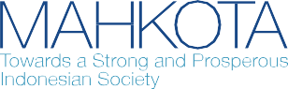

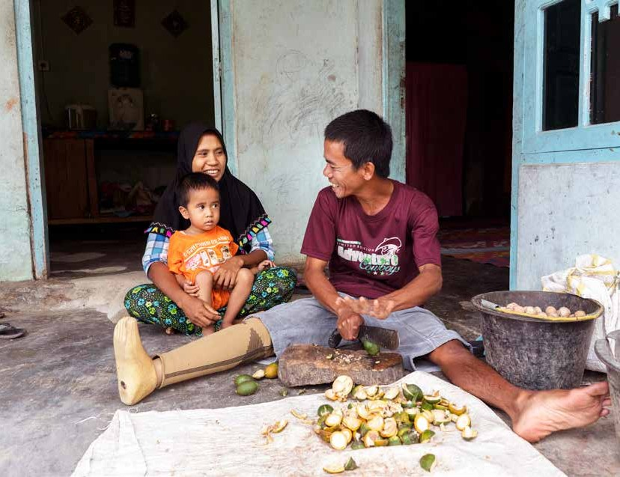

**An Evaluation of MAHKOTA’s Contribution to National Disability Regulations and Policy**

June 2021

**Cover Photo by Fauzan Ijazah for MAHKOTA**

**Disclaimer:**

**This publication has been funded by the Australian Government through the Department of Foreign Affairs and Trade. The views expressed in this publication are the author’s alone and are not necessarily the views of the Australian Government.**

**The Australian Government neither endorses the views in this publication, nor vouches for the accuracy or completeness of the information contained within the publication. The Australian Government, its officers, employees and agents, accept no liability for any loss, damage or expense arising out of, or in connection with, any reliance on any omissions or inaccuracies in the material contained in this publication.**

**This publication is intended to provide general information only and before entering into any particular transaction users should: rely on their own enquiries, skill and care in using the information; check with primary sources; and seek independent advice.**

**An Evaluation of MAHKOTA’s Contribution to National Disability Regulations and Policy**

**Author:** Anne Lockley Fiona Kotvojs Tania Warokka Sisilia Pratiwi

**June 2021**

**Acknowledgements:**

MAHKOTA would like to express its appreciation to all informants who participated in this evaluation. Special thanks is extended to the MAHKOTA Social Protection Program Officer, Diah Ayu Noorsinta Hidayati for her advice, information, and support.

Contents

Section 1: Introduction 11

1.1 Overview of MAHKOTA 11

Section 2: Evaluation Methodology 12

Section 3: Indonesia’s Disability Legislative Environment 16

3.1 A brief outline of the context of DPO participation in developing Indonesian legislation and regulations 17

Section 4: Evaluation Findings 18

* 1. MAHKOTA’s linking of stakeholders, both within GoI, and between GoI and other stakeholders

(KEQ 3) particularly DPOs (KEQ 2) 18

* 1. MAHKOTA’s contribution to shaping the drafting process (KEQ 1) through ensuring DPO participation (KEQ 2) 20
  2. The impact of MAHKOTA’s contribution on the resulting content of the regulations (KEQ 4) 23
  3. A brief note on the political economy of this initiative 25

Section 5: Conclusions and Recommendations 29

* 1. Conclusions 29
  2. Key Recommendations for Improving Future Related Processes (KEQ 5) 30

Appendix 1: People Interviewed 33

Appendix 2: Program Theory for MoSA Development of Implementing Regulations and MAHKOTA Investment 34

Appendix 3: Timeline of MAHKOTA Support to Drafting of Regulations 35

Appendix 4: Stakeholder Mapping 37

Figures

Figure 2.1: Hypothesised Engagement and Role of MAHKOTA in Development of Two 12

Figure 2.2: Process of Contribution Analysis 13

Tables

Table 3.1: Status of Ministerial Regulations for Implementation of the National Disability Law 16

# Executive Summary

MAHKOTA1 commissioned this evaluation to investigate, document, and communicate its contribution to the development and content of supporting government regulations to the National Disability Law (Law No. 8/2016), specifically the government regulation (*peraturan pemerintah*: PP) on the provision of social welfare (KeSos) for people with disability and the PP on the provision of habilitation and rehabilitation services for people with disability (HabRehab). Over approximately two years MAHKOTA provided a range of inputs to facilitate and strengthen engagement between Government of Indonesia (GoI), particularly the Ministry of Social Affairs (MoSA) as the lead government agency for these regulations, and civil society stakeholders, including disabled persons organisations (DPOs), with the intention of helping to develop the regulations to a mutually acceptable end product.

The evaluation responds to five key evaluation questions:

1. What was MAHKOTA’s contribution to shaping the PP drafting process? Which elements improved or did not improve the process? What evidence is there that these changes have been applied to the drafting process of other PP?
2. What was MAHKOTA’s contribution to DPO participation in the PP drafting process and what was the result? What evidence is there that these changes have been applied to the drafting process of other draft government regulations (*Rancangan Peraturan Pemerintah*: RPP)?
3. How did MAHKOTA link stakeholders, both within GoI, and also between GoI and other stakeholders? What evidence is there that these changes have been applied elsewhere?
4. What impact has MAHKOTA’s contribution had on the resulting content of the regulations?
5. How could the RPP process and MAHKOTA’s contribution have been improved?

The evaluation hypothesis refers to a program theory that has at its heart MAHKOTA providing support to address key capacity gaps, that then enables MoSA’s facilitation of a drafting process that reflects international best practice. The evaluation has involved detailed qualitative analysis of structured interviews with representatives of government, academics, DPOs, and other non-government organisations involved in the drafting of the regulations, a document review, and review of the regulations (one final, one draft) with attention to the specific input of various groups. A draft of the evaluation report was circulated to those involved in the evaluation and other main users of the information; feedback and verification of findings was also sought through an online workshop. This final document reflects this input.2

1 MAHKOTA (Towards a Strong and Prosperous Indonesian Society) is an Australian Government-funded program supporting the Government of Indonesia (GoI) to strengthen its social protection system.

2 At the time of the evaluation, only the regulation on social welfare had already been finalised and signed. The regulation on habilitation and rehabilitation was signed in December 2020, after evaluation processes had been completed.

### Evaluation Findings

The findings are presented against amalgamated questions because it is evident from the analysis that the divisions between key evaluation questions (KEQ) 1, 2, and 3 are somewhat arbitrary. MAHKOTA’s contribution to shaping the drafting process (KEQ 1) is by linking stakeholders (KEQ 3) and central to this is engagement with DPOs (KEQ 2).

#### MAHKOTA’s linking of stakeholders, both within GoI, and between GoI and other stakeholders (KEQ 3) particularly DPOs (KEQ 2)

The linking or convening role of MAHKOTA was viewed as significant by all parties, and without MAHKOTA’s support the engagement of DPOs would not have been as meaningful and prominent. MAHKOTA’s financial contribution to this linking role was important, complementing assistance provided by MoSA and DPOs.

Linking was achieved by organising and facilitating meetings involving government, DPOs, civil society organisations (CSOs), and academia, and by holding smaller group meetings with different parties to build understanding, discuss key issues, and identify different perspectives to bring back to the larger group. The relationships between these stakeholders, which pre-date MAHKOTA’s engagement, continue and were strengthened at an operational level by this experience.

MAHKOTA’s facilitation expertise was recognised as making the process more relaxed and convivial than it may otherwise have been. The evaluation did not, however, explore the reasons why some DPOs and government agencies did not actively participate throughout the entire process. While it is most likely that this is due to the considerable time and resources required for more sustained engagement, it is something that is important to understand from an inclusion perspective and can be incorporated into future analyses.

#### MAHKOTA’s contribution to shaping the drafting process (KEQ 1) through ensuring DPO participation (KEQ 2)

MAHKOTA’s contribution to the drafting process is in four key areas: (i) convening (as mentioned); (ii) facilitating

DPO participation; (iii) technical support; and (iv) mediation. The engagement of the staff member from MAHKOTA accompanying the process was important in all areas. Mediation and technical input were particularly significant contributions, but these three key areas, along with MAHKOTA’s general convening role cannot be separated.

As per international best practice, MAHKOTA contributed to the drafting process by staying true to the core disability inclusion principle of *nothing about us without us.* MAHKOTA contributed to a more accessible environment for DPO representatives to participate through ensuring availability of support services and technology and appropriate meeting and overnight accommodation.

MAHKOTA’s support for, and organisation of, a targeted capacity development intervention (training in December 2018) is considered very significant in building a shared understanding of the concepts of habilitation and rehabilitation and was the basis of redrafting the regulation. A lesson from this experience is to proactively identify areas where a shared understanding of key concepts needs to be developed.

MAHKOTA’s contribution was more significant to the draft PP HabRehab than the PP *KeSos* as the PP *KeSos* was well advanced before MAHKOTA became actively involved. The subject matter was also already better understood by stakeholders than that of the draft HabRehab. Non-government stakeholders involved in the drafting identified that MAHKOTA’s engagement contributed to MoSA being more open to the inputs of diverse groups in the drafting process.

#### The impact of MAHKOTA’s contribution on the resulting content of the regulations (KEQ 4)

MAHKOTA’s role in contributing to the content was as part of a team that developed and agreed on the content. DPOs, with support from the Centre for Law and Policy Studies (*Pusat Studi Hukum & Kebijakan*

*Indonesia*: PSHK) and the Faculty of Law at the University of Gadjah Mada (FH-UGM) led drafting of the regulations and provided legal input to the process. MAHKOTA assisted to find common ground to agree articles that were considered important but contentious. Substantive changes or additions to content are found in both regulations, more so in HabRehab because of the nature of the process and preceding issues.

#### Key lessons and recommendations for improving future related processes (KEQ 5)

Overall, participants in the evaluation reflected that the process of developing the draft regulations was a learning experience. It was important for bringing sometimes disparate groups together and negotiating common ground. There were challenges experienced in terms of the lengthy process and the need to spend more time building a mutual understanding of the concepts. Respondents noted that in the interests of evidence-based policy, the regulations would have benefited from being able to draw on more references or research and information relevant to the implementation context. The reality of policy making, however, is that there is rarely the time and resourcing allocated to this proactively. The development of these regulations was already behind the two-year timeframe specified in the National Disability Law.

### Conclusions

The evaluation has found a number of contributions made by MAHKOTA to the process of developing the two implementing regulations to the National Disability Law.

In relation to the evaluation hypothesis (that MAHKOTA provided support to build the awareness of international standards, and the knowledge, skills, and attitude to apply this to the regulation development so that these regulations reflected international best practices), we found that MAHKOTA did support the drafting process in this way. This was through technical assistance, facilitating collaboration, advocating to agencies for integration of inclusive social protection, and financially supporting various group meetings. The evaluation hypothesis, therefore, holds–with some caveats and different emphases.

In relation to the elements of the program theory, the conclusions of this evaluation are summarised as follows:

**Developing the regulations in accordance with international standards:** The foundation for incorporating international standards is provided by the National Disability Law and ratification of the United Nations Convention on the Rights of Persons with Disabilities (CPRD)–these concepts for inclusion in the PP *KeSos* were already sufficiently understood. In the case of the draft PP HabRehab, however, MAHKOTA’s contribution of bringing in international expertise was significant in building a common understanding of unfamiliar concepts, resulting in redrafting of the regulation. While not explicitly identified in terms of international standards in the program theory, the other area of significant contribution to highlight is in relation to implementation of internationally recognised best practice stemming from the *nothing about us without us* principle. At its core this is MAHKOTA’s strong emphasis on DPO engagement, and the attention to inclusion strategies to make this meaningful.

**Facilitating collaborative development of the regulations with DPOs:** MAHKOTA’s contribution to this is recognised by all stakeholders interviewed. DPO engagement did not happen because of MAHKOTA, but MAHKOTA made it wider and more productive. MAHKOTA’s role in mediating the interests of different stakeholders to mutual agreement is well regarded. MAHKOTA was careful to be supporting DPO leadership with MoSA, rather than taking over.

**Integrating inclusive social protection into the regulations:** The drafting team has ensured inclusive social protection into the PP *KeSos*, but it could be argued that this is the purpose of the regulation, and so would have happened anyway. MAHKOTA did, however, assist the team to find a suitable compromise for the eligibility for social security that reflects the inclusion aspirations of the DPOs. The team collaboration supported by MAHKOTA for drafting the PP HabRehab has led to a more robust and fit-for-purpose

regulation that has wider support than it did at the start of the process. MAHKOTA’s contribution in terms of convening and then facilitating and, when necessary, mediating the input of different stakeholders is a clear contribution to those stakeholders’ agreement with the content of the regulations.

**MAHKOTA’s funding for group discussions, meetings, and the technical workshop:** This was essential for the representative and inclusive nature of the process, and for developing a shared understanding of the basis of the regulations, more so the challenging regulation for HabRehab.

In terms of other actors, MAHKOTA’s work builds on various inputs through other processes, and a long history of support from other development partners and DFAT-funded programs, most notably *Program Peduli* and the Australia-Indonesia Partnership for Justice (AIPJ).[1] As such, the outputs achieved can be seen as those of a team, with the voice of DPOs at the front. MAHKOTA’s role was to support that team.

**Recommendations**

This has identified a small set of core recommendations that have been confirmed with the participants in this evaluation. It is difficult to be specific about a precise actor(s) responsible for implementing these recommendations, as it will depend on the topic and leadership of the regulations or other policy being developed. The recommendations therefore refer to the roles of government stakeholders, development partners (such as DFAT and their portfolio programs), and DPOs / other non-government partners, which may be acting independently or as part of the established disability sector working groups. Recommendations are:

**Recommendation 1: All stakeholders should commit to the centrality of DPO engagement, and support this through openness, transparency, and attention to the requirements of accessible and inclusive participation.** The centrality of the views and experiences of people with disabilities is essential for applicability of the regulations. Resources for convening, and attention to accessibility and inclusivity make this work.

**Recommendation 2: Development partners and their programs, such as MAHKOTA, could engage in active facilitation of diverse stakeholder interests in such a way as to strengthen the leadership of mandated agencies and attention to the perspectives of DPOs in the process.** A multi-stakeholder approach is essential but takes effort while a neutral party can help to identify mutually acceptable compromise positions.

**Recommendation 3: All stakeholders should aim for consistent participation and representation from start to finish to the extent possible and ensure newcomers or substitute personnel are briefed on agreements to date.** It is strongly recommended that development partner programs provide consistent support through a designated staff member.

**Recommendation 4: (a) DPOs and disability working groups (*Pokja*) should continue to develop their understanding of government policy making to improve their own ability to identify mutually acceptable positions; and (b) all parties should invest in proactive research on the underlying conditions relevant to development and implementation of upcoming regulations.** In the absence of sufficient financial support from other sources (e.g. GoI), this is likely to require the financial and possibly technical support of development partners.

**Recommendation 5: (a) It is suggested that the GoI open the final stages of regulation drafting process to representatives of DPOs, at least as observers; and (b) if it is not possible for at least one DPO representatives to participate at this stage, then it is recommended that non-government stakeholders work with government representatives prepared to act as champions to advocate for the full draft regulation on behalf of DPO stakeholders and to report back on sticking points and requested changes**. Participation in the final stages of the drafting process is limited. In these stage, a draft of the regulation is presented to representatives of all related ministries by MoSa. Following this, the draft is ‘harmonised’, a process in which the Ministry of Law and Human Rights and other relevant ministries and government agencies review proposed legislation to ensure that it does not conflict with existing laws and regulations. This is the final step before the draft legislation is presented to the President for signing. The discontinuity of actors, including NGO/DPO stakeholders, between earlier drafting processes and these final stages, raises the potential for last minute changes that are different to the shared vision of the NGO/DPO stakeholder group.

**Recommendation 6: Where appropriate and requested by relevant Indonesian stakeholders, development partners and their programs, such as MAHKOTA, should consider supporting ongoing capacity development at national and regional levels and, where possible, identify needs and arrange this early in the regulation drafting process.** High quality and targeted capacity development is invaluable when concepts need to be better and jointly understood. This extends to developing a better understanding of the implementation context to inform the regulation content.

# Abbreviations and Acronyms

AIPJ Australia-Indonesia Partnership for Justice

Bappenas National Development Planning Agency (*Badan Perencanaan Pembangunan Nasional*) CRPD Convention on the Rights of Persons with Disabilities

CSO Civil Society Organisation

DFAT (Australian) Department of Foreign Affairs and Trade

DPO Disabled Persons’ Organisation

FH-UGM Faculty of Law, University of Gadjah Mada (*Fakultas Hukum, Universitas Gadjah Mada*) GoI Government of Indonesia

HabRehab Habilitation and Rehabilitation

Kesos Social Welfare (*Kesejahteraan Sosial*)

KEQ Key Evaluation Question

KSI Knowledge Sector Initiative

KSP Presidential Staff Office (*Kantor Staf Presiden*)

MAHKOTA Towards a Strong and Prosperous Indonesian Society (*Menuju Masyarakat Indonesia yang Kokoh dan Sejahtera*)

M&E Monitoring and Evaluation

MoSA Ministry of Social Affairs (*Kementerian Sosial*)

NGO Non-government organisation

PAK Inter-ministerial meeting (*Pertemuan Antar Kementeria*n)

PKH Family Hope Program (*Program Keluarga Harapan*)

Pokja Working Group (*Kelompok kerja*)

PP Government Regulation/Implementing Regulation (*Peraturan Pemerintah*)

PSHK Centre for Indonesian Law and Policy Studies (*Pusat Studi Hukum & Kebijakan Indonesia*) RPP Draft Government Regulation (*Rancangan Peraturan Pemerintah*)

SAPDA Centre for Advocacy for Women and Children with Disability (*Sentra Advokasi Perempuan Difabel Dan Anak*)

Setneg State Secretariat (*Sekretariat Negara*)

SLRT Integrated Referral Service System (*Sistem Layanan Rujukan Terpadu*)

TNP2K National Team for the Acceleration of Poverty Reduction (*Tim Nasional Percepatan Penanggulangan Kemiskinan*)

UN United Nations

YAKKUM Yayasan Kristen Untuk Kesehatan Umum

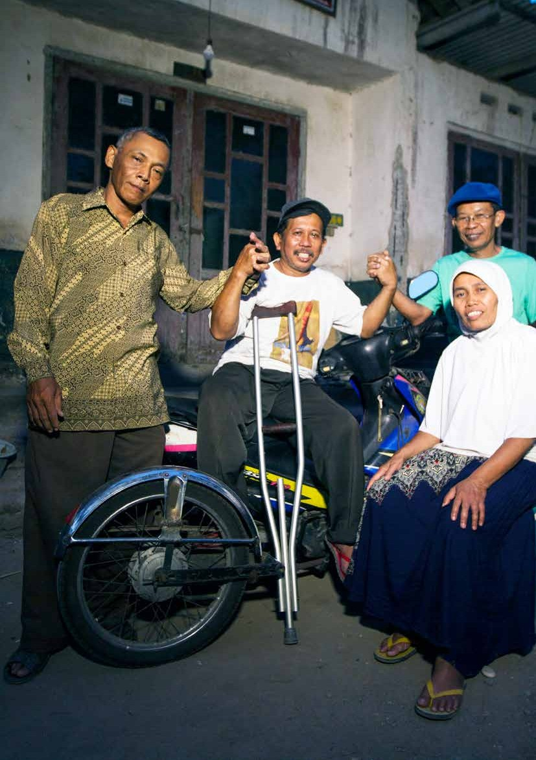

Photo by Rachma Safitri for MAHKOTA

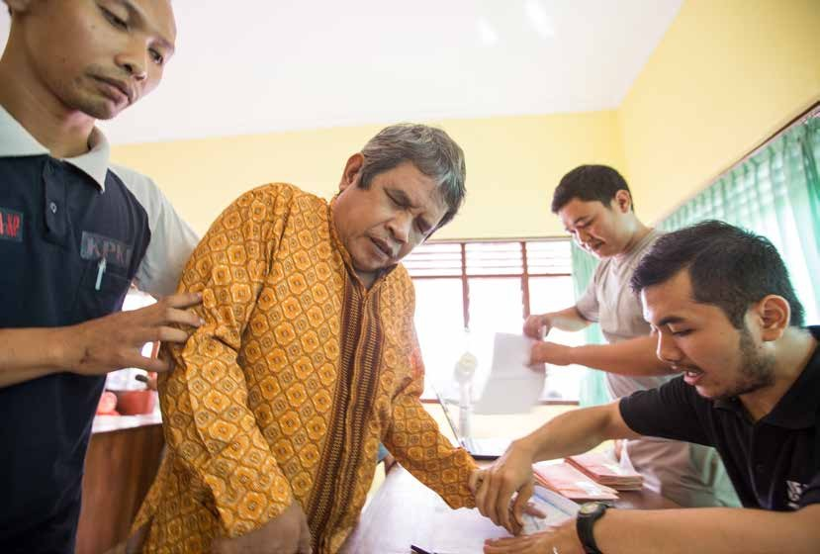

Photo by Rachma Safitri for MAHKOTA

Section 1:

# INTRODUCTION

This evaluation was commissioned by MAHKOTA to investigate, document, and communicate its contribution to the development and content of supporting government regulations to the National Disability Law (Law No. 8/2016)–specifically the regulation on the provision of social welfare (*Kesejahteraan Sosial*: *KeSos*)4 and habilitation and rehabilitation services for people with disability (HabRehab). Over approximately two years MAHKOTA has provided a range of inputs to facilitate and strengthen engagement between the Government of Indonesia (GoI) and civil society stakeholders, including disabled persons organisations (DPOs), with the intention of helping to develop the regulations to a mutually acceptable end product. The evaluation is intended to provide MAHKOTA and other stakeholders with an understanding of the extent and nature of MAHKOTA’s contribution to the regulations, and with learning to inform approaches to future policy formulation, including to improve processes and collaboration, and to contribute to decisions about the added value of development partner support. It responds to five key evaluation questions (detailed in Section 2), which provide the structure for the presentation of evaluation findings in Section 4.

### 1.1. Overview of MAHKOTA

MAHKOTA (Towards a Strong and Prosperous Indonesian Society) is an Australian Government-funded program supporting GoI to strengthen its social protection system. MAHKOTA operates as a flexible facility, working primarily with the Secretariat of the National Team for the Acceleration of Poverty Reduction (TNP2K), a think tank under the purview of Indonesia’s vice president that was established by GoI to inform and undertake innovative policy reforms and initiatives. MAHKOTA also provides technical assistance to line ministries and sub-national governments that play key roles in planning and implementing social protection programs.

MAHKOTA’s goal is that Indonesia’s economic growth is inclusive and sustainable by pursuing three contributing outcome streams:

1. Effective coverage of social protection and productive inclusion programs: This outcome stream focuses on increasing social protection budget allocations by national and local government, expanding existing social protection and productive inclusion programs, and improving the effectiveness and inclusiveness of existing programs and implementation of new programs.
2. Improved access to inclusive social protection: Focusing primarily on improving the management and use of data for improved access to social protection programs.
3. Contributions to macroeconomic policy related to inequality and social protection: Designed to give MAHKOTA flexibility to support GoI priorities that are adjacent to, but not directly under, the two main outcome streams. This recognises that certain non-social protection investments are critical to achieving inclusive economic growth and can reinforce and/or be informed by direct investments in social protection.

The subject of this evaluation falls under the first of these but is relevant to all three outcome streams.

4 *Peraturan Pemerintah Republik Indonesia Nomor 52/2019 tentang Penyelenggaraan Kesejahteraan Sosial bagi Penyandang Disabilitas* (Regulation of the Government of the Republic of Indonesia No. 52/2019 on the Implementation of Social Welfare for People with Disability).

Section 2:

# EVALUATION METHODOLOGY

An evaluation plan was developed in May 2020, with five key evaluation questions.5 The plan was structured as two phases and included some contingencies to allow for adjustments that may be necessary because of Covid-19. The enduring lockdown meant that these adjustments, and others were needed.

1. What was MAHKOTA’s contribution to shaping the RPP (*Rancangan Peraturan Pemerintah*: RPP) drafting process? Which elements improved or did not improve the process? What evidence is there that these changes have been applied to the drafting process of other RPP?
2. What was MAHKOTA’s contribution to DPO participation in the RPP drafting process and what was the result? What evidence is there that these changes have been applied to the drafting process of other RPP?
3. How did MAHKOTA link stakeholders, both within GoI and between GoI and other stakeholders? What evidence is there that these changes have been applied elsewhere?
4. What impact has MAHKOTA’s contribution had on the resulting content of the PPs?
5. How could the RPP process and MAHKOTA’s contribution have been improved?

The original evaluation methodology included two core aspects:

1. It draws on the principles of utilisation-focused evaluation (Patton 2008),6 to the extent that this has been possible in the Covid-19 context.
2. A contribution analysis framework (Mayne 2001) (see Figure 2.1), applied to assess the causal question (that is, the role of MAHKOTA in bringing about the desired changes) and to test the theory of change.

**Figure 2.1: Hypothesised Engagement and Role of MAHKOTA in Development of Two Disability- related Government Regulations**

Potential alternative explanations:

* NO capacity gap.
* Capacity gap filled by Gol agencies.
* Other DFAT-funded programs (e.g. AIPJ2, Program Peduli).
* Organisations supporting PwD
* Other development partner programs.

Risks:

* S&K gaps weren’t Identified correctly
* Attitude of staff has not changed.
* Changes in MoSA at Ministerial leveI or managerial level =>change in direction and priorities.
* Loss of funds for meetings and focus groups.

**MAHKOTA investment addresses capacity gaps**

Awareness of international standards.

**MAHKOTA influence on the process**

Knowledge, skills and attitude to:

* + Develop PP in accordance with international standards.
  + Facilitate collaborative development of the RPP with DPO.
  + Integrate inclusive social protection into Regulation.
  + Justify to other agencies the basis for the RPP.

Resources to:

* + Fund focus groups and meetings.

**MAHKOTA investment enables MOSA RPP development process to reflect international good practice**

RPP development increasingly reflects international good practice & creates space to work with CSO and DPO collaboratively.

5 These questions were refined through the analysis (see Section 4).

6 The evaluation plan identified the primary audiences (but not users) as: (i) GoI; (ii) DFAT; and (iii) MAHKOTA, and the secondary audiences as CSOs working on disability issues and policies, in particular DPOs and their working groups (*pokja*). The evaluation process and findings now indicate that the primary users are MAHKOTA and other development partners, DFAT, and the *pokja*. Some aspects are relevant to GoI.

The cause–effect issue at the heart of the evaluation, as identified in the evaluation plan, is that the development process for the regulations was not reflecting international best practice, resulting from a lack of awareness of international standards and of the knowledge, skills, and attitude to apply this to the development of regulations. MAHKOTA’s role was to support MoSA to address these capacity constraints through technical assistance, facilitating collaboration, advocating to agencies for integration of inclusive social protection, and financially supporting various group meetings.

This hypothesised cause-effect relationship, including both MoSA and MAHKOTA’s contribution is depicted in the *program theory* that was used as the basis for the evaluation process (see also Appendix 2). An extract of the section of this program theory that is tested through this evaluation is in Figure 2.1. This also identifies risks and alternative explanations for the outcomes that have been tested through the evaluation.

The gathering of evidence has included:

* *Structured interviews* with 15 individuals, representing the main stakeholder groups involved in the drafting of the regulations. Interviews focused on those who had been most involved and ensuring coverage of the main actors–MoSA, Bappenas, DPOs, other civil society organisations (CSOs), academia, and MAHKOTA.
* *A document review*, focusing on MAHKOTA activity reports, meeting records, and some general contextual information.
* *Review of the regulations* (one final, one draft) with attention to the specific input of various groups.

**Figure 2.2: Process of Contribution Analysis**

**Revise contribution claim**

**Additional evidence**

**Cause-effect issue**

The analytical process to *assess the contribution claim* was firstly through content analysis of the interview transcripts (Figure 2.2). Qualitative analysis codes used reflected the focus of the key evaluation questions (role of various actors, changes, challenges, lessons, and recommendations) and then more specific detail (related to content, process, specific roles, and technical issues). Responses were tallied against the codes to identify the key points of commonality and outlying opinions. It should be noted that the interview guide was developed with an intention to avoid leading questions, that might prompt an interviewee to respond in the way they think they are expected to (for example, by automatically praising MAHKOTA’s role or assigning overly significant contributions). Questions focused generally on the process, drawing out who did what and what this is believed to have led to.

**Program theory**

**Gather evidence**

**Assess contribution claim**

The evaluation methodology included attention to ethical principles including informed consent and confidentiality. The quotes used in this report have been verified with their sources and specific permission was obtained for their use. There has been consistent attention to appropriately rigorous analysis and to ensuring that each voice has equal weight. The evaluators were aware of potential for power dynamics and sensitivities to influence the findings and have endeavoured to present findings fairly and constructively. MAHKOTA also confirmed the evaluation findings with key stakeholders as outlined below.

Triangulation of the key findings has been achieved by comparing and verifying the findings of the analysis of the interviews with the document review and analysis of regulation content. A formal process was implemented through which written feedback was provided by key informants and main evaluation users (MAHKOTA, DFAT) on the draft of the evaluation report. An online workshop was then held with representatives of the government and non-government organisations/DPOs involved.

A limitation of the original evaluation plan in relation to the utilisation-focused evaluation methodology is that it was developed within MAHKOTA rather than with input from potential users to the evaluation questions (other than DFAT). The effects of this were potentially compounded by the adaptation of the second phase of the evaluation to the limitations of the Covid-related travel and meeting restrictions. Circulation of the draft report, request for structured feedback, and the on-line follow-up session have, however, enabled dissemination and discussion of findings with expected primary users.

A further limitation is that the list of those interviewed is not exhaustive although the evaluation plan had identified a much larger list of potential informants. On review, many of these had only been involved very peripherally (for example, by attending just one meeting). Of course, interesting points and additional richness come from all interviews, but the evaluation team assessed that the smaller group represented the most informed perspectives, and interviews were not yielding inconsistent information that needed to be explored further. The evaluation did not explore why some organisations–particularly some of the DPOs–did not stay with the process as this was not part of the brief. Knowing who is “not in the room” can, however, be important for understanding the dynamics of exclusion. This is something that is recommended to be included in key evaluation questions for future evaluations related to MAHKOTA’s engagement in the disability sector.

The evaluation was conducted by MAHKOTA’s Monitoring and Evaluation Advisor and Monitoring and Evaluation Officer, who were not involved in the implementation of MAHKOTA’s support to the development of the regulation. Support for analysis and report writing was provided by external evaluation specialists.

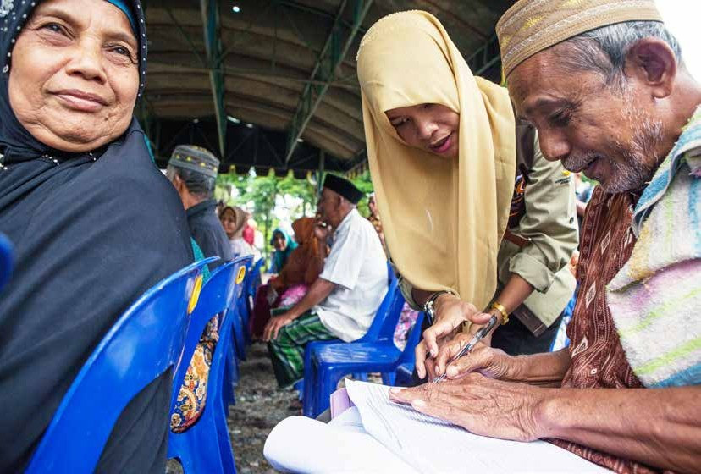

Photo by Fauzan Ijazah for MAHKOTA

Section 3:

# INDONESIA’S DISABILITY LEGISLATIVE ENVIRONMENT

Indonesia signed the United Nations Convention on the Rights of Persons with Disabilities (CPRD) on 30 March 2007 without reservations, and subsequently ratified the convention with Law No. 19/2011. Ratification of the convention signified a shift in the understanding of disability (defined in the convention as ‘an evolving concept’) resulting from the ‘interaction between persons with impairments and attitudinal and environmental barriers that hinder their full and effective participation in society on an equal basis with others’.7 As the basis for the social model of disability, this understanding of disability as the interaction between impairments and various barriers in society, was in contrast with previous approaches and the associated laws and regulations that conceptualised disability only in terms of impairments as ‘flaws’ or handicaps,8 that were met with a health, charity, or welfare response.

The recognition of full and equal rights of persons with disabilities heralded by the ratification of the CPRD required greater formalisation in Indonesian legislation (Edwards 2014). A significant step towards this was the enactment of the National Disability Law No. 8/2016, after which various GoI ministries commenced drafting eight supporting regulations. As of December 2020, six of these regulations have been finalised, one is in the process of final ministerial review, and one is yet to be commenced in terms of government deliberations. It is noted that according to the direction of the law this process is late. Article 152 states that any implementing regulations to this law are to be issued within two years of its enactment, something that was identified in this evaluation as unrealistic from the outset.

**Table 3.1: Status of Ministerial Regulations for Implementation of the National Disability Law**

| **Focus of Regulation** | **Mandated Ministry** | **Status** |
| --- | --- | --- |
| Planning, implementation, and evaluation | Bappenas | PP No. 70/2019 (Signed October 2019) |
| Decent accommodation for students with disability | Ministry of Education and Culture | PP No. 13/2020 (Signed February 2020) |
| Decent accommodation in justice process | Ministry of Law and Human Rights | PP No. 39/2020 (Signed July 2020) |
| Accessibility and public services | Ministry of Public Works and Housing | PP No. 42/2020 (Signed July 2020) |
| Concessions | Ministry of Finance | Ministerial engagement not commenced9 |

7 United Nations. Convention of the Rights of Persons with Disabilities, 2006 (preamble).

8 For example, earlier disability and human rights law uses terminology that translates to ‘persons with deficit/s’ *(penyandang cacat*), or as being ‘lacking’ (for example, *tunarungu* - ‘lacking hearing’), and follows a more medical or welfare-based model compared to the social and rights-based model of the CPRD.

9 A draft of the regulation has been prepared by the Working Group on Implementation of Law on Persons with Disabilities (Jakarta *Pokja*) and the Coalition of Disabilities Community (Yogyakarta *Pokja*) and submitted to the Ministry of Finance. The ministry is, however, reluctant to accept the mandate as the ministry responsible for this regulation and has requested more evidence on this role before initiating the deliberation and collaborative drafting process. The Fiscal Policy Agency, which is leading on this process on behalf of the ministry, has requested assistance from the Australia-Indonesia Partnership for Economic Development (PROSPERA) for a cost analysis to be presented to the ministry.

| **Focus of Regulation** | **Mandated Ministry** | **Status** |
| --- | --- | --- |
| Disabilities Services Unit – employment sector | Ministry of Labour10 | Ministerial review |
| Social Welfare | Ministry of Social Affairs (MoSA) | PP No. 52/2019 (Signed July 2019) |
| Habilitation and Rehabilitation | PP No. 75/2020 (Signed December 2020) |

### 3.1. A brief outline of the context of DPO participation in developing Indonesian legislation and regulations

DPO engagement in the process of drafting the PP *KeSos* and the draft PP HabRehab was facilitated through two NGO/DPO-driven working groups (*Pokja*)–one in Jakarta and one in Yogyakarta.

The Jakarta-based group, representing national organisations, is the continuation of a legal working group established in 2013 to advocate on the disability bill. This was triggered by concern that the draft bill prepared by the Indonesian Human Rights Commission and MoSA at that time did not accommodate the rights and needs of people with disability. The Jakarta *Pokja* includes DPOs and disability service providers and allies including the Centre for Indonesian Legal and Policy Studies (*Pusat Studi Hukum & Kebijakan Indonesia*: PSHK).

The Yogyakarta *Pokja* or *Koalisi Masyarakat* (Community Coalition) is made up of, and represents, people with disability and DPOs based outside of Jakarta, primarily Yogyakarta. This group is also actively engaged in advocacy on disability policy. It has been vocal about the need to shift away from the traditional charity or health-based models of disability, a stance that is in line with MAHKOTA’s social protection approach.

A significant area of MAHKOTA support has been in facilitating collaboration between DPOs and GoI, making it important to acknowledge the foundations on which this is built.

In 2017 DPOs, including the Centre for Advocacy for Women and Children with Disability (*Sentra Advokasi Perempuan Difabel Dan Anak*: SAPDA) rejected early efforts to draft the implementing regulations under the National Disability Law (No. 8/2016) and, after lobbying Bappenas, SAPDA was assigned the mandate for leadership of the *KeSos* and HabRehab.11 SAPDA led much of the early engagement with GoI, with the Law Faculty of Universitas Gadjah Mada (*Fakultas Hukum-Universitas Gadjah Mada*: FH-UGM) engaged through a memorandum of understanding to provide support for the drafting.

Through the early process it was recommended to pursue separate regulations, and SAPDA successfully advocated for this to Bappenas. This was consistent with the intention of the CPRD and Disability Law in separating various inclusion strategies from welfare. Bappenas also agreed to engaging the *Pokja* in the drafting process because ‘*(GoI) cannot make a law without seeing the real needs of the community; the drafting process must always involve people who will be the subject of the implementation of the regulation’*.12 13

MAHKOTA’s role in the development of these regulations builds on inputs supported through the Australia-Indonesia development partnership, including through the Australia-Indonesia Partnership for Justice (AIPJ) Phases 1 and 2, and *Program Peduli,* and other actors, including disability lead partner Yayasan Kristen Untuk Kesehatan Umum (YAKKUM). AIPJ, in particular, has a long history of supporting DPOs to engage in legislative and policy development, including the development of the National Law on Disability.

10 This evaluation uses the gender-neutral translation of *Kementerian Ketenagakerjaan*, otherwise translated as the Ministry of Manpower.

11 Stakeholder interview, SAPDA, May 2020.

12 Stakeholder interview, Bappenas, May 2020.

13 Law No. 12/2011 concerning the formation of regulations and laws (Section 96) states that people have the right to give oral and/or written input in the formation of regulations, with ‘people’ defined as an individual or group that has an interest in the substance of the draft regulations.

Section 4:

# EVALUATION FINDINGS

The evaluation findings are presented against amalgamated questions because it is evident from the analysis that the divisions between key evaluation questions (KEQ) 1, 2, and 3 are somewhat arbitrary. MAHKOTA’s contribution to shaping the drafting process (KEQ 1) is by linking stakeholders (KEQ 3) and central to this is engagement with DPOs (KEQ 2). Engagement with DPOs is, therefore, integrated with KEQ 1 and 3. A discussion of alternative explanations, as per the contribution analysis methodology is included in each section.

### MAHKOTA’s linking of stakeholders, both within GoI, and between GoI and other stakeholders (KEQ 3) particularly DPOs (KEQ 2)

Key Findings:

* The linking or convening role of MAHKOTA was viewed as significant by all parties and, without MAHKOTA’s support, the engagement of DPOs would not have been as meaningful and prominent.
* MAHKOTA’s financial contribution to this linking role was important.
* As per international best practice, MAHKOTA contributed to the drafting process staying true to the core disability inclusion principle of *nothing about us without us.*
* Linking was achieved by organising and facilitating meetings involving government, DPOs, CSOs, and academia, and by holding smaller group meetings with different parties to build understanding, discuss key issues, and identify different perspectives to then bring back to the larger group.
* MAHKOTA contributed to a more accessible environment for DPO representatives to participate by ensuring availability of support services and technology and appropriate meeting facilities and overnight accommodation.
* MAHKOTA’s facilitation expertise was recognised as making the process more relaxed and convivial than it may otherwise have been.
* The relationships between these stakeholders, which pre-date MAHKOTA’s engagement, continue and were strengthened at an operational level by this experience.

MAHKOTA’s early engagement began in late 2017 when MAHKOTA’s gender and social inclusion adviser supported MoSA in some preparatory work for the combined KeSos and HabRehab regulation. During 2018 MAHKOTA remained involved, but more as an observer or meeting participant. In late 2018 as a complementary activity to some of its other work on disability inclusion, MAHKOTA formally approached the MoSA legal department to offer assistance to support the development of the now two regulations, with an explicit intention to support the active engagement of DPOs in the development process. MoSA agreed, and MAHKOTA and MoSA started working together on this in December 2018, with MAHKOTA committing to seeing the process through. The timeline and key inputs/outputs of MAHKOTA and MoSA and others are presented in Appendix 3.

#### Contribution: Financial and organising resources to broaden and improve participation, without taking over

MAHKOTA’s financial support to meetings and workshops and, where necessary, travel costs for participants

meant that the participation was wider, inputs were better quality, and the discussion more informed. As the initiating and mandated ministry, MoSA has a significant contribution to make to convene stakeholder meetings for developing the regulations, however, limited resources were available for the development

of the regulations within MoSA and DPOs. MAHKOTA was able to supplement the financial and logistical support provided by others, including from YAKKUM/*Program Peduli* and MoSA, and from FH-UGM for the honorarium for their drafters.

MAHKOTA’s contribution helped to ensure that the draft of the regulations represented the leadership of DPOs complementing the voice of government. As noted by SAPDA:

(MAHKOTA) gives funding but then doesn’t position itself as ‘then I have to lead’, but positions

that it is disability organisations that have the role to lead, and then they (MAHKOTA) are facilitating. It was in my opinion one of the things I appreciate from the MAHKOTA team.14

MAHKOTA’s role in convening–that is bringing the different stakeholders together to discuss, draft, and review the draft regulations–was recognised as a significant contribution by all interviewees. It was considered that without this DPO participation would not have been as meaningful, and ‘*it would not have been possible to fulfil the component of public participation … (and persons with) disabilities to its full potential*’’.15

Interviewees identified that one of the factors making MAHKOTA’s convening and facilitation of the process effective was the consistent support provided by MAHKOTA’s facilitator. In the words of one stakeholder, the facilitator ‘*feels like a single fighter doing everything from contacting participants, sharing invitations, to making sure we have tickets–she was multi-tasking*’.16 MAHKOTA’s facilitator was also acknowledged for being prepared to meet informally out of hours to assist in the formulation of a strategy or to map the articles across regulations in preparation for formal discussions, and an approach that was important in moving discussions forward. The sense of responsibility taken, or ‘working with the heart’ evidenced MAHKOTA’s commitment to ensuring that the regulations have the best chance of making a difference for people with disability.17

#### Contribution: Implementation of best practice inclusion strategies

MAHKOTA’s inclusion strategies were identified as ‘*providing space and opportunities for DPOs*’,18 in such a way as to improve the quality of community participation and that of DPOs and people with disabilities.19 These strategies included:

* ensuring meeting venues and accommodation were appropriate,20 ensuring that there was enough food for the long sessions, and instituting regular breaks that are particularly important for people with disability, but make it more productive for everyone;
* building in techniques to encourage more equal participation, starting with actively welcoming participants on arrival to make sure they feel welcome and comfortable, rotating the provision of the opening speech, providing plenty of microphones, always having DPOs and GoI in the same room, opening with participants sharing their experiences and how they wanted to proceed, and ensuring all have the same opportunity to speak;
* providing relevant assistance such as sign language interpreting, note taking, and resting rooms and quiet spaces to accommodate different impairments; and
* active facilitation whereby each item would be discussed one by one, and avoidance of single party domination on certain points.

14 Stakeholder interview, SAPDA, May 2020.

15 Stakeholder interview, KSP, May 2020.

16 Stakeholder interview, YAKKUM, August 2020.

17 Stakeholder interview, Bappenas, May 2020.

18 Stakeholder interview, Bappenas, May 2020.

19 Stakeholder interview, PSHK, May 2020.

20 This included attention to venue entry, bathrooms, and hotel rooms with accessibility features, and considering the layout and required movement between areas (sufficient space for wheelchairs, passage from the meeting room to bathrooms and meal locations).

#### Contribution: Building trust and understanding of DPO priorities and experience

Informants21 highlighted the contribution of MAHKOTA in bringing DPO representatives from regions together with national government to expose various stakeholders to the views and experiences of people with disability. This was achieved through organising regional (Yogyakarta and Sukoharjo) discussions, and YAKKUM and SEHATI were invited to present their experiences of community-based rehabilitation to demonstrate how the concepts of habilitation and rehabilitation cannot be achieved by separating people with disability from their communities in an institutionalised response by central agencies.

Through their initiatives, DPOs and disability service providers were able to share what they have done and their best practices, complementing the usual research and analysis used by government with their first-hand experience of the issues being addressed. This was important ‘*not only at the central government level but also at the DPO level–to listen, then appreciate, because (first-hand experience) is rarely included in policy*.’22 MAHKOTA also facilitated DPO engagement by providing them the opportunity to review various documents and discuss them within their own networks or with MAHKOTA directly–before attending the forum with the government.

It is important to recognise that DPO participation and the involvement of people with disability has not occurred *because* of MAHKOTA. The working groups collectively, and their individual members, have a history of advocating to, or working alongside, the government on various issues, dating at least back to their work on the disability law. Government agencies, including MoSA have a history of engagement with DPOs and were able to identify relevant participants for the drafting processes and connect to the working groups. The difference with MAHKOTA is the quality of that participation, including the breadth, balance of different views, and space for DPO genuine input.

### MAHKOTA’s contribution to shaping the drafting process (KEQ 1) through ensuring DPO participation (KEQ 2)

Key Findings:

* MAHKOTA’s contribution to the drafting process is in four key areas: (i) convening (discussed in the preceding section); (ii) facilitating DPO participation; (iii) technical support; and (iv) mediation. The engagement of the staff member from MAHKOTA accompanying the process was important in all areas. Mediation and technical input were particularly significant contributions, but these three key areas, along with MAHKOTA’s general convening role cannot be separated.
* MAHKOTA’s support for, and organisation of, a targeted capacity development intervention (training in December 2018) is considered very significant in building a shared understanding of the concepts of habilitation and rehabilitation as the basis of redrafting the regulation.
* MAHKOTA’s contribution was more significant to the draft PP HabRehab than the PP *KeSos* as the PP *KeSos* was well advanced before MAHKOTA became actively involved, and the subject matter was already better understood by stakeholders than that of the draft HabRehab.
* Non-government stakeholders involved in the drafting identified that MAHKOTA’s engagement contributed to MoSA being more open to the inputs of diverse groups in the drafting process.

#### Contribution: Mediation of different interests and perspectives towards common ground

MAHKOTA’s facilitation of GoI and DPOs/ CSOs towards agreement, or mediation, was the contribution to the drafting process most mentioned by informants and was acknowledged by all. MAHKOTA was seen to ‘*understand that (the participants) are not yet one voice, (and) can assist the discussion process (towards) mutual*

21 Representatives of DPOs (SAPDA and SEHATI), disability service provider YAKKUM (*Pusat Rehabilitasi*/Rehabilitation Centre YAKKUM), from the Yogyakarta *Pokja*, and the NGO (not a DPO) PSHK from the Jakarta *Pokja* were interviewed for the evaluation.

22 Stakeholder interview, SEHATI, August 2020.

*agreement*’.23 MAHKOTA invested in building greater mutual understanding of government and non-government parties (for example, by explaining the dynamics and pressures faced by MoSA from CSOs and DPOs24) and presented the needs of each party and proposed solutions that met those needs.25 This helped to ‘unstick’ or progress some repetitive discussions:

We are quite helped by the facilities and support, both morally and materially. In my opinion, MAHKOTA’s presence and involvement is both facilitating, and as a mediator in this long process. MAHKOTA is always present at every meeting, giving views and mediating when the situation gets tense and heated due to the tough discussions. This is very important … making it easier to decide something from the different views.26

The mediation function was also seen to encourage MoSA to be more open to the inputs of civil society and DPOs–including the representatives from the Yogyakarta *Pokja*. This could be challenging because these inputs were based on ‘many interests, different paradigms, and diverse frameworks’.27 Representatives of both government and non-government actors mentioned the importance of having a party (assumed to be one that is relatively neutral) to help to break deadlocks, manage competing agendas, and the tensions that arise in long and drawn out processes.

#### Contribution: Providing highly regarded technical input to break a deadlock and improve the substance of the draft PP HabRehab

Relevant to both regulations, MoSA notes MAHKOTA and MoSA have discussed information to improve

knowledge related to different types of disability, something that is important for a comprehensive policy framework. Technical inputs to the drafting process were made by DPOs based on their first-hand experience and through a highly regarded training workshop organised by MAHKOTA and facilitated by an international disability expert.28 This workshop was relevant to the finalisation of the *KeSos* regulation with its focus on inclusive social protection and was intended to provide the conceptual clarity needed to progress the stalled process of drafting the PP HabRehab.

The draft HabRehab regulation that had been prepared by GoI, and that had been the basis of discussion, was not supported by DPOs and non-government disability service providers, including those involved in habilitation and rehabilitation. It was considered impractical and conceptually confused. Stakeholders involved did not have a clear understanding of the difference between habilitation (that responds to impairments experienced from birth) and rehabilitation (that responds to impairments acquired at some point in a person’s life).

While the National Disability Law includes the right to habilitation and rehabilitation (Article 21) and for this to be carried out in the family, community, and institution (Article 112) it did not define the concepts. In developing the implementing regulation DPOs and GoI became locked in a cycle of ‘they have to be separate’ (DPOs) and ‘but what’s the difference’ (GoI). In response to this deadlock, MAHKOTA encouraged MoSA, with support from Bappenas, to delay progressing that draft into the signing process and arranged a training workshop in December 2018.

The training workshop on understanding the concepts of habilitation and rehabilitation was universally highly regarded and most of those interviewed, including representatives of DPOs, MoSA, Bappenas, PSHK, and the Presidential Staff Office (*Kantor Staf Presiden*: KSP) stated that this was a significant contribution of MAHKOTA.

23 Stakeholder interview, Bappenas, May 2020.

24 Stakeholder interview, YAKKUM, August 2020.

25 Stakeholder interview, MoSA, May 2020.

26 Stakeholder interview, Setneg, May 2020.

27 Stakeholder interview, FH-UGM, May 2020.

28 The expert, Alexander Cote is one of the founders of the Centre for Inclusive Policy. He participated in the negotiations of the CRPD, and subsequently contributed to its implementation and monitoring.

It was ‘*a turning point for understanding the concept of HabRehab*’29 and assisting participants, particularly DPOs, to manage misconceptions about habilitation and rehabilitation that focus on institutionalisation, and to synchronise the substance of this with MoSA and Bappenas. One of the DPOs interviewed (SEHATI) found it so useful that their DPO network invited the expert to talk with them more about social protection and its relationship with habilitation and rehabilitation. Pre- and post-training surveys undertaken demonstrate improved knowledge and understanding on the rights of people with disability and how social protection can protect them from falling into poverty. Ninety percent of participants reported a high level of satisfaction with the event, finding it accessible and inclusive, and that it improved their knowledge of habilitation, rehabilitation, and social protection for people with disability.

The training was considered successful in building the necessary common understanding from which to build the regulations, and in triggering a much-needed reworking of the draft to make it practical and relevant to different stakeholders (see next section). A redrafting team was convened in MoSA and the KSP agreed to reconvene a drafting team in January 2019. As one respondent noted, ‘*unfortunately (this) momentum occurred at the end of the drafting phase*’.30 Nevertheless, the combination of the mediation described at the start of the section, and the targeted technical input resulted in the final draft (of the PP HabRehab) being considered sufficiently in accordance with the views of ministries/agencies and DPOs, although not all ideas could be ‘100 percent accommodated’.31

As a result of this, MAHKOTA’s contribution to the draft PP HabRehab was found to be much more significant than for the PP *KeSos* which was well underway32 before MAHKOTA became actively involved:

With the PP KeSos yes there were problems but not so significant, but in those final moments if we did not have friends from MAHKOTA or financial support from MAHKOTA then maybe it wouldn’t be finished. But I can honestly say that if there was no MAHKOTA then it is unlikely the draft HabRehab would be finished … I can say HabRehab is 100 percent the support of MAKHOTA. 33

#### Contribution: Building trust and openness to future engagement

There are some indications of changes in attitude and awareness in the government agencies that accompanied the process that may be applied to relevant work in the future. One informant stated: ‘*Without MAHKOTA’s facilitation of the process and budget support it would not be possible to fulfil the element of public participation, in this context people with disabilities … KSP hopes to collaborate again, in a better way and with quality*’.34 Similarly DPO representatives interviewed mentioned changes in perspective. The SEHATI representative, for example, reflected that: ‘*The learning is how we can be more objective in seeing a problem from various points of view…Now I listen more first, and objectively think about the perspective from which this issue is viewed*’’.35 SAPDA acknowledged the exposure to ‘win-win’ negotiating–or ‘*calm between our egos*’ to find a solution, expressed in the articles of the regulation that can be understood by many.36 MAHKOTA’s facilitator highlighted the value of this because DPOs are the common element in processes led by different government agencies and, therefore, an important mechanism through which experience is transferred across different regulations.

29 Stakeholder interview, SAPDA, May 2020.

30 Stakeholder interview, FH-UGM, May 2020.

31 Stakeholder interview, KSP, May 2020.

32 Support was also provided by AIPJ 2 and *Program Peduli* through their partners SAPDA and YAKKUM respectively.

33 Stakeholder interview, SAPDA, May 2020.

34 Stakeholder interview, KSP, May 2020.

35 Stakeholder interview, SEHATI, August 2020.

36 Stakeholder interview, SAPDA, May 2020.

### The impact of MAHKOTA’s contribution on the resulting content of the regulations (KEQ 4)

Key Findings:

* The contribution of MAHKOTA to the content is as part of a team–the team provided and agreed the content, and MAHKOTA’s role in convening, supporting, and mediating the team to do this is significant.
* DPOs, with support from PSHK (Jakarta *Pokja*) and UGM (Yogyakarta *Pokja*) led drafting of the regulations. MAHKOTA assisted to find common ground to agree articles that were considered important but contentious.
* Substantive changes or additions to content are found in both regulations, more so in HabRehab because of the nature of the process and preceding issues.

As discussed, MAHKOTA’s significant contribution was also to assist DPOs and MoSA to achieve consensus on the content of the draft PP *KeSos*–even more so on HabRehab. The value add of MAHKOTA was to bring the interests of DPOs, and the (sometimes different) interests of government agencies together was, especially at times of contestation, to agree mutually acceptable content.

#### Contribution of government and DPO/CSO stakeholders

The draft PP is the product of a multi stakeholder team, with the inputs of DPOs at the forefront. On behalf of the Yogyakarta *Pokja,* FH-UGM led drafting of the initial *KeSos* regulation, and PSHK (on behalf of the Jakarta *Pokja*) led drafting of the HabRehab regulation. These organisations can, therefore, be assessed to have made the most significant contribution to the content. FH-UGM’s engagement was a result of a request by SAPDA for their input on both RPPs and was formally established through an MoU between the two organisations. FH-UGM’s role was as a consultant to support the legal drafters and was responsible for ensuring that the draft complied with the law and procedures for development of a regulation. PSHK’s involvement came through their membership in the Jakarta *Pokja*. PSHK converted the early DPO-led draft of the HabRehab regulation into the format for submission to MoSA for discussion. PSHK and FH-UGM were involved in both regulations but had these specific drafting roles. Having this legal input in the drafting team was important for fulfilling the technical requirements and bringing this knowledge to the discussion of the substance.

MoSA, Bappenas, KSP, and Setneg were all engaged as per their ministerial and agency mandates (refer Appendix 5). As the initiating ministry, MoSA led design of the regulations and has put thoughtful effort into managing the whole process from start to finish in terms of both administrative process and implementation. This is in accordance with the National Disability Law and other requirements concerning the development of government regulations. Bappenas contributed to the substance of the drafts, assisted in synchronising the regulations, and brought their expertise and appropriate language related to planning aspects, and shared experience from leadership on a related regulation (PP No. 70/2019 on planning, organisation, and evaluation). Disability is not new for Bappenas; its key role and function references marginalised groups, in which people with disability are included.

#### Contribution to the content of the draft PP *KeSos*

The drafting of PP *KeSos* was a more inclusive process from the outset, reflecting that the focus of the regulation, being social welfare, was already understood by key stakeholders in its mainstream form (that is focused on the general population rather than disability specific). Indonesia has an established social welfare system, that those involved in drafting this regulation have had exposure to. In the context of the National Disability Law, the provision of social welfare encompasses social rehabilitation, social security, social empowerment, and social protection (Article 90).

In PP *KeSos* the targets of social rehabilitation, empowerment, and protection were defined as being all people with disability, their families, and disability groups and communities, however, in the government harmonisation

draft, social security, which includes social insurances, was limited to people with disability formally identified as being poor, or those with severe disability. DPOs and the *Pokja*s emphasised that most people with disability can be considered vulnerable to poverty. The MAHKOTA facilitator was able to work with both parties to agree compromise text to include people with disability who did not have an income (Article 42), defined further in the explanatory notes as ‘those who do not work, are unable to work, and/or unable to adequately meet their economic needs’. MAHKOTA and DPO representatives assessed that this would be sufficiently inclusive of people with disability that need this support. MAHKOTA also provided technical input that has informed the PP in relation to data collection, learning from the implementation of social protection programs targeting the very poor (for example, *Program Keluarga Harapan*: PKH), and connections with the Integrated Referral Service System (*Sistem Layanan Rujukan Terpadu*: SLRT).37

There are some issues important to DPOs that were not addressed in this now final regulation–for example, the PP *KeSos* only refers to rehabilitation and not habilitation. DPOs wanted to see the concept of social empowerment expanded to include community empowerment in terms of broadening understanding of how to be disability inclusive (the enabling environment) rather than focusing only on the person with the disability and their family. Social protection has been downsized (by excluding aspects of legal assistance, mentoring, and capacity building); and there is no provision for government and local government to implement training to increase attention and care for people with disability.38 Otherwise, the final changes made by GoI to the draft prepared by the group were generally to simplify text, achieve greater clarity and consistency, and remove repetition. The content of the regulation reflects the contribution of the multi-stakeholder group, almost in its entirety.

#### Contribution to the content of the draft PP HabRehab

When MAHKOTA became formally involved in supporting MoSA to finalise the regulations, the draft HabRehab regulation was considered by GoI to be almost ready for signing. It had been through inert-agency discussion and through the regulatory ‘harmonisation’ process to ensure that it is synchronized with other regulation, thus avoiding overlapping and contradictory legislation. However, no outside parties had been involved in these important late steps–as they had been in finalising the *KeSos* regulation.

The resultant draft, based on a revision prepared by the Jakarta *Pokja* with support from PSHK is substantially changed from the initial GoI draft, clearly defines the concepts, and most importantly reflects the input of the DPOs, in particular:

* The definition of habilitation has been changed–from ‘*a process to assist people with disabilities in achieving, nurturing, or improving their skills, functions, and social roles in daily life through the help of medical, social, educational, psychological, skills, and mentoring services in order to carry out their functional abilities’* (draft 19 May 2018, pre training) to ‘*a process of service and support provided to a person with a disability from birth to ensure people with disabilities achieve and develop self-reliance according to their specific abilities so that they can be active and fully participating in all aspects of life*’ (final draft agreed 20-22 May 2019).
* The definition of a rehabilitation process has been changed–from ‘*a process that enables people with disabilities to achieve and maintain self-reliance, physical, mental, social, disability skills to the maximum, as well as the opportunity to participate in all aspects of life*’ (draft 19 May 2018) to ‘*a process of service and support provided to a person with a disability not from birth to restore and maintain function and develop self-reliance, so as to participate fully in all aspects of life*’ (final draft agreed 20-22 May 2019).

As per the PP *KeSos*, this regulation is considered to reflect the contribution of the multi-stakeholder group.

37 SLRT is a MoSA initiative intended as a ‘one stop shop’ for accessing various support services including social protection and poverty reduction programs and providing a complaints mechanism. It is planned to be established in every city and district by 2024.

38 Extracted from a Comparative Study of the RPP by UGM-DPO, PAK (Pertemuan Antar Kementerian), *Harmonisasi*, and PP *KeSos*, notes from a reflection on the process of developing PP No.52/2019 on Social Welfare for People with Disabilities, facilitated by SAPDA January 2020.

### A brief note on the political economy of this initiative

In pulling together the findings of this evaluation it is useful to draw on principles of political economy analysis as it relates to the policy process.

The policy environment in Indonesia is conducive to development and reform of disability regulations– evidenced by ratification of the CPRD, passing of the National Disability Law, and establishment of ministerial mandates. Understanding motivations and incentives, therefore, becomes more important to the *process* of the reforms that are triggered by this foundation. Ministries involved in these processes (drafting the *KeSos* and HabRehab regulations) became open to wider participation and recognised the centrality of engagement with DPOs but did not necessarily know the best way to do this or have the resources to support it optimally. The reality of implications for implementation–including changes in government workflows and resourcing requirements–all brought uneasiness to the process. This is where MAHKOTA presented clear added value–as demonstrated by the experience of these regulations: firstly by bringing resources to the convening process; and secondly by working to build mutual understanding of various stakeholders’ positions, and then mediating this to find a common ground.

This could be taken further through greater investment in developing the information or evidence base to inform the regulations. Gaps in this information create delays and contribute to more convoluted processes; conversely good information and experience assist the process. For example, AIPJ reported the development of the regulation on decent accommodation in justice processes (PP No. 39/2020) proceeded relatively smoothly because of the established relationships and strong knowledge about sub-national actors and their roles and capacities. AIPJ’s consultant notes: ‘*The challenge is bringing the concept into the local context–what are the local structures that you can work with, who should be implementing this if you want to have the services as close to possible (to people with disabilities). You need to know what the reality is in the field*.’39 To be effective in operationalising the law, the implementing regulations need to be relevant to, and able to be interpreted by, service providers, and uncertainty about this creates a blockage.

Within the GoI the various ministries have different roles and power at different stages of the process, and so engagement needs to be wider than the initiating ministry. Setneg, for example, has a highly influential role in the drafting process because they are required to approve the substance before it proceeds to ministerial approval and final signing. KSP, operating directly under the president, ensures that their directions, vision, and mission are correctly interpreted and applied by ministries to their policies and budgeting. In this case KSP monitored provisions in relation to the rights of people with disability and emphasised that the substance of the regulation must reflect the views of the service providers and users and the general population that the regulation relates to. KSP and Setneg can, therefore, be very strategic allies in the final approval stages. Bappenas’s general oversight and coordination role and leadership of planning and budget processes are also important throughout the process. As demonstrated by the early (pre-MAHKOTA) mandating of SAPDA in the drafting of the then combined *KeSos* and HabRehab regulation, and their intervention with MoSA to not push the finalisation of the unsupported draft of HabRehab show the different, but similarly strategic value of ongoing engagement of Bappenas in the process.

The relevance of these aspects of the political economy to this evaluation is that MAHKOTA’s contribution to the regulation was informed by an understanding of these roles and responsibilities. This is evidenced by the ongoing engagement and emphasis on building a shared understanding, *across the whole group*, of different perspectives, priorities, and limits. MAHKOTA’s understanding of the political economy also meant it was able to assist such stakeholders to fulfil their mandates, rather than step in and take over–something that MAHKOTA appears to have done well.

39 Stakeholder interview, AIPJ, November 2020.

The engagement and leadership of DPOs and their close allies in the drafting process is essential. The core inclusion principle and international best practice of *nothing about us without us* is critical if regulations are going to be relevant. That is, DPO and wider CSO engagement can serve to strengthen legislation and make it more appropriate to local conditions, particularly when DPOs or CSOs have a role in the implementation of those regulations and when the relevant ministry/ies do not have the first-hand knowledge and experience to fully understand what is needed,

DPOs are also a conduit of information through their own networks, and a common stakeholder to development of disability regulations across different initiating ministries. DPOs carry their experience with them and can pollinate later processes with these lessons and good practices as they go.40 MAHKOTA has assisted DPOs to understand the government perspective which may help their future communication to be increasingly constructive. The wider engagement of government agencies, and their direct exposure to the reality of life for people with disability, and the operating context of DPOs that MAHKOTA assisted to facilitate, builds their understanding and commitment, and can be a personal motivation for GoI officials to promote more inclusive practice.

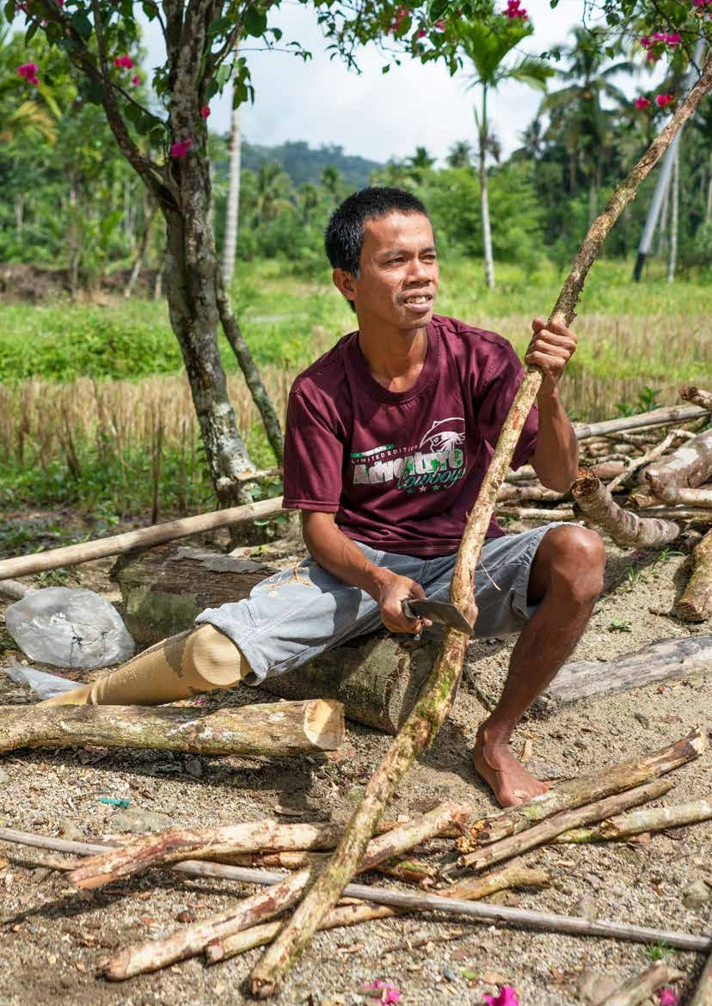

Section 5:

# CONCLUSIONS

The evaluation has found a number of contributions made by MAHKOTA to the process of developing the two implementing regulations to the National Disability Law.

The cause–effect issue identified in the evaluation plan is that the development process for the regulations was not reflecting international best practice, resulting from a lack of awareness of international standards and of the knowledge, skills, and attitude to apply this to the development of regulations. MAHKOTA’s role was, therefore, to support MoSA to address these capacity constraints through technical assistance, facilitating collaboration, advocating to agencies for integration of inclusive social protection, and financially supporting various group meetings. We can see that the hypothesis has held, with some caveats and different emphases. In relation to the elements of the program theory, the conclusions of this evaluation are summarised in the following subsections:

#### Developing the regulations in accordance with international standards

The foundation for incorporating international standards is provided by the National Disability Law and ratification of the CPRD. Concepts for inclusion in the PP *KeSos* were already sufficiently understood, however, in the case of the draft PP HabRehab MAHKOTA’s contribution of bringing in international expertise was significant in building a common understanding of unfamiliar concepts, resulting in redrafting of the regulation.

The regulations are a continuation of the shift from a charity to rights-based approach, and the HabRehab regulation reflects the shift to the social model of disability from the previous medical model of disability. MAHKOTA’s role in this shift is as a supporter, participant, and advocate, rather than driver, as the shift was well underway. MAHKOTA has, however, assisted in building an understanding of this shift through the process, particularly with the technical inputs. While not explicitly identified in terms of international standards in the program theory, the other area of significant contribution to highlight is in relation to implementation of internationally recognised best practice stemming from the *nothing about us without us* principle. At its core, this is MAHKOTA’s strong emphasis on DPO engagement and the attention to inclusion strategies to make this meaningful.

* + 1. **Facilitating collaborative development of the regulations with DPOs**

MAHKOTA’s contribution to this is recognised by all stakeholders interviewed–DPO engagement did not happen because of MAHKOTA, but MAHKOTA made it wider and more productive. MAHKOTA’s role in mediating the interests of different stakeholders to achieve mutual agreement is well regarded. MAHKOTA was careful to be supporting DPO leadership in its engagement with MoSA, rather than taking over.

#### Integrating inclusive social protection into the regulations

The GoI drafting team has ensured inclusive social protection into the PP *KeSos* but it could be argued that this is the purpose of the regulation, and so would have happened anyway. Nevertheless, MAHKOTA did assist the team to find a suitable compromise for the eligibility for social security that reflects the inclusion aspirations of the DPOs. The team’s collaboration with NGO/DPO stakeholders, supported by MAHKOTA, for drafting the PP HabRehab has led to a more robust and fit-for-purpose regulation that has wider support than it did at the start of the process.

#### Justifying to other agencies the basis for the RPP

‘Justifying’ is not the right word, as agencies were on board with the intent of the RPP and the justification is in the mandate provided by the law. MAHKOTA’s contribution in terms of convening and then facilitating

and, when necessary, mediating the input of different stakeholders is, however, a clear contribution to those stakeholders’ agreement with the content of the regulations.

#### MAHKOTA’s funding for group discussions, meetings, and the technical workshop

Funding provided by MAHKOTA was essential for the representative and inclusive nature of the process and for developing a shared understanding of the basis of the regulations–more so the challenging regulation for HabRehab. In terms of other actors, MAHKOTA was the main development partner program involved, but built on various inputs through other processes. As such, the outputs achieved can be seen as those of a team, with the voice of DPOs at the forefront. MAHKOTA’s role was to support that team.

The evaluation did not find evidence that observed changes have been applied to the drafting processes of other regulations as there has not been an opportunity for this to happen in the context of Covid-19, and with the other implementing regulations complete, awaiting signature, or yet to start. There were, however, reported changes in openness, knowledge, and understanding of other stakeholders’ perspectives and an ongoing willingness for future engagement.

### Key Recommendations for Improving Future Related Processes (KEQ 5)

The key recommendations in this section for future similar processes have been confirmed with the participants in this evaluation–with each recommendation followed by a summary of the lesson that has informed it. It is difficult to be more precise about the target of these recommendations, as it will depend on the topic and leadership of the regulations or other policy being developed. The recommendations, therefore, refer to government stakeholders, development partners (such as DFAT and their portfolio programs), and DPOs/other non-government partners who may be working independently or as part of the established disability sector working groups.

#### Recommendation 1: All stakeholders should commit to the centrality of DPO engagement, and support this through openness, transparency, and attention to the requirements of accessible and inclusive participation.

The centrality of DPO views and experiences is essential for applicability of the regulations–and, as the purpose

of the regulations is to guide implementation, this is critical. DPOs are a key mechanism for disseminating information about the regulations through their networks. Participation in the full process builds DPO ownership of the final product and an understanding of the intent, limitations, and different priorities of different stakeholders that they can draw on when explaining the regulations to others.

From this engagement in the full process, DPOs gain capacity and experience to take into future similar processes while resources for convening, and attention to accessibility and inclusivity make this work. These include attention to meeting and accommodation venues, availability of support services and devices (for example, sign language interpreters, adapted information, and communications technology), and meeting agendas and processes. Reflecting on their own experience, AIPJ staff interviewed suggest that development partner programs can play different roles at different times to support DPO engagement. This includes providing funding; embedding technical advisory support within DPOs; operating as a bridge or convening partners to bring in DPOs and others, particularly government stakeholders together; and stepping in to assist in breaking deadlocks, fill capacity gaps, or keep the motivation.

#### Recommendation 2: Development partner programs, such as MAHKOTA, could engage in active facilitation of diverse stakeholder interests in such a way as to strengthen the leadership of mandated agencies and attention to the perspectives of DPOs in the process.

All actors must be clear up front on expectations, commitments, and timeframes. A multi-stakeholder approach

is essential but takes effort. All stakeholders bring their own perspectives and skills to the process–DPOs their first-hand experience; GoI agencies their official mandates; and PSHK and UGM their legal expertise. A neutral

party (as was MAHKOTA in this case) can help to identify mutually acceptable compromise positions, but this requires specific effort–both behind the scenes and in plenary.

Feedback on the draft of this evaluation proposed that more could be done to use these meetings to build a common understanding of concepts, rather than just focusing on agreeing the articles and completing the drafts of the regulations. This would be assisted by external facilitation that balances the inputs of the various groups.41

#### Recommendation 3: All stakeholders should aim for consistent participation and representation from start to finish to the extent possible and ensure newcomers or substitute personnel are briefed on agreements to date.

Having a core group that follows the full process would be ideal–challenges were identified with changes in representatives. The first challenge was because ‘*there were people who didn’t participate one day and then the next day they did, and didn’t agree, and so (the draft) had to be dismantled again*.’42 Secondly, challenges were also noted in relation to having the right agencies in the room for regulations that require multi-sectoral implementation. In the case of the draft HabRehab regulation this included the Ministry of Education and Culture, MoSA, the Ministry of Health, and the Ministry of Labour. These ministries were not all able to attend the same meetings.43

It is strongly recommended that development partner programs provide consistent support through a designated staff member, as happened in this case. An upfront statement of commitment, and an outline of the nature and flexibility of support available would be welcomed by GoI stakeholders to assist coordination across different projects, programs, and development partner initiatives.

#### Recommendation 4a: DPOs and disability working groups (*pokja)* should continue to develop their understanding of government policy making to improve their own ability to identify mutually acceptable positions.

**Recommendation 4b: All parties should invest in proactive research on the underlying conditions relevant to development and implementation of upcoming regulations.**

As suggested by FH-UGM, this can include regulatory studies that build understanding of the drivers for the

different actors, and field studies to provide the drafting team with accurate information about the implementation context. This will also mitigate potential imbalances in the process whereby physical consultations are dominated by a few usually Java-based stakeholders. Research contributes to the inclusiveness of information and knowledge when direct involvement from different regions is not possible.44

In the absence of sufficient financial support from other sources (e.g. GoI), an extensive consultation and development process is likely to require the financial and possibly technical support of external partners such as MAHKOTA. This evaluation shows that some progress has been made in developing mutual understanding of the realities of the policy context, but greater understanding of government parameters, motivations, and decision making will assist DPOs to be well-prepared and realistically propositional in future engagements.

#### Recommendation 5a: It is suggested that the GoI open the final stages of the regulation drafting process to representatives of DPOs, at least as observers.

**Recommendation 5b: If it is not possible for at least one DPO representative to participate at this stage, then it is recommended that non-government stakeholders work with government representatives prepared to act as champions to advocate for the full draft regulation on behalf of the NGO/DPO stakeholder group, and to report back on sticking points and requested changes.**

41 Stakeholder feedback FH-UGM, November 2020.

42 Stakeholder interview, SEHATI, August 2020.

43 Stakeholder feedback PSHK, November 2020.

44 Stakeholder feedback FH-UGM, November 2020.

Reduced or different participation at the later stages when, in accordance with GoI requirements for the finalisation of regulations, the draft is presented to other GoI stakeholders and ‘harmonised’ to ensure synchronicity with existing legislation, caused some concerns. While non-government stakeholders recognise GoI’s established processes for the inter-ministerial meeting (PAK), the lack of transparency at this final stage, and the potential for last minute changes, is not felt to be ideal, especially after the shared journey to get there.

*… it could be that those who participated in the inter-ministerial meeting (PAK) process were people who were not intensively involved in the process of preparing the RPP from the start … (and) did not follow the intense debating process that we did… perhaps we have agreed with the Ministry of Social Affairs on the draft regulation (RPP), but then when there is the PAK process and civil society are not involved, we do not know what happened in there: what arguments arise, what kind of negotiations there are, what kinds of deals emerge, these are what we find difficult to access.45*

#### Recommendation 6: Where appropriate and requested by relevant Indonesian stakeholders, development partners and their programs, such as MAHKOTA, should consider supporting ongoing capacity development at national and regional levels and, where possible, identify needs and arrange this early in the process.

Interviewees most commonly highlighted the need for capacity development, either of specific stakeholders,

or of the DPO regional network (recommended by YAKKUM and SEHATI), by ongoing provision of consultancy support (requested by MoSA), and to build MoSA’s leadership for development and implementation of these and other regulations (UGM). High quality and targeted capacity development is invaluable when concepts need to be better–and jointly–understood. This lesson is demonstrated by the pivotal role played by the delivery of the social protection and habilitation/rehabilitation workshop to break an extended deadlock.

It also raises the question of whether such needs can be identified and addressed early in the process so that the momentum that they bring happens at the right time. Linked to this, comparison of the experience of developing, and finalising the PP *KeSos*, and that of the draft PP HabRehab show the difficulty that can arise when regulations are looking at new or unfamiliar concepts (HabRehab) as opposed to when the technical content is understood and well researched (*KeSos*). This affects the readiness and ability of the government to engage with different stakeholders and perspectives. As a Bappenas representative noted, the ministry needs to be clear on its own position first.46

45 Stakeholder interview, YAKKUM, August 2020.

46 Stakeholder interview, Bappenas 2, May 2020.

## Appendix 1: People Interviewed

|  |  |
| --- | --- |
| **Ministries/Institution**s | **Name and Position** |
| Ministry of Social Affairs | Tina Camelia  Compiler of Social Service Materials, Directorate of Social Rehabilitation of People with Disability |
| Evy Flamboyan  Head of Legal Decree Drafting, Legal Bureau |
| Bappenas | Dwi Rahayuningsih  Planner, Directorate of Poverty Reduction and Social Welfare |
| Ely Dinayanti,  Planner, Directorate of Poverty Reduction and Social Welfare |
| State Secretariat | Aci Ariesta  Head of Sub-division for Disaster Management, Poverty Alleviation and Social Protection |
| Presidential Staff Office | Sunarman Sukamto  Associate Expert, Deputy V KSP |
| **Jakarta Working Group** | |
| *Pusat Studi Hukum & Kebijakan (PSHK)*  *Indonesia* (Indonesian  Policy and Legal Studies Centre) | Fajri Nursyamsi  Director of Advocacy and Networks |
| **Yogyakarta Working Group** | |
| Gadjah Mada University | Tody Sasmita  Lecturer, Faculty of Law |
| SAPDA | Nurul Saadah Andriani Director |
| Ayatullah RK Program Coordinator |
| YAKKUM *Pusat Rehabilitasi* (Rehabilitation Centre) | Ranie Ayu Hapsari  Project Manager, *Program Peduli*, Disability Pillar, Rehabilitation Centre |
| *Perkumpulan Disabilitas* (Disability Collective) SEHATI Sukoharjo | Edy Suprianto Head |
| **Development Programs** | |
| **MAHKOTA** | Diah Ayu N.H  Senior Social Protection Program Officer |
| AIPJ | Lia Marpaung Joni Yulianto |

## Appendix 2: Program Theory for MoSA Development of Implementing Regulations and MAHKOTA Investment

Inclusivity accommodated at National level

* Increase awareness of the concept of disability in Gol agencies
* Changes of approach (from charity based to human-rights based)
* Increase commitment from Government of Indonesia
* Changes in commitment to develop 8 Government Regulations rather than 1 Master Regulation.
* The finalisation of Government Regulation is max 2 years.

**Shift in Norms**

Potential alternative explanations:

* NO capacity gap.
* Capacity gap filled by Gol agencies.
* Other DFAT-funded programs (e.g. AIPJ2, Program Peduli).
* Organisations supporting PwD.
* Other development partner programs.

Risks:

* S&K gaps weren’t Identified correctly
* Attitude of staff has not changed.
* Changes in MoSA at Ministerial leveI or managerial level =>change in direction and priorities.
* Loss of funds for meetings and focus groups.

Sustainable Development Goals ASEAN Enabling Masterplan 2025: Mainstreaming the Rights of Persons with Disabilities

**Regulation No. 11/2009 on Social Welfare**

**Regulation No. 19/2011 on the Ratification of the Convention on the Rights of People with Disability**

**Regulation No. 8/2016 on People with Disabilities**

National Medium-Term Development Plan 2015 -2019

**MAHKOTA investment addresses capacity gaps**

Awareness of international standards. Knowledge, skills and attitude to:

**MAHKOTA influence on the process**

* Develop PP in accordance with international standards.
* Facilitate collaborative development of the RPP with DPO.
* Integrate inclusive social protection into Regulation.
* Justify to other agencies the basis for the RPP.

Resources to:

* Fund focus groups and meetings.

**MAHKOTA investment enables MOSA RPP development process to reflect international good practice**

RPP development increasingly reflects international good practice & creates space to work with CSO and DPO collaboratively.

Legend National level Agency level MAHKOTA

* Draft Government Regulation is finalised
* President signed the Government Regulation

**Policy Change**

* Dissemination to Provincial and District Governments
* Provincial and District/City
* Governments implement new policy.

**Policy Implementation**

* Preparation in accordance with division of roles within MoSA.
* Collaboration between DPOs and Agencies/Ministries and Working Groups
* Bappenas
* State Secretariat
* President’s Staff Office
* PMK

**Preparation of Agency Regulation**

## Appendix 3: Timeline of MAHKOTA Support to Drafting of Regulations

**2017**

**Q4**

**2018**

**Q1**

**2018**

**Q2**

**2018**

**Q3**

**2018**

**Q4**

**Plenary meeting between MoSA and MoLHR**

on the final draft of PP KeSos (Sep 2018)

Meeting on Harmonisation of RPP KeSos (Jul 2018)

Small Team Meeting on Harmonisation of RPP KeSos (Aug 2018)

RPP KeSos drafting workshop.

Discussion & preparation of draft RPP HabRehab for people with disability (Dec 2017)

Public consultation for RPP HabRehab at Bandung (organised by MoSA) (Oct 2018)

**Workshop for disability facilitators** in Jakarta (organised by MoSA) (Oct-Nov 2018)

**Two-day meeting facilitated by SAPDA** and attended by representatives of KSP, AIPJ2, MAHKOTA and NGOs to review the latest draft

PP HabRehab (Oct 2018)

Small Team Meeting on Harmonisation of RPP KeSos (Oct-Nov 2018)

Preparation Meeting for the Inter-ministerial meeting for RPP KeSos for people with disabilities (Apr 2018)

Internal Meeting of Legal Bureau & Dir. Social Disability Rehabilitation (Mar 2018)

No submission by Bappenas to BPHN for RPP HabRehab

|  |
| --- |
| RPP HabRehab drafting workshops (6-7, 18, 21 Feb 2018)  Discussion on RPP HabRehab Pokja version Comparison of content RPP HabRehab Pokja version with Dec version 2017 |
| HabRehab draft finalisation workshop Merging the RPP Pokja & MoSA versions Discussion per Articles (Mar 2018) |
| Meeting on draft finalisation and preparation for Inter-ministerial Meeting (Apr 2018) |
| Inter-ministerial meeting on the final draft of PP HabRehab (May 2018) |

|  |
| --- |
| **RPP Social Welfare** |
| RPP KeSos drafting workshop – content discussion (Dec 17) |
| RPP KeSos drafting workshop Discussion on Articles No. 1-34 |
| RPP KeSos drafting workshop (Feb 26, 2018) Presentation on Concept & Implementation of Social Protection for people with disability Discussion on Article No. 35 – addition of articles on Section VII on M&E (Jan 18) |
| Finalisation workshop draft RPP KeSos for people with disability (Feb 2018) |

**RPP HabRehab**

Inter-ministerial meeting on the final draft of PP KeSos (May 2018)

Final harmonisation of RPP KeSos for people with disability (organised by MoSA) (Oct 2018)

Training on Social Protection and Inclusion HabRehab for people with disability (Dec 2018)

**2019**

**Q1**

**2019**

**Q2**

**2019**

**Q3**

**2020**

**Q1**

**2020**

**Q2**

**2020**

**Q3**

**2020**

**Q4**

Infographic Production on PP KeSos

Limited discussion on reflection of process PP No. 52/2019 on Social Welfare for people with disability (initiated by SAPDA & UGM). The event aimed to measure the quality of the content of PP No. 52/2019 on Social Welfare for people with disability and the participation

(cross-party coalition) process in the preparation of PP No. 52/2019 on Social Welfare for People with Disability (Jan 2020)

RPP HabRehab has been signed on behalf of President of Republic of Indonesia,

by Deputy of Law & Regulation – State Secretariat (PP No.75/2020 on Habilitation and Rehabilitation for People with Disability) (15 Dec 2020)

Discussion & coordination with officials from Dir. Social Rehabilitation for people with disability – MoSA on the Pocket Book of PP KeSos foreword & publication.

Finalisation of the videographic, pocketbook & Powerpoint

RPP KeSos has been signed on behalf of President of Republic of Indonesia, by Deputy of Law & Regulation – State Secretariat (PP No. 52/2019 on Social Welfare for Persons with Disability)

(July 2019)

Synchronisation of RPP HabRehab Pokja version with Harmonised version of 9-11 Jul 2018

Due to Covid-19 → delay in the process of RPP HabRehab

|  |
| --- |
| **RPP Social Welfare** |
| Small Team Meeting on Harmonisation of RPP Social Welfare (Jan 2019) |
| Plenary Meeting on Harmonisation (Jan 2019) |
| RPP KeSos has been submitted to State Secretary to be passed (Apr 2019) |

|  |
| --- |
| **RPP HabRehab** |
| Follow-up workshop on drafting the HabRehab regulation (Apr 2019)   * Synchronisation of HabRehab definition in accordance with social protection   training & inclusive HabRehab for people with disability   * + Discussion of Articles 1-17 |
| MAHKOTA and MoSA conduct a joint workshop on drafting the RPP HabRehab for people with disability (May 2019)   * Synchronisation of “H” definition   + Discussion of Articles 1-17 |
| MoSA supported by MAHKOTA conducted a workshop on Drafting RPP HabRehab (Jul 2019)  Discussion on Articles 18-43 |

Launching PP KeSos (MoSA) & PP Planning/ Masterplan (Bappenas) for Persons with Disability (Dec 2019)

**2019**

**Q4**

Inter-ministerial Meeting (Oct 2019)

* Finalise the contents of all articles and submit the final version for harmonisation to the Ministry of Law and Human Rights

|  |  |
| --- | --- |
| Harmonisation (second) of RPP HabRehab (May 2020)  Attended by MoSA and MoLHR | |
| Harmonisation (second) of RPP HabRehab (Jul 2020). Attended by MoSA and MoLHR | |
| Supported/funded by MAHKOTA | Supported/funded by MoSA |
| Collaboration funding between the event organiser and the participants | |

## Appendix 4: Stakeholder Mapping

|  |  |
| --- | --- |
| **Stakeholders** | **Roles & Responsibility** |
| MoSA | Mandated ministry for development and leadership on implementation of the regulations on social welfare and habilitation and rehabilitation. |
| Bappenas | Technical expertise related to poverty and social protection. Mandated ministry for linked regulation on planning, organisation, and evaluation (PP No. 70/2019). |
| *Sekretariat Negara* (State Secretariat) | Very important and powerful role as required to approve the substance of the draft regulation before it proceeds to ministerial approval and final signing. |
| KSP | Role in strengthening the substance. KSP also acts as a link for ministries and agencies involved. Can offer a short-cut resolution of intractable problems. |
| *Kementerian Hukum dan HAM* (Ministry of Justice and Human Rights) | The deciding ministry always involved in all stages including the llharmonisation process. |
| *Kementerian Koordinator PMK* (Coordinating Ministry for Human Development and Cultural Affairs) | Has a role similar to the KSP to ensure that discussion of the draft regulations is inclusive of the poor and persons with disability. Has a role in communicating the progress of all draft regulations. |
| *Kementerian Pemberdayaan Perempuan & Perlindungan Anak* (Ministry of Women’s Empowerment and Child Protection) | Provides technical review. |
| *Kementerian Tenaga Kerja*  (Ministry of Labour) | Provides technical review. |
| *Kementerian Kesehatan* (Ministry of Health) | Provides technical review. |
| POKJA (*Kelompok Kerja*) (Working Group) Jakarta and Jogjakarta | NGO/DPO-led group that provides technical review and support, and facilitates coordination and collaboration among NGO/DPO and GoI stakeholders. |
| *Perhimpunan Jiwa Sehat* (PJS) (Mental Health Association) | Involved in drafting; key responsibility for the substance of the regulation. |
| *Pusat Studi Hukum & Kebijakan Indonesia* (PSHK) |
| *Pusat Pemilihan Umum Akses Penyandang Cacat* (PPUA) (Centre for Election Access for People with Disability) | Engagement through Jakarta POKJA. Intermittent attendance at meetings and events. |
| *Perkumpulan Penyandang Disabilitas Indonesia* (PPDI) (Indonesian Association of People with Disability) |

|  |  |
| --- | --- |
| **Stakeholders** | **Roles & Responsibility** |
| *Himpunan Wanita Disabilitas Indonesia* (HWDI) (Association of Indonesian Women with Disability) |  |
| *Gerakan Kesejahteraan untuk Tuna Rungu Indonesia (Movement for the Welfare of Deaf Indonesians) (Gerkatin)* |
| ALPHA I (*Asosiasi Alumni Program Beasiswa Amerika-Indonesia*) (Indonesia-America Association of Scholarship Program Alumni) |
| UCPRUK (United Cerebral Palsy Wheels for Humanity) |
| CBM Indonesia |
| PSBN (*Panti Sosial Bina Netra*) Tamiyat Bekasi (Residential Home for the Blind) |
| *Rumah Autis Tanjung Priok* (Autism House Tanjung Priok) |
| Mimi Institute |
| Pusat Layanan Juru Bahasa Isyarat Indonesia (PLJ) |
| UGM | Involved in drafting; key responsibility for the substance of the regulation. |
| Sentra Advokasi Perempuan Difabel dan Anak (SAPDA) |
| YAKKUM (Peduli parter) | Technical input in relation to habilitation/rehabilitation. |
| SEHATI Sukoharjo47 |
| SIGAB (*Sasana Inklusi dan Gerakan Advokasi Difabel*) (Institute for Inclusion and Advocacy of People with Disability) | Small involvement, active in justice issues. |
| AIPJ2 | Initial involvement in meetings about PP *KeSos* but withdrew as more relevant to MAHKOTA’s program objectives and agreed work plan; ongoing partnership with SIGAB, involved in drafting PP No. 39/2020 PP on Decent Accommodation in justice process. |

47 An organisation for people with disability in Sukoharjo.

## References

Edwards, N. 2014. “Disability Rights in Indonesia? Problems with Ratification of the United Nations Convention on the Rights of Persons with Disabilities.” *Australian Journal of Asian Law*, 15:1.

Mayne, J. 2001. “Addressing Attribution Through Contribution Analysis: Using Performance Measures Sensibly.”

*Canadian Journal of Program Evaluation* 16(1):1-24.

Patton, M.Q. 2008. “Utilization-Focused Evaluation.” Saint Paul: SAGE Publishing.

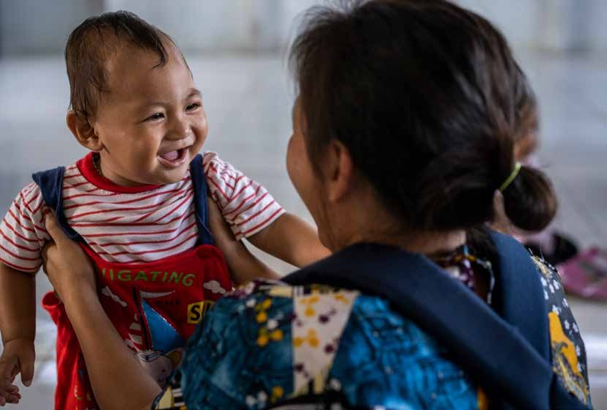

Photo by Fauzan Ijazah for MAHKOTA

1. Australia has a longstanding commitment to disability inclusion. In Indonesia this includes support for AIPJ Phases 1 and 2, and Program Peduli. AIPJ has a long history of supporting DPOs to engage in legislative and policy development, including the development of the National Law on Disability.