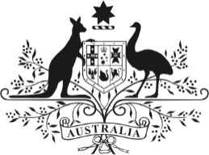 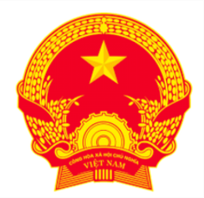

**Joint** Communiqué

## Fourth Australia-Vietnam Economic Partnership Meeting

**Held in Adelaide on 17 October 2024**

**Joint communiqué between** Minister for Trade and Tourism, Senator the Hon Don Farrell, and His Excellency Dr Nguyen Chi Dung, Vietnamese Minister of Planning and Investment

1. Australia’s Minister for Trade and Tourism, Senator the Hon Don Farrell, and Vietnam’s Minister of Planning and Investment, His Excellency Dr Nguyen Chi Dung, co-chaired the fourth Australia-Vietnam Economic Partnership Meeting in Adelaide on 17 October 2024.
2. The Ministers observed that the Prime Ministers’ declaration in March 2024 of a Comprehensive Strategic Partnership (CSP) between Australia and Vietnam reflected the strategic trust and shared ambitions of the two countries. The Ministers welcomed new opportunities to increase economic cooperation as we face common challenges and opportunities including climate change, energy transition and supply chain diversification.
3. The Ministers acknowledged the continuing importance of the *Australia - Vietnam Enhanced Economic Engagement Strategy* and welcomed its achievements to date. The Ministers noted the potential to further boost trade and investment through initiatives under *Invested: Southeast Asia Economic Strategy to 2040*.
4. The Ministers were encouraged by impressive 79 per cent growth in two-way trade over the last three years to $26.2 billion in 2023. The Ministers discussed potential opportunities to increase investment ties between Australia and Vietnam, working together to resolve regulatory barriers and maximise commercial opportunities.
5. The Ministers discussed the significant contribution of Australia’s development program to supporting Vietnam’s green and inclusive growth. The Ministers expressed their shared commitment to continuing a high quality and respectful development partnership, ensuring timely approvals and implementation to deliver on our CSP commitments.
6. Both Ministers also discussed international issues and reiterated their shared commitment to global economic integration and a rules-based trading system, ASEAN centrality and a region which is peaceful, stable and prosperous and in which sovereignty is respected.
7. Both Ministers reaffirmed the strategic importance of the Economic Partnership Meeting in the bilateral economic architecture. The Ministers noted the creation of a new Trade Ministers’ Dialogue and Energy and Minerals Dialogue in 2024, augmenting the shared effort towards greater economic engagement.
8. The Ministers welcome progress towards concluding the amending protocol to the Air Services Agreement between Australia and Vietnam.   
   Both countries looked forward to the next Economic Partnership Meeting, to be hosted by Vietnam in 2025.