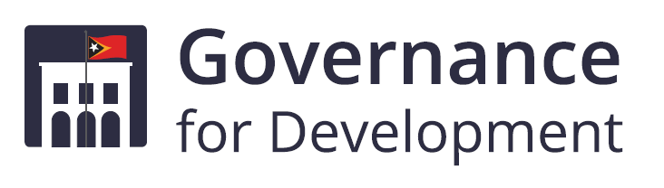
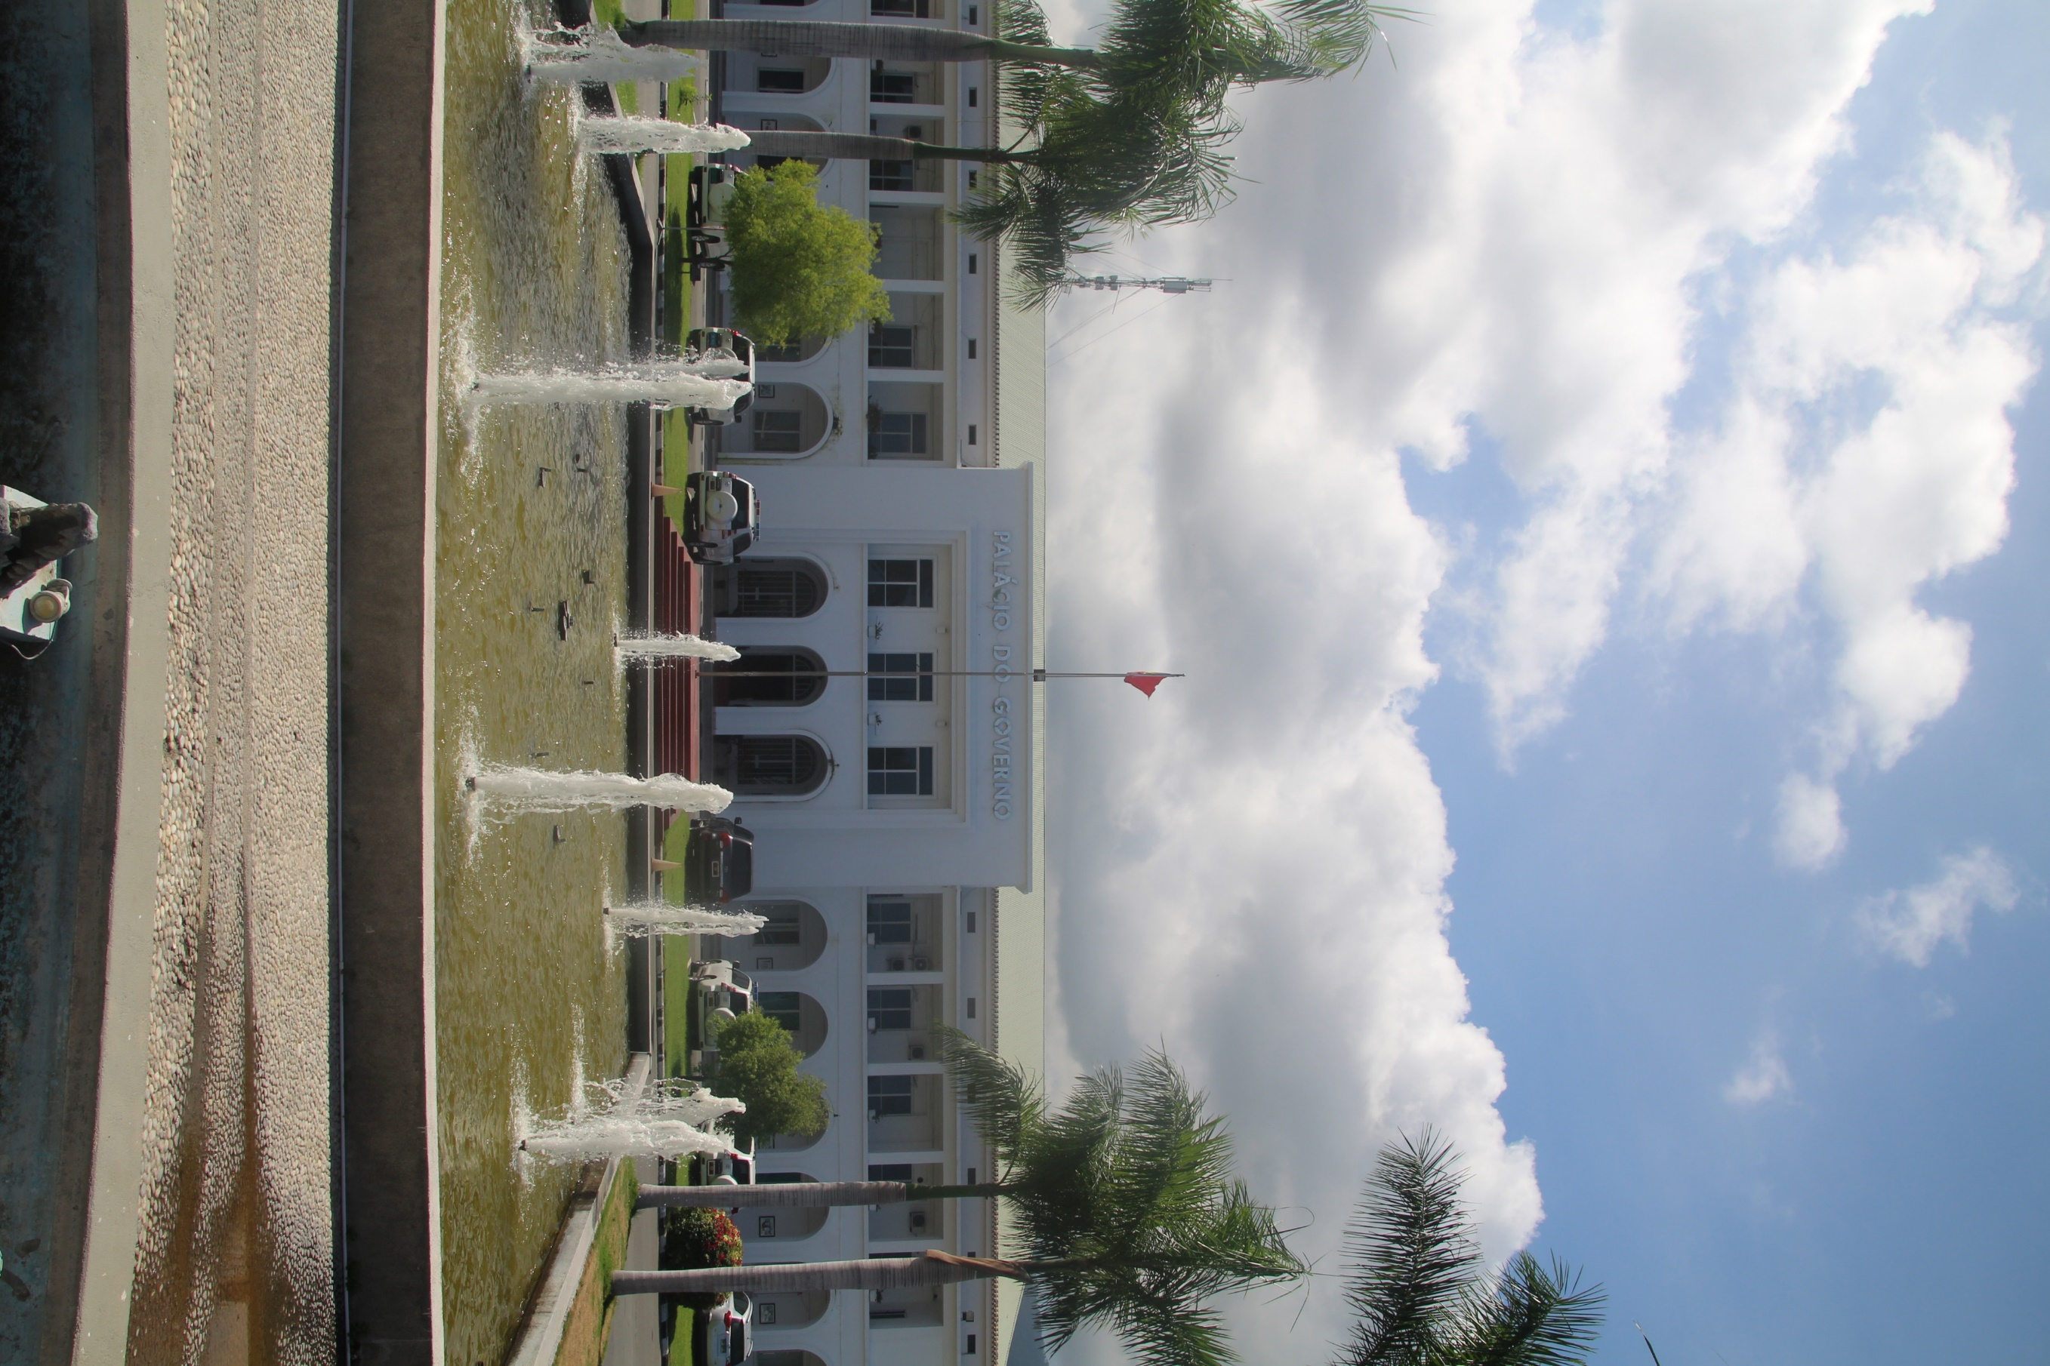
GfD Completion Report 2014–2022
Submitted to DFAT – February 2022

Preferred citation: Timor-Leste Governance for Development GfD Completion Report 2014–20222,
For further information, please contact:
GfD Contractor Representative, Gavin Wyngaard
Level 4, 501 Swanston Street, Melbourne, Victoria 3000 Australia
+61 3 9937 0751
Gavin.wyngaard@cardno.com

Acknowledgements
This document is produced by Cardno solely for the benefit and use by the client in accordance with the terms of the engagement. Cardno does not and shall not assume any responsibility or liability whatsoever to any third party arising out of any use or reliance by any third party on the content of this document.
This publication has been funded by the Australian Government through the Department of Foreign Affairs and Trade. The views expressed in this publication are the author’s alone and are not necessarily the views of the Australian Government.

The Governance for Development Program is supported by the Australian Government and managed by Cardno.

Contents
Executive Summary vi
1 Introduction, context and program history and evolution 1
1.1 Completion Report purpose and structure 1
1.2 Summary timeline of key events in GfD Context 2
1.3 Investment context analysis 2
1.4 Program Design, Monitoring and Evaluation 3
2 Achievement against End of Program Outcomes across the life of the Program 1
3 Program progress, achievements, and lessons – Phase One 2014-2017 2
3.1 The GfD management model 2
3.2 Cardno’s Support Services role 3
3.3 Adviser activities and achievements 6
3.4 Lessons learned from Phase One 10
4 Progress Evaluation – Phase Two and GfD Transition Program 11
4.1 Effectiveness 12
4.2 Efficiency 27
4.3 Relevance (Including Key Evaluation Question 8: Using the right approach to maximise the long-term impact of the program) 31
4.4 Gender and Social Inclusion 33
4.5 Sustainability 36
4.6 GfD’s Monitoring Evaluation and Learning Plan 2019 - 22 37
4.7 Risk Management and Safeguards 39
4.8 COVID-19 40
5 Reflection and lessons learned 42
6 Priority Recommendations 46
6.1 Program 46
6.2 Delivery 46
6.3 Management and program governance 47
Annex 1 Historical and political context and its impact on GfD 48
Annex 2 Detailed Theory of Change/ Theory of Action in Timor-Leste Governance for Development Investment Design 50
Annex 3 GfD’s Theory of Change and Work Area Theory of Change diagrams 2019 - 2021 51
Annex 4 Organisational Chart as at 31 January 2022 55

Abbreviations and Acronyms
ABS Australian Bureau of Statistics
AACTL Civil Aviation Authority Timor-Leste
ADB Asian Development Bank
AIP Aid Investment Plan
AMP Alliance for Change and Progress
ANATL Air Navigation Administration of Timor-Leste
ANC National Communication Authority
BNCTL Banco Nacional de Comércio de Timor-Leste
Cardno Cardno Emerging Markets
CDRP COVID-19 Development Response Plan
CG Constitutional Government
CIGC Integrated Crisis Management Centre
CNRT National Congress for Timorese Reconstruction
CSC Civil Service Commission
DBFTL Dalan Ba Futuru Timor-Leste
DBS Direct Budget Support
DC Desired Change
DFAT Department of Foreign Affairs and Trade
DPO Disabled Persons Organisation
EOPO End of Program Outcomes
ERC Economic Recovery Commission
ERP Economic Recovery Plan
FIFO Fly In Fly Out
FM Frenti Mudança
FRETILIN The Revolutionary Front for an Independent Timor-Leste
GESI Gender Equality and Social Inclusion
GfD Governance for Development (and Governance for Development Transition Program)
GfDSS GfD Support Services
GoTL Government of Timor-Leste
GRB Gender Responsive Budgeting
HR Human Resources
HRM Human Resources Management
ICT Information and Communications Technology
IFC International Finance Corporation
IGfDSS Interim Governance for Development Support Services
INO Intermediate Outcome
JSMP Judicial System Monitoring Programme
KEQ Key Evaluation Question
KHUNTO Enrich the National Unity of the Sons of Timor
LES Locally Engaged Staff
LRC Law Reform Commission
LTA Long Term Adviser
M&E Monitoring and Evaluation
MCAE Office of the Minister for the Coordination of Economic Affairs
MECAE Office of the Minister of State for the Coordination of Economic Affairs
MEL Monitoring, Evaluation and Learning
MELF Monitoring, Evaluation and Learning Framework
MELP Monitoring, Evaluation and Learning Plan
MLD Mini Learning Dialogue
MoF Ministry of Finance
MoH Ministry of Health
MRLAP Ministry for Legislative Reform and Parliamentary Affairs
OECD Organisation for Economic Cooperation and Development
OPM Office of the Prime Minister
OSA Other Significant Achievement
PAF Performance Assessment Framework
PBA Program Budgeting Adviser
PBB Program Based Budgeting
PCM Presidency of the Council of Ministers
PD Democratic Party
PEA Political Economy Analysis
PFM Public Financial Management
PMIS Personnel Management Information System
PSCDP Public Sector Capacity Development Program
R&R Review and Reflection
RAEOA Região Administrativa Especial de Oecusse Ambeno
SDP Strategic Development Plan
SEII Secretary of State for Equality and Inclusion
SERVE Servico de Registro e Verifikasaun
STA Short Term Adviser
SQ Sub Question
SSC Story of Significant Change
TAF The Asia Foundation
The Embassy Australian Embassy in Dili
ToC Theory of Change
UPMA Monitoring, Evaluation and Planning Unit
USAID United States Agency for International Development
VfM Value for Money
WDPTL Workforce Development Program Timor-Leste
WEE Women’s Economic Empowerment
WH&S Workplace Health and Safety
WTO World Trade Organisation

Executive Summary
The Governance for Development (GfD) Program was an eight-year, A$72 million governance program, implemented by Cardno Emerging Markets (Australia) Pty Ltd (Cardno). The program ran from mid-2014 until 30 June 2021, with a one-year $7.5 million transition phase extending the program until 30 June 2022. GfD worked towards achieving a stable and prosperous Timor-Leste by means of economic development and better service delivery. It had two End-of-Program Outcomes (EOPOs): ‘Government of Timor-Leste (GoTL) makes evidence-based decisions and policy’, and ‘GoTL improves implementation of policy and delivery of services’ by working through three areas of reform: Public Financial Management (PFM), Public Administration, and Economic Development. It built on the Interim Governance for Development Support Services (IGfDSS) program, which ran from August 2012 to April 2014. The interim program, also implemented by Cardno, served as an opportunity to trial the innovative approaches that would be included in the final GfD design, and to undertake foundational activities that would be continued in the long-term program.
Program design and evolution
The design of the GfD program was largely completed under AusAID, prior to its merger with the Department of Foreign Affairs and Trade (DFAT) in 2013. It was anticipated in the design that the Australian Embassy in Dili would have a strong hands-on role and would directly manage implementation of the GfD program. Under the first phase of the program (2014 – 2017) the role of Cardno was focused largely on adviser management and support, operations, and logistics. However, the intended role of the Embassy was impacted by significant reductions in budget and resources in 2014, placing heavy demands on the Counsellor and First Secretary who had primary responsibility for the management of the program. As a result, the DFAT Timor-Leste Desk (Desk) in Canberra assumed a significant role, including managing the Head Contract between DFAT and Cardno, and becoming involved in Monitoring and Evaluation (M&E), Gender Equality and Social Inclusion (GESI) and engagement with grant partners. An effective triangular relationship between the Embassy, Desk and Cardno ensured that the program continued to deliver under circumstances that were significantly different from those envisaged when GfD was first designed.
Under the second phase of the program from mid-2017, a number of changes were made to the role of the managing contractor, primarily due to the growing workload of Embassy staff. Cardno assumed responsibility for the contracting and management of grants, other than those with multilateral organisations, and the position of Deputy Director of Operations was upgraded to Director of Operations. Further changes were made in late 2018 when the position was changed to GfD Team Leader, with an associated increased role in program strategy and input into program decisions. A second international management position, Program Coordinator, was also created, with lead responsibility for the program’s M&E. Through these changes the strong ‘one team’ approach between Cardno and the Embassy continued.
The program’s Theory of Change (ToC) also evolved. The original design included six EOPOs, driving towards a single goal of ‘Poverty reduction in Timor-Leste through economic development and delivery of services’, under two pillars: ‘Fiscal and Economic Policy’, and ‘Improved Services’, the latter encompassing PFM and Public Administration. In early 2018 the ToC was significantly revised. The updated ToC included a new Program Goal: ‘A stable and prosperous Timor-Leste’ in alignment with the Australian aid program’s goal in Timor-Leste, underpinned by ‘Economic Development’, and ‘Better Service Delivery’, and just two EOPOs. Further adjustments were made to the ToC in 2019. The EOPOs were changed slightly to the following:
- Government makes evidence-based policies and decisions
- Government improves implementation of policies and delivery of services
Rather than having a separate ToC with separate EOPOs for each of the program’s three work areas – PFM, Economic Policy and Public Administration – a decision was made to maintain consistent EOPOs and Intermediate Outcomes across all three workstreams, with foundational activities, influencing activities and immediate outcomes being developed specific to each work area. This approach reinforced cohesion across the program, and synergies between workstreams.

Program context
GfD supported a total of four different Timor-Leste governments with four different Prime Ministers and five different coalitions. Despite political differences, the overarching goal of most of these governments was to achieve the outcomes presented in the national Strategic Development Plan (SDP) 2011 - 2030. Notwithstanding this continuity in commitment to the SDP, GfD’s investment context changed significantly over the life of the program, particularly when there was a change in Government, coalition arrangements, or Prime Minister, necessitating GfD to assess the new context and review entry points to continue supporting the implementation of the Government's reform agenda and the program’s strategic objectives. The advent of COVID-19 in early 2020 further impacted significantly on the context within which the program was being implemented.
Phase One
Cardno’s primary focus in Phase One was on operations and logistics, human resource management, financial management and Workplace Health and Safety (WH&S) as well as the integration of GESI into program management and delivery, and the establishment and implementation of an M&E system.
Robust processes for the recruitment and selection of advisers were put in place, and a ‘one stop shop’ was established through which all team members could submit administrative documents. A performance management system was implemented, along with a program of staff development and training. Feedback from Review and Reflection (R&R) workshops towards the end of the first phase indicated a generally high level of satisfaction with the GfD advisers and their ability not only to provide high quality technical advice, but also to strengthen capacity of Timorese across the civil service. High quality administrative and logistics systems ensured that advisers and counterparts received the support that they needed in a timely and cost-effective manner. The program paid particular attention to WH&S, not only striving to ensure that all GfD team members were working in a safe and healthy environment, but also building the understanding of GoTL counterparts of the importance of paying attention to WH&S.
M&E remained a challenge throughout the first phase of the program. The initial M&E plan, developed by an international adviser, was refined with significant input from Desk and the Embassy, with the support of a national M&E consultant. While program quarterly reports provided a comprehensive narrative of activities undertaken under each workstream and attempted to relate activities and achievements to program outcomes, the linkages were not always clear, and it was difficult to get a cohesive picture of the effectiveness of activities in progressing towards anticipated program outcomes. A series of useful Monitoring, Evaluation and Learning (MEL) activities were, however, undertaken, including both planning and Political Economy Analysis (PEA) sessions and annual R&R workshops involving GoTL counterparts and a range of other stakeholders. These formal planning and review processes were an important element of the program’s governance processes and were complemented by weekly program discussions involving the Cardno and Embassy GfD teams as well as Desk, which provided a forum to discuss the political context and its impact on the program on a real time basis.
Although decisions around program strategy were the responsibility of the Embassy, the Cardno-managed GfD Support Services (GfDSS) influenced program achievements through its ability to select and support a high-quality team of advisers and to provide them with the support they needed to perform their roles effectively. The early years of GfD’s PFM support focused on Direct Budget Support (DBS) through the Ministry of Finance (MoF). However, a change of Government in early 2015 changed the institutional and political context of DBS significantly. Responsibility for GoTL’s annual budget was transferred from MoF to the newly-formed Planning, Monitoring and Evaluation Unit (UPMA) in the Office of the Prime Minister (OPM). Around the same time MoF did not achieve some of the agreed targets in the DBS monitoring matrix, leading to DBS being terminated. In parallel DFAT-Canberra terminated its contributions to the Australia-World Bank Strategic Partnership Timor-Leste Trust Account on the basis that the Analytical and Advisory Activity was underperforming. GfD’s PFM support shifted to UPMA in 2015, and GfD entered into a partnership with the Organisation for Economic Cooperation and Development (OECD), which supported GoTL to develop the GoTL Budgetary Governance Roadmap. The roadmap was approved by Council of Ministers (CoM) in 2017, setting out a long-term, sequenced approach to budgetary governance and PFM reform, including the implementation of Program Based Budgeting (PBB), development of a Medium-Term Expenditure Framework, and civil service capacity building reforms. GfD-funded advisers in UPMA supported initial steps in the implementation of this roadmap, including the establishment of a PBB structure and associated costing models, the development of a Gender Responsive Budgeting (GRB) policy note and incorporation of gender markers into PBB guidelines, and the development of an integrated planning and budgeting management information system, Dalan Ba Futuru Timor-Leste (DBFTL).
GfD’s progress in relation to Economic Policy during the first phase of the program was hampered by limited Embassy resources, the resource-intensive engagement associated with DBS, and tensions in Australia’s relationship with Timor-Leste as a result, in part, of negotiations around the Timor Sea. The slower than anticipated pace of engagement meant that GfD focused on where it could get traction, rather than necessarily where it was anticipated in the original design, or where it was most strategically influential. However, a number of pieces of policy and legislation in relation to the Business Enabling Environment, accession to the World Trade Organisation (WTO) and economic diversification more broadly, were progressed through a combination of advisory support and inputs from GfD’s grant partners Monash University and the Australian Bureau of Statistics (ABS). Through a grant agreement with the Asia Development Bank (ADB), GfD also commenced support for the transformation of the country’s Government-owned National Commercial Bank, Banco Nacional de Comércio de Timor-Leste (BNCTL), to become a fully licenced commercial bank. In early 2017 GfD appointed the program’s first adviser to the Civil Aviation Authority Timor-Leste (AACTL), and with their support, the National Civil Aviation Policy was approved by the CoM in May 2017, providing a national vision and direction for civil aviation in Timor-Leste. GfD also provided two international advisers to the National Communication Authority (ANC) to support diversification in the telecommunications sector and to develop the mandate of ANC as the telecommunications regulator. However, while some progress was made in relation to institutional capacity building and the development of a number of technical manuals, the bigger aim of establishing ANC as an effective independent regulator was impeded by internal politics, and a decision was made to withdraw support to ANC in 2017.
The focus of GfD’s Public Administration support during Phase One was on Human Resource Management (HRM) reform through support to the Civil Service Commission (CSC). GfD supported the development of the CSC’s Strategic Plan 2015-2030 in July 2017, as well as the completion of the National Staffing Diagnostic project which provided baseline information on the current status of the Government workforce, HRM practices and constraints. A number of policy and legislative reviews were completed, and progress started on establishing an interface between the CSC’s Personnel Management Information System (PMIS) and MoF’s Financial Management Information System (FMIS) – central to improving the accuracy of the Government’s payroll.
Specialist resources to support GESI were limited during most of Phase One, with a Fly In Fly Out Gender expert from DFAT visiting Timor-Leste on a semi-regular basis to advise the GfD team. Despite limited resources, Cardno, with the support of the Timor-Leste Desk, developed a Gender Strategy and Practice Note to guide the GfD team in their implementation of gender policy and practice. GESI considerations were addressed in internal policies and practices, including in recruitment and selection and training activities and M&E. At a program level, the appointment of dedicated gender resources in early 2017 led to significant progress with respect to GRB, and the consideration of gender and inclusion in the development of the National Employment Strategy, as well as in the CSC 2018 Annual Action Plan.
Phase Two and GfD Transition Program
A progressive re-shaping across Phase Two of both GfD’s M&E system and ToC, as well as of Cardno’s role and resourcing, contributed to significant progress being made towards GfD’s EOPOs under Phase Two. There are numerous examples of where evidence provided by GfD informed decision-making and policy development (EOPO1). For example the development of an action plan to streamline key business licensing processes following analysis supported by GfD, use of the DBFTL management information system by the Budget Review Committee in their consideration of the 2021 budget, consideration of research and analysis provided by GfD advisers and grant partners to inform the development of the COVID-19 Economic Recovery Plan (ERP), and the development of COVID-19 safety arrangements for Dili airport on the basis of the advice of the GfD Strategic Aviation Adviser.
While progress was slower in relation to EOPO2, there are examples of improved policy implementation across all three workstreams. For example, the development and approval of the 2021 and 2022 General State Budgets using a PBB approach was a significant step in the implementation of key aspects of the Budgetary Reform Roadmap. In relation to Public Administration, three rounds of merit-based promotion for general career regime civil servants were completed in 2019, 2020 and 2021, demonstrating the commitment of the CSC to strengthening meritocracy across the civil service. And a number of improvements were made to business registration and licensing processes following a mapping of current licenses and development of an action plan for improvement, strengthening the Business Enabling Environment.
Specifically in relation to PFM, the progressive implementation of a PBB approach to annual planning and budgeting continued throughout Phase Two, with the 2021 budget being the first in which all GoTL entities (with the exception of those within the Região Administrativa Especial de Oecusse Ambeno (RAEOA)) drafted their budgets using a program classification structure. In preparing the 2022 budget RAEOA too adopted a PBB approach. Development of DBFTL continued, and it became an integral tool to support the annual planning and budgeting process. From 2018 onwards, the parliamentary Budget Review Committee was trained in the use of DBFTL and drew on it heavily in their consideration of the 2021 and 2022 budget proposals. Significant progress was also made with respect to GRB. All Government entities applied a ‘gender marker’ in preparing their 2020 budgets, with 11 institutions using the gender marker correctly and including appropriate targets and indicators, and in the 2022 budget all GoTL entities included a program specifically focused on gender. Drawing on information captured through the gender marker, the Government’s annual performance reports now include a section on gender, enabling the Secretary of State for Equality and Inclusion to monitor Line Ministry implementation of gender policies and commitments.
In relation to Public Administration, GfD continued to support HRM reform through engagement with the CSC. Two key pieces of legislation were developed during this period with the support of GfD: on Civil Service Workforce Planning, and on Individual Performance Management. However, pressure on the CoM schedule, and other political imperatives, led to delays in approval of this legislation. The successful implementation of three rounds of merit-based promotion for civil servants was a significant achievement. Significant progress was also made with respect to civil service Information and Communications Technology (ICT) systems, including further progress towards an interface between the CSC’s PMIS with the MoF FIMS, the establishment of remote access to the PMIS for many CSC staff, and the introduction of an online ‘ticketing’ system enabling remote lodgement of enquiries to the CSC by Line Ministries. GfD also placed advisers in TIC Timor, GoTL’s central ICT agency, with a focus on ICT strategy and ICT governance. When this work was disrupted by COVID-19, GfD took advantage of the opportunity to support the development of a ‘COVID-19 dashboard’ that provides authenticated information on the status of COVID-19 in Timor-Leste. More recently GfD supported progression of a plan to implement a ‘Unique ID’ system across Timor-Leste, and developed an implementation strategy which was approved by CoM in mid-2021. GfD also supported the pilot of an e-governance assessment which will provide baseline information on the basis of which to develop the GoTL ICT Strategy during the final months of GfD.
In 2019 GfD also provided support for broader public administration reform efforts within the Ministry of Legislative Reform and Parliamentary Affairs (MRLAP). GfD advisers supported development of a Public Administration Reform document, which set out five pillars of reform for public administration. The document is comprehensive and draws on best practice examples from across the globe. There are, however, differences of opinion within the Government with respect to some of the recommendations, and while the document has been approved in general terms by the CoM, specific pieces of legislation are still to be approved. GfD withdrew its support for these MRLAP-driven reforms in January 2020, given the potential conflict that had emerged with respect to policy objectives and long-term support that the program had provided to the CSC.
An assessment of the impact of GfD support on the civil service workforce was completed in January 2022, indicating overall positive results, but noting the need for more strategic decisions around the focus of advisory support, greater focus on capacity building, and a clear exit strategy to reduce the reliance on external advisory support.
GfD’s support for Economic Policy suffered some setbacks under the Seventh and early stages of the Eighth Constitutional Government, with political in-fighting and major structural changes disrupting the possibility of significant progress. GfD economic advisers were resourcefully shifted across agencies until opportunities emerged under a re-shaped Eighth Government to place a number of economic and legal advisers in the newly-established office of the Minister for the Coordination of Economic Affairs (MCAE). In the interim, GfD’s macro-economic advice continued to influence policy and decision-makers, including through an adviser in OPM, and research papers provided by GfD’s grant partner, Monash University. In 2020, the re-establishment of MCAE provided opportunities for re-engagement, and GfD support for the accession of Timor-Leste to the WTO intensified. GfD advisory expertise in this area has been critical and may have future positive spin-off effects in terms of Timor-Leste’s business enabling environment. Further, COVID-19 provided opportunities for GfD advisers and Monash University to provide economic analysis to support the development of a COVID-19 ERP. Two other GfD grant partners, The Asia Foundation (TAF) and Oxfam, pivoted their work to undertake research on the social and economic impacts of COVID-19, which were also provided to the Economic Recovery Commission (ERC) that was tasked with the development of the ERP.
Significant progress was also made with respect to the Business Enabling Environment. A GfD adviser in MRLAP supported legislative developments which culminated in the ratification of the Decree Law on Arbitration and the signing of the New York Convention on Arbitration, both in early 2021 - a step towards reducing the risk of running a business in Timor-Leste. Processes for business registration and licensing were streamlined as a result of support from GfD’s grant partner the International Finance Corporation (IFC) and a GfD national adviser. In the banking sector, a new Decree Law and by-laws were adopted through an Extraordinary General Assembly Meeting of BNCTL in early 2020, raising BNCTL’s corporate governance systems to international standards that fulfil Central Bank regulations – changes which enable the bank to enter into international transactions and compete with a foreign commercial banks. However, the next stage of this work – providing technical assistance to strengthen the Bank’s strategic planning and risk management – was not achieved under GfD due to COVID-19 travel restrictions. Through IFC GfD also contributed to improved access to finance through the microfinance institution Kaebauk Investimentu no Finansas (KIF). However, roll out of a planned agent and mobile banking system, which would have significantly improved banking accessibility to people in rural areas, experienced significant delays, and was eventually put on long-term hold as a result of delays to the development of KIF’s Core Banking System.
GfD’s support for strengthening aviation safety and security increased throughout Phase Two. With strong support from GfD, the Government established AACTL as Timor-Leste’s first independent aviation regulator with its own board and budget at the start of 2019, and GfD supported AACTL to establish an appropriate organisational structure and to fill positions with people with the requisite skills and experience. Early relations were established between aviation authorities in Timor-Leste and Australia through a GfD-funded study tour to Australia. GfD supported the development of over 15 pieces of legislation and international agreements, along with a wide range of manuals, guidelines, and procedures in relation to airport safety, security and facilitation, and more than 20 manuals and regulations that are central to air navigation safety. COVID-19 travel restrictions in 2020 severely hampered the ability of international advisers to build the capacity of AACTL to fully understand and own the documentation that had been produced. Once travel resumed under the transition program in mid-2021 significant resources were put into building capacity within both AACTL and the airport operator, Air Navigation Administration of Timor-Leste (ANATL).
A priority for the second phase of GfD was to promote the engagement of Non-Government stakeholders in the development and implementation of policy and legislation. At a systemic level, GfD developed, with the endorsement of the office of the Presidency of the Council of Ministers, an infographic on the inclusive policy development cycle. The program also supported UPMA to share information on GoTL’s planning and budgeting processes with civil society partners through a series of presentations and roundtable discussions. In early 2018 the CSC, with support from GfD, led the development of a Workforce Planning Policy and associated Decree Law through processes that involved a wide range of external stakeholders – a significantly different approach from how the CSC had historically developed policy. More recently GfD was instrumental in ensuring that GoTL adopted an inclusive approach to reforms to business licensing. A technical working group was established to lead the reforms which included not only GoTL representatives, but also representatives from a number of private sector and civil society organisations. GfD also worked through grant partners to support a wide range of civil society partners to advocate for changes of importance to their constituencies. GfD’s grant agreement with TAF supported the bi-annual Tatoli! public opinion survey which provided GoTL with community feedback on Government priorities and public perceptions of the performance of the Government. Following the onset of COVID-19 this was transformed into a bi-monthly pulse survey, providing a rapid, time-series assessment of the socio-economic impacts of COVID-19 and public perceptions of the Government’s response, the results of which were provided to the ERC and other key stakeholders to inform policy and decision-making. Further, the Policy Leaders Group, a network of emerging Timorese leaders with an interest in public policy, was supported through TAF to conduct TV talk shows on a range of topics in relation to economic development and diversification. In 2020 the Policy Leaders Group rebranded as ‘KDA’I’ and registered as an independent organisation, with a view to becoming an independent think tank.
In other sectors, GfD supported local NGOs Fundasaun Mahein to provide essential security sector monitoring, reporting and advocacy, and the Judicial System Monitoring Programme (JSMP) to promote access to justice for community members by improving public awareness and understanding of democracy and the legislative process. There are examples of both grant partners advocating successfully to influence Government decision-making, but a decision was made not to continue support for them under the Transition Program, due to a lack of strategic fit with GfD’s mandate.
Gender Equality and Social Inclusion
GfD’s GESI resources increased significantly during Phase Two. By early 2020 the program engaged a GRB adviser in UPMA, a cross program GESI adviser focused on Women’s Economic Empowerment (WEE) and on the integration of GESI into civil service workforce policies, and a cross program Civic Engagement Adviser. Changes were made to GESI-related M&E under Phase Two, with the addition of a principle of ‘Promotion of gender equality and social inclusion’ in the ToC, and sub-questions added under each program-related Key Evaluation Question in relation to gender. From 2020 GESI was included as one of the standard objectives to report against in adviser monthly activity trackers, in an effort to both retrieve more data on GESI-related work, as well as to serve as a monthly reminder to advisers of the importance of this cross-cutting issue. Internally, GfD continued to improve the gender sensitivity of its policies and practices. By 31 January 2022 47% of the GfD team were women, including the Team Leader and one of two Deputy Team Leaders, and specific support was provided to support female advisers in their career development. Updates were made to Terms of Reference to incorporate GESI, and questions on GESI were included in all recruitment processes to ensure that successful candidates had a sound understanding of GESI principles. A recent review of GfD’s HRM policies by the team’s GESI adviser found that, with small adjustments, the policies were gender sensitive and supported equal employment practices for men and women. GfD’s GESI adviser also provided training to the team, including a program for GfD’s economic advisers on WEE, and GESI training for the Operations team. At a program level some of the notable achievements included significant progress in relation to GRB, the inclusion of a number of GESI priorities under the new CSC mandate, further integration of GESI principles into civil service HRM policies and practices, and an increase in the number of women in senior positions in the civil service. Coordination by GfD in 2019 of the first seminar on disability in the civil service workforce, a subsequent series of focus group discussions about barriers for people with a disability in the civil service workforce, and a review of the inclusiveness of CSC policies and legislation undertaken under the Transition Program are anticipated to lead to policy and potentially legislative changes in the future.
GfD modalities
GfD’s primary modes of delivery were through short and long term advisory inputs, and through grant partners. The profile of advisers shifted increasingly to in-line national advisers, who constituted 86% of GfD’s long term advisers by the end of the Transition Program (compared with 27% in 2014). The appointment of national advisers was not only lower cost, but also promoted sustainability through the building of local capacity. The value of this was evidenced in particular in 2020, when all international advisers were temporarily demobilised as a result of COVID-19. GfD engaged Short Term Advisers (STAs) where specific technical expertise was required on a short term or periodic basis, such as in the aviation sector, and in the early days of establishing the foundations for PBB. Wherever possible, STAs were partnered with long term national staff who were able to continue to progress reforms in the absence of the STAs. This was particularly important during the COVID-19 pandemic, when STAs were unable to travel to Timor-Leste, and national staff played a crucial role in ongoing engagement with counterparts and progression of reforms, such as in aviation and business licensing. In PFM, where a large number of STAs needed to be drawn on during the early years of PFM reform, Cardno recruited a pool of STAs in a bulk round, who received long term contracts, but were only used as required. This was a cost-effective way to recruit and retain expertise that could be drawn on quickly, based on need.
Providing support to grant partners proved to be an efficient and appropriate delivery modality in the majority of cases. The value of their inputs significantly increased with an increased focus on program cohesion throughout Phase Two. Opportunities were identified for collaboration not only across GfD program advisers, but also across grant partners, and between grant partners and advisers ensuring that ‘the whole is greater than the sum of its parts’. Two grantees that were less successful in achieving all their objectives were multilateral agencies working in the financial sector (ADB and IFC). After some initial good progress with BNCTL, the former was hamstrung by a lack of in-country advisers, which placed them at a significant disadvantage when COVID-19 struck. Despite a no-cost extension, they were unable to complete their final deliverables and funds had to be returned at the end of their extension period in December 2020. IFC work on the KIF agent and mobile banking system was unable to be completed as a result of issues with the development of the KIF Core Banking System. Both examples reinforce the importance of closely monitoring the progress of grant partner work, heeding early warning signs, and taking swift action when progress looks like it is being derailed.
GfD Resourcing
GfD's evolving ‘one team’ approach across Cardno and the Embassy and the increase of Cardno's program management resources from one to two international positions at the start of 2019 relieved pressure on the Embassy team and led to increased efficiency gains. However, as noted in the 2019 Independent Program Review, the program would have benefitted from additional resources to strengthen technical leadership of its three workstreams. Following the Review, it was agreed that it was too late in the program to appoint full time technical leads, but a decision was made to create a Strategic Advisory Team (SAT) involving senior technical experts in PFM, Economic Development, Aviation and Public Administration to act as a sounding board for program planning, reporting and problem solving and mentoring advisers. Following its creation in mid-2020, the SAT was hampered by COVID-19 and an inability to travel to Timor-Leste, however still provided valuable inputs and advice remotely to both the Team Leader and Embassy team. Under the GfD Transition Program, the role of the SAT was expanded to include mentoring of and guidance to the advisory team in respective workstreams.
The Cardno team in Melbourne provided valuable program management support throughout Phase Two and the Transition Program and was able to capitalise on the joint Cardno management in Timor-Leste of GfD and the PARTISIPA program. This enabled sharing of not only corporate resources (Contractor Representative, Program Manager, Program Administration Officer) but also some program resources across the two programs.
COVID-19
As for all development programs in Timor-Leste, COVID-19 was highly disruptive to GfD’s operations and program implementation. A motivated and professional advisory team, supported by a capable operational and management team, ensured that adverse effects and related losses in momentum were kept to a minimum in spite of the challenges of a repatriated international workforce, extended periods of working from home for national advisers, and an inability of STAs and grant partners to travel to Timor-Leste.
Further, the program was able to pivot a number of its activities to support the Government’s response to and the country’s recovery from the COVID-19 crisis. GfD advisers and grant partners provided analysis and advice to inform the development of the initial COVID-19 response package, and the subsequent ERP. GfD advisers in UPMA also worked with the ERC and Line Ministries to ensure that ERP priorities were reflected in the 2021 budget.
GfD’s ICT advisers in the CSC, TIC Timor and UPMA supported a number of e-governance advancements that improved the ability of the Government to establish effective remote work arrangements. These included an open-source videoconferencing system which is now widely used across Government, including by CoM, to hold remote meetings, establishing remote access to the PMIS for CSC staff, establishing an online ticketing system for Line Ministries to lodge enquiries with the CSC, establishing an online appeals process for civil servants challenging the results of the promotions process, and establishing an online application process for business registration. GfD also supported the establishment of a ‘COVID-19 dashboard’ which provides verified, up-to-date information on COVID-19 for use by the Government, other stakeholders, and the community.
In civil aviation, GfD supported the development of AACTL COVID-19 safety arrangements and provided strategic and technical advice in relation to the impacts of COVID-19 on global aviation, and the likely path to recovery.
Reflections and Lessons Learned
GfD’s use of advisory support as a key modality was appropriate, in particular as it evolved from predominantly international inputs to predominantly in-line national advisers. The ability of the program to attract a cohort of highly capable national advisers was a significant achievement. A place remains for international inputs, and for direct capacity substitution, but this needs to be determined on the basis of a robust assessment of need, with clearly defined technical inputs, a clear exit plan, and clear and ongoing messaging to GoTL reinforcing that the input is time-limited and must remain strategic rather than operational. Capacity building needs to remain a focus of all advisory support to ensure the sustainability of progress. A future governance program should also consider other modalities, such as identifying and supporting local champions of reform.
The judicious use of grant partners was also a strength of the program. However, the effective management of grant partners to ensure that maximum benefits can be derived from their inputs is time consuming and requires proper resourcing. To capitalise on grant partner inputs, careful attention needs to be paid to ‘fit’ in relation to the rest of the program’s portfolio, and their ability and willingness to collaborate with other areas of the program. Further, engagement with multilateral grants partners, while sometimes strategic given their expertise and gravitas, brings particular issues in terms of ‘ways of working’, bureaucratic systems, and often high operating costs which need to be considered.
Developing an appropriate M&E system for a flexible and responsive governance program is challenging and resource-intensive. GfD’s pragmatic adaptation of some of the approaches advocated for by M&E House led to an approach that was more fit-for-purpose, and enabled a deep dive into evidence and progress. The establishment of annual ‘Desired Changes’ rather than yearly fixed targets also proved to be a useful adaptation of a standard approach that better suited the flexible and adaptive nature of GfD, and could be used as a model for other similar programs.
While the program’s planning was based on regular discussions around the political economy, the Independent Program Review team found that the program’s documentation of analysis of the political economy to support decision-making was lacking. A key learning is the importance of recording the rationale for decision-making to ensure that there is a documented trail to inform future decision-making, based on past analysis and experience.
Further, reforms can only be achieved if the governance program’s support aligns with the agenda and priorities of GoTL. GfD’s adoption of a range of mechanisms for open and frank discussion with GoTL counterparts about priorities and their satisfaction with GfD support, including both R&R workshops and regular and documented formal and informal management meetings, was important in ensuring that GfD inputs were in line with GoTL’s agenda and evolving strategy. In spite of this regular communication, the formal establishment of joint work strategies with the Government counterparts with which GfD engaged proved to be challenging.
A decision was made early in the program design not to establish a steering committee involving GoTL and other stakeholders, given the likelihood that within the political context of Timor-Leste, such a committee could be captured by political interests. While there was sound justification for this approach, the lack of such a coordination mechanism impacted on the ability to adopt a cohesive approach to setting priorities for GfD.
Progress in the area of governance requires a long-term view. Rather than deciding to pull out support completely from an intervention that is not achieving traction, in some instances it may be more strategic to leave a reform on a slow-burn, postponing it until such time that it again becomes politically possible or technically feasible. This was evidenced through GfD’s decision to maintain the program’s economic advisers after the Office of the Minister of State for the Coordination of Economic Affairs (MECAE) was disbanded in 2017 with the changeover to the VII Constitutional Government. After a brief hiatus, these advisers were then well positioned to join MCAE when a new Minister was appointed in 2020.
GfD’s complex and evolving ‘ways of working’ with the Embassy demonstrated the importance of clarity of responsibilities and authorities, and of regular and open communication across all those involved. Without strong relationships, and a high level of trust between the Embassy and GfD team, significant tension could have resulted between the parties.
Programmatically, GfD made earlier progress in relation to evidence-based policy development than implementation of policies and improvements to service delivery. This is to be expected, given the time lag between policy development, and policy implementation. Further, while GfD was able to influence the implementation of policies in central agencies, the program had little or no influence over ‘downstream’ implementation in service delivery agencies. This nexus between ‘upstream’ and ‘downstream’ policy implementation needs to be carefully considered in the design and implementation of PROSIVU. In addition, advisers need to continue to ensure the integration of implementation considerations in the early phases of policy development, including adequate budget allocation for implementation by national directorates.
Stronger collaboration between the governance program, which is in the strongest position to influence policy development and legislation, and DFAT programs focussing on implementation, will also enhance implementation of reforms. This collaboration needs to be embedded within program designs, supported by strong cross-program leadership from the Embassy.
The lack of adequate cross-program resourcing (M&E, GESI) in the early years of the program impacted on progress in these areas, as well as a dearth of data on project progress and achievements in those years. The significant advances made in relation to GESI, Civic Engagement and M&E since the creation of the positions clearly illustrates the importance of ensuring that cross-program roles are appropriately resourced. Further, the absence of technical leads in the program’s three workstreams not only placed significant pressure on the Team Leader, but also meant that workstream-focused leadership and coordination was challenging.
Priority Recommendations
The following recommendations are provided for consideration in the design and implementation of any subsequent governance program in Timor-Leste.
Program
- Recognising the long-term nature of governance reforms, the successor program should concentrate on continuing to progress and embed implementation of the work that is already underway, in addition to exploring opportunities to branch out into a range of relevant emerging reform areas.
- Strengthening the interface between ‘upstream’ policy development and ‘downstream’ service delivery will be central to the successful strengthening of service delivery. This interface needs to be a priority consideration in program design of both upstream and downstream programs, and supported by strong leadership from the Embassy.
- Strategic linkages between GfD workstreams need to be identified and capitalised on, to avoid silos and maximise opportunities for synergies.
- Engagement not only in the planning and budgeting aspects of PFM reform, but also in relation to financial flows, will be central to successes in strengthening service delivery of Line Ministries and in the municipalities.
- Drawing on the findings of the recently completed assessment of GfD’s support to the civil service, continued support for public administration reform in the CSC should remain a priority for a successor program, as upstream reforms achieved in this work area have significant potential to improve service delivery downstream.
- Economic diversification should also remain a key objective of any future governance program, not only to reduce dependence on a finite revenue source for the country, but particularly to unlock the growth potential in the agriculture sector.
Delivery
- A range of modalities are available to address problems or progress reforms. The first step in assessing any potential support should be to analyse the issue and determine the best approach and most suitable option.
- Advisors are a key component of the GfD program. The next phase will require a thoughtful consideration of the type of advisors, roles and skills required, including the balance between national and international inputs, and where necessary, direct Technical Assistance to complement long term capacity building.
- Grant partnerships should remain one of the lead modalities of program implementation. However, alternative models of procuring services from multilateral agencies or through sub-contracts with private sector entities should also be considered where appropriate.
- The governance program’s convening power should continue to be used to facilitate coordination between and across Government entities, CSOs, DFAT investment partners, and between development partners in sectors where objectives and work areas intersect.
- Flexibility should be built into the design of any successor program, including into implementation plans and budget, leaving a portion of the budget unallocated to enable informed but quick response to changing context and emerging priorities.
Management and program governance
- High level governance arrangements should be considered, including how to involve relevant GoTL representatives in program planning. Establishment of a Steering Committee should remain an option under a future program, coupled with adequate safeguards to ensure the Committee is not captured or overshadowed by party politics, and an assessment in the early years of the program of the effectiveness of this mechanism.
- Adequate resources must be built into the program design to provide not only technical inputs but also cross-program support, and program and technical leadership and coordination for both advisers and grant partners.
- Structured, formal, and documented PEAs should become integral to the management of a governance facility.
- A clear ‘Ways of Working’ needs to be established that outlines the roles of DFAT and Managing Contractor, on the basis of a realistic assessment of the resources available within the Embassy to support the program.
- The design for the future program needs to recognise the medium and long-term impacts of COVID-19, both on Timor-Leste and therefore implications for GfD programming, and also in relation to the practical aspects of managing the program.

Introduction, context and program history and evolution

Completion Report purpose and structure
This Completion Report has been prepared by Cardno Emerging Markets (Australia) Pty Ltd (Cardno), the managing contractor of the Governance for Development (GfD) Program Timor-Leste, as the program draws to a close following an initial three-year contract, a four-year extension and a further one year Transition Program contract. A Completion Report for the previous Interim Governance for Development Support Services (IGfDSS) program was submitted at the end of the interim phase in 2014. The report provides a summary of the program, its evolution over the eight-year period, its activities, approaches, and achievements, and most importantly the lessons learned across the life of the program. This Completion Report is intended not only to illustrate the achievements of the program in relation to End of Program Outcomes (EOPOs), but also to provide insights for PROSIVU, the successor program to GfD, and for other governance programs in the region funded by the Department of Foreign Affairs and Trade (DFAT).
Under the original design of GfD, the Australian Embassy in Dili (the Embassy) was responsible for technical direction of the program, with logistical and operational support provided by Cardno. The original Scope of Services made it clear that ‘DFAT will directly manage the implementation of the GfD Program, forming a single implementation team with the Contractor’ and that ‘The Contractor is to work to DFAT’s direction. The Contractor will not be responsible for strategic or operational direction-setting of the program…’. The program evolved over time, with a clear differentiation between the initial contract (2014 - 2017) and extension (2017 – 2021), and further changes in 2019 when the position of Director of Operations was re-shaped as a Team Leader role, at which point Cardno took on an increasing role in contributing to program strategy and decisions on program activities and resource investments. This report focuses solely on the Cardno-managed elements of the program, and therefore has two distinct reporting phases, the first of which reflects Cardno’s role of facilitating and contracting (2014-17), and the second (2017-21) which reflects Cardno’s increased role in relation to program strategy, and a strengthened Monitoring and Evaluation (M&E) system that assessed progress in relation to EOPOs. Achievements under the first seven months of the third reporting phase, the GfD Transition Program (July 2021 to January 2022), have been incorporated into the section on the second phase of the program.
The structure of the report is therefore as follows:
- Summary of the contextual changes across the life of the program, recognising the significant impact changes of Government in Timor-Leste had on GfD’s strategy and engagement, and the recent impact of COVID-19;
- Overview of the program design, and the evolution of the Theory of Change (ToC) and implementation approach across the life of the program;
- Summary of progress against the EOPOs;
- Progress during the first phase of the program, 2014–2017, with a focus on the management and operational efficiency and effectiveness of the program. Given Cardno’s limited role with respect to programming decisions, this section looks specifically at Cardno’s support services role, and adviser activities and achievements, with a final section that considers lessons from Phase One that informed Phase Two;
- Progress during the second phase of the program, 2017–2021, and first seven months of the subsequent Transition Program, July 2021 – January 2022, with a focus on achievements in relation to EOPOs. Given Cardno’s increased involvement in whole-of-program decision-making throughout this phase, the section is structured around DFAT’s Aid Effectiveness Criteria; and
- Reflections and lessons learned for consideration by the PROSIVU Program, and other DFAT-funded governance programs in the region.

Summary timeline of key events in GfD Context
Below is a timeline highlighting key events across the life of the program set against the backdrop of different Constitutional Governments (CGs). This timeline is not meant to be exhaustive but draws out key events that impacted significantly on the program. Please find a detailed analysis of the context under different governments in Annex 1.
Figure 1 Key events in GfD and GfD Transition Program
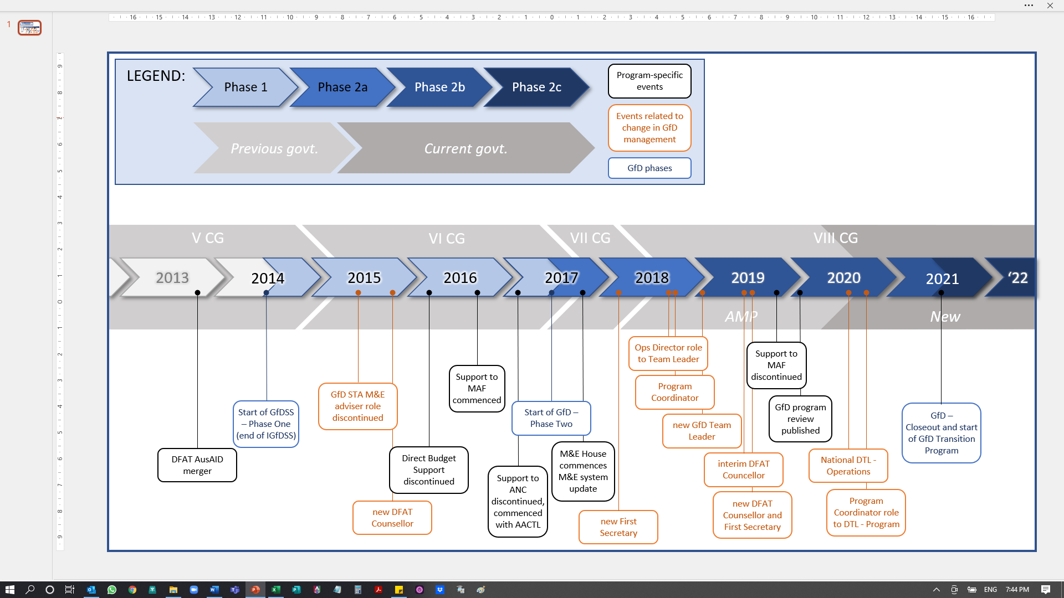

Investment context analysis

Political context
GfD supported a total of four different governments with four different Prime Ministers and five different coalitions. Despite political differences, the overarching goal of most of these governments was to achieve the outcomes in the national Strategic Development Plan (SDP) 2011 - 2030, which was developed in 2010 by the Fourth Constitutional Government (IV CG). Notwithstanding continuity in commitment to the SDP across different governments, GfD’s investment context changed significantly over the life of the program, particularly when there was a change in Government, coalition arrangements, or Prime Minister, necessitating GfD to assess the new context and new entry points to continue supporting the implementation of the Government's reform agenda, as well as the program’s strategic objectives and work areas.
GfD started in 2014 under the fifth Constitutional Government (V CG). The SDP had been published a year prior to this Government’s formation which guided the Government’s program in relation to decision-making on budgeting, planning, and infrastructure investments. In 2015, the sixth Constitutional Government (VI CG) was formed, representing a ‘Government of National Unity’. The Government continued implementation of the SDP and introduced a number of reforms that aligned with GfD’s objectives, the most notable one being a reform of Public Financial Management (PFM), within which the introduction of Program Based Budgeting (PBB) was a significant focus. These PFM reforms were supported by GfD-funded inputs from the Organisation for Economic Cooperation and Development (OECD), with a view to enabling more efficient, transparent, and accountable planning and budgeting by Line Ministries and Autonomous Agencies. The establishment of an office for a Minister of State for the Coordination of Economic Affairs (MECAE) also paved the way for economic policy reform. The seventh Constitutional Government (VII CG) which started in 2017 brought a period of political instability as the Government was unable to secure a coalition that would give it a majority in Parliament. Progress of a number of governance reforms in which GfD was involved, including PFM and economic policy, slowed significantly. Following fresh elections in 2018 a new coalition Government, the eighth Constitutional Government (VIII CG) was appointed. Instability and political infighting continued under the first iteration of this coalition, including a lack of confirmed ministerial appointments. A coalition rearrangement and the appointment of a number of new ministers in 2020, including in the Ministry of Finance (MoF) and the Office of the Minister for the Coordination of Economic Affairs (MCAE), presented opportunities for GfD-supported reforms to once again gain momentum, particularly in relation to PFM and economic policy.
At each significant political shift, GfD and its advisers had to build new relationships with and gain the trust of new politicians and Government officials, which led to delays and loss of momentum on several occasions. The context under each of the four governments is described in detail in Annex 1, which includes a number of examples of how thinking and working politically was required on an ongoing basis to maintain reform continuity.

Other contextual factors: COVID-19
The first COVID-19 case in Timor-Leste was confirmed on 21 March 2020. In response, the Government took swift action to request the President of the Republic to declare a national State of Emergency, which he did on 27 March 2020. The Government nominated a number of public service sectors as ‘essential’ and key central governance functions remained operational, though at reduced capacity. Public transport and passenger flights were suspended for a period of two months, after which the State of Emergency regulations were slowly eased. However, trade through the border with Indonesia and air travel remained restricted, resulting in sharp drops in tourism activity levels and pressure on Timor-Leste’s supply chains and international trade. The Government was able to contain the cases, under the guidance of an Integrated Crisis Management Centre (CIGC). The Government also set up a COVID-19 emergency fund to purchase medical supplies, outfit medical facilities to be able to treat COVID-19 patients, and to implement initial COVID response measures such as individual household payments to offset initial economic hardship caused by the State of Emergency. In mid-2020 an Economic Recovery Commission (ERC) was established to advise on long term post-COVID economic recovery. With significant support from GfD, the ERC developed a longer-term Economic Recovery Plan (ERP), and guided the development of the 2021 budget to ensure that the agreed COVID-19 related expenditures were reflected within it.
Additional cases were detected in border villages following a number of illegal border crossings from Indonesian West-Timor in early January 2021. The Government was quick to instate ‘sanitary fences’ (localised border closures) around these locations, but was unable to contain local transmission, and the virus spread to Dili in early March 2021. Thereafter, the Government imposed a sanitary fence on the capital, restricting use of public transport and entry in and out of the city border, and a lockdown that required all non-essential businesses to close and non-essential workers to work from home, once again severely impacting the economy, and in particular the economic situation of those working in the informal economy.
The COVID-19 Delta variant reached Timor-Leste in August 2021. However, in spite of a significant rise in case numbers in August and September, Timor-Leste was spared the health system crisis and significant number of deaths seen in other countries in the region, possibly due to the early and effective roll-out of vaccinations, and the youth of the population. By late September the worst of the wave had passed, and lockdown restrictions were lifted. The GfD team progressively returned to the workplace in October and November, and the Government of Timor-Leste (GoTL) lifted the State of Emergency in December 2021. As at the time of writing, case numbers remain low, although the arrival of the Omicron variant is anticipated, which may impact on the final months of the Transition Program.

Program Design, Monitoring and Evaluation

Original design and Scope of Services
The original program design was completed in 2013 during the implementation of the IGfDSS program which ran from August 2012 to April 2014. The interim program, also implemented by Cardno, served as an opportunity to trial the innovative approaches that would be included in the final GfD design, and to undertake foundational activities that would be continued in the long-term program.
The design of the GfD program was largely completed under AusAID, prior to its merger with DFAT in 2013. Inherent in the program was a primary role for the Embassy, under which DFAT would directly manage implementation of the GfD Program. The core team was headed by a DFAT Program Director ‘more akin to that of a Program Team Leader than a traditional DFAT Counsellor, since he or she is part of the implementing team’. Other anticipated key DFAT support included a Deputy Program Director - Program and Policy Coordination, two international Assistant Directors (PFM and Fiscal and Economic Policy) and a Senior Locally Engaged Officer (Public Administration). The Cardno-managed function of Deputy Director of Operations (subsequently Director of Operations) was limited to high quality logistical and technical support – primarily logistics, procurement, recruitment, and Human Resources Management (HRM) – as well as M&E. All grant partners were managed by the Embassy. Although Cardno produced the M&E Plan and Framework, and quarterly program reports, the contractor had no influence over program strategy and direction, and decisions around modalities, activities and counterpart engagement were all made by the Embassy.
The original design included six EOPOs, driving towards a single goal of ‘Poverty reduction in Timor-Leste through economic development and delivery of services’, under two pillars: Fiscal and Economic Policy, and Improved Services, the latter of which encompassed PFM and Public Administration.
Figure 2 Overall End of Program and Intermediate Outcomes
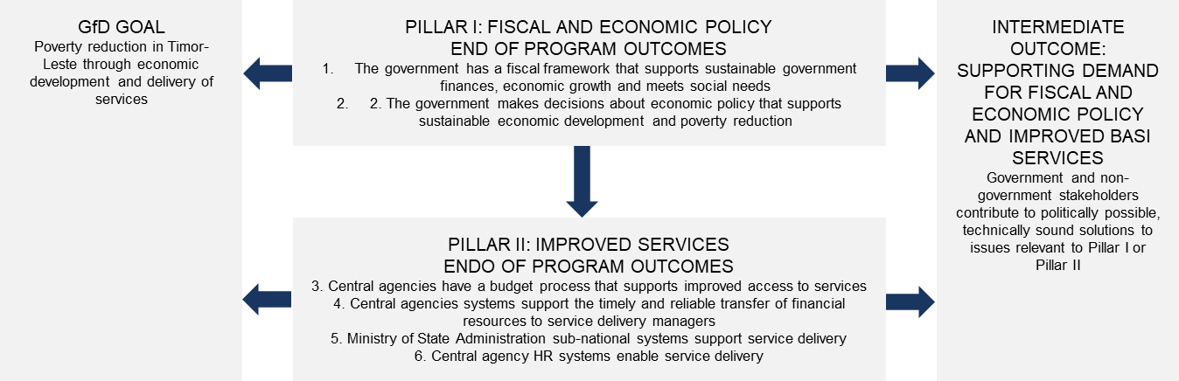
A more detailed Theory of Action and respective pathways of change were included in one of the design’s annexes (See Annex Two). Given the limited role of Cardno during this phase, reporting was largely focused on the contractor’s operational and logistical role, including financial management, adviser engagement and ongoing management, administrative management and support, M&E systems, facilitation of workshops, training and other events, workplace health and safety and security, and asset management. Advisers submitted individual quarterly reports, but although these were in latter quarters consolidated into a single ‘Quarterly Adviser Report’, there was limited analysis of progress towards program outcomes. A Monitoring, Evaluation and Learning (MEL) Framework was developed by an M&E Adviser with strong input from DFAT, however, the operationalisation of the framework was limited during the first phase of GfD.

Evolution of the Theory of Change
A cut to the Timor-Leste aid budget in 2014/2015 meant that resources in the Embassy were increasingly stretched, with the Program Director being assigned to manage an increased number of programs and additional demands being placed on other Embassy staff involved in GfD. The associated risks were noted in the IGfDSS Completion Report:
‘The ability of DFAT to implement GfD based around the original design could be an issue. The emergence of DFAT as the GoA Agency responsible for the Aid Program brings with it some complexity and a potential change in the focus of the Aid Program in Timor-Leste. A possible reduction in numbers may mean that the size of the DFAT GfD team will decrease thus impacting the proposed reach of the Program across GoTL. If DFAT do not have the permanent staff available to support across all desired areas of the Program, the good relationship with the support services team could be called upon to provide further technical support as may be required’ .
To offset a number of these resource limitations, DFAT’s Timor-Leste Desk (Desk) worked with the Performance and Quality team within the Embassy and GfD’s Short Term M&E adviser and provided guidance on how to develop workstream ToCs for GfD towards the end of 2014. ToCs were subsequently developed for each of GfD’s workstreams, with corresponding measurable ‘progress markers’ or indicators for each. Some of these were quantitative but the majority were qualitative. By 2015, these progress markers were refined in consultation with advisers, and they were included in quarterly adviser reports for advisers to report against. However, advisers still mostly reported at the activity-level, as was noted in an assessment undertaken by the national M&E Officer in 2015.
Under the second phase of the program from mid-2017 onwards, a number of changes were made to the role of the managing contractor, primarily due to the growing workload of Embassy staff and the strain this was placing on the One Team model. Responsibility for the contracting and management of grants, other than those with multilateral organisations, was handed to Cardno, and the position of Deputy Director of Operations (the most senior Cardno position) was upgraded to Director of Operations, with revised Terms of Reference (ToR) which recognised the increased responsibilities of the role, particularly with respect to grant management. Cardno’s role remained, however, that of providing operational and logistical support to a program which continued to be led by the Embassy, with the Program Director still described in the Scope of Services as being the de facto Team Leader.
In early 2018 the program’s ToC was significantly revised following the establishment of M&E House. The mandate of M&E House was to improve and streamline M&E across the Timor-Leste aid program and to enable more consistent performance analysis across all DFAT-funded programs against a common Performance Assessment Framework (PAF). The updated ToC included a new Program Goal: ‘A stable and prosperous Timor-Leste’ in alignment with the Australian aid program’s goal in Timor-Leste, underpinned by Economic Development, and Better Service Delivery, and two program EOPOs:
- Government makes better decisions and develops evidence-based policies
- Government improves implementation of policies and delivery of services
Sub-ToCs were then developed for each of the program’s three workstreams, each with their own EOPOs:
Work Area | EOPOs
PFM | - Government has an improved budgetary governance system
Economic Policy | - Government makes better economic policy decisions that are based on evidence  - Government improves implementation of economic policies and delivery of business-enabling services
Public Administration | - Government makes better public administration policy decisions that are based on evidence  - Government improves implementation of public administration policy
Many of the ToC changes were aimed at clearer expression of what the program was already doing and what had been intended in the original ToC. While the ToC was adjusted quite significantly, this did not represent a significant re-orientation of the program’s direction or priorities.

Current Theory of Change
In recognition of the broadened scope of work and delegation of increased responsibility for strategic program management, further changes were made to the program structure in late 2018 and early 2019. The position of Director of Operations was changed to GfD Team Leader, with an associated increased role in program strategy and input into decisions regarding program direction, resources, and activities. A second international management position, Program Coordinator, was created, with lead responsibility for the program’s M&E. While overall responsibility for the program strategy and budget remained with the DFAT Program Director, supported by the DFAT Program Manager, the Cardno Team Leader:
‘…plays a key role in steering the program’s overall strategy, is responsible for generating options and recommendations to translate agreed support into action and results, and manages the program’s monitoring, evaluation and learning framework’.
Through these changes there continued to be a strong One Team approach in which the Cardno and Embassy teams worked closely together and consulted on all key decisions in relation to the program direction and investments.
Further adjustments were made to the ToC in 2019. The EOPOs were changed slightly to:
- Government makes evidence-based policies and decisions
- Government improves implementation of policies and delivery of services
Rather than having a separate ToC for each work area with separate EOPOs, a decision was made to maintain consistent EOPOs and Intermediate Outcomes (INOs) across all three workstreams, with foundational activities, influencing activities and immediate outcomes being developed specific to each work area. The ToC also included key principles that cut across all of the levels of impact from activities to EOPOs, largely based on DFAT’s aid effectiveness criteria. This approach reinforced cohesion across the program, and synergies between workstreams. The current whole-of-program ToC is provided overleaf, with the work area diagrams provided in Annex Three.

Figure 3: GfD Theory of Change 2019 - 2022
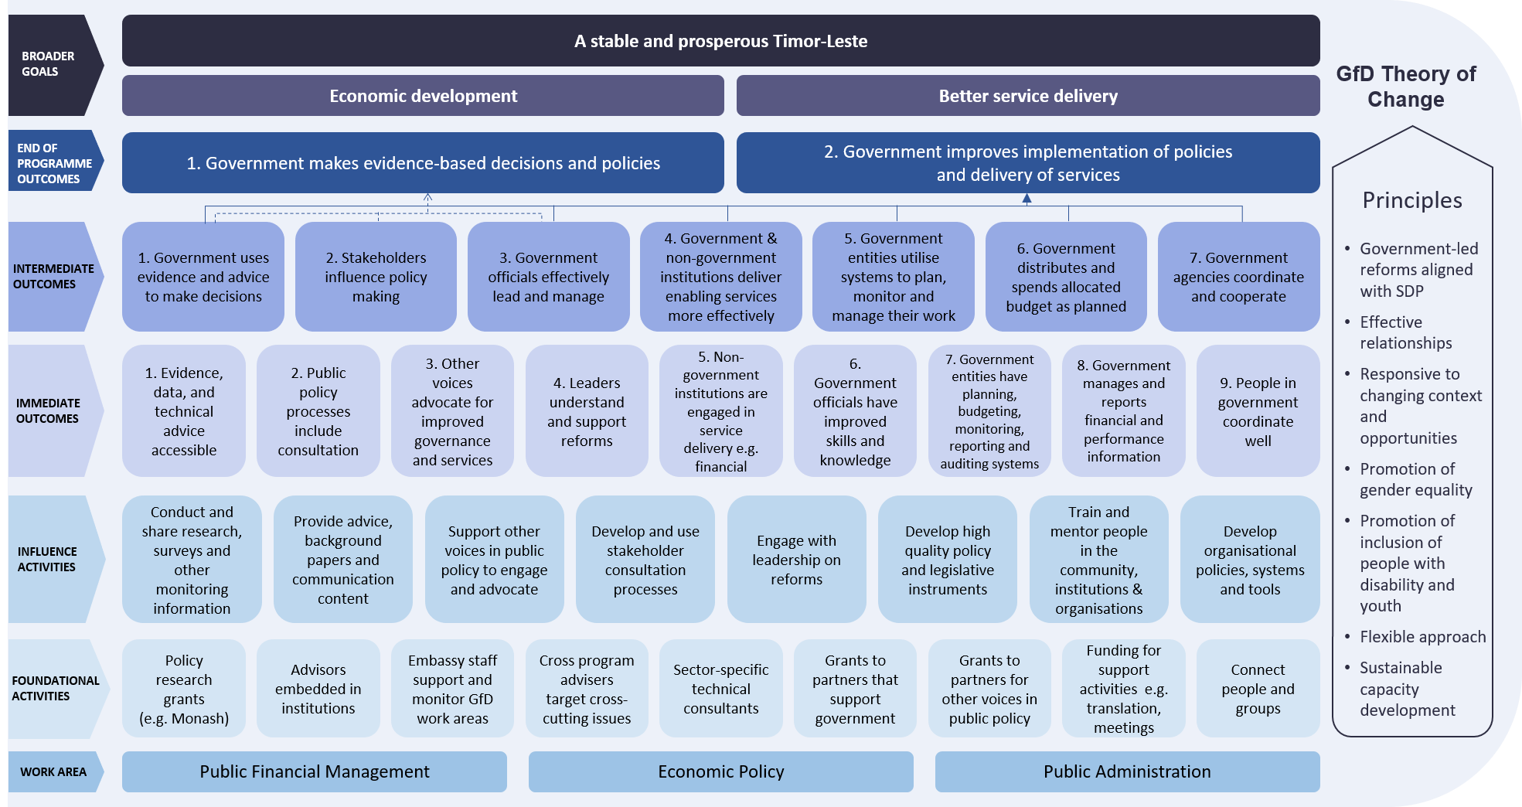

Achievement against End of Program Outcomes across the life of the Program
The progressive changes to GfD’s ToC and amendments to the EOPOs demonstrate both the complexity of monitoring and evaluating governance programs, and the evolution of understanding of the priorities of both the Australian aid program and GoTL in relation to strengthening governance in Timor-Leste. This adaptive approach to program strategy, monitoring and evaluation, and the preparedness to refine and improve the ToC and Monitoring, Evaluation and Learning Plan (MELP), was integral to the achievement of significant progress in relation to governance reform. The final EOPOs, and the related INOs, were clear and measurable, albeit through qualitative, rather than quantitative, means.
The tables and charts below provide a summary of achievement of INOs across the final three years of the program (the period in which the revised MELP enabled clear linkages to be drawn between Desired Changes (DCs), INOs, and EOPOs). They also summarise the ratings for the Stories of Significant Change (SSCs) submitted since 2017, noting that SSCs were a key externally-validated element of GfD’s MELP. Similar data on achievements during the Transition Program will be made available in the final month of the program, with an interim report on progress to 31 October 2021 presented in the latest GfD Six Month Update.
Figure 4 Relation between SSCs, DCs, INOs and EOPOs – since 2017
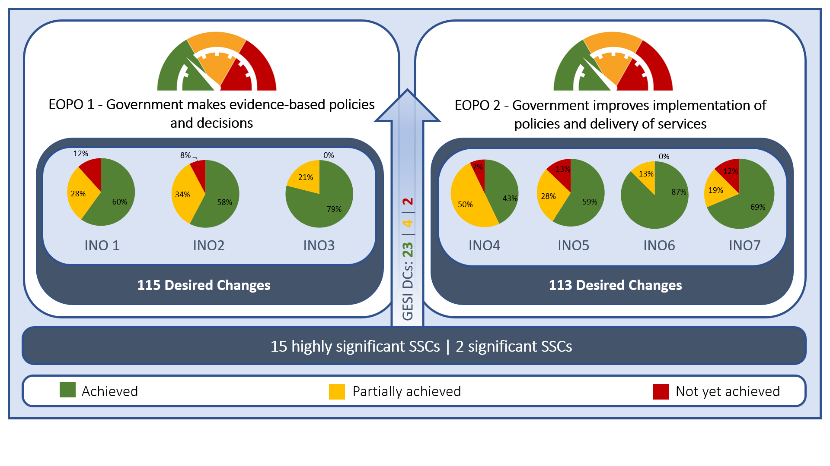
While Figure 4 misses the nuances of the qualitative information that underpins these results, and treats all DCs equally, the charts provide a quantitative indication that significant progress was made towards both EOPOs by January 2022, noting that progress against EOPO1 was faster than against EOPO2. This is not unexpected, given that policy development precedes policy implementation, and there will necessarily be a lag between the two. With respect to EOPO2 it could also be argued that while attribution to GfD for improved implementation of policies is fairly clear, it is harder to attribute improved delivery of services, given that GfD had no direct role in service delivery other than in a few very specific areas (e.g. business registration and licensing through Servico de Registro e Verifikasaun (SERVE)). While the program played a role in reducing the human resources and PFM constraints to government service delivery, it had no direct influence over major service delivery entities such as the ministries of health, education or social security. In spite of this, there is significant evidence of implementation of evidence-based policies across all three workstreams, particularly from the latter years of the program.
Detailed narrative descriptions of achievements in relation to both EOPOs are provided in Section 3 (Phase One) and Section 4 (Phase Two and Transition Program). However, a few illustrative examples are provided here, which have been documented through GfD SSCs:
EOPO1: Government makes evidence-based decisions and policies:
- Inclusive process of developing National Civil Aviation Policy (NCAP) Growing Aviation to 2030: Providing Connectivity to Support Economic and Social Development
- Inclusive process of developing Civil Service Commission (CSC) Workforce Planning Policy and Decree-Law
- Development of ERP based on economic analysis and evidence
EOPO2: Government improves implementation of policies and delivery of services:
- Implementation of three rounds of merit-based general career regime promotions in the civil service
- Implementation of a PBB approach for the development of the General State Budget across all government entities
- Gender mainstreaming in budget process to improve service delivery and enhance gender equality
- Streamlining of business registration and licensing processes following business process mapping and analysis

Program progress, achievements, and lessons – Phase One 2014-2017

The GfD management model
The purpose of the first three-year phase of GfD was to ‘establish good relationships and programs of work with central agencies and make reasonable progress in contributing to the end of program outcomes’. As mentioned above, the role of Cardno during this time was focused largely on adviser management and support, operations, and logistics, reflected in the name of the Cardno-managed element of the program of GfD Support Services (GfDSS). Throughout this section attempts have been made to differentiate between the contributions and achievements of GfDSS and of the GfD program more broadly, although the distinction is at times challenging.
Under GfDSS the Managing Contractor was tasked to:
- Support DFAT staff to manage and coordinate implementation of the program;
- Develop and maintain systems to deliver program support flexibly and quickly, including approaches to ensure gender equality was appropriately addressed, through analysis, information, training, and reporting;
- Recruit and manage the non-DFAT personnel, administrative, financial, operational, and logistical resources required for successful implementation of the program. This included providing administrative systems for the monitoring and management of short and long-term advisers;
- Bring forward advice and ideas to the DFAT personnel, including ideas for better ways of working with Government partners, suggestions for improving efficiencies and innovative approaches to program management that would benefit GfD; and
- Promote gender equality and disability inclusion through the GfD program.
The intended hands-on role of the Embassy was impacted by significant reductions in budget and resources, placing heavy demands on the Counsellor and First Secretary who had primary responsibility for the management of the program. As a result, DFAT Desk in Canberra assumed a much greater role than is usual, including managing the Head Contract between DFAT and Cardno, initiating weekly Ways of Working meetings, refining the program’s M&E Plan, and leading the preparation for Review and Reflection (R&R) workshops. The Embassy and Desk also joined GfDSS in highly structured and minuted Fortnightly Operational Management Meetings, which included updates on all advisers in different Government counterpart offices, financial management, Workplace Health and Safety (WH&S) and risk management, as well as discussions on program reporting and M&E, Gender and Social Inclusion (GESI), and engagement with grant partners. The meetings enabled the One Team structure to function, ensuring DFAT and Cardno were across both program and operational developments.
As the Counsellor Economic and Rural Development was progressively tasked with managing an increasing number of programs, the expectations of the role of the Managing Contractor shifted. However, the ability of GfDSS to respond to this was limited, given that the team had been recruited for their operational and logistical ability, and not for their ability to engage strategically with counterparts and take a stronger role with respect to the program’s direction and strategy. The role of the Timor-Leste Desk therefore continued to be crucial, and an effective triangular relationship between Post, Desk and GfDSS ensured that the program continued to deliver under circumstances that were significantly different from those envisaged when the program was first designed.

Cardno’s Support Services role
In terms of operations and logistics, the transition from IGfDSS to GfDSS in 2014 was largely seamless. The ‘Ways of Working’ on IGfDSS had been designed to set the stage for the operational aspects of the longer-term GfDSS program. In effect the start of GfDSS was ‘business as usual’, with advisory support continuing and some enhancement of the administrative and logistics support provided by the program.
Cardno’s management of Human Resources (HR) was boosted by the establishment of a HR unit in the GfDSS office, headed by a Senior HR/Recruitment Manager. Cardno head office took over corporate support for the program from the Jakarta office, and a Program Support Officer was allocated to the program. The Program Support Officer worked closely with the HR unit to streamline the responsibilities and procedures for all support functions and review or create HR policies and procedures and corresponding systems to assure the timeliness and quality of recruitment, selection and management of all members of the GfD team, including Locally Engaged Staff (LES), Long Term Advisers (LTAs) and Short Term Advisers (STAs). An Adviser Support Centre provided a ‘one stop shop’ through which all team members could submit administrative documents including leave applications, financial claims, and administrative queries. A performance management system was introduced for all advisers, which involved input from counterparts, the Embassy, and the GfDSS Senior HR Officer. A staff development plan was developed and implemented, which included formal capacity development plans for each based on current and future job requirements, as well as regular in-house briefing sessions on various aspects of GfDSS, including overall program information, specific areas of program support, the Quality Management Plan, and Cardno and DFAT policies. These briefing sessions were interspersed with HR-run training programs on specific areas of professional skill development including customer service, setting goals and completing work, priority management, report writing, and supervising/managing small teams.
Across the three years of the first phase of the program a total of 21 LTAs, 43 LES and 47 STAs were engaged. An initial high reliance on international advisers was fit-for-purpose in the early years of the program (13 LTA and 5 LES in year one), but progressively shifted to greater engagement of national advisers. By the end of the first phase in May 2017 the program was engaging a total of 17 international and 31 national long-term advisers.
Feedback from R&R workshops towards the end of the first phase indicated a generally high level of satisfaction with the GfD advisers and their ability not only to provide high quality technical advice, but also to strengthen capacity of Timorese across the civil service:
- ‘Strong feedback from GfD advisers and civil servants that GfD was doing an excellent job of mentoring Timorese junior professionals, particularly in MECAE and OPM. As a result, high quality Timorese advisers were stepping up into leadership positions.
- Within MECAE, CSC and OPM, GfD is building strong teams and improving inter-governmental coordination; advisers feel strongly supported by DFAT’.
Drawing on Cardno’s well-established corporate support, GfDSS was quick to establish systems for sound financial management, including development of a Lifetime Budget which enabled both annual and whole-of-program budget to be tracked continuously across the life of the program. Informed by the Lifetime Budget, the program came in close to its budget target at the end of Phase One.
GfDSS’ processes for administration and logistics were established and well-resourced early in the program, with the appointment of a number of senior national staff who, it was envisaged, would move progressively into levels of increased responsibility (the Office Manager appointed during Phase One was promoted to the position of Operations Manager, and then Deputy Team Leader – Operations under Phase Two). The program provided responsive and cost-effective support not only for the day-to-day establishment and running of the office, including program Information and Communications Technology (ICT) needs and the procurement and management of assets, but also for a wide range of program activities, including translation and interpretation, study tours, conferences, and meetings. Further, the GfD office established robust WH&S processes and procedures, including a WH&S committee which involved representatives from all of Cardno’s programs operating in Timor-Leste. The committee established a number of key processes across Phase One of the program, including arrangements with a security provider, arrangements with a medical centre and ambulance provider, leasing of satellite phones, the development of a safety and security plan, and establishment of procedures in response to specific security risks. This was particularly important given that most GfD advisers were working within GoTL ministries. They were supported to conduct individual WH&S assessments and make adjustments to make their workplaces as safe as possible. GfDSS established a culture that recognised the importance of WH&S and was able to role model this culture with counterpart agencies, demonstrating the importance of safe workplaces and the importance of taking action in the face of workplace hazards or health and safety risks.
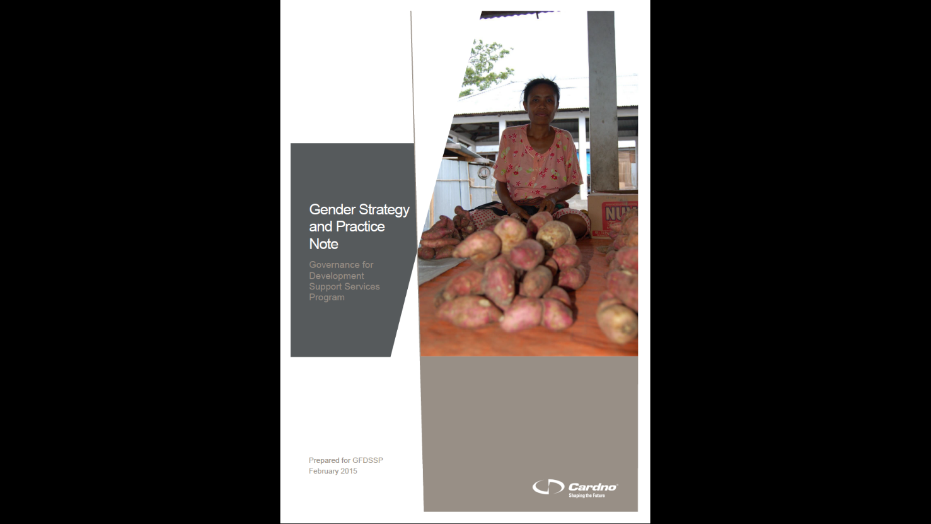
The GfD design highlighted the importance of addressing the cross-cutting issue of gender and disability, guided by two main Australian aid policies: i. ‘Promoting opportunities for all – Gender equality and women’s empowerment’, and ii. ‘Development for All: Towards a disability-inclusive Australian aid program 2009–2014’. One of the main anticipated outcomes was ‘the production of analysis that enables key decision-makers to better understand the particular needs of women and girls, and people with disabilities in relation to economic, fiscal and service delivery policy.’ It was envisaged in the design that the Deputy Director Operations would be assisted by STA Gender and Disability Experts. However, specific gender expertise (in the form of a LES Gender and Inclusion adviser supported with some short-term inputs from an STA gender consultant) was not put in place until early 2017. In the absence of gender expertise within the team, GfD was supported by a Fly In Fly Out (FIFO) Gender expert from DFAT who visited Timor-Leste on a semi-regular basis to facilitate gender workshops and advise the GfD team.
Cardno developed a Gender Strategy and Practice Note to guide gender both within and the team and in its activities
In the meantime, in 2015 Cardno developed a Gender Strategy and Practice Note to inform and guide the GfD team and advisers in their consideration and implementation of gender policy and practice in their everyday work. The Strategy and Practice Note provided guidance on ways to support gender work within the team itself as well as the activities implemented and supported by the program’s advisers, based on the three-pronged approach of:
- Be aware and learn;
- Take opportunities to influence where possible; and
- Do no harm when influencing is not possible.
Internally this meant the application of the principles of gender equity and social inclusion in all GfD operations, including hiring practices, inclusion of gender specific content in ToRs, engagement with GoTL, local partners, and consideration of broader programming decisions. The Strategy and Practice Note highlighted the importance of role modelling gender-inclusive policies and practices in GfD’s own internal work practices and in work with external partners and stakeholders. Across Phase One of the program, 33% of the GfD team were women. Externally, the strategy aimed to increase awareness of gender and inclusiveness across central agencies in GoTL. Building capacity through training, awareness raising, and the development of specific resources was a priority, along with the identification and appointment of gender ‘focal point(s)’ within Cardno and the GfD adviser group. Further, the GfD program committed to applying a gender lens to all research activities, M&E and reporting on how the program impacted differentially on men and women, including ensuring that data generated by the GfD support team were gender-disaggregated wherever possible.
Some specific achievements in relation to gender and inclusion under the first phase of the program included the following:
- Training on Gender Responsive Budgeting (GRB) was provided to Line Ministry and Autonomous Agency officials responsible for planning, budgeting, M&E and gender working groups to equip them to incorporate gender activities in their plans and budget;
- Addition of a gender marker summary to all key reports going to the Budget Review Committee;
- Gender and inclusion were taken into consideration in the development of the National Employment Strategy, and the associated policies were aligned with existing gender and disability strategies and policies such as National Action Plan on Gender and Private Sector, SEPFOPE Gender Strategies, Maubisse Declaration, CEDAW Concluding Observations, and National Action Plan for People with Disabilities;
- Capacity Building was provided by the GfD Gender Adviser to the Law Reform Commission (LRC) in relation to the career progression, professional development, and job certainty for the national lawyers within the Commission, all of whom were women; and
- The CSC 2018 Annual Action Plan was revised in 2017 with the support of the GfD Gender Adviser to elaborate gender-sensitive programs, sub-programs and activities. Gender and disability inclusion, as well as environmental initiatives, began to be incorporated into CSC policies. The anti-sexual harassment policy was launched in 2017, and a Memorandum of Understanding between the CSC and UN Women was drafted.
Under IGfDSS, there was an acknowledgement that disability had been ‘left off the table’ in relation to employment and accessibility. This was, in large part, perceived to be due to the absence of legislation in relation to disability, in addition to cultural stigma that surrounds people with disabilities in Timor-Leste, as reflected in adviser reports. In light of this, increased attention was paid to issues of disability inclusion in reporting under GfD.
Finally, in relation to the M&E function, an M&E system, plan, and framework was developed in 2014, building on work undertaken during IGfDSS. In the first quarterly report under GfD Phase One it was noted that:
‘Due to the iterative and flexible nature of GfD it has proven challenging to develop an M&E system. This is characteristic of governance programs across the board’ and that ‘Promulgation of the overall M&E plan and Framework amongst GfDSS and the advisers remains a concern as the adviser group are expected to work towards the expectations of these documents whilst not being privy to the intended outcomes that the framework defines’.
M&E remained a challenge throughout the first phase of the program, in part because the limited agency of GfDSS to strategically plan and define longer term objectives against which to report, which limited the team’s ability to monitor and evaluate in a structured and systematic manner. The initial M&E plan, developed by an international adviser, was refined with significant input from Desk in Canberra and the Embassy, supported by a national M&E consultant. Data collection tools included program activity notes, advisor quarterly reports, institution and stakeholder snapshots, a range of activity tracking tools, and R&R processes, with results reported in quarterly program reports produced by Cardno for DFAT. While the reports provided a comprehensive narrative of activities undertaken under each workstream and attempted to relate activities and achievements to program outcomes, the linkages were not always clear, and it was difficult to get a cohesive picture of the effectiveness of activities in progressing towards anticipated program outcomes.
Under the first phase of GfD, however, a series of useful MEL activities were undertaken, including both planning sessions (2014 Political Economy Analysis (PEA) workshop, 2015 mini-re-design workshop, 2016 planning day) as well as annual R&R workshops involving GoTL counterparts and a range of other stakeholders. These stakeholders included ‘critical friends’ who provided useful reflections on the progress of the program and technical assessments of each of the work areas, and identified areas for improvement. Given a decision in the program design not to create a Steering Committee for GfD, these planning and review processes were an important element of the program governance processes. These formal processes were complemented by weekly program discussions involving the Cardno and Embassy GfD teams as well as the DFAT Timor-Leste Desk, which provided a forum to discuss the political context and its impact on the program on a real time basis. PEAs, planning sessions and R&R workshops informed ongoing adjustments to the program, including key decisions in relation to starting or withdrawing GfD support for particular activities. Although the R&R sessions provided useful insights and inputs into future activities, no consolidated review of progress was provided on either an annual basis, or at the end of the first three-year phase of the program, with the Embassy deciding that the R&R sessions provided sufficient basis on which to make informed decisions about the direction of the program. However, while the PEA, planning and R&R workshops produced useful insights, there was scope to strengthen follow-up in terms of documentation and implementation of recommendations.

Adviser activities and achievements
Although decisions about where GfD should invest its resources were the responsibility of the Embassy, GfDSS influenced the achievements of the program through its ability to select and support a high-quality team of advisers. Some key achievements under each workstream are described below.

Public Financial Management
During the first phase of GfD the program engaged with the following Government entities in relation to PFM:
- MoF;
- Office of the Prime Minister (OPM)/ Monitoring, Evaluation and Planning Unit (UPMA);
- Ministry of State Administration;
- Ministry of Public Works, Transport and Communication; and
- Ministry of Health (MoH).
In the early years of GfD, PFM support was through Direct Budget Support (DBS) and strengthening associated systems. A Fiduciary Risk Assessment of Timor-Leste PFM systems completed by MoF and DFAT in August 2012 concluded that if 12 Mutually Agreeable Results were attained within MoF, then future donor support could move to DBS. DFAT and MoF entered into a Direct Partner Funding Agreement in early 2014. GfD long-term advisers were placed in OPM and in the Ministries of Finance, Health, State Administration, and Public Works, Transport and Communication to link MoF PFM performance gains to budget/public expenditure practices in key Line Ministries and agencies. MoF policy support was funded through a World Bank Trust Fund to which Australia contributed. The funding agreement required six-monthly joint monitoring of MoF organisational performance improvements, using a complex performance measurement matrix, undertaken by specialist short-term advisers. It required a continued relationship of trust between DFAT and MoF, and all sides needed to have the technical and relationship skills to maintain a sound understanding of, and confidence in, the DBS model, and a coordinated effort from the Embassy, with a significant proportion of the GfD-related time of the Counsellor and First Secretary focused on DBS. Challenges began to emerge early in the process, when MoF was unable to open a DBS sub-bank account at the reserve bank to hold Australian funds. DFAT/MoF jointly agreed to place funds in an ANZ bank account, a decision which was later cited as an example of potential financial irregularity.
In early 2015, the institutional and political context of DBS changed significantly when a unity Government came to office with a Prime Minister who supported Government-wide PFM reforms alongside the existing MoF-led initiatives. Meanwhile PFM reform was making very slow progress in MoF. Responsibility for GoTL’s annual budget was transferred by Decree Law 22/2015 from MoF to the newly-formed UPMA in OPM. During 2015, DFAT lost confidence in DBS’ joint monitoring model for MoF internal capacity building and recalibrated the DBS monitoring matrix. MoF did not achieve some of the agreed targets in the matrix, leading to DBS being terminated. Around the same time DFAT in Canberra assessed that the World Bank Sydney-administered Analytical and Advisory Activity was underperforming and terminated its contributions to the Australia-World Bank Strategic Partnership Timor-Leste Trust Account.
GfD’s support for PFM shifted to UPMA in 2015, and GfD entered into a partnership with OECD, who supported GoTL to develop the GoTL Budgetary Governance Roadmap. The roadmap was approved by Council of Ministers (CoM) in 2017. It was developed through an inclusive whole-of-government consultation process, and strongly championed by the Prime Minister. It sets out a long-term, sequenced approach to budgetary governance and PFM reform, including progression of the implementation of PBB, development of a Medium-Term Expenditure Framework, and civil service capacity building reforms.
Further, in 2014 and 2015 GfD placed an adviser in MoH, with a view to strengthening the interface between upstream (Central Agency) PFM reform and downstream (Line Ministry) implementation of the reforms. While this strengthened the relationship between GfD and MoH and helped GfD understand the complexities of PFM at the level of an implementing agency, it proved difficult to translate this understanding into programmatic solutions and did little to strengthen the implementation of PFM reforms in the health sector, particularly at the municipal level.
While based on sound reasoning given the political and institutional context at the time, the withdrawal from DBS, coupled with challenges in Australia/Timor-Leste relations as a result of maritime boundary negotiations, led to strained relations between DFAT and MoF, and the end of any practical engagement between GfD and MoF. The Embassy, through GfD, offered other forms of PFM support to MoF, but these offers were not taken up. One implication of this was that GfD was unable to progress work in relation to financial flows and the disbursement of funds – a key element of reducing barriers to service delivery. Nonetheless, significant achievements were attained by the end of the first phase of GfD, including the following:
- The GoTL Budgetary Governance Roadmap was approved in early 2017;
- A PFM Working Group was established by OPM with GfD support. It was approved through a resolution in the CoM, with responsibility for oversight of the implementation of the Budgetary Governance Roadmap. With GfD support, an implementation plan for the Roadmap was developed;
- A GRB policy note was developed and submitted to the PFM Working Group for approval;
- Changes were made to the Budget and Financial Management law through GfD advisory inputs to accommodate the reform program;
- Phase Two PBB was implemented (establishment of PBB structures and associated costing tools) including for municipalities, and an associated instruction manual developed to assist Line Ministries and Autonomous Agencies to complete the 2018 PBB Annual Plan template;
- PBB guidelines were developed to facilitate the elaboration of municipality action plans based on PBB;
- The programs and activities for both the ‘Good Governance’ and the ‘Revenue’ programs (programs common to most entities) were further developed, with GfD support;
- Through UPMA, and in collaboration with the Gender Focal Points of OPM and the Secretary of State for Support and Socio-Economic Promotion of Women, GfD supported the development and incorporation of gender markers into the PBB guidelines in order to capture gender sensitivity in programs, sub-programs, and activities;
- With GfD support, UPMA and MoF developed an integrated budgeting tool – Dalan Ba Futuru (DBFTL) – which incorporates planning, procurement, costing, and M&E components;
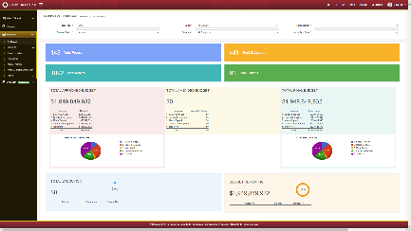
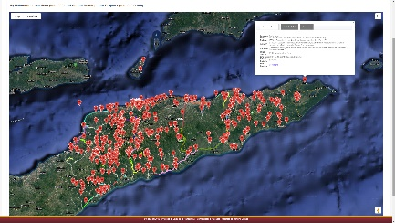
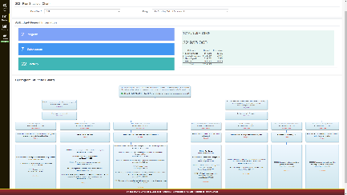
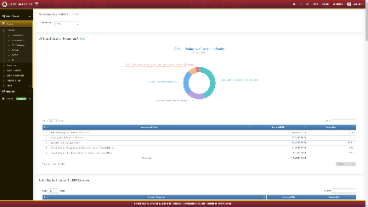
- GfD supported improved quarterly and annual reporting to National Parliament, reflecting the new PBB approach, and the design of a dashboard report on quarterly monitoring of annual plans, providing a simplified and informative snapshot of key achievements per quarter to allow easier monitoring by National Parliament; and
DBFTL user interface screenshots
- The draft Procurement Law was developed with input from GfD advisers and was shared with Government for comment prior to going for public consultation.

Economic Policy
GfD’s engagement in relation to Economic Policy during the first phase of the program was diverse. A reduction in Embassy resources, the resource-intensive engagement in relation to DBS, and tensions in Australia’s relationship with Timor-Leste as a result of negotiations around resources in the Timor Sea, impacted on the program’s ability to engage productively with some counterparts in relation to economic policy. The slower than anticipated pace of engagement impacted on the program’s progress in early years and meant that GfD engaged where it could get traction, rather than necessarily where was anticipated in the original design, or where was most strategically influential. In spite of this ‘responsive’ model of engagement, some significant progress was made by the end of the first phase.
GfD engaged with the following Government entities in relation to economic policy during the first phase of the program:
- MECAE
- Ministry of Transport and Communication/ Civil Aviation Authority Timor-Leste (AACTL)
- LRC
- Banco Nacional de Comércio de Timor-Leste (BNCTL)
- National Communication Authority (ANC).
MECAE
- MECAE continued to work towards its main objectives of private investment, economic diversification and sustainable employment, and prepared detailed planning on priorities for reforms under the VII CG based on a thorough analytical review of World Bank, Asian Development Bank (ADB) and United States Agency for International Development’s (USAID) Millennium Challenge Corporation economic analyses.
- Monash University, through its grant agreement with GfD, became a trusted partner of MECAE, through the provision of specific research reports, as well as through advice on the use of statistical and economic modelling to underpin the development of economic policy.
- The Investment Policy was drafted, internal agreement reached and initial consultations with external stakeholders completed, based on extensive internal discussions on the Investment Reform Map ‘action plan’ conducted by MECAE/TradeInvest.
- ‘A Guide to Economic Reform and Growth’ was developed, with significant input form GfD advisers, which set out a path towards economic diversification and served as a basis for future advocacy for economic reform
- From mid-2016, GfD played an active role in the process of developing an understanding of World Trade Organisation (WTO) accession requirements and coordinating across ministries to prepare relevant documents and processes. As part of the WTO accession process, MECAE finalised the Memorandum on the Foreign Trade Regime which was approved by CoM on in June 2017 and subsequently circulated to member countries.
- GfD worked with the MECAE Legal Unit to prepare a procedure on policy development and consultation followed by legal drafting as the last stage. The procedure involved policy-level discussion and debate at CoM prior to development of laws and sought to mandate engagement with relevant stakeholders outside of the normal group of civil lawyers, Portuguese speakers and Line Ministries in Dili.
- A number of pieces of legislation central to strengthening the Business Enabling Environment were passed including Company Law, Commercial Register Decree Law and SERVE Decree Law, Legislative Authorisation Law for the Recovery and Insolvency Code, and Commercial Licensing Decree Law.
- Progress was made in relation to a number of agriculture planning and assessment tools, including the Instrumentu ba Programasaun Agrikola, a Rapid Agriculture Assessment of the impact of El Niño 2015/2016 and commencement of planning for the 2018 agriculture census.
- Progress was also made within MoF including development of a series of policies and laws in conjunction with different international organisations regarding program implementation.
- The National Employment Strategy was drafted and approved.
Ministry of Transport and Communication/AACTL
With GfD support, the National Civil Aviation Policy was approved by CoM in May 2017, providing a national vision and direction for civil aviation in Timor-Leste. A Civil Aviation Agreement was signed with Australia, and the Board of Directors of AACTL appointed.
Law Reform Commission
The LRC, supported by GfD, completed the Business Framework Report, and hosted a debate on the recommendations in the report.
BNCTL
Through GfD funding, ADB commenced support for the transformation of the country’s Government-owned National Commercial Bank, BNCTL, to become a fully licenced commercial bank.
ANC
GfD provided two international advisers to ANC to support diversification in the telecommunications sector and to develop the mandate of ANC as the telecommunications regulator. While some progress was made in relation to institutional capacity building and the development of a number of technical manuals, the bigger aim of establishing ANC as an effective independent regulator which could resolve a monopoly position in the sector was impeded by internal politics, including a change in internal stakeholders, and some internal resistance to GfD’s work in relation to telecommunications reform and diversification. A decision was made to withdraw support to ANC in 2017 due to an assessment that the remaining GfD adviser was not being used to his full potential. In early 2017 the GfDSS Quarterly report noted that:
‘The current activities in the telecommunications sector are not sustainable, and are, in fact, having a detrimental effect. The authority is not regulating, fees aren’t being collected, services aren’t being delivered and furthermore, a number of ANC staff have left already, and others are seeking jobs elsewhere’.

Public Administration
During the first phase of GfD the program engaged with the following Government entities in relation to Public Administration:
- CSC; and
- National Institute of Public Administration (INAP).
The Australian Government has supported the CSC since its inception in 2009, originally through the Public Sector Capacity Development Program (PSCDP). The work continued through the first phase of GfD, with a focus on strengthening HRM across the civil service. Achievements supported by GfD through this first phase included the following:
- Official launch of the CSC Strategic Plan 2015-2030 in July 2017 as a blueprint for public administration Reform in Timor-Leste;
- Completion of the National Staffing Diagnostic project, providing baseline information on the current status of the Government workforce, HRM practices and constraints for the incoming VII CG;
- Completion by the CSC Secretariat of a reflection and self-assessment of their own services to underpin improvements in CSC structures, workforce data, archive management and HRM procedures;
- Completion by the CSC of a Public Perception Survey of the Public Service with a focus on the key development, policy, and program indicators of the Timor-Leste SDP, with a view to informing the incoming Government about focus areas for improvement, and to providing benchmark indicators of the performance of services of the relevant GoTL entities. A technical team comprising personnel from different CSC directorates were trained as survey enumerators and were involved in the analysis of the survey results, to enable the CSC to conduct similar surveys annually;
- Development by the CSC of an orientation guideline for investiture into the public service, supporting Government entities to comply with the legal provisions of the Civil Service Statute to ensure that only personnel who pass through a merit-based selection process can be part of the civil service;
- Development by the CSC of a comprehensive manual on administrative acts to promote the efficiency, effectiveness, and responsibility of the staff in the provision of services, as well as a manual on financial processes that defines the mechanism of how to use and manage the CSC budget;
- A review of the Personnel Management Information System (PMIS) maintenance contracts, which increased transparency and accountability in the management of the PMIS contract and set the stage for the CSC to be able to take greater control of updates to the system, with a view to reducing maintenance costs and improving performance;
- Development by CSC of a technical proposal for an interface between the PMIS and MoF’s Financial Management Information System (FMIS) to be developed using open-source technology with maximum national ownership to guarantee both financial and technological sustainability. The interface was intended to reduce the incidence of ghost-workers and double-payments;
- Establishment by the CSC of a Workforce Planning Steering Committee, drafting of a workforce policy and guidelines to include in a workforce planning manual;
- Development of a civil service Training Needs Analysis tool, to be piloted in the CSC; and
- Completion of revision of all modules generated by INAP for pre-service training, leadership training, administrative assistant training and local leaders training.

Lessons learned from Phase One
As would be expected in a program that was designed to be flexible and responsive within a fluid political context, a number of changes were made with respect to GfD’s engagement with GoTL during the first phase. These included:
- The withdrawal of DBS, following an assessment that the risks of continuing with DBS were unacceptably high, and consequently support for MoF (given that MoF did not accept offers of alternative forms of support), with GfD’s support for PFM reform shifting to supporting development and implementation of the Budgetary Governance Roadmap, including PBB, through UPMA;
- Withdrawal of the adviser who had been placed in MoH to support downstream elements of PFM reform in a Line Ministry, linked to the withdrawal of DBS;
- Withdrawal of advisory support in ANC when it proved difficult to gain traction for reforms in the telecommunications sector, largely due to internal politics and to a lack of understanding of key people within ANC of the Commission’s regulatory role;
- Establishment of advisory arrangements within AACTL in response to a request for support from Australia from the newly-established GoTL Inter-Ministerial Group under MECAE; and
- Transfer in the first quarter of 2015 of a long time Locally Engaged Junior Trainer in INAP to a permanent role in INAP, directly employed by the Government. This concluded DFAT support for training positions in INAP which had been funded by GoA through the earlier IGfDSS Program as well as the PSCDP.
These changes were on the basis of strategic decisions made by the Embassy, drawing to a certain extent on reporting and advice provided by Cardno. However, there are some associated lessons learned that influenced the direction and management of Phase Two and Cardno’s role in managing the program.
- While a heavy reliance on international advisers was appropriate in the early years of the program, it was important to shift this model over time to an increasing focus on the appointment and career development of national advisers. Not only was this important for capacity-building and sustainability, but it became clear that reliance on a small number of international advisers could be risky, and highly dependent on the skills and attitude of the individual advisers. In both ANC and MoH the characteristics and approaches of the individual advisers impacted to some extent on progress made as a result of those placements. While there remained a need for international advisers with high levels of technical expertise in certain areas, for example the aviation sector, such appointments needed to be based on sound analysis, and clearly scoped.
- Changes in Embassy resourcing had a significant impact on the program in its early years. The resultant close working relationship between Cardno, the Embassy and Desk and systematisation of communication was critical to success of the program. Regular meetings of this ‘triangular’ management group allowed the program to respond as needed to emerging issues and to changes in context. However, better documentation of decisions and the basis on which they were made would have provided a greater level of confidence in the appropriateness and accountability of program decisions to both DFAT and external stakeholders.
- The M&E challenges faced in Phase One impacted on the ability to strategically direct GfD, and to capitalise on the totality of GfD as a coherent program. There were limited attempts to find synergies across the work areas, or to integrate the work of grant partners with the work of national and international advisers. Without a coherent binding story, the program did not have a clear framework within which to make decisions on GoTL requests for support and was unable to capitalise on the collective benefits of the work areas. As a result, the outcomes of a series of Technical Assistance inputs did not necessarily add up to something that was greater than the sum of the individual parts of the program.

Progress Evaluation – Phase Two and GfD Transition Program
The first phase of the GfD Program concluded on 30 June 2017. A Deed of Amendment was signed on 14 June 2017 that extended GfD into a second phase 1 July 2017 – 30 June 2021. DFAT entered into a new contract with Cardno to implement the GfD Transition Program from 1 July 2021 – 30 June 2022, maintaining the same ToC as for GfD Phase Two, and with the entire team transitioning to the new contract, with the exception of a few positions that transferred to the GoTL payroll.
Given Cardno’s strengthened role in relation to program strategy and investment decisions under Phase Two and the subsequent Transition Program, this section is structured according to DFAT’s aid effectiveness criteria of:
- effectiveness
- efficiency
- relevance
- gender and social inclusion
- sustainability
- monitoring and evaluation
- risk management and safeguards.

Effectiveness
Effectiveness is a measure of the extent to which an aid activity achieves its objectives, responding to the question ‘Has the program achieved the outputs and outcomes that it expected over the lifetime of the investment?’. The consideration of effectiveness involves assessing the achievement of results at a number of levels, including against the EOPOs, and the program’s Key Evaluation Questions (KEQs).

Achievements in relation to End of Program Outcomes – Phase two and Transition Program
Successive GfD progress reports, and the GfD Independent Review, noted significantly more progress in relation to EOPO1 compared with EOPO2. This was to be anticipated, given that policies need to be developed before they can be implemented, and it is therefore logical that the latter should lag behind the former. However, in the final year of the program and in the Transition Program significant progress was made in relation to both EOPOs. For a summary of progress against the EOPOs across the life of the program see Section 2.
There are numerous examples across the second phase of the program and the GfD Transition Program of evidence informing decision-making and policy development (EOPO1). The provision of research and analysis by grant partners and advisers was core to GfD’s work. However, central to this EOPO is the extent to which this research and analysis was used by the Government to inform policy development and Government decision-making. A number of elements of GfD’s approach were central to achieving this EOPO. In particular the ‘soft skills’ of the GfD advisory team and their ability to communicate effectively with GoTL decision makers encouraged the use of robust data and analysis in policy development and Government decision making. At a more practical level, investment in high-quality translation services to ensure research was available in Tetun, and efforts to present data to busy decision-makers in creative and easily accessible formats (e.g. with the use of infographics) ensured that information was more likely to be read.
A few recent examples of policies and decisions that were based on sound evidence and analysis supported by inputs from GfD grant partners and advisers include the development of an action plan to streamline key business licensing processes following mapping and analysis supported by GfD, use of the DBFTL management information system by the Budget Review Committee in their consideration of the 2021 and 2022 budgets, consideration of research and analysis provided by GfD advisers and grant partners to inform the development of the COVID-19 ERP, and the development of COVID-19 safety arrangements for Dili airport on the basis of the advice of the GfD Strategic Aviation Adviser. More examples specific to each workstream are provided in the section 4.1.2.
Story of Significant Change (Aug 2020): GfD contributes evidence and advice to support development of COVID-19 economic stimulus and recovery measures (PAF#21 Instances of evidence available for decision-making) | Rating: Highly Significant
A key lesson from the COVID-19 pandemic has been the importance of an appropriate immediate economic response and longer-term recovery plan that is based on sound economic evidence and analysis, with awareness of other country experience as well as unique factors and vulnerabilities in Timor-Leste. These frameworks will be critical to minimising the short- and long-term economic impacts of COVID-19.
GfD’s national advisers, who were pre-positioned in key ministries, were able to provide timely advice to GoTL as the COVID-19 pandemic began to impact Timor-Leste, and GfD grant arrangements pivoted to undertake research on the social and economic impacts of COVID-19 and community perceptions of the Government’s response. GfD advisers and grant partners are continuing to provide information and analysis that is being used by the Economic Recovery Commission as it plans for the longer-term recovery of Timor-Leste’s economy.
GfD has influenced decision-making at the highest levels, on the most significant issues facing Timor-Leste at the present time, as the country responds to COVID-19. Elements of the analysis and data provided by GfD are evident in the Government’s response measures, which have included a focus on women and vulnerable groups, and a focus on economic productivity. GfD was also influential in mitigating the impacts of the land border closure on import of agricultural inputs. Key stakeholders have confirmed the influence of GfD inputs on outputs of both the CIGC and Economic Recovery Commission, and that GfD continues to be a valued part of planning processes for the country’s longer-term COVID-19 response.
In relation to EOPO2, there are examples of improved policy implementation across all three workstreams. For example, the development and approval of the 2021 and 2022 budgets using a program budgeting approach was a significant step in PFM reform and the implementation of key aspects of the GfD-supported Budgetary Reform Roadmap. In relation to Public Administration, the third round of merit-based promotion for general career regime civil servants was completed in late 2021 after two previous successful rounds in 2019 and 2020. The new process, to which GfD advisers contributed significantly, ensured for the first time that promotions in the civil service were based on merit, through an objective testing process. Under the Economic Development workstream, a number of improvements were made to the business licensing process following a mapping of current licenses and development of an action plan for improvement, strengthening the Business Enabling Environment and revised SOPs and new workflows are in place to improve and expedite the business registration process. Again, more detailed examples are provided in response to the KEQs in section 4.1.2.
Story of Significant Change (July 2019): First National Seminar on Disability Inclusion in Public Administration (PAF#20b: Instance of improved policy implementation) | Rating: Significant
A National Disability Policy was endorsed in 2012 and the rights of people with disabilities are enshrined in the constitution, however implementation has been minimal. Disability inclusion in the Civil Service is a priority of the Civil Service Commission (CSC), however, little progress has been made, and significant barriers remain to people with disabilities’ participation in the Civil Service workforce, exacerbated by public servants’ limited understanding about disability inclusion.
GfD supported the CSC to hold a National Seminar on People with Disability in Timor-Leste’s Public Administration. The objective was to create awareness and understanding of people with disabilities in Timor-Leste and the Civil Service, and the challenges they face in workforce participation.
Through the seminar, CSC leaders demonstrated their strong support for disability inclusion. The CSC has subsequently worked with GfD to plan to develop a better understanding of people with disabilities across the Civil Service, to inform future implementation of the National Disability Policy. Coordination between the CSC and other Government entities around disability inclusion has improved. Moreover, there has been a significant change in the CSC’s engagement with Disabled Persons Organisations (DPOs). The seminar was the CSC’s first engagement with DPOs, but now Ra'es Hadomi Timor Oan is participating in consultations on Civil Service workforce planning.

Achievements in relation to Key Evaluation Questions – Phase Two and Transition Program
The establishment of M&E House in late 2017 signalled a major change in M&E and reporting practices for all Implementing Partners across the Australian aid program in Timor-Leste. ToCs were redesigned, and overarching KEQs and more detailed Sub Questions (SQs) were formulated to improve monitoring of progress against the ToC. Not only did this serve to strengthen the linkage between planning and monitoring, but it also served to focus data collection methods across programs and enable programs to collect more meaningful data to feed into Embassy reporting processes and monitoring of progress against the PAF.
The following section has been structured by KEQs.

Key Evaluation Question 1: To what extent did GfD contribute to improved budgetary governance?
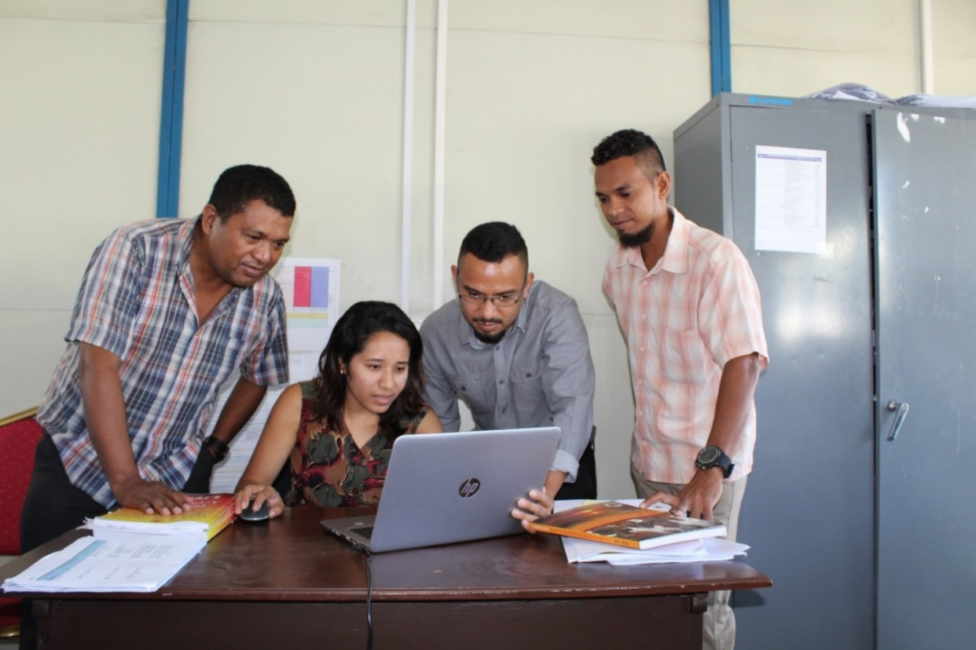
GfD’s Program Budgeting Advisers worked closely with UPMA to support the implementation of PBB

The VI CG’s reform agenda prioritised economic development and increased revenue, as well as reduced expenditure and greater efficiency. In March 2017, the CoM approved a Budgetary Governance Roadmap that sets out a medium-term plan of carefully sequenced reforms to achieve reduced spending, improved use of resources for maximum benefit to Timor-Leste, and increased transparency, designed to be implemented over a five-year period. Responsibility for leading these reforms and the implementation of a new approach to planning and budgeting was delegated by the Prime Minister to UPMA within OPM. A key plank of these reforms was a shift from a budget structure based on inputs, which measures budget execution against line items, to a program budgeting structure, which measures the results of the expenditure, i.e. the programs and services delivered. This is a foundational step for budgetary governance reform. The OECD, through GfD funding, provided advice on the development of the GoTL Budgetary Reform Roadmap, and has since undertaken a review of progress and provided advice on further updates to the Roadmap.
From 2017 GfD provided a team of national Program Budgeting Advisers (PBAs) to UPMA, along with a number of short term and long-term international adviser inputs, to support the implementation of the Government’s priority PFM reforms. With GfD support, program budgeting structures were established for all service delivery institutions in 2017. The budgets of these institutions were aligned with their annual plans, and for the first time the institutions were required to report the results of expenditure against service delivery programs, allowing oversight of budget expenditure and contributing to increased accountability. PBB has been progressively rolled out since then, with the 2021 budget being the first in which all entities with the exception of those within Região Administrativa Especial de Oecusse Ambeno (RAEOA) drafted their budgets using a program classification structure. The program structure was significantly refined for the 2022 budget, and all entities including RAEOA developed their 2022 budget based on this new program structure. While there is further work to be done to embed the concept and application of PBB and to build the capacity of Line Ministries to fully apply it at the level of service design and delivery, a solid and sustainable foundation has been laid. There are improvements every year in the application of this approach, particularly in those ministries such as Health and Education which have been using program budgeting since 2017. 2021 was a transition year in which UPMA, having led the catalytic transformation of Timor-Leste’s budgeting approach, handed over responsibility for the annual planning and budgeting process to MoF. UPMA became an autonomous agency at the start of 2022, and is now turning its attention to medium term planning, monitoring and evaluation, as planned in the Budgetary Governance Roadmap. A draft Medium Term Planning Framework has already been developed, and a whole-of-government M&E Framework will be developed in the first half of 2022, with support from GfD. This shift in responsibilities, coupled with the appointment of a new Minister of Finance in 2020, provided opportunities for GfD to re-engage with MoF. As at 31 January GfD had two advisers based in MoF, and a clear appetite from MoF for further support from the program. In January 2022 a new Budget and Financial Management Law was approved by the National Parliament, which enshrines PBB as the basis for the development of all future general state budgets. The Law is expected to be promulgated by the President in February 2022.
‘Linking our budget request to program targets made it easier for HNGV to make a proposal for increased budget, and to defend it confidently in front of KROP [Budget Review Committee]. We expect positive impacts on service delivery across many areas from better patient care, training, expansion of existing services and development of new services…’
Executive Director National Hospital Guido Valadares, Ministry of Health
The introduction and implementation of PBB was supported by the development and implementation by GfD of the DBFTL Management Information System, which captures multi-layered information about programs, activities, and associated budgets to inform both planning and budgeting. From 2018 onwards, the Parliamentary Budget Review Committee was trained in the use of DBFTL and drew on it heavily in their consideration of the 2021 and 2022 budget proposals. MoF have confirmed that DBFTL will continue to be the main tool to support annual planning, monitoring and evaluation following transition of leadership of the process to the Ministry. Future work will see elements of DBFTL being made available to civil society to provide greater transparency around planning and budgeting, and the development of an interface between DBFTL and MoF’s FMIS.
A third significant achievement was the introduction of GRB, another priority in the GoTL Budgetary Governance Roadmap. With the support of the GfD GRB Adviser, all Government entities applied a ‘gender marker’ in preparing their 2020 budgets. The 2022 budget preparation required all Government entities to include a GESI program, and saw the gender marker being applied at the subprogram rather than program level, with funds allocated to ‘principal’ GESI activities increasing by 190%, and an overall 2% increase in the percentage of general state budget funds allocated to gender in comparison with 2021. The next step will be to support all Line Ministries to identify appropriate targets and indicators to underpin their gender markers, and to continue to embed an understanding of GRB across Line Ministries. Information provided by the gender marker enables the Secretary of State for Equality and Inclusion (SEII) and UPMA to monitor institutional programs and activities related to the promotion of gender equality. It also assists in tracking the overall funds allocated to the promotion of gender equality. This information is published and made available to National Parliament. In addition to this being useful in its own right, it further entrenches gender as an integral priority in program planning and budgeting. The Government’s annual performance reports now include a section on gender, which further enables SEII to analyse the Annual Report and review Line Ministry plans and budgets through a gender lens to monitor implementation of gender policies and commitments. The independent GfD review team noted that GfD’s support for GRB ‘… was a strategic, central reform, continued by successor governments, which will assist GoTL deliver and monitor its gender objectives across ministries and agencies’.

Story of Significant Change (March 2019): Strengthened alignment between Government priorities and budget allocations. (PAF#8: Instance of improved systems for service delivery) | Rating: Highly Significant
Prior to implementation of program budgeting reforms, budget submissions based on input costs (e.g. fuel, rent) led to insufficient spending on priorities and inefficient use of Government funds.
The GfD Program provided a team of advisers to continue the roll out of the Budget Reform roadmap, developed through GfD funding by OECD in 2016. With this assistance, 31 Government entities adopted a program budgeting approach to their 2019 budget submission (in addition to the 25 that had transitioned to program budgeting in 2018). GfD also supported implementation of a new, structured, collaborative process of budget development through which budget ceilings were allocated to sectors, and entities were supported to develop and present their own annual plans and associated budget proposals.
This gave entities greater understanding and ownership of their budget and an opportunity to advocate for increased funds linked to program priorities, while giving the Budget Review Committee a greater understanding of, and rationale for, final budget allocations. Although entities were presented with 2018 budget amounts as their initial budget envelope, 50 out of 56 agencies using program budgeting were successful in advocating for additional budget, which amounts to USD$315.475 million allocated to entities above their initial allocation.

Key Evaluation Question 2: To what extent did GfD contribute to improved public administration?
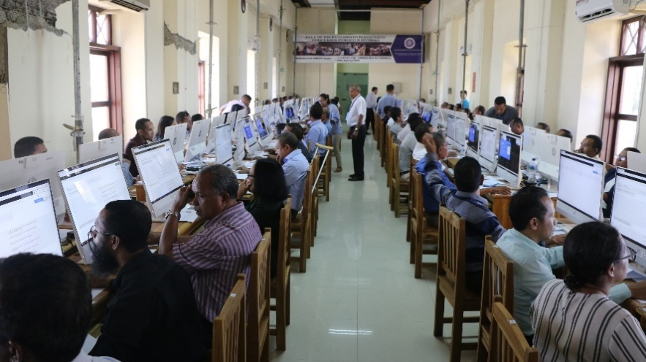
The first civil service merit-based general career regime promotion process was held in 2019

GfD’s support to public administration under the program’s second phase and Transition Program focused on four key entities: The CSC, TIC Timor (ICT Agency), and the Ministry for Legislative Reform and Parliamentary Affairs (MRLAP), the latter of which was disbanded in 2020 and advisory support moved to the office of MCAE and later the Presidency of the Council of Ministers (PCM).
GfD’s support to the CSC was the continuation of many years of support for the development and implementation of strengthened HRM policies and practices, dating from the PSCDP and continued throughout Phase One of GfD. Two key pieces of legislation were developed during this period with the support of GfD: legislation on Civil Service Workforce Planning, and legislation on Individual Performance Management. Both are still awaiting approval by CoM, with delays due to a lack of political consensus, and to COVID-19. Without the legislation in place GfD was unable to support progress with respect to workforce planning and performance management in the civil service. However, there was significant progress in other areas, the most notable of which was the implementation of a new system of merit-based promotions for civil servants. The first round of merit-based promotions took place in 2019, the second in 2020 and the third in 2021. Across the three promotion rounds, a total of 3,293 (959 women and 2,334 men) general career regime civil servants across all grades were promoted to the next civil service category out of a total of 27,434 (6,844 women and 20,590 men) applicants. While the total number of men promoted in the three rounds was higher than that of women, the percentage of female applicants who received a promotion was higher than the percentage of male applicants (14% vs. 11% on average), showing higher capacity among female civil servants to qualify for promotions. The promotion process was based on a range of supporting documentation evidencing performance of the civil servant, and the results of a computerised aptitude test. This reform ensured a more balanced, objective, inclusive, and fair promotion system, open to anyone, regardless of their political affiliations, gender, and family connections. There are plans to expand the process in 2022 to include some streams of special career regime civil servants (in the first instance justice, health and education). In parallel, work continues to assure merit-based recruitment and selection processes, based on terms of reference and objective and inclusive selection criteria, including to fill positions in the new CSC organic structure that will be implemented to reflect the needs and priority activities of the third CSC mandate. This marks an important and necessary foundation to improve the quality of the civil service workforce.
‘The inputs from the consultation will help the CSC to have a better design for the planning of the workforce in the future and inform Government on how to regulate the number of civil servants and to improve mobility across the civil service’.

CSC Commissioner responsible for
Workforce Planning
GfD’s legal advisers in the CSC not only supported the development and application of legislation but were also instrumental in reforming the process for addressing disciplinary cases. In 2020 the number of pending cases reduced from 270 to 71 through the application of a systematic approach and more timely decision making. For the first time penalties were applied in some cases, such as removal from public office, or ineligibility to sit the promotions test, serving as a disincentive for others to commit workplace breaches.
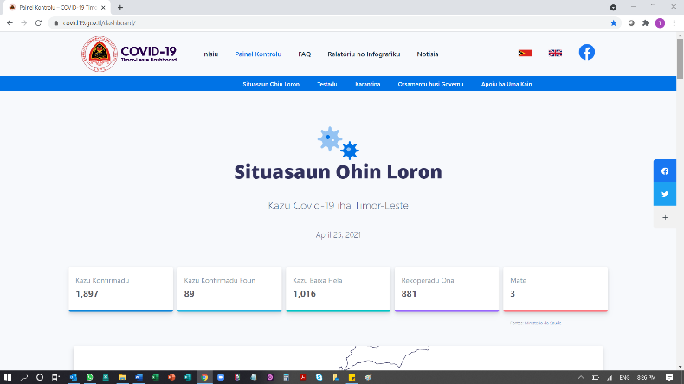
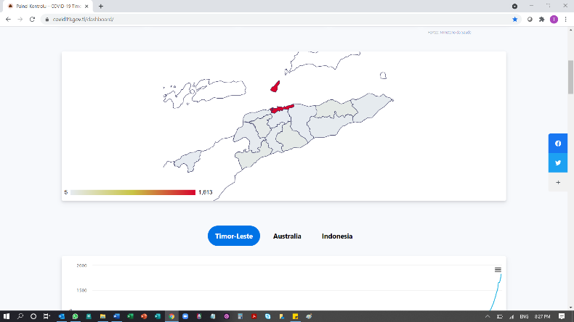
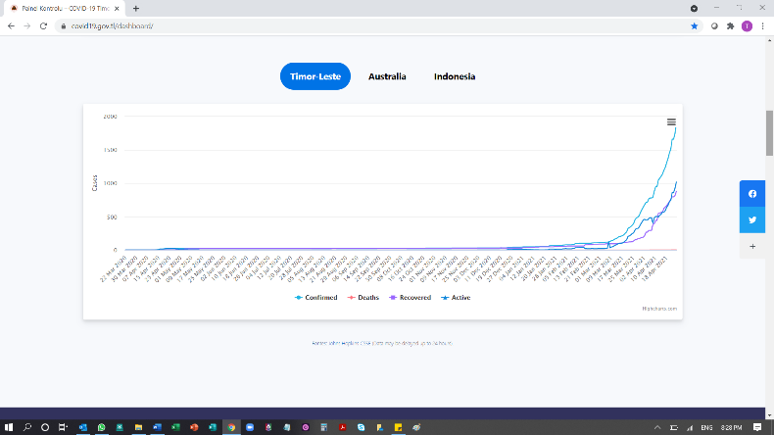
GfD also supported strengthening of the CSC’s ICT systems, including progress towards an interface between the CSC’s PMIS with the MoF FIMS – important to ensure that personnel management information records match financial payroll records, to remove a number of ‘ghost workers’ who are no longer in the civil service and to reduce payment errors. Formal agreement was reached on the interface, and technical issues resolved. The process now requires finalisation of data cleansing (ensuring that fields in both systems are accurate and match), a process which was slowed by the introduction of a new Organic Law for the VIII CG which realigned Government structures. Through GfD support and prompted by COVID-19, many CSC staff are now also able to access the PMIS system remotely – a significant benefit given the significant increase in remote working arrangements. GfD also supported the development of an in-house system for conducting the computerised promotion tests using open-source software rather than relying on the commercial PMIS provider that had previously supported the testing process, which significantly reduced costs and increased flexibility. In 2021 the GfD ICT adviser supported the introduction of an online ‘ticketing’ system enabling remote lodgement of enquiries to the CSC by Line Ministries. Work will continue in 2022, with GfD support, on the in-house development of a replacement PMIS using open source software, with a view to significantly reducing costs and increasing flexibility.
TIC Timor developed a COVID-19 dashboard – ‘The Single
Source of Truth’ about COVID-19
Following the establishment of the 3rd mandate of the Commission in mid-2020, GfD supported the new Commission’s process of planning and prioritisation. The priorities, which include a significant emphasis on gender and inclusion, have been finalised, and funding has been included in the 2022 budget.
In mid-2019 a decision was made for GfD to provide advisory support to TIC Timor, GoTL’s central ICT agency, in recognition of the central importance of ICT in supporting public administration reform. The focus of GfD’s work was on ICT strategy and good governance, and in particular the development of an e-governance strategy for GoTL (a priority under GoTL’s Public Administration Reform program). When this work was disrupted by COVID-19, GfD took advantage of the opportunity to support the development of a ‘COVID-19 dashboard’ that provides authenticated information on the status of COVID-19 in Timor-Leste, in the form of both a website and phone app. More recently GfD supported progression of a plan to implement a ‘Unique ID’ system across Timor-Leste. A draft strategy was developed through widespread consultative mechanisms and approved by CoM in mid-2021, and GfD appointed additional resources to support progression of this important initiative. GfD will finalise a baseline assessment of e-governance across GoTL in early 2022, which will inform development of the GoTL ICT strategy in the first half of 2022.
In 2019 GfD also provided support for broader public administration reform efforts within MRLAP. The GoTL’s Public Administration Reform document was completed within this period, which set out five pillars of reform for public administration:
- Service delivery processes;
- Incentives and accountability;
- HR management and development;
- Rationalising functions and structures; and
- Doing business.
The Public Administration Reform document is comprehensive and draws on best practice examples from across the globe. There are, however, differences of opinion at senior levels within the Government with respect to some of the recommendations, in particular in relation to HRM and the competencies of the CSC. While the document has been approved in general terms by the CoM, specific pieces of legislation to underpin reforms are still to be approved. GfD withdrew its support for these MRLAP-driven reforms in January 2020, given the potential conflict in relation to public administration reform that had emerged with respect to the long-term support that the program had provided to the CSC. Following the disbanding of MRLAP in mid-2020, GfD’s legal adviser moved to PCM, where she was instrumental in the implementation of a more coordinated approach to legislative and policy development, and in strengthening policy development processes and capacity, including through the development of an infographic on GoTL’s Inclusive Policy Development cycle.
Story of Significant Change (Dec 2018): Inclusive process of developing CSC Workforce Planning Policy and Decree-Law (PAF#16: Instance of Inclusive Policy Development) | Rating: Highly Significant
The Human Resources Management policies were previously written directly as laws by CSC-contracted advisers working in isolation, without consultation with the Line Ministries and Autonomous Agencies and with little involvement of the CSC itself.
In early 2018, the CSC with support of GfD led the development of the Workforce Planning Policy and the associated Decree Law through consecutive processes that were inclusive and consultative. This is significantly different from the way CSC has historically developed policy. The policy development involved a wide range of stakeholders, a series of comprehensive, inclusive and ongoing consultations, discussions and workshops informed the policy, and the policy was established prior to the law being drafted. The Decree Law was drafted through a similarly inclusive and consultative way, based on the policy. The GfD Human Resource Management Adviser supported CSC to facilitate the policy development process and to draft the Decree Law.
The result is a policy and Decree Law that is owned and understood by the CSC and the stakeholders who will be involved in the implementation.

Key Evaluation Question 3: To what extent did GfD contribute to development and implementation of evidence-based economic policy?
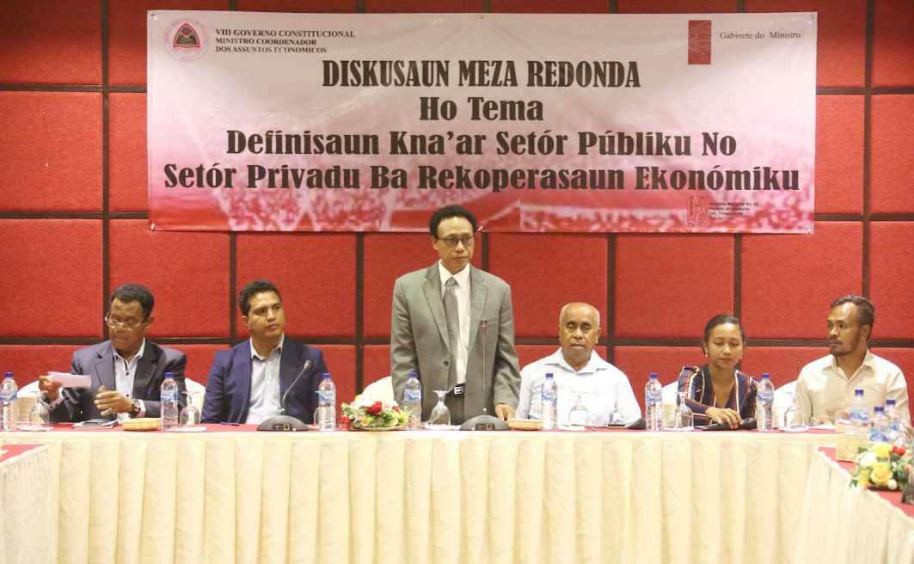
GfD advisers (on the right) were significant contributors to a public and private sector discussion on economic recovery

GfD’s support for economic policy suffered some setbacks under the VII and early stages of the VIII CGs, with political instability and major structural changes disrupting the possibility of significant progress. MECAE was disbanded, and there was no ministry tasked with the central coordination of economic policy. Some GfD economic advisers shifted from MECAE to MRLAP, whose minister was eventually also appointed as acting Minister MCAE. One Economic Adviser moved to OPM where he provided macro-economic advice and analysis to the Prime Minister. The contract of one adviser, initially based in TradeInvest, was not renewed, given the challenges of engagement in relation to business enabling reform. It continued to be difficult to get traction on significant macroeconomic policy reform during this period, given the lack of a clear ministerial mandate, and a Minister who was stretched very thin across a broad portfolio.
However, throughout 2019 GfD’s adviser in OPM continued to provide macro-economic advice and analysis to the Prime Minister and contributed to the production of policy briefings and analysis that were used to inform decision-making at the highest levels (for example research on tariff policies). Data collected through the MEL system demonstrated an increase in demand for GfD-supported evidence and economic data in decision-making within OPM. Monash University, through its grant with GfD, continued to produce important economic research, including in relation to connectivity, economic diversification, education, agriculture (including coffee) and the youth bulge. Findings of a Monash report on the coffee sector were referenced by the President of the Republic during his speech on the 20th anniversary of Restoration of Independence Day, and a report on internet connectivity, ‘Speed Matters: The Case for an International Cable Internet Connection for Timor-Leste’ was used by the Executive Director of TIC Timor to brief the Prime Minister on internet connectivity issues. Timor-Leste has now agreed to proceed with the establishment of a submarine cable connection, in part as a result of this research. Once in place, this is expected to lead to significant long-term economic benefits for the country.
In 2019 GfD engaged Oxfam to work on a range of economic-related topics under a program named Hadalan. In September 2019 Oxfam launched reports on the importance of economic diversification, and on women in agriculture. GfD’s support for this research not only expanded the evidence base to inform decision-making and guide sound economic policy making at the highest levels of Government, but also gave greater voice to local NGOs, CSOs and universities in the economic policy debate. It also provided opportunities to further develop CSO capacity to undertake quality economic research. And with the GfD-funded support of the Australian Bureau of Statistics (ABS), some major macroeconomic statistics were made available to the public by the General Directorate of Statistics (GDS), with timeliness progressively improving in the release of results such as the Business Activity Survey, Consumer Price Index and Gross Domestic Product figures. Not only did the partnership with ABS yield strong development results, but it also strengthened Government-to-Government relations and facilitated peer-to-peer learning with counterparts in GDS.
GfD also supported the first Informal Sector Survey within SEFOPE, and through cooperation with ABS and GDS obtained approval and budget for a Labour Force Survey to be conducted in 2021. Data collection was completed in late 2021, and analysis will be completed in early 2022 and shared with decision makers by mid-2022 with the support of GfD’s adviser in SEFOPE. Overall capacity for evidence-based decisions making in labour force planning has increased through GfD advisory support.
In 2020 a number of contextual changes presented opportunities for GfD to contribute to evidence-based policy development: COVID-19 provided a catalyst for an economic plan that would support the country to recover from the economic impacts of the pandemic, and a re-shaping of the governing coalition led to the re-establishment of MCAE, to which two GfD advisers transferred from MRLAP in September 2020. GfD support for the accession of Timor-Leste to the WTO intensified, and while the direct benefits of this process may take many years to take effect, the process of fulfilling WTO accession requirements indirectly led to improved analysis within Government in relation to critical opportunities for economic diversification, including identifying key sectors, increased coordination across economic ministries, and the development of key pieces of legislation to underpin economic development and strengthening of the private sector, including opportunities for international trade. The work is ongoing, but GfD adviser expertise in this area has been critical and will have positive spin-off effects in terms of Timor-Leste’s business enabling environment.
GfD advisers provided significant input into the Government’s COVID-19 ERP, alongside Monash University through its grant from GfD. Further, two other grant partners, The Asia Foundation (TAF) and Oxfam, pivoted the focus of their work to undertake research on issues related to the social and economic impacts of COVID-19, which also influenced the development of the ERP. TAF commenced a series of bi-monthly ‘pulse surveys’ exploring the impact of COVID-19 on the community and public perceptions of the Government’s response, which were presented to the ERC as they prepared the ERP. Oxfam produced reports on the economic impact of COVID-19 on rural women, and on the informal sector. Receiving timely community feedback regarding the impacts of COVID-19 and State of Emergency on people’s lives, and perceptions of the Government’s response, provided a critical evidence base to support government decision-making that adequately responded to and mitigated impacts on citizens. In early 2022 TAF, through GfD funding, will conduct a comprehensive public opinion survey, with the results expected to be available prior to the 2022 Presidential election.
‘GfD was instrumental in raising that problem (i.e. land border import restrictions of agriculture inputs) to the right policy makers and getting the attention that it needed…we tried all different kind of angles because the main issue for us is we want the issue addressed. However, we don’t work with the Government, so we don’t have that leverage...Even other organizations, they also suggested to us, ‘I think you should talk to GfD because they have the advisers in the Government’.’

Zannat Ferdous, Market Development Facility

Key Evaluation Question 4: To what extent did GfD contribute to strengthening the Business Enabling Environment?
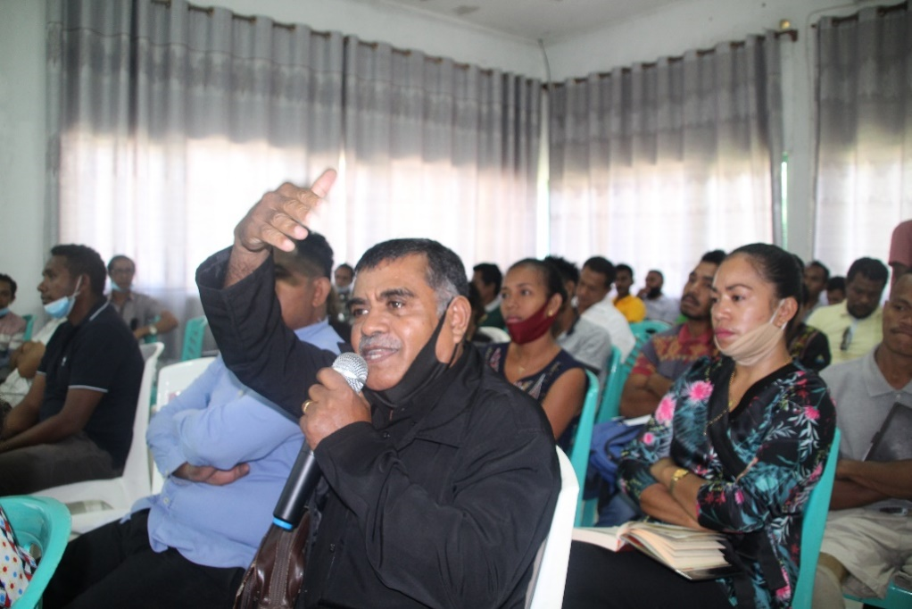
CSOs were invited to a presentation and discussion on improvements to business licensing processes

Establishing a strong private sector will be fundamental to achieving Timor-Leste’s economic diversification and growth goals. But Timor-Leste has one of the lowest rankings in the world in relation to Ease of Doing Business (181 out of 190 countries in the 2020 World Bank report). A significant contributor to this ranking is the lack of formal processes for commercial dispute resolutions, which means that establishing and running a business is extremely risky. In 2019 and 2020, a GfD adviser in MRLAP supported legislative developments which culminated in the ratification of the Decree Law on Arbitration and the signing of the New York Convention on Arbitration, both in early 2021 – a step towards reducing the risk of running a business in Timor-Leste.
GfD also invested heavily in streamlining processes for business registration and licensing, both through a grant with the International Finance Corporation (IFC) and through the placement of an adviser within SERVE. In October 2019, IFC completed an inventory of business licenses, as well as recommendations for simplifying the registration process. An Economic Activities Licensing Reform Working Group was subsequently established by the Acting Minister of MCAE and an Action Plan was prepared which outlined activities to be undertaken by the group through to December 2020, including follow-up on quick wins recommended from the licensing inventory. Most of these quick wins were implemented in 2020 and 2021. Further improvements have been driven by the GfD in-line adviser, including work to establish a facility to lodge business registration applications online, the development of an offline standalone database record system for SERVE, and the in-house development of a Business Registration application using open source software.
‘GfD’s technical support in the secretariat of the working group is crucial. GfD’s adviser worked with SERVE staff to ensure relevant documents are synthesized and making it available to head of the working group and members for better flow of discussion… The working group meeting was conducted almost every week upon the release of the dispatch to establish the Working Group. The Minister was also expecting the working group to produce the action plan within 2 months of the Working Group commencement. Unless the documents are well elaborated and ready on time, the discussions in Working Group meeting would not have clear direction.’

Feliciano da Costa, Principal Adviser in MCAE and the head of Business Licensing Reform Technical Working Group
Strengthening financial services is another key pillar of an improved business environment. Significant achievements were attained in relation to BNCTL, Timor-Leste’s first national commercial bank, which is responsible for social security payments to Timorese, including vulnerable segments of society. With support from GfD through a co-financing agreement with ADB, a new Decree Law and by-laws were adopted through an Extraordinary General Assembly Meeting of BNCTL in early 2020, raising BNCTL’s corporate governance systems to international standards that fulfil Central Bank regulations. These changes enable the bank to enter into international transactions and compete with a number of previously established foreign commercial banks. However, the next stage of this work – providing technical assistance to strengthen the Bank’s strategic planning and risk management, was delayed, and not achieved under GfD due to COVID-19 travel restrictions.
Through IFC GfD also contributed to improved access to finance through the microfinance institution Kaebauk Investimentu no Finansas (KIF). However, roll out of a planned agent and mobile banking system experienced significant delays, and was eventually put on long-term hold, when KIF ended the contract of the consultant developing their Core Banking System (a pre-requisite for the agent and mobile banking to progress). This work is now facing further significant delays and GfD and the Embassy decided to withdraw financial support for this activity. Although this project faced unforeseen implementation challenges, the roll out of mobile banking services across the country remains highly relevant for any future governance program in Timor-Leste. Improving access to banking facilities in rural areas will undoubtedly unlock private sector potential, further spurring on economic growth and diversification.
Story of Significant Change (Aug 2020): GfD contributes to the inclusive policy development to improve business registration and licencing system (PAF#16: Instance of Inclusive Policy Development) | Rating: Highly Significant
The process of obtaining the licenses required to operate a business in Timor-Leste is time consuming, costly, and lacks transparency. A number of licenses that are ‘required’ in fact have no legal basis. While SERVE was established as a one stop shop to manage the process of business licensing, it has struggled to fulfil this role, with a recent inventory identifying over 60 possible license requirements, many of which are not enshrined in any legislation and not managed by SERVE. Business and civil society has not previously been involved in the development of relevant legislation and policy, meaning that it may not be fit-for-purpose and, does not reflect the needs of the community that needs to work within it.
GfD advisers and grant partners recommended the establishment of a working group to consider the outcomes and recommendations from the inventory process, including membership of the working group, which was to include representatives of both business and civil society.
The Working Group was established in October 2019, with representative from the Timor-Leste Chamber of Commerce and Industry, and of Timor’s NGO Forum, FONGTIL. The Working Group drafted an Action Plan for business licensing reform, along with a number of quick wins. Both were approved by the Minister, who issued a despatch that the reforms should be implemented. While the process is not complete, a number of quick wins are in place to reduce the number of licenses required that have no legal basis, reduce unnecessary fees, and streamline coordination of the licensing process.

Key Evaluation Question 5: To what extent did GfD contribute to supporting aviation sector development?
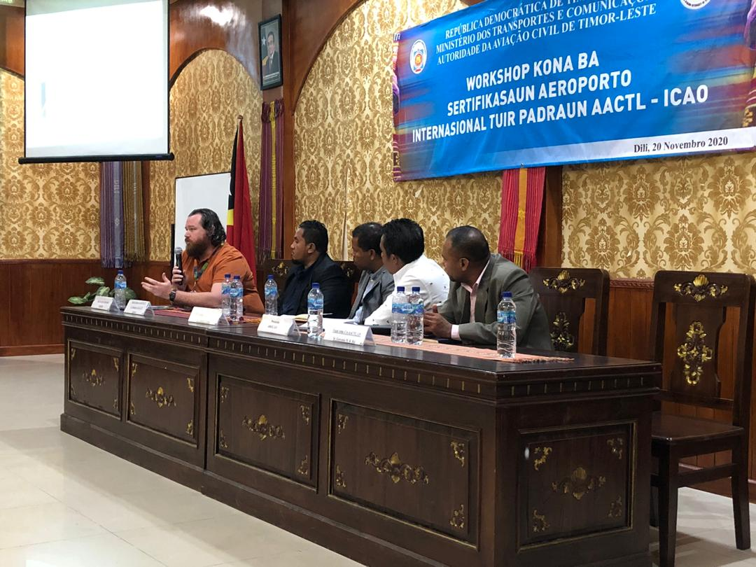
GfD coordinated an AACTL workshop on aerodrome certification

Recognising the critical role of aviation in the development of Timor-Leste’s economy and its regional integration objectives, GfD supported Timor-Leste’s aviation sector from late 2016 onwards. The program provided expert advice to the Inter-Ministerial Working Group developing Timor-Leste’s National Civil Aviation Policy (NCAP), which was approved by the Government in mid-2017. The highest priority in implementing the NCAP was to ensure that Timor-Leste has a continuing capability to implement international standards for safety and security of civil aviation. The International Civil Aviation Organization (ICAO) had identified areas of concern for Timor-Leste, including the legal and organisational foundations of AACTL. In assisting Timor-Leste to implement the NCAP, GfD supported technical and legal reform and capacity building in relation to airport and aviation safety and security, Air Navigation Services, and aviation strategy and policy. Recognising that Timor-Leste lacked the specific technical capability to address serious deficiencies in the field of Air Navigation Services, a consultancy firm was engaged in mid-2020 ,significantly increasing the resources being provided by GfD to support AACTL to bring its Air Navigation Services documentation, systems processes, and capacity up to international standards.
With strong support from GfD, GoTL established AACTL as Timor-Leste’s first independent aviation regulator with its own board and budget at the start of 2019, and throughout 2019 and 2020 GfD supported AACTL to establish an appropriate organisational structure and to fill positions with people with the requisite skills and experience. GfD also supported a study tour for Board members and senior staff to Australia, which served not only to build their knowledge and understanding of the role of an aviation sector regulator, but also to start to build linkages with key Australian aviation organisations and other relevant government agencies such as the Civil Aviation Safety Authority, Air Services Australia, the Australian Transport Safety Bureau and the Australian Bureau of Meteorology. Challenging dynamics within the Board and tight budgetary constraints until mid-2020 continued to hamper progress in terms of institutional strengthening and the progression of legislation. A change in Board membership in mid-2020 opened up opportunities to progress the filling of key positions in AACTL. However, low levels of capacity, and ongoing role-ambiguity between AACTL as the regulator and the Air Navigation Administration of Timor-Leste (ANATL) as the airport management agency and implementer of some regulatory functions, meant that progress continued to be slow, and there is still much to be done for AACTL to secure its independent regulatory role according to its mandate, and to fulfill the requirements of an upcoming ICAO audit.
A challenge for GfD’s technical aviation advisers was to balance doing the work (drafting legislation, regulations, manuals, and guidelines) and building local understanding and ownership of this critical documentation to assure its implementation. GfD’s International Aviation Legal Adviser, in partnership with a national legal adviser, supported the development of over 15 pieces of legislation and international agreements. The Technical Aviation Specialist drafted a wide range of manuals, guidelines, and procedures in relation to airport safety, security and facilitation. And GfD supported the development of more than 20 manuals and regulations that are central to air navigation safety. The entry into force of the Air Services Agreement between Australia and Timor-Leste in early 2021 was a significant achievement that will continue to strengthen aviation ties between the two countries. The advent of COVID-19 severely hampered the ability of international advisers to travel to Timor, who in the meantime focused on the development of the documentation required to meet international standards. With the resumption of some travel in mid-2021, significant progress was made in building the capacity of AACTL in relation to Air Navigation Services, and in particular ensuring that the documentation that had been produced was understood, owned, maintained and implemented by the AACTL team. This work will continue for the remainder of the Transition Program, with an increased focus on building capacity within ANATL.
GfD provided advice to both AACTL and the Embassy on a number of strategic aviation issues, ranging from airfares and the attraction of airlines to Timor-Leste, to the pros and cons of establishing a national flag carrier, and more recently, the post-COVID recovery of the aviation sector and associated requirements to assure the COVID-safety of flights coming into and out of Timor-Leste. Discussions of a proposal to shift the management of Timor-Leste’s upper airspace to Australia commenced and will progress further in early 2022. This change would provide significant annual revenue to GoTL. A significant achievement in late 2021 was the establishment of a National Security and Facilitation Committee. This committee is required under the international standards relating to Aviation Security and Facilitation, with primary responsibility to develop and monitor implementation of relevant national plans. With the outbreak of the COVID-19 pandemic, new arrangements and facilities required at national airports brought the field of Facilitation into sharp focus. In the remaining months of the Transition Program GfD will support AACTL to operationalise the Committee, and to develop appropriate national security and facilitation programs. The COVID-19 pandemic has brought new challenges for Facilitation, with growing emphasis on ensuring social distancing, enabling contactless processes, passenger documentation and protection of staff. The GfD advisers provided briefings to AACTL on these matters, but creating conditions for COVID-safe travel will be a continuing challenge.
Story of Significant change (May 2018): Inclusive process of developing National Civil Aviation Policy (NCAP) - Growing Aviation to 2030: Providing Connectivity to Support Economic and Social Development (PAF#16: Instance of Inclusive Policy Development) | Rating: Highly Significant
GoTL had a draft National Civil Aviation Policy (NCAP) that was prepared by the Ministry of Public Works, Transport and Communication (MOPTC) and only addressed narrow technical objectives of MOPTC. This initial draft policy didn’t address the linkages between aviation policy and economic development that were identified as goals in the GoTL’s Guide for Economic Reform and Growth (GRFE) 2015-2017. The need for inclusion of a wider range of stakeholders was identified by the GfD Economic Adviser and the Technical Coordinator of the Office of the Minister of State Coordinating Economic Affairs (MECAE). GfD advisers (Economic Adviser, National Project Manager and Junior Professional Economist) supported the facilitation of an Inter-ministerial Working Group (IMWG) on Aviation in late 2016. Upon request from MECAE, GfD provided an International Air Transport Specialist to work with the IMWG to develop a comprehensive NCAP. The IMWG included representatives from each sector involved in the development of the aviation sector, i.e., finance, public works, infrastructure, tourism and the aviation regulator. The policy development process was highly inclusive, and the revised policy was informed by evidence. The resultant policy supports the objectives of the Timor-Leste National Strategy Development Plan 2011-2030 and has the potential to contribute to economic diversification when fully implemented. The policy was approved by the Council of Ministers on 30 May 2017.

Key Evaluation Question 6: To what extent did GfD support other voices to engage with the policy-making process and to advocate for improved service delivery?
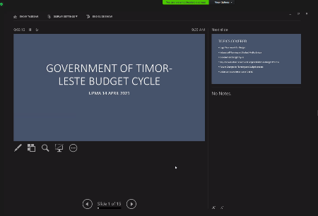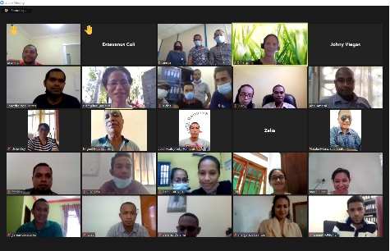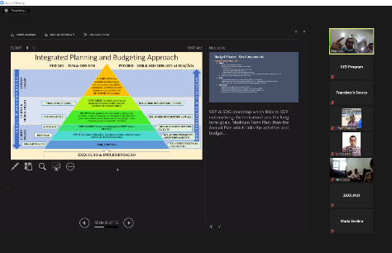
GfD partnered with UPMA to run a ‘virtual roundtable’ discussion of the budget cycle for civil society organisations

A priority for the second phase of GfD was to promote the engagement of non-government stakeholders or ‘other voices’ in the development and implementation of policy and legislation. This was through both supporting mechanisms for GoTL to seek meaningful engagement with civil society and other non-government stakeholders, and through supporting CSOs and other non-government stakeholders to advocate for change and hold the government to account.
GfD achieved a number of successes in relation to inclusive policy development. In early 2018 the CSC, with support from GfD, led the development of a Workforce Planning Policy and associated Decree Law through processes that were inclusive and consultative – a significantly different approach to how the CSC had historically developed policy. The process involved a wide range of stakeholders, giving voice to people outside Government, and a series of comprehensive, inclusive, and ongoing consultations, discussions, and workshops to inform the policy. Furthermore, the policy was established prior to the law being drafted instead of the previous practice of law preceding the policy – a good governance best practice. The Decree Law was drafted through a similarly inclusive and consultative process, based on the policy.
More recently GfD was instrumental in ensuring that GoTL adopted an inclusive approach to the process of policy change in relation to business licensing. A technical working group was established to lead the process of streamlining licensing processes which included not only GoTL representatives, but also representatives from the Timor-Leste Chamber of Commerce including the Associação de Empresarias e Mulheres Timor-Leste (a Timorese Businesswomen Association), and FONGTIL (umbrella organisation for Timorese non-government organisations).
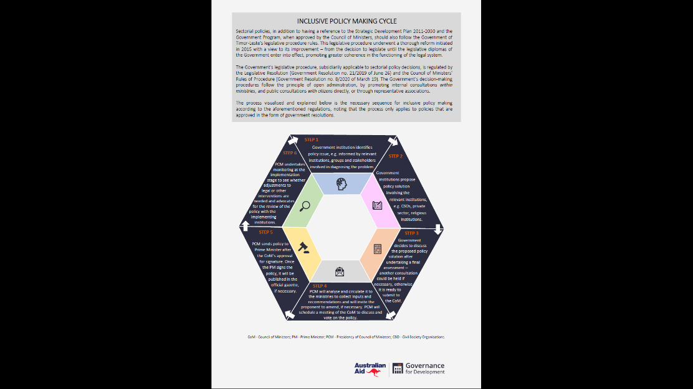
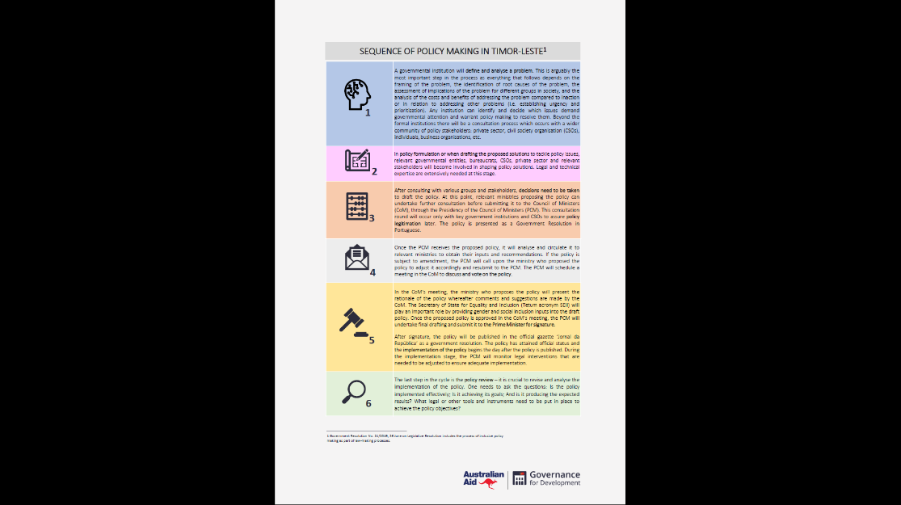
At a systemic level, GfD developed, with the endorsement of PCM, an infographic on the inclusive policy development cycle. The infographic was shared with relevant stakeholders, and in particular relevant NGOs and CSOs working to influence public policy, and discussed through a series of roundtable meetings, including with other DFAT-funded programs. GfD also supported the sharing of information on GoTL’s planning and budgeting processes with civil society partners. This included a series of discussions with CSOs in relation to the Budgetary Governance Roadmap and culminated in a roundtable on the planning and budgeting cycle involving a range of CSOs and led by UPMA in April 2021. During the Transition Program GfD supported coordination and facilitation of CSO consultations in relation to both the Unique ID project, and Timor-Leste’s accession to the WTO – both strategic priorities of keen interest to civil society.
Inclusive Policy Making Cycle infographic (front and back)
GfD also worked through grant partners to support a wide range of civil society partners to advocate for changes of importance to their constituencies. Oxfam’s Hadalan program, funded by GfD, started in mid-2019, with the purpose of strengthening the pathways and capacity of diverse voices to collaborate in order to understand, influence and monitor public policy related to economic diversification and agriculture. Through Hadalan a number of background and research papers were developed and presented to GoTL, including on Economic Diversification and on Women in Agriculture. In late 2020 Hadalan supported a coalition of agricultural organisations to present their concerns and priorities in relation to the 2021 budget to GoTL’s Women’s Parliamentary Caucus, GMPTL. Hadalan also coordinated several expos of youth working in agriculture and the productive sectors, both in Dili and in the municipalities, which provided opportunities for advocacy to decision-makers on the importance of sound policy and GoTL investment in agriculture and the productive sectors. In other sectors, GfD supported local NGOs Fundasaun Mahein to provide essential security sector monitoring, reporting and advocacy, and the Judicial System Monitoring Programme (JSMP) to promote access to justice for community members by improving public awareness and confidence in the legislative and justice sector along with strengthening awareness of democracy and the legislative process. As an example of successful advocacy, JSMP’s Report and Recommendations for Civil Law Litigation Reform, developed with support from GfD advisers, was a catalyst for GoTL discussions on the need to strengthen civil law litigation, and was used by MRLAP and other government stakeholders to inform initial steps in policy and law reform, with specific recommendations reflected in the ministry’s 2020 budget. JSMP advocacy also influenced amendments to the Anti-Corruption law and a number of other key pieces of legislation in 2020. Grant funding to JSMP and Fundasaun Mahein was not continued under the Transition Program, due to concerns raised through the Independent Review about strategic fit with the core scope of GfD’s work.
GfD’s grant agreement with TAF also gave prominence to ‘other voices’. TAF’s bi-annual Tatoli! public opinion survey provided GoTL with community feedback about government priorities, and public perceptions on the performance of the Government. Following the onset of COVID-19 this was transformed into a bi-monthly pulse survey, providing a rapid, time-series assessment of the socio-economic impacts of COVID-19 and public perceptions of the Government’s response. These reports were provided to the ERC and other key GoTL stakeholders, as well as development partners such as World Bank, to inform policy and decision-making. A further, full Tatoli! Survey is being conducted in the lead up to the 2022 Presidential election. In addition, through the TAF grant the Policy Leaders Group, a network of emerging Timorese leaders with an interest in public policy, was supported to conduct TV talk shows on a range of topics in relation to economic development and diversification, involving representation from civil society and the private and public sectors. Topics included agriculture, tourism, and land use, and more recently, the implications of COVID-19 on the economy. In 2020 the Policy Leaders Group rebranded as ‘KDA’I’ and registered as an independent organisation, with a view to becoming an independent think tank, and has continued to lead public discussion on topics including Timor-Leste’s reliance on the Greater Sunrise project, and on the importance of evidence-based policy-making. A significant event will be held in the lead up to the Presidential election, canvassing a range of policy issues.
Story of Significant change (July 2019): Judicial System Monitoring Program (JSMP) Report and recommendations on civil law litigation reform in Timor-Leste available for decision-makers (PAF#21. Instance of evidence available for decision-makers) | Rating: Highly Significant
The absence of a sound system for resolving contractual disputes is a significant obstacle for attracting investment into Timor-Leste. Potential investors assess how conducive local systems are to starting and operating a business. Timor-Leste currently performs very poorly in these assessments: without the ability to enforce contracts, businesses place themselves at considerable risk.
Supported by GfD, JSMP produced Report and Recommendations for Civil Law Litigation Reform in Timor-Leste, aimed at encouraging institutions to establish the necessary conditions for efficient and equitable civil law proceedings. The report was launched in February 2019 and disseminated to decision-makers within the GoTL and development partners.
The report was a catalyst for GoTL discussions on the need to strengthen civil law litigation and has been used by the Ministry of Legislative Reform and Parliamentary Affairs (MRLAP) and other government stakeholders to inform initial steps in policy and law reform. Specific recommendations are already being considered by MRLAP and are being reflected in the ministry’s 2020 budget. It has also informed development partner decisions: for example, the USAID Millennium Challenge Cooperation is developing a stream of work on civil litigation / contract enforcement for inclusion in its Compact with Timor-Leste.

Efficiency
GfD's M&E system collected mainly qualitative evidence on efficiency questions. The 2019 Independent Review of GfD provided useful analysis of efficiency, including Value for Money (VfM) assessments, but also demonstrated the challenges in assessing VfM. VfM assessments by the review team were mixed, finding that overall program VfM was ‘adequate’ and that the VfM of some activities was ‘good’ or ‘excellent’ (e.g., ABS support to GDS, civil aviation activities), but some were rated as ‘adequate/borderline’ or ‘poor’ (activities with respect to financial services undertaken by multilateral grant partners).
The review team assessed that reallocation of responsibilities from DFAT to Cardno, following appointment of a Team Leader with greater involvement in strategy, strengthened the efficiency of the program. They also assessed that GfD would benefit from the appointment of technical managers and external sounding boards to provide technical direction to the different work areas. In response to this recommendation, GfD established a Strategic Advisory Team (SAT) that provided technical support and advice to the Embassy and GfD Management Team and mentoring support to work areas and individual advisers.
The review team also noted the scope for further interaction between GfD and other Australian development programs to leverage GfD’s access and ability to engage with central GoTL agencies. Initial scoping in relation to joint work to assess barriers to service delivery with PHD and PARTISIPA was undertaken as a result of that finding, with further progress on implementation of the findings of the scoping exercise anticipated during the final months of the Transition Program. Under the Transition Program a significant piece of collaborative work was also undertaken with the Workforce Development Program Timor-Leste (WDPTL) around understanding and addressing issues of youth unemployment.
The review team noted that while advisers provided valuable support to GoTL to develop new systems and contribute to strengthening individual skills and competencies, the pressure to deliver short-term results meant that the advisory modality did not always lead to more sustainable organisational capacity. GfD continued to work with its advisory team and grant partners to identify opportunities to build capacity not just at an individual level, but also at an institutional level and across Government.
And finally, the review team found that grants to national and international organisations were an efficient modality to deliver, building on the reputations and technical skills of grant partners, although while some were rated as ‘excellent’ in terms of VfM (ABS and Monash), some were rated as ‘adequate /borderline’ or ‘poor’ (ADB, IFC). This finding influenced decisions on grant partner engagement under the subsequent GfD Transition Program.

How GfD Worked (including Key Evaluation Question 7: Strategic engagement with partners)
During Phase Two and the Transition Program, GfD maximised its efficiency by using mixed modalities (short- and long-term advisory support, training, and grants) to ensure that appropriate support was provided to GoTL counterparts and grant partners. The efficiency of Cardno-recruited technical assistance was maintained by using international expertise where required, but prioritising national expertise where possible. This was not only lower cost, but also promoted sustainability through the building of local capacity. In January 2021, 86% of long-term advisers were national (compared with 27% at the end of year one). The value of this was evidenced in particular in 2020, when all international advisers were temporarily demobilised as a result of COVID-19. The ability of the national team to continue, initially from home, but eventually back in their counterpart offices, not only meant an almost seamless continuation of the program, but also built the confidence of GoTL counterparts in the ability of GfD to be able to continue to provide timely and quality advice, even during conditions of remote working.
‘Even when the GfD advisers were working remotely, their works were tremendous, and they contributed to the successful mitigation response to COVID-19’

UPMA Coordinator
In addition, GfD leveraged existing capabilities and resources within GoTL and supported local counterparts to lead change. The in-line day-to-day management of advisers by GoTL counterparts strengthened local ownership of reforms and ensured GfD's work remained consistent with local priorities. While there was an ongoing risk of ‘adviser capture’ and advisers providing capacity substitution for civil servant roles, this was largely mitigated through regular formal and informal communication with GoTL counterparts. In addition, GfD supported opportunities for advisers to be transferred to the government payroll, a number of examples of which were in place by the end of Phase Two of the program.
Advisers also reported contractually to the GfD Team Leader, and adviser performance was closely monitored by the Cardno GfD team and the Embassy. Data from annual adviser performance management reviews, conducted collaboratively with GoTL counterparts, indicated that the majority of advisers performed extremely well. Where this was not the case, GfD took remedial action, including terminating or declining to renew adviser contracts, which occurred in a small number of cases.
GfD engaged STAs where specific technical expertise was required on a short term or periodic basis, such as in the aviation sector, and in the early days of establishing the foundations for PBB. Wherever possible, STAs were partnered with long term national advisers or directly with counterpart staff who were able to continue to progress reforms in the absence of the STA. This was particularly important during the COVID-19 pandemic, when it was not possible for STAs to travel to Timor-Leste, and national staff on the ground played a crucial role in ongoing engagement with counterparts and progression of reforms, such as in aviation (AACTL) and business licensing (SERVE). In PFM, where a large number of STAs needed to be drawn on during the early years of PFM reform, Cardno recruited a pool of short-term advisers in a bulk round, who received long term contracts, but were only used as required. This was a cost-effective way to recruit and retain expertise that could be drawn on quickly, based on need.
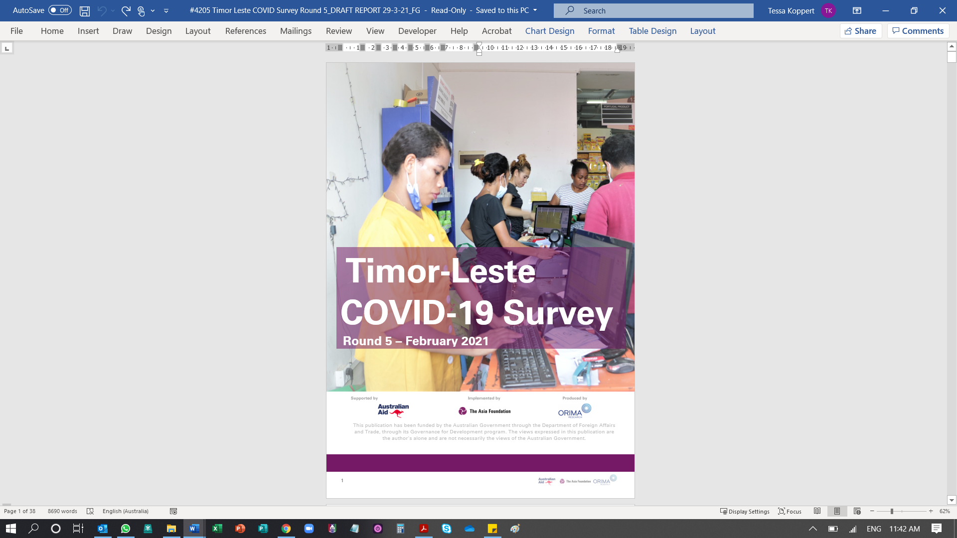
In-line sectoral advisers were supported by GfD’s locally engaged cross-program team, which provided support and advice in relation to gender and inclusion, M&E, civic engagement, and communications. The formation of the cross-program team yielded many benefits to the program as cross-fertilisation between each of the team members’ field of expertise occurred organically and on an ongoing basis. The team also worked together to produce a weekly media monitoring report to keep track of news related to GfD achievements, which was in turn used to strengthen GfD’s evidence base in monitoring project impact.
TAF’s COVID-19 survey informed decision making by Government and other stakeholders
Grant partners proved to be efficient and appropriate modalities of delivery in the majority of cases. The ABS maintained a strong partnership with GDS within MoF, and successfully supported improvements in both the timeliness and quality of financial and macro-economic statistics. Monash University provided valuable economic analysis and evidence to inform policy development, through both targeted reports, and through tailored advice on economic priorities in response to the COVID-19 crisis. OECD provided trusted and valued advice to GoTL to underpin the development of the Budgetary Governance Roadmap and the implementation of PFM reforms. Both TAF and Oxfam, while already delivering in line with original grant agreements, were able to pivot quickly when COVID-19 appeared and to draw on their extensive networks to undertake a range of research in relation to the socio-economic impacts of COVID-19, and the Government’s response. In particular, TAF’s collaborative approach in consulting with GfD management on products and publications was highly appreciated and should serve as a model for future engagement with grant partners. While a decision was made not to continue funding of Fundasaun Mahein and JSMP after June 2021 on the basis of relevance to the scope of GfD (see next section), they achieved significant outcomes as a result of advocacy in their respective sectors at relatively little cost.
Two grant partners that were less successful in achieving all their objectives were multilateral agencies working in the financial sector, ADB and IFC. After some initial good progress with BNCTL, the former was hamstrung by a lack of in-country advisers, which placed them at a significant disadvantage when COVID-19 struck. Despite a no-cost extension, they were unable to complete their final deliverables in relation to supporting BNCTL strategy and risk management, and funds had to be returned at the end of their extension period in December 2020. IFC work on the KIF agent and mobile banking system was unable to be completed as a result of a decision by KIF to completely re-start the Core Banking System development process. Both of these examples reinforce the importance of closely monitoring the progress of grant partner work, heeding early warning signs, and taking swift action when progress looks like it is being derailed.
While the majority of GfD’s non-advisory activity budget covered the costs of grant partners (87%), a small percentage (13%) was spent on other activities such as training or study tours, as well as contracts with service providers for specific pieces of work. An example of the latter was the contract with a consultancy firm to provide inputs in relation to Air Navigation Services. Decisions around activities were deliberate and targeted. For example, GfD funded a study tour for the Board and key staff from AACTL to develop both knowledge and relationships with Australian aviation-related entities, and funded two AACTL staff to attend training on human factors through the Australian Transport Safety Bureau in Canberra, as well as two Timorese to attend a six month RMIT program on accident investigation. GfD also funded representatives of two non-government stakeholder groups to attend the Voluntary National Review and its presentation to the UN High Level Political Forum in New York in July 2019, and supported greater engagement by senior personnel in AACTL, including the President, in regional forums on aviation matters under the auspices of ICAO. In late 2021 GfD funded a combination of GfD advisers, GoTL officials and non-government representatives to attend a series of bilateral and multilateral meetings in Geneva in relation to WTO accession.
GfD's ‘convening power’ and strong coordination mechanisms have been well recognised. GfD devoted substantial time and resources to coordination with stakeholders. For example, GfD coordinated a range of working groups for DFAT-funded programs across Phase Two, including on decentralisation, ICT and private sector development. Two collaborative activities progressed under the Transition Program, one with PHD and PARTISIPA looking at Constraints to Service Delivery, and one with WDPTL looking at issues of Youth Unemployment. There is scope for this coordination to expand under the PROSIVU program, in particular with the PARTISIPA and PHD programs in relation to strengthening implementation of systems and service delivery reforms within Line Ministries, with the Market Development Facility (MDF) and TOMAK in relation to economic diversification and private sector development and with WDPTL in relation to issues of employment and labour force supply and demand. GfD also engaged with other development partners to ensure harmonisation of work in common areas, including with UN Women in relation to GRB, supporting the Agriculture and Fisheries Development Partner working group, and collaborating with USAID’s NGO Advocacy for Good Governance Activity. The program’s relationship with the World Bank in relation to PFM was impacted to some extent by GfD’s withdrawal from DBS and from the World Bank Analytical and Advisory Activity in 2015. However regular dialogue continued around a range of issues, including for example e-governance and the development of the Unique ID, and the Australian aid program is well-positioned to re-engage with the World Bank in relation to PFM under the PROSIVU program as the relationship with MoF is strengthening once again.
A notable change during Phase Two and the subsequent Transition Program was increased program cohesion and ensuring that ‘the whole is greater than the sum of its parts’. Opportunities were identified and progressed in relation to collaboration across not only GfD program advisers, but also across grant partners, and between grant partners and advisers. For example, ABS and Monash University collaborated on a time series analysis of the Business Activity Survey to provide data on labour productivity and how to overcome constraints to unlock future productivity potential. ABS also worked with GfD’s GESI adviser and the CSC to discuss means of identifying people with a disability working within the civil service. GfD’s economic and PFM advisers collaborated in the development and budgeting of the COVID-19 ERP. GfD’s Civic Engagement adviser was able to secure the support of legal advisers working in the CSC and PCM to progress the development of an inclusive policy development infographic. And GfD’s ICT advisers in the CSC, UPMA and TIC collaborated regularly on a range of government-related ICT issues, including platforms for working from home, and remote access to government ICT systems.

Management and program resourcing
GfD's evolving One Team approach across Cardno and the Embassy led not only to strengthened governance of the program, but also to increased efficiency gains throughout Phase Two and the Transition Program. The increase of Cardno's resources for program management from one to two international positions at the start of 2019 relieved pressure on the Embassy team, and enabled GfD to shift from an operational focus to more effectively engaging in program strategy, implementation, and quality assurance, with decisions on program direction, strategy and resource allocation being jointly made by the Embassy/Cardno GfD team. Weekly program/Embassy/Cardno meetings provided a forum to discuss both operational and programmatic issues (including those relating to Timor-Leste’s ever changing political economy), and to ensure that emerging issues were identified and addressed. This was further strengthened in mid-2020 with the promotion of the Program Coordinator and Operations Manager positions to Deputy Team Leader roles, the former focusing on program issues, and the latter on operations. The Deputy Team Leader - Operations was a national staff member who had progressively taken on increased responsibilities across the life of the program, and who played a key role in ensuring the seamless continuation of the program when all international staff were temporarily demobilised in 2020 due to COVID-19.
As noted in the 2019 Independent Program Review, the program would have benefitted from additional resources to strengthen technical leadership of its three workstreams. This was not assessed by the Embassy as providing VfM during the final 18 months of the program. A decision was, however, made to appoint a SAT involving senior technical experts in PFM, Economic Development, Aviation and Public Administration to act as a sounding board for program planning, reporting and problem solving and mentoring advisers. Following its creation in mid-2020, the SAT was hampered by COVID-19 and an inability to travel to Timor-Leste, however still provided valuable inputs and advice remotely to both the Team Leader and Embassy team. The ToR of the SAT were amended under the Transition Program to also include mentoring and guidance to GfD advisers working in their respective workstreams, which added significant value to the advisers and relieved the pressure on the Team Leader.
The Cardno team in Melbourne provided valuable program management support throughout Phase Two and the Transition Program, and was able to capitalise on the joint Cardno management in Timor-Leste of GfD and the PARTISIPA program. This enabled sharing of not only corporate resources (Contractor Representative, Program Manager, Program Administration Officer) but also some program resources across the two programs. For example, from March 2020 until August 2021 an international Finance Manager was shared one-third / two-thirds between GfD and PARTISIPA respectively, and the programs were able to provide back-up resources for each other when staff were on leave. Where appropriate, professional advice such as legal advice on labour law issues was procured jointly across the two programs. A joint Cardno Timor-Leste Incident Management Team met regularly to discuss the programs’ response to COVID-19 and other health and safety issues.
Throughout Phase Two and the Transition Program, the program budget was tracked through its Lifetime Budget. Regular meetings between the Embassy and GfD Management (monthly, increasing in frequency towards the end of the financial year) provided an opportunity to track spending, to review or decide on budget allocations, and to make adjustments as necessary. An example of adjustment was when COVID work from home arrangements and travel restrictions prevented certain activities from progressing in 2020 and 2021. A decision was made to reallocate the unallocated budget to other COVID-related activities within the program, or to other COVID-19 priorities within DFAT’s Timor-Leste aid program. Program expenditure came in close to the finally agreed budget in every year.

Relevance (Including Key Evaluation Question 8: Using the right approach to maximise the long-term impact of the program)
GfD was designed to be a flexible, adaptive program that responded to the context and needs of GoTL, within the framework of DFAT’s Timor-Leste Aid Investment Plan (AIP) and later its Timor-Leste COVID-19 Development Response Plan (CDRP). Programming decisions were based on the premise that all activities should be ‘technically feasible and politically possible’. While under Phase One programming decisions were made almost exclusively by the Embassy in consultation with GoTL counterparts, as the Cardno GfD team’s involvement in strategy increased throughout the second phase of the program, so too did their input into programming decisions. These decisions were made largely on the basis of informal analyses of the political economy undertaken in weekly program team meetings.
A decision was made early in the program design not to establish a Steering Committee involving GoTL and other stakeholders, given the likelihood that within the political context of Timor-Leste, such a committee would be captured by political interests. GoTL representatives and other stakeholders were consulted, but did not have a formal role in resource allocation decisions. They were also involved in annual R&R workshops and one PEA session supported by the Timor-Leste Desk in August 2018, which provided an opportunity for both GoTL counterparts, and other stakeholders such as other development partners, to provide feedback on GfD activities and suggestions for future program priorities.

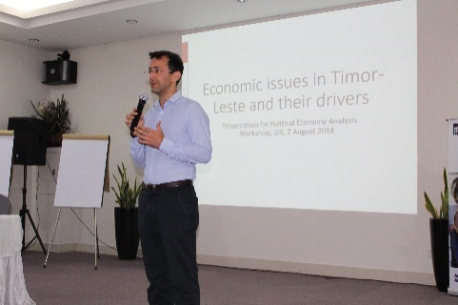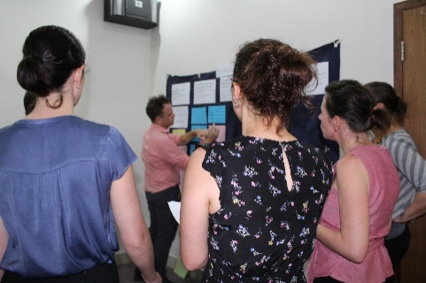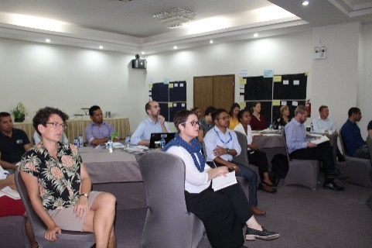
Political Economy Analysis workshop supported by Timor-Leste Desk in 2018

The approach to governance of the program was supported by the Independent Program Review. The review team did, however, recommend that GfD should adopt a more formal and documented approach to PEAs, and to use R&R workshops more strategically. In response to this, a series of formal PEAs were completed for each work area in September 2020, and again in August 2021. Scheduling of R&R workshops in 2020 and 2021 remained problematic due to the constraints of COVID-19, but regular meetings were held with GoTL counterparts and other GfD stakeholders, either face-to-face or remotely, to discuss the program and its future priorities, in particular as input to the design of the GfD successor program.
Examples of changes in program priorities throughout Phase Two as a result of changing context, requests from GoTL and analysis through formal and informal PEA processes included the following:
- Two international advisers were placed in MRLAP in 2019 to support broad public administration and business enabling reforms. These resources were not continued in 2020 as a result of conflicting agendas between MRLAP and the CSC, the latter of which has been supported by the Australian Aid program for over 10 years.
- In mid-2019 GfD appointed two advisers to TIC Timor, GoTL’s central ICT agency, to support ICT governance and the development of an e-governance strategy. Two further national advisers joined the TIC team in April and May 2021 respectively.
- Two GfD economic advisers moved from MRLAP to MCAE when it was re-established in mid-2020. This was followed by the appointment of two legal advisers, one national and one international, to support legislation in relation to economic development, strengthening the business enabling environment, and accession to WTO.
- Resourcing to the aviation sector was significantly increased in mid-2020 through the engagement of a consultancy firm with expertise in Air Navigation Services, with a view to supporting catalytic changes to Timor-Leste’s air navigation safety. Such expertise was required to enable Timor-Leste to meet important and obligatory international standards.
- A national adviser was appointed to SERVE in early 2019 to provide ongoing on-the-ground support to progress reforms in relation to business registration and licensing.
- From mid-2019 GfD appointed two M&E advisers to UPMA in recognition of the shifting role from budget preparation to M&E of program and budget implementation.
- Following the appointment of a Minister of Finance in late 2020, GfD resumed dialogue with MoF with a view to supporting the transition of annual planning and budgeting from UPMA to MoF. GfD appointed its first advisers to MoF since 2015 in December 2021 and January 2022, with a further adviser expected to be appointed in early 2022.
The Independent Program Review concluded that while the GfD work areas were relevant at a high level, specific work area priorities were at times less so. In particular they questioned the significant focus on HRM in relation to public administration, and lack of engagement around what they considered to be two significant areas of economic development: land reform, and oil and gas. In relation to the former, GfD commissioned an assessment of the impact of GfD support on the civil service in late 2021. The assessment was finalised in January 2022 and will inform decisions in relation to Public Administration support under PROSIVU. It should be noted that public administration in Timor-Leste to a large degree rests on HRM practices and affects a workforce of over 30,000, making the civil service the biggest formal employer in the country. Adherence to merit-based recruitment and selection processes in government is also of key importance in assuring good governance. The management of this significant workforce is therefore a significant component of good public administration.
In relation to economic development, while the importance of the two issues raised by the review team is not disputed, there are valid diplomatic and political reasons why the program did not work in these two areas, and why GfD focused its resources on economic diversification, strengthening the business enabling environment (including the financial sector), and on strengthening the aviation sector.
The strategic fit of the work of two of GfD’s grant partners, JSMP and Fundasaun Mahein, with GfD’s scope of work was also questioned by the Independent Program Review team. The team assessed that the work of both CSOs sat outside the main program thematic objectives (justice and security sector respectively). As a result, a decision was made not to continue funding these organisations under GfD after June 2021.
In addition to its relevance to the priorities of GoTL, GfD reflected the priorities of the Australian aid program. The Australian Government’s 2017 Foreign Policy White Paper has a key focus on building a stable and prosperous Indo-Pacific region, ‘underpinned by open economies and the rule of law’. Timor-Leste’s AIP 2015-2019 notes that ‘Australia has an enduring interest in a stable, peaceful and prosperous Timor-Leste’. From its inception GfD was focused on reducing poverty in Timor-Leste through economic development and delivery of services with the broad program goal of ‘a stable and prosperous Timor-Leste’. GfD reported on a six-monthly basis against the AIP’s PAF, and specifically against the PAF indicators of ‘instances of improved business environment’, ‘instances of women’s leadership opportunities and empowerment’ and ‘instances of evidence available for decision-making’. The program’s achievements against these PAF indicators were captured in the program’s SSCs, of which 15 were rated highly significant and two significant. Examples are provided in previous sections of this report.
Following the advent of COVID-19, DFAT released ‘Partnerships for Recovery: Australia’s COVID-19 Development Response’. Under this overarching global plan, subsidiary two-year CDRPs were developed to replace country AIPs, including for Timor-Leste. Under the Timor-Leste CDRP GfD reports against two main indicative narrative indicators: ‘examples of policy and technical advice on stimulus measures and longer-term economic recovery’ and ‘examples of strengthened governance systems (including in emergency preparedness and response)’. SSCs were developed for both of these indicators in 2021.

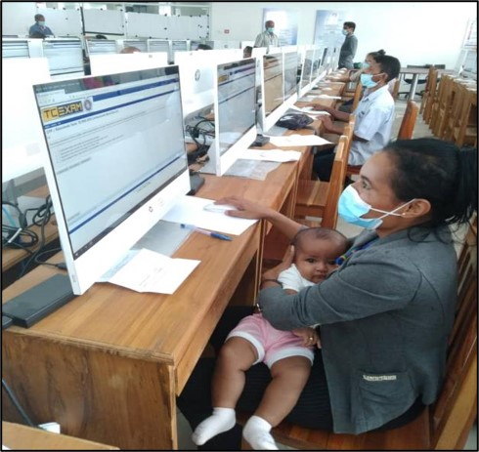
Gender Equality and Social Inclusion
Accessibility was key in the latest CSC rounds of general career regime promotion
GfD’s GESI resources increased significantly during Phase Two. In early 2017, a locally engaged gender adviser was appointed, with a view to supporting both gender mainstreaming across the program, and the implementation of GRB across GoTL institutions as part of the PFM reform process. However, by mid-2018 the adviser’s work was focused solely on supporting both SEII and UPMA to implement GRB, and the decision was made to engage an Inclusive Policy and Gender Adviser to support GfD. This adviser focused on the Economic Policy and Public Administration Reform workstreams, with an increased focus on social inclusion and civic engagement (people with disability, youth, and other voices in public policy, etc.). A national adviser focusing specifically on disability was also engaged throughout 2019. In February 2020 further changes were made to the inclusion team, with the Inclusive Policy and Gender adviser changing to the role of Civic Engagement adviser, and the recruitment of a locally engaged GESI adviser to provide advice and support to ensure that gender and disability considerations, as well as broader social inclusion, were incorporated in all aspects of GfD’s work and considered across GoTL program implementation.
The GESI and the Civic Engagement adviser, supported by the Program Coordinator (and later the Deputy Team Leader – Program), worked together to develop a GESI Strategy and Action Plan and a Civic Engagement Strategy and Action Plan to plan and operationalise work on Gender and Social Inclusion, informed by an analysis of risks and gaps related to GESI, the earlier GfD Gender Strategy and Practice Note and relevant DFAT policies related to GESI. The strategies were regularly reviewed and updated throughout the remaining months of the GfD program and the subsequent Transition Program through bi-monthly meetings involving the Team Leader and Deputy Team Leader – Program, to identify and respond to emerging risks, challenges and opportunities.
A specific focus of the GESI adviser role was to strengthen GfD’s engagement in relation to Women’s Economic Empowerment (WEE), through both building the gender awareness and capacity of GfD’s economic advisers, and through engagement with MCAE. Concept notes on both WEE training and the development of a WEE strategy were drafted by MCAE and are expected to be submitted to GfD for support during the remaining months of the program. A second focus was the incorporation of gender and disability into all civil service HR policies. A series of focus groups were supported by GfD in 2019 to look at the barriers facing people with a disability in the civil service workforce. Throughout the Transition Program the GESI adviser worked with the CSC to progress the recommendations, including raising public awareness through TV debates, and coordinating a review of civil service policies and legislation from GESI and disability perspectives. There are indications that the CSC has increased its dialogue with DPOs in relation to strengthening opportunities for people with a disability in the civil service workforce.
‘I think the GfD was the key in the implementation of GRB, with the current resources we have, their skills and knowledge in the area and links they have with the Line Ministries, they are able to lead the Line Ministries on how they could be able to implement the agreements that have signed or the commitments they made.’

Brigida Soares, Coordinator of UPMA
The GESI adviser also provided critical support to grant partners such as TAF and Oxfam to ensure their research and reports were gender sensitive and socially inclusive and wherever possible included disaggregated data on gender and disability.
In addition to GfD’s work in relation to WEE and GESI in Public Administration, GfD’s GRB adviser led significant progress in relation to GRB (see section 4.1). Timor-Leste’s progress with respect to GRB was recognised internationally in late 2021 through a presentation by the GRB adviser at a conference of the International Consortium on Governmental Financial Management. The gender marker was expanded in 2021 to include Government programs that support people with disabilities. GfD’s GESI and GRB advisers contributed to discussions with both Oxfam and with other DFAT-funded programs in relation to Disability-Responsive Budgeting, which is anticipated to gain momentum in coming years.
Story of Significant change (Aug 2020): Key Government of Timor-Leste institutions demonstrate effective implementation of Gender Responsive Budgeting reforms (PAF#20b: Instances of improved policy and implementation) | Rating: Highly Significant
While Timor-Leste is party to international treaties on gender and aspires to gender equality in its Strategic Development Plan, the country had no mechanism for implementing gender mainstreaming in Government programs, nor allocating budget to or monitoring the results of gender programs.
Governance for Development (GfD) not only supported preparation and endorsement of a Gender Responsive Budgeting (GRB) policy note, but also the development of tools to facilitate GRB, including gender markers and gender indicators, and the integration of these into Government planning and the Financial Management Information System (FMIS). Since 2017, GfD has supported government entities to implement these GRB tools, and in preparing the 2020 budget all entities included gender markers. 11 of these also developed relevant gender-focused targets and indicators. GfD also provided training to relevant Parliamentary Commissions (C and F) as well as the Secretary of State for Equality and Inclusion (SEII) to build their understanding of the concepts and importance of gender mainstreaming and GRB.
Not only is GRB now an integral element of the Government’s planning and budgeting process, with nearly 40% of program funds identified as having some gender-related component, but the Government now also includes analysis of gender programming and budgeting in its annual and quarterly reports. Further, Government entities have a better understanding of and commitment to the importance of addressing gender in their planning and budgeting.
GfD participated regularly in forums in relation to GESI including through engagement with partners such as UN Women and the Parliamentary Women’s Caucus, and attendance at gender and protection working group meetings with other partners working on GESI related objectives, activities, and programs. This enabled the GESI and GRB advisers to both contribute from the perspective of GfD, and to share information with GfD advisers on emerging gender equality issues in Timor-Leste.
GESI-related M&E was strengthened under Phase Two. In the redesigned ToC, GESI and ‘Promotion of gender equality and social inclusion’ were included as a ‘principle’ and mainstreamed across the program. Through further updates to the Monitoring, Evaluation and Learning Framework (MELF) in 2019/2020 a KEQ was added in relation to civic engagement: ‘KEQ6: To what extent did GfD support other voices to engage with the policy-making process and to advocate for improved service delivery?’. SQs were also included under each of the program-related KEQs in relation to gender e.g. ‘SQ1.4: To what extent are PFM policies, systems, and processes more gender-responsive and socially inclusive?’ From 2020 GESI was included as one of the standard objectives for advisers to report against in their monthly activity trackers, both in an effort to retrieve more data on GESI-related work undertaken by advisers, as well as to serve as a monthly reminder to advisers of the importance of this cross-cutting issue. Wherever possible the program collected sex disaggregated data, for instance in relation to trainings provided by advisers in their counterpart agencies. In the 2019/2020 Annual Report the ‘summary of program performance’ chapter included a separate section on gender and social inclusion, and all reporting from then on (including verbal six-monthly reports) included a separate GESI section to highlight activities and outcomes as well as lessons learned related to GESI. GESI reporting improved further under the Transition Program, when DCs with a specific focus on GESI and those pertaining to the GESI-focussed SQs in each workstream were specifically reported on in the six-monthly report. These changes to the M&E system enabled the program to collect evidence that showed the extent to which the program benefitted women and disadvantaged demographics. An assessment of achievement of DCs against GfD’s GESI principle showed that the majority of GESI-related DCs (79%) had been achieved. Four DCs (14%) were partially achieved, two DCs (7%) were not achieved – both due to COVID-19 related restrictions.
Internally, GfD continued to make improvements in relation to its policies and practices. Efforts continued to specifically recruit women to the program (by 31 January 2021 47% of the GfD team were women, including the Team Leader and one of two Deputy Team Leaders), and specific support was provided to support female advisers in their career development. For example, GfD’s GRB adviser undertook an internship with the Timor-Leste Embassy in New York, and through this gained extensive exposure to the UN and UN processes. Updates were made to ToR to include a clause stating that Cardno encouraged applications by women and people with a disability, and questions on GESI were included in all recruitment processes to ensure that successful candidates had a sound understanding of GESI principles. In the ToR of most advisers, a task related to identifying opportunities and ensuring promotion of gender equality, women’s empowerment and inclusion was included. The monthly adviser activity tracker included a specific section on progress against this ToR task. A recent review of GfD’s HR policies by the team’s GESI adviser found that, with small adjustments, the policies were gender sensitive and supported equal employment practices for men and women. The proposed adjustments were subsequently implemented, for instance by conducting gender awareness training for advisers and operational staff.
At a program level, there were a number of notable achievements in relation to GESI across Phase Two. In particular:
- The development and subsequent implementation of a GRB policy which led to the inclusion of gender responsive programs in the GoTL Program Budget structure, and gender markers and indicators that enable Government to track and report on its expenditure on initiatives that promote gender equality. Use of these markers and indicators is progressively improving, and in the 2021 budget there was a significant increase in allocations to the 16 programs in which gender was considered a ‘principal’ objective (from 3% to 5% of General State Budget). Further progress was made in preparation of the 2022 budget, with an increase of 190% in funding to programs with a gender marker of ‘Principal’.
- Inclusion of a number of priorities in relation to GESI in the priorities of the new CSC mandate.
- Integration of GESI principles into civil service HR policies and practices. For example five percent of General Career Regime promotion test questions in the 2020 and 2021 promotions round were on GESI, informed by GfD’s GESI adviser, and there was improved accessibility for pregnant and nursing women, elderly, and people with disabilities to the promotion process.
- Increase in the number of women in senior management positions in the civil service from 20% in before the annual merit-based promotion rounds started in 2019 to 36% on average across the three promotion rounds, as a result of equal access being provided to men and women in the promotions process, and of long-term mentoring of female CSC leaders by GfD advisers. This not only increased women’s chances of promotion, but also equipped them to drive GESI reforms across the public service. Further, a higher percentage of women (14%) than men (11%) were successful in their promotion applications under the three rounds of General Career Regime promotion across the civil service.
- Coordination by GfD in 2019 of the first seminar on disability in the civil service workforce, and subsequent comprehensive series of focus group discussions about barriers for people with a disability in the civil service workforce. The outcomes and recommendations of these focus groups were collated, and are in the process of being implemented at the time of writing. The CSC is now actively engaging with DPOs in relation to opportunities for people with a disability in the civil service workforce.
- Completion of a number of pieces of research by grant partners TAF and Oxfam into the specific impacts on women of COVID-19 and the State of Emergency, which were provided to the ERC to inform the COVID-19 ERP.
- Delivery of a training program to GfD’s economic advisers on WEE and how to ensure that it is mainstreamed in the development of economic policy.
- Delivery of GESI induction briefings to new GfD advisers and conduct of bi-annual GESI refresher trainings for both advisers and GfD operational staff.
- Development of concept notes for the development of a WEE Strategy and delivery of WEE training for MCAE.

Sustainability
GfD’s approach to sustainability was built primarily around the following approaches:
- Progressively increased engagement of national rather than international advisers
- Focus on capacity building reinforced in adviser ToR, recruitment, induction, briefing and training as well as in monitoring and evaluation tools
- Capacity building focused not only at individual, but also at organisational and systemic (whole-of-government) level
- Close engagement with counterparts, and ‘partnering’ of advisers and counterparts wherever possible
- Use and strengthening of GoTL systems, in partnership with counterpart entities, rather than the introduction of parallel systems
A key element of GfD’s approach to sustainability was the increased engagement of national rather than international advisers, which will not only ensure that those resources remain in country when the Transition Program draws to an end, but also provided opportunities to build local capacity and support the careers of emerging local leaders. An example of this was in PFM, where a team of national PBAs worked alongside both short term and long-term international advisers, as well as the OECD. Through this, the PFM skills and expertise of the national PBAs deepened, to the extent that the advisers became well recognised for their leadership with respect to the annual planning and budgeting process. In mid-2021, the positions transferred to the GoTL payroll – some to UPMA and some to MoF, ensuring that the Government is no longer reliant on development partners to support this crucial process, and that the skills are retained within GoTL. Similarly, under both the Economic and Public Administration workstreams, towards the end of the Transition Program national advisers were leading the work, with mentoring support where needed from SAT members, grant partners or international advisers.
GfD also progressively increased its focus on capacity building rather than simply providing technical ‘capacity substitution’. Building the capacity of national counterparts was reinforced in the ToR of all advisers, and interrogated during recruitment processes. In August 2019, the Team Leader and Program Coordinator designed and ran a series of workshops for advisers on capacity building, including the importance of considering capacity at the individual, organisational and institutional levels, and ensured that capacity development was discussed in all program planning and evaluation workshops. The risk of capacity substitution and the implications for sustainability were raised as a recurring theme in review and reflection workshops, learning dialogues, and in discussions with the SAT, and as a result changes were made to the monthly activity tracker template to require advisers to report on monthly progress against the capacity building objective in their ToR.
There are examples of where COVID-19 has both strengthened, and reduced, opportunities to build local capacity. In the CSC, for example, the temporary demobilisation of the International ICT Adviser to Australia in 2020 meant that the CSC ICT team had to take on tasks themselves for which they would previously have deferred to the adviser. Through this enforced ‘learning by doing’ they built skills, confidence, and knowledge. In aviation, however, the inability of the Air Navigation Services team and other international advisers to travel to Timor-Leste meant that while the development of documentation progressed rapidly, local ownership and understanding largely stalled in 2020. The resumption of travel by the ANS team in mid-2021 enabled an intensive focus on capacity building in the second half of the year, which will continue through until the end of the Transition Program.
Ensuring that advisers focus on sustainable individual and organisational capacity development rather than simply ‘doing the job’ of civil servants, will be an ongoing challenge for the PROSIVU program, but can be addressed to a large extent through appropriate recruitment, selection and training, and regular forums to discuss how individual and organisational capacity development is progressing. There remains a time and a place for specific capacity substitution inputs, particularly in very technical areas. However, GfD was at pains to partner this technical expertise, often provided by international experts, with a national adviser, and with relevant GoTL staff, to ensure transfer of knowledge and to reduce dependency.
The partnership approach between GfD and the program’s GoTL counterparts also played a significant role in the sustainability of outcomes. The dual reporting structure – to GoTL counterparts for day-to-day work planning and management, and to the GfD Team Leadership for contractual and performance issues – provided opportunities to also build capacity within GoTL management. The Coordinator of UPMA, for example, provided feedback on a number of occasions on the benefits of being exposed to systematic and merit-based recruitment and selection processes, and to formal annual performance reviews for all advisers.
As the program draws to a close there is evidence of sustainability of reforms that have been initiated under GfD. For example, enshrining PBB in the new Budget and Financial Management Law, and adoption of DBFTL by MoF as the system to underpin budget preparation, monitoring and reporting, will ensure that reforms to the annual planning and budgeting process continue. The progressive increased ownership by the CSC of the merit-based promotions process, now in its third year, suggests that this process has now become embedded and will continue. In addition, the CSC’s inclusion focus has increased to the point where the Commission is now actively seeking out dialogue with disability partners – a process that was initiated by GfD organising disability inclusion focus groups in the civil service, as well as a national disability inclusion seminar. And the availability of funds in the 2022 budget for a number of key initiatives, including the establishment of the WTO Secretariat, and the implementation of the Unique ID project, are strong indicators of the commitment of GoTL to implement the work that has been started with strong support from GfD. The engagement by GoTL of a number of advisers who were formerly employed by GfD demonstrates a further commitment to continuing work that was initially undertaken through GfD support.

GfD’s Monitoring Evaluation and Learning Plan 2019 - 22
GfD’s final MELP was developed through a participatory process between the GfD Program team and M&E House between August 2017 and February 2018 and was reviewed and finalised in March 2019. It was reviewed on an as needed basis and at least annually, in accordance with results from M&E stocktakes undertaken by M&E House. The MELP was structured around the following components:
- ToC: presents the hypothesis of how change will happen, in order to contribute to the identified EOPOs
- Scope: covers the purpose, audience, and boundaries of the MELP
- KEQs: presents the questions for each outcome and identified evaluation criteria, with corresponding SQs and indicators. Criteria used to develop the SQs are based on Development Assessment Criteria standards
- Implementation plan: defines how the MELP will be implemented, assessed, and reviewed.
The MELP described a number of data collection methods, the most important ones being SSCs, monthly adviser activity trackers, grant partner reports, key informant interviews and Political Economy Analyses (PEAs). It included a MELF that listed annual targets, and the INOs that the targets related to, as well as data collection methods. GfD named its annual targets ‘Desired Changes’ or 'DCs’ to indicate their flexible and variable nature. From 2018, DCs were developed in consultation with advisers, grants partners, the Embassy and the SAT. They were developed based on the three criteria of ‘feasibility’, ‘significance to a specific reform’, and ‘attributability to GfD’. They were reported against in annual reports by means of a traffic light system, indicating whether the DC had been achieved (green), partially achieved (amber), or not yet achieved (red). Baselines were established in one of two ways:
- For early DCs, the baseline was implicit in the way the DC was worded, e.g.: ‘AACTL established as autonomous agency’, implies that at the time of development of the DC, the AACTL was not yet established as an autonomous agency.
- During the Transition Program establishment of baselines for new DCs was more deliberate, through consultation with advisers and grant partners about the status of the DC at the time of development, and identifying any work already undertaken in preparation for the achievement of the DC.
In the ToC the DCs sat at the activity level (i.e. foundational and influence activities), which when achieved contributed to the achievement of immediate and subsequently INOs. For each DC a decision was made about which INO it predominantly contributed to. There are seven INOs – three of which contributed to the achievement of EOPO 1: government uses evidence and advice to make decisions; stakeholders influence policy making; and, government officials effectively lead and manage.

Four INOs contributed predominantly to the achievement of EOPO 2: government and non-government institutions deliver enabling services more effectively; government entities utilise systems to plan, monitor and manage their work; government distributes and spends allocated budget as planned; and, government agencies coordinate and cooperate.

Program implementation progress against the ToC was measured by means of monthly and six-monthly adviser reports and six-monthly grant partner reports. In their six-monthly reports, advisers reported progress against their TOR objectives (including on GESI, disability, COVID-19 and capacity development), any challenges and learnings they identified, training data disaggregated by gender and disability, as well as progress against achieving DCs and Other Significant Achievements (OSAs). They were also requested to include evidence to substantiate their achievements in the form of quotes, links to media articles, pieces of gazetted legislation or policies, manuals, guidelines, etc. Grant partners reported against their own MELPs that were developed in collaboration with GfD to align with GfD’s M&E system and ToC, and partners were also asked to include evidence. All these reports and supporting evidence, augmented by GfD’s weekly media monitoring reports, were collated into evidence matrices by GfD’s M&E team and subsequently verified in Mini Learning Dialogues (MLDs) – half-day workshop sessions with advisers in each workstream focussed on validating progress and evidence, and learning from successes and failures. Traffic light ratings for DCs were verified in these dialogues and any additional OSAs not captured through the formal DCs, as well as risks and key learnings, were identified. In addition to MLDs, PEA and Planning workshops were organised annually to identify constraints, opportunities and inform program strategy development in each workstream. The PEAs were also used to inform the development of DCs. Regular informal discussions of the political economy with both workstream teams and the Embassy ensured that changes in context were considered in GfD’s planning and resource investment decisions in real time. All of these reporting processes and their products fed into GfD’s six-monthly and annual progress reports. According to M&E House Stocktakes 2017-2020 both GfD’s M&E system and progress reports adhered largely to DFAT M&E Standards on progress reporting and the DFAT Timor-Leste Good Practice Note on Reporting. The GfD M&E report preparation process is illustrated in the figure below.
Figure 5 GfD Report Preparation Process
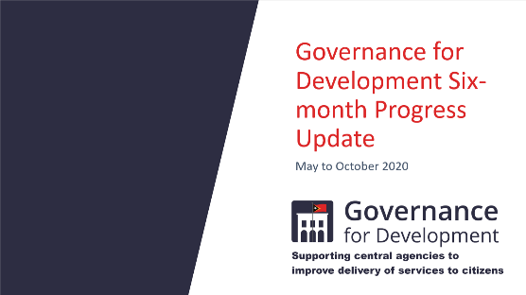
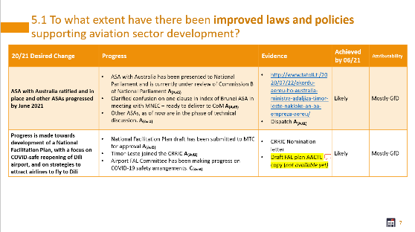
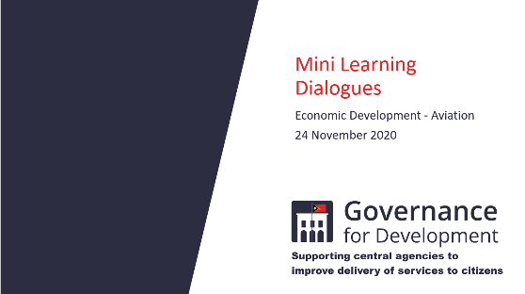
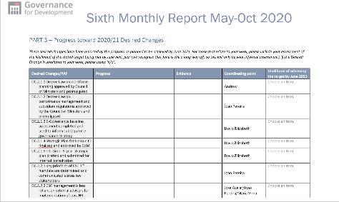
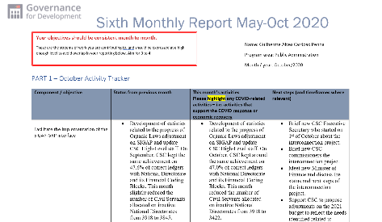
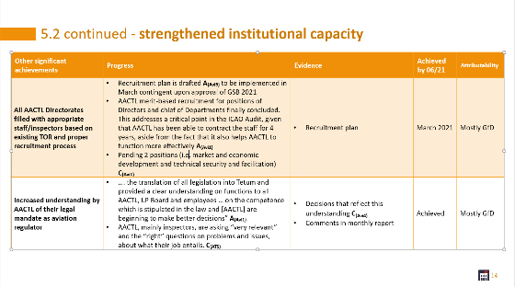

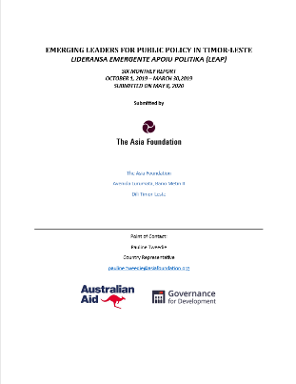
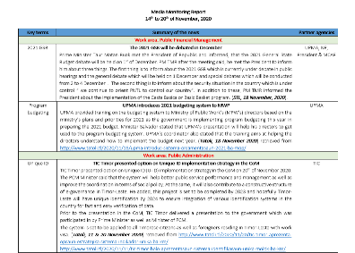
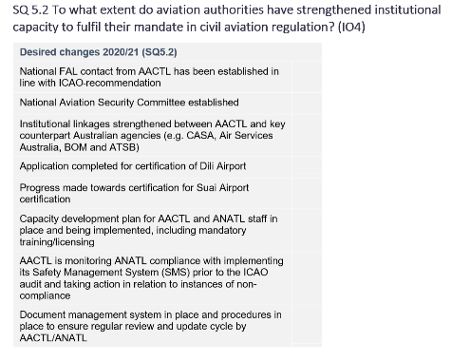
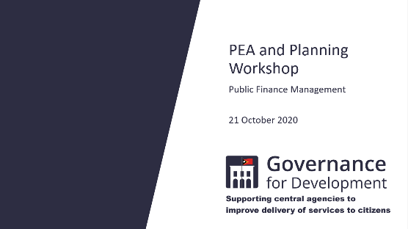
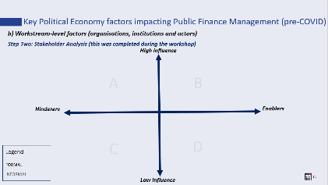
Workstream-specific Political Economy Analysis (PEA) and Planning workshops
Desired Changes (DC) and Other Significant Achievements (OSA)
Grant Partner and Adviser Reporting
Evidence Matrices (EM)
Mini Learning Dialogues (MLD)
Final verification and filling in gaps
Six-monthly/ Annual progress report

GfD as a governance program was essentially an adaptive facility. Experience from other adaptive programs suggests that more than 10% of total budget should be allocated to MEL, compared with 4-7 % for non-adaptive programs. GfD’s MELP of 2019 showed that the allocation for M&E in the 2018/2019 financial year was a mere 2.2%. In the GfD Transition Program this increased to 5.6% due to an increase in funds allocated for learning dialogues and PEA and Planning workshops, and the creation of a Grants and M&E Coordinator position. Internal GfD M&E resources were supplemented by M&E House - a standalone M&E program providing advice and assistance to DFAT programs from 2018 until late 2020, and by the Embassy Program Quality team during 2021. However, there is scope for M&E resources to be increased further under PROSIVU to assure the iterative learning, reflection and adaptation that is the hallmark of a best practice adaptive facility.

Risk Management and Safeguards
GfD met all DFAT requirements in terms of risks and safeguards, and had in place governance arrangements to ensure this throughout the program. These arrangements included discussion of risk at regular meetings between the Embassy, Cardno and the program team, periodic reviews of the risk register and mitigation strategies, regular reporting on risks in six monthly and annual plans, and the use of exception reporting where necessary.
GfD developed a Risk Management Plan that detailed those risks that could be reasonably anticipated, their likelihood and impact, options to reduce the risks, the responsible entities and the approach to risk mitigation. The plan was updated regularly during implementation to reflect changes in the situation and context of the program. The Risk Management Plan categories remained largely unchanged from IGfDSS until the end of Phase One – ‘Fiduciary’, ‘Political and Relationship’, ‘Environmental’ and ‘Sustainability’, but underwent some significant changes in Phase Two. In Phase Two the plan was renamed the GfD Risk Register, and was harmonised with the ToC to ensure that greater attention was paid to programmatic risks, with the following new risk categories:
- Achievement of GfD Goal: A Stable and Prosperous Timor-Leste, characterised by economic development and better service delivery;
- Achievement of EOPOs 1 and 2;
- Achievement of INOs;
- Sustainability risks; and
- Implementation/ operational Risks (including a Health and Safety sub-category).
Linking the risks to achievement of components of the ToC allowed the program to assess more than just operational risks. It enabled the Embassy and GfD management team to intermittently take stock and assess strategic bottlenecks in the achievement of program outcomes – effectively adding another layer of review and reflection and thereby increasing scope for timely identification of appropriate remedial actions where needed. In Phase Two and the subsequent Transition Program, key risks to the program primarily revolved around loss of momentum on significant reforms due to political instability and lack of State Budget. Key measures identified to mitigate these risks included:
- ongoing monitoring of the political landscape, and regular conversations between the Embassy and GfD about how to adapt to changes in context;
- formal PEAs, as recommended in the GfD Review;
- appointment of an SAT to provide impartial and independent advice on GfD’s strategy in each of its work areas;
- regular formal and informal engagement with GoTL counterparts – both politicians and bureaucrats; and
- maintaining flexibility to enable the program to adapt or refocus its approach where necessary.
Operational risks were largely managed through periodic review and updating of GfD’s Quality Management Plan (Operations Manual) to ensure that it remained fit for purpose.
The impact of COVID-19 added another layer of risk in Phase Two and throughout the Transition Program. In response, GfD developed both a Business Continuity Plan and Program Continuity Plan that addressed both the risks (operational and programmatic) and mitigation strategies. GfD’s Risk Register was updated as well to include the risks as well as mitigation strategies related to COVID-19.
Cardno developed and trialled several safeguard polices under IGfDSS. These policies were then firmly embedded in GfD Phase One and reviewed and adapted under Phase Two. The initial safeguard policies included: ‘WH&S’, ‘Anti-Fraud’, and ‘Child Protection’. These policies were improved and refined over the life of the program and a number of other policies were added, including a Cardno corporate policy called ‘The Cardno Way’ with subsidiary policy guidelines on ‘Preventing Sexual Exploitation, Abuse, and Harassment Procedure (PSEAH)’, and ‘Modern Slavery and Human Trafficking’. The policies were introduced to staff through inductions, briefings, trainings and refreshers (online and/or in-person), and were translated into Tetum. GfD’s GESI adviser helped to contextualise the trainings for local staff, in particular the Child Protection and PSEAH training, by including examples of relevant local legislation and policies and by expanding on cultural practices that have a bearing on how the topic is addressed locally.

COVID-19
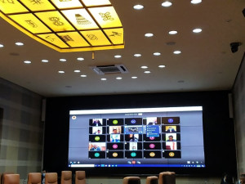
As for all development programs in Timor-Leste, COVID-19 was highly disruptive to GfD’s operations and program implementation. A motivated and professional advisory team, supported by a capable operational and management team, ensured that adverse effects and related losses in momentum were kept to a minimum. As was highlighted in previous sections of the report, this dedication was appreciated and commended by GfD’s government counterparts.
First remote CoM meeting held using JITSI
In March 2020 all international staff were repatriated and continued providing support remotely. LTAs and international NGO grant partner staff based out of Dili were able to return to Timor-Leste in the second half of 2020 and the first quarter of 2021. However, STAs and staff of international (multilateral and Australian) grant partners working with FIFO models remained unable to return throughout 2021 due to arduous, costly and time-consuming re-entry procedures and in-country travel restrictions instated by GoTL. Where possible they continued to provide remote input, but their inability to travel to Timor-Leste impacted on their ability to support in-country capacity building. This particularly affected GfD’s work in aviation until mid-2021 when the company engaged to support strengthening of ANS resumed travel to Timor-Leste. Work being undertaken by GfD’s multilateral grant partners working in the financial sector (ADB and IFC) was also severely impacted by the inability of international advisers to travel to Dili. National advisers continued to provide support working from home, progressively returning to their counterpart offices in July and August 2020. With the confirmation of non-quarantined COVID-19 cases in Dili in March 2021, all staff once again commenced work from home arrangements, which remained in place until towards the end of 2021.
Despite the deep socio-economic crisis caused by the pandemic, it also provided new opportunities, accelerated momentum for a number of reforms, and made evident needs that had previously been disregarded. The ICT capabilities of GoTL are still nascent, resulting in inefficiencies and backlogs in almost all areas of public administration. To citizens this translates into poor service delivery marked by long queues and waiting periods. For a long time, business registration had to be done in person and with extensive supporting paperwork. GfD, through its advisory support in SERVE, was instrumental in simplifying and digitalising this process, doing away with the need for time-consuming in person registration. This process had already commenced pre-COVID-19, however the pandemic gave additional impetus to the work and drove home the importance of this reform.
Similarly, in the CSC, the appeals process not only required in-person participation, but also required municipal civil servants to travel to Dili to participate. This process has now also been moved to an online system – accelerated by the pandemic. In addition, the CSC approved a new system (an opensource software called ‘osTicket’) to manage and transfer documents online and internally between Line Ministries and as a means of communications and receiving requests from the public. This new system may greatly improve inter-agency coordination and communication for a government that still mostly relies on hard-copy letters. And while the CSC was previously largely dependent on international ICT advice, the pandemic necessitated CSC ICT staff to work independently to monitor and maintain systems while the international GfD ICT adviser was working abroad, resulting in significant capacity development gains. ICT advisers at TIC and the CSC also worked together to review opensource teleconferencing options, to support establishment of cost-effective electronic communication methods and work-from-home systems. In March 2021, the CoM held its first remote meeting using the GfD-enabled JITSI software, which is now in widespread use across GoTL as a platform for teleconferencing. Furthermore, with GfD support the CSC was able to improve remote access to the civil service database (SIGAPNET), enabling effective remote working arrangements for civil servants. Innovations such as these, that were spurred on by the pandemic, are expected to have far-reaching and long-term positive impacts on the efficiency of service delivery systems going forward.
Another key achievement in this period was the establishment of the national COVID-19 dashboard. This dashboard provides a repository for updated and accurate information about the pandemic in the country, with research documents and infographics related to the impacts of COVID-19 and how to mitigate them, and news updates provided by the CIGC.
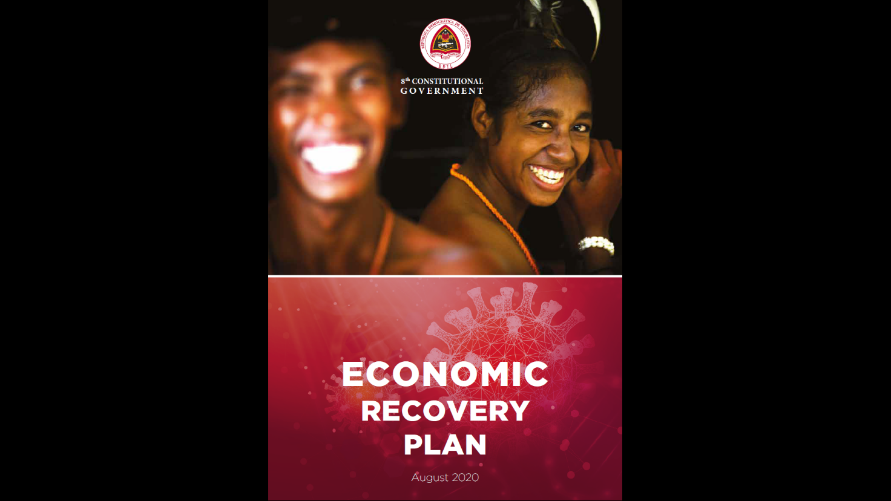
For civil society as well, the pandemic has had some positive outcomes. For instance, it resulted in a marked growth in civic space, and increased attention to civil society in the media, as a result of the mechanisms established by CSOs to monitor and disseminate information about GoTL’s COVID-19 response. With the financial support of GfD through Oxfam, a CSO information centre was established and housed at the national CSO umbrella organisation, FONGTIL. The information centre enabled prominent CSOs to get together and share research findings and opinions on topics related to GoTL’s proposed stimulus packages, disability inclusion, education, informal sector workers, and agriculture, and broadcast this to the national media. International grant partners Oxfam and TAF pivoted to undertake research on the economic and social impacts of COVID-19, including in relation to women and people with disabilities, as well as an evaluation of the household-level impacts of the Uma Ka’in payment – a cash payment of US$200 provided by the Government to households with an income under US$500 per month. Monash University also pivoted to provide support to GfD advisers working on economic policy, as well as analysis directly to the ERC which informed the initial COVID-19 stimulus package and subsequent COVID-19 ERP. In parallel, GfD’s economic advisers provided significant analysis and inputs to support development of the immediate COVID-19 response, and longer term ERP.
GoTL’s Economic Recovery Plan guides Timor-Leste’s future economic reform
In the PFM space, GfD advisers supported planning and monitoring of the COVID-19 fund in collaboration with the CIGC, including the establishment of a program classification framework, indicators and monitoring mechanisms, and entry of data into DBFTL. Advisers furthermore worked in close collaboration with the ERC to support integration between economic recovery planning and budget preparation to enable ‘the budget to follow the strategy’, and ensure Line Ministry 2021 and 2022 budgets reflected the priorities in the COVID-19 ERP. A significant consequence of COVID-19 for GfD was a much closer working relationship between the program’s Economic Policy and PFM advisers, who worked closely together on the development and costing of, and subsequent budgeting for, the COVID-19 ERP. This process highlighted the importance of these two workstreams working more collaboratively in the future.
GfD’s Legal Adviser in MRLAP/PCM shifted focus to the development and review of legislation in relation to COVID-19, such as legislation related to the States of Emergency and related implementation measures.
In civil aviation, GfD supported the development of AACTL COVID-19 safety arrangements (AACTL Guidance Document COVID-19) on the basis of information from the Strategic Aviation Adviser on the impacts of COVID-19 on the global aviation sector and ICAO priorities for COVID-safe recovery of the sector. Aviation advisers also supported technical and legislative work on aviation safety and security in Timor-Leste, both in relation to the movement of people through the airport in light of COVID-19 and, and more broadly in relation to how the sector operates in Timor-Leste and can recover from the impacts. This aviation work will continue to be particularly important given Timor-Leste’s place in DFAT’s ‘Humanitarian Corridor’.
In summary, while COVID-19 led to a slowing or halting of many reforms and ongoing activities, GfD and its partners were able to pivot quickly to support the Government’s immediate and longer-term response efforts, and to capitalise on the opportunities afforded to increase future effectiveness and efficiency of the Government.

Reflection and lessons learned
GfD activity funds were generally allocated to two key program implementation modalities: provision of advisory support (approximately 60%), and provision of grants to international and local partners, including for training initiatives (approximately 40%).
Advisory support, as GfD’s key implementation modality, consumed the majority of the program’s resources and time. It proved to be a highly effective modality, not least because it fills a great need in Timor-Leste. There is a limited pool of well-educated and knowledgeable human resources in a number of key ministries responsible for the sustainable, stable, and inclusive economic development of the country, partly due to an inability of the civil service to attract and retain qualified personnel, but also due to historically poor recruitment practices. The ability to provide this expertise through GfD not only filled a key expertise gap but was also a significant contributor to improved inter-agency coordination between Ministries. A notable example was of advisers based at different government agencies being able to progress work on interfaces between core government databases to improve systems’ efficiency and optimise service delivery. A future governance program should, however, also consider other modalities, such as identifying and supporting local champions of reform.
The provision of in-line advisers, whether national or international, brings the risk of donor reliance and capacity substitution, rather than sustainable capacity development, and of ongoing reliance by GoTL on GfD support. GfD recognised that there was a time and a place for capacity substitution, particularly during the early phases of the program, and most specifically in highly technical areas such as aviation. However, such support needs to be deliberate and provided on the basis of a robust assessment of need, with clearly defined technical inputs, a clear exit plan, and coherent and ongoing messaging to GoTL that the input is time-limited and must remain strategic rather than operational. Capacity building needs to remain a focus of all advisory support to ensure the sustainability of progress.
The ability of the program to attract a cohort of highly capable national advisers was a significant achievement of the program and led to a shift in the balance between national and international inputs. This had a number of benefits. National advisers have a deep understanding of and connection to the context in Timor-Leste, strong local networks, and are able to influence in ways that can sometimes be challenging for internationals. They are also here for the long term and will play an ongoing role in the sustainable long-term development of the country. When internationals were repatriated during COVID-19, the national advisers remained, and were able to seamlessly continue their support to the Government at a time of particular strategic importance for the country. Further, national advisers are a more cost-effective resource than internationals. This is not to say that internationals should not be engaged – for reasons of specific technical expertise, independence from the complex politics of Timor-Leste, credibility in the eyes of counterparts, or the ability to bring a breadth of expertise and experience from having worked across a wide range of countries and settings – but the use of international advisers should be judicious and carefully considered.
While advisory support was GfD’s implementation modality mainstay, significant funds and time were also spent on engaging grant partners. The effective management of grant partners to ensure that maximum benefits can be derived from their inputs proved to be time consuming and requires proper resourcing, in particular for local CSOs with high needs in terms of capacity building. However, even for large international or multilateral partners, the management of workplans and budget, quality control of outputs, reporting, and identification of opportunities for collaboration across the program requires significant time and resources. Grant partners should be selected on the basis of their ‘fit’ in relation to the rest of the program’s portfolio to facilitate synergistic cooperation with advisers as well as interagency collaboration between partners. Further, local partners must have local credibility, be generally perceived to be free from political bias and have a base level of operational capacity. There should be a clear indication in initial concept notes of how the grant partner’s ‘theory of action’ harmonises with the program’s ToC, and reporting schedules and expectations should be established clearly during the grant negotiation process. This will not only facilitate program progress reporting but will also maximise the extent to which the ‘sums’ of the program are interlinking and effectively and efficiently working towards the same overarching ‘whole’. Any subsequent program should be resourced to ensure adequate management and monitoring of, and coordination with, grant partners, and in particular local partners. Twinning with Australian Government entities, such as ABS, has proven positive and should continue or be expanded as a modality under a future program.
Working with multilateral agencies presents particular challenges. While there are some clear technical and relationship benefits of working with multilateral partners, the common multilateral model of FIFO advisers, coupled with a relatively small in-country presence, proved to be less than fit-for-purpose for the Timorese context, particularly since the advent of COVID-19. Longer term in-country support was found to be more context-appropriate, and necessary for long term capacity development. While multilateral organisations generally have long-standing reputations and expertise in some fields of relevance to GfD and bring a certain legitimacy and weight to policy debates, their bureaucratic systems, relatively high operating costs, and standard operating models such FIFO need to be considered in any decision to engage with them. Further, they have previously shown inflexibility in their reporting processes which made it challenging to keep track of their progress within the framework of the program’s own M&E processes. Where engagement with multilateral agencies is determined to be appropriate, alternative contracting models such as procurement rather than grant funding, with payments based on the delivery of clearly agreed outcomes, may be worth considering.
As described in previous sections of the report, GfD’s MEL system underwent some significant changes across the life of the program. Monitoring and evaluating progress for a flexible and responsive governance program such as GfD is a significant challenge. For GfD this necessitated largely qualitative data collection and analysis, which was further complicated by difficulties in collecting robust and verifiable evidence to support claims of achievement. Establishing attribution in relation to achievements is also challenging, and further compounds the complexity of reporting accurately, adequately, and meaningfully. GfD’s MEL processes evolved significantly across the life of the program. Besides the many accomplishments supporting government, GfD identifies this as an achievement in its own right – and potentially one that could serve as a model for the development of MEL systems of other flexible governance programs. The support of M&E House to develop GfD’s ToC and related KEQs and SQs, and the introduction of evidence matrices and Learning Dialogues, provided a robust structure to the program’s data collection, analysis, and reporting. However, the processes were also time-consuming and resource-intensive. GfD pragmatically adapted what were initially seen as ‘one-size-fits-all’ processes to provide a better fit for the program, including a redesign of Learning Dialogues into half day structured workstream focus groups that allowed a deep dive into evidence and progress. Perhaps the most innovative and useful evolution in GfD’s M&E system was the development of its annual targets, flexibly referred to as ‘Desired Changes’ or ‘DCs’. These DCs provided the program with clear and well-defined benchmarks to track throughout the year as well as across the life of the program. While the formulation of DCs is a challenging exercise, as the constantly evolving political economy context throughout any given year will likely impact on their relevance and achievability, they provided a fit-for-purpose alternative to a detailed annual plan, and enabled the program to be held to account for progress and achievements across the year, linked to the program’s intermediate outcomes and EOPOs. Further, there is a fine line between being ‘responsive, flexible and adaptive’ and being ‘reactive’, as noted in the GfD Independent Review. Establishment of DCs on the basis of clearly documented PEAs helped to ensure that the program was responsive, on the basis of evidence and analysis, rather than simply reactive to GoTL requests.
Progress in the area of governance is slow and requires a long-term view. The roads to reforms are often long and winding and a change in political climate may mean an activity has to be paused, of may enable a reform to be implemented that was previously unthinkable. Rather than deciding to withdraw support completely from an intervention that is not achieving traction, in some instances it may be more strategic to leave a reform on a slow-burn, postponing work on it until it again becomes politically possible or technically feasible. This will not only enable the reform to be picked up more rapidly under more favourable conditions and prevent a total loss of momentum, but also enables the retention of critical and trusted advisory support. One notable example of this was GfD’s decision to retain economic advisers in the absence of a GoTL economic counterpart, seeking opportunities for their skills to be used elsewhere while awaiting the reappointment of a minister to lead economic policy and the opportunity to re-engage. An adviser with key knowledge and skills in relation to WTO accession was therefore able to continue work on this important GoTL objective once MCAE was re-established. Such decisions need to be informed by an in-depth understanding of the political context and ongoing analysis of the political economy.
GfD’s complex and evolving ‘ways of working’ demonstrated the importance of clarity of responsibilities and authorities, and of regular and open communication across all those involved. The tripartite arrangement between the Embassy, Cardno GfDSS, and the Timor-Leste Desk during the early years of the program was successful because of regular dialogue and structured meetings. In the latter years, with input into strategy increasingly devolved to the Cardno GfD team, the arrangement worked because of a high level of trust between the Embassy and GfD team, and open and effective communication. Without these strong relationships, significant tension could have resulted between the parties. Future programs should consider these program management arrangements and establish clear, explicit ways of working that are regularly revisited. The Cardno GfD team also recognised the importance of understanding and respecting the boundaries of its authority, and the role of bilateral or other pressures within the broader scope of the Australian Aid Program in Embassy decision-making around program priorities. The Independent Program Review team criticised GfD for ‘mission creep’ and at times engaging in activities that were outside the scope of the program design. However, this is the reality of a program such as GfD. A practical implication of this is that a certain percentage of the program’s budget needs to remain unallocated to allow for these types of changes to be made rapidly.
The review team also found that the program’s documentation of analysis of the political economy to support decision-making was lacking. While the Embassy and GfD team asserted that these PEA discussions did take place on a regular basis, there was little documentation to evidence this. A key learning is the importance of documenting the rational for decision-making, not only to satisfy any future reviews, but also to ensure that there is a documented trail to inform future decision-making, based on past analysis and experience. GfD addressed this recommendation by minuting the weekly GfD-Embassy meetings and documenting formal PEA related discussions.
Reforms can only be achieved if a governance program’s support aligns with the agenda and priorities of GoTL. A range of mechanisms for open and frank discussion with GoTL counterparts about priorities and their satisfaction with GfD support, including R&R workshops as well as regular and documented formal and informal management meetings, were critical to ensuring that GfD inputs were valued and impactful. These discussions were also essential to inform strategic changes to GfD’s MEL and planning. In spite of this regular communication, the formal establishment of joint work strategies with the Government counterparts with which GfD engaged proved to be challenging.
A decision was made early in the program design not to establish a steering committee involving GoTL and other stakeholders, given the likelihood that within the political context of Timor-Leste, such a committee would be captured by political interests. While there was sound justification for this approach, the lack of such a coordination mechanism impacted on the ability to adopt a cohesive approach to setting priorities for GfD.
Counterpart engagement in Timor-Leste depends very heavily on face-to-face engagement. This reliance was significantly challenged by the advent of COVID-19, and the need to implement remote working arrangements. Over time, some counterparts became increasingly comfortable with engaging by teleconference and email. However, for some, the inability to engage in person impacted on the ability to develop strong and trusting relationships. This was particularly an issue when counterparts changed, and there was no opportunity to meet with them and establish a relationship in person.
Programmatically, while GfD made good progress against both EOPOs, progress was faster in relation to EOPO1 (evidence-based policy development) than EOPO2 (implementation of policies and improvements to service delivery). As discussed earlier in this report, this is to some extent to be expected, as policy and legislative development precedes policy implementation. Further, GfD’s lack of engagement with service delivery entities limited the program’s ability to directly impact service delivery. However, there are a few lessons to consider in the design of PROSIVU if the program is to significantly influence policy implementation:
- The importance of ensuring the integration of implementation considerations in the early phases of policy development, including adequate budget allocation for implementation by national directorates. It is common for these two processes to be viewed completely separately. The PROSIVU program should play a role in ensuring that policy development and implementation are viewed as two ends of an integrated continuum.
- Embedding stronger collaboration between the governance program, which is in the strongest position to influence policy development and legislation from the perspective of central agencies, and DFAT programs focussing on implementation through work with implementing agencies within program designs. The majority of GfD advisers were placed at levels where they could influence the development of policies and legislation (i.e. at ministries responsible for economic, HR, and IT policy and legislation) but few were placed at direct service delivery level (i.e. Directorates General, National Directorates, Autonomous Agencies, Public Institutes, Municipalities, etc.). A short-lived attempt to strengthen the link between upstream policy development and downstream service delivery by placing a GfD adviser in MoH was abandoned when the adviser was unable to establish the relationships needed to make the role effective. Collaboration with other programs that have a strong relationship with the downstream ministries may be a more effective means of approaching this. But to do so will require cross-program leadership from the Embassy which has the ‘umbrella view’ of the aid program, and cannot rely on distinct programs alone to facilitate this collaboration.
Adequate resourcing is key to program success. The rapid evolution of resources available from the Embassy led to different and unexpected demands being placed on the program, but this was not reflected in a comprehensive assessment of the changed program resourcing requirements. It was only in 2017 that specific GESI-focused resources were appointed, and not until 2019 that full time position was created to support the complex M&E of the program. Similarly, a role to support the engagement of Other Voices was only created in late 2018. The lack of these positions in early years of the program impacted on progress in these areas, and the significant advances made in relation to both GESI and M&E, as well as Civic Engagement. The more recent creation of the positions and associated progress clearly illustrates the importance of ensuring that cross-program roles are appropriately resourced. Further, the original design envisaged significant technical leadership from the Embassy in each of the program’s workstreams. When this was not able to be provided, the absence of technical leads in the program’s three workstreams not only placed significant pressure on the Team Leader, but also meant that workstream-focused leadership and coordination was challenging. The creation and evolution of the SAT in the final years of the program went some way towards addressing. Any future program should recognise the importance and value of ensuring that these resourcing issues are addressed and that the team structure is properly designed to meet program requirements.

Priority Recommendations
The following recommendations are provided for consideration in the design and implementation of the PROSIVU program in relation to programmatic, delivery and management aspects of the program.

Program
- GfD has supported progress of many important policy and legislative reforms across its three workstreams. Recognising the long-term nature of governance reforms, PROSIVU should concentrate on continuing to progress and embed implementation of the work that is already underway, while exploring opportunities to branch out into a range of relevant emerging reform areas.
- Strengthening the interface between ‘upstream’ policy development and ‘downstream’ service delivery will be central to the successful strengthening of service delivery. This interface needs to be a priority consideration for PROSIVU, as well as in the design and implementation of programs that support the delivery of services. DFAT has a crucial leadership role to play in supporting this interface, and the required collaboration across programs.
- The transition of annual planning and budgeting from UPMA to MoF, while positive, represents a risk for ongoing PFM reform. The design of the PROSIVU program needs to pay specific attention to this, as well as considering the outcomes of the recently-completed Assessment of National Systems and a potential return to some form of DBS.
- PFM as a GfD work area is increasingly linked to the Economic Development and Public Administration workstreams. Strategic linkages between these different workstreams need to be identified and capitalised on, to avoid silos and maximise opportunities for synergies.
- Re-engagement with MoF opens opportunities for the PROSIVU program to engage not only in the planning and budgeting end of PFM, but also in consideration of financial flows. Engagement in this area will be central to successes in strengthening service delivery of Line Ministries and in the municipalities.
- Pending the outcomes of the impact assessment of GfD’s support to the civil service, continued support for public administration reform in the CSC should remain a priority for the PROSIVU program, as upstream reforms achieved in this work area have significant potential to improve service delivery downstream. And since it is Timor-Leste’s largest formal employer, gains achieved in civil service employment have high potential of transforming public policy, for instance in relation to mainstreaming gender and social inclusion.
- Economic diversification should also remain a key objective of the PROSIVU program, not only to reduce dependence on a finite revenue source for the country, but particularly to unlock the growth potential in the agriculture sector which is the main source of livelihood for around 70% of the population, and where even slight increases in productivity and access to capital would translate into significant economic (and human development) gains at the national level.

Delivery
- A range of modalities are available to address problems or progress reforms. The first step in assessing any potential support should be to allocate sufficient time to systematically analyse the issue and determine the best approach and most suitable support option.
- Advisors are a key component of the GfD program. The new PROSIVU program will require a thoughtful consideration of the type of advisors, roles and skills required, including the balance between national and international inputs, and where necessary, direct Technical Assistance to complement long term capacity building.
- Grant partnerships should remain a key modality of program implementation. They offer flexible engagement with reputable partners that can easily be adapted to match and respond to a changing context. However, alternative models of procuring services from multilateral agencies or through sub-contracts with private sector entities should also be considered where appropriate.
- PROSIVU’s convening power as a governance program working with central agencies should continue to be used to facilitate coordination between government entities, CSOs, DFAT investment partners, and between development partners in certain sectors where objectives and work areas intersect. Strengthening these coordination links will not only serve to support good governance overall at the national level, but will also enable the program to form linkages and identify alternative avenues to progress reforms and form strategic coalitions.
- Flexibility should be built into the design of the PROSIVU program, including into implementation plans and budget, i.e. allowing time and funds for review, reflection and learning moments throughout the program, communicating with counterparts about the relevance of these, and leaving a portion of the budget unallocated to enable quick response to changing context and emerging priorities.

Management and program governance
- High level governance arrangements should be considered, including how to involve relevant GoTL representatives in program planning. Establishment of a Steering Committee should remain an option, coupled with adequate safeguards to ensure the committee is not captured or overshadowed by party politics, and an assessment in the early years of the program of the effectiveness of this mechanism.
- Adequate resources must be built into the PROSIVU program design to provide not only technical inputs but also cross-program support, and program and technical leadership and coordination for both advisers and grant partners.
- Structured, formal, and documented PEAs should become integral to the management of PROSIVU. Not only are these useful in monitoring the operating environment, but they also help to plan and guide the program and provide justification for course direction changes.
- A clear ‘Ways of Working’ needs to be established that outlines the roles of DFAT and Managing Contractor, on the basis of a realistic assessment of the resources available within the Embassy to support the program.
- The design for PROSIVU needs to recognise the medium and long-term impacts of COVID-19, both on Timor-Leste and therefore implications for GfD programming, and also in relation to the practical aspects of managing the program.

- Historical and political context and its impact on GfD

V Constitutional Government (August 2012 - February 2015)
GfD started in 2014 under the fifth Constitutional Government (V CG) which had been formed in August 2012. Kay Rala Xanana Gusmão (Gusmão) was Prime Minister and Minister of Defence and Security, and he led a coalition Government comprised of the National Congress for Timorese Reconstruction (CNRT) (founded and led by Gusmão), Democratic Party (PD) and Frenti Mudança (FM). The Strategic Development Plan (SDP) had been published a year prior to this Government’s formation and guided the Government’s decision-making in relation to budgeting, planning, and infrastructure investments. One of the underlying philosophies of the SDP is to ‘frontload’ the economy by investing heavily in infrastructure such as a national road network and electrification of rural areas, to service the entire population by 2030. Developing Timor-Leste’s social capital is a key SDP priority, with a focus on investing in education and health and spurring on the country’s economic development through increased investment in agriculture, tourism and oil and gas. Government spending under this Government continued to increase following in the footsteps of the IV CG. Drawing down the Petroleum Fund in excess of its Estimated Sustainable Income was justified by virtue of the projected longer-term positive impacts that a number of these ‘one-off’ investments would have on the economy.

VI Constitutional Government (February 2015 - September 2017)
Gusmao resigned as Prime Minister in 2015, making way for a ‘national unity Government’ that brought together the two largest (and rival) parties in Timor: The Revolutionary Front for an Independent East Timor (FRETILIN) and CNRT (as well as PD and FM). Dr Rui de Araujo was sworn in as the head of this sixth Constitutional Government (VI CG); Gusmão continued to serve as Minister for Planning and Strategic Investment. With ongoing political support from Gusmão, Prime Minister De Araujo continued implementation of the SDP and introduced a number of reforms that were aligned with GfD’s objectives – the most notable one being significant reform of Timor-Leste’s planning, budgeting and Public Financial Management (PFM) system. GfD provided implementation support for Prime Minister de Araujo’s vision for budgetary governance reform, with a view to enabling more efficient, transparent, and accountable planning and budgeting by line ministries and autonomous agencies. The VI CG concluded with the September 2017 parliamentary election.

VII Constitutional Government (September 2017- June 2018)
The seventh Constitutional Government (VII CG), led by FRETILIN Secretary-General Mari Alkatiri, was sworn in as a minority Government in September 2017, having been unable to secure a coalition that would give it a majority in parliament. The Government’s program did not pass in parliament, resulting in a de facto caretaker Government that fell after less than a year. For a period of nine months, this Government was forced to operate on an emergency budget (duo decimal) system. This required the budget to be executed on a monthly basis and using the same line items as had been used in the previous financial year. A number of ongoing reforms, such as the budgetary governance reforms supported by GfD, stalled as the new ministers were largely unfamiliar with the reforms and their significance. A period of uncertainty ensued, but concerted efforts to clarify the significance of the reforms eventually led to the VII Government’s support. The structure of Government changed quite significantly during this time, including with the disbanding of the Minister of Economic Affairs (MECAE). Under previous governments, GfD had invested heavily in reforms led by this institution, such as the development of the Guide for Economic Reform and Growth of Timor-Leste (GRFE) 2015-2017. This strategy operationalised the economic diversification goals set out in the SDP and the VI CG Program. This reform was discontinued by the VII CG and has not been resumed the Eighth Constitutional Government (VIII CG).
Due to the unstable nature of the VII Government, ‘GfD and the broader Australian Embassy met with VII Government representatives in institutions relevant for GfD and noted requests for assistance but did not go ahead and offer support in case another change in political power transpired’. However, GfD concluded that continued support to implement the SDP would likely remain relevant under this and future governments. Under the VII CG, only two pieces of legislation were passed that were developed with inputs from GfD: Decree-Law No 1/2018 of 24 January on the Public Administration Careers Promotion Scheme and Decree-Law No 13/2018 of 16 May on the Norms of Civil Aviation Security.
As the VII CG was unable to pass its program or a budget in parliament, President of the Republic Francisco Lu’Olo Guterres dissolved Government and called an early parliamentary election, held in May 2018.

VIII Constitutional Government (June 2018 - present)
New AMP Coalition (June 2018 - June 2020)
The Alliance for Change and Progress (AMP) composed of CNRT, the Popular Liberation Party (PLP) and the Enrich the National Unity of the Sons of Timor party (KHUNTO) – a newly formed party with a constituency consisting largely of youth and martial arts group members - won the parliamentary election in 2018 and subsequently formed a majority Government. Despite representing one of the smaller parties in the coalition, Taur Matan Ruak, founder of the new PLP party, was appointed Prime Minister. Unlike previous CNRT-led governments, whose focus was more on infrastructure, this Government’s program put more emphasis on human capital development by investing in improving human development indicators related to health and education. Much of the VI CG structure was reinstated under this Government, including reinstating a Coordinating Minister for Economic Affairs (MCAE). This position, in addition to six other key ministerial positions including the Minister of Finance, remained vacant until the formation of a new coalition in June 2020. This was due to a protracted political stalemate that saw President Lu’Olo refuse to appoint a number of ministerial candidates to these positions. By its own admission, this Government was stymied in its ability to adequately implement its program due to the incomplete Government structure, though it still felt it could achieve its objectives.
As with the previous Government, the new Prime Minister was unfamiliar with some GfD-supported reforms, mainly those related to PFM that had been initiated under the VI CG, but decided to continue with these reforms after their merit became clear. In the absence of an economic minister, GfD agreed to support Minister for Legislative Reform and Parliamentary Affairs (MRLAP) who held the MCAE position on an acting basis, with a view to retaining a number of GfD’s economic advisers and maintaining momentum of its economic development reforms in anticipation the appointment of a new MCAE minister.
New Coalition / Restructured Composition (June 2020 - present)
The stalemate which had led to the inability to appoint a number of Ministers in key ministerial positions, resulted in rising political tensions between PLP and CNRT. The conflict came to a head in the first quarter of 2020 and eventually led to a restructuring of the Government on 12 May 2020, to include FRETILIN and exclude CNRT. KHUNTO sided with PLP and FRETILIN to form a new PLP-FRETILIN-KHUNTO-PD coalition. The constitutionality of this restructuring continues to be disputed by CNRT. The restructured composition of the VIII CG included five new FRETILIN ministers and one PD minister to fill the vacant positions. Most importantly for GfD, a new MCAE Minister from FRETILIN was appointed, while the previous MRLAP Minister from PLP was reappointed as Minister of the Presidency of the Council of Ministers (PCM) and a FRETILIN member was appointed as Minister of Parliamentary Affairs and Social Communication. Further, a new Minister of Finance was appointed who was then replaced due to ill health by an independent Minister in November 2020. In this period the Civil Service Commission (CSC) also saw a change in its Secretariat members when transitioning from its second to its third Mandate, though the President remained.
- Detailed Theory of Change/ Theory of Action in Timor-Leste Governance for Development Investment Design
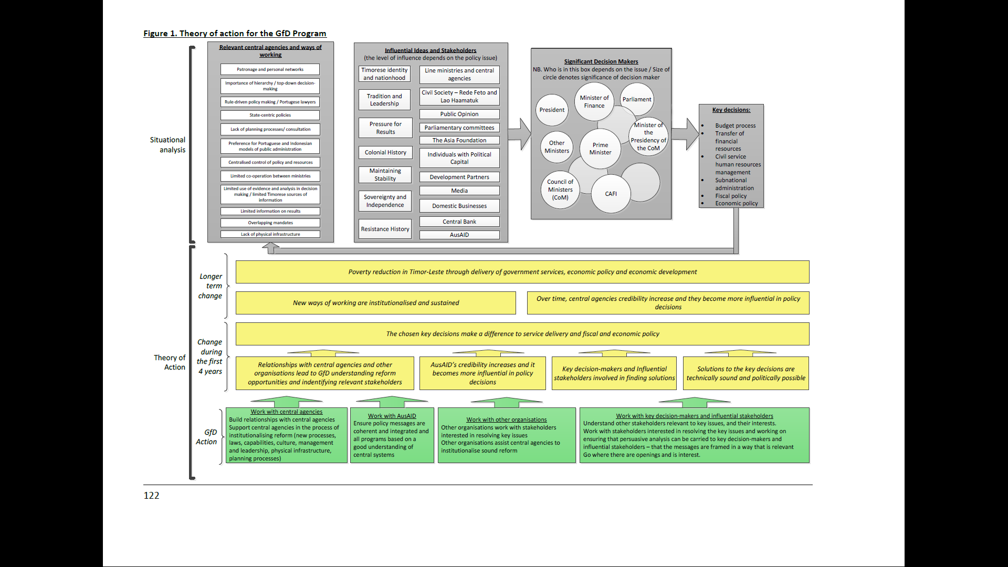

- GfD’s Theory of Change and Work Area Theory of Change diagrams 2019 - 2021

Theory of Change for Public Financial Management
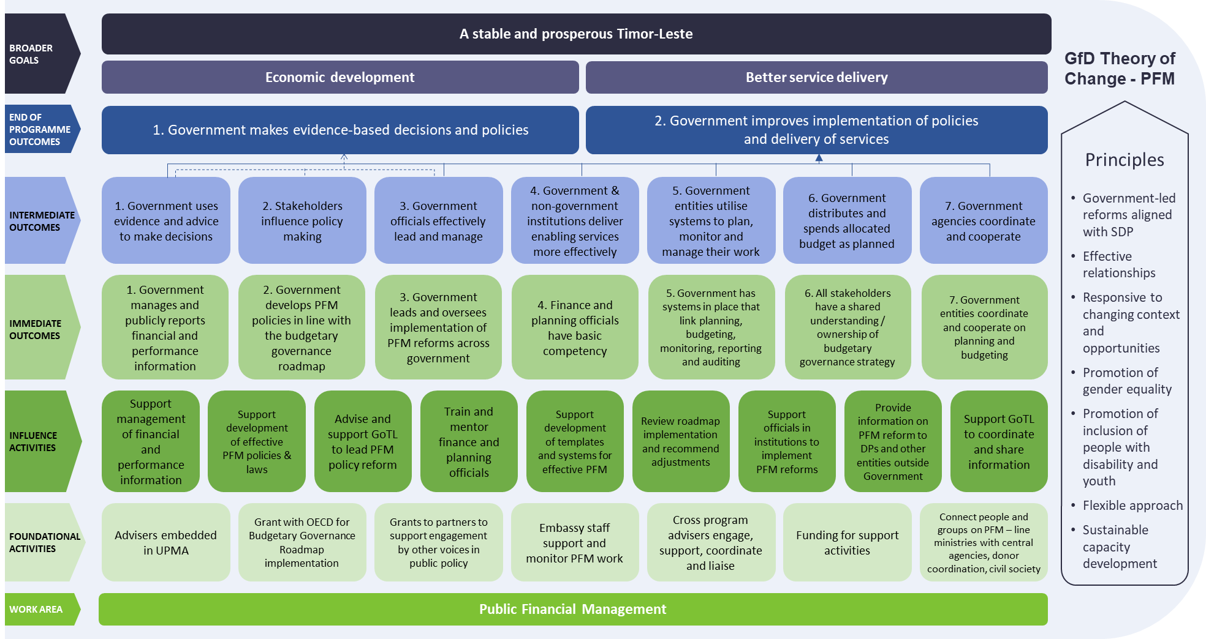

Theory of Change for Public Administration
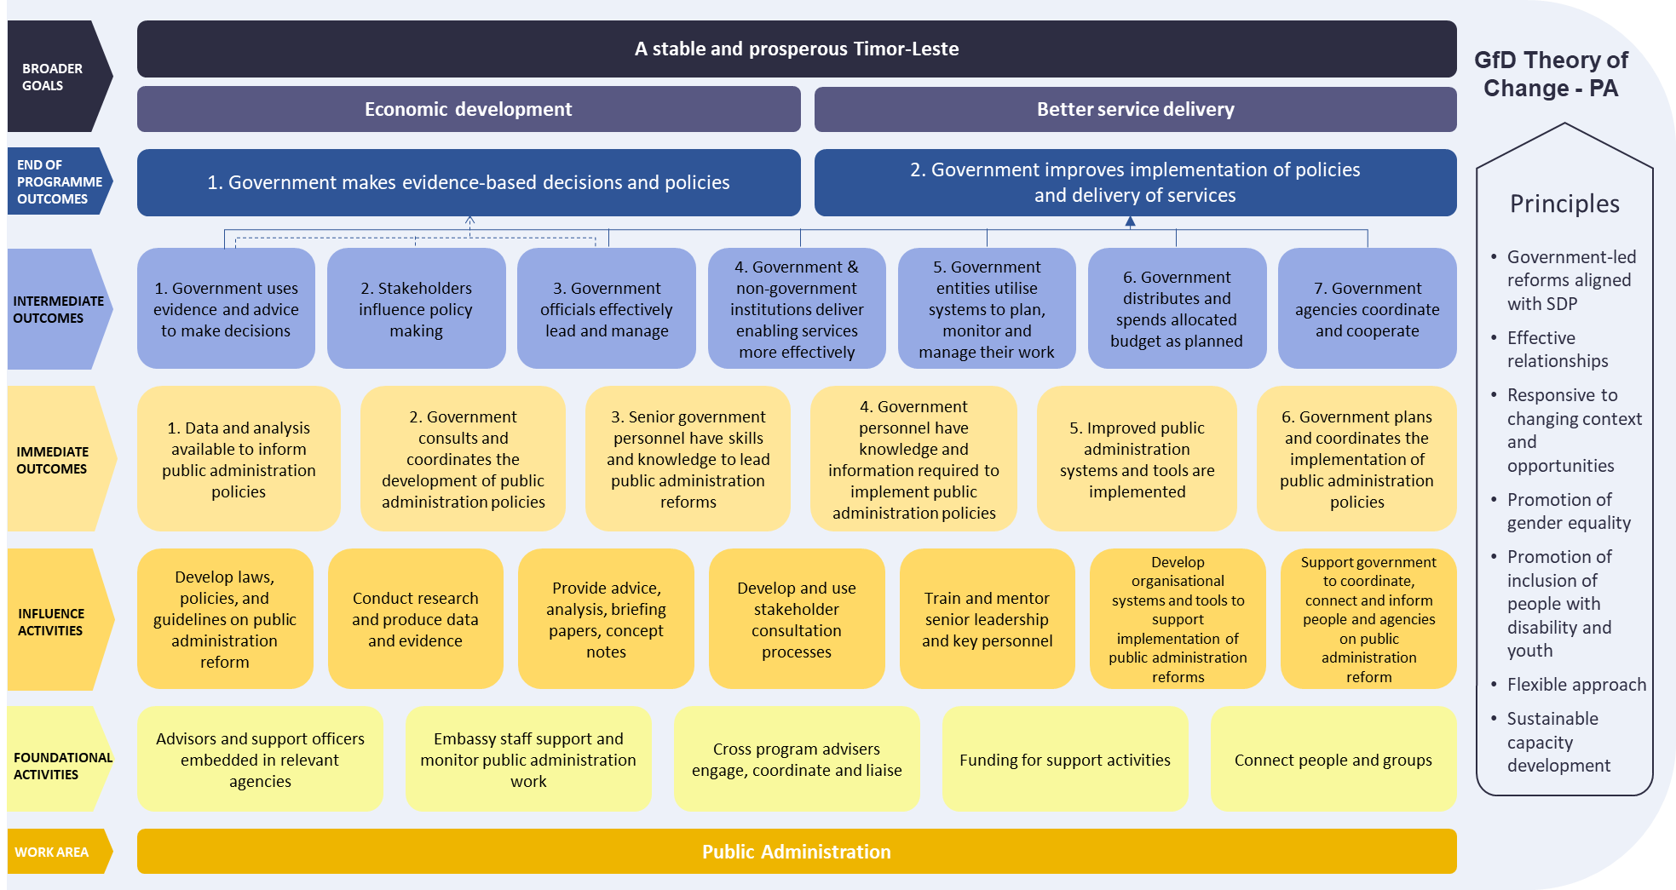

Theory of Change for Economic Development
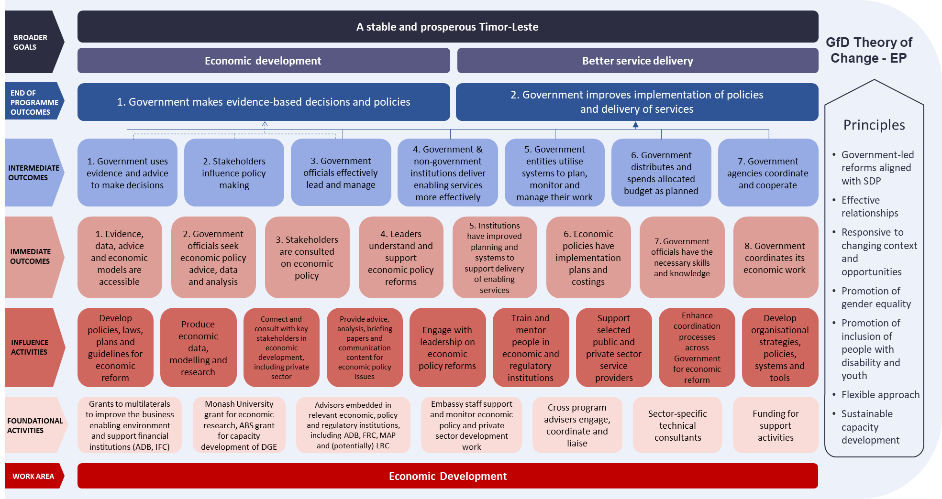

- Organisational Chart as at 31 January 2022
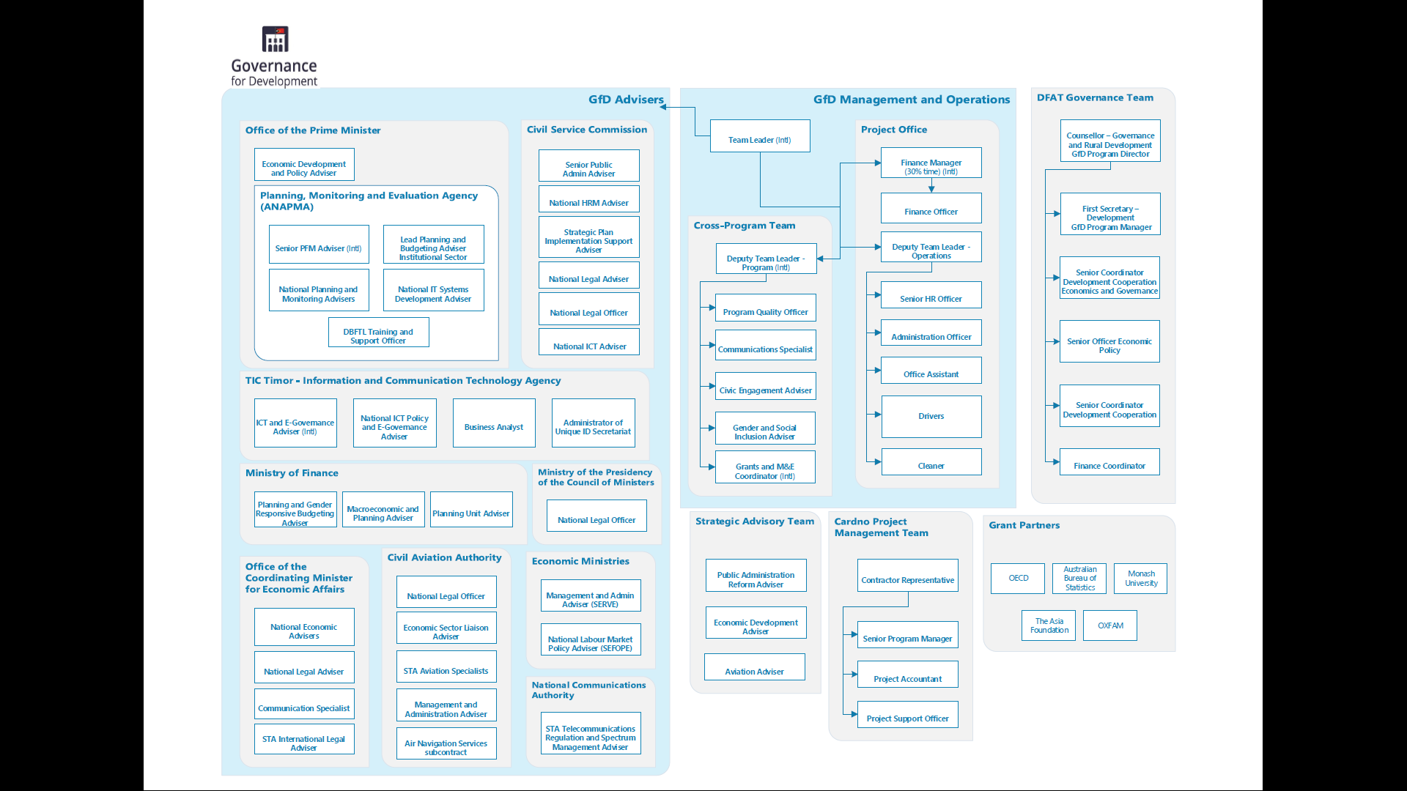

Contract between DFAT and Cardno Emerging Markets for Governance for Development Program (Timor-Leste), July, 2014
Original Contract, Schedule 1 Scope of Services, Clause 1.15, p. 78, May 2014
IGfDSS Completion Report, 2014
i. Support for Telecommunications, ii. Support for Financial Sector, iii. Statistics support to DGE, iv. PFM Coordination, v. Establishment of PFM Working Group, vi. PFM Systems Support for Procurement, vii. Contracting and Payment Systems, viii. PFM Deconcentration Support MoF with implementation of District Treasuries pilot initiative; ix. Support to Ministry of State Administration’s role in deconcentration; x. HRM support to Civil Service Commission; xi. Research, Analysis and Planning; xii. Support for Good Public Policy; xiii. Support to Prime Minister’s Office; xiv. Support for Gender Equality
GfDSS Adviser Q2 Progress Reports Analysis - what worked and did not work well in the new template report P:\Administration\1 - Archive\GfD Monitoring and Evaluation\2_Reports\Report_New templates_2015\Analysis Adviser Report_what worked & did not work well.docx
GfD Team Leader Terms of Reference
GfD Six month report, December 2021
Cardno GfD Scope of Services 2014
Cardno GfD Scope of Services 2014
The ‘Ways of Working’ approach was trialled under the IGfDSS program which started by conducting six-monthly reflection or ‘ways of working’ meetings. (Cardno IGfDSS Completion Report, 2014)
GfD R&R Report Nov 2016 – Diana Nelson
AAPTIP Gender Strategy, 2014, Cardno Emerging Markets as cited in the GFDSSP Gender Strategy and Practice Note, 2015
A gender marker provides a means to categorise Government programs based on their gender relevance and expected contribution to gender equality within the context of the country’s inclusive and sustainable development.
IGfDSS Program Completion Report, 2014
Q1 GfDSS Management Report
https://www.mof.gov.tl/wp-content/uploads/2016/07/03-Economic-Reform.pdf
GfDSS Quarterly report (Q10) November 2016 – January 2017
DFAT, Review of Australia’s Governance for Development program in Timor-Leste and management response, 2020. Weblink: https://www.dfat.gov.au/publications/aid/review-australias-governance-development-program-timor-leste-and-management-response
DFAT, Review of Australia’s Governance for Development program in Timor-Leste and management response, 2020. Weblink: https://www.dfat.gov.au/publications/aid/review-australias-governance-development-program-timor-leste-and-management-response
DFAT, Review of Australia’s contribution to private sector development in Timor-Leste, 2018. Weblink: https://www.dfat.gov.au/sites/default/files/timor-leste-review-of-australias-contribution-private-sector-development-summary-8page.pdf
2017 Foreign Policy White Paper, Government of Australia, 2017. https://www.dfat.gov.au/sites/default/files/2017-foreign-policy-white-paper.pdf
Timor-Leste Governance for Development Investment Design, 2013
Timor-Leste COVID-19 Development Response Plan, 2020. https://www.dfat.gov.au/sites/default/files/covid-response-plan-timor-leste.pdf
Gender Equality and Women’s Empowerment Strategy, DFAT and Development for All 2015-2020: Strategy for strengthening disability-inclusive development in Australia’s aid program, DFAT
Strengthening the Gender Responsive Budgeting implementation in Timor-Leste, Flora Brytes, December 2021
Story of Significant Change. 2019.Female civil servants are increasingly recruited and promoted due to gender-sensitive employment policies.
DFAT/ M&E House. Working paper: MEL for Adaptive Management. Draft, December 2020
https://covid19.gov.tl/dashboard
GfD Timor-Leste Progress Report – 1 August 2017 to 31 May 2018. Weblink: https://www.dfat.gov.au/sites/default/files/timor-leste-gfd-progress-report-2017-2018.pdf
In the portfolios of health; state administration; finance; tourism, commerce and industry; economy; and former combatants
http://www.tatoli.tl/2019/05/29/mensajen-pm-ba-ezekutivu-sira-asistensia-publika-labele-para/

