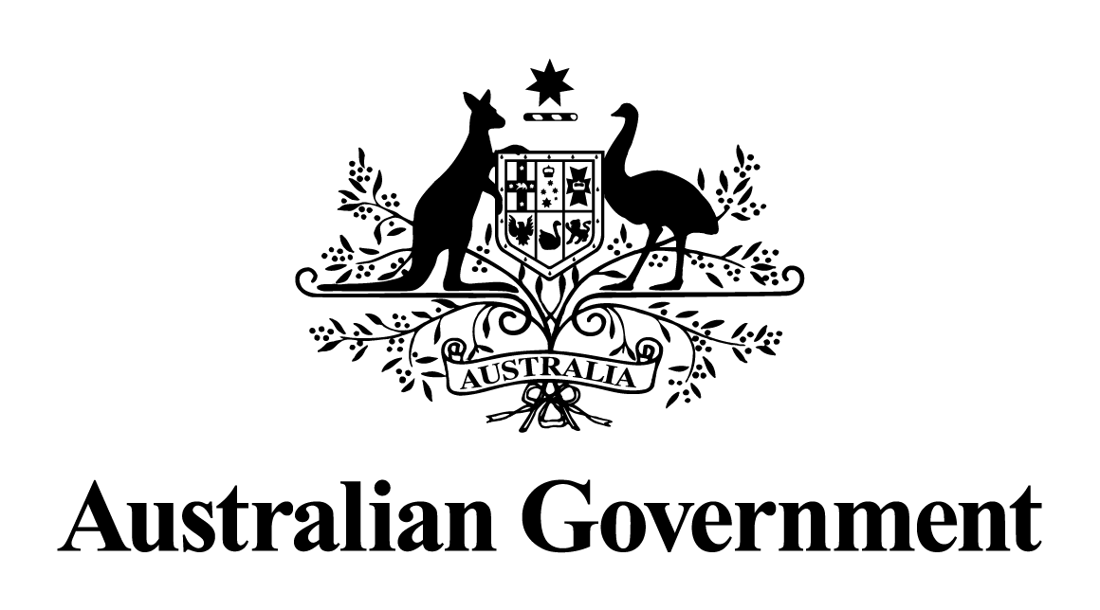

# Australian Government response to the Foreign Affairs, Defence and Trade References Committee report:

# Efficacy of the Department of Foreign Affairs and Trade due diligence framework

September 2024

## Introduction

The Australian Government welcomes the opportunity to respond to the report of the Foreign Affairs, Defence and Trade References Committee (‘the Committee’) on its inquiry into the: Efficacy of the Department of Foreign Affairs and Trade (‘DFAT’) due diligence framework (‘the report’).

The Government recognises and appreciates the work of the Committee. The report is comprehensive and detailed, with four recommendations. The Government also notes the additional comments from some members of the Committee, including their concerns about recommendations one, two and three.

The Government has carefully considered the report and does not accept recommendations one and two. The Government notes recommendations three and four.

DFAT makes extensive use of a range of partners, and in turn their downstream partners, to support implementation of the Australian development program. DFAT’s Due Diligence Framework (the Framework) is part of its broader risk management approach, applying a structured and consistent methodology to review a potential partner’s ability to deliver services in line with the policy requirements of the Australian development program. The Framework assists financial delegates to satisfy *Public Governance, Performance and Accountability Act 2013* requirements to discharge their duties with the degree of care and diligence a reasonable person would exercise.

The Framework is one element of the Government’s risk management approach to the delivery of official development assistance in the high-risk context of Myanmar. DFAT’s approach extends beyond the selection assessment of partners to the close monitoring of program delivery and implementation. DFAT actively monitors programs throughout their life-cycle to confirm that Australian assistance has been delivered as intended and has not been misdirected to the regime.

The Government remains deeply concerned about the situation in Myanmar, and the ongoing repression and violence by the military regime. The Government remains committed to supporting the people of Myanmar through the provision of sustained development and humanitarian assistance. The Government does not provide direct funding to the Myanmar military regime and takes proactive steps to ensure assistance is neither diverted to the regime nor legitimises or gives credibility to the regime.

## Response to the recommendations

### Recommendation 1

***The committee recommends that the Australian Government direct the Department of Foreign Affairs and Trade to develop and implement an alternative and more flexible due diligence framework to be used when a recipient community is in a defined contested environment.***

**Response: Not accepted.**

The Government does not accept this recommendation. Under *Australia’s International Development Policy*, we will continue to deliver a high-quality, effective development program underpinned by rigorous performance and delivery frameworks.

The Government considers the existing Due Diligence Framework used by DFAT fit-for-purpose. The Framework allows DFAT to employ a risk-based approach to the engagement of a wide range of implementing partners, many of whom operate in difficult environments.

The Framework establishes important minimum requirements for any implementing partner delivering development cooperation or humanitarian assistance, regardless of the environment. These minimum requirements are reflected in the seven criteria applied for a baseline due diligence assessment (Entity Details; Past Performance; Fraud and Corruption Control; Proscribed List Checks; Integrity System Checks; Child Protection; and Preventing Sexual Exploitation, Abuse and Harassment). Delegates may elect to include additional assessment criteria depending on a range of factors such as the complexity and financial value of the activity, operating environment and delivery arrangements.

Guidance for departmental officers provides some flexibility in how assessments are conducted. It outlines a range of evidence that can be used to complete assessments and indicates they are to be based on a pragmatic evaluation of the best available evidence at the time of completion.

The Framework is a risk management tool and not a hard gate for funding, except in instances where a potential partner is on one of DFAT’s prohibited dealings lists (e.g. sanctions). It is used to ensure that the delegate has the information they need to make an informed decision, including how risks identified in the assessment process will be mitigated.

DFAT is currently considering the recommendations from a strategic review of the Australian NGO Cooperation Program (‘ANCP’) accreditation process and funding policies to ensure these are fit for purpose and able to adapt to multiple contexts, including in Myanmar. ANCP accreditation is a rigorous process, which aligns with and satisfies DFAT’s due diligence requirements.

### Recommendation 2

***The committee recommends that the Australian Government direct the Department of Foreign Affairs and Trade to develop a decision support tool to assist officers conducting risk management assessments to make it easier to facilitate better distribution of aid funding using the proposed contested environment due diligence framework.***

**Response: Not accepted.**

The Government does not accept this recommendation. DFAT has a comprehensive risk management policy with procedures and supporting systems to assist officers conducting risk management assessments in relation to development and humanitarian investments.

Risk management is a key focus of the investment design process and is subject to testing and quality assurance. For every investment, there is screening for mandatory policy considerations, including environmental and social safeguards, fraud and corruption and terrorism resourcing risks, as well as other common risk factors. Risks associated with a potential implementing partner, identified through the due diligence assessment process, are also incorporated into investment risk registers stored on the department’s online program management platform, AidWorks.

Delegates approving investment designs are responsible for ensuring all material risks have been identified and appropriate management controls and treatments are in place. The Risk Appetite Statement and Tolerances Levels for the development program provide guidance to departmental officers as to which categories of risk require greater attention in decision making and management effort during implementation.

A strong focus on risk management is maintained throughout the implementation phase of an investment. DFAT recommends that investment managers review investment risk registers at least quarterly. In addition, all investments over $3 million are required to undergo an annual performance assessment, which includes criteria related to risk management.

### Recommendation 3

***The committee recommends that the Australian Government utilise any new due diligence framework to engage with and strengthen ties with aid partners and stakeholders on the ground in contested environments, such as the National Unity Government, faith-based non-government organisations and civil society organisations.***

**Response: Noted.**

The Government notes this recommendation.

Although the Government does not accept recommendations one and two, it notes the intent of this recommendation in terms of strengthening localisation, which is a key commitment of *Australia’s International Development Policy*.

Australia already engages with development and humanitarian partners and stakeholders on the ground in contested environments, including Myanmar.

The Government appreciates the importance of hearing and understanding the voices of all stakeholders in Myanmar. Australian officials engage with representatives of the National Unity Government, faith-based non-government organisations (NGOs), civil society organisations and other groups. Australia will continue to engage with all relevant stakeholders to reduce the politicisation of international development assistance, and to advocate for access to people in need and the safety of those providing assistance.

Australia’s development and humanitarian assistance for Myanmar is delivered through United Nations (UN) agencies, multilateral and regional partners, international NGOs, local NGOs and local civil society organisations. While Australia’s direct funding partners are mostly multilateral agencies and international NGOs, they partner with local groups to deliver assistance.

### Recommendation 4

***The committee recommends that further details be released as soon as possible on the Australian Government’s new International Development Policy’s key commitments on:***

***- providing multi-year funding and capacity development to local organisations, with support as needed to meet policy requirements; and***

***- designing a new Civil Society Partnerships Fund that will support local CSOs.***

***In particular, detailing how these programs will apply in the context of Myanmar and resolve the challenges being faced under the current framework.***

**Response: Noted.**

The Government notes this recommendation. *Australia’s International Development Policy* prioritises locally-led development, multi-year funding and capacity development to local organisations, with support as needed to meet policy requirements. The policy also includes a commitment to design a new Civil Society Partnerships Fund that will support local civil society organisations. DFAT will release further details as arrangements are developed.

To facilitate implementation of these commitments, DFAT has recently published new guidance on supporting locally-led development. The guidance emphasises there is no ‘one size fits all’ approach to locally-led development programming. Further detail will be outlined at country-level in Development Partnership Plans, and at program-level through investment designs, taking into account factors such as country context, development objectives, delivery models, partners, risk and safeguarding.

Providing support for organisational capability (e.g. financial management, child protection policies) will be central to locally-led development: this can be provided directly in funding agreements or via intermediaries. Strategies will be tailored with the local organisation.

In certain contexts, it may not be possible to partner directly with local actors. In those cases, DFAT will work indirectly through intermediaries such as Australian NGOs, international NGOs, multilateral agencies and managing contractors. For example, to advance locally-led development, ANCP allows partner NGOs to plan multi-year programs and projects, and is also trialling a ‘pass down’ of a minimum $10,000 for each Australian NGO annual grant to local partners to support their administrative costs.

The Government has a range of multi-year humanitarian and development programs in Myanmar across several sectors, where the direct implementing partner is a multilateral agency or international NGO, but which partner with a range of local organisations to implement activities on the ground. Many of these programs provide multi-year funding and capacity development for local organisations. Noting the sensitivities and security situation in Myanmar, the Government does not publicise the details of local implementing partners. This is at their request.