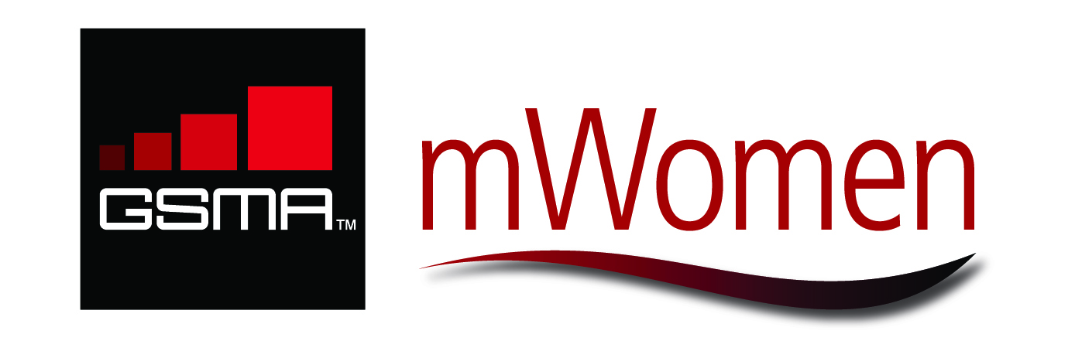
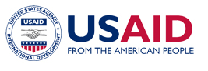



FACTSHEET: GSMA mWomen Program Global Development Alliance

Overview

Partners: USAID, AusAID, GSMA and Visa Inc.

Goal: To reduce the mobile phone gender gap by 50 percent: By enabling an additional 150 million women in developing countries to own and effectively use mobile phones, the GSMA mWomen Program Global Development Alliance (GDA) will increase women's access to vital information, networks and services, thereby accelerating women’s leadership potential and empowering them to improve their quality of life and that of their families and communities.

Location: Low- to middle-income countries, with an initial focus on South Asia, the Middle East, Sub-Saharan Africa, and the Pacific

Funding: US$9.7 million over three years

Timeline: October 2011 – September 2014

Website: www.mwomen.org

Background

- The GSMA mWomen Program is an unprecedented global public-private partnership between the worldwide mobile industry and the international development community.

- The Program aims to reduce the mobile phone gender gap by 50 percent and provide life-enhancing services to underserved women in developing countries.

- The Program was launched with U.S. Secretary of State Hillary Rodham Clinton and Mrs. Cherie Blair in October 2010.

- It highlights both a commercial and social opportunity through working with: 30 industry partners in the GSMA mWomen Working Group to create innovative business models to reduce overall cost; the development community, NGOs, governments and operator marketing teams to address cultural barriers; the design and international development communities to help women become more comfortable using mobile phones; and NGOs and content aggregators to increase the availability of life-enhancing mobile services.

- The Global Development Alliance represents Phase 2 of the GSMA mWomen Program, and builds on the current grants by USAID and AusAID (approximately $500,000 each) to GSMA, which were made under Phase I to support the development of the mWomen Business Case Framework and Research into the ‘Wants and Needs of Base of the Pyramid (BOP) Women.’

- The GSMA mWomen Program is an initiative of the GSMA Development Fund, implemented through the GSMA Foundation. The GSMA Development Fund exists to accelerate economic, social and environmental development in underserved markets through the use of mobile technology, leveraging the industry expertise of the GSMA and its members, as well as the expertise of international development agencies and non-profit organizations.

Partner Contributions

Under the Global Development Alliance, the partners have each awarded the following over three years:

  - USAID is providing US$3.35 million under a cooperative agreement to the GSMA Foundation;
  - AusAID has awarded a grant of US$3.6 million to the GSMA Foundation;
  - The GSMA will contribute US$2.2 million to the program; and
  - Visa Inc. has made a contribution of US$700,000 to the GSMA Foundation, specifically for research into women’s demand for and usage of mobile technologies, including mobile financial services.

Key Objectives of the GSMA mWomen Global Development Alliance

The GSMA mWomen Program aims to reduce the mobile phone gender gap by 50 percent by employing the following impact strategies:

- Shift mobile industry resources to reach underserved women and establish the women's market segment as a key opportunity for the mobile industry;
- Catalyze the creation, launch and scaled distribution of life-enhancing mobile value-added services for underserved women;
- Support underserved women's effective use and ability to engage with mobile technology; and
- Provide access to mobile products and services to enable women’s leadership and empowerment.

Key Activities of the GSMA mWomen Global Development Alliance
- Provide human resource grants to operators to help them identify and implement at scale new commercial and social opportunities, products and services for underserved women (launching mid-2012);
- Provide grants for NGOs to collaborate with mobile operators in designing activities that address the barriers to mobile phone usage among women, particularly technical literacy and traditional attitudes surrounding women’s ownership of mobile phones (launching 2013);
- Conduct research into women’s demand for and usage of value-added services, including mobile financial services (2010-2014);
- Assess and effectively replicate pilot projects for bringing women into the retail stream of the mobile value chain (ongoing);
- Consult with mobile network operators to design and operationalize customer strategies for targeting underserved women (ongoing);
- Design and disseminate an underserved women’s marketing toolkit to demonstrate how mobile industry marketing campaigns can be leveraged for behavior change communications aligned with development objectives (launching mid-2012);
- Institutionalize underserved women as a recognized market segment by implementing and awarding an mWomen Global Mobile Award. This will reward the best mobile product or service targeting women in emerging markets, as part of the most coveted industry awards at GSMA’s annual Mobile World Congress (awarded annually);
- Focus attention on the mobile user experience of underserved women. Strategies will help women feel more comfortable using mobile phones, thus maximizing potential for life-enhancing benefits of the tool (ongoing); and
- Share knowledge and catalyze the replication of best practices throughout the mobile industry and international development community (ongoing).

Why Women & Mobile?

Mobile phone adoption in the developing world is growing at a rapid rate; today four out of five mobile connections are in developing countries. However, women, particularly those living on less than $2 per day, are not benefiting from mobile technology in an equal manner to men. In fact, research by the GSMA and the Cherie Blair Foundation for Women showed that a woman in a low- to middle-income country is 21 percent less likely to own a mobile phone than a man. This mobile phone gender gap represents 300 million women in the developing world without access to this potentially life-enhancing tool.

Focusing on women and enabling their ownership and use of mobile technology has a powerful impact on improving lives and livelihoods. Studies have shown that a 10 percent increase in mobile phone penetration rates has led to an additional 1.2 percent increase in GDP in low- and middle-income countries. Benefits from mobile technologies include improving women’s literacy and girls’ education, advancing access to health and education, supporting women’s civic participation and activism, increasing the sense of security and independence for women, and amplifying economic opportunities and incomes for women living under $2 per day. Because women direct the majority of their income to their families and communities, these benefits are widely shared. Thus, women and mobiles are a powerful combination for development outcomes.
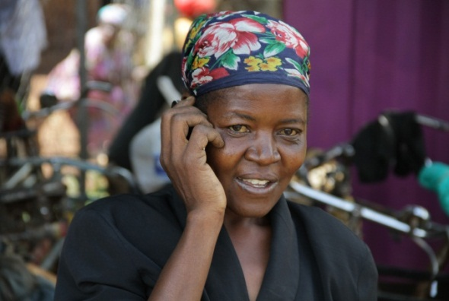
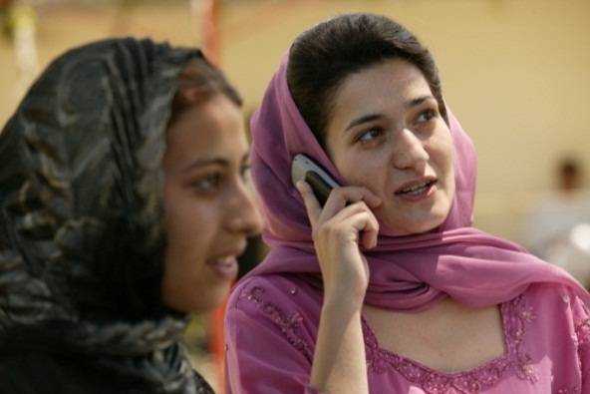

More about the Partners
USAID
The U.S. Agency for International Development (USAID) is an independent agency that provides economic, development and humanitarian assistance around the world in support of the foreign policy goals of the United States.

As stated in the President’s National Security Strategy, USAID’s work in development joins diplomacy and defense as one of three key pieces of the nation’s foreign policy apparatus. USAID promotes peace and stability by fostering economic growth, protecting human health, providing emergency humanitarian assistance, and enhancing democracy in developing countries. These efforts to improve the lives of millions of people worldwide represent U.S. values and advance U.S. interests for peace and prosperity. USAID provides assistance in sub- Saharan Africa, Asia and the Near East, Latin America and the Caribbean, and Europe and Eurasia.

AusAID
The Australian Agency for International Development (AusAID) is the Australian Government agency responsible for managing Australia's overseas aid program. The purpose of the Australian aid program is to help people overcome poverty, focusing efforts in areas where the Agency can make the biggest difference.

Australia’s expertise in health, education, gender equality, law and order, infrastructure, rural development, and the environment draws on world best practice, as does its work helping combat global threats such as people trafficking, illicit drugs, HIV/AIDS and other communicable diseases. Australia also responds to emergencies such as cyclones, floods, tsunamis and earthquakes.

GSMA
The GSMA represents the interests of mobile operators worldwide. Spanning more than 220 countries, the GSMA unites nearly 800 of the world’s mobile operators, as well as more than 200 companies in the broader mobile ecosystem, including handset makers, software companies, equipment providers, Internet companies, and media and entertainment organizations. The GSMA also produces industry-leading events such as the Mobile World Congress and Mobile Asia Congress.

For more information, visit Mobile World Live, the online portal for the mobile communications industry, at www.mobileworldlive.com.

Visa Inc.
Visa is a global payments technology company that connects consumers, businesses, financial institutions and governments in more than 200 countries and territories to fast, secure and reliable digital currency. Underpinning digital currency is one of the world’s most advanced processing networks—VisaNet—that is capable of handling more than 20,000 transaction messages a second, with fraud protection for consumers and guaranteed payment for merchants. Visa is not a bank, and does not issue cards, extend credit or set rates and fees for consumers. Visa’s innovations, however, enable its financial institution customers to offer consumers more choices: Pay now with debit, ahead of time with prepaid or later with credit products.

For more information, please visit: www.mwomen.org, www.ausaid.gov.au , www.usaid.gov and www.corporate.visa.com.

Wireless Intelligence August 2011.
GSMA; Cherie Blair Foundation for Women; Vital Wave Consulting. (2010). Women & Mobile: A Global Opportunity. London: GSMA.
Deloitte 2007.

