**HAARP China Country Program**

**Completion Review Report**

**July 1st, 2008 to June 30th, 2012.**



**Activity Name:** HIV/AIDS Asia Regional Program (HAARP)

**Activity Implementing Agency:** NCAIDS, Yunnan and Guangxi Project Management Office

**Activity code and funding agreement number:** FA45HIV03.

**Size of the activity:** AUD 7,400,000.

**Duration of the activity:** July 1st, 2008 to June 30th, 2012.



**Table of Contents**

Acronyms ........................................................................................................................................................... 3

Acknowledgements .......................................................................................................................................... 4

Executive Summary ......................................................................................................................................... 5

Brief outline of HAARP activities and achievements ........................................................................... 5

Key outcomes............................................................................................................................................ 6

Sustainability ............................................................................................................................................. 8

Challenges ................................................................................................................................................. 8

Lessons Learned ...................................................................................................................................... 9

Conclusion ............................................................................................................................................... 10

Long-Term Benefits ................................................................................................................................ 10

Ⅰ.Project Background .................................................................................................................................. 11

Project Goal and Objectives.................................................................................................................. 11

Project area and target groups ............................................................................................................. 11

Ⅱ. Implementation of Project....................................................................................................................... 13

1. Implementation and progress of project activities ......................................................................... 13

2. Completion of comprehensive intervention indicators .................................................................. 13

3. Project outcomes and impact ........................................................................................................... 24

4. Monitoring and Evaluation (M&E) .................................................................................................... 31

5. Investment and Financial management .......................................................................................... 32

Ⅲ.Main Achievements, Experience and Suggestions .............................................................................. 36

1. Main Achievements ............................................................................................................................ 36

2. Experience and suggestions ............................................................................................................ 38

3. Difficulties and challenges ................................................................................................................ 40

4 Conclusions .......................................................................................................................................... 41

Ⅳ. Next-Step Plans ........................................................................................................................................ 42

1. Plan of project hand-over .................................................................................................................. 42

2. Plan of using project experience and output .................................................................................. 43

Annex 1 Project Areas ................................................................................................................................... 45

Annex 2 HAARP M&E Framework ...............................................................................................................46

Annex 3 Assets purchased by HAARP........................................................................................................ 55

**Acronyms**

AIDS Acquired Immunodeficiency Syndrome

ART Antiretroviral therapy

AUD Australian Dollars

AusAID Australian Agency for International Development

CDC Centre for Disease Control and Prevention

DFAT Department of Foreign Affairs and Trade (Australia)

DFID Department for International Development (UK) FSW Female sex worker

HAARP HIV/AIDS Asia Regional Program HIV Human Immunodeficiency Virus IDU Injecting drug use/r

IEC Information Education and Communication

M&E Monitoring and evaluation

MMT Methadone maintenance therapy

NCAIDS National Centre for AIDS/STD Control and Prevention

NGO Non-governmental organisation

NPO National Project Office

NSP Needle and syringe program MoUs Memorandums of Understanding OWs Outreach workers

OSI Open Society Institute

PMO Project Management Office

PMTCT Prevention of Mother to Children Transmission

TSU Technical Support Unit (HAARP) UNAIDS United Nations Programme on HIV/AIDS UNFPA United Nations Population Fund

UNODC United Nations Office on Drugs and Crime

USAID United States Agency for International Development

VCT Voluntary Counselling and Testing YDHR Yundi Harm Reduction Network YPBH Yunnan Provincial Bureau of Health

YNAB Yunnan Provincial HIV/AIDS Prevention and Control Bureau

**Acknowledgements**

The implementation and achievement of HAARP would not be possible without the help of the Government of People’s Republic of China, Government of Yunnan Province, Government of Guangxi Zhuang Autonomous Region, HAARP program staff, and all other implementing agencies, program partners, NGOs, HIV and drug affected families and other individuals. We express our gratitude to all of them.

This report aims to summarize the main outcomes and outputs of HAARP and highlight key achievements from 2008 to 2012. All project staff and related experts provided assistance in drafting this report. Data and activity information was collected from 31 counties of HAARP and technical inputs were provided by experts at all levels of implementation. We would like to thank for all of them, including Dr Sun Jiangping, Dr Liu Hui and Dr Xue Hui from NCAIDS, Director Yang Jinye, Dr Liu Wei, Project Officer Yang Ji and Wu Yufei from Guangxi CDC, Director Xie Yu, Lei Yujing, Duo Lin and Duanyong from Yunnan.

**Executive Summary**

**Brief outline of HAARP activities and achievements**

In the period 2008-2012, HAARP covered thirty-one cities or counties in the Chinese provinces of Yunnan and Guangxi with harm reduction services targeting male and female substance users, particularly those who inject and their sex partners. Harm reduction interventions have effectively reduced the spread of HIV among the local population of injecting drug users (IDUs) and their partners in these sites. The percentage of IDUs testing HIV positive decreased from 34.4% to 26.5% over the implementation period in Yunnan and from 18.8% to 11.1% in Guangxi.

The project objective "to reduce the spread of drug use-related HIV/AIDS spread in Guangxi and Yunnan" has been achieved. HAARP has also supported capacity development to support the scale-up of harm reduction activities, helping to build core capacity in service providers, law enforcement agencies and organizations of people who use drugs. Over the past four years HAARP has delivered 1,454 trainings, which produced more than 20,000 practitioners. As part of the HAARP project, workshops for the families and sex partners of drug users were also held. It is estimated that the project provided 7.24 million person-times of harm-reduction services to over 12,000

IDUs, and delivered 8,250,977 syringes and needles, and 1,086,023 condoms.

Referral services for drug users consisting of Voluntary Counseling and Testing (VCT), antiretroviral therapy (ART), CD4 testing, TB treatment, and other related services were also provided as part of HAARP. Social support has also been negotiated for drug users, including the advocacy for very poor people who use drugs to get a subsistence allowance from the Government of China. As part of the project, nearly 4000 IDUs have been initiated and retained in methadone maintenance treatment (MMT), and 3,726 used services that promoted safe sex (e.g. condoms).

The project established cross-border cooperation with concerned counterpart agencies in Vietnam and Myanmar to promote harm reduction. It is estimated that the project provided harm reduction services to 1,000 IDUs from Vietnam and Myanmar.

Apart from service delivery and capacity building, HAARP has contributed to the generation of a vast body of epidemiological and operational research. A number of studies were conducted, including more than 20 investigations and reports; 84 papers were published in different national and international peer reviewed journals.

Critically, HAARP promoted the introduction of a range of policies that support

implementation of harm reduction - at the national and provincial level. The project has also had a significant impact on 29 county-level policies in Yunnan and Guangxi. For example, Liuzhou County provided certificates for outreach workers (OWs) to help them to conduct harm reduction services without being arrested by police, which was not possible before HAARP.

**Key outcomes**

**Objective 1: Institutional Capacity Development (improve the planning capacity and multiple-sectoral coordinating capacity of implementing institutions to respond to IDU-related HIV transmission).**

The implementation of the project improved multi-sectoral collaboration between public health, public security, education, and civil affairs departments at the city and county level. Multiple departments, including public health, public security, education and publicity department, now jointly conduct awareness and public advocacy work. Most significantly, HAARP practitioners presented the project evidence and lessons learnt during implementation, and used it to advocate for appropriate policy changes with government officials at various levels. The project promoted policies that improve access to clean needles in Yunnan as of 2010, and the core project indicators of HAARP were utilized by government to assess the work of HIV/AIDS control and intervention in the entire province. The Health Department and Public Security Bureau in Guangxi province published official documents stressing the importance of needle syringe programs to reduce the risk of HIV/AIDS transmission. In addition, HAARP provided evidence for the changing of content in new official drug policy which was issued in June 2011 and around 68,000 former drug users who had been abstinent for more than three years were removed from the Public Security Dynamic Control System, which help them get back to main stream society and reduced social discrimination. All these changes demonstrate that HAARP has helped not only to improve access to services for IDUs, but also influenced official drug policy for the better.

**Objective 2: Technical Capacity Development (improve management capacity and technical capacity of harm reduction project staff).**

HAARP has provided a full range of domestic and international skills trainings, meetings and workshops for outreach workers and thus established a stable and competent outreach team. It also organized visits to project sites for public security and public health department personnel to exchange views and information in order to achieve mutual improvement. These activities are very important for future HIV/AIDS control

and prevention work both at the local and national level. HAARP staff have written more than 20 reports on the outcomes at different project sites and published 84 studies about harm-reduction in academic journals. Some of the papers won awards at the

local and national level. Yunnan and Guangxi provinces set up a network database to

monitor program progress. The project database of HAARP Yunnan has been adopted by the Government to manage the data of NSP in the whole province.

**Objective 3: Community capacity development to provide comprehensive service and interventions for IDUs.**

A major contribution of HAARP is that members of the community and family members of drug users recognize Needle Syringe Programs (NSPs) as an effective

harm-reduction measure. The project improved the local prevention and control network using community resources, and mirrored the characteristics of Australian needle program interventions and provided comprehensive harm reduction services for IDUs. In some project areas employment and accommodation were made available to IDUs to help support entry into drug dependence treatment and provide stability. The project has seen the rate of sharing needles among IDUs decline significantly over the project period (27.8% to 5.9% in Guangxi and 53.1% to 31.7% in Yunnan), and the percentage of IDUs testing HIV positive has also declined (34.4% to 26.5% in Yunnan and 18.8% to 11.1% in Guangxi). The proportion of IDUs reporting good HIV knowledge awareness and condom use (12.6% to 39.9% in Guangxi and 42.7% to 61.9% in Yunnan) and voluntary counseling and testing (VCT) have also increased.

With the capacity improvement and help of HAARP, local NGOs have successfully applied for other agencies for support to conduct harm reduction services (Global Fund, Open Society Institute (OSI), and projects in Hong Kong and Taiwan), which can help to maintain the project work after the end of HAARP.

**Objective 4: Scale-up Closed Setting Harm Reduction Services (provide harm-reduction training in detoxification and rehabilitation centers).**

Over the past four years, HAARP organized 218 trainings for staff of the drug dependence treatment and rehabilitation centers. In total, 6,019 police staff and 12,074

IDUs have been involved. Project staff in Yunnan also conducted harm-reduction training for 600 inmates of the Ruili Ying Jiang Drug Addiction Treatment and Rehabilitation Centre from Myanmar. The harm-reduction training to drug users and policemen in detoxification centers helped to raise HIV awareness among participants, and improved the understanding among policemen of harm reduction measures. In order to reduce relapse into drug use after leaving detoxification centers, detention centers in Guangxi province agreed to refer released detainees to local Methadone Maintenance Treatment (MMT) clinics with the active support and advocacy of HAARP. This can help IDUs to keep away from illegal drugs and crime, and get the support from families and overall contributes to reduced discrimination

**Objective 5: Implement Harm Reduction in Cross-border Region**

HAARP provides foreign drug users in the border region with clean syringes, alcohol wipes, injection water, condoms and abscess management in Yunnan and Guangxi.

185 Vietnamese drug users received harm reduction services in Guangxi and 174 drug

users from Myanmar received MMT in Yunnan. HAARP Guangxi held regular cross-border HIV prevention and control of the joint meeting with Vietnam boarding areas to promote information and data sharing. HAARP Yunnan signed memorandums of understanding (MoUs) with Myanmar and Vietnam to establish long-term and stable cooperation on HIV/AIDS control and prevention in cross-border areas. HAARP also collaborated with Yunnan Police Officer Academy to provide 15 harm-reduction trainings for harm reduction to 490 senior anti-drug police officers from South-east Asian countries. HAARP developed materials in Chinese, Burmese, Vietnamese and Laos, as well as bilingual materials in cross-border areas to promote harm reduction.

**Sustainability**

HAARP has worked actively with Government partners to ensure the sustainability of its activities. HAARP will hand over its harm-reduction services and all relevant documentation to local public health administrative departments to ensure the continuous provision of harm reduction services.

All the 24 NSP sites which were set up with local institutions in 19 counties of Yunnan were transferred to the NSP Working Group of Yunnan Province, and will remain operational as part of the current implementation strategy of the local health departments. The existing 21 NSPs in Guangxi will be increased to 29 after the completion of HAARP, and they will continue to provide harm reduction services with the financial support from the local and provincial level. Most counties will continue to employ qualified outreach staff to provide harm reduction services. They will continue to receive logistical and financial support, and also a small subsidy from the government.

The National Project Office will share the knowledge and experience nationally and internationally through conferences and seminars, and publishing articles in peer reviewed academic journals. The Project Management Office will further analyze the project data with local project offices, and advocate policy improvement to local government in order to help make NSPs play a more prominent role in other geographical areas not covered so far. HAARP has had strong partnership with

grass-roots organizations and the community in the implementation of the project. The National Project Office will assist NGOs and outreach workers, the backbone of the project implementation, to provide harm reduction services in the future.

**Challenges**

The quality of the intervention for IDUs needs to be maintained and improved, especially after the end of HAARP. An ongoing challenge is the ‘dosage’ or intensity of harm reduction interventions. For example, currently each IDU on average gets just under one syringe each day, which affects the effectiveness of NSP in reducing

transmission of blood borne viruses. This will remain a concern after HAARP ends and how dosage can be maintained will be an issue that will require innovation and advocacy. The intervention for female IDUs and sexual partners of IDUs is also a relatively new component of the project which needs to be strengthened. Only some HAARP sites provide trainings among the sexual partners or families of IDUs. As HIV transmission to sexual partners from IDUs is still increasing, more females need to be targeted.

Finally, drug user groups and NGOs need more support. The capacities of NGOs have been significantly improved after a series of training and experiences sharing workshops, but they will be not able to conduct activities without financial and technical support. Whether they are able to get enough help or not after HAARP will decide their existence and future activities.

Current cross border cooperation on harm reduction service needs to be continued. HAARP has signed a formal cooperation agreement with NGO concerned and provide free clean needles and methadone for Vietnamese and Burmese drug users in the border area, but it is difficult to continue without other agencies taking over, particularly when funds are not available.

**Lessons Learned**

A major lesson learnt from the implementation of HAARP is that a good multi-sectoral cooperation forms the basis for carrying out harm reduction work smoothly. Active collaboration between public health and public security sectors in China has been the key to the successful implementation of the project. The right choice of out-reach workers, and the provision of intensive training are needed for scaling up coverage. The support of the government and active involvement of NGOs is also critical to delivering HIV/AIDS control and prevention services. It needs to be emphasized here that the participation of the target people in activities concerning and benefitting them is also desirable and needed.

In cross border regions, strengthening information, communication and joint action between countries at the province level, city level and county level is beneficial for building a regional cross-border harm-reduction cooperation mechanism. However, promotion of policy-making at the national level to cooperate with neighboring countries is still limited. Policy change will rely mainly on the cooperation between the health and law enforcement departments, and the strong evidence and advocacy is needed to ensure this. Another important lesson learnt is that continued ‘real time’ and effective monitoring and evaluation of project activities is very important in ensuring that project activities are implemented appropriately and effectively. Harm reduction interventions should be combined with local HIV/AIDS control and prevention activities to ensure the sustainability rather than stand alone interventions.

**Conclusion**

HAARP has operated successfully and in accordance with the annual work plan with the efforts at all levels and the support of professionals, health practitioners, Ministry of Health, and DFAT. Significant progress was made in the areas of policy development, multi-sectoral cooperation, capacity building, harm-reduction interventions for drug users and their sexual partners, referral services, multi-level supervision and evaluation and involvement of NGOs in cross-border project cooperation. The HAARP project in Guangxi has led government departments to pay increased attention to the implementation of harm-reduction work. Multi-sectoral cooperation and coordination were strengthened; target groups benefitted from the project; the project developed HIV-prevention-and-control capacity of project staff; the capacity and technical abilities in delivering harm reduction services were further improved; harm-reduction measures in closed settings were improved; and harm-reduction coverage in cross-border region was scaled up. In sum, the project objectives were met and the project was a success.

**Long-Term Benefits**

HAARP had an important impact on the policies and practices for the control and prevention of HIV/AIDS among drug users in Yunnan and Guangxi. The project provided harm reduction services to both men and women, helping to improve public health outcomes for a range of blood borne diseases and improved drug policy at the local, provincial and national level. It also strengthened the partnership between health departments and other sectors enhanced the capacity of staff through trainings, visits and experience sharing. The training carried out in places of detention of drug users has reduced high-risk behaviors.

The project drew on lessons and experiences from Australia. The project-based long-term cooperation mechanisms will contribute to the control and prevention o f HIV/AIDS cross-border areas. The implementation of HAARP in Guangxi and Yunnan - the outreach approach, policy advocacy, project management and harm reduction theory – has produced results that have played a role in guiding the region's HIV prevention and control policies. This experience of HAARP has also impacted to HIV/AIDS work in the whole country. Project personnel and multi-sectoral leaders will continue to apply learned theories, methods and positive experience to HIV/AIDS interventions. The project also trained a group of NGO workers in the HIV/AIDS intervention, which improved the widespread involvement of NGOs. HAARP has helped to improve HIV prevention and control in local areas, and cultivate a management team with high professional standards and a stable and competent out-reach team.

Ⅰ.**Project Background**

**Project Goal and Objectives**

**Goal:** Reduce injecting-drug-use-related HIV transmission in Guangxi and Yunnan.

**HAARP has six objectives. These are:** Objective 1: Institutional Capacity Development; Objective 2: Technical Capacity Development; Objective 3: Community Capacity Development;

Objective 4: Scale up Closed Settings Harm Reduction Services;

Objective 5: Implement Harm Reduction in Cross-border Region; Objective 6: Monitor and Evaluation (M&E).

**Project area and target groups**

The target groups were IDUs and their sexual partners in 31 counties and cities of Guangxi and Yunnan. The locations are shown in Figures 1 and 2 (a list of the geographical locations can be found in Annex 1).

Fig 1: Project sites in Yunnan

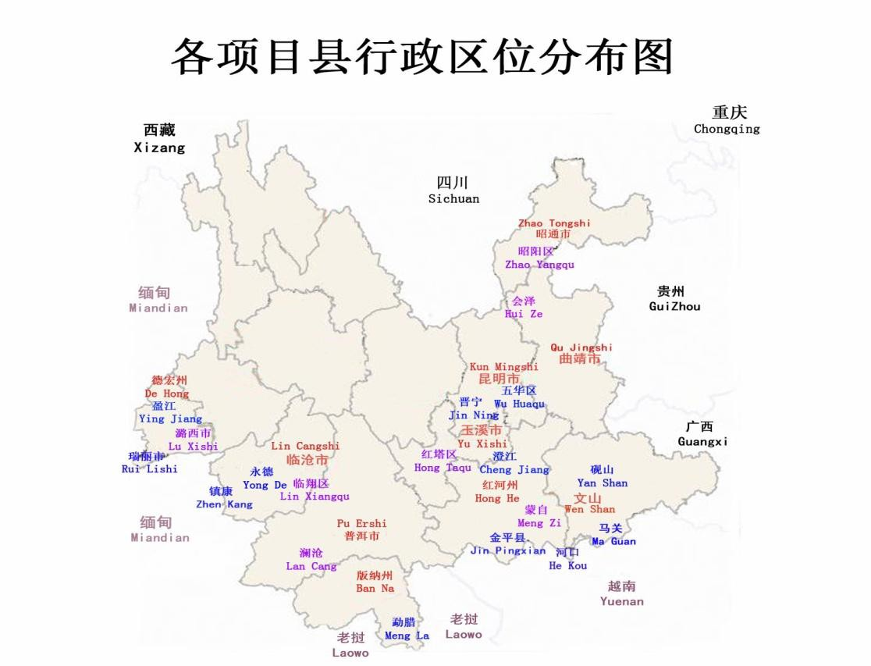

Fig 2: Project sites in Guangxi

广西项目点地理分布

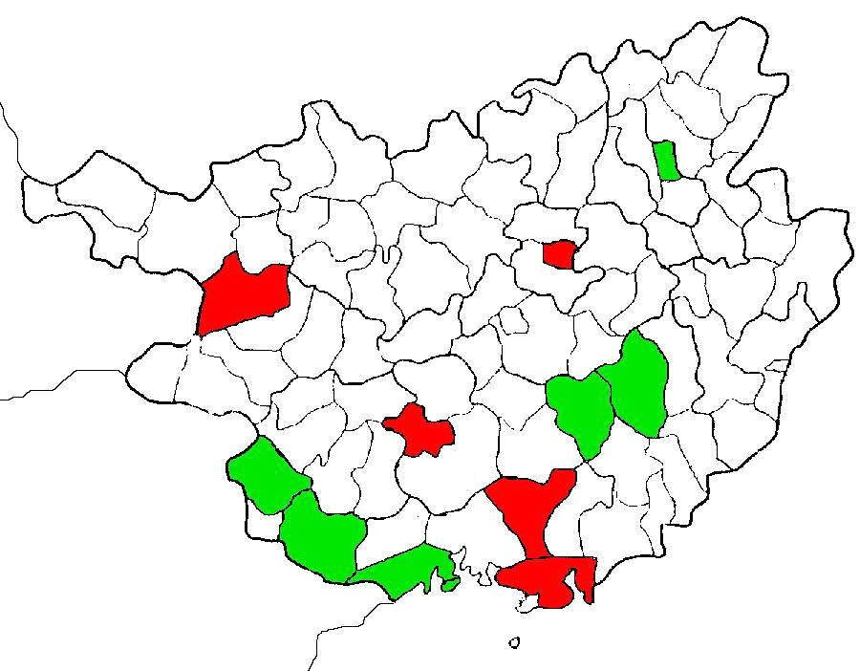

location of EAPs

桂林 **Guilin**

Yunnan

百色 **Baise**

龙州 **Longzhou**

南宁 **Nanning**

柳州 **Liuzhou**

桂平

**Guiping**

贵港 **Guigang**

梧州

**Wuzhou**

vietnam

宁明 **Ningming**

防城港

**Fangchengang**

灵山 **Lingshan**

合浦 **Hepu**

原项目点

ARHP SITE

新项目点

New SITE

Ⅱ. **Implementation of Project**

**1. Implementation and progress of project activities**

Within the project life cycle, HAARP followed the annual plan for implementation. The main activities included participating in different international exchange meetings and trainings; holding trainings in for management staff, outreach workers, peer educators, detoxification persons, community residents and policemen in closed settings; providing clean syringes, alcohol wipes, injecting water, condoms, and IEC materials to drug users; providing referral of MMT, VCT and ART; and conducting M&E of the project.

**2. Completion of comprehensive intervention indicators**

**1) HAARP Implementation Data:** Tables 1 and 2 summarize the project outputs in the areas of service delivery and capacity building over the project period. Table 3 presents annual information from annual surveillance data collected in project sites on HIV risk behaviors and prevalence. As can be seen, the project has rapidly scaled up coverage of harm reduction and HIV treatment. At the same time, there is a decreasing trend in risk behaviors and HIV prevalence in project sites.

**Implementing Region**

**Table1: Harm Reduction Service Provision**

**Yunnan Guangxi Total**

**08-09 09-10 10-11 11-12 08-09 09-10 10-11 11-12 08-09 09-10 10-11 11-12**

**NSP scale up**

|  |  |  |  |  |  |  |  |  |  |  |  |  |  |  |
| --- | --- | --- | --- | --- | --- | --- | --- | --- | --- | --- | --- | --- | --- | --- |
| No. of NSP sites | |  | 8 | 24 | 24 | 24 | 11 | 21 | 21 | 21 | 19 | 45 | 45 | 45 |
|  | | Male | 22 | 73 | 144 | 144 | NA | 78 | 91 | 80 | NA | 151 | 235 | 224 |
| No. of ORW | | Female | 4 | 14 | 20 | 20 | NA | 38 | 32 | 39 | NA | 52 | 52 | 59 |
|  | | Subtotal | 26 | 87 | 164 | 164 | 55 | 116 | 123 | 119 | 81 | 203 | 287 | 283 |
| **No of IDUs and sex partners accessing NSP, condom and referral services** | | | | | | | | | | | | | | |
| No. of IDUs | in | Male | 2268 | 4698 | 5942 | 5614 | NA | 3495 | 4319 | 4446 | NA | 8193 | 10261 | 10060 |
| NSP |  | Female | 490 | 1126 | 1485 | 1399 | NA | 896 | 1047 | 1135 | NA | 2022 | 2532 | 2534 |
| Sexual partners of drug  33 users covered | | | | 85 | 346 | 507 | NA | 401 | 762 | 1142 | 33 | 486 | 1108 | 1649 |
| Subtotal | |  | 2791 | 5909 | 7773 | 7520 | 2947 | 4792 | 6128 | 6723 | 5738 | 10701 | 13901 | 14243 |
| Person/times counting) of drug | | (visits users in | 39325 | 87833 | 136653 | 128249 | 115258 | 149370 | 215533 | 205767 | 154583 | 237203 | 352186 | 334016 |
| NSP | |  |  |  |  |  |  |  |  |  |  |  |  |  |
| No. clean needles distributed | | | 430744 | 739228 | 1137730 | 1004651 | 899838 | 988188 | 1440516 | 1610082 | 1330582 | 1727416 | 2578246 | 2614733 |
| No. condoms distributed | | | 70010 | 100499 | 210400 | 163818 | 107302 | 92613 | 159943 | 181438 | 177312 | 193112 | 370343 | 345256 |
| No. IEC distributed | | | 3357 | 10369 | 15968 | 13033 | 19536 | 35397 | 64027 | 90027 | 22893 | 45766 | 79995 | 103060 |
| No. successful referral to  other services | | | 1064 | 2410 | 2341 | 2811 | 981 | 1890 | 1284 | 2978 | 2045 | 4300 | 3625 | 5789 |
| MMT clinic | | | 445 | 974 | 819 | 563 | 274 | 251 | 268 | 321 | 719 | 1225 | 1087 | 884 |
| STD clinic | | | 20 | 94 | 114 | 37 | NA | 9 | 28 | 45 | 20 | 103 | 142 | 82 |

|  |  |  |  |  |  |  |  |  |  |  |  |  |
| --- | --- | --- | --- | --- | --- | --- | --- | --- | --- | --- | --- | --- |
| VCT | 352 |  |  |  |  |  |  |  |  |  |  |  |
| ART | 114 | 106 | 145 | 248 | NA | 50 | 35 | 33 | 114 | 156 | 180 | 281 |
| TB | 27 | 29 | 308 | 134 | NA | 21 | 17 | 31 | 27 | 50 | 325 | 165 |
| PMTCT | 46 | 331 | 190 | 168 | NA | 1 | 10 | 11 | 46 | 332 | 200 | 179 |
| Primary health service | 60 | 418 | 193 | 219 | NA | 0 | 159 | 190 | 60 | 418 | 352 | 409 |

**Implementing Region**

Trainings to executive? staff in county projects

**Table 2: Capacity Building Activities**

**Yunnan Guangxi Total**

**08-09 09-10 10-11 11-12 08-09 09-10 10-11 11-12 08-09 09-10 10-11 11-12**

224 347 23 6 NA 58 65 23 224 405 88 29

Number of people participated in trainings from County project management

staff

Male 381 522 188 127 NA 47 73 50 381 569 261 177

Female 67 131 150 108 NA 21 33 36 67 152 183 144

Subtotal 448 653 338 235 NA 68 106 86 448 721 444 321

Outreach training times 55 246 60 176 33 109 70 49 88 355 130 225

Male 392 704 68 2207 NA 184 143 123 NA 888 211 2330

ORWs in trainings

Female 43 81 20 1203 NA 75 65 88 NA 156 85 1291

Subtotal 435 785 88 3410 73 259 208 211 508 1044 296 3621

|  |  |  |  |  |  |  |  |  |  |  |
| --- | --- | --- | --- | --- | --- | --- | --- | --- | --- | --- |
| 758 | 1435 | 1442 | NA | 1558 | 767 | 2347 | 352 | 2316 | 2202 | 3789 |

Police training times 5 6 15 6 7 17 16 17 12 23 31 23

152 2200 157 NA 1034 377 1236 NA 1186 2577 1393

**Table 3: Outcome and impact indicators (based on annual project surveillance)**

|  |  |  |  |  |  |  |  |  |  |  |  |  |  |
| --- | --- | --- | --- | --- | --- | --- | --- | --- | --- | --- | --- | --- | --- |
| No of Police who accept trainings | Male | 120 |  |  |  |  |  |  |  |  |  |  |  |
| Female | 10 | 25 | 220 | 12 | NA | 186 | 82 | 195 | NA | 211 | 302 | 207 |
| Subtotal | 130 | 177 | 2420 | 169 | 241 | 1220 | 459 | 1431 | 371 | 1397 | 2879 | 1600 |
| Times of trainings in closed-settings/detox  centres for inmates | | 11 | 22 | 11 | 28 | NA | 19 | 25 | 20 | 11 | 41 | 36 | 48 |
| Number of inmates being trained from closed-setting/de  tox centres | Male | 443 | 1673 | 180 | 1482 | NA | 914 | 1975 | 4090 | 443 | 2587 | 2155 | 5572 |
| Female | 17 | 468 | 27 | 92 | NA | 24 | 181 | 508 | 17 | 492 | 208 | 600 |
| Subtotal | 460 | 2141 | 207 | 1574 | NA | 938 | 2156 | 4598 | 460 | 3079 | 2363 | 6172 |

|  |  |  |  |  |  |  |  |  |
| --- | --- | --- | --- | --- | --- | --- | --- | --- |
| **Implementing Region** | **Yunnan** | | | | **Guangxi** | | | |
| **08-09** | **09-10** | **10-11** | **11-12** | **08-09** | **09-10** | **10-11** | **11-12** |
| Percentage of those not sharing needles when injecting drugs in last  month | 46.9% | 56.8% | 62.8% | 68.3% | 72.2% | 87.2% | 94.1% | - |
| Condom use percentage of last sex with any partner | 42.7% | 54.1% | 50.6% | 61.9% | 12.6% | 38.8% | 39.9% | - |
| IDU testing HIV Positive percentage | 34.4% | 34.2% | 27.4% | 26.5% | 12.7% | 16.8% | 13.7% | 11.1% |

**Note: NA means data not available for that period.**

**2) Completion of Core Indicators**

**a. Number of drug users accessing NSP:** During 2008 to 2012, the number of drug users covered by NSPs in Guangxi and Yunnan increased every year. The total number of drug users accessing NSPs rose from 5,705 in 2008-09 to

12,578 in 2011-12, indicating an over 200% increase. See Fig 3 below.

**Figure 3: Number of drug users in NSP**

Persons

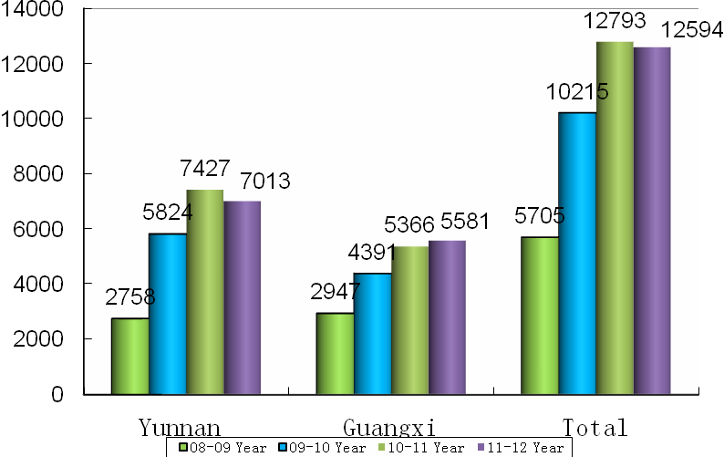

Regions

**b. Number of clean needles distributed**

During 2008-2012, the number of clean needles distributed in Guangxi and Yunnan increased every year. The total number rose from 1,330,582 in 2008-09 to 2,614,733 in 2011-12. See Fig 4 below.

No. of needles

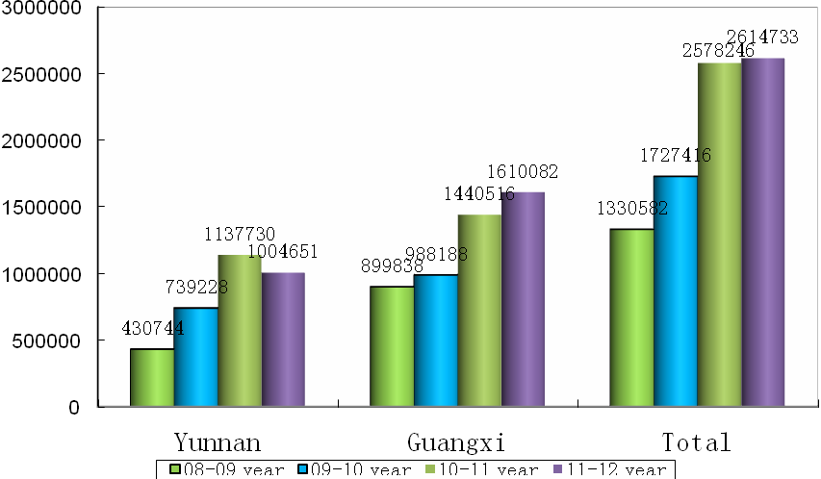

**Figure 4: Clean needles distributed**

Regions

**c. Number of condoms distributed**: During 2008-2012, number of condoms distributed in Guangxi and Yunnan increased every year. The total number of condoms distributed rose from 177,312 in 2008-09 to 345,256 in 2011-12 (See

Fig 5)

No. of condoms

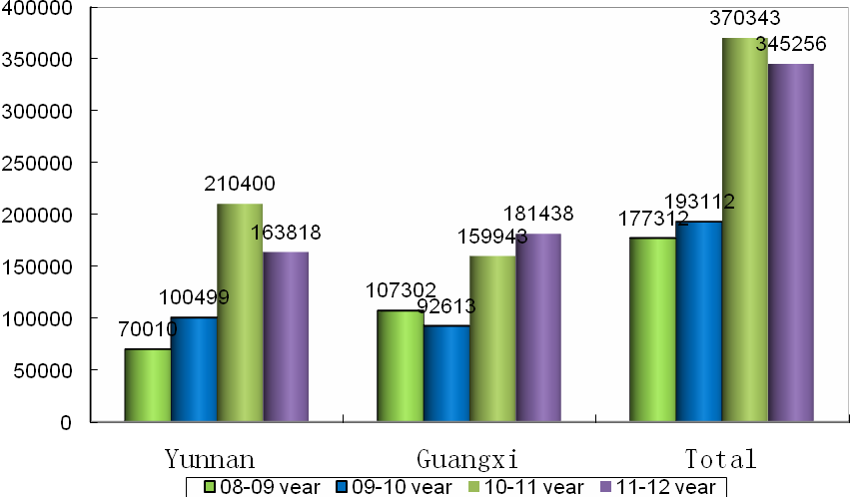

**Figure 5: Condoms distributed**

Regions

**d. Number of successful referral to other HIV and Drug services:** During 2008-

2012, HAARP provided referral services to IDUs, most of which were introduced to MMT clinics. The total number rose from 2,045 in 2008-09 to

5,789 in 2011-12 (see Fig 6).

Persons

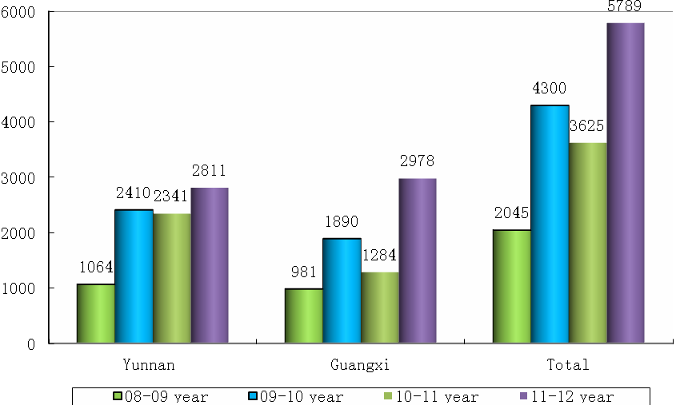

**Figure 6: Successful referral to other service**

Regions

**e. Harm Reduction Service Received by Target Group**

With the implementation of HAARP, target people received harm reduction services, including free clean needles, condoms, peer education and VCT. All these services could help them to reduce high risk behaviours. According to the annual HAARP surveillance results in project counties in 2008 (baseline) and 2012 (end line), the percentage of receiving these services have increased. See Figures 7 and 8.

**Figure 7: Percentage of IDUs reporting receiving harm reduction services in**

**Yunnan**

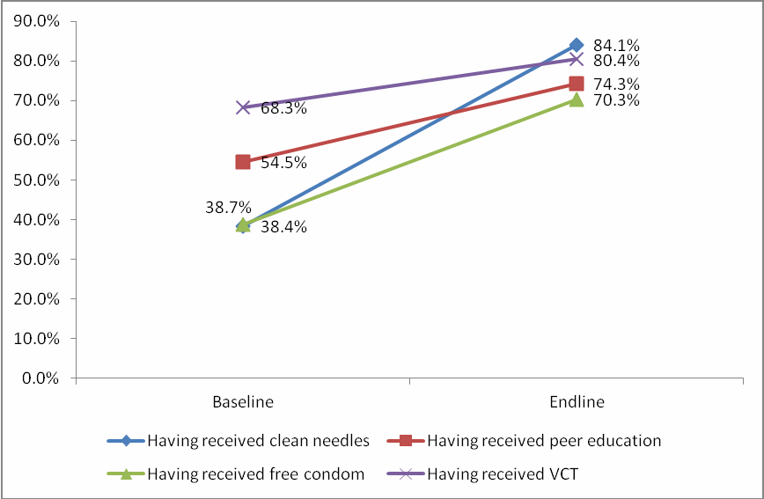

Percentage

Surveillance

**Figure 8: Percentage of IDUs reporting receiving harm reduction services in**

**Guangxi**

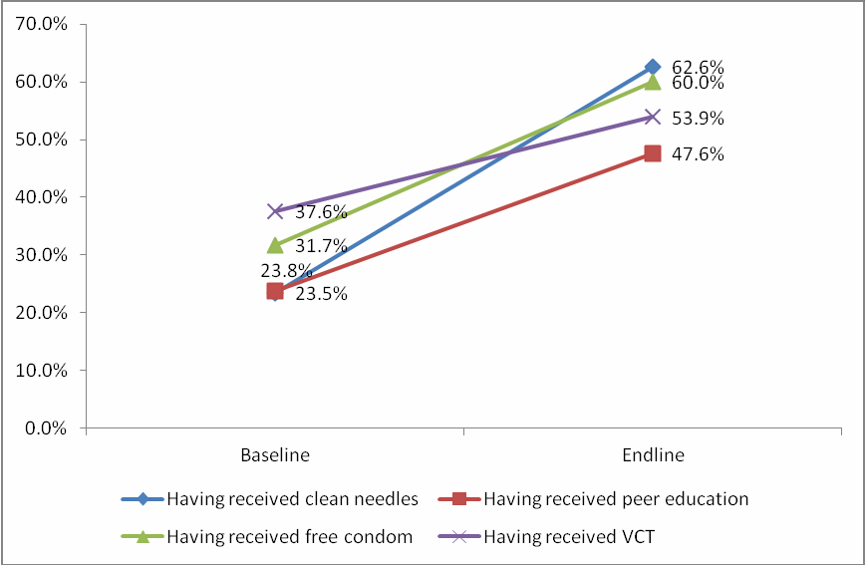

Percentage of receiving the service

Surveillance

According to the comprehensive surveillance data, the percentage of IDUs who

received harm reduction services rose during the implementation of HAARP.

**f. Contribution of HAARP to local NSP service in Yunnan and Guangxi** Beside NSP supported by HAARP, local government supported NSP in other counties. But the quality and coverage of those supported by HAARP were much better than others. HAARP supported 45 NSP sites in Yunnan and Guangxi, accounting for 19% of the total NSP sites in two provinces. These sites covered an average of 8,748 IDUs per month, accounting for 51% of total IDUs covered by all NSP sites. Many other NSP sites became operational after

2010, with the advocacy of HAARP (based on the positive results). This was a great contribution of HAARP to local NSP services.

**Figure 9: Percentage of NSP sites supported by HAARP and others in 2 provinces**

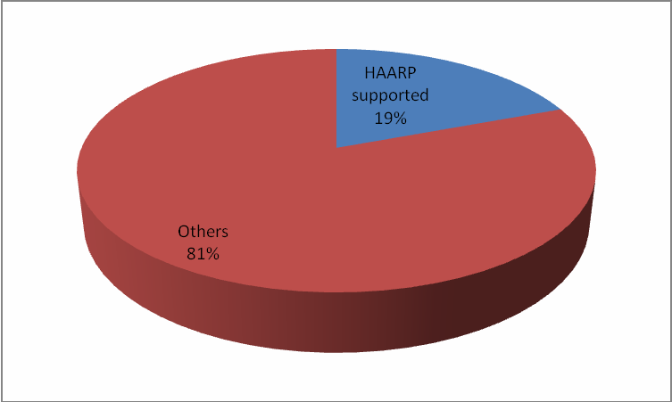

**Figure 10: IDUs covered by NSP supported by HAARP and others in 2 provinces**

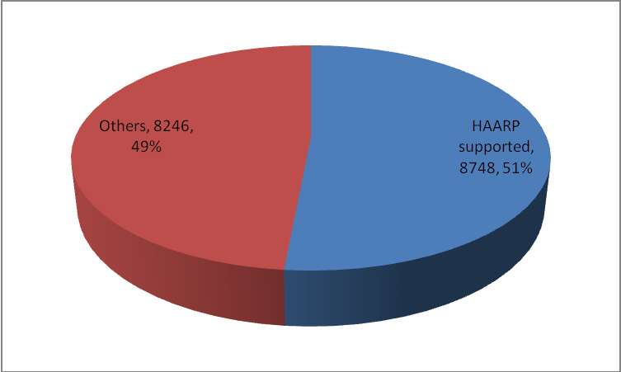

The good quality of HAARP NSP sites was due to the quality of management

and services. NSP sites supported by HAARP set goals for staff and assessed their performance against them. This approach led to good staff performance. A series of capacity building activities provided training to outreach workers and improved their skills. HAARP also provided NSP services in private clinics and pharmacies as extended service sites based on the NSP sites, which could cover more IDUs than other NSP sites. HAARP encouraged drug users to get involved and most outreach workers were enrolled from within the community of drug users, which created better communication and trust.

**2) Effectiveness of HAARP**

**a. Percentage of IDUs not sharing needles when injecting drugs in last month:** During 2008-2012, with the implementation of HAARP, the percentage of IDUs not sharing needles (during the last month) increased in the 31 counties of Yunnan and Guangxi. The percentage of IDUs not sharing needles reached 94.1% in Guangxi in 2011, which exceeds the goal for 2015 set in the China’s 12th five year action plan.

**Figure 11: Percentage of not sharing needles in last month**

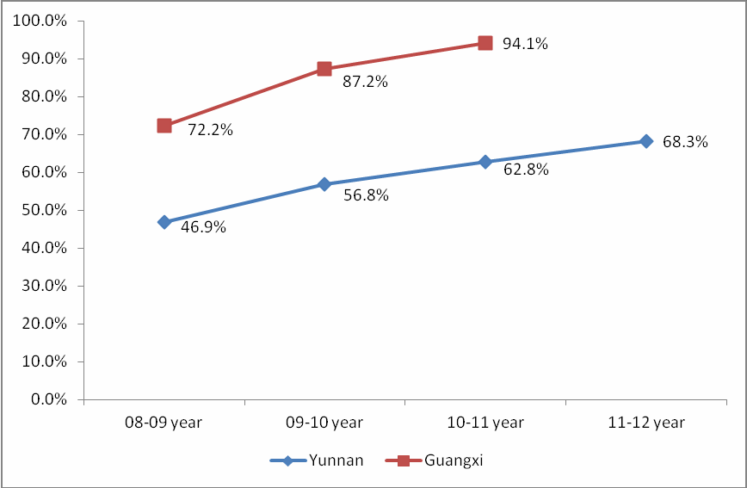

Percentage IDUs not sharing needles last month

Year

**b. Percentage of IDUs using condoms use during last sex with any partner:** With the specific efforts to halt sexual transmission of HIV among IDUs and their partners in HAARP, the percentage of condom use among IDUs increased, reducing the risk of new HIV infections and sexually transmitted infections. See Figure 12.

**Figure 12: Percentage of condom use during last sex**

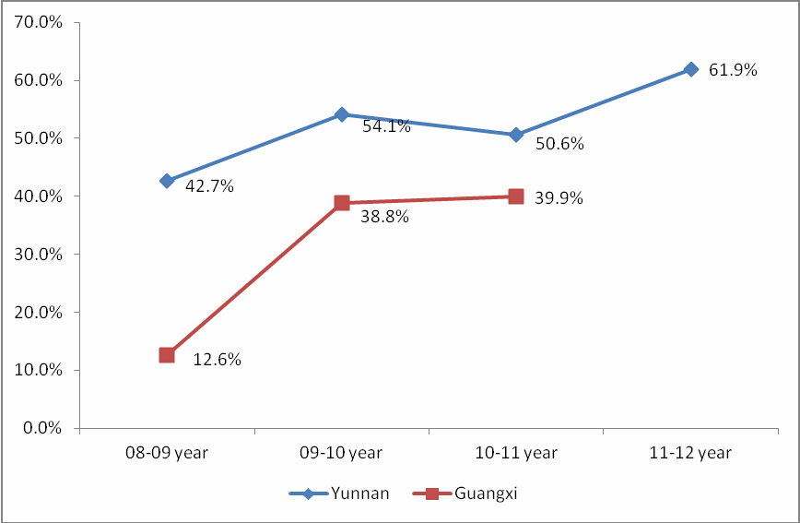

Percentage of condom use

Year

**C. Percentage of IDU’s HIV testing positive:** With the implementation of HAARP, the percentage of IDUs testing HIV positive decreased, an indication of the effectiveness of HAARP.

**Figure 13: Percentage of IDUs testing HIV positive in annual project surveillance**

**(prevalence)**

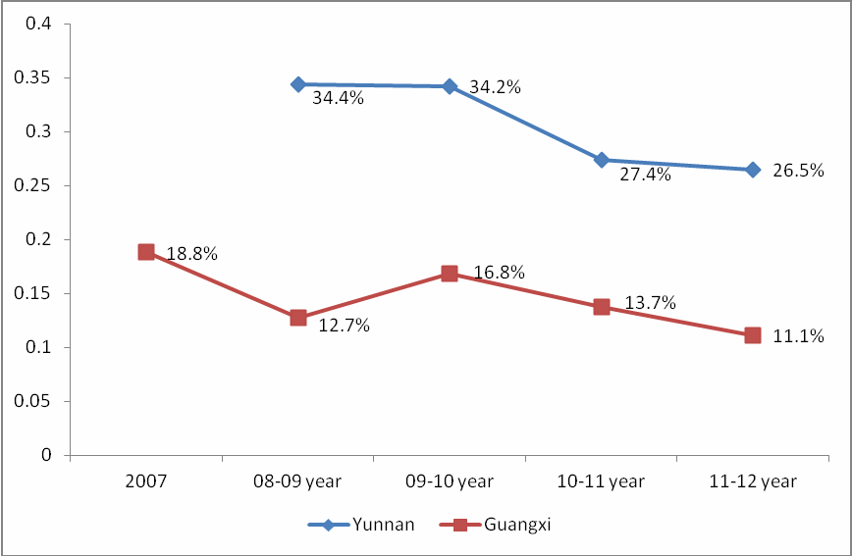

Percentage of HIV positive IDUs

Year

The percentage of IDUs testing HIV positive in 9 counties fell, or was stagnant

in 3 counties in Yunnan. The corresponding numbers in Guangxi were 7 and 4 respectively. In total, 23 out of 31 counties (or 74.2% of counties) saw a decrease or stabilisation in the percentage of IDUs who tested HIV positive.

**3. Project outcomes and impact**

**Objective 1: Institutional capacity development: Improve plans of implementing sectors and coordination ability of multi-sectoral cooperation to reduce the spread of HIV/AIDS in IDUs.**

**Outcome 1: Establishment of a multiple-sectoral cooperation mechanism, creation of a supportive environment, and improvement of existing**

**multi-sectoral cooperation mechanisms.**

HAARP focused on capacity building and multi-sectoral coordination. Yunnan and Guangxi offices regularly reported on the progress of project activities to the local stakeholders and shared information and experience of harm-reduction activities. The capacity to control and prevention HIV/AIDS has been significantly improved at various levels. The duties and responsibilities of HIV-prevention of departments of public health, public security, education and publicity in the province of Guangxi and Yunnan have been clarified and put into effect. HAARP made full use of this opportunity and all the project sites’ offices continuously participated in various kinds of HIV-prevention publicity conducted jointly by the departments of public health, public security, education and publicity. With promotion of HAARP, the implementation of NSP has been one of the annual assessment indicators of public security department work in Guangxi, and thus pushing the public security department to actively participate in the work of needle exchange. Yunnan has also made NSP as an assessment indicator on HIV/AIDS control and prevention of governmental work. These could help project to get strong support to conduct activities smoothly.

**Outcome 2: Promote policy making and change based on evidence from project.**

HAARP Yunnan and Guangxi worked with public health, public security, education and publicity officials to enhance their understanding of the role of harm reduction, and thus promoted the smooth implementation of the project. “A Report about the Feasibility of Past Drug Users withdrawal from the Dynamic Controlling Mechanism”, published by the Yundi Harm-reduction Network Organization, has played a significant role in informing official drug policy. According to the policy issued, around 68,000 drug users who have not

taken drugs for more than three years were removed from the public security dynamic control system. It has improved the lives of these former IDUs by reducing stigma and harassment and has helped the project to get trust from IDUs and their families. .

In 2010 Yunnan Provincial Government reinforced the simple needle syringe program management office set up earlier and provided more resources and authority, then 88 clean needle syringe points was established across the province (24 of them were supported by HAARP). Meanwhile, the Provincial Government purchased sterile needles and syringes worth 1.2 million RMB to support harm reduction efforts in the Province. This was directly related to a positive assessment on their part of the role that NSPs can play in improving public health outcomes. This assessment was in turn largely influenced by the advocacy and good quality implementation of HAARP.

The Guangxi Public Security Department issued a ‘Notice about doing a good job in HAARP’ and a ‘Notice about actively implementing HIV-prevention’ aimed at making public security officials in project cities/counties actively cooperate and support investigators in carrying out a base-line survey, and enabling public security to help project offices implement HAARP smoothly. The public health and public security sectors in Liuzhou jointly formulated a note called ‘Management methods for peer educators of HAARP’, and provided credentials for those peer educators registered with them. In Liuzhou, the peer educators are required to follow the job regulations to carry out needle syringe distribution within a distance of 500 meters from the NSP site; if they did not violate any laws, searching and arresting them was not allowed. If they are arrested, they should be released unconditionally, which guaranteed the smooth implementation of NSP. This kind of clear agreement from public security to support harm reduction and public health efforts, has perhaps been one of the greatest achievements of HAARP.

**Objective 2: Capacity building: enhancing the management and technical capacity of health practitioners in terms of harm reduction intervention.**

**Outcome 1: Establishment of a stable and qualified team of outreach workers**

Capacity building is key to ensure high-quality and effective operations of a project. HAARP focused on capacity building of different groups of staff (e.g. project officials, project managers and outreach workers). The means employed in building capacity included trainings, study visits abroad, and the development of training materials. For instance, some groups received trainings tailored to their needs. Other groups such as the police, community police, drug rehabilitation police officers and people involved in the implementation (agency personnel), the township hospital’s medical staff,

community officials, educators, cadres of the Women's Federation, Imams were also covered. Their capacities to support HIV/AIDS prevention and care measures have been improved at various levels.

**Outcome 2: Knowledge and experience sharing based on HAARP implementation and outcomes, which provided evidence to inform policy making.**

HAARP actively communicated and shared experiences with other HIV/AIDS control and prevention projects through meetings, trainings, technical support and supervision. In Yunnan and Guangxi HAARP’s PMOs attended and participated in a conference held by UNFPA, UNODC, TSU, UNAIDS, Daytop, and DFID. Some participants from HAARP gave presentations at the conference. Moreover, staff participated in the “The Fourth (and Fifth) Meeting of the China AIDS Control and Prevention and International Cooperation Projects”, “The World AIDS Conference”, and “The Asia-Pacific AIDS Conference 2010”, and “The Philippines Global Drug Policy Project Capacity Building and Web Conference 2010”. HAARP carried out a range of operational research studies every year to assess the knowledge of public security officers, drug users and their sexual partners, and community residents toward HIV/AIDS control and prevention and their attitudes towards HAARP supported projects. The findings of these investigations have been providing evidence for the decision-making of the local government, department of public security, public health, civil affairs, education, advocacy, etc.

**Outcome 3: Establishment and improvement of unique identifier based web based monitoring database for HAARP sites.**

HAARP Yunnan and Guangxi both established network databases to monitor project outputs. With the ability to directly enter and export data, the database also has the functions of query, summary and statistics. As long as the internet is available, people can check and download data of any period of time from the network database, know about the work progress of the project sites, and also accurately sum up the number of the covered clients through the unique code number. The unique ID code protected confidentiality of clients. The databases are human labor-saving and efficient. It is notable that the database of Yunnan has been utilized by the local Health Department and promoted as the local NSP management network database

**Outcome4: Knowledge management and promotion of HAARP**

**operational research**

Project staff published 84 papers in academic journal in China and abroad according to the project experience and practice in academic journals published papers 84. PMO staff established website and published a

newsletter quarterly. Yunnan also compiled and distributed seven projects publications (named Chenxi) and they also developed training materials in multiple languages and produced a training CD about outreach training and NSP.

A study conducted by HAARP and five counties of Yunnan and the Fourth China-UK HIV/AIDS project called "HIV infection rates among people who take methadone’ won the Health Department of Yunnan Province Science and Technology Progress Award in 2012". ‘The Guideline for the Public and Security to Control and Prevent HIV/AIDS’ supported by HAARP was given the outstanding Achievement Award in Social Science. With the capacity improvement of project practitioners, 'Methadone Replacement Therapy for Drug Users - the Community-based Management Model Building and Application' issued by Guangxi, won the Medical Promotion of Appropriate Technology Award and Liuzhou Science and Technology Progress Award. The "Chengjiang County HIV/AIDS epidemic trend analysis and countermeasures (1996 to 2008)" conducted by Yunnan Chengjiang County in 2009 also won Cheng Jiang County People's Government Science and Technology prize, and

'the Study about Comprehensive Intervention for Drug Users in Chengjiang County infected with HIV High-risk Behaviors" were awarded with the third prize of Science and Technology of Yuxi City People's Government and the Chengjiang County People's Government of Science and Technology prize.

**Objective 3 Community capacity development for providing comprehensive intervention for IDUs.**

**Outcome 1: Conduct various forms of publicity and advocacy; strengthen publicity in community; constantly expand coverage; ensure that beneficiary groups are more targeted.**

Each project sites carried out publicity on AIDS Day and Anti-Drug Day every year, using different forms, such as signature campaigns, art performances, and lectures, to raise awareness and advocate for harm-reduction. Representatives from local government and local sectors of public security, public health, education, and publicity participated in the publicity campaign ensuring multi-sectoral involvement. The project sites also targeted community residents, migrant workers, students and farmers to carry out harm-reduction publicity, through wall slogans, banners, billboards, evening shows, meetings with family members, IEC materials and advertisements in newspapers and television. The forms of publicity were more diversified, and the publicity was more targeted and more effective. The awareness in the community was further strengthened, and the impact of the project was expanded.

**Outcome 2: Strengthen behavioral intervention among IDUs in a more**

**comprehensive way.**

HAARP focused on providing clean needles to IDUs, utilizing community resources, involving community-based target groups, providing drug users and their sexual partners with comprehensive and high-quality services, and thus effectively reduced the high-risk behavior and the risk of HIV transmission in the target population.. Some feasible, sustainable harm reduction experiences and modes have been developed and promoted. As a result, IDUs and their families have been provided with clean syringes and needles, condoms peer-education, MMT, STD treatment and referral, VCT, ARV treatment, abscess management and PMTCT. HIV positivity rates in project areas have declined.

**Outcome3: Expansion of effective intervention models through pharmacy/clinic approaches to scale up coverage of the project**

HAARP tried some new approaches in order to scale up the coverage of the project, and then started a working model of implementing NSP through pharmacies and clinics. HAARP Guangxi selected a total of 14 pharmacies

&clinics in remote townships in Ningming, Longzhou and Youjiang District of Baise to work as NSP sites to provide free clean needles to local drug users. Within 3 months, 134 drug users were covered and 1,961 syringes were distributed.

This model of NSP through pharmacy/clinic could cover those drug users in remote regions, thus scaling up the coverage of the project, and achieving good results in the aspect of implementing harm-reduction in remote regions. This model was promoted to some other sites areas to reduce the harm. These pharmacy &clinics based NSPs have been expanded to more pharmacies and clinics locally - this work will be carried out by the Global Fund during the transition period. After the end of the Global Fund project, these entire services will be managed by the local health bureaus. The NSPs established in pharmacies and clinics will be transferred to be in the charge of local village doctors. Guangxi CDC has reported the experience to the Health Department and the AIDS Prevention Committee, and promoted the policies improvement in remote areas of the region.

**Outcome 4: Encouraging target group members to participate and engage with project activities.**

HAARP provides a range of opportunities for target group to participate in project activities. NGOs have been supported in terms of technology, information and funds, which can improve the ability of the target population to participate in HIV/AIDS prevention and control in a more widespread and inclusive way. Yundi Harm-Reduction Network was established in 2008 with the support of HAARP, Yunnan. It has developed into an organization of 31

NGOs, with a total membership of more than 380 persons. Yundi Harm

Reduction Network conducted first aid trainings for overdose prevention using naloxone among drug users.

Other organisations such as the Mans Ivy Team and Zhaoyang District New Home Team carried out the intervention for female drug users and sexual partners of people in methadone maintenance therapy. Yingjiang AIDS prevention Council set up a Burmese comprehensive intervention service center for FSW and IDU, the Zhenkang Beacon workstation carried out cross-border cooperation in terms of living assistance to very poor Burmese drug users. In some areas drug users are offered employment and

accommodation. Some sites in Guangxi applied for subsistence allowances for the approximately 80 IDUs who have difficulty in making ends meet.

HAARP provided comprehensive technical support and training for civil society and NGOs, focusing on funding information collection, donor funding applications and management reports for project activities. This support improved the capacity of NGOs and contributed the their application for Global Fund Project bidding activities, the Open Society Institute, Hong Kong and Taiwan project activities and some other multi-resource harm-reduction activities. . They bridged the funding gap of some HAARP project activities and thus ensured the sustainability of HAARP.

**Object 4: Improvement of harm reduction capacity of relevant sectors**： **Conduct harm reduction strategy training in drug dependence treatment and rehabilitation centers.**

**Outcome 1: Strengthening cooperation with the rehabilitation centers to guarantee project operation.**

When HAARP commenced, public security departments in custodial rehabilitation centers were quite critical of the implementation of harm reduction interventions. During the project implementation, HAARP offices from each level communicated and coordinated with public security and other departments concerned, helping to raise awareness, and further strengthening the cooperation between health and public security departments. Police officers from these centers were trained more than 50 times in knowledge and skills associated with HIV/AIDS control and prevention, and the rationale behind the policies concerned, which guaranteed the implementation of project. The percent of those supporting providing harm reduction services to IDUs increased from less than 50% to 97%during the project period according to a survey conducted among staff at these centers.

**Outcome 2: Conducting education to drug users in custodial settings to support behavior change.**

Project sites held trainings for drug-users under detoxification in Compulsory

Rehabilitation Centers. They introduced information relating to HIV prevention

and harm-reduction knowledge, referral information and MMT. Through several episodes of training, people under detoxification improved their awareness of blood borne viruses and drug related harms. The access to referral information helped them to get timely referral services, and they would be referred to local MMT clinic for receiving MMT. Multiple forms of training and awareness helped them to make behavioral changes, return to society and protect themselves against the negative health consequences of substance use in a better way.

The annual survey data show that the safe injection rate among the custody population proportion increased from 19.80% to 50.75 (p <0.001), and the rate of condom use rose from 64.06% to 96.75% (p <0.001), the realization rate of methadone referral rose from 1.96% to 11.25% (p <0.001). These data were from the annual project surveillance survey and suggested that the training was helpful to reduce the high-risk behavior of custody drug treatment staff and return to society.

**Objective 5: Implement of harm reduction in cross-border regions. Outcome1: Establishment of joint control and prevention mechanisms**

**for cooperation in border areas.**

HAARP Yunnan and Guangxi established joint control and prevention mechanisms for cooperation in border areas in various ways. Guangxi CDC and sites established cooperation mechanisms with counties in Vietnam to discuss how to control and prevent HIV/AIDS in cross-border areas, particularly among the mobile population. A coordination mechanism has been established with Vietnam, and meetings with Departments of Health, Public Security and others, to strengthen the communication network have been regularly held. The focus of these meetings has been to discuss how to improve the cooperation between public security sector and public health sector in the border region, and how to jointly implement harm reduction and other HIV/AIDS-related services among drug users in the border region. Both China and Vietnam organized ‘on-site’ visits and shared information to promote cooperation between the two sides. They also invited provincial level stakeholders to participate the joint meetings regularly. Although a formal cooperation agreement was not signed officially, but the two sides have reached consensus.

HAARP Yunnan made contact directly with Vietnamese Ministry of Health; in Myanmar it worked via the United Nations Office on Drugs and Crime Office; and in Lao PDR via the Lao Ministry of Health with the support of Yunnan Foreign Affairs Office. HAARP Yunnan also signed cooperation agreements with Asian Harm Reduction Network (Myanmar), Medicines Sans Frontiers (Myanmar), Family Health International 360 (Vietnam), providing intervention and referral services for IDUs, sex workers, long haul truck drivers and those

receiving drug dependence treatment. After four years, HAARP establish the long-term sustainability of the cross-border cooperation mechanisms, effectively providing comprehensive intervention services for high-risk groups in border areas. HAARP Yunnan, in cooperation with the Yunnan Police College, also conduct 17 harm-reduction trainings toward 459 Southeast Asia senior anti-drug police officers

**Outcome2: Providing harm-reduction service to IDUs from both countries simultaneously on the border line.**

In order to provide services to drug uses, the Border Project County make full use of community and township hospitals, pharmacies, clinics, language training schools to set up needle syringe distribution points. Utilizing the existing community resources, the practitioners deliver free clean needles and condoms to drug users, conduct peer education training, print harm-reduction materials in Chinese, Chinese and Myanmar, Chinese and Vietnam, Chinese and Laotian. HAARP Yunnan helped provide living assistance and short-term jobs for 227 Burma border drug users and MMT services for 174 cross-border Burmese drug users.

In Ruili and Yingjiang, 100 Burmese FSWs have been covered by outreach services involving more than 800 Vietnam FSWs. 3500 truck drivers, 100 Laos truck drivers and 250 Mekong river boat crew and other cross-border high-risk mobile populations were provided free condoms, clean needles, referrals, VCT and some other intervention Three sites in Guangxi are border areas with Vietnam (Fangchenggang, Yasuaki and Longzhou). As they communicate in the same language and have close contacts, the drug users often cross the border. .

Guangxi Health Department and the CDC have paid much attention to the HIV/AIDS prevention and control work associated with Vietnam. Advocacy and intervention have been conducted in a flexible way with the county level sectors in cross-border areas. HAARP Guangxi provided harm-reduction service to 75 cross-border Vietnamese drug users every month-4200 syringes,

300 condoms and 210 IECs were distributed. In addition, the project sites also provided other services, such as abscess management and public health service. Up to the present, 185 Vietnamese IDUs have been covered by HAARP Guangxi. Providing harm reduction service to these drug users is beneficial to expand the impact on cross-border drug users in the border region, and also beneficial for HIV prevention and control in the border area.

**4. Monitoring and Evaluation (M&E)**

Monitor and evaluation is the key for high quality project implementation and to

ensure the achievement of project core indicators. HAARP combined external supervision and internal monitoring together to supervise the implementation of project. During the implementation of project, web based database was established and used to follow the on time progress of the project work.

The external and internal M&E was conducted with the assistance of Regional Project Office and Technical Support Unit (TSU), and combined with that of professionals from province, state, and county level. TSU sent experts to Yunnan and Guangxi to conduct on-site supervision, and helped organize mid-term evaluations and the final evaluation of the project. HAARP offices discussed the feedback from these reviews and discussed how to further improve the future work after each evaluation.

Provincial experts focused on M&E project activities and use of funds, and conducted these activities every six months; city level experts focused on the quantity and quality outreach work in project counties and drug treatment; county PMO focused on the work carried out by the activity stations, including coverage, quality of service, outreach work.

Meanwhile, the provincial PMO also organized occasional random monitoring, special topic/issue based monitoring, joint monitoring and cross county monitoring. In the process of M&E, the supervisory staff learned about the project implementation through on-site visits, review of the files, interviews of staff and target populations. This helped to expose the issues and helped experts to provide technical support timely.

Yunnan and Guangxi PMO both set up a web-based database to provide up-to-date information and evidence for a scientific, efficient, standardized M&E of the project. The database consists of a range of data sheets, design and development of the project consists of a series of project outputs, including the numbers for project coverage and service quality of service referrals, the number of management and outreach staff personnel trainings, development of promotional materials, published articles, cross-border activities, the supervisory activities of fixed assets etc. The reporting system provided timely and accurate information to make the existing problems clear and ensure the M&E activities normal.

**5. Investment and Financial management**

**Financial Management**

According to the national PMO “CAHHF Project Activities Guide”, Yunnan and Guangxi PMOs provinces developed the “Project Financial Management Manual”. PMOs at all levels hired dedicated project finance staff, finance staff, who strictly followed this Manual. PMOs carried out the activities of funds transfer, use of funds, expense reimbursement standards of accounting and financial reporting regularly under the guidance of the Project Financial Management Manual; PMO at each level was required to establish independent accounts for the project, the implementation of independent

accounting. The budget was strictly used according to the funding approval process in terms of budget control, internal reporting, authorizing the ratification of control, the property control report. Purchase of project materials was within budget expenditure; if the price exceeds the standard, it needs to be triple-checked among three suppliers and sign a procurement contract. All purchase was conducted according to Australia Health and AIDS Project Activities Guideline, Provincial Project Financial Management Manual and Provincial Government procurement guidelines.

**Income and expenditure**

DFAT actually authorized the project a total funding of 6.39 million AUD over the past four years (08-09 year 1.5 million, 09-10 1680000, 10-11 and 175 million, 11-12 annual 1.46 million). All the project funds have been used and some of the activities were support by matched fund at all levels.

**Table 4. Income and expenditure (Yuan RMB)**

|  |  |  |  |  |  |  |
| --- | --- | --- | --- | --- | --- | --- |
|  | | 08-09 | 09-10 | 10-11 | 11-12 | Total |
| **Income** | | | | | | |
| NCAIDS | | 604,321 | 727,584 | 746,509 | 607,191 | 2,685,605 |
| Yunnan | | 2,547,380 | 5,590,160 | 6,157,330 | 5,592,474 | 19,887,344 |
| Guangxi | | 4,373,454 | 3,563,054 | 3,980,496 | 3,605,023 | 15,522,027 |
| Interest | | 8,090 | 11,331 | 13,709 | 20,623 | 53,753 |
| **Total** | | **7,533,245** | **9,892,129** | **10,898,044** | **9,825,311** | **38,148,729** |
| **Expenditure** | | | | | | |
| Object 1 | NCAIDS | — | 246,573 | 432,845 | 298,208 | 977,626 |
| Yunnan | — | 915,724 | 893,769 | 400,606 | 2,210,099 |
| Guangxi | — | 193,191 | 216,131 | 203,046 | 612,368 |
| **Subtotal** | — | **1,355,488** | **1,542,745** | **901,860** | **3,800,093** |
| Object 2 | NCAIDS | — | 204,172 | 179,459 | 142,063 | 525,694 |
| Yunnan | — | 957,500 | 752,409 | 473,653 | 2,183,562 |
| Guangxi | — | 408,330 | 557,856 | 862,647 | 1,828,833 |
| **Subtotal** | — | **1,570,002** | **1,489,724** | **1,478,363** | **4,538,089** |
| Object 3 | NCAIDS | — | 0 | 0 | 0 | 0 |
| Yunnan | — | 1,489,853 | 1,651,835 | 1,309,362 | 4,451,050 |
| Guangxi | — | 1,865,343 | 2,225,205 | 1,361,807 | 5,452,355 |
| **Subtotal** | — | **3,355,196** | **3,877,040** | **2,671,169** | **9,903,405** |
| Object 4 | NCAIDS | — | 0 | 0 | 0 | 0 |
| Yunnan | — | 93,718 | 158,574 | 426,090 | 678,382 |

|  |  |  |  |  |  |  |
| --- | --- | --- | --- | --- | --- | --- |
|  | Guangxi | — | 167,812 | 107,294 | 121,455 | 396,561 |
| **Subtotal** | — | **261,530** | **265,868** | **547,545** | **1,074,943** |
| Object 5 | NCAIDS | — | 0 | 0 | 0 | 0 |
| Yunnan | — | 361,396 | 509,087 | 1,150,673 | 2,021,156 |
| Guangxi | — | 56,683 | 34,386 | 96,539 | 187,608 |
| **Subtotal** | — | **418,079** | **543,473** | **1,247,212** | **2,208,764** |
| Object 6 | NCAIDS | — | 280,768 | 171,435 | 174,924 | 627,127 |
| Yunnan | — | 1,778,664 | 2,191,658 | 1,848,485 | 5,818,807 |
| Guangxi | — | 872,402 | 883,576 | 960,989 | 2,716,967 |
| **Subtotal** | — | **2,931,834** | **3,246,669** | **2,984,398** | **9,162,901** |
| **Total** | | **7,533,245** | **9,892,129** | **10,965,519** | **9,830,547** | **38,221,440** |
| **Balance** | | 0 | 0 | -67,475 | -5,236 | -72,711 |

*Expenditure in 2008-2009 year was not described according to the objective, no data available for that year.

**Matching funds**

NCAIDS provides matching funds for the project implementation to support the capacity building of social organizations, meetings and M&E costs. Yunnan AIDS Prevention Bureau provided money to buy a number of needles for the

19 project counties. PMO in county level also provides offices, office equipment, and staffs as matching funds. Implementing units arranged room for the project office as a project office, leasing a dedicated office and place the NSP, condom warehouse, promotional materials and other supplies. Vehicles, office equipment from the project conducting sectors (including cameras, photocopiers, air conditioning, computers, etc.) were available for the conduct of project activities. Some NSPs were arranged by community's committee. Besides hiring full-time project managers and financial officers, project partners also arranged part-time managers and financial officers carrying out the project work. Those sectors will integrate resources of other project resources (such as the central funding for public awareness, local AIDS prevention funding, local financial funding, etc.) and financial resources of HAARP, which are very important for project implementation. NCAIDS has provided matching funds of about 300,000 Yuan RMB in the past four years. Yunnan government has provided matching funds for clean needles continuous procurement and training for a total of about 4 million Yuan, HAARP Guangxi and Australia integrated the funding resources of HAARP with that of other projects (such as central funding for public awareness, local AIDS prevention funding, funding for local financial unit costs), a total of

2,184,000 Yuan RMB approximately.

**Purchase of equipment**

According to the approved annual work plan each year in the county, necessary equipment were purchased within the funding budget. All equipment purchases were done in accordance with state bidding procedures. PMO at all levels in the project will formally hand over the fixed assets to the project support sector according to the financial requirements to ensure the security and integrity.

Ⅲ**.Main Achievements, Experience and Suggestions**

**1. Main Achievements**

**1) The goal of reducing injecting-drug-use-related HIV transmission in**

**Guangxi and Yunnan has been achieved.**

HAARP provided high-quality comprehensive harm reduction services for drug users and their sexual partners. According to the project's monitoring data over the past four years, the proportion of target group who getting access to clean needles, peer education, free condoms, and HIV counseling and testing services has suggested a significant increase. Meanwhile, 45 NSPs covered

51% of the target group in the two provinces. Data across each year show that syringe sharing decreased significantly, condom use and effective high-risk behavior change of drug users increased, and the percent of IDUs testing HIV positive decreased. All these show that the project goal, reducing injecting-drug-use-related HIV transmission in Guangxi and Yunnan, has been mainly achieved through four years implementation.

**2) Strengthening multi-sectoral cooperation and building a supportive environment to promote the introduction of harm reduction policies** HAARP Yunnan and Guangxi address the partnership with public security sector on the base of project practice, trying to improve public health, public security, education and publicity to understand the role of harm reduction, and thus promoted the smooth implementation of the project. The long-term, multi-sectoral cooperation activities of HAARP and the effect NSP based harm-reduction services, improving the introduction of relevant policies at all levels. HAARP promoted a series of policy changes related with NSP both in Yunnan and Guangxi, which will provide help to future NSP work. Meanwhile, the impact of HAARP has been enlarged through publication and distribution of Chinese and English magazines, media network publicity and the discussion about actual work cases, practices and experiences.

**3) The combination of project activities and local HIV/AIDS control and**

**prevention enlarged the project’s sustainability.**

HAARP county-level agencies and staff are all from the local health department and the county-level project work contents are consistent with the regularly required HIV/AIDS control and prevention practice. At the same time, the project fully utilized the existing methadone service point or existing high-risk populations intervention activity stations, and a range of services

such as county doctors, pharmacies, clinics, grocery stores and training school NSPs, through local methadone outpatient outreach workers and families of drug users, to make the project work combined with local HIV/AIDS prevention and control work, greatly reducing the cost of management. In addition, the project's referral service are all conducted through the combination of county-level medical services, health and social care and the sectors' regularly daily work, which can effectively maximize existing resources and ensure the sustainability of the project.

**4) The widespread involvement of target population promoted the community-based harm-reduction services.**

HAARP involved target group in project activities in terms of plan and budget making, conducting of activities, and structure organization. It provides a range of opportunities for the target population and recruits outreach workers, supporting NGOs, encouraging the target groups being involving in the project activities, which effectively improves the involvement’s quality in a more widespread and valid way. The project activities had a positive impact on the health and life style of the target population-most of them acquire the knowledge and skills associated with harm reduction, attitudes and behavior changed, HIV prevalence gradually declined. The peer educators showed a sense of responsibility and become the key for the intervention for the drug users. In addition, the rights and relationship with community has been realized, family and social functions recovered, social discrimination reduced. NGOs have been developed and can independently carry out project activities, some of them able to supply for social funds. Accessibility and quality of required services for female IDUs and their sexual partners have also been strengthened through recruiting female outreach workers.

**5) Exploration and improvement of an effective harm reduction and sustainable mode**

The implementation of HAARP explored a series of effective harm reduction models and provided evidence for other related projects and regions. Each project site explored service provision models in terms of its own characteristics. The project organization has prepared a set of practices and exchanged experiences in a variety of ways, providing a reference for other regions.

**6) The establishment of cross-border co-operation mechanisms**

The project carried out a series of cross-border cooperation activities, including training for the anti-drug police from southeast Asian countries and the Vietnamese, Lao and Burmese students studying in Kunming, providing harm reduction services for Vietnam and Myanmar in China border areas, inviting HIV/AIDS control and prevention practitioners of neighboring countries to conduct a joint policy advocacy, information exchange and advocacy

training. These activities effectively promote the establishment of cross-border cooperation mechanisms. The Guangxi PMO regularly organize cross-border joint with the relevant agencies in Vietnam. Yunnan PMO signed agreements with Vietnam and Myanmar government and social organizations, and established a long-term stable mechanism for cross-border cooperation. Based on the evidence of HAARP, although both sides have established good communication and cooperation mechanisms, further cooperation still faces challenges, the most important obstacle is the lack of signed cooperation agreements between the regional and national government. The main difficulties of cross-border project is the lack of clear policy and funding support in terms or each country, and cooperation are often vulnerable to the impact of foreign affairs. In terms of the future cross-border cooperation, the point is to improve the capacity of cross-border staff, and to explore the specific content of cooperation in appropriate strategy.

**2. Experience and suggestions**

**1**）**Government support is critically important for the implementation of the project.**

The attention and support from government is very important for the implementation of the project. Under the multiple-sectoral cooperation mechanism, different sectors identify their own responsibilities and tasks; the government takes the leadership; sectors of public security, public health, education and publicity jointly conduct publicity; and communities and women federations continuously collaborate. All of these provide great help for creating an enabling and supportive environment. Recognition and support from the public security sector is the key to the successful implementation of the project. The public security sector takes efforts to assist with the implementation of the project through policy advocacy, occupational exposure prevention training to strengthen cooperation with public security departments. A variety of strategies which project office staff adopted helped to solve some unexpected problems at work in a flexible way, and contributed to a good supportive environment for NSP.

**2) Capacity building of the project practitioners and establishment of a high-quality work team**

Development of capacity of the project practitioners is pivotal to implementing the project. Their capacities were enhanced through project planning, content design, training, and experience sharing, visits and training tool development. Practitioners and outreaches from all levels were supported in terms of project planning; institution instruction, funding and M&E, and this helped improved the management and technical capacity. The establishment of the effective

workforce contributed a lot to this very project.

**3) Exploration and improvement of the NSP model, which increased work efficiency**

HAARP practitioners studied the experiences and models of other countries and gradually built up the HAARP model in accordance with realities of project sites. On this basis, and in keeping with local demand, village clinics, pharmacies, private clinics, grocery stores show potential for development into NSPs. These also provide referral and behavioral intervention services for the target population. This model is highly targeted and yet supports integration of harm reduction into existing health infrastructure rather than stand-alone only approaches.

.

**4) Improving the level of target population participation in project activities**

HAARP has provided a series of opportunities for target population to participate in the actual implementation and therefore benefit from it. The activities of recruiting outreach workers from the target group and building their capacity, supporting NGOs in aspects of technical, fund, information and experience sharing, can validly enhance the initiative and effectiveness of target population personally participate in the project . Exploring the strategies of target population participating in different fields can expand the social benefits and impact of the project.

**5) Promotion of information sharing in border areas and building up harm reduction interventions in a cooperative way**

HAARP established harm reduction services sites to carry out cross-border services in the border area. In order to get the support and help of all levels of government, cross-border joint meeting, information sharing, capacity building and joint intervention conducted by the cross-border cooperation sectors. These activities can also help to establish a long-term cooperation mechanism and promote HIV/AIDS control and prevention in cross-border area. Information sharing can be arranged flexibly at the levels of national, provincial, city and county.

**6) A combination of project activities with local /HIV control and prevention worked to sustain the project**

The process of project planning, activity conducting and M&E were completely integrated with local HIV/AIDS control and prevention work, which can help obtain the support of local related sectors, and also ensure the long-term implementation of the project. The project results have been deeply studied and the reliable strategies have also been institutionalized to ensure the stability of policy and the sustainability of the project. The experiences and lessons summed up are promoted to the non-project sites to strengthen the

sustainability of the project results. The fact that local government has been actively engaged in planning and implementation of HAARP has made it easier to achieve advocacy gains in the project.

**3. Difficulties and challenges**

**1) The quality of the intervention for IDUs needs to be improved.**

NSP aims at providing clean needles for IDUs and thus reduce the incidence of HIV transmission associated with syringe sharing. Therefore, if the frequency of getting access to NSPs is not enough, and cannot meet their needs, the objectives of the intervention will be hard to achieve. Although the population covered by the services and the number of clean needle delivered have been increasing over the past four years, among the target population, every drug user covered is HAARP got just under one needle per day on average, but the goal was set up as 'one clean needle per day for every drug user', which means the gap needs to be further bridged. The project should focus on deliver NSPs for the target group, and outreach work for people who are not willing/able to access clean needles on a timely basis. Exploring diverse service delivery modalities such as needle syringe social marketing and secondary syringe exchange will be important to consider going forward.

**2) The interventions toward female IDUs and sexual partners of IDUs needs more attention**

Although the project has been effectively provided a range of comprehensive interventions for the local IDUs, the efforts to target and reach sexual partners of these IDUs with required services need to be strengthened. The package they need is also different - the reason could be that most of them are different in terms of health behaviors - they are often not drug users themselves, therefore the intervention which is effective to both of the two groups are difficult to standardize. In this project, only some of the sites conducted awareness and trainings among the sexual partners or families of IDUs. Given the fact that HIV/AIDS infection rate of sexual partners of IDUs is still rising, how to the prevent HIV/ADIS transmission associated with unprotected sex will need to be the focus of future efforts.

**3) NGOs concerned need further support**

NGOs have significantly improved under the support of project as capacity has been built; while at the same time their support and involvement is necessary to implementation of programs that directly concern them. Some of them have successfully applied for other social funds. However, in reality most of NGOs in sites area are not able to undertake meaningful activities without fiscal and capacity support. Moreover, if the current partner NGOs cannot gain support from other projects, the ongoing activities are at the risk of being interrupted. In

the current transition plan, the local government can cover the expenses for project required supplies, but does not include the costs for employing staff in NGOs.

**4) The policy advocacy of the project results need to be further strengthened**

HAARP have been attempting to provide free clean needles and methadone for Vietnamese and Burmese drug users in the border area, but it is difficult to continuing carry out cross-border intervention cooperation due to the limitation of the current policy. HAARP has been providing services for Vietnamese and Burmese in these areas through signing a formal cooperation agreement with NGOs concerned, but this cannot guarantee the stability of the project activities in reality, particularly when funds are not available.

**4 Conclusions**

With the leadership of the Ministry of Health, the support of the DFAT, and the efforts of practitioners from all level, HAARP have been carried out according to the annual work plans, and the funds have been used appropriately and with a value for money focus Significant achievements have been made in a range of aspects of government advocacy, multi-sectoral collaboration, project database management, staff capacity enhancement, comprehensive harm-reduction interventions for drug users and their sexual partners, referrals, multi-level supervisory assessment, NGOs participation and cross-border coordination. The Government has paid much attention on work for reducing the harm of drugs, multi-sectoral cooperation further strengthened, the target population involved in the project and benefit from it, technical and capacity of related staff to reduce harm of drug, community capacity building further enhanced, harm-reduction in places of detention improved, coverage of harm-reduction in cross-border areas expanded, project experiences shared with other project areas.

Ⅳ**. Next-Step Plans**

**1. Plan of project hand-over**

**1**）**Hand-over of fixed assets, intervention supplies, and ensure smooth transition**

According to the project management guidelines, staff will check and register all the fixed assets purchased since the implementation of HAARP. After the project stops, hand over to local public health sector of all the fixed assets of the project, including computers, copy machines, printers, financial software and network direct reporting system will be done. Staff will follow all the regulations of asset management of the project implementing unit to conduct unified management. Unified management will be applied to intervention supplies which were also purchased by the project, such as syringes, condoms, alcohol and cotton swabs, and use these supplies to carry out harm reduction without service interruption. There are a number of left over items such as

998,900 syringes, 99,876 condoms, 136,153 package alcohol swabs, and

97,500 distilled water, which will be used to provide harm reduction services in the project areas in the following 6 months-from July to December 2012.

**2**）**Files and data of the project**

The project, after several years of implementation, has accumulated lots of materials (different kinds of notices, documents, records of activities, and photos), financial reimbursement materials, financial statements, and

out-reach materials. These will be sorted out and filed - these materials will then be hand over to the local CDCs which are responsible for safekeeping. According to Accounting Records Management Guideline of Department of Finance, accounting documents and accounting books of HAARP will be required to be kept for 15 years at least, long-term project files 15 years and short-term 10 years.

**3**）**Project staff**

The project provided lots of training workshops about project management, financial management and outreach skills, and cultivated a group of staffs who are familiar with project management as well as a stable out-reach team. After the project finished, some sites will apply for other fund to continuously employ the project staffs and some of the out-reach workers to implement intervention among drug users continuously. HAARP will support NGOs apply other social funds to carry out activities of other projects.

As HAARP Guangxi finished, some outreach workers cannot continue to carry out harm reduction services due to a range of reasons such as relocation, poor

physical condition, being arrested for stealing drug products. 95 of 119 outreach workers in Guangxi can continue the outreach work. 50 outreach (about 1/3) workers in Yunnan can get some financial support to continue to provide clean needles outreach services.

**4**）**NSP centers**

The responsibility for the taking over of HAARP NSPs will be given to local CDC to continue the harm-reduction intervention. 12 sites of the total 21 in Guangxi will apply for funds from the centre or local funds from the program to continue NSPs, and keep the community-based intervention model. Wuzhou, Lingshan and Liuzhou will integrate NSP sites of HAARP with Global Fund HIV Project to continue harm reduction through the model of outreach. Longzhou county will replace the downtown DIC, and set up 3 NSP points in communities where out-reach workers are located (Kangping Community, Xinhua Community and Longjiang Community). Ningming will set up 6 drugstore clinics as NSPs. 29 NSPs in Guangxi will continue to provide harm reduction services to drug users after HAARP ends.

Yunnan will transfer the NSPs established to Yunnan NSP Working Group, which is in charge of the management of NSP of the whole province. The transfer of staff lists, files, and technology has been finished. Some NSPs were integrated with local agencies in the first place, which can therefore continue the existing work. Other NSPs will get the Yunnan Provincial Government funding to continue the work related to the project. Therefore, all the NSPs will continue harm reduction services with the support of the Yunnan Provincial Government.

**2. Plan of using project experience and output**

**1) Summary and promotion of the successful experience**

The project results and success have been published, and the experiences were also shared in China and abroad in various ways, including experience exchange seminars and academic articles publish. A key lesson to be shared is that drug users can act as out-reach workers to carry out NSP and also deliver overdose prevention services using Naloxone. In remote rural area, owners of pharmacies/clinics and village cadres can implement NSP as out-reach workers. Through these different working models, the project can scale up the coverage of NSP and enable more drug users to receive harm reduction service. Continue the multi-sectoral cooperation with public security and anti-drug, civil affairs, women's federations and communities to promote the integration of resources, attend and help drug users living with HIV/AIDS and economic issues, expanding the services for this group.

**2) Analysis and use of project data**

HAARP PMOs at all levels will strengthen data analysis and collation, and thus support staff to deliver harm-reduction intervention on the basis of existing program data. Meanwhile, the national PMO will support the existing staff to write academic articles and be published in China AIDS and other magazines. The analysis and use of project data will provide evidence for local HIV/AIDS control and prevention, bridge the gap in this very aspect, and thus contribute to the future project associated with HIV/AIDS cross-border cooperation. National PMO will conduct in-depth analysis of the existing data with the provincial PMO of Yunnan and Guangxi. This analysis will focus on comparing the differences of NSPs in HAARP sites and non-HAARP areas, evaluation the effectiveness of the services, and thus provide evidence for departments concerned to improve policy.

National PMO will make every effort to promote the successful experience of the project, including experience sharing meeting of international cooperation projects, AIDS Conference, experience Sharing Conference of intervention for drug users; national PMO promote the concept that involving in the target group, introduce the qualified NGOs and outreach workers to other sites area and help them enhance the capacity and obtain funding support, and thus continue harm reduction services after the project ends.

**Annex 1 Project Areas**

HAARP supported the project activities on national level, Guangxi and Yunnan provincial level and activities in 31 cities and counties in Yunnan and Guangxi listed as below:

|  |  |  |  |
| --- | --- | --- | --- |
| **Yunnan: 19 sites** | | | |
| **City** | | | **District/County** |
| Kunming | | | Wuhua |
| Jinning |
| Yuxi | | | Hongta |
| Chengjiang |
| Honghe | | | Mengzi |
| Jinping |
| Hekou |
| Dehong | | | Luxi |
| Ruili |
| Yingjiang |
| Lincang | | | Zhenkang |
| Yongde |
| Linxiang |
| Wenshan | | | Yanshan |
| Maguang |
| Banna | | | Mengla |
| Puer | | | Lancang |
| Zhaotong | | | Zhaoyang |
| Qujing | | | Huize |
| **Guangxi: 12 sites** | | | |
| **City** | | **District/County** | |
| Nanning | | Xixiangtang | |
| Baise | | Youjiang | |
| Wuzhou | | Dieshan | |
| Liuzhou | | Yufeng | |
| Qinzhou | | Lingshan | |
| Beihai | | Hepu | |
| Chongzuo | | Ningming | |
| Longzhou | |
| Fangchenggan | Fangcheng | |
| Guigang | Gangbei | |
| Guiping | Guiping | |
| Guilin | Guilin | |

**Annex 2 HAARP M&E Framework**

**I. Basic program Information**

|  |  |  |  |  |
| --- | --- | --- | --- | --- |
| **Codes** | **Information** | **Description** | **Frequency** | **Methodology** |
| 1.1 | No. of Drop in Center | the Drop in Center sponsored by program functioned as specially providing needle and syringe exchange, health education, condom distribution and referrals etc comprehensive Harm Reduction services | Six Monthly | Field visit and provincial management office reports |

**II. Outputs Quantitative, based on the county level**）

|  |  |  |  |  |  |  |
| --- | --- | --- | --- | --- | --- | --- |
| **Codes** | **Indicators** | **Description** | **Baseline** | **Methodology** | **Frequency** | **Notes** |
| **NSP** |  |  |  |  |  |  |
| 2.1 | No. of IDUs (male and female) reached by the program | No. of IDUs (male and female) reached by program services including NSP, IEC materials, condom distribution etc through EAP site, Drop in Center,  ORWs etc | End of  ARHP | Monthly log sheets | Monthly |  |

|  |  |  |  |  |  |  |  |  |  |  |  |  |  |  |
| --- | --- | --- | --- | --- | --- | --- | --- | --- | --- | --- | --- | --- | --- | --- |
| |  |  | | --- | --- | | Monthly | Sex partners：admit to  be the sex partners of IDUs，no matter long term or short term,  male or female, document spouse or temporal partner and their gender if  possible | | Monthly |  | | Monthly |  | | Monthly |  | | Monthly |  | | Monthly |  | | Monthly |  | |
| 2.2 | No. of IDUs' sex partners reached by the program | No. of IDUs' sex partners reached by the program through Drop in Center, ORWs etc | End of  ARHP |
| 2.3 | No. of IDU contacts reached by the program | No. of IDU contacts reached by the program services including NSP, IEC materials, condom distribution etc through EAP site, Drop in Center,  ORWs etc | End of  ARHP |
| 2.4 | No. of NS distributed | No. of NS distributed through EAP site, Drop in Center, ORWs etc | End of  ARHP |
| No. of NS distributed per  individual | No. of NS distributed/No. person  received NS | End of  ARHP |
| 2.5 | No. of NS retrieved | No. of NS retrieved through EAP site, Drop in Center, ORWs etc | End of  ARHP |
| 2.6 | No. of condoms distributed | No. of condoms distributed through EAP  site, Drop in Center, ORWs etc | End of  ARHP |
| No. of condoms distributed per individual | No. of condom distributed/No. person received condom | End of  ARHP |

|  |  |  |  |
| --- | --- | --- | --- |
|  | No. of lubricant packs dispensed | No. of lubricant packs dispensed through EAP site, Drop in Center,  ORWs etc | 1st distribution |
| 2.7 | No. of IEC materials distributed | No. of IEC materials distributed through  EAP site, Drop in Center, ORWs etc | End of  ARHP |
| No. of IEC materials distributed to IDU clients |
|  | Completed referrals  made | Successful referrals to related health services made through EAP site, Drop in Center, ORWs etc (including IDUs  and their sex partners） | End of  ARHP |
| MMT |
| Sexual health services |
| VCCT |
| HIV or OI treatment |
| TB treatment and monitoring |
| PMTCT |

|  |  |
| --- | --- |
| Monthly | could be started from  2011－2012 |
| Monthly |  |
| Monthly |  |
| Monthly | Successful referral： there are signed confirmation records or receipts by related referral accepting agencies |
| Monthly |
| Monthly |
| Monthly |
| Monthly |
| Monthly |
| Monthly |

2.8

|  |  |  |  |  |  |  |
| --- | --- | --- | --- | --- | --- | --- |
|  | General health |  |  |  |  |  |
| **Capacity**  **Building** |  |  |  |  |  |  |
| 2.9 | No. of person episodes of training(management  staff at county level) | Including provincial and county level training to management staff at county  level | End of  ARHP | Provincial Project Management Office Capacity Building and Training Plan | Six  Monthly |  |
| 2.10 | No. of management staff at county level trained | Including provincial and county level training to management staff at county  level, male and female No. | End of  ARHP | Six  Monthly |  |
| 2.11 | No. of person episodes of training (ORW) | Including provincial and county level training to ORWs | End of  ARHP | Six  Monthly | A structured training with agenda and content no shorter  than 1 hour |
| 2.12 | No. of ORWs trained | Including provincial and county level  training to ORWs, male and female No. | End of  ARHP | Six  Monthly |  |
| 2.13 | No. of person episodes of training (law  enforcement officials) | Including provincial and county level training to policemen | End of  ARHP | Six  Monthly |  |
| 2.14 | No. of law enforcement officials trained | Including provincial and county level training to policemen, male and female  No. | End of  ARHP | Six  Monthly |  |
| 2.15 | No. of person episodes of training (in closed settings) | training in closed settings | End of  ARHP | Six  Monthly |  |

Monthly

|  |  |  |  |  |  |  |
| --- | --- | --- | --- | --- | --- | --- |
| 2.16 | No. of person trained (in  closed settings) | training in closed settings, male and  female No. | End of  ARHP |  | Six  Monthly |  |
| 2.17 | No. of person episodes of training (other health  care providers) | Including provincial and county level training to other health care providers | End of  ARHP | Six  Monthly |  |
| 2.18 | No. of other health care  providers trained | Including provincial and county level  training to other health care providers | End of  ARHP | Six  Monthly |  |

**III. Outcome indicators(based on the provincial level)**

|  |  |  |  |  |  |  |  |
| --- | --- | --- | --- | --- | --- | --- | --- |
| **Codes** | **Types** | **Indicators** | **Description** | **Baseline** | **Methodology** | **Frequency** | **Notes** |
| 3.1 | Quantitative | 1,Percentage of local IDUs reporting  ever sharing injecting equipment in the last month | 1,Numerator:No. of local IDUs reporting sharing injecting equipment in the last month Denominator: No. of local  IDU( estimated No of CDC) | End of  ARHP | Provincial Comprehensive Surveillance | Annual |  |
| 2,Percentage of local IDUs reporting  ever sharing injecting equipment in the last time | 2,Numerator:No. of local IDUs reporting sharing injecting equipment in the last time Denominator: No. of local IDU(estimated No of local IDUs  by CDC) | End of  ARHP | Provincial Comprehensive Surveillance | Annual |  |

|  |  |  |  |  |  |  |  |
| --- | --- | --- | --- | --- | --- | --- | --- |
|  | Quantitative e | Percentage of target group (IDU and their sex partners) using condoms in the latest sexual intercourse | Numerator:No. of local target group (IDU and their sex partners) reporting  using condoms in the latest sexual intercourse Denominator: No. of local target group (IDU and their sex partners) reporting had sexual  intercourse | End of  ARHP | Provincial Comprehensive Surveillance | Annual |  |
| 3.3 | Quantitative /qualitative | HIV risk knowledge knowing rate amongst local IDUs | Knowledge and attitude of  IDUs | End of  ARHP | Provincial Comprehensive  Surveillance | Annual |  |
| qualitative | Law enforcement agencies provide support for program activities through  - greater awareness of HIV and  HR practices  - more progressive attitudes towards IDUs and HR approaches  - Changed practices in contributing to an enabling environment for program delivery | KAP of policemen | 1st survey | Pre- and post evaluation of LE training sessions  KAP surveys of operational police ORW surveys Clients surveys Stories of change case Studies (digital) | Annual | TSU will help to develop detailed interview questionnaire |

3.2

|  |  |  |  |  |  |  |  |
| --- | --- | --- | --- | --- | --- | --- | --- |
|  | Quantitative /qualitative | Functioning and effective multisectoral collaboration in providing programmatic and policy guidance and practice:  - PAWCO  - Provincial Leading  Group/Management Boards  - Joint training with health and law personnel | KAP of project management staffs | 1st survey | Attendance and frequency of PAWCO meetings, outcomes documented and implemented Attendance and frequency of PLG and Management Boards meetings, outcomes documented and  implemented | Annual |  |
|  |  |  |  |  | No. of joint trainings undertaken with health and law enforcement personnel  Pre- and post evaluation of joint training  sessions |  |  |

|  |  |  |  |  |  |  |  |
| --- | --- | --- | --- | --- | --- | --- | --- |
|  | qualitative | Community awareness and support of HIV prevention through harm reduction strategies | KAP of community population | 1st survey | Focus group discussions, public surveys assess public support for program  activities | Annual |  |
| The China CP is able to respond to client needs by providing appropriate services and support | IDUs' satisfaction | 1st survey | Client satisfaction surveys | Annual |

Capacity building programs contribute to:

- improved technical knowledge

- improved management

- improved service delivery

including trainings to ORWs, county level project management staffs, policemen, etc and the effect of trainings

1st survey

Pre- and post training evaluation of training sessions

KAP surveys for service delivery personnel Stories of change case studies

(digital)

Annual

**IV. Impact indicators(based on provincial level)**

|  |  |  |  |  |  |  |  |
| --- | --- | --- | --- | --- | --- | --- | --- |
| **Codes** | **Types** | **Indicators** | **Description** | **Baseline** | **Methodology** | **Frequency** | **Notes** |
| 4.1 | Quantitative | Annual HIV reported incidence rate in local drug user populations | Numerator: No. of annual local newly reported HIV cases  Denominator: No. of local  population | End of  ARHP | Provincial Comprehensive Surveillance | Annual | It's based on the reported cases and different with incidence rate |

**Annex 3 Assets purchased by HAARP**

|  |  |  |  |
| --- | --- | --- | --- |
| No. | Asset | Amount | Organizations |
| NCAIDS | | | |
| 1 | Laptop* 2 | 36,200.00 | NCAIDS |
| 2 | Fax*1 | 1,800.00 | NCAIDS |
| 3 | Printer*1 | 2,650.00 | NCAIDS |
| 4 | Camera*1 | 4,860.00 | NCAIDS |
| Guangxi | | | |
| 5 | Sony Camera*1 | 1,950.00 | PMO |
| 6 | HP Printer*1 | 2,630.00 | PMO |
| 7 | HP Printer*1 | 2,630.00 | PMO |
| 8 | HP Printer*1 | 2,630.00 | PMO |
| 9 | Canon Duplicator | 9,368.00 | PMO |
| 10 | Lenovo Laptop*1 | 6,550.00 | PMO |
| 11 | Lenovo Laptop*1 | 6,550.00 | PMO |
| 12 | Lenovo Laptop*1 | 6,550.00 | PMO |
| 13 | Lenovo Desktop computer*1 | 3,750.00 | PMO |
| 14 | Lenovo Desktop computer*1 | 3,750.00 | PMO |
| 15 | Lenovo Desktop computer*1 | 3,750.00 | PMO |
| 16 | Drinking Fountain*1 | 998.00 | PMO |
| 17 | Canon Scanner*1 | 1,800.00 | PMO |
| 18 | Mobile Hard Disk*1 | 560.00 | PMO |

|  |  |  |  |
| --- | --- | --- | --- |
| 19 | Mobile Hard Disk*1 | 560.00 | PMO |
| 20 | Nikon Camera*2 | 2385 per camera | Provincial Health Bureau |
| 21 | Sony Laptop*3 | 14980 per | Provincial Health Bureau |
| 22 | Nikon Flash*1 | 2,300.00 | Provincial Health Bureau |
| 23 | HP Scanner*1 | 8,244.00 | Provincial Health Bureau |
| 24 | IBM Laptop*1 | 11,699.00 | Guangxi Policeman  Education School |
| 25 | Lenovo Laptop*1 | 5,000.00 | Youjiang District |
| 26 | HP Printer*1 | 1,250.00 | Youjiang |
| 27 | Canon Printer*1 | 3,300.00 | Youjiang |
| 28 | Sony Voice Recorder*1 | 900.00 | Youjiang |
| 29 | Mobile Hard Disk*1 | 850.00 | Youjiang |
| 30 | Mobile Phone*1 | 2,100.00 | Wuzhou |
| 31 | Camera*1 | 3,189.00 | Wuzhou |
| 32 | Mobile Hard Disk*1 | 789.00 | Wuzhou |
| 33 | Laptop*1 | 1,950.00 | Wuzhou |
| 34 | HP Laptop*1 | 9,200.00 | Wuzhou |
| 35 | Panasonic Duplicator *1 | 10,600.00 | Wuzhou |
| 36 | HP Desktop Computer *1 | 5,850.00 | Wuzhou |
| 37 | Panasonic Printer*1 | 1,600.00 | Wuzhou |
| 38 | TOSHIBA Projector *1 | 9,000.00 | Wuzhou |
| 39 | EPSON Printer*1 | 2,260.00 | Ningming |
| 40 | Lenovo Computer*1 | 4,000.00 | Ningming |
| 41 | Lenovo Computer*1 | 4,000.00 | Ningming |
| 42 | Sony Camera*1 | 3,000.00 | Ningming |
| 43 | Laptop*1 | 4,000.00 | Longzhou |
| 44 | Printer*1 | 1,680.00 | Longzhou |

|  |  |  |  |
| --- | --- | --- | --- |
| 45 | Camera*1 | 3,850.00 | Longzhou |
| 46 | Printer*1 | 2,500.00 | Longzhou |
| 47 | Desktop Computer*1 | 4,650.00 | Lingshan |
| 48 | Voice Recorder*1 | 2,760.00 | Lingshan |
| 49 | Wireless network card*1 | 2,400.00 | Lingshan |
| 50 | Camera*1 | 2,450.00 | Guiping |
| 51 | Laptop*1 | 6,300.00 | Guiping |
| 52 | Desktop Computer*1 | 4,050.00 | Guiping |
| 53 | Voice Recorder*1 | 975.00 | Guiping |
| 54 | Wireless network card*1 | 428.00 | Guiping |
| 55 | Mobile Phone*1 | 2,550.00 | Guiping |
| 56 | Projector*1 | 8,650.00 | Guiping |
| 57 | Mobile Hard Disk*1 | 590.00 | Guiping |
| 58 | Printer*1 | 990.00 | Guilin |
| 59 | Desktop Computer*1 | 5,000.00 | Guilin |
| 60 | Camera*1 | 4,010.00 | Guilin |
| 61 | Desktop Computer*1 | 4,600.00 | Fangchenggang |
| 62 | Camera*1 | 2,900.00 | Fangchenggang |
| 63 | Printer*1 | 1,500.00 | Fangchenggang |
| 64 | Camera*1 | 1,400.00 | Hepu |
| 65 | Camera*1 | 1,400.00 | Hepu |
| 66 | Desktop Computer*1 | 5,680.00 | Hepu |
| 67 | Printer*1 | 1,300.00 | Hepu |
| 68 | Camera | 1,450.00 | Hepu |
| 69 | Laptop*1 | 5,890.00 | Hepu |
| 70 | Desktop Computer*1 | 6,750.00 | Guigang |

|  |  |  |  |
| --- | --- | --- | --- |
| 71 | Camera*1 | 3,200.00 | Guigang |
| 72 | Laptop*1 | 7,000.00 | Guigang |
| 73 | Desktop Computer*1 | 5,540.00 | Liuzhou |
| 74 | Voice Recorder*1 | 690.00 | Liuzhou |
| 75 | Mobile Hard Disk*1 | 980.00 | Liuzhou |
| 76 | Camera*1 | 2,500.00 | Nanning |
| 77 | Printer*1 | 2,000.00 | Nanning |
| 78 | Desktop Computer*1 | 5,000.00 | Nanning |
| Yunnan | | | |
| 79 | Computer, Duplicator,  Desks, Fax, File Cabinet | 74,871.00 | PMO |
| 80 | Duplicator, Camera, Video  Camera | 20,620.00 | Jinning |
| 81 | Duplicator, Camera | 14,945.00 | Chengjiang |
| 82 | Duplicator, Camera | 13,790.00 | Yanshan |
| 83 | Computer, Duplicator, File  Cabinet | 17,400.00 | Yongde |
| 84 | Computer, Video Camera, File Cabinet, Mobile hard  disk | 15,480.00 | Mengzi |
| 85 | Computer, Video Camera | 14,550.00 | Maguan |
| 86 | Computer, Camera, File  Cabinet, Drinking Fountain | 12,485.00 | Wuhua |
| 87 | Computer, Video Camera,  Camera | 15,750.00 | Linxiang |
| 88 | Computer, Camera | 11,700.00 | Huize |
| 89 | Computer, Video Camera,  Camera | 18,060.00 | Zhaoyang |
| 90 | Computer, Video Camera, TV, DVD, Desks, File  Cabinet | 19,080.00 | Mengla |
| 91 | Computer, Desks | 10,150.00 | Hekou |
| 92 | Computer, Desks, File  Cabinet | 11,900.00 | Hongta |

|  |  |  |  |
| --- | --- | --- | --- |
| 93 | Computer, Camera | 12,030.00 | Jinping |
| 94 | Computer, Video Camera | 13,750.00 | Luxi |
| 95 | Computer, Desks | 10010.00 | Ruili |
| 96 | Computer | 8750.00 | Yingjiang |
| 97 | Computer | 8750.00 | Zhenkang |
| 98 | Computer, Video Camera | 14750.00 | Lancang |
| 99 | Ruili：TV, Desks, Fans and  Drinking Fountain. Zhaoyang: Washing machines, tumble dryers, washing machines, bubble  machines, vacuum cleaners | 25314.00 | Coordinator |