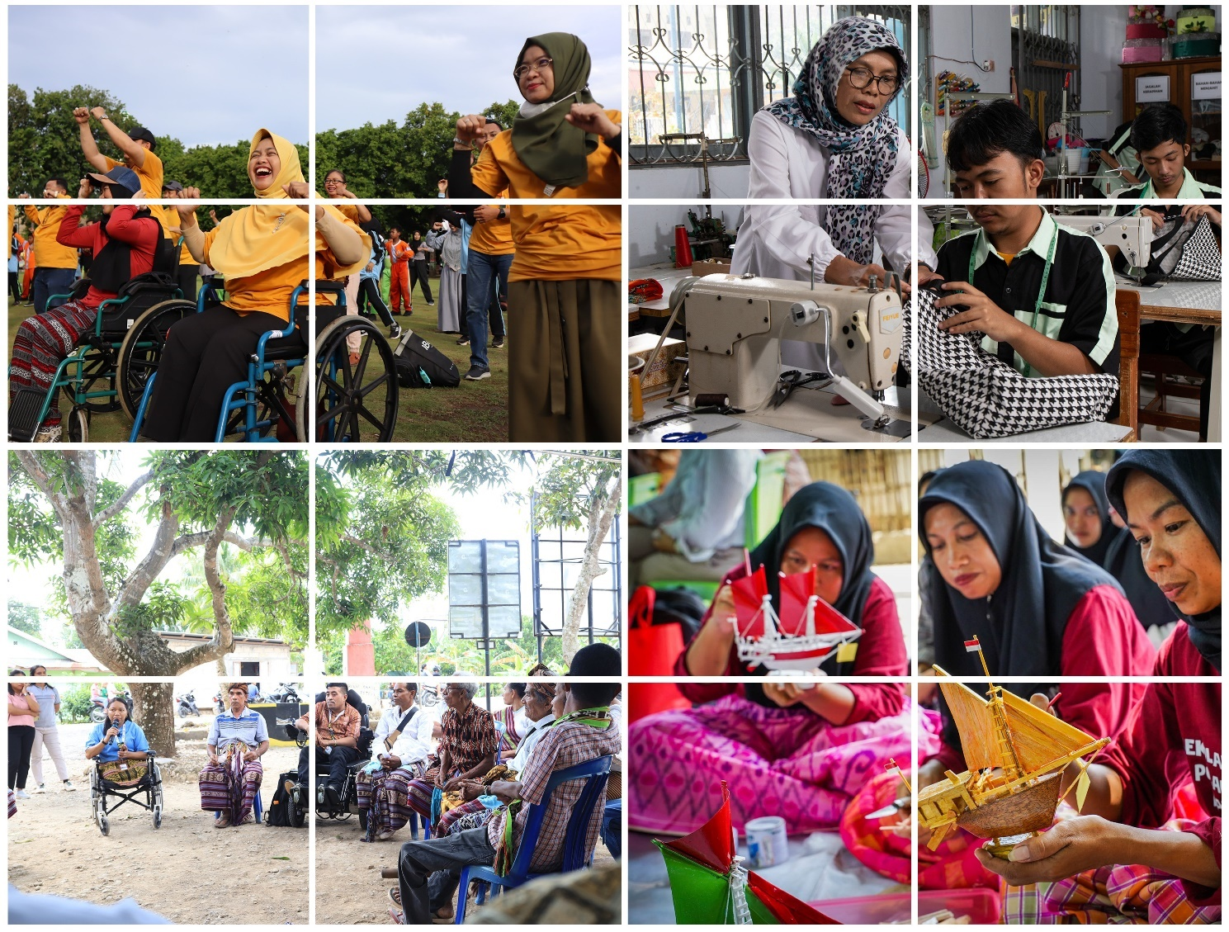

|  |
| --- |
| **Australia-Indonesia Partnership Towards an Inclusive Society** **(INKLUSI)**  **Midterm Review**  **Findings and Recommendations** |

**December 2024**

**Graham Teskey, Heni Pancaningtyas, and Anna Winoto**

**Contact Details**

|  |  |
| --- | --- |
| Review team Contact | Client Contact |
| **Graham Teskey** | **Simon Flores** |
| Team Leader | Counsellor |
| Abt Global | Australian Embassy in Jakarta |
| [Graham.teskey@abtglobal.com](mailto:Graham.teskey@abtglobal.com) | [Simon.Flores@dfat.gov.au](mailto:Simon.Flores@dfat.gov.au) |

**Document review and authorisation**

|  |  |  |
| --- | --- | --- |
| Version | Date distributed | Issued to |
| First draft | 25 July 2024 | Malithi Burrowes |
| Second draft | 15 October 2024 | Simon Flores |
| Final draft | 9 December 2024 | Malithi Burrowes |

|  |  |
| --- | --- |
| Authors | Graham Teskey, Heni Pancaningtyas, and Anna Winoto |

**Acknowledgement**

The review team would like to thank all the people consulted, particularly Malithi Burrowes (First Secretary, Governance, Australian Embassy, Jakarta), Ramot Aritonang (Senior Program Manager, Australian Embassy, Jakarta), all staff of the INKLUSI secretariat, the Government of Indonesia, and INKLUSI CSO partners (*Mitra)*. All gave their time willingly. Thanks also to Rebecca King in the Abt Brisbane office for constant logistical support.

**Disclaimer**

This Mid-term Review (MTR) was undertaken by Graham Teskey (Team Leader), Heni Pancaningtyas (Gender Equality Disability, and Social Inclusion (GEDSI) and Civil Society specialist), and Anna Winoto (Governance and Community Development specialist). The views expressed in this report are those of the review team and do not necessarily reflect those of the Government of Indonesia, the Australian Government, Department of Foreign Affairs and Trade (DFAT) or Abt Global.

Table of Contents

Acronyms and Abbreviations iv

1 The INKLUSI Program 1

2 Review purpose 3

3 Findings 5

4 Recommendations 10

## Acronyms and Abbreviations

|  |  |
| --- | --- |
| Acronyms and  Abbreviations | Description |
| AIPTIS | The Australia Indonesia Partnership Towards an Inclusive Society |
| AWPB | Annual Work Plan and Budget |
| Bappenas | Badan Perencanaan Pembangunan Nasional (Ministry of National Development Planning Indonesia) |
| CSO | Civil Society Organisation |
| DFAT | Department of Foreign Affairs and Trade |
| EoPO | End of Program Outcome |
| GEDSI | Gender equality, disability, and social inclusion |
| GoI | Government of Indonesia |
| IKLIMSS | Indonesia Climate Change Support Services |
| IO  KINETIK | Intermediate Outcome  The Australia-Indonesia Climate and Infrastructure Partnership |
| KRQ | Key review question |
| MEL | Monitoring, evaluation, and learning |
| MERLA | Monitoring, Evaluation, Research and Learning |
| MTR | Mid-term review |
| *Mitra* | INKLUSI CSO partners |
| OCAT | Organisational Capacity Analysis Tool |
| SKALA | Sinergi dan Kolaborasi untuk Akselerasi Layanan Dasar |
| SWOT | Strengths, Weaknesses, Opportunities and Threats |

## 1. The INKLUSI Program

* 1. **INKLUSI is working to increase the participation of marginalised groups in, and their benefit from, Indonesia’s development.** INKLUSI works with government and civil society partners to advance their work in gender equality, the rights of persons with disabilities, and social inclusion. INKLUSI is a five-year (2021-2026), AUD 75 million Australian Government program with a possible three-year extension of up to AUD 45 million (2026-2029). It partners with 11 Indonesian civil society organisations (and their multiple local partners), and eight research partners.
  2. **The goal of the program is that ‘no one is left behind: more marginalised people participate in and benefit from decisions about Indonesia’s sociocultural, economic, and political development****”.** The objective of the program is: “To strengthen the contributions of civil society, in partnership with government, to gender equality, disability and social inclusion (GEDSI) for marginalised people.”
  3. **INKLUSI has two End of Program Outcomes.** EoPO1 is focused on direct results for marginalised people (e.g. improved access to services, improved livelihoods), achieved by partner Civil Society Organisations (CSO). EoPO2 focuses on deeper systems change that CSOs can help promote, stimulate, or broker - including policy process, social norms, and a more accommodating CSO enabling environment.
* **EoPO1: Direct Outcomes –** Partner CSOs empower marginalised people in the areas of access to services and protection from violence (sociocultural); inclusive citizenship and participation (political); and economic recovery and livelihoods (economic).
* **EoPO2: Systemic Outcomes** – Partner CSOs, Government of Indonesia (GOI) and other stakeholders collaborate to influence systemic changes in: GOI policy process; CSO enabling environment; and social norms and public discourse.
  1. **Two Intermediate Outcomes (IO) seek to support achievement of both EoPOs**:
* **IO1: Strengthened CSO capabilities –** Partner CSOs are delivering on their mandates in a competent, adaptive, accountable, and GEDSI-responsive manner; and
* **IO2: Stakeholder partnerships and collective action** –Strengthened coordination, policy dialogue, and collaboration between partner CSOs, government, private sector and key stakeholders in public policy and discourse.
  1. **INKLUSI is complex**. Technically, it is neither a program nor a facility. The Secretariat consider themselves to be a ‘facilitating partner.’ It is the partners (the *mitra*) that deliver the INKLUSI program. At the start of the program, the Secretariat provided grants to the *mitra* to do foundational work including research on relevant issues and the selection of districts. The Secretariat’s role is thus to enable its 11 national CSO partnersto deliver their own programs, in the locations where they work, and which are designed to meet local needs.
  2. **INKLUSI’s has five characteristics**:
* **Its *modus operandi* is to work from the bottom-up**. *Mitra* submit Annual Work Plan and Budget (AWPB) which reflect their areas and locations of interest. These are reviewed by the Secretariat to ensure line of sight to the EoPOs, and to agree on a budget. Each *mitra* is then expected to deliver its annual plan;
* **It works with the state and with society**. It does this by using or creating a conducive environment for partnership discussion where the two can meet and discuss shared challenges;
* **It empowers marginalised people** by addressing power imbalance, improving their capacity, and providing space to participate;
* **It works with multiple levels of government:** national, districts (*kabupaten* and *kota*/municipalities), sub-districts, and villages; and
* **It works on both service delivery (EoPO1) and policy advocacy and reform (EoPO2)**.
  1. **INKLUSI works in a complicated ‘ecosystem.’** Within this ecosystem ‘everything is connected to everything else.’ The two EoPOs are related. What happens at village level is reported up the GoI chain and is considered by relevant policy makers. The national policy environment has implications for the ways in which local *mitra* work. National and local *mitra* use their learning and experience to lobby for change at village, sub-district, district, province, and national level. All INKLUSI activities are interconnected. Figure 1 represents this complexity graphically.

## Figure 1: The INKLUSI ‘ecosystem’

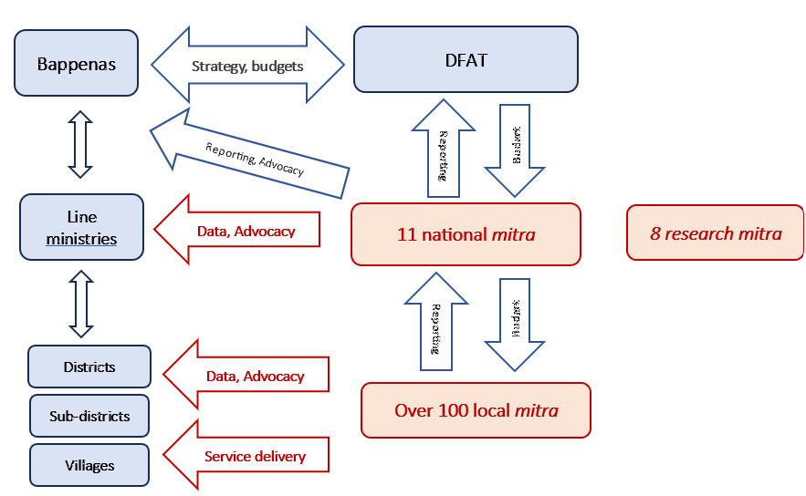

## 2. Review Purpose

1. **The review has two primary objectives:**

* To assess the progress of INKLUSI toward supporting the work of civil society in advancing GEDSI for marginalised people in Indonesia; and
* To consider how to optimise the final three years of INKLUSI, ensuring its alignment with Indonesian and Australian priorities, and informing DFAT’s decision on executing the recommendation to extend the contract.

1. **The secondary objective of the review** is to identify lessons emerging from INKLUSI for DFAT, e.g. on locally led development, civil society strengthening, and advancing GEDSI. The latter will be achieved through a holistic approach which recognises that people experience multiple and overlapping forms of disadvantage that affect their access to services and to participate in society.

**Process**

1. **The review was undertaken as follows**:
   * + Pre-departure briefs from the Embassy in Jakarta, the INKLUSI secretariat, and the Impact Evaluation team from Latrobe University;
     + Desk-based document review;
     + In-person meetings with stakeholders in Indonesia;
     + Presentation of the *Aide Memoire* to Embassy staff on Thursday 13 June 2024;
     + Preparation of the first draft of the report; and
     + Revision and drafting of the final report after comments received from DFAT.

**Review of documents**

1. **The team gathered information from** the Embassy in Jakarta, the INKLUSI Secretariat, the GoI, the 11 INKLUSI national partners, the eight INKLUSI research partners, and local partners in Southeast Sulawesi, South Sulawesi, East Java, and Banten. The team also spoke with the Contractor Representative.
2. **A review plan was prepared and submitted to DFAT for comment and subsequently revised**. The review focused on understanding the progress achieved by INKLUSI in Phase 1. Program effectiveness was achieved through review and verification of existing program evidence in discussion with national and local partners. The data collection process focused on
   * + a comprehensive document review;
     + semi-structured interviews with DFAT, INKLUSI partners, and the GoI; and
     + field visits to four provinces, visiting INKLUSI local partners.
3. **Key informant interviews and focus group discussions were conducted.** The data collection process included sub questions for each of the five key review questions, allowing the review team to shape and adapt their enquiry to the interests and focus of respondents. Data pertaining to all questions was collected and analysed, with particular attention to areas of major correspondence and consensus. The outcomes and the issues identified in this report were those which were verified by several different sources throughout the review. It should be noted that there were some differing opinions expressed, the findings in this report reflect areas where there was strong consensus from a range of data sources.

**Limitations**

1. **The review was undertaken halfway through the fourth year of a five-year program**. The first year of INKLUSI (2021) constituted inception. The Secretariat was established, and the 18-month consultative design process culminated in January 2022. At that time eight national *mitra* had been selected. They were invited then to prepare a one-year Annual Work Plan for 2022. Three further national partners then joined the program. It was only in January 2023 that national partners commenced implementing three-year work programs (2023-2025). Thus, the review is assessing two and half years of progress of which the first year consisted of short-term stand-alone activities. The review should not be seen as an impact evaluation. It has focused on the value of INKLUSI to date, and in the current context, and its strategic value for a possible three-year extension. The review did not undertake a detailed study of specific INKLUSI activities and outputs. The focus was on the strategic value of the program, the appropriateness of the development methodology, and the current and likely future context for program implementation. The review complements the longer-term Impact Evaluation now under way.

## 3. Findings

1. **The Australia Indonesia Partnership Towards an Inclusive Society (AIPTIS), more commonly known as INKLUSI, is complex, challenging, ambitious, and developmentally unorthodox**. It is *complex* because it involves over 100 partners at multiple levels of government and seeks to bring together the state and civil society. It is *challenging* because it is working on complex issues of identity. It is *ambitious* because it aims to reach some of the most marginalised and excluded communities in the country, who often experience multiple forms of discrimination. It is *developmentally unorthodox* because it seeks to achieve coherence by articulating two EoPOs, and then relying on the program’s multiple partners to identify their own work plans with a line of sight to those EoPOs.
2. **INKLUSI is funding groundbreaking work in a diverse country, and where achieving inclusion is a priority (‘****no-one left behind’).** The approach is justified, and it is broadly working. There are issues arising, but none are serious enough to call into question the integrity or the viability of the program.
3. **The program brings together numerous civil society organisations (CSOs) which in some cases act together to lobby and advocate.** It has legitimated a rights-based approach to disability and socially excluded groups, moving away a focus on ‘access’ to state-sponsored services. The program has been operational for 30 months (and only 18 months from the date the CSOs began multi-year programs); it is only recently that judgements can be made on time-series data.

**“INKLUSI helped us shift from a focus only on gender to a focus on disability and inclusion.”**

**“Before INKLUSI I felt ashamed to leave the house.”**

CSO partners

1. **A strength of the program is the commitment of the Government of Indonesia (GoI).** This is due both to the real commitment of the GoI to these issues and to the eighteen-month consultation process of the design. The latter is now paying dividends.

**“INKLUSI has positioned the marginalised to be the subjects of their own**

**development, and not the object of ours.”**

**“Greater INKLUSI impacts means great focus.”**

Two senior GOI officials

1. **INKLUSI is ‘doing development differently.’** Perhaps not in the way intended by the doctrines of ‘Problem Driven Iterative Adaptation’, but it is doing development incrementally, cautiously, and purposively. INKLUSI’s interpretation of ‘doing development differently’ delivers strengths and challenges (Figure 2).

## Figure 2: INKLUSI strengths and challenges

|  |  |
| --- | --- |
| Strengths | Challenges |
| * A sophisticated and challenging program, the design of which enables a context and location specific approach. * The program addresses critical issues which give priority to equality, diversity, and inclusion. * The design empowers local civil society organisations to pursue their own agency in response to the needs of their local communities. * The program works in a subtle way which facilitates locally led development. * Range of CSO partners | * A sophisticated and challenging program, the design of which makes it difficult to articulate one clear and convincing narrative. * The program addresses issues, which are being discussed nationally. * The design empowers local civil society organisations, increasing the possibility of incoherence and the absence of a clear strategic focus. * The program works in a subtle way which may end up being no more than a grants program. |

1. **This Mid-term review in country mission took place between May 27 and June 14, 2024**. Its purposes were twofold. First, to assess the progress of INKLUSI towards supporting the work of civil society in advancing gender equality, disability, and social inclusion (GEDSI) issues. Second, to consider how to improve INKLUSI performance in phase 1, and any possible three-year extension.
2. **Figure 3 summarises the findings of the review against the five specific key review questions (KRQs).**

## Figure 3: Findings

**KRQ 1. Effectiveness: To what extent is INKLUSI achieving what it was intended to do?**

|  |  |
| --- | --- |
| Key Review Question | Review team summary |
| 1. Is the program enhancing CSO capabilities, supporting stronger partnerships and collective action to achieve GEDSI and civil society outcomes as designed? | 1. Yes – broadly. While some national *mitra* are well established and ‘institutionalised,’ some smaller local partners have limited funding sources, and may encounter recruitment and financial management issues. They are also vulnerable to variations in their operating space as the local (and national) political economy shifts. The ‘capacity development’ role of INKLUSI must continue to be prioritised over the remainder of Phase 1, and in any possible three-year extension.   The danger however is ‘mission creep.’ This arises from three sources: first, the absence of a useful definition of the marginalised (the review team estimate that the current INKLUSI definition encompasses 85% of the country’s population); second, the commitment to work in 32 provinces with 120 *mitra;* and third, to set Annual Workplans and Budgets (AWPBs) from the ‘bottom – up’. The combined impact could be (emphasise could be – it is not clear so early in the implementation of the program) a lack of strategic focus. This the review team see as a real risk. |
| 1. Is the program on track to meet its end of program outcomes, particularly to support systemic change (EoPO2)? | 1. The program is on track for both EoPOs. However, this is only because no hard numbers have been built into EoPOs or indeed the Intermediate Outcomes (IOs). For example, EoPO1 requires that “Partner CSOs empower marginalised people in the areas of access to services and protection from violence, inclusive citizenship and participation and economic recovery and livelihoods”. The question for DFAT is – how many people will rate as success? |
| 1. How could the approach in any three-year extension improve effectiveness, efficiency, and sustainability? | 1. EoPO2 says “Partner CSOs, GOI and other stakeholders collaborate to influence systemic change in the GOI policy process, CSO enabling environment and social norms and public discourse”. There is evidence that there has been some change in national and local policy processes, and thus the enabling environment ***for some issues and in some locations*** has improved.   This is challenging for DFAT. One way to ‘optimise’ the approach is to reduce the number of dimensions of exclusion on which the program now works and focus on those key dimensions but in fewer provinces. However, in so doing this would remove at a stroke the ambition to ‘leave no-one behind.’ There is a real trade off here between effectiveness and impact on the one hand, and comprehensiveness and integrity on the other. A case can be made either way. |

**KRQ 2. Monitoring, Evaluation, Research and Learning (MERLA): How well is the MERLA system generating the information needed to meet INKLUSI’s needs and those of its stakeholders, including government?**

|  |  |
| --- | --- |
| Key Review Question | Review team summary |
| 1. Is there scope to optimise the MERLA system in any extension phase? | 1. Yes**.** The review team would propose two changes. First, the team would propose that future partner budgets are considered against performance in the previous year. It misses the opportunity to incentivise better performance. It is recommended that this be introduced from mid-2025. Second, the 2023 Monitoring, Evaluation and Learning (MEL) plan proposes outlines several additional MEL-related works. The review team would propose that some of these be dropped. |
| 1. What are the recommended key areas of focus for INKLUSI’s learning agenda, including GEDSI learning, for the remaining program period? | 1. The review team recommends five key areas of learning:    1. How has INKLUSI contributed to strengthened capacities of its CSO partners at national and local levels?    2. How can INKLUSI’s empowerment model be adapted into existing and emerging mechanisms for government collaboration with CSOs?    3. How has INKLUSI facilitated systemic change at national and subnational levels?    4. How has INKLUSI approached sensitive social inclusion issues and what can be learned from these experiences?    5. How have INKLUSI collective action activities influenced systemic change in social norms?   To support the learning agenda, the Review team suggests that the Secretariat create more systematic approaches to facilitate learning between *mitra*, between national and local *mitra*, and between government and *mitra*. The regional meetings and technical working groups could be optimized for this purpose. |

**KRQ 3. Relevance. To what extent is INKLUSI positioned to meet Australia and Indonesia’s priorities?**

|  |  |
| --- | --- |
| Key Review Question | Review team summary |
| 1. As Australia’s flagship GEDSI program, how relevant is INKLUSI to Australia’s broader GEDSI partnership with Indonesia? | 1. INKLUSI is highly relevant to Australia’s broader GEDSI partnership with Indonesia. The program has contributed to inclusion of GEDSI in the Indonesian development plans and policies, improved the benefit and inclusion of marginalised groups from the object to the subject of development. |
| 1. How well is INKLUSI coordinating and harmonising its activities internally and with other DFAT programs and development partners? | 1. The program has mechanisms to coordinate its activities through various governance arrangements that include key INKLUSI stakeholders. There are some good practices of coordination with other DFAT programs. There are suggestions to improving and increasing coordination within DFAT and requests from CSO partners to facilitate linkages with other DFAT programs. |
| 1. What have been significant opportunities and constraints presented by the modality in advancing GEDSI and support for civil society? | 1. The modality has supported local leadership and organisations to be the drivers of development and change. Additionally, it has fostered partnership between CSOs and government to advance GEDSI and improved services. Constraints encountered include different capacity level of local partners, challenges in working in different systems of CSO and government. |

**KRQ 4. Future: What opportunities exist to further align INKLUSI with the direction provided in Australia’s new International Development policy?**

|  |  |
| --- | --- |
| Key Review Question | Review team summary |
| 1. How could INKLUSI sensibly integrate a stronger climate focus? | 1. The Secretariat has conducted some initial analysis to identify entry points for climate integration. INKLUSI’s empowerment model is well suited to strengthen community awareness and resilience to climate change. National *mitra* can empower local *mitra* and communities to increase their awareness, assess their vulnerabilities and impact, and find ways to strengthen their resilience. Some *mitra* are already implementing climate-related activities, although they are not recorded or reported as such. INKLUSI can offer learning and evidence on the nexus between GEDSI and climate in the Indonesian context. The review recommends DFAT and the Secretariat to seek opportunities to work with other DFAT programs, especially the Indonesia Climate Change Support Services (IKLIMSS) and the Australia-Indonesia Climate and Infrastructure Partnership (KINETIK), and development partners on climate. |
| 1. What other opportunities for enhancement and increased alignment exist? | 1. The program is already delivering on DFAT’s International Development priorities on GEDSI, disability inclusion, and locally led development. The review recommends three opportunities for further enhancement:    1. developing simplified and more practical versions of the GEDSI handbook for *mitra* and government counterparts.    2. documenting INKLUSI’s multi-layered approach to empower marginalised communities and the transformation journeys of the communities, local leaders and gender, disability, and social inclusion champions who are involved.    3. tailoring the MEL and reporting to the local context and local-level learning in the provinces and districts in support of locally led development. |

**KRQ 5. Learning: What are significant lessons from INKLUSI that could inform DFAT’s approach to support GEDSI, civil society strengthening, and locally led development?**

|  |  |
| --- | --- |
| Key Review Question | Review team summary |
| 1. What are significant lessons from INKLUSI’s design and procurement approaches? | 1. The co-design process was intensive and time-consuming, but effective for generating ownership of GoI and CSOs toward the program. Positioning the managing contractor as facilitating partner supports the empowerment objective of the program. |
| 1. Are there elements of the design and procurement approach which could be scaled-up, or conversely avoided, elsewhere? | 1. There are several elements of the design and procurement that could be scaled up, such as co-design with partner government and CSOs, core support, earmarking the budget for partner support, and flexible, multi-year funding. Learning from INKLUSI on these would benefit the ongoing development of the Indonesia CSO Endowment Fund and DFAT’s Civil Society Partnership Fund. |

## 4. Recommendations

1. **Figure 4 presents the Review team’s recommendations**. Recommendations are presented in three categories: strategic, programmatic, and operational.

## Figure 4: Review Recommendations

### **Strategic**

| Recommendation | Short term (to December 2025) | Three-year possible extension phase, (2026-2029) |
| --- | --- | --- |
| * + 1. INKLUSI has expanded significantly beyond the six dimensions of exclusion identified in the AIPTIS Learning Brief. This risks mission creep. It is recommended that the program adopts a clear strategy for the extension phase. This has two elements. First, whether to continue the ‘broad and shallow’ approach, or switch to a ‘narrow but deep’ approach Second, to adopt a clear and specific definition of just who is, and who isn’t, marginalised. | * This is the most important issue for DFAT and the GoI. These two issues should be considered, and the pros and cons more fully articulated. The decision should be made by the 2025 meeting of the Program Steering Committee. * The definition of ‘marginalised’ should establish the parameters for any extension phase of the program. |  |
| * + 1. DFAT and the GoI to recognise that the program is going well but that achieving the EoPOs are likely to require an extension phase. DFAT should think beyond the current phase of the program. | * None | * DFAT should take an early decision on any extension phase. |
| * + 1. The program should prepare a program wide Theory of Change – one that assesses the political feasibility of the program, and it should be reviewed and assessed at the six monthly INKLUSI internal reflection workshops. | * This should be a priority exercise for any extension phase. It will assist in the decision whether to continue broad/shallow or go narrow/deep. | * The Theory of Change to be reviewed six-monthly |
| * + 1. DFAT to facilitate coordination and collaboration among DFAT programs. DFAT and the GoI should consider a joining with Sinergi dan Kolaborasi untuk Akselerasi Layanan Dasar (SKALA) and trial an INKLUSI- SKALA program in a province where both are now working). DFAT could also advise in ‘ways of working’. | * None. Initial discussions should be tabled at the Program Steering Committee to consider the viability of the idea. If it is considered worth pursuing, a study should be commissioned to outline how it could work. The report should go back to the Steering Committee for a decision. | * Implementation of the initiative if endorsed by the Steering Committee |
| * + 1. INKLUSI should document its strategies including promoting social inclusion; models of empowerment; systemic change in social norms; and strategies to influence change. | * The Secretariat to draft these short ‘How To’ notes and disseminate. | * Implementation |

### **Programmatic**

| Recommendation | Short term (to December 2025) | Three-year possible extension phase, (2026-2029) |
| --- | --- | --- |
| * + 1. INKLUSI Secretariat to continue reporting to DFAT on the changing country context as Indonesia continues its developmental trajectory. | * The Secretariat must be vigilant in its coverage and understanding of what is happening on the ground and report to DFAT and the GoI through the Program Steering Committee. |  |
| * + 1. The Secretariat should prepare both Sustainability and Exit Strategies in simple and accessible language to guide extension any phase operations and programming. The Secretariat should consider options for CSO sustainability including using the Endowment Fund initiative. | * To be undertaken as soon as possible, and submitted to the Program Steering Committee for consideration | * To become operational |
| * + 1. Secretariat to prepare a Guidance Note on how to operationalise inclusion at the village and sub-district levels. | * Prepare after consultations with local *mitra*, to be a priority in any three-year extension phase. | * To become operational |
| * + 1. The Secretariat should adopt its preferred organisational model against which partners can self-assess. There are many models available: the Open Systems model, the McKinsey 7S model and the Organisational Capacity Analysis Tool (OCAT) model, the European Centre for Development Policy and Management five elements model, the Burke-Litwin model, and the Strengths, Weaknesses, Opportunities and Threats (SWOT) model. | * The Secretariat should adopt one – either the SWOT or the 7S model. Neither is the most sophisticated, but they are the most intuitive and easiest to understand and apply. Capacity development in more than proficiency in managing money. This model then can be used by *mitra* and they can share their experience against a common model. | * Monitor its application |
| * + 1. The Secretariat should review the MEL plan. This will include:  1. Future INKLUSI annual reports to expand on what ‘providing support’ means 2. Adding a sixth question interrogating efficiency – what it costs to deliver one unit of ‘services’ under EoPO1 3. To reduce the number of MEL activities 4. The Secretariat to consider if it is possible to integrate the three monthly Badan Perencanaan Pembangunan Nasional (Ministry of National Development Planning Indonesia) and six monthly DFAT reporting requirements. 5. DFAT should assure themselves that INKLUSI’s Monitoring and Learning Plan will deliver appropriate Tier 2 indicators for the DFAT-wide three tier Performance Assessment Framework. | 1. The Secretariat to revise reporting to be specific about what assistance has been provided, rather than generic claims of ‘support’ 2. Commission and undertake an independent assessment of INKLUSI’s efficiency in EoPO1 3. The MEL Unit in the Secretariat should give immediate thought to which monitoring exercises can be dispensed with 4. The review team recognise this may be difficult 5. DFAT to discuss with Canberra | * A revised list of MEL deliverables to be introduced in any extension phase |
| * + 1. Annual budget allocations for INKLUSI *mitra* should be decided on both the forward work plan proposed and *mitra* performance in the previous year. | * Socialise the change and introduce it for the next budget cycle |  |
| * + 1. The Secretariat provide national *mitra* with a realistic budget ceiling mid-year, providing certainty. This may also require DFAT to be more advanced in its financial planning. | * This would avoid the current two-step budget process which almost inevitably requires national *mitra* to resubmit a reduced annual work plan in November. |  |
| * + 1. INKLUSI to adopt a formal learning program to inform a possible three-year extension. DFAT should make appropriate funding available. | * To be commenced as soon as possible | * To be used in the design of any extension phase |
| * + 1. Secretariat to consider portfolio wide collaboration: consolidation of messaging, program coordination and information sharing, and cross-program learning. | * To be commenced over the next 18 months, one by one | * To be institutionalised (i.e. to become routine and regular) in any extension phase |
| * + 1. Secretariat to give further thought to how it can be assured that the program’s research agenda more fully aligns with the work of CSO *mitra* – in terms of both what they do and how they work together. | * This ‘think piece’ or guidance note to be drafted before the commissioning of any future research | * Any extension phase research to be guided by the document |
| * + 1. DFAT and the Secretariat consider ways further to integrate climate change into the program. | * A short assessment of what the program is now doing should be commissioned as soon as possible | * Implementation of a climate interventions to commence |

### **Operational**

| Recommendation | Short term (to December 2025) | Three-year possible extension phase, (2026-2029) |
| --- | --- | --- |
| * + 1. The Secretariat to produce a shorter, more accessible, guide to GEDSI. | * Immediately |  |
| * + 1. The Secretariat, and national and local *mitra*, to attempt to capture or describe in some way ‘transformation journeys’ of individuals, groups, or communities, to which they are witness. | * As soon as possible – and as resources are made available |  |
| * + 1. Refer to *local mitra* not sub-partners or sub-*mitra.* | * Immediately, in documentation and meetings |  |
| * + 1. Secretariat to develop an annual calendar that flags key events in the annual program management cycle to give *mitra* more advanced noticeregarding upcoming events. | * Secretariat to try and plan its events further in advance |  |
| * + 1. Secretariat to ensure trainings and capacity support reflects the realities of local *mitra* circumstances. | * Immediately. To be aware of diversity of local context. Beware urban bias |  |
| * + 1. Secretariat take care not to overburden national and local *mitra*, administratively or financially. | * The Secretariat to continue its consideration of the administrative and disbursement burden placed on national and local *mitra* |  |