02
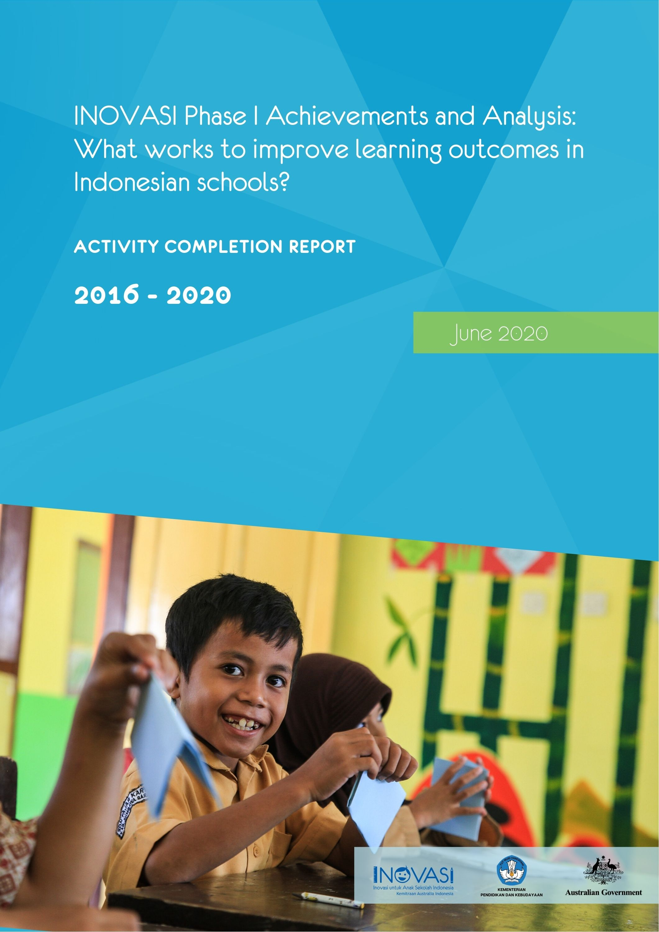
July 2017
Report title report title report title

INOVASI – Innovation for Indonesia’s School Children
Ratu Plaza Office Tower 19th Floor,
Jl. Jend. Sudirman Kav 9, Jakarta Pusat, 10270
Indonesia
Tel : (+6221) 720 6616
Fax : (+6221) 720 6616
http://www.inovasi.or.id

Submitted June 2020

Cover photo courtesy of Palladium

The governments of Australia and Indonesia are partnering through the Innovation for Indonesia’s School Children (INOVASI) program. INOVASI seeks to understand how to improve student learning outcomes in literacy and numeracy in diverse schools and districts across Indonesia. The first phase of the program (AUD49 million) began in January 2016 and continued until June 2020. Working with Indonesia’s Ministry of Education and Culture, INOVASI has formed partnerships with 12 districts in: West Nusa Tenggara; Sumba Island, East Nusa Tenggara; North Kalimantan; and East Java.
INOVASI is an Australia–Indonesia Government Partnership – Managed by Palladium.

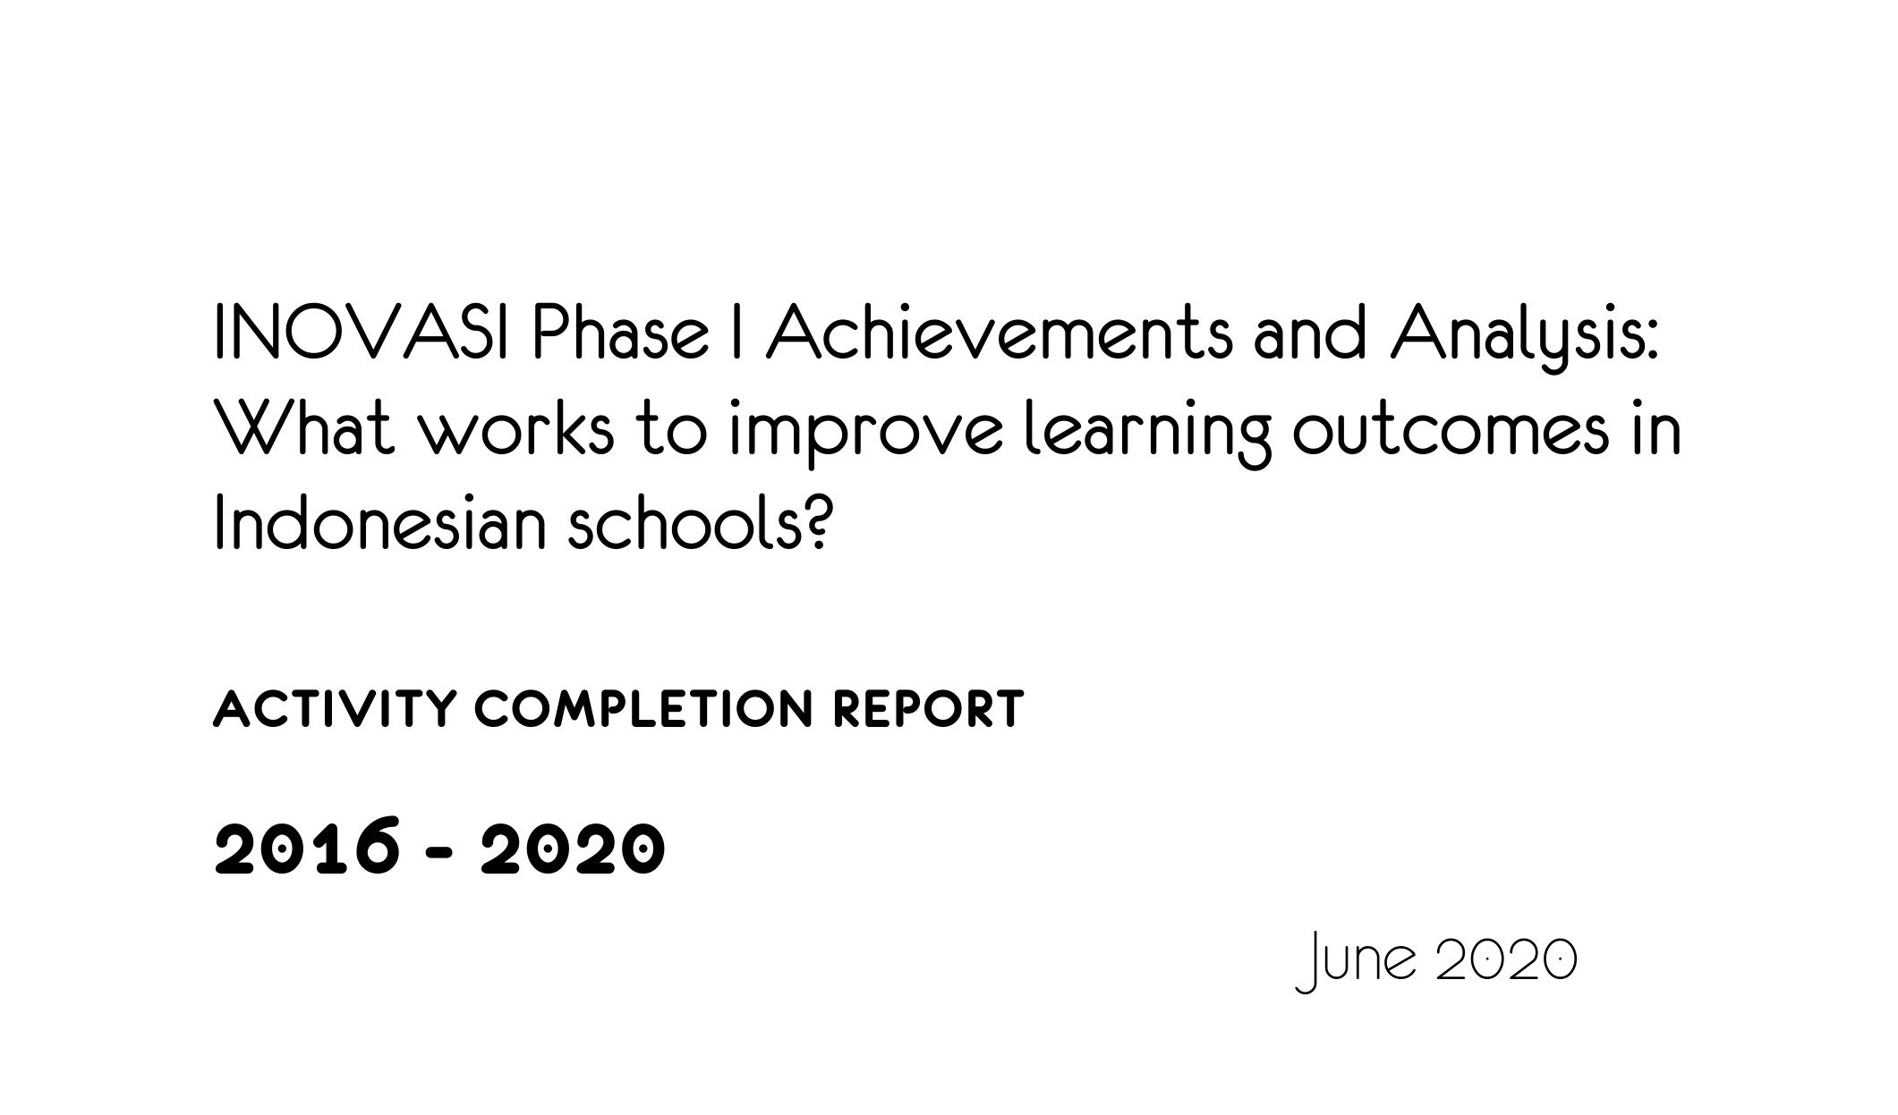

Version | Submission date | INOVASI approved by | DFAT approved by
1.0 | 15 June 2020 | Program Director | N/A
2.0 | 5 August 2020 | Program Director | Laila Yudiati
3.0 | 15 December | Program Director | Laila Yudiati

Contents
Acronyms, abbreviations and Bahasa Indonesia terms vi
EXECUTIVE SUMMARY vii
SUMMARY DATA 1
1 OVERVIEW 3
1.1 Program Rationale and Relevance 3
1.2 Goal and Expected Outcomes 4
1.3 Changes in INOVASI’s Operating Context 4
1.4 Types of Support 6
1.5 Expenditure and Financial Analysis 7
2 PILOTS 10
2.1 Contribution to Program Goal 11
2.2 Progress towards End-of-program Outcomes 12
2.3 The Evidence Base: What’s Working? 18
2.4 Snapshot of Findings from Pilots and Provinces: Literacy 25
2.5 Snapshot of Findings from Pilots and Provinces: Numeracy 28
2.6 The Grant-based Partnerships Pilots 29
2.7 Cost-benefit Analysis 30
3 CHALLENGES, RISKS, OPPORTUNITIES AND LESSONS LEARNED 35
3.1 Challenges and Risks 35
3.2 Lessons Learned 38
4 MONITORING, EVALUATION, RESEARCH AND LEARNING 41
4.1 Monitoring, Evaluation, Research and Learning Systems in Phase I: Strengths and Weaknesses 41
4.2 Towards Phase II 43
5 COMMUNICATIONS 46
5.1 Communication Products 46
5.2 Towards Phase II 48
6 CROSS-CUTTING ISSUES 50
6.1 Gender 50
6.2 Disability and Inclusion 50
6.3 Child Protection 51
6.4 Environmental Policy 52
6.5 Private Sector Engagement 52
7 SUSTAINABILITY 54
7.1 Scale-out and Sustainability: Evidence from Phase I 55

References 58
ANNEXES 60
Annex 1: Thematic Studies Summaries 60
Executive Summary: Literacy Thematic Study 60
Executive Summary: Numeracy Thematic Study 62
Executive Summary: Continuing Professional Development Thematic Study 62
Executive Summary: Gender Thematic Study 65
Executive Summary: Problem-Driven Iterative Adaptation Approach Thematic Study 67
Executive summary: Disability Inclusion Thematic Study 69
Executive Summary: Partnership Thematic Study 71
Annex 2: Key Achievements, Challenges and Lessons Learned, by Province 72
North Kalimantan 72
West Nusa Tenggara 73
East Java 75
East Nusa Tenggara 76
Annex 3: Implementing Partners, Contract/Grant Value and Key Achievements 79
Annex 4: List of all INOVASI Knowledge Products: Phase I 84
Annex 5: New Regulations 2016–2020 140
Annex 6: District Education Finance Assessment 147
Annex 7: Selected Achievements of the Pilots in Phase I 150

List of figures
Figure 1: INOVASI: spending patterns, 2016–2019 8
Figure 2: Changes in teaching practices: baseline–endline results 19
Figure 3: Percentage of students who passed the basic literacy test at baseline and endline, four provinces 26
Figure 4: Regression analysis – the cost of delaying basic literacy skills 31
Figure 5: Increase in basic literacy skills due to Round 2 INOVASI pilots 32
(excluding grant-funded pilots) 32
Figure 6: Students passing the basic literacy test, North Kalimantan 33
Figure 7: INOVASI and TASS response during the COVID-19 pandemic 36

List of tables
Table 1: What works and what doesn’t work to improve learning outcomes: evidence from INOVASI Phase I 12
Table 2 : Grade progression on the individual component skills, by province 27
Table A1: Partners, program focus and grant values 78

Acronyms, abbreviations and Bahasa Indonesia terms
ACDP Analytical and Capacity Development Partnership
AKSI Indonesian students’ performance assessment (Asesmen Kinerja Siswa Indonesia)
AUD Australian dollars
Bappenas Indonesian Ministry of National Planning and Development
BOS schools operational funds (Bantuan Operasional Sekolah)
BOSDA regional schools operational funds (Bantuan Operasional Sekolah Dearah)
CPD continuing professional development
CSR Corporate Social Responsibility
DFAT Australian Department of Foreign Affairs and Trade
GESI gender equality and social inclusion
ÌDR Indonesian rupee
ID-TEMAN Improving Dimensions of Teaching, Education and Learning Environment program
INOVASI Innovation for Indonesia’s School Children (Inovasi untuk Anak Sekolah Indonesia)
KKG teachers’ working groups (kelompok kerja guru)
KOMPAK Australia–Indonesian government partnership to reduce poverty
madrasah Islamic primary school
MERL monitoring, evaluation, research and learning unit
MoEC Indonesian Ministry of Education and Culture
MoRA Indonesian Ministry of Religious Affairs
Muhammadiyah Islamic organisationin Indonesia
NGO non-governmental organisation
NTB West Nusa Tenggara
NTT East Nusa Tenggara
NU Ma’arif Islamic organisation in Indonesia (Nahdlatul Ulama Ma'arif)
OPOB One Person, One Book program
PDIA problem-driven iterative adaptation approach
PIRLS Progress in International Reading Literacy Study
PISA Programme for International Student Assessment
RISE Research for Improving Systems of Education project
SIL Summer Institute of Languages (Suluh Insan Lestari)
SIPPI INOVASI’s education and learning survey (Survei INOVASI Pendidikan dan Pembelajaran Indonesia)
TASS Technical Assistance for Education System Strengthening program
Temu INOVASI INOVASI’s public meetings to discuss innovation in education
TIMSS Trends in International Mathematics and Science Study
UNICEF United Nations Children's Fund

EXECUTIVE SUMMARY
The Innovation for Indonesia’s School Children (Inovasi untuk Anak Sekolah Indonesia – INOVASI) program is a partnership between the governments of Australia and Indonesia. INOVASI includes Indonesia’s Ministry of Education and Culture (MoEC), Ministry of Religious Affairs (MoRA), the National Development Planning Ministry (Bappenas) and sub-national partners in the provinces of West Nusa Tenggara (NTB), East Nusa Tenggara (NTT), North Kalimantan and East Java. The program seeks to identify and support changes to education practice, systems and policy that demonstrably accelerate improved student learning outcomes. INOVASI is managed by Palladium on behalf of Australia’s Department of Foreign Affairs and Trade (DFAT). The program was planned as an eight-year initiative over two phases. Phase I commenced on 18 January 2016 and concluded on 30 June 2020. This activity completion report was prepared during a six-month transition period (January–June 2020) as INOVASI prepared for Phase II that began in July 2020.
The goal of INOVASI is to accelerate progress towards improved learning outcomes for Indonesian students. It focuses on three areas of investigation: quality of teaching in the classroom; quality of support for teachers; and learning for all. INOVASI had three expected end-of-program outcomes to achieve this goal:
- A credible body of evidence is available of what policy and practice changes work to improve student learning outcomes in Indonesia.
- Decision makers have access to and use this evidence to facilitate and implement more effective education reforms.
- The effective policy and practice changes identified are reflected in Indonesian government (district, provincial, national) policies, regulations, budgets and plans.
Working closely with the Technical Assistance for Education System Strengthening (TASS) program, INOVASI substantially achieved these three outcomes in the first phase and is set to continue building on these achievements in Phase II. TASS was a responsive, demand-driven technical assistance facility also funded by DFAT. Working with MoEC, MoRA and Bappenas, TASS was designed to improve the effectiveness of policy and practice in the education sector through a systems strengthening program that operated on a response-to-demand basis. In INOVASI Phase II, TASS will merge into INOVASI as a technical unit.
During the first four and a half years of the program, INOVASI established itself as an adaptive, responsive program and gained the trust of the Indonesian government as a key partner in development. Acting as a critical friend, INOVASI supported government in making key reforms in the system and leveraged the evidence from its pilots to broker change in both the policy and service delivery space. Working collaboratively with Harvard’s’ Centre for International Development, INOVASI pioneered a problem-driven iterative adaptation (PDIA) approach to supporting education sector reform.
Previous efforts to reform education in Indonesia achieved participation rates of close to 100 per cent for primary school children. However, learning outcomes have not improved significantly using the traditional top-down cascade training approach. International ‘best practice’ solutions imported over the years failed to take root in Indonesia and brief, one-off training activities have not resulted in meaningful change to teaching practice. Thus INOVASI took a different approach in facing these challenges by working with national and local partners, exploring the problems from their perspective and then developing solutions using trial and error to achieve the best results in a given context. We call this an iterative approach and it is a signature feature of the INOVASI program. Through this approach, we learn together what does and doesn’t work to support sustainable improvements in student learning over time.
INOVASI is currently working in 22 districts across four provinces: West Nusa Tenggara (NTB), East Nusa Tenggara (NTT), North Kalimantan and East Java. This includes 17 original partner districts and five additional districts that joined in 2020 with independent funding. Over Phase I, the program designed and implemented 110 distinct pilot activities, including 36 implemented by non-government partners, universities and the Islamic organisations, Muhammadiyah and Nahdlatul Ulama (NU) Ma’arif. The pilots started in 2017 with Guru BAIK that used an adapted action research approach to explore problems in the classroom. This approach helped change teachers’ mindsets –shifting their focus from delivering the curriculum to ensuring their students were learning. Although teachers’ approaches improved significantly, the gains recorded in student learning outcomes were modest. Learning from this experience, we adopted a cluster-based short-course approach to continuing professional development in our second round of pilots, through routine school cluster teachers’ working group meetings over a twelve-month period. Results were encouraging and we recorded substantial gains in students’ literacy and numeracy scores (especially in the poorer and more remote regions). We further iterated the approach in the next round of pilots by adding a politically-informed component to link efforts at the school cluster level with the executive branches of government in the districts. Our aim was to link the evidence of positive changes in practice with system-level changes at district and eventually provincial levels. The approach worked best in districts like Bulungan in North Kalimantan and East Sumba in East Nusa Tenggara. While the initial inputs were small in scale, the team built strong collaborative relationships with local authorities and helped design large scale-out programs fully funded by the district. These collaborations not only had an impact on attitudes and practices at the level of teachers and school leaders but also at the political and executive leadership levels within government. More resources were directed at reforms focusing on quality in the sector as a whole and the outcomes of these initiatives were subject to more scrutiny.
These positive trends led to higher levels of co-investment and joint funding than expected from government partners in Phase I of the program. Approximately 1,500 schools benefitted from local government co-investment and joint funding support for key INOVASI pilot work. Between 2017 and 2019, partner district governments allocated nearly AUD1.9 million through co-investment, starting with AUD286,000 in 2017, nearly doubling to AUD488,000 in 2018 and doubling again to AUD1.2 million in 2019. In 2020, another AUD1.2 million will bring the direct co-investment up to AUD3.1 million to date. The COVID-19 pandemic is likely to affect these 2020 commitments but the general trend is clear – more domestic resources are going into quality-focused reforms than ever before. While the demonstration effect of INOVASI’s pilots helped stimulate this shift in resource allocation, we also supported our government partners in the process of optimising their planning and budgeting processes so they had enough funds to invest in initiatives proven to promote quality in education and improve students’ learning outcomes.
These successful pilots and scaling efforts informed both sub-national and national policy by identifying the problems and demonstrating what can work at classroom, school and district level to improve learning outcomes. Districts issued 51 new regulations to consolidate ongoing efforts to improve literacy, numeracy and inclusion. The following five high-level policy and program changes illustrate the efficacy of the approach at the national level:
- The literacy pilot activity in North Kalimantan identified a problem of book availability arising from a restrictive, centralised and slow approval process in Jakarta. Around 85 per cent of children say they love to read but they cannot access appropriate books and literacy levels are chronically low. Following extensive consultations, the Ministry of Education and Culture (MoEC) issued two pivotal decrees. The first decree provides an expanded book list that now includes pre-primary books that primary school students can use for beginning reading. The second decree provides a broad list of approved books that includes publications by non-governmental organisations and small publishers.
- In West Nusa Tenggara, East Nusa Tenggara and East Java, INOVASI developed and piloted a Student Learning Profile (Profil Belajar Siswa) so teachers can identify children’s disabilities and learning difficulties. In collaboration with TASS and MoEC, INOVASI developed an application that links to MoEC’s information management system. MoEC piloted the instrument nationally in more than 3,000 schools and trained more than 127,000 teachers or assessors to use the profile and the linking application. Lessons from the field testing were used to refine the instrument.
- The Ministry of Religious Affairs (MoRA) developed a continuing professional development (CPD) program with initial technical support from TASS. MoRA is scaling out this program nationally with a World Bank loan that also covers other areas to strengthen education outcomes. INOVASI supported the pilot process for the program and MoRA has decided to adopt and adapt the INOVASI modules on literacy and inclusion for this national program.
- INOVASI’s modules were approved for use in MoEC’s national continuing professional development program in 2019, however, this program was superseded by the 2020 program.
- In early 2020, MoEC launched a large-scale, nation-wide grants program, called Program Organisasi Penggerak (‘change agent’ program). This is the first MoEC initiative to mobilise non-government partners to run its continuing professional development. MoEC consulted intensively with the grants team to learn from INOVASI’s experience of implementing its partnership program. INOVASI also provided technical support in the form of a consultant to design the monitoring and evaluation system, and assistance in adopting the PDIA approach, based on INOVASI’s experience. INOVASI’s modules for continuing professional development in literacy, numeracy and inclusion are available and approved for adoption or adaptation in this program.
- MoEC’s Program Organisasi Penggerak, is using a problem-driven iterative adaptation (PDIA) approach specifically for grantees who have planned interventions that are yet to be proven successful. This decision was based on INOVASI’s experience of using this methodology.
Moving into Phase II, INOVASI will build on the momentum established in Phase I. The recent appointment of Nadiem Makarim, a reform-focused Minister for Education and Culture, combined with the strong working relationships and trust established in the provinces and districts between INOVASI and TASS with government and non-government counterparts and ministerial advisors, has created a platform for the forward agenda. The evidence from pilots and research in Phase I provides the basis for ongoing reform. MoEC has signalled potential areas of collaboration with INOVASI on the key reform areas of national curriculum, assessment and teacher management policy. Partner provinces and districts are excited about potential ongoing participation in the INOVASI partnership to improve learning outcomes.
As an adaptive program, we will use the lessons from Phase I to improve the approach in Phase II. In addition to merging INOVASI and TASS, the main change will be to reconceptualise the program role from designer and implementer to broker, catalyst, collaborator, evaluator and communicator. Phase II will seek a balance between pilots, scale out and systemic change – with the latter ultimate outcome sought in Phase II. Among other things, this means a stronger, more efficient monitoring, evaluation, research and learning (MERL) approach and a stronger role in brokering partnerships with the private sector and civil society. Thus, INOVASI will continue its adaptive approach to working with partners at national, sub-national and local levels to identify and solve problems together.
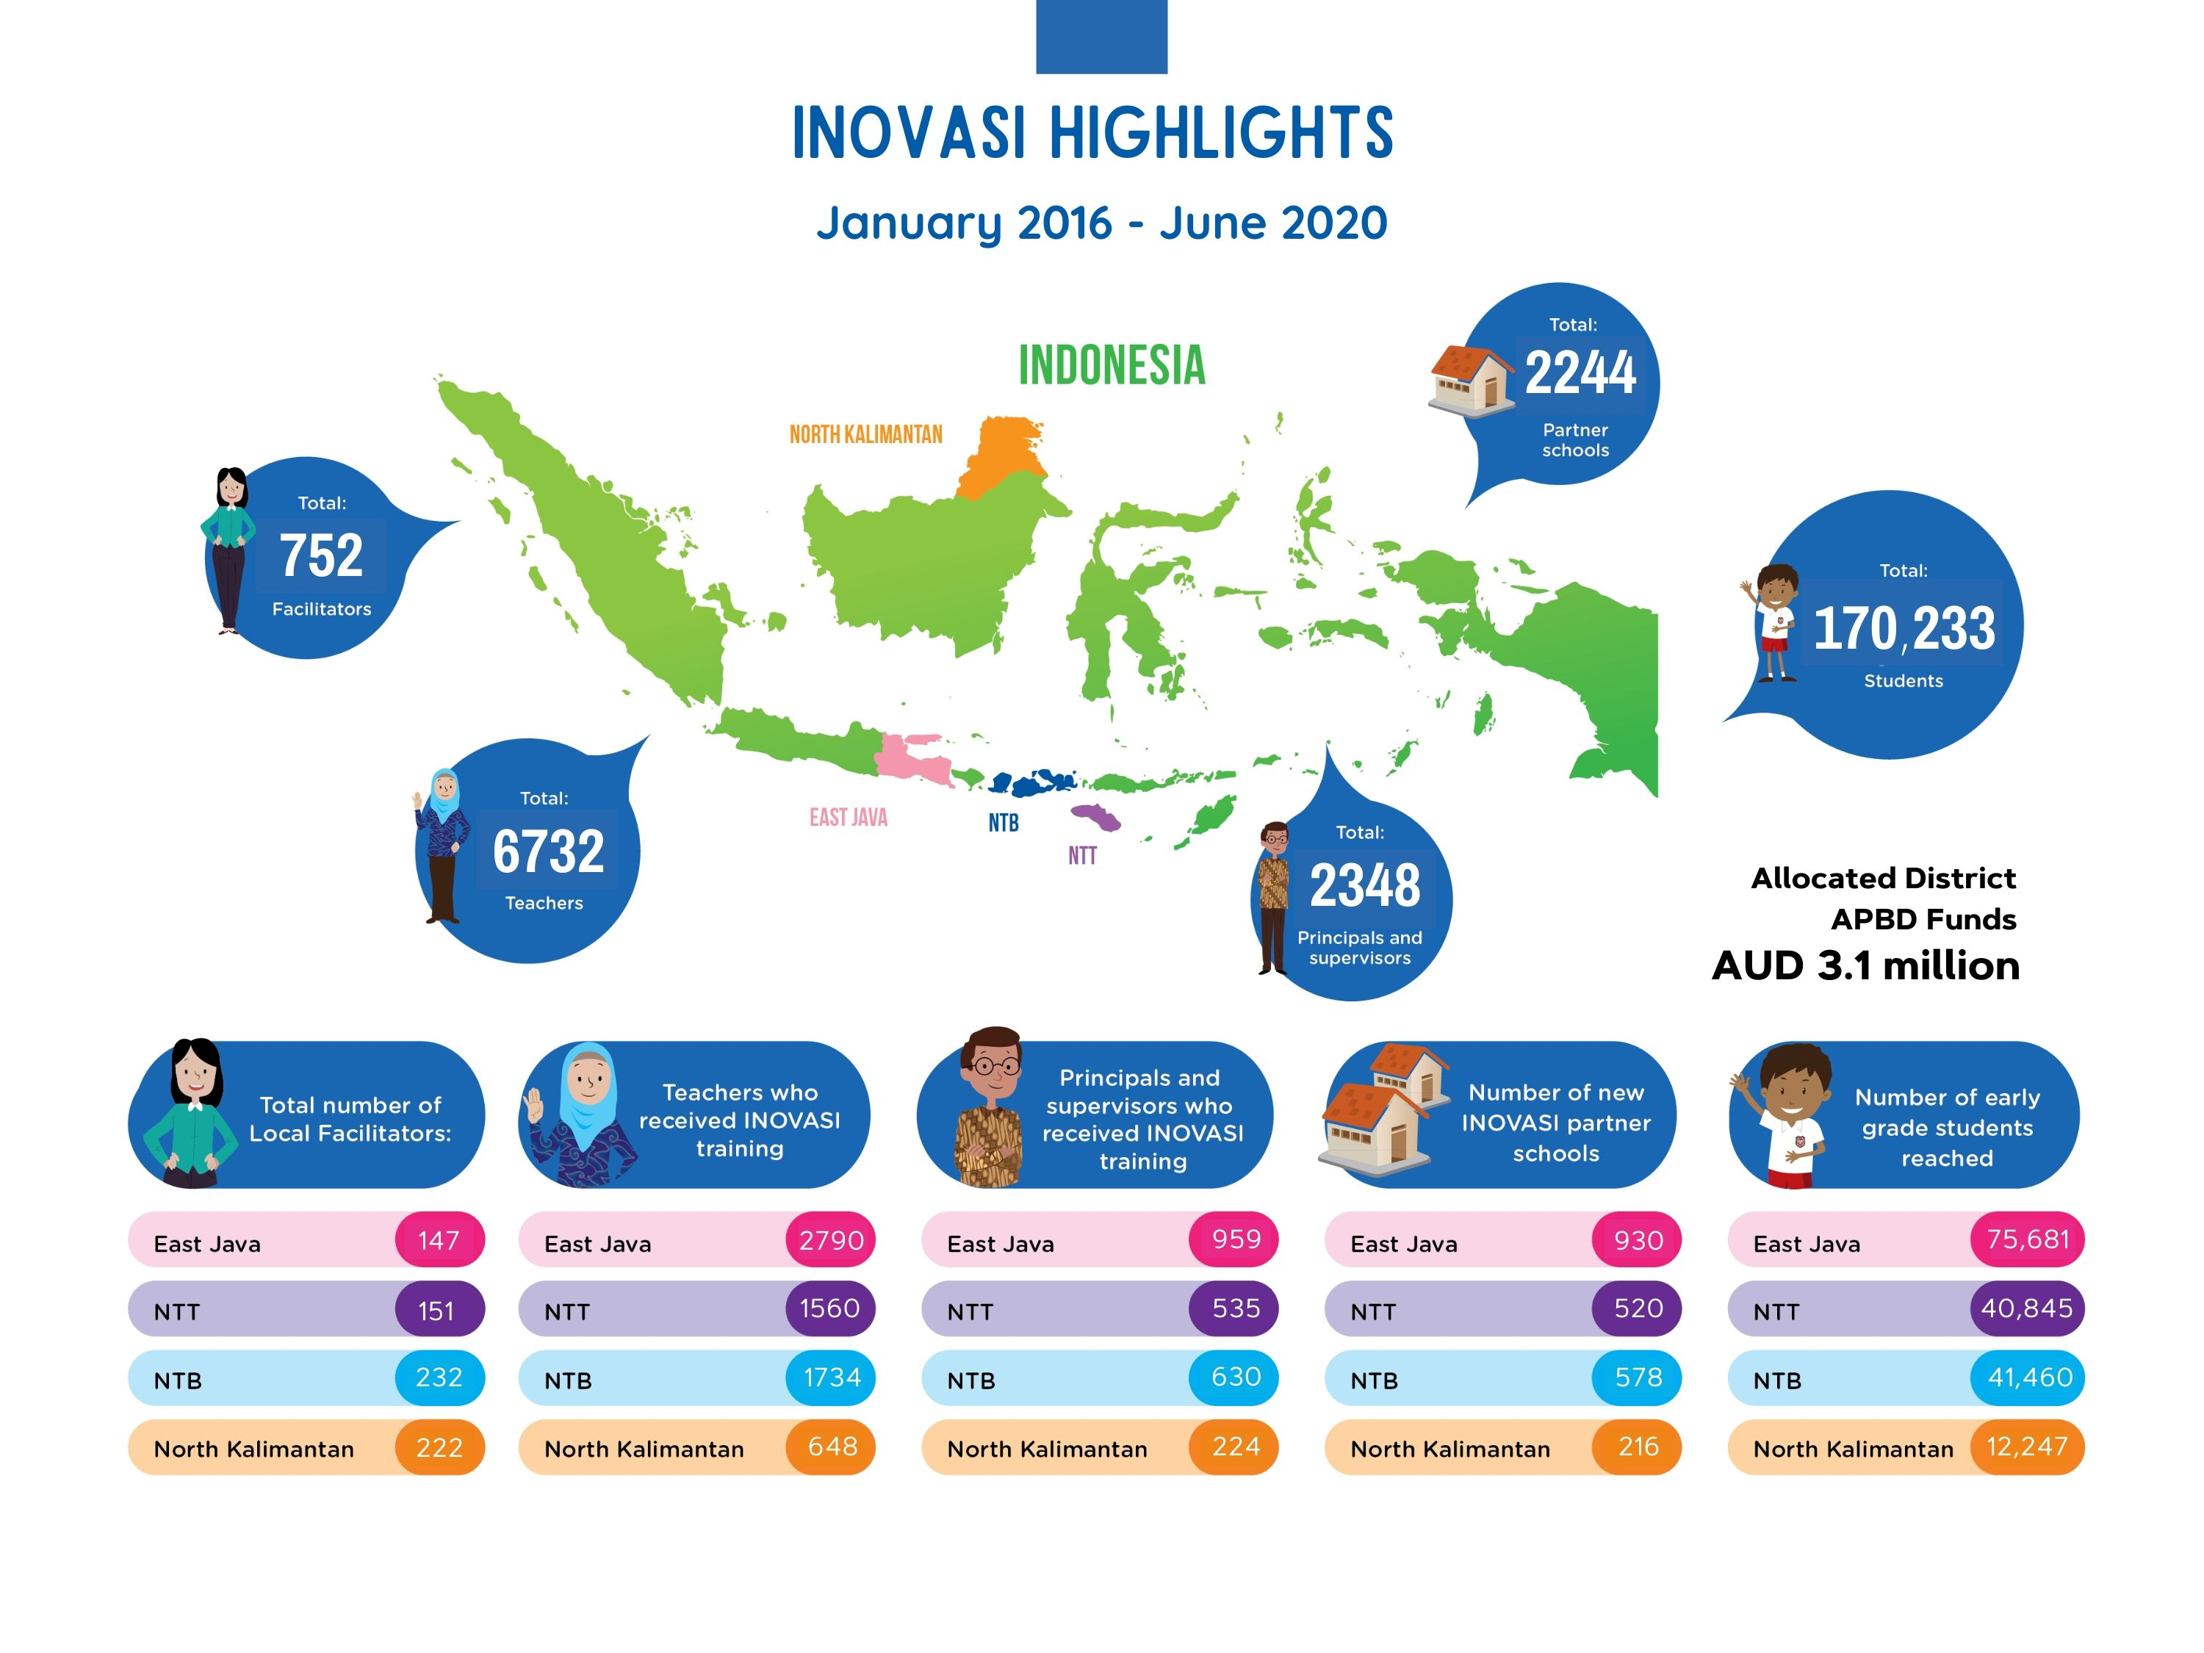
The numbers above include both INOVASI school partners as well as scale-out schools

SUMMARY DATA
Name of activity | Innovation for Indonesia’s School Children (INOVASI) Phase I
Approved budget for managing contractor | AUD51 million (excluding Indonesian government financing and separate Australian government funds for design, tender and independent M&E)
Final expenditures | AUD49,155,100
Source of funds and other contributions | Australian Department of Foreign Affairs and Trade  Government of Indonesia (district/provincial/national)
Program duration | 4.5 years (excluding Phase II)
Start date | 18 January 2016
End date | 30 June 2020
Australia Indonesia Aid Investment Plan objective: | Objective 2: Human development for a productive society
Program objective | Goal: to accelerate progress towards improved learning outcomes for Indonesian students  End of program outcomes:  - A credible body of evidence is available of what policy and practice changes work to improve student learning outcomes in Indonesia.[1]  - Decision makers have access to and use this evidence to facilitate and implement more effective education reforms.  - The effective policy and practice changes identified are reflected in Indonesian government (district, province, national) policies, regulations, budgets and plans.
Program summary | The Innovation for Indonesia’s School Children (INOVASI) program is a partnership between the governments of Australia and Indonesia. Working directly with local partners, INOVASI seeks to understand how student learning outcomes in literacy and numeracy can be improved in diverse primary schools and districts across Indonesia.
Government of Indonesia partners | The Ministry of Education and Culture (Subsidiary Arrangement signatory and Implementing Authority), also working with the Ministry of Religious Affairs, the Ministry of National Development and Planning, the Ministry of Home Affairs, the Ministry of Village and Development of Disadvantaged Regions and the Ministry of Administrative and Bureaucratic Reform, as well as the Ministry of Finance
Activity location: | West Nusa Tenggara, East Nusa Tenggara, North Kalimantan and East Java

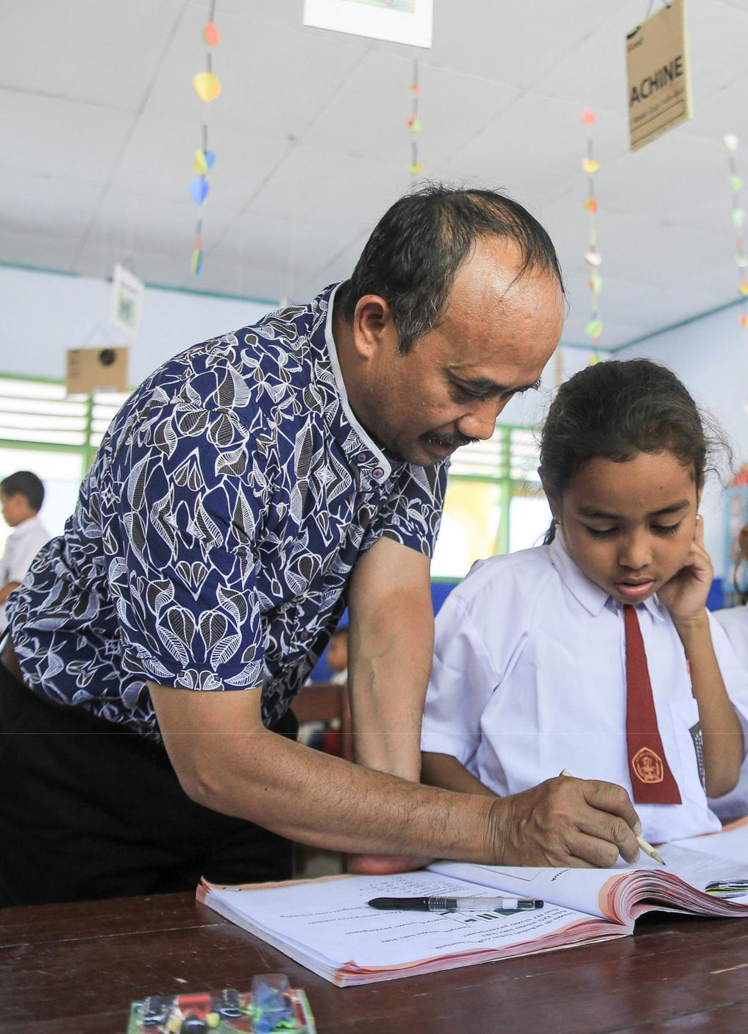

- OVERVIEW
This activity completion report for the Innovation for Indonesia’s School Children (INOVASI) program Phase I was compiled by the Managing Contractor during the six-month transition period (January–June 2020), as INOVASI prepared for the next phase of the program. Phase II commenced in July 2020 and integrates the INOVASI and TASS programs.
The report begins with an overview of the program’s rationale, relevance, goals and expected outcomes. This section also covers changes in the operating context, the types of support provided as well as a financial summary. We then analyse the program’s progress and achievements by summarising the program outcomes, the body of evidence produced and its influence on policy designed to improve learning outcomes. The final sections discuss: the challenges, risks and lessons learned; the monitoring, evaluation, research and learning (MERL) component; the communications component; cross-cutting issues; and finally, sustainability. Each of these sections describes lessons learned, what worked well and what can be improved in Phase II. In this way, the activity completion report is forward looking and will inform the implementation in Phase II.
  - Program Rationale and Relevance
The Australian Department for Foreign Affairs and Trade (DFAT), in consultation with the Indonesian government, designed the INOVASI program in 2014 to address two main challenges. Firstly, while Indonesia had succeeded in getting children into school, this had not resulted in improvements in children’s learning outcomes. Secondly, previous efforts to improve education focused on better access and top-down, one-size-fits-all solutions to improve learning but this approach had not resolved what has become known as Indonesia’s ‘learning crisis’.
‘INOVASI is designed to be transformational by investigating what works and what doesn’t work to get teachers teaching better and students learning more, and why, in order to leverage Indonesia’s substantial spend in education. It is not designed to be a program for directly delivering education services. It will be transformational by:
- Understanding local challenges and opportunities to improving student learning outcomes by bringing together key government and non-government stakeholders;
- Generating evidence of what works and what does not work to improve student learning in Indonesian classrooms by trialling and testing local solutions (tested strategies);
- Sharing this evidence with stakeholders in target and non-target districts to promote adaptation and replication of tested strategies in target and non-target districts’ (Final design of INOVASI) (DFAT, 2014).
Six years on, improving the quality of basic education remains a priority for Indonesia and its National Mid-term Development Plan 2020–2024 recognises this as essential to the country’s future economic development (Bappenas, 2019). Australia has supported the education sector in Indonesia for over two decades. This history of cooperation in the sector underpins the bilateral relationship as well as people-to-people links between the countries. INOVASI is one of several programs that DFAT funds to support improved quality basic education in Indonesia. Others include, for example, a partnership with UNICEF in Papuan provinces, a World Bank partnership (ID-TEMAN), a governance program (KOMPAK) and the global research initiative, Research for Improving Systems of Education (RISE). DFAT’s ‘… current strategy supports Indonesia’s own systems to improve quality of education by using their own funds in ways that are efficient and effective’ (Nichols and Bodrogini, 2019: i).
  - Goal and Expected Outcomes
The goal of INOVASI is to accelerate progress towards improved learning outcomes for Indonesian students. It focuses on three areas of investigation: quality of teaching in the classroom; quality of support for teachers; and learning for all. Under INOVASI’s theory of change, three end-of-program outcomes will achieve this goal:
- A credible body of evidence is available of what policy and practice changes work to improve student learning outcomes in Indonesia.
- Decision makers have access to and use this evidence to facilitate and implement more effective education reforms.
- The effective policy and practice changes identified are reflected in Indonesian government (district, provincial, national) policies, regulations, budgets and plans.
The program was designed to achieve these sequential outcomes after eight years with the first outcome contributing to the second and the second contributing to the third. Working closely with TASS, INOVASI has made significant progress toward these three outcomes in Phase I and is set to strengthen this achievement in Phase II. However, the three outcomes are no longer regarded as strictly linear or sequential. Experience has shown that while each contributes to the others, they may be achieved concurrently or in a different sequence, in relation to specific policy outcomes. For example, policymaking is a political process and providing evidence to support policy improves that process but evidence is produced continuously. Thus leveraging emerging evidence and communicating this in targeted ways is also ongoing, as personnel change and the political and policy environment evolves.
  - Changes in INOVASI’s Operating Context
INOVASI Phase I coincided with the first term of President Joko Widodo whose national agenda and equalising, meritocratic vision created a conducive atmosphere for education reforms and specifically for efforts to improve equity and quality. These aspirations are reflected in government’s policy of developing the country from the geographic fringes and working inwards. The national focus on literacy aligned with grassroots movements and with INOVASI’s interest in building foundational skills. At the same time, within the Ministry of Education and Culture (MoEC), the head of the research and development body (Balitbang) took ownership of INOVASI as a vehicle to support the government’s broader reform agenda.
This political climate helped INOVASI to achieve its end-of-program outcomes by the end of Phase I and to build its credibility as a partner as the government embarks on its ambitious reform program under the new Minister for Education and Culture, appointed in October 2019. This reform program addresses the curriculum, student assessments and teachers’ continuing professional development.
Notwithstanding the positive climate for reform, challenges for education remain. The progress in Indonesia’s education system over the last two decades led to increased spending and a range of policy reforms to ensure gender-balanced, near-universal school enrolment. However, the issues of improving quality and equity still need to be addressed. Sometimes referred to as a ‘learning crisis’, many Indonesian children do not acquire the fundamental skills to participate in the economy, society or further education and fall behind their peers in the region and globally. Thus, the Australian and Indonesian governments agreed that INOVASI should focus on literacy, numeracy and inclusion in the early grades over the course of Phase I.
Due to its adaptive methodology, INOVASI accommodated the lessons learned during its implementation and responded to changes in the operating context. Examples of this include: (1) adapting and strengthening the problem-driven iterative adaptation (PDIA) approach in pilots to incorporate increasingly sophisticated technical, political and cultural methodology; (2) increasingly engaging with the Technical Assistance for Education System Strengthening (TASS) program; (3) responding to local situations, such as the earthquakes in Lombok and West Nusa Tenggara; (4) adapting to changes in government policy and personnel at sub-national and national levels, including the appointment of new ministers in 2019; and (5) pivoting to support government during the COVID-19 crisis that began in February 2020.
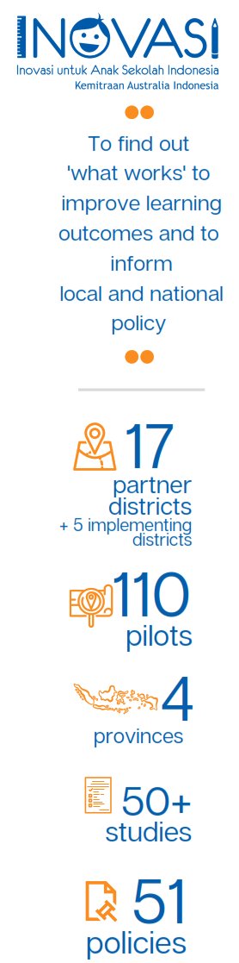
  - Types of Support
INOVASI worked in 17 key partner districts in four provinces, commencing with West Nusa Tenggara in 2016, adding East Nusa Tenggara and North Kalimantan in 2017, and East Java in 2018. Towards the last year of the program, five additional districts became INOVASI implementing partners. While Phase I activities were mainly at sub-national level, INOVASI also worked with policymakers, administrators, practitioners and stakeholders at national, provincial, district and school levels to identify local problems related to teaching and learning, and to jointly develop appropriate solutions for local contexts. Based on INOVASI’s theory of change, the primary mode was to pilot these local solutions and support scale out at district level. The aim was to find out what works and, conversely, what doesn’t work to improve learning outcomes, and to use this evidence to inform local and national policy. The pilots mainly involved continuing professional development conducted in school cluster-based teachers’ working groups (KKG).
The first year of the program, 2016, served as an inception period to establish the program and explore problems associated with learning at the national and district level. In 2017, INOVASI began a classroom action research pilot, Guru BAIK, based on the problem-driven iterative adaption (PDIA) approach developed by the Centre for International Development at Harvard University. Learning from this pilot in West Nusa Tenggara and further developing the PDIA approach, we worked with local stakeholders to explore the problems in a pre-pilot period. This was followed by a series of technically and politically informed ‘short course’ pilots in 2018–2019. These included pilots to improve literacy, language transition, numeracy, inclusion, community participation, leadership and multi-grade teaching. Through a mix of small grants and sub-contracts, INOVASI also partnered with 31 non-governmental organisations, universities and local agencies (including Indonesian research foundations) to pilot a range of approaches to improving learning outcomes and to conduct research. In total, we conducted 110 pilots, consisting of 74 INOVASI-funded pilots and 36 locally-funded pilots (through local government budget funds, the schools’ operational grants – BOS – and corporate social responsibility funds – CSRs) across 22 partner districts and four provinces. The 74 INOVASI-funded pilots included three Guru BAIK pilots, 37 short-course style pilots and 34 grant-based partnerships pilots.
Research and policy work continued simultaneously at district, provincial and national levels. Around 50 studies were conducted and 51 policies were issued. In addition to working closely with TASS, the program collaborated with UNICEF, KOMPAK, ID-TEMAN, RISE and the Tanoto Foundation’s PINTAR project.
The grant-based partnerships allowed INOVASI to learn from local partners and also to broker government collaboration and coalitions with the non-government sector. We engaged in public diplomacy through various platforms and events, such as Temu INOVASI. We also provided technical support, including to MoEC, to: (1) develop and pilot a national students’ performance assessment (AKSI); (2) review and update a national teacher competency framework; (3) develop new approaches to approving books for schools; and (4) develop and pilot an instrument for identifying special needs (Student Learning Profile). INOVASI worked with the Ministry of National Planning and Development (Bappenas) and TASS to contribute to the National Mid-term Development Plan (RPJMN) as well as with the Ministry of Religious Affairs (MoRA) to pilot its continuing professional development program (again, with TASS). Partnerships with NU Ma’arif and Muhammadiyah, Indonesia’s main Islamic organisations, were politically significant and provide a basis for further improvements in the Islamic basic education sector in Phase II.
Initially, DFAT had envisaged that TASS would work closely with MoRA while INOVASI would work with MoEC. This division related to the different management models in the two ministries. MoEC takes a decentralised approach, with responsibilites devolved to the regions and districts, while MoRA maintains a centralised model with the Islamic schools (madrasah) coming directly under the ministry. Thus in the first two years, INOVASI did not engage closely with MoRA or work with the madrasah. However, at the beginning of 2018, inputs from local governments and NU Ma’arif, resulted in a change of policy and MoRA became a part of the INOVASI program. TASS was working within MoRA to support the development and piloting of a national continuing professional development system for their teachers and from 2018 INOVASI also became involved in this process. INOVASI helped to implement the pilot in East Java and to adapt approaches and modules for teacher training in literacy and numeracy for use in madrasah. At the same time INOVASI expanded the pilots in West Nusa Tenggara and East Java to include clusters of madrasah and engaged a senior Islamic education specialist – a resource shared with TASS. Following a series of negotiations, INOVASI signed memorandums of understanding with both NU Ma’arif and Muhammadiyah. The work with MoRA and the Islamic organisations continued for the remainder of Phase I and is being further strengthened in Phase II.
As a result of the work with MoRA and the Islamic education sector, MoRA adopted INOVASI’s modules on literacy and numeracy for its continuing professional development program that will be scaled out nationally with financial support from a World Bank loan. The largely private Islamic schooling sector consists predominately of small, family-based madrasah serving rural and poor communities but 20 per cent of Indonesian children are schooled in these madrasah. While the fundamentals of teaching and learning, literacy, numeracy and inclusion are the same across the different sectors, madrasah face specific problems of limited resourcing and supervision. Nonetheless, MoRA is committed to improving teacher quality and learning outcomes, and the community support for madrasah and the Islamic sector provides an excellent basis for partnership. The work in Phase I has laid the foundations for INOVASI to build on this partnership in Phase II.

  - Expenditure and Financial Analysis
By the end of Phase I, Palladium had invoiced DFAT for a total of AUD49,155,100 in reimbursable costs for the program covering the whole Phase I duration from January 2016 to 30 June 2020.
INOVASI spent more for each financial year of the program as it added more provinces and extra activities across national and provincial levels. The spending patterns across financial years are shown in figure 1.

Figure 1: INOVASI: spending patterns, 2016–2019
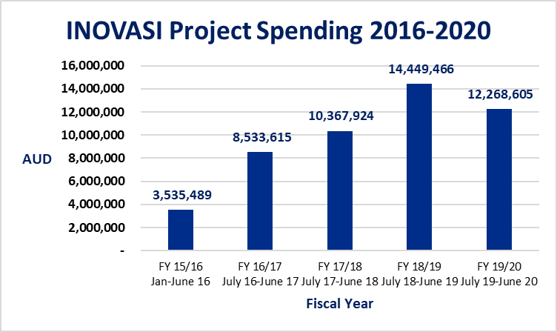

During INOVASI Phase I, several external audits were conducted, with the latest one completed in March 2020 for the 2019 calendar year period. The audit was conducted by Johan Malonda audit firm and there were no major negative findings in relation to compliance nor value for money. All audit findings and action items were followed up and reconciled, with detailed audit reports shared with DFAT.

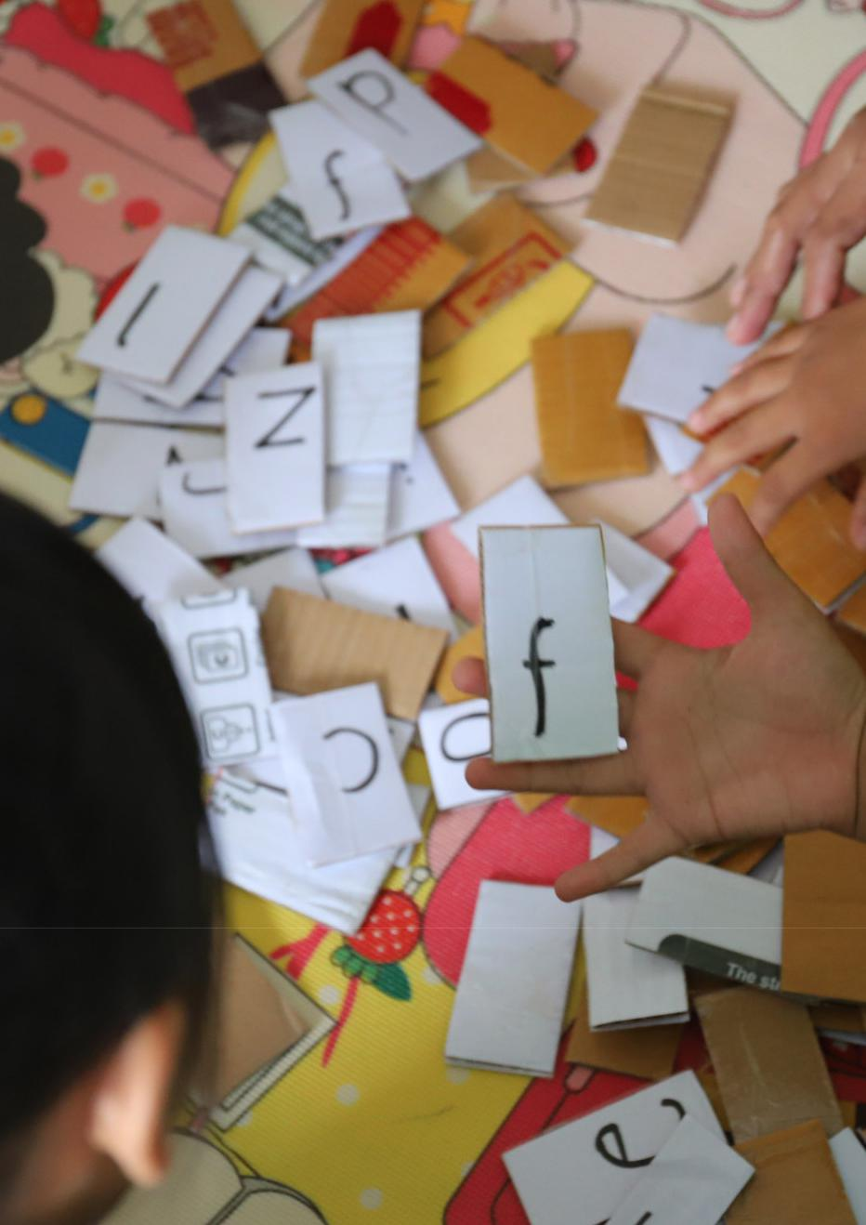

- PILOTS
Pilots are at the heart of INOVASI’s approach to finding out what works to improve learning outcomes and we funded 74 locally contextualised pilots in schools and districts in Phase I. INOVASI strengthened the evidence from these pilots (summarised in section 2.3) through a range of research activities. Our communications strategy leveraged this evidence base to support policy development across different parts of the system and to broker exchanges of experience, skills and capability across the actor groups in the sector.
INOVASI facilitated four rounds of pilots in Phase I. Round 1 in 2017 consisted of the Guru BAIK and Gema Literasi pilots in West Nusa Tenggara. A period of exploring problems followed in late 2017 and early 2018 and, based on our findings, we designed the Round 2 pilots that we conducted in 2018 and 2019. These pilots focused on literacy, numeracy, inclusion, language transition, multi-grade learning and school leadership. Over the same period (2018–2019), our non-governmental organisation and university partners conducted the grant-funded pilots on the same themes. Taking lessons from the Round 1 and 2 pilots, Round 3 took place in the second half of 2019, focusing again on literacy, numeracy, inclusion and language transition. Round 4 pilots, conducted in parallel with Round 3, focused on systemic reform at district and provincial level to support the institutionalisation and scale out of successfully piloted continuing professioinal development programs. These pilots were known as ‘Jalan Andrews’ (Andrews’ way) referring to Matt Andrews, one of the prinicipal authors of the problem-driven iterative adaptation approach (Andrews, Pritchett and Woolcock 2017).
When considering how far INOVASI helped accelerate progress towards improved learning outcomes in Phase I, we need to recognise that INOVASI is a partnership. In the first two years, our activities focused on building working relationships, exploring problems and developing the PDIA approach to finding solutions at school and classroom levels. The Round 1 pilots, Guru BAIK and Gema Literasi, demonstrated that changes in teaching practice can improve learning outcomes, especially in literacy. These pilots were subsequently scaled out in six districts with local government funding. Scale-out pilots also improved learning outcomes while later pilots took a more technical and political approach to achieving this goal.
The transition from classroom action research in Round 1 to technically-informed pilots on literacy, numeracy and inclusion in Rounds 2 and 3 was an iteration of the model taking a more politically-informed approach that also deepened INOVASI’s impact. INOVASI supported continuing professional development in existing teachers’ working groups (KKG) to develop technical skills and raise awareness among teachers. School supervisors monitored the program while teachers and school heads assessed the learning outcomes. In regions where local government bought into the program it had the greatest impacts, both in terms of scale out and learning outcomes.
Over the four and a half years of Phase I, the INOVASI pilots acted as the proof of concept, demonstrating how to effectively support reform in teaching and learning within the larger system, without taking on a quasi-service delivery role. By building trust and approaching problem solving in a collaborative way, INOVASI became a trusted partner to teachers, schools, government and civil society, and thus fostered positive change. The evidence from our pilot experience became a catalyst for reform in aspects of the system at district, school and classroom levels while TASS developed this same capability in the national policy space. With the two programs being integrated, we are set to realise the full potential of the joint program in Phase II.
  - Contribution to Program Goal
INOVASI aims to accelerate progress towards improved learning outcomes for Indonesian students by catalysing changes in the system that can benefit students across the country. While Phase I piloted approaches that demonstrably improved learning outcomes in the specific contexts of our partner schools and districts, our broader contribution comes from leveraging the evidence from these pilots to inform policy at the regional and national levels.
We made the most contribution in Phase I when our work aligned with policy areas where there is emerging consensus across actor groups that something needs to change. Aiming to improve Indonesia’s economic productivity in the longer term, government wants to see a shift from a workforce of low and semi skilled labour to an educated workforce that can compete in the knowledge economy at national and international levels. Thus government and civil society were already focusing on basic education and the need to boost students’ performance in literacy and numeracy. Furthermore, our pilot focus areas of community participation, school leadership, mother tongue transition, inclusion and multi-grade learning all feed into the same goal of fully developing the country’s human capital.
Box 1: Improved learning outcomes in literacy
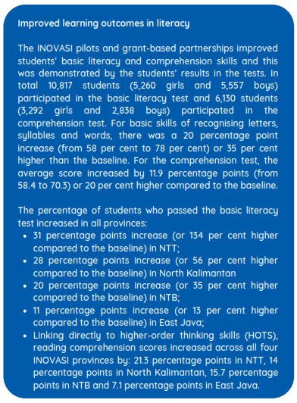
Results from the pilots contributed significantly to the program goal and also laid the groundwork for increasing the pace of change in Phase II. However, Indonesia faces a number of geographical, logistical and cultural challenges in improving learning outcomes at scale, relating to the size and make-up of the country and the diversity of languages and cultures. Some communities have deeply embedded beliefs about the process of learning and the roles that schools, teachers and learners should play. Also, gender roles are also still culturally determined in some communities. Furthermore, government may not have the necessary human and other resources to raise awareness, train teachers and advocate for fresh thinking in education across the country.
Nevertheless, during Phase I INOVASI and TASS created opportunities for government and civil society actors to advance the quality education agenda and this process will continue in Phase II. INOVASI’s school and cluster-based pilots had a demonstration effect that allowed us to extend the reach and influence of the program to district and provincial levels. This natural bottom–up progression of the learning through the pilots from schools and school clusters to districts and provinces generates confidence in alternative ways of doing things. Thus, the program can help the national government extend its reach as it rolls out key policy changes by feeding information back to government on how those policy imperatives and changes are being taken up at lower levels of the system. This is the feedback loop where INOVASI becomes a knowledge broker, connecting different actor groups within the system.
This system-level change becomes the focus for INOVASI in Phase II although we will continue to support wider scale out and sustainability of the Phase I outcomes. INOVASI will leverage these outcomes to support Indonesia’s efforts to reform policy in key areas, such as curriculum, assessment, teachers’ continuing professional development, teacher training and teacher management.

  - Progress towards End-of-program Outcomes
INOVASI contributed to the program goal through the three end-of-program outcomes we describe in this section. However, our achievements varied depending on a range of factors across different contexts.
End-of-program outcome 1: A credible body of evidence is available of what policy and practice changes work to improve student learning outcomes in Indonesia
Table 1 presents the issues and the evidence emerging from our pilots and related activities on what does and doesn’t work to improve learning outcomes. In the first column we identify and explain the issues and in the second column we assess the relative success of different solutions in local contexts. The evidence is drawn from the pilots and supported by INOVASI and TASS research, as well as by lessons from earlier programs in Indonesia and elsewhere. This evidence is discussed in more detail in section 2.3 and in Annex 7.

Table 1: What works and what doesn’t work to improve learning outcomes: evidence from INOVASI Phase I
Key areas : Literacy and numeracy
Defining the problems | Emerging evidence
Learning outcomes across the curriculum are below expectations for many Indonesian students throughout their schooling and this is largely due to their limited foundational skills in literacy and numeracy. This is reflected in students’ relatively low scores, for example, in the Programme for International Student Assessment (PISA) tests. Furthermore, on leaving high school students are not prepared for the world of work:  - Early grade teachers lack the knowledge and skills to teach basic literacy and numeracy.  - The curriculum does not include a methodology for teaching literacy in the early grades but teaching reading is not part of the preschool curriculum either.  - The primary maths curriculum is too abstract and fast-paced which means, for example, that teachers and students in the mid-primary classes are still confused about fractions.  - Teachers and students lack access to appropriate children’s books for beginning reading. This may be due to: cumbersome book approval systems; inadequate book supplies to remote areas; limited business models in publishing and book distribution; and lack of awareness of the value of non-textbooks in literacy learning. | What works?  - Cluster-based short courses are an effective way of upskilling teachers – and this demonstrably improves learning outcomes.  - Building a reading culture in schools and communities improves learning outcomes.  - Providing appropriate books improves learning outcomes.  - Districts can take the lead and where they do, results are impressive.  - The most effective way to improve literacy involves multiple stakeholders, multi-source funding, and policy and technical support.  - Learning outcomes improve most in the regions where education is weakest and learning outcomes are poorest before the intervention.  What doesn’t work?  - While top-down, centrally-driven cascade training appears to be a practical solution to reaching more teachers, it has not always succeeded in changing practices.  - Teachers cannot be expected to find their own solutions without technical support and access to a body of professional knowledge.  - Teachers cannot make and sustain changes in their teaching practices without corresponding changes to the curriculum and assessment processes to support them.
Key areas : Inclusion
Defining the problems | Emerging evidence
- Teachers lack the knowledge and skills to accurately identify children with disabilities or learning needs and to integrate these children into mainstream classes.  - Many children entering primary school are not fluent in Bahasa Indonesia, the language of instruction, so they fall behind their peers and typically never catch up.  - Girls tend to outperform boys in primary classrooms.  - Women are under-represented in leadership positions in the basic education system. | What works?  - The Student Learning Profile that INOVASI and TASS developed and MoEC piloted is an effective and easy-to-use tool that enables teachers to better identify students’ special needs.  - Using mother tongue in the early grades and transitioning to Bahasa Indonesia proved to be a successful approach and increased students’ scores more than by just running the regular literacy pilots.  - INOVASI Phase I identified issues around gender in the classroom and the education system and we plan to address these issues in Phase II.  What doesn’t work?  - Enabling teachers to identify disabilities and learning needs is not enough. They need strategies and support to include children with disabilities and special needs in mainstream classes.  - Expecting teachers to find their own solutions is unrealistic. Teachers need to be given agency and have ownership of solutions that work in their context but they also need technical support and advice to find the best solution.  - Without strong regulatory support from districts, teachers are reluctant to use local languages in the classroom.
Key areas : Teacher support and leadership
Defining the problems | Emerging evidence
- For many small primary schools in Indonesia the policy of separate classes and a teacher for each grade is inefficient and unproductive.  - Teachers’ working groups are typically underused as a forum for continuing professional development.  - Principals and supervisors need to strengthen their leadership skills but MoEC’s leadership training centre in Central Java is unable to meet the demand.  - Districts lack the credible data they need on learning outcomes to develop new policies. | What works?  - Multi-grade teaching is more efficient for teacher deployment and it improved the classroom climate and learning outcomes in pilot schools.  - Leadership training for principals works well when linked to specific learning objectives, such as improving literacy.  - Short-course style continuing professional development works well in teachers’ working groups when facilitators are well prepared and the training focuses on identified district priorities, such as literacy or numeracy.  - Results from credible assessment processes can be used to create awareness of the need for improvement and to drive policy reforms.  What doesn’t work?  - If regulations are not accompanied by a practical implementation plan and supported with resources, they are unlikely to make a difference.

End-of-program outcome 2: Decision makers have access to and use this evidence to facilitate and implement more effective education reforms
Box 2: Key national policy outcomes
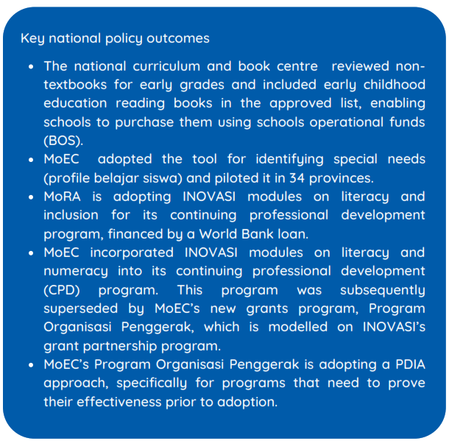
The evidence INOVASI generated was communicated to decision makers strategically to support the reform process through various channels:
- Targeted policy products, such as the emerging evidence document (INOVASI, 2018), policy briefs and presentations in public forums (policy consultations and Temu INOVASI events) at national and sub-national levels;
- Thematic studies published in the final months of Phase I and appended to this report, will be summarised and packaged as policy briefs for decision makers;
- Small meetings and one-on-one consultations with senior government officials and ministerial advisors, through audiences, meetings and online communications (WhatsApp, email);
- Curated joint-monitoring visits for national officials to see the evidence of improved practices in schools and districts firsthand and to directly consult with practitioners and local officials;
- Broader communication platforms, including through the INOVASI website, Facebook and WhatsApp groups, and regular provincial newsletters.
INOVASI’s Communications Strategy was instrumental in achieving the broad reach of the program. Evaluating this strategy will be a priority early in Phase II to assess its success in influencing policy and behaviour change, and to update the strategy for Phase II.
In Phase II we will collate the key findings from Phase I and make them available in an accessible format and location after some consideration and consultation. A common criticism of donor studies is that the findings are not easily available to decision-makers and stakeholders once the project is completed. With an increasing sense of partnership and ownership of INOVASI within MoEC, finding a sustainable solution to this problem will be a priority in Phase II.

End-of-program outcome 3: The effective policy and practice changes identified are reflected in Indonesian government (district, provincial, national) policies, regulations, budgets and plans
In Phase I, INOVASI facilitated policy dialogues that resulted in 51 regulations at village, district and provincial levels. In addition, INOVASI’s work in collaboration with TASS resulted in five significant national policies and programs. INOVASI works closely with MoEC’s policy research, curriculum and assessment centres and the Directorate General for Education Personnel and Phase II will focus increasingly on this area.
Box 3: District education finance analysis
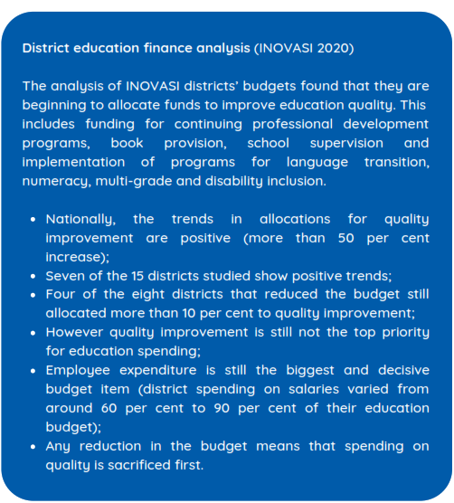
- At district and provincial level, INOVASI’s inputs (pilots, research and policy work) can be linked directly with the policy outcomes (new regulations). In East Nusa Tenggara, INOVASI and TASS worked together on a province-wide ‘grand design’ to improve learning outcomes, especially in literacy, numeracy and character education.
- The impact on INOVASI’s partner districts is evident in their annual budgets that now emphasise programs to improve learning outcomes, including by scaling out successful pilots. This emerged from an analysis of education finance patterns in the districts and by tracking trends in funding over the last three years. Key findings are described in Box 3.
- At national level, the impact of INOVASI’s policy work is less linear but in some ways more significant. This is due to the complex policy environment and the role played by multiple stakeholders – including other DFAT-funded programs such as ID-TEMAN, KOMPAK, UNICEF and RISE. INOVASI worked closely with TASS to leverage the outcomes and networks of the two programs.
In brief, the policy impacts at national and sub-national levels are as follows:
- Literacy and numeracy: Using assessment results to highlight the low literacy and numeracy levels among local children effectively leveraged policy support in INOVASI partner districts and at provincial level in East Nusa Tenggara. The aim was to create a ‘sense of crisis’ to stimulate political support for ‘doing things differently’ around literacy in early grades.
- Book supplies: INOVASI worked with MoEC’s curriculum and book centre, non-government agencies and the publishing industry to improve book supplies – including to remote areas, such as North Kalimantan. We engaged with Indonesia’s national publishing industry body, representing firms like Gramedia and Airlangga, and partnered with the Asia Foundation to provide free-download digital children’s books. We also partnered with the Pen Circle Forum (Forum Lingkar Pena) to provide inclusive books, using pictorial sign language. As a result of this ongoing engagement, the ministry’s book centre amended its policy on books for primary schools and agreed to review the content of children’s workbooks and teachers’ guides for literacy and numeracy.
- Curriculum review: Government began a review of the national curriculum in 2019 and INOVASI and TASS supported this process by providing specialised advisors and feedback from INOVASI’s literacy and numeracy pilots. INOVASI will therefore have the opportunity to leverage relevant evidence from the pilots and research activities to contribute to this ongoing process in Phase II.
- Inclusion: Central Lombok embraced inclusive education, making it a significant policy platform. The Student Learning Profile, was initially developed for Central Lombok’s pilot but MoEC (supported by TASS and INOVASI) then piloted the tool in inclusive schools nationwide and the application is subsequently being refined. The next step is to develop a guidebook for teachers on integrating children with identified special needs in regular classes. This is significant because interest is now evident up to the national level.
- Continuing professional development: Cluster-based continuing professional development is a priority for both MoEC and MoRA. Both ministries have approved the training modules INOVASI designed and teachers are now credited for attending the sessions, contributing to their career advancement. Districts have adopted the approach and are scaling it out. INOVASI has also started to adapt traditional training modules for online and remote delivery.
- Partnerships with non-government organisations: INOVASI is working closely with MoEC on its new Program Organisasi Penggerak that will give small grants to several hundred non-government partners to provide continuing professional development to teachers across the country. This program is modelled on INOVASI’s grant-based partnership program and INOVASI is helping the ministry to design and implement it.
- Problem-driven iterative adaptation (PDIA) as an approach: Based on how INOVASI has been working, MoEC is also adopting a PDIA approach specifically for its large-scale Program Organisasi Penggerak that is still at its inception stage.
- Multi-grade learning: With no tradition of using multi-grade classes, introducing this approach in Indonesia is likely to be challenging. It is expensive initially as teachers need incentives and training, parents and teachers need persuading, and local district officials must learn to manage the more complicated system. Nonetheless, MoEC is considering the multi-grade approach as part of its new strategic plan and the personnel director for the madrasah wants to include it in MoRA’s continuing professional development program. Teachers in small schools already end up teaching students in different school years at the same time but without the official support and expertise that can turn this into an advantage.
- Assessment: INOVASI has maintained strong links to MoEC’s national assessment centre under the research and development body and one of government’s emerging priorities is to routinely use assessments at the classroom level to drive planning at the national policy level. Participating in international benchmarking tests, such as PISA, Trends in International Mathematics and Science Study (TIMSS) and the Progress in International Reading Literacy Study (PIRLS) has highlighted the need to improve learning outcomes – and develop credible measures of progress. TASS and INOVASI both worked with MoEC on developing and piloting the Indonesian students’ performance assessment (AKSI, now AKM) approach. INOVASI also helped pilot the effective use of formative assessment in classrooms, schools and districts to inform practice and policy.
  - The Evidence Base: What’s Working?
Box 4: Correlation analysis: literacy and numeracy skills
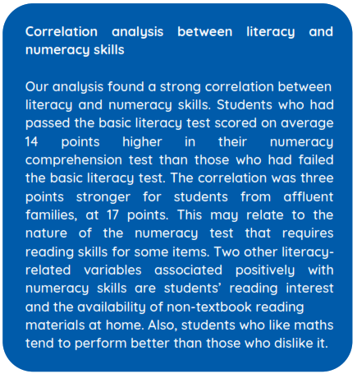
Phase I of INOVASI sought to find out what works to improve learning outcomes – and to use this evidence to inform policy. This section summarises and discusses the findings under INOVASI’s three areas of investigation, based primarily on results from the comprehensive baseline and endline studies, using INOVASI’s education and learning survey, SIPPI (Survei Inovasi Pendidikan dan Pembelajaran Indonesia).
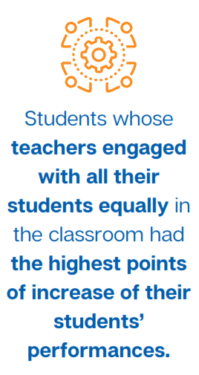
The results are aggregated from the three rounds of INOVASI-led and grant-funded pilots without considering variations across pilots or the diversity of approach, context or performance. In this aggregation, 380 out of 746 schools (51 per cent) and 1,078 out of 2,238 teachers (48 per cent) benefitting from INOVASI support were randomly selected for the baseline and endline surveys. With 95 per cent confidence level and 5 per cent margin of error, the samples were sufficient to represent program-level results. The analysis includes before and after comparisons (baseline–endline surveys), correlation analyses and monitoring data derived from the spot checks. The spot checks consisted of classroom observations, surveys and interviews.
Further details on the results are available in Annex 7 and in the thematic studies that bring together evidence from all the pilots in the key areas of literacy, numeracy, disability inclusion, gender, continuing professional development and sustainability, the PDIA approach, and partnerships. See Annex 1 for abstracts of these studies.
The quality of teaching in the classroom

Student-centred teaching
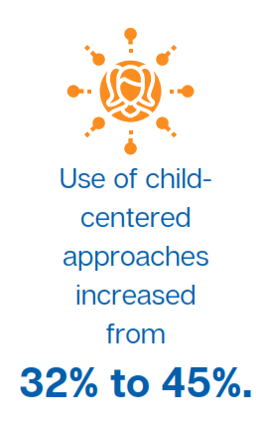
One issue that affects the quality of teaching in the classroom is whether and how much the teacher uses student-centred approaches. These include, for example, using open-ended questions, delving into students’ opinions, using appropriate teaching tools, recognising students’ efforts and having well-balanced interactions with students in the front, middle and back of the classroom. These contrast with teacher-centred practices that rely on reading exercises, repeating or memorising and copying from the blackboard, with lessons typically focusing on textbooks and teachers explaining in one-way communication. Teachers who participated in the INOVASI pilots are clearly shifting towards student-centred approaches with students actively participating in the learning. Evidence of this shift was drawn from teacher interviews and classroom observations. Furthermore, the literacy thematic study (Fearnley-Sander 2020) investigated outcomes from 25 pilots on teacher improvement and books, and concluded that most participating teachers changed their practices and adopted ‘critical elements for teaching reading’.
Teacher interviews: Most teachers (68 per cent) in the baseline interviews acknowledged that their style of teaching was teacher-centred and dominated by lecturing. Following the interventions, the percentage of teachers who said they used student-centred approaches increased from 32 per cent to 45 per cent. The use of discussions, question-and-answer sessions and debates had increased by the endline although lecturing remained dominant.
Classroom observations: Positive changes in classroom teaching practice were evident during the observations and these are shown in figure 2.
Figure 2: Changes in teaching practices: baseline–endline results
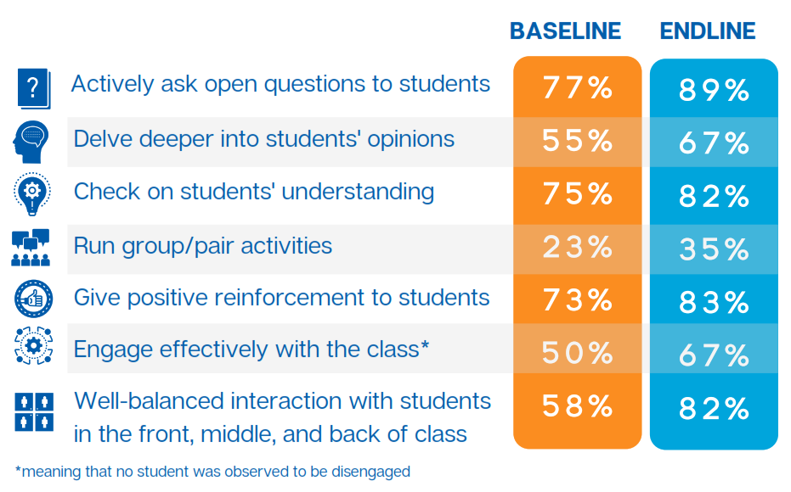

‘Literate’ classrooms
Another key issue in the quality of teaching is whether students are learning in ‘literate classrooms’. SIPPI describes these as ‘print-rich’ classrooms that have books, reading corners and classroom displays of learning materials and the students’ own work. Following the pilots, more classrooms were in this category. Teachers used the walls for displays and in language transition classrooms both local languages and Bahasa Indonesia materials were included. This exposes children to literacy materials in their day-to-day activities.
• The percentage of teachers displaying students’ work increased by 26 points, from 45 per cent to 71 per cent.
• The percentage of teachers displaying teaching/learning materials or aids increased by 15 points from 69 per cent to 84 per cent.
• More teachers have set up reading corners in their classrooms that include non-textbook readers and children’s literature, with a 23 point increase from 24 per cent to 47 per cent.
A similar trend was found in INOVASI’s first round of technical literacy pilots and in the partnership pilots, with the results doubling (from 23 per cent to 55 per cent and from 22 per cent to 44 per cent respectively). The format and standard of the reading corners varied across schools and areas as some appeared to be well-organised, with small areas set up interestingly for comfortable reading, while others were just basic facilities to keep books. Some schools allocated books for inside and outside the classroom to allow students easier access to books. Regardless of the variations, the reading corners mean that students now have more access to books.

Numeracy teaching
INOVASI conducted two rounds of pilots on numeracy in six districts. An analysis of results in the thematic study on numeracy (van der Heijden 2020) found that participating teachers improved their own understanding of the mathematical content and pedagogy needed to support children’s understanding of basic numeracy concepts. The quality of their knowledge and skills in teaching numeracy also improved. This, in turn, led to students improving their conceptual knowledge and understanding of number, as well as their ability to demonstrate their reasoning and apply their knowledge (see section 2.5).
Aside from the quantitative results from the baseline and endline surveys, the numeracy study used a teacher practice index based on the SIPPI indicators in the observations and interviews and the results suggest that a change in pedagogy had an impact on students’ thinking and reasoning abilities (van der Heijden 2020, 20). Teachers used relevant concrete and visual materials effectively to scaffold students’ understanding towards more abstract concepts. They asked students more open-ended questions, although students needed more exposure and experience in explaining the processes and thinking about how they arrived at a solution. Teachers also took a student-centred approach in organising their students into groups based on their pre-assessment data.
Furthermore, the numeracy study showed that after the pilot, teachers developed more confidence in their students’ ability to understand the subject and more students said they considered numeracy their favourite subject. Teachers who have a growth mindset tend to be more effective in building their students’ confidence in learning, a key element in improving the quality of learning and teaching (Dweck, 2008).
The quality of support for teachers
In investigating the quality of support for teachers, INOVASI focused on the following key issues: continuing professional development and teachers’ working groups; school leadership; and book provision.

Teachers’ working groups and continuing professional development
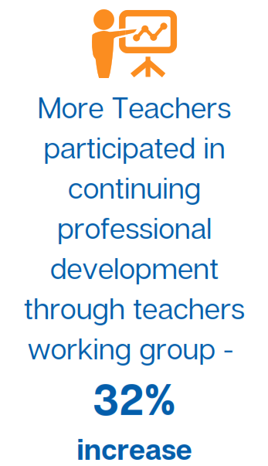
The Ministry of Education and Culture aimed to develop and refresh the professional skills of teachers, principals and supervisors through the working group cluster system (INOVASI July 2019) and it issued standards and operating procedures to support these groups (Ministry of National Education 2008, 2010). However, INOVASI’s study on working groups in five of the target districts in West Nusa Tenggara province (INOVASI June 2019) found that ‘as a forum for improving the quality of teachers, principals and supervisors, the working groups are not yet functioning optimally’. At this stage, the study reported that: ‘Some working groups offer professional development through training and other activities but this is still not common and administrative tasks or lesson planning dominate.’ Recognising the challenge that the government faced in ensuring that the working groups fulfilled their remit, INOVASI resolved to contribute to this process through its pilot program.
INOVASI’s Round 2 and 3 pilots in 2018–2019 included support for teachers and principals through continuing professional development delivered through the working groups as well as through follow-up mentoring activities. Data from these two pilot rounds show that more teachers participated in training for teachers (excluding INOVASI training) with a 10 percentage point increase from 62 per cent to 72 per cent. In the last year of the program, more teachers participated in continuing professional development activities in teachers’ working groups with a 32 percentage point increase from 43 per cent to 75 per cent.
As a result of continuing professional development activities in the teachers’ working groups, some teachers reported that they improved their lesson planning by analysing their students’ ability, considering teaching techniques targeted at their learning levels and including learning media. While the increases were small (from 81 per cent to 83 per cent), they were more obvious for teachers incorporating newly-introduced active teaching approaches and media in lesson plans (11 points).

School leadership
INOVASI ran two leadership pilots (Batu City and West Sumba) in Phase I and this is a potential area of focus in Phase II. Monitoring data record that more principals ran professional development sessions in their schools (known as ‘mini KKG’) as a result of the program with increases of 39 and 25 percentage points for Batu City and West Sumba respectively. However, no significant improvement was reported in principals’ instructional leadership. This is an area that potentially drives better teaching practices.
The number of principals supporting teachers by ensuring they have learning materials also differed in the two pilots with the number in Batu City decreasing by 15 percentage points and the number in West Sumba increasing by 67 percentage points. The starting point was lower in West Sumba compared to in Batu City but other variables confirmed that the pilot had limited influence on managerial decisions to support teachers for quality learning. Nevertheless, spot-check data showed that principals who took part in the leadership pilots were more likely than their counterparts to allocate the schools operational (BOS) funds to support literacy and numeracy.
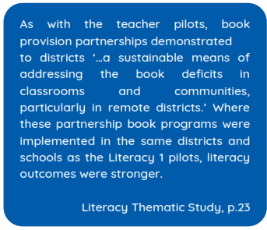
A key finding from the pilots is that combining leadership training for principals with the literacy and numeracy training for teachers resulted in better learning outcomes than running the literacy and numeracy pilots on their own. For instance, the results from a numeracy pilot that was combined with a leadership pilot and a numeracy pilot without the leadership program were 84 per cent and 32 per cent respectively for better learning outcomes. A similar trend was evident for other types of technical pilots. Overall for both literacy and numeracy pilots, the results for better learning outcomes were more than double when the leadership pilot was included (76 per cent for any pilot plus leadership versus 34 per cent for any pilot without leadership).

Book provision
INOVASI partnered with several non-government organisations and private companies’ corporate social responsibility programs to improve book supply in schools and communities, as a critical element in improving reading (Fearnley-Sander 2020). This was evident especially in North Kalimantan, where Litara, the One Person, One Book program (OPOB) and the Asia Foundation (digital books) worked with the district and local communities to improve access to appropriate children’s books. The district provided local funding for schools and set up a working group to approve books. In the four Sumba districts, Rainbow Reading Gardens (Taman Baca Pelangi), a non-governmental organisation, established demonstration school libraries.
‘Two of the book pilots combined book supply with teacher development. In Central Lombok, the Pen Circle Forum (Forum Lingkar Pena) developed books to support inclusive teaching, designing books with sign language and modelling inclusion though the diversity of characters included in the stories. In two districts of Sumba, the Indonesian Children’s Literature Foundation (Yayasan Literasi Anak Indonesia – YLAI) provided a sample of balanced literacy teaching through the number of graded readers it has developed. It also modelled the shared and guided reading methodologies that enable teachers to put books at the centre of basic skills development and comprehension in reading’ (Fearnley-Sander 2020, 24).
Learning for all
Certain groups of children can be excluded from learning, including: children who are not yet fluent in Bahasa Indonesia, the language of instruction; children with disabilities; children living in remote areas; and boys or girls who are excluded from aspects of learning due to gender. INOVASI took a twin-track approach to exploring the issues and piloting solutions for inclusion: mainstreaming and targeting individuals and groups potentially at risk. Key elements of this strategy included:
- Improving how teachers identify and teach children with disabilities;
- Investing in basic literacy for the many children who do not speak Bahasa Indonesia at home (language transition pilots);
- Identifying innovations that improve teaching and learning in schools in remote areas;
- Exploring issues around gender equality and women’s empowerment (Gibson and Purba 2020).

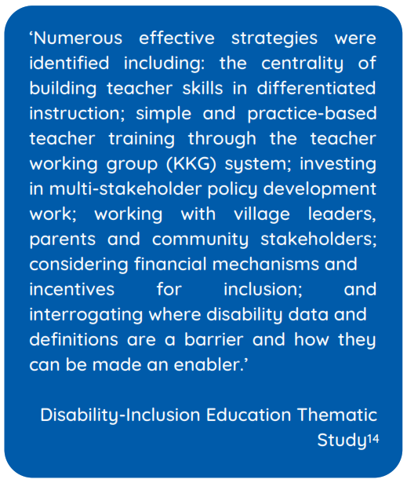
Disability inclusion
In Phase I INOVASI conducted three pilots and three grant-funded partnerships that focused on disability-inclusive education. The studies explored the problems, developed and tested the Student Learning Profile and undertook an extensive multi-stakeholder policy analysis and development process to prepare the Central Lombok Regency Inclusive Education Roadmap (2019–2021). A thematic study on disability inclusion (Sprunt 2020) draws together the evidence from this work.
The study found improvements in learning outcomes among students with disabilities in the INOVASI pilot schools and highlighted the value of strengthening disability data systems and policy tools to enable inclusive education.
INOVASI conducted inclusion pilots in Central Lombok, Sidoarjo and East Sumba. As a result, in these districts, children with disabilities had more opportunity to enrol in regular schools. Villages also initiated support to assist families with special needs children. In Central Lombok, teachers in partner schools learned to use the Student Learning Profile to identify students with specific learning problems. The teachers then prepared individualised lesson plans for these students. Spot-check data from the inclusion pilot showed, for instance, that 86 per cent of teachers with children with disabilities in their classes reported they used the profile to identify specific conditions that affect learning for their students. However, 68 per cent said that they still need further coaching in using the profile and developing appropriate lesson plans while 18 per cent reported that they lacked specific support for students with disabilities. Thus, more work is needed to ensure quality learning for children with disabilities.

Differentiated learning and gender inclusion
Aside from the targeted disability inclusion pilots, the other pilots also generally promoted learning for all. Teachers participating in the pilots learned to assess students’ learning skills and support those in need through differentiated learning, additional sessions, different tasks or assignments and grouping children with similar levels of learning ability. Except where indicated, the following results are aggregated from the Phase I Rounds 2 and 3 pilots and grant-based partnerships:
- In language transition pilots, the student learning outcome gaps between children who speak a local language and those who speak Bahasa Indonesia were reduced, although results varied across the three language transition pilots.
- Studies have revealed that students from families with low socio-economic status are behind in their reading levels and have limited interest (Van Vechten 2013; Aikens and Barbarin 2008). The endline study of INOVASI pilots shows the gap is closing between students from low and high quantiles of the socio-economic index and the difference came down from 47 to 30 points on the endline basic literacy test.
- In the multi-grade pilot, test scores in Probolinggo in East Java increased the most among the five districts involved while on the baseline the students’ performance was the lowest across these pilots. The scores increased by 18 points from 62 per cent to 80 per cent (the provincial range is 10 to 18 points) or, as a proportion, by around 28 per cent (the provincial range is 13 per cent to 28 per cent). Nevertheless, the score remained the lowest at 80 per cent compared to 98 per cent in Batu City. The trend was similar for the average score in the literacy comprehension test although the gaps were small.
- INOVASI’s literacy and numeracy tests, disaggregated by gender, show that girls consistently outperformed boys. This was true in the baseline and the endline tests, and across the four provinces. The gender gap, however, was smaller by the endline. While the pilots did not specifically target boys or aim to close the gap, this effect is likely the result of teachers using more effective practices that engaged both boys and girls. At baseline, for example, the gap for literacy ranged from 8 to 13 points across provinces. By endline, the gap in all provinces ranged from 2 to 11 points for INOVASI’s first round of pilots. For all pilots, including grant-funded partnership pilots, the gap ranged from 5 to 20 points.
The disability inclusion thematic study (Sprunt 2020) highlights areas where the program can be strengthened in Phase II. This includes: proactively using and strengthening the work of disabled peoples’ organisations and disability service units in supporting inclusive schools; designing pilots with a broader focus than just teacher capacity development, to address the issue of most children with disabilities being out of school; building the capacity and commitment of principals and supervisors to ensure accessible infrastructure, adequate resources and greater support for teachers; and addressing the system and teaching capacity required to implement assessments inclusively.
In Phase II we will build on the findings from Phase I and deepen our work on gender equality by taking action to:
- Involve a full-time gender specialist from the beginning of Phase II (to ensure pilot designs and policy work take account of gender from the outset);
- Include gender-focused activities and events in the workplan and dedicate a realistic budget to support these activities;
- Seek out allies in government and civil society who can help us make wise choices about how we engage on gender;
- Explore the feasibility of designing and delivering a gender-focused pilot (grant, short-course or other) in Phase II;
- Strengthen the school leadership pilot to improve leadership and management skills for all principals and to promote women’s empowerment;
- Consider the potential for character education to provide opportunities for children to practise values of equality, respect and teamwork – these can and should include a gender dimension (Gibson and Purba 2020).

2.4 Snapshot of Findings from Pilots and Provinces: Literacy
INOVASI conducted a thematic study to analyse the results of all its Phase I pilots that explored ways to improve literacy outcomes (Fearnley-Sander 2020). The main finding from the pilots and the study is that student outcomes improved in the pilot schools – more than could be explained by natural growth. This finding was echoed in the other thematic studies for numeracy, disability inclusion, partnerships and continuing professional development.
Other key findings on what worked to improve literacy can be classified into the elements that helped mitigate disadvantages in particular contexts. The commitment to literacy development of most district governments was a critical element. A pattern that emerged throughout all findings was that the most disadvantaged districts made the most gains and thus, with support from the intervention, they were able to quickly close the gap with the more advantaged districts. A related finding was that outcomes from pilots adapted to target specific contextual difficulties, such as language of instruction or access to books, outstripped results from the mainstream approaches to improving teachers’ know-how in teaching reading.
Such findings have implications for future strategies to maintain and extend the gains in literacy. The short duration of the pilots means that while the shift towards student-centred teaching practices has been remarkable, a permanent paradigm shift is not yet guaranteed.
The following results are aggregated from Rounds 1 and 2 pilots and grant-based partnerships.

Literacy – basic decoding and comprehension skills
The percentage of students passing the basic literacy test in the baseline ranged widely across the four provinces. East Java had the largest proportion of students passing the test at 82 per cent while East Nusa Tenggara had the smallest proportion at 23 per cent. Half the students passed the test in North Kalimantan and 57 per cent passed in West Nusa Tenggara.
Following the pilots, East Java still had the highest proportion of students passing the test and while East Nusa Tenggara still had the lowest, it had improved the most with an increase of 31 percentage points. This was followed by North Kalimantan (28 points), West Nusa Tenggara (20 points) and East Java (11 points). In terms of percentage increase, East Nusa Tenggara improved by more than double (134 per cent increase), while East Java improved by just 13 per cent since the pass rate there was already high.

Figure 3: Percentage of students who passed the basic literacy test at baseline and endline, four provinces

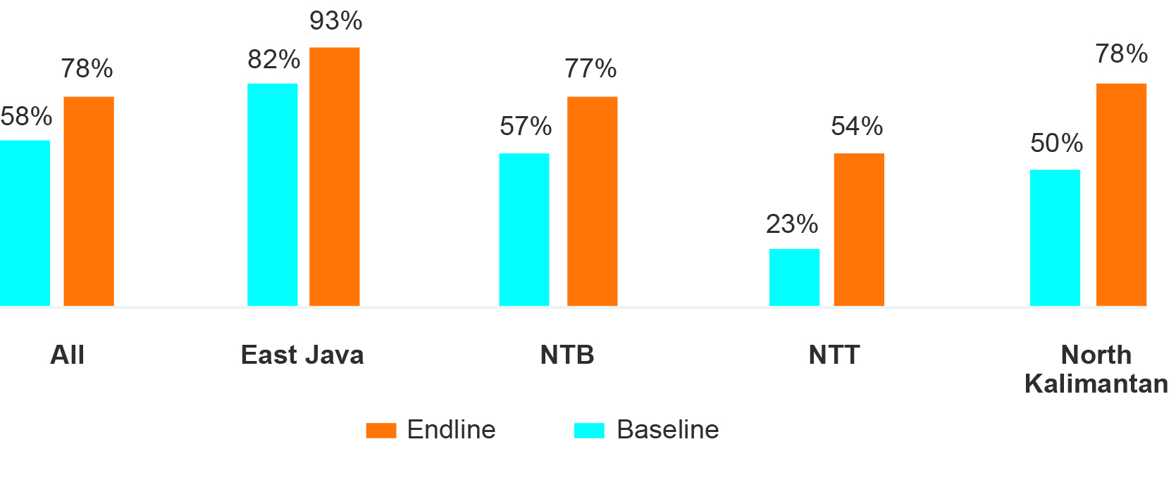
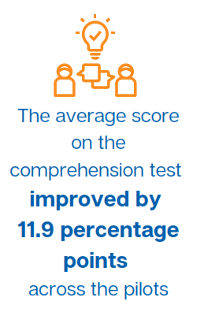
While the performance was generally strong in grade three, about 11 per cent of the 3,414 grade three students failed the basic test. For the most basic component of letter recognition, 4 per cent of grade three students (about 137 students) still struggled. East Nusa Tenggara had the highest percentage of grade three children who failed at 8 per cent while no grade three students failed in North Kalimantan.
The average score on the comprehension test improved by 11.9 percentage points across the pilots (from 58.4 to 70.3). East Java had the highest scores and East Nusa Tenggara had the lowest in both the baseline and endline tests. However, East Nusa Tenggara had the greatest increase that was three times that in East Java (21 points versus 7 points). Most students passed the test on explicitly-stated information and making straightforward inferences but were weak on interpreting and integrating ideas. This was the most challenging part of the test and average scores were below 50 in both baseline and endline tests, with the lowest levels of improvement.
The impact of the pilots when they are funded and implemented by the districts will be investigated in Phase II. In a case study of seven schools in North Kalimantan that participated in the scaled-out literacy pilot, the percentage of students who passed the basic literacy test improved from 68 to 80 per cent (an increase of 12 percentage points) while students participating in the original INOVASI pilot improved by 28 points. These results need further investigation and should not be considered conclusive given the small size of the study and the number of variables. The results indicate that the scale-out activities improved literacy skills in Bulungan and the program reached more than 100 schools with less technical support than the original pilot.

Which literacy pilots were most effective and why?
The literacy thematic study (Fearnley-Sanders 2020) analysed results from the Literacy 1 and 2 pilots, INOVASI’s major experiment in literacy teaching development.
Table 2 : Grade progression on the individual component skills, by province
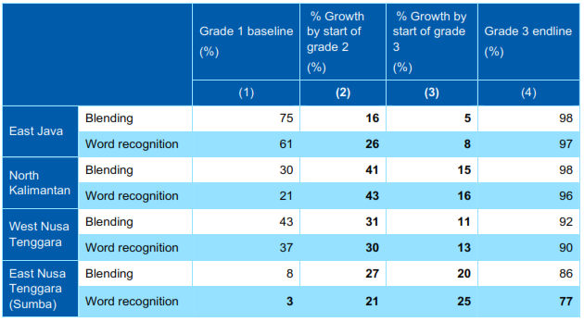

As illustrated in table 2, results on the different component skills in some provinces, notably East Nusa Tenggara and North Kalimantan, reveal larger effects than those at the aggregated basic literacy test level. These findings are valuable diagnostically and show, for example, the low level of word recognition among grade one students in Sumba compared with the other provinces. The gains in that case also show the capacity of the program to overcome these key inhibitors to reading progress. Word recognition also lags behind the other foundational skills in most provinces but conspicuously in Sumba. This may point to language of instruction and vocabulary problems that are not fully recognised in early grades literacy methodologies. This suggests that phonological approaches are not enough to overcome these issues on their own.
Overall, the findings also showed that the considerable variability in the extent of effect across the provinces relates to their different baseline levels and the pattern of the lower the baseline, the higher the gain was sustained.
The pilots were effective in improving comprehension skills — showing more gains than in the component skills — and particularly in the higher-order thinking skill of inferencing. This attests to the value of the balanced literacy approach adopted in the Literacy 1 and 2 pilots. East Java in particular improved more in comprehension skills than in component skills, suggesting that the emphasis needs to be on developing teaching methods in higher order skills rather than in beginning reading skills. Teaching methods in the component skills already seem to be adequate in the province.
The extent to which a disadvantaged region such as Sumba closed the gap with other provinces in comprehension indicates that higher-order thinking is accessible to students even if their basic reading skills are limited. Another important finding is that Sumba leads the other provinces in the gains on listening comprehension, indicating the districts recognise the value of teaching methodologies that strengthen second language learners’ understanding.
Nevertheless, the performance on comprehension, particularly in disadvantaged provinces, should not conceal the scale of the problem of reading poverty, represented by the small proportion of children in the Literacy 1 and 2’s catchment areas that proved eligible for the comprehension tests.

2.5 Snapshot of Findings from Pilots and Provinces: Numeracy
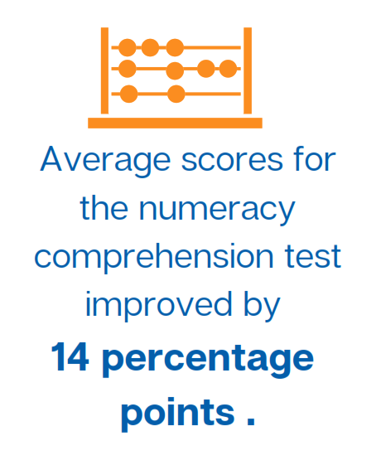
The following results are aggregated from the Rounds 2 and 3 pilots (Numeracy 1 and Numeracy 2) and grant-based partnerships conducted in Sumbawa and East Java. Average scores for the numeracy comprehension test improved by 14 percentage points (from 54.7 to 68.8), consistent with literacy across provinces, while East Java had the highest average scores on the numeracy comprehension test and East Nusa Tenggara had the lowest. The gap between the two was 18 percentage points.
INOVASI’s Numeracy 1 and 2 pilots improved students’ knowledge and, significantly, its application. This suggests that the improved pedagogy is having an overall impact on student learning. Boys still performed slightly below girls but gains were evident, particularly among the boys. With a more student-centred approach, students were enjoying the subject and had more positive perceptions of it.
Teachers who took part in the teachers’ working group sessions improved in most areas of their teaching practice and this affected students’ progress positively. Teachers became more knowledgeable about early numeracy teaching, especially considering their mediocre scores in the baseline SIPPI teacher test. However, they need to learn more about how to scaffold and support students’ responses and give feedback on learning.
Following the pilot, teachers arranged their classes in groups to support student-centred approaches, explained the learning objective at the outset and asked the students more questions. This is a tangible shift from a didactic teacher-centred approach. The teachers’ own expanded knowledge and use of numeracy content and processes also demonstrates their growth mindset towards learning new content and methods.
The thematic study on numeracy (van der Heijden 2020) provides evidence that more time and emphasis should be given for teachers to focus on early conceptual knowledge, skills and understanding in the early-grades curriculum. This will ensure a solid basis for more abstract learning later on.
Prior to the pilot, the teachers were not using specific methods to develop a solid understanding of number and students did not have adequate time to practise and explore number concepts. The training in the teachers’ working group meetings means teachers can continue to learn with and from their colleagues and develop effective teaching practices. Differentiated training for teachers and principals would also create awareness and support for new approaches.
Aside from effective methods, teachers need manageable teaching and learning materials that fit the context as well as the students’ varying levels and learning needs. They also need to conduct regular and varied assessments to gain insights into any difficulties or misconceptions the students may have so they can better organise their classes to meet individual, group and whole-class learning needs. In Phase II the districts have requested support with improving numeracy in the upper primary grades.

Which numeracy pilots were most effective?
Differing conditions and timing for the baseline–endline studies make it difficult to compare outcomes of the two numeracy pilots (van der Heijden 2020). The overall average score in each of the numeracy learning outcomes increased in both districts after the Numeracy 1 was implemented. In Sidoarjo, the overall baseline score improved from 69 per cent to 78 per cent. In Sumbawa the gains were greater, with an average baseline score of 51 per cent and an endline score of 71 per cent. For Numeracy 2, there were only three months between the baseline and endline student learning assessments, making it difficult to make claims about the impact of the pilot on students’ learning improvements. The key is to establish if students progressed in number (content) as well as in applying that knowledge and in developing their reasoning skills (cognitive).
The results of the Numeracy 2 baseline numeracy test look slightly different from the Numeracy 1 results where almost all students achieved a mean score of 97–100 per cent. In Numeracy 2, the grade one students’ starting point was lower on recognising numerals (91 per cent) and this may indicate a lower ability in reading, less previous exposure and the timing of the survey (after just one semester in school). The additional districts in the Numeracy 2 cohort are also lower than Sidoarjo and Sumbawa in terms of socio-economic status. Boys’ scores were lower than girls’ scores in both pilots but both made similar progress, although number discrimination remains an issue. This ability to understand quantities of numbers is essential and affects other areas of mathematical development.

2.6 The Grant-based Partnerships Pilots
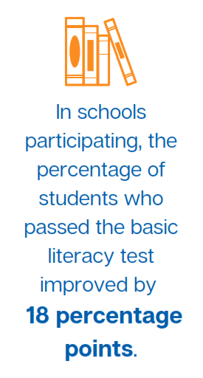
The grant-based partnership program overall generated students’ interest in reading and developed their literacy skills. In schools participating, the percentage of students who passed the basic literacy test improved by 18 points, from 60 per cent to 78 per cent. The grantees achieved this by collaborating with schools to provide libraries and working with community reading centres. For instance, in Central Sumba, the number of students who said they enjoyed reading rose by 42 percentage points, from 53 to 95 per cent, and in other Sumba districts this rose to 100 per cent. Each pilot was designed to deliver specific results, such as promoting better access for special needs children, increasing parents’ engagement and training teachers in literacy and numeracy.
Some grantee pilot programs also faced challenges, for example, in coordinating with government and sustaining the intervention, while others established good relationships with local government and will collaborate further. However, most grantee programs are not yet at this stage. The relatively short implementation period made it difficult for local government to adopt the pilot approaches.
The grant-based partnership program cost around IDR28 billion for 22 grantees, including the costs of grantees’ training and socialisation workshops. This is equivalent to around 16.5 per cent of the total INOVASI program activity estimated spending in Phase 1 of around IDR170 billion. The costs per school varied, ranging from about IDR27 million to IDR165 million. The two with the lowest costs were NU Maarif and Pen Circle Forum while the programs with the highest costs were the Summer Institute of Languages (SIL) and Rainbow Reading Gardens.
Nevertheless, the Rainbow Reading Gardens pilots, for example, provided many books and increased interest in and access to reading, contributing to better literacy skills. The Muhammadiyah and NU Ma’arif pilots both improved literacy in terms of basic skills and comprehension, with increases in the test results of 1 and 3 points respectively for basic skills and about 2 points and 10 points respectively for comprehension. The Muhammadiyah pilot schools were within the top 20 per cent of INOVASI’s school quality index, so the starting point was higher and the outcomes were less dramatic – a pattern observed across the pilots. Results from the NU Ma‘arif numeracy pilot, however, are still to be proven.
The Muhammadiyah and NU Ma’arif results reflect a number of realities, including differing approaches to managing the organisations and the pilots within them, different starting points in terms of general school quality and a late start for activities in both partnerships. However, these organisations’ enthusiasm and committment in the first round of grant-based partnership activities provide a sound base to build on in Phase II.
A thematic study on partnerships (Amalia, Arsendy and Purba 2020) analyses the outcomes and lessons learned from the grant-based partnership program in more detail. The study found that while the grant-funded partnership programs generated positive results, measured in changing practices and improved learning outcomes, the challenges related to program design and sustainability persist. One main challenge was the short duration of these pilot programs, giving the government, facilitators and beneficiaries little time to build their capacity to independently apply and sustain the changes after the program. Other challenges arose from: varying levels of competence and commitment among participants and implementers; limited supporting regulations at the school, office and village levels; and inconsistent support from principals and local governments. Phase II provides an opportunity for follow-up monitoring to assess the sustainability of outcomes from these partnerships and determine the factors associated with their effects and sustainability. This evidence is valuable for MoEC in planning its large-scale partnership, Program Organisasi Penggerak.

2.7 Cost-benefit Analysis
We conducted a simple cost–benefit analysis of the Indonesian and Australian governments’ investment in the INOVASI program although these preliminary findings warrant further analysis for conclusive insights. We found that it costs more to achieve basic literacy and comprehension skills in districts where most children failed the basic literacy test than in better-served districts (see figure 4). For example, the cost per student to increase literacy comprehension test scores by 1 point was about AUD57 in Central Sumba, 50 times more than the cost in Batu City (approximately AUD1). However, as reported, gains in the more disadvantaged districts where more children failed the basic literacy test in the baseline are much larger than in the better-served and higher-performing districts.
A regression analysis found that a 1 per cent increase in the proportion of students passing the basic literacy test would reduce the cost of a one-point increase in literacy comprehension test scores by AUD0.62. The endline results from the pilots reveal that students whose teachers took part in the pilots were 20 percentage points more likely to pass the basic literacy test than others. This means that districts that invest in scaling out INOVASI pilot interventions are projected to save an average of AUD13.2 per student to increase their literacy comprehension score by one point.

Figure 4: Regression analysis – the cost of delaying basic literacy skills
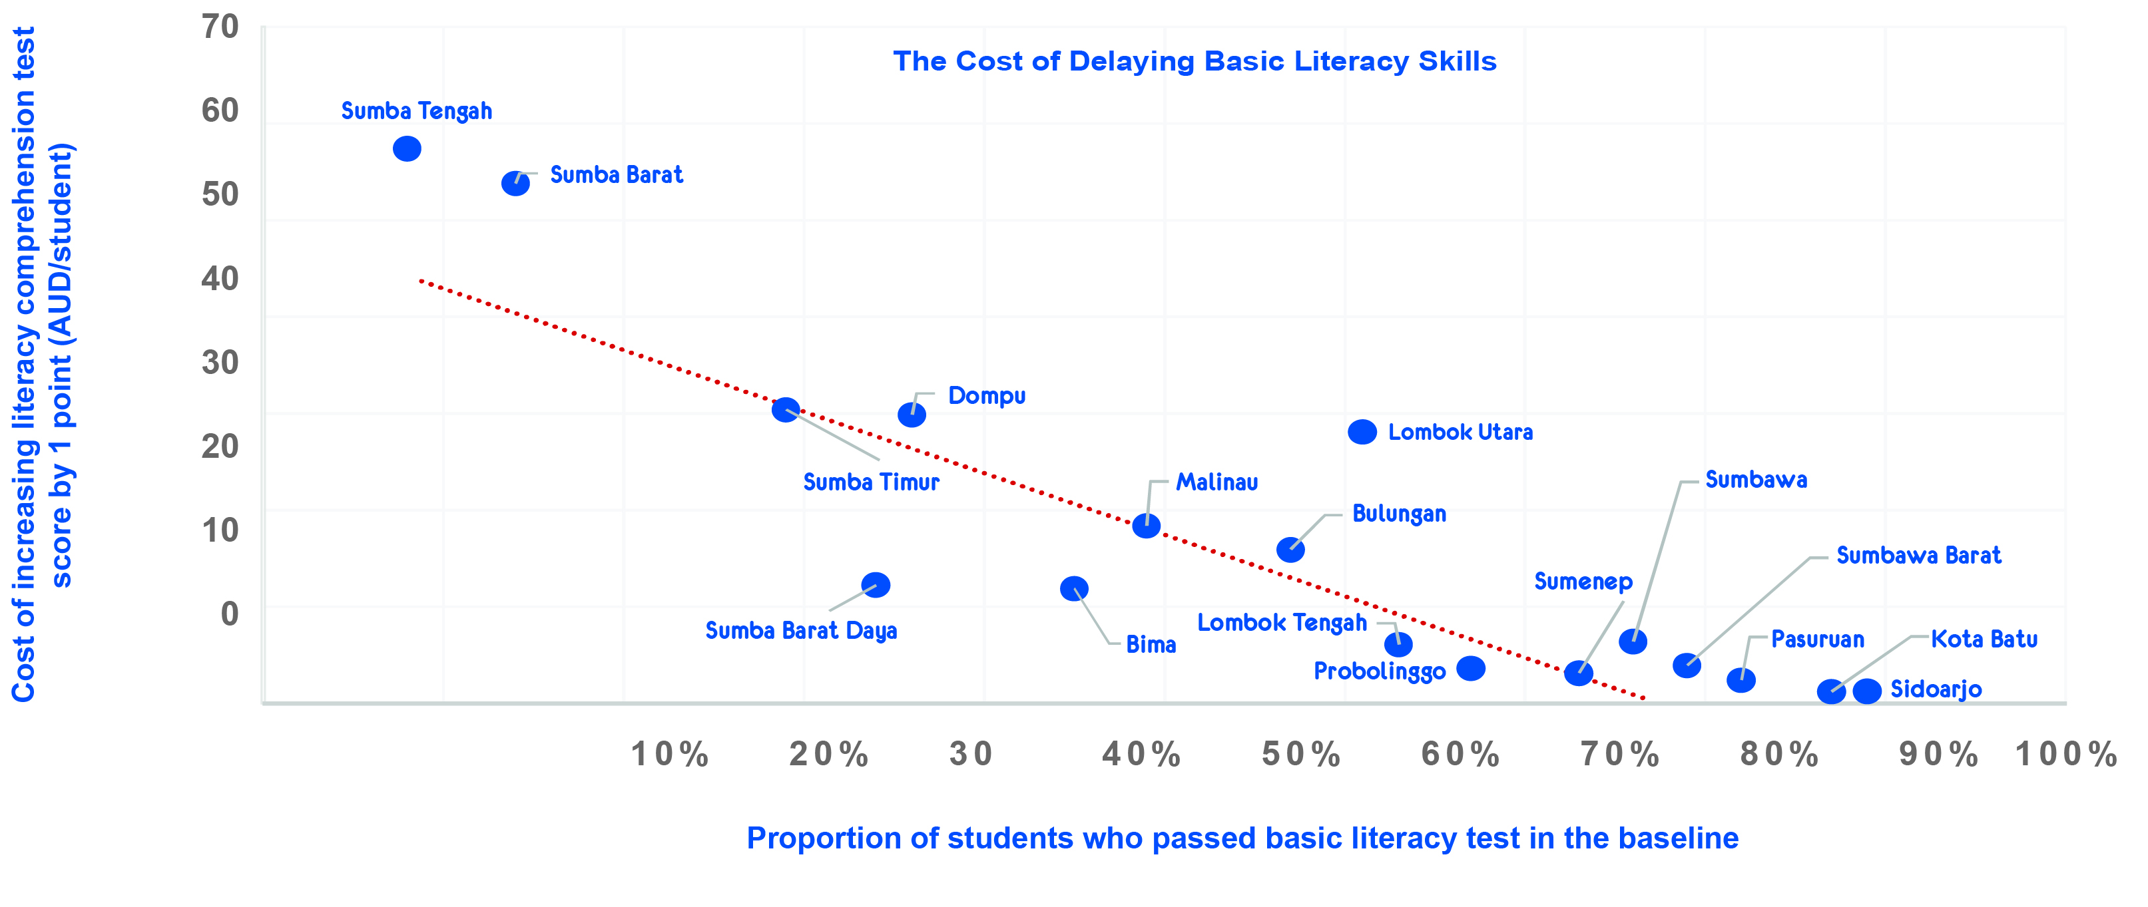
One finding that emerged clearly from our work in Phase I is that a one-size-fits-all approach does not work. Remote and disadvantaged regions need different support and INOVASI’s Phase I modules are generally more appropriate for these regions. For example, as shown in figure 5, literacy pilots in East Nusa Tenggara increased scores on basic literacy by 2.5 times, while the increase was modest in more developed regions, such as East Java.
Figure 5: Increase in basic literacy skills due to Round 2 INOVASI pilots (excluding grant-funded pilots)

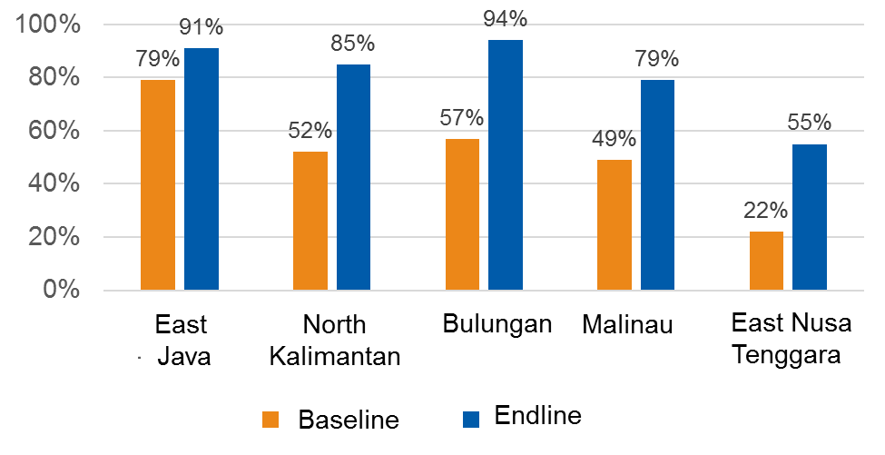

Another finding from Phase I is that the comprehensive approach in Bulungan, North Kalimantan had a greater and quicker impact than in other regions (figure 5). The program in this district involved many actors (government, community, university and private sector) and had strong political support from the regent. After one and a half years, the level of literacy in pilot schools in Bulungan was higher than the average in East Java that began with a much higher average baseline score. As figure 6 illustrates, the intervention in Bulungan saved the districts one year of schooling to achieve a basic literacy standard for most students (87 per cent). This district is currently scaling out the literacy program to all teachers and all schools and the benefits will potentially be massive.

Figure 6: Students passing the basic literacy test, North Kalimantan
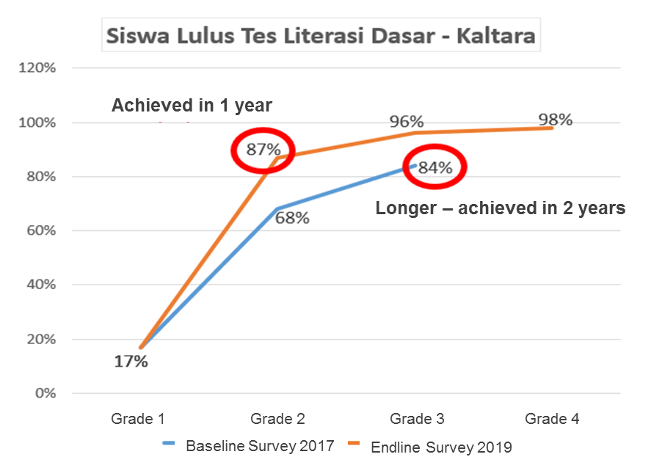

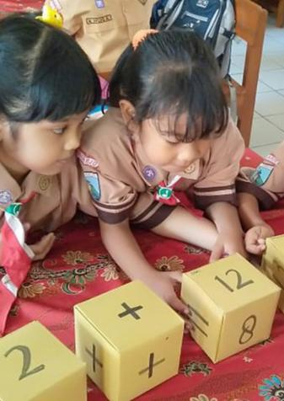
- CHALLENGES, RISKS, OPPORTUNITIES AND LESSONS LEARNED
INOVASI is an adaptive program and Phase I provided many opportunities to learn from experience, respond to challenges, and identify and mitigate risks. As the program moves into Phase II, we need to take stock of these lessons learned.
  - Challenges and Risks
This section focuses on the current challenges and risks INOVASI faces as the program transitions to Phase II as well as those we navigated in Phase I. Some issues, such as using the PDIA approach, present challenges or risks but also provide opportunities.

Government partners
In Phase I, INOVASI cultivated broad and deep working relationships across key directorates in MoEC and MoRA that do not depend on individual champions. Nevertheless, if the new minister restructures or reshuffles senior positions within MoEC we may need to rebuild some of these key partnerships. A possible reshuffle was reportedly delayed by the COVID-19 pandemic but is likely to take place in 2020. A change of minister, which is always a possibility, would also likely result in further reshuffling of senior positions.
Elections occurred at all levels in Phase I and will also take place in Phase II. There are risks for potential political unrest during and after elections that may create challenges for a program like INOVASI that works through government to achieve outcomes. In Phase I, we were able to handle any unrest and navigate changes in personnel and priorities. Teams at the provincial level will need to exercise prudence in maintaining relationships and continuing to leverage strong working relationships with the regional development planning agency, local leaders and civil society organisation partners. Furthermore, as districts adopt, adapt and scale out pilots developed by INOVASI, the risk that they will dilute the effectiveness of the interventions through reduced resourcing is real. The INOVASI team can only influence the direction pilots take in proportion to the level of support we provide.
The current COVID-19 crisis is a major distraction for government and risks derailing the reform movement that began in late 2019. The closure of schools could increase the learning gap between advantaged and disadvantaged students, with special needs students particularly at risk. The full consequences of the crisis are not yet known but are likely to impact on government priorities and on the INOVASI program. We should anticipate a slower start to Phase II, given that district budgets for scaling out pilots have been diverted to addressing the pandemic. The first two months of Phase II will focus on developing the program strategy and a comprehensive workplan for the first year. In this context INOVASI will need to consider which activities to drop, add or keep and which to adapt or improve. Our priorities are likely to include humanitarian responses, health infrastructure and communications, governance technical assistance and support for early recovery and inclusion. Figure 7 illustrates the responses from INOVASI and TASS to the situation created by the COVID-19 pandemic in Phase I.
Figure 7: INOVASI and TASS response during the COVID-19 pandemic
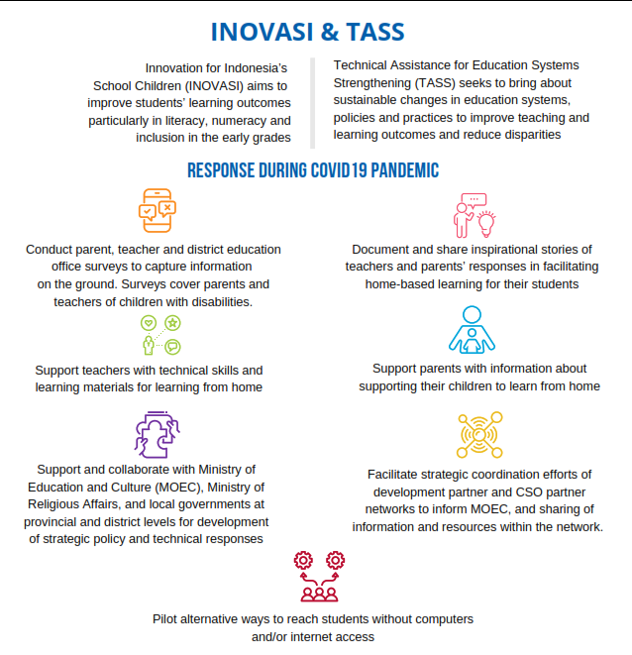

Internal changes in INOVASI
As an adaptive program, INOVASI has evolved over Phase I. The lengthy process of finalising the program design was followed by a protracted inception period stretching into the first 18 months (2016 to mid-2017) before the program got fully underway. As the program found its strategic intent and orientation 12–18 months in, changes in senior personnel caused some loss of momentum but ultimately resulted in a stronger team and a focused and cohesive program. Activity scaled up rapidly and the early underspend was made up in the third and fourth years. We expect to take the key management team forward into Phase II and ensure a seamless transition.

Budget adjustments
In the second half of Phase I, the budget pressures that DFAT was under led to a number of changes in our program. We spread INOVASI’s budget over six additional months up to 30 June 2020 by restructuring activities and staff to accommodate the extra time. Also, after our budget was cut by over AUD2 million in early 2019, we had to refocus our priorities, scale down some activities and then gradually phase down staff from December 2019.
The risk of further adjustments is real, given Australia’s national review of its aid priorities and the impact of the COVID-19 pandemic. In May 2020, DFAT released the policy document, Partnerships for Recovery, Australia’s COVID-19 Development Response (DFAT 2020) and INOVASI Phase II aligns well with this policy. The investment supports the Indonesian government and contributes to the development policy action areas by promoting: (1) economic recovery through building the quality of Indonesia’s human capital; (2) stability and social cohesion by helping maintain education services; (3) health security by using the education system to promote COVID-19-safe practices; and (4) protecting the most vulnerable by minimising the widening of existing inequalities (economic, gender, social, geographic). Nonetheless, further adjustments to INOVASI’s budget are possible in this period of economic uncertainty.
These adjustments create a challenge as activities and programs may have to be dropped or downsized. While we have managed this so far, in future we will build a margin for error into budgets and plans to anticipate further changes. During the final years of Phase I, INOVASI developed a conservative approach to budgeting that allows for possible reductions. Going into Phase II, we are taking a more proactive approach by exploring opportunities to attract additional funding from other sources, including from the Indonesian government . This will not only counteract Australia’s declining aid budget but also diversify the funding platform and strengthen the sustainability of the program’s efforts.

Adaptive, politically-informed approaches
INOVASI adopted the PDIA approach developed by Harvard University’s Centre for International Development. PDIA is an emerging and dynamic methodology that we are still learning and our approach to it is still evolving within the program (Kleden 2020). Our approach to PDIA and adaptive programming in Phase I was both effective and cutting-edge. This perception was supported in the independent review conducted by DFAT (Nichols & Bodrogini 2019), in discussions at the Australian Aid Conference in 2020 and in consultations with Lant Pritchett and senior RISE and Harvard researchers. Nonetheless, PDIA and adaptive programming create risks and challenges, not least being the long timeline and serious stakeholder engagement required for deep change to result.
This development and interpretation of PDIA in INOVASI has at times been contested, creating tensions within the team. We refined the approach over Phase I, moving from a formulaic method for classroom action research in the early Guru BAIK pilot to an integrated, politically-informed and technically-sound approach to working with teachers, national stakeholders and districts in subsequent pilots (Kleden 2020). Some saw this shift as abandoning the principles of PDIA at the time and it did lead to a more uniform approach to teacher development modules during the first round of ‘short-course’ pilots. However, we needed to find a balance between local ownership and existing professional knowledge. We could not expect village teachers to solve problems on their own without the benefit of local and international experience and understanding of how to teach literacy and numeracy.
One key idea from PDIA is the need for a sufficiently large ‘change space’ to allow reform to take root and to sustain this reform. This is known as the ‘triple A concept’ that refers to the need for ability, authority and acceptance to be present and intersecting in any reform process. INOVASI has worked mainly on developing the ability of teachers and administrators while thinking and working politically to expand the authority for teachers to innovate and change their teaching practices. The new Minister for Education and Culture is expanding this political dimension by issuing edicts and policies to encourage diversity, deregulation and innovation at the local level. However, reforms can only succeed with full support for the reform agenda from government officials at the various levels. Furthermore, we have yet to systematically address the third ‘A’, acceptance. This is the cultural dimension. While evidence from the early Guru BAIK pilot suggests teachers were developing a growth mindset and becoming more accepting of change, this needs to be better incorporated into the mainstream continuing professional development modules. Future pilots and related activities need to focus on all three aspects in equal measure, depending on the context: ability (technical capacity building), authority (thinking and working politically) and acceptance (cultural work to develop a growth mindset among teachers and administrators).
Managing local initiatives in pilot design and implementation
Internal tension arose in 2018 between the central team’s desire to see its well-planned modules faithfully implemented and the local teams’ desire to adapt and iterate the approach in response to local challenges and opportunities. This was resolved in 2019 through dialogue and sharing local initiatives that proved successful. In Phase II, we expect to work more closely with national as well as local government counterparts in the co-design, implementation, monitoring and evaluation of pilots. We also expect to see provincial managers and their teams adopt a more diverse, decentralised and bespoke approach to address local issues and maximise on local opportunities. This will mitigate the risk of tension between technically-informed design and local initiative.
Adapting the generic training materials in response to local feedback requires a high level of capacity among district and local facilitators. Ensuring the quality of the adapted design and implementation means coordinating with the central team and this takes time. These resources – capacity and time – are not always available. Overall, the approach worked better in some regions than others but this was mainly due to the strength of leadership at provincial level.
While local facilitators cannot be expected to adapt training materials, they can adapt and develop the strategies, concepts, assessment ideas and activities in INOVASI’s generic materials. In Phase II, INOVASI will explore and pilot approaches to remote training for continuing professional development facilitators, quality control and delivering materials to teachers that allow for local ownership and contextualisation.
We also need to make it clear to districts that when INOVASI pilots a new approach, we cannot be sure it will work until the evidence is in. Districts and other partners need to realise that the pilot process is iterative and developmental, and that they are partners in that process. They are not ‘buying’ an approach with guaranteed results.
  - Lessons Learned
Key lessons from INOVASI’s experience in Phase I are as follows:
- The PDIA approach works well at district level. In districts like Bulungan, where the PDIA methodology and the ‘thinking and working politically’ approach was most successfully implemented, the districts took ownership of the problem and the solutions, leading to proven practices being scaled out across the whole district. This included teacher training in literacy through teachers’ working groups, book procurement, and coordination with local libraries and village-based reading centres.
- Initial pilots can be small and affordable but still produce significant results. For example, Bulungan began with pilot programs in only seven schools.
- Effective pilots are comprehensive and draw on the knowledge of what works and what does not work from previous projects. Over 50 years of partnership between the Australian and Indonesian governments, the non-government sector and other donors in Indonesia, the most successful pilots have drawn on earlier work, taken a political approach at district level, and involved co-funding and partnerships with all levels of government, with universities and non-governmental organisations. The successful technical training program for teachers, for example, learned from the ‘pure’ PDIA approach used in the earlier Guru BAIK pilot in West Nusa Tenggara that relied on teachers’ initiative without providing the benefits of technical training.
- Localised programs and sub-national actors can drive national policy change. For example, as a result of innovative approaches in North Kalimantan, the national government changed regulations and practices around book approval to streamline the process and allow schools to procure more books.
- Using evidence as it emerges can build local ownership of the problem and drive reform. The most successful pilot teams did not wait for the lengthy process of producing ‘rigorous’ results but instead used preliminary findings from rapid assessments to get buy-in from local partners.

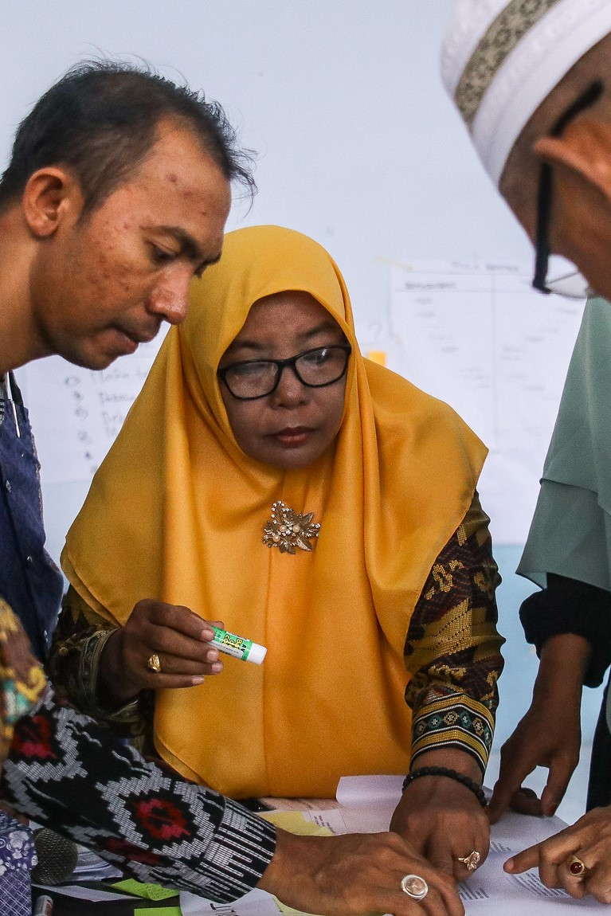
- MONITORING, EVALUATION, RESEARCH AND LEARNING

4.1 Monitoring, Evaluation, Research and Learning Systems in Phase I: Strengths and Weaknesses
INOVASI’s monitoring, evaluation, research and learning (MERL) system was designed to have three levels in Phase I:
- Program-level monitoring and evaluation (long feedback loop, aggregated baselines and endlines);
- Pilot-level monitoring, evaluation and learning (intermediate feedback loop, structured baseline and endline, and spot checks.)
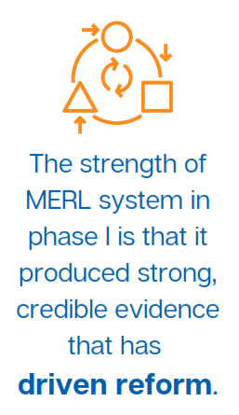
- Pilot-level monitoring and experiential learning (tight feedback loop, day-to-day observations, reflection and learning) (INOVASI January 2018).
In implementing this three-tier structure, the baseline and endline surveys used to evaluate individual pilots formed the core of the baseline and endline surveys used to evaluate the program. This integrated or ‘nested’ structure produced strong consistent data but was also problematic in that it did not address the unique character of each individual pilot. While this weakness was made up for to some extent in spot checks and other measures such as pre-tests and post-tests, it was a missed opportunity.
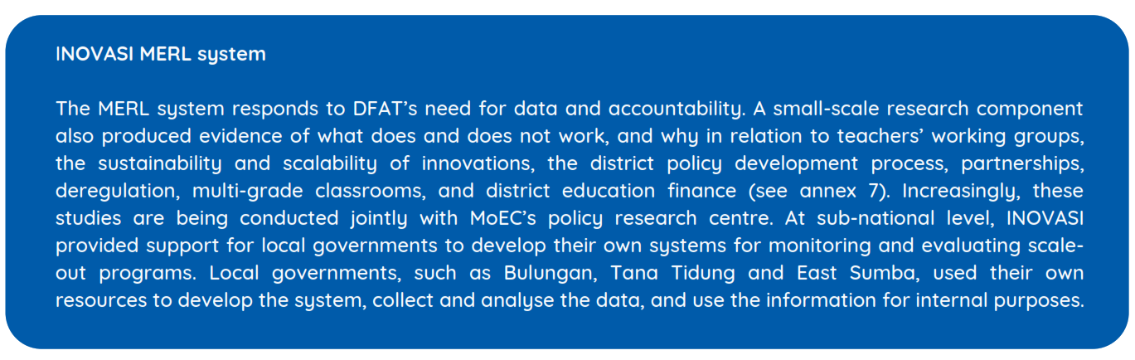
The system also included a responsive research component and a learning component, focused on knowledge sharing. The strength of this system in Phase I is that it produced strong, credible evidence that has driven reform, informing the decision-making process at both national and sub-national levels. What makes the evidence credible is that it focused on learning outcomes, rather than using teacher behaviour as a proxy. Evidence of change in teacher behaviour was useful for explaining why learning outcomes improved – but learning outcomes are what matters to decision-makers. MoEC recognised this approach as a model for its large-scale Program Organisasi Penggerak and appreciated the PDIA elements that mean implementers can learn by doing when they do not yet have a fully-defined approach or solution.
Box 5: INOVASI’s monitoring, evaluation, research and learning system
The evidence produced from pilots and responsive research has informed policy as intended and was well received in public consultations (such as Temu INOVASI) and discussions with government and donor partners. The learning component ensured that knowledge produced by the program was shared internally and with development partners, including DFAT, as well as externally with the government and non-governmental organisations. The evidence from pilots, research, international experience and previous programs was brought together in seven thematic studies on: continuing professional development and sustainability; literacy; numeracy; gender equality and social inclusion; disability inclusion; PDIA; and partnerships (see annex 1).
The MERL approach also had its weaknesses. Monitoring and evaluation are critical to INOVASI’s theory of change and scale-out strategy because of their role in producing evidence. This strategy requires a flexible and nimble system that can provide quick feedback at the same time as building a credible body of evidence of what works. This area of the program still needs improvement.
Four fundamental design problems emerged with INOVASI’s MERL approach during Phase I:
- Integrating the pilot and program level baseline–endline data and analysis reduced the value of both program and pilot evidence. The program evaluation suffered because of the short-term nature of the pilots and lack of a methodology to trace policy impacts. Instead of program outcome evidence having the quality of a three-year experiment, the outcomes are based on 6–12 month periods (the overall span of the pilot rounds).
- The MERL imperatives for ‘rigour and credibility’ as well as ‘speed and responsiveness’ seemed to be competing.
- The iterative nature of INOVASI’s pilots made it difficult to hold constant what was being evaluated, a bit like trying to hit a moving target.
- A technical problem was the ambitious database in terms of the amount of data to be collected. This occurred because the SIPPI data system was developed before we knew exactly what information we should collect and analyse. This made the system expensive and slow, and the data difficult to manage, creating challenges for advisors and researchers.
These problems were compounded by the decision to outsource data collection to local agencies. From one perspective, this increased objectivity – and therefore credibility – of the results. However, from another perspective, it reduced credibility because the enumerators collecting data were mostly not professional educators and were thus unable to interpret or understand the classroom practice they were observing. The division of responsibilities within the INOVASI team, between the MERL and education personnel, also created inefficiencies and concerns about credibility. While the baseline–endline mechanism is too cumbersome for the pace of pilots and scale out, we have not been able to optimise evidence of improvement from short feedback loops. The results are generally credible but the current system proved too slow to provide timely feedback for government partners and for implementers.
Districts, national government and DFAT all work within the constraints of budget and planning cycles that require planning for up to a year. Meanwhile, baseline–endline studies do not provide evidence until around six months after a pilot is completed. The pilot-level monitoring and experiential evaluation approach intended to provide quick feedback within the pilots, was not as effective as expected. In this context, the pilot process itself is problematic. Pilots implemented within a six-month cycle may not produce convincing evidence of improved learning outcomes. Moreover, the PDIA process assumes that pilots are developed in an iterative way and that it takes time – probably several years in our context – to produce the rigour of results that can inform scale out and policy. This timeframe is too long for the four-year program cycle.
INOVASI’s MERL strategy and results framework were redesigned in the second half of 2017. The monitoring and evaluation functions were integrated with the previously separate research and learning functions. This allowed only two years to implement the new system. In this period, INOVASI focused on ‘exploring the design space’ – working with local partners to find solutions to problems of education quality – leaving the production of rigorous evidence to others or to a later stage. INOVASI’s iterative, exploratory pilot approach does not produce hard evidence. It does require credible evidence, however, to support scale out and scale up to policy level. It is only when successfully piloted solutions are scaled out (or even better scaled up to sub-national and national policy level) that more statistically rigorous studies can be conducted to generate evidence of the effectiveness of solutions. The Phase I MERL strategy, re-designed in 2017, did not allow for comprehensive evaluation of scaled-out programs. Randomised controlled trials (or similar) may be undertaken in Phase II, possibly by a third party. Against this background, we are currently reviewing approaches to baseline–endline studies, spot checks, reflection and strategy-testing processes:
- Baseline–endline studies: INOVASI conducted baseline and endline studies on all pilots in Phase I using the program’s SIPPI framework and instruments. These studies include substantial student learning assessments, teacher surveys, classroom observations, interviews and contextual data collection. In Phase II, we will improve the processes for generating credible evidence to support scale out and scale up in two ways: (1) by reducing the amount of data and size of samples for baseline–endline studies to enable an affordable, quicker turnaround; and (2) by tailoring the instruments and methodologies to the themes in each pilot to ensure we obtain more subject-specific data for analysis.
- Spot checks: INOVASI conducted spot checks during pilot implementation in Phase I and updated the instruments in 2019. These spot checks included classroom observations, surveys and interviews, and gave early indications of any successes. They also enabled deeper analysis of variables to answer the questions about how and why change occurs and makes a difference to learning outcomes in different contexts. However, budget constraints in Phase I meant that spot checks were only undertaken once for each pilot. This approach is being reviewed for Phase II as we may need to integrate the spot check and reflection or pilot monitoring processes.
- Reflection and pilot monitoring: INOVASI Phase I used a reflective process to provide real-time feedback on pilot processes and enable iterations and ‘learning by doing’ through discussion with local facilitators and participants in teachers’ working group sessions. We are working to improve this reflection process for Phase II. The two roles of reflection, as a learning process and as a means of producing evidence, need reconciling – and the process needs improving.
- Strategy testing: Strategy testing is integral to the adaptive approach. In Phase I it was not integrated into MERL processes, leading to duplicative activity and strategy testing not being able to access timely data to evaluate strategies.

4.2 Towards Phase II
As an adaptive program, INOVASI and TASS will review the MERL approaches in Phase I and design an effective approach for Phase II. The new approach will build on the strengths of the approaches in both the TASS and INOVASI Phase I programs and will include:
- Appointing TASS’s international advisor as monitoring and evaluation advisor, and INOVASI’s current strategic planning advisor as research and learning advisor;
- Introducing a methodology to trace policy – attributing contributions to policy development and changes in practice resulting from policies implemented – based on the successful TASS approach to program evaluation;
- Ensuring that monitoring and evaluation systems capture not only improvements in learning outcomes but changes in behaviour and systemic change;
- Engaging national and sub-national stakeholders by: giving them greater ownership of the MERL process and outputs; co-designing and co-implementing the pilots and co-publishing the results; doing more structured joint monitoring visits; and involving stakeholders in monitoring field activity and setting targets around sustainability;
- Instituting a strong reflection process to enable learning-by-doing and an iterative, continuing improvement process within pilots, and better integrating the MERL, Education Program Development and Communications team members in the provincial teams;
- Taking a more targeted, rigorous and consistent approach to measuring learning outcomes, tailored to the key pilot themes in each location (literacy, numeracy, character education, and so on). The approach may draw on lessons from DFAT’s teacher development multi-year study series conducted in Lao PDR, Timor-Leste and Vanuatu (DFAT 2019);
- Strengthening qualitative research approaches to answer the ‘why?’ question in pilots: what works and why;
- Integrating financial monitoring to better evaluate the cost–benefit of different approaches;
- Developing a lighter, nimbler database and data management system for quicker turnaround and easy access to data and findings from pilots and responsive research;
- Conducting longitudinal pilots and studies that may use existing data from earlier pilots and include longer pilots with a built-in six-month cycle of activity but longer engagement with selected schools and teachers;
- Using stronger integration and a more structured methodology for routine strategy testing;
- Seeking opportunities for small-scale responsive research to support demand from government partners and to explore findings from the pilots.
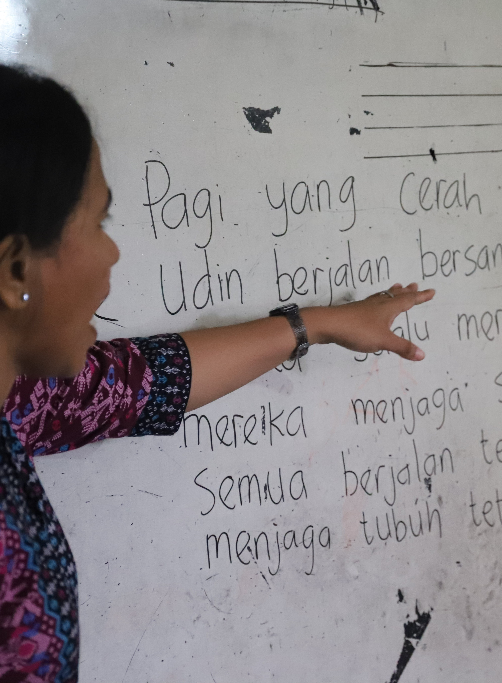

- COMMUNICATIONS
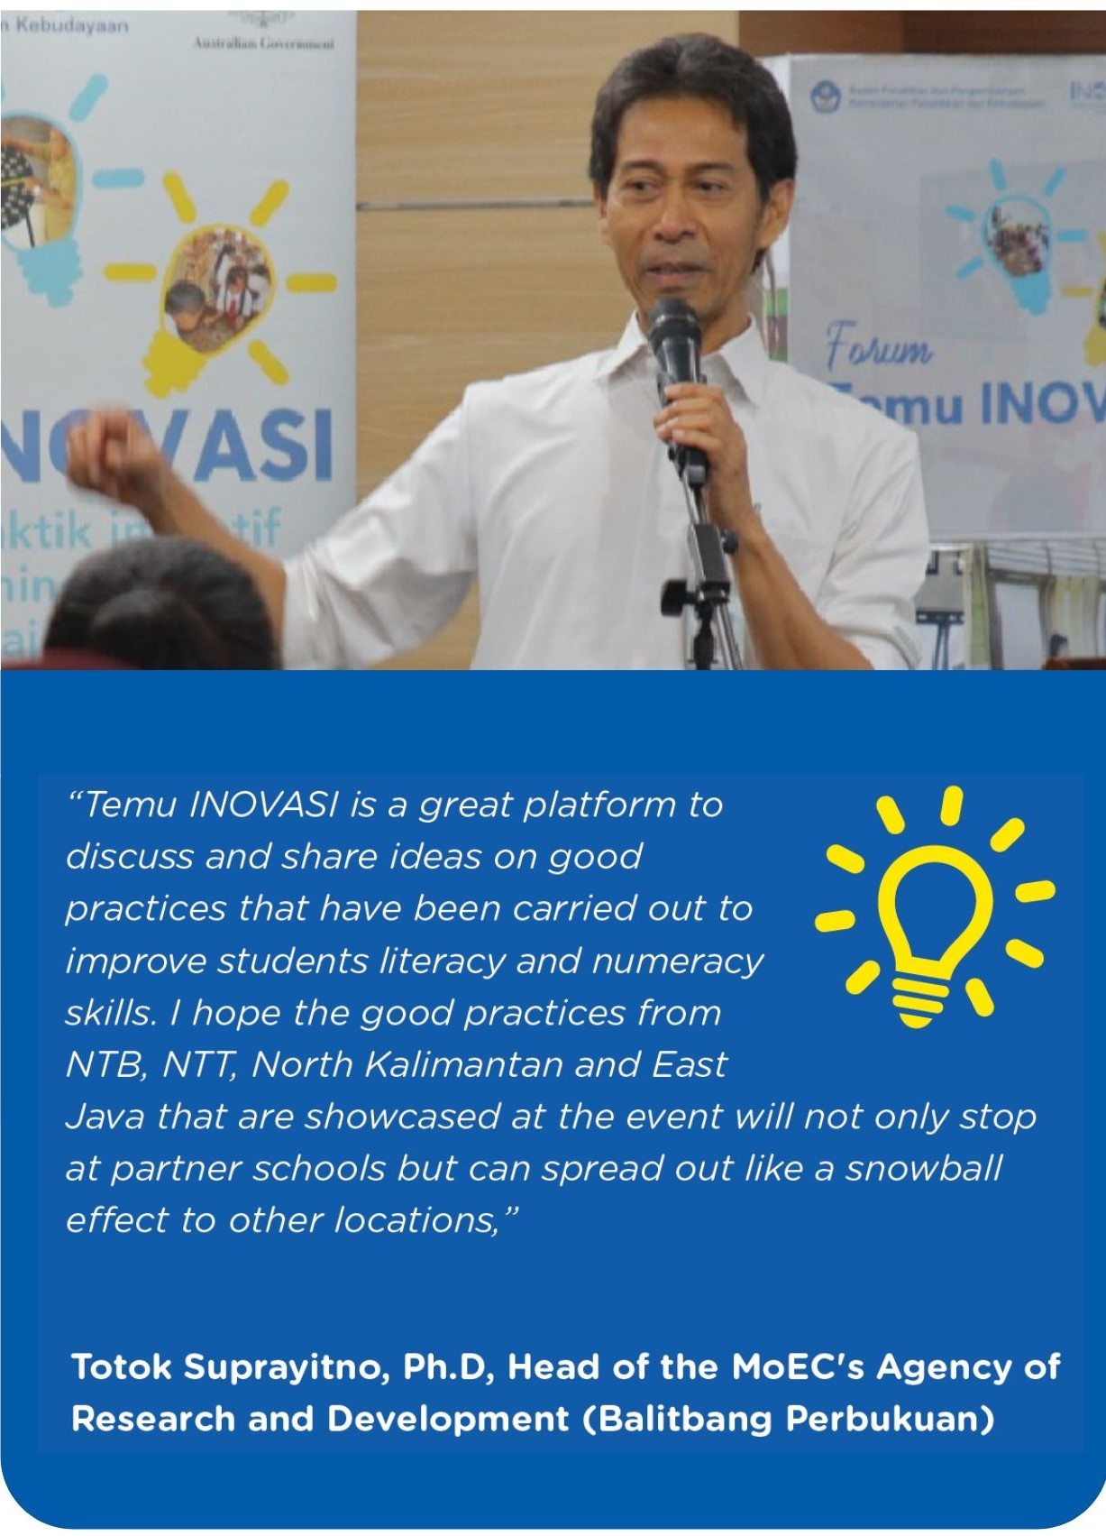
Given the iterative, locally-focused and problem-driven nature of INOVASI, the Communications team had to be agile and proactive to play an effective strategic role. Over the course of Phase I, we strengthened our communications systems, processes and platforms, and significantly increased our communications products and media engagements. As more evidence emerged from the pilots and from strategic research and policy initiatives, particularly in the 2018–2019 period, the Communication unit used various ways to target and reach audiences (INOVASI 2018). In the 2019–2020 period, INOVASI’s strategic communications function evolved again, as the need to inform policy and practice became ever more vital.

5.1 Communication Products
Throughout the program, as documented in the six-monthly reports, INOVASI has produced a total of 714 communications products. This includes stories from the field, promising practice booklets, newsletters, infographics, videos, policy briefs, social media content, press releases and other products for significant meetings and events. In 2019, we conducted a communications evaluation through a series of interviews to assess the effectiveness of our communications strategy.Education stakeholders reported that they value INOVASI communications products that improve and inspire changes in teaching practice and classroom management. Government stakeholders emphasised that communications products and platforms, including videos, are the most effective way to show what is happening on the ground and give a human face to pilot progress and findings. They are also useful emotive tools during advocacy efforts.

Events
As part of INOVASI’s strategy to engage with the Indonesian government and foster dialogue around evidence-based teaching practices that are proven to work, the program took various opportunities to conduct or support government and partner-led events. Whether events are led or supported by INOVASI, they effectively promote program findings, practices and progress, and offer opportunities to engage with and influence key decision makers. Temu INOVASI is a highly valued event format at provincial and national levels. In 2018–2019, Temu INOVASI events were held at national level four or five times a year. Events were also held at provincial level in East Java and West Nusa Tenggara, and in various partner districts. In total, over the lifetime of the program (2016–2020) 17 such events were held in Jakarta and at the provincial and district levels.

Digital and social media reach
Social media platforms are more effective in reaching INOVASI’s audience. As confirmed by our monthly digital analytics, people generally prefer to access INOVASI products and content via the program’s social media platforms – rather than on the INOVASI website.
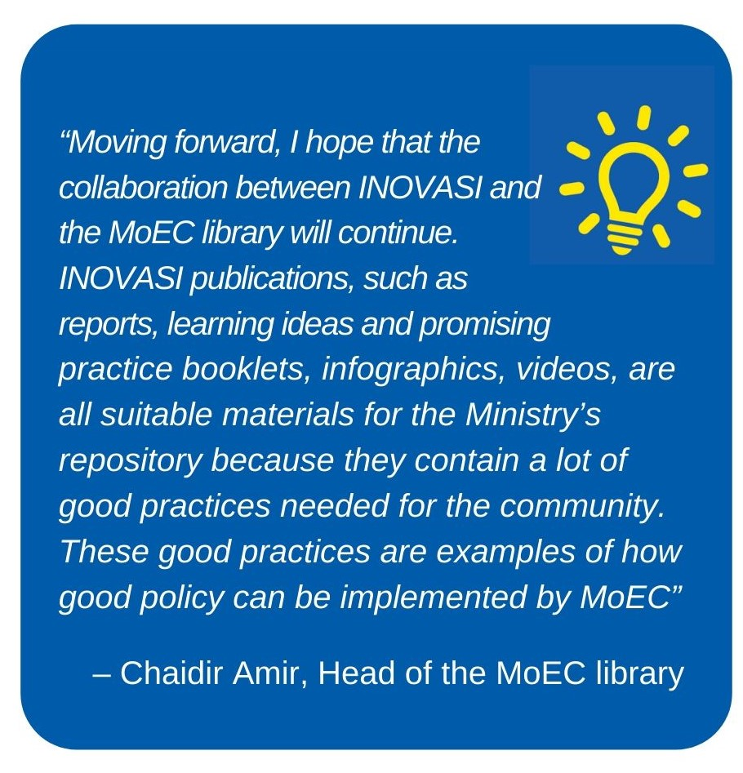
Co-creating and disseminating content is vital for digital sustainability. In the 2018–2019 period, INOVASI engaged with MoEC’s information and communication technology (ICT) department in a number of ways. For example, the ICT department hosted INOVASI products on its Rumah Belajar (learning home) website, we jointly created content for teachers’ radio and TV talk shows using online platforms, and we shared initial ideas for a formal partnership in Phase II. With its website, large networks within and between all districts in Indonesia, and internal digital equipment, the ICT department is the ideal partner for INOVASI’s digital scale out in the future. Furthermore, using digital platforms will be key to scaling out teaching ideas and practices.
INOVASI and TASS also organised a five-day study tour to Australia for MoEC’s ICT team and ambassadors of Rumah Belajar in August 2019. This visit provided an opportunity for learning by sharing common education problems and discussing solutions.

Media coverage
As seen through INOVASI’s media monitoring, updates and progress covered in strategic publications hold far more weight than lesser-known media platforms. By the beginning of 2020, INOVASI appeared in 116 articles in both Kompas (print) and Kompas.com. At the national level, publications like these are more likely to reach targeted MoEC stakeholders. When shared through the MoEC/INOVASI WhatsApp group, the Kompas publication name also holds more value. This is echoed at the district level.

Strategies that serve audience and purpose
Tailoring products for different audiences and purposes is key in INOVASI’s current communications approach. A one-size-fits-all approach to developing and disseminating products is inadequate and will not be effective in the long term. We will need strategies for different audiences and different purposes. Many district-level stakeholders emphasised that certain products may suit the local context and certain platforms would be better based on local needs.

Supporting gender equality and social inclusion initiatives
During Phase I, INOVASI’s Communications team mainstreamed gender, disability and social inclusion best practices in developing and disseminating all communications materials. We ensure that our materials do not reproduce negative gender and social stereotypes and that content is balanced and inclusive. This includes videos, talk show panels at events as well as imagery used in publications, digital materials and training modules. We strive to reflect the diversity of partner students and teachers wherever possible. The Communications team also played a pivotal role in ensuring compliance with child protection requirements. All products comply with DFAT’s child protection policy and guidelines for staff, referring to the use of social media accounts, geo tagging, and managing child and parent consent forms when taking photos and videos.

5.2 Towards Phase II
Communications are essential to the program strategy for both Phase I and Phase II. The role of communications is more strategic in INOVASI than in other programs where the focus is primarily on promoting the program and supporting public diplomacy. In addition to these functions, INOVASI relies on communications to support a policy advocacy agenda and to share evidence and good practices developed in the program. However, measuring the level of influence of communications is not straightforward and more needs to be done to develop this process in Phase II. This will be built into the updated MERL strategy. Early in Phase II, we expect to update the program Communications Strategy and conduct a study to evaluate the effectiveness of communications in supporting policy and practice change.
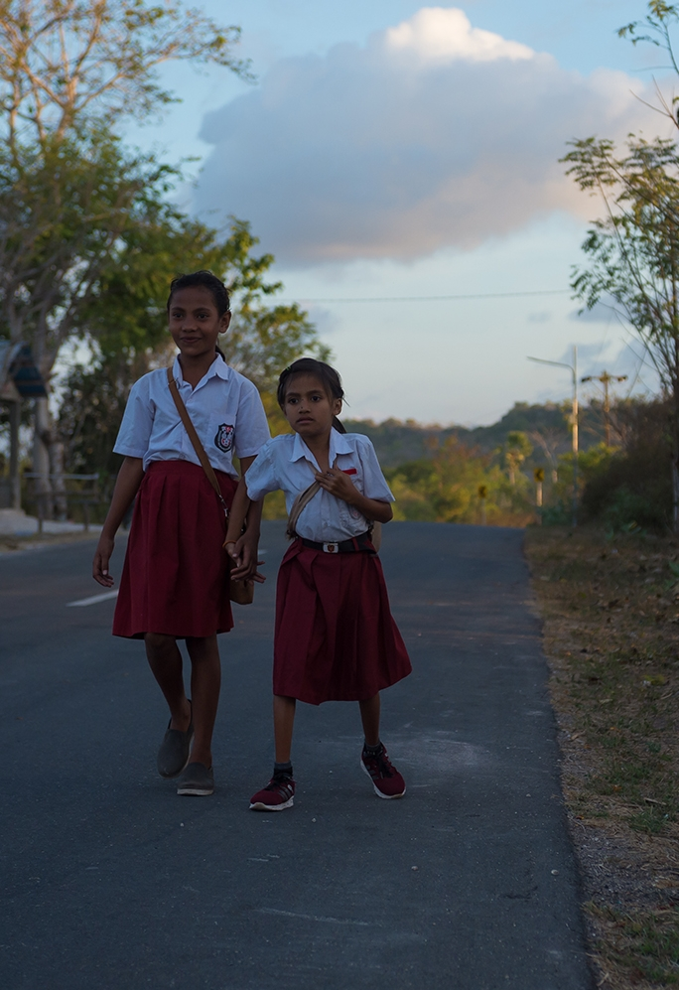

- CROSS-CUTTING ISSUES
INOVASI has three major cross-cutting issues – gender equality, social inclusion (disability, remoteness and ethnicity) and child protection. These were built into the design, implementation and evaluation of all activities and programs. In addition, INOVASI increased its efforts over Phase I on environmental impact and private-sector engagement. The Gender Equality and Social Inclusion (GESI) Strategy (revised in October 2018 and due for further revision in 2020) addresses issues of access to education, opportunities and barriers to learning, and how best to reflect INOVASI’s commitment to providing quality education to all children.
Box 6: Key activities focusing on cross-cutting issues
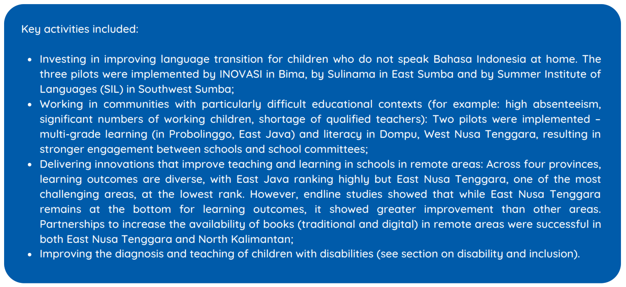

6.1 Gender
Although INOVASI did not focus on gender equality in Phase I, this issue nevertherless featured in our work as follows: we achieved a modest reduction in the ‘boys’ achievement gap’ in numeracy and literacy in INOVASI pilot schools; we used sex-disaggregated instruments for most of our data collection and analysis; we screened the final versions of all our pilot materials to ensure they were ‘inclusive’ before formally handing over to MoEC; we discussed how gender is relevant within INOVASI (harassment) and in operations (recruitment) among the INOVASI family; and lastly we incorporated gender equality and social inclusion materials in all INOVASI pilots.
Challenges related to gender and social inclusion persisted during this period. For example: stereotyping in textbooks and school practices; disproportionate promotion of men within the bureaucracy; and the lack of differentiated teaching practices, among others. We plan to review and address these issues in Phase II.

6.2 Disability and Inclusion
Disability and inclusion are key areas for INOVASI. Early findings highlighted the challenges to delivering quality education for students with disabilities. These include, for example, teachers’ ability to identify disability and address learning support needs for students with disabilities, and the limited enrolment of children with disabilities due to systemic and socio-cultural barriers. At the request of the district government, the first inclusive education pilot was implemented in 19 schools, including four madrasah in Central Lombok. Baseline data showed low levels of competence among teachers in literacy and numeracy that was a potential confounder in teachers’ assumptions about students who have disabilities. The early pilot was restructured to build in teacher competencies in literacy, with an emphasis on inclusive teaching skills. Subsequent inclusive education pilots focused more directly on disability-inclusive education.
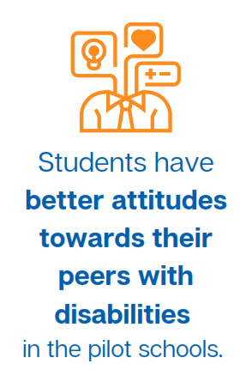
The second round of inclusive pilots was implemented in 27 schools, including two madrasah, across Central Lombok, East Sumba and Probolinggo. In East Sumba and Central Lombok, grant-based partnerships included Circle of Imagine Society (CIS) Timur and University of Mataram respectively, while training in Probolinggo and Central Lombok was provided through locally-recruited facilitators, thus contributing to sustainability and preparing for subsequent government-led scale out pilots. The pilots used the five-unit disability-inclusive education module to build teachers’ skills in using the Student Learning Profile to identify students with functional difficulties and address their learning and support needs.
With support from INOVASI and TASS, MoEC developed an application to collect data and map the distribution of students with disabilities to inform human resource planning for special education teachers and mentors. A plan to film online training to expand the use of the Student Learning Profile is pending due to the COVID-19 pandemic. MoRA has started training supervisors and principals to use the Student Learning Profile primarily so they can identify the needs of inclusive madrasah at the local level and justify awarding ‘inclusion’ grants.
Endline findings show that students in the pilot schools in all three districts have better attitudes towards their peers with disabilities, while teachers’ attitudes, confidence and knowledge have also improved. In East Sumba, village heads, community members and school principals were more open to enrolling children with disabilities in mainstream schools. However, endline assessments of priorities show that only 5–10 per cent of teachers and principals consider inclusive education to be a top priority. The issue is eclipsed by concerns around infrastructure, support to teachers, learning facilities and budgets or staffing, highlighting the fundamental challenges facing many schools.
Disability and gender inclusion were not a focus for the governance aspects of Phase I. However, these issues will be addressed in Phase II, with measures put in place to ensure that women, people with disabilities and other marginalised groups are well represented in steering committees and governance bodies, as well as in program activities.

6.3 Child Protection
All INOVASI personnel received refresher or induction training in child protection, the code of conduct, diversity and respectful workplaces. Over Phase I, INOVASI improved its safeguarding mechanisms based on lessons learned from the field. This included having focal point personnel in each province, making reporting mechanisms accessible at the community level and developing appropriate materials on child safeguarding for INOVASI staff, partners, local facilitators and teachers.

6.4 Environmental Policy
To minimise negative impacts resulting from aid investments and to reduce the vulnerability of communities to disaster and climate change, INOVASI conducted an environmental assessment early in 2019. We also decided to ban the use of single-use plastic in key program activities where feasible, in accordance with DFAT’s environmental and social safeguard policy. This ban extended to venues that organised our national events, as well as INOVASI event venues at the provincial, district and school levels. At the INOVASI Jakarta office, waste management has improved and staff separate office waste into plastic, paper and organics to send to a recycling company twice a week.
In terms of reducing environmental disaster risk, INOVASI continues to ensure the safety of staff during environmental events, like the Kalimantan fires, by providing masks and allowing staff to work from home.

6.5 Private Sector Engagement
In championing the sustainable expansion of the INOVASI and grant-funded pilots, the program has proactively explored partnerships with the private sector. In North Kalimantan, the broad collaboration involved the private sector (specifically through the corporate social responsibility program of local industry), book suppliers and village libraries or literacy working groups to support the procurement of children’s reading books. In West Sumba, two school libraries were built and more are planned from private funds raised by Rainbow Reading Gardens, one of our grantee partners. In other districts in East Nusa Tenggara, a range of stakeholders engaged in improving education quality, including the private sector and corporate social responsibility projects. INOVASI also collaborated with the Tanoto Foundation to co-develop training for the Numeracy 2 module and to co-host INOVASI’s Learning Days.
Going forward in Phase II we will increasingly focus on: leveraging private-sector funding; building coalitions of change; creating partnerships between universities, local government, non-government agencies and the private sector; and finding common spaces where interests intersect around funding and programming to improve learning outcomes in literacy, numeracy and inclusion. Sustainability will increase with more parts of the ecosystem working together to improve learning outcomes and education quality.

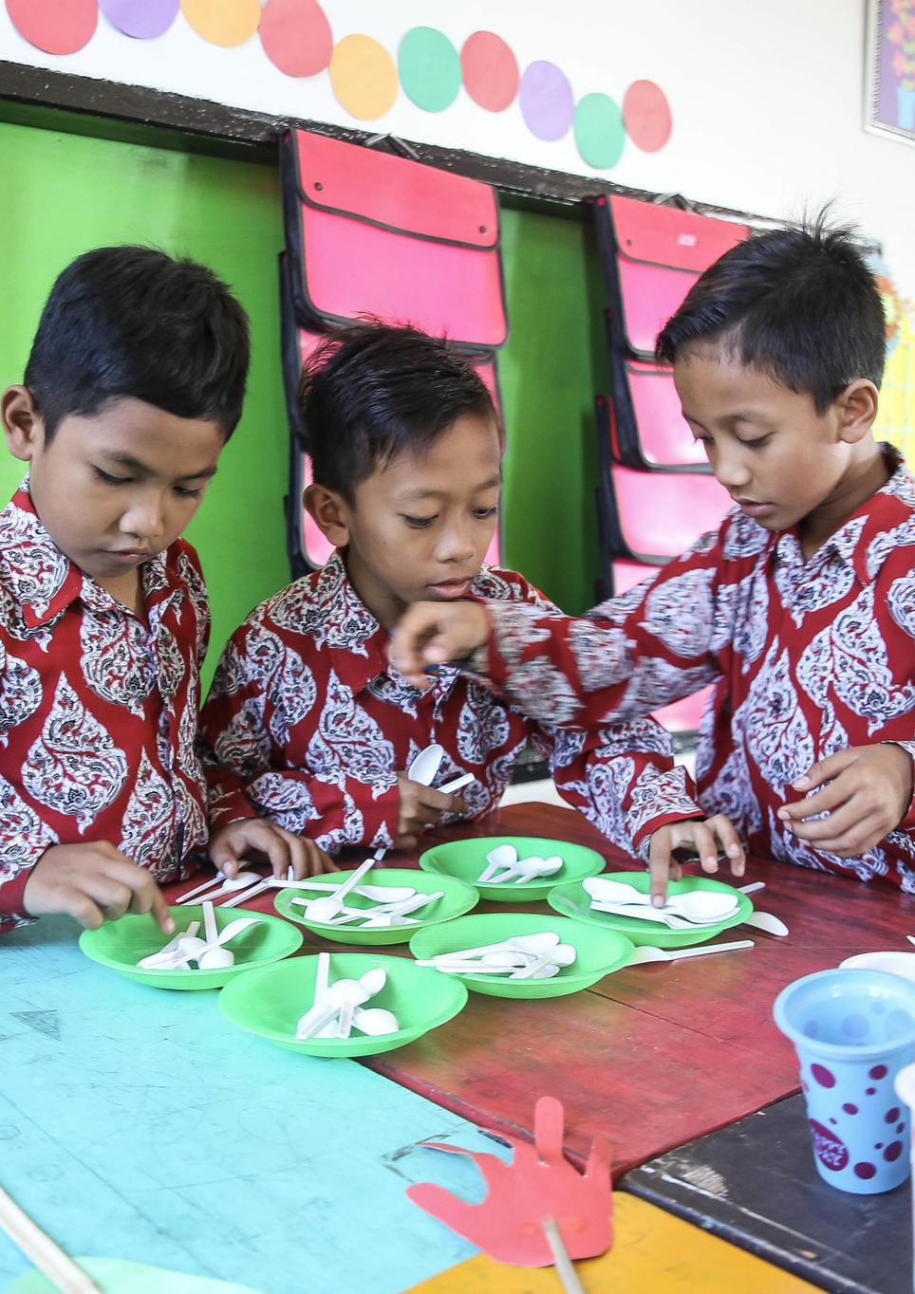

- SUSTAINABILITY
Sustainability is central to the INOVASI Phase I program design as its ultimate goal is to support and inform policy and practice development in education at sub-national and national levels. Initially, we piloted local solutions to learning problems identified by the partner districts. This approach evolved as INOVASI revitalised the teachers’ working groups and trained local facilitators to pilot short courses to improve teachers’ professional practice in key areas. INOVASI also worked at system level with districts, provinces and national governments to embed the lessons from these pilots in policy and programs. This work is expected to continue in Phase II.
The purpose of scaling out successful practices was three-fold: (1) to increase the impact of the program, reaching a wider group of schools, teachers and students; (2) to find out if the approaches worked to improve learning outcomes in different contexts and at the system level; and (3) to build a strong partnership and a sense of ownership for the INOVASI program within government. This ownership is intended to sustain both the approach to continuous improvement and the results from the program activities.
The question of sustainability needs to be considered in this context. The 2019 independent review of INOVASI and other DFAT education investments reported as follows:
‘The move to the short course modality has been an effective approach to build the competency of teachers and improve learning outcomes for students, rather than focusing on PDIA as an activity in itself for the initiation of each pilot. However, caution should be exercised in developing further “implementation” activities for expansion, rather than a true piloting and testing phase to address new problems. Sustainability should be sought in local levels (and national government) taking up the lessons from proven pilot lessons rather than expanding implementation of successful activities to new locations’ (Nichols and Bodrogini 2019, 28).
Sustainability may include:
- Changes to teaching and education management practices that continue beyond the life of the program, demonstrating the sustainability of the outcomes.
- Successfully piloted approaches, such as implementing short courses or using the Student Learning Profile, that are expanded through independent funding and by independent implementers. Funding can come from government (especially district budgets), the private sector, philanthropy or donor programs, such as the World Bank funded loan for continuing professional development in MoRA. Implementers can include: districts; other government agencies, such as the educational quality assurance agencies; non-governmental organisations; and universities. This demonstrates the sustainability of the approach.
- ‘Scaling up’ program outcomes, in the form of changes to systems, policy and programs in the government that result in improved learning outcomes. This broader form of sustainability represents the sustainability of principles established by the pilots.
While these are all valid, as suggested in the extract from the strategic review, Phase II of INOVASI is designed to tackle the third aspect of sustainability: scaling up to system level. Meanwhile we still need to monitor the first two aspects, including the scale out to new schools and districts, to confirm and further improve the effectiveness of the approaches introduced in Phase I. In other words, we need to find out what works at system level. This will provide stronger evidence to inform policy as it evolves.

7.1 Scale-out and Sustainability: Evidence from Phase I
INOVASI’s thematic study on continuing professional development and sustainability (Cannon 2020) addresses two main questions about sustainability and scale out: is there evidence to show which approaches are likely to be sustained – and why; and is there evidence to show which approaches have actually been sustained – and why? An analysis of the literature, INOVASI documents, field data and the results of case studies confirms that INOVASI’s approaches are likely to lead to the sustainability and scale out of benefits from the pilots. This conclusion is informed by testing INOVASI’s approaches in context against a set of educational, management and sustainability/scale-out indicators. Phase II will provide an opportunity to test this empirically.
The thematic study offers further evidence that the benefits from past development project activities have been sustained. These are primarily in teaching and learning but also in school-based management and these benefits reinforce INOVASI’s work. Factors associated with sustainability at school level include: (1) the relevance of the learning and teaching approaches adopted for teachers’ day-to-day work; (2) the increased motivation to teach derived from seeing students’ results improve; (3) educational leadership provided by principals and supervisors; and (4) a strong sense of local ownership and responsibility for change. Another element that would enhance ownership and sustainability is if the role of local facilitators, trained through the pilots, could be institutionalised giving them the status and authority to continue their mentoring support in the schools and working groups after the program ends.
District governments’ policies and regulations, as well as their financial support, further reflect local ownership. In line with INOVASI’s theory of change, the thematic study finds that:
‘…sustainability and scale out are being achieved from the “bottom–up” by teachers and facilitators, initially within schools, but subsequently at more substantial levels, including the teachers’ working groups, sub-districts and districts as a whole’ (Cannon 2020).
Notwithstanding this, INOVASI’s spot-check data shows that most of the pilot schools do not allocate schools operational funds to some core teaching support processes. Experience also shows that continuing professional development programs are often not sustained beyond the life of the program. This is partly due to facilitators being absorbed back into the system without the funding or status to continue their role and districts discontinuing funds and support for the training. Another risk is that districts rely on the donor-funded program to provide materials and train facilitators and, without ongoing technical support, the program fades even when the district is financially committed to continuing it. These risks will be acknowledged and addressed in Phase II, beginning with a joint review and sustainability strategy development process with our counterparts. Going forward into Phase II, we need to assess to what degree the positive results from Phase I are being sustained, including the outcomes from Guru BAIK, the grant-funded partnerships and the later pilots. Phase II will provide a rare opportunity for a longitudinal study of impact and sustainability and a chance to explore ways to ensure sustainability.
INOVASI’s success in producing sustainable outcomes in Phase I is indicated primarily by the principles established in the pilots and research activities that are being used to inform government policy and practice at national and sub-national levels:
- New districts are buying into the program and planning to fully fund the scale out of successful practices to transform teaching and learning for basic skills in literacy, numeracy and inclusion;
- Partner districts are funding the scale out of activities to reach all teachers;
- Non-governmental organisations are establishing partnerships with districts to expand successfully piloted programs;
- MoEC is also reviewing its national curriculum, assessment policies and practices, and INOVASI’s pilots are helping to inform this process. Technical assistance for this process was provided by TASS in the first phase.
Notwithstanding these strong indicators of success, Phase II provides a unique opportunity to improve and test the approaches developed under Phase I and to confirm their sustainability – as well as the sustainability of INOVASI’s program-level approach to adaptive programming and iterative development. The core principles of partnership, adaptability, learning by doing, and ‘thinking and working politically’ will be further developed and tested through Phase II of INOVASI.

Governance as a sustainability mechanism
As described in the introduction, INOVASI is a partnership. Over the four and a half years of Phase I, this sense of partnership and ownership has grown steadily, along with the trust built among partners at national level by TASS and INOVASI – and at sub-national level, primarily by INOVASI. This places us in a strong position to further build the sense of ownership and commitment to the program in Phase II. Ideally, by the end of Phase II, INOVASI will be fully embedded in the Indonesian system and fully owned by our partners, in a way that sustains the program’s achievements beyond the period of DFAT’s financial support. One way to support this process is through governance arrangements.
Throughout Phase I, INOVASI and TASS shared a national steering committee that was chaired by the head of MoEC’s research and development body. The chairperson, Totok Suprayitno, became a strong advocate for the program. The committee, comprised of senior government officials, held six-monthly meetings with the program management team and DFAT. Over time, these meetings evolved to become larger and more representative and included a number of program personnel and partners from national and sub-national levels. INOVASI’s Management Unit was set up late in the second year, to provide a forum for echelon 2 and 3 personnel in MoEC to participate and to arrange joint monitoring visits to the field.
At sub-national level, the arrangements also evolved over time. DFAT did not have a memorandum of understanding with provinces or districts – these were signed between the national government, represented by the national steering committee chairperson, and the sub-national governments, represented by the governor. In West Nusa Tenggara, the first partner province, memorandums were established with the province and partner districts. In the other later provinces, the agreement was between national and provincial government, with partner districts as signatories. Sub-national governments were usually represented at provincial steering committee meetings by the deputy governor and deputy regent in each district. Meetings were typically held every six months. District planning meetings were held occasionally in the lead up to steering committee meetings, to allow for a less formal, more interactive joint planning process.
This arrangement worked well and supported a sense of ownership within the Indonesian government. Based on this experience in Phase II, we recommend keeping the national steering committee small and confining meetings to the membership of senior officials who can take decisions. They may appreciate the opportunity to meet across sectors and ministries at this high level and focus on policy and how INOVASI can support the development of better policy to improve learning outcomes. The committee can continue to be chaired by a senior MoEC official and possibly co-chaired with MoRA. A smaller committee can approve annual work plans and consider the Indonesian government contributions (in finances and in-kind) to the program as it progresses in Phase II. The national steering committee can establish standing working groups to address key themes, including cross-ministerial coordination, national–sub-national coordination and coordination with the non-government sector. These working groups can replace INOVASI’s current Management Unit and provide for greater participation and ownership. At sub-national level, we recommend that the government’s internal memorandum of understanding be between national and provincial governments only, with arrangements for districts left to the discretion of the provinces. This arrangement should allow for more flexibility, enabling districts to enter or leave the program as commitments and contexts evolve.
In Phase II INOVASI team members will use inclusive language and INOVASI will no longer be characterised as a program funded by DFAT and delivered by Palladium. It is a partnership, co-funded and jointly managed with the Indonesian government. For example, there should be no distinction between INOVASI pilots and locally-funded pilots as all pilots will be co-designed and co-implemented. If governance arrangements are handled well by both partners and if conditions are conducive and there is a perceived need for INOVASI to continue beyond Phase II, it may then be possible for the national steering committee to continue to manage a fully Indonesian phase of the INOVASI program.

References
Aikens, Nikki and Oscar Barbarin. 2008. “Socioeconomic Differences in Reading Trajectories: The Contribution of Family, Neighbourhood and School Contexts.” Journal of Educational Psychology 100(2) (2008): 235–51. https://www.researchgate.net/publication/232547275_Socioeconomic_Differences_in_Reading_Trajectories_The_Contribution_of_Family_Neighborhood_and_School_Contexts
Amalia, Mia, Senza Arsendy and Rasita Purba. 2020. Education Partnership to Improve Learning Outcomes. Jakarta: INOVASI.
Andrews, Matt, Lant Pritchett and Michael Woolcock. 2017. Building state capability: evidence, analysis, action. Oxford: Oxford University Press. http://library.oapen.org/handle/20.500.12657/31857
Australian Department of Foreign Affairs and Trade (DFAT). 2014. INOVASI: Innovation for Indonesia’s School Children (Inovasi untuk anak Sekolah Indonesia) Final Design. Jakarta: DFAT. https://www.dfat.gov.au/sites/default/files/indonesia-inovasi-design-document.pdf
Australian Department of Foreign Affairs and Trade (DFAT). April 2019. Education Analytics Services (EAS) Teacher Development Multi-Year Studies Series: Timor Leste. Barton: DFAT. https://www.dfat.gov.au/about-us/publications/Pages/education-analytics-services-teacher-development-multi-year-studies-series-timor-leste
Australian Department of Foreign Affairs and Trade (DFAT). 2020. INOVASI Phase II Investment Design Update. Jakarta: DFAT. https://www.dfat.gov.au/sites/default/files/inovasi-phase-ii-investment-design-update.pdf
Australian Department of Foreign Affairs and Trade (DFAT). Undated. Partnerships for Recovery: Australia’s COVID-19 Development Response. https://www.dfat.gov.au/sites/default/files/partnerships-for-recovery-australias-covid-19-development-response.pdf
Cannon, Robert. 2020. Continuing Professional Development and Sustainability. Jakarta: INOVASI. https://www.inovasi.or.id/en/publication/a-study-of-cpd-and-the-sustainability-of-benefits-in-indonesia-from-inovasi-pilot
Dweck, Carol. 2006. Mindset: The New Psychology of Success. New-York: Random House USA.
Fearnley-Sander, Mary. 2020. Literacy. What Works and Why: Emerging Evidence from INOVASI on Effective Practice in Early Grades Literacy. Jakarta: INOVASI. https://www.inovasi.or.id/en/publication/literacy-what-works-and-why-emerging-evidence-from-inovasi-on-effective-practice-in-early-grades/
Gibson, Sam and Rasita Purba. 2020. Gender and Education. Studies of Gender in the Implementation of INOVASI's Pilot Programs to Improve Student Learning Outcomes. Jakarta: INOVASI.
INOVASI. January 2018. INOVASI Guiding Program Strategy, Part 2. Jakarta: INOVASI.
INOVASI. February 2018. INOVASI Communications Strategy. Jakarta: INOVASI.
INOVASI. November 2018. Emerging Evidence and Policy Recommendations. Internal document. Jakarta: INOVASI.
INOVASI. February 2019. Baseline Report. Malinau and Bulungan, North Kalimantan. Jakarta: INOVASI. https://www.inovasi.or.id/en/publication/report-baseline-report-malinau-and-bulungan-north-kalimantan/

INOVASI. June 2019. A Study Report on Working Groups for Teachers, Principals and School Supervisors as a Forum and Support Network for Continuing Professional Development. Jakarta: INOVASI. https://www.inovasi.or.id/en/publication/study-a-study-report-on-working-groups-for-teachers-principals-and-school-supervisors-as-a-forum-and-support-network-for-continuing-professional-development/

INOVASI. July 2019. Baseline Report. East Java. Jakarta: INOVASI. https://www.inovasi.or.id/wp-content/uploads/2019/09/19_09_05-INOVASI-East-Java-2018-Baseline-Report-FINAL-ENG.pdf
Ministry of National Education (Indonesia). 2008. Standar Pengembangan Kelompok Kerja Guru (KKG)/ Musyawarah Guru Mata Pelajaran (MGMP). [Standards for Developing Primary and Subject Teachers’ Working Groups]. Directorate General of Teachers and Education Personnel, Jakarta: Ministry of National Education.
Ministry of National Education. 2010. Rambu-rambu Pengembangan Kegiatan KKG dan MGMP. [Guidelines for Developing KKG and MGMP Activities]. Jakarta: Directorate Generals of Education Quality Improvement and Higher education, Ministry of National Education.
Ministry of National Planning and Development (Bappenas). 2019. National Mid-term Development Plan 2020–2024 (Rencana Pembangunan Jangka Menengah – RPJMN). Jakarta: Bappenas.
Nichols, Paul and Petra Bodrogini. 2019. Strategic Review Report: Australia’s Investments in Basic Education in Indonesia. Jakarta: DFAT. https://www.dfat.gov.au/sites/default/files/indonesia-australias-investments-in-basic-education-strategic-review-report.pdf
Kleden, Paskal. 2020. Using Problem-driven Iterative Adaptation to Accelerate the Progress of Indonesian Students’ Learning Outcomes. Jakarta: INOVASI. https://www.inovasi.or.id/en/publication/using-pdia-to-accelerate-the-progress-of-indonesian-students-learning-outcome
Sprunt, Beth.2020. Lessons from INOVASI’s Phase One Work on Disability-Inclusive Education. Jakarta: INOVASI. https://www.inovasi.or.id/en/publication/lessons-from-inovasis-phase-1-work-on-disability-inclusive-education/NOVASI
van der Heijden, Mary. 2020. What Works and Why: Emerging Evidence from INOVASI on Effective Practice in Early Grades Numeracy. Jakarta: INOVASI. https://www.inovasi.or.id/en/publication/numeracy-what-works-and-why-emerging-evidence-from-inovasi-on-effective-practice-in-early-grades
Van Vechten, Diana. 2013. Impact of Home Literacy Environments on Students from Low Socioeconomic Status Backgrounds. Education Masters Paper 248. https://fisherpub.sjfc.edu/education_ETD_masters/248

ANNEXES

Annex 1: Thematic Studies Summaries

Executive Summary: Literacy Thematic Study
Fearnley-Sander, Mary. 2020. What Works and Why: Emerging Evidence from INOVASI on Effective Practice in Early Grades Literacy. Jakarta: INOVASI.
This study provides an account of INOVASI’s approach to improving early grades literacy in the program partner areas, the emerging evidence on the outcomes of this approach for students and teachers, and an analysis of what works to improve teaching and learning in those contexts.
INOVASI’s literacy orientation derives from Indonesia’s own nation-building vision of literacy as the means of widening horizons and capabilities in individuals and communities, as outlined in the Ministerial Regulation No 23 of 2015 on Character Development that triggered Indonesia’s literacy movement. This shares the belief in literacy’s potential that underpins literacy studies internationally. INOVASI’s support aligned with government’s aspirations in its approach to building strong foundations for thinking skills in the early grades.
Taking a problem-based capability-building development approach, INOVASI supported districts in identifying problems and piloting contextually-adapted solutions. Focusing on INOVASI’s lead pilots, the study investigates whether student and teacher literacy outcomes improved as a result of these experiments and what elements contributed to or challenged change.
The study develops an analytical framework to assess INOVASI’s work in improving literacy and to explore the program’s extensive data resources. INOVASI’s effect is aligned with strategies evidenced to work in global and Indonesian research and this lends value to the local evidence generated by the program. The study also conducts its own teaching case studies to elucidate the significance of quantitative findings by thick descriptions of practice and to probe the mindset drivers of teachers’ behaviour that influence classroom teaching and learning and their expectations of their students’ potential in literacy.
Key findings from the study show that student outcomes improved over the pilots – more than could be explained by natural growth – and students’ comprehension skills showed the most gain. The main findings on teacher improvement are that most teachers participating acquired critical skills of teaching reading. The most significant of these skills is their new capacity to identify the nature of a child’s reading problem and organise teaching to address it. Making learners’ problems the focus of teaching is potentially the point of departure for student-centred teaching. Developing students’ understanding and engagement with learning to their full potential depends on that shift.
The key findings on what worked can be classified as those elements that mitigated the disadvantages of a particular context. In this process, the commitment to literacy development shown by most district governments was a critical element. A pattern throughout the findings was that the most disadvantaged districts made the most gains and, with the support of the intervention, showed their capability of quickly closing the gap with the more advantaged districts. A related finding was that where pilot adaptations specifically targeted contextual difficulties, such as with language of instruction or access to books for children to read, outcomes outstripped the results of the mainstream approach to improving teachers’ know-how in teaching reading.
Such findings have implications for future strategies to maintain and extend the gains in literacy. The short duration of the pilots means that while the shift towards student-centred teaching practices has been remarkable, a permanent paradigm shift is not yet guaranteed.

Executive Summary: Numeracy Thematic Study
van der Heijden, Mary. 2020. What Works and Why: Emerging Evidence from INOVASI on Effective Practice in Early Grades Numeracy. Jakarta: INOVASI
This study was designed and conducted by INOVASI to explore the impact of two main pilot teacher training programs on the teaching and learning of early grade numeracy concepts. These 'short courses’ were implemented in partner districts in Indonesia. The process was underpinned by the program’s theory of change based on a problem-driven iterative adaptation approach (PDIA). The study discusses what works in INOVASI’s partner districts and potentially in other Indonesian contexts to develop the numeracy knowledge, skills and behaviours, including fluency and flexibility with numbers, that students and teachers need.
Over the last ten years, the results for 15-year old Indonesian students participating in the Programme for International Student Assessment (PISA) show little improvement and about 40 per cent of the students scored below the lowest level in the international standard. In 2018, the results in mathematics show Indonesia ranking 70th out of 77 other countries, with a persistently and particularly low achievement level in thinking ability, mathematical inquiry and reasoning. This means that if students do not develop these basic competencies in numeracy then the prospect of a highly skilled and relevant workforce remains slim.
Although factors such as curricula, leadership, funding, family interest and involvement all contribute to student achievement, the most influential factor is the teacher. INOVASI’s two numeracy pilot studies in Indonesia consisted of two main teacher training programmes involving over four hundred teachers and over 10,000 students in grades one to three.
The training programs that INOVASI designed and conducted had to be practical, engaging and reflective in order to develop teachers’ own understanding of the curriculum content and how young children learn basic concepts. The 'short courses’ took place in district cluster teachers’ working group (KKG) meetings and were presented by locally-trained facilitators who also supported teachers through mentoring sessions in the classroom.
The study collected both quantitative and qualitative data to establish what works in INOVASI’s partner districts and to investigate to what extent training teachers in specific areas will result in improved student learning outcomes. The emphasis was on teaching methods, providing and using appropriate materials and improving students’ higher-order thinking skills in applying their newly developed knowledge and skills.
The mixed method approach discussed in the study includes: teacher observations; student and teacher assessments; teacher interviews; and in-depth video observations.
Our overall findings suggest that teachers improved their own understanding of the mathematical content and the pedagogy needed to support children’s understanding of basic numeracy concepts. The quality of teachers’ knowledge and skills in teaching numeracy progressed significantly. This in turn led to gains in students’ ability in both conceptual knowledge and understanding in number and in their ability to demonstrate their reasoning and apply their knowledge. Teachers used relevant concrete and visual materials effectively to scaffold students understanding towards more abstract concepts. They also asked students more open-ended questions, although students needed more exposure and experience in explaining the processes and thinking about how they arrived at a solution. Teachers also organised the classes so that students were in groups and, in the video studies, teachers had used pre-assessment data to organise the groups.
Students overall progressed in understanding and applying numbers. The use of materials to aid learning was evident in the videod lessons and teachers reported that the students were more engaged as a result. Both students and teachers needed more support in understanding how the use of materials helped them to learn specific concepts and be able to explain them. However based on the endline assessments, students progressed in reasoning and application. While the baseline showed that boys were often behind girls in mathematics, after the training pilots the boys progressed as much as and in some cases more than the girls.
This study provides evidence from INOVASI’s first phase that suggests more time and emphasis should be given in the curriculum for teachers to focus on early conceptual knowledge, skills and understanding. This will ensure a solid basis for more abstract learning later on.
Teachers have not been exposed to the methods that are essential in developing a deeper understanding of number and the students have not had adequate time to practise and explore number concepts. The training in the teachers’ working group meetings means that teachers can continue to learn with and from others and will be able to build on their teaching practices. Differentiated training for teachers and principals would also create awareness and support for new aproaches.
Teaching and learning materials that fit the context, and are manageable and appropriate for the varying levels need to be provided and should be aligned with the students’ learning needs.
Teachers also need to conduct varied and regular assessments so they can use the outcomes effectively to organise the class. These assessments will give them insights into any difficulties or misconceptions the students may have so they can better meet individual, group and whole-class learning needs.

Executive Summary: Continuing Professional Development Thematic Study
Cannon, Robert. 2020. Continuing Professional Development and Sustainability. INOVASI. Jakarta
INOVASI’s approach to improving learning outcomes in early grades is through a strategy known as problem-driven iterative adaptation (PDIA). Development strategies begin with understanding local challenges, and designing, implementing, and testing contextually-relevant intervention pilots to improve learning and teaching. Working with local communities of practice, the teachers’ working group, is a key strategy. The continuing professional development (CPD) of teachers, principals and supervisors is the common approach to achieve change.
This study explores whether INOVASI’s approach works – and why – with a focus on the CPD of early-grade teachers through short courses in literacy, numeracy and supporting issues. The study further considers the sustainability and scale-out of benefits to local stakeholders. INOVASI’s approach to CPD, sustainability, and scale-out is consistent with the findings of studies published in the international and local literature. Used as a benchmark, these studies indicate no shortcomings in either INOVASI’s design or implementation of change. This outcome is reflected in the success of the work being undertaken in districts and schools. The evidence is that INOVASI and its Indonesian partners are working at the cutting-edge of sound, educational development practice in school reform to achieve improved learning outcomes in literacy and numeracy for children.
The success of INOVASI’s approach is due to its alignment with government policies, with the needs of teachers and schools, and with the evidence for educational change. The findings of the study confirm that PDIA principles are relevant in helping Indonesian education to become ‘unstuck’ in its progress towards achieving quality outcomes at scale, and in explaining what works and why in CPD and the sustainability and scale-out of benefits.
Case studies from East Java provide insights into how the processes of sustainability and scale-out have operated, demonstrating the face-validity of a set of indicators developed for the study. Further work is essential to develop an understanding of sustainability and the scale-out of benefits in other cultural contexts in Indonesia where INOVASI is also working.
School improvement must be managed on a continuing basis and not as a ‘one-off’ event. Accessible and continuing technical support to schools and districts is essential to sustain, scale-out, and to advance change.
This study adds value to previous research in this domain by identifying and clarifying those factors that increase the likelihood of CPD achieving its intended outcomes in Indonesia, and the benefits arising from those outcomes being sustained and scaled out.

Executive Summary: Gender Thematic Study
Gibson, Sam and Rasita Purba. 2020. INOVASI and Gender Equality: Reflecting on What We Learned in Phase I and Looking Ahead to Phase II. Jakarta: INOVASI
At the juncture between Phase I and Phase II, this study is both a look back, as we reflect on what INOVASI learned over 2016–2020, and a look ahead to how we will approach gender in the next four years. Our intended audience is internal, primarily INOVASI management and staff, and secondarily, our colleagues from the TASS program and DFAT. Unlike the themes of continuing education, disability, literacy, numeracy and problem-driven iterative adaptation (the other thematic study topics), we did not focus on gender equality in Phase I. Therefore, this study does not delve deeply into ‘what works’ for gender equality.
While INOVASI took a relatively light touch to gender in Phase I, Phase II presents the opportunity to build on what we learned and focus on two areas that we are uniquely positioned to consider from a gender perspective: educational leadership and character education. An energised contribution in Phase II means that INOVASI will need to invest in new in-house skills and forge alliances with new partners in government and civil society.
In Phase I we embedded gender in our wider gender equality and social inclusion (GESI) strategy. This strategy outlines our scope of work in the following areas: gender equality and empowerment; disability and social inclusion; and child protection. It advocates a twin-track approach for inclusion of both mainstreaming and targeting individuals and groups potentially at-risk. Key elements of this strategy included:
- Investing heavily in basic literacy for the many children who do not speak Bahasa Indonesia at home (multi-language pilots);
- Improving how teachers identify and teach children with disabilities;
- Piloting approaches in communities that have difficult educational contexts (for example, high absenteeism, low parent engagement, child labour);
- Identifying innovations that improve teaching and learning in schools in remote areas.
Although we included gender equality and women’s empowerment in the strategy and to a certain degree we have put the gender mainstreaming track in place, Phase I did not target gender equality. We have nonetheless:
- Celebrated a modest reduction in the ‘boys’ achievement gap’ in numeracy and literacy (in INOVASI pilot schools);
- Ensured that most of our data collection and analysis was sex-disaggregated (and also tracked other dimensions of disadvantage such as disability, mother tongue and socio-economic status);
- Screened all our pilot materials to ensure the final versions are ‘inclusive’ and gender-balanced;
- Periodically discussed with our team how a gender perspective is relevant in our own workplace (harassment), in operations (recruitment) and pilots (learning days).
In Phase II we intend to build on this experience and to deepen our work on gender equality with renewed commitment by taking action to:
- Involve a full-time gender specialist from the beginning of Phase II (to ensure pilot designs and policy work take account of gender from the outset);
- Ensure that we include gender-focused activities and events in the workplan and dedicate a realistic budget to support these activities;
- Seek out allies in government and civil society who can help us make wise choices about how we engage on gender;
- Explore the feasibility of designing and delivering a gender-focused pilot (grant, short-course or other) in Phase II;
- Strengthen the school leadership pilot to both improve leadership and management skills for all principals, and promote women’s empowerment;
- Consider the potential for character education to provide opportunities for children to practise values of equality, respect and teamwork – these can and should include a gender dimension.

Executive Summary: Problem-Driven Iterative Adaptation Approach Thematic Study
Kleden, Paskal. 2020. Using PDIA to Accelerate the Progress of Indonesian Students’ Learning Outcomes in Literacy, Numeracy, and Inclusion. Jakarta: INOVASI.
INOVASI adopted PDIA as its primary approach from the outset. However, the way we apply and interpret PDIA has evolved since the program began. In 2016, we used the approach primarily to conduct classroom action research and also to encourage teachers to develop a growth mindset (Dweck, 2006). At that time, INOVASI applied PDIA at the classroom level, asking teachers to identify their students’ learning problems and devise solutions. However, at the second strategy testing session in 2017 the team decided that many teachers still lacked fundamental competencies in teaching literacy and numeracy so expecting them to identify problems and solutions on their own was unrealistic. After that, INOVASI instituted a short-course approach that was itself an iteration built on knowledge from previous donor-supported education programs. Local iterations of INOVASI’s own short courses began in 2019 when local stakeholders started to adjust the content of the courses and decide how best to deliver them in their own districts.
Since 2018, INOVASI’s PDIA approach has also included a ‘thinking and working politically’ component. The program works with the districts to develop more appropriate regulations to support better learning outcomes. Other aspects of the program that reflect this thinking are the team’s efforts to influence district budget allocations away from infrastructure and towards activities to improve the quality of learning and teaching. The most recent iteration is the application of PDIA at the district level. Using PDIA, INOVASI works together with district-level officials in identifying the district’s most pressing challenges.
To assess whether the PDIA approach has been effective, this study examines the evidence from the Guru BAIK pilot and the most recent Jalan Andrews pilot that is extending the use of PDIA at the district level. There are four main reasons to examine the evidence from Guru BAIK. First, Guru BAIK is the first pilot and lessons learned from this pilot have been embedded in all the other pilots. Second, by focusing on Guru BAIK we prevent any overlap with other thematic case studies that examine the other pilots on literacy, numeracy and inclusion in greater detail. Third and most importantly, Guru BAIK includes problem solving and growth mindset components. Finally, it is also the only pilot that has counterfactuals, namely the Literacy Boost and the Literacy 1 pilot, that do not include these PDIA components. The evidence shows that Guru BAIK has more impact on student literacy scores than Literacy Boost. The data also shows that teachers that benefitted from Guru BAIK before participating in the Literacy 1 pilot performed better than those who only participated in the Literacy 1 short course.
Furthermore, teachers with Guru BAIK experience contributed to higher learning outcomes among children with special needs and those from poor socio-economic backgrounds. Nevertheless, there is need for more data. The current available evidence is based only on a small number of districts.
Concerning the application of PDIA at the district level, there are some known challenges but also positive indications. One of the barriers is that PDIA requires initiative and active involvement from its counterparts but in the district bureaucracy, officials tend to prefer to wait for instructions. On some of the positive findings, officials became more data-driven in identifying problems and in looking for solutions. The application of PDIA also apparently helped to break down silos among the 6 INOVASI | Using PDIA to Accelerate the Progress of Indonesian Students’ Learning Outcomes – June 2020 various actors. District stakeholders became aware that addressing an education problem is not the sole responsibility of the district education office but requires collaboration with other stakeholders. Finally, while there is clarity about what PDIA means as a concept, its application is subject to different interpretations. Indonesia already has experience with other ‘PDIA-like’ initiatives that are context-specific and seek to strengthen local solutions and decentralised decision making. These interventions have also faced cultural and political challenges. Any aid program trying to implement PDIA needs to anticipate those challenges.
Executive summary: Disability Inclusion Thematic Study
Sprunt, Beth. 2020. Lessons from INOVASI’s Phase 1 Work on Disability-Inclusive Education. Jakarta: INOVASI.
The purpose of this study is to assemble and examine early findings from the disability inclusion aspects of INOVASI’s work in Phase I. This includes a particular focus on the activities in three pilot districts (Central Lombok, Probolinggo and East Sumba), within grant-based partnerships, and in activities focused on systems and policy engagement. The study explores what has worked and not worked to improve disability-inclusive education in INOVASI, and what enablers and barriers are important to take note of in progressing Indonesia’s inclusive education reforms.
Indonesia’s legal and policy framework supports the right of children with disabilities to access a quality and inclusive education. This is most clearly outlined in Law No 8 of 2016 on Disability and the related Government Regulation No 13 of 2020 regarding Appropriate Accommodation for Students with Disabilities. Despite a supportive legal framework, various datasets, including most recently the Indonesian Bureau of Statistics 2018 national socioeconomic survey (Susenas) show concerningly low rates of school enrolment, completion and progression of Indonesia’s children with disabilities.
During Phase I, INOVASI focused on piloting disability-inclusive education capacity development programs for teachers, developing and testing the Student Learning Profile and undertaking an extensive multi-stakeholder policy analysis and development process to develop the Central Lombok Regency Inclusive Education Roadmap (2019-2021). The data used for this study was drawn from three quantitative studies and an extensive document analysis. The studies included a pre-test and post-test of teachers in the inclusion pilot schools, the Indonesian education and learning innovation survey (SIPPI) and the spot-check assessment involving classroom observations and interviews.
The study showed impressive improvements in learning outcomes among students with disabilities in the INOVASI pilot schools and highlighted the value of strengthening disability data systems and policy tools to enable inclusive education. Numerous effective strategies were identified including: the centrality of building teachers’ skills in differentiated instruction; simple and practice-based teacher training through the teachers’ working group system; investing in multi-stakeholder policy development work; working with village leaders, parents and community stakeholders; considering financial mechanisms and incentives for inclusion; and interrogating where disability data and definitions are a barrier and how they can be made into enablers.
The findings also highlighted areas where improvements are needed. This included proactively using and strengthening the work of Disabled Peoples Organisations and Disability Service Units in supporting the inclusive schools; designing pilots with a broader focus than just teacher capacity development to address the fact that most children with disabilities are out of school; building the capacity of principals and supervisors to enable accessible infrastructure, access to resources and greater support for teachers; and addressing system and teaching capacity required to implement assessments inclusively.
Further implications point to the importance of: strengthening partnerships with universities and other teacher training institutions; updating the General Guidelines for the Implementation of Inclusive Education to incorporate the obligations outlined in Government Regulation No 13 of 2020 regarding Reasonable Accommodation for Students with Disabilities; ongoing support to disability identification mechanisms that inform resource decisions; monitoring and evaluating the efforts of inclusive education policy development and implementation; developing a range of communications materials to increase awareness of policies and systems, such as guidance for school leaders on accessing resources for inclusion through BOS funding; strengthening linkages between schools and early intervention, health and specialist services; and working with communities and other stakeholders to address non-school barriers to inclusive education.

Executive Summary: Partnership Thematic Study
Amalia, M., Senza Arsendy and Rasita Purba. 2020. Education Partnership to Improve Learning Outcomes. Jakarta: INOVASI.
Since 2018, INOVASI has worked together with 20 selected partner organisations through the grant-based partnership program. The collaboration aims to test various approaches that may improve education quality, particularly in the early grades. Working with local organisations is also expected to promote sustainability of the program and its results.
INOVASI’s baseline and endline surveys reveal that the program produced promising results, for example, more supportive learning environments, improved teaching practices, increased involvement of communities and parents, and better learning outcomes. A follow-up qualitative study was conducted to provide a comprehensive understanding of how partners' approaches and uniqueness contribute to those results.
The study cites key factors affecting the quality of learning including: the ‘teaching at the right level’ approach; ‘literate’ classroom environments; and supportive school policies. Furthermore, collaboration with teacher training institutes resulted in significant changes in the pre-service training curriculum. Also, the use of mother-tongue in the early grades meant that students who do not speak Bahasa Indonesia enjoyed a more interactive learning experience. In INOVASI’s work on inclusive education, partnerships between communities and schools improved access to education for children with disabilities. Collaboration between parents and schools also contributed to more parents becoming involved in their children’s schooling. Finally, establishing libraries in both schools and communities, supported by the distribution of child-friendly books and trained librarians increased students’ interest in reading and their reading ability.
The grant-based partnership program has also provided some promising results overall although some challenges remain. The main issue the program faced was the short duration of program implementation meaning that the beneficiaries had little time to develop the capacity to continue the program and maintain results. While some district governments have taken the initiative to scale out the programs, other districts have not. Thus relevant policies and regulations are needed to mobilise resources and sustain the promising practices generated by the partnership program.
Despite the challenges, the study outlines four mechanisms that could be used to sustain these programs: implementing them within partner schools; adoptions of good practices by other schools that are usually disseminated through communities of practice on social media; scale out with government support; and changes within partner organisations.
This study concludes with an assessment of what works and what does not work in achieving program objectives. The lessons learned enrich INOVASI’s understanding of effective approaches to improve the quality of learning in primary schools, especially for the early grades. In addition, by citing the evidence, this study contributes to the discussion on the role of non-governmental organisations in education development.

Annex 2: Key Achievements, Challenges and Lessons Learned, by Province

North Kalimantan

KEY ACHIEVEMENTS
- The main achievement of the early grade literacy pilot in North Kalimantan is that various stakeholders have used the endline results as a powerful advocacy tool to promote early grade literacy programs in INOVASI non-partner areas.
- The education office scaled out the literacy pilot in two partner districts (Bulungan and Malinau) and one non-partner district (Tana Tidung) with some variations.
- Bulungan district has been implementing the literacy program in its entirety (design, personnel, budget and monitoring and evaluation system) since the beginning of 2020.
A more detailed explanation for the province and each district follows.
Literacy working group of North Kalimantan province:
- North Kalimantan has formed a literacy working group that includes various literacy actors.
- This group has coordinated the procurement of 30,000 children's books from various parties.
- The group organised a literacy camp to consolidate the literacy movement in North Kalimantan province and invited special staff from the President’s Office to attend.
Bulungan district:
- Bulungan scaled out the early grade literacy pilot to all schools in the district using 2019 local government budget funds (APBD).
- The district also scaled out a primary higher grade literacy pilot to all schools using the 2020 APBD.
- Bulungan allocated APBD through the regional schools operational funds (BOSDA) to purchase children's reading books in the 2018, 2019 and 2020 fiscal years.
- The district is implementing an existing main task and functions-based literacy program (tupoksi) across sectors monitored by supervisors, starting in 2020.
Malinau district:
- Malinau district scaled out the early grade literacy pilot through the village library/community reading centre synergy program with schools using funding from the local village budget in the 2019 and 2020 fiscal years.
- The district also scaled out the early grade literacy pilot to remote schools through 100 contracted teachers in the 2020 fiscal year.
- The pilot was also scaled out in schools that can only be reached through difficult road/river trips in seven clusters (45 schools) and using the budget from the 2020 APBD.
Tana Tidung district:
- Tana Tidung district adopted the early grade literacy pilot for all schools (30 schools) using the 2020 APBD budget.
- The district procured children's books for all schools using the BOSDA 2020 budget.
- The synergy of the village library/community reading centres was socialised in schools in all sub-districts. Some villages bought children's books using the 2020 local village budget.
- Tana Tidung district developed a monitoring and evaluation system for the early grade literacy pilot by conducting baseline, midline and endline studies funded by the 2020 budget. Baseline data were collected and are still being analysed.

CHALLENGES
- The main challenge in implementing pilots in North Kalimantan is that the province does not have the resources within the education office to provide quality training and guidance.
- The second challenge is the difficult terrain in North Kalimantan meaning that not all schools are easily reached by road.
- Another challenge is the limited capacity of civil society organisations working on literacy issues in North Kalimantan. Most of these organisations are volunteer-based and focus on delivering books to remote areas rather than on literacy in schools.

LESSONS LEARNED
- Pilots with a specific focus are easier to implement.
- Involving policymakers at the provincial and district levels as well as technical advisors from the education office is key to the district taking over responsibility for managing the program.
- The district needs intensive and in-depth technical support. Although they have the funds, personnel and time, difficulties still arise in implementing the pilots without technical support.
- Three issues reflect the district’s readiness to take over the program: the confidence of the policymakers; availability of the technical personnel to carry it out; and the budget.
- The pilot design needs to be adapted to local conditions, especially geographical conditions, making it impossible to faithfully replicate the teachers’ working group model training program.

West Nusa Tenggara

KEY ACHIEVEMENTS
- INOVASI works with the government to collect evidence by working within the system, especially through the teachers’ working groups and using local facilitators. We have revitalised dormant working groups and demonstrated their potential as a broad and relatively cheap solution to improving the quality of teaching, as the government originally envisaged.
- The pre-pilots and pilots on inclusive education in Central Lombok produced the evidence that led to the Student Learning Profile tool that is now used nationally.
- Partnerships with various non-governmental organisations and the University of Mataram enriched the evidence generated by the pilots and expanded INOVASI’s network, forming a broad coalition to overcome the problems.
- Various policies in the form of regents and districts regulations, circulars and instruction letters were produced by the six local governments.

CHALLENGES
- The MERL team cannot provide feedback quickly enough for ongoing program improvement.
- Evidence or research and survey results from Jakarta are slow, resulting in frequent loss of momentum.
- As evidence from intermediate results is often slow, communication and advocacy with policymakers is more often based on personal contacts than on strong evidence.
- The communication products in West Nusa Tenggara have not been clearly targetted. We have not monitored which policymakers are at what level or whether the right target audience is receiving messages and to what extent the messages changed their perceptions and behaviour.
- The quality of independent scale-out pilots by local governments and teachers’ working groups still varies and some do not have monitoring and evaluation mechanisms in place.
- Policies are often constrained due to changes in local government personnel and reviews have not yet been done to assess the effectiveness of these policies in driving change.
- Improvements in learning outcomes are limited to the pilot target and only some schools maintain the changes from the pilot. Information is not available on accelerated learning improvements in scale-out target schools as they did not all conduct baseline studies.

LESSONS LEARNED
- In Phase I, most of the financial and human resources were dedicated to monitoring and evaluating pilots to produce evidence related to literacy, numeracy and inclusive education. Other evidence, especially on literacy and numeracy, has been produced by other institutions including grantees, United Nation agencies, non-governmental organisations and teacher training institutes. INOVASI needs to reflect on whether this ‘evidence’ is only ‘self-generated evidence’ or actually extracted from a meta-analysis of the existing body of evidence.
- INOVASI needs to focus on filling the gaps in evidence in relation to inclusive education/learning for all, digital learning and character education.
- INOVASI needs to clarify who are considered the policymakers. Is it only the district, provincial and national governments? What about cluster heads, school principals, heads of teacher training institutes, for example, who have the authority to produce policies and allocate budgets to support scale out? By defining the policymakers, we can target the strategy, products and communication platforms more accurately.
- Key evidence-based messages need to be continuously reinforced and monitored to check that the target audience receives the messages and to find out whether they result in changes in perception and behaviour.
- We also need to clarify what we mean by scale out. Is it only related to the pilot? Is it still a scale out if, for example, only the literacy formative assessment is scaled out? If the child protection principle is scaled out, for example in Sumbawa, would that also be considered as a scale out?
- INOVASI in West Nusa Tenggara needs to support districts with data on literacy and numeracy on all primary/early grade students so the districts priority areas become clearer.
- More effort should be made to improve school principals and teachers’ autonomy and freedom in learning and teaching practices so that change is more sustainable.

East Java

KEY ACHIEVEMENTS
- Scale out: Various achievements or changes in partner schools encouraged a number of stakeholders in the partner districts to scale out the INOVASI module material and deliver the full courses or selected parts of them. In the five INOVASI partner districts, 909 schools, including 75 madrasah and 834 primary schools, benefitted from the INOVASI modules in 2019 and 825 schools, including 41 madrasah and 784 primary schools, will benefit in 2020.
- NU Ma‘arif and Muhammadiyah: Through partnership grants with Muhammadiyah the INOVASI literacy pilot expanded coverage beyond partner areas, including in Ngawi, Jember and Trenggalek. Muhammadiyah will also scale out the pilot through four Muhammadiyah universities in East Java that all have schools under their guidance. Despite the challenges, NU Ma'arif has scaled out the INOVASI literacy and numeracy pilot to Central Java besides implementing scale out in East Java.
- Local government regulation: Since the INOVASI pilot was first implemented in East Java in 2018, the district/city government has issued 16 regulations. One of the ongoing provincial government regulations is on replicating the INOVASI education pilot in madrasah in Pasuruan and Sidoarjo districts (MoRA regional office circular No B-3474/Kw.13.2.5./HM.01/7/2019).
- Enhancing the capabilities of the Probolinggo district education office through the PDIA process: INOVASI supported the Probolinggo district education office over a six-month period to reform its system. This was through a thorough review of the tasks and responsibilities of staff under each unit that supports education using the PDIA process, known locally as Jalan Andrew (Andrew’s way). This process resulted in the revision of the Tegent’s regulation No 82 of 2018 on the Organisational Structure and Work Procedure of the Education Office by adding the task functions of several new units, including learning units, materials development and institutions, functional position groups and integrated data management.

CHALLENGES
- Coordination between INOVASI and the provincial government was limited in Phase I. This was due to difficulties in securing a meeting with the governor to introduce the INOVASI pilot. In addition, the provincial government only has special authority at the secondary school level so it cannot intervene directly in basic education since that comes under the district or city government.
- The change in the head of local government affects the sustainability of the INOVASI pilots since education policies and coordination with INOVASI need to be reintroduced. INOVASI will need to promote the program among new officials who may already have their own priorities. The heads of the Sumenep and Sidoarjo district education offices are also due to retire in 2020 and in early 2021.
- The organisational structure of the district/city education office will change with the Minister of Home Affairs decree No 130/14106/SJ/2019 to simplify the administration processes in the regional government environment. If the process is protracted, it may not be clear who has collective responsibility for the professional development of supervisors, principals and teachers.
- The process of transforming the teachers’ working groups into productive and effective spaces for teachers’ professional development has not been easy. In general, not many teachers consider these working groups as a platform to develop their capacity.
- Teachers still have difficulty in understanding the curriculum and in integrating the material learned in the teachers’ working group (INOVASI modules) into their teaching. So far, teachers still tend to depend on textbooks and do not apply the approaches from the modules systematically.
- Facilitators still need to develop their ability to support teachers in implementing the INOVASI modules. There are not enough effective facilitators to support the scale out of the INOVASI pilot in the partner districts.
- In general, any scale outs depend on ad hoc local budget allocations from year to year and rely on support from INOVASI staff in planning and training of trainers. So far the district office has not made systematic changes to review and strengthen long-term continuing professional development for teachers.

LESSONS LEARNED
- Regulations need to be based on the needs of all parties and take into account the views of all levels – from classrooms and schools through to district offices – to run effectively and at scale. These include regulations such as: (a) the Regent’s regulation on Managing Primary School Multi-grade Learning in Probolinggo, (b) the Regent’s regulation on Technical Guidelines for Provision and Use of State and Private Assistance BOS Funds in 2019 (BOSDA) and (c) the head of the Pasuruan district education office Circular on Implementing the Literacy Movement in Schools.
- With the high turnover of key officials at provincial and district level, we need to resocialise the INOVASI pilot for continuity in coordination and support from the local government offices.
- In addition to the core material in the INOVASI modules, the material on pedagogy, active learning, classroom management, understanding the curriculum, growth mindset, and gender equality and social inclusion helped local facilitators and teachers to implement the modules in the teachers’ working groups and respond to the needs of individual students in the class.
- Parental support in learning is important, especially for parents whose children are in multi-grade classes and this support increased significantly after the training for parents. Parents can now actively monitor their children's learning development at home.
- Support from school supervisors and principals in organising the teachers’ working groups and implementing the outcomes in the classroom improves the quality of learning. Teachers are more confident in implementing their new learning in class if they have the right level of support.
- Having one key counterpart partner in the district office helps in coordinating, accelerating and sustaining the pilot program.

East Nusa Tenggara

Key achievements
- Scale-out: Policy work in analysing district budgets in the four target districts in Sumba has had an impact and district budgets have reallocated funds from physical infrastructure to learning/teaching quality in the last two years – amounting to IDR15,7 billion to scale out the program.
- Scale out: Learning from Sumba, the new district of Nagekeo in Flores has allocated IDR336 million to scale out the literacy program in the district.
- Partnerships: Some of the grant-based partnership pilots have also been scaled out, fully or partially, by the district governments in partnership with YLAI in West Sumba (literacy), with Lily and William in Southwest Sumba (literacy) and with Sulinama in East Sumba (language transition). Rainbow Reading Gardens also raised funds for new school libraries in East Sumba, West Sumba and Southwest Sumba.
- Inclusion: School stakeholders and the community are more aware of children’s right to education after the inclusion program implemented by CIS Timor and students with disability can now access schooling more easily. CIS Timor has also worked with five villages to develop village laws on inclusion.
- Assessment: Implementing a formative assessment tool to assess reading ability and student’s reading groups (like the reading camp in West Sumba) has improved students’ performance, including their reading ability (basic and comprehensive literacy). This led to the regent’s instruction on Mapping Students’ Reading Ability and Formative Assessment in West Sumba.
- Evidence to policy: The provincial parliament used evidence from various studies, including the Analytical and Capacity Development Partnership (ACDP) study and INOVASI’s pilot progress reports in Sumba, to inform the local government planning and policy support to education, especially on the literacy movement.
- Provincial planning: INOVASI in Sumba has been invited to contribute to the schools’ medium term planning process at provincial level conducted by the human resources development agency.
- The East Nusa Tenggara governor and related key government education institutions at provincial level have adopted INOVASI pilots on literacy and numeracy as the focus area in the ‘grand design’ for education and its roadmap.

Challenges:
- Sustainability: Change in the classrooms and schools during pilots may be difficult to sustain because no system is in place to institutionalise the pilot approach. For example, a monitoring mechanism did not seem to be in place after the INOVASI pilots were completed to ensure continuity and sustainability. Some schools may continue on their own and some may not. The teachers’ working groups have not been used continuously as a platform for teachers’ professional development.
- Language transition based approach: The variety of mother tongues used either by teachers or students in Sumba posed a challenge in implementing the language transition based approach with one dominant mother tongue, as used by Sulinama in East Sumba and by Summer Institute of Languages in Southwest Sumba. In some cases, the teachers may not speak the same local dialect as most of the students.
- Absenteeism: The SIL partnership work on the use of language transition to bridge student learning faced challenges of absenteeism from students, teachers and principals. This impacted on the learning in general. Another challenge is the relatively short period of the pilot given that language transition programs generally require a longer period to have an impact.
- Coordination: Close coordination and collaboration is key to ensuring program sustainability, especially in areas where many other agencies are working in similar programs. Coordination with other agencies with the same stakeholders was sometimes challenging, especially in scheduling when we could engage with similar beneficiaries.
- Relative short duration of pilot implementation: Implementing the training material intensively in classrooms was challenging due to the short duration of the program (one semester). Changes were not yet visible.
- Facilitators: Many local facilitators are relatively young and are contract teachers. They encounter problems when they have to ‘mentor’ more senior teachers with civil servant status. Changes are only likely to happen through local facilitators if they are institutionalised within the district education system.
- Province and district: The governor of East Nusa Tenggara has committed to linking pre-school education, basic education and senior high education but barriers persist in the education law related to the authority between the provinces and districts.

Lessons learned:
- When decision makers have a strong sense of ownership of the pilot process they are more likely to allocate funds to scale out the INOVASI pilots.
- Documented evidence and ‘killer facts’ on student learning are powerful advocacy tools for planning and policy changes.
- Issues of inclusive and special needs education can only be resolved by multi-stakeholders. The role of the regional development planning agency is essential to engage the education, women's empowerment and child protection, social affairs, community empowerment and health offices.
- Teachers are the key determinant in students’ success and if teachers do not implement new skills learned in professional training for various reasons, change is unlikely to occur.
- Increasing the change spaces in authority, acceptance and ability for education personnel from school to provincial level will yield better results.

Annex 3: Implementing Partners, Contract/Grant Value and Key Achievements

During Phase I, INOVASI engaged with 22 partners to provide services for quality improvement. These partners consisted of seven teacher training Institutes, 13 non-governmental or civil society organisations and the two Islamic organisations, Muhammadiyah and NU Ma‘arif. To support the national policy issues of literacy (including libraries and language transition), numeracy and inclusion in primary schools, these partners implemented various pilots across 20 districts within the four INOVASI partner provinces. These pilots took place during the period 2017–2019 and each one lasted for eight to 15 months. The partners worked with a range of stakeholders in developing and implementing in-service training materials, mentoring, working with communities and reading centres, as well as designing and implementing monitoring and evaluation activities. Grants allocated to these ‘grantees’ totalled AUD2.8 million with total expenditures of AUD2.6 million, making an overall spn rate of 93.22 per cent by the end of the program.

Table A1: Partners, program focus and grant values

No | Partner | District | Area of focus | Award amount  in IDR | Expended  In IDR | Burn  Rate
 | East Nusa Tenggara |  |  | 7,882,608,633 | 6,981,664,460 | 88.57 per cent
1 | Yayasan Sulinama (Sulinama Foundation) | East Sumba | Literacy – bi-lingual | 1,202,959,000 | 1,193,185,571 | 99.19 per cent
2 | CIS Timor Society | East Sumba | Inclusive education | 1,452,213,776 | 1,413,985,176 | 97.37 per cent
3 | Taman Bacaan Pelangi (Rainbow Reading Gardens) | East Sumba, Southwest  Sumba,  Central Sumba,  West Sumba | Library | 1,836,079,357 | 1,529,152,932 | 83.28 per cent
4 | Yayasan Literasi Anak Indonesia - YLAI (Indonesian Children’s Literacy Foundation | West Sumba  Southwest Sumba | Literacy | 1,976,356,500 | 1,537,185,278 | 77.78 per cent
5 | Suluh Insan Lestari | Southwest Sumba | Literacy -bi-lingual | 1,415,000,000 | 1,308,155,503 | 92.45 per cent
 | West Nusa Tenggara |  |  | 9,465,511,498 | 9,221,518,855 | 97.42 per cent
6 | Forum Lingkar Pena | Central Lombok | Inclusive book development and training | 507,515,000 | 507,515,000 | 100.00 per cent
7 | Edukasi 101 | Sumbawa, West  Sumbawa | Literacy & Numeracy | 1,859,675,000 | 1,767,622,301 | 95.05 per cent
8 | Dompet Dhuafa Pendidikan | Dompu | Literacy & Leadership | 1,004,857,000 | 862,427,819 | 85.83 per cent
9 | Sahabat Pulau Indonesia | Bima | Literacy & Numeracy | 724,315,000 | 714,804,237 | 98.69 per cent
10 | Yayasan Tunas Aksara | North Lombok | Literacy | 999,985,600 | 999,985,600 | 100.00 per cent
11 | Save the Children | North Lombok, Sumbawa | Literacy | 3,890,757,898 | 3,890,757,898 | 100.00 per cent
12 | Universitas Negeri Mataram (Mataram State University | Central Lombok | Inclusive Education | 478,406,000 | 478,406,000 | 100.00 per cent
 | East Java |  |  | 7,289,465,000 | 6,796,330,852 | 93.23 per cent
13 | Kolaborasi Literasi Bermakna (Kampus Guru Cikal, IniBudi, PSPK, Keluarga Kita) | Batu city,  Probolinggo | Literacy | 2,866,655,000 | 2,651,605,001 | 92.50 per cent
14 | Universitas Islam Negeri – UINSA (Surabaya State Islamic University) | Pasuruan | Literacy | 584,710,000 | 524,083,277 | 89.63 per cent
15 | Universitas Negeri Surabaya – UNESA (Surabaya State University) | Sidoarjo | Literacy | 658,150,000 | 596,266,485 | 90.60 per cent
16 | Bina Nusantara University (BINUS) | Sumenep | Numeracy | 765,000,000 | 693,638,656 | 90.67 per cent
17 | UniversitasNahdlatul Ulama Surabaya - UNUSA (Nahdlatul Ulama University Surabaya) | Pasuruan | Numeracy | 664,950,000 | 614,274,306 | 92.38 per cent
18 | Dikdasmen Pimpinan Wilayah (PW) Muhammadiyah Jawa TImur | Sidoarjo,  Ngawi  Jember  Trenggalek | Literacy | 750,000,000 | 716,463,127 | 95.53 per cent
19 | Lembaga Pendidikan (LP) Ma'arif NU Pusat | Sidoarjo  Pasuruan  Sumenep | Literacy & Numeracy | 1,000,000,000 | 1,000,000,000 | 100.00 per cent
 | North Kalimantan |  |  | 2,828,185,300 | 2,603,248,377 | 92.05 per cent
20 | Universitas Negeri Makassar – UNM (Makassar State University) | Bulungan | Literacy | 603,014,800 | 564,850,428 | 93.67 per cent
21 | Universitas Borneo Tarakan -UBT (University of Borneo Tarakan) | Malinau | Literacy | 714,208,000 | 679,442,082 | 95.13 per cent
22 | Litara foundation- OPOB | Malinau,  Bulungan | Literacy/  Books | 1,510,962,500 | 1,358,955,867 | 89.94 per cent
General Total |  |  |  | 27,465,770,431 | 25,602,762,544 | 93.22 per cent

Key achievements
- Building trust/brokering: Traditionally, the relationship between the non-government sector and the government is complex but some areas of cooperation between have recently improved, especially in the area of education. Through the partnerships and grants program, INOVASI brought the supply and demand sides together by creating opportunities for the two parties to collaborate and explore initiatives to improve students’ learning outcomes. This experience built trust between them and several local governments continued the partners’ programs in the second year, beyond the grant contracts, thus sustaining the investment. For example, the district education office in West Sumba has agreed to support the continuation of YLAI’s program through a cost-sharing scheme. Also, in Southwest Sumba, YLAI, the district education office and the Lily and William Foundation have agreed to continue supporting the ten pilot schools – a collaboration of three parties.
- Monitoring and evaluation: While many participating partners brought strong programs with them, most lacked capability in monitoring and evaluating the activities effectively. INOVASI supported the grantee partners in developing a monitoring and evaluation framework based on the theory of change and helped design theories of change for each of the pilots. Besides this technical support to partners, INOVASI also conducted baseline and endline surveys, and spot checks for the grant-based partnerships pilots to identify programs and practices that improve learning outcomes.
- Strengthening engagement with Indonesia’s non-government education sector: Many non-governmental organisations contribute to development processes, including in the education sector. The grants program meant that INOVASI could invest in activities consistent with its own high-level objectives and bring together more education stakeholders with a common cause – thereby leveraging collective action. MoEC appreciated INOVASI’s grant-based partnership program, its PDIA approach and assessment methods and this inspired it to launch its recent partnership program with non-governmental organisations, Program Organisasi Penggerak. The program is designed to be expansive with potentially more than 100 non-governmental organisations participating. The initiative, scheduled for the beginning of the 2020 school year, reflects MoEC’s desire to leverage the good practices that these and other organisations have demonstrated in supporting and capacitating school stakeholders to improve students’ learning outcomes.
- Strengthening organisations’ business capability: The capacity of non-governmental organisations, universities and teacher training institutions needs strengthening, especially in terms of business processes. Some organisations did not yet have well-established procurement and financial management systems. They typically lacked experience working with donor-funded programs with regard to compliance. Throughout the grant-based partnership, regular support included training in how to set up good standard operating procedures for recruitment and procurement processes, and how to set up procedures for financial processes and good reporting systems. Despite the stringent procedures put in place by INOVASI, organisations expressed their appreciation and said the training strengthened their organisational capability as service providers.
- Highlighted achievements: Apart from improving teachers and principals’ knowledge, attitudes and practices, some highlights from the grant-based partnership pilots’ achievements are as follows:
- Access to reading books is key to improving students’ interest and skills in reading. In Central Sumba, interest in reading almost doubled – from 53 per cent to 95 per cent – and students passing the basic literacy test tripled in Central Sumba (from 15 per cent to 54 per cent).
- A new initiative by Forum Lingkar Pena aimed to reach deaf children by developing and producing 170 sets of the Si Bintang series consisting of 21 books each, using sign language. These books were disseminated to INOVASI inclusive schools in Central Lombok.
- Communities, teachers and principals in East Sumba are more aware of the rights of disabled children to education. CIS Timor worked closely with the community in five villages to advocate for these children’s right to education and increased enrolment of children with disabilities in schools. Regulations on inclusive education have also been ratified at the village level.
- Generally, stakeholders are also more aware of gender equality and social inclusion issues in the classroom and in selecting and developing children’s books to use in schools.

Annex 4: List of all INOVASI Knowledge Products: Phase I

Training Module (8)
Title |  | Year | Link
1 | Early Grade Literacy 1 | 2019 | Not yet online
2 | Early Grade Literacy 2 | 2019 | Not yet online
3 | Early Grade Numeracy 1 | 2019 | Not yet online
4 | Early Grade Numeracy 2 | 2019 | Not yet online
5 | Disability and Inclusion 1 | 2019 | Not yet online
6 | Disability and Inclusion 2 | 2019 | Not yet online
7 | Multigrade Teaching | 2019 | Not yet online
8 | School Leadership | 2019 | Not yet online

Student’s Worksheet for Learning from Home (8)
Title |  | Year | Link
1 | Literacy (Grade 1) | 2020 | Not yet online
2 | Literacy (Grade 2) | 2020 | Not yet online
3 | Literacy (Grade 3) | 2020 | Not yet online
4 | Numeracy (Grade 1) | 2020 | Not yet online
5 | Numeracy (Grade 2) | 2020 | Not yet online
6 | Numeracy (Grade 3) | 2020 | Not yet online
7 | Character Education | 2020 | Not yet online
8 | Psychoeducation | 2020 | Not yet online

Factsheet (6)
 | Title | Year | Link
1 | About INOVASI | 2019 | - https://www.inovasi.or.id/en/publication/fact-sheet-about-inovasi-march-2019/ https://www.inovasi.or.id/id/publication/lembar-fakta-tentang-inovasi-maret-2019/
2 | INOVASI in NTB | 2019 | - https://www.inovasi.or.id/en/publication/fact-sheet-inovasi-in-west-nusa-tenggara-december-2018/  - https://www.inovasi.or.id/id/publication/lembar-fakta-program-inovasi-di-nusa-tenggara-barat-desember-2018/
3 | INOVASI in NTT | 2019 | - https://www.inovasi.or.id/en/publication/fact-sheet-inovasi-in-east-nusa-tenggara-december-2018/  - https://www.inovasi.or.id/id/publication/lembar-fakta-program-inovasi-di-nusa-tenggara-timur-desember-2018/
4 | INOVASI in North Kalimantan | 2019 | - https://www.inovasi.or.id/id/publication/lembar-fakta-program-inovasi-di-kalimantan-utara-oktober-2018/
5 | INOVASI in East Java | 2019 | - https://www.inovasi.or.id/en/publication/fact-sheet-inovasi-in-east-java-december-2018/  - https://www.inovasi.or.id/id/publication/lembar-fakta-program-inovasi-di-jawa-timur-agustus-2019/
6 | INOVASI Grants Partnerships with CSOs | 2018 | - https://www.inovasi.or.id/en/publication/fact-sheet-inovasis-partnership-with-18-ngos-and-education-organisations-in-indonesia/  - https://www.inovasi.or.id/id/publication/lembar-fakta-kemitraan-inovasi-dengan-18-lsm-dan-organisasi-pendidikan-di-indonesia/

Thematic Case Study (7)
Title |  | Year | Link
1 | Literacy  Studies of INOVASI’s pilot programs in literacy implemented in four provinces in Indonesia | 2020 | https://www.inovasi.or.id/en/publication/literacy-what-works-and-why-emerging-evidence-from-inovasi-on-effective-practice-in-early-grades/
2 | Numeracy  Studies of INOVASI’s pilot programs in numeracy implemented in four provinces in Indonesia | 2020 | https://www.inovasi.or.id/en/publication/numeracy-what-works-and-why-emerging-evidence-from-inovasi-on-effective-practice-in-early-grades
3 | Gender and Education  Studies of gender in the implementation of INOVASI’s pilot programs to improve students learning outcomes | 2020 | https://drive.google.com/drive/folders/1dSJCHMsEWmPiH09xbPtsmu3piV8-29td?usp=sharing (not for public sharing)
4 | Disability and Inclusion  Studies of inclusion in the implementation of INOVASI’s pilot programs to improve students learning outcomes | 2020 | https://www.inovasi.or.id/en/publication/lessons-from-inovasis-phase-1-work-on-disability-inclusive-education.
5 | PDIA to Accelerate Progress of Indonesian Students’ Learning Outcomes in Literacy, Numeracy, and Inclusion  Lessons from INOVASI’s experience with PDIA, a learning by doing approach to develop the capability to solve complex problems | 2020 | https://www.inovasi.or.id/en/publication/using-pdia-to-accelerate-the-progress-of-indonesian-students-learning-outcome
6 | Continuing Professional Development (CPD) and Sustainability  Studies of Continuing Professional Development and the Sustainability of Benefits in Indonesia from INOVASI’s pilots | 2020 | https://www.inovasi.or.id/en/publication/a-study-of-cpd-and-the-sustainability-of-benefits-in-indonesia-from-inovasi-pilot
7 | Partnerships for Learning  Studies of INOVASI’s pilot programs in literacy, numeracy, and inclusion implemented in partnerships with NGOs, Teacher Training Institutes and CSOs | 2020 | Not yet online

Policy Brief (8)
Title |  | Year | Link
1 | Early grade literacy | 2019 | - https://www.inovasi.or.id/id/publication/risalah-kebijakan-literasi-dasar/  - https://www.inovasi.or.id/en/publication/policy-brief-early-grade-literacy-in-indonesia-october-2019/
2 | Early grade numeracy | 2019 | - https://www.inovasi.or.id/id/publication/risalah-kebijakan-numerasi-dasar-oktober-2019/  - https://www.inovasi.or.id/en/publication/policy-brief-early-grade-numeracy-october-2019/
3 | Multi-grade teaching | 2019 | - https://www.inovasi.or.id/id/publication/risalah-kebijakan-pengajaran-kelas-rangkap/  - https://www.inovasi.or.id/en/publication/policy-brief-multi-grade-teaching-october-2019/
4 | Mother language transition strategies | 2019 | - https://www.inovasi.or.id/id/publication/risalah-kebijakan-penggunaan-bahasa-daerah-di-kelas-awal-sebagai-transisi-ke-bahasa-indonesia/  - https://www.inovasi.or.id/en/publication/policy-brief-mother-language-transition-in-education-october-2019/
5 | School leadership | 2019 | - https://www.inovasi.or.id/id/publication/risalah-kebijakan-kepemimpinan-dan-manajemen-sekolah/  - https://www.inovasi.or.id/en/publication/policy-brief-school-leadership-and-learning-october-2019/
6 | Inclusive education | 2019 | - https://www.inovasi.or.id/id/publication/risalah-kebijakan-pembelajaran-untuk-semua-anak-oktober-2019/  - https://www.inovasi.or.id/en/publication/policy-brief-inclusive-education-october-2019/
7 | Assessment | 2019 | - https://www.inovasi.or.id/id/publication/risalah-kebijakan-memanfaatkan-penilaian-untuk-peningkatan-hasil-pembelajaran/  - https://www.inovasi.or.id/en/publication/policy-brief-assessment-for-improved-learning-outcomes-october-2019/
8 | Strengthening KKG and teacher's CPD | 2019 | - https://www.inovasi.or.id/id/publication/risalah-kebijakan-kelompok-kerja-guru-kkg-sebagai-wadah-pengembangan-keprofesian-berkelanjutan/  - https://www.inovasi.or.id/en/publication/policy-brief-improving-teacher-working-groups-in-indonesia-october-2019/

Research Report (19)
Title |  | Year | Link
1 | Multigrade Teaching | 2019 | - https://www.inovasi.or.id/id/publication/laporan-pembelajaran-kelas-rangkap/
2 | Baseline Report: East Java | 2019 | - https://www.inovasi.or.id/id/publication/laporan-baseline-jawa-timur/  - https://www.inovasi.or.id/en/publication/report-baseline-report-east-java/
3 | The Status of Children with Disabilities and Inclusive Education in Central Lombok, West Nusa Tenggara (NTB) | 2019 | - https://www.inovasi.or.id/id/publication/laporan-kondisi-anak-berkebutuhan-khusus-abk-dan-pendidikan-inklusi-di-lombok-tengah/  - https://www.inovasi.or.id/en/publication/report-the-status-of-children-with-disabilities-and-inclusive-education-in-central-lombok/
4 | Midterm Evaluation Report:  INOVASI in West Nusa Tenggara (NTB) | 2019 | - https://www.inovasi.or.id/id/publication/laporan-studi-midline-inovasi-nusa-tenggara-barat/
5 | Baseline Report: North Kalimantan | 2019 | - https://www.inovasi.or.id/id/publication/laporan-baseline-kalimantan-utara/
6 | Education Innovations in East Java:  a review and analysis of INOVASI’s stocktake study | 2019 | - https://www.inovasi.or.id/id/publication/laporan-inovasi-pendidikan-di-jawa-timur-penilaian-dan-analisis-terhadap-studi-inventarisasi-praktik-baik-inovasi/  - https://www.inovasi.or.id/en/publication/report-education-innovations-in-east-java-a-review-and-analysis-of-inovasis-stocktake-study/
7 | A study report on working groups for teachers, principals, and school supervisors as a forum and support network for CPD | 2019 | - https://www.inovasi.or.id/id/publication/laporan-studi-kkg-kkm-kkks-kkps-sebagai-wadah-jejaring-pendukung-pengembangan-keprofesian-berkelanjutan-pkb/  - https://www.inovasi.or.id/en/publication/study-a-study-report-on-working-groups-for-teachers-principals-and-school-supervisors-as-a-forum-and-support-network-for-continuing-professional-development/
8 | Baseline Report:  Sumba, East Nusa Tenggara (NTT) | 2019 | - https://www.inovasi.or.id/id/publication/laporan-baseline-sumba-nusa-tenggara-timur/  - https://www.inovasi.or.id/en/publication/report-baseline-report-sumba-east-nusa-tenggara/
9 | Final Report: Guru BAIK pilot, building teachers capacity in West Nusa Tenggara (NTB) | 2019 | - https://www.inovasi.or.id/id/publication/laporan-akhir-guru-baik-mengembangkan-kapasitas-guru-di-nusa-tenggara-barat-indonesia/  - https://www.inovasi.or.id/en/publication/report-guru-baik-building-teachers-capacity-in-west-nusa-tenggara-indonesia/
10 | Final Report: Gema Literasi pilot, improving literacy for early grade students in West Nusa Tenggara (NTB) | 2019 | - https://www.inovasi.or.id/id/publication/laporan-akhir-gema-literasi-meningkatkan-literasi-siswa-kelas-awal-di-nusa-tenggara-barat-indonesia/  - https://www.inovasi.or.id/en/publication/final-report-gema-literasi-improving-literacy-for-early-grade-students-in-west-nusa-tenggara-indonesia/
11 | Local Socio Economic and Cultural Contextual Analysis of Basic Education in Lepadi, Ranggo, and Tembalale Villages in Dompu, West Nusa Tenggara (NTB) | 2019 | - https://www.inovasi.or.id/id/publication/laporan-analisis-konteks-lokal-sosial-ekonomi-dan-budaya-terkait-pendidikan-dasar-di-desa-lepadi-ranggo-dan-tembalale-kecamatan-pajo-kabupaten-dompu-nusa-tenggara-barat/  - https://www.inovasi.or.id/en/publication/report-local-socio-economic-and-cultural-contextual-analysis-of-basic-education-in-lepadi-ranggo-and-tembalale-villages/
12 | Laporan: Sintesis Hasil Studi Diagnostik Pembelajaran Pendidikan Dasar di Enam Kabupaten Mitra INOVASI di Provinsi Nusa Tenggara Barat | 2018 | - https://www.inovasi.or.id/id/publication/laporan-sintesis-hasil-studi-diagnostik-pembelajaran-pendidikan-dasar-di-enam-kabupaten-mitra-inovasi-di-provinsi-nusa-tenggara-barat/
13 | A Case Study of Teachers Cluster Working Group (KKG) in Moyo Hulu - Sumbawa, West Nusa Tenggara (NTB) | 2018 | - https://www.inovasi.or.id/id/publication/laporan-studi-kasus-kkg-di-moyo-hulu-sumbawa/  - https://www.inovasi.or.id/en/publication/report-a-case-study-of-teachers-cluster-working-group-in-moyo-hulu-sumbawa/
14 | Midterm Evaluation Report:  Guru BAIK pilot | 2018 | - https://www.inovasi.or.id/id/publication/laporan-laporan-evaluasi-proses-pelaksanaan-program-rintisan-guru-baik/  - https://www.inovasi.or.id/en/publication/report-guru-baik-pilot-midterm-evaluation-report/
15 | Baseline Report:  Guru BAIK pilot | 2018 | - https://www.inovasi.or.id/id/publication/laporan-program-rintisan-guru-baik-baseline/  - https://www.inovasi.or.id/en/publication/report-guru-baik-baseline-report/
16 | Program Baseline:  Education in West Nusa Tenggara (NTB) | 2018 | - https://www.inovasi.or.id/id/publication/laporan-gambaran-umum-pendidikan-di-provinsi-nusa-tenggara-barat-ntb/  - https://www.inovasi.or.id/en/publication/report-program-baseline-report-west-nusa-tenggara-ntb/
17 | Rapid Participatory Situation Analysis:  Education in North Kalimantan | 2018 | - https://www.inovasi.or.id/id/publication/laporan-analisis-situasi-partisipatif-cepat-rpsa-untuk-dukungan-pembelajaran-provinsi-kalimantan-utara/  - https://www.inovasi.or.id/en/publication/report-rapid-participatory-situation-analysis-north-kalimantan/
18 | Indonesian National Assessment Program (INAP/AKSI) 2016 | 2018 | - https://www.inovasi.or.id/id/publication/laporan-asesmen-kompetensi-siswa-indonesia-aksi-provinsi-ntb-2016/  - https://www.inovasi.or.id/en/publication/report-indonesian-national-assessment-program-inap-ntb-2016/
19 | Intervention, Practices, and Contextual Factors Linked to Indonesian Students Literacy and Numeracy Learning Outcomes | 2018 | - https://www.inovasi.or.id/id/publication/laporan-intervensi-praktik-dan-faktor-kontekstual-terkait-hasil-belajar-literasi-dan-numerasi-siswa-indonesia/  - https://www.inovasi.or.id/en/publication/report-interventions-practices-and-contextual-factors-linked-to-indonesian-students-literacy-and-numeracy-outcomes/

Infographic (15)
Title |  | Year | Link
1 | Leading a Generation of Learners | 2019 | - https://www.inovasi.or.id/en/publication/infographic-leading-a-generation-of-learners/  - https://www.inovasi.or.id/id/publication/infografik-pemimpin-pembelajaran-generasi-pembelajar/
2 | Preparing a Generation for the 21st Century: The Case for Improving Early Grade Literacy and Numeracy | 2019 | - https://www.inovasi.or.id/en/publication/infographic-preparing-a-generation-for-the-21st-century-the-case-for-improving-early-grade-literacy-and-numeracy/  - https://www.inovasi.or.id/id/publication/infografik-mempersiapkan-generasi-abad-21-pentingnya-kemampuan-dasar-literasi-dan-numerasi-kelas-awal/
3 | Buku Bacaan untuk Siswa Kelas Awal di Kalimantan Utara | 2018 | - https://www.inovasi.or.id/id/publication/infografik-buku-bacaan-untuk-siswa-kelas-awal-kalimantan-utara/
4 | Mid-term Evaluation:  Guru BAIK Pilot in NTB Province | 2018 | - https://www.inovasi.or.id/en/publication/infographic-guru-baik-pilot-mid-term-evaluation-west-nusa-tenggara-ntb/  - https://www.inovasi.or.id/id/publication/infografik-evaluasi-tengah-tahun-program-rintisan-guru-baik-ntb/
5 | Classroom Insights: Guru BAIK Pilot in North Lombok and Sumbawa, NTB | 2018 | - https://www.inovasi.or.id/en/publication/infographic-classroom-insights-from-guru-baik-pilot-schools/  - https://www.inovasi.or.id/id/publication/infografik-praktik-pembelajaran-di-sekolah-sekolah-peserta-program-rintisan-guru-baik/
6 | Program Baseline:  Education in West Sumbawa, NTB | 2018 | - https://www.inovasi.or.id/en/publication/infographic-program-baseline-west-nusa-tenggara-ntb-west-sumbawa/  - https://www.inovasi.or.id/id/publication/infografik-temuan-awal-gambaran-umum-pendidikan-di-sumbawa-barat-ntb/
7 | Program Baseline:  Education in Sumbawa, NTB | 2018 | - https://www.inovasi.or.id/en/publication/infographic-program-baseline-west-nusa-tenggara-ntb-sumbawa/  - https://www.inovasi.or.id/id/publication/infografik-temuan-awal-gambaran-umum-pendidikan-di-sumbawa-ntb/
8 | Program Baseline:  Education in Dompu, NTB | 2018 | - https://www.inovasi.or.id/en/publication/infographic-program-baseline-west-nusa-tenggara-ntb-dompu/  - https://www.inovasi.or.id/id/publication/infografik-temuan-awal-gambaran-umum-pendidikan-di-dompu-ntb/
9 | Program Baseline:  Education in North Lombok, NTB | 2018 | - https://www.inovasi.or.id/en/publication/infographic-program-baseline-nusa-tenggara-barat-north-lombok/  - https://www.inovasi.or.id/id/publication/infografik-temuan-awal-gambaran-umum-pendidikan-di-lombok-utara-ntb/
10 | Program Baseline:  Education in Central Lombok, NTB | 2018 | - https://www.inovasi.or.id/en/publication/infographic-program-baseline-nusa-tenggara-barat-central-lombok/  - https://www.inovasi.or.id/id/publication/infografik-temuan-awal-gambaran-umum-pendidikan-di-lombok-tengah-ntb/
11 | Program Baseline:  Education in Bima District, NTB | 2018 | - https://www.inovasi.or.id/en/publication/infographic-program-baseline-nusa-tenggara-barat-bima/  - https://www.inovasi.or.id/id/publication/infografik-temuan-awal-gambaran-umum-pendidikan-di-bima-ntb/
12 | Program Baseline:  Education in NTB Province | 2018 | - https://www.inovasi.or.id/en/publication/infographic-program-baseline-nusa-tenggara-barat/  - https://www.inovasi.or.id/id/publication/infografik-temuan-awal-gambaran-umum-pendidikan-di-provinsi-nusa-tenggara-barat-ntb/
13 | A Case Study of KKG in Moyo Hulu-Sumbawa, NTB | 2018 | - https://www.inovasi.or.id/en/publication/infographic-a-case-study-of-kkg-in-moyo-hulu-sumbawa/  - https://www.inovasi.or.id/id/publication/infografik-studi-kasus-kkg-di-moyo-hulu-sumbawa/
14 | Rapid Participatory Situation Analysis (RPSA) in North Kalimantan Province | 2018 | - https://www.inovasi.or.id/en/publication/infographic-rapid-participatory-situation-analysis-north-kalimantan/  - https://www.inovasi.or.id/id/publication/infografik-analisis-situasi-partisipatif-cepat-rpsa-untuk-dukungan-pembelajaran-provinsi-kalimantan-utara/
15 | District Profile: Education in INOVASI’s Six District Partners in NTB | 2018 | - https://www.inovasi.or.id/en/publication/infographic-west-nusa-tenggara-ntb-district-profile/  - https://www.inovasi.or.id/id/publication/infografik-potret-pendidikan-dasar-enam-kabupaten-mitra-inovasi-di-ntb/

Booklet of Early Grade Teaching Practices: Literacy, Numeracy, Inclusion (13)
Title |  | Year | Link
1 | Southwest Sumba, NTT: Promising Practices in Early Grade Literacy, Numeracy, and Inclusion | 2020 | Not yet online
2 | West Sumba, NTT: Promising Practices in Early Grade Literacy, Numeracy, and Inclusion | 2020 | Not yet online
3 | Central Sumba, NTT: Promising Practices in Early Grade Literacy, Numeracy, and Inclusion | 2020 | Not yet online
4 | East Sumba Promising Practices in Early Grade Literacy, Numeracy, and Inclusion | 2020 | Not yet online
5 | Bima, NTB: Promising Practices in Early Grade Literacy | 2020 | Not yet online
6 | NTB: Promising Practices in Early Grade Literacy, Numeracy, and Inclusion | 2020 | Not yet online
7 | East Java: Promising Practices in Early Grade Literacy Learning | 2020 | Not yet online
8 | East Sumba, NTT: Promising Practices of Inclusive Education in Early Grades | 2020 | https://www.inovasi.or.id/id/publication/ide-ide-pembelajaran-inklusi-di-kabupaten-sumba-timur-ntt/
9 | Sidoarjo, East Java: Promising Practices in Early Grade Numeracy Learning | 2019 | https://www.inovasi.or.id/id/publication/ide-ide-pembelajaran-numerasi-di-kabupaten-sidoarjo/
10 | Southwest Sumba, NTT: Promising Practices in Early Grade Literacy and Numeracy Learning | 2018 | https://www.inovasi.or.id/id/publication/ide-ide-pembelajaran-literasi-dan-numerasi-di-sumba-barat-daya/
11 | East Java Study Stocktake:  Promising Practices in Early Grade Literacy, Numeracy, and Inclusion | 2018 | https://www.inovasi.or.id/id/publication/praktik-praktik-baik-di-pendidikan-dasar-provinsi-jawa-timur/
12 | NTB: Promising Practices in Early Grade Literacy, Numeracy, and Inclusion | 2018 | https://www.inovasi.or.id/id/publication/praktik-praktik-baik-di-pendidikan-dasar-ntb/
13 | East Java Study Stocktake:  Six Top Practices in Early Grade Literacy, Numeracy, and Inclusion | 2017 | https://www.inovasi.or.id/id/publication/buku-kecil-praktik-praktik-baik-di-pendidikan-dasar-jawa-timur/

Big Book (44)

Sumba, NTT
Title |  | Year | Link
1 | Bertamasya ke Pantai | 2020 | Not yet online
2 | Gemar Berolahraga | 2020 | Not yet online
3 | Kebunku | 2020 | Not yet online
4 | Kegiatan Kesukaan Anggota Keluarga | 2020 | Not yet online
5 | Merawat Halaman Rumah | 2020 | Not yet online
6 | Rumah Adat Sumba | 2020 | Not yet online
7 | Sahabat Sejati | 2020 | Not yet online
8 | Sekolahku Tercinta | 2020 | Not yet online
9 | Tugas Andro di Rumah | 2020 | Not yet online
10 | Bermain Kelereng | 2020 | Not yet online
11 | Buah-buahan | 2020 | Not yet online
12 | Kegiatan Sehari-hari di Sekolah | 2020 | Not yet online
13 | Kuda Bora | 2020 | Not yet online
14 | Kampungku | 2020 | Not yet online
15 | Hasil Kebunku | 2020 | Not yet online
16 | Keluargaku | 2020 | Not yet online
17 | Rumahku | 2020 | Not yet online
18 | Saya Hidup Sehat | 2020 | Not yet online
19 | Singa dan Tikus | 2020 | Not yet online
20 | Daur Hidup Kupu-kupu | 2020 | Not yet online
21 | Keluargaku | 2020 | Not yet online
22 | Sayuran | 2020 | Not yet online
23 | Rumah Nenek | 2020 | Not yet online
24 | Aku dan Delano | 2020 | Not yet online
25 | Gemar Menggambar | 2020 | Not yet online
26 | Kebun Bunga | 2020 | Not yet online
27 | Kupu-kupu | 2020 | Not yet online
28 | Juku dan Wangga Watu | 2020 | Not yet online
29 | Tiduhai | 2020 | Not yet online
30 | Rambu Anak yang Baik | 2020 | Not yet online
31 | Tomat Kesukaanku | 2020 | Not yet online
32 | Petualanan Si Air | 2020 | Not yet online
33 | Terperosok di Kubangan Kerbau | 2020 | Not yet online
34 | Ama dan Ina | 2020 | Not yet online
35 | Sakit Gigi | 2020 | Not yet online
36 | Lau Pahikung | 2020 | Not yet online
37 | Aku Anak Gembala | 2020 | Not yet online
38 | Tubuhku | 2020 | Not yet online
39 | Aku Suka Menolong | 2020 | Not yet online
40 | Bermain Kelereng | 2020 | Not yet online
41 | Menanam Jagung | 2020 | Not yet online
42 | Air Sumber Energi | 2020 | Not yet online
43 | Banjir | 2020 | Not yet online
44 | Akibat Tidak Belajar | 2020 | Not yet online

Video (192)
Title |  | Year | Link
1 | Supporting Belajar dari Rumah | 2020 | Not yet online
2 | Program Scale Out in North Kalimantan | 2020 | Not yet online
3 | [Literasi] Program Kemitraan INOVASI dengan LSM, LPTK, dan Ormas | 2020 | Not yet online
4 | [Numerasi] Program Kemitraan INOVASI dengan LSM, LPTK, dan Ormas | 2020 | Not yet online
5 | [Inklusi] Program Kemitraan INOVASI dengan LSM, LPTK, dan Ormas | 2020 | Not yet online
6 | Program Kemitraan INOVASI dengan LSM, LPTK, dan Ormas (Summary) | 2020 | Not yet online
7 | Capaian Program di Provinsi NTB | 2020 | Not yet online
8 | Capaian Program di Provinsi Jawa Timur | 2020 | Not yet online
9 | (Numerasi) Program Numerasi Kelas Awal di Sidoarjo, Jawa Timur & Sumbawa, NTB: Hasil Endline | 2020 | https://youtu.be/FFLVi0wawrA
10 | [Inklusi] NTB & NTT: Pendidikan Inklusif dan Pembelajaran Literasi Dasar yang Berkualitas | 2019 | https://youtu.be/ELt-fw9VdoA
11 | [Literasi] Dompu, NTB: Replikasi program literasi di KKG secara swadaya | 2019 | https://youtu.be/MI2r81b9Fxk
12 | [Literasi] Program INOVASI di Kalimantan Utara 2019 | 2019 | https://youtu.be/0tNGZ3afGRA
13 | [GuruBAIK] Sumbawa Barat, NTB: Tingkatkan mutu pembelajaran di kelas awal | 2019 | https://youtu.be/xVzutBtnAIA
14 | [Literasi] West Sumba, NTT: (YLAI) Tutorial Manajemen Kelas Kegiatan Membaca Terbimbing | 2019 | https://youtu.be/cU4WwDusDJE
15 | [Literasi] Sumba Barat, NTT: (YLAI) Tutorial Kegiatan Membaca Terbimbing dengan Buku Jenjang C | 2019 | https://youtu.be/ph3lx_f-IBY
16 | [Literasi] Sumba Barat, NTT: (YLAI) Tutorial Kegiatan Membaca Terbimbing dengan Buku Jenjang B | 2019 | https://youtu.be/MRF7w2VehAo
17 | [Literasi] Sumba Barat, NTT: (YLAI) Tutorial Kegiatan Membaca Terbimbing dengan Buku Jenjang A | 2019 | https://youtu.be/bd-QhUQeb8c
18 | [Literasi] Sumba Barat, NTT: (YLAI) Manajemen Kelas - Kegiatan Membaca Bersama | 2019 | https://youtu.be/q-t3utGEZRs
19 | [Literasi] Sumba Barat, NTT: (YLAI) Kegiatan Membaca Bersama 3 | 2019 | https://youtu.be/v06kZJK0Mlc
20 | [Literasi] Sumba Barat, NTT: (YLAI) Kegiatan Membaca Bersama 2 | 2019 | https://youtu.be/WA6oeZFwJVE
21 | [Literasi] Sumba Barat, NTT: (YLAI) Kegiatan Membaca Bersama 1 | 2019 | https://youtu.be/cAlX7jVy1Ko
22 | Bima dan Dompu, NTB: Program Peningkatan Kemampuan Literasi Kelas Awal 2 | 2019 | https://youtu.be/LIlHYsFFEH4
23 | [Literasi] Kalimantan Utara: Kolaborasi untuk Meningkatkan Kemampuan Literasi Siswa Kelas Awal | 2019 | https://youtu.be/4aIHcmIG1CE
24 | [Literasi] Sumba Barat, NTT: Program Literasi Kelas Awal 1 | 2019 | https://youtu.be/nr7fumOhK3Y
25 | [TASS] Pustekkom Kemendikbud Study Visit ke Australia | 2019 | https://youtu.be/icPaSPXVj9Y
26 | [Highlights] Temu INOVASI Sumbawa 2019 | 2019 | https://youtu.be/UE9HAACKLVE
27 | [Literasi] Bima, NTB: (SPI) "Sunbright from The East" | 2019 | https://youtu.be/g8nwcZZmwF8
28 | [Literasi] Sumba Barat, NTT: (YLAI) Tutorial Membaca Interaktif | 2019 | https://youtu.be/wTZlKoB-nW8
29 | [Literasi & Numerasi] NTB: (Edukasi101) Program Linumeratif di Sumbawa & Sumbawa Barat | 2019 | https://youtu.be/9OEMNqfNQCM
30 | [TASS] Jawa Timur: Pengembangan Keprofesian Berkelanjutan untuk Guru Madrasah #2 | 2019 | https://youtu.be/q5pW21Wxrok
31 | [TASS] Jawa Timur: Pengembangan Keprofesian Berkelanjutan untuk Guru Madrasah #1 | 2019 | https://youtu.be/6ENFR-YKc4Y
32 | [Kepemimpinan] Sumba Barat, NTT: Testimoni Program Rintisan Kepemimpinan dan Pembelajaran | 2019 | https://youtu.be/MwiY8MiqEro
33 | [Inklusi] Sumba Timur, NTT: Pelatihan Guru Tentang Pendidikan Inklusif (CIS Timor) | 2019 | https://youtu.be/PMBfj0nq1A0
34 | [Inklusi] Sumba Timur, NTT: Keterlibatan Masyarakat, Dukung Pembelajaran Inklusif (CIS Timor) | 2019 | https://youtu.be/5VhbLYhbdlI
35 | [Inklusi] Sumba Timur, NTT: Kerja Sama Berbagai Pihak untuk Pembelajaran Inklusif (CIS Timor) | 2019 | https://youtu.be/XxMvHbeePtE
36 | Pembelajaran Kelas Rangkap di Probolinggo, Jawa Timur: Peluang dan Tantangan | 2019 | https://youtu.be/jw1ySlF6Brs
37 | Kepemimpinan Pembelajaran yang Mendukung Literasi di Kota Batu | 2019 | https://youtu.be/60yZ2sm949A
38 | Pemanfaatan Bahasa Ibu: Solusi Lokal Peningkatan Kemampuan Literasi Siswa SD Kelas Awal | 2019 | https://youtu.be/hvCsIWnJs8w
39 | [Literasi] Sumba Timur, NTT: Pembelajaran Multi Bahasa Berbasis Bahasa Ibu | 2019 | https://youtu.be/byppgV0qnSg
40 | [Kelas Rangkap] Probolinggo, Jawa Timur: Pembelajaran Kelas Rangkap di SDN Ngadisari 2 | 2019 | https://youtu.be/3q9NXJjohIw
41 | Probolinggo, Jawa Timur – Kontrak Belajar | 2019 | https://youtu.be/BPMjCFD4oRk
42 | [Highlights] Temu INOVASI Sumbawa 2019 | 2019 | https://youtu.be/UE9HAACKLVE
43 | Temu INOVASI #5 | Pemanfaatan bahasa Ibu: Solusi lokal Peningkatan Kemampuan Literasi Siswa | 2019 | https://youtu.be/bh5HrLjJFtU
44 | Temu INOVASI #4 | Inovasi Pembelajaran: Solusi Konteks Lokal untuk Tingkatkan Mutu Pendidikan | 2019 | https://youtu.be/WurYMXP4rWU
45 | Temu INOVASI #3 | Prospek Gerakan Literasi Dasar di Daerah 3T | 2019 | https://youtu.be/lJ9RWWZZ4cg
46 | Temu INOVASI #1 | Praktik Inovasi Pembelajaran: Peluang dan Tantangan | 2019 | https://youtu.be/W-qcZpMC1HY
47 | Temu INOVASI #6 | Pembelajaran Kelas Rangkap di Pendidikan Dasar: Peluang dan Tantangan | 2019 | https://youtu.be/0ejaIchCJpE
48 | [Temu INOVASI #4] Sesi Pasar Ide 2: "Manajemen Berbasis Sekolah" | 2019 | https://youtu.be/0TjeLsLeUPQ
49 | [Temu INOVASI #4] Sesi Pasar Ide 1: "Inovasi Pembelajaran" | 2019 | https://youtu.be/Duze3MG2ORo
50 | [Temu INOVASI #4] Sesi Pasar Ide 3: "Kebijakan Pendidikan" | 2019 | https://youtu.be/SMnnxPRNyVw
51 | [Highlights] Temu INOVASI NTB | Mataram, 18-19 Desember 2018 | 2019 | https://youtu.be/bT9Qj6a3U3s
52 | [Highlights] Temu INOVASI #4 | Jakarta, 28 November 2018 | 2019 | https://youtu.be/TgF7gRnZrlc
53 | [Highlights] Seminar Partnerships for Learning 2 | Surabaya, 7-9 Nov 2018 (IND) | 2019 | https://youtu.be/WIJpkhenJ4Q
54 | [Highlights] Seminar Partnerships for Learning 2 | Surabaya, 7-9 Nov 2018 (ENG) | 2019 | https://youtu.be/_LS4_F5uuEE
55 | [Voxpop] Opini - Wakil Bupati Bima: Program INOVASI & upaya meningkatkan mutu pendidikan NTB | 2019 | https://youtu.be/XU9b7Vm3yn4
56 | [Voxpop] Opini - Pengawas SD Lombok Timur: Program INOVASI & upaya meningkatkan mutu pendidikan | 2019 | https://youtu.be/8KG-eSVpvk4
57 | [Voxpop] Opini - Bappeda Sumbawa: Program INOVASI & upaya meningkatkan mutu pendidikan NTB | 2019 | https://youtu.be/L_hfOBoziqk
58 | [Voxpop] Opini - Dinas Sosial NTB: Program INOVASI & upaya meningkatkan mutu pendidikan NTB | 2019 | https://youtu.be/kvYIZmTf6x0
59 | [Voxpop] Opini - Guru SDN Taloko, Bima: Program INOVASI & upaya meningkatkan mutu pendidikan NTB | 2019 | https://youtu.be/iG45gRIF0BA
60 | [Voxpop] Opini - Bupati Sumbawa Barat: Program INOVASI & upaya meningkatkan mutu pendidikan NTB | 2019 | https://youtu.be/WhvgK3V5eo8
61 | [Voxpop] Opini - Gubernur NTB: Program INOVASI dan upaya meningkatkan mutu pendidikan | 2019 | https://youtu.be/ifkvWrEk48c
62 | [Voxpop] Opini - Sekretaris Dinas KominfoTIK NTB: Upaya meningkatkan mutu pendidikan di NTB | 2019 | https://youtu.be/My0fqZrSQr8
63 | [Voxpop] Opini - Kepala LPMP NTB: Meningkatkan mutu pendidikan di Provinsi NTB | 2019 | https://youtu.be/t7ymb5P_fzQ
64 | [Voxpop] Opini - Guru SDN 11 Taliwang, Sumbawa Barat: Meningkatkan mutu pendidikan di NTB | 2019 | https://youtu.be/27OEshjT0y0
65 | [Voxpop] Opini - Guru SDN 3 Lape, Sumbawa: Meningkatkan mutu pendidikan di NTB (Pendidikan Inklusif) | 2019 | https://youtu.be/CTaXXChIHqw
66 | [Voxpop] Opini - Kepala Dinas Pendidikan Lombok Tengah: Meningkatkan mutu pendidikan di NTB | 2019 | https://youtu.be/9ipA8o_v590
67 | [Voxpop] Opini - Dit. PKLK Kemendikbud: Meningkatkan mutu pendidikan di Provinsi NTB | 2019 | https://youtu.be/2LKLozJ87EY
68 | [Voxpop] Opini - Guru SDN Pangenjar, Sumbawa: Meningkatkan mutu pendidikan di NTB | 2019 | https://youtu.be/RbNrgL9xfZo
69 | [Voxpop] Opini - Kedubes Australia: Meningkatkan mutu pendidikan di NTB | 2019 | https://youtu.be/hBek2XLpmgM
70 | Vox pop: Why is it important to develop student’s skills for the 21st century? | 2019 | https://youtu.be/Jb56Hsh25kw
71 | Vox pop: Why is enhancing the quality of literacy and numeracy important in the early grades? | 2019 | https://youtu.be/AxrS2Xhtd7s
72 | Vox pop: How will the partnership with INOVASI strengthen learning outcomes - KLB | 2019 | https://youtu.be/MOjNcfJuelc
73 | Vox pop: How will the partnership with INOVASI strengthen learning outcomes - Dompet Dhuafa | 2019 | https://youtu.be/YfpCodqdVkI
74 | Vox pop: How will the partnership with INOVASI strengthen learning outcomes - TBP | 2019 | https://youtu.be/00jJiROIffc
75 | Vox pop: How will the partnership with INOVASI strengthen learning outcomes - SIL | 2019 | https://youtu.be/4oBcQ5Veclg
76 | Vox pop: How will the partnership with INOVASI strengthen learning outcomes - Edukasi 101 | 2019 | https://youtu.be/r-0mUe8-9K8
77 | Vox pop: How will the partnership with INOVASI strengthen learning outcomes - UBT | 2019 | https://youtu.be/kc311NI0UtQ
78 | Vox pop: How will the partnership with INOVASI strengthen learning outcomes - Binus | 2019 | https://youtu.be/ZGGRCM1CEWw
79 | Vox pop: How will the partnership with INOVASI strengthen learning outcomes - FLP | 2019 | https://youtu.be/BQa3RK2_T2M
80 | Vox pop: How will the partnership with INOVASI strengthen learning outcomes - Sulinama | 2019 | https://youtu.be/NPl3R-VLYTE
81 | Vox pop: Why do partnerships and collaboration matter in education - Sahabat Pulau Indonesia | 2019 | https://youtu.be/yfJRDuwo-Vc
82 | Vox pop: Why do partnerships and collaboration matter in education - CIS Timor | 2019 | https://youtu.be/kk0_TmLRxUk
83 | Vox pop: Why do partnerships and collaboration matter in education - Litara | 2019 | https://youtu.be/73q50u2m0vE
84 | Vox pop: Why do partnerships and collaboration matter in education - UNUSA | 2019 | https://youtu.be/JqHyAnAt8FY
85 | Vox pop: Why do partnerships and collaboration matter in education - UNM | 2019 | https://youtu.be/7CRKF6I5lUw
86 | Vox pop: Why do partnerships and collaboration matter in education - YLAI | 2019 | https://youtu.be/oFqjM7Sj6k8
87 | Vox pop: Why do partnerships and collaboration matter in education - UNESA | 2019 | https://youtu.be/gZAbEOnvkXI
88 | Vox pop: Why do partnerships and collaboration matter in education - UINSA | 2019 | https://youtu.be/yXh-QUI6vGA
89 | Vox pop: How local government and local organisations can work together - Fasli Jalal | 2019 | https://youtu.be/WzAm1d6ZGtE
90 | Vox pop: How local government and local organisations can work together - Imam Prasodjo | 2019 | https://youtu.be/yVuYY_McNzI
91 | Vox pop: How local government and local organisations can work together - Moch Abduh | 2019 | https://youtu.be/kW2HQZpYdM8
92 | Vox pop: Mengapa membangun keterampilan siswa untuk abad ke-21 penting? | 2019 | https://youtu.be/ODgylYttThk
93 | [Voxpop] Opini - Pentingnya pembelajaran literasi dan numerasi di kelas awal | 2019 | https://youtu.be/mP39wzXUzI4
94 | [Voxpop] Opini - UINSA: Pentingnya kemitraan dan kolaborasi dalam peningkatan mutu pendidikan | 2019 | https://youtu.be/a0vzC6F4Slw
95 | [Voxpop] Opini - UNESA: Pentingnya kemitraan dan kolaborasi dalam peningkatan mutu pendidikan | 2019 | https://youtu.be/bvjaGDeybE8
96 | [Voxpop] Opini - YLAI: Pentingnya kemitraan dan kolaborasi dalam peningkatan mutu pendidikan | 2019 | https://youtu.be/fmzZp8Y6qdM
97 | [Voxpop] Opini - UNM: Pentingnya kemitraan dan kolaborasi dalam peningkatan mutu pendidikan | 2019 | https://youtu.be/s1TqOjwqAxA
98 | [Voxpop] Opini - UNUSA: Pentingnya kemitraan dan kolaborasi dalam peningkatan mutu pendidikan | 2019 | https://youtu.be/2dAniqx18b4
99 | Vox pop: Mengapa kemitraan dan kolaborasi penting dalam pendidikan - Litara | 2019 | https://youtu.be/muhntyKnBVk
100 | Vox pop: Mengapa kemitraan dan kolaborasi penting dalam pendidikan - CIS Timor | 2019 | https://youtu.be/3l-P_nxxwTQ
101 | Vox pop: Mengapa kemitraan dan kolaborasi penting dalam pendidikan - Sahabat Pulau Indonesia | 2019 | https://youtu.be/4J9BYVJ7AEg
102 | Vox pop: Bagaimana program hibah INOVASI akan meningkatkan hasil belajar siswa - Sulinama | 2019 | https://youtu.be/SZAnvWp8-Nw
103 | Vox pop: Bagaimana program hibah INOVASI akan meningkatkan hasil belajar siswa - FLP | 2019 | https://youtu.be/6JfY9w21x8o
104 | Vox pop: Bagaimana program hibah INOVASI akan meningkatkan hasil belajar siswa - Binus | 2019 | https://youtu.be/o83l8pkhXfI
105 | Vox pop: Bagaimana program hibah INOVASI akan meningkatkan hasil belajar siswa - UBT | 2019 | https://youtu.be/kHAgXa60sgc
106 | Vox pop: Bagaimana program hibah INOVASI akan meningkatkan hasil belajar siswa - Edukasi 101 | 2019 | https://youtu.be/EZJfpAKRMYM
107 | Vox pop: Bagaimana program hibah INOVASI akan meningkatkan hasil belajar siswa - SIL | 2019 | https://youtu.be/6W46cFz4_zs
108 | Vox pop: Bagaimana program hibah INOVASI akan meningkatkan hasil belajar siswa - TBP | 2019 | https://youtu.be/MlU6CL_WvyU
109 | Vox pop: Bagaimana program hibah INOVASI akan meningkatkan hasil belajar siswa - Dompet Dhuafa | 2019 | https://youtu.be/zbaQeIC9zpc
110 | Vox pop: Bagaimana program hibah INOVASI akan meningkatkan hasil belajar siswa - KLB | 2019 | https://youtu.be/HEe9JY2_7NA
111 | Vox pop: Bagaimana pemerintah dan lembaga pendidikan lokal dapat bekerja sama - Fasli Jalal | 2019 | https://youtu.be/Cp8aOinQWT4
112 | Vox pop: Mengapa kemitraan dan kolaborasi penting dalam pendidikan - Imam Prasodjo | 2019 | https://youtu.be/CNQ4FelcdbM
113 | Vox pop: Mengapa kemitraan dan kolaborasi penting dalam pendidikan - Moch Abduh | 2019 | https://youtu.be/OngQsh8_mvY
114 | Akselerasi Mutu Pendidikan Menuju NTB yang Gemilang: Solusi Lokal untuk Inovasi Pembelajaran | 2018 | https://youtu.be/q8rUTVJlj3M
115 | [INOVASI] Praktik baik peningkatan mutu pembelajaran di NTB, NTT, Kaltara dan Jatim | 2018 | https://youtu.be/YXZr8ymIUHY
116 | Praktik gerakan literasi di Sumba Barat Daya dan Sumba Timur, NTT | 2018 | https://youtu.be/1a5QrwHG-7M
117 | Meningkatkan Keterampilan Literasi di Kalimantan Utara | 2018 | https://youtu.be/9lPAtKTo5RQ
118 | [Literasi-Numerasi] Sidoarjo, Jawa Timur: Inovasi alat peraga dan media pembelajaran | 2018 | https://youtu.be/MpsRbIXdfys
119 | [Literasi] Sumenep, Jawa Timur: Program Literasi di SDN Pangarangan 3 | 2018 | https://youtu.be/2pQQhWp6YHw
120 | [Literasi-Numerasi] Magetan, Jawa Timur: Ide Pembelajaran 'Paman Membeli Kata' | 2018 | https://youtu.be/t1CCmgkOh5A
121 | Banyuwangi, Jawa Timur – Gerakan Pendidikan Inklusi dan KKG Inklusi | 2018 | https://youtu.be/EaNVzVN6tVU
122 | Sumenep, Jawa Timur – Komunitas Rumah Literasi | 2018 | https://youtu.be/Q8hK9u4mGBE
123 | Sumenep, Jawa Timur – Kepemimpinan Inovatif Kepala SDN Pamolokan 3 | 2018 | https://youtu.be/rMMiss2HWf0
124 | Gresik, Jawa Timur – Praktik Lesson Study | 2018 | https://youtu.be/wxJJNys9tak
125 | Nganjuk, Jawa Timur – Praktik Inovatif Mengajar Silang | 2018 | https://youtu.be/czdJrGOzZxE
126 | Bima, NTB – Cerita ide pembelajaran Yayu Yuliati | 2018 | https://youtu.be/1CGg7Wuh6wU
127 | Lombok Tengah, NTB – Cerita ide pembelajaran Umi Maharani | 2018 | https://youtu.be/xeryH8M-TEg
128 | Dompu, NTB – Cerita ide pembelajaran Siti Nur Saodah | 2018 | https://youtu.be/2uV1ekiOz8A
129 | Lombok Tengah, NTB – Cerita ide pembelajaran Sapti Oktaria | 2018 | https://youtu.be/owNT6ey3k2A
130 | Bima, NTB – Cerita ide pembelajaran Husni | 2018 | https://youtu.be/vwoxtEmGaqk
131 | Lombok Tengah, NTB – Cerita ide pembelajaran Halimatussakdiah | 2018 | https://youtu.be/_syMhmNrseY
132 | Dompu, NTB – Cerita ide pembelajaran Amirudin | 2018 | https://youtu.be/aJNaRiyMILM
133 | Dompu, NTB – Cerita ide pembelajaran Muhammad Asyrul Riady | 2018 | https://youtu.be/6xk_VUTG_18
134 | [Literasi-Numerasi] Batu, Jawa timur: Biji Jagung untuk Pembelajaran Tematik di Kelas II | 2018 | https://youtu.be/SQkgvCPDXb8
135 | [Numerasi] Batu, Jawa Timur: Pembelajaran Tematik di Kelas II "Jual Beli di Pasar Kelas" | 2018 | https://youtu.be/-XvHN041K4k
136 | [Kepemimpinan] Batu, Jawa Timur: Strategi Kepala Sekolah dalam meningkatkan mutu pembelajaran | 2018 | https://youtu.be/Is-tL8QT7EI
137 | [Kepemimpinan] Bondowoso, Jawa Timur: Pendampingan Pengawas Sekolah melalui Forum KKG | 2018 | https://youtu.be/9MfWZHPkB3o
138 | Mojokarang, Jawa Timur – Pembelajaran FPB dengan Biji-Bijian di Kelas V SDN Mojokarang | 2018 | https://youtu.be/CJF1Uo0hFuk
139 | Bondowoso, Jawa Timur – Praktik Baik Pendampingan oleh Pengawas Sekolah | 2018 | https://youtu.be/2PdX5pLObs4
140 | Batu, Jawa Timur – Praktik Baik Kepemimpinan Kepala SDN Punten 1 Kota Batu | 2018 | https://youtu.be/spyTj9PGQc8
141 | Tentang Program INOVASI (Inovasi untuk Anak Sekolah Indonesia) | 2018 | https://youtu.be/j6e8cUSoMh8
141 | [Highlights] Temu INOVASI Jawa Timur | Surabaya, 26 April 2018 | 2018 | https://youtu.be/SJQtiHtu4yE
142 | [Highlights] Seminar Partnerships for Learning 1 | Bali, 7-9 Mei 2018 | 2018 | https://youtu.be/1CM52xmRvtE
143 | Vox Pop: Temu INOVASI Jawa Timur, 26 April 2018 | 2018 | https://youtu.be/avPPbXNC6Q8
144 | VoxPop: Bagaimana Anda meningkatkan mutu pendidikan di Indonesia - SMSG | 2018 | https://youtu.be/MGQTlIPU6EI
145 | VoxPop: Bagaimana Anda meningkatkan mutu pendidikan di Indonesia - R2R | 2018 | https://youtu.be/nAAHawmbI4I
146 | VoxPop: Bagaimana Anda meningkatkan mutu pendidikan di Indonesia - i2i | 2018 | https://youtu.be/X571I418UqM
147 | VoxPop: Bagaimana Anda meningkatkan mutu pendidikan di Indonesia - Green School | 2018 | https://youtu.be/oOBa5DDSlug
148 | VoxPop: Bagaimana Anda meningkatkan mutu pendidikan di Indonesia - TBP | 2018 | https://youtu.be/QTrp0RcNkH0
149 | VoxPop: Bagaimana Anda meningkatkan mutu pendidikan di Indonesia - INOVASI | 2018 | https://youtu.be/OCpc8gYjaHs
150 | VoxPop: Bagaimana Anda meningkatkan mutu pendidikan di Indonesia - PGRI | 2018 | https://youtu.be/LNVIZmQn-QM
151 | VoxPop: Bagaimana Anda meningkatkan mutu pendidikan di Indonesia - Dewan Pendidikan | 2018 | https://youtu.be/9c27c51F__s
152 | VoxPop: Bagaimana Anda meningkatkan mutu pendidikan di Indonesia - IM | 2018 | https://youtu.be/9nd8eDakf4Q
153 | VoxPop: Bagaimana Anda meningkatkan mutu pendidikan di Indonesia - GLS | 2018 | https://youtu.be/3rCMXcTNTfk
154 | VoxPop: Mengapa koalisi dan kemitraan penting untuk meningkatkan mutu pendidikan - Sulinama | 2018 | https://youtu.be/sA3NrHNuG5Q
155 | VoxPop: Mengapa koalisi dan kemitraan penting untuk meningkatkan mutu pendidikan - IM | 2018 | https://youtu.be/J31Ktyy1hWY
156 | VoxPop: Mengapa koalisi dan kemitraan penting untuk meningkatkan mutu pendidikan - YSTC | 2018 | https://youtu.be/Lg2yTPmoQ1g
157 | VoxPop: Mengapa koalisi dan kemitraan penting untuk meningkatkan mutu pendidikan - STC | 2018 | https://youtu.be/t0A_RWprTBQ
158 | VoxPop: Mengapa koalisi dan kemitraan penting untuk meningkatkan mutu pendidikan - PGSD | 2018 | https://youtu.be/vkPAFvsVMO0
159 | VoxPop: Mengapa koalisi dan kemitraan penting untuk meningkatkan mutu pendidikan - Disdik | 2018 | https://youtu.be/615I7ZuBNjQ
160 | VoxPop: Mengapa koalisi dan kemitraan penting untuk meningkatkan mutu pendidikan - IRGSC | 2018 | https://youtu.be/QaMk5cyI3TQ
161 | VoxPop: Mengapa koalisi dan kemitraan penting untuk meningkatkan mutu pendidikan - YLAI | 2018 | https://youtu.be/wUzs1lGFBOk
162 | VoxPop: Mengapa koalisi dan kemitraan penting untuk meningkatkan mutu pendidikan - TAF | 2018 | https://youtu.be/EqMYsi57v9Y
163 | VoxPop: Mengapa koalisi dan kemitraan penting untuk meningkatkan mutu pendidikan - Pratham | 2018 | https://youtu.be/igmaAoMvjiA
164 | Praktik-Praktik Baik: Dompu, Nusa Tenggara Barat. Ketahui lebih lanjut tentang praktik-praktik pembelajaran yang menjanjikan di Dompu. | 2017 | https://youtu.be/znPyuhQ4mRM
165 | Praktik-Praktik Baik: Bima, Nusa Tenggara Barat. Ketahui lebih lanjut tentang praktik-praktik pembelajaran yang menjanjikan di Bima | 2017 | https://youtu.be/AMHe7iDuqXE
166 | MI Amanah, Madrasah Inklusif – Sekolah Serasa di rumah Sendiri | 2017 | https://youtu.be/GmoqF84LZPY
167 | Kepemimpinan Inovatif Kepala SDN Sumbergondo 2 Batu | 2017 | https://youtu.be/DMpsxnKqF8U
168 | Inovasi Program Literasi, PAKEM-MIKIR, dan Bengkel Kerja Guru di SDN Kebondalem | 2017 | https://youtu.be/xYmH2-81Jpk
169 | Kisah Inspiratif: Gerakan literasi ‘Ransel Buku’ di Palangka Raya, Kalimantan Tengah | 2017 | https://youtu.be/5IfX6k3IdSU
170 | Kisah Inspiratif: Nursida Syam dan Pentingnya Budaya Membaca | 2017 | https://youtu.be/9Y-afIx4lGg
171 | Kisah Inspiratif: Budaya membaca dan menginspirasi anak untuk bermimpi besar | 2017 | https://youtu.be/D7CxeydkGb8
172 | Inspirasi dari Guru, Guru BAIK, Nusa Tenggara Barat (NTB) | 2017 | https://youtu.be/0BgLzmzgfj4
173 | Program Rintisan Peningkatan Kualitas Pembelajaran Matematika di Kelas Awal (PERMATA) | 2017 | https://youtu.be/9lVirBkyOj4
174 | Program Rintisan Peningkatan Kualitas Pembelajaran untuk Anak Berkebutuhan Khusus (SETARA)` | 2017 | https://youtu.be/OvPFxt4yXx0
175 | Peningkatan Kualitas Pembelajaran dengan Melibatkan Komunitas Masyarakat (BERSAMA) | 2017 | https://youtu.be/ZsfW5bcfli0
176 | Program Rintisan Peningkatan Kualitas Pembelajaran Literasi di Kelas Awal (PELITA) | 2017 | https://youtu.be/95SnUzbxrgU
177 | Peningkatan Kualitas Pembelajaran dengan Gerakan Menggunakan Bahasa Indonesia (GEMBIRA) | 2017 | https://youtu.be/Lv_Oshemkd4
178 | District Planning Meeting Highlights – Sumba, Nusa Tenggara Timur | 2017 | https://youtu.be/7NHyaedxbDY
179 | North Kalimantan - District Planning Meeting Highlights (ENG) | 2017 | https://youtu.be/bwYBWe9-Kyc
180 | Inspirasi dari Guru | 2017 | https://youtu.be/s5uZRy0gySU
181 | Inspirasi dari guru (ENG) | 2017 | https://youtu.be/Qq8Ry0xPdgQ
182 | Inspirasi dari Guru NTB | 2017 | https://youtu.be/0BgLzmzgfj4
183 | Temu Inovasi: Sesi Diskusi Panel | 2017 | https://youtu.be/zdwE_6AJgBY
184 | Temu Inovasi: Tunjangan Inovasi | 2017 | https://youtu.be/kKNIxWmvfJI
185 | Temu Inovasi Highlights, April 2017 | 2017 | https://youtu.be/uzS8STbYf2I
186 | Temu Inovasi: NTB Governor with teachers | 2017 | https://youtu.be/APXzoyU2CNw
187 | Temu Inovasi: Press Conference | 2017 | https://youtu.be/iZBxcDF_pZ8
188 | Vox Pop Temu INOVASI: Apa permasalahan yang Anda temui dalam proses pembelajaran terkait literasi dan numerasi? | 2017 | https://youtu.be/XdFBbZgjrao
189 | Vox Pop Temu INOVASI: Pesan dan kesan untuk acara Temu INOVASI. | 2017 | https://youtu.be/S6dsamvrjIk
190 | Vox Pop Temu INOVASI: Apa pentingnya kemampuan literasi & numerasi? | 2017 | https://youtu.be/ntzZ6GJAveU
191 | Vox Pop: Harapan Anda kepada program INOVASI | 2017 | https://youtu.be/jxK-T0qn7KA
192 | Vox Pop Temu INOVASI: Apa pendapat Anda tentang program INOVASI? | 2017 | https://youtu.be/FqcKK6lyM7w

Newsletter (46)
Title |  | Year | Link
1 | INOVASI Insights  11th Edition: April-June 2020 | 2020 | Not yet online
2 | Berita INOVASI  Edisi 11: April - Juni 2020 | 2020 | Not yet online
3 | INOVASI Insights  10th Edition: January-March 2020 | 2020 | http://www.inovasi.or.id/en/publication/inovasi-insights-edition-10-january-march-2020
4 | Berita INOVASI  Edisi 10: Januari – Maret 2020 | 2020 | https://www.inovasi.or.id/id/publication/berita-inovasi-edisi-x-jan-mar-2020/
5 | INOVASI Insights  9th Edition: October-December 2019 | 2019 | https://www.inovasi.or.id/en/publication/inovasi-insights-edition-9-october-december-2019/
6 | Berita INOVASI  Edisi 9: Oktober-Desember 2019 | 2019 | https://www.inovasi.or.id/id/publication/berita-inovasi-edisi-ix-okt-des-2019/
7 | INOVASI Insights  8th Edition: July-September 2019 | 2019 | https://www.inovasi.or.id/en/publication/inovasi-insights-edition-8-july-september-2019/
8 | Berita INOVASI  Edisi 8: Juli-September 2019 | 2019 | https://www.inovasi.or.id/id/publication/berita-inovasi-edisi-viii-juli-sept-2019/
9 | INOVASI Insights  7th Edition: April-June 2019 | 2019 | https://www.inovasi.or.id/en/publication/inovasi-insights-edition-7-april-june-2019/
10 | Berita INOVASI  Edisi 7: April-Juni 2019 | 2019 | https://www.inovasi.or.id/id/publication/berita-inovasi-edisi-vii-april-juni-2019/
11 | Berita INOVASI Provinsi NTB  Edisi April-Juni 2019 | 2019 | https://www.inovasi.or.id/id/publication/berita-inovasi-nusa-tenggara-barat-april-juni-2019/
12 | Berita INOVASI Provinsi NTT  Edisi April-Juni 2019 | 2019 | https://www.inovasi.or.id/id/publication/berita-inovasi-nusa-tenggara-timur-april-juni-2019/
13 | Berita INOVASI Provinsi Kalimantan Utara  Edisi April-Juli 2019 | 2019 | https://www.inovasi.or.id/id/publication/berita-inovasi-kalimantan-utara-april-juli-2019/
14 | Berita INOVASI Provinsi Jawa Timur  Edisi April-Juni 2019 | 2019 | https://www.inovasi.or.id/id/publication/berita-inovasi-jawa-timur-april-juni-2019/
15 | INOVASI Insights (Berita INOVASI)  6th Edition: January-March 2019 | 2019 | https://www.inovasi.or.id/en/publication/inovasi-insight-edition-6-january-march-2019/
16 | Berita INOVASI  Edisi 6: Januari-Maret 2019 | 2019 | https://www.inovasi.or.id/id/publication/berita-inovasi-edisi-vi-januari-maret-2019/
17 | Berita INOVASI Provinsi NTB  Edisi Januari-Maret 2019 | 2019 | https://www.inovasi.or.id/id/publication/berita-inovasi-nusa-tenggara-barat-januari-maret-2019/
18 | Berita INOVASI Provinsi NTT  Edisi Januari-Maret 2019 | 2019 | https://www.inovasi.or.id/id/publication/berita-inovasi-nusa-tenggara-timur-januari-maret-2019/
19 | Berita INOVASI Provinsi Kalimantan Utara  Edisi Januari-Maret 2019 | 2019 | https://www.inovasi.or.id/id/publication/berita-inovasi-kalimantan-utara-januari-maret-2019/
20 | Berita INOVASI Provinsi Jawa Timur  Edisi Januari-Maret 2019 | 2019 | https://www.inovasi.or.id/id/publication/berita-inovasi-jawa-timur-januari-maret-2019/
21 | INOVASI Insights  5th Edition: October-December 2018 | 2018 | https://www.inovasi.or.id/en/publication/inovasi-insight-edition-5-october-december-2018/
22 | Berita INOVASI  Edisi 5: Oktober-Desember 2018 | 2018 | https://www.inovasi.or.id/id/publication/berita-inovasi-edisi-v-oktober-desember-2018/
23 | Berita INOVASI Provinsi NTB  Edisi Oktober-Desember 2018 | 2018 | https://www.inovasi.or.id/id/publication/berita-inovasi-nusa-tenggara-barat-oktober-desember-2018/
24 | Berita INOVASI Provinsi NTT  Edisi Oktober-Desember 2018 | 2018 | https://www.inovasi.or.id/id/publication/berita-inovasi-nusa-tenggara-timur-oktober-desember-2018/
25 | Berita INOVASI Provinsi Kalimantan Utara  Edisi Oktober-Desember 2018 | 2018 | https://www.inovasi.or.id/id/publication/berita-inovasi-kalimantan-utara-oktober-desember-2018/
26 | Berita INOVASI Provinsi Jawa Timur  Edisi Oktober-Desember 2018 | 2018 | https://www.inovasi.or.id/id/publication/berita-inovasi-jawa-timur-oktober-desember-2018/
27 | INOVASI Insights  4th Edition: August-October 2018 | 2018 | https://www.inovasi.or.id/en/publication/inovasi-insight-edition-4-august-october-2018/
28 | Berita INOVASI  Edisi 4: Agustus-Oktober 2018 | 2018 | https://www.inovasi.or.id/id/publication/berita-inovasi-edisi-iv-agustus-oktober-2018/
29 | Berita INOVASI Provinsi NTB  Edisi Agustus-September 2018 | 2018 | https://www.inovasi.or.id/id/publication/berita-inovasi-nusa-tenggara-barat-agustus-september-2018/
30 | Berita INOVASI Provinsi NTT  Edisi Agustus-September 2018 | 2018 | https://www.inovasi.or.id/id/publication/berita-inovasi-nusa-tenggara-timur-agustus-september-2018-2/
31 | Berita INOVASI Provinsi Kalimantan Utara  Edisi Agustus-September 2018 | 2018 | https://www.inovasi.or.id/id/publication/berita-inovasi-kalimantan-utara-agustus-september-2018/
32 | Berita INOVASI Provinsi Jawa Timur  Edisi Agustus-September 2018 | 2018 | https://www.inovasi.or.id/id/publication/berita-inovasi-jawa-timur-agustus-september-2018/
33 | INOVASI Insights  3rd Edition: April-July 2018 | 2018 | https://www.inovasi.or.id/en/publication/inovasi-insight-edition-iii-april-july-2018/
34 | Berita INOVASI  Edisi 3: April-Juli 2018 | 2018 | https://www.inovasi.or.id/id/publication/berita-inovasi-edisi-iii-april-juli-2018/
35 | Berita INOVASI Provinsi NTB  Edisi April-Juli 2018 | 2018 | https://www.inovasi.or.id/id/publication/berita-inovasi-nusa-tenggara-barat-april-juli-2018/
36 | Berita INOVASI Provinsi NTT  Edisi April-Juli 2018 | 2018 | https://www.inovasi.or.id/id/publication/berita-inovasi-nusa-tenggara-timur-april-july-2018/
37 | Berita INOVASI Provinsi Kalimantan Utara  Edisi April-Juli 2018 | 2018 | https://www.inovasi.or.id/id/publication/berita-inovasi-kalimantan-utara-april-juli-2018/
38 | Berita INOVASI Provinsi Jawa Timur  Edisi April-Juli 2018 | 2018 | https://www.inovasi.or.id/id/publication/berita-inovasi-jawa-timur-april-juli-2018/
39 | INOVASI Insights  2nd Edition: March 2018 | 2018 | https://www.inovasi.or.id/en/publication/inovasi-insight-edition-2-march-2018/
40 | Berita INOVASI  Edisi 2: Maret 2018 | 2018 | https://www.inovasi.or.id/id/publication/berita-inovasi-edisi-ii-maret-2018/
41 | Berita INOVASI Provinsi NTB  Edisi Maret 2018 | 2018 | https://www.inovasi.or.id/id/publication/berita-inovasi-nusa-tenggara-barat-maret-2018/
42 | Berita INOVASI Provinsi NTT  Edisi Maret 2018 | 2018 | https://www.inovasi.or.id/id/publication/berita-inovasi-nusa-tenggara-timur-maret-2018/
43 | Berita INOVASI Provinsi Kalimantan Utara  Edisi April 2018 | 2018 | https://www.inovasi.or.id/id/publication/berita-inovasi-kalimantan-utara-banuanta-april-2018/
44 | INOVASI Insights  1st Edition: December 2017 | 2017 | https://www.inovasi.or.id/en/publication/inovasi-insight-edition-1-december-2017/
45 | Berita INOVASI  Edisi 1: December 2017 | 2017 | https://www.inovasi.or.id/id/publication/berita-inovasi-edisi-i-desember-2017/
46 | Berita INOVASI Provinsi NTB  Edisi Desember 2017 | 2017 | https://www.inovasi.or.id/id/publication/newsletter-berita-inovasi-provinsi-ntb/

Stories from the Field

Literacy (101)
 | Title | Location | Link
1 | Ensuring Students in Central Sumba Continue Learning During the Pandemic | NTT | - https://www.inovasi.or.id/en/story/ensuring-students-in-central-sumba-continue-learning-during-the-pandemic/  - https://www.inovasi.or.id/id/story/memastikan-siswa-di-sumba-tengah-terus-belajar-di-masa-pandemi-covid-19/
2 | Kolaborasi Guru dengan Paguyuban Kelas untuk Mendukung Proses Belajar dari Rumah | East Java | - https://www.inovasi.or.id/id/story/kolaborasi-guru-dengan-paguyuban-kelas-untuk-mendukung-proses-belajar-dari-rumah/
3 | Improving Students’ Reading Comprehension and Communications Skills through Storytelling | NTT | - https://www.inovasi.or.id/en/practices/improving-students-reading-comprehension-and-communications-skills-through-storytelling/  - https://www.inovasi.or.id/id/practices/meningkatkan-pemahaman-dan-kemampuan-komunikasi-siswa-melalui-dongeng/
4 | Big Books in Mbojo Language | NTB | - https://www.inovasi.or.id/en/practices/big-books-in-mbojo-language/  - https://www.inovasi.or.id/id/practices/media-big-book-dalam-bahasa-mbojo/
5 | Bangun Kedekatan Personal untuk Meningkatkan Kemampuan Membaca Siswa | North Kalimantan | - https://www.inovasi.or.id/id/practices/bangun-kedekatan-personal-untuk-meningkatkan-kemampuan-membaca-siswa/
6 | Mengenal Huruf dengan Metode Saya Suka Membaca | NTB | - https://www.inovasi.or.id/id/story/mengenal-huruf-dengan-metode-saya-suka-membaca/
7 | Menggunakan Puzzle dan Kartu Huruf untuk Mengenal Sayur dan Buah | North Kalimantan | - https://www.inovasi.or.id/id/practices/menggunakan-puzzle-dan-kartu-huruf-untuk-mengenal-sayur-dan-buah/
8 | Juara Lomba Perpustakaan di Sumba Tengah Berkat Pengelolaan yang Baik | NTT | - https://www.inovasi.or.id/id/story/juara-lomba-perpustakaan-di-sumba-tengah-berkat-pengelolaan-yang-baik/
9 | Berbekal Buku Digital, Siswa Kian Gemar Membaca | North Kalimantan | - https://www.inovasi.or.id/id/story/berbekal-buku-digital-siswa-kian-gemar-membaca/
10 | Enam Cara SD di Tanjung Selor, Kalimantan Utara Meningkatkan Mutu Sekolah | North Kalimantan | - https://www.inovasi.or.id/id/practices/enam-cara-sd-di-tanjung-selor-kalimantan-utara-meningkatkan-mutu-sekolah/
11 | https://www.inovasi.or.id/id/practices/gambar-berseri-memudahkan-siswa-kelas-tiga-belajar-menulis-cerita/ | North Kalimantan | - https://www.inovasi.or.id/id/practices/gambar-berseri-memudahkan-siswa-kelas-tiga-belajar-menulis-cerita/
12 | Belajar Kalimat Aktif Transitif Jadi Lebih Menyenangkan di Sumbawa Barat, NTB | NTB | - https://www.inovasi.or.id/id/practices/belajar-kalimat-aktif-transitif-jadi-lebih-menyenangkan-di-sumbawa-barat-ntb/
13 | Metode dan Media Pembelajaran Yang Kreatif, Mempercepat Anak Membaca | North Kalimantan | - https://www.inovasi.or.id/id/practices/metode-dan-media-pembelajaran-yang-kreatif-mempercepat-anak-membaca/
14 | Upaya Gugus Senguyun di Bulungan, Kaltara agar Siswa Terampil Membaca | North Kalimantan | - https://www.inovasi.or.id/id/practices/upaya-gugus-senguyun-di-bulungan-kaltara-agar-siswa-terampil-membaca/
15 | Mengenal Ciri Makhluk Hidup dengan Papan Baca | North Kalimantan | - https://www.inovasi.or.id/id/story/mengenal-ciri-makhluk-hidup-dengan-papan-baca/
16 | Mentoring Guru Sebagai Media Berbagi Ilmu di MI Miftahul Khoir III | East Java | - https://www.inovasi.or.id/id/practices/mentoring-guru-sebagai-media-berbagi-ilmu-di-mi-miftahul-khoir-iii/
17 | Belajar Menulis Nama Benda Sambil Bermain di Bulungan, Kalimantan Utara | North Kalimantan | - https://www.inovasi.or.id/id/practices/belajar-menulis-nama-benda-sambil-bermain-di-bulungan-kalimantan-utara/
18 | Kotak ATM Ajaib Bantu Siswa Kelas Awal di Sumenep Belajar Membaca | East Java | - https://www.inovasi.or.id/id/practices/kotak-atm-ajaib-bantu-siswa-kelas-awal-di-sumenep-belajar-membaca/
19 | Kebun Literasi Ibu Parniwati di Lombok Utara, Nusa Tenggara Barat | NTB | - https://www.inovasi.or.id/id/story/kebun-literasi-ibu-parniwati-di-lombok-utara-ntb/
20 | Kartu Gambar Binatang Ternak | NTT | - https://www.inovasi.or.id/id/practices/kartu-gambar-binatang-ternak/
21 | LANIPESI: Lafal – Intonasi – Ekspresi lewat Puisi | NTT | - https://www.inovasi.or.id/id/practices/lanipesi-lafal-intonasi-ekspresi-lewat-puisi/
22 | KAKAKTUA PEDE: Buat Siswa Percaya Diri dalam Membaca | NTT | - https://www.inovasi.or.id/id/practices/kakaktua-pede-buat-siswa-percaya-diri-dalam-membaca/
23 | KOSAKATA: Kulihat Sekitar, Kutulis Katanya | NTT | - https://www.inovasi.or.id/id/practices/kosakata-kulihat-sekitar-kutulis-katanya/
24 | Program Literasi di Sumenep | East Java | - https://www.inovasi.or.id/id/practices/sumenep-program-literasi/
25 | Magic Mirror & Tangga Cerita | East Java | - https://www.inovasi.or.id/id/practices/sidoarjo-magic-mirror-tangga-cerita/
26 | Belajar membaca dengan kartu alfabet | NTB | - https://www.inovasi.or.id/id/practices/lombok-tengah-belajar-membaca-dengan-kartu-alfabet/
27 | Belajar tanda baca lewat buku cerita | NTB | - https://www.inovasi.or.id/id/practices/lombok-tengah-belajar-tanda-baca-lewat-buku-cerita/
28 | Bermain peran di halaman sekolah untuk memahami bacaan | NTB | - https://www.inovasi.or.id/id/practices/lombok-tengah-bermain-peran-di-halaman-sekolah-untuk-memahami-bacaan/
29 | Metode bermain peran untuk memahami bacaan | NTB | - https://www.inovasi.or.id/id/practices/lombok-tengah-metode-bermain-peran-untuk-memahami-bacaan/
30 | Mengenal Kata-Kata Baru Sambil Bermain Tutup Botol | North Kalimantan | - https://www.inovasi.or.id/id/practices/mengenal-kata-kata-baru-sambil-bermain-tutup-botol/
31 | Menggunakan Peta Membaca, Guru Lebih Memahami Kemampuan Membaca Anak | North Kalimantan | - https://www.inovasi.or.id/id/practices/pakai-peta-membaca-guru-lebih-memahami-kemampuan-membaca-anak/
32 | Pancaliga agar Anak Mudah Menyusun Kata | East Java | - https://www.inovasi.or.id/id/story/pancaliga-agar-anak-mudah-menyusun-kata/
33 | Sering Bacakan Cerita, Siswa di Bulungan Menjadi Rajin Sekolah | North Kalimantan | - https://www.inovasi.or.id/id/story/guru-di-bulungan-sering-bacakan-cerita-siswa-pun-lebih-rajin-sekolah/
34 | Kelas Literat & Budaya Baca di Bulungan dan Malinau, Bantu Anak Cepat Membaca | North Kalimantan | - https://www.inovasi.or.id/id/story/kelas-literat-budaya-baca-di-bulungan-malinau-bantu-anak-cepat-membaca/
35 | Guru di Bulungan Ajak Siswa Giat Menulis dengan Penyampaian Cerita yang Interaktif | North Kalimantan | - https://www.inovasi.or.id/id/story/guru-di-bulungan-ajak-siswa-giat-menulis-dengan-penyampaian-cerita-yang-interaktif/
36 | Dedikasi Guru untuk Meningkatkan Literasi Siswa SD di Sumba Tengah, NTT | NTT | - https://www.inovasi.or.id/id/story/dedikasi-guru-untuk-meningkatkan-literasi-siswa-sd-di-sumba-tengah-ntt/
37 | Learning from Home Ideas: Pop-up Storybook to Stimulate Children’s Interest in Reading | East Java | - https://www.inovasi.or.id/en/practices/learning-from-home-ideas-pop-up-storybook-to-stimulate-childs-interest-in-reading/  - https://www.inovasi.or.id/id/practices/ide-belajar-di-rumah-moveable-book-untuk-mendorong-minat-baca-anak/
38 | Membantu anak bercerita kembali dengan menggunakan gambar dan buku kecil | North Kalimantan | - https://www.inovasi.or.id/id/practices/membantu-anak-bercerita-kembali-dengan-menggunakan-gambar-dan-buku-kecil/
39 | Belajar Nama Anggota Tubuh dengan Kartu Huruf dan Gambar | East Java | - https://www.inovasi.or.id/id/practices/belajar-nama-anggota-tubuh-dengan-kartu-huruf-dan-gambar/
40 | Layanan Khusus untuk Siswa SD yang Lamban Membaca di Bulungan, Kalimantan Utara | North Kalimantan | - https://www.inovasi.or.id/id/practices/layanan-khusus-untuk-siswa-sd-yang-lamban-membaca-di-bulungan-kalimantan-utara/
41 | Dengan Mainan Bongkar Pasang, Belajar Kata Jadi Menyenangkan | North Kalimantan | - https://www.inovasi.or.id/id/practices/dengan-mainan-bongkar-pasang-belajar-kata-jadi-menyenangkan/
42 | Membantu Siswa Kelas Satu SD di Malinau Mengenal dan Menulis Kata, Huruf, dan Angka | North Kalimantan | - https://www.inovasi.or.id/id/practices/membantu-siswa-kelas-satu-sd-di-malinau-mengenal-dan-menulis-kata-huruf-angka/
43 | Meningkatkan minat belajar siswa di Sumba Barat Daya, NTT melalui program Membaca Berimbang | NTT | - https://www.inovasi.or.id/id/practices/meningkatkan-minat-belajar-siswa-di-sumba-barat-daya-ntt-melalui-program-membaca-berimbang/
44 | Big Book Untuk Meningkatkan Minat Belajar Siswa di Sumba Barat, NTT | NTT | - https://www.inovasi.or.id/id/practices/big-book-untuk-meningkatkan-minat-belajar-siswa-di-sumba-barat-ntt/
45 | Kamus sederhana dalam bahasa Bima | NTB | - https://www.inovasi.or.id/id/practices/bima-kamus-sederhana-dalam-bahasa-bima/
46 | Animasi daun lontar | NTB | - https://www.inovasi.or.id/id/practices/bima-animasi-daun-lontar/
47 | ‘Smile card’ | NTB | - https://www.inovasi.or.id/id/practices/sumbawa-collect-your-smile-card/
48 | DRTA (directed, reading, thinking activity) untuk memahami bacaan | NTB | - https://www.inovasi.or.id/id/practices/sumbawa-drta-directed-reading-thinking-activity-untuk-memahami-bacaan/
49 | Penggunaan gambar-gambar kontekstual | NTB | - https://www.inovasi.or.id/id/practices/sumbawa-penggunaan-gambar-gambar-kontekstual/
50 | Kartu kata dan kartu bergambar | NTB | - https://www.inovasi.or.id/id/practices/sumbawa-kartu-kata-dan-kartu-bergambar/
51 | Kartu Baca Suku Kata | NTB | - https://www.inovasi.or.id/id/practices/lombok-utara-kartu-baca-suku-kata/
52 | Media gambar berseri | NTB | - https://www.inovasi.or.id/id/practices/lombok-utara-media-gambar-berseri/
53 | Cerita Bergambar | NTB | - https://www.inovasi.or.id/id/practices/lombok-utara-cerita-bergambar-foto/
54 | Meningkatkan Kemampuan Literasi: Upaya Kepala Sekolah di Kota Batu Mendekatkan Buku Kepada Siswa | East Java | - https://www.inovasi.or.id/id/story/meningkatkan-kemampuan-literasi-upaya-kepala-sekolah-di-kota-batu-mendekatkan-buku-kepada-siswa/
55 | Saat Membaca di Desa Taras, Malinau Dilakukan dengan Kegiatan yang Menyenangkan | North Kalimantan | - https://www.inovasi.or.id/id/story/saat-membaca-dilakukan-dengan-kegiatan-yang-menyenangkan-di-malinau/
56 | Upaya Kepala Sekolah di Bulungan Membangun Sekolah Literat di Tepi Sungai Buaya | North Kalimantan | - https://www.inovasi.or.id/id/story/upaya-kepala-sekolah-di-bulungan-membangun-sekolah-literat-di-tepi-sungai-buaya/
57 | Ide Pembelajaran Literasi di Sumba Barat Daya, NTT | NTT | - https://www.inovasi.or.id/id/story/ide-pembelajaran-literasi-di-sumba-barat-daya-ntt/
58 | Mengembangkan Sebuah ‘Kelas Literat’ Zero Budget di Pulau Madura | East Java | - https://www.inovasi.or.id/id/story/mengembangkan-kelas-literat-zero-budget-di-pulau-madura/
59 | Kelas Literat Membuat Siswa SD di Sumba Barat, NTT Betah di Kelas | NTT | - https://www.inovasi.or.id/id/story/kelas-literat-membuat-siswa-sd-di-sumba-barat-ntt-betah-di-kelas/
60 | Kiprah Kepala Sekolah di Pelosok Lombok Utara dalam Meningkatkan Kualitas Pendidikan di Daerahnya | NTB | - https://www.inovasi.or.id/id/story/kiprah-kepala-sekolah-di-pelosok-lombok-utara-dalam-meningkatkan-kualitas-pendidikan-di-daerahnya/
61 | Making reading fun in Kaliamok Village, North Kalimantan | North Kalimantan | - https://www.inovasi.or.id/en/story/making-reading-fun-in-kaliamok-village-north-kalimantan/  - https://www.inovasi.or.id/id/story/membuat-membaca-jadi-menyenangkan-di-desa-kaliamok-kalimantan-utara/
62 | Interactive teaching methods motivate students to learn in West Sumbawa | NTB | - https://www.inovasi.or.id/en/story/interactive-teaching-methods-motivate-students-to-learn-in-west-sumbawa/  - https://www.inovasi.or.id/id/story/kelas-literat-memotivasi-siswa-belajar-di-sumbawa-barat/
63 | Membantu Proses Pembelajaran Literasi Siswa dengan Permainan Tutup Kata | North Kalimantan | - https://www.inovasi.or.id/id/practices/membantu-proses-pembelajaran-literasi-siswa-dengan-permainan-tutup-kata/
64 | UNESA Implementasi Program Literasi Ramah Anak di Kabupaten Sidoarjo | East Java | - https://www.inovasi.or.id/id/story/unesa-implementasi-program-literasi-ramah-anak-di-kabupaten-sidoarjo/
65 | Dinas Pendidikan Sumba Barat Perluas Penerapan Reading Camp di Seluruh SD/MI | East Java | - https://www.inovasi.or.id/id/story/dinas-pendidikan-sumba-barat-perluas-penerapan-reading-camp-di-seluruh-sd-mi/
66 | Gerakan Satu Lembaga Satu Produk Inovasi Literasi | East Java | - https://www.inovasi.or.id/id/story/gerakan-satu-lembaga-satu-produk-inovasi-literasi/
67 | Supervisi Kelas yang Berpihak pada Peningkatan Literasi | NTT | - https://www.inovasi.or.id/id/story/supervisi-kelas-yang-berpihak-pada-peningkatan-literasi/
68 | Kolaborasi antara Sekolah dan TBM Bantu Anak Cepat Membaca | North Kalimantan | - https://www.inovasi.or.id/id/story/kolaborasi-antara-sekolah-dan-tbm-bantu-anak-cepat-membaca/
69 | Gerakan Literasi SDN Punten 01 Kota Batu Hasilkan Antologi Cerpen | East Java | - https://www.inovasi.or.id/id/story/gerakan-literasi-sdn-punten-01-kota-batu-hasilkan-antologi-cerpen/
70 | Kunjungan Studi Delegasi Afganistan ke Sekolah Mitra Program Literasi INOVASI di Sumba Timur, NTT | NTT | - https://www.inovasi.or.id/id/story/kunjungan-studi-delegasi-afganistan-ke-sekolah-mitra-program-literasi-inovasi-di-sumba-timur-ntt/
71 | Saya Suka Membaca Demi Peningkatan Kualitas Literasi di Lombok Utara | NTB | - https://www.inovasi.or.id/id/story/saya-suka-membaca-demi-peningkatan-kualitas-literasi-di-lombok-utara/
72 | Learning for all levels through the Literacy 2 Short Course Pilot | NTB | - https://www.inovasi.or.id/id/story/menghadirkan-pembelajaran-untuk-semua-melalui-literasi-dua/  - https://www.inovasi.or.id/en/story/learning-for-all-levels-through-the-literacy-2-short-course-pilot/
73 | Membaca untuk semua, membaca karena suka! | NTB | - https://www.inovasi.or.id/id/story/forum-lingkar-pena-buku-si-bintang/
74 | Deputy Regent of West Sumba welcomes child friendly libraries | NTT | - https://www.inovasi.or.id/en/story/deputy-regent-of-west-sumba-welcomes-child-friendly/  - https://www.inovasi.or.id/id/story/wakil-bupati-sumba-barat-resmikan-perpustakaan-ramah-anak-sd-inpres-poma/
75 | West Sumba puts education quality first | NTT | - https://www.inovasi.or.id/en/story/west-sumba-puts-education-quality-first/  - https://www.inovasi.or.id/id/story/sumba-barat-mengutamakan-kualitas-pendidikan/
76 | Primary schools in Bima move to replicate INOVASI pilot approaches | NTB | - https://www.inovasi.or.id/en/story/primary-schools-in-bima-move-to-replicate-inovasi-pilot-approaches/  - https://www.inovasi.or.id/id/story/sekolah-dasar-di-bima-mereplikasi-program-inovasi-secara-mandiri/
77 | A new literacy program helps student learning in Islamic schools | East Java | - https://www.inovasi.or.id/en/story/a-new-literacy-program-helps-student-learning-in-islamic-schools/  - https://www.inovasi.or.id/id/story/program-pengembangan-literasi-membantu-pembelajaran-siswa-di-madrasah/
78 | Reading Camp: one solution to improve children’s literacy skills | NTT | - https://www.inovasi.or.id/en/story/reading-camp-one-solution-to-improve-childrens-literacy-skills/  - https://www.inovasi.or.id/id/story/reading-camp-solusi-tingkatkan-kemampuan-literasi-anak/
79 | Literacy Pilot in Dompu Awakens Teachers’ Creativity | NTB | - https://www.inovasi.or.id/en/story/literacy-pilot-in-dompu-awakens-teachers-creativity/  - https://www.inovasi.or.id/id/story/program-rintisan-sahabat-literasi-indonesia-mengembalikan-kreativitas-guru-di-dompu/
80 | ‘Saya Suka Membaca’ program in North Lombok | NTB | - https://www.inovasi.or.id/id/story/belajar-membaca-di-lombok-utara/  - https://www.inovasi.or.id/en/story/learning-to-read-in-north-lombok/
81 | Literacy pilot in Dompu encourages teachers to keep learning | NTB | - https://www.inovasi.or.id/en/story/literacy-pilot-in-dompu-encourages-teachers-to-keep-learning/  - https://www.inovasi.or.id/id/story/program-rintisan-sekolah-literasi-indonesia-di-dompu-mengajak-guru-terus-belajar/
82 | A culture of reading emerges in a remote school in West Sumba | NTT | - https://www.inovasi.or.id/en/story/a-culture-of-reading-emerges-in-a-remote-school-in-west-sumba/  - https://www.inovasi.or.id/id/story/budaya-membaca-muncul-di-sekolah-terpencil-di-sumba-barat/
83 | Building a movement of innovative teachers in West Sumbawa | NTB | - https://www.inovasi.or.id/en/story/building-a-movement-of-innovative-teachers-in-west-sumbawa/  - https://www.inovasi.or.id/id/story/guru-yang-penuh-inovasi-membantu-siswa-belajar-literasi-di-sumbawa-barat/
84 | Teacher creativity, a key way to improve basic literacy outcomes in West Sumbawa | NTB | - https://www.inovasi.or.id/en/story/teacher-creativity-a-key-way-to-improve-basic-literacy-outcomes-in-west-sumbawa/  - https://www.inovasi.or.id/id/story/kreativitas-guru-cara-utama-untuk-meningkatkan-literasi-dasar-di-sumbawa-barat/
85 | Strengthening the language transition process in Bima classrooms | NTB | - https://www.inovasi.or.id/en/story/strengthening-the-language-transition-process-in-bima-classrooms/  - https://www.inovasi.or.id/id/story/membangun-pemahaman-siswa-di-bima-ntb-dengan-transisi-bahasa-pengantar-pembelajaran-dari-bahasa-daerah-ke-bahasa-indonesia/
86 | Improving learning for mother language speakers on Sumba Island, Indonesia | NTT | - https://www.inovasi.or.id/en/story/improving-learning-for-mother-language-speakers-on-sumba-island-indonesia/ https://www.inovasi.or.id/id/story/meningkatkan-pembelajaran-untuk-penutur-bahasa-ibu-di-pulau-sumba-indonesia/
87 | Enhancing learning for mother language speakers | NTB | - https://www.inovasi.or.id/en/story/enhancing-learning-for-mother-language-speakers/  - https://www.inovasi.or.id/id/story/menjembatani-pengetahuan-melalui-transisi-bahasa/
88 | INOVASI Trains Muhammadiyah Facilitators | East Java | - https://www.inovasi.or.id/en/story/inovasi-trains-muhammadiyah-facilitators/ https://www.inovasi.or.id/id/story/inovasi-latih-fasilitator-muhammadiyah/
89 | Building a national literacy movement: the power of a good story book |  | - https://www.inovasi.or.id/en/story/building-a-national-literacy-movement-the-power-of-a-good-story-book/ https://www.inovasi.or.id/id/story/membangun-gerakan-literasi-nasional-kekuatan-sebuah-buku-bacaan-yang-bagus/
90 | A locally driven approach helps improve basic literacy teacher training and learning in Bima | NTB | - https://www.inovasi.or.id/en/story/a-locally-driven-approach-helps-improve-basic-literacy-teacher-training-and-learning-in-bima/ https://www.inovasi.or.id/id/story/solusi-lokal-untuk-masalah-lokal-membantu-meningkatkan-pembelajaran-guru-literasi-dasar-di-bima/
91 | Gerakan Literasi SDN Punten 01 Hasilkan Antologi Cerpen | East Java | - https://www.inovasi.or.id/id/story/gerakan-literasi-sdn-punten-01-hasilkan-antologi-cerpen/
92 | Bima school principal champions INOVASI language and learning pilot | NTB | - https://www.inovasi.or.id/en/story/bima-school-principal-champions-inovasi-language-and-learning-pilot/ https://www.inovasi.or.id/id/story/kepala-sekolah-di-bima-menjadi-pendorong-program-rintisan-transisi-bahasa/
93 | Local facilitators in North Lombok learn foundational literacy teaching strategies | NTB | - https://www.inovasi.or.id/en/story/local-facilitators-in-north-lombok-learn-foundational-literacy-teaching-strategies/ https://www.inovasi.or.id/id/story/fasilitator-daerah-di-lombok-utara-belajar-strategi-mengajar-literasi-dasar/
94 | Building phonological awareness to improve students’ literacy skills in Bima | NTB | - https://www.inovasi.or.id/en/story/building-phonological-awareness-to-improve-students-literacy-skills-in-bima/ https://www.inovasi.or.id/id/story/bangun-kesadaran-fonologis-untuk-meningkatkan-kemampuan-literasi-siswa-di-bima/
95 | Improving literacy skills for children in Pulau Moyo | NTB | - https://www.inovasi.or.id/en/story/improving-literacy-skills-for-children-in-pulau-moyo/ https://www.inovasi.or.id/id/story/meningkatkan-kemampuan-literasi-di-pulau-moyo/
96 | Innovating to develop students’ literacy skills in North Lombok | NTB | - https://www.inovasi.or.id/en/story/innovating-to-develop-students-literacy-skills-in-north-lombok/  - https://www.inovasi.or.id/id/story/berinovasi-untuk-mengembangkan-kemampuan-literasi-anak-didik-di-lombok-utara/
97 | A first for Indonesia: Bulungan uses BOSDA funding to supply reading books in schools | North Kalimantan | - https://www.inovasi.or.id/en/story/a-first-for-indonesia-bulungan-uses-bosda-funding-to-supply-reading-books-in-schools/  - https://www.inovasi.or.id/id/story/pertama-di-indonesia-bulungan-gunakan-bosda-untuk-suplai-buku-bacaan-di-sekolah/
98 | INOVASI holds workshop on School Literacy Movement in Peso, Bulungan | North Kalimantan | - https://www.inovasi.or.id/en/story/inovasi-holds-workshop-on-school-literacy-movement-in-peso-bulungan/  - https://www.inovasi.or.id/id/story/inovasi-mengadakan-lokakarya-gerakan-literasi-sekolah-di-peso/
99 | Getting the basics right: literacy in North Lombok | NTB | - https://www.inovasi.or.id/en/story/getting-the-basics-right-literacy-in-north-lombok/  - https://www.inovasi.or.id/id/story/mengajarkan-dasar-dasar-dengan-benar-literasi-di-lombok-utara/
100 | The transition from mother tongue: challenges and opportunities | NTB | - https://www.inovasi.or.id/en/story/the-transition-from-mother-tongue-challenges-and-opportunities/  - https://www.inovasi.or.id/id/story/transisi-dari-bahasa-ibu-tantangan-dan-peluang/
101 | A local solution to mother tongue language transition in Bima | NTB | - https://www.inovasi.or.id/en/story/a-local-solution-to-mother-tongue-transition-in-bima/  - https://www.inovasi.or.id/id/story/a-local-solution-to-mother-tongue-transition-in-bima/

Numeracy (58)
Title |  | Location | Link
1 | Eksplorasi Media Pembelajaran untuk Motivasi Belajar Siswa | NTB | - https://www.inovasi.or.id/id/story/eksplorasi-media-pembelajaran-untuk-motivasi-belajar-siswa/
2 | Siswa Sulit Mengenal Angka, Hesti Ekawati Gunakan Media Es Krim Bingkai 10 | NTB | - https://www.inovasi.or.id/id/story/siswa-sulit-mengenal-angka-hesti-ekawati-gunakan-media-es-krim-bingkai-10/
3 | Antusiasnya Siswa Belajar Penjumlahan dengan Tangga Penjumlahan | East Java | - https://www.inovasi.or.id/id/story/antusiasnya-siswa-belajar-penjumlahan-dengan-tangga-penjumlahan/
4 | Improving numeracy learning outcomes in Sumenep, East Java | East Java | - https://www.inovasi.or.id/en/story/improving-numeracy-learning-outcomes-in-sumenep-east-java/  - https://www.inovasi.or.id/id/story/meningkatkan-pembelajaran-numerasi-di-sumenep-jawa-timur/
5 | Building the basics: numeracy skills for Sumbawa students | NTB | - https://www.inovasi.or.id/en/story/building-the-basics-numeracy-skills-for-sumbawa-students/  - https://www.inovasi.or.id/id/story/meningkatkan-kemampuan-numerasi-siswa-di-sumbawa/
6 | ‘Tangkel Ion’, Media Pembelajaran dari Batok Kelapa Karya Guru di Sumbawa Barat, NTB | NTB | - https://www.inovasi.or.id/id/practices/tangkel-ion-media-pembelajaran-dari-batok-kelapa-karya-guru-di-sumbawa-barat-ntb/
7 | Geser Maju Mundur Angka (GEMA), Ide Pembelajaran dari Sumbawa | NTB | - https://www.inovasi.or.id/id/practices/geser-maju-mundur-angka-gema-ide-pembelajaran-di-sumbawa-ntb/
8 | Manfaatkan Barang Bekas untuk Membuat Media Pembelajaran Numerasi | NTB | - https://www.inovasi.or.id/id/practices/manfaatkan-barang-bekas-untuk-membuat-media-pembelajaran-numerasi/
9 | Tubuh Kita Ternyata Bisa Jadi Alat Ukur! | East Java | - https://www.inovasi.or.id/id/practices/tubuh-kita-ternyata-bisa-jadi-alat-ukur/
10 | Pancat: Cara Mudah Belajar Bilangan Loncat | East Java | - https://www.inovasi.or.id/id/practices/pancat-cara-mudah-belajar-bilangan-loncat/
11 | Belajar Pembagian Sambil Memanfaatkan Sampah Plastik | East Java | - https://www.inovasi.or.id/id/practices/belajar-pembagian-sambil-memanfaatkan-sampah-plastik/
12 | Puzzle Tangram untuk Belajar Bangun Datar | East Java | - https://www.inovasi.or.id/id/practices/puzzle-tangram-untuk-belajar-bangun-datar/
13 | Pohon Pintar Membuat Siswa Senang Berhitung | East Java | - https://www.inovasi.or.id/id/practices/pohon-pintar-membuat-siswa-senang-berhitung/
14 | Belajar Angka dengan Topi Moncu | East Java | - https://www.inovasi.or.id/id/practices/belajar-angka-dengan-topi-moncu/
15 | Belajar Penjumlahan Berulang Sambil Bermain Dakon | East Java | - https://www.inovasi.or.id/id/practices/belajar-penjumlahan-berulang-sambil-bermain-dakon/
16 | Banlus Membuat Soal Cerita Lebih Mudah | East Java | - https://www.inovasi.or.id/id/practices/banlus-membuat-soal-cerita-lebih-mudah/
17 | Pizza OCHAN Latih Anak Belajar Pecahan | East Java | - https://www.inovasi.or.id/id/practices/pizza-ochan-latih-anak-belajar-pecahan/
18 | ‘Dekak-dekak’ Media Sederhana untuk Belajar Nilai Tempat | East Java | - https://www.inovasi.or.id/id/practices/dekak-dekak-media-sederhana-untuk-belajar-nilai-tempat/
19 | ‘Pak Ali’ Bantu Siswa Belajar Perkalian | East Java | - https://www.inovasi.or.id/id/practices/pak-ali-bantu-siswa-belajar-perkalian/
20 | Asyiknya Bermain Dajurang | East Java | - https://www.inovasi.or.id/id/practices/asyiknya-bermain-dajurang/
21 | Bermain Tebak Angka dan Gambar dengan Cobil | East Java | - https://www.inovasi.or.id/id/practices/bermain-tebak-angka-dan-gambar-dengan-cobil/
22 | Pohon Numerasi Memudahkan Belajar Penjumlahan dan Pengurangan | East Java | - https://www.inovasi.or.id/id/practices/pohon-numerasi-memudahkan-belajar-penjumlahan-dan-pengurangan/
23 | Semangka Sebagai Media Operasi Hitung Pecahan | East Java | - https://www.inovasi.or.id/id/practices/semangka-sebagai-media-operasi-hitung-pecahan/
24 | Serunya Belajar Matematika dengan Permainan Punakawan | East Java | - https://www.inovasi.or.id/id/practices/serunya-belajar-matematika-dengan-permainan-punakawan/
25 | Kenali Alhima Melalui Dongeng Numerasi | East Java | - https://www.inovasi.or.id/id/practices/kenali-alhima-melalui-dongeng-numerasi/
26 | Kata Kunci Cerita Bantu Siswa Pahami Soal Cerita | East Java | - https://www.inovasi.or.id/id/practices/kata-kunci-cerita-bantu-siswa-pahami-soal-cerita/
27 | ‘Yuk Berjuang’ Operasi Bilangan Penjumlahan dan Pengurangan | East Java | - https://www.inovasi.or.id/id/practices/yuk-berjuang-operasi-bilangan-penjumlahan-dan-pengurangan/
28 | Bermain ‘Anang Berang’ Menyeimbangkan Otak Kanan dan Kiri | East Java | - https://www.inovasi.or.id/id/practices/bermain-anang-berang-menyeimbangkan-otak-kanan-dan-kiri/
29 | Biji Srikaya Sebagai Media Berhitung | East Java | - https://www.inovasi.or.id/id/practices/biji-srikaya-sebagai-media-berhitung/
30 | Ultrasi, Si Ular Tangga Numerasi | East Java | - https://www.inovasi.or.id/id/practices/ultrasi-si-ular-tangga-numerasi/
31 | Kartu Pecahan untuk Membantu Belajar Bilangan Pecahan | East Java | - https://www.inovasi.or.id/id/practices/kartu-pecahan-untuk-membantu-belajar-bilangan-pecahan/
32 | Corong Penjumlahan dari Barang Bekas | East Java | - https://www.inovasi.or.id/id/practices/corong-penjumlahan-dari-barang-bekas/
33 | Mengenal Lambang Bilangan dengan Bantuan Benda di Sekitar | NTT | - https://www.inovasi.or.id/id/practices/mengenal-lambang-bilangan-dengan-bantuan-benda-di-sekitar/
34 | Menghitung dengan jambu mete | NTB | - https://www.inovasi.or.id/id/practices/dompu-menghitung-dengan-jambu-mete/
35 | Bambu Menghitung | NTB | - https://www.inovasi.or.id/id/practices/dompu-bambu-menghitung/
36 | GEMPITAMOR (gelas kopi tambura bernomor) | NTB | - https://www.inovasi.or.id/id/practices/dompu-gempitamor-gelas-kopi-tambura-bernomor/
37 | Toro’ Berbagi | NTB | - https://www.inovasi.or.id/id/practices/sumbawa-barat-toro-berbagi/
38 | Media Ukur untuk belajar matematika | NTB | - https://www.inovasi.or.id/id/practices/sumbawa-barat-media-ukur/
39 | Eksplorasi Gambar Bangun Datar | NTB | - https://www.inovasi.or.id/id/practices/lombok-utara-eksplorasi-gambar-bangun-datar/
40 | Media Belajar dari Kulit Kerang | NTB | - https://www.inovasi.or.id/id/practices/lombok-utara-media-kulit-kerang/
41 | Kupu-Kupu Pecahan | NTB | - https://www.inovasi.or.id/id/practices/sumbawa-kupu-kupu-pecahan/
42 | Deka-deka untuk Menjelaskan Nilai Tempat | NTB | - https://www.inovasi.or.id/id/practices/lombok-tengah-deka-deka-untuk-menjelaskan-nilai-tempat/
43 | Media batu kerikil untuk belajar konsep penjumlahan | NTB | - https://www.inovasi.or.id/id/practices/lombok-tengah-media-batu-kerikil-untuk-belajar-konsep-penjumlahan/
44 | Media batu kerikil untuk belajar perkalian | NTB | - https://www.inovasi.or.id/id/practices/lombok-tengah-media-batu-kerikil-untuk-belajar-perkalian/
45 | Media pembelajaran jambu mete dan kartu numerik | NTB | - https://www.inovasi.or.id/id/practices/lombok-tengah-media-pembelajaran-jambu-mete-dan-kartu-numerik/
46 | Ranting dan gambar bangun dua dimensi | NTB | - https://www.inovasi.or.id/id/practices/lombok-tengah-ranting-dan-gambar-bangun-dua-dimensi/
47 | Belajar konsep FPB dengan media biji-bijian | East Java | - https://www.inovasi.or.id/id/practices/jawa-timur-belajar-konsep-fpb-dengan-media-biji-bijian/
48 | Kartu Numerik Roman | NTB | - https://www.inovasi.or.id/id/practices/sumbawa-kartu-numerik-roman/
49 | Tabel pecahan visual | NTB | - https://www.inovasi.or.id/id/practices/sumbawa-tabel-pecahan-visual/
50 | Poster konsep kali, bagi, tambah, kurang | NTB | - https://www.inovasi.or.id/id/practices/bima-poster-konsep-kali-bagi-tambah-kurang/
51 | Puzzle pecahan | NTB | - https://www.inovasi.or.id/id/practices/sumbawa-puzzle-pecahan/
52 | Latihan rutin perkalian dasar | NTB | - https://www.inovasi.or.id/id/practices/sumbawa-latihan-rutin-perkalian-dasar/
53 | Guru harus bisa menurunkan ego dan belajar dari anak | NTB | - https://www.inovasi.or.id/id/story/guru-harus-bisa-menurunkan-ego-dan-belajar-dari-anak/
54 | Menggunakan bahan pembelajaran lokal di Bima | NTB | - https://www.inovasi.or.id/id/story/menggunakan-bahan-pembelajaran-lokal-di-bima/
55 | Menggunakan boneka untuk belajar | NTB | - https://www.inovasi.or.id/id/story/menggunakan-boneka-untuk-belajar/
56 | Bamboo and coffee beans help the learning process in Dompu | NTB | - https://www.inovasi.or.id/en/story/bamboo-and-coffee-beans-help-the-learning-process-in-dompu/  - https://www.inovasi.or.id/id/story/bamboo-and-coffee-beans-help-the-learning-process-in-dompu/
57 | Improving multiplication in Sumbawa | NTB | - https://www.inovasi.or.id/en/story/improving-multiplication-in-sumbawa/  - https://www.inovasi.or.id/id/story/improving-multiplication-in-sumbawa/
58 | Making math learning fun and effective | NTB | - https://www.inovasi.or.id/en/story/making-math-learning-fun-and-effective/  - https://www.inovasi.or.id/id/story/making-math-learning-fun-and-effective/

Inclusion (20)
Title |  | Location | Link
1 | Mendorong Pendidikan yang Berkualitas bagi Semua Anak, termasuk Anak Berkebutuhan Khusus (ABK) | NTB | - https://www.inovasi.or.id/id/story/mendorong-pendidikan-yang-berkualitas-bagi-semua-anak-termasuk-abk/
2 | Guru di Lombok Tengah, NTB: Harus Kreatif dan Optimis Demi Anak Didik | NTB | - https://www.inovasi.or.id/id/story/guru-di-lombok-tengah-ntb-harus-kreatif-dan-optimis-demi-anak-didik/
3 | Pembelajaran Berkualitas bagi Anak Berkebutuhan Khusus di Lombok Tengah, NTB | NTB | - https://www.inovasi.or.id/id/story/ari-karnia-mendukung-anak-dengan-kesulitan-fungsional-di-lombok-tengah/
4 | Menulis di Udara | NTT | - https://www.inovasi.or.id/id/story/menulis-di-udara/
5 | Pembelajaran Efektif dan Inovatif untuk Siswa dengan Bermacam Kemampuan dan Disabilitas | NTB | - https://www.inovasi.or.id/id/practices/pembelajaran-efektif-dan-inovatif-untuk-siswa-dengan-bermacam-kemampuan-dan-disabilitas/
6 | Meningkatkan Mutu Pendidikan Inklusif di Lombok Tengah, NTB | NTB | - https://www.inovasi.or.id/id/story/meningkatkan-mutu-pendidikan-inklusif-di-lombok-tengah-ntb/
7 | INOVASI joins international conference on inclusive education in Surabaya |  | - https://www.inovasi.or.id/en/story/inovasi-joins-international-conference-on-inclusive-education-in-surabaya/  - https://www.inovasi.or.id/id/story/inovasi-turut-serta-dalam-konferensi-internasional-pendidikan-inklusi-di-surabaya/
8 | INOVASI and CIS Timor help teachers design classes more suitable to diverse student needs | NTT | - https://www.inovasi.or.id/id/story/inovasi-dan-cis-timor-membantu-guru-merancang-kelas-yang-sesuai-untuk-beragam-kebutuhan-siswa/  - https://www.inovasi.or.id/en/story/inovasi-and-cis-timor-help-teachers-design-classes-more-suitable-to-diverse-student-needs/
9 | INOVASI and CIS Timor help parents and schools better understand students with special needs | NTT | - https://www.inovasi.or.id/en/story/inovasi-and-cis-timor-help-parents-and-schools-better-understand-students-with-special-needs/  - https://www.inovasi.or.id/id/story/inovasi-dan-cis-timor-membantu-orangtua-dan-sekolah-lebih-memahami-siswa-berkebutuhan-khusus/
10 | INOVASI and CIS Timor help teachers improve teaching methods in the classroom | NTT | - https://www.inovasi.or.id/en/story/inovasi-and-cis-timor-help-teachers-improve-teaching-methods-in-the-classroom/  - https://www.inovasi.or.id/id/story/inovasi-dan-cis-timor-membantu-guru-meningkatkan-cara-mengajar-di-kelas/
11 | INOVASI and CIS Timor help teachers to identifying student learning abilities | NTT | - https://www.inovasi.or.id/en/story/inovasi-and-cis-timor-help-teachers-to-identifying-student-learning-abilities/  - https://www.inovasi.or.id/id/story/inovasi-dan-cis-timor-membantu-guru-mengidentifikasi-kemampuan-belajar-siswa/
12 | INOVASI and CIS Timor help teachers to use better learning media and teaching methods | NTT | - https://www.inovasi.or.id/en/story/inovasi-and-cis-timor-help-teachers-to-use-better-learning-media-and-teaching-methods/  - https://www.inovasi.or.id/id/story/inovasi-dan-cis-timor-membantu-guru-menggunakan-media-pembelajaran-dan-metode-pengajaran-yang-lebih-baik/
13 | Central Lombok develops strategic program for inclusive education | NTB | - https://www.inovasi.or.id/en/story/central-lombok-develops-strategic-program-for-inclusive-education/  - https://www.inovasi.or.id/id/story/lombok-tengah-merumuskan-program-strategis-untuk-pendidikan-inklusi/
14 | Aria Wiranata: Mendukung Pendidikan Inklusi Melalui INOVASI Pembelajaran | NTB | - https://www.inovasi.or.id/id/story/aria-wiranata-mendukung-pendidikan-inklusi-melalui-inovasi-pembelajaran/
15 | Socialization and workshop on inclusive education pilot in Central Lombok | NTB | - https://www.inovasi.or.id/en/story/socialization-and-workshop-on-inclusive-education-pilot-in-central-lombok/  - https://www.inovasi.or.id/id/story/sosialisasi-dan-lokakarya-program-rintisan-pendidikan-inklusi-di-lombok-tengah/
16 | Teaching children with learning barriers in Central Lombok | NTB | - https://www.inovasi.or.id/en/story/teaching-children-with-learning-barriers-in-central-lombok/  - https://www.inovasi.or.id/id/story/mengajar-anak-dengan-hambatan-belajar-di-lombok-tengah/
17 | Learning more about inclusive education in Central Lombok | NTB | - https://www.inovasi.or.id/en/story/learning-more-about-inclusive-education-in-central-lombok/  - https://www.inovasi.or.id/id/story/fasilitator-daerah-lombok-tengah-belajar-lebih-banyak-tentang-pendidikan-inklusi/
18 | Improving the quality of education for children with learning disabilities in Central Lombok: pilot reflection and validation | NTB | - https://www.inovasi.or.id/en/story/improving-the-quality-of-education-for-children-with-learning-disabilities-in-central-lombok-pilot-reflection-and-validation/  - https://www.inovasi.or.id/id/story/meningkatkan-kualitas-pembelajaran-anak-dengan-hambatan-belajar-di-lombok-tengah-refleksi-program-rintisan-dan-validasi/
19 | Learning for all in Lombok Tengah | NTB | - https://www.inovasi.or.id/en/story/learning-for-all-in-lombok-tengah/  - https://www.inovasi.or.id/id/story/pembelajaran-untuk-semua-di-lombok-tengah/
20 | Pendidikan Inklusi di ‘Sekolah Garasi’ | East Java | - https://www.inovasi.or.id/id/practices/jawa-timur-pendidikan-inklusi-di-sekolah-garasi/

CPD (26)
Title |  | Location | Link
1 | KKG Mini Inovasi di Sidoarjo Berdampak Pada Peningkatan Kualitas Siswa | East Java | - https://www.inovasi.or.id/id/practices/kkg-mini-inovasi-di-sidoarjo-berdampak-pada-peningkatan-kualitas-siswa/
2 | Menyalakan Semangat Guru Saling Berbagi Ilmu di Dompu, NTB | NTB | - https://www.inovasi.or.id/id/story/menyalakan-semangat-guru-berbagi-ilmu-di-dompu-ntb/
3 | Cetak Guru Profesional untuk Indonesia Maju | Central Java | - https://www.inovasi.or.id/id/story/cetak-guru-profesional-untuk-indonesia-maju/
4 | Inisiasi Kemandirian di Gugus Kec. Woja | NTB | - https://www.inovasi.or.id/id/story/inisiasi-kemandirian-di-gugus-kecamatan-woja/
5 | Penguatan Guru melalui Kegiatan Lesson Study di Sumba Timur, NTT | NTT | - https://www.inovasi.or.id/id/story/penguatan-guru-melalui-lesson-study-di-sumba-timur/
6 | KKG Aktif di Lombok Tengah, Upaya Mandiri demi Meningkatkan Mutu Pendidikan | NTB | - https://www.inovasi.or.id/id/story/kkg-aktif-di-lombok-tengah-upaya-mandiri-demi-meningkatkan-mutu-pendidikan/
7 | Menghadirkan ‘Guru BAIK’ di Tiap Sekolah | NTB | - https://www.inovasi.or.id/id/story/menghadirkan-guru-baik-di-tiap-sekolah/
8 | INOVASI’s GEMBIRA pilot holds its last training workshop with teachers | NTB | - https://www.inovasi.or.id/en/story/inovasis-gembira-pilot-holds-its-last-training-workshop-with-teachers/  - https://www.inovasi.or.id/id/story/pelatihan-terakhir-program-rintisan-gembira-di-kabupaten-bima/
9 | Guru BAIK pilot ready to make a real change to teaching and learning in Central Lombok | NTB | - https://www.inovasi.or.id/en/story/guru-baik-pilot-ready-to-make-a-real-change-to-teaching-and-learning-in-central-lombok/  - https://www.inovasi.or.id/id/story/program-rintisan-guru-baik-siap-untuk-membuat-perubahan-nyata-untuk-pembelajaran-di-lombok-tengah/
10 | Teachers learn strategies for assessment and effective learning in Dompu | NTB | - https://www.inovasi.or.id/en/story/teachers-learn-strategies-for-assessment-and-effective-learning-in-dompu/  - https://www.inovasi.or.id/id/story/guru-belajar-strategi-penilaian-dan-pembelajaran-yang-efektif-di-dompu/
11 | New learning methods help improve student motivation in Sumbawa classrooms | NTB | - https://www.inovasi.or.id/en/story/new-learning-methods-help-improve-student-motivation-in-sumbawa-classrooms/  - https://www.inovasi.or.id/id/story/meningkatkan-motivasi-belajar-siswa-dengan-metode-pembelajaran-yang-menyenangkan-di-sumbawa/
12 | INOVASI pilot expanded to non-partner teachers by Central Lombok District Government | NTB | - https://www.inovasi.or.id/en/story/inovasi-pilot-expanded-to-non-partner-teachers-by-central-lombok-district-government/  - https://www.inovasi.or.id/id/story/perluasan-program-rintisan-inovasi-kepada-guru-non-mitra-di-lombok-tengah/
13 | Teachers in Dompu develop simple and creative learning solutions | NTB | - https://www.inovasi.or.id/en/story/teachers-in-dompu-develop-simple-and-creative-learning-solutions/  - https://www.inovasi.or.id/id/story/guru-di-dompu-kembangkan-gagasan-solusi-pembelajaran-yang-sederhana-dan-kreatif/
14 | Developing teacher literacy skills in Dompu | NTB | - https://www.inovasi.or.id/en/story/developing-teacher-literacy-skills-in-dompu/  - https://www.inovasi.or.id/id/story/guru-di-dompu-kembangkan-kemampuan-literasi/
15 | Guru BAIK pilot helps teachers improve teaching and learning in Dompu | NTB | - https://www.inovasi.or.id/en/story/guru-baik-pilot-helps-teachers-improve-teaching-and-learning-in-dompu/  - https://www.inovasi.or.id/id/story/inovasi-ajak-guru-di-dompu-jadi-lebih-baik/
16 | Guru BAIK pilot helps teachers explore new learning strategies | NTB | - https://www.inovasi.or.id/en/story/guru-baik-pilot-helps-teachers-explore-new-learning-strategies/  - https://www.inovasi.or.id/id/story/program-rintisan-guru-baik-membantu-guru-menemukan-strategi-pembelajaran/
17 | Active Learning in East Sumba | NTT | - https://www.inovasi.or.id/en/story/active-learning-in-east-sumba/  - https://www.inovasi.or.id/id/story/pembelajaran-aktif-di-sumba-timur/
18 | Early grade teachers in Southwest Sumba make innovative new learning tools | NTB | - https://www.inovasi.or.id/en/story/early-grade-teachers-in-southwest-sumba-make-innovative-new-learning-tools/  - https://www.inovasi.or.id/id/story/guru-kelas-awal-di-sumba-barat-daya-membuat-media-pembelajaran-yang-inovatif/
19 | Uncovering new learning methods in Bima | NTB | - https://www.inovasi.or.id/en/story/uncovering-new-learning-methods-in-bima/  - https://www.inovasi.or.id/id/story/menemukan-metode-pembelajaran-baru-di-bima/
20 | Exploring literacy problems and learning solutions in North Kalimantan | North Kalimantan | - https://www.inovasi.or.id/en/story/exploring-literacy-problems-and-learning-solutions-in-north-kalimantan/  - https://www.inovasi.or.id/id/story/kegiatan-sintesis-menemukan-masalah-dan-solusi-pembelajaran-di-kalimantan-utara/
21 | Challenges and misperceptions: formative assessment in Sumbawa and North Lombok | NTB | - https://www.inovasi.or.id/en/story/challenges-and-misperceptions-formative-assessment-in-sumbawa-and-north-lombok/  - https://www.inovasi.or.id/id/story/tantangan-dan-mispersepsi-penilaian-formatif-di-sumbawa-dan-lombok-utara/
22 | Local Facilitators learn a new way of problem solving in North Kalimantan | North Kalimantan | - https://www.inovasi.or.id/en/story/local-facilitators-learn-a-new-way-of-problem-solving/  - https://www.inovasi.or.id/id/story/fasilitator-daerah-belajar-cara-baru-dalam-menyelesaikan-masalah/
23 | Guru BAIK: a new way of thinking for teachers in Indonesia | NTB | - https://www.inovasi.or.id/en/story/guru-baik-a-new-way-of-thinking-for-teachers-in-indonesia/  - https://www.inovasi.or.id/id/story/guru-baik-sebuah-pemikiran-baru-bagi-guru-guru-di-indonesia/
24 | Konsep PDIA yang diusung INOVASI sejak awal membuat program ini berbeda | NTB | - https://www.inovasi.or.id/id/story/konsep-pdia-yang-diusung-inovasi-sejak-awal-membuat-program-ini-berbeda/
25 | Dengan KKG Mini, Pelajaran Matematika Jadi Menyenangkan | East Java | - https://www.inovasi.or.id/id/practices/dengan-kkg-mini-pelajaran-matematika-jadi-menyenangkan/
26 | KKG Mini Inovasi Berdampak Pada Peningkatan Kualitas Siswa | East Java | - https://www.inovasi.or.id/id/practices/kkg-mini-inovasi-berdampak-pada-peningkatan-kualitas-siswa/

Multigrade Teaching (2)
Title |  | Location | Link
1 | Kelas Rangkap, Mengatasi Kekurangan Guru di Kaki Gunung Bromo | East Java | https://www.inovasi.or.id/id/story/kelas-rangkap-mengatasi-kekurangan-guru-di-kaki-gunung-bromo/
2 | Bangkitkan Semangat Guru dan Siswa Melalui Model Pembelajaran Kelas Rangkap | East Java | https://www.inovasi.or.id/id/practices/bangkitkan-semangat-guru-dan-siswa-melalui-model-pembelajaran-kelas-rangkap/

Leadership (9)
Title |  | Location | Link
1 | Primary school inspires a reading culture in Bulungan | North Kalimantan | - https://www.inovasi.or.id/en/story/primary-school-inspires-a-reading-culture-in-bulungan/  - https://www.inovasi.or.id/id/story/sebuah-sekolah-dasar-menginspirasi-budaya-membaca-di-bulungan/
2 | Improving the role of school principals through leadership workshops | East Java | - https://www.inovasi.or.id/en/story/improving-the-role-of-school-principals-through-leadership-workshops/  - https://www.inovasi.or.id/id/story/meningkatkan-peran-kepala-sekolah-melalui-lokakarya-kepemimpinan/
3 | Meet the principal who keeps innovating and supporting the ‘modern Kartini’ in West Sumbawa | NTB | - https://www.inovasi.or.id/en/story/meet-the-principal-who-keeps-innovating-and-supporting-the-modern-kartini-in-sumbawa/  - https://www.inovasi.or.id/id/story/kepala-sd-yang-terus-ber-inovasi-dan-mendukung-para-kartini-modern-di-sumbawa/
4 | Innovative Principals Receive Awards on National Education Day | NTB | - https://www.inovasi.or.id/en/story/innovative-principals-receive-awards-on-national-education-day/  - https://www.inovasi.or.id/id/story/kepala-sekolah-ber-inovasi-raih-penghargaan-pada-peringatan-hardiknas/
5 | Local solutions to local challenges: school supervisors explore language and learning challenges in East Sumba | NTT | - https://www.inovasi.or.id/en/story/local-solutions-to-local-challenges-school-supervisors-explore-language-and-learning-challenges-in-east-sumba/  - https://www.inovasi.or.id/id/story/solusi-lokal-untuk-masalah-lokal-pengawas-sekolah-mengeksplorasi-tantangan-bahasa-dan-pembelajaran-di-sumba-timur/
6 | Inovasi pembelajaran buah kebersamaan di sekolah di Mojokerto, Jawa Timur | East Java | - https://www.inovasi.or.id/id/practices/mojokerto-inovasi-pembelajaran-buah-kebersamaan-di-sekolah/
7 | Kepemimpinan Kepala Sekolah di Kaki Gunung Arjuna yang efektif | East Java | - https://www.inovasi.or.id/id/practices/jawa-timur-kepemimpinan-kepala-sekolah-yang-efektif/
8 | Komitmen kepala sekolah dalam meningkatkan kualitas sekolah | East Java | - https://www.inovasi.or.id/id/practices/jawa-timur-komitmen-kepala-sekolah-dalam-meningkatkan-kualitas-sekolah/
9 | Teknik pembelajaran kreatif yang lahir dari supervisi Pengawas Sekolah yang baik | East Java | - https://www.inovasi.or.id/id/practices/jawa-timur-teknik-pembelajaran-kreatif-yang-lahir-dari-supervisi-pengawas-sekolah-yang-baik/

Community Engagement (13)
Title |  | Location | Link
1 | Mendorong Keterlibatan Orang Tua di Lereng Bromo dalam Proses Pembelajaran di Sekolah | East Java | https://www.inovasi.or.id/id/story/mendorong-keterlibatan-orang-tua-di-lereng-bromo-untuk-meningkatkan-kualitas-pendidikan/
2 | Pelibatan masyarakat dalam Pembelajaran Anak: Kisah Dukungan Ibu di Dompu, NTB | NTB | https://www.inovasi.or.id/id/story/pelibatan-masyarakat-dalam-pembelajaran-anak-kisah-dukungan-ibu-di-dompu-ntb/
3 | Engaging parents for better learning outcomes | NTB | - https://www.inovasi.or.id/en/story/engaging-parents-for-better-learning-outcomes/  - https://www.inovasi.or.id/id/story/melibatkan-orang-tua-untuk-pendidikan-siswa-yang-lebih-baik/
4 | Involving parents in a child’s education | NTB | - https://www.inovasi.or.id/en/story/involving-parents-in-a-childs-education/  - https://www.inovasi.or.id/id/story/melibatkan-orang-tua-untuk-pendidikan-anak/
5 | The role of parents in the learning process | East Java | - https://www.inovasi.or.id/en/story/the-role-of-parents-in-the-learning-process/  - https://www.inovasi.or.id/id/story/peran-orang-tua-dalam-proses-pembelajaran-anak/
6 | INOVASI hands over child friendly bamboo schools to North Lombok district | NTB | - https://www.inovasi.or.id/en/story/inovasi-hands-over-child-friendly-bamboo-schools-to-north-lombok-district/  - https://www.inovasi.or.id/id/story/serah-terima-sekolah-bambu-ramah-anak-dari-inovasi-ke-kabupaten-lombok-utara/
7 | Strengthening parental support for children’s learning | NTB | - https://www.inovasi.or.id/en/story/strengthening-parental-support-for-childrens-learning/ https://www.inovasi.or.id/id/story/memperkuat-dukungan-orangtua-demi-pembelajaran-anak/
8 | Evaluation of Psychoeducation in North Lombok | NTB | - https://www.inovasi.or.id/en/story/evaluation-of-psychoeducation-in-north-lombok/  - https://www.inovasi.or.id/id/story/refleksi-psikoedukasi-di-lombok-utara/
9 | Bulungan launches independent Teacher Working Group in response to low student reading skills | North Kalimantan | - https://www.inovasi.or.id/en/story/bulungan-launches-independent-teacher-working-group-in-response-to-low-student-reading-skills/ https://www.inovasi.or.id/id/story/kabupaten-bulungan-kembangkan-kkg-mandiri-untuk-mengatasi-rendahnya-keterampilan-membaca-siswa/
10 | Training West Sumba teachers in basic literacy | NTT | - https://www.inovasi.or.id/en/story/training-west-sumba-teachers-in-basic-literacy/ https://www.inovasi.or.id/id/story/melatih-guru-di-sumba-barat-tentang-literasi-dasar/
11 | Strengthening education after the Lombok earthquake | NTB | - https://www.inovasi.or.id/en/story/strengthening-education-after-the-lombok-earthquake/ https://www.inovasi.or.id/id/story/memperkuat-pendidikan-setelah-gempa-lombok/
12 | Community involvement and gender equality in Dompu | NTB | - https://www.inovasi.or.id/en/story/community-involvement-and-gender-equality-in-dompu/  - https://www.inovasi.or.id/id/story/pelibatan-masyarakat-dan-kesetaraan-gender-di-dompu/
13 | Transforming community space and place for student | NTB | - https://www.inovasi.or.id/en/story/transforming-community-space-and-place-for-student/  - https://www.inovasi.or.id/id/story/mengubah-ruang-dan-tempat-masyarakat-untuk-pembelajaran-siswa/

Partnerships for Learning
Title |  | Location | Link
1 | Improving educational quality: the power of partnerships and learning |  | - https://www.inovasi.or.id/en/story/improving-educational-quality-the-power-of-partnerships-and-learning/  - https://www.inovasi.or.id/id/story/meningkatkan-kualitas-pendidikan-kekuatan-kemitraan-dan-pembelajaran/

Advocacy (36)
Title |  | Location | Link
1 | Realokasi APBD dari Pembangunan Fisik ke Mutu Pembelajaran untuk Menyelesaikan Persoalan Literasi Dasar di Sumba | NTT | - https://www.inovasi.or.id/id/story/realokasi-apbd-dari-pembangunan-fisik-ke-mutu-pembelajaran-untuk-menyelesaikan-persoalan-literasi-dasar-di-sumba/
2 | Dinas Pendidikan Sumba Timur Gelar Sosialisasi Penguatan KKG 2020 | NTT | - https://www.inovasi.or.id/id/story/dinas-pendidikan-sumba-timur-gelar-sosialisasi-penguatan-kkg-2020/
3 | Lokakarya Kedua Roadmap Grand Design Pendidikan dan Kebudayaan: Inisiasi Pembentukan Komite Kolaborasi Pendidikan NTT Bangkit | NTT | - https://www.inovasi.or.id/id/story/lokakarya-kedua-roadmap-grand-design-pendidikan-dan-kebudayaan-inisiasi-pembentukan-komite-kolaborasi-pendidikan-ntt-bangkit/
4 | Konsultasi Publik: Grand Design Pendidikan dan Kebudayaan Provinsi NTT | NTT | - https://www.inovasi.or.id/id/story/grand-design-pendidikan-dan-kebudayaan-provinsi-nusa-tenggara-timur-ntt/
5 | Tingkatkan Kemampuan Membaca Siswa, Disdikbud Kabupaten Tana Tidung (KTT) Rancang Strategi Khusus | North Kalimantan | - https://www.inovasi.or.id/id/story/tingkatkan-kemampuan-membaca-siswa-disdikbud-ktt-rancang-strategi-khusus/
6 | Pengalaman INOVASI dalam Meningkatkan Kemampuan Literasi Siswa Kelas Awal: FGD dengan Pemangku Kepentingan di Kabupaten Tana Tidung, Kalimantan Utara | North Kalimantan | - https://www.inovasi.or.id/id/story/pengalaman-inovasi-dalam-meningkatkan-kemampuan-literasi-siswa-kelas-awal-fgd-dengan-pemangku-kepentingan-di-kabupaten-tana-tidung-kalimantan-utara/
7 | Peningkatan Kemampuan Literasi Siswa di Bulungan, Kalimantan Utara Berdasarkan Hasil Survei Akhir Program INOVASI 2019 | North Kalimantan | - https://www.inovasi.or.id/id/story/peningkatan-kemampuan-literasi-siswa-di-bulungan-kalimantan-utara-berdasarkan-hasil-survei-akhir-program-inovasi-2019/
8 | Visi Mencerdaskan Anak Bangsa di Lombok Tengah Melalui Program Guru BAIK | NTB | - https://www.inovasi.or.id/id/story/visi-mencerdaskan-anak-bangsa-di-lombok-tengah-melalui-program-guru-baik/
9 | Creating equality through quality education | National | - https://www.inovasi.or.id/id/story/menciptakan-kesetaraan-yang-responsif-melalui-pendidikan-inklusif/  - https://www.inovasi.or.id/en/story/creating-equality-through-quality-education/
10 | Bupati Sumba Barat Instruksikan Pemetaan Kemampuan Literasi | NTT | https://www.inovasi.or.id/id/story/bupati-sumba-barat-instruksikan-pemetaan-kemampuan-literasi/
11 | Replicating INOVASI’s pilot programs in Sumba through local ownership | NTT | - https://www.inovasi.or.id/en/story/replicating-inovasis-pilot-programs-in-sumba-through-local-ownership/  - https://www.inovasi.or.id/id/story/replikasi-hasil-rintisan-program-mitra-inovasi-melalui-swakelola-tipe-iii/
12 | Edukasi 101 and INOVASI share teacher success in West Sumbawa | NTB | - https://www.inovasi.or.id/en/story/edukasi-101-and-inovasi-share-teacher-success-in-west-sumbawa/  - https://www.inovasi.or.id/id/story/edukasi-101-dan-inovasi-gelar-karya-linumeratif-di-sumbawa-barat/
13 | INOVASI supports literacy program for Islamic schools in East Java | East Java | - https://www.inovasi.or.id/en/story/inovasi-supports-literacy-program-for-islamic-schools-in-east-java/  - https://www.inovasi.or.id/id/story/inovasi-beri-penguatan-kepada-kepala-madrasah-di-jawa-timur/
14 | West Sumba Regent says that teachers must be creative | NTT | - https://www.inovasi.or.id/en/story/west-sumba-regent-says-that-teachers-must-be-creative/  - https://www.inovasi.or.id/id/story/bupati-sumba-barat-guru-harus-kreatif-dalam-mengajar/
15 | West Sumba puts education quality first | NTT | - https://www.inovasi.or.id/en/story/west-sumba-puts-education-quality-first/  - https://www.inovasi.or.id/id/story/sumba-barat-mengutamakan-kualitas-pendidikan/
16 | Replicating INOVASI’s pilot programs in Sumba through local ownership | NTT | - https://www.inovasi.or.id/en/story/replicating-inovasis-pilot-programs-in-sumba-through-local-ownership/  - https://www.inovasi.or.id/id/story/replikasi-hasil-rintisan-program-mitra-inovasi-melalui-swakelola-tipe-iii/
17 | INOVASI works with Bima district government to ensure program sustainability | NTB | - https://www.inovasi.or.id/en/story/inovasi-works-with-bima-district-government-to-ensure-program-sustainability/  - https://www.inovasi.or.id/id/story/pemkab-dan-inovasi-menyiapkan-keberlanjutan-program-di-kabupaten-bima/
18 | The Head of Indonesia’s Research and Development Agency encourages Bima teachers to develop their creativity | NTB | - https://www.inovasi.or.id/en/story/the-head-of-indonesias-research-and-development-agency-encourages-bima-teachers-to-develop-their-creativity/  - https://www.inovasi.or.id/id/story/kepala-balitbang-meminta-guru-untuk-mengembangkan-kreativitas-di-bima/
19 | Journalists in East Java gather to learn more about INOVASI and basic education | East Java | - https://www.inovasi.or.id/en/story/journalists-in-east-java-gather-to-learn-more-about-inovasi-and-basic-education/  - https://www.inovasi.or.id/id/story/jurnalis-di-jawa-timur-mengenal-lebih-dekat-inovasi-dan-upaya-peningkatan-mutu-pendidikan/
20 | Stakeholders in West Sumbawa encourage strategic policies to improve the quality of basic education | NTB | - https://www.inovasi.or.id/en/story/stakeholders-in-west-sumbawa-encourage-strategic-policies-to-improve-the-quality-of-basic-education/ https://www.inovasi.or.id/id/story/pemangku-kepentingan-di-sumbawa-barat-dorong-kebijakan-strategis-untuk-tingkatkan-mutu-pendidikan-dasar/
21 | Sumbawa local government committed to supporting INOVASI pilots | NTB | - https://www.inovasi.or.id/en/story/sumbawa-local-government-committed-to-supporting-inovasi-pilots/ https://www.inovasi.or.id/id/story/pemkab-sumbawa-berkomitmen-dukung-program-rintisan-inovasi/
22 | A Literacy District: INOVASI ready to support Bima | NTB | - https://www.inovasi.or.id/en/story/a-literacy-district-inovasi-ready-to-support-bima/ https://www.inovasi.or.id/id/story/bersama-program-kemitraan-inovasi-pemerintah-upayakan-bima-jadi-kabupaten-literasi/
23 | District Government and INOVASI plan solutions for education issues in Pasuruan | East Java | - https://www.inovasi.or.id/en/story/district-government-and-inovasi-plan-solutions-for-education-issues-in-pasuruan/ https://www.inovasi.or.id/id/story/pemkab-dan-inovasi-merencanakan-solusi-untuk-masalah-pendidikan-di-kabupaten-pasuruan/
24 | Australian Foreign Minister meets innovative teachers in Surabaya | East Java | - https://www.inovasi.or.id/en/story/australian-foreign-minister-meets-innovative-teachers-in-surabaya/ https://www.inovasi.or.id/id/story/menlu-australia-bertemu-guru-guru-inovatif-di-surabaya/
25 | Five districts in East Java ready to support innovation in basic education | East Java | - https://www.inovasi.or.id/en/story/five-east-java-districts-ready-to-support-innovation-in-basic-education/ https://www.inovasi.or.id/id/story/lima-kabupaten-kota-di-jawa-timur-siap-ber-inovasi-dalam-pendidikan/
26 | Teachers and principals in Central Lombok welcome Guru BAIK pilot | NTB | - https://www.inovasi.or.id/en/story/teachers-and-principals-in-central-lombok-welcome-guru-baik-pilot/ https://www.inovasi.or.id/id/story/sosialisasi-program-rintisan-guru-baik-di-lombok-tengah-disambut-baik/
27 | Guru BAIK pilot gets underway in West Sumbawa | NTB | - https://www.inovasi.or.id/en/story/guru-baik-pilot-gets-underway-in-west-sumbawa/ https://www.inovasi.or.id/id/story/sosialisasi-program-rintisan-guru-baik-di-sumbawa-barat/
28 | Innovative teacher shares experiences at NAIDOC Breakfast Meeting in Surabaya | East Java | - https://www.inovasi.or.id/en/story/innovative-teacher-shares-experiences-at-naidoc-breakfast-meeting-in-surabaya/ https://www.inovasi.or.id/id/story/guru-inovatif-berbagi-pengalaman-di-naidoc-breakfast-meeting-di-surabaya/
29 | INOVASI works with Central Lombok on a roadmap for educational quality | NTB | - https://www.inovasi.or.id/en/story/inovasi-works-with-central-lombok-on-a-roadmap-for-educational-quality/ https://www.inovasi.or.id/id/story/inovasi-bekerja-dengan-lombok-tengah-menyusun-peta-jalan-untuk-pendidikan-yang-setara/
30 | INOVASI ajak media lokal kenali isu pendidikan di NTB | NTB | - https://www.inovasi.or.id/id/story/inovasi-ajak-media-lokal-kenali-isu-pendidikan-di-ntb/
31 | Desa Ranggo and Desa Lepadi identify literacy and numeracy issues in Dompu | NTB | - https://www.inovasi.or.id/en/story/desa-ranggo-and-desa-lepadi-identify-literacy-and-numeracy-issues-in-dompu/ https://www.inovasi.or.id/id/story/desa-ranggo-dan-desa-lepadi-kenali-isu-literasi-dan-numerasi-di-dompu/
32 | Central Lombok Participates in Road to Indonesia Development Forum 2018 | NTB | - https://www.inovasi.or.id/en/story/central-lombok-participates-in-road-to-indonesia-development-forum-2018/ https://www.inovasi.or.id/id/story/lombok-tengah-berpartisipasi-dalam-road-to-indonesia-development-forum-2018/
33 | INOVASI shares good education practices at IDF 2018 in Solo | East Java | - https://www.inovasi.or.id/en/story/inovasi-shares-good-education-practices-at-idf-2018-in-solo/ https://www.inovasi.or.id/id/story/inovasi-berbagi-praktik-baik-pendidikan-di-idf-2018-di-solo/
34 | INOVASI supports Dompu government to develop education roadmap | NTB | - https://www.inovasi.or.id/en/story/inovasi-supports-dompu-government-to-develop-education-roadmap/  - https://www.inovasi.or.id/id/story/inovasi-dukung-pemerintah-kabupaten-dompu-susun-peta-jalan-pendidikan/
35 | Journalists and media stakeholders gather in Waingapu to discuss the importance of improving educational quality | NTT | - https://www.inovasi.or.id/en/story/journalists-and-media-stakeholders-gather-in-waingapu-to-discuss-the-importance-of-improving-educational-quality/  - https://www.inovasi.or.id/id/story/jurnalis-dan-pemangku-kepentingan-media-mendiskusikan-pentingnya-meningkatkan-kualitas-pendidikan-di-waingapu/
36 | INOVASI shares 2017 pre-pilot results and 2018 planning from West Nusa Tenggara | NTB | - https://www.inovasi.or.id/en/story/inovasi-shares-2017-pre-pilot-results-and-2018-planning-from-west-nusa-tenggara-2/  - https://www.inovasi.or.id/id/story/inovasi-membahas-hasil-pra-rintisan-2017-dan-rencana-2018-di-ntb-2/

Social Media Copy (43)
Title |  | Year | Link
1 | Facebook posts June 2020 | 2020 | Monthly schedule of daily Facebook posts, including proposed text, hashtags, links and imagery
2 | Facebook posts May 2020 | 2020 | Monthly schedule of daily Facebook posts, including proposed text, hashtags, links and imagery
3 | Facebook posts April 2020 | 2020 | Monthly schedule of daily Facebook posts, including proposed text, hashtags, links and imagery
4 | Facebook posts March 2020 | 2020 | Monthly schedule of daily Facebook posts, including proposed text, hashtags, links and imagery
5 | Facebook posts February 2020 | 2020 | Monthly schedule of daily Facebook posts, including proposed text, hashtags, links and imagery
6 | Facebook posts January 2020 | 2020 | Monthly schedule of daily Facebook posts, including proposed text, hashtags, links and imagery
7 | Facebook posts December 2019 | 2019 | Monthly schedule of daily Facebook posts, including proposed text, hashtags, links and imagery
8 | Facebook posts November 2019 | 2019 | Monthly schedule of daily Facebook posts, including proposed text, hashtags, links and imagery
9 | Facebook posts October 2019 | 2019 | Monthly schedule of daily Facebook posts, including proposed text, hashtags, links and imagery
10 | Facebook posts September 2019 | 2019 | Monthly schedule of daily Facebook posts, including proposed text, hashtags, links and imagery
11 | Facebook posts August 2019 | 2019 | Monthly schedule of daily Facebook posts, including proposed text, hashtags, links and imagery
12 | Facebook posts July 2019 | 2019 | Monthly schedule of daily Facebook posts, including proposed text, hashtags, links and imagery
13 | Facebook posts June 2019 | 2019 | Monthly schedule of daily Facebook posts, including proposed text, hashtags, links and imagery
14 | Facebook posts May 2019 | 2019 | Monthly schedule of daily Facebook posts, including proposed text, hashtags, links and imagery
15 | Facebook posts April 2019 | 2019 | Monthly schedule of daily Facebook posts, including proposed text, hashtags, links and imagery
16 | Facebook posts March 2019 | 2019 | Monthly schedule of daily Facebook posts, including proposed text, hashtags, links and imagery
17 | Facebook posts February 2019 | 2019 | Monthly schedule of daily Facebook posts, including proposed text, hashtags, links and imagery
18 | Facebook posts January 2019 | 2019 | Monthly schedule of daily Facebook posts, including proposed text, hashtags, links and imagery
19 | Facebook posts December 2018 | 2018 | Monthly schedule of daily Facebook posts, including proposed text, hashtags, links and imagery
20 | Facebook posts November 2018 | 2018 | Monthly schedule of daily Facebook posts, including proposed text, hashtags, links and imagery
21 | Facebook posts October 2018 | 2018 | Monthly schedule of daily Facebook posts, including proposed text, hashtags, links and imagery
22 | Facebook posts September 2018 | 2018 | Monthly schedule of daily Facebook posts, including proposed text, hashtags, links and imagery
23 | Facebook posts August 2018 | 2018 | Monthly schedule of daily Facebook posts, including proposed text, hashtags, links and imagery
24 | Facebook posts July 2018 | 2018 | Monthly schedule of daily Facebook posts, including proposed text, hashtags, links and imagery
25 | Facebook posts June 2018 | 2018 | Monthly schedule of daily Facebook posts, including proposed text, hashtags, links and imagery
26 | Facebook posts May 2018 | 2018 | Monthly schedule of daily Facebook posts, including proposed text, hashtags, links and imagery
27 | Facebook posts April 2018 | 2018 | Monthly schedule of daily Facebook posts, including proposed text, hashtags, links and imagery
28 | Facebook posts March 2018 | 2018 | Monthly schedule of daily Facebook posts, including proposed text, hashtags, links and imagery
29 | Facebook posts February 2018 | 2018 | Monthly schedule of daily Facebook posts, including proposed text, hashtags, links and imagery
30 | Facebook posts January 2018 | 2018 | Monthly schedule of daily Facebook posts, including proposed text, hashtags, links and imagery
31 | Facebook posts December 2017 | 2017 | Monthly schedule of daily Facebook posts, including proposed text, hashtags, links and imagery
32 | Facebook posts November 2017 | 2017 | Monthly schedule of daily Facebook posts, including proposed text, hashtags, links and imagery
33 | Facebook posts October 2017 | 2017 | Monthly schedule of daily Facebook posts, including proposed text, hashtags, links and imagery
34 | Facebook posts September 2017 | 2017 | Monthly schedule of daily Facebook posts, including proposed text, hashtags, links and imagery
35 | Facebook posts August 2017 | 2017 | Monthly schedule of daily Facebook posts, including proposed text, hashtags, links and imagery
36 | Facebook posts July 2017 | 2017 | Monthly schedule of daily Facebook posts, including proposed text, hashtags, links and imagery
37 | Facebook posts June 2017 | 2017 | Monthly schedule of daily Facebook posts, including proposed text, hashtags, links and imagery
38 | Facebook posts May 2017 | 2017 | Monthly schedule of daily Facebook posts, including proposed text, hashtags, links and imagery
39 | Facebook posts April 2017 | 2017 | Monthly schedule of daily Facebook posts, including proposed text, hashtags, links and imagery
40 | Facebook posts March 2017 | 2017 | Monthly schedule of daily Facebook posts, including proposed text, hashtags, links and imagery
41 | Facebook posts February 2017 | 2017 | Monthly schedule of daily Facebook posts, including proposed text, hashtags, links and imagery
42 | Facebook posts January 2017 | 2017 | Monthly schedule of daily Facebook posts, including proposed text, hashtags, links and imagery
43 | Facebook posts December 2016 | 2016 | Monthly schedule of daily Facebook posts, including proposed text, hashtags, links and imagery

Press Release
Title |  | Year | Link
I. Press Release
1 | NTB SC Meeting | 2020
2 | East Java SC Meeting | 2020 | https://www.inovasi.or.id/id/news-and-press/rapat-ke-2-tim-pembina-steering-committee-program-inovasi-di-provinsi-jawa-timur/
3 | NTT SC Meeting | 2020 | https://www.inovasi.or.id/id/news-and-press/rapat-ke-4-tim-pembina-steering-committee-program-inovasi-di-provinsi-ntt/
4 | The 3rd Partnerships for Learning (online) | 2020 | https://www.inovasi.or.id/id/news-and-press/talkshow-kemitraan-untuk-pembelajaran-p4l-3-kolaborasi-untuk-meningkatkan-kualitas-pendidikan-dasar-literasi-numerasi-dan-inklusi/
5 | Temu INOVASI #9 | 2020 | https://www.inovasi.or.id/id/news-and-press/temu-inovasi-feb-2020-membangun-landasan-kemampuan-numerasi-kelas-awal/
6 | Temu INOVASI #8: Disability Inclusive Education and Literacy Learning | 2019 | https://www.inovasi.or.id/id/news-and-press/temu-inovasi-8-pendidikan-inklusif-dan-pembelajaran-literasi-dasar-yang-berkualitas/
7 | East Java SC Meeting | 2019 | https://www.inovasi.or.id/en/news-and-press/east-java-inovasi-steering-committee-meeting/  https://www.inovasi.or.id/id/news-and-press/jawa-timur-rapat-koordinasi-komite-pengarah-program-inovasi/
8 | Temu INOVASI – Sumenep, East Java | 2019 | https://www.inovasi.or.id/id/news-and-press/workshop-dan-pameran-hasil-karya-literasi-dipamerkan-di-temu-inovasi-kabupaten-sumenep/
8 | National Teacher’s Day (Endline) | 2019 | https://www.inovasi.or.id/en/news-and-press/national-teachers-day-what-works-to-improve-learning-quality-and-student-learning-outcomes/  https://www.inovasi.or.id/id/news-and-press/inovasi-endline-2019/
9 | Ma’arif NU joint monitoring visit | 2019 | https://www.inovasi.or.id/en/news-and-press/inovasi-and-maarif-nu-conduct-joint-monitoring-of-education-activities-in-sidoarjo-and-pasuruan-east-java/
10 | DFAT senior official visits  Pilot progress in partner provinces | 2019 | https://www.inovasi.or.id/en/news-and-press/minister-counsellor-from-the-australian-embassy-in-jakarta-visits-earthquake-affected-north-lombok-school-sdn-2-malaka/  https://www.inovasi.or.id/id/news-and-press/perwakilan-kedutaan-besar-australia-ke-sekolah-terdampak-gempa-di-lombok-utara-sdn-2-malaka/
11 | Muhammadiyah joint monitoring visit | 2019 | https://www.inovasi.or.id/en/news-and-press/inovasi-and-muhammadiyah-conduct-joint-monitoring-of-education-activities-in-sidoarjo-east-java/  https://www.inovasi.or.id/id/news-and-press/inovasi-dan-muhammadiyah-melakukan-pemantauan-bersama-atas-kegiatan-pendidikan-di-sidoarjo-jawa-timur/
12 | Temu INOVASI #7: Collaboration in Improving Literacy Skills of Early Grades Students | 2019 | https://www.inovasi.or.id/id/news-and-press/temu-inovasi-7-kolaborasi-dalam-meningkatkan-kemampuan-literasi-siswa-kelas-awal/
13 | 4th Islamic Schooling Conferences and Forum in Melbourne, Australia | 2019 | https://www.inovasi.or.id/en/news-and-press/inovasi-joins-the-4th-islamic-schooling-conferences-and-forum-in-melbourne-australia/  https://www.inovasi.or.id/id/news-and-press/inovasi-turut-serta-dalam-4th-islamic-schooling-conferences-and-forum-di-melbourne-australia/
14 | INOVASI and Ma’arif NU launch new education pilot | 2019 | https://www.inovasi.or.id/en/news-and-press/inovasi-and-maarif-nu-launch-new-education-pilot-to-strengthen-basic-education-in-east-java/  https://www.inovasi.or.id/id/news-and-press/peresmian-kerja-sama-program-inovasi-dan-lp-maarif-nahdlatul-ulama-dalam-bidang-pendidikan-dasar/
15 | Temu INOVASI #6: Multigrade Teaching in Primary Education – Challenges and Opportunities | 2019 | https://www.inovasi.or.id/en/news-and-press/multi-grade-teaching-in-basic-education-opportunities-and-challenges/  https://www.inovasi.or.id/id/news-and-press/pembelajaran-kelas-rangkap-di-pendidikan-dasar-peluang-dan-tantangan/
16 | INOVASI and Muhammadiyah launch new education pilot | 2019 | https://www.inovasi.or.id/en/news-and-press/inovasi-and-muhammadiyah-launch-new-education-pilot-to-strengthen-basic-education-in-east-java/  https://www.inovasi.or.id/id/news-and-press/peresmian-kerja-sama-program-inovasi-dan-muhammadiyah-dalam-bidang-pendidikan-dasar/
17 | Temu INOVASI in Batu City, East Java | 2019 | https://www.inovasi.or.id/en/news-and-press/local-solutions-to-improve-education-quality-explored-at-temu-inovasi-forum-in-batu-city-east-java/  https://www.inovasi.or.id/id/news-and-press/solusi-lokal-dalam-rangka-meningkatkan-kualitas-pendidikan-dasar-dipamerkan-di-temu-inovasi-kota-batu/
18 | Australia’s Deputy Head of Mission and World Bank Indonesia Country Director visit to Sumba Island | 2019 | https://www.inovasi.or.id/en/news-and-press/australias-deputy-head-of-mission-and-world-bank-indonesia-country-director-visit-government-leaders-and-communities-on-sumba-island/  https://www.inovasi.or.id/id/news-and-press/kunjungan-wakil-duta-besar-australia-untuk-indonesia-dan-kepala-perwakilan-bank-dunia-untuk-indonesia-dan-timor-leste-ke-pulau-sumba-ntt/
19 | Temu INOVASI #5: Mother Tongue Based Multilingual Education, Learning Solutions for Students Low Literacy Skills | 2019 | https://www.inovasi.or.id/id/news-and-press/temu-inovasi-5-pemanfaatan-bahasa-ibu-solusi-kabupaten-atas-rendahnya-kemampuan-literasi-siswa-sd-mi-kelas-awal/
20 | Joint agreements and a meeting between the East Java Governor and 5 regional leaders from INOVASI partner districts. | 2019 | https://www.inovasi.or.id/en/news-and-press/meeting-between-east-java-governor-and-5-regents-mayors-from-inovasi-partner-districts/  https://www.inovasi.or.id/id/news-and-press/penyerahan-kesepakatan-bersama-dan-sarasehan-dengan-gubernur-jawa-timur-dan-5-bupati-walikota-mitra-inovasi/
21 | Temu INOVASI #4: Local solutions to improve education quality in Indonesia | 2018 | https://www.inovasi.or.id/en/news-and-press/local-solutions-to-improve-education-quality-explored-at-temu-inovasi-forum-in-jakarta/  https://www.inovasi.or.id/id/news-and-press/forum-temu-inovasi-hadirkan-solusi-konteks-lokal-dari-berbagai-daerah-di-indonesia-untuk-tingkatkan-mutu-pendidikan/
22 | Temu INOVASI #3: Basic Literacy Movement in 3T Regions |  | https://www.inovasi.or.id/id/news-and-press/temu-inovasi-3-prospek-gerakan-literasi-dasar-di-daerah-3t/
23 | INOVASI signs Partnership Agreements with Ma’arif NU and Muhammadiyah | 2018 | https://www.inovasi.or.id/en/news-and-press/inovasi-signs-partnership-agreements-with-maarif-nu-and-muhammadiyah/  https://www.inovasi.or.id/id/news-and-press/inovasi-menandatangani-perjanjian-kerja-sama-dengan-maarif-nu-dan-muhammadiyah/
24 | Temu INOVASI #2: Encouraging Reading Culture in Indonesian Children | 2018 | https://www.inovasi.or.id/id/news-and-press/temu-inovasi-2-mendorong-budaya-baca-anak-indonesia/
25 | The 2nd Partnerships for Learning education seminar | 2018 | https://www.inovasi.or.id/en/news-and-press/education-innovators-from-indonesia-and-abroad-meet-to-discuss-education-quality-and-partnerships-in-bali/  https://www.inovasi.or.id/id/news-and-press/pelaku-inovasi-pendidikan-di-indonesia-dan-internasional-berkumpul-di-bali-membahas-kemitraan-dan-peningkatan-mutu-pendidikan/
26 | East Java Temu INOVASI forum | 2018 | https://www.inovasi.or.id/en/news-and-press/innovative-practices-across-east-java-is-showcased-in-temu-inovasi-forum/  https://www.inovasi.or.id/id/news-and-press/praktik-praktik-inovatif-pendidikan-dasar-di-jawa-timur-dipamerkan-di-acara-temu-inovasi/
27 | Temu INOVASI #1: Learning Innovation –Challenges and Opportunities | 2018 | https://www.inovasi.or.id/id/news-and-press/temu-inovasi-1-praktik-inovasi-pembelajaran-peluang-dan-tantangan/
28 | West Nusa Tenggara Provincial Government award recognition: INOVASI as a valued development partner in the quest to improve the quality of education in West Nusa Tenggara | 2018 | https://www.inovasi.or.id/en/news-and-press/ntb-provincial-government-rewards-inovasi-program/  https://www.inovasi.or.id/id/news-and-press/pemerintah-provinsi-ntb-menganugerahi-penghargaan-kepada-program-inovasi/
29 | Education roadmap design for Dompu | 2018 | https://www.inovasi.or.id/en/news-and-press/inovasi-and-dompu-local-government-discuss-education-roadmap-design-for-dompu/  https://www.inovasi.or.id/id/news-and-press/audiensi-program-kemitraan-indonesia-australia-inovasi-dengan-pemerintah-kabupaten-dompu-membahas-penyusunan-peta-jalan-roadmap-pendidikan-kabupaten-dompu/
30 | Central Lombok Temu INOVASI forum | 2018 | https://www.inovasi.or.id/en/news-and-press/temu-inovasi-inspiration-from-the-teachers-a-forum-to-discuss-and-share-learning-innovation-on-literacy-numeracy-in-lombok-tengah/  https://www.inovasi.or.id/id/news-and-press/temu-inovasi-inspirasi-dari-guru-forum-diskusi-dan-berbagi-inovasi-pembelajaran-literasi-numerasi-di-lombok-tengah/
31 | Official launch of the Implementation of INOVASI partnership program in North Kalimantan | 2017 | https://www.inovasi.or.id/en/news-and-press/official-launch-of-inovasi-program-in-north-kalimantan/  https://www.inovasi.or.id/id/news-and-press/kemendikbud-dan-pemerintah-provinsi-kaltara-luncurkan-program-inovasi-untuk-anak-sekolah-indonesia/
32 | Official launch of the Implementation of INOVASI partnership program in East Nusa Tenggara | 2017 | https://www.inovasi.or.id/en/news-and-press/official-launch-of-inovasi-program-in-east-nusa-tenggara/  https://www.inovasi.or.id/id/news-and-press/kemitraan-indonesia-australia-resmi-diluncurkan-di-sumba-ntt/
33 | Winners of the 2017 INOVASI Innovations Drive – West Nusa Tenggara | 2017 | https://www.inovasi.or.id/en/news-and-press/winners-of-the-2017-west-nusa-tenggara-inovasi-innovations-drive-competition/  https://www.inovasi.or.id/id/news-and-press/inilah-para-pemenang-lomba-inovasi-pembelajaran-literasi-dan-numerasi/
34 | West Nusa Tenggara Temu INOVASI | 2017 | https://www.inovasi.or.id/en/news-and-press/temu-inovasi-ntb-inspiration-from-teacher-using-innovation-to-improve-literacy-and-numeracy-learning-outcomes/
35 | Launch of INOVASI Facebook Page | 2016 | https://www.inovasi.or.id/en/news-and-press/national-teachers-day-2016-and-the-launch-of-inovasi-facebook-page/  https://www.inovasi.or.id/id/news-and-press/hari-guru-nasional-2016-dan-peluncuran-facebook-page-inovasi/
36 | International Seminar on Improving Education Quality in Developing Countries: Challenges and Opportunities (Lant Pritchett, PDIA) | 2016 | https://www.inovasi.or.id/id/news-and-press/seminar-internasional-tantangan-dan-kesempatan-dalam-meningkatkan-kualitas-pendidikan-di-negara-negara-berkembang/
37 | MOU Signing between NTB Governor with Bupati of Six District Partners | 2016 | https://www.inovasi.or.id/id/news-and-press/penandatanganan-mou-gubernur-dengan-enam-bupati-di-ntb-untuk-implementasi-program-inovasi/
38 | INOVASI Roadshow in West Nusa Tenggara | 2016 | https://www.inovasi.or.id/id/news-and-press/program-kemitraan-inovasi-diperkenalkan-di-enam-kabupaten-di-provinsi-ntb/
39 | Official launch of the Implementation of INOVASI partnership program in West Nusa Tenggara | 2016 | https://www.inovasi.or.id/id/news-and-press/pemerintah-provinsi-nusa-tenggara-barat-mencanangkan-program-inovasi/

Annex 5: New Regulations 2016–2020
List of local policies supporting/expanding INOVASI approaches within the period of 2017-2020

No | Areas of jurisdiction | Subject | Types of Policy | Policy registered number | Respective authorities
West Nusa Tenggara (NTB)
1 | Sumbawa | Guideline in implementing Literacy Boost Pilot | District Head Regulation | No 5/2017 | Head of Sumbawa district
2 | Sumbawa | Replication of Literacy Boost pilot in 10 schools, funded by the district fund (APBD) | Decree | SK No 83/2018 | Head of Sumbawa district education department
3 | North Lombok | Collaboration between North Lombok district and MoRA for teachers’ professional development, involving INOVASI partner schools | MoU | 97/DI.I.II/KS.02/I/2018 No: 02/PKS/2018 | North Lombok district government and MoRA
4 | North Lombok | Guidelines for improving competencies, characters and better education services | Circular letter | No. 21/2019 | Head of North Lombok district
5 | Central Lombok | Road map for inclusive education in 2018-2021 (in relation to INOVASI inclusive pilot – SETARA) | District Head Regulation (Peraturan Bupati) | Number 31/2019 | Head of Central Lombok district
6 | Central Lombok | Establishing a team to strengthen teachers’ working groups (KKG and MGMP) for delivering in-service training for teachers | Decree | No: 514/2019 | Head of the Central Lombok district education department
7 | Bima | Guidelines for developing and evaluating 2018 the village annual budget (APBDes), supported by KOMPAK & INOVASI | Decree | No: 5/2018 | Head of Bima District
8 | Dompu | Setting up a team for developing Dompu roadmap on numeracy and literacy | Decree | SK No. 03/60/DIKPORA/2018 | Head of Dompu district
9 | Dompu | Supporting INOVASI BERSAMA pilot | Decree | SK Kepala Desa No 25/2018 | Village head
10 | Dompu | Conducting reading competition, integrated with the Tambora Celebration event | Circular Letter | NA | Head of Dompu district
11 | Dompu | Follow up on Dompu roadmap on literacy and numeration for primary schools and madrasah, 2019–2021 | Decree | No 800/89/Dikpora/2019 | Head of Dompu education department
12 | Dompu | To set up a team for improving learning quality for literacy | Decree | No: 800/86/Dikpora/2019 | The Head of Dompu Education Department
13 | Dompu | Strengthening the student’s ability to read and write | Circular Letter | No 421.2/10/Dikpora/2019 | The Head of Dompu Education Department
14 | Dompu | Mutual collaboration agreement between education department and schools | MoU | 421/Dikpora/2019 | Head of Dompu education department and school principals
15 | Bima | Launching Bima Literacy Program to improve students’ literacy skills | District Head Regulation | No 11/2019 | Head of Bima district
16 | Bima | Collaborative agreement between education department and targeted school principals to support literacy program | MoU | No 421/2019 | Education department and school principals
17 | Bima | Encouraging teachers to improve teaching skills on literacy for better teaching practices | Circular Letter | NA | Head of Bima education department
18 | Bima | Assigning the technical unit of Wawo sub-district to scale out cluster-based basic literacy training | Circular letter | NA | Head of Wawo sub-district technical unit
East Java
19 | East Java province | MoRA in East Java to support replication of INOVASI approaches, particularly in five partner districts to replicate literacy, numeracy and leadership pilots | Circular Letter | B-3474/Kw. 13.225/HM. 01/7/2019 | Head of East Java MoRA unit
20 | Batu | Launching Batu as ‘Kota Literasi’ or Literacy City | Mayor Regulation | No 93/2018 | Mayor of Batu
21 | Batu | To upgrade and continue capacity development for teachers | Circular Letter | No 92/2018 | Mayor of Batu
22 | Probolinggo | Determining targeted schools for multi-grade pilot | Decree | No 420/516/426.101/2018 | Head of education department
23 | Probolinggo | Management of multigrade implementation at primary school | District Head Regulation | No 18/2019 | Head of Probolinggo district
24 | Probolinggo | School selected for scaling out multi-grade approach | Decree | No: 420/002/426.101/2020 | Head of education department
25 | Probolinggo | Literacy Movement in Probolinggo | District Head Regulation (Perbup) | No 62/2018 | Head of Probolinggo district
26 | Pasuruan | Implementing literacy movement in schools | Decree | 421.2/1464/424.071/2019 | Head of education department
27 | Sumenep | Agreement on ‘Home of Literacy’ (Rumah Literasi) between INOVASI and education department | MoU | NA | Rumah Literasi Foundation and Sumenep education department
North Kalimantan
28 | Bulungan | Set up a team for literacy movement and book provision | Decree | SK No: 896/1721/ DISDIKBUD-III/2018 | Head of education department
29 | Bulungan | Implementation of cluster-based foundational literacy pilot for the period of 2017–2019 | Decree | No 800.05/830/DISDIKBUD-III/2018 | Head of education department
30 | Bulungan | Instruction for 15 minutes reading practice | Circular Letter | No 420/4673/DISDIKBUD-III/2018 | Head of education department
31 | Bulungan | To support literacy program | Decree | No: 421/9380/DISDIKBUD-III/2018 | Head of education department
32 | Bulungan | Collaboration between the quality assurance council and education department for certifying participants of teacher training via teachers’ working groups | MoU | NA | Education department and education quality assurance council
33 | Bulungan | Stipulating 2018 district fund (BOSDA) for schools to purchase reading books | Circular Letter | NA | Head of education department
34 | Bulungan | The amendment of Bulungan Regulation No. 14/2018 on using the Bulungan fund and the accountability aspects | District Head Regulation | No 1/2019 | Head of Bulungan district
35 | Malinau | Implementation of agreement on the literacy program between INOVASI and Malinau government | Circular Letter | No. 420/628/PTK/Disdik | Head of education department
36 | Malinau | Assigning literacy villages and libraries to support integrated community and school libraries | District Head Regulation | SK No: 041.1/K.313/2018 | Head of Malinau district
37 | North Kalimantan province | Establishment of provincial literacy working group | Decree | No 188.44/K.814/2018 | Governor of North Kalimantan
East Nusa Tenggara (NTT)
38 | West Sumba | Guideline for implementing literacy program to support literacy movement | District Head Regulation | No 2/2019 | Head of West Sumba district
39 | West Sumba | Instruction for principals and early grade teachers to participate in literacy workshops via teachers’ working groups in 2018 | Decree | NA | Head of education department
40 | West Sumba | Re-instruction for principals and early grades teachers to participate in literacy workshops via teachers’ working groups in 2019 | Decree | NA | Head of education office
41 | West Sumba | Mapping out students’ basic literacy skills | District Head Regulation | No. 1 Year/2019 | Head of West Sumba district
42 | West Sumba | Assigning two staff to coordinate support for scale-out pilots | Assignment letter | No: B-212/422.2/53.12/07/2019 | Head of education department
43 | West Sumba | Establish collaboration with YLAI to scale out YLAI, previously implemented under INOVASI partnership scheme | MoU | NA | Education department and YLAI
44 | East Sumba | Instruction for principals and early grade teachers to attend literacy workshops, co-funded by INOVASI and BOS 2018 | Decree | PEND.420/3.757/IX/2018 | Head of education department
45 | East Sumba | Re-instruction for principals and early grade teachers to attend literacy workshops, co-funded by INOVASI and BOS (Jan-June 2019) | Decree | NA | Head of education department
46 | Central Sumba | Instruction for principals and early grade teachers to attend literacy workshops 2018 | Decree | NA | Head of education department
47 | Central Sumba | Re-instruction for principals and early grade teachers to attend literacy workshops 2019 | Decree | NA | Head of education department
48 | Southwest Sumba | Instruction for principals and teachers to attend teachers’ working groups | Decree | NA | Head of education department
49 | Southwest Sumba | Establish collaboration with YLAI, INOVASI’s partner under partnership scheme | MoU | NA | Education department and YLAI
50 | East Sumba | Re-instruction for targeted teachers to participate in teachers’ working group activities (for new targeted schools in July–December 2019) | Decree | NA | Head of education department
51 | East Sumba | Assigning local facilitators to support scale-out pilots | Assignment letter | NA | Head of education department

Annex 6: District Education Finance Assessment

Summary – District Education Financing Analysis
Indonesia has progressed significantly in access to basic education with government spending in the past 15 years more than doubling and education participation reaching almost 100 per cent at the primary school level. However, this progress is not reflected in increased learning outcomes. Various tests that assess students' knowledge and skills in basic literacy and numeracy indicate that the performance of Indonesian students is not yet up to their peers from other countries.
This district or city education financing analysis gives an overview of the allocation and proportion of expenditure for education functions, namely expenditures budgeted by the educational regional apparatus organisation (organisasi perangkat daerah – OPD) and by other regional apparatus organisations for educational purposes, in the local government budget of 16 INOVASI partner districts or cities for the 2016–2019 fiscal years. The results of this analysis serve various purposes, including:
- General purposes: (a) as input in the preparation of education planning and evaluation, especially relating to the quality of student learning as the main objective of the education process standard; (b) as input in setting priorities for education funding, especially related to improving the quality of learning in literacy and numeracy skills; (c) as an evaluation material to assess the allocation of education spending and whether it meets the needs of students and teachers in classroom learning;
- Specific purposes: (a) to find out whether the education budget allocation in the annual district budget (APBD) meets the need for access to schooling and learning; (b) to encourage a commitment for increasing the allocation (or reallocation) of the education budget, especially to support the quality of student learning; (c) as information that can be used in improving education budget formulation to make it more favourable for learning.
Conclusions from the analysis are as follows:
- Spending allocations for functions in education in 16 INOVASI partner districts/cities in 2016-2019 ranged from IDR117.82 billion to IDR1.44 trillion. This represented proportions of the total local government budget ranging from 15.8 per cent to 42.3 per cent. Note that districts with highest education function spending do not always equate to districts allocating the highest proportions since the proportion depends on each district’s total local goverment budgets.
- In 2019, 11 districts/cities (69 per cent) increased allocations for education function expenditures while five districts (31 per cent) decreased their allocations. In terms of the proportion of total expenditure, 7 districts (44 per cent) had a greater proportion and 9 districts/cities (56 per cent) had a lower proportion of the total budget. Higher allocations reflected a higher proportion of the budget in 7 districts and lower allocations reflected a lower proportion of the budget in 5 districts. However, 4 districts/cities had higher allocations but a lower proportion of the budget.
- Allocations to improving learning quality in the 17 partner districts/cities over 2016–2019 ranged from IDR170 billion (excluding non-budgeted expenditure) to IDR189.46 billion. This shows the disparities in allocations for learning quality spending among the districts/cities (1: 1,100). In 2019, 9 districts/cities (56 per cent) increased allocations for learning quality spending but allocations went down in 7 districts (44 per cent). This shows that increases and decreases in learning quality spending in the number of districts/cities were almost balanced.
- In 2019, 6 districts (38 per cent) increased the proportion of learning quality expenditure in relation to direct education function spending and 10 districts/cities (62 per cent) decreased this proportion. On the other hand, 9 districts/cities (56 per cent) experienced an increase and 7 districts (44 per cent) experienced a decrease in the proportion of learning quality expenditures to education function expenditures. Districts that experienced an increase in the proportion of learning quality spending to direct education function expenditures could also experience an increase in the proportion of learning quality spending on education function expenditures, and vice versa. On the other hand, districts that have experienced an increase in the proportion of quality learning spending on direct education function expenditures may have decreased the proportion of quality learning spending on education function expenditures, and vice versa districts / cities experienced a decline in the proportion of learning quality spending on direct education function expenditures.
- Allocation of spending on quality for primary school level learning in 16 INOVASI districts/ cities in 2016–2019 ranged from IDR40 billion (excluding non-budgeted) to IDR132.84 billion. The amount not budgeted was up to IDR62.64 billion.
- The allocations for learning quality spending are higher at the primary school level than at the junior high school level .Primary schools thus appear to be a dominant priority in most districts/cities (81 per cent) however, when the allocations per school per year and the number of students per year are taken into account, they are actually lower compared to the junior high school level (up to 1: 3,8 and 1: 3,3).
- INOVASI partner districts/cities demonstrate many good practices to increase education quality, for example:
  - East Nusa Tenggara increased the education budget for the quality of learning in all districts over the 2016–2019 period, showing that the four district governments in Sumba are committed to following the recommendations from the local government budget analysis study conducted in 2018. These increased budget allocations are used for the following: to replicate the INOVASI program, thus increasing teacher capacity, especially in basic literacy teaching skills in the early grades through teachers’ working groups (leadership for learning pilot); to procure reading books; to integrate literacy programs into medium-term school plans and budgets; and to fund competitions to improve basic literacy skills.
  - West Nusa Tenggara has consistently allocated a budget for programs to improve the quality of learning, especially at the primary school level, in their local government budget over the 2017– 2020 period. These funds are used for: the Additional Authority Competency progam that provides teachers as special assistance companions (guru pembimbing khusus) for students experiencing functional barriers to learning; the Learning Innovation (INOBEL) competitions that recognise creative primary school teachers; the Temu INOVASI events; and procuring children's reading books.
  - East Java has allocated education function expenditure in addition to direct expenditure as well as indirect expenditure in the form of grants and social assistance for private schools and madrasah. The province has replicated the INOVASI pilot program and drafted related regulations to support the scale out of the literacy, numeracy, multi-grade classes, and school principal leadership pilots using BOSDA funds starting in 2019. Also, a minimum of 5 per cent is to be used to support the movement to promote a reading culture (Gerakan Budaya Literasi) through public and private primary schools in both libraries and classrooms.
  - Bulungan in North Kalimantan issued a regent's policy in 2017 on using the regional. schools operational funds (BOSDA). This was followed by Regent’s regulation No 14 of 2018 providing technical guidelines on using the schools’ operational funds to improve the quality of basic education by implementing school literacy programs. The regulation allows schools to reallocate their BOSDA funds to purchasing reading books for children at both primary and junior high school levels. Schools must include allocations to purchase books in their school activity plans and budgets to have their plans approved by the BOSDA management team.

Annex 7: Selected Achievements of the Pilots in Phase I

 | KEY ACHIEVEMENTS in PHASE I
Pilot co-design, co-funding and scale out  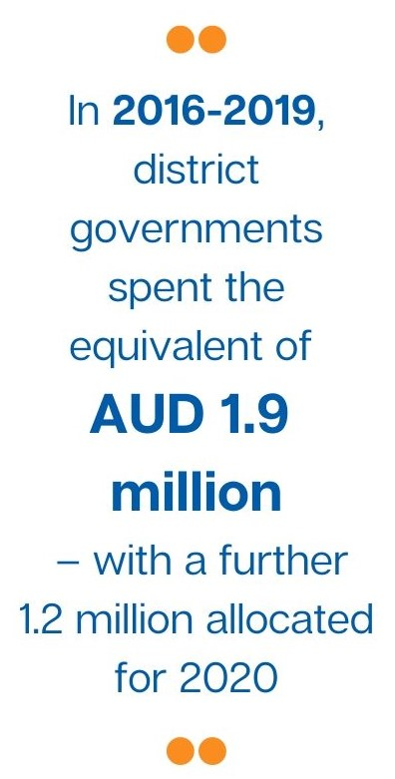 | - The level of ownership of the INOVASI program progressed throughout Phase I, with 110 pilots increasingly co-funded, co-designed and co-managed with districts, MoRA and other agencies.  - Over the four years, 2016–2020, district governments allocated the equivalent of AUD3.1 million in local government funding to scale out and implement pilots. The actual amount spent was AUD1.9 million up to December 2019.  - Additional funding of AUD75,000 has been leveraged from NGOs and the private sector (corporate social responsibility programs).  - In addition to the 700 or more schools taking part in INOVASI-funded pilots, the total number of schools that participated in scale-out programs is estimated at about 1,500. This equates to 4,600 teachers and 117,000 early grade students.  - A total of 17 Temu INOVASI events were held with nine being at the national level. A total of 1,153 participants, including 368 government officials, attended the nine national Temu INOVASI.  - INOVASI is the leading co-facilitator of a digital community of practice group on Facebook (Komunitas Inovasi Pembelajaran) together with other education organisations and MoEC, including MoEC’s ICT Department, Indonesia Mengajar, Save the Children, Asia Foundation, IniBudi and Rainbow Reading Gardens. The group has 13,747 members (teachers and principals), with more than 8,900 being active members. The membership has increased steadily along with the number of posts. The month of June 2020 alone saw more than 660 posts with 1,051 comments and 5,465 reactions.
Pilot impact on participants’ mindset  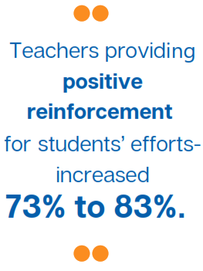 | Based on INOVASI survey data, mindset shift features prominently with increasing ratings around developing a passion for learning in students, encouraging active learning and appreciating students’ efforts. Other notable developments:  - More teachers provide positive reinforcement for students’ efforts, increasing from 73% at baseline to 83% at the endline.  - The percentage of teachers who reported that student learning outcomes need to be in schools’ top three priorities increased by 13%, while the proportion of teachers who said that financial support needs to be among the top three priorities decreased by 23%.  - Teachers are more disciplined with fewer numbers of teachers being absent for more than two days in the last semester, declining from 42% to 34%. Across all pilots, the percentage of teacher-centred teaching mode decreased by 11 points, from 71% to 60%. This means that the percentage of teachers using traditional didactic methods, such as reading aloud, chorus responses, students copying from the blackboard, rote learning and lecturing reduced and the trend is towards active learning approaches.  - Increased percentage of teachers whose confidence and knowledge improved while levels of anxiety about disability-inclusive education decreased – data generated from inclusive pilots only (East Sumba, Probolinggo and Central Lombok):  - Teachers in all districts showed improved knowledge. The increase percentage ranged from 43% to 62%  - Teachers in all districts showed improved confidence. The increase percentage of teachers who improved ranged from 48% to 76%.  - Teachers in all districts showed decreased anxiety; however, in East Sumba the decreased percentage was lower than Central Lombok and Probolinggo (48%, 70%, 70% respectively); this implies that while their knowledge improved, their concerns persisted.
Pilot impact on teaching skills and knowledge  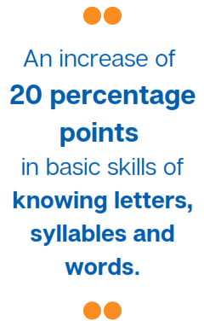 | - Improvements were observed across all pilots. Teachers are equipped with better pedagogical and technical skills for teaching literacy and numeracy.  For skills in literacy:  - Teachers’ pre-test and post-test on units 1–3 in Literacy 1 showed: 90% of teachers improved in the post-test (647 teachers in 13 districts participated).Teachers’ pre-tests and post-tests on Units 4–7 in Literacy 1 showed: 92 per cent of teachers improved in the post-test (632 teachers in 15 districts participated). However, in both tests, only a few districts scored 50% or above. The tests reflected teachers’ knowledge on appropriate pedagogies.  - In practice, teachers demonstrated the integration of technical skills in the teaching of literacy. The top two percentages were for practising reading aloud and writing (72% each). The two lowest percentages were on matching letters to their sounds and storytelling (26% and 29% respectively). The other variables ranged between 30% to 57%, such as, reading aloud with their students, listening to a text and answering comprehension questions and building words from syllables.  For skills in numeracy:  - Teachers’ understanding of teaching practice was assessed through pre-tests and post-tests in the Numeracy 2 pilot. The results showed that 78% of teachers improved their scores in the post-test, implying better knowledge of teaching methods. The three areas most improved were using the number line for teaching subtraction, pattern discrimination and place value.  - In practice, the improvement was assessed through a teachers’ index, comprising teaching and technical skills. The index was increased significantly for Numeracy 1, from 22 to 62 but less clear in Numeracy 2, i.e. from 62 to 66. Overall, the gain was significant, from 22 to 66.  - Teachers created more supportive learning environments with initial evidence of promoting learning for all by making specific efforts for those in need. The proxy of providing specific efforts for those in need is through the variable of developing specific lesson plans. Overall, the increase in the percentage of teachers who analysed students’ competencies when developing lesson plans was small, only by 2 points, from 81% to 83%. However, for those who did the analysis, more obvious progress was found: more teachers incorporated specific techniques (from 80% to 91%) and specific teaching aids in their plans (from 81% to 92%).  - Classroom observation data from spot checks showed 92% of pilot schools implementing formative assessment.  - Improved teacher technical knowledge is shown in pre-tests and post-tests for short courses. Participants’ scores improved by about 20 points and 5 points respectively on the first and second rounds of literacy pilots.
Inclusion, disability and gender  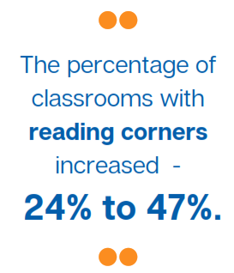  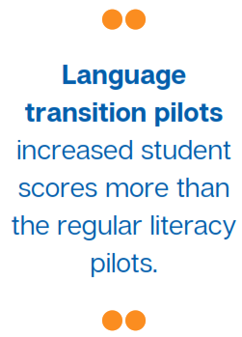 | - The pilot on inclusive education in Central Lombok led to INOVASI developing a Student Learning Profile tool (Profil Belajar Siswa) based on the Washington Group’s functional model for teachers to identify special needs. Working with TASS and MoEC the team developed an application for the tool that MoEC piloted across all designated inclusive schools at all levels in all districts. Work is ongoing to refine the tool and develop a manual for teachers on how to include children with identified special needs.  - Gender equality and social inclusion (GESI) elements embedded in INOVASI’s leadership pilot materials help to encourage accessibility for children with disabilities (by building ramps, installing a disabled toilet) – although data are not yet available to demonstrate impact.  - For GESI sessions in East Java, the scores improved by about 2 points and more teachers claimed they treat girls and boys equally (improved from 73% to 87%).  - In Phase I, INOVASI explored problem areas for gender issues. Access for boys and girls to schooling is no longer a major issue in Indonesia. Girls outperform boys in both literacy and numeracy. Gender disparities persist in the teachers’ promotion system, with women being under-represented in leadership positions and yet generally outperforming men (according to teachers’ own perceptions).  - The predominance of mother tongue is a significant factor in children’s exclusion in many remote regions. Children entering school are not fluent in Bahasa Indonesia, the official language of instruction. INOVASI conducted a number of pilots to develop approaches to the transition from mother tongue to Bahasa Indonesia in early grades. These language transition pilots increased student scores more than the regular literacy pilots.  - Multi-grade pilots, especially in Probolinggo, successfully demonstrated how the approach can improve learning outcomes for children in small schools in remote areas.
Improvements in district education service delivery  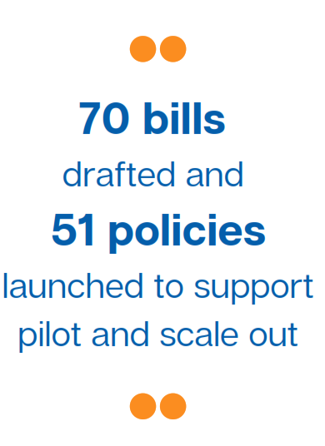 | - Changes in practice at district or sub-district level that generate better education service delivery include improved teaching techniques for more effective learning and new initiatives focusing on students’ needs. Throughout the INOVASI program, service delivery for the education sector within partner districts improved as reflected by the scaling out of INOVASI approaches acknowledged by its district partners as endorsing better practices:  - All 17 partner districts have been actively involved in co-designing, co-funding and co-managing the pilots from 2017 to 2020: Bima, Dompu, Central Lombok, North Lombok, Sumbawa, West Sumbawa, West Sumba, Southwest Sumba, Central Sumba, East Sumba, Bulungan, Malinau, Batu City, Sidoarjo, Pasuruan, Probolinggo and Sumenep.  - INOVASI spot checks to monitor the pilots showed improvements and progress in several aspects, including for scale-out pilots. For example: children have better access to books; literacy activities are stronger and supported by school policy; and schools allocate funds to develop learning media and improve teachers’ capacity. Across all pilots, the percentage of teachers using appropriate learning media increased by 23 points, from 38% to 61%. The percentage of classrooms with reading corners almost doubled from 24% to 47% (excluding reading corners with only textbooks). This becomes 68% (increased by 44 points) when reading corners with only textbooks are included.  - All the 17 partner districts allocated local funds to scale out the INOVASI pilots, worth AUD3.1 million. In addition to the key partners, in 2020, two new districts started to collaborate with INOVASI and scale out the program developed by INOVASI with neighbouring districts. The two districts are Tanah Tidung in North Kalimantan and Nagekeo in East Nusa Tenggara.  - All 17 partner districts supported and leveraged the programs with local policies: 70 bills were drafted and 51 policies were launched to support pilots and scale out. Out of these policies, 43% were district head decrees, 20% were circular letters, 16% were head or mayor’s regulations, while 12% were memorandums of understanding (MoUs) and other types of regulations.
Policy change, influence and support  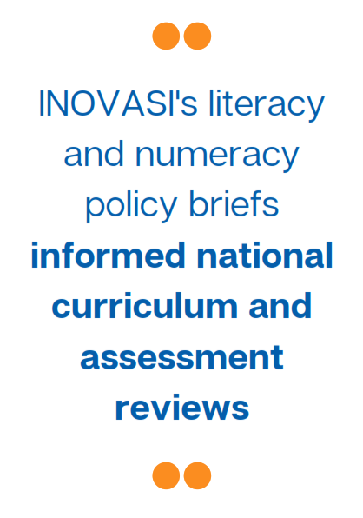  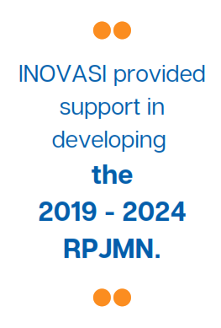 | - At sub-national level, INOVASI’s work resulted in 51 new policies, where 49 policies were at district level for 15 districts and an additional two policies at provincial level for North Kalimantan and East Java. These regulations enabled ongoing district efforts to improve literacy, numeracy and inclusion:  - Early evidence of success in districts’ take up of problem-based policy development was evident in partner districts using the PDIA approach, such as Central Lombok consulting with teachers and stakeholders on teachers’ working group guidelines.  - In East Nusa Tenggara, INOVASI built on the political momentum created by the previous DFAT-funded Analytical and Capacity Development Partnership (ACDP) program and provided ongoing support for the politically significant cross-district Sumba education forum.  - In 2019, INOVASI supported the East Nusa Tenggara provincial government in preparing a consultative ‘grand design’ for basic education and a roadmap to implement it. This is significant as the province is taking the lead in coordinating an integrated approach to improving learning outcomes within the districts that are responsible for basic education. The grand design focuses on foundational skills – literacy, numeracy and inclusion, along with character education.  - Working with stakeholders, INOVASI conducted a comprehensive analysis of district education finance (see annex 7 for a summary of the district education finance assessment), showing trends of increasing spend on quality improvement, over three years, that they shared with other programs and donors as well as local and national government. The study highlights the need to increase funding for programs and activities to improve learning outcomes and is useful to leverage political support for this funding.  At national level, the program’s work resulted in four main developments: (1) the adoption and national scale out of a tool to identify children with special needs; (2) improved procedures to approve children’s books; (3) adoption and adaptation of training modules in literacy and numeracy for national professional development programs in MoEC and MoRA; and (4) adoption and adaptation of INOVASI’s approach to grant-based partnerships in MoEC’s national 'change agent’ program, Organisasi Penggerak.  - Through direct advocacy and shared activities, INOVASI has supported the head of MoEC’s research and development body and the Ministry of Home Affairs, and accelerated interest in policy settings that are responsive to sub-national contexts and priorities.  - Responding to a request from MoEC, INOVASI also conducted a study into regulations and over-regulation in the sector that inhibit innovation in teaching and learning. This study was co-authored with MoEC’s policy unit and was disseminated internally.  - INOVASI produced a series of policy briefs, based on outcomes from the pilots, that have been used at national and sub-national levels to advocate for changes to curriculum, assessment, teacher management, financial management and systemic support, all aimed at improving learning outcomes for Indonesian children. An example of this is the literacy and numeracy policy briefs that arose from pilot outcomes and are now informing the national curriculum and assessment reviews.  - INOVASI provided support in developing the 2019–2024 mid-term national development plan (RPJMN). Additionally, INOVASI supported curriculum analysis and numeracy modules at the national level that are being adapted for use by both MoEC and MoRA in continuing professional development approaches.



These end-of-program outcomes were updated for Phase II as outlined in the INOVASI Phase II Design Update document (DFAT, 2020).
[1] The original end-of-program outcomes in the program design document (May 2014) refer to a ‘robust’ body of evidence. Following advice from DFAT, we replaced the term ‘robust’ in the first end-of-program outcome with ‘credible’ since we will not conduct randomised controlled trial type research. Rather, we aim to explore and test local solutions to local problems to produce plausible and compelling evidence for decision makers.
Australia’s support to Indonesia’s education development spans over 70 years, if the Columbo Plan and Australian Volunteers Abroad (AVI) programs are included.
The original end-of-program outcomes in the program design document (DFAT 2014) refer to a ‘robust’ body of evidence. Following advice from DFAT, we replaced the term ‘robust’ in the first end-of-program outcome with ‘credible’ since we will not conduct randomised controlled trial type research. Rather, we aim to explore and test local solutions to local problems to produce plausible and compelling evidence for decision makers.
Note that the end-of-program outcomes were intended to be met by the end of Phase II, after eight years of program implementation. The INOVASI Phase II design includes updated end-of-program outcomes.
Temu INOVASI is an event where education policymakers, practitioners and communities meet to discuss how to improve learning outcomes. The event is hosted by INOVASI together with our government partners approximately every three months.
The Round 2 pilots that began with problem exploration in 2017 were initially referred to as follows: PELITA (literacy pilot), PERMATA (numeracy pilot), BERSAMA (community participation pilot); SETARA (inclusion pilot); and GEMBIRA (language transition pilot). We subsequently abandoned these titles in favour of more descriptive terms, for example, Literacy 1, Literacy 2.
This is an internal document that was the basis for consultations and presentations with MoEC and the subsequent series of policy briefs co-published with MoEC’s education policy research centre.
A summary of this study is available in Annex 1 of this document
A summary of this study is available in Annex 1 of this document.
A summary of this study is available in Annex 1 of this document.
A summary of this study is available in Annex 1 of this document.
Four pilots focused on language transition: Bima, Dompu, East Sumba and West Sumba. The East Sumba pilot, implemented by Sulinama, and INOVASI’s pilot (GEMBIRA) in Bima both closed the gap between children who speak local languages and those who speak Bahasa Indonesia. The gap reduced by 4 and 7 points respectively. Results were stronger for the GEMBIRA pilot in Bima that reduced the gap seven times more than the pilot in Dompu where the gap decreased only by 1 point. The West Sumba pilot, run by SIL, did not produce the expected result. This may be because the intervention needed longer to generate results or there may be other technical reasons that require further verification.
Note that this measure is from Round 2 (the first round of short-course pilots).
The gap increased in East Nusa Tenggara. This result may be due to a greater gap between girls and boys in one of the grantee pilots for language transition teaching.
This occurred due to external conditions around program budget changes, timing of the school year and Ramadan.
Excluding the Literacy Boost pilot, run by Save the Children, as this pilot was implemented in a different pattern of partnership.
In Phase 2, we will explore methodologies for analysing unit cost and cost benefit for a range of interventions. This has not been possible with the data available for Phase I. Each pilot and grantee program worked differently with schools on different interventions over different timeframes so there was no common basis for comparison. However, the grants program overall represents 16.9 per cent of the INOVASI budget.
A summary of this study is available in Annex 1 of this document.
This refers to basic literacy skills only (letter, syllables, words). East Java scores were higher for comprehension.
In December 2017, Lant Pritchett, one of the authors of PDIA and a consultant to both INOVASI and RISE, visited INOVASI sites and spent time with the team. In consultations between INOVASI and RISE, he recommended that INOVASI focus on ‘crawling the design space’ and, when solutions are ready to be scaled out, RISE could conduct randomised control trial studies.
INOVASI internal communications evaluation report was submitted as annex 6 of the January 2020 six-monthly report.
In 2019, MoRA piloted the Student Learning Profile at around the same time as MoEC. In late 2019, MoRA started awarding grants to inclusive madrasah and using the Student Learning Profile to identify the needs of the madrasah and their eligibility for the grants.
In North Kalimantan at the provincial level, the literacy working group organised for companies’ corporate social responsibility funds to support book procurement, particularly reading books for children. The companies involved included Bank Indonesia and MEDCO. In Malinau district, North Kalimantan, PT Baradinamika Mudasukses (a mining company) supported reading by providing reading books and financing village representatives to attend reading centre strengthening activities hosted by INOVASI.
A summary of this study is available in Annex 1 of this document.
The term ‘scale out' refers to when districts or other parties fund and manage the program, independent of the INOVASI program.

