INVESTED: INDONESIA TO 2040 — Opportunities and Pathways for Australian Investors

# Foreword by Professor Jennifer Westcott AO, Business Champion for Indonesia



I am delighted to share Invested: Indonesia to 2040 with Australian corporate and institutional investors. Australia is fortunate to be neighbours with Indonesia. This document sets out why, and encourages you to be part of its economic transformation over the coming decades.

Section 1 sets out Indonesia’s growth trajectory: the scale of the addressable market is compelling. Section 2 explains the investment landscape. I want you to know that this is a dramatically different Indonesia from the 1990s. The reform agenda over the last two decades has been significant and will continue as Indonesia starts its OECD accession process. There are now more ways to invest in Indonesia, and through Invested: Australia’s Southeast Asia Economic Strategy to 2040, there are additional government-backed initiatives to help facilitate market entry for Australian businesses. Section 3 sets out the six main sectors where Australian investors are well positioned to make an impact, and where many are already doing so.

Since being appointed as Australia’s Business Champion for Indonesia in March 2024, I have been struck by two things. The first is the size of the opportunity Indonesia presents, and that other countries are already taking advantage. I want to ensure Australia doesn’t miss out. The market is not without risk, but if you invest through the right business structure, build personal relationships and invest for mutual benefit over the long-term, then you will find Indonesia to be an exceptionally welcoming market. The second is that both the Indonesian and Australian Governments want this. Doors are open on both sides. The timing has never been better.

Professor Jennifer Westacott AO, November 2024

Chancellor, Western Sydney University

Australia’s Business Champion for Indonesia

Contents

Foreword by Professor Jennifer Westcott AO, Business Champion for Indonesia 1

Indonesia at a Glance 3

Section 1 — Why Indonesia? 4

Drivers of Indonesia’s growth 4

Section 2 — A more favourable investment environment 7

Indonesia’s economic milestones 7

Investment Pathways 8

Corporate Direct Investment 8

Institutional Capital 8

Support for Australian investors 9

Section 3 — Sector Snapshots 11

Healthcare 13

Green energy transition 15

Agriculture and food 17

Infrastructure 19

Education & skills 21

Additional resources 23

QUESTIONS 23

# Indonesia at a Glance

* An economy on the move:  
  Currently the 16th largest. Forecast to be the 4th largest by mid-century.
* A growing consumer class:  
  By 2040, 63 million Indonesian households will have disposable incomes of US$15,000 or higher. This will be five times larger than Australia.
* A digitally savvy “smart phone-first” population:  
  220 million internet users in 2024, with 99 per cent of 16-64 year olds owning a smart phone.
* Prudent fiscal management:  
  Indonesia has been rated ‘investment grade’ since 2017 by three big rating agencies (S&P, Moody’s and Fitch).
* Living standards are improving:  
  Poverty has reduced from 23 per cent in 1999 to 10 per cent in 2023. Mortality rates for children under five have halved over the past two decades.
* A more educated labour force:  
  Secondary school enrolment rates now at 90 per cent (up from 60 per cent in 2005). There are 10 million tertiary students enrolled at 4,500 higher education institutions. Improving quality of education is a government priority.
* A decade of transport infrastructure investment:  
  6,000 km of new national roads and 2,103 km of new toll roads, 1,600 km of new railway lines, 27 new airports and upgrades to 64 existing airports, 26 new ports and upgrades to 190 existing ports.
* Becoming a central player in the global Electric Vehicle (EV) market”  
  As the largest motorcycle and second largest vehicle manufacturer in Southeast Asia, Indonesia is becoming a central player in the global EV market. Hyundai and CATL have established battery plants, and Vinfast and BYD plan to build vehicle plants.
* 99 per cent of Australian and Indonesian goods enter tariff free under IA-CEPA:  
  Bilateral trade is growing under the favourable terms of the Indonesia-Australia Comprehensive Economic Partnership Agreement (IA-CEPA) (2020). Two-way trade is now at AU$26.7 billion (2023), up from AU$18.3 billion (2022). Indonesia is our 13th largest trading partner.
* Indonesia’s foreign investment realisation:  
  Grew 10 per cent in 2023 to reach US$50 billion. Australia is Indonesia’s 10th largest source market but has a small (and declining) market share (less than 1 per cent).

# Section 1 — Why Indonesia?

Indonesia is the fourth most populous country and third largest democracy in the world. Its

population of 280 million is young and digitally savvy. Indonesia is becoming more urbanised,

wealthy and educated. Meeting the needs of this massive population presents opportunities

for Australian companies.

Indonesia’s annual Gross Domestic Product (GDP) growth reached 5–6 per cent over the last two decades, while President Prabowo is aiming for 8 per cent growth. Indonesia is on track to become a top ten economy by the mid-2030s, and the fourth largest economy by mid-century. Indonesia is currently the largest economy in Southeast Asia and the 16th largest in the world, with annual GDP of US$1.48 trillion in 2024 (IMF)

(Figure 1).

Since the 1997 Asian Financial Crisis, economic and democratic reforms have underpinned Indonesia’s strong economic growth, stability and improvements in living standards. These reforms helped Indonesia navigate the Global Financial Crisis and COVID-19 particularly well.

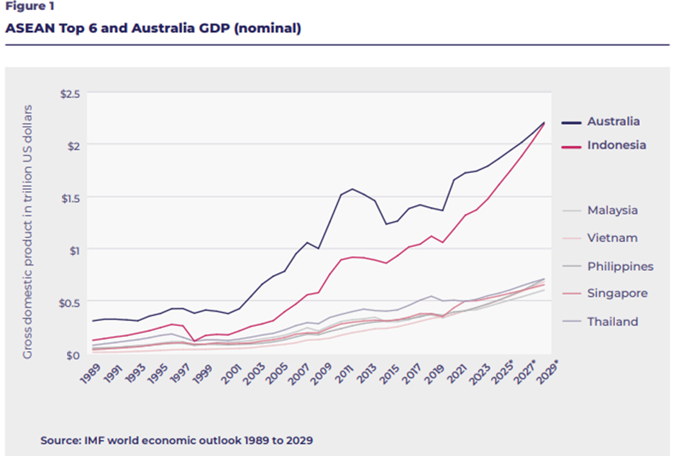

## Drivers of Indonesia’s growth

Approximately 60 per cent of Indonesians live in cities, and this number is expected to continue rising. Greater Jakarta is home to around 35 million people while 11 other cities have populations exceeding one million people. Urbanisation will create opportunities for Australian companies in waste management, flood mitigation, public transport, housing and urban design.

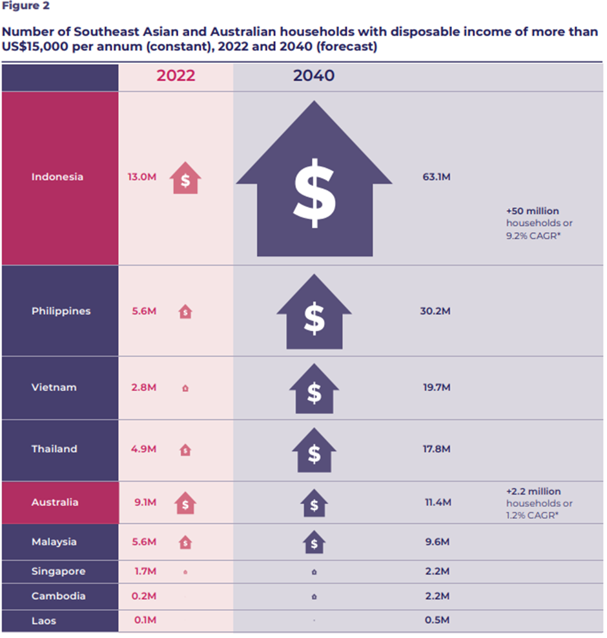[1]

Domestic consumption contributes more than half of Indonesia’s GDP. By 2040, 63 million Indonesian households will have disposable incomes of more than US$15,000 per annum, up from 13 million in 2022 (Figure 2). Indonesia’s expanding consumer market is increasingly attracted to premium Australian food and lifestyle products.

With a median age of just 29 years, Indonesia is benefiting from the ‘demographic dividend’ of a young working age population for the coming decades. Indonesia plans to capitalise on this dividend by investing in education and healthcare, supporting sectors that will lead to job creation, fostering entrepreneurs and investing in infrastructure development to improve connectivity.

There will also be opportunities for Australia to support Indonesia’s human development priorities.

Indonesia is a highly digitally-networked country with approximately 220 million internet users. In 2023, the gross merchandise value of Indonesia’s e-commerce market reached AU$118 billion, the largest in Southeast Asia by value. This figure is projected to reach AU$199 billion by 2025. Indonesia is building new industries and diversifying sources of investment, including in sectors aligned with the energy transition and its goal to reach net zero by 2060. The Indonesian Government is encouraging investment from domestic and foreign companies to support development of renewables, including its EV manufacturing ambitions.

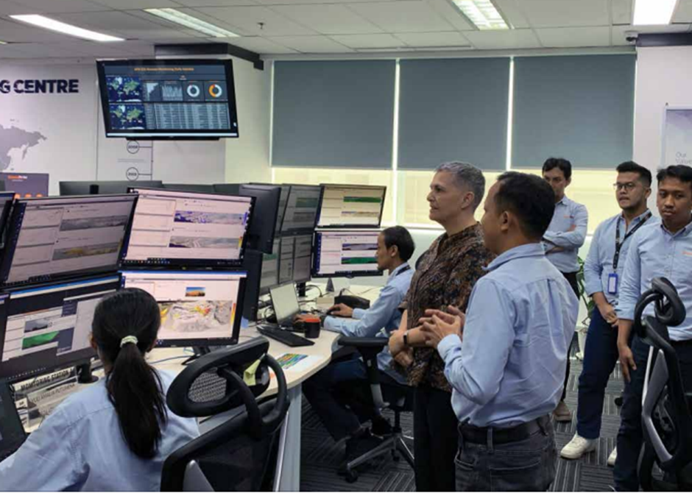

Australian Ambassador to Indonesia Penny Williams PSM visiting GroundProbe’s Global Monitoring Centre in Balikpapan, where a specialist Indonesian geotechnical workforce monitors sites around the world to provide early warning of potential wall failures at mine sites and other critical locations.

# Section 2 — A more favourable investment environment

Since the Asian Financial Crisis (AFC), Indonesia has significantly reformed and strengthened its institutions, laying the foundations for three decades of impressive economic growth. While there are still risks and complexities, in recent years Indonesia has sought to attract foreign investment by removing ‘red tape’ and assisting businesses.

The Indonesian Government now offers a range of incentives in priority sectors of which Australian investors can take advantage. These include reductions to corporate income taxes, import taxes and land and rent levies. Indonesia’s Special Economic Zones (SEZs) also offer investors a range of incentives.

In October 2020, the Omnibus Law on Job Creation (Law) was ratified. The Law streamlined business licensing, relaxed restrictions on foreign investors and opened up foreign ownership in previously restricted sectors (including in telecommunications, construction, oil and gas, and electricity distribution). The Law also liberalised labour laws which now allow for more flexible contracts and termination procedures, simplified environmental impact assessments and land procurement processes for infrastructure and development projects.

These reforms have also been complemented by reforms to Indonesia’s State-Owned Enterprises (SOEs) including consolidation of the number of SOEs, partial or full privatisation, debt restructuring, sectoral diversification, digital transformation and improvements to corporate governance. As a result of these changes, Indonesia’s SOEs have experienced strong financial growth in recent years, with a net income of US$19 billion and an 8.5 per cent Return on Equity (ROE) in 2023.

In addition to Indonesian reforms, the Indonesia–Australia Comprehensive Economic Partnership Agreement (IA-CEPA) came into force in 2020, playing a major role in further reducing barriers to trade and investment between our countries.

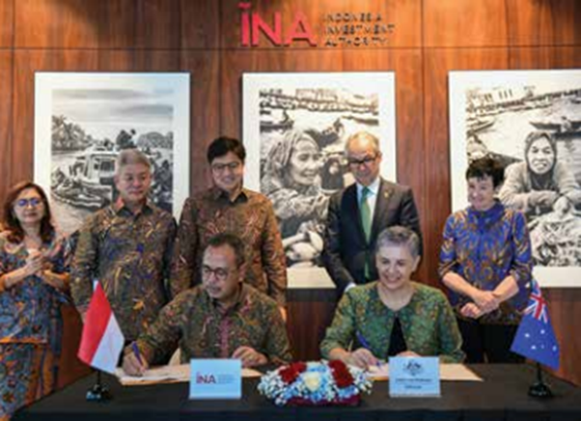

Signing a Memorandum of Understanding between the Australian Embassy Indonesia with Indonesia Investment Authority (27 June 2024).

## Indonesia’s economic milestones

* **1997**: Indonesia is one of the worst hit economies by the AFC
* **2000**–**03**: Establishment of the Anti-Corruption Commission and Competition Commission
* **2008**: Indonesia avoids the worst effects of the GFC, and joins the G20 economies
* **2017**: Indonesia joins the US$1 trillion club of economies Indonesia; achieves ‘investment grade’ credit rating
* **2020**: Omnibus Law on Job Creation ratified, including the creation of the Indonesia Investment Authority
* **2022**: Indonesia achieves upper-middle-income status, after achieving 5–6 per cent growth for three decades
* **2024**: The OECD opens accession discussions with Indonesia

## Investment Pathways

Indonesia’s reform agenda over the last two decades has been significant and is set to continue. There are also more ways to invest in Indonesia – either as a corporate or institutional investor. And, through Invested: Australia’s Southeast Asia Economic Strategy to 2040, there are additional government-backed initiatives to help facilitate market entry for Australian businesses.

### Corporate Direct Investment[2]

* **Representative office:** often used to establish an early-stage market footprint.
* **Franchising/licensing:** offers business owners retention of control while leveraging local partners’ dynamism.
* **Joint Venture:** agreement between Australian and Indonesian parties.
* **Foreign-owned enterprise:** these are wholly foreign-owned enterprises, which can include investment companies.

### Institutional Capital

#### Indirect investment

* **Fund of funds:** a convenient way to gain portfolio exposure to Indonesia and a diversified set of assets or asset classes.
* **Fixed income instruments:** such as a sovereign bond issued by the Ministry of Finance. These can also include corporate bonds issued by Indonesian corporates or SOEs.
* **Asset managers/general partner:** includes the ability to allocate via a mandate and first rights to co-invest directly alongside local or international funds. Covers equities, private equity, private credit or debt and some fixed income.

#### Direct investment

* **Corporate securities:** of companies listed on the Indonesian Stock Exchange (IDX).
* **Public-Private Partnerships (PPP):** via syndicate or consortium (also includes corporate PPP with either operational sector or technology specialisation). Origination and equity risk on greenfield developments with an availability payment and abatement regime.
* **Specialist platforms:** which provide direct exposure to high investment grade economic assets such as toll-roads, airports and ports.
* **Co-investments:** alongside private equity or venture capital allocations.

#### Indonesia’s conglomerates: a growing investor cohort in Australia and potential partners for Australian investors in Indonesia

Indonesia’s conglomerates are key potential partners for Australian companies when they invest in Indonesia. Most have growing commercial interests in Australia and familiarity with doing business in Australia. In 2023, Indonesian investment into Australia reached AU$2.2 billion – almost double the level of outbound Australian investment into Indonesia – and most was spearheaded by Indonesian conglomerates. Their investment in Australia spans property, resources, renewables and manufacturing sectors. Notable investments include Salim Group’s AU$393 million acquisition of Rex Minerals copper/gold project on the Yorke Peninsula. Salim also own the Atlantic Vanadium project in Western Australia. Sinarmas owns the majority share of ASX200 Stanmore Coal and the Ravenswood Gold project, and a Sinarmas-related entity acquired the Merredin solar farm in Western Australia.

#### Indonesia Investment Authority

Established in 2020 as Indonesia’s sovereign wealth fund (rated BBB, ‘investment grade’ and capped at the sovereign rating) the Indonesia Investment Authority (INA) offers Australian investors a promising new partnership model for investing into Indonesia.

INA is a member of the International Forum of Sovereign Wealth Funds and a full signatory to the ‘Santiago Principles’, committing INA to the highest standards of good governance, accountability, transparency and prudent investment practices.

Through a memorandum of understanding signed in June 2024, the Australian Government is working closely with INA to find assets and structures which are suited to Australian investors.

To date, INA has deployed over US$3 billion across nine deals with foreign investors in transport and logistics, digitalisation, green energy and healthcare. INA is increasingly interested in food and agriculture, critical minerals and financial services projects.

Recent INA deals with foreign partners include: the acquisition of Indonesia’s largest hospital network with Swire Pacific Limited; the establishment of a modern warehouse network with ESR-Logos and Mitsubishi; the establishment of a toll-road platform with Abu Dhabi Investment Authority (ADIA) and the Netherlands’ APG, Europe’s largest pension fund.

## Support for Australian investors

The Australian Government is working with investors to achieve commercial success in Indonesia. This includes the establishment of a new Deal Team at the Australian Embassy Jakarta in 2024. The Deal Team blends private sector expertise with Australian Government capabilities (including finance) to provide outward investment services.

The Deal Team identifies assets and projects for Australian investors. Those that are assessed as appropriate are shared with Australian participants. To date, the Deal Team has identified 117 Indonesian projects and progressed 22 for further assessment across multiple sectors (health, infrastructure, agribusiness and food, energy, and more).

The Deal Team is supported by Export Finance Australia (EFA), and its AU$2 billion Southeast Asia Investment Financing Facility (SEAIFF). Building on EFA’s existing commercial tools (loans, guarantees, insurance), the SEAIFF provides new financing capabilities (including equity) to support investment into Indonesia assessed to be in Australia’s national interest. It aims to finance infrastructure across a range of sectors, including telecommunications, energy, electrification, water, sanitation and transportation.

Additional initiatives to help Australian companies include:

* An **Australian Business Champion for Indonesia, Professor Jennifer Westacott AO.**
* The **Australia-Southeast Asia Business Exchange** focused on bringing business delegations to Indonesia. Recent delegations include those in digital technology (June 2024) and skills and education (September 2024).
* A technology **Landing Pad** in Jakarta to provide tailor-made support for Australian technology businesses to increase readiness and market alignment, and to identify, qualify and execute opportunities in Indonesia’s dynamic technology sector.
* A AU$100 million facility to unlock **climate finance in Indonesia through KINETIK**, the Australia–Indonesia Climate and Infrastructure Partnership, for climate-focused SMEs and green infrastructure.
* A new facility for **infrastructure project preparation under KIAT**, the Indonesia Australia Partnership for Infrastructure.
* Our three free trade agreements (FTAs) with Indonesia: IA-CEPA; the ASEAN-Australia-New Zealand Free Trade Agreement (AANZFTA); and, the Regional Comprehensive Economic Partnership (RCEP).
* To learn more about these initiatives, email business.engagement.jakarta@dfat.gov.au

# Section 3 — Sector Snapshots

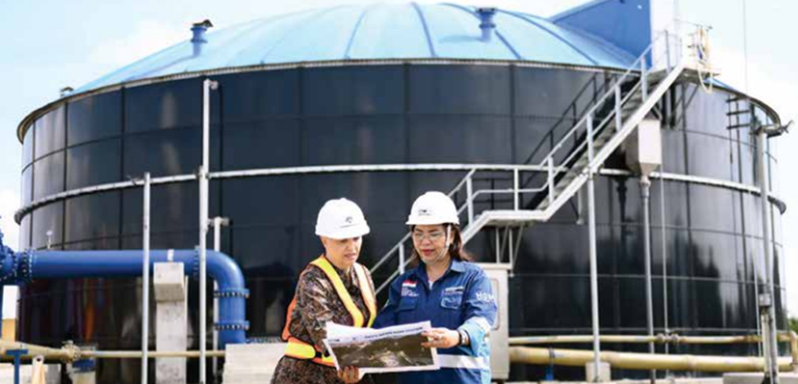

Ambassador Williams visiting a new wastewater treatment plant in Palembang, a IDR 1.6 trillion (AU$160 million) project funded by Australia and Indonesia.

## Resources

* Downstream processing assets
* Environmental management and waste solutions
* Workforce safety-related training, systems and technology
* Optimising operations
* Low-carbon and energy efficient technology
* Workforce upskilling

**Key players**

* Thiess
* Orica
* Austin Engineering
* Macmahon Holdings
* Molycop
* Como Engineering
* Nusantara Resources
* Arcadia Holdings
* Nickel Industries

Indonesia is one of the world’s largest exporters of thermal coal, and a significant producer of copper, gold, nickel, tin and bauxite. It is the location of the largest gold mine, second largest copper mine, and two of the five largest coal mines in the world, measured by annual production. Mining and quarrying accounts for 10 per cent of GDP (around US$140 billion).

There is a long history of investment and Australian capability supporting the growth of the Indonesian mining sector, with a considerable Australian diaspora working for Indonesian and foreign mining companies across the archipelago.

Indonesia is a profitable and growing market for a wide range of operators and mining equipment, technology and services (METS) providers, with strong alignment between Australian METS capability and the needs of the Indonesian mining sector.

Indonesia is progressively implementing policies to increase downstream processing of commodities including nickel, copper and bauxite. This is driving significant investment in the development of downstream processing assets. After its success in developing its nickel processing sector, Indonesia is continuing to seek foreign investment to achieve its ambition of becoming the largest battery manufacturing ecosystem outside of China. Similarly, to support its EV manufacturing ambitions, Indonesia is interested in sourcing Australian lithium.

Critical to Indonesia’s success will be the improvement of its environmental, social, and governance factors (ESG) across the entire sector – without higher ESG ambition, Indonesia recognises it will not be able to attract the breadth of foreign institutional investors it is seeking, and will limit its ability to supply into the biggest EV markets globally, such as in Europe and the United States.

The increase in sophistication and standards across Indonesian mining is driving a corresponding need for more highly-skilled workers. The Indonesian sector recognises the depth and relevance of Australia’s university and vocational training capabilities and its links to Australia’s resources industry. This has created scope for new partnerships between Australian institutions, Indonesian industry and Indonesian institutions.

## Healthcare

* Advisory health services to private hospitals
* Workforce skills development and training
* Specialist health service delivery
* Digital health
* Complementary medicines and products

### Key players

* Aspen Medical
* Blackmores
* Monash IVF
* Icon Group

The outlook is bright for Indonesia’s AU$37 billion health care market. Indonesia’s healthcare sector has undergone considerable reform over the past decade. These reforms, which will continue under the Prabowo administration, have yielded results: Indonesians are now living longer, while the mortality rates of children aged under five have more than halved over the past two decades.

From a low base, more middle and upper-income Indonesians now have private health insurance and are adopting healthier lifestyles.

However, similar to other emerging economies that have reduced the incidence of communicable diseases (e.g. malaria and tuberculosis), Indonesia is seeing an increasing burden of non-communicable diseases like diabetes and cardiac disease.

Healthcare is a key sector where Australian capability and innovation can play a longer-term role to support Indonesia’s vision of providing digitised, advanced healthcare services to its growing population.

The Indonesian Government is committed to ‘capturing’ long-term health servicing in Indonesia, rather than seeing a continued rise in outbound medical tourism to Singapore and Malaysia.

This means there are opportunities for Australian providers to support quality assurance in the private hospital sector, including hospital accreditation and advisory services. There are also opportunities for joint ventures or “Centre of Excellence”-style partnerships in areas such as cancer care, cardiac care, neurology and women’s and children’s health.

Additionally, Indonesia is a growing market for complementary medicines and products. There is growing demand for services around women’s health and fertility, including strong appetite for discretionary consumer spending on products such as pregnancy supplements and digital monitoring solutions.

Indonesian consumers are some of the most ‘online’ in the world, with strong interest in wearable and remote solutions. Digital health solutions – ranging from digitised medical records to consumer access to digital healthcare services – are ways for Indonesia to achieve both scale and standardisation. Novel screening solutions such as AI-based diagnostic solutions can fill gaps in clinicians’ availability and skill level.

### Indonesia’s Special Economic Zones present opportunities for international health providers

In 2021 the Indonesian Government expanded the mandate of Special Economic Zones (SEZs) to include those dedicated to the health, education and digital economy sectors. There are two health-focused SEZs under development: in Bali (Sanur) and in Batam. In these SEZs, healthcare providers can enjoy 100 per cent foreign ownership, are able to employ foreign doctors and can import specific medications not otherwise available in Indonesia without Indonesian FDA approval.

The Bali International Hospital development, located within the Sanur SEZ, is further presenting opportunities for Australian companies to partner in delivery of specialist health services (e.g. oncology). Icon Group is establishing a Centre of Excellence in Oncology under a joint operation model with the Bali International Hospital. The Batam SEZ will be anchored by private hospital group, Mayapada Hospital.

### Aspen Medical helping to improve healthcare in Indonesia

There is huge demand for new and upgraded health infrastructure across Indonesia to respond to rising consumer expectations for better healthcare experiences.

In 2020, Aspen Medical formed a partnership with Indonesian state-owned enterprise PT Jasa Sarana to build hospitals and community healthcare clinics in West Java. They plan to construct more than 650 primary healthcare clinics and up to 23 hospitals in the province. In June 2023, Aspen Medical International broke ground on its first hospital in Depok, West Java, valued at AU$70 million. In March 2024 they announced plans to expand into eastern Indonesia in partnership with Indonesian company Tridaya Group.

The key to this success, according to Aspen Medical Indonesia CEO, Dr Andrew Rochford, is to take a long-term view of the project, and appreciate the local business culture. While regulatory uncertainty and changes can create challenges to doing business in Indonesia, Aspen Medical has drawn on the knowledge and experience of its local partner and its own willingness to learn the local business culture and practices to navigate through these processes.

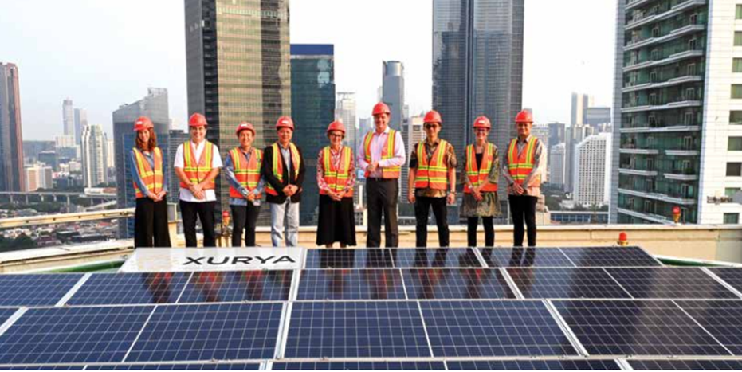

Australia’s Ambassador for Climate Change Kristen Tilley visiting rooftop solar panels at Plaza Indonesia, Jakarta.

## Green energy transition

* Emission reduction technologies for coal mines
* Green hydrogen
* Smart building/energy efficiency technologies
* Industrial and domestic solar farms
* Workforce skills and development
* Blue carbon
* EV sector, including lithium

### Key players

* Blue Diamond Machinery
* Monash University
* University of Melbourne
* University of Queensland

Indonesia is committed to reaching net zero by 2060.

The green energy transition will be critical to this, and requires over US$1 trillion in investment to reach this target.

Indonesia is the world’s largest exporter of coal (by tonnage), with coal being responsible for about 60 per cent of the country’s electricity generation. As a major coal producer, Australia has well developed coal transition and emissions reduction technologies that can assist Indonesia to decarbonise its energy and mining industries.

Indonesia’s Minister for StateOwned Enterprises recently stated that retiring 15 gigawatts (or 60 per cent) of coal power generation over the coming 30 years will require US$600 billion in capital support. Many governments, including Australia, are supporting Indonesia to make this happen.

Indonesia wants to become a global centre for producing EVs and is seeking to leverage the country’s rich nickel resources and existing car manufacturing base to develop an EV battery and car manufacturing ecosystem. Global EV makers including China’s BYD and Hyundai are establishing manufacturing bases in Indonesia. Indonesia requires lithium to support its ambition to build an EV industry and has expressed interest in working with Australia to secure future supplies, forecast to reach 150,000 tonnes of lithium per annum by 2035.

Indonesia also wants to develop a green hydrogen industry and expand collaboration on solar power generation. There are ambitious plans to develop floating solar energy farms in Batam, and in 2023 the largest solar floating power plant in Southeast Asia was opened in Cirata, West Java (the third largest in the world). The Cirata Floating Solar Power Plant has capacity of 192 megawatts and is a joint venture with Masdar (UAE) and Indonesian SOEs.

Developing the workforce required to support renewable energy generation is another area of opportunity. Australia’s Future Battery Cooperative Research Centre (CRC) estimates that by 2025 the global battery industry will need four million workers – including chemists, material scientists and power engineers. This will require a massive investment in training and education and is a potential area of future collaboration.

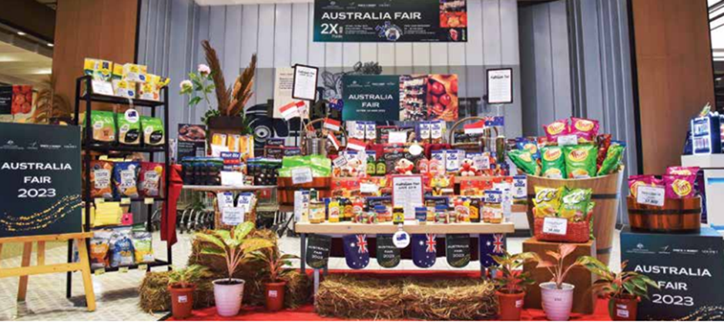

Australia Fair 2023 stand at Ranch Market and The Gourmet supermarkets in Jakarta, Surabaya and Malang, showcasing the wide range of Australian fresh produce and packaged goods currently available to Indonesian customers.

## Agriculture and food

* Premium products for food service
* Bulk ingredients
* Horticulture
* Beef and dairy production

### Key players

* CPC
* AAM Investment Group
* Samex
* Cheetham Salt
* CBH
* Manildra
* Ausfine
* Arnotts

Agribusiness, food and consumer goods are some of the most significant categories of Australian goods exports to Indonesia. Indonesia is generally Australia’s largest export market for wheat and live cattle, third largest for dairy, fifth for boxed beef, and more recently, second for cotton.

From a grocery product perspective, there is strong consumer recognition of Australian products and growing strength in breakfast cereals, cheese, plant-based milks, cleaning and laundry products, and skincare. Australian vitamins and supplements have also been a major success story.

Australia also holds the greatest market share for imported wine, and there is a significant amount of ingredients imported from Australia for value-added food manufacturing, including skim milk powders for dairy, sugar for confectionery, potatoes for snack products and salt and meat products for frozen foods.

There are still challenges for the sector including dominance of smallhold farming, government policies around food self-sufficiency and lengthy regulatory timeframes for some products to obtain either ‘registration’ or import permits. Despite this, we see strong long-term opportunity with Indonesia’s agribusiness sector contributing 12.4 per cent to GDP and employing 40 per cent of the workforce. This reflects the increased strategic focus of the new administration on food security. In particular, opportunities are seen in the manufacturing sector but also within the above sectors to meet the Indonesian consumer’s increasing demands for higher quality, healthier and trusted products.

The Indonesian Government is eager to attract investment, including into major sectors where it looks to improve self-sufficiency, like beef herd and production, dairy production and aquaculture. In 2023 Indonesia attracted FDI of US$1.8 billion into the sector, with aquaculture being a growth sector. There are some examples of success particularly around beef feed lot joint venture partnerships, though the majority of Australian activity remains export-oriented.

President Prabowo’s election commitment to deliver nutritious meals to 83 million school students, pregnant mothers and toddlers will be a major undertaking. The Australian Government is actively exploring possible options to support the President’s signature policy to improve nutrition outcomes. This may offer opportunities for Australian industry. The Jakarta Deal Team is supporting several Australian corporate investors to expand into Indonesia’s food and agriculture sector.

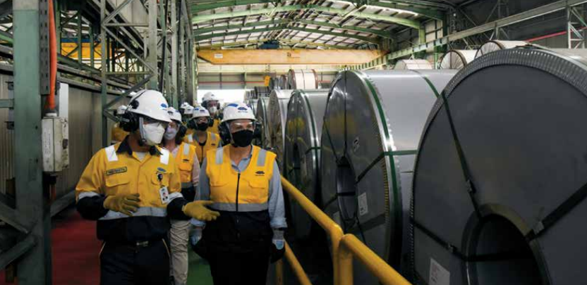

Ambassador Williams visiting the NS Bluescope Indonesia in Cilegon, Banten.

## Infrastructure

* Water
* Transport infrastructure
* Sustainable infrastructure
* Digital infrastructure
* Greenfield city projects
* Sanitation

### Key players

* Aurecon
* Leighton
* Bluescope Steel
* McConnell Dowell

Indonesia is rapidly urbanising with estimates that over 70 per cent of its population will be living in urban centres by 2050. This large-scale urbanisation trend continues to drive investment in infrastructure. By 2040, a forecast US$1.7 trillion in investment will be required to meet this need.

Reducing urban congestion, improving roads, rail and airports, improving water and air quality, and helping to increase the resilience of cities which are sinking or prone to natural disasters are all key elements of Indonesia’s infrastructure development program. Australian business can play a role in improving the liveability of Indonesia’s vast urban areas. For example, most new buildings in larger cities must be certified under the Green Building Council, which is driving interest in green building supplies, energy efficiency and smart building technologies – areas where Australia has strong capabilities.

The Indonesian Government is investing in public transport including the light rail system in Jakarta, with plans for another in Bali. Surabaya is also engaging the UK Government to fund a feasibility study for its proposed Mass Rapid Transit (MRT) system. Furthermore, larger cities such as Surabaya, Semarang and Medan are actively integrating the concept of TransitOriented Development (TOD) into their public transport design, as are some of the leading private developers.

In the water sector, Indonesia is committed to delivering piped clean water to 100 per cent of households, preventing overuse of groundwater. This is driving investment in dams for water supply as well as technologies and services for the management of water and wastewater – areas where Australia has considerable expertise. Indonesia is starting to develop its municipal sanitation sector, with only five per cent of the country currently being covered with proper sanitation systems. Developing the sanitation regulation and technology suitable for Indonesia can provide opportunities for Australian consultants and design companies.

The New Capital project is an ambitious initiative for the country. The Indonesian Government is actively seeking domestic and international investors to participate in the project, opening access to the surrounds of the core area of the New Capital for investors to concept, design and build.

We are also seeing growing interest in the digital infrastructure sector, including data centres, as evidenced by the investment by the Macquarie Asset Management-led consortium into Bersama Digital Infrastructure Asia.

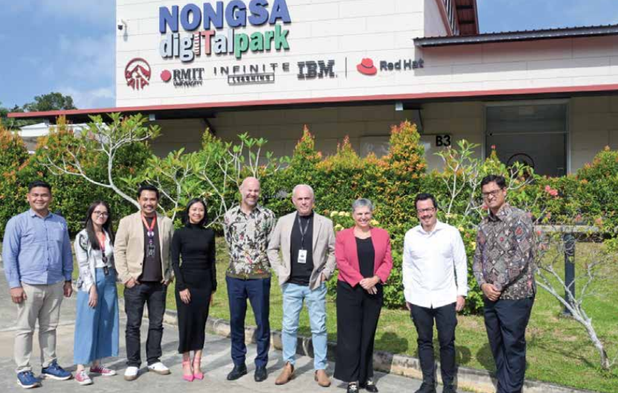

Ambassador Williams visiting the Nongsa Digital Park which has partnered with the Royal Melbourne Institute of

## Education & skills

* Transnational education
* Tailored programs for corporates,
* government agencies and SOEs
* Skills for growth sectors – green
* skills, health and digital
* Executive education

### Key players

* Monash Indonesia
* Western Sydney University, Indonesia
* Deakin–Lancaster Indonesia

Human capital development is a national priority as Indonesia seeks to add 57 million skilled workers to the economy by 2030. While public funding has increased, Indonesia is seeking greater involvement of international education, training, and research providers to meet its human capital needs.

Indonesia’s strong economic growth has increased demand for quality education and skills training. There is high demand for training and education across emerging technology sectors such as AI, data analytics, cyber security, logistics/supply chains and digital transformation. There are also opportunities in sustainable energy, healthcare and advanced biotechnology. The most popular courses are still business management, accounting and commerce programs.

We are seeing growing demand from Indonesia’s private sector and SOEs for customised short courses or micro-credentials from international providers. Recently PLN (the state-owned electricity network), Bio Farma (the stateowned vaccine manufacturer) and Unilever have engaged Australian education providers to support their workforce capability development needs.

Indonesian universities continue to express their desire to collaborate with Australian universities on a range of partnership opportunities, including student mobility, articulation programs, dual/joint degrees, academic exchanges and research partnerships.

Indonesia’s demand for vocational skills represents the greatest need, and an opportunity for Australian vocational education providers, RTOs and dual sector universities to offer programs that will provide ‘job ready’ graduates.

## Additional resources

DFAT’s [2022 Blueprint for Trade and Investment with Indonesia](http://www.dfat.gov.au/publications/trade-and-investment/blueprint-trade-and-investment-indonesia)

DFAT’s [Using IA-CEPA to do business with Indonesia](http://www.dfat.gov.au/trade/agreements/in-force/iacepa/using-ia-cepa-do-business-indonesia)

Asialink Business’s [Doing Business Guide: Indonesia](http://www.asialinkbusiness.com.au/research-resources/doing-business-guide-indonesia) which provides corporate investors with further practical advice regarding market entry models.

PwC’s 2023 [Investing in Indonesia Guide](http://www.pwc.com/id/en/publications/tax/investing-in-indonesia.pdf)

Indonesia’s Ministry of Investment[2022 Indonesia Investment Guidebook](http://www.bkpm.go.id/storage/file/pdf/1683512273.pdf) for an overview of investment procedures, legal and taxation requirements for foreign investors.

## QUESTIONS?

Please contact business.engagement.jakarta@dfat.gov.au

1. **CAGR** = compound annual growth rate

   **Notes**: Excludes Brunei and Timor-Leste. Constant dollars measure changes in real purchasing power over time as they account for inflation.

   **Source**: Austrade Economics analysis of Euromonitor, Economies and Consumers data, 2022.
2. Direct corporate investment requires a minimum capitalisation of IDR 10 billion (around AU$1 million, subject to sector specific regulations). The dominant model used to access the market in some sectors is via distributors, partners and agents. This does not involve direct investment.