INVESTED: THE PHILIPPINES TO 2040
  - Opportunities and Pathways for Australian Investors

Foreword 1

The Philippines at a glance 2

SECTION 1: WHY THE PHILIPPINES? 3

SECTION 2: A MORE FAVOURABLE INVESTMENT ENVIRONMENT 5

SECTION 3: SECTOR SNAPSHOTS 9

Foreword

It is a privilege to share Invested: The Philippines to 2040 with Australian corporate and institutional investors. As one of the fastest-growing economies in Southeast Asia, the Philippines presents significant opportunities for Australian businesses and investors. There is strong support from the Australian and Philippine governments to deepen economic and business ties, as demonstrated by the elevation of the relationship to a Strategic Partnership in September 2023.
This document seeks to provide a snapshot of the pathways for Australian investors to enter the Philippine market and to encourage the business community to take advantage of the opportunities available. Section 1 provides an overview of the strength of and outlook for the Philippine economy. Section 2 explores recent reforms implemented by the Philippine Government to further open the economy to foreign investment and improve the ease of doing business. Section 3 highlights key sectors important to the Philippines’ economic transformation and in which there are real opportunities for Australian investors to make an impact.
In the past year as Australia’s Business Champion for the Philippines, I have connected with business leaders in both countries and led a high-profile delegation of Australian businesses to Manila. I have been impressed by the genuine desire and commitment of our respective business leaders to deepen connections and explore commercial prospects for increased two-way trade and investment.
From the perspective of Macquarie Group, with our track record of more than 20 years of successful investment in the Philippines, I encourage Australian businesses and investors to adopt an opportunity mindset when approaching the Philippines. I welcome the Australian Government’s focus on Southeast Asia under Invested: Australia’s Southeast Asia Economic Strategy to 2040 and the opportunity to connect Australian investors to the people and tools they need to navigate challenges and take advantage of opportunities in the Philippines.

Shemara Wikramanayake, March 2025
Macquarie Group Chief Executive Officer and Managing Director
Australia’s Business Champion for the Philippines

The Philippines at a glance
- One of the fastest-growing economies in Southeast Asia
Real GDP growth is forecast at around 6 per cent per annum for 2025-2029, and 5.2 per cent per annum over the next two decades. The Philippines aims to attain upper middle-income status by early 2026.
- A growing consumer class
Consumer spending is the top contributor to GDP, with remittances from overseas Filipino workers (OFWs) providing a steady inflow of liquidity.
- A young, educated and skilled labour force
The Philippines enjoys a population dividend, with a median age of 25.7 years old. The working population is highly proficient in English and the total number of higher education graduates in 2022-2023 reached 666,298 students.
- A strong information technology and business process management (IT-BPM) sector
In 2023, the Philippine IT-BPM sector employed 1.7 million people and generated approximately A$53.28 billion in revenue. It also accounted for 18 per cent of global IT-BPM market share.
- Philippine foreign investment realisation
Total foreign direct investment reached approximately A$13.71 billion in 2023. Australia is the Philippines’ 31st largest source market but has a small market share.
- Prudent and improving fiscal management
The Philippines has been rated ‘investment grade’ by the three big rating agencies (S&P, Moody’s and Fitch) since 2013. In 2024, R&I and S&P upgraded their sovereign credit rating and economic outlook, respectively.
- An enhanced foreign ownership regime
Recent economic reforms have liberalised key sectors, such as certain renewable energies and infrastructure, to allow 100 per cent foreign participation.
- A comprehensive trade relationship
Bilateral trade continues to grow on preferential terms under the ASEAN-Australia-New Zealand Free Trade Area (AANZFTA) and the Regional Comprehensive Economic Partnership (RCEP). Two-way trade stood at A$10.2 billion in 2023, up from A$8.2 billion in 2022.

SECTION 1: WHY THE PHILIPPINES?
The Philippines is one of the fastest-growing economies in Southeast Asia, ranking first in the region in 2023. GDP grew at 5.6 per cent in 2024, attributed to increases in household and government expenditure, imports and exports, and the industrial and services sectors.
The Philippine Government has set a target of 6 to 8 per cent annual growth from 2025 to 2028, supported by continued infrastructure investments, an enhanced business environment and increased national competitiveness.
Figure 1: The Philippines Gross Domestic Product (US$)
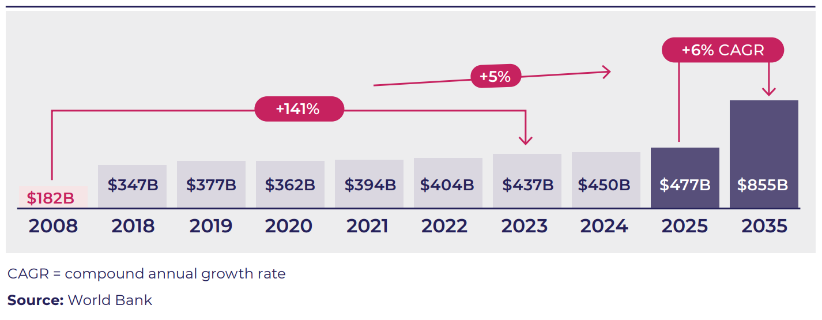
In 2024, R&I (Japan) awarded the Philippines an ‘A-’ sovereign credit rating and S&P (US) upgraded its economic outlook from ‘stable’ to ‘positive’, reflecting a growing confidence in the Philippine Government’s recent economic reforms and fiscal consolidation program.
The Philippine Government is on track to meet its target of maintaining inflation at 2 to 4 per cent from 2025 to 2028. Inflation declined to 3.2 per cent in 2024 from 6 per cent in 2023. The leadership of Dr. Eli Remolona Jr, Governor of the Bangko Sentral ng Pilipinas (Central Bank of the Philippines) has been instrumental in maintaining economic stability.

Drivers of the Philippines’ growth
Government priorities and responding to the demands of a growing population continue to drive economic growth. Significant investments are being made to improve transportation infrastructure, increase renewable energy, and enhance the defence and information and communication technology (ICT) sectors. For 2025, the Philippine Government has allocated PHP1.54 trillion (A$40.7 billion) for infrastructure disbursements (5.4 per cent of GDP). The Government aims to increase infrastructure spending to 5 to 6 per cent of GDP, with a projected disbursement of PHP2.14 trillion (A$56.6 billion) by 2028.
An expanding consumer base, coupled with rising disposable incomes and a growing middle class, are creating opportunities for investors. Domestic consumption accounted for 72.5 per cent of GDP in the first half of 2024. By 2040, an estimated 30.2 million Filipinos are expected to have an annual disposable income exceeding US$15,000 (Figure 2).
OFWs contribute further to the economy, with record high remittances of approximately A$56 billion in 2023 (8.5 per cent of GDP).
The Philippines is entering a demographic ‘sweet spot’, with its population having a median age of 25.7 years. This young, educated and English-proficient labour pool is well-suited to meet the demands of a competitive global market. Recent economic reforms have also enhanced the ease of doing business and are driving increased digitisation across government.
With its robust macroeconomic fundamentals, expanding consumer market and competitive workforce, the Philippines is primed to sustain its upward trajectory. Investors looking to capitalise on a dynamic and rapidly growing market will find the country well-positioned for long-term growth.
Figure 2: Number of Southeast Asian and Australian households with disposable income of more than US$15,000 per annum (constant), 2022 and 2040 (forecast)
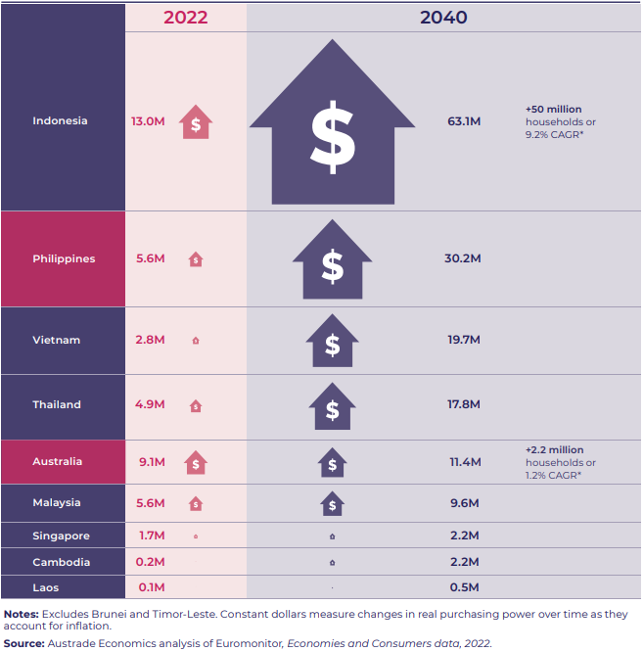

SECTION 2: A MORE FAVOURABLE INVESTMENT ENVIRONMENT
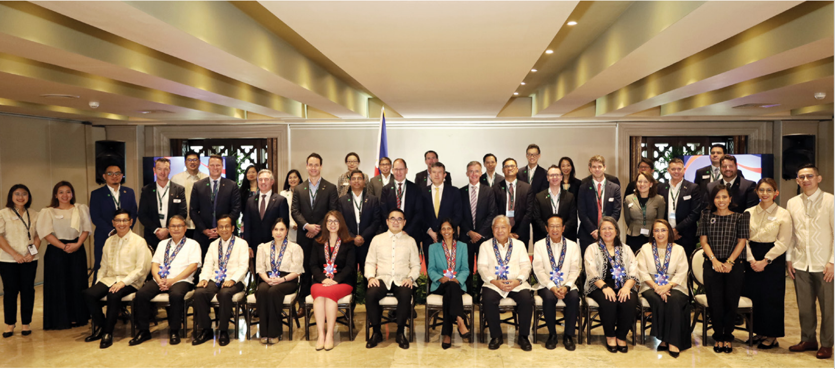
Image: Australian Government business mission to the Philippines with Philippine Government Ministers in September 2024.
Since the COVID-19 pandemic, the Philippine Government has sought to attract further foreign investment and increase exports to support its economic recovery and improve living standards. While there are still risks and complexities, improvements in the investment environment and the ease of doing business stand to benefit Australian investors.
The Philippine Government offers a range of incentives in priority sectors that align with Australia’s comparative advantage, including reductions to corporate income tax rates, deductions and VAT exemptions, and incentives made available in Philippine Special Economic Zones. In 2023, the President of the Philippines, Ferdinand R. Marcos Jr., established Green Lanes for Strategic Investments, allowing all Philippine Government offices to expedite, streamline and automate processes for strategic investments.
These incentives and pathways are supported by comprehensive reforms to key legislation that have liberalised the economy and opened avenues to increased foreign investment, including:
- the Retail Trade Liberalization Act: lowers the minimum paid-up capital and investment per store requirements for 100 per cent foreign ownership, as well as removing the public offering requirement for retail enterprises with more than 80 per cent foreign ownership
- the Foreign Investments Act: reduces the minimum capital requirements for foreign nationals to fully own domestic micro, small and medium enterprises, subject to certain conditions
- the Renewable Energy Act: implementing rules allow 100 per cent foreign ownership of solar, wind, biomass and ocean or tidal energy projects
- the Public Services Act: allows 100 per cent foreign ownership of select public services, including shipping, railways, airports and air carriers, subways, toll operations, transport network companies and telecommunications.
In addition, in 2023 AANZFTA was upgraded for a second time and RCEP entered into force, further reducing barriers to trade and investment.

The Philippines’ economic milestones
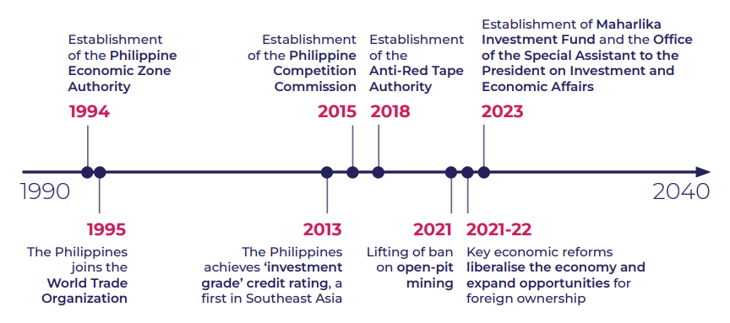

Image: Australian Ambassador to the Philippines, Ms HK Yu PSM, with OSAPIEA Secretary Frederick Go and ARTA Secretary Ernesto Perez at the ARTA-led Economic and Ease of Doing Business Briefing in January 2024.

Anti-Red Tape Authority (ARTA)
ARTA was established in 2018 under the Ease of Doing Business and Efficient Government Service Delivery Act. ARTA is responsible for implementing a national ‘anti-red tape’ policy and promoting the ease of doing business, as well as monitoring and ensuring compliance with the national policy. ARTA is involved in initiatives to streamline and promote digitisation of various government services. These initiatives include the Electronic Business One-Stop Shop, which aims to streamline the procedures for filing of applications and issuance of local business licenses, permits and clearances, and authorisations by local governments. ARTA also supports the Green Lanes for Strategic Investments and has established an e-ARTA Complaints Management System (CMS). CMS aims to streamline the lodgement and management of complaints about red tape encountered by businesses. ARTA can assist in addressing red tape issues by investigating the matter and convening discussions with relevant agencies.

Investment pathways
The Philippines’ reform agenda over the last two decades has been significant and is set to continue. There are multiple ways for Australian corporate and institutional investors to invest in the Philippines. And, through Invested: Australia’s Southeast Asia Economic Strategy to 2040, there are now additional government-backed initiatives to facilitate market entry for Australian businesses and investors.

Corporate Direct Investment
- Representative or liaison office: often used to establish an early-stage market footprint.
- Branch office: used for quick market entry to test a new location or expand operations while offering business owners retention of control, except in industries listed in the Philippines’ Foreign Investment Negative List.
- Regional operating headquarters: used to establish a presence in another country to provide administrative and operational services for a foreign corporation’s activities in the region, and offers business owners retention of control and ownership.
- Retail trade/franchising: offers business owners retention of control while leveraging local partners’ dynamism.
- Joint venture: agreement between Australian and Filipino parties.
- Domestic market enterprise: enables foreign ownership of small and medium enterprises that are focused on the domestic market, subject to certain conditions.

Institutional Capital
Indirect investment
- Fund of funds: a convenient way to gain portfolio exposure to the Philippines and a diversified set of assets or asset classes.
- Asset managers/general partner: includes the ability to allocate via a mandate and first rights to co-invest directly alongside local or international funds. Covers equities, private equity, private credit or debt and some fixed income.

Direct investment
- Corporate securities or foreign portfolio investments: includes securities and investments in local and foreign-issued equities listed on the Philippine Stock Exchange.
- Private equity: investments in listed and non-listed Philippine businesses.
- Fixed income instruments: bonds/notes or similar instruments issued in the domestic market with prior approval from the Central Bank of the Philippines.
- Co-investments: alongside private equity or venture capital allocations or with the Maharlika Investment Fund.
- Public-Private Partnerships (PPP): via syndicate or consortium (also includes corporate PPP with either operational sector or technology specialisation). Origination and equity risk on greenfield developments with an availability payment and abatement regime.

Philippine conglomerates: a growing investor cohort in Australia and potential partners for Australian investors in the Philippines
Philippine conglomerates wield considerable influence, including to shape economic policies, attract investment and foster economic growth. They have diversified portfolios with commanding market share in their respective sectors and are key potential partners for Australian businesses as they can help navigate risk and the local business environment, as well as assist with making connections. They value Australian expertise and experience. Conglomerates will look to partner with foreign businesses that bring new capabilities and innovations that drive productivity, efficiency and sustainability, as well as access to other markets and projects.
In 2024, the Kmart Group partnered with the Ayala Group to open its Anko (Kmart’s home and lifestyle brand) flagship store in the Philippines. The Ayala Group played a key role in facilitating the entry into the Philippine market, as well as helping the Kmart Group to reach Filipino consumers through a well-established and prime retail location. Early results are very positive and both groups are looking to expand into more locations in 2025 and beyond.
Jaime Augusto Zobel de Ayala, Chairman of the Ayala Group said of the partnership: “It was our great privilege to have partnered with Kmart to launch the Anko brand in the Philippines and to have worked with our energetic and dedicated counterparts from Australia. I believe this experience highlights our shared vision to find ways to partner for our countries’ and companies’ shared benefit.”
Some conglomerates have growing commercial interests and familiarity with doing business in Australia. Conglomerates’ investment in Australia spans renewable energy, infrastructure and agribusiness. Notable investments include AC Energy’s 13-gigawatt (GW) project pipeline of renewable energy projects, and the International Container Terminal Services Inc. (ICTSI) investment at the Port of Melbourne.

Support for Australian investors
The Australian Government is working with investors to achieve commercial success in the Philippines, including through the new Deal Team at the Australian Embassy in Manila.
The Deal Team provides outward investment services and helps to identify opportunities and projects for Australian investors in the Philippines. Since being established in 2024, the Deal Team has identified 154 potential projects and progressed 21 for further assessment across sectors such as infrastructure, renewable energy and education.
The Deal Team is supported by Export Finance Australia (EFA) and its A$2 billion Southeast Asia Investment Financing Facility (SEAIFF). Building on EFA’s existing commercial tools (loans, guarantees, insurance), the SEAIFF provides new financing capabilities (including equity) to support investment into the Philippines assessed to be in Australia’s national interest. It aims to finance infrastructure across a range of sectors, including telecommunications, energy, electrification, water, sanitation and transportation.
Additional initiatives to help Australian businesses and investors include:
- An Australian Business Champion for the Philippines, Ms Shemara Wikramanayake.
- The Australia-Southeast Asia Business Exchange focused on bringing business delegations to the Philippines. Recent delegations covered skills and education (May 2024) and digital technology (February 2025).
- Our two free trade agreements (FTAs) with the Philippines: AANZFTA and RCEP.

SECTION 3: SECTOR SNAPSHOTS
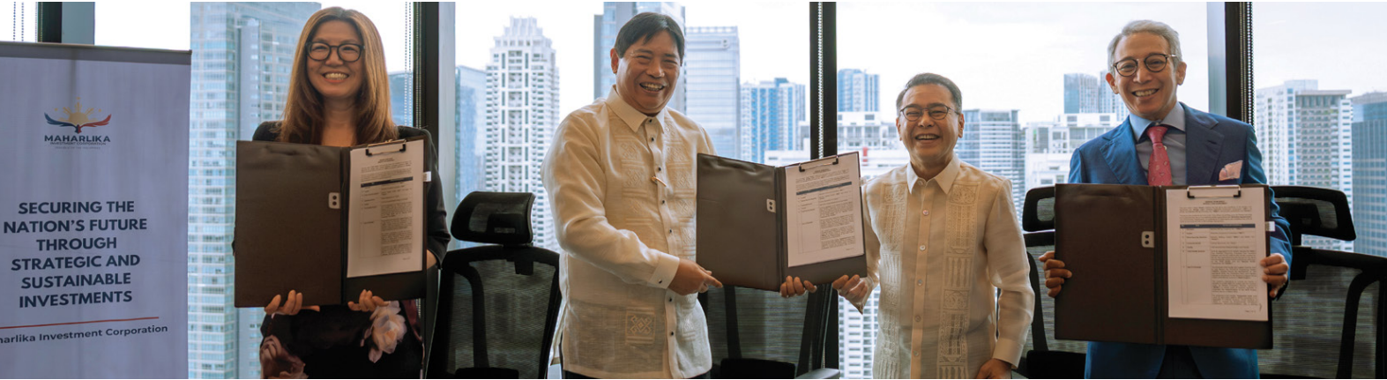
Image: Signing ceremony of the binding term sheet between the Maharlika Investment Corporation and Makilala Mining Co. Inc., the Philippine subsidiary of Australian company Celsius Resources Ltd.

RESOURCES

Opportunities
- Public and private sector partnerships in strategic exploration projects
- Value-added processing of green metals
- Exploration technologies and services, including geospatial mapping
- Environmental, social and governance technologies for water treatment, recycling, tailings treatment and mine rehabilitation
- Education and training

Key Australian players
- Celsius Resources Limited
- Blackstone Minerals / IDM International
- GHD
- OceanaGold
- Orica
- RTG Mining Inc.
- SMEC
- Weir Minerals Australia
With demand for increased sophistication and standards across the Philippine mining sector, there is greater scope for new partnerships with Australian businesses and investors. The Philippines is the world’s fifth most mineralised country, with an estimated A$1.3 trillion in mineral reserves. It has the third-largest deposits of gold, fourth for copper, fifth for nickel and sixth for chromite. However, only 5 per cent of these reserves have been explored and only 2.58 per cent of the country’s land area is subject to mining permits.
The Philippine Government recognises that the mining sector is an engine for economic growth and is fast-tracking the sector’s development with a range of initiatives, including:
- lifting the ban on open-pit metal mining, and allowing 100 per cent foreign-owned companies to engage in large-scale exploration, development, and utilisation of specific minerals under Financial and Technical Assistance Agreements
- streamlining the investment process, including digitising mining permits, parallel processing with other Government agencies and recognising community engagement and consultation
- providing greater confidence and clarity on the investment process, such as planned reforms to clarify royalties and streamlined national and local taxes
Australian capability has long supported the Philippine mining sector, including developing key legislation, and Australian companies have played a significant role in developing the mining industry. Over 20 Australian mining equipment, technology and services, and engineering and consulting businesses operate in the Philippines, including GHD and SMEC.
Currently, 58 metallic mines, 59 operating non-metallic mines, and seven processing plants need investment partners to expand. Major projects in the permitting process or development and investment negotiations include:
- Tampakan Copper-Gold Project: Southeast Asia’s largest untapped mine is progressing towards commercial operations in 2026
- King-King Copper-Gold Project: St. Augustine Gold and Copper Ltd. The feasibility study is being updated
- Silangan Copper-Gold Project: Project of Philex Mining is at the construction stage. Commercial operations to begin in 2026
- Maalinao-Caigutan-Biyog Copper-Gold Project: Celsius Resources secured the first copper-gold mining permit in 15 years.

INFRASTRUCTURE

Opportunities
- Partnerships via PPP projects
- Design and consultancy
- Sustainable and energy-saving construction technology, materials and services
- Flood control mitigation technology and services

Key Australian players
- BG&E
- BMD Group
- GHD
- Leighton Contractors (Asia) Limited
- Premier Concrete Equipment
- Ricardo Rail
- SMEC
The Philippines is experiencing transformative urban growth. The urban population is projected to be 100 million by 2050, and the nation is mobilising unprecedented resources to meet its infrastructure needs. Under the Philippine Development Plan (2023-2028) and the ambitious Build-Better-More Program, the Philippine Government has more than doubled infrastructure spending to 6 per cent of GDP. As at January 2025, 186 flagship projects are in the pipeline, spanning critical sectors from transport to urban development.
The Philippine Government is funding its infrastructure development through:
- National budget: Government infrastructure spending and other capital outlays grew to A$27.8 billion in 2023
- Official development assistance: from Japan International Cooperation Agency, Asian Development Bank (ABD), World Bank and the Asian Infrastructure Investment Bank
- PPPs: 175 PPP infrastructure projects worth PHP2.47 trillion (A$65.2 billion) are in the pipeline.
Outside Metro Manila’s megacity development, regional growth centres like Cebu, Davao, Iloilo and General Santos are emerging as investment hotspots. Major property developers are creating integrated urban communities, expanding opportunities for engineering, construction and infrastructure service providers.
The Philippine Government’s prioritisation of infrastructure development is creating greater opportunities in sectors aligned with Australian capabilities, particularly in rail, road, airports and ports. Legislative changes to allow 100 per cent foreign ownership of certain infrastructure projects and the increase in the number of PPP projects demonstrates the Government’s eagerness to tap into private capital. There is also enormous opportunity to win service contracts managed by local businesses in partnership with an implementing government agency.
Opportunities for Australian businesses are also available through goods and services supply chain contracts (e.g., design, construction, building materials and technology). For example, Leighton Asia, GHD and SMEC have partnered with local businesses to undertake contracting work on different phases of infrastructure projects, while BMD Group partnered with ICTSI to expand port operations in Luzon.

Philippine Investment Alliance for Infrastructure Fund
The Philippine Investment Alliance for Infrastructure (PINAI) was launched in 2012 by the Philippine Department of Finance to address the lack of infrastructure financing and provide a new investment opportunity for the Government Service Insurance System (GSIS), the Philippines’ largest investment fund. PINAI was the largest and first-of-its-kind infrastructure fund dedicated to the Philippines and reached its target fund size at first close with investor commitments of US$625 million.
Macquarie Asset Management (MAM) was appointed as the PINAI fund manager due to its expertise and invested in the fund alongside GSIS, Dutch pension investment manager APG and the ADB. PINAI has targeted investments across the entire spectrum of infrastructure sectors. It invested in six infrastructure assets – three brownfield and three partially greenfield – including three renewable energy companies, one conventional power business, one mass transit project, and one storage and logistics asset.
According to the ADB, PINAI has played an important role in demonstrating that the infrastructure sector in the Philippines is investable and attractive, even for international fund managers. It has contributed to demonstrating that infrastructure funds in the Philippines are a viable and attractive investment proposition for both domestic and international pension funds, and other institutional investors.

GREEN ENERGY TRANSITION

Image: Ambassador Yu with President Marcos, Department of Trade and Industry Secretary Cristina Roque, and StB Giga Chairman Trevor St Baker at the StB Gigafactory inauguration in New Clark City.

Opportunities
- Capital and equity to fund development of renewable energy projects
- Smart grid technologies
- Infrastructure to support offshore wind projects
- Skilling of renewable energy workforce
- Alternative technologies such as nuclear, hydrogen, ammonia and waste-to-energy

Key Australian players
- Corio Generation / Vind Energy Corporation
- Energy World Corporation
- Entura
- GHD
- Macquarie Group
- Sacgasco / Nido Petroleum
- StB Giga Factory, Inc.
The Philippine business environment for energy is one of the most investor-friendly in the region, with it being ranked the second most attractive developing economy for renewable energy investment in 2024.
The Philippines is actively transitioning towards a sustainable and self-reliant energy sector with a target of 35 per cent renewable energy by 2030, and 50 per cent by 2040. Achieving this target will require estimated investments of A$130 billion by 2028 and A$918 billion by 2050.
The Philippine private sector is driving energy transition efforts, with conglomerates developing their own energy projects and decarbonisation strategies. The energy and utilities sectors are largely deregulated and full foreign ownership of solar, wind, hydro, ocean, and tidal resource projects is now permissible, creating an abundance of opportunities for Australian industry.
While access to electricity has improved, energy security is still a challenge. The cost of electricity is second only to Singapore in Southeast Asia. The Philippines also trails other countries in utilising renewable energy. It has an estimated potential renewable energy capacity of 162.6GW and the Philippine Government has set a target of producing 98GW of renewable energy by 2050. However, only 6.6GW is currently provided through solar, wind, geothermal, hydro power and biomass. A roadmap released by the Philippine Department of Energy and the World Bank shows there is the potential to install 40GW of offshore wind power. To support this, the Philippines will need large manufacturing ports, marshalling ports, and ports for operations, maintenance and training. There is also interest in Energy Storage Systems and Mini Grid Systems / Small Power Utility hybridisation for smaller islands.
To further accelerate renewable energy development, the Philippine Government has introduced fiscal and non-fiscal incentives, duty-free importation of equipment, zero-VAT rating and income tax holidays. The Energy Virtual One-Stop Shop, a web-based filing and monitoring system for energy-related applications and repository for information on energy projects, has streamlined the approval process and made it more transparent. The Green Energy Auction Program facilitates and supports timely investments in additional renewable energy capacities through a competitive bidding process. Opportunities are also available through goods and supply chain contracts (e.g., consulting services, construction and supplying innovative technologies).

EDUCATION & SKILLS

Opportunities
- Auxiliary provider branch campuses and services
- Transnational education partnerships
- Tailored programs for corporates, government agencies and state-owned enterprises
- Corporate micro credentials / training in food and hospitality, ICT and financial services
- Skills for growth sectors, including technology, marine engineering and health

Key Australian players
- Australian Institute of Higher Education
- Deakin University
- Edith Cowan University
- Education Centre of Australia
- Macquarie University
- Southern Cross University
- University of Adelaide
- University of Melbourne
- University of Western Australia
Education is a high priority for the Philippine Government due to its capacity to support economic growth and development, help reduce poverty and build national competitiveness. The Philippine Development Plan (2023-2028) aims to achieve globally competitive and inclusive technical and vocational education and training and higher education sectors, and improve research output for a broader knowledge economy. The education budget rose to PHP1.05 trillion (A$27.8 billion) in 2025, up from PHP983.5 billion (A$26 billion) in 2024.
The Transnational Higher Education Act 2019 allows foreign universities to provide education services through partnering with a local institution, a move which came four years after the Philippine Commission on Higher Education (CHED) lifted a moratorium on transnational education programs. While transnational education partnerships in the Philippines have expanded rapidly since 2019, less than 1 per cent of domestic institutions are involved in transnational education, with higher concentration in the National Capital Region for business programs.
Australia is recognised for its high-quality international education and is one of the top destinations for Filipino students. Between 2022 and September 2024, the number of Filipino students studying in Australia increased by 113 per cent. This has influenced Filipino universities and vocational education providers to pursue partnerships with Australian institutions and education providers. Edith Cowan University and Arellano University have agreed to recognise and transfer study credits for Bachelor of Nursing students. There are also opportunities to deliver joint or dual postgraduate degrees with a Philippine partner. The University of Western Australia has a joint Master of Business Administration program with the Asian Institute of Management. Following the success of the Australia-Southeast Asia Business Exchange program, 15 Memoranda of Understanding (MOUs) were signed between Australian and Philippine institutions or education providers. These MOUs cover a range of subjects, such as the MOU between Swinburne University and Asia Pacific College to develop partnerships in information technology and computer science. Following consultations between the Philippine Board of Investments (BOI), CHED and the Australian Government on the importance of transnational education and increasing opportunities for international collaboration, BOI amended its Strategic Investment Priority Plan to allow auxiliary service providers to set up branch campuses in the Philippines. These amendments aim to attract more businesses by allowing foreign-owned higher education institutions to access incentives.

Image: Australia-Southeast Asia Business Exchange mission focused on transnational education in May 2024.

DIGITAL ECONOMY


Image: Delegate at a site visit during the Australia-Southeast Asia Business Exchange mission focused on technology innovation in February 2025.

Opportunities
- Artificial intelligence and automation
- E-commerce expansion
- Smart cities development
- Cybersecurity growth
- Data centres
- Digital infrastructure investments

Key Australian players
- Canva
- EzyPay
- GHD
- Kantanna
- Leighton Contractors (Asia) Limited
- Netlinkz
- Sekuro
- Telstra
The Philippines is positioning itself as a digital economy powerhouse and is increasingly recognised for its connectivity potential due to its strategic location for submarine cable networks and developing data centre market.
The digital economy sector contributed A$55.8 billion in 2023 (8.4 per cent of GDP). E-commerce remains the primary growth driver, accounting for 70 per cent of digital activities and is projected to reach A$63.43 billion by 2025. This is supported by good internet penetration (73.1 per cent of population by 2023) and high smartphone adoption (86 per cent of population by 2023).
The surge in digital payments, comprising 52.8 per cent of retail transactions, illustrates the growing adoption of platforms like GCash and Maya, with the Central Bank of the Philippines targeting a 60 to 70 per cent share by 2028.
Key initiatives, such as the E-Government Masterplan 2022 and the National ICT Development Agenda (2023-2028), aim to expand broadband access, modernise public services and enhance ICT skills, further driving digital transformation. The Philippines’ National Fiber Backbone aims to increase internet connectivity service capacity across the country.
The Government’s proactive reforms, including full foreign ownership in telecommunications and incentives for digital infrastructure investments, have created opportunities in fibre-optic networks, subsea cables, data centres and cloud services. Australian companies can share their expertise in areas such as cybersecurity, digital infrastructure, software development and ICT training. Australian businesses like Canva and Sekuro have expanded their foothold in the Philippine market, leveraging strategic partnerships with the public and private sectors.

AGRICULTURE & FOOD

Opportunities
- Food manufacturing / packaged food products
- Horticulture and high value crops
- Beef and dairy production
- Bulk ingredients for food service and manufacturing
- Warehousing, logistics and cold storage

Key Australian players
- Accolade
- Australian Fine Foods
- Bega
- CBH
- Frosty Boy
- Graincorp
- Lactalis
- Manildra
- Noumi
- Thomas Foods International
- Treasury Wines
- Trisco
- Viterra
The Philippine agrifood market has an estimated value of A$72 billion. The Philippines’ strong economy in the last decade has led to an increase in the middle class and domestic consumption. Despite the growth in demand, domestic agriculture production faces challenges such as land ownership restrictions, supply chain inefficiencies and natural disasters.
Enhancing domestic food security is a priority for the Philippine Government. The Philippines is a net importer of agrifood products and has significant dependence on imports of staple products, including rice. To address these concerns, the Philippine Government is encouraging investment across the agribusiness and food value chain through partnerships with local businesses to increase the sector’s self-sufficiency, productivity and efficiency.
Australia is the Philippines’ leading import source country for animal feed grains, lamb, grapes and citrus, the second for wine and beef, and fourth for dairy products. Australia’s reputation for producing diverse and highquality products and expertise in food production positions us well as an investment partner across Philippine supply chains.
Philippine food manufacturers are actively seeking to partner with Australian business to meet increasing domestic demand for premium, novel products, such as high-value fresh and processed fruit, dairy, small goods and snacking products, as well as to explore export opportunities to neighbouring markets.
Manufacturers are seeking greater supply chain integration and certainty of supply through more strategic partnerships. Due to historical and defence ties, the Philippine market remains highly integrated with the US. However, Australia has increasingly become an in-demand alternative source market for most agrifood products due to US supply and logistics issues, as well as Russia’s invasion of Ukraine.
Our FTAs add to Australia’s credentials as a trade and investment partner. Ninety-five per cent of Australian products enter the Philippines tariff free under AANZFTA, while lower tariffs under RCEP have also benefited Australian products.

Image: Australian Embassy staff with Farmers Haven Program Coordinators at Australia Friendship Day 2024.

ADDITIONAL RESOURCES
Australian Government’s Invested: Australia’s Southeast Asia Economic Strategy to 2040 dfat.gov.au/southeastasiaeconomicstrategy
Australian Government’s Advancing Implementation
dfat.gov.au/invested
DFAT’s Australia-Philippines bilateral relations
dfat.gov.au/geo/philippines
Asialink Business’ Doing Business Guide: The Philippines asialink.unimelb.edu.au/business/publication/doing-business-guide-philippines
PwC’s Doing Business and Investing in The Philippines 2024
pwc.com/ph/en/business-guides/philippine-business-guide.html
The Philippine Board of Investments’ Investors’ Guidebook 2022
boi.gov.ph/wp-content/uploads/2022/07/2022-Investors-Guidebook-as-of-06-June-2022.pdf
Austrade’s Go Global Toolkit
export.business.gov.au
Austrade’s Step ahead with Southeast Asia
austrade.gov.au/asea

QUESTIONS?
To contact the Deal Teams, visit austrade.gov.au/asea/seaidt-contact

Central Bank of the Philippines, ‘Selected Economic and Financial Indicators’, 2025; ’Central Bank of the Philippines, ‘Personal Remittances set a New Record High in December 2023’, 2024, accessed 31 January 2025.
The Corporate Recovery and Tax Incentives for Enterprises to Maximize Opportunities for Reinvigorating the Economy (CREATE MORE) Act 2024 introduces a 20 per cent Corporate Income Tax Rate for Registered Business Enterprises on taxable income derived from registered projects or activities during the taxable year. The CREATE MORE Act also provides for enhanced deductions and VAT relief.
100 per cent foreign ownership of telecommunications services is allowed based on reciprocity, otherwise foreign ownership is restricted to a maximum of 50 per cent.
Philippine Department of Environment and Natural Resources, ‘2023 Minerals Industry at a Glance’, 2025, accessed 31 January 2025.
BloombergNEF, ‘Climatescope 2024: Emerging Markets Power Factbook’, November 2024, accessed 31 January 2025.
Data Reportal, ‘Digital 2023: The Philippines’, 2023, accessed 31 January 2025.

