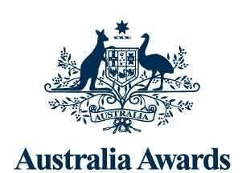

Australia Awards   
Global Tracer Facility

Investigating the Contribution of   
Alumni Workshops to Australia   
Awards Program Outcomes using   
Social Networks Analysis

April 2023

The views expressed in this report are those of the authors and do not necessarily reflect the policy or position of the Australian Government, its agencies or representatives.

Australian Department of Foreign Affairs and Trade

With the exception of the Commonwealth Coat of Arms and where otherwise noted, all material presented is provided under a Creative Commons Attribution 3.0 Australia license.

**Acknowledgements:**

The authors would like to thank DFAT’s Australia Awards and Global Education Programs Section, in particular Dr Hazel Lang, for supporting this case study and the generous advice and assistance provided by the Australia Awards – South Asia & Mongolia program team, particularly Lakmini Dissanayake. The team are also indebted to the support provided by Dr Dean Lusher, Dr Peng Wang and Ali Hassani from SNAToolbox.

Most importantly, we thank the 27 alumni who attended the 2018 Regional Alumni Workshop in Bhutan and took the time to complete the case study survey and share their views with us.

**Recommended citation:**

Buckley, S., Clarke, L. & Hsien, M. (2023). *Investigating the Contribution of Alumni Workshops to Australia Awards Program Outcomes using Social Network Analysis*. Australia Awards Global Tracer Facility, Australian Department of Foreign Affairs and Trade. https://www.dfat.gov.au/publications/people-people/australia-awards-global-tracer-facility-year-7-results

# Contents

Contents 3

Executive Summary 4

Alumni connections and impact of the 2018 workshop 4

Identifying network leaders 4

Key findings and implications regarding post-award enrichment programs 5

1. Introduction 8

1.1 The 2018 Regional Alumni Workshop 8

1.2 Study Objectives 9

1.3 Social network analysis 10

1.4 Scope and alumni participants 10

2. Attitudes Towards the 2018 Regional Alumni Workshop and Connecting with Australia 12

2.1 Introduction 12

2.2 Impact of the workshop on alumni networks 12

3. Mapping Connections Between 2018 Workshop Alumni Using Social Network Analysis 15

3.1 Introduction 15

3.2 Exploring different types of alumni networks 15

3.3 Connections made before and during the 2018 workshop 16

3.4 Alumni connections for developing links with Australia 17

3.5 Job advice and skills sharing networks among alumni 19

3.6 Informal connections network 20

3.7 Identifying leaders and leadership characteristics among alumni 22

3.8 Combined current connections 23

4. Conclusion and Implications 26

4.1 Summary of findings 26

4.2 Implications for the region and for the Australia Awards 26

5. Abbreviations and Acronyms 28

Annex 1: Methodology and Limitations 29

Case study design 29

Survey instrument development 29

Target population 30

Fieldwork 30

Limitations 31

Executive Summary

**Building on previous Global Tracer Facility (GTF) case studies investigating alumni networks, this case study used social network analysis (SNA) to map connections between a cohort of 42 alumni that participated in a post-award enrichment workshop to examine its impact on the Australia Awards long-term Program Outcomes. The alumni workshop, titled *Australia Awards Alumni as Champions for the Environment and Climate Action,* was conducted in 2018 in Bhutan by the Australia Awards – South and West Asia Program (AASWAP; now known as the Australia Awards – South Asia & Mongolia program). The workshop was designed to cultivate communities of practice among attending alumni through project group work and an in-person workshop that allowed alumni with similar interests to meet, discuss ideas and collaborate.**

This case study investigated the long-term impact of the 2018 workshop. In particular, it focussed on whether the format of this post-award enrichment opportunity was successful in developing connections between alumni and whether these connections were maintained four years later.

Twenty-seven of the 42 alumni from the cohort responded to an online survey assessing their attitudes towards the workshop and their social networks with their fellow workshop peers. Importantly, the responses show that most alumni (around 90 per cent) were still part of a new connection developed at the workshop. Five types of current connections or networks were investigated between alumni including: networks for developing connections with Australia (the *Australian connections network*); for seeking job advice (the *job advice network*); for sharing work-related skills and information (the *skills sharing network*); for informal connections like friendship (the *informal connections network*) and leadership (the *leadership network*).

Alumni connections and impact of the 2018 workshop

Importantly, in terms of the long-term Program Outcomes of the Australia Awards, most alumni in this case study indicated that the 2018 workshop provided an opportunity to use skills and knowledge from their Australia Awards scholarship (Outcome 1) and helped them to form ongoing networks with alumni from their own and other countries (Outcome 2). The network visualisations developed from the data collected in this study show that alumni remained highly connected to one another four years after the 2018 workshop – these connections are both with alumni from the same and different countries. The most common ways alumni reported interacting with one another was for informal reasons and to develop connections with Australia. These findings demonstrate that post-award enrichment programs like the 2018 workshop help to establish alumni networks and reinforce alumni links with Australia, which strengthens alumni capabilities to use their skills, knowledge and networks to contribute to sustainable development.

Identifying network leaders

SNA also provided an innovative way to identify and illustrate leaders within the alumni cohort. Six alumni from five countries were recognised more frequently by peers as being leaders within the cohort (highlighted in the network visualisation by a black ring around the circle that represents them), with the analysis showing that leaders were identified by peers from their own country as well by peers from other countries. Characteristics more frequently associated with identified leaders were a passion for the field of climate change, an ongoing connection with peers, and demonstrated willingness to support peers to further their career and achieve their goals.

Combined current relationships among workshop alumni in Australian connections, job advice, skills sharing, and informal connections networks with leaders highlighted with black circles (large circles=survey respondents, small circles=non-respondents)

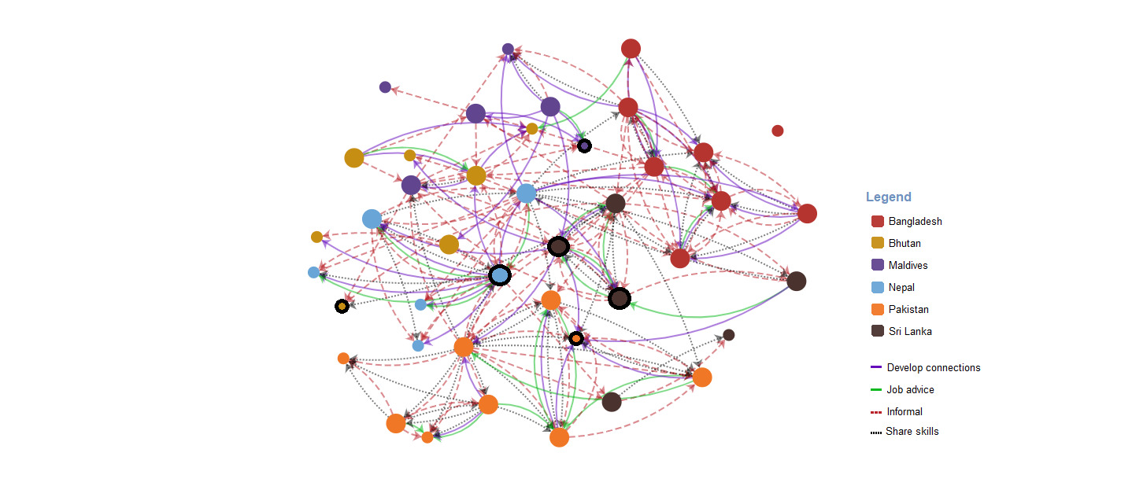

Key findings and implications regarding post-award enrichment programs

This case study illustrates that Australia Awards-linked enrichment programs provide an opportunity to develop connections between alumni that become ongoing sources of professional and personal support. This case study replicates previous GTF SNA findings showing that in-person events for alumni from different countries help to develop enduring alumni cross-country networks.

Interestingly, this new study found a higher concentration of connections between alumni in this 2018 workshop cohort compared to previous GTF SNA research of other alumni groups, which involved an on-award enrichment program and the country-wide Kiribati alumni network. This finding highlights the value of the format employed for the post-award enrichment program investigated; specifically, an in-person workshop with a smaller cohort of alumni that were all interested in a common area of work (environment and climate action) and completed a collaborative project. These findings suggest that programs for smaller cohorts of alumni with shared professional interests may foster more cohesive networks or communities of practice than programs for larger groups of alumni who have different professional interests and help to strengthen long-term Program Outcomes for the Australia Awards. Analyses also identified network leaders, information that is useful for the Australia Awards when considering future opportunities for alumni and how to leverage network connections to broaden alumni connections with Australia and better support alumni professional development.

Investigating the Contribution of Alumni Workshops to Australia Awards Program Outcomes using Social Network Analysis
Post-award enrichment activities like the Australia Awards 2018 Regional Alumni Workshop help to strengthen long-term Program Outcomes for the Australia Awards by:
• building on the knowledge and skills alumni developed during their Australia Award and reinforcing links with Australia through interactions with Australia Awards regional and country programs.
• establishing new connections between alumni that become ongoing sources of personal and professional support.

Alumni social network mapping
Four years after the workshop, over 97% of alumni are still connected to at least one other alum, a higher degree of alumni connectedness compared to previous GTF SNA research of alumni groups.  Furthermore: 
• Almost 85% of alumni contacted another workshop alum and/or have been contacted to develop connections with Australia.
• More than 75% of alumni connected with or were contacted by an alumni peer to share information about skills relevant to their work.
• Alumni identified 6 workshop peers from 5 countries as leaders within this network, identifying leadership traits as passion for the environment, ongoing connection with peers, and supporting others’ career goals. 
These findings highlight the value of post-award enrichment programs and the strengths of the 2018 workshop – (1) a small cohort of alumni who (2) shared a professional interest and (3) collaborated in small-group project work. Australia Awards Program Outcomes can be fostered and improved through involvement in well-structured and focussed post-award enrichment opportunities. 

A Network map of alumni
Image: In this figure, relationships between alumni for the Australian connections, job advice, skill sharing, and informal connections networks with leaders identified are illustrated together in the same network map. The combined network map shows 42 circles spread out where each circle represents an alumnus. Twenty-seven of the circles/alumni are larger to show that these alumni completed the social network survey questions. Fifteen of the circles/alumni are smaller in size to the large circles, to show that these alumni did not respond to the survey. Six of the circles have a black ring around them to indicate alumni that were most frequently identified as leaders by the alumni. Each circle is coloured to represent the country the alumni are from. Red circles show the alumni is from Bangladesh, mustard circles show the alumni is from Bhutan, purple circles show the alumni is from the Maldives, blue circles show the alumni is from Nepal, orange circles show the alumni is from Pakistan, and brown circles show the alumni is from Sri Lanka. Lines between circles/alumni are used to illustrate relationships in the network and these are coloured purple for Australian connections relationships, green for job advice relationships, black dotted for skill sharing relationships, and red dashed for informal connections relationships. Arrowheads on the end of the lines indicate the direction of the nominated relationship. The combined network map with leaders identified shows a highly connected alumni cohort, with only one isolate. Some of the alumni leaders are highly connected to their alumni peers and others are not as connected to others in the combined network.

Participants: Alumni who attended the 2018 Australia Awards Regional Alumni Workshop: Australia Awards Alumni as Champions for the Environment and Climate Action
Case study participants: 27 alumni – 12 women, 15 men




# Introduction

**The Australia Awards Global Tracer Facility (GTF) analyses and reports on data collected from alumni of Australian development scholarships funded by the Australian Department of Foreign Affairs and Trade (DFAT). Research by the GTF helps DFAT to assess the development contributions, and public and diplomacy outcomes of Australia’s investment in the Australia Awards. Since 2016, the GTF has conducted an annual program of work including a Global Tracer Survey and focussed case studies to develop an evidence-base to understand the long-term outcomes for alumni.**

In 2020, the GTF introduced social network analysis (SNA) into the range of approaches used to explore the long-term impact of the Australia Awards. This case study used SNA to map connections between alumni that attended a post-award enrichment workshop, focussed on bringing together a small group of alumni with shared professional interests. Specifically, alumni participated in the 2018 Regional Alumni Workshop conducted by the Australia Awards – South and West Asia Program (AASWAP; now known as the Australia Awards – South Asia & Mongolia program). GTF researchers designed an online survey to assess the long-term impact of the workshop and identify alumni connections established at and maintained four years after workshop participation. The survey fieldwork was conducted in October to November 2022.

Results from this survey are discussed in this report. These findings are intended to provide evidence examining effective enablers to achieving Australia Awards long-term Outcomes 1 – alumni use their skills, knowledge, and networks to contribute to sustainable development, and 2 – alumni are contributing to cooperation between Australia and partners countries.

## The 2018 Regional Alumni Workshop

Since 2015, AASWAP has conducted an annual Regional Alumni Workshop for a select group of Australia Awards alumni to present and discuss their work and build connections with peers from across the region. Each workshop focuses on a theme that is a priority to the Australian Government and the South and West Asia region.

For this study, the 2018 workshop was chosen as a specific focus in a GTF case study because its topic – climate change – is a key focus for DFAT, and because the length of time – four years – which had passed between the workshop and this case study would make it possible to examine the ongoing connections between participants.

The workshop theme centred on the urgent need for climate change action and was titled *Australia Awards Alumni as Champions for the Environment and Climate Action.* It was held in Thimpu, Bhutan over five days in November 2018.

To select the alumni that would attend the workshop, AASWAP posted an expression of interest notice on their website calling for applications from groups of alumni, with each group composed of alumni from the same country. The application process also required each alumni group to prepare a project idea related to one of the following topics: (1) water, food, or energy security; (2) public health (in the context of humanitarian response and climate change adaptation); (3) green technology/low-carbon practices; (4) disaster preparedness and humanitarian response; and (5) environmental protection and preservation. Successful applicants were provided with funds to work on their project prior to the workshop as well as funds to attend the workshop in Bhutan. Fifty alumni were funded and across this larger group, 14 small groups worked on a specific project. Alumni groups were also asked to select a mentor who would support their project from the design stage to its completion.

Of the 50 alumni funded, 44 attended the workshop in Bhutan. An overarching objective of all Regional Alumni Workshops conducted by AASWAP is to consolidate and reinforce alumni links with Australia. A specific aim of the 2018 workshop and project activities was to develop communities of practice among alumni by:

* building within-country alumni networks through project group work pre, during and post participation in the workshop,
* building new cross-country alumni networks and strengthening existing cross-country networks via an in-person event (i.e. the workshop) that allowed alumni with similar interests to meet and discuss ideas.

## Study Objectives

Three specific aims were developed to guide the case study:

* to examine alumni attitudes towards the 2018 workshop and identify whether the workshop allowed alumni to build on the knowledge and skills developed during their Australia Awards scholarship,
* to determine if alumni developed connections with alumni peers during the 2018 workshop,
* to determine if alumni *maintained* connections with alumni peers in the four years since the workshop.

More generally, this case study assessed whether the format of this post-award enrichment opportunity was successful in cultivating connections between alumni. This new research complements previous work by the GTF exploring alumni networks using SNA as an analysis tool. In 2021, the GTF explored the ongoing networks and connections of alumni who had participated in a leadership program while on award, and in 2020 the GTF conducted a SNA study of Kiribati alumni and the way in which they remain interconnected.

In addition to the aims specific to this case study, all research conducted by GTF is framed within the overall objective of the Australia Awards: to support ‘partner countries to achieve their development goals through education and knowledge transfer and to build enduring relationships with Australia that advance mutual interests’. Two long-term Program Outcomes to achieve this overall aim are outlined in the Australia Awards Global Strategic Framework[1] and Australia Awards Global Monitoring and Evaluation Framework[2]. Briefly, these outcomes are:

* **Outcome 1:** Alumni use their skills, knowledge, and networks to contribute to sustainable development.
* **Outcome 2:** Alumni contribute to cooperation between Australia and partner countries.

## Social network analysis

Social network analysis (SNA) is focussed on identifying relationships between people and examining how these relationships impact on the individual. Social relationships or social networks can be observed in many different contexts like the workplace and in schools. Using SNA supplements the traditional quantitative and qualitative techniques utilised in Global Tracer Surveys, which focus on the frequency of contact and most significant relationships developed during their participation in the Australia Awards.

A greater understanding of the type and nature of social connections between alumni can also be used to support alumni engagement activities. For instance, SNA used in GTF case studies has been able to identify the way in which alumni from particular cohorts are interconnected and how they use these connections to socialise, to find career opportunities and to pursue connections with Australia. This information has then been used to provide advice to DFAT, Posts and managing contractors about how to tailor communication with alumni to ensure that existing alumni networks are being used to target professional development and other alumni engagement opportunities.

## Scope and alumni participants

SNA provided an innovative approach to investigating the impact of the 2018 workshop and its focus on facilitating the development of communities of practice amongst alumni that attended. As noted above, 44 alumni attended the workshop in Bhutan. Of these 44 participants, 42 were the focus population of the case study[3]. These 42 alumni were from countries across South West Asia, including the Maldives, Pakistan, Sri Lanka, Nepal, Bangladesh and Bhutan.

Contact details for the 42 alumni were provided by AASWAP. The GTF contacted alumni via email to notify them of the case study and survey details. Of the 42 alumni contacted, 27 responded to the survey. This was a response rate of 64 per cent, which is high compared to previous GTF surveys and comparable to previous SNA case studies.

Of the alumni who responded to the survey, 88.5 per cent were employed full time. Very few were self-employed (3.8%), employed part-time (3.8%) or not employed (3.8%). Approximately two-thirds of responding alumni (68.0%) reported having formal leadership roles in their current workplace and approximately one-third (32.0%) considered themselves to have informal leadership roles.[4] These patterns were similar to those found in the GTF’s Longitudinal Survey in 2021.[5]

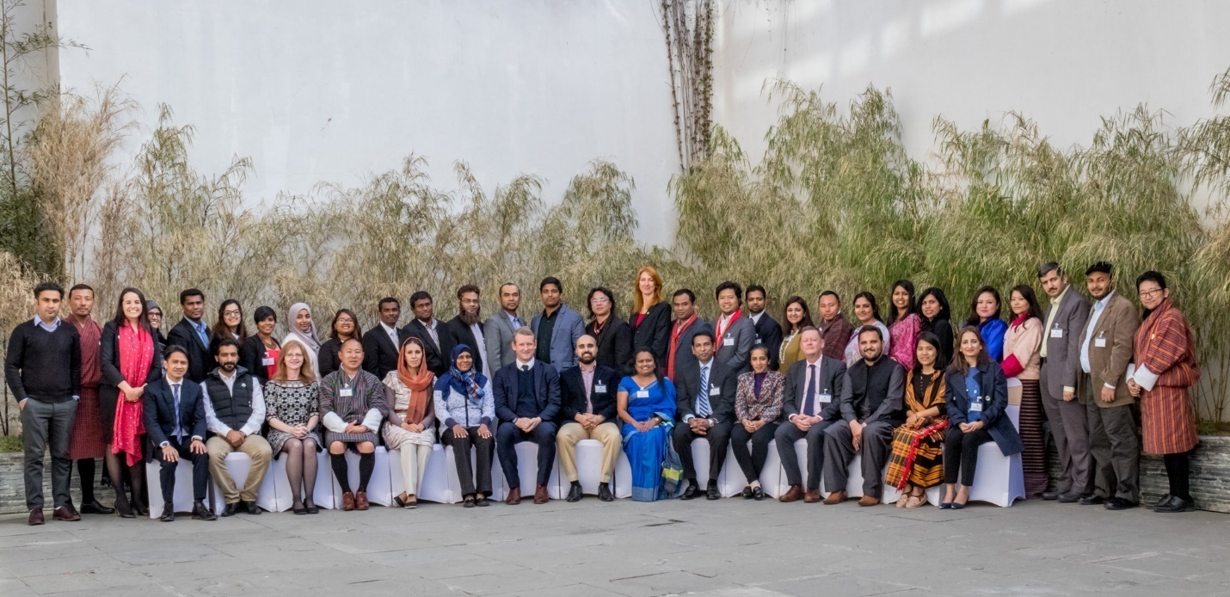

Alumni participants and workshop facilitators at the Regional Alumni Workshop in Thimphu, Bhutan, 2018: Australia Awards Alumni as Champions for Environment Protection and Climate Action (Source: Australia Awards – South Asia & Mongolia)

# Attitudes Towards the 2018 Regional Alumni Workshop and Connecting with Australia

The large majority of alumni in this case study responded that the 2018 workshop provided an opportunity to use skills and knowledge from their Australia Awards scholarship and to form networks with alumni from their own country and other countries. Almost 90 per cent of responding alumni agreed that opportunities at the workshop to work on their project, and hear about other alumni projects focussed on the environment and climate action were useful for their future professional development. This finding and others highlight the ways in which the workshop helped to address Outcome 1 – Alumni use their skills, knowledge and networks to contribute to sustainable development – for attending alumni.

## Introduction

This chapter explores the first aim of the case study; that is, *to examine alumni attitudes towards the 2018 workshop and identify whether the workshop allowed alumni to build on the knowledge and skills developed during their Australia Awards scholarship.* The purpose of this is to examine the usefulness of post-award workshops to support alumni in developing their practice using their Australian skills and knowledge. Alumni that participated in this case study completed a survey that explored alumni views around the effectiveness of the workshop, the networks alumni established at the workshop and networks maintained post-workshop participation. Findings presented in this report are based on the responses of 27 alumni. Alumni responses help to illustrate the long-term implications of post-award enrichment workshops for alumni professional development and professional and personal networks with other Australia Awards alumni.

## Impact of the workshop on alumni networks

Figure 1 presents alumni attitudes towards the 2018 workshop. All participants agreed (7.4%) or strongly agreed (88.9%) that they were able to use skills and knowledge from their Australia Awards scholarship to design and implement their project. Similarly, there was also strong agreement overall that the workshop enabled participants to form networks with other alumni from their own country (92.6%), as well as with alumni from other countries in the region (92.3%). Only a small proportion (7.4% and 7.7%, respectively) disagreed or were neutral in their response about the impact of the workshop on developing networks with other alumni from their own country or from other countries in the region.

Figure 1: Alumni attitudes towards the 2018 Regional Alumni Workshop (RAW) (n=27)

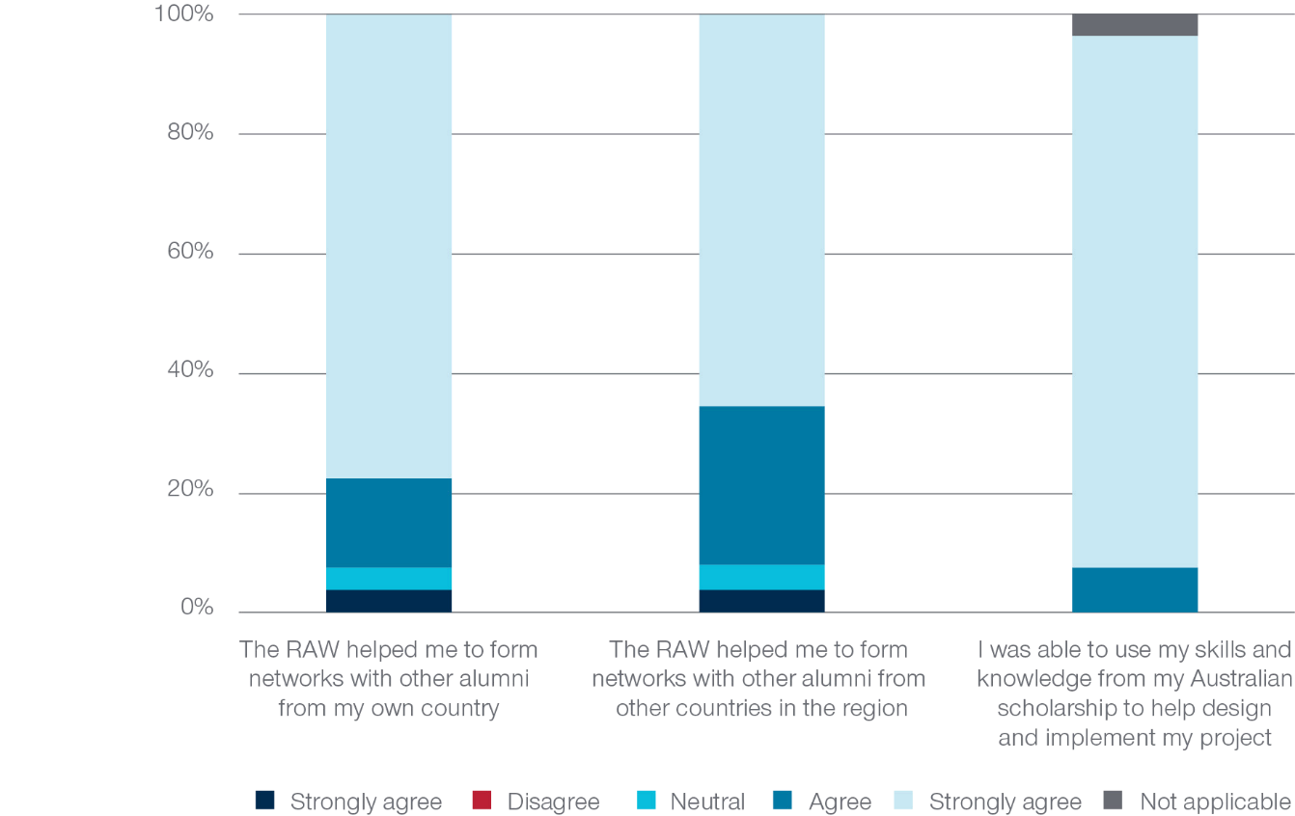

Alumni were also asked to rate the usefulness of the workshop sessions they attended for their professional development. Given these reflections were being asked of alumni four years post-participation in the workshop, ‘I cannot recall’ was listed as an additional response category. The three sessions receiving the most positive feedback involved:

* alumni presenting their project to the larger group and hearing about other alumni projects (88.5% of alumni rated this session as useful and 11.5% responded with a neutral rating),
* alumni attending a field trip and information sessions in and about Bhutan (88.5% of alumni rated this session as useful, 7.7% responded with a neutral rating and 3.8% rated it as not useful), and
* a session that provided alumni with the opportunity to collaborate with peers on their group project (84.6% of alumni rated this session as useful and 15.4% responded with a neutral rating).

Alumni responses to other sessions were more variable. Just over half of responding alumni (53.8%) rated the storytelling skills session about pitching their project and the session where they received feedback from the Environmental Innovation Specialist as useful. Approximately ten percent of alumni (11.5%) rated the pre-workshop planning and mentoring as not useful (73.1% rated the session as useful).

Figure 2 shows responses from alumni when they were asked if/how long their project continued after the 2018 workshop. These data help to investigate the potential long-term and ongoing impact of this post-award enrichment program. Alumni responses were mixed. The largest percentage of alumni (25.9%) responded that their project continued for 12 months. Almost one quarter of responding alumni (22.2%) reported that their project was still ongoing four years later, however, the same percentage of alumni (22.2%) reported that their project did not continue after the workshop. Just over ten per cent of alumni (11.1%) reported that their project continued for only six months or two years, and 7.4% of alumni reported that their project ran for more than two years but was not still in operation.

These findings link to the long-term Program Outcomes of the Australia Awards. Just over 20% of responding alumni were still engaged in networking opportunities with other alumni around their project four years later and just under 70% were engaged in networking opportunities with fellow alumni for at least 12 months post-workshop. These sustained networking opportunities also demonstrate that alumni are/were still connected to the AASWAP program in a long-term capacity illustrating cooperative partnerships between alumni and Australia that align with Outcome 2.

Figure 2: Continuation of project after completing the 2018 workshop (n=27)

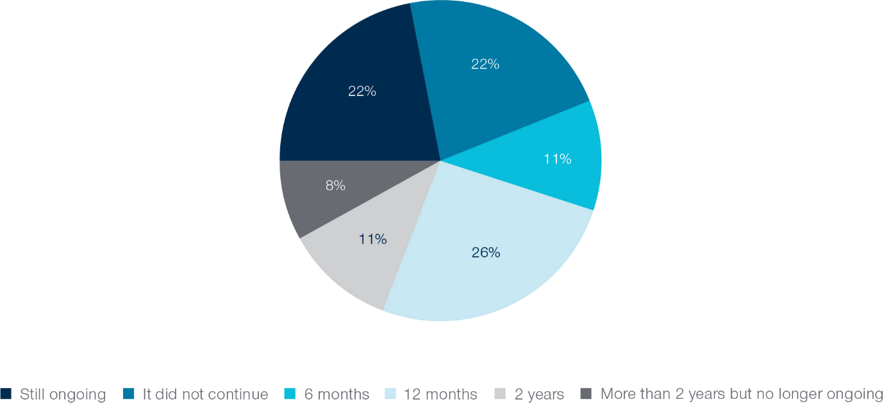

At the end of the survey, alumni were asked if they would be interested in participating in any future workshops and if they would also be interested in mentoring other alumni in their field that are participating in a workshop for the first time. All alumni that responded to these questions answered that they would be interested in participating in future workshops and would be interested in mentoring future workshop attendees. Alumni responses illustrate their ongoing engagement and willingness to be involved in Australia Awards activities.

# Mapping Connections Between 2018 Workshop Alumni Using Social Network Analysis

The use of SNA in this case study demonstrates that alumni remained highly connected four years after the 2018 workshop and that these connections are maintained for both professional and social reasons. Importantly, one of the most common reasons alumni interacted with one another was to develop connections with Australia. Analyses also identified network leaders, information that is useful for the Australia Awards when considering future opportunities for alumni and how to leverage network connections to broaden alumni connections with Australia.

## Introduction

This chapter uses SNA to investigate the following aims of the case study and determine:

* if alumni developed connections with alumni peers during the 2018 workshop
* if alumni maintained connections with alumni peers four years after the workshop.

These aims were integral to better understanding the way in which post-award programs can contribute to the Program Outcomes of the Australia Awards. In addition to investigating these aims, the social network approach adopted in this case study allowed for an innovative analysis of leadership among the cohort of alumni that attended the workshop – an important facet to understand given the strong emphasis of the Australia Awards on developing leaders.

|  |
| --- |
| **Social network terms** |
| **Ties**—Relationships in a network/between alumni |
| **Isolates**—Network members/alumni with no ties in a network |
| **Dyadic relationship**—A relationship between two people |
| **Clustered relationships**—Broader than a dyadic relationship, when relationships overlap with one another in a network |

## Exploring different types of alumni networks

Given the focus of the 2018 workshop on developing connections between alumni and building communities of practice, it was important to identify connections that existed between alumni before the workshop and connections that developed during the workshop. The next step was to map current connections between alumni that still existed, four years after the workshop.

To differentiate these different types of connections, the case study examined seven alumni networks:

1. The **connections made before the workshop network:** Connections between alumni that existed before alumni participated in the 2018 workshop
2. The **connections made during the workshop network**: Connections between alumni that developed/began at the 2018 workshop
3. The **Australian connections network:** Current connections between alumni maintained to develop connections with Australians or Australian organisations
4. The **job advice network:** Current connections between alumni maintained to seek job advice
5. The **skills sharing network:** Current connections between alumni maintained to share skills or information related to work
6. The **informal connections network**: Current connections between alumni maintained for informal reasons (for example, friendship connections, family, other social groups)
7. The **leadership network:** Current identification of alumni leaders in the 2018 workshop cohort

The results of the SNA are based on 27 alumni who responded to the social network section of the survey. In completing this part of the survey, an alum could nominate any of their workshop peers as someone they developed a connection with during their participation in the program.

|  |
| --- |
| To explore each network graphically, the program VPNet (SNA Toolbox Pty Ltd, 2022) was used to create network visualisations. In each visualisation, a circle is an alumni member, and a line between circles represents a tie or relationship between alumni. The arrowheads represented on the ties illustrate the direction of the relationship. |

## Connections made before and during the 2018 workshop

Figure 3 shows a visualisation of the 42 alumni that attended the 2018 workshop with each circle in the visualisation representing an alum. Alumni that responded to the survey are represented by larger circles and alumni who did not respond but were nominated by others (non-respondents) are represented by smaller circles. The colour of each circle represents an alum’s country of origin. Across the seven network questions, all 42 alumni in the 2018 workshop cohort were nominated by at least one of their fellow alum in at least one network question. Thus, all 42 alumni are represented in all the network maps presented in this chapter.

Figure 3: New and Old connections: Alumni connections that existed before the 2018 workshop and connections made during the 2018 workshop (large circles=survey respondents, small circles=non-respondents)

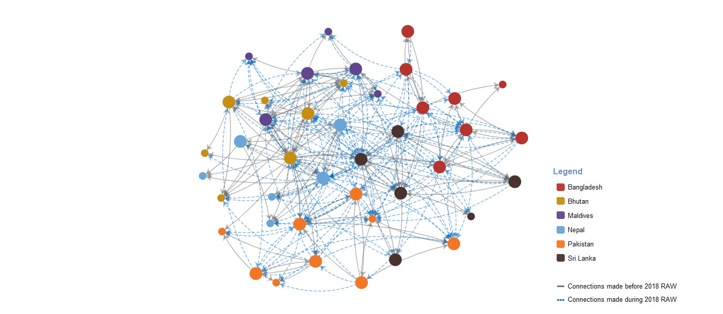

Figure 3 is a combined visualisation of two networks: connections made before the 2018 workshop and connections made during the workshop. All alumni are connected to at least one other alumni through the network that focuses on connections made before the 2018 workshop. The network map shows highly clustered patterns of interactions among alumni, with many new connections made at the workshop between alumni from different countries.

The two networks illustrated in Figure 3 had the highest density, or the greatest number of ties/connections, of all the networks mapped in the case study. Given alumni engaged in project work with alumni from their own country, the high number of ties in the network illustrating connections made before the workshop is not surprising. The greatest number of ties across all networks was found in the network of connections made during the workshop indicating that not only was the workshop objective of building connections between alumni achieved, but also the wider aims of the Australia Awards to build and maintain connections between alumni.

## Alumni connections for developing links with Australia

Figure 4, the Australian connections network, is the first of five networks that map ongoing connections between alumni that were reported four years after the 2018 workshop. Data presented in Figure 4 helps to build an understanding of how alumni maintain links with Australia post-award. Almost 85 per cent of alumni were connected in the Australian connections network indicating they reported contacting another workshop alum and/or would be contacted by a workshop alum to develop connections with Australia. Around 17 per cent of alumni were isolates in the network or were not connected to their peers for this type of interaction. There is some evidence of clustered relationships among alumni in this network, with some connections overlapping. The network map also shows that some alumni contact peers from other countries to help with connecting with Australia.

Figure 4: Australian connections network: Relationships among workshop alumni for developing connections with Australia (large circles=survey respondents, small circles=non-respondents)

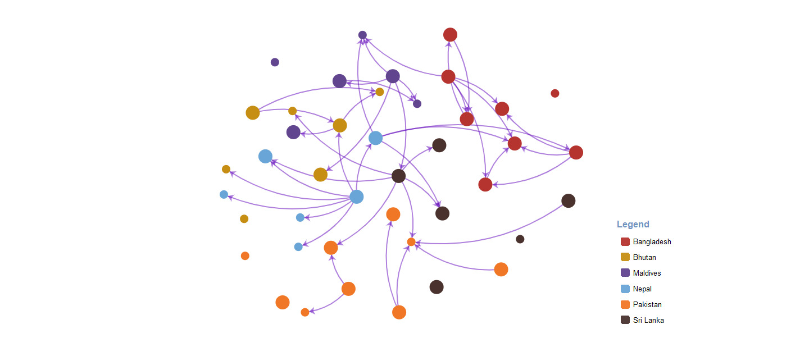

Interestingly, the percentage of alumni that reported engaging with one another for the purpose of connecting to Australia is much higher for the 2018 workshop group than found in previous GTF SNA case studies that have investigated this network among other alumni cohorts.[6] This may be due to the engagement fostered at the workshop and/or the alumni’s shared interest in the environment and climate action. However, it should also be noted that the workshop 2018 cohort is much smaller than the alumni cohorts studied in prior GTF case studies.[7]

Alumni were also asked who else they currently contact to develop connections with Australia or Australian organisations. Figure 5 illustrates that most participants (approximately 74%) indicated that they would approach Australia Awards alumni from their home country who did not attend the 2018 workshop. Alumni were also likely to reach out to AASWAP or the Australia Awards Program in their country (59.3%), as well as lecturers and university staff they met on award while in Australia and the Australian High Commission / Embassy / Consulate in their country (51.9%).

Figure 5: People outside of the 2018 workshop cohort that alumni contact to develop connections with Australia or Australian organisations (n=27)

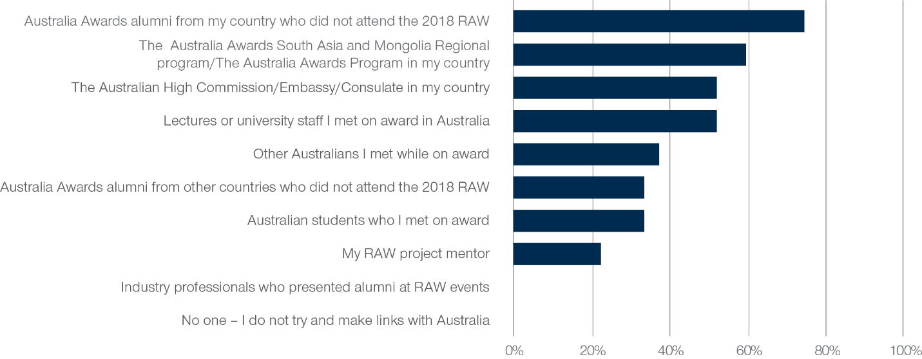

## Job advice and skills sharing networks among alumni

Figure 6 illustrates both the job advice (green lines) and the skills sharing (black dotted lines) networks among alumni, which were the networks with the least number of ties in the case study. About 40 per cent of alumni were isolates in the job advice network, indicating that alumni likely seek advice about job opportunities within other relationships. Connections that did exist were almost exclusively between alumni from the same country and tended to be dyadic. A dyadic structure in this network is characteristic of this type of relationship, wherein an individual is more likely to seek advice from a few trusted sources rather than a larger group of contacts.

In comparison to the job advice network, the skills sharing network (related to sharing information about knowledge and skills relevant to their field of work) was much more clustered with more examples of reciprocal connections and more instances of cross-country interactions. More than three quarters of alumni reported connecting with or were contacted by an alumni peer to share information about skills relevant to their work. This percentage was higher among this 2018 workshop alumni group than that found for other alumni cohorts in previous GTF SNA case studies.[8]

Figure 6: Relationships among workshop alumni in job advice and skills sharing networks (large circles=survey respondents, small circles=non-respondents)

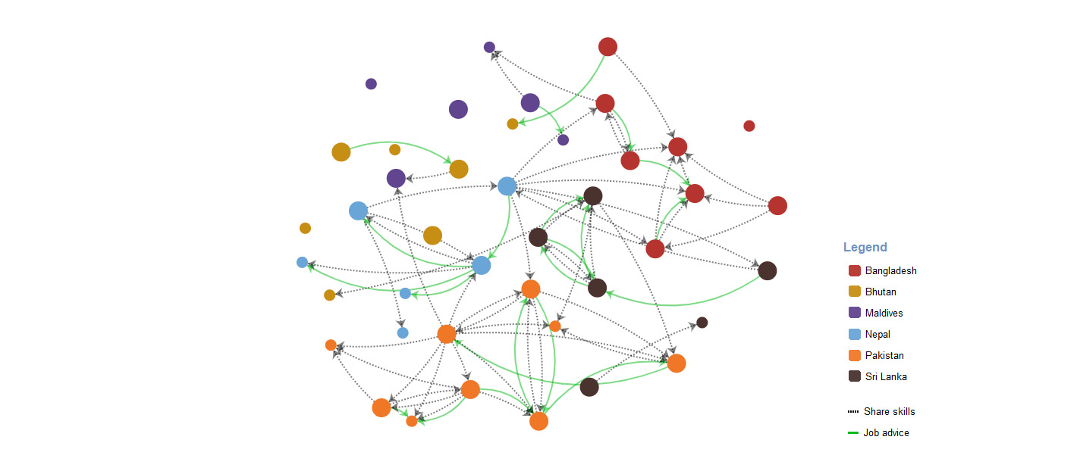

## Informal connections network

Previous GTF SNA case studies have illustrated that informal relationships between alumni (e.g. friendships) are often a common way that alumni report connecting with one another. This was also true for the 2018 workshop alumni group – the informal network, visualised in Figure 7, had the greatest number of ties across alumni’s current networks. This network was also highly clustered with many reciprocated ties. This structure is typical of the type of social connection depicted in this network where friendships are most likely the interaction being reported. There were also several instances of informal connections existing between alumni from different countries. Only two alumni were isolates in this network, meaning over 95 per cent of the 2018 workshop cohort were informally connected with at least one alum peer four years after the workshop.

Similar to a pattern found with the Australian connections network and the skills sharing network, the percentage of 2018 workshop alumni connected to one another in the informal network was higher than the percentage found across informal networks for other alumni groups in previous GTF SNA case studies[9], further highlighting the strength of the ongoing bonds within this group of alumni and providing evidence that post-award workshops are able to facilitate these outcomes.

Figure 7: Informal connections network: Relationships among workshop alumni linked to friendships, family, and/or other social groups (large circles=survey respondents, small circles=non-respondents)

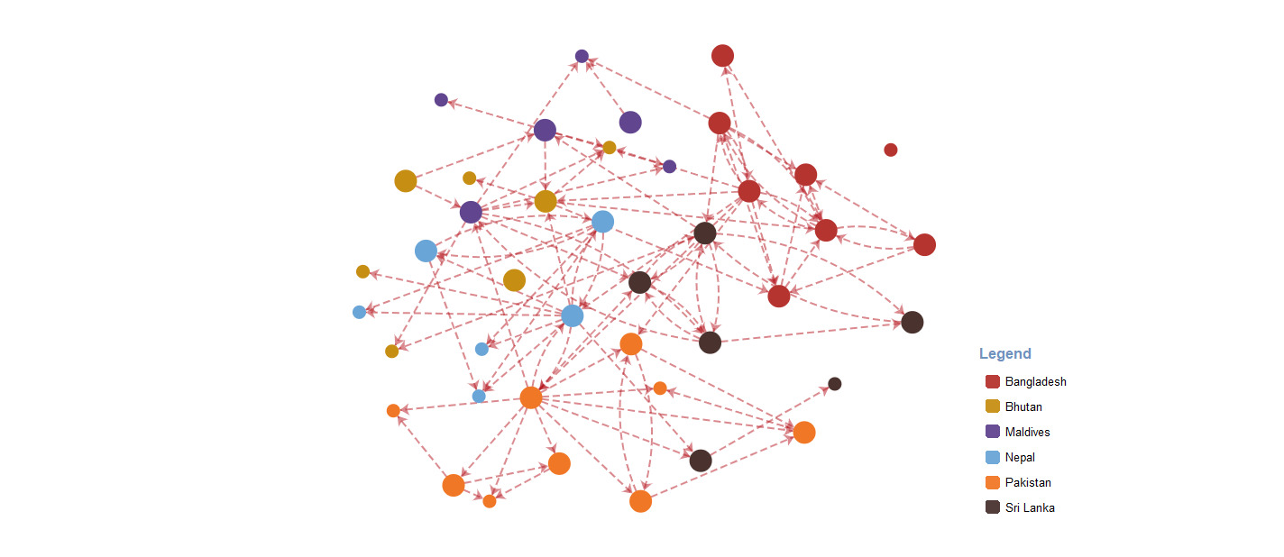

## Identifying leaders and leadership characteristics among alumni

Figure 8: Leadership network: Alumni leadership nominations within the 2018 workshop cohort (large circles=survey respondents, small circles=non-respondents)

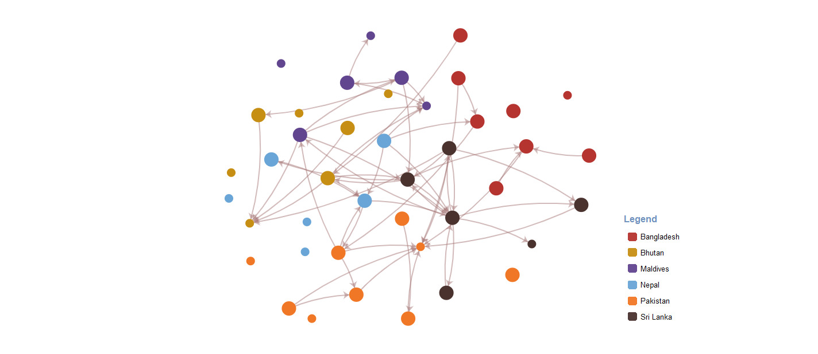

To improve understanding of the role of leaders and leadership within this network, alumni were asked to identify workshop peers that they would characterise as leaders in the cohort. SNA provides a unique way to investigate leadership as it can visually capture and communicate a group’s shared perspective. This network was examined in the case study to help AASWAP identify members of the 2018 workshop cohort that could support alumni participating in future workshops, an example of the way in which SNA can be used by the Australia Awards to identify leaders for ongoing engagement.

Figure 8 shows the leadership network for the 2018 workshop cohort. Twenty-two alumni, or just over 50 per cent of the group, were identified by their peers as a leader at least once. Of these 22, 12 alumni were identified by several peers as leaders within the cohort. The alum that was distinguished the most as a leader was identified by eight peers. Alumni who were more frequently identified (by between four to eight peers) were nominated by alumni from their own country and at least one other country. This group of alumni leaders are represented in the final network visualisation in this chapter, in Figure 11.

Alumni were also asked to report on the specific leadership characteristics of the alum or alumni they nominated as leaders. Figure 9 presents these characteristics. The majority of alumni reported that their nominated alum was a leader because they were passionate about the environment and climate action (74.1%). This was followed by reporting that they had good relationships with most workshop alumni (55.6%) and were supportive and gave good advice to fellow workshop alumni (59.3%).

The insight presented by these data is important because it helps to understand the leadership perspectives and expectations of Australia Awards alumni. More broadly, this helps the Australia Awards program by showing that alumni value leaders who have a passion for their area or expertise; maintain relationships with other alumni; and are supportive and encouraging to others to further their career and achieve goals. This information can be helpful when thinking about ways to recruit and engage with alumni in future post-award enrichment activities.

Figure 9: Characteristics of workshop alumni leaders (n=27)

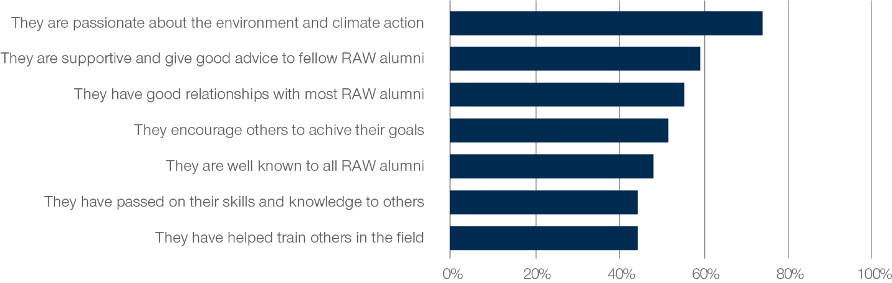

## Combined current connections

Figure 10 presents a combined visualisation of current connections of the alumni involved in the 2018 workshop. Essentially this is an overlap of several of the individual maps presented in discussion above: the Australian connections network, the skills sharing network, the job advice network, and the informal connections network. Figure 10 helps to illustrate that the 2018 workshop alumni cohort are highly connected to one another via the various types of networks examined in this case study. More than 97 per cent of alumni are connected to at least one other alum[10], suggesting that almost all relationships formed between alumni at the 2018 workshop are maintained in the present. The strength of this finding is important as an example to demonstrate the way in which the Australia Awards Program Outcomes can be fostered and improved through involvement in well-structured and focussed post-award programs such as the workshop used as an example in this study.

Figure 10: Combined current relationships among workshop alumni in Australian connections, job advice, skills sharing, and informal connections networks (large circles=survey respondents, small circles=non-respondents)

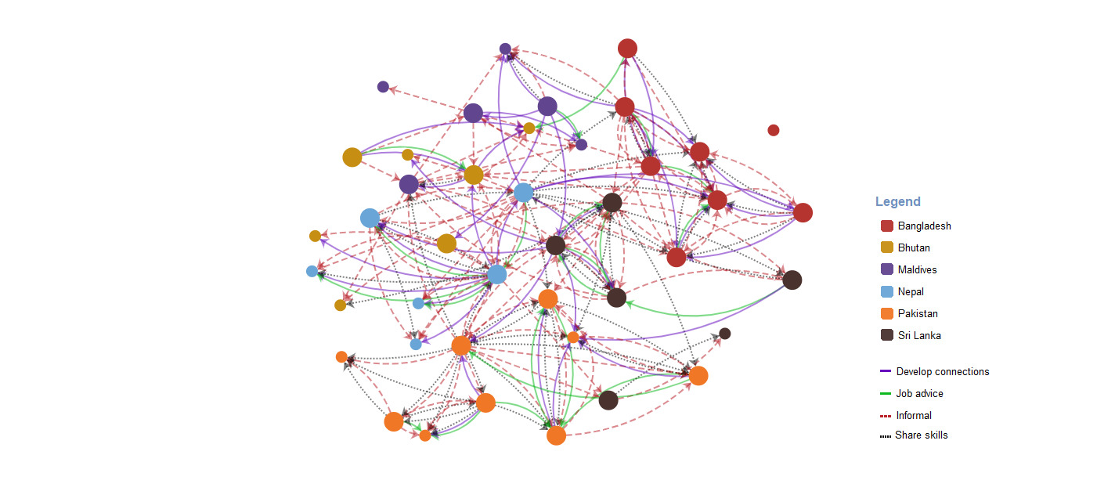

A further means of building on the findings highlighted above is to add another layer to this mapping by highlighting the key identified leaders within this cohort of alumni. Figure 11 shows the combined network map with the six alumni who were most frequently identified by their peers as leaders, emphasised by a black ring around the circle that represents them.[11] The figure shows that some of the alumni leaders are highly connected to their alumni peers (e.g. the two leaders from Sri Lanka) and others are not as embedded in the combined network (e.g. the leader from Bhutan). This suggests that the attribute of being socially connected may not have been as strongly associated with alumni perceptions of leadership, or at least that this attribute was not as prioritised by some alumni. This aligns with the finding from Figure 10 that the most common alumni attribute linked to leadership nominations was being passionate about the environment and climate action.

Figure 11: Combined current relationships among workshop alumni in Australian connections, job advice, skills sharing, and informal connections networks with leaders highlighted with black circles (large circles=survey respondents, small circles=non-respondents)

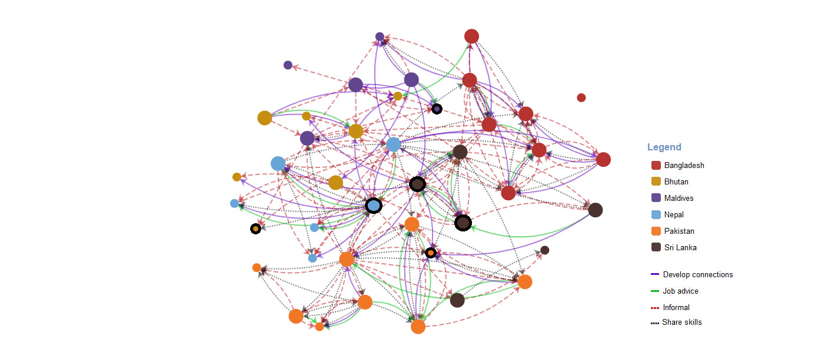

# Conclusion and Implications

## Summary of findings

In this case study, the impact of a post-award enrichment workshop on helping to establish and develop ongoing connections between participating alumni was investigated via multiple methods including traditional survey techniques and SNA. Alumni reported that the 2018 workshop allowed them to use the skills and knowledge they developed on-award and that following the workshop they have maintained connections with Australia through fellow alumni, and through networks with the Australia Awards regional and country programs. Alumni responses demonstrate that this post-award engagement is effective in contributing to the achievement of the Australia Awards Program Outcomes.

Mapping connections between alumni using SNA illustrated that there are benefits to alumni and to the Australia Awards program more broadly of implementing engaging and focussed post-award workshops for alumni. Most central to this outcome is the finding that the relationships that formed between alumni during the workshop have largely been sustained four years later.

The use of SNA also provided an innovative way to examine perceptions of leadership in the cohort of alumni that attended the workshop. Six alumni from five countries were identified through the analysis in this study as being particularly important leaders within this network. The results from the analysis showed that these alumni are seen as leaders by peers from their own country as well by peers from other countries. The study also showed that the key leadership values identified by alumni in this network were a passion for the field of climate change, an ongoing connection with peers, and demonstrated willingness to support peers to further their career and achieve their goals.

## Implications for the region and for the Australia Awards

Implications of this case study are relevant for the Australia Awards program as a whole and to specific regional and country programs – and others interested in ongoing alumni engagement. Around 85 per cent of alumni considered sessions at the workshop of focus in this case study that involved project-work and collaborating with peers to be useful for their future professional development. In addition, all responding alumni reported that they would be interested in participating in future workshops and would be interested in mentoring future workshop alumni. For the Australia Awards program, these findings suggest that post-award workshops are valued, are relevant for alumni long-term professional development, and that interest by previous workshop attendees to engage in future opportunities as mentors can help to build interconnections across alumni cohorts.

The broader implications of this study relate to the value of post-award enrichment opportunities such as the one focussed on in this study for contributing to the long-term networking outcomes of the Australia Awards. Four years after attending the workshop more than 97 per cent of alumni were still connected to at least one other alum via the networks investigated in the case study. These connections include interactions between alumni from different countries. Furthermore, a higher percentage of alumni in this case study were connected to their alumni peers compared to previous GTF SNA case studies of other alumni groups. Programs that bring together small groups of alumni and provide a format for alumni to collaborate in project-based work may have greater facility to build long-term connections between alumni. When these connections are also formed between alumni with a shared professional interest, more cohesive networks or communities of practice are likely to develop and be sustained into the future. This has implications for the design of post-award as well as on-award programs designed to better engage alumni.

Across all the GTF’s SNA case studies, a consistent finding has been the high degree of connectedness between Australia Awards alumni, both within and across-countries. These connections have been illustrated among different sized groups of alumni that participated in on-award and post-award enrichment programs, and among a large group of Australia Awards alumni from the same country. However, this case study also demonstrated how SNA can highlight peer-perceived leaders within a small cohort of alumni. Knowing who the leaders or ‘enablers’ are within a group may be important for identifying alumni who should receive specific professional development training. For instance, identified leaders could be recruited for mentor programs or help to strengthen diplomatic relations through advisory roles or links with Australian universities or businesses.

This case study also illustrates the specific leadership dynamics within the cohort of alumni that attended the 2018 workshop. For this group, the most frequently reported characteristic of identified leaders was passion for the field of climate change. Leadership dynamics and valued leadership characteristics may vary across different groups of alumni and could also operate in different ways to support alumni development. Identifying and understanding these dynamics, characteristics and mechanisms of leadership support could also be used to pinpoint alumni that are best placed to lead engagement initiatives and to better engage cohorts as a whole through collective growth opportunities.

# Abbreviations and Acronyms

|  |  |
| --- | --- |
| AASWAP | Australia Awards – South and West Asia Program |
| DFAT | Department of Foreign Affairs and Trade |
| GTF | Australia Awards Global Tracer Facility |
| SNA | Social network analysis |
| RAW | Regional Alumni Workshop |

Annex 1: Methodology and Limitations

**In this annex, further methodological details of the case study’s approach are provided including survey development, information about the target population and fieldwork. The annex also outlines limitations of the case that should be considered when interpreting findings.**

Case study design

As noted in Chapter 1, the three specific aims of this case study were:

* To examine alumni attitudes towards the 2018 workshop and identify whether the workshop allowed alumni to build on the knowledge and skills developed during their Australia Awards scholarship
* To determine if alumni developed connections with alumni peers during the workshop in Bhutan
* To determine if alumni *maintained* connections with alumni peers four years after the workshop

In addition, the overarching purpose of the Australia Awards – to support ‘partner countries to achieve their development goals through education and knowledge transfer and to build enduring relationships with Australia that advance mutual interests’ – is assessed in all GTF research. For this case study, the relevant long-term Program Outcomes were:

* **Outcome 1:** Alumni use their skills, knowledge and networks to contribute to sustainable development.
* **Outcome 2:** Alumni contribute to cooperation between Australia and partner countries.

These outcomes are presented in the Australia Awards Global Strategic Framework[12] and Australia Awards Global Monitoring and Evaluation Framework[13]. The outcomes along with the specific aims of this case study guided the methodological approach of this research and were a frame of reference for interpreting the case study findings.

Survey instrument development

The survey instrument in this case study was designed to examine social networks between 2018 workshop alumni to determine whether alumni connections were developed at the workshop and maintained in the present. It was also constructed to investigate alumni’s experience of the workshop in order to highlight how the post-award enrichment opportunity may have contributed to the long-term Program Outcomes of the Australia Awards.

The final survey included three sections:

**Section 1—Introduction & Social Networks:**

* Networks among alumni developed during participation in the 2018 workshop
* Networks among alumni maintained in the present related to:
  + Connecting with Australians or Australian organisations
    - Other connections with Australia or Australian organisations beyond the 2018 workshop alumni group.
  + Seeking advice about job opportunities
  + Sharing information and skills related to field of work
  + Connecting with alumni for informal reasons (e.g., friendships, relationships based around family and other social groups)
  + Nominations of leadership in the 2018 workshop alumni group
    - Characteristics associated with leadership nominations

**Section 2—Experience of the 2018 workshop:**

* Views of the 2018 workshop for forming networks and using skills and knowledge
* Views on the specific sessions delivered at the 2018 workshop
* Ongoing contact with project mentors
* Project duration

**Section 3—Background information:**

* Employment
* Leadership positions
* Award details
* Interest in participating in future workshops and mentoring future workshop attendees

Target population

The target population of this case study were Australia Awards alumni that participated in the Australia Awards South and West Asia Regional Alumni Workshop 2018: Australia Awards Alumni as Champions for the Environment and Climate Action. This cohort was chosen as they participated in a targeted, face-to-face initiative designed to engage the shared interest of alumni in the region and because of the specific objective of the workshop to develop communities of practice among attendees. This aligned with the social network approach intended for the case study and allowed for an innovative analysis of the impact of the workshop.

Data relating to this target population was compiled via two means. First, Australia Awards South Asia and Mongolia provided the GTF with its list of alumni that participated in the 2018 workshop. The GTF researchers supplemented this list with an extract of alumni contact information from the DFAT Global Alumni database.

A total of 44 alumni attended the workshop, however two alumni from Afghanistan were excluded from the survey due to the timing of data collection intersecting with political changes to the country, leaving a final target population of 42 alumni. All the alumni had at least one email that did not bounce back and no alumni refused to participate in the survey.

Fieldwork

The survey data was collected using an online survey platform. Each alum in the target population was provided with a unique URL to link to the survey via email invitation. The GTF employed an approach to survey collection which involved: having a clearly defined target population; identifying the extent to which the target population can be reliably contacted; and providing each member of the population with a unique access link to the survey. This approach helps to ensure accurate data collection, enables a clear understanding of response patterns, and provides a baseline from which to examine the validity of survey responses and findings.

Prior to full survey implementation, alumni in the target population were contacted to inform them of the upcoming survey and provide an opportunity for them to opt-out of participation.[14] Fieldwork commenced on October 19 and closed on November 14, 2022. Survey response data were collected and stored on servers in Australia. Throughout the fieldwork period, response data were routinely extracted by the GTF team and used for updating response lists. Alumni who had not responded to the survey were contacted via email with personalised reminders to complete the survey.[15] In total, four reminder emails were sent during fieldwork to encourage alumni to participate in the survey.

Of the 42 alumni successfully contacted via email and invited to participate, **27 responded to the survey and were included in the analysis for this report—a response rate of 64 per cent.** This responserate was high in comparison to other GTF research and alumni-based surveys conducted internationally and is comparable to other GTF SNA research. As an example, the GTF Global Tracer Survey conducted in 2020 achieved a response rate of 25.9 per cent.[16]

Limitations

Positive response bias

The issue of positive bias in survey research is relevant to the current study as it is likely that alumni who positively regarded their 2018 workshop experience, formed social networks with their workshop peers, and in general were positive about their experience receiving an Australian Government scholarship and the future career opportunities it provided were more likely to respond to the survey. The Commonwealth Scholarship Commission in the UK,[17] emphasises this issue in alumni research noting that:

… those who reply to sample surveys are likely to be engaged with alumni associations or tracing (e.g. Day, Stackhouse and Geddes, 2009) and disproportionately represent the ‘successful’ outcomes of scholarship programmes (p.9).

The possible impact of positive bias should be considered when interpreting the findings from this case study and the implications drawn around the Australia Awards.

With an understanding of this issue in alumni survey research, the GTF implemented processes to mitigate and identify any bias in the data collected. These processes included:

* Setting a clear boundary around the target population and dedicating time in the design stage of the case study to understand how the 2018 workshop was created, conducted and evaluated by AASWAP;
* Creating a unique URL for each alum in the target population to access the survey so that the GTF could identify any patterns in how alumni were responding to the survey;
* Investigating the characteristics of alumni who responded to the survey and those who did not to identify any measurable differences in these groups (in particular, gender, country of origin);
* Developing survey items focussed on avoiding leading questions and ensuring a wide range of response options;
* Working carefully during fieldwork to provide tailored ‘reminder’ emails to alumni to encourage high levels of participation.

It is also important to note that case study findings are drawn from the responses of 27 alumni (64% of the target population) and are not representative of the whole cohort of alumni that attended the 2018 workshop. However, alumni responses were still able to illustrate that a high percentage of alumni are connected to one another in the networks investigated.

Social Network Analysis

Due to the way that data is collected and analysed, SNA as a research approach is more sensitive to missing data issues. A high response rate for SNA research is therefore more important than it may be in other traditional research studies. For this case study, the response rate of 64 per cent is higher than other alumni-related survey research, particularly given alumni were contacted regarding a workshop they had attended four years prior to the survey. While future GTF SNA research would still benefit from a higher response rate, the high percentage of alumni connected to each other within each of the networks investigated lends credibility to the data collected.

It should also be noted that while the GTF team consulted with AASWAP about the survey design and the social networks that would be explored, it is possible the case study did not capture all of the network types or ways alumni were connecting to one another that were important for the 2018 workshop cohort.

1. See: https://www.dfat.gov.au/sites/default/files/australia-awards-global-strategic-framework-2021-24.pdf
2. See: https://www.dfat.gov.au/sites/default/files/australia-awards-global-monitoring-and-evaluation-framework-2022.pdf
3. Two alumni from Afghanistan who participated in the workshop were not included in this study. Given the timing of the fieldwork and the political changes occurring in the country, researchers and DFAT decided that engaging these alumni in this research was not appropriate.
4. Demographic and other general questions were asked at the end of the survey including questions about employment status and leadership roles. Two alumni did not complete the leadership questions and one did not complete the question about employment status. Thus, the leadership data reported here are based on the responses of 25 alumni and the employment data are based on the responses of 26 alumni.
5. See: https://www.dfat.gov.au/sites/default/files/australia-awards-gtf-yr6-alumni-growth-tracking-australia-awards-alumni-longitudinal-tracer-survey-2021.pdf
6. For instance, in the GTF SNA study of the Australia Awards Leadership Program 2013-2014 cohort, approximately two thirds of alumni were connected to one another through their Australian connections network.
7. For instance, there were 287 alumni in the Australia Awards Leadership Program 2013-2014 cohort.
8. Note in previous GTF SNA studies, the skills sharing network was labelled the information sharing network.
9. For instance, in the GTF SNA study of the Australia Awards Leadership Program 2013-2014 cohort, approximately two thirds of alumni were connected to one another through their informal connections network.
10. The one alum that did not have connections identified in this study did not respond to the survey and it is possible that if they did, they would be connected to other alumni through their own nominations or through the nominations of other non-responding alumni.
11. These six alumni, from five different countries, received between four to eight ‘leadership nominations’ from their peers.
12. See: https://www.dfat.gov.au/sites/default/files/australia-awards-global-strategic-framework-2021-24.pdf
13. See: https://www.dfat.gov.au/sites/default/files/australia-awards-global-monitoring-and-evaluation-framework-2022.pdf
14. To aid in data collection, a dropdown list of 2018 workshop alumni names was programmed into the online survey software. Alumni were informed prior to fieldwork that all 2018 workshop alumni names would be included and asked to notify researchers if they wanted their name removed from the list and/or did not want to participate in the case study. There were no alumni who asked for their name to be removed and/or said that they did not want to participate.
15. For example, alumni who had started the survey but not completed were encouraged to finish and alumni who had been mentioned by others as members of their network were sent a tailored message.
16. See: https://www.dfat.gov.au/people-to-people/australia-awards/australia-awards-global-tracer-facility-year-5-results/australia-awards-alumni-global-tracer-survey-2020
17. Mawer, M. (2014). A study of research methodology used in evaluations of international scholarship schemes for higher education. Commonwealth Scholarships Commission. London.