Photo of Mel Nava, the CEO and Founder of 1Export, a female-founded and -led start-up company in the Philippines in front of the Filipino brands she helps in exporting globally. 
  
INVESTING IN WOMEN

*SMART ECONOMICS*

# CATALYSING INCLUSIVE, SUSTAINABLE ECONOMIC DEVELOPMENT IN SOUTHEAST ASIA

Investing in Women (IW) is a multi-country Australian Government initiative in Southeast Asia that seeks to accelerate women’s economic equality. By fostering equitable opportunities within the private sector, IW aims to promote inclusive and sustainable economic growth in targeted countries.

Building on the results, partnerships and lessons established under the first seven years of the program (2016-2023), IW works to extend and deepen Australia’s contribution to advancing gender equality in Southeast Asia by influencing and growing an ecosystem of policymakers, business leaders, capital providers and women’s economic equality actors.

Photo above features Mel Nava, CEO and Founder of 1Export, a female-founded and -led start-up company in the Philippines that supports the growth of Filipino brands on the global stage. Photo from Investing in Women.

## THE CHALLENGE

Women’s economic equality is achieved when women—alongside all genders—can succeed equally and advance economically, make and act on economic decisions in a sustainable manner, and be recognised and rewarded equally for paid and unpaid work opportunities. It is not only a fundamental aspect of promoting gender equality; it is key to enhancing business competitiveness, fuelling inclusive economic growth and building equitable societies. Despite the immense potential, women continue to be underrepresented at all levels of economic participation.

In the rapidly evolving and diverse landscape of Southeast Asia, gender inequality stands as a significant barrier to economic advancement. While some progress has been made, the region continues to grapple with significant gender gaps in economic opportunities and outcomes. The evidence clearly shows that investing in women—unlocking their productivity, skills, talent, innovation and leadership—benefits not only the women themselves but also their families, communities, workplaces and nations. Investing in women, as employees, employers and entrepreneurs, is a strategic imperative to achieve sustainable development in Southeast Asia.

## THE APPROACH

IW supports women to thrive in the workplace and succeed in business. To achieve this aim, IW partners with a diverse ecosystem of business leaders, capital providers, entrepreneurs and gender equality advocates in Indonesia, the Philippines, Vietnam and Myanmar. By working to reduce or remove the structural barriers to women’s economic participation, IW will accelerate progress towards women’s economic equality.

**By advancing women’s economic equality, IW works to build the foundation for more inclusive, resilient, and gender-equal societies and economies.**

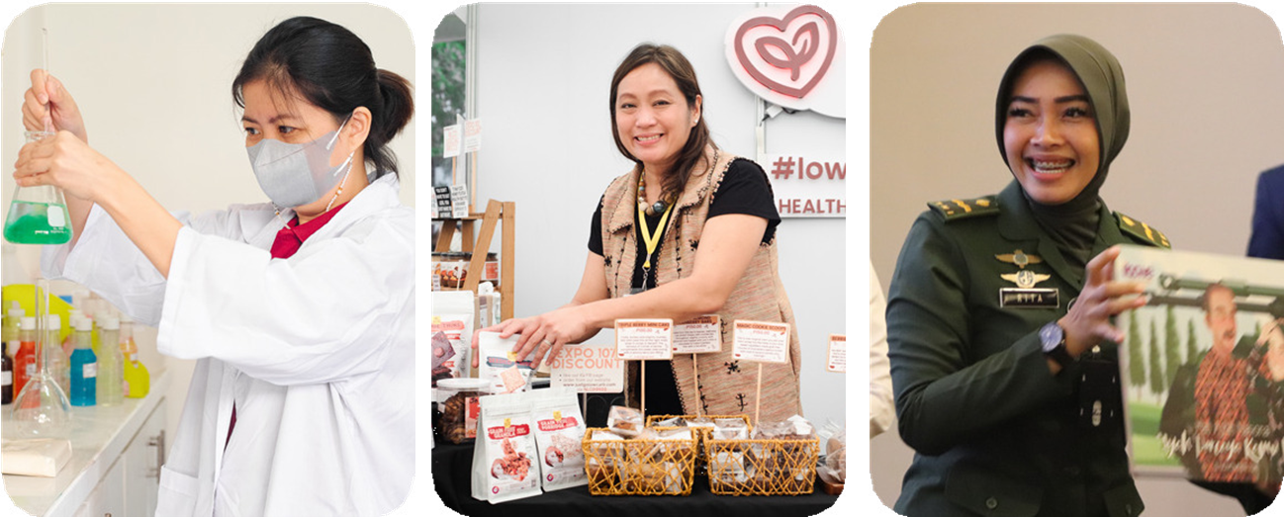

Featured photos (from left to right): Annie Guiang, head of quality control at Prime Innov8 in the Philippines; Jeannie Andrada, founder and product creator of JustGoLowCarb in the Philippines, and Rita Erna Mayasari, member of the Army Women’s Corps (Kowad) in Indonesia. Photos from Investing in Women.

## ACHIEVEMENTS TO DATE

IW has been tackling women’s economic equality with the support of the Australian Government since 2016. Since then, IW has:

**>173 MAJOR BUSINESSES, ~1M EMPLOYEES**

Established Business Coalitions for workplace gender equality in Indonesia, the Philippines, Vietnam and Myanmar. (Data as at August 2024).

**$15.4M INVESTED TO 82 WOMEN-LED/OWNED SMEs**

Worked with 10 investing partners, that catalysed over AUD 525 million to bridge the finance gap for women entrepreneurs. (Data as at June 2023).

**3.4X INCREASE IN NUMBER, 7X INCREASE IN VALUE OF GLI DEALS**

Increased deal growth in the regional investment community via gender lens investing in partnership with market-building allies. (Data as at June 2023).

**MORE THAN 311M IN ONLINE REACH**

Supported local partners to deliver targeted advocacy campaigns across Indonesia, the Philippines, and Vietnam. (Data as at June 2023).

## DRIVING IMPACTFUL CHANGE FOR GENDER EQUALITY

IW uses innovative approaches to catalyse women’s economic participation and strengthen the enabling environment for women’s economic equality, including:

An icon image consisting of a group of four people with a gear and equal sign as visual representation of the Workplace Gender Equality workstream of Investing in Women. **Workplace Gender Equality** supporting partners, including Business Coalitions, that work with influential businesses to shift workplace cultures, practices and policy, and achieve workplace gender equality.

An icon image consisting of a group of four pieces of puzzle with a piece of paper and a check mark as a visual representation of the Enabling Policy Reforms workstream of Investing in Women. **Enabling Policy Reform** working to strengthen the evidence base and drive collective action needed to influence and inform policy reform that supports women’s equal economic participation.

An icon image consisting of a group of a group of purple and orange chat bubbles with either a positive or negative sign inside them as a visual representation of the Campaigns and Communities of Practice workstream of Investing in Women. **Campaigns and Communities of Practice** supporting locally driven campaigns that promote positive examples of gender equality to strengthen public support for women’s economic participation.

An icon image consisting of a bag of money, an arrow graph going upwards and hand holding a magnifying glass with gender equality sign inside it as a visual representation of the Gender Lens Investing  workstream of Investing in Women. **Gender Lens Investing** working to increase investment in Small and Medium Enterprises (SMEs) that disproportionately benefit women in Indonesia, the Philippines and Vietnam.

While we acknowledge the diverse roles women play in society and the economy, our efforts focus on women in the formal sector and small-to-medium-sized business owners, recognising them as crucial drivers of progress on gender equality that can stimulate broader change.

## PARTNERING FOR PROGRESS

Our success hinges on collaboration with those driving change in the region. We work with a diverse array of stakeholders in our target countries who are committed to accelerating women’s economic empowerment in Southeast Asia.

### WORKPLACE GENDER EQUALITY

In Indonesia, Myanmar, the Philippines and Vietnam, Investing in Women supports locally owned and led Business Coalitions that help employers create a fairer workplace, attract and retain diverse teams and deliver on their ESG strategies. The Business Coalitions provide customised advice and support to companies seeking to improve WGE and benefit from the positive impacts to their businesses. They also work in partnership with the private sector and other stakeholders to advance public policy reforms that remove barriers to workplace gender equality.

Together, Businesses Coalition members employ more than one million employees.

* [IBCWE in Indonesia](http://ibcwe.id)
* [BCGE in Myanmar](https://www.mbcgea.com)
* [PBCWE in the Philippines](https://pbcwe.com.ph)
* [BSA](https://bsaonline.vn) and [ECUE](https://ecue.vn) in Vietnam

### ENABLING POLICY REFORMS

Investing in Women works with credible local institutions with capability to integrate private sector experiences and perspectives into policy dialogues. Through these partnerships, IW will identify and contribute to policy or regulatory reforms in Indonesia, the Philippines and Vietnam that support better access to quality care services. This work will have a sharp focus on the evidence-base and collective action needed to influence and inform policy change that supports women’s economic equality.

|  |  |  |  |
| --- | --- | --- | --- |
| **INDONESIA** | **PHILIPPINES** | **VIETNAM** | **MULTI-COUNTRY** |
| IW works with **IBCWE** in conducting trials of employer- supported childcare with selected member- companies, documenting implementation insights to engage policymakers on the role of the private sector in the care economy. | Together the  **National Economic and Development Authority**, IW supports research activities on workforce policies that contributes to builds a dynamic, inclusive and gender-equal Philippine labour market. | By working with the **private sector and non-traditional partners**, IW will invest in building the evidence-base for more and diverse gender- responsive, at-home aged care solutions in Vietnam. | The **Global Institute for Women’s Leadership (GIWL)** at the Australian National University is spearheading the Future Demand for Care research which explores the changing demand for care in the context of demographic, social, and economic transitions, and the impacts of these shifts on women’s position in the economy. |

### CAMPAIGNS AND COMMUNITIES OF PRACTICE

Investing in Women supports locally driven campaigns in Indonesia, the Philippines and Vietnam that highlight examples of gender equality to strengthen public support for women’s economic participation. Recognising the need for local leadership, innovation, and action to address barriers to women’s economic empowerment, IW also fosters a community of advocates that will continuously build evidence that supports the broader adoption of progressive attitudes and behaviours.

|  |  |  |
| --- | --- | --- |
| **INDONESIA** | **PHILIPPINES** | **VIETNAM** |
| **Kopernik**, a research and innovation lab for social and environmental challenges, is leading the *Generasi Setara* (Equal Generation) initiative, which collects and deploys evidence of gender-equal sharing of roles in Indonesian homes to broaden public support for women’s economic equality.  **Magdalene**, a women-focused digital publication, is amplifying stories on, and supports cohorts of, early adopters negotiating unpaid care work and income earning roles through its Wave for Equality campaign and community of practice. | **Good Return**, with the **Alliance of Philippine Partners in Enterprise**  **Development, Inc. (APPEND)**, is building a cohort of gender equality and women’s economic equality advocates among staff of microfinance institutions (MFIs).  **Oxfam Pilipinas**, with the Institute for **Social Entrepreneurship in Asia (ISEA)** and **OCI Group Manila**, empowers advocates in the social enterprise sector to adopt diverse, inclusive, gender-equal and socially accountable business and workplace practices that support the care economy. | **ECUE**, is leading the Vietnam Gender Equality Movement (VGEM), a community of gender advocates who identify, aggregate, and amplify positive examples to inspire more people to adopt gender equality.  **Tuva Communication** is riding on trending social media topics to mainstream gender analysis and catalyse public conversations supportive of gender equality through the *Nhà Nhiều Cột* (House with Many Pillars) initiative. |

### GENDER LENS INVESTING

Investing in Women is partnering with industry players to increase capital providers’ demand for Gender Lens Investing strategies and products, catalyse the supply of financial instruments tailored to the needs of small businesses owned or led by women, and invest in SMEs that disproportionately benefit women through a ‘fund of funds’ model, implemented by DFAT’s **Australian Development Investments (ADI)**.

|  |  |
| --- | --- |
| **MARKET BUILDING** | **INNOVATION WINDOW** |
| IW is partnering with leading ecosystem players to broaden the demand for gender lens investing products and funds, including the **Global Impact Investing Network (GIIN)**, **Global Private Capital Association (GPCA)**, and **Propelevate**.  Our partners will expand the business case for investing in women by showcasing successful GLI investments, increasing the visibility of investible funds that use a gender lens and convening influential ecosystem actors as GLI advocates. Together they will influence capital providers, including development finance institutions, institutional investors, family offices, and other capital providers, to increase their investment in women-owned or -led small businesses (WSBs). | IW will work with local partners in Indonesia, the Philippines, and Vietnam to develop and test innovative financial solutions for small but growing women-owned or -led businesses that are too large for microfinance but too small for most formal finance options. IW will pilot financial solutions specifically designed to address the constraints these businesses face in each of the three target countries, with the goal of creating a demonstration effect in the market for broader adoption of such solutions.  Innovation Window partners include **Terratai** in Indonesia, **ARQ SME BDC** in the Philippines and **Beacon Fund** in Vietnam. |

[World Wide Web icon: Visit investinginwomen.asia for more information investinginwomen.asia](https://investinginwomen.asia/)  [LinkedIn icon: follow Investing-in-Women on LinkedIn Investing-in-Women](https://www.linkedin.com/company/investing-in-women) [Instagram icon: follow @investinginwomen on Instagram @investinginwomen](https://www.instagram.com/investinginwomen/)   
[E-mail icon: contact us at communications@iwa.asia via email communications@iwa.asia](mailto:communications@iwa.asia)  [@investinginwomen](https://www.youtube.com/@investinginwomen) [Facebook icon: follow @InvestingInWomenAsia on Facebook @InvestingInWomenAsia](https://www.facebook.com/InvestingInWomenAsia)

