­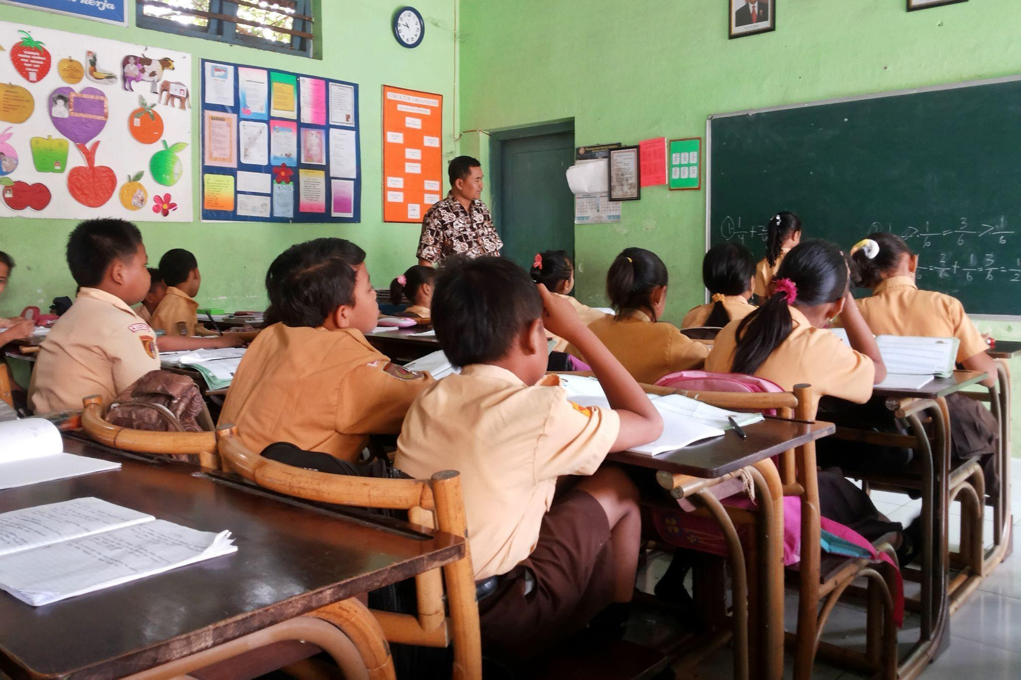

**J-PAL SOUTHEAST ASIA: REFLECTING ON 10 YEARS**

Since its establishment ten years ago, the Abdul Latif Jameel Poverty Action Lab Southeast Asia (J-PAL SEA) has become a leading voice in efforts to ensure that regional policies intended to reduce poverty are informed by rigorous scientific evidence, supported by core funding from the Department of Foreign Affairs and Trade (DFAT) Australia in 2013-2022.

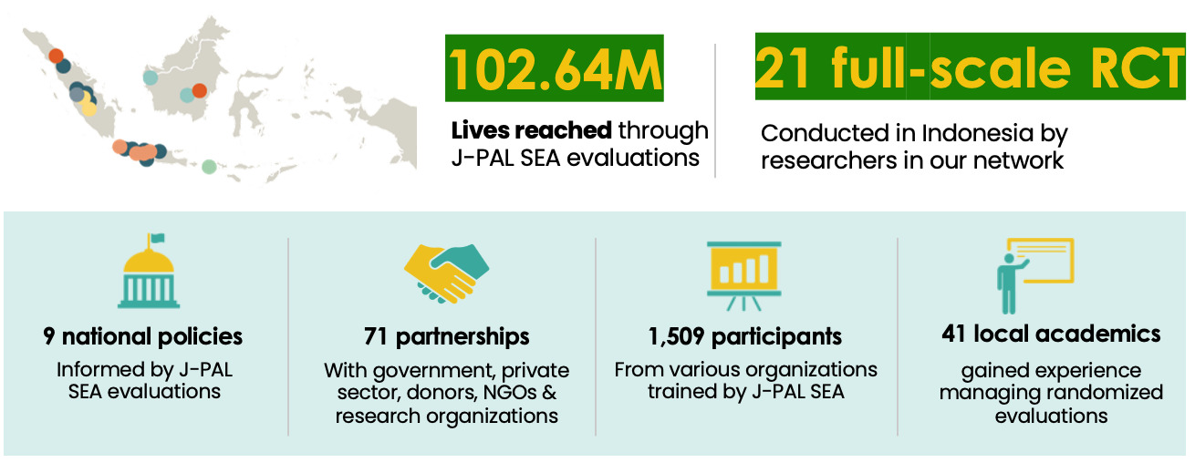

Figure 1. J-PAL SEA's Reach

J-PAL SEA was established in 2013 at the University of Indonesia’s Faculty of Economics and Business with the mission of creating a more productive and inclusive society via rigorous research, policy outreach, and capacity building. Concretely, J-PAL SEA conducts randomized evaluations to test and improve the effectiveness of development programs and policies, builds partnerships with policymakers to use the findings from this research in their decision-making, and trains policymakers and researchers to become better producers and consumers of impact evaluations. For example, researchers have provided evidence that informed the Government of Indonesia’s decisions surrounding social protection programs:

* In **2013**, the result of a [randomized evaluation](https://www.povertyactionlab.org/evaluation/improving-transparency-and-delivery-subsidized-rice-program-indonesia) on improving the delivery of Raskin, Indonesia’s food assistance program, informed the government’s decision to [scale up the delivery of Raskin ID cards](https://www.povertyactionlab.org/case-study/targeted-information-improve-social-assistance) to 15.5 million households.
* In **2018**, the [positive long-term impact](https://www.povertyactionlab.org/evaluation/medium-term-impact-conditional-cash-transfers-health-and-education-indonesia) of the national conditional cash transfer program (*Program Keluarga Harapan*, or PKH) informed government plans to increase the allocation of funding for the program to cover 10 million households.
* In **2020**, evidence of the effectiveness of transitioning to non-cash food assistance (*Bantuan Pangan Non-Tunai*, or BPNT) assisted the government to [continue the expansion of electronic vouchers](https://www.povertyactionlab.org/evaluation/impacts-kind-food-transfers-versus-electronic-vouchers-poverty-reduction-indonesia) to 20 million households.
* Also in **2020**, results from a [previous evaluation](https://www.povertyactionlab.org/evaluation/effectively-targeting-anti-poverty-programs-indonesia) informed the use of community targeting methods to distribute cash transfers during Covid-19, which provided relief to over [eight million recipients](https://www.povertyactionlab.org/case-study/community-based-targeting-combat-covid-19-induced-poverty) previously unenrolled in any social protection program.



**Education** | J-PAL SEA shared several recommendations on post-pandemic school reopening strategies, which was later adopted by The Indonesian Ministry of Education, Culture, Research, and Technology in their [operational guidelines](https://repositori.kemdikbud.go.id/22506/1/Panduan_Penyelenggaraan_Pembelajaran_di_Masa_Pandemi_1_Juni_2021.pdf) for teachers and schools.

An icon indicating finance related matters.


**Digital Financial Services** | J-PAL SEA’s [Inclusive Financial Innovation](https://www.povertyactionlab.org/initiative/inclusive-financial-innovation-initiative) Initiative (IFII) aims to generate evidence on what digital financial services work, why they work, and how they can be deployed to maximize impact. Since 2020, IFII has awarded eight research grants and published a white paper titled “[Toward Inclusive Digital Finance in Indonesia](https://www.povertyactionlab.org/sites/default/files/review-paper/ifii-whitepaper.pdf).”

An icon indicating gender related matters.


**Gender** | J-PAL SEA has helped evaluate efforts to [empower female migrant workers](https://www.povertyactionlab.org/evaluation/empowering-migrant-workers-access-quality-overseas-placement-services) in accessing quality overseas job placements, [understand the impact of transparency and accountability programs on maternal health](https://www.povertyactionlab.org/evaluation/can-transparency-and-accountability-programs-improve-health-experimental-evidence), and challenge [child-marriage perceptions among teenagers and parents in Indonesia](https://www.fkpindonesia.org/announcement/20230316).



**Health** | J-PAL SEA has helped investigate the long-term impacts of [distributing conditional community block grants](https://www.povertyactionlab.org/case-study/incentivized-community-grants-aid-effectiveness) on health outcomes, and evaluated efforts to [enrol informal sector workers](https://www.povertyactionlab.org/evaluation/achieving-universal-coverage-unenforceable-mandate-evidence-government-indonesias-jkn) in Indonesia’s National Health Insurance program.



**Transportation** | J-PAL SEA helped cultivate a culture of evidence in TransJakarta, the city’s Bus Rapid Transit (BRT) network, and the largest in the world. The team assisted TransJakarta in developing a data management system, supporting the company to move from anecdotal evidence to data-driven decisions when allocating bus routes.

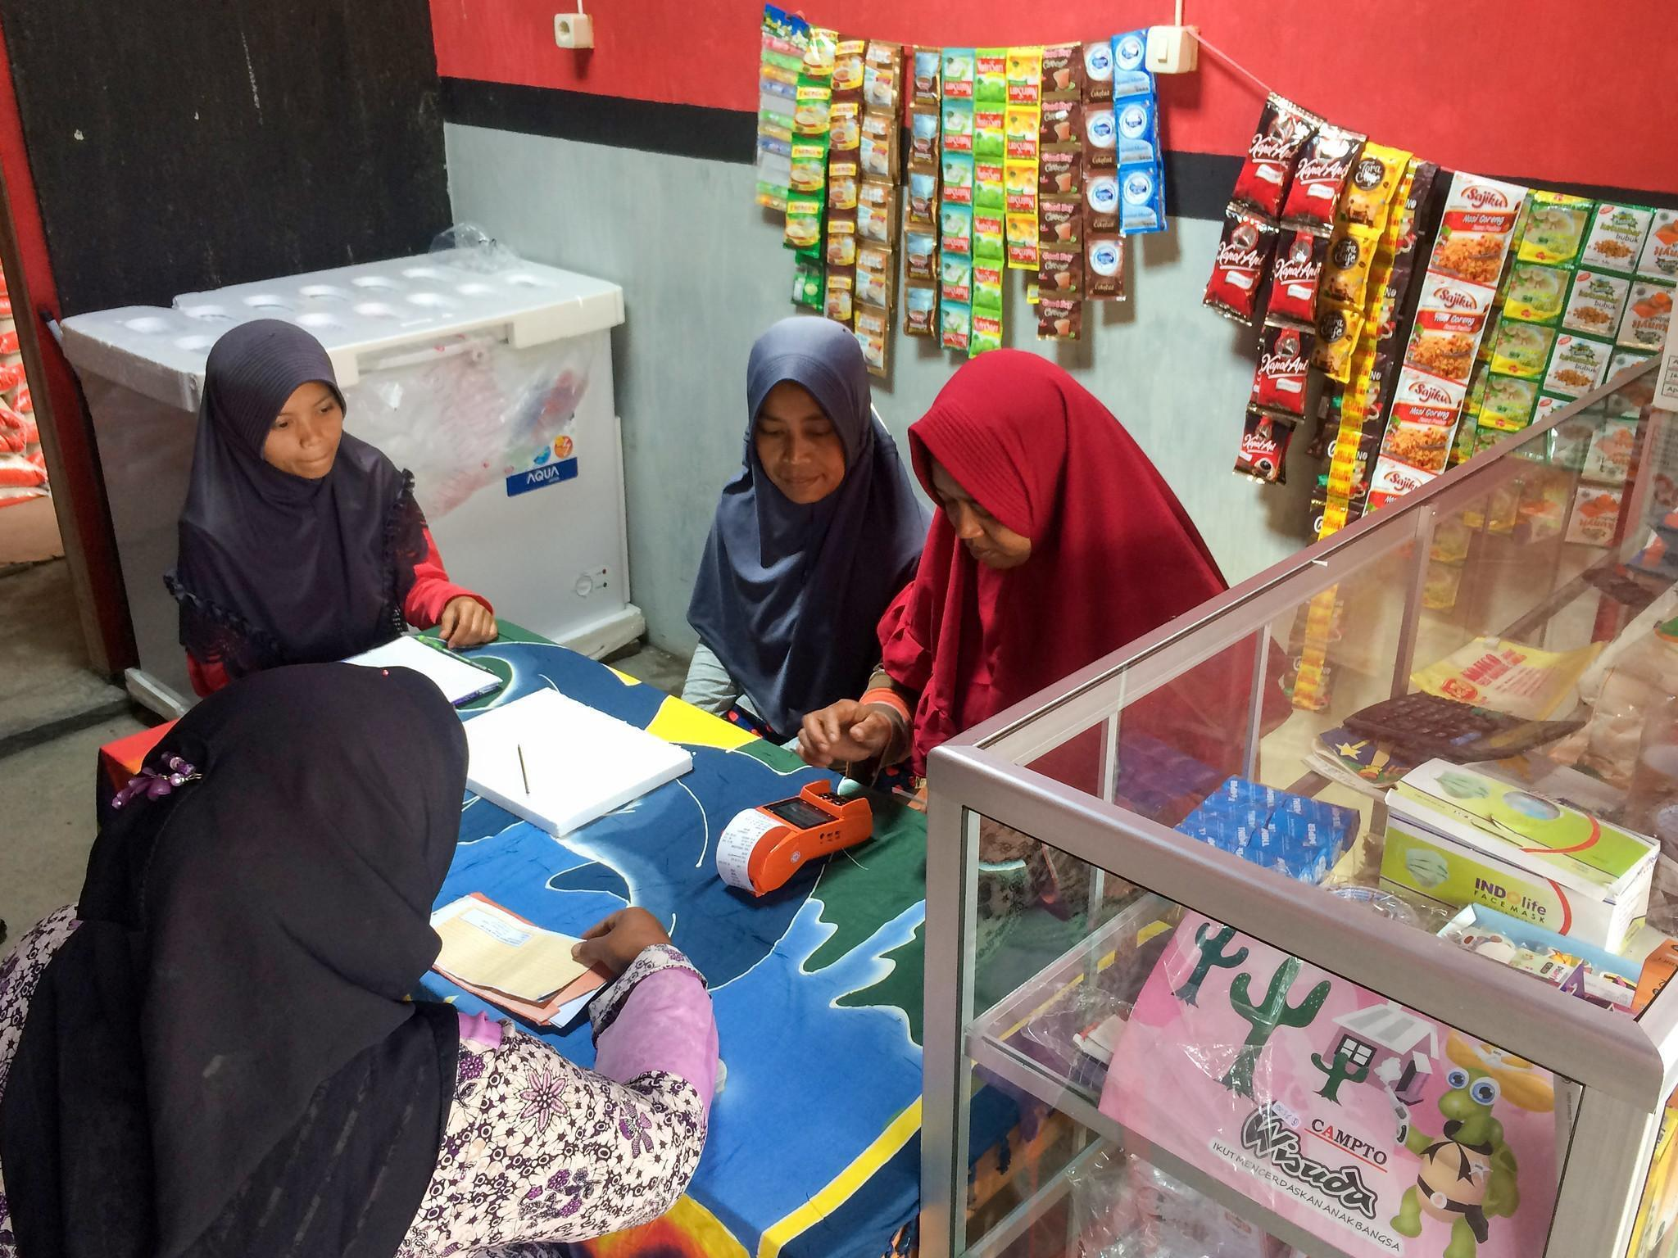

Figure 2. A corner shop owner and bank agent serve a government assistance recipient| Ivan Mahardika, J-PAL SEA

J-PAL SEA has also contributed greatly to expanding a culture of using and sharing evidence in Indonesia. Throughout the past decade, J-PAL SEA has reached and collaborated with many government and NGO partners in one-to-one meetings, evidence sharing presentations, in-person conferences, online webinars, and capacity-building workshops. To date, J-PAL SEA has:

**Sustained meaningful partnership with the Government of Indonesia.** The evaluations of Bantuan Pangan Non-Tunai and Kartu Prakerja were a result of long term engagements with the National Team for the Acceleration of Poverty Reduction (TNP2K), Ministry of Social Affairs (MoSA) and National Planning Agency (Bappenas). To date, J-PAL SEA has Collaborated with a total of 71 partners from government agencies, donors and non-governmental organizations in conducting evaluations.

**Organized training courses to increase partner awareness of the importance of impact evaluations for better decision making.** Training has helped J-PAL SEA deepen its relationships with partners. For example, since training Bappenas officials in 2020, J-PAL SEA has collaborated with Bappenas on four additional evaluations. Moreover, J-PAL SEA has also trained government and development partners in South Korea, Papua New Guinea, and Thailand to foster reciprocal learning across international contexts.

**Organized public discussions and evidence dissemination sessions on timely policy issues.** Amidst the peak of the Covid-19 outbreak, J-PAL SEA hosted a conversation with esteemed panelists Sri Mulyani (Minister of Finance, Government of Indonesia), Abhijit Banerjee (Director, J-PAL), and Chatib Basri (former Minister of Finance, Government of Indonesia), who shared their insights on how to navigate emerging challenges in the post-pandemic era. In 2021, J-PAL SEA hosted a talk with the Deputy of Gender Equality at the Ministry of Women’s Empowerment and Child Protection, Dra. Lenny N. Rosalin, and J-PAL affiliated researcher Seema Jayachandran to discuss the importance of addressing gender norms in improving gender equality in Indonesia.

Figure 3. A picture of Indonesian Regional Science Association (IRSA) training in Aceh. Photo courtesy of Lisnawati, J-PAL SEA.


Figure 3. A corner shop owner and bank agent serve a government assistance recipient| Ivan Mahardika, J-PAL SEA

Figure 4. Nurturing The Next Generation of Indonesian Development Economists. Since the establishment of J-PAL Southeast Asia (SEA) in 2013, we have focused on building a cadre of local researchers and policy practitioners in development economics and strengthening the use of rigorous evidence in policymaking. Over the years, J-PAL SEA helped grow the network of local Indonesian researchers (professors, post-doctoral scholars, and PhD students) experienced in conducting randomized evaluations. To date, 39 Indonesian academics and practitioners have gained experience managing randomized evaluations in collaboration with J-PAL SEA. Moreover, to increase the pipeline of young researchers, J-PAL SEA provides mentorship and guidance to staff as they apply to graduate schools. To date, 11 of our alumni have pursued graduate degrees.


Figure 4. Nurturing The Next Generation of Indonesian Development Economists

Figure 5. A picture of a farmer harvesting coffee beans in Kawah Ijen, East Java. Courtesy of Nok Lek, Shutterstock 


Figure 5. A farmer harvesting coffee beans in Kawah Ijen, East Java| Nok Lek, Shutterstock

**LOOKING AHEAD**

Over the next year, J-PAL SEA is exploring opportunities to fill evidence gaps in climate-, education- and gender-related policies in Indonesia. Fresh from its first environment-focused research-to-policy conference in October 2022, J-PAL SEA is focusing to develop a portfolio of studies on waste management and firm practices, energy efficiency, and forest and marine ecosystem management. In the gender sector, female labor force participation is a priority theme, and in the education sector, J-PAL SEA will be focusing on pedagogy, teacher training and the role of technology in promoting an effective educational environment.

J-PAL SEA is continuing to promote evidence use and generation on digital financial inclusion through the Inclusive Financial Innovation Initiative, as well as on improving the productivity of micro, small, and medium enterprises (MSMEs). Through its postdoctoral fellowship program, training for emerging scholars, and learning collaborative events, J-PAL SEA strengthening collaboration with researchers across Indonesia.

J-PAL SEA’s work from the past ten years extends well beyond the highlights mentioned above, and we encourage you to learn more by visiting [**Our Website**](http://povertyactionlab.org/southeast-asia) or [**contacting the J-PAL SEA Policy Team**](http://SEA_Policy_Managers@povertyactionlab.org) for more information.