Kiribati country case study

AusAID Pacific social protection series: poverty, vulnerability and social protection in the Pacific

March 2012

© Commonwealth of Australia 2012

Published by the Australian Agency for International Development (AusAID), Canberra, March 2012.

This document is online at www.ausaid.gov.au/publications

The principal authors of this report are Stephen Kidd and Ueantabo Mackenzie.

**Disclaimer:** The views expressed in this publication are those of the authors and not necessarily those of AusAID.

For further information, contact:

AusAID GPO Box 887 Canberra ACT 2601

Phone (02) 6206 4000   
Facsimile (02) 6206 4880   
Internet www.ausaid.gov.au

1. Introduction to the research

Pacific Island countries have varying social protection systems, informal and traditional. These systems are important in supporting the most vulnerable members of society and those affected by personal and natural disasters. In the Pacific Islands social protection has typically been an area of low government involvement. Knowledge about formal social protection in the region is limited, and there have been no studies on the impact of such schemes on poverty, human development and economic growth.

There is no one agreed definition of social protection, but this body of research—commissioned by AusAID—uses the term to refer to the set of public actions aimed at tackling poverty, vulnerability and social exclusion, as well as providing people with the means to cope with major risks they may face throughout their life.

Social protection’s core instruments include regular and predictable cash or in-kind transfers to individuals and households. More broadly, social protection includes instruments that improve people’s access to education, health care, water, sanitation, and other vital services.

Traditional social protection in the Pacific Islands is stretched by new challenges, most recently the 2008–09 global food, fuel and financial crisis. This has led to greater attention to innovative social protection mechanisms that tackle chronic poverty, mitigate the impact of shocks, improve food security and overcome financial constraints to accessing social services. This attention has been driven by the success of mechanisms in other parts of the world.

In an environment with limited or conflicting information about patterns of poverty and vulnerability, knowing whether social protection represents a sound, or even appropriate, policy choice is difficult. This research looks at poverty, vulnerability and social protection across the dimensions of health and education, gender, social cohesion, economic growth, and traditional protection networks in the Pacific Islands. It aims to improve the evidence base on formal and informal social protection programs and activities in the Pacific region and make recommendations on support for strengthening and expanding social protection coverage so it can contribute to achieving development outcomes.

The research was conducted by social protection experts and is based on case studies in Kiribati, Samoa, Solomon Islands and Vanuatu—representing the three sub-regions of Melanesia, Micronesia and Polynesia—and a review of secondary literature. It also commissioned a set of research papers:

> an overview of poverty and vulnerability in the Pacific, and the potential role of social protection

> a briefing on the role of social protection in achieving health and education outcomes

> a life-cycle approach to social protection and gender

> an assessment of the role of social protection in promoting social cohesion and nation-building in the Pacific

> an assessment of the relationship between social protection and economic growth

> a review of the strengths and weaknesses of informal social protection in the Pacific

> a micro-simulation analysis of social protection interventions in Kiribati, Samoa, Solomon Islands and Vanuatu.

2. About this research paper

This research paper, ‘Kiribati country case study’, examines the adequacy of social protection in Kiribati—formal and informal, and core and crosscutting. It begins by describing the nature of the livelihoods in-country and then examines the stresses and challenges facing Kiribati’s economy and society. The research paper then assesses the country’s poverty and vulnerability and describes its current social protection.

Throughout the research paper, reference is made to alternative forms of formal social protection that could be put in place. These are not policy recommendations, but rather ideas to stimulate debate on social protection direction in Kiribati.[1]

The research involved the following activities:

> a comprehensive review of relevant literature, databases and Internet resources in the Pacific region and in Kiribati

> an analysis of 2006 national household survey data for Kiribati, undertaken by David Abbott and Michael Samson of the research team

> consultations in-country with stakeholders, including with government, civil society organisations, academics, donors and international organisations, private sector and a sample of households in urban and rural areas

> consultations by email and phone with relevant international stakeholders.

In this research paper, formal social protection is understood to comprise two complementary dimensions, one narrow and one broad:

> In a narrow sense, core social protection is a country’s system of regular and predictable cash transfers (although, in some contexts, in-kind transfers—such as food—can be included). These transfers can be financed by government, through contributions or by employers and could be legislated. Core social protection is often referred to as the social security system.

> In a more broad sense, social protection can be understood as cutting across other basic services, such as health and education, enabling people to overcome the financial barriers they face when accessing these services.

Since Independence in 1979, the Republic of Kiribati’s economy has depended on migration, remittances, fishing fees, aid and bureaucracy. Over the past decade the economy has stagnated, with per capita gross domestic product (GDP) falling. The 2008–09 global recession intensified pressures, resulting in significant falls in remittances and the value of the stabilisation fund. This increased pressure on government finances, with the national budget falling by around 10 per cent between 2008 and 2010.

Kiribati is in a relatively weak position to respond to its economic challenges. It is significantly disadvantaged by distance from global markets and the dispersion of its many islands. Its workforce is generally low skilled. Schools are not delivering education of adequate quality, with only around one third of children finishing secondary school. The low skills of many young people mean that, despite a youth bulge, Kiribati cannot take full advantage of this segment of the population to generate economic growth. The population is also gradually ageing. The private sector is poorly developed and there is significant dependence on public sector employment, characterised by low wages and productivity.

Livelihoods vary significantly between South Tarawa and the Outer Islands. On the Outer Islands, households with sufficient labour capacity engage in subsistence agriculture and fishing. There are few employment opportunities and an increasing number of households struggle due to limited labour capacity. The main exception is in the eastern Line Islands, which has more land and significant in-migration. Forty-four per cent of the population live on urban South Tarawa, now effectively full. Subsistence activities are not viable, unemployment is high and wages generally low. Sanitary conditions are not good, especially in squatter housing.

One lucrative livelihood for male I-Kiribati is to work as seamen, although only a minority of the 4000 trained have jobs. Salaries are reasonably good. Employment on foreign ships was hit badly during the global recession.

Poverty is a reality on Kiribati and it is no longer a rural idyll. People need cash to buy food, clothes and durables, pay for education and some health costs, and finance churches that do not give back in a material sense. The 2006 national household survey calculated a poverty rate of 22 per cent, although this may have risen to 24 per cent by 2010. But people move in and out of poverty, so a more realistic measure of the number of poor people—those who spend some time in poverty over some years—would be the proportion of those living under double the basic needs poverty line. This indicates that 57 per cent of the population should be considered poor and seems consistent with a 2010 United Nations Children’s Fund (UNICEF) survey which reported more than half of households not having enough to eat.

Specific population categories experience greater vulnerabilities, including:

> *Women*—experience high levels of gender-based violence, and it is difficult for them to leave abusive husbands due to limited economic opportunities. Female single-headed households are over-represented among the poor.

> *Children*—poverty is an increasing concern for children. Infant mortality rates are rising, there appears to be higher levels of poverty among children living with older people, and early childhood malnutrition seems to be prevalent (almost certainly due to poverty as well as poor feeding practices).

> *Young people*—experience high levels of unemployment and many depend on subsistence activities that do not reflect their aspirations. Initiatives to enable young people to gain employment are limited. A number of young girls have moved into well-paid sex work among foreign seamen.

> *People with disability*—comprise around four per cent of the population, are likely to be living in poorer households and receive limited support from government. Signs are that, once their parents are no longer around, support from other family members may be limited.

> *Older people*—over-represented among the poor and increasingly appear to be responsible for caring for the children of migrants.

I-Kiribati adhere to traditional egalitarian values and norms of supporting family, although systems are under stress. Informal care structures are weakening, increasing poverty. Indeed, traditional social protection provision is uneven; people living in better-off extended families—in particular those receiving remittances—are more likely to get support. For others, receiving adequate support is limited. In fact, only around 17 per cent of the population is likely to benefit from remittances.

Government has some formal social protection programs. A key one is the Elderly Fund that costs around 0.93 per cent of GDP. In 2010 the fund was estimated to reduce the poverty gap in beneficiary households by 19 per cent and the national poverty gap by 5 per cent. Another key one is the Copra Fund Subsidy, which guarantees a minimum price to producers. This costs 2.8 per cent of GDP but its benefits are unevenly distributed and it is less accessible to households with restricted labour capacity.

Taking a broader perspective on social protection the Kiribati Government provides free primary and lower secondary education. Gross enrolment has been 100 per cent at primary school but is falling in part due to increasing poverty. Secondary school students have to pay fees. Church schools do not provide financial support to poor students, with the exception of some limited help. High fees and the need to pass an exam to enter senior secondary school significantly reduces school enrolment.

Access to health services is generally free although some health fees were introduced in 2006.

This research paper identifies opportunities for further study that could fill gaps in knowledge and add to the evidence base on social protection in the Pacific.

**Figure 1. Map of Kiribati**



Courtesy of the University of Texas Libraries, The University of Texas at Austin.

3. About Kiribati

Kiribati is in central Pacific, comprising 21 inhabited low-lying islands, no more than three metres above sea level. Its landmass is 726 square kilometres, yet the country extends 5000 kilometres from east to west and 2000 kilometres from north to south. Around 100 000 people live in Kiribati, most in the west in the Gilbert Islands—with almost 44 in the urban centre of South Tarawa. Small populations are growing on the Line Islands to the east. The Phoenix Islands are almost uninhabited.

Since Independence in 1979, Kiribati’s economy has moved towards a migration, remittances, aid and bureaucracy structure (Thomas & Tonganibeia 2006:42). External revenue sources are the economy’s bedrock with gross national income, including earnings from overseas, around 85 per cent higher than GDP of $164 million.[2] Most external earnings come from fishing fees, profits from the stabilisation Revenue Equalisation Reserve Fund and remittances from seamen and others. Overall, external earnings provide around 40 to 45 per cent of national monetary income (Asian Development Bank [ADB] 2009:17, 22).

The Kiribati economy has suffered a downturn since 2000, with per capita GDP—as expressed in constant prices—falling from $795 to around $745 in 2010. Early on, this downturn was caused by increases in the cost of fuel, fluctuations in copra prices and volatility in fishing-license income (Ministry of Finance and Economic Planning [MoFEP] 2007:5). The 2008–09 global recession exacerbated problems, with GDP contracting by 0.7 per cent in 2009. Nonetheless, GDP is expected to rise by 3 per cent in 2011 and 2012, as a result of an increased demand for seafarers and improved returns from offshore investments (ADB 2011:234).

Kiribati’s long tradition of providing informal social protection has evolved during the colonial period. Before Kiribati was colonised the basic unit of economic organisation was the *kainga*, a residential group of a small number of extended families (International Labour Organization [ILO] 2006). However, *kainga* broke down when Christianity and colonial rule were introduced, as people relocated from dispersed traditional lands to centralised villages. The immediate family (usually the household) became the most important economic unit. New institutions, in particular churches, began to replace the role wider kinship groups had had in giving people a sense of belonging.

Kiribati society has strong egalitarian values (ADB 2009:89). Traditionally, affluence was discouraged and equality maintained through ostracism, shaming and sharing surplus wealth (Kuruppu 2009:806). While much sharing was voluntary, the *bubuti* system was key in maintaining equality, implicitly providing those in need with informal social protection. Those with a surplus were required to share it with extended family members in need. These members could make a ‘non-refusable request’ to another extended family member who had to comply. Non-compliant people were said to lack love and compassion and they were shamed and ostracised. *Bubuti* is prevalent today.

Older people, children and people with disability were traditionally cared for in the household and by extended family. Older people have always been respected and male elders remain the main decision makers in many rural communities. It is also common for children to be cared for by relatives other than parents.

Households are to be *toamau*—balanced in age and gender so there is a good division of labour and everyday needs are met. Each household needs enough members to carry out essential tasks such as fishing, cutting copra and toddy, cooking, making crafts and gardening. Traditionally, if a household was missing someone, the extended family would be asked for help.

While similar traditional social protection systems continue to be prevalent in all developing countries, increasing poverty, urbanisation, migration and cultural change are placing these systems under stress. At this point in Kiribati’s development, the state needs to establish more formal social protection mechanisms to support the most vulnerable.

4. Livelihoods in Kiribati

There is a significant difference in the livelihoods between those living on the Outer Islands and in urban South Tarawa. On the Outer Islands, most households subsist and obtain cash through fishing, agriculture, cutting copra, making and selling crafts and other produce, such as toddy and bread, and casual employment. Agricultural production was best in the Line Islands due to greater availability of land and growing numbers of settlers in recent years (Thomas & Tonganibeia 2006:41). Many Outer Islands were well-endowed with marine resources with estimated annual per capita fish consumption among the highest in the world (Gillett & Lightfoot (2001:58). Relatively few employment opportunities are available on the Outer Islands, including in the public sector.

In South Tarawa subsistence agriculture is limited due to urban environment and high population density. Fishing resources have been severely depleted (Kuruppu 2009:804) and traditional landowners can no longer benefit from their land, as they no longer have access to it (ADB 2007:10f). These landowners received rent—often from government—but as little as $20 a year. A 2010 UNICEF study identified these landowners as the most vulnerable people in South Tarawa. The main livelihood options in South Tarawa are in employment, but relatively few jobs are available. Out of the 40 000 workforce only 30 per cent had jobs according to the ADB (2009:72)—7000 in public administration, 1800 in publicly owned enterprises and around 3000 in the private sector.

A large proportion of the population can be considered unemployed (unable to engage in paid labour or gain adequate cash income from self-employment). However, estimates of unemployment varied due to whether the 58 per cent of the working-age population involved in subsistence activities should be considered unemployed (Secretariat of the Pacific Community [SPC] 2007:55). For example, Tatoa and Rouatu (2006 in ADB 2009:70) have argued that unemployment should cover all subsistence workers who would prefer wage labour if it were available and they therefore rated unemployment at 64 per cent. In contrast, MoFEP (2007:9) used the ILO definition of the number looking for work and calculated unemployment at 35 per cent.

Despite variance in estimates, a high number of people in Kiribati are unemployed and there is no support program for them.

Lack of jobs means employment as seamen and migration are important livelihood strategies. Many families depend on remittances, which Abbott and Pollard suggested was around 12 per cent of GDP (2004:61). Kiribati has around 4000 trained seamen although only a minority have jobs. The two main employers of seamen are the South Pacific Marine Service (SPMS), a German consortium of shipping agencies, and the Kiribati Fishing Services (KFS), which provides seamen for Japanese fishing fleets. A number of I-Kiribati are employed by other companies and work on American, Indonesian, Norwegian and South Korean ships. Figure 1 indicates that between 2000 and 2005 an average of 1041 seamen were employed through SPMS and 316 through KFS. By early 2010 these numbers had fallen.

**Figure 2: Average employment on SPMS and KFS ships, 2000–10[3]**

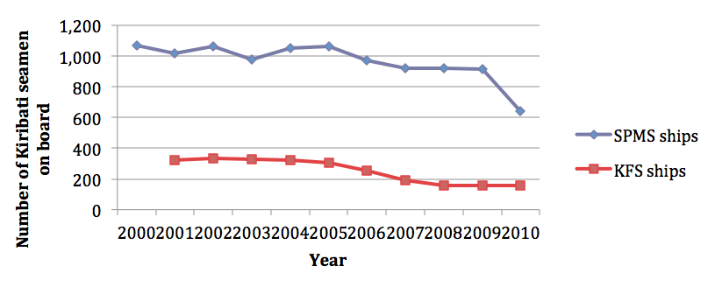

Source: SPMS and KFS records (2011)

Seamen are among the highest earners in Kiribati, with wages up to US$3363 a month. Figure 2 indicates total remittance income between 2005 and 2009 when an average of $8.24 million was remitted, equivalent to around 5.4 per cent of GDP. The drop in the number of sailors in 2009 reduced this amount.

**Figure 3: Total income from remittances from SPMS and KFS seamen, 2005–09**

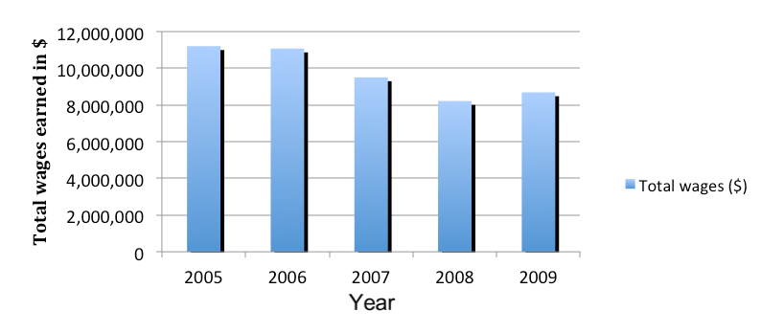

Source: SPMS and KFS records (2011)

The Kiribati Ministry of Labour continues to search for job opportunities for seamen and there have been attempts to give women jobs on ships. In 2007–08, a small number of young women were employed on SPMS ships but this did not go well. Most became pregnant, one committed suicide, their presence provoked fights among I-Kiribati seamen, and ship owners complained about their work standards. As a result, the program was terminated.

Other small-scale overseas work opportunities are available—as temporary or permanent migrants, especially in Australia and New Zealand. A small number obtained jobs—57 in 2010—through New Zealand’s Recognised Seasonal Employer program (McLellan 2008). The Ministry of Labour organises the scheme aiming to distribute jobs fairly between islands and include the less educated. However, the demand for the program far exceeded the number of jobs available, with 1000 I-Kiribati applying when the program first began (ADB 2009:76).

5. Stresses on the Kiribati economy and society

The unique challenges faced by the economy and wider society help explain Kiribati’s poverty and vulnerability. These include the country’s remoteness and dispersion of its islands, its vulnerability to international economic fluctuations, over-stretched public finances, the dominance of an inefficient public sector, limited opportunities for private sector expansion, demographic challenges, increasing demands among the population for cash, low skill levels and vulnerability to natural shocks.

**5.1. Remoteness and geographic dispersion**

Kiribati’s distance from world markets is a significant challenge, resulting in more costly imports and exports that impact on its international competitiveness. This also limits opportunities to exploit tourism. The distance between islands also creates challenges. Transport could be unreliable making it is difficult for islands to export produce and often delaying import arrivals (Thomas & Tonganibeia 2006:39, 42). Shops were often depleted of consumer goods. Cash could be in limited supply on islands, a major constraint to developing private enterprise (Thomas & Tonganibeia 2006:49). Banking services were poorly developed and payment for copra often delayed.

**5.2. Vulnerability to international economic fluctuations**

As a small country with a weak economy Kiribati is at risk to international economic fluctuations. Its use of the Australian dollar means it is vulnerable to fluctuations in exchange rates. Rising international prices impact on the local economy; for example, in 2008, higher food prices increased inflation to around 19 per cent (International Monetary Fund [IMF] 2009). The Revenue Equalisation Reserve Fund was badly hit by the global recession, dropping in value from $637 million in 2007 to $389 in 2008—with no recovery in 2009—significantly reducing government income (IMF 2009). Fishing licences, which brought in $31 million in 2009, have been unreliable, although they have risen since 2007 (IMF 2009). Remittances dropped significantly during the global recession, as ships were withdrawn from service.

**5.3. Over-stretched public finances**

The weakness of Kiribati’s economy, exacerbated by the global recession, has increasingly strained government finances. Kiribati has been running an unsustainable budget deficit, with spending exceeding revenue by between 10 and 30 per cent a year from 2004 to 2010 (ADB 2009:11). This had two significant implications. First, were large and potentially unsustainable drawdowns of the Revenue Equalisation Reserve Fund—more than $50 million in 2008 and 2009, for example, threatening Kiribati’s long-term financial security (ADB 2010:250). Second, government had to reduce its spending—from $98.7 million in 2008 to $87.5 million in 2010—which has had a knock-on effect on public service delivery and economic growth (Government of Kiribati [GoK] 2009).

**5.4. Demographic challenges**

Kiribati’s population has more than tripled in the past 80 years. Population growth remains high at 1.8 per cent a year and the population is likely to increase by 30 per cent by 2025 (SPC 2007:73). As the World Bank (cited in MoFEP 2007:4) has noted, rate of population growth has a significant influence on future wellbeing and if not arrested will increase demands on housing, land, energy, water, educational services, health services and employment opportunities (cf. SPC 2007:80). High fertility is a key cause of rapid population growth, although it declined from 4.5 children per woman in 1995 to 3.5 in 2005, probably due to higher contraceptive use in 2002–04. This resulted in a young population with 37 per cent below 15 years of age (SPC 2007:75).

Fertility should continue to fall although the introduction of the universal old age pension—known as the Elderly Fund (Section 5.3.1)—may impact on this.[4]

As fertility rates fall there is a gradual ageing of the population. The population over 60 years of age is expected to grow to 8 per cent in 2025 and 18 per cent by 2050 (Hayes 2009). A fall in the proportion of children will reduce dependency ratios by 2025, from 74 to 64 per 100 people of working age (SPC 2007:83).

Another demographic challenge is internal migration patterns. Inward migration to South Tarawa has contributed to poor housing and sanitary conditions. In recent years—and probably because South Tarawa is essentially ‘full’—the migration pattern has changed. The annual increase declined to 1.9 per cent between 2000 and 2005. During this period the highest population growths—and, therefore, most in-migration—were on the Line Islands, including 8 per cent on Kiritimati.[5]

Outward migration has increased population ageing in most of the Gilbert Islands. In 2005 the proportion of those over 60 years of age on the Line Islands and Tarawa was 4.7 per cent, while in some Outer Islands it was between 8 and 11 per cent.[6] As Kiribati continues to age, some islands could have up to 17 per cent of the population as elderly by 2025.

**5.5. Increasing needs and demands for cash**

Kiribati is increasingly monetised, with people needing cash for needs. Diets have changed and Kuruppu (2009:804) indicated that people were spending around 30 per cent of income on imported food. Two other significant areas of expenditure are education and the church.

The church is a major source of financial stress for families. Average offerings, for example, are up to 28 per cent on the Outer Island and possibly significantly more for poor households (ADB 2009:90). A 2005 government report stated that demands from churches to pay fees could be almost $300 a year. Indeed the ADB (2007:13) reported that two communities found the need to contribute money to the church a source of financial difficulty. Kuruppu (2009:806) has argued that: ‘to maintain their power-base, the church has gradually exploited “collectivism” to serve its own interests rather than the needs of its followers.’ They ostracise and shame people into sharing their wealth with them.[7]

Church income is not used to help those in need, but instead to build and maintain elaborate buildings and cover staff and other costs. The government increased its contribution to churches to reduce demands placed on members, but to no avail (ADB 2009:90).

**5.6. Low skill levels**

Kiribati’s economic prospects are hampered by low skill levels. The ADB (2009:57, 67) has argued that inadequate English skills prevent I-Kiribati from obtaining jobs overseas and recent results in schools indicate that 70 per cent of students are at risk of illiteracy. I-Kiribati are at a major disadvantage compared to other Pacific Islanders: only 12 to 14 per cent of Kiribati students who sat the University of South Pacific’s English Language Skills Assessment test passed with a Band 3, compared to the average across the Pacific of 52 to 54 per cent (Ministry of Education [MoE] 2008b).

A number of reasons explain low skill levels. Many children leave school early, particularly during the transition to senior secondary school. Teaching quality has been inadequate (cf. GoK 2005) with, for example, only 35 per cent of senior secondary school teachers having the minimum training required (MoE 2008b). Although the secondary school curriculum is in English, teachers tend to teach in the Kiribati language. The teaching environment and school infrastructure quality are also issues, with many buildings in need of repair.

After school training is available in different centres, although places are limited. Two centres provide training for seamen: The Maritime Training Centre (which provides six months of intensive English language training) and the Fisheries Training Centre. The Kiribati Institute of Technology offers vocational training, although—as the ADB (2009:74) noted—not on skills demanded by employers or the wider region. The University of the South Pacific offers a one-year foundation course so students can continue studying in the university’s main campuses in Fiji and Vanuatu.

**5.7. Vulnerability to natural shocks**

The Commonwealth Vulnerability Index, which examines vulnerability of developing countries to economic and natural shocks, ranked Kiribati as one of the five most vulnerable countries in the world (Atkins & Easter 2000:3ff). The low-lying nature of its atolls means that, if no adaptation measures are undertaken, much of the country could be submerged. Yet, as the ADB (2009:47) has argued, Kiribati is no better protected than it was 10 years ago.

Main natural shocks include high tides, storm surges and long droughts. The World Bank reported in 2006 that Kiribati had the highest rainfall volatility index in the Pacific. Shanty dwellers who live near the sea in South Tarawa are most vulnerable to flooding. There are no formal systems to provide assistance to those who suffer from flooding.

6. Poverty, inequality and vulnerability in Kiribati

Across the Pacific, there are significant debates on the depth and nature of poverty. Much regional literature is reluctance to accept that poverty exists, with many authors arguing the term ‘hardship’ is better. This is essentially a semantics debate. In consultations undertaken by the ADB (2007:4) in Kiribati, poverty was defined as ‘having nothing’ or being without food, land, money or other resources. Usually, this would be better translated as destitution. Hardship was translated as ‘having difficulties providing for the family’s needs’. This seems to reasonably describe poverty as it is conventionally understood internationally, in particular in developed and middle-income countries.[8] This research paper uses ‘poverty’ to align with conventional international practice.

This section examines levels of inequality in Kiribati and then provides an overview of poverty in-country. It concludes by identifying population categories that are particularly vulnerable.

**6.1. Inequity in Kiribati**

Although I-Kiribati have strong egalitarian values, the ADB (2009:95) has described rising inequalities in income and opportunity as one of the country’s most serious risks. In 2006 the Gini coefficient, a measure of statistical disbursement, was 0.39, representing a relatively high level of inequality (Abbott 2010:34). The richest decile of households is 10 times better off than the poorest. Levels of inequality varied within regions (Figure 4). The lower Gini coefficient in South Tarawa may reflect the prevalence of low wages while the higher figure in the rest of the Gilberts may result from differences between islands.

**Figure 4: Gini coefficients within regions of Kiribati**

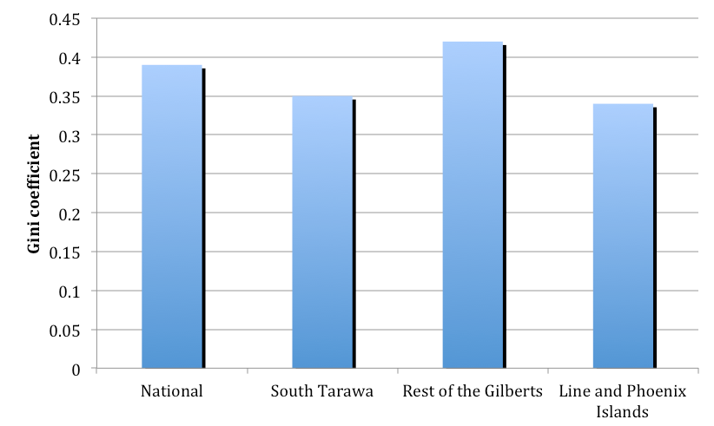

Source: Analysis of 2006 household survey data undertaken by this research

High inequality is widely recognised as damaging to a country’s wellbeing, reducing economic growth and limiting the impact of growth on poverty.[9] It can also give rise to increasing social unrest. Although the government has recognised growing inequality, its strategy to narrow the gap between rich and poor has focused on private sector development and improved service delivery (ADB 2009:95). Yet, most countries that have successfully tackled high inequality have invested significantly in core social protection and other public services.

**6.2. Overview of poverty in Kiribati**

The 2006 national household survey estimated a national poverty rate of 22 per cent against a basic needs poverty line, although this may have risen to 24 per cent by 2010. Five per cent of households were in extreme poverty, unable to reach the food poverty line (Abbott 2010:31ff). However, poverty rates calculated from household surveys provide a static picture of poverty. In reality, people move in and out of poverty when their circumstances change or when they are affected by shocks—such as illness, unemployment or death of a breadwinner. This means the number of people in poverty over time is dynamic. The dynamic nature of poverty has not been measured in Kiribati, as it would mean returning to households regularly to measure expenditure.

One means of estimating the number who spend time in poverty or who are vulnerable to falling into poverty is to use a higher poverty line. World Bank studies in Pakistan indicated that doubling the basic needs poverty line may be appropriate for capturing those vulnerable to poverty (Kidd et al. 2010), while a 2011 World Bank study in Indonesia suggested using a 50 per cent increase in the poverty line. Figure 5 presents the results in Kiribati from applying alternative poverty lines, indicating that between 47 per cent and 66 per cent of the population could be regarded as poor or vulnerable to falling into poverty in 2006. Even a small increase of 20 per cent in the basic needs poverty line gives a poverty rate of 34 per cent, indicating how close many people are to the line. The 2006 national household survey results are corroborated by a 2010 UNICEF survey which found that more than half of households reported not having enough money for food. A United Nations (2009) survey indicated that 86 per cent of people were in a seriously more difficult financial situation in 2009 compared to 2008.

**Figure 5: Percentage of the population that could be regarded as poor and vulnerable to poverty, using different basic needs poverty lines**

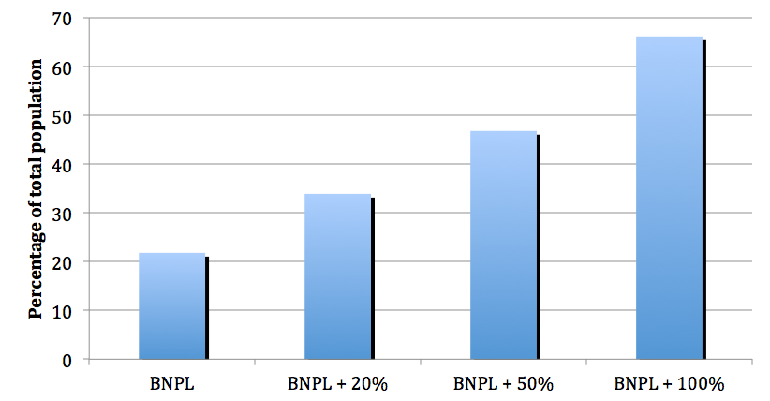

Source: Analysis of 2006 household survey data undertaken by this research

Poverty in Kiribati has an urban face. The poverty rate in South Tarawa (2006) was higher than the national average, at 24 per cent (Figure 6). This resonates with the consultations undertaken by the ADB (2007:5) which indicated that people believed poverty to be worse on South Tarawa because of the greater need for cash. Indeed, for some time it has not been unusual for South Tarawa residents to be short of food and cash, with a 2001 survey indicating that 52 per cent of South Tarawa’s urban households regularly did not have enough cash to meet daily basic needs (MoFEP 2007:10).

**Figure 6: Poverty rates across Kiribati, using the basic needs poverty line**

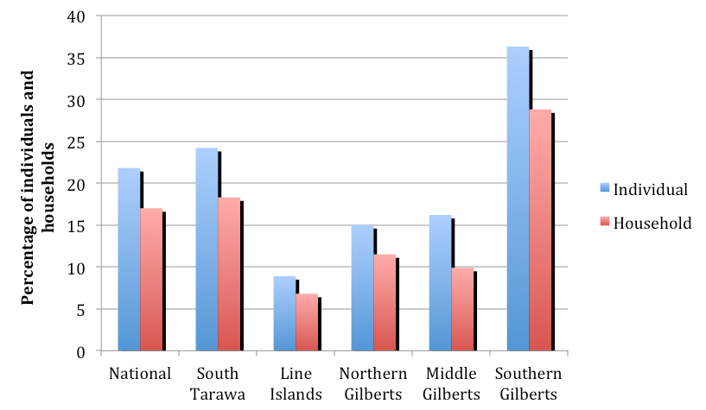

Source: Analysis of 2006 household survey data undertaken by this research

The exception to the urban poverty trend is the Southern Gilberts group of islands with a basic needs poverty rate of 36 per cent. In fact, 16 per cent of the population in these islands were below the food poverty line. The Southern Gilberts are among the most remote islands and, generally, among the smallest. They have limited resources for their own production, are vulnerable to drought and experience periodic problems with shipping and supplies. These islands have the highest proportion of older people and therefore a lower proportion of working age adults and a higher dependency ratio. In contrast, the Line Islands face the least poverty, reflecting a younger migrant population and greater natural resources.

There is a link between household poverty and the amount of food a household produces (Figure 7). Of particular note is the minimal level of subsistence production on the rural Gilbert Islands among the three poorest deciles, where they even produce less than similar households in South Tarawa. This may be because those living in South Tarawa have less access to land. The ADB (2009:9) recognised that those unable to access land on the Outer Islands could experience extreme poverty or may have low labour capacity.

**Figure 7: Weekly household production of own food consumed (per capita adult equivalent a week)[10]**

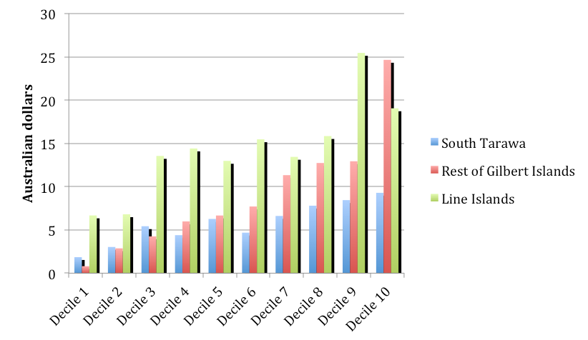

Source: Analysis of 2006 household survey data undertaken by this research

The 2006 national household survey provided information on the main activity of the head of each household. As Figure 8 illustrates, those in the poorest quintile had less access to employment (including self-employment), while a higher proportion was engaged in domestic activities (indicating a female-headed household). The better off the household, the more the head was engaged in employment or in their own business.

**Figure 8: Activity status of heads of households in each decile**

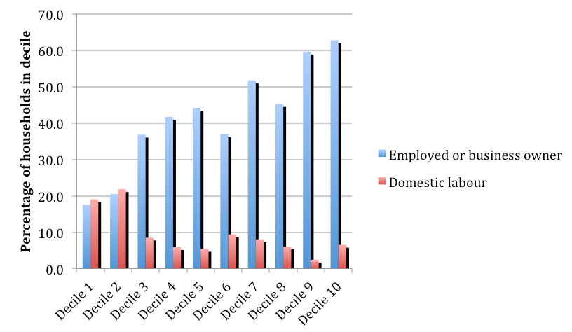

Source: Analysis of 2006 household survey data undertaken by this research

Many poor families buy food with relatively poor nutritional qualities to minimise spending. They are more likely to buy on credit and a 2010 UNICEF study found that 47 per cent of Kiribati households interviewed were in debt. Having a job was no guarantee of escaping poverty, in particular in South Tarawa (Abbott 2010:37). A quarter of households in the poorest three deciles were headed by someone who was employed, but these were usually larger households with many children or older people.

One possible indicator of extreme poverty in South Tarawa is the number of people scavenging for recyclable material. The owner of the local recycling plant estimated that between 50 and 100 families recycle as their only source of income.

**6.3. Vulnerable categories of the population**

Specific categories of Kiribati’s population experience higher rates of poverty or other vulnerability. These include a significant proportion of women (affected by gender relations), vulnerable children, unemployed young people, people with disability and older people.[11]

**6.3.1. Women and gender relations in Kiribati**

Kiribati society has been traditionally male dominated with women in subordinate positions. In communities, elder men are the decision makers. Following marriage, women move into their husband’s household where they assume a subordinate position and take on the bulk of domestic chores. In the traditional economy, women have the heaviest workloads. Although they have less access to employment, 38 per cent of paid workers were women in 2005 (SPC 2007:45).

According to the 2006 national household survey, around one in five households are headed by single females. Overall, these are over-represented among the poor, comprising around one in four households in the poorest quintile in South Tarawa and the rural Gilbert Islands.[12] The ADB (2009:89) noted that extended family support for abandoned wives is decreasing, while increasing numbers of men are leaving their wives. It is difficult for abandoned wives to get child maintenance through the courts, given the absence of family law in Kiribati. The Ministry of Internal and Social Affairs (MISA) supports some abandoned wives by obliging husbands to pay child maintenance. In 2009 the ministry supported 47 child maintenance cases, likely only a small proportion of the real number.

One key challenge faced by I-Kiribati women is the high level of domestic violence. More than 68 per cent of women aged 15 to 24 years who had been in a partnership, had experienced physical or sexual violence (Figure 9).[13] Violence from partners could be severe, involving punching, kicking and the use of weapons.[14] It has resulted in fatality.[15] High levels of violence may be caused by the stresses of poverty. A 2010 study by Kiribati’s MISA and National Statistics Office (NSO) indicated that levels of violence are higher on South Tarawa due to pressures relating to the high cost of living, unemployment, overcrowding and the greater availability of alcohol. Also, violence is regarded as acceptable in Kiribati. Many women believe men are justified in beating their wives, especially is the wife is unfaithful or disobedient. Furthermore, the law does not regard partner violence as a crime. There has also been a gradual weakening of community and family control over behaviour (GoK 2005).

**Figure 9: Percentage of women aged 15 to 49 years who have been in a relationship and who have reported intimate partner violence**

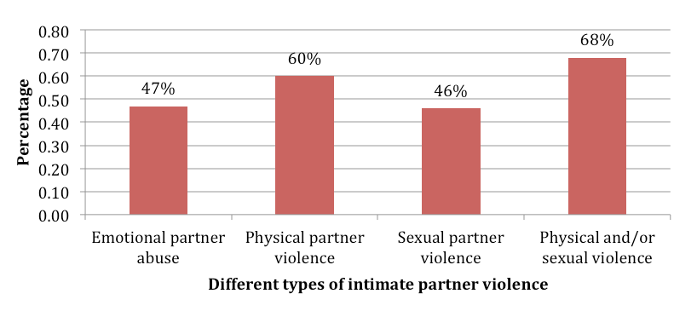

Source: MISA & NSO (2010)

In the past few years, the government has paid greater attention to domestic and sexual violence. The police formed a Domestic Violence Unit in 2006 and are active in increasing women’s awareness of their rights. As a result, more women are reporting violence. In the first six months of 2008, 22 cases of domestic violence were reported but this increased to 147 cases in the last six months. In 2009, 239 complaints were made. However, there is no family law—although one is being drafted—so police have to press charges of common assault.

Another challenge is that most women withdraw their complaints, often within a few days. One reason for doing so and deciding to remain with abusive partners is women’s fear of losing financial support or access to resources needed for themselves and their children. The ADB (2009:93) noted that many abused women have no independent financial means and often nowhere to go if they leave their partners. The only option was a Crisis Centre on South Tarawa run by the Catholic Church, which helped 38 women in 2009–10. Outside South Tarawa there was no refuge for abused women and minimal counselling support for victims (GoK 2005).

A program providing abused women with access to income if they leave violent partners may address some challenges. For example, women could be supported to establish an independent business, such as through a program offering a lump sum supplemented with a regular monthly grant for 12 to 24 months, which they could use to acquire assets. This may encourage more women to leave difficult situations and may dissuade husbands from violence.

**6.3.2. Vulnerable children**

Many children in Kiribati are vulnerable. Infant mortality rates have been among the highest in the Pacific and have been deteriorating (ADB 2009:33). In 2000 rates were 43 per thousand but this rose to 52 per thousand by 2005 (ADB 2009:33). One explanation for high infant mortality was the poor water supply and sanitation, with diarrhoea common (GoK 2005).

Deteriorating infant mortality rates may also reflect the country’s worsening economic situation. Children were over-represented among the poor (Figure 10). Overall, in 2006, the basic needs poverty rate of households with children was 18.3 per cent, compared to a poverty rate of 9.8 for households without children. When measured against double the basic needs poverty line, 60.4 per cent of households with children were poor or vulnerable to falling into poverty. Children who live in households with older people tended to be the poorest, with a poverty rate of 25 per cent.

**Figure 10: Location of children 0 to 4 years of age; children 0 to 14 years of age; and children living with elderly people, across wealth deciles**

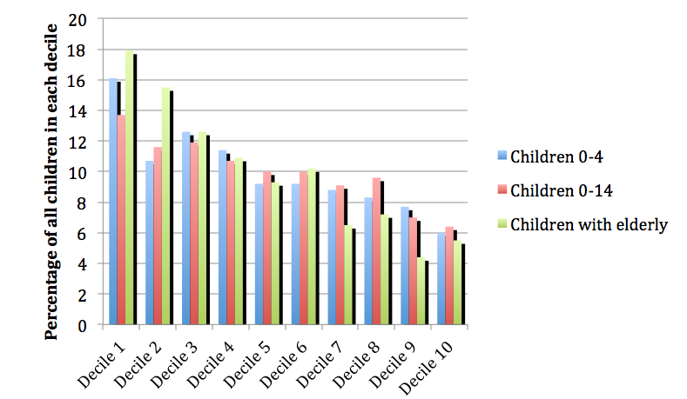

Source: Analysis of 2006 household survey data undertaken by this research

A closer look at national household survey data indicates that the highest levels of child poverty are in the rural Gilbert Islands. Figure 11 indicates that, in South Tarawa, households with children were better off than the rest of the population—although many still lived in poverty. In the rural Gilbert Islands, households with children were significantly worse off. In part, this may have been due to the relatively high proportion of children (28 per cent) living in households headed by older people in the rural Gilbert Islands, with 61 per cent in the lowest three deciles (Abbott 2010:36).

**Figure 11: Proportion of households with and without children aged 0 to 14 years living in poverty (basic needs poverty line)**

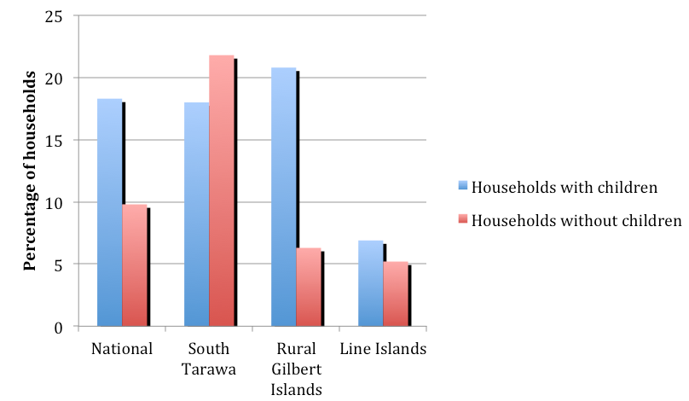

Source: Analysis of 2006 household survey data undertaken by this research

It is likely that the household survey analysis underestimates the real stresses placed on children and mothers. Although a household may have an expenditure implying it is not poor, the cash available may not benefit the women and children in the household. For example, on payday, the ADB (2009:89f) has described how some men stayed away from home over the weekend, returning the following week without any cash and leaving wives and children to struggle for the rest of the month.

Some children experience significant levels of malnutrition. A recent study (Entelberg 2007, in MoFEP 2007:12) found malnutrition rates of 18 per cent among children aged 0 to 2 years. In 2009, on the Outer Islands, 145 children aged 0 to 4 years received hospital treatment for malnutrition.[16] These most severe cases indicate that the problem may be more widespread.

There has been debate on the causes of malnutrition. Some have blamed parents for poor budget management, non-adherence to six months of breast-feeding, early weaning and providing children with inappropriate food (ADB 2007:13; MoFEP 2007:12). Others have pointed to the cost of baby formula, which was $30 a tin and beyond the reach of poor families. This may be why parents have had to buy condensed or ‘sunshine’ milk and mix it with water. A UNICEF (2010) study reported that, in 6 per cent of households, children missed meals because there was no food and in another 15 per cent of households, adults sometimes cut back or skipped meals so children could eat. Despite debate on causes it is clear that malnutrition has been a significant concern and that more reliable data is needed to understand it (MoFEP 2007:13).

Child labour, eliminated in the 1990s, was increasing, especially in South Tarawa (ADB 2007:13). UNICEF (2010) found 5 per cent of boys and 10 per cent of girls under 15 years of age earning income for their families. It is common for such children to sell crafts or collect tins for recycling. A number are involved in sex-work (Section 4.3.3).

I-Kiribati children whose mothers suffer domestic violence were more likely to repeat a year of school or drop out altogether (MISA & NSO 2010). Some experienced physical and sexual abuse and a recent survey (MISA & NSO 2010) reported that 19 per cent of women claimed they had been sexually abused before the age of 15 years. MISA dealt with only eight cases of child abuse in 2009, indicating the problem remains hidden. Children who move to South Tarawa from the Outer Islands to access secondary education may be particularly vulnerable. Kiribati families traditionally share children and, because there are no senior secondary schools on many Outer Islands, families often send their children to stay with relatives on South Tarawa. Receiving families cannot refuse such requests. However, some children being cared for may have received inadequate attention (GoK 2005). One reason for poor care may be that many sending families forget their reciprocity arrangement and do not send food to those caring for their children.[17]

Some countries outside of the Pacific, such as Mauritius, Namibia, Nepal and South Africa, have had child grants to help tackle child poverty and malnutrition, with Aguero et al. (2007) demonstrating good impacts on stunting among young children in South Africa. There is also international evidence that children benefit from pensions and disability benefits. Given that irreversible damage can be caused by stunting in a child’s early years, in particular to cognitive development, there have been strong arguments for making child grants a priority (United Kingdom Department for International Development [DFID] 2010). It has been estimated that a grant of $15 a month to all Kiribati children aged 0 to 4 years would reach 56 per cent of the population—who live in 46 per cent of households—and reduce the poverty gap in those households by 14 per cent and the household poverty rate by 11 per cent.[18] It is also estimated that it would reduce the national poverty gap by 7 per cent and the poverty rate by 6 per cent.

The cost of a grant of $15 a month to all 0 to 4 year olds in Kiribati would be $2.43 million. Figure 12 indicates this would be the equivalent of 1.47 per cent of GDP and, over time, the cost, as a proportion of GDP, could fall considerably, reaching just more than 0.5 per cent of GDP by 2050.

**Figure 12: Potential cost of a grant for all children aged 0 to 4 years, 2010–50[19]**

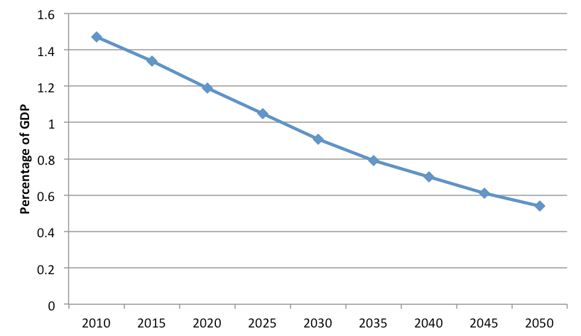

Source: Author’s modelling analysis (2009)

**6.3.3. Unemployed young people**

Unemployment is prevalent in Kiribati and is a particular challenge for young people. Around 2000 young people entered the labour force each year, but only 500 find jobs in the formal sector (ADB 2009:73). Figure 13 demonstrates that most young people remained outside of formal sector employment. While most young people aspire to work in this sector, most end up engaging in the subsistence economy.

**Figure 13: Proportion of young people in the labour force engaged in formal sector employment**

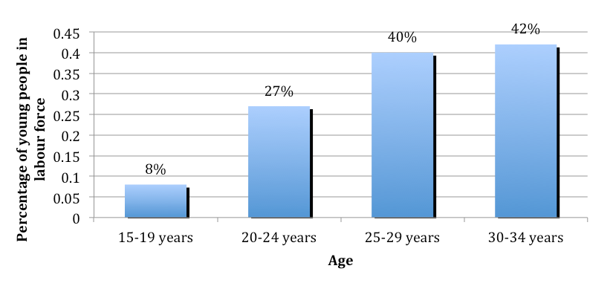

Source: MoFEP (2007:57)

High levels of youth unemployment contributed to a rise in social problems and young people were increasingly drinking, becoming involved in gangs and creating other law and order concerns (ADB 2007:13). Suicide, rape and teenage pregnancies were other community challenges cited. A relatively large number of young girls as young as 13 years of age turned to sex-work in the port of Betio, South Tarawa. While apparently well paid, many of these young girls are separated from community ties and their risk of HIV infection is relatively high.

The GoK approved a national youth development strategy in 2009, stating that, in addressing unemployment, priority will be given to young people with a focus on enhancing their chances of migrating or working as seamen. But, I-Kiribati young people have low skill levels, particularly in English (Section 3.7), with only 22 of the 500 passing the May 2010 entrance exam for the Maritime Training Centre—less than the number of potential places.

The Ministry of Labour has implemented projects in South Tarawa to help young people establish businesses, with support from the ILO, but these cover only approximately 120 participants. The Ministry of Labour hopes to expand the projects.

A number of developing countries have work programs addressing youth unemployment, such as India’s Employment Guarantee Scheme. Such a program in Kiribati could provide a daily wage to people—including young people—working on public infrastructure programs and guarantee a maximum number of days of employment a year (in India, it is 100 days). To facilitate self-targeting, the wage would have to be set at a low level so only those in real need would have access. Such a scheme could be combined with capacity building to provide young people with skills for the labour market.

**6.3.4 People with disability**

The Kiribati National Disability Survey, carried out in 2004–05, found 3840 people living with disability—including 723 children aged 0 to 14 years—comprising around 4 per cent of the population, with 55 per cent male and 45 per cent female (MISA 2010). No reliable information is available on poverty levels among people with disability as they were not identified in the 2006 national household survey, but they are likely over-represented among the poor. Mental illness appears to be on the increase. One hospital for the mentally ill in South Tarawa accommodated up to 64  patients but it was poorly maintained, sparsely furnished and under-resourced (ADB 2009:85).

Traditional care structures for people with disability appear to be breaking down. Parents are prepared to care for people with disability, however once the parents die the people with disability are obliged to move from one relative to another, with many reluctant to care for them. This lack of care has led some people with disability to form their own community on South Tarawa, which belongs to the national disabled persons’ organisation.

A draft national policy and action plan on disability is being prepared with social security and poverty alleviation as a strategic policy area. There are no plans for a disability grant, despite this being proposed by government. The only financial government support is payment of school fees for children whose parents have a disability.

People with disability believe a disability grant would make a significant difference to their lives. Rather than having to move from household to household they believe relatives would compete to have them with a grant that would help cover costs. A grant of $40 a month aimed at the 1000 people with the most severe disability in Kiribati, who are under 70 years of age, would cost around $0.5 million a year, or 0.3 per cent of GDP.[20]

**6.3.5. Older people**

Households with older people were over-represented among the poor (Figure 14). Households with residents over 60 years of age had a poverty rate of 23 per cent, compared to a poverty rate of 15 per cent for households without older people. Poverty appeared to increase as older people age, since the poverty rate of households with those over 70 years of age was 28 per cent. Around 72 per cent of those in this age group could be regarded as being in poverty or vulnerable to falling into poverty. In the absence of the Elderly Fund (Section 7.3.1) households with older people would be even poorer.

**Figure 14: Proportion of all older people—over 65 years of age—in each wealth decile**

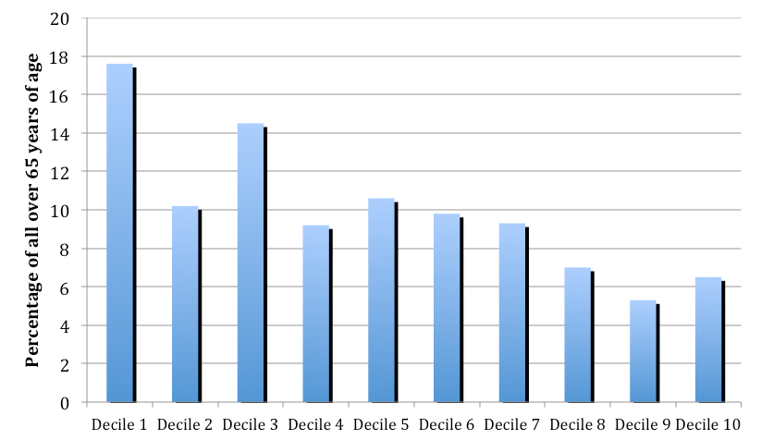

Source: Analysis of 2006 household survey data undertaken by this research

The traditional mechanisms of care for older people appear to be breaking down, and there are no homes for older people in Kiribati. Research by the ADB (2007:12, 16) suggested that those living in poverty are increasingly less likely to provide elderly parents with support. The rapid ageing that was taking place in many of the Gilbert Islands may have exacerbated this trend, where 15.6 per cent of households were headed by older people, compared to 11.7 per cent in South Tarawa (Abbott 2010:36). Older people on the Outer Islands are more likely to be left without sufficient support as their children migrate to work, although some will receive remittances (Section 5.1). Indications were that many older people in the rural Gilbert Islands had additional responsibility of caring for children of migrants (Abbott 2010:36). Although uncommon, older people can appeal to MISA if their children do not support them, with 35 such cases in 2009, an increase of 34 per cent on 2008.

The ageing of the population will require greater attention to meet health care, social care and income support needs. If formal mechanisms of support are not strengthened, then poverty levels may increase among the growing number of older people and family members who must care for them.

7. Social protection in Kiribati

This section assesses the extent to which Kiribati’s tradition of information social protection is coming under stress and then describes some of the formal social protection programs introduced.

**7.1. Stresses on traditional informal social protection**

Traditional care systems have been breaking down for some time in Kiribati. The ADB (2007:12) and MoFEP (2007:10) argued that traditional values were weakening, social networks eroding and people prioritising their nuclear family, not their extended family. This has consequences, especially for single women, vulnerable children, the elderly and people with disability. Poor households, because of insufficient cash, were less able to fulfil social obligations which could lead them to drop out of social networks (MoFEP 2007:10). Many benefit from informal social protection—for example, by sharing remittances—but growing numbers of vulnerable people are missing out.

Households with limited labour capacity—such as small households headed by the elderly or households with many children—are increasingly likely to be abandoned by informal social protection systems. While households are expected to have the right balance of age and gender so they can meet all their needs this is a growing challenge on the Outer Islands as the able-bodied migrate.

One challenge is that traditional social protection systems provide uneven support. Those in more prosperous nuclear or extended families receive higher benefits as they have more resources to access. The highest proportion of gifts and remittances were received by the richest households and, indeed, was likely to be a significant factor in explaining their greater wealth (Figure 15). This distinction was particularly noticeable in South Tarawa since those in the richest decile received almost half of all gifts and remittances, likely reflecting that they had members employed as seamen. The inability of the traditional social protection system to provide equitable distribution of resources is seen by the very poor who receive few gifts or remittances. The weakness of traditional social protection in the Pacific—including remittances—in providing an effective safety net was highlighted by Gibson (2006). Indeed, Gibson found that inter-household transfers and remittances could increase inequalities.

**Figure 15: Proportion of gifts and remittances received by households in each wealth decile[21]**

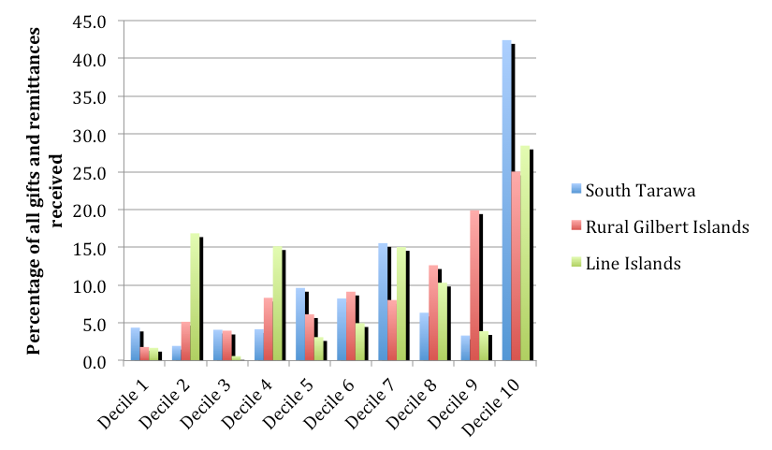

Source: Analysis of 2006 household survey data undertaken by this research

The uneven distribution of informal social protection is also illustrated by the sharing patterns of remittances, in particular from I-Kiribati seamen. This has become obligatory and has almost institutionalised social norms of sharing.[22] Seamen must specify who will receive their remittances and bank accounts opened for each recipient. Seamen can support a significant number of people, although estimates vary: an SPC study calculated that, on average, six people benefit from a seaman’s remittances and the New Zealand Agency for International Development (NZAID 2003) indicated most seamen support three families, with an average of five people per family.[23]

However, according to Borovnik (2006:157), only 17 per cent of the population benefited from remittances—directly and indirectly—and this figure fell further in the global recession. Figure 16 shows the limited distribution on the Outer Islands that received remittances from SPMS and KFS seamen. Only in one island did more than 10 per cent of households receive remittances.[24]

**Figure 16: Proportion of households on the Outer Islands receiving remittances from SPMS and KFS seamen[25]**

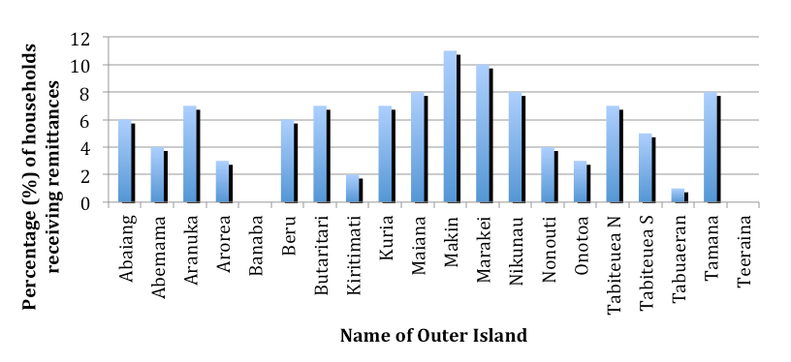

Source: Post Office records on remittances sent to islands

Seafarer work patterns have encouraged many of their families to settle in South Tarawa. This has enabled seaman to spend more time with their family on their return to South Tarawa for breaks (Borovnik 2006:159) and to resist pressures from extended relatives. Seamen who live on the Outer Islands have to stay on South Tarawa with extended relatives while waiting to travel and have to provide gifts to them, which means their own families and parents miss out.

Another challenge with the traditional social protection system in Kiribati is that it can act as a tax on working people, reducing their willingness to invest in business. I- Kiribati entering into business are often subjected to the demands of *bubuti* from extended family members. This has led to many businesses failing and has damaged economic growth (ADB 2009:96). In fact, a common strategy was for families to place a non-Kiribati family member as owner or manager of the business since they were more able to resist *bubuti* (ADB 2009:96).

**7.2. Formal instruments that provide access to public services**

Social protection includes measures to enable families to overcome the financial barriers to accessing public services, such as education and health. The GoK has a number of such measures in place. This section provides an overview of health and education, examines patterns of access and describes social protection measures in each sector.

**7.2.1. Access to education services**

Across Kiribati pre-school and primary schooling is provided locally. Junior secondary schools were present on most islands—with many established in recent years (ADB 2007:8), but senior secondary schools were fewer in number and mainly on South Tarawa. Many children from the Outer Islands have to travel to South Tarawa for senior secondary school, staying with relatives or boarding. The state provides free compulsory education for children up to 12 years of age, or until the end of Class 6, and free education to Form 3. However, students going to senior secondary school pay fees. The state subsidises schools. In the 2006 budget, $363 was allocated for each primary school student and $1274 for each secondary school student (ADB 2009:55).

Enrolments in primary school were relatively high—90 per cent gross enrolment and 74 per cent net enrolment in 2008 (MoE 2008a:15). While the proportion of children entering school who had attended early childhood education programs rose from close to zero in 1990 to 77 per cent in 2006 (GoK 2005; MoE 2008:13), there were concerns that attendance at primary school was falling. Although survival rates to the end of primary school were above 100 per cent between 1992 and 2006 (MoFEP 2007:16), they dropped to 80 per cent by 2009.[26] Enrolment at junior secondary schools also fell from 89 per cent in 2003 to 79 per cent in 2006 (ADB 2009:56).

Although primary and junior secondary schools are without fees, they are not entirely without cost for parents who cover informal costs such as contributions for special events, school supplies and uniforms. Once children attend junior secondary school, many families have to pay travel costs because schools are further away from many villages. Additional costs may lead poor families to keep children out of school. Concerns with the quality of education may also dissuade parents from enrolling children.

Enrolment at secondary school was much lower, at 34 per cent, in 2006 (MoE 2008a). As Table 1 indicates, as children became older, boys were more likely than girls to drop out of school. The large drop in enrolment in the transition to senior secondary school probably reflected three key factors. The first is the requirement for children to pass the Junior Secondary Certificate Examination to enter senior secondary school. The second is insufficient places in senior secondary school (cf. GoK 2005). The third is cost, since fees are charged for senior secondary school, in particular for children who do not obtain a scholarship.

**Table 1: Gender balance in Kiribati school enrolment by level**

|  |  |  |
| --- | --- | --- |
| **School level** | **Female** | **Male** |
| Primary | 49% | 51% |
| Junior secondary | 52% | 48% |
| Senior secondary | 54% | 46% |

Source: ADB (2009:57)

The state provides financial assistance as scholarships to the best-performing, yet it is likely these disproportionately benefit those who are better off and those living in South Tarawa. Scholarships are also provided for the children of parents or orphans with disability, but the children need to perform well. In fact, in the 2011 GoK budget this funding—currently around $60 000—was transferred from recurrent expenditure to the development budget, which may indicate a weakening in priority.[27] There is also variation in the level of government funding given to different types of senior secondary schools. In 2006 church schools educated 73 per cent of senior secondary school students and received 14 per cent of the education budget. Government schools educated around 27 per cent of senior secondary school students and received 27 per cent of the budget (ADB 2009:55).

The Protestant and Roman Catholic churches are the main providers of secondary education but they offer no financial support to students. The Church of the Latter Day Saints reduced fees if children converted to Mormonism (Kuruppu 2009:805) and the Church of the Latter Day Saints offered a couple of scholarships a year to high-achieving students.

**7.2.2. Accessing health services**

Health services in Kiribati comprised 85 health centres and clinics on the Outer Islands and a referral hospital and clinics on South Tarawa (MoFEP 2007:4). A hospital is being built on the southern Gilberts, with funding from Taiwan. In 2009 there were 25 doctors, 329 nurses and 48 midwives.[28] Clinics are staffed mainly by Cuban doctors, with the Ministry of Health paying for salaries and accommodation.

Diarrhoea and infectious diseases were the main illnesses (Table 2) but Kiribati had begun an epidemiological transition as non-communicable and lifestyle diseases were becoming more frequent. Obesity among the adult population is a growing challenge and alcohol and smoking-related diseases are on the rise. Indeed, nearly 70 per cent of males and almost 50 per cent of women smoked (SPC 2007:38f). As the population ages, non-communicable and lifestyle diseases will comprise an increasing proportion of the health burden, at potentially higher cost to the budget.

**Table 2: Main illnesses treated by the Kiribati health system in 2009**

| **Illness treated** | **Number of cases** |
| --- | --- |
| Diarrhoea | 62 723 |
| Acute respiratory infection | 27 660 |
| Communicable diseases | 11 095 |
| Eye diseases | 5391 |
| Non-communicable diseases | 2914 |

Source: Ministry of Health records (2009)

Most health services are free and paid for from general taxation although, in 2006, charges were introduced for dental, x-ray and laboratory services (ADB 2009:83). There is an essential drug list and only medicines on it can be prescribed. If patients have to stay in hospital, the Ministry of Health pays for the meals and essential expenses of one relative to care for them. The free health care system enables poor families to access health services reasonably well and out-of-pocket health expenditures are small.

However, the hospital on South Tarawa provides a limited set of services and serious cases are referred overseas. Due to high referral costs, the ministry uses a system of rationing and decisions are made by a committee of doctors. Only those with good prognosis who are likely to live for another five to 10 years are referred. There are examples of more powerful families attempting to influence this process, but no evidence on whether they succeeded.

**7.3. Core formal social protection**

Kiribati has a few core formal social protection programs which are discussed in this section. Indeed, many have argued that the public administration functions as a form of unemployment program (cf. Borovnik 2005:4). The main cash transfers are the Elderly Fund and the Copra Fund Subsidy. The Kiribati Provident Fund has potential social protection aims. However, No core social protection programs are targeted at the very poor or destitute.

**7.3.1. The Elderly Fund**

The Elderly Fund is a universal non-contributory pension for older people. It began in 2004 and may have contributed to the victory of the Opposition in the 2003 election. The fund was introduced to deal with a reduction in care of the elderly and to demonstrate the respect traditionally accorded to them in Kiribati culture. As a universal pension, the fund is available to everyone of eligibility age.

Before June 2011 the Elderly Fund was provided to everyone aged 70 years and over. However, on 1 June 2011 the eligibility age reduced to 67 years. In May 2010 there were 2090 beneficiaries, covering around 97 per cent of those eligible. Following its expansion, the number of beneficiaries was not known but census data suggested around 3050 people would be eligible.[29] Comparisons of census and administrative data indicate that a small number of eligible people do not receive the pension.

Between 2004 and June 2011 beneficiaries received $40 a month and the overall budget in 2010 was $1 068 000, around 0.6 per cent of GDP. However, from 1 June the benefit increased to $50 for those over 70 years of age, while it remained $40 for those aged 67 to 69 years. With continuing take-up of 97 per cent, the annual budget would likely have increased to $1 695 000, or 0.93 per cent of GDP. Assuming that the Elderly Fund benefit is indexed to inflation and that the trend GDP per capita growth rate of the past 20 years continues, even taking into account the increase in the elderly population by 2050, it is unlikely that the cost of the scheme, as a proportion of GDP, will rise significantly. Therefore, the Elderly Fund should not turn into an unsustainable fiscal burden.

MISA manages the Elderly Fund and Island councils pay recipients monthly. Most beneficiaries travel to their Island Council for their cash. If people cannot travel, Island councillors deliver cash to beneficiary homes.

The Elderly Fund is popular with high take-up. Complaints focus on the amount paid and the eligibility age, although this may have been partially addressed by the changes introduced in June 2011. Nonetheless, the current value of the over-70 pension was 33 per cent of per capita GDP, which compared favourably with many similar universal pension schemes in other small states[30] (Figure 17). Many people believed the eligibility age should be reduced to 60. In fact, in December 2005, the Opposition was defeated in a Parliamentary motion to this effect.

**Figure 17: Value of universal pensions across the world, as a percentage of gross domestic product per capita**

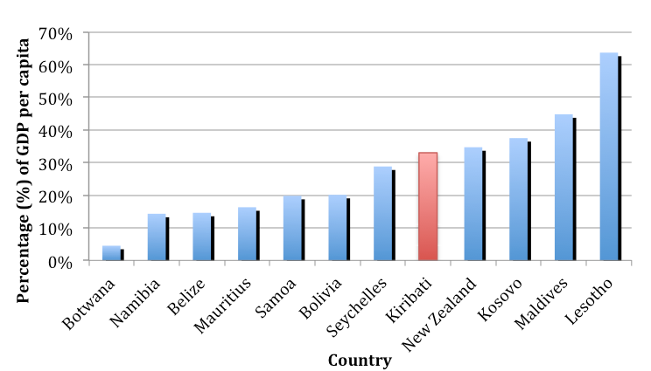

Source: <http://www.pension-watch.net/about-social-pensions/about-social-pensions/social-pensions-database>

To date the fund’s impact has not been evaluated. Sixty-three per cent of beneficiaries were women and, as with most universal non-contributory pensions, the Elderly Fund has been an effective means of providing women with a guaranteed income in old age (Kidd 2009). Among the richest quintile of the population the fund comprised only 10 per cent of average adult expenditure in 2006. However, among the poorest quintile it was equivalent to more than 80 per cent of average adult expenditure.

The Elderly Fund has had a significant impact on poverty among households with those over 70 years of age. In 2010 it reduced the poverty gap in such households by an estimated 19 per cent, the poverty rate by 14 per cent and the national poverty gap by 5 per cent. If the pension size were increased to $60 a month, it would further reduce the poverty gap in households with those over 70 years of age by 9 per cent, reducing the overall poverty gap by 28 per cent and reducing the national poverty gap by 7 per cent. The cost would be 1.11 per cent of GDP.

Consultations with older people indicate that they use fund income to support other household members, including children. This is in line with elsewhere in the world where pensions have had significant impacts on children’s wellbeing.[31] Before June 2011, 12 per cent of households benefited from the Elderly Fund and the recent reduction in the age of eligibility likely increased coverage to around 16 per cent.

Another positive benefit of the Elderly Fund is that it appears to have strengthened traditional forms of social protection. Anecdotal evidence points to improved care of some elderly people and may explain the 29 per cent increase in beneficiaries in Kiritimati, South Tarawa and Tabuaeran between 2004 and 2010, compared to the 9 per cent decrease elsewhere. Migrants to these islands may be more willing to invite their pensioner parents to live with them. Cash from the fund also enables older people to maintain social obligations, thereby reducing isolation. Nonetheless, Chung (2011) mentioned anecdotal evidence of some elderly people losing financial support from relatives, although this does not appear to be widespread.

Chung (2011) also noted concerns over competition between elderly peoples’ children to access the pension, with anecdotal reports of cash forcefully being removed from recipients. However, if this problem exists, it appears to be restricted to a small minority. It is possible that competition between children to live with their elderly parents is a sign that the pension provides incentives for increasing care. Kiribati could examine Mauritius, which triples the value of its universal pension at age 90 years. This costs relatively little as few people live to this age. It also encourages families to increase care and acts as a strong incentive for the elderly to live longer. It is also possible that improved home care for the elderly reduces health care costs overall.

Reducing the age of eligibility to 60 years would significantly increase the fund’s impact on poverty.[32] The fund would reach a quarter of households nationally and would reduce the overall poverty gap in households with those over 60 years of age by 25 per cent. The overall reduction in the national poverty gap would be 10 per cent and the reduction in the national poverty rate 11 per cent.

The cost of providing the Elderly Fund to everyone over 60 years of age would be around $2.85 million a year—corresponding to 1.65 per cent of GDP—a budget increase of $1.15 million. While this may seem substantial, it could provide significant economic stimulus across Kiribati, increasing consumption and helping support business. When compared to other countries with similar universal pension schemes, the cost of extending the fund to everyone over 60 years of age would be similar to what many other countries are paying (Figure 18). In fact, the current spend of 0.93 per cent of GDP is a relatively low cost when compared to other countries.

**Figure 18: Costs of the Elderly Fund—current costs and potential costs for everyone over 60 years of age—compared to universal pensions in other developing countries[33]**

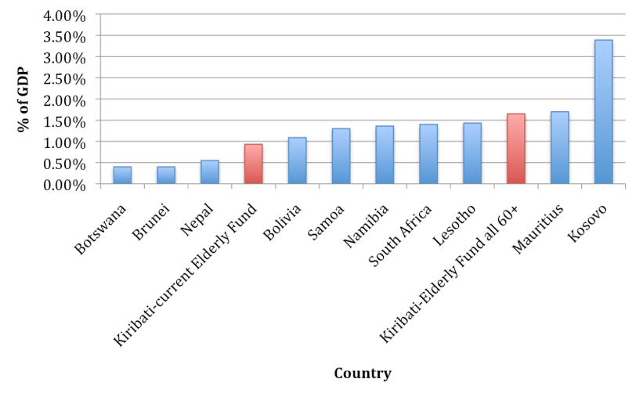

Source: <http://www.pension-watch.net/about-social-pensions/about-social-pensions/social-pensions-database>

One weakness is that the Elderly Fund is not underpinned by legislation. Universal pensions are often regarded as entitlements, which could be undermined in Kiribati if legislation were put in place. Furthermore, legislation could establish firm rules—such as on indexing the pension—and make it more difficult for governments to modify the pension without broad consensus.

As it is provided to everyone over the age of eligibility, the Elderly Fund uses a form of universal targeting. As the World Bank (1994) and Holzmann et al. (2005) noted, this is the most effective way to ensure poor older people can access the pension. Pensions targeted at the poor have a weak record in reaching the poor and are more susceptible to corruption. Furthermore, universal social protection schemes tend to be more popular politically and can sustain larger budgets and provide greater resources to poor people (Kidd et al 2011).

**7.3.2. The Copra Fund Subsidy**

The Copra Fund Subsidy[34] is Kiribati’s largest formal social protection mechanism although it has multiple objectives. One is to maintain copra production—a main export—while encouraging people to remain on the Outer Islands, rather than migrate to South Tarawa. Another is to ensure a cash supply to the islands to help maintain and stimulate island economies. The Copra Fund Subsidy is also a form of unemployment benefit, providing a cash income to able-bodied people who cannot get employment.

The subsidy began in the mid-1990s and guarantees a minimum purchase price for copra from the GoK ($0.70 cents a kilo in February 2010). This comprises a significant proportion of government spending. In 2009, the government paid out $4.54 million representing 5 per cent of the national budget and 2.8 per cent of GDP.[35] In 2009 the average per capita annual subsidy on the Outer Islands was $81.

The Copra Fund Subsidy is managed by the Ministry of Commerce, in collaboration with the Kiribati Copra Society. Funds are transferred to Island Council bank accounts and payment is the responsibility of the local Assistant Treasurer. Copra producers are paid the guaranteed price in cash when they bring copra in for weighing. Weak administration is a concern and a number of people have been prosecuted for corruption.

One challenge with the subsidy is that it is inequitable in supporting islands and households. Islands with the highest copra production receive the highest subsidy. This can lead to significant inequities between islands with the subsidy value between $4 a person a year on North Tarawa to $527 a person a year on Teeraina (Figure 19).

**Figure 19: Size of per capita annual subsidy received by each island from the Copra Fund**

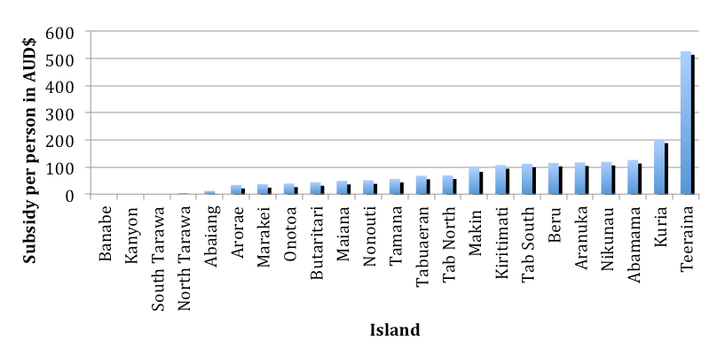

Source: Data provided by the Ministry of Commerce (2010)

Although no reliable quantitative data is available on distribution variability between households on one island, consultations on Tabiteuea indicate it can be significant. For example, in one village the highest income from copra for a household in May 2010 was $86 while the lowest was $12; in another village, household income from copra in the same month varied from $10 to $91. Income variability can be explained by differences in the size of landholdings, their productivity and distance of households from plots. Another key factor is household composition—those with less labour capacity find it more difficult to harvest and prepare copra for sale. This was likely to discriminate against households with older people, people with disability and single parents (cf. ADB 2009:118).

It should not be assumed that the Copra Fund Subsidy is an essential means of maintaining copra production. Indeed, it is possible that an artificially high price for copra has discouraged investment in crop improvements given that 46 per cent of the country’s estimated 11 million coconut trees are senile (ADB 2009:122).

**7.3.3. The Kiribati Provident Fund**

The Kiribati Provident Fund[36] was established in 1977 by an Act of Parliament using funds transferred from the government pension scheme. Its initial funding was $0.5 million and this has grown to $90 million. Compared to other Pacific Island provident funds, this one is well managed and financially sound, maximising returns by investing 80 to 90 per cent of funds overseas. It was hit by the global recession—with a 15 per cent negative return in 2008—but recovered in 2009. Its main attraction is that it pays a guaranteed minimum rate of interest of 4 per cent on savings (in most years a higher rate is achieved).

The Kiribati Provident Fund mainly serves formal sector employees who contribute 15 per cent of their salaries, with half provided by the employer. It is gradually expanding into other sectors and since 2003 seamen have been able to contribute as voluntary members (although there is no employer contribution). Currently, there are almost 20 000 active contributors, with around 1000 paying voluntary contributions. Most contributors are male—67 per cent in 2004 (ILO 2006)—but the number of women contributors is growing. Only recently have wives been able to benefit from their deceased husband’s funds.

The fund is not strictly a social protection mechanism. It is more a long-term savings scheme. In contrast to many other provident funds, it does not provide members with a regular old age or disability pension. Instead, members receive a lump sum on reaching official retirement of 50 years of age with partial withdrawals permitted from 45 years of age. Many beneficiaries use their lump sum to buy large goods, such as vehicles, to avoid losing cash to extended family *bubuti* demands. The significant increase in buying new vehicles—including mini-buses—was linked to the availability of lump sums from the fund (ADB 2009:100).

The Kiribati Provident Fund has explored providing a regular pension, for example by enabling members to annuitize 25 per cent of savings. Despite proposals by the ILO in 2006, little has been done. Transforming the fund into a pension would present two significant challenges: members would have to be convinced of the value of receiving part of their savings as a regular pension rather than as a lump sum and the official retirement age of 50 years would make it difficult to build an actuarially sound and meaningful pension. Another proposal, currently under discussion by the Fund, is to build a health insurance scheme into the Kiribati Provident Fund to support members referred overseas for treatment.

**7.3.4. Labour legislation**

Kiribati has limited labour legislation, mainly a Workers’ Compensation Scheme that came into law in 1977, with the most recent amendment in 1998. The scheme mandates employers to provide benefits for temporary or permanent incapacity. With temporary incapacity, a proportion of an employee’s salary is to be paid until they return to work. With permanent incapacity, the benefit is provided as lump sum equivalent to 48 months of earnings, or a maximum of $25 000, whichever is less.

Government has not yet activated legal provisions for a minimum wage and labour enforcement officers. Kiribati has no health and safety legislation, although a proposal is being drafted. Since joining the ILO in 2000, Kiribati has ratified core ILO conventions on freedom of association, the right to organise and bargain collectively, and the abolition of forced labour. Ratifying other conventions was being considered (ADB 2009:69). To date there has been no comprehensive review of labour legislation to decide what legal provisions should be introduced as a priority, nor has there been an assessment of the value of activating provisions for a minimum wage.

**7.4. Social protection provision by non-state actors**

There is almost no social protection provision by non-state actors in Kiribati. While churches generated a large income from members, Kuruppu (2009:805) noted this provides little support to the poor and vulnerable. The Kiribati Protestant Church has a small discretionary fund to help people facing difficulties but no formal programs. However, it has set up a program to help women with cervical cancer travel overseas for treatment. The Catholic Church’s main support is the crisis centre for women escaping domestic violence. The Church of the Latter Day Saints provides limited ad hoc assistance to members in need.

One reason for the churches’ lack of support can be found in their message that spiritual recognition is gained through serving the church and the social group, rather than the individual (Kuruppu 2009:805).

8. Conclusions and recommendations

Kiribati’s economy is particularly vulnerable and faces many challenges. One is the growing evidence of poverty as a daily reality for a significant proportion of the population. As Thomas and Tonganibeia (2006:39) argued, no longer are the people living in ‘subsistence affluence’, in particular those in South Tarawa. Subsistence activities may provide many people on the Outer Islands who do not have jobs with access to food—except for the most vulnerable—but it does not provide the cash they need.

Some population categories are increasingly vulnerable. The traditional informal social protection system is under stress and cannot provide adequately for everyone, as indicated by higher levels of poverty among groups such as the elderly, people with disability, vulnerable children and single mothers. Young people, who experience high levels of unemployment and disillusionment, are in danger of becoming a lost opportunity for economic growth as well as a future burden. The high level of inequality—particularly in a country with such a strong egalitarian ethic—should be a significant policy concern given its likely negative impact on economic growth and poverty reduction and the danger it may lead to increasing social conflict.

Clearly, as in all economies, economic growth and job opportunities—alongside progressive social policy—are the best means of tackling poverty and vulnerability. Yet, job creation prospects are limited in Kiribati and migration is an option for only a few. The government has already put in place some formal core social protection schemes, notably the Elderly Fund and the Copra Fund Subsidy, with the latter functioning as a form of unemployment program on the Outer Islands (with concerns about its equity). The government also provides access to other key public services, most notably health and education, but there are questions about quality and access to secondary education, especially for those from poor families.

A key policy question for government is the possible need to expand formal social protection, in light of limited government financing. This research paper sets out evidence on potential core social protection programs—such as for groups like vulnerable women, young children, people with disability, the unemployed and an expansion of the Elderly Fund to those over 60 years of age—but it does not make recommendations. It intends to generate debate by highlighting Kiribati’s challenges and setting out evidence for potential innovative programs.

Core social protection programs are not just a cost to the state. They are an investment. They can build human capital, especially by increasing the effectiveness of public services such as health and education, and they can strengthen a country’s competitiveness. Cash transfers can also be an important stimulus to local economies and support business development. This can be an important complement to activities promoting private enterprise, especially among young people.

Kiribati’s two major cash transfer programs—the Elderly Fund and Copra Fund Subsidy—also have the potential to use funds to extend financial services to the Outer Islands, which, at present, are limited. The forthcoming introduction of mobile phone technology on the Outer Islands opens the possibility for the government to develop electronic management information systems, for the fund and the subsidy, enabling more effective monitoring and reducing the potential for corruption. Importantly, this could facilitate the introduction of electronic delivery of cash to beneficiaries, bypassing local councils and using the private sector. This could be linked to the provision of financial services to beneficiaries and enable the GoK to use the country’s cash grants as a form of subsidy to enable it to work with banks and/or mobile phone companies to encourage them to establish financial service providers on the Outer Islands.

Kiribati is not alone in the world of social protection. Similar discussions on the role social protection can play in poverty reduction and economic development are underway in many developing countries. Yet, these systems can take decades to build. Kiribati has already started. It now needs to decide its future direction.

Social policy reforms in Kiribati require more in-depth study. This research paper identifies opportunities in a number of areas, which could fill gaps in knowledge and significant addition to the evidence base on social protection in the Pacific. These include:

> **A study on the Copra Fund Subsidy**. This would build better understanding of subsidy distribution and whether it achieves its objectives. The study could assess uses of copra fund finances for alternative forms of social protection. It could also investigate governance arrangements to propose how to deal with alleged corruption.

> **A study on early childhood malnutrition.** Indications are that malnutrition among young children is a major issue, but there is little information on its scale, causes, impacts and solutions. It would be valuable to review early childhood malnutrition in Kiribati, to understand it better and to identify long-term solutions.

> **Linking cash delivery and financial inclusion.** The GoK delivers a significant amount of cash to the Outer Islands for the Elderly Fund and the Copra Fund Subsidy (more than $6 million). In the near future, most islands will have mobile phone coverage and a study could assess the potential for delivering cash electronically directly to beneficiaries, cutting out intermediaries, reducing costs and extending coverage.

> **Evaluation of the Elderly Fund.** The Elderly Fund is an innovative scheme in the Pacific context, but there is little evidence of its effectiveness and impact. An evaluation would add to the evidence base on social protection in the Pacific and be the first comprehensive evaluation of a universal pension in a developing country. It would also contribute to policy development in Kiribati.

9. References

Abbott, D 2010, *Kiribati: Analysis of the 2006 Household Income and Expenditure Survey.* Fiji Islands: United Nations Development Programme Pacific Centre.

Abbott, D & Pollard, S 2004, *Hardship and Poverty in the Pacific.* ADB, Manila, Philippines.

ADB 2002, *Kiribati: Monetization in an A toll Society.* ADB, Manila, Philippines.

ADB 2006, *Pacific Regional Social Protection Systems Assessment*. Report prepared for the ADB—TA 6207: REG.

ADB 2007, *Priorities of the People: Hardship in Kiribati.* Philippines: ADB publication.

ADB 2009, ‘Kiribati Social and Economic Report 2008: managing development risk’, Philippines: ADB publication in *Pacific Studies Series.*

ADB 2011, ‘The Pacific’, *Asian Development Outlook 2011*, pp. 223–242. ADB.

Aguero, J, Carter, M & Woolard, I 2007, ‘The Impact of Unconditional Cash Transfers on Nutrition: the South African Child Support Grant’, working paper no. 39. Brasilia: International Poverty Centre.

Atkins, J, Mazzi, S & Easter, C 2000, *A Commonwealth Vulnerability Index for Developing Countries: the Position of Small State*, Commonwealth Secretariat, economic paper no. 40.

Beets, J 2001, ‘Declines in Finfish resources in Tarawa Lagoon, Kiribati, Emphasize the Need for Increased Conservation Effort’, *Atoll Research Bulletin*, no. 490: pp. 1–14.

Boldrin, M, De Nardi, M & Jones, LE 2005, *Fertility and Social Security*, National Bureau of Economic Research, National Bureau of Economic Research, working paper no. 11146.

Borovnik, M 2005, ‘Remittances: An Informal but Indispensable Form of Income for Seafarer Families in Kiribati’, Centre for Indigenous Governance and Development, Working Paper series, no. 8/2005.

Borovnik, M 2006, ‘Working overseas: Seafarers’ remittances and their distribution in Kiribati’, *Asia Pacific Viewpoint*, vol. 47, no. 1, April 2006, pp. 151–161.

Chirchir, R & Kidd, S 2011, *Good Practice in the Development of Management Information Systems for Social Protection*, Pension Watch Briefings on Social Protection in Older Age, HelpAge International.

Chung, M 2011, *Assessment of the Appropriateness and Feasibility of a Cash Transfer Pilot Scheme to Address the High Vulnerability of Adolescents and Young People to Sexually Transmitted Infections and HIV in Betio and South Tarawa, Kiribati.* UNICEF feasibility study.

Devereux, S 2001, *Social Pensions in Namibia and South Africa*, Institute of Development Studies, discussion paper no. 379, February 2001, Institute of Development Studies, Brighton, Sussex, England.

Department for International Development 2010, *The neglected crisis of undernutrition: DFID’s Strategy*, DFID, London, England.

Duflo, E 2000, ‘Grandmothers and Granddaughters: Old Age Pension and Intrahousehold Allocation in South Africa’, National Bureau of Economic Research Working Paper Series; working paper no. 8061, National Bureau of Economic Research, Washington DC.

Galaso, V, GattI, R & Profeta, P 2008, I*nvesting for the Old Age: Pensions, Children and Savings.* Social Protection Discussion Paper no: 0838. World Bank, Washington, DC.

Gibson, J 2006, ‘Are There Holes in the Safety Net? Remittances and Inter-household Transfers in Pacific Island Economics’, working paper no. 1, Pasifika Interactions Project.

Gillett, R & Lightfoot, C 2001, *The Contribution of Fisheries to the Economies of Pacific Island Communities.* ADB, Manila, Philippines.

GoK 2005, *Kiribati Islands. A Situation Analysis of Children, Women and Youth.* UNICEF Pacific Office, Suva, Fiji.

GoK 2009, *2010 Budget.* Tarawa: Kiribati Ministry of Finance and Economic Development.

Hayes, G 2009, *Population Ageing in the Pacific Islands; Future Prospects and Emerging Challenges*, Paper presented at the 2009 Conference of the Population Association of New Zealand: ‘Distinct Communities, Diverse Populations, Different Futures: Towards 2030,’ 31 August to 1 September 2009, Wellington, New Zealand.

Holmqvist, G 2010, ‘Fertility impact of social transfers in Sub-Saharan Africa—What about pensions?’, Brooks World Poverty Institute, working paper no. 119, University of Manchester, Manchester, United Kingdom.

Holzmann, R, Hinz, R, von Gersdorff, H, Gill, I, Impavido, G, Musalem, AR, Palacios, R, Robolino, D, Rutkowski, M, Schwarz, A, Sin, Y & Subbarao, K 2005, *Old-Age Income Support in the Twenty-first Century: an International Perspective on Pension Systems and Reform*, World Bank, Washington DC.

ILO 2006, *Social Protection for All Men and Women: A Sourcebook for Extending Social Protection Coverage in Kiribati—Options and Plan*, Sub-Regional Initiative on Social Security in Pacific Island Countries: International Labour Organization. Suva, Fiji.

IMF 2009, *Public Information Notice: IMF Executive Board Concludes 2009 Article IV Consultation with Kiribati*, IMF public information notice no. 09/54.

Kidd, SW 2009, ‘Equal Pensions, Equal Rights: Achieving Universal Pension Coverage for Old Women and Men in Developing Countries’, *Gender and Development*, 17:3, pp. 377–388.

Kidd, SW, Wylde, E & Tiba, Z 2010, *Building a Social Protection Floor in Pakistan*, Unpublished report for UNICEF, Pakistan.

Kidd, SW, Calder, R & Wylde, E 2011, *Assessing targeting options for Nepal’s social grants: What does the evidence tell us?*, Development Pathways and DFID, Nepal.

Kuruppu, N 2009, ‘Adapting water resources to climate change in Kiribati: the importance of cultural values and meanings’, *Environmental Science and Policy,* 12 (2009): pp. 799–809.

MacKenzie, United Nations 2004, *Kiribati Adaption Project: Social Assessment Final Report*. Report prepared for Kiribati Adaptation Project.

MacLellan, N 2008, *Workers for All Seasons? Issues from New Zealand’s RSE program,* Australia: Institute for Social Research, Swinburne University of Technology, Melbourne, Australia.

Ministry of Education 2008a, *Digest of Education Statistics 2008.* Kiribati MoE, Statistics Unit, publication.

MoE 2008b, *Cooperation for the Enhancement of Quality Education Outcomes for our Children. Kiribati National Education Summit Outcomes; Education Sector Strategic Plan.* Kiribati MoE publication.

Ministry of Finance and Economic Planning 2007, *Republic of Kiribati. Millennium Development Goals.* Kiribati, MoFEP.

Ministry of Internal and Social Affairs 2009, Kiribati Government. *National Youth Development Strategy 2010.* Kiribati Ministry of Internal and Social Affairs publication.

MISA 2010, *National Policy on Disability and Action Plan 2011–14.* Kiribati Ministry of Internal and Social Affairs.

MISA and National Statistics Office 2010, *Kiribati Family Health and Support Study: A study on violence against women and children*, Kiribati MISA & and NSO publication.

New Zealand Agency for International Development 2003, *NZAID support for the Kiribati Marine Training Centre: Feasibility design study*, August 2003, New Zealand Maritime School in association with Asia Pacific Maritime Institute, Wellington, New Zealand.

Samson, M, Lee, U, Ndlebe, A, Mac Quene, K, van Niekerk, I, Gandhi, V, Harigaya, T & Abrahams, C 2004, *The Social and Economic Impact of South Africa’s Social Security System,* EPRI Research.

Secretariat of the Pacific Community 2007, *Kiribati 2005 Census, Volume 2: Analytical Report.* SPC, New Caledonia.

Thomas and Tonganibeia 2006, ‘Pacific Island Rural Development: Challenges and prospects in Kiribati’ in Connel, J & Waddell, E (eds) *Environment, Development and Change in Rural Asia-Pacific: between local and global.* Routledge, United Kingdom.

Townsend, P 2007, *The Right to Social Security and National Development: Lessons from the Organisation for Economic Co-operation and Development experience for low-income countries*, Issues in Social Protection: discussion paper no. 18. Social Security Department, ILO.

United Nations 2009, *Voices of the Vulnerable in the Pacific—Summary Note*, Paper prepared for the United Nations Secretary General Update Report.

UN Development Programme 2005, *Human Development Report 2005—International cooperation at a crossroads: Aid, trade and security in an unequal world.* United Nations Development Programme, New York, United States.

UN Populations Fund 2006, *Adolescent Sexual and Reproductive Health Situation Analysis for Kiribati. A Review of Literature and Projects 1995–05.* Fiji: UNFPA Office for the Pacific.

UNICEF 2010, *Sentinel Sites Report: Kiribati.* Draft report for UNICEF.

World Bank 1994, ‘Averting the old age crisis: policies to protect the old and promote growth’, Oxford University Press, New York, United States.

World Bank 2000, *The 2000 WB Regional Economic Report.* World Bank, Washington DC.

World Bank 2005, *World Development Report 2005:* A Better Investment Climate for Everyone. World Bank, Washington DC.

World Bank 2006, *Opportunities to Improve Social Services: Human Development in the Pacific Islands*, World Bank, Washington DC.

World Bank 2011, *Protecting Poor and Vulnerable Families in Indonesia: A Comprehensive Review of Indonesia’s Social Assistance Programs and Public Expenditures, to Support the Building of a True Social Safety Net for All Poor and Vulnerable Households.* Consultation Draft, World Bank, Washington DC.

1. A description of the methodology is in Annex A.
2. ADB 2009:16, source of data on current GDP is available on: <www.imf.org/external/np/sec/pn/2009/pn0954.htm>, viewed on 30 June 2010.
3. 2010 figures for KFS refer to employment from January to April and for SPMS figure employment in May 2010.
4. See Kidd (2009) and Holmqvist (2010) for how pensions lead to fertility reductions.
5. Government has been encouraging people to move to Kiritimati to reduce pressures on South Tarawa. It plans to settle up to 15 000 people on Kiritimati, although this might damage natural resources and impact negatively on tourism (ADB 2009:10).
6. In Maiana, Nikunau and Onotoa, 8 per cent of the population was over 60 years of age in 2005; in Beru 9 per cent; in Tamana 10 per cent; in Arorae 11 per cent (SPC 2007).
7. Kuruppu (2009:805) has noted that the rights of the social group are paramount to those of the individual: ‘The moral economy of the household was one in which livelihood assets were maintained to serve the wider purpose of reproducing interpersonal relationships … Financial resources provided personal significance when they were spent on satisfying community obligations, particularly those related to the church.’
8. Similar arguments on the absence of poverty in Kiribati—but a prevalence of hardship—can be found in documents such as Kuruppu (2009:804), ADB (2007:3) and MoFEP (2007:10).
9. United Nations Development Programme (2005) and World Bank (2005) discuss the impacts of inequality on poverty and economic growth.
10. Refers to the wealth deciles in each region and not to where the households are located in the national wealth distribution.
11. Categories drawn from ADB 2007.
12. The 2006 national household survey reported that in South Tarawa single female-headed households are over-represented among the richest quintile, comprising 28 per cent of all households. However, this is likely to result from a flaw in survey methodology as women whose husbands are working as seafarers may have been counted as single.
13. Most information on domestic violence is taken from MISA & NSO (2010). Research by the ADB (2007:14) reported that women mentioned domestic violence as a challenge.
14. Women also suffer violence from men other than their partners, in particular from those living in the same household. Eleven per cent of women aged 15 to 48 years reported experiencing physical violence from someone other than their partner. Most commonly, perpetrators are members of the woman’s family, in particular her father or stepfather (MISA & NSO 2010). Police records in South Tarawa for 1999–2000 indicated that many perpetrators were drunk young men, with victims often their mothers and sisters (GoK 2005).
15. Te Uekera (national newspaper), 20 August 2010, p. 1.
16. Source: Ministry of Health database.
17. Personal communication with the Head of Department of Social Welfare.
18. Micro-simulation results are in Samson (2011). The poverty rate of households with children aged 0 to 4 years would be reduced from 16.9 to 15.3 per cent. It would reach 56 per cent of the population who live in 46 per cent of households.
19. The cost projections assume population growth, that GDP per capita growth continues at the trend growth rate of the past 20 years (1.61 per cent) and the size of the grant is indexed to inflation.
20. Calculations assume administration costs equivalent to 5 per cent of the benefit.
21. Deciles represent the wealth distribution in each region, rather than the location of households in national wealth deciles.
22. Borovnik (2006) provides a good description of the sharing of seafarers’ remittances in Kiribati. Much of the information in this report is taken from her article, supplemented by this research paper’s own investigations.
23. Information on both studies is taken from Borovnik (2006).
24. Remittances are sent through the Post Office as monthly standing orders. The proportion of households receiving remittances may be higher in South Tarawa because many seafarers’ families have moved there.
25. Data is from Post Office records combining remittances sent for June 2007 for SPMS seamen and August 2007 for KFS seamen. Although not completely accurate the number of remittances varies little. The number of households was obtained from the 2005 census and it is assumed that no household receives more than one transfer.
26. Data provided by the MoE.
27. Personal communication with Taakei Taoaba.
28. Source: Ministry of Health records (2009).
29. Calculations based on 2005 Census data using medium population projections (SPC 2007).
30. For Kiribati it could be argued that it would be more relevant to compare the value of the pension with per capita gross national income. This would give a value of around 18 per cent of gross national income per capita.
31. There is significant international evidence of old age pensions being used to support children. In Namibia, around 70 per cent of the pension income is given to other people (Devereux 2001). In South Africa, children living with pensioners are 3 to 5 centimetres taller that children who do not (Duflo 2000; Samson et al. 2004).
32. One concern of the current age of eligibility is that many people who reach 60 years of age will die before reaching 70. At age 60, the average woman will live for another 16 years and the average man for another 13 (SPC 2007:24f). This suggests a large proportion of people who reach 60 years of age will not survive to receive their pension or will benefit from it for only a few years. In contrast, once the average woman reaches 70 years of age, she will benefit from the Elderly Fund for another 10 years while the average man will benefit for another 8 years. There are also concerns that, given the official retirement age of 50 years for those working in the public sector, 20 years is a long time to wait to receive a pension.
33. The South Africa pension is not universal, but it reaches more than 70 per cent of the elderly.
34. Government provides other subsidies to support outer island populations, such as a seaweed subsidy mainly to benefit Kiritimati and Tabuaeran on the Line Islands (ADB 2009:113). On Butaritari and Makin, where banana cultivation is the main economic activity, growers get a subsidy for free transportation of bananas to South Tarawa, equivalent to $7 a bunch (ADB 2009:122). The subsidy is paid to traders who buy the bananas for $1–1.20 a kilo from producers and sell them in South Tarawa for $3 a kilo.
35. It is difficult to know the true cost to government of the subsidy since part of the cost is presumably recovered when the copra is sold on the world market. However, copra prices fluctuate significantly MoFEP (2007:6).
36. Most information in this section is from the Managing Director of the Kiribati Provident Fund.