

Australia Awards Global Tracer Facility

Global Tracer Survey 2022  
Laos Country Report

# Outcomes Summary

This country report details the responses of alumni from **Laos** to the Australia Awards Global Tracer Facility’s 2022 **Global** **Tracer Survey**. The Global Tracer Survey was conducted in November and December 2022.

Alumni were asked a range of questions via an online survey, focussed on exploring the long-term outcomes of the Australia Awards. In total 5,116 alumni from more than 108 different countries participated in the survey. A 24% response rate was achieved globally. **This report focuses on the response data of alumni from Laos**.

The summary text below provides insight into alumni responses in relation to the Australia Awards [Program Outcomes](https://www.dfat.gov.au/about-us/publications/australia-awards-global-strategic-framework-and-global-monitoring-and-evaluation-framework#monitoring-and-evaluation-framework). In addition to the summary below, the report contains detailed tables with data aligned to the [Global Performance Targets](https://www.dfat.gov.au/sites/default/files/australia-awards-guidance-note-3-core-global-indicators.docx). These data tables are intended for country programs to be able to use as a resource for reporting of their **Core Country Program Indicators**.

For **Laos**, there were 679 alumni included in the target population. Responses were received from 143, a **response rate of 21.1%**. Of those who responded, 49% were women and 1% identify as having a disability. A total of 15% of these alumni hold a leadership role in their community and of those alumni employed, 63% indicated that they hold a formal leadership role in their work.

The survey data provide a valuable quantitative insight into alumni use of knowledge and skills, development of networks and contribution to cooperation with Australia. The responses also offer rich examples from alumni of the types of contributions they are making, the way in which they are using their award, and the things that help and hinder them in reaching their potential.

The goal of the Australia Awards is ‘to support partner countries to achieve their development goals through education and knowledge transfer and to build enduring relationships with Australia that advance mutual interests’.[1] The results of this survey are shown in this report with reference to the long-term program outcomes of the Australia Awards. the following summary offers findings based on the responses of alumni from Laos. Further findings are included in the infographic following this summary.

**Program Outcome 1:** *Alumni use their skills, knowledge and networks to contribute to sustainable development*.

Most alumni from **Laos** (94%) indicated they have **passed on their skills and knowledge** to their colleagues and 99% indicate that they have improved the organisations they work on since return from their award.

Furthermore, alumni are using their new knowledge and skills to **improve their communities** (90%), contribute at a **national level** (90%) and make contributions at a regional or **global level** (71%).

**Program Outcome 2:** *Alumni contribute to cooperation between Australia and partner countries*.

37% of alumni from **Laos** have maintained frequent contact with other scholarship/Australia Awards alumni, while 7% are in frequent contact with Australian students/alumni.

Of those responding to the Global Survey, 7% have frequent contact with the lecturers/academics from their host institution, and 10% with Australian Embassies, High Commissions or Consulates, or with their local Australia Awards office.

50% of alumni from **Laos** indicated they have developed a professional partnership with Australians or Australian organisations since returning from award.

**Support for returning home**

This Global Tracer Survey included a new focus on alumni reintegration and support on returning home. For alumni from **Laos**, 21% indicated that they had participated in a reintegration-type program as part of their return from award. Of those who participated in a program, 35% said this program was provided by the local Australia Awards Program, and 31% indicated it was provided by the Australian High Commission or Embassy.

In addition to this Outcomes Summary, this report includes an infographic as well as data tables including the detail of respondents from **Laos** to the Global Tracer Survey. As noted earlier, the data tables correspond to the Australia Awards Global Performance Targets, they include benchmark data from the entire survey response population.

For further information about the Australia Awards Global Tracer Facility and the full Global Tracer Survey 2022 Report, please visit the website: <https://www.dfat.gov.au/publications/people-people/australia-awards-global-tracer-facility-year-7-results>

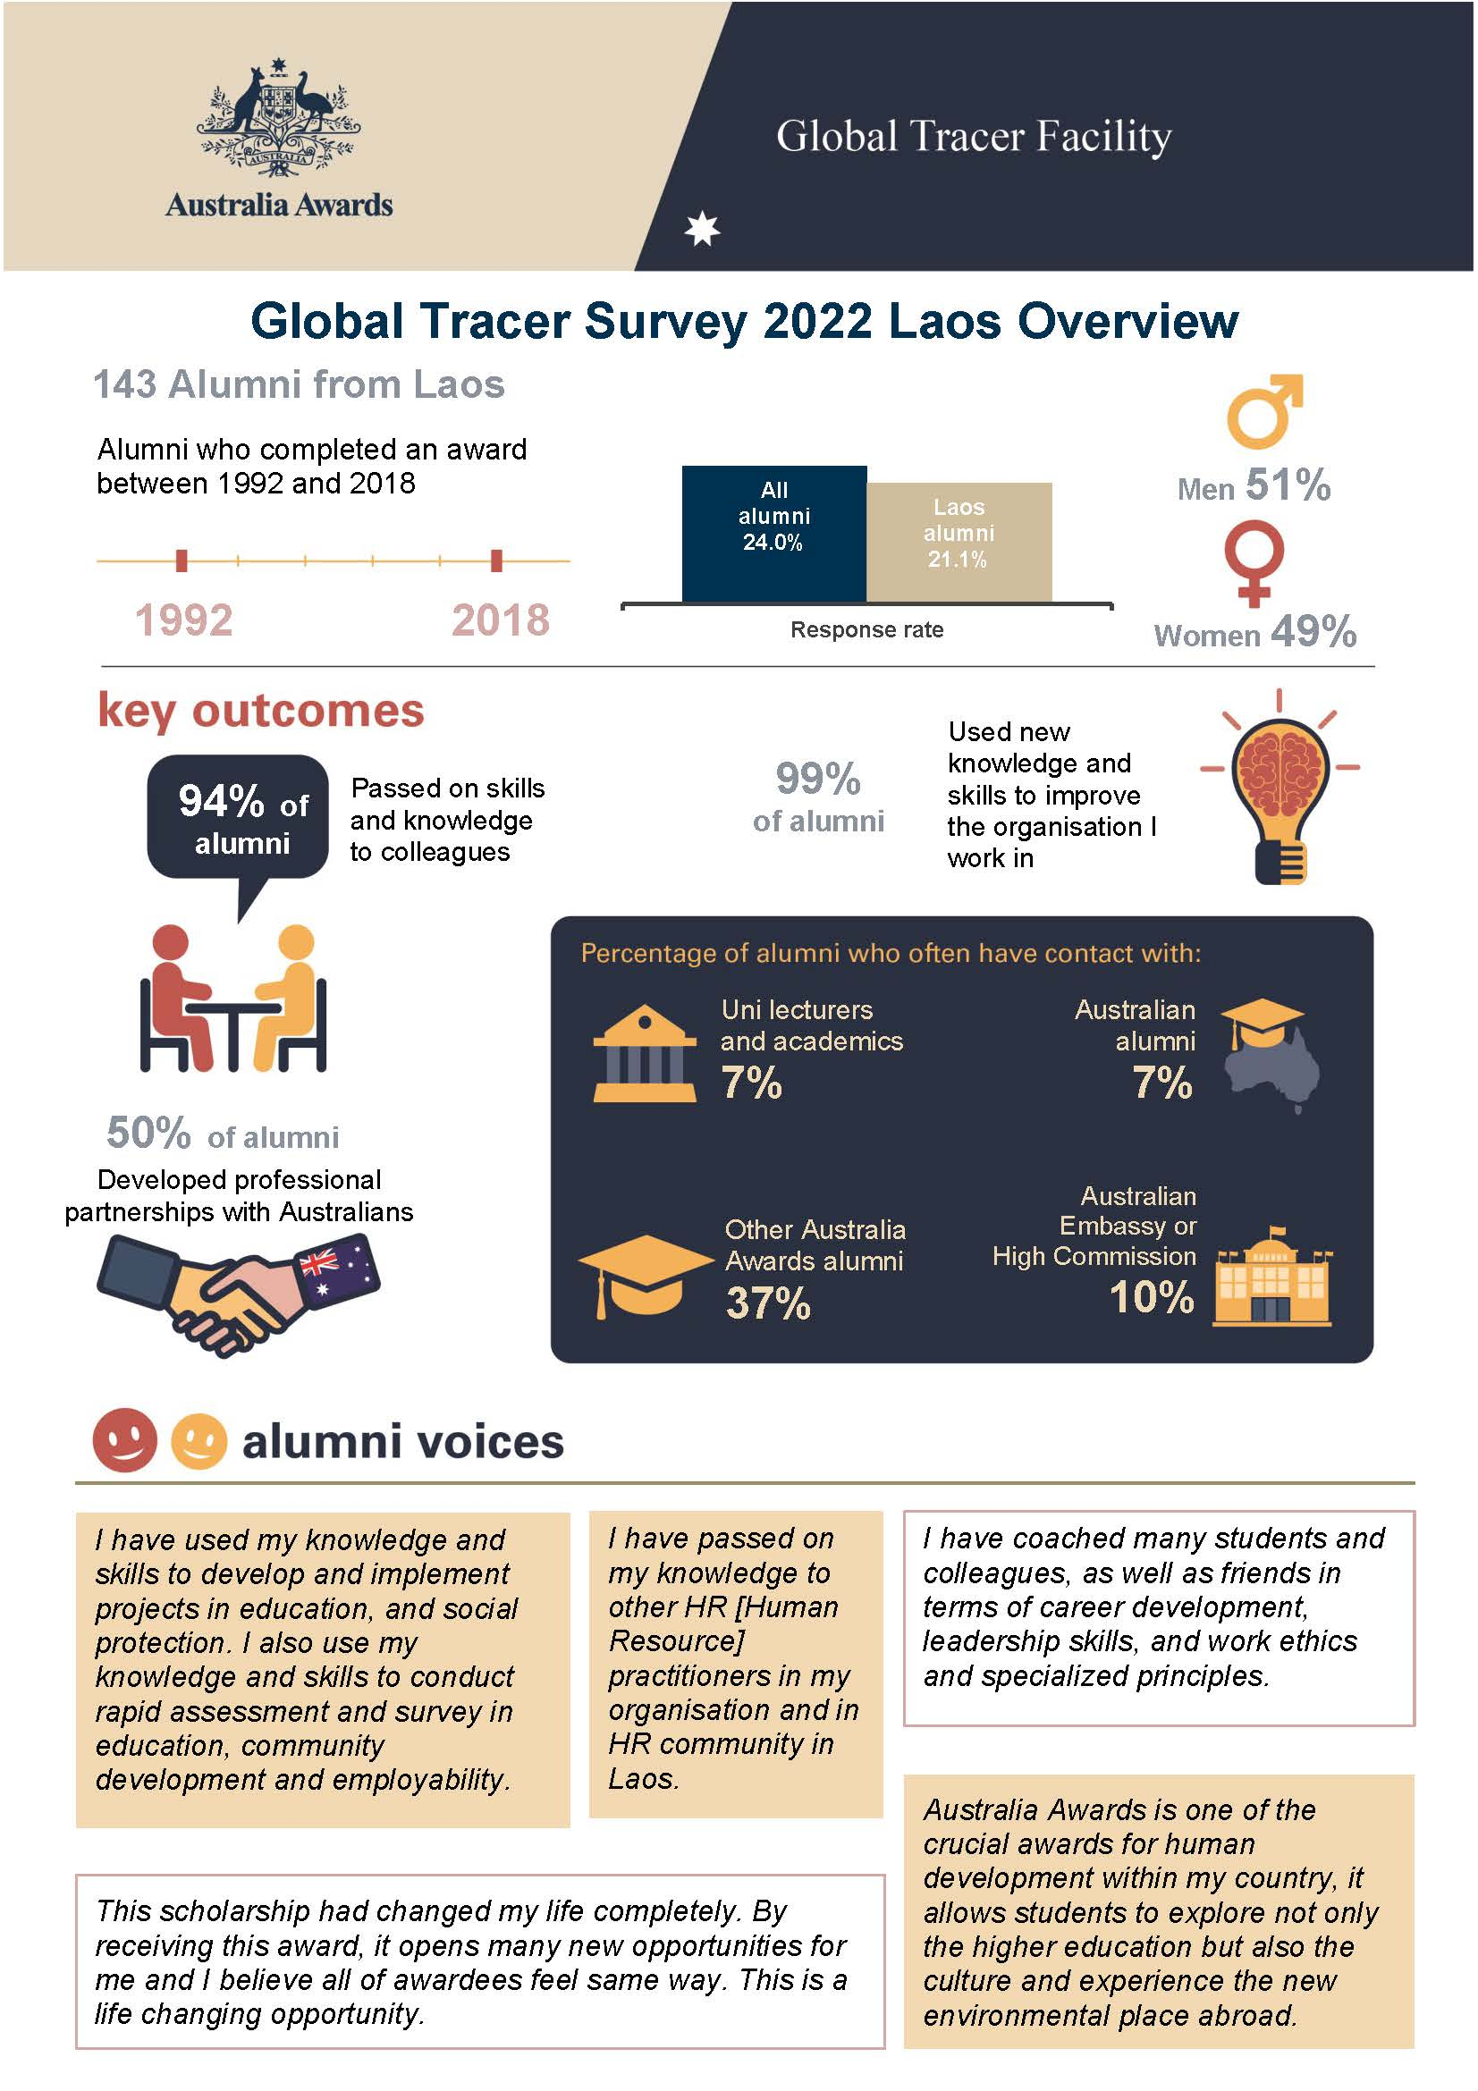

Table 1: Australia Awards Key Performance Target 3 *Influencing Development*, alumni from Laos and All alumni

|  |  | **LAO**  **Female**  **Count** | **LAO**  **Female**  **Column N %** | **LAO**  **Male**  **Count** | **LAO**  **Male**  **Column N %** | **LAO**  **Total**  **Count** | **LAO**  **Total**  **Column N %** | **Global**  **All Alumni**  **Count** | **Global**  **All Alumni**  **Column N %** |
| --- | --- | --- | --- | --- | --- | --- | --- | --- | --- |
| **Target 3.2**  As a result of my award I have used my new knowledge and skills to improve the organisation I work in | Strongly agree | 44 | 63.8% | 40 | 55.6% | 84 | 59.6% | 3134 | 63.2% |
| Agree | 25 | 36.2% | 30 | 41.7% | 55 | 39.0% | 1681 | 33.9% |
| Neither agree/Disagree | 0 | 0.0% | 2 | 2.8% | 2 | 1.4% | 125 | 2.5% |
| Disagree | 0 | 0.0% | 0 | 0.0% | 0 | 0.0% | 12 | 0.2% |
| Strongly disagree | 0 | 0.0% | 0 | 0.0% | 0 | 0.0% | 10 | 0.2% |
| **Target 3.2**  As a result of my award I have used my new knowledge and skills to contribute to improving local communities. | Strongly agree | 31 | 45.6% | 30 | 41.7% | 61 | 43.6% | 2251 | 46.4% |
| Agree | 29 | 42.6% | 36 | 50.0% | 65 | 46.4% | 2045 | 42.2% |
| Neither agree/Disagree | 8 | 11.8% | 5 | 6.9% | 13 | 9.3% | 485 | 10.0% |
| Disagree | 0 | 0.0% | 1 | 1.4% | 1 | 0.7% | 56 | 1.2% |
| Strongly disagree | 0 | 0.0% | 0 | 0.0% | 0 | 0.0% | 12 | 0.2% |
| **Target 3.2**  As a result of my award I have used my new knowledge and skills to make contributions to development at a national level in my country | Strongly agree | 35 | 51.5% | 34 | 47.2% | 69 | 49.3% | 2323 | 48.1% |
| Agree | 25 | 36.8% | 32 | 44.4% | 57 | 40.7% | 1905 | 39.4% |
| Neither agree/Disagree | 8 | 11.8% | 5 | 6.9% | 13 | 9.3% | 505 | 10.5% |
| Disagree | 0 | 0.0% | 1 | 1.4% | 1 | 0.7% | 83 | 1.7% |
| Strongly disagree | 0 | 0.0% | 0 | 0.0% | 0 | 0.0% | 15 | 0.3% |
| **Target 3.2**  As a result of my award I have used my new knowledge and skills to make contributions to development at a regional and/or global level | Strongly agree | 16 | 24.6% | 18 | 25.4% | 34 | 25.0% | 1585 | 33.7% |
| Agree | 33 | 50.8% | 30 | 42.3% | 63 | 46.3% | 1983 | 42.2% |
| Neither agree/Disagree | 14 | 21.5% | 19 | 26.8% | 33 | 24.3% | 925 | 19.7% |
| Disagree | 2 | 3.1% | 3 | 4.2% | 5 | 3.7% | 193 | 4.1% |
| Strongly disagree | 0 | 0.0% | 1 | 1.4% | 1 | 0.7% | 17 | 0.4% |
| **Target 3.3**  Describe an example of a contribution you have made through your current employment using the knowledge, skills and/or networks developed while on Award | Gave a response | 47 | 74.6% | 49 | 68.1% | 96 | 71.1% | 3771 | 79.8% |
| I have not yet done this | 0 | 0.0% | 1 | 1.4% | 1 | 0.7% | 164 | 3.5% |
| Prefer not to say | 16 | 25.4% | 22 | 30.6% | 38 | 28.1% | 791 | 16.7% |
| **Target 3.3**  Describe an example of a contribution you have made through volunteering in your community using the knowledge, skills and/or networks developed while on Award | Gave a response | 40 | 63.5% | 27 | 37.5% | 67 | 49.6% | 3009 | 63.7% |
| I have not yet done this | 9 | 14.3% | 11 | 15.3% | 20 | 14.8% | 683 | 14.5% |
| Prefer not to say | 14 | 22.2% | 34 | 47.2% | 48 | 35.6% | 1030 | 21.8% |

Table 2: Australia Awards Key Performance Targets 4 and 5 *Alumni networks and bilateral links*, alumni from Laos and All alumni

|  |  | **LAO**  **Female**  **Count** | **LAO**  **Female**  **Column N %** | **LAO**  **Male**  **Count** | **LAO**  **Male**  **Column N %** | **LAO**  **Total**  **Count** | **LAO**  **Total**  **Column N %** | **Global**  **All Alumni**  **Count** | **Global**  **All Alumni**  **Column N %** |
| --- | --- | --- | --- | --- | --- | --- | --- | --- | --- |
| **Target 4.1**  Since returning from award how often are you in contact with other Australia Awards students | Never | 2 | 3.3% | 7 | 10.1% | 9 | 7.0% | 275 | 6.4% |
| Sometimes | 33 | 55.0% | 39 | 56.5% | 72 | 55.8% | 2338 | 54.3% |
| Often | 21 | 35.0% | 18 | 26.1% | 39 | 30.2% | 1255 | 29.2% |
| Always | 4 | 6.7% | 5 | 7.2% | 9 | 7.0% | 435 | 10.1% |
| **Target 4.1**  Since returning from award how often are you in contact with an Australian / Australian Awards alumni association in your country | Never | 3 | 5.2% | 6 | 9.1% | 9 | 7.3% | 711 | 16.8% |
| Sometimes | 42 | 72.4% | 49 | 74.2% | 91 | 73.4% | 2312 | 54.7% |
| Often | 13 | 22.4% | 10 | 15.2% | 23 | 18.5% | 805 | 19.0% |
| Always | 0 | 0.0% | 1 | 1.5% | 1 | 0.8% | 401 | 9.5% |
| **Target 5.1**  Since returning from award how often are you in contact with Individuals in Australian businesses, professional associations and/or organisations working in your field | Never | 25 | 47.2% | 30 | 47.6% | 55 | 47.4% | 2051 | 50.9% |
| Sometimes | 22 | 41.5% | 23 | 36.5% | 45 | 38.8% | 1530 | 38.0% |
| Often | 6 | 11.3% | 8 | 12.7% | 14 | 12.1% | 358 | 8.9% |
| Always | 0 | 0.0% | 2 | 3.2% | 2 | 1.7% | 90 | 2.2% |
| **Target 5.1**  Since returning from award how often are you in contact with The Australian High Commission/Embassy/Consulate OR Australia Awards team in your country | Never | 17 | 30.9% | 19 | 29.7% | 36 | 30.3% | 1453 | 34.6% |
| Sometimes | 32 | 58.2% | 39 | 60.9% | 71 | 59.7% | 2196 | 52.3% |
| Often | 5 | 9.1% | 5 | 7.8% | 10 | 8.4% | 437 | 10.4% |
| Always | 1 | 1.8% | 1 | 1.6% | 2 | 1.7% | 109 | 2.6% |
| **Target 5.1**  Since returning from award how often are you in contact with Australians that you work with /alongside as part of your job | Never | 9 | 18.0% | 13 | 21.0% | 22 | 19.6% | 1558 | 39.8% |
| Sometimes | 25 | 50.0% | 35 | 56.5% | 60 | 53.6% | 1567 | 40.1% |
| Often | 11 | 22.0% | 11 | 17.7% | 22 | 19.6% | 548 | 14.0% |
| Always | 5 | 10.0% | 3 | 4.8% | 8 | 7.1% | 238 | 6.1% |
| **Target 5.2**  What is the important relationship/connection you developed as a result of your award? | Gave a response | 32 | 58.2% | 27 | 43.5% | 59 | 50.4% | 2691 | 69.9% |
| I have no relationship or connection | 2 | 3.6% | 6 | 9.7% | 8 | 6.8% | 365 | 9.5% |
| Prefer not to say | 21 | 38.2% | 29 | 46.8% | 50 | 42.7% | 794 | 20.6% |

**Table 3: Australia Awards Key Performance Target 6 *Women’s Leadership*, alumni from Laos and All alumni**

|  |  | **LAO**  **Female**  **Count** | **LAO**  **Female**  **Column N %** | **LAO**  **Male**  **Count** | **LAO**  **Male**  **Column N %** | **LAO**  **Total**  **Count** | **LAO**  **Total**  **Column N %** | **Global**  **All Alumni**  **Count** | **Global**  **All Alumni**  **Column N %** |
| --- | --- | --- | --- | --- | --- | --- | --- | --- | --- |
| **Target 6.4**  Do you hold a Leadership role within your current employment | I have a formal leadership role (e.g. manager, supervisor, executive) | 32 | 62.7% | 37 | 62.7% | 69 | 62.7% | 2635 | 68.7% |
| I have an informal leadership role (e.g. mentor) | 12 | 23.5% | 15 | 25.4% | 27 | 24.5% | 661 | 17.2% |
| I do NOT have a leadership role | 4 | 7.8% | 4 | 6.8% | 8 | 7.3% | 426 | 11.1% |
| Prefer not to say | 3 | 5.9% | 3 | 5.1% | 6 | 5.5% | 113 | 2.9% |
| **Target 6.4**  Do you hold a Leadership role within your community | Yes | 8 | 15.4% | 9 | 14.3% | 17 | 14.8% | 1077 | 26.0% |
| No | 39 | 75.0% | 45 | 71.4% | 84 | 73.0% | 2800 | 67.5% |
| Prefer not to say | 5 | 9.6% | 9 | 14.3% | 14 | 12.2% | 271 | 6.5% |

Table 4 Respondent characteristics, alumni from Laos and All alumni, GTF Global Tracer Survey, 2022

|  |  | **LAO**  **Count** | **LAO**  **Column N%** | **All Alumni**  **Count** | **All Alumni**  **Column N%** |
| --- | --- | --- | --- | --- | --- |
| Gender | Female | 70 | 49.0% | 2446 | 47.9% |
| Male | 73 | 51.0% | 2665 | 52.1% |
| Decade in which award was completed | 1980s | 0 | 0.0% | 4 | 0.1% |
| 1990s | 18 | 12.6% | 241 | 4.8% |
| 2000s | 52 | 36.4% | 1148 | 22.8% |
| 2010s | 73 | 51.0% | 3636 | 72.3% |
| Time spent in Australia on award | One month or less | 3 | 2.1% | 322 | 6.3% |
| More than 1 month, but less than 6 months | 7 | 4.9% | 250 | 4.9% |
| Between 6 and 11 months | 4 | 2.8% | 223 | 4.4% |
| One or two years | 79 | 55.2% | 3163 | 61.8% |
| More than two years | 50 | 35.0% | 1129 | 22.1% |
| Not Stated | 0 | 0.0% | 29 | 0.6% |
| Sector of alumni current employment | Private | 37 | 33.6% | 574 | 14.9% |
| Public/Government | 35 | 31.8% | 1747 | 45.3% |
| University/academia (public or private) | 8 | 7.3% | 842 | 21.9% |
| Non-government organisation | 7 | 6.4% | 350 | 9.1% |
| Multilateral organisation | 18 | 16.4% | 247 | 6.4% |
| Other | 4 | 3.6% | 70 | 1.8% |
| Prefer not to say | 1 | 0.9% | 23 | 0.6% |
| Leadership role within current employment | I have a formal leadership role (e.g. manager, supervisor, executive) | 69 | 62.7% | 2639 | 68.7% |
| I have an informal leadership role (e.g. mentor) | 27 | 24.5% | 662 | 17.2% |
| I do NOT have a leadership role | 8 | 7.3% | 426 | 11.1% |
| Prefer not to say | 6 | 5.5% | 113 | 2.9% |
| Leadership role within their community | Yes | 17 | 14.8% | 1078 | 26.0% |
| No | 84 | 73.0% | 2803 | 67.5% |
| Prefer not to say | 14 | 12.2% | 272 | 6.5% |

Table 5: Australia Awards Core Indicators

| **No** | **Global Performance Target** | **Country program core indicators** |
| --- | --- | --- |
| 1 | Country programs attract and select increasing proportions of diverse, eligible applicants, placing them in Awards that align with DFAT priority areas | 1.1 Number and percentage of Australia Awards allocated disaggregated by key diversity markers. |
| 1.2 Number and percentage of awardees who successfully complete an Australia Award course and obtain the course qualification. |
| 1.3 Number and percentage of total Australia Awards allocated to priority areas at a country level. |
| 2 | Country programs effectively promote the Australia Awards to vulnerable and minority groups, have demonstrated capacity and processes in place to support GEDSI inclusion, and strive to strengthen systems and practice if standards are not met. | 2.1 Number and percentage of people from vulnerable groups who apply for an Award each year vs percentage of people from each group receiving an Award each year. |
| 2.2 $ Investment in and number and representative lists of efforts undertaken by country programs that have or are expected to result in greater inclusion of vulnerable groups in the Australia Awards. |
| 2.3 Country rating for disability: ‘The investment identifies and addresses barriers to inclusion and opportunities for participation for people with disabilities to enable them to benefit equally from the aid investment’. |
| 3 | Australia Awards is an effective mechanism which contributes to an increasing number of alumni better equipped to influence development outcomes in their home countries across a diversity of sectors. | 3.1 Number and percentage of awardees who report satisfaction with their award. |
| 3.2 Number and percentage of alumni who report the usefulness of the Award in enabling them to contribute to development. |
| 3.3 Number and percentage of alumni able to provide valid examples of contributions to country objectives, using the skills, knowledge or networks gained from their award. |
| 4 | Country / regional programs build a bigger, stronger network of active alumni by creating meaningful opportunities for quality engagement that contributes to alumni advancement in their home country. | 4.1 Number and percentage of active alumni. |
| 4.2 Number and percentage of alumni who report that they have participated in valuable alumni activities. |
| 5 | Australia Awards and alumni engagement increasingly contribute to enduring relationships and mutual cooperation between Australia and the partner country. | 5.1 Number and percentage of alumni who have drawn on bilateral links, established through the Australia Awards. |
| 5.2 Number and percentage of alumni able to provide valid examples of participation in mutual collaborations between their country and Australia, after their completion of the Australia Award. |
| 6 | The Australia Awards contributes to a growing cohort of women leaders who are increasingly able to participate, influence and lead across a diversity of development sectors. | 6.1 Number and percentage of Australia Awards allocated to development sectors where women’s skills and participation are most needed in each country. |
| 6.2 Country rating for gender equality ‘The investment is making progress as expected in effectively implementing strategies to promote gender equality and women's empowerment’. |
| 6.3 Number and percentage of women who experience career advancement partially attributable to their participation in the Australia Awards. |
| 6.4 Number and percentage of women alumni able to provide examples of enhanced leadership or empowerment partially attributable to their participation in the Australia Awards. |

1. See <https://www.dfat.gov.au/sites/default/files/australia-awards-global-strategy.pdf> and <https://www.dfat.gov.au/sites/default/files/australia-awards-global-monitoring-evaluation-framework.pdf> for detailed information about the long-term outcomes.