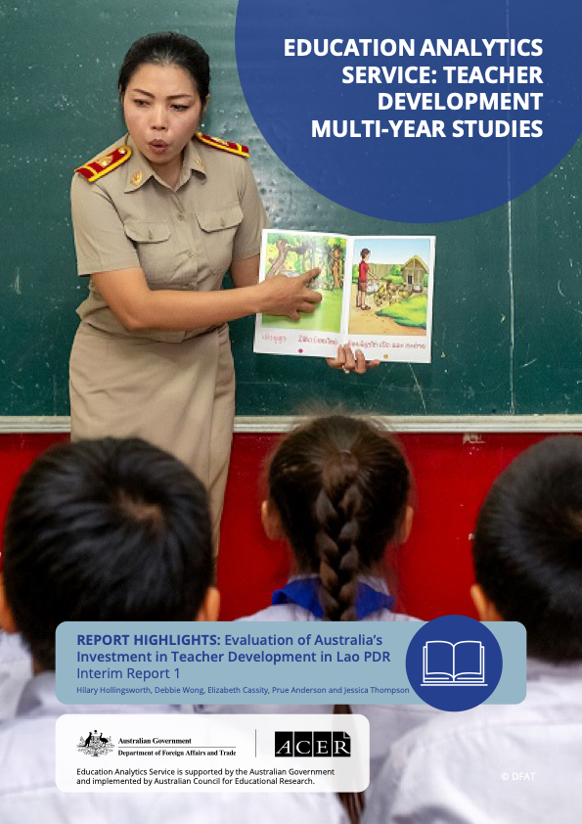

Introduction
The Government of Lao People’s Democratic Republic (Lao PDR) is undertaking significant primary education reforms, supported by the Australian Government’s Department of Foreign Affairs and Trade (DFAT) through its flagship Basic Education Quality and Access in Laos program (BEQUAL). The Australian Government has commissioned a study to investigate how the BEQUAL program is making a difference to improving teaching quality and student learning outcomes. This research is part of a multi- year study series undertaken by DFAT’s Education Analytics Service to investigate teacher and learning development initiatives in three countries: Lao PDR, Timor-Leste and Vanuatu.
In 2019, the new curriculum for Lao language and other subjects was introduced for Grade 1 (G1) and is being phased in across all five primary grades. The new curriculum promotes teaching practices that support pedagogies focused on student- centred approaches, active learning, assessment of student learning progress, and a phonics approach to teaching reading. Teachers are being provided with teacher guides and other teaching and learning resources, and receive face-to-face orientation on the new curriculum. In BEQUAL-targeted districts, education support grants are also available to facilitate additional in-service support for teachers and principals, such as participation in communities of practice and use of self-access learning tools.
This study has provided the opportunity to investigate teaching quality and student literacy outcomes in Lao PDR over two rounds of data collection, with another planned for October 2022.
The Baseline Report captured ‘state of play’ information in 2019 prior to major curriculum changes, as well as the onset of the COVID-19 pandemic. This summary provides an overview of findings and recommendations from the second year (2021) of the study, following two years of BEQUAL support for the implementation of the new G1 Lao language curriculum.

Methodology
The EAS Teacher Development Multi-Year Study for Lao PDR (the Study) seeks to answer the question:
To what extent does BEQUAL support improve teaching quality and student literacy in Lao PDR?
The two key questions are:
- To what extent and how does teaching quality change following BEQUAL-supported in-service program?
- To what extent and how do students’ literacy outcomes change following the new curriculum implementation?
The Study adopts a mixed methods approach using both quantitative and qualitative methods. The Study follows teachers and principals over three cycles of data collection while the new G1 Lao language curriculum is rolled out in the original 32 BEQUAL target districts – some of the country’s most disadvantaged districts. The table below provides a snapshot of the 2021 sample.
Quantitative:
- Surveyed 355 schools
- 345 principal questionnaires (21% female (F); 79% male (M))
- 363 G1 teacher questionnaires (54% F; 46% M)
3,120 G1 students (47% F; 53% M)
2,212 G1 students tested (51% F; 49% M)
Qualitative:
- Case studies in 12 schools
- 33 interviews with principals, G1 teachers and pedagogical advisers
- 30 classroom observations of G1 Lao language lessons

Summary of findings
Overall, the BEQUAL teacher development investment is making some positive contributions to improving teaching quality, but there is yet to be an impact on student learning outcomes.
The new curriculum requires significant change for teachers and more time and support is needed before teachers can comprehensively understand and incorporate these new approaches into their teaching practice. Changes to teaching quality are not yet substantial enough to impact student literacy outcomes.

Teaching quality
To what extent, and how, does teaching quality change following a BEQUAL-supported in-service program?
The 2021 results show that the majority (87%) of G1 teachers participated in the Ministry of Education and Sport (MoES)/BEQUAL new curriculum orientation. Overall, this BEQUAL-supported in- service program has strengthened aspects of G1 teachers’ knowledge, attitudes and practices in line with the new curriculum for Lao language. While it is possible that the extent of improvement in G1 teaching practices have been curbed by COVID-19 disruptions, these outcomes are in line with the expectations of BEQUAL, following 1 to 2 years of implementation. That is, teachers are becoming increasingly familiar with the new curriculum, are showing more confidence with using the resources, and are engaging more with curriculum support systems and resources. Nevertheless, reports from respondents and the concerning results of the G1 Lao language literacy test indicate teachers need much more professional learning support for Lao language.
To what extent do teachers’ knowledge, attitudes and practices change following the in-service program?
Two years following the introduction of the new G1 curriculum for Lao language, G1 teachers are reporting increased awareness of the new pedagogies, have broadened their range of teaching and learning activities and use of resources, and are engaging more with formative assessment methods as part of their Lao language teaching.
Notable positive changes between May 2019 and April 2021 that were perceived and reported by participants, or observed by researchers include:
- significantly increased awareness and confidence of student-centred teaching methods, with some limited improvement in understanding these methods
- high use of and reliance on the new teachers’ guides and textbooks for preparing lessons
- greater emphasis on active teaching and learning activities, including increased use of group and paired work (i.e. in addition to whole- class and individual activities), more activities such as story-telling, games, songs and drama, as well as use of a broader range of resources
- greater awareness and confidence about assessment methods, and some increased use of formative assessment practices in the classroom
- more consistency in hours spent teaching Lao language, but difficulties with having enough time to teach the Lao language curriculum each week remains.
Areas for further investigation in the final year of data collection relate to teachers’ use of strategies to support gender equality, high achieving students, and students with difficulties.
What factors enable or impede teachers aligning their practice to the new curriculum?
Respondents identified a number of factors enabling and impeding changes to teaching practice. The 2021 results show higher levels of participation in Lao language training, more engagement with communities of practice and self-access learning, and that teachers are receiving higher levels of technical support for their Lao language teaching from their colleagues. As an example, pedagogical adviser (PA) support has increased significantly in 2021.
While teachers appreciated and valued the orientation sessions, the new curriculum and its pedagogies represent a significant departure from the former curriculum. Teacher knowledge and experience of Lao language and understanding of the new curriculum were reported as a key challenge. Teachers noted they need more professional learning. Many respondents felt that the teaching methods were challenging, that the orientation was too short, and expressed the need for more professional learning, particularly on the Lao language curriculum, Lao language teaching methods, and teaching Lao to non-Lao speakers.
In terms of student factors, teachers reported that G1 students’ low Lao language skills, high levels of student absenteeism and limited parental support were key issues for teaching Lao language.

Student literacy outcomes
To what extent, and how, do students’ literacy outcomes change following the new curriculum implementation?
Results from the 2021 G1 student Lao language literacy test are concerning. While they indicate slight improvement in overall student performance after the introduction of the new G1 curriculum, this result needs to be considered with caution as less than one per cent of G1 students met the expectations of the new G1 Lao language curriculum. Consistent with 2019 results, nearly 25 per cent of G1 students tested in 2021 had very limited or no Lao language literacy skills for G1.
Notably, students found giving sounds extremely hard. Giving sounds for letters was introduced in the 2021 test, as a phonics approach represents a major shift in the new curriculum to teaching reading. The test data suggest that teachers are not yet able to effectively teach letter sounds.
There were regional variations in student performance. In both 2019 and 2021, Phongsali had the highest proportion of students in the low performing levels (48% in 2021), while Sekong had the highest proportion in the high performing levels (31% in 2021). This disparity has widened over this period.
While there were no gender differences in 2019, in 2021 female students performed better than male students, both overall and across half of the provinces (Sekong, Saravane and Savannakhet). This is particularly stark in Sekong, where there are twice as many high-performing female students than male students. The proportions of low-performing male students were similar in both years.
How does the new curriculum influence students’ attitudes and disposition towards learning?
Findings about students’ attitudes and dispositions towards learning emanated from teacher perception data and classroom observations focused on the classroom environment. The 2021 results indicate small positive shifts in enjoyment of Lao language lessons and more consistent classroom culture, teacher-student relationships and interactions.
Do changes in teaching quality correlate with changes in students’ literacy outcomes?
Data collected in 2021 showed that correlations between teaching practices and student performance were weak. This likely indicates that the early changes made by teachers to their practice are not yet substantial enough to impact student learning.
However, the 2021 results indicate certain student and teacher factors were associated with G1 student performance levels. Student factors that were positively associated with higher G1 test performance included students’ participation in kindergarten or pre-school, students’ home language if Lao-Tai, more exposure to stories and Lao language resources at home and in the community, higher family wealth, and lower absenteeism levels.
Teachers who were female, older, more experienced and had permanent teaching status tended to have students who performed better in G1 tests. Alignment between the student and teachers’ home language if Lao-Tai was also associated with stronger test performance. Unlike in 2019, more hours spent per week teaching Lao language were positively associated with higher G1 test performance in 2021.

Conclusions and recommendations
Key findings from the Baseline Report and this Interim Report 1 highlight the complex interface between context, curriculum and teaching, and the important role teachers and parents play in supporting children to transition to school, particularly given many are not prepared for G1. Recommendations for policymakers are:
- Focus on building students’ oral language skills in Lao language.
The 2021 Lao language literacy results suggest the standards of the new Lao language curriculum may be too high for the majority of G1 students. Many students have extremely limited oral language skills in Lao. More time is needed to teach students to speak and understand Lao language proficiently before they can start to learn to read and write in Lao. Students need the opportunity for intensive Lao language instruction and stimulation to improve their general cognitive abilities (short-term memory and executive function) before they are ready for the G1 curriculum. It is unlikely that the current offering of pre-school/kindergarten provides this focused support, and that a different program is required.
2. Embed ongoing professional learning for teachers, principals and PAs.
Although there are indications of improved teaching practices, teachers still find Lao language teaching to be difficult and this is evident in the poor student learning results. There is a need for ongoing professional learning and resources for teachers, principals and Pas to extend their knowledge and application of effective Lao language teaching strategies. In particular, teaching Lao to non-Lao speakers, how to engage with classes made up of diverse ethnicities and language groups, and a better understanding of phonics, needs to be an explicit focus of future training. Small, targeted and regular professional learning programs could build on and integrate the gains made so far in improving teaching practices. Providing PAs and principals with the opportunity and resources to establish new and strengthen existing communities of practice could be a more cost-effective measure than large-scale training programs.
3. Target interventions for the lowest performing students and boys.
Additional student and teacher interventions to support boys and the lowest performing students need to be considered. While this Study provides a starting point for understanding some of the key factors for low performance, further research into boys’ underperformance and the underperformance of students in Phongsali is recommended.
4. Advocate and educate parents and communities on the role they can play in promoting students’ readiness for school and the inclusion of children with disabilities.
Parents have a role to play in providing a stimulating environment for their children and developing early oral language skills, even in low-literacy contexts. Teachers and principals need advice on how to work with parents and communities to improve parental engagement in student learning, both at home and in schools. Teachers, principals, parents and carers also need to have the knowledge and skills on how to effectively support children with disabilities in both the school and in the home. A government- run advocacy campaign could complement this work.
To read the full Lao PDR Interim Report 1 please visit the DFAT website. *Where available, sex- disaggregated data is provided in the full report.
© 2022 The Commonwealth of Australia, represented by the Department of Foreign Affairs and Trade.
Recommended APA citation:
Hollingsworth, H., Wong, D., Cassity, E., Anderson, P., & Thompson, J. (2022).
Report Highlights: Evaluation of Australia’s investment in teacher development in Lao PDR: Interim Report 1. Australian Council for Educational Research.

