

Multi-factor Authentication (MFA)

NCP Online
Multi-factor authentication (MFA) checks to prove your identity when logging into a system. MFA is being implemented across all Government systems including NCP Online.
Use the email and password that was sent to you in your Application invitation email and click the ‘Log in’ button. Note that when you are prompted to renew your password the minimum password requirements are as follows:
Between 14 and 20 characters in length, will require at least 1 Uppercase, 1 lowercase, I numeric and 1 special character (!@#$%^&*<>,.?). When the username/password combination has been authenticated:

Authenticator App

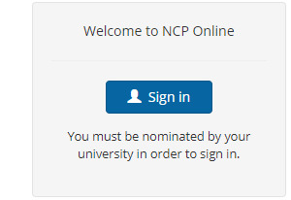

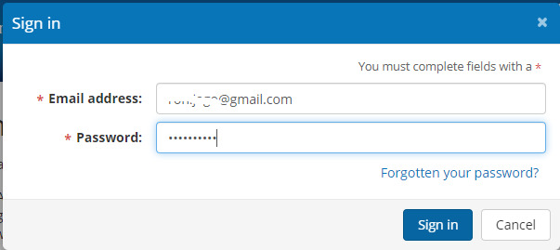
Click on the ‘Sign in’ button will take you to the home page and the pop up screen below will open:
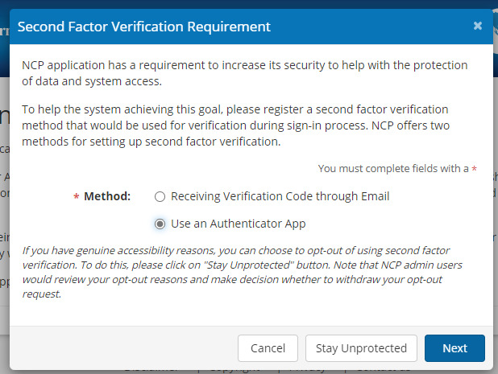
Authenticator app – this option requires you to download an authenticator app from the app store. Any authenticator app can be used. However, Google and Microsoft authenticators have been used extensively in testing. Once implemented you will need to open the app each time you log onto the system to get the current code and enter it into the system to gain full access.
Email – this option means that each time you log onto the system an email will be sent to your logon email address with a one-time code which you need to enter before getting full access.
If you choose: ‘Use an Authenticator App’ as the method and click ‘Next’. A screen with a QR code will be displayed. Open your authenticator app and add an account (this process varies between apps). Select the ‘scan QR code’ option. Once scanned you will see a code. Enter the code into the ‘Enter the code’ field and click the ‘Next’ button.
Note – codes are refreshed every 30 seconds. QR codes are generated for each individual account and scanning the one below will not work for any other user email/account.
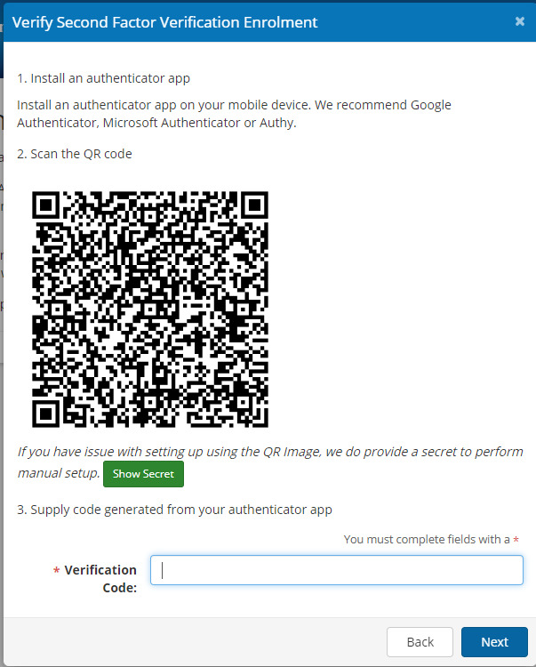

Email
If the email option is selected on the Second Factor Verification Requirement screen the following screen is displayed:
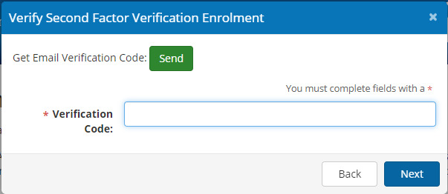
Click the Send button to generate an email to your email address:
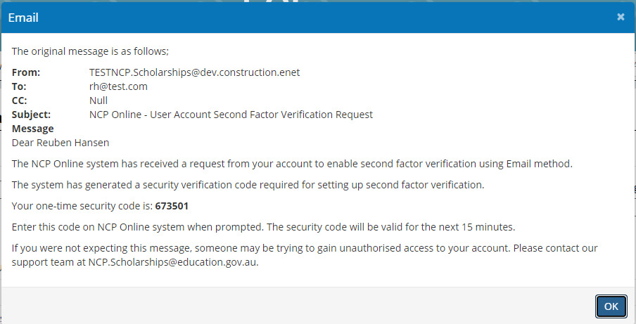
Enter the code into the verification Code field and click the ‘Next’ button.

Referee Report
This is similar to the Nomination logon:
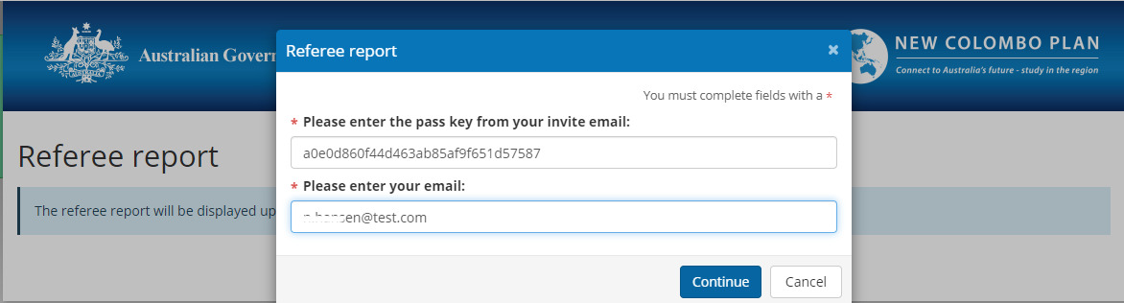
The referee will be required to enter the passkey supplied and the email address that the invitation was sent to. Once entered they need to click on the ‘Continue button to proceed.
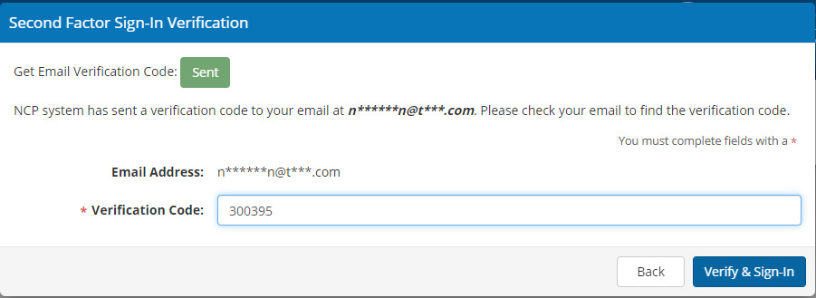
They will click on the ‘Send’ button to generate the email with the one time code. Once retrieved from the inbox it should be entered in Verification code field and click the ‘Verify & Sign in’ button to open the referee report.

