
New Colombo Plan Scholarship Program - 2024 Round

Application Guide
for nominees to complete the application form in NCP Online

This guide aims to assist nominees in submitting applications for the 2024 round of the New Colombo Plan (NCP) Scholarship Program using the NCP Online website. Please note that the screenshots below may show previous round information and should be considered as an example only.

You do not need to complete the application form in one session. You may save your work in each section and continue at a later time (prior to the closing date).

If you experience any technical issues using the nomination form or have any questions, please contact the NCP Secretariat at ncp.secretariat@dfat.gov.au.

Application Form – Home page

When the application period opens, nominees are sent an email with a link to the NCP Online website and a temporary password. Select the link and enter the password to log in to the NCP Online website. When you have logged in, you will be asked to log in using a Multi-factor Authentication (MFA) process.

Multi-factor authentication (MFA) checks to prove your identity when logging into a system. MFA is being implemented across all Government systems including NCP Online. Read a guide on how to log into NCP Online using MFA [PDF 957 KB].

Once you have logged into NCP Online, select the Edit button to open the application form.

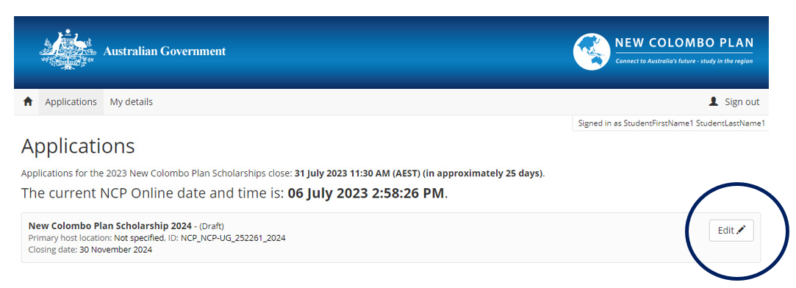

1. Introduction tab

The Introduction Tab holds important information to do with the current round including your applicant ID number, dates to be aware of and other useful round information.

To navigate your way through each screen, use the Previous and Next buttons located at the bottom left-hand side of each page or click on the section title located on the left-hand side of the screen. Only use the submit button once you have completed your sections in full and you are ready to formally submit your application.

As you move through your application and successfully complete each section, a tick will appear next to the section title on the left-hand side of the screen.

There is no action required for this section. Once you have read the information and you are ready to move to the next screen, click on the Next button.
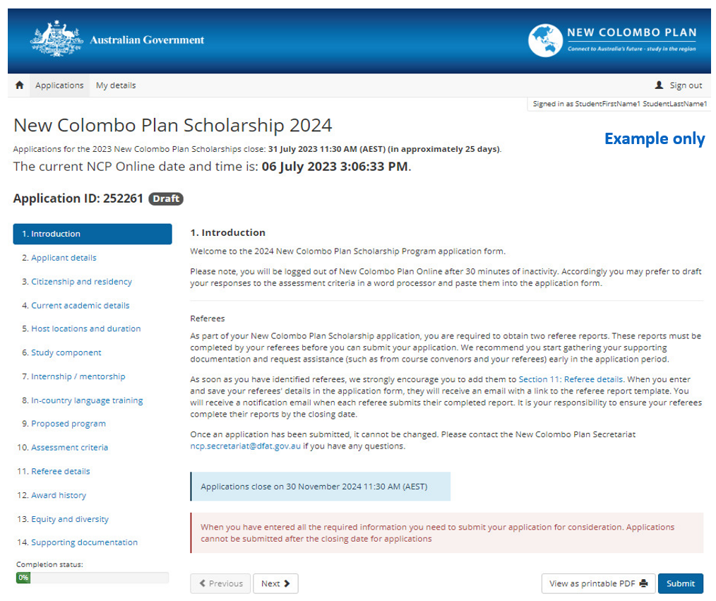

Please note that the screenshots provided may show the previous round’s information, including dates, and should be considered as an example only.

2. Applicant details tab

The Applicant details tab is where your personal information is located. Some information from your Nomination may appear. Please check that this information is correct – especially your email address, and that all information has been entered (including your address details) as this is how we will communicate with you.

To update the below Applicant details information, click on the Edit button, enter / update your details and click Save.

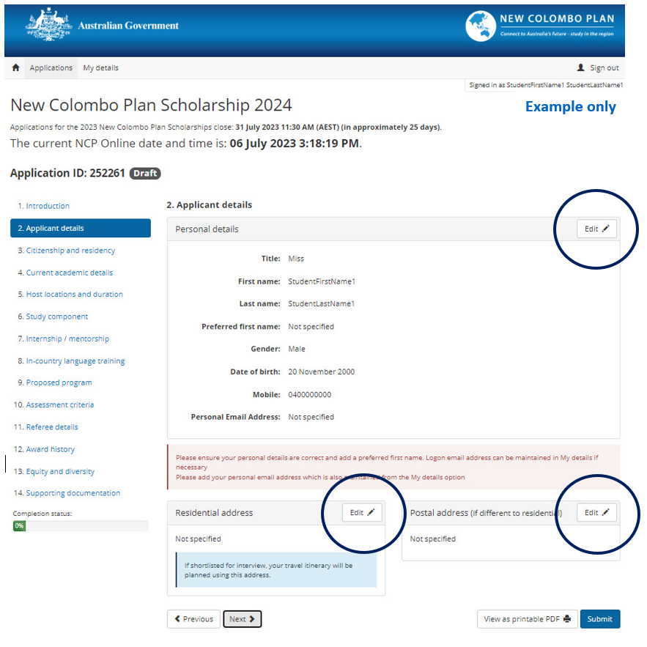

3. Citizenship and residency tab

The Citizenship and residency tab is where you advise us of your Citizenship / Residency status. This screen will default to the below and you will need to click on the Edit button to update your status information.

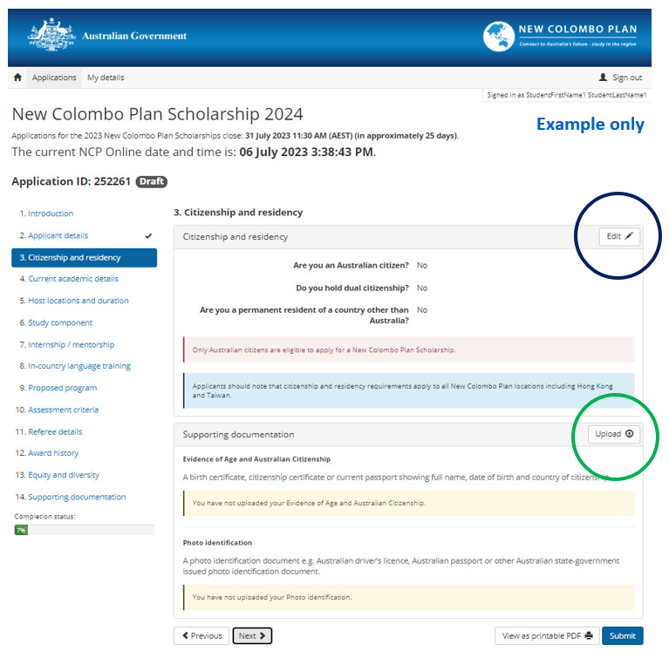
When you click Edit, the below popup box will open:

Answer each question with either a Yes or No and remember to click Save.

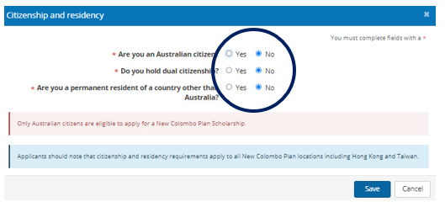

You will be returned to the citizenship and residency main page where you are required to upload your supporting documentation including evidence of age and Australian Citizenship and your Photo Identification.

To upload your supporting documentation, click on the upload button, use the dropdown arrow to select the document type, add the document via the Browse button then click on Upload.

Hint: If you have made a mistake, you can delete the document by clicking on the trash can next to the Document name and re upload the correct version up until you have submitted your application.

Note: All documents will be verified after applications have closed.

4. Current academic details tab

The Current Academic Details tab is where you enter your current University and Academic details. Once again, the screen will default to the below and you will need to click on the Edit button to update your status information.
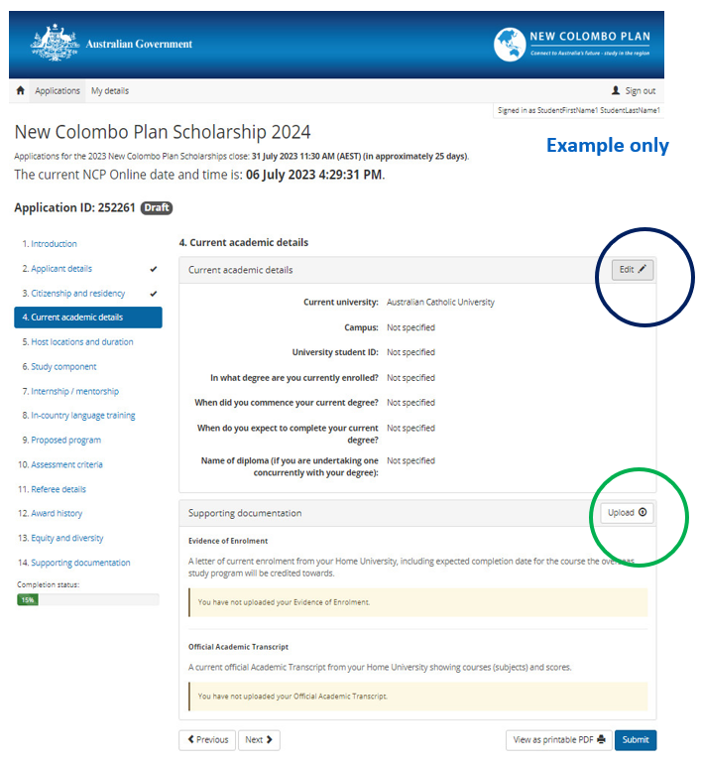

When you click Edit, the below popup box will open:
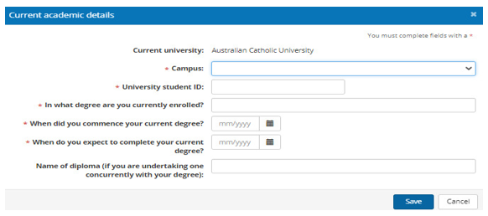

Update all fields with an *and once completed, click on Save.
You will be returned to the Current Academic Details main page where you are required to upload your supporting documentation including Evidence of Enrolment and an Official Academic Transcript.

To upload your supporting documentation, click on the upload button, use the dropdown arrow to select the document type, add the document via the Browse button then click on Upload.

Hint: If you have made a mistake, you can delete the document by clicking on the trash can next to the Document name and re upload the correct version up until you have submitted your application.

Note: All documents will be verified after applications have closed.

5. Host location and duration tab

The Host Location and Duration tab is where you let us know which location you are intending on studying your Scholarship. Click on the Add Host Location button to enter your selection.
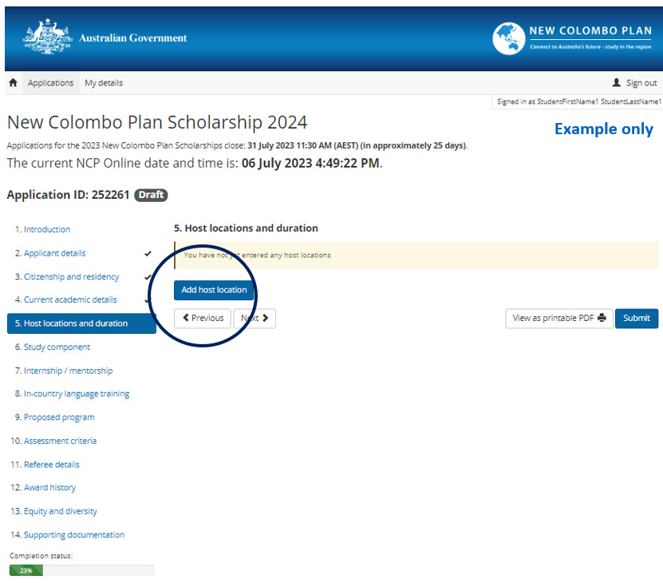

When you click on the Add Host Location button, the below popup box will open:

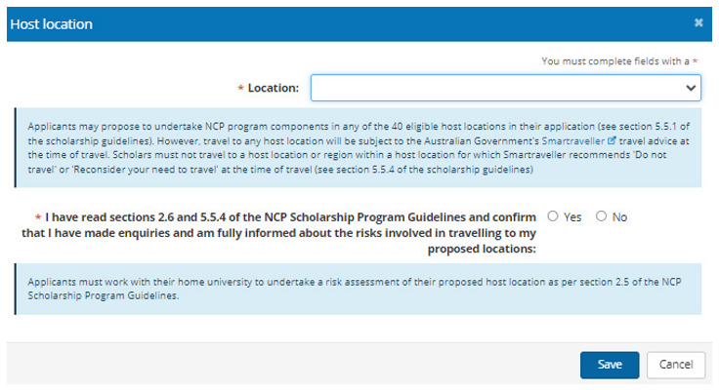
Select your Host Location by clicking on the drop-down arrow. Complete the confirmation question noted with an
* and when ready, click Save.

You will be returned to the Host Location and Duration tab and the Host Location you just selected is now displayed. The next step is to advise how long you will be studying at your Host Location University.

Click on the Add University Duration button to enter your duration.

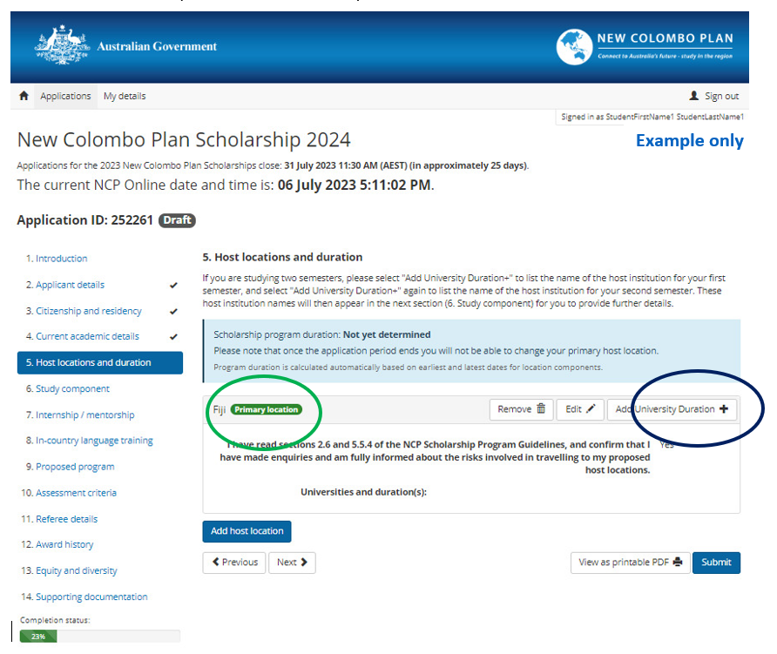

When you click on the Add University Duration button, the below popup box will open:
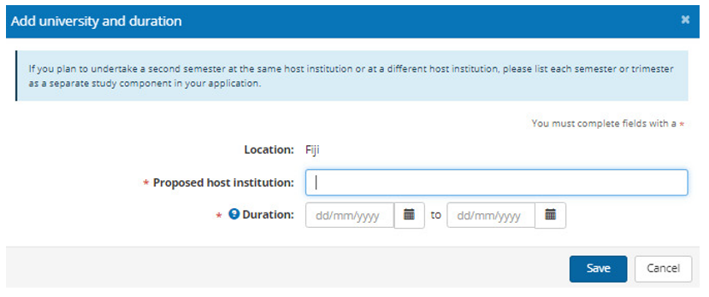

Enter the Proposed Host Location Institution and the start and end dates of your Study Component and click Save.

6. Study Component tab

The Study Component tab is where you advise what you will be studying while at your Host Location University. Click on Edit to complete your Study Component Information.
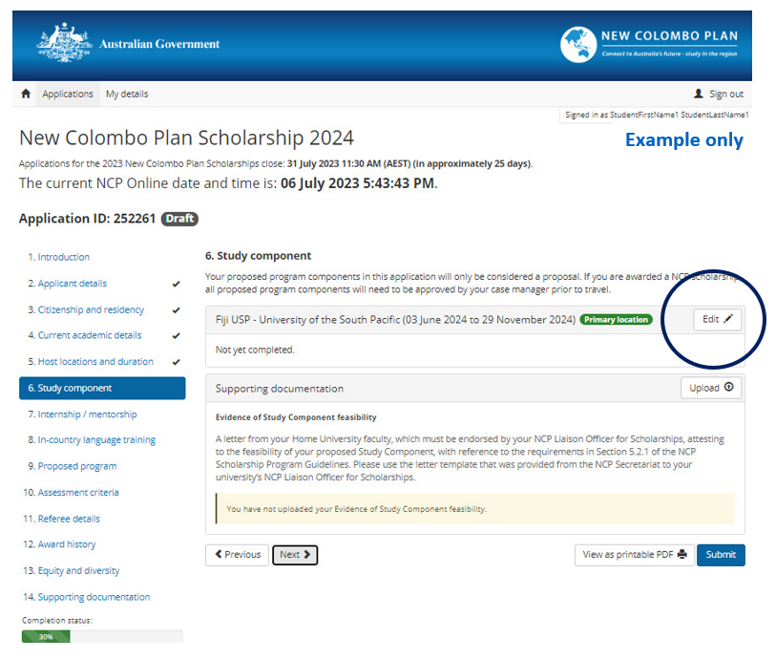
When you click on Edit, the below popup box will open:
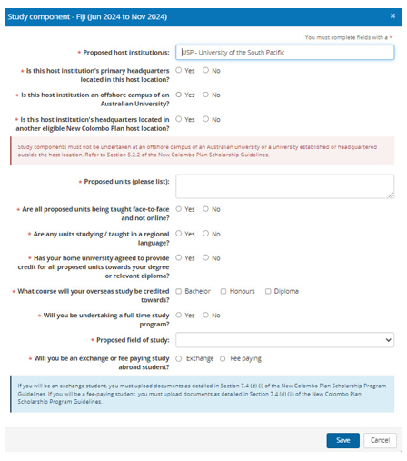
Completed all fields marked with an * (asterix)

If you answered, ‘yes’ to the question “Is this host institution an offshore campus of an Australian University?”, you will see the following screen, prompting you to upload the Host Institution Approval Request form.

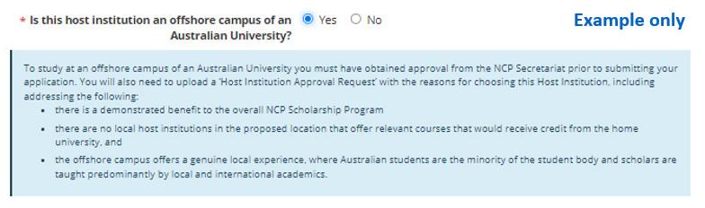
If you answered, ‘yes’ to the question “Is this host institution’s headquarters located in another eligible New Colombo Plan location?”, you will see the following screen, prompting you to upload the Host Institution Approval Request form.
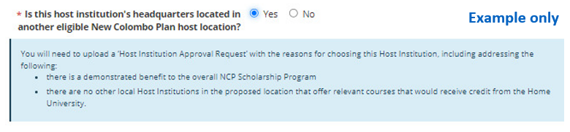
If you are an Honours student, you will see the following screen when you select the “Honours” checkbox:
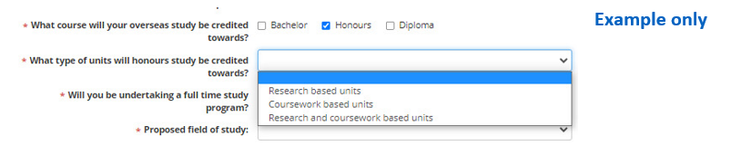
If you select “Research based units” or Research and Coursework base units in the question “What type of units will Honours study be credited towards?”, your additional questions will be presented depending on your selection.

Once all fields are completed you will be returned to the Study Component main page where you are required to upload the Study Component supporting documentation including Evidence of Study Component Feasibility from your home university endorsed by your NCP Liaison Officer and Fee-Paying arrangements (for full fee-paying applicants) or an exchange arrangement (for exchange applicants). 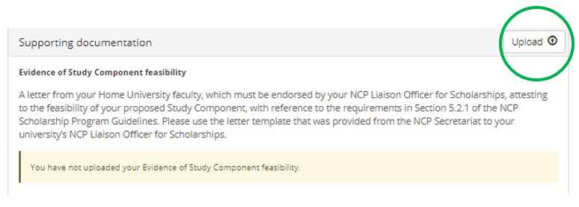
Click on the Upload button and select the Document Type then use the Browse button to upload your evidence.

Note: All documents will be verified after applications have closed

7. Internship/Mentorship tab
The Internship/Mentorship tab is where you add your proposed internship / mentorship component information. Click on the Add Internship / Mentorship button and complete your details. 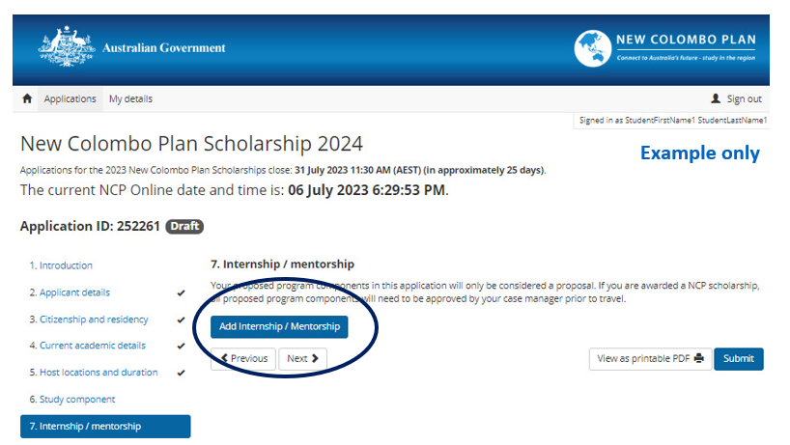

When you click on the Add Internship / Mentorship button, the below popup box will open:
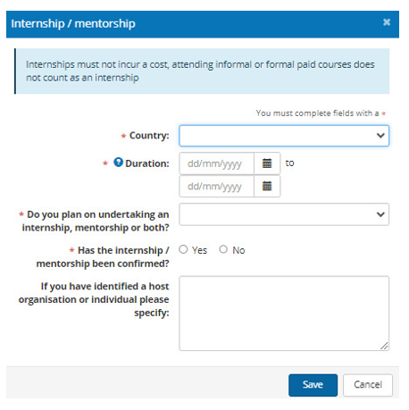
Complete all fields marked with an * and click Save once done.

8. In-country language training tab

The In-Country Language tab is for you to enter your proposed Language Training components. Click on the Add Language Training button and complete your language training details. When you click on the Add Language Training button, the below popup box will open:
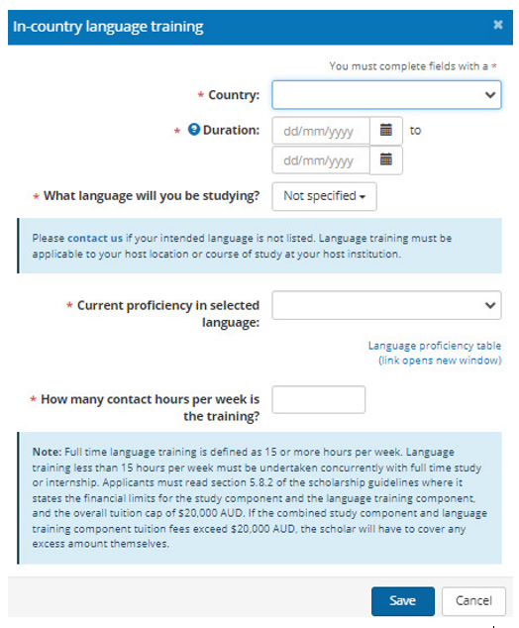
Complete all fields marked with an * and click Save once done.

9. Proposed program tab

The Proposed Program tab is an overview of your program components choices and how they relate to each other. To complete this section of your application, click on the Edit button. There is a 500-word limit.
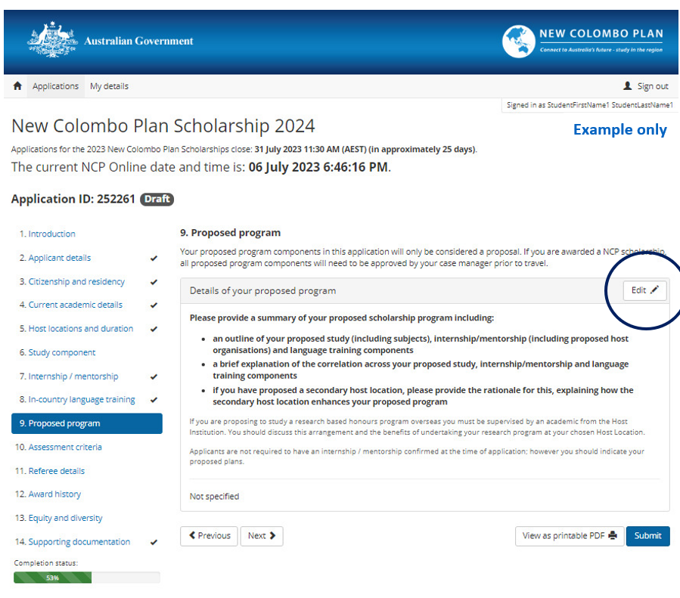

10. Assessment Criteria tab

There are four Assessment Criteria which you will be assessed against, and responses are limited to 300 words per criterion. Use the guidance below each criterion to assist in writing your response and your responses must be completely self-contained (that is, no hyperlinked or other material may be incorporated by reference).

Click on the Edit button for each criterion to write your response and remember to click Save once done.

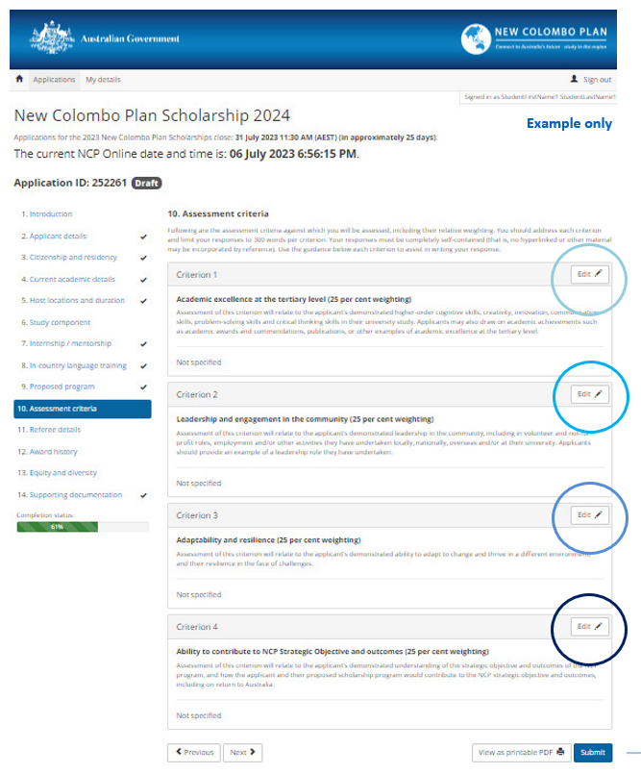

11. Referee details tab

As part of your application, you are required to obtain two referee reports (including one from an academic referee). These must be completed by your referees before you can submit your application. 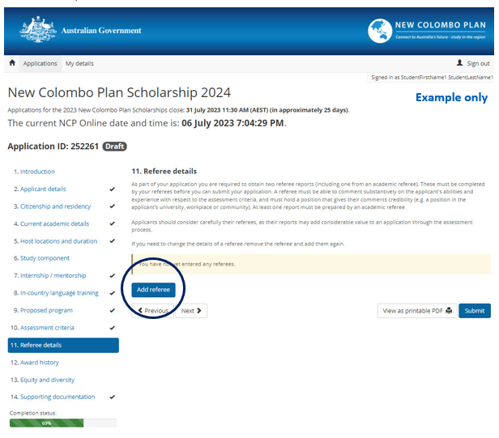

To add a referee, click on the Add referee TAB.

When you click on the Add Referee button, the below popup box will open:
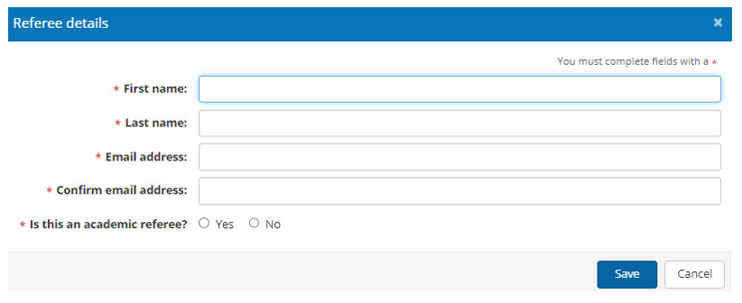When you have entered your referee’s details and selected Save, your referee will be emailed a link to complete a referee report. You will not be able to view your referee’s report on the system.

If you need to change the details of a referee remove the referee and add them again.

12. Award History tab

Please let us know if you have previously received an NCP Mobility Grant or applied for an NCP Scholarship by clicking Edit and answering the below questions. 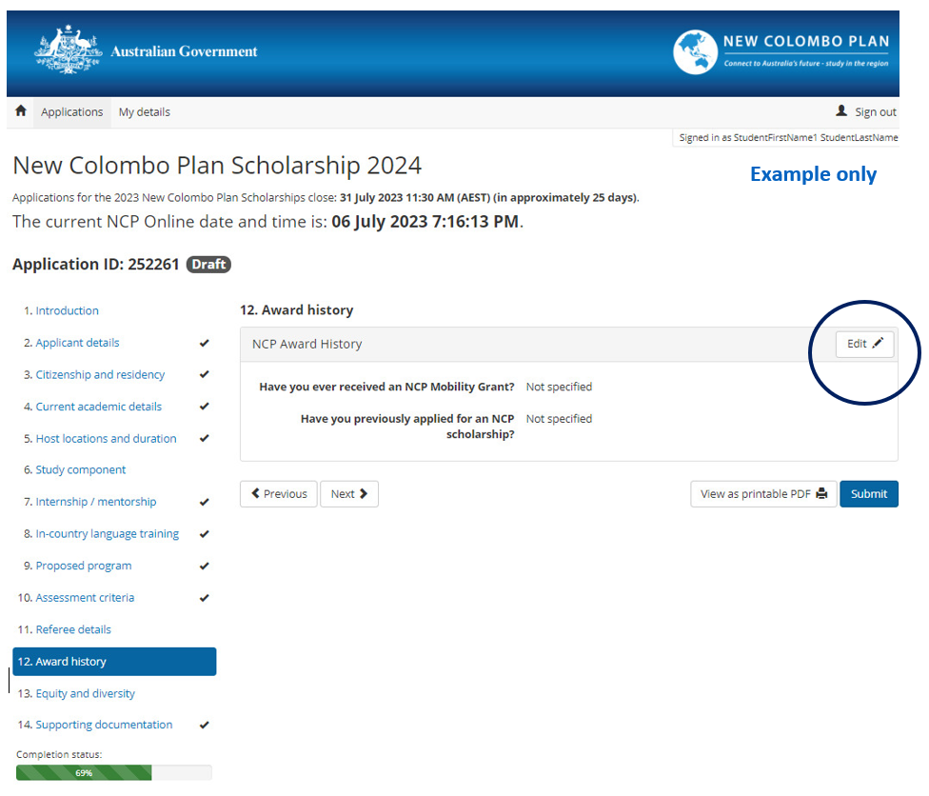

Note: Previous NCP scholarship applicants who were unsuccessful are welcome to apply again

13. Equity and diversity tab

The Equity and Diversity information is collected to ensure that the New Colombo Plan is equitable and reaching a broad spectrum of Australian undergraduates. It will be used solely for the purposes of administering and performance monitoring of the New Colombo Plan, and only disclosed in a de-identifiable manner for the same purposes, unless otherwise permitted by Australian law. It will not be used or disclosed for the purposes of assessing applications. The information collected in this section will be managed in accordance with the Privacy section of the New Colombo Plan Scholarship Program Guidelines.

To enter your responses, click on Edit and remember to click Save once done.
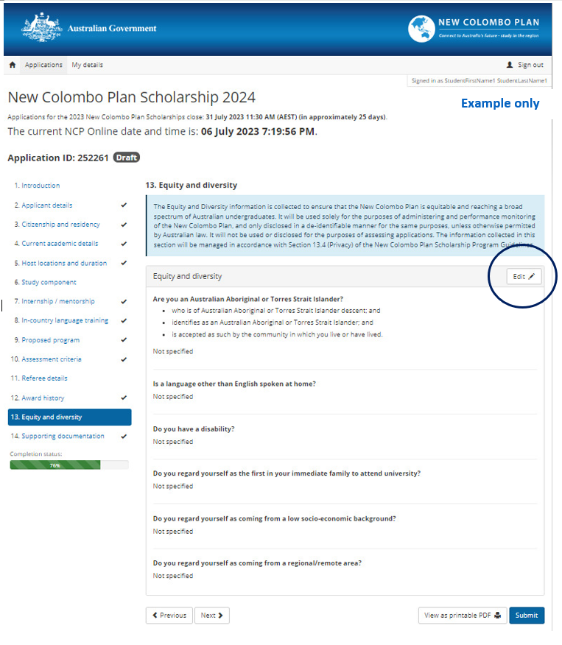

14. Supporting documentation tab

This tab is a list of the required supporting documents. They can be uploaded in the relevant section or in this final section. 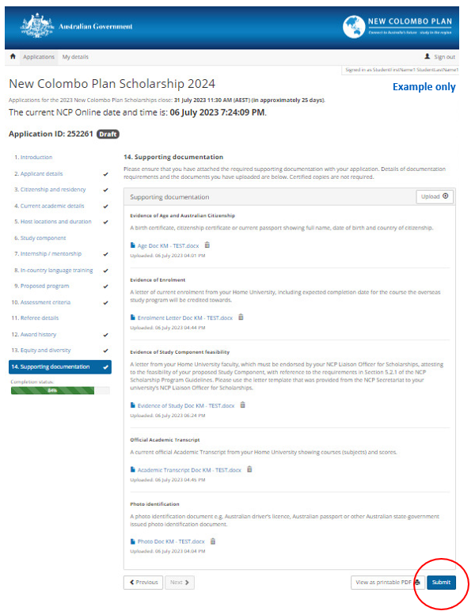
When you have completed all sections of the application form, select Submit.

