AUStralian trade and development business network, ADELAIDE

Submission to the Development Policy Review

**briefing paper for DFAT POLICY REVIEW, 2022**

Jim Redden, Executive Officer,

Australian Trade and Development Business Network

Senior Economist and Lecturer

Institute for International Trade

University of Adelaide

[james.redden@adelaide.edu.au](mailto:james.redden@adelaide.edu.au)

DECEMBER 2022

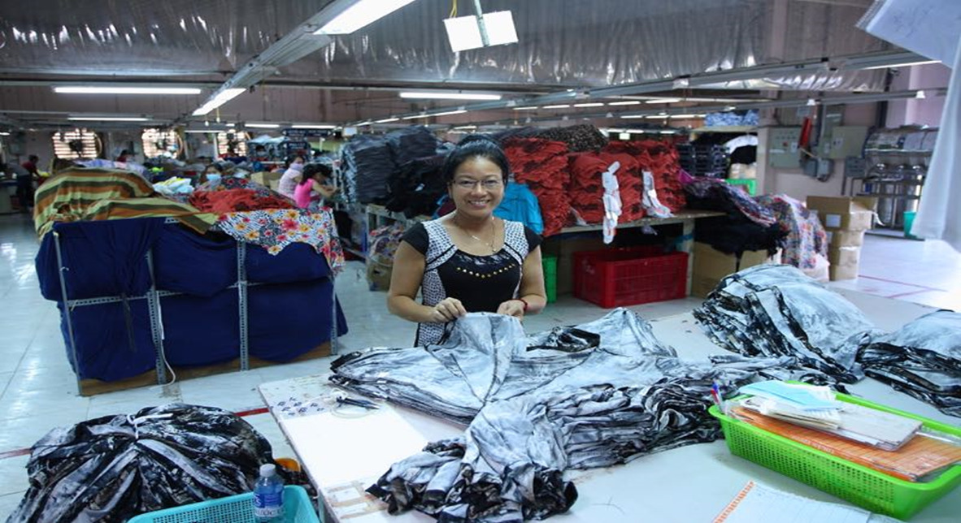

# Introduction

This policy brief is based on the knowledge and experience of private sector businesses and academics involved with the Australian Trade and Development Business Network (ATAB) and in particular with the Institute for International Trade at Adelaide University – people who are either concerned with or deeply involved in the delivery of aid, trade or sustainable development programs.

It is intended to serve as background information on policy areas of relevance to Australia’s Development Policy Review Team in their deliberations on policy issues and priorities in development aid.

It embraces some wider considerations of Australia’s commitment to the Sustainable Development Goals (SDGs), and strategies for communicating development to the general public in support of Australia’s international development objectives.

Based on initial discussions during the briefing session in Adelaide, the following areas of Australia’s development assistance program are examined.

* The Pacific Region
* Engaging the Private Sector
* Aid for Trade
* The SDGs. Aid, Governance and Africa
* Communicating Development to the Public

Each section will identify some of the key issues and opportunities. It needs to be noted that this is an overview and aims to be relatively short and succinct. It is acknowledged that each of these policy areas could warrant more much detailed analysis and discussion.

Please note that this policy brief and the issues and suggestions put forward are not those of any one particular organisation, company or individual but represent the collective experience and learnings of the membership of ATAB. ATAB members include San Remo, ANZ Bank, Beach Energy, Scope Global/Palladium, DT Global, the Institute for International Trade, the University of Adelaide and Flinders University.

# 2. The Pacific Region

## **2.1 Background**

ATAB acknowledges the following as areas of importance in the engagement of the Australian aid program in the Pacific Island region and recognises the need for an integrated approach to these policy matters.

* Social infrastructure
  + Health and Education
  + Good Governance
  + Social inclusion – Gender and Disability issues
  + Disaster preparedness
* Economic Development and Trade
  + The regional economy and economic development
  + Trade connectivity and aid for trade
  + Labour mobility
  + Hard infrastructure
* Geo-Political
  + Regional Security
  + Increased Chinese investment and foreign policy interest
* Climate change and Environmental Sustainability

The following explores some key priorities for Australia in these areas so as to develop stronger regional engagement and contribute to sustainable development in the Pacific region at a practical level.

## **2.2 Soft Infrastructure vs Hard Infrastructure**

**Issues**

There is a trend in current government policy, to focus more on hard infrastructure financing away for spending and initiatives in support of social programs or soft infrastructure issues.

The Australian Infrastructure Financing Facility for the Pacific has been well established as a $2 billion plus infrastructure initiative, and is supported by an extra $1 billion in capital to EFIC, Australia’s export financing agency.

While there is no argument about the hard infrastructure needs of Pacific Island Countries (PICs) and the potential link between infrastructure development and poverty alleviation when well delivered in a socially inclusive manner (ie employing locals, ensuring gender analysis in the design and impact of the infrastructure), there are questions as to whether this is the best use of Australia’s limited aid funds, given the current limit of approximately $4.5 billion.

ATAB concerns are on two counts. One, there are concerns about the potential depletion of limited aid funds away from Australia’s acknowledged expertise in the delivery of social, health, education, vocational, employment and governance programs across the Pacific region. A diversion of funds in this way would seem to undermine our long-term investments in and Australia’s standing as a donor with expertise in people to people, human development and business skills programs.

Secondly, Australia can do more to strategically leverage the use of our limited funds in this area, not only by channelling our limited funds through regional and multilateral organisations such as the ADB, but also by working collaboratively with those bilateral donors whose prime focus is on the delivery of hard infrastructure. Such donors include Japan, Taiwan, Germany and China for example. Australia cannot compete with the much larger aid spend on hard infrastructure of countries like China and Japan but we can work strategically in cooperation with them to nuance the delivery of programs to ensure social inclusion and good governance components.

For example, Australia has put $25 million into a major World Bank (WB) trade connectivity and infrastructure program across South Asia. The WB has a multi-billion dollar fund based on contributions from a range of donors globally. Australia’s role has been to provide expertise on how the roads, waterways and bridges etc are designed and implemented in a way that takes full account of the needs of the poorest, of SMEs who trade along these routes and of the needs of women in the informal sector and women traders. That aid for trade program was particularly effective and wound up in 2020.

With regards to China’s aid program, rather than competing, Australia has fine examples already of close cooperation with the Chinese aid program for example in the provision of anti-malarial programs to PNG, where Australia provided much of its knowledge and expertise in knowing the right people, institutional and cultural processes for the program to be successful while China provided the materials and medical expertise. Rather than treating China as a development rival in the region, ATAB believes we need to be sending a clear message of our desire to work together and share expertise in the delivery of both hard and soft infrastructure programs. ATAB strongly supports the Foreign Minister’s attempts to encourage this improved relationship.

**Opportunity/Recommendations – Soft v Hard Infrastructure**

The current Review should therefore consider the following:

1. **Reinforce the people to people, human development and business skills focus of Australian aid in general and to the Pacific in line with our expertise and either maintain or boost current expenditure on social, health, educational, vocational and SME/aid for trade programs. (more on Aid for Trade later)**
2. **Limit Australian funding to the Pacific Infrastructure Facility and direct it to work with DFAT in the strategic leveraging of funds from other bilateral, regional and multilateral donors whereby Australia while contributing some finance to the hard infrastructure, will focus primarily on soft infrastructure issues ensuring connectivity to the needs of the poor.**
3. **Seek to announce a new program of regional cooperation across the Pacific in support of the SDGs and a more integrated approach which combines hard and soft infrastructure programs. Programs of regional and strategic cooperation could then be negotiated with other regional partners including Japan, Taiwan and South Korea.**

## **2.3 Economic Development and Trade**

Labour Mobility

**Issues**

Labour mobility schemes between Australia and the Pacific have to date demonstrated some real benefits to both the Australia economy and to Pacific Islanders.

The current Australian Government is committed to Pacific labour mobility through the Pacific Australia Labour Mobility (PALM) program which now includes the Seasonal Worker Program, as a means to foster economic growth and development for Pacific people while providing benefit to Australian business in rural and regional Australia, where it is clear and demonstrated that no Australian workers are available.

Reasonably strict labour-market testing and compliance is built into all Pacific labour initiatives to try and ensure that no Australians are disadvantaged by these initiatives, although such initiatives need to be closely checked and monitored. That said, the public diplomacy impact of Pacific labour mobility is very high and works on multiple levels as foreign policy linkages between Australia and our neighbours are strengthened.

The benefits from Pacific labour initiatives are multiple and cascading:

* Individual Pacific workers earn relatively high wages, much of which are remitted to their home countries, often for their children’s education, businesses and/or improved housing
* Families and businesses in home countries receive a crucial source of capital which they then invest in their local communities, reducing dependency on aid and government assistance
* Program participants return to their home countries with an enhanced skill set and invaluable experience which they can then apply to their own businesses and places of employment
* Australian employers that are unable to attract local staff to seasonal/rural/low-skill work benefit from a motivated and dedicated workforce.
* Strong people-to-people links are established between program participants and Australian employers and some communities.

The benefits of labour mobility for PICs is highly valued and was the main issue for Pacific negotiators during the PACER Plus trade negotiations over the last 10 years. Particularly vulnerable micro states such as Kiribati are benefitting significantly from both Australian and New Zealand labour mobility programs. Other Small Island States such as Tonga, Samoa and Vanuatu rely significantly on labour sending programs, so long as they manage the balance of labour needed at home with the needs of Australia and NZ.

On a separate matter, the Australian Pacific Labour Scheme also has scope to be further developed by way of a two-way program which would include skilled Australian workers going to Pacific Islands to assist in areas of need. Initial observations indicate opportunities exist in areas such as engineering and architecture, marine biology, technicians to help adapt to climate change, accountants and finance management, agricultural and horticultural expertise, ICT experts and in various areas of teaching both at a vocational and tertiary level.

The Pacific Technical Assistance Mechanism (PACTAM) already promotes the placement of Australian technical expertise, but this role could be enhanced to also include everything from voluntary position to positions paid by Pacific governments and regional or multilateral organisations and would complement the aims of PACER Plus.

A stronger two-way labour mobility program has the potential to contribute to broader regional cohesion by developing significant person to person and organisation to organisation relationships. Together with scholarship programs such as the Australia Awards, and business relationships already developed, there are opportunities to build practical personal, professional, organisational and economic linkages and exchanges throughout the region.

The two-way mobility is sanctioned in the PACER Plus trade and development agreement, though the Arrangement on Labour Mobility. There is also a chapter on the movement of people (semi to high skilled) across the region as well as a MOU on the temporary mobility of low to unskilled workers. Those Pacific leaders concerned about brain drain out of their own countries would welcome a greater commitment from Australia to deliver some of our technical expertise into the region.

**Opportunity/Recommendations: Labour Mobility**

The Review might consider therefore, three options in the labour mobility sector.

1. **Firstly it is recommended that Labor support the maintenance of, and in specific sectors, the expansion of the PALM for Pacific Island workers.**
2. **That government enhances PALM to promote Australian expertise and skills in contributing to the development of the region by addressing those areas of skills shortage in the Pacific.**

## **2.4 Geo-Political: Regional Security**

**Issues**

Australia operates in a contested and competitive global environment. As outlined in the 2017 Foreign Policy White Paper, we operate in an increasingly contested and competitive global environment, with new and influential development partners. There is a clear opportunity for Australian Government aid investments to operate as important trust-building mechanisms between Pacific Island governments and Australia.

Our experience on the ground in delivering bilateral aid investments has seen a sense of ownership on the part of Pacific partners, positioning Australia – through sector reform programs for example – to increase its influencing agenda around government co-investment and long-term sustainability.

ATAB strongly supports remarks made at a recent address to Adelaide University by Senator Wong stating “We need a sophisticated and consistent approach to managing differences, while working together where we can. And we need to deal with China on the basis of respect, not fear.”

As already discussed, ATAB therefore believes closer cooperation with China in the design and delivery of the China aid program to the Pacific region would be appropriate and both welcomed by the Chinese authorities and in Australia’s national interest. No doubt, our existing cordial relations with Taiwan would need to be carefully managed given their important connections with 8 Pacific Island countries where they have embassies.

In terms of other regional security issues in the Pacific region, ATAB would highlight the following recent developments:

* The security and stability of the Pacific is fundamental to Australia’s national interests, as identified in the 2017 Foreign Policy White Paper
* The ‘Step up’ approach in the Pacific commits Australia to a more intense, supportive and ambitious role in the region across various sectors, including security. The basis of this step up in the area of security is the Australia Pacific Security College (APSC), an Australian Government initiative,
* As noted in the 2016 Defence White Paper, there has been a commitment over recent years by Pacific island countries to collaborate so as to better address shared challenges
* A range of measures to enhance Australia’s engagement in the Pacific were identified at the 48th Pacific Islands Forum (PIF) Leaders’ Meeting in Apia, Samoa in 2017. This included a commitment to build on the Biketawa Declaration (2000), recognising the increasingly complex regional security environment
* It was agreed to aim to strengthen regional security cooperation in the Pacific and increases the region’s capacity to manage shared security threats.
* Agreed to expand the concept of ‘security’ under the adoption of Biketawa Plus (now called the Boe Declaration) to include human security, humanitarian assistance, environmental security, and regional cooperation in building resilience to disasters and climate change, including through regional cooperation and support
* The Forum Leaders endorsed the Boe Declaration on regional security at the 2018 Leaders Forum in Nauru, September 2018
* The Forum Secretariat has been tasked to draw up an implementation plan to support the Boe Declaration by November 2018 (still underway)

Australia’s role in regional engagement is guided by domestic policy and is sometimes contentious. While issues such as climate change and governance can be divisive, there are none the less opportunities for Australia to provide more technical engagement where issues of common interest can be identified. This can be achieved practically at an operational level by pursuing opportunities to provide technical advisers and linkages between government agencies.

In addition to pursuing close cooperative ties with China in the Pacific, there is ample room for increased collaboration with other donors, including with DFID (where the UK are opening an addition 3 embassies in the region), with France, Germany and the EU generally as well as with Asian aid donors including Japan, Taiwan and Korea.

**Opportunities/Recommendations: Geo-Political**

So consistent with our proposal under the sharing of skills in terms of more open labour mobility, ATAB would suggest the following for Labor:

1. **Provide more technical engagement where issues of common interest can be identified with Pacific Island Governments**
2. **Develop stronger linkages between government agencies in Australia and the Pacific**
3. **Develop closer cooperation with China in the design and delivery of China’s aid program to the Pacific region while also developing closer links with the European and other Asia aid donor governments working in the Pacific.**

## **2.5 Private Sector Development in the Pacific**

It is acknowledged that Australia’s efforts to provide support to the development of the private sector in the Pacific has met with mixed results. Challenges have included small limited local markets, stringent and at times insurmountable requirements for access to international markets, and complex social and cultural contexts. However, there have been some significant successes within the following projects:

* The Enterprise Challenge Fund, where contestable grants were put on offer to innovative businesses in the Pacific, based on co-contributions. The current PACER Plus Implementation Unit is looking to build on such grant based schemes working in with Pacific Trade and Invest
* The Pacific Horticultural and Agricultural Market Access (PHAMA) Program is a multi-country program that was designed as a trade facilitation program to assist PICs to achieve increased market access for agricultural and horticultural products and has achieved good results across its target countries including Papua New Guinea, Solomon Islands, Vanuatu, Fiji, Tonga and Samoa.
* The Business Partnership Platform (BPP) is also helping to accelerate Australia’s collaboration with a few businesses in the Pacific region.
* The Kiribati Facility which through supporting the Kiribati Institute of Technology, the Marine Training College as well as the School of Nursing and Health in Kiribati, has now prepared and trained over 6,500 locals.
* The Tonga Skills and the Vanuatu Skills Partnership, comprising a dual approach to influence key institutions to operationalise a more enabling policy and regulatory environment that supports economic growth. They also take a leadership role in brokering the delivery of services and creation of new businesses and jobs.
* The Pacific Private Sector Development Initiative (PSDI) and Pacific Business Investment Facility (PBIF) - ADB led but with Australian and other donor funding has seen good use of funds for collaborative development work.

Most of these programs are managed either by or in partnership with the private sector in Australia working in collaboration with governments, the private sector and NGOs in the Pacific and we can build further on this based on lessons from what has worked in the past and what has not.

There is scope to provide more assistance for SME start up programs as well as in Aid for Trade programs particularly for female managed enterprises which tend to better maximise the flow on social as well as economic welfare effects. Australia is also well placed to assist in a range of areas including in regional trade facilitation (access to international markets), regulatory frameworks and trade regulation, the meeting of sustainability standards required by regional and global value chains as well as technical support to the emerging private sector in Pacific countries.

**Opportunities /Recommendations: Private Sector Development in the Pacific**

1. **Consider increased technical and training support for SME start-up and consolidation particularly for SMEs managed by women so as to support the emerging private sector in Pacific countries – using existing funding platforms such as through the PACER Plus Implementation Unit or PHAMA.**
2. **Increase assistance to SMEs and private sector networks in the Pacific in trade facilitation by assisting with access to international markets, through assistance in regulatory frameworks and trade regulation and aid for trade programs**

## **2.6 Climate change**

The Boe Declaration, referred to earlier, is also a reaffirmation by all member countries (including Australia and New Zealand) that climate change is ‘the greatest threat’ to the livelihoods, security and wellbeing of the peoples of the Pacific.

Climate change is a very immediate priority for many countries in the Pacific Region. The World Bank, ADB and UNDP are all funding programs to assist small island countries with adaption to climate change, as are a number of bilateral donors including from the EU and New Zealand. Australia has a very modest program to date with Palladium, a private sector firm based in Brisbane, currently planning and developing a climate change adaption program.

While Australian policy on climate change has at times been confusing and created tensions, a small increase in practical assistance in programs focusing on climate resilience would be welcomed not only for the practical benefit but as a representation of solidarity with the Pacific communities on the threat to their future well-being because of global warming and climate change.

**Opportunity/Recommendations: Climate Change in the Pacific**

There is a strategic opportunity for Labor to revisit Australia’s regional discussion on climate change in the Pacific context by embracing some of the following suggested policies:

1. **Expand climate resilience programs in emergency preparedness, agriculture, and appropriate infrastructure**
2. **Expand engagement for migration options for at risk populations (such as Kiribati and Tuvalu) through support for labour mobility, education and scholarship opportunities.**
3. **Continue to strengthen Australia’s policy position on climate change in the Pacific context consistent with the Sustainable Development Goals to which we are a signatory.**



**(Photo: Low Lying Shores of Kiribati)**

# 3. Engaging the Private Sector

## **3.1 Private sector managing contractors as an instrument of aid delivery**

**Issues**

One issue can best be described as a debate about which type of organisations are best placed to deliver Australia’s development cooperation program.

Obviously it is a matter of relative proportionality in supply. No-one is seriously suggesting the aid be delivered from one sector alone whether that be the public, private, NGO or multilateral sector.

ATAB, while wishing to highlight the relative advantages of aid delivered through the private sector, clearly also acknowledges the strengths of NGOs and other sectors. Indeed the private sector regularly partners with both local developing country NGOs or CSOs as well as with international ANCP accredited NGOs such as World Vision and Oxfam. That said, there are some distinct advantages associated with private sector companies delivering development cooperation programs.

The private sector, including three major companies with an international development base here in Adelaide[1], are considered to be highly effective and efficient in delivering Australian aid as the following demonstrates:

* The Performance of Australian Aid Report (2016/17) shows that **commercial partners** achieved the highest average Partner Performance Assessment (PPA) rating by delivery partner type – and this has been an ongoing trend.
* Agreements with commercial contractors are characterised by a high level of **managerial direction, transparency and control by DFAT** whereas NGOs tend to have more direct control and direction over the nature of the programs they implement with DFAT ANCP grant funding. This is not a negative concern about NGOs but just a statement of fact that the private sector is more rigorously accountable to the government of the day through DFAT.
* Private sector contractors deliver approximately 21% of the development cooperation program drawing on a broad range of expertise and knowledge across various priority sectors while reducing risk and financial exposure for DFAT.
* The amount of funding to the private sector from the Australia aid program compares negatively to that going to the multilateral sector. The delivery through multilateral agencies increased from 34% in 2013–14 to 42% in 2016-17 and that this occurred in an environment of reduced aid spending. Well-designed programs accompanied with robust control and oversight mechanisms from DFAT mean the Australian government has high level of managerial direction and control over investments through private sector companies and contractors relative to NGO and multilaterals.
* The private sector is able to manage and implement major development contracts for DFAT and other donors, beyond the reach of most NGOS

On this last point, for example, Scope Global manages a major, multifaceted program in the Pacific called the Kiribati Facility, which includes a skills employment program and the effective management of the Kiribati Institute of Technology.

Competencies required to do this include:

* Building close working partnership with the Government of Kiribati and specific departments there
* The need to partner closely with SMEs and private sector businesses in Kiribati to determine labour market demand
* Close and diplomatic relations with other donors from NZ, Taiwan, Japan, the EU and multilateral donors
* A strong human resource development and management component that is culturally sensitive
* Access to TVET skills and competencies and knowledge of TAFEs in Australia and APTC and other regional University programs
* The ability to recruit experts in climate change, gender, disability, monitoring and evaluation and other technical expertise as required
* Strict ongoing accountability to DFAT and the Australian Government

With multi-year funding and rigorous accountability mechanisms in place, the private sector was awarded this project based on its track record in managing multi-faceted projects and its ability to network regionally and if necessary globally, to find the right expertise and technical experience to do the job.

The Australian Pacific Labour Scheme, NZ’s labour mobility programs and regional demand from places like Tuvalu for trained nurses and health workers, all depend on the Kiribati Facility to provide them with or assist them with information, graduates or Kiribati workers to fill positions abroad. The Kiribati Institute of Technology itself has now trained over 6,500 local Kiribati assisting them into real jobs either locally or overseas.[2] At present at least, few NGOs have the experience or networks to undertake such an assignment.

The same can be said of major infrastructure projects requiring soft infrastructure support. DFAT partners with the World Bank in the delivery of some excellent trade facilitation and gender programs throughout South Asia. The private sector has the capacity to deliver hard infrastructure programs.

In summary, if there is to be a comparison between delivery of aid programs through the private sector and Managing Contractors as compared with delivery through NGOs, the following needs to be considered:

* Relative advantages - NGOs and Managing contractors have very different strengths
* Value for money – Efficiency
  + Actual cost – real comparisons are needed, noting that currently funding for NGOs is assessed very differently from contracts with the private sector.
  + Different cost incentives:
    - NGOs mainly rely on donor funding for their existence, and grants tend to be less price sensitive / competitive.
    - Managing Contractors have a strong incentive to be very cost competitive, as this is a primary factor in winning tenders.
    - Effectiveness – we need to look at the history of performance who gets the best results and value for money – a balanced discussion of relative strengths.

As such ATAB reiterates that it is not arguing necessarily that more aid funds should be delivered through the private sector but rather for an evidence-based and balanced approach should be applied.

**Recommendation: Balance of Aid Suppliers**

* **ATAB recommends that DFAT adapt its approach over time as needed in terms of the aid delivery spread between NGOs, multilaterals, private contractors and other delivery partners, while noting the particular cost efficient and high accountability of the private sector especially in managing major contracts requiring multiple skills and expertise.**

## **3.2 The role of the private sector in developing countries**

**Issue/Background**

As is often referenced, the private sector is the engine of growth in most modern economies. Private investment and an increase in private sector-led productivity are generally the transformational forces in economic development and technology transfer for low income developing countries. The private sector, whether in Australia or in a developing country, is usually best placed to promote business activities that can bring the poor into the market as producers, consumers and employees.

Pro-poor private sector development can take many forms – the development of new products or services, assisting SMEs to understand and meet the requirements of local or export markets, using local private sector distribution networks, bringing the poor into larger regional or global supply chains.

The Australian Government has since 2014, put more emphasis on engaging the private sector in aid and development acknowledging that capital flows, investment, job creation and taxation revenue flows in developing countries are principally the result of private sector activity. The private sector in Australia is well placed to partner with and stimulate private sector developing in developing countries as it provides the business knowledge and expertise required to build a successful business and ideally create long-terms sustainable growth.

Typically, private sector development cooperation activities include:

* Value chain analysis and programs which contribute to the development of markets in partner countries
* The support of local businesses e.g. through ‘Challenge Funds’
* Capacity building for businesses in partner countries through private sector development funds or through Aid for Trade if exporting/importing
* Help to reduce regulatory barriers to greater private sector activity
* Support for Australian and partner country businesses where their activities/businesses closely align and objectives contribute to agreed development goals

**Recommendation: Private Sector in Developing Countries**

1. **It is recommended that the Australian aid program should seek to increase its focus on private sector development in developing economies utilising where appropriate, partnerships with and the skills of the private sector in Australia.**
2. **By framing or reinforcing the aid and development cooperation program in the context of the Sustainable Development Goals, the government can focus more strongly on private sector development of SMEs and their related supply chains in our partner developing countries.**

# 4. Aid for Trade

**Issue**

In the relative hierarchy of human needs, no doubt shelter, food and clean water, health and basic education are primary to any community’s survival and the alleviation of extreme poverty. The next step up, so communities do not fall back into poverty, is self-sufficiency and a sustainable income - and for most people this comes from the regular income of a job.

Support for training and employment is therefore an essential component of effective and sustainable development cooperation programs in line with the SDGs. Sustainable employment is driven domestically by both private and public sectors in the local economy, while SMEs and multinational companies are the primary drivers of employment across many sectors in the international trade arena.

In the domestic economy, aid programs need to target local private sector development particularly of SMEs who employ many of the low skilled and low-income groups. Larger multinational investments are of course very important but tend to drive themselves and rarely are in need of donor assistance. Public sector capacity building and reform programs are also particularly important as a source of sustainable employment in many developing countries.

Most developing countries rely on international trade as an important source of revenue, employment creation and self-reliance away for dependence on aid and loans. As such, support especially for SMEs to become ‘trade ready’ and internationally competitive is also a vital component along the path to inclusive economic sustainability.

This is where Aid for Trade becomes significant in the medium to longer-term development equation. The concept of Aid for Trade is a relatively recent phenomenon following the request from many WTO developing countries at the 2005 Ministerial meeting in Hong Kong.

There is was agreed that “effective Aid for Trade should enhance growth prospects, reduce poverty, complement multilateral trade reforms, and distribute the global benefits of trade more equitably across and within member countries” (WTO, 2006).

The following diagram nicely summarises the agreed components of Aid for Trade in support of driving trade related poverty reductions and global competitiveness in developing countries.

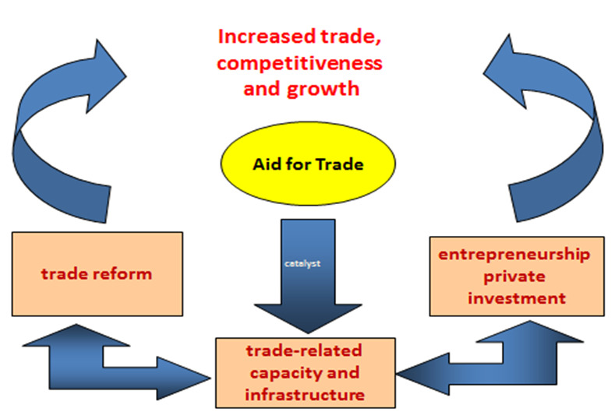

While internationally, AfT expenditure has focussed heavily on trade and economic hard infrastructure, (approximately 50% of all AfT was spent on economic infrastructure globally between 2006-2021), Australian Aid for Trade (AfT) in ATAB’s view, has correctly focussed more on the following areas of developing country development:

* Building technical and commercial capacity
* Strengthening the trade related regulatory environment
* Contributing to the development of trade agreements
* Supporting Australian private sector to access partner country markets for reciprocal benefit

Where Aid for Trade is particularly effective is when it targets the practical needs of SMEs to be able to gain entry into regional and global supply chains. Focussing in particular on women run SMEs and/or those SMEs employing significant numbers of women, AfT is able to facilitate long-term, continuous employment and income targeting some of the lowest income groups in developing communities – and this is a worthwhile spend. Two brief case-studies demonstrate the case, the first looking at a study of women SMEs exporting watermelons from the Pacific Island Kingdom of Tonga.

**Tonga and Trade in Watermelons**

New Zealand and the EU had stopped importing watermelons from Tongan SMEs due to the high number of contaminated watermelon shipments. In order to meet sustainability standards, including New Zealand’s biosecurity regulations, as well as EU HACCP (hazard analysis) certification, Tongan producers needed appropriate small scale infrastructure and food safety processes to be in place.

Two key sources of Aid for Trade were able to gradually address the compliance needs of Tongan SMEs. Initially, the EU and German aid for trade provided a fumigation chamber and improvements to general processing facilities. This was then followed by an Australian-funded Aid for Trade program called Pacific Horticultural and Agricultural Market Access (PHAMA) which began assisting Tonga’s farmers, and especially women SME exporters, to build their capacity to comply with New Zealand’s, the EU’s but also Australia’s biosecurity requirements and HACPP certification.

The Aid for Trade support over four years has resulted in exports of watermelons from mainly women led SMEs increasing from 86 tonnes in 2010 to 271 tonnes in 2013. The success was essentially driven by well targeted Aid for Trade support in the form of training support for women to meet compliance standards.

*(Redden, J., The Role of Aid for Trade in Building the Capacity of Developing Country Firms to meet Sustainability Standards, ICTSD, 2017)*



The second case-study demonstrates the use of Aid for Trade in support of labour standards in South East Asia.

**Better Work Projects in South East Asia**

To support the improvement of labour standards in South East Asia in the garment and footwear factories, Australia has partnered with the International Labour Organization and the International Finance Corporation, through their Better Work program. The program has improved workplace standards, including wages, working hours, maternity leave and labour relations. The program is operating in 1600 factories that together employ more than 2 million workers in seven countries.

Australia’s AfT funding for Better Work goes to projects in Bangladesh, Cambodia, Indonesia and Vietnam. In addition to improving working conditions, the program has led to a 22 per cent increase in productivity, and a 25 per cent increase in profitability, for participating factories.

*(ILO website, 2018:* [*https://www.ilo.org/global/about-the-ilo/newsroom/news/WCMS_106218/lang--en/index.htm*](https://www.ilo.org/global/about-the-ilo/newsroom/news/WCMS_106218/lang--en/index.htm)*)*

)

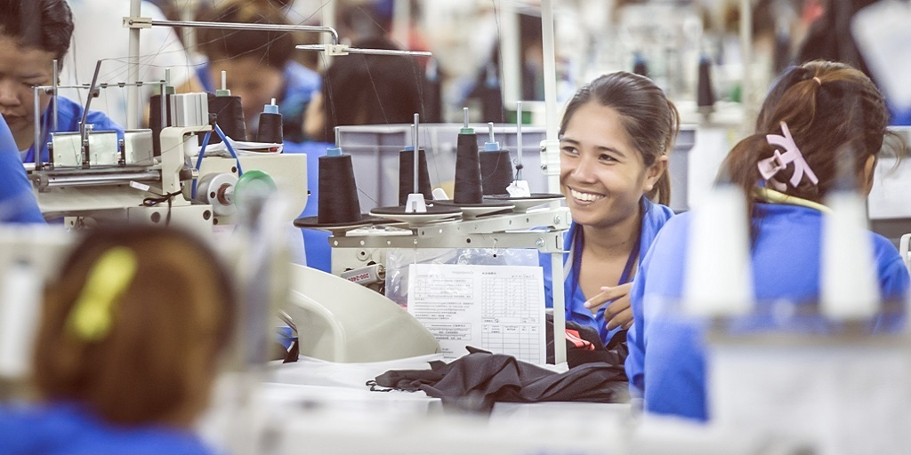

**(Photo: Better Work Warehouse, Cambodia)**

Finally ATAB itself has sponsored various AfT programs drawing in the expertise and resource support of the private sector in Australia. Beach Energy, for example, when it was operating in Tanzania contributed to the training of low income workers around Lake Tanganyika in exploration related jobs from basic boat handling and navigating positions to semi-skilled positions in collecting oceanographic data and in managing oil and gas exploration procedures.

**The Benefits of Aid for Trade**

**In a recent review undertaken by the Institute for International Trade of Australia’s Aid for Trade program, the following evidence for the specific benefits of Aid for Trade were highlighted:**

* Overall it has been shown that one dollar invested in AfT is, on average, associated with an increase of nearly USD$8 in exports from all DCs and an increase of USD$20 in exports from the poorest countries. These empirical findings are confirmed by the anecdotal evidence outlined in the 117 case studies provided by the public sector, private sector, academics and NGOs in response to the 2015 call for submissions.[3]
* AfT has an ongoing focus on private sector development, including linkages between business and commercial operations in Australia and for DC recipients. For example, the ANZ Bank has delivered a number of AfT capacity building programs for SMEs in the Pacific region to assist with financial management of their business and trading operations.
* AfT promotes Australian services, agricultural goods, technology and expertise with multiplier effects for recipient countries and Australia.
* When applied to resource rich developing countries, AfT translates as Australian support for the implementation of trade and investment liberalisation measures which reduce barriers to entry and increase the ease of doing business for Australian mining companies by:
  + “Building institutions for, and governance of the resources sector
  + Developing infrastructure to support resources development and economic growth
  + Ensuring robust fiscal policy and competitiveness measures
  + Facilitating local content to stimulate local businesses and jobs
  + Transforming resource wealth into broad, inclusive socioeconomic development

**Recommendations**

If Australian aid can focus even more clearly on the specific supply side barriers facing SMEs whether in dealing with customs, e-commerce[4] procedures or in meeting sustainable standards then it is a vital component of an integrated development program that seeks to drive self-reliance and sustainability for our development partners.

We would also suggest a refined strategic focus for DFAT based on some of the following principles:

* A strategy which is more directly aligned with and supportive of the SDGs – hence more focus on inclusive benefits from trade (i.e SMEs, women, youth, micro enterprises/entrepreneurs) which also incorporates environmental, food security, health, education and employment dimensions.
* Innovative financing/partnerships with SMEs in developing countries and the role of technology transfer should be key cross-cutting themes.
* The refined strategy should be based on an approach which links our bilateral, regional and global efforts to maximise the impact of Australian aid for trade investments.
* It needs to be underpinned by a robust monitoring and evaluation framework – which is aligned with global approaches so that tracking progress is easier.

**Recommendation: Aid for Trade**

1. **ATAB suggests that the government consider a quota of around 15% of ODA for Aid for Trade programs while undertaking measures to ensure a more refined Aid for Trade strategy – one where the focus is clearly on the needs of SMEs and undertaken in a gender inclusive manner and in a way that underscores the value of trade agreements for our development partners and which is clearly aligned to the Sustainable Development Goals.**
2. **Strengthening Support for the Multilateral Trading System through trade policy, regulatory reform and trade facilitation efforts. This is critical in the context of rising trade protectionism and should remain the primary focus for Australia’s AfT program.**
3. **Australia should focus on its comparative advantage in building human resources, educational and institutional capacity in the region. Given the focus of the Asian Development Bank, Japan and China on infrastructure development, and given Australia’s limited budget, the most strategic spend of Australian tax payer dollars is in capacity building and educational work which not only builds self-reliance but assists significantly in the development of close ongoing social and financial relationships. Australia is in an ideal position to focus its AfT program on trade related capacity building and technical assistance, as there is a lack of support globally for this area of AfT which assists developing countries to build their capacity to negotiate favourable trade terms, implement multilateral and bilateral trade commitments, reform national economic and trade policies, facilitate trade processes and procedures, and build trade-enhancing institutions that reinforce the importance of prudential regulation and social inclusion objectives.**
4. **Australian aid and AfT should also continue to play a prominent role in building trade, educational and vocational capacity in the Pacific region. Given that trade liberalisation can lead to a loss of tariff revenue, on which a number of Pacific Island countries are dependent, as well as the changing patterns of demand for workforce skills, there is a need for aid funds in general, as well as AfT funds, to be available to support temporary balance of payments issues and training/retraining the work force in areas of vocational or tertiary education to upskill those in the local workforce affected adversely as a result of trade liberalisation measures.**
5. **Aid and AfT in support of temporary labour mobility in the Pacific will assist young people to develop their work skills and self-confidence, increase remittances to the home country and ultimately help build self-reliance after returning home, and is a sound investment of Australian aid resources. In most Pacific Island countries, there is a rapidly expanding youth population where labour demand far outstrips supply. The government is to be commended for its expansion of PALM. The maintenance and expansion of temporary labour mobility schemes is consistent with commitments made in the Pacific Island trade and development agreement PACER Plus which contains a memorandum of understanding that member countries will benefit from increased access to temporary labour market access to Australia and New Zealand, whilst remaining sensitive to labour supply issues and sustainable development locally**
6. **Finally and consistent with close cooperation with regional as well as multilateral Aid for Trade partners, it is suggested that Australia undertake further research to examine how we can more closely cooperate with other major donors in our region including multilateral donors such as the World Bank, UN bodies and the WTO but also with major bilateral donors to the region including Japan, China, Taiwan, the USA, the EU, UK, France and Germany, with a particular view to developing mutual cooperation, maximising resource efficiency and reducing duplication.**

# 5. The SDGs, Aid and Governance in Africa

There is no doubt that the Coalition Government has largely neglected Africa in favour of the Indo-Pacific. Given the diminished aid budget, it means that only skeleton programs remain there in training and scholarships as well as a small amount for humanitarian emergencies. There are two particular concerns here, one from a humanitarian perspective and the other from a more economic diplomacy and private sector development perspective.

Goal two of the Sustainable Development Goals strives for “Zero Hunger” by 2030. Unfortunately, hunger and malnutrition remain a large barrier to developing Africa. Approximately 27.4% of the population in Africa was classified as severely food insecure in 2016, which is almost four times as high as any other region. Alarmingly, food insecurity is on the rise, specifically in sub-Saharan Africa. From 2014 to 2017, food insecurity increased by about 3% (FAO, 2017). The need for agricultural support, climate change adaption and basic health, education and humanitarian programs remain vital especially for the young people of Africa.

While the EU continues to pull its weight given historical ties and the more generous Scandinavian aid programs, the USA is planning to cut aid to Africa by approximately 30%. Australia has been a well-respected and long-term supporter of poverty reduction, debt relief and fairer trade for African nations and it would be a serious waste to undermine this investment through ongoing neglect.

Secondly and consistent with SDG 9 (Industry Development), Africa can benefit from private sector investment as well as Aid for Trade from Australia. Sub Saharan Africa remains the region with the highest concentration of Australian mining projects with over 220 Australian companies with operations there ranging from the mining or exploration for minerals, oil and gas, as well as investments in solar, geo-thermal and other renewable energy resources. Estimating the value of Australian mining investment in Africa is tricky, given the lack of data on Australian FDI by industry and region. However in 2010 the Lowy Institute estimated a total of around AU$20 billion for all Australian resources investment in Africa, including oil and gas. DFAT has previously estimated that the value of mining investment in Africa by Australian companies was about AU$24 billion, and the Australia Stock Exchange values Australian discovery at approximately $1.1 trillion.

Given Australia’s major economic interests in Africa as the continent’s largest mining investor and the current government’s supposed focus on ‘economic diplomacy’, the downgrading of Australian aid and diplomacy in Africa appears inconsistent with both economic evidence and Australia’s long term national interest.

Resource rich African nations need support to develop their mining governance capabilities so that they are investor friendly but with strong checks and balances to regulate for responsible and sustainable corporate mining practices. Good mining governance means better tax and royalty collection for redistribution of wealth but it also means ensuring jobs and flow on effects for small business and local suppliers throughout the local economies. Further, good mining governance makes it easier and more efficient for Australian companies to invest confidently in developing nations. Australia, through economic diplomacy and its aid for trade program, can support resource-rich developing countries in Africa to:

* Build institutions for, and governance of, the resources sector
* Ensure robust fiscal policy and competitiveness measures
* Facilitate local content to stimulate local businesses and jobs
* Spend the financial returns from resources wisely
* Transform resource wealth into broad, inclusive socioeconomic development
* Gain community support for responsible Australian companies
* Partner with Australian mining companies in development activities

The current Government’s short term budgetary cuts in aid could well undermine the industry’s longer term economic and strategic interests in Africa and ATAB feel that even with a modicum of expenditure in this area through the Aid for Trade program, Australia can make a difference and pursue a win-win approach both for Australian mining and renewables investment interest as well as providing vital jobs and investment for poorer, yet resource rich, African nations.

**Recommendation: Africa**

**The Policy Review considers an increase of 50 per cent on its current aid allocation to Africa (currently around $250m including the Middle East) hypothecated for basic humanitarian programs while directing Aid for Trade funds to support mining governance initiatives as part of the refinement of the Aid for Trade strategy.**



**Photo: US Aid funded solar panel and skill development project in Nigeria**

# 6.Communicating Aid Effectiveness to the Public

**Issues/Background**

**ATAB and the Institute for International Trade welcomes the government’s commitment to rebuild the Australian aid budget as a way of beginning to restore the respectability of Australia’s contribution to global poverty alleviation and progress toward the SDGs.**

In a changing world communication about development challenges and advocacy for change have become increasingly complex. The Sustainable Development Goals (SDGs) encompass a very broad set of development targets where official development assistance (ODA) from OECD countries is perhaps less central to development debates. At the same time, there has been a rise in the number of new donors and funding mechanisms combined with an increase in the number of issues on the aid and development agenda (disability, climate change, refugee support, inequality etc.)

It’s difficult enough for development professionals to keep on top of the range of complex development debates and targets, let alone for the general public. Simplifying aid and development messages is therefore no easy task.

However we would contend that to walk away from the debate on aid effectiveness may be akin to a ‘head in the sand’ approach, risking further misunderstanding and ultimately further reduction to the aid budget in Australia. Successful campaigns on the control of guns in Australia or more recently on same-sex marriage were not won on the basis of hoping no-one will notice if we quietly introduce new legislation.

As a recent OECD report concluded “Public dialogue around international commitments, aid budgets and the future of development co-operation is crucial to creating better-informed citizens committed to sustainable development.” The issues should be openly debated.

While acknowledging that foreign aid is not an issue on the radar of many voters, we believe there is a strong groundswell of support for effective and well distributed aid amongst middle Australia. Surveys undertaken by Flinders University and ANU over the last 10 years indicate that support for either an increase in foreign aid or for it to remain about the same is around 50%. Importantly, however, of those who opposed to foreign aid, most believed that the amount of Australia’s spending on aid was significantly higher that it is in reality with many believing we gave 10 per cent of our GNI to foreign aid! As such there is significant room for education and a broadening of the base of understanding and support for foreign aid and its objectives.

Notwithstanding opposition from the Far Right, ultra-conservative groups and some of the rank and file who believe charity starts and stops at home, middle Australia and the business community is not generally opposed to aid and development spending that:

* Assist vulnerable people in humanitarian disasters and conflict zones
* Helps poor to low income communities to help themselves economically and move out of dire poverty
* Contributes to better governance, less corruption and regional security
* Sends Australian aid volunteers and workers overseas to help in various situations
* Sees an increase in the ability of the receiving country to increase its business and trade with Australian companies

However one of the key issues we face is what can appear contradictory arguments in support of aid as follows:

1) Benefits to Australia (security /trade/political power/diplomatic leverage)

2) Benefits to recipient (moral argument/altruistic etc.)

The two messages can really jar against each other in determining a clear communication message, but the challenge is to communicate both objectives as a ‘win-win’ scenario in an increasingly inter-dependent planet.

How do we as political leaders together with the aid, trade and development community, in the private, academic and NGO sectors, better communicate that these outcomes, in an honest and pro-active manner?

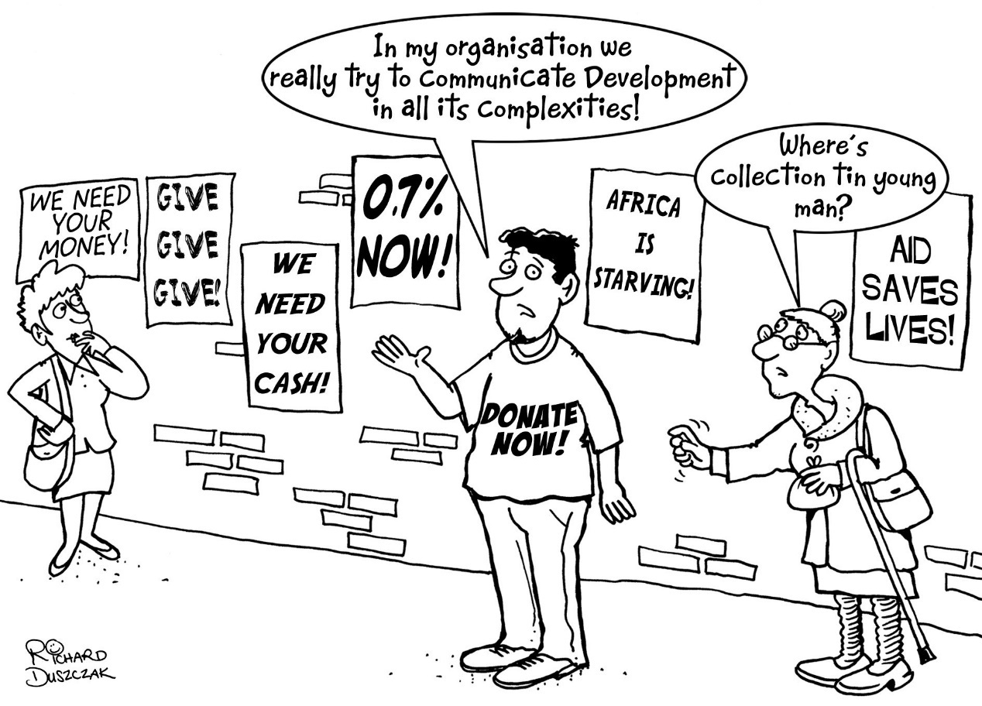

**Opportunities/Recommendations: Communicating Development**

The following suggestions are possible strategies that we, together with a Labor Government, might develop in support of a stronger aid program. Some are new while others build on previous initiatives ATAB believes have been successful.

1. **ATAB suggests that the Government could consider the appointment of Aid Ambassadors either on a state by state basis or on a sectoral basis. There are precedents for this such as the appointment of Natasha Stott-Despoja as Ambassador for Women and Girls with regular contributions to radio and TV talk shows as well as features in daily papers. It is envisaged the appointments would not be paid positions but expenses and overseas travel to a development forum or aid project could be covered by DFAT. Aid Ambassadors could include a mix of experts from the development field, sports stars in particular, media personalities, well-known actors such as Hugh Jackman, well-regarded academics, former politicians and it might deliberately be useful to include a farmer/agricultural ambassador and an Aboriginal ambassador (possibly through the DFAT Indigenous Suppliers Network) who would assist with dampening the view that charity starts and stays at home.**
2. **ATAB believes we need to better harness social media and the voice of younger people in the communicating of positive aid and development stories but also in championing debates around the best forms of aid and priorities Australia should be pursuing. This strategy can be developed through the growth of a student and youth conference with an aim to establish a vocal and participative network.**
3. **There is also good evidence to suggest a short, sharp television advertisement showing the long term impact of, for example, a DFAT funded health initiative or a DFAT funded education initiative teaching young people employment skills or local businesses about standards that will help them to build the local economy, would go down well with the Australian public and help build support both for the work of DFAT and also for the aid program.**
4. **Every private business and NGO involved in the delivery of aid, should be encouraged to adopt and promote one of its major and most effective aid projects as an ongoing ‘news story’ – promoted in the local press, through social media and where possible in more prominent daily papers. The focus of the stories would be on impact and demonstrating results – how Australian aid either from the community or government – is making a difference. As part of this story we need to improve efforts in bringing our recipient partners to Australia for speaking tours or media comment wherever possible. There seems to be little attention to sharing aid stories with the Australian public.**
5. **Two central pillars of successful communication on development co-operation are the use of new communications tools and support for global education. On the latter, it would be prudent to support an increase in University courses that either include a development dimension (e.g. Medical degrees that include courses or electives in “Third World” health issues) to fully fledged courses on aid and development issues as part of science, social science and humanities courses.**
6. **It would be useful to examine in more detail how aid agencies in other donor countries such as the Scandinavian countries and the UK communicate development effectiveness. DFID in the UK produces schools packs on various aid programs for example explaining how the UK have assisted in disaster relief programs and in assisting asylum seekers.**
7. **More regular and standardised polling of public opinion to then better segment our audiences with appropriate communication strategies would be useful to the private sector, NGOs and government.**
8. **Finally, it is recommended that advocacy efforts be funding in support of increased, well spent and effective development aid need to be targeting to existing politicians and leaders. At the end of the day, it is leadership that is required at the high-level decision making process and a well briefed parliament is a very good way to ensure this. ACFID, for example, used to play a valuable role in this process, and effectively briefed many key political stakeholders in the lead up to the Rudd Government decision to double Australia’s aid and development contribution.**

***November, 2022***

++++++++++++++++++++++++++++++++++++++++++++++++++++++++++++++

# Appendix A: E-Commerce Case-Study

**THE NORA’S PLANTATION FOODS STORY**

Nora was a young Samoan widow. With very little means she still managed to take in and care for other children alongside her own. Using her skills as an educator she taught them to live well using the land, making the best of natures’ resources. Her gardens were full of fruit trees and vegetables to sustain the extended family, ensuring that each child was fed, clothed and sent to school as if they were her own. The children now live happily in several countries but the values instilled by Nora are very much a part of their lives.

One of Nora’s grand-daughters, Mona Lisa Karene, and her husband, John Seedhouse, founded Nora’s Plantation Foods, using Nora’s legacy as its foundation. By offering a consistent market to vegetables and fruit growers in Samoa, Nora’s Plantation Foods contributes to better livelihoods, allowing families to live together in the comfort of their homes, preserving traditional village customs and giving them the ability to access essential services such as health care.

**E-COMMERCE AND NORA’S**

Nora’s Plantation Foods came to sell online because Samoa is a remote island in the Pacific and they needed to let the world see their business and hear their story.

With the support of a quite small Aid for Trade grant from the German Government (GIZ), the founders were able to introduce their first products to online customers, without waiting for distributors or looking for funds to build a store in overseas markets.

**Their website and online stores – in addition to generating sales – provide credibility to any potential Business to Consumers (B2B) customers before a meeting - they can see where the business is, the people involved and the products they sell.**

**Their secure payment system through PayPal gives their online customers peace of mind for online payments. Nora’s B2C online customers now come from Australia, the United States, Canada, New Zealand and France.**

They get a number of queries about bulk orders through the website and they process those via email due to differences in demand, terms and conditions for each B2B customer.

The company is now looking to add some European foreign languages to their website as they are getting a few queries from European countries about bulk orders; which also means that more B2C customers in those countries will feel happier dealing with them.

+++++++++++++++++++++++++++++++++++++++++++++++++++++++++++++++++

* Greater upstream engagement with private sector in the concept and design phases of DFAT investments. At the very earliest stages of a country/ or new donor program planning the private sector should be consulted on issues of additionality, impact, sustainability and governance. They are rarely consulted, usually to the detriment of the project.

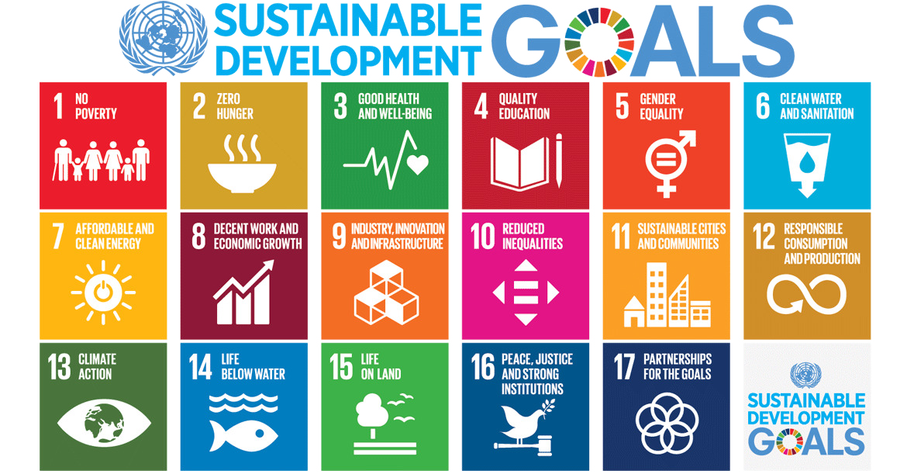

1. AECOM, Scope Global and Coffey International
2. This figure is based on the period 2011-2018 and includes the number of participants in skills training covering long and short courses, English language training and labour mobility preparation. The total population of Kiribati is just over 110,000 people.
3. OECD/WTO, Aid for Trade at a Glance, 2015
4. For an interesting example of an E-Commerce and gendered Aid for Trade project see Appendix A