

End of Investment Evaluation: Pacific IUU Fishing

Final Report

19 May 2022

**Prepared by:**

**Matt Smith**

**Catherine Renshaw**

**Acknowledgements**

The review team are grateful to the DFAT for support and guidance throughout this assignment, and for their patient assistance during numerous interactions with the review team. We also thank all those informants in who kindly made time to talk with us and provide information and insights.

**Disclaimer**

The opinions expressed are those of the review team, and do not necessarily reflect those of DFAT. Responsibility for the opinions expressed in this report rests solely with the authors.

Table of Contents

Table of Contents 2

Executive Summary 3

Introduction 5

Background 5

Evaluation features 5

Project features 8

Key Findings 9

Overall conclusions 19

Key Lessons for the future 20

Recommendations 21

Annex 1: List of Key Informants 23

Annex 2: Additional Needs 24

Executive Summary

Introduction

1. This is the report of the end-of-investment evaluation of the Pacific IUU Fishing project. The evaluation was commissioned by DFAT and has been assigned to the Strategic Development Group. The review covers the period from the start of the project in 2017 to the end of 2021.
2. The main objectives of the review are to inform DFAT of progress and outcomes to date against the expected desired outcomes of the project, inform learning, and to provide recommendations to help shape future related projects.

Methodology

1. A mixed-methods approach was adopted, using key informant interviews, supported by a review of extensive project documentation, and the analysis of survey data from PICs. Due to COVID restrictions, all interviews were conducted remotely. 11 different fisheries agencies completed the survey, and a further 14 key informants were interviewed.
2. Limitations faced during the evaluation were primarily related to the ongoing pandemic. Timing of the fieldwork also created challenges due to the Easter break. The evaluation team mitigated these limitations using multiple approaches to data gathering.

Key findings

1. The **headline findings** of this evaluation include:

* **Relevance**: the project remains relevant to Australia’s goals in the Pacific, it remains relevant to the needs of the PICs, and the objectives of the project remain relevant to combatting IUU fishing in the Pacific.
* **Effectiveness**: Whilst the initial design of the project (with limited articulation of expected results and targets) makes it difficult to gauge the success of the project the evaluation team found high levels of satisfaction with the direct support received and that PICs were subsequently applying the support in their work. Overall, we found that the operational component (AFMA) was largely successful as results were tangible and delivered face to face. Whereas the Legal support (FFA/AGD) had weaker successes partly due to Covid removing face to face engagement with PICs, plus dependence on complex and slow procedures in-country to agree and ratify legislation. Respondents reported they were satisfied with the pivot by the project within the Covid-19 context.
* **Efficiency**: Planned outputs within the intended timeframe have largely been met, although the pandemic has curtailed face-to-face activities. Key informants did raise some concerns about the fact that AGD’s considerable technical expertise was not fully utilized in the project (primarily due to the slow pace of legislative reform in targeted PICs, which is outside the control of the project). The project has slightly underspent against its original budget, again as a result of COVID-19. In hindsight it would have been useful to have directed more funding towards national activities as opposed to regional activities to further strengthen the translation of the NTSA into national policy and implementation.
* **Coherence**: Whilst there is an inherent logic to the design, in practice the sequencing of activities created challenges for the project, especially as the legislative and procedural issues and clarifications took longer than expected which led to delays in operational support being launched. Key informants noted that the objectives of the project were not clearly articulated and that the different components of the project were not fully integrated.
* **Impact**: The project has had a positive impact at both national and regional level. It is very likely that without the project efforts to implement the NTSA would have stalled. The benefits of information sharing across the region was a well reported positive impact by respondents. PICs reported that the project had contributed to changes because of both legal and policy advice, and operational advice.
* **Sustainability:** Support for activities that progress ratification and implementation of the NTSA by PICs will have ongoing sustainable outcomes as countries recognise the benefits of cooperation in terms of cost effectiveness, efficiencies, and opportunities. Nevertheless, informants were strongly of the view that the work to operationalize the NTSA has only just begun.
* **Gender and social inclusion:** Whilst the project did not have an explicit objective pertaining to either gender equality or social inclusion, the project did make some effort to track gender disaggregated data, opened up its activities to a wider audience (i.e. beyond just officers) and ensured strong gender equity messaging through training materials. Thought will need to be given to ensuring a more deliberate focus on gender and social inclusion in future programming.

Conclusion

1. Our overall conclusion is that the need and value of the project has been validated. Engagement with fisheries agencies across the Pacific remains strong. There remains high demand from PICs for further engagement with Australia on the NTSA, in particular with operationalising the intent of the NTSA.
2. Factors for the project’s success include the use of highly competent partners and cooperative operational activities. PICs were generally satisfied with the activities delivered by the project and highly valued the Australian subject matter expertise and training that is being provided to the Pacific region.
3. Fragmentation and the sequencing of activities has been a challenge for the project, and although the project management team did intervene to manage some of these aspects, the initial design logic meant that initiatives were never fully integrated. With different components of the project acting independently of each other this has hindered lesson learning across the project.
4. The project has helped demonstrate the benefits of the NTSA to PICs and should contribute to increased and ongoing activity under the NTSA to help combat IUU fishing. There is also a recognition that additional time and investment is required to realise the ambitious objectives set out in the initial design. To ensure that greater impact can be achieved in the next phase it will be important to ensure that future programming is preceded by a rigorous design that clearly articulates the scope, outcomes, governance arrangements and how progress will be measured.

Recommendations

1. Considering the findings of this evaluation, the end of investment evaluation makes 4 recommendations which are listed in full on **page 21**. One of which is strategic of nature aimed at ensuring greater communication with PICs about DFAT’s intent re future programming, and three recommendations which seek to reinforce the project’s operations.

Introduction

## Background

1. DFAT’s support to address illegal, unreported and unregulated (IUU) fishing in the Pacific aims to build regional and national capacity to undertake enforcement operations and implement the Niue Treaty Subsidiary Arrangement (NTSA) for the sharing of fisheries and non-fisheries information by working with the Australian Fisheries Management Authority (AFMA), the Attorney General’s Department (AGD) and Forum Fisheries Agency (FFA).
2. Investment in Pacific fisheries assistance remains highly relevant. IUU fishing remains an ongoing challenge for PICs and Australia (especially given the emerging and realised compliance risks and changing regulatory environment associated with COVID-19), threatening economic returns from fisheries and food security. The links between IUU fishing and other maritime crimes are well known and working cooperatively across multiple agencies ensures efforts are focused and countries are able to maximise the use of limited resources. PICs rely heavily on cooperative surveillance and enforcement activities to protect and manage their fisheries resources. DFAT’s support for implementation of the NTSA and the related cooperative activities are of significant benefit to the region by strengthening fisheries surveillance and enforcement.
3. Cooperative fisheries enforcement operations and building on existing capacity remain the key strategies to combat IUU fishing in the region. The EEZ’s of PICs cover approximately half of the Western and Central Pacific Ocean (WCPO) region and supply 34 percent of the world’s tuna catch each year, with an estimated value of USD $4-5 billion in recent years. The wider WCPO supplies roughly 60 percent of the world’s tuna (Source: World Bank - Tuna Fisheries paper). PICs, with small administrations and large EEZs, continue to need support and capacity building to ensure these valuable resources are conserved effectively and efficiently.

## Evaluation features

The Task

1. To conduct an end of investment evaluation of DFAT’s support to address IUU fishing in the Pacific from 2017 to 2021. The evaluation set out to mee four objectives:

* inform DFAT of response to and implementation of lessons from mid-term review;
* inform DFAT and implementing partners of implementation progress and outcomes to date in the context of achieving desired outcomes;
* provide recommendations to improve delivery of Project outputs and objectives, management & coordination, quality and M&E systems for future related projects; and
* inform decisions regarding ongoing sustainability.

1. In so doing the evaluation assessed performance of the initiative, taking into account:

* the high-level objectives and expected results of the Project from its inception in 2017;
* key deliverables from the Project Activity Schedule and governance architecture;
* budget and institutional arrangements across key partners and target stakeholders including DFAT, AGD, AFMA, the FFA, and key Pacific Island countries (PICs).

Our approach

1. As set out in the Evaluation Plan, the review team conducted a mixed-methods approach (largely remotely), using key informant interviews (KIIs), supported by a review of extensive project documentation, and the analysis of survey data (a list of the organisations we interviewed can be found in **Annex 1).**
2. Surveys developed and administered remotely to PICs were completed by 11 different fisheries agencies. Although the survey was administered anonymously some respondents self-identified including Tonga, Cook Islands, Nauru, Solomon Islands, Marshall Islands, Tuvalu).
3. A breakdown of the 14 key informants interviewed (see **Annex 1 for more detail)** includes:

* DFAT
* AFMA
* AGD
* FFA
* Department of Defence
* MFAT, NZ DPI
* PICs x4 – Solomons, FSM, Vanuatu, and Samoa.

1. As part of the process the review team also prepared a presentation to test emerging findings with project management (shared on 27 April 2022)**.**

Limitations

1. Limitations faced during the review were primarily related to the ongoing COVID-19 pandemic, which prevented conducting any face-to-face interviews. In addition, the timing of the field work (largely conducted in the run up to the Easter break) also had an impact on accessing key informants in the PICs directly. Nevertheless, the review team were able to mitigate access issues by ensuring that all respondents were also given an opportunity to complete a short survey.
2. The limited articulation of expected results and targets in the original design of the project did also create a challenge for the review team as it hindered our ability to gauge the success or otherwise of the project. Nevertheless, as we illustrate further below, a number of common themes did emerge during our interactions with respondents which demonstrate where the project was successful.

Subject being reviewed

1. Under this DFAT funded initiative, AFMA, in conjunction with the Attorney General’s Department (AGD) and the Pacific Islands Forum Fisheries Agency (FFA) Secretariat, partners with Pacific countries to strengthen regional monitoring, control and surveillance (MCS) information sharing arrangements and develop responses to IUU threats to the region’s fisheries resources. Specifically, this investment delivers a strengthened regional MCS framework by providing assistance at the national and regional level to Pacific island countries (PICs) to ratify and implement the Niue Treaty Subsidiary Agreement (NTSA) on cooperative maritime surveillance and enforcement.
2. Key features of the investment designed to build capacity to prevent, deter and eliminate IUU fishing in the Pacific include:

* enhancing regional data and information sharing and cooperation;
* supporting risk-responsive tasking of assets; and
* strengthening the capacity of PICs to undertake preventative enforcement operations.

1. The types of activities undertaken by the project were widespread, examples included:

* providing specialist and technical assistance at the national and regional level to ratify and implement the Niue Treaty Subsidiary Agreement (NTSA) on cooperative maritime surveillance and enforcement;
* developing administrative and instructional material in-country to ensure that MCS standards are relevant, effective, compatible and harmonised;
* actively participate in and support a diverse range of cooperative enforcement operations in the Pacific;
* working with the FFA Secretariat in delivering various components of the University of the South Pacific’s (USP’s) Certificate IV in Fisheries Enforcement and Compliance course and South Pacific Community’s (SPC) Certificate IV in Coastal Fisheries and Aquaculture Compliance course, and other applicable courses as requested;
* developing IUU threat assessments to support the real time, risk based, responsive tasking of assets.

1. The changing circumstances brought about by COVID-19, meant many anticipated engagement opportunities have not been realised since March 2020 due to travel restrictions. Nevertheless, project partners, where feasible, did adapt the project by pivoting to remote/on – line delivery of certain components.

## Project features

*Figure 1: Logical Model*

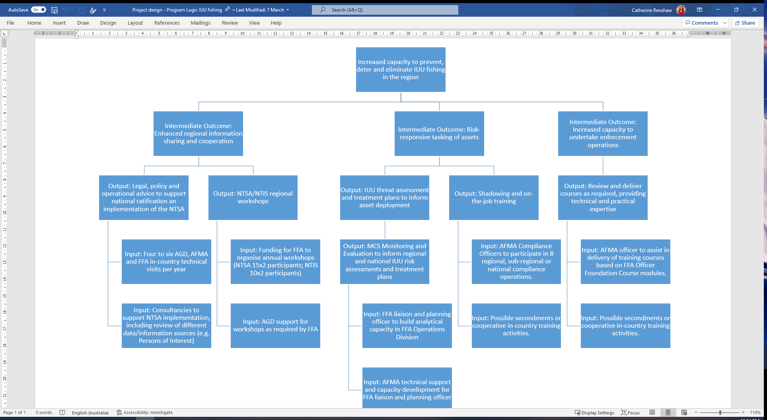

1. The project’s logic model provides the first steps in setting out the causal pathways that the project aims to follow in achieving its wider aim of “Increased capacity to prevent, deter and eliminate IUU fishing in the region”. However, this would traditionally be translated into a more detailed plan with targets and indicators for success, particularly at ‘output’ and ‘end of project outcome’ levels. Quantitative indicators were set up according to each partner (i.e., for AGD, FFA and AFMA), however these were not linked to specific targets or baseline figures. The project logic is also heavily focused on inputs, which would normally be reserved for other tools such as a workplan or budget, and the M&E plan should be focused on outputs and outcomes.
2. This lack of clear qualitative or quantitative targets (and related indicators at a project level) makes it challenging to assess the extent to which the project has successfully achieved its objectives.
3. A well-articulated project logic (with theory of change and narrative components) can be a useful way of illustrating the linkages between project components, such that the “whole is greater than the sum of its parts”. It is recommended that in the next phase of NTSA support this element of project design is articulated in more detail.

Key Findings

1. The evaluation findings and the evidence to substantiate them are presented below. We present the evidence in response to the 7 key evaluation questions the evaluation set out to answer, and we begin by examining the extent to which the project has remained relevant.

Relevance: Relevance of the Project?

1. The project remains **relevant to Australia’s policy goals in the Pacific**. This investment and associated activities continue to build on Australia’s established relationships and broadly support Australia’s “stepped up” engagement in the Pacific as articulated in the Department of Foreign Affairs and Trade’s 2017 Foreign Policy White Paper. The project also forms part of long-standing, coordinated investment by Australia to support implementation of the region’s *Framework for a Pacific Oceanscape.* The project complements the *Regional Roadmap for Sustainable Pacific Fisheries*, developed by FFA, and the Defence led *Pacific Maritime Security Project.*
2. The project is **relevant to the needs of the PICs**. Fisheries is a standing agenda item for the Pacific Island Forum Leaders annual meeting, and IUU fishing remains and ongoing challenge for PICs, especially as it threatens economic returns from fisheries and food security. PICs rely heavily on cooperative surveillance and enforcement activities to protect and manage their fisheries resources. PICs require support to ratify and then implement Niue Treaty Subsidiary Agreement (NTSA), and greater capacity to undertake preventative enforcement operations. In interviews and in response to the survey PICs reported high levels of relevance of the NTSA support activities to the needs of their fisheries agencies.
3. **Objectives of the project remain relevant to combatting IUU fishing in the Pacific**. By aiding the ratification and implementation of the NTSA through, for instance, cooperative maritime surveillance and enforcement, the project is helping to strengthen the regional MCS framework and information sharing arrangements. This in turn will help to improve responses to IUU threats to the region’s fisheries resources.

Effectiveness: How effective has the project been?

1. Whilst it is difficult to determine effectiveness without being able to compare results achieved with what was expected evidence gathered during the **fieldwork does provide a strong sense of the effectiveness of the project**.
2. In the following graph (Figure 1), the level of satisfaction with different activities is illustrated. As can be seen, **levels of satisfaction are relatively high**, with the majority of respondents reporting they were satisfied with most activities.
3. **PICs reported that overall they were satisfied with direct support**, and were able to apply the support in their work (ratifying and implementing NTSA; workshops; Instructional materials on MCS; enforcement support). However the found the following components less effective: IUU threat assessment support, and the extent to which the project promoted GESI across its activities; plus delays and difficulties in utilizing the NTIS system.

Figure 1: Level of satisfaction with different project activities (Source: own survey)

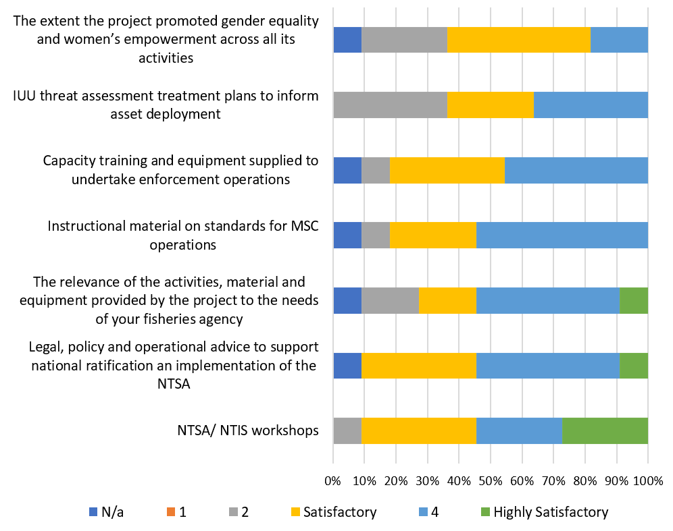

1. Overall, we found that the **operational component (AFMA) was largely successful** as results were tangible and delivered face to face. Whereas the **Legal support (FFA/AGD) had weaker successes partly due to Covid removing face to face engagement with PICs**, plus dependence on procedures in-country to agree and ratify legislation. The slow pace of legislative reform is well recognised by respondents, as can be seen in the following:

*There have been some beneficial changes in operational aspects and we are undergoing many legislative, policy and other amendments but a lot of these are under action or in draft form. We find it takes some time, even years to get legislative or regulative changes made, but Its important that we recognize that different national systems will implement measures differently.*

1. On the whole **respondents reported they were satisfied with the pivot by the project within the Covid-19 context** (Figure 2). Respondents were generally understanding of the pivot, as one respondent noted: ‘I would say it is ok, but there is less interaction when there is a virtual meeting but it is still convenient given our current situation of COVID-19’. But the lack of interconnectivity does pose unique challenges within the Pacific, as illustrated in the following response: ‘Internet is one of our biggest challenges and it affects the remote support and also the quality of virtual interactions’.

Figure 2: Level of satisfaction with pivot due to Covid-19

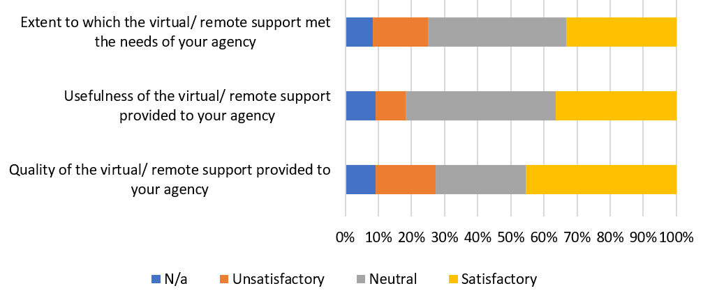

1. With reference to the effectiveness of the delivery mechanism and approach, feedback from **key informants suggested that Australian posts in the Pacific have largely not been utilised to promote ratification of the NTSA**, given that this engagement with PICs was the role of FFA, however it may be useful in the future to engage bilateral and other mechanisms alongside the FFA to promote ratification and identify where further support is required.

Efficiency: How efficient has the project been?

1. Activities conducted under the project (involving the FFA secretariat, AFMA and AGD) were all **working towards a common goal to address IUU fishing reflects an efficient use of resources**. Moreover, drawing on a diverse range of complementary expertise contributed to efficiencies.
2. Nevertheless, key informants did raise **some concerns about how the fact that AGD’s considerable technical expertise was not fully utilized in the project** (primarily due to the slow pace of legislative reform in targeted PICs, which is outside the control of the project). To some extent this was also further exacerbated by staff turnover within the AGD, which meant gaps for institutional memory and relationships building which is seen to be vital to building meaningful relationships in the Pacific. In addition, the smaller number of requests for assistance may have been attributable to the fact that a component of AGD support around the NTIS system was not online until 2020, and therefore the immediate benefits of data sharing were not obvious to PICs. Hence, the focus on developing a compliant ISMS policy may have been somewhat lacking. In the later phases of the project, the COVID-19 pandemic may have meant that longer term projects such as developing ISMS policies were simply deprioritised.
3. **COVID-19 notwithstanding the project did deliver the bulk of its activities**, although it did slightly underspend against its original budget (primarily because face-to-face activities/workshops/training were scaled back and delivered remotely).
4. The estimated total value of the project was **AUD$ 4,419,362.00**, against which **AUD$ 3,673,791.00** was spent. An underspend of **AUD$ 745,571.00** (17% of original budget). Payments made to the key partners are reported in the table below (Table 1):

Table 1: Project payment schedule (source: data supplied by DFAT)

|  |  |  |  |  |
| --- | --- | --- | --- | --- |
| **Payments** | **AFMA** | **AGD** | **FFA** | **Total** |
| **2021** | $486,332.00 | $19,902.00 | N/A | $506,234.00 |
| **2020** | N/A | N/A | $475,525.00 | $475,525.00 |
| **2019** | $475,748.00 | $183,985.00 | $498,525.00 | $1,158,258.00 |
| **2018** | $697,240.00 | $182,138.00 | N/A | $879,378.00 |
| **2017** | N/A | $178,871.00 | $475,525.00 | $654,396.00 |
| **Total** | $1,659,320.00 | $564,896.00 | $1,449,575.00 | **$3,673,791.00** |

1. Some additional feedback from key informants regarding the way the spending was structured:

* Funding was originally envisaged to be spent on regional activities, and in hindsight it **would have been useful to direct more funding at the national level to increase capacity** there in translating the NTSA into national policy and implementation
* **Monitoring of project activities was challenging as the work of this contract overlapped with FFA core business**, and this sometimes led to bottlenecks and difficulty in separating out activities
* **Forecasting of reporting expectations and the impact on budgeting could have been made more clear from DFAT** to the partners, in order for their project management and M&E capabilities to be adequately resourced.

Coherence: To what extent was the project coherent

1. There is **an inherent logic to the design** – *Legislative and Procedural issues and clarifications* at start, followed by operational support; however in practice this led to some frustration as roll out of AGD support encountered challenges (e.g. slow pace of legislative reform; countries initially reluctant to share IUU fishing information; and staff changeover affecting relationships) which in turn hindered roll out of operational activities.
2. **Issue of a sequencing was a challenge**, especially in the short time frame. The expectation was that the approach would roughly follow a 3-step process: Step 1 - raise awareness; Step 2 - ratify NTSA; Step 3 – build capacity. In practice this created unnecessary delays. Ideally it would have helped had capacity building activities could have taken place while the NTSA was waiting for ratification rather than after ratification.
3. Respondents were of the view that **the objectives of the project were not clearly articulated by FFA** and hence members were not clear about the purpose of the project beyond their engagement. Whilst the project had a strong focus in terms of the different activities, respondents were unclear as to how the different components interacted or how they supported each other – i.e. what did the sum of the parts add up to? Similarly, the FFA devised a communication strategy in 2019 to promote the wider project amongst members, however with the onset of Covid, the strategy was deprioritised, and communication was carried out on an ad hoc basis.
4. Nevertheless, **respondents were also of the view that the ‘correct’ partners were used, and PICs were clear about the different roles these partners provided**. AFMA was seen to be the best option for providing an understanding of operations, and AGD for its legal expertise. Respondents were also of the view that the ‘balance’ was appropriate, and that the legal inputs had to be done in conjunction with operational aspects, and as one respondent noted the success of the project “could not have been achieved without a dedicated project in place. We have worked on a number of projects throughout the region, and if there is no dedicated project the momentum drops off” (KII Transcript).
5. In terms of project partners working together coherently, it is noted that the survey carried out by the FFA secretariat in 2021 of their members to examine their understanding of the NTSA, progress in ratifying and additional needs, much of what was requested in terms of additional support and in some cases the barriers to implementation was shared again by respondents to the survey and key informant interviews conducted for this evaluation (see **Annex 2**: **Table 2** for more details). Whilst the findings of the 2021 survey were discussed by the FFA secretariat with its members in a workshop, many of the issues raised in that survey remain and have yet to be fully addressed. This suggests that partners still need to do more to work together coherently to address IUU fishing related challenges.

Impact: What impacts did the project achieve?

1. As we note below **the project has had a positive impact not only at country level, but also at regional level** as the following comment illustrates:

*Before we had the NT, contact and support would be ad hoc and with regular contacts. It was ok, flexible and didn’t require too much time, it wasn’t as effective as you weren’t getting reports or debriefs, so no structure. We might do a patrol and it went well and sometimes not hear back until 6 months after the patrol. With NT the provisions on reporting after patrol forces information sharing and discipline with reporting and follow up with cases of non-compliance. While we used to do it anyway, it’s brought structure, discipline and follow through. Information sharing has increased, which is pretty fundamental.*

1. Prior to project there was broad support for the NTSA, core funding was already going to the FFA to support implementation of the NTSA, but the consensus is that some of the work would have happened, but very slowly. A key purpose of the project was that it ensured more resources and tools, and greater coordination to make things happen. And as noted below things did happen and it is very likely that **without this support the same progress would not have been made**.
2. The **benefits of information sharing across the region was a well reported positive impact** by respondents. Specifically, the reciprocal nature of the NTIS, in PICs being able to offer and request support from across the region (instead of via ad hoc bilateral arrangements), and the ability to see what is taking place across the region, has been extremely useful in a coordinated effort to prevent and tackle IUU fishing. Some countries noted their vast EEZ and limited assets to effectively carry out MCS activities, so the ability to call upon neighbouring PICs for support has been beneficial. Support to MCS activities in the region is no longer seen in terms of Australia and NZ providing, and the PICs receiving, and this is a positive impact of the NTSA project.
3. Another impact of the project, as noted by several respondents, was **the role the project has played in unifying the region**. According to those respondents, the NTSA is a world leading agreement in terms of tackling IUU fishing, and the ability for PICs to work in a coordinated way that is backed by a treaty level agreement and managed through a designated project of work gives the agreement credibility and the region something to unify behind.
4. In terms of specific changes or benefits of the project **PICs reported that the project had contributed to changes as a result of legal and policy advice, and operational advice**. The following three graphs (Figure 3,
5. Figure 4, and Figure 5) highlight specific areas of change.

Figure 3: Changes due to project interventions: Legislative support (source: own survey)

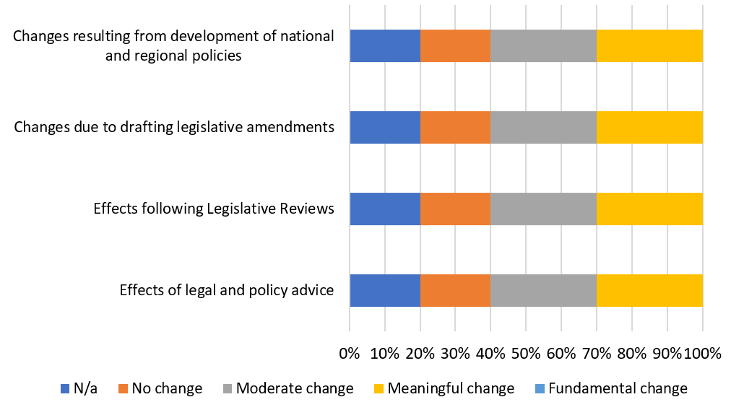

Figure 4: Changes due to project interventions: Operations (source: own survey)

Figure 4 deals with 'Changes due to project interventions: Operations'. Possible responses are: not applicable, no change, moderate change, meaningful change, fundamental change. Row 1 deals with capacity and willingness to undertake enforcement operations to prevent, deter and eliminate IUU fishing in the Pacific. 20% responded not applicable. 20% responded moderate change. 60% responded meaningful change. Row 2 deals with 'Changes due to use of Standard Operating Procedures and equipment'. 20% responded not applicable. 50% responded moderate change. 20% responded meaningful change. 10% responded fundamental change. Row 3 deals with 'Training and on-water technical and capacity support onboard Pacific Class Patrol Boats and Guardian Patrol Boats.' 10% responded not applicable. 20% responded no change. 20% responded moderate change. 40% responded meaningful change. 10% responded fundamental change. Row 4 dealt with 'Improvements due to use of instructional material or standards and procedures for MCS operations'. Over 15% responded not applicable. Over 25% responded moderate change. 45% responded meaningful change. Under 10% responded fundamental change. Row 5 deals with 'Preparing for NTSA cooperative surveillance and enforcement activities'. 10% responded not applicable. 30% responded moderate change. 50% responded meaningful change. 10% responded fundamental change. Row 6 deals with 'Capacity and willingness to develop treatment plans to inform asset deployment to prevent, deter and eliminate IUU fishing in the Pacific'. 10% responded not applicable. 30% responded moderate change. 50% responded meaningful change. 10% responded fundamental change. Row 7 dealt with 'Capacity and willingness to conduct IUU threat assessments to prevent, deter and eliminate IUU fishing in the Pacific.' 10% responded not applicable. 30% responded moderate change. 50% responded meaningful change. 10% responded fundamental change. Row 8 dealt with 'Effect of MCS officers cross vested under NTSA.' 20% responded not applicable. 10% responded no change. 20% responded moderate change. 30% responded meaningful change. 20% responded fundamental change. 

Figure 5: Changes due to project interventions: Cooperation (source own survey)

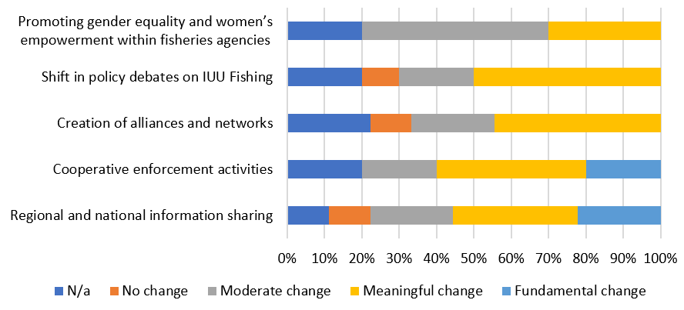

1. In summary, PICs reported most changes resulting from the project to be around:

* Cooperative enforcement activities
* Regional and national information sharing
* Capacity and willingness around asset deployment preparation, conducting threat assessments, and undertaking enforcement activities
* Shift in policy debates on IUU fishing
* Use of SOPs

1. PICs reported less meaningful changes with respect to:

* As a result of national/regional policies
* Due to legislative changes/reviews

1. Examples of specific changes made by PICs, in their own words include:

* Analysing contact and inspection report to see where we can improve in the future joint exercise
* It helps a lot in our fisheries agency in terms of enforcing and prosecuting IUU fishing activities in the Solomon Islands.
* No, but it's comforting to know that the NTSA give greater options than national capabilities can offer.
* Our Department is now able to request for boarding kits equipment from AFMA early this year. Also our Fisheries will greatly benefit from knowledge and data sharing from other Fisheries in the region.
* Yes better awareness on the usefulness of data resulting in improved data collection and analysis

Sustainability:

1. **Respondents of the view that without the project the NTSA would not have been ratified**/ members would not have understood the importance of the NTSA – so at the high level the project is sustainable as the value of the NTSA is now understood. As one informant noted: “we have moved from demystifying NTSA to a more output driven focus on operationalising NTSA”.
2. **Support for activities that progress ratification and implementation of the NTSA by PICs will have ongoing sustainable outcomes as countries recognise the benefits of cooperation** in terms of cost effectiveness, efficiencies, and opportunities. Utilisation and implementation of the NTSA to facilitate monitoring, control and surveillance activities during FFA led fisheries operations and in support of the Defence led Pacific Maritime Security Project has seen positive outcomes. AGD has ensured countries have a better understanding of what the NTSA means for a country, and the capacity training work has evolved and also expanded its focus beyond the officers.
3. **Activities did demonstrate the benefits of the NTSA to the wider FFA membership and should contribute to increased and ongoing activity** under the arrangement. PICs now better understand the benefits that flow from the NTSA. Evidence also suggests that the FFA is now in a better place to support the operationalization of NTSA – again this points to sustainability.
4. Nevertheless, **genuine concern from FFA and PICs that without funding, many of the operational aspects of the project implemented by AFMA might not continue**. Many informants were of the view that the work to operationalize the NTSA has only just begun. There are still a few countries that need to ratify the NTSA (Fiji, Kiribati, Tokelau, and PNG) and these countries will need to be reassured as to why they should endorse the NTSA.
5. Moreover, **the work on the NTIS is still very much at an early stage**. To ensure that information sharing becomes widespread there remains plenty of work still to do to enhance sustainability of efforts to date. The real challenge in relation to data security is ensuring that ISMS policies are implemented at the national level through relevant procedures and that national ISMS policies are interoperable across the region. For example, it is possible that countries have adopted ISMS policies but have yet to set up procedures needed to implement the policies. Any future support for the NTSA project could focus on in-country support for developing data security procedures and continuing monitoring and evaluation of how these procedures are being implemented. Such assistance could utilise the National Information Security Management System (ISMS) policies – Guidance for FFA Members document produced by the FFA to ensure a level of consistency across national ISMS policies. Without robust data security policies, procedures and assurance at the national and regional level, countries (including Australia) are reluctant to share sensitive data, and this undermines the ability for the NTSA to build institutional capacity to prevent, deter and eliminate IUU fishing.

GESI: To what extent did the project contribute to gender equality and social inclusion?

1. **Social constructs of gender have historically kept women out of maritime operations**, particularly offshore, and whilst this was not a key focus of the project it was still imperative for the project to have done more to promote women’s participation and leadership within fisheries agencies responsible for combatting IUU fishing in the Pacific. This is particularly important bearing in mind DFAT’s strong commitment to gender equality. DFAT’s *Gender Equality and Women’s Empowerment Strategy 2016* identifies ‘enhancing women’s voice in decision-making, leadership and peacebuilding as one of its three priorities. Similarly, DFAT has a strong commitment on disability inclusion (2015 strategy – *Development for All: Strategy for strengthening disability inclusive development in Australia’s Aid Program)*.
2. Whilst the project did not have an explicit objective pertaining to either gender equality or social inclusion, **the project did at a very basic level track gender disaggregated data**. Over time, as a result of the FFA having a strong focus on gender inclusivity (as a result of its own gender equality strategy), the project did open up activities to a wider audience (i.e. beyond just officers). Informants noted that the impact of the training elements led to women moving upwards in their respective agencies as a result of training. In addition, a better gender balance was achieved primarily because of opening up of workshops as for example, data entry staff participated more often (who are typically female). The project did nevertheless face the challenge that participation in in-country activities was determined by the host country, and so efforts to broaden inclusion were often constrained by the host country’s approach to inclusion.
3. **Pivoting to remote/ online engagement had the unintended benefit of allowing implementing partners the opportunity to intensify messaging on gender equity** (e.g. material/videos/animation provided AFMA with an opportunity to increase the use of women as role models). In addition, the legal work being supported by AGD was focused on building capacity and promoting gender equity, in addition to raising awareness on gender issues within the NTSA.
4. **In the future thought should be given to ensuring that workplans specifically spell out how GEDSI issues will be addressed in activities**, that the MEL framework systematically collects sex and disability disaggregated data, that project communications (as already being done by AFMA and AGD) promote gender equal representation and highlight the contributions of diverse women, consider how best to mentor female fisheries officers, and ensure that technical assistance demonstrates gender diversity and showcases diverse women’s talent in the fisheries and maritime sector.

Conclusions, lessons learned and recommendations

1. Based on the findings presented in the previous section, an overall assessment of the project is provided below, key lessons for the next phase of the project are listed followed by recommendations of how DFAT can take action to build on the review findings and the lessons learned.

## Overall conclusions

1. The need and value of the project have been validated. There is clear evidence of how the project is aligned with the needs of PICs and that the project is closely aligned with the priorities of the Australian Government in the Pacific. There remains high demand from PICs for further engagement with Australia on the NTSA, in particular a strong sense that PICs need further support operationalising the intent of the NTSA.
2. The limited articulation of expected results and targets in the original design of the project did create a challenge for the review team as it hindered our ability to gauge the success or otherwise of the project. Nevertheless, a number of areas of success did emerge during our interactions with respondents which demonstrate where the project was successful including NTSA/NTIS workshops; legal, policy and operational advice to support national ratification of the NTSA; capacity building activities and materials; use of SOPs and threat assessments and so on.
3. Factors for the project’s success include the use of highly competent partners and cooperative operational activities. PICs were generally satisfied with the activities delivered by the project and highly valued the Australian subject matter expertise and training that is being provided to the Pacific region. PICs provided a range of different examples of how the project has contributed to improved capacity, and ultimately, also contributing to strengthening their ability to combat IUU fishing.
4. The legal and practical frameworks for undertaking NTSA activities are now largely in place. However, there is a risk that the NTSA could become a treaty on paper only, unless countries start utilising it to undertake cooperative surveillance and law enforcement activities. Currently the view is that not many members have engaged to the full potential yet, despite ratifying, but that Australia has done the most under the NTSA in terms of activities and hence why PICs are keen to learn from the Australian experience.
5. Fragmentation, and the sequencing of activities has been a challenge for the project, and although the project management team did intervene to manage some of these aspects, the initial design logic meant that initiatives were never fully integrated. Despite efforts to promote greater coherence there is a sense that different components of the project act independently of each other and this has hindered lesson learning across the project.
6. Whilst the project was effective in adapting and responding to COVID-19, the pandemic did curtail many of the face-to-face activities. Several operational activities were delayed as a result of the pandemic (such as surveillance related activities) as they could not be replicated remotely, similarly aspects of the legal advice were constrained by the lack of in-country work. PICs were appreciative of the fact that the project did continue, albeit remotely. An unintended consequence of the remote work is that it allowed partners to increase messaging on gender equity in the sector.
7. The project has helped demonstrate the benefits of the NTSA to PICs and should contribute to increased and ongoing activity under the NTSA to help combat IUU fishing. Whilst the project has undoubtedly been of tremendous value, there is also a recognition that additional time and investment is required to realise the ambitious objectives set out in the initial design. With the project now having established a solid foundation and built close working relationships with fisheries agencies across the Pacific, greater impact can be achieved in the next phase. It will be important however to ensure that the next phase is preceded by a rigorous design that clearly articulates the scope, outcomes, governance arrangements and how progress will be measured.

## Key Lessons for the future

1. A **less ambitious project would have been prudent** – objectives in the initial design were at a very high level, project could have initially focused on awareness raising initially and then phased in capacity building later.
2. Whilst the project did have a steering group, it met infrequently. **More frequent steering group meetings to discuss/monitor progress** may have helped ensure greater coherence, helped address challenges collectively, and helped share lessons learnt more widely. All parties could have been better consulted at the start and that their views/objectives were built in from the outset to ensure greater ownership and understanding. PICs are not aware of what the future for the project holds, and there is deep concern that support has finished.
3. A **coordinated, multi-pronged approach to advocacy** (as opposed to relying on FFA to drive process) may have been more effective, as it would have ensured using multiple channels (e.g. bilateral engagements, Posts, other Australian partners) to nudge those PICs who have yet to ratify the NTSA. Engaging more directly with partner countries, such as through bilateral engagements to address bottlenecks, would have been more effective than waiting for FFA to address the challenges.
4. Individual activities in partner countries were effective, but not always sustainable due to high staff turnover in fisheries agencies. **Regional organisations need to be empowered to support and strengthen capacity across the region** and to plug gaps when capacity issues emerge at country level.
5. **Mix of remote interaction and face to face works best**. In practice this could mean

* initial workshops and technical work (done remotely),
* a phase in the project where support could be provided face-to-face (pandemic regulations allowing) to fisheries ministries to implement those things (the key being to tailor the advice/technical inputs to the specific context and to help agencies implement/operationalise that advice in-country)
* Follow-up remotely to monitor the progress/ provide additional inputs and advice.

## Recommendations

1. Considering the findings of this review, and the lessons learned, we make the following recommendations.

Strategic

1. The Political climate/ geo strategic competition in Pacific means it is imperative for Australia to stay involved and the objectives of the project remain critical to helping to ensure this. Moreover, the need to continue to support efforts to combat IUU fishing across the Pacific remain critical. Whilst PICs expect support to continue, they remain unclear as to how this support may be realised. We therefore recommend:
   1. DFAT/FFA communicate to PICs as to what is due to happen next with the support, and how it might be transitioned.

Operational

1. The midterm reflection session noted that whilst the steering committee (SC) had met several times, there was a need for the SC to meet more regularly to assist with communication and coordination of project activities. Our evaluation found that collaboration and communication between partners was not optimal, that there was some fragmentation between different components of the project, and that this had impacted on the effectiveness of delivery. We therefore recommend:
2. In designing the next phase careful thought will be required as to the governance structure both in terms of its scope (and frequency of meetings) and its role in enhancing coordination and coherence across the project.
3. The legal and practical frameworks for undertaking NTSA activities are now largely in place. The challenge however remains as to how best to ensure that PICs start utilising it to undertake cooperative surveillance and law enforcement activities. We therefore recommend:
4. The next phase increases its focus on strengthening its capacity building initiatives (**Annex 2** provides a list of topics that these capacity building initiatives could help address).
5. Whilst the project did not have any specific objectives relating to either gender equality or social inclusion, future programming will need to make a more deliberate effort to ensure the project aligns with DFAT’s strong commitment to inclusion. We therefore recommend:
6. That in designing the next phase of support the project deliberately clarifies what it can
   * 1. realistically and feasibly achieve within the next reporting period with regards to both gender equality and social inclusion,
     2. the type of support it can provide to ensure its implementing partners promote gender and social inclusion efforts,
     3. the steps the project will take to strengthen the commitment of PICs to promote gender and social inclusion within the sector, and
     4. how the project will monitor progress against its commitment to gender equality and social inclusion.

# Annex 1: List of Key Informants

Project Management / Implementation

|  |  |
| --- | --- |
| **Name** | **Organisation** |
| Liz Brierley | Director Pacific Maritime Security Program |
| Merryn Cavenagh | Legal Adviser, Regional Fisheries | Fisheries Branch | AgVet Chemicals, Fisheries, Forestry and Engagement Division |
| Pio Manoa | FFA |
| Viv Fernandes | A/g Senior Manager, International Compliance Policy |
| Anh Thu | DFAT |
| Jo Anderson | MFAT |
| David Power | DFAT |
| Andy Wright | NZ DPI |

PICs

|  |  |
| --- | --- |
| **Name** | **Organisation** |
| Federated States of Micronesia | Youky Susaia Jr, Justino Helgen, Mr. Whylik Alfons |
| Samoa | Ueta Faasili |
| Solomons | Bill Triffit |
| Vanuatu | Felix Toa Ngwango |

# Annex 2: Additional Needs

| PICs | Additional Needs/ support |
| --- | --- |
| Cook Islands | * Need **ongoing NTIS training** maybe biannually for new recruited fisheries and maritime police |
| Federated States of Micronesia | * **Support in adapting SOPs**. A particular challenge is that when playing the role of assisting party, the national Covid regulations apply to all law enforcement officers, which state they are not allowed to board fishing boats at all. In writing the SOPs there was no allowance for this type of Covid regulation or how to work around it. The SOPs need to be revisited to ensure they are fit for purpose, and support from FFA is required for that. * **NTIS System.**More training is required for fisheries officers, law enforcement and navy representatives who are using the NTIS, so that they can be familiar with the notifications/forms/annexes that need to be sent to the administrator if they are attempting to request or offer assistance. This is not limited to the FSM, discussions with other FFA members suggests that others are also finding they are getting lost in the system and finding it difficult to navigate. |
| Marshall Islands | * Better promotion of the capacities of the tools available, and targeting for specific needs according to members fisheries profiles (i.e. PSM) |
| Nauru | * **VMS data sharing** with other nation that are not sharing this data - especially for vessel monitoring system or port to port monitoring on ALL flag vessel and or foreign license vessel that are license to fish in zone. e.g if a foreign license vessel of interest enters the EEZ of the nation that are not sharing VMS data, the image disappear and make it hard to track the progress of the vessel. |
| Samoa | * **NTIS System.** This needs ongoing work with the system to iron out the bugs. The more that it was being used, the more bugs were found, so needs to be monitored for issues going forward. * **Support in implementing NTSA at national level**. Policies need to be devised for every request or offer, e.g. on what grounds, what threshold to ask for help, and what will be accepted in terms of a request; deciding on cost recovery for joint operations or if a member wants to use our assets for a patrol, what are the minimum standards. At this level, operationalising it will take work. Sharing experiences with other FFA members on cost sharing of assets/data/operations between countries would be extremely useful. * **Training and support on detainments or addressing infringements during IUU activities.**E.g. How do we deal with policing, and progress prosecution if infringements were noted during NTSA operation. We need support to develop processes and procedures as our experience is limited in enforcement, especially in multi-lateral operations. |
| Solomon Islands | * More support on **implementing NTIS** * **Better understanding of the success of the NTSA** (e.g. If there were some big wins under the NTSA that could be shared, it might be easier to motivate PICs to get on board * A greater understanding from FFA on the **aims of the wider project**. Greater communications to a broader range of stakeholders on what is going on would be well received * More training and workshop should be carried out to educate and train officers (**Compliance or Enforcement**) to be fully equipped of the importance of surveillance and monitoring of IUU fishing activities in our fisheries waters. |
| Tonga | * Tablets to collect and store data |
| Vanuatu | * **Clarity on the objectives of the project** – unaware of the scope of the project * A number of new recruits from the police force that are in police maritime agencies, which requires a lot of training in **MCS and other NTSA requirements** |

**Table 2: Results from FFA secretariat survey in 2021**

|  |  |  |  |
| --- | --- | --- | --- |
| FFA Member State | Contact | Areas of support requested in FFA Secretariat survey – same or different to feedback above? |  |
| Samoa | Ueta Faasili | * Assistance to review/update SOPs * barriers or difficulties that prevent us from utilising the NTSA in MCS activities: cost recovery mechanisms for MCS activities * Assistance to develop and implement ISMS policy (eg. procedures, databases, training) | Same  Same  Same |
| NZ | Richard Martin | NTIS needs electronic forms where parties can work together on their respective forms. Having the ability to push assets availability through the system to parties and non-parties so a regional response can be prepared. | Different |
| Solomons | E. Honiwala  S. Maeniuta | * Assistance or guidance to update Annex C(1) and C(2) * Feedback to the NTSA Administrator on how to improve service on NTIS: more assistance - support and training * Assistance to develop and implement ISMS policy (eg. procedures, databases, training) | Different  Different  Different |
| Niue | Launoa Gataua | * Assistance to develop and implement ISMS policy (eg. procedures, databases, training) | Different |
| Tonga | Losilini | * Assistance to develop and implement ISMS policy (eg. procedures, databases, training) | Different |
| Tuvalu | Kct Saifoloi | * Assistance to develop and implement ISMS policy (eg. procedures, databases, training) | Different |