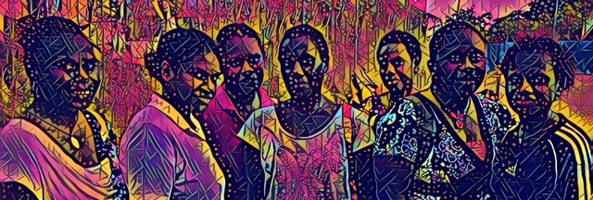

**Pacific Women Shaping Pacific Development in Papua New Guinea**

**Mid-term Review of the   
Papua New Guinea Country Plan**

Prepared for:

The Australian Department of Foreign Affairs and Trade

by

Ann Braun

Development Evaluation | Monitoring and Evaluation Support

PO Box 3729, Richmond 7050, New Zealand

Mobile: +64 22 970820 | +64 27 6024916

Katherine Yuave

Monitoring and Evaluation Practitioner

PO Box 4702, Boroko, National Capital District, Papua New Guinea

Mobile: +675 7205 2169

**August 2017**

Contents

Executive Summary v

1. Introduction 1

1.1. Background 1

1.2. Purpose 2

1.3. Stakeholders and governance 2

1.4. Methods 2

1.5. Limitations 3

2. Findings 4

2.1. Papua New Guinea context analysis: synopsis 4

2.2. Situation analysis: Country Plan portfolio 5

2.3. Progress towards Country Plan objectives 7

2.4. Progress towards Country Plan outcomes 10

2.5. Upholding country plan principles 13

2.6. Examples of Benefits 14

2.7. Country Plan Focus and Design 14

2.8. Management 16

2.9. Governance 19

3. Conclusions 20

3.1. Progress against the Country Plan 20

3.2. Focus and design of the Country Plan 21

3.3. Management 23

3.4. Governance 23

4. Recommendations 23

Appendices 25

Appendix 1 Outcomes expected by 2016 under the *Pacific Women* Papua New Guinea Country Plan for 2014–2019 25

Appendix 2 *Pacific Women* Papua New Guinea Theory of Change 22

Appendix 3 Evaluation objectives and questions 23

Appendix 4 Context analysis methodology 26

Appendix 5 Mid-term review schedule 32

Appendix 6 Analysis of the *Pacific Women* Papua New Guinea portfolio against the Country Plan 34

Appendix 7 Assessment of progress against Country Plan objectives, outcomes, and principles 44

Appendix 8 *Pacific Women* Papua New Guinea partner network 56

Appendix 9 Papua New Guinea context analysis 60

Appendix 10 The *Pacific Women* Papua New Guinea portfolio at a glance 66

Appendix 11 Case reports: project benefits 68

Appendix 12 Women’s Business Resource Centre: User Stories 73

Appendix 13 Insights and Messages 75

Tables and Figures

Table 1: Examples of the use of evidence in projects funded by *Pacific Women* 9

Table 2: Strengths and weaknesses of the *Pacific Women* Papua New Guinea Country Plan 16

Table 3: Recommendations 23

Table 4: Revised evaluation objectives and questions 25

Table 5: Context analysis summary 2014–2019 *Pacific Women* Papua New Guinea Country Plan 27

Table 6: Initial sources for context analysis 29

Table 7: Meetings and interviews 32

Table 8: Analysis of the portfolio of projects against the Country Plan 34

Table 9: Progress in leadership and influence, women’s economic empowerment and violence response and services 44

Table 10: Progress in learning and understanding 52

Table 11: Program principles scorecard 53

Table 12: Project linkages to youth, men, persons with disabilities, church and faith-based organisations, and the private sector 55

Table 13: Issues and opportunities identified by implementing partners and stakeholders 75

Figure 1: Country Plan objective scorecard 7

Figure 2: Country Plan outcomes scorecard for leadership and influence 10

Figure 3: Country Plan outcomes scorecard for women’s economic empowerment 11

Figure 4: Country Plan outcomes scorecard for violence response and services 12

Figure 5: Project links with key stakeholder groups 13

Figure 6: Ripple effects of the Malasang 1 Resource Centre 69

Terms and Acronyms

APEC Asia-Pacific Economic Community

AUD Australian Dollar

CEDAW Convention on the Elimination of all forms of Discrimination against Women

DFAT Department of Foreign Affairs and Trade (Australia)

OECD Organisation for Economic Cooperation and Development

PGK Papua New Guinea Kina

PNG Papua New Guinea

UNDP United Nations Development Program

UNICEF United Nations Children’s Fund

UN Women United Nations Entity for Gender Equality and the Empowerment of Women

SASA! Violence prevention community mobilisation approach originally developed in Uganda

Executive Summary

**This mid-term review of the Pacific Women Shaping Pacific Development (*Pacific Women*) second country plan for Papua New Guinea (Country Plan) is intended to promote learning and improvement, accountability, and whole-of-program quality assurance**. The review does this by identifying significant contextual developments, assessing progress towards the objectives of the Country Plan, reviewing its focus, and suggesting ways to streamline program management and governance.

**The review found that the context analysis developed in the Country Plan remains valid.** While inequalities between men and women remain entrenched in Papua New Guinea, the legal and policy framework has advanced, and there have been significant developments in the enabling environment since the Country Plan was formulated.More women are contesting elections and considerable progress has been made in achieving a basic level of response to the needs of survivors of family and sexual violence. More girls are attending school and more women are working in the formal sector.

**The funded portfolio corresponds well to the Country Plan design.** This is despite funding cuts in the bilateral budget and capacity constraints at the Australian High Commission in Port Moresby and slower implementation of the *Pacific Women* Support Unit, delaying some implementation. These challenges were mitigated by leveraging $12.38 million in additional funding from other sources and through the establishment of a *Pacific Women* Support Unit sub-office.

**More than half of the projects demonstrate evidence of acting together for change, taking advantage of the existing networks built by implementing partners** **and supported by networking events and people-to-people channels facilitated by the *Pacific Women* Support Unit.** This strong result points to the emergence of the coordinated approach sought by the Country Plan. The use of evidence by 23 of 26 implementing partners is also a strong result. At least 15 of the 18 projects with potential to contribute to service improvements demonstrate evidence of doing so.

**There is evidence of achievements in four of the five outcome areas in women’s leadership and influence.** The strongest results are in the Autonomous Region of Bougainville where projects have influenced government policies and programs promoting women’s leadership, contributed to increasing the number of women contesting community government elections, and built women and girls’ skills to fulfil leadership roles.

**For women’s economic empowerment, there is evidence of results in three of the four interim outcome areas:** increased safety, productivity and incomes; skills for employment or business; and private sector policy changes. The weakest performance is in demonstrating results related to increased access to markets.

**There is excellent progress in four of the eight outcome areas in response to violence against women and expanded support services.** All projects working towards the development of advocacy coalitions, testing of prevention programs, and development of service delivery models and of the referral pathway demonstrate results. Eight of the 11 projects demonstrate results on assembling evidence on causes of violence and drivers of change. Despite the current government budget crisis, five of 11 projects have made progress in influencing government funding and coordination of family and sexual violence services. One project that is addressing sorcery-related violence has evidence of contributions to saving women and children’s lives. Evidence is lacking to demonstrate a contribution to reducing violence against women in targeted provinces.

**The program is on track for achieving program objectives and outcomes, with the strongest results in responses to violence against women and expanded services for survivors.**

**Program principles are strongly upheld across the portfolio.** The strongest performance in upholding principles is in testing innovative ideas, supporting indigenous organisations and supporting Government of Papua New Guinea policy and coordination. More than half of the projects demonstrate an integrated approach.

**In Bougainville and the National Capital District, there is evidence of important benefits at the individual level, and of benefits extending beyond individuals to the family, community and/or institutional levels.** This was especially evident in the more mature projects visited. All projects visited have examples of transformative cases.

**The Country Plan is targeted specifically to empower women, reduce and prevent family and sexual violence, and work towards equality.** It is well aligned with Papua New Guinea’s Development Cooperation Policy and Australia’s Gender Equality and Women’s Empowerment Strategy. It recognises the importance of culture-specific understanding for addressing gender inequality.

**The design is supported by strong international evidence in favour of targeted interventions focused specifically on achieving equality for women.** The program has tapped into international knowledge and experience to introduce, adapt, and test innovative approaches for addressing the root causes of family and sexual violence and inequality.

**Stakeholders identified many strengths:** flexibility, pragmatism, positioning of family and sexual violence as a public health issue, support for networking and coalition building among a diversity of partners, building on existing structures, and looking for synergies and opportunities to replicate successes.

**While the program now has partners supporting efforts in 15 provinces and Bougainville, only Bougainville has projects working towards all three of *Pacific Women* Papua New Guinea’s intended outcomes.** This suggests that some departure from the theory of change, which is that change in attitudes, policy and services depends on working across the three intended outcomes.

**More than half the projects are funded for three years or less.** Given the Country Plan’s focus on projects with potential to change social norms, attitudes, policies and laws, and the challenging context, the project durations are short. So far there are few examples of other Australian government funded programs taking up the successes identified by *Pacific Women.*

**Stakeholders identified several weaknesses:** insufficient emphasis to violence against children and to women’s economic empowerment including livelihood options for survivors of family and sexual violence, lack of clarity on positioning for women’s economic empowerment and women’s leadership and influence, and insufficient emphasis to geographic targeting especially in relation to women’s leadership and influence initiatives. While the lack of direct funding to local organisations was raised as a concern there was acknowledgement that institutional strengthening of local organisations carried out by many programs over many years has built the capacity of individuals but not necessarily local organisations. Some local organisations expressed their preference to be funded through strong, long-term relationships with international partners. They noted advantages including risk sharing and support to build capacities in networking and influencing, conducting research, and accessing opportunities for engaging and sharing knowledge with other key players.

**There are some management and governance issues.** With changing and layered relationships between the Australian High Commission and the *Pacific Women* Support Unit sub-office, there has been confusion about the nature and role of the program. Some misconstrue it as a grants program and some are concerned that it plays a coordination role in parallel to the Government of Papua New Guinea or duplicates efforts of other Australian-funded development programs. The *Pacific Women* Support Unit is overstretched, which limits opportunities for it to play a more of a policy guidance role. Opportunities to draw on the collective expertise of the Reference Group expertise have so far been limited.

**Looking forward, the review team recommends staying the course by maintaining funding for current programs to enable them to reach their potential, and maximise their synergy and impact by continuing to integrate intended outcomes and connect partners.** The review identifies several specific actions that can be taken to make the Country Plan more relevant, effective, and sustainable.

1. Introduction
   1. Background

Pacific Women Shaping Pacific Development (*Pacific Women*) was announced by the Australian Government in August 2012. It commits up to $320 million[1] over 10 years in 14 Pacific Islands Forum member countries. The program aims to improve opportunities for the political, economic, and social advancement of Pacific women. The *Pacific Women* Papua New Guinea program is *Pacific Women’s* largest country program, and the smallest of Australia’s investments in Papua New Guinea.[2] During its first phase (2012–2014), Australia invested $8.4 million in the *Pacific Women* Papua New Guinea program and $58 million is budgeted for the second phase (2014–2019).

The current portfolio consists of 37 investments, in Sepik, Western Province, Eastern Highlands, Simbu and Morobe, the National Capital District and the Autonomous Region of Bougainville (Bougainville). They are led primarily by multilateral organisations, international nongovernmental organisations, and Australian tertiary institutions working in partnership with 20 Papua New Guinea government agencies, 13 civil society organisations, two faith based organisations, seven tertiary institutions, as well as the private sector. Projects were chosen for their potential to contribute to changing social norms, attitudes, policies, and laws to promote gender equality.

Projects work towards four interconnected intended outcomes:

* increase women's leadership and influence in decision-making, including at local government level (leadership and influence);
* increase economic opportunities for women (women’s economic empowerment);
* strengthen the national response to violence against women and provide expanded support services (violence response and services); and
* enhance knowledge and evidence to inform policy and practice (learning and understanding).

The Australian Department of Foreign Affairs and Trade (DFAT) Gender and Sports section at the Australian High Commission in Port Moresby manages the program. A *Pacific Women* Support Unit sub-office in Port Moresby handles contracting, monitoring, evaluation, and reporting. It also promotes learning, networking and coalition-building. A Papua New Guinea Reference Group was established in late 2016 to provide advice on strategic direction.

### Objectives[3]

* By 2019 partners supported through the program will act together for change and use evidence from research, monitoring and evaluation. Services delivered, supported or influenced through the program will improve in one or more dimensions.[4]

### Principles

* Adopt an integrated approach designed to catalyse change in key areas.
* Trial innovative ideas and identify what works for uptake by DFAT’s larger investment areas.
* Increasingly support indigenous organisations to bring about change.
* Support Government of Papua New Guinea policy and coordination.
* Retain flexibility to respond to emerging opportunities.

The Country Plan identifies four to eight intended outcomes for each of the Country Plan’s outcomes expected by 2016 (Appendix 1). The theory of change (Appendix 2) is that by working across the gender equality issues of leadership and influence, women’s economic empowerment and violence response and services, the program will advance incremental changes already underway in attitudes, the policy environment, and violence survivor services, bringing change to large numbers and diverse groups.

* 1. Purpose

This is a multi-purpose review intended to promote learning and improvement, accountability, and whole-of-program quality assurance. The main objectives are:

* Identify significant contextual developments.
* Identify progress towards the objectives of the Country Plan.
* Review the focus and design of the Country Plan.
* Identify ways to streamline program management and governance.

The evaluation questions associated with each objective are detailed in Appendix 3.[5]

* 1. Stakeholders and governance

The main stakeholders of this review are DFAT, the Government of Papua New Guinea, the Autonomous Bougainville Government, implementing partners, and the *Pacific Women* Support Unit. A mid-term review reference group provided oversight to the review. The composition and responsibilities of the group are detailed in the evaluation plan. The review team was accompanied by members of the national and Autonomous Bougainville Government’s Department for Community Development.

* 1. Methods

We (the review team) undertook a context analysis and document analysis,[6] observed the *Pacific Women* Annual Learning Workshop (2–4 May 2017), and conducted field visits to eight projects. The report is based on information up to the time that we finished information gathering, on 29 June 2017.

The methodology for the context analysis is described in Appendix 4. We engaged implementing partners, and where possible, beneficiaries and other stakeholders, through semi-structured interviews with individuals and/or groups. The visit schedule is in Appendix 5. We compared the portfolio of *Pacific Women* Papua New Guinea projects against the design guidance provided in the Country Plan. The analysis is provided in Appendix 6.

We conducted an assessment of progress against the Country Plan based on information gathered during the Annual Learning Workshop, from the *Pacific Women* Papua New Guinea Annual Performance Reports, baseline studies, recent evaluations, and field visits. The 2016-2017 *Pacific Women* Papua New Guinea Annual Performance report identifies 37 projects. Four projects that funded refurbishments and/or provision of equipment were excluded from the analysis, as were projects completed during Phase 1 (2012–2014) and those which have not yet begun implementation at the time of the field visit. This left a total of 26 projects with five in the leadership and influence intended outcome, seven in women’s economic empowerment and 14 in violence response and services, including the learning and understanding research projects which, for most analyses, were classified under each of the other three intended outcomes.

We assessed the set of information sources available for each of the 26 projects to determine contributions to Country Plan objectives and the outcomes expected by 2016, and assessed alignment with program principles.[7] The rubrics used and the overall assessment are in Appendix 7.

The Country Plan envisions that by 2019 partners will be acting together for change. To visualise the extent to which partners are networked (a precondition for coordinated action), we constructed network maps (Appendix 8). These illustrate the potential benefit of network mapping to *Pacific Women* and could serve as the starting point for a time series documenting the evolution of networks.

* 1. Limitations

Security and time constraints limited the depth of engagement during the eight field visits. Beneficiaries (individuals and sub-projects[8]) selected for participation by implementing partner organisations generally reflected a selection bias towards those with positive views. We were not able to meet with beneficiaries of all projects.[9] In many cases, meetings were held at the implementing office, often with large, mixed groups, with beneficiaries and staff from several implementing partner organisations. This left no opportunity for individual interviews. We had limited knowledge of gender mainstreaming activities implemented in other DFAT programs.

*Pacific Women* Papua New Guinea Annual Performance Reports were a principal source of information and evidence for this review. They contain progress reports for each project, which vary in detail and comprehensiveness. Wherever possible, progress analysis report information was complemented by information gathered at the Annual Learning Workshop,[10] and from program evaluations and baseline studies.[11]

In an independent evaluation of a complex program, the team or team leader would generally design the evaluation during a design and inception phase in consultation with the evaluation reference group. This would be based on evaluability, project document, and portfolio analyses. This evaluation, however, lacked an inception phase. DFAT and the *Pacific Women* Support Unit predetermined the methods used for addressing the evaluation questions and selected the projects to be visited based on: accessibility, cost, and the availability of previous evaluations.

1. Findings
   1. Papua New Guinea context analysis: synopsis

The context analysis developed in the Country Plan remains valid. Significant contextual developments since the Country Plan are below, with a full update of the context analysis in Appendix 9.

Advances in the policy and legal framework include the passing of the 2016 National Gender-Based Strategy and *Family Protection Act* regulations. The *Civil Registration Act* was amended to prohibit polygamy. Changes proposed to the 2015 Marriage Bill will give women equal rights to property and assets on divorce.

Considerable progress has been made in achieving a basic level of response to the needs of survivors of family and sexual violence. Even so, the family and sexual violence epidemic continues, including high levels of violence against children. The National Policy on Child Protection was recently finalised. There is a budgetary and debt crisis, dimming prospects for implementation of these and other policies and reforms.

The reach of primary schools has grown, but health services have contracted. There is an unmet need for sexual and reproductive health and family planning services. Free tuition increased girls’ school attendance, but the risk of violence and lack of water and sanitation facilities for menstrual hygiene remain problematic.

Women now occupy nearly a quarter and a third of senior and middle management positions respectively in central government agencies. They are well represented as teachers and health workers, but rural women face many obstacles in accessing income from both agriculture and waged employment. There is growing pressure for both rural and urban women to generate income in addition to their domestic responsibilities.

Papua New Guinea’s private sector has potential to be a vehicle for addressing gender inequality, including in the coffee, cacao, and extractive industries in rural areas. Favourable developments for women’s economic empowerment include new small and medium enterprise start-up programs, increasing options for accessing financial services, a surge in youth-led enterprises, and the emergence of social impact enterprises.

There was an increase in the number and percentage of women contesting elections. Five per cent of candidates for the 2017 national elections were women though no women were ultimately successful. The opportunity to see more women as candidates and in leadership roles is contributing to changing the social narrative of women in leadership.[12]

Broad drivers of change include the huge youth population, urban areas (driving demand for rural goods, labour, and supply remittances), and the expanding working middle class (including young women who attained education in the last decade). Middle class opinions are important in framing village discussions of social issues and in reshaping the public sphere. Technology is also creating change. Competition in the mobile phone subsector is driving the expansion of coverage, rapid penetration of mobile phones, and use of social media. These affect all aspects of rural and urban life.

* + 1. Development cooperation policy and funding[13]

### Papua New Guinea

The 2016 Papua New Guinea Development Cooperation Policy[14] reflects a changing approach to the way Papua New Guinea applies development cooperation resources. It signals a shift from the traditional donor-recipient engagement paradigm to one of economic cooperation.

The policy addresses Government of Papua New Guinea concerns regarding sovereignty, thin spread of resources across the country, coordination and performance management, disbursement delays, and the creation of parallel systems driven by the low confidence of development partners in the government’s systems and processes. The policy views exclusion and gender discrimination as a cross-cutting challenge, along with environmental sustainability and reaching geographically isolated areas.

### Australia

In 2016, DFAT launched a Gender Equality and Women’s Empowerment Strategy. The strategy is based on an understanding of gender inequality as the result of unequal power distribution between women and men, exacerbated by ongoing discrimination, weaknesses in laws, policies and institutions, and social relations that normalise inequality. The priorities enshrined in the policy are enhancing women’s voice in decision-making, leadership, and peace-building; promoting women’s economic empowerment; and ending violence against women and girls.

The strategic objectives of Australia’s aid program in Papua New Guinea for 2015/16 to 2017/18 are promoting effective governance, enabling economic growth, and enhancing human development. Gender equality is treated as a cross-cutting issue and programs are expected to integrate gender equality.

### International

International research questions the effectiveness of gender mainstreaming approaches in practice and supports theCountry Plan’sapproach of targeted interventions focused specifically on achieving gender equality for women. *Pacific Women* alsoaligns with recommendations from international meta-evaluation to use result-focused terminology, support direct action in context, prioritise actions that matter the most, use theories of change and seek evidence.[15]

* 1. Situation analysis: Country Plan portfolio

The *Pacific Women* Country Plan was designed to be part of a large Australian aid program that supports church partnerships and has significant programs in justice, education, governance, infrastructure and the health sectors. The *Pacific Women* program assessed the needs required to achieve the goals of *Pacific Women* and sought to meet the intended outcomes in Papua New Guinea by addressing gaps in these other programs.

A comparison of the *Pacific Women* Papua New Guinea projects against the design guidance in the Country Plan demonstrates that the portfolio corresponds well to the design (Appendix 6). Some liberty has been taken in interpreting the design guidance in implementation. For example, no specific innovation and consolidation fund was established; instead several innovative pilot projects were funded.

Appendix 10 provides a full summary of the timing and duration, funding source, and geographic focus for *Pacific Women’s* Papua New Guinea projects.

The Country Plan envisioned continuation of several projects from the first phase[16], complemented by additional projects launched together early in the second phase. This proved overly ambitious, particularly as the *Pacific Women* Support Unit sub-office was not fully operational until March 2016. Of the new projects, five were launched in the first financial year of the Country Plan, eight in the second, and four in the third.

In several areas of the Country Plan no projects have been funded to date. This is because other development partners or Australian government funded programs have agreed to support those projects.[17]

Lack of government capacity has been a second reason for not delivering an element of the Country Plan. An example is the provision of technical support for Asia-Pacific Economic Coordination (APEC) women in business activities associated with Papua New Guinea hosting the APEC Leader’s Forum in 2018. It is currently in proposal development stage.

Australian Government budget decisions and difficulties finding appropriate partners to deliver approved projects in Papua New Guinea affected delivery of the Country Plan. In 2016, the expected bilateral budget of $12 million was reduced by approximately $2 million. As a result, the designs for the Women in Leadership Support program (Leadership Support) and Women in Mining project were not started in the timeframe planned. Creating an entrepreneurial ecosystem project (Entrepreneur), the WECREATE Challenge and UNICEF’s Partnership for Positive Parenting (Positive Parenting) all experienced delays in finding appropriately skilled partners.

As foreseen in the Country Plan, the largest share of funding[18] (65 per cent) is for violence response and services projects. The program leveraged 30 per cent of total funding for these from other sources. Women’s economic empowerment, and leadership and influence account for 20 per cent and 15 per cent of program funding respectively. The program leveraged 9 per cent and 48 per cent respectively of total funding for these areas from other sources. The US Embassy is the program’s strongest partner among bilateral donors.

Funding for individual projects ranges from $40,000 for *Kirapim Kaikai na Maket* to $5.7million for Port Moresby: A Safe City for Women and Girls Program (Safe Markets). Ten projects receive less than $1 million, ten between $1 million and $3 million, and six above $3 million. Five projects have been operating for one year or less, and eight are funded for more than three years. During or before the 2017/18 financial year, 18 projects are due to finish.

The current geographic focus is in line with the Country Plan, which expanded the initial focus on the Eastern Highlands and Simbu, Western Province, Central Province and the National Capital District to include Bougainville, Morobe and Sepik. *Pacific Women* partners are supporting efforts in 15 provinces and Bougainville, plus two that are national in scope.[19] Bougainville and the National Capital District have the highest density of partner efforts. Twelve projects have activities in Highlands provinces, with many working in multiple sites. Of the 16 areas in which partners are working, only Bougainville has projects in all three of *Pacific Women’s* intended outcomes areas. Seven of the 16 areas have projects in violence response and services only.

**Ways partners work with government**

* The Nazareth Centre is working with the Autonomous Bougainville Government on a safe house policy.
* UNICEF works with the Department for Community Development to bring together the few agencies working in child protection.
* UN Women worked with the National Capital District Commission to establish a Market Division.
  1. Progress towards Country Plan objectives

We assessed whether there is evidence that *Pacific Women* Papua New Guinea projects have contributed to the County Plan’s objectives. The scorecard showing overall progress towards Country Plan objectives at this midway point of the Country Plan is in Figure 1.[20]

Figure 1: Country Plan objective scorecard

**Key**

| ⬤ The objective or outcome is not applicable | ⬤ Too early to assess or insufficient evidence to permit assessment | ⬤ Evidence of contribution to the objective |
| --- | --- | --- |

|  |  |  |  |  |  |  |  |  |  |  |  |  |  |  |
| --- | --- | --- | --- | --- | --- | --- | --- | --- | --- | --- | --- | --- | --- | --- |
| **Partners act together** | | | | | | | | | | | | | | |
| Women’s Leadership & Influence (5) | ⬤ | ⬤ | ⬤ | ⬤ | ⬤ |  |  |  |  |  |  |  |  |  |
| Women’s Economic Empowerment (7) | ⬤ | ⬤ | ⬤ | ⬤ | ⬤ | ⬤ | ⬤ |  |  |  |  |  |  |  |
| Family and Sexual Violence (14) | ⬤ | ⬤ | ⬤ | ⬤ | ⬤ | ⬤ | ⬤ | ⬤ | ⬤ | ⬤ | ⬤ | ⬤ | ⬤ | ⬤ |
| **Partners use evidence** | | | | | | | | | | | | | | |
| Women’s Leadership & Influence (5) | ⬤ | ⬤ | ⬤ | ⬤ | ⬤ |  |  |  |  |  |  |  |  |  |
| Women’s Economic Empowerment (7) | ⬤ | ⬤ | ⬤ | ⬤ | ⬤ | ⬤ | ⬤ |  |  |  |  |  |  |  |
| Family and Sexual Violence (14) | ⬤ | ⬤ | ⬤ | ⬤ | ⬤ | ⬤ | ⬤ | ⬤ | ⬤ | ⬤ | ⬤ | ⬤ | ⬤ | ⬤ |
| **Improved Services** | | | | | | | | | | | | | | |
| Women’s Leadership & Influence (5) | ⬤ | ⬤ | ⬤ | ⬤ | ⬤ |  |  |  |  |  |  |  |  |  |
| Women’s Economic Empowerment (7) | ⬤ | ⬤ | ⬤ | ⬤ | ⬤ | ⬤ | ⬤ |  |  |  |  |  |  |  |
| Family and Sexual Violence (14) | ⬤ | ⬤ | ⬤ | ⬤ | ⬤ | ⬤ | ⬤ | ⬤ | ⬤ | ⬤ | ⬤ | ⬤ | ⬤ | ⬤ |

* + 1. Partners act together

The implementing partners of more than half of the projects demonstrate evidence of acting together for change (Figure 1). Partner network maps (Appendix 8) support this finding and illustrate the links among partners working within and between intended outcomes.

The maps demonstrate considerable linkages between violence response and services and women’s economic empowerment; and some linkages between violence response and services and leadership and influence; and between leadership and influence and women’s economic empowerment. There are many linkages with district, provincial and national government agencies.

Working across intended outcomes creates strong incentives for implementing partners to access expertise from each other. This is illustrated by the Safe Markets, Safe Public Transport for Women, Girls and Children (Safe Transport), and the Family Support Centre Assistance projects. Safe Markets has worked in three markets, initially focusing on increasing safety for vendors and buyers. Vendors associations then became a channel for improvements to market policies, hygiene, food handling, and safety. They facilitated access to financial services and advocacy for family and sexual violence services. The Family Support Centre Assistance project has provided gender sensitisation training for all the Safe Markets and Safe Transport service providers and duty bearers, and trained them on the family and sexual violence referral pathway in Port Moresby and how to make a referral.

With respect to violence response and services, the Family and Sexual Violence Action Committee worked with the Papua New Guinea Counselling Association, Oil Search Foundation, and ChildFund. They developed a 10-year framework[21] to create a fully functioning local professional counselling association, and a curriculum to strengthen tertiary education and address the lack of qualified counsellors.

**How *Pacific Women* contributes to partners acting together for change**

*‘Pacific Women* has joined up the actors in the Papua New Guinea gender research space.’

‘*Pacific Women* [Support Unit] encouraged integration by calling a meeting and reminding us we needed to align our program and services with the Gender-Based Violence policy and ensure we don’t duplicate what others are doing.’

‘*Pacific Women* have a good understanding of the policy environment, are responsive to it, and have built a strong network of implementing partners.’

In women’s economic empowerment, Pacific Adventist University developed financial and business literacy modules for low literacy contexts for the Increasing economic opportunities for women smallholders project (Family Teams). These have been piloted in the Coffee Industry Support Project (CARE Coffee). Several women who participated in the pilot have established micro-businesses. Modules will be finalised and published in the next reporting period. The Women’s Business Resource Centre also plans to use the modules, and discussions to have the modules certified as meeting the standards of the Papua New Guinea Centre for Excellence in Financial Inclusion in 2017.

This points to a coordinated approach characterised by collaboration between implementing partners and with government agencies. The implementing partners interviewed for this review attributed these linkages primarily to their own networking efforts, but also recognised the important contribution of DFAT and the *Pacific Women* Support Unit to catalysing and supporting collaboration through networking meetings and events as well as informal people-to-people channels. Partners and stakeholders also recognised several other important roles played by *Pacific Women*:

‘The benefit of having a specialist program like *Pacific Women* is the specialist knowledge. We need access to those gender specialist skills.’

‘Through *Pacific Women* local nongovernmental organisations have received international exposure and recognition.

‘*Pacific Women* links partners to important issues such as disability inclusion.’

* + 1. Partners use evidence

The review found examples of partners using evidence to inform decision-making and programming in 23 of 26 projects (Figure 1).[22] Table 1 describes examples of how projects are using evidence.

Table 1: Examples of the use of evidence in projects funded by *Pacific Women*

| **Investment** | **Example** |
| --- | --- |
| Strengthening Business Coalitions for Women (Business Coalition) | Since 2014 the Business Coalition for Women has supported Papua New Guinea’s private sector to recruit, retain, and promote women as employees, leaders, customers, and business partners. It provides member organisations with model policies, good practices, case studies, and practical tools for nurturing talent and promoting economic empowerment. Three member companies participated in a study to identify the financial costs of gender-based violence to business. The research monetised staff time lost to gender-based violence, costs of dealing with it, and indirect costs, such as staff turnover. The Coalition uses the findings as part of a business case for investing in gender. |
| Positive Parenting | Positive Parenting is working with the Catholic dioceses of three provinces to pilot an adapted approach that proved successful in Australian Aboriginal and Torres Strait Islander communities. The pilot is evaluating the extent to which community facilitators deliver the material as intended and the participation of registered families in the training. A baseline study of attitudes, practices and decisions around parenting is also underway. |
| End Violence Against Children Campaign | The campaign targets Simbu, Jiwaka, Madang, Eastern and Western Highlands, and Bougainville. Each region chose the campaign methods they thought would work best from an array of different models. A mobile phone survey approach is being tested to assess the effectiveness of the campaign. The baseline survey made calls to 2,000 people in each area. The survey will be repeated after the roll out of the campaign. |

* + 1. Improved Services

At least 15 projects are contributing to service improvements (Figure 1).

**Examples of Service Improvements**

The Femili PNG Family and Sexual Violence Case Management Centre in Lae (Femili PNG) provides integrated case management services for survivors of family and sexual violence. It has become the best practice model in Papua New Guinea. Case management can include referrals for medical treatment, safe accommodation, and legal advice. For clients with challenging or complex cases, case conferences bring together a range of stakeholders to work for the best outcomes. For those who want to leave a situation of violence relocation or family reunification is the best option. Finally, if a client has not been able to achieve desired outcomes from the police or the justice system case workers can advocate on their behalf. During 2015/16, its second year of operation, Femili PNG assisted 507 new clients and their families, conducted 3,547 client support consultations, helped hundreds of clients and their dependents obtain emergency accommodation, Interim Protection Orders, and relocations and expanded staffing in Lae from 12 to 16.

CARE Coffee supports training services for coffee farming families on the Model Farming Family, Family Business Management, Financial and Business Literacy, Women in Agribusiness, and Coffee Husbandry and Management and fish farming.

*Komuniti Lukautim Ol Meri* has adapted an internationally recognised socio-ecological model of violence prevention for the Papua New Guinea Highlands context and now reaches 17 wards in remote areas.

* 1. Progress towards Country Plan outcomes

**Figure 2 summarises overall progress towards the outcomes**[23] **of the Country Plan in leadership and influence.[24]** There is significant progress on four of the five interim outcomes.There is no evidence of progress for the outcome on development of mining agreements favourable to women’s interests[25] as no projects have yet been funded due to implementation delays.

The Office of the Development of Women developed the National Gender-Based Violence Strategy with assistance from the UNDP program, Support for Strengthening National Coordination, Implementation and Monitoring Mechanisms to Prevent and Respond to Family and Sexual Violence (National Mechanisms) project. The Strategy takes a comprehensive approach and places the Government in a leadership role in coordinating gender policy. Projects in Bougainville influenced government policies and programs promoting women’s leadership. They contributed to increasing the number of women contesting community elections and to building women’s and girls’ skills to fulfil leadership roles. The Leadership Support project helped women candidates understand campaigning, the importance of raising funds, having male backers, and preparing a long-term campaign plan. Its full contribution to women contesting national and local elections will be clear after the 2017 and 2018 election results.

The number of investments in leadership and influence has increased since July 2015 from one to five projects.[26] This outcome area is also supported by achievements in several projects classified under women’s economic empowerment and in violence response and services. A project under development with the Office of the Development of Women on APEC-related research will further strengthen achievements in leadership and influence and women’s economic empowerment. The building of confidence and knowledge through women human rights defenders in Bougainville has contributed to women being selected for roles in local government.

Figure 2: Country Plan outcomes scorecard for leadership and influence

**Key**

| ⬤ The objective or outcome is not applicable | ⬤ Too early to assess or insufficient evidence to permit assessment | ⬤ Evidence of contribution to the objective |
| --- | --- | --- |

|  |  |  |  |  |  |
| --- | --- | --- | --- | --- | --- |
| **Project** | **Government promotes WLI** | **ODW[27] coordinates gender policy development** | **Skills to fulfil roles** | **Women contest elections** | **Mining agreements** |
| Inclusive Development in post-conflict Bougainville (Inclusive Development) | ⬤ | ⬤ | ⬤ | ⬤ | ⬤ |
| Women’s Forum | ⬤ | ⬤ | ⬤ | ⬤ | ⬤ |
| Young Women’s Leadership Project | ⬤ | ⬤ | ⬤ | ⬤ | ⬤ |
| Voter education in Bougainville (Voter Education) | ⬤ | ⬤ | ⬤ | ⬤ | ⬤ |
| Leadership Support | ⬤ | ⬤ | ⬤ | ⬤ | ⬤ |
| National Mechanisms | ⬤ | ⬤ | ⬤ | ⬤ | ⬤ |

**Figure 3 summarises overall progress towards the outcomes of the Country Plan in women’s economic empowerment.**[28] The number of investments in women’s economic empowerment has increased since July 2015 from two to six projects.[29] Evidence of progress in this outcome area is strongest among the more mature projects: CARE Coffee, Business Coalition, Family Teams, and Safe Markets.[30] The best performance is in the outcomes of increased safety, productivity and incomes, and skills for employment or business. Entrepreneur and WECREATE Challenge have potential to contribute to connecting entrepreneurs launching small businesses to markets. Benefits of these initiatives are described in the case reports in Appendix 11.

Figure 3: Country Plan outcomes scorecard for women’s economic empowerment

**Key**

| ⬤ The objective or outcome is not applicable | ⬤ Too early to assess or insufficient evidence to permit assessment | ⬤ Evidence of contribution to the objective |
| --- | --- | --- |

| **Project** | **Increased safety, productivity & incomes** | **Skills for employment or business** | **Private sector policy changes** | **Increased access to markets** |
| --- | --- | --- | --- | --- |
| CARE Coffee | ⬤ | ⬤ | ⬤ | ⬤ |
| Business Coalition | ⬤ | ⬤ | ⬤ | ⬤ |
| Family Teams | ⬤ | ⬤ | ⬤ | ⬤ |
| Entrepreneur | ⬤ | ⬤ | ⬤ | ⬤ |
| WECREATE Challenge | ⬤ | ⬤ | ⬤ | ⬤ |
| *Kirapim Kaikai na Maket* | ⬤ | ⬤ | ⬤ | ⬤ |
| Do No Harm | ⬤ | ⬤ | ⬤ | ⬤ |
| Safe Markets | ⬤ | ⬤ | ⬤ | ⬤ |
| Safe Transport | ⬤ | ⬤ | ⬤ | ⬤ |

**Figure 4 summarises overall progress towards the outcomes of the Country Plan in violence response and services.**[31] The program demonstrates excellent progress in advocacy coalitions, testing of prevention programs, and development of service delivery models and referral pathways. There is good progress on assembling evidence on causes of violence and drivers of change.

Five of 11 projects demonstrate evidence of progress in relation to government coordination and funding of services. This is a good result considering the strong influence of contextual factors, particularly the current budget crisis (Section 2.1). Most projects lack evidence to demonstrate reductions in violence against women in targeted provinces, although at least two (Safe Markets and from Gender-Based Violence to Gender Justice and Healing (Gender Justice and Healing)) have anecdotal evidence (Appendix 11). One of the projects aiming to save women and children’s lives from extreme violence has reported contributions to this outcome.

Figure 4: Country Plan outcomes scorecard for violence response and services

**Key**

| ⬤ The objective or outcome is not applicable | ⬤ Too early to assess or insufficient evidence to permit assessment | ⬤ Evidence of contribution to the objective |
| --- | --- | --- |

| **Project** | **Referral pathways** | **Government funds and coordinates services** | **Reduced violence against women in targeted places** | **Evidence on causes / drivers available** | **Lives saved** | **Models of service delivery** | **Prevention programs tested** | **Advocacy coalitions** |
| --- | --- | --- | --- | --- | --- | --- | --- | --- |
| Safe Markets | ⬤ | ⬤ | ⬤ | ⬤ | ⬤ | ⬤ | ⬤ | ⬤ |
| Responding to gender-based violence and sorcery-related violence in the Highlands (Highlands Sorcery-Related Violence) | ⬤ | ⬤ | ⬤ | ⬤ | ⬤ | ⬤ | ⬤ | ⬤ |
| National Mechanisms | ⬤ | ⬤ | ⬤ | ⬤ | ⬤ | ⬤ | ⬤ | ⬤ |
| Femili PNG | ⬤ | ⬤ | ⬤ | ⬤ | ⬤ | ⬤ | ⬤ | ⬤ |
| Building the capacity of Papua New Guinea’s Family and Sexual Violence Action Committee (Family and Sexual Violence Action Committee) | ⬤ | ⬤ | ⬤ | ⬤ | ⬤ | ⬤ | ⬤ | ⬤ |
| Safe Transport | ⬤ | ⬤ | ⬤ | ⬤ | ⬤ | ⬤ | ⬤ | ⬤ |
| *Komuniti Lukautim Ol Meri* | ⬤ | ⬤ | ⬤ | ⬤ | ⬤ | ⬤ | ⬤ | ⬤ |
| Gender Justice and Healing | ⬤ | ⬤ | ⬤ | ⬤ | ⬤ | ⬤ | ⬤ | ⬤ |
| Positive Parenting | ⬤ | ⬤ | ⬤ | ⬤ | ⬤ | ⬤ | ⬤ | ⬤ |
| End Violence Against Children Campaign | ⬤ | ⬤ | ⬤ | ⬤ | ⬤ | ⬤ | ⬤ | ⬤ |
| Highland Sexual, Reproductive and Maternal Health | ⬤ | ⬤ | ⬤ | ⬤ | ⬤ | ⬤ | ⬤ | ⬤ |
| SASA! Pilot and Family Support Centre Assistance (Family Support Centre Assistance) | ⬤ | ⬤ | ⬤ | ⬤ | ⬤ | ⬤ | ⬤ | ⬤ |
| Communication strategies for social change against sorcery-related violence (Communication Strategies) | ⬤ | ⬤ | ⬤ | ⬤ | ⬤ | ⬤ | ⬤ | ⬤ |
| Improving the impact of state and non-state interventions in overcoming sorcery accusation-related violence (Improving Impact) | ⬤ | ⬤ | ⬤ | ⬤ | ⬤ | ⬤ | ⬤ | ⬤ |

**Table 10 summarises contributions of projects to the learning and understanding outcomes of the Country Plan.** All projects are contributing to the development of learning modules, products, and networks. Evidence in the *Pacific Women* annual performance reports and evaluations demonstrate that at least half the projects are contributing to learning by stakeholders about more effective ways to strengthen women’s empowerment and influence. These actions address the first two learning and understanding outcomes of knowledge and learning.

Five of the violence response and services projects are contributing to the availability of information and training to support recovery from trauma. The Family and Sexual Violence Action Committee are supporting the development a counselling curriculum and best practice manuals (section 2.3.2).

The final learning and understanding outcomes, scholarship availability and uptake of *Pacific Women* projects by other DFAT investments, are not project-linked. Scholarships are being progressed through Australia Awards (Appendix 6). Section 2.8.2 provides a discussion of uptake.

Figure 5 demonstrates the extent of linkages between projects[32] and key stakeholder groups (Table 12 contains details by project). Most projects work with men and with the private sector. Over 30 per cent of projects work with youth and with churches and/or other faith-based organisations. Less than 20 per cent are currently working with persons with a disability. While the overall record on working with men is strong (Figure 5), only one project, Gender Justice and Healing, has a specific focus on addressing issues faced by men and boys such as trauma and other mental health issues arising from sexual and other violence. This is a relatively small component of the larger project and limited by resource constraints.

Figure 5: Project links with key stakeholder groups

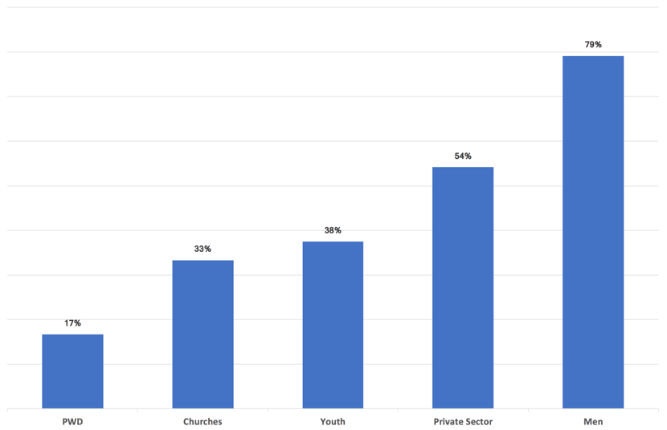

Three projects target families (CARE Coffee, Family Teams, Positive Parenting) and six use community-based models (Voter Education, Highlands Sorcery-Related Violence, *Komuniti Lukautim Ol Meri*, Gender Justice and Healing, Highland Sexual Reproductive and Maternal Health, Family Support Centre Assistance).

* 1. Upholding country plan principles

Four of five program principles are strongly upheld across the portfolio of projects. The strongest performance is in testing innovative ideas, supporting indigenous organisations, and supporting Government of Papua New Guinea policy and coordination.

More than half of the projects address more than one intended outcome, which is the criterion for demonstrating an integrated approach. There was insufficient information available to assess adherence to the flexibility principle in most projects. Table 9 summarises project contributions towards upholding the principles underpinning the Country Plan[33] and Table 11 provides details by project. Six projects demonstrate evidence of upholding all five program principles, including *Komuniti Lukautim Ol Meri*.

Example of upholding all five program principles: *Komuniti Lukautim Ol Meri*

**Integrated Approach:** The primary focus of *Komuniti Lukautim Ol Meri* is reducing the level of violence against women and girls using a socio-ecological model. Working with adult and youth women and men, the project combines family and sexual violence prevention and response with a focus on building capacity in community governance and leadership (empowerment).

**Testing Innovative Ideas:** The project has adapted an internationally recognised model[34] of violence prevention for the Papua New Guinea Highlands context.

**Supporting Indigenous** **Organisations:** The projectworks with community mobilisers, Family Support Centres, youth gender fora, and schools.

**Supporting Government of Papua New Guinea policy and coordination:** It is delivered in partnership with the Western Highlands and West Sepik Provincial Health Authorities and the Sandaun Provincial Administration Department of Community Development.

**Flexibility:** To improve sustainability the project has identified the need to identify a different local organisation to take the lead in coordination meetings involving service providers in the referral and case management pathways.

* 1. Examples of Benefits

There is evidence of women and others benefitting in a range of ways through the work of the *Pacific Women* Papua New Guinea program. We prepared four case reports for projects in Bougainville and the National Capital District to illustrate this. These are reported in Appendix 11and Appendix 12.

The examples highlight a range of benefits, including reduced domestic burden and income generation for women and a reduction in family and sexual violence and sorcery accusation-related violence. There are services for young men and boys who were raised in abusive homes and are now expressing negative sexual behaviours and using drugs and alcohol and more open discussions about sexually transmitted infections and teenage pregnancy. Girls and boys are now helping with cooking, laundry, carrying water, and chopping firewood at home, and more girls are in leadership roles at school. Women starting up businesses have gained contacts and networking skills.

There are also identified benefits rippling out from primary interventions, such as the support provided for 22 children survivors of a landslide drawing on the Nazareth Centre’s capacity in trauma counselling. A further example of ‘ripple effects’ from the women’s resource centre in Malasang 1 is shown in Appendix 11.

* 1. Country Plan Focus and Design

The 2017 Annual Learning Workshop[35] and field visits provided an opportunity to gather insights and messages from *Pacific Women* implementing partners and stakeholders. Together with the context analysis (Section 2.1 and Appendix 9) and the strengths and weaknesses identified by implementing partners and other stakeholders (section 2.7.1 and Appendix 13) these provide background for the conclusions and recommendations on the focus and design of the Country Plan.

Key messages from the Annual Learning Workshop, big picture issues, implementation challenges, and opportunities raised by implementing partners and stakeholders during interviews and during the Papua New Guinea case study prepared as part of the Year-Three Evaluation of *Pacific Women* (Papua New Guinea Case Study),[36] are in Appendix 13.

* + 1. Country Plan strengths and weaknesses

**Implementing partner and Government of Papua New Guinea perspectives**

Engaging implementing partners and Government of Papua New Guinea staff on the strengths and weaknesses of the Country Plan proved challenging because few are familiar with it. *Pacific Women* Papua New Guinea Reference Group members and some implementing partners recommended that the Country Plan be socialised through workshopping and engaging partners in monitoring progress against it.

The 10-year lifespan of the *Pacific Women* program was mentioned when the question about strengths and weaknesses was posed. Some implementing partners felt that this was not long enough, particularly given the complexity and diversity of the Papua New Guinea cultural context.

While they may not be aware of the details of the Country Plan, implementing partners are familiar with the funded portfolio through attendance at the Annual Learning Workshops. A key message of the Annual Learning Workshop, frequently reiterated to the review team, was that not enough is being done in Papua New Guinea and by the *Pacific Women* program to address violence against children, or in women’s economic empowerment. It was not clear whether these interlocutors were aware of other Australian investments in economic growth.

Many of the implementing partners interviewed criticised the lack of funding to local organisations, and advocated for direct funding for women’s and faith-based organisations. DFAT is also concerned about the dominance of international nongovernmental organisations, multilateral organisations and Australian tertiary organisations as funding recipients. This is because support to indigenous organisations is a principle underpinning the Country Plan. However, provision of direct funding has been limited by the inability of local organisations to meet DFAT’s high standards for capacity to develop and manage programs, and to report on finances and results. There are exceptions, and organisations that do have the capacity, like Femili PNG, Institute of National Affairs, and the Community Development Workers Association Inc., are directly funded.

A solution to this conundrum, proposed repeatedly by stakeholders, was for *Pacific Women* to support the provision of institutional strengthening for long enough to enable local organisations to meet this high bar. However, further discussion generally brought out the point that such institutional strengthening has been carried out in Papua New Guinea by many programs over a period of years, but has not consistently resulted in the emergence of local organisations able to meet DFAT’s due diligence requirements. Possible explanations put forth for this were:

* The performance of international partners varies in providing capacity building and operational support for local nongovernmental organisation partners. In the absence of adequate support, so much staff time of the nongovernmental organisation is spent to meet financial and results reporting requirements that implementation suffers.
* Local organisations fail to reach the due diligence standard because their international partners lack a strategy for exiting the institutional strengthening mode.

Several participants added that while institutional strengthening is intended to benefit local organisations, it also benefits individuals, who are then able to move on to better remunerated roles in government, international nongovernmental organisations, or the private sector. Such turnover creates an on-going need for institutional strengthening in local nongovernmental organisations. It suggests it may continue to be difficult for *Pacific Women* to fulfil this operational principle.

Some local organisations expressed a preference for continuing to receive funds through an international nongovernmental organisation partner. These organisations explained that their strong, long-term relationship conferred many advantages. Advantages include access to support that goes beyond financial and results reporting, to developing capacities such as networking and influencing, conducting research, and accessing opportunities for engaging and sharing knowledge with other key players.

*Pacific Women’s* strategy for supporting local organisations has been to fund international nongovernmental organisations who work with local nongovernmental and community-based organisations (for example, International Women’s Development Agency working with the Bougainville Women’s Federation and the Nazareth Centre). The scorecard on upholding principles of the Country Plan (Table 11) indicates that 24 of the 26 projects work with local organisations and/or local government.

**Other perspectives**

Country Plan strengths and weaknesses from the perspective of DFAT, other donors, the *Pacific Women* Support Unit, and staff of other programs funded by DFAT are summarised in Table 2.

Table 2: Strengths and weaknesses of the *Pacific Women* Papua New Guinea Country Plan

| **Strengths** | **Weaknesses** |
| --- | --- |
| * First program in Papua New Guinea totally focused on women. * Holistic approach to family and sexual violence. * The positioning of family and sexual violence as an epidemic, together with the strategy to strengthen services and then move into prevention. * The design creates a network that can be used for scaling up and moving into different outcome areas. * The design supports networking of women’s development at government level as well as networking between organisations. * The design understands the need to fill niches rather than seeking to solve gender inequality. * Flexible design. * The program builds on existing structures and looks for synergies. It takes what works in one place and tries it elsewhere. * The plan targets the Highlands corridor, a critical geographical area with high levels of tribal violence and low women’s agency. | * In women’s economic empowerment and leadership and influence the positioning has not been as clear as for violence response and services.[37] * Leadership and influence work has been focused around specific events (elections); the plan needs to look at where the work should be targeted to connect with other initiatives. |

* 1. Management
     1. DFAT–*Pacific Women* Support Unit relationship

The *Pacific Women* Support Unit sub-office in Port Moresby became effective in March 2016 after delays in gaining agreement from the Government of Papua New Guinea. Before the establishment of the sub-office, DFAT called on management support from *Strongim Pipol Strongim Nessen* program.

The Papua New Guinea Case Study pointed out that these changing and layered relationships have created confusion among some implementing partners and stakeholders about the nature and role of the *Pacific Women* program in Papua New Guinea. Two related misconceptions were identified in this review.

Some perceive *Pacific Women* Papua New Guinea as a grants program geared around requests for proposals and expressions of interest. They lack understanding of the rather subtle point of difference, which is that the portfolio of projects aims to fulfil specific design guidance (Appendix 6). More generally, there appears to be a low level of awareness of the Country Plan.

Some see *Pacific Women* as a parallel structure and are concerned that the program may be undermining the role of the government agency that leads coordination of the complex, cross-sectoral issues in women’s development. This is the Office of the Development of Women, which sits in the Department for Community Development and Religion.

Through DFAT’s Gender and Sports section and, more recently, through the *Pacific Women* Support Unit sub-office, *Pacific Women* Papua New Guinea has been playing a facilitation role, catalysing and strengthening networking and coalition-building, information flow, monitoring and evaluation capacity, and introducing approaches that have been successful outside Papua New Guinea for testing and adaptation. As a nongovernmental project implementation unit, it is difficult for the *Pacific Women* Support Unit to engage with the Office of the Development of Women on behalf of DFAT, and the *Pacific Women* Support Unit is not authorised to do so. The misperception about *Pacific Women’s* role may be related to insufficient communication to stakeholders about the role of the *Pacific Women* Support Unit.

The Department for Community Development and Religion and Department for Community Development in Bougainville both indicated a desire for a closer working relationship with the *Pacific Women* program and Support Unit staff.

* + 1. Uptake by other DFAT programs

A key assumption underpinning the theory of change is that promising approaches identified by *Pacific Women* will be taken up by DFAT’s larger investment areas. The Papua New Guinea Case Study reports that *Pacific Women* is seen within the Australian High Commission in Port Moresby as ‘the specific investment in a challenging area that complements and offers direction setting experience to the broader DFAT gender mainstreaming strategy.’ This review learned that DFAT staff in PNG also value the specialist gender expertise associated with the projects funded under *Pacific Women.*

While staff at the Australian High Commission in Port Moresby recognise the scaling up of successes identified by *Pacific Women* as a potentially valuable strategy, there are only a few examples[38] to date where this has been put into practice.*Pacific Women* has, however, influenced other sector programs[39] and successfully leveraged co-funding from other DFAT programs to expand the reach of several projects,[40] including:

* The Young Women's Leadership Project is co-funded by the Bougainville Peace-Building Program.
* The Highlands Sorcery-Related Violence and Highlands Sexual Reproductive and Maternal Health projects are both funded by the Australian Nongovernmental Organisation Cooperation Program.
* Refurbishments to Family Support Centres, the Lifeline Centre and the Koki Market Transit Centre[41] were co-funded by the Health and Education Procurement Facility.
  + 1. Coordination

*Pacific Women* Papua New Guinea has women’s equality as its primary objective. It sits alongside other DFAT-funded programs expected to work within the gender mainstreaming paradigm. Australia’s current Aid Policy was launched in June 2014. It establishes gender equality and women’s empowerment as a priority for development and requires that 80 per cent of all Australia’s aid investments, regardless of objectives, will effectively address gender issues in their implementation. Increased expenditure on gender will be tracked using the OEDC Development Assistance Committee gender markers identifying a ‘principal’ or ‘significant’ expenditure on gender related issues.[42]

Potential for coordination issues is inherent in DFAT’s simultaneous use of two strategies for promoting gender equality through gender mainstreaming and gender specific activities. The need for greater coordination to avoid duplication were raised in discussions with some DFAT programs. The *Pacific Women* Support Unit proactively facilitates information sharing between programs and stakeholder to promote coordination.

The Bougainville Peace-Building Program has investments that integrate leadership and influence and women’s economic empowerment objectives within its pillars of Autonomy, Economic Development, and Peace and Security. Examples include:

* Young women’s leadership training delivered by five international nongovernmental organisations[43] in cooperation with district youth associations.
* The Bougainville Cacao Family Support Project implemented by CARE, which empowers women and children in the family unit through the production of cacao.
* The Community Grants program provides funding for community projects, including infrastructure applying an approach similar to the Inclusive Development project. Many women are leading and organising the projects.

In response to the concern about duplication and coordination in Bougainville, the Department for Community Development outlined its stance on coordination and aid effectiveness in general:

* Donors engaging with local organisations in Bougainville should seek recommendations from the Department on suitable partners, to maximise alignment and avoid overburdening organisations that are in demand as partners.
* The Autonomous Bougainville Government uses its influence with donors. As an example, the Autonomous Bougainville Government made a request to the World Bank for extension of the Inclusive Development project and sees the women’s economic empowerment aspect of that work as very important. While it cannot support this financially it can recommend and influence donors.
* The Department is considering hosting a forum for all donors, nongovernmental organisations, and implementers of development projects to improve information flow and coordination. This will provide a way to map activities and check for duplication. The Department commended the Inclusive Development project for presenting a map of its sites in Bougainville at the *Pacific Women* Annual Learning Workshop and expects other development projects to follow this lead.
* The Department is developing a strategic plan. An Autonomous Bougainville Government / non-government organisation partnership policy is one of the priorities for the department.

Both the Department for Community Development and implementing partners in Bougainville indicated a desire for more direct engagement with the *Pacific Women* Support Unit. The department indicated a desire to deepen their understanding of the *Pacific Women* program.

* + 1. Staff resourcing

The *Pacific Women* Support Unit sub-office supports the DFAT Gender and Sports team to manage and implement *Pacific Women* in Papua New Guinea. It is staffed by a country manager, program manager, finance and administration officer, monitoring, evaluation and learning officer, and an administration and security assistant. Technical assistance is provided by a monitoring and evaluation adviser. The key functions are provision of policy and technical advice, activity management, meeting facilitation logistics and support, capacity building, monitoring, evaluation, reporting, knowledge management, and communications.

Since March 2016, day-to-day management of most projects funded under the *Pacific Women* Papua New Guinea program have been transitioned from DFAT to the *Pacific Women* Support Unit sub-office. DFAT retains management of the contracts and the strategic relationship for projects implemented by UN agencies.

The reporting process requires analysis and synthesis of more than 30 reports from implementing partners every six months to feed into the *Pacific Women* annual performance report and DFAT’s annual performance report. For the first year, these reports had different cycles and different indicator counting processes, though these are being reconciled to some extent. The database for program reporting for *Pacific Women* activities across all participating countries and regional activities is still a work in progress.

A key function of the *Pacific Women* Support Unit sub-office is promoting learning and networking among partners and stakeholders. It has organised (or significantly supported delivery of) 29 small events averaging 10 participants, and delivered two major conferences attended by 101 participants in 2016 and 165 in 2017.

The workload associated with meeting these complex demands has overstretched the *Pacific Women* Support Unit sub-office. In response, in May 2017, DFAT approved an increase of two additional staff, recognising the added value the Support Unit provides in coordination and program management. The risk remains that expectations will outstrip human capacity within the Support Unit.

* 1. Governance

*Pacific Women* sources regional and bilateral funds and is implemented through a range of partnerships while seeking to influence whole of country aid programs. It is managed by DFAT, advised by a board of eminent Pacific women and men and has an external Support Unit to help with the many facets of program level and activity level implementation. *Pacific Women* is a new model for DFAT from both the regional and country program perspectives.[44] The overall picture of *Pacific Women* Papua New Guinea is that of a complex program requiring effective oversight.

The Papua New Guinea Country Plan was designed with, and approved by, the Government of Papua New Guinea. The Country Plan provides the design guidance for the portfolio of projects. It is the first gender specific program with a subsidiary arrangement under the Treaty on Development Cooperation with the Government of Papua New Guinea.[45] Progress towards intended outcomes are reported in the annual aid partnership talks between the two Governments. In addition, Government of Papua New Guinea representatives were on the Women in Leadership design team in 2016 and involved in this evaluation.

The approved Country Plan includes a Papua New Guinea Reference Group: the only example of a country-specific governance group within the *Pacific Women* program. The Reference Group is responsible for providing guidance to the *Pacific Women* Papua New Guinea program, promoting coordination across relevant initiatives and informing policy development. The Group is composed of three representatives from Papua New Guinea’s justice sector, three from the private sector (associated with the Business Coalition for Women), three others from the Government of Papua New Guinea (two from the Department for Community Development and Religion and one from the Department of National Planning and Monitoring), one from the National Family and Sexual Violence Action Committee, and two from implementing partner organisations (UN Women and Femili PNG).

The delayed start of Phase 2 of the program meant delays in the inauguration of the Reference Group. The first meeting was deferred several times due to member unavailability. Although regular contact between DFAT, *Pacific Women* Support Unit staff and some of the Reference Group members has occurred since the start of Phase 2 in July 2014, the Reference Group has met only once in November 2016, constraining the use of its expertise. A second meeting was scheduled for July 2017.

Concerns and questions about governance were raised in interviews with Reference Group members. These included the clarity of the governance arrangements including the role of the Reference Group itself, transparency of decision-making, and questions around program strategy. Many of these concerns were also reported in the Papua New Guinea Case Study.

1. Conclusions
   1. Progress against the Country Plan

The funded portfolio corresponds well to the design guidance in the Country Plan. Delays in funding due to cuts in the global bilateral budget and constraints in staff recruitment resulted in implementation delays. These were mitigated to some extent by leveraging funding from other sources and the recruitment of high calibre staff for the *Pacific Women* Support Unit sub-office, which now manages most of the portfolio.

More than half of the projects demonstrate evidence of acting together for change, taking advantage of the existing networks built by implementing partners and supported by networking meetings and events, and people-to-people channels facilitated by the *Pacific Women* Support Unit. Given half the projects are funded for three years or less, and half began implementation one year or more after the start of the Country Plan, this is a strong result. It points to the emergence of the coordinated approach sought by the Country Plan. The use of evidence by 23 of 26 implementing partners is also a strong result, especially considering that all projects that have not yet demonstrated use of evidence are at the early stage of implementation. At least 15 of the 18 projects with potential to contribute to service improvement demonstrate evidence of doing so.

There is evidence of achievements in four of the five outcome areas in the leadership and influence intended outcome. The Office of the Development of Women developed the National Gender-Based Violence Strategy with support through the *Pacific Women* funded UNDP National Mechanism project. The set of projects in Bougainville have influenced government policies and programs promoting women’s leadership, contributed to increasing the number of women contesting community government elections, and to building women’s and girls’ skills to fulfil leadership roles. Assessment of progress in relation to women contesting national and local level government elections must wait until after the 2017 and 2018 results are in. For developing mining agreements favourable to women’s interests, no projects have been funded to date. This result area is also supported by achievements in projects classified under women’s economic empowerment and in violence response and services.

For women’s economic empowerment, there is evidence of results in three of the four outcome areas: increased safety, productivity and incomes, skills for employment or business, and private sector policy changes. The weakest performance is in demonstrating results related to increased access to markets.

In violence response and services, there is excellent progress in four of the eight intended outcome areas: development of advocacy coalitions, testing of prevention programs, development of service delivery models and development of the referral pathway. All projects working towards these outcomes demonstrate results. There is good progress on assembling evidence on causes of violence and drivers of change, with eight of 11 projects demonstrating results. Despite the current government budget crisis, five projects made progress in influencing government funding and coordination of family and sexual violence services. One of the projects addressing sorcery-related violence has evidence of contributions to saving women’s and children’s lives. Projects lack evidence to demonstrate a contribution to reducing violence against women in targeted locations.

Overall, the program is on track for achieving program objectives and outcomes with the strongest results in violence response and services.

Four of the five program principles are strongly upheld across the portfolio of projects. The strongest performance is in testing innovative ideas, supporting indigenous organisations, and supporting Government of Papua New Guinea policy and coordination. More than half of the projects demonstrate an integrated approach. There was insufficient evidence to assess adherence to the flexibility principle in most projects.

In the sample of projects visited, there is evidence from participants of important benefits at the individual level, and of benefits extending beyond individuals to the family, community and/or institutional levels, especially in the more mature projects. All projects visited have examples of transformative cases, both at the individual level and over multiple levels.

* 1. Focus and design of the Country Plan
     1. Strengths

The *Pacific Women* Papua New Guinea Country Plan is an intervention targeted specifically to empower women, reduce and prevent family and sexual violence, and work towards equality. It is well aligned with Papua New Guinea’s Development Cooperation Policy and Australia’s Gender Equality and Women’s Empowerment Strategy. The program is based on the understanding of unequal power as a root cause of unequal relations between men and women. It recognises the importance of a culture-specific understanding for addressing family and sexual violence and the deeper issue of inequality, and the challenges these pose in culturally and linguistically diverse Papua New Guinea.

The design is supported by strong international evidence in favour of targeted interventions focused specifically on achieving equality for women. The program aligns with recommendations from international meta-evaluation to use result-focused terminology, support direct action in context, prioritise actions that matter the most, use theories of change, and seek evidence. It has tapped international knowledge and experience to introduce, adapt, and test innovative approaches. These address the root causes of family and sexual violence and inequality that go beyond awareness-raising, have been successful elsewhere, and are rooted in public health and socio-ecological models for achieving behaviour change.

Additional strengths of the program identified by stakeholders include flexibility; pragmatic understanding of the need to fill niches rather than seeking to solve the whole problem; positioning of family and sexual violence as a public health issue, together with a strategy to improve response and move into prevention. Support for networking and coalition building involving a diversity of government, civil society, and private sector partners; building on existing structures; and looking for synergies and opportunities to replicate successful approaches were also identified as strengths.

* + 1. Weaknesses

**Geographical coverage and the theory of change**

The Country Plan expanded the initial focus on the Eastern Highlands and Simbu, Western Province, Central Province and the National Capital District to include Bougainville, Morobe and Sepik. The program now has partners supporting efforts in 15 provinces and Bougainville, and two leadership and influence projects with national scope. Bougainville and the National Capital District have the highest density of projects. Twelve projects have activities in Highlands provinces, with many working in multiple sites.

Only Bougainville has projects in all three of *Pacific Women’s* intended outcomes. Seven of the 16 project areas have projects in violence response and services only, an apparent conflict with the theory of change, which is that change in attitudes, policy, and services depends on working across the three intended outcomes. This point was also raised in the Papua New Guinea Case Study:

The interconnectedness of the intended outcomes in contributing to gender equality and women’s empowerment means that while clear progress can be made in one outcome, *the task is never complete until the other outcome areas have also been addressed among the same individuals / in the same communities.* This means that the issue of coverage is in fact central to the Theory of Change: if coverage is not achieved by all outcome areas in the same locations, there is reason to doubt that the programme logic will hold and produce the overall outcomes anticipated.[46]

According to DFAT, the difference between Bougainville and the other program geographies has resulted from a decision to focus initially on the urgent need to work on violence response and services. This was a significant gap across the Australian aid program and effective implementing partners were available.

Investments in women’s economic empowerment and leadership and influence are increasing within the portfolio. The theory of change indicates that it will be at least as important to build into all investments, irrespective of their primary focus, efforts to address each of the intended outcomes.

### Short Timeframe

While the program has eight projects that have been funded for longer than three years, half (13) are funded for between two and three years, and five are funded for two years or less. Given the Country Plan focus on projects with potential to change social norms, attitudes, policies and laws, and the challenging context, the project durations are short.

### Assumption about uptake

The Country Plan assumes that other DFAT programs will take up successful approaches identified by *Pacific Women* Papua New Guinea. However, there are only a few examples yet where this has happened.

### Concerns identified by partners and stakeholders

Concerns about the Country Plan were identified by implementing partners and stakeholders. They were insufficient emphasis to violence against children and to women’s economic empowerment (including livelihood options for survivors of family and sexual violence); the lack of funding to local organisations, lack of clarity on positioning for women’s economic empowerment and leadership and influence, and insufficient emphasis to geographic targeting (specifically mentioned in relation to leadership and influence). There were calls at the Annual Learning Workshop and during the interviews with stakeholders for more family and community-based approaches, more programs focused on men, greater inclusion of persons with disabilities, and more inclusion of faith-based organisations as partners.

In a small program tensions exist between identified needs and available funding. The program has already demonstrated its ability to leverage additional resources. These concerns reinforce the need to continue efforts to influence and work collaboratively with larger Australia-funded sector investments especially those focused on enabling economic growth and the Church Partnerships Program. This program is already supporting several family and community-based initiatives. Sharing the lessons and experiences of these programs with other stakeholders is important.

While the lack of direct funding to local organisations has been an on-going concern to DFAT and the *Pacific Women* Support Unit, 24 of the 26 projects demonstrated evidence of working with and contributing to the strengthening of national and provincial governments and local organisations. Some local organisations expressed a preference for receiving funding indirectly through an international partner. This relationship confers benefits and protects from risks, both of which would be lost under a direct funding arrangement.

* 1. Management

The review identified four management issues:

* The changing and layered relationships between DFAT and the *Pacific Women* Support Unit has created confusion about the nature and role of the *Pacific Women* program in Papua New Guinea. Some misconstrue it as a grant program.
* Some are concerned that the program is playing a coordination role in parallel to the Government of Papua New Guinea. Others, including some DFAT sector programs, note the potential for duplication and the need for better coordination.
* The workload associated with meeting demands from both the regional and bilateral aspects of the *Pacific Women* program has overstretched the *Pacific Women* Support Unit sub-office and limits opportunities for it to provide more policy and technical advice.
* Eighteen of the *Pacific Women* Papua New Guinea projects are due to end before or during the 2017/18 financial year. Assessment of proposals and negotiation of agreements and amendments will add significantly to the workload of the *Pacific Women* Support Unit.
  1. Governance

The review identified one governance issue: opportunities to draw on the collective expertise of the Papua New Guinea Reference Group expertise have been limited. Concerns exist within the Reference Group about roles, the clarity of the governance arrangements and whether enough attention is being given to the strategic direction of the program.

1. Recommendations

We recommend that *Pacific Women* Papua New Guinea stays the course by maintaining funding for current programs to enable them to reach their potential, and maximise their synergy and impact by continuing to integrate themes and connect partners. Table 4 lists specific recommended actions.

Table 3: Recommendations

| **No** | **Recommendation** |
| --- | --- |
| 1 | Ensure that stakeholders understand the role of the *Pacific Women* Support Unit and that *Pacific Women* is not a grants program. |
| 2 | Continue to build relationships with the Government of Papua New Guinea, especially the Department for Community Development and Religion, the Department of National Planning and Monitoring, and the Bougainville Department of Community Development. This could include providing Program reporting that clearly identifies *Pacific Women* contributions to the Government’s strategic and policy commitments. |
| 3 | Review the theory of change within the Papua New Guinea program in consultation with implementing partners and stakeholders. |
| 4 | Do more to engage the Papua New Guinea Reference Group in advising DFAT on key strategic decisions, for example: should the program maintain its present course of working on violence reduction and services in a relatively large number of provinces, while adding more activities on women’s economic empowerment and leadership and influence to selected geographies? If so which specific geographies (urban areas, districts, provinces) should be the focus? |
| 5 | Engage the Papua New Guinea Reference Group and key implementing partners on the best way to build on existing networks and other mechanisms to strengthen support for child victims of family and sexual violence. |
| 6 | Continue to facilitate networking and coalition building among implementing partners and between existing and potential partners by providing formal and informal opportunities and safe spaces. Use these opportunities to strategise and prioritise together, taking advantage of learning from within the program and also from international experience. |
| 7 | Use *Pacific Women* networking and coalition-building opportunities to disseminate approaches used successfully by international partners to support local partners. |
| 8 | Raise the profile of Pacific Women initiatives with DFAT staff and sector programs.  Identify potential for uptake of successful approaches and priority areas for coordination and bring these to DFAT staff and sector program team attention. |
| 9 | Continue programs and approaches that have demonstrated good results and develop a strategy to ensure continuation after 2019. |

Appendices

Appendix 1 Outcomes expected by 2016 under the *Pacific Women* Papua New Guinea Country Plan for 2014–2019

Outcomes that reflect Country Plan objectives and principles are indicated (**O** reflects an objective; **P** reflects a principle)

| **#** | **Leadership and influence** | **Women’s economic empowerment** | **Violence response and services** | **Learning and understanding** |
| --- | --- | --- | --- | --- |
| 1 | Government of Papua New Guinea policies and programs promote women’s leadership and decision-making. (**P**) | Women in agriculture and informal markets have increased safety, productivity and incomes. | Referral pathways and coordinated quality services support survivors of family and sexual violence in priority provinces. (**O**) | Learning modules, products and networks address knowledge gaps and incrementally contribute to learning platform and program performance. (**O**) |
| 2 | Office of the Development of Women effectively coordinates gender policy development and implementation and reports against Government of Papua New Guinea obligations. (**P**) | Women have the skills required to access formal employment and business opportunities. | Government effectively coordinates and begins to fund service provision for survivors of violence. (**O**) | Participants and stakeholders learn more effective ways to strengthen women’s empowerment and increase their influence. (**O**) |
| 3 | Women in elected, appointed and administrative positions at local, district and provincial levels have the skills required to fulfil their role and effectively represent women’s interests. | Private sector businesses adopt policy changes and promote workplace practices, which promote gender equality and women’s participation and more jobs. | Reduced violence against women in some targeted places. | Certification of Trauma Counselling Curriculum and Counsellors’ Best Practice Manual are developed. |
| 4 | More women successfully contest elections and Parliament more able to represent both women’s and men’s interests. | Women have increased access to markets. | Evidence about the causes of violence and the drivers of change is available. | Increased availability of scholarships for women in areas that address knowledge and skills gaps constraining women’s empowerment. |
| 5 | Mining agreements are developed in consultation with women and represent women’s interests and are models for other natural resource agreements. |  | Women and children’s lives saved from extreme violence and helped to rebuild their lives.[47] | Good quality information and training is available to support women’s recovery from trauma, increase self-confidence, and contribute to improvement of their livelihoods. |
| 6 |  |  | Innovative models of service delivery established and sustained over time. (**O**) | Innovative approaches that improve women’s lives trialled through *Pacific Women* are taken up by other Australian investments. (**P**) |
| 7 |  |  | Targeted family and sexual violence prevention programs are tested in priority provinces. |  |
| 8 |  |  | Promising coalitions supported to effectively advocate Papua New Guinea solutions for reducing violence. (**O**) |  |

Appendix 2 *Pacific Women* Papua New Guinea Theory of Change

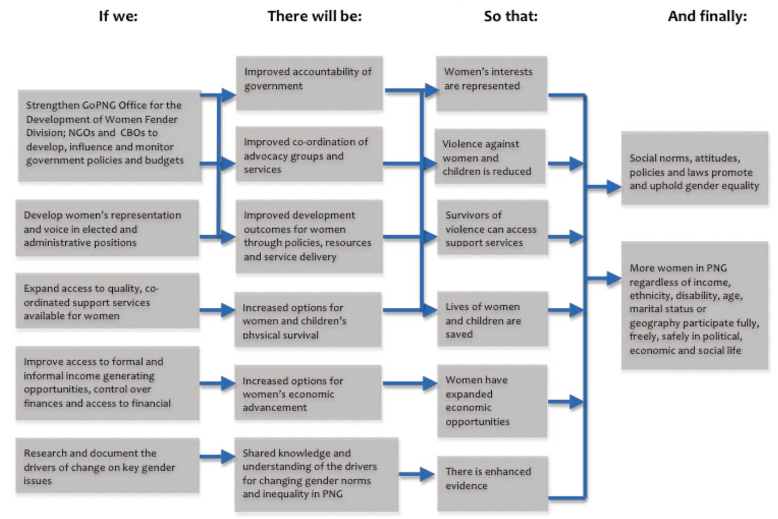

*DFAT 2015 Pacific Women Papua New Guinea Second Country Plan Monitoring and Evaluation Framework (2014–2019), p6.*

Appendix 3 Evaluation objectives and questions

This appendix has two parts:

* An explanation of agreed modifications to the evaluation objectives and questions
* The final revised version of the evaluation questions and modifications

**Explanation of modifications**

The objective of the Country Plan as originally stated (see page 9) is:

‘At the end of the second country plan it is expected that the resources and capacities established by or supported through the program will act together for changes and will be more informed through ongoing learning and experience. Services will be more widely available and considerably more developed to respond to diverse needs of women.’

By agreement with DFAT and the *Pacific Women* Support Unit this objective has been restated to increase evaluability:

* partners act together for change
* partners use evidence from research, monitoring and evaluation
* services delivered, supported or influenced by partners have improved in one or more dimensions (visibility, availability, reach, quality)

DFAT and the *Pacific Women* Support Unit agreed to the review team’s proposal to further streamline the evaluation objectives (Table 6 of the evaluation plan shows the original objectives and questions). The following are the changes to the objectives:

* Objective C (Identify changes in the working relationships between implementing partners, local and national government and how the program is contributing to these) and associated evaluation questions are subsumed under Objective B (Identify and assess progress towards the Country Plan objectives).
* Objective D (Engage stakeholders in testing the validity of the assumptions underpinning the theory of change[48]) and associated evaluation questions are subsumed under Objective E (Contribute to discourse on the focus and design of the Country Plan).

The final, agreed version of Table 6 of the evaluation plan has four objectives:

* identify significant contextual developments with potential significance for programming and implementation
* identify and assess progress towards the country plan objectives
* contribute to discourse on the focus and design of the country plan
* identify ways to streamline and improve the efficiency of program management and governance

The questions under Objective B were reframed and streamlined to improve focus and evaluability.

The final agreed questions under Objective B are:

* To what extent has the Country Plan been delivered as designed?
* How well is the program progressing against the objectives of the Country Plan?
* How well is the program progressing against the Country Plan outcomes in women’s influence and leadership, economic empowerment and in the national response to family and sexual violence?
* To what extent does the program exemplify/uphold the key principles underpinning the Country Plan?
* How are implementing partners working with each other and with local and national government, and how has *Pacific Women* contributed to this? (To what extent is a coordinated approach emerging among implementing partners, local, and national government?
* How are women benefitting from the leadership and influence, women’s economic empowerment and violence response and services projects visited in Bougainville and in the National Capital District?

Table 4: Revised evaluation objectives and questions

| **Evaluation Objectives** | **Evaluation Questions** |
| --- | --- |
| **A/** Identify significant contextual developments with potential significance for programming and implementation | 1. How is the context for *Pacific Women* changing in Papua New Guinea? 2. What are we learning about changing social norms and promoting gender equality in Papua New Guinea? |
| **B/** Identify and assess progress towards the Country Plan objectives[49] | **Relevance, Effectiveness, Impact and Sustainability**   1. To what extent has the Country Plan been delivered as designed? 2. How well is the program progressing against the objectives of the Country Plan? 3. How well is the program progressing against the Country Plan outcomes in women’s influence and leadership, economic empowerment and in the national response to family and sexual violence? 4. To what extent does the program exemplify/uphold the key principles underpinning the Country Plan? 5. How are implementing partners working with each other and with local and national government, and how has *Pacific Women* contributed to this? (To what extent is a coordinated approach emerging among implementing partners, local, and national government? 6. How are women benefitting from the influence and leadership, women’s economic empowerment and violence response and services projects visited in Bougainville and in the National Capital District? |
| **C/** Contribute to discourse on the focus and design of the Country Plan | **Monitoring, Evaluation and Learning**   1. What are the strengths and weaknesses of the Country Plan design from the perspective of donors, Government of Papua New Guinea and other key stakeholders? 2. Are changes needed to the focus and design of the Country Plan to make it more relevant, effective and sustainable?[50] 3. What are the opportunities for and barriers to more direct funding of indigenous nongovernmental organisations? |
| **D/** Identify ways to streamline and improve the efficiency of program management and governance | **Efficiency**   1. How can the program management and governance be improved? 2. Is the level of staff resources suitable for efficient program management? 3. How well is *Pacific Women* leveraging off other DFAT-funded programs in Papua New Guinea? |

Appendix 4 Context analysis methodology

The *Pacific Women* Support Unit provided a set of documents for the analysis and set of themes was agreed:

### General context

* Papua New Guinea economy and developments in energy, transport, communications, health and education.

### Context related to Pacific Women’s thematic areas

* Policy / legal environment
* women’s leadership and influence
* women’s economic empowerment
* family and sexual violence.

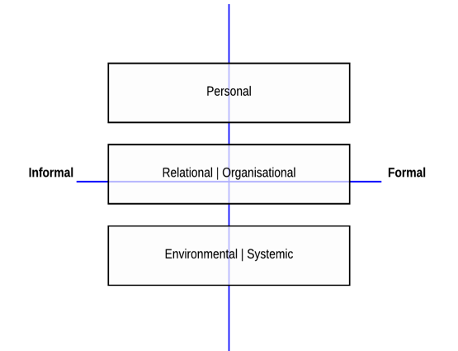The documents provided were imported into NVivo for coding. A relative lack of very recent material became apparent during coding, leading to the identification of some additional material to fill gaps. Once coding was completed a summary was generated for each theme, and compared against a baseline consisting of the context analysis summary in the 2014-2019 *Pacific Women* Papua New Guinea Country Plan (see Appendix 5.4 – Appendix Table 2 below). The baseline analysis used the Rao framework[51], which is helpful for identifying where change is occurring in a system. A modified version of this framework based on Oxfam’s Guide for Measuring Women’s Empowerment[52] was used for the 2017 context analysis.

The draft analysis was presented for validation at the 2017 *Pacific Women* Annual Learning Workshop and then revised to correct errors and fill gaps identified by implementing partners. The process is summarised in the figure below.[53]

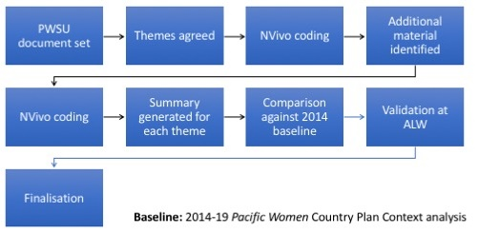

The initial sources used in the context analysis are identified in Table 5. Additional material used in the finalisation after the Annual Learning Workshop validation are also identified.

Table 5: Context analysis summary 2014–2019 *Pacific Women* Papua New Guinea Country Plan

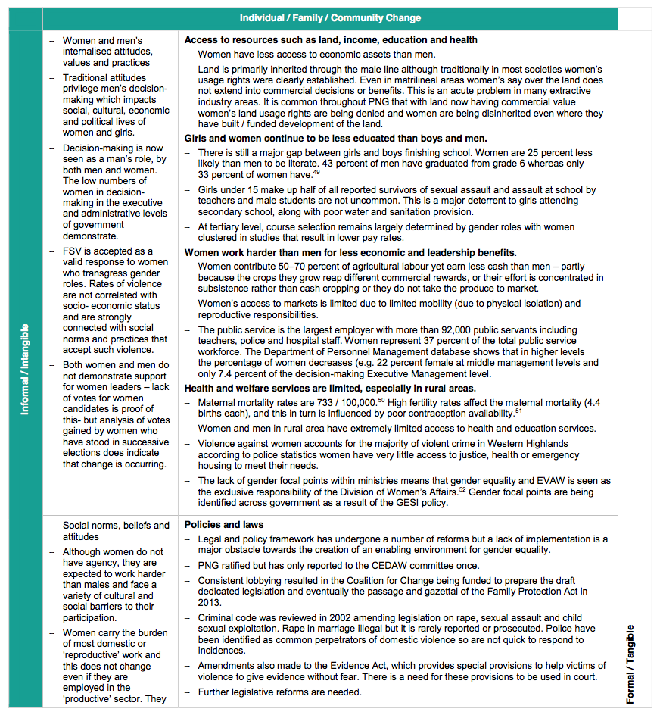

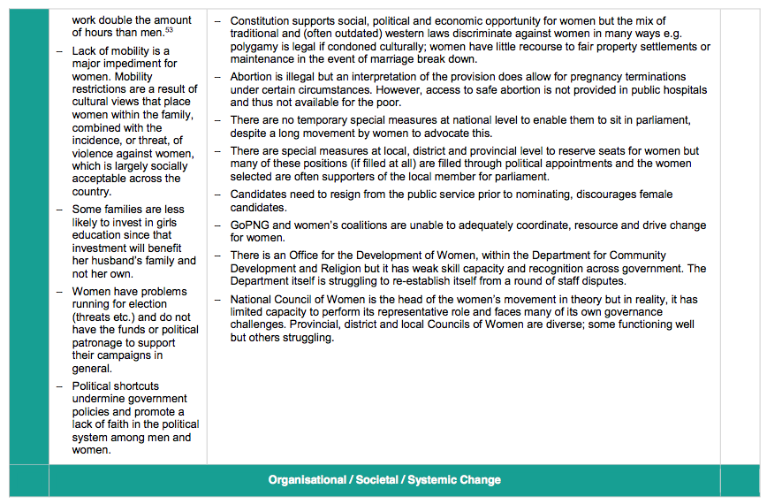

Table 6: Initial sources for context analysis

** Indicated as priority sources by *Pacific Women* Support Unit

++ Provided by *Pacific Women* Support Unit

| **Priority Topics** | | **Priority sources\*\*** | **Other sources** |
| --- | --- | --- | --- |
| Country Plan Themes | Women’s leadership & Influence | SSGM 2016[54]  McIntyre 2017[55]  Brimacombe 2017[56] | WB 2012[57]++  NDCD 2014[58] |
| Women’s economic empowerment | WB 2014[59] | WB 2012  DPC blog posts  NDCD 2014  Andrews 2013[60] |
| Family and Sexual Violence - policy & legal context | National Gender-Based Violence Strategy  CEDAW report[61]  UPR report[62]  Human rights situation analysis[63] | NCDC 2014 |
| Additional themes | Family and sexual violence - General |  | MSF 2016[64]++  WB 2012  NDCD 2014  Darko et al 2015[65] |
| Women’s access to health and education | 2015 MDG report[66]  UPR report | ADB Gender Analysis 2016 |
| Crime/Insecurity |  | Spark 2014[67]++  Lakhani & Willman 2014[68]  WB 2012 |
| Papua New Guinea operating environment | Political economy | ADB Gender Analysis 2016[69] | BTI 2016[70] |
| General | ADB Gender Analysis 2016 | MTDP 2016-17[71]  WaSH Policy 2015  UNDP 2015[72]  JICA 2010[73] |
| Energy | ADB Gender Analysis 2016  Seeding Social Enterprise[74] | ADB Gender Analysis 2016  IFC 2014[75] |
| Communications | ADB Country Plan 2016  Seeding Social Enterprise  Phones Against Corruption[76] | ADB Gender Analysis 2016  Brimacombe 2017++  Watson 2012[77]  Yamo 2013[78] |
| Transport | ADB Gender Analysis 2016  Seeding Social Enterprise | ADB Gender Analysis 2016 |
| Population, demography, urbanisation | ADB Gender Analysis 2016 | Jones 2012[79]  ADB 2013[80] |
| Additional sources added after validation workshop | Haley. N. 2016.[81] (Women in the public service)  Church Partnership Program 2016[82]  Universal Basic Education Plan 2009[83]  WASH in Schools 2016[84]  CARE DPC Poverty Study[85]  IFAD Rural Poverty Portal[86]  World Bank 2011. Reproductive Health at a Glance[87]  Independent Formative Evaluation of Family Health Centres[88]  World Bank 2011. PNG Climate Change Country Profile[89]  NARI 2015[90] (Drought, Frost, Climate change)  UNFPA 2010. Regional Consultation on Family Planning [91]  Forsyth, 2016[92] (Sorcery Related Violence)  PNG Department of the Treasury 2015[93] (District Improvement Support Funds)  Baker 2016[94] (Temporary Special Measures)  UNDP Temporary Special Measures[95]  Haley and Zubrinich 2015. (Limited Preferential Voting)[96]  Baker (Reserved seats)[97] | | |

Appendix 5 Mid-term review schedule

Table 7: Meetings and interviews

| **Date** | **Activity** | **Who** | **Organisation** |
| --- | --- | --- | --- |
| 1 May | Meet with DFAT-Gender and Sport | Susan Ferguson, Roselyn Kenneth, Donna Kingelty | Australian Department of Foreign Affairs and Trade |
| 1 May | Meeting | *Pacific Women* Support Unit | *Pacific Women* Support Unit |
| 1 May | Meeting | Katherine Lepani | PNG Governance Facility |
| 1 May | Meet Organisational Strengthening Advisor | Rebecca Robinson | Organisational Strengthening Adviser to the Family and Sexual Violence Action Committee |
| 2 May | Annual Learning Workshop |  |  |
| 2 May | Meeting | Elena Leddra | International Women’s Development Agency Program Manager |
| 3 May | Annual Learning Workshop |  |  |
| 4 May | Annual Learning Workshop |  |  |
| 4 May | Meeting | Daisy Plana | Chief Executive Officer Femili PNG |
| 5 May | Context Analysis Workshop | *Pacific Women* funded partners |  |
| 8 May | Meet Secretary for the Division of Community Development | Mana Kakarouts | Autonomous Bougainville Government |
| 8 May | Meet with Director for Social Services | Medley Koito | Autonomous Bougainville Government |
| 8 May | Meet with Project Staff | Shirley Sahoto | Inclusive Development for post-conflict Bougainville-World Bank |
| 8 May | Meet with Project Beneficiaries from Buka | Calc Women’s Group | Inclusive Development for post-conflict Bougainville- Beneficiaries |
| 8 May | Meet with Project Beneficiaries from Buka | Saput Women’s Group | Inclusive Development for post-conflict Bougainville- Beneficiaries |
| 9 May | Meet with Executive Director | Barbara Tanne | Bougainville Women’s Federation |
| 9 May | Meet with Voter Education Staff | Voter Education Project Team | Bougainville Women’s Federation |
| 9 May | Meet with Young Women’s Leadership Staff | Young Women’s Leadership Project Team | Bougainville Women’s Federation |
| 9 May | Meet with Project Beneficiaries | Project beneficiaries | Bougainville Women’s Federation |
| 10 May | Meet with Centre Coordinator and Project Coordinator | Sister Lorraine Garasu and Agnes Titus | From Nazareth Centre for Rehabilitation Gender-Based Violence to Gender Justice and Healing Project |
| 10 May | Meet with Project partners and beneficiaries | Project partners and beneficiaries | Nazareth Centre for Rehabilitation |
| 11 May | Meet with and Interview DFAT Bougainville officer | Cameron Daraugh | Australian Department of Foreign Affairs and Trade |
| 11 May | Travel to IDIB Sites |  |  |
| 12 May | Debrief to DFAT, ABG and *Pacific Women* Partners |  |  |
| 15 May | Meet with Business Coalition for Women Staff | Lavui Bala, Nona Sananti Diya | Business Coalition for Women |
| 15 May | US Embassy Gender focal point staff | Brad Coley, Beverly Thacker | US Embassy (cofounders of WECREATE Challenge; Women’s Business Resource Centre; Women’s Forum) |
| 15 May | Meet with UNICEF Chief of Child Protection | Asefa Dano | UNICEF |
| 16 May | Meet with Project Staff | Staff | Population Services International |
| 16 May | Meet with Project beneficiaries and partners | Partners and Beneficiaries | Population Services International |
| 16 May | Meet with Gender Equity and Social Inclusion Adviser | Tau Geno- Hoire | PNG Governance Facility |
| 16 May | Meet with Justice Services and Stability for Development | Edwina Kotoisuva, Deputy Team Leader | Other Australian Government-funded sector programs |
| 17 May | Meet with Department of National Planning and Monitoring | Ilma Gani, Lina Luingi | Department of National Planning and Monitoring |
| 17 May | DFAT Economic Governance, Bougainville teams, Political Counsellors | Jodie McAlister, Tim Bryson, Sarah De-Zoeten | Australian Department of Foreign Affairs and Trade |
| 18 May | UN Women Safe Cities programs - Safe Markets and Safe Public Transport Projects | Project Staff and Beneficiaries | UN Women |
| 18 May | Meet with Executive Director of the Office of the Development of Women | Gayle Tatsi | Department for Community Development |
| 18 May | Meet with Mid-term Review Reference Group Member | Beatrice Tabeu | UN Women |
| 19 May | Entrepreneurial Ecosystem (Center for International Private Enterprise (CIPE) and WECREATE Challenge) | CIPE Director and CIPE PNG Program Manager  PNG Governance Facility WECREATE Challenge implementing team | CIPE and PNG Governance Facility |
| 19 May | Meet with Women’s Business Resource Centre Users and Beneficiaries | Beneficiaries | WECREATE Challenge and CIPE |

Appendix 6 Analysis of the *Pacific Women* Papua New Guinea portfolio against the Country Plan

Table 8: Analysis of the portfolio of projects against the Country Plan

| **Investment envisioned  in Country Plan/  Indicative value (AUD)** | **Design Guidance** | **Projects Implemented** | **Observations** | **Funding level**  **(AUD)**  (*Pacific Women* Papua New Guinea only) |
| --- | --- | --- | --- | --- |
| **Increase women’s leadership and influence in decision-making, including at local government level** | | | | |
| Technical support for Office of the Development of Women and National Council for Women to coordinate policy, implementation and reporting on women’s leadership / ($500,000) | * Technical support in the lead up to APEC[98] Women in Business activities for both Office of the Development of Women and National Council of Women to design and carry out a range of inclusive activities that will benefit emerging women business leaders, community organisations and women in the informal sector. | * None to date | * *Pacific Women* Support Unit currently working with Department for Community Development and Religion on proposal related to economic research for APEC. |  |
| * Technical support to provide high quality reporting and coordination on national and international obligations for women’s empowerment (e.g. Pacific Island Leaders Declaration on Women’s Empowerment). | * None to date | * UN Women has been funding this work especially in relation to CEDAW reporting. |  |
| Leadership for local-level appointed women (Local Level Government and provincial assemblies / ($3,000,000) | * Conduct a learning / training needs / capacity assessment for women in both elected and nominated local government and Provincial Assembly positions. | * None to date | * The design process for the Women in Leadership Program included discussions in four regions and addressed these questions. There are expectations that the Papua New Guinea Governance Facility will be involved in this work. * The Women in Leadership Support program includes efforts to support nominated and elected and women. |  |
| * Design, develop and roll out a program to increase women’s leadership in local and provincial government (elected, appointed and administrative). | * Increased Women’s Representation in Local Government * Young Women’s Leadership Project * Women in Leadership Support Program | * Implemented by the Centre for Democratic Institutions from May – Aug 2013 in the Eastern Highlands. * In progress. * In progress. | 350,000  646,320[99]  1,937,592[100] |
| * Work with men in local, district and provincial government to reduce barriers to women’s equality. | * None to date | * Several projects work with men, but not specifically with men in government. An example is: *Komuniti Lukautim Ol Meri* which focuses on primary prevention, engaging with men, counselling and support services. |  |
| Improved opportunities for women in parliament and within elections  / ($3,000,000) | * Support for Papua New Guinea efforts to increase fairness in elections. * Support stakeholders to increase parliamentary capacity to represent women’s interests. * A scholarships program for women to access short governance courses. | * Voter Education Leadership Support * Women in Leadership Support Program | * In progress. * In progress. * Not funded or managed through *Pacific Women* – but progressing with Australia Awards | 451,888  see above |
| Strengthening local women’s voices to advocate women’s issues within, for example, agreements in the extractives sector; legislation and service delivery / ($1,500,000) | * Provide technical assistance to mining councils to renegotiate community mining agreements. * Resource effective women’s networks so they can perform their work more easily. | * Papua New Guinea Women in Mining expected to start in mid-2017 | * Scoping mission in progress to identify activities in specific locations. Memorandum of Understanding with World Bank and Mining Resources Authority in process*.* | $520,000[101] |
| Expansion of UN Women Safe Cities/Markets program  / ($6,000,000) | * Expand, modify & refine safe markets concept to include wholesaling and to introduce and expand the provision of learning and banking, education & childcare services at markets. | * Safe Markets * Construction Koki Market Transit Centre | * In progress.[102] * Completed April 2017. | 4,200,000[103]  492,508[104] |
| * Establish a safe bus program for women to increase safety for women accessing produce markets. | * Safe Transport | * In progress. | 3,000,000 |
| Improving gender equality in the formal sector and economic opportunities for women in the value chain / ($5,000,000) | * Increase women’s access to new markets in fresh produce, using mobile phone technology to link growers to markets and improve the quality of produce. | * None to date | Family Teams has linked communities in Highlands with bulb onion production and markets. Linking to markets is considered as being more within the space of the Market Development Facility. |  |
| * Establish a Business Incubator (WECREATE Challenge) in partnership with other development partners, to increase women’s profits. | * Women’s Business Resource Centre * WECREATE Challenge | * In progress. * In progress (NOTE: WECREATE Challenge is an accelerator not an incubator). | 342,533[105]  292,538 |
| * Work with the Business Coalition for Women in Papua New Guinea to expand their membership and support businesses to diagnose, develop and implement solutions for gender inequalities at work | * Since Business Coalition for Women was established in 2014 membership has grown to 65 companies[106] | * In progress. | 3,400,000 |
| **Increase economic opportunities for women** | | | | |
| Increasing economic opportunities for women smallholders and their families / ($3,000,000) | * Increase economic opportunities for women in cash cropping / mono-crop areas in Papua New Guinea. * Pilot, expand, adapt and test innovative approaches that aim to increase the benefits to women in agriculture. | * CARE Coffee * Family Teams * *Kirapim Kaikai na Maket* | * In progress. * In progress. * In progress. | 4,507,131  3,000,000  40,000 |
| Employment and financial literacy and business education for poor women through Ginigoada.  / ($3,000,000) | * Expand women’s financial literacy and business development skills to vulnerable women (especially young women) in priority provinces. | * Financial literacy training for men and women in Yangoru-Saussia District, E Sepik * Family Teams | * In progress.[107] * In progress.[108] | 316,500  see above |
| Strengthening national coordination, implementation and monitoring mechanisms to respond and reduce family and sexual violence / ($4,000,000) | * Research and development of a Government of Papua New Guinea framework for family and sexual violence interventions. * Develop a national Gender Based Violence strategy in partnership with relevant stakeholders and roll out in pilot ministries and four provinces. * Strengthen provincial Family and Sexual Violence Action Committee in four provinces. * Capacity building and support for family and sexual violence champions and human rights defenders in eight provinces to raise awareness and prevent family and sexual violence. * Provide support for women’s coalitions effectively advocating changes. | * Family and Sexual Violence Action Committee * National Mechanisms * Femili PNG * *Komuniti Lukautim Ol Mer* * Gender Justice and Healing * Highlands Sorcery-Related Violence * Family Support Centre Assistance | * Core funding provided to Family and Sexual Violence Action Committee project in 2016. Technical support in progress to implement recommendations of 2014 organisational capacity assessment. * Gender-Based Violence Strategy has been launched; Provincial Family and Sexual Violence Action Committees have been established in the National Capital District, Milne Bay, Morobe and East New Britain. 150 champions identified and trained across eight provinces to support provincial Family and Sexual Violence Action Committees; Documentary film series (*Yumi Kirapim Senis*) widely disseminated and screened to raise awareness of local initiatives on Gender-Based Violence. * Femili PNG has been providing direct organisational strengthening to service provider partners in Morobe as well as promoting stronger coordination and case management. * *Komuniti Lukautim Ol Meri* has been strengthening coordination in West Sepik and Western Highlands districts resulting in formation of District Family and Sexual Violence Action Committees in West Sepik. Also includes training of community mobilisers – raising awareness on gender-based violence, human rights, and support services available. * Nazareth Centre, the implementing partner contributes to coordination of the sector in Bougainville, and has hundreds of Women Human Rights Defenders and male advocates. * Highlands Sorcery-Related Violence is working with Human Rights Defenders to create a formal association. * Population Services International’s work on community outreach and behaviour change communication tools is increasing awareness on family and sexual violence and the services available within Port Moresby. * Coalition building is an element of several projects (Young Women’s Leadership Project, Business Coalition, Highlands Sorcery-Related Violence, Family and Sexual Violence Action Committee) and a primary purpose of the annual Women’s Forum. | 920,596  3,500,000  (see below)  2,500,000  1,693,366  3,294,517  3,479,000[109] |
| Continuing the demonstration case management centre in Lae to provide quality support services for survivors of violence / ($4,000,000) | * Demonstrate quality service delivery to survivors of violence and train other services to follow suit. | * Femili PNG | * In progress. | 5,820,153[110] |
| Establishing quality support services for survivors of violence in rural and remote areas – Repatriation and reintegration / ($2,500,000) | * Technical and administrative support of a repatriation model for the removal of women and children from dangerous environments in rural areas where they do not have the means to return to their own family support base in their village due to extreme violence, including sorcery related violence. | * Highlands Sorcery-Related Violence[111] * Gender Justice and Healing | * In progress. * In progress. * Related research in progress:   + Improving impact.   + Communication Strategies. | (see above)  (see above)  1,059,239  719,801 |
| Establishing Family Support Centres in rural and remote areas e.g. Daru/Sepik/Highlands / ($1,500,000) | * Rebuild of the Family Support Centre Daru in accordance with the Family Support Centre guidelines. * Work with Health Program to support Family Support Centres in Sepik. * Work with Law and Justice Program to consolidate Family Support Centres in the Highlands region. * Provision of training and support to the staff of selected Family Support Centres | * Eastern Highlands Provincial Family Support Centre * Support to Family Support Centres and Health Clinics in Southern Highlands * Support to the Family Support Centre in Port Moresby * Family Support Centre Assistance Project * Family and Sexual Violence Action Committee * Femili PNG * *Komuniti Lukautim Ol Meri* | * The DFAT Health Program built ‘state of the art’ Family Support Centres in Daru (and Arawa, Bougainville) and are now piloting training for new staff in both sites. * *Pacific Women* provided equipment to 8 ICRC-supported health facilities in Southern Highlands as well as to the Family Support Centre in the Western Highlands. * There are two existing Family Support Centres in East Sepik – Wewak[112] and Maprik district. * Refurbishment completed June 2015. * Equipment purchase completed Jan 2017. * Refurbishment[113] completed Mar 2017. * In progress (Port Moresby). * Clinical guidelines developed for Family Support Centres.[114]      * In progress. * In progress.[115] * In progress. | $283,208  $38,714  187,057  see SASA! pilot below[116]  See above for funding |
| Fund to support sustainable safe house provision / ($6,000,000) | * Where feasible, build on local initiatives to increase the stock of safe houses in program target regions. | * None to date | * The Justice Services and Stability for Development Program is working to build safe houses. Efforts to work with Oxfam to identify safe house to support with some internal structures were unsuccessful. * Business Coalition for Women is exploring the feasibility of converting a property owned by Coalition-members and Bank South Pacific into a Safe House and Case Management and Counselling Service to support victims of Family and Sexual Violence. |  |
| Innovation fund to prevent and raise awareness of family and sexual violence / ($5,000,000) | * An innovation and consolidation fund will be reserved to pilot and test new approaches to preventing family and sexual violence and to consolidate promising but not yet sustainable activities. | * *Komuniti Lukautim Ol Meri* * Positive Parenting * SASA! Pilot (Family Support Centre Assistance) * End Violence Against Children Campaign * Femili PNG * Highlands Sorcery-Related Violence * Highlands Sexual Reproductive and Maternal Health | * In progress (Highlands Sorcery-Related Violence, Femili PNG, *Komuniti Lukautim Ol Meri*, Positive Parenting, End Violence Against Children Campaign, Highlands Sexual Reproductive and Maternal Health). | 2,500,000  1,787,760  3,479,000  1,995,000  See above for funding  1,000,000[117] |
| **Enhance knowledge and evidence to inform policy and practice** | | | | |
| Develop and implement a Research Strategy for *Pacific Women* Papua New Guinea / ($2,000,000) | * Strategy will be developed through a participatory workshop where existing knowledge and research questions will be identified and prioritised for research investment. | * None to date | * As an input to the *Pacific Women* Papua New Guinea Annual Conference in 2016, relevant research by partners[118] was identified. A meeting outcome was a decision to support the development of a wider Papua New Guinea research group rather than pursuing a *Pacific Women* Papua New Guinea research strategy. * Related investment: Research training Program implemented starting in 2017 by the State, Society and Governance in Melanesia program of the Australian National University. | 695,458 |
| Establishment of an annual learning forum for *Pacific Women* partners / ($250,000) |  | * In progress (annually) | * Annual conference/learning workshop held in 2016 and 2017. | approx. 85,000/pa |
| Development of curricula, learning modules and scholarships for short term courses / ($3,000,000) | * Development of curricula and learning modules across priority gender issues (e.g. trauma counselling, running a business, governance and women’s leadership). * Piloting testing and institutionalisation of curricula and learning modules. * Establishment of short term scholarships for women to access key learning areas. | * Handled through a cluster of existing projects | * Several projects include development of curricula and learning modules.[119] * There may be opportunities through Australia Awards Certificates in Counselling, Entrepreneurship, Agribusiness, Leadership and Management (nongovernmental organisation). |  |
| Maintenance of a virtual clearing house for gender equality and women’s empowerment / ($250,000) | * Develop a Papua New Guinea virtual clearing house to reports, data, training materials and research. | * None | * The Papua New Guinea Governance Facility design included a ‘Knowledge Platform’ and the *Pacific Women* Shaping Pacific Development Research Strategy includes a Pacific-wide knowledge management system. |  |
| Support to Australian funded sectoral programs to achieve better results / ($1,500,000) | * Pilot gender equality and women’s empowerment approaches for health, education, law and justice, governance, transport, with a view to demonstrating effect and passing back to the sectors as they are re-designed. | * Highlands Sexual Reproductive and Maternal Health | * In progress | 1,000,000 |

Appendix 7 Assessment of progress against Country Plan objectives, outcomes,[120] and principles[121]

Table 9: Progress in leadership and influence, women’s economic empowerment and violence response and services

| **Key:** | The objective or outcome is not applicable | ⬤ | Too early to assess, or insufficient  evidence to permit assessment | ⬤ | Clear evidence of progress  towards the objective or outcome | ⬤ |
| --- | --- | --- | --- | --- | --- | --- |
| **Assessment criterion for each principle:**  Applying Integrated Approach **(IA)**:The investment addresses more than one of the Pacific Women thematic areas.  Testing innovative ideas **(IN)**: The investment is developing or testing a new model or approach, innovating with an established model or carrying out research to support innovation.  Supporting indigenous organisations **(IO)**: The investment works with and contributes to strengthening local groups or organisations, including provincial and national government agency, individual entrepreneurs and researchers excluded.  Supporting Government of Papua New Guinea policy and coordination **(GV)**:The investment demonstrates alignment with or support for local, municipal, provincial or national government policies, strategies, and/or programs.  Flexibility to respond to opportunities **(FL)**: The investment has adjusted implementation to respond to opportunities or barriers.  **Note:**  Projects visited during the Mid-Term Review are indicated with light shading.  Projects with titles in shaded cells were initiated during the first phase (2012-13) of the Pacific Women Papua New Guinea Country Plan. | | | | | | |

| **1. Women’s Leadership and Influence** | | | | | | | | | | | | | |
| --- | --- | --- | --- | --- | --- | --- | --- | --- | --- | --- | --- | --- | --- |
| **Investment Information** | | | **Objectives** | | | **Intended Outcomes** | | | | | **Principles** | **Sources of  Evidence** (ALW: Annual Learning Workshop; APR: Annual Performance Report) | **Other outcomes**[122] |
| **Title** | **Program & Total funding**  (AUD million) | **Timeframe** | **Partners act together** | **Partners use evidence** | **Improved services** | **Government promotes leadership and influence** | **ODW[123] coordinates & reports** | **Skills to fulfil roles** | **Women contest elections** | **Mining agreements** |
| Inclusive Development in post-conflict Bougainville | P: 2.500 T: 4.920 | 04/15 -- 03/18 | ⬤ | ⬤ | ⬤ | ⬤ | ⬤ | ⬤ | ⬤ | ⬤ | IA  IN  IO  GV  FL | Field visit, ALW, Evaluation, APR | * Women in informal leadership positions gaining skills for formulating and managing small-scale community infrastructure projects leading to an increase in positive perception of women. * Increased involvement of women in village governance. * Many sub-projects reduce women’s drudgery; some provide economic benefits. * Strengthening of informal systems of social and political organisation within and around the sub-project communities. |
| Women’s Forum | P:0.062 T: 0.120 | 03/16-02/17 | ⬤ | ⬤ | ⬤ | ⬤ | ⬤ | ⬤ | ⬤ | ⬤ | IO | APR, https://goo.gl/NRJ4v9 |  |
| Young Women’s Leadership Project[124] | P:0.646  T: 1.402 | 01/16-06/18 | ⬤ | ⬤ | ⬤ | ⬤ | ⬤ | ⬤ | ⬤ | ⬤ | IA  IN  IO  GV  FL | Field visit, ALW, APR  http://tiny.cc/gs5xly | * Inclusion of women with disabilities in training * Hands on advocacy experience including in in disability advocacy. * Several young women trained via Young Women’s Leadership Project are forming associations, starting businesses and pursuing further education. * Men who were trained with their spouses acting as advocates for Bougainville women and Bougainville Women’s Federation. * Research on women in Autonomous Bougainville Government public service * Young Women’s Leadership Project co-funded by Australian Bougainville Peace Building Program. |
| Voter Education in Bougainville | P: 0.452  T: 0.452 | 05/16-12/17 | ⬤ | ⬤ | ⬤ | ⬤ | ⬤ | ⬤ | ⬤ | ⬤ | IN  IO  GV  FL | Field visit, APR | * Inclusion of women and men with disabilities in voter education training. * A lower number of invalid votes in at least one ward during April 2017 community government elections. * An increase in membership of young women in Bougainville Women’s Federation and a raised profile of Bougainville Women’s Federation. |
| Women in Leadership Support Program | P: 1.502  T: 3.000 | 12/16-06/21 | ⬤ | ⬤ | ⬤ | ⬤ | ⬤ | ⬤ | ⬤ | ⬤ | IN  IO  GV | ALW, APR |  |

|  |  |  |  |  |  |  |  |  |  |  |  |  |  |  |  |  |  |  |
| --- | --- | --- | --- | --- | --- | --- | --- | --- | --- | --- | --- | --- | --- | --- | --- | --- | --- | --- |
| **2. Women’s Economic Empowerment**[125] | | | | | | | | | | | | | | | | | | |
| **Key:** | The objective or outcome is not applicable: | | | | | ⬤ | | | Too early to assess or information  insufficient to permit assessment: | | | | | ⬤ | | Clear evidence of progress  towards the objective or outcome: | | ⬤ |
| **Principles**: **IA**: Applying Integrated Approach; **IN**: Testing innovative ideas; **IO**: Supporting indigenous organisations; **GV**: Supporting Government of Papua New Guinea policy and coordination;  **FL**: Flexibility to respond to opportunities | | | | | | | | | | | | | | | | | | |
| **Activity Information** | | | | **Objectives** | | | | **Intended Outcomes** | | | | | **Principles** | | **Sources of Evidence**  (ALW: Annual Learning Workshop; APR: Annual Performance Report) | | **Other outcomes** | |
| **Title** | | **Program & Total funding**  (AUD million) | **Timeframe** | **Partners act together** | **Partners use evidence** | | **Improved services** | **Safety, productivity, incomes** | | **Skills for employment or business** | **Private Sector** | **Increased access to markets** |
| Coffee Industry Support Project | | P: 4.507  T: 4.507 | 07/13-06/19 | ⬤ | ⬤ | | ⬤ | ⬤ | | ⬤ | ⬤ | ⬤ | IA  IN  IO  GV  FL | | ALW, APR, Evaluation | | * Increased capacity to provide extension and other services appropriate for both women and men * Household labour and decision making more equitably shared in smallholder coffee farming families * Improved access by women to services and information supporting coffee farming needs * Increased engagement of women in coffee marketing activities * Increased recognition by coffee industry stakeholders of the value of improving women’s engagement | |
| Strengthening business coalitions for women | | P: 3.400  T: 3.400 | 05/14-06/18 | ⬤ | ⬤ | | ⬤ | ⬤ | | ⬤ | ⬤ | ⬤ | IA  IN  IO | | Field visit, ALW, APR, Evaluation  http://tiny.cc/b83vly  http://tiny.cc/6a5vly | | * Business Coalition for Women model policy to address family and sexual violence is supported by customized training and a suite of implementation strategies. | |
| Family Teams: Increasing economic opportunities for women smallholders and their families | | P: 3.000  T: 3.000 | 07/15-06/18 | ⬤ | ⬤ | | ⬤ | ⬤ | | ⬤ | ⬤ | ⬤ | IA  IN  IO  FL | | ALW, APR, Evaluation, http://tiny.cc/54fmly  http://ow.ly/Tw1O30cFlJl | | * Increased family harmony (including lowered levels of domestic violence), opportunities for women to pursue different activities (to traditional household roles), increase in participation in household work by other family members, and increase in discussion and consultation between family members. | |
| Creating an entrepreneurial ecosystem[126] | | P: 0.343  T: 0.765 | 10/15-06/17 | ⬤ | ⬤ | | ⬤ | ⬤ | | ⬤ | ⬤ | ⬤ | IN  IO | | Field Visit, APR | |  | |
| WECREATE Challenge | | P: 0.293  T: 0.585 | 12/15-12/18 | ⬤ | ⬤ | | ⬤ | ⬤ | | ⬤ | ⬤ | ⬤ | IN | | Field visit, ALW, APR | |  | |
| *Kirapim Kaikai na Maket,* Tsak Valley | | P: 0.040  T: 0.040 | 09/16-12/18 | ⬤ | ⬤ | | ⬤ | ⬤ | | ⬤ | ⬤ | ⬤ | IO | | APR | |  | |
| Do No Harm: Research on women’s economic empowerment and violence against women in Melanesia | | P: 0.362  T: 0.532 | 02-2014-06/17 | ⬤ | ⬤ | | ⬤ | ⬤ | | ⬤ | ⬤ | ⬤ | IA | | ALW, APR,  http://tiny.cc/pp7ily | | * Local researchers trained in Bougainville and the Highlands * Dissemination of research findings and recommendations to other partners and stakeholders through Annual Learning Workshop | |

|  |  |  |  |  |  |  |  |  |  |  |  |  |  |  |  |  |  |  |  |  |  |  |
| --- | --- | --- | --- | --- | --- | --- | --- | --- | --- | --- | --- | --- | --- | --- | --- | --- | --- | --- | --- | --- | --- | --- |
| **3. FSV Prevention and Response**[127] | | | | | | | | | | | | | | | | | | | | | | |
| **Key:** | The objective or outcome is not applicable: | | | | | | ⬤ | | Too early to assess or information  insufficient to permit assessment: | | | | | | | ⬤ | | | | Clear evidence of progress  towards the objective or outcome: | | ⬤ |
| **Principles**: **IA**: Applying Integrated Approach; **IN**: Testing innovative ideas; **IO**: Supporting indigenous organisations; **GV**: Supporting Government of Papua New Guinea policy and coordination;  **FL**: Flexibility to respond to opportunities | | | | | | | | | | | | | | | | | | | | | | |
| **Activity Information** | | | | **Objectives** | | | | **Intended Outcomes** | | | | | | | | | | **Principles** | **Sources of Evidence** | | **Other outcomes** | |
| **Title** | | **Program & Total funding**  (AUD million) | **Timeframe** | **Partners act together** | **Partners use evidence** | **Improved services** | | **Referral pathways** | | **Government funds and coordinates services** | **Reduced VAW** | **Evidence available** | **Lives saved** | **Models of service delivery** | **Prevention programs tested** | | **Advocacy coalitions** |
| Port Moresby: A Safe City for Women and Girls[128] | | P: 4.200  T: 10.98 | 02/13-12/17 | ⬤ | ⬤ | ⬤ | | ⬤ | | ⬤ | ⬤ | ⬤ | ⬤ | ⬤ | ⬤ | | ⬤ | IA  IN  IO  GV | Field visit, APR, Evaluation, http://tiny.cc/89nily | | * Market vendors and controllers trained on referral pathway * Disability inclusion in conduct of safety audits * Increased access to bank accounts * Improved market infrastructure * Vision articulated for ongoing development of city markets | |
| Responding to Gender-based & sorcery-related violence in the Highlands | | P: 1.340  T: 5.180 | 05/14-06/19 | ⬤ | ⬤ | ⬤ | | ⬤ | | ⬤ | ⬤ | ⬤ | ⬤ | ⬤ | ⬤ | | ⬤ | IN  IO  GV  FL | ALW, APR | | * Capacity development in monitoring and evaluation, media &and communications | |
| Strengthening national mechanisms to prevent & respond to family and sexual violence | | P: 3.500  T: 4.000 | 06/14-06/17 | ⬤ | ⬤ | ⬤ | | ⬤ | | ⬤ | ⬤ | ⬤ | ⬤ | ⬤ | ⬤ | | ⬤ | IO  GV | APR | |  | |
| Femili PNG | | P: 3.096  T: 4.264 | 06/14-06/17 | ⬤ | ⬤ | ⬤ | | ⬤ | | ⬤ | ⬤ | ⬤ | ⬤ | ⬤ | ⬤ | | ⬤ | IN  IO  GV | ALW, APR | | * Femili PNG case management approach recognised as good practice in the sector. | |
| Building the capacity of Papua New Guinea’s Family and Sexual Violence Action Committees | | P: 0.921  T: 0.921 | 10/14-06/18 | ⬤ | ⬤ | ⬤ | | ⬤ | | ⬤ | ⬤ | ⬤ | ⬤ | ⬤ | ⬤ | | ⬤ | IN  IO  GV | APR, Interview[129], Evaluation | | * Supporting establishment of the Papua New Guinea Counselling Association. | |
| Safe Public Transport for Women, Girls and Children | | P: 3.000  T: 3.435 | 02/15-12/17 | ⬤ | ⬤ | ⬤ | | ⬤ | | ⬤ | ⬤ | ⬤ | ⬤ | ⬤ | ⬤ | | ⬤ | IA  IN  IO  GV  FL | Field visit, APR, Evaluation | | * Planning tools[130] available to transport planners and development partners. | |
| *Komuniti Lukautim Ol Meri* | | P: 2.500  T: 2.500 | 04/15-03/18 | ⬤ | ⬤ | ⬤ | | ⬤ | | ⬤ | ⬤ | ⬤ | ⬤ | ⬤ | ⬤ | | ⬤ | IA  IN  IO  GV | ALW, APR, Evaluation | | * Establishment of a promising model to address violence against children. | |
| Gender Justice and Healing in Bougainville | | P: 1.693  T: 1.693 | 04/15-03/18 | ⬤ | ⬤ | ⬤ | | ⬤ | | ⬤ | ⬤ | ⬤ | ⬤ | ⬤ | ⬤ | | ⬤ | IN  IO  GV | Field visit, ALW, APR | | * Outreach via an exchange visit to a response team providing similar services in another province. * Development of promising school-based modules. | |
| Partnership for Positive Parenting | | P: 1.788  T: 1.788 | 04/15-12/17 | ⬤ | ⬤ | ⬤ | | ⬤ | | ⬤ | ⬤ | ⬤ | ⬤ | ⬤ | ⬤ | | ⬤ | IA  IN  IO  GV  FL | ALW, APR | | * Knowledge, skills and experience gained by intended service providers (Catholic Archdioceses of Madang, Kundiawa and Mt Hagen) through piloting of the program. | |
| End Violence Against Children Campaign | | P: 1.995  T: 1.995 | 04/17-12/18 | ⬤ | ⬤ | ⬤ | | ⬤ | | ⬤ | ⬤ | ⬤ | ⬤ | ⬤ | ⬤ | | ⬤ | IA  IN  IO  GV | ALW, APR | | * Successful provincial action plans attributed to action of church leaders. | |
| Highland Sexual Reproductive & Maternal Health | | P: 1.000  T: 2.000 | 07/15-06/17 | ⬤ | ⬤ | ⬤ | | ⬤ | | ⬤ | ⬤ | ⬤ | ⬤ | ⬤ | ⬤ | | ⬤ | IN  IO  GV | ALW, APR | | * More pregnant women choosing to deliver at the Aseki Health Centre labour ward. | |
| SASA! Pilot and Family Support Centre Assistance | | P: 0.979  T: 1.148 | 10/15-09/17 | ⬤ | ⬤ | ⬤ | | ⬤ | | ⬤ | ⬤ | ⬤ | ⬤ | ⬤ | ⬤ | | ⬤ | IA  IN  IO  GV  FL | ALW, APR, Field visit | | * Family and sexual violence outreach to Safe Markets, sports sector and hospitality sectors. | |
| Communication strategies for social change against sorcery-related violence | | P: 0.720  T: 0.896 | 08-16-06/19 | ⬤ | ⬤ | ⬤ | | ⬤ | | ⬤ | ⬤ | ⬤ | ⬤ | ⬤ | ⬤ | | ⬤ | IA  IN  IO  GV  FL | ALW, APR, http://tiny.cc/9u7ily | |  | |
| Improving state & non-state interventions in overcoming sorcery accusations-related violence in Papua New Guinea | | P: 1.059  T: 1.867 | 09/16-06/20 | ⬤ | ⬤ | ⬤ | | ⬤ | | ⬤ | ⬤ | ⬤ | ⬤ | ⬤ | ⬤ | | ⬤ | IA  IN  IO  GV | APR, http://tiny.cc/agcjly | |  | |

Table 10: Progress in learning and understanding[131]

| **Investment Title** | **Knowledge** | **Learning** | **Counselling** | **Scholarships** | **Recovery** | **Uptake**[132] |
| --- | --- | --- | --- | --- | --- | --- |
| **Women’s economic empowerment** |  |  |  |  |  |  |
| Inclusive Development in post-conflict Bougainville | ✓ | ✓ | n/a | n/a | n/a |  |
| Women’s Forum | ✓ | ✓ | n/a | n/a | n/a |  |
| Young Women’s Leadership Project | ✓ | ✓ | n/a | n/a | n/a | ✓ |
| Voter Education in Bougainville | ✓ | ✓ | n/a | n/a | n/a |  |
| Women in Leadership Support Program | ✓ | ✓ | n/a | n/a | n/a |  |
| **Leadership and influence** |  |  |  |  |  |  |
| Coffee Industry Support Project | ✓ | ✓ | n/a | n/a | n/a | ✓ |
| Strengthening business coalitions for women | ✓ | ✓ | n/a | n/a | n/a |  |
| Family Teams: Increasing economic opportunities for women smallholders | ✓ | ✓ | n/a | n/a | n/a |  |
| Creating an entrepreneurial ecosystem | ✓ | ✓ | n/a | n/a | n/a |  |
| WECREATE Challenge | ✓ | ✓ | n/a | n/a | n/a |  |
| *Kirapim Kaikai na Maket*, Tsak Valley | ✓ |  | n/a | n/a | n/a |  |
| **Violence response and services** |  |  |  |  |  |  |
| Port Moresby: A Safe City for Women and Girls | ✓ | ✓ |  | n/a |  |  |
| Responding to gender-based violence and sorcery-related violence in the Highlands | ✓ |  |  | n/a |  | ✓ |
| Support for strengthening national coordination, implementation and monitoring mechanisms to prevent and respond to family and sexual violence | ✓ |  | ✓ | n/a | ✓ |  |
| Family and Sexual Violence Case Management Centre, Lae (Femili PNG) | ✓ |  |  | n/a | ✓ |  |
| Building the capacity of Papua New Guinea’s Family and Sexual Violence Action Committee | ✓ |  |  | n/a |  |  |
| Safe Public Transport for Women, Girls and Children | ✓ | ✓ |  | n/a |  |  |
| *Komuniti Lukautim Ol Meri* | ✓ | ✓ |  | n/a | ✓ |  |
| From Gender-Based Violence to Gender Justice and Healing | ✓ |  |  | n/a | ✓ |  |
| Partnership for Positive Parenting | ✓ |  |  | n/a |  |  |
| End Violence Against Children Campaign | ✓ |  |  | n/a |  |  |
| Highland Sexual Reproductive and Maternal Health | ✓ |  |  | n/a |  | ✓ |
| SASA! Pilot and Family Support Centre Assistance | ✓ |  |  | n/a | ✓ |  |
| Do No Harm: Research on women’s economic empowerment and violence against women in Melanesia | ✓ |  |  | n/a |  |  |
| Developing communication strategies for social change against sorcery-related violence | ✓ |  |  | n/a |  |  |
| Improving the impact of state and non-state interventions in overcoming sorcery accusation-related violence in Papua New Guinea | ✓ |  |  | n/a |  |  |

Table 11: Program principles scorecard

**KEY:** ⬤ Insufficient information available to assess ⬤ Evidence of adherence to principle

| **Investment** | **Principles** | | | | |
| --- | --- | --- | --- | --- | --- |
| **Integrated approach** | **Testing innovative ideas** | **Supporting indigenous organisations** | **Supporting Government of Papua New Guinea policy and coordination** | **Flexibility** |
| Inclusive Development in Bougainville | ⬤ | ⬤ | ⬤ | ⬤ | ⬤ |
| Women’s Forum | ⬤ | ⬤ | ⬤ | ⬤ | ⬤ |
| Young Women’s Leadership Project | ⬤ | ⬤ | ⬤ | ⬤ | ⬤ |
| Voter Education in Bougainville | ⬤ | ⬤ | ⬤ | ⬤ | ⬤ |
| Women in Leadership Support Program | ⬤ | ⬤ | ⬤ | ⬤ | ⬤ |
| Coffee Industry Support Project | ⬤ | ⬤ | ⬤ | ⬤ | ⬤ |
| Strengthening business coalitions for women | ⬤ | ⬤ | ⬤ | ⬤ | ⬤ |
| Family Teams: Increasing economic opportunities for women smallholders | ⬤ | ⬤ | ⬤ | ⬤ | ⬤ |
| Creating an entrepreneurial ecosystem | ⬤ | ⬤ | ⬤ | ⬤ | ⬤ |
| WECREATE Challenge | ⬤ | ⬤ | ⬤ | ⬤ | ⬤ |
| *Kirapim Kaikai na Maket*, Tsak Valley | ⬤ | ⬤ | ⬤ | ⬤ | ⬤ |
| Port Moresby: A Safe City for Women and Girls | ⬤ | ⬤ | ⬤ | ⬤ | ⬤ |
| Responding to Gender-Based Violence and Sorcery-Related Violence in the Highlands | ⬤ | ⬤ | ⬤ | ⬤ | ⬤ |
| Support for strengthening national coordination, implementation and monitoring mechanisms to prevent and respond to family and sexual violence | ⬤ | ⬤ | ⬤ | ⬤ | ⬤ |
| Family and Sexual Violence Case Management Centre, Lae (Femili PNG) | ⬤ | ⬤ | ⬤ | ⬤ | ⬤ |
| Building the capacity of Papua New Guinea’s Family and Sexual Violence Action Committee | ⬤ | ⬤ | ⬤ | ⬤ | ⬤ |
| Safe Public Transport for Women, Girls and Children | ⬤ | ⬤ | ⬤ | ⬤ | ⬤ |
| *Komuniti Lukautim Ol Meri* | ⬤ | ⬤ | ⬤ | ⬤ | ⬤ |
| From Gender-Based Violence to Gender Justice and Healing | ⬤ | ⬤ | ⬤ | ⬤ | ⬤ |
| Partnership for Positive Parenting | ⬤ | ⬤ | ⬤ | ⬤ | ⬤ |
| End Violence Against Children Campaign | ⬤ | ⬤ | ⬤ | ⬤ | ⬤ |
| Highland Sexual Reproductive and Maternal Health | ⬤ | ⬤ | ⬤ | ⬤ | ⬤ |
| SASA! Pilot and Family Support Centre Assistance | ⬤ | ⬤ | ⬤ | ⬤ | ⬤ |
| Do No Harm: Research on women’s economic empowerment and violence against women in Melanesia | ⬤ | ⬤ | ⬤ | ⬤ | ⬤ |
| Developing Communication Strategies for social change against sorcery-related violence | ⬤ | ⬤ | ⬤ | ⬤ | ⬤ |
| Improving the impact of state and non-state interventions in overcoming sorcery accusation-related violence in Papua New Guinea | ⬤ | ⬤ | ⬤ | ⬤ | ⬤ |
| **Totals** | **14** | **22** | **24** | **19** | **10** |

Table 12: Project linkages to youth, men, persons with disabilities, church and faith-based organisations, and the private sector

| **Investment Title** | **Addresses child family and sexual violence** | **Works with youth** | **Works with men** | **Works with persons with disabilities** | **Works with churches** | **Works with private sector** | **Addresses Access to financial services** |
| --- | --- | --- | --- | --- | --- | --- | --- |
| Inclusive Development in post-conflict Bougainville |  |  | ✓ |  |  |  |  |
| Women’s Forum |  |  | ✓ |  | ✓ | ✓ |  |
| Young Women’s Leadership Project |  | ✓ | ✓ | ✓ |  | ✓ |  |
| Voter Education in Bougainville |  | ✓ | ✓ | ✓ |  | ✓ |  |
| Women in Leadership Support Program |  |  |  |  |  |  |  |
| Coffee Industry Support Project |  |  | ✓ |  |  | ✓ | ✓ |
| Strengthening business coalitions for women |  |  | ✓ |  |  | ✓ |  |
| Family Teams: Increasing economic opportunities for women smallholders |  | ? | ✓ |  |  | ✓ |  |
| Creating an entrepreneurial ecosystem |  |  |  |  |  | ✓ |  |
| WECREATE Challenge |  |  | ✓ |  |  | ✓ |  |
| *Kirapim Kaikai na Maket*, Tsak Valley |  |  | ✓ |  |  |  | ✓ |
| Financial Literacy Training – Yangoru-Saussia District |  |  | ✓ |  |  |  |  |
| Port Moresby: A Safe City for Women and Girls | ? | ? | ✓ | ✓ |  | ✓ | ✓ |
| Responding to gender-based violence and sorcery-related violence in the Highlands |  | ✓ |  |  | ✓ |  |  |
| Support for strengthening national coordination, implementation and monitoring mechanisms to prevent and respond to family and sexual violence |  |  |  |  |  |  |  |
| Family and Sexual Violence Case Management Centre, Lae | ✓ | ✓ | ✓ |  | ✓ | ✓ |  |
| Building the capacity of Papua New Guinea’s Family and Sexual Violence Action Committee | ✓ |  | ✓ |  | ✓ | ✓ |  |
| Safe Public Transport for Women, Girls and Children | ? | ✓ | ✓ |  |  | ✓ |  |
| *Komuniti Lukautim Ol Meri* | ✓ | ✓ | ✓ |  | ✓ |  |  |
| From Gender-Based Violence to Gender Justice and Healing | ✓ | ✓ | ✓ | ✓ | ✓ |  |  |
| Partnership for Positive Parenting |  |  | ✓ |  | ✓ |  |  |
| End Violence Against Children Campaign | ✓ | ✓ | ✓ |  | ✓ |  |  |
| Highland Sexual Reproductive and Maternal Health |  | ? |  |  |  |  |  |
| SASA! Pilot and Family Support Centre Assistance | ✓ | ✓ | ✓ |  |  | ✓ |  |



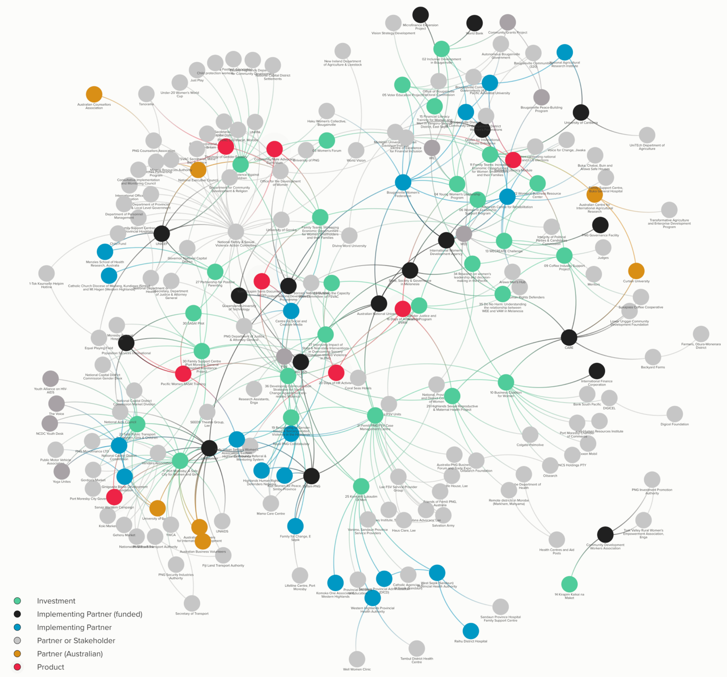Appendix 8 *Pacific Women* Papua New Guinea partner network

A) [Overall network](https://embed.kumu.io/bae6f3092845ef52d8f39014421570ec#pwspd-png):   
Investment and partnership connections

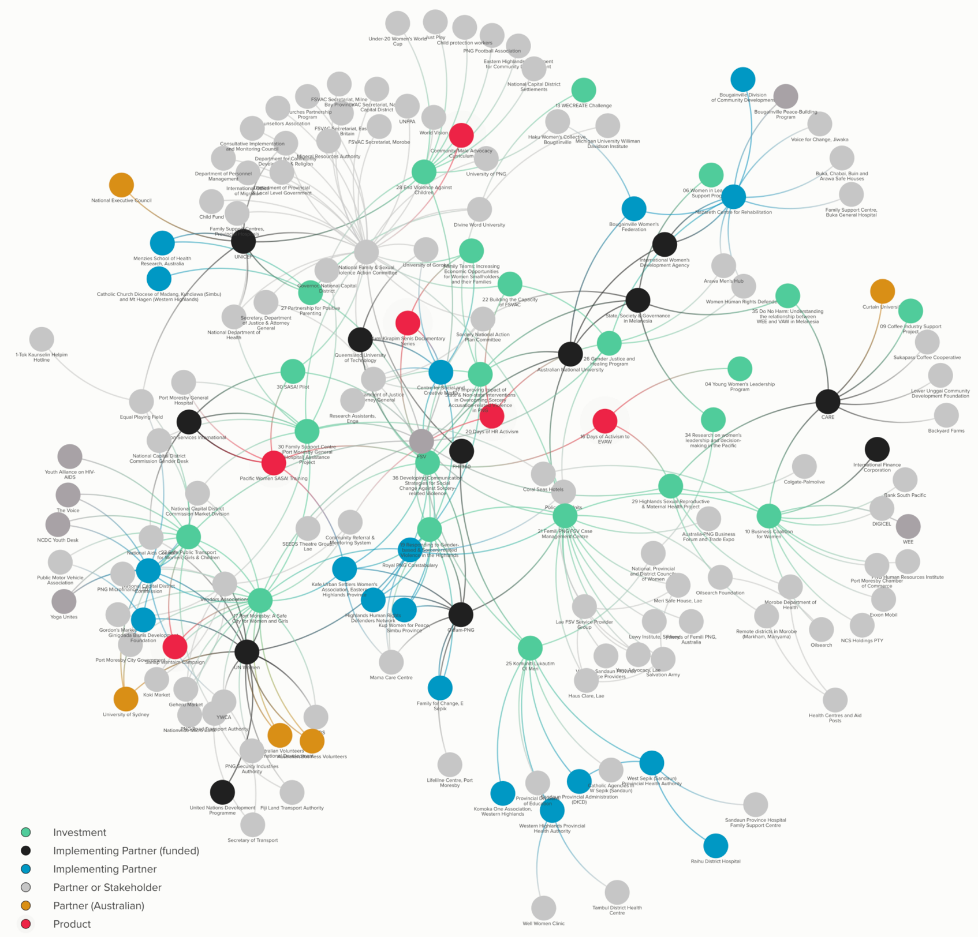B) Family and Sexual Violence Sub-Network

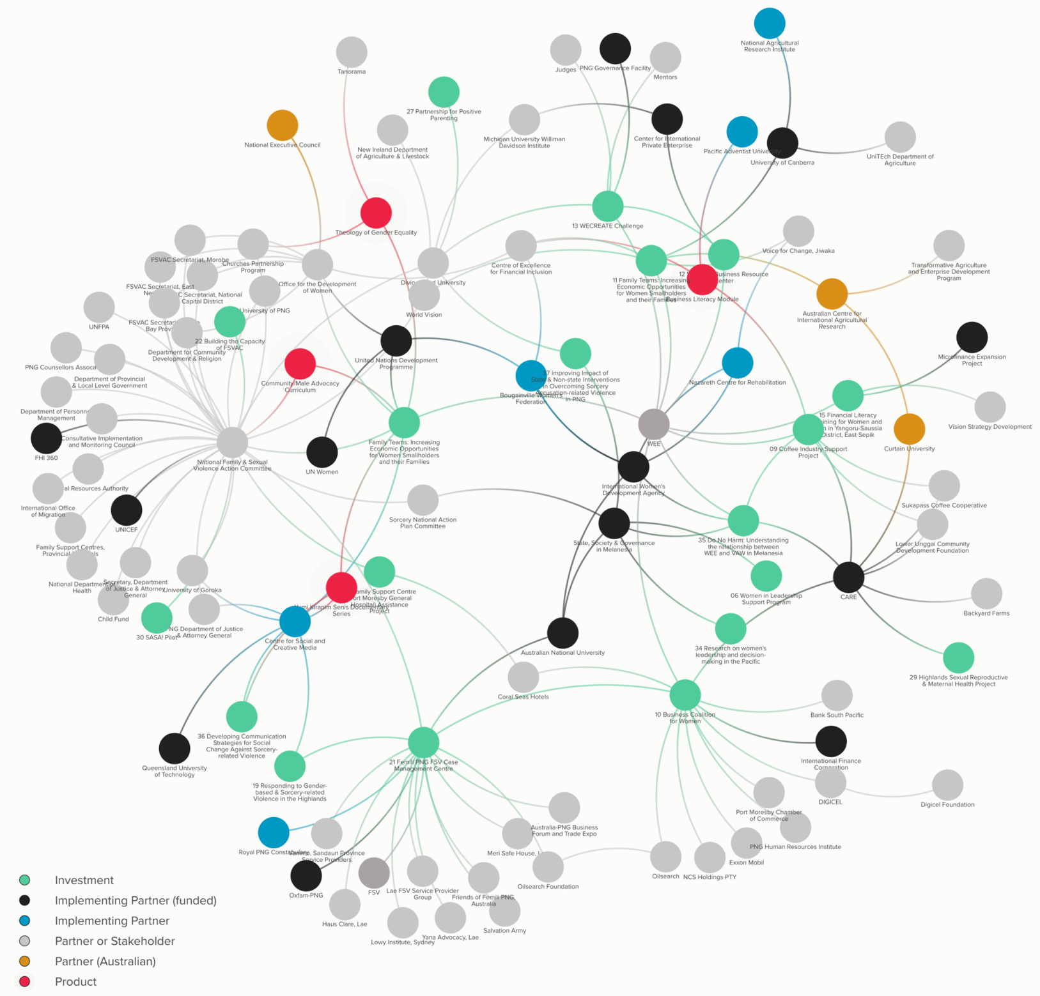C) Women’s Economic Empowerment   
 Sub-Network

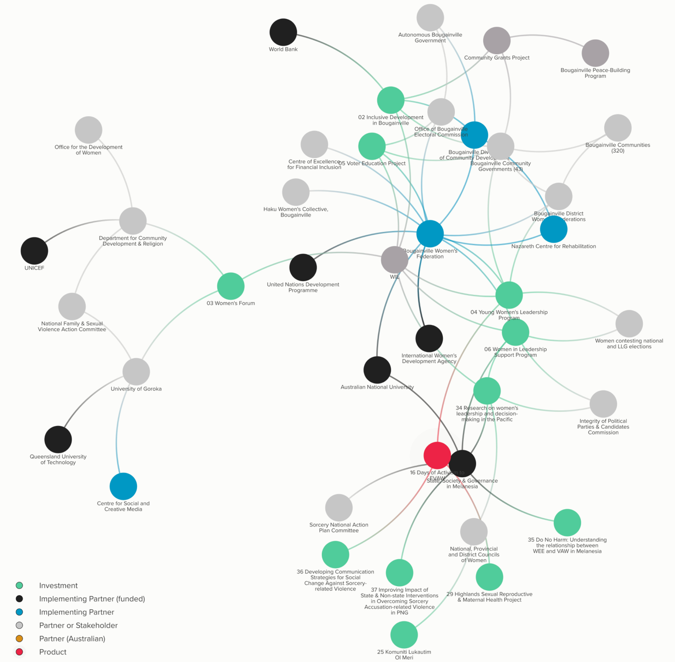D) Women’s Influence and   
 Leadership Sub-Network

Appendix 9 Papua New Guinea context analysis

Most of the key messages about the Papua New Guinea context identified in the *Pacific Women* Papua New Guinea Country Plan remain valid; however, there have been notable developments in some areas and the original analysis was largely silent on wider trends in demography, urbanisation, and technology as drivers and influencers of change.

### Continuing norms and practices

Customary obligations for male heads of families to create social wealth drives cultural norms and the power imbalance between men and women. Men decide how accumulated family wealth is used or distributed. Families are less likely to invest in education for girls. Women are expected work harder than men to provide for daily household needs through food-crop production, animal husbandry and marketing of produce.

Large family size impacts women’s domestic burden and ability to earn an income. Women suffer from malnutrition, excessive workloads, restricted mobility, poor access to safe water, excessively repeated pregnancies, high maternal mortality, and family and sexual violence, which are alarmingly common. Family and sexual violence is accepted as a response to transgression of gender roles in rural and urban areas, and regardless of socioeconomic status.

Despite changes in women’s development in urban areas and the trend for women to enter more formal jobs, start businesses, and attain leadership positions, gender inequality largely remains unchanged in rural areas. Neither women nor men demonstrate support for women leaders and women face multiple barriers when running for public office. Political shortcuts undermine government policies and promote a lack of faith in the political system among men and women.

### Continuing patterns in access to resources and in implementation of the policy and legal framework

Girls and women continue to be less educated than boys and men. Women have less access to economic assets than men and achieve fewer economic and leadership benefits. Health and welfare services are limited, especially in rural areas. Sexual and reproductive health services are a huge unmet need. Unmet need for contraception is over 40 per cent.

The legal and policy framework has undergone reforms, but lack of implementation is a major obstacle in the creation of an enabling environment for gender equality. Political will to fund the implementation of policies favouring gender equality is lacking.

### Developments in access to education and health[133]

Churches continue to play a major role in education service delivery administering about half of elementary and primary schools. Papua New Guinea’s primary schools have expanded rapidly over the past decade, but fewer services are now provided by health clinics with much more funding reaching schools than clinics. The Department of Education has been able to hire new teachers while many retired health workers continue to work with no one to replace them. The number of teachers has grown by one third with the share of female teachers growing from a quarter to one half. In the average primary school, 89 per cent more children were enrolled in 2012, compared to 2001, with the gender parity shifting from 50 to 90 per cent. The gap between boys and girls in school completion could be changing. In 2010 the grade 8 completion rates were 52 and 45 per cent for boys and girls respectively. These were projected to rise to 54 per cent for boys and 50 per cent for girls by 2017. A qualitative assessment in 16 districts revealed that more girls are reaching and completing grades 10-12 than boys.

While free tuition has increased school attendance girls experience multiple impediments to attendance both at home and in school, including risk of violence and limited or no access to water and sanitation facilities in schools to enable menstrual hygiene. Heads of schools and school boards are mostly male. The limited education opportunities are especially in problematic in the Highlands region, which has the largest population and where tribal conflicts remain common. Warring clans and tribes now use high-powered weapons such as M16s and self-loading rifles.

### Developments in access to formal employment

Women now occupy 23 per cent of all senior management positions and 31 per cent of middle management positions in central government agencies. By contrast, women still fare poorly at in provincial government and in the uniformed services with very few occupying critical decision-making positions. Women are best represented in the service professions, accounting for 54 per cent of all health workers and 42 per cent of teachers.

### Emerging shifts in norms and practices

The demand on women to generate income in addition to domestic responsibilities is a major shift from the past and gaining economic opportunities is a pressing need. More women are seen to have money, be effective as financial managers, be in positions of leadership, have the means to be mobile and become educated, although they continue to lack full control over decision-making. Youth hold different value, and marriage is changing, with more youth choosing their own partners and living together without parental approval. Young women who gained education in the last decade are finding expression in new and unprecedented ways.

### Developments in the policy and legal framework and in the law and justice sector

The *Family Protection Act* was enacted in 2013. Related regulations were passed in May 2017. However, there is low awareness of the Act and it implications (for example, that Interim Protection Orders can now be issued by village court magistrates), including among the implementing organisations. Polygamy was outlawed in 2014. Since 2015 the *Civil Registry Act* only allows monogamous marriage. Changes proposed in 2016 to the *Marriage (Amendment) Bill* 2015 and the *Matrimonial (Clauses) Bill*, will enable women and men to have equal rights to property and assets when a marriage breaks up.

The law and justice sector has seen an overall rise in numbers of magistrates, lawyers and police, and in the number of women in the sector. The recruitment of female village court magistrates has progressed much more rapidly than expected (from 10 in 2004 to 940 by 2014), with the goal of one woman per village court exceeded in many communities. However, this increase has not kept pace with population increase and female magistrates lack an enabling environment.

The National Gender-Based Violence Strategy 2016-2025 was endorsed by the National Executive Council in 2016. The roll-out remains a challenge for the Department of Community Development and Religion due to budget and capacity issues. Through the 2012 Gender Equity and Social Inclusion Policy gender-based violence is being addressed through workplaces using help desks. The National Policy on Child Protection (*Lukautim Pikinini* 2017–2027) was endorsed in early 2017 along with regulations for the new *Lukautim Pikinini Act* (2015).

Reserved seats for women were introduced in the Bougainville Autonomous Government and have been repeatedly proposed in Papua New Guinea. In Bougainville three seats are reserved for women and for ex-combatants. Each voter casts three votes for representatives in the Assembly: one for their local member of parliament, one for the reserved woman’s seat and one for the reserved ex-combatant’s seat. This system has been criticised for acting as a ceiling on women’s representation, leading to a perception that reserved seats are ‘women’s seats’ and general seats are therefore ‘men’s seats’. Since the introduction of Limited Preferential Voting in 2007 the incidence of money politics and political gifting has proliferated.

### Advances in efforts to address family and sexual violence

* An increase in Family Support Centres, with the first established at Lae hospital in 2003 and 15 (nominally) established by 2015 in 13 of Papua New Guinea’s 22 provinces.
* Establishment of provincial Family and Sexual Violence Action Committees including within the National Capital District Commission.
* Increased mobilisation of women and men Human Rights Defenders especially in the Highlands and Bougainville.
* Establishment of 17 police Family and Sexual Violence Units and the development of the Family and Sexual Offences Unit.
* The dramatic increase in the number of female village court magistrates.
* Improvements through advocacy and training to the referral pathway connecting survivors to assistance beyond immediate medical care.
* Passing of the Sorcery National Action Plan by the National Executive Council in July 2015. The Sorcery National Action Plan is implemented under the leadership of the Department of Justice and Attorney General. An implementation plan was developed and approved by the Sorcery National Action Plan core committee in April 2016. Four cases of effective action in 2016 demonstrate the benefits of the network building approach that underlies the Sorcery National Action Plan.
* Local actors intend to use new media to present a more representative and deeper discourse on sorcery accusation-related violence to counterbalance extremely negative portrayal by the international media.
* The District Services Improvement Program distributed an overall budget of PGK 1,780 million to 89 districts between 2008 and 2012. The Program released PGK 10 million per district per year in 2013 and 2014; creating opportunities to access funding to improve service delivery. However, limited financial reporting provided by districts to the Department of Finance is impeding the continuation of distributions.
* Women’s organisations are currently those most involved in family and sexual violence / gender-based violence work, with faith-based organisations playing an increasing role. In 2016, the Church Partnership Program launched *The Theology of Gender Equality*, reflecting the common theology and understanding of seven partner churches.
* Research has demonstrated that the private sector is impacted daily by incidents and repercussions of family and sexual violence and has the potential to tackle family and sexual violence issues. The Papua New Guinea Business Coalition for Women has developed family and sexual violence packages for business and a few businesses have collaborated on workplace policies of zero tolerance.

Despite these advances, an adequate response to family and sexual violence survivor needs is still far from reality. Where referral pathways exist, they need stronger coordination. There are insufficient safe houses to meet demands and service providers lack practical packages of tools. Users and service providers need better knowledge of services and how to access them. Gaps in referrals remain. One bottleneck is decision-making about who is qualified to make a referral. Access to trauma counselling remains another gap.

Many children and youth, both male and female, are victims of family and sexual violence and affected by ongoing fear and insecurity. Working with children is a major gap in existing services. There is no evidence to suggest that the amendment of the *Criminal Code* to make sorcery-related killings punishable by death has lessened violent attacks against women, especially in remote regions.

Key actors and sectors that remain largely uninvolved include: youth, men, sport, education, welfare, and other public service sectors, the private sector, and the Department for Community Development and Religion.

### Wider trends

Despite strong growth in Papua New Guinea’s large extractive industries drawing upon substantial reserves of gold, oil, gas, copper, silver and timber, widespread rural poverty persists. The high expectations for liquefied natural gas creating a boom in government revenues have not been met. Instead the national budget is under severe pressure because of low commodity prices and a large debt. The budget looms large among a variety of factors that are likely to limit the implementation of important recent policies and laws underpinning the attainment of gender equality.

The agriculture sector accounts for about a third of Papua New Guinea’s gross domestic product. Coffee and cacao are the main cash crops, employing about half of the total labour force in their production, processing and sale and offering potential opportunities for women and families to improve their livelihoods.

Coffee production is the backbone of the rural economy in the highlands provinces. Almost 90 per cent is produced by an estimated 370,000 smallholders who lack adequate access to agricultural inputs, technology and training for increasing productivity and adding value to increase benefits locally. Approximately a fifth of Papua New Guinea's rural population is engaged in cacao production, processing and sale. East New Britain and the Autonomous Region of Bougainville produce 70 per cent of total cacao exports. The appearance in 2006 of the cacao pod borer, an invasive species, has harmed the rural economy.

Papua New Guinea is one of the lowest ranking countries in the United Nations’ Human Development Index outside of sub-Saharan Africa. Income inequality is the highest in the Asia-Pacific region, and poverty is strongly entrenched in some areas.

Studies conducted between 1974 and 2004, which now require updating, consistently indicated that the most disadvantaged districts were in Sandaun and Western Province along the Indonesian border and in Simbu and Morobe in the Highlands. Districts consistently been found to be among the most disadvantaged since 1975 are; Middle Ramu, Rai Coast, Telefomin, Vanimo-Green River (incorporated in Amanab District), Jimi, and Goilala. Obura-Wonenara in the Eastern Highlands was also considered by most studies to be disadvantaged. These areas are isolated, have low levels of cash incomes and poor access to services. Environmental factors including climate change affect the productivity and reliability of subsistence farming, and create vulnerability to food shortages and malnutrition.

Levels of crime and violence in Papua New Guinea remain high. The homicide rate was 10.4 per 100,000 habitants in 2010, roughly the same as in 2000. It varies widely across regions. Based on Royal Papua New Guinea Constabulary data the rates of 66 per 100,000 in Lae and 33 in the National Capital District are amongst the highest in the world. Estimates using data from victimization surveys implemented by the Law and Justice Sector Secretariat are much higher at 750 and 323 for Lae and the National Capital District respectively. Alcohol and drug use is a contributing factor to violence and crime. Victims of family and sexual violence often claim alcohol played a triggering role.

### Drivers of change

About half Papua New Guinea’s population of over seven million is under 20 years old. Youth numbers are expected to double in the next 20 years. This huge youth population, is a key driver of change.

The expansion of informal settlements indicates that urbanisation is occurring much faster than suggested in the 2011 census. Papua New Guinea’s cities and towns are centres of formal and informal economic activity, have higher income levels, more health and education options, drive demand for rural labour and goods, and supply remittances to rural areas. Urban areas are central to reducing overall levels of poverty and hardship, and Papua New Guinea’s growing inequality as they are home to Papua New Guinea’s growing urban ‘working’ middle class, which includes young women who attained education during the last decade. Middle class opinions are important in framing village discussions of social issues and reshaping the public sphere.

Linked to this is the rapid spread of mobile phones. They are affecting all aspects of life in both rural and areas and blurring the boundaries between them. Phones have changed the pace and nature of communication. They offer potential to improve service delivery in sectors such as health, education, law and justice; are increasing access to financial services, creating employment and driving other markets, such as solar-powered products for rural electrification. With most of Papua New Guinea off-grid, the demand for solar-powered products for charging mobile phones, has potential to open the door for new forms of rural entrepreneurship. Solar powered products could also contribute to improving well-being of rural women and girls, starting with less dependence on kerosene for lighting and cooking.

Favourable developments for women’s economic empowerment include: the emergence of small and medium enterprise start-up programs; increasing options for accessing finance; a surge in youth-led enterprises; and the emergence of social impact enterprises that engage with low income populations and focus on women’s empowerment and youth employment.

National elections will be held in 2017. They will be followed by local level government elections in 2018. Five per cent of candidates for the 2017 elections are women, signifying an increase in the number and percentage of women contesting. Candidates who have received support (for example, through the *Haus Krai* campaigns, training on how to succeed in contesting elections), are serious about standing, understand campaigning, have raised funds, have male backers, and are prepared with a five-year plan. The opportunity to see more women as candidates and in leadership roles is contributing to changing the social narrative of women in leadership.

The 2016 Papua New Guinea Development Cooperation Policy[134] reflects a changing approach to the way Papua New Guinea applies development cooperation resources. It signals a shift from the traditional donor-recipient engagement paradigm to one of economic cooperation.

The policy addresses Government of Papua New Guinea concerns regarding sovereignty, thin spread of resources across the country, coordination and performance management, disbursement delays, and the creation of parallel systems driven by the low confidence of development partners in government systems and processes.

The policy is aligned with Vision 2050 (which describes aspirations for Papua New Guinea to progress towards the top 50 countries in the Human Development Index ranking), the 2014 strategy for Responsible Sustainable Development, and the National Delivery Framework (which identifies the responsibilities of the national government, provinces, districts and wards, and regional service delivery centres). The policy calls for at least 50 per cent of development partner programs to be targeted towards infrastructure.

The policy identifies a series of guiding principles: sovereignty; alignment with Papua New Guinea development plans and strategies, steering of resources towards the sub-national level and distributing them in accordance with the National Service Delivery Framework; design of subnational programs and projects in consultation with Provincial Administrations and District Development Authorities; approval of projects, capacity development strategies, and technical advisory support by the recipient head of agency; utilisation by development partners of Government of Papua New Guinea processes, procedures, and systems; relationships based on mutual respect, responsibility, transparency, and accountability; a focus on a limited number of strategic sectors of comparative advantage; reflection of resources in and delivery through Government of Papua New Guinea’s annual budget and sector-wide approach; active Government of Papua New Guinea involvement in development cooperation projects and programs; a growing focus on supporting economic-oriented infrastructure enablers and economic growth prospects; and deepening of south-south relationships in addition to north-south cooperation.

The policy views exclusion and gender discrimination as a cross-cutting challenge, along with environmental sustainability and reaching geographically isolated areas.

Appendix 10 The *Pacific Women* Papua New Guinea portfolio at a glance

### A) Timing and duration of projects

Source: Annex 1, Draft *Pacific Women* Papua New Guinea Annual Performance Report for 2016-2017; Country Plan duration: Five financial years from July 2014 to June 2019. Months remaining calculated from May 2017; Inclusive Development in post-conflict Bougainville continued into Phase 2 after a no-cost extension. A first phase of *Komuniti Lukautim Ol Meri* was funded by another DFAT program. The Women’s Forum is an annual event coordinated by the US Embassy since 2014. The *Pacific Women* support Unit sub-office was fully operational as of March 2016. Numbers and acronyms are working titles only.

### B) Funding source by theme

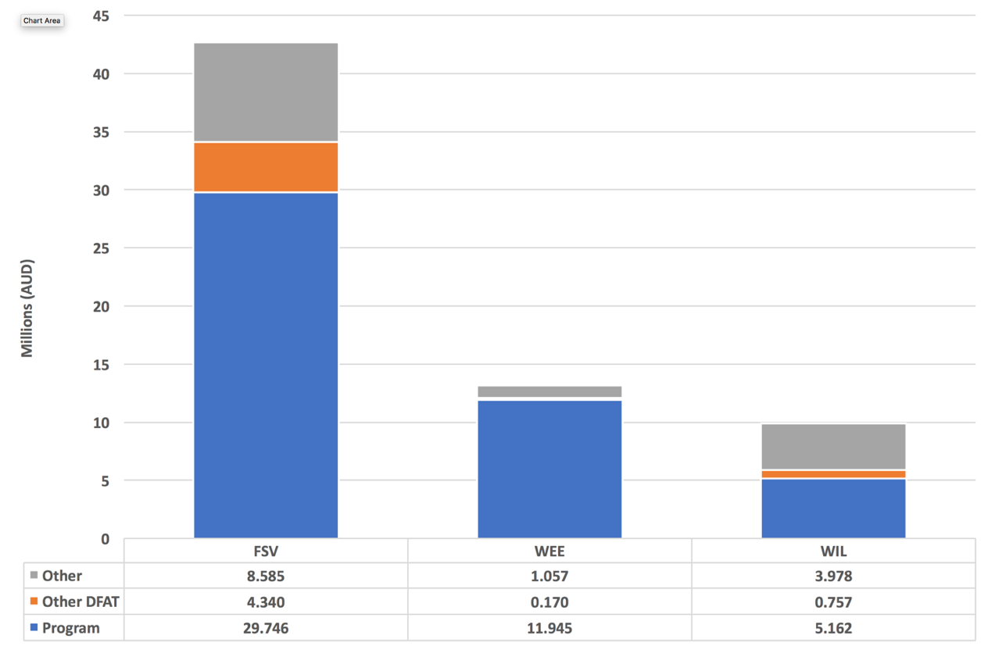

### C) Geographic focus

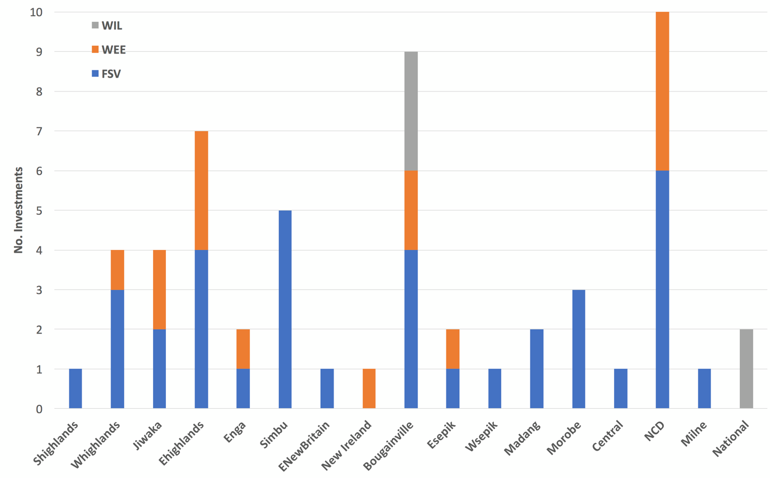

### Abbreviations

|  |  |
| --- | --- |
| FSV | Family and sexual violence (violence response and services) |
| WEE | Women’s economic empowerment |
| WIL | Women in leadership (leadership and influence) |
| Shighlands | South Highlands |
| Whighlands | West Highlands |
| Ehighlands | East Highlands |
| ENewBritain | East New Britain |
| ESepik | East Sepik |
| Wsepik | West Sepik |
| NCD | National Capital District |

Appendix 11 Case reports: project benefits

### Inclusive Development in post-conflict Bougainville

The Inclusive Development in post-conflict Bougainville (Inclusive Development) project uses small public infrastructure projects as a vehicle to improve quality of life in remote rural areas and to strengthen capacity of participating communities to prioritise, design, manage and maintain the infrastructure. The Inclusive Development project delivers infrastructure by working with community-based women’s groups. The project has built water supply systems, water and sanitation systems, community resource centres, classrooms, aid posts and feeder roads.

The Inclusive Development project uses a regional approach to train women’s groups in participatory planning covering community mapping, needs analysis, conflict management, project management and implementation, good governance, monitoring, and evaluation. Meeting other groups in the training areas has proved to be a form of empowerment. Trained groups prepare expressions of interest. After pre-screening by Inclusive Development, these are screened by a committee of officers from community government, including women and youth representatives, and the Autonomous Bougainville Government Department for Community Development. From a shortlist of five the committee selects one.

Successful proposals are funded as sub-projects. Before funding is released the group is required to open a bank account for management of the funds and each community is responsible for providing 10 per cent of the value of the sub-project in kind. Technical support and guidance is provided to each women’s group to manage their sub-project through to successful completion.

When they begin training most women are shy, but they gain confidence. They procure their own materials, identify their own technical specialists and do all the administrative work. The Illiterate women in the groups are also involved. A man might accompany the women for security reasons. The Inclusive Development project facilitates affiliation of women to the Bougainville Women’s Federation and access to Human Rights Defender training by the Nazareth Centre. Sub-project management experience builds confidence and some women have been inspired to stand in community government and Autonomous Bougainville Government elections.

The review team visited three sub-projects in the villages of Gohi, Munius and Malasang 1, North Bougainville District. In Gohi and Munius women’s groups implemented the installation of community water storage tanks. In Malasang 1, the construction of a community resource centre and two water storage tanks.

Before the installation of the tanks women and children walked long distances, and up and down steep cliffs, to fetch water for drinking, cooking, and washing clothes. They walk from one to three hours daily. During the dry season water shortages caused severe hardship. Eight tanks were installed at Gohi and six at Munius with tank sizes ranging between 5,000 and 9,000 litres. The tanks at Gohi and Munius are shared by several villages and access is controlled by the women’s groups.

Although the tanks are not enough to meet all water needs they are sufficient to meet basic needs for drinking and cooking, and have considerably reduced women’s domestic burdens. The improved water supply is also making difference to health.

In Malasang 1, the resource centre project has been more transformative. The centre generates income for shareholders through rental to users from other communities, serving as a hub for meetings and transit accommodation, and by supporting a variety of local income generation schemes. Shareholders also earn dividends from exports of cacao. The centre also serves as a venue for women’s capacity building events, and for fund raising for community needs and school fees. Capacity-building programs carried out to date include financial literacy and training on cooking, baking and cacao farming and training by the Nazareth Centre for women human rights defenders. Membership has risen to 3,000 and there are plans to build an extension to the centre.

The women’s resource centre in Malasang 1 is an example of a transformative project creating more ripple[135] effects for women, their families and communities.

Figure 6: Ripple effects of the Malasang 1 Resource Centre

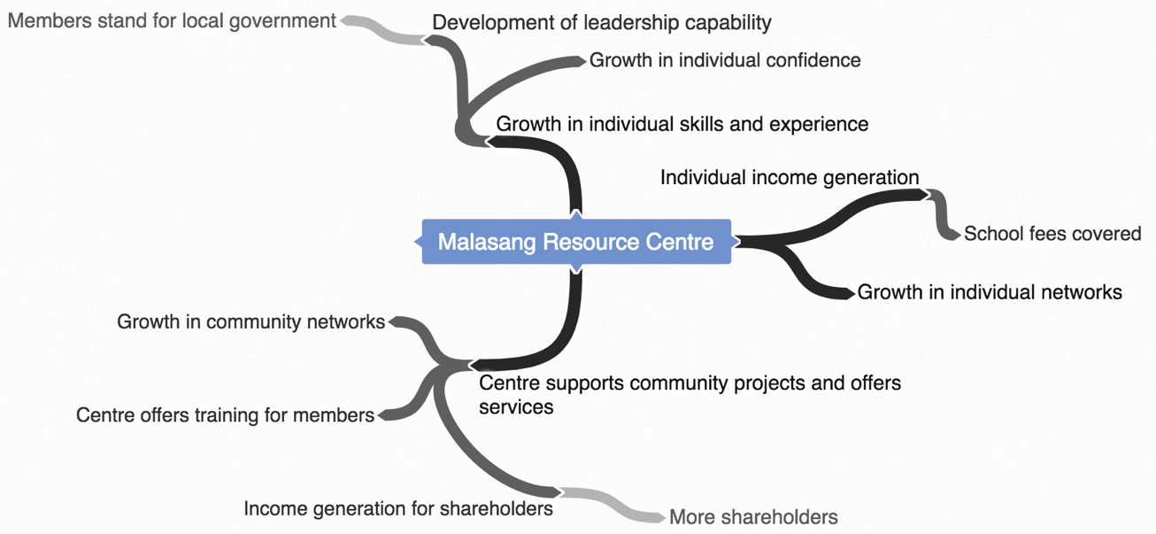

### From gender-based violence to gender justice and healing

The Sisters of Nazareth started the Nazareth Centre for Rehabilitation 17 years ago with PGK 1,000. Initially three sisters and five young men, former drug users rehabilitated by Centre Director Sister Lorraine Garasu, did all the work. The resources and capacities of the Nazareth Centre are home grown and developed organically. The infrastructure now includes the Centre at Chabai, an office and Men’s Hub in Arawa, and three safe houses.

The Nazareth Centre’s peace-building work related to the Bougainville conflict led to the establishment in 2013 of the Family Support Centre at Buka General Hospital. The Department for Community Development placed the Nazareth Centre’s director in charge of the Family Support Centre and she was in that role until 2016. The Nazareth Centre trained the Family Support Centre health workers and Bougainville Police in handling gender-based violence cases, and is currently providing training via the Community Policing Program supported by New Zealand. The Nazareth Centre’s work on access to justice for survivors of gender-based violence has been supported by a New Zealand family court lawyer who trained lawyers, public prosecutors, and worked for two years with the Senior Principal Magistrate (now a judge).

In 2013, International Women’s Development Agency began working with the Bougainville Women’s Federation and learned of the Nazareth Centre through that organisation. Through this Sister Lorraine supported Bougainville Women’s Federation’s organisational development for six months, and International Women’s Development Agency learned about the Nazareth Centre’s work with a few women human rights defenders mobilised with UNDP funding. International Women’s Development Agency was supporting women human rights defenders in the Highlands and began to support the Nazareth Centre’s work with women human rights defenders.

At the time, International Women’s Development Agency policy did not permit support to faith-based organisations, so funding was through very small grants. After a Board change and an organisational review of the Nazareth Centre, International Women’s Development Agency changed policy and begun to fund the Nazareth Centre directly. From 2012 to 2016 the Nazareth Centre and the Bougainville Women’s Federation were involved in the Funding Leadership Opportunities for Women program, a multi-country, multi-partner program supported by the Government of the Netherlands and managed by International Women’s Development Agency.

The funding provided by *Pacific Women* has enabled the Nazareth Centre’s women human rights defenders program to reach villages, and work with chiefs, youths, and male advocates. The women human rights defenders are volunteers who work as counsellors, mediators and advocates.

Many women human rights defenders have been elected to represent their wards. In Bougainville, each ward is now represented by one man and one woman, so there are 424 women in local level government. The Nazareth Centre intends to continue to build the capacity of the women human rights defenders in these new roles. Participation in the Nazareth Centre’s annual Women Human Rights Defender Forum has more than doubled since 2015, with many more young women involved and mature women giving space to young women presenters.

Bana has seen a reduction in family and sexual violence resulting from sustained work by women human rights defenders to change attitudes and behaviour and intervene in conflicts, including sorcery-related violence, using Melanesian diplomacy. Funds to extend training on counselling have made a big difference to women human rights defenders.

Trauma counselling is very important and not just for cases of family and sexual violence. A recent landslide killed two children and traumatised 22 others. The first responders were the Nazareth Centre and the Buin District Administration. High schools, primary schools, and hospitals are sending people to the Nazareth Centre for training in trauma counselling, but working with health and education can be challenging because of the protocols that must be followed.

Safe houses and access to justice for victims have been strengthened. The Nazareth Centre is currently developing a safe house policy with the Autonomous Bougainville Government with support from the DFAT Law and Justice Program. The Nazareth Centre has contributed to several other Autonomous Bougainville Government policies but is mindful that all require funding for implementation.

*Pacific Women* funding has enabled the Nazareth Centre to have an office in Arawa with a Men’s Hub based there. The Men’s Hub is in demand with an average of 10 clients per day, but only three days of counselling can be provided per user due to resource constraints. One community brought a group of 17 youths with problems. Many young men and boys were raised in abusive homes and are now expressing negative sexual behaviours, using drugs and alcohol. The three-day program is not sufficient.

The schools-based program is part of the Nazareth Centre’s male advocacy program, which is about men educating men to address family and sexual violence. The model has its roots in the Nazareth Centre’s school camps program and the modules were developed from existing resources. The program is helping teachers in 12 schools who struggle to teach sexual and reproductive health. They feel uncomfortable and tend to skip the topic, but are learning from the Nazareth Centre’s trainers. The modules are: Who am I*,* about personality integration; My Sexuality, on sexual and reproductive health; and Leadership and Governance. Peer educators report that program has whole villages talking about sexually transmitted infections and teenage pregnancy. Both boys and girls are now helping with cooking, laundry, carrying water and chopping firewood at home. Before girls looked down on themselves and thought boys were better. Now both are in leadership roles at school (prefect, class captain). Youth homebrew and drug consumption has dropped.

### Benefits of projects implemented by the Bougainville Women’s Federation

In addition to improving knowledge and contributing to changed voting behaviour, the beneficiaries and providers of the Voter Education project identified ripple effects, including benefits for persons with disabilities, for the profile and reach of Bougainville Women’s Federation, and supporting the Autonomous Bougainville Government through outreach to remote communities.

First person accounts by participants in the Young Women’s Leadership training indicate that the training has provided a foundation that will require support and follow-up to sustain and extend.

**Young Women’s Leadership Project**

*‘I travelled to the United States to meet young women leaders there. Impressed by their access to formal education.’*

*‘I gained personal confidence through participation and now feel able to take part in decision-making.’*

*‘I especially value learning about human rights. The topic opened our minds about practices in our villages.’*

*‘I participated in the Young Women’s Leadership Project training and as served as a researcher for Bougainville Women’s Federation. I gained the confidence to stand in the recent ward councillor elections, came in second and plan to try again. I’m also supporting others to stand.’*

*‘Since the training, I’ve been taking part in peacebuilding, interacting with police and public servants, and sharing ideas from my understanding of human rights.’*

*‘Before the Young Women in Leadership Project training, our practices and customs in the village seemed right. I’m now seeing things differently and can differentiate right from wrong. I’ve gone from being no one to being someone who commands respect from men, women other young people, and from male and female church leaders and chiefs. I have the confidence to speak.’*

*‘The human rights training has had a big impact on the behaviour of our spouses, who are now male advocates. They’re drinking responsibly, are more respectful of young women and want more training.’*

*‘The project has made a big difference in Waikunai district where consumption of marijuana and alcohol is very high. It imparted knowledge that has really helped young men.’*

*‘Through the Young Women’s Leadership Project, the Bougainville Women’s Federation has established young women’s associations in 5 of Bougainville’s 13 districts.’*

*‘Young Women’s Leadership Project boosted young women to contest community government elections and to join the Bougainville Women’s Federation caucus. These are big achievements.’*

**Voter Education in Bougainville**

*‘Thirty women were trained as voter education trainers; 20 men were trained as advocates--male human rights defenders for women’s rights.’*

*‘People with disabilities benefitted from the voter education training and from knowing there are ways to help them vote.’*

*‘The work on voter education has reached people in very remote areas and has raised the profile of ‘Bougainville Women’s Federation.’*

*‘‘Bougainville Women’s Federation membership has increased with more young women joining. Women are coming out of villages to attend district level ‘Bougainville Women’s Federation meetings.’*

*‘There has been a mentality change. People understand more the importance of selecting good leaders rather than their relatives.’*

*‘The mock election has prepared people to cast their votes correctly.’*

*‘The number of informal votes is lower in some wards.’*

*‘More women and young girls turned out at the polling areas during the recent community government elections.’*

*‘More women are exercising their right to vote. We’re most proud to see the women from the lost generation, who missed out on formal education, exercising their right.’*

*‘During the voter education work the ‘Bougainville Women’s Federation also did awareness training with men on the importance of protecting women and not perpetrating family and sexual violence.’*

*‘A benefit for everybody is learning about the differences between the ballot papers for the Autonomous Bougainville Government and national elections.’*

*‘As a trainer, I’ve gained a lot of knowledge regarding electoral processes. Before I only knew I could cast a vote, but knew nothing about governance or corruption. This work has given me a lot of confidence.’*

*‘No other grassroots program has this level of access to communities. ABG benefit from ‘Bougainville Women’s Federation because they don’t have the funds or manpower to reach the village level.’*

### Beneficiaries’ recommendations to Young Women’s Leadership and Voter Education in Bougainville projects

* Deepen the Young Women’s Leadership training
* Extend the Young Women’s Leadership training to reach all the young women in all districts of Bougainville
* Support our networking and make greater use of the Young Women Leaders network
* Provide leadership training to other key groups such as chiefs
* Work to change the attitudes of mature women leaders who see young women as competitors and don’t support or mentor them
* Include male advocates in the Young Women’s Leadership training to help them understand and better support young women in leadership roles
* Carry out voter education on a continuous basis to reach new voters.
* It’s risky for women to travel alone; advocate to Autonomous Bougainville Government to provide protection to women working on Bougainville Women’s Federation initiatives.
* Standardise training-of-trainers for voter education and certify trainers. Use qualified training organisations such as CARE or Nazareth Centre for Rehabilitation.
* Train more male advocates.

Appendix 12 Women’s Business Resource Centre: User Stories

First person accounts from users of the Women’s Business Resource Centre, which opened November 2016 in Port Moresby suggest that benefits for individuals can accrue rapidly and can be transformative. These include knowledge and skills for small business start-up, contacts, and networking skills. The accounts also revealed an interest in social enterprises among several Centre users. Presentations by WECREATE Challenge finalists at the Annual Learning Workshop point to similar benefits.

I’m an avid newspaper reader and heard about the WECREATE Challenge, but wasn’t selected. Through WECREATE I got connected to the Women’s Business Resource Centre, and now I’m developing a business around providing life and trade skills to women in my community. In Papua New Guinea, we have attitude problems--we look down on informal sector women. I’m focusing getting these skills disseminated right to the very bottom of the informal sector where some women are literate, some not.

************

I want to work with trainers who are certified so that the training can be the best and help women find a way to sustain themselves and move on with their lives. I’m starting by collecting information on, for example, how many people can provide training in sewing. I want to accommodate informal sector women, and women of different professions in this and don’t intend to wait for Government TVET [technical and vocational education and training] funding! Instead I’ll roll out life skills training myself to help women be more employable.

************

The Women’s Business Resource Centre is a key place for networking. The networking sessions have been so helpful to me personally. They helped refine my profile and there’s a twist —I found out how my knowledge and skills fit — and with help from the Women’s Resource Business Centre came up with this idea for working with women in the informal sector. Maybe I’ll even be able to extend this to people at home in Western Gulf Province.

************

I have a makeup business. At the Women’s Business Resource Centre, I’ve gotten insights into paying tax and help with social media. I now have a Facebook page and had advice from the WBRC to use my own name in the brand. This has helped with getting customers. Also, I learned that I can establish branches of my brand, like hair by me, clothing by me. I’m now at the product development stage and looking at how to differentiate myself from other makeup services. The starting point was a big change in my Facebook presence.

************

I’m a tax accountant by profession and was introduced to the Women’s Business Resource Centre through WECREATE after I got sick and had to pull out. But I had a training session here at the Centre, and since then I won a fellowship with Australia Awards. I had to come up with a project and my project is come back and teach what I learn. I'm planning to get like-minded people in same room. I'm 27 years old and want to encourage young ones to get something going and not just rely on parents. What happens if you don’t’ get a place at uni, or drop out? — this is what I will do when I come back.

************

The big strategy I learned is bootstrapping. I’m working with the indigenous people of Port Moresby—we have been marginalised and have no more say here—so I’m forming a women’s association. The idea is to have women registered through the association as bakers, seamstresses, for tire repair. We even we have a lady mechanic teaching other ladies how to fix cars. We haven’t gotten anywhere with previous governments —so now we are just going to help ourselves by bootstrapping. We created create our own pool of money and members can borrow to do a start-up and slowly repay the loan. If you can sell anything—even a hotcake—you’re an entrepreneur—but it’s about how you manage your money. We're going to launch after elections because we have no idea who will be there. We have 150 women with stalls ready come out.

************

My business is upgrading office girls. I've been doing this for 11 years and have diversified into different communities working with young women, drop outs, female inmates, who can work in housekeeping and janitorial roles. These are the people who work in all these buildings in the city's diplomatic residences.

************

I switched off between February and now because I've been looking for women trainers. So, I tendered a profile here at the Women’s Business Resource Centre. I'm developing a big program for developing women—through this housekeeping work I'm already considering the illiterate group. The office girls training has been on hold, but now I'm ready to pay my membership fee and kick off that topic in June.

**User’s Recommendations to the Women’s Business Resource Centre**

* Provide training on savings and cash flow management.
* Provide advance notice on what’s coming up at the Centre.
* Develop a bigger Women’s Business Resource Centre in a more accessible location.
* Run informal sector trainings in the field.
* Run train the trainer programs.
* A lot of people are in the dark about taxes and can be conned - very important area for business owners.
* Provide more on financial literacy—we all need to concentrate on this and need to know the requirements before starting anything.

Appendix 13 Insights and Messages

**Key messages from the 2017 Annual Learning Workshop**

* A root cause of unequal relations between men and women is unequal power.
* Changing negative and harmful attitudes and behaviours of men and boys towards women and girls and involving men and boys as advocates seen as key to achieving gender equality in Papua New Guinea.
* Mobilisation of young women seen as key for achievement of gender equality in Papua New Guinea.
* Women’s economic empowerment needs boosting, but is not a panacea for family and sexual violence or gender inequality.
* Churches and faith-based organisations are important partners in preventing and responding to family and sexual violence and achieving gender equality.
* More family and community-based approaches to family and sexual violence prevention and response, economic empowerment and leadership development are needed.
* The prevalence of violence against children is very high. While Papua New Guinea has a *Child Protection Act*, implementation provisions are not yet in place, placing serious constraints on service provision.
* Continued alignment around the new National Gender-Based Violence Strategy is a must for all partners and stakeholders
* Stakeholders are concerned about the limited presence and engagement of the coordinating government agency, the Department for Community Development and Religion.

Table 13 summarises the main big picture issues, implementation challenges and opportunities raised by implementing partners and stakeholders during interviews and those identified in the Papua New Guinea Case Study. Points from the Papua New Guinea Case Study are in italics. Points raised in both interviews and the Papua New Guinea Case Study are indicated with a double asterisk.

Table 13: Issues and opportunities identified by implementing partners and stakeholders

|  |  |
| --- | --- |
| **A. Big Picture Issues** | |
| **Constraints** | **Concerns** |
| * Lack of political will and funding to implement key national strategies underpinning gender equality. * Low engagement by Department for Community Development and Religion, the key national government department as the coordinating agency for women’s development. * Continuing low literacy, numeracy and financial illiteracy among women and girls hampers work in women’s economic empowerment, leadership and influence, and violence response and services prevention and response. * Few donors and limited funding for child protection in Papua New Guinea; Lack of safe houses and counsellors for children affected by family and sexual violence. * Insufficient safe houses and resources to operate them.** * Insufficient understanding of the effects of trauma on health, well-being and relationships. * A weak evidence base on what works in women’s economic empowerment in Papua New Guinea. * Papua New Guinea lacks an enabling environment for businesses. | * Livelihood options for family and sexual violence survivors are urgently needed to provide an alternative to returning home and remaining at risk.** * Insufficient understanding of power differences as the root cause of gender inequality may be a barrier to power-based behaviour change approaches. * Little attention to the role of homebrew and drug use in family and sexual violence. * Low inclusion of people with disabilities. * Men and youth are being left behind. Many suffer mental health problems and trauma from violence including family and sexual violence. * No gender-based violence prevalence study for Papua New Guinea.** * *No prevalence study for violence against children.*[136] * Poor coordination among development partners * Perception of *Pacific Women* as a parallel structure[137] undermining the role of Department for Community Development and Religion in coordination. * *Provincial Family and Sexual Violence Action Committee secretariats are not yet able to lead effectively.* * *A risk in working with churches and faith-based organisations is the possibility of incompatible attitudes towards gender equality* |
| **B. Implementation and Sustainability Challenges** | |
| **Project-level** | **Portfolio Level** |
| * Travel is risky for women human rights defenders, counsellors and trainers. * High financial and time costs associated with management of serious family and sexual violence cases especially repatriation cases. * Safe house work is risky and staff work under intense pressure. * Volunteers in family and sexual violence work and safe house staff work in high risk conditions under intense pressures, suffer stress and burnout. There is little support for their psychosocial needs and volunteers have limited options or support for addressing livelihood needs.** * Mature women leaders are not necessarily willing to mentor and support young women. * Poor roads and high transport costs hamper projects working in remote rural areas. * *Although there have been successes in targeting communities with a high level of need, gaps remain in family and sexual violence service provision most often related to geographical coverage which is the major challenge in successfully targeting and reaching vulnerable communities.* | * (Mis)understanding of the *Pacific Women* country program as a grants program. * The complexity of the changing and layered relationships between DFAT and the *Pacific Women* Support Unit Papua New Guinea sub-office.** * The need for attribution is a barrier to coalition-building. * Coordination between DFAT sectoral programs (particularly Justice, Governance and Bougainville Peace-building) and *Pacific Women.* * *Overstretched budget in the face of the coverage challenges in Papua New Guinea. In some cases, it has been possible to leverage funds from other DFAT sources to make project budgets more realistic.* * *Achievement of coverage in the all three outcome areas in targeted locations* |
| **C. Opportunities** | |
| **Strategies and Entry Points** | **Relationships** |
| * Work through existing structures rather than creating new ones. * Develop a consistent, clear and inclusive national message around equality, using words that don’t put people off. * Follow what works and build on successes. * Geographical focus is important for sustainability. * Develop a roadmap for achieving women’s economic empowerment in Papua New Guinea, drawing on learning from Pacific research. * Take advantage of the political opportunity created by Papua New Guinea’s hosting of the APEC Leader’s Forum in 2018. * Position family and sexual violence as a public health issue (an epidemic). * Deepen Papua New Guinea ownership of development projects by engaging more local organisations in implementation. | * Work with implementing partners who are committed to enhancing the capacity of the local partners they work with not just in core capabilities such as financial management and results reporting but more widely. * Deepen relationships with District Development Authorities. * Create more linkages with the private sector; much more could be done to leverage the influence of the private sector in leadership and influence, women’s economic empowerment, and violence response and services. * Create more linkages with faith-based organisations, for example with the DFAT-funded Papua New Guinea Church Partnership Program.** * Deepen relationships with the health and education sectors and with DFAT sectoral programs in these areas. * *Develop more systematic linkages between partners working in different intended outcomes.* * *Develop more linkages with DFAT’s wider activities in enabling economic growth.* |

1. All references are to Australian dollars unless otherwise stated.
2. With an annual budget of about $12 million Pacific Women Papua New Guinea represents about 2.2 per cent of Australian government funding in Papua New Guinea, which stood at $549.7 million in 2015–2016 including non-bilateral funds. (Source: ITAD. 2017. Pacific Women 3 Year Evaluation Country Case Study for Papua New Guinea).
3. Agreed restatement of the original Country Plan objective.
4. Service dimensions: visibility, availability, reach, quality.
5. By agreement with DFAT and the Pacific Women Support Unit, the evaluation objectives were streamlined from six to four. Details of the streamlining are given in Appendix 3.
6. Documents included *Pacific Women* Papua New Guinea Annual Performance Reports, baseline studies, and recent evaluations.
7. The evaluation questions included ‘Are the principles underpinning the theory of change still appropriate and relevant to the context of Pacific Women in Papua New Guinea?’ The plan for handling this question was to use material from a session on the topic to be facilitated by Pacific Women monitoring and evaluation staff during the Annual Learning Workshop. As that session was not held, an alternative approach was taken, focusing on how well projects uphold the key principles.
8. Three sub-projects were visited in the case of Inclusive Development in post-conflict Bougainville.
9. The Partnership for Positive Parenting project is in the process of adapting an approach that is successful elsewhere for the Papua New Guinea context, and have few beneficiaries to date and none in the two field sites. Meeting with representatives of the populations targeted by the Ending Violence Against Children Campaign was not feasible; however, it should be noted that UNICEF is developing a mobile survey for impact assessment. The review team met with service providers who are benefitting from the Family Support Centre Assistance Project through training, but not with people served by the Family Support Centre or through the outreach work of the project.
10. Annual Learning Workshop presentations were made by the following projects: Inclusive Development in post-conflict Bougainville, Young Women’s Leadership Project, Strengthening Business Coalitions for Women, Family Teams: Increasing economic opportunities for women smallholders project, Strengthening national mechanisms to prevent and respond to family and sexual violence, Family Support Centre Case Management Centre in Lae, Do No Harm research, Communication strategies for social change against sorcery-related violence, Research on women’s leadership and decision-making in the Pacific (including Papua New Guinea).
11. Evaluations and baseline studies reviewed: Coffee Industry Support Program Evaluation Report 2017; Pacific Partnership Review 2017 (section on Business Coalition for Women); FHI 360 Baseline Survey for *Komuniti Lukautim Ol Meri* 2014; Inclusive Development in Bougainville - Case Studies 2016; Review of Ending Violence Against Women Counselling in the Pacific 2017; Safe Cities Markets and Transport Baseline Report 2016; Pacific Women 3 Year Evaluation Country Case Study for Papua New Guinea 2017.
12. This report considers information up to the time that the review team finished field work and information gathering, on 29 June 2017. New information emerging after this date, such as the results of the 2017 national election, have not been included in the analysis.
13. Sources: DevPolicy Blog: <http://devpolicy.org/five-lean-years-australias-aid-program-tightened-belt/> <http://dfat.gov.au/aid/Pages/australias-aid-program.aspx>; <https://www.devex.com/news/insights-for-the-australian-aid-program-from-budget-inquiries-90416>; DFAT. 2017.Performance of Australian Aid 2015-16; DFAT. 2016. Gender Equality and Women’s Empowerment Strategy; <http://dfat.gov.au/about-us/publications/Pages/aid-investment-plan-aip-papua-new-guinea-2015-16-to-2017-18.aspx> (websites accessed 10 June 2017).
14. Papua New Guinea Department of National Planning and Monitoring 2016, 2016 Development Cooperation Policy.
15. See, for example, Brouwers, R. 2013. Revisiting Gender Mainstreaming in International Development: Goodbye to an Illusionary Strategy. Working Paper 556, International Institute of Social Studies, Erasmus University, Rotterdam <https://repub.eur.nl/pub/39504/> (Accessed 27 June 2017); Sandler J and A Rao 2012. The elephant in the room and the dragons at the gate: strategising for gender equality in the 21st century, Gender & Development, 20:3, 547-562 <http://dx.doi.org/10.1080/13552074.2012.731741> (accessed 27 June 2017).
16. Inclusive Development in Bougainville, Coffee Industry Support Project, and Strengthening Business Coalitions for Women.
17. Examples of this include: UN Women funding technical support to provide reporting and coordination on Papua New Guinea’s international obligations related to women’s empowerment; the Market Development Facility expected to fund work to increase women’s access to new markets in fresh produce; the DFAT-funded Health Program built Family Support Centres in Daru, Western Highlands and the DFAT-funded Law and Justice Program is working to build safe houses; the Papua New Guinea Governance Facility design includes a ‘Knowledge Platform’ and regionally the Pacific Women program includes a Pacific-wide knowledge management system.
18. This analysis includes financial information for the 26 projects as described in the methodology section.
19. Projects national in scope are the Women’s Forum and the Women in Leadership Support Program.
20. See Appendix 7 for details by project.
21. The implementation of the 10-year framework is supported through Global Fund managed by Oil Search Foundation.
22. Women’s economic empowerment projects that have not yet demonstrated use of evidence have only recently begun implementation (Appendix 7).
23. The full text of the outcomes expected by 2016 under the Country Plan are in Appendix 1.
24. See Appendix 7 for details by project.
25. The outcome statement is: Mining agreements are developed in consultation with women and represent women’s interests and are models for other natural resource agreements.
26. See Appendix 10 for details.
27. Office of the Development of Women.
28. See Appendix 7 for details by project.
29. See Appendix 10 for details.
30. Safe Markets is identified primarily as a violence response and services project but is also contributing to this outcome.
31. See Appendix 7 for details by project.
32. Learning and understanding research projects were excluded from the data used to create this figure.
33. See section 1.1 for a full statement of the program principles stated in the Country Plan.
34. <https://www.cdc.gov/violenceprevention/pdf/sem_framewrk-a.pdf> (accessed 10 June 2017).
35. The Annual Learning Workshopspanned three days, with a day each on leadership and influence, women’s economic empowerment and violence response and services. Each morning after a keynote talk, DFAT presented a report on progress towards Country Plan outcomes, key achievements, and lessons on that day’s intended outcome. A learning and reflection session followed, with presentations by implementing partners on research and achievements, and a few by other stakeholders. Concurrent sessions in the afternoons used different modalities, including panel discussions, monitoring and evaluation, and other workshops. The monitoring and evaluation workshops focused on the process for developing a program theory of change, methods for participatory planning and data collection, how Pacific Women project level data is aggregated to tell a country and regional performance story, and on practical strategies for analysing evaluative data. From the point of view of the review team, the main strength of the workshop was in providing opportunity for participants to learn about the program and the implementing partners. It was less effective as a networking and coalition-building event, with a very full program and little time or space for safe, informal interaction. The emphasis on information sharing and learning and skills development also meant that it did not serve as an opportunity for strategic reflection.
36. ITAD 2017 *Pacific Women* 3 Year Evaluation – Progress Report – Country Case Study for Papua New Guinea.
37. Related to this was the observation that few partners are available with a proven track record in leadership and influence and women’s economic empowerment.
38. The CARE Cocoa project in Bougainville, funded through the Bougainville program has adopted a design and approach that draws on the experience and lessons from CARE Coffee. It may be counted as an example of the replication of successful strategies. The example of Safe Markets has influenced market refurbishment by Papua New Guinean Members of Parliament and discussions are ongoing to ensure that lessons from the Inclusive Development program of delivering community development projects through women’s group to be incorporated into larger community development investments.
39. As noted in section 2.2, DFAT was able to influence other sector programs to deliver some of the Country Plan priorities such as increasing the number Family Support Centres and safe houses.
40. For an overall picture of funds leveraged from other sources see section 2.2 and Appendix 10.
41. As these were refurbishment projects, they were excluded from consideration in this report (section 1.4).
42. In comparison to other donors, Australia has a high proportion of aid focused on gender equality as a significant objective but does not compare as well on activities supporting gender equality as a principal objective. Australia also has a high proportion of activities that have not been screened against the gender marker. This may inflate the percentage of gender-equality focused aid, which is calculated as a percentage of screened aid (source: International Women’s Development Agency Policy Brief: <http://tiny.cc/oci0ly> (accessed 23 June 2017).
43. Caritas, World Vision, Credit Union Foundation of Australia, Plan International, and Adventist Development Relief Agency.
44. ITAD 2017 *Pacific Women* 3 Year Evaluation Country Case Study for Papua New Guinea.
45. Signed by the Minister for Religion, Youth and Community Development and the Australian High Commissioner 21 April 2015.
46. ITAD 2017 *Pacific Women* 3 Year Evaluation – Progress Report – Country Case Study for Papua New Guinea.
47. Refers to repatriation, a term used in Papua New Guinea for supporting people to leave their homes when they are facing threats of or extreme forms of violence. This is often related to accusations of sorcery.
48. In relation to the evaluation objective D (Engage stakeholders in testing the validity of the assumptions underpinning the theory of change), the evaluation plan envisioned that stakeholders would be engaged in testing the theory of change in a session at the Annual Learning Workshop; however, this session was not held. Interviews held during the field visits are therefore the main source of information for the associated evaluation question (Are the principles/assumptions underpinning the theory of change still appropriate and relevant to the context of *Pacific Women* in Papua New Guinea?).
49. **Country Plan objective (revised version):** 1)Partners act together for change. 2) Partners use evidence from research, monitoring and evaluation. 3) Services delivered, supported or influenced by partners have improved in one or more dimensions (visibility, availability, reach, quality).
50. **The key principles/assumptions currently underpinning the design are**: 1) adopt an integrated approach designed to catalyse change in a number of key areas; 2) trial innovative ideas and identify what works with a view to handing to the larger investment areas; 3) increasingly support indigenous organisations to bring about change; 4) support Government of Papua New Guinea policy and coordination; and 5) retain flexibility to respond to emerging opportunities.
51. Rao et al. 2016. Gender at Work: Theory and Practice for 21st Century Organizations.
52. <https://oxfamilibrary.openrepository.com/oxfam/bitstream/10546/620271/1/gt-measuring-womens-empowerment-250517-en.pdf> (accessed 10 June 2017).
53. Abbreviations: **PWSU**: *Pacific Women* Support Unit; **ALW**: Annual Learning Workshop.
54. Barbara, J and K Baker. 2016. Improving the electoral chances of *Pacific Women* through an evidence based approach. State, Society and Governance in Melanesia program of the Australian National University.
55. McIntyre, M. IN: Transformations of Gender in Melanesia 2017.
56. Brimacombe. T. 2017. IN: Transformations of Gender in Melanesia.
57. World Bank. 2012. Papua New Guinea 2011-2012 Country Gender Assessment.
58. NDCD. 2014. BEIJING + 20 Papua New Guinea National Review on the Implementation of the Beijing Declaration and the Platform for Action and the Outcomes of the 23rd Special Session of the General Assembly.
59. World Bank. 2014. Fruit of Her Labour. Policy Note.
60. Andrews. 2013. Gender and Economic Choice. World Bank.
61. Oct 2016 Brief on PNG’s CEDAW Legislative review covering 1) the legislative review; 2) development of the Organic Law on Gender Equity; 3) CEDAW reporting; 4) Bougainville Women’s Protection Law.
62. United Nations General Assembly Human Rights Council Working Group on the Universal Periodic Review Twenty-fifth session 2-13 May 2016 A/HRC/WG.6/25/PNG/2.
63. SPC. 2016. Papua New Guinea. Human Rights in the Pacific - A situational analysis.
64. Médecins Sans Frontières. 2017. Return to Abuser: Gaps in services and failure to protect survivors of family and sexual violence in PNG.
65. Darko, E. W Smith and D Walker 2015. Gender Violence in Papua New Guinea. The cost to business. ODI.
66. Department of National Planning and Monitoring. 2015. Millennium Development Goals 2015 Summary Report for Papua New Guinea.
67. Spark. C. 2017. IN: Transformations of Gender in Melanesia.
68. Lakhani, S and AM. Willman. 2014. Research and Dialogue Series: The Socio-economic Costs of Crime and Violence in Papua New Guinea Paper No. 1 Trends in Crime and Violence in Papua New Guinea.
69. ADB. 2016. Gender Analysis for the PNG Country Partnership.
70. BTI. 2016. Papua New Guinea Country Report. Bertelsmann Stiftung Transformation Index.
71. Department of National Planning and Monitoring. Medium term development Plan 2. 2016-2017. Pathway to a Responsible

    Sustainable Future, Department of National Planning and Monitoring.
72. UNDP, 2015. Human Development Report 2015, Work for Human Development. Briefing Note for Countries on the 2015 Human Development Report, Papua New Guinea.
73. JICA. 2010. Country Gender Profile: PNG.
74. Intellecap. 2015. Seeding Social Enterprise in Papua New Guinea.
75. International Finance Corporation. 2014. Lighting Papua New Guinea. Off-Grid Lighting Market Analysis.
76. Pilot using mobile technology reported in 2016 PNG Performance Report.
77. Watson. A. 2012. Could mobile telephony be harnessed for development in PNG. Contemporary PNG Studies: Divine World University Research J. V 17.
78. Yamo. H. 2013. Mobile Phones in Rural Papua New Guinea: A Transformation in Health Communication and Delivery Services in Western Highlands Province. MS Thesis. AUT.
79. Jones, P. 2012. Managing Urbanisation in Papua New Guinea: Planning for Planning’s Sake? Working Paper 33. Alfred Deakin Research Institute.
80. Asian Development Bank. 2013. Fragility Assessment of an Informal Urban Settlement in PNG.
81. Haley. N. 2016. State of the service: women’s participation in the PNG public sector. http://devpolicy.org/state-service-womens-participation-png-public-sector-20160304/.
82. Church Partnership Program. 2016. The Theology of Gender Equality.
83. National Executive Council. 2009. Universal Education Plan. Papua New Guinea Department of Education.
84. <http://washinschoolsmapping.com/wengine/wp-content/uploads/2016/12/Maso-Papua-New-Guinea.pdf> (Accessed 27/06/17).
85. Rogers. C. Bleakey, R. and Wala O. 2011. Rural poverty in remote Papua New Guinea Case study of Obura-Wonenara District. CARE and Australian National University Development Policy Centre.
86. http://www.ruralpovertyportal.org/country/home/tags/papua_new_guinea.
87. <http://siteresources.worldbank.org/INTPRH/Resources/376374-1303736328719/PNGhealth42211web.pdf> (Accessed 27/06/17).
88. Butcher et al. 2016. Independent Formative Evaluation of Family Health Centres. IOD PARC.
89. World Bank. 2011. Climate Change Country Profile for PNG.
90. NARI. 2015. Drought & frost 2015: Agricultural coping Strategies <http://tiny.cc/i7f1ly> (Accessed 27/06/17).
91. Hayes, G. 2010. Family planning in Papua New Guinea: current status and prospects for re-positioning family planning in the development agenda. UNFPA - ICOMP Regional Consultation.
92. Forsyth, M. 2016. Responses to and Issues Arising from Recent Cases of Sorcery Accusation Related Violence in PNG. RegNet Research Paper No. 2016/122. Available at SSRN: https://ssrn.com/abstract=2869615 (Accessed 27/06/17)
93. <http://www.treasury.gov.pg/html/national_budget/files/2015/Vol1-Economic%20and%20Development%20Policies.pdf> (Accessed 27/06/17).
94. Baker, K. 2016. Improving Women’s Electoral Chances through an Evidence-Based Approach: Temporary Special Measures and Institutional Approaches. State, Society and Governance in Melanesia program of the Australian National University. In Brief 2016/36.
95. http://iknowpolitics.org/sites/default/files/booklet_undp_pasific_part2.pdf.
96. <http://devpolicy.org/assessing-the-shift-to-limited-preferential-voting-in-papua-new-guinea-money-politics-20150901/> (Accessed 27/06/17).
97. Baker. K. 2014. Women’s Representation and the Use of Reserved Seats in Bougainville. State, Society and Governance in Melanesia program of the Australian National University <http://www.pacificwomen.org/wp-content/uploads/SSGM-IB-2014_2.pdf> (Accessed 27/06/27).
98. Papua New Guinea will host the APEC Leader’s Summit in 2018.
99. An additional $756,586 is contributed by the DFAT Bougainville program.
100. Women in Leadership Support is not funded by *Pacific Women* but from another DFAT source managed by the *Pacific Women* Papua New Guinea Support Unit. An additional $1.5 million is contributed by the State, Society and Governance in Melanesia program.
101. An additional $550,000 is provided through another DFAT bucket.
102. Safe Markets has developed an organic approach based on a progression of activities that build on social capital and work layer by layer. Safety was the initial urgent issue and was addressed first. The next priority identified was hygiene. Currently the focus is on economic empowerment while also weaving in other issues.
103. Total funding includes an additional $1.5 million from *Pacific Women* regional funding.
104. This project was co-funded by *Pacific Women* and managed by another DFAT program. Total funding is $656,384.
105. Both of these activities are co-funded with the United States Government.
106. Business Coalition for Women has developed a family and sexual violence/sexual harassment model policy and a safety audit tool to help businesses improve capacity to take account of women’s needs; an Australian accredited course on leadership, and a mentoring course that will be rolled out soon and a course for board members. Business Coalition for Women is working with the Papua New Guinea Human Resources Institute to provide anti-sexual harassment training.
107. Amendment recently signed with Asian Development Bank to be delivered by Microfinance Expansion Project in April/May 2017.
108. Through the Family Teams project, Pacific Adventist University developed the financial /business literacy training for low literacy contexts. Has been piloted in Kokoda and with CARE Coffee project partners in Eastern Highlands and negotiations are underway to run regularly through the Women’s Business Resource Centre.
109. The Family Support Centre Assistance and SASA! Project received an additional $500,000 has been contributed by the *Pacific Women* regional program.
110. New agreement signed for an additional three years adding $2.7 million to the initial funding of $3,096,186.
111. Goes beyond the rural and remote aspects with a comprehensive approach that includes prevention and response.
112. *Komuniti Lukautim Ol Meri* works to strengthen the Wewak and Western Highlands Family Support Centres.
113. Refurbishments of Lifeline Refuge, Koki Market Transit Centre and the Port Moresby General Hospital Family Support Centre were co-funded by *Pacific Women* but carried out by other DFAT programs.
114. Consultations with Family Support Centre managers in five provinces in 2016 with additional consultations planned for 2017.
115. Femili PNG has been providing regular induction and ongoing training with Morobe Family Support Centre.
116. The Family Support Center Assistance Project is funded together with the SASA! pilot (see below).
117. This project is co-funded with the Australian Nongovernment Cooperation Program.
118. Both local and international partners; not limited to *Pacific Women* implementing partners.
119. Examples include: Center for International Private Enterprise’s work with three Papua New Guinea universities to incorporate entrepreneurship into university curriculum; The National Family and Sexual Violence Action Committee is redesigning a curriculum on family and sexual violence-related laws into a one day course and developing a curriculum for community/male advocates; *Komuniti Lukautim Ol Mer*i is training teachers using the safe school program training curriculum; Population Services International is reviewing the curriculum used for gender-based violence sensitisation training with the National Department of Health to incorporate components from *SASA!.* Bougainville Women’s Federation have developed mentoring guides. Oxfam partners and Queensland University of Technology are developing a toolkit for developing information, education and communication materials. The Family and Sexual Violence Action Committees project is supporting the Papua New Guinea Counselling Association to develop certified curriculum for ‘barefoot’ (first contact) counsellors. The Centre for Democratic Institutions created handbook on running for local government in 2013 which *Pacific Women* shared with Bougainville Women’s Federation in 2016. Pacific Adventist University is developing the financial literacy curriculum which we’ve piloted through other *Pacific Women* partners and they are discussing with Centre for Excellence in Financial Inclusion how to certify.
120. For full statements of Country Plan objectives, principles and outcomes see Appendix 1.
121. Completed activities are not included in this assessment.
122. Other outcomes include but are not necessarily limited to those identified here.
123. Office of the Development of Women.
124. Young Women’s Leadership Project and Voter Education in Bougainville are both implemented by the Bougainville Women’s Federation with support from the International Women’s Development Agency.
125. See page 44 for explanations of shading, criteria related to principles, and other important information.
126. Creating an entrepreneurial ecosystem and WECREATE Challenge are part of a cluster managed by different partners.
127. See page 44 for explanations of shading, criteria related to principles, and other important information.
128. This investment is part of a cluster, which also includes Safe Transport and Koki market infrastructure improvement
129. The review team interviewed the Organisational Strengthening Adviser supporting the National Family and Sexual Violence Action Committee under this investment.
130. Safety audit, gender-sensitive indicators.
131. For full outcome statements see Appendix 1.
132. These projects are currently co-funded by other DFAT investment areas (The Bougainville Peace-building Program in the case of the Young Women’s Leadership Project, and the Australian Nongovernmental Cooperation Program in the case of projects Responding to Gender-based Violence and Sorcery-related Violence in the Highlands and Highland Sexual Reproductive & Maternal Health).
133. Sources for the context analysis update are provided in Table 6.
134. Papua New Guinea Department of National Planning& Monitoring (2016). *2016 Development Cooperation Policy.*
135. Ripple effect mapping (<http://tiny.cc/ygnyly>. Accessed 10 June 2017) was introduced to implementing partners at the *Pacific Women* Annual Learning Workshop by the Family Teams project. A rapid version has been used here to summarise intended and unintended outcomes reported during interviews.
136. UNDP has undertaken a literature review of available research and services baseline exercises over a wide area (Source: ITAD. 2017).
137. Concerns about sovereignty and about lack of confidence in Government of Papua New Guinea systems and processes leading development partners to create parallel structures are expressed in the executive summary of Papua New Guinea’s 2016 Development Cooperation Policy.