

**Penyediaan Air Minum dan Sanitasi Berbasis Masyarakat (PAMSIMAS)**

**Final Independent Evaluation  
Volume 1 - FINAL v.2**

**Commissioned by DFAT**

**APPENDICES 1 – 4**

**Paul Murray, Lina Damayanti, Ross Kearton,**

**Annie Soegito, and Felicity Pascoe**

**9th January 2023**

**Appendix 1: Villages Surveyed During the Fieldwork Phase**

|  |  |  |  |
| --- | --- | --- | --- |
| **Province** | **District** | **Village** | **Village_Code** |
| JAWA TENGAH | SEMARANG | Cukilan | 29629 |
| JAWA TENGAH | GROBOGAN | Tambakselo | 30233 |
| JAWA TENGAH | GROBOGAN | Mangin | 3315020011 |
| JAWA TENGAH | GROBOGAN | Tlogomulyo | 33150303 |
| JAWA TENGAH | DEMAK | Krajanbogo | 33210105 |
| JAWA TENGAH | DEMAK | Mrisen | 3321080019 |
| JAWA TENGAH | DEMAK | Tlogopandogan | 3321100017 |
| JAWA TENGAH | DEMAK | Bermi | 3321120006 |
| JAWA TENGAH | SEMARANG | Jombor | 33221503 |
| JAWA TENGAH | SEMARANG | Kalikayen | 3322152005 |
| JAWA TENGAH | GROBOGAN | Tunggu | 58000 |
| JAWA TENGAH | DEMAK | Pamongan | 59961 |
| JAWA TENGAH | SEMARANG | Gogodalem | 724 |
| JAWA TENGAH | SEMARANG | Gunung Tempung | 3322040011 |
| KALIMANTAN SELATAN | TANAH LAUT | Martadah | 11947 |
| KALIMANTAN SELATAN | BANJAR | Pasar Lama | 36215 |
| KALIMANTAN SELATAN | BANJAR | Tambak Baru Ilir | 38749 |
| KALIMANTAN SELATAN | BARITO KUALA | Sidorejo | 54881 |
| KALIMANTAN SELATAN | TANAH LAUT | Handil Negara | 6301030009 |
| KALIMANTAN SELATAN | TANAH LAUT | Batu Tungku | 63011006 |
| KALIMANTAN SELATAN | TANAH LAUT | Bingkulu | 63011101 |
| KALIMANTAN SELATAN | BANJAR | Mandi Kapau Timur | 63030408 |
| KALIMANTAN SELATAN | BANJAR | Pekauman Ulu | 6303051009 |
| KALIMANTAN SELATAN | BANJAR | Tanah Intan | 63030813 |
| KALIMANTAN SELATAN | BARITO KUALA | Anjir Muara Lama | 6304050012 |
| KALIMANTAN SELATAN | BARITO KUALA | Dwipasari | 63040803 |
| KALIMANTAN SELATAN | BARITO KUALA | Pinang Habang | 6304090010 |
| KALIMANTAN SELATAN | BARITO KUALA | Sungai Lumbah | 63041504 |
| NUSA TENGGARA TIMUR | TIMOR TENGAH SELATAN | Fatumnasi | 15874 |
| NUSA TENGGARA TIMUR | ROTE NDAO | Busalangga Timur | 33254 |
| NUSA TENGGARA TIMUR | TIMOR TENGAH SELATAN | Kesetnana | 37866 |
| NUSA TENGGARA TIMUR | TIMOR TENGAH SELATAN | Oelbubuk | 37882 |
| NUSA TENGGARA TIMUR | KUPANG | Oelatimo | 39092 |
| NUSA TENGGARA TIMUR | KUPANG | Oesao | 53031102 |
| NUSA TENGGARA TIMUR | KUPANG | Oesena | 5303130012 |
| NUSA TENGGARA TIMUR | KUPANG | Tuatuka | 5303140002 |
| NUSA TENGGARA TIMUR | TIMOR TENGAH SELATAN | Tublopo | 53040704 |
| NUSA TENGGARA TIMUR | TIMOR TENGAH SELATAN | Fatumnasi | 53040901 |
| NUSA TENGGARA TIMUR | ROTE NDAO | Kolobolon | 53140106 |
| NUSA TENGGARA TIMUR | ROTE NDAO | Lekunik | 5314010P02 |
| NUSA TENGGARA TIMUR | ROTE NDAO | Saindule | 5314010P03 |

**Appendix 2: PAMSIMAS Activity Components & Their Evolution**

PAMSIMAS Activity Components & Their Evolution

Component 1: Community Empowerment and Local Institutional Development

This component supported interventions at local community, district and provincial levels. It will support CDD planning and management of water, sanitation, and hygiene improvement programs, build stakeholder commitment and expand the capacity of central, provincial and district government agencies.

Subcomponent 1.1: At the community level, coordinate the development of training programs for Community Facilitators to facilitate development of CAP; at the provincial and district levels coordinate the development of training programs in health, community development/social inclusion and WSS engineering to support implementation of CDD processes and mentor community facilitators. The subcomponent also aims to ensure quality community level training and skills transfer to government agencies for mainstreaming CDD approaches into WSS service delivery.

Subcomponent 1.2: Focus on strengthening program management for project implementing units, project coordination groups, CAP evaluation teams and related programs. This subcomponent was further included development of guidelines, manuals and training for these purposes, and integration of critical operations for post-construction management into existing GOI functions.

Subcomponent 1.3: Support capacity building and advocacy activities for government and civil society to improve overall water and sanitation service delivery, encourage increases or reallocations in overall local government budgets towards CDD WSS efforts, and promote postconstruction innovations to enhance the sustainability of PAMSIMAS-supported WSS services over the long run.

New subcomponent added in PAMSIMAS 3, which was subcomponent 1.4: Development of mechanisms and capacities of village government for maintaining and expanding water supply and sanitation services. Provides capacity building and advocacy activities for village governments to maintain and expand water and sanitation services, encourage allocation of village government budgets to promote post-construction activities to enhance sustainability of PAMSIMAS-supported water supply and sanitation services. The activities will include integration of water and sanitation expenditure into the mid-term and annual development plans of village government, and facilitation to increase village government’s expenditure to maintain and expand the existing water supply facilities.

Component 2: Improving Hygiene and Sanitation Behaviour and Services

This component was ensure that targeted community households gain access to improved sanitation facilities of their choice, are using improved WSS infrastructure effectively and are progressively adopting key hygiene practices.

Subcomponent 2.1: Support a phased program of Community-Led Total Sanitation (CLTS), commencing with safe excreta management, promotion of hand washing, and later address issues such as water storage, food hygiene, solid waste and wastewater management. (Note: currently known as Sanitasi Total Berbasis Masyarakat/STBM)

Subcomponent 2.2: Aims to: (i) generate consumer demand for improved sanitation, (ii) facilitate the ability of local markets to respond to that demand, and (iii) promote improved hygiene behaviour.

Subcomponent 2.3: Beneficiary communities is eligible for a school sanitation and hygiene improvement grant through the CAP 2 process funded under component 3.

Subcomponent 2.*4: S*upport Provincial and District units responsible for Environmental Health and Hygiene promotion by financing training and initiatives to promote district monitoring of WSS MDG targets.

Component 3: Water Supply and Public Sanitation Infrastructure

Under this component the project provides participating communities with a menu of technical options for rural water supply and public sanitation infrastructure. The majority of financing is expected to fund the construction of new facilities, but the rehabilitation of existing, non-functioning facilities is not excluded. Funding will be through block grants for construction and training to beneficiary communities based on evaluation of the CAP. The community were fully responsible for operation and maintenance costs. In addition, each participating district government will agree to implement a counterpart (replication) program, fully funded from the local government budget for a number of additional communities, as a condition of entry into the project,

This component is finance 70% of the costs for implementation of the physical WSS facilities, school and community hygiene promotion, capacity building for community management, procurement of materials and equipment needed for construction, and development of a construction schedule and labour management plan (including identification of external skilled labour and civil works contractors, if required, to be contracted and supervised by the community). The remaining 30% was funded by the district budget (10%) and by the participating villages (20%) as a condition of entry into the project. Technical assistance to determine water demand and system options, engineering design options, operational and maintenance training, and water source assessment was financed under Component 5.2.

Component 4: District and Village Incentives Grants

This component is provided incentives under two grant windows.

Subcomponent 4.1: the executing agency was finance grants to Districts. Grants was awarded through a competitive process employing selection criteria agreed with the Bank. Districts that have demonstrated good practice in their support of CDD WSS and have exceeded implementation targets was rewarded with incentive grants to further expand and sustain the program in their District.

Subcomponent 4.2: the project was finance grants to villages. Grants was awarded through a competitive process employing selection criteria agreed with the Bank. Villages that have demonstrated good practice and exceeded the hygiene improvement, community mobilization, and WSS access targets identified in their CAP was eligible for a grant to be used for further improvement of the community environment.

Component 5: Implementation Support and Project Management

This component provides technical implementation support for components 1, 2, 3, and 4 and project management services to the implementing agencies. Support for project implementation covers (i) technical assistance for sectoral activities in training, capacity building, health, sanitation, and water supply at village, district, provincial and central levels of Government; (ii) project management and implementation oversight and quality control, in particular financial and technical monitoring and reporting of project components; (iii) the evaluation of project outcomes; and, (iv) the progressive transfer of these functions and responsibilities to local agencies.

Subcomponent 5.1: the project was finance, for the duration of the project, a

Central Management Advisory Consultant team responsible for technical implementation

support, overall project management, monitoring of implementation, support preparations for a sector-wide program, and financial reporting. This Consultant also provided oversight and technical guidance to consultants engaged at the provincial and district levels.

Subcomponent 5.2: the project was finance 11 service contracts for Provincial and District Management Consultants. The use of locally recruited community facilitators, trained by the project, produce a pool of district and provincial expertise to meet increased demand for facilitation as a result of scaling up in the WSS sector as well as from other local community driven programs.

Sub-component 5.3: the project was finance, for the duration of the project, a service contract for an Independent Impact Evaluation Consultant who will report directly to the Steering Committee. The consultant will evaluate the achievement of project objectives, the quality of project processes and the performance of implementing agencies, including CPMU, PPMUs, and DPMUs

Components of PAMSIMAS and Evolution over the 3 Phase

Table 1: Component 1 - Community Empowerment and Local Institutional Development

|  |  |  |
| --- | --- | --- |
| PAMSIMAS 1 | PAMSIMAS 2 | PAMSIMAS 3 |
| * Separate CAPs (CAPs-1 and CAP-2), essentially covering the village plans related to component 3 and Component 2 respectively. * A team of facilitators consist of 3 members: community development facilitator, health and hygiene facilitator, and infrastructure facilitator * Implementing unit at community level an ad hoc team called Tim Kerja Masyarakat/TKM (Community Working Team) | * A single CAP will be required for target villages covering all activities funded under the village grant. * A team of facilitators consist of 2 members: community development facilitator and infrastructure facilitator, through STBM approach the roles and functions of HH facilitator transferred to sanitarian * Implementing unit replaced by non-ad hoc institution that serve as steering committee called as Kelompok Keswadayaan Masyarakat/ KKM (Community Self-help Group), which expected to continue the function to advocate the mainstreaming of WSS CDD at village level * Districts are required to develop RAD AMPL (Districts Action Plan on WSES) as part of effort to mainstream CDD approach * A senior facilitator(s) called as ‘sustainability facilitator’ hired to provide support to past villages which are on the operation and maintenance stage * Introducing KPSPAM associations at district, province, and national level | * Component title revised to ‘Community Empowerment, Local and Village Institutional Development’ to reflect increased institutional development of village governments in support of the decentralization agenda under the Village Law. * Include Ministry of Village, Development of Disadvantage areas, and transmigration as one of PIU of PAMSIMAS * Addition of sub-component 1.4: Support to Village Governments, for provision of technical advisory services and training to village governments for maintaining and expanding water supply and sanitation services, and advocacy for budget allocations for postconstruction activities to enhance sustainability * Community Action Plans for universal access to water supply and sanitation * Procurement of facilitator services on multiyear contracts (*Note: Previously facilitators contacted in a yearly basis using GOI fund that often delay up to 2-3 months in the beginning of the financial year, which caused facilitators turnover*) |
| Implementing Agencies:   * Directorate General of Village and Community Empowerment, MOHA * Directorate General of Regional Development, MOHA | Implementing Agencies:   * Directorate General of Village and Community Empowerment, MOHA * Directorate General of Regional Development, MOHA | Implementing Agencies:   * Directorate General of Village and Community Empowerment, MOHA * Directorate General of Regional Development, MOHA * Directorate General of Development and Empowerment of Village Community, Ministry of Village, Development of Disadvantage areas, and transmigration |

Table 2: Component 2 - Improving Hygiene and Sanitation Behaviour and Services

|  |  |  |
| --- | --- | --- |
| PAMSIMAS 1 | PAMSIMAS 2 | PAMSIMAS 3 |
| * Total sanitation approach (focus on removing OD practice and hand washing with soap) | * Sanitation implementation will be undertaken on a district wide basis under the STBM program approach but will be coordinated with CAP implementation in target villages. * 1 Provincial Health Coordinator per province and 1 District Level STBM Facilitator per district recruited to provide implementation and capacity building support for District STBM implementation * Roles and functions of HH facilitator transferred to sanitarian and health cadres | * Development of additional models to generate consumer demand for improved sanitation by improving the ability of local markets to respond to that demand. * Mainstream the Behaviour Change and Communication approach for promoting improved hygiene and sanitation behaviour. * Standardized training for sanitarian and relevant stakeholders through accredited training modules and e-learning modules. * Endorse multi-sector linkages and collaborative work, for example to support the government priority for stunting prevention |
| Implementing Agency:   * Ministry of Health | Implementing Agency:   * Ministry of Health | Implementing Agency:   * Ministry of Health |

Table 3: Component 3 - Water Supply and Public Sanitation Infrastructure

|  |  |  |
| --- | --- | --- |
| PAMSIMAS 1 | PAMSIMAS 2 | PAMSIMAS 3 |
| * Focus on new village water supply systems * Block grant funding proportion: 70% APBN; 10% APBD; 20% community * Selection of villages conducted by coordination team from LG only | * Two additional “windows” for accessing village grants: (a) expansion of existing village systems; and (b) optimization of existing underperforming systems. * Block grant funding proportion: 80% APBN or APBD and 20% community * Selection of villages conducted by partnership committee which include non-government members | * About 4,000 villages will be financed by the loan. Counterpart funds will be used for financing the remaining villages. * Block grant funding proportion: 70% APBN or APBD; 20% community; 10% Village Govt. fund * Introduced Disability Inclusive Design (DID) facilities |
| Implementing Agency:   * Ministry of Public Works and Housing | Implementing Agency:   * Ministry of Public Works and Housing | Implementing Agency:   * Ministry of Public Works and Housing |

Table 4: Component 4 - District and Village Incentives Grants

|  |  |  |
| --- | --- | --- |
| PAMSIMAS 1 | PAMSIMAS 2 | PAMSIMAS 3 |
| * Special incentive grants for good performing villages (Hibah Insentif Desa/Village Incentive Grant) and districts (Hibah Insentif Kabupaten/District Incentive Grant). | * Incentives to Participating Districts and Villages that have met or exceeded predetermined project performance criteria to support complementary activities of expansion and/or optimization of existing community water supply schemes. * Introduce special purpose grant (Hibah Khusus Program/HKP), which mostly for rehabilitation due to special case such as disaster | * Additional performance grants to well performing district associations of BPSPAMS * Support grants to underperforming villages * Additional output-based incentive grant to districts to extend 100% coverage * Introduce HID MAMA (Hibah Insentif Desa Menuju Air Minum Aman/Village incentive grant toward safely managed drinking water), which mostly introduced chlorination system |
| Implementing Agency:   * Ministry of Public Works and Housing | Implementing Agency:   * Ministry of Public Works and Housing | Implementing Agency:   * Ministry of Public Works and Housing |

Component 5: Implementation Support and Project Management

|  |  |  |
| --- | --- | --- |
| PAMSIMAS 1 | PAMSIMAS 2 | PAMSIMAS 3 |
| * Separate provincial and district level implementation management support technical assistance teams (PMAC, DMAC) supporting the PPMU and DPMU respectively | * Regional Oversight Management Services contracts, as a replacement of PMAC and DMAC, are located in 7 regions to provided support and capacity building for PPMUs and DPMUs in their respective regions * Training and Development Service team to be provided at the central level to provide strategic planning, preparation and quality assurance for training and capacity building services nationally. * Preparation of sector-wide program for water supply and sanitation using PAMSIMAS as a platform for rural WSS | * Additional ROMS as the geographical coverage is expanded * Improved ICT enabled project monitoring, knowledge sharing and training content delivery to enable scale-up * The PAMSIMAS approach was accepted as the preferred approach to rural water supply and sanitation |
| Implementing Agency:   * Ministry of Public Works and Housing | Implementing Agency:   * Ministry of Public Works and Housing | Implementing Agency:   * Ministry of Public Works and Housing |

**Appendix 3: Files Referenced in Section 3**

Embedded Files:

1. ***Development Results – PAMSIMAS Programme (Full Version)***

**A.4. Development Results – PAMSIMAS Programme (In Full)**

This section addresses evaluation objective 2: *Evidence of broad development results of PAMSIMAS at the end of Phase 3* (see Section 1.1).

A great deal has been written about PAMSIMAS and its successes and challenges and much of this has been based on the huge amount of data held on the PAMSIMAS Management Information System (MIS). Necessarily, some of this data will be reproduced here to illustrate the extent to which the programme’s key performance indicators (KPI) have been met and reference will be made to the PAMSIMAS results framework and key performance indicators, which can be found in the IET’s Evaluation Plan[1].

The Programme Development Objective (PDO) is: “**To increase the number of under-served rural and peri-urban populations accessing sustainable water supply and sanitation services**” (see Section 3 for details of how the PDO has evolved during the programme). This is largely an output objective (number), but it has an inference at the outcome level through the use of the term sustainable.

To facilitate the analysis of effectiveness, 3 outcomes statements have been extracted from the PDO:

**Outcome 1 (water):** Under-served and low income rural and peri-urban populations gain sustainable access to improved water supply services.

**Outcome 2 (sanitation):** Under-served and low income rural and peri-urban populations gain sustainable access to improved sanitation services.

**Outcome 3 (sustainability):** Villages with improved water supply systems are managing and financing these effectively*.*

Armed with the KPI and the 3 outcomes statements a full analysis of development results is possible. Reference will be made to the qualitative and quantitative data collected during the fieldwork in 42 villages and HH survey in 37 villages. The IET understand that these are small samples of all villages that have participated in the programme, but interesting trends are shown by this data that assist with the arguments presented and it has allowed a direct comparison with data held on the MIS for these villages.

A summary of some key output achievements of the whole PAMSIMAS programme are summarised in Table 4.1 (reported November 2021), and specific to each phase of the programme in Table 3.2 as accessed from the MIS.

Table 4.1: Output Achievements of PAMSIMAS, 2008-2021 (reported[2])

|  |  |  |  |
| --- | --- | --- | --- |
| Programme Focus | Target | Achieved | Excess |
| Water (people) | 22.1 m | 24.4 m | 10.4% |
| Sanitation (people) | 14.9 m | 16.4 m | 10.1% |
| ODF (% of 36,800 villages) | 60% | 82% | 36.7% |
| Community Action Plans (villages) | 27,000 | 36,800 (100%) | 36.3% |
| Handwashing Programmes (% of 36,800 villages) | 60% | 92% | 53.3% |
| Sanitation facilities& Hygiene Programmes (schools) | 60% | 96% | 60% |

Table 4.2: Output Achievements of PAMSIMAS Phase 1, 2 and 3 (accessed from MIS)

| **Programme Focus** | **Phase 1** | **Phase 2** | **Phase 3** | **Total** |
| --- | --- | --- | --- | --- |
| Water (people) | 6,275,338 | 8,355,477 | 10,065,432 | 24,696,247 |
| Sanitation (people) | 8,515,881 | 8,667,502 | 8,841,881 | 26,025,264 |
| ODF (% of 35,438 villages) | 86% | 82% | 79% | 81% |
| Community Action Plans (villages) | 100% | 100% | 100% | 100% |
| Handwashing Programmes (% of 35,438 villages) | 95% | 93% | 91% | 92% |
| Sanitation facilities& Hygiene Programmes (schools) | 93% | 96% | 98% | 97% |

**A.4.1 Outcome 1 - Water Supply & Capacity**

**A.4.1.1 Data from PAMSIMAS MIS**

Drawing on Table 3.1 and 3.2, and date held on the MIS, key findings are:

* According to the MIS, 24,696,247 people[3] are benefiting from improved water sources, about 1.5% up on the figure presented in Table 6.1 (November 2021).
* The KPI 1 was exceeded by 10.4% according to Table 6.1 as of November 2021, but at the time of writing this has increased to 12.2%.
* Of the 35,100 villages entered into the MIS, 31,893 (90.9%) have fully functioning facilities; 1,805 (5.1%) partially functioning; 1,399 (4.0%) not functioning[4]. Approximately three-quarters of all WSS are supplying water at less than installed capacity, not including the non-functioning villages.
* Collectively, 843,665 people are without PAMSIMAS water as a result of non-functional facilities, and a further 1,066,494 people are affected by poorly functioning WSS.
* Bali is the only province with all water facilities functioning, according to data held on the MIS.
* MIS data indicates that the average water use as a function of installed capacity is 74%[5]. Crudely, this means that PAMSIMAS water facilities have the potential to serve a further 6.5 million people if all operated at installed capacity.

There are several plausible reasons for this high rate of under-utilisation, including poor system functionality; diminishing ground water sources due to climate change and/or over-utilisation; and lack of finance to increase the number of HCs.

The coverage of village communities with improved water sources shows a mixed picture:

* Just 21.7% of villages have a coverage of 80% or more.
* Significantly, 36.9% have 20% or less of the village community benefiting from PAMSIMAS water.

This finding is significant, since the fieldwork identified some tensions among the “haves” and “have nots”, particularly if alternative water sources were far or the “have nots” were compelled to purchase water. This exemplifies the challenges that villages face in expanding upon their water supply systems (WSS), which might involve difficulties locating additional water sources or financing more HCs.

The water coverage by province varies considerably as shown in Figure A.4.1. In particular:

* Highest water coverage is in Papua Barat (75.4%), Maluku Utara (67.2%), and Sulawesi Tengah (61.2%).
* Lowest coverage is in Kepulauan Bangka Belitung (2%), Jawa Barat (3.2%), and Lampung (3.3%)[6].

Further, 1,238 PAMSIMAS water sources have experienced diminished quantity since their first use. The percentage of water sources impacted are most marked in:

|  |  |  |  |  |  |
| --- | --- | --- | --- | --- | --- |
| **Province** | Sulawesi Barat | Gorontalo | Riau | Kalsel | Nusa Tenggara Barat |
| **% water sources with diminished supply** | 9.0% | 8.7% | 8.4% | 7.5% | 6.4% |

This issue was identified during fieldwork and is discussed immediately below.

Figure A.4.1: Percentage Coverage of Improved Water Sources by Province

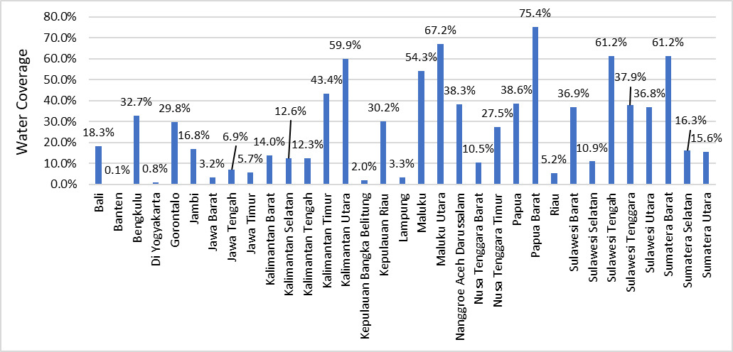

**4.1.2 Data from the Field – Qualitative (FGD & KII)**

Table 4.3 present some key data on water source(s) and households covered that was collected from 42 villages during the fieldwork. Fields highlighted red are data that are inconsistent with that held on the MIS.

The most striking feature of this table is the extent to which the MIS data does not align with the information collected in the field. Some variations might be explained through the MIS update scheduling, but others appear to be rogue data. For example:

* There are 2 villages where the water source appears to have been wrongly entered or not amended after upgrades/changes – Tambakselo (Central Java) and Dwipasari (South Kalimantan).
* During the fieldwork, the IET identified 5 villages with non-functioning systems. Three of these appear in the MIS as either fully or partially functioning – Kalikayen (Central java); Saindule (NTT); and Bati-Bati (South Kalimantan).
* The IET identified a further 14 others that were functioning partially such that they could not fulfil at least basic domestic water requirements, and the 7 WSS in NTT had rota schemes in place where households received water once or twice each week. However, all these WSS on the MIS were classified as functioning well at more than 80% of installed capacity.
* Overall, the MIS and IET data do not align for 17 (41%) of the 42 villages on the rating of functionality. According to the WB[7], facilitators conducted quarterly checks in every PAMSIMAS village to assess the functionality of WSS and the number of beneficiaries and was the case in every year of the programme. The IET’s findings suggest that these three-monthly checks may not be supplying, in all cases, accurate data. This is concerning since the data supplied is used to update the Sustainability module on the MIS.
* The IET data on the number of households benefiting from PAMSIMAS water does not align with the MIS in 24 of the villages visited.
* Across 14 villages in Central Java, information from the field showed that 2,873 HH are benefiting from improved water under PAMSIMAS from all WSS, whereas the MIS indicates 3,372HH, which is ***17% larger*** than the data collected during the fieldwork.
* Across 14 villages in NTT, the IET identified 766 HH benefiting, whereas the MIS indicates 2,425 HH. The MIS value is ***three times larger*** than that collected during fieldwork.
* Across the 14 villages surveyed in South Kalimantan, the IET found 1,907 HH benefiting, while the MIS indicates 1,369 HH. In this case the MIS data is ***28% lower*** than identified in the field.

Table A.4.2: PAMSIMAS Water-Related Field Data Compared with that Held on the MIS

| Province | District | Village | Implementation Year | Water Source | Survey | MIS | Survery | MIS |
| --- | --- | --- | --- | --- | --- | --- | --- | --- |
| Central Java | Semarang | Kalikayen | 2013 & 2015 (HID) | Borehole | 0 | 124 | 0 | 2 |
| Central Java | Semarang | Jombor | 2012 (DFAT & APBD) | Borehole | 80 (~670 HH in village) | 336 | 2 | 2 |
| Central Java | Semarang | Gunung Tumpeng | 2013 | Borehole | 40 | 87 | 1 | 2 |
| Central Java | Semarang | Cukilan | 2018 | Borehole | 200 (1,900 HH in village) | 227 | 1 | 2 |
| Central Java | Semarang | Gogodalem | 2021 (DFAT) | Borehole | 180 (1,000 HH in village) | 80 | 1 | 2 |
| Central Java | Grobogan | Tlogomulyo | 2011 & 2013 (HID) | Borehole | 706 | 475 | 2 | 2 |
| Central Java | Grobogan | Mangin | 2015 | Borehole | 479 (2,379 HH in village) | 605 | 2 | 2 |
| Central Java | Grobogan | Tambakselo | 2018, 2018 (HKP) | Spring and Borehole (MIS=Surface Water) | 66 | 85 | 1 | 2 |
| Central Java | Grobogan | Tunggu | 2021 (DFAT) | Borehole | 17 | 50 | 1 | 2 |
| Central Java | Demak | Mrisen | 2013 & 2021 | Borehole | 413 | 375 | 2 | 2 |
| Central Java | Demak | Tlogopandogan | 2013 & 2018 (HAMP) | Borehole | 422 | 354 | 2 | 2 |
| Central Java | Demak | Bermi | 2013 | Borehole | 0 | 0 | 0 | 0 |
| Central Java | Demak | Krajanbogo | 2011 | Borehole | 102 | 442 | 1 | 2 |
| Central Java | Demak | Pamongan | 2021 (DFAT) | Borehole | 168 | 132 | 2 | 2 |
| NTT | Rote Ndao | Saindule | 2015 & 2020 | Borehole/Deep well | 0 (yard taps) | 191 | 0 | 2 |
| NTT | Rote Ndao | Busalangga Timur | 2018 & 2021 (HID) | Borehole/Deep well | 35 (public taps) | 278 | 1 | 2 |
| NTT | Rote Ndao | Lekunik | 2015 & 2019 (HKP) | Borehole/Deep well | 38 (public taps & yard taps) | 172 | 1 | 2 |
| NTT | Rote Ndao | Kolobolon | 2011 (DFAT) & 2013 (HID) | Spring | 43 (public taps) | 216 | 1 | 2 |
| NTT | Rote Ndao | Loleoen | 2019 | Spring | 34 (public taps) | 123 | 2 | 2 |
| NTT | TTS | Fatumnasi | 2017 | Spring | 83 (yard taps) | 149 | 2 | 2 |
| NTT | TTS | Oelbubuk | 2020 | Spring | 61 (public taps) | 223 | 2 | 2 |
| NTT | TTS | Tublopo | 2011 (DFAT), 2015 (HKP) & 2019 (DAK) | Spring | 150 (public taps) | 139 | 1 | 2 |
| NTT | TTS | Kesetnana | 2020 | Spring | 80 (yard taps) | 177 | 2 | 2 |
| NTT | TTS | Tumu | 2012 | Spring | 0 | 0 | 0 | 0 |
| NTT | Kupang | Oesao | 2011 (DFAT) | Borehole/Deep well | 26 (public taps) | 193 | 1 | 2 |
| NTT | Kupang | Oelatimo | 2019 | Borehole | 90 (public taps) | 155 | 1 | 2 |
| NTT | Kupang | Tuatuka | 2013 & 2020 (HID) | Spring | 96 (+ 40 taps & 10 hydrants) | 170 | 2 | 2 |
| NTT | Kupang | Oesena | 2013 & 2019 (HKP) | Spring | 30 (HCs) | 239 | 1 | 2 |
| South Kalimantan | Barito Kuala | Dwipasari | 2008 | Borehole to public taps [MIS= Surface water to HCs] | 220 (public taps) | 37 | 2 | 2 |
| South Kalimantan | Barito Kuala | Pinang Habang | 2013 & 2020 (APBD) | Borehole | 10 (80 HH in village) | 26 | 1 | 2 |
| South Kalimantan | Barito Kuala | Sidorejo | 2021 | Surface Water | 50 (75 HH in village) | 16 | 2 | 2 |
| South Kalimantan | Barito Kuala | Anjir Muara Lama | 2015 & 2019 (HKP) | Surface Water | 16 | 16 | 1 | 1 |
| South Kalimantan | Barito Kuala | Sungai Lumbah | 2012 (DFAT) | Surface Water and Dug well | 57 (900 households) | 58 | 2 | 2 |
| South Kalimantan | Tanah Laut | Batu Tungku | 2010 | Borehole [MIS=Borehole & Surface Water] | 30 | 104 | 2 | 2 |
| South Kalimantan | Tanah Laut | Bingkulu | 2012 (DFAT | Borehole | 54 | 31 | 2 | 2 |
| South Kalimantan | Tanah Laut | Martadah | 2018, 2018 (HKP) & 2019 (HAMP) | Borehole | 90 (500 HH in village) | 87 | 2 | 2 |
| South Kalimantan | Tanah Laut | Bati-Bati | 2012 (DFAT) | Borehole | 0 | 25 | 0 | 1 |
| South Kalimantan | Tanah Laut | Handil Negara | 2014 | Borehole | 225 (670 HH in village) | 130 | 2 | 2 |
| South Kalimantan | Banjar | Mandi Kapau Timur | 2010 & 2014 (HID) | Borehole [MIS=Borehole & Spring] | 375 (425 HH in village) | 388 | 2 | 2 |
| South Kalimantan | Banjar | Pekauman Ulu | 2015 | Borehole [previously Surface Water] | 200 (600 HH in village) | 180 | 2 | 2 |
| South Kalimantan | Banjar | Tambak Baru Ilir | 2018 & 2020 (HID) | Surface Water | 196 | 157 | 2 | 2 |
| South Kalimantan | Banjar | Tanah Intan | 2012 (DFAT) & 2017 (HKP) | Spring & Borehole [MIS=Borehole] | 384 (425 HH in village) | 114 | 2 | 2 |

FDGs with villages communities and KPSPAM revealed aspects on the capacity of WSS and the supply variations. These are summarised below:

**Seasonal Variations:**

* **Central Java**: Half of the 14 villages suffered water shortages during the dry season. During seasonal water shortages, villagers generally returned to their private wells or purchased water from local water vendors.
* **NTT**: Only one village, Tublopo, reported water shortage during the dry season.
* **South Kalimantan**: Four of the 15 villages experienced water shortages during the dry season, and reverted to river and well water, or purchased from local vendors.

**Peak Periods**: Almost every village that received water on a daily basis suffered shortages at peak periods (early morning and late afternoon) and during Ramadan.

**WSS Functionality:**

* **Central Java:** Of the 12 functioning WSS, 6 were unable to meet demands from consumers and this was mainly because the WSS had connected further HHs without provision of additional water sources. Other issues identified were regular pump failures and pipe breakages – pipes were laid at 400mm below ground level which appeared inadequate, especially when laid alongside roads and subject to heavy loading.
* NTT: The main issue identified was that in the absence of grid electricity many villages had installed solar power units to drive the pumps. These could pump adequately only during bright sunlight, so a rotation system has been necessary where households receive water once or twice each week.

**Diminishing Supply from Source:** Many villages with deep groundwater sources had noted a reduction in yield over time, which is due to a lowering of the water table. This is likely to continue to worsen unless there is increasing regulation of private wells being drilled. While no village was identified to be in a critical state, as yields continue to reduce, some village governments have financed the drilling of additional wells close by the original PAMSIMAS one, which can only exacerbate the problem in future.

Finally, of the 42 villages surveyed only 1 had reached 100% water coverage and that was Dwipasari in Barito Kuala district of South Kalimantan. Here the community was served by communal public taps, which is recorded incorrectly on the MIS as HCs.

**4.1.3 Data from the Field – Quantitative (HH Survey)**

A report of the HH survey results is presented in Volume 2 of this report[8]. Although the respondents of the HH survey may not be regarded as a random sample of the whole programme, after selection of villages the households were selected randomly by the enumerators and the 830 respondents is a statistically significant sample of PAMSIMAS’ total beneficiaries. The IET view this survey as adding significantly to the body of knowledge on the outcomes of the PAMSIMAS programme.

Of all 830 households surveyed during the fieldwork, 817 (98.4%) indicated they had an improved water source through the PAMSIMAS programme. In particular:

* Almost three-quarters of households received water via HCs, which were mainly located in Central Java and South Kalimantan.
* In NTT 54 (21.7%) indicated they received water via HCs.
* Taps and hydrants were the source of water for the majority of respondents in NTT and the whole of Dwipasari village in South Kalimantan.
* 1.7% (*n*=14) of all respondents indicated their improved water source was rainwater harvesting and attributed this to PAMSIMAS. These were all households from NTT: Loleoen (*n*=3); Oesao (*n*=8); and Tublopo (*n*=3).

***Availability of Water***

Respondents were asked about whether water was always available from their improved sources and responses from the 817 households are summarised below:

* Overall, 76.2% of all 817 households have water available ***all*** or ***most of the time***, which aligns well with the average water use data as a function of installed capacity from the MIS, which is approximately 74%.
* Most HHs have water available ***all*** or ***most of the time*** in Central Java (86.9%) and South Kalimantan (95.5%).
* 60% of HHs surveyed in NTT get water ***some of the time***, ***rarely*** or ***not at all***.

***Reasons why Water is not Always Available***

In total, 262 (32%) respondents had various issues with their supplies of PAMSIMAS water. Reasons for why their PAMSIMAS water supply was not always available are shown by district[9] in Figure A.4.2.

Figure A.4.2: Reasons why PAMSIMAS water supply was not always available

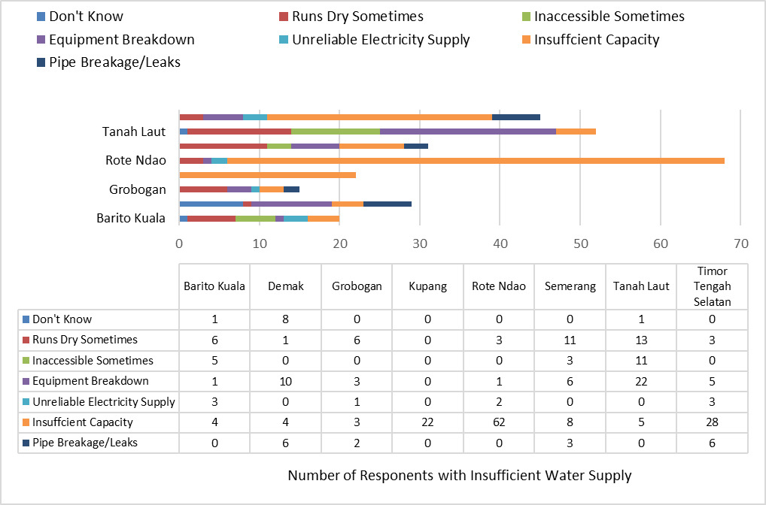

The absence of Banjar district, South Kalimantan, in the figure is worthy of note since all 116 respondents from four villages surveyed indicated that they always had PAMSIMAS water supplies, and this was verified during field visits. Banjar district stood out during the field study as having some of the highest performing PAMSIMAS projects and respective KPSPAM. Other key features of Figure 4.2 are:

* Half of all respondents indicated that the capacity of the source was insufficient and/or there were too many consumers that led to rationing/rotation of supplies.
* This issue is most prominent in Rote Ndao, NTT, where 94% of all respondents with a water supply problem (*n*=66) indicated insufficient capacity as the reason. In reality, this was not caused so much by insufficient capacity but to the inadequacies of the solar power units driving the pumps.
* Similar issues are experienced in Timur Tengah Selatan and Kupang, again in NTT, where 46% and 100% of all respondents with a supply problem indicated their PAMSIMAS water source had inadequate capacity.
* Equipment breakdowns contributed significantly to poor water supplies in Tanah Laut, South Kalimantan, and these derived mostly from Martadah village.
* Lack of water during the dry seasons was a significant issue for respondents in Tanah Laut (28%); Semarang (36%) and Grobogan (55%) in Central Java.

**4.2 Outcome 1 – Water Quality**

**4.2.1 Data from PAMSIMAS MIS**

In terms of water quality and treatment, the MIS indicates that:

* 25,917 (73.8%) KPSPAM had conducted water quality test and the results met the “air minum layak” standard[10].
* 3,241 (9.2%) KPSPAM had tested the quality of water and it did not meet the required standard.
* 5,892 (16.8%) KPSPAM had never conducted water quality tests[11].
* About 240 (0.7%) of 35,100 villages indicated that their water treatment went beyond rudimentary coagulation and filtration by applying a range of physical, chemical and biological means of treating water, including disinfection/chlorination, treatment to control iron (aeration and zeolite), slow sand filtration, ultraviolet filters, and reverse osmosis.
* 1,046 water sources have experienced a reduction in water quality.
* Significantly, every province involved in PAMSIMAS recorded at least 1 source of water with diminishing quality.

Water quality reduction was most marked in the following provinces:

|  |  |  |  |  |  |
| --- | --- | --- | --- | --- | --- |
| **Province** | Sulawesi Barat | Riau | Maluku Utara | Papua Barat | South Kalimantan |
| **% water sources with diminished quantity** | 9.8% | 8.3% | 8.0% | 6.9% | 6.2% |

**4.2.2 Qualitative Data – FGD & KII**

During the fieldwork, qualitative data was collected on water quality through FGDs and KIIs; quantitative data from the HH survey (ordinal data related to respondent’s opinions on quality); and water samples collected for testing of physical and biological properties. These three sets of data are discussed in turn, below.

**4.2.3 Quantitative Data – HH Survey**

The HH survey posed several questions about the quality of the water received from PAMISIMAS WSS and some of the results are discussed in the subsections below.

***Do You Drink PAMSIMAS Water?***

Of all 817 respondents accessing PAMSIMAS water[12], 537 (65.7%) indicated that they used the water for drinking. Interestingly, this is in the same order as the percentage of water supplied that was categorised as “air minum layak” from the test results held on the MIS: 73.8%.

The percentage of HHs drinking PAMSIMAS water disaggregated by province shows that the largest proportion of HHs drinking the water was in NTT (99.6% - all but one respondent) and least in Central Java (37.8%). There appears to be a strong association between the availability and affordability of alternative sources of drinking water and the proportion of households that drink PAMSIMAS water. For example, in NTT many communities were highly reliant on the supply from PAMSIMAS systems due to the lack of free or affordable nearby alternatives. Although the majority of villages received water just once or twice a week, many had installed fibreglass tanks to store water in sufficient quantities to mitigate against buying water from vendors, which is beyond the means of many. Conversely, in the rather more affluent Central Java province and despite the majority of water sources supplying good quality water, almost two-thirds of the HHs surveyed chose not to drink PAMISMAS water, even though most water could be safely consumed after rudimentary treatment.

***Do You Treat Water?***

* Of the 537 HH that used the water for drinking, 514 (95.7%) treated it first.
* There were 23 respondents that drunk the water without first treating it, and these were all from South Kalimantan: Banjar (*n*=17); Barito Kuala (*n*=5); and Tanah Laut (*n*=1).
* All 514 HH that treated their water before drinking indicated that they boiled it.
* A further 77 (15%) strained the water after boiling; 12 (2.3%) allowed the water to settle; and 2 (0.4%) added chlorine.

***Subjective Water Quality***

Those households that drank PAMSIMAS water were asked their opinion about its quality by rating their agreement with the statement: “The PAMSIMAS water is of good quality that’s always safe to drink after we treat it”, and the results showed that 97.7% (502) *Agreed* or *Agreed strongly* with the statement.

**4.2.4 Water Quality Test Results**

Water samples were taken in 36 villages, including 5 schools in NTT and 1 in Central Java and a summary of results are shown in Table 4.4. In particular:

* 5 met quality standards for drinking water (Permenkes 492, 2010), which were 2 in Central Java (Gogodalem and Tunggu) and 3 in NTT (Busalangga Timur, Lekunik, and Loleoen). The sources were from deep wells/boreholes and one spring.
* All but two water samples were found to fulfil “air minum layak” – safe to drink if boiled first.
* The two samples that were deemed unsafe to drink even after boiling were the water tested from Sungai Lumbah, which had a pH of 4.5, and Handil Negara with high ammonia. These are likely to be caused by a combination of agricultural and small-scale mining runoff.

Overall, water is safe drink after boiling from 37 of the 39 supplies tested, as is the standard practice in Indonesia, and which was shown to be the case by the IET’s household survey for 95.7% of everyone that drank PAMSIMAS water, including those surveyed in villages where the water met drinking water standards (Permenkes 492, 2010).

**4.3 Outcome 2 – Improved Sanitation**

**4.3.1 Data from PAMSIMAS MIS**

According to the GOI, 16.4 m people are benefiting from improved sanitation (KPI 2) as of November 2021 (see Table A.4.3). Data held on the MIS gives 26,025,264 people[13], which is about 9.5 m more people or 58% greater than the published figure[14]. Table 3.3 shows the number of people benefiting from improved sanitation in each phase of the programme, the number of villages targeted, and the number of people benefiting per village for each year of the 3 phases.

Table A.4.3: People with Access to Improved Sanitation by Village and Phase

|  |  |  |  |  |
| --- | --- | --- | --- | --- |
|  | Phase 1 | Phase 2 | Phase 3 | Total |
| People with access to improved sanitation | 8,515,881 | 8,667,502 | 8,841,881 | 26,025,264 |
| Number of years in phase | 5 | 3 | 6 | 14 |
| Number of villages targeted | 6,831 | 9,940 | 18,329 | 35,100 |
| People with improved sanitation per village | 1,247 | 872 | 482 | --- |
| People per village per year | 249 | 291 | 80 | --- |

Table A.4.4: Summary of Water Quality Test Results

| Province | Village | Year of PAMSIMAS | Water Source | Adequacy of Supply | Treatment | Water Quality (Test Results) | Perception of Quantity and Quality |
| --- | --- | --- | --- | --- | --- | --- | --- |
| Central Java (Semarang) | Kalikayan | 2013 | Not functional | --- | --- | --- | --- |
| Central Java (Semarang) | Jombor | 2012 | Deep well (1) | OK now. Additional 2 wells through SAF | Treatment for Fe & Colour | Meets Standards, but reported high Fe, odour | Treatment provided for PAMSIMAS well & quality improved but not satisfactory. Quality from SAF wells poor. Quantity adequate |
| Central Java (Semarang) | Gunungtempung | 2013 | Deep well (1) | OK. Now 8 additional wells (not PAMSIMAS) | None | 1 of 2 samples has total coliform | Good quality and sufficient quantity. |
| Central Java (Semarang) | Cikulan | 2018 | Deep well (1) | Inadequate | None | High Colour. Both samples have total coliforms | Severe water shortage in dry season. Water quality good. |
| Central Java (Semarang) | Gogodalem | 2020 | Deep well (1) | Water shortage in dry season | None | **Meets Standards Permenkes 492, 2010** | The well is under capacity. Some sediment in water. |
| Central Java (Grobogan) | Tlogomulyo | 2011 & 2014 | Deep wells (2) | Usually sufficient except in festive season | None | High TDS (salinity), Cl, CaCO3 | Quantity sufficient. Water quality good enough. |
| Central Java (Grobogan) | Mangin | 2011 & 2014 | Deep well (1) | OK for service area but need additional well for expansion. | None | 1 of two samples have total coliforms. | Quantity ok if restrict supply to service area. Quality good. |
| Central Java (Grobogan) | Tambakselo | 2018 | Deep wells (2), One failed. | Water shortage in dry season | None | High colour. 1 sample has total coliforms. | Quality not good. Impacted by lime in soil. |
| Central Java (Grobogan) | Tunggu | 2021 | Deep well (1) | OK but only 17 HC | None | **Meets Standards Permenkes 492, 2010** | Quantity and quantity good. |
| Central Java (Demak) | Mrisen | 2013 & 2021 | Deep wells (2) | Shortage during peak hours | None | High Colour and Salinity | Quantity ok except in peak hours. Quality very good. |
| Central Java (Demak) | Tlogopandogan | 2013 | Deep wells (2) | Adequate. Some shortage in peak hours. Village provided 3 more wells. | None | High Colour and Salinity. 2 samples have total coliforms. | Quantity ok except in peak hours. Quality not so good. Needs filtration. |
| Central Java (Demak) | Bermi | 2013 | Not functioning | --- | --- | --- | --- |
| Central Java (Demak) | Kraganbogo | 2011 | Deep well (1) | Adequate but limited connections | None | High Colour and Salinity. 2 samples have total coliforms. | Water sufficient and of good quality |
| Central Java (Demak) | Pamongan | 2020 | Deep well (1) | Insufficient water | None | High Colour. 1 of 2 samples have total coliforms. | Need additional well. Water quality is good |
| NTT  (Rote Ndao) | Saindule | 2015 & 2020 | Not functioning | --- | --- | --- | --- |
| NTT  (Rote Ndao) | Busalangga Timur | 2014, 2018, & 2021 | Borehole | 2014 WSS not functional. Replaced by system built in 2018 & 2021. Residents receive water 1 or 2 times pw. | None | **Meets standards Permenkes 492, 2010** | Quantity poor. Solar powered pump insufficient so residents get water once or twice pw. No complaints about quality. |
| NTT  (Rote Ndao) | Lekunik | 2015 & 2019 | Borehole | Quantity adequate in the beginning sufficient but it has reduced gradually. Now only receive water 1 day pw. | None | Meets standards Permenkes 492, 2010 | Inadequate supply. No complaints about quality. |
| NTT (Rote Ndao) | Loleoen | 2013 & 2019 | Spring | Inadequate; residents get water 1 day pw but most HH have adequate storage facilities. | None | Meets standards Permenkes 492, 2010 | Each of 5 hamlets receive water 1 day pw, most houses have their own tank to store sufficient quantity for the week. |
| NTT (Rote Ndao) | Kolobolon | 2011 & 2013 | Spring | Inadequate and the systems in 1 hamlet is not functioning. | None | Very high e-coli and total coliform in community system. School water better, but still presence of e-coli. | Quantity sufficient in one Hamlet but it is reducing noticeably with time. |
| NTT – Timur Tengah Selatan | Fatumnasi | 2017 & 2021 | Spring | Adequate but serves just 1 hamlet of 80 HH | None | Prescence of e-coli in both samples (1 from school). | Quantity sufficient and no complaints about quality despite high lime content. |
| NTT – Timur Tengah Selatan | Oelbubuk | 2020 & 2021 | Spring and Borehole | Inadequate; residents get water 1 to 2 days pw. | None | Prescence of e-coli, otherwise good. | Quantity poor. Solar powered pump insufficient so residents get water once or twice pw. No complaints about quality despite high lime content. |
| NTT – Timur Tengah Selatan | Tublopo | 2011, 2015 & 2019 | Spring (2) | The system built in 2011 stopped functioning and was fixed by the fund from 2015, some of the 2019 fund was for repairs. | None | Prescence of e-coli and high total coliforms in all 3 samples (2 from local schools). One schools had high salinity (TDS). | The system with solar panel pump delivers water 1-2 days per week. No complaints about quality. |
| NTT – Timur Tengah Selatan | Kesetnana | 2020 | Spring | Quantity insufficient. Initially water distribution was good; over time distribution capacity reduced - led to rotation. Communities at last point of system have no water since 2021. | None | Prescence of e-coli. Despite complaints of lime, hardness (CaCO3) is within standards. | The system with solar panel pump delivers water 1-2 days per week. Water contains high concentration of lime. |
| NTT – Timur Tengah Selatan | Tumu | 2012 | Not functioning | --- | --- | --- | --- |
| NTT Kupang | Oesao | 2011 | Borehole and dug well | Sufficient and exceeds demand. Can be used for expansion. | None | Very high e-coli and total coliform. | Quantity sufficient and quality good. Water tests every 6 months. |
| NTT Kupang | Oelatimo | 2019 | Borehole (1) | Sufficient. Water distributed to water reservoirs built by PLAN (8 reservoirs) and public taps. | None | Hamlets 1 and 4 have E.coli and high total coliform. | Quantity and quality good. Water quality tested once in 2019. |
| NTT Kupang | Tuatuka | 2013 & 2020 | Spring [MIS=Borehole] | PAMSIMAS repairs (2013) the water supply system which was previously built by PLAN Int’l but had not been functioning for a long time. | None | Both samples (1 community & 1 school) have e-coli and community water has high total coliform. | Quantity sufficient and quality good |
| NTT Kupang | Oesena | 2013 & 2019 | Spring | Broncaptering system built in 2013 broke down after 3 months. Water tower built in 2019 with solar pump. Capacity of source exceeds demand. | None | Prescence of e-coli, otherwise good. | Only 2 of 3 distribution systems operational. As with all solar powered pump systems, consumers get water 1 to 2 times pw. |
| South Kalimantan Barito Kuala | Dwipasari | 2008 & 2010 | Borehole to public taps | Quantity sufficient for all. No tariff but households contribute depending on financial ability. This has worked well. | None | Good physical and chemical characteristics, but contained E. Coli | Water started good but over time it turned yellow and took on a bad taste. Could drink in the first year. Water for drinking needs to be bought from a private water kiosk. Some water points are still drinkable after boiling. |
| South Kalimantan Barito Kuala | Pinang Habang | 2013 & 2020 | Surface Water | Reservoir tank burst in 2014 and not replaced until 2021. Only 10 of the 50 HH resumed service. | Rudimentary coagulation and settling. | Good physical and chemical properties, but traces of e-coli. |  |
| South Kalimantan Barito Kuala | Sidorejo | 2021 | Surface Water | Adequate but this source is not sufficient to extend to the remaining 25 houses. | Rudimentary coagulation and settling. | Results show water has good physical and chemical constituents - very marginally acidic. Presence of e-coli. | Acidity goes up during harvest time. Households boil before drinking. Regular power outages disrupt supply 1 or 2 times each week. |
| South Kalimantan Barito Kuala | Sungai Lumbah | 2012 | Surface Water and Dug well | Sufficient for washing and cleaning. | Rudimentary coagulation and settling. | Highly acidic at pH of 4.5, slightly high Fe content and presence of E. coli. | Residents don't drink water; they buy from PDAM.KPSPAM plan to add chlorination and pH regulation. Quantity sufficient and saves women about 1 hour each day. |
| South Kalimantan Tanah Laut | Batu Tungku | 2010, 2012 & 2017 | Spring | Had a problem drilling the borehole. They had to move 4 times because of rock. The place where we were able to drill. Insufficient capacity at peak times. | None | Physical and chemical constituents are good - no sign of high salinity. No bacteriological test done - no sanitarian available. | The water was drinkable at the start but has become progressively more saline. Water is not used for drinking or cooking now. Shortages at peak times. |
| South Kalimantan Tanah Laut | Bingkulu | 2012 | Borehole | High turbidity first 3 months. Last test December 2021 also showed very high levels of E. Coli and total coliforms. Quantity sufficient. | None | Physical and chemical characteristics were good. No bacteriological test done - sample bottle broken. | Very turbid in the 3 months after borehole drilled. Many people resorted to river water during this period. Clear now. No water shortage. |
| South Kalimantan Tanah Laut | Martadah | 2018, 2018 & 2019 | Borehole | Want more HCs but capacity of PAMSIMA water is insufficient. Proposal has been submitted for others to get connected. | None | Physical and chemical properties. No bacteriological test done - no sanitarian available to supervise. | Very limited supply during dry seasons. All residents drink water after boiling. |
| South Kalimantan Tanah Laut | Bati-Bati |  | Not functioning | --- | --- | --- | --- |
| South Kalimantan Tanah Laut | Handil Negara | 2014 & 2017 | Borehole | Water not drinking water quality, but the quantity is sufficient. | None | High ammonia (NH3-N) and slightly high Fe. | Water turns yellow after settling. Have to buy water which comes from the mountain area. No dry season for last 2 years. The borehole has never run dry. |
| South Kalimantan Banjar | Mandi Kapau Timur | 2010 & 2014 | Borehole | Water not drinking water quality, but the quantity is sufficient. | None | Physical and chemical constituents are good. No bacteriological test done - no sanitarian available to supervise. | They have finance to treat add chlorination plant and this will be completed by December 2022. Currently, residents boil before drinking. |
| South Kalimantan Banjar | Pekauman Ulu | 2015 & 2019 | Spring & Surface Water | In 2015, the water source was the local river, but the water quality was very poor. In 2019, with assistance HAMP a 95 m borehole was drilled. | None | FE is high and presence of e-coli. | Households drink the PAMSIMAS water after boiling and quantity is sufficient all-year. |
| South Kalimantan Banjar | Tambak Baru Ilir | 2018 & 2020 | Surface Water | Water not drinking water quality, but the quantity is sufficient. | Rudimentary coagulation and settling. | Good physical & chemical qualities but e-coli present. | People routinely boil before drinking. The village would prefer a borehole. Shortages during dry season - low river volume. |
| South Kalimantan Banjar | Tanah Intan | 2012 & 2014 | Spring | According to KPSPAM, the water was drinking quality and the quantity is sufficient. | None | Results showed water of good physical and chemical properties. No sanitarian to supervise collection of water sample. | Community is very happy with quality and drink water directly. |

Since data from villages is being updated regularly, it is not surprising that Phase 3, despite targeting significantly more villages than in the first or second phases, has far fewer people benefiting from improved sanitation per village and per year. One would expect the figures from Phase 3 to continue to climb going forward as improved hygiene messages embed within communities. Further, there are 1,921 villages that are new to PAMSIMAS III that have no data for improved sanitation (KPI 2) on the MIS, presumably due to the update schedule.

The coverage of improved sanitation across the provinces is mixed as shown in Figure A.4.3. The most notable feature of the plot is that no province has reached a mean coverage beyond about 44% and there are some provinces, such as Bali and DI Yogyakarta, in which villages are very far behind at less than 10% coverage. Clearly, this is a very challenging aspect of PAMSIMAS since it requires significant social change, but one might have anticipated greater success given that “Improving hygiene and sanitation behaviour and services” was one of the 5 key activity components of the programme. Affordability could be responsible for low coverage since there was a zero-subsidy policy in phase 1 and 2 of the programme, and the limited HH survey results showed that only 15.7% of the households surveyed with improved sanitation facilities, had benefited from a subsidy.

Figure A.4.3: Average % Coverage of Improved Sanitation for Each Province

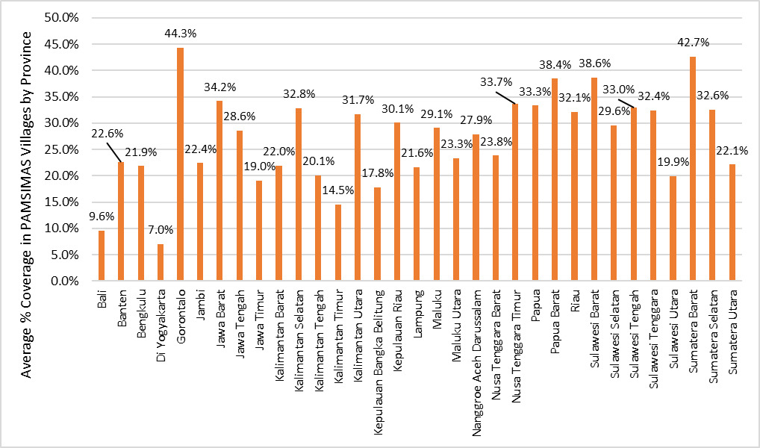

Table A.4.5 shows the average percentage coverage[15] for each year of the programme and as expected, the coverage increases with time. Interestingly, a simple log-linear regression of this data shows an extremely good fit, as also shown in Figure A.4.4. This model predicts that if hygiene and sanitation socialisation continue at the same intensity and all other internal and external influences remain as at the time of writing, it would take a further 10 years to 2033 for all 31,500 villages to reach 100% coverage of improved sanitation.

Table A.4.5: Average Percentage Coverage of Improved Sanitation by Year of PAMSIMAS

|  |  |  |  |  |  |  |  |
| --- | --- | --- | --- | --- | --- | --- | --- |
| Year | 2008 | 2009 | 2010 | 2011 | 2012 | 2013 | 2014 |
| % Coverage | 56.8% | 53.3% | 43.5% | 45.1% | 29.8% | 40.9% | 42.4% |
| Year | 2015 | 2016 | 2017 | 2018 | 2019 | 2020 | 2021 |
| % Coverage | 38.4% | 40.9% | 28.6% | 27.4% | 21.8% | 12.6% | 3.5% |

While the model is a good fit for the data available, it does not consider all plausible factors that might influence sanitation decisions at the household level, including affordability and land availability, it does suggest that other strategies should be considered to augment STBM to help hasten the pace of change.

Figure A.4.4: Relationship between ln (% Coverage)[16] and Progression of Years

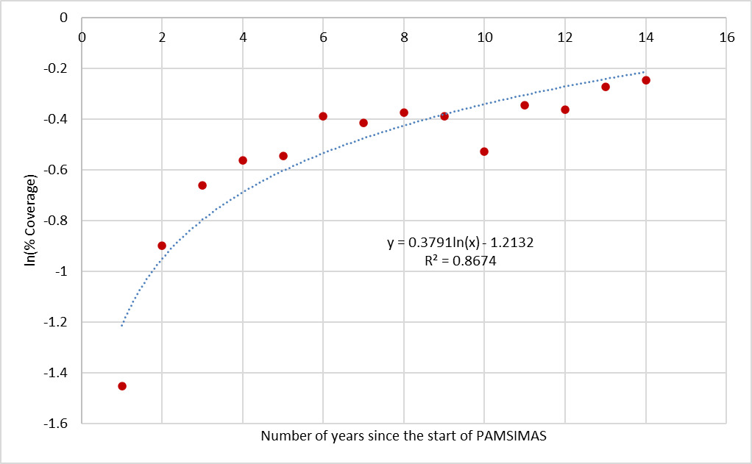

**4.3.2 Data from the Field**

***Improved Sanitation Coverage***

The household survey asked respondents whether they had built an improved toilet facility as a result of PAMSIMAS, and of the 830 respondents, 185 (22.3%) indicated they had. By province, this is 178 (96.2%) households in South Kalimantan; 7 (3.8%) in Central Java, and none in NTT.

This is an odd result since information collected during the fieldwork indicated that there was almost 100% coverage of private toilets in all the villages surveyed in Central Java and South Kalimantan, and across some villages in NTT.

FGDs with village communities, however, revealed that some people did not associate the hygiene and sanitation socialisation with the PAMSIMAS programme, rather believing it to be an extension of the PUSKESMAS services. This could account for this anomaly, but it is also plausible that improved sanitation facilities had been present before PAMISMAS in some villages, as was identified through the HH survey.

The IET note that “baseline data” on sanitation facilities was not gathered in the formal sense of a household survey but was collected through social mapping, as part of the Problem Identification and Situation Analysis (IMAS, ***Identifikasi Masalah dan Analisa Situasi***) process for developing Community Action Plans (CAP).

While social mapping can yield a good approximation of WATSAN facilities, female headed households, indigenous people, PWD, and economic and socio-cultural aspect of communities in small villages, hamlets or neighbourhoods, it does not work so well in larger villages[17]. It is also noted that in most villages just one such social mapping exercise was conducted as part of the IMAS and had the participation of 1%, on average, of village communities.

While an excellent tool to support the development of CAPs, it can only yield an approximation at best for baseline WATSAN and, further, the IMAS did not appear to address hygiene behaviours.

Other significant findings from the HH survey are:

* 93.2% of all respondents using an improved sanitation facility at the time of the survey, indicated that they had this facility before the programme.
* And similar results were found in South Kalimantan for hygiene behaviours.
* The lack of accurate baseline data on sanitation and (apparently) none for hygiene behaviours means that it would not be sound to attribute all these improvements to PAMSIMAS or the supporting STBM programme.

The field study also indicated that sanitation improvements did not appear to be strongly linked to coverage of improved water supply services. Anecdotally, there was no obvious difference in improved sanitation coverage between villages with a partially or non-functioning WSS and one where most or all households received PAMSIMAS water all or most of the time. And this is also reflected by the data held in the MIS.

Worthy of note is that of the 27 villages visited in Central Java and South Kalimantan, data held on the MIS reports that just 5 had sanitation coverage over 40%, ranging from 42% in Tambak Baru Ilir to 96% in Dwipasari. A further 12 were marked as having no households with improved sanitation. This MIS data does not align with the IET’s assessment during the fieldwork, where improved sanitation coverage was not far from 100% in the villages in these two provinces.

***Subsidised Sanitation Facilities***

Just 29 (15.7%) respondents who associated their improved sanitation facilities with PAMSIMAS indicated that they received subsidies, and the majority were from South Kalimantan.

The IET see this as an area that needs further consideration going forward, particularly in relation to communities that have proved more challenging to trigger using the approaches adopted in the STBM programme.

***Hygiene Behaviours***

FGDs with all village communities demonstrated a high-level understanding of good hygiene practices, including key times for handwashing, and always using soap. However, women often quipped about the men resisting change and continuing with poor hygiene practices. It was noted during the fieldwork that men had been largely overlooked during hygiene socialisation and this is viewed as a missed opportunity.

The household survey investigated hygiene practices with enumerators asking permission to see the respondent’s handwashing facilities and, encouragingly, none of the 830 interviewees refused permission. The results of observations showed that:

* 70.1% (*n*=582) of homes were confirmed to have water for handwashing, either a tap inside the home or outside with running water, or mobile container in or outside the home.
* All respondents (n=323) in South Kalimantan and 97.7% (n=253) in Central Java were confirmed to have handwashing facilities.
* Only 2.8% (n=7) of respondents in NTT were seen to have handwashing facilities, despite all these villages had participated in STBM socialisation activities and communities had shown a good awareness of good hygiene practices during FGDs.

This tends to demonstrate that there is no one standard route to improving hygiene practices widely across disparate contexts. For some communities, it appears that more fundamental social changes are required to create the “critical mass” necessary to successfully trigger improved hygiene practices.

Enumerators also checked whether soap/detergent was available at the handwashing facilities of the 582 respondents (Centra Java *n*=252; NTT *n*=7; South Kalimantan *n*=323) that were seen to have these facilities, and the results of observations are:

* Hygiene behaviours are poorest in NTT. Of the 248 respondents across the 12 villages covered by the HH survey in NTT, only 7 (2.8%) had water for handwashing and of these 6 were observed to have soap available.
* South Kalimantan has the most widespread good hygiene practices. Here, 98.5% (*n*=318) of respondents were seen to have soap available for handwashing.
* Results from Central Java showed that 79.4% (*n*=200) of households had soap at their handwashing facilities.

These are very encouraging result from the households surveyed in Central Java and South Kalimantan, most particularly since houses were chosen by enumerators at random and their work was unannounced.

It is important to note, however, FGD with communities in South Kalimantan revealed that good hygiene behaviours had been adopted widely before the PAMSIMAS programme started in their villages, and this is supported by the results of the HH survey there. According to this survey, 90.7% (*n*=293) of respondents in South Kalimantan before PAMSIMAS used soap and water at key times to wash their hands, and this is only marginally below the figure of 98.5% at the time of the survey.

Again, the lack of progress in NTT tends to show that some communities require more intensive or different approaches to trigger improved hygiene and sanitation behaviours.

***Open Defecation***

Of the 185 respondents with improved sanitation facilities, 36 (19.5%) indicated that they see signs of open defecation in their neighbourhood. These were all from South Kalimantan and are 10 of the 12 villages surveyed there:

* Sidorejo
* Dwipasari
* Bingkulu
* Pekauman Ulu
* Martadah
* Tambak Baru Ilir
* Batu Tungku
* Tanah Intan
* Sungai Lumbah
* Handil Negara

According to the PAMSIMAS MIS, those villages highlighted above (blue) are certified open defecation free (ODF). This disparity might be caused by old habits returning over time in these villages. If so, it appears that STBM messaging requires a longer-term, continuous approach and, perhaps, an increased use of subsidies for improved sanitation facilities.

**4.4 Outcome 3 – WSS Management & Financing**

**4.4.1 MIS Data –KPSPAM Management and Tariffs**

The MIS gives the status of water charges for each KPSPAM, and these are rated as:

1. No fees charged.
2. Community contributions when required.
3. Fixed monthly charge
4. Monthly charge based on volumetric use.

The data accessed from the MIS for all provinces shows that:

* 4,589 KPSPAM (13.1%) charged a monthly tariff based on metered use.
* 19,330 (55.1%) charged a fixed monthly fee.
* 8,760 (25.0%) reached out to their communities for contributions when required, and
* 2,421 (6.9%) had no charge and received no financial support from their communities.
* KPSPAM that either reach out to communities when required or get no community financial support constitute one-third of all water management groups.

The MIS also holds data on fees collected and operation and maintenance (O&M) costs for KPSPAM and these are categorised as:

1. Charges <O&M costs. Collectively, monthly charges are not a good reflection of the cost of O&M.
2. Charges =>O&M costs. Collectively, monthly charges at least adequate for routine O&M, but this may not cover serious equipment breakdowns, and
3. Charges >= Cost Recovery (CR). The situation all KPSPAM should be working towards, where charges exceed O&M costs such that revenue enables payment of staff wages (encouraging retention of technically sound staff) and to save and plan for extending supplies, adding treatment facilities, or delivering other innovative water-related projects.

The state of KPSPAM financial health is very mixed across the provinces. Figure A.4.5 shows the percentage of KPSPAM falling under each fee category disaggregated by province.

Figure A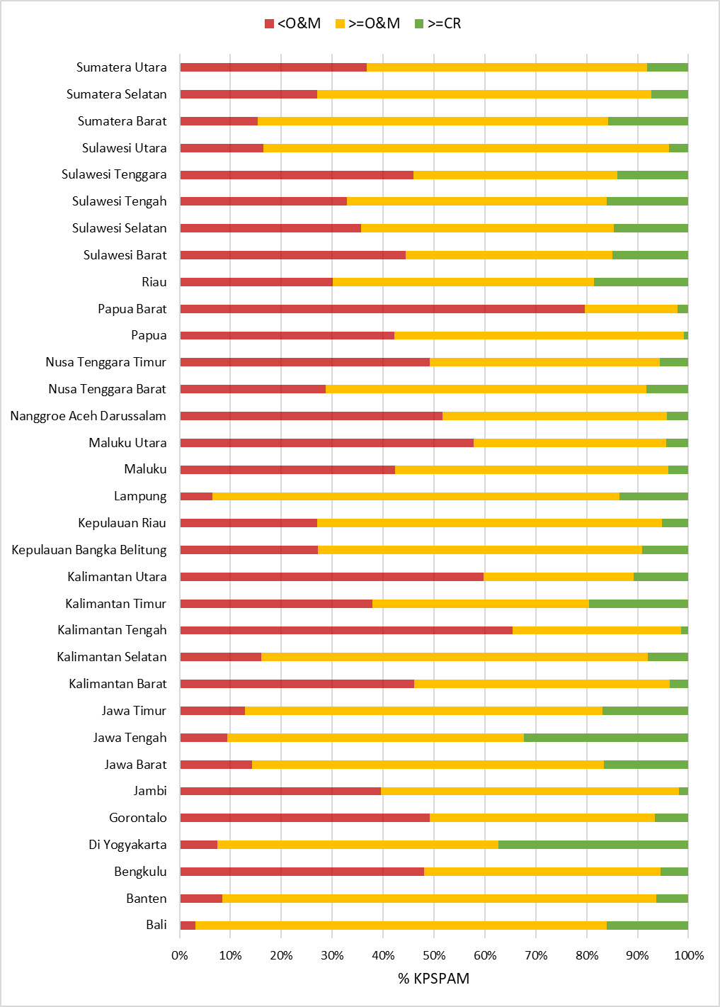.4.5: State of KPSPAM Cost Recovery by Province

The notable points from this figure are:

* The highest performing province is Bali with 97% of its KPSPAMs breaking even or better in terms of tariff income to O&M expenditure.
* Others are close behind, such as Lampung (93.5%), and DI Yogyakarta (92.6%).
* There are 13 provinces that have less than 60% of their KPSPAMs breaking even.
* Papua Barat is an extreme case that has just 20% of its KPSPAMs managing well financially.

According to the MIS, 3,204 (9%) WSS are either not working or only partially functioning. Comparing this figure with the percentage of KPSPAMs not able to meet O&M costs from tariffs of 26.8% (MIS data), tends to suggest that either the MIS data on functionality gives an over-optimistic view or many of these obtain regular financing from elsewhere (community contributions, village funds, etc); the most likely situation is a combination of the two. Whatever the case, over one-quarter of KPSPAMs appear to be in a precarious financial situation and are likely to struggle to sustain services in the longer-term.

Without wishing to state the obvious, KPSPAMs are more likely to be able to sustain their water supplies if they are, at least, able to cover O&M costs from consumer charges, and this is borne out by the data. For example:

* Bali with 97% of its KPSPAMs in good financial health, is reported as having all its 356 water systems functioning well.
* Lampung, with the overwhelming majority of KPSPAMs in good financial health has 1,294 (98%) of its 1,315 facilities functioning well.
* Conversely, Papua Barat with just 20% of its KPSPAMs able to cover O&M costs from tariffs, has almost one-quarter (24%) of all its 479 water supply facilities either not working or only partially functioning.

The message is clear: to help ensure sustainability of water supply facilities all KPSPAMs must be/become financially independent entities and should be striving for cost recovery (CR) or better and, realistically, this can only be achieved if all/most water supplies are metered.

**4.4.2 Involvement of Women in KPSPAM**

***MIS Data & Other Studies***

The link between women’s participation in water governance and success and sustainability of interventions has been identified[18][19]. While not widely investigated and reported on, the studies available find that the involvement of women in key Water User Committee (WUC) roles was associated with more effective water management, including regular meetings and revenue collection, and improved functioning of water systems.

The PAMSIMAS programme set a minimum requirement of 30% female participation in community planning, implementation, operation and maintenance and in community institutions, including KPSPAM. Using data available from the MIS, over the period 2013 through 2022 there are 176,431 members of KPSPAM and 55,535 (31.5%) of these members are women; marginally above the requirements. The Beneficiary Survey (2013) found that during PAMSIMAS I the participation of women in the KPSPAM and the planning process was 35%, and the data indicates that women’s representation has not increased since the beginning of the programme. It has also not been consistent across the programme. One third of the KPSPAMs (34%) included in the Interim Evaluation Study of PAMSIMAS III had no women on the water management committee[20].

Further, in a 2021 study by the WB on gender participation in PAMSIMAS[21], it was found that just 2.2% of KPSPAMs had female leadership. Using multiple linear regression, this study predicted that for every   
10-percentage point increase in female KPSPAM leadership there is a corresponding 11% higher likelihood of scheme being fully functional over the previous 5 years. It also discovered that “Women’s participation in project activities seems to be strongly associated with likelihood of having female KPSPAM leader”.

The IET was unable to access MIS data on the gender make-up of KPSPAM and women in leadership roles across all years of the programme. However, the gender disaggregated data for 2019 to 2021 has been compiled and analysed, and the results are shown in Appendix 3 of the main report as an embedded file 2 (this document is embedded file 1).

The data shows that over the period 2019-2021, 2.8% of villages had a woman leading the management of KPSPAM, which aligns well with the more extensive WB study. Nonetheless, some provinces have significantly more female leaders, for example, Sulawesi Utara and Gorontalo have 12.3% and 11.5%, respectively.

These results exemplify the beneficial influence women’s participation has on the management and sustainability of WASH programmes.

***Qualitative Data from the Field***

KPSPAM personnel were engaged with during the fieldwork phase and, generally, their composition met the 30% female benchmark. Most women in KPSPAM were working as Treasurer, Secretary, or Tariff Collectors. However, the KPSPAM in Jombor, Central Java was led by a woman. Staff in the majority of KPSPAM were volunteers, although there were some exceptions whereby the staff were paid a small incentive from the operating surplus.

**4.5 Gender Equality in Other Aspects of PAMSIMAS**

The IET concludes that the PAMSIMAS General Guidelines (2022) and accompanying guides focused on gender mainstreaming (namely, the Standard Operating Procedures on Gender Mainstreaming Strategies and Women’s Participation in the Programme (GM SOP) and the Gender Action Plan (GAP) outlined sufficient guidance to promote gender equality in PAMSIMAS.The General Guidelines included a high-level vision for promoting gender equality where:

“***men and women both have access, authority and opportunity to use resources and have the authority to make decisions on how to use and produce the resources. In addition, they also have equal control over development and obtain equal benefits from the results of the development***” (PAMSIMAS General Guidelines 2022, *p. 64*).

The accompanying GM SOP then provided details on how to achieve this. The GM SOP included guidance and targets to involve women in all stages of the programme as project proposers; decision-makers; implementers; observers (to monitor projects); caretakers (maintenance of facilities); and beneficiaries. Targets and quotas included ensuring women comprise at least 40% of participants in: village socialization; the Problem Identification and Analysis stage (or IMAS); KKM membership; the Plenary of ProAksi PJM to develop CAPs; and representation in KPSPAM (see Section 3.4.2, above). Beyond quotas that helped to ensure women were present, the GM SOP also included requirements to promote women’s empowerment and influence over decisions and their control over built facilities. The IMAS required separate FGDs for men and women, the rules for management and development were to be in favour of women’s interests, and built facilities had to be sensitive to the needs of users, especially women and children. A full list of requirements and targets at each project stage is included in Appendix 3 of the main report as an embedded file number 3.

In addition, the IET found the PAMSIMAS Gender Action Plans (GAPs) – attached to the Gender Mainstreaming SOP – to be strategic in guiding the programme to promote gender equality.The GAP includes 12 components[22] that each provide specific guidance on how PAMSIMAS ensured women were involved, could influence decisions, and received leadership support. For example, female candidates were to be encouraged to apply for positions to provincial and technical consultant teams and as facilitators, and gender specialists (e.g. from women’s NGOs) were to coach facilitators on gender sensitive strategies. To support women’s leadership, community facilitators were also to encourage women to stand for local elections in the village implementation teams. CAPs were not to be approved if the process to develop them was dominated by the elite and/or men.

**4.5.1 Benefits to Women**

The PAMSIMAS Beneficiaries Study conducted in 2018 involving PAMSIMAS I and II villages[23] noted that:

* The programme reduced distance to water sources for 51% of respondents and time spent collecting water for 53% of respondents.
* Reduced distance to water sources helped to increase personal safety for 57% of women.
* Distance also decreased the physical burden of carrying water.
* PAMSIMAS has improved water quality and 85% of households now use PAMSIMAS water for drinking and cooking.

These benefits were felt predominantly by women as 91% of women surveyed were confirmed as the primary consumer of home water and 86% of adult women are primarily responsible for collecting and storing water at home. For a small number of women (3.2% of respondents) PAMSIMAS allowed them to use time gained for income generating activities. Similar benefits for women were also recorded in the PAMSIMAS Impact Study 2010-2012, the EPE Household Survey and were noted by women joining the EPE FDGs in all field locations visited. Further, the EPE Household Survey recorded an average time saving of 6.4 hours over all 830 respondents surveyed and for collecting water once on any given day after PAMSIMAS (compared to before the programme; a two-thirds time reduction) and other benefits such as increased access to household handwashing facilities.

**4.5.2 Women’s Representation in PAMSIMAS**

PAMSIMAS reported women’s representation in facilitation at all levels of programme governance throughout the life of PAMSIMAS.MIS data from the end of the programme[24] showed women represented between 25% and 33% of roles in PAMSIMAS facilitation (NMC, Provincial and District ROMs and Facilitator Teams).[25] The participation of women during village socialisation and CAP preparation was higher at 37%[26]. Including quotas for the participation of women has been critical to ensuring women attended meetings and were represented in various forums[27]. Further, adjusting the meeting times to suit women’s requirements significantly increased their attendance[28].

Women taking on facilitation roles tended to be from the elite in the community and commonly held other representative roles in the village in the past. The EPE field mission found that women on PAMSIMAS committees representing the needs and priorities of women were often from the elite (wives of the village head, members of PKK, village office staff). Most had previously held facilitation roles supporting village development and so were well placed (networked and with facilitation skills) to take on roles in PAMSIMAS. Women consulted during the EPE field mission confirmed that women selected to represent their community were often from the elite[29] and/or were often single/without children. Profiles of women in leadership roles on the PAMSIMAS website were also those women who previously or currently held roles of responsibility in the village. The EPE did not find evidence that efforts were made by the programme to encourage non-elite women to take up leadership and facilitation roles and thus played a role in building new leadership. However, the lack of evidence on women facilitators who are non-elite may in part be due to the focus of the MIS and data gathering on numbers of women (not who the women were or the quality of their engagement).

The Beneficiary Survey (2013) found women reported increased confidence where, over time, they felt increasingly comfortable expressing their opinions in meetings. Confidence and networks helped their professional growth. Further, the World Bank Gender Impact Study conducted in 2021 found that PAMSIMAS did play a major role in improving confidence and ability of women to voice themselves however only for a small number of elite women.

However, in general women continued to face challenges in speaking up and influencing decisions in PAMSIMAS, and village development more broadly.Discussions with women (from the elite and non-elite) in the field highlighted the challenges they face in the confidence to speak up in village meetings (including PAMSIMAS) and men dominated village decisions. The PAMSIMAS Beneficiary Survey[30] also found that although women participated, village meetings and internal BPWSS meetings were mostly attended by men and women had limited voice and control of decisions. Divisions of role within PAMSIMAS also tended to reinforce traditional stereotypes. Men were involved in labour activities while women contributed food and beverages during meetings[31], raises an important point that increasing women’s participation in terms of numbers, without tackling professional stereotypes and gender bias, will not be effective. Specific strategies to build women’s confidence and leadership skills are referred to in the PAMSIMAS GAP, however the EPE found little evidence that these leadership activities were carried out. Women met in the field during the EPE mission had not participated in leadership activities.

Location, economic status and social standing influence women’s access to and use of PAMSIMAS water, and their extent of involvement in the programme. The IET found that PAMSIMAS addressed women in the programme as homogenous, masking disparities in their access and involvement across the programme.FGDs and the household survey conducted as part of this evaluation uncovered those elite women tend to have greater access to meetings and information. For example, the wife of the village head receives information about water maintenance before other women and has time to prepare alternative sources. Women of higher economic status often have multiple sources of water and are less reliant on PAMSIMAS compared to women in remote areas or of lower SES for whom PAMSIMAS is commonly their sole water source. Women of higher SES are more likely to have a water source in the home compared to women of lower SES who use a community water source. To further illustrate the disparities between women, the EPE Household Survey (2022, page 10) found that the ‘real’ mean household income swings (improvements) for female headed households (FHH) were significantly less – up to 4 times – than households headed by men.[32] This indicates that during PAMSIMAS women from FHH may have benefitted less economically compared to women in male headed households. The implicit assumption that women are homogenous, with common needs, disadvantages marginalised and more vulnerable women in the community. As noted above, women in facilitation roles were primarily from the elite. Their time, responsibilities, and priorities are likely different to working mothers, elderly women, and women with disability. As hidden power relations exist between women of different social status, elite women in representation roles may not have represented the needs of all women of all status in the community.

**4.5.3 Focus on Men?**

The programme did not work strategically with men to build their commitment to and awareness of the importance of WASH. This is regarded by the IET as a missed opportunity for broader sustainability objectives.Village development decision making remains male dominated (Interim Evaluation Study of PAMSIMAS III, 2019) and during FGDs for the EPE, women reported that men prioritise roads and bridges in village planning.[33] Where men were involved in water management, they tended to place greater focus on water tariffs. In comparison, women were more concerned with access to and management of the water service, followed by good sanitation (PAMSIMAS III Interim Evaluation Study, 2019, page 9, 47-8). Similarly, the PAMSIMAS Beneficiary Study (2018) found that women contributed cash more often to water supply construction compared to men and were more willing to pay for a good domestic water service. Further, although fewer women attended village water meetings in PAMSIMAS, their participation increased when the water system was not functioning, to twice the representation (33%) of meetings in villages with a fully functioning system (17%) (Interim Evaluation Study PAMSIMAS III – 2019, p.46-47). It is critical to involve women in training and activities related to WASH and the EPE notes that PAMSIMAS did well to build women’s awareness and understanding on the importance of health and hygiene. However, a more sustainable approach to influencing village development more broadly must also involve men in a more strategic way. Building men’s awareness of, and commitment to, clean water, health and hygiene may help to influence broader village development processes (such as *Musyawarah Desa*) to better prioritise WASH.

**4.6 Cross-Sectoral Collaborations**

Overall, the IET found that cross-sectoral collaborative working has functioned well at all levels of government. This is commended by the IET, particularly in view of decentralisation and subsequent fragmentation of roles and responsibilities for WASH over several local agencies. This finding is in stark contrast to what was discovered during the sAIIG end of programme review, where cross-sectoral and inter-agency collaboration at local government-level was largely absent. Clearly, one obvious difference between this programme and sAIIG is the sheer magnitude of PAMSIMAS, and it appears that this has focused all key stakeholders and has been the driving force to strong collaborative efforts locally. While much of the focus in PAMSIMAS reports has been on KPI targets and achievements, the IET consider this “new” way of working as one of the foundational pillars supporting the successes of the programme and could become one of the enduring legacies of PAMSIMAS.

**4.7 Mainstreaming of PAMSIMAS Approaches**

Although the funding support from World Bank loan and DFAT trust fund has ended, the GOI continues to implement PAMSIMAS in 2022 to around 1,800 villages spread in 253 districts via GOI APBN and APBD, and limited amounts from the remaining DFAT trust fund. Based on discussion with MOPWH, budget for PAMSIMAS in 2023 has been secured although the amount is lower than 2022, as is the whole budget profile for water supply sector. Nonetheless, the continuation of PAMSIMAS despite the flow of funding support from other sources has ended, does show the GOI’s commitment to mainstream and scale-up the PAMSIMAS approach.

In addition, PAMSIMAS was able to influence regulatory framework by recognising the community-management organisation as one of the water supply services delivery institutions in government regulation no. 15/2015 on water supply system. In chapter VI article 42 there are 4 types of institutions for water supply delivery: state-owned or LG-owned enterprise (BUMN/BUMD), technical management unit/regional technical management unit (UPT/UPTD), community group/managed (KPSPAM), and private sector. The recognition in government regulation provides a strong foundation for community-managed system like PAMSIMAS.

The introduction of the Village Law in 2014 brought a significant change to the village governance structure by providing for greater accountability of the village government to their communities. This law allowed village governments to receive fund transfers from the central government budget for ensuring financing of development priorities at the village level. PAMSIMAS, through MOVDT, has influenced the regulation of village law on the priorities for use village funds to explicitly state that water and sanitation is one of key priorities to be financed through the village fund. However, the actual priorities remain the decision of the village government through village council meetings (Musyawarah desa).

While this is a move in the right direction, the IET found that many villages visited had not prioritised WASH in their current development plans.

1. ***KPSPAM Leadership Disaggregated by Gender 2019 to 2021***

**NUMBER OF HEAD KPSPAMS BY GENDER IN ALL PROVINCE 2019-2021**

**Head of KPSPAMS 2021 - all village**

| No | Region | #Male Leader | #Female Leader | % | Total |
| --- | --- | --- | --- | --- | --- |
|  | **NATIONAL** | **5,676** | **140** | 2.41% | **5,816** |
| 1 | Nanggroe Aceh Darussalam | 146 | - | 0.00% | **146** |
| 2 | Sumatera Utara | 255 | 5 | 1.92% | **260** |
| 3 | Sumatera Barat | 296 | 6 | 1.99% | **302** |
| 4 | Riau | 228 | 2 | 0.87% | **230** |
| 5 | Jambi | 136 | 4 | 2.86% | **140** |
| 6 | Sumatera Selatan | 278 | 4 | 1.42% | **282** |
| 7 | Bengkulu | 73 | 1 | 1.35% | **74** |
| 8 | Lampung | 359 | 10 | 2.71% | **369** |
| 9 | Kepulauan Bangka Belitung | 46 | 2 | 4.17% | **48** |
| 10 | Kepulauan Riau | 35 | - | 0.00% | **35** |
| 11 | Jawa Barat | 373 | 2 | 0.53% | **375** |
| 12 | Jawa Tengah | 728 | 5 | 0.68% | **733** |
| 13 | Di Yogyakarta | 44 | 1 | 2.22% | **45** |
| 14 | Jawa Timur | 517 | 12 | 2.27% | **529** |
| 15 | Banten | 104 | 4 | 3.70% | **108** |
| 16 | Bali | 83 | 3 | 3.49% | **86** |
| 17 | Nusa Tenggara Barat | 110 | 3 | 2.65% | **113** |
| 18 | Nusa Tenggara Timur | 301 | 6 | 1.95% | **307** |
| 19 | Kalimantan Barat | 190 | 4 | 2.06% | **194** |
| 20 | Kalimantan Tengah | 121 | 9 | 6.92% | **130** |
| 21 | Kalimantan Selatan | 189 | 5 | 2.58% | **194** |
| 22 | Kalimantan Timur | 38 | 3 | 7.32% | **41** |
| 23 | Kalimantan Utara | 36 | 1 | 2.70% | **37** |
| 24 | **Sulawesi Utara** | **117** | **14** | **10.69%** | **131** |
| 25 | Sulawesi Tengah | 88 | - | 0.00% | **88** |
| 26 | Sulawesi Selatan | 170 | 8 | 4.49% | **178** |
| 27 | Sulawesi Tenggara | 110 | 7 | 5.98% | **117** |
| 28 | **Gorontalo** | **59** | **8** | **11.94%** | **67** |
| 29 | Sulawesi Barat | 65 | 3 | 4.41% | **68** |
| 30 | Maluku | 126 | 1 | 0.79% | **127** |
| 31 | Maluku Utara | 59 | 1 | 1.67% | **60** |
| 32 | Papua Barat | 67 | 3 | 4.29% | **70** |
| 33 | Papua | 129 | 3 | 2.27% | **132** |

**Head of KPSPAMS 2020 - all village**

| #Male Leader | #Female Leader | % | Total |
| --- | --- | --- | --- |
| 6,184 | **216** | 3.38% | **6,400** |
| 175 | 4 | 2.23% | **179** |
| 251 | 5 | 1.95% | **256** |
| 366 | 19 | 4.94% | **385** |
| 207 | 3 | 1.43% | **210** |
| 174 | 1 | 0.57% | **175** |
| 340 | 5 | 1.45% | **345** |
| 108 | 4 | 3.57% | **112** |
| 359 | 5 | 1.37% | **364** |
| 39 | 4 | 9.30% | **43** |
| 52 | - | 0.00% | **52** |
| 370 | 12 | 3.14% | **382** |
| 766 | 34 | 4.25% | **800** |
| 52 | 2 | 3.70% | **54** |
| 524 | 25 | 4.55% | **549** |
| 121 | - | 0.00% | **121** |
| 70 | 2 | 2.78% | **72** |
| 106 | - | 0.00% | **106** |
| 356 | 10 | 2.73% | **366** |
| 165 | 5 | 2.94% | **170** |
| 125 | 2 | 1.57% | **127** |
| 233 | 7 | 2.92% | **240** |
| 62 | 1 | 1.59% | **63** |
| 33 | 1 | 2.94% | **34** |
| 127 | **18** | **12.41%** | **145** |
| 126 | 4 | 3.08% | **130** |
| 249 | 14 | 5.32% | **263** |
| 137 | 8 | 5.52% | **145** |
| 63 | **10** | **13.70%** | **73** |
| 87 | 1 | 1.14% | **88** |
| 86 | 1 | 1.15% | **87** |
| 68 | 2 | 2.86% | **70** |
| 38 | 5 | 11.63% | **43** |
| 149 | 2 | 1.32% | **151** |

**Head of KPSPAMS 2019 - all village**

| #Male Leader | #Female Leader | % | Total |
| --- | --- | --- | --- |
| 6,524 | **178** | 2.66% | **6,702** |
| 216 | 1 | 0.46% | **217** |
| 274 | 5 | 1.79% | **279** |
| 322 | 8 | 2.42% | **330** |
| 215 | 4 | 1.83% | **219** |
| 157 | 3 | 1.88% | **160** |
| 315 | 5 | 1.56% | **320** |
| 139 | 2 | 1.42% | **141** |
| 338 | 12 | 3.43% | **350** |
| 51 | 1 | 1.92% | **52** |
| 26 | - | 0.00% | **26** |
| 496 | 6 | 1.20% | **502** |
| 718 | 11 | 1.51% | **729** |
| 64 | - | 0.00% | **64** |
| 541 | 10 | 1.81% | **551** |
| 132 | 4 | 2.94% | **136** |
| 106 | 4 | 3.64% | **110** |
| 100 | - | 0.00% | **100** |
| 259 | 5 | 1.89% | **264** |
| 241 | 10 | 3.98% | **251** |
| 164 | 17 | 9.39% | **181** |
| 140 | 4 | 2.78% | **144** |
| 52 | 8 | 13.33% | **60** |
| 61 | 3 | 4.69% | **64** |
| 126 | **20** | **13.70%** | **146** |
| 147 | 3 | 2.00% | **150** |
| 217 | 7 | 3.13% | **224** |
| 184 | 5 | 2.65% | **189** |
| 62 | **6** | **8.82%** | **68** |
| 82 | 3 | 3.53% | **85** |
| 129 | - | 0.00% | **129** |
| 83 | 1 | 1.19% | **84** |
| 118 | 6 | 4.84% | **124** |
| 249 | 4 | 1.58% | **253** |

1. ***Requirements for the Involvement and Empowerment of Women in PAMSIMAS***

Table 1: Requirements for the Involvement and Empowerment of Women in PAMSIMAS

|  |  |
| --- | --- |
| ACTIVITY | TARGET |
| Village Socialization | * The presence of women in socialization meetings and community consultations/*Rembug Desa* (evidence: minutes/attendance list) * 40% of adult participants who take part in community meetings to decide on program specialisation are women |
| IMAS (Problem dentification and Situational Analysis) and CLTS | * The presence of women in every meeting and focused discussion (evidence: minutes/attendance list) * Presence of at least 40% of women in triggering (evidence: minutes/attendance list) * Access of women in decision making through separate focused discussions (evidence: minutes) * 40% of the population who attended the IMAS Plenary Meeting are women |
| Community Implementation Team/CIT (*Kelompok Keswadayaan* Masyarakat/KKM) Establishment and Plenary | * Attendance of at least 40% of women in the plenary meeting of the CIT election (evidence: minutes/attendance list) * Representation of women in the structure of LKM/Satlak PAMSIMAS (evidence: minutes/attendance list), at least 40% of CIT members are women |
| Preparation and Plenary of ProAksi PJM (Medium Term Planning for Drinking Water, Health and Sanitation) | * The presence of women in every meeting of the selection of options and the preparation of the ProAKSi PJM (evidence: minutes/attendance list) * Access of women in decision making through separate focused discussions (evidence: minutes/attendance list) * Selected options are sensitive to women users * 40% of adult participants involved in the ProAksi PJM Plenary meeting are women |
| Preparation and Plenary Community Action Plan (CAP)/*Rencana Kerja Masyarakat* (RKM) | * presence of women in every RKM preparation meeting (evidence: minutes) * 40% of adult participants involved in RKM Plenary meetings are women * Access of women in decision making through separate focused discussions (evidence: minutes) |
| Implementation of Activities (SPAMS Construction, Training and Health) | * Involvement of women in training, at least 40% of the total training participants (evidence: minutes) * Construction of built facilities is sensitive to the needs of users, especially women and children (construction reports) |
| Maintenance and Sustainability | * Representation of women in the structure of the Drinking Water and Sanitation Facilities Management Group/*Kelompok Pengelola Sarana Air Minum dan Sanitasi* KPSAMS (evidence: minutes of establishment of KPSPAMS) * Rules for utilization, management, and development in favour of women's interests (KPSPAMS rules) |

*Source: Standard Operating Procedures for Gender Mainstreaming and Increasing Women’s Participation PAMSIMAS*

Appendix 4: **Files, Figures & Tables Referenced in Section 4**

Embedded Files:

1. ***Assessment of DID Infrastructure***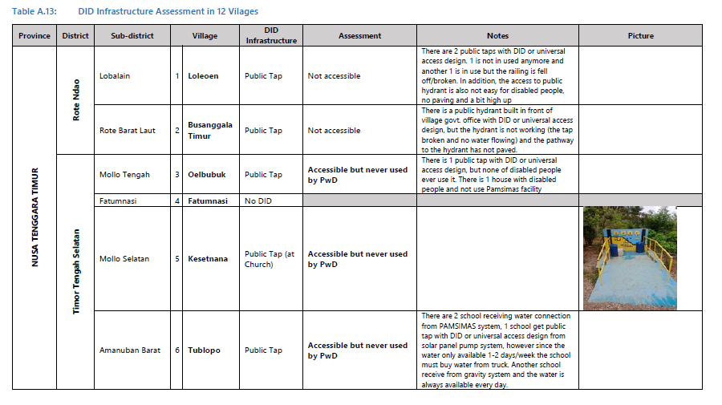

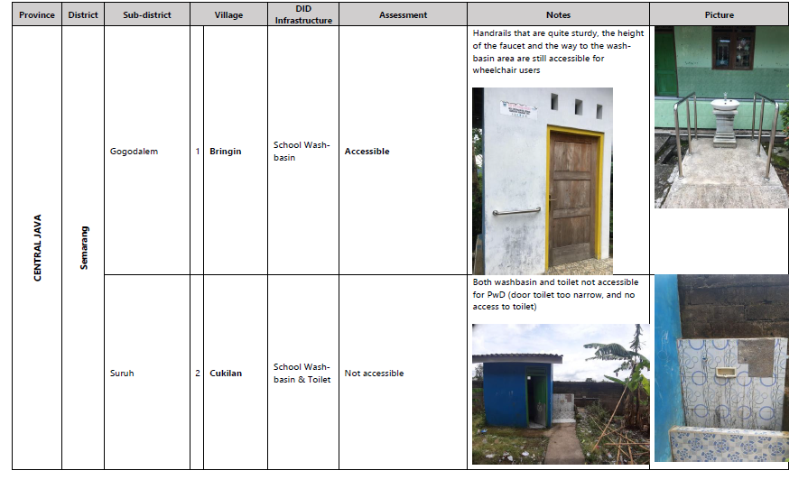

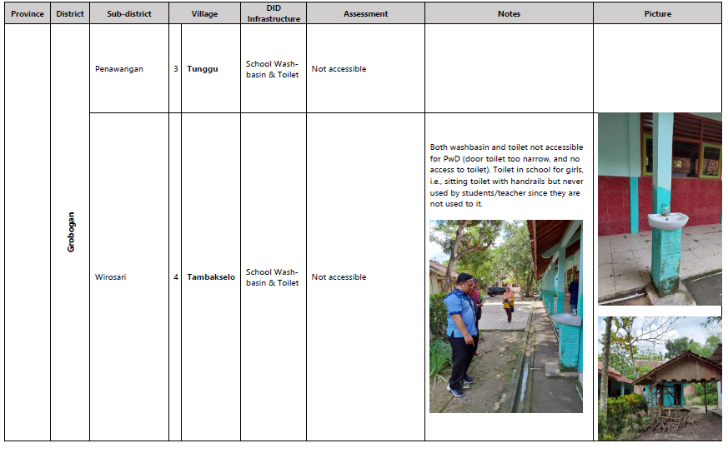

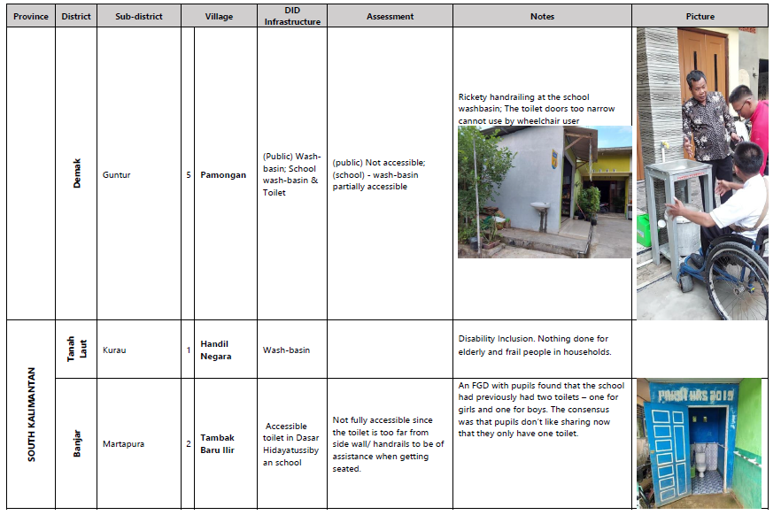

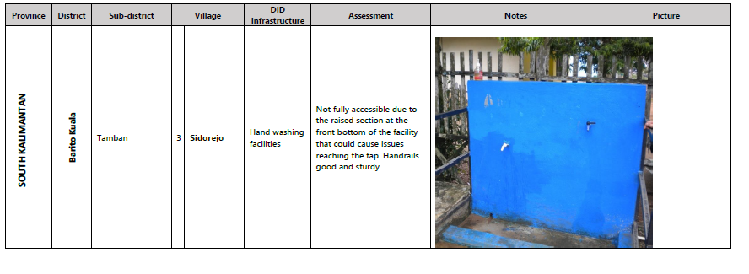

1. ***M&E Activities and Discussions of DFAT’s Direct Contribution to PAMSIMAS (Full Version)***

Monitoring and Evaluation

1. DFAT’s Direct Contribution to PAMSIMAS

The WB, DFAT and the GOI are commended by the IET for their efforts in developing robust M&E systems – results framework with pertinent KPI; development of a comprehensive database (the MIS) holding information on all key performance indicators (KPI) and more that is publicly accessible from [PAMSIMAS MIS](https://pamsimas.pu.go.id/); systems to validate the accuracy of data collected at the local-level; and the regular reporting and commissioning of reports on programme progress.

This level of detail and transparency of data is not a routine feature of bilateral and multi-lateral funded programmes, and the accessibility of PAMSIMAS data has allowed for numerous independent (and commissioned) researchers to analyse and report on the PAMSIMAS programme.

**1.1 The Results Framework and KPI**

**1.1.1 Most KPI are Pitched at the Output-Level**

In all, 16 key performance indicators (KPI) were defined for the programme; 3 at the project development objective level (PDO); and 13 at the intermediate results level. As to be expected, the majority of intermediate result KPI are pitched at the output level.

One, however, that of KPI 10: “*percent of villages with improved water supply systems that are functioning to the satisfaction of the majority of targeted community*” is an outcome indicator and is more appropriately placed at the PDO level.

Now, the three PDO level KPI are:

1. Number of additional people with sustainable access to improved water facilities.
2. Number of additional people with sustainable access to improved sanitation facilities.
3. Percent of villages with improved water supply systems that are effectively managed and financed.

The most notable feature of these KPI is that they are phrased as outputs, and it is only the inclusion of the term “sustainable” that gives them a marginal outcome complexion. However, this level of indicators is constrained by the PDO statement since it is also pitched, largely, at the output level:

*“To increase to the number of under-served rural and peri-urban populations accessing sustainable water supply and sanitation services.”*

The upshot of this is that, aside from KPI 10, there are no KPI that reflect the higher outcome level of the PAMSIMAS programme, which could be health, livelihood, education, or quality of life related indicators. Afterall, the purpose of improved WASH is to enhance the quality of life and enable people to fully exploit the opportunities available to them. This is not to say that tracking the number and quality of infrastructure is less important, since it is a critical component in the process. Clearly sustainability is an outcome, but there are questions about how sustainability (and functionality of WSS) has been monitored.

This is viewed as a missed opportunity during the design of the results framework, and inclusion of appropriate outcome indicators would have added valuable insights into the impacts of improved WASH on “people and their lives” which, as stated before, is the prime purpose of such WATSAN facilities and good hygiene behaviours.

This omission in the evaluation framework has been reported on previously In the Independent Evaluation Group’s (IEG) Implementation Completion Report (ICR) on DFAT’s grants. In this report the PDO was described as “*not pitched at a sufficiently high level to suggest a potential solution to the development problem that the project is intended to address. In other words, the objective was not defined such that its achievements would be plausibly traceable to improvements envisioned to arise from increased access to water supply and sanitation services, such as improvements in health outcomes, production and income or other factors affecting community livelihoods*”.

A sample of plausible outcome indicators and data sources are shown in Table 1.1. Such indicator data related to health, livelihoods/productivity, education, and quality of life should be reasonably accessible and could be collected either through random sample surveys or via longitudinal studies of specific households. Clearly, to track the changes there needs to be equivalent baseline data and this could be collected immediately after the selection of a given village.

Table 1.1: Plausible Indicators for WASH Outcomes

|  |  |  |
| --- | --- | --- |
| Outcome | Outcome Indicator(s) | Data Source |
| Health | * Number of recorded cases of poor sanitation-related illnesses over period * Number of recorded cases of water-borne diseases over period | PUSKESMAS records |
| Livelihoods | * Number of days off sick from work over period * Hours worked per week * Approximate mean monthly incomes over period * Inventory of household assets over period * Debts | Random sample survey or longitudinal studies of specific households |
| Children’s Education | * Number of days off sick from school * Progression of grades over period | School records |
| Quality of Life | Satisfaction with:   * Standard of living * Health * Quality of local environment * Future security, etc | Random sample survey or longitudinal studies of specific households |

**1.1.2 Definition of KPI**

The three PDO KPI are compound indicators, which requires inputs on more than one theme and some degree of judgements rather than one specific measurement. For example, KPI 1 is concerned with improved water facilities and their sustainability. First, the meaning of sustainable access to improved water facilities does not appear to be defined. For example, should a household that receives piped water once or twice each week be considered as having sustainable access to improved water facilities?

The IET’s fieldwork discovered that half of the reported ‘fully functioning’ systems have issues either with water shortages during peak periods or in the dry season or were running at less than design capacity and operating water rationing rota. Yet the MIS has most of these fulfilling KPI 1, for example the villages of Lekunik, Busalangga Timur, Tublopo, Timor Tengah Selatan, and Oesao, despite all customers suffering severe water shortages for several years.

For KPI 3, there appears to be similar issues. For example, what constitutes effectively managed and financed water supply systems. It seems from the results framework that effective management is associated with having various protocols in place, such as KPSPAM work plans, but while these protocols are ***necessary***, they are not ***sufficient*** to ensure effective management, which needs an outcome indicator to sufficiently track effective management – that is evidence (or proxies) of plans or protocols being implemented with results.

The IET’s fieldwork discovered that “effectively financed” can come in various forms, such as through the formal tariff route (fixed or metered) or through community contributions as and when required. A case in point is Dwipasari in Barito Kuala district, South Kalimantan. This village is marked on the MIS for KPI 3 as effectively managed and financed, however, the KPSPAM has never charged a tariff and, presumably, doesn’t have much in its financial books. Nonetheless, in this case the IET agree with the MIS rating of an “effectively managed and financed” operation. Dwipasari have always relied on community donations as and when required and this has served the village well; it has universal coverage of water and this has been the case since 2008, with an upgrade in 2010 using a village incentive grant (HID).

It appears that for the case of Dwipasari, someone made an informed judgement on this village, since viewing the raw data alone it is difficult to see how a machine would rate this operation as highly.

In the same way that Dwipasari’s *ad hoc* financial systems have been recognised as successful – most probably on the basis of knowledge outside of the KPI-related data, others charging tariffs and having management policies and procedures, but doing less well than Dwipasari at the outcome-level, are likely to receive the same rating erroneously unless external judgements are made.

**1.1.3 KPI –** **Considerations Going Forward**

***Three PDO KPIs***

Some modest adjustments to PDO KPI could enhance the utility of the results framework and create a set of outcome indicators at the PDO-level within the structure of the current programme.

Consider deconstructing KPI 1 and 2 and creating two indicators from each: one at the output-level and one at outcome-level, as shown in Table 4.2. Use of outcome KPI 1.a removes the current challenges in defining what constitutes a fully functional water supply system and places it in the hands of the consumer. This outcome indicator could also be in the form of a revised version of KPI 10; as mentioned before this a well-defined sustainability outcome indicator in the current results framework and would have the same benefits in identifying the functionality of systems but based on the demand-side. The revised KPI 1.b output indicator largely reflects much of the current KPI 1 data but is decoupled from the outcome of sustainability. Also consider decoupling the three sustainability elements of KPI 3 – technical, financial, and institutional – as shown in the table, below.

Table 1.2: Minor Adaptations to KPI 1, 2 and 3 to Enhance Utility of the Results Framework

| No. | Revised KPI | Definition | Benefits/Notes |
| --- | --- | --- | --- |
| 1. | a. Outcome | Number of (additional) people that receive sufficient improved water supplies for all their household needs  OR Revised version of KPI 10:  % of villages with improved water supply systems that meets household demands in full to the satisfaction of [90%] or more of the community | This would enable identification of WSS that under the current KPI that might be considered as ”fully functional” but supply insufficient quantities of water to each household. This could be achieved through longitudinal studies of a cross-section of households or via an annual census conducted by KPSPAM and make separate studies by consultants unnecessary, as is currently the case for KPI 10. |
|  | b. Output | Number of additional people with access to improved water facilities | This would remain essentially the same as the current  KPI 1. |
| 2. | a. Outcome | Number of (additional) people with improved sanitation facilities built to technical standards and with access to septage management services (if required) | This brings in the issue of the quality of infrastructure and sustainable septage management, which have not been considered in the current programme. |
|  | b. Output | Number of additional people with access to improved sanitation facilities | This would remain essentially the same as the current  KPI 2. |
| 3. | a. Outcome | Identical to KPI 1.a | Relates to the aspect of technical sustainability, and finance and management sufficiency |
|  | b. Output | Percent of KPSPAMS that have workplans and allied management, O&M, and financial protocols in place | This covers the outputs that are necessary (but not sufficient) for KPSPAMS to manage their WSS well. Sufficiency of management is tracked via KPI 3.a (≡ KPI 1.a) |
|  | c. Output | Percent of KPSPAMS charging tariffs => CR | This covers the financial output necessary (but not sufficient) for KPSPAMS to operate, maintain, and sustain WSS. Financial sufficiency is tracked via KPI 3.a (≡ KPI 1.a) |

Concerns related to sustainability of sanitation infrastructure are poor design and construction and lack of access to septage management services (see Section 4.7.4). These were not the focus of PAMSIMAS but, going forward, these issues should be considered. The revised KPI 2.a factors in design and construction standards and the important issue of septage management, both of which should be given greater emphasis in any future programming. The revised KPI 2.b output indicator is likely to reflect much of the current KPI 2 data but, like KPI 1.b, is decoupled from the outcome of sustainability.

***KPI 10***

KPI 10: “***percent of villages with improved water supply systems that are functioning to the satisfaction of the majority of targeted community***” is a very significant indicator of WSS sustainability, encompassing sufficiency, quality, affordability, and convenience of water supplies from the perspective of consumers. It is the only indicator in the results framework that can be straightforwardly identified as an outcome indicator and, in the opinion of the IET, is a far more useful guide of WSS sustainability than KPI 3[34]. Nonetheless, it has some weaknesses in its framing and challenges in tracking it.

For example, “… ***functioning to the satisfaction of the majority of targeted community***” seems to imply that as long as a minimum 51% of consumers are ***satisfied*** or ***moderately satisfied***, then KPI 10 would be recorded as 100%. However, this is not how KPI 10 has been treated in the two beneficiary surveys in 2018 and 2019.

First, only between 7 and 10 households were surveyed in each village during these surveys and the results were aggregated across all villages. This serves to mask any poorly performing villages since the overall KPI 10 average will be inflated by any high performing villages, all from the perspective of a very small sample of households. It is, however, difficult to be definitive due to the confusing way data has been presented in these survey reports. For example, they refer to the percentage of villages when referring to the level of satisfaction – 32% were fully satisfied; 48% were moderately satisfied; and 20% were less satisfied (see *p. 68* of the 2019 survey). These results are difficult to make sense of since the results were from surveys of up to 10 households, so one would expect each village to have three figures representing the satisfaction rating scale and not one of the three for any given village.

Second KPI 10 was broken down into elements of water adequacy, continuity, and quality; safety; distance from home; water tariffs; and services by KPSPAMS. These were treated as equally valued by households since a simple average was taken to arrive at the final KPI 10 value. This is most unlikely to be the case and, if given the choice, households would have weighted these elements differently depending on their circumstances.

In summary, while KPI 10 appears to be a valuably indicator of sustainability, the way it has been treated and reported has detracted from it reflecting the true consumer level of satisfaction and, therefore, a more representative view of WSS functionality and potential for sustainability.

**1.2 Monitoring**

### **1.2.1 Systems and Data Validation**

The PAMSIMAS General Guidelines (PGG) details all monitoring activities conducted throughout the activity cycle, from preparation, planning, implementation, and sustaining infrastructure and allied services. All such data is available from the MIS.

Of specific interest to the IET is the monitoring at “sustaining infrastructure and allied services” level, which is essentially the process of collecting data on the KPI in the results framework.

According to the PGG, monitoring to capture this data is carried out by Supervisory Teams (ST), which are village community groups. The ST use standard questionnaire templates to enter data and then these are passed to the district government for checking/cleaning and entering into the MIS.

To check the integrity of the data entered into the MIS, the National Management Consultant (NMC) team oversees a telephone and facilitator-led field validation survey every 3 months (started in PAMSIMAS III). The survey uses a questionnaire template to collect information from a random sample of villages, and the NMC is supported by ROMS at both the provincial and district governments. For example, with 3,346 villages at the end of 2021, this survey would require sampling randomly 390 villages[35].

While the IET have been granted access to the validation data on module 73 of the MIS, which has 14,358 entries or villages sampled[36], it is not certain how this data is treated if found to be substantially different from that held in the sustainability dataset. Regardless of this final step in the validation process, data collected by the IET in 43 villages during a field mission between 11th and 22nd of September 2022, did not compare well with that held on the MIS. These disparities will not be reiterated here but a full account of them can be found in Appendix 3 and a summary in Section 3.1.2 of the main report.

The IET accept that 42 villages is not a statistically significant sample, but the extent of disparities from the number of households benefiting right through to the functioning of water supply systems requires some further investigation. This is particularly so in view of the purpose of the MIS as a management tool, and since the two beneficiary surveys conducted in 2018 and 2019 were based on samples that were not statistically significant either[37], yet, for example, data on KPI 10 is reported widely as a key successes[38].

**Baseline Data and Attribution**

Surprisingly, the PAMSIMAS programme has no baseline data. One might argue that the sheer magnitude of the programme made this task too difficult and/or costly. However, considering the huge investment in the programme and the scale of the monitoring covering every village participating in PAMSIMAS, it is difficult to reconcile the lack of baseline data on either aspect of difficulty or cost.

The lack of baseline data poses several challenges, since it adds a degree of uncertainty to the data, particularly in relation to sanitation and hygiene, and makes it difficult to assess PAMSIMAS at the outcome and wider impact-level. Clearly, there is no question about the PAMSIMAS water supply systems since they did not exist at the baseline, but sanitation facilities and hygiene behaviours are a different matter.

The IET’s fieldwork and HH survey indicated that in some villages, particularly in South Kalimantan, good hygiene behaviours had been generally adopted before the PAMSIMAS programme, despite some of these villages having no private latrines and being compelled to use hanging toilets. Further, the majority of survey respondents in Central Java and all respondents in NTT did not associate the construction of their private latrines with the PAMSIMAS programme. There were some villages where the IET discovered that some private and communal toilets had been constructed by the MOPWH, but the team does not know whether the toilets in other villages were there before the programme started and/or had been built under other government or INGO programmes during PAMSIMAS.

This challenge was raised in the PAMSIMAS Interim Evaluation Study: Beneficiary Survey, in which it is stated that “*there are now [December 2019] four times more households with access to sanitary toilets than households with traditional (unimproved), or no latrines. How much this is the effect of the programme cannot be stated, because there are no ‘before PAMSIMAS’ data*.”

***Gender-Related Monitoring***

In line with the Monitoring Framework, the IET finds that the MIS collected and analysed adequate sex-disaggregated data to track participation and representation of women (and men) and the benefits they gained from the programme. The monitoring and reporting also adequately tracked results aligned with the core programme indicators, for example related to the percentage of women participating in various stages of implementation and their representation (e.g., in KPSPAM). The monitoring tools did not capture data and information on the quality of women’s involvement which meant that there was no data gathered and analysed in a systematic way about gender equality. The programme did, however, capture and analyse rich information related to gender equality beyond participation through several reviews and surveys during the lifetime of the programme.[39] It is important to note that the MIS was designed to capture data on key indicators only, and qualitative aspects related to women’s influence, empowerment, leadership were not key indicators. However, the GM SOPs set an expectation that the programme would gather data and information on these aspects. Specifically, evidence on the quality of women’s participation and their ability to influence decision-making (e.g., evidenced in meeting minutes from CAPs, Preparation and Plenary of ProAksi PJM, establishment of KPSPAM) (Gender Mainstreaming SOP, page. 11-12). However, this was not included in the MIS.

As the PAMSIMAS Monitoring Framework did not reflect the ambition outlined in the GM SOP and GAP on women’s influence, empowerment and control over resources, these results were not prioritised during implementation.With no focus on quality aspects in the monitoring and reporting cycle there was no incentive for programme actors to deliver many of the qualitative requirements that promoted gender equality in the GM SOPs and GAP.Further, there is little evidence that recommendations related to improving the implementation towards gender equality were addressed through PAMSIMAS iterations. For example, DFAT’s commissioned Independent Review of PAMSIMAS and WASPOLA (2013) acknowledged that gender monitoring focused on the percentage of women but did not provide any information on quality (the role of women or their leadership) and suggested DFAT take a more strategic approach. The proposed changes in the PAD for PAMSIMAS III in 2015 however did not address this recommendation.

***Disability-Related Monitoring***

As with the monitoring of gender, the MIS effectively captured quantitative data on DID but did not capture information on the quality of facilities.The MIS gathered data on the number of people with disability in a village; numbers of people with disability participating in community meetings and trainings; number of people with disabilities with access to water and sanitation; and the number of facilities built under DID. The collecting and management of this disability data began during PAMSIMAS III, prompted by DFAT’s introduction of DID, and at this point historic data was gathered for PAMSIMAS I and II. These indicators align with the requirements in the Monitoring and Evaluation Framework but do not capture data on whether facilities built were accessible and the extent to which they met the DID standards. The spot check instrument used for field audits also does not include a field of inquiry on DID quality and alignment with DID standards. This makes it difficult to determine how many people with disabilities now accessing accessible facilities that meet DID standards and draw judgement on the real benefits of the DID.

**1.3 Management, Learning and Accountability**

The IET’s experiences with the MIS have shown it to be challenging to use for all but accessing the headline data. So, while all the data is publicly available, to make sense of it one needs some practical knowledge of relational databases (MS Access or SQL server) since the MIS online cannot be queried to access bespoke sets of data directly. This alone, makes the MIS far less accessible than one would anticipate.

From this perspective, it is unlikely that personnel in government ministries, DFAT or the WB routinely and independently used the MIS for management of the programme. Nonetheless, the IET are aware of some highly skilled IT staff in the WB that are called on often, including by the IET, to generate various data set reports from the MIS.

FGDs with staff from several government ministries in the last week of the fieldwork, confirmed that the MIS was not routinely used, but anecdotal evidence suggests that they, too, received data set reports on request from the WB.

In summary, the MIS holds a wealth of data and it is the IETs opinion that, while the MIS data may not be independently accessed by all key stakeholders, it has been used at all stages of PAMSIMAS to manage, learn from and adapt the programme. For example, lack of consumer demand indicated by HC targets not being met led to changes in village selection criteria, and higher than expected water system failures that led to a greater emphasis on O&M capacity building in PAMSIMAS III (see Section 5.4 for more discussions on programme adaptations).

PAMSIMAS, through its MIS and regular progress reporting by the GOI, WB and DFAT, and commissioning of independent surveys, reviews and evaluations – much of which is publicly available online - demonstrates a high level of transparency and accountability over all aspects of the PAMSIMAS programme.

1. [PAMISIMAS Evaluation Plan, 16.10.22](https://kiatcardno.sharepoint.com/:w:/g/ETQzh7Q-pM9JkufYcSO6U98BBmC1F6fdSnFsZroSEkyTYA?e=mP4Kyi)
2. Aide Memoire - INDONESIA: Third Additional Financing for the Third Water Supply and Sanitation for Low Income Communities (PAMSIMAS III) (Ln.8578-ID and TF0A6336) Virtual Closing Mission, November 4 to 30, 2021.
3. This MIS data was accessed 17/11/2022.
4. It is important to note that KPI 10: “Percent of villages with improved water supply systems that are functioning to the satisfaction of the majority of targeted community” is not accessible from the MIS. This is unfortunate since it is a good proxy indicator of KPSPAM health. Nonetheless, comparable data has been accessed from available sustainability data.
5. σ=±0.23, or 0.74 ±0.23. The standard deviation (σ) is very high indicating that there is a very large spread of data around the average.
6. Banten and DI Yogyakarta are not considered here due to some missing data on the MIS.
7. Private communication, 20/12/2022.
8. [Household Survey for PAMSIMAS: Volume 2 Final Evaluation Report](https://kiatcardno.sharepoint.com/:w:/s/PAMSIMAS.EPR/EeY_ZHTv65xJvI83Shs0Ze8BhDx1ArPZQ-o4jbHo5ZoGGg?e=R7k5Ao)
9. The data is disaggregated by district to illustrate the significant variations in the data.
10. Air minum layak is defined as water that requires only one step of treatment at household level to make it safe for drinking. Household level water treatment could be through boiling, filtration, disinfection, etc., although in Indonesia boiling is the most common method.
11. A further 50 villages had no data.
12. It is important to note that villages with non-functioning PAMSIMAS WSS were not included in the household survey.
13. Accessed on 19/11/2022 using Rekap-KPI for KPI 2, MS Access and a query on Kode Desa to link this with the Sustainability data.
14. The reason behind this disparity is that the improved sanitation statistics for PAMSIMAS have been accessed from the government’s STBM database under the control of the MOH rather than from the MIS. However, in 2018, the STBM database experienced some problems that, to date, have not been resolved. Consequently, in early 2022 the CPMU made a decision to revert back to the MIS data, and since no sanitation data had been entered into the STBM database since 2019, the MIS data shows a dramatic increase over the last published dataset (Private communication with the WB, 02/12/2022). Presumably, the 16.4 m people benefiting from improved sanitation published in November 2021, refers to data held on the STBM database at the end of 2018.
15. The percentage coverage is $=\{\frac{\left[People with Improved Sanitation]\right.}{[Total Village Population]}$} x 100
16. Ln is the natural logarithm.
17. See [Participatory Methods and Tools for Extension: Social Map, INTRAC 2017](https://www.google.com/url?sa=t&rct=j&q=&esrc=s&source=web&cd=&ved=2ahUKEwin163ih5_8AhWVWcAKHbMkCrAQFnoECA4QAw&url=https%3A%2F%2Fwww.fauna-flora.org%2Fapp%2Fuploads%2F2017%2F11%2FFFI_2013_Social-Mapping.pdf&usg=AOvVaw00oBoQjDXzYIT8xRJtR5XF) and [Social Mapping, Anju Sapkota, 2017](https://www.slideshare.net/Anjusapkota/social-mapping-81891736)
18. ["Factors influencing knowledge and practice of hygiene in Water, Sanitation", 2014](https://www.researchgate.net/profile/Tahera-Akter/publication/264902227_Factors_influencing_knowledge_and_practice_of_hygiene_in_Water_Sanitation_and_Hygiene_WASH_programme_areas_of_Bangladesh_Rural_Advancement_Committee/links/5639ce5c08ae2da875c85434/Factors-influencing-knowledge-and-practice-of-hygiene-in-Water-Sanitation-and-Hygiene-WASH-programme-areas-of-Bangladesh-Rural-Advancement-Committee.pdf)
19. <https://practicalactionpublishing.com/article/2415/download?type=download>
20. Interim Evaluation Study – PAMSIMAS III, 2019, p. 50
21. The IET was not successful in accessing this WB report but comments here are from a PowerPoint file, based on that report, that was used in a December 2021 presentation.
22. The 12 components were: Policy and Guidelines, Selection of Consultants, Selection of Community Facilitators, Orientations, Capacity Building for Technical Consultants and Community Facilitators, Training Service Providers, Community Processes, Community Capacity building, Socioeconomic Incentive Funds, Mainstreaming and scaling up CDD approach for WSS, Monitoring and Evaluation, and Knowledge Management.
23. The study involved 2,045 beneficiaries and stakeholders from 40 villages in 12 provinces.
24. DFAT’s Annual Report 2021
25. More specifically, 25% of staff in the NMC and Prov ROMS, 33% of members in the District ROMS Team, and 30% of facilitators in the Facilitator Team were women. PAMSIMAS has faced challenges increasing the number of female facilitators qualified as technical specialists for water and sanitation (FM WSS). However, women were well represented (60%) as Sanitarians (PUSKESMAS environmental health officers) facilitating the community for sanitation and health activities (DFAT Evaluation 2021, *p. 14*).
26. DFAT’s Annual Report 2021
27. Gender Impact Study, WB, 2021
28. Interim Evaluation Study PAMSIMAS III: Beneficiaries Survey - 2019, *p.9*
29. Elite women are defined as those who are wives or relatives of the village head, involved in leading PKK activities, working in the government office and so on.
30. Evaluation Report PAMSIMAS, “Report on Interim Evaluation Study: Beneficiary Survey”, 15/12/2019, *p.44*
31. Gender Impact Study, WB, 2021
32. In Central Java, the mean swing (improvement) in incomes of all HHs surveyed is almost 4 times that of female headed households. Similar trends are observed in South Kalimantan and NTT but to lesser degrees, at 1.5 times and almost 3 times respectively compared to female headed HHs. See Volume 2 of this report for more details on the changes in HH incomes over the programme.
33. This was recorded during FGDs, Banjar District and Tanah Laut District South Kalimantan, in Semarang District, Grobogan District and Demak District in Central Java.
34. KPI 3 is a complex compound indicator involving management and finance components
35. PAMSIMAS uses Slovin’s technique for random sampling of a large population: $n=N/(1+Ne^{2}$), where $n=Sample size$; $N=Total PAMSIMAS villages$  
    ; $e=Margin of error$, which is routinely taken as 0.05 (5%).
36. Note that a village can be sampled during more than one survey, such is the nature of random sampling, so 14,358 entries does not necessarily mean that these are for unique PAMSIMAS villages.
37. At 95% confidence level and 5% margin of error.
38. For example, see the Implementation Completion and Results Report, PAMSIMAS Support Trust Fund, World Bank, June 14, 2018.
39. For example: the PAMSIMAS Impact Study (2013); the PAMSIMAS Beneficiary Study (2018); the PAMSIMAS Interim Evaluation Study: Beneficiary Survey (2019); and the Gender Impact Study (2021).