May 2018

Jeremy Syme, Lydia Tanner, Gideon Gelesi and Renee Martin

**EVALUATION REPORT**

Youth With a Mission

Medical Ships Australia

Youth With a Mission - Medical Ships Australia (YWAM MSA)

# Executive summary

Youth With a Mission Medical Ships Australia (YWAM MSA) is an NGO providing health services and health capacity development in Papua New Guinea (PNG). It was awarded an Australian Department of Foreign Affairs and Trade (DFAT) grant of $2m over four years (2015-16 to 2018-19). The grant funded operational costs including ongoing repairs and maintenance for YWAM MSA’s “mothership,” the acquisition of two tenders, and support for tender operations to facilitate access to hard-to-reach communities.

DFAT and YWAM MSA commissioned this evaluation to review YWAM MSA activities undertaken between the last quarter of 2015 and December 2017. The evaluation team (ET) was asked to quantify the volume of services provided; assess the perceptions of beneficiaries/key stakeholders from community, District, Provincial and National levels; evaluate capacity building impact, service distribution equity and disability and gender inclusiveness; assess the quality of service provision, the governance systems and the quality assurance mechanisms; quantify the cost of service provision with comparison to other modes of service delivery; consider complementarity or possible service duplication with other health services in the area; document lessons learnt for possible application to other health service agencies in PNG; and make recommendations on future service delivery and funding.

The evaluation used a mixed-methods approach including an extensive desk review of YWAM MSA reports and other relevant documents, key informant interviews, and focus groups with a broad range of stakeholders. Fieldwork was conducted in Bamu River in Western Province aboard the mothership (MV YWAM PNG) and included visits to remote communities to observe delivery of public health and clinical services. An aide memoire was presented at the conclusion of the field visit.

Overall, YWAM MSA has delivered on its contractual obligations and has exceeded quantitative targets for service delivery under the funding contact. The ET noted an unusual underpinning of the contract, whereby DFAT funded capital purchases for the ship but required YWAM MSA to report against health service performance metrics in two of DFAT’s priority provinces - Western and Gulf. YWAM MSA delivered services to these two provinces as well as to Central, Milne Bay, Oro and Morobe Provinces.

**Coordination and complementarity with other services**

Primary health care services are well aligned with national priorities outlined in the National Health Plan (2010-2020), which prioritises strengthened primary health care for all and improved service delivery for the rural majority and urban disadvantaged. However, ophthalmology, optometry and dental work are not identified as priorities within the NHP, which emphasises a “back to basics” approach.

YWAM MSA medical teams follow the PNG Standard Treatment Guidelines for clinical practice in children, adults, sexually transmitted infections, oral health and obstetrics & gynaecology. This includes taking a nurse-led approach to service delivery, using local equipment and NDoH formulary drugs.

YWAM MSA has formed very strong relationships with persons of influence at all levels of government. Teams of district health officers plan for and participate in regular outreaches. YWAM MSA senior personnel also communicate with national, provincial and district health authorities on outreach locations, targets and priorities. However, the YWAM MSA executive retains decision-making on locations and priorities for service delivery and there is a need to deepen coordination with operational staff at the provincial and national levels to ensure optimal coordination of services and utilisation of resources.

At the provincial level, YWAM MSA has developed strong relationships with senior members of the Provincial Government and visits the Provinces at their invitation. This has resulted in significant financial support from a number of provinces. Senior health officers were aware of YWAM MSA’s activities, had met YWAM MSA staff, and received reports and there were some examples of co-delivery of land-based dental and optometry outreaches. However, these same health officers felt they have little oversight of decisions on the location or prioritisation of activities. The Provincial Health Advisors communicate on occasion (usually precipitated by YWAM MSA) to agree the targets for future outreach visits however they would prefer to be more involved in early planning for the longer term.

At the national level, there is generally less understanding of the YWAM MSA approach and service delivery activities. Discussions with NDoH, Medical Board, DNP&M, and WHO all recognised that YWAM MSA operate a ship which was purchased partially with PNG funding and that it visits multiple Provinces usually at the invitation of a Provincial government. However, interviewees commonly expressed that YWAM MSA could improve communication with officers responsible for operationalising service planning, adherence to standards and the implementation of funding decisions.

**Quality of services**

The public sector’s diminishing capacity to provide health services means that remote populations become increasingly vulnerable and outreach patrols to rural villages are critical to providing effective rural primary health care. YWAM MSA supports districts to deliver outreach patrols to remote areas that are severely under-serviced and, in some circumstances, completely un-serviced by other health service providers.

YWAM MSA delivers clinical services through national and overseas volunteers. The nature of volunteerism means that turnover of clinical practitioners is high and that team members come from a variety of training settings and experiences. This creates challenges associated with ensuring a consistent approach to delivery of services, including clinical experience of the PNG context and effective delivery of health information messaging. YWAM MSA provides a two-day orientation for volunteers on arrival but more thorough preparation may be required for general volunteers conducting health education and for clinical practitioners without experience of the PNG context.

The ET observed YWAM MSA delivering services in an inclusive approach. Women and men are almost equally represented in dental and health education services. Women account for 70% of primary health clinic services (skewed by provision of antenatal care and family planning). Clinic teams were observed to actively seek out people confined to their homes in order to deliver services to people who could not reach the clinic site. Nearby villages are advised where and when YWAM MSA will be in attendance so potential patients may travel to attend.

**Contribution to health improvements**

YWAM MSA delivers supplemental health services to underserved (and un-served) areas of six Provinces – the ET was tasked to evaluate services to Gulf and Western Provinces as the targets for the DFAT funding. A broad set of primary health services were delivered to these communities in the review period, including 23,708 immunisations, 15,357 primary health consultations, 838 family planning consultations and 525 antenatal consultations. These are supplementary services that form 1-5% of total service provision in Western Province.

Community members were overwhelmingly positive regarding the provision of services and it is not uncommon for YWAM MSA teams to be unable to meet the demand for services (a triage system is used to prioritise). In focus groups, community representatives and local health care workers highlighted the importance of immunisation, antenatal care and family planning services.

YWAM MSA does not currently collect regular data on health knowledge or health outcomes in the communities it services. However, a small survey collected in 2017 provides evidence of an increase in vaccination levels among villages served that is supported by community focus groups. The quality of health information sharing was variable (with a significant capacity gap between senior staff and general volunteers) and YWAM MSA would benefit from a baseline on health knowledge and practices in key areas to inform its approach.

YWAM MSA has invested in an electronic information management system that allows it to review and aggregate data on its clinical and health promotion services. There is a need for YWAM MSA to shift from data collection as a means to report activities towards a system of ongoing monitoring and appropriate evaluation as a central part of operational decision-making. This would include learning on the relative effectiveness of different health information activities, capacity building activities, and services. This will require investment in in-house capacity and fostering a culture of continuous learning and improvement in which targets, performance, risks and overarching experiences are regularly reflected on and used to inform ongoing activity. Such a system will highlight both areas of strong performance as well as areas of weakness and facilitate quick course correction as necessary.

**Cost of services**

In the PNG health system, human resources account for much of service provision costs, but the YWAM MSA model of service delivery has volunteerism at its core which discounts this element from its costing base. During the evaluation period YWAM MSA has acquired and fit out MV YWAM PNG requiring significant capital allocations, support for which has been forthcoming from the GoPNG, DFAT and the private sector.

There have been definitional inconsistencies during the period, which renders it infeasible to determine a cost per unit of service. This means that it is not possible to determine the cost per unit of service delivery by YWAM MSA. Using what is acknowledged by the NDoH as the most appropriate costing study as a comparator[1], delivery of YWAM MSA service numbers (for 2015-17) in the Western Province health system would cost between AU$160,00 and AU$320,000. (It should be noted that the facility based model is the basis for the Western Province costing and that there it is acknowledged that patrol based outreach relies on different resourcing. There is no comparator information relating to patrol based outreach service delivery). Whilst these costs do not account for the costs associated with health promotion and capacity building activities that YWAM MSA delivers, they are an important consideration in donor investment decisions. That being said, the systemic level failures in the PNG health system mean that it is not reasonable to assume that the equivalent amount of funds would have been efficiently and effectively channeled through the system to address the needs of vulnerable, remote populations.

The ET acknowledge the difficulty of comprehensively comparing the YWAM MSA model of service delivery to other models, particularly in relation to health services to remote communities and acknowledge the cooperation of the YWAM MSA team with this evaluation.

**Sustainability of approach**

YWAM MSA benefits from multiple funding sources however there is a reliance on donations and volunteers that poses a risk to the viability of ongoing activity. This is compounded because YWAM MSA has received significant financial contributions from across the GoPNG – a government that is grappling with a fiscal crisis, poor medium term economic projections and the immediate challenge of responding to a humanitarian disaster (2018 earthquake) and the cost associated with APEC preparations.

Whilst YWAM MSA has certainly demonstrated its ability to leverage private sector support (aligned with DFAT’s commitment to private sector engagement). However, in a competitive and economically challenging environment it is important to be able to demonstrate a professionalised approach to development and an ability to measure impact – doing so requires confirmation of baseline and then agreed, consistent performance metrics and systems to collect and report data over medium term. Without an ability to address these needs ability to attract financing from donors (including the private sector) will be constrained. YWAM MSA needs to invest in capacity in this area.

# Acronyms

CHW Community Health Worker

DDA District Development Authority

DFAT Department of Foreign Affairs and Trade

DNPM Department of National Planning & Monitoring

DOT Direct observation treatment

DTS Discipleship training scheme

ENHIS Electronic National Health Information System

ET Evaluation team

FP Family planning

GoPNG Government of Papua New Guinea

KII Key Informant Interviews

LLG Local level government

MBPNG Medical Board of Papua New Guinea

MCH Maternal and child health

MDR Multi-drug resistant (TB)

NCD National Capital District (PNG)

NDOH National Department of Health

NGO Non-government organisation

NHIS National health information system

NHP National Health Plan

PHA Provincial Health Adviser

PHO Provincial Health Office

PNG Papua New Guinea

ToR Terms of Reference

WASH Water and Sanitation

WHO World Health Organization

YWAM MSA Youth With A Mission - Medical Ships Australia

# Introduction to reviewers

This evaluation was conducted by four evaluators who were selected by DFAT (Jeremy Syme, Dr Gideon Gelesi and Renee Martin) and YWAM MSA (Dr Lydia Tanner).

**Jeremy Syme** (Team Leader) is an experienced manager and adviser in health, governance and infrastructure with more than 20 years’ experience in International development, the majority in PNG. In the last ten years, he has held positions of Chief Adviser, Team Leader and Program Director within a range of donor supported development programs.

**Dr. Lydia Tanner** (M&E Specialist) leads The Research People, a team of researchers from the UK, Uganda, India and Egypt engaged in mixed-methods research studies and evaluations. Her work explores humanitarian response, primary health, partnership, and system strengthening. Lydia holds a PhD in medical engineering and undertaken research consultancies in more than 20 countries with a mix of international and national organisations and networks.

**Dr. Gideon Gelesi** (Clinical Expert) is a Papua New Guinean trained and registered medical practitioner with post-graduate training in Internal Medicine. As Director of My Healthcare he now specialises in health service restructuring and governance systems strengthening. He is an experienced health service manager with more than 15 years as a consultant to both corporate and government clients.

**Renee Martin** (Health Economist) is a Senior Manager PwC’s Health Economics and Policy team. She brings more than fifteen years of public health capability to the role and has extensive experience working with Governments and NGOs in developing countries to design, deliver and finance sustainable health programs that are appropriate to local conditions. Renee has significant expertise in monitoring and evaluating health programs and developing frameworks and metrics to capture impact.

# Acknowledgements

The evaluation team expresses its gratitude and appreciation to YWAM MSA, to PNG National, Provincial and District health officials, and to communities in the Bamu LLG who responded to our questions, offered their views and opinions, and provided information about the project.

Senior personnel at YWAM MSA were particularly generous with their time and provided a wide array of information at short notice. The hard work and dedication of senior personnel at YWAM MSA is impressive and we appreciated all the support they provided before, during and after our visit.

The ET also acknowledge the Department of Foreign Affairs and Trade (DFAT) in Canberra and at PNG Post for their support, timely feedback on earlier documents and agreement to adjust the delivery timing of this report.

TABLE OF CONTENTS

Executive summary 2

Acronyms 5

Introduction to reviewers 6

Acknowledgements 6

1 Introduction 8

1.1 YWAM MSA and DFAT Funded activities 8

1.2 purpose of the evaluation 9

2 Approach & Methodology 10

2.1 Summary of evaluation plan 10

2.2 Limitations 11

3 Findings 12

3.1 Introduction to approach 12

3.2 Coordination and complementarity with other services 13

**3.2.1** Alignment with national and provincial priorities 13

**3.2.2** Alignment with national policies and standards 14

**3.2.3** Coordination with PNG Government-funded services 15

**3.2.4** Complementarity with other services 18

3.3 Quality of YWAM MSA services 18

**3.3.1** Volume and equity of services 18

**3.3.2** Quality of Clinical and Public Health Services 21

**3.3.3** Quality of health promotion 21

**3.3.4** Capacity building of workforce and sustainable improvements 23

**3.3.5** Facility and supply chain support 24

**3.3.6** Quality of data systems and learning 25

3.4 Contribution to health improvements 26

**3.4.1** Perspective of rural beneficiaries 26

**3.4.2** Contribution to health improvements 27

3.5 Cost of services 30

**3.5.1** Overview of economic context within which YWAM MSA is operating 30

**3.5.2** Understanding YWAM MSA revenue and expenses and potential to disaggregate unit costs 31

**3.5.3** Have YWAM MSA’s activities impacted health outcomes in Western and Gulf Provinces? 36

**3.5.4** Does YWAM MSA analyse cost effectiveness of primary and secondary prevention vs curative approaches? 37

**3.5.5** Comparison of YWAM MSA services with comparative cost models 37

4 Recommendations 40

Annexes 42

Annex 1: Evaluation framework 42

Annex 2: List of evaluation activities 44

# Introduction

## YWAM MSA and DFAT Funded activities

Youth With a Mission Medical Ships Australia (YWAM MSA) is a Non-Government Organisation (NGO) that provides health services and health capacity development in Papua New Guinea (PNG). Services are delivered from MV YWAM PNG, a large ship (“the mother ship”) that provides a platform for smaller vessels to access remote coastal and inland communities that are hard to access via land. YWAM MSA began work in PNG in 2010 using a smaller ship (Pacific Link) and has progressively enlarged its mobile health program into parts of Gulf, Western, Central, Milne Bay, Oro and Morobe provinces.

Figure 1: YWAM MSA outreach locations for the Pacific Link and YWAM PNG in 2010-2017

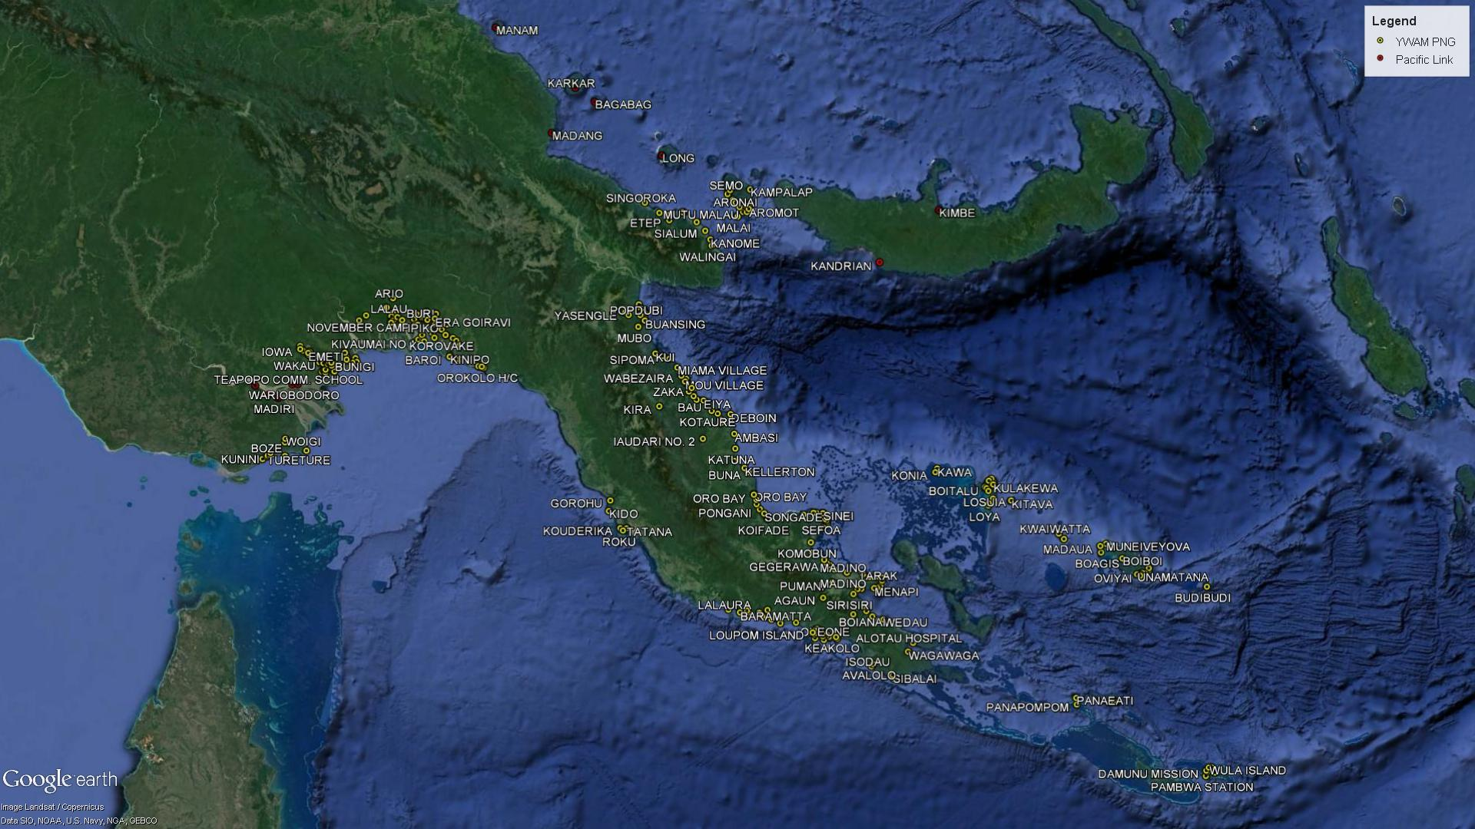

The Australian Department of Foreign Affairs and Trade (DFAT) awarded a grant of $2m over four years (2015-16 to 2018-19) to YWAM MSA. The agreement was executed in September 2015 and the first tranche of funding was received later that month. This evaluation thus incorporates the activities that were undertaken in the last quarter of 2015, in 2016 and 2017. The grant funded the acquisition of two new tenders, enabled subsequent tender operations, and funded ongoing repairs and maintenance for the mother ship.

The premise underpinning this allocation was that access to high quality, safe, well maintained and reliable tenders enables the delivery of maternal and child health, dental and eye health services and the provision of health promotion activities in very remote and difficult to reach areas of two of DFAT’s priority provinces, Western and Gulf. YWAM PNG visited Western and Gulf Provinces two times (each) per year during the reporting period and YWAM MSA also sent land-based teams into the two Provinces. (YWAM MSA also uses equipment funded by DFAT during visits to Central, Milne Bay, Morobe and Oro Provinces).

In addition to financial support from DFAT, YWAM MSA also receives substantial additional funds and benefits from in-kind contributions that support the provision of its services in PNG.

The grant agreement with DFAT sets out a performance framework that includes delivery of specific health outputs to support the achievement of the program’s six main objectives:

1. **Reduction in maternal mortality**  – antenatal care, family planning, promotion of positive maternal and child health (MCH) behaviors including skilled birth attendance, and incentivising health workers to provide an ongoing service
2. **Reduction in childhood mortality** – immunisation coverage (MR and Pentavalent immunisations), community education on immunisation, and incentivising local health workers to provide an ongoing service
3. **Addressing second tier health priorities – eye and oral health –** eye health checks, surgical services (cataract), epidemiological information on eye health shared with local health workers, school screenings (for teeth and eyes), support to eye health workers, dental care (extraction, restorations, fluoride lacquer therapy and cleaning), community education, support to health workers
4. **Health worker strengthening** – including supervisory support visitsto rural health workers and engaging and training other PNG health staff including medical students, local ophthalmologists, remote health worker teams, and others
5. **Distribution of essential healthcare consumables -** YWAM PNG acts as a supply ship, transporting essential medical commodities to remote locations.

In tandem with its service delivery activity, YWAM MSA delivers a significant amount of community education, which covers public health messages on TB, malaria, family planning, HIV/AIDS, nutrition and water and sanitation (WASH) amongst others. YWAM MSA is also committed to supporting capacity enhancement among PNG local health workers, to highlighting the needs of severely neglected populations, and to promoting positive connections between people in Australia and PNG.

## purpose of the evaluation

This document outlines the findings of the evaluation conducted between March and April 2018. The evaluation aims to review and assess the relevance, quality, effectiveness and value for money of YWAM MSA’s activities between September 2015 and December 2017 with reference to DFAT-funded activities in Western and Gulf Provinces. Despite it being a contractual requirement, a mid-term review of YWAM MSA was not undertaken. The terms of reference for the evaluation are thus very comprehensive – with a summary of the 14 objectives provided in Figure 2.

Figure 2: Objectives of the evaluation

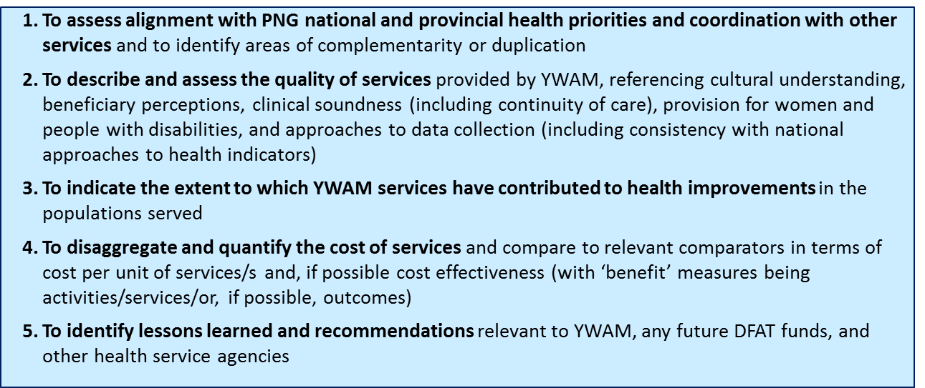

# Approach & Methodology

## Summary of evaluation plan

The evaluation uses a mixed-methods approach to explore YWAM MSA’s approach, processes and achievements. It relies heavily on qualitative data collection including a review of key documents, in-depth interviews with key informants, and observations of field activities. The qualitative data was complemented by an economic analysis. Where possible, relevant statistical data on health outcomes has been obtained.

**Evaluation questions**

The evaluation plan includes a structured framework of 14 key evaluation questions (Annex 1). The priority questions related to the quality and costs of services and perceptions of local impact. Consideration was also given to service provision from a gender and social inclusion perspective.

Where possible, the ET drew upon multiple sources in order to triangulate data and compare the perspective of different stakeholders. Differences are noted in the analysis below. Where appropriate the ET has drawn upon available third-party data from the NDoH, National Statistics Office and WHO, as well as YWAM MSA data to inform our assessment about DFAT’s investment.

**Evaluation activities**

The evaluation began with a detailed document review to understand the reported activities, challenges, and outcomes. A structured approach was being taken to reviewing documents ahead of the fieldwork in line with the key topics listed in the Evaluation Framework. A full list of documents is provided in Annex 2.

Fieldwork was conducted in Port Moresby and in a series of locations in Western Province to provide insight into different types of activities that YWAM MSA undertakes. Fieldwork included the following elements (a full list of activities and consultations is provided in Annex 2):

1. **Fieldwork briefing -** The fieldwork began with a briefing from YWAM MSA staff to provide the ET with insight into program operations, strategy, management, monitoring and reporting. The ET also attended a three-hour component of the briefings for volunteers participating in the outreach to Bamu local level government (LLG) in Western Province.
2. **Key informant interviews** were conducted with NDOH, DNPM, and provincial health authorities, the WHO, district health service providers, YWAM MSA staff and DFAT high commission staff to collect information on attitudes and perceptions of officials and toward the program. Interviews lasted 45-60 minutes and were guided by a semi-structured interview template.
3. **Focus groups** were conducted with village leaders, and men and women (separately), YWAM MSA volunteers, YWAM MSA clinical leads, and long-term staff. The ET were only able to speak with one remote health worker who was interviewed individually.
4. **Observations** of community engagement, health promotion, clinical service delivery, volunteer inductions and information sharing, were conducted to collect information on ongoing activities and contextual challenges and successes (a list of observations is included in Annex 2). The observations allowed the ET to assess indications of cultural respect and sensitivity, appropriateness of interventions, skills in procedures, and extent of/approach to mentoring/education of local staff.
5. **Feedback** on emerging findings was shared with YWAM MSA and DFAT at the end of the fieldwork phase.

## Limitations

The evaluation was limited in three anticipated ways:

* **Location sample:** Due to the limited number of days for fieldwork in PNG, and the anticipated travel distances to communities, the ET were only able to visit a limited number of the communities engaged in the project in Western Province. It was not possible to visit any locations in Gulf Province and the Acting Provincial Health Advisor was the only official available to interview from Gulf Province
* **Large number of questions:** The evaluation approach prioritises breadth of analysis over depth. The ET has relied on external data to underpin our analysis of outcomes and cost effectiveness.
* **Lack of comprehensive data:** Financial records that date back four years – and which have been compiled over a period during which YWAM MSA’s systems and processes have matured – were reviewed (e.g. the ET have learned of inconsistent definitions being used throughout the period which means that service provision numbers by category cannot be relied upon; and, the ET found inconsistent reporting of disaggregated data - by gender and age across the evaluation period).

# Findings

## Introduction to approach

PNG’s progressively deteriorating infrastructure for the distribution of goods and services - which impacts health and food security - has contributed to continued poor health indicators and an alarming increase in diseases like TB, with only marginal improvement in morbidity. This is accompanied by an increase in non-communicable disease, another area that is severely neglected. It is accepted that the poorest individuals and communities suffer the greatest impact of diminished services, as they either have to travel long distances to health facilities, or wait for outreach patrols to come to them. The public sector’s diminishing ability to provide health services means that remote populations become increasingly vulnerable.

District and provincial health services in Gulf and Western provinces are overstretched, and the health system lacks the resources or systems to deliver against its health plan. The ET visited a local level government (LLG) area in which there is only one community health worker and the closest health center is up to a six-hour journey by canoe, subject to favorable tides. Beneficiaries described a myriad of health challenges stemming from intermittent access to clean water, poor sanitation, poor nutrition, and little access to medicine. Outside of district capitals, most women give birth in their homes and they have few options in occluded deliveries.

Conducting health outreach patrols to villages that do not have stand-alone health facilities is critical to providing effective rural primary health care. YWAM MSA provides a supplemental service that help districts fulfill this service gap.

YWAM MSA delivers most of health services through mobile patrols facilitated by the ship YWAM PNG.[2] The ship completes two-week outreaches out of ports in PNG (most frequently Port Moresby) carrying the consumables and volunteer teams needed to deliver its services. The YWAM PNG serves as a ‘mothership’ with extended range tenders facilitating access to communities. Land based patrols have also been deployed alongside and independently of the ship since 2009.

The ship hosts 100-130 volunteers in a variety of teams some of who are deployed to villages close to the ship’s anchorage via small boats. In the evaluation period, women accounted for 59% of the volunteer labor across all missions. YWAM MSA benefits from an extremely motivated team of long-term full-time volunteers that manage activities. All of the long-term volunteers are required to have completed Discipleship Training School (DTS), a five-month full-time training program incorporating lectures and outreaches.

The delivery teams comprise 2-3 primary health care teams (working alongside district health teams), two health education teams, and dental, optometry, and ophthalmology[3] teams. The majority of the team members are international and there are efforts to increase cultural awareness through including PNG nationals on each team and via weekly cultural training in Townsville for the DTS volunteers. The majority of the volunteers bring specific skills to the missions (e.g. nurses, cooks, electricians, dentists, optometrists). “General Volunteers” and “DTS students/staff” accounted for about 30% of all volunteers between 2015 and 2017.

YWAM MSA also works with the district health officers to deliver land-based outreaches. In Western Province, for example, YWAM MSA teams participated in land patrols lasting 6-8 weeks in Middle Fly district between 2014 and 2016. Future land-based patrols are being planned for more remote parts of the district (Lake Murray and Nomad LLGs) in May 2018. Similarly, in Gulf Province, land-based teams delivered a one-week optometry and dental pilot program with the Kerema Hospital.[4]

## Coordination and complementarity with other services

This section outlines findings relating to YWAM MSA’s coordination with the PNG health system. It reviews YWAM MSA’s alignment with national and provincial priorities, alignment to national standards, and coordination with other health providers at the district, provincial and national levels.

### Alignment with national and provincial priorities

Overall, YWAM MSA aligns with priorities insofar as it provides a platform for primary health care for hard-to-reach rural populations, including maternal health services and immunisation. The National Health Plan (2010-2020) (NHP) prioritises strengthened primary health care for all and improved service delivery for the rural majority and urban disadvantaged. A summary of the stated priorities for service delivery and health system strengthening are outlined in Table 1. A distinctive feature of YWAM MSA’s approach is that it delivers services across a broad range of the Key Result Areas.

That being said, ophthalmology, optometry and dental work are not identified as priorities within the NHP, which emphasises a “back to basics” approach. In consultations with national and provincial health advisors, these services were described as side benefits of the YWAM MSA operational model. These services represent a significant and growing proportion of YWAM PNG’s service output - from 3% of all service numbers in 2015, increasing to 24% of all service numbers in 2016 following a refit of YWAM PNG, and then to 30% in 2017. (Overall, the target in the DFAT grant has these services accounting for 14% of all services over the 2015-2017 period; performance targets were surpassed with these three services actually accounting for 22% of all services in the period).

Table 1 National Health Plan (2011-2020) priorities and YWAM MSA services

|  |  |
| --- | --- |
| **NHP Priorities** | **Alignment of YWAM MSA services** |
| **Service delivery** | |
| KRA 1: Improve service delivery | * Co-delivery of remote health patrols with district health officers |
| KRA 2: Strengthen partnerships and coordination with stakeholders | * As above |
| KRA 3: Strengthen health systems including health workforce, financing, ICT, infrastructure, drug and medical supplies, leadership and governance) | * Informal training and support for clinical skills of rural workforce * Support for drug and medical supply chain in locations visited |
| **To address health priority outcomes in...** | |
| KRA 4: Child survival (IMCI, immunisation, pneumonia, nutrition) | * PNG standard immunisation schedule applied, (MR and Pentavalent vaccines represent a part of this schedule) * Pneumonia treatment |
| KRA 5: Maternal health (FP, population, supervised deliveries, EOC, adolescent health) | * FP services * ANC including tetanus vac’s + birth kits |
| KRA 6: Reduce burden of communicable disease (STIs, HIV, malaria, TB) | * Malaria and STI treatment * Diagnosis of TB and HIV with the intention of onward referral |
| KRA 7: Promote healthy lifestyles (health promotion, water supply, sanitation, NCDs, nutrition) | * Health promotion activities |
| KRA 8: Preparedness for diseases outbreaks (Institute of public health, CDC, CPH, climate change) | * NA |

### Alignment with national policies and standards

The NHP outlines steps that should be taken to improve the availability, accessibility, equity, quality, and use of health services. Overall, YWAM MSA facilitates engagement with remote communities that have few services, and therefore helps to improve availability and equity of health services.

A common theme in interviews with national and provincial officials was the need to ensure YWAM MSA adheres to treatment protocols. The ET confirmed that YWAM MSA adheres to standard treatment protocols and observed it in practice. YWAM MSA medical services are guided by a series of policies and manuals that are shared with volunteers (digitally) before the start of the outreach. These cover the YWAM MSA approach to service delivery, processes for consent, questions to ask during consultations, as well as detailed guidelines on clinical areas such as family planning or maternal health. The manuals refer to PNG Standard Treatment Guidelines for clinical practice in adults[5], children, sexually transmitted infections, oral health and obstetrics & gynecology. Services are delivered using the same equipment and medicines that are available to local health workers. Practically, this means taking a nurse-led approach to delivery and to using local equipment (for example, when giving immunisations YWAM MSA uses the same pre-filled syringe with an integral needle that is used by the district patrol teams).

Nevertheless perspectives on the standard of YWAM MSA healthcare delivery varied amongst national level interviewees who highlighted two concerns.

First, YWAM MSA cannot reliably deliver full preventative or treatment courses according to the timeline in the standard guidelines because of its visit schedule. For example, in one visit per six months, YWAM MSA cannot deliver the PNG Childhood Immunisation Schedule according to timelines. Full doses of MR and Pentavalent can be delivered at 12-18 months and 18-24 months respectively (although this is made difficult by regular movement of many families for hunting or work). The YWAM MSA grant agreement notes that its services are designed to bolster and not take the place of provincial and district health services, which remain responsible for delivering the required quarterly patrols.

Second, all clinical practitioners who wish to practice in PNG regardless of time period must be registered under the PNG Medical Registration Act (1980). This has not always been the case with YWAM MSA clinical staff on outreach visits and, on occasion, the PNG Medical Board (MBPNG) reports that it has been requested to grant registration retrospectively. YWAM MSA reports that overseas practitioners who volunteer aboard but do not have PNG registration are placed in the roles of final year clinical students and are supervised by registered persons. Similarly, it is understood that a volunteer on board the ship is undertaking TB smears and staining in the laboratory. The ET is advised this function is the work of a qualified medical laboratory technologist, trained at a recognised institution and registered under the Medical Board of PNG. The MBPNG was very clear that all applicants for registration must adhere to the requirements in the Act.

Several interviewees suggested appointing a senior national public health medical officer to the ship’s crew as a way of ensuring standards compliance (although, there was no suggestion as to the financial or volunteering support for this position if established). It would be difficult to view this option as an NDoH priority at this time of staffing restraint.

|  |
| --- |
| **Recommendation to YWAM MSA:**   * review procedures for registration with the PNGMB to allow sufficient time for all clinical service practitioners to be registered ahead of service delivery. This might include volunteer submission of registration documents at the point of application to YWAM MSA. It is understood that YWAM MSA are currently in discussion with NDoH and PNGMB on this matter. |

### Coordination with PNG Government-funded services

YWAM MSA has formed very strong relationships with persons of influence at all levels of government. District officials regularly participate in outreaches and the ET observed communication with provincial and district health authorities regarding outreach locations, targets and priorities. However, the YWAM MSA executive retains decision-making on locations and priorities for service delivery, and there is a need to deepen coordination with operational staff at all levels.

**National**

The ET met with the NDoH Secretary, two Deputy Secretaries, three Executive Managers and other departmental staff in both clinical support and administrative roles. Consultations with the WHO, the PNGMB and DNP&M were also undertaken. There was immediate recognition of YWAM MSA and the services it provides, a testament to a very successful communication strategy. As expected, there were varying levels of understanding of the function and geographical spread of service delivery. There was doubt as to whether YWAM MSA activity was represented in the National Health Information System (NHIS) data despite agreement that YWAM MSA provided the information regularly (discussed in Section 3.3.6).

Overall, YWAM MSA services are perceived as a welcome addition and a means of providing services to remote areas that are severely under-serviced and, in some circumstances, completely un-serviced (e.g. no immunisation due to lack of cold chain) by other health service providers.

Ownership of the YWAM PNG asset was raised as a concern in four interviews. Despite the significant contribution of the GoPNG and other local donations in purchasing the asset, YWAM PNG was not seen as ‘Papua New Guinean,’ particularly by interviewees in Port Moresby. In contrast, national volunteers and recipient communities expressed strong bonds with YWAM MSA, the vessel (and the services it provides).

Of greater concern was the lack of active involvement of national, provincial and district officials in the governance of YWAM MSA’s functions and programming of its activities. The ET observed that YWAM MSA has strong relationships with influential leaders and at the community level. However, at the executive level in Port Moresby, the ET heard descriptions of a “loose arrangement” to coordinate activities that was not in the spirit of “a true partnership.” This perhaps points to the need for YWAM MSA to ensure greater communication and information dissemination at the ‘missing-middle’ of interested stakeholders.

As an example, the ET was advised that the GoPNG decision to recurrently fund YWAM MSA was made at ministerial level and that at the Departmental level there were some difficulties in operationalising the decision effectively due to the absence of required bureaucratic process.

YWAM MSA should focus on improving communications with those in government responsible for operational-level decisions on service planning, adherence to standards and funding to enable genuine and efficient coordination of activities and allocation of resources.

The appointment of a NDoH representative to the YWAM MSA Board could well address several of the concerns raised at National level. It could also provide a direct linkage to PNG systems and an in-country point of focus on operational/administrative matters.

|  |
| --- |
| **Recommendations to YWAM MSA**:   * develop communication strategy to target mid-level key opinion holders and public servants at the implementation level to enhance understanding of YWAM MSA operations, its purpose and modalities, and to promote coordination. The ET recognises the strength of communications at the highest levels of government and with communities. * consider expanding the YWAM MSA board to include representation of a PNG national |

Three persons interviewed also commented on YWAM MSA receiving funds that they felt should be applied to other mainstream avenues of health service delivery. These interviewees described funding being diverted from mainstream health services at the political level. Others described the direct funding to YWAM MSA as a missed-opportunity cost - “*the more fund outside health service providers, the longer we delay the strengthening of our own health system.*”

Specifically, in an interview with a representative from Gulf province (the Province from which YWAM MSA has recently received an allocation of PGK 300,000), it was stated that PGK250,000 would be sufficient to maintain (not re-establish) the cold chain for the Province for a year. There was no suggestion that the Gulf donation was sourced from the health budget or indeed any expectation that it would come to the health sector in the absence of YWAM MSA.

The ET cannot predict what would happen if the equivalent amount of donor provided funding was allocated directly to the PNG health system (as there are very significant health system barriers that would prevent optimal service delivery). Certainly, YWAM MSA has been contributing to address the low immunisation coverage in Gulf Province in the evaluation period with YWAM MSA activity in the Province specifically relating to immunisation, including facilitating 6 monthly immunisation patrols in specific catchments (Karati, Baimaru and Ihu catchments in Kikori District), assistance with maintenance of cold-chain equipment in Karati in 2015, and delivery of immunisation supply to some facilities with cold-chain capacity.

**Provincial**

Provincial level health services include a hospital(s) and the provision of rural health outreach. The provincial hospital at Daru in Western Province, for example includes a well-equipped ward for TB. However, outreach services in the province are hampered by poor coordination and are restricted to the North Fly area.

YWAM MSA has developed strong relationships with influential members of Provincial Governments and visits the provinces at their invitation. This has resulted in significant financial support from a number of provinces.

The ET interviewed two Provincial Health Advisors (PHA) and a hospital CEO. The interviewees were aware of YWAM MSA’s activities, had met YWAM MSA staff, and received reports. There were also examples of provincial teams working alongside YWAM MSA – for example to deliver land-based dental and optometry outreach services in Gulf Province.

The interviewees spoke positively about YWAM MSA’s ability to access “people that feel their health is forgotten.” Provincial budgets are tight, and funding is often restricted, for example to TB and HIV programs. The officials reported that the ship enabled access to communities that district outreach teams do not reach.

However, while the provincial health offices are informed of YWAM MSA activities, they felt they have little oversight of decisions on the location or prioritisation of activities. Provincial Health Advisors are involved in agreeing targets for future visits. However, they expressed concerns over the short length of YWAM MSA visits and the small selection of villages chosen for outreach activities. It is important to recognise the potential tension developing between provincial and district health service managers/providers with the sometime competing interests of Provincial Health Authorities (PHA) and DDA’s and associated funding flows. Equally as important is the need to recognise YWAM MSA as a supplemental service and not a replacement for either provincial or district service delivery responsibilities.

The PHA’s from both Western and Gulf Provinces are keen to discuss an expansion of YWAM MSA service both clinically and geographically. Whilst there is support and funding from the political side, it is important that the mobilisation of that commitment fits functionally with the management of health services across the provinces. In any discussion on expansion, it is important that the YWAM MSA service is recognised as supplemental and not (at this time) as a substitute for provincial and district service delivery requirements.

|  |
| --- |
| R**ecommendation to YWAM MSA**:   * strengthen coordination with provincial health offices by advocating for effective health stakeholder coordination and ensuring earlier and longer-horizon planning of outreach activities. This includes coordinating involvement of Provincial personnel as well as prioritising program activities. |

**District**

Within the health system architecture, district offices are responsible for rural service provision. This includes a mandate to conduct quarterly outreach visits in order to “to provide essential immunisation, nutrition monitoring, antenatal care, and family planning.”[6]

Outreach visits to the remote communities in Gulf and Western Province visited by YWAM MSA were infrequent before it began activities. However, YWAM MSA are keen to avoid creating a parallel health system. YWAM MSA consults district health officials before its outreach and engages in proactive two-way information sharing. District teams plan for and participate in the two-week six-monthly outreaches including mobilising funds and district patrol staff, living on the ship, and co-delivering primary health services. During the evaluation, a team of five district health workers from Emeti and Balimo health centers participated in the visit, working alongside the immunisation and laboratory volunteers.

It is not possible to ascertain whether the introduction of ship services has resulted in an increase or decrease in the responsibilities felt by district service providers (as asked in the evaluation plan). At present, district staff do not conduct additional quarterly visits to the communities visited during the evaluation, citing challenges in funding flows and transportation. The district officer interviewed advocated that YWAM MSA services are expanded into other hard-to-reach areas and stay for longer time frames. However, YWAM MSA staff cite one example of a district in which the officers had initiated patrols to an LLG after a joint patrol with a YWAM MSA land team.

During the DFAT program period, district (and provincial) staff were consulted on their priorities but the final selection and planning was led by YWAM MSA. The YWAM MSA executive makes decisions on the schedule, locations and services. Communities were selected according to:

* priority areas identified by local government,
* access, including where the ship can anchor,[7]
* findings of village assessments[8] conducted prior to the first visit in 2010,
* risk assessment
* provincial funding contributions and other signs of collaboration

In focus groups, YWAM MSA staff noted they are undergoing a strategic review and discussed the possibility of expanding services in some locations while reducing engagement in others. One option for refining locations considered the level of District Development Authority (DDA) engagement and participation in the ship’s service delivery as well as the possibility of joint funding for future outreaches. However, to date YWAM MSA has not ceased engagement with any LLGs to which it provides service.

### Complementarity with other services

The ET did not observe any evidence of coordination, overlap or complementarity with other non-governmental health services. District health officers and community members reported that there were no other services in the areas visited (with the exception of DOTS village health volunteers trained by World Vision).

YWAM MSA reports relationships with a range of organisations, church-affiliated health services, and civil society organisations in Port Moresby and in other districts.[9] For example, it is planning to coordinate with the Fred Hollows Foundation and other NGOS working in the avoidable blindness sector on targets for optometry and ophthalmology services to end preventable blindness.

## Quality of YWAM MSA services

This section outlines strengths and weaknesses in YWAM MSA’s approach to service delivery including the volume of services, the quality of clinical and health education services, the approach to capacity delivery and the quality of its data systems. Several strengths that are observed across YWAM MSA’s work, including prioritisation of hard-to-reach areas, inclusion of people with disabilities, and the intention of co-delivering services alongside PNG team members. The section also discusses YWAM MSA’s emphasis on short-term missions across a wide geographical area, which has implications for the quality of clinical and education services as well as the continuum of care.

### Volume and equity of services

Table 2 provides a summary of service provision and health promotion numbers for both Western and Gulf provinces for 2015-17.

Table 2 Summary of YWAM MSA service provision in Western and Gulf provinces 2015-17

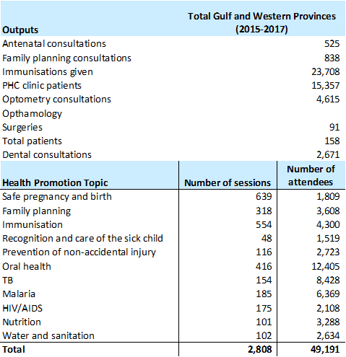

YWAM MSA visits five other provinces in addition to Western and Gulf and Table 3 outlines total service provision across the country in the evaluation period.

Table 3 Summary of YWAM MSA service provision in PNG in 2015-17

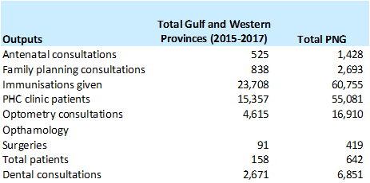

There was incomplete gender disaggregated data provided in regular YWAM MSA reporting to DFAT. Upon request the ET was provided with more detailed output reporting by gender – year on year the quality and completeness of this information varied, however an analysis of that which was provided indicates that women and men are almost equally represented as recipients of dental services and in health promotion activities (NB health promotion attendees by gender in 2015 was not provided). Men accounted for about 60% of all optometry and ophthalmology consultations and women accounted for nearly 70% of primary health consults – driven by the fact that they are recipients of antenatal care and family planning commodities. Figure 3 demonstrates these trends.

Figure 3 Gender disaggregated outputs

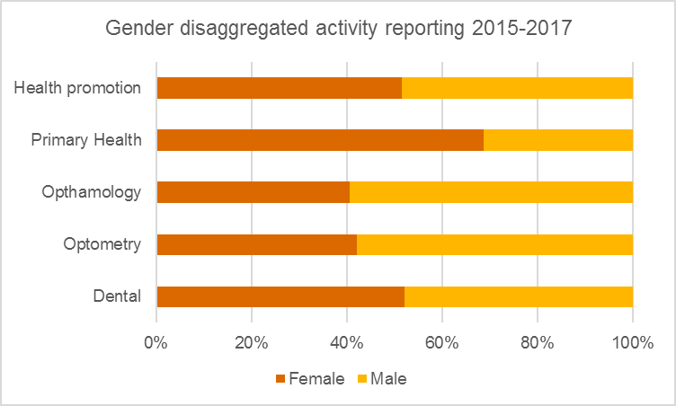

YWAM MSA staff noted challenges in delivering dental and optometry services to men and women equally. They report women will often prioritise attending the clinic for child vaccinations and there are therefore fewer women available for dental or optometry during the morning. The ET observed YWAM MSA staff actively seeking to reach both men and women, including by making lists of female patients to prioritise during the afternoon sessions.

The ET observed YWAM MSA delivering services with an inclusive approach, including actively seeking out people confined to their homes to deliver services to people who could not come to the clinic site. Three of the senior personnel on the evaluation outreach were physiotherapists with particular commitment to service provision that supports better outcomes for people with disabilities. This is also observed through prioritisation of ophthalmologist volunteers to provide cataract surgery, which is improving outcomes. The ET was unfortunately unable to convene a focus group for beneficiaries with disabilities to discuss their perceptions and there is no data on the quantum of unmet need for interventions for people with disability.

### Quality of Clinical and Public Health Services

YWAM MSA’s model is based on volunteerism, which, by its nature means that there is a high turnover of clinical practitioners from different training settings and countries. This leads to potential variability in the competence and approach of clinicians delivering services.

The ET observed aspects of clinical care being delivered by overseas trained clinicians including general practitioners, midwives, medical students and physiotherapists. Local health workers from the Balimo District, and, in some instances PNG-trained medical/dental volunteer officers, supported YWAM MSA volunteers. YWAM MSA recognises that the wide range of sources of its clinical practitioners and the turnover of volunteers from outreach to outreach heightens the need for comprehensive orientation and strong clinical supervision.[10]

The YWAM MSA outreach patrols embrace two aspects of medical care: community-level interventions for epidemiological disease control and clinical care for individuals. Quality assurance approaches need to cater to these different program elements.

In discussion with the YWAM MSA leadership team it was accepted that this is an area requiring ongoing attention. Part of their approach includes structured supervision via long-term YWAM MSA personnel. This includes a Clinic Manager, who is charged with oversight of the outreach, Senior Clinic Leaders focused on the outreach functions, and support to the various clinic leaders in the field. YWAM MSA clinic managers and senior leadership teams demonstrated a thoughtful approach to dealing with difficult clinical cases and were supported in the field with excellent radio and other communication facility.

YWAM MSA adheres to the NDoH Standard Treatment Guidelines for clinical practice in children, adults, sexually transmitted infections, oral health and obstetrics & gynecology, and maintains cold chain practice for vaccines in compliance with medical standards of practice in PNG. This cold-chain capacity was recognised by the PHA’s as a critical element of service that is currently lacking across the Provinces.

The ET did not observe PNG representation amongst the clinical leadership during the outreach - should this be representative of other outreaches it raises an important risk around sensitivity to culturally important elements of health service provision, which require special attention.

|  |
| --- |
| **Recommendation to YWAM MSA**:   * continue to strengthen the supervision of clinical practice in line with the NDoH clinical practice standards with emphasis on consistency of approach in the delivery of public health messages. * consider options for identifying and recruiting more PNG nationals who can provide clinical leadership during outreaches |

### Quality of health promotion

General volunteers deliver health promotion activities on one of 26 topics (in 14 categories) that include hand-washing, oral hygiene, and child spacing. The volunteers seek out groups of people that are waiting for clinical services, or bringing together groups of adults or children in a church building or school. Information is presented on flip-charts designed by YWAM MSA, the NDoH, and other international organisations.

Table 4 provides details about the health promotion themes, the number of sessions that YWAM MSA convened for each and the total number of attendees at these sessions in Gulf and Western Provinces during 2015-2017. These numbers are significantly higher than was targeted in the performance matrix.

Table 4 Number of sessions and attendees at health promotion sessions

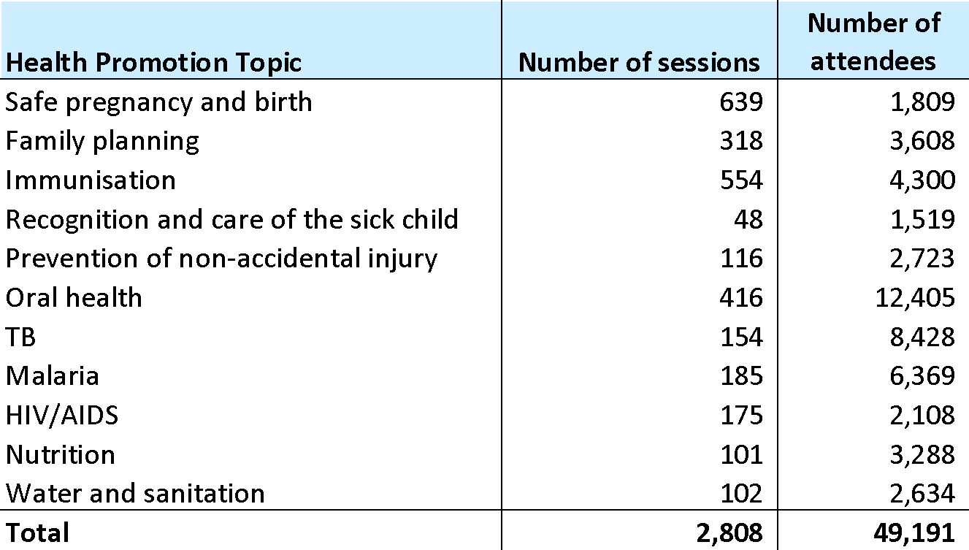

Table 5 provides a summary of health promotion activities delivered during the evaluation outreach. The activities cover a broad range of topics, but the most frequent sessions were in primary health care (most significantly general hygiene, body washing and hand washing) and dentistry (oral hygiene and how to brush your teeth). These sessions are accompanied with distributions of soap and toothbrushes/toothpaste respectively. The table also illustrates the health promotion activities conducted with smaller groups as part of health consultations. For example, ANC clinics include information on danger signs in pregnancy and safe labor. Finally, the water and sanitation promotion activities are conducted with small groups responsible for maintaining water tanks.

Table 5 Health promotion activities during evaluation outreach

|  |  |  |  |
| --- | --- | --- | --- |
| Topic | Number of sessions | Number of participants | Average session size |
| Non accidental injury | 11 | 287 | 26 |
| Malaria | 26 | 152 | 6 |
| Immunisation | 19 | 195 | 10 |
| Family planning | 32 | 468 | 15 |
| Child health | 9 | 257 | 29 |
| Safe pregnancy and birth | 77 | 256 | 3 |
| Nutrition | 34 | 539 | 16 |
| TB | 8 | 300 | 38 |
| HIV/AIDS | 2 | 74 | 37 |
| Dentistry | 51 | 1748 | 34 |
| Water and sanitation | 9 | 40 | 4 |
| Optometry | 10 | 175 | 18 |
| Primary health care (including hygiene) | 120 | 3181 | 27 |
| Other | 7 | 178 | 25 |
| **Total** | **415** | **7850** | **19** |

There is a significant capability gap between senior leaders and general volunteers in this area. The ET observed YWAM MSA staff deliver health information on pregnancy and family planning in an interactive and engaging way: incorporating words from Tok Pisin, asking beneficiaries to share what they already knew, and promoting discussion on barriers to change. The general volunteers tended to present the information in English and without facilitating discussion. The presentation style also lacked acknowledgement of barriers to practice or implementation.

Health information could also be more contextualised to the village location and to local customs. For example, volunteer midwives will encourage women to “eat more fruits and vegetables” during pregnancy. In focus groups, several women interpreted this to include Sago, a carbohydrate that provides very little protein, vitamins, or minerals. A better understanding of local options would improve the quality of information sharing.

Health education should also address the services that are being provided to ensure they are fully understood. The ET observed this happening effectively during ANC but it should be prioritised across services. In Oropei for example, women believed that immunisations would stop babies from getting sick from “*things like malaria that are here with us. It stops the babies from getting malaria, cough and TB.”*

|  |
| --- |
| **Recommendation to YWAM MSA**:   * Strengthen processes for recruitment and training of health education volunteers to lessen the skills gap between senior staff and general volunteers and to ensure contextualization of key messages |

### Capacity building of workforce and sustainable improvements

YWAM MSA seeks to build capacity of the rural health workforce through supervisory support visits and peer-support to rural health workers.[11] Focus groups with YWAM MSA senior personnel and with the rural health worker in the Bamu LLG provided examples of skill building and information sharing that can be categorised as follows:

* **Peer learning through co-delivering health services**: YWAM MSA doctors and nurses work alongside PNG health workers during outreaches for 1 - 10 days. The district health offices, for example, worked with YWAM MSA nurses to deliver vaccinations. The nurse interviewed during the evaluation similarly recounted examples of working alongside international midwives from YWAM PNG during ANC visits and exchanging information on ways of working.
* **Training or discussion:** Clinic leaders will take opportunities to review medication supplies or facilitating training discussions with remote healthcare workers. These interactions generally last 1-2 hours and revolve around learning needs that that the health worker identifies (explicitly or through informal discussion).
* **Introduction of dental services:** There are several locations (including one in Western and several in Gulf Province) where community health workers (CHWs) have worked alongside dentists as dental assistants. Dental chairs have been left behind with a small number of CHWs so that they can continue to provide basic dental services (as per the Oral Health Standard Treatment Guidelines).
* **Exposure to new areas:** YWAM MSA has facilitated at least two district health workers to conduct land patrols into new areas never previously visited by the district health service. This category also includes YWAM MSA’s efforts to introduce volunteers from PNG to health needs in hard-to-reach parts of the country.
* **Encouragement and “values”:** When asked about capacity development, YWAM MSA staff, local volunteers, and a national health advisor, all included examples relating to “values” or “character” development. This included encouraging remote health workers in their roles and supporting district health workers and PNG volunteers to develop skills in time management, volunteerism, and professional conduct.

In total, YWAM MSA has delivered 206 days of co-delivery or training with local health workers. However, it is difficult to establish the scale or depth of YWAM MSA’s contribution to stronger district health services. Staff and volunteers recounted stories and examples of sharing knowledge or supporting new skills for *individuals* in each of the categories above. Yet, while these examples are valuable, the skills building is opportunity-led, arises through relationships, and is based on an informal identification of needs. YWAM MSA does not currently have an approach to assessing capacities (at the individual or district levels) or a framework for intentionally building particular capabilities across the health network. An assessment of capacity gaps across the health workforce in YWAM MSA’s areas of activity would be a useful starting point to support capacity development.

There was only one remote health worker in the area visited by the evaluation team. She has been co-delivering YWAM MSA clinics in her village over the past five years, which she described as an opportunity to “learn from each other’s ways of working”. However, she could not recall any specific areas of learning or information exchange. When asked about how YWAM MSA could better support remote health workers, she said she would benefit from a more formal skills update, for example on new immunisation guidelines.

Finally, YWAM MSA purposefully selects underserved locations with the intention of “shining a light” on the health needs in those locations and “creating an enabling environment for others to demand better services”. Advance teams conduct a basic village assessment to ascertain priority needs and access to services. In at least two cases, this information has been used to advocate for patrols into new areas or reopening of aid posts. There is an example in Oro Province of the district continuing patrols into the area after the first visit.

|  |
| --- |
| **Recommendation to YWAM MSA**:   * formalise a capacity building approach that contributes to individual and system capabilities. Working with national, provincial and district stakeholders to develop this approach may help YWAM MSA to clarify and obtain feedback from national and provincial stakeholders on how it can contribute to system strengthening. |

### Facility and supply chain support

YWAM MSA informs district and provincial health officers of its visits and discusses how it might support the health system during its outreach. In the past, this has included providing solar power to aid posts, conducting supervisory visits, transporting and installing equipment, or transporting drugs. The specific activity depends upon the strength of the existing relationship and the support that is requested. During the evaluation outreach, YWAM MSA supported the local aid post in Bamio and the health centre at Emeti by repairing the solar power.

### Quality of data systems and learning

YWAM MSA has built a comprehensive electronic patient record system. Beneficiaries arriving at a YWAM MSA clinic are registered on a bespoke information management system built on the FileMaker platform and accessed via iPads. A local wireless network allows the doctor or nurse to view the triaged patients and flags up patients with TB. It is an intuitive and comprehensive software package, developed over several iterations, that allows YWAM MSA to monitor its services and to quickly aggregate data for reporting.

There are some concerns around patient consent and ownership of highly identifiable and sensitive data. YWAM MSA collects a significant amount of personal data including a photograph of each patient, and information on their symptoms, diagnosis and treatment, and additional details including TB status. The data is owned by YWAM MSA and is stored and shared under the YWAM MSA privacy policy. During clinic observations some patients were not told why their data was being collected. Moreover, old patient data cannot currently be recalled during clinics, which means the added benefit of collecting personalised patient data is unclear.

The NDoH is currently developing an electronic national health information system (eNHIS), which has been successfully trialed in six provinces including Milne Bay Province where YWAM MSA currently operate. Donor funding has recently been committed to expand the eNHIS nationwide which includes an enhancement that will provide mobile (i.e. non-organisationally based) ability to record activity with a geographical reference that ensures it is credited appropriately in the NHIS. Given this development, the YWAM MSA FileMaker data capture may have limited utility going forward. YWAM MSA has indicated that it is keen to be included in the eNHIS roll out.

YWAM MSA staff cited examples of aggregated data being used to underpin activity decisions. YWAM MSA uses data from previous outreaches to inform stock decisions. For example, in locations where a high number of malaria patients were previously seen, YWAM MSA report increasing their order size for first-line antimalarial medication as well as requiring midwives to routinely test for malaria.

The aggregated data from each mission is also transferred to the TB Suspects Register form, the Leprosy Reporting form, the Monthly Catchment Summary form, and Outbreak Reporting form and submitted to district health office. Despite evidence that YWAM MSA shares summary data, the ET cannot conclude whether YWAM MSA data is being consolidated at the district or provincial level. This is a systemic structural issue that is not YWAM MSA specific.

YWAM MSA also uses its patient data system to report output figures for the DFAT grant. These figures represent the number of services delivered, rather than the number of beneficiaries reached. YWAM MSA is currently reviewing its approach to M&E including strengthening output reporting and exploring options assessing outcomes. In 2017 it conducted surveys in Western and Gulf provinces to ascertain estimates on immunisation coverage and MCH care.

**Lessons learned**

YWAM MSA senior personnel take a proactive approach to learning and improvement and provided detailed insights into the purchase of the YWAM PNG, the refits, and the changes in strategy that resulted. YWAM MSA team members identified four areas of learning since the outset of the project that have informed project planning and implementation:

1. **Redundancy in service provision**. YWAM MSA staff emphasised the value of redundancy when they plan ship activities and outreach teams. In particular, staff reported that increasing the number of ship berths from 50 to 132 beds has allowed them to deliver a broader range of services and to include more local mariners and health educators.
2. **Using local equipment.** YWAM MSA began using local equipment (such as syringes) and processes (such as implants without the need for sterilisers) to demonstrate how local health workers could deliver services. This has helped counter arguments from health officials that services cannot be provided without access to high-tech solutions.
3. **Greater co-delivery of services**. Staff and volunteers emphasised that they are increasingly aware of the need to support and build the local health system whilst also delivering services.
4. **Building relationships.** In particular, leaders from the ship will establish a relationship with leaders in the community, to explain the services that are being offered. Staff noted that their role as volunteers - rather than paid service providers - is significant in establishing trust and setting expectations.

This learning is generated through a reflective discussion and information sharing within the team. However, it could be supported through a more rigorous Monitoring and Evaluation system that draws on quantitative data on costs, risks and impacts to inform decisions. YWAM MSA is conscious of the need for stronger monitoring data on outcomes and has taken steps to invest in internal capacities and develop frameworks and surveys.

|  |
| --- |
| **Recommendations to YWAM MSA:**   * strengthen approaches to ongoing monitoring and appropriate evaluation so that data feeds into operational decision-making. Collect data on the effectiveness and changes resulting fro health information activities, capacity building activities, and clinical services. This will require investment in in-house capacity and fostering a culture of continuous learning and improvement. * review data collection and privacy policy, particularly relating to ownership, use and security of patient photographs and sensitive diagnostic and treatment information * continue to investigate piloting the NDoH eNHIS |

## Contribution to health improvements

This section summarises findings on YWAM MSA’s contribution to improved health outcomes in Gulf and Western provinces. It includes comments on the perspective of rural beneficiaries as well as drawing on relevant statistical data where available.

### Perspective of rural beneficiaries

Overall, rural beneficiaries and remote health workers highly valued YWAM MSA services and teams. This is exemplified by a story recounted by YWAM MSA in which women in Gulf Province collected 2000 Kina from community members to contribute to purchase of the YWAM PNG.

Beneficiaries and community leaders participating in focus groups said that they trusted YWAM MSA health workers and that the ship provided access to healthcare that is otherwise unavailable. It is common for the teams to be unable to meet all of the demands on their time in a single day. Clinic teams use a triage system to prioritise core MCH activities and report that it is exceptionally rare for presenting children not to be immunised. In some locations, the community will organise itself so that children are vaccinated before other services are requested.

There is poor mobile signal in Western and Gulf provinces, which means that most communities are unaware of the health outreaches until the ship arrives. The nomadic lifestyles of many families mean that those who are not in the village when the ship arrives do not have time to travel in order to access services. YWAM MSA indicated though that people do at times travel to neighboring villages to seek treatment, and for this reason, the outreach itinerary is shared on arrival in an area to allow for this possibility across the following days.

Community members were positive regarding the selection of services. During focus groups, women and community leaders described their priorities as access to maternal care and child immunisation. For example community leaders in Sogeri stated:

*“The most important thing is immunisation to check the children don’t get diseases. Number two is implants to control number of children. Number three is checking the baby belly, so that if the baby is breech then the mother can rush to Bamio”*

Men discussed a wider range of priorities including maternal and child care and dental pain, as well as access to mosquito nets. They often suggested that YWAM MSA visits should be more frequent. Their perspectives on health improvements as a result of services are outlined in the next section.

Finally, while there are no formal feedback mechanisms, the ET observed community leaders discussing health priorities with YWAM MSA clinic leaders and noted several instances where men in the village presented YWAM MSA with letters of request that were opened and discussed immediately.

### Contribution to health improvements

Analysis of YWAM MSA service delivery figures and Provincial service delivery figures confirms the supplementary nature of YWAM MSA’s services - YWAM MSA services represent a small proportion of primary health services in Western Province (see Table 6). Over the evaluation period YWAM MSA administered 14% of immunisations in Western Province. In 2017, YWAM MSA delivered 1% of family planning services, 2% of mobile primary health services, and 5% of maternal health services relative to Western Province’s activity. At a more granular level, it is noted that in its contractual arrangements with DFAT, it is specified that Middle Fly District in Western Province and Kikiori District in Gulf Province will be prioritised as the locations for the YWAM PNG deployments and associated land-based teams. (The ET does not know on what basis the funding from Western and Gulf Provincial governments was provided - i.e. whether it was prioritised by district).

Table 6 YWAM MSA service provision relative to overall delivery in Western Province

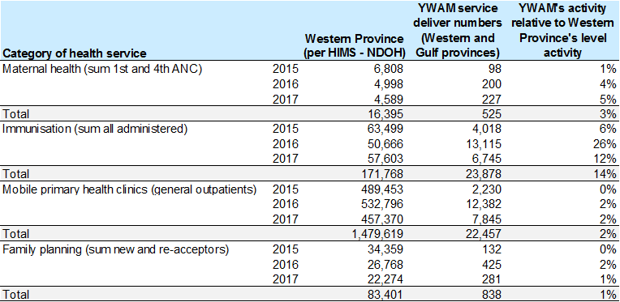

Nevertheless, the services are very significant for the communities reached. Provincial and district health officials report that there are few - or no - primary health services in the locations that YWAM MSA visits in Western and Gulf Provinces. From the perspective of rural health workers and community leaders, the most impactful services have been ANC provision (including tetanus immunisations and birthing kits), immunisations for children, and access to long-term family planning.

There is no robust longitudinal data on primary health or MCH outcomes at the local level in PNG (from YWAM MSA or others). The supplementary and location specific nature of services means that attribution of any change in district or Provincial level data (which itself is often of poor quality) is problematic. Discussion of health outcomes data at the Provincial level are discussed in the next section on cost effectiveness (Section 3.5.3).

**Immunisations**

YWAM MSA has provided a full or partial course of the Measles-Rubella (MR) Vaccine and Pentavalent Vaccine[12] to children, as well as the tetanus vaccine to pregnant women. In total more than 6,500 children in Gulf and Western provinces received vaccinations from YWAM MSA in the review period and YWAM MSA administered nearly 24,000 vaccinations in total.

YWAM MSA has not collected baseline data on immunisation coverage and there is no secondary data on immunisation rates for the LLGs visited. YWAM MSA did conduct a small survey of 102 children in villages served in Middle Fly District (Western Province) in 2017 and found a coverage level of 80.4%. MR vaccine coverage at 16 months was 4.5% for children born between June 2009 and Nov 2011 (before the first ship outreach) compared to 27.9% for children born since Sept 2014 (not statistically significant 5% level). In a survey of 88 children in communities served in Kikori District (Gulf Province), the coverage was 79%. The rate at 16 months increased from 14% to 53% in the two age cohorts (statistically significant at the 5% level). Similar increases were seen among the sample for Pentavalent Vaccine coverage at 24 months.[13] The small sample makes it difficult to draw conclusions about the herd immunity levels achieved at the LLG level. Whilst the data indicates that YWAM PNG is contributing to improved diseases prevention at the village level the six-monthly visit schedule makes timely vaccination difficult which possibly constrains impact of immunization activities.

|  |
| --- |
| **Recommendation to YWAM MSA:**   * A systematic approach to service planning be adopted that enhances coordination between YWAM MSA supplemental services and the province/district outreach services. YWAM MSA could assist in the process of setting a coordinated annual visitation program with the functions of each entity clearly defined. |

**Family planning**

Local aid posts deliver contraceptive injections and promote family planning at the community level.[14] YWAM MSA has augmented this family planning provision through 838 contraceptives (including implants that are effective for five years) in the reporting period.

A YWAM MSA survey of 107 women in 14 villages it visits in Middle Fly district (Western Province) and 100 women in 13 villages in Kikori district (Gulf province) found that family planning coverage was 53% and 75% respectively in 2017. YWAM MSA does not have baseline data for this cohort to establish any relative increase.

Community leaders report that the majority of women are open to family planning for child spacing but emphasised the importance of men and women attending clinic together (something that was observed in several cases during the clinics). Many women attending focus groups had contraceptive implants or injections and were positive about the effects of family planning on their families. For example, women in Sogeri explained:

*“Since the boat comes, things are more ok. Now we have the option to have the implant. Before more women dying because of child complications but with the implant fewer mothers are dying. The children’s growth was also not good but now we can see that the children are growing”*

Nevertheless, there were a small number reported rumors that implants could lead to sickness or death, which underlined the need for ongoing community engagement and discussion on family planning to address concerns as they arise.

**Maternal health**

*“Our greatest health challenge is childbirth. We are worried about the complications. If it doesn’t turn out to be good then it is difficult. You have to paddle down the river for an hour but often there is no transport”* **-** Women focus group in Sogeri

Health promotion by local aid posts, and supplemented by YWAM MSA, has encouraged women to access ANC. In Gulf and Western Provinces, women access ANC at the local aid post, often travelling by canoe. YWAM MSA has augmented these services with 525 ANC appointments that also include a tetanus vaccination and provision of a birth kit that includes a clean knife for cord cutting (a major risk for infection is cutting the cord with a dirty object).

In focus groups, the majority of women reported delivering with unskilled birth attendants at home. If there are complications in the locations visited, women will attempt to reach the aid post at Bamu or - in exceptional circumstances - to travel to the hospital at Daru. For most women, there are few realistic referral options.

Nevertheless, YWAM MSA provides information on the referral pathway for clinic leaders and includes information on referrals in the clinic inductions for all health personnel. Midwives said that they would check with the clinic leader for referral options if needed. However written information could help inform their understanding of the local context.

**Other primary clinic services**

The primary health clinics diagnose and treat a broad range of ailments - from malaria to diarrhea to knee pain. The clinics will diagnose TB (a mobile laboratory is housed aboard the mothership) and HIV, but refer patients onward (normally to the local aid post) for treatment.

**Dental and eye care**

*“It is important for us because when the YWAM MSA ship comes here it is telling us about our tooth problems. When we experience pain we can go across to them and have teeth out”* - Male focus group in Torobina

Focus group participants were enthusiastic about the provision of dental and eye care. A vanishingly small proportion of CHWs have experience in dental work and dental pain is generally left unresolved. In Gulf and Western provinces combined, YWAM MSA has delivered 2,671 dental consultations and almost 16,000 toothbrushes. It has also delivered 4,615 optometry consultations (with provision of glasses) and has completed 91 cataract surgeries.

**Health education**

*“They do lessons on washing hand and brushing teeth each time they come. We already knew about washing hands. The new thing that one lady taught us is how to deliver the babies and how to take the baby out of the mother’s womb. How to wash and feed the baby. She was from America and she explained how to cut the cord with razor or bamboo.” Women in Torobina*

YWAM MSA has delivered a significant number of health information sessions that exceeded planned targets. For example 3,288 attendees participated in 101 nutrition sessions and 1,519 attendees participated in training on child sickness. These topics are very relevant given the high stunting rate and under-five mortality rate in PNG.

YWAM MSA has not yet collected any data on knowledge or practices relating to its health education and therefore it is not possible to ascertain the level of knowledge transfer, retention or change in practices. YWAM MSA recognized this as a weakness in its approach to monitoring and reported that it is developing survey tools to facilitate future assessment of change in knowledge and behavior.

In focus groups, men and women recalled that they had attended health promotion activities on family planning, HIV, diarrheal diseases, and hygiene. However few were able to recount the details of messages. For example, men in Torobina could recall a lesson on oral hygiene but could not remember what they had learned.

The community education appears to have promoted the importance of immunisation, family planning and ANC among community members. For example, village elders in Sogeri said that as a result of the health promotion they collect children together in the morning during YWAM MSA outreaches so that vaccinations can be given ahead of other health services.

However, others were unable to describe actions that had been taken as a result of education activities. They described significant barriers to practicing health promoting behaviors - such as access to clean water - that need to be more thoroughly understood by YWAM MSA.[15] This could be achieved through barrier analysis (or similar) process.

|  |
| --- |
| **Recommendations to YWAM MSA**:   * Conduct knowledge, attitude and practice (or similar) survey to obtain baseline information on knowledge on key health information topics in the communities served * Consider barrier analysis or other participatory methods to explore the barriers to behavior change in the communities served and to tailor messaging accordingly |

## Cost of services

### Overview of economic context within which YWAM MSA is operating

Notwithstanding a PNG Government goal of providing universal primary health coverage, service delivery indicators – such as outpatients visits per person, immunisation rates, skilled birth attendance and antenatal care – have generally declined over the period from 2006 to 2016. This decline is due to a myriad of constraints related to human resources, the availability of supplies, infrastructure, financing and geography. These systemic level challenges are experienced more acutely in rural and remote areas, where rural aid posts continue to close, and facilities conduct only a fraction of planned outreach activities.

Despite the pressing need to improve health outcomes, current budget projections indicate that health spending is likely to decline substantially in the coming years, forcing the sector to rely on efficiency rather than additional resources to improve service delivery. Public spending represents over 80 percent of total health expenditure (THE). Thus, the current budget projections of a 29 percent decline in public health expenditure from 2016 to 2021 are likely to result in a sharp fall in THE. These cuts, combined with high projected population growth, will likely see real per capita THE in 2021 fall to levels of the late 1990s.

Improving the quality of spending will be vital if PNG is to minimise the impact of reduced financial resources on the delivery of health services, and to translate the available funds into improved health outcomes. Ensuring adequate health services for the roughly 80 percent of Papua New Guineans who live in rural areas remains critical. In this context, innovative new methods and partnerships for rural service delivery may need to be considered, such as expanding partnerships with churches, telemedicine, and supportive supervision.

YWAM MSA is one potential partner with whom the District, Provincial and National Departments of Health can collaborate to augment service delivery activity and thereby contribute to improved health for a vulnerable and chronically underserved rural and remote population in Gulf and Western Provinces.

‘Quality of spending’ as it relates to YWAM MSA is an issue that is pertinent to DFAT, the National Government of PNG, Provincial Health Authorities and District Development Authorities as well as to individual private donors. As financial backers of YWAM MSA, each of these contributors should understand:

* the economic viability of the model of operation, including sources of funding, cost base, activity projections and financing pipeline
* operational level policies and procedures that inform day to day financial decisions, including those relating to procurement
* governance arrangements that are in place to support strategic decision making, including decisions pertaining to the suite of services on offer and the geographic ‘footprint’ within which services will be made available.

The evaluation TORS have been used to frame responses to each of these issues.

### Understanding YWAM MSA revenue and expenses and potential to disaggregate unit costs

As is consistent with a volunteer-based approach**,** the majority of YWAM MSA’s revenue is accounted for in ‘donated labor and gifts’. During the period 2015-2017, YWAM MSA’s revenue showed an upward trend and, in this time, donated labor and gifts represented an increasing proportion of overall revenue (see Figure 4). ‘Donated labor’ accounts for almost 50% (AU$9.9m) of total revenue over 2015-2017. This figure represents the accumulated value of volunteer time – with each individual ‘valued’ according to the role that they play in the missions. Australian pay scales have been used as bases for the applied rates (e.g. the Australian crew salary guidelines[16], pay scale guidance[17] for specialist health roles). Volunteers do not attract a financial cost (i.e. they are classified as non-monetary revenue and expenses). There is however an economic and opportunity cost associated with these volunteers, i.e. the volunteers themselves are resources that, if they were not spending time on YWAM MSA missions, could have been undertaking other activities that could, at least in principle, have generated health impact.

Monetary revenue fell by just on a third from AU$3.5 million in 2015 to AU$2.4 million in 2017.

Figure 4 Disaggregation of YWAM MSA revenue

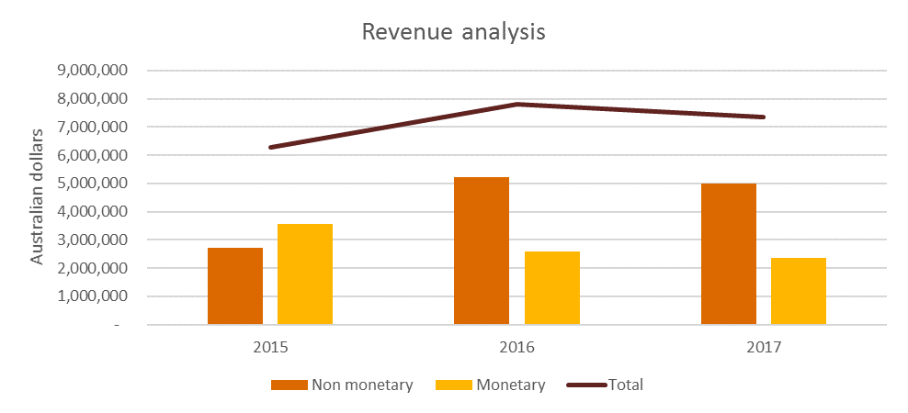

Analysis of ‘Monetary’ revenue over this period showed that whilst DFAT’s contribution to overall revenue is small, in terms of contribution to monetary revenue, it has been of increasing importance over the grant period. ‘PNG monetary donations’ and ‘PNG grants and sponsorship’ have represented declining sources of monetary revenue for YWAM MSA year on year but remain an important source. PNG sourced donations, grants and sponsorship originate from a variety of sources, including the National Department of Health, National Department of Planning and Monitoring, Provincial and District Authorities, and PNG businesses. PNG originating contributions have been declining during the evaluation period - this is not unexpected in an economic climate that has been characterised by budget cuts and financing bottlenecks (see Figure 5 which represents both capital and operational funding).

A diverse funding base is important, especially when operating in a fragile environment like PNG where the economy is vulnerable to shocks e.g. resource price fall, foreign exchange crisis etc. YWAM MSA’s public relations and marketing approach ensures a profile that attracts sponsorship.

Figure 5 YWAM MSA source of monetary revenue

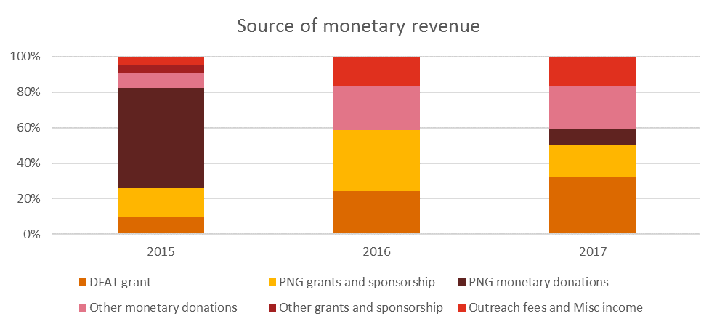

Total expenses over the same period have shown an upward trajectory with the valuation of ‘volunteer labor’ plateauing and stabilising at about half of overall expenses from 2016 (see Figure 6).

Figure 6 YWAM MSA expense analysis

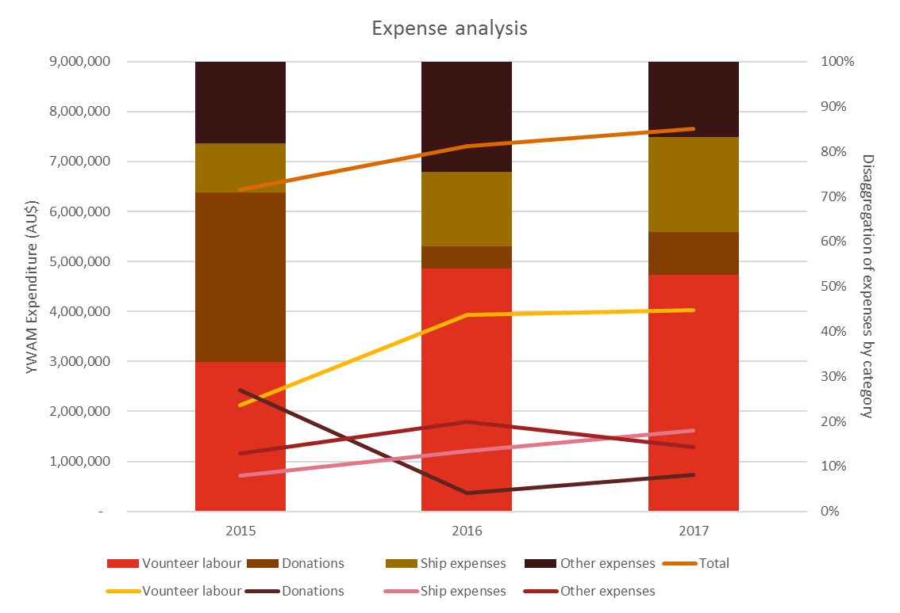

Of those expenses that have monetary implications, ship expenses have shown an upward trend in real terms and represent an increasing percentage of total monetary expenses year on year (see Figure 7).

Figure 7 Monetary expense analysis

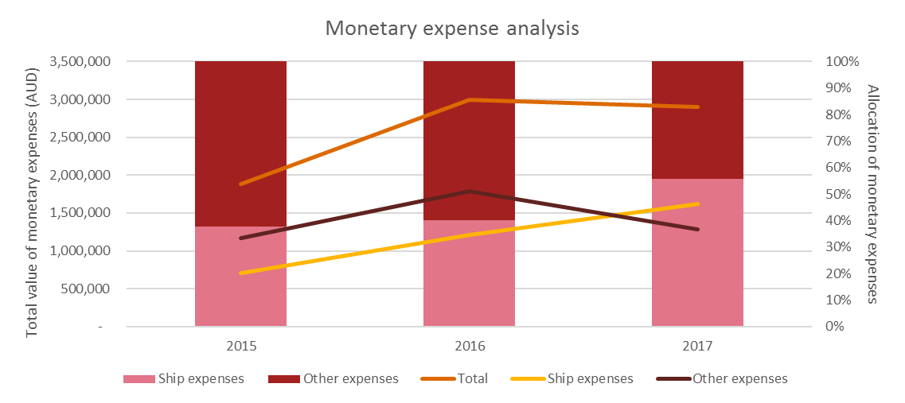

This increase relates to completion of acquisition of the new vessel in 2015 and outlays in the subsequent years associated with the fit out of the boat and investment in auxiliary equipment (e.g. tenders) to enable more efficient and safer service delivery, including in more remote areas.

“Other expenses’ is largely representative of the overhead costs associated with YWAM MSA operations. This category includes employee expenses (some YWAM MSA head office staff are paid employees), medical expenses, office administration, travel costs, insurances, depreciation, legal and financial and advertising/marketing costs, along with a miscellaneous category. These costs have decreased as a percentage of monetary costs from 62% in 2015 to 44% in 2017. When considering total monetary and non-monetary expenses, ‘other expenses’ account for 18%, 25% and 17% in 2015, 2016 and 2017 respectively.

Figure 8 illustrates the downward trend in capital costs over the evaluation period. The YWAM MSA finance team have indicated that they expect a stabilisation of expenses in the future now that the fit out is completed.

Figure 8 Allocation of monetary expenses across cash and capital

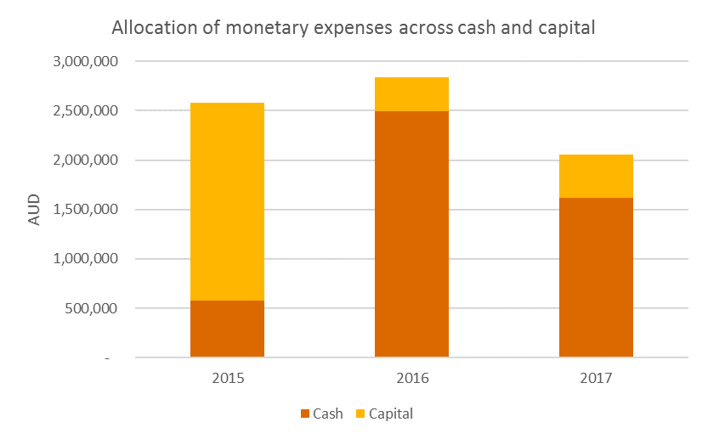

DFAT’s grant to YWAM MSA has been acquitted to date largely in line with the budget as agreed in the contract. Almost 70% of DFAT grant funds in the 2015-17 period were allocated across the costs of the two new tenders, subsequent tender operations and ongoing repairs and maintenance for the mothership (see Table 7).

Table 7 Acquittal of DFAT grant 2015-17

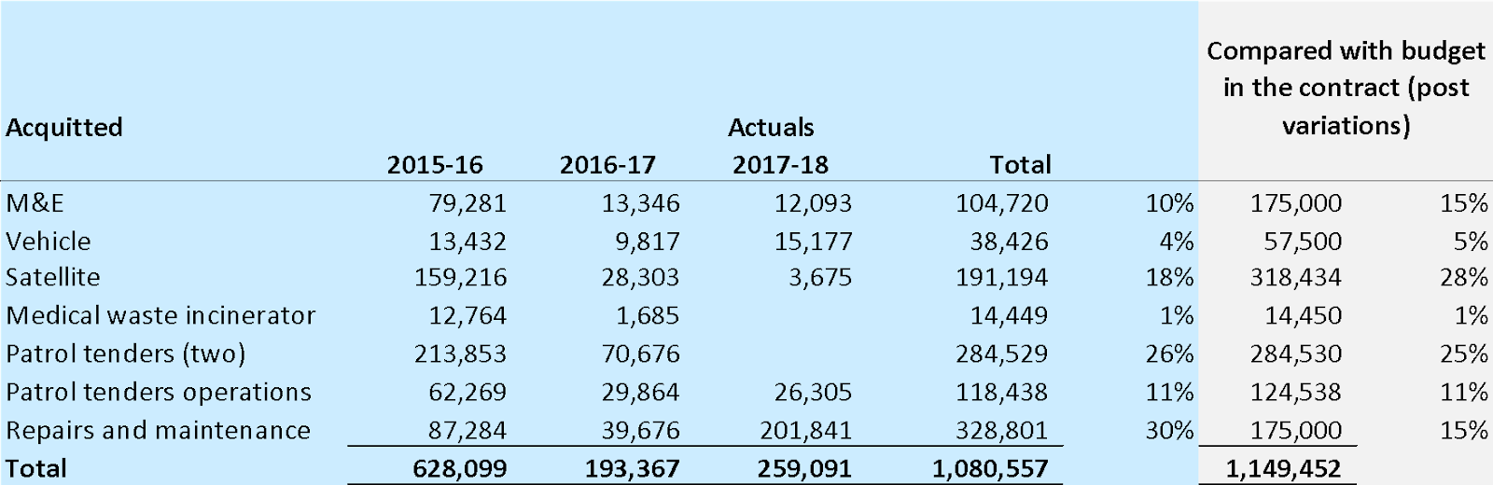

The performance metrics associated with the DFAT grant relate to delivery of health services and information and capacity building of PNG service providers. As proscribed in the contract however, the majority of the grant funds have been used to cover the capital and operating expenses required to acquire and maintain the mother ship, tenders and other ship related outgoings. YWAM MSA’s reported service delivery outputs indicated that they have well exceeded target levels (see Table 8).

Table 8 Comparison of actual outputs versus performance targets

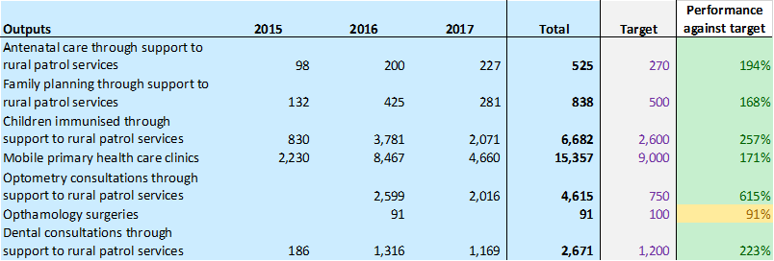

It is difficult to draw conclusions about the information in this table based on the following limitations:

* the reporting is of raw output numbers rather than performance against baseline, hence it is not possible to determine relative performance
* in discussions with YWAM MSA is was acknowledged that when the grant was awarded the potential service delivery increase associated with the larger ship and improved tenders was difficult to predict, although projections for a five-fold increase in capacity were made at the outset. These estimates have been well exceeded and this three-year period has provided an opportunity to learn about how to maximise the breadth of reach of the activities
* the reporting period spans a time during which the mothership has been continually upgraded with each re-fit enabling increased service numbers (the quantum of which would have been difficult to predict in 2015)
* inconsistent reporting of outputs is evidenced throughout the reporting period - e.g. some of the outputs have been misclassified (this largely relates to application of different definitions relating to immunisation v’s mobile primary health care clinics); in some reports number of children immunised is provided in the logframe and in others it is the number of vaccines administered; and in some reports the child/adult disaggregated information is provided and not in others.
* there are no obvious trends for any of the types of services except that over time, optometry and dental consultations account for increasing proportions of overall service delivery numbers (24% and 30% in 2016 and 2017 respectively).
* the high numbers of immunisations in 2015 relate to the fact that there was a measles outbreak in PNG in 2014-15 and in response the government initiated a large-scale national vaccination campaign to bring the outbreak under control. YWAM MSA provided measles vaccination as part of this campaign. This was an atypical event and the trend is not then representative of more regular patterns of immunisation provision.

**The uncertainty associated with these output numbers precludes analysis that could elicit a ‘cost per unit of service’.**

Service delivery numbers alone are not representative of YWAM MSA’s broader approach to working in partnership with the government of PNG to contribute to better health outcomes for rural and remote populations. YWAM MSA delivers health promotion sessions addressing safe pregnancy and birth, family planning, immunisation, prevention of accidents/injury, oral health, TB, malaria, HIV/AIDS, nutrition and water and sanitation in tandem with the outreach missions that it conducts. In reports to DFAT, YWAM MSA indicates that health promotion efforts reached approximately 50,000 attendees during the 2015-17 period. This far exceeds the target health promotion attendee numbers in the performance matrix which was 17,250 over the three-year period. This could be indicative of an inability to accurately predict the demand for information at project inception but it also reflects the fact that a single person can attend multiple health promotion sessions and that each one of these sessions (whether a one on one discussion when waiting in line for primary health services or as a participant in a formal, group education session) is being counted. Whilst it is positive that there are large numbers of attendees at health promotion sessions, these raw numbers provide no insight about the effectiveness of such sessions.

YWAM MSA is also committed to supporting the development of capacity among PNG health providers and to this end has provided training sessions in which more than 300 PNG health workers from both Western and Gulf Provinces have participated. PNG health workers have also been specifically engaged in the provision of ophthalmology services.

And finally, YWAM PNG has been used as a supply ship, helping to distribute medical supplies to rural locations and providing transport for provincial health teams, enabling them to deliver on their commitment to provide rural outreach services.

### Have YWAM MSA’s activities impacted health outcomes in Western and Gulf Provinces?

It is not possible to determine whether YWAM MSA’s activities have impacted on health outcomes because reporting is at the output level. That being said, analysis has been conducted to measure YWAM MSA’s outputs relative to the overall level of activity at the Provincial level. Provincial level activity information relates to Western Province only. Data comes from the NDoH health information management system. YWAM MSA service numbers are for activities in both Western and Gulf provinces so the relative relationship is overstated. YWAM MSA’s optometry and dental health activities have been categorised as ‘primary health’ activities for this analysis to ensure that all service delivery activities are captured.

As illustrated in section 3.4.2 at the output level, YWAM MSA’s service delivery activities in Western and Gulf provinces represent a very small proportion of total provincial level activity.

Notwithstanding the relatively small number of services, those that have been provided by YWAM MSA have reached populations that otherwise would likely not have received any health services at all. YWAM MSA’s contribution is thus valuable, particularly in provinces that are largely underperforming compared to national level performance against indicators set out in the National Health Plan (2010-2020). For example, in the NHP 2016 Sector Performance Annual Review it was shown that:

* Gulf was one of the three provinces with the lowest measles vaccination rate for children under one with coverage rates of 19.24% and 23.6% in 2015 and 2016 respectively compared with national coverage rates of 29.2% and 36.4% across these two years. In Western Province in 2015 coverage rates exceed national rates (46.8% versus 39.2%) but in 2016 this reversed with a provincial coverage rate of 27% compared with the national rate of 36.4%
* percentage of third dose pentavalent coverage in children under one year shows the same trends with Gulf Province coverage significantly lower than national level 19% and 25% in 2015 and 2016 compared with a national coverage rate of 54% and 44% in these two years. Western Province showed a downward trend from 57% coverage in 2015 to 28% in 2016
* antenatal coverage rates in both Gulf and Western provinces are much closer to the national average (which has shown a decline in all regions between 201 and 2016)
* both provinces demonstrate better than the national rate for availability of medical supplies in both 2015 and 2016.

### Does YWAM MSA analyse cost effectiveness of primary and secondary prevention vs curative approaches?

The ET is not able to determine whether YWAM MSA analyses the cost effectiveness of primary and secondary prevention versus curative approaches. That being said, curative services (i.e. ophthalmic surgeries) are a very small percentage of overall services and the evidence in the literature indicates that cataract surgery is one of the most cost effective public health interventions[18].

### Comparison of YWAM MSA services with comparative cost models

There is scant costing information available from PNG that can be used to underpin cost comparisons across different approaches to health interventions. The ‘Papua New Guinea: Modeling costs and efficiency of primary health care services in PNG’ study produced by the Monash University Centre for Health Economics in 2011 is considered by the NDOH as the best basis for cost analysis[19]. As is the case for any modelling exercises, this study relies on a variety of assumptions and thus caution should be applied when interpreting the findings. The model provides us with costs per service and annual costs of running health centers in nine districts in Western Province. Health centers are both easy and difficult to access and include both government and Catholic service providers. There are no patrol outreach activities associated with these health centers. The study notes that a number of provinces would need to invest in bringing health centers to Minimum standard for procedures - this absence of infrastructure undermines provincial level capacity to deliver services.

This evaluation does not attempt to compare YWAM MSA costs with costs in the government and Catholic sectors in Western province. Rather, we have used the per service costs from the study and applied them, adjusted for CPI and exchange rate movements, to the output numbers that YWAM MSA has reported for Western and Gulf provinces to provide an indication of what it could cost to deliver the same number of services through a *facility-based model within the health system*. The YWAM MSA service delivery model is one based on outreach and hence it is not appropriate to draw conclusions about the relative costs of service delivery. Furthermore, there can be no certainty about how the equivalent amount of funding would be spent at the provincial health level. In an environment in which fiscal resources are scarce and acknowledging that the provincial governments are providing financial contributions to YWAM MSA, these comparisons might be useful considerations when making difficult allocative decisions. As an example, in a discussion with the PHA on maintaining the cold chain (currently non-existent), the ET were advised that approximately K250,000 would deliver on that requirement.

Two comparison scenarios are presented (see and Table 9 and Table 10) : the first uses unit costs that are 72% of the national average costs (the Monash modeling study finds that Western province annual costs are running at 72% of the national average running costs); and the second scenario runs comparisons using Western province average numbers (but noting that costs are not provided for service delivery in all of the nine districts considered in the study)Salary costs are the largest contributor to annual costs and are accounted for in the Monash modeling. Year on year inflation rates have been applied to the costs of services.

The ET was unable to source comparative costs for rural dental consultations nor optometry consultations. For the dental consults we have taken the mid-point between the costs associated with general inpatient and outpatients and applied this to the number of YWAM MSA services. This is a reasonable assumption - it acknowledges that delivery of dental services takes more time and skill that general outpatient services but equally, that it is not as technical as general inpatient costs.

Table 9 Calculating the costs of delivering YWAM MSA service numbers using 72% of the national average as the cost base

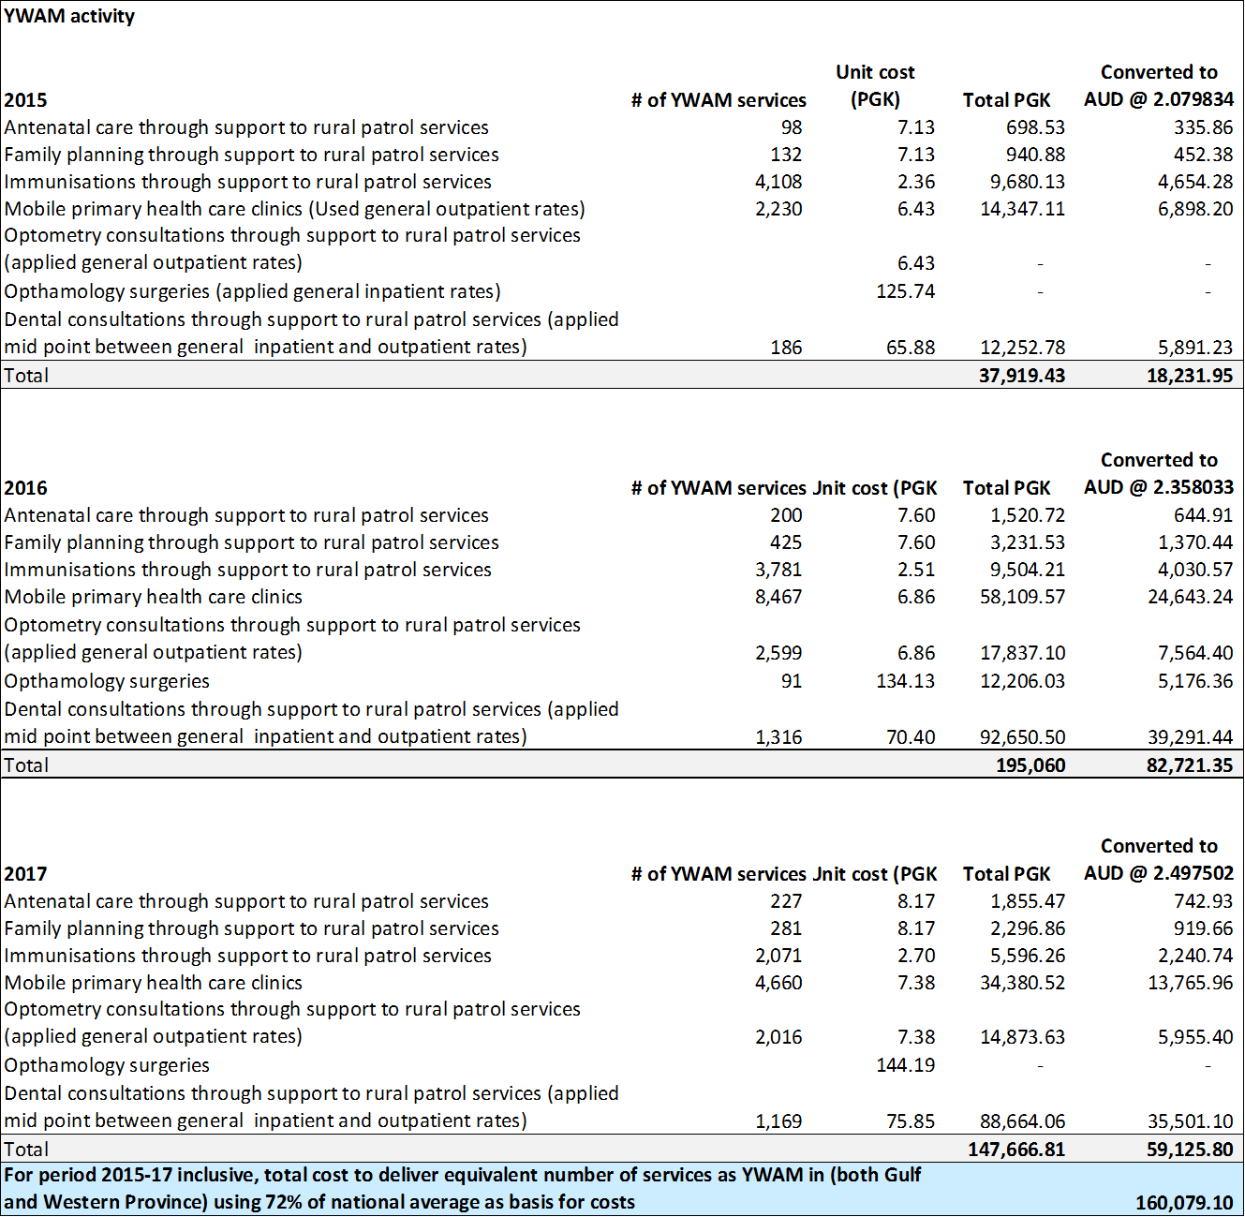

Table 10 Calculating the costs of delivering YWAM MSA service numbers using the average costs for Western Province

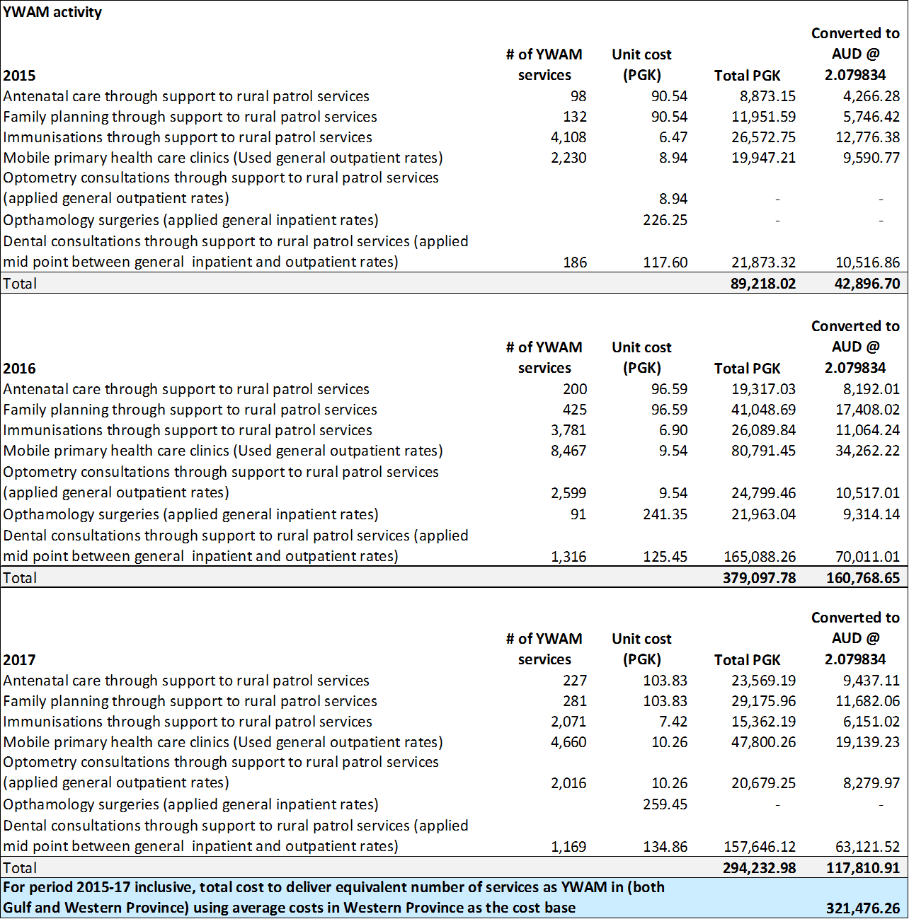

It is acknowledged that YWAM MSA provides more than just these services during outreach visits - YWAM MSA also delivers health promotion education sessions; health worker mentored clinical placement; water and sanitation activities including tank installation, maintenance and repair and water filter training as necessary; and, solar electrification of some remote health facilities. Delivering these additional activities has financial implications - the costing model does not provide costs for such activities and so these have not been included in the analysis. Furthermore, the service costs represent the costs at the district level and do not take into account the overheads that are associated with delivering health in a national health system.

# Recommendations

**Recommendations to DFAT:**

* consider developing a costing model for remote patrol based health services in PNG
* invest in partnership with YWAM MSA by providing a more thorough review and response to submitted reports and by working with YWAM MSA and GoPNG to agree on mutually beneficial priorities and outcome areas
* prioritise mid-term evaluations for new partner organisations to support stronger partnership and improve learning
* the competitive grants program presents an opportunity to consider YWAM MSA’s appetite for responding to findings and recommendations in this evaluation and to work with YWAM MSA to strengthen coordination and collaboration with GoPNG

**Recommendations to YWAM MSA**

**Strengthening collaboration and investing in higher-level development of PNG**

* consider expanding the YWAM MSA board to include representation of a PNG national
* develop communication strategy to target mid-level key opinion holders and public servants at the implementation level to enhance understanding of YWAM MSA operations, its purpose and modalities, and to promote coordination. The ET recognises the strength of communications at the highest levels of government and with communities.
* strengthen coordination with provincial health offices by advocating for effective health stakeholder coordination and ensuring earlier and longer-horizon planning of outreach activities. This includes coordinating involvement of Provincial personnel as well as prioritising program activities.
* review procedures for registration with the PNGMB to allow sufficient time for all clinical service practitioners to be registered ahead of service delivery. This might include volunteer submission of registration documents at the point of application to YWAM MSA. It is understood that YWAM MSA are currently in discussion with NDoH and PNGMB on this matter.
* continue to strengthen the supervision of clinical practice in line with the NDoH clinical practice standards with emphasis on consistency of approach in the delivery of public health messages.
* consider options for identifying and recruiting more PNG nationals who can provide clinical leadership during outreaches

**Management and governance**

* strengthen processes for recruitment and training of health education volunteers to lessen the skills gap between senior staff and general volunteers and to ensure contextualization of key messages
* conduct knowledge, attitude and practice (or similar) survey to obtain baseline information on knowledge on key health information topics in the communities served
* consider barrier analysis or other participatory methods to explore the barriers to behavior change in the communities served and to tailor messaging accordingly
* strengthen approaches to ongoing monitoring and appropriate evaluation so that data feeds into operational decision-making. Collect data on the effectiveness and changes resulting from health information activities, capacity building activities, and clinical services. This will require investment in in-house capacity and fostering a culture of continuous learning and improvement.
* review data collection and privacy policy, particularly relating to ownership, use and security of patient photographs and sensitive diagnostic and treatment information
* continue to investigate piloting the NDoH eNHIS

**Reviewing approach**

* A systematic approach to service planning be adopted that enhances coordination between YWAM MSA supplemental services and the province/district outreach services. YWAM MSA could assist in the process of setting a coordinated annual visitation program with the functions of each entity clearly defined.
* formalise a capacity building approach that contributes to individual and system capabilities. Working with national, provincial and district stakeholders to develop this approach may help YWAM MSA to clarify and obtain feedback from national and provincial stakeholders on how it can contribute to system strengthening.

# Annexes

## Annex 1: Evaluation framework

The evaluation follows a structured framework that outlines 14 key questions, with sub-questions and sources of evidence that should be consulted for each. Multiple sources are consulted for each evaluation topic in order to triangulate assertions and compare the different perspectives of stakeholders.

|  |  |  |
| --- | --- | --- |
| **TOPIC** | **SUB-TOPIC** | **SOURCE** |
| Volume of services provided by YWAM MSA | * Quantity of beneficiaries reached * Equity, gender, disability and vulnerability characteristics of the beneficiaries * Skills, experience and cultural understanding of the service providers | * YWAM MSA six-monthly reports * Service delivery observations |
| Perception of rural beneficiaries | * Perceptions of remote health workers on activities and impact * Perceptions of community on activities and impact * Effectiveness of community health promotion activities * DP perceptions align with sustainable development objectives | * Focus groups with remote health workers and wider community * Feedback from individual beneficiaries |
| Alignment with national and provincial priorities | * Services align with national and provincial priorities * Services align with national and provincial policies and standards * Extent of data sharing with the national health information system | * Comparison of Government plans with YWAM MSA activities in document review * Key Informant Interviews (KII) with national and provincial health officers |
| Quality of clinical and public health services | * Relevance of services * Assessment of clinical governance policies, processes and systems * Assessment of quality assurance mechanisms (including continuity of care: considering referral networks) * Are adolescents provided with family planning advice and are there any sensitivities for YWAM MSA as a faith-based organisation? * Strengths and weaknesses in approach to service delivery | * YWAM MSA reports * KII with YWAM MSA staff * KII with remote health workers * KII with other stakeholder * Observations of service delivery |
| Contribution to health improvements | * Proportion of MCH and eye and dental care services (in Western and Gulf Provinces) provided by YWAM MSA * Assessment of the nature, quality and quantity of health services provided * What services have the highest impact in terms of improved health? | * Document review (with reference to available data from YWAM MSA and third-parties regarding vaccination, family planning, ANC, eye and dental care)[20] * KII with remote health workers |
| Quality of data systems | * Approach to data collection * Extent to which data approaches complement health information systems * Extent to which data informs project design and implementation * Has YWAM MSA been able to use data to improved cost effectiveness? * Critical gaps and how they might be filled | * Document review (with reference to available data processes and indicators) * KII with YWAM MSA staff * KII with GoPNG |
| Coordination with PNG Government-funded services | * Degree to which YWAM MSA services are coordinated with Government-funded services * Degree to which YWAM MSA services are building capacities and contributing to sustainable improvements * Evidence that YWAM MSA is adding to – rather than substituting - GoPNG services and responsibilities | * KII with YWAM MSA staff, government officials, and remote health workers |
| Complementarity and duplication | * Extent of complementarity / overlap with other health services (included those funded by Australia or other donors, NGOs and mining companies) * Assessment of whether there has been decline in other service provision? | * Review of health plans to identify other services * KII with government health officers and other stakeholders |
| Gender and people with disabilities | * How do YWAM MSA services impact women and people with disabilities * Assessment of whether there any groups being systematically missed | * Focus groups with female beneficiaries and people with disabilities * Data on beneficiaries and YWAM MSA volunteers by gender |
| Disaggregated costs | * Cost of providing YWAM MSA services disaggregated by source of funding; direct and indirect costs; and key inputs and activities (cost per unit of service/activity) * What are the key drivers of cost and how have they changed over time? * What are the trends in terms of volume of services? * Does YWAM MSA analyse cost effectiveness of primary and secondary prevention vs curative approaches? * What services have the highest impact in terms of cost? | * YWAM MSA financial records * YWAM MSA acquittal reports * YWAM MSA progress and annual reports |
| Comparison of YWAM MSA services with other health service providers | * If possible, compare YWAM MSA delivered services with relevant comparators in terms of cost per unit of service/s and, cost effectiveness (with ‘benefit’ measures being activities/services/or, if possible, outcomes) | * Literature review * YWAM MSA progress and annual reports |
| Lessons learned | * What has been learned that is relevant to other health service delivery agencies | * Drawing on all sources |
| Recommendations | * How should future service delivery be improved * How should any future funding be focused | * All above on all sources |

## Annex 2: List of evaluation activities

**Document review**

|  |
| --- |
| **PNG documents and reports**   * National Health Plan 2011-2020 * Standard Treatment Guidelines for Common Illness of Adults in PNG * Standard Treatment Guidelines for Common Illness of Children in PNG * 2016 Sector Performance Annual Review: National health plan performance report card * National Health Plan 2011-2016 Sector Performance Annual Review Scorecard (District Profiles against National Averages) * NDOH Assessment health services (Took kit for districts) * Western Provincial Administration: Middle Fly District Health Integrated Patrol Program. Dated March 2018. * PNG Medical Registration Act 1980 (consolidated to 21 of 1998) * Standard Treatment for Common Illnesses of Children in Papua New Guinea 9th Ed, 2011 * NDoH EPI Aid for Health Workers 2016   **YWAM MSA – DFAT funding agreement and reports**   * Deed of variation between YWAM Medical Ships Australia and Abt Associates * HHISP Grant Agreement * HHISP YWAM MSA Annual Report 2015 * HHISP YWAM MSA Annual Report 2016 * HHISP YWAM MSA Annual Report 2017 * YWAM MSA Financial statements 2015-2018 * Indicator performance   **YWAM MSA Documents**   * 2018 Outreach Information * 2018 'Preparing to come' * Outline of Group Medical Orientation * Letter from Consort express regarding Cadet Service and Training onboard YWAM PNG * Family planning policy * YWAM MSA briefing for NACD APril 2017 * 2018 Outreach 3 Personnel List * YWAM MSA Steamship Trading Company 2017 Sponsorship Report * 2014-18 outreach schedules * Gulf and Western province maps of YWAM MSA impact areas 2014-18 * Summary of land based activities in last 12 months * Board meeting agenda December 2017 * Map of Gulf and Western engagement 2014 - 2018 (to compliment the broader, PNG-wide, map also provided) * Summary of MOUs in PNG * Village assessment form 2017 * Summary statistics from Week 1, Outreach 3 2018 (field week aboard) * Health promotion statistics for Outreach 3 2018 * Risk Management Manual (general); * Summary of land-based outreach patrols 2014-17 * Procurement policy: summary document drawing on streams of guiding policy and procedure   **Other reports**   * Financing PNGs free primary health care policy user fees funding and performance * Australian Government Health for development strategy 2015-20 * National department health policies - Reproductive health training unit * Australian Government Aid Investment Plan * PNG Health Delivery Strategy 2011-15 * Monash University (2011) Papua New Guinea: Modeling costs and efficiency of primary health care services in Papua New Guinea. Produced by the Monash University Centre for Health Economics. * ADI Integrated Rural Health Patrols & In-Service Training in New Ireland, PNG 5-Year Evaluation: 2011-2015 Analysis and Key Findings * Morrison and Henderson (2017) Five years of ADI Integrated Rural Health Patrols in New Ireland, PNG. 14th National rural health conference * Service delivery and reform in PNG 2002-2012: A lost decade? * Service delivery by health facilities in Papua New Guinea: report based on country-wide health facility survey. May 2017 |

**Fieldwork activities in Western Province including focus groups and observations**

|  |  |  |  |
| --- | --- | --- | --- |
| **Activity** | **Detail** | **Male participants** | **Female participants** |
| 17/03/2018 | | | |
| Orientation | Including initial briefing and tour of ship.  Travel to Western Province |  |  |
| 18/03/2018 | | | |
| Briefing | Introduction to YWAM MSA activities and modalities |  |  |
| Observation | Volunteer induction (3 hours) |  |  |
| Observation | Community introductions (3 hours) |  |  |
| 19/03/2018 | | | |
| Observation | Community meetings | 75 (inc children) | |
| Observation | Registration of patients and ANC set-up |  | 2 |
| Observation | Hand washing health education (for children, 45 minutes) | 30 | 40 |
| Observation | Health education on maternal care |  | 5 |
| Observation | Family planning clinic including 2 x implants |  | 2 |
| Observation | Community discussion on water supply and broken tanks | 5 |  |
| Focus group | Village leader, pastor and teacher | 3 |  |
| Focus group | Male beneficiaries | 4 |  |
| Focus group | Female beneficiaries |  | 6 |
| 20/03/2018 | | | |
| Observation | Community meeting | 90 (inc children) | |
| Observation | 2 x health education on family planning | 10 |  |
| Observation | Primary health clinic including immunization (1 hour observation) | 5 + 10 infants | 13 + 10 infants |
| Observation | Dental health education and clinic (1 hour observation) | 5 | 5 |
| Immersive observation | Dr Gideon Gelesi participated in a day-long primary health clinic including treating and observing treatment of MCH patients, PHC outpatients and optometry patients | 12 cases | |
| Focus group | Community leaders | 10 |  |
| Focus group | Male beneficiaries | 5 |  |
| Focus group | Female beneficiaries |  | 8 |
| Interview | Dental clinic lead |  | 1 |
| 21/03/2018 | | | |
| Observation | Community meeting | 70 | |
| Observation | Dr Gideon Gelesi participated in treating an emergency patient onboard including observing procedures and working alongside district and YWAM MSA teams (4 hours) |  |  |
| Observation | Health education on maternal care and observation of volunteer clinician engagement (30 minute observation) |  | 10 |
| Focus group | Community leaders and male beneficiaries | 7 |  |
| Focus group | Female beneficiaries |  | 3 |
| Interview | In depth discussion with remote health worker |  | 1 |
| Focus group | Review of Filemaker clinic management and health information system |  | 2 |
| Focus group | Clinical management team |  |  |
| 22/03/2018 | | | |
| Observation | Primary health clinic (30 minute observation) |  | 4 |
| Observation | 2 x health education for oral care and hygiene | 40 | |
| Focus group | Community leaders | 2 |  |
| Focus group | Male beneficiaries | 5 |  |
| Focus group | Female beneficiaries |  | 8 |
| Interview | Village councilor | 1 |  |
| Interview | Follow-up discussion with remote health worker (with additional evaluator) |  | 1 |
| Interview | District health officer |  | 1 |
| Focus group | Senior (long-term) YWAM MSA personnel | 5 | 1 |
| Focus group | Short-term YWAM MSA volunteers | 4 | 4 |
| 23/03/2018 | | | |
| Focus group | Senior YWAM MSA personnel on future plans | 2 | 1 |
| Observation | Laboratory |  |  |
|  | Travel to Daru |  |  |
| 24/03/2018 | | | |
|  | Feedback on ship-based evaluation activities |  |  |

**Consultations and key informant interviews**

|  |  |  |  |
| --- | --- | --- | --- |
| **NAME** | **POSITION** | **ORGANISATION** | |
| YWAM MSA MEDICAL SHIP | | | |
| Ken Mulligan | Managing Director | YWAM MSA | |
| Anna Scott | Director / Public Relations and Media Manager | YWAM MSA | |
| Jeremy Schierer | Director / Port Captain | YWAM MSA | |
| Jeana Wiemeyer | Management Committee / Ship Manager | YWAM MSA | |
| Sarah Dunn | Management Committee / Doctor | YWAM MSA | |
| Matt Scott | Management Committee / Marine Superintendant | YWAM MSA | |
| Angelica Langlais | Clinic Leader | YWAM MSA | |
| NATIONAL Dept. HEALTH | | | |
| Pascoe J Kase | Secretary for Health | NDOH | |
| Paison Dakulala | Deputy Secretary (NHSS) | NDOH | |
| Elva Lionel | Deputy Secretary (NHP &CS) | NDOH | |
| Ken Wai | Executive Manager - Strategic Policy | NDOH | |
| Navy Mulou | Technical Advisor– Health Economics | NDOH | |
| Sibauk Vivaldo Bieb | Executive Manager – Public Health | NDOH | |
| Goa Tau | Executive manager – Medical Standards & Accreditation | NDOH | |
| Melkior Taminza | National Health Information | NDOH | |
| Gregory Mainao | Technical Advisor – Oral Health | NDOH | |
| Abel Marome | Technical Advisor - Leprosy | NDOH | |
| Kimberley Kawapuro | Policy & Research Officer – Office of Deputy Secretary | NDOH | |
| Anna Maalsen | Team Leader – Health System Strengthening | WHO | |
| MEDICAL BOARD | | | |
| Osborne Liko | Chairman | MBPNG | |
| Paul Sali | Deputy Chairman | MBPNG | |
| Western Province | | | |
| Gordon Mase | Director Nursing | | Balimo H/C |
| Alma Maraga | Nursing Officer/Midwife | | Daru Hospital |
| Daniel Pelowa | Medical Laboratory Technician | | Balimo H/C |
| Wessy Girinde | Medical Laboratory Assistant; Microscopist & Gene Xpert Technician | |  |
| Violet Baida | Nursing Sister | | Bamio Aid Post |
| Orpah Tugo | Chief Executive Officer | | Daru Hospital |
| Benny Kombuk | Director Medical Service | | Daru Hospital |
| Department of National Planning & Monitoring | | | |
| Michael Bejigi | Assistant Secretary-  Social Monitoring & Evaluation | | DNPM |
| Rose Raka - Koyama | a/First Assistant Secretary –  Monitoring & Evaluation Division | | DNPM |
| Osana Mera | Senior Monitoring & Evaluation Officer | | DNPM |
| Dorothy Marang | Senior PO –  Education | | DNPM |
| Ilma Gani | Assistant Secretary  AusAID Branch FAD | | DNPM |
| Chi –Haru Sait | AID Coordinator – Health  AusAID Branch FAD | | DNPM |
| Nathan Gabriel | PO – Education Social Sector  SAD | | DNPM |
| Francis Nori | PPO – Health, HIV & AIDS  Social Sector Branch | | DNPM |
| Elisha Tamanabae | Trainee – Law & Justice Sector  SAD | | DNPM |
| Gulf Province | | | |
| Ben Bal | Provincial Health Adviser | | Gulf Province |

1. Papua New Guinea: Modeling costs and efficiency of primary health care services in PNG’ study produced by the Monash University Centre for Health Economics in 2011
2. The majority of services in Gulf and Western Province are delivered through day-long patrols and on-ship clinics, but YWAM MSA also conducts 2-5 day patrols to more remote communities during ship outreaches, as well as extended range outreach patrols by helicopter or on foot.
3. Ophthalmology teams are deployed to Gulf and Western Provinces every two years
4. Other patrols have been undertaken to other Provinces
5. http://www.adi.org.au/wp-content/uploads/2016/11/Standard-Treatment-Guidelines-for-Common-Illness-of-Adults-in-PNG.pdf
6. National Health Plan 2011-2020: Volume 1 policies and strategies
7. Some communities not accessible by boat are reached via land-patrols or Heli-supported extension patrols
8. Village assessments are made through a discussion of health needs, priorities and challenges with community leaders and representatives before the ship’s first visit
9. YWAM advised the ET that it collaborates in the field with the Fred Hollows Foundation, PNG EYEcare, Layla Foundation and Pacific International Hospital; PNG Prevention of Blindness League; Gulf Christian Services and Anglican Health Services among others.
10. As well as appropriate registration, which is discussed in Section 3.2.2
11. YWAM also delivered capacity building activities outside of its health work, including experience for local trainee mariners and for those interested in hospitality sector. Each outreach includes approximately 20% team members from PNG (the evaluation outreach included 41 team members from PNG).
12. covering Diphtheria, Pertussis, Tetanus, Hepatitis B and Hib. DPT
13. data was collected by a YWAM team from households in the communities where clinics are conducted. The team worked hard to achieve representative coverage but a random sampling strategy was not possible.
14. For example, over 20% of female focus group attendees reported receiving regular contraceptive injections from the local aid post
15. YWAM has attempted to support better access to clean water through replacing taps on broken water tanks however there are challenges associated with ongoing vandalism to tanks
16. http://www.crewpacific.com.au/crew-information/worldwide-salary-guidelines/australia
17. https://www.payscale.com/research/AU/Job=Dentist/Salary
18. Chao, T. et al. *Cost-effectiveness of surgery and its policy implications for global health: a systematic review and analysis.* Lancet Glob Health 2014;2: e334–45
19. Per discussion with Navy Malau, Health Economist, PNG NDOH
20. We are aware that there is a paucity of reliable third-party data in the regions under study.