
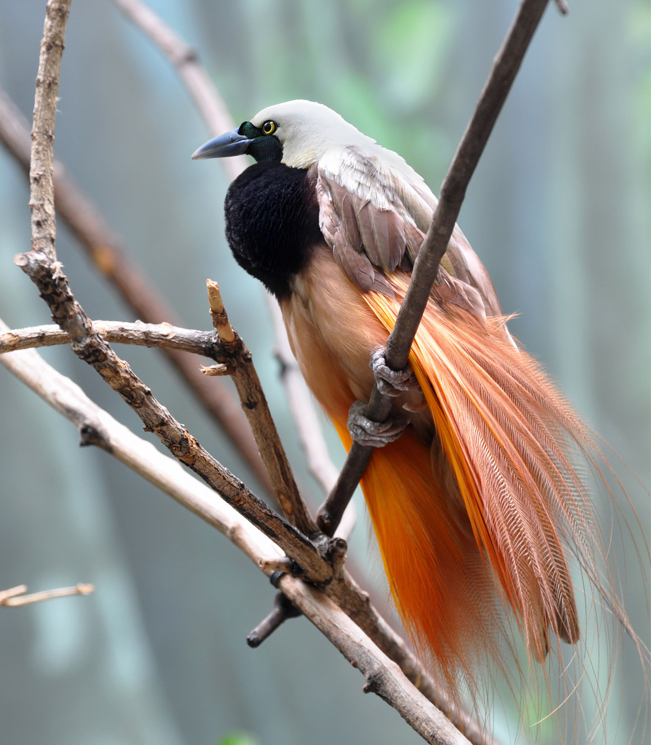

Final Independent Evaluation

9 November 2022

Education Emergency Response and Recovery Plan (EERRP)

Education Emergency Response and Recovery Plan (EERRP)

Final Evaluation

9 November 2022

© Commonwealth of Australia, 2020
Copyright protects this publication. Except for purposes permitted by the Copyright Act 1968 of the Commonwealth of Australia, reproduction, adaptation, electronic storage, and communication to the public is prohibited without prior written permission. Enquiries should be addressed to
All third-party material, including images, contained in this publication remains the property of the specified copyright owner unless otherwise indicated, and is used subject to their licensing conditions.

Key information | Details
Disclaimer | This document has been produced with information supplied to HDMES by sources/data collection methods. While we make every effort to ensure the accuracy of the information contained in this report, any judgements as to the suitability of the information for the client’s purposes are the client’s responsibility. The views expressed in this report are those of the review team and do not necessarily reflect the views of the Australia Government. HDMES extends no warranties and assumes no responsibility as to the suitability of this information or for the consequences of its use.

Contents
Abbreviations and Acronyms ii
Executive Summary 1
1. Introduction 5
2. Program Background 5
2.1 Evaluation Purpose 7
2.2 Approach and Methodology 7
2.3 Evaluation Limitations 10
3. Key Findings 11
3.1 To what extent has the EERRP progressed its four intended outcomes/phases, considering different results/approaches for boys and girls? 11
3.2 To what extent is the EERRP being delivered efficiently? 23
3.3 To what extent are the EERRP’s management and implementation arrangements appropriate (e.g., NDoE oversight/involvement, role of the grant agent, implementation approaches/partners etc.)? 24
3.4 To what extent has the EERRP mainstreamed and incorporated GEDSI strategies? 26
3.5 What are the key lessons from the design of the EERRP 27
3.6 What are the key lessons from the implementation of the EERRP? 28
4. Recommendations 30
Annex 1 – Terms of Reference 32
Annex 2 – GEDSI Spectrum 43
Annex 3 – List of Documents 45
Annex 4: List of People Consulted 46
Annex 5 – School Visit Schedule 51
Annex 6 – EERRP Partners 53
Annex 7 – EIE Technical Working Group Members 54
Annex 8 – Secretary's Circular No: 19 of 2020 55
Annex 9 – Secretary's Circular No: 5 of 2020 59

Abbreviations and Acronyms
Term | Definition
AHC | Australian High Commission [Port Moresby]
AUD | Australian Dollar
DFAT | Department of Foreign Affairs and Trade [Australia]
DRM | Disaster Risk Management
EERRP | Education Emergency Response and Recovery Plan
EiE | Education in Emergencies
FGD | Focus Group Discussion
GEDSI | Gender Equality, Disability and Social Inclusion
GoA | Government of Australia
GoPNG | Government of Papua New Guinea
GPE | Global Partnership for Education
HDMES | Human Development Monitoring and Evaluation Services
HLP | Home Learning Pack
ICT | Information Communication Technology
IERC | Inclusive Education Resource Centres
KEQ | Key Evaluation Question
KII | Key Informant Interview
M&E | Monitoring and Evaluation
NCD | National Capital District
NDoE | National Department of Education
NES | National Education System
NGO | Non-Government Organisation
PEA | Provincial Education Authority
PNG | Papua New Guinea
PSS | Psychosocial Support
SBOM | School Boards of Management
SLIP | School Learning and Improvement Plan
SoE | State of Emergency
TBK | Teacher Booster Kit
TOR | Terms of Reference
ToT | Training of Trainers
TWC | Technical Working Committee
UNICEF | United Nations Children’s Fund
WASH | Water, Sanitation and Hygiene

 | Executive Summary

This report details the results and findings of a final evaluation of the Education Emergency Response and Recovery Plan (EERRP). The evaluation assessed the overall effectiveness of the EERRPP in supporting the National Department of Education (NDoE), through its Education in Emergencies (EiE) cluster to respond to the COVID-19 pandemic. The evaluation covered the implementation period of May 2020-October 2022.
The evaluation had two purposes:
- Assess: This involved an assessment of the following: (i) progress towards the EERRP’s intended outcomes; (ii) the extent to which the EERRP was implemented efficiently; (iii) the appropriateness of management and implementation arrangements; (iv) the extent to which gender equality, disability, and social inclusion (GEDSI) have been addressed in the response; and (v) key lessons from EERRP’s design and implementation.
- Inform: The assessment also informed recommendations relevant to the ongoing implementation of the EERRP, as well as efforts to strengthen the resilience of the education system more broadly and specifically in management, operational and policy settings.

Data collection included: (i) a desk review and analysis of key program documents; (ii) an initial briefing with DFAT and HDMES staff (iii) Key Informant Interviews (KIIs); (iv) Focus Group Discussions (FGDs); and (v) final analysis and synthesis. A total of 100 interviews were conducted (43% male and 57% female). A total of 45 students were interviewed (33% male and 67% female). A total of 21 schools were visited across three provinces.

To what extent has EERRP progressed against its four outcomes?
The EERRP is a highly relevant and appropriate plan for mapping, planning, and developing a context-specific approach to responding to the COVID-19 pandemic. The EERRP was not a normal or traditional emergency response, given the unprecedented nature of the pandemic, which tends to focus on immediate needs to distribute support and focuses on “quick returns” and outputs. The ERRPP has made solid progress towards defined outputs, intermediate outcomes, and broader outcomes. Results against key outcomes include:
Outcome 1: To what extent were boys and girls in target areas able to safely learn remotely?
The PNG Government issued Circular 19/2020 authorising the shutdown of schools. The initial consideration of the evaluation was that schools were locked down for extended periods, however it appears that most schools only shut for a period of two-weeks and in some cases, did not close at all. Provincial Education Authorities (PEAs) acted relatively independently to respond to needs; and principals and teachers also provided relevant work assignments and homework for students. Schools in urban settings tended to complete more learning from home than those in rural areas.
The success of programme interventions to support home learning were somewhat mixed. Given that these were newly developed, the Home Learning Packs (HLPs) and Techer Booster Kits (TBKs) were delivered well after initial lockdowns and remote learning but are of high quality and are a significant contribution to NDoE for the future. From a GEDSI perspective, the HLPs and TBKs are inclusive, consistently portraying images of girls, boys, and children with disabilities.
There are some concerns related to the “equity” of the distribution of resources. It is unclear in some cases how schools were prioritised and selected.
Outcome 2: To what extent have boys and girls and male and female teachers in target areas returned to school safely?
Given that schools ultimately only closed for a short period or didn’t close at all meant that this EERP outcome itself is somewhat obsolete. However, all emergency guidance emphasised the need for adaptions on return to school to account for learning losses and wellbeing impacts of the emergency. Most schools visited during the evaluation took initiatives to enable the children’s learning to continue by sending home lessons/assignments and shifting teaching and classes during the lockdown.
The most significant current threat to school enrolments and returning to school is reported as the threat of community violence due to ethnic clashes and recent political elections. Most teachers have also returned to teaching positions, with reporting suggesting that 96% of all teachers in targeted schools have returned to teaching positions. From the perspective of students, approximately 25% of students of both genders in mainstream schools were identified as having left or withdrawn from school during the lockdown, primarily due to parents’ and guardians’ fear of COVID-19 transmission in schools.
The backpacks were intended to be provided to students in the most remote areas to encourage their return to school and provide them with essential learning materials. However, distribution of these materials has faced a range of challenges that undermine their purpose, including inadequate supply of the packs to the schools to meet needs; inappropriate approaches taken for pack distribution to the students; and partial pack distribution, where useful stationery items were missing from the bags.
The WASH component is highly relevant and appropriate and has helped support a safe return to school. The WASH component has faced significant delays due to the time taken to complete assessments, access available resources, and transport the infrastructure to sites. While WASH infrastructure was broadly well received by schools, discussions with implementing agencies and schools indicated that planning and construction did not consider gender and disability accessibility issues. Of the 21 schools visited, only one school in Port Moresby and one in Lae had WASH clubs. All schools that had received WASH facilities had received hand washing training.
Outcome 3: To what extent are boys and girls in target areas safe and learning?
Schools play a vitally important role in the safety and wellbeing of students. The provision of mental health and psychosocial support to students and their families is an important component of this.
Key activities under the psycho-social support (PSS) and wellbeing component of the EERRP include developing a training program for guidance officers and teachers, including practical PSS support and wellbeing resource materials and guidelines for teachers. These were developed with the technical support of Griffith University, Australia. There are some questions around gender elements of the training and the impacts of challenges that boys and girls face. The cascading of training has not been as successful to date as anticipated, particularly for PSS training.
Outcome 4: To what extent is the education system more resilient to future disruptions?
Despite the challenges of COVID-19, the EERRP has supported the NDOE to make significant changes and contributions to strengthening the education system going forward. DRM training was well received by all schools visited, and schools expressed appreciation for the training provided to support them, even though most schools are yet to or are in the process of drawing up their DRM Plan.

To what extent is the EERRP being delivered efficiently?
Emergency responses are inherently complex. While demand and expectations are often high, the reality of planning and distributing assistance is very different. The nature of the EERRP tended to focus on developing resources that would be useful not only for the COVID-19 response but could also be utilised in future emergencies or responses. Despite delays, the EERRP has witnessed a significant acceleration of support in the last 12 months.
The use of sub-grantees for localised implementation and management working under the guidance and coordination of UNICEF and under the overall leadership of the NDoE is efficient.

Management and Implementation Arrangements
The EERRP was GoPNG designed, implemented, and managed. The use of UNICEF as a coordination agency was sound and builds on success of experience and knowledge. The use of UNICEF in a coordinating role also supported the NDoE to maintain a more strategic oversight role while maintaining close control over implementation and decision-making functions.
The use of NGOs and sub-grantees is appropriate and advantageous. The key reason is that NGOs have a presence in target areas, can mobilise resources quickly and often have pre-existing relationships with local authorities and communities. One area for improvement through the program is, however, the coordination between and amongst NGOs.

GEDSI
The evaluation found that overall attention to gender equality and inclusive education was a strong feature of the NDoE’s approach to implementing the EERRP. Overall, the EERP has invested in resource and skills development that has significant potential to increase equitable access to learning and improve learning outcomes. While some EERRP activities explicitly addressed gender and disability considerations, others would have benefited from more explicit attention to the specific challenges faced by girls in emergency and post emergency contexts and the barriers to education for children with disabilities that are exacerbated by crises and emergencies.

Key Learnings
The evaluation identified several key learnings from both a design and implementation perspective. The lessons reflect many of the findings and include commentary around: (i) design; (ii) alignment to policies and plans; (iii) coordination arrangements; (iv) use of local leadership and decision-making structures; (v) engagement with provinces and districts; and (vi) equity in distribution.

Key Recommendations
The following recommendations are indicative and based on initial observations and findings from the field:
Recommendation 1: NDoE, through the EiE TWC, to ensure that strategies and plans are prepared to ensure that HLPs and TBKs are mainstreamed and supported in schools. NDoE should also coordinate with UNICEF to make sure all relevant training is provided to principals and teachers. NDoE should also confirm that educational tools and approaches continue to be utilised in future emergency response or for student absences and where remote learning is required.
Recommendation 2: NDoE to review current communication and engagement protocols with Provincial and District authorities to ensure there is a clear and consistent chain of command for future emergency responses. At present provincial authorities tend to be excluded from information sharing and are often not engaged in decision-making which leads to independent and ad hoc decisions and approaches being applied that often contradict national guidance (i.e. compliance with school lockdown circulars).
Recommendation 3: UNICEF to initiate a series of audits and spot-checks in coordination with sub-grantees to ensure that all resources have been procured and distributed according to agreed schedules and plans and to update the reporting of results to reflect an accurate picture of what has been achieved to date.
Recommendation 4: NDoE and development partners, in response to future emergencies, should focus more on immediate resourcing needs of schools (e.g., pens, paper, printer ink etc) while other more longer-term resources are developed (e.g., manuals and learning packs). Teachers and principals are resilient and are well positioned to respond to immediate needs. However, school budgets are often tight and there is limited scope to adjust to emergency responses.
Recommendation 5: In response to the recommendation above, NDoE and PEAs should discuss and consider the allocation of emergency budget lines that could be mobilised at short notice to respond to all emergencies. Un-used budget in the event of no emergencies could be reallocated to other budget lines in accordance with government guidelines and procedures.
Recommendation 6: DFAT, UNICEF and sub-grantee partners to carefully consider full cost implications of participation in emergency response events and the provision of infrastructure (particularly WASH facilities). The evaluation noted several unintended outcomes, particularly to the provision of water which have caused considerable stress for schools with regards to the payment of water bills, particularly in urban areas. The same also applies to the “cost” of removing teachers from schools to attend training events, often creating opportunity cost effects through school closures and disrupted classes. Provision of limited HLP resulted in schools needing to do multiple copies, increasing printing and photocopying cost and schools drawing from other budget lines. Intended and unintended costs should be fully reflected in partner proposals and budgets.
Recommendation 7: DFAT and UNICEF to arrange a no-cost extension to enable NGO partners to complete outstanding WASH facilities. A recommended timeframe is for 9-months through to the end of June 2023. Participating NGOs should develop clear workplans and strategies to fulfil target requirements and report fortnightly to DFAT on progress.
Recommendation 8: DFAT to consider options and strategies to integrate teacher professional development (psychosocial support and disaster risk management support) into broader government-government bi-lateral education programs. This would build upon gains derived through the EERRP and to support the institutionalisation of DRM plans into broader SLIPS and other institutional arrangements for schools.

 | - Introduction

This report details the results and findings of a final evaluation of the Education Emergency Response and Recovery Plan (EERRP). The evaluation assessed the overall effectiveness of the EERRPP in supporting the National Department of Education (NDoE), through its Education in Emergencies (EiE) cluster to respond to the COVID-19 pandemic. The evaluation covered the implementation period of May 2020-October 2022.
The EERRP was supported by the Global Partnership for Education (GPE) and the Department of Foreign Affairs and Trade (DFAT) under the PNG-Australia Partnership. Both donors supported the NDoE with a total funding contribution of AUD11.5million and AUD4million respectively to implement Phase One of the plan. An additional contribution of AUD18million in funding was provided by DFAT in August 2021 to increase scope and coverage and to support important elements of the EERRP (e.g., Water, Sanitation and Hygiene - WASH facilities). This represented Phase 2.
The evaluation also highlighted key learnings through implementation to guide ongoing programming between the Government of Australia (GoA) and Government of Papua New Guinea (GoPNG).

- Program Background

The COVID-19 pandemic disrupted learning for 1.5 billion children representing over 89% of the world’s student population, including all 2.4 million students in Papua New Guinea (PNG). On 20 March 2020, the first COVID-19 case in PNG was confirmed in Morobe, and within two days the PNG Government issued a State of Emergency (SoE), putting the country into lockdown. As part of the initial lockdown, schools were closed from 6 April 2020. While schools reopened on 4 May 2020, provincial education authorities initially delayed the return of students to allow time for schools to adequately prepare.
The GPE funded a rapid assessment of the COVID-19 situation. The assessment was conducted between April-May 2020 and included telephone interviews with the head teachers of 404 schools and education institutions (2% of the National Education System). The assessment identified significant challenges in delivering safe and accessible education during the pandemic. Students faced barriers to accessing remote learning, including limited access to basic learning materials (i.e., writing materials and textbooks) and technology (including internet, telephones, or radio). Schools also faced challenges, including a lack of booster learning materials, as well as limited availability of clean water, sanitation, and handwashing facilities.
In response to these challenges, the NDoE activated the EiE Cluster, to bring together key education stakeholders and agree on a coordinated response. The EiE Cluster, led by the NDoE and includes the United Nations Children’s Fund (UNICEF) and Save the Children as co-chairs, DFAT, and GPE, developed the Papua New Guinea COVID-19 Education Emergency Response and Recovery Plan (EERRP). The structure and content of the ERRPP are summarised in Diagram 1 below.
Diagram 1: NDoE COVID-19 Response Plan Results Framework
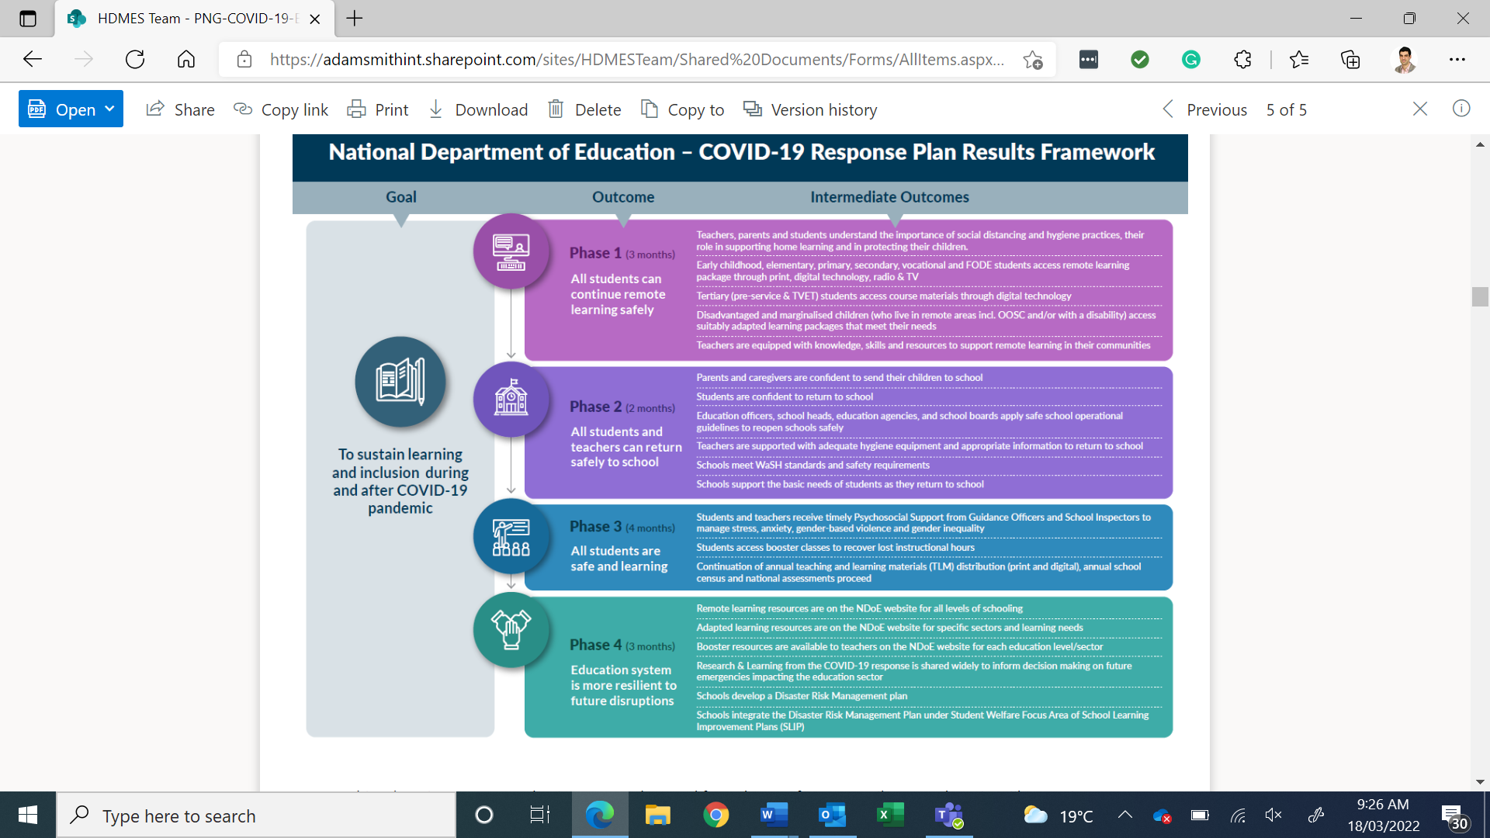

The goal of the EERRP is ‘to sustain learning and inclusion during and after the COVID-19 pandemic’ and is structured around four independent yet interrelated phases, including (i) remote learning; (ii) returning to school safely; (iii) safe learning at school; and (iv) resilience-building. Given the fluid nature of the response to the COVID-19 pandemic, these phases (which are also considered to be the end of program outcomes) did not occur in a linear pattern.
To progress these phases/outcomes, a range of activities were implemented, including but not limited to: (i) awareness raising initiatives (outreach sessions, print and online media, SMS blasts etc.); (ii) provision of training and materials to teachers to deliver remote learning, training for teachers to deliver psychosocial programs in school, construction of WaSH facilities in target schools; (iii) back to school resources for students and teachers (e.g. personal protective equipment for teachers, assistive devices for children with disabilities, stationery for students etc.); and (iv) supporting schools to develop and implement Disaster Risk Management (DRM) Plans.
The EERRP targeted three urban areas (Lae, Madang, and the National Capital District), where population density and total cumulative cases were highest, as well as Western and Sandaun Provinces, which border Indonesia, and the Autonomous Region of Bougainville (ARoB). These locations were targeted on the basis that they faced the greatest risks from COVID-19.
Initial funding for the EERRP was provided by GPE (AUD 11.5million) and DFAT (AUD 4million) in 2020. GPE funding largely covers early childhood, elementary and primary education, while DFAT initial funding of AUD4million supported the EERRP to expand to secondary education, as well as undertake WaSH activities in Vanimo (Sandaun) and all three regions of ARoB. The GoA provided an additional AUD12million in April 2021 and a further AUD6million in June 2021 to expand support for implementation (from early childhood to secondary education) of the EERRP in targeted provinces. This included 18 Vocational Education Training schools, as well as provision of hand washing facilities to an additional 500 schools and printing and distribution of Home Learning Packs (HLPs) and Teacher Booster Kits (TBK) for approximately 320,000 students in target provinces.
EERRP activities included broadcasting of televised lessons and radio programs; incentive backpacks to encourage a return to school; school inspections; e-libraries; psycho-social support (PSS); safety and wellbeing training for teachers and children; assistive devices for Inclusive Education Resource Centres (IERCs); positive parenting program; training for School Boards of Management (SBoM), head teachers, teachers, and student leaders; and incorporating DRM into School Learning and Improvement Plans (SLIPs).
The GPE Accelerated Funding grant agreement ceased in August 2022 and DFAT will finalise its support by the end of December 2022. UNICEF is the grant agent for GPE and the implementing partner for DFAT, responsible for distributing funding, ensuring appropriate processes and policies are in place, and liaising with NDoE and sub-grantee delivery partners on program implementation, program, reporting, financial acquittals, and monitoring and evaluation. Implementation by sub-grantee NGOs initially included World Vision, Save the Children and ChildFund and was then expanded to include ANIS Foundation and CARE International to provide support to the WASH component.
NDoE has oversight of all partner selection and components of the EERRP, with UNICEF as the grant agent/implementing partner and the five NGOs as delivery partners. NDoE’s EiE Technical Working Committee (TWC) representation consists of eight NDoE divisional leads and oversees financial management, progress monitoring, and approval of all knowledge products developed through the EERP.

2.1 Evaluation Purpose
The evaluation had two purposes:
- Assess: This involved an assessment of the following: (i) progress towards the EERRP’s intended outcomes; (ii) the extent to which the EERRP was implemented efficiently; (iii) the appropriateness of management and implementation arrangements; (iv) the extent to which gender equality, disability, and social inclusion (GEDSI) have been addressed in the response; and (v) key lessons from EERRP’s design and implementation.
- Inform: The assessment also informed recommendations relevant to the ongoing implementation of the EERRP, as well as efforts to strengthen the resilience of the education system more broadly and specifically in management, operational and policy settings.

Approach and Methodology
Based on the evaluation’s purpose outlined above, the evaluation focused on data and information collection around the following key evaluation questions (KEQs).
- To what extent has the EERRP progressed its four intended outcomes/phases, considering different results/approaches for boys and girls?
- To what extent were boys and girls in target areas able to safely learn remotely?
- To what extent have boys and girls and male and female teachers in target areas returned to school safely?
- To what extent are boys and girls in target areas safe and learning?
- To what extent is the education system more resilient to future disruptions?
- How sustainable are key achievements?
- To what extent is the EERRP being delivered efficiently?
- To what extent are activities being delivered in a timely and economic way?
- To what extent have efficiencies been realised (e.g., leveraging financial and in-kind support)?
- To what extent are efficiencies driving change?
- To what extent are the EERRP’s management and implementation arrangements appropriate (e.g., NDoE oversight/involvement, role of the grant agent, implementation approaches/partners etc.)?
- To what extent has the EERRP mainstreamed and incorporated GEDSI strategies?
- What are the key lessons from the design of the EERRP?
- Are there areas of the design that failed or could be improved?
- What are the key lessons from the implementation of the EERRP?
- Are there areas of the implementation that failed or could be improved?
- How will COVID-19 reshape humanitarian responses moving forward? What does an event like COVID-19 mean to how the education sector maintains continuity of learning and services?

The areas of inquiry under KEQ 1 drew on international learnings and resources for education in emergencies and education recovery, including the RAPID Framework , which has been endorsed as a framework to respond to COVID-19 learning losses by the World Bank, the Bill & Melinda Gates Foundation, the Foreign, Commonwealth & Development Office (FCDO), UNICEF, USAID, and UNESCO. Areas of inquiry under KEQ 1 are outlined in the Terms of Reference (Annex 1).
Assessment of KEQ 4 was closely aligned and integrated with KEQ 1 to ensure that the consideration of gender equality, disability and social inclusion is central to the assessment of program outcomes. This approach drew on the EIE GENKIT, a resource package on gender in education in emergencies developed by the United Nations Girls’ Education Initiative (UNGEI) in partnership with Education Cannot Wait (ECW) and the Inter-agency Network for Education in Emergencies (INEE). Consideration of effective GEDSI strategies under each of the outcome areas was also informed by HDMES GEDSI tools, including the GEDSI Spectrum (refer to Annex 2).
The overall approach to the evaluation incorporated a mixed-method parallel convergent design that incorporates a quantitative assessment alongside qualitative data collection. This approach was proposed to collect valuable data and information that can be triangulated and serve to present data and information in a manner to inform and underpin key findings and recommendations.
Diagram 2: Summary of Approach and Methodology
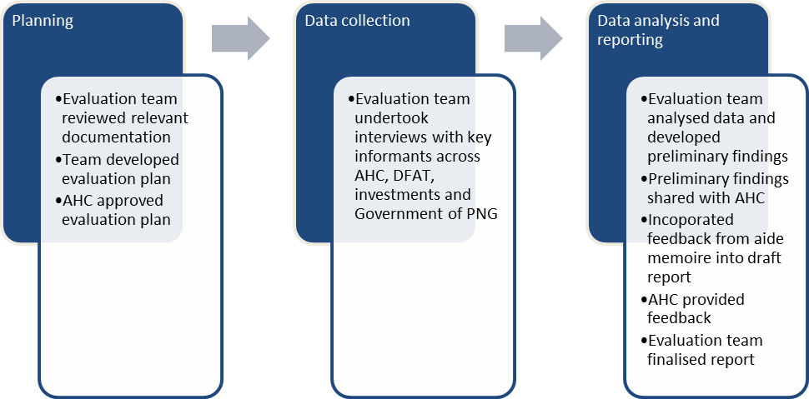

In keeping with the mixed-method approach, data collection methods involved both quantitative and qualitative elements. Methods included: (i) a desk review and analysis of key program documents; (ii) an initial briefing with DFAT and HDMES staff iii) Key Informant Interviews (KIIs); (iv) Focus Group Discussions (FGDs); and (v) final analysis and synthesis.
The benefit of this approach was that it allowed for the targeting of individuals and groups who were able to provide in-depth insights into the EERRP. It was also a financial and time efficient approach as it enabled a broad range of individuals to be contacted and consulted in a short period of time. Key informants involved in the evaluation included DFAT (Post and in Canberra), GPE, UNICEF, sub-grantees, NDoE, provincial and district administrators, school principals, teachers, and students. In some cases, parents were also consulted. Annex 3 provides a list of documents consulted in the desk review. A total of 100 interviews were conducted (43% male and 57% female). A total of 45 students were interviewed (33% male and 67% female). A total of 21 schools were visited across three provinces. Annex 4 provides a list of people consulted and Annex 5 details the schools visited during fieldwork.
Annexes 6 and 7 also provide details of EERRP partners, stakeholders, and the EiE Technical Working Group (TWG) members.

Evaluation Limitations
All reviews and evaluations have limitations. Table 1 below summarises key limitations pertaining to this evaluation and strategies employed during the evaluation process to mitigate impacts.
Table 1: Evaluation limitations and mitigation strategies
Category | Potential limitations at the start of the evaluation | How these limitations were mitigated
COVID-19 | Changes in restrictions affect scheduling and data collection. Potential for localised lockdowns in some provinces | The evaluation plan included flexibility in data collection approaches. Two members of the evaluation team were present in country for fieldwork and the GEDSI adviser supported remotely.
Security Threats | Recent elections have left some provinces and some communities on high alert with evidence of tensions over election results. | Evaluation team liaised closely with HDMES security advisers and team leader to plan and schedule visits and to maintain flexibility to adjust as well.
Time and Resources | The current schedule and proposed sampling highlight many people and stakeholders to consult and engage with. | Prioritised sampling approach and confirmed arrangements. Completed interviews concurrently (field-based and remote) to minimise time. Also, flexibility was built in to adjust schedules (COVID-19/security).
Remote evaluation | Loss in the availability and overall quality of data collection. Misinterpretation of data. | Two team members were present in country. The team agreed on an approach to share summary notes and provide updates and thoughts based on analysis. The mix of remote and in-country work mitigated the risk associated with sole remote evaluations.
Clash with other evaluations | UNICEF is running an endline study concurrently with the proposed evaluation. Has the risk of overloading GoPNG, provincial and school leadership. | Careful selection of schools that sit outside the UNICEF study were completed Also sought to utilise the data from the UNICEF study, but the report was prepared well in advance of the completion of the study.
Obtaining information from FGDs | Unwillingness of some students (boys and girls) to participate and parents to make comment. | The FGD for adolescents was done by gender – separate boys and girls (we have two focus groups). The team notified the groups about what was to be expected to be asked (hygiene, SGBV and SRH topics) during the FGD prior to commencing the discussion. Anyone uncomfortable with these topics was invited to leave at any time. Privacy of the setting of the interview room was considered and maintained through the interview.
Data limitations | Conducting data analysis can be challenging if the necessary data was not collected from the start of the program. | Engaged key stakeholders to identify what tacit knowledge there is and use this, with limitations of evidence clearly communicated in reporting.

- Key Findings

The following section highlights key findings against the stated KEQ. As indicated in the methodology section, GEDSI considerations are integrated into the findings as well as addressed in a standalone question.

3.1 To what extent has the EERRP progressed its four intended outcomes/phases, considering different results/approaches for boys and girls?
The EERRP is a highly relevant and appropriate plan for mapping, planning, and developing a context-specific approach to responding to the COVID-19 pandemic. The EERRP was a unique collaboration between the Government of PNG (GoPNG), UNICEF, Non-Government Organisation (NGOs) partners and donors (GPE and DFAT). Although unknown at the time, the COVID-19 pandemic has become a multi-year protracted crisis. At the time the EERRP was being developed, there were no comparable reference points upon which to predict the scale of COVID-19’s impact and as such, the EERRP was designed in anticipation that the pandemic would lead to extended school closures and disrupted education. It was a program designed to evolve in response to a very dynamic context.
The EERRP was not a normal or traditional emergency response, which tends to focus on immediate needs to distribute support and focuses on “quick returns” and outputs. The EERRP was primarily a comprehensive, socio-economic response that maintained a longer-term “line of sight” that sought not only to respond to immediate needs but to build and strengthen approaches that could be utilised in the future. This was a position taken by all development partners. Successive lockdowns were disruptive, as they were around the world, although they were not as extensive in Papua New Guinea as they were in many other countries. However, disrupting education services on a national scale is not without consequence. Without the EERRP, it is likely that Papua New Guinea would be ill-placed and under-resourced to address future disruptions to education and associated impacts in the longer-term. EERRP investments in teacher training, education resource development, disaster risk management, and WASH infrastructure in schools are relevant not only in the context of COVID-19, but in the broader context of PNG’s education system and its resilience in emergencies.
The ERRPP has achieved most outputs but progress towards intermediate outcomes, and broader outcomes is less clear. The ERRPP results framework is quite detailed, and first observations suggested the framework was overly complex for an “emergency response”. However, as indicated above, the EERRP is more than an emergency response. The use of the term “emergency” tends to connotate a rapid, short-term, initial response. The EERRP strategy, which viewed the response more as a long-term development type intervention that was the correct one and has proven appropriate and effective to date. It is noted that several intermediate outcomes are to be assessed as part of an endline survey but at the time of writing of this report information and data was somewhat limited. The evaluation team drew upon the results reported by UNICEF as a basis and used its own analysis and fieldwork to identify further findings to support evidence of achievement.
Key findings, commentary, and analysis on progress towards each defined outcome are provided below.

Outcome 1: To what extent were boys and girls in target areas able to safely learn remotely?
Under Outcome 1, it has been reported that the outcome is achieved and all nine outputs under the outcome have also been achieved. Data from the reports suggest that 426,420 students have received access to radio and TV broadcast messages (against a target of 400,000). Output targets have been reported as achieved and complete.
In response to the pandemic outbreak, the NDoE issued a Secretary’s Circular 19/2020 in April 2020. The circular authorised a suspension of all schools for the period 6-27 April 2020. The circular applied to all schools operating under the National Education System (NES) and other “permitted schools providing education in the general education sector.” The circular complied with the broader GoPNG SoE provisions around lockdowns and restrictions on movement and travel. A copy of the Circular is provided in Annex 8.
The initial hypothesis of the evaluation was that schools were locked down for the period outlined in the circular. However, evidence from field visits indicated that schools did not necessarily close for the period. Actual evidence suggests that schools only closed for a period of one to two weeks. In some cases, schools remained open but staggered classes to comply with social distancing measures and other health protocols in accordance with government guidance on COVID-19. The extent to which boys and girls were out of school due to COVID-19 was far less than anticipated under the EERRP. In addition, by the time learning materials and out-of-school resources were developed, the impacts of COVID-19 on school attendance had largely passed. As such, the lens that has been applied to the assessment of interventions to support safe remote learning and safe return to school following school closures has been broadened to consider how these interventions will support boys and girls in future school disruptions related to weather events, natural disasters, conflict, or pandemics.
Provincial Education Authorities (PEAs) took a strong leadership role in coordinating with schools and principals to follow guidance and to adopt context specific and localised approaches. Under Circular 19/2020, Provinces had autonomy to make decisions based on local conditions and needs. The decentralised approach to management and decision-making is a strength and helped education services maintain some level of consistency for schools and respective regions and limit interruptions to student learning. School inspectors also played a critical role in supporting schools during the lockdown period (and as part of ongoing support) in monitoring compliance and offering localised guidance and support.
Schools tended to act independently and create their own work sheets, assignments, and work tasks to support students to work remotely. A key learning is that in emergency responses, the provision of materials such as printer ink and paper are a high priority for schools as many were under-resourced and had to draw down funding from other budget lines to produce materials for remote learning. This is especially important in the context of Papua New Guinea, where most students are not able to access electronic devices, smartphones, and internet connectivity. Without adequate resources, schools are often limited in their ability to support learning in a remote environment.
Students in urban settings tended to complete more school learning from home than those in rural settings. The main influence was the ability to access school to return assignments and pick up new work. Travel costs, however, were a severe impediment, with public buses also maintaining social distancing measures while increasing fares to cover the loss of passengers. This meant many students who were learning from home could not access school. However, the primary factor affecting students’ learning is the ability and willingness of parents and guardians to support their learning. FGDs with students revealed that parents in settlements and remote areas tended to place less emphasis on education or lack the facilities at home to support remote learning. It was also revealed that the home chores were increased for children whilst at home. As expected, many young and adolescent girls were often drawn into household chores rather than continuing learning. Boys were also assigned household tasks but tended to have more “free time” than girls based on feedback from FGDs across three provinces.
The EERRP responded to the remote learning provisions through several strategies and means. These included: (i) health and social distancing measures; (ii) provision of information on remote learning measures; (iii) radio and media programs; and (iv) provision of school backpacks, home learning packs and teacher booster kits. Teachers were also trained in approaches to remote learning support.
The success of these interventions is somewhat mixed. Immediate information and communication materials (NDoE) were distributed to schools along with initial personal protection equipment. Posters and other communication materials were rapidly deployed and accessible through the NDoE website. These materials are of high quality, context specific and inclusive. Most schools visited had these materials displayed in public areas in schools. Media and radio programs were a helpful and innovative response, however these tended to be accessed only by students who had access to a TV/radio and often those that lived in more urban settings. However, given the short lockdown period of most schools, students tended not to access these messages as they perceived the period to be a “holiday”. When students did work remotely, the main driving force was individual relationships with teachers, particularly those teachers that developed individual work assignments.
The HLPs and TBKs are of high quality and are a significant contribution to the NDoE. However, due to the time required to prepare, quality assure and print and distribute these materials, their effectiveness during the current emergency has been somewhat limited. However, as a long-term resource, the resources are a substantive addition to the NDoE approach to support schools and learning. The HLPs and TBKs are of a high standard and quality but are viewed more as a longer-term development intervention rather than an effective element of the COVID-19 emergency response. That said, the products remain highly relevant and applicable to future emergencies and disruptions to learning. To date, approximately 10,000 HLPs and TBKs have been distributed to target schools. The extent to which schools and teachers are aware of these materials as emergency resources, however, is limited, and this may well hamper their use in future emergencies.
From a GEDSI perspective, the HLPs and TBKs are inclusive, consistently portraying images of boys, girls, and children with disabilities. The content of the materials is also balanced, presenting positive stories and examples that profile both boys and girls. The materials were reviewed by Save The Children from a gender and inclusion perspective, and images were carefully selected to be culturally appropriate and reviewed by NDoE. Inclusive adaptations were also made to learning resources for children with disabilities, such as large print resources for vision-impaired students and sign language translation for children with hearing impairments. Overall, IERCs in NCD, Kiunga, Lae, Madang, and Vanimo were targeted to support COVID-19 prevention and control and prioritised for the distribution of materials. Progress was hampered, however, by resource constraints, including the availability of braille printing resources and limited availability of media recording facilities for sign language translation. The two IERCs visited as part of the evaluation fieldwork had received the full complement of the materials allocated.
There are some concerns related to the “equity” of the distribution of resources. It is unclear in some cases how schools were prioritised and selected. The selection of six provinces and associated districts was appropriate, given their heightened risk exposure to COVID-19. However, evidence suggests that of the schools targeted, many have not received the correct allocation of HLPs and TBKs. School backpacks tend to be used as a “reward” or “incentive” mechanism for students for various reasons, such as those who have high attendance in classes, are student leaders and have paid for school fees and/or uniforms. This in direct contradiction to the intent of school backpacks, which was to incentivise the return to school for those students most disadvantaged and at-risk. HLPs and TBKs are only being received now (Oct 2022), in some cases without associated training and/or support. A total of 6,051 teachers (M: 2,962 and F: 3,089) against an initial target of 1,957, have been trained to date on how HLPs and TBKs are to be used and applied. While many teachers and principals are pleased with the resources, quite a few remain unsure of what the resources are to be used for, particularly those who have not been briefed or trained in how they are to be utilised and/or applied. The evaluation team also has concerns about the appropriate storage of resources in schools for use in future emergencies.
The EERRP also resourced a positive parenting program called ‘Parenting in Emergencies’, designed to equip parents with skills to support their children during the pandemic. As described above, the impact of the pandemic on children was less than anticipated and like other interventions, the parenting program was delivered after schools had returned and did not directly contribute to boys’ and girls’ safety while learning remotely. However, there is relevance for this program in the broader context of PNG and the likelihood of future emergencies.
The program, developed by Save the Children includes prompts for parents to reflect on how cultural norms and stereotypes may harm both women and men and affect their caring roles, including the different ways that male and female caregivers provide warmth and structure for children. It promotes positive gender norms, emphasising that children need both women and men to help them learn, grow, and develop and that sharing parenting responsibilities supports families to be strong, productive, happy, and resilient. The program advocates home environments where females and males are equally recognised, respected, and valued. The program materials could, however, be further enhanced by addressing how male and female caregivers treat each other, emphasising that role modelling the respectful treatment of men and women is vital for children to develop positive relationships with others. There was not adequate evidence available to assess this program from the perspective of parents. From the two FGD with the parents, only one group of parents of students attending an IERC had acknowledged receiving this training and stated the training was very useful to them.
The Parenting in Emergencies program successfully advocates that gender inequality is harmful to both girls and boys and encourages parents to treat them equally. However, the program misses an opportunity to address adverse gender norms that face children as they develop and how these norms can impact and limit their full development and potential. For example, the program does not deliver messages about the importance of girls attending high school and secondary school or address issues of equality with respect to boys’ and girls’ expected contributions to household chores, the risks that many girls face in relation to violence and sexual abuse, the importance of supporting girls to share their views and opinions in family discussions, the need for teenage boys and girls to learn about sexual and reproductive health, and for boys and girls to learn respectful ways of managing conflict with each other. Helping parents to understand the distinct issues that typically face girls and boys as they develop and identify the negative impacts of traditional gender norms on girls and boys is an important step to modelling and embedding positive parenting practices.
The program also overlooks the opportunity to advocate for equal treatment of children with disabilities. In PNG, where stigma and cultural beliefs around disability lead to widespread exclusion of people with disability, parents’ attitudes towards and treatment of children with disabilities are critical, particularly in remote communities. Similarly, parents’ acceptance of children who may be neuro-diverse or express diversity in other ways is also an essential foundation for children’s inclusion, access to education, and development. The program would also have been enhanced if the resources created for parents and families were presented in Tok Pisin, the language used in everyday contexts, such as in the home and between parents and children. Despite these observations, the Parenting in Emergencies program is a valuable and useful resource and, if resourced appropriately to provide comprehensive training to Master Trainers, has the potential to provide an important foundation for child protection and development.

Outcome 2: To what extent have boys and girls and male and female teachers in target areas returned to school safely?
According to reported results, the outcome statement has been achieved with 157,659 students returning to schools (target 157,867). In addition, a total of 96% of teachers had returned to school to re-commence work. A total of 9 out 10 outputs under the framework have also been realised. As indicated in the recommendations it is important that the results are reviewed and tested. The current endline survey may also provide an update to some of these figures and how they have been reported.
Given that schools only closed for a short period (or didn’t close at all) meant that this EERRP outcome itself is somewhat obsolete. However, the evaluation focused on the return to normal teaching approaches and resumption of classes. Consultations with targeted schools indicated that most students have returned to school (as supported by the reported result above) and resumed normal classes. However, there have been some disruptions to this. These include:
- An additional NDoE Secretary’s Circular (5/2020) in 2020 allowed parents to remove students from school if they were concerned about the health and safety of their children. The circular also allowed parents to determine when students were ready to recommence and to start school in grades where they left. This Circular had a much greater impact on learning than COVID-19 itself. It meant that students were removed from school with limited resources for learning at home and returned to school classes in the same grade level that they departed, leading to overcrowded and bulging classrooms. Students transitioning through school grades are now combined with returning students. This is most significant in Year 8 as students return to complete exams to progress to high school.
- Some parents, particularly in urban areas, removed students from urban schools and split families, with one family member returning to villages and rural settings to enrol students in smaller, more remote schools. This approach was quite common in Morobe with students and one parent returning to highland provinces to continue schooling.
- Girls tend to have been slightly more affected than boys in returning to school. Enrolment numbers will need to be confirmed, but anecdotal evidence suggests that girls in more cases than boys were transferred to other schools or remained at home for longer periods of time than boy students.

All emergency guidance emphasised the need for adaptions on return to school to account for learning losses and wellbeing impacts of the emergency. Most schools visited during the evaluation took initiatives to enable the children’s learning to continue by sending home lessons/assignments and shifting teaching and classes during the lockdown. For most secondary and primary schools, priority was given to grades 8, 10 and 12 to prepare for the national exam, thus effective shifting teaching was conducted for these grades. With the support of the NDoE, national exams were delayed where necessary and accordingly. Unfortunately, it was found that the student’s level of concentration and effort put into their studies during school closures dropped. Generally, while some students completed their assessments, others did not, nor attended shifting classes. This was particularly for lower grades students. TVET schools, on the other hand, engaged mainly in practical technical work/sessions, faced a very challenging situation. These initiatives taken by the individual schools have made it a little easier for a catch-up. Regardless, catch-up classes were rolled out where needed and for specific grades as per the teacher’s judgements, which means more topics could be covered in a day, extra homework assigned, and assessments undertaken.
The largest current threat to school enrolments and returning to school is the threat of community violence due to ethnic clashes and recent political elections. Again, this was most prevalent in Morobe province. The COVID-19 lockdowns and option to withdraw students through government circulars have contributed to a culture of keeping students away from schools in the event of any tension or flare-ups. This has significant implications for individual schools in terms of planning, maintaining adequate social distancing measures and a safe learning environment, and impacting other students who are graduating through school levels.
Most teachers have also returned to teaching positions, with reporting suggesting that 96% of all teachers in targeted schools have returned to teaching positions. However, the result does not reflect on-going concerns (due to COVID-19) and challenges in dealing with over-crowded classrooms. Many teachers interviewed indicated feelings of concern, anxiety, and uncertainty. Many have their own families and feel under-resourced and unsupported in dealing with new practical realities and the shift towards new ways of learning.
From the perspective of students, approximately 25% of students of both genders in mainstream schools were identified as having left or withdrawn from school during the lockdown, primarily due to parents’ and guardians’ fear of COVID-19 transmission in schools and as indicated earlier, the issuance of NDoE Secretary’s circular (5/2020). The same number of male and female students withdrew, and a slightly higher proportion of boys returned to school. There was not a significant difference between girls and boys. However, the teachers have noted a new trend that more female students are returning to classes compared to past crises, and that girls are doing better academically than boys.
Case Study 1: Teachers Returning to School Ms. Doreen Silas – Gerehu Secondary School
Ms. Silas is the Head of English for the school. She oversees the work of 20 teachers from year 7-12. At present class sizes sit at approximately 60 students per class. Ms. Silas indicated that the school initially followed government guidance to shut down but ultimately opened to staggered classes of 30 students per class. School was opened as “students are not trained or knowledgeable about home learning and distance education”. Although teachers provided worksheets and assignments, many students did not complete these.
Since normal classes have resumed, Ms. Silas notices that girl attendance is down slightly when compared to boys. Girls are “often transferred to smaller schools back in home provinces or in rural areas” Ms. Silas indicated.
The other key challenge the school has faced is returning students who were removed by parents and who now wish for their children to resume classes. “This has had a significant impact upon our school as already full classrooms are now overflowing and we have limited space to teach.
Unfortunately, Ms. Silas feels she has not had much support in terms of training and that teachers have been exposed to many risks, despite the efforts of NDoE.
In looking forward, Ms. Silas is confident that the school will be better prepared in the future. Some key actions currently being taken are to: (i) recruitment of a media team to develop online classes and videos that can be used remotely; (ii) developing an emergency plan and providing refresher training to students. The school is also partnering with St Johns for first aid training of teachers.

Unrelated to the EERP, interviews with the FODE/TVET schools also indicated that there seems to be an increasing number of girls enrolling in FODE and TVET; however, these enrolments may not be linked to the impacts of school withdrawals during COVID-19 as there is no way to track school leavers from the time during the lockdown to their enrolment in FODE/TVET. FODE and TVET schools provide a great opportunity for students up to the age of 35, and women, girls, and marginalised groups to have reasonable access to this tier of education. TVET schools to a degree were much less influenced by COVID-19 than primary and secondary schools as most of the TVET students are technically adults and could make independent decisions and also fall back on other interests (i.e. employment or intermittent work) to support themselves through COVID-19. FODE was the only type of school outside the mainstream schools that adapted well to the pandemic and lockdown in terms of allowing the continuity of learning and education (except for tutorial classes). Overall, its learning and teaching model is well suited to effective remote learning.
Back-to-school posters targeting elementary, primary, and secondary students developed under the EERRP are inclusive and gender sensitive. They show images of a male, female, and student with a disability. Posters targeting educators and school staff also show images of a girl, boy, and a student in a wheelchair. Posters aimed at parents show both men and women in caring roles. These materials signal important messaging that schools are a place for everyone. The inclusion of images of children with disabilities is particularly positive, given the stigma and access challenges experienced by children with disabilities and their families.
Teacher training support materials highlight how gender equality can be facilitated in the classroom through simple, practical actions like seating arrangements, allocating responsibilities for class tasks, and bringing greater intentionality to conversations and communication. The EERRP intended for health and safety measures installed in schools to adhere to gender-sensitive guidelines. However, discussions with implementing partners and field visits found that practical actions like physical distancing and seating arrangements were not practical in overcrowded classrooms.
The NDoE also developed awareness materials for schools and communities to support their adjustment to a “New Normal/Niupela Pasin”, meaning a new way of living and going about their lives, work, and interactions with others. These new ‘normal messages’ to teachers, parents and children were produced in English, Motu and Tok Pisin. The messages are grouped for Lower Primary, Primary and Secondary and both boys and girls are portrayed in materials targeted at each educational level. Posters also include images of children with disabilities in these ‘new normal’ materials.
The backpacks were intended to be provided to students in the most remote areas to encourage their return to school and provide them with essential learning materials. However, distribution of these materials has faced a range of challenges that undermine their purpose, including inadequate supply of the packs to the schools to meet its needs; inappropriate approaches taken for packs distribution to the students; and partial pack distribution, where useful stationery items were missing from the bags. For example, 18 of the 21 schools visited during the evaluation did not receive the learning resource packs. This included schools in the Vanimo-urban district as part of the rural schools. In Port Moresby, only one primary school of 2200 students received only two learning resource packs with a menstrual hygiene pack in each bag. This was impossible to distribute to the students and kept at the school’s administration office. Due to the significant distribution challenges and failure, there is no evidence that these packs have been equitably distributed to girls, students with disabilities, or students whose education was most impacted by COVID-19.
Menstrual hygiene packs were also intended to be distributed to encourage upper primary and secondary girls to return to school. Despite inquiries targeted at a range of stakeholders, no formal feedback was provided to the evaluation team about these menstrual hygiene packs. As they were intended to be distributed with incentive packs, they likely experienced similar distribution challenges. Consequently, there is little to report on their effectiveness in terms of encouraging girls to return to school.
The WASH component is highly relevant and appropriate and has helped support a safe return to school. WASH is critical in promoting healthy school communities, given COVID-19 can be spread due to lack of handwashing and poor hygiene practices. Under ERRPP, WASH is highly visible and is well regarded as a means of supporting schools and promoting hygiene practices among students. The WASH component also supports the NDoE’s broader response and commitment to its WASH in School Policy by having WASH facilities in all schools. A total of 526 (including 31 secondary) schools were assessed through the Rapid Audit WASH baseline conducted by World Vision. Of these schools assessed using the m-Water platform, 119 assessments were funded by AHC. The WASH hardware component has been completed in 171 schools, benefitting over 98,000 students (47,410 girls) in NCD, Lae, Madang, Western, Sandaun and ARoB with handwashing stations and water tanks.
The WASH component has faced significant delays due to the time taken to complete assessments, access available resources, and transport the infrastructure to sites. The evaluation team acknowledges that there has been a shift from the provision of temporary handwashing facilities towards more permanent structures, which is a positive move. However, it has pushed out the timeframes for implementation, which could have been avoided to a degree by focusing initially on schools and locations with better access. It is likely that the overall target for WASH (500 schools) will not be reached by the end of the current implementation period, and a no-cost extension is required. If this is granted, it is anticipated that participating NGOs will need to develop clear workplans, strategies and guidelines to complete the remaining infrastructure. This will require careful monitoring and supervision by DFAT.
While WASH infrastructure was broadly well received by schools, discussions with implementing agencies and schools indicated that planning and construction did not consider gender and disability accessibility issues. Stakeholders pointed out that schools’ existing infrastructure left very limited options for where the taps and basins could be placed in the school to be inclusive. For example, hand washing stations are typically positioned close to water tanks and iron rooves, which may not be in preferred locations for girls. For example, a secondary school in Lae had the WASH basins built next to the Home Economic Classroom for girls but were not able to have these hand washing basins at preferred locations most accessible to girls. There were no examples sighted of ramps to hand washing stations or other disability adjustments to increase access for students with disabilities.
Those students perhaps most in need of WASH facilities also missed out because they attend schools whose existing infrastructure (e.g., source of running water, iron roofing to catch rainwater, etc.) was insufficient to accommodate hand washing stations. For example, an elementary school in Vanimo visited during the evaluation missed out on WASH support due to its poor infrastructure, leaving the children with no access to a water supply and handwashing facilities. While it was evident that the teachers interviewed understood the need for girls and boys to have safe access to WASH facilities, they did not have much say much about the location of the construction of these hand taps and basins. Several urban schools visited in Lae and Port Moresby indicated that they would have preferred proper ablution blocks to be built for girls.
Of the 21 schools visited, only one school in Port Moresby and one in Lae have WASH clubs. These WASH clubs have been relatively recently established, for example, the WASH club for the school in Port Moresby was formed only two weeks prior to the date the evaluation team visited the school on 31st August 2022. The selection of the students is balanced, including a boy and a girl in every class as the WASH committee representatives for their grade/class.
There have been some unintended consequences of the WASH facilities, with evidence of vandalism and destruction of infrastructure. This is exacerbated by schools not having adequate skills and/or resources to replace damaged infrastructure. In addition, it is unclear how some schools have been assessed with crowded urban schools often receiving facilities that do not meet adequate student ratios, whereby some rural schools have received significant infrastructure, which in some cases is under-utilised.
A final consequence is that all schools have reported significant increases in water bills as students wash their hands. Unfortunately, budget lines for other school resources and activities are being cut to pay for increased water usage.
Case Study 2: Increase in water bills Ms. Christine Marcus – Gerehu Primary School
Ms. Christine Marcus is the Deputy Head Teacher (DHT) for the Upper Primary School. Ms. Marcus stated that the school was pleased to have had received WASH facilities mid last year (2021), with the four taps and hand washing basins very helpful.
However, given the high student population of 1500 students with 36 teaching staff (excluding the elementary students and teaching staff which shared the same school campus and facilities), the water bills significantly increased within less than 6 months. “The water bill was so high; the school was not able to pay, and Eda Ranu PNG Ltd (the water company) disconnected the water supply”. The school was without water for 2 weeks. It was impossible to continue classes without proper water supply for students to drink and for the toilets. The school board came to an arrangement with Eda Ranu PNG Ltd and water supply was eventually restored.
“Unfortunately, it not long before the hand wash facilities were vandalized, by the surrounding residents”. All left now are 2 taps, without hand washing basins.
Ms. Marcus notes that better planning should be done before such support (WASH) is provided to the school in the future. She also hopes that “parents and people in the surrounding community could be more supportive and respect school properties which their own children use’’.

Outcome 3: To what extent are boys and girls in target areas safe and learning?
Schools reported that most students returned to school. Some school reported a slight increase in the number of girl students dropping out of school or being transferred. It appears that the target of 90% of students have returned but this needs to be verified in the endline study. A total of 10 indicators have been achieved out of a total of 14 (against 11 outputs).
Schools play a vitally important role in the safety and wellbeing of students. The provision of mental health and psychosocial support to students and their families is an important component of this. Under outcome three of the program, student safety and wellbeing are a key focus, ensuring students can resume classes after school closures. This includes providing mental health and psychosocial support to students and their families. This support also consists of a forum to address issues relating to Gender Based Violence (GBV) and protection. School closures and the fact that many students and their families have faced additional challenges, stresses, and fears related to the COVID-19 pandemic and other adverse events affirm the need for the program’s focus on psychosocial support and safety as part of the education response. However, the evaluation found that aside from COVID-19, interventions aimed at student wellbeing are widely needed. Such interventions have a potentially critical role to play in any future education system.
Key activities under the psycho-social support (PSS) and wellbeing component of the EERRP include developing a training program for guidance officers and teachers, including practical PSS support and wellbeing resource materials and guidelines for teachers. The program materials are a rich and comprehensive resource, helping teachers understand the development changes children experience at different ages and the factors that impact their wellbeing. For example, the manual for teachers working with children over 16 years of age explains that the transition to adulthood is accompanied by a desire for increased independence, low self-esteem, and the desire for social belonging, which often increases opportunities to engage in risk-taking behaviours such as withdrawing from school, substance abuse (using drugs and alcohol), and sexual encounters including having unprotected sex.
The PSS materials are gender-neutral – meaning that they do not explore the differentiated experience of boys and girls as they navigate adolescence. Materials could have been extended by integrating cultural and gender influences that impact girls and boys at each developmental stage, such as pressure for teenage boys to find work and earn income and social norms for girls to take on more household duties. All materials could also have included a section on identifying the additional challenges facing children with disabilities.
While PSS materials included basic information about gender-based violence (GBV), they do not differentiate the risks facing or experiences of girls, boys, or children with disabilities. The materials would have been well supplemented by a resource on sexual and reproductive health so that teachers are better equipped to provide students with information and resources so that adolescent girls and boys know their rights and can make informed and safe decisions.
The general plan for implementation of PSS programs comprised: (i) Tier 1 Phase – Training of Trainers (ToTs), conducted by Child Fund’s Training Program Trainers (with supply chain support by Child Fund); and (ii) Tier 2 Phase – School-level roll out of trainings, conducted by ToT. The response to the training was somewhat mixed, with many teachers unsure how to apply learning. School guidance counsellors welcomed the approach as it provided advice and guidance on referral options.
As the PSS program exposes teachers to some very sensitive issues that young people may face, there is a risk of harm to students if guided conversations with students experiencing abuse are not managed well. The finding is not to suggest that the psychosocial support is not appropriate, but rather the training could have focused more on a select number of teachers and representatives and more time and follow-up planned. All materials could also have included a section on identifying the additional challenges facing children with disabilities.
The cascading of training has not been as successful to date as anticipated, particularly for PSS training. This is primarily due to teachers not fully understanding or appreciating the concepts and the time required to develop knowledge and skills. Teachers interviewed also strongly suggested that more time should have been considered to run the PSS training with a reasonable trainer to participants ration. In Morobe, more than 500 teaching staff in the Lae Urban District participated in three days training. Cascading training for DRM tends to have worked better as many teachers and principals are familiar with terms and concepts and have had training through previous interventions. The work of ChildFund across these two interventions is of a high standard, but the focus has been on the reach of training delivery rather than investing time on a smaller, more targeted number of teachers who would most likely benefit from in-depth and intensive training.

Outcome 4: To what extent is the education system more resilient to future disruptions?
Outcome results for this outcome were pending based on the final endline study. From 11 outputs under the outcome, it is unclear what has been achieved to date. The targets do not appear clear or realistic. Additional information will need to be sourced from the endline.
Despite the challenges of COVID-19, the pandemic, through the EERRP, has supported the NDOE to make significant changes and contributions to strengthening the education system going forward. As indicated earlier, the HLP and TBKs, along with psychosocial and disaster risk management training materials, can be utilised again and applied for any type of disaster, emergency and/or disruption to school learning. All materials have been uploaded to the NDoE website, and schools have been advised to access resources as required. In some instances, information has also been uploaded on RACHEL, which is consistent with the NDOE strategy of developing e-catalogues and e-libraries.
In the first three months of 2021, NDOE and Child Fund PNG worked together to produce the School Disaster Risk Management Training Manual and support materials. ChildFund PNG staff, with NDOE colleagues, conducted three-day ToT workshops for provincial NDOE officials in five provinces. These provincial trainers then presented the training to Head Teachers and School Board of Management members from over 400 schools in target areas. The participants were mainly Teachers-in-Charge, Head Teachers and Principals of Elementary, Primary and Secondary Schools. The purpose of the training was to equip participants to lead a process of preparing DRM plans for their schools and incorporate them into their overall SLIPs. Other key resources developed are the School DRM Template and the NDOE SLIP Policy and Guidelines document.
The training program emphasises that disasters and emergencies produce conditions that can increase vulnerability, and it is therefore vital to consider child protection risks such as exploitation, lack of access to education, family separation, physical harm, abuse, and neglect. Additional measures during an emergency need to be implemented to ensure that vulnerable groups are not exposed to child protection risks. As part of the training, participants are encouraged to identify all the different groups of people that are more vulnerable to hazards in a school setting, including small children, people with a disability, and women and girls. It is important to identify who is more vulnerable in the school so that plans can include actions to protect these people in an emergency.
PNG is a country vulnerable to extreme geothermal and weather-related events as well as global emergencies such as pandemics and climate change. In response, the EERRP sought to build capacity and resilience at the school level by assisting schools to develop Disaster Risk Management (DRM) Plans for their schools and integrating them into their broader School Learning Improvement Plans (SLIPs). This work was often implemented alongside PSS support. The training has been highly regarded by participating principals as relevant and appropriate, and several visited schools have revised, updated, and implemented new DRMs.
DRM training was well received by all schools visited, and schools expressed appreciation for the training provided to support them, even though most schools are yet to or are in the process of drawing up their DRM Plan. A primary school in Vanimo is the only school that has completed its DRM Plan. According to interviews with the head teacher and the deputy head teacher, the DRM Plan is inclusive, reflecting approaches for students living with a disability. Generally, the evaluation found that DRM conversations in schools are primarily focused on mapping natural disaster risks and understanding approaches taken during a disaster. Until schools complete their DRM Plan, most schools are yet to come to the point of identifying and including GEDSI-specific approaches in their DRM Plans.
The EERRP also encourages schools to establish or reform a school disaster risk committee and emphasises that any committee should include a representative from all groups, such as teachers, school leadership, parents, and students, including women and ideally a person with a disability. Such action is important to ensure that all community groups' perspectives and vulnerabilities are considered when developing a disaster risk management plan.
DRM training and support are now being applied to SLIPs. While schools interviewed and consulted were at various stages of reviewing and updating SLIPs, the training received through ERRPP is highly regarded and appreciated and is being applied. Teachers and principals see a direct link between DRM training and longer-term planning and preparation. The addition of other teaching and learning material also provides greater confidence for schools as they embark on revised planning and disaster response initiatives.
Some schools have received tablets and smart phones. These schools tend to be in urban centres, and the resources are useful for future teaching and learning exercises. There is a risk of potentially exacerbating inequalities between rural and urban schools, but the NDOE’s rollout of ICT networks and systems is a long-term initiative. The EERRP has demonstrated through this “pilot initiative” that there is appetite and scope for more e-learning resources. ICT work should be viewed a more lomger-term development investment rather than the focus of an emergency response.
The EERRP has also generated a series of research and knowledge products which have also been distributed to provinces, districts, and schools. While the products in some cases are quite detailed, the results can be summarised into simple infographics and shared with schools for information and to share experiences and key lessons. Teachers in schools can also access eighteen books about preparing for and responding to emergencies. The set consists of fiction and non-fiction books with Pacific Island settings, ranging from simple stories with illustrations to more sophisticated graphic novellas and scientific texts.
Perhaps the greatest evidence of change has been through the actions of principals and teachers. Although there is no statistically significant evidence, interviews and consultations with teachers and principals revealed individual stories of resilience and change. Despite the challenges, principals and teachers have tried very hard to maintain continuity in learning and to provide a safe environment for children. Principals have worked hard to maintain and support community engagement and communication, and many reported better relationships as a result. The EERRP has played a role in this, but the individual capacity and drive of principals and teachers to undertake independent work and initiatives cannot be underestimated.

How sustainable are key achievements?
Traditional emergency response programs tend not to be sustainable given the nature of assistance being provided (i.e., immediate need, often disposable or consumed and rapid). However, through the implementation of the EERRP model, the portfolio of work delivered has a significant chance of maintaining a high degree of sustainability. It is an interesting observation since the EERRP, although having an “emergency response” title is in reality more of a “resilience recovery plan”. As indicated earlier in the report, many of the products and services provided are primarily for the longer-term. On one hand, the resources have not reached desired targets in the timeframe of the COVID-19 shutdowns, but the resources are well received and applied as a means for preparation for future emergencies.
The HLPs and TBKs can be utilised in future emergency responses or if a student is unable to attend school. The training materials could be utilised, but psycho-social training requires more advanced technical knowledge and experience. The student welfare materials can continue to be applied, but it is unlikely teachers will continue to train others.
The NDoE also has a “package of materials” that can also be utilised institutionally. The EERRP is also a viable model that demonstrates how future responses should be designed and structured. That is, GoPNG led with technical advice and assistance provided as required and demanded. The model also demonstrated that NDOE staff have significant individual capacity to lead and drive the process. The inability of external “technical experts” to travel to PNG meant that localised efforts and capacity were required, and the combination of partnership meant that successful outcomes in terms of governance and management were realised. The approach serves as useful learning for future emergency assistance.
  - To what extent is the EERRP being delivered efficiently?

To what extent are activities being delivered in a timely and economic way?
Emergency responses are inherently complex. While demand and expectations are often high, the reality of planning and distributing assistance is very different. This observation holds true for PNG, which has its own complexities about geographical coverage, access to remote communities, and often strong and independent provincial decision-making.
The nature of the EERRP tended to focus on developing resources that would be useful not only for the COVID-19 response but could also be utilised in future emergencies or responses. This is particularly true regarding the HLPs, TBKs and WASH facilities. If assessed as a traditional emergency response, it would be argued that the work to date has been somewhat inefficient. However, in viewing the response through the lens of a longer-term intervention and focusing on quality materials and infrastructure, the EERRP has proven to be quite efficient.
As indicated earlier, the selection of six provinces for work was appropriate. A broad-based national response would have limited resources and minimised impact. The selection of priority provinces not only targeted support in high-risk areas, but also allowed the NDoE to potentially pilot some interventions while still maintaining a focus on longer term strategies and plans (i.e., National WASH policy).
Despite delays, the EERRP has witnessed a significant acceleration of support in the last 12 months. This is evident in terms of HLPs/TBKs, training and WASH facilities being distributed and installed across targeted locations. There are some challenges, particularly about WASH in terms of meeting deadlines and targets. This is understandable given the quality of the infrastructure design, materials availability, and access to sites, particularly remote rural schools, and locations.

To what extent have efficiencies been realised (e.g., leveraging financial and in-kind support)?
The use of sub-grantees for localised implementation and management working under the guidance and coordination of UNICEF is efficient. It is difficult to make definitive conclusions without an adequate counterfactual but the use of NGOs with localised knowledge, contacts and relationships should in theory help expedite implementation and delivery. While in theory this is efficient, the impacts of COVID-19 and border closures, as well as supply chain issues and availability of local resources (i.e., printing machines) meant that overall costs were higher than what would normally have been expected. However, through careful planning and close partnership, resources were procured and produced. It would be easy to indicate inefficiencies however, given the uncertainty of the pandemic and the challenges.
The EERRP provided a useful model on how to leverage support between donors. DFAT stepped in with additional financing to cover WASH facilities. However, it is unclear if this was leveraged rather than meeting a need and filling a gap. Given implementation is continuing across the various outcomes, it is hard to determine if additional finance has been leveraged. There doesn’t appear to be any formal additional “in-kind” contributions, but it is evident that NGOs have provided additional input and support to implement key activities which may not have been budgeted or allocated for as part of initial proposals.

To what extent are efficiencies driving change and how could EERRP interventions potentially evolve further to support future emergencies?
As indicated in the section above (Outcome 4), the EERRP has had a strong influence in building the resilience of schools and institutional arrangements overall to respond to future emergencies. EERRP intervention have demonstrated that practical approaches can be designed and delivered to support schools. Key examples of how efficiencies have been driving change include:
- Having a governance and management mechanism that is GoPNG led. This ensures important contextual factors are considered and localised responses can be developed and applied that utilise existing systems and processes.
- Alignment of strategies and activities to existing policies and frameworks not only ensures alignment but also promotes longer-term ownership and sustainability.
- Targeted support in most vulnerable areas (e.g., geographical locations and based on stakeholder needs) enables more support to be delivered and reduces broader logistical planning to ensure wider coverage. Resources and technical assistance can be better targeted and support deeper engagement rather than spreading resources too thinly.
- Using sub-grantees and organisations that have existing relationships and operations in target areas enables more rapid responses and support.
- Autonomous decision-making in provincial and district authorities allows for localised responses to address priorities needs and issues.

The EERRP has responded to short-term needs but as indicated earlier, has taken a more long-term holistic view to development. The model itself serves a useful guide to future response mechanisms to emergencies and the lessons learned in following sections are also important to guide these structures into the future in preparation for other emergency responses.
  - To what extent are the EERRP’s management and implementation arrangements appropriate (e.g., NDoE oversight/involvement, role of the grant agent, implementation approaches/partners etc.)?
The EERRP was GoPNG designed, implemented, and managed. This is a critical success and has contributed to longer-term ownership and sustainability. Strong leadership and management within the NDoE have also been strong contributors to establishing roles, responsibilities and lines of communication and decision-making. Importantly it has also raised the profile of the NDoE and exposed key EiE cluster members to detailed planning and management processes. In effect, the EERRP has contributed to individual capacity and professional development.
The use of UNICEF as a coordination agency was sound and builds their experience and knowledge. The evaluation team reviewed several possible models, including (i) direct support through the NDoE system to schools; (ii) direct engagement of NGOs; or (ii) the use of a managing contractor through the bilateral partnership. These models would have proven more costly and inefficient. The use of UNICEF, who has experience and knowledge of emergency responses, was a sound call and serves as an example for future interventions. The use of UNICEF in a coordinating role also supported the NDoE to maintain a more strategic oversight role while maintaining close control over implementation and decision-making functions.
The use of NGOs and sub-grantees as implementers is appropriate and advantageous because: (I) NGOs have technical knowledge and skills in emergency response areas; (ii) they often have existing relationships with provincial authorities, local communities, and schools; and (iii) they often have rapid response mechanisms that allow them to mobilise resources and expertise quickly, at a relatively low cost compared to other alternatives.
There is evidence of good coordination and partnership between the EiE Cluster and UNICEF. There were some challenges at the commencement of the EERRP around control of funding, but these issues were quickly resolved, and implementation commenced. Reporting lines are clear, and the EiE report that UNICEF has been a professional partner and supported implementation and management arrangements.
One area for improvement is the coordination between and amongst NGOs. Once grants were awarded, NGOs tended to work in a siloed manner to undertake and complete planned works. This, in some cases, led to uncoordinated implementation, which resulted in schools being visited multiple times by differing organisations, all vying for time and attention to implement assistance (e.g., training, briefings, installation of WASH facilities etc.). The evaluation recognises that the implementation period was relatively tight, given the initial delays. However, the establishment of relatively high targets meant that NGOs would always struggle to meet these within the defined timeframe. The scheduling of some training events forced the closure of schools and classes, which is just as disruptive as the situation seeing to be addressed and resolved.
Coordination with provinces could have been enhanced, particularly in planning and advising on scopes of work and implementation arrangements. Of the provinces visited, provincial education authorities (PEAs) were not always clear as to who was working in the province, at what schools and in what capacity. PEAs were invited to attend events and, in some cases, close out workshops and training, but were often unclear as to what program the support derived from or who was managing the process. District authorities tended to have a clearer idea as most NGOs often have closer relationships with these stakeholders. Key learnings are to ensure that PEAs are fully briefed and engaged prior to engagement, reporting lines should be strengthened to ensure information is fed through the PEA, and reports and information should be distributed back to PEAs.
From a M&E perspective, there could have been greater attention to detail regarding regular spot checking and auditing of program deliverables. Evidence from the fieldwork did indicate resources not being delivered or having only recently being delivered and/or installed in the period prior to the evaluation. Information contained in reports did not necessarily correspond with the realities on the ground. This, to a degree, brings into question the results being reported as part of ongoing reporting. It is encouraged that UNICEF, in consultation with NGOs, confirm information and data and what has been delivered to date and ensure there is adequate evidence available to support reported results for validation.
  - To what extent has the EERRP mainstreamed and incorporated GEDSI strategies?
The evaluation found that overall attention to gender equality and inclusive education was a strong feature of the NDoE’s approach to implementing the EERRP. The NDoE actively considered and discussed the needs of girls and students with disabilities during the design and oversight of the EERRP. This bodes well for attention to gender and inclusion issues by NDoE officials in future emergency responses. Similarly, the evaluation team found that principals and teachers were very conscious of and sensitive to girls’ attendance at school and that there was broad local support for resourcing inclusive education resource centres.
Overall, the EERRP has invested in resource and skills development that has significant potential to increase access to learning and improve learning outcomes for boys and girls, including children with disabilities and children from marginalised communities, over the long term and in response to future crises and education disruptions.
Overall, EERRP initiatives were designed to support inclusive, safe, remote learning, promote equity between girls and boys and respond to the needs of children with disabilities. The development of home learning packs for remote learning, booster packs for missed learning, the positive parenting program, the in-school psychosocial program, and improved WASH facilities are important developments that seek to address the challenges that face children who experience intersecting vulnerabilities. Investments in developing distance education materials for radio, television, NDoE’s website and home learning packs for students certainly have the potential to increase education access for children with disabilities and further potential for distance education to reach out-of-school children.
While some EERRP activities explicitly addressed gender and disability considerations, others would have benefited from more explicit attention to the challenges faced by girls in the PNG context, including adverse gender norms, menstrual hygiene, sexual and reproductive health, and the risks of gender-based violence. Most EERRP resources and programs missed the opportunity to tackle and address the most significant risks to girls in remote learning and emergency contexts, including the likelihood that girls would be expected to contribute more to household chores and domestic duties while out of school, may experience gender-based violence due to increased family stress factors related to the pandemic.
EERRP also overlooked the opportunity to advocate for the inclusion of children with disabilities. In PNG, where stigma and cultural beliefs around disability lead to widespread exclusion of people with disability, parents’ attitudes towards and treatment of children with disabilities are critical, particularly in remote communities. Similarly, parents’ acceptance of children who may be neuro-diverse or express diversity in other ways is also an essential foundation for children’s inclusion, access to education, and development. Resources and training for teachers and parents would have been significantly strengthened by explicitly considering children with disabilities.
However, the more significant challenge that will potentially undermine the likelihood of EERRP interventions contributing to the learning of boys and girls, including children with disabilities and children from marginalised communities, is that most EERRP interventions have not had sufficient time to be embedded and therefore may not be sustained.
In accordance with the evaluation methodology, the evaluation assessed each outcome from a GEDSI perspective against the GEDSI spectrum to assess whether the EERRP was GEDSI negative, neutral, sensitive, responsive, or transformative. The following table summarises the results.
Table 2: GEDSI Spectrum Assessment
Outcome Area | GEDSI Spectrum Assessment
Outcome 1 | Overall, activities under Outcome 1 are assessed to be GEDSI Sensitive. This means that the materials and approaches developed for remote learning recognise that boys and girls, children in remote areas and children with disabilities have different needs, interests, and access to resources, but took only minimal action to respond to these differences
Outcome 2 | Overall, activities under Outcome 2 are assessed to be GEDSI Neutral. This means that interventions designed to encourage a safe return to school demonstrated only limited recognition that girls, students with disabilities and remote students have different needs, interests, and access to resources and took only minimal action to respond to these differences and did not explicitly address inequality.
Outcome 3 | Overall, activities under Outcome 3 are assessed to be GEDSI Neutral. This means that the psychosocial support and wellbeing activities under the EERRP demonstrated limited recognition that girls, students with disabilities and remote students have different experiences, needs, interests, and access to resources and took only minimal action to respond to these differences.
Outcome 4 | Overall, activities under the DRM component of the EERRP are assessed to be GEDSI Responsive. While most schools are yet to develop DRM Plans, the training and guidance to schools aim to develop a clear understanding of risks faced by women, people with disabilities and different marginalised groups in the context of a disaster and develop actions to address these risks. The training also recognises the importance of meaningful participation by and representation of marginalised groups in disaster risk committees.

  - What are the key lessons from the design of the EERRP
As indicated earlier in the report, the design of the EERRP was locally led, promoted strong engagement and dialogue and was comprehensive in responding to current and emerging needs and priorities. The EERRP was also aligned with existing NDoE and GoPNG policies and strategies. The evaluation team discussed and considered a range of immediate and longer-term lessons related to the design and implementation of the EERRP. The following lessons are prioritised for the purposes of the final evaluation report:
Lesson 1: The overall design of any emergency response requires strong local leadership and engagement. Understanding emergencies is only one component of the response. A deep understanding of context, current situations and existing systems is essential. It is also vitally important to understand and reflect current capacity and institutional constraints to ensure any response plan not only responds to needs but also addresses constraints.
Lesson 2: Emergency response plans need to focus on immediate response priorities and maintain a longer line of sight to focus on a transition to sustainability and development outcomes. Traditional emergencies tend to focus on short-term assistance. However, for these interventions to be sustained, there is a need to incorporate elements of development planning and prioritisation to ensure these results are embedded, institutionalised, and applied for the longer-term.
Lesson 3: Design processes need to ensure alignment with longer-term policies and strategies. Alignment to these is critical to ensure effective buy-in and to promote ownership and long-term sustainability. In all emergency responses, alignment to existing longer-term policies and plans is key (e.g., PNG National WASH Strategy). The EERRP recognised a need to respond to immediate issues (Circular 19/2020 and 5/2020) but also maintained alignment with key government policies and national strategies. This is a critical component for longer-term sustainability and institutionalisation of efforts.
Lesson 4: Coordination and engagement are critical for the success of design processes and the definition and clarification of roles and responsibilities at the outset minimises potential risks associated with fragmentation and siloed work. The use of technical working groups and a coordinating agency oversighted by a strong governance committee is a useful and effective model for future response mechanisms.
Lesson 5: The targeting of efforts to six priority provinces was a sound move and helped focus efforts on priority locations and centres. It also helps in the prioritising of needs and allows for deeper engagement and support rather than trying to spread limited resources evenly across all 22 provinces.

Are there areas of the design that failed or could be improved?
Although there were no failures per se, there are some areas for improvement.
It is important to keep things relatively simple and focused. The ERRPP did focus on emergency response, but several of the deliverables and proposed strategies were more “development in nature”. As indicated earlier, this is a strength but does lead to complexities in the short-term, particularly when responding to immediate needs. While having an “emergency response” is acceptable, the focus should be more on a “resilience response”, which provides an opportunity to structure approaches and interventions that meet short-term needs while also planning for longer-term development.
Given the EERRP was also focusing on a longer-term intervention, the planning and staging of interventions needs to be clear from the outset. Working in PNG is challenging and all implementing partners have experience and knowledge of the context. This requires a more staged approach to engagement that allows for adequate planning and implementation and time to factor in potential delays and supply-chain issues and delays.
For future response efforts, sub-grantee budgets could be structured against performance-based results. Funding and support should also be contingent on performance and delivery. This approach would create opportunities to be more strategic and enable more careful planning and implementation. The approach, while controversial, is consistent with shifts in aid modalities and delivery models away from standard approaches and towards a focus on performance. It also helps maintain accountability and transparency by assessing what has been delivered and overall quality.
  - What are the key lessons from the implementation of the EERRP?
The EERRP implementation period generated a significant number of lessons. The evaluation reviewed documentation related to key lessons but also formed lessons based on fieldwork, internal analysis, and reflection. Key lessons learned derived from the implementation of the EERRP include:
Lesson 1: The NDoE Secretary's appointment of a TWC and designation of EiE focal points in the relevant Divisions enabled ownership, accountability, timely and efficient decision making and ultimately program delivery under challenging circumstances. While the TWC directly managed decision-making relating to the response, the TWC mechanism also ensured all divisions were committed to the mission and goals of the EERRP. A key lesson learned from the response has been to ensure that, where possible, emergency programming is embedded in NDoE workplans and systems of accountability are created through standing meetings, operational oversight by NDoE divisions and open communication.
Lesson 2: Key risks and challenges need to be identified at the outset and factored into planning. The setting of targets should consider and reflect on these risks. Ambitious targets that do not reflect real-time and on-the-ground realities will only lead to disappointment. Delays to implementation often can be foreseen and in the context of the COVID-19 uncertainties at the time of planning, a more considered approach to target setting may have ensured a higher focus on quality rather than reach and coverage. It also allows for the possibility of delays, supply chain issues and access to remote locations.
Lesson 3: To deepen alignment and collaboration with NDoE, PEAs, and NGOs, clear protocols for engagement with the Provincial Departments of Education should be set and led by the NDoE would ensure even smoother and more efficient running of the response. PEAs were often left out of consultations and were not aware of work being implemented within schools in their province.
Lesson 4: School principals and teachers are critical for the success of any emergency response (and subsequent development programs). Professional development of principals and teachers is a long-term investment and requires appropriate levels of professional development and support. There is a need to embed a culture of performance development, and this should be supported by NDoE and, if possible, through DFAT’s existing bilateral arrangements in the education sector.
Lesson 5: The distribution of resources and infrastructure should be scheduled to coincide with training and capacity development activities. Too often resources were left sitting as teachers, principals and schools waited for training and awareness raising. This was particularly evident for HLPs and TBKs as well as WASH facilities. In some instances, training was provided before resources and infrastructure were provided.
Lesson 6: The importance or developing approaches, strategies and resources that meet the needs of both boys and girls but also recognises the differences in terms of need, learning and commitments and responsibilities outside of school. Standardised approaches may promote a degree of equality but often overlook the subtle nuances of the needs of both boys and girls.

Are there areas of the implementation that failed or could be improved?
The key area for improvement is to ensure adequate oversight and verification of work and deliverables. While sub-grantees are perfectly capable of managing workplans and scopes of work, it is important for accountability and transparency that regular spot checks and assessments are completed to ensure deliverables have reached the right location and in the agreed quantity. This is primarily the role of UNICEF, but when linked to the possible introduction of performance-based contracts and approaches, it would place stronger emphasis on sub-grantee partners to self-assess and ensure reporting is accurate and a true reflection of work.
Longer development, particularly investments in infrastructure, takes time, particularly when a high-quality standard is expected. Planning for infrastructure provision requires strong planning
From a GEDSI perspective, earlier sections of the report indicated that the program missed an opportunity to address adverse gender norms that face children as they develop and how these norms can impact and limit their full development and potential. It is important that resources and messaging target the specific needs of both boys and girls and recognise the challenges that girls in particular face when trying to advance access, learning and participation.

How will COVID-19 reshape humanitarian responses moving forward? What does an event like COVID-19 mean to how the education sector maintains continuity of learning and services?
The impacts of COVID-19 will be felt by PNG for a long time, not just from an education perspective but more broadly economically and socially. COVID-19 has changed the ways in which individuals and communities engage. The challenges presented by COVID-19 have also aided in strengthening resilience and planning and helped design better approaches. The EERRP is an example of this. The approaches taken have provided a model for future responses and demonstrated that a rapid response mechanism underpinned by longer-term development principles could be developed and applied through locally led leadership and alignment to existing strategies and plans.
The process has also generated significant lessons, some of which have been raised above. Ultimately the education sector in PNG is more resilient and better resourced because of the EERRP. The products and deliverables generated through the EERRP have a high degree of sustainability and usability.
The COVID-19 situation has also exposed other areas for improvement, namely the ongoing professional development of teachers and the need for adequate school inspection services to act as a conduit to help responses but also to facilitate and support communication, engagement, and decision-making. The combination of school principals, teachers and school inspectors is critical for long-term change in schools. These individuals require ongoing support to maintain levels of capacity and professionalism. On-going professional development and adequate budget resources for school supplies are essential. Given the need to avoid further school disruptions, school professional development programs need to be long-term, ideally classroom based and utilise existing school resources.

- Recommendations

The following recommendations are indicative and based on initial observations and findings from the field:
Recommendation 1: NDoE, through the EiE TWC, to ensure that strategies and plans are prepared to ensure that HLPs and TBKs are mainstreamed and supported in schools. NDoE should also coordinate with UNICEF to make sure all relevant training is provided to principals and teachers. NDoE should also confirm that educational tools and approaches continue to be utilised in future emergency response or for student absences and where remote learning is required.
Recommendation 2: NDoE to review current communication and engagement protocols with Provincial and District authorities to ensure there is a clear and consistent chain of command for future emergency responses. At present provincial authorities tend to be excluded from information sharing and are often not engaged in decision-making which leads to independent and ad hoc decisions and approaches being applied that often contradict national guidance (i.e., compliance with school lockdown circulars).
Recommendation 3: UNICEF to initiate a series of audits and spot-checks in coordination with sub-grantees to ensure that all resources have been procured and distributed according to agreed schedules and plans and to update the reporting of results to reflect an accurate picture of what has been achieved to date.
Recommendation 4: NDoE and development partners, in response to future emergencies, should focus more on immediate resourcing needs of schools (e.g., pens, paper, printer ink etc) while other more longer-term resources are developed (e.g., manuals and learning packs). Teachers and principals are resilient and are well positioned to respond to immediate needs. However, school budgets are often tight and there is limited scope to adjust to emergency responses.
Recommendation 5: In response to the recommendation above, NDoE and PEAs should discuss and consider the allocation of emergency budget lines that could be mobilised at short notice to response to all emergencies. Un-used budget in the event of no emergencies could be reallocated to other budget lines in accordance with government guidelines and procedures.
Recommendation 6: DFAT, UNICEF and sub-grantee partners to carefully consider full cost implications of participation in emergency response events and the provision of infrastructure (particularly WASH facilities). The evaluation noted several unintended outcomes, particularly to the provision of water which have caused considerable stress for schools with regards to the payment of water bills, particularly in urban areas. The same also applies to the “cost” of removing teachers from schools to attend training events, often creating opportunity cost effects through school closures and disrupted classes. Provision of limited HLP resulted in schools needing to do multiple copies, increasing printing and photocopying cost and schools drawing from other budget lines. Intended and unintended costs should be fully reflected in partner proposals and budgets.
Recommendation 7: DFAT and UNICEF to arrange a no-cost extension to enable NGO partners to complete outstanding WASH facilities. A recommended timeframe is for 9-months through to the end of June 2023. Participating NGOs should develop clear workplans and strategies to fulfil target requirements and report fortnightly to DFAT on progress.
Recommendation 8: DFAT to consider options and strategies to integrate teacher professional development (psychosocial support and disaster risk management support) into broader government-government bi-lateral education programs to build upon gains derived through the EERRP and to support the institutionalisation of DRM plans into broader SLIPS and other institutional arrangements for schools.

 | Annex 1 – Terms of Reference

Background
The COVID-19 pandemic has disrupted learning for 1.5 billion children representing over 89% of the world’s student population, including all 2.4 million students in Papua New Guinea (PNG). On 20 March 2020, the first COVID-19 case in PNG was confirmed in Morobe, and within two days the PNG Government issued a State of Emergency, putting the country into lockdown. As part of the initial lockdown, schools were closed from 6 April 2020. While schools reopened on 4 May 2020, provincial education authorities initially delayed the return of students to allow time for schools to adequately prepare.
The Global Partnership for Education (GPE) funded a rapid assessment of the COVID-19 situation. The assessment was conducted between late April to early May 2020 and included telephone interviews with the head teachers of 404 schools and education institutions (2% of the National Education System). The assessment identified significant challenges in delivering safe and accessible education during the pandemic. Students faced barriers to accessing remote learning, including limited access to basic learning materials (i.e., writing materials and textbooks), as well as access to technology (including internet, telephones, or radio). Schools also faced challenges, including a lack of booster learning materials, as well as limited availability of clean water, sanitation, and handwashing facilities.
In response to these challenges, the National Department of Education (NDoE) activated the Education in Emergencies (EiE) Cluster to bring together key education stakeholders and agree on a coordinated response. The EiE Cluster, which is led by the National Department of Education and includes the United Nations Children’s Fund (UNICEF), the Australian High Commission (AHC), and GPE, developed the Papua New Guinea COVID-19 Education Emergency Response and Recovery Plan (EERRP). The goal of the EERRP is ‘to sustain learning and inclusion during and after the COVID-19 pandemic’ and is structured around four phases: (i) remote learning; (ii) returning to school safely; (iii) safe learning at school; and (iv) resilience-building (see figure below). Given the fluid nature of the response to the COVID-19 pandemic, these phases (which are also considered to be the end of program outcomes) may not occur in a linear pattern. For example, schools that reopen may need to close again if a local outbreak of COVID-19 occurs (as occurred in April and September 2021).

To progress these phases/outcomes, a range of activities have been/are being implemented, including but not limited to awareness raising initiatives (outreach sessions, print and online media, SMS blasts etc.), provision of training and materials to teachers to deliver remote learning, construction of Water, Sanitation and Hygiene (WaSH) facilities in target schools, back to school packs for students and teachers (e.g. personal protective equipment for teachers, stationary for students etc.), and supporting schools to develop and implement Disaster Risk Management Plans.
The EERRP targets three urban areas (Lae, Madang, and the National Capital District), where population density and total cumulative cases are highest, as well as Western and Sandaun Provinces, which border Indonesia and the Autonomous Region of Bougainville (ARoB). Initial funding for the EERRP was provided by GPE (AUD 11.5M) and AHC (AUD 4M) in 2020. GPE funding largely covers early childhood, elementary and primary education, while DFAT initial funding of AUD4m supported the EERRP to expand to secondary education, as well as undertake WaSH activities in Vanimo (Sandaun) and all three regions of ARoB. The Australian Government provided an additional AUD 12M in April and a further AUD 6M in June 2021 to expand support to implementation (from early childhood to secondary) of the EERRP in targeted provinces – including 18 Vocational Education Training schools, as well as provision of hand washing facilities to an additional 500 schools, printing and distribution of Home Learning Packs and Booster Packs for approximately 320,000 students in the target provinces.
While there is no set end date to the plan, the GPE Accelerated Funding grant agreement ceases on May 31, 2022, and DFAT by the end of December 2022. UNICEF is the grant agent for GPE and the implementing partner for DFAT– responsible for distributing funding and ensuring appropriate process and policies are in place and liaising with NDoE and NGOs on these (e.g., financial acquittal, M&E). Implementation by the three NGOs covers both GPE and AHC funded activities. The WaSH activity has now expanded to include ANIS Foundation and CARE International. For example, NDoE has oversight of all components of the EERRP, with UNICEF as grant agent/implementing partner and the three NGOs as delivery partners. NDoE’s EiE TWC representation consists of 8 divisions overseeing the implementation of the EERRP.
NDoE has broad oversight of EERRP’s implementation through the EiE Technical Working Committee (EiE TWC), which comprises eight NDoE divisional leads and oversees financial management, progress monitoring, as well as approval of all knowledge products.

Gender Equity
It is important for the review to consider the gaps between girls and boys in access to education and completion which widen as children progress through the PNG school system. Although enrolment rates are high in Elementary and the rate of girls’ enrolment has grown faster than boys over the past two decades, attendance and completion patterns remain obstinately weak.
For girls and boys, the most significant loss in transition from one year to the next occurs from Grade 8 to 9 (primary to lower secondary), where only 63.1% of boys and 55.1% of girls graduate to secondary. Limited access to toilets, menstrual and personal hygiene facilities and supplies prevent girls from to continuing their education. Loss in retention starts as early as Grade 3, when just 84% of boys and 81% of girls transition from Elementary 2 to primary school (Grade 3). The COVID-19 pandemic has placed pressure on this already very vulnerable period in children’s education. As the economic crisis deepens in the country, pressure on girls and boys to contribute to the family income is increasing, leading to permanent school dropout.
UNICEF and its partners supported a range of interventions including:
- Ensuring materials and training have inclusive content reflecting the PNG context and protagonists of different abilities as well as particular focus on empowering women and girls.
- Wherever possible ensuring equal participation of males and females in program activities such as materials creation training and monitoring.
- Ensuring the voices of students living with disabilities and women and girls are documented in both quantitative and qualitative data collection.
- Versioning academic materials for students with additional needs to ensure full access and participation in learning.
- Provision of MHM facilities and training on school WaSH clubs.
- Provision of accessible WaSH infrastructure.
- Training for teachers on sensitization around GBV/SEA.

1.1 Current COVID-19 situation
As of February 2022, there have been more than 38,000 cases of COVID-19 throughout PNG and 610 deaths. However, case numbers are likely to be an under-estimated due to limited availability of free testing. Only 348,938 people have been vaccinated as of February. The increasing number of cases and relatively low vaccination rates have resulted in lockdowns and school closures in April and September 2021. UNICEF estimates that up to mid-2021 school closures resulted in students losing an average of 400 hours of instruction time. In a baseline undertaken by UNICEF of schools in target areas in May 2021, both student and teacher numbers had not returned to pre COVID-19 levels with at least 6% to 10% of students withdrawing. More boys had returned to school on a regular basis, with girls more likely remaining at home, likely to assume caring and domestic duties.

Scope

2.1 Purpose
The evaluation will assess the following: progress towards the EERRP’s intended outcomes; the extent to which the EERRP was implemented efficiently; the appropriateness of management and implementation arrangements; the extent to which gender equality, disability, and social inclusion (GEDSI) have been considered in the response; and key lessons from EERRP’s design and implementation. This assessment will then inform recommendations relevant to the ongoing implementation of the EERRP, as well as efforts to strengthen the resilience of the education system more broadly and specifically in the management, operational and policy settings.

2.2 Audiences
Audiences are described as either primary – those who will make decisions based on the evaluation and so it is designed to meet their information needs – or secondary – those who may have an interest in information generated by the evaluation and so this information could be shared in some form.
The primary audiences are the Department of Foreign Affairs and Trade (DFAT) (including PNG Post and Desk), GPE, NDoE (including Provincial and District Education Officers (PDoEs) in target areas), UNICEF, and other implementing partners (e.g., sub-grantees). These audiences want to know all or most of the topics described above and will use this information to inform current and future education support (whether in PNG or more broadly), as well as reporting where relevant.
Secondary audiences include PDoE’s in non-target areas, as well as other development partners including NGOs and other donors. These audiences want to understand the key lessons from the design and implementation of the EERRP which may inform their own programming.
DFAT will publish the final report assuring it is in accordance with the Transparency Charter. HDMES will work with DFAT and its partners to provide clear instructions on how sensitive information is to be communicated.

2.3 Key Evaluation Questions
Based on the evaluation’s purpose, the evaluation will focus on the following key evaluation questions (KEQs). These KEQs will be further refined during the inception phase and additional sub-KEQs will be developed where appropriate.
- To what extent has the EERRP progressed its four intended outcomes/phases, considering different results/approaches for boys/girls?
- To what extent were students in target areas able to safely learn remotely?
- To what extent have students and teachers in target areas returned to school safely?
- To what extent are students in target areas safe and learning?
- To what extent is the education system more resilient to future disruptions?
- To what extent is the EERRP being delivered efficiently?
- To what extent are activities being delivered in a timely and economic way?
- To what extent have efficiencies been realised (e.g., leveraging financial and in-kind support)?
- To what extent are efficiencies driving change and how could EERRP interventions potentially evolve further to support future emergencies?
- To what extent are the EERRP’s management and implementation arrangements appropriate (e.g., NDoE oversight/involvement, role of the grant agent, implementation approaches/partners etc)?
- How sustainable are key achievements?
- To what extent has the EERRP mainstreamed and incorporated GEDSI?
- What are the key lessons from the design of the EERRP?
- To what extent did good design contribute to the four intended outcomes/phases?
- Are there areas of the design which failed or could be improved?
- What are the key lessons from the implementation of the EERRP?
- To what extent did good implementation strategies contribute to the intended outcomes of the EERRP?
- Are there areas of the implementation which failed or could be improved?
- How will COVID-19 reshape humanitarian responses moving forward? What does an event like COVID-19 mean to how the education sector maintains continuity of learning and services?

2.4 Boundaries
The evaluation will focus on the development and implementation of the EERRP. This includes all activities funded by GPE and DFAT, including activities implemented or supported by UNICEF, sub-grantees (ChildFund PNG, Save the Children PNG and World Vision PNG), NDoE and any other partners. The evaluation will not focus on COVID-19 support that may have contributed towards the EERRP’s outcomes but were not directly implemented through the EERRP (e.g., activities undertaken through the PNG Partnership Fund). A list of schools, provinces and districts targeted with COVID-19 support through other DFAT education programs is provided in annex 3.

2.5 Resources
The evaluation will be led by HDMES with a Short-Term Adviser (STA) contracted as the Team Lead who will have experience leading evaluations. The Team Lead will be supported by an Education Specialist/GEDSI Adviser who will provide specialist experience and knowledge in both education and GEDSI. The STA will be supported by HDMES Policy and Research Officers in PNG providing additional data collection support. HDMES’ M&E Education Specialist and Team Leader will provide quality assurance of key reporting deliverables. Key duties for the Evaluation Team Leader are provided in Annex 1.

Methodology
An indicative methodology is described below. Noting the continually evolving nature of the national government’s response to COVID-19, the methodology may need to be reviewed and adapted. A more detailed methodology will be detailed in the evaluation plan (developed by HDMES in consultation with AHC and partners.

3.1 Planning
An inception meeting will be undertaken via teleconference between the evaluation team and DFAT staff to clarify the scope of the evaluation including the KEQs, key informants, site visits and timeframes. This meeting will inform the development of an evaluation plan of no more than 20 pages plus annexes.
Concurrently, the evaluation team will undertake a review of program documentation and map relevant evidence against KEQs using an evidence matrix. These documents include funding proposals, project plans, and progress reports. UNICEF is also undertaking an endline study over June and July 2022, following up with a sample of target EERRP schools to identify changes since the baseline in 2021, including student and teacher attendance, implementation of disaster risk management plans etc. It is noted that COVID-19 may have negatively impacted attendance and retention. Measuring this impact is important to assess success / failure of interventions – more an indicator that the response was much needed and there is an array of externalities at play e.g., gendered roles in the home, reintroduction of school fees under the TGFS which occurred in 2019, economic stresses due to C-19 leading to drop out, child labour and family violence etc. The evaluation will be mindful to assessing attribution and causality.
The endline is to be undertaken across Lae, Madang, NCD, Western (North Fly) and Sandaun (Vanimo/Telefomin). ARoB will not be targeted for the Endline study as schools only received handwashing facilities only and were not covered in the EERRP Baseline study. Endline results may not be available until July.
This document review will also identify gaps that will contribute to the selection of key informants and further development of interview guides.

3.2 Consultations
The evaluation team will undertake consultations with key informants outlined in the table below. These consultations will be undertaken via a mix of face-to-face and phone/WhatsApp. Of the six EERRP target areas, the evaluation team will visit three. One of these will be NCD. The other two areas will ensure a mix of rural and urban settings. Across the three target areas, the evaluation team will examine elementary, primary, secondary schools, and VET schools, and include a range of stakeholders (teachers, education officials, project staff). A final decision on the target areas will be made during the inception process as part of further discussions with DFAT and other partners. Target areas may overlap with those covered in the UNICEF endline study; however, different schools should be visited to reduce evaluation fatigue and to verify endline results.
Where possible and COVID-safe, group interviews will be undertaken across all key informant groups. The number of interviewees suggested below is based on what can be realistically reached within the evaluation’s timeframes. The estimate is based on experience with similar reviews in PNG. However, the exact figure will be discussed with DFAT and other partners (including UNICEF) during the evaluation planning process.
DFAT will provide the contact details for all interviewees, as well as send a summary of the evaluation questions to interviewees prior to the evaluation team making contact.
Group | Details
AHC | Approximately four interviewees (Counsellor, Frist/Second Secretary, Program Managers). A group interview could be undertaken.
DFAT Canberra | Approximately three interviewees (PNG Desk, Education Section). These would be undertaken remotely.
GPE | Approximately two to three interviewees (contract contact point, education specialist). These would be undertaken remotely.
UNICEF | Approximately five to six interviewees (e.g., Chief of Education, Education Specialist, program staff etc.). A group interview could be undertaken.
Sub-grantees | Approximately 9 to 12 interviewees across Save the Children, World Vision and ChildFund (Program Manager/ Country Director, technical advisers, project staff, M&E staff). A group interview could be undertaken for each sub-grantee. Interviews could also be undertaken with sub-grantee staff in target areas.
NDoE | Approximately five interviewees (selected members of the EiE TWC, NDoE staff overseeing implementation of EERRP activities). These could be undertaken in-person and/or remotely as required.
Provincial and district education authorities/officers | In each of the three target areas to be visited by the evaluation team, relevant provincial and district education officials will be interviewed. Approximately, four officials could be interviewed by area –this estimate requires further discussion with AHC and other partners.
Schools | Approximately two to four schools could be visited per area. Within these schools, teachers, principals, and members of school boards could be interviewed. Students could also be interviewed but would require a teacher present and possibly parental consent. This and the number of schools per target area would need to be discussed in more detail during the evaluation planning process.

3.3 Data analysis and reporting
While the exact method for analysis will be decided by the evaluation team, analysis of interview data will likely occur on an ongoing, iterative basis during consultations. Evidence from the document review and the consultations will then be synthesised against the KEQs to develop preliminary findings and recommendations.
These will then be presented to key DFAT staff in an in-person briefing. This presentation will enable DFAT to provide feedback which can then be incorporated into updated preliminary findings and recommendations. These will then be presented to a wider group of key stakeholders (GPE, UNICEF and NDoE). This presentation could occur during a monthly EiE Cluster Group meeting.
Based on feedback from these briefings/meetings, the evaluation team will submit a draft report to DFAT. The report will meet DFAT’s M&E Standards (Standard 6), which requires reports to have a succinct executive summary (2 to 3 pages), clearly address the KEQs in the body of the report, and ensure recommendations are clear and unambiguous. Information should be sensitive to the bilateral relationship`. The report will be no more than 30 pages plus annexes.
DFAT may decide to share the report with key stakeholders such as GPE, UNICEF and NDoE for further feedback. DFAT should coordinate this feedback and consolidate it within a single report to be provided to the evaluation team. A final report will then be developed and submitted by the team to DFAT. The report will be published on DFAT’s website and will need to meet DFAT’s accessibility guidelines.
A stand-alone summary will be provided alongside the final report, so that the findings and recommendations can be shared with partners. This summary could be the executive summary of the full report or a more visually engaging piece (e.g., summary report that includes pictures, graphs etc.).

Evaluation Team
The composition of the evaluation team, including roles and responsibilities are described in the table below.
Role | Responsibilities
Team Leader | Responsibilities  - Key client contact  - Lead the inception meeting  - Lead the drafting and finalisation of the evaluation plan  - Review relevant documentation  - Lead consultations, both remote and in-country  - Lead the preliminary analysis and the presentation of findings to AHC and others  - Lead the drafting and finalisation of the evaluation report  Skills and Experience  The Evaluation Team Leader will be responsible for the overall delivery of the final evaluation report and will have:  - Proven experience in designing DFAT aid programs, with a preference for evaluating education programs.  - Prior experience with development programs in PNG or within the Pacific  - sound knowledge of DFAT key policy priorities such as gender equality, disability inclusion, risk management and innovation  - Excellent analytical skills  - Excellent communications skills (both written and spoken), including the ability to convey messages clearly and succinctly in complex multi-cultural environments  - Strong interpersonal skills and an ability to work collaboratively with DFAT managers and technical experts.
HDMES Policy and Research Officer | - Participate in the inception meeting  - Support development of evaluation plan  - Support consultations as required by the Team Leader. Another PRO can be drawn on to support consultations as required.  - Support the preliminary analysis and presentation of findings to AHC and others  - Support the drafting and finalisation of the report
HDMES GEDSI Adviser | Provide input into the development of the evaluation plan, preliminary findings briefing packages and draft report to ensure that GEDSI is appropriately integrated. This could include ensuring that data collection tools include GEDSI specific questions, ensuring that the sample of interviewees include a mix of people (women, men, PWD), developing guidance for conducting interviews in a GEDSI sensitive manner, and participating in analysis of GEDSI data (e.g., KEQ 4)
HDMES Team Leader and Education M&E Specialist | Review the evaluation plan, preliminary findings briefing packages, as well as draft and final reports  Throughout the evaluation, the HDMES Team Leader and Education M&E Specialist will meet with the evaluation team to discuss progress and any issues. These meetings will fortnightly/monthly.

Reporting Requirements
Specific deliverables are expected at key points in the evaluation: an evaluation plan at inception, an aid memoir (in the form of a slide pack) after the in-country trip, a final report following consolidated feedback from DFAT and other stakeholders, as well as a brief, stand-alone summary report.
To allow sufficient time for consultations, analysis, writing and feedback, the deliverables need to be adequately spaced. The table below shows expected deliverables and timing. Specific dates will need to be agreed during the inception process.
Reporting product | Due date | Description
Draft evaluation plan | Mid-July | The evaluation plan should comply with DFAT’s M&E Standards (Standard 5) and include refined KEQs, description of the methodology to collect data against the KEQs, evaluation timeline, and a detailed breakdown of responsibilities between team members. The evaluation will be conducted in line with DFAT’s Research overview | Australian Government Department of Foreign Affairs and Trade (dfat.gov.au).  A detailed description of stakeholder engagement will be included in the plan, including the locations that will be visited, who will be interviewed, as well as engagement protocols (e.g., introductions, consent, confidentiality etc.). The plan should no more than 20 pages plus annexes.
Final evaluation plan | End of July | The final evaluation plan should address all comments and questions from AHC on the draft.
Draft evaluation report | Early October | The evaluation report should meet DFAT’s M&E Standards (Standard 6) and address the KEQs. The report should have a succinct and clear executive summary (two to three pages) that is written in plain English that can be read as a stand-alone document. Key achievements and challenges should be clearly presented in the executive summary, throughout the report and should be evidence-based. The recommendations should be clear and unambiguous. Any sensitive information that could damage the bilateral relationship should be presented in a separate classified report. The report should be more than 30 pages plus annexes.
Final evaluation report | Mid-November | The final report must incorporate feedback on the draft report from the AHC, as well as other stakeholders as relevant. The report will be published on the DFAT website in accordance with the Transparency Charter. The final report should also meet DFAT’s accessibility guidelines.
Summary report | Mid-November | A stand-alone (maximum three pages – no attachments) summary report will be provided alongside the final report. It must summarise key findings and present final recommendations.

Governance
The evaluation will be managed by HDMES following interview selection by DFAT, including holding regular check-ins. The DFAT representative will oversee the evaluation and will:
- participate in an inception meeting with the team.
- coordinate DFAT’s review of the evaluation plan and provide consolidated feedback.
- coordinate and attend both preliminary findings sessions (one with DFAT and one with partners).
- coordinate feedback on the draft report and provide consolidated comments to evaluation team; and
- accept the final report and summary report.

Annex 2 – GEDSI Spectrum

Under each outcome area, the evaluation team will assess whether the project is GEDSI negative, neutral, sensitive, responsive, or transformative. The descriptors below will be used as a guide to make this assessment.
GEDSI negative – Education projects can be GEDSI negative when they are insensitive to the needs and interests of different groups and consequently perpetuate – and likely exacerbate – existing social inequalities. Education projects can also be GESI negative by recognising the different situations of different groups but either failing to take these into account; deliberately targeting those who are easier to reach and thus further marginalising others; or exploiting differences to achieve program goals.
GEDSI neutral – A program may be GEDSI neutral where it intends to affect all people in the same way and assumes that the impact will be the same for everyone. A GESI neutral education project will fail to recognise the different roles and power of women and men, boys and girls, and other segments of the community and will fail to address barriers to access and participate in education. GESI neutral policies or programs will only result in equitable outcomes by accident, if at all.
GEDSI sensitive – An education project is GEDSI sensitive if it demonstrates basic recognition that women and segments of the community have different roles, responsibilities, needs, interests, ability to enact power, access to resources and capacities, but takes only minimal action to respond to these differences. A GESI sensitive education project recognises the differences but does not explicitly address inequality. It may aim to increase education access for different groups but will not explicitly address the different barriers or vulnerabilities such as the risk of violence, or challenge discriminatory social norms. It will focus more on practical needs (conditions) than strategic interests (position and power) of different marginalised groups.
GESI responsive – An education project is GEDSI responsive when it is based on a clear understanding of barriers faced by women in all their diversities, by people with disabilities and different marginalised groups, and there is a clear intention to address these barriers. It will include some recognition of intersectional inequalities. It will recognise barriers at different levels such as household, community, organisations, sectoral and/or structural. It will address both needs and interests, supporting marginalised groups to have increased access and control over education. It may recognise different kinds of biases and resistance to positive change towards equality. It will recognise the importance of meaningful participation by and representation of marginalised groups. It may include strategies that recognise existing attitudes and barriers but may result in superficial or temporary results rather than deep, sustainable, structural change.
GESI transformative – An education project is GEDSI transformative when it explicitly challenges harmful social norms and power imbalances to change the position of women and girls in all their diversities, people with disabilities, and people from other marginalised groups, such as people from sexual and gender minorities. It recognises the significance of violence as a barrier and as a risk relating to challenging power and takes a clear Do No Harm approach. It takes an iterative approach to building relationships and understanding issues based on lived experience of those affected. It understands the intersections between different oppressions. It aims for genuine and equal representation at all levels. It resources all necessary GEDSI strategies, including supporting local organisations representing the rights of women and marginalised groups. It is alert to and committed to addressing unintended consequences and potential harms. It is committed to protection of all vulnerable people and has articulated channels for referral to services where available. It understands bias, resistance and backlash and has nuanced approaches to address them.

Annex 3 – List of Documents

# | Document Name
1 | 210601 COVID-19 EERRP WaSH in Schools Rapid Assessment Report V3
2 | 210616 NDoE COVID baseline Presentation
3 | 220506 Third Rapid Survey
4 | AHC Signed Exchange of Letter June 16, 2021
5 | EiE GENKIT
6 | EERRP Report Annual rep 20-21 Phase 1 UNICEF PNG Resubmission October 2021
7 | EERRP Report Annual rep 21-22 Phase 1 UNICEF PNG
8 | Emergency Assessment of WASH in Schools Results
9 | Exchange of Letter - UNICEF and DFAT - Additional Support to COVID-19 Education Emergency Response April 2021
10 | GENDER BARRIERS
11 | Guide-for-Learning-Recovery-and-Acceleration-06-23
12 | IASC GUIDANCE
13 | Intersectionality-resource-guide-and-toolkit-en
14 | Joint Monitoring Visit Review V3 2022
15 | lessons_on_education_recovery
16 | NDoE Baseline Report
17 | OVERCOMING GENDER
18 | PNG AHC COVID-19 Funding Expansion Proposal Concept Note Updated Jan 22
19 | PNG AHC COVID-19 Funding Proposal (Final)
20 | PNG-COVID-19-Education-Response-and-Recovery-Plan-(Final-Draft-04-05-2020) (1)
21 | PNG-COVID-19-Education-Response-and-Recovery-Plan-(Final-Draft-04-05-2020)
22 | PNG Youth & Adolescent Health Policy (2014)
23 | Reimagining Girls Education
24 | Second Rapid Assessment
25 | The Gendered Impacts of COVID-19 School Closures in PNG FINAL_clean
26 | UNICEF CHECKLIST
27 | UNICEF and AHC Exchange of Letters - COVID-19 response - June 2020
28 | WHERE ARE WE ON EDUCATION RECOVERY
29 | WHY GENDER MATTERS

Annex 4: List of People Consulted

Organisation | Name | Designation/Role | Province
Anis Foundation | Robert Kombi | CEO | NCD
CARE International | Karen Poli | HR Manager | NCD
 | Jey Kumar | Technical Advisor | Sandaun -Vanimo
ChildFund PNG | Rhett Kosowan | EERRP Project Manager | NCD
 | Mr. Paul Kupa | - Program Coordinator / Master Trainer for DRM-SLIP program (CFPNG EERRP Disaster Risk Management Program) | NCD
 | Jessica Hampton | Senior Education Advisor | Australia
DFAT Canberra | David Slattery | Director, Human Development and Environment. | Australia
 | Eloise Saif | Assistant Secretary, PNG Human Development and Environment Section, Office of the Pacific – DFAT Canberra | Australia
DFAT Post | Sharon McIvor | Second Secretary – Foundations, Education & Leadership | NCD
 | Marlon Butler | First Secretary, Education and Leadership | NCD
 | Chris Graham | Second Secretary, Education | NCD
 | Jonda Rahiria | Assistant Program Manager, Foundations Education & Leadership | NCD
Contractors | Judith Reen | Team Leader, Partnerships for Improving Education, Abt Associates (Formerly Education Consultant leading on the EERRP program, up to May 2022, and now with Abt Associates) | NCD
 | Catherine Johnson | Education Specialist, Partnerships for Improving Education, Abt Associates (whilst working for Abt’s PPF program, contributed as a technical writer for the Home Learning Packs and Booster Packs) | NCD
 | Meggie Kua | Program Manager, Partnerships for Improving Education, Abt Associates (formerly with UNICEF during inception phase of the EERRP support, and recently with ChildFund on the EERRP program) | NCD
 | Clarence Burain | Program Manager, Partnerships for Improving Education, Abt Associates (formerly with Save the Children, Manager for the EERRP project and recently moved to join Abt Associates) | NCD
Global Partnership for Education | Muhammad Tariq Khan | Senior Education Specialist & Country Team Lead | USA

Organisation | Name | Designation/Role | Province
National Department of Education | Annemarie Kona | Deputy Secretary Policy and Planning and Corporate Services. OIC – TVET/UNESCO. EiE TWC Chair | NCD
 | Thomas Podarua | Assistant Secretary ICT and Deputy Chair EIE TWC | NCD
 | Boio Naime | EiE Focal Point – General Education Services | NCD
 | Patrick Silata | Assistant Secretary School Inspections Division | NCD
 | Philip So’on | Assistant Secretary - Guidance and Counselling | NCD
 | Priscilla Rasehei | a/Assistant Secretary - Research, Evaluation and Statistics Division | NCD
 | Avea Averoa | WaSH Unit – Policy Planning Division | NCD
Provincial Department of Education - NCD | Mrs. Elizabeth Kosi | Senior School Inspector Basic Education | NCD
Provincial Department of Education - Morobe | Mr. Keith Tangui | Morobe Provincial Education Advisor | Morobe
 | Mr. Laga | Lae-Urban Education District Manager | Morobe - Lae
 | Mr. Soroname Aule | School Inspector (Basic education) | Morobe - Lae
Provincial Department of Education – Sandaun West Sepik | Hillary Suamba | Sandaun Provincial Education Advisor | Sandaun- Vanimo
 | Mathew Twei | District Elementary Trainer | Sandaun- Vanimo
 | Basil Pere | Superintendent Schools Operation and Standard | Sandaun- Vanimo
 | Chris Nangi | Provincial Guidance and Counselling Officer | Sandaun- Vanimo
 | Timothy Sel | Provincial TFF and School Census Coordinator | Sandaun- Vanimo
 | Libert Wani | Provincial TVET Inspector Sandaun | Sandaun- Vanimo
 | Raymond Mause | Appointment Officer | Sandaun- Vanimo
 | Dianne Taruari | Administration Assistant | Sandaun- Vanimo
Save the Children | Lydia Seta | EERRP focal point | NCD
 | Joy Wong | Education Specialist | NCD
Schools (21)
Bumayong Secondary School | Mr Kembri Wasuwe | Deputy Head - Guidance Counsellor | Morobe - Lae
Bumneng Elementary School | Mrs. Esther Marigon | Head Teacher | Morobe - Lae
 | Mrs. Maltida Lama | Teacher | Morobe - Lae
 | Mr. Robin Maima | Teacher | Morobe - Lae

Organisation | Name | Designation/Role | Province
Cheshire Disability Services PNG | Ms. Shirley Tuvi | Program Coordinator | NCD
 | Ms. Paulina Wingi | Early Intervention class teacher (and Senior Teacher) | NCD
Dapu Primary School | Mrs. Susana Same | Head Teacher | Sandaun - Vanimo
 | Mr. Simon Ariman | Deputy Head Teacher | Sandaun - Vanimo
Don Bosco Vocational School | Mr. Banak | Principal | Sandaun - Vanimo
 | Mr. Charles Temai | Deputy Principal | Sandaun - Vanimo
 | Mr. Simon Amil | Guidance Counsellor | Sandaun - Vanimo
FODE NCD | Mr. Anthony Ray | Principal | NCD
 | Mr. Ralph Mosiri | Deputy Principal | NCD
 | Mrs. John | NCD Coordinator | NCD
 | Mr. Kenneth Bade | Central Assistant Coordinator | NCD
Four Mile Primary School | Mrs. Jessica Walpe | Senior Teacher | Morobe -Lae
 | Mr. Kare Tore | Head Teacher | Morobe -Lae
 | Mr. Newton Maneka | Deputy Head Teacher | Morobe -Lae
 | Mr. Momoru Morea | Teacher - SSM | Morobe -Lae
Gentamo Primary School | Mrs. Max | Head Teacher | Morobe -Lae
 | Mrs. Nakau | Early Childhood Teacher | Morobe -Lae
 | Mr. Ananias | School Administration Officer | Morobe -Lae
 | Mr. Quasepe | Upper Primary Teacher | Morobe -Lae
Gerehu Primary School | Ms. Christine Marcus | Deputy Head Teacher Upper Primary | NCD
 | Mrs. Sheila Jamunang | Head Teacher - Elementary | NCD
Gerehu Secondary School | Mrs. Junnie M. Samson | Deputy Principal | NCD
 | Ms. Doreen Silas | Teacher | NCD
Lae Secondary School | Mr. Kenneth Ropra | Deputy Principal - Administration | Morobe - Lae
 | Mr. Salvador Gua | Teacher - SSM Science | Morobe - Lae
 | Mr. Jim Arnold | Teacher | Morobe - Lae
Markam Road Primary School | Mr. William Kennedy | Head Teacher | Morobe - Lae
 | Mr. Bruce Tanda | Senor Teacher and School Guidance Counsellor (Boys) | Morobe - Lae
 | Mrs. Esther Kanawi | Senor Assistant Teacher | Morobe - Lae
Sacred Heart Primary School | Mrs. Sabaret | Head Teacher | NCD
 | Mrs. Marcella Mohe | Deputy Head Teacher | NCD
 | Ms. Gloria Aipe | Teacher | NCD
 | Ms. Loe Tokmun | Teacher | NCD
 | Ms. Ama Raei | Teacher | NCD
 | Mr. Bege Owame | Teacher | NCD
St. Francis Technical | Mr. Mugo | Deputy Head Teacher | Morobe - Lae

Organisation | Name | Designation/Role | Province
St. Therese Vocational Centre | Ms. Tracy Yapi | Manager | Morobe- Lae
Transmitter Elementary School | Ms. Jennifer Naiyon | Teacher | Sandaun - Vanimo
 | Ms. Nanu Fokia | Teacher | Sandaun - Vanimo
 | Ms. Rita Bang | Teacher | Sandaun - Vanimo
 | Ms. Genevienve Niel | Head Teacher | Sandaun - Vanimo
Vanimo IERC | Ms. Ludmilla Wakolen | Deputy Head Teacher | Sandaun - Vanimo
Vanimo Primary School | Mr. Paul Pohu | Head Teacher | Sandaun - Vanimo
 | Mr. Luke Lukima | Deputy Head Teacher | Sandaun - Vanimo
Vanimo Secondary School | Mr. John Kanz | Principal | Sandaun - Vanimo
Waigani Primary School | Mr. Warem Toso | Deputy Head Teacher | NCD
Warakong Primary School | Mr. Gerad Awalaki | Head Teacher | Sandaun - Vanimo
UNICEF | Dr Chiharu Kondo | Chief of Education | NCD
 | Michelle Mefeae | Education officer | NCD
 | Surya Acharya | WaSH Consultant | NCD
World Vision | Clement Chipokolo | Director Programme Operations | NCD
 | Sonia Sheungyan Yeung | WASH Portfolio Manager | NCD
 | Jonathan Kanau | EERRP WaSH Project Manager | NCD

*Note: The list of stakeholders is in no ranking or order of importance. However, is in alphabetical order by organisation.

Annex 5 – School Visit Schedule

Activity and School | Date | Province | Time | Evaluation Team Members Responsible | Remarks
NCD School consultations | 30 August–2 September 2022 and 9 and 22 September
FODE NCD | 30 August 2022 | NCD | PM | Ty and Monica
Hohola Sacred Heart Primary School | 31 August 2022 | NCD | PM | Ty and Monica
Cheshire Inclusive School | 1 September 2022 | NCD | AM | Ty and Monica
Gerehu Secondary School | 9 September 2022 | NCD | AM | Ty and Monica | Port Moresby National High School substituted due to the school’s acknowledgement of not being a EERRP School.
Waigani Primary School | 22 September 2022 |  |  |  | Additional -extra school
Gerehu Primary School | 22 September 2022 |  |  |  | Additional -extra school
Lae School consultations | 4-9 September 2022
Four Mile Primary School | 5 September | Morobe | AM | Ty and Monica
Markham Road Primary School | 5 September | Morobe | AM | Ty and Monica
Bumneng Elementary School | 6 September | Morobe | AM | Ty and Monica | Lae Adventist Elementary School substituted due to fighting.
St Therese Vocational Centre | 6th September | Morobe | PM | Ty and Monica
Lae Secondary School | 6 September |  | PM
Gentamo Primary School | 7 September | Morobe | AM | Ty and Monica | Morobe Inclusive Education Research Centre relocated – substituted.
St Francis Technical Centre | 7 September |  | AM |  | Additional -extra school
Bumayong Secondary School | 7 September | Morobe | PM |  | Additional -extra school
Vanimo School consultations | 12–15 September 2022 |  |  | Ty, Monica, and Jonda
Don Bosco Secondary School Secondary School | 12 September 2022 | West Sepik – Sandaun | AM | Ty, Monica, and Jonda
Dapu Primary School | 13 September 2022 | West Sepik – Sandaun | PM | Ty, Monica, and Jonda
Transmiter Elementary School | 13 September 2022 | West Sepik – Sandaun | AM | Ty, Monica, and Jonda
Don Bosco Secondary School | 13 September 2022 | West Sepik – Sandaun | PM | Ty, Monica, and Jonda
Vanimo Inclusive Education Research Centre | 13 September 2022 | West Sepik – Sandaun | PM | Ty, Monica, and Jonda | Additional -extra school
Vanimo Primary School | 14 September 2022 | West Sepik – Sandaun | AM | Ty and Monica | Additional -extra school
Warakong Elementary School | 14 September 2022 | West Sepik – Sandaun | AM | Ty and Monica | Additional -extra school

Annex 6 – EERRP Partners

While the NDoE is the main implementing partner responsible for around 60% of the funded EERRP program implementation, three key NGO partners were selected through an expression of interest (EOI) process based on their existing reach and programmatic strengths (then expanded by two more).
NGO | Details
Save the Children | Home Learning Packs  Booster Packs  Teacher Guidance  Positive Parenting in Emergencies Programme  IEC Materials – Back to School / Covid-19 Safe School Guidelines (New Normal)
Child Fund | Disaster Risk Management (DRMs) and incorporation into School Learning and Improvement Plans (SLIPs).  Safety and Wellbeing (PSS) training and support for teachers and children from all sectors.  Inclusion: assistive devices for Inclusive Education Resource Centres (IERCs) as well as those receiving home-based care or mainstream support in schools.  Coordination of monitoring activities conducted by School Inspections Division (SID): planning, procurement, logistics, payment of allowances, support with monitoring, and data management.
World Vision | Phase I: Rapid Audit and Baseline Report  Locations Phase I: ARoB (100), NCD (41), Morobe (19), Madang (1), Western (5), Sandaun (5).  Locations Phase II: Madang, NCD, Western  Provision of Handwashing Facilities / water storage  Mobilisation of WaSH Clubs  Training for School Boards of Managements (SBoMs), Head Teachers, Teachers, and Student Leaders
Anis Foundation | Locations: Lae, NCD  Provision of Handwashing Facilities / water storage  Mobilisation of WaSH Clubs  Training for SBoMs, Head Teachers, Teachers, and Student Leaders
CARE | Location: Sandaun  Provision of Handwashing Facilities / water storage  Mobilisation of WaSH Clubs  Training for SBoMs, Head Teachers, Teachers, and Student Leaders

Annex 7 – EIE Technical Working Group Members

A special standing committee was set up in May 2020 in response to the outbreak of the pandemic. Members were selected from a range of key implementing divisions.
The committee:
- With support from members of the Education Cluster led in the design of the Education in Emergencies Response and Recovery Plan.
- Endorsed and supported application to the GPE Accelerated Funding window for COVID-19
- Endorsed and supported application to the Australian Government for an initial AUD 4M to support High School Students and WaSH and an additional AUD 18M to support WaSH, academic materials, and VET interventions.

The committee regularly:
- Provides implementing partners with permission and support to access schools, teachers, and students.
- Critiques and endorses knowledge products created under the program.
- Provides an accountability mechanism by way of regular progress updates from implementing Divisions and their NGO partners.
- Ensures fidelity targets outlined in the program.
- Decides on appropriate allocation of GPE funding for program expenditure. All decisions are supported with a minute from the Deputy Secretary as Chair.

No. | Position | Name | Title
1. | EiE TWC Chair | Annemarie Kona | Deputy Secretary Policy Planning and Corporate Services  OIC – TVET/UNESCO
2. | Deputy Chair | Thomas Podarua | Assistant Secretary ICT
3. | EiE Focal Point | Boio Naime | General Education Services
4. | Member | Patrick Silata | Assistant Secretary School Inspections Division
5. | Member | Stephen Tandale | Curriculum Development Division
6. | Member | Philippa Darius | Curriculum Development Division
7. | Member | Hatsi Miro | Assistant Secretary
8. | Member | Joseph Auli | Executive Director UNESCO
9. | Member | Cathy Sowi | Teacher Education Division, Inspector Inclusive Education
10. | Member | Philip So’on | Assistant Secretary Guidance and Counselling
11. | Member | Anthony Rayappan | Director, Flexible Open Distance Education (FODE)
12. | Member | Stanphill Dekama | Executive Officer to Secretary  OIC Director TVET
13. | Member | Priscilla Rasehei | a/Assistant Secretary - Research, Evaluation and Statistics Division
14. | Member | Packiam Arulappan | Assistant Secretary Measurement Services Division
15. | Member | Allan Jim | Assistant Secretary – Teacher Education Division
16. | Member | Avea Averoa | WaSH Unit – Policy Planning Division

Annex 8 – Secretary's Circular No: 19 of 2020

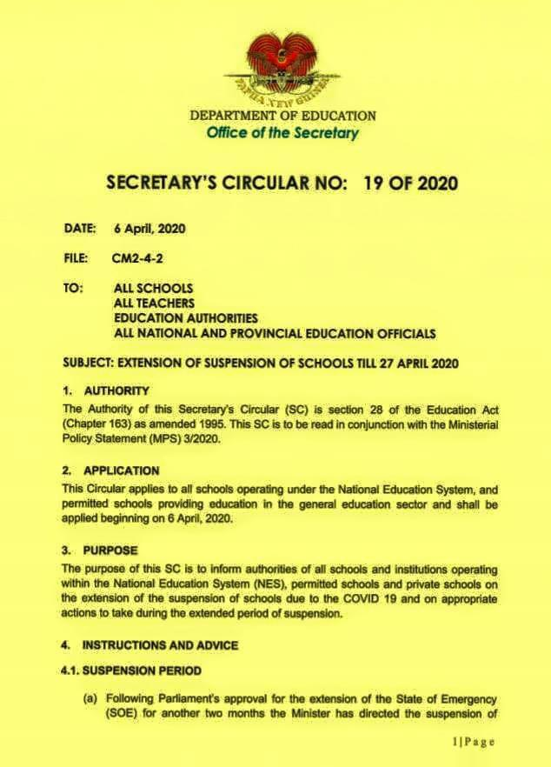
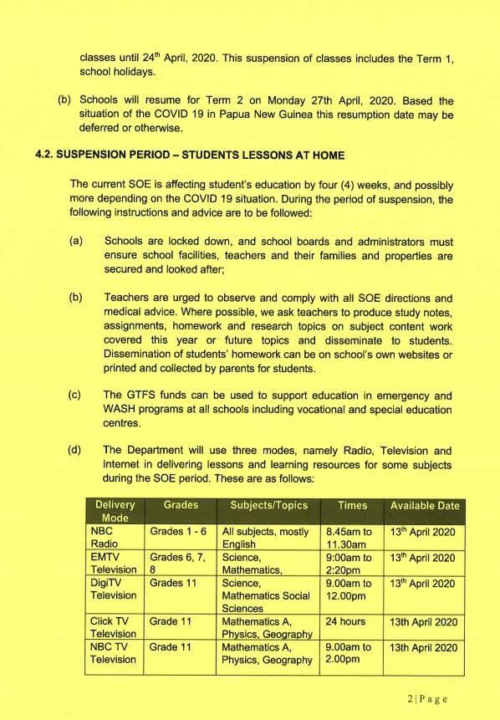

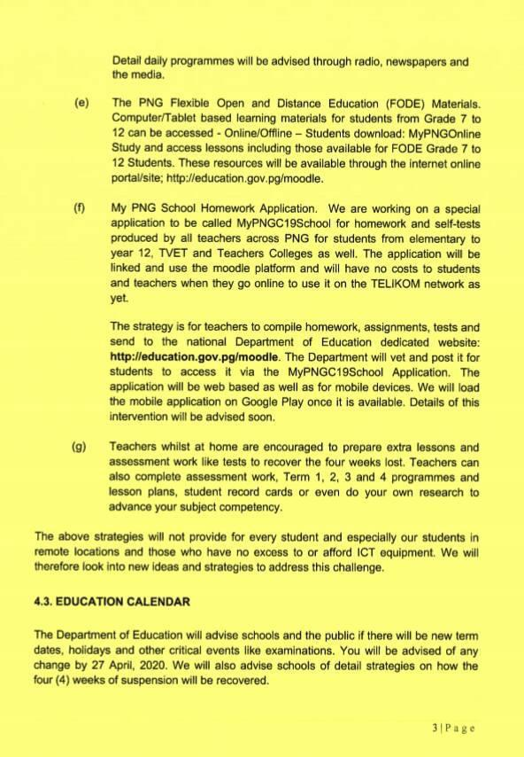

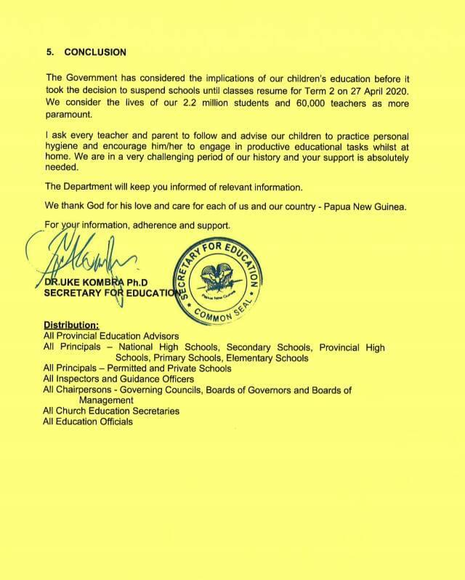

Annex 9 – Secretary's Circular No: 5 of 2020

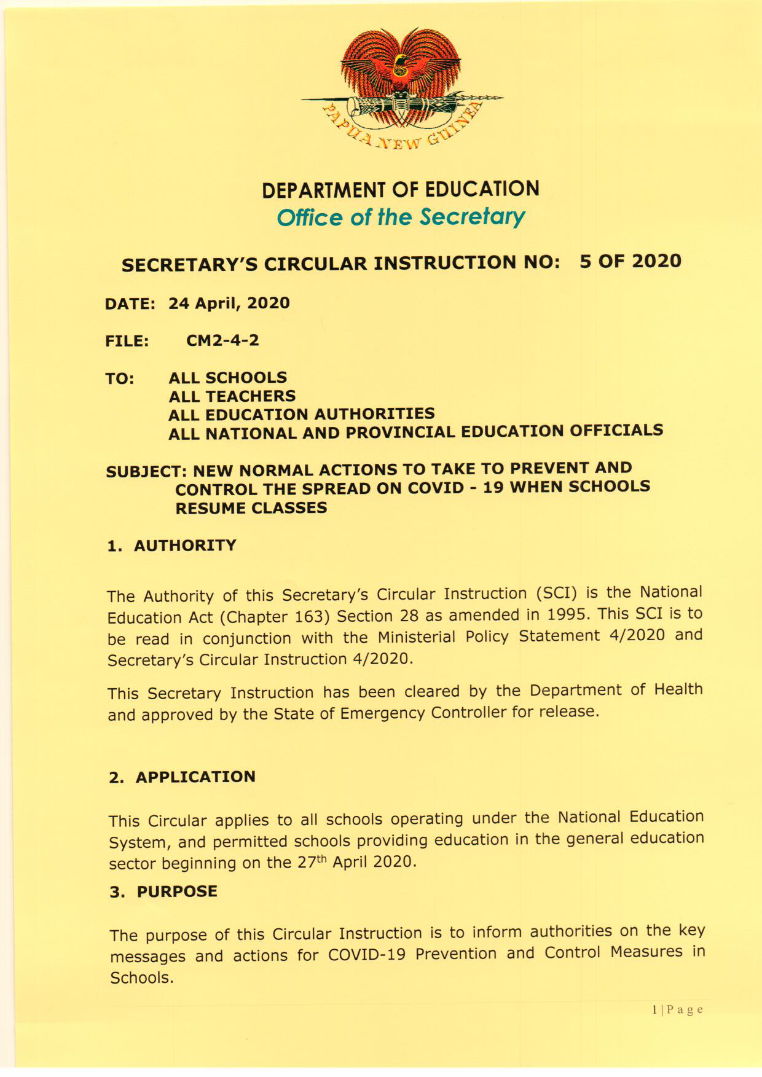

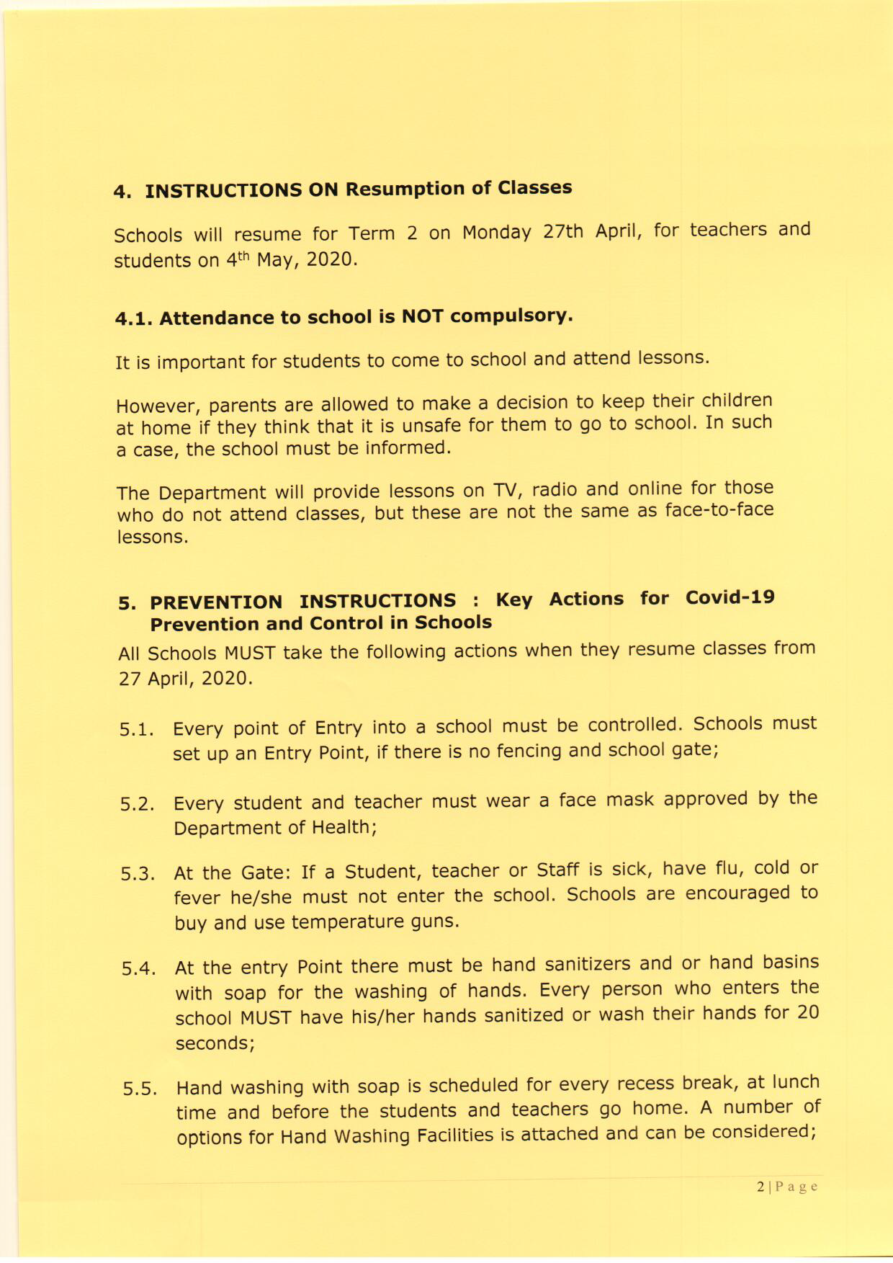

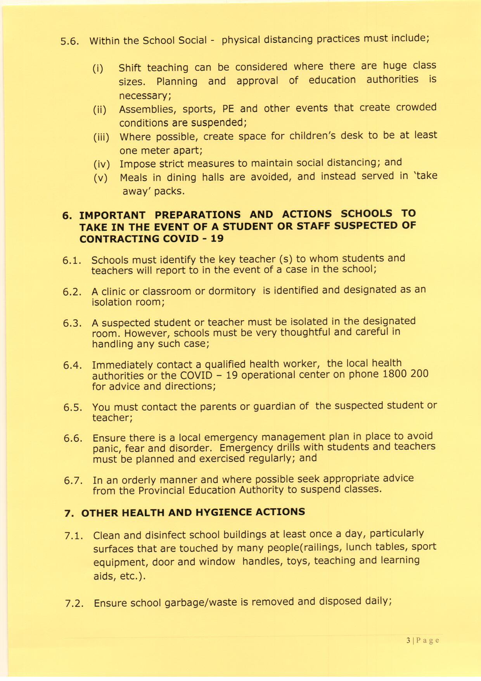

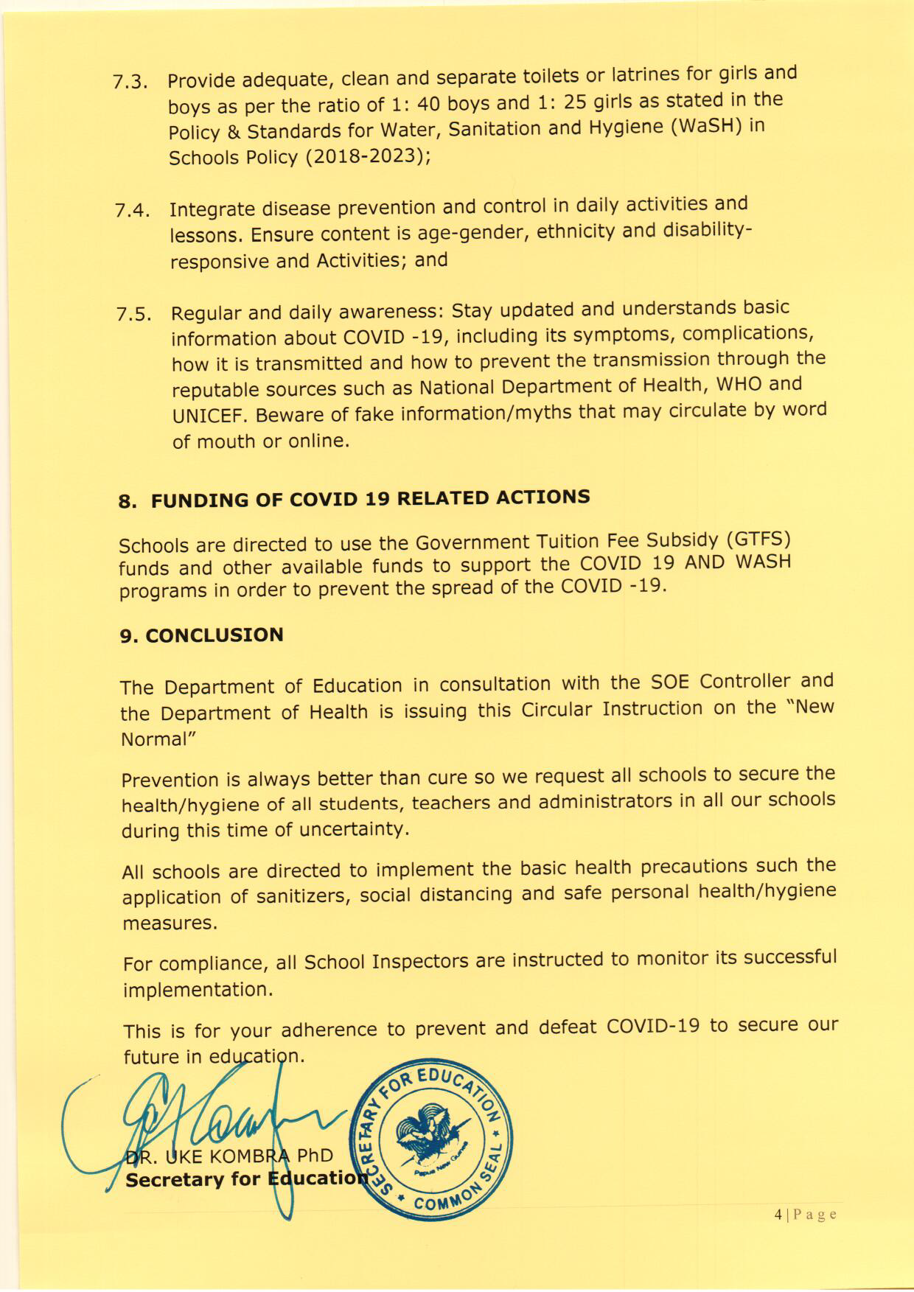

UNESCO Global Education Coalition https://en.unesco.org/covid19/educationresponse/globalcoalition
Papua New Guinea COVID-19 Education Emergency Response and Recovery Plan, 4 May 2020.
At the time of drafting the final evaluation report, several initiatives were continuing and remained incomplete. This was most evident in the provision of WASH facilities.
Annex 6 provides a breakdown of different interventions by sub-grantee partner.
Refer below to ‘KEQ 1 and 4: FRAMEWORK FOR INQUIRY’ for further breakdown of this KEQ.
This metric is mindful of challenges assessing in humanitarian responses which are often designed to respond to and meet immediate and critical need.
Refer below to ‘KEQ 1 and 4: FRAMEWORK FOR INQUIRY’ for further breakdown of this KEQ
Mindful of EERRP being a response set up to meet acute need, programmed for development impact/dividend.
Using the RAPID Framework to Address COVID-19 Learning Losses and Build Forward Better
EIE GENKIT
A convergent parallel design allows evaluations and assessment to concurrently conduct quantitative and qualitative elements in the same phase of the research process. The approach weighs the dual methods equally, analyses the two components independently, and interprets the results together to generate and support key findings and recommendations.
This includes church based and private and independent school providers.
https://www.education.gov.pg/quicklinks/iec.html
https://www.education.gov.pg/quicklinks/iec/documents/STC061_NDOE_v6-STICKERS.pdf
https://www.education.gov.pg/quicklinks/iec/documents/Teachers/IEC_Teachers_Poster_ENGLISH.pdf
UNESCO Global Education Coalition https://en.unesco.org/covid19/educationresponse/globalcoalition
Papua New Guinea COVID-19 Education Emergency Response and Recovery Plan, 4 May 2020.
Department of Education (2015) EMIS data 2015.
Department of Education (2018) Out of School Children Report (Unpublished)
De Paz, C; Muller M; Munoz Boudet, A; and Gaddis, I. (2020) Gender dimensions of the COVID-19 response. Policy Note April 16. The World Bank Group
Home - PNG | COVID 19 (info.gov.pg)
UNICEF, EERRP Annual Report, 2020-2021
This metric is mindful of challenges assessing in humanitarian responses which are often designed to respond to and meet immediate and critical need.
Mindful of EERRP being a response set up to meet acute need, programmed for development impact/dividend.
GPE interventions will run from May and endline in June/July with a Final report due in August 2022.
Consider Inspectors who were integral to MEAL and program delivery.

