# 2018-19 Performance of Australian Aid

## Updates November 2020

* Page 10, paragraph 3, should read: Progress against performance benchmarks by Pacific programs was mixed, with 56 per cent of benchmarks achieved and 33 per cent partly achieved (Figure 6). Six benchmarks (eight per cent) were not achieved.
* Page 11, Figure 6 should read:

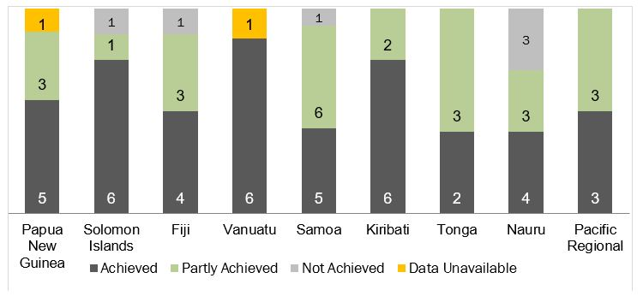

* Page 11, paragraph 4, should read: For Southeast and East Asia, 71 per cent of performance benchmarks were achieved and 27 per cent were partly achieved (Figure 8). One benchmark (2 per cent) was not achieved.
* Page 12, Figure 8 should read:

