

Performance of Australian Aid

**2014–15**

ISSN 2204-6593 (Print)

ISSN 2204-9649 (Online)

ISBN 978-1-74322-295-9 (Booklet)

ISBN: 978-1-74322-297-3 (Word document)

ISBN 978-1-74322-296-6 (PDF format)

With the exception of the Commonwealth Coat of Arms and where otherwise noted, this report is licenced under a Creative Commons Attribution 3.0 Australia licence http://creativecommons.org/licenses/by/3.0/au/.

You are free to reuse, modify, remix and distribute this material. The entire publication may be included as an appendix in your work for reference if you wish. Under the terms of the licence, you are required to attribute DFAT material in the manner specified (but not in any way that suggests that DFAT endorses you or your use of the work).

### DFAT material used ‘as supplied’

Provided you have not modified/remixed the material in this publication in any way it may be reused provided the following attribution is given:

Source: DFAT publication ‘Performance of Australian Aid 2014-15’.

### Derivative material

If you have modified/remixed the material in this publication, or derived new material from it in any way, the following attribution must be used:

Based on the DFAT publication ‘Performance of Australian Aid 2014-15’.

### Use of the Coat of Arms

The terms under which the Coat of Arms can be used are detailed on the It’s an Honour website http://www.itsanhonour.gov.au/coat-arms/index.cfm.

**Accuracy of information**

The Department of Foreign Affairs and Trade (DFAT) has taken great care to ensure the information contained in this publication is as correct and accurate as possible.

However, DFAT does not guarantee, and accepts no legal liability whatsoever arising from or connected to, the accuracy, reliability, currency or completeness of any material contained in the publication. DFAT accepts no responsibility for any loss, damage or injury resulting from reliance on any of the information or views contained in this publication.

DFAT recommends that users exercise their own skill and care with respect to their use of the material contained in the publication and that users carefully evaluate the accuracy, currency, completeness and relevance of the material for their purposes.

**Unless otherwise specified, all amounts are in Australian dollars.**

This report has been prepared by an editorial team comprising Sarah Barns, Daniel Bui, Sydney Carpenter, Fiona Crockford, Scott Dawson, Belynda McNaughton, Mark Palu, Vivienne Sykes, Sally-Ann Thomas and Tim Vistarini.

### Contact

Inquiries about this document should be directed to:

Department of Foreign Affairs and Trade RG Casey Building, John McEwen Crescent, Barton ACT 0221 Australia

Phone +61 2 6261 1111 Fax +61 2 6261 3111

*Published by the Department of Foreign Affairs and Trade, 8 February 2016.*

# Table of Contents

Executive summary 4

Introduction 5

Chapter 1 Performance against strategic targets 11

Chapter 2 Country and regional program performance 29

Pacific 32

East Asia 40

South and West Asia, Africa, the Middle East and Other Regions 51

Chapter 3 Global program performance 61

Development Banks and UN Funds 61

Australia Awards 66

Australian NGO Cooperation Program 68

Australian Volunteers for International Development Program 69

Chapter 4 Sector and thematic performance 71

Infrastructure, trade facilitation and international competitiveness 72

Agriculture, fisheries and water 74

Effective governance: policies, institutions and functioning economies 76

Education and Health 78

Building resilience: humanitarian assistance, disaster risk reduction and social protection 82

Gender equality and empowering women and girls 85

Disability-inclusive development 87

Innovation 89

Annex A Official Development Assistance delivered by other   
government agencies 92

Annex B Independent Evaluation Committee and Office of Development Effectiveness Assessment 96

List of acronyms 101

# Executive summary

This report summarises the performance of the Australian aid program in 2014-15. It reviews progress with implementation of the Government’s policy and performance framework for the aid program.

Chapter 1 reviews progress towards the 10 strategic targets set by the Government to assess the performance of the aid program as a whole. Good progress has been made against the strategic targets. As at 1 November 2015, seven of the ten targets had been achieved, with another two on track to be achieved within the required timeframe. Performance against the remaining target on gender has improved, but the target has not yet been achieved.

Chapter 2 summarises the performance of country and regional aid programs. Overall, country and regional programs performed well against their strategic objectives and performance benchmarks in 2014–15, although differences in performance between and within regions remain. Addressing gender equality issues more effectively and improving monitoring and evaluation of aid investments remain common areas for further improvement. Chapter 2 also summarises international reporting of progress against the Millennium Development Goals for each major region where Australia provides aid.

The performance of global programs in 2014–15 is assessed in Chapter 3. Core funding to multilateral organisations and Australian non-government organisations (NGOs) continued to produce strong development results across a range of areas. Scholarship and volunteer programs also continued to perform effectively. Multilateral Performance Assessments for the Asian Development Bank (ADB), United Nations Development Programme (UNDP), United Nations Children’s Fund (UNICEF) and World Food Programme (WFP) were completed in 2015 and confirm that these organisations are performing effectively.

Chapter 4 examines the performance of the Australian aid program across the six priority investment areas outlined in the aid policy. For the first time, performance is also assessed in terms of disability-inclusive development and innovation. Aid investments produced strong results in most areas but gender equality and disability-inclusive development remain areas for further improvement.

# Introduction

As part of the performance framework for the Australian aid program, *Making Performance Count,*[1] the Government committed to publish an annual Performance of Australian Aid report. This second annual report summarises the performance of the Australian aid program in 2014-15.

The Government’s aid policy, *Australian aid: promoting prosperity, reducing poverty, enhancing stability*,[2] affirms the purpose of the aid program as ‘promoting Australia’s national interests by contributing to sustainable economic growth and poverty reduction’. To achieve this, the aid program focuses on driving private sector and human development in the Indo-Pacific region through investments in six priority areas:

• Infrastructure, trade facilitation and international competitiveness;

• Agriculture, fisheries and water;

• Effective governance: policies, institutions and functioning economies;

• Education and health;

• Building resilience: humanitarian assistance, disaster risk reduction and social protection; and

• Gender equality and empowering women and girls.

Since the release of *Australian aid* in June 2014, country, regional and global programs have been reshaped to align with the aid policy framework. New strategies were also developed to guide investments in effective governance, agriculture, fisheries and water, aid for trade, disability inclusive development, education, health, social protection, infrastructure and private sector development. Australia’s new gender equality and women’s empowerment strategy, Australia Awards Global Strategy and humanitarian assistance strategy will be released in the first quarter of 2016.

In March 2015, the Foreign Minister launched the innovationXchange (iXc) to promote and encourage innovation across the aid program. The iXc works with country programs and sector teams to support innovative ideas and share ‘next practice’ in global development. It tests new approaches to designing and delivering aid, including co-creation of solutions to difficult development problems, and open calls for development innovations and new models for bringing medium-large businesses into the Pacific.

## Outline of this report

This report is divided into four chapters and two annexes.

Chapter 1 reports on the 10 strategic targets under *Making Performance Count*, which provide the basis for assessing the performance of the aid program as a whole.

Chapter 2 summarises the performance of country and regional aid programs, which represented 69 per cent of total aid spent in 2014-15. The analysis draws on a selection of results from four regional groups: Pacific; East Asia; South and West Asia; and Africa, the Middle East and other regions.

Chapter 3 highlights significant results from major global programs including core funding to key multilateral development organisations and Australian NGOs. The performance of Australian scholarships and volunteer programs is also summarised in this chapter.

Chapter 4 assesses the performance of the Australian aid program across the six priority areas of investment under the aid policy as well as disability-inclusive development and innovation. Aggregate development results for Australia’s aid in 2014-15 against twenty key indicators are also summarised here under relevant priority areas.

The report also includes a summary of the major activities and achievements of official development assistance (ODA) appropriated to other Australian Government departments and agencies (Annex A).

The performance information in this report has been quality assured and verified by the Office of Development Effectiveness (ODE), under the guidance of the Department of Foreign Affairs and Trade’s (DFAT) Independent Evaluation Committee. Their comments are at Annex B.

## Approach to assessing performance in the aid program

The analysis in this report draws on performance assessments undertaken at three levels of the aid program (refer Figure 1):

• whole of aid program level;

• bilateral (country and regional) and global programs; and

• individual aid investments.

The performance of key aid delivery partners is also separately assessed.

At the whole of aid program level, alignment with the Government’s policy directions and progress against the 10 strategic targets in *Making Performance Count* are assessed and reported annually in DFAT’s *Annual Report* and *Performance of Australian Aid* reports.

At the program level, the approaches to performance assessment are tailored to the characteristics of different programs.

For country and regional aid programs, performance is assessed each year and published in Aid Program Performance Reports (APPRs). To ensure the assessments made are contested and robust, all APPRs are peer reviewed and approved by DFAT senior management. The ODE also conducts an annual independent quality review of APPRs. Judgements about performance are made against program objectives contained in existing strategy documents for each country or regional program, and expressed as one of three ratings: progress towards objectives is on track; progress is at risk (less than expected); or progress is not on track. APPRs also report on progress against program-specific performance benchmarks and mutual obligations. In 2014-15, all twenty-seven programs for which an APPR was required completed and published their APPRs on the Department of Foreign Affairs and Trade (DFAT) website. These comprised twenty-two reports for country programs, four reports for regional programs and one report for the Australian NGO Cooperation Program (ANCP) which provides funding to accredited Australian NGOs.

Figure 1: Performance assessment in the Australian aid program

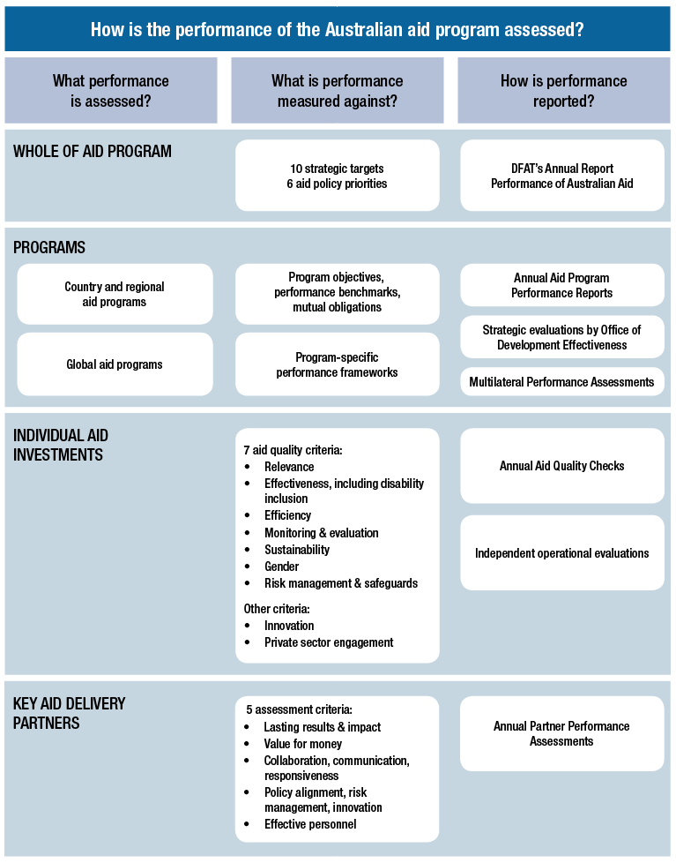

DFAT introduced a new multilateral performance assessment process in 2015. The new system assesses the performance of key multilateral organisations which receive core funding from Australia. Summaries of Multilateral Performance Assessments completed in 2015 for the ADB, UNDP and UNICEF are included in Chapter 3 and for the WFP in Chapter 4 of this report. Each year a number of new Multilateral Performance Assessments will be undertaken, providing comprehensive coverage of all major multilateral partners over a 3-4 year period.

Since the first Performance of Australian Aid report, DFAT has continued to upgrade its systems for reporting on aid performance, making a number of changes ahead of the 2014-15 investment quality reporting period. The changes were designed to:

• provide more streamlined and strategic reporting of aid performance and results;

• include humanitarian aid in the investment quality reporting system;

• include risk management and safeguards as a new quality criterion for aid investments;

• incorporate value for money assessments into investment quality reporting criteria;

• gather a wider range of quantitative information on other aspects of performance underpinning investment quality;

• gather quantitative information on how aid investments address disability, innovation and private sector engagement;

• introduce end-of-investment reports;

• clarify and improve the consistency of the definitions for different performance ratings, linking them to the aid investment quality criteria; and

• gather quantitative, standardised information on the performance of major aid delivery partners.

| Gathering more comprehensive investment quality information: gender equality |
| --- |
| A key element of reforms to DFAT’s investment quality reporting in 2014-15 was to gather a wider range of quantitative information on key aspects of performance underpinning standard investment quality criteria. For each of the 7 aid quality criteria, DFAT now gathers additional information on between 6 to 10 related aspects of performance. For example, in reaching a judgement about whether an aid investment is making a difference to gender equality and empowering women and girls, DFAT aid managers now rate, on a 1-6 scale, the performance of the aid investment against the following additional questions:  • Analysis of gender equality gaps and opportunities substantially informs the investment;  • Risks to gender equality are identified and appropriately managed;  • The investment is making progress as expected in effectively implementing strategies to promote gender equality and women’s empowerment;  • The monitoring and evaluation system collects sex-disaggregated data and includes indicators to measure gender equality outcomes;  • There is sufficient expertise and budget allocation to achieve gender equality related outputs of the investment; and  • As a result of the investment, partners increasingly treat gender equality as a priority through their own policies and processes. |

Under DFAT’s aid management policies, investment quality reporting must be completed annually for all aid investments and agreements over $3 million. Through Aid Quality Checks (AQCs), each aid investment is rated as performing satisfactorily or unsatisfactorily on a six-point scale against seven aid quality criteria.[3] Investment performance is also assessed in terms of disability-inclusive development, innovation and private sector engagement. In 2014–15, 481 AQCs were completed.[4] Over 99 per cent of eligible aid investments were assessed.[5] To ensure performance assessments in AQCs are robust and contestable, they are subject to peer moderation. The ODE also undertakes an annual spot check of the quality of AQCs. All aid investments with a budget of $10 million or more are also required to undergo an independent evaluation at least once in their lifetime.

Partner Performance Assessments review how well key implementing partners (commercial contractors, NGOs, multilateral organisations) are delivering the services specified in aid agreements. Key implementing partners under each aid agreement valued over $3 million are rated as performing satisfactorily or unsatisfactorily on a six-point scale against five assessment criteria. In 2014–15, over 92 per cent of eligible aid agreements were assessed.

Performance information generated at the individual aid investment level feeds into assessments of program performance, which in turn provides the basis for assessing the performance of the aid program as a whole.

To ensure that the department’s reporting on the performance of Australian aid is rigorous, credible and supported by robust evidence, the ODE, under the guidance of the Independent Evaluation Committee, undertakes strategic evaluations of particular programs or thematic areas and provides independent oversight of departmental aid performance assessment systems. A list of evaluations undertaken by ODE in 2014-15 is at Annex B.

## Transparency

The publication of an annual Performance of Australian Aid report forms part of the Government’s ongoing commitment to high standards of transparency and accountability in the management of the Australian aid program. Over 300 new aid-related documents have been released on DFAT’s website since June 2014. This includes twenty-five Aid Investment Plans, nine sector and thematic strategies, and twenty-seven APPRs. Nineteen independent operational evaluations were published on the DFAT website during 2014-15 and ODE published eight strategic evaluations in 2015. Australia also fulfilled its aid reporting obligations to the OECD Development Assistance Committee and International Aid Transparency Initiative. Information on aid-related business opportunities, annual procurement plans, multi-use lists and contracts awarded is made available through the AusTender website (tenders.gov.au). Information on aid fraud control strategies, fraud losses and recoveries is also published on the DFAT website.

# Chapter 1 Performance against strategic targets

*Making Performance Count* identified 10 strategic targets to ensure the aid program is well managed, achieving value for money and delivering on the key priorities outlined in the Government’s aid policy *Australian aid: promoting prosperity, reducing poverty, enhancing stability*.

Since July 2014, good progress has been made towards achieving these targets. Seven of the ten targets have been achieved with another two on track to be achieved within the required timeframe. Performance against the remaining target on gender has improved, but the target has not yet been achieved.

## Target 1: Promoting prosperity

***Promote economic development by increasing Australia’s aid for trade investments to 20 per cent of the aid budget by 2020***

**Status: On track**

**The aid program is on track to meet this target within the required timeframe. The estimated expenditure on aid for trade in 2014-15 was $824.9 million. This equates to approximately 16.4 per cent of total Australian aid, an increase of 3.6 percentage points on the 2013-14 outcome.**

Figure 2: Aid for Trade expenditure as a percentage of total Australian ODA[6]

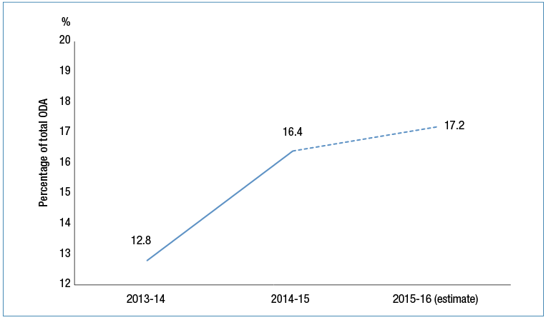

Australia’s aid policy puts a strong emphasis on aid for trade. The aid for trade target of 20 per cent of the total aid budget by 2020 is consistent with the performance of other key donors and the increasing demand from developing countries.

Aid for trade helps developing countries address their internal constraints to trade, which in turn acts as a catalyst for economic growth and poverty reduction. No country has achieved high and lasting growth without participating in international trade, as recognised in the Sustainable Development Goals and the July 2015 Fifth Global Review of Aid for Trade. The OECD-WTO estimates that one dollar of aid for trade investment is associated with an increase of eight dollars in additional exports.[7]

The strategy for Australia’s aid for trade investments was released in July 2015 and encourages innovation, including by partnering with the private sector and promoting market-based solutions. Australia’s aid for trade priorities include trade and investment policy and trade facilitation, global value chains, infrastructure, private sector development, economic empowerment of women, knowledge and skills development, agriculture, and services.

In 2014-15, the largest share of Australia’s aid for trade assistance was spent on infrastructure, including in transport, energy and communications (see Figure 3). Other significant shares related to trade facilitation and international competitiveness, including trade policy and agriculture, fishing and forestry.

Figure 3: Aid for trade expenditure by investment area, 2014-15

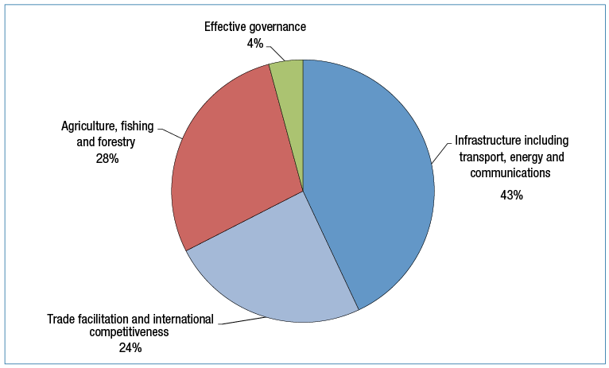

Australia’s aid for trade is delivered through multilateral, regional and bilateral channels. In July 2014, DFAT’s portfolio ministers launched Australia’s multilateral aid for trade flagship, the Global Trade Integration Facility (see Chapter 4). Other examples of aid for trade assistance include:

• at the regional level, the Greater Mekong Subregion Trade and Transport Facilitation program is helping to streamline border procedures and reduce the time required to process and clear goods through customs; and

• at the bilateral level, Australia is strengthening the Solomon Islands’ agriculture and quarantine services, and improving the country’s market access and trade opportunities, through the Solomon Islands Biosecurity Development Program.

The aid program is on track to meet the target of aid for trade expenditure equalling 20 per cent of the aid budget by 2020 with aid for trade related investments prominent in new Aid Investment Plan pipelines. It is estimated that expenditure on aid for trade will increase from 16.4 per cent in 2014-15 to 17.2 per cent of total Australian ODA in 2015-16. However, concerted programming efforts will be required to ensure the target of 20 per cent is met by 2020.

## Target 2: Engaging the private sector

***All new investments will explore innovative ways to promote private sector growth or engage the private sector in achieving development outcomes***

**Status: Achieved**

**The aid program achieved this target in 2014-15, with all new investments exploring innovative ways to promote private sector growth or engage the private sector.**

The Government’s aid policy identified the private sector as an essential partner to achieving Australia’s sustainable development outcomes in the region. In response, DFAT has reviewed its aid investment policies, strategies and processes to support increased collaboration with the private sector. Aid investment guidance now includes private sector engagement and promoting private sector growth as key considerations for all new aid investment concepts and designs. Revised sector strategies also incorporate objectives relating to private sector collaboration and growth.

How individual investments promote private sector growth or engage the private sector in achieving development outcomes is now considered as part of annual Aid Quality Checks.

Formal partnerships were introduced in 2014-15 to promote greater engagement between DFAT and the private sector, including:

• a partnership with the business-led United Nations Global Compact Network Australia, a corporate sustainability initiative which builds the capacity of Australian businesses to engage and partner in international development activities; and

• a four year agreement with Fairtrade Australia New Zealand to increase Australian consumer awareness of Fairtrade products, increase Australian retailers’ ability to source Fairtrade products from developing countries in the region, and increase overall trade in Fairtrade products in the Asia Pacific.

The *Ministerial Statement on engaging the private sector in aid and development*[8] was released in August 2015, inviting the private sector to collaborate with the aid program on creating sustainable solutions to tackle development challenges in our region.

The *Strategy for Australia’s Aid Investment in Private Sector Development* (PSD Strategy), the companion to the Ministerial Statement, was released in November 2015. The PSD strategy formalised the rationale, principles and approaches for Australia’s aid to improve the growth and inclusion of the private sector.

Both the PSD Strategy and Ministerial Statement incorporated the findings of the June 2015 Joint Standing Committee on Foreign Affairs, Defence and Trade report, Partnering for the Greater Good: the role of the private sector in promoting economic growth and reducing poverty in the Indo-Pacific region.[9]

|  |
| --- |
| **Engaging the Private Sector: Health Product Development Partnerships** |
| In March 2015 the Foreign Minister announced a contribution of $30 million over three years to support Health Product Development Partnerships (PDPs). PDPs are innovative public-private partnerships that co-invest in the development of new drugs and diagnostic tests for neglected diseases in the developing world. These mechanisms use public and philanthropic funding to incentivise and engage the pharmaceutical industry and academic research institutions in undertaking research and development for diseases of the developing world. A pooled funding mechanism enables Australia to co-invest with other donors, global health organisations, private philanthropic organisations, and pharmaceutical companies to help bring to market diagnostic tools and medicines for tuberculosis and malaria which are high burden diseases in the Indo-Pacific region. In 2014-15 DFAT entered into product development partnerships with *Medicines for Malaria Venture*, *The Foundation for Innovative New Diagnostics* and the *Global Alliance for TB Drug Development.* |

## Target 3: Reducing poverty

***By July 2015, all country and regional programs have Aid Investment Plans that describe how Australia’s aid will promote economic growth in ways that provide pathways out of poverty***

**Status: Achieved**

**Aid Investment Plans have been completed for all major country and regional programs.**

Aid Investment Plans set out the direction for a country or regional program, and are designed to help ensure the most effective use of aid. They describe where, why and how Australian aid will be delivered and the expected results to be achieved. Aid Investment Plans are based on economic, political and social analysis that identifies the key constraints to economic growth, private sector development and poverty reduction. Drawing on this analysis, each individual Aid Investment Plan identifies a set of strategic objectives, priority aid sectors and specific aid investments to promote economic growth and poverty reduction.

Aid Investment Plans for all major country and regional programs, twenty-five in total, were published on the DFAT website on 30 September 2015. The deadline for the completion of Aid Investment Plans was extended from July 2015 to September 2015 to enable 2015-16 budget outcomes to be taken into account.

Aid Investment Plans contain performance benchmarks and mutual obligations (see strategic target 6) tailored to the circumstances of each country or region. Performance against the strategic objectives in an Aid Investment Plan, as well as its performance benchmarks and mutual obligations, is reviewed annually through Aid Program Performance Reports.

## Target 4: Empowering women and girls

***More than 80 per cent of investments, regardless of their objectives, will effectively address gender issues in their implementation***

**Status: Not yet achieved**

**Although the aid program’s performance on gender improved in 2014-15, this target has not yet been achieved.**

Empowering women and girls is one of the aid program’s six priority investment areas. Gender inequality undermines economic growth, human development and poverty reduction. There is clear evidence that women’s empowerment is essential to achieve sustainable, inclusive economic growth.

Data to track progress towards this target is drawn from DFAT’s annual AQCs. The target tracks the percentage of investments that are rated ‘satisfactory’ or above for gender equality in AQCs. In 2014-15, 78 per cent of aid investments were rated as satisfactorily addressing gender equality during their implementation, just short of the target of 80 per cent.[10] This was a significant improvement from the 2013-14 baseline of 74 per cent.

Performance on gender varied widely by investment priority area. Investments in the education and health sectors continue to perform above the 80 per cent target, though there is still room for improvement. Investments in the agriculture, fisheries and water sector have significantly improved their performance on gender equality while gender equality results for investments in the “effective governance” priority investment area also improved. Investments in these two priority areas benefited from increased engagement with female stakeholders, including analysis of their needs, introduction of gender awareness training and gender equality strategies, effective partnerships and dedicated resources for gender equality promotion and setting of clear targets around gender equality results.

Investments in the priority investment area of “infrastructure, trade facilitation and international competitiveness”, on the other hand, saw significantly lower ratings than the previous year with an overall rating of 64 per cent satisfactory. This is likely to reflect growing awareness of the importance of gender inequalities in economic sectors combined with greater understanding about what constitutes effective performance on gender equality.

Figure 4: Gender performance by investment priority area

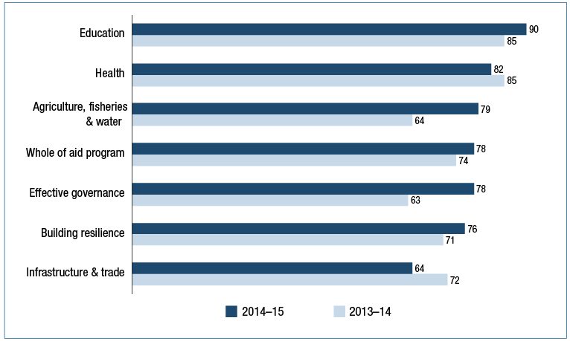

|  |
| --- |
| **Mainstreaming Women’s Economic Empowerment: The Market Development Facility** |
| The Market Development Facility (MDF) is focused on reducing poverty by stimulating economic growth. It works through partnerships with the private and public sector to identify and develop new products and services or new ways of doing business, which provide increased income and employment opportunities for poorer populations. MDF shares the risk of investment to turn local opportunities into realities.  The facility is a six-year multi-country program that started in Fiji in 2011 and expanded to Timor-Leste (2012), Pakistan (2013), and Sri Lanka and Papua New Guinea in mid-2015.  Gender equality was a consideration in only some of the sectors and industries initially selected in Fiji, Timor-Leste and Pakistan. During the past year, MDF developed a strategic guidance note on mainstreaming women’s economic empowerment that integrates gender considerations into all aspects of the program from sector selection through to management and results measurement systems. MDF also commissioned Gender Poverty and Ethnicity studies in Fiji and Timor-Leste to identify the gender and ethnic dimensions to poverty and to pathways out of poverty. Similar studies are planned for all MDF countries. Findings from these studies provided the basis for expanding MDF into sectors with good potential to improve women’s employment and income. The combination of these actions helped the program in Timor-Leste and Fiji to improve its performance rating on gender equality from unsatisfactory to satisfactory between 2014 and 2015. |

To build on progress towards gender equality and ensure DFAT meets the target in 2016, a number of strategies have been put in place. These include: establishment of a new Gender Equality Branch; preparation of a Gender Equality and Women’s Empowerment Strategy, which will provide guidance for investment managers on integrating gender equality into aid investments; access to specialist technical advice; gender assessments and action planning for individual country programs, particularly those that underperformed against the gender equality target; and gender equality training for DFAT staff.

## Target 5: Focusing on the Indo-Pacific region

***Increase the proportion of country program aid that is spent in the Indo-Pacific region to at least 90 per cent from 2014-15***

**Status: Achieved**

**This target was achieved in 2014-15, with 90.4 per cent of country programmable aid spent in the Indo-Pacific region. In the 2015-16 aid budget, 93 per cent of country programmable aid was allocated to the Indo-Pacific region.**

This target ensures that the Australian aid program is focussing on the region where Australia can make the most difference. Stronger economic growth and stability in the Indo-Pacific region is directly in Australia’s interests.

This target measures the proportion of country programmable aid that is spent in countries in the Indo-Pacific region. This includes bilateral and regional aid expenditure, as well as some global and cross regional aid that can be attributed to countries in the Indo-Pacific region. For example, humanitarian assistance earmarked to particular countries is included in country programmable aid, but core funding to international humanitarian agencies and multilateral development agencies is not included.

Figure 5: Percentage of country programmable aid that is spent in the Indo-Pacific region

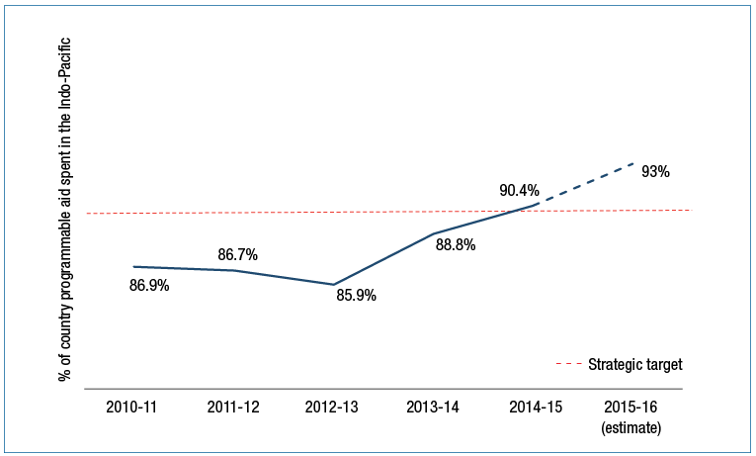

## Target 6: Delivering on commitments

***From July 2015, progress against mutual obligations agreed between Australia and its key partner governments and organisations will form part of program performance assessments***

**Status: Achieved**

**This target was achieved in November 2015 with the publication of 2014-15 Aid Program Performance Reports on the DFAT website.**

Interim performance benchmarks and mutual obligations were identified for all major country and regional programs and published in 2013-14 Aid Program Performance Reports. This target was achieved with progress towards meeting benchmarks and mutual obligations assessed in 2014-15 Aid Program Performance Reports.

**Performance benchmarks** assist with assessing progress against a country program’s objectives. A set of 189 performance benchmarks were reported for 2014-15. Figure 6 shows the progress against benchmarks for the six priority areas of the aid policy. Overall, 121 benchmarks were achieved, 61 were partially achieved and 7 were not achieved. Chapter 2 reports on progress against performance benchmarks by region.

Figure 6: Performance benchmarks by investment priority area, 2014-15

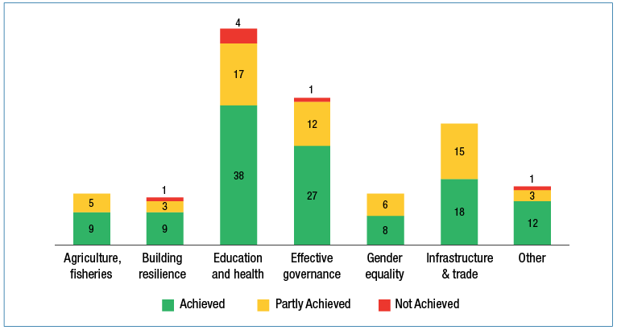

The number of benchmarks for each country program was determined by the size of annual budget allocations. Programs with an annual budget under $50m set 3–6 benchmarks each year, programs over $50m 6–8 benchmarks, and 12 or more benchmarks were set for programs over $300m. Country and regional programs aimed to identify performance benchmarks that: demonstrated a clear line of sight to a program objective; were within Australia’s control to achieve within the timeframe; built on existing monitoring and data collection efforts; and reflected the sectoral breadth and financial profile of the program.

Performance benchmarks were of seven different types. The most frequently used benchmarks were outputs, followed by outcomes and aggregate results.

Table 1: Types of performance benchmarks for 2014-15

| **Benchmark type** | **Definition** | | **Example** |
| --- | --- | --- | --- |
| ***Milestone*** | | A significant point in a contract/program | Papua New Guinea:  Master planning phase of ANGAU Hospital completed and approved by DFAT and PNG Government stakeholders by mid-2015. |
| ***Output*** | | Good/service delivered by the intervention | Laos:  115 schools have water and sanitation facilities meeting Government of Laos quality standards with district funded operation and maintenance plans in place. |
| ***Aggregate result*** | | Intended results of the program, often relating to targeted beneficiaries | Burma (Myanmar):  6,300 households with increased access to financial services, and markets. |
| ***Outcome*** | | Changes that the interventions aim to deliver for targeted beneficiaries  Short term: changes in knowledge, skills, attitudes and motivation  Medium term: behaviour change | Afghanistan:  70 per cent of civil servants trained in public sector management have improved their work practices and ability to perform their job. |
| ***Program management*** | | Related to administration of the aid program; may cover aspects of efficiency, or how the program is targeted/aligned | Pacific Regional Program:  Reduce the number of investments from 75 to 55 by June 2015. |
| ***Partnership*** | | Related to the relationship between DFAT and partners (eg partner government, NGOs, multilaterals) | Philippines:  Facilitate six partnership agreements between Philippine and Australian academic institutions. |
| ***Policy*** | | Related to discussions with partner governments about policy reforms | Solomon Islands:  Agreed Economic and Financial Reform Program matrix for 2014-15 between donor partners and the Solomon Islands Government. |

**Mutual obligations** represent the contributions of Australia and partner governments or organisations to shared development goals. They reflect commitments that are of particular importance for partner government development priorities and Australian aid investments.

The stronger focus on mutual obligations under *Making Performance Count* builds on longstanding and widely accepted aid effectiveness principles. Both the 2005 *Paris Declaration on Aid Effectiveness* and 2011 *Busan Partnership for Effective Development Cooperation* highlight ownership and mutual accountability as key principles for making aid more effective.

A broad range of mutual obligations were identified by country and regional programs and reported against in 2014-15 Aid Program Performance Reports. Australia’s obligations generally take the form of budget commitments, alignment of Aid Investment Plans with country priorities, and ways of working including responsiveness, flexibility and innovation.

Obligations for partner governments are derived from a range of sources. National development plans represent the overall framework for identifying commitments and assessing progress. These commitments vary and range from minimum sectoral budget allocations to specific legislative and policy reforms. For some programs, formal commitments between Australia and the partner government have been agreed and link to national development plans, for example, the Philippines-Australia Statement of Commitment. Mutual obligations have also been identified in areas that support joint programming priorities, for example, PNG and Australia agreed to work together on activities supporting priority infrastructure at the University of PNG.

New performance benchmarks and mutual obligations were included in 2015 Aid Investment Plans. For Pacific programs, mutual obligations will also be confirmed in Aid Partnerships under development. Progress will be reported annually in Aid Program Performance Reports.

## Target 7: Working with the most effective partners

***By July 2015, design and apply new systems to assess the performance of the aid program’s key delivery partners and ensure stronger links between performance and funding***

**Status: Achieved**

**Summary: The target was achieved in 2014-15 with: the introduction of Partner Performance Assessments; a strengthened Multilateral Performance Assessment process for multilateral organisations receiving core funding; reforms to systems for assessing performance under the Australia-NGO Cooperation program; and progress in linking performance to payments in aid agreements.**

Working with the most effective delivery partners helps ensure Australia’s aid investments are achieving value for money.

In 2014-15, 77 per cent of DFAT’s administered ODA was delivered through agreements with three main types of implementing partners: commercial partners, multilateral organisations and NGOs (Figure 7).

Figure 7: DFAT administered ODA by delivery partner type, 2014-15

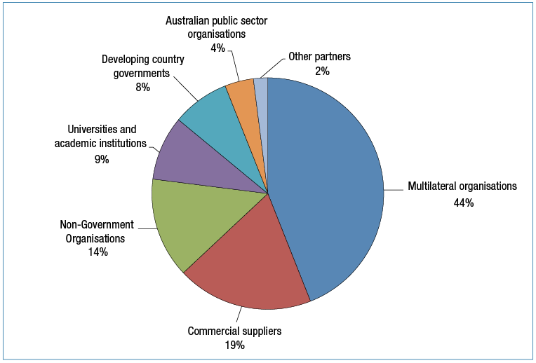

A new system to assess the performance of DFAT’s main aid delivery partners was introduced in early 2015. Partner Performance Assessments (PPAs) review how well key implementing partners (commercial partners, multilateral organisations and NGOs) are delivering the services specified in aid funding agreements. The focus is on the performance of the implementing partner, as distinct from the quality of the investment itself (which is assessed by the annual AQC).

Assessments were completed for funding agreements valued at over $3 million except for core contributions to multilateral organisations. The assessments are made against five standard criteria: deliver lasting results and impact; maximise value for money; collaboration, communication and responsiveness; policy alignment, risk management and innovation; and effective partner personnel. Each criterion is assessed on a six-point scale with ratings 1-3 representing unsatisfactory performance and ratings 4-6 representing satisfactory performance.

Table 2: PPA completed by delivery partner type, 2014-15

| **Partner type** | **Number of PPAs** | **Overall value of agreements assessed ($m)** |
| --- | --- | --- |
| NGOs | 130 | $1,620 |
| Commercial suppliers | 101 | $3,762 |
| Multilateral Organisations | 187 | $3,062 |

The results indicate that the three main delivery partner categories are all performing to an adequate level or better across all assessment criteria. Over 93 per cent of assessments completed had ratings of adequate (4.0) or higher.

Table 3: Average PPA rating score by delivery partner type, 2014-15

| **Commercial Partners** | **NGOs** | **Multilateral Organisations** | **Overall Partner Rating** |
| --- | --- | --- | --- |
| 5.0 | 4.9 | 4.5 | 4.8 |

Commercial partners achieved the highest percentage of assessments rated satisfactory against all five standard assessment criteria (Table 4). More experience in using the PPA process is required before reaching conclusions on the significance of the relative performance of different delivery partners. While the system is new for NGOs and multilaterals, it builds on an existing system used to assess the performance of commercial contractors. Agreements with commercial contractors are characterised by a high level of managerial direction and control by DFAT whereas grant agreements with NGOs and multilaterals have often been conceived as partnership agreements where DFAT has agreed to fund investments over which partners have much greater autonomy in investment design and implementation. Australia’s investment in multilateral programs is often also made in collaboration with other donors, requiring greater degrees of compromise by all parties than is required in other arrangements. In addition, multilateral organisations operate under policies and procedures endorsed by boards (which include Australian representation) and these policies and procedures can be difficult to change quickly to meet Australia’s specific interests in individual countries (in contrast to the flexibility DFAT has when engaging commercial suppliers).

Table 4: Proportion of PPA criterion rated satisfactory by delivery partner type, 2014-15

| **Criterion % satisfactory** | **Commercial Partners** | **NGOs** | **Multilateral Organisation** |
| --- | --- | --- | --- |
| Deliver Lasting Results and Impact | 97% | 96% | 94% |
| Maximise Value for Money | 99% | 97% | 92% |
| Collaboration, Communication and Responsiveness | 98% | 96% | 95% |
| Policy Alignment, Risk Management and Innovation | 100% | 96% | 97% |
| Effective partner personnel | 98% | 95% | 94% |

PPA information is used to inform tender evaluation and agreement award decisions. In addition, good progress has been made by DFAT in linking partner performance to payments in commercial agreements. In 2015, 100 per cent of complex aid tenders released and 94 per cent of complex aid contracts entered into by DFAT linked performance and payment (most commonly by linking a proportion of management fees to PPA scores).

Reforms to systems for assessing the performance of NGOs receiving funding through the Australian NGO Cooperation Program (ANCP) were introduced in 2014-15. Under the ANCP, DFAT has strengthened the quality assurance of performance information provided through the Monitoring Evaluation and Learning Framework and accreditation systems. DFAT’s PPA process has been integrated into ANCP’s program management cycle. Eleven NGOs with agreements under the ANCP in total value of over $3 million were assessed in April 2015. All assessed NGOs satisfactorily met the performance criteria, which confirmed continued access to ANCP funding. Consideration will be given to assessing a larger proportion of accredited NGOs in future. Poor performance is addressed during the reaccreditation process, and between reaccreditation, with information gained from PPAs triggering a performance management process.

A strengthened Multilateral Performance Assessment process for multilateral organisations receiving core funding from the Australian aid program was finalised in 2014-15. These assessments support and inform regular dialogue with multilateral organisations at headquarters level on key performance issues. The assessments draw on a wide range of performance information including from the multilateral organisation itself, Australia’s own experience and the assessments of other development partners. Four assessments were completed during 2015. Chapters 3 and 4 of this report include summaries of assessments completed for the ADB, UNICEF, UNDP and WFP. Assessments of other multilateral organisations receiving significant core funding from Australia’s aid budget will be completed on a rolling basis in future years.

## Target 8: Ensuring value for money

***Deliver high standards of value for money in at least 85 per cent of aid investments. Where standards are not met and improvements are not achieved within a year, investments will be cancelled***

**Status: Achieved**

**This target was achieved in 2014-15 with 87 per cent of investments rated as satisfactory for efficiency and 90 per cent of investments rated as satisfactory for effectiveness.**

DFAT seeks to ensure that value for money considerations are applied across all aid management policies, practices and investments. Data to track progress towards this target is drawn from DFAT’s annual Aid Quality Checks. Investments rated as satisfactory against the efficiency and effectiveness criteria are considered to be delivering high standards of value for money. In 2014-15, 87 per cent of investments were rated as satisfactory for efficiency and 90 per cent of investments were rated as satisfactory for effectiveness.

This strategic target also requires the identification of underperforming investments based on unsatisfactory ratings for both effectiveness and efficiency criteria. In 2014-15, 18 underperforming investments were identified as Investments Requiring Improvement (IRI) and strategies have been put in place to improve performance, overseen by senior management. If performance does not improve within 12 months, investments will be cancelled.

|  |
| --- |
| **Which aid investments are effective and efficient?** |
| Aid investments are assessed annually against the following questions in Aid Quality Checks:  ***Effectiveness - Are we achieving the results that we expected at this point in time?***  • The investment has clear and realistic outcomes, supported by a robust logic and theory of change.  • The investment is on-track towards achieving its expected outcomes.  • The quality of the investment’s outputs and activities is as expected.  • Policy dialogue is used effectively to influence partners and support the investment’s outcomes.  • Intended beneficiaries are satisfied with the investment’s results.  • There is evidence of behaviour change amongst partners and beneficiaries.  • The investment actively involves people with disabilities and /or disabled person’s organisations in planning, implementation and monitoring and evaluation.  • The investment identifies and addresses barriers to inclusion and opportunities for participation for people with disability.  • The investment actively involves Indigenous peoples and /or Indigenous peoples organisations in planning, implementation and monitoring and evaluation.  • The investment identifies and addresses barriers to inclusion and opportunities for participation by Indigenous peoples and /or ethnic minorities.  ***Efficiency - Is the investment making appropriate use of Australia’s and our partners’ time and resources to achieve outcomes?***  • Activities and outputs are delivered on time and in a cost-effective manner.  • Predicted budgets compare well to actual expenditure.  • The investment’s planned funding and timeframe are sufficient to achieve the intended outcomes.  • The volume of outputs and activities is sufficient to achieve the intended outcomes.  • There is sufficient staff (both DFAT and partners) with the necessary skills to manage the investment.  • The investment modality and implementation arrangements are appropriate and proportional to the outcomes sought.  • Implementation arrangements are well harmonised with other donors.  • Implementation arrangements are aligned with partner government systems. |

In 2014-15, the department engaged 2,133 international advisers to support the delivery of the Australian aid program. All advisers were engaged in accordance with the Aid Adviser Remuneration Framework. The framework promotes the transparency of adviser remuneration and allowances based on professional discipline categories and job levels.

In 2014-15, the average remuneration (daily/monthly rates, applicable allowances and support costs) paid to long and short term advisers represent a 28 per cent and 44.2 per cent saving respectively, when compared to remuneration paid prior to the introduction of the framework in February 2011.

## Target 9: Increasing consolidation

***Reduce the number of individual investments by 20 per cent by 2016-17 to focus efforts and reduce transaction costs***

**Status: On-Track**

**The aid program is on track to achieve this target within the required timeframe. By 1 July 2015, the number of individual investments had reduced by just over 18 per cent.**

Focusing on fewer, larger aid investments streamlines DFAT’s aid administration and reduces transaction costs, and it reduces the administrative burden on partner government and key delivery partners. Analysis conducted by the ODE also suggests that higher value investments perform better than lower value investments.

Figure 8: Progress on consolidation of aid investments

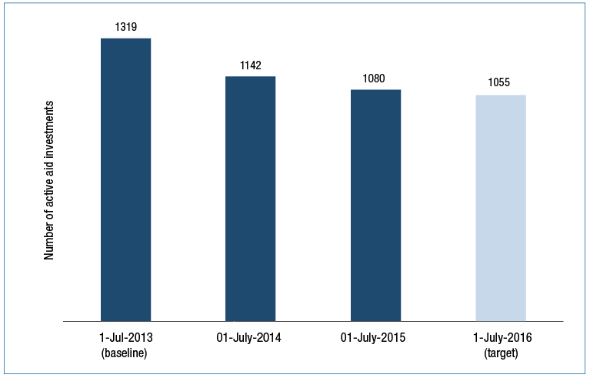

Other measures also show strong consolidation in aid administration. Over the two years from July 2013 to July 2015, the average size of aid investments has increased by more than 20 per cent (Table 5). Over the same period, there has been a 27 per cent reduction in the number of aid agreements (contracts and grant agreements) managed by DFAT, and a 73 per cent increase in the average value of agreements under management.

Table 5: Consolidation at the investment and agreement level

|  | **Investments** | **Average Investment Value** | **Agreements** | **Average Agreement Value** |
| --- | --- | --- | --- | --- |
| July 2013 | 1319 | $20.3m | 3975 | $4.1m |
| July 2014 | 1142 | $22.8m | 3465 | $5.6m |
| July 2015 | 1080 | $24.4m | 2891 | $7.1m |

## Target 10: Combatting corruption

***Develop and implement new fraud control and anti-corruption strategies for all major country and regional programs by July 2015***

**Status: Achieved**

**This target was achieved with new fraud and anti-corruption strategies developed and in place for all major country and regional programs by July 2015.**

These strategies identify the risks and incidence of fraud and corruption of greatest relevance to the delivery of Australian aid in particular countries and regions. They detail fragile and corrupt environments and the controls and measures the Australian aid program will adopt to safeguard aid funding. They also outline the support provided to reduce fraud and corruption in partner countries. The strategies have helped focus DFAT’s efforts on protecting Australian funds overseas and combatting fraud and corruption in partner countries.

Aid program fraud prevention measures set out in the strategies include:

• due diligence assessments on aid delivery partners to ensure Australia works with credible international partners and accredited NGOs;

• assessment of partner government systems to understand weaknesses and to make informed decisions about when to use them, or additional risk mitigation means to employ;

• joint ‘zero tolerance’ statements with partner governments and contractual obligations with delivery partners to ensure effective fraud prevention, detection, investigation and reporting processes and procedures;

• training programs for DFAT staff and external partners involved in aid delivery to strengthen knowledge and capacity for preventing, identifying, reporting and managing fraud and corruption, and supporting a positive risk culture and management approach;

• the integration of lessons learnt from previous instances of fraud into the design of new aid activities, or the redesign of existing activities to prevent the recurrence of fraud;

• varying structures for payments e.g reimbursement rather than advance payment, funding tranches linked to progress; and

• investments to build capacity of partner governments to combat fraud and corruption. These are tailored to individual contexts and cover elements such as local leadership, legal commitments, administrative enforcement mechanisms, and administrative and policy reforms.

The following examples highlight specific country program fraud control initiatives:

• the Fiji program has identified specific fraud and corruption risks in working with civil society organisations. These risks are now managed by strengthening due diligence to ensure partners have strong financial management capacities and financial systems; and

• the Indonesia program fraud control and anti-corruption strategy focuses attention on strengthening the Indonesian Government’s capacity to identify, report and address fraud and corruption. Specifically, economic governance programs support the Indonesian Ministry of Finance and the Indonesian National Planning Agency to lead the implementation of public financial management reforms that aim to improve spending quality and service, and reduce opportunities for fraud and corruption.

# Chapter 2 Country and regional program performance

This chapter summarises the performance of Australia’s country and regional aid programs. Country programmable aid constituted around 69 per cent of total Australian Official Development Assistance (ODA) expended in 2014–15 ($3,460.2 million). Key performance trends, selected results and areas for improvement are highlighted for programs, organised into four regional groups: the Pacific; East Asia; South and West Asia; and Africa, the Middle East and other regions.

For country and regional aid programs, performance is assessed each year and published in APPRs. Judgements about performance are made against program objectives contained in existing strategy documents for each country or regional program, and expressed as one of three ratings: progress towards objectives is on track; progress is at risk (less than expected); or progress is not on track.

Figure 9: Progress against program objectives by region

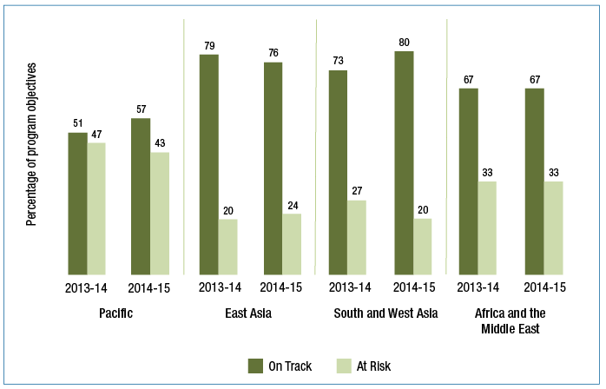

*In 2013/14, 2 per cent of program objectives in the Pacific were rated as off track and 1 percent of program objectives in East Asia were rated off track. No program objectives were rated as off track in 2014/15.

In 2014-15, performance benchmarks were identified for country and regional programs. Details of performance benchmarks and progress against each benchmark is reported in APPRs, available on DFAT’s website. Performance against objectives and benchmarks for individual country programs is summarised by region below (see also discussion of performance benchmarks under strategic target six in Chapter 1).

ODA from Australia and other donors is only one factor in the development progress of countries and regions. For the last fifteen years key aspects of development progress have been tracked against the Millennium Development Goals (MDGs). A new set of Sustainable Development Goals has now been agreed to apply from 2016.

The most recent reporting on progress against the MDGs for the main regions where Australia’s aid is concentrated is shown in Table 6.

Table 6: Progress towards selected key targets under the Millennium Development Goals (MDGs)

| **Goal** | | **Target** | **Pacific[11]** | **East Asia[12]** | **South and West Asia[13]** | **Sub-Saharan Africa** |
| --- | --- | --- | --- | --- | --- | --- |
| MDG ICON | **Eradicate extreme poverty and hunger** | Reduce extreme poverty by half | Data not available | moderate poverty | high poverty | very high poverty |
| Productive and decent employment | very large deficit | large deficit | large deficit | very large deficit |
| Reduce hunger by half | moderate hunger | moderate hunger | high hunger | high hunger |
| MDG ICON | **Achieve universal primary education** | Universal primary schooling | high enrolment | high enrolment | high enrolment | moderate enrolment |
| MDG ICON | **Promote gender equality and empower women** | Equal girls’ enrolment in primary school | close to parity | parity | parity | close to parity |
| Women’s share of paid employment | medium share | medium share | low share | medium share |
| Women’s equal representation in national parliaments | very low representation | low representation | low representation | moderate representation |
| MDG ICON | **Reduce child mortality** | Reduce mortality of under-five-year-olds by two thirds | moderate mortality | low mortality | moderate mortality | high mortality |
| MDG ICON | **Improve maternal health** | Reduce maternal mortality by three quarters | moderate mortality | moderate mortality | moderate mortality | high mortality |
| Access to reproductive health | low access | moderate access | moderate access | low access |
| MDG ICON | **Combat HIV/AIDS, malaria and other diseases** | Halt and begin to reverse the spread of HIV/AIDS | low incidence | low incidence | low incidence | high incidence |
| Halt and reverse the spread of tuberculosis | moderate mortality | moderate mortality | moderate mortality | high mortality |
| MDG ICON | **Ensure environmental sustainability** | Halve proportion of population without improved drinking water | low coverage | high coverage | high coverage | low coverage |
| Halve proportion of population without sanitation | very low coverage | low coverage | very low coverage | very low coverage |
| Improve the lives of slum-dwellers | moderate proportion of slum dwellers | moderate proportion of slum-dwellers | moderate proportion of slum-dwellers | very high proportion of slum- dwellers |
| MDG ICON | **Global partnerships for development** | Internet users | low usage | moderate usage | low usage | low usage |

Source: United Nations Statistics Division, Department of Economic and Social Affairs – Millennium Development Goals: 2015 Progress Chart This progress chart operates on two levels. The text in each box indicates the present level of development. The colours show progress made towards the target according to the legend below:

|  | Target met or excellent progress | |  | | Good progress | |
| --- | --- | --- | --- | --- | --- | --- |
|  |  | |  | |  | |
|  | Fair progress |  | | Poor progress or deterioration | |

## Pacific

***Context***

PNG and Pacific countries have narrow economies, with high public sector expenditure and employment. Some Pacific countries have high levels of per capita aid and remittances. Private sectors are dominated by tourism and primary industries, such as forestry, fisheries and mining. The predominantly rural populations of Pacific countries generally work in informal employment. Domestic markets are small. Infrastructure is limited and costs of service provision are high. The region is vulnerable to global economic downturns and commodity price fluctuations. Natural disasters such as cyclones and drought increase prices and threaten food security. Weak political and economic governance and high input costs constrain private sector growth and service provision. Economic and human development indicators for Pacific countries remain weak and sustainable improvements are hard to achieve.

Extreme poverty is rare, but poverty and vulnerability to hardship are widespread. Low levels of literacy and numeracy remain - in Solomon Islands, only one in five adults are technically literate.[14] Despite some success against health MDGs (refer Table 6) in the region as a whole,[15] significant problems remain, particularly in PNG and other Melanesian countries. In Vanuatu for example the rate of fully immunised children is just 33 per cent.[16] The Pacific also faces a growing epidemic of non-communicable diseases which is imposing a heavy burden on health services and the broader economy. PNG and Pacific societies experience deep gender inequality and extreme rates of gender-based violence. The proportion of seats held by women in national parliament is the lowest in the world, at 4.4 per cent.[17]

However other factors are more positive. For many Pacific Island countries revenues from offshore tuna fisheries have grown rapidly over the past five years reflecting concerted regional management and long-standing support to the sector. This may prove to be a ‘game-changer’ for some economies and locking in these gains is a key priority. Solomon Islands ran peaceful and credible elections in November 2014. Many countries are increasing women’s access to justice - with the enactment of Family Protection Acts in several. Women’s access to paid employment in the nonagricultural sector has grown to 39 per cent. The region has made good progress in expanding access to primary education with enrolment rates now at 95 per cent.[18]

In 2014-15, 23 per cent of total Australian ODA was directed to the Pacific, up from 21 per cent in 2013-14. Australia’s top three aid investment priorities in the Pacific remained governance, education and health. The largest five programs (PNG, Solomon Islands, Fiji, Vanuatu and the Pacific Regional program) accounted for 86 per cent of Australian aid to the Pacific, the same top five as 2013-14.

Table 7: Total ODA to Pacific, 2014–15

| **Country Program** | **2013–14** | **2014–15** |
| --- | --- | --- |
|  | **($m)** | **($m)** |
| Papua New Guinea | 502.4 | 508.9 |
| Solomon Islands | 183.3 | 189.5 |
| Fiji | 62.7 | 62.8 |
| Vanuatu | 60.7 | 114.4 |
| Samoa | 38.6 | 37.6 |
| Kiribati | 32.3 | 30.2 |
| Tonga | 29.5 | 30.3 |
| Nauru | 22.2 | 25.7 |
| North Pacific | 13.1 | 14.6 |
| Tuvalu | 9.5 | 11.2 |
| Cook Islands | 4.5 | 5.0 |
| Niue and Tokelau | 4.4 | 4.7 |
| Pacific Regional | 107 | 125.4 |
| Pacific Total | 1,070.0 | 1,160.3 |

Figure 10: Total ODA to Pacific by investment priority area, 2014–15

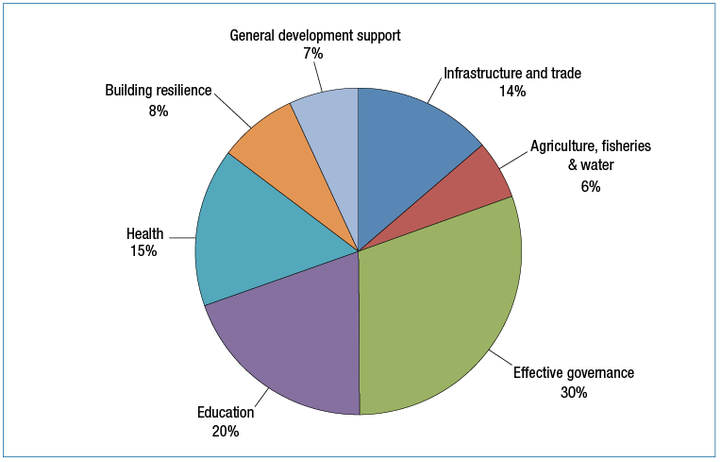

***Program quality***

There is a consistent, positive trend in Pacific program performance over recent years with the percentage of program objectives on track increasing from 46 per cent in 2012-13 to 56 per cent in 2014-15. However, the proportion of program objectives at risk remains higher than in other geographic regions (see Figures 9 and 11).

Figure 11: Progress against program objectives: Pacific, 2014–15

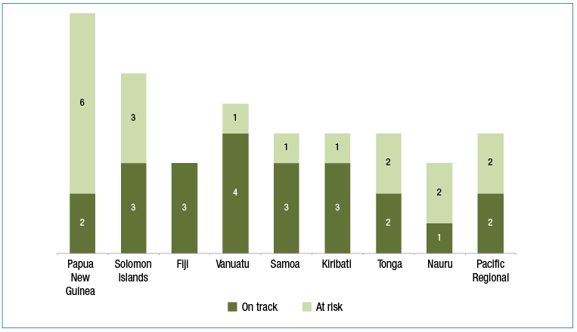

Progress against performance benchmarks was mixed, with 57 per cent of benchmarks achieved and 40 per cent partially achieved. Only two benchmarks (3 per cent) were not achieved.

Figure 12: Progress against performance benchmarks: Pacific, 2014–15

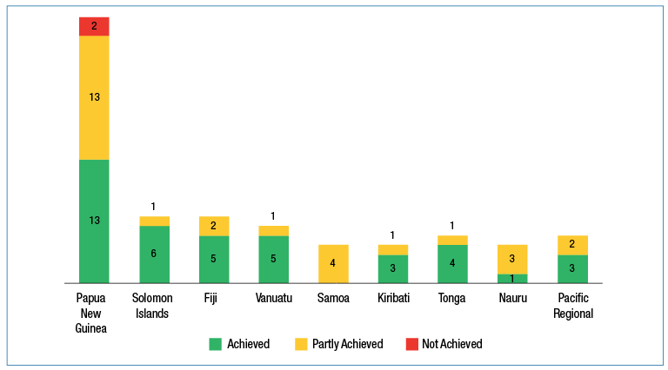

In 2014-15, Australia’s individual aid investments in the Pacific were rated as highly relevant, effective and sustainable (see Figure 13). Ratings for Pacific investments were higher than those for the aid program as a whole against the criteria of relevance, sustainability and gender. On the criterion of efficiency, Pacific investments were rated lower than the aid program as a whole. There remains scope for improvement in the adequacy of monitoring and evaluation arrangements and frameworks. There were eight investments identified as requiring improvement and targeted management responses have been put in place to improve performance in the next twelve month period.

Figure 13: Pacific aid investment performance, 2014-15

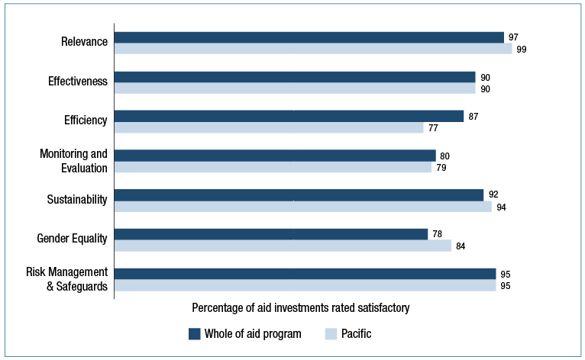

***Analysis of performance***

Australian aid investments were mostly effective in supporting economic development through **infrastructure, trade and private sector development.** Pacific programs have sought to increase their aid for trade impact. In 2014-15, with Australia’s support, 75 per cent of the 16 national priority roads in PNG were maintained in good condition and 600 km of roads in the Solomon Islands were rehabilitated or maintained. In addition to infrastructure, Australia is targeting regional approaches to support the growth of exports, investment and trade integration. For example, Australia supported Pacific export and investment promotion through direct finance and policy advice for the Forum Secretariat’s *Pacific Islands Trade and Invest* network.

**Agriculture and fisheries** are key sectors for many island economies. Revenues from the offshore tuna sector are significant and exhibit sustained growth over recent years. For example, revenues have grown by over 100 per cent over the five year period for both Kiribati (now in excess of US$100 million annually) and the Federated States of Micronesia (touching US$50 million annually). In agriculture, the Pacific Horticultural and Agricultural Market Access Program (PHAMA) helped countries meet the quarantine and other requirements of key trading partners through policy advice and support. For example, PHAMA supported Solomon Islands to comply with illegal logging regulations implemented by Australia in November 2014, allowing the Solomon Islands to maintain its $7 million dollar exports of sawn timber to Australia and New Zealand.

**Effective governance** is the largest priority investment area for the aid program in the Pacific. Despite underfunding of law and justice agencies in PNG, 560 police recruits (including 83 women) were trained to an improved curriculum and graduated from the police college in 2014, up from 229 in 2013. Over 2014-15, 992 village court officials across PNG were provided with improved training, enabling about 459,000 people to access better standards of justice. In the Solomon Islands, Australian support assisted the government to recruit five new magistrates, leading to 604 cases being heard and disposed, significantly higher than the target of 250. Australia’s support for public financial management in the Solomon Islands has improved government budgeting, creating more efficient and streamlined payments, procurement and audit systems, including through increased investments in information technology. This work also reduced the risk of fraud to Australian aid funds spent through Solomon Islands Government (SIG) systems. As a result of long term Australian support, by the end of 2014-15, 25 out of 26 SIG Ministries were connected to the whole of government IT system. This enabled efficiencies and operational improvements by providing internet access, email connectivity and access to financial and human resource management applications for the first time. Australian support to improve the management of human resource information resulted in identification and removal of over 600 false entries from the SIG payroll, saving approximately $5m per year.

Australia’s support to **education** in the Pacific has delivered significant results in the past year. Australia’s education support in PNG supports the delivery of the National Education Plan 2015-20 and the National Training and Higher Education Plan 2015-19. The completion of quality assessment processes for six universities was a significant achievement, representing a key step in improving the quality of PNG higher education. Australia, working with the Department of Education, also built 80 double classrooms, 40 teacher houses and 48 ablution blocks, to help meet critical infrastructure gaps; and supported 5000 student teachers to improve English language competency. As a result of targeted outreach and support, over half (55 per cent) of Australia Awards scholarships were awarded to women.

Australian funding has helped improve access to literacy and numeracy materials across Vanuatu. In 2014-15, 460 year one classrooms were provided with literacy and numeracy kits, and more than 1,900 teachers were trained in their use. Australia’s investment in Vanuatu’s technical and vocational education sector continues to help increase economic opportunities. In 2014-15, 65 per cent of women and 59 per cent of men who participated in technical and vocational education in Vanuatu reported increased incomes or improved livelihoods within eight months of their training. The figure was as high as 93 per cent amongst self-employed people, reflecting the success of the training in promoting private sector growth in Vanuatu.

In Solomon Islands, access to junior secondary school (Grade 7) improved in 2014-15. For the first time, almost 100 per cent of Year 6 students transitioned to Year 7, where the number of places had increased by 11,000 in 2015. Importantly, half of the increase in places is for young girls. Sixty-nine per cent of teachers are now appropriately trained, increasing from 50 per cent since Australia first invested in the sector in 2012. In 2014-15, school grants increased by 23 per cent helping 150,000 primary school students access fee-free education. In terms of regional achievements, in 2014-15, 1,560 Pacific Islanders (35 per cent women) graduated from the Australia-Pacific Technical College (APTC) with internationally-recognised qualifications in areas of industry demand. An independent evaluation completed in November 2014 found that APTC has helped improve standards of technical education and training through partnerships with national institutions. Australia also supported the University of the South Pacific to graduate 4,455 students in 2014 (54 per cent women). Seventy-one per cent found employment within four months of graduation.

Australia’s investments in **health** have also yielded positive results although in some countries efforts are falling short of targets. In Fiji, Australia’s efforts have led to a 25 per cent increase in the number of trained midwives, and there has been an increase in the quality of hospital maternity care standards, with compliance rates rising from 42 per cent in 2014 to 83 per cent in 2015. In PNG, progress is slow and uneven. Australian support continues to contribute to more midwives being trained and registered, with an increase of 128 per cent in registered midwives compared to 2012. While skilled birth attendance is partially on track at 44 per cent, use of condoms and family planning methods across PNG has dropped sharply. Similarly, while access to anti-retroviral therapy for HIV/AIDS is on track (at approximately 80 per cent coverage), the target for pregnant women being tested for HIV (80 per cent in 2015) is unlikely to be met.

In Kiribati, the Australian-supported TB treatment program has shown very positive results - over 90 per cent of identified TB cases have been successfully treated, exceeding the WHO target (80 per cent). An increasing number of TB cases is also being detected which suggests the program is doing a better job of reaching affected communities. Medicine availability in Solomon Islands continued to improve, increasing to 73 per cent at the rural health clinic level in 2014. Efforts to reduce the malaria rate in the Solomon Islands continue to yield results. The national malaria incidence is now 44 cases per 1,000 (representing a 75 per cent drop on 2003 levels). Australian financial and technical assistance was used by the Ministry of Health’s vector control team to fog 983 hectares within Honiara and Guadalcanal to halt the spread of dengue. No dengue related deaths were reported in 2014.

Australia’s regional health program complements bilateral health investments with a strong focus on supporting health activities that require a regional or multi-country approach. Australia provided core support for the College of Medicine, Nursing and Health Sciences at the Fiji National University, which produced 620 graduates in 2014 (75 per cent women). Australia also supported the development of new post graduate courses in pathology, emergency medicine, mental health and oral surgery. Through the Royal Australasian College of Surgeons, Australia provided 43 medical team visits to 10 countries, delivering 4512 consultations.

|  |
| --- |
| **Solomon Islands Health: Innovation in Medical Supplies** |
| Australian-funded development innovation has transformed the Solomon Islands national medical supply system. The availability of essential medical supplies in remote rural health clinics has improved by 40 per cent over the last 5 years as a result of Australia’s sustained support, leading to a corresponding reduction in the number of maternal and child deaths.  The Solomon Islands medical supply system traditionally relied on paper based ordering systems involving banana boats, canoes and long lead times. Orders were commonly delayed or lost entirely in rough seas causing stock-outs of essential supplies, hindering efforts to save lives and improve national health outcomes.  Australian advisers and funding supported the Ministry of Health and Medical Supplies to trial the use of tablet computers with world-first inventory management software (mSupply). This was complemented by other reforms including the introduction of new drug procurement guidelines, a national pharmaceutical officer training program (including on use of the software and tablets), an essential medical supplies list, national antibiotic guidelines, and solar-powered drug warehouses. The Head of the National Stores now carries real-time stock availability information on his smartphone. These systemic improvements have worked together to improve availability of essential medicine, quality of treatment and drug supply transparency.  The country responded quickly to major disease outbreaks that followed the 2014 April flash floods by re-diverting life-saving medicine, including fluids and oral rehydration salts, to affected areas where it was needed to treat major disease outbreaks.  Availability of essential medicine in rural health clinics is now double the World Health Organisation’s developing country average - a significant achievement given Solomon Islands’ treacherous and isolated geography and fledgling national health institutions emerging from civil conflict.  DFAT’s innovationXchange is now exploring opportunities to make the software that has been used so successfully in Solomon Islands and other countries in the region open-source, so it is available to all developing countries for free. |

Australian-funding for capital works and technical assistance has helped the Solomon Islands Water Authority to provide safe and reliable water supply services. The average proportion of water samples that passed WHO bacteria standards increased from less than half in 2011 to 94 per cent in 2014. Around 87 per cent of Honiara had 24 hour water supply, compared to 39 per cent in 2013. By the end of 2014, 9,845 households (around 69,000 people) had water connections – representing a 25 per cent increase compared to 2013.

Australia is supporting **disaster risk reduction** and improving the resilience of communities in the Pacific. Developments in Vanuatu were dominated by Tropical Cyclone Pam, which struck in March 2015. Australia is assisting all island countries to improve their meteorological forecasting and disaster preparedness capacities through the Climate and Oceans in the Pacific Program. This has been critical in preparing for the effects of drought influenced by the onset of the 2015 El Nino event. Australia’s support, through Geoscience Australia, to the Rabaul Volcanology Observatory underpinned a quick response to the August 2014 eruption of Mt Bagana in PNG - appropriate monitoring instruments were installed, improving public safety through early warnings.

Australia continues to play a leading role in promoting **gender equality** in the Pacific. In PNG, Australia promoted women’s economic empowerment through investments in the private sector and rural development. Cash-cropping opportunities for women were opened up in the Eastern Highlands Province, with over 2,000 extension workers, farmers and family members trained on gender equity and diversity, family business management, and training and facilitation skills. However, family and sexual violence is an entrenched and widespread problem across the Pacific. Australia is helping survivors of violence. For example, by June 2015, Australia had supported PNG to establish 15 Family and Sexual Violence Units and four Family and Sexual Violence Desks in police stations across the country. Since 2010, over 35,800 survivors of violence, mostly women, have received support from these units. In 2014, 11,272 (mostly female) survivors of violence received services, up 20 per cent from 2013.

|  |
| --- |
| **Improving gender effectiveness in Technical and Vocational Education and Training** |
| At the start of its third phase in 2013, the Vanuatu Technical and Vocational Education and Training (TVET) program made concerted efforts to increase female participation rates in training activities, recognising that women’s skills development is key to achieving economic growth and improved livelihoods. The program developed a gender equality strategy for participating TVET centres, which addresses barriers to women’s participation and linked training participants to finance. The program works closely with women’s civil society organisations in order to reduce vulnerability to violence and economically empower those who are survivors of violence. To oversee and mainstream a gender equality focus, the program recruited a male officer who takes on a male advocate role. Where possible, the program has an explicit strategy to engage, train and promote local female experts to deliver skill development services, including in traditionally male-dominated industries (e.g. tiling). The program actively promotes and mentors women to take on management and leadership roles, and models this internally.  These efforts have resulted in a significant increase in women’s participation in training activities – from 28 per cent in 2013 to 48 per cent in 2014. Results from training are also positive from a gender equality perspective and 65 per cent of women reporting increased income or improved livelihoods within eight months of training. These actions have seen the investment improve its gender equality performance rating from satisfactory in 2014 to very good in 2015. |

Australia has helped to facilitate **inclusive development** across the Pacific. In PNG, through the Strongim Pipol Strongim Nesen program, Australia provides grants to lead disability organisations such as the National Orthotics and Prosthetics Service (NOPS) and Motivation Australia who distribute assistive devices. In 2014, key results included the distribution of 400 wheelchairs including technical fitting and training by Motivation Australia, NOPS and PNG Assembly of Disabled Persons; and the distribution of 8,000 assistive devices. In Samoa, under a four year Mobility Device Partnership between Motivation Australia and Samoa’s National Health Service, an Australian volunteer has been working as a Prosthetic Orthotic Mentor to help develop the prosthetics and orthotics component of an Integrated Mobility Device Service covering amputation prevention, prosthetics and orthotics, as well as wheelchair services. A total of 391 clients have been individually assessed and prescribed mobility devices since 2014.

***Strengthening future performance***

While performing well against most assessment criteria, Pacific programs are rated as less efficient than the aid program as a whole. While the high costs of operating in the Pacific impact on this rating, all Pacific country and regional programs will look for opportunities to improve efficiency over the coming year. During 2015-16, Australia will seek to improve the effectiveness of aid through new Aid Partnerships negotiated with Australia’s main country partners in the Pacific. These Aid Partnerships will build on the priorities set out in bilateral Aid Investment Plans and specify new mutual commitments and performance benchmarks.

## East Asia

This section reports on Australia’s aid delivered through the Cambodia, East Asia Regional, Indonesia, Laos, Mongolia, Myanmar, Philippines, Timor-Leste and Vietnam programs. In 2014-15, 28 per cent of Australian ODA was directed to East Asia, compared to 27 per cent in 2013-14. Total ODA to Indonesia comprises 43 per cent of the $1.413 billion of Australian ODA spent in East Asia in 2014-15 (see Table 8).

***Context***

East Asia is one of the fastest growing regions in the world, with the Association of South East Asian Nations (ASEAN) members’ combined GDP projected to grow at 5.4 per cent per annum until 2018[19]. Australia’s economic and security interests remain inextricably linked with the region. Total trade with ASEAN countries was over $100 billion in 2014, making ASEAN a larger trading partner for Australia than any country other than China.

Continued economic growth and improved revenue collection saw aid continue to decline as a share of total government expenditure across the region. Cambodia is the only country not yet to have reached lower-middle income status but is expected to do so by 2016. A number of donors have ceased bilateral aid programs in recent years or have plans to do so in coming years. Likewise, the multilateral development banks are transitioning away from highly concessional loans. However, significant challenges exist, with Laos, Cambodia and Myanmar remaining least developed countries. Constraints to economic growth are significant in places across the region, including a lack of skilled workers, costly and unreliable electricity, limited transport infrastructure and high costs of trade. Some countries, such as Timor-Leste and Mongolia depend on finite natural resources for growth. Limited institutional capacities also have the potential to exacerbate constraints to growth, while governance weaknesses create opportunities for corruption.

Indonesia is now a middle-income country but approximately 100 million Indonesians, or 40 per cent of the population, still live on less than US$2 per day. Inequality is growing between Indonesia’s more prosperous, urbanised and developed regions in its west and its less developed, rural, poorer regions in the east.

Aid still plays a critical role in supporting government spending on public goods and services in some countries, and several of the MDGs have not yet been met (refer Table 6). While parity has been achieved on the numbers of girls and boys in primary school across the region, the goal of universal primary education has not yet been reached. Women’s share of paid employment needs to improve across South-East Asia, and while the level of women in national parliaments has increased, it is still low at 18 per cent[20].

Women’s access to economic opportunities, reliable maternal and neonatal facilities, and safe homes and communities still needs to improve across South-East Asia. Maternal mortality rates across the region vary, from around 54 per 100,000 live births in Vietnam[21], to 557 in Timor-Leste[22]. Ending violence against women remains a concern but is receiving increased national attention in some countries, including Timor-Leste and Laos.

Leadership changes or elections in Timor-Leste, Mongolia and Indonesia caused some aid implementation delays while new administrations, policy priorities and working relationships were established. The Myanmar Government highlighted its commitment to reintegrate into the regional and international community by chairing ASEAN in 2014 and signing a number of international security instruments.

Australia’s aid programs to Vietnam, Indonesia and the Philippines and the South-East Asia Regional program are shifting towards an economic partnership approach, emphasising mutual accountability and economic cooperation on shared objectives. Through these programs, Australia’s aid will be catalytic, focusing on policy influence and challenges around economic growth and good governance. This approach leverages both Australia’s diplomatic and development resources for results.

The past year saw the development of new Aid Investment Plans outlining priorities for the next four years. The plans reflect substantial work to update aid operations and investments in line with aid program policy and budget changes.

Table 8: Total ODA to East Asia by country program, 2014–15

| **Country Program** | **2013–14** | **2014–15** |
| --- | --- | --- |
|  | **($m)** | **($m)** |
| Indonesia | 581.1 | 613.8 |
| Philippines | 182.6 | 144.6 |
| Vietnam | 138.9 | 163.6 |
| Timor-Leste | 108.1 | 113.0 |
| Burma | 91.8 | 102.5 |
| Cambodia | 86.9 | 99.2 |
| Laos | 58.5 | 64.2 |
| Mongolia | 15.9 | 16.8 |
| East Asia Regional | 91.5 | 95.6 |
| **East Asia Total** | **1,355.3** | **1,413.3** |

Figure 14: Total ODA to East Asia by investment priority area, 2014–15

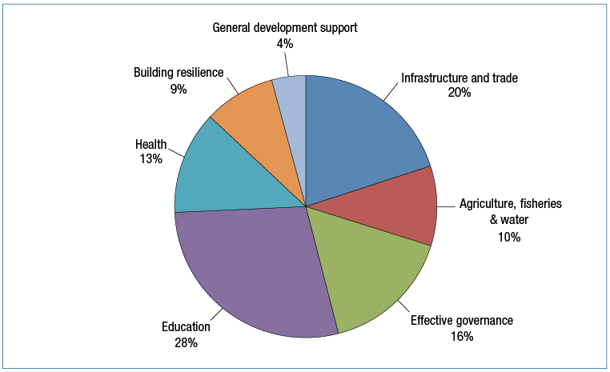

***Program quality***

Progress against country and regional program objectives was sound, with 76 per cent of objectives on track as shown in Figure 15. While no objectives were rated as off-track in the past year, there was an increase in the proportion of objectives at risk. Performance against benchmarks showed some similar trends. The Vietnam, Cambodia and Myanmar programs achieved all their performance benchmarks, while performance against benchmarks was more mixed in other East Asia programs (Figure 16). In Timor-Leste, for example, six out of nine objectives were rated at risk, and five out of six performance benchmarks were partly achieved. This reflects a range of program implementation challenges, including delays following the appointment of the new government.

Figure 15: Progress against program objectives: East Asia, 2014-15

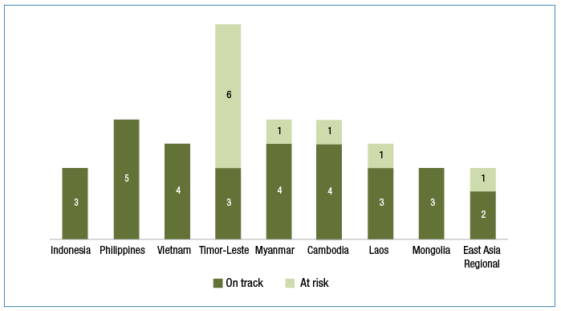

Figure 16: Progress against performance benchmarks: East Asia, 2014–15

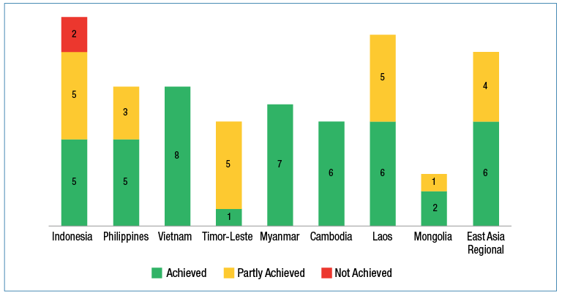

The performance of individual aid investments in East Asia was similar to the aid program as a whole (Figure 17). More than a third of the 154 aid investments across the region performed strongly on value for money, scoring five or six out of six on both effectiveness and efficiency. There were nine investments identified as requiring improvement, and robust management responses have been put in place.

In East Asia, 77 per cent of investments were assessed as effectively addressing gender issues. Improvements to achieve gender equality were notable in the Timor-Leste, Cambodia, Vietnam and Laos programs, while further improvements are required in the Indonesia, Philippines and South-East Asia Regional programs.

ODE’s evaluation of the Vietnam-Australia country strategy 2010-15 found that it was developed through a collaborative process which resulted in a robust framework for the Australia-Vietnam aid relationship. The evaluation concluded that the country strategy maintained relevance according to the evolving policy priorities of the Australian Government during the period 2010-15 and that the implementation of the Australian aid program has been strong, with significant development results achieved with Australia’s aid. However there is room for improvement in areas such as monitoring the outcomes of Australia’s aid to Vietnam and integrating gender issues and the private sector into the aid program

Figure 17: East Asia aid investment performance, 2014-15

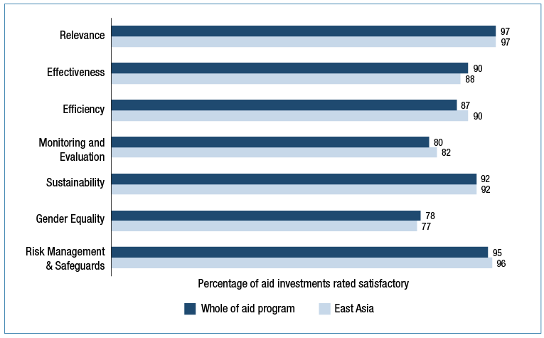

***Analysis of performance***

**Infrastructure and trade** investments showed good progress, with some longer term road infrastructure investments coming to fruition and objectives being achieved in Timor-Leste, Vietnam, Cambodia, Laos, Indonesia, Philippines and East Asia Regional programs.

A significant milestone for the regional trade integration agenda was the completion of the Southern Coastal Corridor Project, co-financed with the ADB. The Cambodia component of the program included 15 kilometres of road upgrades, 54 kilometres of national highway maintenance, and a new cross-border facility on the border with Vietnam. In Laos, the opening of a new transport route with Thailand led to 22 per cent traffic growth and increased trade revenue over the life of the project. In Timor-Leste, an impact study of two rehabilitated roads found benefits included considerably reduced travel times, improved transportation facilities, access to 24-hour ambulance and health services and access to markets. In Indonesia, Australian support contributed to over 2,000km of roads being maintained in 2014-15, doubling the rate of implementation from the previous year.

While the performance of the Greater Mekong Subregion Trade Transport Facilitation project was assessed as underperforming in 2013-14, considerable progress was made after an independent mid-term review was conducted and its recommendations implemented. In Vietnam, the Cao Lanh Bridge project has continued to make good progress. Construction is running ahead of schedule and the bridge itself is more than 50 per cent complete. Resettlement and environmental management are being carefully and externally monitored. A livelihood restoration program is providing vocational training in agriculture and small business for affected households.

More than $658 million of private sector investment was leveraged across East Asia with Australian support, and more than 3200 women and men were trained in trade policy and regulation. Australia advised the Government of Vietnam and the Philippines on how to engage the private sector in the funding and building of infrastructure through Public-Private Partnerships.

Australian support also helped establish the Indonesia Services Dialogue which brings together senior Indonesian policymakers and private sector representatives for evidence-based discussion on critical issues in the services sector. Australia is helping Vietnam to undertake long-term reforms to enhance productivity by targeting three priority areas: promoting economic restructuring; strengthening Vietnam’s competition institutions; and improving rural productivity. Australian support for the development of new enterprise and investment laws helped make it easier for firms to start a business or invest in Vietnam.

A twinning arrangement between the Melbourne Polytechnic and the Dalanzadgad TVET College helped develop and implement competency-based curricula, contributing to a sustainably-managed mining sector in Mongolia.

Australia’s **agriculture and fisheries** programs in Cambodia, Timor-Leste and Indonesia have generated additional agricultural production valued at more than US$30 million. In Timor-Leste, Australia’s long running Seeds of Life program, co-funded by ACIAR, is on track to reach the target of 65,000 farming households – 50 per cent of all farming households in Timor-Leste – utilising improved seed varieties by 2016. Commercial seed producers are playing a growing role in the program as it works towards sustainability.

Australia’s programs have helped over 304,000 poor women and men (47 per cent women) adopt innovative agricultural practices in Indonesia and Cambodia. Engagement with private sector companies in Indonesia have led to increased access to hybrid maize seed suitable for dryland farming in Eastern Indonesia and the introduction of organic fertilisers to poor farmers in East Java. Clearing of unexploded ordnance in Cambodia released 26.5 square kilometres of land for productive uses and in Laos over 66,000 people are now able to safely access arable land previously contaminated with unexploded ordnance.

An effective regional approach to water management is important for the region’s sustainable economic growth. Australia continued its support for the Mekong River Commission (MRC), including: a regional consultation process for the Lao Don Sahong hydropower project; the establishment of a new Faculty of Water Resources at the National University of Laos to train the next generation of water professionals; and implementing Australia’s water modelling software (Source) in national modelling bureaucracies and the MRC. In Mongolia, Australian support for a World Bank Groundwater Management activity helped three River Basin Authorities to increase awareness and promote efficient water management in South Gobi province.

|  |
| --- |
| **Collaborating with the private sector in agriculture in Cambodia** |
| The Cambodia Agricultural Value Chain program (CAVAC), which began in 2007, is recognised as a leading example of aid delivered in collaboration with the private sector. It helps farmers increase their crop yields and incomes by providing them with better inputs – including seeds, fertiliser, pesticide and water - and information on modern farming techniques. The innovative component of CAVAC is that instead of working primarily through Government agriculture extension workers or directly with farmers, it improves market systems by working with privately owned companies such as fertiliser and pesticide traders, and by drawing on behavioural insights to achieve efficient outcomes.  By the end of 2017, rice production yields are expected to increase by 250,000 tons of paddy per annum as a result of CAVAC. With a conservative price estimate of US$200 per tonne of paddy, this means an additional value of production of US$50 million.  In 2014, CAVAC leveraged over US$1 million in private sector funds and increased the incomes of over 135,000 poor women and men. Due to the success of CAVAC, the Australian and Cambodian Governments have agreed to implement a second phase of the program, commencing in 2016. |

In support of **effective governance**, Australia was one of the key donors supporting the preparations for Myanmar’s 2015 parliamentary elections. Australia’s investments complemented the work of Australian Electoral Commission staff to build the technical capacity of Myanmar’s Union Election Commission. In the Philippines, Australia helped build partnerships for reform between government, civil society and the private sector. This included support for Fully Abled Nation, a coalition of civil society organisations, media and government agencies which registered people with disabilities for the 2016 Philippines general election.

Australian assistance to strengthen key national institutions is helping drive economic reform across South-East Asia. Australia is working through government-to-government partnerships to support Indonesia’s priority economic reforms. A study into gender inequality in the labour market in Indonesia provided Indonesian policy makers with an evidence base on labour force participation constraints and gender wage gaps. Australia’s public financial management support to the Timor-Leste Prime Minister’s Office has seen some quick, significant gains in 2014-15, especially in introducing a program budgeting model with the potential to benefit other government agencies such as health and education.

Law and justice investments in Cambodia faced implementation challenges. In Cambodia, for example, it was necessary to reshape objectives for Australia’s community justice assistance due to insufficient progress in broader legal and judicial reform efforts. At the regional level, implementation commenced across six countries on a program to combat trafficking in persons.

Australia’s support for **education** in East Asia has improved outcomes for children, particularly from disadvantaged backgrounds, by helping an additional 203,000 children (43 per cent girls) enrol in school and training approximately 30,000 teachers. In Laos, almost 150,000 girls and boys benefitted from school meals to encourage better attendance and nutrition for in food-insecure areas. In Mindanao, one of the most impoverished regions in the Philippines, Australian support helped educate 45,000 children and train 4,200 teachers/school administrators.

In Indonesia, Australia continued to support improved management and performance of madrasah to assist in closing the quality gap with public schools. Australian assistance to education reforms in Indonesia, the Philippines and Myanmar helped strengthen national education management systems. In the Philippines, Australia helped design and deliver new curriculum and assessment methods for elementary and high school students, and update professional standards for teachers.

More than 115,000 additional births were attended by a skilled birth attendant as a result of Australia’s assistance. Australia’s innovative maternal and child **health** program, where pregnant women are connected to midwives using mobile phone technology, resulted in more mothers giving birth in health facilities in Timor-Leste. In Myanmar, Australia’s investment contributed to improved access to health services in three areas: maternal and child health; communicable diseases (HIV, TB and malaria); and sustainable health systems. Together with the Cambodian Government and other partners, Australia ensured 2.6 million of the poorest Cambodians have access to free essential health care.

|  |
| --- |
| Evaluating results in Indonesia |
| A recent evaluation of the Australia Indonesia Partnership for Maternal and Neonatal Health (AIPMNH) analysed data from the Ministry of Health and found that maternal deaths in Nusa Tenggara Timur, where the partnership operates, were 50 per cent lower in 2014 than they had been in 2009. For Indonesia’s 32 other provinces, the average percentage change was negligible over the same time period, suggesting that other national efforts to reduce maternal mortality have had less of an effect than the AIPMNH. |

Australia’s contribution to the National Target Program on Rural Water and Sanitation helped Vietnam to deliver hygienic water for 1.5 million people, hygienic latrines for 2.5 million people and upgrades of water infrastructure in schools and health clinics.

An ongoing challenge in both the health and education sectors is encouraging partner governments to allocate a higher proportion of national budgets to these priorities. For example, progress against targets for sanitation in Timor-Leste was constrained by ongoing low levels of engagement and resourcing by the Ministry of Health. In another part of the Timor-Leste program, Australian advocacy delivered results, with the Timor-Leste Government funding rural water system maintenance for the first time with a US$1 million budget contribution in 2015. In the Philippines, Australia is supporting partnerships between civil society, private sector, academia and government to advocate and secure change – in one case securing $46 million of additional funding from local and national government budgets to support education reform.

Australia worked with civil society organisations at the community level, and through large scale national programs, to help households increase their incomes and **build resilience** to natural, health or other shocks. More than 15 million women and men living in poverty have increased their access to financial services in Indonesia and Laos in 2014-15. Australia helped 275,000 people adapt to and prepare for the impacts of climate change and natural disasters in Vietnam. In Indonesia, an additional 1,407,000 poor women and men (67 per cent women) gained access to social transfers (such as cash or in kind transfers including food). Australia’s main investment in income generation, social protection and financial inclusion in Laos initially encountered some delays as a result of Lao Government regulatory requirements, but subsequently delivered solid results.

|  |
| --- |
| Enabling difficult policy reforms through social protection in Indonesia |
| Australia’s partnership with the National Team for the Acceleration of Poverty Reduction (TNP2K) in the Vice President’s office demonstrates the leverage that Australia’s support can achieve when aligned with partner government priorities. Through the Poverty Reduction Support Facility, Australia supports TNP2K to improve the quality and reach of Indonesia’s social protection system, which disburses $6.6 billion or 0.6 per cent of GDP in assistance to the poorest 25 per cent of the population. The November 2014 fuel subsidy reduction – one of President Joko Widodo’s top priorities – was in part made feasible through a TNP2K-designed compensation package to 15.5 million households.  TNP2K’s establishment of a unified database is helping Indonesia to improve its allocation of scarce budgetary resources and design more effective poverty reduction programs. The database has helped to accurately target new presidential initiatives including education, health and welfare assistance for poor families. In 2015 the database is expected to cover the poorest 45 per cent of Indonesia’s population or over 100 million people. An independent review in 2015 found that Australia’s support to TNP2K was highly successful. |

In 2014-15, Australia continued to help families and individuals recover from Super Typhoon Haiyan which killed 6,300 people and left 4 million homeless in the Philippines. Australia helped build 1,533 permanent houses with water and sanitation facilities in Leyte. Australia also helped 6,000 households rebuild their livelihoods and earn an income, and constructed 187 classrooms and 65 daycare centres. In Metropolitan Manila, Australia is helping poor urban families better prepare and recover from natural disasters, assisting in the construction of 1,440 homes for informal settler families living in flood-prone areas.

In December 2014, 4 million people were affected by Typhoon Hagupit in the Philippines. Within 24 hours of receiving a request for assistance from the Government of the Philippines, Australia released prepositioned emergency stocks which helped provide life-saving assistance for 205,500 people including 3,000 pregnant and lactating women.

In Myanmar, over 235,000 vulnerable women, men, girls and boys were provided with life-saving assistance in conflicted-affected and displaced communities, including in Rakhine State and on the Thai-Myanmar border.

While the region is on track to achieve the **gender** target overall, more can be done. Performance varies across investments, and new investments, particularly in aid for trade, will need improved effort to address gender effectively.

Meanwhile, several investments that focus on outcomes for women and girls are delivering results. In Cambodia and Indonesia, more than 5200 women survivors of violence received services in 2014-15. In Timor-Leste, Australia worked with government and civil society partners to help 1,052 additional women and children survivors of violence access legal, shelter, counselling and re-integration support. Australia funded research on the contributing factors to intimate partner violence in Cambodia. This research provided the evidence base for the design of two prevention programs to be in implemented in 2015-16 and has been widely shared amongst partners in the sector.

Work with the Civil Service Commission in Timor-Leste identified systemic constraints to greater female representation in the civil service (currently at 28 per cent). In Indonesia, an independent evaluation found that the Australian-supported ‘Empowering Indonesian Women for Poverty Reduction’ program is performing strongly. The program has strengthened partners’ and networks’ capacity to influence government reform, with improvements for poor women. One way the program has done this is through an Innovations Fund that provides grants to women leaders and creative organisations to implement original pilots to improve the lives of poor women. The program expects to scale up these results in the next phase.

***Strengthening future performance***

A continuing focus for improving performance will be to strengthen mutual obligations for achieving results. For example, in 2014-15, Australia advised the Timor-Leste Government that it will only fund a second phase of a rural roads program if Timor-Leste’s commitments to the ongoing resourcing of the sector are clear and firm.

|  |
| --- |
| Mutual accountability for education results in Myanmar |
| In 2014-15, the Myanmar Government continued to demonstrate its commitment to an ambitious reform agenda in the education sector. Australia has taken a lead amongst development partners in providing practical assistance to these reforms. For example, Australia funded in-depth and disaggregated analysis on education access, attainment, reasons for dropout, and household expenditure burdens, which informed the preparation of Myanmar’s National Education Sector Plan. Australia continued to support the Ministry of Education to develop a cross-cutting Basic Education Curriculum Framework and to engage a diverse range of stakeholders across its reform process.  Myanmar’s Parliament passed an important amendment to the National Education Bill in June 2015, improving inclusiveness and accountability. After public criticism of the National Education Law in September 2014, the Myanmar Government asked Australia to provide technical assistance to review the law and coordinate donor comments, which provided important input to the Amendment. The amended Law enshrines the concept of free compulsory education, recognises that regional differences should be reflected in a flexible national curriculum, and highlights the importance of disability inclusive education.  Australia was the first grant donor to fund a government project (Decentralising Funds to Schools Project) using government systems. Australia used results-based financing to manage fiduciary risks, ensure strong government ownership, and leverage policy planning and Myanmar Government funding. |

As highlighted in Aid Investment Plans, Australia is transforming its bilateral aid relationships in the region to economic partnerships. Australian support for policy and technical advice will focus on improving the quality of partner countries’ own investments in infrastructure, economic governance and social policy.

Programs need to maintain efforts on improving gender equality and empowering women and girls. They also need to continue to work with partners to build and maintain relevant monitoring and evaluation systems. Measuring the performance of Australia’s economic partnerships with Indonesia, Vietnam, the Philippines, and through the South-East Asia Regional Program will be a feature of the 2015-16 annual Aid Program Performance Reports.

## South and West Asia, Africa, the Middle East and Other Regions

***Context***

**South and West Asia**

The economies of South and West Asia in general continued to experience strong economic growth in 2014. However, the region still faces significant issues and this growth is not uniform. Nearly 400 million people in South Asia live on less than $1.25 a day.[23] Progress against the MDGs (refer Table 6) was mixed across the region. Access to education and halving extreme poverty has been largely achieved in most countries. However, progress on child mortality and combating HIV/AIDS, malaria and other diseases requires strengthening. Women are over represented in the region’s poor and the female participation rate of 35 per cent in the formal labour force in South Asia is among the lowest in the world.[24]

Development in the region is affected by significant security issues. Although Afghanistan witnessed its first democratic transition of political power in 2014, along with the transfer of security responsibility from NATO to Afghan security forces, the 2015 fighting season has seen the worst civilian casualties on record.[25] The north-west of Pakistan experienced large scale displacement due to ongoing militancy. In 2014-15, the region was also beset by a number of large natural disasters. In April and May 2015, two major earthquakes and subsequent aftershocks led to widespread damage and loss of life in Nepal and the Indian state of Bihar. In September 2014, the Kashmir region of India and Pakistan suffered disastrous floods across 2,550 villages, and 1.5 million people were affected by floods in the Indian state of Assam.

South and West Asia remains of significant importance to Australia’s strategic and economic interests, with deepening of security, economic and trade ties throughout 2014-15. Australia is currently negotiating a free trade agreement with India and continues to work with the Indian Ocean Rim Association on cooperation on maritime safety and security.

Australia spent $475.5 million in South and West Asia in 2014-15, or 9 per cent of Australia’s total ODA. Of this, 68 per cent was spent in Afghanistan, Bangladesh and Pakistan (see Table 9).

Table 9: Total ODA to South and West Asia by country program, 2014–15

| **Country Program** | **2013–14 ($m)** | **2014–15 ($m)** |
| --- | --- | --- |
| Afghanistan | 148.4 | 139.9 |
| Bangladesh | 85.5 | 99.4 |
| Pakistan | 78.7 | 84.6 |
| Sri Lanka | 40.6 | 42.8 |
| Nepal | 32.7 | 57.8 |
| Bhutan | 14.3 | 12.8 |
| Maldives | 7.1 | 6.4 |
| South Asia Regional | 28.1 | 31.8 |
| **South and West Asia Total** | **435.4** | **475.5** |

Figure 18: Total ODA to South and West Asia by investment priority, 2014–15

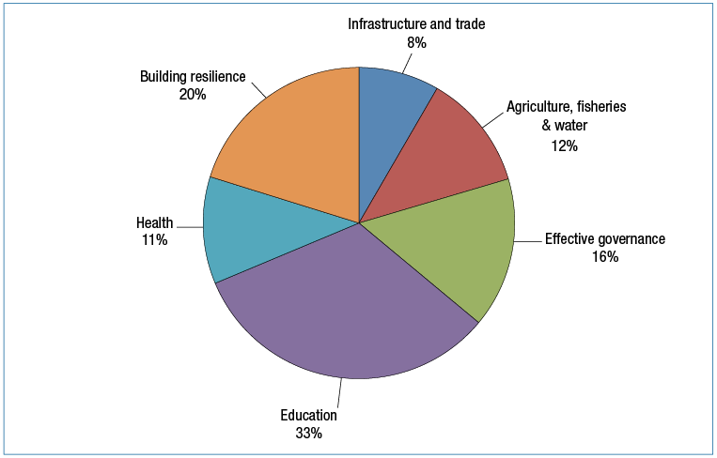

**Africa, the Middle East and Other Regions**

In 2014-15, Africa and the Middle East continued to face substantial challenges to sustainable development, despite an abundance of natural resources, an expanding middle class and significant trade and investment.

Despite forecast economic growth of 4.5 per cent in Sub-Saharan Africa in 2015, nearly one out of two Africans continue to live in extreme poverty and income inequality in the region remains among the highest in the world.[26] Aid still plays a critical role in supporting service delivery and several of the MDGs have not yet been met (refer Table 6). Weak institutions, persistent infrastructure deficits and low levels of basic services risk leaving the region’s vast human potential untapped. Corruption is a key constraint to inclusive growth while civil wars and insurgencies have a significant negative impact on development.

The Palestinian Territories continued to experience poor prospects for economic growth and high unemployment. The conflict in Gaza in July and August 2014 resulted in the deaths of more than 2,300 people and caused over US$4 billion of damage to public infrastructure and housing. The crisis in Syria, Iraq and neighbouring counties continued to create large-scale loss of life and displacement across the region. Refugees, internally displaced people and host communities live in increasingly vulnerable situations and the international community has struggled to provide the level of support required to meet widespread need.

In 2014-15, Australian ODA to Africa, the Middle East, Latin America and the Caribbean was approximately $411.5 million, accounting for around 8.2 per cent of Australia’s total aid budget (see Table 10).

Table 10: Total ODA to Africa, the Middle East and other regions, 2014–15

| **Country Program** | **2013–14** | **2014–15** |
| --- | --- | --- |
|  | ($m) | ($m) |
| Sub-Saharan Africa | 264.3 | 268.5 |
| North Africa and Middle East | 77.4 | 49.8 |
| Palestinian Territories | 55.0 | 69.3 |
| Latin America and the Caribbean | 25.8 | 23.9 |
| Total | 422.5 | 411.5 |

Figure 19: Total ODA to Africa and the Middle East by investment priority, 2014–15

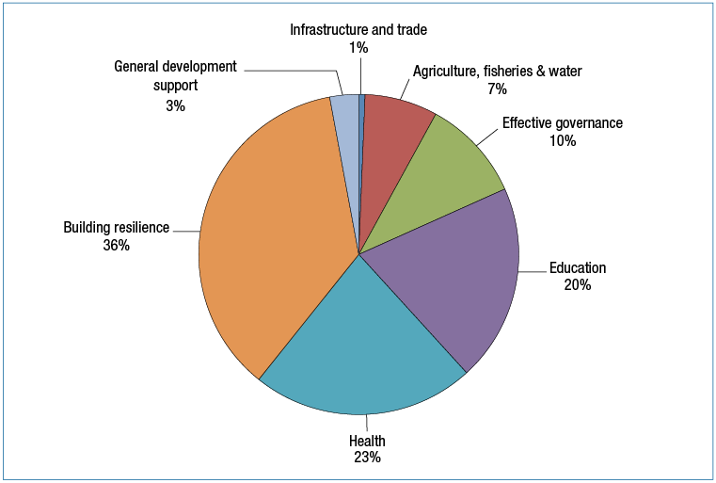

***Program Quality***

Progress against program objectives in South and West Asia improved in 2014-15 with 80 per cent of program objectives assessed as on track (see Figure 20). Programs where progress was less than expected were in Afghanistan and Pakistan, reflecting the difficult operating environments in both countries. Country and regional programs met the majority of performance benchmarks, with one each in Bangladesh and Pakistan not achieved (see Figure 21).

In 2014-15, aid programs to Sub-Saharan Africa and the Palestinian Territories performed well overall. The number of program objectives rated as on track remained consistent with 2013-14. Programs met or partially met the majority of performance benchmarks with only one, in Sub-Saharan Africa, not achieved (see Figure 21).

Figure 20: Progress against program objectives: South and West Asia, Africa and Middle East, 2014-15

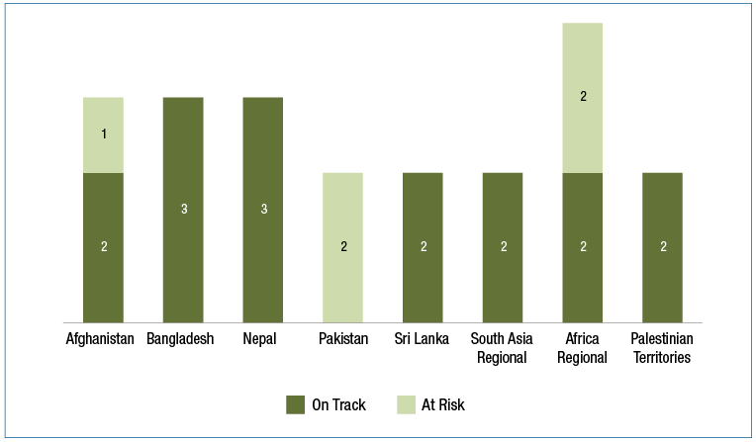

Figure 21: Progress against performance benchmarks: South and West Asia, Africa and Middle East, 2014-15

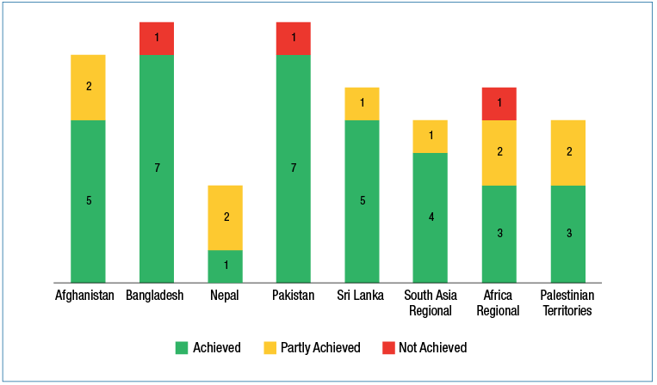

Individual aid investments in South and West Asia performed well overall, exceeding the average performance for the aid program against a number of aid quality criteria (Figure 22). This relatively strong performance reflects efforts by country and regional programs to maximise effectiveness by focusing on a smaller portfolio of higher-performing investments, the closure of low performing investments and the implementation of actions to improve the performance of individual investments. Monitoring and evaluation of individual investments was positively assessed overall but continued to face challenges arising from security issues in many countries. Gender ratings were lower in 2014-15 in the Pakistan and Sri Lanka programs reflecting uneven government capacity to deliver programs and more robust gender analysis identifying areas for improvement in some investments.

The maintenance of quality ratings for investments in Africa and the Middle East reflects the capacity of Australia’s delivery partners to adapt and respond to challenging and dynamic environments. Australia continued to make a valuable and targeted contribution to the region and individual aid investments continued to score highly on relevance, effectiveness and efficiency. Improvement is required for some investments in monitoring and evaluation and gender equality.

Figure 22: Aid investment performance: South and West Asia, Africa and Middle East, 2014-15

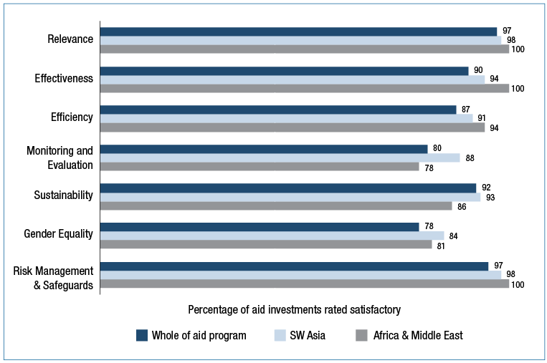

***Analysis of performance***

Good progress was made with investments in **infrastructure and regional economic integration** in 2014 -15. Australia’s support for the World Bank’s North East Local Services Project in Sri Lanka enabled the completion of 772 sub-projects and works, including 623km of access roads, 81 market places, 37 recreation parks, 52 drainage systems, seven community water supply projects and 10 rural electrification schemes. The program also strengthened the capacity of 79 local government authorities to manage and maintain infrastructure assets. At a regional level, the South Asia Regional Trade Facilitation Program mobilised following a period of delay. The program aims to achieve better regional connectivity in trade and supports gender-sensitive approaches in trade facilitation, infrastructure connectivity, livelihood and enterprise development initiatives.

The aid program in Africa achieved strong results in supporting **sustainable economic growth and an increase in productive capacity**. Over 2014, the CSIRO’s Africa Food Security Initiative helped almost 16,000 men and women adopt innovative agriculture and fisheries practices to improve their livelihoods. Australia’s $24.6 million support (2011-16) for the Hunger Safety Net Program enabled an additional 98,000 poor and chronically food insecure women and men in the four poorest counties of Kenya to access financial services through its Index Based Livestock Insurance project. This assisted over 74,000 households to receive regular, timely non-conditional cash transfers, of which 59 per cent of the accounts are owned by women. Australia’s contribution to the African Enterprise Challenge Fund resulted in increased incomes for over 170,000 poor women and men and increased access to financial services for over 90,000 people in Zimbabwe.

Good results were also achieved in Australia’s investments in improving **extractives sector management** in Africa. Contributions to the Australia Africa Partnerships Facility ($125 million over 2009-2015) provided support to 51 African countries by improving technical skills, increased governance capacity and stronger legislative and regulatory frameworks to manage mineral resources equitably and sustainably. Over 400 African professionals and government officials received scholarships or training in extractives governance.

Australia contributed to the development of Pakistan’s **agricultural and water sectors** through its co-investment with the Food and Agriculture Organisation to train 8,700 (37 per cent women) poor farmers in Balochistan in improved seed and plant distribution, water resource management and livestock activities, increasing the gross added value of farmers’ products by almost US$2.5 million in 2014-15.

In support of more **effective governance** in Afghanistan, Australia’s Public Financial Management Program delivered training to 1,580 Afghan civil servants in the Ministries of Agriculture, Economy, Education, Public Health and Public Works. Australia provided funding to help build the Palestinian Authority’s **public financial management capacity** through the World Bank’s Palestine Reform Development Plan. Both the World Bank and the International Monetary Fund commended the Authority’s economic management during 2014-15, particularly its efforts to manage the fiscal crisis resulting from the withholding of revenues by the Government of Israel in early 2015.

Strong results were achieved in **education and health**. These two sectors account for 44 per cent of Australia’s ODA in South and West Asia and 43 per cent in Africa and the Middle East. In Afghanistan, Australia’s contribution to the Afghanistan Reconstruction Trust Fund helped to increase enrolments in primary and secondary education by 2.5 million students (including 39 per cent girls) and increase the percentage of births attended by skilled attendants from 24 per cent in 2007-08 to 46 per cent in 2014. In Bangladesh, Australia’s support has resulted in more than 213,000 teachers (more than 50 per cent women) being trained to improve learning outcomes. Australia’s commitment to education in Bangladesh is being reciprocated by the Government of Bangladesh’s commitment to ambitious education reforms through the Primary Education Development Program Phase III, which met six of nine disbursement linked indicators connected to policy reforms in 2014-15. In Pakistan, Australia’s investments in maternal, newborn and child health performed well. Australia’s partnership with Save the Children resulted in over 6,600 deliveries conducted by a skilled birth attendant compared to the target of 4,300. Australian support also enabled children with disabilities to access health services with 10 disability access ramps constructed in rural health clinics. Child immunisation and medical campaigns included a focus on disability inclusive services. In Sri Lanka’s Central Province, Australia’s partnership with World Vision International provided access to safe water and sanitation to more than 87,000 people.

Through the Australia Africa Community Engagement Scheme, 26,000 children received vaccinations, an additional 408,000 people gained access to safe, sustainable water and appropriate sanitation and government basic service delivery in 11 countries was strengthened. In Ethiopia, Australia has helped more than 55,000 children to be vaccinated and almost 16,000 births attended by a skilled birth attendant. In the Palestinian Territories, Australia’s contribution to the UNRWA’s General Fund helped enable 493,500 children to enrol in school, over 9.5 million patient visits to health facilities (60 per cent female) and 99.3 per cent full immunisation coverage for infants aged 18 months against ten diseases. In Mozambique, more than 19,000 people have increased access to safe water and almost 15,000 people have access to better sanitation. In Zimbabwe, Australia helped 15,000 women and men access safe water.

Australia’s programs in South and West Asia, Africa and the Middle East also focus on **reducing the risk of, and responding to, disasters and vulnerability**. Following the April and May earthquakes in Nepal, Australia provided support packages totalling $28.6 million for humanitarian response and early recovery needs. Australia, in partnership with the Asian Development Bank, had previously supported the retrofitting of 169 schools to improve earthquake resilience. All of these schools survived the 2015 earthquakes and provided much needed safe shelter and community spaces. Australia’s aid program in Afghanistan has a strong focus on building resilience and supporting at risk populations. Of Australia’s total ODA to Afghanistan, 11.5 per cent was spent in Uruzgan, an extremely challenging environment with significant development needs. Despite this context, Australia’s contribution to Save the Children reached its targets, providing education to 3,894 students (24 per cent girls) and training for 24 midwives, 22 female nurses and 30 female teachers.

Australia delivers support through partners in Africa and the Middle East who have proven to be effective and able to access hard to reach places. Humanitarian assistance represented 36 per cent of total aid to these regions in 2014-15 (see Figure 19). In South Sudan, Australia’s support directly responded to critical food and nutrition shortages to provide life-saving assistance for more than 203,000 vulnerable men, women and children and nearly one million vaccinations against measles and polio. In Somalia, Australia’s funding provided life-saving assistance to 187,000 vulnerable women, men and children and helped to build community resilience against floods, droughts and disease. In the Democratic Republic of Congo and the Central African Republic, Australia helped an additional 74,000 vulnerable women and men access food, improved livelihoods, water and health services. In the Palestinian Territories, Australia’s contribution to UNRWA’s Gaza Emergency Appeal (in additional to core funding to UNRWA) enabled emergency food assistance to more than 767,000 refugees. The Australian Government also contributed $50 million in humanitarian assistance to people affected by the crisis in Syria, Iraq and neighbouring countries, to deliver food, medical assistance, shelter and protection, including support for women, girls and survivors of gender-based violence.

The aid program made some progress with **addressing gender equality** in South and West Asia. Australia’s contributions to aid partners in Afghanistan helped to provide shelter and support services to over 1,773 women and children, and training to over 2,562 police and justice officials on the application of the Ending Violence Against Women Law. In Pakistan, a particular success was a Community Investment Fund that provided revolving loans to women. In 2014, there were 313 loans (almost double the target) and an impact assessment found that 93 per cent of women who accessed the Fund increased their incomes. However, increasing the incomes of poor women faced challenges arising from conservative contexts in Balochistan. An investment with the Food and Agriculture Organisation exceeded its targets, with 6,700 people increasing their incomes against a target of 3,000. However, women only comprised four per cent of these figures, lower than the planned target of 15 per cent. A number of programs in Sri Lanka also received unsatisfactory gender equality assessments.

***Strengthening future performance***

Overall, aid programs in South and West Asia continued to progress well against program objectives and performance benchmarks. Achieving better gender outcomes was an area of improvement identified for the majority of programs in South and West Asia. Finalisation of monitoring and evaluation frameworks for key investments, using flexible approaches to monitoring and evaluation in areas with security issues and completion of evaluations were identified as important priorities to strengthen future performance.

With continued consolidation in 2015-16, the bulk of Australia’s aid investments in Africa will be directed to countries where Australia has strong national interests and is able to leverage results, predominately in Eastern and Southern Africa. A number of management actions have been identified, including heightened focus on women’s economic empowerment and working closely with implementing partners to ensure appropriate exit plans from investments ending in 2015-16. The Aid Investment Plan for the Palestinian Territories articulates a revised strategic direction for the program in the context of budget reductions.

# Chapter 3 Global program performance

In addition to country and regional programs, Australia’s aid funding is also provided through a number of global programs. This includes core funding[27] that is provided annually to multilateral development agencies such as the World Bank and UNICEF. Australia’s contributions to these organisations, together with those from other donors, allow them to leverage additional resources and pursue agreed priorities at a scale that would not be possible for Australia to achieve by itself.

In 2015, Australia introduced a new system for assessing multilateral performance (refer discussion under strategic target 7 in Chapter 1). In 2015, multilateral performance assessments were completed for ADB, UNICEF, UNDP and WFP. The assessments confirmed these organisations are performing effectively and their work aligns well with Australia’s priorities.

This chapter describes a selection of the results and achievements from Australia’s core funding to organisations that work across a number of sectors. Multilateral organisations with a specific sectoral or thematic focus are discussed in the context of the aid program’s sector and thematic performance in Chapter 4.

This chapter also reports on the performance of other global programs: the Australia Awards program; funding provided to Australian NGOs under the Australian NGO Cooperation Program (ANCP); and the Australian Volunteers for International Development Program (AVID).

## Development Banks and UN Funds

***World Bank Group***

The World Bank Group (WBG) is Australia’s largest multilateral partner and is the world’s largest development organisation. It is consistently rated as one of the best performing multilateral institutions. Australia is the eleventh largest shareholder of the World Bank and is represented on the Board of Governors and Board of Directors.

In 2014-15, Australia provided $211.7 million to the International Development Association (IDA) – the WBG’s concessional lending arm that assists the world’s poorest countries. Australia also partners with the WBG on specific development programs which complement the objectives of Australia’s aid program. In 2014-15, Australia provided $282.9 million in non-core funding to WBG for country or sector specific activities. Australia was the fourth highest non-core contributor to the WBG for the 2011-2015 period.

Australia will complete a Multilateral Performance Assessment of the WBG in 2016 and participated in the November 2015 Mid-Term Review of the IDA17 replenishment.

Amongst a range of global development outcomes, in 2014-15 Australia’s core contribution supported the WBG to:

• construct or rehabilitate 113,600 kilometres of roads;

• reach 63.9 million people and micro, small, and medium enterprises with financial services;

• provide health, nutrition, and population services to 390.4 million people;

• cover 32.7 million people with social safety net programs; and

• strengthen the public financial management systems of 53 countries.

Australia’s membership of, and financial contributions to, the WBG allows Australia to extend the impact of Australia’s aid by leveraging the WBG’s finances, influence, technical expertise, convening power and role in setting global policy norms and standards. Australia has used its influence to increase IDA allocations to countries in the Pacific. In 2014-15, the WBG provided over US$5.1 billion in lending to the East Asia and Pacific region.

The WBG is undergoing a series of major reforms aimed at increasing collaboration across the arms of the WBG and supporting transformational investments. Australia is monitoring the impact of these reforms on our region. The WBG is about to launch a new Gender Strategy. Australia will be watching closely to see how this is implemented across all elements of WBG operations.

|  |
| --- |
| **Banking our aid: Australia’s non-core funding to the Asian Development Bank and World Bank** |
| Over the last 10 years, around 15 per cent of the Australian aid budget was spent through two multilateral development banks: the Asian Development Bank (ADB) and the World Bank. In 2015, the Office of Development Effectiveness (ODE) completed a major evaluation of the non-core component of this spending. Non-core funding is funding provided for specific purposes (often tied to a specific geographical or sectoral area), and accounts for close to two-thirds of Australia’s funding to the ADB and World Bank. Funding was provided to support a variety of investments, such as building bridges and roads in the Greater Mekong Subregion, community reconstruction in Afghanistan, health sector development in Cambodia, and education reform in the Philippines.  ODE concluded that non-core funding to the ADB and World Bank is an effective and efficient way of delivering Australian aid. Benefits include:  • enabling the banks to provide greater support for the Pacific and Timor-Leste than could have been provided through core funding alone;  • providing Australia with access to the banks’ specialist expertise, and policy discussions with partner governments; and  • providing a secure vehicle for meeting aid commitments to countries or regions where DFAT has a limited presence and faces challenges in delivering aid bilaterally.  ODE made a number of recommendations to improve the effectiveness of DFAT’s partnerships with the banks. In particular, it highlighted the importance of improving DFAT staff engagement with, and understanding of the ADB and World Bank and the way the banks operate if Australia is to get the best results from its partnerships. |

***Asian Development Bank***

The ADB is Australia’s second largest multilateral partner. Australia is the fifth largest shareholder of the ADB and is represented on the ADB Board of Governors and Board of Directors.

In 2014–15, Australia contributed $122.2 million in core contributions to the ADB’s Asian Development Fund, the ADB’s concessional financing arm. Australia also provided approximately $118.5 million of non-core funding to the ADB over the same period for country or sector specific activities. Australia is the third largest non-core funder of the ADB.

The ADB’s strategic priorities align well with Australia’s in the Indo-Pacific region and the ADB is considered a high performing institution by Australia. Amongst a range of development results, in 2014 Australia’s contributions supported the ADB to:

• build or upgrade 7,200 kilometres of roads;

• connect electricity to 70,000 households;

• provide 19.1 million students with a better education;

• train 476,000 teachers;

• deliver 811,000 microfinance loans to women; and

• provide 510,000 households with increased access to basic sanitation.

The ADB’s annual corporate scorecard continues to demonstrate ongoing improvements to its operations and progress against internal reforms. Reform actions identified in the ADB’s mid-term review of its corporate plan, agreed in 2014, are progressing well, with the majority completed and remaining actions underway. These include important reforms to human resources and institutional structures, improving project and program sustainability, and to enhance development impacts. The ADB is also implementing an innovative reform to merge the Asian Development Fund with its Ordinary Capital Resources. Commencing in 2017, this reform will increase ADB’s capacity to provide assistance to developing country members by 50 per cent by 2020.

Australia is strengthening its partnership with the ADB in the Pacific by working to increase the ADB’s field presence and extending the ADB’s Trade Finance Program (TFP) to the Pacific. The TFP fills market gaps for trade finance by providing guarantees and loans to banks to support trade. Australia is also working with the ADB and other donors to increase ADB’s focus on gender, both in programming and at an institutional level.

|  |
| --- |
| Multilateral Performance Assessment: ADB |
| ***Overview of performance***   | **Results and Impact** | Good | **Partnership Behaviour** | Adequate | | --- | --- | --- | --- | | **Relevance and Alignment** | Good | **Organisational Capacity** | Good | | **Value for Money** | Good | **Organisational Governance** | Good |   ***Summary of assessment***  The ADB generally received strong ratings in the 2015 Multilateral Performance Assessment, reflecting the relevance and impact of its operations against Australia’s aid program priorities, robust organisational capacity and governance, significant reform agenda, and strong transparency and accountability mechanisms.  ADB has a strong focus in the Indo-Pacific region, particularly Pacific countries, and has delivered effectively in aid-for-trade, infrastructure, and private sector engagement investments. ADB can further improve by continuing to strengthen its presence and improving the effectiveness of its program delivery in the Pacific, ensuring strong implementation of its gender and fragile and conflict affected situations policies in programming, and reinforcing its commitment to gender diversity in senior management and leadership positions.  Following a mid-term review of its corporate strategy, Strategy 2020, ADB’s implementation of a broad institutional reform agenda is tracking well, including the innovative reform to merge its two financing arms. The corporate reforms will enhance ADB’s flexibility, adaptability to different country contexts, and its responsiveness to donors and client countries, as well as strengthen technical and leadership skills and improve cost-effectiveness and value for money.  ADB is well placed to continue to be a high performing delivery partner for Australia. It has a well-developed results framework that is continually improving with operations that are aligned to partner countries’ development plans. Further improvements are expected to strengthen regional operational support, enhance technical capability and ensure human resourcing is optimised across departments. |

***UN Children’s Fund***

Australia contributed $34.4 million in core funding to UNICEF in 2014–15, plus an additional $41.2 million through earmarked activities. UNICEF’s core resources totalled US$1.3 billion in 2014. Amongst a range of global development outcomes achieved in 2014, UNICEF procured 2.71 billion doses of vaccines, delivering vaccines for 40 per cent of the world’s children. UNICEF provided 13.8 million people with greater access to improved drinking water and more than 11.3 million people with greater access to sanitation. It delivered infant and young child feeding programmes in 80 countries, and piloted or scaled up approaches to improve education access for disadvantaged children in 144 countries. UNICEF also assisted 4.5 million children involved in child labour with education, social protection or child protection interventions.

In 2014, UNICEF and partners responded to 294 humanitarian crises, including providing more than 187 million people with access to clean water, 4.4 million people with access to sanitation and helped over 8.6 million children go to school. UNICEF provided psychosocial support to 3.1 million children and distributed over 5,100 tons of supplies during the Ebola outbreak response.

UNICEF’s Strategic Plan 2014-17 includes a strong focus on results measurement and reporting. Australia is finalising a new Partnership Framework with UNICEF that will set the strategic direction and shared objectives for the Australia-UNICEF relationship. Australia will seek enhanced cooperation with UNICEF to deliver results for children in the Indo-Pacific, including a focus on disability, women and girls, engaging with the private sector and humanitarian response.

|  |
| --- |
| Multilateral Performance Assessment: UNICEF |
| ***Overview of performance***   | **Results and Impact** | Good | **Partnership Behaviour** | Good | | --- | --- | --- | --- | | **Relevance and Alignment** | Good | **Organisational Capacity** | Good | | **Value for Money** | Good | **Organisational Governance** | Good |   ***Summary of assessment***  UNICEF is seen as a high-performing, valued and impartial multilateral partner that achieves strong results with Australian funds.  The Multilateral Performance Assessment notes some variability in UNICEF’s performance across countries and regions, particularly in the Pacific where it found room for improvement in quality and alignment to Australian and regional priorities. UNICEF has been a key partner in developing the DFAT-funded UN Joint Programme on Reproductive, Maternal, Newborn and Child Health in the Pacific.  UNICEF performed well in regard to its partnership behaviour and has a strong and tested approach to innovation. It maintains particular strengths in water, sanitation and hygiene and disability inclusive development. However, UNICEF’s reporting could be strengthened by greater data disaggregation by gender. UNICEF’s gender-focus, highlighted by its Gender Action Plan, as well as its work in humanitarian settings, aligns well with Australia’s international development and humanitarian priorities.  Overall UNICEF was found to be performing consistently to a high standard across all criteria and it remains a trusted partner, especially in responding to humanitarian emergencies and addressing disadvantage for children. |

***UN Development Programme***

Australia contributed $21.2 million in core funding to UNDP in 2014-15, plus an additional $135.9 million through earmarked activities. UNDP core resources totalled US$895.7 million in 2014. UNDP’s programs helped 11.2 million people (5.7 million women) benefit from improved livelihoods in 94 countries and created 920,000 new jobs (41 per cent for women) in 77 countries. Over 18 million new voters were registered in 21 countries, including nearly 4 million in Afghanistan and 750,000 people (51 per cent women) in 22 countries gained access to legal aid services.

UNDP’s Strategic Plan 2014-17 focuses on three main work areas: sustainable development pathways; democratic governance and peacebuilding; and climate and disaster resilience. In 2014, 32 per cent of UNDP expenditure was in Asia and the Pacific. UNDP’s Strategic Plan aligns closely with the priorities of Australia’s aid program.

Australia is finalising a new Partnership Framework with UNDP that will set out the strategic direction and shared objectives for the Australia-UNDP relationship. Australia will seek enhanced cooperation with UNDP on coherence and effectiveness in the Pacific, gender and humanitarian early recovery.

| Multilateral Performance Assessment: UNDP |
| --- |
| ***Overview of performance***   | **Results and Impact** | Good | **Partnership Behaviour** | Good | | --- | --- | --- | --- | | **Relevance and Alignment** | Good | **Organisational Capacity** | Good | | **Value for Money** | Good | **Organisational Governance** | Good |   ***Summary of assessment***  UNDP’s strong ratings in the 2015 Multilateral Performance Assessment reflect the relevance of UNDP’s agenda to Australian priorities, a strong corporate reform agenda and its contribution to the broader work of the UN Development System (UNDS).  UNDP has a strong and appropriate focus on the Indo-Pacific region but more can be done to improve coherence of the UN presence in the Pacific.  UNDP is a responsive and flexible organisation, championing the ‘delivering-as-one’ approach and contributing to global norms and policy settings as they develop. DFAT values UNDP’s role in implementation of global gender, peacebuilding and humanitarian early recovery priorities, as well as coordination of the UNDS.  Having just completed a wide-ranging corporate reform agenda, UNDP is well placed to be a high performing delivery partner for Australia over coming years. UNDP’s results reporting has improved with the introduction of the Strategic Plan (2014-17) and the associated Integrated Results and Resources Framework, which includes baseline reporting and sex-disaggregated data.  At the activity level, DFAT’s assessment confirmed UNDP’s good performance in delivering lasting results. Timelier reporting and more efficient recruitment practices were identified as key areas for improvement. |

## Australia Awards

Australia Awards are a whole-of-government initiative bringing together scholarships and fellowships offered by DFAT, the Department of Education and Training and ACIAR to help meet the long term human development needs of Australia’s developing country partners. In 2014–15, the aid program offered 4,107 new Australia Awards to 87 countries. Eighty four per cent of Australia Awards recipients come from the Indo-Pacific region. The Australia Awards program expensed an estimated $371.2 million in 2014–15. Over 4,450 students successfully completed their studies in 2014–15 (a 98 per cent success rate).

Figure 23: Australia Awards 2014-15 by region

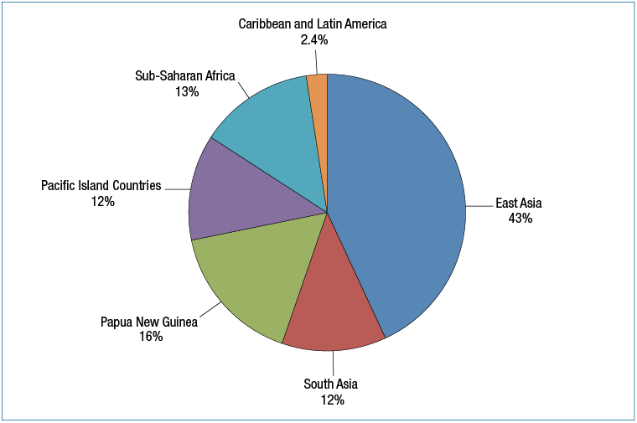

***Contributing to women’s advancement***

Australia Awards contribute strongly to women’s professional advancement. The opportunity to live and study in Australia for an extended period of time not only builds women’s technical skills and capabilities, but also develops personal skills and attributes critical to women exercising effective leadership.[28] In 2014-15, 2,204 women received study and training opportunities under Australia Awards (51 per cent of total awards). Women are still under-represented in decision-making roles in many of the Australia Awards partner countries. Women’s leadership received support in a number of countries through the Australia Awards and related initiatives in 2014-15. For example, in Mongolia Australia established a Women’s Leadership Program to promote and advocate gender equality in graduates in their career development and promotion.

|  |
| --- |
| Australia Awards: Building Women’s Leadership |
| In 2015, the contribution of Australia Awards Scholarships to building women’s leadership was evaluated by the Office of Development Effectiveness.  Female alumnae experience similar barriers to leadership to those faced by other women, such as socio-cultural factors, including family responsibilities; workplace structures and practices; and professional relationships and networks.  The evaluation concluded that Australia Awards Scholarships provide a key mechanism for achieving the Australian aid program’s gender objectives. They contribute strongly to women’s professional development and leadership. Women felt that the prestige and recognised value of overseas tertiary qualifications, combined in many cases with proficiency in English, gave them an advantage over other job applicants, or helped them skip rungs on the professional ladder. Leadership qualities, such as self-confidence, self-belief and open-mindedness, were cited by alumnae as skills they developed while on scholarship, and to a large extent attributed them to the scholarship experience of living in Australia for an extended period of time. Many alumnae reported they felt the scholarship experience made them more equal with decision-makers and empowered them as leaders. Examples of changes to male alumni attitudes and behaviours towards women’s leadership and workplace roles were also reported in the evaluation.  The evaluation found the Australia Awards Scholarships could be particularly transformational for early-career women, or women from countries or areas where women are under-represented in leadership, have limited access to tertiary education, and are impacted by local social and cultural norms. However, the evaluation also concluded that the full potential of scholarships to build women’s leadership has yet to be realised. Actions needed to improve women’s leadership outcomes include increasing women’s access to scholarships and a more strategic use of different types of Australia Award and post award activities. |

***People-to-people links***

Increased engagement with Australia awardees and alumni has helped strengthen people-to-people links and enhance knowledge and skills. In 2014-15, DFAT funded over 70 posts to undertake alumni engagement activities, such as hosting an Australian education week in India, alumni research in Vietnam, and connecting alumni with Australian civil servants and senior representatives from their home countries, while in Australia. These efforts complemented the people-to-people links established through the Government’s New Colombo Plan.

## Australian NGO Cooperation Program

Australians donated over $800 million in 2014 to member organisations of the Australian Council for International Development to support their overseas development and humanitarian work[29]. DFAT recognised these contributions by providing $133 million to the Australian NGO Cooperation Program (ANCP) in 2014-15. NGOs use ANCP funding to leverage additional funding from philanthropic organisations, the private sector and other donors for poverty reduction.

The ANCP recognises the unique strengths that Australian NGOs bring to development activities and Australia’s overall efforts to reduce poverty. In 2014-15, ANCP supported 48 accredited Australian NGOs, and thousands of their developing country partners, to deliver 621 community development activities in 58 countries. These activities directly benefitted more than 19.2 million people, of which 56 per cent were women.

An evaluation by the Office of Development Effectiveness in 2014-15 confirms ANCP is a successful and highly valued program. The evaluation report notes ANCP is flexible and extends the reach of Australia’s aid program, including through public diplomacy opportunities. It is highly aligned with the aid program goals, produces significant results and provides value for money. The report states that Australian NGOs work closely with the private sector, governments, local community groups and disabled people’s organisations. These diverse community linkages, often developed over many years, are one of the known strengths of ANCP. Areas for improvement include the development of a performance assessment framework and program logic for ANCP.

Some of the results of ANCP funding in 2014-15 include: more than 2.5 million people (50 per cent women) gaining increased knowledge of hygiene practices; 2.6 million people (60 per cent women) having greater awareness of gender equality, women’s equal rights and issues related to violence against women; and 1.7 million people (47 per cent women) gaining improved access to essential medicines and health commodities including HIV treatment.

To receive ANCP funding, Australian NGOs must undergo a rigorous up-front accreditation process which assesses the organisational capacity, operational systems and development approaches of Australian NGOs against standard criteria. Each NGO must gain accreditation every five years to continue to receive funding. This process, together with annual partner performance assessments, provides confidence that DFAT is investing in effective partners. During 2014-15, there were a total of 15 accreditation reviews. Eight were reaccreditations and seven were new applications. Of the new applications, four organisations successfully gained accreditation.

## Australian Volunteers for International Development Program

In 2014-15, 1,906 Australians volunteered their time, energy and expertise to work for 1,222 host organisations across 41 countries, funded by the Australian Volunteers for International Development (AVID) program. A total of $56.6 million was expended to mobilise more than 900 new volunteers, as well as provide support to around 1,000 ongoing placements. In 2014-15, 95 per cent of volunteers were placed in in the Indo-Pacific – an increase from 83 per cent of placements in 2013-14. The countries which hosted the most volunteers were Indonesia, Cambodia, Fiji, Vietnam and the Philippines.

AVID’s newly articulated goal and objectives served to focus and strengthen Australia’s international volunteering program. The AVID program seeks to:

• build understanding of Australia’s international role and commitment to integration with the Indo-Pacific region;

• increase the number of volunteers working to improve the economic livelihoods of people in developing countries; and

• develop volunteer assignments in priority areas of governance, health, social infrastructure and services and education.

A redesigned AVID Monitoring & Evaluation Framework released in January 2015 included a structured approach for monitoring, performance assessment and learning for program improvement.

AVID underwent significant changes to improve efficiency in 2014-15 moving to a single consolidated program. In 2014-15, the AVID management structure was reviewed to ensure the program remains as cost effective as possible. Changes were made to in-country management arrangements with a move to one partner operating in most countries. A consolidation of the program’s global footprint also took place, in order to focus on the Indo-Pacific, moving from 41 countries to 28 by 30 June 2015.

# Chapter 4 Sector and thematic performance

This chapter brings together performance information for the six priority areas of investment under the Australian Government’s aid policy. Results against these areas in specific country and regional programs are summarised in Chapter 2. This chapter also includes performance information on disability-inclusive development and innovation.

Sector and thematic strategies have been developed for priority areas to inform investment decisions, strengthen effectiveness of programming and promote coherence across the aid program. Progress against these strategies is reviewed annually and contributes to the analysis in this chapter which also draws on country and regional Aid Program Performance Reports and relevant sector and thematic evaluations.

Figure 24 provides a snap-shot of the current breakdown of aid investments against priority policy areas in 2014–15. Since 2013-14 there has been an increase in the share of ODA going to aid for trade related areas and a corresponding decrease in the share going to education, health and building resilience. This reflects the aid policy’s increased focus on the private sector as a driver of economic growth and poverty reduction. Australia’s estimated expenditure on aid-for-trade of $823.6 million in 2014-15 included investments relating to three priority areas: infrastructure and trade; agriculture and fisheries; and effective governance.

Figure 24: Estimated ODA by investment priority area, 2014-15

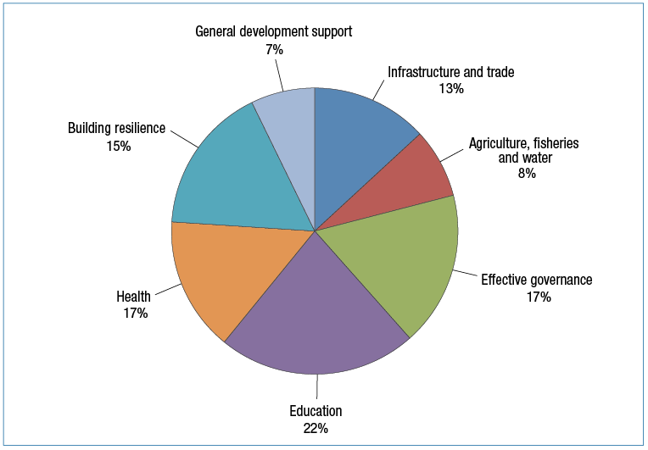

## Infrastructure, trade facilitation and international competitiveness

In 2014-15, Australia invested $627.4 million or 13 per cent of ODA in infrastructure, trade facilitation and international competitiveness.[30] In 2015, the Australian Government released its *Strategy for Investments in Economic Infrastructure*. The strategy identifies the following key priorities:

• mobilisation of private sector to finance and deliver infrastructure to meet the needs of the region;

• improvement of access to infrastructure services to facilitate private sector and human development and promotion of women’s participation and empowerment; and

• promotion of infrastructure to enhance trade and connectivity throughout the region.

Australia’s infrastructure investments in 2014-15 included the construction, rehabilitation or maintenance of over 7,000 kilometres of roads across the Indo-Pacific region. Australian aid has leveraged approximately $691 million in private sector investment in 2014-15. The value of exports facilitated through Australian aid, including new exports, was $206 million and over 5,000 men and women (46 per cent women) were trained in trade policy and regulation.

Australia’s aid program included major new investments in global infrastructure related initiatives in 2014-15. These initiatives are designed to bring private sector financing for infrastructure to developing countries and emerging market economies, helping to address serious shortfalls that constrain trade and growth. Australia’s support for the Global Infrastructure Facility ($25 million) will help identify and prepare complex public-private partnership (PPP) projects in developing countries and emerging market economies. In addition, Australia is working with the ADB on a new mechanism to improve the way PPPs are prepared with a specific focus on our region – known as the Asia Pacific Project Preparation Fund (AP3F).

This work is complemented by renewed Australian support ($11 million) for the Public Private Infrastructure Advisory Facility (PPIAF) which Australia has funded since 2007. The PPIAF targets weak or incomplete legal and regulatory frameworks for PPPs in developing countries. Since 2013, the PPIAF has been supporting the Government of Laos to identify and develop a PPP in the transport sector. PPIAF is now providing further support to help bring National Road 13 to the market as the first PPP in the Lao transport sector. Australia’s renewed support for the PPIAF includes the establishment of a regional office that will help strengthen and expand its operations in the Indo-Pacific region.

Countries in South-East Asia, including Vietnam, the Philippines and Indonesia, are moving further into the middle income bracket. In response, Australia is transitioning its aid infrastructure investments away from construction of infrastructure to an economic partnership approach aimed at helping improve systems and capacity to prioritise investment, better utilise domestic resources and attract private sector investment. To support this transition, Australia has invested in the Private Infrastructure Development Group (PIDG). The PIDG uses donor funds to leverage private financing into much needed infrastructure projects in developing countries and emerging market economies. The PIDG invests in, develops and then sells projects that are commercially viable but are unable to attract private financing due to unacceptable risks deriving from poor project preparation or an uncertain legal and regulatory environment.

|  |
| --- |
| Bringing private investment to fund renewable energy in Vietnam |
| Electricity demand in Vietnam is growing at a rate of 15 per cent per annum. Increased generation capacity is required to support Vietnam’s continued growth and provide stable and reliable electricity to consumers and businesses. Australian support to the Private Infrastructure Development Group has helped corral US$31 million of domestic and foreign private investment to develop a 29.7 megawatt river hydro plant in the poor northern mountains area of Vietnam. The PIDG bought into the project when it had stalled, capital had dried up and investors were shying away due to a lack of clarity around risk. The PIDG turned the project around, shoring up gaps in the environmental and social impact work and restructuring the construction arrangements and contract terms. In late 2014, the project secured adequate debt and equity financing, enabling financial close. The project is expected to achieve a financial internal rate of return of 16 per cent - backed by a power purchase agreement of 20 years. Australia worked closely with the Vietnamese regulator to ensure it set a tariff that would make the project viable. The project will benefit 130,000 people and provide a stable and reliable supply of electricity, including for expansion of mineral processing facilities and fertiliser production. It will also reduce the province’s dependence on unreliable, high cost imported electricity. |

Australia’s multilateral aid for trade flagship, the Global Trade Integration Facility (GTIF), is designed to support multilateral and regional investments that help developing countries in our region to participate in global trade, notably by assisting to address issues such as inefficient and onerous regulations, poor infrastructure and lack of skills. It includes projects to promote stronger, more competitive business sectors as well as efforts to empower women and girls. GTIF investments are beginning to make an impact, including by:

• improving Cambodia’s quality of rice and directly facilitating US$30.5 million of rice exports;

• helping to improve trade flows and productivity by assisting over forty developing countries to undertake trade facilitation reforms and implement the WTO Agreement on Trade Facilitation;

• building the capacity of women entrepreneurs in the Pacific to establish viable businesses and to access international markets and government procurement processes; and

• advising developing countries on the creation of regulatory and institutional frameworks aimed at encouraging public-private partnerships for infrastructure development.

Overall, the performance of investments in this priority area remains strong. However, performance on promoting gender equality objectives in the infrastructure sector remains a concern. In 2014-15, DFAT established a more accurate baseline from which to measure progress, noting that in some cases past gender equality scores had overstated progress in this sector. DFAT is strengthening its advice to help infrastructure managers more effectively integrate gender equality initiatives into Australia’s infrastructure investments.

Figure 25: Infrastructure, trade and international competitiveness: investment performance, 2014-15

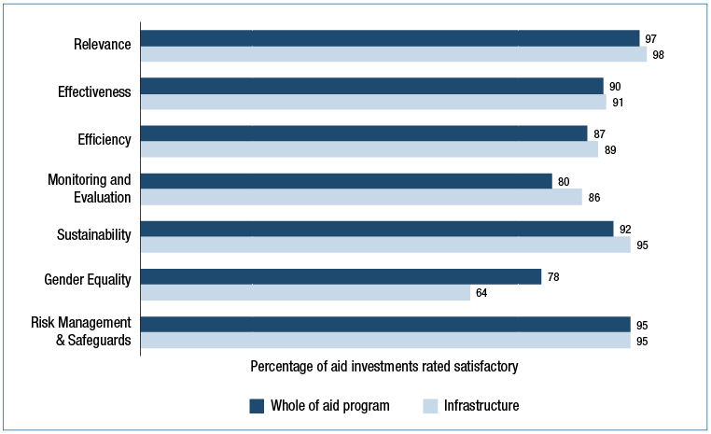

## Agriculture, fisheries and water

In 2014-15 Australia invested $375 million or 7.8 per cent of ODA in the agriculture, fisheries and water sectors to help improve food security and sustainable use of resources in the Indo-Pacific region. Australian aid in 2014-15 increased agricultural and fisheries production by over US$46 million and over 637,000 poor men and women (50 per cent women) adopted innovative agricultural and fisheries practices. Across the region, 17.6 million women and men (20 per cent women) have increased access to financial services and over 764,000 women and men (50 per cent women) have increased incomes as result of Australia’s aid investments.

In February 2015, the Government released the new *Strategy for Australia’s aid investments in agriculture, fisheries and water*. In line with the strategy, Australia’s aid investments are aimed at strengthening markets, innovating for productivity and sustainable resource use, and promoting effective policy, governance and reform among our developing country partners.

During 2014-15, the Australian Government initiated several new agricultural investments to give practical effect to the strategy. In April 2015, the Government announced support for ‘Grow Asia’, a new undertaking by the World Economic Forum and the Association of Southeast Asian Nations (ASEAN) which aims to catalyse sustainable agribusiness opportunities in the ASEAN region. Australia is funding the OECD to build the evidence base and intensify engagement with ASEAN members on agriculture and food security policy. Australia also increased funding to the G20-initiated Global Agriculture and Food Security Program, to facilitate private sector operations in the Indo-Pacific region.

Through its other existing agricultural investments, Australia is working with the private sector and research organisations, including ACIAR, to help small-scale farmers and entrepreneurs, particularly women, to improve productivity and access markets. Key investments in the Indo-Pacific region include: the Australian-Indonesia Partnership for Promoting Rural Economic Development Program (AIP-Rural); the Cambodia Agricultural Value Chain Program (CAVAC); and the multi-country Market Development Facility (see Chapters 1 and 2 for details).

In fisheries, Australian core funding for the key regional fisheries organisations in the Pacific - the Pacific Islands Forum Fisheries Agency (FFA) and the Secretariat of the Pacific Community (SPC) - support multi-year strategies to safeguard tuna resources and increase economic returns to Pacific Island countries. Australia invested around $15 million in the sector in 2014-15. This funding includes support to improve community-based fishery management in a number of Pacific Island countries, to improve food security and ensure long-term sustainability. Australian support is also assisting Pacific Island countries to implement the Niue Treaty Subsidiary Arrangement, which will help combat illegal fishing and improve legal and governance arrangements. Underpinned by good management and Australian support, the offshore tuna sector provided around US$325 million in direct government revenue to the region in 2014 (around 16 per cent higher than 2013). With management support from the FFA, Pacific Island countries successfully negotiated a one year extension to the US Tuna Treaty for 2016 which will deliver US$89 million in direct government revenue to Pacific island countries and represents a significant increase in the rate paid for Pacific fish resources.

|  |
| --- |
| Australian Centre for International Agricultural Research (ACIAR) |
| ACIAR’s bilateral investments in international agricultural research partnerships have generated a fivefold benefit since 1982 and continue to improve trade and economic growth in partner countries. For example:  • DFAT and ACIAR are working in partnership in Timor-Leste to increase yields of key crops by selecting and distributing improved varieties of superior genetic quality. As a result a national seed system has been established. Fifty eight commercial seed producers have started to produce improved varieties of quality seeds, now purchased by the government and directly by farmers.  • In South-East Asia there are now more than 7 million hectares of plantations based on eucalyptus and acacia trees with ACIAR scientists having made major contributions to the domestication and improvement of these trees. In Vietnam there are an estimated 250,000 smallholder farmers growing acacia trees as part of their farming systems generating average annual incomes of $1200.  • ACIAR and DFAT are co-funding a major program on community-based fisheries management in Solomon Islands, Vanuatu and Kiribati, which is resulting in livelihood benefits through improved local management of fisheries resources. Further collaboration with the Secretariat of the Pacific Community is supporting the adoption of the region-wide New Song for Coastal Fisheries: Pathways to Change, which will scale-up community management of near-shore fisheries for income and nutritional benefits. |

In May 2015, Australia established the Australian Water Partnership (AWP) to share Australia’s private and public sector experience and expertise in water resource management with countries in the Indo-Pacific region to improve water security. Since its establishment, the AWP has: in collaboration with the World Bank negotiated to provide technical assistance in weather/water forecasting and river basin planning for Myanmar; provided technical assistance to the Chennai Water Board to help plan improvements to service delivery and revenue collection; and helped establish a water quality reporting system for the clean-up of the Ganges River in India.

Overall, investments in the Agriculture, Fisheries and Water priority area are performing well. In the 2013-14 Aid Quality Check, investments in agriculture, fisheries and water scored 63 per cent or 11 percentage points below the aid program average for addressing gender equality. Since then women’s economic empowerment has been given a high priority. New investment designs are including strategies to empower women to overcome barriers to their participation in the agriculture, fisheries and water sectors. In addition, an operational guidance note has been prepared to support program managers to more effectively address gender equality issues in agricultural investment design and implementation. In 2014-15, the score on the gender criterion across agriculture, fisheries and water Aid Quality Checks has increased to 79 per cent. Segments of the portfolio are performing below average on effectiveness and sustainability criteria. This will be addressed through providing operational guidance notes to improve investment designs and monitoring and evaluation systems.

Figure 26: Agriculture, fisheries and water: investment performance, 2014-15

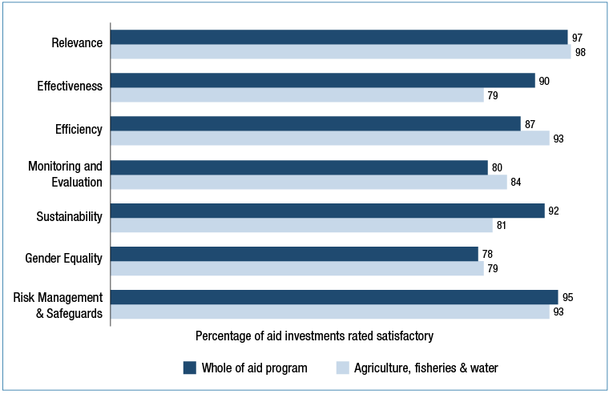

## Effective governance: policies, institutions and functioning economies

In 2014-15, Australia invested $835.5 million or 17.5 per cent of ODA to support more effective governance in partner countries. In this way, Australia continues to support the building of institutions that have a direct role to play in promoting stability, inclusive economic growth and poverty reduction, and in strengthening gender equality and women’s empowerment.

DFAT’s strategy *Effective Governance: Strategy for Australia’s aid investments*, released in March 2015, provides guidance to operational teams on how to design, implement and assess governance programming. Robust analysis increasingly underpins governance investments, especially a greater appreciation of the power dynamics, including the gender dimensions, of the contexts in which Australia works.

In 2014-15, Australia’s governance assistance resulted in important immediate results including the training of over 18,000 police and law and justice officials (18 per cent women) globally. Australia’s investments have also continued to see incremental improvements in government systems and processes that, over-time, will contribute to more predictable regulatory environments for business, better quality and more responsive service delivery, safer communities, and more inclusive and sustainable economic growth.

Australia’s governance programs are increasingly active at the sub-national level. Australia recognises, and seeks to address, the challenges of working with partner governments to improve service delivery across diverse, and often geographically remote, populations. An Office of Development Effectiveness evaluation of Australia’s work in decentralised service systems in the Indo-Pacific region, identified ‘many examples where positive results have been achieved’ in sectors such as health, education and infrastructure including increased rates of school building construction in PNG (including in remote areas) and stronger school-based management in the Philippines. The evaluation also identified how Australian investments could improve country-level analysis, address decentralisation in planning and design, and, in particular, assess short-term service delivery needs against long-term structures and incentives to achieve sustainable service delivery.

Longer-term results are being achieved across a range of areas in the governance portfolio, from law and justice, to economic management. For example, an independent evaluation found that DFAT’s six-year support had helped Samoan law and justice agencies to deliver outcomes including the digitisation of court records, harmonisation of the traditional and formal legal systems and establishment of a National Human Rights Institution. An independent progress review of the Australia-Indonesia Partnership for Justice concluded that the program had increased access to justice for citizens as well as achieved important reforms in Indonesian courts, including increased transparency of judgements and more consistent and higher quality verdicts. The outcomes of these reforms have also improved the enabling environment for international business in Indonesia.

In Indonesia, by establishing and strengthening government-to-government partnerships through the Government Partnerships Fund (GPF) Australia continued to support Indonesia’s priority economic reforms. The Australia Indonesia Partnership on Economic Governance, which works closely with GPF, provided international expertise to support Indonesian economic agencies promote growth and stability in the Indonesian economy. A mid-term review of the Philippines-Australia Public Financial Management program found that the support provided by Australia has been a critical link between the aspirations of the reform minded leadership and the responsiveness of the bureaucracy and external stakeholders.

Around 78 per cent of Australia’s bilateral aid investments are delivered in countries which are fragile or conflict-affected, where governance challenges are particularly acute and can often reverse development gains. Australia’s approach in such areas is to be sensitive to the underlying drivers of conflict and fragility.

Overall, Australia’s investments in governance have performed well, though room for improvement remains. In 2014-15, Aid Quality Checks show that 78 per cent of governance investments satisfactorily addressed gender, significantly improving on last years’ result of 64 per cent. Monitoring and evaluation scores have also improved significantly. More work is needed to understand the drivers of these improvements and ensure they are sustained in future years.

Figure 27: Effective governance: investment performance, 2014-15

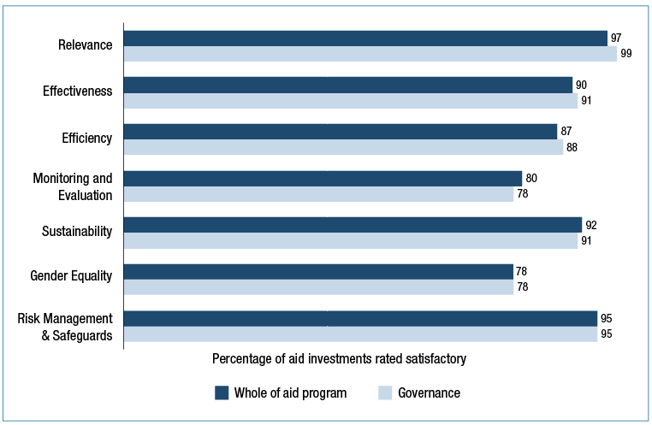

## Education and Health

In 2014-15, Australia provided $1,072.4 million or 22.4 per cent of ODA to support education investments (including Australia Awards, covered in Chapter 3). Investing in global, regional and country-level education solutions for children and adults, drives innovation, economic growth and self-reliance. In 2014-15, Australia’s funding of $63 million for the Global Partnership for Education (which assists 61 countries), contributed to financing the construction or rehabilitation of 5,713 classrooms, provided 12.8 million textbooks and learning materials, and trained over 146,000 teachers. In addition to Australia’s support for the Global Partnership on Education, Australia financed bilateral education programs with 22 countries throughout the Indo-Pacific. Almost 145,000 teachers (40 per cent women) were trained, improving education quality and enabling over 1.8 million girls and boys to enrol in schools across the region. In relation to workforce skill development, 4,800 women and men (48 per cent women) gained recognised post-secondary qualifications.

|  |
| --- |
| Children in Conflict: Education Support for Syrian Refugees |
| In 2014, Australia provided $20 million in humanitarian assistance for the UN’s *No Lost Generation* strategy in Jordan and Lebanon. *No Lost Generation* is aiming to build a better future for children impacted by the Syria crisis by improving access to education and addressing the violence they have faced through dedicated psychosocial support. Within the first year of the strategy, 489,000 Syrian refugee children in the region were receiving some form of schooling, compared to 169,500 the year before. Through *All Children Reading: A Global Challenge for Development Initiative*, Australia is also supporting development of a mobile learning tool to increase literacy rates and psychosocial wellbeing for Syrian children aged 4-10. |

Australia’s aid investments in 2014-15 helped deliver higher quality education services, improve access and increase participation. Only 69 per cent of countries have achieved gender parity in primary education and 48 per cent in secondary education. Improving outcomes for girls requires addressing a range of interlinked challenges including safety, school infrastructure, adequate sanitation, quality of learning, transitions from primary to secondary school, and local leadership. In 2014-15, over 86 per cent of Australia’s aid investments specifically targeted improvements to gender equality. Almost 83 per cent of education investments identified and addressed barriers for people with disabilities.

Programs have responded to the challenge of education quality by investing in curriculum reform, learning materials and improved assessments, enhancing learning environments, and teacher and school management training. In Fiji, Australian-supported schools have seen a nine per cent improvement in the poorest performing students’ results. According to Indonesia’s national accreditation agency, 90 per cent of the 519 Australian-supported madrasah showed improvement in meeting quality standards. In Burma, Australia supported approximately 8,000 teachers and caregivers to improve their competencies in teaching methods for basic education. In Pakistan, Australian investments have led to a 44 per cent increase in children’s reading comprehension in participating schools and monthly monitoring of teacher attendance has led to an extra 6,000 teachers present in classrooms. In Sri Lanka, construction of technical laboratories and Information, Communication and Technology (ICT) centres allowed 948 secondary schools to improve learning in mathematics, English and science.

Figure 28: Education and health: investment performance, 2014-15

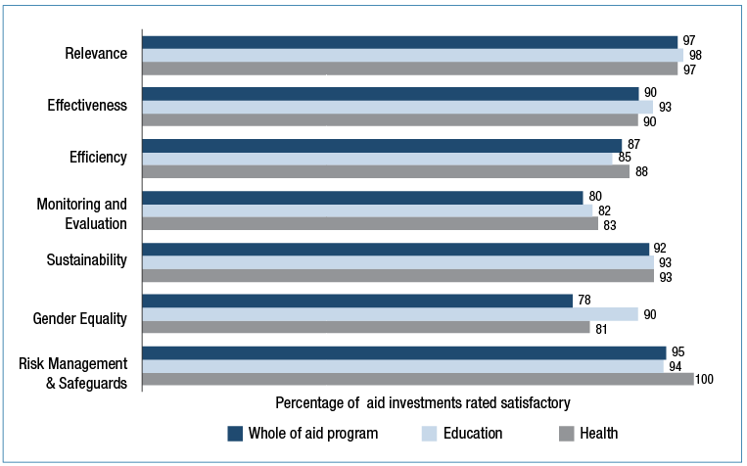

In 2014-15, Australia invested $800 million or 16.7 per cent of ODA in health, including in basic water, sanitation and hygiene (WASH). The majority of this funding (56 per cent) was for bilateral and regional support to countries in Asia and the Pacific. Health investments save lives, underpin economic growth and prosperity, and protect Australia and the region against the risk of cross-border disease threats.

Australia’s investment in health is guided by the *Health for Development Strategy (2015-2020)*, released in June 2015. The strategy covers investment in health, water, sanitation and hygiene, and nutrition – three areas that are crucial to improving health outcomes in a population. Key lessons from a portfolio-wide analysis of health investments and global health trends identified the need to prioritise investment in preventing emerging regional health threats including drug resistant malaria and tuberculosis, and pandemic prone influenzas. It also identified high impact interventions such as family planning as a highly cost effective strategy for reducing maternal deaths and increasing gender equality and women’s empowerment.

Innovation and new approaches and solutions for health, water and sanitation, and nutrition that benefit our region feature in the strategy. Consistent with the strategy, in 2014-15, DFAT’s innovationXchange initiated a Partnership with Bloomberg Philanthropies to improve the availability and use of data for health decision making.

The ODE evaluation *A window of opportunity: Australian aid and child undernutrition*, released in April 2015, found Australia’s investments to address undernutrition to be aligned with the principles of good nutrition practice. The evaluation also identified opportunities to further improve Australia’s investments in nutrition with recommendations to strengthen DFAT’s nutrition planning and implementation processes. The report recommended improved targeting of nutrition interventions through specific life stages, to women and to vulnerable populations, and recommended improvements to monitoring and evaluation practices.

Australia’s health investments have produced good development results in 2014-15. Globally, nearly 470,000 additional births were attended by skilled birth attendants and over 2.8 million children were vaccinated. Investment in water, sanitation and hygiene provided access to safe water for over 2.2 million people (45 per cent women) and access to basic sanitation for over 800,000 people (45 per cent women). Australian assistance helped the Indonesian Government provide incentives for local government investment in water through the Water Hibah (grant) program, resulting in piped water connections to over 600,000 people. The Indonesian Government adopted this incentive-based model in its own budget - increasing prospects for long-term sustainability.

In 2014-15, Australian aid assisted with the global response to the outbreak of Ebola Virus Disease in West Africa, including funding for preparedness activities in South East Asia, Papua New Guinea and the Pacific and managing an Ebola treatment centre in Sierra Leone. The outbreak underscored the importance of countries developing core health capabilities such as disease surveillance, and preparedness and response systems. These lessons will be carried forward in the implementation of DFAT’s health strategy.

In 2014-15, approximately 43 per cent of Australian ODA spent on improving health outcomes was channelled through high-performing global health partners, including the Global Fund to Fight AIDS, Tuberculosis and Malaria (the Global Fund); GAVI, the Vaccine Alliance; World Health Organization; UNFPA; UNAIDS; UNICEF; World Bank and ADB. In 2014-15, Australia’s $50 million funding to GAVI contributed to the immunisation of 58 million children globally. Australia’s $105 million contribution in 2014-15 to the Global Fund helped to provide antiretroviral therapy for 1.5 million people with HIV/AIDS, treated 1.3 million people with tuberculosis and distributed 130 million bed nets to help prevent malaria.

Australian Government health, water and sanitation investments drew on lessons learnt from monitoring and evaluation to improve performance. The 2014-15 aid quality data shows that health, water and sanitation programs are performing well against almost all the quality criteria including in addressing gender, however, more can be done to utilise innovative approaches to deliver improved health and results. DFAT has commenced work to strengthen innovation learning and development in health, water and sanitation programming through non-government, private sector, country and global partnerships.

|  |
| --- |
| Civil Society Knowledge and Learning in Water, Sanitation and Hygiene |
| The Civil Society Water, Sanitation and Hygiene (CS WASH) Fund supports 13 civil society organisations in 19 countries to improve sustainable access to safe water, sanitation and hygiene for poor people. Given the importance of learning to sustainability in the sector, the fund includes a dedicated knowledge and learning component. A key learning outcome concerns the political dimensions of WASH service delivery, particularly the roles civil society organisations can play in bringing citizens closer to government and increasing transparency by both government and civil society to improve WASH outcomes. |

## Building resilience: humanitarian assistance, disaster risk reduction and social protection

In 2014–15, Australia provided $724.4 million or 15 per cent of ODA in humanitarian assistance, disaster risk reduction, social protection and climate change investments. These investments saved lives, limited economic and development losses and reduced vulnerability to crises.

In 2014–15, Australia provided $84.6 million or 1.7 per cent of ODA in assistance with social protection. Australia’s approach involved leveraging partner governments’ own funding to improve social protection for the poor and vulnerable. Australian assistance enabled an additional 1.8 million poor people (60 per cent women) to receive cash, food and other transfers by supporting governments in the IndoPacific to improve the coverage and quality of social protection systems.

In 2014-15, Australia responded to humanitarian emergencies in 21 countries, including Tropical Cyclone Pam in Vanuatu (March 2015) and earthquakes in Nepal (April-May 2015). Australian aid provided over 10.1 million vulnerable women, men, girls and boys with life- saving assistance in conflict and crisis situations.

Australia maintains a range of deployable capabilities to effectively respond to rapid onset and protracted crises. DFAT’s Crisis Response Team was deployed to Vanuatu and Nepal within 36 hours of their disasters. DFAT’s prepositioning of emergency relief supplies throughout the Asia-Pacific region enabled prompt delivery to affected communities. Australia also deployed medical assistance teams to Vanuatu to deliver emergency medical care, and supported RedR Australia to deploy 99 humanitarian specialists to UN humanitarian operations in 34 countries. Fifty-four specialists from the Australian Civilian Corps were deployed to 13 countries to assist with disaster preparedness, reconstruction, capacity building and elections support.

The Indo-Pacific is the most disaster affected region in the world and accounts for around 75 per cent of global fatalities from natural disasters. Australia supported national governments in the Indo-Pacific to increase their capacity to respond to disasters and worked with international partners to build disaster resilience in vulnerable countries. In March 2015 the Government endorsed the Sendai Framework for Disaster Risk Reduction 2015–2030, a global blueprint to build disaster resilience, reduce disaster risk, prepare for and recover from natural disasters. Australia advocated for a focus on how developing countries could mobilise and effectively use all sources of finance, including domestic revenue and remittances, for disaster risk reduction.

Australia is working with partner governments, including stakeholders across the Pacific, to prepare for the World Humanitarian Summit in Turkey in May 2016 aimed at improving the responsiveness and effectiveness of the international humanitarian system. Australia’s focus includes: humanitarian financing reform; stronger protection mechanisms for women, children and people with disabilities; developing differentiated approaches to natural disasters and protracted crises; and engaging the private sector and utilising innovation to drive effectiveness in humanitarian assistance.

Australia’s capacity for humanitarian response is enhanced by drawing on multi-year partnerships with effective global humanitarian organisations. Australia contributed $116.7 million towards World Food Programme (WFP) operations in 2014–15 to help the WFP to provide food assistance to 80 million people. As President of the WFP Executive Board, Australia continued to support improvements and innovations in WFP operations, engagement in the Asia-Pacific region, and a focus on gender equality.

|  |
| --- |
| Multilateral Performance Assessment: World Food Programme |
| ***Overview of performance***   | **Results and Impact** | Good | **Partnership Behaviour** | Good | | --- | --- | --- | --- | | **Relevance and Alignment** | Good | **Organisational Capacity** | Good | | **Value for Money** | Good | **Organisational Governance** | Very Good |   ***Summary of assessment***  WFP is very strong in the rapid delivery of humanitarian response and the distribution of food, cash and vouchers, enabled by specialist staff and a high degree of organisational flexibility. WFP has shifted from food aid to a focus on food assistance, with increased emphasis on resilience, food security and livelihoods, in addition to humanitarian relief. WFP is enhancing its capacity to meet this dual mandate. However, emergency response continues to consume most of its resources, limiting its focus on development objectives. WFP is a valued contributor to the multilateral system. It demonstrates effective leadership and coordination, including managing logistics and communications ‘common services’ on behalf of the humanitarian community. WFP needs to strengthen partnerships with development and non-traditional partners.  WFP’s work is closely aligned with Australia’s development priorities, and it is highly active in Asia. Over the past year WFP has significantly increased its operational capacity in the Pacific, and is working with Australia and Pacific governments to enhance regional disaster preparedness. WFP is improving its promotion of gender equality, but has yet to adequately address disability inclusion. WFP launched an Innovation Accelerator in 2015, which has already developed a number of successful initiatives. WFP engages closely with the private sector, including small-holder farmers, to procure, transport and distribute assistance. WFP is also establishing a business advisory group with representatives of the Australian private sector.  WFP has a strong focus on value for money and transparency, and continuously scrutinises operating costs while working to enhance evidence-based decision making. Reporting is regular and easy to access, and WFP is improving outcome and impact assessment to complement strong output reporting. The organisation manages risk well, despite often challenging operating environments. Internal systems and accountability mechanisms are strong and WFP has clear processes for the allocation of resources, including core funding. |

In 2014-15, Australia provided $35 million to the UN High Commissioner for Refugees to assist in the provision of life-saving humanitarian protection, shelter, water, food and health care to nearly 55 million refugees, internally displaced people and other persons of concern in 127 countries. Australia also provided $46.8 million to the International Committee of the Red Cross in 201415 for its operations in conflict hotspots and efforts to prevent and respond to sexual violence, including through targeted protection programming, restoration of family links, supporting economic security and enhancing access to safe water, sanitation and health services.

The majority of Australia’s funding to major humanitarian partners is ‘unearmarked’ (not tied to a particular country or crisis), which allow partners to prioritise funding to not only meet the most urgent humanitarian needs, but also to continue to address forgotten, often protracted crises. By providing unearmarked funding, Australia has enabled its humanitarian partners to kick-start emergency responses, bolster under-funded operations that don’t make the headlines and allow operations to more effectively plan, budget and implement quickly and effectively.

Acknowledging the impact that humanitarian crises have on women and girls, Australia supported partners to implement sexual and reproductive health programs in humanitarian crises. For example, in 2014-15 Australia supported the United Nations Population Fund to deliver sexual and reproductive health and gender based violence interventions in response to the conflict in Iraq and the earthquakes in Nepal.

Australia reviewed its performance in delivering humanitarian assistance through post-crisis reviews, including an ODE evaluation of Australia’s response to the Syria crisis, which was released in March 2015. It found Australia’s response was relevant and appropriate, but found some shortcomings in the coherence of the response. DFAT is implementing recommendations regarding more strategic and multi-year approaches to protracted crises. The new DFAT humanitarian strategy and the next phase of the Humanitarian Partnership Agreement with Australian NGOS will reflect the Government’s policy priorities and lessons learned from humanitarian responses.

|  |
| --- |
| Humanitarian Response: Australian Civilian Corps |
| Through the Australian Civilian Corps (ACC), DFAT manages a register of civilian specialists—with experience in recovery and stabilisation—who provide preventative and post-crisis support across the Indo–Pacific. A recent example of the ACC mechanism in operation is Australia’s humanitarian emergency response to Tropical Cyclone (TC) Pam in Vanuatu. For almost two years prior to TC Pam, DFAT embedded an ACC Disaster Management Specialist in Vanuatu’s National Disaster Management Office (NDMO) to strengthen the NDMO’s ability to prepare for—and respond to—natural hazards. When TC Pam hit, the ACC Specialist provided a critical operational link between the Government of Vanuatu and international donors and helped facilitate Australia’s humanitarian and consular response, including six additional ACC specialists for post-disaster recovery. This ACC deployment positioned the NDMO well to proactively respond to the disaster—ultimately saving lives. |

Australia provided financial, technological and capacity-building support to developing countries to reduce greenhouse-gas emissions and adapt to climate change. Australia directed $222.3 million towards climate change activities through Australia’s country aid programs and contribution to the Green Climate Fund ($70 million).

Australia funded climate change action grants to assist communities in the Pacific and South-East Asia address climate change and build resilience at the community level. For example, in Timor-Leste, Australia supported Care Australia to enhance the resilience of vulnerable households to the impacts of climate change through protecting water sources.

Monitoring and evaluation has been a weakness in the humanitarian sector globally and in 2014-15 the aid program began to assess quality in the humanitarian sector through tailored AQCs. Investments in building resilience performed above the aid program average on four of the criteria, with more effort required on monitoring and evaluation and gender to meet the aid program average.

Figure 29: Building resilience: investment performance, 2014-15

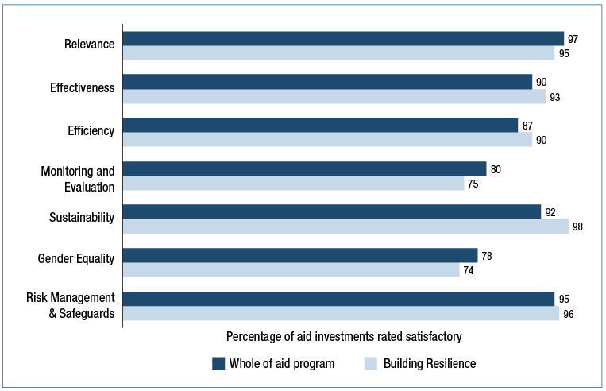

## Gender equality and empowering women and girls

In line with the Government’s aid policy, Australia is committed to investing in three priority areas where there are persistent challenges to gender equality and where progress has been slow: enhancing women’s voice in decision-making, leadership and peace-building; promoting women’s economic empowerment; and ending violence against women and girls. In 2014-15, Australia spent $2.44 billion on investments that targeted gender equality as a principal or significant objective (Figure 30). This represents 54 per cent of DFAT’s country, regional and global aid investments by value across all sectors. This percentage has been relatively stable during the past three years, and is highest in the South and West Asia region.

As a measure of aggregate impact DFAT tracks women’s representation in investment and community- level decision-making bodies. Across the region, the aid program has supported 19,600 management committees in which women are equally represented.

Figure 30: Aid expenditure with a gender-targeted objective, 2014-15

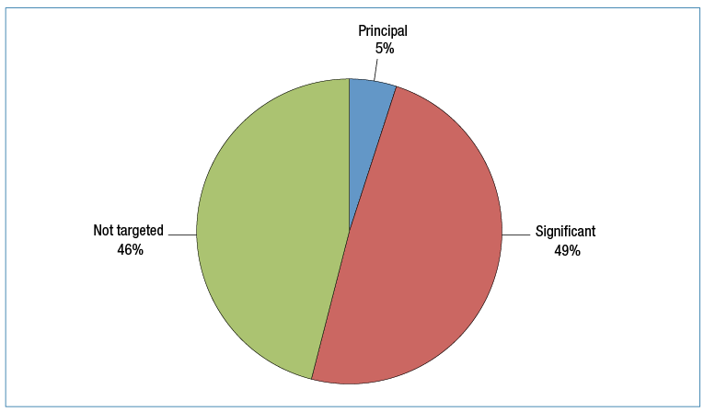

Figure 31 shows investments that identified gender equality as an objective at commencement had higher performance ratings on gender equality as well as on all other quality criteria, compared to investments that do not have gender equality as an objective. Early consideration of gender objectives is clearly a key factor in effectively promoting gender equality during implementation.

Figure 31: Gender equality: investment performance, 2014-15

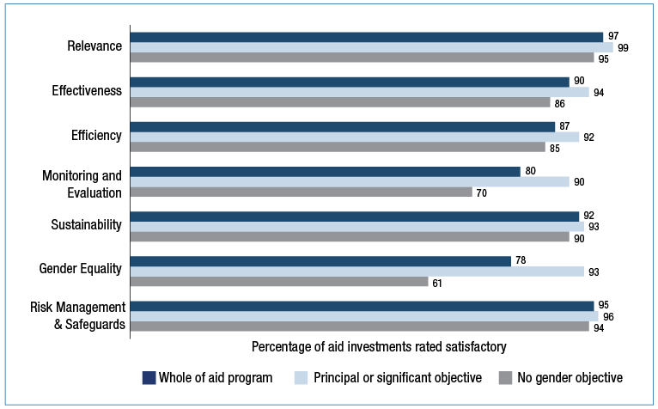

Further analysis of gender performance information can be found in the discussion of strategic target 4 of the aid program performance framework in Chapter 1.

Since 2013, Australia’s Ambassador for Women and Girls, Natasha Stott Despoja, has been an international advocate for gender equality and worked to ensure it is a central focus of Australia’s diplomatic and development efforts. The Ambassador’s participation during 2014-15 at multilateral and regional meetings, in tandem with her bilateral advocacy, ensured that Australia continues to be a strong voice in international efforts to empower women.

Australia’s approach to the promotion of gender equality and women’s empowerment follows a twin-track approach. Track one defines gender equality and women’s empowerment as a discrete strategic priority in the aid program. Track two integrates gender equality effectively in all aid investments, regardless of the sector or focus.

Major gender-focused investments in the Pacific have generated important results for women’s empowerment and gender equality. Pacific Women Shaping Pacific Development (PWSPD) (2012-2022) is a $320 million program to enable women and men across 14 Pacific nations to improve the political, social and economic opportunities for women. Pacific Women works to bring sustained change for women by influencing policies and laws, increasing access to services, and changing attitudes and beliefs about women’s and men’s roles. It supports countries to respond to the Pacific Leaders’ Gender Equality Declaration. Under PWSPD, Australia supported over 30 women parliamentarians and senior government officials to attend the Pacific Women Policy Makers’ Dialogue in Tonga in July 2014 to identify strategies to improve women policy makers’ leadership. To support women’s economic empowerment, the PWSPD Private Sector Development Initiative advised the Governments of Solomon Islands and Vanuatu to reform legislation and develop a secure transaction framework, encouraging women to take out loans and financial institutions to lend to women. As a result of the reform, the number of women borrowers increased significantly. For example, in Vanuatu there was an almost six-fold increase in women borrowers in 2015 compared to 2011.

During 2014-15, Australian-funded action to eliminate violence against women in Afghanistan, Cambodia, Pakistan, Timor Leste and across the Pacific enabled almost 55,000 women survivors of violence to receive quality and timely services such as emergency shelter, legal advice, and counselling. The role of the private sector in addressing violence against women is emerging as an important theme. New studies are demonstrating the cost of violence against women for businesses and public- private partnerships are exploring innovative measures to prevent and respond to violence against women in workplaces, homes and communities.

Australia continued to work closely with UN Women whose normative and global activities are essential to achieving gender equality and women’s empowerment. UN Women’s global reach supported Australia’s ability to engage in policy dialogue and provide development assistance in the Indo-Pacific region and globally. In addition to core funding of $11.8 million during 2014-15, Australia directly supported a number of UN Women’s global and regional programs as well as specific country programs. UN Women works with the private sector, for example with the PNG Nation Wide Micro Bank as part of the UN Women Safe Cities Safe Markets Project. It also influenced the development of Cambodia’s National Action Plan on Violence Against Women to address violence in the private sector, particularly the garment and entertainment industries.

## Disability-inclusive development

*Development for All 2015-2020: Strategy for strengthening disability-inclusive development in Australia’s aid program* was released in May 2015. The strategy aims to support people with disabilities in developing countries to find pathways out of poverty and realise their potential.

An independent review found that DFAT is achieving good value for money from its disability partnerships with the International Disability Alliance, the United Nations Partnership to Promote the Rights of Persons with Disabilities, WHO and UNICEF. The review highlighted the important synergy that these partnerships have created between the UN system and civil society. This has enabled International Disability Alliance to successfully advocate for inclusion of people with disabilities in the goals and targets of the 2030 Agenda for Sustainable Development.

International Disability Alliance is a civil society network of global and regional disabled people’s organisations. Australian funding supports International Disability Alliance to advance the human rights of people with disabilities through advocacy – acting as a united voice of people with disabilities in global debate. This embodies a key principle of Australia’s disability engagement – ‘nothing about us without us’. Australian support also enables International Disability Alliance to build the capacity of national and local disabled peoples’ organisations in the Indo-Pacific region.

Figure 32: Disability-inclusion: investment performance by investment priority area, 2014-15

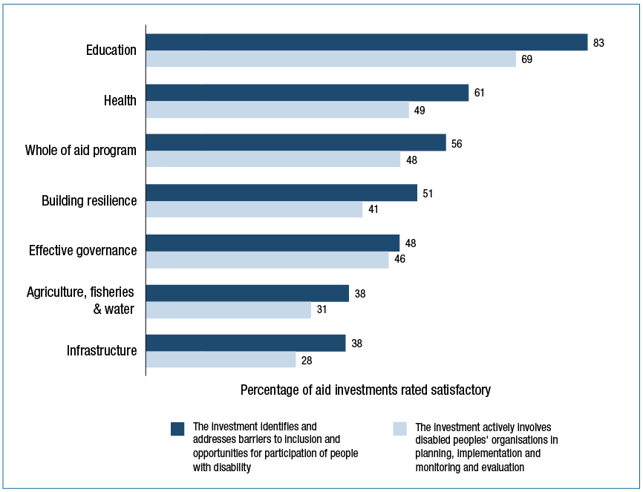

In 2014-15, the disability-inclusive performance of individual aid investments was assessed for the first time through two questions in AQCs (Figure 32). The results show considerable scope for improvement in all sectors. Investments in education perform the most strongly on disability inclusion.

|  |
| --- |
| Inclusive Education in the Pacific |
| The Australian Government is committed to playing a leadership role internationally in disability-inclusive development to enable people with disabilities in developing countries to find pathways out of poverty and realise their full potential. There is a link between disability and poverty, with 80 per cent of people with disabilities living in developing countries, and one-in-five of the world’s poorest having a disability. Education is critical to developing skills to improve livelihoods, lift living standards and gain employment, enabling people in poverty to participate in and contribute to the economy. However, people with disabilities are particularly disadvantaged by poor quality, inadequate and inaccessible education. Of all children who are not in school in the Asia-Pacific region, one-third have a disability. Better access to appropriate education services is required to enable more people with disabilities realise their full potential and live productive lives.  Australia has made strong progress in enabling people with disabilities to benefit from education investments. For example, Australia is working closely with the Fiji Ministry of Education to promote access for children with disabilities to mainstream education. Five demonstration schools across the country are piloting ways to enable children with disabilities to participate in all school activities on an equal basis with others. The Fiji Access to Quality Education Program promotes a model of inclusive education, in which children with disability are educated in classrooms alongside peers who do not have a disability, in schools close to their home. As part of the program, 33 schools have received infrastructure upgrades to make them disability accessible and/or have received inclusive education training.  As a result of Australia’s support to the Government of Kiribati in 2015, 477 children benefited from rehabilitated primary schools built in line with Accessibility Design Guide standards; and 179 children with a disability (up from 137 in 2014) were able to access quality education services at the Kiribati School for Children with Special Needs. In Samoa, Australian assistance in 2014-15 enabled around 580 children and young people with disabilities to attend mainstream and special schools. |

## Innovation

DFAT’s innovationXchange (iXc) was launched in March 2015 to foster and catalyse innovation in the Australian aid program. The work of the iXc incorporates three pillars: Find & Test; Share; and Scale, which describe the activities, approaches and initiatives that iXc will deliver.

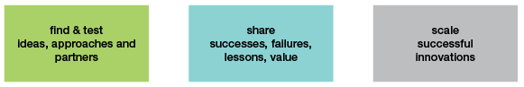

The “Find & Test” pillar seeks to identify and test high impact and locally-owned ideas, approaches and partners. Under this pillar, iXc launched three major ideas challenges in 2015, including the inaugural DFAT Ideas Challenge, the Pacific Humanitarian Challenge and the Blue Economy Challenge. Approximately twenty per cent of ideas from the DFAT Ideas Challenge were focused on opportunities for the aid program. The winning idea, “No Win, No Fee” will test a new approach to improving taxation revenue in developing countries.

iXc has also established collaborative partnerships which started demonstrating results in 2015. Data for Health, a partnership with Bloomberg Philanthropies to improve the health data on which government decisions are made, provides expertise to governments to improve birth and death data, conduct mobile phone surveys on health risk factors such as tobacco and nutrition, and improve data usage by policymakers and health agencies.

The second pillar, “Share” seeks to increase awareness and uptake of successful innovations in the Indo-Pacific. In 2015, iXc hosted secondees from external organisations including USAID, the World Food Programme, CSIRO and the Washington-based Results for Development Institute, to bring new networks and expertise. iXc has run 16 workshops for DFAT staff in which innovative workplace practices, co-creation methodologies and new approaches to design thinking were discussed. iXc also became part of the International Development Innovation Alliance, a working group of eleven global funders active in the area of innovation for development. Through this alliance, iXc is actively collaborating and exchanging lessons learned in areas such as impact measurement, virtual global data platforms and global agenda-setting.

iXc’s third pillar, “Scale” seeks to support successful innovations to scale up. Scaling up good ideas takes time, but iXc has made a number of investments in 2015 with significant potential over coming years. iXc has committed up to $30 million over four years to the Global Innovation Fund, a joint initiative with four other partners which provides support for the development, rigorous testing and scaling of cost-effective social innovations targeted at improving the lives of the poorest people in developing countries. Seed Pacific is a new initiative to develop, test and scale shared value business models that show clear potential to generate commercial returns, while also having a significant development impact. In early 2016 a series of fora will bring businesses together with Pacific governments, regional organisations, academia and civil society to identify opportunities for productive collaboration.

Throughout 2014-15, other programs continued to trial and implement a range of development innovations. For example:

• an SMS alert system powered by Digicel enabled the Government of Vanuatu to warn remote communities of Tropical Cyclone Pam;

• a partnership with global agri-inputs company Syngenta is making technology and training available to extend the mango fruiting season in Indonesia from three to seven months, potentially resulting in 10,000 smallholder farmers doubling their net income;

• a pilot project in the Philippines is making accessible supplementary reading material, linked to the curriculum and written in mother-tongue, for primary school students with low or no vision; and

• a trial of boat schools, clinics and floating latrines is improving school attendance in areas of Bangladesh where government service do not operate.

AQCs assessed progress with implementing innovation in the aid program (Figure 33). The results show that for the aid program as a whole, more than 50 per cent of aid investments are either applying a new approach to aid delivery or trialling or adapting new technologies. Investments in aid for trade related areas show the strongest performance on innovation.

Figure 33: Innovation: investment performance by investment priority area, 2014-15

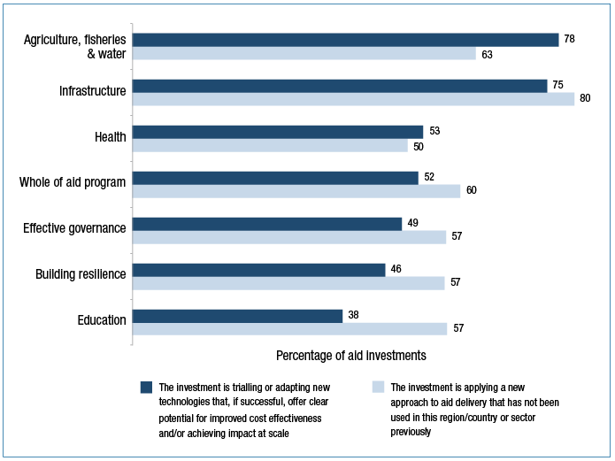

# Annex A Official Development Assistance delivered by other government agencies

## Australian Federal Police

ODA expenditure in 2014–15: $103 million

Australian Federal Police (AFP) programs supported police development in partner police agencies in the Indo Pacific Region to enable the delivery of legitimate, responsive and accountable policing in support of the effective rule of law. AFP police development programs in 2014-15 included: the Regional Assistance Mission to the Solomon Islands (RAMSI), which supported the development of a credible policing capability in the Royal Solomon Islands Police Force; the Pacific Police Development Program, which supported development programs in Nauru, Samoa, Tonga and Vanuatu; the Papua New Guinea – Australian Policing Partnership (PNG-APP) focussed on development of the community policing capability of the Royal Papua New Guinea Constabulary; the Timor-Leste Police Development Program, which focused on enhancing the capability of front-line policing services of the Policia National de Timor-Leste; and the Cyber Safety Pasifika Program, which equipped police in various Pacific countries with the knowledge and resources to educate their communities in all aspects of cyber safety.

The AFP also supported the refurbishment of forensics facilities in Pakistan and the training of Pakistan law enforcement authorities. AFP Pacific Transnational Crime Network advisors focused on enhancing coordination and cooperation between Pacific countries to combat transnational organised crime. The AFP also supports the Pacific Transnational Crime Network of 19 Transnational Crime Units in 13 countries and maintains Senior Liaison Officers (non-ODA funded) in Port Moresby and Suva.

## Australian Centre for International Agricultural Research (ACIAR)

ODA expenditure in 2014-15: $96 million

ACIAR managed research partnerships in the areas of crops, livestock and fisheries, natural resources and forestry, and socioeconomics and policy which generated new technologies and systems, innovation at the farm level, and greater capabilities in research and production. As Australia’s specialist agricultural research-for-development agency, ACIAR actively contributed to the overall aid objectives by improving the productivity and profitability of agricultural systems in countries of the Indo–Pacific region.

A number of examples highlight ACIAR’s contribution. In Indonesia ACIAR trialled and launched innovations to the egg and poultry production system that minimise food safety risks throughout the supply chain. In Pakistan, ACIAR-supported research identified new options for the successful growing of summer vegetables by identifying and characterising varieties of tomato, cucumber and okra tolerant to heat stress. In Tibet Autonomous Region dairy cattle nutrition was improved through better preparation of fodder, provision of adequate water and the addition of mineral concentrates. In Timor Leste Seeds of Life 3 (SoL3) helped 57 farmer groups (comprising an aggregate of more than 1500 members) to become commercial seed producers. ACIAR empowered women’s groups and livelihood development in Fiji led to new mother-of-pearl jewellery being handcrafted by members of Fiji’s Ba Women’s Forum and sold in the Tappoo ‘Market Place’ retail outlet in Suva.

## Treasury

ODA expenditure in 2014-15: $65.8 million

Treasury supported international financial institutions that make significant contributions to development outcomes including: the Asian Development Bank; the World Bank; and the International Monetary Fund. Treasury provided direct technical assistance to build the capacities of the Treasuries and Ministries of Finance in Papua New Guinea, Solomon Islands and Indonesia.

A range of agencies in the Treasury portfolio assisted in training financial regulators, taxation officials and central bank officials in partner countries. These agencies include the Australian Securities and Investments Commission, the Australian Competition and Consumer Commission, the Reserve Bank of Australia, the Australian Bureau of Statistics, the Australian Taxation Office and the Australian Prudential Regulation Authority.

## Department of Education and Training

ODA expenditure in 2014-15: $29 million

The Department of Education and Training managed the Endeavour Scholarships and Fellowships, which focus on developing education and research links between individuals, institutions and countries. They provide opportunities for citizens of countries in the Asia-Pacific, the Middle East and the Americas to undertake short or long term study, research or professional development in a range of disciplines. The scholarships and fellowships are allocated on the basis of a competitive merit process. The Endeavour Scholarships and Fellowships target the best and brightest students, researchers and professionals from both developed and developing countries.

## Department of Health

ODA expenditure in 2014-15: $12.7 million

The Department of Health’s contribution to official development assistance is primarily through the World Health Organization (WHO). The Department’s annual assessed contribution to WHO enables Australia to participate in the World Health Assembly and technical forums and shape regional and global health priorities.

In 2014-15, the Department also made voluntary contributions to the WHO to support its response to the Ebola outbreak in West Africa, as well as to support the development and implementation of the Global Action Plan on antimicrobial resistance.

## Department of Immigration and Border Protection

ODA expenditure in 2014-15: $7.7 million

The Department of Immigration and Border Protection (DIBP) funded a range of activities to strengthen the migration and border management capabilities of partners in the Asia-Pacific, Middle East and Africa. Activities included strengthening border management and migration management capacity, supporting the voluntary return of displaced migrants, and providing care and management services to displaced populations. Activities were delivered directly by DIBP and through funding arrangements with nongovernment organisations and multilateral bodies.

The types of activities funded by DIBP in 2014-15 are represented by the following examples. DIBP delivered border management and English language skills training to over 55 countries, primarily in the Asia-Pacific, to enhance the capability of foreign governments’ border management and security. DIBP organised conferences to address migration and border management issues with partner governments in the Middle East and the Pacific. Funding was provided to the International Organization to Migration to deliver a range of activities globally, including humanitarian assistance to vulnerable populations following the Nepal earthquake and the establishment of a victim reception and support centre in Pakistan for returning migrants. In Sri Lanka, DIBP funded the Association of Mobilizing Community Resources to provide vocational and social assistance to returnees, families and unemployed young people.

## Department of Employment

ODA expenditure in 2014-15: $6.7 million

The Department of Employment continued to manage the whole of government operational aspects of the Seasonal Worker Programme, which provided opportunities for workers from the Pacific and Timor-Leste to earn Australian wages, remit money to families and communities and develop skills and employment experience.

The Department of Employment also paid $9.96 million (of which 60 per cent is ODA eligible) to the ILO in annual membership on behalf of the Australian Government. This money funds the operation of the International Labour Organization together with other member Government contributions.

## Department of Defence

ODA expenditure in 2014-15: $3.8 million

The Australian Defence Force responded to the devastation brought by Tropical Cyclone Pam to Vanuatu in March 2015 through Operation Pacific Assist 2015. More than 500 soldiers, sailors, aircrew deployed during the operation, providing help across the archipelago and significantly assisting the recovery process in the wake of the Category 5 cyclone.

Following the devastating earthquake on April 25th 2015, the Australian Defence Force delivered over 13 tonnes of Australian Aid to Nepal and evacuated 106 Australian and other foreign nationals to Thailand.

Funding under Operation OKRA—the Australian Defence Force’s contribution to the international effort to combat the Daesh (also known as ISIL) terrorist threat in Iraq—included specific humanitarian assistance in the provision of food and water to Yezidi civilians trapped on Mount Sinjar in Northern Iraq.

## Department of Agriculture

ODA expenditure in 2014-15: $3 million

The Department of Agriculture and Water Resources provides an annual contribution to the United Nations Food and Agriculture Organization (FAO) as a component of Australia’s membership fees. The FAO seeks to raise levels of nutrition, improve agricultural productivity and food security, better the lives of rural populations and contribute to the growth of the world economy. Australia, along with New Zealand, co-chairs the FAO South-West Pacific region. Australia works to ensure that the benefits of FAO membership such as agricultural, fisheries and forestry skills and knowledge sharing flow to Pacific Island nations.

## Attorney-General’s Department

ODA expenditure in 2014–15: $2 million

The Attorney-General’s Department (AGD) worked with partner countries, including PNG and Indonesia, to: develop and improve capacity and technical expertise in law and justice agencies; help combat organised crime and corruption; strengthen legal frameworks on terrorism and transnational crime, including people smuggling and human trafficking; and improve domestic crime and policing laws in the Pacific, including implementation of sexual and gender based violence laws.

As part of AGD’s work through the Bali Process on People Smuggling, Trafficking in Persons and Related Transnational Crime, AGD led the establishment of a Working Group on Trafficking in Persons and development of Policy Guides on Identifying and Protecting Victims of Trafficking in Persons to strengthen the regional response to combat people smuggling and human trafficking. AGD also worked with Pacific Island Countries and portfolio agencies, including the Australian Federal Police, to develop model forensics provisions to provide a legal framework to increase technical law enforcement capacity in the region.

## Department of Communications and the Arts

ODA expenditure in 2014-15: $1 million

The Department of Communications and the Arts provided funding to the International Telecommunication Union (ITU), the United Nations specialised agency responsible for international cooperation in the use of telecommunications and the radiofrequency spectrum. Australia’s funding to the ITU assists developing countries in the Asia-Pacific region in the development of communications policy and regulation, including through training programs and expert advice.

Initiatives Australia’s funding supported included: a regional conference on disability and ICTs; a regional forum on e-government and digital societies for sustainable development; policy and regulatory assistance to Cambodia and Laos; assistance to Mongolia’s Communications Regulatory Commission; analogue switch over and digital terrestrial television broadcasting regulatory framework reviews in Tonga and Papua New Guinea; review and revision of telecommunications legislation in the Philippines; and telecommunications regulatory dispute resolution for Myanmar.

## Department of Finance

ODA expenditure in 2014-15: $0.5 million

The Department of Finance provides policy and administrative support to participate in whole-of-Australian-government international activities, including staff deployments. This involves developing, implementing, and managing capacity-building activities that build strong partnerships and promote good governance in the Indo-Pacific region. Finance works with central agency counterparts in partner countries, including Papua New Guinea, Indonesia and the Solomon Islands, to improve public sector governance, budget processes, government asset management and public financial management.

# Annex B Independent Evaluation Committee and Office of Development Effectiveness Assessment

As was the case last year, the 2015 Performance of Australian Aid report provides a sound and credible summary of the effectiveness of Australia’s aid program and the progress made in meeting the Government’s aid policy priorities. Drawing on an array of program and project performance reports and evaluations, the report also highlights the fundamental strengths of Australia’s aid management systems and reviews many of the accomplishments of and the risks facing the aid program.

The report shows there has been commendable progress towards meeting the Government’s policy objectives, with seven of the aid program’s ten high-level targets having now been met. Clearly targets can and do drive organisational change. With this in mind, the Independent Evaluation Committee believes it would now be appropriate to revisit the list of targets and consider other areas that would benefit from the additional momentum and focus that targets bring.

The report details a number of significant changes to DFAT’s aid performance reporting during 2014–15, which have the potential to improve the Department’s aid management capability. For this potential to be fully realised, it will be critical that the Department continues to invest in clear and easily accessible guidance and support for the staff that monitor and assess performance. Equally, emphasis needs to be placed on supporting a culture of constructive debate and contestability over performance assessment results. The Independent Evaluation Committee is pleased to continue playing its role in this process.

**Jim Adams   
Chair   
Independent Evaluation Committee**

# OFFICE OF DEVELOPMENT EFFECTIVENESSOffice of Development Effectiveness

# The following assessment fulfils the Office of Development Effectiveness’ (ODE’s) role to quality assure and verify the performance assessments made in the 2015 Performance of Australian Aid report (PAA).

In general the PAA remains a well-structured and credible document that uses available evidence to present a careful and nuanced statement about the performance of the aid program. The foundations for the report lie in the aid program’s robust performance management policies. This provides for a system of regular performance assessments of major country and regional programs (through Aid Program Performance Reports (APPRs)) and major aid delivery partners. Performance assessments of individual investments are conducted through regular Aid Quality Checks (AQCs) and operational evaluations.

ODE also contributes through its program of independent evaluations and quality assurance work conducted under the oversight of the Independent Evaluation Committee. This statement draws from both of these areas. The scope of our work and the level of assurance it provides about the accuracy of performance assessments in the PAA is explained further below.

On the evaluation side, ODE published eight independent evaluations in 2015 on a variety of topics. While the diversity of the topics addressed make it difficult to generalise about their findings, overall they depict an aid program that is well-managed, and producing real benefits for people in developing countries. For example, ODE’s evaluation of the contribution of aid scholarships to women’s leadership found that studying in Australia has been transformative for many women from countries where restrictive social and cultural norms limit their opportunities. ODE’s evaluation of Australian aid through the World Bank and Asian Development Bank, found (amongst other things) that it has been instrumental in strengthening the work of these partners in our immediate neighborhood, the Pacific and Timor-Leste.

Outside of ODE, most evaluations are completed by operational areas, and focus on individual aid investments. ODE’s latest review of these evaluations has found that most (77%) are adequate quality or better. This result is consistent with our last such exercise in 2014.[31] While this is a good outcome, the failure to publish these evaluations in a timely manner remains a concern. We also found management responses for only about half of the evaluations. Low rates of publication and lack of management responses have been issues for a number of years and should be addressed in order to promote external accountability, and the use of evaluation evidence in decision making.

The performance narrative in the PAA and the targets it reports against rely heavily on the aid program’s system of annual investment-level performance reporting through AQCs. In this context, we acknowledge that the 2015 quality reporting cycle occurred in a period of considerable change to aid management policy within DFAT. This included—as noted in the PAA—adjustments to AQC policy and templates.

While these changes were designed to upgrade and improve performance reporting systems, one unintended consequence was an unprecedented improvement in the 2015 ratings given to investments against four of the six AQC criteria assessed in successive years. While there are a number of reasons for this, changes to the wording of the six-point AQC quality rating scale were a significant factor. These changes appear to have resulted in some investment managers applying the new ratings scale inconsistently. For this reason, increases in the proportion of investments rated as satisfactory against different criteria in 2015 should be treated with caution as they may not reflect corresponding improvements in performance. ODE is confident that these problems have largely been identified and addressed by the Department ahead of the next aid investment reporting cycle.

Notwithstanding these issues, ODE’s spot-check of a random sample of 2015 AQCs again confirmed that these assessments are a robust[32] and integral part of DFAT’s aid performance management system. There was a high degree of compliance with departmental policy, with 99 per cent of relevant investments completing AQCs. Fifty five per cent of total Australian Official Development Assistance (ODA) was covered by AQC reports in 2015, which is similar to previous years’ coverage. Furthermore, ODE’s spot-check found that the robustness of the ratings against quality criteria is consistent with previous years. While we need to keep in mind (for reasons outlined above) that these ratings are not *directly* comparable with those of previous years, we found that approximately 85 per cent of all ratings reviewed were robust.

Another positive finding relates to gender equality ratings in AQCs, which are used to measure performance against the target on *empowering women and girls*. These have traditionally been among the least robust of all quality ratings. In 2014, 78 percent of sampled gender equality ratings were found to be robust. This figure increased to 85 percent in 2015. This improvement is a reflection of the considerable efforts of DFAT’s gender specialists to ensure credible reporting that helps the AQCs to be a sounder source of information on gender equality. Credible performance monitoring will in turn assist DFAT to genuinely achieve the target and enable better outcomes for women and girls.

A final point on AQCs is that good quality monitoring and evaluation continues to be challenging. Reported performance on monitoring and evaluation has consistently been weaker than performance on almost all other AQC criteria. Moreover, there has been a substantial (10%) decline in the robustness of monitoring and evaluation ratings in 2015 compared with previous years. ODE intends to investigate this issue in greater detail as part of its quality analysis work in 2016.

Reporting on country and regional program performance—as evidenced by the preliminary results of ODE’s 2015 APPR review—continues to be good quality. This year’s review notes a greater consistency in the objectives in APPRs, providing greater confidence in the comparability of this year’s ratings of progress with previous year’s ones.

ODE notes the progress made this year in articulating and reporting on performance against benchmarks and mutual obligations in the APPRs and in the PAA. However, our analysis suggests that these remain a work in progress, with more to be done.

ODE also notes the expansion of partner performance assessment systems so that they encompass agreements with multilateral and non-government organisations for the first time. This is an important development that has the potential to improve the management of relationships with multilateral and non-government partners at both operational and headquarters levels. However, given the differences in mandate of partners and partnership arrangements, we caution against placing too much emphasis on a simple comparison of the aggregate ratings for different types of partners. There is a risk that this could encourage misleading or unhelpful interpretations of the value of partnerships with different types of organisations.

ODE’s quality assurance work continues to highlight the importance of maintaining and supporting a culture of internal contestability over performance judgements as a foundation for robust performance management. ODE will continue to play its role in maintaining this culture, and recommends that such a culture continues to be prioritised across the department.

## Nature and scope of ODE assurance

Australia’s aid performance management policy, *Making Performance Count*, gives ODE the task of quality assuring and verifying the performance assessments made in the annual Performance of Australian Aid Report. This approach meets the *Public Governance, Performance and Accountability Act 2013* (PGPA Act) Rule section 17, which requires that Commonwealth entities’ audit committees review the appropriateness of entity performance reporting. In the case of reporting on the performance of Official Development Assistance administered by DFAT, this function is undertaken by ODE in consultation with the DFAT audit committee.

In line with modern management practice, ODE’s approach to this quality assurance role is risk based. Our procedures include, but are not limited to:

• Assessment of the robustness of ratings within a statistically significant random sample of 80 AQC reports (approximately 23 per cent of the base population);[33]

• Detailed preliminary assessment of the quality of all 26 APPRs completed in 2015, covering the 2014–15 financial year;

• Completion of in-depth evaluations of aspects of the Australian aid program (eight in 2015); and

• Detailed assessment of the quality of a sample of 35 operational evaluations completed in 2014, including monitoring of the completion of management responses and publication rates for all operational evaluations.

Consequently ODE does not check or verify the accuracy of every figure and every statement in the PAA. In particular, our approach does not allow us to attest to the accuracy of:

• Financial information and the quality or effectiveness of fraud and anti-corruption strategies;

• Multilateral performance assessments and partner performance assessments;

• Agency estimates of aggregate development results;

• Elements of data from the investment quality reporting system, including data from streamlined aid quality checks (SAQCs) and criteria on risk management and safeguards; and innovation and private sector;

• Estimates of the extent of private sector engagement, including performance under target 2;

• Performance statements covering ODA appropriated to other agencies.

## ODE Published Evaluations: 2015

| Evaluation of the contribution of Australia Awards to women’s leadership | December 2015 |
| --- | --- |
| Banking our aid: Australia’s non-core funding to the Asian Development Bank and World Bank | September 2015 |
| Evaluation of the Australian NGO Cooperation Program | August 2015 |
| Evaluation of the Australia-Vietnam Country Strategy 2010-15 | May 2015 |
| A window of opportunity: Australian aid and child undernutrition | April 2015 |
| Evaluation of Australia’s humanitarian response to the Syria Crisis | March 2015 |
| Research for better aid: an evaluation of DFAT’s investments | February 2015 |
| Working in decentralised service systems: challenges and choices for the Australian aid program | January 2015 |

# List of acronyms

ACC Australian Civilian Corps

ACIAR Australian Centre for International Agricultural Research

ADB Asian Development Bank

AFP Australian Federal Police

AGD Attorney-General’s Department

AIPMNH Australia Indonesia Partnership for Maternal and Neonatal Health

ANCP Australian NGO Cooperation Program

AP3F Asia Pacific Project Preparation Fund

APPR Aid Program Performance Report

APTC Australian Pacific Training College

AQC Aid Quality Check

ASEAN Association of Southeast Asian Nations

AVID Australian Volunteers for International Development Program

AWP Australian Water Partnership

CAVAC The Cambodia Agricultural Value Chain program

CSIRO Commonwealth Scientific and Industrial Research Organisation

DFAT Department of Foreign Affairs and Trade

DIBP Department of Immigration and Border Protection

FAO Food and Agriculture Organization

FFA Forum Fisheries Agency

GAVI Global Fund to Fight AIDS, Tuberculosis and Malaria (the Global Fund)

GDP Gross Domestic Product

GPF Government Partnerships Fund

GTIF Global Trade Integration Facility

IDA International Development Association (of the World Bank Group)

ILO International Labour Organization

IRI Investments Requiring Improvement

ITU International Telecommunications Union

iXc innovationXchange

MDF Market Development Facility

MDG Millennium Development Goal

NATO North Atlantic Treaty Organization

NDMO National Disaster Management Office

NGO Non-Government Organisation

NOPS National Orthotics and Prosthetics Service

ODA Official Development Assistance

ODE Office of Development Effectiveness

OECD Organisation for Economic Cooperation and Development

PAA Performance of Australian Aid

PDP Product Development Partnerships

PHAMA Pacific Horticultural and Agricultural Market Access Program

PIDG Private Infrastructure Development Group

PNG Papua New Guinea

PPA Partner Performance Assessment

PPIAF Public Private Infrastructure Advisory Facility

PPP Public Private Partnership

PWSPD Pacific Women Shaping Pacific Development

RAMSI Regional Assistance Mission to Solomon Islands

SAQC Streamlined Aid Quality Check

SIG Solomon Islands Government

SOL3 Seeds of Life 3

SPC Secretariat of the Pacific Community

TFP ADB’s Trade Finance Program

TMAF Tokyo Mutual Accountability Framework

TNP2K National Team for the Acceleration of Poverty Reduction

TVET Technical and Vocational Education and Training

UNAIDS Joint United Nations Programme on HIV/AIDS

UNDP United Nations Development Programme

UNDS United Nations Development System

UNICEF United Nations Children’s Fund

UNFPA United Nations Population Fund

UNRWA United Nations Relief and Works Agency for Palestine Refugees

WASH Water, Sanitation and Hygiene

WBG World Bank Group

WFP World Food Program

WHO World Health Organization

WTO World Trade Organization

1. Making Performance Count: enhancing the accountability and effectiveness of Australian aid**,** 18 June 2014
2. Australian aid: promoting prosperity, reducing poverty, enhancing stability, 18 June 2014
3. Ratings of 6 (very good), 5 (good) and 4 (adequate) are considered satisfactory ratings; ratings of 3 (inadequate), 2 (poor) and 1 (very poor) are considered unsatisfactory.
4. These comprised 373 Aid Quality Checks, 91 Final Aid Quality Checks and 17 Humanitarian Aid Quality Checks.
5. Investment performance information included in this report refers to DFAT-funded investments only. Whole of aid program data on investment performance in Chapters 2 and 4 relates to DFAT-funded investments only
6. Official Development Assistance; estimated expenditure on aid for trade in 2013-14 was revised from 13.7 per cent following the publication of Performance of Australian Aid 2013-14
7. Organisation for Economic Co-operation and Development and World Trade Organization, 2013, Aid for Trade at a Glance 2013: Connecting Value Chains.
8. http://dfat.gov.au/aid/who-we-work-with/private-sector-partnerships/Pages/private-sector-partnerships.aspx
9. http://www.aph.gov.au/Parliamentary_Business/Committees/Joint/Foreign_Affairs_Defence_and_Trade/Indo-Pacfic_Economic_Growth/Report
10. Gender specialists took part in the moderation of 216 Aid Quality Checks, out of a total of 481 checks completed. This helped to ensure the robustness of the improved gender ratings and generate more realistic baseline performance data for many programs.
11. Data is for the United Nations MDG regional grouping of Oceania.
12. Data is for the United Nations MDG regional grouping of South-eastern Asia and includes data from Brunei, and Singapore but does not include data for Mongolia.
13. Data is for the United Nations MDG regional grouping of Southern Asia and includes data from India and Iran.
14. World Bank provincial literacy study: ‘Hem no leit tumas’, 2014. In Melanesia in particular, many villagers will however speak a number of languages.
15. United Nations, 2015, Millennium Development Goals Report 2015, Key Facts (Regional - Oceania) at: http://www.un.org/millenniumgoals/news.shtml. Infant mortality fell by 31 per cent between 1990 and 2015, dropping from 74 deaths per 1,000 live births in 1990 to 51 in 2015. The maternal mortality ratio declined by more than half, from 390 maternal deaths per 100,000 live births in 1990 to 190 in 2013. New HIV infections fell by 25 per cent and the tuberculosis death rate has fallen by two thirds. The proportion of the population using an improved water source increased from 50 per cent to 56 per cent between 1990 and 2015
16. Vanuatu Demographic and Health Survey, 2013
17. United Nations, 2015
18. United Nations, 2015
19. Economic Outlook for Southeast Asia, China and India 2014 – Beyond the Middle-Income Trap, OECD 2014
20. United Nations Millennium Development Goals Report 2015.
21. World Bank 2015, available at http://data.worldbank.org/indicator/SH.STA.MMRT
22. Timor-Leste Demographic and Health Survey 2009-10
23. http://worldbank.org/en/region/sar/overview#1. These figures exclude Afghanistan.
24. World Bank (2015) World Development Report, www.worldbank.org/en/publication/wdr2015
25. United Nations General Assembly Security Council A/70/359, ‘The Situation in Afghanistan and its implications for international peace and security: Report of the Secretary-General’, 1 September 2015.
26. http://www3.weforum.org/docs/WEF_ACR_2015/Africa_Competitiveness_Report_2015.pdf
27. Core funding refers to financial support that covers basic ‘core’ operational and administrative costs of an organisation and is not earmarked to specific activities.
28. Building Women’s Leadership: the Contribution of Australia Awards Scholarships, Office of Development Effectiveness, 2015
29. According to the ACFID Statistical Survey 2015 (page 23), community donations received by ACFID Members in 2014 totalled   
    $838 million.
30. See also the discussion of strategic targets 1 and 2 of the aid program performance framework in Chapter 1.
31. See Office of Development Effectiveness (2014), **Quality of Australian aid operational evaluations**, <http://dfat.gov.au/aid/how-we-measure-performance/ode/odepublications/Pages/two-reviews-of-australian-aid-operational-evaluations.aspx>
32. A robust rating is one that is an accurate reflection of investment quality on a quality dimension, according to DFAT’s AQC quality rating scale. In ODE’s assessment methodology, a robust rating is one that is justified by: a) the evidence and analysis in the AQC report; or b) the evidence and analysis in the report combined with evidence from interviews with investment managers.
33. The base population from which the 80 reports were drawn includes AQCs completed during investment implementation and at investment finalisation (Final Aid Quality Checks). It excludes Streamlined Aid Quality Checks (SAQCs)—completed for investments valued at less than $10 million—as the absence of text in this report type meant that ODE’s Spot-Check methodology could not be applied to them.