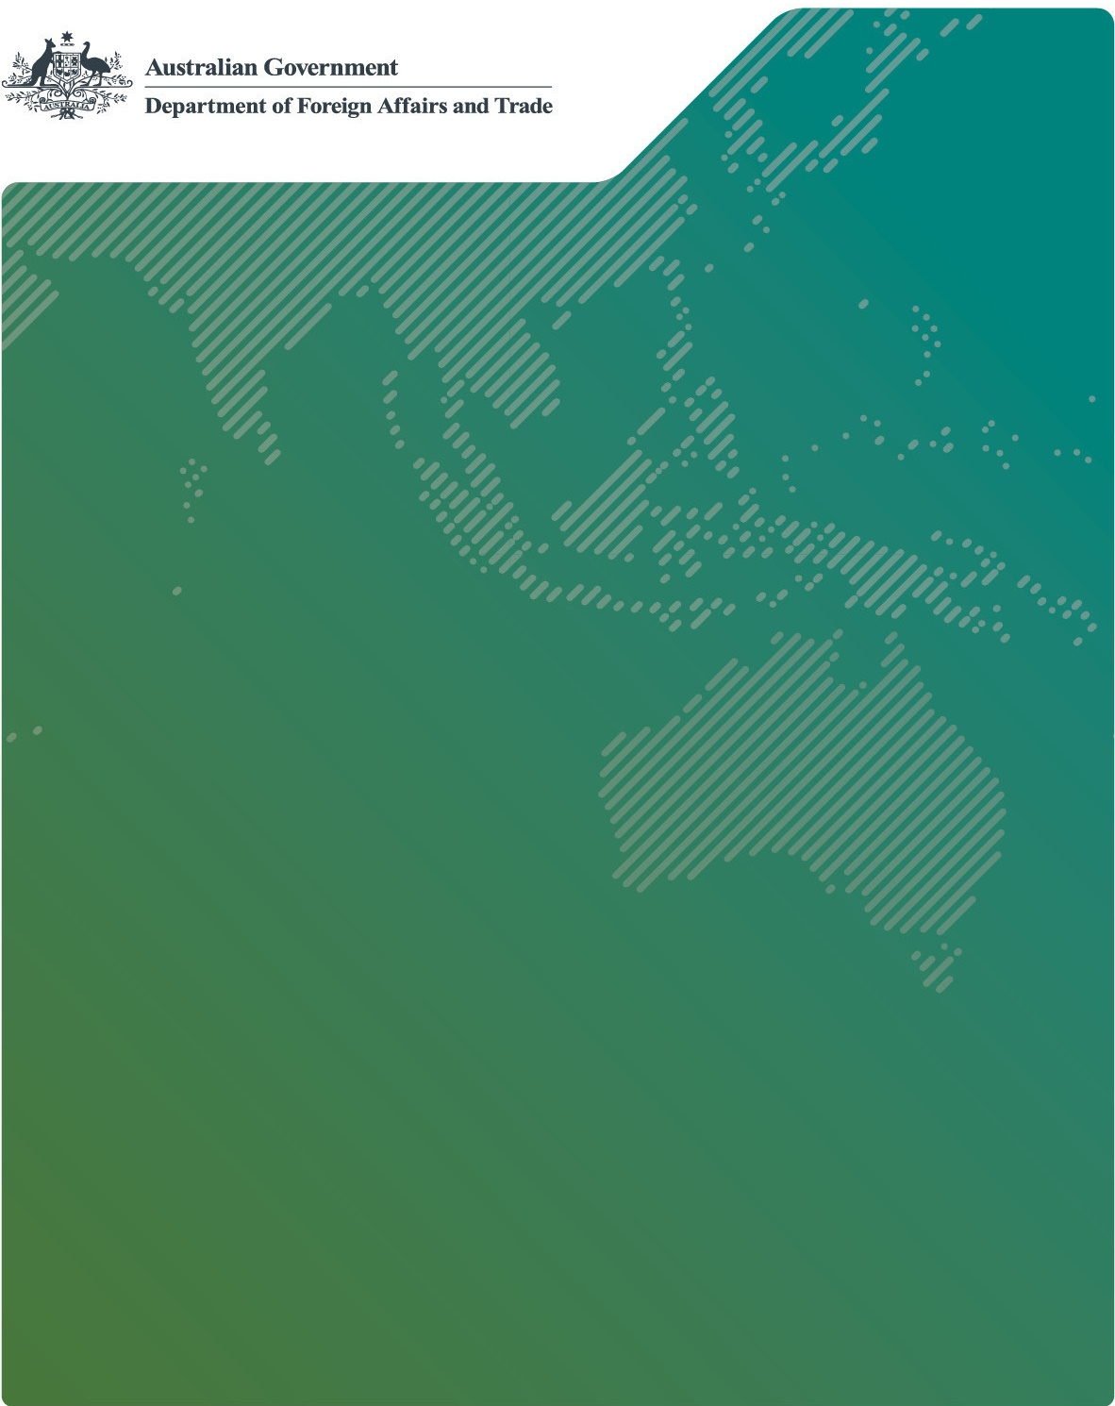

PERFORMANCE OF AUSTRALIAN DEVELOPMENT COOPERATION REPORT 2022–23 – Results snapshot

APRIL 2024

Results snapshot

Australia is contributing to critical needs in our region and globally

* **23.8 million** - vulnerable women, men, girls and boys provided with emergency assistance in conflict and crisis situations
* **3+ million** - couple-years of contraceptive protection made available for sexual and reproductive health
* **10+ million** - people immunised with Australian support
* **31.5+ million** - new or improved therapeutics, diagnostics, vaccines and additional equipment to which Australia has contributed that are accessible in partner countries
* **248,310** - additional girls and boys enrolled in school
* **165.4 million** - people reached with new or improved social protection programs, including remote communities
* **34** - countries Australia has supported in last 12 months to strengthen governance systems
* **248,879** - services provided to women and girl survivors of violence, such as counselling
* **488,942** - female entrepreneurs provided with financial and/or business development services
* **$422.2 million** - of Australian ODA provided in budget finance to respond to the COVID-19 pandemic
* **330** - examples of partnering with the private sector and other partners to ensure supply lines were open during the COVID-19 pandemic

Our global partnerships are supporting collective action

Australian NGO Cooperation Program (ANCP)

* **4.3 million** - people received improved health services
* **230,000** - additional people received sufficient food
* **30,000** - women supported to assume leadership roles
* **$160.7 million** - contributed to the International Development Association, the concessional arm of the World Bank

This funding contributed to:

* + **4.67 GW** - renewable energy generation capacity
  + **23.9 million** - beneficiaries of social safety net programs

Development finance is an increasingly powerful catalyst for enhancing our impact

* **$7.4 billion** - Australia’s development finance portfolio
* **3:1** - programs in the portfolio have been mobilising $3 for every $1 invested
* **$100 million** - dedicated funding through the Pacific Climate Infrastructure Financing Partnership

We are deploying expertise from across the Australian Government to tackle regional challenges

* CSIRO has worked with partners in Indonesia, Thailand and Vietnam to develop the Indo-Pacific Plastics Innovation Network, supporting efforts to translate science, technology and innovation into real-world solutions to plastic pollution.
* A team from Agriculture Victoria trained and supported staff from the Timor-Leste Animal Health Service in livestock disease diagnostics and surveillance, helping control African swine fever and prepare for potential outbreaks of disease.
* Australian Government Solicitor lawyers provided training in legal reasoning and legal writing in Vanuatu and Papua New Guinea.

We are continuing to strengthen how we work and promote genuine partnerships

Our development cooperation is effective

* **Target 85%**
* **86%** - Investments rated as satisfactory for effectiveness and efficiency

We are working hard to meet our gender equality ambition

* **Target 80%**
* **75%** - Investments that address gender effectively

Our development cooperation is increasingly using local actors to deliver

* **3,635** - local personnel employed (up 15% from the previous year)
* **2,451** - local contracts and grants (up 8% from the previous year)
* **$630 million** - total value of local contracts and grants (up 18% from the previous year)