Philippine Civil Maritime Security Program

(Phase 1)

MID-TERM REVIEW REPORT

Start date: 1 March 2021

End date: 30 December 2024

Total proposed DFAT funding: AUD 9 million

Total proposed funding from all donor/s: AUD 9M

Current program fund annual allocation: AUD 9M

AidWorks investment number: INN332

Overall Risk Profile: medium

Risk: medium

Value: low

Concept approved by: N/A

Concept endorsed by AGB: No

Quality Assurance completed: informal quality assurance

Approval: Delegate at Post: Richard Sisson, DHOM

Delegate in Canberra: N/A

Table of Contents

List of Tables 3

List of Figures 4

List of Acronyms 5

Executive Summary 7

Introduction 11

Methodology 14

Logic Model 14

Criteria for the MTR 14

Limitations of the MTR 18

Data Collection and Sampling 18

Data Analysis and Synthesis 21

MTR of the Projects 23

ACIAR 23

Australia Awards 27

CSIRO 32

SCU 32

Stratbase ADRI 36

TAF 38

Key Findings at the Project Level 40

Maritime Security 40

GEDSI 41

Monitoring and Evaluation 42

Key Findings at the Program Level 44

Progress Towards Program Outputs and Outcomes 44

Program Level Merit Ratings 45

Recommendations 47

1. Convene the Program Coordinating Committee (PCC). 47

2. Standardise reporting structure 48

3. Project proponents to undergo GEDSI orientations 48

4. Improve community understanding of the link of geopolitics to livelihoods 48

Appendices 49

Appendix 1: Review Matrix 49

Appendix 2: Survey Questionnaire 62

## List of Tables

Table 1. PCMSP Outcomes and Outputs 11

Table 2. PCMSP Projects 12

Table 3. Consultations with PCMSP Partner Organisations 19

Table 4. Discussions with Stakeholders 20

Table 5. Distribution of Training Participants vs. Survey Respondents 21

Table 6. Merit Rating Matrix 22

Table 7. Areas of Application 29

Table 8. Location and Geographic Scope of Work of Respondents 29

Table 9. Gained Knowledge by Region 31

## 

## List of Figures

Figure 1. PCMSP Logic Model 15

Figure 2. Overall Assessment of the Training's Relevance 27

Figure 3. Relevance of Training Topics 28

## 

## List of Acronyms

ACIAR Australian Centre for International Agricultural Research

AFP Armed Forces of the Philippines

AUKUS Australia, United Kingdom, United States

ANCORS Australian National Centre for Ocean Resources and Security

APS Australian Public Service

AUD Australian Dollar

BFAR Bureau of Fisheries and Aquatic Resources (Philippines)

CMG Civil Maritime Governance

CSIRO Commonwealth Scientific and Industrial Research Organisation

DA Department of Agriculture (Philippines)

DENR Department of Environment and Natural Resources (Philippines)

DENR-BMB Department of Environment and Natural Resources (Philippines)-Biodiversity Management Bureau

DepEd Department of Education (Philippines)

DFA Department of Foreign Affairs (Philippines)

DFAT Department of Foreign Affairs and Trade (Australia)

DHOM Deputy Head of Mission

DOST-PCAARRD Department of Science and Technology-Philippine Council for Agriculture, Aquatic and Natural Resources Research and Development (Philippines)

DPO Disabled Peoples’ Organisation

EO Executive Order

EOPO End-of-Program Outcome

GAD Gender and Development

GEDSI Gender Equality, Disability, and Social Inclusion

GOA Government of Australia

IDD Investment Design Document

IMR Investment Monitoring Report

IO Intermediate Outcome

KAP Knowledge, Attitude, and Practices

LGBTQ+ Lesbian, Gay, Bisexual, Transgender, and Queer

MEL Monitoring, Evaluation, and Learning

MERF Marine Environment and Resources Foundation

MTR Mid-Term Review

PCC Program Coordination Committee

PCG Philippine Coast Guard

PCMSP Philippine Civil Maritime Security Program

PD Presidential Directive

PEA Political Economy Analysis

PHG Philippine Government

PMT Program Management Team

SCU Southern Cross University

SONA State of the Nation Address

Stratbase ADRI Stratbase Albert del Rosario Institute

SWOT Strengths, Weaknesses, Opportunities, Threats

TA Technical Assistance

TAA Technical Assistance Agreement

TAF The Asia Foundation

TMF The Mead Foundation

UNCLOS United Nations Convention on the Law of the Sea

UP-MSI University of the Philippines-Marine Science Institute

USAID United States Agency for International Development

UTS University of Technology Sydney

## 

## Executive Summary

The Philippine Civil Maritime Security Program (PCMSP) covers the March 2021 to December 2024 period with a total funding of AUD 9 million. Within its framework are six organisations working on six different projects, as follows:

1. Australian Centre for International Agricultural Research (ACIAR) on Institutional Effectiveness and Political Economy of Coral Reef Restoration in the Philippines
2. Australia Awards on Training Modules on the Law of the Sea
3. Commonwealth Scientific and Industrial Research Organization (CSIRO)
4. Southern Cross University (SCU) on An Integrated Approach to Marine Resource Conservation and Sustainable Fisheries Management to Strengthen Coastal Communities in Zambales
5. Stratbase Albert del Rosario Institute (Stratbase ADRI) on Strengthening Maritime Security Cooperation in a Multipolar Indo-Pacific
6. The Asia Foundation (TAF) on Waypoints: Navigating Civil Maritime Security Reform

The criteria used in the MTR are directly aligned with existing DFAT monitoring and evaluation tools and standards. Each criterion has a set of key review questions, which are then further broken down into more detailed questions. The criteria include:

1. Relevance
2. Coherence
3. Effectiveness
4. Efficiency
5. Gender equality
6. Disability inclusion
7. Risk and safeguards
8. Building resilience to climate change and disasters
9. Private sector engagement
10. Innovation

The data collection was conducted using several methods. The first was a review of existing proposals, agreements, and progress reports under the PCMSP umbrella. The second data collection method was fieldwork. Virtual and in-person consultations and interviews were held with DFAT Manila and the contract holders, including ACIAR, SCU, Stratbase ADRI, and TAF. Likewise, the MTR team met with the monitoring and evaluation adviser of the PCMSP. Schedules, however, did not match and precluded meetings with CSIRO and the supposed members of the PCC. The MTR team also did field visits to project sites in Pangasinan, Batangas, and Zambales where focus group discussions were set up with stakeholders and beneficiaries of the projects, including local government units, fisherfolk communities, women’s groups, and persons with disabilities and/or disabled persons’ organisations. Finally, a short survey was designed to seek feedback from the participants of ANCORS’ training modules on the law of the sea regarding the relevance of the training content. The survey was distributed to training participants from the Philippines’ DFA. The total number of responses was 38.

Data analysis relied on the review matrix (Appendix 1), which also identifies several subdimensions. The subdimensions are related to the key review questions and can be individually provided with the merit rating matrix, ranging from Very Good to Very Poor.

The key findings are divided into project and program levels. At the project level, the key findings categorized into three:

1. **Maritime security**. The key findings of the MTR in the maritime security aspect are twofold. First, fieldwork in Pangasinan, Batangas, and Zambales revealed microcosms of the South China Sea disputes in municipal waters. In this case, there may be emerging community-level practices and responses that can be transposed to the regional level. Of course, the local and the regional levels of analysis have widely varying structures and dynamics, but exploring these can potentially preclude tensions from rising even further. Another key finding of the MTR in the maritime security aspect is about the Philippines’ heavy reliance on maritime law enforcement in addressing a variety of security threats that range from illegal, unreported, and unregulated fishing, trafficking, to terrorism, among others. The PNP-MG and the PCG are tasked to handle these issues, but an at the most local level is the *Bantay Dagat* (Sea Patrol), composed of volunteers from coastal villages who patrol within 15 kilometers of the shore. Limited resources constrain the *Bantay Dagat* from effective collaboration with government agencies. The *Bantay Dagat* is an overlooked, underutilized, and severely underfunded resource, and yet it is the most immediate and most accessible option for most coastal villages.
2. **Gender Equality, Disability, and Social Inclusion (GEDSI) issues**. Based on data collected during the MTR team’s field visits to Pangasinan, Batangas, and Zambales in April-May 2023, local government officials are aware of the existence of the Gender and Development (GAD) Plan, but this is not always a priority. To the extent that it does become a priority, it is only when a municipality needs to improve its scores in the annual assessment of the Seal of Good Local Government. However, complying for compliance’s sake will not result in genuine inclusion. Women from the coastal communities were portrayed as strong and empowered to do majority of the roles for the economic well-being of the family. However, most of the local communities do not want to see women as members of *Bantay Dagat* or performing jobs that are identified for men. Organizations of persons with disabilities were present at all the field visits, and yet, none of them were invited to join the consultation. Disability is present in all sectors and there were fisherfolks who acquired disabilities due to illegal fishing. Overall, there seems to be no deliberate attempt to invite grassroots representations of basic sectors from the coastal communities who are the primary stakeholders of the PCMSP.  The accessibility of public information materials was not accessible at all.
3. **Monitoring and evaluation**. The practices of the different projects under the PCMSP are best described as recording a minimum amount of information using that organisation’s preferred template. The reporting cycles are aligned with the signing of the respective agreements, rather than with the reporting cycles of DFAT. While this is not uncommon, it hampers DFAT’s internal reporting cycle. Moreover, none of the agencies has a dedicated or part-time designated monitoring and evaluation person. These challenges can be addressed by rolling out the tools included in the PCMSP Implementation Guide. Meanwhile, the Monitoring, Evaluation, and Learning Plan (MEL Plan) provides several indicators for each of the long-term and intermediate outcomes. The program anticipated to reach the latter by December 2022. It is the reviewers’ evaluation that the MEL Plan does not seem to have been adopted by the PCMSP management team.

At the program level, meanwhile, the key findings are categorized into two: progress towards program outputs and outcomes, and program level merit ratings. Based on the PCMSP’s intermediate outcomes, the program is still in the very early stages of the three intermediate outcomes. Arguably, substantial groundwork is being laid down by all the projects. The PCMSP must then set the general direction by convening the PCC at the soonest time possible.

Based on the key findings at the program and project levels above, the following are the recommendations for the PCMSP:

1. **Convene the Program Coordinating Committee (PCC)**. This is critical, not least because it was mandated in the IDD. The PCC can be a venue for the partners and government stakeholders to meet and exchange insights. This can also be an opportunity to discuss the IDD and TAF’s *Kasiguruhan sa Karagatan* report as guiding documents. The PCC can likewise be a platform for the partner organisations to determine their role within the overarching framework and logic of the PCMSP. In particular, TAF can serve as the secretariat, ACIAR, CSIRO, and SCU provide the expert inputs, Stratbase ADRI organises high-level meetings and other avenues to disseminate the findings of the projects and engage with policymakers and stakeholders alike, and the participants of the Australia Awards training modules on the law of the sea can be invited to participate in these events. This way, the PCMSP can be a coordinated effort not only in civil maritime security but also in community building.
2. **Standardise reporting structure.** Systematising the timing and format of the reports is crucial in keeping proper documentation and tracking the progress made. It also makes for easy identification across the board of the types of further interventions that needed achieve the end-of-program outcomes.
3. **Project proponents to undergo GEDSI orientations**. All the proponents of the projects are recommended to undergo this orientation for a better understanding of the twin-track approach. This can result in better planning and impactful mainstreaming of GEDSI issues.
4. **Improve community understanding of the link of geopolitics to livelihoods**. These are two sides of the same coin and should be perceived as mutually reinforcing. For instance, the Bantay Dagat can be a steppingstone to the PCG and to the AFP. Civil maritime security may be soft diplomacy, but the foreign policies of Australia and the Philippines cannot take off without taking heed of what matters most to people as they live their everyday lives. There needs to be an understanding on the ground that governance and food security are not separated or independent from the US-China competition or configurations of Taiwan scenarios. Similarly, governments and state actors must be able to articulate the local consequences of the geopolitical competition.

## 

## Introduction

Phase 1 of the Philippine Civil Maritime Security Program (PCMSP) covers the March 2021 to December 2024 period with a total funding of AUD 9 million. In view of strengthening and supporting civil maritime security in the Philippines, the program logic specified in the Investment Design Document (IDD) identifies the following outcomes and outputs.

Table 1. PCMSP Outcomes and Outputs

|  |  |  |  |
| --- | --- | --- | --- |
| Pillars | *Pillar 1*  *Improving maritime governance systems, processes, and interagency coordination* | *Pillar 2*  *Improving marine natural resources management and environment protection* | *Pillar 3*  *Building informed views about maritime risks and opportunities amongst stakeholders in the Philippines* |
| Outputs | * Philippines' civil maritime agencies' operational capacity Strengths, Weaknesses, Opportunities, Threats (SWOT) analysis conducted with Australian Public Service Agency (APS) Technical Assistance (TA) to identify reform needs * APS Agency TA provided to support identification of civil maritime law enforcement intergovernmental cooperation gaps * Philippine Government (PHG) Agency-internal reform plans identified * APS Agencies' TA mapped against PHG Agencies' reform plans, capacity gaps, and cooperation requirements * APS Agency TA work plans agreed with PHG Agencies | * National-local stakeholder cooperation SWOT analysis on management of marine resources and environment protection in select coastal communities to identify cooperation gaps * TA provided to support identification of national-local stakeholder cooperation gaps * TA work plans to address cooperation gaps agreed * In select coastal communities, established cooperation mechanisms strengthened between national agencies and local stakeholders on issues related to marine resources and environment | * Program Coordination Committee (PCC) stood up and inaugural PCC held (within 12 months of Program start-up) * Strategic guidance on work plan provided by the PCC * Training and capacity development activities delivered * Think pieces, research, and public discussions facilitated * Regular dialogue established between Philippine and Australian civil society, private sector, and government maritime organizations on civil maritime issues, including TA work plans |
| IOs | Philippine civil maritime agencies update communication and coordination protocols | National and local stakeholders update marine management response plans | Philippine government and non-governmental stakeholders renew their knowledge about maritime risks and opportunities |
| EOPOs (by 2024) | Philippine civil maritime agencies implement communication and coordination protocols | National agencies and local stakeholders implement updated marine management response plans | Government and non-governmental stakeholders contribute informed views to public policy discussions about maritime risks and opportunities |

Six projects have been approved under the PCMSP, as follows.

Table 2. PCMSP Projects

|  |  |  |  |
| --- | --- | --- | --- |
| **Project lead** | **Project Title** | **Partners** | **Budget** |
| Australian Centre for International Agricultural Research (ACIAR) | Institutional Effectiveness and Political Economy of Coral Reef Restoration in the Philippines | * University of Technology of Sydney (UTS) * Southern Cross University (SCU) * Macquarie University * University of the Philippines Marine Science Institute (UP-MSI) * Marine Environment and Resources Foundation, Inc. (MERF) | AUD 1,961,411.00 |
| Australia Awards | Provision of scholarships and support the conduct of trainings on United Nations Convention on the Law of the Sea (UNCLOS) | * Australian National Centre for Ocean Resources and Security (ANCORS) | AUD 632,576.48 |
| Commonwealth Scientific and Industrial Research Organization (CSIRO) | Establishing a National Plastics Leakage Baseline and Building Capacity to Measure Marine Litter in the Philippines | * Davao del Sur State College | AUD 999,000.00 |
| Southern Cross University (SCU) | An Integrated Approach to Marine Resource Conservation and Sustainable Fisheries Management to Strengthen Coastal Communities in Zambales | * MERF * The Mead Foundation, Inc. (TMF) | AUD 391,893.70 |
| Stratbase Albert del Rosario Institute (Stratbase ADRI) | Strengthening Maritime Security Cooperation in a Multipolar Indo-Pacific | * De La Salle University Department of International Studies * National Defense College of the Philippines | AUD 350,000.00 |
| The Asia Foundation (TAF) | Waypoints: Navigating Civil Maritime Security Reform | * Amador Research Services | AUD 2,750,000.00 |
|  |  | **TOTAL** | **AUD 7,084,881.18** |

Part of the PCMSP's anticipated governance arrangements includes a Program Coordination Committee (PCC), a small advisory body composed of senior membership officials from Philippine government partner agencies (such as the Department of Foreign Affairs (DFA), the Philippine Coast Guard (PCG), the National Coast Watch Council (NCWC), and the Bureau of Fisheries and Aquatic Resources (BFAR), among others) and senior Australian government representatives (such as the Department of Foreign Affairs and Trade (DFAT), Home Affairs, and ACIAR, among others). The role of the PCC is to meet annually and provide strategic direction, advice, and input into the PCMSP. The body is meant to provide a platform for exchanges about the PCMSP's activities and progress and to discuss civil maritime governance issues, emerging risks, and exchange of information and lessons learned. Other donors may be invited to improve donor coordination and identify complementary programming areas. Based on the PCMSP's IDD the PCC is expected to meet within the program's first year.

An MTR was conducted from February to June 2023 to evaluate the progress that the various projects have made under the framework of the PCMSP. At the same time, the MTR assessed the extent of program support for the six projects. The following section discusses the methodology and procedures undertaken by the MTR team.

## 

## Methodology

### Logic Model

The PCMSP’s logic model (see Figure 1) illustrates the linkages between different components of the program and serves as a guide for the MTR process. The logic model features the flow from inputs to activities and outputs and identifies the key review questions.

### Criteria for the MTR

The criteria used in the MTR are directly aligned with existing DFAT monitoring and evaluation tools and standards. Each criterion has a set of key review questions, which are then further broken down into more detailed questions. The following section defines each criterion and enumerates the key review questions. Meanwhile, the full review matrix can be found in Appendix 1.

#### Relevance

Relevance refers to the extent to which the projects address the needs of the stakeholders, specifically on whether the activities under the projects are suited to the priorities and policies of the target group, recipient, and donor. The key review questions here are:

* RQ1.1 To what extent does the project confirm the program’s needs and contextual analysis?
* RQ1.2 To what extent does the program aim to address the security issues faced by coastal communities and fisherfolks?
* RQ1.3 To what extent is the program logic still valid?

#### Coherence

Coherence determines the projects’ and the program’s compatibility with other interventions in the country, sector, or area. The significance of this criterion cannot be underestimated because the overall cogency and impact of the program rests on the alignment and consistency of the projects’ goals, objectives, and activities. The key review questions for this criterion are:

* RQ2.1 To what extent do other interventions, particularly policies, support or undermine the program and vice versa?
* RQ2.2 To what degree does the program interlink with other development activities that the Philippine government or the Australian government implements in the Philippines on civil maritime governance?
* RQ2.3 To what degree does the program complement, harmonise, and coordinate with other civil maritime governance programs in the Philippines and Southeast Asia?

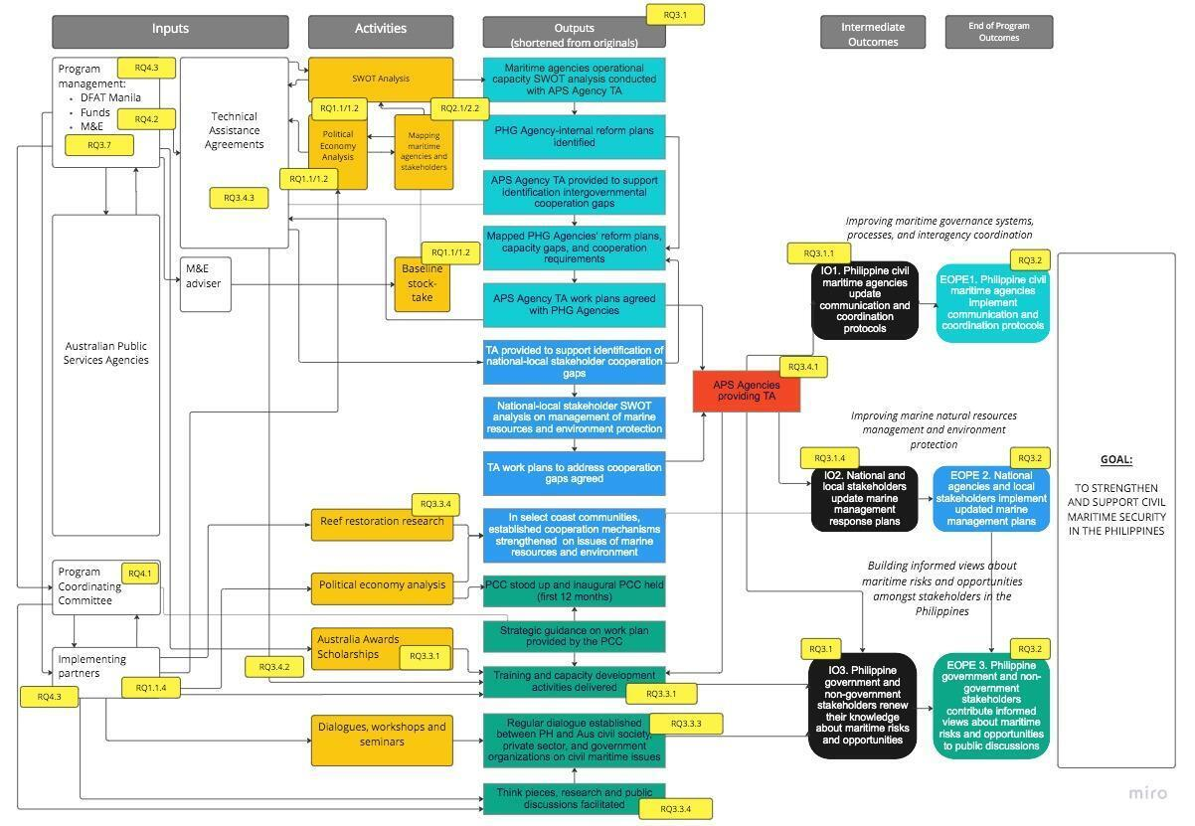Figure 1. PCMSP Logic Model

#### Effectiveness

Effectiveness measures whether the program has achieved the expected outcomes and outputs. It bears reiteration that the end-of-program outcomes are threefold. First, the program aims to have Philippine civil maritime agencies implement communication and coordination protocols for the improvement of maritime governance systems, processes, and interagency cooperation. Second, the program works toward national agencies' and local stakeholders’ implementation of their updated marine management response plans to improve marine natural resources management and environment protection. Finally, the program envisions that government and non-government stakeholders contribute informed views to public policy discussions about maritime risks and opportunities. Doing so not only builds informed views but also shapes the discourse on maritime risks and opportunities in the Philippines. The key review questions here are:

* RQ3.1 What progress has been made toward the program outcomes?
* RQ3.2 What is the likelihood of the achievement of the end-of-program outcomes?
* RQ3.3 To what extent have program activities contributed to the increased knowledge of stakeholders?
* RQ3.4 How important are technical assistance agreements in achieving outputs?
* RQ3.5 What progress has been made at the project level?
* RQ3.6 How satisfied are partners and community stakeholders with the progress made?
* RQ3.7 How effective is the monitoring and evaluation plan of the program and the projects?
* RQ3.8 What were the major factors that influenced the program’s achievement or non-achievement of its outcomes?
* RQ3.9 What, if any, are indications that the outcomes will be sustained after the end of the program?

#### Efficiency

Efficiency ensures that Australia’s investment is cost-effective and that its partners within the program streamline their time and resources to achieve outputs and expected outcomes. Critical here is the role that the PCC plays. The key review questions for this criterion are:

* RQ4.1 How important is the role of the PCC in achieving the program’s outcomes?
* RQ4.2 To what extent does the program have the financial resources to achieve outcomes?
* RQ4.3 To what extent do DFAT and its partners have the human resource capacity to support the efficient achievement of the program’s outcomes?
* RQ4.4 To what extent are the program and the projects implemented as indicated in the work plan?

#### Gender equality

The criterion on gender equality assesses whether the program, i.e., through the projects, can narrow the inequality gap involving women, members of the Lesbian, Gay, Bisexual, Transgender, and Queer (LGBTQ+) communities, and other marginalised sectors. Gender equality measures whether the projects and the program are non-discriminatory based on gender, that forms of violence and harmful practices are eliminated, and that unpaid care and domestic work – tasks that are usually assumed by women – are recognised and valued. Furthermore, this criterion evaluates the extent to which the program and the projects have ensured the full and effective participation of stakeholders, regardless of gender, and that equal opportunities are built into the entire framework from conceptualisation to implementation. The key review questions here are:

* RQ5.1 To what extent were Gender Equality, Disability, and Social Inclusion (GEDSI) mainstreamed and specific interventions undertaken by government agencies?
* RQ5.2 How was GEDSI mainstreamed in the project design and implementation?
* RQ5.3 How are specific interventions planned, delivered, monitored, and evaluated?
* RQ5.4 To what extent did mainstreamed activities and specific interventions complement each other?
* RQ5.5 To what extent does the program practice gender analysis and risk management?

#### Disability inclusion

Disability inclusion entails including people with disabilities in everyday activities and encouraging them to have roles like people who do not have disabilities. It requires that all stages of program development, i.e., from conceptualisation to implementation, are inclusive of and accessible to persons with disabilities. The key review questions here are:

* RQ6.1 To what extent do persons with disabilities and disabled persons’ organisations participate in the program?
* RQ6.2 To what extent are projects and the overall program informed by barrier analysis?

#### Risk and safeguards

The risk and safeguards criterion are actions or measures to help reduce the risk that someone will be harmed. In this sense, safeguards are the procedures that assess the potential risks, impacts, and the corresponding protocols to manage them. The key review questions here include:

* RQ7.1 To what extent are risks identified and documented?
* RQ7.2 What policies and plans do partners have in place to manage environmental and social risks?
* RQ7.3 What resources are allocated to mitigate risks?

#### Building resilience to climate change and disasters

Resilience focuses on the adaptability of the program, the project, and the stakeholders to the impacts of climate change and disasters. The key review questions here are the following:

* RQ8.1 How are risks to climate change and disasters managed?
* RQ8.2 Does the program contribute to reducing the impact of climate change and disasters?
* RQ8.3 How does the monitoring and evaluation system collect data on climate change and disaster risk reduction?

#### Private sector engagement

Private sector engagement tests whether the program and its partners consult, strategise, align, and implement activities with the private sector for greater scale, effectiveness, and sustainable outcomes. The key review questions here are:

* RQ9.1 To what extent is the private sector involved in program implementation?
* RQ9.2 What is the value of leveraged resources from the private sector?

#### Innovation

Innovation assesses the ability of the program and the projects under it to introduce and implement an original and novel contribution to civil maritime security. In view of this, this criterion examines the best practices used in the program, as well as the conditions under which new and organic practices emerged based on local communities’ unique experiences in civil maritime security. The key review question here is:

* RQ10.1 To what extent are the program and the projects promoting and demonstrating innovation?

### Limitations of the MTR

The MTR team was constrained by several factors. First, there were no review questions specified in the Terms of Reference of the PCMSP, which entailed having to create a framework from scratch. Second, the MTR team has been unable to set meetings and consultations with CSIRO due to scheduling misalignments. Third, the PCC has not been convened as a body. The PCC is meant to provide the overarching direction for the projects, thereby strengthening the coherence and impact of the program. Absent the PCC, the MTR team was unable to meet with the supposed members of the Committee and get a comprehensive picture of the PCMSP. In this regard, the MTR’s main recommendation is to convene the PCC at the soonest time possible.

### Data Collection and Sampling

The data collection was conducted using several methods. The first was a review of existing proposals, agreements, and progress reports under the PCMSP umbrella. As the first deliverable of the MTR, the document review identified some preliminary findings, including the need to mainstream GEDSI systematically and organically in the projects. Project-specific documents were unclear as to how particular interventions on GEDSI were planned, delivered, monitored, and evaluated across the board. Contextual factors needed to be examined to identify barriers to inclusion. Apart from gender, another area that needs improvement based on the document review was the projects’ communication strategies and accessibility. While mention is made in the documents, e.g., all the projects commit to disability and social inclusion, there has been little solid evidence regarding accessibility for persons with disabilities.

The second data collection method was fieldwork. Virtual and in-person consultations and interviews were held with DFAT Manila and the contract holders, including ACIAR, SCU, Stratbase, and TAF. Likewise, the MTR team met with the monitoring and evaluation adviser of the PCMSP. Schedules, however, did not match and precluded meetings with CSIRO and the supposed members of the PCC. Table 3 indicates the participants in these meetings.

Table 3. Consultations with PCMSP Partner Organisations

|  |  |
| --- | --- |
| Date | Organisation |
| 21 February 2023 | DFAT Manila   * Jack Williams * Jodie Bisco   ABT Associates   * Quintin Atienza * Andy Bustamante   MTR Team   * Charmaine Willoughby * Johan van Duijn * Carmen Zubiaga |
| 28 February 2023 | DFAT Manila   * Jack Williams * Jodie Bisco   ABT Associates   * Quintin Atienza * Andy Bustamante   MTR Team   * Charmaine Willoughby * Johan van Duijn * Carmen Zubiaga |
| 9 March 2023 | PCMSP   * James McGovern   MTR Team   * Johan van Duijn |
| 16 March 2023 | UTS   * Michael Fabinyi * Nicholas MacClean   ACIAR   * Jing Damaso-Grey   MTR Team   * Charmaine Willoughby * Johan van Duijn * Carmen Zubiaga |
| 23 March 2023 | DFAT Manila for Australia Awards   * Miguel Roberto Borromeo   MTR Team   * Johan van Duijn |
| 27 March 2023 | MERF   * Erlo Matorres   MTR Team   * Johan van Duijn |
| 14 April 2023 | SCU   * Peter Harrison   TMF   * Karen Chan * Relyn Ednalino   MERF   * Jeric Diogon   MTR Team   * Charmaine Willoughby * Johan van Duijn * Carmen Zubiaga |
| 27 April 2023 | Stratbase ADRI   * Krystyna Dy * Alynna Carlos * Jikko Puzon   MTR Team   * Charmaine Willoughby * Johan van Duijn * Carmen Zubiaga |
| 27 April | ACIAR project implementing partner   * Michael Fabinyi (UTS) * Nicholas McClean (UTS) * Vera Horigue (Macquarie University)   MTR Team   * Johan van Duijn |
| 2 May | ACIAR team   * Hazel Aniceto * Chris Cvitanovic * Ann Fleming   MTR Team   * Johan van Duijn |
| 15 May 2023 | TAF   * Kathline Tolosa * Jerrah Mae Anglo   MTR Team   * Charmaine Willoughby * Carmen Zubiaga |

The MTR team also did field visits to project sites in Pangasinan, Batangas, and Zambales where focus group discussions were set up with stakeholders and beneficiaries of the projects, including local government units, fisherfolk communities, women’s groups, and persons with disabilities and/or disabled persons’ organisations. Table 4 indicates the discussions held with various communities at the project sites.

Table 4. Discussions with Stakeholders

|  |  |  |  |
| --- | --- | --- | --- |
| Date | Project | Site | Community/Organisation |
| 27 March 2023 | ACIAR | Bolinao, Pangasinan | Local government unit  Kaisaka, Inc. |
| 28 March 2023 | ACIAR | Anda, Pangasinan | Local government unit  Fisherfolk association  Farmers association  Mariculture operators  Bantay Dagat  Barangay councillors (Tondol)  Tondol Motorboat Association |
| 30 March 2023 | ACIAR | Lobo, Batangas | Local government unit  Olo-Olo Seaside Workers Association  Lobo Marine Environment Conservation Federation  Samahan ng Maliliit na Mangingisda sa Pangangalaga ng Kalikasan sa Barangay Lagadalarin  Barangay officials (Lagadlarin) |
| 13 April 2023 | SCU | Iba, Zambales | Local government unit |
| 14 April 2023 | SCU | Iba, Zambales | Habang Association  Farmers association  Amungan Fishermen Association  Asosasyon ng Malayang Mangingisda ng Iba*,*Zambales |
| 15 April 2023 | SCU | Iba, Zambales | Barangay officials (Amungan) |

Finally, a short survey was designed to seek feedback from the participants of ANCORS’ training modules on the law of the sea regarding the relevance of the training content. The survey was distributed to training participants from the Philippines’ DFA. The total number of responses was 38. Table 5 shows the distribution of participants over the eight trainings and that of the respondents to the survey.

Table 5. Distribution of Training Participants vs. Survey Respondents

|  |  |  |
| --- | --- | --- |
| Training Dates | Distribution of Participants (N = 228 | Distribution of Survey Respondents (N = 38) |
| 16-20 April 2018 | 8% | 0% |
| 13-17 August 2018 | 6% | 3% |
| 2-6 April 2019 | 4% | 8% |
| 31 August-11 September 2020 | 31% | 37% |
| 18-28 May 2021 | 26% | 21% |
| 16-25 November 2021 | 5% | 8% |
| 17-19 May 2022 | 8% | 8% |
| 13-16 February 2023 | 12% | 0% |

### Data Analysis and Synthesis

The MTR team conducted the following to facilitate the analysis and synthesis of the findings:

* Summary notes for each of the activities, in particular interviews and focus group discussions. The notes were:
  + In bullet points, with additional narrative provided as needed.
  + Anonymous, as the names of sources or other personal and identifiable characteristics were not recorded.
* Tabulation of information provided by different sources to allow the easy comparison of findings.

The review matrix (Appendix 1) identifies several subdimensions. The subdimensions are related to the key review questions and can be individually provided with the merit rating matrix in Table 6.

Table 6. Merit Rating Matrix

|  |  |  |
| --- | --- | --- |
| Score | Merit Rating | Description |
| 1 | Very good | Evidence of very strong performance; positive feedback from all consulted sources. No weaknesses were identified. |
| 2 | Good | Evidence of strong performance; predominantly positive comments. No weaknesses, or a few weaknesses without real consequences. |
| 3 | Adequate | Evidence of noticeable positive performance; more than half of the sources suggest a positive performance. Only a few weaknesses were identified with a serious impact on performance. |
| 4 | Less than adequate | A mix of positive and negative comments. Inconsistent comments across the sources of information and the different locations. Sources highlight several weaknesses with a serious impact on performance |
| 5 | Poor | Clear evidence of unsatisfactory performance. Findings are predominantly negative or partially weak evidence. Many weaknesses are identified. |
| 6 | Very poor | No positive evidence was found, or predominantly weak evidence |

## 

## MTR of the Projects

### ACIAR

ACIAR is the recipient of a grant offered by DFAT for the inclusive dates of 14 May 2021 to 30 December 2024. The project – *Institutional Effectiveness and Political Economy of Coral Reef Restoration in the Philippines* – has a total budget of AUD1,961,411. The commissioned organisation is UTS, and the collaborating institution is the UP-MSI. Other third parties involved are SCU and Macquarie University. The project aims to investigate integrating reef restoration governance arrangements with existing marine protected areas.

ACIAR has been able to implement some activities in accordance with the submitted proposal. An inception seminar was held in December 2021 following crafting an interview guide for coral restoration practitioners. Interviews and initial workshops with local government units in the project sites were subsequently conducted from February to July 2022. Some of the key topics in these workshops were the technical aspects of reef restoration, assessments of the state of the reefs, SWOT analysis of coral reef restoration, and network stakeholder mapping. Several activities have also been indicated in the progress reports, such as a consultative workshop with the Philippines' Department of Environment and Natural Resources (DENR).

Consultations and field visits were conducted on 16-30 March 2023. The MTR team met with the partner organisation MERF and held in-person focus group discussions with local communities in the project sites in Pangasinan and Batangas. The following discussion presents data collected from these consultations. Online consultations were held with ACIAR, UTS, and off-site MERF staff.

#### Relevance

ACIAR's project identifies five end-of-program outcomes, with five corresponding intermediate outcomes. Action research into governance and its role in reef protection and restoration in four sites (Bolinao, Cebu, Palawan, and Verde Island Passage) concentrates on enhancing capacity and coordination and being better informed of critical governance gaps and priority actions.

The beneficiaries and stakeholders of the project identified the security threats they currently face, such as storm surges, soil erosion, high fish kills as a result of more fish cages used for mariculture, illegal practices like the use of cyanide or dynamite fishing, mangrove deforestation, and unclear boundaries of municipal waters, which sometimes result in fisherfolks ending up fishing in waters beyond their scope. In view of these threats, the PCMSP and ACIAR’s coral reef restoration is a great opportunity to look at the governance of resources and in particular the restoration interventions. This was not done in the past and therefore emphasises the relevance of the project.

While project officers and beneficiaries alike recognise the critical role that corals and their restoration play, there remains a need to engage in strategic information dissemination. From data gathered during the field visits, most members of the local communities who participated in the focus group discussions were unaware of the details of the project beyond what it is about. The governance and sustainability of the project rest on the prerequisite step of the local communities understanding the social impact of coral reef restoration.

In the first quarter of 2023, the project management made some significant changes to the project design to include support for national level policy development. In consultation with national stakeholders, it increased its relevance by moving resources from establishing reef restoration networks to supporting a Presidential Directive (PD) on coral reef production and programs. The project supported workshops for drafting an Executive Order (EO). UTS called this opportunity a jump forward of two years. The EO will presumably be signed before the President’s State of the Nation Address (SONA) in July 2023.

#### Coherence

The ACIAR project can be considered a standalone project. The activities that have been undertaken so far are responsive to the needs of the communities, and they support the policies of the Philippine and Australian governments in civil maritime governance in the Philippines. The best examples here are developments in a memorandum of agreement in Lingayen Bay in Pangasinan involving three municipalities, updating the coastal resource management plan of Anda (Pangasinan), and the project’s support and active participation in the drafting and lobbying of the abovementioned EO. This vertical integration demonstrates the ACIAR’s project’s coherence and complementarity with other civil maritime security programs, e.g., projects spearheaded by the United States Agency for International Development (USAID).

However, as the ACIAR project is part of the PCMSP umbrella, it needs to be integrated into the framework and aligned with the other projects therein. Project officials, as well as those from the collaborating institutions and third parties involved, share the opinion that there is no link with DFAT other than when there is a visit by an embassy official to one of the project sites. This notwithstanding, the coordination with ACIAR seems to be good with regular meetings and updates.

#### Effectiveness

Significant progress has been made toward the project’s outcomes. The activities conducted by the end of 2022 were important building blocks as they helped identify the priorities and determine their feasibility. For instance, workshops with local government units in the project sites were conducted to discuss the technical aspects of coral reef restoration, assess the state of the reefs, perform SWOT analyses, and initiate network stakeholder mapping.

For 2023, the priorities are to move the memorandum of agreement in Lingayen Bay forward involving three municipalities. Another priority is to support the municipality of Anda in Pangasinan in reviewing and updating its coastal resource management plan. These plans require capacity building, which should go beyond the technical capacity of individuals and include supporting policies and procedures. That being said, the project does not have a formal capacity-building component but does so through activities like planning processes. Stressing the need that there should be systems in place to ensure that coral reef restoration and protection will be continued outside of donor support, project officials and stakeholders recognise that a key challenge is the political will of politicians and the short-term thinking of the general population.

In terms of monitoring and evaluation, the ACIAR project has a well-structured report using an ACIAR template. The report includes reflections and adjustments in the project. However, the reporting schedule is unclear as it varies between what is stated in the proposal and requests from DFAT. The March 2023 report, for instance, was made on special request by DFAT. Moreover, the project indicates milestones, but there are no specific indicators on how they can be measured.

#### Efficiency

As participatory processes are key to the project’s success, implementation can be somewhat slow. One reason is the time it takes for staff recruitment and for said local partners to learn the ropes, so to speak. As the project has multiple sites hinged on hiring personnel to occupy key posts, a slow but steady pace is anticipated.

#### Gender equality

There does not seem to be any initiative from the project or the local government units for a targeted activity for the GEDSI community. Gender sensitivity training is needed to change the perceptions of men in power towards women regarding their roles and responsibilities in the community.

#### Disability inclusion

There does not seem to be any mention of disability inclusion from the field visits. To the extent that it was discussed, it was apparent that barriers to disability inclusion were perceived as only physical. It was evident that there were limited perceptions that lead to stereotyping and a lack of awareness about disability.

#### Risk and safeguards

There is no data on this criterion apart from what was described in the project proposal.

#### Building resilience to climate change and disasters

The project does not take special consideration to its impact on climate change.

#### Private sector engagement

The private sector does not play a direct role in the delivery of the project. However, members of the private sector like mariculture operators are considered important stakeholders and participate in some of the workshops.

#### Innovation

Among the innovative practices that emerge from the project is the use of a political economy analysis to inform the parameters of the activities. Another is the opportunities for people to participate in the process of designing governance mechanisms vis-à-vis the coral restoration. Finally, the project’s officials can work with the national government so there is faster feedback and linking the national level with the local government units.

### 

### Australia Awards

The Australia Awards is a program that provides opportunities for individuals from developing countries to pursue further studies in Australia. The PCMSP supports two activities under the Australia Awards program for government officials of the Philippines: scholarships to pursue a master’s degree and training modules on the law of the sea conducted by ANCORS.

The scholarships stream currently supports the graduate studies of six government officials, two of whom have already started working on their degrees in Australia, and four are to commence in June 2023. The Australian government provides a list of pre-approved schools and programs, and applicants must select a course of study that is related to their respective agencies’ work on maritime security. DFAT Manila disseminates a call for applications to government agencies. All applicants must meet the minimum academic qualifications and occupy a leadership position in the agency. The reason for this is that the scholarships program aims to contribute to strengthening technical capacity in the Philippines.

The training modules on the law of the sea, meanwhile, are developed and facilitated by ANCORS. DFAT has since 2018 supported eight modules specifically for Philippine government agencies. The Australia Awards organized the first four modules, and the rest was in coordination with the PCMSP. Majority of the participants to these modules are from the DFA.

#### Relevance

In the survey conducted for the PCMSP’s MTR, the respondents were asked to provide an assessment of the training’s relevance. The survey questionnaire is found in the Appendix. The overall response is very positive. Figure 2 below shows that 55 percent of the respondents find the training essential, followed by 42 percent who find it very relevant.

Figure 2. Overall Assessment of the Training's Relevance

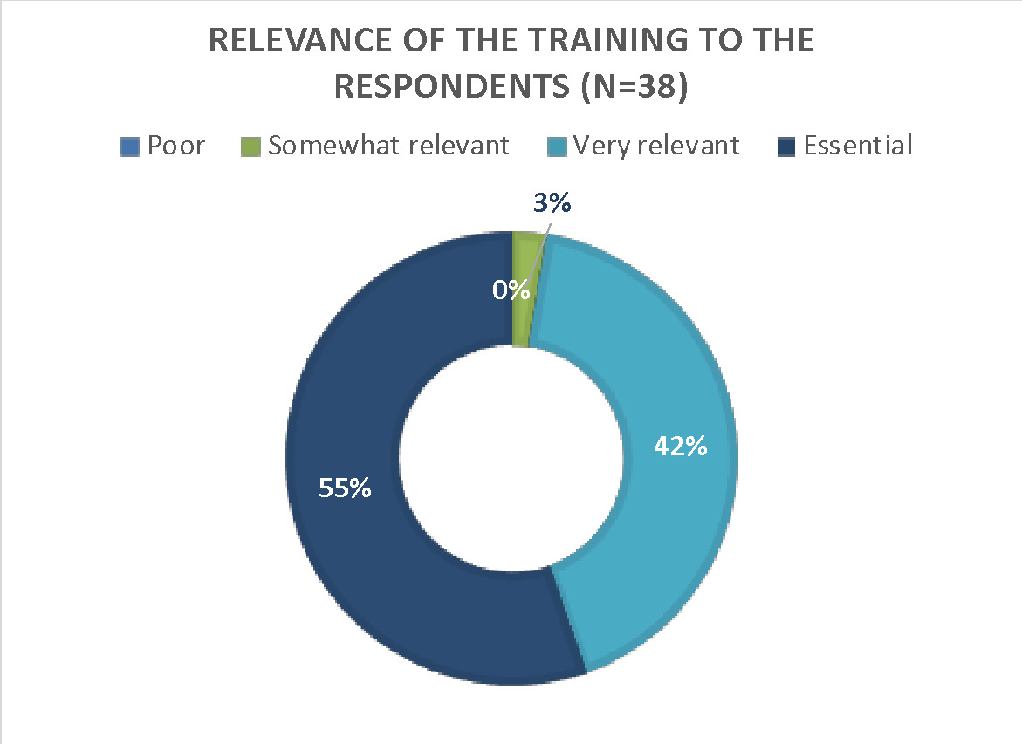

The respondents were also asked to rate the relevance of the training topics to their job. The specific topics that respondents found most relevant are the South China Sea arbitration (83 percent), the settlement of disputes under UNCLOS (78 percent), marine jurisdictional zones under the sovereignty of coastal states (also at 78 percent), and baselines in accordance with UNCLOS (72 percent). Figure 3 below presents this data.

Figure 3. Relevance of Training Topics

Figure 3. Relevance of Training Topics

#### Coherence

Like the ACIAR project, the Australia Awards’ law of the sea training modules can be considered a standalone project. With PHG agencies as the main beneficiaries of the training, the project supports the objectives of the PCMSP. Furthermore, the modules permit the otherwise academic study of international law in general, and the law of the sea in particular, to be more accessible to civil servants in the Philippine bureaucracy. In this context, the Australia Awards project is aligned with the Philippines’ and Australia’s efforts towards the promotion of civil maritime governance in the Philippines. It should also be mentioned that modules of this kind are unique to Australia.

#### Effectiveness

One of the survey questions asked the respondents to identify the areas where they apply the lessons from the modules. A significant percentage of the respondents (74 percent) find the modules most helpful in representing the Philippines to foreign governments, while 32 percent apply the lessons in promoting maritime domain awareness. A sizeable percentage, at 29 percent, utilize the modules in engaging the Filipino community abroad on maritime issues. Table 7 below summarizes this survey item.

Table 7. Areas of Application

|  |  |
| --- | --- |
| Area of Application | Percentage |
| Providing support in international negotiations | 21% |
| Developing internal tools in support of the employer’s activities | 16% |
| Representing the Philippines to foreign governments | 74% |
| Providing legal advice to the employer | 21% |
| Engaging the Filipino community abroad on maritime issues | 29% |
| Aligning Philippine laws on the maritime domain with international law | 11% |
| Promoting maritime domain awareness | 32% |

Since 74 percent of the respondents find the training modules useful in their capacity to represent the Philippines in international affairs, this number is an indication of the effectiveness of the activity. The score can be explained by the number of respondents at the time of the training who were working at diplomatic missions (13 respondents) and the number of respondents who were deployed abroad at the time of the survey (11 respondents). Furthermore, Table 8 shows the location and geographic scope of work of the respondents.

Table 8. Location and Geographic Scope of Work of Respondents

|  |  |  |
| --- | --- | --- |
| Region | Current designated location (N = 228) | Geographic scope of work (N =38) |
| Philippines | 26% | 8% |
| ASEAN member country (other than Philippines) | 8% | 11% |
| Asia (other than ASEAN member states) | 8% | 8% |
| Europe | 24% | 24% |
| North America | 16% | 13% |
| South America | 5% | 5% |
| Australia and Pacific (other than countries included in the earlier categories) | 3% | 5% |
| No specific geographic area | 0% | 18% |
| Other | 11% | 8% |

The varying locations suggest that the lessons from the training modules are applied across the globe. The table below presents the utilisation of the gained knowledge by region. The highlights in Table 9 below indicate which areas of application are more relevant for the respondents across the regions. Representing the Philippines to foreign governments is particularly high among respondents whose geographic scope of work is ASEAN and Europe. As indicated in Table 7 above, 74 percent of the respondents find this as the most significant area where they can apply the lessons from the training modules.

To emphasise the relevance and effectiveness of the law of the sea training modules, below are some direct quotes from the respondents.

* ANCORS trained a generation of PH officials and helped create a common understanding of law of the sea across agencies and institutions. It’s a concrete instance of Australia’s commitment to the rule of law in the maritime domain, through direct enhancement of capacities of its partners in the region.
* It's very helpful to have the basic knowledge about the Law of the Sea, as it enables me to speak or write confidently about Philippine foreign policy and maritime issues. As [a] political officer at a PH embassy, my work regularly requires me to speak to various audiences (students, diplomatic colleagues, etc.) about issues that are important to the Philippines, and I also regularly draft speeches for the Ambassador, press releases and articles on behalf of the embassy.
* I am designing a webinar for my Filipino Community on the importance of maritime issues and the Arbitral Award.
* It has been useful explaining the Arbitration between the Philippines and China to non-government individuals.

There are no other data for the rest of the criteria used in the MTR.

Table 9. Gained Knowledge by Region

|  |  |  |  |  |  |  |  |  |
| --- | --- | --- | --- | --- | --- | --- | --- | --- |
| Geographic scope of work | n | Support in international negotiations | Development of internal tools to support the employer’s activities | Representation of the Philippines to foreign governments | Provision of legal advice to the employer | Engaging the Filipino community abroad on maritime issues | Alignment of Philippine laws on the maritime domain with international law | Promoting maritime domain awareness |
| Philippines | 3 | 33% | 0% | 67% | 33% | 0% | 100% | 33% |
| Other ASEAN member country | 4 | 50% | 25% | 100% | 0% | 0% | 0% | 0% |
| Asia* | 3 | 0% | 33% | 33% | 0% | 33% | 0% | 33% |
| Europe | 9 | 11% | 22% | 89% | 11% | 44% | 0% | 44% |
| North America | 5 | 0% | 0% | 60% | 20% | 60% | 0% | 60% |
| South America | 2 | 0% | 0% | 50% | 50% | 50% | 50% | 0% |
| Australia and Pacific ** | 2 | 0% | 0% | 100% | 0% | 50% | 0% | 0% |
| No specific geographic area | 7 | 57% | 14% | 57% | 57% | 0% | 0% | 14% |

* Other than ASEAN member states

** Other than the countries included in the categories

### CSIRO

The Commonwealth Scientific and Industrial Research (CSIRO) is the recipient of a grant offered by DFAT for the inclusive dates of 6 December 2022 to 30 December 2024. The project – *Establishing a National Marine Plastic Litter Baseline in the* Philippines – has a total budget of AUD999,000. The project aims to develop a national marine litter baseline within the Philippines against which change can be measured. The project also supports strengthening capacity building within the Philippines and establishing a potential national monitoring program to measure mismanaged plastic waste, including microplastics and marine debris.

CSIRO submitted a concept note for training and capacity building for monitoring and assessing marine plastic litter in the Philippines, after which a national baseline assessment survey will be undertaken during the intensive training period. A project inception meeting was held in February 2023 and brought together key partners to identify actions to strengthen land and sea-based litter management in the Philippines. In the meeting were CSIRO researchers, DFAT Manila, DENR, DENR-BMB, and its National Solid Waste Management Commission. Stakeholders from Western Philippines University, Davao del Sur State College, United Nations Habitat, University of San Carlos Cebu, UP-MSI, and Palawan Council for Sustainable Development also attended the meeting. In total, more than 45 participants participated in the kick-off event. The project kick-off meeting started with an overview and a discussion in the morning, followed by a participatory session in the afternoon using an interactive forum where participants were asked questions and their responses were viewed in real time in a slide. The product used in the workshop was Slido.

Due to scheduling conflicts, CSIRO was unable to meet with the MTR team. The latter was informed that updates on the project will be included in the July 2023 report. Hence, there is insufficient data for the MTR of the CSIRO project.

### SCU

SCU is the recipient of a grant offered by DFAT for the inclusive dates of 15 February 2022 to 31 January 2024. The project *– An Integrated Approach to Marine Resource Conservation and Sustainable Fisheries Management to Strengthen Coastal Communities in Zambales* – has a total budget of AUD391,893.70. SCU works on this project with two partners based in the Philippines. The first is MERF, which provides on-the-ground decision-making input for technical planning and in-country management. The second is TMF, which offers direction setting and implementation planning. Other partners include representatives from local communities in Zambales, including fishers, local government units, and local academics. Stakeholder engagement activities involve the DOST-PCAARRD, the DENR-BMB, and the BFAR. The project's overarching goals are to improve community engagement and training, restore coral and fish habitat, and improve the management of marine protected areas.

Consultations and field visits were conducted on 13-15 April 2023. The MTR team met with the partner organisations (SCU, TMF, and UP-MSI), and held in-person focus group discussions with local communities in the project site in Zambales. The following discussion presents data collected from these consultations.

#### Relevance

The SCU project’s goals support and are aligned with the PCMSP’s objectives. The goals of restoring corals and ensuring the proper management of marine protected areas hinge on strong engagement with the local community. The SCU project team conducted a preliminary assessment and validation of the sites in Zambales in January-February 2022. The locations include Bani Marine Protected Area (Masinloc), Hermana Menor (Sta. Cruz), and Calanga Reef (Iba). Updates from SCU's August 2022 progress report include baseline coral reef community data, coral sexual propagation, and coral asexual propagation. The first meeting/workshop with the local fishing community was completed in May 2022 after the first successful coral spawning. Another August 2022 progress report update was a meeting between the scientists/researchers and local community members. The purpose of the meeting was to inform the local community about the project and to encourage them to become involved. Shortly prior to the mid-term review team’s field visit in April 2023, the SCU team through its partners (TMF and UP-MSI) had just concluded the coral spawning for the year. These activities demonstrate that groundwork has been laid out since the onset of the project.

It was also apparent that the project team’s relationship with the local government unit is positive and the project itself is perceived similarly, as evidenced by the signing of a memorandum of agreement. This relationship needs to be maximised, especially in cognisance of the budgeting cycle to gain support for the marine protected area. Currently, there does not seem to be any tangible or financial support provided by the local government unit. SCU and TMF can likewise reach similar memoranda of agreement with other government agencies, such as, for instance, the PCG.

#### Coherence

Within the parameters of the PCMSP framework, the SCU to a certain extent overlaps with what ACIAR is doing. Both concern coral reef restoration and improving the management of marine protected areas. Where the SCU project adds value is the location of the project site, i.e., Zambales. Hence, the scope of the PCMSP’s commitment to coral reef restoration is extended with the ACIAR and SCU projects.

While the project leads of ACIAR and SCU know each other and share their expertise, the mid-term reviewers understand that the teams of both projects have not had the opportunity to exchange experiences and insights. A platform where they can do so may prove helpful for both projects and the overarching goals of the PCMSP. The other projects within the program may find the same platform to be beneficial.

#### Effectiveness

There is no doubt that the science behind the SCU project is solid. The impact of coral reef restoration to the marine ecosystem is undeniable. In this sense, the project has so far been effective and very successful. It is the social impact, however, that needs calibration. A deeper relationship with the local government unit needs to be cultivated and can be extended to other agencies in the project site. Consistent engagement with the local community can also be a confidence-building measure and can plant the seeds of empathy, commitment, and empowerment, all of which are prerequisites to the management of marine protected areas and the sustainability of the project’s goals.

The project’s information and education campaign in one of the elementary schools is an admirable effort. It is certainly one way to instil the values of environmental awareness and compassion to school children. SCU and TMF can boost the gains it has achieved in this area by ensuring that the foundational practices herein can and are replicated in other schools in as systematic fashion as is possible. Such may require closer collaboration with the Department of Education (DepEd).

In terms of monitoring and evaluation, SCU provides a detailed description of the scientific research implemented under the project. The proposal describes a Knowledge, Attitude, and Practices (KAP) study to inform a social marketing campaign, but to the MTR team’s knowledge, this study has so far not been conducted.

#### Efficiency

The efficiency of the project is stymied by the lack of a preexisting marine protected area plan, this despite assurances from the local government during the project conceptualization stage that such a plan exists. Absent the plan, SCU and TMF will have to spend considerable time drafting a document in consultation with the stakeholders, instead of working on improving and implementing one, as indicated in the project proposal.

#### Gender equality

In the coral spawning activity in April 2022, the project team reported a balanced distribution of men and women with a ratio of 1:1. Local boat and boat staff were also employed in the fieldwork operations, as well as local hospitality and household help personnel to assist in logistics and food preparations for the field workers. While this practice is commendable, a quantitative approach in determining gender participation in project activities and project roles can only be the starting point. A systematic attempt to connect with organisations of persons with disabilities, women, and other marginalised sectors can ensure the project’s inclusivity.

#### Disability inclusion

The criterion on disability inclusion is an extension of the evaluation for gender equality (see above). Similarly, a systematic attempt to connect with organisations of persons with disabilities and to align those efforts with the overall goals of the project can benefit the local community and improve maritime security.

#### Risk and safeguards

There is no data on this criterion apart from what was described in the project proposal.

#### Building resilience to climate change and disasters

The project does not take special consideration to its impact on climate change.

#### Private sector engagement

The private sector does not play a direct role in the delivery of the project. However, members of the private sector like the operators of Sundowners Beach Resort in Zambales are considered important stakeholders.

#### Innovation

The information and education campaign of the SCU project in one of the elementary schools is innovative in comparison to the other efforts within the PCMSP. A more sustained and integrated approach is needed to make this work, not least because the benefits of this particular initiative can only be measured in the long term.

### 

### Stratbase ADRI

The Stratbase ADRI is the recipient of DFAT grant for the inclusive dates of 15 February 2022 to 30 December 2024. The project – *Strengthening Maritime Security Cooperation in a Multipolar Indo-Pacific* – has a total budget of AUD350,000. The project aims to actively engage key stakeholders in raising awareness and shaping the discourse on civil maritime security and the need for multilateral cooperation.

An online consultation between the MTR team and representatives of Stratbase ADRI was held on 27 April 2023. The following discussion presents data collected from this consultation.

#### Relevance

The Stratbase ADRI plans to elevate the discourse on civil maritime security through quarterly papers and monthly commentaries, public perception surveys, networking and advocacy, quarterly virtual roundtables, the annual high-level conference on the anniversary of the 2016 arbitral ruling (12 July), and regular advocacy campaigns using social and traditional media. In this context, the Stratbase ADRI project is a useful component to the PCMSP framework.

#### Coherence

The Stratbase ADRI can be a standalone project. By itself, the organisation can carry out its mandate of elevating the discourse on civil maritime security and shaping public discourse. As a component of the PCMSP framework, however, its role is to bring together the expertise from the ACIAR project, the participants to the law of the sea training modules conducted by ANCORS under the aegis of the Australia Awards, CSIRO, SCU, TAF, and the rest of the partner organisations. The activities under the PCMSP banner must put the projects and the people involved on the spotlight. Doing so can guarantee the coherence and cogency of the program.

#### Effectiveness

The effectiveness of the project can be measured by its long-term impact. The only success indicators as of the moment are that the planned activities and outputs have been fulfilled, i.e., research outputs like quarterly papers and monthly commentaries, roundtable discussions, and events have so far met their targets. Based on the number and scope of event attendees, the range of topics around civil maritime security has arguably increased the knowledge of stakeholders. A major factor for this is the extensive private sector network of the organisation. In that sense, the Stratbase ADRI’s project has so far been effective. Sustaining this will require closer coordination with the other projects under the PCMSP.

In terms of monitoring and evaluation, the project counts virtual and in-person participants, as well as the number of comments and sharing of a post or link. The analysis of participants by gender is disaggregated, but persons with disabilities are counted together with women, rather than numbers provided separately. Monitoring media coverage also does not provide gender or otherwise disaggregated data. The project monitors outputs, but there are no follow-up activities how these have changed the sentiment of participants, shaped public opinion, or affected any of the outcomes beyond that of increasing knowledge.

#### Efficiency

While in general efficiency is achieved, some of the challenges for the organisation are that the topics for outputs and events seem to be redundant. One way to address this is to tap the vast resources and deep knowledge of the experts involved in the PCMSP. Convening the PCC will increase the scope and deepen the impact of the project.

#### Gender equality

Like majority of the projects under the PCMSP framework, the Stratbase ADRI is committed to gender equality. Efforts are being made to have women speakers in the events under the PCMSP, but a quantitative approach in determining gender participation in the project’s activities and roles can only be the starting point. A more systematic attempt to connect with organisations of persons with disabilities, women, and other marginalised sectors can engender and live up to the program’s commitment to social inclusion.

#### Disability inclusion

The Stratbase ADRI has been able to effectively use hybrid setups during its events. In-person events often include speakers connected via Zoom, and live events are livestreamed on social media. This setup works for the mobility impaired, but not so much for others. One recommendation to ensure disability inclusion is to make the communication strategies accessible to all. For instance, live captioning or the use of sign language during livestreams can be extremely helpful.

#### Risk and safeguards

There is no data on this criterion apart from what was described in the project proposal.

#### Building resilience to climate change and disasters

The project does not take special consideration to its impact on climate change.

#### Private sector engagement

The private sector plays a direct role in the delivery of the project. Stratbase ADRI’s deep linkages with the private sector enable the organisation to tap knowledge and expertise therein. In this context, Stratbase ADRI’s ability to disseminate information and shape discourse extends to the private sector as a key stakeholder in the PCMSP’s implementation.

#### Innovation

The most innovative contribution of Stratbase ADRI to the PCMSP is its capacity to engage the private sector and tap high-level decision-makers. If the organisation can benefit from the platform that a convened PCC can offer, it can make a real difference in ensuring that civil maritime security remains on the agenda in the Philippines.

### TAF

TAF is the recipient of a grant offered by DFAT for the inclusive dates of 1 March 2022 to 30 December 2024. The project – *Waypoints: Navigating Civil Maritime Security Reform* – has a total budget of AUD2,750,000. TAF partners with Amador Research Services (ARS). The project's overarching strategic goal is to foster institutional change by helping the Philippine government and its citizens strengthen structures and processes supporting civil maritime security.

An in-person consultation between the MTR team and representatives of TAF was held on 15 May 2023. The following discussion presents data collected from this consultation.

#### Relevance

TAF’s goals and activities are critical to the overarching objectives of the PCMSP. TAF has already completed its first output, i.e., the comprehensive analysis of civil maritime agencies’ capacity, mandates, operating environment, and cooperation. The report, “*Kasiguruhan sa Karagatan*: Advancing the Interests of an Archipelagic Nation,” provides a review and analysis of the maritime law enforcement practice in the Philippines. It includes an overview of the security threats to civil maritime security, including illegal fishing, terrorism, piracy, smuggling, human trafficking, marine pollution and environmental degradation, and grey zone operations. The report recommends interventions in the strategic policy and legislative frameworks, the maritime law enforcement system, capacity and capability development, and pre-emptive, preventive, and regulatory actions. The report should be considered as the baseline study and the reference point for all the other projects within the PCMSP.

#### Coherence

TAF’s role within the PCMSP framework is to set the tone and direction for the entire program. As such, it provides the logic and the coherence that then becomes the backbone of the PCMSP.

#### Effectiveness

TAF presents an elaborate monitoring and evaluation plan, which includes reform monitoring to assess the extent to which the objectives of the project are being met. However, no monitoring report has so far been shared with the MTR team.

This notwithstanding, TAF has so far done the groundwork for creating networks, professional linkages, and coalition building for the maritime security sector in the Philippines. An indication of its effectiveness is that the maritime zones bill has already been passed in the Philippine Congress. The bill is foundational and serves as the main reform that can engender other needed reforms in the maritime sector.

#### Efficiency

While in general efficiency is achieved, some of the challenges for the organisation are that the *Kasiguruhan sa Karagatan* report is unavailable to the other projects in the PCMSP. If dissemination is infeasible at this point, perhaps its contents can be discussed in the inaugural convention of the PCC. It cannot be emphasised enough that gathering the members of the PCC is critical to the overall coherence, effectiveness, and efficiency of the program.

#### Gender equality

TAF is committed to gender equality. Efforts are being made to have women participants and stakeholders in the project. TAF also understands that a quantitative approach in determining gender participation is a prerequisite step, but by no means the only step an organisation can take.

#### Disability inclusion

TAF understands that a systematic attempt to connect with organisations of persons with disabilities is necessary. Aligning those efforts with the overall goals of the project can guarantee social inclusion as a means to achieve civil maritime security.

#### Risk and safeguards

There is no data on this criterion apart from what was described in the project proposal.

#### Building resilience to climate change and disasters

The project does not take special consideration to its impact on climate change.

#### Private sector engagement

The private sector plays a direct role in the delivery of the project. TAF’s partners in implementing the project are from the private sector.

#### Innovation

The most innovative contribution of TAF to the PCMSP is its ability to build coalitions to lobby for reforms in the national government concerning maritime security. TAF is seen as an authoritative and credible entity to lay the necessary groundwork and professional networks that will lead to these reforms.

## 

## Key Findings at the Project Level

The MTR’s key findings at the project level, i.e., ACIAR, Australia Awards, CSIRO, SCU, Stratbase ADRI, and TAF, are categorized into three: maritime security, GEDSI issues, and monitoring and evaluation.

### Maritime Security

The objectives of the PCMSP complement the thrust of Australia’s foreign policy. With minilateral arrangements like AUKUS and the Quad, Australia has managed to renew and expand its role in the Indo-Pacific. Similarly, it has staked its claim in defending the rules-based international order and committing to freedom of navigation and overflight in the South China Sea. As such, Australia has become a major player in maritime security in Southeast Asia.

Bilateral relations between Australia and the Philippines remain strong, but whereas in the past the focus has been on counterterrorism, nowadays the relationship has shifted to maritime security. The two countries have been consistent in their military-to-military connections, having participated in joint exercises and renewing their commitment to the rule of law. Beyond the military, the relationship has progressed meaningfully to economic, trade and investment, and private sector linkages. In 2015, the two countries upgraded their relationship to a comprehensive partnership, with the possibility of transforming it to a strategic partnership within a year or two. In Australian Foreign Minister Penny Wong’s recent trip to Manila, she announced several initiatives to enhance maritime cooperation, including technical assistance and capacity building for the PCG, transfer of equipment, skills, and technologies that could aid maritime domain awareness and marine protection. Against this backdrop, the civilian aspect of maritime security supports Australian foreign policy vis-à-vis the Philippines. In this context, the PCMSP is a critical factor in deepening the Australia-Philippine bilateral relationship.

The key findings of the MTR in the maritime security aspect are twofold. First, fieldwork in Pangasinan, Batangas, and Zambales revealed microcosms of the South China Sea disputes in municipal waters. According to fisherfolk communities, the boundaries between municipalities are unclear, which often lead to poaching, fishing in or extracting resources from areas beyond where they are allowed, or the abuse of the different regulations in different municipalities. If caught, errant fisherfolk would plead ignorance of the rules, pay the fine if they could afford it, and get off pretty much scot-free. Similar logics are evident in the South China Sea. In this case, there may be emerging community-level practices and responses that can be transposed to the regional level. Of course, the local and the regional levels of analysis have widely varying structures and dynamics, but exploring these can potentially preclude tensions from rising even further.

Another key finding of the MTR in the maritime security aspect is about the Philippines’ heavy reliance on maritime law enforcement in addressing a variety of security threats that range from illegal, unreported, and unregulated fishing, trafficking, to terrorism, among others. The PNP-MG and the PCG are tasked to handle these issues, but an at the most local level is the *Bantay Dagat* (Sea Patrol), composed of volunteers from coastal villages who patrol within 15 kilometers of the shore. Limited resources constrain the *Bantay Dagat* from effective collaboration with government agencies. The *Bantay Dagat* is an overlooked, underutilized, and severely underfunded resource, and yet it is the most immediate and most accessible option for most coastal villages.

In short, the bottom-up approach of civil maritime security substantially complements state-to-state policies. To further advance the foundational gains that the PCMSP has started, issues concerning gender and disability on one hand, and monitoring and evaluation on the other must be addressed.

### GEDSI

Based on data collected during the MTR team’s field visits to Pangasinan, Batangas, and Zambales in April-May 2023, local government officials are aware of the existence of the Gender and Development (GAD) Plan, but this is not always a priority. To the extent that it does become a priority, it is only when a municipality needs to improve its scores in the annual assessment of the Seal of Good Local Government. However, complying for compliance’s sake will not result in genuine inclusion. Key findings on women empowerment and disability inclusion are based on data gathered during the field visits.

Women in the coastal communities are often left with huge responsibilities of taking care of the whole family, while their husbands are out in faraway seas to try to bring home a higher catch volume. In a focus group discussion with a group of women in one of the municipalities, it was reported that there was no violence against women in their communities. Instead, men who brought home a small catch or no catch all were victims of verbal and physical abuses by their wives. In a plenary discussion with fisherfolks in four communities, it was evident that men have high respect for women in general, especially in their role as mothers and partners in forming a solid family relationship and community building. However, most of them do not want to see women as members of *Bantay Dagat* or performing jobs that are identified for men. Men mentioned traditional roles for women to perform in the project.

Women from the coastal communities were portrayed as strong and empowered to do majority of the roles for the economic well-being of the family. They are the front to loan sharks to finance the family’s small business (variety stores, market stalls for the fish they sell) and education of their children. They perceive education as the only way to escape poverty and for their children not to experience the hardships of fishing. Women are empowered to do their traditional roles because of their experiences such as addressing the challenges of poverty, raising their children, and taking care of older family members, while at the same time helping the community to be a better place for their children. They are, in general, optimistic, and welcome any intervention to pursue their roles in the family and the community.

Organizations of persons with disabilities were present at all the field visits, and yet, none of them were invited to join the consultation. Disability is present in all sectors and there were fisherfolks who acquired disabilities due to illegal fishing. An example is one fisherman in Anda, Pangasinan who lost fingers due to dynamite fishing. His visual functioning was also affected because of the debris that injured his eyes. The trauma caused him to leave fishing and change jobs as a construction worker. Deep dive fishing also causes deafness among divers who were mostly children and youth in coastal areas. Despite these, there seems to be a lack of awareness on disability and majority of the participants in the focus group discussion had no idea how persons with disabilities would or could participate in the PCMSP’s coral reef restoration projects.

Consultations with Stratbase ADRI and TAF claimed that persons with disabilities were welcome as participants in their respective forums and events, but there seems to be no deliberate attempt to invite grassroots representations of basic sectors from the coastal communities who are the primary stakeholders of the PCMSP.  The accessibility of public information materials was not accessible, such as providing captions for people who are hard of hearing or sign language interpreters for the deaf or hard of hearing. During the consultation on the Proposed Executive Order on Coral Reef Restoration conducted by SCU and UP-MSI, dissemination and translation of scientific research languages into layman’s term was also raised during the open forum. Universal design in development communication must ensure that a maximum number of people will understand the information for their full and effective participation in the discussion, especially on matters that affect their development.

### Monitoring and Evaluation

While a recalibration of the GEDSI issues within the parameters of the project is necessary, so is a review of the monitoring and evaluation procedures of the entire program. The practices of the different projects under the PCMSP are best described as recording a minimum amount of information using that organisation’s preferred template. The reporting cycles are aligned with the signing of the respective agreements, rather than with the reporting cycles of DFAT. While this is not uncommon, it hampers DFAT’s internal reporting cycle. Moreover, none of the agencies has a dedicated or part-time designated monitoring and evaluation person.

These challenges can be addressed by rolling out the tools included in the PCMSP Implementation Guide. The guide provides baseline information and a monitoring and evaluation work plan, as well as a template for semi- and annual reports. These reports help in gaining uniformity in the project planning and documentation, not only in addressing the concerns of the partners, but also facilitating the work of the DFAT program managers.

Meanwhile, the Monitoring, Evaluation, and Learning Plan (MEL Plan) provides several indicators for each of the long-term and intermediate outcomes. The program anticipated to reach the latter by December 2022. It is the reviewers’ evaluation that the MEL Plan does not seem to have been adopted by the PCMSP management team. Some of the indicators in the MEL Plan contain multiple variables thereby making progress difficult to describe. An example is the “# and quality of management plans developed and implemented, attributed to improved cooperation modalities.” The term quality is used multiple times in indicators, without providing a definition of quality, or a rubric to assess the level of quality.

There are, however, a number of aspects of the MEL framework that remain valid as the program goes into its second half. The MEL framework prescribes a number of indicators that will be difficult to measure progress against because they are inherently connected to the management structure that has been missing to date, the lack of the PCC and a PMT proactively working with partners and sharing an advocacy agenda. In conclusion, the program’s monitoring and evaluation is weak. There is no structured data collection to show the program makes progress towards its objectives, and partners can report in their preferred format.

## 

## Key Findings at the Program Level

The MTR’s key findings at the program level (PCMSP) are categorized into two: progress towards program outputs and outcomes, and program level merit ratings.

### Progress Towards Program Outputs and Outcomes

The PCMSP has the following intermediate outcomes:

* Pillar 1: Philippine civil maritime agencies update their communication and coordination protocols
* Pillar 2: national and local stakeholders update marine management response plans
* Pillar 3: Philippine government and non-governmental stakeholders renew their knowledge about maritime risks and opportunities

Based on these, the program is still in the very early stages of the three intermediate outcomes above. Arguably, substantial groundwork is being laid down by all the projects. The PCMSP must then set the general direction by convening the PCC at the soonest time possible.

### Program Level Merit Ratings

|  |  |  |  |
| --- | --- | --- | --- |
| **Criterion** | **Review questions** | **Subdimension** | **Merit rating** |
| 1. Relevance  To what extent does the program address the needs of the stakeholders? | RQ1.1 To what extent did project research confirm the program’s needs and contextual analysis? | Accuracy needs analysis | Very good |
| Relevance  To what extent does the program address the needs of the stakeholders? | RQ1.2 To what extent does the program aims to address the security issues faced by coastal communities and fisherfolks? | Program addressing community needs | Very good |
| Relevance  To what extent does the program address the needs of the stakeholders? | RQ1.3 To what extent is the program logic still valid? | Validity program logic | Very good |
| 2. Coherence  Is the program compatible with other interventions in the country, sector, or institutions? | RQ2.1 To what extent do other interventions (particularly policies) support or undermine the Program and vice versa? | Supporting policies | Very good |
| Coherence  Is the program compatible with other interventions in the country, sector, or institutions? | RQ2.2 To what degree does the program interlink with other development activities that the PHG or the GoA implements in the Philippines on civil maritime governance (CMG)? | Links with other CMG programs or activities | Very good |
| Coherence  Is the program compatible with other interventions in the country, sector, or institutions? | RQ2.3 To what degree does the program complement, harmonize, and coordinate with other civil maritime governance programs in the Philippines and regionally? | Coherence with other CMG programs  (Investment Monitoring Report (IMR)) | Adequate |
| 3. Effectiveness  Has the investment achieved the outputs and outcomes expected at this time? | RQ3.1 What is the progress made towards the program outcomes? | Progress to date | Less than adequate |
| Effectiveness  Has the investment achieved the outputs and outcomes expected at this time? | RQ3.2 What is the likelihood that the EOP outcomes will be achieved? | Likelihood to achieve outcomes | Adequate |
| Effectiveness  Has the investment achieved the outputs and outcomes expected at this time? | RQ3.3 To what extent have program activities contributing to an increased knowledge of stakeholders? | Increasing stakeholder knowledge | Adequate |
| Effectiveness  Has the investment achieved the outputs and outcomes expected at this time? | RQ3.4 How important are Technical Assistance Agreements (TAAs) in achieving outputs? | Importance of TAAs | Very good |
| Effectiveness  Has the investment achieved the outputs and outcomes expected at this time? | RQ3.5 What is the progress made at project level? | Progress at project level | Adequate |
| Effectiveness  Has the investment achieved the outputs and outcomes expected at this time? | RQ3.6 How satisfied are partners and communities with the progress made? | Satisfaction of partners and communities (IMR) | Adequate |
| Effectiveness  Has the investment achieved the outputs and outcomes expected at this time? | RQ3.7 How effective is the M&E plan of the program and those of the partners? | Effectiveness M&E plan (IMR) | Less than adequate |
| Effectiveness  Has the investment achieved the outputs and outcomes expected at this time? | RQ3.8 What were the major factors influencing the Program’s achievement or non-achievement? | Influencing factors (Will not be rated) |  |
| Effectiveness  Has the investment achieved the outputs and outcomes expected at this time? | RQ3.9 What, if any, are indications that outcomes will be sustained after the end of a project? | Likelihood of sustained results (IMR) | Adequate |
| 4. Efficiency  Is the investment making an efficient use of Australia’s and our partners’ time and resources to achieve outputs and expected outcomes?  (IMR) | RQ4.1 How important is the role of the PCC in achieving the program outcomes? | Importance PCC | Very good |
| Efficiency  Is the investment making an efficient use of Australia’s and our partners’ time and resources to achieve outputs and expected outcomes?  (IMR) | RQ4.2 To what extent does the program have the financial resources to achieve the outcomes? | Appropriately financed | Very good |
| Efficiency  Is the investment making an efficient use of Australia’s and our partners’ time and resources to achieve outputs and expected outcomes?  (IMR) | RQ4.3 To what extent do DFAT and partners have the human resource capacity to support an efficient achievement of outcomes (IMR) | Appropriate HR allocation | Adequate |
| Efficiency  Is the investment making an efficient use of Australia’s and our partners’ time and resources to achieve outputs and expected outcomes?  (IMR) | RQ4.4 To what extent are the program and the supported project implemented as per work plan? | Following work plans | Adequate |
| 5. Gender equality | RQ5.1 To what extent were GEDSI mainstreamed and specific interventions taken up by government agencies | GEDSI interventions in government agencies | Less than adequate |
| Gender equality | RQ5.2 How were GEDSI mainstreamed in project design and implementation? | GEDSI mainstreaming in projects | Less than adequate |
| Gender equality | RQ5.3 How were specific interventions planned, delivered, monitored and evaluated? | Project management (IMR) | Less than adequate |
| Gender equality | RQ5.4 To what extent did mainstream activities and activities of specific interventions complement each other? | Complementation of GEDSI activities | Less than adequate |
| Gender equality | RQ5.5 To what extent does the program practice gender analysis and risk management? | Practicing gender analysis (IMR) | Less than adequate |
| 6. Disability inclusion | RQ6.1 To what extent are PWDs and DPOs participating in the program? | Participation PWDs and DPOs | Less than adequate |
| Disability inclusion | RQ6.2 To what extent are projects and the overall program informed by barrier analysis? | Applying barrier analysis | Less than adequate |
| 7. Risk and safeguards | RQ7.1 To what extent are risks identified and documented? | Maintaining risk registers | Good |
| Risk and safeguards | RQ7.2 What policies and plans do partners have in place to manage environmental and social risks? | Environmental and social risk policies and plans | Good |
| Risk and safeguards | RQ7.3 What resources are allocated to mitigate risks? | Resources for mitigating risks | Good |
| 8. Building resilience to climate change and disasters | RQ8.1 How are risks to climate change and disasters being managed? | Managing climate change and disaster risks | Good |
| Building resilience to climate change and disasters | RQ8.2 Does the program contribute to reducing climate change and disaster risks? | Reducing climate change and disaster risks | Good |
| Building resilience to climate change and disasters | RQ8.3 How does the M&E system collect data on climate change and DRR actions? | M&E system for CC and disaster risks | Less than adequate |
| 9.Private sector engagement | RQ9.1 To what extent is private sector involved in the implementation of the program? | Private sector engagement | Good |
| Private sector engagement | RQ9.2 What is the value of leveraged resource from the private sector? | Leveraging of resources | Very good |
| 10. Innovation | RQ10.1 To what extent are the program and projects promoting and demonstrating innovation? | Innovativeness of program | Very good |

## Recommendations

Based on the key findings at the program and project levels above, the following are the recommendations for the PCMSP:

1. Convene the Program Coordinating Committee (PCC). This is critical, not least because it was mandated in the IDD. The PCC can be a venue for the partners and government stakeholders to meet and exchange insights. This can also be an opportunity to discuss the IDD and TAF’s *Kasiguruhan sa Karagatan* report as guiding documents. The PCC can likewise be a platform for the partner organisations to determine their role within the overarching framework and logic of the PCMSP. In particular, TAF can serve as the secretariat, ACIAR, CSIRO, and SCU provide the expert inputs, Stratbase ADRI organises high-level meetings and other avenues to disseminate the findings of the projects and engage with policymakers and stakeholders alike, and the participants of the Australia Awards training modules on the law of the sea can be invited to participate in these events. This way, the PCMSP can be a coordinated effort not only in civil maritime security but also in community building.
2. Standardise reporting structure. Systematising the timing and format of the reports is crucial in keeping proper documentation and tracking the progress made. It also makes for easy identification across the board of the types of further interventions that are needed to achieve the end-of-program outcomes.
3. Project proponents to undergo GEDSI orientations. All the proponents of the projects are recommended to undergo this orientation for a better understanding of the twin-track approach. This can result in better planning and impactful mainstreaming of GEDSI issues.
4. Improve community understanding of the link of geopolitics to livelihoods. These are two sides of the same coin and should be perceived as mutually reinforcing. For instance, the Bantay Dagat can be a steppingstone to the PCG and to the AFP. Civil maritime security may be soft diplomacy, but the foreign policies of Australia and the Philippines cannot take off without taking heed of what matters most to people as they live their everyday lives. There needs to be an understanding on the ground that governance and food security are not separated or independent from the US-China competition or configurations of Taiwan scenarios. Similarly, governments and state actors must be able to articulate the local consequences of the geopolitical competition.

## 

## Appendices

### Appendix 1: Review Matrix

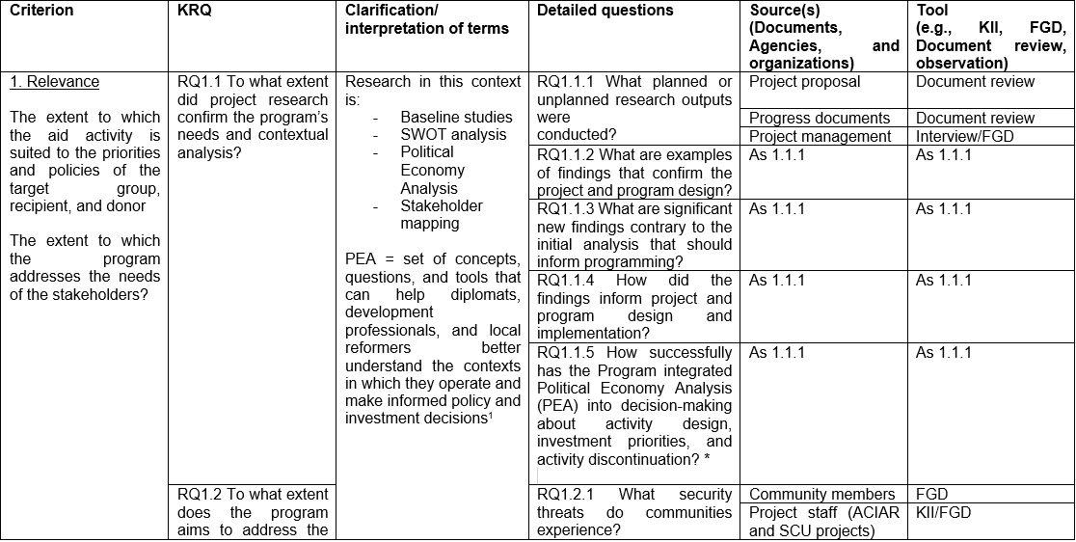

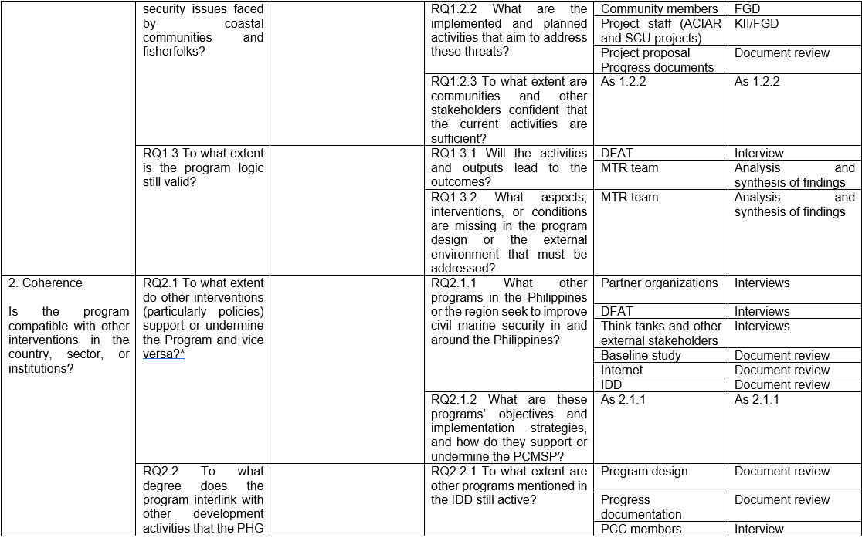

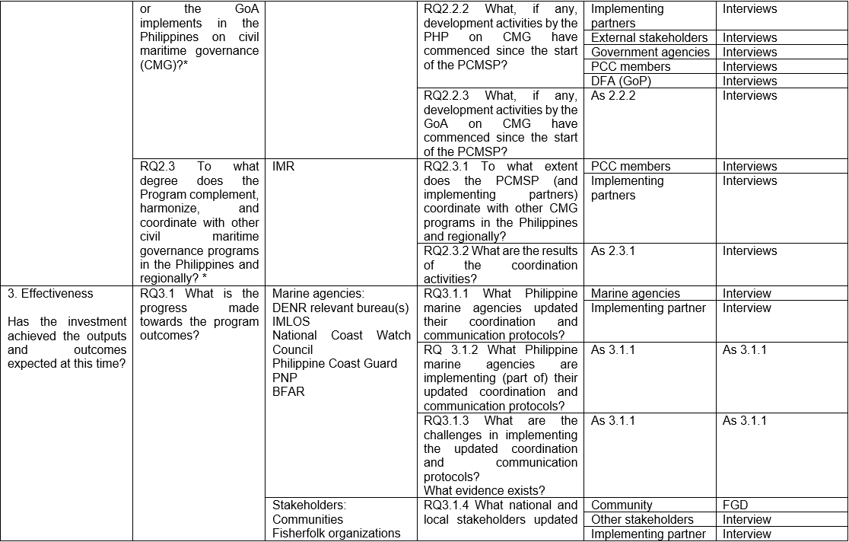

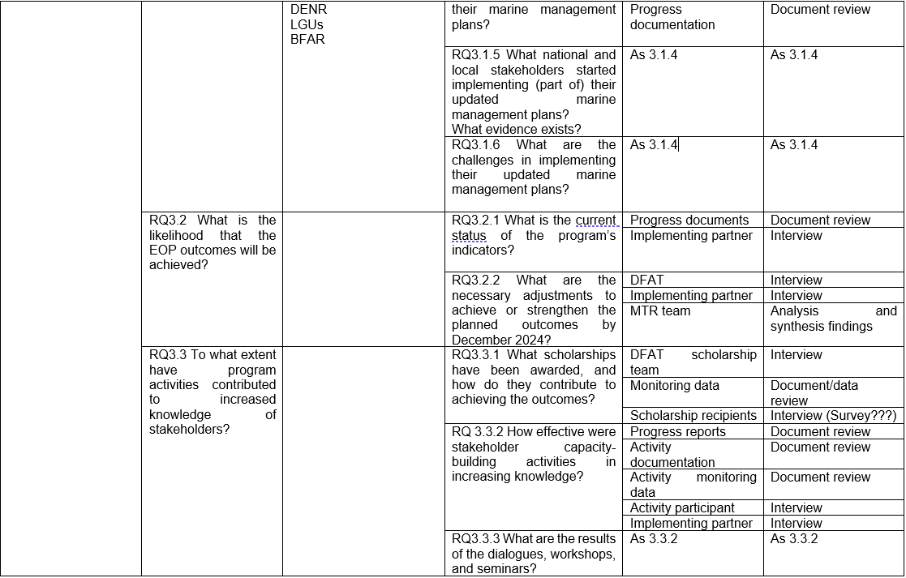

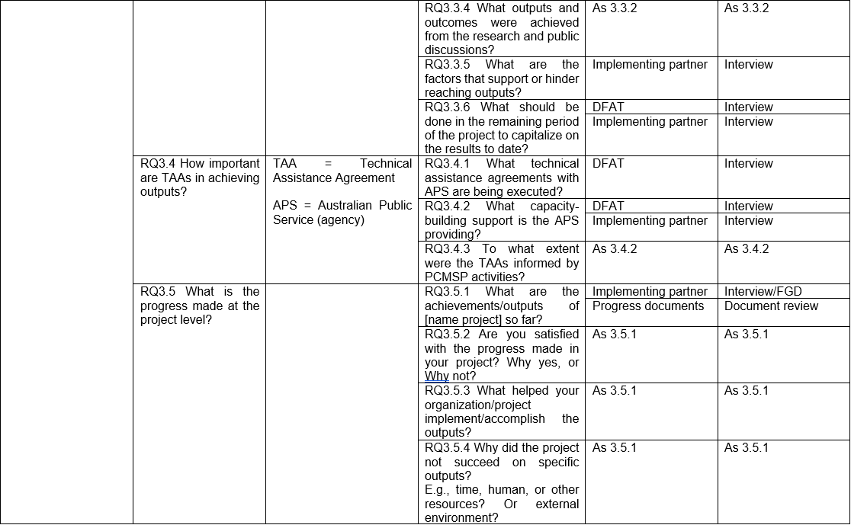

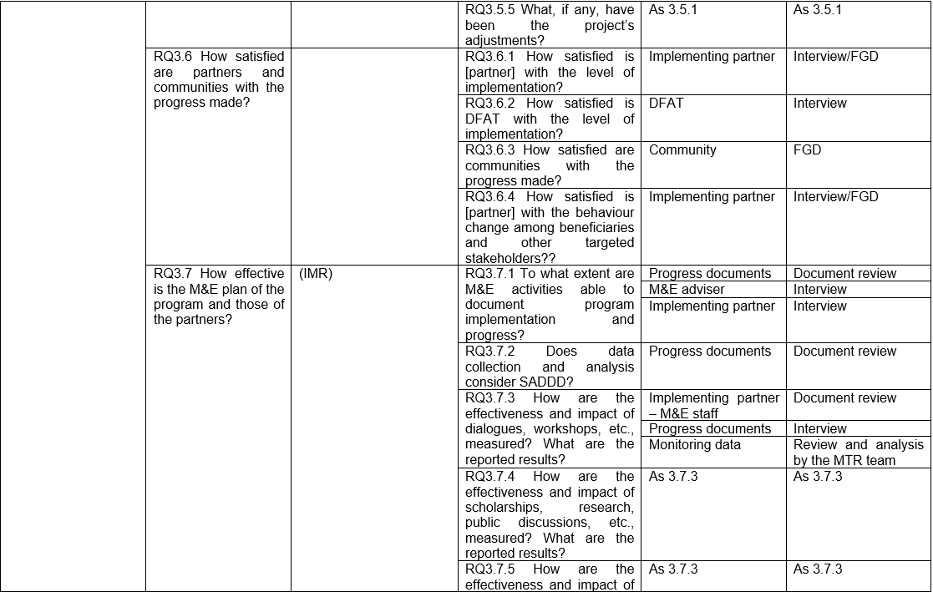 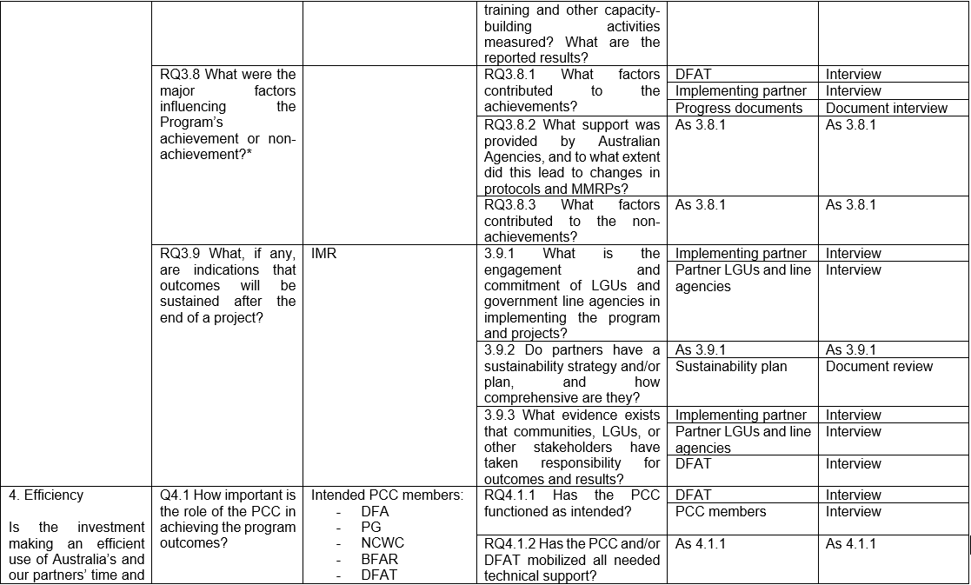 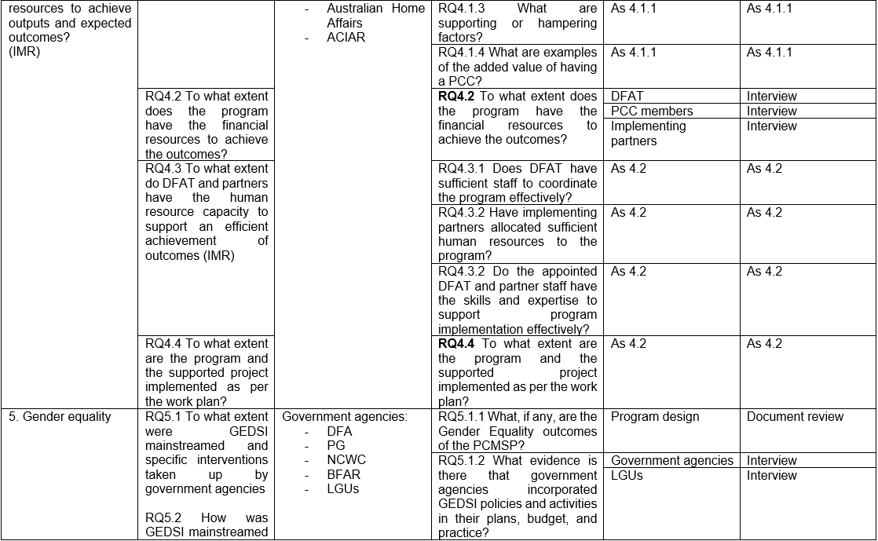 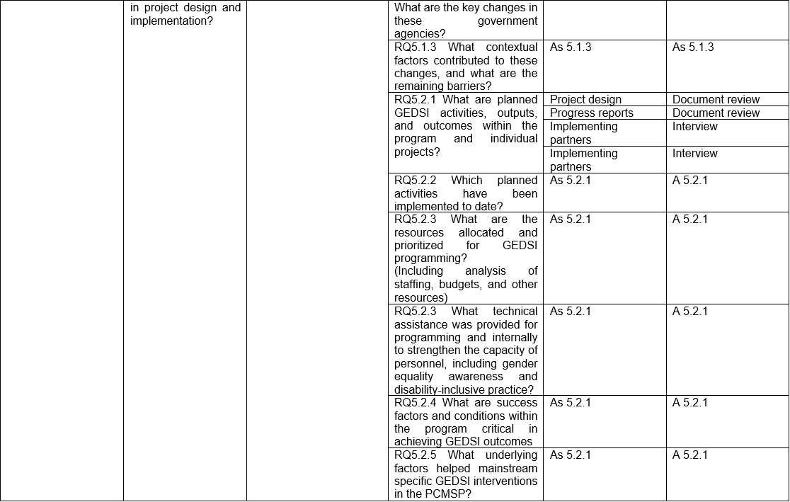 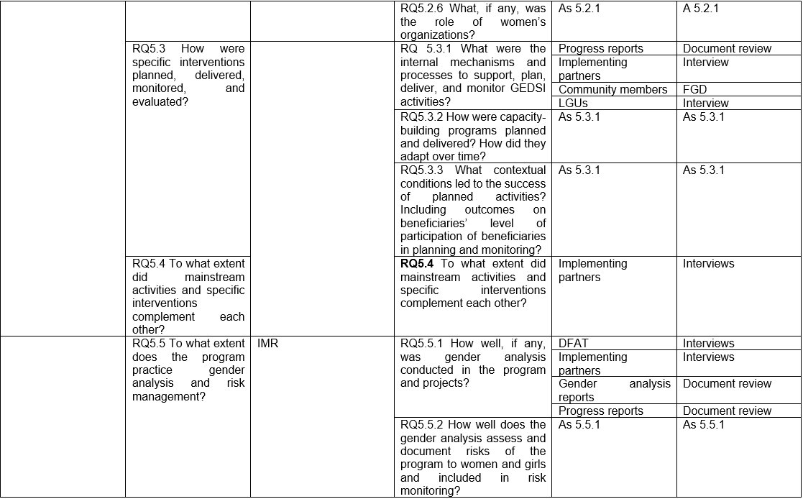 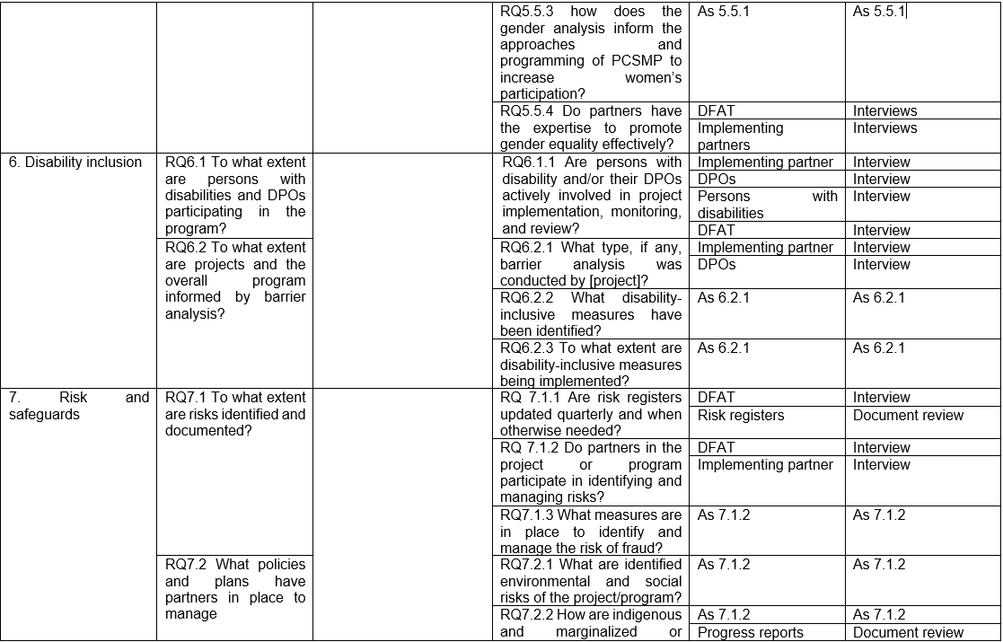 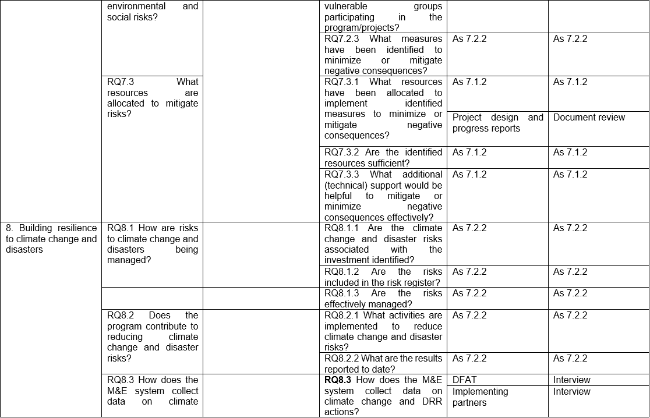 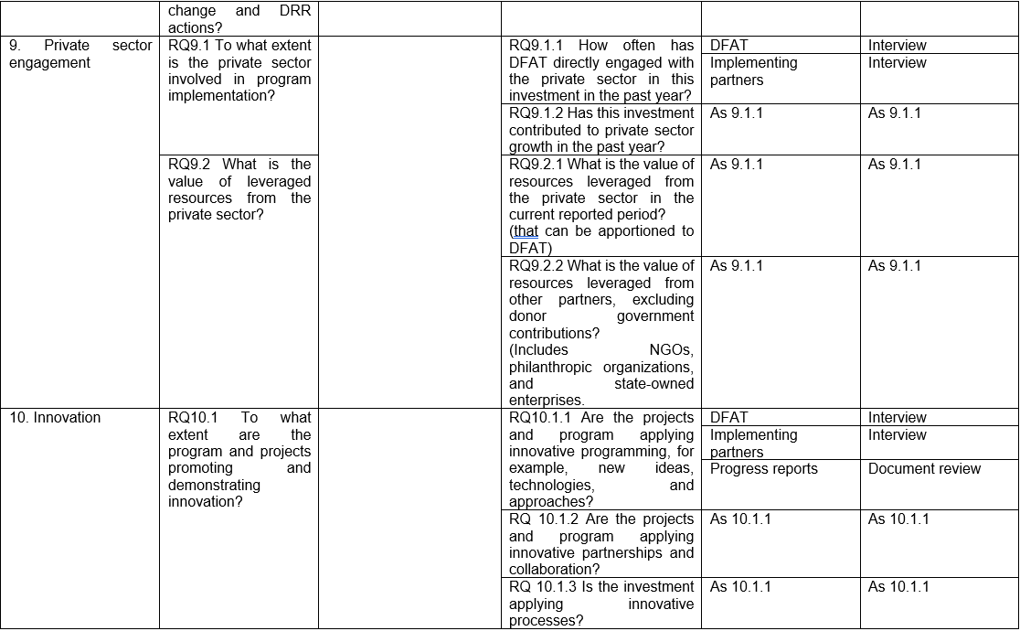

### Appendix 2: Survey Questionnaire

