
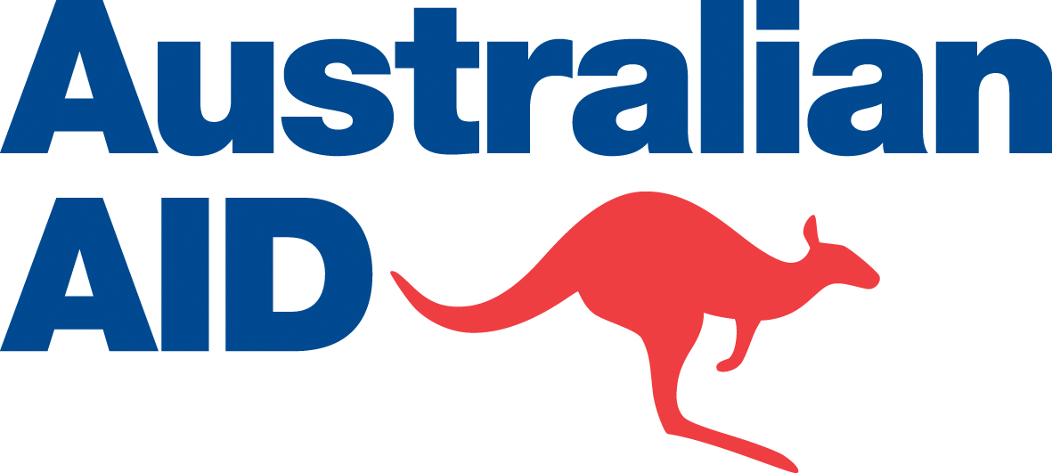


Independent Evaluation of PNG Media for Development Initiative
Joint AusAID-NBC-ABC Management Response

Aid Activity Summary

Aid Activity Name | Media for Development Initiative (MDI)
AidWorks initiative name and number | PNG Media Program INF759
Commencement date | 4 January 2005 | Completion date | June 30 2012
Total Australian $ | Media Development Initiative: $14.32m  Satellite Distribution System: $4.16m  Total: $18.48m
Total other $ | Not applicable
Delivery organisation(s) | Australian Broadcasting Corporation (ABC)
Implementing Partner(s) | National Broadcasting Corporation (NBC)
Country/Region | PNG
Primary Sector | Democratic Governance (Media)

Aid Activity Objective:

MDI has been operational since January 2005. Its goal has been “to support an open and democratic media that gives voice to all PNG citizens, provides nationwide access to information and culture, and delivers development content for the benefit of the people.”

There have been two phases to MDI. The first phase of the initiative, which was completed in 2006, supported media-related organisations and NGOs to address the challenges of ‘access’, ‘content’ and ‘voice’. The second phase, which has achieved positive results has been extended three times since July 2006 and is due to finish in June 2012. The initial focus of the second phase was on strengthening the organisational capacity of the NBC through its existing relationship with the ABC. In 2010, AusAID, the NBC and the ABC agreed to adopt a ‘communications for development’ (C4D) approach to MDI by placing greater emphasis on the delivery of content related to development issues.

Independent Evaluation Summary

Evaluation Objective:

The objective of the evaluation was to assess the implementation of the initiative and recommend activities that could be implemented under the existing initiative or a new one.

Evaluation Completion Date:

Friday 24 February 2012

Evaluation Team:

Independent Consultant Ms Annmaree O’Keefe

Methodology:

The Terms of Reference for the review required the independent assessment to focus in particular on the DAC-specific criteria of relevance, effectiveness and sustainability with a further basic assessment of impact, monitoring and evaluation, gender equality, analysis and learning.

The evaluation plan mapped out the three stages for the review – preparation, in-country and report drafting. The preparatory phase involved the review of relevant AusAID documents and reports including the findings of the 2010 review of the PNG-Australia Development Cooperation Treaty, MDI project documents and reports including earlier review reports, the 2010 Record of Understanding (ROU) between AusAID and the ABC, the partnership agreement between NBC, ABC and AusAID. The reviewer also had access to the preliminary and draft findings coming out of the stakeholder analysis and the audience surveys – both quantitative and qualitative - commissioned by the ABC.

During the in-country visit from 29 January to 11 February 2012, interviews were held with NBC management and staff in Port Moresby as well as two provincial stations, Radio Eastern Highlands Province in Goroka and Radio Milne Bay in Alotau. Discussions were also held with relevant AusAID staff in Port Moresby and Goroka as well as representatives from key NGOs in Port Moresby, Alotau and Goroka. Efforts to meet with appropriate government representatives, including the Minister responsible for NBC were unsuccessful due to their changing commitments.

Key findings:

- “MDI is making a very effective contribution to the NBC and its role as a key partner in the development of PNG” [p.3 of evaluation report].
- “The organisational support provided through the project has been important in assisting NBC maintain the core technological and human capacity elements needed for successful broadcasting and credibility” [p.4].
- MDI has also built the capacity of the NBC to produce “high quality content related to development issues such as maternal health and gender-based violence” [p.4].
- “NBC’s relationship with the ABC – both through the project and through the longstanding peer to peer relationship – has been an important factor in the success of the project” [p.3]
- The prospects for sustaining the gains of MDI are looking more favourable due to the alignment of the project’s objectives with the NBC’s own priorities and greater ownership of the project’s outcomes [p.4].
- But the NBC faces considerable challenges, including “limited budget predictability, limited resources and at times, attempted political interference” [p.19]
- Ageing infrastructure is a particular problem with dilapidated buildings, partially inoperable studios and antiquated, poorly maintained transmission systems [p.24]
- Nevertheless, the NBC continues to be “the most effective medium for disseminating key messages appropriate to PNG’s development challenges” [p.19].

Criteria Ratings:

Evaluation criteria | Rating (1-6) | Explanation
Relevance | 6 | Through the continued focus on radio, the project has supported NBC’s efforts to provide broadcasting services across the country particularly in rural and remote areas of PNG where 85% of the population lives. The recent emphasis on supporting the provision of high quality content about health (Safe Motherhood) and gender (gender-based violence) is directly addressing two of the major development challenges confronting PNG
Effectiveness | 5 | NBC’s capacity to provide quality broadcasting services across the country continues to improve through MDI2’s support. The project built on past achievements to successfully introduce the community for development approach to content. The organisational support provided through the project has been important in assisting NBC maintain the core technological and human capacity elements needed for successful broadcasting and credibility.
Sustainability | 4 | Prospects for sustainability are looking more favourable than findings of earlier reviews thanks to the alignment of the project’s objectives with NBC’s own objectives. Senior management is taking greater ownership and responsibility for the project’s outcomes. However, it is unlikely that the C4D programming could be sustained if support for this activity is concluded at the end of June 2012 and without the appointment of a counterpart within NBC.
Impact | 3  5 | Because the emphasis on content quality through a C4D framework is relatively recent, the impact of this aspect of the project’s work is still relatively limited.  However the organisational strengthening work has directly supported NBC’s efforts to increase its reach across the country, particularly in remote and rural areas.
Monitoring and evaluation | 4 | The 2010 review found that more work was needed in this area. A similar conclusion could be made at this time except for two issues. Firstly, the M&E framework agreed to at the start of the current extension was no longer valid following policy and focus changes. Partners agreed that re-working the framework in the remaining time would not be a good use of resources. Secondly, the ABC has commissioned audience surveys and stakeholder analysis which will provide important feedback on relevant data and trends.
Gender equality | 5 | While gender equality remains an outstanding area of concern in PNG, the focus on gender related issues in the project’s priority area (content quality) has responded directly to this issue and as a result, provided important opportunities to inform NBC staff about gender issues and to apply them to their programming and personal lives. This will need to be an ongoing priority but the rating reflects the significant improvement achieved in this area.
Analysis and learning | 5 | Despite the changed focus after the start of the current extension, the project team were able to apply processes and approaches grounded in development-related broadcasting expertise appropriate to the NBC context. The approach has encouraged NBC ownership and supported ongoing learning.

Management Response

AusAID, the NBC and the ABC welcome the evaluation of MDI by independent consultant Ms Annemaree O’Keefe and acknowledge that the evaluation report produced is of a high quality. This evaluation will assist us to further strengthen our partnership.

The methodology of the evaluation was detailed and strategic, which has ensured the correct questions were asked and the appropriate stakeholders were consulted. The evaluation report is reasonably thorough and balances the objectives of the study. The content of the report is also clear and well-presented.

The findings of the evaluation were well supported by evidence but more will need to be done to regularly monitor and evaluate the impact of our work. The findings did a good job of highlighting both the NBC’s achievements and its ongoing challenges. MDI’s support to extend the reach of radio, train NBC staff, transition to flow programming and raise awareness of development issues are particularly noteworthy.

The recommendations of the evaluation flow logically from its findings and are straight forward and feasible. The NBC, the ABC and AusAID are in general agreement on accepting all of the recommendations.

Recognising the achievements of MDI and the benefits of ongoing support to the NBC, AusAID has proposed another phase of media assistance under the Strongim Pipol Strongim Nesen (SPSN) program. The specific actions required to implement the recommendations of this evaluation will be agreed upon during discussions of the next phase of media support.

The ABC, AusAID and the NBC look forward to a strong partnership in the future that will continue to promote an open and democratic media that gives voice to all PNG citizens, provides nationwide access to information and culture, and delivers development content for the benefit of the people.

Recommendation One

Recommendation:

“Provide strategic advisory support relevant to NBC’s reporting and coverage of the 2012 elections”

Response:

Agree. AusAID, the NBC and the ABC are committed to supporting PNG’s democracy and helping ensure the 2012 elections are free, fair and safe. The NBC’s role in providing credible news and information will be critical in ensuring the elections are calm and transparent. The ABC will provide strategic advice and expertise where required and requested. The NBC, the ABC and AusAID will ensure that there are no gaps in assistance due to the transition from one phase of media support to another.

Recommendation Two

Recommendation:

“Maintain the emphasis on communications for development in a way that supports the momentum already achieved and facilitates an effective handover to a new media development activity”

Response:

Agree. AusAID, the NBC and the ABC agree that communications for development should remain a focus of future assistance while also recognising the benefits of organisational capacity building and infrastructure support. The ABC and the NBC’s appointment of a communications for development specialists will reinforce the momentum achieved over the past 18 months. The specific development areas for focus will be agreed upon during discussions of the next phase of media support.

Recommendation Three

Recommendation:

“Project framework to be shaped by NBC’s own objectives and in line with Australian Government’s development objectives in PNG”

Response:

Agree. The NBC has a crucial role in supporting PNG’s development efforts and underpinning national unity and stability. The NBC has also made notable development achievements in recent years, such as expanding radio access in rural areas and producing high-quality content related to issues such as maternal health and gender-based violence. MDI has been well aligned to NBC’s corporate plan and the PNG and Australian government’s development objectives. The NBC, the ABC and AusAID will continue to regularly review the strategic direction of our partnership to maximise its relevance and development impact.

Recommendation Four

Recommendation:

“Radio to remain the principal medium but multi-media platforms incorporated as accessibility and affordability improves.”

Response:

Agree. Radio remains the most effective medium for disseminating information to the majority of PNG’s population despite rapid increases in ownership of computers, mobile phones and television. Radio is also better positioned to target assistance to the poor. UN statistics from 2010 suggest that internet access in PNG was as low as 1.2% with mobile phone access moderately higher at 27.8%. More comprehensive data from the 2009-10 Household Income and Expenditure Survey (HIES) will be available later this year to inform decisions about future media support. The NBC and ABC supported 2012 National Media Survey will also help maximise the relevance and impact of the NBC’s current radio and television broadcasting.

The ABC, AusAID and the NBC will retain radio as the principal medium for support and include television as a secondary medium under the next phase of assistance. NBC has recently invested heavily in television, which can be an effective medium to address the communications for development agenda in pictures. We will also remain flexible in using other media in the future such as mobile phones and the internet given the interconnectivity of media platforms.

Recommendation Five

Recommendation:

“Provincial network overhaul in line with roots and branch review”

Response:

Agree. The NBC’s provincial network is crucial for connecting the majority of PNG citizens who live in rural and remote areas. Inadequate funding to maintain and update the provincial network has caused it to age. The ABC, AusAID and the NBC strongly support the recommendation of a review of the provincial network while recognising there are financial, technical and political challenges to finding long-term solutions.

Recommendation Six

Recommendation:

“NBC and PNG government ownership entrenched through incentive-based grants”

Response:

Agree. The findings of this evaluation indicate that there is already strong ownership of MDI. The NBC’s leadership and the alignment of the program with NBC’s needs and the PNG and Australian government’s development objectives have contributed to this. The NBC, the ABC and AusAID will explore ways to increase the sustainability of assistance and reinforce ownership, including through incentive-based grants. AusAID and ABC will support the NBC to take more direct management of the support over time. The types of activities or reforms that would be appropriate for incentive-based grants will need to be further discussed. Finally, the NBC, the ABC and AusAID will not only look to pool and leverage AusAID and GoPNG funds but also those of other partners.

Recommendation Seven

Recommendation:

“Project management to remain with ABC”

Response:

Agree. The NBC and the ABC have a decades-long peer to peer relationship, which has been an important factor in the success of MDI. AusAID and the ABC also share a history of working together on media issues of common interest. The ABC and AusAID’s strategic partnership agreement recognises the value of the two agencies’ closer collaboration.

AusAID, the NBC and the ABC will maintain similar project management arrangements to MDI in the next phase of assistance. We will ensure that the provision of future assistance through the SPSN program does not weaken our relationship or reduce the effectiveness of the media support. We will at the same time explore opportunities for the SPSN program to supplement our partnership with strategic inputs and operational efficiencies.

Recommendation Eight

Recommendation:

“No gap between the current activity and its successor”

Response:

Agree. The ABC, AusAID and the NBC will work together to ensure there is no funding gap and minimal disruption during the transition to a new phase of assistance under the SPSN program. We will work together to negotiate a key partnership agreement, activity plan and multi-year funding deed over the coming months. AusAID will pursue an interim funding mechanism through SPSN for continued support to the NBC if the new partnership negotiations are not concluded by 30 June 2012.

Although the NBC and the ABC have put forward strong arguments to AusAID to provide assistance until the end of the NBC’s current corporate plan in 2015, AusAID is only in a position to give a commitment to June 2014. AusAID will look to provide more predictability by June 2013 following reviews of SPSN and the PNG governance program.

AusAID’s ‘AidWorks’ system shows the start date as 23 September 2003. There are a number of small contracts in 2003 and 2004,linked to the design process. The 2005 date is the date of commencement of the Record of Understanding between AusAID and the ABC.
http://data.un.org/Data.aspx?d=ITU&f=ind1Code%3aI99H
http://data.un.org/Data.aspx?d=ITU&f=ind1Code%3aI911

