PNG Micro, Small and   
Medium Enterprise and   
Informal Sector Study

The Australian Government, through the Australia PNG Economic Partnership, has commissioned a landmark study into PNG’s micro, small and medium enterprises (MSMEs) and informal sector.

The survey of more than 2,600 businesses across 21 provinces, conducted between 10 Junes and 30 July 2024, found that MSMEs are active in more than 16 industries and help provide access to vital goods and services, as well as much-needed employment, for communities in urban, rural and remote locations.

## Key Findings*

#### **Who are PNG’s micro, small and medium business owners?**

**97%** are Papua New Guinean.

Most (**85%**) operate as sole trader.

Formal sector

|  |  |  |
| --- | --- | --- |
|  | **Gender** (Women) | **35%** |
|  | **Age** (39 years or less) | **44%** |
|  | **Education** (University/technical/trade qualifications) | **41%** |
|  | **Paid employees** | Average of **7** |
|  | **Turnover (annual)** less than K60,000 | **67%** |
|  | **No loans/credit**  outstanding | **76%** |

Formal MSMEs, by industry

**A pie chart of formal MSME by Industry:
Retail: 57%
Hospitality: 19%
Transport services: 13%
Vehicle servicing/sales: 13%
Communications & IT services: 6%
Manufacturing: 6%
Farming: 6%
**

* Data applies to formal MSMEs.

#### **They are optimistic about the future…**

**79%** expect business to improve in the year ahead

**64%** plan to hire more staff

#### **But they face several obstacles to growth, including most commonly…**

**56%** Difficulty accessing loans/credit

**80%** Government corruption

**71%** Late or no payment

**65%** Government regulations

**62%** Crime and security issues

#### **And they encounter a significant array of other challenges…**

**25%** of women MSME owners say they have to overcome bigger hurdles than their male competitors, e.g. more onerous family/*wantok* obligations, workplace discrimination and disrespect, threats and abuse

**80%** of MSME owners have been impacted by climate change

**3%** of MSME owners are with a disability, most commonly vision or mobility issues

**56%** of MSMEs experienced difficulties getting a loan

#### **What MSMEs want is…**

****Better access to finance was the top priority for half of MSMEs, followed by improved training and opportunities, particularly in management and financial skills

PNG Micro, Small and   
Medium Enterprise and   
Informal Sector Study

The study included responses from 1,302 informal businesses across 21 provinces. It found that informal businesses are active in more than 12 industries and help provide access to vital goods and services, as well as much-needed employment, for communities in urban, rural and remote locations.

Key Findings*

#### **Who are PNG’s informal sector business owners?**

**92%** are Papua New Guinean

Informal sector

|  |  |  |
| --- | --- | --- |
|  | **Gender** (Women) | **50%** |
|  | **Age** (39 years or less) | **57%** |
|  | **Education** (University/technical/trade qualifications) | **11%** |
|  | **Paid employees** | Average of **2.4** |
|  | **Turnover (annual)** less than K60,000 | **91%** |
|  | **No loans/credit** | **94%** |

Formal MSMEs, by industry

**A pie chart of formal MSME by Industry:
Retail: 74%
Hospitality: 19%
Farming: 18%
Vehicle servicing/sales: 6%
Manufacturing: 6%
Communications & IT services: 5%
Transport services: 2%
**

* Data applies to formal MSMEs.

#### **They are optimistic about the future…**

**80%** expect business to improve in the year ahead

#### **But they face several challenges to growth, including most commonly…**

**30%** Poor sales and profits

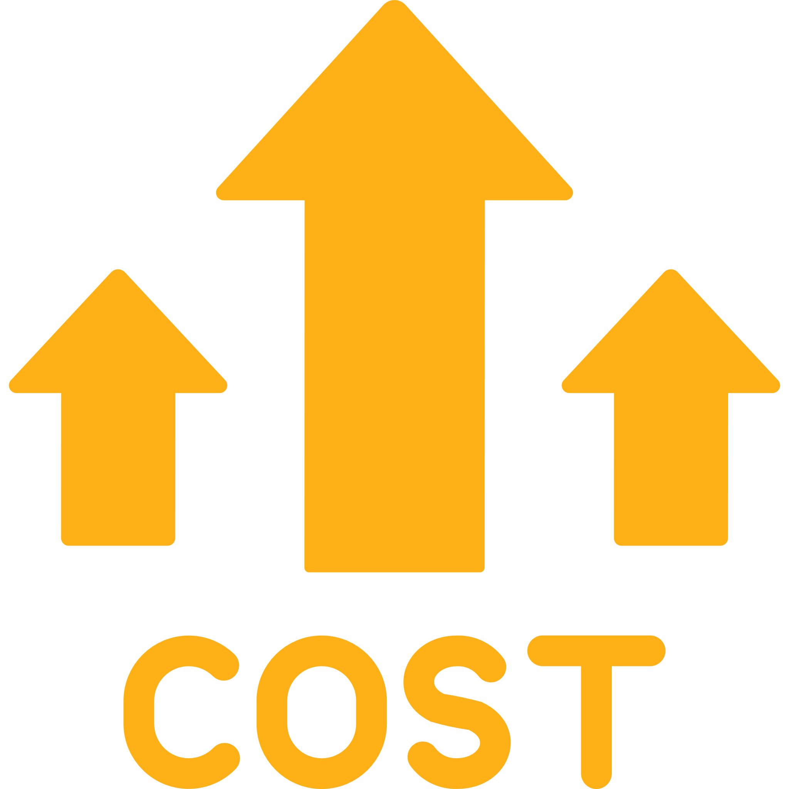**17%** Competition

**8%** High operational costs

**7%** Obligations to family and *wantoks*

**7%** Law and order issues

#### **What MSMEs want is…**

Improved financial accessibility (**18%**), followed by assistance to promote business development and expansion (**13%**) and training in business management (**9%**).

#### **Formalising informal businesses**

**61%** of informal business show interest in formalising their business and **37%** indicate they are unlikely to formalise because…

**30%** Do not know how to register

**17%** Say it is too expensive to register

**8%** Indicate the business is too small

[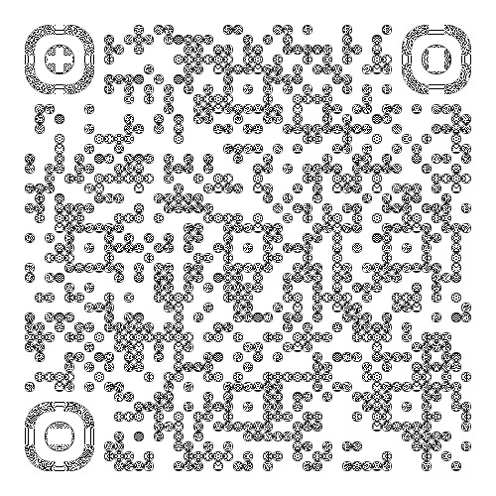](https://www.dfat.gov.au/geo/papua-new-guinea/australia-papua-new-guinea-documents)

Scan the QR code to view the full report, or visit [**dfat.gov.au/geo/papua-new-guinea/australia-papua-new-guinea-documents**](https://www.dfat.gov.au/geo/papua-new-guinea/australia-papua-new-guinea-documents)