2019-20 papua new guinea development program progress report

|  |  |
| --- | --- |
| **Program Budget** | **2019-20 Budget Estimate ($m)\*** |
| Bilateral | 512.3 |
| Regional | 49.7 |
| Global | 12.8 |
| Other Government Departments | 32.7 |
| **Total Australian ODA to Papua New Guinea** | **607.5** |

*Actual expenditure is expected to be available in December 2020

Infrastructure and trade – 28%
Agriculture, fisheries and water – 2%
Governance – 30%
Education – 13%
Health – 21%
Building resilience – 4%
General development support – 2%
Due to rounding total percentage may not add up to 100 per cent


**COVID-19 Development Response**

* In 2019-20, our bilateral development program funding was reprioritised across all sectors to support PNG’s response to COVID-19. This support included:
* direct funding to provinces for COVID-19 preparation and response
* procurement of over two million pieces of personal protective equipment to protect PNG’s frontline workers
* working with PNG to strengthen its testing and surveillance capacity, through the provision of 20,000 sample collection kits, 15,000 rapid serology tests, four new Polymerase Chain Reaction testing machines, co-funding for 15,000 GeneXpert cartridges, and over 3,500 samples tested in Australia.
* To improve COVID-19 public health messaging, we have provided significant support for information campaigns through multiple platforms
* for example, our Church Partnership Program is supporting PNG’s churches to promote COVID-19 safe behaviours across the country, including through TV and radio programs, such as *PNG’s Hour of Hope*.
* We have launched a new internet-based program to provide health care workers with access to vital COVID-19 training and mentoring from Australian clinicians.
* Through Australian support, *Pacific Women* partners are supporting vital domestic violence crisis and counselling support services to continue in PNG during COVID-19.
* The Australian Defence Force is supporting PNG’s COVID-19 response with logistics, including flights for workers, testing and supplies, border security, and the refurbishment of PNG Defence Force buildings for quarantine use.
* We are realigning the PNG-Australia Policing Partnership and broader law and justice programs to support Royal Papua New Guinea Constabulary (RPNGC)’s COVID-19 preparedness and response, including the implementation and enforcement of measures to prevent further community transmission. We are assisting RPNGC and other law and justice agencies to continue to respond to Family and Sexual Violence cases.

**Other program highlights**

* Australia and PNG successfully negotiated the Comprehensive Strategic and Economic Partnership (CSEP), signed by Prime Ministers on 5 August 2020. The CSEP provides a framework to deepen the PNG-Australia Partnership in key areas – security cooperation, trade and investment, governance, people-to-people and institutional links, social and human development and regional and multilateral cooperation. These priorities are supported through Australia’s development program in PNG, and whole-of-government partnerships including the Defence Cooperation Program and the PNG-Australia Policing Partnership.
* Australia’s development program in PNG supports objectives on infrastructure, health, education, governance and law and justice. Gender equality cuts across all sectors.
* In November 2019, Australia provided PNG with a short-term loan of USD300 million following a request from the PNG Government to meet a financing shortfall and to help deliver economic reform. Over the past nine months, we have supported the PNG Government to advance this program of reform, which includes its participation in an IMF Staff Monitored Program to support macroeconomic and financial sector stability.
* In 2019-20, more than 40 per cent of Australia’s bilateral Official Development Assistance was invested in infrastructure projects in PNG. Projects included the Coral Sea Cable, redevelopment of the Angau Hospital in Lae, and maintenance support for 1,833km of PNG’s national priority roads across 11 provinces and the Autonomous Region of Bougainville.
* In February 2020, the Coral Sea Cable System – a 4,700km long fibre optic submarine cable linking Australia to Port Moresby and Honiara – began operating. The cable system provides PNG with more reliable and affordable international telecommunications access. With a capacity of up to 20 terabits per second, the new cable brings next-generation connectivity to PNG.
* Australia has supported the PNG National Agriculture & Quarantine Inspection Authority through awareness, surveillance and containment to help slow the spread of African Swine Fever (ASF) in the Highlands. This is helping maintain livelihoods, food security and cultural traditions in PNG.
* In 2019, the first PNG workers arrived in Australia under the Pacific Labour Scheme. As of June 2020 there were 141 PNG workers in Australia under the Seasonal Worker Programme and Pacific Labour Scheme. Australia continues to support PNG workers to keep earning during COVID-19.
* In 2019-20, we supported PNG to secure a USD9.4million Global Partnership for Education grant which is helping primary school children safely resume learning.
* In 2019-20, 406 Papua New Guineans were supported by long and short-term tertiary Australia Awards scholarships in Australia and PNG. In addition, we finalised plans to scale-up our Technical and Vocational Education and Training (TVET) investment in support of PNG’s economic recovery, which will commence with an additional 100 TVET scholarships next year.
* Australia’s ongoing program of support to PNG’s health sector has continued to support maternal and child health, funded immunisations, helped combat communicable diseases (malaria, HIV, and TB), and continued the redevelopment of ANGAU memorial hospital in Lae. We are providing health sector support as part of the Government of PNG’s COVID-19 response.
* Under the PNG Partnership Fund (PPF), we have provided over 246,000 people with family planning services and treated nearly 20,000 people for sexually transmitted infections and HIV.
* Australia has provided crisis support for almost 1000 women and girl survivors of violence, businesses management training to over 1000 women, and support to women to take on leadership roles in workplaces, communities, markets and government.
* Australia has also supported the successful conduct of a referendum on Bougainville’s future political status in November 2019.
* In 2019-20, we supported the trekking industry and new war history museums along the Kokoda Track before pivoting to support Kokoda Track communities cope with the loss of trekking incomes once COVID-19 led to the closure of the Track.

## Progress against 2019-20 performance indicators

| **strategic OBJECTIVE** | **Performance assessment framework indicator/ benchmark** | **Brief summary of progress against indicator/benchmark** |
| --- | --- | --- |
| **Objective 1: Promoting effective governance.**  Sub-objective 1.1: Developing public sector leadership.  Sub-objective 1.2: Integrating partnerships to improve access to services.  Sub-objective 1.3:  Effective law and justice system | 1. Number of women and men trained and engaged by Papua New Guinea in positions where they can practice new knowledge and skills.  2. Number of women and men graduating from courses delivered by the Pacific Leadership and Governance Precinct.  3. Number of partnerships.  4. Number of women, men and youth using improved services provided by civil society, private sector partners or sub-national governments.  5. Number of women and men with greater awareness of legal rights and responsibilities | ~ 97,342 (45,927 women, 51,415 men). Target was 33,062.  This target was exceeded.  ~ 697 (304 women, 393 men). Target was 840.  The target was not fully met as the Precinct’s activities were paused due to the COVID-19 pandemic.  ~ 527. Target was 116. This target was significantly exceeded, as partnerships with farmer groups in Bougainville and SMEs (through EGIG) far exceeded their targets.  ~ 887,170 (438,652 women, 404,163 men, 38,097 youth, 6258 gender not specified). Target was 853,525 (incorrectly listed as 32,188 in 2018-19 APPR). This target was met.  ~ 115,712 (1,403 women, 1,309 men, 113,000 no gender reported). Target was 140,000. Target not met as large group activities were postponed due to COVID-19. |
| **Strategic Objective 2: Enabling economic growth**  Sub-objective 2.1:  Well-maintained economic and social infrastructure.  Sub-objective 2.2:  Catalyse inclusive economic growth | 6. Length of Papua New Guinea priority roads maintained.  7. Value of private sector investment leveraged (AUD).  8. Value of development investment attracted to PNG facilitated by or value-added to by Australia (AUD).  9. Number of women & men with better access to financial services.  10. Number of women and men with better access to markets | ~ 1,833. Target was 1,500 km. Australia invested in routine and periodic maintenance of 1,833 kilometres of roads defined by PNG as priority national highways, exceeding our target of 1,500 kilometres.  ~ $7,348,057. Target was $3,000,000. Australian ODA funds triggered substantial investment by the private sector in development outcomes. This target was significantly exceeded.  ~ $1,140,331,035. Target was $90,000,000.  Australia has leveraged significant additional financing including AUD$527m in IMF financing under the Rapid Credit Facility. Development investment is well beyond target for this period.  ~ 9,579 (5,220 women, 4,359 men). Target was 6,440.  ~ 1,091,678 (529,437 women, 562,241 men,). Target was 900,000. This target was exceeded with TSSP contributing over 90 per cent of beneficiaries. |
| **Strategic Objective 3: Enhancing human development**  Sub-objective 3.1:  More effective education service delivery system.  Sub-objective 3.2:  More effective health security systems and health services.  Sub-objective 3.3:  Gender equality and women’s empowerment | 11. Number of women and men (by province) graduating from Australia Awards, APTC and Fellowships.  12. Couple years protection (i.e. protection provided by contraception in one year) in Eastern Highlands, Bougainville, Morobe and National Capital District.  13. Percentage of tuberculosis patients in Western Province retained in treatment.  14. Number of women and girls who have accessed crisis support services and family and sexual violence centres.  15. Number of women trained or mentored and engaged by Papua New Guinea in positions to influence decision-making, including through candidacy in elections and at the local government level.  16. Aid effectiveness - DFAT delivers effective programs in Papua New Guinea. | ~ 478 (222 women, 256 men). Target was 90 graduates In-Australia long-term; 250 In-PNG graduates; 150 short course graduates.  APTC Graduates: 199 (58 women, 141 men); Australia Awards: 279 (164 women, 115 men); In-PNG Scholarships 112(38 men, 74 women); Short Course Awards 98 (42 men, 56 women).  ~124,727. Target was 56,000. This target was significantly exceeded as 2019-20 targets for PPF were incomplete.  ~ 99 per cent. Target was 85 per cent. This target was exceeded. Western Province continues to have strong case identification and treatment success rates.  ~ 3,738. No target was set. Through Australian support, Pacific Women partners provided vital crisis and counselling support services in PNG during COVID-19.  ~ 792. Target was 650 (Target was incorrectly listed as 16,701 in 2018-19 APPR). This target was exceeded.  ~ Target: COVID-19 Development Response Plan prepared.  Due to COVID-19 we have developed a COVID-19 Development Response Plan with a Performance Framework |
| Shared Development Objective:  **Economic and strategic partnership that contributes to sustained and inclusive economic growth in Papua New Guinea Broader Partnership Indicators** | 17. Number of women and men travelling between Australia and Papua New Guinea (by class of visa).  18. Number of women and men Australian tourists travelling to Papua New Guinea.  19. Value of trade between Australia and Papua New Guinea (as goods, services).  20. Number of Australian companies doing business in Papua New Guinea, and number of transactions.  21. Foreign Investment Stock.  22. Number of institutional partnerships.  23. Number of twinning/short term arrangements | ~ 30,056 Papua New Guinean arrivals in Australia (short term movements). Figure unavailable for Australian departures for PNG (short term movements).  ~ Figure unavailable at time of reporting.  ~ $7.5 billion in 2019.  ~ Figure unavailable at time of reporting.  ~ $17.0 billion in 2019  ~ 20 partnerships between Australian and PNG Government agencies.  ~ 3. |

## ANNEX A: Program Quality Investment Monitoring Report ratings

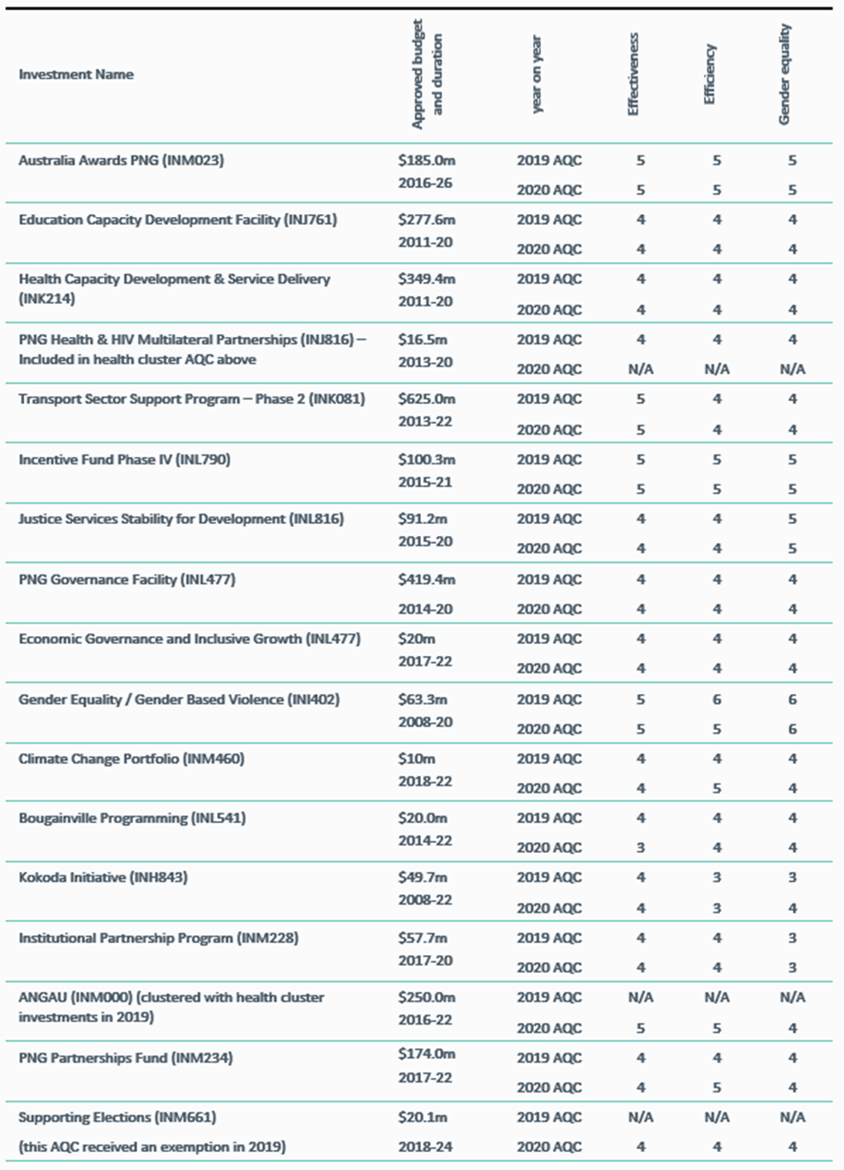

### Investment Monitoring Report ratings for 5 investments

### Final Investment Monitoring Report ratings

|  |  |  |  |  |  |  |  |  |
| --- | --- | --- | --- | --- | --- | --- | --- | --- |
| Investment name | Approved budget  and duration |  | Effectiveness | Efficiency | Gender equality | Relevance | Monitoring and Evaluation | Sustainability |
| Sports for Development (INL684) | $5.0m | 2019 AQC | 5 | 5 | 4 | N/A | N/A | N/A |
|  | 2015-19 | 2020 FAQC | 3 | 3 | 3 | 5 | 2 | 3 |

**Definitions of rating scale**:

Satisfactory (4, 5 and 6)

6 = Very good; satisfies criteria in all areas.   
5 = Good; satisfies criteria in almost all areas.  
4 = Adequate; on balance, satisfies criteria; does not fail in any major area.

Less than satisfactory (1, 2 and 3)

3 = Less than adequate; on balance does not satisfy criteria and/or fails in at least one major area.  
2 = Poor; does not satisfy criteria in major areas.  
1 = Very poor; does not satisfy criteria in many major area.