

Education Learning and Development Module

**Monitoring and**

**evaluation**

Practitioner Level

2018

CONTENTS

Acronyms 3

1 Introduction 4

2 Monitoring versus evaluation 4

3 Monitoring and evaluation standards 4

4 Monitoring and evaluation in practice 7

5 Evaluation considerations 10

6 Education indicators 11

7 Monitoring and evaluation reporting 12

8 Gender and social inclusion considerations in monitoring and evaluation 15

9 Test your knowledge 17

References and links 19

# Acronyms

AQCs Aid Quality Checks

AIP Aid Investment Plan

APPR Aid Program Performance Reports

DAC Development Assistance Committee (OECD)

DFAT Australian Government Department of Foreign Affairs and Trade

EMIS Education Monitoring Information Systems

EOPOs End of Program Outcomes

FAQCs Final Aid Quality Checks

GER gross enrolment rate

GESI gender equality and social inclusion

IPRs Independent Progress Reports

JCSEE Joint Committee on Standards for Educational Evaluation

M&E monitoring and evaluation

MEF monitoring and evaluation framework

NER net enrolment rate

NGO non-government organisation

ODA official development assistance

OECD Organisation for Economic Co-operation and Development

PAFs Performance Assessment Frameworks

PPAs Partner Performance Assessments

SDGs Sustainable Development Goals

UIS UNESCO Institute of Statistics

UNESCO United Nations Educational, Scientific and Cultural Organization

# Introduction

This Practitioner level module is designed to ensure staff members who manage education investments, can understand the concepts and monitoring and evaluation (M&E) practices needed for designing and supervising education investments.

It is recommended that staff complete the *Monitoring and Evaluation: Foundation level* module as background information to this Practitioner level module.

# Monitoring versus evaluation

Monitoring and evaluation are different but complementary activities. The key to understanding the role of monitoring is to remember that monitoring is intended to be a regularly available method of analysis using a continuous flow of information. Monitoring routinely answers the question: ‘What is going on?’

Evaluation tends to be discrete and generally episodic in nature. Evaluation answers the question: ‘What happened?’

**Monitoring is as important as evaluation**

The ‘streams of information for evaluation’ are provided by monitoring. Monitoring translates objectives into performance indicators, collects data on those indicators, compares results with targets, reports progress to managers and alerts them to problems.

Without the routine and constant monitoring of progress there cannot be feedback and correction to ensure that the activity is on track to achieve its target end-outcomes.

High quality M&E products ensure that information generated from investments has a credible basis and is suitable for use to make important programming decisions for wider learning. In turn, this is expected to lead to improved accountability, and a more effective aid program delivered efficiently.

# Monitoring and evaluation standards

## M&E guidance and standards

Directives in establishing and implementing M&E through the aid program have progressed over time to improve the quality and use of M&E, and to integrate evaluative thinking into everyday work. Important guidelines that should be consulted in designing and supervising M&E include:

* [DFAT’s Aid Programming Guide](http://dfat.gov.au/about-us/publications/Documents/aid-programming-guide.pdf)
* [2016 DFAT Aid Evaluation Policy](http://dfat.gov.au/aid/how-we-measure-performance/ode/Documents/dfat-aid-evaluation-policy-nov-2016.pdf)
* [DFAT Monitoring and Evaluation Standards](http://dfat.gov.au/about-us/publications/Documents/monitoring-evaluation-standards.pdf)

Sources: DFAT 2017a, 2017b, 2017c.

Below are key aspects of M&E, as it applies to the project cycle:

### Designing M&E

Monitoring and evaluation needs to be considered from the design stage of each activity. M&E should be based on a solid review, in collaboration with key stakeholders, of the program logic and theory of change to describe the extent to which the activity can be monitored and evaluated. A key aspect of a well-designed M&E system is that it clearly articulates end-of-program outcomes.

A good M&E design should consider, and measure, the starting point (baseline), to thereby inform realistic outputs, milestones, and performance targets (outcomes). These should be reflected in an M&E plan which describes the M&E system design, key M&E approaches and activities.

An M&E plan that includes a well-defined monitoring and evaluation framework (MEF), with clear points for evaluation, is a key tool for policy dialogue and for ensuring efficiency and effectiveness in development investments. The M&E plan should clarify M&E criteria, processes, outputs, timeframes, roles and responsibilities at the outset. The 2017 DFAT M&E Standards provide in-depth guidance on establishing an M&E plan.

### M&E and supervising activities

Monitoring and evaluation is important for the ongoing management and supervision of development activities. The information derived from M&E informs policy or operational dialogue with the partner government and involved stakeholders, with a view to continuous improvement.

Monitoring and evaluation is an essential tool of development management and is a key informant of policy and operational dialogue with partner governments, partners and other key stakeholders. M&E provides a basis for accountability to stakeholders. When reported clearly, M&E processes and outcomes help identify shared learning about a range of areas, including good practice, effective strategies and tools, and information about specific issues. M&E supports well-informed management through evidence-based decision making.

Monitoring and evaluation data is critical for Aid Program Performance Reports (APPR), Aid Quality Checks (AQCs), Final Aid Quality Checks (FAQCs), Independent Progress Reports (IPRs), and Partner Performance Assessments (PPAs).

### DAC Principles

The OECD [Development Assistance Committee (DAC) Principles](http://www.oecd.org/dac/evaluation/daccriteriaforevaluatingdevelopmentassistance.htm) set out criteria to be used for the evaluation of development assistance. They are perhaps the most important set of definitions in the field of development M&E.

The DAC Principles are:

* **Relevance**: the extent to which the aid activity is suited to the priorities and policies of the target group, recipient and development partners.
* **Effectiveness**: a measure of the extent to which an aid activity attains its objectives.
* **Efficiency**: an economic term which measures the output – qualitative and quantitative – in relation to the inputs.
* **Impact**: the positive and negative changes produced by a development intervention, directly or indirectly, intended or unintended.

**Sustainability**: is concerned with measuring whether the benefits of an activity are likely to continue.

**Source**: Development Assistance Committee 2017.

### DAC Principles adapted

The Australian aid program has modified the DAC Principles to suit its perspectives. The following additional criteria are used by Australia in its M&E work:

* **Monitoring and evaluation:** whether an appropriate system is being used to assess progress towards meeting objectives.
* **Analysis and learning:** whether the aid activity is based on sound technical analysis and continuous learning.

**Gender equality:** whether the aid activity is making a difference to gender equality and empowering women and girls.

**Alignment with key policy priorities:** whether the aid activity is aligned with policy priorities in disability, indigenous peoples and/or ethnic minorities, climate change and disasters, private sector, and innovation.

# Monitoring and evaluation in practice

## Setting up and supporting M&E systems

There are many ways of establishing and implementing M&E, with various evaluation theories, methodologies and methods that can be applied in different contexts. While there is no single correct way of establishing or carrying out M&E, [the DAC criteria](http://www.oecd.org/dac/evaluation/daccriteriaforevaluatingdevelopmentassistance.htm) and [DFAT M&E Standards](http://dfat.gov.au/about-us/publications/Documents/monitoring-evaluation-standards.pdf) provide the common approaches on selecting what to measure, as well as the crucial elements necessary in setting up an M&E system.

The key elements of effective M&E include the need to:

* formulate outcomes and goals
* select outcome indicators to monitor
* collect baseline information associated with input, output and outcome targets
* set specific targets and dates for reaching the outcomes and goals
* collect data to assess whether input, output and outcome targets are being met

analyse and report results.

Sources: DAC 2017, DFAT 2017c.

## Step-wise approach

Since there is no standard blueprint in practice for how we collect the key M&E system ingredients, following a sequenced step approach can be helpful.

Figure 1 shows a sequence of key steps towards setting up an education M&E system. It emphasises how the starting point for developing an M&E framework is the identification of outcomes.

It is the desired outcomes which drive the M&E system, and indicators, baseline data, and specific targets for the indicators are essential to monitoring and evaluating progress towards their achievement.

Figure 1: Key steps towards setting up an illustrative education M&E system

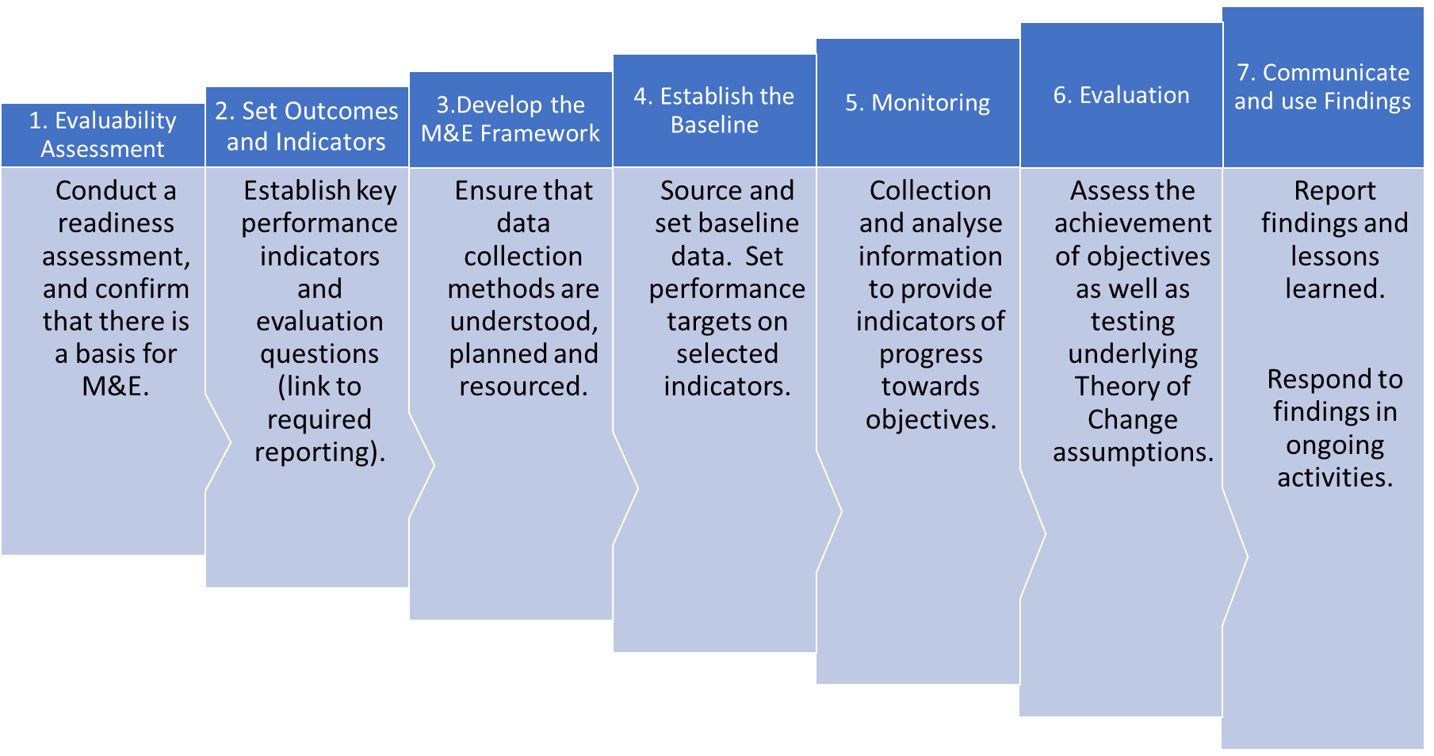

**Note**: Throughout, it is important to sustain M&E systems (by establishing clear roles and responsibilities, obtaining reliable information, assigning accountability, and building capacity) so that M&E becomes embedded in the decision-making process.

### Step One: Evaluability assessment

Conducting an evaluability assessment requires discussions with key stakeholders to confirm a shared interpretation of the expected short-term and end of program outcomes. It will also assess partner government capacity to provide data or to run an M&E framework. Such an assessment is useful in providing a foundation assessment of whether an M&E system needs to be established for an individual education project or program, or whether it can draw from existing systems (e.g. whole-of-government or line ministry M&E systems).

### Step Two: Select outcomes and indicators

Once it is confirmed that there is an adequate basis for M&E, outcomes will need to be set and performance indicators established against these. This requires key internal and external education stakeholders to be engaged in a participatory fashion in setting outcomes and targets to monitor and evaluate. This step involves setting key performance indicators to monitor progress with respect to inputs, activities, outputs, outcomes, and impacts. Illustrative outcomes indicators, and the way they might be reported over time are provided at Table 1.

Table 1: Example of education outcomes indicators and reporting over time

|  |  |  |  |  |
| --- | --- | --- | --- | --- |
| **Outcomes** | **Baseline indicators** | **Baselines** | **Target indicators** | |
| 1. Children of country X have better access to primary school | 1. Percentage of eligible urban girls and boys enrolled in primary school 2. Percentage of eligible rural girls and boys enrolled in primary | 1. In 2012, 75% of children aged 6-11 2. In 2012, 40% of children aged 6-11   (Baselines should be sex-disaggregated) | 1. By 2018, 85% of children aged 6‑11 2. By 2018, 60% of children aged 6‑11   (Sex-disaggregated) |
| 2. Primary school learning outcomes for girls and boys are improved | 1. Percentage of Grade 6 girls and boys scoring 70% or better on standardised maths and science tests | 1. In 2012, 75% of students scored 70% or better in maths and 61% of students scored 70% or better in science   (Sex-disaggregated) | 1. By 2018, 80% of students scoring 70% or better in maths and 67% or better in science  (Sex-disaggregated) | |

### Step Three: Develop the M&E framework

The M&E framework (and M&E plan) should be established so that it can operationalise all M&E activities. The framework should specify the timing of, and responsibilities for, data collection so that information is available to support planning and implementation. An emphasis should be given to ensuring accountability and reporting requirements are met, and that information and knowledge are used to improve performance.

### Step Four: Establish performance baselines

Baselines establish a starting point from which to monitor and evaluate progress towards the intended results, and achievement of defined targets. This step builds on the previous steps by examining baseline indicator levels and desired levels of improvement. Baseline indicators should be measured just before, or as soon as possible after, activities have commenced.

### Step Five: Monitoring

Monitoring includes both implementation and results monitoring. The reach/coverage, quality, and exposure of participants to key deliverables are monitored. This is a vital stage, described in further detail later in the module.

### Step Six: Evaluations

Planning for evaluations is important in understanding the uses and timing of evaluations. Building a monitoring system to track performance gives ongoing information (via selected indicators) on the direction, pace and the magnitude of change. Evaluations are about gaining perspective, to answer the general question, ‘what is happening, and why?’.

### Step Seven: Respond to findings

The final element of an M&E system is to report data to help decision-makers make the necessary improvements in policy, projects, and programs. Using findings is critically important in sharing knowledge, deriving lessons, making modifications and designing new, evidence-based initiatives.

# Evaluation considerations

## M&E must begin at the beginning

A major limitation in carrying out evaluations occurs when necessary information and data are not available. Without robust data, including baselines, there are difficulties in conducting evaluations, particularly for analysing education outcomes and impacts. For this reason, an M&E system must be designed and built into the education aid activity from the very beginning. Some key considerations that need to be addressed through M&E design are discussed next.

## Education Monitoring Information Systems (EMIS)

Evaluations of programs supported by the Australian aid program do not usually generate their own data: they are dependent on the quality of baseline data and the information systems of partner governments, such as the Education Monitoring Information Systems (EMIS). This preferred reliance on partner systems underlines the importance of support for strong partner government M&E systems. Strong country-led M&E systems are the most sustainable, allowing for robust tracking and analysis of partner government and development partners’ investments in outputs and outcomes.

## Analysing gender and equity benefits and outcomes

The analysis of gender and equity benefits and outcomes requires that relevant data is disaggregated. Ideally, data should be disaggregated by gender, locality (urban/ rural/ remote), sub-nationally (province/state), socioeconomic status, disability, and other indicators of vulnerability or exclusion relevant to the country context (such as ethnicity). In many cases the lack of disaggregated data limits the extent to which inclusion/ marginalisation effects can be considered in performance tracking or evaluations.

Given the importance of gender equality, gender inclusion and social inclusion in the Australian aid program, it is imperative that all M&E information is at a minimum disaggregated by gender, disability status and marginalised group. Further, M&E needs to assess whether programs address any particular needs that marginalised populations/ groups may have that may not be shared by the wider population, or may not have been considered in society or by decision-makers.

# Education indicators

## Typical education indicators

Typical indicators used in education, and thus comprising part of education program M&E, are the net enrolment rate and the gross enrolment rate. Understanding these rates, and the differences between them, provides useful insight into education program M&E.

|  |
| --- |
| Net Enrolment Rate (NER)  The [NER](http://uis.unesco.org/en/glossary-term/net-enrolment-rate) calculates the number of enrolled children in the official school age group divided by the total number of children in the official school age group. Therefore, it is a ‘right age’ enrolment measure. The NER generates basic information about access to schools but does not reveal anything about what is happening in school, or if children are attending regularly.  NER = Number of enrolled children in the official school age group divided by total number of children in the official school age group  Source: UNESCO Institute for Statistics (UIS) 2017a. |

|  |
| --- |
| Gross Enrolment Rate (NER)  The [GER](http://uis.unesco.org/en/glossary-term/gross-enrolment-ratio) determines the number of students enrolled, of any age, divided by the number of right age children for that stage of education. The GER can be helpful in identifying if there are large numbers of underage or, more typically, overage students in the system. With the GER, it is possible to have a percentage over 100: that would indicate that there are under- and over-age students at a given grade or stage of education.[1]  GER = Number of enrolled children of all ages divided by total number of children in the official school age group  Source: UNESCO Institute for Statistics (UIS) 2017b. |

## Not all indicators are equal

**The use of indicators is a vital component of the education project or program**.

Where concepts are tricky or data are in short supply, it is common to turn to ‘proxy indicators’. Proxy or indirect indicators are used to demonstrate the change or results where direct measures are not feasible. Some objectives, particularly impact objectives, are difficult to monitor. It is often necessary to select indirect or proxy indicators that may be easier for evaluators to measure.

For example, we can indicate the literacy level in a household by whether there are family members who are literate – this is termed an ‘indirect’ measure of literacy because it does not directly assess the skill of each family member. A direct indicator would be based on the results of a literacy test given to all individuals.

Proxies can be useful, but can also be misleading. For example, most developing countries collect data on school dropouts, but there are multiple reasons for dropping out. Reduced dropout is likely to be only a partial and indirect consequence of a program to improve say, school infrastructure.

# Monitoring and evaluation reporting

## Reporting requirements

There are several M&E reporting and quality assurance processes that are routinely required within the Australian aid program. These are:

* **Aid Program Performance Reports (APPRs):** APPRs must be produced annually by country and regional programs that have an annual total official development assistance (ODA) allocation of $15 million or more. APPRs assess the progress against Aid Investment Plan (AIP) targets and commitments for the portfolio of investments that relate to that AIP.
* **Performance Assessment Frameworks (PAFs):** Programs with an annual total ODA allocation of $50 million or more must have a PAF in place that includes measurable indicators for assessing progress towards a program’s overall stated objectives.
* **Aid Quality Checks (AQCs):** Program areas and Posts prepare AQCs each year using evidence gathered on each investment in excess of $3 million. Information for the AQC is derived from implementing partner reporting, monitoring visits, reviews and evaluations. The AQC process assesses the performance of an investment over the previous 12 months.
* **Final Aid Quality Check (FAQC):** In the final year of an investment, an FAQC is conducted instead of an AQC. Each FAQC provides information on the final performance of an Australian aid investment against planned outcomes, and should reflect on the performance of an investment throughout its life, identifying lessons learned to inform future designs and strategic directions.
* **Evaluations:** Each year, programs must prepare a list of priority evaluations for approval by the relevant First Assistant Secretary for inclusion in DFAT’s Annual Evaluation Plan. Prioritised evaluation topics should serve to guide current and future programming. Selected evaluations may target areas where there are significant evidence gaps, issues that pose significant risks, high profile interventions or investments of high financial value.

**Partner Performance Assessments (PPA):** Each year, agreement managers must complete an assessment of implementing partners’ performance in relation to specific agreements (commercial agreements and grant agreements). PPAs are mandatory for commercial suppliers, non-government organisations (NGOs) and multilateral organisations with agreements valued at $3 million or more.

## Evaluation criteria

All DFAT reporting templates list the required evaluation criteria. The reviewer usually completes the template providing the necessary data and in some cases assigning a numerical ranking for each of the evaluation criteria. The criteria and the ratings scale are shown in Figure 2.

Figure 2: Evaluation Criteria Rankings from PPAs

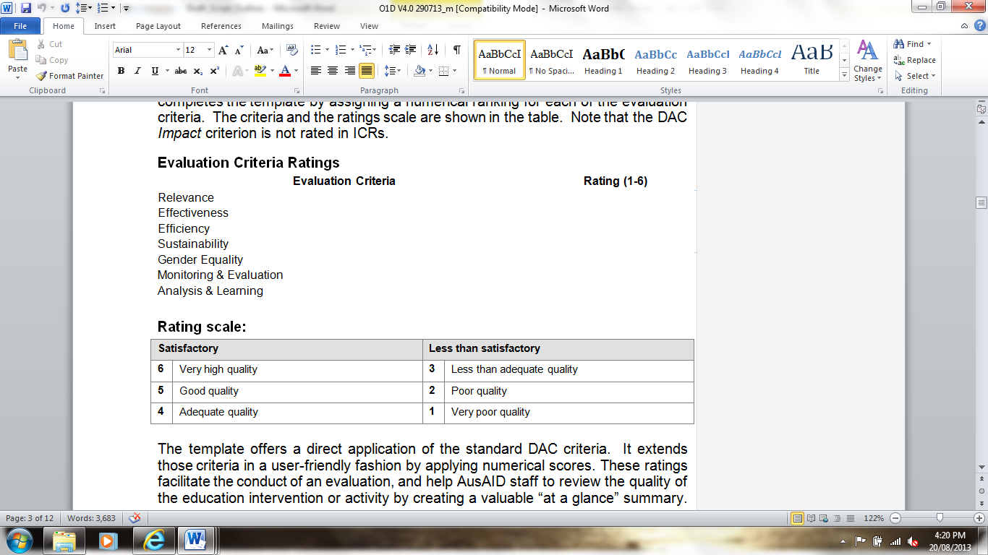

The template offers a direct application of the standard DAC criteria. It extends those criteria in a user-friendly fashion by applying numerical scores. These ratings facilitate the conduct of an evaluation, and help staff to review the quality of the education intervention or activity by creating a valuable ‘at a glance’ summary.

The DAC criteria are not always easy to apply in practice, and numerical ratings mean that staff can learn vital evaluative lessons by directly comparing ratings.

### Critical operational issues

Staff engaged in commissioning or managing education M&E Reports (APPRs, AQCs, PPAs and evaluations) need to be aware of three critical operational issues:

1. Despite the definitional help in the templates, the evaluation criteria can be interpreted in different ways. This does not diminish the quality of any given evaluation, but it does limit the extent to which cross-comparison of programs is possible.
2. Applying a numerical figure is potentially helpful in applying the evaluation criteria, but the ratings may be applied differently by different reviewers. It is important to provide a considered narrative against each score to add depth to evaluation ratings.
3. Aid activities are frequently delivered or managed by contractors. In such cases evaluations (with the exclusion of APPRs) may focus on contractor performance in delivering agreed outputs rather than on the achievement of more strategic project outcomes. The risk is that the evaluation can become limited to operational implications. A focus on progress towards the End of Program Outcomes (EOPOs) can assist in maintaining a broader focus.

## Managing evaluations

When managing or supervising M&E activities, issues to consider include:

* when commissioning an evaluation, ensure that those contracted to do the work are fully briefed on the possibility of inconsistency in interpreting the DAC criteria and the numerical rating system used, and are advised to be explicit about the potential of those inconsistencies in their review
* emphasise to those carrying out the evaluation that it should give prominence to the appraisal of strategic outcomes and impacts rather than focusing exclusively on implementation or contractor performance
* in reviewing and commenting on M&E, emphasise the extent to which reviewers have addressed the known problems of interpretation of criteria, consistency of ratings, and a disproportionate focus on outputs rather than aid impact and effectiveness.

Chapters three and four of the [DFAT Aid Programming Guide](http://dfat.gov.au/about-us/publications/Documents/aid-programming-guide.pdf) provide detailed guidance on the process to follow for APPRs, AQCs, FAQCs, Evaluations and PPAs.

Source: DFAT 2017a.

# Gender and social inclusion considerations in monitoring and evaluation

|  |
| --- |
| Gender equality and social inclusion in monitoring and evaluation  **Gender-sensitive and social inclusion measurements in education are critical for three reasons**:   1. To build the case for placing gender equality and social inclusion (GESI) at the centre of development practice. 2. To enable better planning and actions to effectively address gender equality and social inclusion challenges. 3. To hold institutions to account on their commitments to gender equality and social inclusion. |

The Australian aid program has progressed gender equality and social inclusion (GESI) to an approach that emphasises GESI as a core strategic development issue.

Special target groups for gender equality and social inclusion include: women and men; girls and boys; people with disabilities; people living in or at risk of poverty; ethnic or religious minorities; indigenous communities; the elderly; the sick or infirm; those with low levels of education; as well as cross-sections of these groups (for example, women with disabilities).

Monitoring and evaluation must start by deciding what aspects of gender equality and social inclusion to measure. These may reflect the priorities of decision-makers and development partners rather than those of the girls and boys, women and men the initiative is intended to benefit. Tailored interventions or special attention is required in determining GESI measurement strategies to:

* allow the voices of special target groups to be heard in the design, implementation and evaluation of the activity (that is, ‘nothing about us without us’)
* purposefully reach special target groups, and provide the opportunity to participate as equally in the program as other groups
* allow special target groups to enjoy program benefits equally with others in that community or population

ensure the program addresses any needs that special target groups may have that may not be shared by the wider population, or may not have been considered in society or by decision-makers.

Very few M&E frameworks enable an understanding of how change happens or how the GESI context has been altered. Gender-sensitive measurements alone do not improve gender equality. For M&E data to be useful it must be analysed, disseminated and acted upon.

In deciding what to measure for GESI, we must: i) establish key objectives and goals; ii) identify the changes required to achieve these goals; and iii) decide what kinds of indicators will enable us to measure progress towards these changes. This requires consideration throughout the project or program cycle.

## Key considerations for integrating GESI into M&E

Things to think about in making these decisions include:

* **Concept**: is there a policy and institutional framework to promote GESI in education? What is the level of input from stakeholders – girls, boys, women, men and other stakeholders?
* **Design and appraisal**: do inputs and activities reflect GESI sensitive objectives? Are targets set in consultation with key stakeholders? Do the planning and implementation agencies have capacity to identify and address GESI issues? Do the tools and methods of data collection reflect GESI outcomes and impacts? Is the possibility of a stand-alone GESI study considered?
* **Implementation**: are GESI sensitive and GESI-disaggregated data being collected? Are gender-concerned and disabled person organisations involved in monitoring progress? Are the results being disseminated?

**Evaluation**: did girls and boys, women and men, people with disabilities, people living in poverty, ethnic or religious minorities, indigenous communities, the elderly, the sick or infirm participate and benefit from the process of establishing objectives and goals? How do the results compare with the targets? What accounts for variation in GESI outcomes? How did risk indicators and critical assumptions about GESI support or hinder progress? What are the prospects of sustaining GESI equality achievements in the long term?

|  |
| --- |
| Case study: Vanuatu Skills Partnership  The Vanuatu Skills Partnership (previously the Vanuatu Skills for Economic Growth Program) has progressed its response to GESI through gender inclusion, gender equality and social inclusion of people with a disability. The program has established a GESI framework within its M&E system to focus M&E efforts to GESI.  See the References and Links for [Vanuatu Skills for Economic Growth Phase 3 Completion report](http://dfat.gov.au/about-us/publications/Documents/vanuatu-tvet-skills-economic-growth-phase-3-completion-report.pdf)  Source: DFAT 2016. |



# Test your knowledge

## Assessment questions

Answer the following questions by ticking ‘True’ or ‘False’. Once you have selected your answers to all the questions, turn the page to ‘The correct answers are...’ to check the accuracy of your answers.

Question 1

Monitoring and evaluation goes beyond compliance, to focus on outcomes and impacts.

Is this statement true or false? □ True □ False

Question 2

While M&E systems are usually set up in a results-based framework, in practice evaluations of aid activities tend to default to evaluating compliance and implementation.

Is this statement true or false? □ True □ False

Question 3

Establishing attribution is straightforward in education.

Is this statement true or false? □ True □ False

Question 4

Both monitoring and evaluation are meant to influence decisions to improve, change or discontinue an intervention.

Is this statement true or false? □ True □ False

Question 5

Reference to ‘findings and evidence’ are sufficient information in an evaluation report.

Is this statement true or false? □ True □ False



## The correct answers are...

Question 1

Monitoring and evaluation goes beyond compliance, to focus on outcomes and impacts.

**This statement is true.** This is generally referred to as a results-based approach.

Question 2

While M&E systems are usually set up in a results-based framework, in practice evaluations of aid activities tend to default to evaluating compliance and implementation.

**The statement is true.** Lack of data, poorly specified indicators, and limited understanding of causal relationships between inputs, process and results all contribute to difficulties in evaluating impacts and outcomes.

Question 3

Establishing attribution is straightforward in education.

**The statement is false.** ‘Attribution’ is the causal relationship between inputs and educational outcomes. In many areas of education it is very difficult to establish the causal role of specific inputs or processes. Instead, development partners tend to focus on the contribution of activities to education outcomes.

Question 4

Both monitoring and evaluation are meant to influence decisions to improve, change or discontinue an intervention.

**The statement is true.**

Question 5

Reference to ‘findings and evidence’ are sufficient information in an evaluation report.

**The statement is false.** A comprehensive evaluation report should include ’findings and evidence’, as well as ‘conclusions’, ‘recommendations’ and ‘lessons learned.’

# References and links

**All links retrieved July, 2018.**

Department of Foreign Affairs and Trade (DFAT) 2016, Skills for economic growth: Vanuatu Technical and Vocational Education and Training Sector Strengthening Program – Phase 3: Completion report 2013-2016, June, DFAT, <http://dfat.gov.au/about-us/publications/Documents/vanuatu-tvet-skills-economic-growth-phase-3-completion-report.pdf>

2017a, Aid programming guide, March, DFAT, <http://dfat.gov.au/about-us/publications/Documents/aid-programming-guide.pdf>

2017b, DFAT aid evaluation policy, February, DFAT, <http://dfat.gov.au/aid/how-we-measure-performance/ode/Documents/dfat-aid-evaluation-policy-nov-2016.pdf>

2017c, DFAT monitoring and evaluation standards, April, DFAT, <http://dfat.gov.au/about-us/publications/Documents/monitoring-evaluation-standards.pdf>

Development Assistance Committee 2017, DAC criteria for evaluating development assistance, OECD, <http://www.oecd.org/dac/evaluation/daccriteriaforevaluatingdevelopmentassistance.htm>

UNESCO Institute for Statistics (UIS) 2017a, ‘Net enrolment rate’, Glossary, UNESCO, <http://uis.unesco.org/en/glossary-term/net-enrolment-rate>

2017b, ‘Gross enrolment ratio’, Glossary, <http://uis.unesco.org/en/glossary-term/gross-enrolment-ratio>

**Learn more about…**

* *Chianca’s international aid evaluation analysis and policy proposals, found at:* <http://institutofonte.org.br/sites/default/files/Chianca%20T.pdf>
* *The Sustainable Development Goals (SDG 4),*  *found at:* <http://www.un.org/sustainabledevelopment/education/>
* *Department of Foreign Affairs and Trade (DFAT) 2015, Strategy for Australia’s aid investments in education 2015 -2020, found at*: <http://dfat.gov.au/about-us/publications/Documents/strategy-for-australias-aid-investments-in-education-2015-2020.pdf>
* *DFAT aid program performance reports (APPR), found at:* [http://dfat.gov.au/about-us/publications/Pages/aid-program-performance-reports.aspx](http://dfat.gov.au/about-us/publications/Pages/aid-program-performance-reports.aspx%20)
* *Joint Committee on Standards for Educational Evaluation (JCSEE) accepted international standards, found at:* <http://www.jcsee.org/program-evaluation-standards>
* *Kusek J & Rist R 2004, Ten steps to a results-based monitoring and evaluation system: a handbook for development practitioners, World Bank, found at:* <https://openknowledge.worldbank.org/handle/10986/14926>
* *OECD-DAC’s Glossary of key terms in evaluation and results based management, found at:* <http://www.oecd.org/development/peer-reviews/2754804.pdf>
* *OECD-DAC’s Principles for evaluating development cooperation: Summary of key norms and standards, found at:* <http://www.oecd.org/dac/evaluation/dcdndep/41612905.pdf>
* *UNESCO’s 2016 Global Education Monitoring (GEM) Report: Education for people and planet: Creating sustainable futures for all, found at:* <http://unesdoc.unesco.org/images/0024/002457/245745e.pdf>
* *World Bank 2004, Influential evaluations: Evaluations that improved performance and impacts of development programs, found at:* <http://siteresources.worldbank.org/EXTEVACAPDEV/Resources/4585672-1251727474013/influential_evaluations_ecd.pdf>
* *World Bank 2004, Monitoring & Evaluation: Some tools, methods & approaches, found at:* <http://siteresources.worldbank.org/EXTEVACAPDEV/Resources/4585672-1251481378590/MandE_tools_methods_approaches.pdf>

1. In the denominator, the Gross Primary School Enrolment Rate considers children usually between the ages of 6–11. The Gross Secondary School Enrolment Rate considers children usually between the ages of 12–17, while the Gross Tertiary Education Enrolment Rate considers the number of young people in the five-year age group following the secondary school leaving age (for example, 18 to 23 year olds).