

**The Australian Government’s**

**Fiji Program Support Facility**

**Program Design Update – Australia’s Support to Fiji’s Health Sector**

June 2022



Fiji Program Support Facilityis managed by Tetra Tech International Development, on behalf of the Australian Government

**Document Control**

|  |  |
| --- | --- |
| **Program:** | Australia’s Support to Fiji’s Health Sector (Fiji Health Program) |
| **Original commencement date:** | 2018 |
| **Design update commencement date:** | 1 January 2022 |
| **End date:** | 31 December 2024 |
| **Current program indicative annual allocation: AUD** | $5 million |
| **Current program indicative Phase 2 allocation: AUD** | $12.5 million |

|  |  |
| --- | --- |
| **Client** | Department of Foreign Affairs and Trade |
| **Project name** | Fiji Program Support Facility |
| **DFAT agreement number** | 73250 |

**Review and revisions log**

|  |  |
| --- | --- |
| **Date** | **Version** |
| 30 June 2022 | Draft submitted to DFAT |
| 23 September 2022 | Second draft submitted to DFAT. Revised to incorporate feedback from Independent Appraisal and DFAT. |
| 3 January 2023 | Document approved by DFAT |

**Contents**

Abbreviations 4

Executive Summary 5

A. Introduction 7

B. Development context 7

C. Key changes from original design and justification for areas of investment 11

D. Program logic 13

PRIMARY AREAS OF INVESTMENT 16

Supply Chain Reform Project 16

Digital and Health Information Project 19

Patient Safety and Quality Care Project 22

TARGETED AND RESPONSIVE SERVICES 25

Targeted services in Maternal and Newborn Care, Child Ear and Eye Care, and NCD and Rehabilitation Services 25

Flexible and response assistance 28

E. Gender Equality, Disability and Social Inclusion 29

F. Climate change/disaster risk reduction 31

G. Key policy priorities 32

H. Sustainability and institutionalisation 34

I. Monitoring, evaluation and learning 35

J. Implementation arrangements 37

K. Risk management and safeguarding 39

M. Annexes 41

Abbreviations

ANC Antenatal care

AWP Annual Work Plan

CRP COVID-19 Development Response Plan

CSO Civil Society Organisation

CWM Colonial War Memorial Hospital

DFAT (Australian Government’s) Department of Foreign Affairs and Trade

FHP Fiji Health Program

FPBS Fiji Pharmaceutical and Biomedical Services Centre

FPSF Fiji Program Support Facility (‘the Facility’)

GEDSI Gender equality, social and disability inclusion

IPC Infection prevention and control

KPP Key policy priority

LTDD Leptospirosis, Typhoid, Dengue and Diarrhoeal Diseases

MEL Monitoring, evaluation and learning

MHMS Ministry of Health and Medical Services

MNC Maternal and Newborn Care

NCD Non-communicable disease

OPD Organisation of Persons with Disabilities

PATIS Plus Patient Information System (Fiji’s electronic medical record system)

PSEAH Prevention of sexual exploitation, assault and harassment

RIS/PACS Radiology Information System / Picture Archiving Communication System

The Facility Fiji Program Support Facility

The Program Australia’s Support to Fiji’s Health Sector Program

WHO World Health Organization

Executive Summary

This program design update outlines the goals of Australia’s support to Fiji’s health sector from January 2022 to December 2024. It is the second phase of the Fiji Health Program (FHP) and is part of the Fiji Program Support Facility[1]. Australia’s bilateral aid program invests about AUD 5-6 million per year into strengthening health services in Fiji, accounting for about 30 per cent of the Facility’s total budget.

The outbreak and response to COVID-19 has dominated Fiji’s health sector over the past two years, shifting priorities and resources. Despite this, many long-term challenges – such as weaknesses in health systems and the rise of non-communicable diseases and disability – continue.

The strategic case for Australian engagement in the Fiji health sector continues to be strong. Phase 2 of FHP delivers against DFAT’s *COVID-19 Development Response Plan for Fiji* which commits to increasing support for public health programs[2], particularly improvements in the quality of health service delivery, evidence-based policies and systems, preparedness for health emergencies at CWM Hospital and more efficient, reliable medical supply chains. FHP also aligns with Australia and Fiji’s broader *Vuvale Partnership*, which focuses attention on improving health service delivery with a focus on vulnerable groups (including persons with disabilities). Building on the success of Australia and Fiji’s joint response to the COVID pandemic, FHP will continue supporting MHMS by delivering rapid support in emergencies and delivering long-term changes to make the health system more effective, efficient and relevant to the ‘new normal’ way of living and working in Fiji.

This design update provides a ‘refresh’ of the original design, adopting lessons from COVID, aligning with the *Ministry of Health and Medical Services (MHMS) Strategic Plan 2020-2025*, and incorporating recommendations from the *Strategic Review of the Fiji Health Program* undertaken in early 2022. Each project was developed in consultation with MHMS and partners and endorsed at the Program Coordination Committee in June 2022.

**FHP’s end-of-program outcomes are:**

1. FHP supports MHMS supply chain reforms to improve access to essential drugs and medical supplies
2. FHP assistance enables MHMS to produce quality, usable data using strengthened digital and health information systems
3. FHP support to targeted hospitals improves clinical governance, patient experience, and nursing services
4. FHP assistance improves targeted services in maternal and newborn care, child ear and eye health, and for NCD and rehabilitation services, in selected communities, clinics and hospitals
5. FHP supports MHMS timely response to public health emergencies, COVID outbreaks and emerging priorities

This design update outlines strong investment in health systems strengthening, with major projects in supply chain management and digital and health information. Both of which faced major challenges over the past few years. These investments are cross-cutting, benefiting all public health and clinical services.

The **Supply Chain Reform** Project has been implemented since 2020. The first stage of the project included an initial deployment of a new logistics management information system (mSupply) at major warehouses, divisional hospitals and health centres in Central Division. The next stage of the project will roll-out mSupply to all health facilities in Fiji to increase national medicines availability from 74% in 2021 to over 90% by 2024. It will also reform procurement and tendering processes, addressing major inefficiencies that contribute to Fiji paying an estimated 30-40% more on average than comparable Pacific Island Countries for medicines and consumables[3].

**Digital and health information** has been identified as a top priority because it is “the backbone” of the health system, generating data and evidence that drives priorities and resource allocations. A 2019 review[4] of Fiji’s previous Digital Health Strategy identified a lack of foundations for digital health as a severe constraint to architecting a future in digital health. In response, FHP will address both the immediate and longer-term needs of MHMS, by strengthening national leadership (through development of a Digital Health Strategy), upgrading and repairing core health information systems (including infrastructure, software and processes) and setting up timely and accurate reporting and quality assurance mechanisms (like dashboards, clinical coding and core indicators).

FHP will also continue to invest in strengthening **clinical governance** at major hospitals in Fiji. Outbreaks of COVID exacerbated existing weaknesses in patient safety and quality care, leading to hospital and ward closures and preventable illnesses and deaths among patients and health workers. Investing in these initiatives will improve the effectiveness and efficiency of the hospital system and reduce avoidable costs, such as treating complex hospital acquired infections or longer than necessary hospital stays. The focus on patient experience and customer care will enable targeted support for women, persons with disabilities and vulnerable groups.

As part of the design update, FHP has consolidated three areas that remain priorities but receive a smaller proportion of the overall funding. The focus on **maternal and newborn care** is in recognition that maternal services are the largest utiliser of any health service in Fiji, accounting for one quarter to one third of all hospital admissions[5]. Likewise, **NCDs and rehabilitation services** are targeted as Fiji has the world’s highest recorded death rate from type 2 diabetes mellitus and an average of three diabetic-related amputations per day[6]. School-based screening for **hearing and visual impairment** was a priority of MHMS given its link to lifelong development and learning potential[7].

In recognition of the increasing risk of natural disasters, the effects of climate change and other **public health emergencies** (such as disease outbreaks), FHP will maintain the ability to provide flexible assistance based on needs and where it can have the greatest impact.

While the end-of-program outcomes (EOPOs) are presented separately, there is intersectionality between them in improving data, workforce development, good governance, inclusiveness and partnerships. Across all investments, FHP will support MHMS to improve gender equality, disability and social inclusion in health services. FHP will partner with Organisations of Persons with Disabilities (OPDs) and civil society organisations (CSOs) to improve reach and quality of services for these groups.

FHP will have a strong focus on institutionalising the systems, policies and positions within each priority area so that the gains continue beyond the life of the investment period. If this is achieved, then Australia’s investment in Fiji’s health sector will be well positioned –with a strong evidence base – to demonstrate that it has contributed to significantly improving health outcomes for Fiji’s population, particularly for the most vulnerable groups.

1. Introduction

Phase 1 of the Fiji Health Program (FHP) finished in December 2021, with Phase 2 extending to December 2024. This design update provides a ‘refresh’ of the original design, aligning it with the *MHMS Strategic Plan 2020-2025*, incorporating lessons from the first phase of implementation and the changed situation due to COVID, and adopting the recommendations and findings from the *Strategic Review of FHP* that was completed in April 2022.

1. Development context

**Overview**

The outbreak and response to COVID has dominated Fiji’s health sector over the past two years, shifting priorities and resources. Despite this, many of the longer-term challenges identified in the original design – such as weak systems and the rise of non-communicable diseases and disabilities – remain relevant. There have also been some promising developments, including the launch of the *MHMS Strategic Plan 2020-2025*, which positions Fiji well for further improvements over the coming years, and has a strong focus on achieving universal healthcare, particularly for women and vulnerable groups.

For FHP, about 50% of its FY 2020/21 and FY 2021/22 budgets were redirected to the COVID response and vaccination roll-out, expanding the program size from a historical AUD 5 million per year to AUD 6-7 million per year. The response also meant that some priorities outlined in the original design took on renewed importance, particularly clinical governance (which includes infection prevention and control), while others reduced (at least temporarily) in priority, such as NCDs. COVID also highlighted weaknesses in existing systems for digital health and supply chain management that will now form core pillars of FHP’s investments in Phase II.

**Situation analysis**

The *MHMS Strategic Plan 2020-2025* promotes universal health coverage and subsequent plans aim to address the social determinants of health which includes gender equality. Fijians have access to most health care services for free or at low costs[8]. The Free Medicine Program enables lower-income Fijians to access a range of prescription medicines free of charge[9].

Primary health care – including maternal and child health care and family planning services – are available across over 200 nursing stations and health centres located in rural, peri-urban and urban areas. Secondary health care is provided at 17 sub-divisional hospitals and three divisional hospitals, with advanced maternal units. Health care for mental health and rehabilitation is delivered through two specialist hospitals in Suva.

Women are both the primary users of the health system and comprise a majority of the workforce. Three out of every five health care workers in Fiji are female (63%). Despite this, there is under-representation of women in managerial and decision-making positions with 41% of senior roles filled by women (Band J and above)[10]. According to 2020 data, Fiji has met its 2021 target of one doctor per 1,000 population but the SDG 3.c.1 targets for nurses and midwives (5.5 and 1.6 per 1,000 population respectively) has not been met.

The COVID-19 pandemic has significantly impacted the health of Fijians and the health care system, particularly during surges of community transmission in 2021 and 2022. The resulting outbreak led to national lockdowns, spikes in hospitalisations and deaths from COVID, and a major response effort focusing on improving access to essential and quality care, scaling up the vaccine program, and a risk communications campaign. Almost a year later – as of June 2022 – 95% of adults (586,000) had received at least two doses of the COVID vaccination[11] and hospitalisations and deaths had declined significantly.

Maternal services are the largest utiliser of any health service in Fiji, accounting for one quarter to one third of all hospital admissions[12]. Prior to COVID, Fiji was making good progress in maternal health. It is unclear what impact COVID – and reduced access to sexual and reproductive health – has had. At 35.6 deaths per 100,000 live births[13], Fiji’s maternal mortality rate (MMR) is half of the 2030 SDG 3.1.1 target of 70 deaths per 100,000 live births[14]. Fiji has also achieved the SDG 3.1.2 target, namely 100% of births in Fiji are attended by skilled birth attendants.[15] There are about 20,000 births in Fiji per year, with about 250-300 perinatal deaths[16]. The Fiji Perinatal Review (2020) found the most common preventable contributing factors to perinatal deaths was lack of or infrequent attendance to antenatal care (31%) and caregivers not providing recommended best practice (15%)[17]. Clinical and mental health care for women pre and post miscarriage – which occurs in about one in three pregnancies[18] – is often not available and limited data exists.

In 2020, 83% of deaths in Fiji were due to NCDs (SDG 3.4.1)[19] and for more than a decade, NCDs have been responsible for more than 70% of premature deaths[20]. Breast and cervical cancers are the leading NCD causes of death among Fijian women. Obesity has increased rapidly in Fiji, largely due to poor diets and low levels of physical activity[21]. Fijian girls and women are significantly more overweight than boys and men[22]. In 2020, 70% of Fijian women of reproductive age (15-49 years) were overweight or obese[23].

This has contributed to Fiji having the world’s highest recorded death rate from type 2 diabetes mellitus (T2DM) with 188 deaths per 100,000 population[24]. Obesity is the strongest risk factor for T2DM, with women at greater risk than men for the same level of obesity[25]. The MHMS website states that 30% of Fijians have been diagnosed with diabetes[26]. It is unlikely that Fiji will meet the WHO 2030 target for a prevalence rate of 8%.[27] In Fiji, it is the most common cause of nontraumatic lower extremity amputations that account for about 40% of all hospital operations[28]. Maternal mortality among Fijian women is also largely linked to the incidence of diabetes[29].

The last census (2017) reported that 13.7 percent of the population aged three and above noted at least one functioning challenge (disability)[30]. This figure is not disaggregated by sex or gender. Due to discriminatory and unequal gender norms, women with disabilities experience impairment differently than men and boys. In 2020, only 28% of health care facilities in Fiji were physically accessible to persons with disabilities, despite this being mandated by the Fiji Building Code; 9% had information, education and Communication (IEC) materials available in braille or contrasting colours; and, of 36 facilities with delivery beds, only 61% were adjustable[31].

MHMS has identified a need to improve hearing and visual impairment screening and services for children. These impairments, if not addressed, will inhibit a child’s development and learning potential[32]. While accurate data on hearing impairment in Fiji is not available, preliminary studies have estimated around 10% of Fijians have hearing impairment and rates in Fiji are 3–5 times greater than other Australasian countries[33]. There are also elevated rates of blindness caused by trachoma, refractive error and diabetes retinopathy but the Pacific Eye Institute at CWM Hospital is providing comprehensive national eye care services and trainings.

There is minimal data on the prevalence of mental disorders in Fiji and it remains heavily stigmatised. St Giles Hospital in Suva is the only MHMS facility specialised in psychiatric care. Stress Management Wards in division and sub-division hospitals expand the availability of short-term care for mild mood disorders[34], albeit only in urban centres.

**Strategic alignment**

The strategic case for Australian engagement in the Fiji Health sector continues to be strong. Australia has been supporting Fiji’s health sector for decades, with Phase 1 and 2 of FHP building on investments since 2011 by the Fiji Health Systems Support Program (FHSSP)[35].

As the focus shifts from COVID, MHMS has signalled that it wants to continue investments in longer-term reforms outlined in the *MHMS Strategic Plan 2020-2025* and the *Remodelling of Health Service Provision 2020*/21. These policy documents provide the framework for FHP’s investments and realignment of end-of-program outcomes around the three pillars of public health, clinical services and health system strengthening. The remodelling plan was developed in response to COVID as an “opportunity for the Ministry to remodel its service provision, to ensure that the delivery of health services by the Ministry is effective, efficient and relevant to the ‘new normal’ way of living and working in Fiji.”[36]

Phase 2 of FHP continues to support Australian priorities. It delivers against DFAT’s *COVID-19 Development Response Plan for Fiji.* This commits to increasing support for public health programs[37], particularly improvements in the quality of health service delivery, evidence-based policies and systems, preparedness for health emergencies at CWM Hospital and more efficient, reliable medical supply chains.

FHP also aligns with Australia and Fiji’s broader *Vuvale Partnership*, which focuses attention on improving health service delivery with emphasis on vulnerable groups (including the elderly and persons with disabilities): ‘We will work together to strengthen health policy, financing, planning, information systems and data, procurement and supply processes, leadership, management and workforce development in both countries through sharing best practices and strengthening capacity building opportunities.’ Building on the success of Australia and Fiji’s joint response to the COVID pandemic, FHP will also continue to complement MHMS procurement and recruitment systems by delivering rapid support in response to acute emergencies.

The *MHMS Strategic Plan 2020-2025* contributes to and references Fiji’s *National Development Plan (NDP)* which emphasises inclusive socio-economic development to improve the social wellbeing of all Fijians, with no one being left behind “regardless of geographical location, gender, ethnicity, physical and intellectual capability and social and economic status”. The NDP is complemented by Fiji’s *National Gender Policy and Rights of Persons with Disabilities Act 2018*. This states that people with disabilities have the right to the enjoyment of the highest attainable standard of health without discrimination on the basis of disability. FHP also contributes to DFAT’s *Gender Equality and Women’s Empowerment Strategy*, adopting the twin-track approach (GEDSI specific and mainstreaming initiatives) and aiming to enhance women’s voice in decision-making and leadership.

Underpinning Australia’s and Fiji’s goals is to achieve universal health coverage (UHC). UHC is the foundation to achieving Sustainable Development Goal (SDG) 3, to ‘ensure healthy lives and promote wellbeing for all at all ages’[38], and Fiji has made a strong commitment to achieving UHC and SDG 3 in the *MHMS Strategic Plan 2020-2025.* UHC means that all people have access to the health services they need, when and where they need them, without financial hardship.[39] Advancing progress towards UHC is a key element of this design update.

1. Key changes from original design and justification for areas of investment

DFAT’s original design included a five-year (2017-21) program of support to the health sector within a budget envelope of about AUD 5 million per year. The vision for the program was aligned to the *National Strategic Plan 2016-2020* to achieve “a population that is healthy and lives in partnership with a caring, sustainable healthcare system.” This is largely consistent with the goal and funding envelope of Phase 2 of FHP. Furthermore, the original design notes that “any future DFAT support in health should focus on strengthening the systems that promote efficiency, quality of care and capacity to ensure that Fiji is able to effectively manage its disease burden sustainably.” This remains relevant today.

The original FHP design focused on five strategic objectives, with 17 corresponding sub-objectives. The strategic objectives were broad to enable flexible support and covered a wide range of health systems and services. There were no individual project plans or detailed break-down of what each of these components included. In the first few years of FHP, there was a heavy reliance on individual international technical advisers, compared to the project team and institutional partnership approach reflected in this design update.

**FHP’s original strategic objectives, based on the initial design:**

1. Improve health service delivery
2. Strengthen public health services
3. Strengthen health policy, financing and planning
4. Strengthen leadership, manage­ment and work planning
5. Strengthen health information for decision making.

In 2019, FHP supported MHMS to develop the *MHMS Strategic Plan 2020-2025* and has since been realigning investments to support its implementation. In 2021, MHMS released the *Remodelling of Health Service Provision Plan 2020/21* which further outlined priorities in the context of COVID. The realignment involved FHP more clearly defining areas of investment and restructuring its budget and resourcing to support the delivery of these projects. For example, scaled up support for supply chain reforms, which was not in the original design. In Phase 1 of the investment, FHP supported and implemented a broad range of activities under the five strategic objectives outlined in the original design document. Informal feedback from DFAT during this period was that FHP was spread too thin and was not able to adequately demonstrate results.

To inform the design update, the Facility funded an independent strategic review of FHP in April 2022. The strategic review was undertaken at an opportune moment that helped to inform this program design update. It provided a way for the Facility and FHP management team to reflect on what was working well and areas that could be improved. The review recommended that FHP retain and strengthen the following areas:

* **Digital and health information.** The Permanent Secretary for MHMS explained this is a top priority because it is “the backbone” of the whole of the health system, generating data and evidence that then drives priorities and resource allocations.
* **Supply chain reforms** is another particularly strong area of FHP engagement to date, according to the review. This directly and visibly improves overall health services because drugs and equipment can be released on time and with minimum delay, reducing the risk of stock outs. Supply chain reform is linked to digital and health information. As with digital and health information, supply chain reform can directly and substantively improve the overall effectiveness, efficiency, equity, and sustainability of the health system. It can also directly contribute to patient safety (such as minimising risk of expired drugs) and can be a sound investment in disaster preparedness (through rational pre-positioning of essential drugs and equipment).
* **Clinical governance** at the hospital level is an important area because of its direct effects on improving patient safety. By tracking, and averting, otherwise preventable mistakes, clinical governance directly improves the effectiveness and efficiency of the hospital system and reduces otherwise avoidable costs, such as longer hospital stays and more complex and expensive treatments.
* **Disability and rehabilitation** was recommended because it is an area of particular priority and comparative advantage for DFAT. Among other things, this is also a growing area in Fiji: Fiji now has an average of three diabetic-related amputations per day because of the rise of NCDs, one of the highest rates per capita in the world. This, in turn, generates an otherwise preventable source of people living with a disability.

The review team also recommended expanding digital health for NCD prevention and control and the Expanded Program on Immunisations (EPI). Following internal reflections and discussions with MHMS, it was assessed that digital health for NCDs would be better addressed through the digital health project[40]. For EPI, FHP will remain flexible for opportunities, but it was assessed that other partners – such as UNICEF – were in a stronger position to lead this area of support.

The other two areas of support – for maternal and newborn care (MNC) and child ear and eye care (school screening) – are ongoing commitments where FHP assessed it has a strong comparative advantage and are MHMS priorities. FHP’s support to MNC aims to implement key recommendations from the FHP-funded 2021 Perinatal Review[41] which aligns with the investments in safe motherhood training for community health workers, training of midwives, and targeted support for divisional and sub-divisional hospital-based services. In addition, MHMS requested assistance on hearing and ear disease services, particularly for children. FHP assessed this was a gap that could serve as a conduit for improving ear and eye health services and cooperation between ministries and partners (as it involves collaboration between MHMS, the Ministry of Education, Heritage and the Arts, civil society organisations, organisations for persons with disabilities, and the Fiji Education Program).

1. Program logic

FHP will support MHMS to achieve the mission of the *MHMS Strategic Plan 2020-2025* of “Empowering Fijians to achieve optimal health and wellbeing through the delivery of cost-effective, quality and inclusive health services.” The program contributes to the MHMS strategic priorities:

1. Reform public health services to provide a population-based approach for diseases and the climate crisis (PUBLIC HEALTH)
2. Increase access to quality, safe and patient-focused clinical services (CLINICAL SERVICES)
3. Drive efficient and effective management of the health system (HEALTH SYSTEM STRENGTHENING).

The end-of-program outcomes (EOPOs) have been selected based on health sector and Ministry needs and gaps (including those identified during the COVID pandemic), FHP’s demonstrated and comparative strengths, and available resources.

By December 2024, FHP will be able to demonstrate progress in these areas:

**Primary investment areas**

|  |  |  |
| --- | --- | --- |
| **End-of-program outcome** | **Estimated 2.5 year investment (AUD)** | **Locations** |
| **EOPO 1: Supply Chain Reforms**  FHP supports MHMS supply chain reforms to improve access to essential drugs and medical supplies | $2.5m  ($1.0m/yr) | Nationally |
| **EOPO 2: Digital and Health Information**  FHP assistance enables MHMS to produce quality, usable data using strengthened digital and health information systems | $2.5m  ($1.0m/yr) | Nationally |
| **EOPO 3: Patient Safety and Quality Care**  FHP support to targeted hospitals improves clinical governance, patient experience, and nursing services | $1.7m  ($0.7m/yr) | 4 hospitals  (3x Suva, 1x Labasa) |

**Secondary investment areas**

|  |  |  |
| --- | --- | --- |
| **End-of-program outcome** | **Estimated 2.5 year investment (AUD)** | **Locations** |
| **EOPO 4: Targeted assistance**  FHP assistance improves targeted services in maternal and newborn care, child ear and eye health, and for NCD and rehabilitation services, in selected communities, clinics and hospitals | $2.7m  ($1.1m/yr) | Nationally |
|  |  |  |
| * Maternal and Newborn Care | ~$0.4m/yr | Hospitals and high-birth rate areas |
| * Child Ear and Eye Care | ~$0.4m/yr | 90 priority schools |
| * Rehabilitation and Disability Services | ~$0.3m/yr | Tamavua-Twomey Hospital and nationally |

**Flexible and responsive support**

|  |  |  |
| --- | --- | --- |
| **End-of-program outcome** | **Estimated 2.5 year investment (AUD)** | **Locations** |
| **EOPO 5: Responsive assistance**  FHP supports MHMS timely response to public health emergencies, COVID outbreaks and emerging priorities | $1.0m  ($0.4m/yr) | Nationally and as needed |

**Intersectionality between EOPOs**

While the EOPO’s are presented separately, there is intersectionality between them in improving data, workforce development, good governance, inclusiveness and partnerships. These themes continue to be raised by MHMS stakeholders as priorities for investment and are assessed as areas FHP has a comparative strength. These areas include:

|  |  |
| --- | --- |
| **Theme** | **Details** |
| **Data availability, quality and use** | FHP will support evidence-based decision-making, resulting in high quality, timely, relevant and accessible information at each level of the health system. This has been an ongoing challenge for MHMS and will be a focus for FHP’s NCD, vision and hearing screening, rehabilitation, supply chain, digital information, quality care and patient experience activities. |
| **Workforce development** | A well-trained, distributed and supported workforce is essential for the delivery of high-quality care. FHP will continue to use a diverse approach to capacity development, drawing on training, coaching, mentoring, online study, salary support, inline technical advisers and capacity supplementation. Key investments are staffing for clinical governance hubs, management of supply chains, digital health reforms and training for midwives. |
| **Inclusion** | prevent and redress health and social inequities  among the most vulnerable and excluded popul  Inclusive healthcare aims to prevent and redress health and social inequities for vulnerable groups. FHP will target services and entry points to support inclusion and UHC. It has expanded its investment in patient experience to reach the most vulnerable users of hospital services, such as persons with disabilities and mental illnesses. FHP is also investing in community-based outreach services – particularly for maternal and newborn care, school vision and hearing screening and rehabilitation services – to improve access among hard-to-reach groups. |
| **Governance** | Good governance in the health sector will improve responsiveness, accountability and the quality of health service delivery. FHP is supporting existing governance and coordination mechanisms where they exist (such as Clinical Service Networks) and working with MHMS to establish mechanisms where they do not exist (such as in digital health and development partner coordination). |
| **Partnerships** | FHP pairs international best practice with local expertise. FHP is harnessing leading international technical agencies in infection prevention and control, supply chains, digital health, and disability services. These are then matched with local expertise and delivery capacity through MHMS, private sector providers, CSOs and OPDs, and locally engaged teams.  FHP will continue to leverage partnerships with Australia’s regional organisations and programs. This includes the Royal Australian College of Surgeons for clinical service strengthening (particularly infection prevention and control and clinical governance); the Pacific Community (SPC) for public health and clinical services, the Vaccine Access and Health Security Initiative for EPI and COVID vaccine roll-out, and the Indo-Pacific Centre for Health Security for digital health and supply chain reforms. |

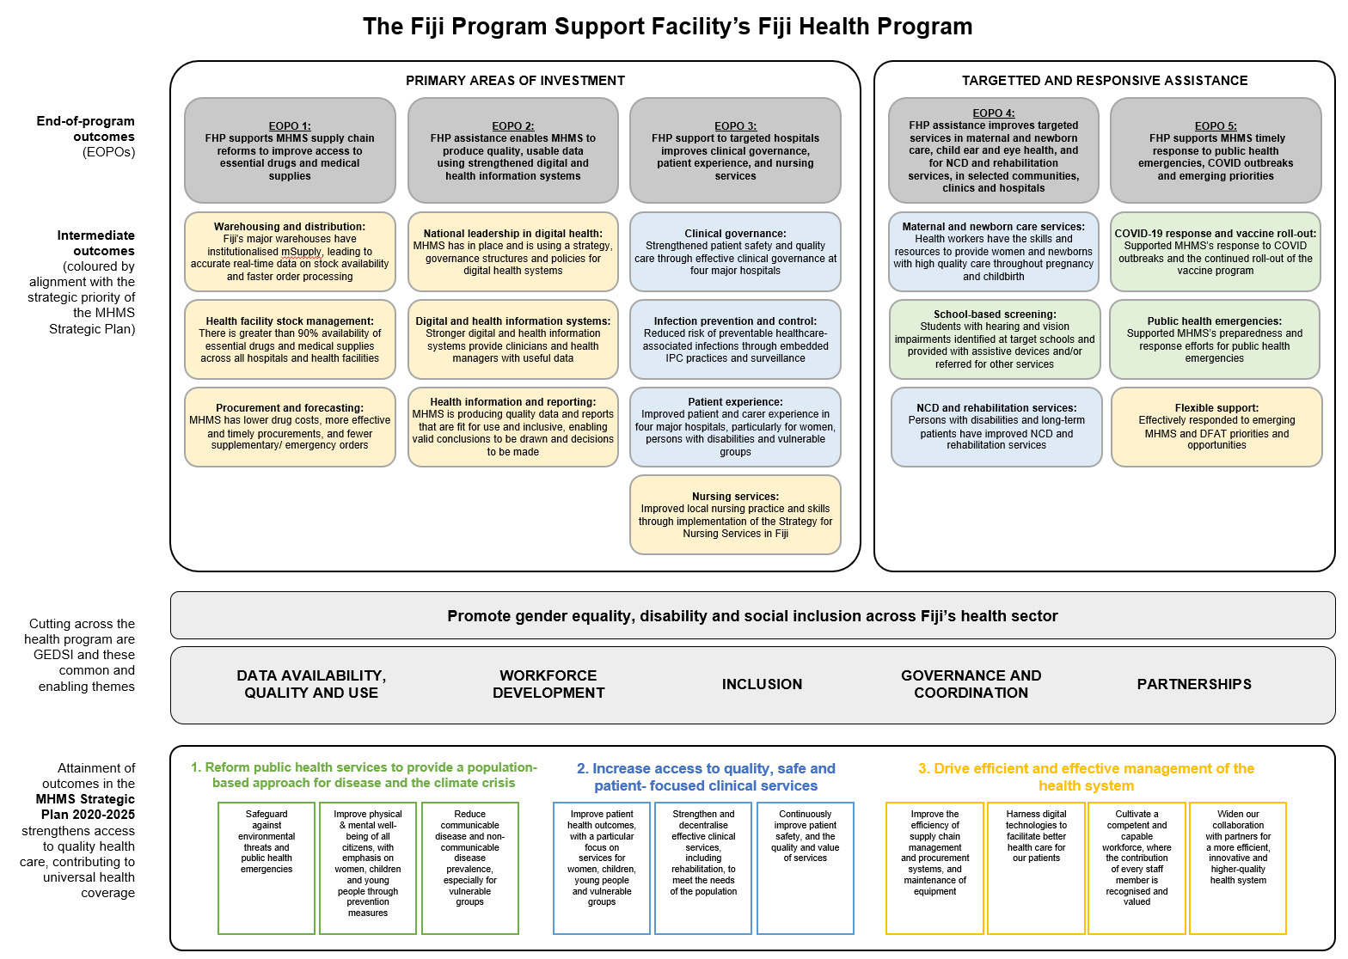

## PRIMARY AREAS OF INVESTMENT

### Supply Chain Reform Project

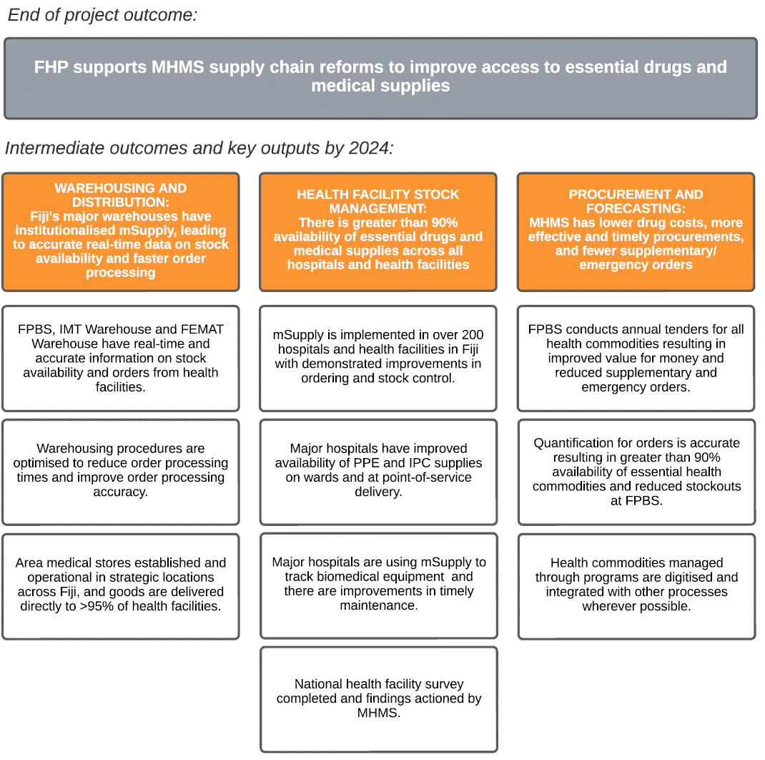

In partnership with Beyond Essential Systems (BES), FHP will continue supporting MHMS to undertake supply chain reforms to improve access to essential drugs and medical supplies for those who need them. The project aims to:

* Strengthen warehousing and distribution at FPBS and major warehouses;
* Improve availability of drugs and medical supplies at hospitals and health facilities; and
* Streamline national procurement, forecasting and ordering processes for drugs and medical supplies.

**Warehousing and distribution**

FHP will support FPBS to strengthen warehousing and distribution through improvements in three areas.

First, FHP will support FPBS to optimise the use of mSupply to order and distribute drugs. With two BES project officers working alongside FPBS staff, FHP will use on-the-job training, audits and process monitoring to further streamline ordering and stock management processes.

Second, FHP and BES will support MHMS and FPBS to institutionalise mSupply and the new stock management processes. This will include operationalising stock management SOPs (already drafted and agreed), and allocation of FPBS officers with specific mSupply functions to enable Fiji to independently manage mSupply.

Based on these two outcomes, Fiji’s major warehouses – at FPBS, the COVID Incident Management Team (IMT) warehouse, and the Fiji Emergency Medical Assistance Team (FEMAT) warehouse – will receive and respond to orders through mSupply and access real-time data on stock availability and other key performance indicators. This will help FPBS to improve accuracy and average order processing time at warehouses from several weeks to less than the five days target for regular orders.

The third activity in this outcome area will support FPBS to establish second-level medical stores (SLMS) in Northern and Western Divisions. Implementation of SLMS was identified as a high priority in BES’s initial Health Supply Chain Assessment in 2019[42]. While the construction of these warehouses is beyond FHP’s scope, FHP will help with operationalising these facilities through setting up mSupply, introducing SOPs, and training new staff. By 2024, at least one SLMS should be established and operational (noting this is dependent on construction of the SLMS). The SLMS will lower the risk of catastrophic stock loss in the event of a disaster (currently a national security risk with all bulk stock located centrally), reduce storage pressure on FPBS, and improve distribution network efficiencies.

**Health facility stock management**

The project’s second major outcome area focuses beyond warehousing and aims to improve availability of drugs and medical supplies at all hospitals and health facilities. This outcome will be delivered through two main activities – expansion of m-Supply to all health facilities and improvements to high-need health facilities – with a third provisional activity focused on tracking biomedical equipment through mSupply.

FHP will roll mSupply out at all health facilities with reasonable internet connections. FHP will provide training, IT equipment (tablets and/or desktops) and regular support – all in partnership with FPBS – to ensure these health facilities fully adopt mSupply for their stock management and ordering. The aim is to increase availability of essential health supplies from 74% in 2021 to over 90% by 2024, using a tracer list (or ‘basket of goods’) – assessed using mSupply and periodic physical audits.

A 2021 review of infection, prevention and control (IPC) identified logistic weaknesses within CWM as the main driver of poor IPC practice. FHP will address this by recruiting a hospital supply chain specialist to lead targeted intra-hospital logistics and storage reforms (‘the last 500m’) and physical audits of essential IPC and personal protective equipment (PPE) on wards and service delivery points.

Alongside mSupply’s roll-out, FHP will also help improve the accessibility and condition of high-need health facilities. BES will conduct a national health facility survey in 2024, covering over 90% of health facilities and focusing on collecting data on drug availability, infrastructure and equipment (to compare to the 2020 baseline health facility survey). A lesson learned from the baseline survey was the need to have a response mechanism to address any major deficiencies identified by the survey. FHP will support MHMS to make improvements at the 20 facilities (five per division) with the most immediate needs. This will include a joint maintenance and support team visiting the facilities to address and resolve basic supply, training and maintenance issues. By 2024, FHP will have supported MHMS to improve storage equipment and basic infrastructure at 40 health facilities.

A third provisional activity under this outcome area will be focused on tracking and maintaining biomedical equipment (identified as a key issue in an internal CWM review of unusual occurrence reports that showed that 21% of incidents were attributed to essential equipment not being available due to maintenance issues). The project will explore the use of mSupply as a tool for tracking biomedical equipment and this will be combined with a broader set of activities to improve the skills and resources of the biomedical teams. Should it proceed, the activity will result in major hospitals using mSupply to track biomedical equipment and undertake timely maintenance.

**Procurement and forecasting**

The final outcome focuses on helping to reduce drug and supply costs through streamlined national procurement, forecasting and ordering processes.

FHP will recruit a senior supply chain specialist to help FPBS undertake national procurement reforms including moving to annual tenders and digitising tender evaluations using mSupply’s tender module. The specialist will support development of guidelines, training and any other necessary reforms. By 2024, FPBS will conduct annual tenders and use mSupply’s tender module to evaluate and manage procurements.

At the same time, the project will help FPBS to digitise orders. FHP and BES will pilot digitisation of the Free Medicines Program (FMP) and present a report on the outcomes and future proposal for complete digitisation. In addition, FHP and BES will support FPBS to phase out its Bulk Purchase Scheme (BPS), which was previously assessed as inefficient and in need of replacement. Vertical programs – such as UNFPA’s management of family planning – will also be integrated into the ordering and stock management processes in mSupply. Finally, FHP and BES will help FPBS update its Essential Medical Supplies List (EMSL) stipulating which consumables, lab, dental and x-ray items FPBS will procure, distribute and monitor routinely.

By 2024, these improvements to FPBS ordering systems will result in consolidated lists of drugs and supplies across FPBS, health facility and partner order lists, as well as more accurate annual quantification of needs using average monthly consumption data from mSupply.

**Conclusion**

By the end of the project, these three outcome areas (stronger stock management, increased drug availability at facilities and reduced procurement costs) will together help MHMS and FPBS ensure health workers have the drugs and medical supplies they need to provide high quality health services in both major hospitals and remote clinics.

### Digital and Health Information Project

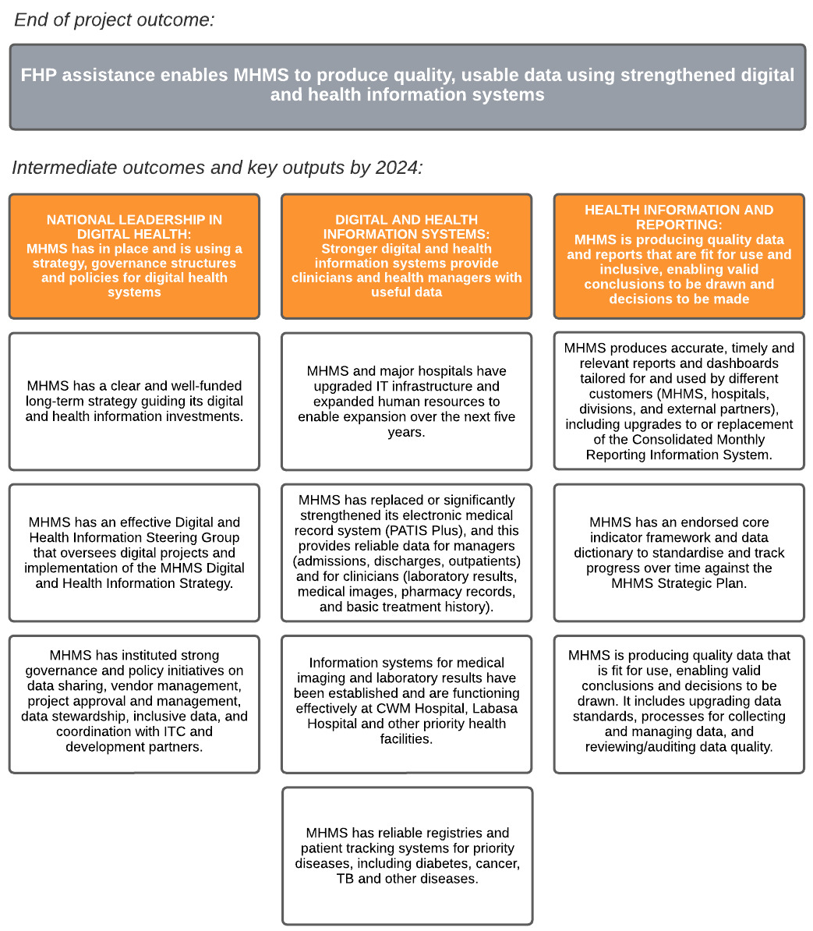

This project focuses on the building blocks of digital health. It involves a partnership with a leading digital health agency in the Pacific (Health Informatics) complemented with the setting up of a Project Management Unit (PMU) within MHMS, staffed with local experts on information technology, clinical coding and health analytics. There are three main goals:

* Strengthening national leadership and governance in digital health;
* Upgrading core digital and health information systems so that they are functional and reliable; and
* Instituting improved health information and reporting approaches to give health managers the data they need in a timely, accurate and accessible way they can use.

The outputs and outcomes were informed by reviews undertaken by Gevity Consulting in 2019 and Health Informatics Consulting in 2022. These reviews both identified the need for strengthening the building blocks for digital health, including leadership, people and an enabling environment; a stable, accessible and reliable hardware and software infrastructure; and data quality, coding and standards.

**National leadership in digital health**

A core focus of FHP’s support to MHMS will be strengthening national leadership on digital health. Fiji’s digital health space has become increasingly complex, with an expanding scope of work for the teams overseeing and using these systems.

Therefore, the priority will be to support MHMS to develop a Digital and Health Information Strategy and costed Action Plan. This will lay out the priorities and timeline for MHMS and provide the flagship policy document to guide future investments in digital health (from MHMS and development partners).

FHP will also assist with instituting mechanisms within MHMS to effectively manage the multitude of digital projects and health information needs. The establishment and operationalisation of the Digital and Health Information Steering Group will provide MHMS with a mechanism to approve new projects, oversee implementation of the Digital Health Strategy, and provide advice to senior leadership on digital and health information matters. The makeup of this Steering Group will be determined by MHMS. It will be important that it is representative and inclusive (such as including MHMS managers and clinicians and possibly other government agencies, like ITC and the Ministry of Women). MHMS does not currently have a Digital Health Strategy or Steering Group, meaning the future of health and clinical information systems is being shaped by evolution rather than a clear and systematic vision and plan.

FHP will also assist in the development of policies and SOPs, project management systems, knowledge management, inclusive data (such as collection and use of disability and gender-disaggregated data), and coordination.

**Digital and health information systems**

The second key objective is that MHMS and its hospital­s have well-functioning digital and health information systems providing clinical data to improve patient care. Areas of support will cover a wide range of issues with varying degrees of complexity, from minor system fixes, capacity development, resolution of major project and technical issues, support for management of major projects and system upgrades, and direct technical support for digital medical imaging (Radiology Information System/Picture Archiving Communication System (RIS/PACS)) and disease registries.

FHP will upgrade critical IT infrastructure (such as servers) and advocate to MHMS to expand human resources for IT. FHP will work with MHMS to strengthen PATIS Plus (the national electronic medical record system) – which is now over 10 years old – and potentially replace it within the project period. Other activities will include operationalising the RIS/PACS at CWM and Labasa hospitals and potentially more health facilities (it is not yet working as intended in any facility) and strengthening the quality of disease registries and tracking systems to improve clinical management and follow-up.

**Health information and reporting**

The final objective will be on turning data into actionable information. MHMS is not currently producing annual or standardised indicator reports, there is no endorsed MEL plan, and there is an agreed need to upgrade MHMS’s routine health information system (CMRIS) and data and coding standards.

To support evidence-based healthcare delivery, health system planning, and MEL, the health information system will need to produce high quality information that is complete and accurate at the time it is used for decision making. During the Strategic Review of FHP, challenges with getting accurate and complete data were regularly raised by MHMS and development partner stakeholders[43]. A key deliverable will be assisting MHMS to develop and report on a core indicator framework and data dictionary to standardise and track progress over time against the MHMS Strategic Plan.

**Conclusion**

As a result of this project, MHMS will automate some of its data collection and verification processes to allow staff to focus on higher value job functions, such as critical analysis and better reporting. In addition, the development and implementation of data standards will result in clearly defined data needs and processes that ensure data is complete, accurate and timely. Having a strong understanding of stakeholder information requirements – through agreed indicators and reporting formats – will also ensure that the right information is provided in an accessible way. Finally, with a leadership structure in place for digital information, MHMS’ leadership will, on a regular basis, consider and make decisions about health data and information systems.

### Patient Safety and Quality Care Project

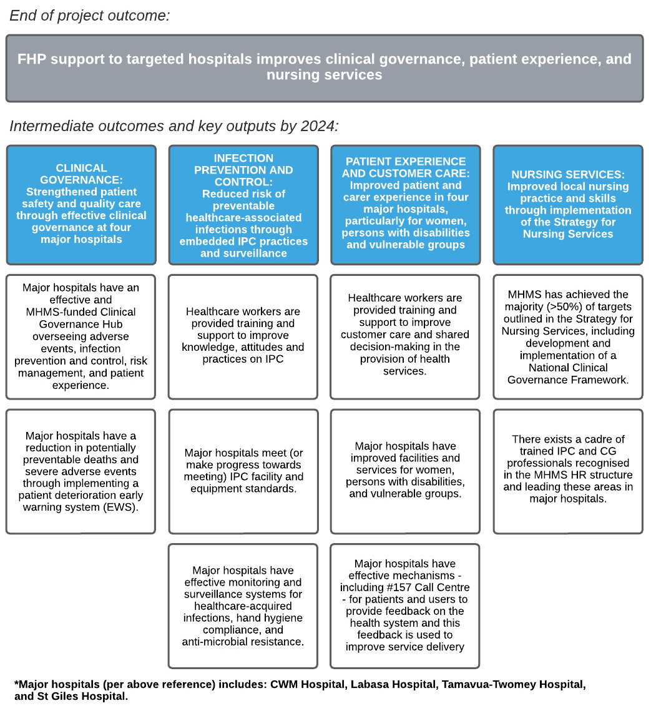

This project will work with MHMS and hospitals to improve quality, safe and patient-focused clinical services. FHP is partnering with the Doherty Institute to provide technical assistance on clinical governance and infection prevention and control (IPC). This support will be complemented with a locally-led team of experts in clinical governance, IPC, patient experience and customer care, and nursing services. There are four key goals:

* Institutionalising effective clinical governance teams, structures and systems that lead continuous improvement initiatives at major hospitals;
* Embedding IPC practices and surveillance to reduce preventable infections;
* Improving the overall experience and customer service received by patients, particularly for women, persons with disabilities and vulnerable groups; and
* Strengthening nationally-led initiatives to improve nursing services and conditions.

Assistance will be prioritised at the two major referral hospitals[44] (CWM and Labasa) and the two specialist hospitals (St Giles for psychiatric care and Tamavua-Twomey for rehabilitation, TB and other services). While FHP initially aimed to establish a larger number of hubs at all sub-divisional and divisional hospitals, FHP and MHMS decided to focus limited resources on ‘getting it right’ at the four target hospitals.

**Clinical governance**

The first outcome will be to support MHMS to continue establishing and improving clinical governance hubs at selected major hospitals. These hubs – made up of interdisciplinary staff – are responsible for overseeing patient safety and quality care. This covers adverse events, risk management, IPC and customer relations.

FHP will support modernising the unusual occurrence reports (UORs) system and training staff to use it as a tool for continuous improvement. UORs document near misses, adverse events, and other issues and if used effectively are a critical tool in reducing preventable deaths and injuries.

Following a recommendation from the Australian Medical Assistance Team (AUSMAT) in late 2021, FHP will be partnering with the Doherty Institute to set up and operationalise a patient deterioration early warning system (EWS) in critical care units at CWM and Labasa hospitals. This was assessed as one of the most effective ways to reduce preventable deaths.

The EWS will consist of four components:

Rolling out observation charts to document patient ‘vitals’, identify warning signs and provide clear advice on how to respond (integrated into the charts);

Training clinical staff to recognise deteriorating patients and use the clinical emergency response system (CERS);

Training staff in advanced cardiac life support (ACLS); and

Putting in place the infrastructure and equipment to manage deteriorating patients and cardiac arrests, including emergency trolleys, defibrillators, intercom and a rapid response pager system.

Through these activities, critical care units will have the equipment and skilled clinical staff to respond effectively to deteriorating patients. It will lead, by 2024, to a reduction in preventable deaths and severe adverse events.

**Infection prevention and control**

As a component of clinical governance, FHP will support MHMS to reduce the risk of hospital-acquired infections through effective IPC practices and surveillance. FHP is partnering with the Doherty Institute which brings specialist expertise in IPC and clinical governance[45].

FHP will support MHMS to implement IPC guidelines, set up IPC systems, conduct regular audits, and train staff on IPC compliance at the four target hospitals. This will draw on the expertise of the Doherty Institute, lessons from the COVID pandemic, the results of the most recent IPC audit (funded by FHP) and the SPC-developed IPC Handbook.

Based on IPC audit findings, FHP will procure equipment and undertake small refurbishments. This will include installing or upgrading facilities (such as handwash basins) and equipment (such as rackings and bins). There will also be interlinkages with FHP’s Supply Chain Reform Project, particularly to improve availability of IPC and PPE supplies.

By 2024, it is expected that major hospitals will be monitoring and responding to hospital acquired infections, hand hygiene compliance, and anti-microbial resistance leading to a reduction in preventable infections.

**Patient experience and customer care**

Alongside improvements to IPC and CG, FHP is supporting MHMS to improve patient and carer experiences, particularly for women, people with disabilities and vulnerable people. This will involve working with MHMS at the national level and with Customer Relations Officers and Boards of Visitors at each of the target hospitals.

Based on the 2019 study of customer care, FHP will support the development and implementation of learning and development strategies to enhance customer care by health workers. This will include adapting the existing Fiji Ministry of Civil Service training on customer service and rolling it out across the four hospitals. There will also be other trainings and activities to raise understanding on gender, disability and social issues, particularly for senior health managers at hospitals.

With few effective policies or feedback mechanisms on customer service, support will be provided to draft policies on aspects of customer care such as handling complaints. Methods to receive and action customer feedback will also be addressed, such as a digital suggestion box, a functional 157 complaints line and representative patient surveys. By the end of the program these policies and responsibility for training will be transferred to the CG hubs, which will then conduct future training and manage customer service in their hospitals.

Working with Boards of Visitors at the four hospitals, FHP will use patient feedback and hospital visits to identify improvements to hospital facilities that meet the needs of women, people with disabilities and vulnerable groups. This may include improvements to waiting areas and wards (such as shade, drinking water, toilets, extra beds or rooms for carers), better information services (such as information boards and desks) and targeted services and facilities (including sign language interpreters and ramps).

Through these initiatives, the outcomes will beimproved customer care by health workers, improved facilities and services (particularly for women, people with disabilities, and vulnerable groups) and effective mechanisms for patients to provide feedback on the health system.

**Nursing services**

Finally, FHP will help MHMS improve nursing practice and conditions by supporting implementation of the *MHMS Strategy for Nursing Services 2022-2024* (developed with FHP support). The Strategy provides a framework to improve nursing leadership, clinical practice and governance, and workforce development.

One key area of support will be to establish career pathways for nurses in IPC and clinical governance. Fiji does not have any professional IPC or clinical governance qualifications and even those trained in these fields receive no professional recognition or additional allowance. FHP will work with MHMS and the Fiji Nursing Council to establish a specialist field for IPC and clinical governance nurses with commensurate allowances. FHP will help to establish partnerships with the Australasian Institute of Clinical Governance and Australian College of IPC to deliver online and mixed method courses, particularly the Certificate in Clinical Governance for Patient Safety and Quality Care and the ‘Foundations for IPC’ course.

By 2024, FHP will have supported MHMS to achieved over 50% of the targets outlined in the strategy, including establishing a cadre of trained and internationally recognised IPC and clinical governance professionals at Fiji’s major hospitals.

**Conclusion**

By 2024, MHMS and hospitals will have the systems, structures and skilled workforce to continuously improve patient safety and the quality and value of services.

## TARGETED AND RESPONSIVE SERVICES

### Targeted services in Maternal and Newborn Care, Child Ear and Eye Care, and NCD and Rehabilitation Services

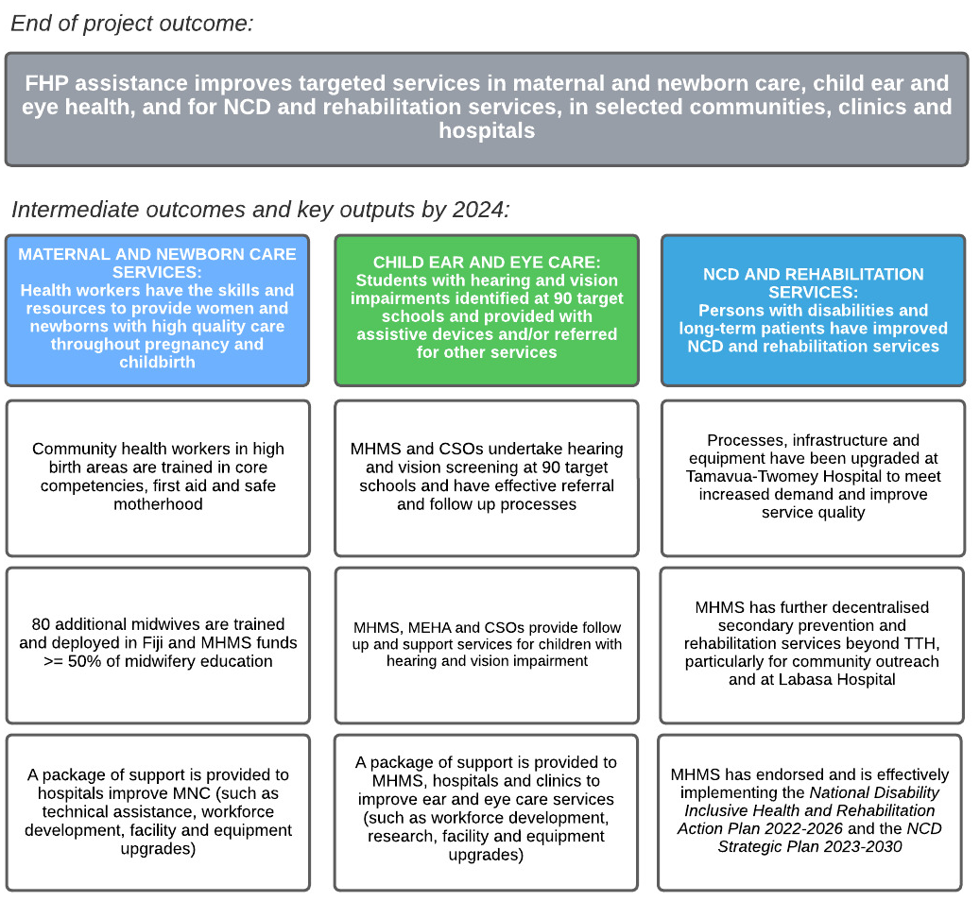

As part of the design update, FHP has consolidated three areas of investment that remain priorities but receive a smaller proportion of the overall funding. FHP assesses that targeted investments in these sub-sectors will deliver positive health outcomes for women, persons with disabilities and vulnerable groups, while also leveraging existing partnerships and demonstrating value for money.

This targeted assistance includes:

* Providing health workers with the skills and resources to deliver high quality care to women and newborns throughout pregnancy and childbirth;
* Screening children at schools for hearing and visual impairments, and linking them with health and support services; and
* Strengthening NCD and rehabilitation services for persons with disabilities and long-term patients.

**Maternal and newborn care**

To improve access to quality, safe and person-centred[46] maternal and newborn care (MNC) services, FHP will invest in training community health workers (CHWs) and midwives and addressing gaps identified by the FHP-funded Perinatal Review and through consultations with the Clinical Service Networks (CSNs) for obstetrics and paediatrics. The initiatives will address the ‘three delays’ in providing perinatal care: mothers not recognising early danger signs and seeking medical help at health facilities; care and referral by sub-divisional hospitals; and care at divisional hospitals.

In communities, FHP and MHMS will help improve CHW knowledge and skills on first aid and safe motherhood practices by partnering with Medical Services Pacific (a specialist health CSO) and St John Association of Fiji (a local CSO with expertise in first aid). The training will provide CHWs – who are usually the first point of contact for rural women – with the knowledge, skills and confidence to recognise danger signs, deliver basic information on safe motherhood, and facilitate referrals for antenatal care and childbirth. FHP will also equip CHWs with a health kit they can use for basic duties and to engage, educate and assess mothers.

Phase 1 of FHP helped close the midwife gap by funding tertiary midwifery education. FHP will continue to support this training, but with a gradual transition for funding to MHMS over FHP’s remaining 2.5 years (to be achieved through policy dialogue with MHMS). By the end of the program, FHP will have helped close the establishment gap and institutionalised funding within the MHMS budget for midwifery education.

With most births in Fiji delivered at major hospitals, FHP will also support initiatives to strengthen MNC at divisional hospitals and sub-divisional hospitals. It will do this by updating clinical guidelines and associated trainings for hospital staff, upgrading maternity wards and equipment (from both a clinical and patient experience perspective), and supporting national governance and oversight of MNC.

**Child ear and eye care**

FHP will work to strengthen school screening for vision and hearing impairments and linkages to health and support services. This is a collaboration with CSOs, MHMS and the Ministry of Education, Heritage and the Arts (MEHA). The aim is that by 2024, MHMS and MEHA will have a model for the continuation of these services through ongoing CSO partnerships with Project Heaven and the Frank Hilton Organisation (FHO).

Project Heaven will screen students at 90 target schools (this will be a collaboration with the Fiji Facility Education Program, and while the target is 90, this may change depending on MHMS, MEHA and available resources). Those identified with hearing and visual impairment will be referred to health services in line with existing clinical standards and linked to education and social services, including being recorded in the Fiji Education Management Information System (FEMIS) so that financial assistance can be provided (depending on the condition and severity).

FHP will also partner with FHO and the Fiji Disabled People’s Federation (FDPF). FHO will provide audiometry and speech pathology services, including trainings for health workers and teachers, and will lead the fitting and maintenance of hearing aids. FPDF will engage with communities and schools – through consultations and trainings – to raise awareness on disability inclusion and the violence against women and girls resulting from disability stigma in these communities.

The final activity will be providing a flexible package primarily focused on improving hearing and ear disease services in Fiji. This will be adapted based on need, but may include provision of equipment, trainings and technical assistance to existing ENT medical officers and nurses.

**NCD and rehabilitation services**

FHP will support initiatives to increase access to secondary prevention[47], rehabilitation and mobility services for persons with disabilities and patients in long-term care. It will do this through a combination of activities at the community, hospital and national levels. This will be delivered in partnership with Motivation Australia and local OPDs, particularly the Spinal Injuries Association. A “Nothing about us, without us” approach will guide the project.

Together with Motivation Australia, FHP will help upgrade processes, infrastructure and equipment at TTH to meet increased demand and improve service quality. This support will sustain these critical services while a new rehabilitation hospital is constructed by KOICA over the next five years. Aspects of FHP’s support will be to source and trial prosthetics and orthotics (P&O) equipment that are more appropriate to Fiji’s conditions, establish a database of amputees and persons with disabilities in need of continuing services, and update treatment and referral guidelines (and conduct associated trainings).

At the same time, FHP will support MHMS to decentralise secondary prevention and rehabilitation services beyond TTH. FHP will fund logistics, equipment and other costs for MHMS outreach teams to visit all divisions twice per year over the life of the project (considerably expanding the scope of currently under-resourced MHMS outreach and providing a database of amputees for future service delivery). The visits will offer services to people unable to travel to TTH to be assessed and fitted with prosthetics and provided with basic diabetic foot or limb care. Depending on capacity, FHP may also support MHMS to establish and equip its first rehabilitation hub in Labasa.

At the national level, Motivation Australia will support MHMS to finalise and implement the *National Disability Inclusive Health and Rehabilitation Action Plan (2022-2026).* Most assistance from FHP will centre around goal 2: “MHMS rehabilitation and assistive products workforce strengthened; and rehabilitation and assistive products services being accessed by all who may benefit.”

At the time of developing this design document, MHMS was finalising its *NCD Strategic Plan 2023-2030*. FHP has held discussions with MHMS on areas to support under this strategy. The agreed approach is to provide flexible support where MHMS has gaps and FHP has a comparative advantage. This will be prioritised in areas that link with other FHP investments. Examples may include supporting diabetic footcare to reduce the rate of amputations and initiatives to improve data and reporting on NCDs and disabilities.

### Flexible and response assistance

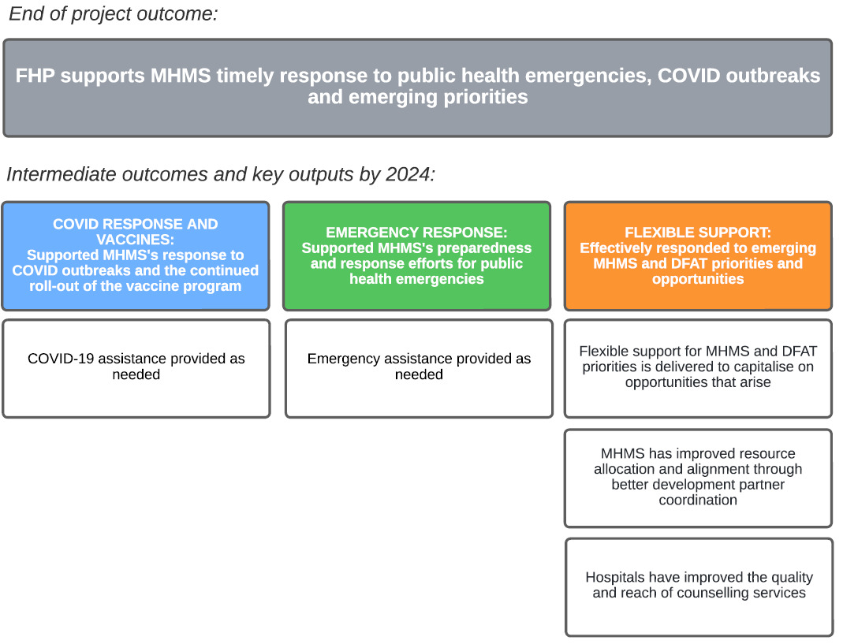

This area of investment aims to provide flexible support to MHMS to effectively respond to changing MHMS priorities and opportunities. Over the program implementation period, new opportunities and challenges will arise which FHP will be well-positioned to capitalise on. FHP will maintain an element of flexibility and responsiveness, but will assess requests based on needs, urgency, ability of MHMS to fund, comparative advantage and strategic alignment with Australian investments, and value for money.

**COVID response and vaccines**

FHP will continue to support the COVID vaccination roll-out with a team of data managers and logistics staff (up to December 2022 or as needed) and broader assistance on the response based on future outbreaks and gaps. In part, FHP support will respond to any gaps identified in the next MHMS intra-action review of Fiji’s COVID response.

**Emergency response**

FHP will support MHMS preparedness and response efforts to public health emergencies as they arise. Dedicated funding will be allocated for this purpose and reallocated after cyclone season (if no disasters). Historically, the most common responses have been for natural disasters, such as hurricanes and flooding, and/or disease outbreaks, such as leptospirosis, typhoid, dengue and diarrhoeal diseases (LTDD), measles and meningococcal disease.

**Flexible support**

Two existing priorities (but not major investments) include support for development partner coordination and hospital-based counselling. FHP assesses that these are key areas that the program can support MHMS without developing individual projects.

FHP will support development partner coordination through the engagement of a Development Partner Coordination Specialist. This position will be based in the Executive Support Unit and work closely with a dedicated MHMS counterpart. There will be a strong emphasis on supporting MHMS to identify the scope and value of development partner assistance to the health sector, mapping these, and improving transparency and accessibility of development partner support. These activities will facilitate MHMS leadership and direction of this support and ensure development partners are aligned to the Ministry’s goals and strategic objectives.

Counselling services is another critical area that is under resourced within the hospital sector. FHP will address this gap through the continued funding of Empower Pacific, a CSO that specialises in counselling services. FHP will explore options with MHMS and Empower Pacific for a longer-term solution to hospital-based counselling services. FHP will also support MHMS to develop national Counselling Standards for Hospitals with the University of the South Pacific.

1. Gender Equality, Disability and Social Inclusion

Inclusion is an inherent principle of the *MHMS Strategic Plan 2020-2025*, upon which the FHP program design is aligned. The *MHMS Strategic Plan* aims to improve the social wellbeing of all Fijians, with no one being left behind “regardless of geographical location, gender, ethnicity, physical and intellectual capability and social and economic status”.

**Lessons learned from Phase 1 of the Fiji Health Program**

FHP undertakes GEDSI reflect and refocus sessions every six months and conducted a GEDSI analysis as part of the Strategic Review process. The program is supported by the Facility’s GEDSI team and FHP has allocated three focal points who together help to identify ways to address gaps and harness opportunities to improve FHP activities. The key lessons learned during phase 1 include:

|  |  |
| --- | --- |
| **Lesson** | **Response** |
| FHP needs to support MHMS to institutionalise and sustain changes on GEDSI. | FHP will need to assess, and then address, the extent to which GEDSI initiatives supported by FHP are being institutionalised and sustained within MHMS, and how they are meeting the needs of women and girls, people living with disabilities, or the poor and marginalised. |
| FHP needs a systematic way to track progress against agreed entry points on GEDSI and to mainstream GEDSI in program planning and implementation. | FHP and the GEDSI team set up a ‘GEDSI tracker’ that tracks progress against entry points and is reviewed and adapted six-monthly. FHP has allocated designated GEDSI focal points to support the Team Leader to ensure GEDSI is routinely considered and there is close coordination with Facility GEDSI team. |
| OPDs have specialist skills and networks that can be leveraged by FHP to achieve better GEDSI outcomes. | FHP allocated specific funding for OPDs in its annual work plans and has incorporated joint planning and activities for specific projects. This has included OPDs undertaking accessibility audits with FHP funding refurbishments and OPDs leading trainings for health workers and communities on GEDSI related issues. |
| FHP should be cautious about investing in new areas to specifically address GEDSI. The focus should be on strengthening GEDSI in existing investments. | FHP is prioritising entry points within existing areas of investment. This includes better targeting investments on patient experience, community and hospital MNC, and rehabilitation services. |

**GEDSI entry points and gaps to be addressed by FHP**

FHP uses the twin-track approach to implement GEDSI: specific initiatives and mainstreaming. ‘Health for all’ and ‘nothing about us without us’ are two principles being adopted by FHP. These principles will be translated into action through expansion in community-based approaches, partnerships with OPDs and CSOs, and GEDSI-specific and mainstreaming interventions, such as activities on maternal and newborn care, patient experience, inclusive data, hearing and visual impairment screening, and rehabilitation services.

**GEDSI specific**

Of the five end-of-program outcomes, the targeted services in maternal and newborn care, child ear and eye care and NCD and rehabilitation services specifically focus on gender and disability issues.

The disability inclusion specific interventions are:

* Child ear and eye care; and
* NCD and rehabilitation services.

Child ear and eye care activities will support CSOs and MHMS to undertake school-based screening to identify and reduce childhood disability for hearing and visual impairment. This will address gaps in childhood disability screening and referral for support services, and the linkage between the education and health ministries and CSOs.

NCD and rehabilitation activities will support MHMS to deliver quality rehabilitation and mobility device services. It addresses gaps in prosthetics and orthotics services identified from a review by Motivation Australia and includes partnerships with (and funding for) OPDs. It has also been expanded to include community-based rehabilitation and referral pathways, as MHMS identified this as an ongoing challenge.

The gender inclusion specific intervention is:

* Maternal and Newborn Care (MNC).

FHP is investing to improve women’s access to, quality of and demand for maternal health services. Midwives – who are 98% women – will be trained to fill a critical workforce and service gap identified by MHMS. Another gap is access to accurate information on antenatal care, birth preparedness and safe motherhood in communities. This will be addressed through supporting MHMS to develop and deliver a basic training package for community health workers. FHP will promote MNC services that focus on ‘person-centred care’ to provide women with choice, control and continuity of care.

**GEDSI mainstreaming**

FHP will support MHMS in the following cross-cutting initiatives to address inequalities in gender, disability and social inclusiveness.

FHP will invest in improving the patient experience for women, persons with disabilities and vulnerable groups. A dedicated Patient Experience, Gender and Inclusion Coordinator will oversee these initiatives. Activities cut across components of the Patient Safety and Quality Care, MNC and Rehabilitation and Disability Service projects. Improvements will be achieved through:

* Partnering with OPDs, women’s organisations, Boards of Visitors and other stakeholders to identify opportunities and barriers to service delivery and dignified care. This will include engaging OPDs to conduct disability access audits;
* Upgrading non-medical facilities and equipment at specialist hospitals for mental illness (St Giles) and rehabilitation services (Tamavua-Twomey) and two divisional hospitals (CWM and Labasa). The goal will be to improve the physical environment for patients and carers on accessibility, privacy and liveability; and
* Providing support to review and fix patient feedback mechanisms (such as Customer Relations Officers at hospitals and the #157 call centre) to improve responsiveness to user feedback and continuous improvement of services.

There will also be a focus on providing health workers with tools and skills they need to provide more responsive and inclusive healthcare and to create a more open, safe and inclusive workplace. FHP will support MHMS through:

* The development and roll-out of training packages on customer care (aligned with the Ministry of Civil Service trainings), with specific modules on GEDSI;
* Trainings on GEDSI, prevention of sexual exploitation, assault and harassment (PSEAH) and child protection; and
* Technical assistance to MHMS in the revision of policies and procedures related to PSEAH and child protection (pending an assessment on gaps/needs).

FHP will be working across different EOPOs to improve the availability and use of inclusive and disaggregated data so that health managers better understand, address, and monitor the needs of marginalised people. Technical support will be provided to strengthen the use of data by MHMS in the development of targeted indicators, dashboards and reports that highlight disparities in sex, age, geographic location, and disability status. This is relevant for all FHP investments.

Social inclusion across the health program is emphasised through supporting MHMS to deliver health services in geographically vulnerable communities. FHP aims to strengthen access to quality community-based health services for antenatal care, rehabilitation outreach, hearing and visual impairment, and disease screening activities. Training of midwives as part of MNC workforce development will also support MHMS to decentralise MNC services, enabling more highly trained midwives to be deployed in rural and remote locations. The Supply Chain Reform Project will improve availability of drugs and medical supplies at hospitals and health facilities across Fiji. This is a project that will benefit all Fijians, with anticipated impact on facilities in remote areas.

1. Climate change/disaster risk reduction

FHP will focus its support on emergency preparedness and response and areas for mainstreaming climate change and disaster risk reduction (DRR). There are no climate change or DRR-specific projects.

The 2022 Strategic Review of FHP noted that “There are currently some areas, [that] while unquestionably important, are not recommended for major investment… Activities that may well fall into this category is providing significant support for … climate change.”

Therefore, FHP will take a mainstreaming approach to climate change and DRR. Opportunities for mainstreaming include:

* Improving data and reporting on climate-related indicators, such as resilience of health facility infrastructure (susceptibility to flooding, solar panels, etc) and for common diseases and health conditions (LTDD, malnutrition).
* Climate-proofing health facilities and warehouses, such as supporting the establishment of second-level medical stores (to decentralise supply chains and reduce the strategic risk of one main warehouse) and upgrading hospital and health facility infrastructure (drainage, roof leakages, cyclone resilience).
* Strengthening development partner coordination within MHMS, which can assist MHMS to map and align investments and goals on climate change and DRR.

1. Key policy priorities

The key policy priorities identified below are in areas where either FHP can advocate for significant positive change or where there is a strategic risk to DFAT’s investments in the health sector.

**KPP 1: Strengthen development partner coordination**

MHMS does not have a strong development partner coordination mechanism. FHP plans to fund a development partner coordination specialist to assist MHMS map development partner activities and develop stronger systems for tracking and coordinating partner activities. This will ultimately need strong MHMS leadership and sustained advocacy from partners (including DFAT) on the importance of coordinated development assistance (particularly in complex, multi-donor areas such as digital health systems and emergency response).

“Donor coordination is weak, thereby making it difficult to determine if Australian aid funding through the FHP is being used to best effect. More specifically, there is no real ‘donor mapping’ that maps where the strategic financing gaps are in the public health budget of Fiji, and which bilateral or multilateral development agencies are best placed to respond. It is not possible to know if FHP programs are complementing – or competing with – other development partners. The longstanding convention and agreed principle is that donor coordination is the responsibility of the partner government (in this case MHMS) which is to be ‘in the driver’s seat’.”

*Strategic Review of the Fiji Health Program, April 2022*

**KPP 2: Increase investment in human resources for information technology and longer-term upgrades**

DFAT is investing significant resources into digital and health information through FHP (as described above) as well as other investments such as the Indo-Pacific Centre for Health Security. This includes not only the specific project in this area, but also other projects – such as supply chain and patient safety and quality care – which rely on strong digital systems to be effective. Other development partners are also investing heavily in expanding digital solutions, but major weaknesses remain within MHMS to manage these systems. The initial review of MHMS’s digital health needs undertaken by Health Informatics identified human capacity as the primary challenge and risk.

“The Gevity Mid-Term Review of the [Digital Health] Strategy contained the following observations:

‘Domain knowledge and technical expertise – both embodied in people – are critical, scarce resources in any digital setting. Therefore, human and organizational capacity must be seen as a foundation on which the Ministry must define, refine, and underline their success strategies. Unfortunately, there are several vacancies that cannot seem to be filled in the IT Unit. Ultimately, the environment and foundation in which the proposed organization structure could be built and flourish in carrying out the Strategy has not been created.’

Those comments are still valid and the situation has in fact become worse with loss of the last remaining senior IT officer to a private hospital and the loss of several skilled coding staff to the Lautoka PPP Hospital.

Within the Data Analysis and Management Unit the loss of capacity can be seen in the backlog of coding and most particularly in the loss of analysis skills, demonstrated by the fact that the last Health Status Report produced by the section was in 2018.”

*Fiji Digital Health Project: Initial Review and Workplan, April 2022*

**KPP 3: MHMS actively takes over funding and management in agreed investment areas to ensure long-term sustainability**

For the long-term sustainability of DFAT’s investment, it will be essential that some programs and systems are fully transitioned to MHMS. This will require MHMS to fund specific human resource positions, licence and subscription fees, maintenance and support costs, and other resources as required. Specifically, this will include (but not limited to):

|  |  |
| --- | --- |
| **Investment** | **Details** |
| **Supply chain reforms** | There will be ongoing support costs for mSupply which MHMS will need to take over. There will also be a need for additional human resources – logistics officers to provide user support and IT officers to address technical issues. |
| **Digital and health information reforms** | The effective implementation of the Digital and Health Information Strategy will require an ongoing commitment from MHMS. This will include maintaining the Digital Health Steering Committee (involving time from senior officials, but no additional resources). There will be additional positions needed, particularly for the management of medical imaging (RIS/PACS), clinical coding, and divisional and hospital IT officers. MHMS will also need to ensure any new or existing licence and subscription fees are routinely paid and that service level agreements with local IT providers are adequately funded. |
| **Midwifery education** | The Strategic Review of FHP noted that “Midwifery training is something that Fiji, as an upper-middle income country with good educational facilities and staff, is capable of managing and financing by itself.” FHP is funding scholarships, but to ensure a cadre of midwives is trained annually, this will need to fully transition to MHMS. |
| **Clinical governance hubs** | MHMS has identified improving clinical governance in hospitals as a key priority. This can only be achieved through the establishment and effective operation of clinical governance hubs at hospitals, who actively monitor and manage patient safety and quality care. MHMS will need to ensure these hubs are adequately resourced with dedicated clinical governance, IPC and customer relations officers/managers. |

**KPP 4: MHMS should continue its focus on achieving universal healthcare, particularly on improving access to quality health services for women, persons with disabilities and vulnerable groups**

The MHMS Strategic Plan notes “We want to achieve universal health coverage (UHC) by providing the quality healthcare necessary for good health. Through an integrated approach to public health and by strengthening the continuum of care for patients, we will improve the health and wellbeing of all Fijians and combat the social determinants that affect people’s lives, especially the lives of the most vulnerable and marginalised.” This is a worthy goal that requires a concerted effort to ensure vulnerable groups – including those without a strong voice – are considered and prioritised in health planning and implementation. To achieve UHC, FHP will advocate for:

|  |  |
| --- | --- |
| **Investment** | **Details** |
| **‘Nothing about us, without us’ approach** | FHP and DFAT will strongly advocate for MHMS to engage organisations for persons with disabilities, women’s groups, boards of visitors, and civil society organisations in meaningful ways. |
| **Actionable data on GEDSI** | FHP and DFAT will encourage and support MHMS to actively collect and report on health service performance for women, persons with disabilities and vulnerable groups to identify gaps and improve accountability. |
| **Community-based services** | FHP will actively support initiatives to improve MHMS’s ability to deliver community-based services to rural and remote locations, particularly for poor and underserved areas. The focus will be through FHP’s targeted services in maternal and newborn care, child ear and eye care, and rehabilitation services. |
| **Patient experience and customer care** | Vulnerable and marginalised groups – such as the poor, those with mental health conditions, and persons with disabilities – can face greater discrimination in accessing quality health services. FHP will work with MHMS to improve feedback and accountability mechanisms so that these individuals are treated with dignity and respect. |

1. Sustainability and institutionalisation

Achieving sustainability requires that FHP plans for the eventual handover or continuation of benefits from interventions after the program ends. This has been a key consideration in the design of projects.

The Strategic Review noted that Fiji is an upper-middle income country which can fund many initiatives without development partner support. And that for the long-term sustainability of Australia’s investments, it will be essential MHMS takes over the management and resourcing longer-term (such as for midwifery education and supply chain reforms).

FHP has included institutionalisation and transition as a key policy priority and will continue to highlight at Program Coordination Committees and other forums. The establishment of the Budget and Resourcing Committee will be a key mechanism to highlight and track transition status of human resource positions and funding arrangements so that they are included in future human resource establishment and budget submissions.

Transition indicators (such as ‘% funding from MHMS’ and ‘evidence of increased MHMS resourcing’) have been incorporated into the Results Framework. Towards the end of the Facility, FHP may develop a specific sustainability or exit strategy outlining transition arrangements and priorities.

FHP has adopted the following principles for sustainability and transition[48].

|  |  |
| --- | --- |
| **Investment** | **Details** |
| **Developing a shared vision and design** | This program design – and the associated project designs – have been developed to align with MHMS’s strategies, plans and goals. This includes, not only the overarching strategic documents, but also sub-sector plans, such as the National Disability Inclusive Health and Rehabilitation Action Plan, the NCD Strategic Plan, and the Digital and Health Information Strategy. When investing in new systems or approaches, FHP needs to ensure that MHMS is fully supportive and has the capability and resources to take forward, such as for mSupply and digital medical imaging. |
| **Joint implementation through MHMS systems** | All of FHP’s activities are delivered through MHMS’s existing networks. FHP does not have any standalone projects. The projects outlined in this design are all co-designed with MHMS counterparts and will involve some level of co-implementation and investment from MHMS (whether in terms of funding or personnel/time costs). Each project has also been allocated a focal point in MHMS to improve accountability of FHP and ownership by MHMS. |
| **Tracking progress** | This program design outlines the EOPOs, intermediate outcomes and outputs that will be tracked six-monthly. These serve as the shared vision of priorities. FHP also has a results framework laying out quantitative and qualitative indicators which, where available, have been aligned with MHMS indicators. Specific indicators have also been developed to track sustainability (such as funding % from MHMS and # of facilities actively using mSupply). |
| **Continuous learning and adaptation** | FHP will remain flexible based on MHMS needs, achievements, and an ongoing reflection of what is and is not working. Feedback will be sought from MHMS, development partners, CSOs and OPDs, health service users, and other sources. FHP will also commission evaluations/reviews where it is assessed they will help to inform future investments. |

1. Monitoring, evaluation and learning

*The FHP Results Framework is available at Annex D of this design.*

FHP monitoring, evaluation and learning (MEL) aligns with the principles, standards and processes outlined in the Fiji Facility’s MEL Plan and MEL Guide (both documents submitted with this design).

The 2022 FHP strategic review noted “strong investment in MEL (around 6.4% of total program funds i.e. within the recommended range of 4-7% being allocated to MEL by DFAT)”. This resourcing will continue, with at least one full-time MEL Specialist working within the FHP team and FHP MEL supported by the Facility’s cross-program MEL team. Recent efforts to build the MEL capacity of FHP staff will continue, and MEL requirements will be built into implementing partner agreements to support the work of FHP MEL.

FHP **monitoring** will be guided by:

* The Fiji Facility’s monitoring workplan (updated biannually), which includes regular monitoring visits to health facilities, as well as support for MHMS monitoring and information systems.
* The indicators in the FHP results framework, which includes relevant mandatory indicators from the Fiji Facility Performance Assessment Framework, DFAT’s Tier 2 indicator list, and the Fiji COVID-19 Response Plan.

FHP **evaluation** will be guided by:

* Internal and independent reviews and evaluations to assess performance of FHP investments and to identify opportunities and gaps that can strengthen support to MHMS.
* Evaluative questions will test key assumptions in FHP’s program logic. These questions include:
  + To what extent has FHP helped MHMS to respond to health emergencies?
  + Are vulnerable Fijians (remote communities, elderly, young, women and girls, people with disabilities) benefiting from improved health services? How?
  + Are MHMS and FPBS supply chains delivering drugs more consistently and cheaply, particularly to peripheral health facilities?
  + Has patient safety and care improved at divisional hospitals?
  + To what extent is MHMS sustaining systems (particularly information systems) supported by FHP?
  + Has FHP strengthened the partnership between DFAT and the Government of Fiji?
* Questions raised by DFAT, by members of the PCC, or at FHP learning events (including at reflect and refocus talanoas and the Facility’s most significant change event). The evaluative questions above are subject to review at the Facility’s learning events (listed below).

FHP will commission independent evaluations of the following key FHP projects:

* Supply Chain Reform Project: Assess the extent to which reforms in supply chain and procurement systems have generated sustainable savings in time and money for the health sector.
* Patient Safety and Quality Care Project: Assess the extent to which a system for monitoring and responding to patient deterioration has led to a reduction in preventable deaths and severe adverse events.

FHP **learning** will be structured around:

* Reflect and refocus talanoas, which allow a periodic collective reflection to discuss performance and make joint decisions about where programs and activities need to intensify effort, pull back, or change strategic direction. Talanoas are the critical process linking performance information into decisions about program direction. Participation will include partners and MHMS, depending on the project.
* Collection and discussion of significant change stories and case studies at the annual most significant change event. The most significant change process facilitates collective deliberation and learning about FHP’s (and the broader Facility’s) most significant results (positive or negative), and how these lessons might be applied to other aspects of the health program. It also offers opportunity for collective validation of the accuracy and significance of the stories.

FHP MEL will work closely with the Facility’s GEDSI team to mainstream GEDSI considerations, including project designs and logic models, outcomes and indicators, and monitoring and evaluation activities.

FHP MEL will work closely with the Facility’s communications team to increase the number and quality of public diplomacy opportunities to elevate the profile of Australia’s investment in Fiji’s health sector. These will focus on achievement of FHP outputs and outcomes and demonstrable improvements in the lives of people in Fiji.

For more information on FHP’s MEL systems, refer to the Facility’s MEL plan and guide.

1. Implementation arrangements

**Program management**

FHP is part of the Facility Program Support Facility (FPSF). It is managed by a dedicated team of health and operations professionals who – in consultation with DFAT, MHMS and the broader Facility Program Support Facility – set the strategic direction, allocate and manage resources, and are responsible for program and project management for all activities.

FHP is supported by the Facility Management Unit (FMU). FMU provides additional financial management, operations, procurement, human resources, MEL, GEDSI, safeguarding, and management support.

FHP is headed by a Team Leader (Health), with three units: Technical Assistance and Partnerships; Performance and Communications; and Program Support and Operations. The core team consists of nine positions. The lead for technical assistance is the Public Health Specialist. This role oversees the quality of assistance, coordination with key partners and the alignment with MHMS priorities. The lead for performance and communications (which includes monitoring, evaluation, research, learning and adaptation) is the Design, Monitoring and Evaluation Specialist. This role is being localised as an Associate Monitoring, Evaluation and Learning Specialist. The lead for program support and operations is the Project Manager. This position is supported by three officers with expertise in finance, operations, and project management.

While there are no dedicated GEDSI positions, FHP has three focal points for GEDSI who work closely with the FMU’s GEDSI team to ensure the program is making progress in this area.

**Organisation chart for FHP core staff**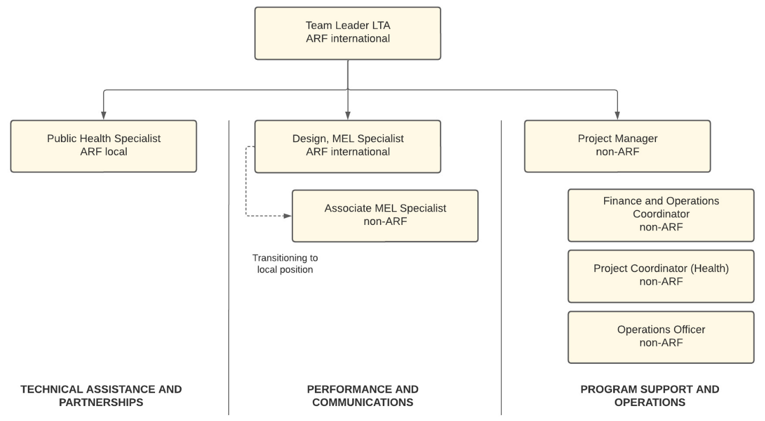

**Governance arrangements**

|  |  |
| --- | --- |
| **Investment** | **Details** |
| **Program Coordination Committee** | The Program Coordination Committee (PCC) provides strategic direction to, and oversight of, the Australia-Fiji Health Program (FHP), and as such provides high level governance of the program. It meets on a six-monthly basis or more frequently if needed.  It is the peak forum for senior managers across MHMS, DFAT, and the Facility to engage, discuss and agree on the key direction, priorities and ongoing implementation issues for the Health Program aligned to MHMS’s strategic objectives. The PCC provides a forum for joint consultation, planning, learning, coordination and decision-making to underpin delivery of FHP results and sustainability. |
| **FHP-MHMS Budget and Resourcing Committee** | FHP will seek to re-establish an FHP-MHMS Budget and Resourcing Committee. This will aim to identify resourcing provided to MHMS and ways to improve longer-term funding and human resources for investments, such as maintenance and support costs for new systems and transition of staff to MHMS. It will meet on a six-monthly basis or more frequently if needed. |
| **DFAT Weekly Meetings** | The Team Leader (Health) and Program Manager (DFAT) meet weekly to discuss priorities and issues. The meeting aims to keep both parties informed of emerging issues and to ensure alignment of priorities. The Counsellor (Development Cooperation), Facility Leader and GEDSI Specialist also attend meetings on an ad hoc, as needed, basis. Minutes and agenda are documented at every meeting. |
| **Working groups for projects/areas of investment** | FHP is prioritising working groups led by MHMS, rather than project-specific working groups. The main coordination and oversight bodies are:   * Clinical service networks for paediatrics and obstetrics (ongoing) * Technical Working Group on School-based Screening (to be set up) * Technical Working Group or Steering Group on Patient Safety and Quality Care (to be set up) * Technical Working Group on Rehabilitation Services (ongoing) * Technical Working Group on Supply Chain Reforms (ongoing) * Steering Group on Digital and Health Information (being set up) |

1. Risk management and safeguarding

*The FHP risk register is available at Annex F.*

FHP has undertaken a review of major risks – using the DFAT Risk and Safeguard Screening Tool – and identified five primary categories: contextual, programming, stakeholder, environmental and legal. The risks identified will be managed and monitored on an ongoing basis, with the tool formally reviewed and updated quarterly.

A key element of risk management is communication – and FHP will ensure that DFAT (and MHMS when relevant) are aware of risks, mitigation strategies and whether additional actions are needed. This will be through direct communication with DFAT if a risk increases or incident occurs or through formal governance mechanisms, such as the Program Coordination Committee (PCC) and the weekly DFAT meetings. Being part of the Facility, FHP will also be integrated into the Facility Management Unit risk management processes and benefit from additional management and oversight support as needed (particularly for legal risks, such as fraud, child protection and sexual exploitation, assault and harassment).

**Contextual:**

Fiji has a planned national election in late 2022. This may disrupt programming through changing priorities, personnel at MHMS, or political instability. During the election period, FHP will need to be more vigilant to ensure decisions made and initiatives launched are seen as apolitical – and if there is a real or perceived risk that may benefit one side of politics, then it may be prudent to delay until after the election (such as a major investment announcement).

As a mitigation, FHP will liaise closely with DFAT on the political situation and any decisions or announcements during this period, including considering implications. The Fiji Program Support Facility – including potentially FHP team members – will support the Government of Fiji through deployment of Election Monitors. This will be undertaken at the direction and approval of DFAT.

**Programming:**

There are four inter-related program risks:

* Sub-optimal program performance;
* FHP investments not being transitioned effectively to MHMS;
* Poor continuity of partners and / or services providers; and
* Vulnerable women, children and men not being adequately served by MHMS.

In broad terms these risks can be divided between MHMS and FHP.

Management of the programmatic risks most directly related to MHMS focus on human and budget resourcing, changed MHMS priorities and limited political will or governance structures for transition of projects to MHMS.

The programmatic risks most directly related to FHP are poor performance of FHP staff and / or service providers, non-alignment with MHMS priorities (or changed MHMS priorities), potential disagreements with service providers on technical direction or contractual / payment and relatively small pool of services providers. The Risk Register identifies MEL and GEDSI risks for both MHMS and FHP.

FHP will mitigate these risks through greater focus on institutionalisation (at the PCC and re-establishing the Budget and Resourcing Committee), investing in MEL (including feedback loops with Reflect and Refocus Sessions and tracking mechanisms for outcomes, outputs and GEDSI entry points), and ensuring FHP maintains strong program support and operations capabilities (to maintain efficiencies in contracting and payments and inclusive recruitment processes).

**Stakeholder:**

Limited strategic governance and stakeholder coordination may contribute to high transaction costs for MHMS (especially senior leadership) and inefficient use of development partner resources (both human and financial).

FHP aims, in part, to mitigate these risks though the recruitment of a Development Partner Coordination Specialist to work with the Executive Support Unit of MHMS and also FHP working proactively to coordinate with existing development partners within the sector.

**Environmental:**

Environmental risks centre on emergency response and the potential impact of natural disasters and disease outbreaks. Natural disasters, such as cyclones and flooding, are increasing in both severity and frequency due to climate change. Disease outbreaks may also be more likely to occur, such as another variant of COVID or a re-emergence of vaccine preventable diseases (particularly measles and meningococcal) as vaccination rates have reduced. Both natural disasters and disease outbreaks would result in MHMS and FHP diversion of funds and priorities, requiring a dedicated response.

These risks are mitigated in part through ensuring close alignment and discussion with MHMS, DFAT and other stakeholders following a disaster or disease outbreak to determine the size and scope of assistance provided. FHP has also allocated funding specifically for COVID and emergency response so that regular programming will not be impacted unless the response goes above this.

**Legal:**

There are three key legal risks:

* Fraud by FHP, MHMS or delivery partners;
* Child or children harmed or abused due to FHP-supported activities; and
* Individual(s) sexually exploited, abused or harassed (SEAH) due to FHP-supported activities.

These risks are both direct for individuals and FHP (e.g. an individual is harmed or fraudulent activity reduces effectiveness of FHP) but are also broader as reputational risks to DFAT, MHMS, FHP and the wider Facility. Any credible suspicion or allegation of fraud, child abuse or SEAH would be escalated to DFAT in accordance with DFAT policies.

Fraud risk is significant from a resourcing perspective but also in the potential loss of trust, termination of contracts (staff or service providers) and the need for resources being diverted for potential audit follow-up and investigation. The fraud risks are mitigated through training and awareness, strong procurement and recruitment processes, an external (to FHP) financial manager in FMU, strong contracting processes, and all staff signing Conflict of Interest and Code of Conduct forms.

Both the child protection and prevention of sexual exploitation, abuse and harassment (PSEAH) risks are managed and mitigated through the DFAT compliant child protection risk assessment tool and the DFAT compliant PSEAH policy. All FHP staff, partners and downstream service providers (including CSOs and OPDs) are compliant with the child protection requirements. All FHP staff are required to complete child protection and PSEAH training.

FHP adheres to all safeguarding measures according to the Facility’s Child Protection Plan and PSEAH Plan, which ensures compliance with DFAT’s Child Protection and PSEAH standards. Downstream partners are also required to comply with these standards.

All FHP activities are subject to their own child protection and PSEAH risk assessments, and additional mitigations include:

* Ensuring that personnel are accompanied by other adults when in the presence of children or vulnerable adults;
* Ensuring any photography meets DFAT requirements including informed child/individual/parent/guardian consent as required;
* Avoiding or reducing overnight stays in small or rural communities wherever possible; and
* Development of a PSEAH code of conduct for roll out to all Facility staff for signing.

1. Annexes

ANNEX A: PROGRAM LOGIC

ANNEX B: HUMAN RESOURCES AND PROGRAM MANAGEMENT STRUCTURE

ANNEX C: 3-YEAR BUDGET

ANNEX D: RESULTS FRAMEWORK

ANNEX E: HIGH-LEVEL IMPLEMENTATION PLAN

ANNEX F: PROGRAM RISK MATRIX

ANNEX G: Alternate text for: The Fiji Program Support Facility’s Fiji Health Program (accessible)

ANNEX H: Alternate text for: Supply Chain Reform Project (accessible)

## ANNEX I: Alternate text for: Digital and Health Information Project (accessible)

ANNEX J: Alternate text for Patient Safety and Quality Care Project (accessible)

ANNEX K: Alternate text for: Targeted services in maternal and Newborn Care, Child Ear and Eye Care, and NCD and Rehabilitation Services (accessible)

ANNEX L: Alternate text for: Flexible and responsive assistance (accessible)

ANNEX M: Alternate text for: Organisation chart for FHP core staff (accessible)

**Reference documents (provided separately)**

EXECUTIVE SUMMARY OF STRATEGIC REVIEW OF THE FIJI HEALTH

MANAGEMENT RESPONSE TO RECOMMENDATIONS FROM STRATEGIC REVIEW

EXECUTIVE SUMMARY OF ORIGINAL DESIGN DOCUMENT

## Annex G: Alternate text for: The Fiji Program Support Facility’s Fiji Health Program (accessible)

PRIMARY AREAS OF INVESTMENT

**END OF PROGRAM OUTCOME (EOPO) 1: FHP supports MHMS supply chain reforms to improve access to essential drugs and medical supplies**

* + **Warehousing and distribution**: Fiji’s major warehouses have institutionalised mSupply, leading to accurate and real-time data on stock availability and faster order processing.
  + **Health facility stock management**: There is greater than 90% availability of essential drugs and medical supplies across all hospitals and health facilities.
  + **Procurement and forecasting**: MHMS has lower drug costs, more effective and timely procurements and fewer supplementary/emergency orders.

**EOPO 2: FHP assistance enables MHMS to produce quality, usable data and using strengthened digital and health information systems**

* + **National leadership in digital health:** MHMS has in place and is using a strategy, governance structures and policies for digital health systems.
  + **Digital and health information systems**: Stronger digital and health information systems provide clinicians and health managers with useful data.
  + **Health Information and reporting**: MHMS is producing quality data and reports that are fit for use and inclusive, enabling valid conclusions to be drawn and decisions to be made.

**EOPO 3: FHP support to targeted hospitals improves clinical governance, patient experience, and nursing services**

* + **Clinical governance:** Strengthened patient safety and quality care through effective clinical governance at four major hospitals.
  + **Infection prevention and control:** reduced risk of preventable healthcare-associated infections through embedded IPC practices and surveillance.
  + **Patient experience:** Improved patient and carer experience in four major hospitals, particularly for women, persons with disabilities and vulnerable groups.
  + **Nursing services:** Improved local nursing practice and skills through implementation of the Strategy for Nursing Services in Fiji.

TARGETTED AND RESPONSIVE ASSISTANCE

**EOPO 4: FHP assistance improves targeted services in maternal and newborn care, child ear and eye health, and for NCD and rehabilitation services, in selected communities, clinics and hospitals**

* **Maternal and newborn care services:** Health workers have the skills and resources to provide women and newborns with high quality care throughout pregnancy and childbirth.
* **School-based screening:** Students with hearing and vision impairments identified at target schools and provided with assistive devices and/or referred for other services.
* **NCD and rehabilitation services:** Persons with disabilities and long-term patients have improved NCD and rehabilitation services.

**EOPO 5: FHP supports MHMS timely response to public health emergencies, COVID outbreaks and emerging priorities**

* **COVID-19 response and vaccine roll-out:** Supported MHMS’s response to COVID outbreaks and the continued roll-out of the vaccine program.
* **Public health emergencies**: Supported MHMS’s preparedness and response efforts for public health emergencies.
* **Flexible support**: Effectively responded to emerging MHMS and DFAT priorities and opportunities.

CROSS CUTTING AND ENABLING THEMES: Promote gender equality, disability and social inclusion across Fiji’s health sector

* Data availability, quality and use
* Workforce development
* Inclusion
* Governance and Coordination
* Partnerships

Attainment of outcomes in the **MHMS Strategic Plan 2020-2025** strengthens access to quality health care, contributing to universal health coverage

1. Reform public health services to produce a population-based approach for disease and the climate crisis

* Safeguard against environmental threats and public health emergencies.
* Improve physical & mental well being of all citizens, with emphasis on women, children and young people through prevention measures.
* Reduce communicable disease and noncommunicable disease prevalence, especially for vulnerable groups.

1. Increase access to quality, safe and patient-focused clinical services
   * Improve patient health outcomes with a particular focus on services for women, children, young people and vulnerable groups.
   * Strengthen and decentralise effective, clinical services, including rehabilitation, to meet the needs of the population.
   * Continuously improve patient safety, and the quality and value of services.
2. Drive efficient and effective management of the health system
   * Improve the efficiency of supply chain management and procurement systems, and maintenance of equipment.
   * Harness digital technologies to facilitate better health care for our patients.
   * Cultivate a completed and capable workforce, where the contribution of every staff member is recognised and valued.
   * Widen our collaboration with partners for a more efficient, innovative and higher-quality health system.

## Annex H: Alternate text for: Supply Chain Reform Project (accessible)

***End of project outcome:***

FHP supports MHMS supply chain reforms to improve access to essential drugs and medical supplies

***Intermediate outcomes and key outputs by 2024:***

**WAREHOUSING AND DISTRIBUTION: Fiji’s major warehouses have institutionalised mSupply, leading to accurate real-time data on stock availability and faster order processing**

* + FBPS, IMT Warehouse and FEMAT Warehouse have real-time and accurate information on stock availability and orders from health facilities.
  + Warehousing procedures are optimised to reduce order processing times and improve order processing accuracy.
  + Area medical stores established and operational in strategic locations across Fiji, and goods are delivered directly to >95% of health facilities.

**HEALTH FACILITY STOCK MANAGEMENT: There is greater than 90% availability of essential drugs and medical supplies across all hospitals and health facilities**

* + mSupply is implemented in over 200 hospitals and health facilities in Fiji with demonstrated improvements in ordering and stock control.
  + Major hospitals have improved availability of PPE and IPC supplies onwards and at point-of-service delivery.
  + Major hospitals are using mSupply to track biomedical equipment and there are improvements in timely maintenance.
  + National Health facility survey completed and findings actioned by MHMS.

**PROCUREMENT AND FORECASTING: MHMS has lower drug costs, more effective and timely procurements, and fewer supplementary/ emergency orders**

* + FBPS conducts annual tenders for all health commodities resulting in improved value for money and reduced supplementary and emergency orders.
  + Quantification for orders resulting in greater than 90% availability of essential health commodities and reduced stockouts at FBPS.
  + Health commodities managed through programs are digitised and integrated with other processes wherever possible.

## Annex I: Alternate text for: Digital and Health Information Project (accessible)

***End of project outcome:***

FHP assistance enables MHMS to produce quality, usable data using strengthened digital and health information systems

***Intermediate outcomes and key outputs by 2024:***

**NATIONAL LEADERSHIP IN DIGITAL HEALTH: MHMS has in place and is in place a strategy, governance structures and polices for digital health systems.**

* + MHMS has a clear and well-funded long-term strategy guiding its digital and health information investments.
  + MHMS has an effective Digital and Health Information Steering Group that oversees digital projects and implementation of the MHMS Digital and Health Information Strategy.
  + MHMS has instituted strong governance and policy initiatives on data sharing, vendor management, project approval and management, data stewardship, inclusive data, and coordination with ITC and development partners.

**DIGITAL AND HEALTH INFORMATION SYSTEMS: Stronger digital and health information systems provide clinicians and health managers with useful data**

* + MHMS and major hospitals have upgraded IT infrastructure and expanded human resources to enable expansion over the next five years.
  + MHMS has replaced or significantly strengthened its electronic medical record system (PATIS Plus), and this provides reliable data for managers (admissions, discharges, outpatients) and for clinicians (laboratory results, medical images, pharmacy records, and basic treatment history).
  + Information systems for medical imaging and laboratory results have been established and are functioning effectively at CWM Hospital, Labasa Hospital and other priority health facilities.
  + MHMS has reliable registries and patient tracking systems for priority diseases, including diabetes, cancer, TB and other diseases.

**HEALTH INFORMATION AND REPORTING: MHMS is producing data and reports that are fit for use and inclusive, enabling valid conclusions to be drawn and decisions to be made**

* + MHMS produces accurate, timely and relevant reports and dashboards tailored for and used by different customers (MHMS, hospitals, divisions, and external partners), including upgrades to or replacement of the Consolidated Monthly Reporting Information System.
  + MHMS has an endorsed core indicator framework and data dictionary to standardise and track progress over time against the MHMS Strategic Plan.
  + MHMS is producing quality data that is fit for use, enabling valid conclusions and decisions to be drawn. It includes upgrading data standards, processes for collecting and managing data, and reviewing/auditing data quality.

## Annex J: Alternate text for Patient Safety and Quality Care Project (accessible)

***End of project outcome:***

FHP support to targeted hospitals improves clinical governance, patient experience, and nursing services

***Intermediate outcomes and key outputs by 2024:***

**CLINICAL GOVERNANCE: Strengthened patient safety and quality care through effective clinical governance at four major hospitals**

* + Major hospitals have an effective and MHMS-funded Clinical Governance Hub overseeing adverse events, infection prevention and control, risk management, and patient experience.
  + Major hospitals have a reduction in potentially preventable deaths and severe adverse events through implementing a patient deterioration early warning system (WES).

**INFECTION PREVENYION AND CONTROL: Reduced risk of preventable healthcare-associated infections through embedded IPC practices and surveillance**

* + Healthcare workers are provided training and support to improve knowledge, attitudes and practices on IPC.
  + Major hospitals meet (or make progress towards meeting) IPC facility and equipment standards.
  + Major hospitals have effective monitoring and surveillance systems for healthcare-acquired infections, hand hygiene compliance, and anti-microbial resistance.

**PATIENT EXPERIENCE AND CUSTOMER CARE: Improved patient and carer experience in four major hospitals, particularly for women, persons with disabilities and vulnerable groups**

* + Healthcare workers are provided training and support to improve customer care and shared decision-making in the provision of health services.
  + Major hospitals have improved facilities and services for women, persons with disabilities, and vulnerable groups.
  + Major hospitals have effective mechanisms – including #157 Call Centre – for patients and users to provide feedback on the health system and this feedback is used to improve service delivery.

**NURSING SERVICES: Improved local nursing practice and skills through implementation of the Strategy for Nursing Services**

* + MHMS has achieved the majority (>50%) of targets outlined in the Strategy for Nursing Services, including development and implementation of a National Clinical Governance Framework.
  + There exists a cadre of trained IPC and CG professionals in the MHMS HR structure and leading these areas in major hospitals.

*Major hospitals (per above reference) includes; CWM Hospital, Labasa Hospital, Tamavua-Twomey Hospital, and St Giles Hospital.*

## Annex K: Alternate text for: Targeted services in maternal and Newborn Care, Child Ear and Eye Care, and NCD and Rehabilitation Services (accessible)

***End of project outcome:***

FHP assistance improves targeted services in maternal and newborn care, child ear and eye health, and for NCD and rehabilitation services, in selected communities, clinics and hospitals.

***Intermediate outcomes and key outputs by 2024:***

**MATERNAL AND NEWBORN CARE SERVICES: Health workers have the skills and resources to provide women and newborns with high quality care throughout pregnancy and childbirth**

* + Community health workers in high birth areas are trained in core competencies, first aid and safe motherhood.
  + 80 additional midwives are trained and deployed in Fiji and MHMS funds >=50% of midwifery education.
  + A package of support is provided to hospitals to improve MNC (such as technical assistance, workforce development, facility and equipment upgrades).

**CHILD EAR AND EYE CARE: Students with hearing and vision impairments identified at 90 target schools and provided with assistive devices and/or referred for other services.**

* + MHMS and CSOs undertake hearing and vision screening at 90 target schools and have effective referral and follow up processes.
  + MHMS, MEHA and CSOs provide follow up and support services for children with hearing and vision impairment.
  + A package of support is provided to MHMS, hospitals and clinics to improve ear and eye care services (such as workforce development, research, facility and equipment upgrades).

**NCD AND REHABILITATION SERVICES: Persons with disabilities and long-term patients have improved NCD and rehabilitation services**

* + Processes, infrastructure and equipment have been upgraded at Tavamua-Twomey Hospital to meet increased demand and improve service quality.
  + MHMS has further decentralised secondary prevention and rehabilitation services beyond TTH, particularly for community outreach and at Labasa Hospital.
  + MHMS has endorsed and is effectively implementing the *National Disability Inclusive Health and Rehabilitation Action Plan 2022-2026* and the *NCD Strategic Plan 2023-2030*.

## Annex L: Alternate text for: Flexible and responsive assistance (accessible)

***End of project outcome:***

FHP supports MHMS timely response to public health emergencies, COVID outbreaks and emerging priorities

***Intermediate outcomes and key outputs by 2024:***

**COVID RESPONSE AND VACCINES: Supported MHMS’s response to COVID outbreaks and the continued roll-out of the vaccine program**

* + COVID-19 assistance provided as needed.

**EMERGENCY RESPONSE: Supported MHMS’s preparedness and response efforts for public health emergencies**

* + Emergency assistance provided as needed.

**FLEXIBLE SUPPORT: Effectively responded to emerging MHMS and DFAT priorities and opportunities**

* + Flexible support for MHMS and DFAT priorities is delivered to capitalise on opportunities that arise.
  + MHMS and alignment through better development partner coordination.
  + Hospitals have improved the quality and reach of counselling services.

## Annex M: Alternate text for: Organisation chart for FHP core staff (accessible)

* Team Leader LTY (ARF International)

Technical assistance and partnerships

* Public Health Specialist (ARF Local)

Performance and Communications

* Design, MEL Specialist (ARF International)
  + Associate MEL Specialist (non-ARF – transitioning to local position)

Program Support and Operations

* Project Manager (non-ARF)
  + Finance and Operations Coordinator (non-ARF)
  + Project Coordinator – Health (non-ARF)
  + Operations Officer (non-ARF)

1. The Fiji Program Support Facility (“the Facility”) was established in 2017 to support and implement Australia’s aid programs such as health, education, emergency preparedness and response, and governance in Fiji.
2. Australian Government DFAT. “Fiji COVID-19 Development Response Plan”. Retrieved from https://www.dfat.gov.au/development/australias-development-program/covid-19-development-response-plans/fiji-covid-19-development-response-plan
3. Beyond Essential Systems (2019). Fiji Health Supply Chain Assessment.
4. Gevity Consulting (2020). *Fiji HIS – CIS Strategy 2016 – 2020 Mid-Term Review.*
5. Murdoch Children’s Research Institute (2021). Fiji Perinatal Review.
6. <https://www.theguardian.com/world/2020/jun/27/our-diet-is-killing-us-quietly-fijis-diabetes-crisis> <https://www.rnz.co.nz/international/pacific-news/394023/diabetic-amputations-40-percent-of-all-fiji-surgery> (accessed 9 May 2022)
7. https://www.ncbi.nlm.nih.gov/books/NBK52711/#ch1.s6
8. MHMS (2020). National Strategic Plan 2020-2025.
9. Asante, A.D. et al., 2017. Financing for universal health coverage in small island states: evidence from the Fiji Islands; Boyle, M., 2018. More than 30 thousand Fijians benefit from medicine scheme. <https://www.fbcnews.com.fj/news/more-than-30-thousand-fijians-benefit-from-medicine-scheme/> (accessed 6 July 2022)
10. MHMS. Strategic Workforce Plan 2020-2030. (UNPUBLISHED). P11. Based on internal analysis as of 24 August 2022, the top three MHMS positions are filled by males (Minister, Permanent Secretary and Chief Medical Adviser) and 6 out of 10 heads of units are female. One of five major hospital Medical Superintendents is female and one of the three Divisional Medical Officers is female.
11. MHMS COVID-19 Update, 16 May 2022 (via Twitter)
12. Murdoch Children’s Research Institute (2021). Fiji Perinatal Review.
13. MHMS, 2018. 2017 Health Status Report
14. <https://data.worldbank.org/indicator/SH.STA.MMRT?locations=FJ> (accessed 10 November 2021)
15. FBOS, 2021. Fiji MICS 2020 (Preliminary Results)
16. MCRI (2020). Fiji Perinatal Review.
17. MCRI (2020). Fiji Perinatal Review.
18. Miscarriage Care Needs to Change Around the World. <https://www.forbes.com/sites/alicebroster/2021/04/28/miscarriage-care-needs-to-change-around-the-world-according-to-new-report/?sh=47fa147957ae> (accessed 24 May 2022)
19. Data provided by MHMS
20. FBOS, 2019. Republic of Fiji Vital Statistics Report 2012-2017
21. Hendricks, A-M. et al., 2015. Perspectives of Fijian Policymakers on the Obesity Prevention Policy Landscape
22. Hendricks, A-M. et al., 2015. Perspectives of Fijian Policymakers on the Obesity Prevention Policy Landscape
23. FBOS, 2021. Fiji MICS 2020 (Preliminary Results)
24. <https://asiapacificreport.nz/2018/05/30/diabetes-deaths-in-fiji-worst-in-the-world-says-report/>. (accessed 8 May 2022)
25. Lin et al., 2015 Diabetes and Obesity Trends in Fiji
26. <http://www.health.gov.fj/diabetes-2/diabetes/> (accessed 10 May 2021)
27. <https://www.nutraingredients-asia.com/Article/2018/06/04/Fiji-s-diabetes-epidemic-Nation-already-exceeding-WHO-s-predicted-rate-for-2030> (accessed 9 May 2021)
28. <https://www.theguardian.com/world/2020/jun/27/our-diet-is-killing-us-quietly-fijis-diabetes-crisis> <https://www.rnz.co.nz/international/pacific-news/394023/diabetic-amputations-40-percent-of-all-fiji-surgery> (accessed 9 May 2022)
29. MHMS, 2014. Reproductive Health Policy
30. Fiji Bureau of Statistics (2017). The census found that the permanent population of Fiji was 884,887.
31. UNFPA, 2020. Health Facility Readiness and Service Availability (HFRSA) Assessment
32. https://www.ncbi.nlm.nih.gov/books/NBK52711/#ch1.s6
33. <https://www.health.gov.fj/wp-content/uploads/2021/01/Clinical-Guidelines-Primary-Ear-Disease-and-Hearing-Care-in-Fiji.pdf> (accessed 22 September 2022)
34. <https://www.health.gov.fj/mental-health/> (accessed 22 November 2021)
35. FHSSP, valued at A$33 million, was implemented in two Phases (2011 – 2014 and 2014 – 2016), both of which were managed by Abt-JTA.
36. MHMS (2020). Remodeling of Health Service Provision 2020/2021. P2.
37. Australian Government DFAT. “Fiji COVID-19 Development Response Plan”. Retrieved from https://www.dfat.gov.au/development/australias-development-program/covid-19-development-response-plans/fiji-covid-19-development-response-plan
38. Global Goals. “3 Good Health and Well-Being”. Retrieved from: https://www.globalgoals.org/goals/3-good-health-and-well-being/
39. WHO. “Universal Health Coverage”. Retrieved from: https://www.who.int/health-topics/universal-health-coverage#tab=tab_1
40. Since 2018, FHP had been piloting an NCD screening application for female cancers and cardiovascular disease but it was assessed that the MHMS building blocks for digital health needed to be prioritised before this approach could be expanded. The pilot finished in June 2022.
41. Murdoch Children’s Research Institute (2021). Fiji Perinatal Review.
42. Beyond Essentials (2019). Health Supply Chain Reform: Review and Design. P4.
43. Fiji Facility Health Program Strategic Review (2022)
44. Lautoka Hospital is under a Public Private Partnership and is outside the scope of targeted assistance. But it will be involved in national coordination activities on patient safety and quality care.
45. This partnership was developed to complement the Australian-funded COMBAT AMR (Anti-Microbial Resistance) Project which is regionally and laboratory focused. COMBAT-AMR is also led by the Doherty Institute.
46. The term “person-centred care” represents healthcare that focuses on an individual’s unique needs, expectations, and aspirations; recognises their right to self-determination in terms of choice, control and continuity of care; and addresses social, emotional, physical, psychological, spiritual and cultural needs and expectations. In maternal and newborn health, person-centred care acknowledges that a woman and her unborn baby do not exist independently of the woman’s social and emotional environment and incorporates this understanding in assessment and provision of healthcare.
47. Secondary prevention refers to when a person has diabetes (or other disease) and preventing it from further deteriorating. In this case, providing early intervention to reduce the risk of amputation.
48. Adapted from USAID (2019). Guide for developing sustainability and transition plans. Version 2.0.