Final

Review of DFAT’s   
Health Advisory Services

Prepared for DFAT

22 September 2021

Contact Details

|  |  |
| --- | --- |
| Clear Horizon Contact | Client Contact |
| Dave Green | Deidre Ballinger |
| Principal Consultant | Assistant Director Global Health Policy Branch |
| Clear Horizon Consulting | Department of Foreign Affairs and Trade |
| 132B Gwynne St, Cremorne VIC 3121 |  |
| P: (03) 9425 7777 | P: (02) 6261 5430 |
| E: dave@clearhorizon.com.au | [E:](mailto:mail@clearhorizon.com.au) deidre.ballinger@dfat.gov.au |

Document review and authorisation

|  |  |  |  |
| --- | --- | --- | --- |
| Version | Date distributed | Issued to | Comments |
| A | 21 July 2021 | Deidre Ballinger, Dave Green | Pre-draft review |
| B | 2 Aug 2021 | Deidre Ballinger, Dave Green | Draft review |
| C | 15 Aug 2021 | Deidre Ballinger, Dave Green | Draft review incorporating DFAT comment |
| D | 29 August 2021 | Deidre Ballinger, Dave Green | Draft review incorporating SHS comment |

|  |  |
| --- | --- |
| Lead author/evaluator | Dr Fiona Kotvojs |
| **Project Director** | David Green |
| **Internal Contributors** |  |
| **External Contributors** | Rebecca Dodd |
| **Last Saved** | 6/10/2021 3:24 PM |
| **Clear Horizon Reference No.** |  |

Disclaimer

This document has been produced with information supplied to Clear Horizon by Department of Foreign Affairs and Trade, including the Deed and Draft Scope of Services for the Specialist Health Services (SHS), SHS Annual Reports, Scope of Services for this review and information from interviews. While we make every effort to ensure the accuracy of the information contained in this report, any judgements as to suitability of the information for the client’s purposes are the client’s responsibility. Clear Horizon extends no warranties and assumes no responsibility as to the suitability of this information or for the consequences of its use.

Acknowledgements

For the evaluation team, it was a pleasure to evaluate a program that had performed extremely well and, overall, provided a quality service. Hence, before we start, we want to emphasise that the weaknesses identified are relative weaknesses in the midst of a strong performance by the SHS team.

We recognise that everyone from whom we collected data is time poor. We would therefore like to acknowledge the time you each generously gave to undertake interviews and complete surveys, and then clarify responses. To those who extracted data from DFAT and SHS systems, thank you. The SHS team’s patience and assistance in responding to questions and providing data in such a timely and supportive manner throughout this evaluation, made our work much easier. Thank you for all your assistance. We hope that this evaluation will provide information that you are all able to use to improve international development assistance.

Contents

1 Executive Summary 7

2 Introduction 10

3 Background 12

Prior to SHS 12

SHS 13

Design of the Review 15

Scope 15

Summary of overarching system 15

Data collection and analysis 15

Reporting 16

Limitations 16

4 Looking back: The influence of SHS on Australia’s health investments performance 18

Relevance: 18

Effectiveness 25

Outcome 34

Sustainability 37

Efficiency 38

5 Looking forward: Changes to improve health advisory support 48

Need for external support 48

Current and future health needs of DFAT 49

Opportunities 50

Governance 54

6 Conclusion and Recommendations 58

Appendix 1 Theory of Change 61

Appendix 2 Methodology 62

Appendix 3 Are the Type 1, Type 2 and Rapid Tasking functions fit for purpose? 100

List of figures

Figure 1. Principal stages of advice requests for each mode 14

Figure 2. Overview of the review design 16

Figure 3. Change in use of SHS by DFAT over time 18

Figure 4. SHS mechanisms used by DFAT 19

Figure 5. Comparison of volume of work undertaken through SHS and HRF 20

Figure 6. Change in type of work completed through SHS over time 20

Figure 7. Comparison of type of work undertaken through SHS and HRF 21

Figure 8. Change in SHS mechanisms used by DFAT 24

Figure 9. Comparison of characteristics by DFAT commissioners to SHS and HRF 26

Figure 10. Concentration of award of contracts among consultants 28

Figure 11. DFAT commissioners’ assessment of SHS’s contribution to specific outcomes 34

Figure 12. Proportion of DFAT commissioners who agree with statement regarding SHS/HRF inputs and processes 39

Figure 13. Proportion of DFAT commissioner who disagree with statement regarding SHS/HRF inputs and processes 41

Figure 14. Why commissioners used other sources of technical assistance 41

Figure 15. Commissioner’s perspective on whether SHS/HRF saved them time 47

Figure 16 Tricker’s framework for Board governance 57

List of tables

Table 1 Data collected through different mechanisms 17

Table 2. Pros and cons of using external technical expertise 52

Acronyms

|  |  |
| --- | --- |
| Acronyms | Description |
| APA | Adviser Performance Assessment |
| APPR | Annual Program Performance Review |
| AQC | Aid Quality Check (annual) |
| CHS | Centre for Health Security |
| CUA | Cost Utility Analysis |
| DFAT | Department of Foreign Affairs and Trade |
| HPB | Health Policy Branch |
| HPR | Health Programs,Performance Section |
| HRF | Health Resource Facility |
| HSI | Health Security Initiative |
| M&E | Monitoring and Evaluation |
| PPA | Partner Performance Assessment |
| PT | Priority Task |
| QA | Quality Assurance |
| QFB | Quality Feedback (A SHS database) |
| RR | Rapid Response |
| SHS | Specialist Health Service |
| SO | Services Order |
| TA | Technical Assistance |
| T1 | Type 1 (includes QA) |
| T2 | Type 2 (excludes QA) |
| ToR | Terms of Reference |

# Executive Summary

## Key data

* 1. Commenced: June 2015
  2. Finishes: June 2022
  3. Duration: 7 years
  4. Modality: Facility
  5. Managing contractor: Abt Associates (formerly Abt JTA Pty Ltd)

Tasks completed at time of review: 316

DFAT’s Specialist Health Service (SHS) is an Australian Government-funded Facility sourcing technical assistance to support DFAT’s portfolio of health investments at global, regional and country levels. This review is the first review of both the effectiveness of the provider and the model. The core purpose of this review is to determine whether the SHS model met its objectives and to inform development of a business case for health advisory support to DFAT in the future.

SHS’s goal is to improve the performance of Australia’s international development activities in the health sector through contributions to health policy, strategic planning and health programming.

To achieve this, the Facility uses three mechanisms:

* 1. Rapid Response (RR) requests are for smaller tasks (e.g., short papers, presentations, synthesis papers) and include work that can be completed by the SHS technical team within three input days. The cost of these requests is met through funding of SHS positions in the core contract.
  2. Priority Tasking (PT) is a variation of a RR for occasions when the core technical team cannot respond to a RR due to competing priorities or a lack of expertise. With DFAT's agreement, a consultant may be contracted for up to five days to complete the tasks.
  3. Services Orders (SO) are for work that requires substantial contracted expertise. SHS sources, engages, mobilises and contract-manages the advisers.

For both PT and SO, there are two options in regard Quality Assurance (QA):

* + 1. Type 1 (T1SO) contacts include SHS having responsibility for QA.
    2. Type 2 (T2SO) contacts exclude SHS having responsibility for QA.

This evaluation answered two key evaluation questions: (i) within the context of the health sector, how have the services provided by SHS influenced Australia's health investments performance (in the Indo-Pacific) with regard to relevance, effectiveness, efficiency, and sustainability? And (ii) what changes, modifications or improvements to approaches and activities by DFAT would facilitate a robust model of health advisory support?

To answer these two questions, this evaluation completed: independent QA on 36 tasks (plus four additional tasks completed by consultants who commissioners had identified as having completed at least one task of a consistently unacceptable standard), 42 stakeholder interviews, 52 commissioner survey responses, a Cost Utility Analysis of data from five SHS databases’, plus a review of available documents.

This evaluation found that SHS has performed extremely well and, overall, provided a quality service. At a Facility design level, the mechanisms available have been relevant to the needs of commissioners. In terms of implementation, commissioners considered that the technical expertise available, ability to provide required services in a timely manner, and the quality of the output were all relevant. In a dynamic environment, SHS has been able to respond to changes in demand in a timely and effective manner.

SHS has contributed to the improvement of Australia’s aid program by informing discussions (primarily through RR and T1SO), building partner capacity and filing line roles (primarily through T2SO). Commissioners have identified the areas in which contributions were made to be the quality of the health program, meeting Australia’s aid effectiveness commitments, and contributing to health policy and strategy. However, the overall contribution could have been magnified through improved processes for monitoring impact, sharing information and cross-Departmental learning. While SHS could have been more proactive in proposing approaches to achieve this, ultimately this is DFAT’s responsibility.

In the context of SHS, sustainability has been defined as the assurance that services will be maintained in the event of staff change or contractor change. In this setting, the processes defined in the Operations Manual are deemed adequate to ensure sustainability. However, this narrow definition of sustainability may account for the generally limited attention to sustainability of benefit across SHS activities. A broader focus, which encompasses the long-term sustainability of the health investments SHS advice is supporting, is recommended for future.

There was significant value gained in terms of sustainability where consultants had a long-term association with specific countries or subsector (for example the drawdown contracts used in Kiribati and Nauru and for gender). More broadly, in this context, SHS contributed to coordination of support to the health sector in these countries and coherence of the health program. Outside of this, there is little evidence to suggest that SHS advice has made a significant contribution to either coordination across health programming areas or coherence of the health program. Stakeholders broadly agreed that this was an unrealistic expectation based on the design of SHS.

The delivery of SHS can be considered relatively efficient given: (i) it has delivered the results expected at a process and output level; (ii) the costs for doing this are comparable to what can be expected in the broader marketplace; and (iii) the Cost Utility Analysis (CUA) identified SHS provided greater value for money than the Health Resource Facility (HRF). However, as noted earlier, evidence of change at outcomes level has been weak due to limited sharing of information, unrealistic outcomes and lack of a clear outcome’s framework and outcomes monitoring.

In addition, the distribution of SHS work across consultants was limited; one third of the assignments were completed by just 10% of the consultants engaged, and half of the assignments by under 20% of engaged consultants. On average, the technical health specialists are investing in RR far more than the three days allocated. This creates overall inefficiencies. Their work on human resource management and administration tasks (outside management of consultants) is also not an efficient use of these personnel. The constraint on the advisor fee rates under the Adviser Remuneration Framework and the limited size of the Facility have both reduced efficiencies[1].

The evaluation of HRF identified areas where HRF services could be improved and made recommendations for the next phase of support. Unfortunately, there is no evidence of implementation of most of these recommendations or their consideration after SHS was contracted. The HRF evaluation recommendations remain applicable in any subsequent SHS phase.

There is very clearly a need in DFAT for ongoing support (to administer and manage consultants), and for additional technical/sectoral health expertise. Therefore, this evaluation has recommended a future phase of support. This evaluation concluded that the value of such support to DFAT would be maximised if this external mechanism was combined with increased internal health capacity. In addition, maximising the use of the Facility will improve efficiency. In addition, DFAT needs to implement actions that will ensure greater understanding of the breadth of technical support available to DFAT officers working in the health sector and minimise duplication/overlap of similar facilities.

Recommendations have been limited to specific high priority areas of consideration related to maximising the effectiveness and efficiency of future support. The following sets out these recommendations and the page on which additional information can be found:

[**Recommendation 1**   
A central mechanism to provide DFAT with health specialist support be continued following SHS. This should include a function for recruitment and management of consultants to support the health sector as well as for quick turnaround health advice. 49](#_Toc79918224)

[**Recommendation 2**   
DFAT look to avoid duplication and overlap between mechanisms which provide health sector expertise. 50](#_Toc79918225)

[**Recommendation 3**   
Future support be designed to focus on core areas of health specialist advice, i.e., Universal Health Coverage (health in development) and health security to provide flexibility in terms of the range of technical areas in which support can be provided. 50](#_Toc79918226)

[**Recommendation 4**   
DFAT to encourage open recruitments for technical assignments where it is appropriate to do so and where time is not a critical factor. 51](#_Toc79918227)

[**Recommendation 5**   
Access to a diverse consultant pool should be a key selection criteria in the tender process for the successor to SHS. 51](#_Toc79918228)

[**Recommendation 6**   
The next phase support a formal mentoring program to expand the pool of technical experts with DFAT and Pacific Island nation experience. 51](#_Toc79918229)

[**Recommendation 7**   
DFAT increase internal capacity to support strategic health sector engagement, including coherence of policy and programs and of DFAT officers’ capacity to effectively participate in health policy dialogue and manage health investments. 52](#_Toc79918230)

[**Recommendation 8**   
Implement strategies within DFAT to increase awareness and use of any future Facility. 53](#_Toc79918231)

[**Recommendation 9**   
The Steering Committee’s ToR for the next phase have a greater strategic focus, including monitoring results against a results framework (including implementation of all approved recommendations from this evaluation), and be reviewed annually. 55](#_Toc79918232)

# Introduction

DFAT’s Specialist Health Service (SHS) is an Australian Government-funded Facility sourcing technical assistance to support DFAT’s portfolio of health investments at global, regional and country levels. This seven-year Facility commenced in June 2015 and finishes in June 2022 with a total contract value of $33.423 million to-date. Through that time SHS has been managed by Abt Associates (formerly Abt JTA Pty Ltd) following a competitive tender process. Both two-year options for extensions have been enacted and the Facility has now commenced its final year of implementation. This review is the first review of both the effectiveness of the provider and the model[2].

The core purpose of this review is to determine whether the SHS model met its objectives and to inform development of a business case for health advisory support to DFAT in the future.

## SHS objectives

* 1. Ensure DFAT has access to high-quality health technical inputs that deliver evidence-based and timely health policy and program advice through both the core team and additional expertise as required.
  2. Demonstrate efficiency and value for money in delivering services.
  3. Improve the consistency and standard of DFAT health policy advice and programming.
  4. Support health policy coherence and best practice across DFAT health portfolio.
  5. Ensure DFAT health policy, advice and programming is informed by the highest quality up-to-date technical information and expertise available.
  6. Support health policy coherence and best practice across DFAT’s health portfolio.

SHS’s goal is to improve the performance of Australia’s international development activities in the health sector through contributions to health policy, strategic planning and health programming. To achieve this goal, SHS’s original contract specifies two end of program outcomes:

* 1. DFAT has access to high-quality health technical inputs that deliver evidence-based and timely health policy and program advice; and
  2. SHS demonstrates efficiency and value for money in its delivery of high-quality services.

To achieve this, Abt Associates were contracted to[3]:

* 1. Provide demand driven, efficient and cost-effective access to international health in development expertise.
  2. Assist DFAT Program Managers[4] ensure the Australian aid program is up to date with current trends and developments in the health sector and to apply this knowledge practically throughout the aid program.
  3. Provide the Australian aid program with access to high quality and timely advice by undertaking synthesis reports and rapid response requests for DFAT as required.
  4. Assist DFAT Program Managers to ensure Program consistency and quality in health policy and programming across the aid program.

This report sets out the findings from the review of SHS. A brief background is provided and then findings in relation to how SHS services have influenced Australia's health investments performance regarding relevance, effectiveness, efficiency, and sustainability. Following this assessment of performance, the next section looks to the future and identifies improvements to approaches and activities that would facilitate a robust model of health advisory support. This final section includes recommendations for both DFAT and any future service provider.

# Background

## Prior to SHS

Between 2009 and 2015 the Australian aid program sourced its technical advice and support on health issues from the “AusAID Health Resource Facility (HRF)”. The HRF was set up to support a (then) rapidly growing portfolio of health and HIV investments and a scaling-up health aid budget.

Ian Anderson's[5] recollection is that there were two main reasons the original HRF was established. The first was that AusAID recognised it needed greater and quicker access to a wider range of technical expertise in the health sector programs than it had in-house. This was because health sector programs were increasing in both value and complexity (for example, broader health system strengthening). This created an increase in "demand" for a wider pool of expertise that could be sourced and contracted more quickly. However, there was also a "supply" problem: too many reports of Managing Contractors and individual consultants delivering poor quality products were being received. AusAID staff were frequently having to send reports back because they were not fit for purpose. In short, AusAID staff were spending too much time (i) trying to identify and contract health expertise and (ii) managing the contractor to obtain what was required rather than managing the program or the project. There was therefore a need for some sort of administrative intermediary who could quickly and efficiently identify and recruit high quality technical expertise and provide quality control of the reports and advice coming in.

To address these problems, AusAID engaged an external project, HRF, to provide support in three ways:

* 1. Analytical and advisory services, i.e., sourcing, contracting, managing and quality assuring consultants to assist with program design, implementation, and evaluation etc. This provided a Quality Assurance (QA) role with both AusAID and consultants to ensure clarity in requests and quality reports.
  2. A rapid response or knowledge function to produce fast-turnaround analytical pieces; and
  3. Learning and development and knowledge services, to build the capacity and skills of aid program staff.

This also saved AusAID officers time which enabled AusAID to focus on the higher-level activities rather than at the more administrative level.

Mr Anderson also noted that the HRF quickly evolved to having another useful but unintended function. It served as a "safe" intermediary between DFAT and consultants. For example, Managing Contractors and consultants complained that the high turnover of AusAID desk officers meant that they were often being asked to back-track on work, redo work that had been previously accepted, or do new work that was not in their original Terms of Reference. Some Managing Contractors and consultants were hesitant to raise the issue with the desk officer. Having senior people with good people-management skills in HRF became a bridge to resolving issues in a professional manner.

The HRF model was considered highly successful based on the demand for analytic and advisory support, and rapid response, being much higher than originally envisaged: the Facility delivered 236 service orders (7,236 consulting days) and 232 rapid responses over the four years. A 2013 independent evaluation found its services to be responsive, flexible, and professional and its outputs of very high quality and relevant. There was good evidence of HRF outputs being used (‘uptake’) and of subsequent positive impact on Australia’s country support, health policies and engagement with multilateral agencies.[6]

The evaluation also identified areas where the HRF services could be improved and made recommendations for the next phase of support. These included: the need to boost DFAT staff capacity to commission well, to ensure results were well used; increasing the focus on cross-cutting issues, including gender, disability and equity; strengthening knowledge management, for example by doing meta-analyses of work commissioned; expanding the pool of consultants, with a particular focus on sourcing people from Asia and the Pacific; and stronger performance management of the Facility by DFAT. The evaluation found the HRF to be a high-cost model, with high overheads, though noting that the volume of worked pushed down unit costs over time. A key difference between HRF and SHS is that all HRF service orders were quality assured, so all consultancies attracted a higher management fee. The SHS model includes a ‘recruit-only’ option (i.e finding consultants on behalf of DFAT without contracting them) and Service Order Type 2 contracts with no quality assurance function, with a lower management fee.

## SHS

### SHS staffing profile

The staffing comprised:

Three technical positions (a director, two senior technical officers and a half-time junior technical officer).

One operations manager.

One full-time administrative positions with a second since 2018.

Two part-time specialist positions (a monitoring and evaluation specialist for approximately 20 days per year and a strategic and quality assurance adviser for approximately 24 days per year).

When the SHS contract was originally awarded (June 2015), the aid program was focused on two development outcomes: strengthening private sector development and enabling human development. To achieve these outcomes, the program recognised the need to address regional barriers to growth and key poverty challenges. Consequently, education and health were one of the six priority areas. Australia’s development assistance focused on supporting changes to policies and systems to deliver better health to the Indo Pacific region. There was a strengthened focus on results and value for money in aid delivery with the expectation that programs would be able to demonstrate how they were improving health in the region. To enhance the quality and effectiveness of Australia’s assistance in the health sector required access to high quality technical expertise. SHS was established as a primary source for this expertise.

SHS was intended as the primary source from which DFAT would:

* 1. Access health and development technical advice for rapid response advisory services. This would be conducted by SHS specified personnel.
  2. Source, prequalify, engage and performance manage short and long-term health and development technical advisory expertise.
  3. Identify health expertise for separate engagement by DFAT or other Australian government organisations.

The Deed identifies that SHS was intended to provide innovative thinking and advice on “leveraging instruments”[7], building sustainable health institutions and engaging private health actors. The advice provided was to encourage/ facilitate/ enable a coherent approach to health programming across DFAT while being calibrated to specific contexts of countries and regions. SHS services are provided through three modes: Rapid Response requests, Priority Tasking and Services Orders (refer Figure 1)[8]:

Figure 1. Principal stages of advice requests for each mode

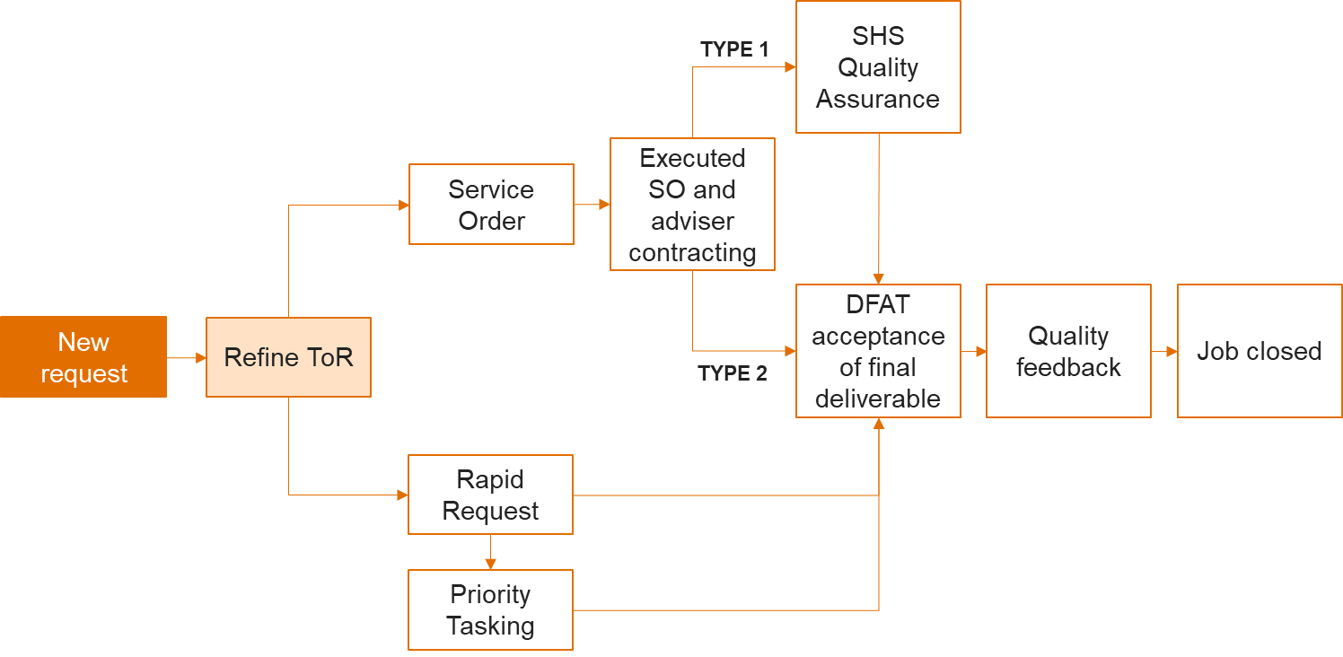

* 1. RR (RR) requests are for smaller tasks (e.g., short papers, presentations, synthesis papers) and include work that can be completed by the SHS technical team within three input days. Although the actual time period within which SHS is to complete the RR request will vary, the expected due date will be specified at the time of commissioning the work. The cost of these requests is met through funding of SHS positions through the core contract.
  2. Priority Tasking (PT) is a variation of a RR for occasions when the core technical team cannot respond to a RR due to competing priorities or a lack of the required specialist expertise. In these instances, the PT allows SHS, with DFAT’s agreement, to contract a consultant for up to five days to complete the tasks. The PT was agreed by DFAT as part of the December 2017 contract amendment. This mechanism is limited to requests from Health Policy Branch and the Centre for Health Security as PT are covered by SHS’s core budget.
  3. Services Orders (SO) are for work that requires substantial contracted expertise. SHS sources, engages, mobilises and contract-manages the advisers. There are two types of SO, Type 1 and Type 2.
* For Type 1 SO (T1SO), SHS provides day-to-day management of the contracted adviser, quality assuring their work and ensuring the deliverable is completed as required.
* For Type 2 SO (T2SO), SHS supports the recruitment of the contracted advisor, then hands over advisor management and quality assurance of outputs to the DFAT commissioning staff. Both T1SO and T2SO are funded by the respective DFAT program area. Management fees are lower for T2SO.

## Design of the Review

After consultation with DFAT, two key review questions were agreed:

* 1. Within the context of the health sector, how have the services provided by SHS influenced Australia's health investments’ performance (in the Indo-Pacific) with regard to relevance, effectiveness, efficiency, and sustainability?
  2. What changes, modifications or improvements to approaches and activities by DFAT would facilitate a robust model of health advisory support?

A series of prioritised sub-questions were developed (Appendix 2).

## Scope

This review scope was bounded by:

**Focus**: Input provided through Rapid Requests, Priority Tasks and Service Orders. The performance and impact of alternate providers of health sector advice are outside the scope of this review.

**Time period**: July 2015 to present. The focus was on activities completed by the end of 2020 as the database provided by SHS only included activities completed to end 2020. Therefore, only these had a complete data set available (refer Limitations in Appendix 2).

**Stakeholders:** The Canberra based Health Policy Branch (HPB) in DFAT and other relevant policy teams (for example water and sanitation), Centre for Health Security (CHS), DFAT officers at Post, SHS team.

## Summary of overarching system

The agreed priority for this review is learning. Based on this, the review focussed on analysis of extreme cases while ensuring a good breadth of different mechanisms and types of tasks. Reflecting this, the sampling approach combines Extreme Case and Maximum Variation sampling. Primary data was sourced through interviews and secondary data from documents and SHS databases. A combination of qualitative and quantitative analysis was undertaken, and the Cost Utility Analysis implemented to compare efficiency of SHS and HRF. In addition, where comparisons could be made against the previous ‘phase’ of SHS (HRF), this was undertaken. This enables change over time to be determined and an assessment of whether the recommendations in the HRF evaluation have been implemented and achieved the desired impact. This is summarised in Figure 2. Further details are included in Appendix 2.

## Data collection and analysis

A wide range of data sources and data collection methodologies were used (Figure 2 and Table 1 with further detail in Appendix 2). In addition, analysis of task outputs, interviews and survey responses were conducted independently and then the findings compared. This supported triangulation of data and analysis. As a result, the evaluation team is confident that the findings are robust.

Figure 2. Overview of the review design

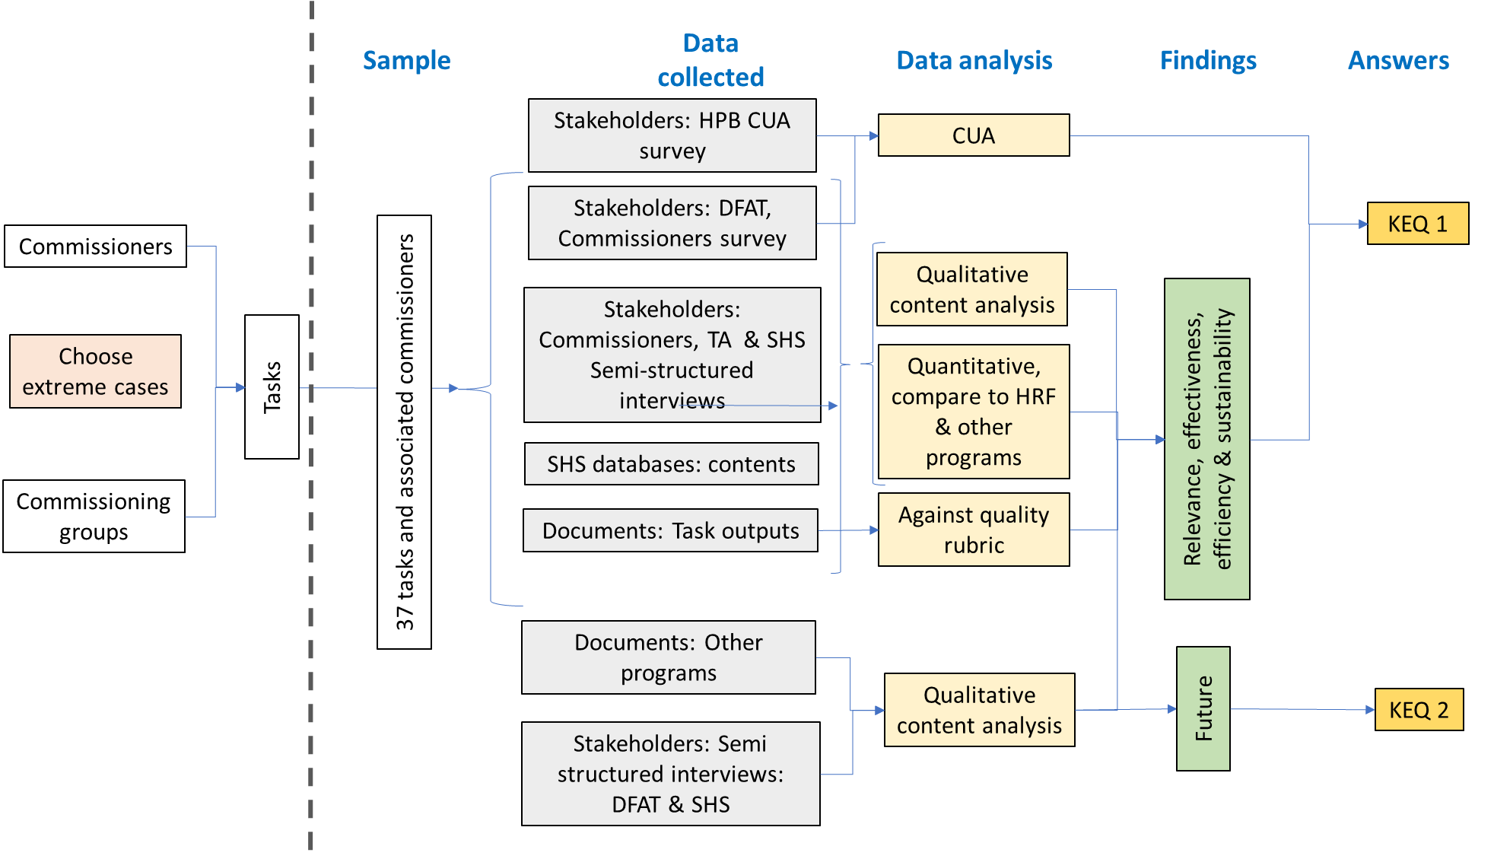

## Reporting

Confidentiality was assured to all interviewees. Where it was either necessary to identify the source of data or they may be able to be identified from the comments, the section of this report was provided to the interviewee for approval prior to its inclusion in this report. To ensure that the evidence trail remains available, the source has been identified in the footnotes using a coding system that still provides the required confidentiality to interviewees. A draft of the report was also provided to SHS for comment before finalising.

## Limitations

The limitations of this review are included in Appendix 2. These can be summarised as:

* 1. Availability of quality data on comparable initiatives has limited comparison of the effectiveness and efficiency of SHS and other initiatives.
  2. Full data on more recently commissioned tasks under SHS is not available where the task has not been completed. Therefore, these have been excluded from this evaluation. Similarly, data on Priority Tasks was limited[9] and they were often recorded as Rapid Response Tasks in SHS spreadsheets. Consequently, the focus on Priority Tasks was more limited than planned.
  3. Many commissioners of tasks under SHS have left DFAT employment. Data could not be collected from most of these commissioners.

The review team does not believe these limitations have impacted the extent to which this review has been able to adequately answer the key evaluation questions.

Table 1 Data collected through different mechanisms

Table 1 shows data collected through different data collection methods, which includes summary of tasks completed by SHS in the review period, number of in-depth interviews conducted, number of survey respondents, and databases analysed. 

* The independent review of the quality of tasks was completed by a health specialist employed by DFAT. This reviewed the quality of tasks against a quality rubric (refer Appendix 2).   
** Excludes tasks that were ongoing at time of evaluation  
*** Includes three tasks flagged by DFAT commissioners as unsatisfactory at time of commission.

# Looking back: The influence of SHS on Australia’s health investments performance

## Relevance:

*SHS was considered by all management and users of its services (both interviewed and surveyed) to be extremely relevant. In assessing the relevance, users identified several factors including: extent to which areas of technical expertise reflect DFAT needs, ability to provide required services in a timely manner, and quality of output (in particular, the relevance of services delivered to the context).*

### Who used SHS?

In total, to December 2020, 316 activities had been completed under SHS[10]. The use of SHS has grown since it commenced in 2015 until Covid (Figure 3). This growth has primarily been a consequence of increased demand in Canberra (primarily from HPB and CHS) with the use by Posts remaining fairly consistent (9 – 24 activities p.a). As the number of activities commissioned by Posts did not consistently or significantly change the proportion of all SHS support going to Posts has decreased over time. In addition, the Health and Education Fund increased use of SHS in 2020 to mobilise advisers.

Figure 3. Change in use of SHS by DFAT over time

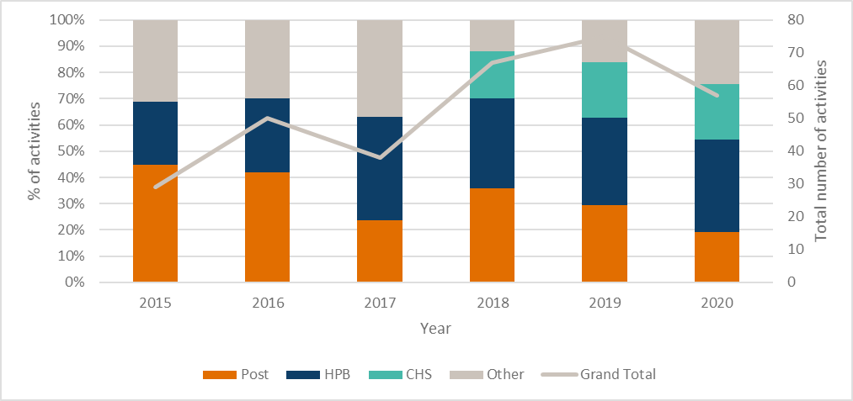

Posts, HPB and CHS commissioned the most activities under SHS. While each unit uses all mechanisms (excluding PT which has limited use across DFAT), there are key differences in the way different areas of DFAT draw on SHS (Figure 4)[11]. Posts use all mechanisms to a similar extent. In contrast, HPB primarily uses RR while CHS uses T2SO and makes little use of T1SO. This has implications for identifying future needs.

Figure 4. SHS mechanisms used by DFAT

Interviewees who had commissioned work that did not proceed reported this was because another donor funded the work, or it was deemed not to be needed (or they were unable to remember). When work did not proceed, it used SHS resources at the initial stage. However, it is not possible to analyse trends in tasks that did not proceed as SHS practice changed after the first two years. SHS advised that new tasks are now only recorded when there is a high level of certainty that the task would proceed.

The volume of work undertaken by SHS is significantly less than under HRF[12] (Figure 5). The reason for the decline from HRF to SHS were not systematically explored in this evaluation, however possible reasons are put forward in Section 4, Efficiency. These include the reduction in the Australian aid program from July 2015, reduced awareness of the available support and need for such support.

Figure 5. Comparison of volume of work undertaken through SHS and HRF

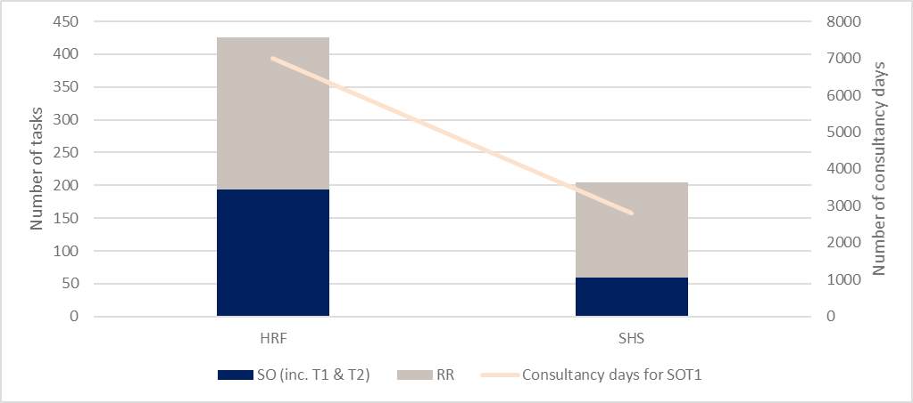

### How has DFAT utilised SHS?

SHS was used for a variety of activities. Key amongst these were reviews and evaluations, appraisals, designs, policy work and developing background briefings (Figure 6).

Figure 6. Change in type of work completed through SHS over time

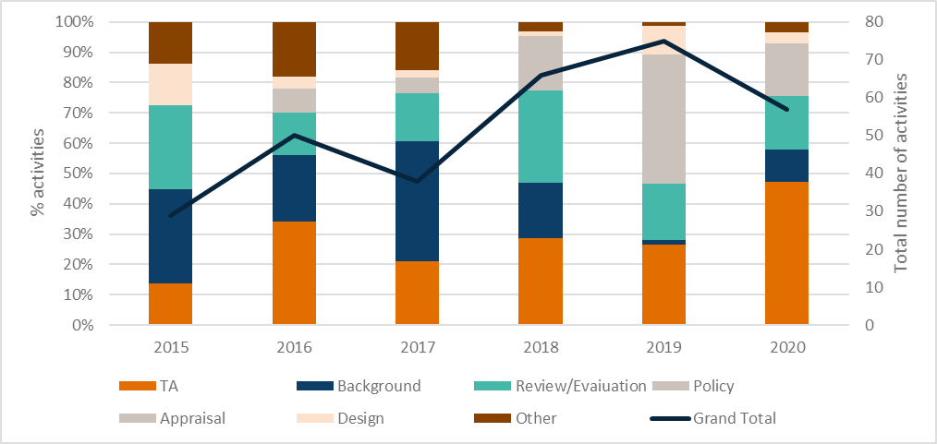

Initially the most frequent activities (almost 1/3) were developing background papers including briefing notes, literature reviews, research, summary reports and synthesis papers. Over time, the focus changed and by 2019, background papers comprised at most 10% of SHS activities. The emphasis on reviews and evaluations has increased, as has provision of technical advisors. By early 2020 (prior to Covid), 27 advisors were contracted through SHS. SHS have advised that this was influenced by the Health Security Initiative (HSI) starting and subsequent recruitment of long- term advisers for the CHS and an increased use of STA to provide advisory support to Posts on long draw down contracts.

The variability in type of work undertaken is also clearly demonstrated when SHS is compared to HRF (Figure 7). For example, provision of TA was negligible in HRF and has grown throughout the SHS contract, and HRF saw a greater focus on designs, reviews and evaluations and policy work.

While SHS was able to respond to changes in DFAT’s technical needs, SHS took a proactive approach to these changes by reviewing the consultant database and seeking additional consultants in emerging areas. They also discontinued areas that had been initially identified at the time of tender and proved not to be required.

Figure 7. Comparison of type of work undertaken through SHS and HRF

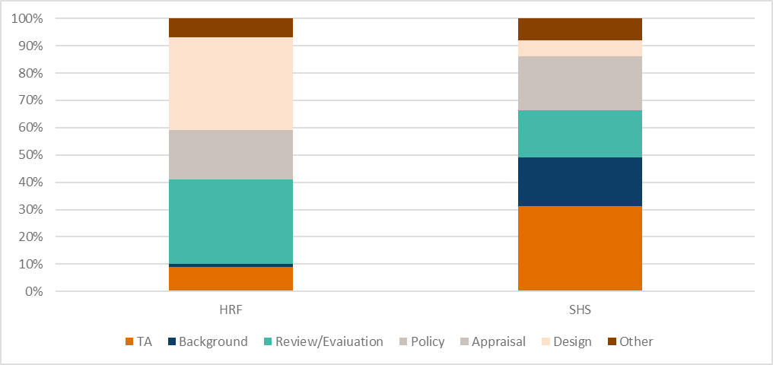

### Why did DFAT Officers use SHS?

When DFAT officers required health expertise, SHS was generally the first, and often only source considered and few sourced the required expertise elsewhere. This was particularly the case for RR and T2SO. Five factors contributed to this use of SHS:

* 1. Ease of use. Almost everyone interviewed who had commissioned activities through SHS chose SHS because of the ease of use. Obtaining advice and contracting TA through SHS was described as “*really a light touch*”, with a process that was relatively quick, administratively easy and convenient[13]. Some interviewees noted that because the contracting arrangements were already in place, and it was not necessary to go to tender, this saved significant time and energy[14]. For those at Post, this was particularly important because many considered their capacity to complete the administrative processes associated with commissioning tasks, especially complex ones, was time-limited[15].
  2. The need for quick advice or provision of expertise. SHS was described as a mechanism through which consultants could be contracted quickly (faster than working through public service channels) - (discussed under Efficiency). Where there was an urgency in receiving advice, this speed was particularly important[16].
  3. Previous positive experiences using SHS. Where an interviewee or survey respondent had used SHS more than once, a consistent reason given for repeated use was their previous positive experience with SHS or its predecessor, HRF[17] (discussed under Effectiveness), or the experience of others that they had observed. In these cases, the interviewee rarely considered any alternatives.
  4. Knowledge of the services offered by SHS. Most of those who had commissioned tasks through SHS had worked in either HPB or CHS. Others had become aware of the services through workshops where this information was provided[18].
  5. Technical services provided reflected DFAT needs (discussed in the following section). For some interviewees, SHS was considered to offer a comparative advantage over other options because of its health expertise. Based on this, they presumed SHS could recruit from a strong pool of specialists[19].

A number of those interviewed were unaware of any alternative options available at that time. In general, once alternative options became available (for example, contracting options managed through CHS[20]), those interviewed said that they continued to use SHS because of their previous experience[21]. The exception to this was those working in CHS who generally used the contractor available to them. A small number of those interviewed in HPB chose it because this was the mechanism HPB managed, and therefore from their perspective, it was the default[22].

A general thread through many of the interviews with long-term DFAT officers was that a Facility such as SHS was essential where DFAT did not have the internal expertise. They reported that when DFAT had specialists in thematic areas, this expertise could be drawn upon internally. When these positions were removed from the organisation, it became essential to obtain this expertise externally[23].

Although commissioners generally considered SHS as the first source of technical health sector expertise, a large proportion of survey respondents (32%) indicated that they had procured technical assistance from other sources[24]. While large, this figure is much less than that during HRF (80%)[25] when Standing Offers were also available and provided an easy contracting mechanism. Where DFAT officers obtained expertise from sources other than SHS, this was generally from an existing mechanism or open-source tendering. These other mechanisms were chosen because[26]:

* 1. Several Posts had alternate providers, generally an in-country health Facility but also included options such as the PNG Human Development M&E Services. In some cases, there was an in-country panel on which to draw (for example, Vanuatu, Fiji, Timor Leste, PNG and Solomon Islands). In these cases, this was often the first source except where there was a potential conflict of interest, or the in-country program had other priorities on which to apply their resources at that time[27].
  2. The contract for SHS will finish in 2022. Where this preceded the duration of the input under a service order, several interviewees noted they had selected an alternative contractor, available to CHS to ensure continuity in management[28].
  3. An alternative contractor available to CHS was perceived to have greater flexibility in deploying consultants overseas. This was because that contractor had in-country offices which made managing an adviser in-country easier. There was a perception that other Managing Contractors were able to contract advisers into locations to which SHS was unable (particularly due to Covid). However, investigations indicated that while provision of support may have been easier where Managing Contractors had in-country offices, the constraints on contracting due to Covid related insurance issues were the same across providers.

Only one respondent in surveys or interviews indicated that another mechanism was more cost efficient. However, 7% of survey respondents noted that they had to use alternative mechanisms as SHS advisor fees were constrained by the ARF rates and the consultant they wanted would not work for this rate[29].

The main reason interviewees and survey respondents ceased using SHS was because former commissioners of tasks moved to a role where such support was no longer required[30]. There was no evidence that a lack of relevance contributed to interviewees and survey respondent’s cessation in using SHS.

### Choice of specific mechanism within SHS

*The choice of mechanism is a function of the speed with which the activity needed to be completed, the number of person days, and whether the commissioner considered there was value in SHS undertaking QA of the activity. However, there has been a tendency for T2SO to become a default for many commissioners.*

SHS offers a variety of mechanisms, and the relative usage of these mechanisms has changed over time (Figure 8). Most commissioners have clear reasons for choosing a specific mechanism.

Commissioners consistently identified that rapid response was selected when the task needed to be done quickly, required specialist health advice and could be done within three days of input. These needs could be met specifically because SHS have people available almost immediately to do the work[31]. One DFAT officer noted that they considered this service was effectively ‘*free’* because it was included in SHS’s core contract.[32]

Service Orders were used for longer pieces of work. Initially T1SO was the default mechanism for Service Orders (Figure 8). Over time, the use of T2SO has grown so that by 2017 its use equalled that of T1SO and since then has exceeded it. By 2019, T2SO comprised almost half the activities under SHS. SHS advised that where a commissioner requests support through a Service Order, they always explain and discuss both options. SHS “*always recommends Type 2 for LTA and long-term STA (as) it would make no sense for them to report to SHS (as this would be) inefficient as SHS has no visibility of (the) day to day work of advisers embedded in DFAT or deployed overseas and (where there are) no specific deliverables to QA[33]”.*

T1SO have only been used for work of less than six months input. This mechanism was generally selected by the commissioner where they wanted to have quality assurance provided externally. This was generally because the commissioner did not have the expertise, the commissioner considered an additional reviewer would be useful or to reduce their workload[34]. Where business units have their own quality assurance mechanism (e.g Office for Development Effectiveness) they found that the duplication of QA by SHS delayed finalisation of outputs due to duplication of roles[35].

Figure 8. Change in SHS mechanisms used by DFAT

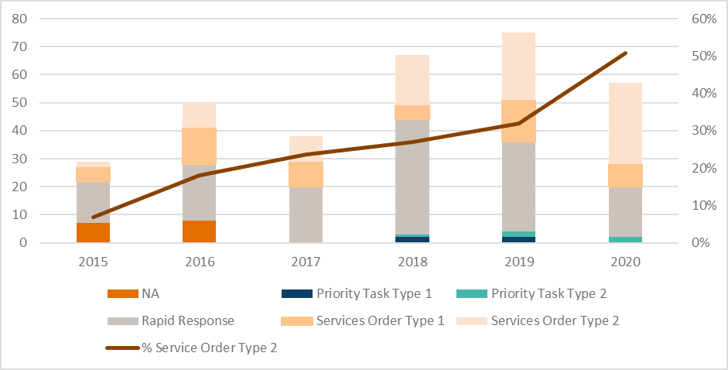

A small number of commissioners chose T1SO as a key element of their risk management strategy to reduce the risk of poor-quality TA or a TA becoming unavailable during the contract. As one commissioner described: “*I wanted a fallback position if (a long-term placement) did not work out because it was being done over a long period. So, using type I rather than type 2 was a kind of backup for me, a bit of risk management*”[36].

T2SO was consistently used when the commissioner made the decision that provision of quality assurance services by SHS was not required[37] regardless of the length of input (approximately 80% of tasks completed as T2SO were short term assignments). This was for a range of reasons including that the commissioning unit had internal quality assurance mechanisms via staff with technical knowledge of the output (for example ODE)[38]. T2SO was a preferred mechanism where the commissioners already knew who they wanted to appoint (the reasons varied between extension of existing contract or selection of a preferred, known consultant). In these cases, “*we just wanted the administration done by SHS as it was just the contracting that needed to be done*” [39]. Where there was also a short window of opportunity in which to engage a contractor and complete the work, having SHS undertake the contracting enabled this window to be accessed[40]. In one case, the commissioner had selected T2SO because SHS would, from their perspective undertake a lot of the day-to-day management of the TA; “*SHS did all of the logistics, so that was a great weight off my mind*.”[41]

In addition, DFAT has increased the number of LTA contracted through SHS for positions which operate as in-line positions. This has particularly been the case for positions in CHS. SHS has also advised that there has been an increase in STA advisors on long-term contracts to Posts. However, from available data, this would have been minimal.

### What changed with Covid?

In 2020, DFAT’s needs changed markedly because of Covid. From a technical perspective the focus on health security increased as did demand for health specialists as against generalists. DFAT officers interviewed considered SHS had consistently been able to meet these technical needs.

In addition, the mechanisms through which services were supplied dramatically changed. DFATs “*needs moved from provision of STA to what is now effectively a labour hire arrangement”[42]* to provide surge capacity. Demand for appointment of LTA increased. This created a few challenges as SHS had not been established to source significant numbers of LTA. The initial Scope of Services provided limited attention to the management of LTA, in particular their care and well-being[43]. In this new, unexpected environment, there were significant complexities where an advisor was contracted to SHS but worked for another organisation (for example the PNG Institute of Medical Research, World Health Organisation or a partner government). Without an extensive on the ground presence achieved through a network of overseas offices, this created challenges for SHS in meeting occupational health and safety requirements and ensuring accountability for inputs[44], [45]

Despite this extreme level of change in need, SHS has performed well. DFAT considered SHS “*have been very responsive to our changing needs. … We wouldn’t have been able to (respond effectively to the changes due to Covid) without SHS*”[46].

## Effectiveness

*SHS has contributed to improving Australia’s aid program and broader outcomes, with the exception of coordination and coherence which was not an appropriate outcome for this design. However, the overall contribution could have been magnified through improved: attention to cross-cutting issues, processes for monitoring impact, sharing information and cross-Departmental learning. Ultimately, this is DFAT’s responsibility, as is the narrow definition of sustainability which may account for the generally limited attention to sustainability of benefit across SHS activities.*

*Adviser quality, SHS management and SHS outputs were all found to be of a generally high standard.*

All available data indicates that overall, SHS provides a quality service to support DFAT. For example, the minutes of the steering committees consistently include statements such as DFAT “*value(s) the support and regards the SHS as essential to the delivery of the Aid Program. The SHS’s ongoing high-performance and DFAT’s sustained high demand for services was acknowledged*”[47]. Similarly, in interviews, survey responses[48] and post task evaluations, commissioners of tasks consistently indicated a very high level of satisfaction with SHS.

### Adviser quality

Strengths: Adviser quality, diversity of pool

Weaknesses: Size of consultant pool & diversity of nominated candidates.

The quality of consultants is generally considered to be high. This was reflected in post activity evaluations, survey responses and interviews[49]. All survey respondents considered the consultants provided by SHS were well matched to DFAT needs. Commissioners of tasks and DFAT managers consistently identified that SHS has “*proven that they can source quality advisors*”[50] . As can be seen in Figure 9, a slightly greater proportion[51] of survey respondents considered that the quality of consultants was a specific strength of SHS compared to HRF.

Figure 9. Comparison of characteristics by DFAT commissioners to SHS and HRF

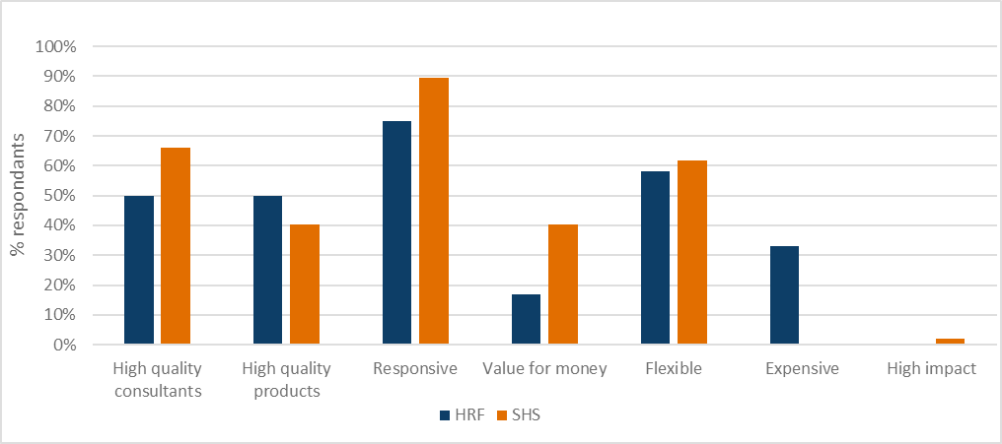

#### Size of pool

There is a general perception that SHS has access to a pool of high-quality consultants able to work across different areas of health and development expertise. Therefore, it is the first port of call for many in DFAT when looking for a health specialist. However, SHS’s database is relatively small, now comprising only 400 consultants after several years of proactive expansion by SHS[52] and is separate to that of Abt. The members of this pool change over time.

By comparison, HRF drew on a database of approximately 12,000 health consultants plus that of associates. Despite the larger size of HRF consultant database and the larger number of tasks it managed, HRF both nominated and contracted only some 75% of the number nominated and contracted by SHS from their smaller database[53]. I.e., SHS provided a greater number of different quality consultants from a smaller pool. Clearly, the size of the pool is not the only measure and it is questionable whether HRF’s larger pool provided added value.

The limitation in size of the SHS pool was recognised by a small number of those surveyed and interviewed with comments such as “*I would like them to have a stronger consultant network - often have to put suggestions forward to them[54]”.* The limited pool of quality advisers for specific activities was most frequently raised by commissioners of Type 2 contracts.

While Abt is in association with UK consultancy group Oxford Policy Management to deliver SHS, this relationship is rarely used. To date, only eight assignments[55] (four different advisers) were filled by consultants from OPM. SHS advise that this small number is because (i) the ARF rate precludes many UK based consultants; (ii) SHS considers the OPM consultants are not suitable for the particular task at the time or (iii) when opportunities arise, OPM did not propose advisers. This means that in practice, the additional value for sourcing consultants from associates databases may be limited. This limitation should be considered when determining assessment criteria for future tenders.

#### Diversity

DFAT is seeking to increase the diversity of consultants working on its programs, and in particular the proportion of consultants engaged from the Indo-Pacific or partner countries, and achieve gender balance. To achieve this, facilities such as SHS need to have a diverse pool of consultants upon which to draw and shortlist a diverse range of consultants. DFAT then needs to select from the nominated candidates an increasingly diverse range of consultants.

The database includes approximately 6% of consultants from Asia and 8% from the Pacific[56]. A similar proportion of all consultants nominated come from the Pacific or Asia[57]. On an annual basis this has varied from 5 to 15%, however there have been no trends[58]. Approximately 10% of all appointments were consultants from the Pacific or Asia. Among these, Pacific Island consultants were most frequently appointed (6%). It is expected that these figures have increased during Covid due to travel restrictions however this is unclear from the available data.

Some 54% of consultants in SHS’s database are women[59], and approximately 53% of appointed consultants have been women over the life of SHS[60]. Annual figures range between 47 and 61%, but again no trends are visible. No analysis was undertaken about specific areas to which women were appointed.

Few DFAT commissioners interviewed considered the diversity of SHS’s TA pool. Where it was considered, interviewees and survey respondents generally considered diversity requirements had been met. Indeed, overall, more survey respondents perceived SHS’s pool of consultants to be diverse compared to HRF survey respondents[61]. However, 33% of survey respondents identified diversity of the consultant pool as one of the ways SHS could improve. From their perspective, too great a number of nominated consultants were already well known to DFAT and therefore could have been easily sourced without SHS assistance. In particular, a small number of survey respondents were concerned that a high proportion of nominated non-health specialist consultants were former DFAT staff which constrained diversity. SHS has proactively expanded the pool of consultants without previous DFAT experience. As a result, the proportion of consultants included in the SHS database with no previous DFAT experience is relatively high (44%), with an additional 12% gaining their DFAT experience through SHS.

While a desire for new consultants was expressed, interviewees also acknowledged the challenge: *“these consultants (with DFAT experience) are solid, they know what they are doing, they have moved with DFAT as we have moved*”[62]. Consequently, they tended to be selected more frequently than those without previous DFAT experience.

While DFAT requires SHS to recruit an increasingly diverse range of advisors, the diversity of engaged consultants is contingent on DFAT selection. To date, 458 different consultants have been nominated, with some nominated up to 15 times (Figure 10). Of these, 254 different consultants were appointed (of whom 128 were single source, i.e., proposed by DFAT to SHS). These consultants have been appointed up to nine times. Overall, the distribution of SHS work was quite concentrated, with one third of the work going to just 10% of the selected consultants and half going to under 20% of the selected consultants (Figure 10).

Figure 10. Concentration of award of contracts among consultants

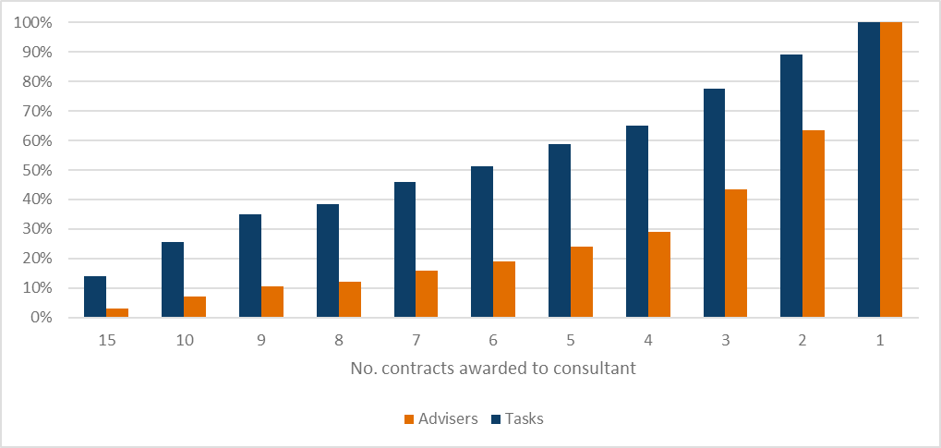

### SHS Management

Strengths: Professional relationships, responsive & flexible

Weaknesses: Risk management, nomination of suitable alternate candidates

Overall, SHS management was found to be of a high standard and to have improved over time[63]. This was both in terms of sourcing, pre-qualifying, recruiting and contracting external technical advisers; along with the administrative management of advisers. This was clearly demonstrated with less than 1% of post-task evaluations identifying issues with TA management[64], and 95% of survey respondents considering commissioning services through SHS to be easy, 90% characterising SHS as highly responsive and 61% recognising its flexibility (Figure 9).

The SHS team was generally considered by Commissioners to be “*very easy to work with*”, helpful and effective communicators, and to manage activities well, even in difficult situations[65]. Findings from the independent quality review[66] match interviewee responses. For most tasks reviewed, SHS management (including support to ToR development and sourcing of quality consultants and QA of outputs) was graded as being of a good standard. Strengths of SHS management include timeliness and responsiveness: most reports were delivered on time or before the due date, and where delays occurred, they were typically days rather than weeks, or if longer than that, negotiated with DFAT. For RR requests, the turnaround time was usually quite short.

Similarly, interviewed consultants consistently made comments to the effect that “*everyone in SHS is very friendly, very interested or committed to what they do. None are just doing it as a job. This makes a difference*”[67]. In general, consultants could think of little that SHS could do to improve the way they were managed. Suggestions offered largely related to processes such as improving the relevance of timesheets and reducing the focus on paper-based materials.

Most commissioners considered that SHS had provided the level of support required to clarify requirements and develop the ToR[68]. However, a small number identified as a challenge the extent of administrative requirements to obtain SHS support, including developing Request Notes, ToR etc. This was considered by a few to be onerous for RR tasks and where a short turnaround was required. Given that RRs are simple to initiate, it is likely that this reflects a capacity issue among a few commissioners. A small number of commissioners also noted that, primarily for T2SO, they needed more support than was provided to develop ToR, draft service orders and negotiate contracts[69]. By contrast, other commissioners considered it helpful to talk through and clarify wording of the ToR with SHS. However, none of the commissioners interviewed were able to remember this process having made improvements as a result[70].

Again, this corresponds with findings from the independent quality review. SHS contribution to developing ToR was found to be useful, but typically confined to clarification of tasks, reformatting, and revising the proposed number of consultant days. There were a small number of examples of the process adding strategic significant value, i.e., changing the scope or the nature of the task but these were few. Where the independent reviewer considered there were gaps in DFAT’s original draft ToR (such as, a lack of focus on gender analysis, no mention of number of years of required experience) these were rarely corrected by SHS. Similarly, there were a small number of examples of ToR drafted by DFAT focussing on technical or clinical skills but failing to request expertise in development or broader health sector development experience in a developing country context, and SHS not identifying these deficiencies in cases where the independent reviewer considered this should occur.

There was also the suggestion by a small number of commissioners that development of the ToR should be outsourced completely to SHS to reduce DFAT workload. In some cases, the independent quality review found SHS did produce a first draft of the ToR following a phone discussion with DFAT. These drafts were adequate in that they had a clear task description, timeframe and measurable output, but often lacked a strategic development lens. SHS developing ToR is neither practical nor desirable from a quality perspective[71].

Together, these issues regarding ToR development suggest a lack of capacity among some DFAT Officers in this area. This is critical. As the Principal Health Specialist noted, the quality of the output is dependent on the clarity in communicating what is required. She noted that this responsibility starts and ends with DFAT. SHS’s role is to work with the commissioner to ensure the requirements are clearly documented. This is discussed further in Section 4 Efficiency.

SHS’s ability to recruit quality advisors in the required timeframe was recognised[72]. This was for both positions based in Australia and at Post. However, for approximately 7% of service orders (excluding sole-source), only two candidates were nominated[73]. Similarly, the independent quality review found that, of the 11 tasks reviewed involving a SHS-led recruitment process, in almost all cases only one or two of the candidates proposed by SHS met all the selection criteria outlined in the ToR despite nomination of a larger number of candidates. There were also examples of inappropriate candidates being put forward (e.g., a health economist recommended to develop an infectious disease plan). Further, in some cases, SHS proposed candidates that had worked predominantly or solely in a high-income country context as the pool did not contain sufficient candidates with the required expertise. Given the importance of development expertise and experience to successful completion of development assignments, this represents a limitation of SHS pool of experts. This indicates that the contractual requirement of nominating a minimum of three advisors with skills and experience suitable for each of the identified roles[74] was frequently not met. SHS has advised that it is often impossible to identify candidates who meet all requirements in a ToR, especially when time is short.

In cases where selection criteria are very specific, e.g., an architect with experience of health facility design in the Pacific, a limited number or even single candidate is justifiable. In these cases, the DFAT requirement that three CVs be put forward for every task could be waived. This would avoid SHS and DFAT having to source and review unsuitable candidates.

Approximately 5% of survey respondents noted that candidates nominated by SHS were not always available or suitable for the position[75]. A more efficient process would be to confirm availability before nomination. SHS has attributed this to DFAT often requiring an immediate start and seeking known consultants in high demand who are unavailable; or DFAT taking a long time to select the candidate and the consultant they select no longer being available. This indicates a lack of understanding in DFAT of realistic timelines involved in the recruitment, selection and mobilisation process.

The consultants engaged through SHS who were interviewed either couldn’t remember their induction or agreed that it included only documents sent via email. None were able to remember being provided a verbal briefing or being provided a technical induction as set out in the Operations Manual[76]. SHS has advised that it offers a technical briefing for all Type 1 and Type 2 consultants and it is DFAT’s choice as to whether this occurs.

A small number of consultants thought that SHS should be an “*intermediary between DFAT and the consultant*”[77]. To this end, consultants saw part of SHS’s role as helping them to address issues arising in their engagement with DFAT. In particular, there was a perception that DFAT is often unclear about what work it wants undertaken[78]. These consultants considered that SHS could play a role in clarifying the scope of requirements at the outset, and where needed during the task itself.

Several interviewees reported that on T2SO, SHS was unable to help resolve the situation when the scope of requirements changed during their assignment[79]. However, this was only identified by T2SO based overseas[80]. When based in Australia, changes in ToR were resolved when the consultant’s contract was renewed/extended. In addition, most interviewed T2SO consultants on overseas assignments felt there was generally little support provided; this sentiment is characterised by the comment, “*once they send you off, you’re on your own*”[81]. By contrast, all consultants who had needed support due to ill health or other personal problems, found SHS to be excellent[82].

There appeared to be little consideration of risks associated with specific assignments[83]. As one commissioner noted “*in retrospect, it is clear that the choice of consultant, her location, and the timeframe associated with the (task) were risks … These were not identified in a formal way*” [84]. Similarly, where DFAT nominates the adviser (sole-sourcing), SHS does not provide advice as to the suitability of this consultant or propose alternatives as required by Clause 7.5 of the Statement of Requirement.

There was a sense among some DFAT officers that SHS was considered to be part of the DFAT team and that this contributed to SHS’s effectiveness. The Principal Health Specialist stated she had specifically worked to achieve this because she believed that if SHS staff understood DFAT well, they would be better able to meet DFAT needs. However, others felt that SHS was not considered part of the DFAT team and in practice had no role in contributing to strategic direction, coordination or coherence of the health portfolio.

### Outputs

Strengths: QA process

Weaknesses: Inadequate rigour in achieving required standard for first draft. Recommendations being impractical, unprioritised or excessive.

Commissioners were typically satisfied with the quality of work undertaken by SHS for RR, T1PT and T1SO[85]. This is reflected in post activity evaluations, interviews with commissioners and the commissioner’s survey.

The quality of the work undertaken through the RR mechanism was generally identified as being of high standard[86]; in one case it was identified as gold standard[87]. Descriptions such as “*they are able to synthesise complex issues in a way that makes it clear and simple and focuses on what matters*”[88] were typical. In several cases, the commissioner considered that SHS went above and beyond what was realistically possible in the three days allocated. As one interviewee stated: “*we were always able to depend on SHS for quick, short health analysis that met our needs*.”[89].

The findings of the independent quality review again align with interviewee views. Looking at all sampled T1SO[90] and RR, the majority were consistently assessed as being of an acceptable standard. While there were a small number of substandard outputs, there were fewer in the second half of the SHS contract compared to the first half, and conversely a growing number of above-standard products in later years. This indicates improvement over time.

The quality criteria against which SHS performed best was “output delivers on ToR”,with around half of the 22 outputs considered being above standard, and most of the others at standard. For this criterion, most outputs met all requirements set out in the ToR; were clear and well written; and included evidence of consultation with in-country stakeholders (where appropriate). A smaller number also included clear summaries and prioritised their recommendations. The most common weakness for this criterion were a high number of DFAT comments on the first draft, suggesting the delivered task did not meet expectations and implying a fair amount of DFAT input to get drafts ‘up to scratch’; there were also some examples of outputs for which the independent quality review considered there to be a high number of unfeasible recommendations and limited stakeholder consultation, but these were the minority.

In relation to the criteria: “output considered technically sound”, most tasks again scored at either standard (roughly half) or above standard (a third). For this criteria, key strengths were a clear and well referenced evidence base, appropriate reference to relevant international and regional experience (e.g., to other Pacific countries in the case of Pacific tasks), and a comprehensive and balanced consideration of the topic. Where outputs scored less well this was typically because they were less well evidenced, lacked technical depth or reference to other relevant experience. More broadly, very few of the tasks reviewed included a focus on innovative approaches[91].

The quality review also provided insight into the role of QA in ensuring the quality of assignments. Of the 13 T1SO reviewed, there were examples of SHS providing significant and substantive input to improve the quality of submitted drafts. There was also one example of editing and revision of an output from a T2SO being commissioned as a separate rapid response (given there was no provision for quality assurance under T2) – demonstrating the potential added value of the T1 mechanism. There was just one example in the 36 tasks reviewed of a consultant failing to deliver on a contract: this was a T2SO, with the consultant selected by DFAT. SHS’s role was to terminate the contract early.

#### Poor quality outputs

Commissioners recognised that the quality assurance on reports provided by SHS ensured that in almost all cases, outputs met DFAT needs or, that SHS provided a safety net when an adviser’s performance was inadequate. For example, they noted that SHS had rewritten whole reports to make them workable and had completed reports where a consultant left before the work was finished. In these cases, the DFAT commissioner recognised that it is in the quality assurance process that the “*value of SHS lies*” [92]. As a result of this quality assurance process, poor quality outputs were an exception.

This is reflected in post activity evaluations identifying only approximately 4.5% of activities as having an issue of any type[93]. In some of these cases, the commissioner incorrectly thought SHS was responsible for the quality of consultant outputs under T2SO. The issues raised by DFAT commissioners include:

* Feasibility of recommendations. The most frequent issue was with the number of recommendations and in some cases their breadth. For one task this was described as “*The recommendations were more of a presentation of a best practice model rather than being specific to the current situation*”[94].
* Quality control. In a small number of cases, to be able to finalise the report DFAT needed to provide unexpected input on the quality of the report and areas of the ToR that were not addressed.
* In one case, “*The logic flow and the final edit and style check were weak and a copy editor was contracted by DFAT to complete the editing of the report*”[95].

Only some 1% of all completed activities[96] were identified as not meeting any of the measures of quality used by SHS. This equates to just four activities (one RR and three T1SO), none of which were sole sourced, and all occurred before 2019. An independent quality review was conducted on these assignments. This confirmed these outputs as sub-standard: they did not deliver on the ToR (i.e., did not respond to key questions in the ToR), the quality of advice and recommendations was poor (i.e., generic, did not deepen DFAT’s understanding of the issue or provide new insights, and/or was inappropriate for the context).

For the T1SO, a comparison of CVs to selection criteria suggests that in all three cases, the consultant selected was not well matched to the task, and in at least one case the consultant had performed poorly on previous assignments for DFAT/AusAID[97]. In two of the three cases, candidates were re-nominated for future activities throughout the life of SHS[98] – suggesting poor systems within SHS to keep track of under-performing consultants. One has since been appointed twice, the second time also identified as producing a substandard output.

Finally, while SHS had a QA role on the three T1SOs, the final product in two cases remained sub-standard. In the third case, the final report was a significant improvement on the draft originally submitted, reflecting substantial SHS input. Correspondence suggests that DFAT played a key role in closely guiding the revision: down to proposing text for inclusion. These examples suggest that while the QA process applied by SHS added value, adequate mechanisms were not in place to respond to the relatively rare ‘catastrophic’ consultant failure.

In the case of the RR identified by the Quality Feedback Database as being of low quality, the independent evaluation of this product concurs with that assessment. However, this assessment notes that DFAT’s expectations on what could be produced within the three days of rapid response timeframe were unrealistic.

Overall, quality assurance provided by SHS to Type I tasks is recognised as providing added value. This is through both (i) SHS reviewing all outputs and working with the consultant to achieve an appropriate quality prior to the output submission to DFAT and (ii) SHS providing a backup mechanism to ensure a task is completed and the output produced where an advisor does not perform. However, there is a need for improved mechanisms to respond where there is catastrophic failure on the part of a consultant to meet the required standards.

## Outcome

Used to: improve Australia’s aid program or inform discussions (RR and T1SO). Build partner capacity or fill a line role (T2SO).

Constraints to use: lack of formal process to share information (other than EDMG).

There was widespread agreement among commissioners that SHS had contributed to achieving high quality outcomes (Figure 11) although they did not consider SHS to be a “high impact” program (only one out of 54 survey respondents characterised SHS as a high impact program). Broadly, outputs produced through RR & T1SO were considered to contribute to enhancing the effectiveness of Australia’s aid program (at a program or individual investment level) or inform policy and programming discussions and outputs from T2SO helped develop partner capacity and provided surge capacity in Australia. The direct impacts are discussed below. The indirect impacts; resulting from time freed up through the delegation of tasks to SHS, enabling DFAT officers to consider key issues more deeply; are more difficult to document, but no less important.

Figure 11. DFAT commissioners’ assessment of SHS’s contribution to specific outcomes

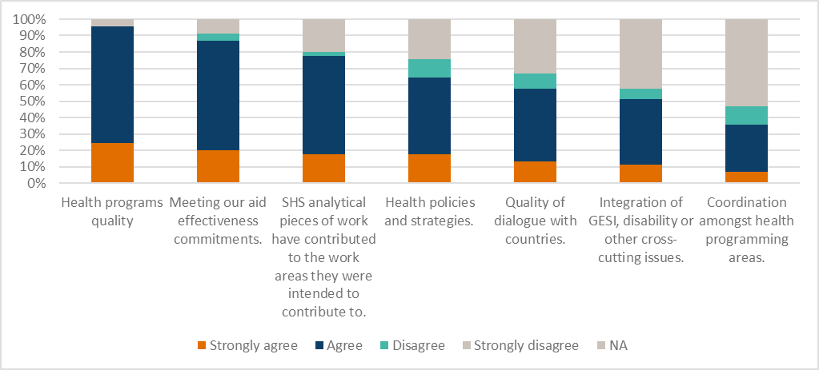

At a country or regional level, SHS has contributed to the quality of the health program, policy, strategy and dialogue with partners. Some 95% of survey respondents considered that SHS had made a direct contribution to the quality of the health program (Figure 11). For example, outputs produced by STA informed early thinking about possible ways DFAT could engage with or support partner governments by clarifying the real problem (rather than a symptom) and provided initial options of strategies Australia could support to address these problems[99]. Quality design documents also contributed to the quality of the health program. Where the activity involved reviewing a design, commissioners consistently reported that this work had strengthened the design[100]. In several other cases, analysis of a series of reports, identification of trends and issues was used to improve existing and future programs[101].

High-level policy discussions within DFAT, with other government agencies and multilaterals, and at a regional level were informed by outputs, particularly those produced through RR. Some 2/3 of survey respondents considered the activity they had commissioned had contributed to health policy and strategy (Figure 11). Frequently, analysis undertaken through RR provided information that directly contributed to the quality of policy discussions within DFAT. Those interviewed often held that the SHS output contributed to the rigour and depth of policy discussions[102]. Examples include the development of a strategic framework to support Australia’s health work in the Pacific, discussions with partner governments and other donors [103]. In each case, the commissioner reported that SHS outputs had helped inform the final outcome.

The impact pathway of LTA was different. Often the consultant filled a line role with the aim of developing capacity among partner agency staff and supporting development or implementation of new systems, strategic plans and policy[104]. In other cases, they provided surge capacity in Australia and their presence enabled DFAT to respond quickly to issues raised by other government agencies or posts[105]. The Principal Health Specialist advised that these issues were often significant, impacting upon Australian security or health and well-being of Pacific Island populations in Australia. She noted that without their presence, the response would not have been timely and would have detracted from the region’s health security.

### Coordination & Coherence

DFAT has the primary role in ‘enabling’/applying learnings to achieve coherence. Consequently, many commissioners and consultants interviewed were surprised coordination and coherence were anticipated outcomes of SHS. This was also reflected by survey respondents (Figure 11). As a result, there was a general perspective that this was an unrealistic outcome given the design and that achievement of this outcome was primarily dependent upon DFAT actions rather than those of SHS[106].

Therefore, it is not surprising that there is little evidence to suggest that the SHS Facility has made a significant contribution to either coordination amongst health programming areas within DFAT, partners or stakeholders; or coherence of the health program. In general, DFAT activity commissioners did not consider that work undertaken through SHS would contribute to either coherence or coordination within an activity, a program, or across the sector[107]. Even at the level of influencing application of lessons learned between programs or regions, evidence for a SHS contribution was limited.

Interviews only identified one example where SHS was considered to have made an important difference to coordination. In this recent case, SHS “*brought all the relevant parts of DFAT together for the design team and it worked really well*.”[108]. Other influences of SHS on this outcome were small. For example, through improving coherence within a design document, providing a contemporary perspective to inform DFAT on an issue and contribute to decision-making, or helping understanding of what was happening in other countries across the sector through the development of country fact sheets.

There are a few examples of RR assignments that summarised a series of papers or reports. However, the available evidence is that these were used to inform individual health programming and policy discussions rather than applied across the development program and therefore made little contribution to coordination or coherence.

For Service Orders, the strongest examples of SHS facilitating coherence and coordination were where a single advisor provided support to a country over a long period. For example, draw down support provided to Nauru and Kiribati. This was a function of having specific, highly experienced advisors involved in a single program for a long period of time.

The limited contribution of the SHS Facility to application of lessons learnt between programs, countries or regions is at least in part a consequence of the lack of a formal mechanism for sharing reports produced through SHS (other than placing them in the EDRMS). Even documents that may have had widespread interest were not formally shared by DFAT[109].

### Without SHS

“how would we have got through everything without SHS” - DFAT Commissioner

Most interviewees identified that health programming and policy advice would not have been as effective without SHS. They considered that SHS has played a key role in supporting DFAT’s health portfolio.

Commissioners reflected that while some RR and T1SO activities would have been undertaken without SHS, they “*would have taken years to complete or the project (to which they contributed) would not have gone ahead*”[110]. This was reinforced through the survey in which 80% of respondents identified that without SHS, the knowledge would not have been available in a timely manner. Other activities would not have commenced because there were insufficient internal resources or expertise to complete the activity or manage others to complete it[111]. Some support commissioned by Posts may have been undertaken by other donors and other opportunities would have been missed. Interviewees considered this would have reduced opportunities to develop relationships with partner governments[112].

In contrast, interviewees generally reported that T2SO activities would still have occurred. These would have been outsourced, just as occurred prior to SHS. However, those interviewed considered that the process would have been less efficient and slower[113].

### Cross-cutting issues and policy alignment

Overall, SHS addressed DFAT’s Health for Development Strategy well while cross-cutting issues were poorly addressed in ToR (drafted by DFAT) and outputs (produced by consultants). The exception was where the activity specifically focused on a cross-cutting issue. This was evidenced in the independent review of outputs and consultant interviews.

The independent quality review found the strongest alignment to DFAT policies was with the Health for Development Strategy. For example, many tasks took a health systems’ strengthening lens and/or made direct reference to the DFAT strategy. By contrast, alignment with disability policies was very weak; with few outputs having any level of reference. This was supported by findings during consultant interviews: the only time consideration of disability was identified was where the task was specifically related to disability.

Alignment with DFAT’s gender policy was also weak. Almost one third of commissioners interviewed reported that Gender Equity and Social Inclusion (GESI) was either not addressed, or if it was, there was relatively small consideration. Several commissioners noted that while there is an implicit requirement for “*all technical advisors … to focus on the cross-cutting issues, including GESI*[114]”, this was rarely explicit.

While a gender analysis would not have been relevant in all tasks, the independent quality review found it was relevant to around three quarters of those reviewed but not mentioned in approximately half of these with few including a thorough and mainstreamed gender analysis. In addition, while a small number of reviewed tasks included partial gender references (for example, indicating how the investment would benefit women) they did not consider how gender differences might constrain implementation. The notable exceptions to this trend occurred when the ToR explicitly included a strong focus on GESI.

SHS engagement of a highly experienced and respected gender advisor on a draw-down contract appears to have had a positive impact. DFAT commissioners noted the advisor made a significant contribution to improving design, policy and technical advice. In addition, the WASH team considered that gender had been well integrated into their programs by the technical advisors contracted through SHS under T2SO.

## Sustainability

DFAT and SHS have agreed that “*Sustainability in the context of SHS is the assurance that services will be maintained in the event of staff change or contractor change*”[115]. The processes detailed in the Operations Manual are deemed to ensure sustainability. This definition may account for the limited attention to sustainability identified during interviews. During interviews, two aspects were identified. The first was sustainability of benefits; the second, sustainability of DFAT’s access to health expertise.

Sustainability of task benefit (i.e., whether the benefits of work commissioned through SHS are sustained) was rarely considered by either consultants or commissioners. The comments by a commissioner that “*I don’t recall anything related to sustainability with this task*”[116] and consultants “*I would not say there was a specific focus on sustainability*[117]” were reflective of the tenor of most interviews; neither commissioners nor consultants could recall whether sustainability was addressed in the terms of reference or subsequent work. The exception is where consultants have a long-term association with specific countries through a drawdown contract.

The short-term focus of SHS activities was considered by consultants and commissioners to constrain attention to sustainability of benefit. Sustainability was “*often not looked at because it is outside our program scope*”[118], in part because SHS was providing specific advice and not technical assistance[119]. For others, the lack of long-term monitoring contributed to the lack of focus on sustainability.

The second perspective was sustainability of DFAT’s access to health expertise (both internal and external). Commissioners varied in their perspective from some believing DFAT needed internal health expertise (and therefore capacity of DFAT Officers developed) and others believing depending on external expertise was appropriate (and therefore, no focus on developing internal health capacity).

A large number of commissioners felt that the reduction in internal health expertise had adversely impacted the quality of delivery of health development assistance. For these commissioners, the absence of SHS having a formal role in DFAT capacity development (in comparison to HRF which did develop DFAT health capacity) was a distinct weakness of the SHS design[120].

If DFAT is to continue to source external sectoral expertise, it will need access to a consultant pool with both technical and country experience. Several consultants expressed concern that they were approaching retirement and there was no pool of younger professionals to replace them. They recommended that young consultants be paired with experienced professionals and a mentoring approach be adopted to introduce them into the sector and the country to ensure sustainability of the consultant pool[121].

Given the highly dynamic environment in which SHS operated over a seven-year program which spanned multiple variations in government funding and priority changes, SHS met the agreed definition of sustainability for this Facility. However, more broadly, it appears that neither sustainability of benefits from the investment or of DFAT access to relevant health professionals have been considered or addressed in sufficient depth across all elements of the Facility.

## Efficiency

*SHS can be considered relatively efficient given (i) it has delivered the results expected at a process and output level; (ii) the costs for doing this are comparable to what can be expected in the broader marketplace and less than under HRF. However, delivery at outcomes level has been weak due to SHS design rather than its implementation.*

*SHS’s QA process was found to add value because the DFAT commissioner may not have the technical expertise to judge the quality of the output and the process provided a safety net to DFAT where consultants underperformed. Therefore, T1SO should be considered as the rule and T2SO the exception. Efficiency would also be improved by increased understanding among commissioners about the difference between T1SO and T2SO.*

Efficiency refers to the extent to which an intervention uses resources to deliver results in the most cost-effective and timely way possible in comparison to alternatives. The following analysis will consider the effectiveness of processes, cost of services provided, effective use of specific resources (in particular technical health specialists) and timeliness of service delivery. It will also consider value for money.

### Is SHS being implemented efficiently?

There are two elements to this question, the first is whether the results are being delivered. The second is whether use of resources maximises returns.

#### Delivery of results

SHS has been effective in delivering on outputs (Section 4 Effectiveness). They also implement processes that deliver as expected (Figure 12). Commissioners considered that SHS provided both a higher calibre of consultants and more timely access to knowledge and evidence than would have been available without SHS. In addition, commissioners found: it was easy to commission services through SHS, the consultants provided matched DFAT needs and the quality assurance process[122] added value. These all indicate that the expected results of SHS processes were delivered. DFAT commissioners also reported that over time, there had been an improvement in SHS’s efficiency through improved processes.

Figure 12. Proportion of DFAT commissioners who agree with statement regarding SHS/HRF inputs and processes[123]

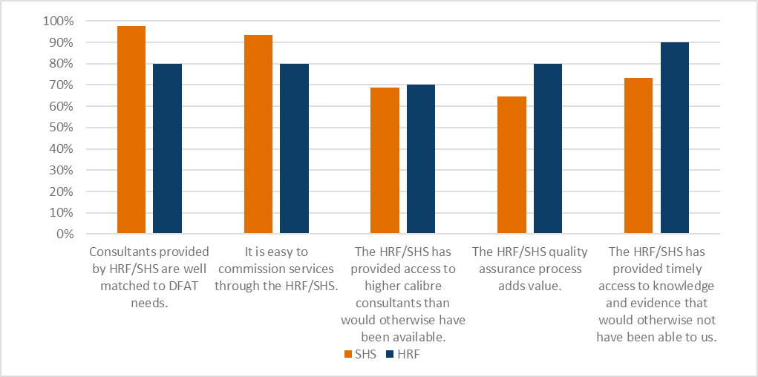

SHS is designed to enable DFAT to quickly source TA from a wide pool of expertise. This underpins the perception that SHS has provided access to higher calibre consultants than would otherwise have been available. However, the value gained from SHS is limited by three factors:

* 1. The high use of sole-sourcing at DFAT direction (Section 4 Effectiveness). Over the life of SHS, approximately one third of consultants have been sole-sourced[124]. While this figure has varied on an annual basis (between 15 and 46%) there has been an overall trend to increasingly use sole-sourcing. This is addressed by subsequent recommendations.
  2. DFAT selection of known advisors with limited utilisation of the broader, unknown pool. As shown in Figure 10, one third of the work was undertaken by approximately 25 consultants and half went to under 50 consultants.
  3. Lack of recognition by some DFAT Officers of realistic workflow timelines. For example, a consultant initially identified to do a task may not be available if the contract is not progressed in a timely way. This means that SHS may have to identify and shortlist consultants for an activity multiple times. This also creates frustration amongst consultants who set aside time for an activity (and consequently turned down other work opportunities) and it is then delayed.

In the first two cases, the resources invested by SHS to expand the diversity of quality consultants in the pool is wasted. If DFAT wants to use known consultants, with proven reputations, establishing a mechanism that requires a diverse pool of candidates to be nominated will not maximise efficiency.

There is a lack of consistency across SHS staff with the average duration of the SHS Director being 2 years[125], the Senior International Health Specialist 1.2 - 1.5 years, and the International Health Specialist 1 – 1.2 year[126]. Regardless of the competency of the individuals in these positions, it will take time for them to become familiar with the Scope of Services, extensive suite of processes used by SHS, and activities being planned or implemented. More significantly, half the consultants interviewed reported that these staff changes created discontinuity with management of their assignments and difficulties emerged when new managers had a different interpretation of a ToR or expectations[127]. Strategies to improve consistency should be considered. These strategies must address the specific reason staff leave or are not contracted beyond the probation period. Reasons given by previous staff of SHS who were interviewed include the type of work (largely administrative rather than using technical expertise), workload and management style. Addressing this may impact the structue of any future Facility.

The SHS health specialists provide significant levels of support to recruit, appoint, mobilise and manage consultants. Several consultants and former SHS staff indicated that they believed that this was not an efficient use of the health specialist’s time. From their perspective, it would be more efficient for such work to be undertaken by Abt[128]. SHS operates largely as an independent entity on a day-to-day basis in relation to Abt. As a result, while Abt provide support, the proportion of support in terms of recruitment, appointment, mobilisation and on the ground support of consultants provided by Abt as against the SHS team is less than many SHS staff and consultants expect. They considered this support would be more effectively provided by human resource specialists and represents a lower efficiency in use of health specialist time.

SHS was perceived by those who completed the commissioners survey to be more efficient than HRF in three areas (Figure 13): (i) how well consultants matched DFAT needs; (ii) the ease of commissioning services and (iii) providing access to high calibre consultants who would not otherwise have been available. The Cost Utility Analysis (Appendix 2) also found that SHS was more efficient than HRF where efficiency considers both effectiveness and cost. This would suggest a process of improvement has occurred between HRF and SHS[129].

Figure 13. Proportion of DFAT commissioner who disagree with statement regarding SHS/HRF inputs and processes[130]

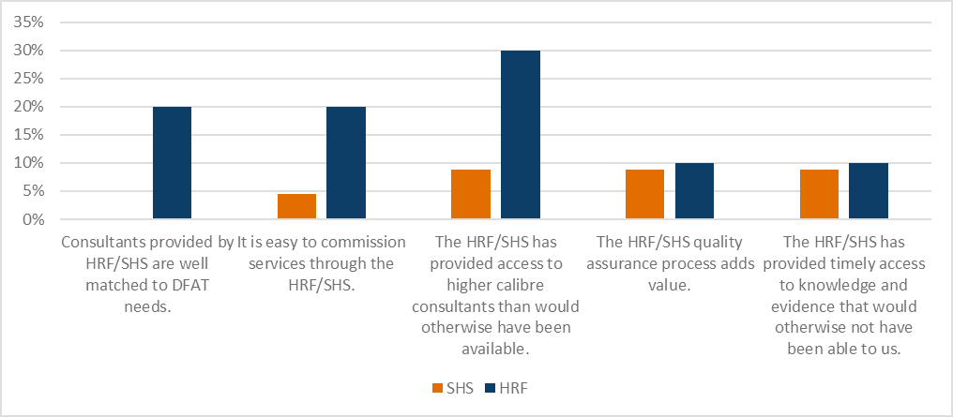Where commissioners had sourced consultants through other mechanisms, the major reason was because those mechanisms were considered to be more efficient (Figure 14). This has been discussed under Relevance. There has been no statistically significant change in this result to that of HRF.

Figure 14. Why commissioners used other sources of technical assistance[131]

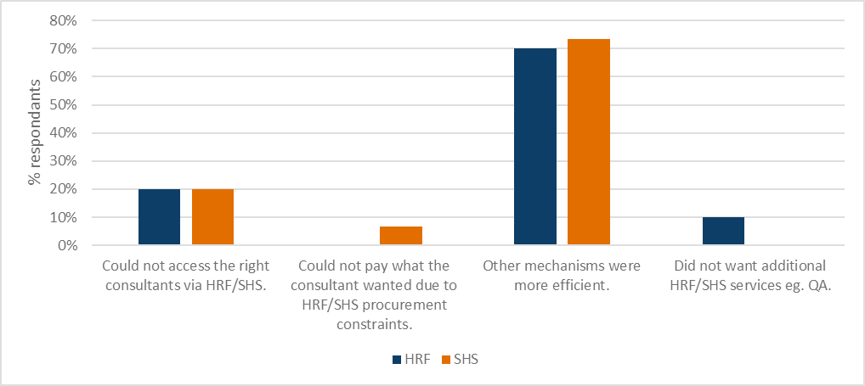

#### Use of resources

There appears to be a general lack of awareness within DFAT of SHS’s scope[132]. This would suggest SHS is not being used to its full potential. Some who had used it as a mechanism to engage consultants to provide surge capacity were not aware that it also provided RR services[133]. As one Commissioner described it “*I first thought that SHS was a bodyshop, but it is much more than that. It is not fully utilised as (SHS’s scope) is not understood*”[134]. This lack of understanding was recognised, but solutions to address it were limited. For example, workshops to discuss the support SHS could provide had been held when officers from Post came to Australia for other meetings. Information had also been included in various internal newsletters[135]. Increased use of SHS, would increase efficiency as the fixed costs would be spread across a greater number of tasks[136].

The tender required that SHS provide staffing that would enable delivery of the Scope of Services. While the type of services was known, the quantum of activities to be implemented within each service type was unknown and variable. Therefore, a service provider needed to staff SHS in such a way as to provide the necessary flexibility in a cost-effective manner. This variability is a challenge to cost efficiency as it means that at times staffing may be excessive and at other times, resources may be constrained[137].

The costs associated with SHS fundamentally comprise two components: (i) reimbursable costs for consultants contracted under service orders and priority tasks; and (ii) management costs (including core personnel) for delivering the Scope of Services.

#### Reimbursable costs for consultants contracted under service orders and priority tasks

In terms of absolute dollar amounts, the fees paid for advisors are relatively low given they remain at the ARF rates. The use of these rates for new (but not existing) contracts was discontinued by DFAT in 2020 because they no longer represented market rates and constrained the availability of consultants. However, as SHS has been extended, the ARF rates have continued to apply. Consequently, the pool of consultants from which SHS can draw has been constrained[138].

Where DFAT has wanted to contract specific consultants who were unwilling to work within the ARF rates, they have used other mechanisms. These other mechanisms have not necessarily been as easy or as efficient to use as SHS. In a small number of cases, it led to teams being contracted through different mechanisms and reporting to different managers. This was identified in five of the key informant interviews and, in approximately one third of these cases, created difficulties within teams and inefficiencies in delivery. Thus, the constraint on the fee rates has created inefficiencies for SHS and the broader DFAT development program.

There is also an incorrect perception amongst some consultants that the limitation on rates is imposed by Abt rather than by DFAT. A few consultants interviewed noted this had adversely affected their long-term relationship with Abt.

The reimbursable costs associated with an adviser (for example, airfares, accommodation, travel insurance) represent approximately 33% of adviser fees. Therefore, there is a potential for significant efficiencies to be achieved where a Contractor works to ensure that these costs are minimised. Commissioners and consultants commented that SHS had made savings for DFAT on these costs. This was achieved through identification of cheaper airfares and accommodation in-country. A small number of advisors complained that the accommodation provided was inappropriate, e.g., it had an inadequate Internet service. However, the accommodation chosen is based on DFAT rates for accommodation and recommendations from DFAT posts and is (typically) used by other contracting companies. Therefore, it has been deemed within the industry to be appropriate. The savings achieved by SHS in these costs requires additional input of time by Abt (and therefore costs to Abt). This represents an efficiency gain for DFAT (the actual gain cannot be quantified with the available data).

#### Management costs

Across initiatives, management fees for delivery of services vary based on what is included in the fee. Therefore, comparison between contracts is difficult as subtle differences may have significant impacts on service delivery. Possible comparisons for SHS include: HRF management fees (the predecessor to SHS), the former DFAT Standing Offers, two standing panels and several Facilities[139]. However, none of these are identical to SHS. For example, the former DFAT Standing Offers did not require a Managing Contractor or individual consultant to maintain a team to service DFAT needs on demand. One standing panel also operates in large part as a program; providing more proactive input into DFAT’s program with specific responsibilities for strategic advice in particular countries. In addition, it provides more advice through a core team and mobilises fewer independent advisers. Another contract requires a proactive approach in developing strategic advice, development of the capacity of DFAT staff in a specific technical area and provision of targeted support to regional and national non-government and community-based organisations. These Facilities differentiated payments across a broad range of services or number of consultants supported but did not integrate provision of a rapid response function. Some of the Facilities supported an order of magnitude more consultants[140].

While HRF had a comparable Scope of Services, SHS proved significantly smaller in scale. When SHS was tendered, the expectation was that it would manage a similar number of activities as HRF or continue the growth HRF had experienced. However, this did not occur[141]. In practice, on an annual basis, SHS has completed approximately 20% of the service orders and 42% of the help desk/rapid response requests completed by HRF. Consequently, one would expect the management costs for SHS to be a higher proportion of overall costs than for HRF as fixed overhead costs are spread across a smaller expenditure on activities.

Given these factors, only broad ranges of comparable costs can be established. Based on the development initiatives described earlier in this section, a management cost of:

* 10 to 20% would be considered extremely low and only possible where the contract simply required ad hoc support through provision of individual consultants.
* 20 to 30% could be expected where the Scope of Services includes an on-demand element of support.
* more than 30% could be expected where the initiative is providing on-demand technical advice and ongoing support to recruit, mobilise and support consultants in-country.

Using this benchmark, the management costs for SHS are at a level considered reasonable.

SHS is fundamentally comprised of two components: (i) technical health support and (ii) human resource management and administration. There is no distinction in the contract between the resources used by each of these elements.

SHS health specialists indicated that while most of their time was spent on technical aspects, quite a bit was spent on human resource management and administration. Several considered it would be more effective for specialists in human resources to recruit and shortlist consultants.

The contract states that the management fee is not paid where a consultant provides less than two weeks input. Given that the same amount of work is required to recruit, contract and mobilise the consultant for any Service Order, the expectation that these services will be provided essentially free, seems an onerous expectation on a Managing Contractor. Realistically, these costs will need to be recovered and this is best done if specifically identified rather than being built into overheads.

Demand for T2SO has grown significantly over the life of the Facility. As can be seen in Figure 8, it quickly grew from 7% to approximately 33%, and then to over 50% of the number of activities. Thus, it would have initially comprised a small component of the total management fee on SHS. However, over time, these activities came to comprise most activities on which management fee was recovered. While the management support to these consultants does not require SHS to provide quality assurance, all other support is the same. Given that the management fee for these activities is set quite low, it is likely that SHS has not received the returns expected on this element.

This is further compounded by the misunderstanding that emerged during the interviews among many commissioners that SHS is also responsible for identifying and resolving any quality issues associated with the input or output. This is not a responsibility of SHS for T2SO and should therefore not be considered to be covered in the management fee.

Commissioners generally considered that SHS was efficient. Some 40% of survey respondents specifically identified value for money as a characteristic of SHS (Figure 9) and none of the survey respondents considered it expensive (Figure 9). However, many commissioners considered RR to be “free” (effectively because they did not see these costs); and did not consider the costs of this service were paid through Services Order 1 – Core Management and Set-up Activities. Similarly, many commissioners of T1SO and T2SO thought that the management fee was low[142]. Several considered that it was probably less than it should have been and noted that it was less than when they engaged advisers through other mechanisms. However, it seems likely that they were only considering the fixed percentage applied to the consultant’s fee (the Adviser/National Management Fee), rather than also considering costs paid through Services Order 1 – Core Management and Set-up Activities.

### Are the Type 1, Type 2 and Rapid Tasking functions fit for purpose?

#### Are RR tasks genuinely 3 days?

For a task to be completed as a RR, it must be able to be completed within three days. However, SHS has advised that on average, they provide eight to ten days input completing a RR task (including responding to DFAT feedback). The reasons for this varied (Appendix 3).

Former SHS staff also advised that this time often included clarification of requirements of a specific RR. The evaluation team considers that, while important to clarify requests, spending days liaising with DFAT about requirements of a specific RR, is not efficient. This appears to be a consequence of poorly defined requests. The cause for this should be identified[143] and addressed before any future support is designed.

In addition, if this mechanism is to work as intended: where SHS identifies a proposed RR cannot be completed to the required standard within the three days, discussions should occur with DFAT to either break the task into several RR or use other mechanisms (PT or SO). SHS have advised that this is now occurring. There also needs to be a shift in expectations so that where RR is requested, SHS ‘cuts the cloth to suit the fabric’.

SHS has suggested that future support include a variety of types of RR with varying number of days depending on complexity of task. This is likely to make RR more complex, losing one of the main benefits of RR. Therefore, this evaluation team does not recommend this approach. With RR, PT and SO, there is a reasonable variety of mechanism to reflect different needs[144].

#### Are Service Orders appropriately used?

While Service Orders can be used for inputs of any duration, they are primarily used for inputs longer than 5 days. They are a relatively simple way in which this longer expertise can be accessed. In most cases, T1SO was the appropriate mechanism for the work commissioned; these included concept and design work, and in-country evaluations. In these cases, the QA could ensure appropriate use of international evidence and alignment with good practice principles for development and relevant DFAT policies. As outputs from such tasks are typically lengthy reports (25-30 pages), QA was able to improve readability and clarity of recommendations (Appendix 3). However, just under a third of the T1SO reviewed may have been more appropriate as T2SO as there was a limited role for QA. Examples include specialised technical tasks, such as an audit; tasks that require independent appraisal; and instances where DFAT provided a consultant to work with another development partner on a short-term assignment. This means that services (QA) were paid for which added little value.

T2SO were used appropriately in many cases where SHS QA services were not required. For example, to recruit consultants with specific technical or clinical skills to work with other development partners (e.g., as part of a Global Fund team) or to work in an intermittent but long-term advisory capacity with countries (e.g., providing an agreed number of support days over a year). T2SO have also been used to run recruitment processes for long-term advisors where SHS will have no QA responsibility. However, in about one-third of examples reviewed, the evaluation team concluded T2SO were used inappropriately. For example, for in-country design or advisory work for consultants that have more generic health skills – such as team leaders or health information specialists. The independent quality reviewer concluded that such work was likely to benefit from QA and support from SHS – including to ensure it is consistent with other TA provided to that country.

Confusion among commissioners between T1SO and T2SO led to a small number of cases where commissioners selected a contracting mechanism that did not best suit their needs[145]. This led to inefficiencies and caused dissatisfaction where: the commissioner incorrectly expected SHS to oversight and follow-up submission and quality of outputs for T2SO; or didn’t understand what work SHS was doing in relation to contract management.

Commissioners consistently identified as a strength of SHS the simplicity of the process for recruiting and contracting in comparison to other available mechanisms[146], particularly where sole-sourcing was DFAT’s preferred approach as it avoided a lengthy recruiting process if DFAT used alternate mechanisms. While there were examples of appropriate use of sole-sourcing, a high number of sole-source appointments suggests that many were for DFAT’s convenience and lacked transparency.

#### Does the SHS QA process add value?

The QA process applies only to Type 1 contracts, both PT[147] and longer-term SO. The process is detailed in the Operations Manual and appears to be consistently applied (Appendix 3).

In most Type 1 tasks reviewed, the chosen consultant performed well. In these cases, the QA process was assessed to add little value[148]. This also reflected the perspective of advisers interviewed who were considered to have performed well[149].

When the commissioned consultant did not deliver a quality product, the QA process added value[150]. In these cases, SHS has the responsibility of negotiating with the consultant to perform any additional work required and/or addressing perceived deficiencies in the output. From DFATs’ perspective, having SHS responsible for resolving these issues was a significant benefit as they did not have the expertise to determine whether the technical quality of the report was appropriate and would have had difficulty finding adequate time to work with a consultant. However, in this sample, SHS's input was often reactive; a response to negative feedback from DFAT rather than conducted in advance of the first submission to DFAT.

The additional cost for QA to DFAT is significant, yet small when compared to, for example, the impact of poor-quality strategic advice or designs on the development program. Therefore, the value added of an effective QA process should be considered in light of this broader picture rather than the cost of an individual task implemented under SHS.

In summary, RR and SO are fit for purpose. However, efficiency would be improved if understanding among commissioners about the difference between T1SO and T2SO was improved. In practice, T1SO should be considered as the rule and T2SO the exception, applicable only where QA is either not required or for a very specific reason, SHS is not best placed to provide this service (such as an area where they do not have the expertise or a potential conflict of interest). Further, SHS’s QA process was found to add value. The key reasons are that the DFAT commissioner may not have the technical expertise to judge the quality of the output and it provides a safety net to DFAT in cases where consultants underperform.

### Does SHS improve DFAT efficiency?

Commissioners and DFAT management considered that SHS had improved the efficiency of DFAT through saving DFAT officers’ time and in providing technical advice in a timely manner.

DFAT officers saved time by effectively delegating recruitment, contracting and management of consultants to SHS. This finding was reflected in both the survey results (Figure 15) and interviews and was also a finding of the HRF evaluation. A few DFAT commissioners noted that they were able to use this time for higher level tasks including planning, strategic thinking and policy implementation[151].

This was complemented by SHS providing technical advice quickly and through a “*light touch*” mechanism (RR). The availability of this timely advice was consistently seen as a positive and important to support the quality of the aid program[152]. Commissioners noted that gaining access to a budget for this work may have been a challenge. Posts in particular found the RR mechanism useful and considered it efficient because “*we don’t pay anything”*. Others considered that to obtain equivalent analysis through other sources would have been more costly and taken longer, adversely impacting the efficiency of the aid program[153].

Figure 15. Commissioner’s perspective on whether SHS/HRF saved them time

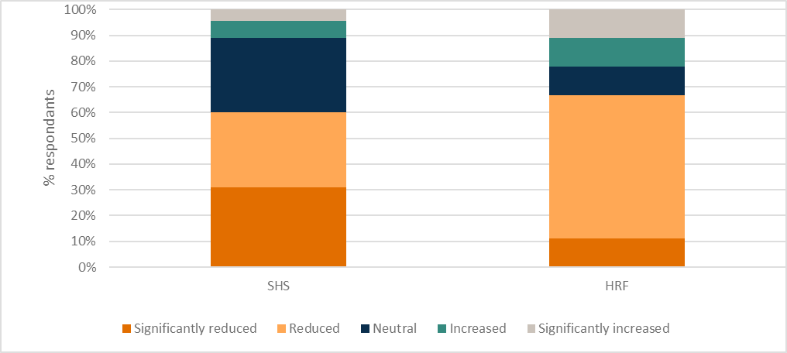

# Looking forward: Changes to improve health advisory support

This section looks at DFAT’s future health support needs and based on this, and the findings set out in Section 4, makes recommendations on ways in which future health advisory support can be improved. Where a recommendation is made, it is set at the start of a section, and the rationale for the recommendation then follows.

## Need for external support

Recommendation 1   
A central mechanism to provide DFAT with health specialist support be continued following SHS. This should include a function for recruitment and management of consultants to support the health sector as well as for quick turnaround health advice.

All those interviewed who had commissioned work through SHS considered that the need remained for something similar to SHS into the future. In particular, the need for support to undertake short pieces of analytical work was identified. A small number of commissioners noted that there was no other avenue to easily have this work undertaken.

Many also believed the organisation was becoming more reactive. As a result, there was demand for a process to respond quickly to identified needs. This meant that access to fast, responsive advice and surge capacity was essential. Covid appeared to have exacerbated this.

Posts in particular reported that they needed access to RR-type support. In addition, an Australia-based DFAT manager explained that since Covid, “*Posts are so stretched that they don’t want guidance and capacity building, they want a help desk function where they can get expert review of proposed M&E arrangements for investment designs and contractual arrangements*”. Several posts have contracted their own resource facilities (for example, Fiji, Papua New Guinea, Solomon Islands, Timor Leste, and Vanuatu) and others are currently in the process of establishing these (Papua New Guinea, Samoa and Tonga). Interviewees advised these allow them to engage technical specialists across a range of areas, including health. However, those that already have such facilities established, still often access SHS for specialist health consultants for RR engagements. This indicates while these facilities will decrease demand, there remains a continuing need for the type of support provided by SHS.

While there was agreement that ongoing access to sectoral expertise should continue, views on the form of this support varied. Most considered something similar to SHS and its predecessor HRF was appropriate. One commissioner suggested that future support may be more effective as some form of think-tank. This would provide DFAT with strategic and policy-level advice and better inform higher level decision-making. Several commissioners recommended that future support should expand the number of placements within DFAT, in the form of long-term contracted-in expertise. This would potentially provide any Facility with a better understanding of DFAT context and enable strategic input.

A Facility such as SHS offers huge value for DFAT in recruiting and managing consultants, which takes significant time and expertise. This is exacerbated by the increasing complexities of human resource management requirements in Australia and overseas, and a highly dynamic environment created by Covid. Therefore, there is a need for an external support to undertake this function.

In determining the most appropriate mechanism to adopt, there are several strategic decisions that DFAT should make. These relate to whether the performance of Australia’s international development activities in the health sector will be best supported through: centralised or decentralised recruitment models; and increased internal technical health expertise.

Recommendation 2   
DFAT look to avoid duplication and overlap between mechanisms which provide health sector expertise.

There is currently only one central mechanism through which health expertise can be recruited, SHS[154]. A second engagement mechanism is managed by Cardno which enables recruitment of specialists to support health security, but not the broader health sector. At present, there is some overlap between SHS and the mechanism managed by Cardno. At a country level, some Post have their own mechanisms for recruiting technical specialists, including health specialists. These are able to target specialists who already have a connection with a specific country or sector.

There are also a range of alternate mechanisms emerging through which health specialists may be able to be recruited. Each of these is independent, and on initial assessment, it appears there is little consideration of potential duplication. While it may be convenient for a business unit to have their own panel, this does not promote coherence in advice and is inefficient for both DFAT and consultants due to the high level of duplication of services.

Before a decision is made as to any ‘follow-on’ for SHS, DFAT should consider whether this approach of numerous overlapping mechanisms through which health sector expertise can be obtained should be allowed to proliferate or a more focused, agencywide approach would be both more effective and efficient. Where multiple mechanisms are used, strategies to avoid duplication and maximise their efficiency should be identified. This may, for example, result in a decision to expand the scope of an existing mechanism (such as that managed by Cardno) to provide the broader support the health sector requires, or to revise scopes of other mechanisms (including those at Posts) to minimise duplication.

## Current and future health needs of DFAT

Recommendation 3   
Future support be designed to focus on core areas of health specialist advice, i.e., Universal Health Coverage (health in development) and health security to provide flexibility in terms of the range of technical areas in which support can be provided.

Prior to Covid, DFAT’s health focus (and consequently the nature of demands on SHS) was primarily related to support for universal health coverage and SDG3 (Ensure healthy lives and promote well-being for all at all ages); delivered through an advisory, rather than direct service delivery. Over the last 18 months, Covid has led to a change in the support required. There has been an increased focus on health security and less on health in development. Travel restrictions have resulted in a reduced demand for overseas advisers, and where such assistance is required, an increased demand for locally engaged consultants. The need for Australian-based health security specialists has also increased to meet additional demands associated with the expansion of the CHS. The required speed of response was also considered to have increased because of the Covid pandemic and its fast-moving nature.

However, once the Covid crisis has passed, commissioners generally do not anticipate a significant change in DFAT’s future health needs. This is because they expect the health program to continue to focus on universal health coverage, and health security; not least because the healthcare disruptions caused by Covid may reverse previous improvements in health services. Change in long-term technical health needs is only expected to occur when there is a change in DFAT strategy, policy, and funding priorities.

The Principal Health Specialist considered that the bilateral health program landscape will likely remain consistent, i.e., a focus on Pacific with some work in South-East Asia, complemented by a few regional programs. This is not expected to lead to change in future demands for health expertise.

From previous experience, attempts to forecast changes in future needs have not been particularly successful. The SHS contract included a list of specialist areas that SHS was to incorporate in their pool of technical health specialists[155]. However, this proved far broader than what was required and omitted a number of needed areas. Therefore, the value of such a list in the contract is questionable.

The Principal Health Specialist also emphasised that the design of the next Facility should not be based on meeting emergency needs as experienced over the last 18 months with Covid. She emphasised that any future emergency would be different to our experiences with Covid and consequently we would need a different set of resources. Instead, any future support must ensure ease of access to a broad range of high-quality expertise at short notice.

## Opportunities

Any future initiative should integrate a range of strategies to improve the effectiveness and efficiency of both the international development program and the delivery of technical health support to the program in the long term.

#### Sole-sourcing

Recommendation 4   
DFAT to encourage open recruitments for technical assignments where it is appropriate to do so and where time is not a critical factor.

DFAT’s use of sole-sourced consultants has increased. During HRF, it was 23%. The evaluation of HRF identified that this figure was too large and a problem in terms of efficiency. However, it has since grown from 23% to approximately 50% under SHS.

If DFAT intends to continue sole-sourcing at scale, such contracting should be through a Type 2 approach where the Facility does not have responsibility for QA. In addition, a different contracting mechanism would be more efficient as many of the systems established and operated by SHS to recruit consultants are not required.

#### Consultant pool

Recommendation 5   
Access to a diverse consultant pool should be a key selection criteria in the tender process for the successor to SHS.

Recommendation 6   
The next phase support a formal mentoring program to expand the pool of technical experts with DFAT and Pacific Island nation experience.

Contracting out the provision of technical health expertise requires a large pool of experienced, diverse consultants from which to draw. Without this pool, the depth and breadth of expertise will not be available. If this is to be DFAT’s approach, it should ensure the next provider has direct access to a large and diverse consultant pool of technical health expertise. In addition, formal strategies may be required to ensure DFAT staff access, use and support the continuous growth of this pool.

While DFAT has indicated that it wants access to a diverse pool of consultants, in practice the same consultants are often chosen. As noted previously, increasing the diversity in a consultant panel and of those nominated will have little impact unless these consultants are ultimately selected by DFAT. As many of these candidates (particularly those from the Pacific and Southeast Asia) have less experience working in international development or with DFAT, they are often not selected.

Further, many consultants working in the Pacific can be expected to retire over the next 10 years. Without introducing younger consultants to the countries in which DFAT operates and the development context, the shortage of consultants with experience in Pacific Island nations will continue to increase.

Given the uniqueness of the Pacific and its importance to DFAT’s aid program, a formal, DFAT-funded mentoring strategy is warranted. This may include a requirement that any experienced candidate (for example, with more than 10 years’ experience) selected for a task must mentor a consultant from a country in which the task is occurring, or a young technical specialist without development experience, or a younger development expert with experience from outside the Pacific.

#### Expand usage

Recommendation 7   
DFAT increase internal capacity to support strategic health sector engagement, including coherence of policy and programs and of DFAT officers’ capacity to effectively participate in health policy dialogue and manage health investments.

Over the last five years, DFAT has moved from a position where it held depth of sectoral and development expertise internally to one where this expertise has been largely contracted on a case-by-case basis. There are pros and cons with each approach (Table 2).

Table 2. Pros and cons of using external technical expertise

|  |  |
| --- | --- |
| Advantages of external technical expertise | Disadvantages of external technical expertise |
| Enables lower DFAT staffing levels | Likely to be more costly if expertise is accessed |
| Provides access to a broader range of expertise | Limited ability to adopt a strategic approach to determine what expertise DFAT needs and when this is required |
|  | More limited ability to determine whether external advice provided is fit for purpose and of appropriate quality |
|  | Facilitates follow-up of internal use of outputs |
|  | Limits contribution to coherence and coordination across the development program |
|  | More limited input into the strategic direction of DFAT’s health program |
|  | Deskills DFAT |

Many commissioners expressed deep concern with the loss of internal technical expertise[156] had reduced their ability to understand technical health issues, clearly identify the technical expertise needs and then develop clear, effective terms of reference to respond to these needs. Several commissioners noted that this reduced capacity inhibited their ability to participate in effective policy dialogue with partner governments, regional organisations and internally; and to be informed purchasers of technical assistance[157].

To overcome these challenges, greater internal sectoral expertise can be achieved through either (i) increasing FTE or (ii) contracting positions into DFAT. These internal experts would have greater input into the strategic direction of DFAT’s health program as it was generally agreed that this is difficult when such services are contracted out. They could also develop the capacity of other DFAT staff to engage in health policy dialogue and contract effective external support. There was also a perception amongst many that non-specialist DFAT officers would be more willing to discuss challenges with people ’sitting inside’ the Department, who have a stronger understanding of context. As a result, greater internal capacity may increase demand for external support, through prompting DFAT program managers to adopt a greater focus on technical questions and gaps, building capacity for commissioning, and facilitating stronger strategic oversight of the DFAT health investment portfolio.

The development of DFAT staff capacity could also be expanded by drawing on support from the next phase. For example, the active support of learning events and coaching of DFAT officers, particularly at Post; developing on-line learning programs on effective contracting; and preparation of knowledge synthesis summaries.

Recommendation 8   
Implement strategies within DFAT to increase awareness and use of any future Facility.

Most commissioners considered that they (or others) had lost opportunities to use the expertise accessible through SHS. This occurred because DFAT officers did not fully understand SHS or did not think to access it. There was a perception that people either saw SHS as a mechanism through which they could recruit consultants or as a source of short analytic pieces, but not both. This limited the extent to which the support available through SHS was requested[158].

The following opportunities are at a process level. Numbered recommendations have not been included for these to ensure the focus of recommendations remains on the highest priority matters.

#### Coherence and coordination

For any future technical health sector support to contribute to coherence and coordination, specific support will be needed to (i) facilitate sharing of information within DFAT; and (ii) ensure consistent application of expert advice [159]. Examples of possible actions include:

* Sharing information:
  + Ensuring stakeholders are aware that specific reports have been produced. This would require informing them directly or through newsletters. While outputs are saved in EDRMS, and made accessible to all DFAT staff[160], stakeholders may not be aware of a report’s existence.
  + Providing consolidated thematic summaries to all posts with health programs and those in HPB and CHS.
  + Providing full or summarised copies of reports to consultants undertaking a similar assignment. Ideally, DFAT should do this more broadly, but at the minimum, SHS should provide this support to consultants working through SHS[161].
  + Supporting publication of work in the public domain.
* Consistency in advice:
  + Increase use of drawdown contracts so that a single adviser provides on-going advice to a country or in a specific technical area (such as nutrition).

An external Facility such as SHS cannot implement many of these activities (though it could provide support to facilitate them). Responsibility for implementation ultimately rests with DFAT. Internal expertise could manage, if not implement, these activities.

### *Improving efficiency*

Efficiency can be improved by both SHS and DFAT changing practices. Areas identified are listed below.

#### Changes SHS can make to improve efficiency

Recommendations made by commissioners to improve SHS efficiency[162] include:

* SHS advising the Commissioner during the tasking process if a particular area is not SHS’s expertise. In these situations, the Commissioner may choose to look at other sources of expertise.
* Establishing an online platform for completion of requests, terms of reference, service orders to replace the existing manual system. In practice, the security requirements of DFAT’s IT network may create challenges for establishing this with an external service provider.
* Increasing consistency of Specified Personnel to improve efficiency.
* Managing RR so that the time allocated to the work is more reflective of the time budgeted.

The health specialists engaged by SHS in the core management team undertake extensive work to support the recruitment and selection of consultants, and their support and management once appointed. This is not a good use of these specialist skills. Efficiencies could be created by having administrative, HR and management staff undertake these activities.

#### Changes DFAT can make to improve efficiency

* Provision of increased flexibility within the contract to enable a Managing Contractor to respond to changes in demand more quickly (through changed staffing levels for example) would enhance efficiency.
* The greater the usage of SHS, the greater its efficiency. Use can be increased by a better awareness of the availability of both RR and SO throughout DFAT and increased proactive tasking. DFAT should consider how proactive tasking and awareness of this support can be increased.
* Improving understanding among commissioners of the differences between T1SO and T2SO, along with the circumstances in which external, independent, specialist QA is most appropriate, should improve efficiency.
* Improving understanding of realistic timelines for activity contracting and implementation, and the implications of delay among DFAT officers should also improve efficiency.
* Further simplifying the template Service Order for use on SHS.

## Governance

Recommendation 9   
The Steering Committee’s ToR for the next phase have a greater strategic focus, including monitoring results against a results framework (including implementation of all approved recommendations from this evaluation), and be reviewed annually.

Governance and management are different. Governance is about planning the framework for work and ensuring it is done. As such, governance looks to the future (strategy formulation and policy making) and to the past (providing accountability, monitoring and supervision). In contrast, management largely focuses on the day-to-day implementation of strategy through management (organising the work) and operations (doing the work).

SHS management is overseen by a regular monthly management meeting comprising those with day-to-day responsibilities for management at DFAT and SHS. Participants considered that these meetings facilitated effective management and engaged senior managers as required.

Governance of SHS lies with the Steering Committee, comprising DFAT’s Principal Health Specialist and activity manager, and DFAT personnel from corporate, policy and geographic regions as deemed appropriate; SHS director and staff. The Steering Committee is scheduled to meet six monthly, however in practice meetings generally occurred only annually. In the two and a half years following December 2018, the minutes identify that the Steering Committee meetings occurred with only the Australian-based members.

The responsibilities of the Steering Committee are fundamentally strategic, including: strategic oversight of SHS and its work, forward planning and annual performance reviews of SHS. The Scope of Services also notes that the Steering Committee will assist DFAT in the oversight of SHS to promote policy coherence and consistency across the DFAT health programs. However, in practice much of the Steering Committee’s work focusses on day-to-day management.

During interviews, members of the Steering Committee commented that there needed to be more attention given to: emerging issues; how SHS could be used more effectively to support DFAT health strategy; and, identifying and addressing lessons learnt. However, minutes for the Steering Committee show that while these issues are often presented, they rarely generate a strategic discussion or response.

This evaluation also identified a lack of focus on SHS’s contribution to outcomes and objectives level and how this could be improved. In particular, while promoting policy coherence and consistency was an objective of SHS, and recognised by almost everybody interviewed as being unrealistic, this does not appear to have been addressed by the Steering Committee. This is unfortunate as a more strategic approach may have catalysed approaches to support policy coherence and consistency.

In addition, there appears to be little identification of follow-up action and monitoring at subsequent Steering Committee meetings of whether agreed actions occurred or if/how the data collected was applied. There was also little evidence that Steering Committee meetings considered risk to any degree[163].

Perhaps most significantly is the failure of the Steering Committee to consider implementation of the recommendations from the 2013 evaluation of HRF which made recommendations for the next phase of support. These recommendations do not appear to have been captured in SHS’s Performance Assessment and Evaluation Plan (which was correctly aligned to the Theory of Change). Therefore, they were not reported to the Steering Committee which appears only to have considered what SHS reported.

These recommendations included:

* The need to boost DFAT staff capacity to commission well. There has been no formal mechanism to enhance DFAT staff capacity to commission. In fact, the evidence available from interviews with DFAT managers, commissioners and SHS officers indicated that DFAT staff capacity to commission has reduced in part as a consequence of DFAT’s changed organisational structure. There was clear agreement that the quality of the output was critically dependent upon the clarity in specifying the work commissioned. The need to boost DFAT staff capacity to commission remains a high priority.
* The need to ensure results were well used. Prior to Covid, outputs were expected to be well used. Post task evaluations conducted by SHS found that for 95% of tasks, commissioners considered that the result would be useful. This implies that most expected to use the output. However, there has been no subsequent follow-up on the actual use of outputs and difference this made. Responsibility for this should be identified and reporting to the Steering Committee on findings included in any future phase of support.
* Increasing the focus on cross-cutting issues, including gender, disability and equity. There has been an increased focus on cross-cutting issues. However, this evaluation found that except with the scope of services specifically related to a cross-cutting issue, there was generally inadequate attention to these issues. Any future phase of support still needs to include an increased focus on cross-cutting issues.
* Strengthening knowledge management, for example by doing meta-analyses of work commissioned. There is no evidence that this recommendation has been applied.
* Expanding the pool of consultants, with a particular focus on sourcing people from Asia and the Pacific. Numerically, the pool of consultants available has reduced under SHS. However, in practice, the number of different consultants nominated and contracted has increased. SHS has also undertaken very specific activities in the second half of the Facility to improve the diversity of the pool. There is a need for DFAT to formally support practices which will increase contracting of a wider range of consultants. For sustainability reasons, as discussed in this evaluation, this must occur in any future phase of support.
* Stronger performance management of the Facility by DFAT. Application of this recommendation was not considered specifically by this evaluation. However, this evaluation did find that the Facility would benefit from adoption of a more strategic approach by the Steering Committee. This is evidenced by – amongst other things – the Steering Committee’s failure to consider recommendations from the HRF evaluation.

These recommendations from the HRF evaluation remain applicable in any subsequent SHS phase.

In part, the lack of strategic level discussion and decision making was a consequence of the Steering Committee being used as a forum for discussion instead. The evaluation team was advised that this practice emerged because it was difficult to get representatives from a breadth of DFAT business units and posts who were involved in health together through other mechanisms. The relatively large size (a result of inclusion of representatives from all posts who drew on SHS support) of the Steering Committee would also mitigate against strategic level discussion and decision making.

To overcome this, the Steering Committee must: comprise a small group who have the authority to make strategic decisions in relation to SHS; have clear ToR that focus on the strategic level; and hold regular meetings. The ToR could be based on a model such as that put forward by Tricker (Figure 16). In addition, to avoid detracting from the Steering Committees strategic focus, alternative mechanisms must be used as discussion fora.

Figure 16 Tricker’s framework for Board governance

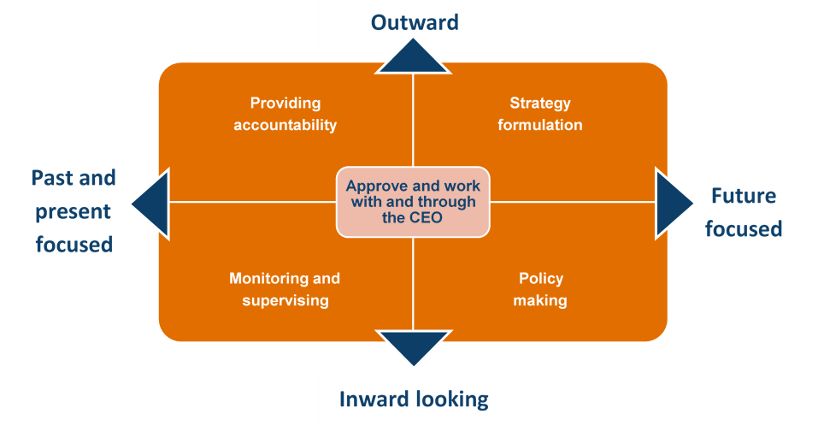

# Conclusion and Recommendations

This evaluation found that SHS has performed extremely well and, overall, provided a quality service. At a Facility design level, the mechanisms available have been relevant to the needs of commissioners. In terms of implementation, commissioners considered that the technical expertise available, ability to provide required services in a timely manner, and the quality of the output were all relevant. In a dynamic environment, SHS has been able to respond to changes in demand in a timely and effective manner.

SHS has contributed to the improvement of Australia’s aid program and informed discussions (primarily through RR and T1SO) and building partner capacity or filling a line role (primarily through T2SO). Commissioners have identified the primary areas in which contributions were made to the quality of the health program, meeting Australia’s aid effectiveness commitments, and health policy and strategy. However, the overall contribution could have been magnified through improved processes for sharing information. While SHS could have been more proactive in proposing approaches to achieve this, ultimately this is DFAT’s responsibility.

In the context of SHS, sustainability has been defined as the assurance that services will be maintained in the event of staff or contractor change. In this setting, the processes defined in the Operations Manual are deemed to ensure sustainability. However, this narrow definition may account for the generally limited attention to sustainability across SHS. A broader focus is recommended for future support.

There was significant value gained in terms of sustainability where consultants had a long-term association with specific countries or subsectors (for example the drawdown contracts used in Kiribati and Nauru and for gender). More broadly, in this context, SHS contributed to coordination of support to the health sector and coherence of the health program. Outside of this, there is little evidence to suggest that SHS has made a significant contribution to either coordination across health programming areas or coherence of the health program. Stakeholders broadly agreed that this was an unrealistic expectation based on the design of SHS.

SHS was found to be a lower cost model than HRF. This is despite the volume of work undertaken through SHS being significantly less than HRF, a factor that increases unit costs for SHS. HRF included QA for all tasks, increasing management costs. However, tasks without QA (Type 2) implemented under SHS receive a lower management fee. As the management fees for Type 2 work are low and could not realistically expect to be reduced, this difference is unlikely to account for the greater cost efficiency of SHS.

SHS can be considered relatively efficient given (i) it has delivered the results expected at a process and output level; (ii) the costs for doing this are comparable to what can be expected in the broader marketplace; and (iii) the CUA identified it provided greater value for money than HRF. However, as noted earlier, delivery at outcomes level has been weak. The use of technical health specialists to undertake human resource management and administration tasks (outside management of consultants) is not an efficient use of these personnel.

The limited size of the Facility also reduces efficiency. Efficiency is improved when the size of the program being supported is maximised and the accuracy of estimated demand is enhanced. In a dynamic environment such as that of SHS (even excluding the impact of Covid), accurate estimates of demand will always be difficult. Identifying ways to provide greater flexibility to staffing and more quickly respond to changes in demand and trends as they emerge is possible and would enhance efficiency.

While SHS has performed extremely well and, overall, provided a quality service, as with all activities, it is important to identify what improvements can be made. In this case, the evaluation has identified areas of relative weakness within the strengths of SHS. These include the limited size of the consultant pool; not always conducting referee checks prior to nomination; re-nominating consultants who previously demonstrated poor performance; insufficient rigour in achieving required standard for output on initial submission; and inclusion of impractical, unprioritised or excessive recommendations in reports. The evaluation team anticipates that, as with any organisation seeking continuous improvement, in consultation with DFAT, SHS and Abt will identify the most appropriate approach for their organisations to address these relative weaknesses.

There is very clearly a need for ongoing support for DFAT in terms of both capacity to administer and manage consultants and technical health capacity. Therefore, this evaluation has recommended a future phase of support. This evaluation concluded that the value of such support to DFAT would be greater if some of this support was internalised within DFAT. In addition, maximising the use of the Facility will improve efficiency. Consequently, DFAT needs to implement actions that will ensure greater understanding of the breadth of technical support available to DFAT officers working in the health sector and minimise duplication/overlap of similar facilities.

Recommendations have been limited to specific high priority areas of consideration related to maximising the effectiveness and efficiency of future support:

[**Recommendation 1**   
A central mechanism to provide DFAT with health specialist support be continued following SHS. This should include a function for recruitment and management of consultants to support the health sector as well as for quick turnaround health advice.  
 49](#_Toc79918224)

[**Recommendation 2**   
DFAT look to avoid duplication and overlap between mechanisms which provide health sector expertise.  
 50](#_Toc79918225)

[**Recommendation 3**   
Future support be designed to focus on core areas of health specialist advice, i.e., Universal Health Coverage (health in development) and health security to provide flexibility in terms of the range of technical areas in which support can be provided.  
 50](#_Toc79918226)

[**Recommendation 4**   
DFAT to encourage open recruitments for technical assignments where it is appropriate to do so and where time is not a critical factor.  
 51](#_Toc79918227)

[**Recommendation 5**   
Access to a diverse consultant pool should be a key selection criteria in the tender process for the successor to SHS.  
 51](#_Toc79918228)

[**Recommendation 6**   
The next phase support a formal mentoring program to expand the pool of technical experts with DFAT and small Pacific Island nation experience.  
 51](#_Toc79918229)

[**Recommendation 7**   
DFAT increase internal capacity to support strategic health sector engagement, including coherence of policy and programs and of DFAT officers’ capacity to effectively participate in health policy dialogue and manage health investments.  
 52](#_Toc79918230)

[**Recommendation 8**   
Implement strategies within DFAT to increase awareness and use of any future Facility. 53](#_Toc79918231)

[**Recommendation 9**   
The Steering Committee’s ToR for the next phase have a greater strategic focus, including monitoring results against a results framework (including implementation of all approved recommendations from this evaluation), and be reviewed annually. 55](#_Toc79918232)

# Appendix 1 Theory of Change[164]

|  |  |
| --- | --- |
| **Goal** | * Improved performance of Australia’s international development activities in the health sector including through contributions to health policy, strategic planning and health programming. |
| **Objectives** | * Improve the consistency and standard of DFAT’s health policy advice and programming * Ensure that DFAT’s health policy, advice and programming is informed by highest quality, up-to-date technical information * Support policy coherence and best practice across DFAT’s health portfolio |
| **Outcomes** | * DFAT has access to high quality health technical inputs that deliver evidence based and timely health policy and program advice; and * The Specialist Health Service demonstrates efficiency and value for money in its delivery of high quality services |
| **Outputs** | * High quality analysis/synthesis of research, knowledge & experience on a wide range of health topics are accessible and useable for DFAT staff when required * Evidence based and robust policy analysis and advice and programming by DFAT officers |
| **Process** | * SHS responds to requests from DFAT staff for consultancy inputs, sources quality consultants, manages logistics, quality assures work * SHS provides technical resources/analysis/synthesis, knowledge management and lesson learning for DFAT to support policy coherence and quality. |
| **Structure & Management** | * Regular liaison with client areas and DFAT contract manager * Governance structure with a Steering Committee and contract manager |
| **Input** | * DFAT provides funding based on demand and contract terms * DFAT staff provide direction to the SHS, commission work and provide feedback |

# Appendix 2 Methodology

### Developing the review design

The review team comprised two members, an independent evaluator and a DFAT health specialist. The team conducted a preliminary document review and held face-to-face discussions with key stakeholders from DFAT and SHS. Based on these discussions, it was agreed that the core purpose of this review is to:

* 1. Determine whether the SHS model met its objectives; and
  2. Inform development of a business case for health advisory support to DFAT in the future.

To achieve this, it was agreed that the review would:

* 1. Assess the relevance, effectiveness, efficiency and sustainability of the SHS-contracted health technical advisory model. Four sub-areas of focus in this objective include:
  + Responsiveness and quality of the outputs provided by SHS;
  + Evidence of ultimate impact (on quality programming at the country level);
  + Influence on ‘health policy coherence’ (utilization of advice at the policy level); and
  + Value for money.
  1. Provide recommendations on any changes, modifications or improvements to approaches and activities required by DFAT to facilitate a robust model of health advisory support based on the key findings and informed by examples of leading models in contextually similar environments (i.e NZ MFAT, CIDA).

Reflecting these objectives, two key review questions were agreed:

* Within the context of the health sector, how have the services provided by SHS influenced Australia's health investments performance (in the Indo-Pacific) with regard to relevance, effectiveness, efficiency, and sustainability?
* What changes, modifications or improvements to approaches and activities by DFAT would facilitate a robust model of health advisory support?

A series of prioritised sub-questions were developed (Annex A). The key evaluation questions were revised and then the subsidiary questions clarified. Comments from key stakeholders were integrated. The priority questions identified by the primary stakeholder were: (i) Who is using the SHS and how; (ii) What were SHS outcomes and are they sustainable and (iii) What are DFAT’s future health advisory needs?

All data collection instruments were drafted, tested, revised, circulated to representative stakeholders for comment, with feedback integrated before finalisation. This included the quality rubric (Annex B), semi-structured interview questions (Annex C) and commissioner survey (Annex D).

The draft review plan was reviewed by DFAT and SHS and comments integrated before finalisation.

### Scope

This review scope was bounded by:

**Focus**: Input provided through Rapid Requests, Priority Tasks and Service Orders. The performance and impact of alternate providers of health sector advice are outside the scope of this review.

**Time period**: July 2015 to present. The focus was on activities completed by the end of 2020 as only these had a complete data set available.

**Stakeholders**: The Canberra based Health Policy Branch (HPB) in DFAT and other relevant policy teams (for example water and sanitation), Centre for Health Security (CHS), DFAT officers at Post, SHS team.

### Evaluability

For an initiative to be evaluable, it requires activities/outputs that can be evaluated, a clear theory of change (Appendix 1) and available data. SHS met these criteria and can be evaluated at this time in a reliable and credible fashion.

### Review principles

The principles applied to this review were as follows:

* 1. **Utilisation-focused**: use of findings was a key principle. To achieve this, the review adopted a Utilisation Focused approach. A Utilisation Focused approach requires (i) gaining commitment from intended users for review use; (ii) focusing on this throughout the course of the review; (iii) conducting effective stakeholder analysis and engagement; and (iv) designing the review to reflect context and stakeholder needs. To maximise utilisation, the key review questions focused on those identified by the primary audience.
  2. **Contribution**: this review focuses on contribution rather than attribution. Outcomes can rarely be attributed to a single factor. This is particularly the case in the complex environments in which international development programs operate and where the input directly contributing to a specific outcome is relatively small (as in SHS).
  3. **Responsibility**: SHS is responsible for the quality of input and output. These outputs will contribute to achievement of the outcomes specified in the theory of change. However, SHS is not responsible for achieving the outcomes. This review will clearly delineate this responsibility.
  4. **Breadth**: SHS uses five different tasking mechanisms, to provide services across more than 13 developing countries, to DFAT in Australia and in some 32 different health and 11 cross-cutting sectors. The review sought to collect data from across all mechanisms and across a range of countries to ensure the breadth of perspective is captured.
  5. **Learning**: A focus of the review was on learning to inform decision making in relation to future support provided.

### Audience

The primary audiences are: (i) DFAT Health Program and Performance Section (HPR) of the Health Policy Branch (HPB) and (ii) SHS. Secondary audiences include: (i) other geographic and policy areas in DFAT delivering health programs, notably the Centre for Health Security and Office of the Pacific; (ii) thematic areas in DFAT considering models to provide policy and strategic support and (iii) contractors providing similar support and (iv) other donors.

This review will be used by:

* 1. DFAT HPR to understand the contribution of their investment and apply lessons to similar efforts.
  2. DFAT HPR to inform the business case for the new mechanism for providing strategic and policy support to programs.
  3. The Human Governance Division to inform thematic support and structural requirements within DFAT to support quality health programming.

### Priority questions

The primary audience provided information on their priority questions. Based on the feedback received, the highest priority information requirements are around:

* Who is using the SHS and how?
* SHS outcomes and their sustainability.
* Future health advisory needs.

### Limitations

The limitations of this review are:

The limitations of this review are included in Appendix 2. These can be summarised as:

* 1. A large number of commissioners of tasks under SHS have left DFAT employment. Data could not be collected from most of these commissioners. Unfortunately, this included all commissioners of tasks undertaken in Samoa. As a consequence, this review does not include tasks undertaken in Samoa, one of the countries that made repeated use of this Facility.
  2. Approximately 110 tasks commenced over the last two years had not been completed and therefore data for many of these was not available. For example, unavailable data included outputs (so the quality of these could not be reviewed) and post task evaluations. Therefore, the sample includes fewer tasks undertaken more recently than had been anticipated.
  3. Quality data on other initiatives (excluding HRF) was limited. This prevented comparisons between the effectiveness and efficiency of SHS and other initiatives.
  4. The HRF survey conducted in 2014 had a relatively small number of respondents (generally only 14 people answered questions). Consequently, there needed to be at least a 10% (and often 20%) difference in results with SHS before it became meaningful.
  5. Disaggregated financial data on SHS was not available through DFAT systems in ways that facilitated detailed comparative analysis with HRF. This has limited the extent of the efficiency analysis.
  6. Data on Priority Tasks was limited and not consistently recorded in SHS spreadsheets (for example in a number of cases it was recorded as a Rapid Response). Consequently, the focus on Priority Tasks was more limited than planned.
  7. SHS undertook data cleaning of databases before the evaluation commenced, however errors in the Knowledge Transfer database were subsequently identified. These included: coding of some PT as RR, misidentifying some commissioners and TA responsible for outputs, and including commissioners as authors of T1SO outputs. Consequently, the figures in Table 1 are minimum as only those confirmed with the interviewee have been included.

The review team does not believe these limitations have impacted the extent to which this review has been able to adequately answer the key evaluation questions.

## Sampling

The population (the set of elements about which the review is to draw conclusions) for this review comprises all tasks undertaken through SHS. As there are over 300 tasks, sampling was essential. A Mixed Purposeful sampling approach was used. This approach adopts more than one sampling technique to obtain an in-depth understanding. Two approaches were used: Extreme Case and Maximum Variation sampling.

The focus of this review was learning to inform decision-making in regard to future health advisory support. As learning is maximised from Extreme Case analysis, this approach was adopted. This involved sampling tasks:

* In countries which used SHS frequently (Kiribati, PNG and Solomon Islands[165]) and those where it was only used once or twice (Fiji, Thailand and Timor Leste), or not at all (Bangladesh & Afghanistan). Initial data suggested that Bangladesh & Afghanistan Posts both had significant health sector programs but had not used SHS support. However, in both countries, funding of activities is through other agencies (a World Bank Trust Fund and BRAC) and they are not relevant to this evaluation.
* Commissioned by frequent commissioners and commissioners who only commissioned a single task.
* From the 18 tasks that did not proceed, a sample of these tasks was selected from those who successfully commissioned other tasks.
* Tasks where the process and output were considered by the commissioner to not meet any of the required criteria.

Selecting all tasks that met these criteria produced a sample of 95 tasks. Maximum Variation sampling was then used to reduce the sample to approximately 40 tasks while drawing the final sample from diverse groups and identifying patterns or themes within and across these groups. For this review, the variations we considered in sampling were the different mechanisms (i.e., rapid response, priority task and service order) and types of tasks (for example, designs, literature review, peer review, technical advice). The reduction in sample size from 95 tasks to 40 tasks was achieved by:

* Removing tasks from commissioners who had commissioned more than three tasks for the same mechanism that:
  + Were not in the six countries upon which this evaluation will focus.
  + Duplicated a specific type of task.
* Including tasks for types of tasks that were not included in the sample.

The final sample provided a mix of tasks across all characteristics used for sampling.

The sample of tasks assessed is set out in Annex E. Commissioners and the consultants on these tasks were interviewed. Some commissioners who had left DFAT for whom we could not easily locate a current contact were not able to be interviewed. There was also an error in a database which we did not identify until late in the evaluation which reduced the number of consultants interviewed. However, this will not impact the results as with qualitative methods, the sample size is not pre-determined. Instead, additional elements of the population are included until there is no ‘new’ data identified. As no ‘new’ data was collected towards the ends of data collection from these samples, the sample set did not need to be expanded.

## Data collection & Analysis

Data collection and analysis methods are summarised in Table 4. Further detail follows.

Table 4. Data collection and analysis methods applied

| Data source | Includes | Sampling strategy | Data collection | Analysis |
| --- | --- | --- | --- | --- |
| Documents | DFAT: Design, QAI, Scope of Services, Deed | Analyse all documents | Document review | Content analysis against the KEQ and quality rubric |
|  | Governance: Minutes of governance meetings, minutes of meetings between SHS & DFAT | Analyse all minutes and others DFAT &/or team believe relevant to KEQ |  |  |
|  | SHS: Outputs | Analyse sample based on Extreme Case and Maximum Variation sampling. |  |  |
|  | SHS: Reports on monitoring and annual reports. | Analyse all documents available (availability was limited) |  |  |
|  | External: evaluations & reviews of other projects providing technical support to a sector |  |  |  |
| Databases | Quantitative data | Frequency & trend analysis where appropriate | From SHS | Frequency |
| Stakeholders | Commissioners | Whole population for survey | Survey | Distribution  Compare to HRF |
|  |  | Sample of commissioners based on Extreme Case and Maximum Variation sampling (this is both those who commissioned numerous SHS tasks and those who commissioned few and Posts that commissioned none. | Semi structured interviews | Content analysis against the KEQ. |
|  | Consultants | Sample of consultants based on Extreme Case and Maximum Variation sampling. |  |  |
|  | SHS | All those involved including former SHS staff |  |  |
|  | DFAT Managers | Members of the SHS Steering Committee and other key informants |  |  |

### Data collection

There are three key sources of data for this review. These are: documents, SHS databases and stakeholders.

#### Documents

Document reviews analyse existing data drawn from available documentation. This review will consider four broad categories of documents:

* 1. SHS outputs, reviewed against a quality rubric to assess the quality of the output (Annex B).
  2. Relevant policy and strategy documents from countries (e.g., DFAT aid investment plans, health design documents, partner government health investments) to assess contribution to outcomes
  3. A review of evaluation reports from similar programs and facilities, both within and external to DFAT, to identify strengths and weaknesses of different mechanisms.
  4. SHS and DFAT’s regular reports produced to inform on-going SHS program management, including Partner Performance Assessment (PPAs) and six-monthly SHS reports, and annual Aid Quality Check (AQC) reports to contribute to the content analysis to address other elements of the review.

#### SHS Databases

SHS maintains a series of databases to manage the Facility and store monitoring data. The key databases from which data was sourced were:

* 1. The Advice Desk Register. This lists all tasks commissioned and documents activity and input-level information. For example, the dates of request, commissioning, completion; early or late completion.
  2. SHS Knowledge Transfer. This lists all tasks requested and identifies a range of primarily output-level detail for the task such as the mechanism used, tasking type, commissioner and author.
  3. TA Pool extracts. This lists all consultants who are available to provide input through SHS. It identifies each consultant, their skills and experience. This does not include TA no longer in the pool.
  4. Proposed candidates. This identifies which candidates were nominated and selected for each task, and how they were sourced.
  5. Quality Feedback (QFB) Database. This is an SHS internal-use database for recording all QFB on SHS for all tasks commissioned through the Facility, used for six-monthly reporting purposes.

1. The SHS team and the evaluation team undertook a data cleaning process. After analysis, it was identified that there remained some errors within the SHS Knowledge Transfer. These included: coding of some PT as RR, misidentifying some commissioners and TA responsible for outputs, and including commissioners as authors of T1SO outputs. The evaluation team does not believe that this will impact the overall findings.

#### Stakeholders

1. Semi-structured interviews are a qualitative method of inquiry that use a set of open questions to explore relevant themes. Those interviewed are not limited in their responses to a set of pre-determined answers, providing a richness of data that captures context. Semi-structured interviews enable participants to focus on what they think is important, while still providing sufficient coverage and structural consistency across respondents to enable rigorous analysis. The flexibility of semi-structured interviews also enables cross checking between respondents.
2. There is a base guide for the semi-structured interviews to be undertaken with stakeholders. This specifies the different questions for each stakeholder group (Annex C). The guide was tested with two key informants and adjusted.
3. Interviews generally occurred by telephone rather than face-to-face due to Covid 19. The team took detailed notes. These were typed and sent to each interview to check and edit as needed. Prior to each interview, the interviewer explained to the interviewee the purpose of the review and use of findings. All interviewees were provided the option of participating or withdrawing. Information in the report drawn from interviews does not include names and is deidentified wherever possible. Where this has not been possible, a copy of that section of the draft report has been provided to the person identified for their approval before inclusion in the report.
4. The HRF evaluation conducted a survey of DFAT stakeholders to gather views on Facility effectiveness and efficiency; this informed recommendations for improved future advisory support to DFAT’s health work. The information gained from these surveys was valuable. This survey was repeated as part of the SHS evaluation. Slight modifications to several questions have been made which will not impact the ability to compare results (Annex E).
5. There were 52 respondents to the survey. They were well representative of those who commissioned tasks through SHS as their distribution across commissioning areas was similar to that of the tasks commissioned, the number of tasks and mechanisms each had commissioned was a similar distribution to that of all commissioners and 56% of respondents had a background in health (similar to the sample interviewed). Although identified as having commissioned an activity under SHS, approximately 10% of respondents were not sure whether they had used SHS services. No further data was collected from these commissioners.
6. The return rate for the survey was much higher for SHS giving more robust data in relation to SHS than for HRF[166]. The two datasets were similar in terms of proportion of respondents by area of agency and health expertise in their background. The significant difference was that 60% of respondents to HRF had used HRF for at least 10 tasks whereas only 17% of SHS respondents had repeatedly used SHS to this extent. Over 50% of the respondents to the survey for SHS had used SHS at most three times. Similarly, all respondents to HRF had used the RR mechanism whereas only 53% had used this for SHS. The responses for SHS therefore represent a broader usage. The types of activities undertaken with similar other than HRF had been used to conduct training and workshops to a much greater degree (30% of respondents) than SHS (6.5%).
7. It must be recognised that the commissioner’s assessment of impact is self-reported and have not been independently verified as SHS does not maintain a record of whether recommendations are applied and there was limited ability to triangulate this with data from independent interviews.

### Analysis

#### Quality

1. Quality of 36 tasks was assessed against a quality rubric (Annex B). Rubrics are a scoring scale used to assess quality against a specific set of criteria. The rubric developed for this review identifies essential criteria for quality (drawn from the Deed and Scope of Services) and the levels of performance for each criterion. The six quality criteria were:
   1. SHS management of the task
   2. Quality of Selected Advisor
   3. Output delivers on ToR
   4. Output is technically sound and evidenced-based
   5. Output aligns with DFAT policies
   6. Advice and recommendations in output reflect country realities (for country-based work)

Where possible, the levels of performance were also drawn from the Deed and Scope of Services. Where this was not possible, they were based on good practice. With only three performance levels, the rubric has been designed so that consistent achievement of the above or below standard quality would be exceptional.

Where the output has already been through a peer review process (for example a design), information in the peer review report was also used to assess the quality criteria. This was supplemented as necessary by the assessment of this evaluation team.

Relevant criteria were assessed for each task: a short narrative was provided for each assessed criteria and colour-coded according to whether it was determined to be below standard (red), acceptable standard (yellow) or above standard (blue). Not all criteria were assessed for all tasks; for Service Orders Type 2 (T2SO) Priority tasks Type 2 (T2PT), the final written product was not reviewed given SHS’s role is confined to sourcing and contracting TA. For these, the focus was on SHS’s support to ToR development and the recruitment process, in particular the quality of proposed and selected advisors (criteria 1-2).

|  |  |  |  |  |
| --- | --- | --- | --- | --- |
|  | T1SO | T2SO | RR | T2PT |
| Strengths and weakness in SHS management of tasks | X | X | X | X |
| Changes in output quality over time | X |  | X |  |
| Strengths and weakness across the criteria 3-6 (i.e., those focussed on quality of output | X |  | X |  |
| Comparison of output quality in sole-sourced vs non-sole-sourced outputs | X |  |  |  |
| Comparison of advisor quality | X | X |  |  |

#### Content analysis

The qualitative data (semi-structured interviews) will be interrogated using content analysis. Content analysis was conducted in parallel with data collection, enabling emerging patterns to be tested in subsequent interviews. Standard qualitative coding techniques were applied, drawing on key words in the review questions and codes based on patterns observed in the data.

Triangulation was undertaken using data collected through different methods (for example, document review and semi-structured interview), sources (different stakeholder groups and within these groups, different key informants), by different data collectors and for tasks drawn from different countries, mechanism and tasking types.

#### Quantitative

Recognising differences in resourcing and context, quantitative analysis compared HRF to SHS and other available initiatives (on a commercial-in-confidence basis). To contribute to the priority questions, this analysis focussed on:

* 1. Change in DFAT needs: frequency analysis will be used to compare the number of DFAT requests against both the source of request, the type of task requested and the length of input.
  2. Diversity: frequency analysis was used to compare the total number in the TA pool database, number and proportion of these who are nominated and gain work, proportion from different regions, and the number and proportion who are new to DFAT work.
  3. Efficiency: survey data from SHS and HRF was compared.
  4. Value for money: this compared the management fee as a percentage of the total program spend. Limited data meant some planned analysis could not be undertaken.

#### Cost Utility Analysis (CUA)

Cost Utility Analysis (CUA) is a mechanism to analyse value for money. This is participatory approach, synthesising multiple outcomes into one ‘utility’ figure for each alternative approach. Stakeholders judge the effectiveness of each outcome for each alternative and collaboratively form conclusions. Alternatives which effectively and efficiently deliver high priority outcomes will cost the least to produce a unit of utility. This approach reveals differences in value judgements, facilitates discussion of barriers to achieving outcomes, and promotes ownership of the result. We recognise that desired outcomes and prioritisation will vary between stakeholder groups, and welcome diversity and debate in discussions.

The alternative approaches were HRF and SHA. The CUA was undertaken drawing data from the commissioner’s survey (for both HRF and SHS effectiveness) and a questionnaire to four DFAT members of either HPB and/or the Steering Committee (for importance). The calculations are presented in Annex F.

## Ethics

There are a range of Standards and Codes of Conduct with which evaluations can comply. This review complies with:

* Standard 5 - Independent Evaluation Plans and Standard 6 - Independent Evaluation Reports of the DFAT Aid Program Monitoring and Evaluation Standards[167];
* The Utility, Feasibility, Propriety[168], Accuracy and E1 of the Evaluation Accountability[169] Standards of the JCSEE Program Evaluation Standards[170].
* The Australasian Evaluation Society Guidelines for the Ethical Conduct of Evaluations[171].

As part of this, it is important to recognize that:

* Confidentiality will be retained wherever possible. Where confidentiality was not practicable, this was explained during the interview and the relevant extract of the report provided to that individual for comment prior to inclusion in this report.
* All interviewers identified themselves at the start of each interview and advised those interviewed of the purpose and use of the review and identity DFAT as the commissioner of the review.
* There are no known actual or perceived conflicts of interests.

## Annex A Key evaluation questions and sub-questions

The key review questions and associated sub-questions are identified below. Those with an asterisk (*) are considered to be the priority questions and those with a hash (#) lower priority

**Key Review Question 1: Within the context of the health sector, how have the services provided by SHS influenced Australia’s health investments performance (in the Indo-Pacific) with regard to relevance, effectiveness, efficiency, and sustainability?**

Sub-questions:

### Relevance:

* 1. Which stakeholders are drawing support from SHS and why/why not?*
  2. What technical assistance needs does DFAT have for health sector support for both emergency response and development programming? *
  3. Do the services offered by SHS match DFAT current needs? Why/why not?
  4. How have DFAT needs changed over time? How has SHS adapted to this?#

### Effectiveness

* 1. Are SHS inputs (recruitment, induction etc) of high quality? #
  2. Are SHS TA (Rapid Response, Service Order Type 1 & Priority Task) inputs of high quality?
  3. Are SHS outputs of high quality?
  4. Are SHS Outcomes of high quality? How has SHS influenced the:
  + Quality of health policy & programming at a global, regional and country level?
  + Quality of individual health investments?
  + Application of lessons learned from other programs (same country) and those from relatable experiences in the region?
  1. Is SHS supporting strengthened coordination amongst health programming areas within DFAT, implementing partners and key stakeholders? If so, how?
  2. Is such coordination improving the quality and coherence of the health in development program? If so, how?*
  3. Has SHS contributed to a positive impact on better health outcomes or better performing health systems functions?
  4. To what extent has the current model assisted in embedding a focus on GESI, disability and other cross-cutting issues?

### Efficiency

* 1. Does the SHS QA process add value? #
  2. Is the current health advisory model (both SHS & DFAT contribution) being implemented in an efficient way (time, personnel, budgets, resources, application of MERL & governance)? How can it be improved?
  3. How effective are SHS delivery mechanisms?
  + Are the Type 1, Type 2 and Rapid Tasking functions fit for purpose?
  + Do they yield varying challenges?
  1. Is the current model value for money?

### Sustainability

* 1. How is sustainability factored into the technical assistance model and what are the opportunities to strengthen it?*
  2. To what benefits does SHS contribute?
  3. Will these benefits continue beyond the end of SHS?

**Key Review Question: What changes, modifications or improvements to approaches and activities by DFAT would facilitate a robust model of health advisory support?**

Sub-questions

* 1. What are the current/future health advisory needs of DFAT programming areas to support high quality, sustainable and strategically coherent health programs? *
  2. Is external technical support still required by DFAT to meet these needs? If so, what models could be used and what practical improvements could be made by DFAT to amplify the benefits of the health technical contract to better (i) inform DFATs influence on health reforms and quality programming in our region, and (ii) achieve program objectives and program accountability?
  3. What other opportunities are there to improve the model of supporting high quality health programs within DFAT?
  4. What are the opportunities that could be magnified?
  5. SHS governance arrangements. What are they? Are they appropriate and sufficient to provide adequate, consistent oversight of the program, respond to lessons learned and manage risks? #
  + Do these arrangements facilitate DFAT’s understanding of the current gaps in quality across the health program?
  + DFAT’s ability to address those gaps in a systematic way?

## Annex B Quality Rubric

|  | 1. **Above standard (meets most of the criteria)** | 1. **On standard (meets at least half of the criteria)** | 1. **Below standard (meets few of the criteria)** |
| --- | --- | --- | --- |
| 1. **Inputs** |  |  |  |
| 1. ***Adviser quality*** |  |  |  |
| 1. ***Technical pool*** |  |  |  |
| 1. Diversity: the pool should include a diversity of consultants in terms of:  * Nationals from regional and partner countries * Gender balance * Nationals from Australia /other developed countries * Background in NGO, private and public sector. | * A large proportion of consultants from regional and partner, particularly Pacific and SE Asia, across all levels and health subsectors * Close to 50:50 gender balance across all levels and health subsectors * Nationals from a broad mix of developed countries across all levels and health subsectors * A broad mix from the NGO, private and public sector across all levels and health subsectors as appropriate. | * Consultants from regional and partner countries, across all levels and health subsectors * Close to 50:50 gender balance, ideally across all levels and health subsectors * Nationals from a broad mix of developed countries and ideally across all levels and health subsectors * Consultants from the NGO, private and public sector across all levels and health subsectors as appropriate. | * Few consultants from regional and partner countries, limited number from Pacific and SE Asia. Those from developing countries are at lower levels and/or in limited health subsectors * Gender ratio is not close to 50:50, particularly at higher levels of experience. Balance is not across all health subsectors * Few nationals from developed countries outside Australia, or limited to lower levels and a few health subsectors * Consultants are predominantly professional consultants from the private sector. Few from NGO or public sector. |
| 1. ***Individual consultants*** |  |  |  |
| 1. Experience: individual consultants in the pool/ nominated to be assessed against:  * Familiarity with the Australian aid program, its priorities, policies and way of working. * Years of professional experience in health, global health or international development * Breadth of relevant country or regional experience * Understanding of the development ‘industry’ and its stakeholders * Direct practical experience of managing health or development programs  1. (Where a mentor is identified for a less experienced young or developing country professional, the mentors experience is to be considered as part of the ‘bundle’.) | * Has had many (>5?) advisory contracts with the AU aid program, across a variety of Posts and programs, and/or experience working for the Australian aid program in a variety of roles. * More than 10 years relevant professional experience * Has experience working in at least 5 countries, in Asia and the Pacific * Has experience working with or for a range (3 or more) relevant stakeholders, e.g., partner governments, UN, bilateral donors, INGOs * Extensive (>10 years) direct experience of managing or implementing health or development programs/ working in the health sector. | * Some experience working with the aid program. * Between 5- and 10-years’ relevant experience. * Has experience working in up to 5 countries in Asia or the Pacific * Has working with up to 3 types of relevant stakeholders, e.g., partner governments, UN, bilateral donors, INGOs * Some (< 10 years) direct experience of managing or implementing health or development programs/ working in the health sector. | * No experience of working for or with the Australian aid program. * Less than 5 years relevant experience * Limited county experience: has worked in two or fewer countries. * Has working with only 1 type of relevant stakeholder (partner governments, UN, bilateral donors, INGOs.) * No or very limited direct experience of managing or implementing health programs/ working in the health sector. |
| 1. ***SHS Management*** |  |  |  |
| 1. Management of TA is in accordance with the processes agreed in the Operations Manual.  * Recruitment (Section 2). Quality pool of nominated candidates for each position * Induction (Section 3.1). TA well briefed to perform role effectively. * Management (Section 3.2). TA well supported to complete role (excludes Service Order Type 2). | * At the time of nomination, all three nominated candidates are capable of undertaking the role from all perspectives (including referee checks etc). * TA have sound understanding of role and responsibility (for themselves, DFAT and SHS), relevant policy compliance requirements, context, * All TOOA are met within specified timeframe * TA satisfied with the management support during assignment. * DFAT satisfied with management. | * All three nominated candidates are technically capable of undertaking the role. * TA have sound understanding of role and responsibility (for themselves, DFAT and SHS), relevant policy compliance requirements, context * All TOOA are met within specified timeframe * TA satisfied with the management support during assignment. * DFAT satisfied with management. | * Not all nominated candidates are capable of undertaking the role from all perspectives (including referee checks etc). * TA have sound understanding of role and responsibility (for themselves, DFAT and SHS), relevant policy compliance requirements, context * All TOOA are met within specified timeframe * TA satisfied with the management support during assignment. * DFAT satisfied with management. |
| 1. **Outputs** |  |  |  |
| 1. Output delivers on ToR: The output:  * Deliverable meets the TOR requirements; * Is clearly written and doesn’t use jargon; * Where appropriate, contains recommendations and advice that are clear and feasible; * Is completed in a timely manner; * Where appropriate, was developed with appropriate level of stakeholder consultation. * Was developed with appropriate level of effective engagement with DFAT. | * Final report / deliverable to DFAT only requires minor editorial type changes. * Readability index Grade 8 * Recommendations have been discussed with and accepted by person responsible for implementing them. * Number of recommendations is less than 8 (or at most 3 per stakeholder). * Timelines for submissions meet client needs, demonstrate flexibility where required. * Extensive breadth of consultation with stakeholders. * Frequent interactions with DFAT & other stakeholders iteratively so no surprises when report is submitted. | * Final report / deliverable requires some editorial type changes. * Readability index less than Grade 12 * Recommendations have been discussed with person responsible for implementing them. * Number of recommendations less than 15 with few minor recommendations. * Timelines for submissions meet client needs, demonstrate flexibility where required. * Consultation occurs with key stakeholders. * Interactions with DFAT & other stakeholders limit the surprises when report is submitted. | * Final report / deliverable requires extensive editorial type changes. * Readability index exceeds Grade 12 * Recommendations have not been discussed with the person responsible for implementing them. * Number of recommendations extensive and often not significant. * Timelines for submissions do not meet client needs or do not demonstrate flexibility where required. * Limited breadth of consultation with stakeholders. * Limited interactions with DFAT & other stakeholders who do not know key findings and recommendations until it is delivered. |
| 1. Output is technically sound and evidenced-based. The output:  * Draws on a broad range of international sources and experience (international best practice, lessons learnt from Australia and regional, other donors); * Draws on quantitative and qualitative evidence; * Is up to date with current trends & developments. | * All conclusions and recommendations are well evidenced. * Very diverse range of relevant, recent international sources (international best practice, lessons learnt from Australia and regional, other donors) and experience, are used to inform findings and recommendations * References the relevant literature in terms of both sector and context. * Methodology is clear and appropriate. * Relevant use of documented quantitative and qualitative data * Extremely good balance of proven & innovative approaches integrated into output where appropriate * Basis for recommending different approaches is extremely clear and well justified. | * Conclusions and recommendations are generally well evidenced. * Relevant, recent international sources (international best practice, lessons learnt from Australia and regional, other donors) and experience are used to inform findings and recommendations * References some relevant literature in terms of both sector and context. * Methodology is documented appropriate. * Relevant use of documented quantitative and qualitative data * Both proven & innovative approaches integrated into output where appropriate. * Basis for recommending different approaches is documented. | * Lack of evidence for conclusions and recommendations. * Lacks evidence of drawing on international sources. Referenced material that is not relevant. * Methodology is not clear. * Personal bias evident * Selective use of evidence to draw conclusions and recommendations * Lacks a mix of proven and innovative approaches where they could have been appropriately integrated. * Basis for recommending different approaches is not clear. |
| 1. Output aligns with DFAT policies. The output:  * Incorporates GESI, DID and other crosscutting perspectives * Aligns to Health for Development Strategy or Partnerships for Recovery and key principles they contain, including sustainability, engagement of the private sector, innovation. | * Integrates crosscutting issues and relevant DFAT policy (including Health for Development Strategy or Partnerships for Recovery and key principles they contain, including sustainability, engagement of the private sector, innovation) throughout output including analysis, conclusions, recommendations. * Where appropriate, explicit reference to crosscutting issues and relevant DFAT policy. | * Clear reference and alignment to crosscutting issues and relevant DFAT policy | * Limited reference to crosscutting issues and relevant DFAT policy. * Document fails to demonstrate GESI & DID |
| 1. Advice and recommendations reflect country realities 2. [for country-based work]. The output:  * Reflects appropriate stakeholder engagement occurred and perspective is incorporated, (including range of DFAT staff, government counterparts, other partners). * Provides evidence that preliminary findings were shared with local counterparts unless DFAT prohibit this. * Advice and recommendations are specifically tailored to country context (i.e., not generic). | * Breadth of consultation with stakeholders. * Frequent interactions with DFAT & all relevant stakeholders (e.g., relevant partner agency, other partner government agencies including MoF, NGO, CBO, multi and bi-laterals) iteratively so no surprises when report is submitted * Formal aide memoire presented and discussed before leaving country. * Clearly identifies which elements of international good practice are relevant and which are not (and why) * Targeted summaries of output for different stakeholder groups. | * Consultation with key stakeholders. * Multiple interactions with DFAT & relevant stakeholders (e.g., relevant partner agency, other partner government agencies including MoF, NGO, CBO, multi and bi-laterals) * Formal aide memoire presented before leaving country. * Clearly identifies which elements of international good practice are relevant. * Clear summary of output for stakeholders. | * Limited consultation with limited number of stakeholders. * No aide memoire is presented before leaving country. * Includes elements of international good practice that are not relevant * Does not consider needs of different stakeholder groups. |
| 1. **Outcomes** |  |  |  |
| 1. Use of output  * Output is applied. * Recommendations are accepted. * Information shared. | * Output has been applied beyond the way intended. * Applied all recommendations or clearly justified why other recommendations should not be applied. * Findings circulated beyond commissioning unit within DFAT and outside DFAT. | * Output has been applied as intended. * Applied most recommendations and clearly justified why other recommendations should not be applied. * Findings circulated beyond commissioning unit. | * Output has not been applied as intended. * Applied few recommendations or lack of justification of why recommendations should not be applied. * Findings were not circulated beyond commissioning unit. |
| 1. Consistency: advice is consistent on same strand across countries on same issues (Part).  * Advice is consistent on same issue within country. * Advice is consistent on same strand across countries, or clear justification for basis of difference. * Information shared across DFAT. * Increased consistency within relevant DFAT program. | * Advice is consistent on same issue within country. * Advice is consistent on same strand across countries, or clear justification for basis of difference. * Evidence that there is an awareness of similar advice elsewhere within DFAT. * Evidence of discussions within DFAT and stakeholders to establish consistency * Evidence of increased consistency within relevant DFAT program. | * Advice is consistent on same issue within country. * Advice is consistent on same strand across countries, or clear justification for basis of difference. * Evidence that there is an awareness of similar advice elsewhere within DFAT. * Evidence of increased consistency within relevant DFAT program. | * Advice is not consistent on same issue within country. * Advice is not consistent on same strand across countries. * No evidence that there is an awareness of similar advice elsewhere within DFAT. * No evidence of increased consistency within relevant DFAT program. |
| 1. Coherence: advice across thematic, cross cutting, technical and systemic is coherent. (Sum)  * Advice reflects DFAT policy. * Advice is coherent within country. * Advice is coherent across countries. * Consideration of areas where coherence should be ensured. * Increased coherence across relevant DFAT programs. | * Advice is consistent with DFAT policy. * Advice is coherent within country. * Advice is coherent across countries, or clear justification for basis of difference. * Evidence that there is an awareness of consideration of areas where coherence should be ensured. * Evidence of discussions within DFAT and stakeholders to establish coherence. * Increased coherence across relevant DFAT programs. | * Advice is consistent with DFAT policy. * Advice is coherent within country. * Advice is coherent across countries, or clear justification for basis of difference. * Evidence that there is an awareness of consideration of areas where coherence should be ensured. * Increased coherence across relevant DFAT programs. | * Advice is inconsistent with or does not consider DFAT policy. * Advice is not coherent within country. * Advice is not coherent across countries and there is no clear justification for basis of difference. * No evidence that there is an awareness of consideration of areas where coherence should be ensured. * No evidence of increased coherence across relevant DFAT programs. |

**For each task, record the evidence in the table below for the analysis of quality. Transfer this information to the relevant summary sheet.**

|  |  |
| --- | --- |
| **SHS Task Number** |  |
| **Task name** |  |
| **Task type** |  |
| **Country or Region of Focus** |  |
| **Year completed** |  |
| **Tasking Type** |  |
| **Author** |  |
| **Commissioning DFAT Officer** |  |
| **Sole-source** | **Yes/NO** |
|  | **Evidence for assessment**  **(Shade blue for above standard, yellow for meets standard, and red for below standard)** |
| **Inputs** |  |
| **Adviser quality** |  |
| **Technical pool** |  |
| Diversity: the pool should include a diversity of consultants in terms of:   * Nationals from regional and partner countries * Gender balance * Nationals from Australia /other developed countries * Background in NGO, private and public sector |  |
| **Individual consultants** |  |
| Experience: individual consultants in the pool/ nominated to be assessed against:   * Familiarity with the Australian aid program, its priorities, policies and way of working. * Years of professional experience in health, global health or international development * Breadth of relevant country or regional experience. * Understanding of the development ‘industry’ and its stakeholders * Direct practical experience of managing health or development programs   (where a mentor is identified for a less experienced young or developing country professional, the mentors experience is to be considered as part of the ‘bundle’.) |  |
| **SHS Management** |  |
| Management of TA is in accordance with the processes agreed in the Operations Manual.   * Recruitment (Section 2). Quality pool of nominated candidates for each position * Induction (Section 3.1). TA well briefed to perform role effectively. * Management (Section 3.2). TA well supported to complete role (excludes Service Order Type 2). |  |
| **Outputs** |  |
| Output delivers on ToR: The output:   * Deliverable meets the TOR requirements; * Is clearly written and doesn’t use jargon; * Where appropriate, contains recommendations and advice that are clear and feasible; * Is completed in a timely manner; * Where appropriate, was developed with appropriate level of stakeholder consultation. * Was developed with appropriate level of effective engagement with DFAT. |  |
| Output is technically sound and evidenced-based. The output:   * Draws on a broad range of international sources and experience (international best practice, lessons learnt from Australia and regional, other donors); * Draws on quantitative and qualitative evidence; * Is up to date with current trends & developments. |  |
| Output aligns with DFAT policies. The output:   * Incorporates GESI, DID and other crosscutting perspectives * Aligns to Health for Development Strategy or Partnerships for Recovery and key principles they contain, including sustainability, engagement of the private sector, innovation. |  |
| Advice and recommendations reflect country realities [for country-based work]. The output:   * Reflects appropriate stakeholder engagement occurred and perspective is incorporated, (including range of DFAT staff, government counterparts, other partners). * Provides evidence that preliminary findings were shared with local counterparts unless DFAT prohibit this. * Advice and recommendations are specifically tailored to country context (i.e., not generic**).** |  |
| **Outcomes** |  |
| Use of output   * Output is applied. * Recommendations are accepted. * Information shared. |  |
| Consistency: advice is consistent on same strand across countries on same issues (Part).   * Advice is consistent on same issue within country. * Advice is consistent on same strand across countries, or clear justification for basis of difference. * Information shared across DFAT. * Increased consistency within relevant DFAT program. |  |
| Coherence: advice across thematic, cross cutting, technical and systemic is coherent. (Sum)   * Advice reflects DFAT policy. * Advice is coherent within country. * Advice is coherent across countries. * Consideration of areas where coherence should be ensured. * Increased coherence across relevant DFAT programs. |  |

## Annex C Semi-structured interview

|  | GHPB | Commissioning officer (task proceeded) | Commissioning officer (task did not proceed) | Non-commissioning units | DFAT health specialists | SHS | Consultants |
| --- | --- | --- | --- | --- | --- | --- | --- |
| **Explain confidentiality. Obtain information on person: health background/experience, time in health role in DFAT** |  |  |  |  |  |  |  |
| **Relevance** |  |  |  |  |  |  |  |
| **Before Covid:** What types of tasks and TA did you draw on SHS to assist with/support? Why did you seek SHS support? |  | X | X |  |  |  |  |
| What types of tasks and TA don't you draw on SHS assistance? Why not? *(technical area, product, location, input length - cross-cutting issues first by omission then explicit)* | X | X | X | X |  |  |  |
| Why did the SHS activity not proceed? |  |  | X |  |  | X |  |
| What technical assistance for the heath sector do you think others in DFAT needed before Covid? Were they able to source this? If so, where/If not, why not? | X |  |  |  | X |  |  |
| **Since Covid:** How has this changed since Covid? Why? | X | X | X | X | X | X | X |
| Has SHS adapted to the changes in the last year? If so, how? | X |  |  |  | X | X |  |
| Looking at the longer term, how have your/DFAT needs changed over the last 5 years? (note time period being discussed). Has SHS adapted to these changes? If so, how? | X | X | X | X | X | X |  |
| How did you find out about SHS and the support it could provide? |  | X | X | X |  |  |  |
| **Effectiveness** |  |  |  |  |  |  |  |
| Why did you choose this mechanism (RR, PT, SO Type 1/2)? Would you do this again? Why/why not? |  | X |  |  |  |  |  |
| How would you describe the quality of support SHS provided? *(clarifying the ToR, recruitment, induction, management) (Use rubric as prompt)* |  | SO & PT |  |  |  |  |  |
| Who was responsible for day-to-day management of the TA and quality assurance of their work? How did this management occur? | SO & PT  Type 2 |  |  |  |  | X |  |
| How would you describe the quality of the product SHS produced? *(delivery on ToR, technically sound & evidence based, alignment with policy, contextualised: Use rubric as prompt)* | X | X |  |  |  |  |  |
| Was this output used? How? Why/why not? |  | X |  |  |  |  |  |
| If the work had not occurred, what would have been different for you or the health program? |  | X |  |  |  |  |  |
| Did the work influence health policy or programming at a global, regional and country level? If so, how? | X | X |  |  | X | X |  |
| Did the work influence a specific in-country initiative? If so, how? | X | X |  |  | X | X |  |
| Have you used the output for other projects/programs/policy/…? If so, how? If not, why not? |  | X |  |  | X |  |  |
| Who have you shared the (output/findings/recommendations) with? Why/why wasn't it shared? | X | X |  | X |  | X |  |
| Do you know the approach other projects/… take to (issue) in (country/region)? How did you find out about this? |  | X |  |  |  |  | X |
| Do you know if the approach taken (as a result of this work) is the same as that on other projects/… in this country/region/…? Why is/isn't it the same? | X | X |  |  | X | X | X |
| In your experience, is advice across thematic, cross cutting, technical and systemic coherent? What contributed to this coherence/Why isn't it coherent? | X | X |  | X | X | X |  |
| Did this activity support coordination amongst health programming areas within DFAT, implementing partners and/or key stakeholders? If so, what difference has it made and how did it do this? | X |  |  |  | X |  |  |
| Can you identify any differences in health outcomes or performance of health systems functions as a result of this work? If so, what are they? | X | X |  |  | X |  |  |
| Were there other benefits to which this work contributed? If so, what were they? Will they still be there in 5 years’ time? | X | X |  |  | X | X |  |
| Did the work make any difference to integration of GESI, disability or other cross-cutting issues into the health sector? If so, what are they? | X | X |  |  | X | X |  |
| What could have been done differently by SHS to have made your work on SHS easier or to improve the quality of your output? *(Clarify if their capacity to commission work was strengthened)* |  | X |  |  |  |  | X |
| **Sustainability** |  |  |  |  |  |  |  |
| What do you understand is meant by sustainability in context of SHS? | X | X |  |  | X | X | X |
| How is sustainability factored into the technical assistance model and what are the opportunities to strengthen this mechanism? | X | X |  |  |  | X | X |
| **Efficiency** |  |  |  |  |  |  |  |
| In your experience, what are the strengths and weaknesses of each mechanism you used (RR, PT, SO) and when should they be used? | Where they used more than 1 | X |  |  | X | X | X |
| What were the strengths of SHS from your perspective? | X | X | X |  | X | X | X |
| What did you find challenging in accessing support from SHS? How could this be overcome? |  | X |  | X | If they know of SHS |  |  |
| How could the processes associated with SHS be improved? (particularly time, personnel, budgets, resources, application of MERL & governance) | X | X |  | If they know  of SHS | X |  | X |
| What were the strengths/weaknesses of SHS in comparison to HRF/adviser panels/other facilities? | X |  | X |  | X | X | X |
| **Governance** |  |  |  |  |  |  |  |
| Who in DFAT has oversight of the whole SHS Facility? Who do you think should have this oversight? Why? | X |  |  |  | X | X |  |
| How well are lessons learned about SHS and the context identified? How are these utilised? Can you provide examples of lessons learnt that have been implemented? | X |  |  |  | X | X |  |
| How well are risks managed and identified? Can you provide examples of risks that have been identified? How were they managed? Who has responsibility to identify and manage risks associated with SHS? | X |  |  |  | X | X |  |
| **Future** |  |  |  |  |  |  |  |
| What do you think your/DFAT needs for health support will be over the next 3 years? | X | X | X | X | X | X | X |
| How do you think these needs can best be met? (Eg SHS/panel/internal/….) Why have you suggested this approach? | X | X | X | X | X | X |  |
| What changes within DFAT processes, structures, … would help to improve the quality of Australia's support to the health sector? | X | X | X | X | X | X | X |
| How do you think the findings from this evaluation can be used? What can the evaluation do to assist with this? | X | X | X | X | X | X | X |
|  |  |  |  |  |  |  |  |

## Annex D Commissioner’s survey

The following lists the questions that were included in the survey by HRF and modifications to the questions that were made in SHS.

| Question | Response | Change to the HRF questionnaire |
| --- | --- | --- |
| **What is your position?** | Open-Ended Response |  |
| **Are you a health specialist or do you have a background in health?** | Yes/No |  |
| **Do you have a good understanding of what the *Specialist Health Services* is and how you can use it?** | Yes/Partial/No |  |
|  | Comment |  |
| **Have you, or anyone in your post/department, used the *SHS* to access technical assistance services?** | Yes/No/Unsure |  |
| **If you answered 'Yes', how many times have you used the SHS?** | 1, 2, 3, 4, 5, 6 – 10, >10 | Added don’t know |
| **How have you used the *SHS*?** | Rapid response analytical work |  |
|  | Identify and contract consultants for longer pieces of work |  |
|  | Support to staff learning and development |  |
|  | I've not used the *SHS* to date (please go to Question 13) |  |
|  | Other (please specify) |  |
| **What type of services have you used the *SHS* for (tick all that apply)?** | Policy or Strategy Development |  |
|  | Evaluation/Review |  |
|  | Scoping Program Design/Design Assessment |  |
|  | Training/workshop |  |
|  | Gap filling |  |
|  | Short knowledge/evidence reports |  |
|  | Other (please specify) |  |
| **How would you rate your overall experience of using the *SHS*?** | Excellent/Good/Poor |  |
| **Which of the following characteristics would you associate with the *SHS*: (tick all that apply)** | High quality consultants | Added other |
|  | High quality products |  |
|  | Responsive |  |
|  | Value for Money |  |
|  | Efficient |  |
|  | Knowledgeable |  |
|  | Flexible |  |
|  | Expensive |  |
|  | High Impact |  |
|  | Not Applicable | Removed as this isn’t relevant |
|  | Comment |  |
| **Have you had technical assistance needs when you could have chosen to use the SHS but have chosen to procure TA from another source? (*tick all that apply)*** | Yes/No | Reordered. Was previously Q 14 |
| **If you have chosen to use another source of technical assistance, please say why you did not choose to use the SHS (please tick all that apply)** |  |  |
| **Could not access the right consultants via SHS** |  |  |
| **Could not pay the consultant I wanted due to SHS procurement constraints** |  |  |
| **Other methods were more efficient.** |  |  |
| **Did not want additional SHS services e.g., Quality Assurance** |  |  |
| **What impact has the *SHS* had on the time you and your staff spend identifying and accessing short term technical assistance?** | Significantly increased/ increased/ neutral/ reduced/ significantly reduced |  |
| **What impact has the *SHS* had on the time you and your staff spend identifying and accessing long term technical assistance?** | Significantly increased/ increased/ neutral/ reduced/ significantly reduced | Added this question given the amount of long-term advisers appointed |
|  | Comment |  |
| **Please state how much you agree with the following statements** |  | Strongly agree/ agree/disagree/ strongly disagree / NA |
| **The SHS has helped us to improve health policies and strategies** | Strongly agree/ agree/disagree/ strongly disagree / NA |  |
| **Consultants provided by SHS are well matched to AusAID needs.** | Strongly agree/ agree/disagree/ strongly disagree / NA |  |
| **It is easy to commission services through the SHS.** | Strongly agree/ agree/disagree/ strongly disagree / NA |  |
| **The SHS has provided access to higher calibre consultants than would otherwise have been available.** | Strongly agree/ agree/disagree/ strongly disagree / NA |  |
| **SHS consultant recommendations in program reviews and evaluations have been followed up and actioned.** | Strongly agree/ agree/disagree/ strongly disagree / NA |  |
| **The SHS has contributed to or is likely to contribute to quality of our health and HIV programs** | Strongly agree/ agree/disagree/ strongly disagree / NA |  |
| **The SHS has contributed to improving our meeting our aid effectiveness commitments** | Strongly agree/ agree/disagree/ strongly disagree / NA |  |
| **The SHS support is likely to contribute to improved quality of dialogue with countries.** | Strongly agree/ agree/disagree/ strongly disagree / NA |  |
| **SHS analytical pieces of work have contributed to the work areas they were intended to contribute to.** | Strongly agree/ agree/disagree/ strongly disagree / NA |  |
| **The SHS has provided timely access to knowledge and evidence that would otherwise not have been available to us.** | Strongly agree/ agree/disagree/ strongly disagree / NA |  |
| **The SHS quality assurance process adds value.** | Strongly agree/ agree/disagree/ strongly disagree / NA |  |
|  | Comment |  |
| **Through using SHS, are you better able to commission work future work?** | Yes/No/Unsure | New question |
| **If yes, please describe what you can do better.** | Comment |  |
| **If yes, please describe how you gained the additional skills, knowledge or confidence to do this.** | Comment |  |
| **Please briefly provide up to three examples of projects where SHS assistance was especially helpful and why.** | Project 1 |  |
|  | Project 2 |  |
|  | Project 3 |  |
|  | Comment |  |
| **In what ways do you think the SHS could improve its services? *(please tick all that apply)*** |  |  |
| **Lower costs** |  |  |
| **More diverse consultant pool (please state how in comment section)** |  |  |
| **More streamlined processes (please state how in comment section** |  |  |
| **Better conflict of interest arrangements** |  |  |
|  | Comment |  |
| **Do you intend to use the SHS in the future?** | Response |  |
| **If no, why not?** | Open-Ended Response | This question did not add much value for the SHS survey as commissioners were really guessing. Recommend it is not included in any future application of this survey. |
| **If yes, what TA services do you intend to use the SHS for?** |  |  |
| **Policy or Strategy Development** |  |  |
| **Evaluation or Review** |  |  |
| **Program Scoping Design or Design Assessment** |  |  |
| **Staff Training/workshop** |  |  |
| **Counterpart capacity building** |  |  |
| **Advisor Gap filling** |  |  |
| **Short pieces of evidence/analysis** |  |  |
| **Other (please specify)** |  |  |

## Annex E Tasks sampled

The following tasks were included in the analysis. There was not sufficient time to analyse additional tasks.

|  |  |  |  |  |  |  |  |  |
| --- | --- | --- | --- | --- | --- | --- | --- | --- |
| SHS Task Number | Task Name | Task Type | Country or Region of Focus | Year Completed | Commissioning Area | Tasking Type | Author | Commissioning DFAT Officer |
| RR-003 | Preliminary Analysis of fiscal space for health in Timor-Leste | Summary Report | Timor-Leste | 2015 | Timor-Leste | RR | Paul Flanagan | Daniel Schuurman |
| SO-158 | IRIMS Scoping Mission, Laos | Technical Assistance | Laos | 2020 | Canberra | Services Order Type 2 | Sarah Clarke | Nic Notarpietro |
| RR-013 | Avian Influenza Investment Design Summary Review | Evaluation | Thailand | 2015 | Thailand | RR | Zoe Croker | Richard Lee |
| DID NOT PROCEED | Public financial management expert to provide advice on whether the Timorese Ministry of Health’s proposed new budgeting template/codes is suitable for a health system in a low-resource, low-capacity setting. | Synthesis Paper | Timor-Leste | 2015 | Timor-Leste | N/A | DID NOT PROCEED | Mia Thornton |
| RR-085 | Lessons learnt from PNG SWAp | Policy/ Analytical | Papua New Guinea | 2018 | Papua New Guinea | RR | Andrew McNee | Will Robinson |
| RR-085 | Lessons learnt from PNG SWAp | Policy/ Analytical | Papua New Guinea | 2018 | Papua New Guinea | RR |  | Will Robinson |
| SO-124 | PNG Health Facility Design | Design | Papua New Guinea | 2019 | Papua New Guinea | Services Order Type 1 | Sarah Clarke | Will Robinson |
| DID NOT PROCEED | Adviser to provide recommendation on the Digitalisation of Tonga's Public Health Data using DHIS2 | 0 | Tonga | 2016 | Tonga | N/A | DID NOT PROCEED | Elizabeth Palu |
| SO-085 | Scoping mission for health security designs (ASIA) | Report | Asia | 2018 | Canberra | Services Order Type 2 | Samantha Colquhoun | Emeline Cammack |
| SO-105 | Nauru health security preparedness plan STA | Technical Advice | Nauru | 2020 | Canberra | Services Order Type 2 | Sara Gloede | Emeline Cammack |
| SO-106 | S/T National Infection Control Practitioner | Technical Advice | Nauru | 2019 | Canberra | Services Order Type 2 | Zoe Croker | Emeline Cammack |
| SO-112 | Infection prevention and control health Facility evaluation adviser | Technical Advice | Samoa | 2019 | Canberra | Services Order Type 2 | Samantha Colquhoun | Emeline Cammack |
| SO-168 | Global Fund - PNG TB expert | Technical Assistance | Papua New Guinea | 2020 | Canberra | Services Order Type 2 | Sarah Clarke | Emeline Cammack |
| SO-169 | Global Fund - RSSH support PNG | Technical Assistance | Papua New Guinea | 2020 | Canberra | Services Order Type 2 | Sarah Clarke | Emeline Cammack |
| DID NOT PROCEED | Legislative review for private medical clinic in Solomon Islands | Technical Advice/Advisory Report | Solomon Islands | 2015 | Solomon Islands | N/A | DID NOT PROCEED | Gina De Pretto |
| RR-043 | Additional Annex for IPA report HSSP Solomon Islands | Appraisal | Solomon Islands | 2017 | Solomon Islands | RR | Ann Larson | Gina De Pretto |
| SO-024 | Health Sector Support Program 2015 - Independent Performance Assessment | Appraisal | Solomon Islands | 2016 | Solomon Islands | Services Order Type 1 | Ronald Horstman | Gina De Pretto |
| SO-048 | Independent Assessment – 2016 Annual Joint Performance Review - Solomon Islands Health Sector | Appraisal | Solomon Islands | 2017 | Solomon Islands | Services Order Type 1 | Ronald Horstman | Gina De Pretto |
| SO-018 | Design Review: Health Sector Support Program 3, Solomon Islands, DFAT Design Expert Angle | Peer Review | Solomon Islands | 2016 | Solomon Islands | Services Order Type 1 | Bernadette Whitelum | Gina De Pretto |
| SO-018 | Design Review: Health Sector Support Program 3, Solomon Islands, Health Financing Perspective | Peer Review | Solomon Islands | 2016 | Solomon Islands | Services Order Type 1 | Ian Anderson | Gina De Pretto |
| SO-018 | Design Review: Health Sector Support Program 3, Solomon Islands, Health Systems Strengthening Angle | Peer Review | Solomon Islands | 2016 | Solomon Islands | Services Order Type 1 | Philip Davies | Gina De Pretto |
| SO-017 | Strengthening gender equality and responses to gender-based violence through the Ministry of Health and Medical Services | Technical Advice/Advisory Report | Solomon Islands | 2016 | Solomon Islands | Services Order Type 1 | Chris Bradley | Gina De Pretto |
| SO-027 | Assistance to engage a Hospital Facility Planner (sole-sourced) | Design | Solomon Islands | 2017 | Solomon Islands | Services Order Type 2 | Aaron Sommerfeld | Gina De Pretto |
| SO-013 | HSSP Team Leader Recruitment Summary | Summary Report | Solomon Islands | 2016 | Solomon Islands | Services Order Type 2 | Specialist Health Service | Gina De Pretto |
| RR-091 | Review of DFA for Kiribati-Australia Health Sector Program | Design | Kiribati | 2019 | Kiribati | RR | Andrew McNee | Kakiateiti Erikate |
| SO-096D | D) Kiribati Australia Health Support Program Finance Guidelines. | Technical Advice/Advisory Report | Kiribati | 2019 | Kiribati | Services Order Type 1 | Andrew McNee | Kakiateiti Erikate |
| SO-096A | A) Strategic Health Advisor (Kiribati) | Technical Advice/Advisory Report | Kiribati | 2020 | Kiribati | Services Order Type 1 | Sarah Clarke | Kakiateiti Erikate |
| SO-096E | E) Audit Consultant for Kiribati Health Program | Technical Advice/Advisory Report | Kiribati | 2019 | Kiribati | Services Order Type 1 | Sara Gloede | Kakiateiti Erikate |
| SO-096 | C) Health Information Support Adviser | Technical Advice/Advisory Report | Kiribati | 2018 | Kiribati | Services Order Type 2 | Andrew McNee | Kakiateiti Erikate |
| SO-096C | C) Health Information Support Adviser | Technical Advice/Advisory Report | Kiribati | 2018 | Kiribati | Services Order Type 2 | Andrew McNee | Kakiateiti Erikate |
| SO-096B | B) Service Development Adviser (Prosthetics and Orthotics) for the Tungaru Rehabilitation Service | Technical Advice/Advisory Report | Kiribati | 2019 | Kiribati | Services Order Type 2 | Jessica Gillmore | Kakiateiti Erikate |
| SO-012 | Health Adviser for Kiribati | Technical Advice/Advisory Report | Kiribati | 2018 | Kiribati | Services Order Type 1 | Kerri Viney, Rob Condon | Kakiateiti Erikate |
| SO-043 | Adviser – National Tuberculosis and Leprosy Strategic Plan | Technical Advice/Advisory Report | Kiribati | 2017 | Kiribati | Services Order Type 1 | Jacqueline Mundy | Kakiateiti Erikate |
| SO-067 | Kiribati Health Delivery Strategy Design | Technical Advice/Advisory Report | Kiribati | 2018 | Kiribati | Services Order Type 1 | Andrew McNee | Kakiateiti Erikate |
| SO-061 | Engage a prosthetics and orthotics adviser to mentor/support Tungaru Rehabilitation Centre Kiribati | Technical Advice/Advisory Report | Kiribati | 2018 | Kiribati | Services Order Type 2 | Ann Larson | Kakiateiti Erikate |
| PT-010 | Technical input to the drafting of a Medium-term C19 Response Strategy for DFATs support to PNG | Technical Advice/Advisory Report | Papua New Guinea | 2020 | Canberra | Priority Task Type 2 | Sarah Clarke | Stephanie Williams |
| RR-106 | Review of ToR for design of PNG Health Contractor and TB Program | Appraisal | Papua New Guinea | 2018 | Canberra | RR | Andrew McNee | Stephanie Williams |
| RR-008 | Assessment of health worker performance for reproductive, maternal and neonatal health | Literature Review | Australia | 2015 | Timor-Leste | RR | Zoe Croker & Ruth Foxwell | Mia Thornton |
| RR-094 | Synthesis of Indo-Pacific scoping mission reports | Evaluation | Australia | 2018 | Canberra | RR | Samantha Colquhoun | Emeline Cammack |
| RR-061 | Preparation for health security scoping missions | Literature Review | Indo Pacific | 2018 | Canberra | RR | Samantha Colquhoun | Emeline Cammack |

## Annex F Cost Utility Analysis (CUA)

Cost Utility Analysis (CUA) is a participatory process, synthesising multiple outcomes into one ‘utility’ figure for each alternative approach. Stakeholders judge the effectiveness of each alternative in relation to prioritised outcomes. Options that effectively and efficiently deliver high priority outcomes will produce the highest unit of utility. The utility achieved from each dollar invested is then calculated. This information enables the cost of each unit of utility to be determined for each of the Options. The lower the cost utility ratio (CUR), the great the amount of utility achieved for each dollar invested. Thus, CUA is a tool that synthesises multiple perspectives and achieves an outcomes focussed consensus.

The utility is calculated as:

Utility = relative importance of outcome to stakeholder x degree of outcome achievement

Cost utility ratio= cost/utility

### Methodology

The two options considered for this CUA were HRF and SHS.

The extent to which the outcomes were achieved was determined from the commissioner survey conducted as part of the evaluation of both HRF and SHS. Two outcomes were excluded from the calculation as data on extent of outcome had not been collected on these for HRF. These outcomes were:

* SHS has contributed to coordination amongst health programming areas within DFAT, implementing partners and/or key stakeholders.
* SHS made a difference to integration of GESI, disability or other cross-cutting issues into the health sector.

However, CUA does enable comparison of options where there are different outcomes. Therefore, the calculations were also completed these outcomes for SHS. The relative results remained the same. For simplicity, only the results with common outcomes are reported here.

The relative importance of outcomes was assessed through a survey to four DFAT (as the client) members of HPB and the Steering Committee. They each scored the importance of the outcomes and the average of these was used.

The utility of each activity was calculated as the sum for each outcome of the relative importance of outcome to stakeholder x degree of outcome achievement.

The relative cost used for both initiatives was the relative cost efficiency reported in this evaluation (a fee multiplier for HRF of 76% and 71% for SHS).

Sensitivity analysis was conducted by:

* varying the relative importance of the outcomes. HRF could only demonstrate a higher CUR than SHS where the outcome “Provision of timely access to knowledge and evidence” was rated at least five times more important than every other outcome.
* varying the extent to which outcomes were achieved. HRF could only demonstrate a higher CUR than SHS where the score for achievement of all SHS outcomes was decreased by approximately 10%. To achieve this, approximately five respondents to the SHS commissioners survey would have had to change their assessment from agreement to disagreement with statements about performance of SHS.

### Results

The results are shown in the table below. This indicates that SHS achieves 60.67 units of utility to 51.24 for HRF for every dollar invested. This is an 18% higher return on investment for SHS than HRF.

|  |  |  |  |  |  |
| --- | --- | --- | --- | --- | --- |
| Result |  | How well it achieved outcome | How well it achieved outcome | Utility score (importance X likelihood) | Utility score (importance X likelihood) |
|  | **Importance of outcome** | **Option** | **Option** | **Option** | **Option** |
|  |  | **HRF** | **SHS** | **HRF** | **SHS** |
| Provision of access to higher calibre consultants than would otherwise have been available. | 11% | 70 | 70 | 7.42 | 7.42 |
| Quality of outputs received by DFAT. | 11% | 70 | 70 | 7.95 | 7.95 |
| Provision of timely access to knowledge and evidence. | 11% | 90 | 73 | 10.23 | 8.30 |
| Quality of our health programs. | 11% | 80 | 96 | 9.09 | 10.91 |
| Meeting our aid effectiveness commitments. | 8% | 50 | 87 | 3.79 | 6.59 |
| Improve health policies and strategies. | 10% | 50 | 64 | 4.92 | 6.30 |
| Improved quality of dialogue with countries. | 8% | 50 | 58 | 4.17 | 4.83 |
| Coordination amongst health programming areas within DFAT, implementing partners and/or key stakeholders. | 10% | Not in HRF Survey |  |  |  |
| Integration of GESI, disability or other cross-cutting issues into the health sector. | 11% | Not in HRF Survey |  |  |  |
| Ease of commissioning of services | 9% | 80 | 92 | 7.27 | 8.36 |
| **TOTAL** |  | **540** | **610** | **54.85** | **60.67** |
| Fee multiplier |  |  |  | 76 | 71 |
| Relative costs for service delivery |  |  |  | 1.07 | 1.00 |
| **Units utility from $1m** |  |  |  | 51.24 | 60.67 |
| **Cost per unit utility $m** |  |  |  | **0.020** | **0.016** |

### Conclusion

Based on CUA, the SHS is more efficient than HRF. Where efficiency considers both effectiveness and cost, SHS provides an approximately 18% higher level of efficiency than did HRF. While variations in input data will influence the result, the sensitivity analysis showed that the relative result was unlikely to change.

# Appendix 3 Are the Type 1, Type 2 and Rapid Tasking functions fit for purpose?

## Are RR tasks genuinely 3 days?

For a task to be completed as a RR, it must be able to be completed within three days. However, SHS has advised that on average, they provide eight to ten days input completing a RR task (including liaison with DFAT).

Of the nine RRs included in the quality review, at least seven were appropriate tasks for a three-day assignment. These included reviews for design documents; requests for a rapid summary of international evidence on incentives for remote health workers; and analysis of budget spreadsheets.

In one case reviewed (a request for summary of lessons learnt from the Sector Wide Approach in Papua New Guinea in 2020) the report produced by SHS was much more comprehensive than what might be expected from three days of work. However, the author was an expert in the subject and had published widely on it previously, so the product was likely a summary of existing material from that author. Equally, a shorter product could also have been done in the time available, drawing on material in the public domain. The two cases that were arguably unreasonable for a three-day assignment were requests to review, edit and provide additional background material and references for a series of country scoping missions. Each three-day assignment involved reviewing five 25-page reports – a more reasonable timeframe for this would likely be one-day per report.

SHS staff who completed RR said that the reasons for spending more than three days on a RR task were varied. Initially SHS was not busy and had the time to do this, however as the work increased, they no longer had this time available. Then the cause was attributed to a commitment to doing a good job and meeting DFAT needs. Over time, they became more experienced at identifying how long a piece of work would take and became better at disaggregating a single long piece of work into a series of RR or moving it to a SO. They also commented that there was often scope creep as the task progressed. In addition, the discussions with DFAT to clarify what was needed and finalise the work often took a long period.

The evaluation team considers that, while important to clarify requests, spending days liaising with DFAT about requirements of a specific RR is not efficient. This would suggest that the commissioner does not know what they need, the requests are not clear, or the work undertaken is not of quality. The later was not found by this evaluation to be the case. The cause for lengthy liaison should be identified[172] and addressed before any future support is designed.

In addition, if this mechanism is to work as intended: where SHS identifies a proposed RR cannot be completed to the required standard within the three days, discussions should occur with DFAT to either break the task into several RR or use other mechanisms (PT or SO). There also needs to be a shift in expectations so that where an input of up to three days is requested, SHS limits the work to this duration – ‘cut the cloth to suit the fabric’.

SHS has suggested that future support include a variety of types of RR with varying number of days depending on complexity of task. This is likely to make RR more complex, losing one of the main benefits of RR. Therefore, this evaluation team does not recommend this approach. With RR, PT and SO, there is a reasonable variety of mechanism to reflect different needs[173].

#### Are Service Orders appropriately used?

Service Orders are a relatively simple way in which more than five days expertise can be accessed. In general, consultants who had worked on T1SO and T2SO tasks did not see the difference between the two as being obvious. Several consultants suggested that this may be because where consultants provide high quality work and the DFAT commissioner has a good understanding of development, SHS will add little value[174]. However, where this is not the case, the value added by SHS through T1SO will be important.

Commissioners consistently identified as a strength of SHS the simplicity of the process for recruiting and contracting in comparison to other available mechanisms[175]. This was particularly the case where sole-sourcing was DFAT’s preferred approach as it avoided a lengthy recruiting process if DFAT used alternate mechanisms. There were specific examples where DFAT had used sole-sourcing appropriately (for example where a consultant had existing strong relationships with partners and these relationships were critical to a successful outcome). However, the high number of sole-source appointments would suggest that many were for DFAT’s convenience and lacked transparency.

Across the sample of T1SO outputs reviewed, in most cases, T1SO was the appropriate mechanism for the work commissioned; these included concept and design work, and in-country evaluations. While a Canberra-based QA process cannot judge how well a country-based task is tailored to local context, it can ensure appropriate use of international evidence and alignment with good practice principles for development as well as relevant DFAT policies. Further, outputs from such tasks are typically lengthy reports (25-30 pages) and QA can help ensure readability and clarity of recommendations. Just under a third of the T1SO reviewed may have been more appropriate as T2SO. These include specialised technical tasks, such as an audit; tasks that require independent appraisal; and instances where DFAT is providing a consultant to work with another development partner on a short-term assignment – in all these cases there is a limited role for QA. Use of T1SO also has the advantage of strengthening Provider (i.e., SHS) knowledge of DFAT’s programming, which in turn supports more strategic and informed engagement.

T2SO have also been used appropriately in many cases where SHS QA services were not required. For example, to recruit consultants with specific technical or clinical skills to work with other development partners (e.g., as part of a Global Fund team) or to work in an intermittent but long-term advisory capacity with countries (e.g., providing an agreed number of support days over a year). T2SO have also been used to run recruitment processes for long-term advisors where SHS will have no QA responsibility. However, in about one-third of examples reviewed, the evaluation team concluded T2SO were used inappropriately. For example, for in-country design or advisory work for consultants that have more generic health skills – such as team leaders or health information specialists. The independent quality reviewer concluded that such work was likely to benefit from QA and support from SHS – including to ensure it is consistent with other TA provided to that country.

Confusion among commissioners between T1SO and T2SO led to a small number of cases where commissioners selected a contracting mechanism that did not best suit their needs[176]. This led to inefficiencies and caused dissatisfaction where: the commissioner incorrectly expected SHS to oversight and follow-up submission and quality of outputs for T2SO; or didn’t understand what work SHS was doing in relation to contract management. For example, a T2SO commissioner said “*we assumed that SHS would manage the contract. But we still had to provide most of the input (for QA), we had expected SHS to provide more input … We had to do almost as much as if we were managing the contract ourselves*”[177]. In this case, the commissioner would have been better using T1SO. This may in part be a result of the increased trend in use of T2SO (Figure 8) – something not originally anticipated to form a large part of SHS services.

#### Does the SHS QA process add value?

The QA process applies only to Type 1 contracts, both PT[178] and longer-term SO. The process is detailed in the Operations Manual and appears to be consistently applied.

In most Type 1 tasks reviewed, the chosen consultant performed well. In these cases, the QA process was assessed to add little value. The process usually only involved formatting and light copy editing[179]. This also reflected the perspective of advisers interviewed who were considered to have performed well[180]. However, when the commissioned consultant did not deliver a quality product the QA process added value. In these cases, SHS has the responsibility of negotiating with the consultant to perform any additional work required, within the terms of the existing contract, and/or addressing perceived deficiencies in the output, for example through editing or conducting additional research.

From DFATs’ perspective, having SHS responsible for resolving these issues with the consultant was a significant benefit. However, it is important that comment from the commissioner to the consultant be truthful. In one case the evaluation is aware of, DFAT provided positive feedback to the consultant but negative feedback on that person’s work to SHS. This created challenges for SHS’s management of the QA process[181].

The independent review identified several examples where SHS's input significantly improved the quality of sub-standard first drafts. However, in this sample, SHS's input was often reactive; a response to negative feedback from DFAT rather than conducted in advance of the first submission to DFAT.

As discussed in Effectiveness, there were relatively few cases (less than 1% of all outputs) where the output was consistently considered by the commissioner to not be of a satisfactory quality. In these cases, while SHS provided high levels of input to try to ensure the output achieved the required standard, it had not been possible. This is not a reflection on SHS’s QA. The fact that there are so few is a strength.

This is also reflected in the perspective of commissioners. Over 60% of survey respondents considered that the SHS QA process added value (there was no statistically significant difference in this to the results for HRF). Several commissioners noted that as they were not health specialists, they would not have been able to determine whether the quality of the technical content of the report was appropriate. Others indicated that they would have had difficulty finding adequate time to work with a consultant where the report was not at the required standard.

There were an extremely small number of examples where the QA process was considered to have slowed and complicated the process without adding significant value. In general, this was where the team was contracted through a variety of contractors rather than a single entity. These were an exception rather than the rule.

There is also provision in SHS’s contract for Specified Personnel to travel to country, though this is rarely used. In one case, it was used to enable a member of SHS with extensive expertise and experience to participate in the design mission. In this case, QA was integrated into the whole design process and the result (as assessed in the peer review process) was a high-quality design. However, it is the evaluation team’s assessment that while this example resulted in a positive outcome, it detracted from the independence of the QA process.

The additional cost for QA to DFAT is significant (5 – 15% of the adviser Adviser/National Management Fee depending on duration of the adviser input[182]). However, this cost is small when compared to, for example, the impact of poor-quality strategic advice or designs on the development program. Therefore, the value added of an effective QA process should be considered in light of this broader picture rather than the cost of an individual task implemented under SHS.

In summary, RR and SO are fit for purpose. However, efficiency would be improved if understanding among commissioners about the difference between T1SO and T2SO was improved. In practice, T1SO should be considered as the rule and T2SO the exception, applicable only where QA is either not required or for a very specific reason, SHS is not best placed to provide this service (such as an area where they do not have the expertise or a potential conflict of interest). Further, SHS’s QA process was found to add value. The key reasons are that the DFAT commissioner may not have the technical expertise to judge the quality of the output and it provides a safety net to DFAT in cases where consultants underperform.

1. SHS has completed approximately 20% of the service orders and 42% of the help desk/rapid response requests completed by HRF. Consequently, one would expect the management costs for SHS to be a higher proportion of overall costs than for HRF as fixed overhead costs are spread across a smaller expenditure on tasks.
2. Review of DFAT Health Advisory Services Draft Terms of Reference for Comment. Dated January 2021
3. Part 5 Draft Scope of Services for SHS
4. At the time the Deed was agreed, this was “Health Advisers”. With the merger of DFAT and AusAID and revised structure this is now the Program Manager.
5. Ian Anderson was not directly involved in setting up the original HRF. However, he was the Branch Head in AusAID managing AusAID's contracts and consultancies around that time - which was around 20 years or so - and was therefore aware of the discussions.
6. Taylor, M, Carlson, C and Burchfield, K (2013). AusAID Health Resource Facility: Independent Evaluation of the Health Resource Facility performance, p.iv
7. Assumed to mean mechanisms to multiple the return to the partner government on DFAT’s investment.
8. SHS 2018 Annual Report
9. The SHS Knowledge Transfer database only included nine Priority Tasks.
10. Based on the SHS Knowledge Management Transfer Database provided by SHS. This included RR, PT and SO. SHS has subsequently advised that until end December 2020 there were 343 requests (298 completed and 45 closed) and up until 13 July the total number of tasks is 425.
11. Source: SHS Knowledge Transfer.
12. The total shown for HRF is for four years and SHS for approximately five.
13. I101 -116
14. I101, 103
15. I 103, 104, 105, 114
16. I001, 102, 106, 113
17. I010, 102, 104-6, 110
18. I010
19. I102, 107, 108, 114
20. These are limited to support for health security programming.
21. I102, 110, 113
22. I110
23. I105, 116
24. Source: SHS Commissioner survey
25. Source: HRF Commissioner survey
26. The reasons were similar between SHS and HRF
27. Source: SHS Commissioner survey, I107, 108
28. I001
29. Several consultants who no longer worked through SHS because of the constraint on fees confirmed this.
30. Source: Commissioner survey
31. I103, I107, I110, I114, I116
32. I103
33. Email dated 13 July 2021
34. I 103, I106
35. I 103
36. I 116
37. I 103, I111, I114
38. I 103. ODE commissioned five of the six Service Orders as Type 2.
39. I 103, I111, I114
40. I103, I 111, I114
41. I116
42. I011
43. I002
44. I002
45. CHS appears to have been better able to respond to this need because they were able to draw on the managing contractor’s (Cardno) broad spread of offices internationally in contrast to the more limited spread of Abt. There was also a perception that SHS was less able to provide insurance for consultants in specific locations (for example Goroka) because of changed insurance restrictions since Covid. However, this was a perception rather than reality and other Managing Contractors interviewed faced the same constraints. The difference appears to be the approach taken by the Managing Contractor to work with DFAT to find a solution that met the needs of both parties.
46. I011, 012
47. Steering Committee Minutes September 2019
48. All respondents identified that they had had a good (49%) or excellent (51%) experience using SHS.
49. Source: QFB Response database, 65% survey respondents identified this as a characteristic of SHS; SHS Commissioner survey
50. I013, I160
51. A variation of +/- 10% would not reflect any significant difference due to the small number of respondents in the HRF survey.
52. I002; TA Pool database
53. HRF nominated only 336 different consultants and contracted 180 different consultants. SHS has nominated 458 different consultants and contracted 254.
54. Source: Commissioner survey
55. Most of whom were already known to DFAT and could be expected to be on Abt database.
56. Source: Panel Matrix_Review Team database
57. Both figures being approximately the same suggests that quality consultants have been included in the database rather than overriding quality control to increase the proportion of Pacific and Asian consultants.
58. Source: Proposed Candidates to DFAT Register. This analysis excludes 2019 - 2021 for which data is incomplete.
59. Source: Panel Matrix_Review Team database
60. Source: Proposed Candidates to DFAT Register.
61. Source: Comparison of Commissioner survey
62. I108
63. QFB Response database
64. Source: Master QFB Response Database
65. I101, I113, I114
66. The independent review of the quality of tasks was completed by a health specialist employed by DFAT. This reviewed the quality of tasks against a quality rubric (refer Appendix 2).
67. I160, I164
68. I101, I102, I104, I110, Commissioner survey & Master QFB Response Database
69. SHS has advised that all contract negotiations are undertaken by SHS and not by DFAT.
70. I116
71. A quality ToR must accurately reflect the needs of the client. This can only be achieved with extensive input from the client.
72. I111, I112, I114, I164; Commissioner survey & Master QFB Response Database
73. Source: proposed candidates to DFAT register
74. Clause 7.5 of the Statement of Requirement and SHS Operations Manual
75. The Operations Manual does not require that nominated candidates are available.
76. I161-164; Chapter 4 of the Operations Manual
77. I160
78. I160, I164
79. I160, I162, I104
80. This was identified by all bar one of the interviewees based overseas.
81. I164
82. I111, I161, I164
83. No evidence was found in reports provided, interviews with commissioners, SHS or consultants.
84. I101
85. I101, I103, I105-108, I110-116
86. I105, I107, I108,
87. I105
88. I108
89. I113
90. SHS is not responsible for QA of T2SO outputs. Therefore, the independent review did not consider these outputs.
91. This is drawn from Statement of Requirements clause 1.7. This reflects DFAT’s priorities as identified in the Health for Development Strategy 2015-2020 and was identified in SHS Annual Reports as occurring.
92. I101, I107
93. Source: Master QFB Response Database
94. QFB Response database (n=316)
95. Source: Master QFB Response Database RN213
96. QFB Response database
97. SHS and DFAT both note difficulties in accessing past Advisor Performance Assessments.
98. As recently as 2019 for one adviser and 2020 for the other. SHS has advised that since 2020 they identify and/or remove non-performing consultants from the database.
99. I113, I114
100. I105, I107, I109
101. I107
102. I 011, I012.
103. I106, I108, I109
104. I107, I114, I115
105. I108, I115
106. The reasons given were:

     * Coordination and coherence must come from DFAT. This can rarely be achieved where technical advice or coordination is outsourced.
     * Coherence is a function of the policy environment. While a piece of work may help inform policy development, what happens with it is DFAT’s responsibility. An external provider does not contribute in any significant way to this.
     * For an external provider to contribute to coherence, they must have up-to-date knowledge of DFAT’s position on most issues. DFAT typically does not have the resources to do this.

    
107. I101, I105, I107, I108, I109, I110, I116
108. I135, I101, I105, I106, I109, I110
109. I110, I 116
110. I110
111. I106, 108, Commissioner survey
112. I111, I114
113. I110, I111, I114, I115
114. I104, I107, I108
115. SHS Annual M&E Report 31 March 2016, 2017; SHS Annual Report 2018, 2019, 2020
116. I113
117. I163, I164
118. I105
119. I107
120. I104, I106 – 108, I110
121. I160, I163
122. The lower value is a consequence of inclusion of T2SO in this category. QA does not apply to the service orders.
123. SHS n=52, HRF n = 14
124. Source: Proposed Candidates to DFAT Register.
125. This excludes an interim Director of 6 weeks. If this position is included, the average duration is 1.5 years.
126. This position has been filled by a combination of long and short-term positions, in part during periods of maternity leave. In all, there have been four people (five assignments) each complete 6 to 13 months in this position interspersed through one person’s 5.5 year engagement. Two people were promoted from Senior International Health Specialist to Senior Technical Lead. The average period engaged on SHS across both positions is 2 years (excluding people who did not successfully complete the probation period).
127. I160, I162
128. SHS has advised that Abt provide extensive end-to-end support for all recruitment processes including scheduling interviews, participating in interviews as needed, completing due diligence, reference checking, advertising etc. They also provide support for all contracting of advisers and book travel and accommodation etc for all advisers. In addition, Abt manage payroll, insurance etc for all advisers. In countries where Abt has an office (such as PNG) they provide in-country support to advisers including security services.
129. Another factor may be that the respondents to the survey for HRF and SHS were from a different population. This is possible as the respondents to HRF were from AusAID whereas for SHS they were from DFAT and there is a perception among those interviewed that AusAID contained more development specialists whereas DFAT contains more generalists. However, this explanation is not seen as likely as both sets of respondents contained the same proportion of health specialists and many commissioners had used both HRF and SHS.
130. SHS n=52, HRF n=14
131. SHS n=52, HRF n=14
132. Almost a quarter of survey respondents stated they did not fully understand the scope of SHS services. Interviews indicated this was an awareness issue rather than due to complexity of mechanisms to access support.
133. I003
134. I013
135. I014
136. If the scale of work through T1SO and T2SO increased to a level where additional resources were required, this could be engaged using the additional adviser management fees paid for this additional work.
137. As Abt won the tender for SHS, it can be assumed that the combination of unit prices in the proposal were deemed to provide the greatest value for money across tenderers.
138. I160, I163, I165
139. Names are not specified for commercial reasons.
140. Specific details of contracts are not presented as they are commercial-in-confidence.
141. While part of the reason may be the reduction in the Australian aid program from July 2015, other factors are likely to have contributed. This is beyond the scope of this evaluation.
142. I103, I107
143. It is likely contributed to by the commissioner’s lack of technical knowledge constraining their ability to clearly define need and ToR.
144. The evaluation team considers it may be possible to merge RR and PT and provide increased flexibility for the core team to either complete a task themselves or use a panel member to do this.
145. Source: QFB Response database, I013, I107
146. Source: QFB Response database
147. PT are not included in this analysis as there are too few tasks in the sample on which to base an assessment.
148. SHS have advised that the technical team and director usually provide extensive input into QA processes in all cases.
149. I160, I163, I164
150. Independent quality review and over 60% of survey respondents considered the SHS QA process added value.
151. Source: Commissioner survey, I105
152. Source: QFB Response database
153. I105, I109
154. DFAT’s Standing Panels have not been continued.
155. ‘Technical’ is used as short-hand for the range of external advice DFAT requires to support the delivery of its health investment and policy engagement in global health. Typically, this advice is a combination of technical (i.e., specialist professional knowledge), development and aid management expertise.
156. By technical expertise, interviewees generally meant possessing a strategic understanding of how the whole health sector operates (rather than just specific sub-sector(s)) in a development context and the potential (and constraints) for development assistance to contribute to health sector reform, combined with an understanding of aid management.
157. This was supported by consultants and former SHS staff.
158. One interviewee suggested that separating SHS into two facilities, one with technical health expertise to support short analytic pieces and one to perform a recruitment/consultant sourcing role. This would allow clearer delineation of responsibility and enable Managing Contractors to recruit teams with the specific skills and experience required to support the two distinct functions. However, it would also duplicate management and administration (with likely different procedures for each facility).
159. I013
160. Interviewees noted giving access to outputs to all DFAT staff was not consistent practice among other sectoral facilities.
161. SHS advise they already do this
162. Source: QFB Response database
163. It was suggested that these discussions did occur on an informal basis and were not minuted.
164. Source: SHS Annual Reports
165. Samoa has not been included as commissioners have left DFAT employ.
166. 14 surveys were returned for HRF and 52 for SHS.
167. https://dfat.gov.au/about-us/publications/Documents/monitoring-evaluation-standards.pdf
168. Standard P1 Responsive and Inclusive Orientation will be limited to what is possible within the two week in-country time frame; P5 Transparency and Disclosure will exclude the optional confidential paper which is only provided to DFAT (if provided).
169. E2 and E3 (Internal Metaevaluation and External Metaevaluation) are not applied as these are outside the scope of this evaluation.
170. Yarbrough, D. B., Shulha, L. M., Hopson, R. K., and Caruthers, F. A. (2011). The program evaluation standards: A guide for evaluators and evaluation users (3rd ed.). Thousand Oaks, CA
171. http://aes.asn.au/images/stories/files/membership/AES_Guidelines_web_v2.pdf
172. It is likely contributed to by the commissioner’s lack of technical knowledge constraining their ability to clearly define need and ToR.
173. The evaluation team considers it may be possible to merge RR and PT and provide increased flexibility for the core team to either complete a task themselves or use a panel member to do this.
174. I160, I164
175. Source: QFB Response database
176. Source: QFB Response database, I013, I107
177. I107
178. PT are not included in this analysis as there are too few tasks in the sample on which to base an assessment.
179. SHS have advised that the technical team and director usually provide extensive input into QA processes in all cases.
180. I160, I163, I164
181. I107, I161
182. This is in addition to the payments for Core Management and Set-up Activities under Service Order 1