**Project Lead:** Lealaiauloto Liai Iosefa-Siitia, Executive Director of SFHA

**Email:** [sfha@lesamoa.net](mailto:sfha@lesamoa.net)

**Phone:** (685) 26929/26549

**Address:** SFHA Head Office, PO Box 3029, Apia, Samoa

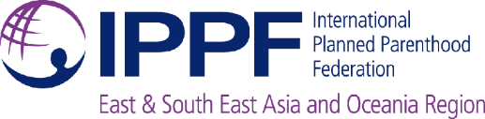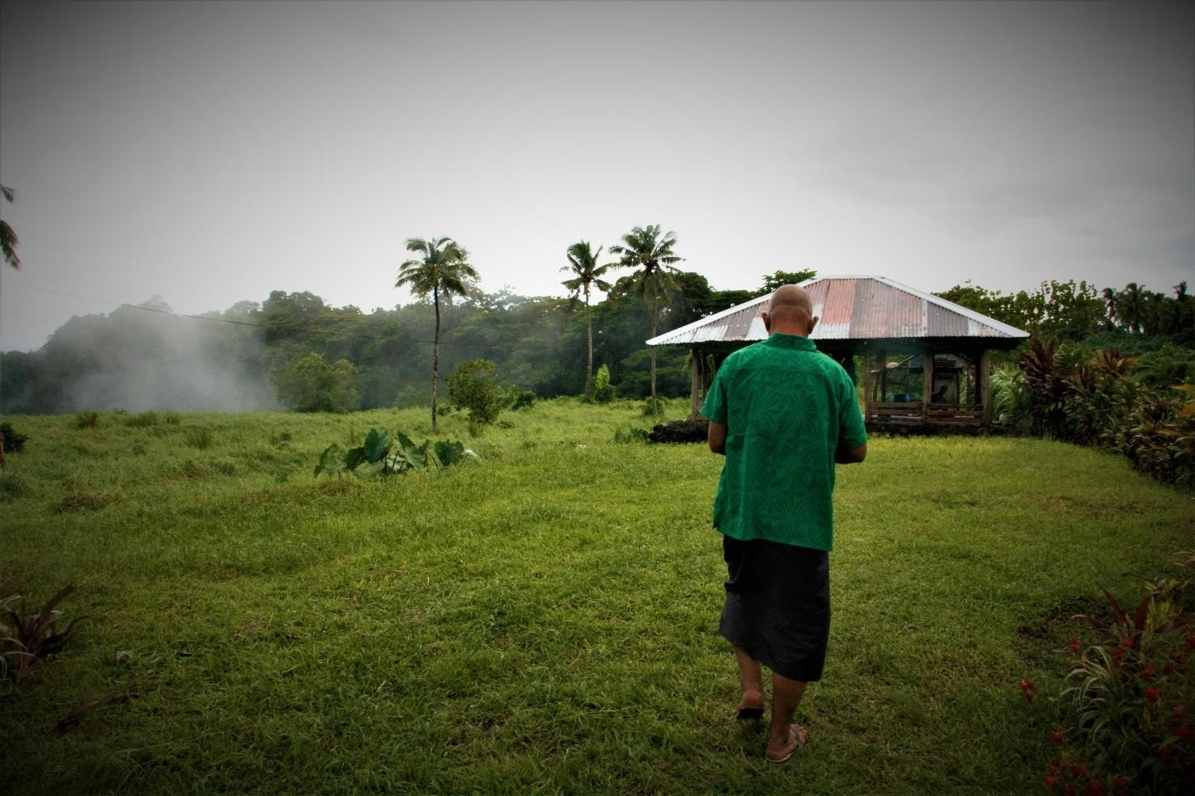

**The Impact Project: Catalysing Sexual and Reproductive Health and Rights in Samoa**

*Bilateral Project Running 2017-2021*

**Led by Samoa Family Health Association (SFA) together with the International Planned Parenthood Federation**

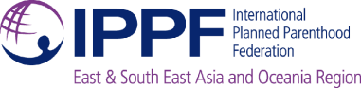

# Project Overview

This project has been jointly developed by Samoa Family Health Association (SFHA), the International Planned Parenthood Federation (IPPF) and the Australian Department of Foreign Affairs and Trade (DFAT) to **build upon and accelerate the impact of the existing regional program** funded by the Australian Government being delivered in Samoa. A consultation in late 2016 highlighted the urgent need for further assistance given the **slow progress in improving national level sexual and reproductive health and rights (SRHR) indicators**, and the **ongoing unmet need for SRHR information and services** throughout the country – particularly for **rural and remote villages**.

The project complements the existing program entitled *Partnerships for Health and Rights (PHRP): Working for Sexual and Reproductive Health and Rights for All in the Pacific.* Commencing in early 2015, the program is focused on improving SRHR outcomes through IPPF’s Member Associations in eight Pacific Island countries: Cook Islands, Fiji, Kiribati, Samoa, Solomon Islands, Tonga, Tuvalu, and Vanuatu. It is a three-year program[1] with an overall budget of AUD 4.5 million. For the period 2015 - 2018, SFHA is receiving approximately AUD 424,000 in funding to support the implementation of the program in Samoa.

The regional program’s purpose is to provide quality, rights-based, integrated SRHR information and services to underserved and marginalised communities in the Pacific. SFHA is currently mid-way through implementing this program in Samoa. While progress has been made, greater investment is needed to achieve the program’s ambitious goals of improving health outcomes in Samoa. The support through this new project will therefore complement and further enhance this program.

The overall approach and four key outcomes of this project – *the Impact Project* – are closely aligned with the existing framework of the regional program to catalyse SFHA’s impact on improving the status of SRHR in Samoa. These four key outcomes of this project are as follows:

* **Outcome 1**: High-quality, integrated SRHR care delivered through quality assured SFHA clinics for all Samoans, particularly the most marginalised;
* **Outcome 2**: High-quality, integrated SRHR care delivered through SFHA outreach teams, exclusively focused on reaching the most remote and marginalised;
* **Outcome 3**: Systems strengthened to support integrated service delivery and effective project implementation; and
* **Outcome 4**: An enabling environment for SRHR created through targeted advocacy and stakeholder engagement.

The Impact Project is well aligned to the national Government’s existing **Strategy for the Development of Samoa 2016-17 to 2019-20** (SDS)[2] to support health and development. Likewise, the project approach firmly aligns with **DFAT’s Aid Investment Plan for Samoa for 2015-16 to 2018-19[3]**, which includes a strategic priority of progressing health and education outcomes. Specifically, the project supports the Plan’s specific goal of **improving the quality of the health system including health information**, and to some extent, supports **reducing violence against women and girls**. From a governance standpoint – another strategic priority under the Plan – the project is a core example of a **civil society initiative to address Samoa’s development challenges**.

Above all, the intention of this project is to **catalyse impact** and make a marked contribution towards **addressing stagnant national health indicators relating to sexual and reproductive health outcomes** in Samoa. Led by HA in collaboration with their parent organisation IPPF, the Impact Project will run for **four years** (June 2017 – June 2021), with a total project budget of **AUD 1,000,000.**



# About SFHA

Samoa Family Health Association (SFHA) is the leading SRHR organisation in Samoa. Since its establishment in 1982, it has been providing family planning and reproductive health services throughout the country. This has been achieved through a permanent clinic in Apia as well as outreach visits to the remote and underserved parts of the main island of Upolu. The organisation has also delivered outreach services to the less populated island of Savai’i since mid-way through 2015.

SFHA has been a fully accredited Member Association of the **International Planned Parenthood Federation** (IPPF) since 2002. Through this affiliation, SFHA receives support with all aspects of project implementation, as well as access to a broad range of relevant training programs to enhance SFHA’s capacity and operations. In addition, the organisation receives core funding from IPPF comprised of a range of international donors to scale up the organisation’s impact.

Through its clinic and outreach operations, SFHA provides a variety of SRHR services including access to modern methods of family planning[4] and emergency contraception, antenatal care up to 36 weeks’ gestation, counselling, pregnancy testing, and sexually transmitted infections (STI) testing and treatment. The organisation is also gradually scaling up its capacity to provide HIV testing and treatment and gender-based violence services. Currently, clients seeking an HIV test are provided with a referral to the national hospital where free testing and treatment is available.

This service offering is in accordance with IPPF’s *Integrated Package of Essential Services* (IPES), which is a key feature of IPPF’s Strategic Framework for 2016 – 2022. SFHA is also integrating information covering SRHR-relevant non-communicable diseases (NCDs) into its services as part of client consultations, given the degree of overlap with SRHR issues. Further, the organisation is currently exploring ways to provide more inclusive service access to persons with a disability.

# Summary of Project Approach

The Impact Project’s Theory of Change (ToC) centres on a key concept in global health: that **reducing maternal mortality and morbidity** in Samoa (project goal) will be facilitated by **increased uptake of SRHR information and service** (project purpose). This concept is well founded in research and practice, with utilisation of contraception and other SRHR services widely regarded as key contributing factors towards improving women’s and communities’ health[5]. It is also identified in Samoa as a priority issue to improve maternal health within national health policy.6 To achieve this desired change, the project has identified underlying contextual barriers that limit uptake of SRHR services in Samoa, and has presented focused interventions to overcome these. Understanding of key barriers has emerged as lessons from SFHA’s previous projects and long-standing presence in Samoa, and includes: **poor physical access** to SRHR services for remote populations, PWD, and youth; **limited knowledge of SRHR** including the perpetuation of myths and misconceptions around contraception and SRHR; **prohibitively high costs** associated with access the SRHR services that are currently available, particularly transport costs and services fees; **socio-cultural and religious objections to SRHR**, particularly for young people; and **lack of political support for SRHR**, especially at the policy and regulatory level.

In response, four focus intervention (activity and output) areas have been identified to specifically capture and address these challenges:

* Strengthen access to education and services for marginalised urban populations (through clinics)
* Transform access to education and services for marginalised rural majority (through outreach)
* Build solid foundations to ensure high quality service delivery (through improved systems)
* Shift attitudes to ensure greater access for all (through advocacy and awareness).

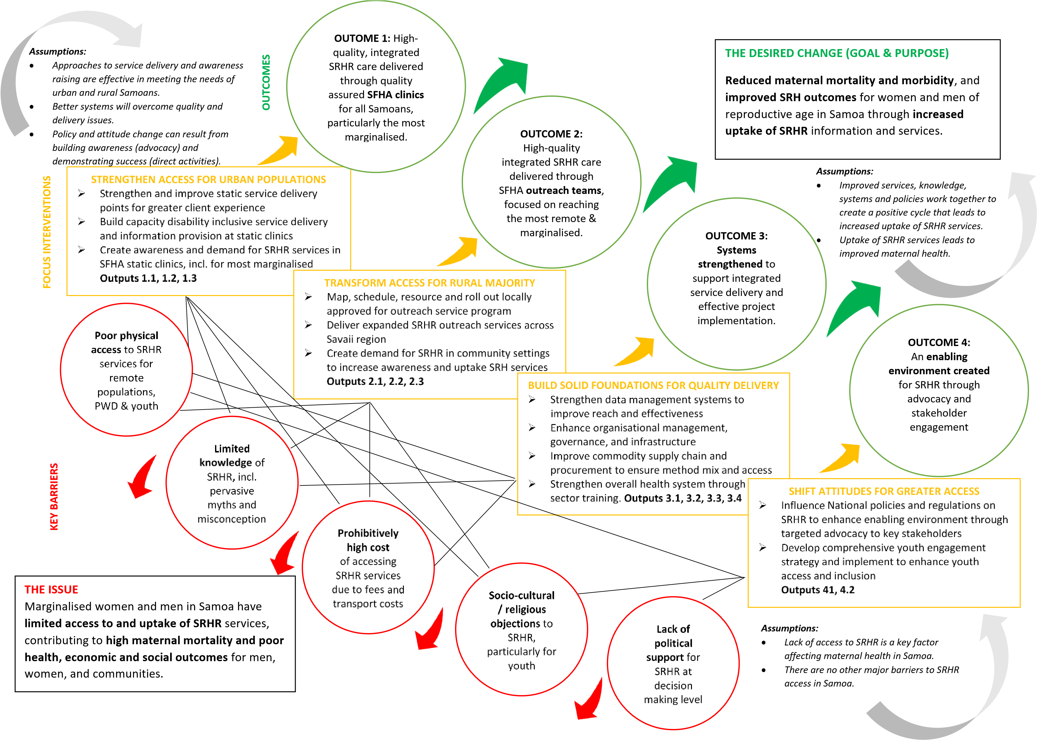

# Results Framework



# Key Implementation Partners

## The Australian Department of Foreign Affairs and Trade (DFAT)

As the donor funding this project, DFAT has been closely involved throughout design and inception phases. The Impact Project will continue to enhancecollaboration between SFHA and DFAT throughout the project implementation period. This close collaboration will help to ensure a streamlined and coordinated approach to drive effectiveness and impact. DFAT Post will also attend regular project planning and coordination meetings, as well as engage in high-level forums in collaboration with SFHA.

## Ministry of Health (MoH)

Likewise, the MoH will also be closely engaged throughout the project. This is underpinned by the Samoan Government’s Health Sector plan to support partnerships with civil society organisations in recognition of their role in complementing government programs and services. Maintaining a strong relationship with the MoH will foster support and facilitation from national and district hospitals, as well as the National Medicines Warehouse for commodity supplies. A focus on training graduate nurses within the clinic on SRHR issues – an existing initiative of SFHA to be scaled up under the project – will complement this, whilst also driving sustainable outcomes through a strengthened public health sector.

## Ministry of Women, Community and Social Development (MWCSD)

The MWCSDis identified as a core partner for this project. The MWCSD is the government focal point mechanism for gender equality and social inclusion in Samoa. They facilitate relationships with villages across the country, and support women representatives in every village. To ensure outreach can be successfully scaled up across Savai’i, the project will work closely in collaboration MWCSD and obtain regular feedback to adapt approaches as required.

## Other Key Stakeholders

The project will also draw on SFHA’s strong existing partnerships with a number of key stakeholders at the local and national level. These include the **Ministry of Education, Sports & Culture**; **Ministry of Police**; **Samoa Red Cross Society**; civil society organizations; faith-based organizations; as well as research and academic institutions.

# Project Budget Snapshot

|  |  |  |  |  |  |
| --- | --- | --- | --- | --- | --- |
| **COST CATEGORY**  *All figures in AUD* | **Year 1**  (Jun 17 -  Jun 18) | **Year 2**  (Jul 18 - Jun 19) | **Year 3**  (Jul 19 - Jun 20) | **Year 4**  (Jul 20 –  Jun 21) | **TOTAL** |
| 1. Staffing and Personnel | 45,875 | 84,000 | 84,000 | 84,000 | 297,875 |
| 2. Travel | 7,215 | 5,135 | 2,080 | - | 14,430 |
| 3. Equipment, Supplies and  Commodities | 83,010 | 18,970 | 15,720 | 15,720 | 133,420 |
| 4. Office and Clinic Costs | 167,629 | 32,657 | 32,657 | 32,657 | 265,601 |
| 5. Project Inception and Closing  Workshops | 2,750 | - | - | 2,750 | 5,500 |
| 6. Project Activity Costs | 32,000 | 39,250 | 39,250 | 39,750 | 150,250 |
| 7. Monitoring and Evaluation | 4,500 | 15,000 | 5,465 | 17,000 | 41,965 |
| **Total** | **342,979** | **195,012** | **179,172** | **191,877** | **909,041** |
| Overhead | 34,318 | 19,513 | 17,928 | 19,199 | 90,959 |
| **GRAND TOTAL (AUD)** | **377,297** | **214,525** | **197,100** | **211,077** | **1,000,000** |

# Work Plan for the Project

|  |  |  |  |  |  |  |  |  |  |  |  |  |  |  |  |  |  |
| --- | --- | --- | --- | --- | --- | --- | --- | --- | --- | --- | --- | --- | --- | --- | --- | --- | --- |
| **ACTIVITY SCHEDULE** | | **Project Year 1** | | | | **Project Year 2** | | | | **Project Year 3** | | | | **Project Year 4** | | | |
| **2017**  **Jun-Sep** | **2017 Q4** | **2018 Q1** | **2018 Q2** | **2018 Q3** | **2018 Q4** | **2019 Q1** | **2019 Q2** | **2019 Q3** | **2019 Q4** | **2020 Q1** | **2020 Q2** | **2020 Q3** | **2020 Q4** | **2021 Q1** | **2021 Q2** |
| **OUTCOME 1. High-quality, integrated SRHR care delivered through quality assured SFHA clinics for all Samoans, particularly the most marginalised** | | | | | | | | | | | | | | | | | |
| **Output 1.1** Static clinic service delivery points strengthened and improved for greater client experience | | | | | | | | | | | | | | | | | |
| 1.1.1 | Clinics adapted to become more youth friendly and accessible |  |  | **X** | **X** |  | **X** |  | **X** |  | **X** |  | **X** |  | **X** |  | **X** |
| 1.1.2 | Clinical quality of care refresher training for all staff with particular focus on LARCs | **X** |  | **X** |  | **X** |  | **X** |  | **X** |  | **X** |  | **X** |  | **X** |  |
| 1.1.3 | New clinic in Moto'otua renovated, refurbished and established | **X** | **X** |  |  |  |  |  |  |  |  |  |  |  |  |  |  |
| 1.1.4 | Anonymous client feedback system developed and rolled out across all service delivery points |  |  | **X** |  |  |  |  |  |  |  |  |  |  |  |  |  |
| **Output 1.2** Capacity built for disability inclusive service delivery and information provision | | | | | | | | | | | | | | | | | |
| 1.2.1 | Disability inclusiveness training conducted with all staff and volunteers of SFHA |  |  |  |  | **X** |  |  |  |  |  |  |  |  |  |  |  |
| 1.2.2 | Consultation conducted with PWD on specific needs and preferences for services and information from SFHA clinics and SDP sites |  |  |  |  |  | **X** |  |  |  | **X** |  |  |  |  |  |  |
| 1.2.3 | IEC materials adapted and tailored to PWDs and distributed across SFHA service delivery points |  |  |  |  |  |  | **X** | **X** |  |  |  |  |  |  |  |  |
| **Output 1.3** Demand created for SRH services in SFHA static clinics, including for most marginalised | | | | | | | | | | | | | | | | | |
| 1.3.1 | Awareness raising and demand generation conducted in and around urban areas |  |  |  | **X** |  |  |  | **X** |  |  |  | **X** |  |  |  | **X** |
| 1.3.2 | Comprehensive SRH services and information provided in urban clinic centres in Apia, Moto'otua and Salelologa | **X** | **X** | **X** | **X** | **X** | **X** | **X** | **X** | **X** | **X** | **X** | **X** | **X** | **X** | **X** | **X** |
| **OUTCOME 2. High-quality integrated SRHR care delivered through SFHA outreach teams, exclusively focused on reaching the most remote and marginalised** | | | | | | | | | | | | | | | | | |
| **Output 2.1** Outreach service program mapped, scheduled, resourced and locally approved for roll-out | | | | | | | | | | | | | | | | | |
| 2.1.1 | Savaii-based midwife and nurse recruited, training and operating outreach visits |  |  | **X** |  |  |  |  |  |  |  |  |  |  |  |  |  |

|  |  |  |  |  |  |  |  |  |  |  |  |  |  |  |  |  |  |
| --- | --- | --- | --- | --- | --- | --- | --- | --- | --- | --- | --- | --- | --- | --- | --- | --- | --- |
| **ACTIVITY SCHEDULE** | | **Project Year 1** | | | | **Project Year 2** | | | | **Project Year 3** | | | | **Project Year 4** | | | |
| **2017**  **Jun-Sep** | **2017 Q4** | **2018 Q1** | **2018 Q2** | **2018 Q3** | **2018 Q4** | **2019 Q1** | **2019 Q2** | **2019 Q3** | **2019 Q4** | **2020 Q1** | **2020 Q2** | **2020 Q3** | **2020 Q4** | **2021 Q1** | **2021 Q2** |
| 2.1.2 | 2nd vehicle purchased to support outreach service delivery across Savaii |  | **X** | **X** |  |  |  |  |  |  |  |  |  |  |  |  |  |
| 2.1.3 | Mini-clinic site identified, refurbished and stocked to support part time service delivery and all outreach activities |  | **X** | **X** |  |  |  |  |  |  |  |  |  |  |  |  |  |
| 2.1.4 | Launch event held for mini clinic and expanded outreach program across Savaii |  |  | **X** |  |  |  |  |  |  |  |  |  |  |  |  |  |
| 2.1.5 | Outreach team schedule and site visit plan developed and rolled out (information and services) |  |  |  | **X** |  |  |  |  |  |  |  |  |  |  |  |  |
| **Output 2.2** Outreach SRHR services delivered across Savaii region | | | | | | | | | | | | | | | | | |
| 2.2.1 | Specific and tailored youth-friendly outreach sessions conducted to provide information and services to young people |  |  |  |  |  |  | **X** |  | **X** |  | **X** |  | **X** |  | **X** |  |
| 2.2.2 | General outreach conducted with women and men in Savaii for information and services |  |  |  | **X** | **X** | **X** | **X** | **X** | **X** | **X** | **X** | **X** | **X** | **X** | **X** | **X** |
| 2.2.3 | Awareness raising carried out in village settings on SGBV with village chiefs, men and young people |  |  |  |  |  |  | **X** |  |  |  | **X** |  |  |  | **X** |  |
| 2.2.4 | Communication enhanced with MWCSD in Savaii to provide updates and adapt outreach program as required |  |  | **X** |  |  |  | **X** |  |  |  | **X** |  |  |  | **X** |  |
| **Output 2.3** Demand generation conducted in community settings to increase uptake of services | | | | | | | | | | | | | | | | | |
| 2.3.1 | Contextualised IEC materials in local language on SRH issues printed and distributed, with focus on LARCs |  |  | **X** | **X** |  |  |  |  |  |  |  |  |  |  |  |  |
| 2.3.2 | Opportunities and forums identified to reach at-risk, marginalised groups with information and services | **X** |  |  |  | **X** |  |  |  | **X** |  |  |  | **X** |  |  |  |
| **OUTCOME 3. Systems strengthened to support integrated service delivery and effective project implementation** | | | | | | | | | | | | | | | | | |
| **Output 3.1** Data management systems strengthened to improve understanding of SFHA's reach and effectiveness | | | | | | | | | | | | | | | | | |
| 3.1.1 | Staff training held on CMIS, VAT and BPT tools to enhance data capture and management, with software implemented |  | **X** |  | **X** |  | **X** |  | **X** |  | **X** |  | **X** |  | **X** |  | **X** |
| 3.1.2 | Data management and project coordination support and mentored by AVID position | **X** | **X** | **X** | **X** | **X** |  |  |  |  |  |  |  |  |  |  |  |

|  |  |  |  |  |  |  |  |  |  |  |  |  |  |  |  |  |  |
| --- | --- | --- | --- | --- | --- | --- | --- | --- | --- | --- | --- | --- | --- | --- | --- | --- | --- |
| **ACTIVITY SCHEDULE** | | **Project Year 1** | | | | **Project Year 2** | | | | **Project Year 3** | | | | **Project Year 4** | | | |
| **2017**  **Jun-Sep** | **2017 Q4** | **2018 Q1** | **2018 Q2** | **2018 Q3** | **2018 Q4** | **2019 Q1** | **2019 Q2** | **2019 Q3** | **2019 Q4** | **2020 Q1** | **2020 Q2** | **2020 Q3** | **2020 Q4** | **2021 Q1** | **2021 Q2** |
| **Output 3.2** Organisational management, governance and infrastructure enhanced to support project | | | | | | | | | | | | | | | | | |
| 3.2.1 | Consultations held with key stakeholders to help inform project |  |  |  |  |  | **X** |  |  |  |  |  |  |  | **X** |  |  |
| 3.2.2 | Youth consultation carried out on operations, strategy and approaches etc. by management and Executive Council |  | **X** |  |  |  | **X** |  |  |  | **X** |  |  |  | **X** |  |  |
| 3.2.3 | Continual trainings for all staff and volunteers on SRHR information, best practices and research |  | **X** |  | **X** |  | **X** |  | **X** |  | **X** |  | **X** |  | **X** |  | **X** |
| 3.2.4 | Office refurbished and supplies and equipment purchased to support effective project delivery | **X** |  |  |  |  |  |  |  |  |  |  |  |  |  |  |  |
| 3.2.5 | Monthly project planning and coordinating meetings held by key SFHA staff | **X** | **X** | **X** | **X** | **X** | **X** | **X** | **X** | **X** | **X** | **X** | **X** | **X** | **X** | **X** | **X** |
| **Output 3.3** Commodity supply chain and procurement strengthened to ensure method mix and access | | | | | | | | | | | | | | | | | |
| 3.3.1 | Commodities procured from NHS Warehouse with additional commodities purchased as buffer stock, including those not covered by UNFPA | **X** | **X** | **X** | **X** | **X** | **X** | **X** | **X** | **X** | **X** | **X** | **X** | **X** | **X** | **X** | **X** |
| **Output 3.4** Health system strengthened through public sector training | | | | | | | | | | | | | | | | |  |
| 3.4.1 | Comprehensive on-the-job training provided to graduate nurses on SRHR via SFHA clinic with particular focus on sensitive, nondiscriminatory client care | **X** | **X** | **X** | **X** | **X** | **X** | **X** | **X** | **X** | **X** | **X** | **X** | **X** | **X** | **X** | **X** |
| **OUTCOME 4. An enabling environment for SRHR created through targeted advocacy and stakeholder engagement** | | | | | | | | | | | | | | | | | |
| **Output 4.1** National policies and regulations on SRHR influenced to enhance enabling environment | | | | | | | | | | | | | | | | | |
| 4.1.1 | Mapping of key stakeholders nation-wide |  |  |  |  | **X** |  |  |  |  |  |  |  | **X** |  |  |  |
| 4.1.2 | Opportunities identified for strengthening youth volunteer engagement at Ministry-led trainings and meetings | **X** |  |  |  | **X** |  |  |  | **X** |  |  |  | **X** |  |  |  |
| 4.1.3 | SFHA engage and contribute to key policy forums focused on enhancing access and lifting policy constraints for SRHR | **X** | **X** | **X** | **X** | **X** | **X** | **X** | **X** | **X** | **X** | **X** | **X** | **X** | **X** | **X** | **X** |
| **Output 4.2** Comprehensive youth engagement strategy developed and implemented | | | | | | | | | | | | | | | | | |
| **ACTIVITY SCHEDULE** | | **Project Year 1** | | | | **Project Year 2** | | | | **Project Year 3** | | | | **Project Year 4** | | | |
| **2017**  **Jun-Sep** | **2017 Q4** | **2018 Q1** | **2018 Q2** | **2018 Q3** | **2018 Q4** | **2019 Q1** | **2019 Q2** | **2019 Q3** | **2019 Q4** | **2020 Q1** | **2020 Q2** | **2020 Q3** | **2020 Q4** | **2021 Q1** | **2021 Q2** |
| 4.2.1 | Training conducted with all service providers and volunteers on youth-friendly approaches and effective facilitation |  |  |  |  | **X** |  |  |  |  |  |  |  |  |  |  |  |
| 4.2.2 | Youth volunteer and peer educator networks expanded in both Savaii and Upolu |  | **X** |  |  |  | **X** |  |  |  | **X** |  |  |  | **X** |  |  |
| 4.2.3 | Consultation with youth volunteers on youthtailored IEC materials and materials redeveloped as needed | **X** |  |  |  |  |  |  |  |  |  |  |  |  |  |  |  |
| 4.2.4 | Youth friendly media and awareness raising strategy developed through consultation with youth |  |  | **X** |  |  |  | **X** |  |  |  | **X** |  |  |  | **X** |  |
| 4.2.5 | Youth Drop-In Centre advocacy and information session schedule developed and implemented for Apia Youth |  | **X** | **X** | **X** | **X** | **X** | **X** | **X** | **X** | **X** | **X** | **X** | **X** | **X** | **X** | **X** |
| 4.2.6 | Youth Drop-In Centre and activities on site at new Apia clinics supported | **X** | **X** | **X** |  |  |  |  |  |  |  |  |  |  |  |  |  |
| **M&E and project reporting** | | | | | | | | | | | | | | | | | |
| (i) | Project inception workshop | **X** |  |  |  |  |  |  |  |  |  |  |  |  |  |  |  |
| (ii) | Monthly data reviews | **X** | **X** | **X** | **X** | **X** | **X** | **X** | **X** | **X** | **X** | **X** | **X** | **X** | **X** | **X** | **X** |
| (iii) | Setting and updating baseline targets |  |  |  |  | **X** |  |  |  | **X** |  |  |  | **X** |  |  |  |
| (iv) | Monthly financial reports prepared | **X** | **X** | **X** | **X** | **X** | **X** | **X** | **X** | **X** | **X** | **X** | **X** | **X** | **X** | **X** | **X** |
| (v) | 6 monthly meetings with DFAT post |  | **X** |  | **X** |  | **X** |  | **X** |  | **X** |  | **X** |  | **X** |  | **X** |
| (vi) | 6 monthly progress report to DFAT |  | **X** |  | **X** |  | **X** |  | **X** |  | **X** |  | **X** |  | **X** |  | **X** |
| (vii) | 6 monthly review of risk matrix |  |  | **X** |  | **X** |  | **X** |  | **X** |  | **X** |  | **X** |  | **X** |  |
| (viii) | Annual progress report to DFAT and IPPF |  |  |  |  | **X** |  |  |  | **X** |  |  |  | **X** |  |  |  |
| (ix) | Project closing workshop |  |  |  |  |  |  |  |  |  |  |  |  |  |  |  | **X** |
| (x) | Mid-Term review by external consultant |  |  |  |  |  |  |  | **X** | **X** |  |  |  |  |  |  |  |
| (xi) | End of project evaluation by external consultant |  |  |  |  |  |  |  |  |  |  |  |  |  |  | **X** | **X** |

1. Initially, the program was planned to conclude at the end of 2017. The program has received a one-year no cost extension to conclude in December 2018.
2. Government of Samoa 2016, *Strategy for the Development of Samoa 2016/17 to 2019/20,* available online:

   <http://www.mof.gov.ws/Portals/195/Services/Economy/SDS%201617-1920_Eng.pdf>
3. DFAT 2015, *Aid Investment Plan Samoa 2015-16 to 2018-19*, available online: [http://dfat.gov.au/aboutus/publications/Documents/samoa-aid-invement-plan-2015-19.pdf](http://dfat.gov.au/about-us/publications/Documents/samoa-aid-investment-plan-2015-19.pdf) 
4. Modern methods of family planning provided include condoms, oral contraceptive pills, contraceptive injections, contraceptive implants (3-year and 5-year implants both available), and intrauterine devices (IUDs).
5. Guttmacher 2014, *Adding it Up: The Costs and Benefits of Investing in Sexual and Reproductive Health*, available online:

   <https://www.guttmacher.org/report/adding-it-costs-and-benefits-investing-sexual-and-reproductive-health-2014> 6 Samoa Health Sector Plan 2008-2018.