Australia-Indonesia Partnership in Disaster Risk Management

SIAP SIAGA

Mid Term Review
October 2023

Acknowledgements
The Mid Term Review was undertaken by Donna Leigh Holden and Dr Saut Sagala and managed by Donna Leigh Holden Consulting.
We would like to thank the Australian Department of Foreign Affairs and Trade and Government of Indonesia partners especially BNPB, Bappenas, MoSA, MoFA, MoHA, and their partners in East Java, Bali, Nusa Tenggara Barat and Nusa Tenggara Timur for your time in engaging with us. Consultations with over 277 people have provided valuable insights into the shifting context and operations of SIAP SIAGA since its inception in 2019.
To the Palladium and IFRC-PMI teams, we have valued your engagement in the process, your openness and robust conversations. We have appreciated your efforts in arranging complex logistics to make sure that we were able to gain as wide a set of insights as possible.
Finally, we would particularly like to acknowledge Gloriani Panjaitan (Ririe) from DFAT Jakarta Post who not only attended throughout the field mission, but has made herself very available to the team for additional interviews, discussions, establishing linkages and sharing her knowledge of the program, its context and stakeholders.
Disclaimer
This publication has been funded by the Australian Government through the Department of Foreign Affairs and Trade. The views expressed are the author’s alone and are not necessarily the views of the Australian Government.

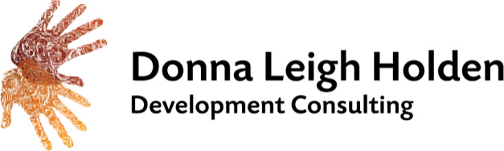

Table of contents
Acronyms and abbreviations 1
Executive Summary 3
1. Background 10
1.1. The Australia-Indonesia Partnership in Disaster Risk Management – SIAP SIAGA 10
1.2. Implementation arrangements 10
2. The review 11
2.1. Key evaluation questions 11
2.2. Approaches, methods and tools 11
2.3. Limitations and changes to the review plan 11
3. Review findings 12
3.1. Quality of evidence 12
3.2. Relevance and coherence 12
3.2.1. Responding to GoI priorities for DRM 13
3.2.2. Responding to GoA priorities for DRM 13
3.2.3. The IFRC-PMI partnership 14
3.2.4. Agility and adaptation 14
3.2.5. Coherence 14
3.3. Effectiveness – progress to outcomes 15
3.3.1. Change pathways and progress to outcomes 16
3.3.2. How has SIAP SIAGA influenced Indonesia’s DRM ecosystem at the national, subnational and regional level? 16
3.3.3. How has the IFRC-PMI investment influenced Indonesia’s DRM system? 20
3.3.4. How did SIAP SIAGA contribute to Indonesia’s COVID-19 response? 22
3.3.5. How has SIAP SIAGA promoted gender equality, disability and social inclusion? 24
3.4. Effectiveness of approaches 26
3.4.1. The systems approach 26
3.4.2. Technical support and capacity development 27
3.4.3. Working across the DRM ecosystem – the pentahelix and civil society engagement 28
3.4.4. Partnership 29
3.5. Efficiency 29
3.5.1. Efficiency of different modalities 30
3.5.2. Impact of Palladium’s adaptive management approach on efficiency 31
3.5.3. Impact of COVID-19 on efficiency 32
3.5.4. Value for money 32
3.6. Future drivers and responses to DRM in Indonesia 33
4. Conclusions and recommendations 36
4.1. Summary conclusions 36
4.2. Recommendations 37
5. Annexes 40
Annex 1: The team 40
Annex 2: SIAP SIAGA program logic 41
Annex 2a: SIAP SIAGA whole of program logic 41
Annex 2b: Palladium revised program logic (2021) 42
Annex 2c: IFRC-PMI program logic at design (2020) 43
Annex 2d: IFRC-PMI amended program logic (2021) 44
Annex 3: Key evaluation questions 45
Annex 4: Methods 46
Annex 5: MTR consultations and informants 49
Annex 6: Pulih Bersama activities implemented by Palladium 52
Annex 7: Value for money 53
Annex 7.1: Value for money tool 53
Annex 7.2: Value for money assessment 54

Acronyms and abbreviations
Term Definition

AA Anticipatory Action

ASEAN The Association of Southeast Asian Nations

AUD Australian Dollar

Bappenas National Development Planning Agency

BMKG Indonesia’s Meteorology, Climatology, and Geophysical Agency

BNPB National Disaster Management Authority

BPBD Regional Disaster Management Authority

BRIL Because Resilience is Local Report

CBDRM Community-based Disaster Risk Management

CCA Climate Change Adaptation

CVA Cash and Voucher Assistance

CVTL Timor Leste Red Cross

DCR Disaster and Climate Resilience

DRM Disaster risk management

DRV Disaster Resilient Villages

EOPO/s End of Program Outcomes

FGD Focus Group Discussion

GEDSI Gender equality, disability and social inclusion

GoI Government of Indonesia

GoA Government of Australia

GPDRR Global Platform on Disaster Risk Reduction

IFRC International Federation of Red Cross and Red Crescent Societies

KEQ Key Evaluation Question/s

KPL Knowledge, Performance and Learning

LPBI-NU Nahdlatul Ulama Agency for Disaster Management and Climate Change

MEL Monitoring, Evaluation and Learning

MDMC Muhammadiyah Disaster Management Centre

MIS Monitoring Information System

MoFA Ministry of Foreign Affairs

MoHA Ministry of Home Affairs

MoSA Ministry of Social Affairs

MOU Memorandum of Understanding

MSS-DM Minimum Service Standards for Disaster Management

Term Definition

MTR Mid Term Review

NTB Nusa Tenggara Barat – West Nusa Tenggara

NTT Nusa Tenggara Timur – East Nusa Tenggara

P4R Partnerships for Recovery

PGI Protection, Gender and Inclusion

PMI Indonesia Red Cross Society – Palang Merah Indonesia

PWD People with disabilities

RCCE Risk Communication and Community Engagement

QoE Quality of Evidence

RenasPB National Plan on Disaster Management – Rencana Nasional Penanggulangan Bencana

RJPMN National Medium Term Development Plan – Rencana Pembangunan Nasional Jangka Menegah

SDBI Satu Data Bencana Indonesia – Indonesia One Data on Disaster

SFDRR Sendai Framework for Disaster Risk Reduction

SIAP SIAGA The Australia-Indonesia Partnership in Disaster Risk Management

SOP Standard operating procedures

ToR Terms of Reference

WOP Whole of program

Executive Summary
The Australia-Indonesia Partnership in Disaster Risk Management (SIAP SIAGA) is an Australian Dollar (AUD) 36 million five-year partnership (2019 – 2024) between Australia and Indonesia which aims to strengthen Indonesia’s management of disaster risks and engagement between Australia and Indonesia. SIAP SIAGA works across four interconnected end-of-program outcomes (EOPO):

- BNPB’s organisational systems are strengthened in better leadership of disaster risk management (DRM).
- Target provinces, districts and villages are better able to prevent, prepare for, respond to and recover from disasters.
- Strengthened cooperation between Australia and Indonesia on regional humanitarian preparedness and responses.
- Strengthened learning, innovation and inclusion for DRM.
The SIAP SIAGA investment is delivered through two separate contract arrangements held by:
- Palladium International Pty Ltd who leads the work with the Government of Indonesia (GoI), specifically the National Disaster Management Authority (BNPB), Ministry of Home Affairs (MoHA), and Ministry of Foreign Affairs (MoFA) among others, and with their subnational agencies in East Java, Bali, Nusa Tenggara Timur (NTT) and Nusa Tenggara Barat (NTB). This component also works with non-government agencies in particular Nahdlatul Ulama Agency for Disaster Management and Climate Change LPBI-NU and the Muhammadiyah Disaster Management Centre (MDMC); and
- The International Federation of Red Cross and Red Crescent Societies (IFRC) and the Indonesian Red Cross (PMI) which focusses on strengthening PMI’s role as a central actor and first responder in Indonesia’s DRM ecosystem.
The Mid Term Review (MTR) was commissioned by the Australian Department of Foreign Affairs and Trade (DFAT) to:
  - assess the performance of the SIAP SIAGA program and the impact of COVID-19 on implementation; and
  - provide a forward-looking analysis to provide recommendations for whether DFAT continues with the plan to extend SIAP SIAGA for a further two years (2024 – 2026), and if yes, what changes need to be made to the program.
Held from May to September 2023, the MTR accessed over 100 documents and engaged over 277 informants from national and subnational GoI partners, DFAT, international DRM actors, civil society and communities in Bali, NTT, NTB, East Java and Banten through remote and face-to-face focus group discussions, field visits, key informant interviews and sensemaking sessions.

Findings
Overall, evidence gained through the MTR demonstrates that SIAP SIAGA has made good progress against all outcome areas and is making a valuable and valued contribution to strengthening Indonesia’s DRM ecosystem. It has worked across national government DRM actors to identify and address blockages to the effective implementation of DRM policy and worked across the system to clarify the roles and responsibilities of different DRM actors and develop coherent policy and regulations at the national level that in turn facilitate subnational governments and agencies to develop norms, standards and procedures that enable them to allocate resources and operationalise local DRM activities.
It has nurtured important relationships between key GoI agencies, PMI and other civil society agencies through which Australian assistance can be directed by local actors in the event of crisis and is working towards identifying avenues for Australia-Indonesia cooperation in the Indo Pacific region. Importantly, it has supported PMI to test and embed new approaches to disaster preparedness and response within its national operations and strengthen its institutional management systems as a central national and regional DRM actor.
Positioned within the BNPB and mandated to work across the DRM ecosystem, SIAP SIAGA was uniquely positioned and had the right set of relationships and approvals in place to enable it to scale up and provide timely, targeted and highly relevant support to the GoI as it mobilised its early response to the COVID-19 pandemic. Further, relationships with PMI and other civil society organisations enabled community based responses targeted to people in vulnerable situations including women, people with disabilities (PWD) and the elderly.

Changes to the architecture and operational arrangements for SIAP SIAGA anticipated in the design, exacerbated by the impacts of the pandemic on the operational context mean that Palladium and IFRC-PMI have implemented standalone programs and there has been limited exploration of how DFAT, IFRC-PMI and Palladium can leverage their capabilities to demonstrate their respective contributions to the outcomes. Moving forward there is scope to bring these investments into greater alignment, strengthen attention to the priorities of the Australian development program in relation to climate change, gender equality, disability, social inclusion, and the role of civil society as key actors for DRM. Further, as national regulatory frameworks are in place, there is scope to deepen subnational level engagement for the implementation of DRM. This requires considered dialogue and planning across the GoI partners particularly for how SIAP SIAGA can best resource the subnational work in line with the priorities established within Indonesia’s National Disaster Management Plan.
The MTR makes the following detailed findings in response to the six key evaluation questions (KEQ) provided in Annex 3.

KEQ 1: Relevance and Coherence

Finding 1: Alignment with Indonesia and Australia’s priorities for DRM
SIAP SIAGA builds on Australia and Indonesia’s long term partnership for DRM in Indonesia and responds strategically to key policy and operational priorities for both countries. This includes strengthening Indonesia’s DRM system and resilience to disaster risk and exploring opportunities for joint Australia - Indonesia collaboration in the Indo-Pacific region.

Finding 2: Agility and adaptiveness
SIAP SIAGA has demonstrated the ability to adapt and respond appropriately to changes in the operational context including COVID-19, local disaster events, shifts in GoI and GoA policy and lessons learned.

KEQ 2: Effectiveness – progress to outcomes

Finding 3: Progress to outcomes
SIAP SIAGA is making good progress against all EOPOs within the program logic. However, changes to the architecture of and operational context for the program mean that Palladium and IFRC-PMI are implementing standalone programs each with their own program logic. As a result, the current program logic no longer fully reflects all approaches and change pathways being pursued within the program. The MTR team considers that the program logic could be updated to better reflect these shifts and the work of all partners.

Finding 4: Contribution to Indonesia’s DRM ecosystem
SIAP SIAGA contributes to the DRM ecosystem in Indonesia by:
  - supporting work across the range of government actors to develop policies and regulations from the national to subnational levels to govern and facilitate DRM planning, resourcing and programming (MoHA, BNPB, MoSA and Bappenas with Palladium support);
  - supporting BNPB to strengthen its role as the technical lead for DRM in Indonesia;
  - supporting the development of guidance and integrated approaches to building resilience at the community level through disaster resilient villages (BNPB, MoHA, MoSA, MDMC and LPBI-NU with support from Palladium);
  - contributing to Indonesia’s national data systems to support DRM planning and response (BNPB and Bappenas with support from Palladium and IFRC with PMI);
  - strengthening PMI’s role as auxiliary to government and a key first responder (IFRC-PMI); and
  - supporting Indonesia and Australia to progress their Joint Commitment to Trilateral Cooperation in the Pacific region and supporting regional linkages through ASEAN and the International Red Cross Red Crescent Movement (MoFA and BNPB supported by Palladium and IFRC-PMI).

Finding 5: Contribution to Indonesia’s response to COVID-19
SIAP SIAGA made important contributions to Indonesia’s response to COVID-19. In particular Palladium played a highly strategic and critical role in the early stages of the pandemic, mobilising a workforce of technical specialists to respond to government priorities and supporting the development of pandemic management guidelines which were critical as they provided the legal basis for local governments to initiate pandemic responses. PMI and other civil society partners such as MDMC and LPBI-NU delivered community based responses with a focus on ensuring that people in vulnerable situations including women, female headed households, the elderly and PWD had access to information, vaccines and short term livelihoods support.

Finding 6: Promotion of gender empowerment, disability and social inclusion
SIAP SIAGA is implementing twin track approaches to gender and social inclusion, building institutional capability for gender mainstreaming within BNPB and PMI, mainstreaming gender and inclusion within GoI policy and regulations, and delivering targeted programming to address the concerns of women,
PWD and people experiencing vulnerability. There is scope to strengthen attention to and resourcing for both gender equality and disability inclusion at all levels of implementation to ensure that program aligns with the expectations of Australia’s new international development policy.

KEQ 3: Effectiveness of approaches

Finding 7: Systems approach
The systems approach used by Palladium is a logical response to the complex and complicated nature of DRM governance in Indonesia. Evidence gained through the MTR, confirms that the approach has contributed to strengthening the congruence of DRM governance from the national through to subnational level with particular regard to Minimum Service Standards for Disaster Management (MSS-DM), data harmonisation and Disaster Resilient Villages (DRV).

Finding 8: Partnerships
The partnering approach that was a key feature of the SIAP SIAGA design logic has not been implemented and in particular the absence of partnering arrangement between IFRC-PMI, Palladium and DFAT creates siloed and parallel approaches that undermines the internal coherence of the investment.

Finding 9: Role of civil society
The role of civil society in the delivery of SIAP SIAGA does not reflect the importance of the role of civil society DRM actors that the design anticipated and there are as yet unexplored opportunities for the program to better demonstrate the strategic role that civil society can play in regard to addressing challenges associated with DRM financing, supporting mobilisation at the community level and bringing evidence to policy fora and decision makers.

Finding 10: Sustainability
SIAP SIAGA planning and prioritisation processes, and ways of working mean that there is a high degree of national government engagement and ownership that underpins sustainability. At the subnational level, the absence of DRM financing and variable capabilities of local disaster management authorities (BPBDs) and other DRM actors, continue to present challenges to sustainability, however SIAP SIAGA is seeking to address these through its working in supporting regulations that create the legal frameworks through which local governments can operationalise DRM.

KEQ 4: Efficiency

Finding 11: Value for money
SIAP SIAGA delivers moderate - good value for money demonstrated through strong consideration of cost consciousness, transparency, accountability and results orientation. We consider that VfM will strengthen as the subnational implementation of national guidelines is rolled out, and if greater coherence between Palladium and IFRC-PMI investments can be facilitated.

Finding 12: Adaptive management
Palladium’s adaptive management approach positioned it to be able to deliver an effective and efficient response to the COVID-19 pandemic and planning systems ensure strong alignment between GoI workplans and the SIAP SIAGA program logic. As the program matures, it will be necessary to consider proportionality and how program resources are best mobilised to support subnational activities.

Finding 13: Impact of COVID-19 on efficiency
COVID-19 left a legacy of staffing arrangement that have normalised remote working and while these were the right decisions at the time, consideration of new workflows and strategies to bring teams together to strengthen programmatic coherence warrant consideration.
COVID-19 also contributed to a significant underspend in the IFRC-PMI project due to some delays in procurement but also as pandemic response overtook some of PMI’s pre-pandemic priorities.

KEQ 5: Drivers for future

Finding 14: Priority considerations for possible future DRM partnership
Analysis of the DRM sector in Indonesia suggests eight key priority areas for DRM that align with shared DFAT and GoI priorities and build upon the legacy of SIAP SIAGA and other Australian - Indonesia partnerships before it. These are:
  - Strengthening the regulatory environment and policy coherence
  - Mainstreaming gender, disability and social inclusion in DRM
  - Strengthening spatial planning regulation
  - Strengthening subnational institutions and DRM financing
  - Strengthening data systems for evidence-based DRM
  - Strengthening Community Based Disaster Risk Reduction (CBDRM)
  - Integration of climate resilience into DRM, and
  - Supporting Indonesia’s role as a regional humanitarian actor.

KEQ 6: Next steps for SIAP SIAGA

Finding 15: Option to extend
Evidence gained through the MTR demonstrates that SIAP SIAGA is making a valuable and valued contribution to strengthening Indonesia’s DRM ecosystem. It has worked across national government DRM actors to identify and address key blockages to the effective implementation of DRM policy and systematically worked across the system to clarify roles and responsibilities of different DRM actors, develop coherent policy and regulations at the national level that in turn facilitate subnational governments and agencies to develop norms, standards and procedures to be able to allocate resources and operationalise local DRM activities.
It has nurtured important relationships between key GoI agencies, PMI and other civil society agencies that can provide vehicles through which Australia assistance can be directed by local actors in the event of crisis.

Finding 16: Considerations for implementation
There is strong support across GoI partners for ongoing collaboration with Australia in regard to existing fields of work related to strengthening the DRM regulatory environment through MSS-DM, operationalising approaches to DRV, supporting the national One Data Indonesia data base and strengthening gender and inclusion mainstreaming. There is further high expectation of DFAT Officers of a stronger alignment of SIAP SIAGA with Australia’s new international development policy with particular regard to gender and social inclusion and climate change.
Given the recommendation to extend, there is a need to refresh the SIAP SIAGA program logic and implementation arrangements to build stronger coherence between the Palladium and IFRC-PMI led activities, provide strong clarity on roles and responsibilities including the role of civil society beyond service delivery, and focus resources and efforts on accelerating progress toward outcomes including linking national and subnational activities and aligning with priorities around climate change and gender inclusion.

Recommendations
The MTR makes four strategic recommendations at the whole of program (WOP) level and a further six operatorial recommendations (O) for consideration by IFRC-PMI and Palladium to support implementation of their respective components. Recommendations have been tested and clarified with key actors through sensemaking, the Aide Memoire and feedback loops on the draft reports.

Recommendation WOP 1
The MTR recommends that DFAT and the GoI enact the option to extend the SIAP SIAGA investment for a further two years to October 2026, and commence action to extend the contracts of IFRC-PMI and Palladium for the same term.

Recommendation WOP 2
In the context of an extension and in order to strengthen internal coherence between the Palladium and IFRC managed component of the program, and focus investments to maximise results, the MTR recommends that DFAT, GoI, Palladium and IFRC - PMI with the support of a design facilitator, undertake a refresh of the SIAP SIAGA program logic that:
  - focuses SIAP SIAGA investments and efforts on areas of demonstrated success and lessons learned;
  - reflects the contributions of all partners to the outcomes including civil society partners;
  - considers the new Australian development policy and in particular shifting policy priorities on climate change, gender, disability and social inclusion.

Recommendation WOP 3
In working through this program logic and associated operational arrangements for a refreshed SIAP SIAGA through to 2026, the MTR recommends that IFRC-PMI and Palladium:
  - explore how shared resources can be allocated to strengthen the partnership and facilitate joint KPL and communications across the program;
  - create opportunities for partnership and collaboration in areas of shared interest at the national, subnational level;
  - ensure that linkages are in place to support engagement of PMI branches in SIAP SIAGA activities in its target provinces;
  - explore ways in which they may be able to collaborate and leverage their respective work on regional collaboration;
  - consider developing a joint approach to integrating climate change within the final two years of programming.

Recommendation WOP 4
Given the strategic importance of the Australia - Indonesia Partnership in DRM, the commitment of the new Australian development policy to support national governments to deliver their own disaster risk reduction, the MTR recommends that DFAT and the GoI establish an agreed timeline and process to progress dialogue regarding the potential priorities and process for scoping future GoA - GoI cooperation for DRM beyond 2026.

Operational recommendations
Additional recommendations are made for Palladium and IFRC-PMI to strengthen existing operations.

Palladium

Recommendation O1.P
The MTR recommends that Palladium engage with its partners to explore how it may more effectively engage its civil society partners as actors across its whole of program efforts including with its government facing work. This may include for example supporting civil society as resource persons to local government, creating space for civil society to engage in national level activities, expanding the resource allocation to its civil society partners to act as champions for change engaging in cross sectoral learning and policy dialogue both externally and but also within their own organisations, expanding the resources available to CSOs for piloting of DRV activities and linking with INKLUSI where there is alignment.

Recommendation O.2.P
The MTR recommends that leading into the refresh, Palladium explore if and how it might structure its team and workflows to ameliorate the impact of a diversified workforce and remote working and increase opportunities to facilitate stronger integration of approaches, induction and cross activity learning.

Recommendation O.3.P
In order to accelerate efforts to support mainstreaming of gender, disability and social inclusion across Indonesia’s DRM system, the MTR recommends that Palladium implement a set of strategies to further strengthen gender and disability inclusion both internally and externally:
  - expanding the use of the gender assessment tool to assess the SIAP SIAGA team’s own capacities with regard to gender and inclusion and support the identification of strategies to address any gaps;
  - expanding the use of the gender assessment together partnerships including at the subnational level;
  - institute internal workflows that ensure that all policy and strategy products development include gender and inclusion analysis by advisers with the relevant expertise in inclusive governance and policy development;
  - institutionalising a check list / tool for assessing the extent to which proposed activities are gender responsive; and
  - engaging specialist expertise either within the team or by partnership with rights holder groups to support strengthening of disability inclusion across the program.

IFRC–PMI

Recommendation O.1.IP
The MTR recommends a partnering mechanism be established between IFRC- PMI, the Australian Red Cross (ARC) and DFAT Indonesia Post to support greater shared understanding and strategic alignment with other DFAT partnerships across the International Red Cross Red Crescent Movement.

Recommendation O.2.IP
In planning for the remaining term of the contract, and the eventuality of an extension to the SIAP SIAGA program, IFRC and PMI should together undertake a realistic assessment of the current level of financial allocation for SIAP SIAGA and absorptive capacity of PMI and consider this in the development of its forward workplan.

Recommendation O.3.IP
In order to accelerate efforts to support mainstreaming of gender, disability and social inclusion and climate resilience, the MTR recommends that IFRC and PMI prepare a set of strategies for how it intends to strengthen gender and social inclusion and climate change as part of its SIAP SIAGA investments.
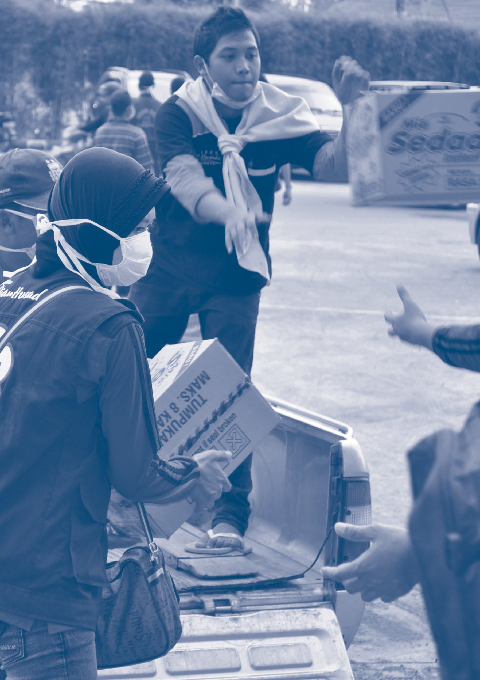

- Background

  - The Australia-Indonesia Partnership in Disaster Risk Management – SIAP SIAGA
The Australia-Indonesia Partnership in Disaster Risk Management (SIAP SIAGA) is an Australian Dollar (AUD) 36 million five-year partnership (2019 – 2024) between Australia and Indonesia which aims to strengthen Indonesia’s management of disaster risks and engagement between Australia and Indonesia.
SIAP SIAGA works across four interconnected end-of-program outcomes (EOPO):
- BNPB’s organisational systems are strengthened in better leadership of disaster risk management (DRM).
- Target provinces, districts and villages are better able to prevent, prepare for, respond to and recover from disasters.
- Strengthened cooperation between Australia and Indonesia on regional humanitarian preparedness and responses.
- Strengthened learning, innovation and inclusion for DRM.
Progress against EOPOs is anticipated through 12 Intermediary Outcomes (IO’s) as seen in Annex 2.
  - Implementation arrangements
SIAP SIAGA is implemented through two separate contract agreements:
  - Palladium International Pty Ltd leads on the body of work with the GoI and some civil society actors. At the national level it supports the National Disaster Management Authority (BNPB), the National Development Planning Agency (Bappenas), Ministry of Home Affairs (MoHA), Ministry of Foreign Affairs (MoFA) and Ministry of Social Affairs (MoSA). At the sub- national level, it works in East Java, Bali, Nusa Tenggara Timur (NTT) and Nusa Tenggara Barat (NTB) provinces with a wide range of subnational government agencies and civil society organisations (CSOs) including subcontracting arrangements with the Nahdlatul Ulama Agency for Disaster Management and Climate Change (LPBI-NU), and Muhammadiyah Disaster Management Centre (MDMC), both of whom have been long term DRM partners of DFAT. At AUD 30.6 million this work represents 85% of the total program value.
  - Support to the Indonesian Red Cross (PMI), another long-term partner to DFAT in Indonesia, is managed by the International Federation of Red Cross and Red Crescent Societies (IFRC), and at AUD 5.4 million represents 15% of the investment.
By having its humanitarian and DRM partners under the same investment, DFAT aims for all partners to work together under one framework to strengthen Indonesia’s DRM system.
During the COVID-19 pandemic Australia provided an additional emergency response package to Indonesia - Pulih Bersama – which included a tranche of funding to Palladium to manage grants to local CSOs which focussed on strengthening local health responses and community resilience. Pulih Bersama also included a range of activities implemented outside of SIAP SIAGA including additional funding to IFRC and PMI which are outside of the scope of the MTR (see Figure 1).
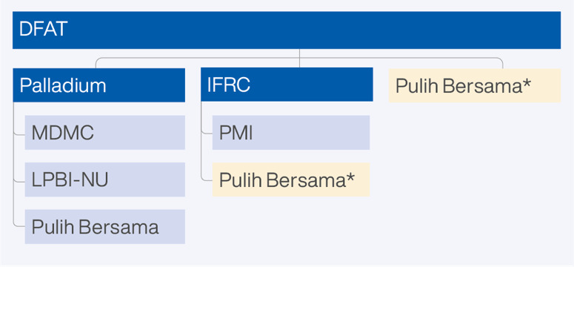
Figure 1: SIAP SIAGA Management Arrangements (*outside of MTR scope)

- The review

The Mid Term Review (MTR) was commissioned by DFAT to:
  - assess the performance of the SIAP SIAGA program comprising the Palladium and IFRC-PMI components including consideration of the impact of the COVID 19 pandemic on implementation;
  - provide a forward-looking analysis to provide recommendations for changes during the life of the program; whether DFAT continues with the plan of extending SIAP SIAGA for a further two years (2024 – 2026), and if yes, whether the program needs to be reshaped (i.e. scope, delivery mechanisms, partners).
  - provide an analysis of Indonesia’s DRM ecosystem to inform the configuration of future Australian support to the DRM sector in Indonesia considering the relevance and effectiveness of the programs, changes to the Indonesian context, and the possible greater integration of DRM with Climate Change Adaptation (CCA).
  - Key evaluation questions
The MTR explored six key evaluation questions (KEQ’s) relating to relevance, effectiveness, efficiency and strategic direction. KEQs are listed in Annex 3 and act as headings within the Findings sections of this report (Sections 3, 4 and 5).
  - Approaches, methods and tools
The MTR was undertaken in line with a Review Plan (see Annex 4) developed in consultation with DFAT and SIAP SIAGA partners. Methods were qualitative with a focus on utilisation and analysis explored progress at three levels: i. pillars/EOPOs, ii. Partnerships - Palladium and IFRC-PMI components and iii. whole of program.
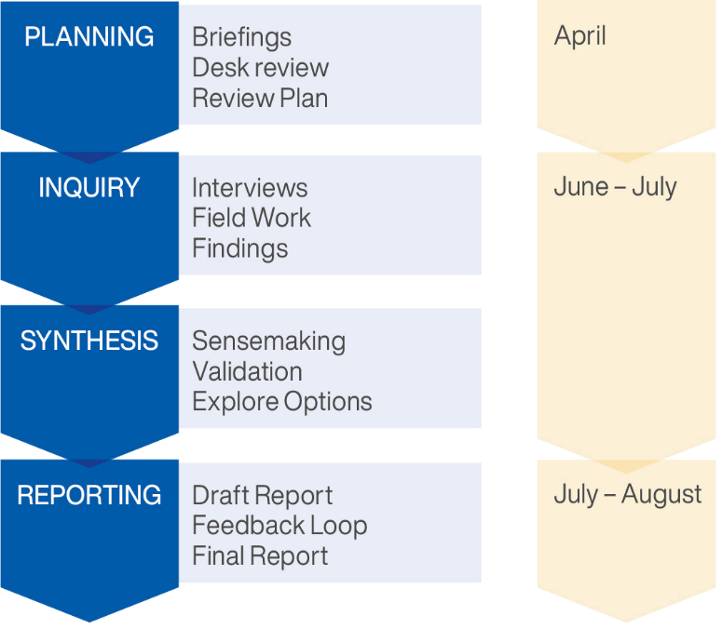
Figure 2: MTR Process and Tools
The MTR drew on a vast set of data from 277 informants (103 women and 174 men) including national and subnational government partners, civil society implementing partners, local civil society and rights holder organisations (Annex 5) and over 150 documents including activity designs, program reports, policy documents, work plans, analytical studies, meeting records, academic studies, DFAT performance assessments and publications.
  - Limitations and changes to the review plan
The MTR was time limited. Proportionality was a consideration in scheduling field consultations. Of the 20 days allocated to MTR consultations, 17 (13 in field and four (4) remote) were allocated to Palladium managed activities (including Pulih Bersama) and three (3) in field days to IFRC-PMI activities.
While the MTR team did plan for bias, we identified early in the process that some pre-MTR briefings may have affected the extent to which independent views were available in some areas. To address this, the MTR team agreed with DFAT to abandon the planned survey and extend the consultation period to enable a series of in-depth follow-up interviews with key informants. While field work was initially planned for Bali and NTB, remote meetings in East Java and NTT, and a field trip to IFRC-PMI activities in Banten were added to the MTR scope to facilitate the collection and verification of evidence across a wider partner and geographic footprint. Program staff of both Palladium and IFRC- PMI were requested to recuse themselves from consultations.

- Review findings
For the purposes of this report, SIAP SIAGA refers to the whole investment which includes the work undertaken by both Palladium and IFRC-PMI. We have throughout the report sought to highlight where findings relate to the work of a single partner. Findings respond to the KEQ’s and have been tested through MTR consultations, sensemaking sessions and feedback loops on the report.

  - Quality of evidence
The findings of the MTR are derived from a range of evidence sources which has to the extent possible been cross verified with program documentation, consultations with a diversity of actors and sensemaking sessions.
Our overall assessment of quality of evidence (QoE) for relevance and coherence is high (see Annex 4). For effectiveness and efficiency, the QoE is:

Palladium managed activities - medium - high
The assessment takes into account the good extent to which outcomes are tracked, documented and analysed through the Palladium Knowledge, Performance and Learning (KPL) system and knowledge products, but are largely self-reported (i.e., by Palladium team members and partners) and learning processes are in the main internally facilitated. Further, the independent verification of reported outcomes during the MTR was affected by limited recall of some stakeholders due to high turnover including the loss of some key GoI actors as a result of COVID-1 and variable levels to which the vast number of stakeholders had insight into program activities beyond those they were directly engaged in, or level of operational understanding of implementational details or strategic intent.

IFRC-PMI managed activities - medium
The assessment takes into account the output focus of IFRC- PMI reporting and the largely self-reported nature of program reporting. Independent verification of the IFRC-PMI supported activities was limited by low oversight of GoI actors of IFRC- PMI’s implementation of SIAP SIAGA and limited opportunity during the evaluation to speak to PMI volunteers and staff involved in the full range of activities at the subregional level.
  - Relevance and coherence

KEQ 1: To what extent does SIAP SIAGA:
• respond to and complement Indonesia’s and Australia’s priorities for DRM, and
• how agile is it to adapt to changes in policy and context (e.g., COVID.19, CCA etc.)?

Finding 1: Alignment with Indonesia and Australia’s priorities for DRM
SIAP SIAGA builds on Australia and Indonesia’s long term partnership for DRM in Indonesia and responds strategically to key policy and operational priorities for both countries. This includes strengthening Indonesia’s DRM system and resilience to disaster risk and exploring opportunities for joint Australia - Indonesia collaboration in the Indo-Pacific region.
Finding 2: Agility and adaptiveness
SIAP SIAGA has demonstrated the agility to adapt and respond appropriately to changes in the operational context including COVID-19, local disaster events, shifts in GoI and GoA policy and lessons learned.

Findings support Recommendations WOP 1 and WOP 4

    - Responding to GoI priorities for DRM
Indonesia places third highest on the global disaster risk index of 193 countries. Disasters cause significant loss of life, economic loss, social impacts, and undermine development gains. Since 2000, Indonesia has lost at least $16.8 billion per year from disasters, and during 1990−2021 as much as $3.5 trillion.
Responding to disaster risk is established as a priority within Indonesia’s National Medium Term Development Plan (RPJMN) 2020-2024, which prioritises three areas; improving environmental quality, increasing resilience towards disaster and climate change, and implementing a low carbon development approach. SIAP SIAGA also contributes to the three of the strategic issues identified within Indonesia’s National Plan on Disaster Management (RenasPB) 2020-2024 specifically DRM management, planning, and investment at the subnational level; adaptation towards the new normal and post-COVID recovery; and reform of the DRM ecosystem through strengthening the DRM system, operationalization of disaster and emergency management and increasing the capacity and capability of DRM actors for fast and reliable DRM.
The relevance and coherence of SIAP SIAGA is ensured through annual work planning processes undertaken in consultation with GoI DRM actors which align with GoI approved work plans and which are approved through the SIAP SIAGA Steering Committee process. MTR consultations with national government actors highlighted the relevance of technical assistance provided through the Palladium managed components of SIAP SIAGA, particularly relating to strengthening the regulatory environment for DRM through the promulgation of Minimum Service Standards for Disaster Management (MSS-DM) and associated local regulations guidelines, and support for Indonesia’s response to COVID-19.
At the subnational level, and in line with Indonesia’s decentralised governance system, SIAP SIAGA supports Regional Disaster Management Authorities (BPBD) in NTT, NTB, East Java, and Bali to fulfil their mandate as the technical lead agency for the development of local policy and guidelines, disaster risk assessments, and coordination between the range of local authorities engaged in DRM at the provincial and district levels. This work is unique to each region, reflecting local priorities and gaps, but is grounded in national policy priorities ensuring coherence in the operationalisation of DRM policy from the national to subnational levels as required within Indonesia’s decentralised governance arrangements.
Finally, SIAP SIAGA’s work on regional cooperation makes a tangible contribution to efforts to progress commitments to the Australia-Indonesia Memorandum of Understanding (MOU) for Trilateral Cooperation with the Pacific which includes a focus on DRM, humanitarian response, climate change among others.
    - Responding to GoA priorities for DRM
Australia and Indonesia have a long history of working together on DRM, including through joint humanitarian response and recovery following the 2004 tsunami and 2006 Yogyakarta earthquakes. The establishment of the BNPB in 2008 created an opportunity for Australia and Indonesia to strengthen cooperation through the Australia Indonesia Facility for Disaster Risk Reduction and other initiatives which brought DFAT and BNPB into partnership to provide strategic support to establishing Indonesia’s DRM infrastructure and capability.
SIAP SIAGA was designed to build on this sustained and trusted partnership and highlights the importance of the relationship to both countries in terms of supporting technical transfer and maintaining connections and touch points that can be mobilised in the event of a crisis where Indonesia requires international assistance. It further explores the potential for this partnership to extend beyond its domestic focus and into the Indo-Pacific region.
At the time of design and inception, SIAP SIAGA responded to Australian development priorities including, the Foreign Policy White Paper’s commitment to boosting resilience to natural disasters through the development program; the Australian Government Humanitarian Strategy’s focus on strengthening DRM systems, preparedness and response; and the Comprehensive Strategic Partnership between Australia and Indonesia commitment to “increase readiness to assist following a natural disaster; and to strengthen collaboration in responding to humanitarian crises in our region.”

In 2020, Partnerships for Recovery (P4R): Australia’s COVID-19 Development Response become the key policy framework for the Australian development program. As Australia’s flagship DRM program, SIAP SIAGA was recognised as a key delivery mechanism for Australia’s support to Indonesia’s COVID-19 response within this framework, and both Palladium and IFRC-PMI rapidly pivoted to supporting Indonesia’s response to COVID-19.
In 2023, SIAP SIAGA remains aligned with Australia’s new international development policy which includes “enhancing state and community resilience to external pressures and shocks” as a key focus, and its priority on prevention and risk reduction across Australia’s development investments and humanitarian assistance. The investment in IFRC and PMI further support the focus on localisation including supporting the role of civil society as key development actors.
DFAT Consular staff in Bali and Surabaya told the MTR that an Australia Indonesia partnership in DRM offers them a deeper understanding of Indonesian disaster response mechanisms and local connections that can be invaluable in the event of disaster.
    - The IFRC-PMI partnership
The logic for integrating DFAT’s partnership with IFRC-PMI within SIAP SIAGA is based on the unique role that PMI plays in Indonesia’s DRM system. As auxiliary to government, formalised through Government Regulation 7/2019 Concerning the Red Cross, PMI has a publicly recognised function in relation to DRM and is a critical partner for BNPB and GoI line ministries. With 34 provincial, 494 district and 3406 sub district branches, 6,600 staff and 317,000 volunteers across Indonesia, PMI has a robust architecture which enables it to train and mobilise its people and assets to respond to disaster events, as well as to support community based preparedness efforts and communications.
As a member of the International Red Cross Red Crescent Movement, PMI is mandated to uphold global commitments and principles for humanitarian action including impartiality, universality and neutrality. As such it plays a key role in promoting good humanitarian practice amongst Indonesian first responders and its role as a key actor and leader in local DRM fora supports coherence across the diversity of DRM actors from the community through to national level.
Working through committed local actors such as PMI who are positioned to respond is an important expression DFAT’s commitment to the localisation of humanitarian action and locally led development.
    - Agility and adaptation
In line with DFAT’s approach to adaptive and responsive partnerships and the uncertain and changeable context of the DRM sector, adaptability and responsiveness is by design, a key feature of SIAP SIAGA. The SIAP SIAGA program logic contains an assumption that response will be a feature of the program in any cycle and that maintaining active partnerships with the GoI and civil society DRM actors will position Australia to support Indonesian disaster responses if requested, and potentially extent in the future to include regional cooperation.
Palladium and IFRC-PMI’s ability to adapt to shifting contexts and critical events was clearly demonstrated during the COVID-19 pandemic (see 3.3.4.) as well as in responses to a range of local disasters including flooding in West and South Kalimantan (PMI), Cyclone Seroja in NTT and the Semeru Eruption in East Java (Palladium). Further, the multi-hazard nature of the SIAP SIAGA approach means it is well positioned to respond to climate risk. Both Palladium and IFRC and PMI are working with GoI on some early programmatic adaptions integrating climate risk into community-based disaster risk reduction activities (CBDRM) and is exploring how to take this work forwards.
    - Coherence
The SIAP SIAGA program logic is internally coherent and the focus on Palladium’s approach on strengthening the DRM regulatory environment through supporting national and subnational actors to develop policy and guidelines to operationalise national DRM policy supports coherence across Indonesia’s DRM system.
The Palladium team engages with other donor initiatives for DRM. It has aligned its work on gender mainstreaming in BNPB with USAID Invest-DM where Palladium works at the policy and regulatory level and Invest-DM supports BNPB through technical training for mainstreaming gender and inclusion. Coordination with the Japan International Cooperation Agency (JICA) on Sendai Framework for Disaster Risk Reduction (SFDRR) monitoring enables Palladium to focus on establishing the Secretariat to monitor SFDRR and national DRM, targets, defining the working and engagement mechanism with line ministries and external stakeholders while JICA focuses on the information technology (IT) aspects.
Palladium has also facilitated the establishment of the national inter-ministerial Collaborative Forum on Welfare based Disaster Resilient Villages (DRV) which brings together ministries with a DRM mandate to improve policy coherence and planning. It has also convened or sponsored several national and subnational learning events which bring together government and non-government partners including rights holder organisations, for knowledge sharing, peer learning and mentoring in the DRM space.

The IFRC-PMI component demonstrates strong internal cohesion with PMI priorities and complements other donor support to PMI. For example, the New Zealand Ministry of Foreign Affairs and Trade supported PMI to build eight subnational warehouses and SIAP SIAGA is enabling IFRC and PMI to establish international standard warehouse and logics management systems and training PMI staff and volunteers in their use. These systems are integrated with BPBD’s logistic system and planning and BPBD staff are included in training. Similarly, IFRC also implements Australian Red Cross (ARC) support to PMI and consultations during the MTR confirmed that mechanisms are in place for coordinated planning between IFRC, ARC and PMI to mitigate overlap and ensure complementarity and alignment between these and SIAP SIAGA.
DFAT plays a role in supporting coherence across DFAT’s development portfolio by sharing information and identifying synergies across its portfolio. The Palladium Team Leader has met with other DFAT programs to draw on learning.
The partnering arrangements anticipated in the SIAP SIAGA design to bring congruence across the different components of the program and its engagements within the DRM ecosystem have not been activated which undermines the internal coherence of the investment. This is discussed in more detail in 3.3.5 Efficiency – Partnerships.
  - Effectiveness – progress to outcomes

KEQ 2: To what extent are SIAP SIAGA investments on track to achieving their intended outcomes (EOPOs and IOs), specifically how and to what extent have SIAP SIAGA investments:
• influenced Indonesia’s DRM ecosystem at the regional, national and subnational level?
• contributed to Indonesia’s COVID-19 response at the national and subnational level?
• what do different partners especially GoI and civil society contribute to the outcomes?
• promoted gender equality and women’s empowerment, disability inclusion and inclusion of people in vulnerable situations?

Finding 3: Progress to outcomes
SIAP SIAGA is making good progress against all EOPOs within the program logic. However, changes to the architecture of and operational context for the program mean that Palladium and IFRC-PMI are implementing standalone programs each with their own program logic. As a result, the current program logic no longer fully reflects all approaches and change pathways being pursued within the program. The MTR team considers that the program logic could be updated to better reflect these shifts and the work of all partners.
Finding 4: Contribution to Indonesia’s DRM ecosystem
SIAP SIAGA contributes to the DRM ecosystem in Indonesia by:
• supporting work across the range of government actors to develop policies and regulations from the national to subnational levels to govern and facilitate DRM planning, resourcing and programming (MoHA, BNPB, MoSA and Bappenas with Palladium support);
• supporting BNPB to strengthen its role as the technical lead for DRM in Indonesia;
• supporting the development of guidance and integrated approaches to building resilience at the community level through disaster resilient villages (BNPB, MoHA, MoSA, MDMC and LPBI-NU with support from Palladium);
• contributing to Indonesia’s national data systems to support DRM planning and response (BNPB and Bappenas with support from Palladium and IFRC with PMI);
• strengthening PMI’s role as auxiliary to government and a key first responder (IFRC-PMI); and
• supporting Indonesia and Australia to progress their Joint Commitment to Trilateral Cooperation in the Pacific region and supporting regional linkages through ASEAN and the International Red Cross Red Crescent Movement (MoFA and BNPB supported by Palladium and IFRC-PMI).
Finding 5: Contribution to Indonesia’s response to COVID-19
SIAP SIAGA made important contributions to Indonesia’s response to COVID-19. In particular Palladium played a highly strategic and critical role in the early stages of the pandemic, mobilising a workforce of technical specialists to respond to government priorities and supporting the development of pandemic management guidelines which were critical as they provided the legal basis for local governments to initiate pandemic responses. PMI and other civil society partners such as MDMC and LPBI-NU delivered community based responses with a focus on ensuring that people in vulnerable situations including women, female headed households, the elderly and PWD had access to information, vaccines and short term livelihoods support.
Finding 6: Promotion of gender empowerment, disability and social inclusion
SIAP SIAGA is implementing twin track approaches to gender and social inclusion, building institutional capability for gender mainstreaming within BNPB and PMI, mainstreaming gender and inclusion within GoI policy and regulations, and delivering targeted programming to address the concerns of women, PWD and people experiencing vulnerability. There is scope to strengthen attention to and resourcing for both gender equality and disability inclusion at all levels of implementation to ensure that program aligns with the expectations of Australia’s new international development policy.

Findings support Recommendations WOP 1, WOP 2, O.2.P

    - Change pathways and progress to outcomes
The MTR has been able to surface and verify evidence that supports partner reporting on progress to outcomes. This evidence confirms that the combined efforts of Palladium and IFRC-PMI and their partners are contributing to each of the EOPOs within the SIAP SIAGA program logic. Despite the disruption of the COVID-19 pandemic, progress has been sound, and is well in line with what would be expected by the mid-term.
The following discussion on effectiveness and progress to outcomes however is not structured around the SIAP SIAGA EOPOs and IOs for two reasons:
- The current program logic developed at design (2018) does not reflect that Palladium and IFRC-PMI are now implementing stand-alone programs each with their own program logic which respond to the contexts and operations of their programs as they have evolved. In the case of Palladium, the analyses undertaken at inception led to the adoption of the systems approach and priority activities agreed with GOI partners. In 2021, Palladium presented a revised program logic (see Annex 2b), and while it offers a line of sight to the whole of program logic, it articulates a different set of EOPOs and IOs. The IFRC-PMI program logic (see Annex 2c) initially aligned with the SIAP SIAGA program logic and IFRC-PMI strategic priorities but was later amended to support the COVID-19 pivot (see Annex 2d) and as such also contains different EOPOs and IOs.
- The SIAP SIAGA program logic separates outcome pathways between the national, subnational land regional levels into standalone pillars. In reality however, as the systems approach shows, linking national and subnational level policy is central to demonstrating functional DRM arrangements in a decentralised governance context, and as such describing these in isolation to the other will simply not provide a clear description of outcomes nor respond to DFAT’s interest in understanding how the work at the national level creates frameworks for DRM governance and management at the subnational level, and conversely how subnational level work informs policy.
As a result, discussion has been structured around the key activities of Palladium and IFRC-PMI respectively so as to clearly illustrate the linkages between the national and subnational work in each activity area. We have also indicated where these contribute to the EOPOs and IOs of the current whole of SIAP SIAGA investment program logic.
Considering that the SIAP SIAGA program logic was developed six years ago and there have been significant shifts in context including new GoI regulations for DRM the MTR team recommends that the SIAP SIAGA program logic is updated to ensure that it reflects the adaptations made in response to these, the emerging lessons from partner programming and the priorities established within the new Australian Development Policy (see Recommendation WOP 2).
    - How has SIAP SIAGA influenced Indonesia’s DRM ecosystem at the national, subnational and regional level?
The Palladium managed component of SIAP SIAGA utilises a systems approach that aims to influence the DRM ecosystem in Indonesia through efforts to maintain and strengthen BNPB’s role as the lead technical agency, including identifying and addressing key gaps and blockages in the DRM system; supporting role clarification and strengthening coordination across GOI Ministries with a mandate for DRM; and ensuring regulatory coherence at the national and subnational level, while concurrently responding to aligned subnational DRM priorities determined through consultation with key actors and aligning with local development priorities, policies and programs including for example local disaster risk assessment and planning processes, safe tourism, gender and disability inclusion (GEDSI) mainstreaming etc.
Operationally this means that SIAP SIAGA’s approach focusses on national policies, systems and regulations that will be implemented at the subnational level. At the subnational level it supports the development and implementation of policies, regulations and Norms, Standards, Procedures, and Criteria (NSPK) that cascade from the national level work, and facilitating feedback and learning loops back to the national level. In this way, Palladium support for the DRM regulatory environment concurrently contributes to SIAP SIAGA EOPO 1, 2 and is supported by KPL efforts in line with EOPO 4.
The following section provides a snapshot of the progress of Palladium managed activities and how together these contribute to strengthening the DRM system at the national (EOPO 1) and subnational level (EOPO 2).

Minimum Service Standards – MSS-DM
In line with Indonesia’s Law 23/2014 on Regional Government, Government Regulation 2/2018 Concerning Minimum Service Standards coupled with MoHA Regulation 101/2018 on Basic Service Technical Standards for Minimum Service Standards in DRM at Regency/City Level outlines the mandatory standards to be established by all regions to provide basic services to communities and governs budget provision, arrangements for MSS-DM implementation and basic DRM services to be provided by local government. These guidelines set the legal frameworks to ensure regional programs and resources are prioritised to protect all citizens right to protection from disaster risk. The administration and monitoring of MSS-DM is the responsibility of MoHA, however responsibility for establishing guidance, technical support and ensuring that delivery is in line with these standards is vest in BNPB as the lead technical agency. At the subnational level BPBD’s are required to monitor implementation and provide technical support to the many line ministries who have varying responsibility DRM within their areas of sectoral focus. This newness of these regulations, complicated governance arrangement, nascent coordination mechanisms and need for role clarity between BNPB and MoHA, meant that prior to SIAP SIAGA commencing there had been limited progress on MSS-DM implementation and was a priority area of technical support requested by the GoI.
At the national level, SIAP SIAGA has supported BNPB and MoHA to clarify roles and responsibility for technical oversight of MSS-DM development, mapping existing NSPK, identifying gaps and supported national consultations to develop and socialise MSS-DM in order that DRM actors understood the policy frameworks and their obligations. At the subnational level, SIAP SIAGA has worked with provincial governments in drafting MSS- DM implementation protocols, and MSS-DM Implementation and Action Monitoring Plans (Binwas). This work contributes to EOPO 1 (IO 1-3) and EOPO 2 (IO 1 and 2). MTR consultations have confirmed that this work has played an important role in strengthening DRM governance and implementation by ensuring that regulations are in place and understood and clarifying the roles and responsibilities of different government actors with DRM mandates and civil society.
MTR consultations have verified evidence contained within Steering Committee Minutes and program reporting that SIAP SIAGA has helped to establish foundational national policy and regulations for DRM planning, financing and implementation which in turn provide subnational governments with a legal basis and operational frameworks through which to implement and finance DRM activities. Beyond the existence of MSS-DM themselves, during consultations and sensemaking sessions BNPB, MoHA and Bappenas spoke of the timeliness of this work and the strategic importance of demonstrating how key Ministries could work together to agree roles and responsibilities. BPBD’s in all four locations reported that this work addressed a major gap in operational guidance to support planning both within individual organisations but also in bringing the range of subnational actors together for coordinated and aligned action. This was particularly visible during field visits to BPBDs in NTB and Bali where informants were able to share local policy and operational guidance documents and in multisectoral consultations where various line ministries discussed the technical support that was being provided by BPBDs (see Box 1).

Box 1: Building subnational capability and collaboration
“Up to now, the preparation of Disaster Risk Assessment documents was always carried out by external consultants, but the process used by SIAP SIAGA made us actors ... we were directly involved in the North Lombok Regency Disaster Risk Assessment.
Also the involvement of representatives of different groups was also more complete, there was a disability representative and others to bring a GEDSI perspective to the assessment.
Personally, I learned a lot, and because of this I have been able to publish a book on how to make disaster risk assessments!
BPBD Informant – NTB

Harmonisation of DRM data systems
Access to accurate, timely data at all stages of the DRM cycle is a critical component of effective DRM systems. BNPBis responsible for the management of Satu Data Bencana Indonesia (SDBI), a harmonised national data management system for DRM. While SDBI has been established for some time, SIAP SIAGA was requested to support BNPB’s Centre for Information and Communication to standardise the platform and develop policies and protocols to govern the collection and exchange of data across the range of government DRM agencies working at the national and subnational levels.
This work contributes to EOPO 1 (IO 1-3) and EOPO 2 (IO 1 and 3) by providing a national framework and joined up subnational systems for the collection of accurate, timely and up-to-date data which in turn facilitates evidence informed DRM planning and management from the local to national levels. Representatives from the six key GoI partner agencies attending the MTR sensemaking workshop highlighted the strategic importance of this work to Indonesia’s DRM system and in particular the contribution that up to date and accurate data makes to the quality of vulnerability and risk assessment, budgeting and disaster response and recovery efforts. This was echoed within subnational consultations in all four provinces where informants confirmed that technical assistance provided by SIAP SIAGA enabled the development of protocols and the collection and integration of district level data into provincial One Data platforms (SATA) in line with SDBI requirements. These efforts also ensured that protocols addressed local data needs to support local DRM priorities. In NTT for example, data collected through the Provincial Disaster Risk Analysis included geospatial information and GEDSI data which was integrated into SATA and in turn SDBI.

Community-based Disaster Risk Management – Disaster Resilient Villages (DRV)
Integrated community based systems that leverage local knowledge and expertise to contextualise and tailor disaster preparedness and response strategies to local contexts are central to minimising loss of life and protecting livelihoods in the event of a disaster, and can assist in strengthening resilience to and mitigating shocks associated with climate change. As such supporting CBDRM is a central component of any DRM system.
Indonesia’s DRM system is populated with a range of CBDRM programs overseen by different Ministries, each of which have different foci and utilise different interventions. Greater coordination between Ministries is required to support improved coherence and congruence of CBDRM approaches through policy alignment, establishment of minimum standards, technical guidelines and monitoring systems.
SIAP SIAGA is working with BNPB to enhance its role as technical lead and coordinator for national level CBDRM programs. An inter-Ministerial collaboration forum for CBDRM initiatives has been established and works to coordinate approaches to CBDRM. SIAP SIAGA technical advisers have supported the forum to develop a conceptual framework and DRV Roadmap which was launched at the National CBDRM Conference in 2022. This DRV Roadmap includes a strong focus on GEDSI and has been incorporated into updated technical guidance for CBDRM and the forum is working to institutionalise it into national and subnational CBDRM processes. BNPB has also integrated this technical guidance into the operational guidance for BPBD’s for the delivery of their own DRV program - Destana.
Building on this work and in collaboration with the Palladium SIAP SIAGA team, PMI has revised its own National CBDRM Guidelines, to adopt both BNPB’s Destana operational guidance and IFRC’s Framework for Community Resilience, which incorporate climate change adaptation, urban resilience, gender and diversity. Given PMI’s reach across 34 provinces, this represents a significant contribution to building community resilience across Indonesia and demonstrates the important role that mass civil society organisations like PMI have in building resilience at the community level.

SIAP SIAGA has also supported BNPB to develop a Digital Catalogue / Dashboard to support national level CBDRM monitoring and access to better information to support the coordination and management of CBDRM/DRV efforts. It has collaborated with CSO Masyarakat Penanggulangan Bencana Indonesia (MPBI) to develop a CBDRM guidebook, drawing on insights from the 2021 and 2022 National CBDRM Conferences.
At the subnational level SIAP SIAGA is supporting the development of local guidance for the implementation of DRV and CBDRM and supporting engagement between provincial and district Disaster Risk Forums (FPRB) for CBDRM activities, including through Pulih Bersama. In July 2023, grants have been allocated to MDMC and LPBI-NU to pilot DRV models in East Java and NTB. It is expected that this work will contribute to further learning and review of approaches leveraged by the KPL system and contributing to EOPO 4. While this is positive, the scope of this work is resource limited and the MTR also considers that there would be considerable opportunity for SIAP SIAGA to harness learning from PMI’s implementation of the DRV approaches.
Support for DRV has been a significant and valuable investment for SIAP SIAGA which contributes to both EOPO 1 and EOPO 2 (IO 1,2) particularly in relation to strengthening technical leadership and implementation of CBDRM - DRV at the subnational level. This work is foundational to ensuring that Indonesia has frameworks and technical standards in place to ensure that all DRM actors are able to implement good practice CBDRM and contribute to community resilience. Consultations with BNPB and MoHA further highlighted an anticipated contribution to EOPO 3 through leveraging Indonesia’s expertise in CBDRM into international fora.

Engagement between Australia and Indonesia in the Indo Pacific Region
The SIAP SIAGA design reflected a shared strategic ambition between Indonesia and Australia to explore avenues for Australian - Indonesian collaboration for disaster response in the Indo Pacific region. This ambition has now been formalised within the Indonesia-Australia MOU for Trilateral Cooperation with the Pacific. The regional engagement work is managed under the Palladium contract and given its diplomatic focus is a unique innovation within the development program, relying on strategic engagement and collaboration between the Governments of Indonesia and Australia who are the central actors in the delivery of the component. The SIAP SIAGA regional engagement team play an important brokering and facilitation role supporting DFAT and MoFA dialogue.
Considering that this form of regional cooperation for DRM this a unique and as yet untested approach within the Australian development program and that “working on multilateral cooperation is always a long game” the MTR considers that SIAP SIAGA has made good progress in bringing Indonesia and Australia to the table to explore practical avenues for partnership in DRM and humanitarian response in the region and progressing their joint commitment to trilateral cooperation (EOPO 3, IO 2 and 3).
Scoping for regional cooperation commenced in October 2020 and since this time, the Regional Engagement Advisors have worked with DFAT and the MoFA to explore the feasibility of a range of options and approaches to potential collaboration. While several tangible activities have been agreed and are being implemented, DFAT and MoHA continue this exploration. Since this time, regional work has yielded several results that demonstrate good progress towards EOPO3 including:
  - the development of a capacity assessment methodology and toolkit, and a short list of countries for possible trilateral cooperation;
  - a training program and guide on the use of the assessment tool;
  - a directory of knowledge products and services/service providers to support trilateral cooperation; and
  - a coastal resilience toolkit.
It is anticipated that as this work progresses, it will lead to the identification of a potential project for joint Indonesia- Australia implementation which in turn will enable further work on the development of working protocols and mechanisms for collaboration. The practical nature of the approach means that the investment also leaves a legacy in the tool kits which have potential wider application for GoI and regional actors (EOPO 3, IO 1 and 3).

The SIAP SIAGA Regional Engagement Team also made a valuable contribution to domestic and regional learning and knowledge management (EOPO4) including through the lessons learning series on the impact of COVID-19 on DRM in the Indo Pacific Region, and the resulting “Because Resilience is Local Report (BRIL)” which was launched at the National Disaster Risk Reduction Day 2022 and at the May 2022 Global Platform on Disaster Risk Reduction (GPDRR). This offered opportunities for DRM actors across the region to engage in real time information exchange and learning throughout the pandemic in order to support their own pandemic responses.
The International Red Cross Red Crescent movement is a key global actor for DRM and in addition to the scope of work implemented under the Palladium contract, IFRC and PMI are also working to support regional cooperation for DRM.
IFRC’s position as a key partner of the Association of Southeast Asian Nations (ASEAN) provides it and PMI with strong linkages to support regional cooperation and influence. Together IFRC and PMI actively participate in a wide range of ASEAN Committees, Working Groups and events including the ASEAN Technical Working Group on Protection, Gender and Inclusion (PGI) and supporting regional research on gender based violence in emergencies. Demonstrating the strategic importance of this relationship, the Secretary General of ASEAN and the Secretary General of IFRC signed a Memorandum of Understanding on Strengthening of Community Resilience in Southeast Asia in May, 2022 which outlines the scope and areas of cooperation between IFRC, 10 National Societies (including the PMI) and ASEAN on matters of mutual interest in supporting, the strengthening of community resilience at regional, national, and local levels in the ASEAN region.
Further, in 2020, leaders from the Timor Leste Red Cross (CVTL) and PMI came together to enhance collaboration to mitigate the spread and impact of COVID-19 and improve disaster response capabilities for CVTL and PMI branches in cross border areas. This work resulted in joint assessments, and responses to communities in vulnerable and remote situations on both sides of the Indonesia - Timor Leste border and a subsequent MOU to support cross border cooperation between CVTL and PMI.
While IFRC and PMI’s contribution to regional engagement is an important contribution to EOPO 3 anticipated within the design, the absence of more formal coordination and/ or partnering mechanisms between DFAT, Palladium, IFRC and PMI means that it is as yet insufficiently captured within the SIAP SIAGA narrative and arguably leveraged across the investment. The MTR considers that strengthening connections between the Palladium and IFRC-PMI components of SIAP SIAGA (in line with Recommendation WOP 2, WOP 3), and an improved partnering mechanism between IRFC-PMI, DFAT and the ARC (Recommendation O.1.IP) will create a dialogue through which DFAT, Palladium, IFRC,
PMI and GoI partners could pursue further opportunities to explore if and how working through the International Red Cross and Red Crescent movement may also contribute to Indonesia’s aspirations for its regional humanitarian action.
    - How has the IFRC-PMI investment influenced Indonesia’s DRM system?
DFAT’s support for PMI through SIAP SIAGA builds on its long-term partnership with PMI and is an important part of its expression of support for locally led humanitarian action. The focus of this work is supporting PMI’s organisational transformation process (2019 – 2024) through which PMI is working to modernise its operations and management systems across Indonesia. Supporting this process makes an important contribution to the Indonesian DRM system by ensuring that PMI as a key humanitarian actor, and auxiliary partner to the GoI in Indonesia has robust management systems in place and maintains a skilled based of volunteers and staff to respond to disaster events and implement effective and efficient DRM programs.
The IFRC-PMI component contributes to all EOPOs 1,2 and 3. IFRC and PMI’s contribution to EOPO 4 is significant through IFRC and PMI’s learning processes and their ability to draw on international evidence, but due to separate contracting arrangements this has not been maximised across the whole SIAP SIAGA portfolio.
IFRC and PMI’s work has contributed to strengthening Indonesia’s DRM ecosystem in several areas:

Emergency preparedness and response capacity
PMI emergency preparedness capacity includes the prepositioning of logistics capability and stock in six warehouses strategically located across Indonesia to enable rapid and timely disaster response which contributes to building community resilience (EOPO 2). For example, IFRC and PMI are working together to strengthen PMI warehouse and logistics management systems in sub-regional warehouses, procurement of relief items to support the needs of women, infants and children as well as the replenishment of the most needed items in an emergency response including tarpaulins, body bags, tents, sarongs, spades etc. This support for the procurement and management of emergency response items means between November 2021 and May 2023, PMI mobilised the distribution of emergency supplies to over 80,000 people affected by disasters in West and Central Kalimantan, East Java, Aceh, Central Java and West Java.

Digitalisation of PMI business processes and access to local data
Also contributing to EOPO 2, as part of its digital reform process, in 2022, PMI undertook a comprehensive digital engagement capacity assessment that gathered data on the digital capabilities, digital literacy and use of technology across 34 Provincial and 129 district branches. This information was used to develop an evidence-informed set of recommendations for the ongoing digital transformation process that have enabled IFRC and PMI IT teams to collaborate on the development of real time systems for disaster response data collection and monitoring using Kobo Toolbox. A key outcome of this work is evidenced by the successful use of Kobo Toolbox for a range of disaster events including PMI’s COVID-19 response, the Foot and Mouth Disease Outbreak and Cianjur Earthquake Responses in 2022.
PMI has also rolled out Microsoft 365 across its operations which MTR consultations revealed is assisting in professionalising communications, providing access to collaboration tools, shared resources, and the ability for PMI branches to provide real time information on disaster events, logistics supplies, and targets to its members and responders. To support the Microsoft 365 rollout, IFRC and PMI developed a series of training modules tailored to PMI tools to train staff and volunteers to use them effectively. As of December 2022, 25% of PMI staff and volunteer workforce (1813 people) were registered to use the Microsoft 365 platform and efforts to move them from legacy systems into Microsoft 365 is ongoing.

Strengthening protection, gender and inclusion
Support for strengthening Protection, Gender and Inclusion (PGI) is an explicit outcome of the IFRC-PMI work and resources through SIAP SIAGA are supporting PMI to develop and implement a PGI Workplan 2021 – 2024. A PGI Working Group has been established to lead this work within PMI and is developing a Roadmap for PGI capacity building in DRM and associated training activities for PMI staff and volunteers. In addition to this, IFRC and PMI deliver targeted activities for women, people with disabilities (PWD), young people and the elderly, and have affirmative processes in place to ensure their participation in program planning, implementation and review.

Building demand and policy frameworks for anticipatory action
IFRC-PMI activities delivered through SIAP SIAGA complement the ARC’s long-term investment in building PMI’s capacity as a key champion for anticipatory action (AA) in Indonesia. Contributing to EOPO 1 and 2, this work has supported the development of an AA Work Plan, to support advocacy and coordination with GoI agencies and working groups on AA including with BNPB, MoHA, and the Ministry of Village
Development for the implementation of AA from the national through to subnational level. As part of these efforts, in June 2022, IFRC with the Anticipation Hub, PMI, BNPB, and Indonesia’s Meteorology, Climatology, and Geophysical Agency (BMKG) further hosted the Multi-stakeholder Partnerships for Anticipatory / Forecast-based Action in Indonesia: Learning and Exchange Workshop to build a body of lessons on AA to inform policy development and build capability and awareness for AA across the DRM ecosystem.
IFRC reporting and consultations with PMI and IFRC staff suggest that this work has a high level of buy in from BNPB, and MoHA and IFRC and PMI are currently supporting the GoI to draft a national policy framework on AA and the development and testing of financing mechanisms.

    - How did SIAP SIAGA contribute to Indonesia’s COVID-19 response?

Palladium managed support for COVID 19 response.
At the onset of the pandemic in March 2020, the Palladium team worked with BNPB to develop a plan to support the GoI’s management of and response to COVID-19, particularly at the early stages supporting the work of the COVID-19 Response Acceleration Task Force.

Box 2: Enabling decentralised response frameworks for COVID-19 response.
Two challenges faced by Indonesia during the COVID-19 response, particularly early on, were coordination between national and sub-national governments to establish policies and protocols, as well as obtaining good quality data on cases and responses at local levels to inform central government policies.
COVID specific protocols, were required to enable the new central entity, the National Task Force on COVID-19 Management, to task and request information from, sub-national governments. In turn and while doubtless keen to act, Provincial, district and city governments were unable to legally respond to COVID-19 until the official guidance was issued by MoHA.
SIAP SIAGA supported MoHA to develop this official guidance; a dashboard of information on health, education, social safety nets and the local economies; and a Circular Letter to permit local governments to work with non- government partners in managing the pandemic.
This support provided the local government with legal tools necessary to respond to the pandemic whilst also giving the central government full visibility of the spread of the virus across the provinces, and the effectiveness of their mitigation efforts.
Source: SIAP SIAGA Case Study 2021

Development of COVID-19 protocols
Palladium management systems the rapid procurement of technical advisers across the DRM ecosystem contributing critical surge capability and technical support to the GoI workforce. This work included the development of COVID-19 protocols such as lock down approaches, policy directives, information education and communications (IEC) materials, data collection systems and communications. To put the scope of this work into perspective, 58 short term and project personnel were mobilised in 2020 and 100 were in place in 2021. Further, the total investment in COVID-19 was AUD 9,141,422 or 54% of total expenditure to June 2023.
The onset of the pandemic created significant challenges in Indonesia’s decentralised governance context, where protocols that enabled the newly formed National Task Force to task and seek information from subnational agencies were yet to be put in place, and without which subnational agencies did not have clear legal authority with which to respond to COVID-19. As evidenced in Box 2, SIAP SIAGA played a central role in establishing the required frameworks for Indonesia’s COVID-19 response at the national and subnational level (EOPO 1 and 2).
MTR consultations with informants from multiple GoI Ministries highlighted that SIAP SIAGA support for activity costs and ensuring that personnel were operational was critical at a time when GoI was still putting in place approvals and funding to implement COVID-19 response activities.
“In the early days of COVID-19, to mitigate and expedite the process of handling COVID-19 … we set up a quarantine workplace at the Hotel Aryaduta for two weeks to compile and detail what the Indonesian government should do. SIAP SIAGA team members were there with us… we worked day and night in lockdown together… we produced Guidelines for Managing COVID-19, Guidelines for Regional Government Management of COVID-19, and Guidelines for COVID-Safe Measures in Local Communities.” GoI MoHA Representative

Development of COVID-19 Monitoring Dashboard
MoHA also requested assistance from SIAP SIAGA for an IT consultant to support the establishment of a web based, mobile COVID-19 Dashboard. SIAP SIAGA GEDSI advisers worked with MoHA and the consultant to ensure that the Dashboard captured disaggregated data to support planning and budgeting for targeted COVID-19 response. This Dashboard significantly improved MoHA’s ability to provide evidence informed advice to national policy and decision-making processes and support local governments in targeting their pandemic responses (EOPO 1 and 2).

Support to Subnational COVID-19 Task Force
At the subnational level, SIAP SIAGA teams in Bali and NTT provided critical support for the development of local regulations and procedures for COVID-19 and supported their COVID-19 responses. The intended work of LPBI-NU and MDMC also pivoted to COVID response and additional grant funding enabled them to implement a range of activities to strengthen community resilience to COVID-19 through supporting village governments to develop and implement standard operating procedures (SOPs) for COVID prevention, establish quarantine facilities, provide personal protection equipment and deliver vaccination programs among others.
A grant for the Communications for Behaviour Change Program supported LPBI-NU and MDMC to work with The Behavioural Insights Team to test behaviour change approaches for COVID-19 and document lessons. These are now being used to finalise a Behaviour Change Toolkit to support future public health campaigns and IEC (EOPO 4).

Support for community based response
During the pandemic, Australia provided a COVID-19 emergency response package for Indonesia - Pulih Bersama – a standalone program delivered through a range of modalities including the Australian Humanitarian Partnership, IFRC-PMI and SIAP SIAGA. Palladium received an additional AUD 2 million through Pulih Bersama to administer grants to CSOs. Ten partners provided direct assistance to 9453 people (45% women), in SIAP SIAGA’s target provinces (see Annex 6).
Local government actors, civil society and DFAT development and consular staff confirmed that this work provided visibility of Australian’s response to COVID-19. It also created entry points for Palladium’s early engagements with local actors as well as a platform to generate real time learning to contribute to COVID-19 response planning in line with EOPO 4. This work also contributed to EOPO 2, by supporting CSOs and local authorities to deliver localised responses including IEC campaigns, vaccination programs, food security, alternative livelihoods and non-cash assistance. MDMC and LPBI-NU also supported village governments and local health services to establish village disaster preparedness teams to plan and deliver COVID-19 response activities. Importantly, LPBI- NU and MDMC utilised inclusive approaches working with government and service provides to collect and analyse disaggregated data and ensure effective targeting.

IFRC-PMI support for COVID-19 response
IFRC and PMI also pivoted to support PMI’s response to COVID-19. While outcomes were COVID specific, they continued to work within the strategic priorities of the PMI transformation process. The strategic value of providing support through PMI is evidenced in its ability to leverage its national architecture to reach a large number of people with a modest investment. Over 548,000 people (9541 male, 9179 female and 529,823 unknowns) were directly reached through PMI COVID-19 responses in 2022. An important feature of PMI’s response has been its focus on providing targeted support to people in vulnerable situations including female headed households, the elderly and people in remote locations.
IFRC and PMI’s programmatic approach mean that support through both the SIAP SIAGA and Pulih Bersama modalities contribute to the same outcomes. As such while PMI’s Pulih Bersama activities are out of scope of the MTR, they cannot be separated from the discussion on PMI’s COVID-19 response as they significantly contributed to SIAP SIAGA outcomes. The MTR found that three key initiatives contributed to PMI’s COVID-19 response.

Risk Communication and Community Engagement (RCCE)
At the national level, support through SIAP SIAGA contributed to the development of PMI’s RCCE Workplan for COVID-19 which provided guidelines, assessment tools and key messages to support the development of IEC materials in a range of thematic and sectoral areas and which included the integration of community engagement and accountability and PGI approaches. The RCCE Workplan ensured a set of standards for PMI volunteers and staff to across PMI branches to implement localised, targeted IEC campaigns directly reaching over 538,000 people. In East Java for example, PMI researched information gaps for the elderly, which led to the development and field testing of targeted messages which were later shared to 80,000 aged persons in four provinces in Java through SMS Blast. PMI also used SIAP SIAGA resources to engage a graphic designer to support the development of vaccination campaign materials which were distributed through PMI hospitals and networks across Indonesia and PMI social media channels – WhatsApp, Facebook and Twitter.

Cash and voucher assistance (CVA)
CVA is an effective mechanism for delivering timely and relevant assistance to people affected by disaster and for some time it has been a preferred mechanism for the GoI in providing social assistance across a range of sectors including in event of a disaster. As a global leader in CVA, IFRC is supporting its member Federations to deliver CVA in humanitarian crises, and COVID-19 provided an entry point to work with PMI to facilitate the use of CVA as a key response mechanism for Indonesia. IFRC worked with PMI staff and volunteers to undertake assessments and subsequently with PMI operations teams to embed CVA management systems.
The impact and transformative nature of this investment is demonstrated in a shift in PMI’s historical reluctance to adopt CVA. The initial CVA pilot supported by SIAP SIAGA delivered CVA to 3744, micro and small business owners severely impacted by COVID-19 in Banten Province demonstrated to PMI the efficiency and effectiveness of CVA as an approach. PMI subsequently extended CVA to a further 5700 micro and small business enterprises using funds donated to it directly by Google. SOPs have been developed and the CVA mechanism has been embedded within PMI operating systems meaning it is now an available mechanism for PMI disaster response. This work contributes strongly to EOPO 2 and particularly IO 2.

Emergency and Pandemic Preparedness
COVID-19 highlighted to PMI that its pre-positioned supply of emergency items and logistics capability was insufficiently nuanced to pandemic response. With IFRC support, PMI undertook an assessment of gaps and logistics supply chains for items required for pandemic response. This work entailed designing specialist equipment such as isolation cubicles, identifying global supply chains and selecting suppliers. All procurement was undertaken through PMI systems using international procurement standards and building staff and volunteer capability to use them. While this has taken considerable time it represents an important institutional capacity outcome for PMI in terms of its preparedness, ensuring that pandemic supplies are available (EOPO 2), but also strengthening of PMI’s own institutional finance and procurement systems.
    - How has SIAP SIAGA promoted gender equality, disability and social inclusion?
Women, PWD, children, the elderly and other people in vulnerable situations are disproportionally affected by disasters. It is therefore vital that DRM policy, planning and implementation are based on a deep understanding of the specific contexts, needs, risks and assets of these groups but concurrently seek to create enabling policy environments for inclusive DRM, build the capability of DRM actors for inclusive DRM and actively target women and citizens in vulnerable situations.
Despite some progress in policy and regulations relating to gender and social inclusion, an analysis of the “Status of Gender and Social Inclusion Mainstreaming in DRM in Indonesia” undertaken by Palladium found:
“... the realisation of institutionalised gender mainstreaming and disability inclusion remains a challenge – not only for the government, but also for other development actors due to several obstacles including:
  - shallow interpretation of gender equality and inclusion;
  - lack of coherence across regulations to allow for understanding at the operational level;
  - incomplete policy and legal frameworks, including weak data systems; and
  - insufficient cross-sector coordination amongst government institutions, including with CSOs and other relevant stakeholders;
  - leading to impediments and delays in the implementation of gender equality and social inclusion.”
In response to this, Palladium’s Gender Equality and Social Inclusion (GEDSI) Strategy for SIAP SIAGA outlines two core areas of work:
  - working with government at the national and subnational level to strengthen attention to gender and social inclusion within regulations and driving coordination and accountability on gender inclusion; and
  - working with civil society including supporting civil society actors to leverage feedback into policy making processes and guidelines, establishing data systems and enhancing communication and accountability.
At the national level SIAP SIAGA has contributed to addressing some gaps in the governance and technical frameworks for gender and inclusive DRM including the drafting of Guidelines for Gender Disaggregated Data and Disability Inclusion for SDBI, the integration of gender and inclusion within some MSS-DM, and ensuring that GEDSI guidelines are in place for DRV.

Palladium also responded to BNPB’s request for technical support for an institutional gender capacity assessment. This assessment found that 70% of 80 senior BNPB officers were gender blind. BNPB officers working on this, reported in MTR consultations and sensemaking sessions that this work provides an evidence base to support gender mainstreaming within BNPB, and highlights the need to build leadership and institutional capability for gender inclusive DRM. BNPB has established a Gender Working Group to move this work forward and continues to draw on technical support from SIAP SIAGA GEDSI Advisers for the implementation of the Gender Mainstreaming Roadmap for BNPB.
At the subnational level SIAP SIAGA gender advisers make a contribution to EOPO 1 and 2 by supporting DRM actors to develop gender inclusive policy and strategies including:
  - Provincial level Policy on Gender Mainstreaming and Disability Inclusion (NTT)
  - Gender Mainstreaming Guidelines – NSPK (NTT and East Java), and
  - Gender Mainstreaming Strategy and Gender Roadmap and Action Plan (Bali).
SIAP SIAGA also supports the work of subnational FPRB which bring together intersectional interests from government, civil society and rights holder organisations into DRM policy dialogue and planning in the four target provinces. MTR consultations confirmed that the FPRB in NTB has supported the establishment of a Gender Working Group for DRM and in NTT the FPRB successfully lobbied for a disability desk in BPBD.
Disability right’s holder organisations are members of all FPRB and were represented in MTR consultations where they provided evidence of their efforts to ensure that disability inclusion was considered in local DRM planning and service provision. In NTB, disability rights organisations through Pulih Bersama supported women with disabilities to generate income through soapmaking and baking, and there was evidence that some of the women continued to seek orders or trade their produce through local stores and/or village enterprises.
There is evidence that SIAP SIAGA KPL processes led by Palladium are collecting disaggregated data and using this to generate lessons and knowledge products on gender inclusion in line with EOPO 4. The Gender Mainstreaming in DRM Toolkits provide a clear example of this work. The BRIL series also integrated gendered considerations within real time reflection and as did the Pulih Bersama Lessons Learned Report. Outside of some learning events including BRIL sessions focusing on disability inclusion, the MTR did not find evidence of similar engagement with right’s holder organisations around national level DRM policy advocacy, development and review.
GEDSI mainstreaming in the Palladium SIAP SIAGA team is currently led by two part time technical advisers and some short-term advisers supporting subnational work. Of these one has some experience in disability inclusion. Consultations suggest that advisers appear to be largely engaged to support specific tasks and there was limited evidence that they were working across the portfolio of activities. This suggests that support for GEDSI mainstreaming may run the risk of being siloed within some activities as opposed to having an inclusion lens applied across the full portfolio of work. A key example of this is the absence of any SOP or workflow within the Palladium team which necessitates a review of draft policy, regulations and guidelines by GEDSI specialists before these are finalised.
There is clear evidence that IFRC and PMI have applied a PGI lens to their work. At the strategic level, IFRC and PMI are collaborating to strengthen PGI mainstreaming across PMI’s national operations as part of its transformation process. IFRC has engaged a PGI Specialist to work with PMI PGI focal points on the development of a PGI Roadmap and Capacity Building Plan to act as a framework for PMI PGI efforts. IFRC and PMI are also key partners in regional PGI initiatives through ASEAN. The MTR was able to verify that IFRC and PMI have actively targeted women, PWD and other groups in project activities and are able to capture this through their monitoring and evaluation systems. IFRC and PMI gender focal points for example, developed PGI criteria for the selection of CVA beneficiaries during COVID-19 and these have been integrated into SOPs for future CVA programming. In 2021 IFRC and PMI undertook a PGI analysis of their COVID-19 operations resulting in practical actions to support improved service delivery such as tailoring support to people in specifically vulnerable situations including the delivery of outreach vaccination services for PWD and the elderly; home visits; and the targeting of tailored messaging for COVID-19 awareness to specific target groups including for pregnant women, PWD and the elderly. Program reporting and MTR consultations confirmed that new digital platforms have enabled PMI volunteers and staff to collect and use disaggregated data for preparedness and response.
While the MTR finds that efforts are being made to progress GEDSI, there has been insufficient attention to disability inclusion across the program. Further there was no evidence of attention to groups experiencing other forms of vulnerability or exclusion such as religious and/or ethnic minorities. In the event of extension increased investment in terms of strategic focus and technical support is required of both Palladium and IFRC-PMI to meet the focus on gender, disability and social inclusion mandated by the new Australian development policy (see Recommendations WOP.2; O.3.P; O.3.IP).

  - Effectiveness of approaches

KEQ 3: What approaches (e.g. systems approach, technical transfer) have been effective in contributing to the outcomes considering:
• key approach’s including systems approach and technical transfer;
• the extent to which capabilities will be sustained beyond the life of the program.

Finding 7: Systems approach
The systems approach used by Palladium is a logical response to the complex and complicated nature of DRM governance in Indonesia. Evidence gained through the MTR, confirms that the approach has contributed to strengthening the congruence of DRM governance from the national through to subnational level with particular regard to Minimum Service Standards for Disaster Management (MSS-DM), data harmonisation and Disaster Resilient Villages (DRV).
Finding 8: Partnerships
The partnering approach that was a key feature of the SIAP SIAGA design logic has not been implemented and in particular the absence of partnering arrangement between IFRC-PMI, Palladium and DFAT creates siloed and parallel approaches that undermines the internal coherence of the investment.
Finding 9: Role of civil society
The role of civil society in the delivery of SIAP SIAGA does not reflect the importance of the role of civil society DRM actors that the design anticipated and there are as yet unexplored opportunities for the program to better demonstrate the strategic role that civil society can play in regard to addressing challenges associated with DRM financing, supporting mobilisation at the community level and bringing evidence to policy fora and decision makers.
Finding 10: Sustainability
SIAP SIAGA planning and prioritisation processes, and ways of working mean that there is a high degree of national government engagement and ownership that underpins sustainability. At the subnational level, the absence of DRM financing and variable capabilities of local disaster management authorities (BPBDs) and other DRM actors, continue to present challenges to sustainability, however SIAP SIAGA is seeking to address these through its working in supporting regulations that create the legal frameworks through which local governments can operationalise DRM.

Findings support Recommendations WOP 2, WOP 3 and OI.P.
    - The systems approach
The systems approach adopted by Palladium works across the DRM system to identify and remove blockages to the effective implementation of DRM. As government systems are dynamic, changeable and deep, and the completion of one task, set of protocols, guidance etc, gives rise to a new body of work, it is critical to ensure strong and clearly visible linkages between work at the national through to varying levels of subnational responsibility and visa-versa. The systems approach acknowledges that blockages exist across the whole DRM ecosystem and therefore requires interventions across the system to improve the coherence and clarity of DRM policies and regulations; and clarify roles, responsibilities and coordination systems at the national and subnational levels to mitigate overlaps and technical overreach.
The identification of systems blockages was based on a series of analyses undertaken and/or commissioned by Palladium at inception. Decisions on priority activities were then made through strategic conversations with BNPB and other GoI partners in line with the RJPMN, their own workplans and the (then) SIAP SIAGA program logic. This work has later informed the development of a program logic for the aspects of SIAP SIAGA managed by Palladium (see Annex 2b).
At the national level, the approach focusses on national policies and regulations that will be implemented at the subnational level; and at the subnational level on implementation support and subnational policies, regulations and NSPK that cascade from the national work. The KPL system facilitates feedback and learning loops throughout the system. In this way, the systems approach also provides the potential for additional value to be created through building capacity for the operationalisation of national policy beyond the target provinces.
The MTR finds that while these linkages are not yet fully optimised, mostly due to their iterative nature meaning that national policies need to be in place before subnational work can progress, there is good progress in all target provinces particularly considering that the program is at the midterm, COVID-19 disruptions and the addition of new Provinces.
As such, the systems approach is a logical response to the complex and complicated nature of DRM governance in Indonesia and there is sound evidence gained throughout the MTR that the approach has contributed to strengthening the congruence of DRM governance particularly for MSS-DM, data harmonisation and DRV.

A key risk for the systems approach is that it is complex, and can be challenging to communicate to some stakeholders. It is therefore critical to establish and maintain clear and intentional parameters and focus to prevent the risk of creep and a confluence of adhoc and unrelated requests. The MTR found evidence that not all team members or partners fully understood the systems approach and particularly linkages between the national and subnational work.
Working at a systems level is complex and dynamic, and it is important to maintain a realistic perspective on what can be attributed as a result in terms of systems change and the sustainability of that change. Working on policy blockages and role clarity with a significant focus on a bureaucracy characterised by high turnover, shifting policy agendas and dynamic briefs, does not remove fundamental structural challenges between national and subnational actors particularly in relation to issues where a blockage may be political. For example, in relation to DRM financing, while MSS-DM are being put in place at the national level, at the subnational level, these require NSPK to authorise local government to allocate resources and implement, however while budgeting is vest in the bureaucracy, ultimate decision making and approval remains in the political sphere. In contexts where political buy in for DRM is low and financial resourcing does not exist, this can present significant blockages. Until a time that improved incentives and/or sanctions for non-adherence to national guidelines is in place, it is critical to work at multiple levels including engaging with the political system and leaders to place DRM as a policy priority and allocate resources at the subnational level. The systems approach as currently implemented appears to focus more deeply on the challenges within the government and it is unclear at this stage if and how the systems approach is being more widely applied across the wider DRM ecosystem including political actors.
    - Technical support and capacity development
The MTR found a high level of satisfaction expressed by SIAP SIAGA government partners regarding the quality and nature of technical support provided by SIAP SIAGA both during and after the COVID-19 pandemic, and at all levels of engagement. Technical assistance is determined by jointly agreed priorities in line with the workplan of BNPB and other national and subnational partners, and needs identified through systems mapping. There is evidence that careful consideration of factors that support the effectiveness of technical advisory services have been considered in the selection and design of tasks, development of Terms of Reference and there are clear deliverables for this work.
Technical support delivered through SIAP SIAGA does however appear to be significantly structured to outputs and expert-centric approaches (training, workshops, expert review) rather than a multi-pronged capacity development approach that work concurrently on building systems capabilities and regenerative competencies. When considering the effectiveness of technical support, it is important to clarify that working within a systems approach does not remove the need for institutional approaches including capacity development and institutional strengthening approaches. Indeed, addressing blockages and gaps is likely to require a portfolio of capacity development approaches delivered concurrently across different parts of the system in order to effect sustainable change.
In line with this, while the KPL system is able to generate a body of evidence to track the extent to which the technical support has contributed to deliverables, it is unclear how it is measuring the extent to which this has resulted in sustained changes to the capacity of the system over time.

    - Working across the DRM ecosystem – the pentahelix and civil society engagement
GoI DRM policy recognises the importance of working across the DRM ecosystem, and BNPB promotes a Pentahelix approach, bringing together government, civil society, the private sector, academia/experts and the media. Programs such as SIAP SIAGA play an important role in supporting these approaches in resource constrained contexts by bringing DRM actors together for planning, clarifying roles and responsibilities, developing local guidance and other forms of collaboration.
In each of the four provinces the MTR found a strong appreciation of and appetite for SIAP SIAGA’s support for multistakeholder engagement in DRM through FPRB which represent diverse interests including rights holder organisations (including women’s, indigenous minority, and disability organisations), child protection organisations, the media and private sector associations among others.
Palladium pays attention to ensuring FPRB are not de-facto channels for project collaboration, but rather key actors in local planning and response by undertaking assessments, developing plans and roadmaps and building internal leadership, operational systems and regulations that formalise and legitimise their role in the DRM ecosystem. Some examples that demonstrate a contribution of multi-actor collaboration to EOPO 2 include:
  - FPRB have formalised roles in MSS-DM for DRM Supervision and Monitoring Plans in all four provinces.
  - In Bali, the FPRB has become a legally incorporated body which means it is recognised by government and able to access funding.
  - In NTT, the FPRB played an important role during the Cyclone Seroja response (2021), operating as a Volunteer Desk, mobilising and managing volunteers and publishing daily situation reports and communications.
  - Also in NTT, the FPRB was instrumental in lobbying for a disability inclusion unit with BPBD.
  - In BALI, the FPRB have provided inputs into the drafting of a Provincial Regulation on DRM and are actively lobbying local Parliament for DRM budgeting.
Indonesian CSOs such as PMI, faith-based organisations such as LPBI-NU and MDMC as well as other CSOs within the Humanitarian Forum Indonesia (HFI) play a significant role in harnessing public support, delivering humanitarian responses and building community resilience to disasters and climate change. They tend to have strong community ties and a volunteer base that mean they have a high level of legitimacy amongst communities and which enable them to provide rapid responses, which are often untied to bureaucratic approval or declaration of emergency. This provides them with a level of adaptiveness, flexibility and reach that government actors will never be able to provide and which are critical for community based responses.
The SIAP SIAGA design pays strong consideration of the role of civil society in DRM and anticipated a strong role for PMI, MDMC and LPBI-NU among others as key program actors, leveraging their comparative advantages, expansive and deep institutional footprints and connections with and understanding of community to pilot approaches to CBDRM, advocate for inclusion and leverage their experience to bring evidence to national and subnational policy DRM processes and development of operational guidelines for CBDRM.
The role of civil society in the delivery of SIAP SIAGA to date however does not reflect this intent. The IFRC-PMI component of the work by way of its separate contract arrangements as well as the timing of the COVID-19 pandemic, has not been integrated into the whole of program approach and works parallel to the Palladium managed component. Specifically the fact that key lessons from IFRC-PMIs work are not integrated with KPL system is a lost opportunity both for the collection and dissemination of lessons learned. MDMC and LPBI-NU activities in support of CBDRM were pivoted in 2020 – 2022 to COVID-19 response, and have only commenced in mid 2023 with a limited budget of AUD 250,000 for two years. MTR consultations with CSO actors indicated a desire for deeper engagement including around analysis, policy dialogue and learning that strategically leverages their extensive experience, expertise and networks within policy fora.
The MTR reaffirms the opportunity that SIAP SIAGA has to demonstrate the strategic role that civil society plays in DRM, and in particular, their ability to reach into community and fulfil unique functions that government cannot, so as to demonstrate solutions to wicked challenges around DRM financing, resource mobilisation for CBDRM, capacity development, information, inclusion and demand driven development approaches particularly at the village, subdistrict and district levels. Increased resourcing for testing these approaches and implementing practical measures to strengthen partnerships and strategic dialogue and learning between civil society and local government actors would make have a positive impact on the delivery of EOPO 2 (IO 2 and 3) and EOPO 4 (IO 2 and 3).

    - Partnership
A partnering approach is a structured and intentional approach that moves beyond coordination and seeks to create equitable relationships between partners that enable them to leverage each other’s competitive advantage and capabilities to deliver on shared objectives and strategic intent. Partnering approaches are a response to complexity and recognize that no single actor can bring about changes to complex systems and challenges. They can also assist to establish working relationships that support innovation, collaboratively identify solutions to shared problems and resolve tensions.
The partnering approach anticipated as a key feature of the SIAP SIAGA design to establish a set of working practices and relationships that would bring congruence across the investment and ensure that multiple actors were contributing to the delivery of outcomes, has not materialised. This is brought about in part by the fact that responsibility for implementing a partnering approach was not included as a deliverable in the Scope of Services for either Palladium or IFRC-PMI. While we understand that there were early brokering activities held at inception this work did not continue during COVID and with the passage of time each partner has moved ahead with their own ways of working.
MTR field consultations, observations and sensemaking sessions reveal that the Palladium SIAP SIAGA team has established effective working relationships with its government partners at the national and the subnational level and is supporting linkages between some GoI agencies. While this is very positive this is not what is meant by a partnering approach. Partnering approaches that establish and make visible principles and agreed ways of working and include regular health checks (as articulated in the design) have the potential to build on working relationships, by embedding collaborative work practices and mutual accountability between different institutions (rather than individuals), generating new initiatives and sustaining the changes the investment is seeking to bring about.
The MTR also considers that the absence of a partnering arrangement between IFRC-PMI, Palladium and DFAT at the whole of program level contributes to a siloing of the two components which undermines the internal coherence of the investment and means that opportunities to leverage the skills, capabilities as assets of both partners (e.g. regional networks such as ASEAN, PMI’s extensive reach for CBDRM and subnational policy making, and policy advocacy for AA) are not realised (see Recommendation WOP.2 and WOP.3).
  - Efficiency

KEQ 4: To what extent do SIAP SIAGA investments represent the best use of resources to achieve its intended outcomes specifically:
• to what extent are the different modalities (e.g., use of subcontracts, grants, mix of short- and long-term advisers) efficient and deliver value for money;
• how has SIAP SIAGA’s adaptive management approach impacted the efficiency of program planning and resource allocation;
• to what extent did COVID-19 impact on efficiency?

Finding 11: Value for money
SIAP SIAGA delivers moderate - good value for money demonstrated through strong consideration of cost consciousness, transparency, accountability and results orientation. We consider that VfM will strengthen as the subnational implementation of national guidelines is rolled out, and if greater coherence between Palladium and IFRC-PMI investments can be facilitated.
Finding 12: Adaptive management
Palladium’s adaptive management approach positioned it to be able to deliver an effective and efficient response to the COVID-19 pandemic and planning systems ensure strong alignment between GoI workplans and the SIAP SIAGA program logic. As the program matures, it will be necessary to consider proportionality and how program resources are best mobilised to support subnational activities.
Finding 13: Impact of COVID-19 on efficiency
COVID-19 left a legacy of staffing arrangement that have normalised remote working and while these were the right decisions at the time, consideration of new workflows and strategies to bring teams together to strengthen programmatic coherence warrant consideration.
COVID-19 also contributed to a significant underspend in the IFRC-PMI project due to some delays in procurement but also as pandemic response overtook some of PMI’s pre-pandemic priorities.

Findings support Recommendations WOP 2, WOP 3, O2.P and O2.IP.

    - Efficiency of different modalities
DFAT and its partners use a range of modalities to deliver SIAP SIAGA. The following provides a summary of findings related to specific modalities which have contributed to our assessment of VfM provided at 3.4.4.

Use of long- and short-term advisers
Palladium addresses efficiency by using different mechanisms to mobilise technical support to ensure that they are fit for purpose and proportionate to task/role. This includes the use of:
  - permanent full-time advisers / activity leads that oversee congruence and consistency across the portfolio in their area of expertise;
  - part-time, long-term adviser roles (LTA) who lead work in their area of expertise including for DRV/CBDRM, gender, disability inclusion, regional engagement and more recently KPL; and
  - specialist STAs who deliver specialised tasks for example data system development, DRV/CBDRM, gender and disability inclusion among others.
Since early 2023, with the exception of the Team Leader, all full time LTA roles are filled by Indonesian nationals and the international KPL and Regional Engagement Advisers are on part time LTA contracts.

IFRC-PMI partnership
IFRC and PMI are significantly behind in program expenditure with approximately AUD 700,000 underspent. Some of this underspend is accounted for by the impacts of COVID-19 which overtook some of PMI’s pre-COVID priorities and focused its attention on mobilising a massive nation-wide response. However, the MTR found some evidence that PMI absorption capacity and/or the extent to which the DFAT priorities align with those of PMI may also contribute to this underspend.
In considering options to address this underspend it is important to consider the sovereignty of PMI over its operations. IFRC works alongside PMI using and strengthening PMI systems to bring about sustainable institutional reforms, however it cannot drive outcomes faster than the will and capability of PMI itself.
In the context of the consideration of the option to extend the SIAP SIAGA investment beyond its current term to 2024, it will be important for IFRC and PMI to reassess the ambition of their shared workplan and budget, and in particular consider what may be a more realistic timeframe for progressing the intended outcomes (see Recommendation O.2 IP).
The MTR team was asked to explore how the IFRC-PMI SIAP SIAGA arrangement aligns with the DFAT-ARC Humanitarian Partnership. The MTR team had discussions with DFAT officers in Canberra and Jakarta, the ARC, IFRC and PMI. ARC confirmed that while support to PMI is currently supported by the DFAT- ARC Humanitarian Partnership, it is delivered through IFRC due to their operational presence within the PMI National Office, and that ARC, IFRC and PMI have carefully calibrated this support to mitigate overlaps and ensure that DFAT resources complement each other. Further separate contracting arrangements and accounting codes are in place to ensure accountable financial management. While this is the case, the MTR considers that creating a mechanism that engages DFAT, IFRC, PMI and ARC into strategic dialogue around their shared work in Indonesia would be valuable (see Recommendation 0.1.IP).

Pulih Bersama and NGO funding windows
Pulih Bersama was a one-off, short-term grant package offered by DFAT to support COVID-19 response efforts to communities in specifically vulnerable situations in Indonesia. It was delivered through a range of different program modalities including IFRC-PMI, the Australian Humanitarian Partnership and as a short-term crisis measure added to the Palladium contract.
The MTR visited four communities in which Pulih Bersama activities were implemented by Palladium partners, and found that while Pulih Bersama provided an injection of income to CSOs to support localised responses to COVID 19, the effectiveness of these interventions was highly variable. We observed appropriate vulnerability targeting, particularly for women with disability in two locations and relationship based distribution in the other two. In all but one case, support for alternative livelihoods were undertaken without any market analysis, financial literacy support, business training or with support from businesspersons, leading to small scale production initiatives such as cake making, soap making that created additional task burden particularly to women with limited opportunity to generate return.

This variability appears to have been shaped by several factors including:
  - Design – established by DFAT as a short-term humanitarian response mechanism, Pulih Bersama contained inherent tensions around the ambition and scope of outcomes (e.g., establishing alternative livelihoods) coupled with the short- term nature of funding (operational duration of nine months).
  - Limited application of global good practice on humanitarian financing which highlight the increased burden that short term project focused funding can create for development partners at the time that they are both affected themselves and busy with implementing crisis responses. This includes utilisation of grant making systems (including partner and project selection and reporting processes) that are proportionate to the short- term humanitarian nature of funding and constrained the operational context while still ensuring accountability.
  - Partner capability, carrying capacity and technical support. COVID-19 was a fast-learning curve for everyone, and partners and program staff alike were working in a changeable context with competing priorities. Some partners reflected that they felt they had insufficient technical support and capability. The MTR considers that the inability to undertake face to face monitoring and technical site visits during this time may have contributed to partners feeling that monitoring efforts were more focused on outputs and outcomes than resolving implementational challenges.
While the Pulih Bersama funding is now completed, and we acknowledge the extraordinary pressure of the circumstances DFAT and Palladium were experiencing, these observations offer important considerations for the shape of future short term, crisis funding mechanisms in the future.
Consultations with LPBI-NU and MDMC who have been long term partners of DFAT and who received additional grants outside of the Pulih Bersama window reported that the grant making system currently utilised by Palladium bore higher transactions costs and created additional burden than their previous direct funding arrangements with DFAT. This included the need to undertake new due diligence assessments when their partnership with DFAT was transferred to Palladium. It would be valuable for Palladium and DFAT to explore good practice approaches to civil society financing to better support key partners such LPBI-NU and MDMC to fulfil the strategic intent of their engagement in relation to their work on delivering outcomes against EOPO2, than approach this engagement from a subcontracting/service delivery lens.
While significant funding was provided to CSOs for the delivery of SIAP SIAGA’s response to COVID-19, much of this was allocated through additional funding sources such as Pulih Bersama. The MTR notes that the forward budget for MDMC and LPBI-NU for testing DRV and CBDRM approaches for the remaining two years of the program is only AUD 250,000 for two of the four target provinces which does not reflect the strategic role anticipated for these partners in program delivery.
    - Impact of Palladium’s adaptive management approach on efficiency
The agility and adaptiveness of Palladium’s management approach was significantly tested with the onset of COVID-19 only a few short months into its Inception. Palladium’s management systems enabled the rapid recruitment and deployment of a large team of STA and a grant management system was put in place to facilitate an additional $3 million in grants as part of the Pulih Bersama package. By the end of the 2019/2020 financial year, only eight months into operations, Palladium’s total expenditure was 114% of the original budget, demonstrating its ability to ensure that assistance was available to GoI needs as they evolved.
Palladium has established a collaborative work planning process with the GoI that draws on results and lessons from the previous year of implementation, and activities requested by government in line with their own workplans, the SIAP SIAGA program logic, and determined through interdepartmental prioritisation processes. This process has been effective in ensuring that program resources are focussed on the delivery of the SIAP SIAGA program logic but also create space to adapt to GoI priorities as they emerge. It also mitigates the risk that adhoc requests could detract from the central purpose of the program. The MTR considers that the absence of significant ‘mission creep’ and focussed nature of the work evidences the effectiveness and efficiency of the adaptive management approach.
Current financial allocations for SIAP SIAGA sees a 60:40% allocation between the national and subnational levels, with BNPB and BPBD as being the primary recipients of this support. As SIAP SIAGA progresses into its final years of operations any increased focus on implementation of national level policies and procedures at the subnational level, is likely to require DFAT and the GoI to re-negotiate how resources are allocated both between the national and subnational levels but also between DRM actors who have different responsibilities for DRM implementation. While some BNPB informants indicated during sensemaking sessions that this was anticipated in the latter years of programming, key informant consultations indicated some resistance to significant change citing complexities in GoI development reporting processes and the ambition of BNPB’s own forward work agenda.

    - Impact of COVID-19 on efficiency

Palladium team structure and work practices
COVID-19 uniquely affected and left a legacy in the architecture of and working arrangements for the Palladium SIAP SIAGA team. The Management Support Office anticipated in the design to be located in BNPB was not established, and while three team members are located in the BNPB office, the rest of the Jakarta team, work from the Palladium Office. All international advisers were relocated in Bali with each working from home rather than in a shared office. Subnational teams work from project offices based within BPBD’s in the four provinces, the KPL team is spread between Aceh, Jakarta and Bali, and STA generally work from home. As travel restrictions have eased, the Team Leader works in Jakarta for three days per week and other advisers travel as required. COVID-19 restrictions also meant that planning, induction, monitoring and learning was undertaken remotely. The first opportunity for the whole team to come was April 2022 and annual face-to-face team planning sessions are now in place.
While decisions relating to the staffing structure and locations were clearly the right ones at the time, the MTR considers that the extent to which remote working is the norm contributes to some siloed, output focussed work practices, and creates insufficient opportunity to bring teams together for deeper conversations, learning and connection. While there is a diversity of views on remote working within the team, consultations suggested that team members felt that more opportunity to bring the team together and travel between locations would add value and provide greater clarity and congruence across the program.
We also note the flat organigram in which the Team Leader Role has a large number of direct reports and overall responsibility for all aspects of the program management including day to day management, program strategy and relationship management, and consider that in the light of a potential extension that Palladium work with DFAT to consider if the current organigram is the right one to take the program forward, and if there may be alternative ways of working that can counterbalance the impact of remote working in line with Recommendation 0.2.P.

IFRC-PMI
A discussion on how COVID-19 contributed to the current underspend of the IFRC-PMI program has been provided in 3.5.1.
    - Value for money
The value for money (VfM) assessment uses DFAT’s VfM assessment tool and looks at VfM across the whole investment and considers the contribution of each component and each actor as well as proportionality of the different investments.
The MTR finds that SIAP SIAGA has delivered good VfM (see Figure 3). This takes into account three operational realities:
  - initial time and transaction costs associated with the inception of SIAP SIAGA as a new partnership between DFAT and the GoI that commenced in November 2019;
  - disruption created by the COVID-19 pandemic including its timing and early focus on pandemic response;
  - the absence of clear mechanisms for leveraging Palladium and IFRC-PMI contributions to the program.
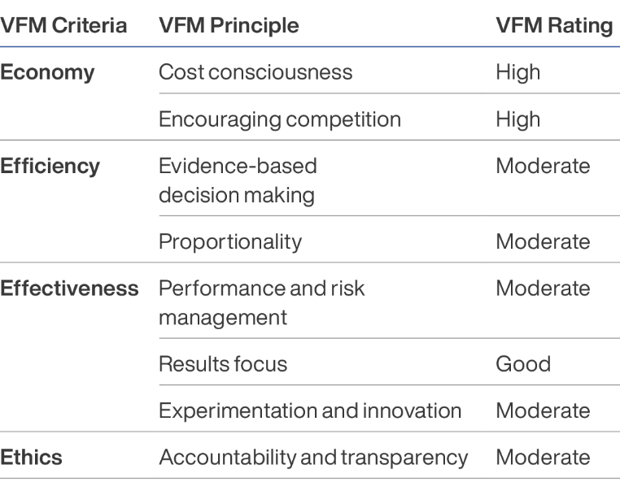
Figure 3: Value for money assessment

A summary of the key considerations that have informed our assessment is provided at Annex 7. While these issues have been discussed within this report, a pattern has emerged which indicates that a number of key strategic issues continue to impact on VfM, specifically:
  - The absence of a partnering approach/mechanism that works to bring coherence and inform collaboration, learning and evidence informed decision making across the whole investment.
  - Absence of a fit for purpose and integrated approach and resourcing for working with and positioning civil society as key actors within the DRM ecosystem with a direct role for delivering on the community resilience/CBDRM pathway i.e., through different DRV models and supporting the MSS-DM implementation at the subnational level.
  - Disproportionate allocation of resources through the Palladium supported activities between national and subnational level activities and across the range of government actors and including for civil society engagement.
  - Future drivers and responses to DRM in Indonesia

KEQ 5: What are the anticipated changes and drivers for future support to DRM in Indonesia and what if any international support is Indonesia likely to need to respond to these priorities and challenges including for gender, disability and social inclusion and CCA?

Finding 14: Priority considerations for possible future DRM partnership
Analysis of the DRM sector in Indonesia suggests eight key priority areas for DRM that align with shared DFAT and GoI priorities and build upon the legacy of SIAP SIAGA and other Australian - Indonesia partnerships before it. These are:
• Strengthening the regulatory environment and policy coherence
• Mainstreaming gender, disability and social inclusion in DRM
• Strengthening spatial planning regulation
• Strengthening subnational institutions and DRM financing
• Strengthening data systems for evidence-based DRM
• Strengthening Community Based Disaster Risk Reduction (CBDRM)
• Integration of climate resilience into DRM, and
• Supporting Indonesia’s role as a regional humanitarian actor.

Findings support Recommendations WOP 1, WOP 2 and WOP 3.
A rapid analysis of Indonesia’s DRM sector was undertaken by the MTR team to provide a current overview of key drivers and challenges for DRM in Indonesia. The analysis highlighted eight key issues that align with GoI and GoA interests and priorities as we understand them, and may inform programming for the duration of the SIAP SIAGA program but also act as key considerations for DFAT and the GoI as they consider the shape of any further partnership for DRM beyond SIAP SIAGA.

Strengthen the regulatory environment and policy coherence
Indonesia continues to face issues in the institutional arrangements of DRM including clarity on the roles and responsibilities and division of authorities between a wide range of DRM actors inherent in the current legislative frameworks. Despite considerable progress in this area, some gaps remain, and policy rules and regulations governing DRM and civil protection in Indonesia could be strengthened. This would enhance collaboration and inter-institutional approaches, and strengthen integration and reference to other government initiatives from the national through to subnational levels.

Mainstreaming gender, disability and social inclusion in DRM
To implement the BNPB’s GEDSI Roadmap it is critical that Indonesia is able to ensure that gender and inclusion are mainstreamed into all DRM policy, MSS-DM and NSPK and other technical guidelines for all disaster-related activities and amongst all stakeholders. This includes addressing risks and vulnerability realities relating to gender-based violence and the protection of children, increasing the role of rights holder groups, women and persons with disability in DRM planning and creating space and resources for rights holder organisations to be advocates for inclusive policy and service delivery. It will also require strengthening technical capability and strong leadership for gender and social inclusive policy.

Strengthening spatial planning on DRM
Spatial planning in Indonesia does not currently utilise scientific data and local knowledge sufficiently to manage disaster risk. In the future, the development of MSS-DM and other national guidelines will be crucial in providing local planners with solid guidance on what to prepare, consider, and do in a risk- based spatial planning process. Addressing this will demand a commitment from national and local planners, especially in planning risk-based spatial planning, including ensuring that local wisdom and the historical data are represented. Engaging in this area would require specific attention to integrate DRM interventions into zoning regulations, through collaboration with new GoI actors such as the Ministry of Public Works and the Ministry of Agrarian Affairs and Spatial Planning as well as mainstreaming DRM into spatial planning at the subnational level.

Strengthening subnational institutions and financing for DRM
At the subnational level BPBD’s have been challenged to create and implement local DM Plans. According to the 2020 BNPB database on DM Plans, only 12 out of the 183 local DM Plans development between 2012 to 2020, were developed by BPBD themselves. Most, (151) were made by BNPB and JICA developed 20.
The Head of BNPB and the 8th Commission of the House of Representatives responded to complaints about the challenges facing BPBD’s in leading DRM efforts highlighting that inadequate funding for BPBDs is one of a number of issues affecting performance. In 2018 the average BPBD budget was only 0.002% of the local budget and not only are BPBD’s challenged to finance their own staffing requirements, but few also have operational budget allocations for DRM implementation. Further high turnover of BPBD personnel means poor retention of DRM knowledge and capability. This capability gap is a persistent challenge to Indonesian’s DRM ecosystem as functional BPBD’s are critical to implementing DRM policy, regulations and planning.

Strengthening accurate population and risk data for evidence-informed planning and decision making
Effective DRM is dependent on accurate and current data, encompassing hazard mapping, vulnerability assessments, and population demographics. As is demonstrated through SIAP SIAGA, challenges persist in data collection, management, and accessibility across Indonesia. Out of date or incomplete data sets hinder comprehensive risk assessments, resource allocation, and evidence-based decision-making in DRR planning and implementation. Access to accurate, usable data relies on effective coordination among government agencies, local authorities, and stakeholders, a commitment to collecting disaggregated data, and aligned data collection and sharing tools that link district, provincial and national data systems.
Limited funding, lack of local regulations, technical expertise and full and equal community participation are among many of the challenges faced by local authorities as they seek to collect and analyse data for DRM purposes. The implementation of Indonesia’s One Data management platform will be an ongoing priority that will have significant impact on protecting citizens before, during and after a disaster.

Strengthening Community-Based Disaster Risk Management – CBDRM
Integrated CBDRM systems are essential for enhancing community resilience, minimising loss of life, protecting livelihoods during disasters, and mitigating climate related risks. These systems leverage local knowledge and expertise to tailor disaster preparedness and response strategies, ensuring effective early warning systems, rapid responses, and sustainable infrastructure development. By fostering collaboration among local communities, government agencies, and stakeholders, integrated CBDRM facilitates a comprehensive approach that addresses diverse hazards, promotes climate adaptation, and empowers communities to make informed decisions. This holistic framework not only safeguards lives and livelihoods during crises but also nurtures long-term resilience that adapts to changing conditions and strengthens Indonesia’s disaster resilience efforts. Mechanisms for financing local responses in the event of disaster are also critical to support this.
There is a significant body work being undertaken in Indonesia to support regulations, standards, capabilities and resourcing and financing arrangements for CBDRM efforts but rolling out CBDRM and community resilience approaches is a mammoth task especially in the context of increasing climate risk. It also requires extending DRM support beyond BNPB and BPBDs as technical agencies and working with through Ministry of Home Affairs and Ministry of Villages who have responsibility for administering the resource mobilisation through district and community planning and budgeting processes. It will also require mechanisms to mobilise civil society and communities themselves to implement local DRM planning and response.

Integrating a climate resilience lens into DRM efforts.
Climate resilience has become a priority within Indonesia’s development planning. Priority Six, of the RPJMN 2020-2024 focuses on increasing disaster and climate resilience and BNPB has integrated CCA into its Master Plan for Disaster Management 2020-2044 and associated policy and the Ministry of Environment and Forestry has developed a National Action Plan for Climate Change Adaptation for 2013-2025. These frameworks set a strategic direction to integrate climate resilience into DRM efforts however implementation of this strategic direction will experience similar challenges to the implementation of DRM policies across a wide range of stakeholders where it is challenging to align approaches, responsibility and metrics. A recent study focusing on the health aspects of the CCA-DRR regulatory framework found poorly interlinked policies, stakeholder engagement, institutional coordination, information and resource sharing, as well as ego- sectoralism presented challenges in developing actionable policies. Further, at the subnational level CCA experiences similar challenges to DRM around awareness, political will and financing for climate resilience efforts and the need to link community knowledge and responses with government planning.
Integrating climate resilience into DRM efforts will create an additional level of complexity for DRM planning. Progressing this work will also require ongoing support for regulatory arrangements, coherence and collaboration between DFAT and other donor initiatives working on DRM and climate governance but should also engage civil society and other actors to support collaboration with local leaders and the utilisation of traditional knowledge.

Supporting Indonesia’s role as a regional humanitarian actor.
Over the past decade, Indonesia has increasingly taken action to strengthen its global engagement in DRM and humanitarian issues. As the host nation for the ASEAN Coordinating Centre for Humanitarian Assistance on Disaster Management (AHA Centre) Indonesia showcases its commitment to fostering regional solidarity and expertise sharing to enhance disaster resilience across Southeast Asia. In 2019, it established the Indonesian Agency for International Development (IndonesiaAID) which provides grants for humanitarian action to in Southeast Asia, the Pacific Islands, and Africa including AUD 5 million for response to Cyclone Winston in Fiji. Since 2020, the MoFA has engaged with DFAT through SIAP SIAGA to explore the potential for Indonesia-Australia cooperation
Domestically collaboration between Indonesian humanitarian and DRM actors will be critical to enabling this work to progress but will next to reach beyond domestic focussed agencies and include Indonesia’s diplomatic capabilities as well as civilian-military linkages. A strategic remedy for addressing some of the challenges in planning and administration of international development cooperation lies within the establishment of a dedicated unit and establishing policy, disbursement and MEL mechanisms that enables Indonesia to build this capability and influence best practice.

- Conclusions and recommendations

KEQ 6: Based on the lessons learned from implementation of the SIAP SIAGA to date, should the two-year extension option be activated to extend the program to October 2026 and what are the considerations and recommendations for the implementation of program in its final year (to October 2024 or in the event of extension to October 2026).

Finding 15: Option to extend
Evidence gained through the MTR demonstrates that SIAP SIAGA is making a valuable and valued contribution to strengthening Indonesia’s DRM ecosystem. It has worked across national government DRM actors to identify and address key blockages to the effective implementation of DRM policy and systematically worked across the system to clarify roles and responsibilities of different DRM actors, develop coherent policy and regulations at the national level that in turn facilitate subnational governments and agencies to develop norms, standards and procedures to be able to allocate resources and operationalise local DRM activities.
It has nurtured important relationships between key GoI agencies, PMI and other civil society agencies that can provide vehicles through which Australia assistance can be directed by local actors in the event of crisis. Integration of climate resilience into DRM, and Supporting Indonesia’s role as a regional humanitarian actor.
Finding 16: Considerations for implementation
There is strong support across GoI partners for ongoing collaboration with Australia in regard to existing fields of work related to strengthening the DRM regulatory environment through MSS-DM, operationalising approaches to DRV, supporting the national One Data Indonesia data base and strengthening gender and inclusion mainstreaming. There is further high expectation of DFAT Officers of a stronger alignment of SIAP SIAGA with Australia’s new international development policy with particular regard to gender and social inclusion and climate change.
Given the recommendation to extend, there is a need to refresh the SIAP SIAGA program logic and implementation arrangements to build stronger coherence between the Palladium and IFRC-PMI led activities, provide strong clarity on roles and responsibilities including the role of civil society beyond service delivery, and focus resources and efforts on accelerating progress toward outcomes including linking national and subnational activities and aligning with priorities around climate change and gender inclusion

Findings support Recommendations WOP 1, WOP 2 and WOP 3.
  - Summary conclusions
Evidence gained through the MTR demonstrates that SIAP SIAGA is making a valuable and valued contribution to strengthening Indonesia’s DRM ecosystem. It has worked across national government DRM actors to identify and address key blockages to the effective implementation of DRM policy and systematically work across the system to clarify roles and responsibilities of different DRM actors, develop coherent policy and regulations at the national level that in turn facilitate subnational governments and agencies to develop norms, standards and procedures to be able to allocate resources and operationalise local DRM activities.
It has nurtured important relationships between key GoI agencies, PMI and other civil society agencies that can provide vehicles through which Australia assistance can be directed by local actors in the event of crisis.
Positioned within the BNPB and mandated to work across the DRM ecosystem, SIAP SIAGA was uniquely positioned and had the right set of relationships and approvals in place to enable it to scale up and provide timely, targeted and highly relevant support to the Government of Indonesia as it mobilised its early response to the COVID-19 pandemic, and the relationship with PMI and other civil society organisations enabled community based responses targeted to people in vulnerable situations including women, PWD, and the elderly.
Sensemaking workshops conducted during the MTR articulated strong support across all partnerships for ongoing collaboration with the Palladium SIAP SIAGA team, with a focus on:
  - strengthening the regulatory environment for DRM through support for MSS-DM with increasing support to subnational actors to support operationalisation;
  - support for unified data management through SDBI at all levels;
  - operationalisation of multistakeholder approaches to DRV; an
  - mainstreaming of gender and social inclusion within DRM (institutions, policies and programs).
This being said, the MTR considers that a number of structural challenges with regard to the current resourcing of the Palladium managed component of SIAP SIAGA may affect the extent to which it is able to scale up support to subnational implementation of DRM including strengthening of BPBD’s role in DRM, the development of NSPK to support operationalisation and resourcing of DRM and implementation of DRV. This also includes the limited funding to civil society partners for their work in strengthening capability for DRV with local government and at the community level. This requires considered dialogue and planning across the GoI partners for how to resource the subnational work in line with the priorities established within the RenasPB.
The MTR also finds that there is a need to strengthen linkages between the IFRC-PMI and Palladium managed components of SIAP SIAGA to ensure stronger coherence at the whole of program level and strengthen collaboration and shared contribution to outcomes.

  - Recommendations
The MTR makes four strategic recommendations at the whole of program (WOP) level and a further six operatorial recommendations (O) for consideration by IFRC-PMI and Palladium to support implementation of their respective components. Recommendations have been tested and clarified with key actors through sensemaking, the Aide Memoire and feedback loops on the draft reports.

Whole of program recommendations

Recommendation WOP 1
The MTR recommends that DFAT and the GoI enact the option to extend the SIAP SIAGA investment for a further two years to October 2026, and commence action to extend the contracts of IFRC-PMI and Palladium for the same term.

Recommendation WOP 2
In the context of an extension and in order to strengthen internal coherence between the Palladium and IFRC managed component of the program, and focus investments to maximise results, the MTR recommends that DFAT, GoI, Palladium and IFRC - PMI with the support of a design facilitator, undertake a refresh of the SIAP SIAGA program logic that:
  - focuses SIAP SIAGA investments and efforts on areas of demonstrated success and lessons learned;
  - reflects the contributions of all partners to the outcomes including civil society partners;
  - considers the new Australian development policy and in particular shifting policy priorities on climate change, gender, disability and social inclusion.

Recommendation WOP 3
In working through this program logic and associated operational arrangements for a refreshed SIAP SIAGA through to 2026, the MTR recommends that IFRC-PMI and Palladium:
  - explore how shared resources can be allocated to strengthen the partnership and facilitate joint KPL and communications across the program;
  - create opportunities for partnership and collaboration in areas of shared interest at the national, subnational level;
  - ensure that linkages are in place to support engagement of PMI branches in SIAP SIAGA activities in its target provinces;
  - explore ways in which they may be able to collaborate and leverage their respective work on regional collaboration;
  - consider developing a joint approach to integrating climate change within the final two years of programming.

Recommendation WOP 4
Given the strategic importance of the Australia - Indonesia Partnership in DRM, the commitment of the new Australian development policy to support national governments to deliver their own disaster risk reduction, the MTR recommends that DFAT and the GoI establish an agreed timeline and process to progress dialogue regarding the potential priorities and process for scoping future GoA - GoI cooperation for DRM beyond 2026.

Operational recommendations
Additional recommendations are made for Palladium and IFRC-PMI to strengthen existing operations.

Palladium

Recommendation O.1.P
The MTR recommends that Palladium engage with its partners to explore how it may more effectively engage its civil society partners as actors across its whole of program efforts including with its government facing work. This may include for example supporting civil society as resource persons to local government, creating space for civil society to engage in national level activities, expanding the resource allocation to its civil society partners to act as champions for change engaging in cross sectoral learning and policy dialogue both externally and but also within their own organisations, expanding the resources available to CSOs for piloting of DRV activities and linking with INKLUSI where there is alignment.

Recommendation O.2.P
The MTR recommends that leading into the refresh, Palladium explore if and how it might structure its team and workflows to ameliorate the impact of a diversified workforce and remote working and increase opportunities to facilitate stronger integration of approaches, induction and cross activity learning.

Recommendation O.3.P
In order to accelerate efforts to support mainstreaming of gender, disability and social inclusion across Indonesia’s DRM system, the MTR recommends that Palladium implement a set of strategies to further strengthen gender and disability inclusion both internally and externally:
  - expanding the use of the gender assessment tool to assess the SIAP SIAGA team’s own capacities with regard to gender and inclusion and support the identification of strategies to address any gaps;
  - expanding the use of the gender assessment together partnerships including at the subnational level;
  - institute internal workflows that ensure that all policy and strategy products development include gender and inclusion analysis by advisers with the relevant expertise in inclusive governance and policy development;
  - institutionalising a check list / tool for assessing the extent to which proposed activities are gender responsive; and engaging specialist expertise either within the team or by partnership with rights holder groups to support strengthening of disability inclusion across the program.

IFRC–PMI

Recommendation O.1.IP
The MTR recommends a partnering mechanism be established between IFRC- PMI, the Australian Red Cross (ARC) and DFAT Indonesia Post to support greater shared understanding and strategic alignment with other DFAT partnerships across the International Red Cross Red Crescent Movement.

Recommendation O.2.IP
In planning for the remaining term of the contract, and the eventuality of an extension to the SIAP SIAGA program, IFRC and PMI should together undertake a realistic assessment of the current level of financial allocation for SIAP SIAGA and absorptive capacity of PMI and consider this in the development of its forward workplan.

Recommendation O.3.IP
In order to accelerate efforts to support mainstreaming of gender, disability and social inclusion and climate resilience, the MTR recommends that IFRC and PMI prepare a set of strategies for how it intends to strengthen gender and social inclusion and climate change as part of its SIAP SIAGA investments.

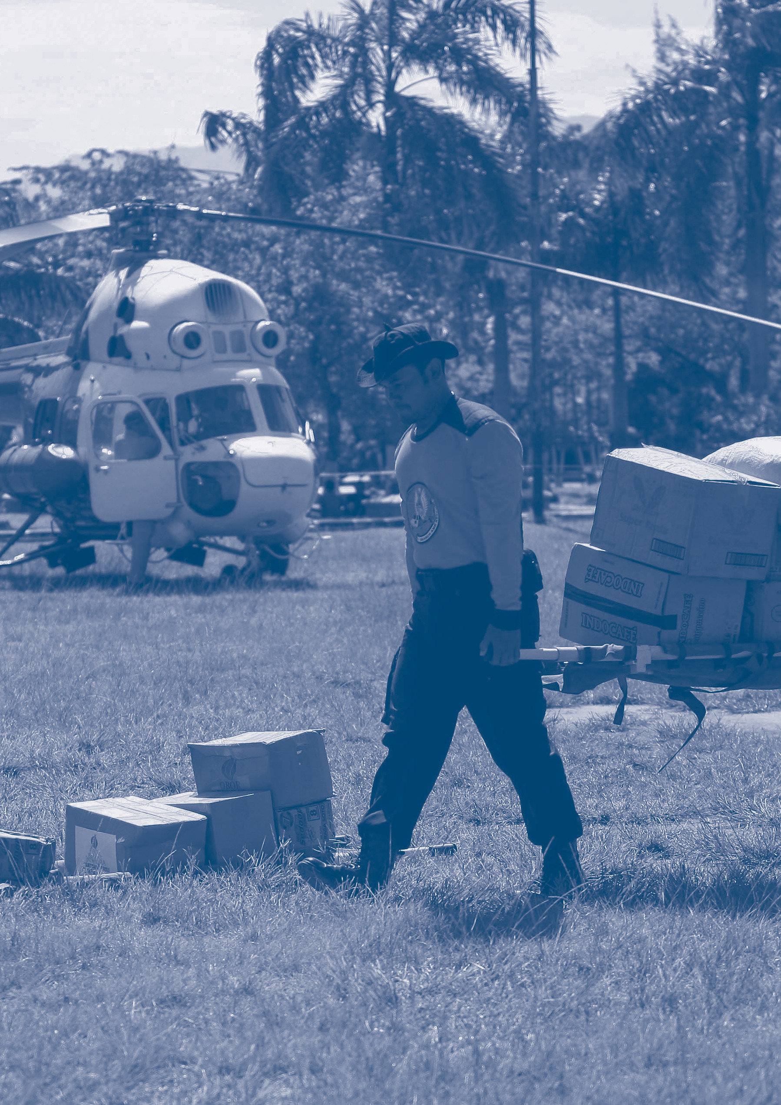

- Annexes

Annex 1: The team
Donna Leigh Holden Consulting (DLHC) is an independent consulting company that convenes a network of independent development practitioners to deliver services in evaluation, design and partnership brokering to a range of government, non-government and multilateral clients worldwide.
DLHC was selected through open tender to deliver the MTR. DLHC has provided evaluation and design services to DFAT since 2003 and has strong currency in DFAT policy and standards and the priorities of the Australian development program, and extensive experience in the Indonesian DRM sector.
Donna Leigh Holden has 25 years’ experience in the evaluation, design and management of humanitarian and development programs and organisations in Asia and the Pacific. As Team Leader, Donna was responsible for leading the MTR including development of analytical frameworks, consultation, analysis and sensemaking. As Contract Holder, she is also responsible for overall quality and delivery of the evaluation.
Dr Saut Sagala is an eminent Indonesian researcher who has worked on over 200 consultancy projects in the DRM, humanitarian and climate change sectors in Indonesia and globally. Saut has a deep operational understanding of DRR/DRM organisations, systems and capabilities in Indonesia. As DRM Specialist, was the lead technical adviser supporting development of analytical frameworks, tools, consultations, analysis and sensemaking and reporting. Saut also lead the sector analysis.

Annex 2: SIAP SIAGA program logic

Annex 2a: SIAP SIAGA whole of program logic
The following program logic is that used at the whole of program level as approved within the SIAP SIAGA design document.

Annex 2b: Palladium revised program logic (2021)
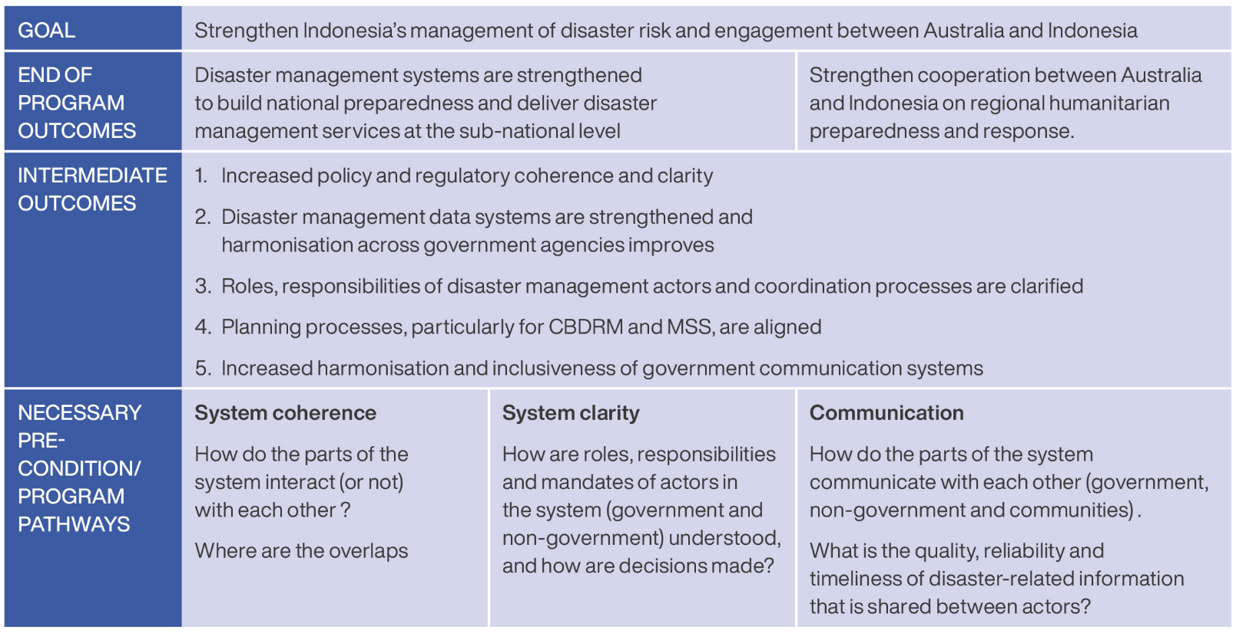

Annex 2c: IFRC-PMI program logic at design (2020)

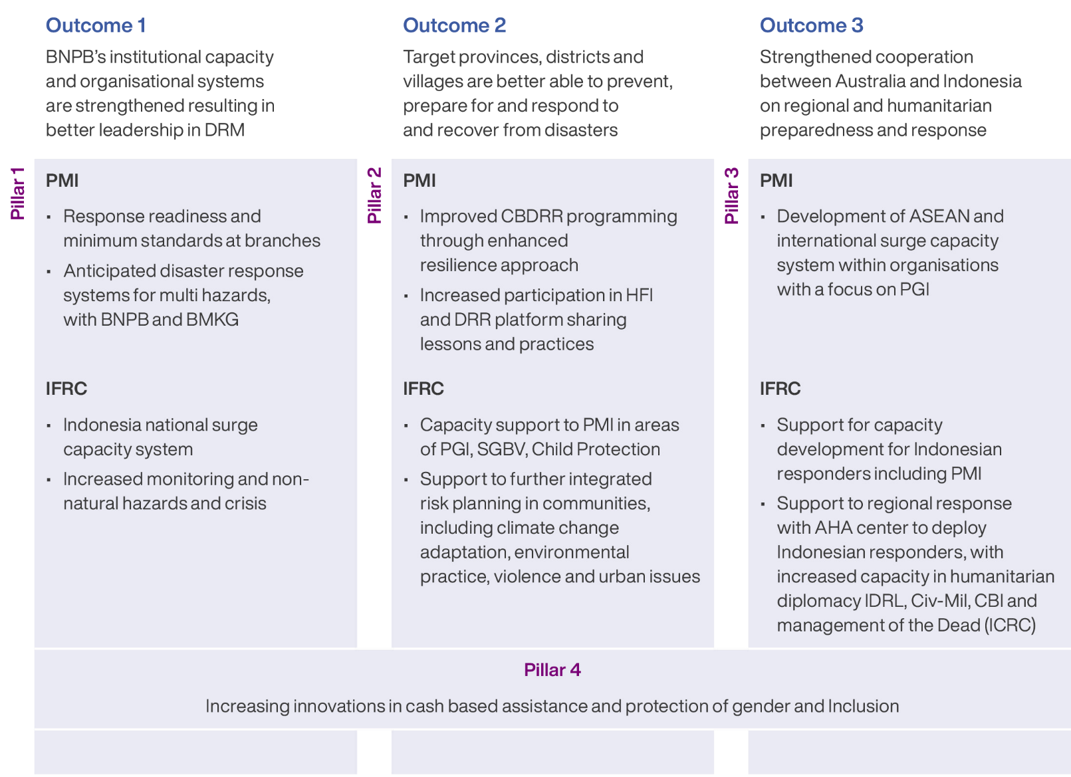

Annex 2d: IFRC-PMI amended program logic (2021)

PMI COVID STRATEGY INTERVENTION

OUTCOME 1 PMI is successfully contributing to national efforts to reduce the impacts and spread of COVID-19 in Indonesia
Output 1.1 Vulnerable households are supported with their recovery from COVID-19 through cash-based interventions
Output 1.2 PMI is actively implementing its policy framework on Protection Gender and Inclusion; Protection against Sexual Exploitation and Abuse and Child Protection
Output 1.3 PMI’s regional warehouses are stocked and deploy relief items to respond to disasters in a timely way during the pandemic
Output 1.4 Risk Communication and Community Engagement on COVID-19 is reaching marginalised and vulnerable groups
Output 1.5 PMI’s cross-border cooperation with CVTL is strengthened to tackle COVID-19
Output 1.6 PMI Digital engagement capacities are clearly mapped and improved to support COVID-19 response
Output 1.7 PMI’s branches are linked into and understand PMI’s Business Continuity Plan
Output 1.8 PMI’s COVID-19 operation contributes to epidemic control measures (testing, point of entry/point of control screening, contact tracing, quarantine, and support for isolation of mild cases).
Output 1.9 PMI’s COVID-19 Operation contributes to infection prevention control (IPC) facilities

OUTCOME 2 PMI is better positioned to respond to the challenges of the global pandemic and concurrent disasters
Output 2.1 PMI is supported to implement its transition process
Output 2.2 PMI is better positioned to mobilise and manage resources locally
Output 2.3 PMI’s Emergency Response Guidelines enable more effective, timely, safe and inclusive disaster response during a global pandemic
Output 2.4 PMI capacity on participatory community risk assessment is strengthened
Output 2.5 PMI’s capacity on data collection, analysis, and visualization to support data driven decision making is improved
Output 2.6 PMI can implement cash and voucher programs in a timely way during emergency operations
Output 2.7 PMI has developed and tested its model to trigger its Emergency Action Plan for flooding under the Forecast based Action program
Output 2.8 IFRC successfully influences the direction and development of various workplans, regional policies and guidance documents under ASEAN and builds collaboration between ASEAN supporting units at country level and national societies in the Southeast Asian Region

Annex 3: Key evaluation questions
The MTR responds to the following KEQs developed in consultation with DFAT and SIAP SIAGA implementing partners IFRC-PMI and Palladium as part of the MTR planning process. These were agreed within the MTR Plan.
Relevance and Coherence
KEQ 1: To what extent does SIAP SIAGA respond to and complement Indonesia’s and Australia’s priorities for DRM, and how agile is it to adapt to changes in policy and context (e.g., COVID.19, CCA etc).
Effectiveness
KEQ 2: To what extent are SIAP SIAGA investments on track to achieving their intended outcomes (intermediate and end of program), specifically how and to what extent have SIAP SIAGA investments:
  - influenced Indonesia’s DRM ecosystem at the regional, national and subnational level?
  - contributed to Indonesia’s COVID-19 response at the national and subnational level?
  - what do different partners especially GoI and civil society contribute to the outcomes?
  - promoted gender equality and women’s empowerment, disability inclusion and inclusion of people in vulnerable situations?
KEQ 3: What approaches have been effective in contributing to the outcomes including for different population groups, considering:
  - key approaches including systems approach, capacity development and technical transfer;
  - the extent to which capabilities will be sustained beyond the life of the program.
Efficiency
KEQ 4: To what extent do SIAP SIAGA investments represent the best use of resources to achieve its intended outcomes specifically:
  - to what extent are the different modalities efficient and deliver value for money;
  - how has SIAP SIAGA’s adaptive management approach impacted the efficiency of program planning and resource allocation;
  - to what extent did COVID-19 impact on efficiency.
Strategic Direction
KEQ 5: What are the anticipated changes and drivers for future support to DRM in Indonesia and what if any international support is Indonesia likely to need to respond to these priorities and challenges including for gender, disability and social inclusion and CCA.
KEQ 6: Based on the lessons learned from implementation of the SIAP SIAGA to date, should the two-year extension option be activated to extend the program to October 2026 and what are the considerations and recommendations for the implementation of program in its final year (to October 2024 or in the event of extension to October 2026).

Annex 4: Methods
The following Annex provides a summary of the Methods and Tools Section of the SIAP SIAGA MTR Review Plan which was developed in consultation with DFAT and its SIAP SIAGA partners Palladium, IFRC-PMI and BNPB.
Figure 4 below shows the overall flow of the MTR and indicates the stages at which the key tools and methods will be applied. A detailed implementation plan and timeline is provided at Annex B.
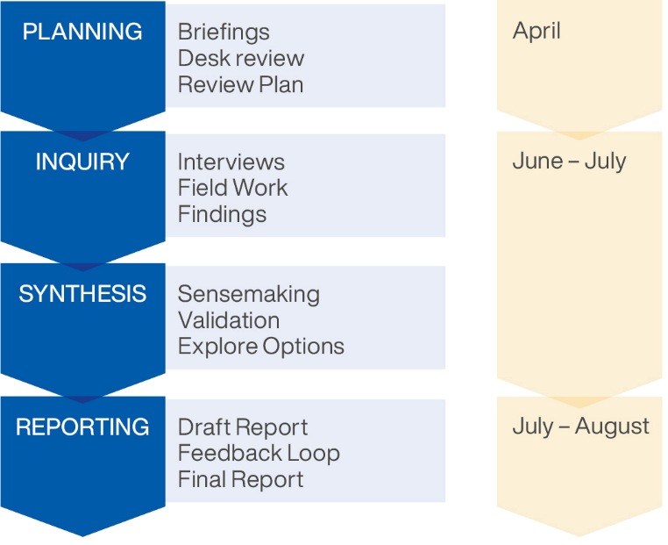
Figure 4: MTR Process and Tools
Understanding that SIAP SIAGA utilises a systems approach to programming that facilitates adaptive support contextualised to the specific needs of a diverse range of partner/ships, locations and sectors, qualitative approaches are best suited to the Review.
Qualitative methods centred around (adapted) outcome harvesting will contribute not only to assessing what the program has delivered, but take informants through a process of exploring process and impact, and unpack how changes have been brought about.
The MTR will apply the following methods and tools:

Desk review and data mining
The purpose of the desk review is to act as the basis for outcome harvesting by providing the team an understanding of the drivers and context for the investments, key assumptions, the range of activities and approaches to delivering the program and reported outcomes. Specifically the desk review will:
  - gain formative information from DFAT and partners on the programmatic intent and reported outcomes;
  - build a narrative around DFAT and partners understanding of the intended and unintended outcomes of program delivery to date;
  - identify available data sources and gaps (if any);
  - identify stakeholders;
  - inform tools and line of inquiry;
  - support cross verification of reported outcomes throughout the Review.
The approach and scope of the desk study includes:
  - a review of available program documentation – design documents, contracts, reports, partner reports, research studies, previous evaluations etc;
  - a review of policy documents that inform design and implementation.

Sector Review
A brief review of Indonesia’s DRM sector will be undertaken to provide:
  - an overview of DRM in Indonesia including Indonesia’s efforts, progress and gaps in mitigating the impact of natural disasters.
  - a contextual basis to assess relevance and coherence;
  - a forward-thinking analysis through which to consider recommendations related to any future programming/investment.
The approach and scope of the sector review includes:
  - an update of earlier sector analysis undertaken by DFAT and Palladium
  - an examination of policies, strategies, and plans that have been implemented to reduce disaster risk, improve management of responses, and increase resilience among communities.
  - a focus on areas of shared interest between Indonesia and the Australian development program.

Consultations
The team will conduct a range of consultations with program actors. The purpose of consultations is to bring robust primary evidence and analysis to the Review including:
  - enabling program actors to reflect on their experience and outcomes achieved by the program;
  - digging deep into issues and exploring how changes have been brought about;
  - enabling cross verification and substantiation of reported outcomes;
  - surfacing any unreported and/or unintended outcomes/consequences.
  - identify emerging impact areas.
The approach and scope of consultations will include remote and face to face, one-on-one and group discussions including:
  - briefings with DFAT and implementing partners.
  - key informant interviews with individuals – DFAT, GoI partners at the national, regional partners.
  - group discussion with program actors and stakeholders including GoI partners at the national and subnational level, implementing partner teams, communities.
Face to face consultations will be held in Jakarta, Bali and NTB, while remote consultations will be undertaken with regional partners and informants in Australia, NTT and East Java (see 5.1 for rationale for selection of provinces). Follow up discussions with SIAP SIAGA partners and DFAT may also be held during the reporting period for clarification on key issues if necessary.

Survey
Understanding that SIAP SIAGA has an extensive range of partners across a wide geographic area and multiple agencies, a brief survey will be used. The purpose of the survey will be to:
  - extend the scope of consultations and encourage diverse engagement in the Review; and
  - ensure the robustness of findings by enabling triangulation of qualitative findings across a wider and more diverse geographic and partner sample.
The approach and scope of the survey will be:
  - a brief survey of no more than eight questions (Likert scale and open-ended questions);
  - applied to partners supported by the Palladium component;
  - a focus on relevance, coherence, effectiveness and future thinking.

Sensemaking – Findings Workshops
Our commitment to utilisation focussed review is expressed through the inclusion of sensemaking / findings workshops as a key methodology for supporting the metanalysis. Throughout the field work the MTR team will conduct regular discussions with DFAT and partners to explore emerging findings and engage in dialogue and sensemaking on emerging findings.
A Sensemaking Workshop will be held at the end of the field mission. The purpose of the workshop is to:
  - articulate key findings and lessons and position these within the program logic and implementation strategy;
  - verify key data, limitations and opportunities.
  - identify and test workable strategies for future programming.
The approach and scope of the sensemaking workshop will:
  - engage DFAT, BNPB and SIAP SIAGA (Palladium and IFRC-PMI) senior managers in facilitated conversations (sensemaking) to maximise learning and ensure that they have an opportunity to explore the data and findings in detail, develop an intimate understanding of their implications and formulate potential strategies for addressing challenges and maximising possibility.
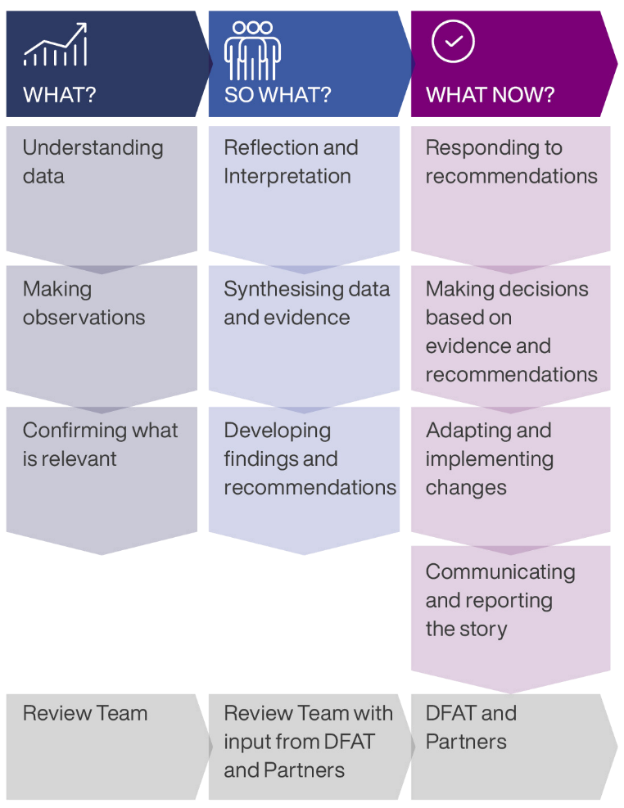
Figure 5: Sensemaking framework

Aide Memoire Presentation
A presentation to wider stakeholders including DFAT Executive and GoI representatives, may be held at DFAT’s request on the last day of the field work following the Sensemaking Workshop.

Data Analysis and Triangulation
The analytical frameworks outline how the metanalysis will be undertaken. Each of these articulate a set of success criteria which assist the MTR team to make an assessment of performance against OECD DAC criteria, DFAT policy standards and the expectations outlined in program documentation.
All data collected will be disaggregated and analysed by gender as well as informant categories – e.g. government, community, program staff etc.
The range of data collection methods proposed will underpin the integrity of the MTR by ensuring that the team is able to collect the depth of data to accurately report on program performance.
Data and evidence will be triangulated and cross validated to critically examine key outcomes, what is and is not working, identify key lessons and ensure the credibility of the Review findings and conclusions. Where verification and triangulation of data is challenged this will be highlighted within the report.

Value for Money
The VfM Assessment Framework is provided in Annex 7.

Site Selection – Field Work Locations
NTB and Bali have been selected in consultation with DFAT and the SIAP SIAGA team for field consultations.
Remote consultations will also be undertaken with key actors from East Java and NTT to ensure that the MTR is able to represent the work undertaken by the implementing teams and partners in locations not visited.
The rationale for selection of these sites has taken into account the following factors:
  - High familiarity of the team with NTT and East Java leading to confidence in remote consultations;
  - State of implementation – Bali being the first and NTB the last provinces rolled out;
  - Complexity if issues – complex political economy, socio-cultural factors, gender and inclusion
  - Diversity of programmatic focus and emergent outcomes
  - Logistics and travel time.

Quality of Evidence Assessment
A Quality of Evidence (QoE) tool will be applied to all methods and data sources. The tool will guide the MTR team in identifying multiple forms of verifiable evidence that will assist in moving reported evidence through a range of dimensions from low to high, enabling the team to assess and articulate the robustness of findings. QoE ratings will be clearly stated within the report.

Quality of Evidence
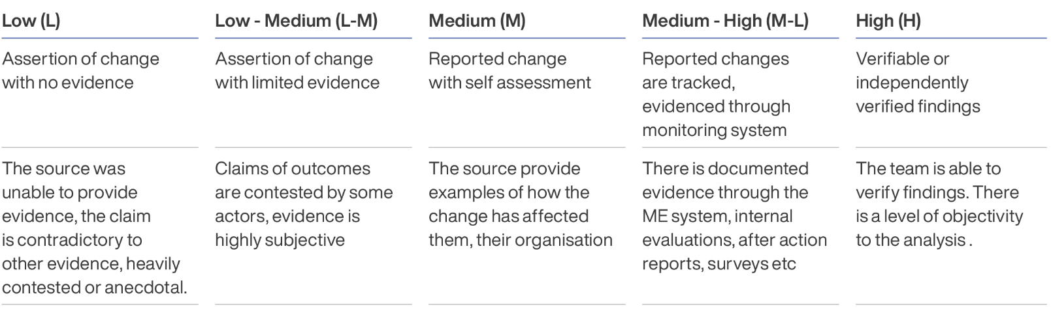
Figure 6: Quality of evidence tool

Annex 5: MTR consultations and informants
The following table summarises MTR consultations. All names are provided in alphabetical order from left to right, and as provided to us by the informant, meaning in some cases titles are provided and others are not and single names and/or nick names may also have been used. As it was not possible to collect names of all people attending group meetings, some are indicated numerically. We apologise for any errors made recording or transcribing names from audio and/or handwritten meeting records and trust these have not created any unintended offence.

DFAT
Piter Edward
Simon Ernst
Louis Henley
Madeleine Moss
Gloriani Panjaitan
Henry Pirade
Yiyik Putri
Emily Rudland
Sarah Stein
Jane Van Vliet
Australian Consul- General Bali
Anthea Griffin and team
Australian Consul- General Surabaya
Fiona Hoggart and team
GoI - National
Bappenas
Uke Mohammad Hussein
BNPB
Irma Dewi
Andi Eviana
Gita
Raditiya Jati
Lilik Kurniawan
Abdul Muhari
Pramudia
Agus Riyanto
Rustian
Pangarso Suryotomo
Dr Ir. Udrekh
Agus Wibowo
MoFA
Garda
Achsunul Habib
Yomi Ayu Lestari
Maria Renata
MoHA
Evan Fardianto
Danang Insita Putra
Edy Suharmanto
Fredrick Simatupang
MoSA
Adrianus Alla
Hikmah
Edi Suwarna
Implementing Partners
IFRC
Fadhil Yusri Aksa
Atik Ambarwati
Rafiq Anshori
Aulia Arriani
Awan
T Khairil Azmi
Achmad Djaelani
Deasy
Eka
Hery Firmansyah
Hendri
Ilham Huznul
Ewinur Machdar
Mahfud
Florensia Malau
Husni Mubarok
Mujtahiddin
Parmin
Hasna Pradityas
Priska
Puput
Elkhan Rahminov
Tetty Rajagukguk
Edwin Siahaan
Vijay Kumar Ummidi
Kristian Yudhianto

Palladium
Janggam Adhityawarma
Mira Augustina
Deni Aulia
Ancilla Bere
Denika Blacklock
Irene Bouwmeester
Wawan Budianto
Lucy Dickinson
Silvia Fanggidae
Ikhyaul Ihsan
Jalal
Oliver Lacey-Hall
Deswanto Marbun
Hasrina Muliawan
Notonegoro
Diyah Perwitosari
Anggraeni Puspitasari
Kamaruddin Rimba
Kristanto Sinandang
Safriza Sofyan
PMI Jakarta
Rafiq Anshori
Abdul Aziz
Desi
Heri Firmansyah
Idon
Istianasari
Ridwan
National CSO Partners
CARI
Retno Rifa Atsari
LPBI-NU
Ali Yusuf
MDMC
Rahmawati Husen
MPBI
Avianto Amri
Sector Specialists
DM INVEST
Andrew Duncan
Consultant
Arthi Patel
ARC
Amy McLachlan
Consultant
Simon Field
Provincial Consultations
Bappeda Bali
Gus Les
BPBD Bali
Putu Anom Agustina, S.IP., M.Si
I Gede Agus Arjawa Tangkas
Ida Ketut Arimbawa, S.Sos., M.Si
I Gusti Alit Tresna Budi
Dante
I Wayan Darma
Agus Hari
Murdika
Wayan Netra
Pika
Gede Adhi Tiana Putra
I Putu Warma Putra
I Wayan Wiasthana Ika Putra
I Made Rentin
I.G.A.K Kartika Jaya Seputra, SH., MH
I Gede Agung Teja
I Made Teja
Wite
Ida Bagus Gde Wesnawa
Ni Made Ary Yanthi
Kemendagri Bali
Ipung Purwanto
Safrizal
Majelis Desa Adat Bali
Gede Sena
Agung Ketut Sudiana
Yayasan IDEP Bali
3 Representatives
Yayasan Kerti Praja Bali
2 representatives
Community
Desa Adat Intaran, Sanur - 8 people
Desa Adat Penglipuran
- 23 people
Banten Community
Nong Ika
Herlina Sari
PMI Banten
Embay B
Humaira
BPBD East Java
Dino Andalanto
Rica Fuspita
Dadang Iqwandy, ST., MT
Andika Nurrahmad Sudigda, ST., M.Si
Satrio Nurseno
Yudi Dwi Prasetyo
Gatot Soebroto, SE., M.PSDM
Biro Pemerintahan dan Otonomi Daerah Jatim x 1
Bappeda East Java
Sri Muti’atun

DP3AK East Java
Ihdiny
One Widyawati
Kominfo East Java
Agus Budi Sampurno
Lailatus Syarifah
Venus Vebryana
Wawan
Sekda NTB
Jun Aryono
Bappeda NTB
Suryani Eka
Satriya
BPBD NTB
Ilhamn Adriansyah
Agus
Ahmadi
Made Andre
Andre Apriyanto
Dayat
Abdul Gani
Iva
DE Nayang
Rijal
Samsiah Samad
Made Sastra
Wati
BMKG NTB
Ricko
FRPB NTB
11 Representatives
Community
23 Representatives
BPBD NTT
13 Representatives
Bappeda NTT
4 Representatives
Sekda NTT
3 Representatives
FRPB NTT
Agus
Pieter Ahab
Amros
Caroline
Endang
Pak Fester
Jefri
Yan

Annex 6: Pulih Bersama activities implemented by Palladium
The following activities were managed by Palladium as part of DFAT’s wider Pulih Bersama package to support Indonesia’s response to COVID-19.

Province Partner Location (District)
East Java ADEMOS, YISI, AAI, ARM Consortium Pacitan and Pasuruan
Save the Children Indonesia (STCI)
and Wahid Foundation Indonesia Consortium Banyuwangi and Sampang
MDMC Sahabat Pacitan, Trenggalek, and Jember and Malang City
LPBI-NU Gresik, Sidoarjo, Lamongan, Pasuruan, Malang and Kediri
Bali Yayasan Kerti Praja (YKP) Badung
Save The Children Indonesia
(STCI) and IDEP Selaras Alam Consortium Bangli and Karangasem
LPBI-NU Buleleng
NTB Konsepsi NTB and Mitra Samya Consortium Lombok Tengah and Lombok Utara
ADBMI and LGBS Consortium Pujut
LPBI-NU Lombok Barat
NTT YAKKUM, SOPAN Sumba, Yayasan
KOPPESDA Consortium Sumba
Swara Parangpuan, PIAR, Yayasan Ume
Daya Nusantara Consortium Kupang District, Kupang City, East Sumba District, and Rote Ndao District

Annex 7: Value for money

Annex 7.1: Value for money tool
Value for money (VfM) analysis contributes to our assessment of efficiency and was informed by quantitative and qualitative data collected through the MTR process.
An assessment of high, good, moderate, low VfM was undertaken against the four principles and seven criteria of the DFAT’s VfM framework and a brief summary of evidence supporting this assessment is provided below.
It should be noted that the MTR did not undertake a detailed analysis of financial data nor comparative analysis of similar initiatives, but rather an overall assessment of the extent to which DFAT and partners are considering VfM at implementation.
The assessment will assist DFAT and implementing partners to appreciate, assess and judge VfM in ongoing implementation and design of any future programming.
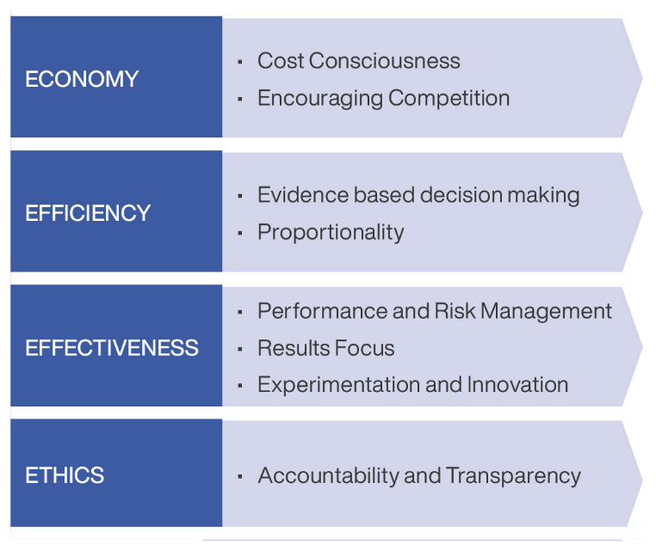
Figure 7: DFAT VfM framework

Annex 7.2: Value for money assessment
The MTR considers that SIAP SIAGA offers good VfM. The assessment using DFAT’s VfM framework is at the whole of program level but makes specific observations on Palladium’s and IFRC-PMI’s contribution.

Economy

Principle 1: Cost Consciousness
Assessment: High
There is evidence that both Palladium and IFRC have structures and systems in place to ensure that costs are key considerations in procurement and operational decision making.
- Both Palladium and IFRC-PMI were able to evidence adherence to documented competitive procurement processes to ensure that goods and services are procurement in line with market rates and cost consciousness.
- Both Palladium and IFRC -PMI demonstrated how they had considered options for the design and delivery of different activities and that they had applied decision making processes that took into account a range of variable including cost, timeliness and quality to ensure the best uses of resources.

- The Dip Test of the Palladium compliance with DFAT contractual and other policy requirements found that Palladium had adequately met requirements and conditions and applied proper authorisation and internal controls to procurement and financial transactions. Palladium has undertaken management responses to the recommendations of the Dip Test.
- IFRC-PMI have met DFAT due diligence requirements. IFRC and PMI have separate contracting and accounting arrangements for all DFAT funded activities including separate arrangements for SIAP SIAGA, Pulih Bersama and activities delivered with ARC resources.
- The MTR found evidence in both the Palladium and IFRC-PMI investments of efforts to align with other actors and ensure the risk of overlap is mitigated.
- Palladium has reinvested any annual surplus of operational costs to programming activities.

Economy

Principle 2: Encouraging Competition
Assessment: High
There is evidence that DFAT, Palladium and IFRC have mechanisms in place that encourage a culture of competition and that design and implementational decisions are driven by consideration of options that offer an optimal mix of costs and benefits.
  - SIAP SIAGA was designed by an independent design team and was subjected to DFAT aid quality processes.
  - The procurement for the Managing Contractor for SIAP SIAGA was undertaken through an open approach to market managed by DFAT in line with its Procurement Policy.
  - The Team Leader role was procured independently of the tender process. Applicants were sought through a competitive, global search and selection undertaken by a panel comprising DFAT, BNPB and the Contractor.
  - Several of DFAT’s long term, strategic partnerships, with IFRC-PMI, MDMC and LPBI-NU were integrated into the SIAP SIAGA design and subsequently directly sourced. This was justified (and approved) by way of these organisations unique position in the global and Indonesian DRM ecosystem, their role as DFAT partners of choice in the event of an emergency response/ activation, and their established performance history.
  - IFRC was identified as the contract holder for the investment in PMI due to its unique position as the Global Secretariat for the International Red Cross Red Crescent and its mandate to support PMI as a Member Society.
  - Procurement for Pulih Bersama (except LPBI-NU and MDMC) partners delivered through Palladium was undertaken through an open procurement process.
  - Palladium and IFRC have open competitive processes in place for the recruitment of short- and long-term staff and advisers. There is some evidence that Palladium needed to expedite some of these during the pandemic to service the high demand of GoI partners noting that 58 and later 100 staff and STA were engaged in Years 1 and 2 respectively.
  - IFRC’s approach to working with PMI has included supporting PMI to establish transparent, competitive procurement processes that meet international standards. All procurements undertaken through the SIAP SIAGA and Pulih Bersama investments utilised these processes.

Efficiency

Principle 3: Evidence Based Decision Making
Assessment: Moderate
  - The SIAP SIAGA design built on the evidence base acquired through a long history of GoA and GoI partnerships in DRM as well as sound analysis of the DRM sector. It was undertaken by a team with appropriate specialist knowledge in the sector. The exception to this is the regional component which represented a new and exploratory field of work driven by a set of unique drivers for both DFAT Post and the Indonesian MoFA.
  - The SIAP SIAGA design was informed by and responds to priorities 2 and 4 of the SFDRR.
  - At the time of design, SIAP SIAGA responded to key GoA and GoI frameworks and commitments including the Australian Foreign Policy White Paper which committed Australia to boosting resilience to natural disasters through the aid program, the Indonesian RPJMN 2015-2019, BNPB Strategy on Disaster Management (2015-2019) and Indonesia’s Disaster Management Master Plan (2015-2045).
  - At Inception the Palladium team commenced a series of key studies to provide an evidence base that informed their programmatic approach. Eleven Studies were conducted to identify and understand key bottlenecks in the Indonesian DRM system as well as a political economy analysis.
  - While Palladium has a team of experienced policy advisers, there is limited evidence that work on MSS-DM, and other policies are consistently drawing on specialist advice or global and national good practice. There is no SOP within the Palladium team for specialist and/or expert review of advice from advisers on policy documents, including policy review from a key technical lens including gender and social inclusion lens or review of subnational policies and regulations.
  - The Palladium team is working with BNPB to undertake a Gender Analysis of BNPB which is being used to inform the development of its Gender Roadmap.
  - The Palladium KPL system is insufficiently resourced to deliver the extent of collaborative learning and knowledge creation anticipated within the design.
  - IFRC-PMI support for CVA is based on GoI research related to effective approaches for disaster research and poverty reduction.

Efficiency

Principle 4: Proportionality
Assessment: Moderate
The MTR found that both Palladium and IFRC-PMI operational and programming systems are proportional to the capacity and appear to be calibrated to maximise efficiency.
Importantly SIAP SIAGA has provided Australia and its GoI partners with a modality through which it can deliver to a wide number of partners, scale up and adapt investments overtime (e.g., addition of new provinces) and in response to crises (e.g., COVID-19 and other disasters such as the Cianjur earthquake, landslide in Riau and flooding in West Kalimantan among others).
  - IFRC-PMI proportionality is impacted by the limited absorption capacity of PMI, coupled with the ambition of the project plans, and the challenges of working as an external partner in supporting an independent sovereign organisation to deliver the intended results.
  - A challenge for the Palladium investments is that the scope of the program is greater than the resources allocated to it. Allocation of resources is also at times challenged by adhoc requests from various partners for activities outside of the scope of the program (i.e., during GPDRR, HKB, Bulan PRB (DRM Month) etc. DFAT and Palladium work to carefully manage any risk that these may detract from the initial strategic intent of the program.
  - The Pulih Bersama design and grant making system was not proportional to the intent and characteristics of the funding available (e.g. short term humanitarian funding and level of funding).
  - Funding available for subnational work in particular support for the testing and learning around CBDRM and CRV is not proportionate with the priority that this has within the SIAP SIAGA program logic.

Effectiveness

Principle 5: Performance and Risk Management Assessment: Moderate
  - Palladium has established good working relationship with DFAT which provides an open and transparent discussion of risks and risk management arrangements and enables regular discussion on risk management of risk.
  - Palladium has mechanisms in place to manage risks and safeguards including child protection, fraud and money laundering, PSEAH etc. as vest in the Contract. Most staff understood their obligations to these policy issues but there are some gaps at the subnational in understanding processes for reporting and escalation of concerns particularly in relation to child protection.
  - There is limited clarity and shared understanding across the Palladium team of the SIAP SIAGA program logic and the KPL approach generally.
  - While risk is integrated into Palladium’s MEL and reporting processes, the absence of regular external monitoring of subnational activities including those of civil society partners, means that the identification and management of risk at the subnational level may be disproportionally vest in subnational teams and or local partners who may be less inclined to report risk or who may have a less nuanced understanding of risk impacts (especially impact to DFAT’s profile) and remedies.
  - IFRC managed risks associated with the implementation of PMI activities. While IFRC is aware of its obligations regarding key safeguards including PSEAH and child protection, and has systems in place to manage these, it has been challenging to incentivise PMI to prioritise these over their own strategic priorities.
  - While IFRC reports on risk in their biannual reports to DFAT, the absence of a regular meeting as exists with Palladium means there is no routine discussion with DFAT on program implementation and risk management.
  - The absence of a regular partnering dialogue and limited monitoring of the IFRC – PMI investment by DFAT (impacted in part by COVID-19) means that there is no routine discussion of risk and programmatic performance.

Effectiveness

Principle 6: Results Focus
Assessment: Good
Both Palladium and IFRC-PMI investments are delivering results, particularly in relation to support for the COVID-19 response. The pandemic however established some ways of working and focus that detract from the initial intent of the design and program logic upon.
  - SIAP SIAGA’s work in DRM governance is making an important contribution to Indonesia’s DRM ecosystem, particularly through supporting MSS-DM and clarifying the roles and responsibilities of different government actors in implementing these; supporting subnational level disaster risk assessments and plans; and contributing to the formulation of subnational level policies, directives and plans to support local DRM priorities.
  - The IFRC-PMI partnership is supporting PMI’s institutional transformation process. Specifically, it has contributed to PMI transformation goals related to modernising human resources, use of technology, international relations, and procurement. These actions contribute to ensuring that local PMI chapters have increased capacity, systems and resources for local response.
  - IFRC-PMI pay sound attention to PGI at the community level ensuring that key vulnerability criterion are in place for programmatic support, but also in relevant protocols and policies.
  - The SIAP SIAGA architecture provided DFAT with several avenues through which it could channel emergency response funding during the COVID-19 pandemic, including to local civil society actors such as MDMC and LPBI-NU, for response at the community level.
  - Palladium was highly agile in pivoting SIAP SIAGA to the emerging COVID-19 pandemic and made a significant contribution to Indonesia’s response, particularly in assisting the Indonesian COVID-19 taskforce at national and sub- national levels in establishing response standards and protocols. Significant numbers of STA were mobilised to fill technical and human resource gaps within a wide range of national and subnational agencies.
  - IFRC and PMI were highly agile in pivoting to COVID-19. As a mass organisation, PMI was able to capitalise on its extensive membership base to disseminate critical health and behaviour change communications to communities across the country. IFRC and PMI also worked together to embed new response mechanisms such as CVA, and procurement supplies such as isolation tents and ambulances for future pandemic response. In PMI systems.

Effectiveness

Principle 7: Experimentation and Innovation
Assessment: Moderate
COVID-19 was a time of rapid learning and high innovation for and SIAP SIAGA partners were required to pivot to new ways of working, new priorities and learn approaches to pandemic control. All SIAP SIAGA partners continue to work with GoI and civil society partners to explore new ways of working across the DRM ecosystem.
  - Palladium recruited an extensive team of short-term advisers to support the GoI to manage its COVID-19 response including identifying appropriate policy and procedural responses.
  - Through its systems approach, Palladium continues to work with GoI to identify new ways of working to engage and address blockages across the DRM system.
  - IFRC and PMI have been successful in supporting the uptake of new innovations within PMI – for example, the use of CVA and by rolling out the Risk Communication and Community Engagement (RCCE) strategy across Indonesia to ensure that COVID-19 information was widely and consistently disseminated and understood all communities. Specifically, this strategy ensures that groups in specifically vulnerable contexts have access to appropriate communications.
  - The regional component of SIAP SIAGA is an innovation and a first engagement with Australia and Indonesia in exploring how Australia and Indonesia might collaborate on disaster response in the Indo-Pacific region.

Ethics

Principle 8: Accountability and Transparency
Assessment: Moderate
The MTR finds that both the IFRC-PMI and Palladium have strong awareness of their accountabilities and adhere to key ethical practices at all levels of implementation.
  - DFAT and Palladium have good and established working relationships, with regular communications and joint discussion around program implementation and risk. Both report a high degree of openness and transparency in this relationship that informs joint decision making.
  - The working relationship between DFAT and IFRC – PMI could be strengthened to strengthen accountability and ensure that DFAT has a deeper understanding of programming context and implementation. This includes regular discussions and joint monitoring to see the implementation of the planned activities.
  - The management arrangement for the IFRC-PMI component of the program is managed separately by DFAT. There is no routine engagement/regular scheduled meeting between DFAT and IFRC-PMI to discuss programming, lessons and risk and no routine monitoring of IFRC activities by DFAT.
  - There is scope for IFRC to bring PMI more closely into the management arrangements of SIAP SIAGA including discussions with DFAT, program steering committee meetings etc.
  - There is no partnering mechanism/schedule of routine meetings that bring the IFRC-PMI and Palladium teams together to hold them jointly accountable for shared strategy aspects of the program logic – i.e., coherence of approaches, subnational collaboration, joint advocacy and learning.

For example: Gender Equality in Monitoring and Evaluation – Good Practice Note (dfat.gov.au)
This arrangement is in place due to the absence of GoI regulation which enables a private entity to engage international NGOs such as IFRC.
Bündnis Entwicklung Hilft (2022), WorldRiskReport 2022, pp. 6-7
Ibid 4
RPJMN 2020-2024 https://peraturan.bpk.go.id/Download/122195/Perpres%20Nomor%2018%20Tahun%202020.pdf
Renas PB 2020-2024 https://perpustakaan.bnpb.go.id/bulian/index.php?p=show_detail&id=1993
Law No. 23/2014 on Regional Government in Indonesia
https://kemlu.go.id/portal/en/read/4331/halaman_list_lainnya/ttrilatera-cooperation-with-pacific-island-countries
2017 Foreign Policy White Paper, Government of Australia at p90
DFAT, 2018
https://www.dfat.gov.au/sites/default/files/covid-response-plan-indonesia.pdf
https://www.dfat.gov.au/sites/default/files/international-development-policy.pdf
https://www.ifrc.org/sites/default/files/2022-11/20221124_Plans_Indonesia.pdf
This writing approach was confirmed and agreed with DFAT Indonesia Post, during the report drafting process.
Kebijakan Teknis Penerapan SPM Sub-Urusan Bencana. Accessed on:https://bnpb.go.id/berita/kebijakan-teknis-penerapan-spm-sub-urusan-bencana
Support for MSS-DM is the most significant financial investment for SIAP SIAGA at AUD 2,800,000 to the end of June 2023.
Desa Siaga (MoH), Kampung Siaga Bencana from (MoSA), Desa Pesisir Tangguh (Ministry of Fisheries and Maritime Affairs), Desa Tangguh Bencana (Destana) from BNPB, Program Kampung Iklim - Proklim) (Ministry of Environment) and Taruna Siaga Bencana - TAGANA from MoSA
The framework was initially coined as Welfare-based Disaster Resilient Villages but is currently referred to by BNPB as DRV.
Total support for DRV to the end of June 2023 is AUD 2,087,123
https://www.pm.gov.au/media/joint-communique-indonesia-australia-annual-leaders-meeting
DFAT officer, Canberra
https://siapsiaga.or.id/because-resiliense-is-local/
IFRC Narrative Report Dec 2022.
ibid
This has not been verified simply due to the limitations on the time allocated to IFRC and PMI.
Delivered through Pulih Bersama
Palladium SIAP SIAGA: Lessons Learned Report No. 7 – Pulih Bersama
The high level of unknown is due to this being related to IEC campaigns
IFRC SIAP SIAGA Report December 2022.
Palladium SIAP SIAGA GEDSI Strategy p. 5
MTR GoI Roundtable, June 2023
There is narrative around the systems approach within the KPL Plan that suggests that “SIAP SIAGA works to a systems rather than an institutional approach” and MTR consultations found that some staff and partners had interpreted this that SIAP
https://bnpb.go.id/berita/bnpb-pastikan-abu-vulkanik-erupsi-gunungapi-taal-tak-sampai-ke-indonesia-1
Learning from Pidie Jaya Earthquake Response, Aceh Province (2017) IFRC, in support of the Indonesia Humanitarian Country Team
https://partnershipbrokers.org/w/wp-content/uploads/2021/02/Brokering-Better-Partnerships-Handbook.pdf
SIAP SIAGA Design p.38 anticipated four partnering mechanisms - three with different GoI actors regarding each pillar and one between DFAT and the MC.
https://www.ghdinitiative.org/ghd/gns/principles-good-practice-of-ghd/principles-good-practice-ghd.html; https://www.oecd.org/development/humanitarian-donors/
The DFAT Inklusi program for example has developed civil society funding mechanisms/partnerships based on a Capacity Development Approach which is based on current evidence around effective grant making systems for engaging civil society.
We note that at the time of writing this is to be increased to three.
With approval by DFAT.
VfM was assessed using DFAT’s 4E VfM assessment tool which considers the seven principles listed in Figure 3.
For example, between DFAT-Palladium-IFRC-PMI and key GoI actors; between Palladium and civil society partners, between the IFRC-PMI and Palladium components and between IFRC-PMI and DFAT
Head of BNPB's Information Data and Public Relations Centre
Srikandini, A. G., Hilhorst, D., & Voorst, R. V. (2018). Disaster Risk Governance in Indonesia and Myanmar: The Practice of Co-Governance. Politics and Governance, 6(3), 180–189. https://doi.org/10.17645/pag.v6i3.1598
For example: Gender Equality in Monitoring and Evaluation – Good Practice Note (dfat.gov.au)
https://www.linkedin.com/in/donna-leigh-holden-58135328/
https://www.linkedin.com/in/sautsagala/
The question, what do different partners contribute to outcomes was a sub question under KEQ 3, however as data analysis and the shape of the report has progressed, it has been integrated into KEQ 2 as we consider formative to the analysis presented in KEQ 3. This change does not affect the key findings.
Given the focus of SIAP SIAGA on strengthening government and PMI systems, with the exception of Pulih Bersama activities it is as yet premature to make an assessment of the impact of this work on specific populations as this is beyond SIAP SIAGAs sphere of control.
In the Review Plan KEQ 5 and 6 appeared in reverse order but for the purposes of reporting flowed better as numbered above.
We understand that Palladium has a survey instrument populated with key stakeholders for this purpose.
https://www.dfat.gov.au/aid/who-we-work-with/value-for-money-principles/Pages/value-for-money-principles
2017 Foreign Policy White Paper, Government of Australia p.90
Indonesian Statistics Bureau (BPS) and The National Team for the Acceleration of Poverty Reduction (TNP2K). Source: IFRC Narrative Report 2021
https://www.ifrc.org/sites/default/files/2022-11/20221124_Plans_Indonesia.pdf

