14 June 2017

The Hon Keith Pitt MP

Assistant Minister for Trade, Tourism and Investment

Australia

Dear Minister

In connection with the signing on 14 June 2017 in Nuku'alofa, Tonga of the Pacific Agreement on Closer Economic Relations Plus (PACER Plus) and in the context of the Australia-New Zealand Closer Economic Relations Trade Agreement (ANZCERTA) done at Canberra, Australia on 28 March 1983 and its related agreements and understandings, and in the context of the Agreement Establishing the ASEAN-Australia-New Zealand Free Trade Area (AANZFTA) done at Cha-am on 27 February 2009, and in the context of the Trans-Pacific Partnership Agreement (the TPP Agreement) done at 4 February 2016 in Auckland, New Zealand, I have the honour to confirm the following undertakings made by the Governments of New Zealand and Australia during the course of the negotiations on the PACER Plus:

New Zealand and Australia agree that the following provisions of the PACER Plus shall not create any rights or obligations between New Zealand and Australia:

* Article 4.2 of Chapter 2 (Trade in Goods);
* Chapter 10 (Development and Economic Cooperation); and
* Chapter 14 (Consultations and Dispute Settlement).

New Zealand and Australia agree that the following provisions of the PACER Plus shall create rights and obligations between New Zealand and Australia:

* Chapter 1 (Initial Provisions and General Definitions);
* Chapter 2 (Trade in Goods) (except Article 4.2, which shall not create any rights or obligations), together with Annex 2-A (Schedules of Commitments on Tariffs) and Annex 2-C (Notification of Modified or New Import Licensing Procedures Pursuant to Articles 14.1(c) and 14.2(b))
* Chapter 3 (Rules of Origin and Verification Procedures) together with Annex 3-A (Declaration of Origin Requirements) and Annex 3-B (Schedule of Product Specific Rules);
* Chapter 11 (General Provisions and Exceptions), which shall only apply between New Zealand and Australia to the extent that the PACER Plus creates rights and obligations between New Zealand and Australia, as modified by this Agreement.

New Zealand and Australia further agree to consider the merits of applying provisions of the PACER Plus not mentioned above as between New Zealand and Australia. Pending any agreement on such application, only those provisions of the PACER Plus as specified in the paragraph immediately above shall create rights and obligations between New Zealand and Australia.

New Zealand and Australia shall, at the written request of the other, promptly enter into consultations with a view to seeking an equitable and mutually satisfactory solution if an issue arises in regard to any rights and obligations applying between New Zealand and Australia under the PACER Plus, as modified by this Agreement.

2

Nothing in the PACER Plus shall be construed to derogate from any rights or obligations of New Zealand or Australia under the ANZCERTA, AANZFTA or the TPP Agreement.

I have the further honour to propose that this letter and your letter of confirmation in reply shall constitute an Agreement between our two Governments on the application between New Zealand and Australia of rights and obligations contained in the PACER Plus, which shall enter into force on the date on which the PACER Plus enters into force for both Australia and New Zealand.

Yours sincerely

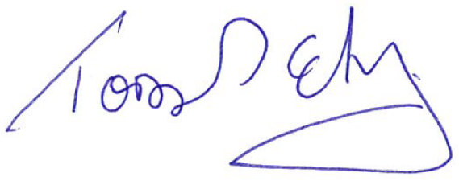

**Hon Todd McClay**

Minister of Trade

New Zealand