September 20, 2018

**REVIEW OF SOLOMON ISLANDS INTERNSHIP TRAINING PROGRAM (SIITP) AS COMMISSIONED BY THE AUSTRALIAN GOVERNMENT DEPARTMENT OF FOREIGN AFFAIRS AND TRADE (DFAT)**

***Author*: Hamish Ewing MBBS.FRACS**

Over the past year, the Solomon Islands Internship Training Program (SIITP) has grown to 59 participants (up from 39 in 2017) including 22 second year interns, 18 first year interns and 19 trainee interns. There are 47 Cuban trained graduates, eight graduates from Fiji universities, three from Taiwan, and one from the People's Republic of China.

There are three main components of the SIITP:

* The Induction Program is a 1 week program preceding the 1 week Institute of Public Administration Management (IPAM) Public Service training
* The Bridging Program a 12 month program with core specialities
* The Internship Program a two year program with core and minor specialities

This report focuses its review on two key components of the SIITP. The Bridging Program and Internship Program proper. Intrinsically linked with the SIITP is the Solomon Islands Graduate Internship Supervision and Support Project (SIGISSP). A DFAT funded initiative, the primary purpose of SIGISSP is to place skilled medical professionals (Mentors) in the Solomon Islands to help the MHMS (Ministry Health and Medical Services) to support, supervise, train and assess new medical graduates through their bridging programs and internships. A secondary role of the ‘skilled medical professionals’ is to provide additional clinical and health workforce management support to MHMS, as required and support the development of key systems, processes and protocols at the National Referral Hospital (NRH).

Information gathering for this review of the SIITP was undertaken at short notice, in the Solomon Islands and was largely based in Honiara, with field trips to the Provincial Urban Health Centre at Good Samaritan Hospital, Guadalcanal, and the provincial General Hospital at Gizo during Monday 10th – Friday 21st September, 2018.

The review included numerous interviews with staff involved in the delivery of SIITP, Role Delineation Policy13 and Provincial Health Management. This was achieved through 45 interviews, ranging from Ministry Levels, to NRH Leadership personnel, SIGISSP staff (Volunteers & Contracted), and ’consumers’ – the Bridging Interns, Interns, Registrars and Provincial Medical Officers. (Attachment 2)

The review also considered numerous reports of past and proposed future development of the programs (Attachment 1), Role Delineation Policy (RDP) documents and all of the documents relating to the current delivery of the SIITP and SIGISSP1, 2,3,4,5,6,7,8. This process has facilitated a better understanding of the current status of the program, and how it relates to the RDP currently being implemented by the Ministry. Hopefully, this review addresses the future structure of an Intern Training Program in the Solomon Islands that is in-line with this newly minted RDP to deliver access to better health care across the nation in a sustainable way.

The Review addresses the headings determined in the Terms of Reference for this study.

1. **DESCRIBE THE CURRENT CONTENT AND DELIVERY OF THE SIITP**
2. **Bridging Program**

This is a one year long program and is compulsory for all Medical Graduates trained outside Fiji National University (FNU) and University of Papua & New Guinea (UPNG) which have been the traditional Medical Schools for Solomon Islanders. The Bridging Course was introduced when the first cohort of Cuban-trained medical graduates returned and were identified to be weak on Clinical Skills compared to their Pacific-trained colleagues. Initially a six-month course was introduced and this was extended to twelve months, which is the current model. These medical graduates have supervised (AVI Intern Supervisors in particular) ward time to upskill in Clinical Practice and in gaining proscribed technical skills required of each of the four specialist rotations included in the year (Internal Medicine, Surgery, Paediatrics and O&G).

There is a daily tutorial to the whole cohort which includes a list of topics determined by the Heads of Department. These topics cover both the commonly encountered conditions as well as critical, not to be missed, conditions. These are largely delivered by their Registrars or the AVI Intern Supervisors.

In addition, there is a weekly small group tutorial on clinical skills, each delivered by the Emergency Consultant Advisor and Clinical Educator. Similarly each department runs some form of unit education, which can be of variable quality. Programmed through the year are excellent and essential Skills Workshops presenting material in a structured way.

The progress of each Bridging Intern is carefully assessed through each block with a Supervisor Assessment, and Logbook tracking of pre-determined activities that reflect generic skills & knowledge required for completion of the program. In addition, there is a Mid-term (Formative) and End-of-Year (Summative) exam. The mid-term is a written paper of Multiple Choice Questions (MCQ) and Short Answer questions which are appropriately, clinically based. The End-of-Year is structured in the same way but has additional Objective Structured Clinical Examinations (OSCE) as well, to assess patient skills.

The Logbook material and the programmed tutorial programme reflect the breadth of condition and skills required for commencing the SIITP.

The consensus of opinion of Department Heads interviewed was that the Bridging Intern Program is successful in improving the essential clinical skills of this group of medical graduates and their capacity to make an independent decision. As importantly, upon completion of SIITP, this group is considered equal to their Pacific-trained colleagues and just as capable of future Specialist training.

It is noted that some Cuban-trained Bridging Interns did not consider that twelve months of up-skilling was needed for them and complained of boredom in the second half of the year. Most recognise the deficiencies in their medical training, which they consider can be quickly remedied. Interestingly, the major hurdle for most of this group was to gain the ‘Medical English’ needed for communication on ward rounds etc. **Opportunities for Improvement**

1. Tutorial topics: These have been determined by the Heads of Department at the commencement of the year. The range of topics seems to cover most common conditions encountered in SI. It appears that there are a few gaps that should be addressed.
2. Tutors: Tutors, usually the Departmental Registrars, can sometimes be unreliable in attendance, they require frequent reminders, and in spite of these reminders, sessions can still be missed which results in the topics being delivered by an AVI Intern Supervisor (unprepared), or the topic carried over to another week, with two topics crammed into one session, or the topic not delivered at all. Sadly, there does not appear to be a commitment from Consultants to be involved with this programme, instead they are delivered by juniors who are not even at Diploma level.
3. Logbooks: Whilst these are very well structured and give a good guide to trainees of the skills and clinical experience expected of them; they appear a little ‘over engineered’ with unreasonable expectations from some departments. They can thus become an arduous burden for all parties, which in turn can lead to poor documentation and unsupervised assessments being signed-off.

**Recommendation**

1. An honest, formal review of the details of Logbook expectations as a team-based exercise is recommended, always bearing in mind that all of their supervising team need to be supportive of this Logbook assessment process as well.
2. Encourage the NRH staff responsible for delivery of Tutorial programme, Registrars and Consultants, to commit to their rostered responsibilities. This will engage the Bridging Interns and reflect a proper sense of professionalism expected of all doctors.
3. Review of the policy decision that all non-Pacific medical graduates undertake the Bridging Intern Program. Consider a screening exam upon return to Solomon Islands to determine their standing, as undoubtedly, the best graduates will be ready for SIITP. This fact becomes evident during the Bridging Program.
4. **Intern Program and subsequent Career Pathway**

This is a two year programme with all trainees rotating through nominated Specialist & sub-Specialty rotations to fully prepare them for Registration as independent Medical Practitioners of the Solomon Islands.

Whilst there are no structured educational sessions for the whole cohort, the Interns are expected to participate in all organised Departmental education sessions. I have learnt that there are significant differences between Departments in this regard. As with the Bridging Interns, the Interns are required to keep a Logbook of their practice with certain tasks needing to be witnessed and countersigned by their supervisors to document acquired competencies. Their performance and Logbook entries are assessed mid-term and end-of-rotation by their supervisor for each rotation. The supervisor is often the Head of Department and the end-of-rotation assessment is often made by the department team. In a good unit this will usually include a Senior Unit Nurse as well. A ‘Pass’ across the two year programme is required for Registration by the Medical & Dental Board (MDB) at the end of their two years.

There are well documented penalties for deficiencies in Logbook submissions or sub-standard Performance reviews. These penalties are for extra time working in the Departments involved. This extra-time comes at the end of the structured two-year course. Penalties can range from two weeks up to a whole year of extra time. In spite of being well documented, it is noted that there are blatant failures to meet Logbook requirements, which indicate poor professionalism as much as failing academic performance.

Built into both programmes is a new support process that has been created to assist poorly performing trainees, or those with other issues, to remediate their year. The Improving Performance Action Plan (IPAP)) is created by the Intern Performance Management Committee when they meet with the trainee. This new level of support (eg. mentors, extra personalised tuition, psychological support) has been very useful and is to be applauded. This process has also led to the removal from training of one and suspension of four trainees – both Bridging Interns and Interns Trainees and also from different University backgrounds.

The career pathway after Registration is not clearly defined. If the pathway for the majority of graduating interns is to work at AHCs, then this should be a clear expectation for all. Most, having completed SIITP, will have their next career step determined by the Posting Committee. This committee is chaired by the Undersecretary for Healthcare, Ministry of Health and includes the Heads of Department at NRH. There is no representative for Provincial Health Directors. Some graduates will be allocated to a year-long Registrar post in a Specialist department at NRH (eg. Surgery/Emergency Medicine/ O&G), often at the request of a Departmental Head, a request usually based on their performance as an Intern whilst on that unit. Some will be posted to Area Health Centres, as self-chosen, but most will find themselves in a General Hospital or Area Health Centre without any clear career path ahead.

The Specialty Registrars in their second year are likely to be posted for one to two years to a General Hospital. They may, or may not, be reappointed to NRH to enable studying for a Diploma or Masters Programme at a future time. This process does not appear structured. Even if a registrar is accepted at the NRH level as a candidate for Post-graduate training, they still have to wait for the awarding of a Government Scholarship to enable this study at FNU or UPNG which can add years onto a training program. (Figure 1)

Reassuringly, UPNG has accepted that two/three years of a Master’s Programme can be undertaken in-country at NRH. In addition, I understand that the FNU M.Med (Surg) program is presently considering the possibility of determining ‘accredited surgical training posts’ within Pacific countries to allow Surgical trainees to spend some of their post-graduate training ‘at home’. This will be a terrific opportunity for the trainee, their family, staff and patients of the ‘accredited’ hospital. This move by FNU is to be encouraged and can, hopefully, include other specialties too.

**Opportunities for Improvement of Intern Training and subsequent Career Pathway**

1. The Role Delineation Policy (RDP) should inform an accurate Solomon Islands (SI) Medical workforce Plan. This, in turn, will help both the Posting Committee and trainee doctors put some shape into both postings and career pathways. It is important that NRH appointments are based upon a competitive application process and that a career pathway follows a Specialist/Service Registrar appointment.
2. Currently, most, but not all Specialist registrars will be posted to a General Hospital for a year or two before a return to NRH and Master’s applications. It is important that these aspiring career Specialists have at least one year of NRH training before being posted to the Provinces. This will ensure an adequate and safe Specialist presence at a General Hospital, albeit at a somewhat junior level of experience. This should also bring the staffing of the General Hospitals into line with the WHO expectations of a “District General Hospital” with access to safe ‘bellwether procedures’15 (Caesarean Section, Diagnostic Laparotomy & Open Fracture). Ultimately, General Hospitals (which is RDP equivalent of the WHO District General Hospital) should be staffed by Consultant Specialists, or “Rural Generalists” as proposed with the Post-Graduate Diploma in Rural and Community Medicine, to ensure that the greatest advantage can be taken of facilities so well defined by the RDP. It is noted that several Specialist Consultants have been posted to Gizo General Hospital, but these postings have never been undertaken.
3. If most graduating Interns are intended for AHC postings, this should be the clear expectation for all. There are not enough NRH Registrar positions to accommodate all graduating Interns, hence the need for competitive appointments. By the same token, it is important that future entry to NRH positions for these doctors is not denied if they have initially been posted to an AHC, especially if, as proposed, a Postgraduate Diploma in Rural and Community Medicine is introduced at SINU in the near future.
4. Interns being posted to AHC positions may need a Preparatory Course to ensure an ideal skills match between facility expectations and Intern capacity (refer to further discussion in section 2(d))

**Recommendation**

An honest, formal review of the details of Logbook expectations by each Head of Department is recommended, always bearing in mind that all of their supervising team need to be supportive of this Logbook assessment process as well. This should include the number of items to be signed off and, in particular, the expected role undertaken by an Intern. The Logbook clearly anticipates that the Intern will be undertaking procedures whilst, in reality, the Heads of Unit do not believe that this is, or should, be the case. The expectation must be realistic if there is to be a true level of competencies upon Registration by the MDB.

To help bridge the workforce gap at General Hospital level there is a need to create a career pathway which develops an appropriately skilled workforce trained to take on the responsibilities at a General Hospital (eg. bellwether procedures), This could be addressed in a number of ways:

- a targeted extra year, or two, as a Registrar in a nominated specialty at NRH.

- by the proposed Post-Graduate Diploma in Rural and Community Medicine at SINU,

- or other similar courses available at other institutions, if available.

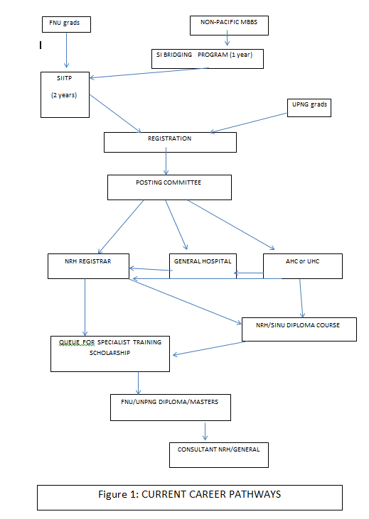

**2. DESCRIBE IN DETAIL THE EXPERIENCE AND TRAINING REQUIRED BY THE END OF INTERNSHIP TO PREPARE DOCTORS FOR PRACTICE IN THE SOLOMON ISLANDS, SPECIFICALLY WITH RESPECT TO PRACTISING OUTSIDE THE NATIONAL REFERRAL HOSPITAL** **(NRH).**

1. **Regarding the competencies and skills required** **for independent practice at the Area Health Centre (Level 2).**

According to the Guide to Intern Training and Logbooks16, it appears that upon completion of the SIITP the Intern should have the ability to handle the tasks likely to present at AHC Level 2, viz:

- *running general clinics with a nurse, to screen, assess, diagnose and treat common medical conditions*

*- undertake basic emergency and trauma care and/or prepare for safe transfer to a hospital*

*- manage short-term inpatient care, including I/V etc, for appropriate conditions*

*- within the constraints of ketamine/regional local anaesthetic blocks, undertake minor superficial surgery or trauma repair*

**Opportunities for Improvement**

1. At AHC level, there is an expectation for *“outpatient psychiatric care, psychological counselling and mental health assessment”*. Interns have NOT had any training in this. At best, they may have confronted an acutely psychotic patient in the Emergency Medicine rotation.
2. Implementation of SolPEN (Solomon Islands Package of Essential Non-communicable disease interventions) is expected. As a group, they have no idea of this plan, so dissemination and education of this package will be required if it is to be promulgated & practised in AHCs across the provinces.

If health leadership is required of these doctors, here too, they have not had any training in this important area.

1. As a group, most Interns at completion of the SIITP state that they do not have the confidence nor the competence to undertake those procedures required in an Operating Theatre at a General Hospital level.

In particular the ‘bellwether procedures’– Caesarean Section, diagnostic laparotomy (appendicectomy, rupture ectopic pregnancy), open limb fracture nor delivering a General Anaesthetic or Spinal Block. The relevant Heads of Department, independently, are also of this opinion and indicate that the Logbook expectations do not match reality on the wards. There will be an occasional enthusiastic, skilled Intern who has gained these competencies, however they believe these trainees are the exception, rather than the general rule.

**Recommendation**

1. Logbooks should be revised to reflect what competencies are achievable in SIITP in standard rotations. Any doctor posted to a General Hospital facility must have the capacity to deal with one or other of the “bellwether” procedures, if this is expected of them. This expectation is likely to mean an extra year of training in one or other specialty to reach a safe level of skill before undertaking such a posting.

An alternative approach is for focussed extra-training in the form suggested in the proposal to SINU for the creation of a Postgraduate Diploma in Rural and Community Medicine. Either approach will guarantee better utilisation of General Hospitals in the Provinces in the time taken for a full Specialist-trained workforce to be achieved, a process that will take many years.

1. Interestingly, my visit to Gizo General Hospital revealed that of the four medical officers posted there, three had an extra and different year of training (O&G, Anaesthesia ,Emergency Medicine) but none of them had any extra surgical training which meant that potentially unsafe surgical procedures may be undertaken. Appropriate postings and training are a necessity.
2. **An outline of the level of expertise expected within each competency or skill.**

As indicated in Logbook guidelines for each rotation, if these requirements have been met under proper supervision then the new Medical Officer at AHC Level 2 will have the expertise and independence to appropriately diagnose, treat or transfer patients presenting for care at an AHC.

**Opportunities for Improvement**

1. Logbooks are a very useful tool to guide learning but are only helpful in confirming competency if there is regular supervision & oversight of the entries made. However, this does not appear to be uniformly present at NRH at present. Some Departments are excellent, but this is not evident across the board. As mentioned earlier, the expectations made upon both Trainee and Supervisors are sometimes unreasonable in these well intentioned and well documented assessment tools. This fact was attested by Department Heads interviewed, as well as the Intern Training Coordinator.

**Recommendation**

1. MTC revise the Logbooks to reflect what is achievable on their units during the course of the Intern rotations to ensure that upon completion of their SIITP they are fit-for-purpose to be posted to an AHC.
2. **An outline of the expected non-clinical skills and competencies that graduates of the internship training programs should have.**

Looking at the RDP expectations of a Medical Officer at AHC level13, there is little expected other than an awareness of *Public health programs and the need to collect vital statistics*. There are three rostered “Public Health” lectures in the Bridging programme but no topics nominated. These are due to be delivered by a representative from the Ministry of Health. It is noted that there is no formal Public Health education content in SIITP. Public Health programs are meant to be covered in the Rural Health rotation, although there is no specific mention of this anywhere to be found.

Logbook requires some reflections on ‘*team player within health facility’, ’ leadership role at a health facility’, ‘recommendations for service delivery and needs and priorities at health facility’, ‘ recommendations of capacity and capability needs and priorities’*.

The need for Health Management & Leadership at the AHC level was discussed during the review, and Ministry leadership members stated that it is unlikely a Medical Officer will be required to take on this responsibility. It is considered that it is probably more important that a long-term appointee (eg. Senior Nurse) undertake such leadership, rather than a doctor who may only be there a short period. Clearly, if this capability is required, appropriate in-service/training is needed.

**Opportunities for Improvement**

1. Interestingly, the Medical & Dental Board of SI publication of Intern Training & Intern Outcome Statements does not include “health management and leadership; research and epidemiology” or public health skills in their document14.

**Recommendation**

1. Ensure that the Medical & Dental Board of SI publication “Intern Training & Intern Outcome Statements” aligns with those qualities expected of a Medical Officer posted to an AHC- Level 2.
2. **An outline of the expected exposure to primary health care in provincial settings**

At present all Interns spend a seven week rotation in Rural Medicine. They are placed in facilities of an Area Health Centre level to be supervised by a Medical Officer alone. There is no specific instruction regarding likely responsibilities expected of a Medical Officer in an AHC nor the policies and protocols currently promoted by the Ministry of Health.

Several Provincial Health Directors interviewed indicated that the Cuban-trained doctors were praised by AHC nurses for their Public Health approach to care. In addition, several of these Cuban-trained doctors expressed frustration that they did not have time to fully utilise their public health skills on outreach visits. Clearly these doctors do have skills to be cultivated.

**Opportunities for Improvement**

1. Whilst the Rural Medicine rotation would seem a reasonable experience, a more structured rotation could be considered, or failing that, consideration of a focussed Preparatory Rotation should be considered after Internship and prior to provincial posting, to ensure Public Health policies etc. are covered and fully understood. This would also allow time for any perceived deficiencies in basic skills (as perceived by either Intern or Area Health Centre role delineation) to be refreshed before placement in an AHC Level 2.
2. This concept was supported by a number of the recent Interns (both Pacific & Cuban graduates) who are currently placed in Area Health Centre Level facilities.

**Recommendation**

1. Explore two options to remove the Public Health Policy knowledge gap.
2. Revise the current Rural Health rotation to include structured education in Public Health policies (SolPEN, etc).
3. Explore the possible addition of a Provincial Posting Preparatory Rotation, prior to posting to an AHC, where indicated. This could include formal education in AHC Policies and management, Mental Health, SolPEN and communicable disease management. In addition, an opportunity for a refresher course in a vital, chosen specialty (eg. O&G).

**3. STRENGTHS AND WEAKNESSES ANALYSIS OF CURRENT DELIVERY OF INTERN TRAINING** (see chart)

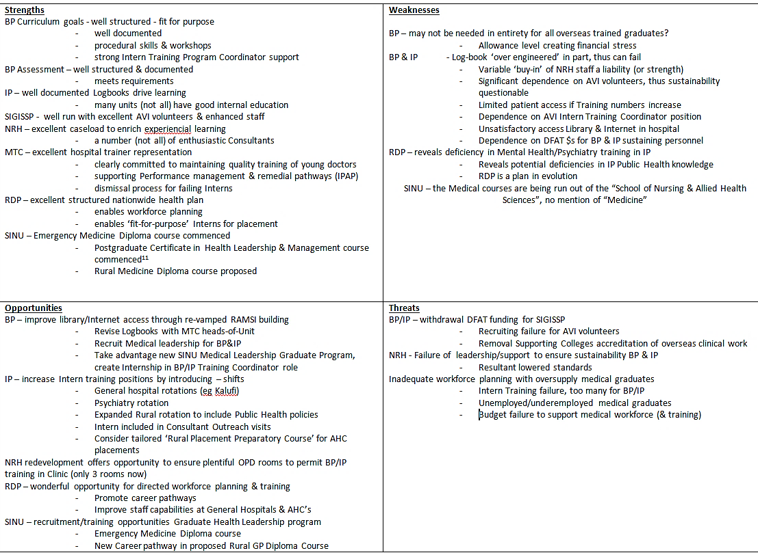

Glossary: BP=Bridging Program; IP= Intern Training Program; RDP = Role Delineation Policy; SINU = Solomon Islands National University; MTC = Medical Training Committee; DFAT = (Australian Department of Foreign Affairs & trade; AVI = formerly known as Australian Volunteers International

**4. DETERMINE WHETHER THE PROGRAM IS SUFFICIENTLY RESOURCED**

The Training Unit does have a budget which is considered adequate for purpose by the Principal Training Officer, NRH. This covers Intern travel to Rural Block placements and Programme consumables.

Library resources are limited in both book stock and access. However, most trainee Interns have either E-books on their laptops or personal hard copy editions. The internet is accessible via WiFi at several points at NRH, viz: current small teaching space and also in the Operating theatre. The NRH library cannot be accessed out-of-hours, only when the librarian is present during working hours. Any data accessed through the internet comes as a personal expense for the Intern.

There is a wonderful opportunity to improve educational material access if the RAMSI space can be renovated. It is essential that there is internet access in this space and that the space is available at all hours if possible. Using keypads, 24-hour access has worked successfully in similar circumstances for students in Australian hospitals. The designs for this space10 can certainly facilitate E-learning opportunities. Internet access could be provided in this space at no charge to the trainees.

Student welfare needs seems to have been well met, either through the Performance Management Committee program or via referral to an on-campus psychology service, ’Empower’. It is important that this facility continues. It is noted that this service is further supported by an Australian Volunteer from the Australian Volunteers Program.

The Bridging Program Intern group indicated that they are finding it impossible to survive on the allowance paid to them without finding accommodation within family or ‘wantok’ households. This accommodation is very often highly unsuitable, as it is either situated at a significant distance from the hospital, which has cost/travel time implications for an already tight budget, or it is a busy, noisy and crowded dwelling in which study is not possible. They believe the allowance should be pitched at a higher level to enable appropriate accommodation. The Intern Program salary does not carry these concerns.

**Recommendation**

1. Endeavour to create the RAMSI building as a 24/7 access education space, with teaching room and electronic education resources.
2. Consider a review of the value Bridging Intern allowance, given the financial challenges reported.

**5. SUSTAINABILITY OF TRAINING PROGRAMMES**

I do not believe that SIGISSP, in its current form, is sustainable without DFAT support, as the AVI volunteers and Extended appointees are the ‘glue’ that is holding both the Bridging and Intern Training Programmes together in many, although not all, Departments at present.

The Intern Training Coordinator, now in a re-defined role of Medical Workforce Development Officer, plays a pivotal role to ensure the delivery of the Lecture/Tutorial program drawn-up by the Department heads at the commencement of the year. He is also totally responsible to see that all Trainees, be they Bridging Program or Interns, satisfactorily meet the Assessment hurdles required for Registration by MDB upon completion of their Intern Traineeship.

Amongst other duties this entails:

* Drafting timetable for Bridging Intern lecture/tutorials/Workshops.
* Generate Rotation program timetables for all Bridging Intern & Intern training.
* Make constant reminders, for the registrars involved, to deliver their proscribed tutorials
* Ensure that each Department Head completes Trainee mid-term and end-of-term assessments in a timely manner.
* Ensure that trainees complete and present their Logbooks to Department Heads, with all assessment tasks having been completed, assessed and signed-off properly and in a timely manner.
* Ensuring that the wellbeing of the trainees is being met, and making the necessary interventions when there is a problem.
* Acting as Secretary for both Medical Training Committee and Postgraduate Training Committee.

These duties, and detailing development projects, are just some of the tasks required of this position at present. It is of interest that during the incumbent’s recent leave, these tasks were unable to be fully met by the NRH Principal Training Officer. It was felt that this was in part due to perceived ‘lack-of-standing’ amongst the NRH medical staff, but also reflected the many other tasks this officer is also responsible for at NRH.

Clearly the position of Intern Training Coordinator is critical for the future of any Training Program.

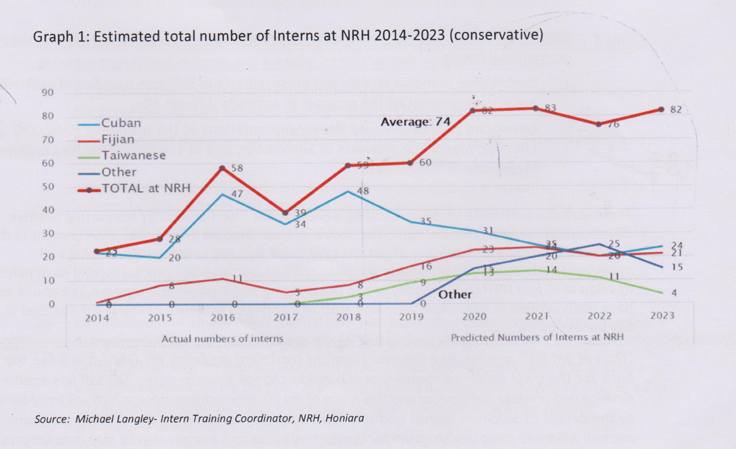It is important that the SIGISSP continues for the immediate future, as there is a predicted increase in the number of medical graduates returning from training outside the South Pacific1.

There is a twin problem here.

1. Too many medical graduates returning to the SI health system.

If these new medical graduates all require upskilling before entering SIITP, they cannot be reasonably accommodated in the Bridging Programme as currently structured. There is no point in overburdening this programme, as the standards of care required by SI of its Intern Trainees will inevitably be lowered.

Some urgent Workforce Planning is required, which should include a limit on the number of Scholarships offered to study Medicine. The Permanent Secretary for Education advised that he was due to visit the Philippines where some 80 students are already enrolled in Pre-Med courses. He was hoping to redirect their careers into other health professions (clinical psychology, allied health, etc.) to best serve the staffing required for new Role Delineation Policy (vide infra)

1. There are a finite number of Intern training positions in the SI Health System9, thus, if there are too many medical graduates (coming from the Bridging Course & FNU) for this number, there will be a delay in these graduates becoming registered doctors or, worse still, failing to ever to enter the health workforce in SI; an ill-afforded wastage of education, training & intellect.

**Recommendations**

1. Determine an agreed number of medical scholarships, based on informed workforce planning informed by the RDP.
2. To sustain the Training Programs there needs to be recruitment of Solomon Island medical staff to replace the current AVI appointees to both lead and oversee the program requirements. This will entail identifying a Medical practitioner, preferably with some seniority, to have a contractual (part-time) appointment as Intern Training Coordinator. This appointee will have to show leadership to bring all the NRH staff, uniformly ‘on-board’ to support training and education, as this task is often being picked-up by the AVI volunteers at present.
3. In addition, this appointee would need to be supported by an Administrative position to undertake many of the tasks presently delivered by the Intern Training Coordinator. There may well be an opportunity to take advantage of those personnel currently studying the SINU Postgraduate Health Leadership & Management11 course to identify someone suitable for either of these two roles.

Is there an opportunity for a work-experience internship here?

1. The number of Intern training positions need to be increased somehow. Some good ideas have already been proposed and these need to be expanded or re-visited.
2. Interns should be working shifts rather than the current arduous hours of on-call and second on-call. At the very least, an extra position could thus be created for each Department. As clearly demonstrated in the Emergency Department, the introduction of shifts works well and allows more staff to be trained also giving time and space for education activities and proper work/life balance. This, in turn, can lead to a happier and more productive workplace
3. Creating more rotations in General Hospitals that have Consultant Specialists7, 12.

This option is presently in place for Kilu’ufi alone, with a surgical rotation sometimes rostered. Why only ’sometimes’? Perhaps the position could be made more interesting if an Intern spent half of their rotation at NRH and the other half in a General Hospital?

Several sensible reports have been made to explore these rotation options7, 12. It remains important that the posting of Consultants to General Hospitals be implemented.

1. Psychiatry is noted to be missing from the Intern Rotations. As Mental Health features prominently at all levels of Health Facility in the RDP, it would seem sensible to include this option in the training program, especially for those trainees destined for AHC’s. The Undersecretary for Health Care advised that there are plans to bring Psychiatry under the umbrella of NRH which would facilitate creation of Psychiatry rotations within SIITP.

These options need to be explored as they can potentially lead to a breadth of rotations to better prepare Interns for posting to an AHC, better support for General Hospitals and a junior workforce better placed for adult learning through improved work/life balance.

The number of post-Registration posts at NRH also needs to be considered, given the anticipated increase in Intern Registrations as well as those Interns returning for PNG. Are there enough Registrar posts available for capacity building the expanded workforce expected of RDP?

1. **AVI Recruitment and Administration**

As indicated in the ‘Strengths and Weakness Chart’, the AVI contribution to the education and Training of doctors cannot be faulted and is the foundation upon which the whole training programme sits. The AVI staff at NRH were interviewed during the review all appeared fully committed and effective in their role in these training programs.

The selection process is clearly excellent. All Senior Registrar and Intern Supervisors were Specialist trainees in various Colleges. These Colleges each accredit up to 6 months of overseas clinical practice toward their Fellowship and this allows such AVI volunteer placements. The Australian College of Emergency Medicine (ACEM) confirms that it strongly upholds its “Global Emergency Care” term as an important option in their trainee’s accredited program. However, the Royal Australasian College of Surgeons does not accredit such time. Clearly, any change to accredited training for time spent overseas would be a threat to the calibre of volunteers in future recruiting.

The recent cohort expressed disappointment that there was no Orientation Program organised for their arrival at NRH, although there was a two-week AVI-led orientation programme organised in-country prior to placement at NRH. As a result, they took some weeks to orient themselves regarding the Programs and their expected role in program delivery. Both the Memorandum of Understanding for the Graduate Internship Supervision and Support Program(Section 4g&h) 17 and AVI-SIGSSP Information for Australian Organisations18 clearlydocument orientation expectations from NRH.

However, their greatest concern was their clinical standing within the Clinical Unit, as this was not at all clear in several units. This concern was heightened as they discovered that they were assumed to be “consultants” by some local staff and found themselves *de facto* in charge of the ward rounds when Consultants and/or Registrars failed to arrive, and not just clinical teachers as anticipated and described in their Position Description. This observation was not true of all units but does need to be addressed as, once again, this issue has been defined in covering documents17, 18

The SIGISSP 6 monthly report1 states “*The SIGISSP Project Manager additionally meet with the Heads of Department supervising volunteers individually to gain a greater understanding of the context of the department, assess progress with the specific volunteer placement, ensure the departments were aware of their responsibilities for the project and to provide tips about how to support a volunteer”.* There is no mention of the volunteer responsibility to the unit and its patient’s care.

It is noted that the O&G Intern Supervisor Position Description19 does not describe the clinical role of the supervisor, other than “being a role model of best clinical practice”. What is missing is a description of where the Intern Supervisor is expected to sit in the line of responsibility within the Unit. The Intern Supervisors indicated that they would like some definition so that all parties understand each other’s role. At the time of the review, this was not always the case. Unfortunately two factors impacted on this group’s arrival. Firstly, the Intern Training Coordinator was on leave after completion of his contract. Secondly the four volunteers arrived at the same time. Usually there will be another AVI volunteer to help with the orientation process. It is noted that under the SIGISSP MOU, the responsibility of NRH Heads of Department to carry out the hospital based orientation, rather than existing volunteers, other than from a collegial perspective.

The Emergency Consultant Advisor and Clinical Educator is fully committed to the training of young doctors. He oversees the lecture programme, takes regular small group tutorials, and ensures all examinations are properly developed, delivered and assessed. Added to this, it is no surprise that the Emergency Department is a fine example of Clinical Delivery and Education. A Diploma course in Emergency Medicine has commenced at SINU and a Diploma Course in Rural Medicine and Community Medicine is being proposed. These are all the product of excellent collaboration between Australian Volunteers and the NRH Personnel.

The Emergency Nurse Advisor was not in NRH at the time of my visit.

**Weaknesses**

1. NRH Orientation program is sub-optimal, including definition of Unit clinical responsibilities.

**Recommendation**

1. Develop an Orientation/Handover package to ensure best induction of AVI volunteers. This needs to include clear instruction regarding AVI volunteer clinical role with agreed responsibilities on patient care. Revisiting the covering documents17, 18,19 to ensure all parties are clear on their roles and responsibilities at the Departmental level. Consider developing a joint orientation package (AVI and NRH) so that all parties are involved and share the implication of the joint party MOU. The uncertainty of the patient role of the Intern Supervisor needs clarification.
2. Consider recruiting an Intern Supervisor to support the undermanned General Surgery Unit. This Unit has significantly fewer NRH Staff compared to other Units, yet has the same number of Intern Training responsibilities. Whilst RACS does not accredit overseas training, the recruitment of an experienced non-accredited trainee could well contribute meaningfully in this Position, to the benefit of all parties

**IN SUMMARY**

Having consulted widely across all parties involved with Intern Training, this review found that the current support for the Bridging program and Intern Training program should continue to be funded as the program is successfully meeting its purpose. In addition, current projections demonstrate an ongoing influx of 80 medical graduates per year until at least 2023. This training demand needs to be met locally and future numbers of trainees contained through informed workforce planning, before embarking on medical training.

The Role Delineation Policy (RDP) document creates a wonderful opportunity to undertake workforce planning with potential career-mapping for all medical graduates, past and future. In the future, it appears that there are improving opportunities for medical graduates to undertake some, or all, of their postgraduate training in-country through arrangements with UPNG, FNU, as well as new courses being commenced or proposed at SINU. Careful planning will ensure that Solomon Island medical graduates can stay in-country working as doctors, rather than spending years overseas. This will enhance family life, workplace standards of care and education as well as a happier environment all round.

Importantly and in general, the SIGISSP is producing Registered Medical Officers fit-for-purpose for posting to Area Health Centres, as defined in the RDP. There are several points of weakness that have been identified that do need to be addressed however, in particular Mental Health and Public Health policy.

Given all of the observations above, it is vital that the Bridging and Intern Training Programs become self-sufficient into the future. It is time to identify and employ medical education leaders from within the Solomon Island Medical Workforce to ensure that future training program needs are sustained with a concomitant maintenance of standards as proscribed in RDP.

To help improve the current programs, a number of observations and recommendations are summarised below.

**SUMMARY OF RECOMMENDATIONS.**

**Bridging Program**

1. An honest, formal review of the details of Logbook expectations by each Head of Department is recommended, always bearing in mind that all of their supervising team need to be supportive of this Logbook assessment process as well.
2. Review of the policy decision that all non-Pacific medical graduates undertake the Bridging Intern Program. Consider a screening exam upon return to Solomon Islands to determine their standing, as undoubtedly, the best graduates will be ready for SIITP. This fact becomes evident during the Bridging Program.
3. Consider a review of the value Bridging Intern allowance, given the financial challenges reported.

**Intern Training Program, Registration and Posting Committee**

1. MTC revise the Logbooks to reflect what is achievable on their units during the course of the Intern rotations and to ensure that upon completion of their SIITP they are fit-for-purpose to be posted to an AHC.
2. Logbooks should be revised to reflect what competencies are achievable in SIITP in standard rotations. Any doctor posted to a General Hospital facility must have the capacity to deal with one or other of the ‘bellwether’ procedures, if this is expected of them. This expectation is likely to mean an extra year of training in one or other specialty to reach a safe level of skill before undertaking such a posting.
3. Ensure appropriate postings are made and that training is of a standard to support the full capacity of the Health Facility to which a Medical officer is posted (General Hospital versus AHC)
4. Explore the possible addition of a Provincial Posting Preparatory Rotation where indicated. This could include formal education in AHC Policies and management, Mental Health, SolPEN and communicable disease management. In addition, an opportunity for a refresher course in a vital, chosen specialty (eg. O&G).
5. Endeavour to create the RAMSI building as a 24/7 access education space, with teaching room and access to education resources.
6. Determine an agreed number of annual medical scholarships, based on informed workforce planning informed by the RDP.

**Sustainability**

1. To sustain the Training Programs there needs to be recruitment of Solomon Island medical staff to replace the current AVI appointees to both lead and oversee the program requirements. This will entail identifying a Medical practitioner, preferably with some seniority, to have a contractual (part-time) appointment as Intern Training Coordinator. This appointee will have to show leadership and be a champion for education to bring all the NRH staff uniformly ‘on-board’ to support training and education, as at present this task is often being picked-up by the AVI volunteers.
2. Consider creating an Administrator position to support the Intern Training Coordinator. There may well be an opportunity to take advantage of those personnel currently studying the SINU Postgraduate Health Leadership & Management course to identify someone suitable for either of these two roles.

Is there an opportunity for a work-experience internship here?

1. The number of Intern training positions need to be increased somehow. Some good ideas have already been proposed and these need to be expanded or re-visited.

- Shifts for Interns

-Creating more rotations in General Hospitals that have Consultant Specialists.

- Psychiatry is noted to be missing from the Intern Rotations. As Mental Health features prominently at all levels of Health Facility in the RDP, it would seem sensible to include this option in the training program, especially for those trainees destined for AHC’s.

**AVI Volunteer Staff**

1. Develop an Orientation/Handover package to ensure the best induction of AVI volunteers. This needs to include clear instruction regarding AVI volunteer clinical role with agreed responsibilities on patient care. Revisiting the covering documents17, 18, 19 to ensure all parties are clear on their roles and responsibilities at the Departmental level. . Consider developing a joint orientation package (AVI and NRH) so that all parties are involved and share the implication of the joint party MOU. The uncertainty of the patient role of the Intern Supervisor needs clarification
2. Support the suggestion for a Clinical Educator with an interest in Rural Medicine to support development of a Post Graduate Diploma in Rural and Community Medicine. This proposed Diploma course is modelled on other similar successful courses elsewhere in Low Income Countries to better serve General Hospitals.
3. Consider recruiting an AVI Intern Supervisor to support the undermanned General Surgery Unit.