

Independent Assessment Report of the

Solomon Islands Education Sector Program 2 Performance-Linked Aid Payment

June 2019

## [www.metis-analytics.com](http://www.metis-analytics.com/)

This report has been prepared by Catherine Yates under the management of the Government of Australia’s (GoA) Department of Foreign Affairs and Trade (DFAT), through its consultancy arrangements with METIS Analytics. The report was commissioned through the Solomon Islands Resource Facility, managed by Cardno.

The views expressed in the report are those of the independent assessor and do not necessarily represent the views and opinions of the Government of Australia, the Solomon Islands Government (SIG) or their agencies and personnel.

The support provided by the Solomon Island’s Australian High Commission (AHC) personnel and personnel in the SIG Ministry of Education and Human Resources Development (MEHRD) is acknowledged and appreciated. The support of the MEHRD Strategic Support Unit in facilitating and managing the review process was invaluable.

# Table of Contents

Table of Contents **ii**

List of tables, figures and diagrams **iii**

Acronyms and Abbreviations **iv**

Executive Summary **1**

1. Introduction **8**
2. Background and Context **8**
3. The Assessment Methodology **9**
4. Review of performance against 2018 Education Performance Matrix **10**
   1. Education Access 11
      1. Target 1.1: Transition rates by level and gender 11
      2. Target 1.2: Safe and equitable access 14
   2. Education Quality 15
      1. Target 2.1: More teachers using improved curriculum 15
      2. Target 2.2: Teachers meeting agreed standards 17
      3. Target 2.3: Students achieving at or above the expected literacy and numeracy level 18
      4. Target 2.4: Percentage of Certified Teachers by gender 19
      5. Target 2.5: School grant expenditure used for learning materials 21
   3. Education Management Systems 22
      1. Target 3.1: Retirement percentage of 2018 school grants 22
      2. Target 3.2: Draft Education Bill is passed 24
      3. Target 3.3: Education Authorities operate to agreed standards 24
      4. Target 3.4: 2018 recurrent expenditure for Basic Education is maintained or improved 25
      5. Target 3.5: Solomon Islands Government Scholarships are sustainable 27
      6. Target 3.6: The Solomon Islands Government maintains its recurrent budget allocation for education in 2018. 30
      7. Target 3.7: External audits of MEHRD finances are conducted. 31
5. Payment Recommendation 32
6. Appraisal of current PLA approach and recommendations on the way forward 34

Appendices **40**

Appendix 1: Education Performance Matrix 2018 **40**

Appendix 2: Terms of Reference **45**

Appendix 3: Key Documents Reviewed **47**

Appendix 4: Key Informant Interviews **49**

Appendix 5: 2018 Performance Summary **51**

# List of tables, figures and diagrams

Table 1: Transition rates for Pre-Primary, Year 6, 9, 11 and 12 (2016-2018) 12

Figure 1: Percentage of Teachers Certified 2016 – 2018 20

Table 2: Second biannual grant retirement rate as at 31 March 2019 23

Table 3: First biannual disbursement percentage 2019 23

Figure 2: Grants per Student primary and secondary recurrent 2017-2018 26

Figure 3: Basic and Senior Education Grants 2016 to 2018 in SBD millions 26

Figure 4: Scholarships: Budget vs Actuals 2016-2018 28

Diagram 1: MEHRD actual and budgeted expenditure in 2018 28

Diagram 2: SIG Tertiary Scholarship Awards 2016-2019 29

Diagram 3: MEHRD per cent of total SIG recurrent budget appropriation. 31

Diagram 4: Performance Linked Aid 2018 MEHRD percentage achievements 33

Figure 5: Comparison of indicators achieved from 2015 to 2018 33

Figure 6: Summary of achieved/part achieved indicator by priority area for 2018 34

Diagram 5: Design and Implement tender process 38

# Acronyms and Abbreviations

|  |  |
| --- | --- |
| **AHC** | Australian High Commission |
| **AWP** | Annual Work Plan |
| **DFA** | Direct Funding Agreement |
| **DFAT** | Department of Foreign Affairs and Trade (GoA) |
| **EA** | Education Authority |
| **EACI** | Education Authority Coordination and Improvement |
| **EO** | End Outcome |
| **EPM** | Education Performance Matrix |
| **ESF** | Education Sector Framework |
| **EQAP** | Educational Quality and Assessment Programme |
| **EYP** | Early Years Program |
| **GoA** | Government of Australia |
| **GPI** | Gender Parity Index |
| **IA** | Independent Assessment |
| **KO** | Key Output |
| **LB** | Learner Book |
| **LEAP** | Leadership for Education Authorities Program |
| **M&E** | Monitoring and Evaluation |
| **MEHRD** | Ministry of Education and Human Resource Development |
| **MEL** | Monitoring, Evaluation and Learning |
| **MOFT** | Ministry of Finance and Treasury |
| **NDS** | National Development Strategy |
| **NEAP** | National Education Action Plan |
| **NEAD** | National Examinations and Assessment Division |
| **NEB** | National Education Board |
| **NER** | Net Enrolment Rate |
| **NTU** | National Training Unit |
| **OAG** | Office of the Auditor General |
| **PAR** | Performance Assessment Report |
| **PEA** | Provincial Education Authority |
| **PFM** | Public Financial Management |
| **PPY** | Pre-Primary Year |
| **SIEMIS** | Solomon Islands Education Management Information System |
| **SIMS** | Scholarship Information Management System |
| **SISE** | Solomon Islands Secondary Entrance (Examination) |
| **SIG** | Solomon Islands Government |

|  |  |
| --- | --- |
| **SINU** | Solomon Islands National University |
| **SISTA** | Solomon Islands Standardised Tests of Achievement |
| **SITESA** | Solomon Islands Tertiary Education and Skills Authority |
| **SMT** | Senior Management Team |
| **SPC** | The Pacific Community |
| **SSU** | Strategic Support Unit – MEHRD |
| **TG** | Teacher Guide |
| **TVET** | Technical, Vocational Education & Training |

# Executive Summary

Under the Solomon Islands Education Sector Program 2, a performance linked aid payment is provided yearly to the Ministry of Education and Human Resource Development (MEHRD) on the achievement of agreed targets set out in the Education Performance Matrix (EPM). The 2018 EPM included 14 targets (and 22 indicators with 30 Expected Results Statements) across three priority areas: access, quality, and management systems. For 2018, based on the sources of information received and consultations with relevant officers on the EPM, **the independent assessor has recommended 68.36 per cent of the performance-linked aid payment be disbursed to MEHRD, which equates to AUD1,093,717**.

#### Summary of Performance against Access Indicators

There has been much analysis and reporting on barriers to access in the Solomon Islands for over a decade, with no corresponding strategy to increase participation rates. Year 6 exams, which are seen as a barrier to Junior High School entrance, are to be phased-out in 2019 and analytical work on its implications is continuing. Transition rates for Year 6 and Year 9 students continue to show minor declines over the last 3 years. Better data verification and an unusual drop from Prep to Primary, could indicate a data quality issue rather than a drop in actual transition rates. While better quantitative information is becoming available, there is little in the way of qualitative data or research. Consultations have continued on the Gender Equality in Education and the Child Protection policies. Community acceptance of such new policies impacts the pace of change that is feasible. Socialisation of new policies also takes time.

|  |  |  |  |  |  |
| --- | --- | --- | --- | --- | --- |
| **MEHRD** | **MELP Outcome Areas** | **Performance Indicators** | **Expected Results Statements** | **IA** | **Payment AUD** |
| **ACCESS EO1.2** | **1.1 Transition rates by level and gender** | 1.1.1 By the end of 2018, the SISE Phase-out Committee has costed plan in place to cater for increased enrolments in years 7 and 10 and alternative placement method and plan  socialised with EAs | Quality costed plan (30%)  SMT Minute endorsing plan (50%) EAs socialisation completed (10%) | 20% (of 90) | $ 20,571 |
| 1.1.2 Transition Rates for year 6 to 7 and year 9 to  10 from 2017 to 2018 show an increase over  2016-2017 | Transition Rates increase (10%) (as per Annual Report 2018) | 0 | $ - |
| **ACCESS EO1 (65)** | **1.2 Safe and equitable access** | 1.2.1 By the end of 2018, Gender Equality in Education Policy – implementation strategy costed and approved by  NEB | A quality Gender Equality in Education Policy – implementation strategy costed (30%) and NEB endorsement minute  (30%) | 20% (of 60) | $ 13,714 |
| 1.2.2 By the end of 2018, Child Protection Policy consulted on and revised in light of consultations | A quality Child Protection Policy consulted with selected EAs and schools (30%) and revisions made based on consultations  (10%) | 100% (of 30)  + 40% (of 10) | $ 38,857 |

#### Summary of Performance against Quality Indicators

The quality indicators focussed on curriculum, teacher standards and certification, students’ literacy and numeracy, and School grants. There have been some positive developments on new curriculum, increased teacher certification and clearing a back-log of teacher appraisals. Improvements in quality takes time and this was borne out in the assessment process.

UNICEF supported MEHRD to develop and test a new improved curriculum for Pre-Primary Year (PPY). Teacher and Learner Guides for core subjects in Year 9 and Nguzu Nguzu Year 1 and 2 Maths are ready for publishing. A *Five-Year Curriculum and Professional Development Plan* provides a coherent framework and plan for development of remaining curricula up to 2024. A Senior Secondary Curriculum Framework has been approved by SMT. This work was completed through contracting-out of services, with positive results (the Quality Indicators show where contracting has been used there have generally been good and timely results).

A lack of agreed and utilised standards is inhibiting education reform and improvement. Teacher standards have not been developed. However, a MFAT technical adviser is assisting with the groundwork for a new approach of teacher self-assessment. A back-log of approximately 3,000 prolonged probationer teacher appraisals was cleared in 2018. The Certificate in Teaching Primary/Secondary was conducted with 79 (31 Female and 48 Male) untrained teachers. There is a positive trend over the last three years of an increasing number of certified teachers.

A Teacher Supply and Demand Study was not completed in 2018. This activity was delayed while awaiting the revised Teachers Service Handbook and the Teacher’s Scheme of Service, which will set a new staffing formula for all school sub sectors, revised salary grading levels based on a career progression model for teachers and subject/teacher allocations per workload for all sub sectors.

The Standardised Tests of Achievement (SISTA) 2017 study results were shared with stakeholders in an EA Conference/workshop and school reports shared with individual schools. Simplified presentations of SISTA results to Schools would improve teachers’ understanding of SITSA and its implications in the classroom. There is some indication that literacy is starting to improve with a 7.4 per cent improvement in Year 6 literacy (comparisons on numeracy where not able to be made with any confidence).

There has been grants training and assessments carried out in 2018. However, many EAs and School Leaders appear ill-equipped to acquit grants. There is limited information on how the grants are used or analysed, and if/how the resources led to improved teaching and learning in schools. Where the School Board, the community, parents and other stakeholders (NGOs and land-owners) understand the purpose of the School Grants and its utilisation limitations, and School Leaders have some financial training, the system seems to be working reasonably well. Financial training at all levels, including School Boards, is an area ripe for contracting-out of services.

|  |  |  |  |  |  |
| --- | --- | --- | --- | --- | --- |
| **MEHRD** | **MELP Outcome Areas** | **Performance Indicators** | **Expected Results Statements** | **IA** | **Payment AUD** |
| **QUALITY IO2.1 (11& 13)** | **2.1 More teachers using new improved curriculum** | 2.1.1 By the end of 2018, PPY Pilot in Honiara, Guadalcanal and Malaita  completed and evaluated | PPY Monitoring Report received by MEHRD and UNICEF (35%) | 100% (of 35) | $ 40,000 |
| 2.1.2 By the end of 2018, Cognition contract (as at June 2018) deliverables  completed and accepted | Cognition deliverables (65%) | 100% (of 65) | $ 74,286 |
| **QUALITY IO2.3.1** | **2.2 Teachers meeting agreed standards** | 2.2.1 By the end of 2018, revised National professional standards for teachers (within Teacher Service Handbook) | Revised quality National professional standards draft consulted with selected provinces (50%) Approval minute from SMT  (50%) | 20% (of 100) | $ 22,857 |
| **QUALITY EO 2** | **2.3 Number of students achieving at or above the expected literacy and numeracy level** | 2.3.1 By the end of 2018,  2017 SISTA results analysed and disseminated in user-friendly way to national, EAs and school level | SMT endorsement minute of SISTA results including national, provincial and school level reports (40%) Evidence of dissemination to national, provincial and school level (e.g. meeting minutes, back to office  reports) (30%) | 100% (of 70) | $ 80,000 |
| 2.3.2 SISTA 2017 results show an improvement in both literacy and numeracy for both grades  4 and 6 | An average of all literacy domains has improved and numeracy has improved (30%) | 10% (of 30) | $ 3,429 |
| **2.4 Percentage of certified teachers by gender** | 2.4.1 By the end of 2018, delivery of USP Certificate in Teaching Primary (courses ED152 and ED100) for 75 untrained  teachers completed | Untrained teachers (target of 75) complete both courses as reported in Annual Report 2018 (30%) | 100% (of 30) | $ 34,286 |
| 2.4.2 By the end of 2018, a Teacher Supply and Demand study endorsed  by SMT | A quality Teacher Supply and Demand study endorsed by SMT (70%) | 0% | $ - |
| **QUALITY**  **(48) TBA** | **2.5 School grant expenditure used for learning materials** | 2.5.1 By the end of 2018, school grants (Secondary, Primary and TVET) training completed in three provinces | Training that promotes the use of school grants for learning materials carried out. Training reports or records for three provinces  in 2018 (50%) | 100% | $ 57,143 |
| 2.5.2. By the end of 2018, analysis of retirements to show breakdown of expenditure | Report on analysis of acquittals showing currently how much of school grants is used for learning materials (50%) | 0 | $ - |

#### Summary of Performance against Management System Indicators

Half of the target areas for this assessment were for achievements against Management System Indicators. MEHRD has the most direct control over management systems and changes are more evident on an annual basis. MEHRD has performed better here, than on Access and Quality indicators where they have less direct control and change can take longer to achieve. The Ministry has the potential to deliver an even stronger performance against these indicators.

The commitment of both the Minister and the Permanent Secretary to change has been a key factor in progressing a significant policy with the drafting of the National Education Bill. The Bill is close to

ready for tabling in Parliament. The long-lead time in drafting and consultation plus the interdependent nature (e.g. Education Regulations, Administrative Instructions, Teachers Service Handbook) of policy shifts is evident.

School grants retirements continue to be late or not done at all leading to schools and EAs missing out on finances and much needed resources to provide a quality education for children. A multi- pronged approach to better equipping Schools with financial training and support is suggested. There was a welcomed increase to 96.3 per cent in the disbursement of the first yearly tranche of 2019 grants to schools. There has been a steady increase in grants expenditure over the last three years; and grant expenditure per student has remained about equal in the last two years in constant prices.

EA Performance Standards were endorsed by NEB in August 2018. The participatory approach to the setting of these Standards should encourage ownership of the assessment process. All EAs undertook initial training in how to use the Standards and how to undertake self-assessment with EAs reportedly now clearer about their role.

There has been a reduction in scholarship spend as a percentage of the overall education budget, though still claiming 37 per cent of recurrent allocation to education. The move towards more rural technical vocational scholarships, local Universities rather than overseas, and the first year of some scholarships will be in the Solomon Islands are positive trends in reducing the number of and educational spend on scholarships. When these changes are bedded-down, per cent expenditure is arguably of more significance than the actual number of new scholarships awarded, though both are important.

MEHRD budget allocations to scholarships are ‘ring-fenced’, meaning that whatever is not expended on scholarships is not able to be used on other parts of the MEHRD budget, such as basic education. This ‘ring-fencing’ is done because of uncertainty around student numbers and consequently to ensure there is enough budget when numbers are confirmed. Any unspent funds at year’s end are returned to consolidated revenue. Without change to this system it is unlikely MEHRD will be able to increase expenditure for basic education.

Thirty-nine per cent of total SIG recurrent expenditure was allocated to the education sector. According to the Office of the Auditor General both 2015 and 2016 MEHRD audits had been completed; and sent to MEHRD. MEHRD went to considerable effort to ensure a response to the 2016 audit was completed for this assessment process.

|  |  |  |  |  |  |
| --- | --- | --- | --- | --- | --- |
| **MEHRD** | **MELP Outcome Areas** | **Performance Indicators** | **Expected Results Statements** | **IA** | **Payment AUD** |
| **MANAGEMENT SYSTEMS EO3.1 (55-66)** | **3.1 Retirement percentage of 2018 Second Biannual School Grants improved and 2019 first tranche disbursement on time** | 3.1.1 At least 65% of 2018 School grants are retired by 31 March 2019 (2018  second biannual) | MEHRD Acquittal report for Primary, Secondary, TVET as at 31 March 2019  – retirements (50%) | 0 | $ - |
| 3.1.2. At least 85% received the first tranche of their 2019 grant by 31  March 2019 | MEHRD Acquittal report for Primary, Secondary, TVET as at 31 March 2019  - disbursement of first tranche for 2019 (50%) | 100% (of 50) | $ 57,143 |
| **MANAGEMENT SYSTEMS**  **(TBA)** | **3.2 New Education Bill is passed** | 3.2.1 Draft Education Bill is endorsed by NEB in October | Bill in final format approved by SMT (50%) | 100% (of 50) | $ 57,143 |
| NEB memorandum to Minister of EHRD (50%) | 100% (of 50) | $ 57,143 |
| **MANAGEMENT SYSTEMS**  **I03.2 (40)** | **3.3 Education Authorities operate to agreed standards** | 3.3.1 By the end of 2018,  Standards approved, 27 EAs receive training including initial self- assessments completed and analysed | Quality EA Standards drafted (20%)  SMT approval minute of EA Standards (50%) Training in initial self- assessments completed  by EACI (30%) | 100% | $ 114,286 |
| **MANAGEMENT SYSTEMS EO3.6** | **3.4 The 2018**  **recurrent expenditure for Basic Education is maintained or**  **improved** | 3.4.1 Recurrent expenditure for per-unit cost per student at Primary and Secondary School in 2018 is equal or  greater than 2017 | Calculate using real prices, recurrent allocation includes primary (50%)  and secondary (50%) grant component. | 100% | $ 114,286 |
|  | **3.5 Solomon Islands Government scholarships budgeting and expenditure is sustainable** | 3.5.1 The total of new SIG scholarship awards allocated for 2018 is 700 or fewer including for local and international  institutions | SIEMIS Expenditure Report as per 2018 Annual Report and NTU SIMS data report (100%) | 70% | $ 80,000 |
| 3.5.2 2018 MEHRD  Scholarship expenditure is not higher than 2017 MEHRD Scholarship  expenditure |
| **MANAGEMENT SYSTEMS**  **E03.3 DFA** | **3.6 The Solomon Islands Government maintains its recurrent budget allocation for education in**  **2017** | 3.6.1 A minimum of 22% of national recurrent expenditure is committed to the education sector | SIEMIS Expenditure Report as per 2018 Annual Report | 100% | $ 114,286 |
| **MANAGEMENT SYSTEMS**  **DFA** | **3.7 External Audits of MEHRD finances are conducted** | 3.7.1 By the end of 2018, 2015 External Audit of MEHRD complete (four cycles and transactions), including MEHRD management response | MEHRD Management Response for External Audit Part 1 completed (70%) MEHRD  Management Response for External Audit Part 2  completed (30%) | 100% | $ 114,286 |

#### Appraisal of current PLA approach and recommendations on the way forward

From all accounts a robust partnership exists between MEHRD, SIG more broadly and donors. The following appraisal and recommendations on the way forward are suggested against this background.

Appraisal

This assessment explores six key themes in appraising the current PLA approach: consistency, control, interdependency, time-frames, data accuracy/research, and partnership. Findings include:

* The net impact of the inconsistency of approaches by different assessors, indicators changing yearly and moving targets is that it creates a ‘shifting-sands PLA’ for MEHRD and AHC, along with a lack of ability to track trends and task completion over time.
* When developing indicators there needs to be continuing recognition of what MEHRD can and cannot control. And at what level of SIG the PLA is pitched to, in terms of who has control.
* Interdependent indicators should be recognised when agreed between partners and where necessary tracked over time, not just annually.
* A few annual indicators are useful, particularly for improvement to management systems where MEHRD has control over the pace of change. Other longer-term indicators, especially for quality, need to show trends over time and set a realistic pace of change with graduated PLA each year as milestones are met towards a target.
* Data accuracy and verification needs to be improved to inform decision making and before consideration of any PLA scale-up. There is little available qualitative data analysed in the Ministry. Although the School Census Forms provide a wealth of qualitative data. MEHRD is keen to pursue better research avenues. Qualitative data is also invaluable to provide the human dimension to already available quantitative data: It can paint a picture of policy implications for key political decision makers plus be a valuable communication tool with media, communities and grass-roots organisations.
* There is a unique opportunity to build on the current partnership and implement an improved approach to PLA.

Way Forward

An improved partnership approach: Engage a skilled Partnership Broker to develop a genuinely agreed and understood Performance Matrix for PLA, and identify any corresponding technical advice requested.

Long-term indicators: Develop a few strategically critical and agreed Access and Quality indicators from NEAP and MEHRD MEL held constant over a realistic timeframe. Payment could be graduated over a 3 to 4-year period (in line with the new ESP design), with a percentage paid each year on achievements towards a longer-term target.

Annual indicators: Identify 3 or 4 shorter-term annual indicators from MEHRD AWP. These annual indicators would most likely fall into the Management Systems target area.

Maintain sight of the bigger picture: The current DFA identifies the percent of SIG expenditure on the education sector, controlled scholarship expenditure and audit as higher order triggers for DFA.

Data and research: PLA verification rests on the quality of data being collected and analysed within MEHRD. It is suggested partners consider investment in data verification. The MEHRD Permanent Secretary is keen for research to inform decision making.

Donor performance: Donors could have PLA partner responsibilities such as the identification and provision of timely technical assistance and the use of MEHRD systems (not financially linked).

Assessment as a partnership: In line with the development of indicators in a genuine partnership, the assessment should be carried out in partnership too. This doesn’t mean the assessor is not independent or is not able to make recommendations with which MEHRD might not agree. It does include partners in the process of data collection, verification and analysis.

Contracting-out: Contracting-out of work such as curriculum development and the SISTA has shown good results and produces timely outputs. There are opportunities to streamline tender processes through development of a design/implement approach that would relieve senior MEHRD staff of involvement at a contractual level while allowing them to focus on outputs and outcomes. An explanation of how this works in practice is provided.

# Introduction

Under the Solomon Islands Education Sector Program 2, a performance-linked aid payment is disbursed yearly to the MEHRD on the achievement of annually agreed targets set out in the EPM. An independent assessor reviews the performance against the EPM and recommends a percentage for the performance-linked aid payment, as well as indicators for the following year.

This report presents the findings and recommendations of an independent, external assessment of the extent to which the MEHRD and the Solomon Islands Government (SIG) have achieved the targets and performance indicators articulated in the 2018 EPM (see Appendix 1).

The purposes of the independent review, detailed in the Terms of Reference (see Appendix 2), were to:

1. review SIG performance against the agreed milestones for 2018 in the attached performance matrix;
2. provide a recommendation of what performance-linked aid payment should be made based on the SIG performance;
3. provide advice on the strengths and weaknesses of 2018 performance indicators;
4. include MEHRD officers working on M&E in as much of the in-country visit as possible, as a learning experience, while maintaining the assessment’s independence; and
5. provide advice on indicators for 2019, informed by priority policy reforms; the Education Sector Program 2 design; and the MEHRD M&E Framework.

The preliminary findings from the review process were reported at the Education Sector Mid-Year Review conducted in Honiara 12 June 2018.

# Background and Context

The Government of Australia (GoA) and Solomon Islands Government (SIG) signed a four-year Direct Funding Agreement (DFA) in 2015, which gave effect to the implementation of the Solomon Islands Education Sector Program 2. The DFA, and the related Statement of Partnership Principles between SIG and Development Partners 2016–2020, established the conditions for the provision of up to AUD32 million over four years through direct budget support for basic education. An additional AUD32 million over four years was to be provided for technical assistance and support for Australia Awards scholarships and (through a managing contractor) the TVET sector.

Of the AUD32 million in direct budget support, up to 20 per cent was to be provided as annual bonus performance-linked aid payments, subject to the MEHRD meeting the targets and indicators detailed in the annual Education Performance Matrix (EPM). This equates to AUD1.6 million per annum (AUD114,286 per Target area).

The targets in the 2018 EPM were derived from the SIG Education Strategic Framework 2016–2030, the MEHRD National Education Action Plan (NEAP) 2013–2015 and NEAP 2016–2020, and Development Partners’ priority areas.

This is the seventh year that an independent assessment against the targets in the EPM has been conducted. For 2018, there was a continued focus on quality and management systems in the EPM

and a decrease in the number of indicators from 31 in 2017 to 14 Target areas with a corresponding 22 indicators in 2018 (and 30 Expected Results Statements).

# The Assessment Methodology

#### Data Collection

It was agreed in the last Independent Assessment that the performance cycle period would align with MEHRD’s calendar year reporting of 2018. Background and contextual information was collected through the review of key documents (Appendix 3) and interviews with key informants at MEHRD, Office of the Auditor General and AHC including relevant technical advisers (Appendix 4). A Monitoring, Evaluation and Learning Plan (MEL Plan) was developed in 2017 to report against the NEAP 2016–2020 and the Education Strategic Framework 2016–2030, as well as international goals such as the Pacific Education Development Framework (PEDF) 2009-2015 and the Sustainable Development Goals (SDGs).

The 2017 Performance Assessment Report (PAR) produced according to the new MEL Plan established a baseline and reported on agreed intermediate and end-of-program outcomes. The Annual Report for 2017 also reporting on outputs. Unfortunately, **neither the 2018 PAR nor the 2018 Annual Report were available at the time of this assessment.** The unavailability of these key reports made the task of verification of progress challenging, particularly as data in the Solomon Islands Education Management Information System (SIEMIS) was not ‘locked-down’ at a certain date therefore data shifted as it was updated. The MEHRD team were helpful in providing various documents such as policies, meeting minutes, data and expenditure reports. The Annual Work Plan process that produces quarterly reports for the Senior Management Team proved useful.

The assessor worked closely with the Strategic Support Unit (SSU) to validate findings and where possible, supplement MEHRD’s existing data collection processes.

The assessor presented the preliminary findings of the independent assessment at the Mid-Year Review Workshop, held on 12 June 2019 in Honiara. MEHRD Workshop presentations on Curriculum Development and Expenditure Performance also informed the findings of this assessment. The Workshop also identified challenges and considered future priorities for the education sector and donor partner support.

#### Measuring Performance

The 2018 EPM consisted of three priority areas: access, quality and management systems, with 14 targets and a corresponding 22 indicators (and 30 Expected Results Statements). As per the DFA, the performance-linked aid payment was calculated based on the percentage of performance indicators that were achieved, multiplied by the total performance-linked aid payment available, which for 2018 is AUD1.6 million. For 2018, as per the DFA, each target area will have equal weight (1/14 =

$114,286).

In 2018, **the 30 Expected Results Statements in the EPM were allocated a percentage of each total performance indicator**. For example, Performance Indicator *2.2: Revised National professional standards for teachers* has two Expected Results Statements each allocated 50% of the total for that Indicator (consultation on professional standards for teachers 50%, approval minute from the Senior Management Team on these professional standards for teachers 50%). While aiming for clarity and

specificity, this is at times confusing and obscures the broader intent of achieving the Performance Indicator. **Where feasible, the assessor has followed this protocol.**

In other cases, where Expected Results Statements are only partly achieved, a pro-rata performance- linked aid payment is made based on verification of progress. The 2018 EPM provided guidance on what kind of source documents would support the indicators, and the assessor weighted the evidence or the stage at which the evidence was at, to show partial achievement of an indicator.

# Review of performance against 2018 Education Performance Matrix

This section of the report provides information about the extent to which the 2018 EPM targets were achieved based on MEHRD reporting and evidence provided to the assessor. It also provides comment on challenges, and suggestions about how MEHRD could improve, where necessary, the processes and procedures it uses to collect data or achieve targets.

### Education Access

#### Target 1.1: Transition rates by level and gender

|  |  |  |
| --- | --- | --- |
| **Performance Indicators** | **Expected Results Statements** | **IA** |
| 1.1.1 By the end of 2018, the SISE Phase-out Committee has costed plan in place to cater for increased enrolments in years 7 and 10 and alternative placement method and plan socialised  with EAs | Quality costed plan (30%) SMT Minute endorsing plan (50%)  EAs socialisation completed (10%) | 20% (of 90) |
| 1.1.2 Transition Rates for year 6 to 7 and year 9 to  10 from 2017 to 2018 show an increase over 2016-2017 | Transition Rates increase (10%) (as per Annual Report 2018) | 0 |

**Source:** SIEMIS, MEHRD SISE Phase-out Committee working papers and minutes, Key Output Report, Quarterly Progress Report, Mid NEAP Review Findings report.

**Performance Indicator 1.1.1** The NEAP has outlined MEHRD’s overarching plan for addressing blockages to participation by 2020. As noted in the 2018 Independent Assessment, there has been much reporting on barriers to access since 2009. The SSU has again confirmed that most of the findings from the *2010 Barriers to Access Report* still stand today. A costed plan to phase-out the Solomon Islands Secondary Entrance Examination (SISE) for year 6 and year 9 students is seen as a first step to reduce barriers to access. A SISE Phase-out Committee was established in 2018 for this purpose. This Committee has produced substantial analysis of the current situation and possible future implications of increased enrolments. These internal working papers include detailed and informative assessments of:

* + - * Available school spaces
      * School upgrades needed
      * Placement rates
      * Specific locations that need further investigation
      * Future classes required
      * Teacher distribution
      * Several options for implementation
      * Enrolment trends over the period 2011-2018 by gender
      * Subject performance by gender
      * Pushouts

A fully costed plan was not completed in 2018; however, the MEHRD Permanent Secretary remains fully committed to removing Year 6 exams in 2019 and analytical work on its implications is continuing. In recognition of the quality analysis and effort of the SISE Phase-out Committee to progress this issue, **indicator 1.1.1 is assessed at 20 per cent achieved (of a possible 90 per cent).**

**Performance Indicator 1.1.2** In 2017 to 2018, transition rates of students from year 6 to 7 has decreased slightly from 89.1 to 88.5 per cent. Year 9 to 10 transition rates also has decreased from

77.3 to 76.2 per cent. Over the three-year period 2016 to 2018 (see Table 1) all years from Prep to year 9 are showing a decrease in transition rates. It is unclear why this is happening, though it could be a function of better data collection and visits to provinces to verify data against School Census Forms. It is also highly unusual to have a drop from Prep to Primary, which would indicate a data quality issue rather rather than a drop in actual transition rates.

#### Table 1: Transition rates for Pre-Primary, Year 6, 9, 11 and 12 (2016-2018).

|  |  |  |  |  |  |  |  |  |  |
| --- | --- | --- | --- | --- | --- | --- | --- | --- | --- |
|  | **2016** |  |  | **2017** |  |  | **2018** |  |  |
| **Year Level** | **M** | **F** | **Total** | **M** | **F** | **Total** | **M** | **F** | **Total** |
| **Prep** | 90.0% | 90.1% | **90.1%** | 86.4% | 86.1% | **86.2%** | 83.9% | 83.1% | **83.5%** |
| **Year 6** | 88.9% | 93.2% | **91.1%** | 88.1% | 90.2% | **89.1%** | 89.5% | 87.5% | **88.5%** |
| **Year 9** | 77.9% | 78.4% | **78.2%** | 78.1% | 76.5% | **77.3%** | 76.3% | 76.1% | **76.2%** |
| **Year 11** | 59.1% | 61.0% | **60.0%** | 59.4% | 57.0% | **58.3%** | 61.8% | 59.4% | **60.7%** |
| **Year 12** | 22.7% | 17.3% | **20.2%** | 21.8% | 15.5% | **18.8%** | 20.8% | 17.0% | **19.0%** |

**Source:** Draft MEHRD Performance Assessment Report 2018. Key Output Report – Information and Systems.

Improved Data and EMIS systems

A targeted school enrolment verification exercise was conducted July to September 2018 with about 2 weeks spent at each of the selected schools in Malaita, Honiara City Council, Makira and Western Province. This exercise found data errors and that large numbers of students reported at the beginning of the year had dropped out by year’s end. The School Census Forms have for the first time in 2019 included names of students. In coming years, the Forms will include student details such as: dates of birth, gender, unique student identifiers, transferred, deceased, left school, pushouts, promoted to next level and those repeating a level. This will see further improvements in data accuracy over time. Ensuring students’ privacy when collecting this data will need to be addressed in the National Education Bill.

The School Census Forms also allows for entry of qualitative data by School Leaders. There is a wealth of information (some of this is heart-wrenching in its call for assistance1) that is simply entered into SIEMIS but never analysed or acted upon directly. Only in cases of a school not receiving the school grant is the issue seen as ‘urgent’ and passed to Grants for actioning. Where the

1 For example: classes still being held in tents some 12 months after a natural disaster; two exhausted teachers carrying the workload of nine teachers; a call for help that has been the same for 31 years; lack of water, toilets, books, chairs and tables.

SIEMIS team identify pressing concerns that can’t be addressed by Grants, there should be the discretion to pass this onto the Senior Management Team.

This qualitative data could be analysed with Computer Assisted Qualitative Data Analysis Software to address real-time needs at schools. With the current upgrading of the SIEMIS system this could be a timely addition. The SIEMIS team is extremely capable and would be able to use such software. Qualitative data is also invaluable to provide the human dimension to already available quantitative data: It can paint a picture of policy implications for key political decision makers plus be a valuable communication tool with media, communities and grass-roots organisations. The Permanent Secretary noted at the Mid-term Review the need for research in the Solomon Islands’ education sector. The School Census Forms could provide a rich source of primary research data.

SIEMIS is the main tool that supports the management of decision-making in MEHRD. However, it only records student aggregates and does not have an electronic student register so there is difficulty in tracking student enrolment and progress in a systematic and accurate way. The review and analysis stage during the preparation of the ICT Master Plan identified the need to upgrade SIEMIS. The proposed upgraded EMIS will promote a primary central data system and one management system to manage all inter-related data. This data will include student information, student assessment management as well as school information, teachers, resources and school infrastructure. This information should not be fragmented across systems or departments.

While upgrading systems is commendable and necessary, the quality of data entered and its analysis is crucial: It is used to make decisions on expenditure and, more importantly, on students’ educational needs. Ongoing verification by MEHRD of data collection and impressing upon EAs and School Leaders the importance of this data is crucial. For donors, Performance Linked Aid (PLA) payments are particularly dependent upon the quality and timeliness of data collection and its analysis to make informed decisions on payment. Some European Aid Agencies, that have a heavy emphasis on using PLA, carry-out data quality audits (personal correspondence Thornton, B. 20192) before triggering a payment. Recommendations on a possible future approach to PLA and data quality is in sections 5 and 6 below.

**Indicator 1.1.2 is assessed as not achieved (0 per cent of a possible 10 per cent), though progress on collecting better data is commended.**

2 Thornton, B. Personal email dated 23 June 2019.

#### Target 1.2: Safe and equitable access

|  |  |  |
| --- | --- | --- |
| **Performance Indicators** | **Expected Results Statements** | **IA** |
| 1.2.1 By the end of 2018, Gender Equality in  Education Policy – implementation strategy costed and approved by  NEB | A quality Gender Equality in Education Policy – implementation strategy costed (30%) and NEB endorsement minute (30%) | 20% (of 60) |
| 1.2.2 By the end of 2018, Child Protection Policy consulted on and revised in light of consultations | A quality Child Protection Policy consulted with selected EAs and schools (30%) and revisions made based on consultations  (10%) | 100% (of 30)  + 40% (of 10) |

**Source:** Quarterly Progress reports, Key Output Report – Access, Output Indicator Tracker Table.

**Performance Indicator 1.2.1** In the 2018 Independent Assessment, the assessor noted that the Gender in Education Policy was still in draft form. Consultations, including with National Education Board (NEB) in November 2017, were finished and the Policy area was making the necessary changes, finalising and costing the implementation plan. As anticipated, the draft policy went before the NEB in December 2018. The necessary costings and timeframe were not attached, consequently the NEB requested these inclusions. The Implementation plan only was re-submitted in 2019. Consequently, the Strategy was not taken to Cabinet, as costings were not included for NEB consideration. MEHRD has requested technical assistance to support costings analysis, as it has found it difficult to work out what is required.

Consultations have continued with Gender Equality in Education School Awareness conducted in Choiseul (3 schools) and Central Province (3 schools), awareness training with 70 teachers (39 males and 31 females), and 423 girls attended the gender/STEM awareness program in 2018.

There is passion and commitment from the MEHRD team to progress this policy, particularly to address sexual harassment. Informants noted the historical, philosophical, cultural and religious views/beliefs that impacted on the pace of change in progressing gender equality. Socialisation of any new policy is time-consuming but necessary. The assessor is cognisant of the underlying issues in achieving this indicator; and, given the continued commitment of and consultations by MEHRD to progress the Gender in Education Policy, **indicator 1.2.1 is assessed as 20 per cent achieved (of a possible 60 per cent).**

**Performance Indicator 1.2.2** Child protection remains an issue with children reporting instances of physical and verbal abuse3. MEHRD is responding with a child protection policy, which is currently in its third draft. Child protection consultations were carried out in the following provinces: Malaita (3 schools), Central Islands (5 schools), Makira Province (4 schools), Honiara/Guadcanal (7 schools), Western Province (4 schools). A questionnaire was developed and used with focus groups of Education Authorities, teachers, students, communities and parents.

3 Thornton, B. and Upton, V. (October 2018), *Education Sector Program 2: Basic Education Component Independent Mid- Term Review.* Prepared for the Australian Department of Foreign Affairs and Trade, Australian High Commission in Solomon Islands.

These consultations did inform draft policy though there is more work to be completed. **Indicator**

**1.2.2 is assessed as 100 per cent achieved (out of a possible 30 per cent) for consultation; and 40 per cent achieved (out of a possible 10 per cent) achieved for revisions made based on these consultations.**

## Education Quality

#### Target 2.1: More teachers using improved curriculum

|  |  |  |
| --- | --- | --- |
| **Performance Indicators** | **Expected Results Statements** | **IA** |
| 2.1.1 By the end of 2018, PPY Pilot in Honiara, Guadalcanal and Malaita  completed and evaluated | PPY Monitoring Report received by MEHRD and UNICEF (35%) | 100% (of 35) |
| 2.1.2 By the end of 2018, Cognition contract (as at June 2018) deliverables completed and accepted | Cognition deliverables (65%) | 100% (of 65) |

**Source:** UNICEF, Key Output Report – Curriculum, Quarterly Progress Reports, Output Indicator Tracker, Mid NEAP Review Findings Report, Cognition Completion Report.

**Performance Indicator 2.1.1** New curriculum development was one of the priorities identified in the NEAP 2016-2020. The identified strategy was to outsource the curriculum development to reduce lead time and ensure quality; develop new curricula for PPY and Senior Secondary and complete existing curricula for Primary and Junior Secondary within this NEAP.

The Pre-Primary Year (PPY) initiative to develop new improved curriculum was led and funded by UNICEF. The PPY curriculum framework and syllabus were finalised after inputs from trial findings and in-service teacher training (INSET) in Guadalcanal, Honiara and Malaita. Two teacher guides and one manual have been printed in readiness for roll-out in 2019. Train the trainers sessions were held across 14 venues. Twenty schools in Honiara were monitored to follow progress on implementation of the new PPY curriculum. This curriculum is now implemented by provinces that have received teacher training in the curriculum to 5-year-olds in Solomon Islands.

UNICEF notes this initiative is a way to finalise and refine curriculum resources in a real-life classroom setting. Curriculum changes were incorporated and revised based on feedback during development. UNICEF will measure the outcomes of teacher training for students over time. Causality will be an issue if trying to evaluate that training is linked to children’s learning outcomes.

There has been some misunderstanding and/or miscommunication about the printing of PPY resources. The MEHRD Curriculum Unit understood that UNICEF would pay for printing the PPY resources; however, UNICEF only paid for the training component. Due to this assumption, the Curriculum Unit did not seek the SIG mandated three quotes for services and was therefore liable for the costs of printing. This example highlights the need for clear written expectations, scope of services, agreements or contracts between MEHRD and other entities (whether they be private companies, NGOs, multilateral organisations or donors). The issue of contracting will be explored further in Section 6.

The PPY curriculum has been developed, tested and is ready for use along with 447 teachers trained.

**Indicator 2.1.1 is assessed as 100 per cent achieved (of a possible 35 per cent).**

**Performance Indicator 2.1.2** Management of the Curriculum development program was awarded to Cognition in October 2017. Cognition contract deliverables have been completed and accepted, as follows:

* Math Teacher Guide Year 8 (*novated to Cognition from previous contractor*)
* Math Teacher Guide Year 9
* English Teacher and Learner Guide Year 9
* Social Studies Teacher Guide Year 9
* Social Studies Learner Guide Year 9
* Nguzu Nguzu Teaching Guide for Maths Year 1
* Nguzu Nguzu Learner Guide for Maths Year 1
* Nguzu Nguzu Teaching Guide for Maths Year 2
* Nguzu Nguzu Learner Guide for Maths Year 2

All the above teacher and learner guides are ready to be sent to a Desk Top publisher and printed (via a tender process).

These deliverables were also completed under this contract:

* Finalisation of the syllabi for Years 1-6 Maths and English with the latter now in schools.
* A review of Learner Books and Teachers’ Guides for core subjects in Years 1–8 to inform future approaches to both curriculum and professional development.
* The development of a *Senior Secondary Curriculum Framework,* which lays the foundation for the re-development of the senior secondary curriculum over the next few years. Most significantly, this includes a focus on the cross-curricular Capabilities, which are designed to inform *all* new curriculum development work, as appropriate in different subjects at different levels of schooling.
* Development of a *Five-Year Curriculum and Professional Development Plan,* which provides a coherent framework and plan for development of remaining curricula up to 2024. It also outlines the associated professional development required to ensure that innovative, outcomes based and student-centered approaches to learning and teaching become an increasing feature of all Solomon Islands classrooms.
* Development of requirements needed to prepare for implementation of the *Five-Year Curriculum and Professional Development Plan* including:
  + Alignment of the competencies/capabilities from Pre-primary to Year 12.
  + A workshop outline, which will guide writers in the development of curriculum resources which integrate the Capabilities.

The Senior Secondary curriculum could not be developed, as there was no existing framework in place. Therefore, Cognition developed the Senior Secondary Curriculum Framework, which has been approved by SMT. At the time of writing this assessment, MEHRD had received a bid waiver for Cognition to write the curriculum teacher and learner guides for Math Year 3, Math Year 4, Nguzu Nguzu English Year 5, Nguzu Nguzu English Year 6.

The original contract deliverables have gone through several iterations, as deliverables were based on certain items of original curriculum that had never been finalised, approved or completed to standard. Cognition led the process of writing textbooks with local input. There were significant delays due largely to the inexperience of local experts in this area or their lack of time to commit to the tasks. **Indicator 2.1.2 is assessed as achieved 100 per cent (of a possible 65 per cent).**

#### Target 2.2: Teachers meeting agreed standards.

|  |  |  |
| --- | --- | --- |
| **Performance Indicators** | **Expected Results Statements** | **IA** |
| 2.2.1 By the end of 2018, revised National professional standards for teachers (within Teacher Service Handbook) | Revised quality National professional standards draft consulted with selected provinces (50%) Approval minute from SMT (50%) | 20% (of 100) |

**Source:** Output indicator tracker, Key Output Reports – Professional Development; and Teacher Management, Mid NEAP Review Findings.

**Performance Indicator 2.2.1** The Teacher Service Handbook is being reviewed and updated but requires school (teacher) standards to be endorsed prior to completion. The performance standards are the centrepiece for teacher, school leader and school performance, accountability and improvement. Lack of agreed and utilised standards is inhibiting education reform and improvement. (Note: The Draft National Education Bill has linked aspects including the Teachers Service Handbook and the Scheme of Service for teachers, which will be explored further in Performance Indicator 3.2.)

Revised National Professional Standards for teachers have not been completed in 2018. However, this is progressing well in 2019. MFAT has funded a technical adviser who is assisting with laying the groundwork for the revised standards. The new approach is a teacher self-assessment model with a reduced number of indicators and a simplified approach. Draft standards for School Leaders include: strategic leadership, leading teaching and learning, relationships and community, systems and accountability, student achievement and progress. Draft standards for teachers include: professional learning, professional practice, supportive learning environment, accountability and commitment, student achievement and progress.

It is expected by end of 2019, a self-evaluation standards trial with the new format will be completed in 3 provinces for teachers and school leaders. The current performance statements for teachers will be reduced to a set of standards. Teachers would self-assess against these standards and then review with EAs. This also would serve as a selection process for promotion. Training and support in the standards is essential for EAs and school leaders to prepare the groundwork for increased EA responsibilities in lifting quality and giving direction to the Education Bill. Building professional networks of EAs will go some-way towards reducing isolation. The aim is to build

professional teachers with good support and strong leaders. Challenges are expected with a self- assessment approach due to cultural norms within a consensus society and working within tightknit communities: Risks will be identified and mitigated throughout the trial.

Teacher Appraisals

The Independent Assessment 2018 noted the low number of probationary teacher appraisals: 216 appraisals in 2016, and 161 appraisals in 2017, with a significant backlog of teacher appraisals of over 3,000 (outstanding since 2009). The time-consuming Whole School Inspection process was replaced with a team of MEHRD and provincial inspectors to focus solely on appraising probationary teachers against the standards.

Approximately 3,000 prolonged probationer teacher appraisals throughout the Solomon Islands were undertaken since the last assessment. Over 2,000 Teacher Appraisals were submitted to the Teaching Service Commission at the end of October 2018. Retraining of 122 School Leaders (Seghe, North Malaita and Nila Clusters) for the teachers’ appraisal procedures and processes was carried out. Monitoring of teachers’ attendance in all the schools visited during the appraisals was undertaken to: report absenteeism in the school (ghost teachers to Teaching Services Division office), discuss the effects of absenteeism to teaching and learning, underline the importance of keeping teacher attendance records for monitoring and provide advice on the control and reporting on absenteeism.

In recognition of the significant work in clearing the backlog of 3,000 teacher appraisals, **indicator**

**2.2.1 is assessed as 20 per cent achieved (out of a possible 100 per cent)**.

#### Target 2.3: Students achieving at or above the expected literacy and numeracy level

|  |  |  |
| --- | --- | --- |
| **Performance Indicators** | **Expected Results Statements** | **IA** |
| 2.3.1 By the end of 2018,  2017 SISTA results analysed and disseminated in user-friendly way to national, EAs and school level | SMT endorsement minute of SISTA results including national, provincial and school level reports (40%) Evidence of dissemination to national, provincial and school level (e.g. meeting minutes, back to office reports) (30%) | 100% (of 70) |
| 2.3.2 SISTA 2017 results show an improvement in both literacy and numeracy  for both grades 4 and 6 | An average of all literacy domains has improved and numeracy has improved  (30%) | 10% (of 30) |

**Source:** Key Output Report – student assessment, SISTA presentation to EAs, SISTA reports 205 and 2017.

**Performance Indicator 2.3.1** The Solomon Islands Standardised Tests of Achievement (SISTA) main study was carried out in November 2017. Development of new instruments for Science (Years 1 to 6) and Literacy and Numeracy (Year 9) were not completed and activities have been moved to 2019. Reports were available from EQAP/SPC in early 2018. This was shared with stakeholders in an EA Conference/workshop and school reports shared with individual schools. This is a good first step in dissemination at a broader level. It possibly needs closer follow up with schools (through EAs) to increase understanding of what SISTA means for schools and its implications. As noted in the last independent assessment, the different user-friendly reporting formats should be the responsibility of the future contractor and outlined in the contract with MEHRD. **Indicator 2.3.1 is 100 per cent achieved (out of a possible 70 per cent).**

**Performance Indicator 2.3.2** The Solomon Islands standardised test of achievement (SISTA) for literacy, writing and numeracy percentages for students achieving at or above the expected standard was compared 2015 to 2017. However, for numeracy and writing there were not enough linking items to be able to compare with any degree of accuracy (at least 30 per cent of items tested need to hold constant over time).

For literacy in Year 64 there appears to be sufficient linking items to make comparisons with some confidence. There has been a 7.4 per cent improvement in Year 6 literacy (from 61.5 to 68.9 per cent). In recognition of the fact that improvements in quality typically take time to achieve, this provides some indication that literacy is starting to improve5, therefore **indicator 2.3.2 is assessed as 10 per cent achieved (of a possible 30 per cent).**

#### Target 2.4: Percentage of Certified Teachers by gender

|  |  |  |
| --- | --- | --- |
| **Performance Indicators** | **Expected Results Statements** | **IA** |
| 2.4.1 By the end of 2018, delivery of USP Certificate in Teaching Primary (courses ED152 and ED100) for 75 untrained teachers  completed | Untrained teachers (target of 75) complete both courses as reported in Annual Report 2018 (30%) | 100% (of 30) |
| 2.4.2 By the end of 2018, a Teacher Supply and Demand study endorsed by  SMT | A quality Teacher Supply and Demand study endorsed by SMT (70%) | 0% |

**Source:** Quarterly Progress Report, Key Output Reports – teacher professional development; and teacher management, Mid NEAP Review Findings Report.

**Performance Indicator 2.4.1** The Certificate in Teaching Primary/Secondary was conducted this year with 79 (31 Female and 48 Male) untrained teachers. These teachers are now qualified and can use effective teaching and assessment strategies. USP has marked final examinations; only 2 people have not been able to complete the Certificate. USP will hold a graduation ceremony in September

4 Thornton, et al. (2018). *Ibid*. p23. “Although MEHRD is being conservative in reporting on improvements in literacy between the last administration of SISTA in 2015 and that of 2017, there are probably sufficient linking items to be able to say there have been improvements in literacy over the last 3 years. This cannot be stated with confidence for numeracy where there are insufficient linking items although scores also improved in this area.”

5 Thornton, et al. (2018)*. Ibid.* p23.

2019. Another 79 teachers are continuing the training and have now completed six of the eight courses contained in this training program. Figure 1 below shows the gradual and welcomed increased percentage of certified teachers over the last 3 years from 70 per cent to 78 per cent.

Teachers were noted as keen to learn, came early to class, were not absent and stayed for the full duration of the course. Teachers stayed in their communities, with USP lecturers working provincially to deliver the course, and teachers were given food allowances. There was also the incentive of moving from a Level 2.5 untrained teacher to Level 5 Certificate Teacher with a commensurate pay increase. Anecdotally, teachers were surprised at how new teaching knowledge and practices worked successfully in the classroom. **Indicator 2.4.1 is assessed as 100 per cent achieved (out of a possible 30 per cent).**

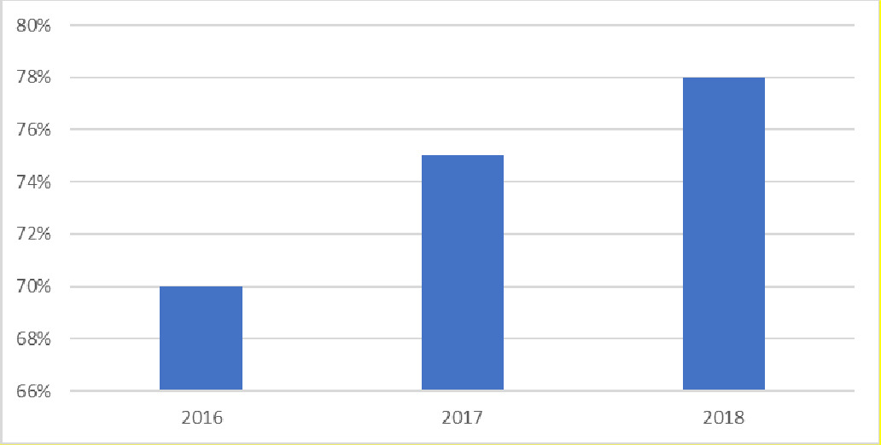

#### Figure 1: Percentage of Teachers Certified 2016 – 2018.

**Indicator 2.4.2** A Teacher Supply and Demand Study was not completed in 2018. This Study is essential for Teaching Services Division to ensure the school system has the correct number of teachers in the correct schools. This is both an accountability and planning activity.

This activity was delayed while awaiting the revised Teachers Service Handbook and the Teacher’s Scheme of Service, which will set a new staffing formula for all school sub sectors, revised salary grading levels based on a career progression model for teachers and subject/teacher allocations per workload for all sub sectors.

A technical advisor is assisting with the revision of the Teaching Services Handbook. Consultation on the draft Handbook took place with Solomon Islands National Teachers’ Association (SINTA), School Leaders, EAs and teachers in the later part of 2018. An expert HRM commenced work on career progression for the Teachers Scheme of Service for teachers in November 2018. The work on the Teaching Service Handbook, inclusive of the Scheme of Service, will continue with appropriate consultation to finalise drafts, which will be released once the Education Bill passes through Parliament. **Indicator 2.4.2 is assessed as not achieved.**

#### Target 2.5: School grant expenditure used for learning materials.

|  |  |  |
| --- | --- | --- |
| **Performance Indicators** | **Expected Results Statements** | **IA** |
| 2.5.1 By the end of 2018, school grants (Secondary, Primary and TVET) training completed in three provinces | Training that promotes the use of school grants for learning materials carried out. Training reports or records for three provinces in 2018 (50%) | 100% |
| 2.5.2. By the end of 2018, analysis of retirements to show breakdown of expenditure | Report on analysis of acquittals showing currently how much of school grants is used for learning  materials (50%) | 0 |

**Source:** School Financial Management training and assessment back to office reports. Key Output Report – Finance.

**Performance Indicator 2.5.1** The MEHRD Finance Team supported the School Grants Unit in the school grant manual training and the new School financial management handbook conducted for school leaders in five Education Authorities (Guadalcanal Province, Seventh Day Adventist, Honiara City Council, Isabel and Renbel). Two EAs (West Guadacanal and Renbel) were assessed for the effectiveness of the training while further assessment is planned for the remaining three EAs.

In Isabel Zone, 48 School Leaders attended a three-day workshop on School Financial Management with an introduction to bookkeeping, school budgeting, cashbooks, financial reporting, petty cash imprest records and basic Excel (this was the only training report sighted by the assessor). Trainers explained the School Financial Management Handbook and its alignment with the School Grant Policy. School Leaders noted that they must have copies of MEHRD Policies and Handbooks, as these policies are implemented at the school level. School Leaders requested ongoing training and follow- up support.

Visits to West Guadcanal and Renbel were follow-up assessments to previous training. Ten schools were visited over a 3-week period in August/September 2018 in West Guadcanal; and another 10 Renbel schools were visited in October/November 2018. Assessments focused on the quality of grant retirements and the School Leaders’ performance in administration.

Results of this assessment were mixed: Some schools are managing the grants well, whereas others are struggling with basic cash books and budget planning. Where the School Board, the community and other stakeholders (NGOs and land-owners) understand the purpose of the School Grants and its utilisation limitations, and School Leaders have some financial training, the system seems to be working reasonably well. This is confirmed by Thornton et al6 who noted the system of grants is working well where a strong parent / community – school relationship, and a strong school board exists. School Leaders who had completed the USP financial training course had no problems in managing the grants in their schools. MEHRD also mentioned that a basic financial management course during teacher training would ensure future School Leaders were prepared for their roles. **Indicator 2.5.1 is assessed as 100 per cent achieved (of a possible 50 per cent).**

**Performance Indicator 2.5.2** Acquittals are not able to show eligible grant expenditure by types of expenditure. At least 40 per cent of grant expenditure should be spent on teaching materials and

6 Thornton, et al. (2018). *Ibid*.

equipment (learning materials). MEHRD notes that schools often see general stationery as learning materials, as some schools don’t have basic stationery. MEHRD saw a slight improvement in understanding grant usage during finance training and assessments.

There is limited data collected or analysis to provide evidence of what resources (school grants) were spent on or how the resources led to improved teaching and learning in schools. Further work is required by MEHRD on school financial management training, reporting tools and data analysis. The Grants and Finance Teams appear stretched with their workload: Financial training at all levels (including School Boards) is an area ripe for contracting-out of services. **Indicator 2.5.2 is assessed as not achieved.**

### Education Management Systems

#### Target 3.1: Retirement percentage of 2018 school grants.

|  |  |  |
| --- | --- | --- |
| **Performance Indicators** | **Expected Results Statements** | **IA** |
| 3.1.1 At least 65% of 2018 School grants are retired by 31 March 2019 (2018 second biannual) | MEHRD Acquittal report for Primary, Secondary, TVET as at 31 March 2019 –  retirements (50%) | 0 |
| 3.1.2. At least 85% received the first tranche of their 2019 grant by 31  March 2019 | MERHD Acquittal report for Primary, Secondary, TVET as at 31 March 2019 - disbursement of first tranche for 2019 (50%) | 100% (of 50) |

**Source**: Key Output Report: finance management. MEHRD financial reports. Financial Report presented at Mid-Term Review.

**Performance Indicator 3.1.** The rate of 2018 second biannual School grants retirement as at 31 March 2019 was 60 per cent (see Table 2), below the indicator level of at least 65 per cent. Some 120 acquittals are with EAs though not received nor entered into the MEHRD Grants system.

As noted in last year’s Independent Assessment, this indicator had the potential to score higher and for this year to be achieved. The last assessor also recommended that this indicator be defined with more detail; that is, clarify second biannual, date of acquittal report and that ECCE not be included. While MEHRD has reasoned that the additional retirements currently sitting with EAs brings the percentage to 65 per cent, the clarity provided in this indicator around acquittal date of 31 March 2019 MEHRD report, second biannual only and exclusion of ECCE precludes assessing this indicator as achieved. **Indicator 3.1.1 is assessed as not achieved.**

#### Table 2: Second biannual grant retirement rate as at 31 March 2019.

|  |  |  |  |
| --- | --- | --- | --- |
| **Sector** | **Disbursement** | **Retirement** | **Retirement**  **Rate** |
| Primary | 709 | 445 | 63% |
| Secondary | 258 | 145 | 56% |
| TVET | 36 | 8 | 22% |
| **Overall rate of retirement** | **1003** | **598** | **60%** |

Late or no retirement of school and EA grants leads to schools and EAs missing out on finances and much needed resources to provide a quality education for children. The timely and accurate retirement of EA and school grants should act as an incentive to ensure the second tranche payment, but some EAs and schools continue to provide late returns, or not at all. Schools that don’t retire grants do not receive the next biannual. There are cases of MEHRD officers on salary deduction for failing to retire on time and therefore not allowed to apply for imprest.

MEHRD has identified some of the key challenges with timely and accurate grants acquittals: high EA accountants’ work-load, School Leaders absenteeism, EA incomplete implementation of its Annual Work Plan, unavailability of transport, and lack of technical and critical audit areas capacities.

The disbursement, utilisation and retirement of School grants is a key performance indicator that impacts directly on Schools on a day-to-day basis. It is an area that MEHRD and donors should consider as a priority for innovative ways to resolve this issue through a multi-pronged approach of contracting-out of training/ongoing support, using NGOs to provide on-the-ground financial guidance to all levels of a School community including parents, the Leadership and Education Authority Program (due to end September 2019), technical assistance and perhaps considering a ‘bonus’ approach to those EAs and Schools who meet certain criteria of grants usage and acquittal. Grants should continue to be an annual indicator on any revised Performance Linked Aid.

**Performance Indicator 3.1.2** There was an increase to 96.3 per cent (up 9.3 per cent from 2018 disbursement) of the first yearly tranche of 2019 grants to schools. This is a significant achievement. See Table 3 below. **This indicator is assessed as achieved 100 per cent (of a possible 50).**

#### Table 3: First biannual disbursement percentage 20197.

|  |  |  |  |
| --- | --- | --- | --- |
| **Sector** | **Registered Schools** | **1st Biannual** | **%disbursement** |
| Primary | 747 | 719 | 96.3% |
| Secondary | 273 | 263 | 96.3% |
| TVET | 47 | 45 | 95.7% |
| **Total** | **1067** | **1027** | **96.3%** |

7 Note: There are 47 TVET Schools. Seven do not have registration numbers.

#### Target 3.2: Draft Education Bill is passed

|  |  |  |
| --- | --- | --- |
| **Performance Indicators** | **Expected Results Statements** | **IA** |
| 3.2.1 Draft Education Bill is endorsed by NEB in October | Bill in final format approved by SMT (50%) | 100% (of 50) |
| NEB memorandum to Minister of EHRD (50%) | 100% (of 50) |

**Source**: Key Output Tracker 2018, Quarterly Results and Highlights report.

**Performance Indicator 3.2.1** The Draft National Education Bill was endorsed by NEB in December 2018. The Minister’s Instructions regarding further work on the Education Bill were drafted and submitted to the Attorney General’s office for advice on how to progress the Instructions. The Education Bill is close to ready for tabling in Parliament. The commitment of both the Minister and the Permanent Secretary to change has been a key factor in progressing this significant policy shift. **This indicator is assessed as 100 per cent achieved (of a possible 100 per cent).**

This drafting of the National Education Bill is a good example of the long lead times necessary to achieve significant changes to policy. It has taken three years to reach the point of the Bill being close to being tabled in Parliament (with significant, responsive and very able technical support). This is not unusual and can take anywhere from a few months to years in a developed country setting, according to the legislative drafting adviser. It also illustrates the interdependent nature of significant policy change. The Education Regulations and Administrative Instructions legislation are necessary to implement the Bill. There are links to and consistency of approach with the Bill to a new Teachers Service Handbook (Professional Standards for Teachers and School Standards included), Scheme of Service, Teacher Supply and Demand study, National Inclusive Education Policy, Child Protection Policy, and Gender Equality in Education Policy.

#### Target 3.3: Education Authorities operate to agreed standards

|  |  |  |
| --- | --- | --- |
| **Performance Indicators** | **Expected Results Statements** | **IA** |
| 3.3.1 By the end of 2018,  Standards approved, 27 | Quality EA Standards  drafted (20%) | 100% |
| EAs receive training | SMT approval minute of EA |  |
| including initial self- | Standards (50%) Training |  |
| assessments completed | in initial self-assessments |  |
| and analysed | completed by EACI (30%) |  |

**Source:** Key Output Tracker 2018. Mid Term NEAP review. Key Output Report – EA Capacity and Standards.

**Performance Indicator 3.3.1** EA Performance Standards were endorsed by NEB in August 2018. The participatory approach to the setting of these Standards should encourage ownership of the assessment process. All EAs undertook initial training in how to use the Standards and how to undertake self-assessment with EAs reportedly now clearer about their role. Data from the initial self-assessment is being used to inform EA and MEHRD annual work planning. Thornton et al8 notes that self-assessments should act as a useful precursor to more in-depth interventions. **Indicator**

**3.3.1 is assessed as 100 per cent achieved (out of a possible 100).**

#### Target 3.4: 2018 recurrent expenditure for Basic Education is maintained or improved

|  |  |  |
| --- | --- | --- |
| **Performance Indicators** | **Expected Results Statements** | **IA** |
| 3.4.1 Recurrent | Calculate using real prices, | 100% |
| expenditure for per-unit | recurrent allocation |  |
| cost per student at Primary | includes primary (50%) and |  |
| and Secondary School in | secondary (50%) grant |  |
| 2018 is equal or greater | component. |  |
| than 2017 |  |  |

**Source:** MEHRD financial reports.

**Performance Indicator 3.4.1** Figure 2 below, using real prices for recurrent expenditure primary and secondary grant component per Student, shows a slight increase of SBD13 for primary in 2018 and a slight decrease of SBD19 for secondary in 2018.9 Figure 3 shows the steady increase in grants over the period 2016 to 2018, at current prices.

Inflation was unusually high in the Solomon Islands in 2018 at 4.2 per cent (in 2017 it was 1.8 per cent)10. The assessor considers that it is fair-minded to take into account this unusually high inflation rate, that overall there is only a SBD6 (about AUD1) drop per unit cost in total grants at real prices over the period 2017 to 2018 and that the general trend is an increase in total grants over this period. Therefore, expenditure per-unit cost in 2018 is reasonably judged as essentially ‘equal’ to 2017. **This indicator is assessed as 100 per cent achieved (out of a possible 100).** Teacher payroll is not included in the per-unit calculation, as payroll for teachers has been miscoded in the past. It is expected this will be rectified over time.

8 Thornton, et al. (2018). *Ibid.*

9 Note: In 2018 Independent Assessment, per-unit costs were overstated for primary and understated for secondary school students due to anomalies in School population calculations.

10 2017 and 2018 Central Bank of Solomon Island’s Annual Reports. Ministry of Finance forecast for 2018 was 2 per cent. <http://www.mof.gov.sb/Libraries/2018_Budget_Books/2018_Volume_1.sflb.ashx>

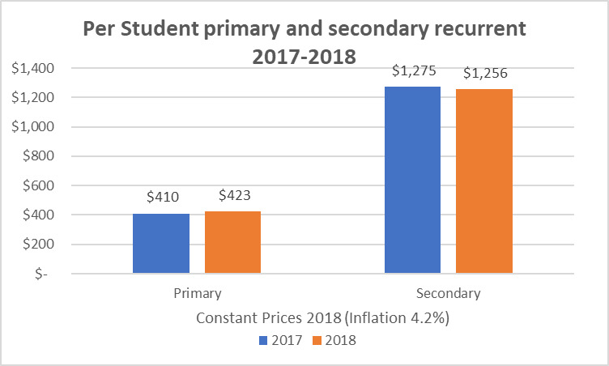

Figure 2: Grants per Student primary and secondary recurrent 2017-2018.

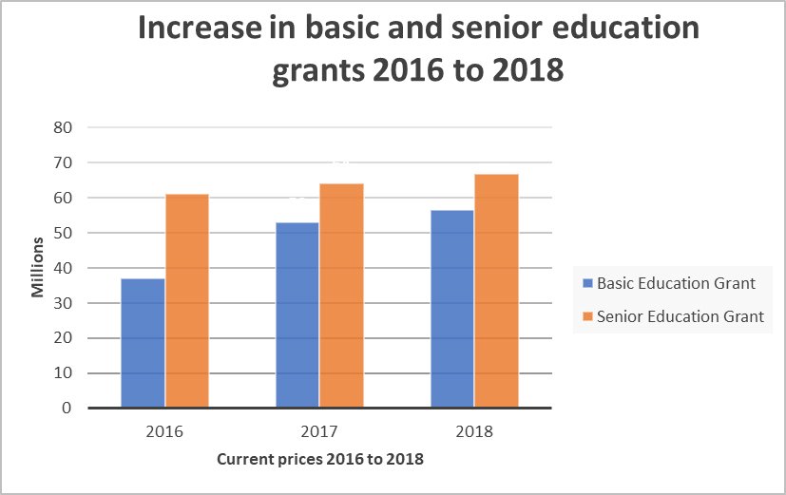

Figure 3: Basic and Senior Education Grants 2016 to 2018 in SBD millions.

#### Target 3.5: Solomon Islands Government Scholarships are sustainable.

|  |  |  |
| --- | --- | --- |
| **Performance Indicators** | **Expected Results Statements** | **IA** |
| 3.5.1 The total of new SIG | SIEMIS Expenditure Report | 70% |
| scholarship awards | as per 2018 Annual Report |  |
| allocated for 2018 is 700 | and NTU SIMS data report |  |
| or fewer including for local | (100%) |  |
| and international |  |  |
| institutions |  |  |
| 3.5.2 2018 MEHRD |  |  |
| Scholarship expenditure is |  |
| not higher than 2017 |  |
| MEHRD Scholarship |  |
| expenditure |  |

**Source**: SIMS data, MEHRD Finance Reports, Mid NEAP Report, Notes from Core Economic Working Group.

**Performance Indicator 3.5.1 and Performance Indicator 3.5.2.** The assessor has made a judgement call to evaluate these two Performance Indicators as one indicator (rather than 50 per cent for each Expected Results Statement). This is because of the interlinked nature of the indicators and recent moves towards local scholarships where the spend will be less but the number of awarded scholarships could be higher. A reduction in scholarship spend as a percentage of the overall education budget is arguably of more significance than the actual number of new scholarships awarded11, though both are important. (For future PLA and linked to any new DFA: expenditure percentage of total education budget and the ratio of local/Rural Training Centres to international scholarships is recommended as a better measure of results rather than raw numbers of scholarships awarded.)

The Core Economic Working Group (CEWG) did an assessment of the PLA matrix in mid-2018. The inclusion of this indicator by MEHRD was seen as a welcome sign of the intention to reduce the number of scholarships and spending. The Ministry is also getting tougher on underperforming students, which will lessen expenditure. (It was reported in the Solomon Times March 2019, that 179 Solomon Islanders’ scholarships to Fiji were terminated due to poor grades12.)

The revised SIG budget allocation to scholarships was high, claiming 37 per cent of recurrent education 2018 expenditure. Actual expenditure was 33 per cent of total MEHRD recurrent expenditure at SBD371,283,664 (see Figure 4 and Diagram 1 below)13. This is an almost 5 per cent drop in actual expenditure from 2017; though still well above 2016 levels14.

11 DFA states that SIG will contain its expenditure on scholarships, will manage risks, and ensure budget and expenditure is sustainable.

12 https[://w](http://www.solomontimes.com/news/government-terminates-179-scholarships/8895)ww[.s](http://www.solomontimes.com/news/government-terminates-179-scholarships/8895)o[lomontimes.com/news/government-terminates-179-scholarships/8895](http://www.solomontimes.com/news/government-terminates-179-scholarships/8895)

13 This also factors in the cost of continuing students from previous years, and as these students graduate, expenditure pressures are expected to ease.

14 Actual expenditure in 2016 was SBD242,309,678. At current prices this is SBD252,486,684. Therefore, a drop of over SBD119m (AUD20m approximately) is necessary to return to 2016 levels of scholarship expenditure.

MEHRD budget allocations to scholarships are ‘ring-fenced’, meaning that whatever is not expended on scholarships is not able to be used on other parts of the MEHRD budget, such as basic education. This ‘ring-fencing’ is done because of uncertainty around student numbers and consequently to ensure there is enough budget when numbers are confirmed. For example, as of June 2019 a master list of actual student numbers has not been able to be finalised. If the list was finalised, the savings identified could be used for other priorities within MEHRD. As it stands the funds will most likely be returned to consolidated revenue at year’s end. If MEHRD does manage to reduce scholarship expenditure over time there may not be any corresponding advantage to other parts of the education sector, although other parts of the Solomon Islands economy could benefit when funds are returned to consolidated revenue.

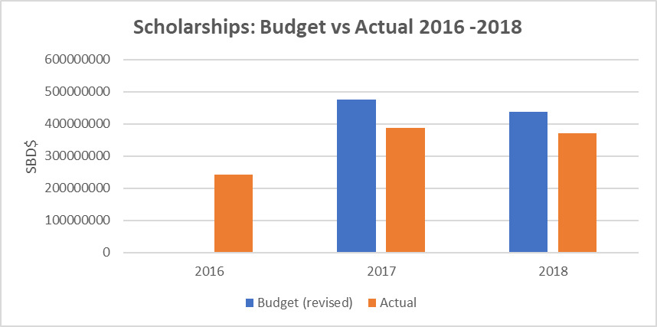

#### Figure 4: Scholarships: Budget vs Actuals 2016-2018.

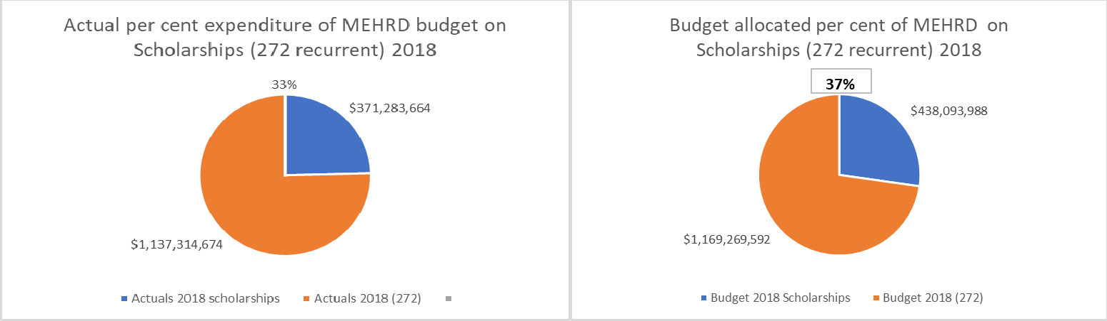

Diagram 1: MEHRD actual and budgeted expenditure in 2018.

The move towards more rural technical vocational scholarships, local Universities rather than overseas, and that the first year of some scholarships will be in the Solomon Islands are positive trends in reducing the number of and educational spend on scholarships. Targets for 2020 are not yet set. New awards will see less international awards and more to Solomon Islands National University and Rural Training Centres. Scholarship Policy and Procedures are to be revised in 2019 in an attempt to increase fairness and transparency in awarding scholarships. The Scholarship Management Instructions are an operational guide to align award of scholarships with the existing Scholarships Policy; however, have yet to be completed. The establishment of the Solomon Islands Tertiary Education and Skills Authority (SITESA), which will be responsible and accountable to the Minister for the management of the SIG scholarship program, should generate better planning, monitoring and reporting on scholarships.

The CEWG noted SIG’s intention to further limit new scholarships awards going forward. Diagram 2 below shows that **new awards in 2018 decreased almost 60 per cent from 2017 (1969 to 835)**. There is a slight increase by 5 per cent from 2018 (835 to 876 as at June 2019), though more of these awards are reportedly to be locally based so expenditure could be expected to decrease.

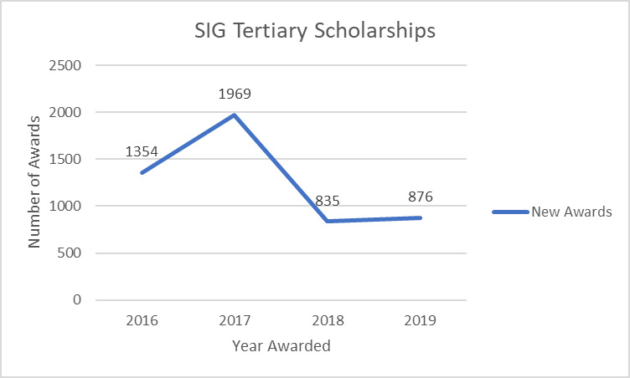

#### Diagram 2: SIG Tertiary Scholarship Awards 2016-201915

A Scholarship database (SIMS) review identified that the system was underutilised with only a small percentage of scholarship data entered: Most data was stored in a range of excel spreadsheets. All 2019 scholarship applications are now entered on a revised database with the next task to enter all

15 Note: these numbers do not tally with last year’s Independent Assessment (1721 students in 2016. 2756 students in 2018). The overall trend of a significant increase in 2017 is evident and matches the increased expenditure on scholarships. The Scholarship Analysis Report 2018 (Fiona O’Meara) noted that 2283 of the awards were verified by award letters in 2017. Even with award letters there is no proof that awardees have taken up offers and started classes. The assessor is unable to confirm with any degree of confidence the accuracy of scholarship numbers provided now or for past assessments. Actual expenditure is therefore a clearer indicator of scholarship sustainability.

historical data. Once this is complete, it should be possible to undertake data analysis to better align scholarships to labour market needs.

CEWG commended the inclusion of actions regarded to be more politically sensitive, notably those related to MP’s discretionary funding including the government’s commitment to capping the number of new scholarships awards. Significant background policy work on vocational scholarships was completed in 2018. While scholarship awards are difficult policy reform, MEHRD is applauded for its attempts to make changes in areas it can control. A Report completed last year16 on scholarships provided the first MEHRD analysis of the fields of study allocations (education at 25 per cent is the largest) and geographical spread (which was aligned with the population, apart from Malaita that had more awards more per capita than other provinces).

Further research into termination, suspension, extension and completion rates along with employment rates of new graduates is necessary. Again, this is another area where research (quantitative and qualitative) could shine a light on a contentious issue: The trade-off between educating primary students and tertiary scholarships. **This indicator is assessed as 70 per cent (out of a possible 100 per cent)** because of the drop in overall scholarship expenditure, the 60 per cent drop in scholarships from 2017 to 2018, and the progress MEHRD in making change where it is possible and within their control17.

#### Target 3.6: The Solomon Islands Government maintains its recurrent budget allocation for education in 2018.

|  |  |  |
| --- | --- | --- |
| **Performance Indicators** | **Expected Results Statements** | **IA** |
| 3.6.1 A minimum of 22% of national recurrent expenditure is committed to the education sector | SIEMIS Expenditure Report as per 2018 Annual Report | 100% |

**Source:** SIG Budget Papers, MoF, MEHRD data presented at Mid-Year Review. Siginfo.

**Performance Indicator 3.6.1**: The very capable Technical Adviser, Finance and MoFT Budget Statements confirmed that the recurrent budget appropriation (272) was SBD1,169,269,592 for 2018. Actuals were SBD1,137,314,674: This decrease in budget to actual was due to a decrease in scholarship expenditure (Diagram 3 below). Scholarships account for 33 per cent of total MEHRD actual recurrent expenditure (allocation 37 per cent). However, as noted in Section 4.3.5 this is still well above 2016 expenditure levels. **This indicator is assessed as 100 per cent achieved (of a possible 100),** as 39 per cent of total SIG recurrent expenditure was allocated to the education sector.

16 Scholarship Analysis Report 2018. Carried out by Fiona O’Meara under the management of MEHRD, firstly as a volunteer and later as a local TA for MEHRD.

17 Holzapfel, S. and Janus, H. (2015), *Improving Education Outcomes by Linking Payments to Results: An Assessment of Disbursement-linked Indicators in five Results-based Approaches*. P7. One measure of the quality of an indicator is the extent to which incentivised actors have control over achieving the intended results. MEHRD has limited control of constituency scholarships; however, is working on strategies to control merit-based scholarship awards.

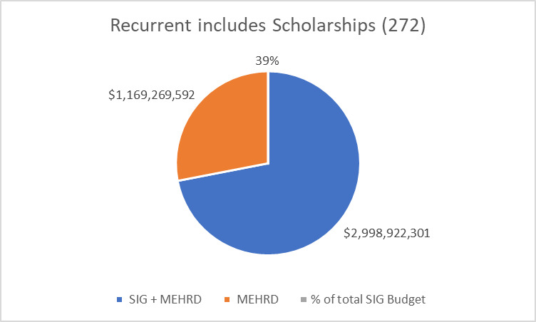

#### Diagram 3: MEHRD per cent of total SIG recurrent budget appropriation18.

#### Target 3.7: External audits of MEHRD finances are conducted.

|  |  |  |
| --- | --- | --- |
| **Performance Indicators** | **Expected Results Statements** | **IA** |
| 3.7.1 By the end of 2018, | MEHRD Management | 100% |
| 2015 External Audit of | Response for External Audit |  |
| MEHRD complete (four | Part 1 completed (70%) |  |
| cycles and transactions), | MEHRD Management |  |
| including MEHRD | Response for External Audit |  |
| management response | Part 2 completed (30%) |  |

**Source:** Office of the Attorney General and MEHRD discussions. Emails between MEHRD Permanent Secretary and OAG.

The SIG faced a huge backlog of external audits across the 24 Ministries when the last Independent Assessment was undertaken. As a result, the Office of the Auditor General introduced a streamlined audit process to undertake the 2015 and 2016 external audits. This was being done in two parts. Part 1 includes the audit of four specific cycles within MEHRD. The four cycles included are: Accountable Officer Reports; Assets/ Stores; Bank Accounts; and Commitment Cards.

Part 2 of the audit is on the financial statements and focuses on transactions across the 24 Ministries that exceed SBD18 million and/or are from high risk areas (e.g. NTU). At the time of the last Independent Assessment, the draft report of Part 1 and relevant management letter had been sent to MEHRD, and the Office of the Auditor General was awaiting a management response from MEHRD. The draft report noted that three out of four areas were rated as high risk. Part 2 of the audit was underway and scheduled to be finalised by the end of June 2018.

18 Note: This is percentage of appropriation, not actual expenditure. <http://www.mof.gov.sb/Libraries/Budget_2019/2019_Recurrent_Budget.sflb.ashx>

The Office of the Auditor General stated that both 2015 and 2016 MEHRD audits had been completed. On 9 May 2019, the OAG sent MEHRD the draft 2016 audit report for SIG and Donor Funds requesting a management response within 20 working to finalise the report. The MEHRD Permanent Secretary responded on 20 June 2019 noting that there were exposed areas where MEHRD could strengthen its internal control systems and ensure compliance with established rules and regulations. This response from MEHRD appears to be triggered by the process of the independent assessment, proving there is an incentive element to PLA. The indicator 3.7.1 called for a management response to the 2015 audit, which has not been provided to the assessor. However, given the considerable effort made by MEHRD to meet what they understood to be a response to the 2016 audit, the assessor considers it is fair to assess **this indicator 4.4.1 as 100 per cent achieved (out of a possible 100 per cent).**

The OAG is now planning the 2017 and 2018 audits, which will be more detailed and expand the scope of the audit to include expenditure, procurement, resources, payroll and specialist imprest. An engagement letter (notice of intent) is being sent to the MEHRD Permanent Secretary, with these audits planned to be completed in 2019.

A recurring issue across most Ministries, noted by the OAG, was that responses to audit issues were not acted upon even when responses were received. Similar findings of non-compliance, procurement rules not being followed, lack of an assets’ register and meeting decisions not documented were repeated year-on-year.

## Payment Recommendation

The payment recommendation was calculated by applying weighting to three priority areas: access, quality and management systems, with 14 targets, a corresponding 22 indicators and 30 Expected Results Statements. A summary of performance against the indicators is at Appendix 5.

The performance-linked aid payment was calculated based on the percentage of performance indicators that were achieved, multiplied by the total performance-linked aid payment available, which for 2018 is AUD1.6 million. **For 2018, each target area has equal weighting (1/14 = $114,286).**

In 2018, Expected Results Statements also were allocated a percentage of each total performance indicator. For example:

*Target Area 2.2*: Teachers meeting agreed standards.

*Performance Indicator 2.2.1*: Revised National professional standards for teachers is weighted at 1/14 = $114,286 total.

*Expected Results Statements:* each Statement is allocated 50% of the total for that Indicator (consultation on professional standards for teachers 50%; and approval minute from the Senior Management Team on these professional standards for teachers 50%).

**The overall recommended Performance Linked payment for 2018 is 68.36 per cent** This is 57 per cent of Expected Results Statements fully achieved and another 11 per cent partially achieved (see Diagram 4 below). It is above the 60 per cent presented at the Mid-Year Review where there were several items still to be decided.



Diagram 4: Performance Linked Aid 2018 MEHRD percentage achievements.

Figure 5 below shows a comparison of indicators achieved/part achieved between 2015 and 2018. Year 2016 appears to be an outlier with an achievement percentage of 91 per cent, whereas other years hover around the 60 per cent mark. (Last year’s Independent Assessor considered that there was an increase in difficulty of indicators for 2017 over the previous year.)

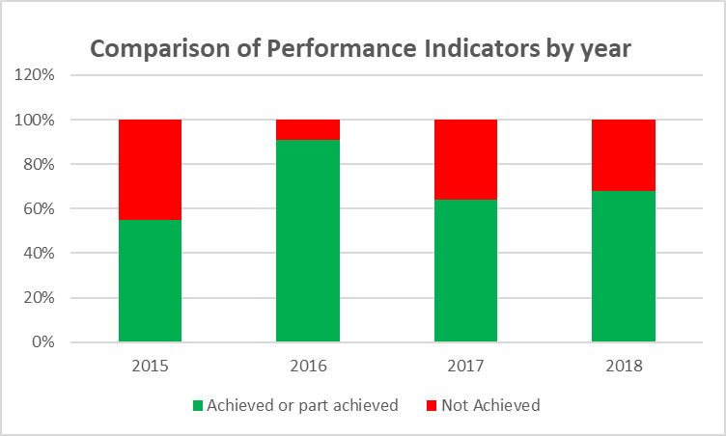

Figure 5: Comparison of indicators achieved from 2015 to 2018.

Figure 6 below provides a summary of achieved/part achieved indicators by priority area for 2018. Management systems achieved the highest percentage, perhaps due to the level of management control able to be exerted in this area. Quality typically takes longer to achieve and see results. Access also takes longer to achieve with indicators such as School transition rates and development of policies that rely on consultations, EA/School/community buy-in and approval by the NEB. A similar pattern of a lag in Quality and Access on annual indicators is seen in last year’s independent assessment.

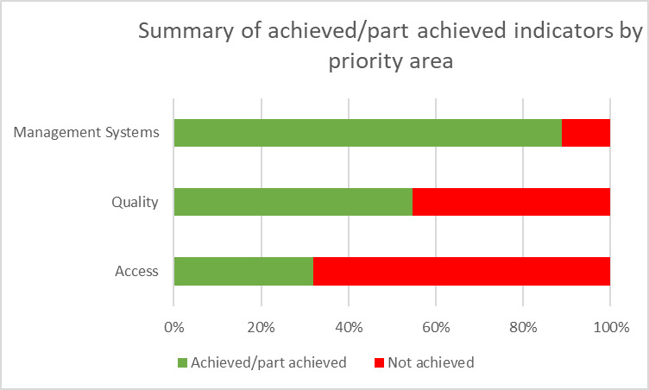

Figure 6: Summary of achieved/part achieved indicator by priority area for 2018.

## Appraisal of current PLA approach and recommendations on the way forward

This section will explore six key themes in appraising the current PLA approach: consistency, control, interdependency, time-frames, data accuracy/research, and partnership.

Consistency: To maintain independence of the Performance Linked Aid process, the AHC usually engages a different assessor each year. As noted last year, this approach has its advantages in that new ideas and different methodologies are used year-on-year. It also moves the goal-posts, changes the focus of key targets and sometimes drops indicators that are going to take time to address particularly in the quality targets.

For example, the backlog of 3,000 teacher appraisals was outstanding in the 2018 review and assessed as 20 per cent achieved given that work had commenced to address the issue. This indicator did not appear again on the 2018 Performance Matrix. However, the 3,000 backlog of teachers had been cleared in 2018. This assessor would not have investigated this issue if an adviser had not brought it to her attention, and a case made for recognition that there was a significant achievement worthy of a 20 per cent assessment. Similarly, last year’s assessor raised concerns that only 26 per cent of the indicators were consistent in 2017 to those in 2015.

The number of indicators shifts each year too: 10 in 2015, 13 in 2016, 31 in 2017 and 22 in 2018 (with 30 Expected Results Statements in 2018). Assessors are most likely attempting to make improvements each year on the process and on the indicators’ measurability and verifiability for the following year.

*The net impact of the inconsistency of approaches, indicators and focus is it creates a ‘shifting-sands PLA’ for MEHRD and AHC, along with a lack of ability to track trends and task completion over time.*

Control: As noted in section 4.3.5 on Scholarships, there must be control over achieving outcomes by ‘incentivised actors’.19 The higher results for MEHRD management systems indicators, over both access and quality, in this assessment and in last year’s assessment bears this statement out (see Figure 6 above). Successive assessors have attempted to ensure MEHRD has control over results. However, for example, the best MEHRD can do in terms of endorsement by a body such as the National Education Board or limiting expenditure on scholarships is to present quality strategies to decision-makers and have standard operating procedures in place. PLA also needs to influence political decision-makers to support and implement changes. The DFA for education does state *inter alia* that SIG will commit 22 per cent of its national recurrent expenditure in the relevant Appropriations Bill for the duration of the DFA, which is a good starting position. More could be achieved in regards to PLA in the Direct Funding Agreement.

*When developing indicators there needs to be continuing recognition of what MEHRD can and cannot control. And at what level of SIG the PLA is pitched to, in terms of who has control.*

Interdependency: Every effort appears to be made in the 2018 Performance Matrix to avoid interdependent indicators. This makes sense, though in some cases interdependent indicators are necessary and should perhaps ‘cascade’ over time to achieve a target. For example, the National Educational Bill is linked to other pieces of legislation necessary to implement the Bill such as the Education Regulations and Administrative Instructions.

*Interdependent indicators should be recognised when agreed between partners and where necessary tracked over time, not just annually.*

Time-fames: Annual indicators don’t always allow for a realistic pace of change. There are several instances in this assessment that highlights this problem. The National Education Bill has taken 3 years to be close to tabling in Parliament. The Gender Equality in Education Policy can only move at the pace of change that the community will accept. Last year’s assessor noted that curriculum reform is a long and iterative process that could not be achieved in the annual indicator. Changes in quality, and in particular changes to improving learning outcomes, takes time.20 This is borne out in the percentage of indicators achieved in this assessment for quality and access (see Figure 6 above).

*A few annual indicators are useful, particularly for improvement to management systems where MEHRD has control over the pace of change. Other longer-term indicators, especially for quality, need to show trends over time and set a realistic pace of change with graduated PLA each year as milestones are met towards a target.*

Data accuracy/research: Data accuracy was an issue throughout this assessment: This largely seems to be a collection issue at the School and EA level. The lack of a ‘books are closed’ date for the previous calendar year also creates a moving feast of data from day-to-day that impacts on the accuracy of analysis. In late June 2019, there was no 2018 Annual Report or Performance Assessment Report available to the assessor. Data accuracy impacts on decision making for students’ education. It also makes verification for PLA difficult. As noted in Section 4.1.1, some European Aid Agencies, that have a heavy emphasis on using PLA, carry-out data quality audits before triggering a payment (personal correspondence Thornton, B. 201921).

19 Holzapfel, S. and Janus, H. (2015). *Ibid.*

20 DFAT, Office of Development Effectiveness, (2016) *Investing in Teachers* Evaluation.

21 Thornton, B. Personal email dated 23 June 2019.

It is encouraging to see the SIEMIS team carrying out verification visits, improving the IT system and including more student data. MEHRD is getting better at collecting and verifying quantitative data. The targeted collection, analysis and use of qualitative data is limited. School Census Forms provide a wealth of data that could be used to paint a picture of the humanity behind the statistics. The Permanent Secretary noted the appetite for research to inform decision making in MEHRD. Hard data, good qualitative stories and targeted research could whet the appetite for change from political decision-makers through to communities and parents.

*Data accuracy and verification needs to be improved to inform decision making and before consideration of any PLA scale-up. MEHRD is keen to pursue better qualitative data and research avenues.*

Partnership: This assessment was the last under the current Direct Funding Agreement in relation to the Solomon Islands Education Sector Program 2 (ends 30 June 2019). DFAT noted at the Mid-year Review that they were confident the partnership would continue, though there could a lag time in finalising an agreement. The Partnership Agreement between SIG and Development Partners is in place until December 2020. MEHRD, DFAT and MFAT were committed to continue working together to achieve improved educational outcomes for children of the Solomon Islands. The MEL Plan, and identifying indicators for measuring progress against the NEAP, has improved consistency of indicators. The new design of ESP2 is currently being drafted. Therefore, a unique opportunity to build on the current partnership and refine the PLA approach exists.

The PLA assessment is time-consuming for MEHRD (the assessor estimates she used at least 4 hours of the SMT time in meetings plus significant time with other MEHRD team members and advisers). MEHRD has indicated that it finds the process disempowering and punitive, rather than incentivising (although there is some proof PLA does act as an incentive, e.g. audit response). All stakeholders agreed there were benefits and disadvantages to PLA. What seemed to be in question was the process, rather than the outcome. Key changes identified are: Developing and evaluating indicators in partnership, ensuring consistency, recognising what MEHRD can and cannot control, acknowledging the time it takes to see change in quality with some indicators being over a longer period, gathering better qualitative/quantitative data to inform decision making and including non- financial indicators for donors.

*There is a unique opportunity to build on the current partnership and implement an improved approach to PLA.*

Recommendations on the way forward on PLA and contracting-out

From all accounts a robust partnership exists between MEHRD, SIG more broadly and donors. The OECD peer review of Australian aid notes that Australian aid in the Solomon Islands is on plan, on budget and on system; and there should be a continued focus on thinking and working politically within the Solomon Islands context.22 With this strong partnership using SIG systems where possible, a new ESP2 design, the current DFA cycle completion and with a MEL Plan and NEAP in place, there is a unique opportunity to build on the current partnership and implement an improved approach to PLA.

There are three fundamental questions stakeholders should consider with the PLA process going forward. Is the PLA:

* contributing to improved educational outcomes for children?

22 OECD peer review 2018 …. [https://read.oecd-ilibrary.org/development/oecd-development-co-operation-peer-reviews-](https://read.oecd-ilibrary.org/development/oecd-development-co-operation-peer-reviews-australia-2018_9789264293366-en#page1) [australia-2018_9789264293366-en#page1](https://read.oecd-ilibrary.org/development/oecd-development-co-operation-peer-reviews-australia-2018_9789264293366-en#page1)

* acting as an incentive?
* progressing the partnership?

There appears to be furious agreement amongst stakeholders from within MEHRD, donors, last year’s assessor, the Team Leader of the new ESP design and the Mid-Term reviewer that the ‘shifting-sands PLA’ being used currently lacks the ability to track quality trends and task completion over time. The following approach draws on the suggestions for change from these stakeholders. It takes into account what MEHRD can and cannot control; the interdependency of indicators; trends over time; data accuracy and verification; and the use of research and qualitative data.

An improved partnership approach: Engage a skilled Partnership Broker to develop a genuinely agreed and understood Performance Matrix for PLA23, and identify any corresponding technical advice needed. The aim of the Broker is to build and strengthen partnerships to deliver impactful programs. Skilled brokering can make a real difference to the effectiveness of partnerships and programs.

Long-term indicators: Develop a few strategically critical and agreed indicators from NEAP and MEHRD MEL held constant over a realistic timeframe. This would be especially relevant for Access and Quality indicators that typically take longer to show improvements. Interdependent indicators to be identified early and ‘cascaded’. Payment could be graduated over a 3 to 4-year period (in line with the new ESP design), with a percentage paid each year on achievements towards a longer-term target. Indicators could track trends over time to include teacher and student performance, transition rates, numbers of certified teachers, numbers of teachers paid on time.

Annual indicators: Identify 3 or 4 shorter-term annual indicators from MEHRD AWP. These annual indicators would most likely fall into the Management Systems target area. For example, grants retirement, merit-based scholarships, systems/standards improvement and responding to audit findings are within MEHRD control.

Maintain sight of the bigger picture: The current DFA identifies the percent of SIG expenditure on the education sector, controlled scholarship expenditure and audit as higher order triggers for DFA.

Data and research: PLA verification rests on the quality of data being collected and analysed within MEHRD. It is suggested partners consider investment in data verification. The MEHRD Permanent Secretary is keen for research to inform decision making.

Donor performance: Donors could have PLA partner responsibilities, such as the identification and provision timely of technical assistance and the use of MEHRD systems (not financially linked).

Assessment as a partnership: In line with the development of indicators in a genuine partnership, the assessment should be carried out in partnership too. This doesn’t mean the assessor is not independent or is not able to make recommendations with which MEHRD might not agree. It does include partners in the process of data collection, verification and analysis. Consideration could be given to an Independent Assessor being engaged over a 3-year rolling period to ensure consistency of approach. This would not compromise independence if indicators were relatively consistent over time.

23 The Partnership Brokers Association has skilled Brokers, who have been engaged by DFAT. Some DFAT staff have attended PBA courses.

Contracting-out

By all accounts contracting out of curriculum work and the SISTA has been successful. This finding is supported by recommendations made by Thornton et al24 that “*MEHRD should continue with its outsourcing especially in the area of larger contracts and pilots; and that AHC maintains its use of parallel support mechanisms into the next phase and considers expanding support through this modality to high poverty regions*”.

The assessor considers there is room to improve and streamline the process of contracting out that would relieve senior MEHRD staff of involvement at a contractual level while allowing them to focus on outputs and outcomes. International donors often use a design and implement approach to procurement that is outlined in Diagram 5 below.

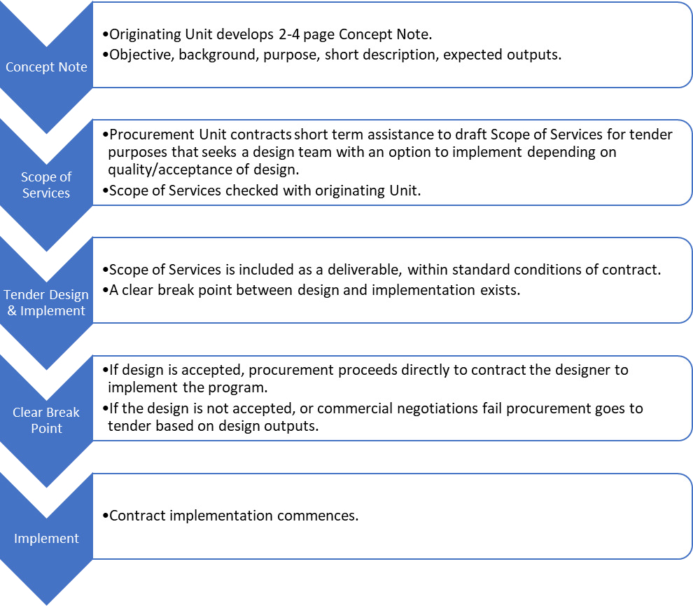

#### Diagram 5: Design and Implement tender process.

24 Thornton, et al (2018). *Ibid*. p8 and p39.

This design and implement tender process involves only minimal effort from the originating Unit with the development of a short 2 to 4-page Concept Note. This Concept Note is then developed into a Scope of Services and put to tender for design and implement with clear break points pending acceptance of the design. The approach saves considerable time getting from the ‘idea stage’ to implementation, relieves the Procurement Unit of developing a tender ready document and allows a dedicated design team to adequately scope needs and avoid assumptions. It also gives the originating Unit the ability to direct the design process and its outputs without having to micro- manage it.

# Appendices

# Appendix 1: Education Performance Matrix 2018

#### Solomon Islands Education Sector Program 2 2018 Education Performance Matrix

**Goal:** To improve the quality of education in Solomon Islands by improving:

1. the quality of teachers and teaching;
2. equitable access to education;
3. the quality and effectiveness of educational leadership and management at all levels of the system; and
4. the resourcing and utilization of available education resources.

|  |  |  |  |  |  |  |
| --- | --- | --- | --- | --- | --- | --- |
| **NEAP**  **Priority** | **NEAP/ MEHRD**  **AWP25** | **MELP**  **Outcome**  **areas** | **2018 Indicators/AWP outputs for Performance Payment** | **Responsible** | **Expected Results Statements** | **Data Source** |
| **Access** | EO1.2 (TBA) | 1.1  Transition rates by level and gender | * + 1. By the end of 2018, the SISE Phase-out Committee has costed plan in place to cater for increased enrolments in years 7 and 10 and alternative placement method and plan socialised with EAs     2. Transition Rates for year 6 to 7 and year 9 to 10   from 2017 to 2018 show an increase over 2016-2017 | NEAD | * Quality costed plan (30%) * SMT Minute endorsing plan (50%) * EAs socialisation completed (10%) * Transition Rates increase (10%) (as per Annual Report 2018) | * Quarterly Progress reports – SES Division/Schools Divisions * SMT minutes * PAR 2018 Data * Key Output Report * Output Indicator Tracker Table * Mid NEAP Review Findings report |
| **Access** | EO1 (65) | 1.2 Safe and equitable access | * + 1. By the end of 2018, Gender Equality in Education Policy – implementation strategy costed and approved by NEB     2. By the end of 2018, Child Protection Policy consulted on and revised in light of consultations | PA | * A quality Gender Equality in Education Policy – implementation strategy costed (30%) and NEB endorsement minute (30%) * A quality Child Protection Policy consulted with selected EAs and schools (30%) and revisions made based on consultations (10%) | * Quarterly Progress reports – SES/Schools Divisions & SSU/Policy unit * Key Output Report - Access * NEB minute * Quarterly Progress reports – SES/Schools Divisions & SSU/Policy unit * NEB minute * Output Indicator Tracker Table |

25 These references relate to either a MELP End or Intermediate outcome, Annual Work Plan 2018 Task number or whether it is a DFA (Direct Financing Agreement) condition. TBA (to be advised) refers to indicators that currently have no Annual Work Plan reference.

|  |  |  |  |  |  |  |
| --- | --- | --- | --- | --- | --- | --- |
| **Quality** | IO2.1 (11& 13) | * 1. More teachers using new improved curriculum | * + 1. By the end of 2018, PPY Pilot in Honiara, Guadalcanal and Malaita completed and evaluated     2. By the end of 2018, Cognition contract (as at June 2018) deliverables completed and accepted | CDD | * PPY Monitoring Report received by MEHRD and UNICEF (35%)   Cognition deliverables (65%) including:   * Year 9 English Teaching Learning Guide ready for desktop publishing and printing * Year 9 Social Studies Teaching Learning Guide for desktop publishing and printing * Year 8 Maths Teacher Guide ready for printing * Year 9 Maths Teacher Guide ready for desktop publishing and printing * Senior secondary curriculum framework complete * Syllabi developed in priority subject(s) | * Quarterly Progress report – SES/Schools Division * Evaluation Report – SES/School Division * Quarterly Progress reports – Curriculum Division * Key Output Report - Curriculum * Completion report – Cognition * Output Indicator Tracker * Annual Report 2018 * Mid NEAP Review Findings report |
| **Quality** | IO2.3.1 (137) | 2.2  Teachers meeting agreed standards | 2.2.1 By the end of 2018, revised National professional standards for teachers (within Teacher Service Handbook) | TPDD  Standards | * Revised quality National professional standards draft consulted with selected provinces (50%) * Approval minute from SMT (50%) | * Quarterly Progress reports – SES/Standards and Performance * Annual Report 2018 * Mid NEAP Review Findings report |
| **Quality** | EO 2  (93) | 2.3 Number of students achieving at or above the expected literacy and numeracy level | * + 1. By the end of 2018, 2017 SISTA results analysed and disseminated in user-friendly way to national, EAs and school level     2. SISTA 2017 results show an improvement in both literacy and numeracy for both grades 4 and 6 | NEAD | * SMT endorsement minute of SISTA results including national, provincial and school level reports (40%) * Evidence of dissemination to national, provincial and school level (e.g. meeting minutes, back to office reports) (30%) * An average of all literacy domains has improved and numeracy has improved (30%)26 | * Quarterly Progress reports – NEAD * Key Output Report – student assessment * Output Indicator Tracker |

26 As per main body of report, the 2018 Preliminary Report on SISTA 2017, states SISTA 2015 & 2017 are not statistically comparable, further discussions with EQAP pending. There is a possibility that EQAP can make a judgement on this.

|  |  |  |  |  |  |  |
| --- | --- | --- | --- | --- | --- | --- |
| **Quality** | EO2.3 (140) | 2.4  Percentage of certified teachers by gender | * + 1. By the end of 2018, delivery of USP Certificate in Teaching Primary (courses ED152 and ED100) for 75 untrained teachers completed     2. By the end of 2018, a Teacher Supply and Demand study endorsed by SMT | TPDD  TSD | * Untrained teachers (target of 75) complete both courses as reported in Annual Report 2018 (30%) * A quality Teacher Supply and Demand study endorsed by SMT (70%) | * Quarterly Progress reports – TPPD * PAR and Annual Report 2018 * Key Output report – teacher professional development * Quarterly Progress reports – TSD * Key Output Report – Teacher Management * Output Indicator Tracker Table * Mid NEAP Review Findings report |
| **Quality** | (48) TBA | 2.5 School grant expenditure used for learning materials | 2.5.1 By the end of 2018, school grants (Secondary, Primary and TVET) training completed in three provinces  2.5.2. By the end of 2018, analysis of retirements to show breakdown of expenditure | Grants Division/ Finance | * Training that promotes the use of school grants for learning materials carried out. Training reports or records for three provinces in 2018 (50%) * Report on analysis of acquittals showing currently how much of school grants is used for learning materials (50%) | * Quarterly Progress reports – Grants * Key Output Report – finance management * Annual Report 2018 |
| **Manag ement** | EO 3.1  (55-56) | 3.1  Retirement percentage of 2018 Second Biannual School Grants improved and 2019 first tranche disburseme  nt on time | 3.1.1 At least 65% of 2018 School grants are retired by 31 March 2019 (2018 Second Biannual)  3.1.2. At least 85% received the first tranche of their 2019 grant by 31 March 2019 | Grants Division/ Finance | * MEHRD Acquittal report for Primary, Secondary, TVET as at 31 March 2019 – retirements (50%) * MERHD Acquittal report for Primary, Secondary, TVET as at 31 March 2019 - disbursement of first tranche for 2019 (50%)   (NB: ECCE to be phased out) | * Key Output report – finance management * Annual Report 2018 * Output Indicator Tracking Table |
| **Manag**  **ement systems** | TBA | 3.2 New  education bill is passed | 3.2.1 Draft Education Bill is endorsed by NEB in October | SMT | * Bill in final format approved by SMT (50%) * NEB memorandum to Minister of EHRD (50%) | * SMT minutes |
| **Manag ement systems** | IO3.2 (40) | 3.3  Education Authorities operate to agreed  standards | 3.3.1 By the end of 2018, Standards approved, 27 EAs receive training including initial self-assessments completed and analysed | EACI | * Quality EA Standards drafted (20%) * SMT approval minute of EA Standards (50%) * Training in initial self-assessments completed by EACI (30%) | * Quarterly Progress reports – EACI * Key Output report – EA Capacity & Standards * EA Conference 2018 report * Mid NEAP Review Findings report |

|  |  |  |  |  |  |  |
| --- | --- | --- | --- | --- | --- | --- |
| **Manag ement systems** | E03.6 | 3.4 The  2018  recurrent expenditure for Basic Education is maintained  or improved | 3.4.1 Recurrent expenditure for per-unit cost per student at Primary and Secondary School in 2018 is equal or greater than 2017 | Finance | Calculate using real prices, recurrent allocation includes primary (50%) and secondary (50%) grant component. (2018 Annual Report, expenditure report (actuals)27 | Key Output report – finance Annual Report 2018 |
| **Manag ement systems** | DFA | 3.5 Solomon Islands Governmen t scholarships budgeting and expenditure is  sustainable | * + 1. The total of new SIG scholarship awards allocated for 2018 is 700 or fewer including for local and international institutions     2. 2018 MEHRD Scholarship expenditure is not higher than 2017 MEHRD Scholarship expenditure | NTU,  Finance | * SIEMIS Expenditure Report as per 2018 Annual Report   (50%)   * NTU SIMS data report (50%) | * NTU reports * SIMS data * Annual financial report 2018 |
| **Manag ement systems** | EO3.3 DFA | 3.6 The Solomon Islands Governmen t maintains its recurrent budget allocation for education in  2017 | 3.6.1 A minimum of 22% of national recurrent expenditure is committed to the education sector | Finance, SMT | * SIEMIS Expenditure Report as per 2018 Annual Report   (100%) | * Annual financial report 2018 |
| **Manag ement systems** | DFA | 3.7 External Audits of MEHRD  finances are  conducted | 3.7.1 By the end of 2018, 2015 External Audit of MEHRD complete (four cycles and transactions), including MEHRD management response | OAG SMT | * MEHRD Management Response for External Audit Part 1 completed (70%) * MEHRD Management Response for External Audit Part 2 completed (30%) | * Quarterly Progress reports – Corporate Services * Annual Report 2018 * SMT minutes |

27 It is recommended that this calculation use only grant expenditure as payroll expenditure for secondary and primary teachers is often wrongly coded. In future years, as the data is cleaned, it would be more accurate to include payroll.

# Appendix 2: Terms of Reference

Australia and the Solomon Islands Government agreed to set annual targets in an Education Performance Matrix attached to the Direct Funding Agreement (DFA) that links performance payments to achievement of the agreed targets. The aim of these payments is to incentivise performance of the education sector.

An Independent Assessor is required to conduct a review of SIG’s performance against the agreed 2018 Education Performance Matrix, recommend a percentage for the performance payment and recommend targets for 2019.

An incentive payment is provided yearly to the Ministry of Education and Human Resource

Development’s (MEHRD) on the achievement of annually agreed targets set out in the education performance matrix.

This year will be the seventh year that an Independent Assessor has assessed the SIG’s performance against a performance matrix.

The Assessor’s report will contribute to the broader sector review undertaken by SIG and development partners at the Annual Joint Review (AJR).

The Assessor should have the following qualifications and experience:

* Experience in Sector Wide Approaches particularly in the service delivery sectors.
* Experience of performance incentive programs/mechanisms.
* Experience in the education sector important and knowledge of education in the Pacific and Solomon Islands an advantage.
* Academic qualifications, i.e. a master’s degree or higher in a relevant field.

The Assessor will provide advice to all parties on the payment of the performance component of the education sector budget support, specifically:

1. Review SIG performance against the agreed milestones in the 2018 Education Performance Matrix.
2. Provide a recommendation of what performance payment should be made based on the SIG’s performance.
3. Provide advice on the strengths and weaknesses of the 2018 performance indicators.
4. Include MEHRD officers working on M&E in as much of the in-country visit as possible as a learning experience while maintaining the assessment’s independence.
5. Provide advice on indicators for 2019 informed by: priority policy reforms; the Education Sector Program 2 (ESP2) design, the ESP2 Mid-term Review; and the MEHRD M&E framework.
6. REPORTING AND IMPLEMENTATION ARRANGEMENTS

The Assessor will implement the assessment as follows:

* 1. Document review of data sources as included in the 2018 Education Performance Matrix (up to 4 days, indicatively 20-23 May 2019).
  2. In-country visit (indicatively from 3 to 12 June 2019) to conduct consultations with key stakeholders including the MEHRD Senior Management Team, key MEHRD divisional heads, and Donor Partners – Australia and New Zealand (up to 12 working days + up to 4 days travel):
* Data collection, analysis, consultations, drafting.
* Separate briefings to the MEHRD Senior Management Team and DFAT on preliminary findings.
* Presentation of findings and recommendations to the AJR (indicatively on 12 June 2019). This presentation should include: tabling of preliminary findings; outlining of areas of strength and weakness; outlining 2018 payment recommendation; outlining recommended 2019 performance indicators; recommendations on how the independent assessment process can be improved.
  1. The assessor will provide the following reports:
* Initial findings from document review two weeks before the AJR (indicatively by 28 May 2019).
* Preliminary findings report provided at the time of the AJR.
* Final report (up to 4 days preparation) submitted no later than 2 weeks after the AJR (indicatively by 26 June 2019). As part of preparing this report the Assessor will, as required, follow- up with DFAT and the MEHRD on issues raised during the in-country mission and AJR in order to confirm findings and data.

1. TIMELINE

A total of up to 20 days is provided for this assignment (plus up to 4 days travel). The assessor must perform the Services and complete all deliverables between 20 May 2019 and 30 June 2019 in accordance with the above indicative timeframes noting that they may change with prior notification.

# Appendix 3: Key Documents Reviewed

|  |  |
| --- | --- |
| **Document** | **Source** |
| Direct Funding Agreement between the Government of Australia and Solomon Islands Government | AHC |
| Solomon Islands Education Sector Statement of Partnership Principles between Solomon Islands Government and Development Partners 2016–2020 | AHC |
| Solomon Islands Education Sector Support Program Independent Performance Assessment 2016 | AHC |
| Solomon Islands Education Sector Support Program Independent Annual Performance Assessment 2017 | AHC |
| Solomon Islands Education Sector Statement of Partnership Principles 2016-2020 | AHC |
| National Education Action Plan 2016–2020 | MEHRD |
| National Education Action Plan 2016–2020 Implementation Framework | MEHRD |
| Performance Assessment Report 2015 & 2016, 2017 | MEHRD |
| MEHRD 2018 Quarter 1 Report | MEHRD |
| MEHRD Monitoring, Evaluation and Learning Plan 2017 to 2020 | MEHRD |
| MEHRD Annual Work Plan 2018 | MEHRD |
| Public Financial Management Plan | AHC |
| Solomon Islands Government Recurrent Estimates 2018 | MOFT |
| Solomon Islands Budget 2018: Budget Strategy and Outlook, Volume 1 | MOFT |
| Central Bank of Solomon Islands, 2018 Annual Report | MOFT |
| School Financial Management Handbook | MEHRD |
| Solomon Islands National Disability Inclusive Education Policy 2016–2020 (Draft) | MEHRD |
| Solomon Islands Gender Equality in Education Policy 2018-2022 (Draft) | MEHRD |

|  |  |
| --- | --- |
| Solomon Islands SISTA Report 2018 | MEHRD |
| 2017 and 2018 Central Bank of Solomon Island’s Annual Reports. | Internet |
| DFAT, Office of Development Effectiveness, (2016) *Investing in Teachers Evaluation.* | Internet |
| O’Meara, F. (2017) Solomon Islands Scholarship Analysis Report – powerpoint presentation | MEHRD |
| https:/[/w](http://www.solomontimes.com/news/government-terminates-179-)w[w.solomontimes.com/news/government-terminates-179-](http://www.solomontimes.com/news/government-terminates-179-) scholarships/8895 | Internet |
| Holzapfel, S. and Janus, H. (2015) Improving Education Outcomes by Linking Payments to Results: An Assessment of Disbursement-linked Indicators in five Results-based Approaches. | Internet |
| OECD peer review 2018 …. [https://read.oecd-ilibrary.org/development/oecd-](https://read.oecd-ilibrary.org/development/oecd-development-co-operation-peer-reviews-australia-2018_9789264293366-en#page1) [development-co-operation-peer-reviews-australia-2018_9789264293366-en#page1](https://read.oecd-ilibrary.org/development/oecd-development-co-operation-peer-reviews-australia-2018_9789264293366-en#page1) | Internet |
| Thornton, B. and Upton, V. (October 2018), *Education Sector Program 2: Basic Education Component Independent Mid-Term Review.* Prepared for the Australian Department of Foreign Affairs and Trade, Australian High Commission in Solomon Islands. | AHC |

# Appendix 4: Key Informant Interviews

|  |  |  |
| --- | --- | --- |
| **Name** | **Position** | **Organisation** |
| Leah Horsfall | First Secretary Education | AHC |
| Moses Tongare | Senior Program Manager | AHC |
| Eileen Kwalea | Program Manager | AHC |
| Anabel Lusk | Second Secretary, Development | NZ High Commission |
| Dr Franco Rodie | Permanent Secretary | MEHRD |
| James Bosamata | Deputy Secretary | MEHRD |
| Joe Ririmae | Under Secretary Corporate | MEHRD |
| Linda Wate | UTSL (Ag)/Director Teacher & Learning | MEHRD |
| Constance Nasi | CEO (Designate) SITESA | MEHRD |
| Mathias Kutai | USES (Ag)/Director TSD | MEHRD |
| Emily Siriki | Director School Review & Standards | MEHRD |
| Curtis Kalu | Manager Scholarships | MEHRD |
| Julie Lilo | Director Schools | MEHRD |
| Martin Marairi | Chief Accountant - Grants | MEHRD – Finance |
| Ben Namo | Manager, Internal Audit | MEHRD – Internal Audit |
| Rose Paia | Manager, Curriculum Development | MEHRD – National Education Services |
| Charles Rouikera | Manager, Teacher Professional Development | MEHRD – National Education Services |
| Ali Zareqe Kiko | Manager, EA Support | MEHRD |
| Moses Nukufakat onu | Manager Grants (Accounts) | MEHRD |
| Henson Makoani | Manager AMD | MEHRD |

|  |  |  |
| --- | --- | --- |
| Christina Bakolo | Coordinator – International Education Coordination and NEB | MEHRD - SSU |
| Margaret Saumare | Team Leader Innovation | MEHRD |
| Anita Ringi | Manager (Ag) Procurement | MEHRD |
| Kathleen Sikapau | Manager, EA Support | MEHRD |
| Christopher Sakiri | Manager (Ag) M&E | MEHRD |
| Tongoua Tabe | Manager (Ag) School/Centre Registration | MEHRD |
| Gladys Siale | Manager Schools | MEHRD |
| John Riare | Manager (Ag) ISD | MEHRD |
| Richard Adomana | Manager Planning | MEHRD |
| Judith Pule | Logistics | MEHRD |
| Katja Juksa | Adviser Procurement | MEHRD - Procurement |
| McGreggor Richards | Technical Adviser, Payments and Finance | MEHRD – Finance |
| Steven Rose | Monitoring and Evaluation Adviser | MEHRD - SSU |
| Gerard Direen | Technical Adviser, School Review and Standards | MEHRD |
| Helen Rose | Education Sector Management Adviser | MEHRD – SSU |
| Christine Swift | Technical Adviser, Legislative Drafter | MEHRD |
| Sam Long | ISD ICT adviser (VSA) | MEHRD |
| Dr Zelalem Taffesse | Chief of UNICEF Solomon Islands Field Office | UNICEF |
| Barry Peddle | Team Leader S4EG | SINU |
| Phil Coogan | Team Leader ESP new design | Cognition NZ |
| Peter Lokay | Auditor General | Office of the Auditor General |
| Johnson Lobo | Senior Adviser | Office of the Auditor General |

# Appendix 5: 2018 Performance Summary

|  |  |  |  |  |  |
| --- | --- | --- | --- | --- | --- |
| **MEHRD** | **MELP**  **Outcome Areas** | **Performance Indicators** | **Expected Results Statements** | **IA** | **Payment AUD** |
| **ACCESS EO1.2** | **1.1 Transition**  **rates by level and** | 1.1.1 By the end of  2018, the SISE Phase- | Quality costed plan  (30%) SMT Minute | 20% (of 90) | $ 20,571 |
|  | **gender** | out Committee has | endorsing plan (50%) |  |  |
|  |  | costed plan in place to | EAs socialisation |  |  |
|  |  | cater for increased | completed (10%) |  |  |
|  |  | enrolments in years 7 |  |  |  |
|  |  | and 10 and alternative |  |  |  |
|  |  | placement method and |  |  |  |
|  |  | plan socialised with |  |  |  |
|  |  | EAs |  |  |  |
|  |  | 1.1.2 Transition Rates for year 6 to 7 and year 9 to 10 from 2017 to | Transition Rates increase (10%) (as per Annual Report 2018) | 0 | $ - |
|  |  | 2018 show an increase |  |  |  |
|  |  | over 2016-2017 |  |  |  |
| **ACCESS EO1 (65)** | **1.2 Safe and**  **equitable access** | 1.2.1 By the end of  2018, Gender Equality | A quality Gender  Equality in Education | 20% (of 60) | $ 13,714 |
|  |  | in Education Policy – | Policy – |  |  |
|  |  | implementation | implementation |  |  |
|  |  | strategy costed and | strategy costed (30%) |  |  |
|  |  | approved by NEB | and NEB endorsement |  |  |
|  |  |  | minute (30%) |  |  |
|  |  | 1.2.2 By the end of 2018, Child Protection  Policy consulted on | A quality Child Protection Policy  consulted with selected | 100% (of 30)  + 40% (of 10) | $ 38,857 |
| and revised in light of | EAs and schools (30%) |  |  |
| consultations | and revisions made |  |  |
|  | based on consultations |  |  |
|  | (10%) |  |  |
| **QUALITY IO2.1**  **(11& 13)** | **2.1 More**  **teachers using** | 2.1.1 By the end of  2018, PPY Pilot in | PPY Monitoring Report  received by MEHRD and | 100% (of 35) | $ 40,000 |
|  | **new improved** | Honiara, Guadalcanal | UNICEF (35%) |  |  |
|  | **curriculum** | and Malaita |  |  |  |

|  |  |  |  |  |  |
| --- | --- | --- | --- | --- | --- |
|  |  | completed and evaluated |  |  |  |
| 2.1.2 By the end of 2018, Cognition contract (as at June 2018) deliverables completed and  accepted | Cognition deliverables (65%) | 100% (of 65) | $ 74,286 |
|  | **2.2 Teachers meeting agreed** | 2.2.1 By the end of 2018, revised National | Revised quality National professional standards | 20% (of 100) | $ 22,857 |
| **QUALITY IO2.3.1** | **standards** | professional standards  for teachers (within  Teacher Service | draft consulted with  selected provinces  (50%) Approval minute |  |  |
|  |  | Handbook) | from SMT (50%) |  |  |
| **QUALITY EO 2** | **2.3 Number of students** | 2.3.1 By the end of 2018, 2017 SISTA | SMT endorsement minute of SISTA results | 100% (of 70) | $ 80,000 |
|  | **achieving at or** | results analysed and | including national, |  |  |
|  | **above the** | disseminated in user- | provincial and school |  |  |
|  | **expected literacy** | friendly way to | level reports (40%) |  |  |
|  | **and numeracy** | national, EAs and | Evidence of |  |  |
|  | **level** | school level | dissemination to |  |  |
|  |  |  | national, provincial and |  |  |
|  |  |  | school level (e.g. |  |  |
|  |  |  | meeting minutes, back |  |  |
|  |  |  | to office reports) (30%) |  |  |
|  |  | 2.3.2 SISTA 2017  results show an | An average of all  literacy domains has | 10% (of 30) | $ 3,429 |
|  | improvement in both | improved and |  |  |
|  | literacy and numeracy | numeracy has improved |  |  |
|  | for both grades 4 and 6 | (30%) |  |  |
|  | **2.4 Percentage of certified teachers** | 2.4.1 By the end of 2018, delivery of USP | Untrained teachers (target of 75) complete | 100% (of 30) | $ 34,286 |
| **by gender** | Certificate in Teaching | both courses as |  |  |
|  | Primary (courses | reported in Annual |  |  |
|  | ED152 and ED100) for | Report 2018 (30%) |  |  |
|  | 75 untrained teachers |  |  |  |
|  | completed |  |  |  |

|  |  |  |  |  |  |
| --- | --- | --- | --- | --- | --- |
|  |  | 2.4.2 By the end of 2018, a Teacher Supply and Demand study endorsed by SMT | A quality Teacher Supply and Demand study endorsed by SMT (70%) | 0% | $ - |
| **QUALITY (48) TBA** | **2.5 School grant expenditure used for learning materials** | 2.5.1 By the end of 2018, school grants (Secondary, Primary and TVET) training completed in three provinces | Training that promotes the use of school grants for learning materials carried out. Training reports or records for three provinces in 2018  (50%) | 100% | $ 57,143 |
| 2.5.2. By the end of 2018, analysis of retirements to show breakdown of expenditure | Report on analysis of acquittals showing currently how much of school grants is used for learning materials  (50%) | 0 | $ - |
| **MANAGEMENT SYSTEMS EO3.1 (55-66)** | **3.1 Retirement percentage of 2018 Second Biannual School Grants improved and 2019 first tranche disbursement on time** | 3.1.1 At least 65% of 2018 School grants are retired by 31 March 2019 (2018 second biannual) | MEHRD Acquittal report for Primary, Secondary, TVET as at 31 March 2019 –  retirements (50%) | 0 | $ - |
| 3.1.2. At least 85% received the first tranche of their 2019 grant by 31 March 2019 | MERHD Acquittal report for Primary, Secondary, TVET as at 31 March 2019 - disbursement of first tranche for 2019 (50%) | 100% (of 50) | $ 57,143 |
| **MANAGEMENT SYSTEMS**  **(TBA)** | **3.2 New Education Bill is passed** | 3.2.1 Draft Education Bill is endorsed by NEB in October | Bill in final format approved by SMT (50%) | 100% (of 50) | $ 57,143 |
| NEB memorandum to Minister of EHRD (50%) | 100% (of 50) | $ 57,143 |

|  |  |  |  |  |  |
| --- | --- | --- | --- | --- | --- |
| **MANAGEMENT SYSTEMS I03.2 (40)** | **3.3 Education Authorities operate to agreed standards** | 3.3.1 By the end of 2018, Standards  approved, 27 EAs receive training including initial self- assessments completed and  analysed | Quality EA Standards drafted (20%)  SMT approval minute of EA Standards (50%) Training in initial self- assessments completed by EACI (30%) | 100% | $ 114,286 |
| **MANAGEMENT SYSTEMS EO3.6** | **3.4 The 2018**  **recurrent expenditure for Basic Education is maintained or improved** | 3.4.1 Recurrent expenditure for per- unit cost per student at Primary and Secondary School in 2018 is equal or greater than 2017 | Calculate using real prices, recurrent allocation includes primary (50%) and  secondary (50%) grant component. | 100% | $ 114,286 |
|  | **3.5 Solomon Islands Government scholarships budgeting and expenditure is sustainable** | 3.5.1 The total of new SIG scholarship awards allocated for 2018 is 700 or fewer including for local and international  institutions | SIEMIS Expenditure Report as per 2018 Annual Report and NTU SIMS data report (100%) | 70% | $ 80,000 |
| 3.5.2 2018 MEHRD  Scholarship expenditure is not higher than 2017 MEHRD Scholarship expenditure |
| **MANAGEMENT SYSTEMS E03.3 DFA** | **3.6 The Solomon Islands Government maintains its recurrent budget allocation for education in**  **2017** | 3.6.1 A minimum of 22% of national recurrent expenditure is committed to the education sector | SIEMIS Expenditure Report as per 2018 Annual Report | 100% | $ 114,286 |

|  |  |  |  |  |  |
| --- | --- | --- | --- | --- | --- |
| **MANAGEMENT SYSTEMS**  **DFA** | **3.7 External Audits of MEHRD finances are conducted** | 3.7.1 By the end of 2018, 2015 External Audit of MEHRD complete (four cycles and transactions), including MEHRD  management response | MEHRD Management Response for External Audit Part 1 completed (70%) MEHRD  Management Response for External Audit Part 2  completed (30%) | 100% | $ 114,286 |
| **TOTAL** |  |  |  |  | **$ 1,093,717** |
| **Percent of total** |  |  |  |  | **68.36%** |