

**Ponlok Chomnes, Cambodia**

**Independent Strategic Review**

Final report

Graham Teskey and Dr Rosita Armytage

July 2022

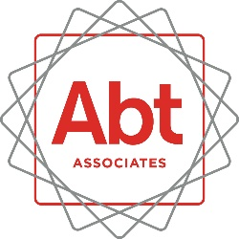

**Contents**

**Abbreviations and acronyms** 2

**Acknowledgements** 3

**1.**  **Summary** 4

**2**  **Purpose** 5

**3**  **Program background** 5

**4**  **Review framing** 5

**5**  **Country context** 6

**6** **Eight issues identified**  7

**7**  **The partners** 12

**8** **Effectiveness** 13

**9**  **Efficiency** 15

**10** **Recommendations** 16

**Annex A: Terms of Reference** 19

**Annex B: Interlocutors** 21

# **Abbreviations and acronyms**

|  |  |
| --- | --- |
| CPP | Cambodian People’s Party |
| CDRI | Cambodia Development Resource Institute |
| CICP | Centre for International Cooperation and Peace |
| CKS | Centre for Khmer Studies |
| CPS | Centre for Policy Studies |
| DFAT | Department of Foreign Affairs and Trade |
| EoPO | End of Program Outcome |
| FF | Future Forum |
| ISR | Independent Strategic Review |
| GEDSI | Gender Equality Disability and Social Inclusion |
| KRQ | Key Review Questions |
| MEF | Ministry of Economy and Finance |
| MEL | Monitoring, Evaluation and Learning |
| MIS | Management Information Systems |
| PEA | Political Economy Analysis |
| RGC | Royal Government of Cambodia |
| ToR | Terms of Reference |

**Acknowledgements**

We would like to thank all the people consulted during the review. In particular, the review team would thank staff of The Asia Foundation, all Core and Emerging partners of the Ponlok Chomnes Program, staff of the Asian Vision Institute, officials of the Royal Government of Cambodia, and colleagues in the Australian Embassy in Phnom Penh. All gave their time and views willingly. Finally - and in particular - we would thank Mr Sokha Seng, Senior Program Manager at the Australian Embassy and Mr Pechet Men, Program Manager at The Asia Foundation for making all the arrangements for the review meetings and for planning our trip to Siem Reap.

# **Summary**

* 1. **This review was undertaken in May 2022**. Its purpose was to assess the extent to which Ponlok Chomnes is contributing to strengthening policy analysis, dialogue and evidence-informed policy making in Cambodia.
  2. **The program has been broadly effective to date, but with caveats.** Should the program be extended in to a second phase from July 2023, it will require a number of important revisions. The program remains unequivocally relevant for both DFAT and the Royal Government of Cambodia (RGC). Should the program be extended to a second phase from July 2023, it will require a number of revisions to enhance its efficiency.
  3. **The program has four objectives.** It has fully met its first objective – increased understanding of Cambodia’s knowledge sector. This objective can be dropped from the final year of the current phase and any future phase. Objectives 2, 3, and 4 are broadly on track, although changes to their articulation are recommended.
  4. **Any extension beyond Phase 1 should encompass four significant revisions**. First, the program goal, its logic, and the theory of change must be revised. There is limited clarity on the strategic intent of the program (the Goal statement): is it to improve capacity in partners, to produce research, or to influence policy? The current Goal claims it is all three. It thus contains a ‘triple hierarchy’ of objectives, which has knock-on implications for the design and implementation of the program. The program logic and the theory of change need revising. It is recommended that a practitioner deeply experienced in Theories of Change and familiar with DFAT’s latest guidance on program logic (February 2022) be contracted to lead a workshop on these issues as soon as possible.
  5. **Second, consideration should be given to expanding the scope and breadth of the program, by increasing the number of Core Partners. A relatively ‘quick and dirty’ scoping study should be undertaken to ascertain the feasibility of think tanks and selected Cambodian universities becoming Core Partners.** A scheme should beconsidered to fund PhD candidates in Cambodian universities, to be jointly supervised by university staff and returned Australian Awardees holding PhDs from some of Australia’s top universities. A much more purposive and active approach to national and international networking should be instigated.
  6. **Third, the program is in need of additional strategic guidance and oversight.** There is little evidence of this to date. Review consultations with the TAF team revealed that strategic testing had not been used by the PC team to interrogate either the program logic nor progress towards the program objectives. It appears to have focused primarily at the activity and output level. There is also little evidence that TAF has drawn on their organisational expertise in strategic planning and strategy testing.
  7. **Fourth, the monitoring and evaluation system is undeveloped.** The emphasis of the monitoring effort has been on inputs, activities, and outputs. It is more akin to an MIS system than an M and E system. Simon Henderson’s proposals from March 2021 are conceptually elegant but too ambitious to be fully implemented. Once the strategic intent and the Goal of any extension is agreed, a revised (and simplified) M and E system must be designed. It is also advised that the Ponlok Chomnes team hire an experienced M and E specialist to guide the MEL process and implement a regular strategy testing process as these skillsets appeared to be missing among the current team.
  8. **The upshot of the third and fourth points is that Ponlok Chomnes is akin to a grants program, with TAF acting as its grants manager.**
  9. **The review identified concerns regarding program efficiency**. The total budget for the program is AUD 5.8 million over four years. **The future of the program?** Although not included in the Terms of Reference (Annex 1), this review has concluded that the program should proceed to a second phase, 2023 - 2027. If the program is extended, the contract with TAF should be renegotiated, with a view to ensuring adequate strategic guidance and oversight, and a functioning MEL system. This does not necessitate additional direct involvement from Ponlok Chomnes leadership, but rather that the entire TAF team (including any regional assistance) proactively identify any areas of weakness in the program logic, assumptions, MEL design of activities, or implementation; that TAF seek to identify opportunities that the program could take advantage of on an ongoing basis; and that TAF proactively bring these to the attention to DFAT with clear advice on what needs to change to maximise the program’s impact.

# **Purpose**

* 1. **The purpose of this independent strategic review (ISR) was to assess the extent to which Ponlok Chomnes approach, theory of change, and program modality are contributing to the objectives of strengthening policy analysis, dialogue and evidence-informed policymaking in Cambodia**. The review has generated recommendations designed to strengthen implementation and management for the final year of the program, and inform the design of what may be the second phase of the program.
  2. **To this end the ISR**:
     + Considered the nature of the ‘policy’ cycle;
     + Questioned the assumptions and the theory of change in the program;
     + Examined the effectiveness of current focus areas, approaches and implementation arrangements in achieving end of program outcomes.

# **A picture containing text Description automatically generated Program background**

* 1. **Ponlok Chomnes is an AUD 5.8 million four-year program (March 2019 - June 2023) that aims to strengthen the capacity of knowledge sector institutions to undertake quality research that informs public policy analysis and dialogue.** The goal of the Ponlok Chomnes program is “to strengthen the capacity of knowledge sector institutions to undertake quality research that informs public policy analysis and dialogue”. This is to be achieved by strengthening the organisational and technical capacity of research institutions, facilitating networking and collaboration among Cambodian and regional research institutions, and supporting an enabling environment for policy dialogue using data. This goal is planned to be realised through four objectives:
     + Objective 1: Increase understanding of Cambodia’s knowledge sector;
     + Objective 2: Strengthen the capacity and networking of established knowledge sector institutions;
     + Objective 3: Support diverse emerging knowledge sector actors to promote inclusive policymaking; and
     + Objective 4: Promote thoughtful and inclusive policy dialogue and analysis.

# **A picture containing text Description automatically generated Review framing**

* 1. **In line with the Review Plan submitted in April, this report has assessed progress of the program and generated recommendations to strengthen implementation and management for the final year and possibly beyond**. The review has examined the approach adopted as well as progress towards the outcomes. The review has assessed the Theory of Change (ToC) and the extent to which it has enabled real-time assessment of the drivers of progress. It has assessed the effectiveness of the current MEL system in terms of its ability to provide sufficient and appropriate data to inform TAF’s approach and test the ToC.

**Structure of the report**

* 1. **The report has six further sections**. Section 5 summarises the current context driving (or possibly inhibiting) the demand for ‘knowledge, evidence, and data’ in Cambodia. Section 6 reflects on eight issues that were identified in the process of undertaking the review. Section 7 summarises the program’s partners and their different political economies. Sections 8, 9, and 10 consider effectiveness, efficiency, and relevance respectively. Section 11 presents options for program evolution as it moves into its final year of the current phase (2022-2023) and possibly into a second phase.

# **A picture containing text Description automatically generated Country context**

* 1. **Cambodia is changing at a rapid rate**. TAF documentation on country context is strong and relevant. The original 2019 technical proposal, the revised request for ‘Stream 2’ funding in 2021, and the July 2021 Two Year Work-plan all comment on the changing context. Particular reference is made to the RGC’s ‘Rectangular Strategy’.
  2. **Rather less well drawn out are the factors driving (or constraining) the demand for knowledge and evidence regarding ‘what works’**. A mix of factors can be identified. First is the increasing integration of Cambodia in to the regional and global economy. The economy has grown by an annual average of 7% per annum since the new millennium, largely based on the production and export of garments. This strategy is time bound. In seeking further growth and development, Cambodia will need to move up the value chain and attract foreign direct investment as well as encourage local entrepreneurship, principally in the manufacturing and service sectors.
  3. **Third, the evidence tells us that as a country develops, a more demanding middle class emerges.** How such demands will be expressed will vary, but it is likely to include demands for better public schooling, governance and health services. A more educated middle class will be better informed and desire more successful public policy.
  4. **Three other factors may suggest an increasing interest in the collection of data and the use of evidence in policy making:** The current Cambodian administration is seeking a legacy; the widespread use of social media; and the rise of an increasingly influential ‘technocratic class’ in certain areas of government. MEF is led by highly trained public servants who are comfortable with handling and analysing data, and drawing policy conclusions.
  5. **It should be emphasised however that these drivers play out primarily in the medium-term**. In the short term (certainly in the life of the current Ponlok Chomnes project) decision making will remain in the hands of a political elite, and research and open policy discussion will probably be limited to service delivery and economic growth.
  6. **In the longer (ten year) term, it is not unreasonable to suppose that opportunities for greater contestation of ideas and policies will open up as the RGC grapples with the challenges that economic development brings**, one of which is managing more meaningful engagement on public policy issues and handling the decentralisation of power and authority.
  7. **These factors, taken together, suggest that the knowledge, data, and evidence are likely to become more, rather than less, prominent in policy debates over the next decade.** Ponlok Chomnes therefore looks likely to be a timely investment. For these reasons its continuation is recommended.

**

**(i) Strategic intent**

* 1. **The goal of Ponlok Chomnes is to strengthen the capacity of knowledge sector institutions to undertake quality research that informs public policy analysis and dialogue**. There are two issues regarding this Goal statement; its intent and its logic. Regarding the former, the Goal makes it clear the production of knowledge and ‘quality research’ is not an end in itself: it is a means to an end, and the ‘end’ is to influence public policy. Thus for Ponlok Chomnes, knowledge is instrumental, rather than intrinsic. There is nothing inherently wrong with this, but it does mean that the program is setting itself a demanding objective. It will be hard unequivocally to identify examples where Ponlok Chomnes has actually influenced policy. Given the logic inherent in the statement (see the next issue on theory of change), the program may strengthen the capacity of the knowledge sector to produce research, but it may not inform public policy. This problem can be rectified by revising the goal and the implicit theory of change.
  2. **The challenge is summarised in Figure 1, which presents a visualisation of the ‘policy making process’ –** a process which translates research into policy, policy into practice and operations, and which then subjects practice to oversight and review, and thus back into policy revision and refinement. What is the strategic intent of the program: how far around this idealised policy chain does its intent travel?

**Figure 1: The policy making process**

Diagram: Depiction of the four stages of the policy making process: research, policy, operations and oversight. 



**(ii) Theory of Change**

* 1. **Primary Question 1 d of the Terms of Reference (see Annex A) asks** “*To what extent does the current Theory of Change provide a clear program logic, reflect an accurate understanding of Cambodia’s policy environment, and provide a sound basis for the programs MEL? What changes are required to strengthen the logic of the program and more effectively guide program MEL?”*
  2. **The goal of the program is “to strengthen the capacity of knowledge sector institutions to undertake quality research that informs public policy analysis and dialogue in Cambodia”.** This statement contains a double hierarchy – in fact a triple hierarchy - which is not allowed in good project design…. To do something in order to achieve something else in order to achieve yet something else…. A goal so formulated makes evaluation almost impossible. Which of these three objectives matter the most? What happens if Ponlok Chomnes achieves the first two but fails the third? Has Ponlok Chomnes therefore failed?
  3. **The theory of change (ToC) that underpins this framework posits that *if* the capacity of knowledge sector institutions are improved, their research products are more relevant for policy making, their networks between research institutes are strengthened, plus more trusting relationships between research institutes and government exist, *then* policymaking processes will be informed by better evidence, leading to better development initiatives in Cambodia.** (*TAF Request for Stream 2 funding, Feb 2021).*
  4. **There are problems with this statement.** A convincing ToC requires a set of ‘if then because’ statements, not just ‘if then’ statements. The ‘because’ element explains *why we think the changes we outline will actually happen* – why they are politically feasible as well as technically desirable. If the ‘because’ element is omitted the ToC is reduced to a theory of action – how we hope the changes will happen. In the statement in the preceding paragraph, why do we believe any of these if-then statements? What evidence do we have that RGC wants all this to happen? It may do but the ToC must capture it. The Program Logic and the ToC must be revised as soon as possible.

**(iii) What is meant by ‘quality research’?**

* 1. **Ponlok Chomnes documents aspire to producing quality research, but there is no explanation of just what constitutes ‘quality’ research.** Only one of the core partners could answer this question unequivocally – and in addition to a range of research standards commonly denoting academic rigour it means seeking sign off by the Ethics Committees of various internationally respected universities for all research projects. Other partners referred to processes of peer review. It was also suggested to the review that Emerging Partners struggled to produce ‘Quality Research’.
  2. **One possible option would be to consider the framing proposed by Carol Weiss in 1979**.[1] This is reproduced in Figure 2. This is one suggestion only. This will need clarifying before a successor phase to the program. Other options for implementing a standard definition to incentivise and monitor “quality research” across Ponlok Chomnes partners may include the provision of standardised guidance to track and monitor improvements in the process followed including referencing multiple sources from creditable sources (both published and unpublished) and triangulating data.

**Figure 2: Considering research quality and impact**

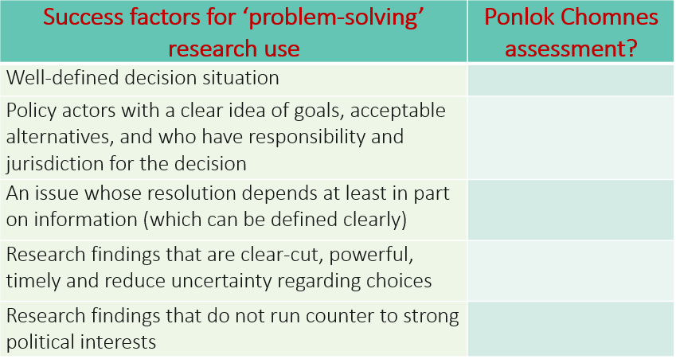

**(iv) Specificity and prescription**

* 1. **Primary Question 4 in the ToRs ask** “What are the benefits and weaknesses of (1) maintaining the currently un-predetermined focus of Ponlok Chomnes research priorities, versus (2) shifting the Ponlok Chomnes design to include a designated proportion of its research on specified priority policy areas (with those priorities being determined by DFAT and TAF, potentially with RGC input)? What would be the impact on program credibility, government and thinktank relations, and sustainability? Figure 3 shows the sector distribution of research reports published to date by both Core and Emerging Partners.

**Figure 3: Ponlok Chomnes research funded 2019-2022**

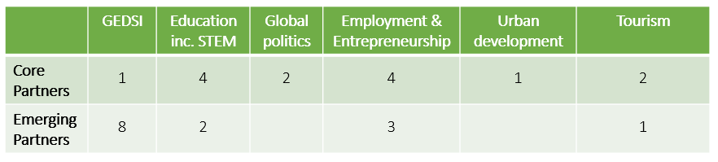

* 1. **At the outset, the program took a deliberate decision not to specify research priorities, themes, or sectors.** It is pertinent to ask whether this remains the appropriate positioning today. The disadvantages are that research may not match DFAT priorities, RGC priorities, or have much at all to do with a development agenda. Second, a thousand flowers blooming may not grow into a coherent garden. It may deliver a wilderness. Third, focusing research in specific areas increases the chance of impact, as one piece of research can be more easily dismissed.
  2. **One the other hand, specifying research priorities carries its own risks.** The definitions would have to be crystal clear to prevent endless discussions about what is in and what is out. Drawing a boundary about eligible research may exclude some current partners and – perhaps more importantly – exclude potential partners that the program would like to draw into the fold. Equally, both current and prospective partners may bridle at being told ‘what they can and what they cannot’ research, reducing partner ownership of the program, and the positive perceptions this aspect of the program has been credited with across parts of Government.
  3. **Although a case can be made either way, it is recommended that this laissez-faire approach be continued.** It is better for DFAT to decide which organisations it would like to partner with (including a view on the areas on which they focus), and then let them get on with it.

**(v) Monitoring and evaluation**

* 1. **Effective monitoring of knowledge sector initiatives is substantively difficult, as knowing when ‘research has influenced policy’ is extremely difficult, if not impossible to prove.** The program has struggled with MEL to date. Most, if not all, of the MEL work has been management information systems (MIS) work, focused on expenditure, inputs and activities – i.e. financial and physical progress. But MIS is not the same as MEL. Even at design stage a number of design weaknesses were built into the program: for example, in ‘Annex F Ponlok Chomnes Program Logic Model’ all the Intermediate Outcome indicators are indicators of Activities and Outputs, rather than Outcomes. Further, Annex F does not match the ToC outline of September 2020: the former has objectives, the latter has Outcomes. In short, the documents are muddled. In the September 2020 ToC model, no Outcome level indicators are provided for Outcomes. Objectives have now become Outcomes (Figure 4).
  2. **Figure 4: Outcomes 2 - 4**

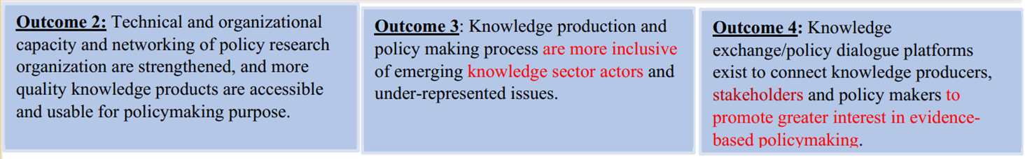

* 1. **A respected consultant was engaged to draft a way forward.** A strategy was delivered in March 2021.[2] The strategy (rightly) attempts to drive Ponlok Chomnes away from reporting on expenditures and activities, and towards measuring the four program objectives. Figure 5 reproduces the consultant’s framing.

**Figure 5: The Henderson MEL framework**

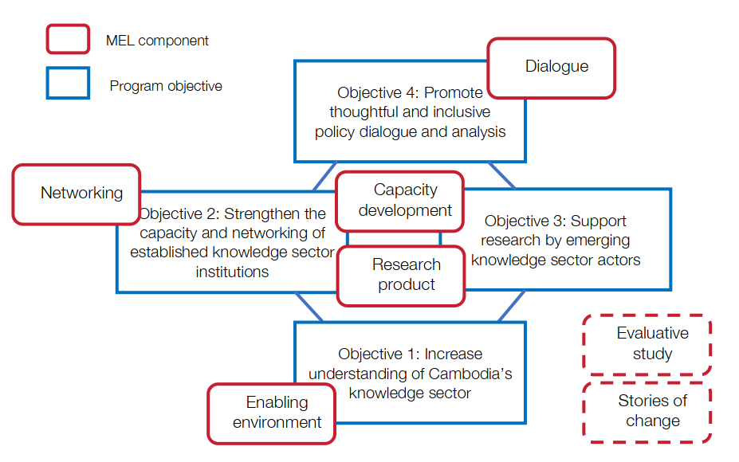

* 1. **Implementing this framework has proved difficult, for three reasons:** first, Covid prevented any meaningful socialisation and training; second, Ponlok Chomnes has no dedicated MEL staff; and third, while the framework is conceptually excellent, it is still demanding to put in place. Virtual training sessions between the consultant in the UK and the program team in Phnom Penh were continuing as this review was undertaken. Unless simplified, prioritised, and supported by a dedicated MEL staff member, it is unlikely that this framing will succeed.

**(vi) Program oversight**

* 1. **There are two issues regarding program oversight, and both arise directly as a result of choices made in the design.** First, at the strategic level, the management and oversight ‘style’ of Ponlok Chomnes is determined by the nature of the program: that it respects the autonomy of the partners. Ponlok Chomnes is content to let a thousand flowers bloom. Thus management and oversight is strategically ‘loose’. And it is loose twice over: first in that DFAT has given a high degree of strategic discretion to TAF in terms of how to use the available grant funding. Second, TAF in turn has an arms length (hands off) relationship with its partners in terms of overarching strategic guidance and oversight.
  2. **At the operational level the opposite is the case**. Here the management style is tight. Rather than discussing strategic issues on a quarterly or semi-annual basis (or reviewing performance annually through an external audit as SIDA is doing with its own research organisation support in Cambodia[3]), DFAT meets with the TAF team monthly to discuss workplan activities and to monitor expenditures, creating an unnecessary burden for both DFAT and TAF. In turn, for TAF program management, MIS has replaced MEL. Because MEL has proved so complicated, Ponlok Chomnes staff compensate and focus on overseeing spending on widgets. The upshot is that TAF spends much of its M and E time on Inputs and Activities, and little on Intermediate Outcomes and EoPOs. The oversight style is therefore ‘loose-loose-tight’ – the precise opposite of what it should be.
  3. **The second issue is the role of the Technical Advisory Council (the TAC).** It is advisory only. It is not clear to this review to whom it provides advice, on what topics, and what those advised should do with the advice is received. To date, the TAC members have not been asked to provide strategic advice to the program, but rather to participate primarily as listeners in TAC meetings in which TAF presents Ponlok Chomnes activities.
  4. **A more charitable view however should prevail.** It is clear that the TAC legitimates the functioning of the whole program. It provides necessary political cover. Representatives of five RGC ministries sit on the TAC. It is recommended that some small ‘tweaks’ be made to the functioning of the Council. Rather than ‘merely’ receive reports from TAF as it seems to do at the moment, the TAC could be invited seriously to discuss one contemporary public policy issue at each meeting (arising from Ponlok Chomnes funded research), and its advice sought on how the program could best use this research.

**Figure 6: Technical Advisory Council**

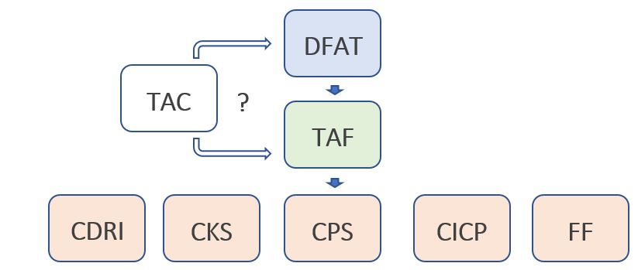

**(vii) Dissemination and communications strategy**

* 1. **Secondary question 3 in the ToRs asks** “to what extent is DFAT engagement with the program being effectively leveraged to strengthen the program’s policy influencing objectives (i.e. through engagement of senior Embassy staff, linkages with other DFAT programs/Australian government departments, and/or through leveraging the Embassy’s diplomatic relationships in the region)? Are there specific ways in which DFAT could/should use its leverage and influence to further strengthen the Ponlok Chomnes approach and outcomes?”
  2. **The response to this question has to be that this aspect of the program has not really commenced**. Partly it was stymied by Covid-19, partly by the ambiguity of Ponlok Chomnes goal statement, and partly by the sheer scarcity of staff time in the Embassy to take this agenda forward. It is interesting to note that action points 3 - 5 of DFAT’s 2022 Ponlok Chomnes Annual Investment Monitoring Report are as follows:

1. DFAT will examine the internal resourcing for providing sufficient oversight of Ponlok Chomnes and identify if additional/targeted resources are required to provide effective oversight/support.
2. Post and TAF will work to facilitate greater communication and engagement between Ponlok Chomnes partner organisations and to develop a sense of a broader Cambodian knowledge sector identity/solidarity.
3. DFAT will use existing relationships with Cambodian government, including through the development program, to build government awareness of Ponlok Chomnes and facilitate greater connections between ministries and research organisations/products. DFAT will also work to promote greater Cambodian government investment in research in Cambodia.
   1. **These three commitments are as yet not being taken forward**. All will require designated staff time, energy, and vision.
   2. **In terms of ‘policy influence’ and engagement with the RGC, three points were made repeatedly to the review**. First, that for research to be trusted by the RGC, the organisation itself must be trusted. Second, where Core Partners do have access to the RGC, it is due to the existence of personal relations with the respective organisation director. Third, influence comes from a continuing relationship built on personal and organisational trust but also based on sound data and rigorous research methodologies.

**(viii) Learning from experience**

* 1. **The experience of the Knowledge Sector Initiative (KSI) in Indonesia is instructive.** In scale and ambition it is very different: the KSI design phase itself took three years, and since inception in 2009 its total funding has exceeded $100 million. KSI funds 16 principal research institutions, and, unlike Ponlok Chomnes, it puts equal emphasis on working with those government agencies most likely to use the knowledge so generated. That said, the objectives of KSI and its underlying thinking are similar. It is interesting therefore to note the lessons of KSI as identified in Simon Henderson Review of October 2021:
     + the contractor (Research Triangle International) were operating mainly as grants manager;
     + KSI was predominantly reactive;
     + there was no consistent strategy regarding the quality of research; and
     + its approach to capacity building was confused.
  2. **Ponlok Chomnes may be in danger of repeating these mistakes**.

# **A picture containing text Description automatically generated The partners**

**Core Partners**

* 1. **Despite the five core partners of Ponlok Chomnes all being in the ‘knowledge sector’**, they are different: they are motivated by different factors, they are financed in different ways, and they have different relationships with the RGC. Notwithstanding these differences, all five are legitimate partners for the program. Figure 7 illustrates the positioning of the five in four dimensions. Two of the partners (the Centre for Policy Studies, CPS, and the Centre for International Cooperation and Peace, CICP) are very small – fewer than six full time staff- and operate as research consultancies. CDRI, has been in existence since 1990. Its driver is to influence public policy. It receives an annual grant of US $600,000 from SIDA. CKS is something of an outlier among the five, as it is directed from the US via a Board comprised of American academics and philanthropists. It is funded by a mix of French, US and Belgian philanthropists. The final core partner, Future Forum (FF) is also a small organisation, but it is aimed at training young Cambodian researchers.

**Figure 7: Different partners, different approaches**

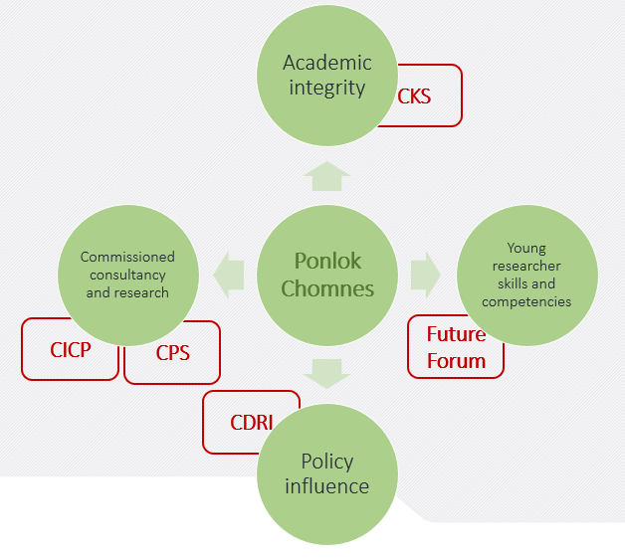

* 1. **The review found impressive leadership of all partners.** Each organisation has its own drivers and its own interests to which it responds.
  2. **Two points should be highlighted**. First (and inevitably), ownership structure and funding source drives the political economy of each organisation. The CDRI strives to be independent but has to walk a narrow line between independence and acceptability to the RGC. CDRI has five centres, and one, the Centre for Educational Research and Innovation, receives funding from Ponlok Chomnes. The CKS is owned and directed from the US.[4] It has a passionate President and an equally passionate Board, most of whom are academics. The CKS is unique among the five partners in that it prioritises independent research of the highest quality. All research proposals have to be approved by the ‘Ethics Committee’ of the associated foreign university, which for Ponlok Chomnes is the University of Sydney. The engagement with University of Sydney is part of CKS’s linkages plan under Stream II. They pair Cambodian researchers and Australian researchers to jointly conduct the research in hope to build capacity of Cambodian researchers.. While CKS privileges the intrinsic value of research and knowledge generation, it is content to sponsor research that is more instrumental and policy oriented. It considers the two approaches complementary rather than contradictory. Although small in terms of full time staff, CKS contracts a wide range of researchers for its programs. It is worth noting that CKS funds research on Cambodia, rather than research by Cambodians. This has resulted in CKS funding an Australian academic at the University of Sydney to undertake research on Cambodian policy, a funding allocation that appears to be at odds with the program’s objective of building Cambodian research capacity. CICP, CPS and FF are owner/founder led and managed. This brings passion and drive to each organisation, but it also brings fragility, and a sort of ‘day to day’, ‘week to week’ existence.
  3. **Second, size matters.** CDRI is well established and has 85 full time staff across its five centres. Ponlok Chomnes supports only its educational research centre. Although small, CKS is financially robust with its US base. By contrast, CPS, CICP, and FF are small-scale micro organisations that must continually work to raise funds. Their challenge is not independence, but sustainability. Each mentioned facing difficulties in recruiting and retaining good young researchers “with both high quality research skills and with a passion for research”.

**Emerging partners**

* 1. **Objective 3 of the program** is to “support diverse emerging knowledge sector actors to promote inclusive policymaking”. This is arguably one of the most interesting elements of the program. The review met with many of these partners and all were impressive and committed. The question is, what do these micro-grants of AUD 20-25,000 per grantee add up to? It is unlikely that they will be able to influence policy in any meaningful way– especially as policy as the policy environment is often driven from the centre in Cambodia. The quality of the research produced is variable, and their voices sometimes struggle to be heard. Further, once the discrete piece of research is completed, that is the end of the matter. The partners are too small to fund follow up work.[5] One option would be for this strand of the program to be closed at the end of Phase 1 in 2023. However, there are good arguments for its continuation: small organisations can make a modest difference at the local level; it contributes to the idea of diversity in knowledge production; and it gives a voice to often marginalised and excluded groups at the subnational level. This review has concluded that this funding stream should continue in line with the revised objective of broadening the space for policy dialogue and discussion.

# **Effectiveness**

* 1. **Effectiveness is concerned with the extent to which stated objectives were achieved**. **To what extent is the program achieving its goal?** The goal of the proposed program is to strengthen the capacity of knowledge sector institutions to undertake quality research that informs public policy analysis and dialogue in Cambodia” *(TAF Revised proposal January 2019).*  Primary Question 1 a in the ToRs asked: “*Do the objectives of the program reflect the most effective way for Australia to support progress on policy analysis and evidence-based policy making in Cambodia given priority needs for the sector and Australia’s experience and comparative strengths?”.*
  2. **Answering this question requires three issues to be disentangled**: how policy is made in Cambodia;is the strategic intent of Ponlok Chomnes to generate knowledge, influence policy or create a space for debate and dialogue; and does Australia have a clear sense of which policies it wishes to influence? This review has concluded that while policy is still decided by a relatively closed circle of senior political elites, space is opening up for policy debates on primarily technical issues in economic development and public service delivery. The strategy adopted by Ponlok Chomnes is, essentially, a broad based ‘scatter-gun’ approach to knowledge generation, with the hope that something, somewhere, may ‘stick’. If Australia wishes to influence specific policies of the RGC, then this clearly will not be the most effective way. Achieving this would require detailed and sustained engagement on the particular policy issue which DFAT wished to influence. If on the other hand Australia wishes to ‘nudge’ the wider culture of policy making towards increased engagement with ‘data’, ‘evidence’, ‘research’ and a greater space in which to explore and contest ideas, then yes, the current conceptualisation of Ponlok Chomnes is appropriate – but this will take several years.
  3. **Figure 11 considers the effectiveness of the program against each of its four objectives**. Objective 1 has been achieved. The April 2022 diagnostic study was particularly useful.[6] The program has undoubtedly been instrumental in mapping the knowledge sector. Success regarding objectives 2, 3, and 4 is rather more equivocal. It would be fair to say that all have been achieved to some extent.
  4. **Primary Question 1 b of the Terms of Reference asks “To what extent is Ponlok Chomnes integrated with and used to amplify/strengthen the broader goals of the Human Development program?”.** The clear answer here is no, it has not. This is for two reasons: first (as far as this review is aware) Ponlok Chomnes has not asked how it could do this (it is not in the program documents nor in its ToC), and the Human Development programs in DFAT have never asked Ponlok Chomnes to do it.

**Figure 11: Program effectiveness**

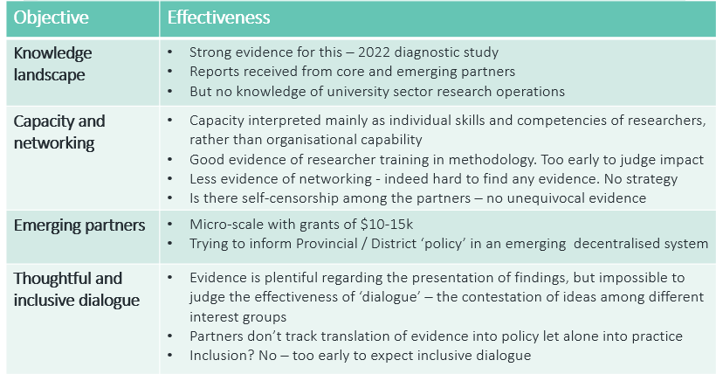

* 1. **Primary Question 1 c asks “Are there other areas of policy analysis, dialogue or policymaking support that are likely to have greater impact on strengthening policy dialogue and analysis in Cambodia as part of Australia’s broader aid portfolio that should be incorporated into future programs?**”. The answer to this question depends on the strategic intent of Ponlok Chomnes. If the objective was to achieve specific changes in certain public policy positions, then the current articulation of Ponlok Chomnes has little chance of achieving this. Given that the core partners can select their own research topics, the chances of them alighting on the very ones that DFAT prioritises are small indeed. Even if they did there is no clear and consistent mechanism in place to bring such research findings to the attention of the RGC. If Ponlok Chomnes were to specify research priorities, and if those selected areas were of priority to RGC, then the chances of actually influencing policy would increase. There are many ‘ifs’ in that sentence.

**In summary: effectiveness at the micro level**

* 1. **The program started modestly with a focus on understanding the knowledge landscape**. This was clearly appropriate. The decision not to specify research priorities ensured that as far as possible the program was locally led, and was seen by many if not all as ‘neutral’ – with no advocacy agenda. The program played a convening role and it achieved a good degree of visibility.
  2. **The program respected the sovereignty of partners**. It allowed smaller Think Tanks to survive, if not to ‘prosper’. Individual research skills and competencies were privileged over organisational development. This is hardly surprising as the former is much easier to conceptualise, plan, deliver, and monitor than are the latter. However, there is no doubt that the smaller partners (CPS, CICP, and FF) struggle with organisational issues due to their extremely small size. The program is working to address a number of the organisational weaknesses identified. Finally, the program avoided being seen as a ‘typical’ donor NGO advocacy program.

**In summary: effectiveness at the macro level**

* 1. **The ‘****chapeau’ Primary Question 1 in the Terms of Reference asks “Is Ponlok Chomnes focus on building the organisational and technical capacity development of the knowledge sector the most effective route to facilitating, shaping and impacting policy dialogue and analysis in Cambodia at the current time?**
  2. **The answer has to be no.** As argued in paragraph 8.5, if DFAT wished to influence specific policies, then Ponlok Chomnes would not be the way to do it. If on the other hand DFAT is content with building a modicum of ‘research capacity’ and broadening the space for alternate views to be examined and discussed with no guaranteed policy implications, then Ponlok Chomnes may well succeed.
  3. **Primary Question 3 asks “How effective has the program been in facilitating engagement, networking, and peer-learning** between Ponlok Chomnes supported organisations and other research organisations in Cambodia and the region, and to what extent has this objective contributed to the overarching End of Program Outcome? Should this outcome be a central goal of future programs, and if so, what approaches can be implemented, expanded, or adapted to strengthen the achievement of this outcome in future programs?”.
  4. **Again, the answer to this question is clearly no**. This may not be *primarily* due to the program. Covid-19 hugely disrupted implementation, and a case can be made that the program is really only now in its second year. While Covid undoubtedly played a part, it is also clear that there is limited culture of cooperation and collaboration among the five core partners. Consequently, the whole is not yet greater than the sum of the parts. It is also clear that the program prioritises independence and integrity over influence and impact as Ponlok Chomnes does not prioritise research areas or themes.

# **A picture containing text Description automatically generated Efficiency**

* 1. **The review found there is a need for greater strategic leadership from TAF.** Three points underpin this view. First, the formulation of the Goal of the program is muddled, as noted in paragraphs 6.3 – 6.6. Second, the theory of change does not qualify as a theory of change as it contains only ‘if-then’ statements, with no assessment of political feasibility. Third, there has been no rigorous interrogation of the program logic of the ToC since inception in 2019.
  2. **The benefits of maintaining the current implementing partner are that it frees up DFAT time for other matters;** it allows a partner to bring deep sector and country experience and knowledge; and it reduces DFAT’s staff time. The costs are that it inserts an additional layer between funder and partners; it imposes a high level of transactions costs; it risks replicating roles in DFAT and TAF; it frustrates some of the core partners; and it outsources learning to the implementor.
  3. **The disadvantages of recontracting would inevitably be a hiatus to the program as the new contractor mobilised and got up to speed;** the high risk of losing some or all of Ponlok Chomnes current high calibre staff (and thus the institutional memory); the need for the new contractor to recreate all the relationships and networks now enjoyed by TAF; and no guarantee that the new contractor would have the strategic capability that TAF do possess. This review therefore would not recommend going back to market, but would recommend a re-negotiation with TAF on the future program to ensure sustained and high quality strategic oversight and adequate resourcing for a streamlined MEL system.

**Relevance**

* 1. **The program remains absolutely relevant**. As was noted in section 5, Cambodia is in transition, and while we know where it has come from, we cannot know for certain where it is headed. Knowledge, data, and evidence are all likely to become more relevant not less in the decade ahead as Cambodia grows and further integrates into the global economy. The latter will demand effective policies. It will also continue to necessitate program support which broadens the space for policy research, dialogue, and contestation, including the views of Cambodians representing diverse perspectives.
  2. **As objective 1 has been achieved, this can be dropped from the program from July 2022**. Objectives 2, 3, and 4 should remain, but in a revised format (see indicative example at Figure 15). Consideration should be given to separating out the capacity objective and the networking objective. Program relevance is summarised in Figure 14.

**Figure 14 Program relevance**

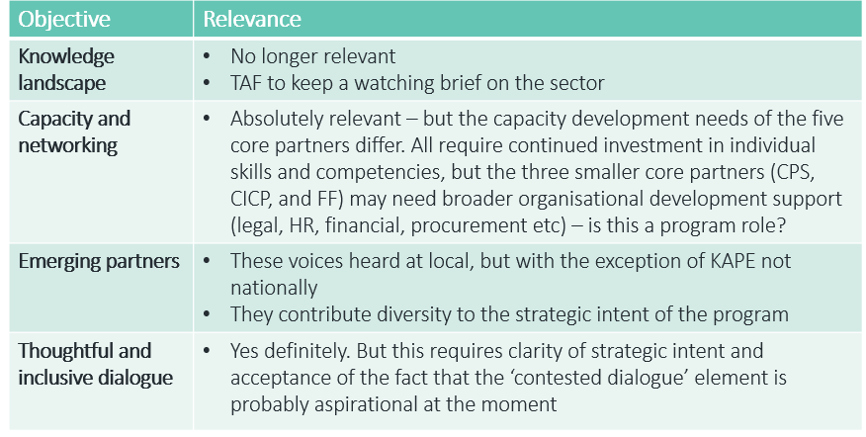

# **A picture containing text Description automatically generatedRecommendations**

**Strategic recommendations**

**The starting point has to be a re-articulation of the program’s strategic intent: everything else flows from this.** There are two options – this review would suggest that maintaining the current Goal statement is not an option:

* + - **A goal oriented towards policy influence and change**. Three issues arise here: to what extent is policy influence a legitimate goal? Does it have a clear conception of where policy change is needed and why? And third, if the answer to the second question is yes, do we think that the Ponlok Chomnes ‘scattergun’ approach will deliver such policy change?
    - **A second option would be to orient the goal to the emergence of a culture of knowledge and evidence production, public policy debate, and contestation.** Here, it is the process of evidence and knowledge production and policy making that is the strategic aim.

**Recommendation 1:** This review would recommend the second option. An indicative Goal statement would be “to foster a culture of knowledge generation and inclusive policy dialogue and debate” (See Figure 15).

**Recommendation 2**: As discussed in paragraphs 6.9 – 6.12 this review has concluded that assuming there will be a phase 2 of the program, no changes should be made to the ability of the partners to choose their own research topics.

**Recommendation 3**: It is also recommended that Ponlok Chomnes develop a dissemination and communications strategy.

**Programmatic recommendations**

**Recommendation 4:**  As discussed in paragraphs 6.18 – 6.19 noted, some minor revisions to the TAC are proposed, making it more of a policy discussion and advisory body to TAF and to partners. There is much expertise in the TAC currently it is not being used.

**Recommendation 5:** Undertake a scoping study as soon as possible to gauge the feasibility of expanding the number of core partners. These could be Cambodian universities, other research institutions, or ‘graduates’ from the Emerging Partners program.

**Recommendation 6**: As a part of the scoping study, investigate the feasibility if the program funding 10-15 Cambodian PhDs per annum, to be supervised by Cambodian university staff and returned Cambodian PhD alumni.

**Recommendation 7**: Draft and implement a coherent strategy for networking – putting in place MoUs with both regional and Australian universities.

**Recommendation 8:** Clarify what is meant by research quality and provide clear guidance/support to partners to achieve it/take steps towards it (see paragraphs 6.7 - 6.8 above).

**Operational recommendations**

**Recommendation 9:** Most importantly, the program logic and its ToC should be revised following agreement on the revised strategic intent of the program (the Goal statement). It is recommended that a practitioner deeply experienced in Theories of Change and familiar with DFAT’s latest guidance on program logic (February 2022) be contracted to co-lead a workshop with support from DFAT advisors on these issues as soon as possible.

**Recommendation 10:** The program should consider establishing a protected funding stream for gender and social inclusion research. While there has been research on gender and inclusion issues, this has come about by happenstance rather than design (see Secondary Question 1 in the ToRs).

**Recommendation 11:** The program must align its emerging MEL framework with the current MIS framework. The Henderson report of March 2021 remains the vision but it needs simplifying and prioritising following reworking of the program logic and ToC. It is unlikely to be even partly implemented in its current form. The MEL training currently being undertaken by the Ponlok Chomnes team should halt until the new Theory of Change is developed and the MEL strategy is directly aligned. The program should also consider hiring a specialist MEL advisor.

**Recommendation 12:** Separate the capacity building objective from the networking objective and plan activities accordingly. The two are different and not natural bedfellows (see Figure 15). Consider also separating capacity building in relation to research capacity and organisational strengthening as program objectives as each requires a different strategy and approach, and require that performance is tracked separately.

**Recommendation 13:** As indicated in the 2022 Ponlok Chomnes Aid Investment Monitoring Report, DFAT should consider allocating more resources (staff time) to the oversight and management of the program (see paragraphs 6.21 – 6.22). DFAT should also consider reallocating responsibility for overseeing the program from A-based staff in the Political team to the Development team where staff have existing development program management skills, are more directly incentivised to ensure program performance, and are better positioned to coordinate with and learn from other parts of the aid program.

**Recommendation 14:** Finally, DFAT and TAF should sit together to clarify levels of delegated authority, DFAT to TAF and TAF to core partners. It is recommended that this include DFAT empowering TAF to reduce the intensity of financial and activity-level scrutiny, where appropriate to do so, to free up staff time to enable greater efficiency and to focus on more strategic aspects of program management.

**Indicative program logic and theory of change**

* 1. **Figure 15 presents what a revised program logic and ToC could look like**. The purpose of the proposed ToC workshop would be to agree such a design among all partners.

**Figure 15: Indicative program logic and theory of change**

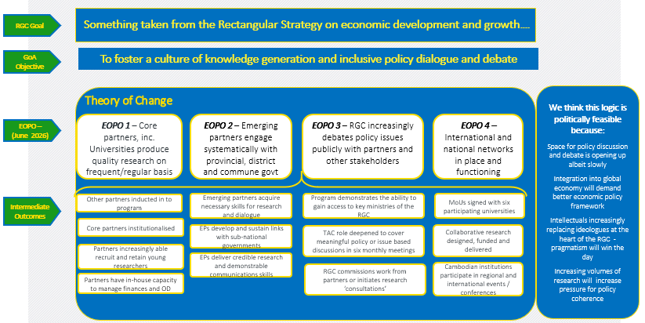

# **Annex A: Terms of Reference**

The principal purpose of this independent strategic review (ISR) is to assess the extent to which Ponlok Chomnes approach, theory of change, and program modality are contributing to its objectives of strengthening policy analysis, dialogue and evidence-informed policymaking in Cambodia. The evaluation will directly inform the subsequent design of future knowledge sector investments in Cambodia. This will include identifying the strengths and/or weakness of the program in regards to achieving policy influence and impact and ensuring post-program impact sustainability, so that the findings can inform the development of future programs in Cambodia and similar DFAT programs elsewhere.

We expect the ISR will:

* Question the current assumptions, theory of change and approach: are our assumptions about how policy is informed and the best routes towards more evidence-based policy-making holding true? Should future programming focus on different approaches?
* Examine the effectiveness of current focus areas, approaches and implementation arrangements in achieving end of program outcomes.

As part of assessing the questions outlined in the Review Purpose above, the review should examine the program MEAL (monitoring evaluation adaptation and learning) system to confirm if it is effectively (a) tracking and assessing progress towards its policy influencing objectives, and (b) supporting program adaptation and learning to maximise impact (and capitalise on emerging opportunities) through effective program feedback loops.

This review will draw on previous data/studies from the Program, targeted semi-structured interviews, and in-person/remote workshops/meetings to assess progress on the key areas noted above, and to inform recommendations to further strengthen performance in these areas in the second phase.

The review will conduct in-person/remote meetings with key DFAT staff at post, Ponlok Chomnes program staff, Cambodian Government stakeholders and other key stakeholders. The primary intended users of this review are the DFAT Phnom Penh post and the TAF Ponlok Chomnes management team. To maximise this review’s usefulness for staff at post, the Consultant will identify lessons for the implementation and oversight of the remaining period of Ponlok Chomnes and for policy dialogue with the Cambodian Government for the future program.

Additional potential audiences for this ISR are the Ponlok Chomnes additional implementing partners, Core Partners, Emerging Grantee Organizations, Cambodian public and other donors in Cambodia.

**Key Review Questions**

A draft set of evaluation questions have been developed and will be refined/finalised once the strategic review team are on board.

**PRIMARY QUESTIONS**

The primary questions the review is intended to cover include:

1. Is Ponlok Chomnes focus on building the organisational and technical capacity development of the knowledge sector the most effective route to facilitating, shaping and impacting policy dialogue and analysis in Cambodia at the current time?
   1. Do the objectives of the program reflect the most effective way for Australia to support progress on policy analysis and evidence-based policy making in Cambodia given priority needs for the sector and Australia’s experience and comparative strengths?
   2. To what extent is Ponlok Chomnes integrated with and used to amplify/strengthen the broader goals of the Human Development program?
   3. Are there other areas of policy analysis, dialogue or policymaking support that are likely to have greater impact on strengthening policy dialogue and analysis in Cambodia as part of Australia’s broader aid portfolio that should be incorporated into future programs?
   4. To what extent does the current Theory of Change provide a clear program logic, reflect an accurate understanding of Cambodia’s policy environment, and provide a sound basis for the programs MEL? What changes are required to strengthen the logic of the program and more effectively guide program MEL?
2. To what extent are the research products produced by the program influencing[7] the RGC, other research organisations (both domestically and regionally), and other knowledge-product consumers and amplifiers (e.g. civil society organisations, the media), and what can be done in future programs to amplify and extend any early indications of influence/ensure the research produced informs Cambodian policymaking?
3. How effective has the program been in facilitating engagement, networking, and peer-learning between Ponlok Chomnes supported organisations and other research organisations in Cambodia and the region, and to what extent has this objective contributed to the overarching End of Program Outcome? Should this outcome be a central goal of future programs, and if so, what approaches can be implemented, expanded, or adapted to strengthen the achievement of this outcome in future programs?
4. What are the benefits and weaknesses of (1) maintaining the currently un-predetermined focus of Ponlok Chomnes research priorities, versus (2) shifting the Ponlok Chomnes design to include a designated proportion of its research on specified priority policy areas (with those priorities being determined by DFAT and TAF, potentially with RGC input)? What would be the impact on program credibility, government and thinktank relations, and sustainability?

**SECONDARY QUESTIONS**

1. To what extent are the program activities supporting the social inclusion and capacity of women and people with disabilities both in research roles and organisations and within Cambodian society more broadly? What specific measures could the program take to enhance its impact on these GEDSI objectives?
2. To what extent has the current program design effectively incorporated strategies and approaches to ensure the sustainability of program outcomes beyond the life of the program? I.e. to what degree is the program (as currently designed) likely to contribute to the sustainable use of evidence-based policy making within RGC, and the continued existence, capability and influence of the Core Partner organisations? What additional measures could be put in place in the next phase to both ensure the longevity of quality independent research organisations in Cambodia, and to strengthen a culture of evidence-based policy making within the RGC (beyond the life of the program)?
3. To what extent is DFAT engagement with the program being effectively leveraged to strengthen the program’s policy influencing objectives (i.e. through engagement of senior Embassy staff, linkages with other DFAT programs/Australian government departments, and/or through leveraging the Embassy’s diplomatic relationships in the region)? Are there specific ways in which DFAT could/should use its leverage and influence to further strengthen the Ponlok Chomnes approach and outcomes?

**Annex B: Interlocutors**

|  |  |
| --- | --- |
| Name | Designation |
| Ms Meloney Lindberg | Country Representative, TAF |
| Ms Diya Nag | Governance and Legal Specialist, Ponlok Chomnes |
| Mr Men Pechet | Program Manager, Ponlok Chomnes |
| Mr Prak Rathyrea | Senior Program Officer, Ponlok Chomnes |
| Ms Sry Bopharath | Program Officer, Ponlok Chomnes |
| Ms Min Samneang | Assistance Program Officer, Ponlok Chomnes |
| Mr Ou Virak | Executive Director, Future Forum |
| Mr Michael Renfrew | Program Director, Future Forum |
| Mr Chea Dara | Program Coordinator, Future Forum |
| A selection of young researchers | Future Forum |
| Dr Pak Kimchoeun | Diagnostic Studies consultant (by webex) |
| HE Mak Ngoy | Director General, Directorate General for Higher Education, Ministry of Education, Youth and Sports, and member of the Technical Advisory Council |
| HE Ros Seilava | Secretary of State, Ministry of Economics and Finance, and member of the Technical Advisory Council |
| Ambassador Pou Sothirak | Executive Director, Cambodia Institute for Cooperation and Peace |
| Mr Ek Bunly | Research Fellow, and PA to the ED, Cambodia Institute for Cooperation and Peace |
| Ms Pich Charadine | Deputy Director, Cambodia Institute for Cooperation and Peace |
| Dr Bradley Murg | Senior Research Fellow, Cambodia Institute for Cooperation and Peace |
| Mr Chan Sophal | Executive Director, Centre for Policy Studies |
| Dr Song Sopheak | Program Director, Cambodia Resource Development Institute |
| Dr Chea Phal | Research Fellow and Director, Centre for Educational Research and Innovation, Cambodia Resource Development Institute |
| Dr Eng Netra | Executive Director, Cambodia Resource Development Institute |
| Ms San Sophany | Director, Centre for Governance and Inclusive Society, Cambodia Resource Development Institute |
| Mr Andreas Zurbrugg | Deputy Ambassador, Australian Embassy, Phnom Penh |
| Mr James Lawler | Third Secretary, Australian Embassy, Phnom Penh |
| Mr Connor Floyd | Second Secretary, Australian Embassy, Phnom Penh |
| Ms Benita Chudleigh | First Secretary, Australian Embassy, Phnom Penh |
| Mr Sokha Seng | Senior Program Manager, Australian Embassy, Phnom Penh |
| Mr Chhay Ros | Senior Program Manager, Australian Embassy, Phnom Penh |
| Ms Setha Chan | GEDSI Program Manager, Australian Embassy, Phnom Penh |
| Ms Eng Chandy | Executive Director, Gender and Development for Cambodia, and member, Technical Advisory Council |
| Ms Sin Putheary | Executive Director, Cooperation Committee for Cambodia, and member, Technical Advisory Council |
| Ms Lim Solinn | Founder and owner, Strategy and Policy Consulting Enterprise, and Former Country Director Oxfam, member Technical Advisory Council |
| Ms Sophoan Phean | National Director Oxfam, and member Technical Advisory Council |
| Dr Chheng Kimlong | Vice President and Director, Asian Vision Institute |
| Dr Ngoun Kimly | Director of Research and Chief Editor, Asian Vision Institute |
| Dr Natharoun Ngo | Country Director Energy Lab, and former Executive Director, Centre for Khmer Studies |
| Ms Suong Samedy | Head of Programs, Centre for Khmer Studies |
| Dr Im Somphors | Senior Research Fellow, Centre for Khmer Studies |
| Dr Eve Zucker | President and CEO of the Centre for Khmer Studies (by webex) |
| HE Tean Samnang | President, National Institute of Diplomacy and International Relations, and member of the Technical Advisory Council |
| Ms Camilla Ottoson | Minister Counsellor and Head of Section, Embassy of Sweden |
| Ms Rasmeykanyka Bin | Program Manager, Embassy of Sweden |
| Ms Sopheakpagna Saut | Researcher, University of Puthisastra |
| Ms Sorsesekha Nok | Research Assistant, Cambodia Resource Development Institute |
| Mr Il Oeur | Executive Director, Analyzing Development Issues Centre |
| Mr San Chey | Executive Director, The Affiliated Network for Social Accountability |
| Mr Him Yun | Executive Director, Coalition for Integrity and Social Accountability Organisation |
| Mr Kurt Bredenburg | Senior Technical Adviser. Kampuchea Action to Promote Education |
| Mr Tout Chamroen | Executive Director, Vicheasthan Bamreu Neak Samrabsamroul Karngea Akphiwat (VBNK) |
| Mr Im Sothy | Executive Director, Youth Council of Cambodia |
| Mr Uk Yuth | Executive Director, Khmer Association for Development of the Countryside |
| Ms Pav Seng Hun | Program Manager, Khmer Association for Development of the Countryside |
| Ms Prom Kimchheng | Executive Director, Komar Rikreay Association (KMR) |
| Ms Tuy Sokuntheary | Komar Rikreay Association (KMR) |
| Mr Kry Solany | My Village Organisation |
| Ms Yon Soknim | My Village Organisation |

1. Carol H. Weiss. The Many Meanings of Research Utilization Public Administration Review [Vol. 39, No. 5 (Sep. - Oct., 1979)](https://www.jstor.org/stable/i356332)
2. Simon Henderson. Developing a monitoring, evaluation, and learning system for the Ponlok Chomnes program
3. SIDA also provides funding to a number of Cambodian research organisations following very similar objectives to the Ponlok Chomnes program. This includes a large amount of funding to CDRI and funding to Future Forum. In the SIDA model, each organisation is given considerable discretion on how to use the funding provided and is audited annually. The findings of this audit are then used to create a workplan for the coming agreement period (usually two years) which are mutually agreed upon by the partners and SIDA, requiring no intermediary to manage the program and significantly reducing SIDA’s investment of staff time
4. <https://khmerstudies.org/>
5. The exception is Kampuchea Action to Promote Education, or KAPE, which is a well-established and well-staffed organisation wielding considering influence on education reform
6. Dr Pak Kimcheoun, ‘A Diagnostic Study of the Policy Process and Use of Data’
7. Consultant to examine influence on a continuum possibly including reading, discussing, referencing, citing, or requesting Ponlok Chomnes research.