Tropical Cyclone Winston

Australia’s Support to Koro Island, Fiji

Koro Island was one of the worst affected parts of Fiji following Tropical Cyclone (TC) Winston in February 2016. The HMAS Canberra, one of Australia’s largest naval vessels, was positioned off Koro for almost one month following the cyclone, providing engineering teams that restored water supply, cleared debris, repaired schools & health facilities, and supported immediate shelter needs. Australian humanitarian supplies including shelter kits, tarpaulins, water and sanitation kits and hygiene kits were distributed on Koro during the humanitarian response. Australia also provided funding to UNICEF to establish temporary learning spaces in schools and deliver educational materials to Koro.

Australia’s assistance to Koro following TC Winston continues through our recovery program, and is focused on building back stronger and more resilient infrastructure and community services. Australia is providing support to:

**Schools:** Australia is rebuilding six schools:

* Koro High School;
* Nacamaki District School;
* Nabasovi District School;
* Tuatua Nasau Primary School;
* Qalivakabau District School; and
* Vunivasa District School.

Nabasovi District School is complete and the remaining institutional buildings are expected to be complete by the start of Term 1, 2018. The rebuilding work is managed by Australia’s Access to Quality Education Program (AQEP), in partnership with the Ministry of Education.

**Shelter:** Australia funded Habitat for Humanity Fiji, (in partnership with New Zealand MFAT), the UN and Fiji Red Cross, to conduct “Build Back Safer” training in late 2016. With Australian funding, Habitat built 10 shelters for village use and trained over 120 people on how to rebuild their homes.

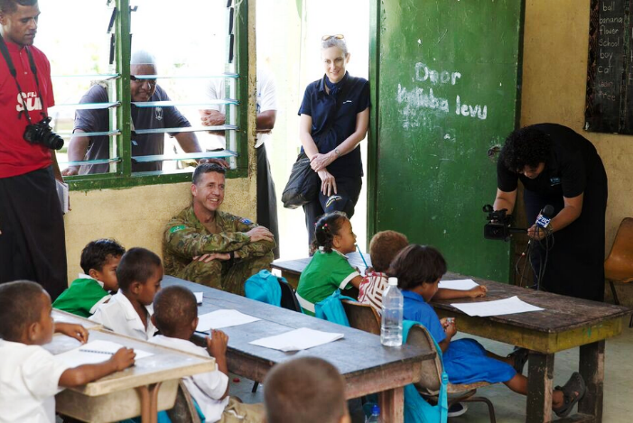

Australia’s former High Commissioner to Fiji, Ms Margaret Twomey, and Australian Defence Force Joint Taskforce Commander Lt Col Scott Hill, observe classes running soon after Tropical Cyclone Winston.

**Health centre:** the Nasau Health Centre on Koro was damaged. Australia provided a temporary nursing station partnership with Habitat for Humanity Fiji. We are now funding the rebuilding & upgrade of the facility to a Level C health centre, in partnership with the Ministry of Health and Medical Services. The work is expected to begin onsite in January 2018.

**Water and sanitation:** Australia supported Oxfam to build 140 toilets across all villages and has provided ten water tanks to supplement current water supply systems. With Australian funding, Oxfam is now partnering with the Water Authority of Fiji to ensure safe water supply for two to three communities that are relocating to a safer location on the island following TC Winston (Nacamaki, Navaga and potentially Sinuvaca).

**Emergency response & preparedness:** With Australian funding, the Fiji Red Cross Society (FRCS) has constructed an office on Koro to be an Emergency Operations Centre during future disasters. It has also enabled the FRCS to preposition emergency supplies to assist up to 200 families immediate following a disaster.