Trade Facilitation Support Program

Stocktaking/Assessment & Learning Review of the Trade Facilitation Support Program:

Final Report

September 30, 2024

About International Economics Consulting Ltd

International Economics Consulting Ltd (IEC) is committed to helping national and international development partners, governments and the private sector create value and promote sustainable growth and development.

With offices in London, Mauritius, and Vietnam, we seek to bring about lasting positive change by delivering strategic advisory services on trade. We specialize in in the areas of international trade and investment, data analytics, public policy, market intelligence, monitoring and evaluation and global value chains (GVCs). We work with both in-house and international experts to provide world-class advisory services to enable governments, development partners and corporations take better strategic decisions.

Acknowledgements

The authors of the report are Paul R Baker (Mission Chief and Senior Trade Economist), William Smith (Senior Monitoring and Evaluation Expert), James Lockett (Senior Trade Facilitation Expert) and Trevor O’Regan (Senior Trade Facilitation Expert). Mia Mikic acted as quality adviser. The team is grateful to Smita Bheenick (IEC, Trade Specialist) for her research and project management support.

The team also benefitted immensely from the time, information and suggestions provided by the team at the World Bank, especially William (Bill) Gain and Aileen Yang. Numerous other key personnel from the World Bank, in Washington DC and in countries, also provided helpful insights. Outside of the World Bank, other international organizations and donors, as well as private sector operators and non-governmental agencies, provided significant feedback to the team’s questions. The list of persons consulted is provided in *Annex E.*

All errors that remain are the authors’ sole responsibility.

**Table of Contents**

List of Abbreviations vii

Executive Summary 1

1 Introduction and Objectives of the Stocktaking Exercise 5

2 Stocktaking Methodology 8

3 Relevance 16

4 Coherence 23

5 Effectiveness 26

6 Efficiency 41

7 Sustainability 47

8 Impact 50

9 Recommendations 54

10 Case Studies 57

Bibliography 89

Annex A Terms of Reference 93

Annex B Results Framework/TOC 100

Annex C Interview Guidelines 104

Annex D Case study approach 108

Annex E List of Interviewees 114

**List of Figures, Tables and Boxes**

Figure 1 TFSP Theory of Change 14

Figure 2 Key Areas of TFSP Assistance 18

Figure 3 Five Measures with the Lowest Implementation Rate 20

Figure 4 TFSP Communication materials developed per year 30

Figure 5 TFSP webpage visits 30

Figure 6 Timeline of implementation of TFA commitments (Fiji) 58

Figure 7 Fiji’s Trade Facilitation Performance (2017 and 2022) 62

Figure 8 Fiji LPI, 2016 and 2023 62

Figure 9 Timeline of implementation of TFA commitments (Lesotho) 66

Figure 10 Lesotho's Trade Facilitation Performance (2022) 70

Figure 11 Lesotho LPI, 2014 and 2018 71

Figure 12 Timeline of implementation of TFA commitments (Guatemala) 77

Figure 13 Timeline of implementation of TFA commitments (Honduras) 77

Figure 14 Timeline of implementation of TFA commitments (El Salvador) 78

Figure 15 Guatemala’s Trade Facilitation Performance (2017 and 2022) 81

Figure 16 Honduras’ Trade Facilitation Performance (2017 and 2022) 81

Figure 17 El Salvador’s Trade Facilitation Performance (2017 and 2022) 82

Figure 18 Guatemala LPI, 2016 and 2023 82

Figure 19 Honduras LPI, 2016 and 2023 83

Figure 20 El Salvador LPI, 2016 and 2023 83

Table 1 Average Alignment Scores of Top Ten TFSP-supported TFA Measures 20

Table 2 TFSP contribution to new funding instruments 25

Table 3 Achievement of output indicators FY 2018, 2022 and 2023 27

Table 4 Achievement of outcome indicators FY 2018, 2022 and 2023. 31

Table 5 TFA articles with greatest progress in alignment 51

Table 6 TFA Sub-articles with greatest average increase in alignment 52

Table 7 TFA measures on which TFSP focused most attention 52

Table 8 LPI scores for 21 TFSP countries on trade facilitation-related criteria 2018 and 2023 53

Table 9 TFSP events held for Lesotho 69

Box 1 Leveraging Partnerships. 24

Box 2 Examples of TFSP global and regional events from TFSP 2023 Annual Report 29

List of Abbreviations

AEO Authorized Economic Operator

AfCFTA African Continental Free Trade Agreement

AI Artificial Intelligence

ASYCUDA Automated System for Customs Data

BAF Biosecurity Authority of Fiji

BITC Botswana Trade and Investment Centre

BPR Business Process Re-engineering

CBM Customs Border Management

CCIE Central American Economic Integration Advisory Committee

CEPA Center for European Policy Analysis

COMIECO Council of Ministers of Economic Integration

COVID-19 Coronavirus disease 2019

DFAT Department for Foreign Affairs and Trade (Australia)

EBA Everything But Arms

EC European Commission

ECLAC Economic Commission for Latin America and the Caribbean

EFI Equitable Growth, Finance and Institutions

EIF Enhanced Integrated Framework

EU European Union

FCDO Foreign, Commonwealth and Development Office

FPTL Fiji Ports Terminal Limited

FRCS Fiji Revenue and Customs Service

FY Financial Year

FYDUCA Factura y Declaración Única Centroamericana (Central American Invoice and Declaration)

GATF Global Alliance on Trade Facilitation

GDP Gross Domestic Product

HMRC HM Revenue & Customs

HQ Headquarter

HS Harmonized System

ICT Information and Communication Technology

IDB Inter-American Development Bank

IEPA Interim Economic Partnership Agreement

IFC International Finance Corporation

IFI International Financial Institution

IMO International Maritime Organization

IT Information Technology

ITC International Trade Centre

LAC Latin America and the Caribbean

LBMS Lesotho Border Management Services

LCCT Lesotho Coordinating Committee on Trade

LDC Least Developed Country

LNDC Lesotho National Development Corporation

LNSW Lesotho National Single Window

LPI Logistics Performance Index

LRA Lesotho Revenue Authority

LRS Lesotho Revenue Service

LTIP Lesotho Trade Information Portal

MOC Ministry of Communications

MOU Memorandum of Understanding

MRE Monitoring, Reporting and Evaluation

MSG Melanesian Spearhead Group

MSME Micro, Small, and Medium Enterprise

NSDP National Strategic Development Plan

NSS National Security Services

NSW National Single Window

NSWL National Single Window Lite

NTFC National Trade Facilitation Committee

OECD Organization for Economic Co-operation and Development

OECD-DAC Organization for Economic Co-operation and Development's Development Assistance Committee

PACER Pacific Agreement on Closer Economic Relations

PICTA Pacific Island Countries Trade Agreement

PIF Pacific Islands Forum

PTP Preferred Trader Programme

RF Radio Frequency

RSL Revenue Services of Lesotho

SACU Southern African Customs Union

SARS South Africa Revenue Service

SDTF Standards and Trade Development Facility

SECO State Secretariat for Economic Affairs (Switzerland)

SICA Sistema de Integracion Centroamericana (Central American Integration System)

SIDS Small Island Developing State

SIECA Sistema de Integracion Económica Centroamericana (Central American Economic Integration System)

SIECO Secretariat for Integration

SME Small and Medium-sized Enterprise

SPARTECA South Pacific Regional Trade and Economic Cooperation Agreement

SPS Sanitary and Phytosanitary

STC Short-Term Consultant

STDF Standards and Trade Development Facility

SW Single Window

TA Technical Assistance

TF Trade Facilitation

TFA Trade Facilitation Agreement

TFAD Trade Facilitation Agreement Database

TFAF Trade Facilitation Agreement Facility (World Trade Organization)

TFI Trade Facilitation Index

TFSP Trade Facilitation Support Program

TIP Trade Information Portal

TOC Theory of Change

TOR Terms of Reference

TRS Time Release Studies

UK United Kingdom

UNCTAD United Nations Conference on Trade and Development

UNECE United Nations Economic Commission for Europe

UNESCAP United Nations Economic and Social Commission for Asia

USA United States of America

USAID United States Agency for International Development

USD United States Dollar

WB World Bank

WBG World Bank Group

WCO World Customs Organization

WEF World Economic Forum

WTO World Trade Organization

# Executive Summary

The World Bank Group (WBG) initiated a final stocktaking exercise, spanning five years from July 2018 to June 2023, as a follow-up to a previous mid-term stocktake covering the initial four years of program implementation. The exercise serves dual purposes, with accountability objectives aimed at offering stakeholders an independent evaluation of the Trade Facilitation Support Program's (TFSP) performance and results during the specified period. It seeks to assess the program's integration of recommendations from the mid-term stocktake and identify lessons learned to enhance effectiveness. Additionally, the stocktaking exercise aims to evaluate how TFSP has complemented other trade facilitation initiatives, especially amid the challenges posed by the COVID-19 pandemic. This includes an examination of partnerships, and coordination efforts with organizations and donors within the country, and on a global scale.

**The relevance of the Trade Facilitation Support Program is evident through the demand from countries and national and regional reform agendas.**

The TFSP has experienced increasing demand, providing assistance to 56 countries by June 2023, indicating the relevance of its support to national governments. The program's country focus is demand-driven, aligning with national government commitments to implementing trade facilitation reforms within the World Trade Organization's Trade Facilitation Agreement (WTO TFA). Sub-Saharan African countries have received the most substantial share of TFSP support. Activities are concentrated on implementing TFA measures, addressing gaps and low implementation rates. Despite pandemic challenges, TFSP has contributed to an increase in overall WTO TFA alignment scores from 41% in 2015-2018 to 53% by 2018-2023, according to the WBG’s TFA Tracking Tool.[1] Adapting to the pandemic, TFSP enhanced virtual communications, utilized local staff, and tailored assistance to trade facilitation reforms addressing public health and safety. Notably, TFSP has integrated a gender lens, conducting Trade and Gender Studies in Pacific Island countries, publishing reports, and engaging with the WTO Gender Research Hub to actively contribute to discussions on gender and trade. With Category C implementation commitments increasing over the medium-term horizon, the requests for support are expected to rise substantially.

**The Trade Facilitation Support Program is aligned with other development partners and has been effective in leveraging other bank programs for additional impact.**

The TFSP collaborates with various implementing agencies at the country level to prevent duplication, maintain consistency, and explore potential cooperation for existing projects within the TFSP. Regular consultative committee meetings involving all donor partner focal points are held semi-annually to share updates on ongoing TFSP activities and gather inputs. Donors have called for enhanced coordination through the WBG's teams to proactively inform missions and embassies about relevant project-level activities, ensuring coherence with ongoing donor-supported efforts. Stakeholders note that the transition of TFSP from the International Finance Corporation (IFC) to the broader Bank's portfolio has strengthened linkages with other WBG departments, resulting in funding from additional WBG programs and funds. A conservative estimate by the WBG suggests that TFSP interventions have leveraged USD 770 million for investment loans and Development Policy Operations (see Table 2 for details).

**The effectiveness of the Trade Facilitation Support Program has translated into more geographic and area coverage, together with inclusiveness.**

In terms of effectiveness, noteworthy indicators include the addition of 11 new countries to the TFSP portfolio post-midterm stocktake, a focus on supporting alignment with 25 out of 47 Trade Facilitation Agreement (TFA) measures, the completion of 47 gap analysis reports since 2014, and a significant increase in female participants in events from 31% in 2018 to over 51% in 2023. Overall, TFSP's multifaceted approach, encompassing a range of activities and outcomes, contributes to its broader objectives in trade facilitation and gender inclusivity.

While not initially undertaken with the specific purpose of empowering agencies to function in times of crises, the Fiji case study exemplifies TFSP's effectiveness in supporting border agencies to anticipate and address COVID-related trade issues promptly, leading to a transition from paper to digital processes.

TFSP has contributed to Lesotho's notable improvement in alignment with six TFA measures and facilitated positive outcomes in Fiji, enhancing cargo manifest processes and fostering cooperation among border agencies. Additionally, TFSP conducted Trade and Gender studies in four Pacific Island countries and Timor Leste, building on initial survey design work in Africa. Though the implementation of study recommendations has been limited, the methodology has been replicated through other trade facilitation programs, including in Brazil, South Africa, Tajikistan, and the Philippines. TFSP does not have any impact or outcome-level objectives relating specifically to gender; however, survey findings inform the design of TFSP projects. Additionally, the gender work has contributed towards greater knowledge on the facets of gender inclusiveness in trade facilitation measures.

At the program level, TFSP employs output indicators without setting specific achievement targets, hindering the assessment of performance against goals. Despite the absence of set achievement targets, TFSP's output indicators provide insights into its activities, including the addition of new countries, focus on TFA measures’ alignment, and notable improvements in specific countries such as Lesotho and Fiji. The program's efforts in conducting Trade and Gender studies reflect a commitment to gender inclusivity, even though the implementation of recommendations is still evolving.

**In terms of efficiency, the program adapted effectively to the COVID-19 pandemic and successfully leveraged World Bank financing but made limited progress in implementing some mid-term stocktaking recommendations, with outstanding issues, particularly in integrating project-level Monitoring and Evaluation Indicators into the program level for reporting.**

Interviewees highlighted TFSP’s adept response to COVID-19 restrictions. In Fiji, for example, TFSP supported border agencies to anticipate and address COVID-related trade issues promptly, leading to the transition from paper to digital processes.

TFSP reports leveraging additional World Bank funding for trade facilitation work in 12 countries. Stakeholders have noted that while leveraging additional funds may enable further investment, this is largely in the form of debt financing, which can add further strain to stretched public finances. However, it is acknowledged that the Bank’s financing can often be grant and/or concessional financing and is the most efficient way to move complex infrastructure reforms forward.

TFSP has maintained its focus on key areas identified in the mid-term stocktake, such as gender, Trade Information Portals (TIPs) and National Single Windows (NSWs). However, there has been limited progress in implementing several mid-term stocktake recommendations, including consideration of more ambitious targets, reinforcing political economy analysis and donor coordination at the country level.

Outstanding issues in monitoring and evaluation persist at the program level, including the limited (though difficult to achieve) measurement of impact on the private sector, a lack of specific targets for output, outcome, and impact, infrequent tracking of Trade Facilitation Agreement (TFA) alignment, and a focus on cumulative achievement figures since TFSP's inception in 2014. However, we acknowledge that the team measures savings to the private sector at the project level, and estimates to date from TFSP are over 98 million USD.

**While many of the interventions under the Trade Facilitation Support Program are sustainable over time, additional pre-planning assessments and support are needed to ensure greater sustainability.**

TFSP emphasizes long-term success by taking a Whole of Government Approach supporting interventions that aim to sustain momentum and generate ongoing benefits for stakeholders even after project closure. The success of TFSP-supported solutions is closely tied to strong local ownership and commitment, particularly evident in case study countries (Fiji, Lesotho and the Deep Integration customs union in Central America) [2] where rapid and effective uptake of technical solutions has occurred, significantly reducing time and costs in cross-border trading. Challenges, however, stem from issues like coordination gaps between ministries, customs, and border agencies, as well as the political will of countries in relation to the reform agenda and their commitments under the WTO TFA. A perceived risk for sustainability lies in the gap between reported numbers on the WTO TFA Categories A, B, and C and the reality on the ground, emphasizing the need for substantial groundwork to ensure TFA implementation is impactful and enduring. TFSP is ideally placed to mitigate these risks by implementing on-the-ground validation of gaps and solutions.

The regional context appears to enhance the sustainability of TF reforms, as seen in Central America's example, where trade facilitation efforts conducted in the framework of a customs union provided added momentum and stability. While regional structures may introduce potential tensions, they generally serve as stabilizing forces. The Pacific Islands, facing unique challenges, are exemplified by Fiji's pursuit of becoming a world-class trade hub, showcasing the achievements and reforms that can be accomplished in the region with TFSP support despite the constraints and challenges that small island economies face.

Looking ahead, TFSP aims to continue supporting accelerated TFA implementation while addressing emerging issues like climate, cross-border emergency preparedness, e-commerce, and gender and inclusion. However, the program acknowledges its short-term limited capacity; and, as a result, may adopt a more selective approach to continue providing existing support and rapid response to client countries while focusing on essential building blocks for creation of reform sustainability. .

**The results of the Trade Facilitation Support Program suggest that the interventions have led to meaningful outcomes and impacts at a national and regional level.**

Trade Facilitation Agreement (TFA) tracker information on alignment with individual TFA measures for seven countries was analyzed as part of the stocktake, using updated data since their baselines were collected. On average, alignment scores for these countries improved from 43% at baseline to 64% at the time of the update. Notably, the greatest average improvements were observed in Articles 7.6 (Average release times), with a 64% average improvement, Article 7.7 (Authorized Economic Operator scheme) with a 48% average improvement, and Article 23 (National Trade Facilitation Committee) with a 44% average improvement—areas where TFSP had a significant focus. However, sub-articles that received TFSP support, such as Article 7.4 (Risk Management) and Article 10.1 (Formalities and Documentation Requirements), did not lead to a major average increase in alignment due to the complexity of these measures and reliance on sequencing of implementation across TFSP and other donor programs.

While direct attribution to logistics performance is not feasible to assess, the TFSP is expected to have contributed towards some outcome indicators for countries in which it was active.

# Introduction and Objectives of the Stocktaking Exercise

## The Trade Facilitation Support Program

The Trade Facilitation Support Program (TFSP) is a technical assistance program administered by the World Bank Group (WBG) that supports countries to align their trade practices and procedures with the WTO TFA. Trade facilitation plays an important role in a country’s economic development as it enhances competitiveness by reducing the time and cost to import and export. Simplified, transparent trade procedures are key components of good trade policy and vital for economic growth, particularly for developing countries as they strive to connect to the global economy and to strengthen domestic economic activity.

The TFSP, launched in 2014, is a multi-donor trust fund that draws on the expertise of both the World Bank and the International Finance Corporation (IFC). To ensure co-ordination of support, it also seeks to work closely with global and regional partners such as the World Trade Organization (WTO), International Trade Centre (ITC), United Nations Conference on Trade and Development (UNCTAD) and the World Customs Organization (WCO).

The TFSP assists client countries in identifying existing constraints and bottlenecks, designing and planning for implementation of reforms, and increasing predictability, transparency, and harmonization of systems and procedures in line with international standards covering import, export and transit activities. The TFSP supports activities through two main components:

* Provision of technical assistance (TA), where the WBG, through the work of the TFSP, assists developing countries in reforming their trade facilitation laws, procedures, processes, and systems;
* Capacity building, including consultative mechanisms within the context of the provisions of the WTO TFA; and facilitation of knowledge sharing, peer-to-peer learning, and the measurement of progress and results.

Priority areas for implementation support are:

* Supporting the ratification of the WTO TFA and meeting the related notification requirements;
* Undertaking WTO TFA Gap Assessments and implementation of reform action plans;
* Supporting the establishment and strengthening of National Trade Facilitation Committees (NTFCs);
* Assisting with the design of risk-based approaches for border clearance;
* Preparing for Trade Information Portal (TIP) and/or Single Window (SW) implementation;
* Leveraging global and regional partnerships and knowledge sharing to ensure optimal delivery of support.

The TFSP is financed by nine development partners: Australia, Canada, the European Union, the Netherlands, Norway, Sweden, Switzerland, the United Kingdom, and the United States of America. Since its inception, 56 countries have received financing for the implementation of trade facilitation and other related reforms. Within the Program’s portfolio, 27% of recipients are in Sub-Saharan Africa, followed by 23% in Latin America and the Caribbean (LAC), 21 % in East Asia Pacific,[3] 20% in Europe and Central Asia, 5% in South Asia and 4% in Middle East and North Africa.

From 2014 to end-June 2023, TFSP received USD 61 million in financial contributions, with disbursements and commitments standing at 89% by June 2023. More information about TFSP can be found at: <http://www.worldbank.org/tfsp>

## Stocktaking Background and Objectives

This stocktaking exercise has been commissioned by the WBG after nine years of program implementation. An earlier mid-term stocktaking exercise was undertaken by the TFSP secretariat on behalf of the WBG, covering the first four years of implementation (i.e., June 2014 to June 2018). This new exercise covers the subsequent five years of implementation from July 2018 to June 2023).

The stocktaking exercise has both accountability and learning objectives. These objectives, as outlined in the TOR, are to:

* Provide TFSP’s stakeholders with an independent, updated assessment of TFSP’s performance and results achieved from July 2018 to date, including how TFSP has progressed in integrating the recommendations made during the mid-term stocktake;
* Identify lessons learned and areas to improve TFSP’s effectiveness and
* Assess how TFSP has complemented other trade facilitation programs, particularly during the COVID-19 pandemic, including building partnerships and coordinating with other organizations/donors in-country as well as at the global level.

## Target Audience

The intended audiences of this stocktaking exercise are:

* Stakeholders in client countries, particularly the relevant focal ministries and departments focusing on trade facilitation, private sector representatives involved in cross-border trade, and (other) members of National Trade Facilitation Committees or equivalent.
* TFSP donor contributors, including bilateral and multilateral organizations and other partners.
* World Bank Group staff and management, TFSP Secretariat members, particularly the TFSP project’s Task Team Leaders (TTLs), and other WBG staff involved in the trade facilitation agenda.
* The broader community which supports WTO TFA implementation, such as the WTO.

# Stocktaking Methodology

## Stocktaking Framework

The stocktaking exercise involves a theory-based rather than an experimental evaluation approach. As such, the approach examines the internal logic of the program as articulated in the Theory of Change (TOC), objectives, and indicators. A Theory of Change includes activities, outputs and outcomes, and intended impact, as well as the mechanisms of change that link these various levels, the assumptions these involve, and the risks attached. The approach involves an assessment of the internal logic of the theory of change and the extent to which the theory has played out in practice.

As suggested in the TOR and elaborated in the inception report, the team assessed the TFSP against the six OECD-DAC criteria of Relevance, Coherence, Effectiveness, Efficiency, Impact and Sustainability. Some of the potential stocktaking questions set out in the Terms of Reference (ToR) have been redefined, and others have been added (see annexes A and C). The main cross-cutting issues addressed are gender and, to a lesser extent, climate change, under both relevance and effectiveness. The stocktaking matrix below presents the stocktaking questions clustered according to the OECD-DAC criteria, together with our approach and sources of data.

Where possible, information and views from interviews were triangulated from other sources, such as documents and data. Views will be sought from other organizations working in trade facilitation (e.g., STDF, WTO, WCO, UNCTAD) to gain an external perspective on the Program. The team used findings from the evaluation to present recommendations for ongoing TFSP implementation.

All interviews have been documented and shared amongst team members, and answers to stocktaking questions reviewed by all team members, as well as an external peer reviewer (Mia Mikic) before submission of the final draft report to the client.

| **OECD-DAC criteria** | **Stocktaking questions** | **Approach** | **Source of Data** |
| --- | --- | --- | --- |
| **Relevance** | 1. How relevant is TFSP to full and effective implementation of the WTO TFA and, where relevant, related trade facilitation reforms? 2. Have most TFSP interventions been targeted at TFA articles where there are the biggest gaps in alignment? 3. Have TFSP interventions been aligned to the objectives of national governments? 4. How and where has a gender lens been included in TFSP activities/projects? | * Data and document review * Program level interviews * Case Studies | WBG documents and data:   * Gap analysis reports; * TFA Tracking tool; * National government letters of request; * Annual Reports; * Gender study documents.   Government policy documents in case study countries.  Key Informant Interviews (KIIs) with TFSP management and staff; partner government agencies and private sector representatives in case study countries. |
| **Coherence** | 1. Have TFSP interventions been designed and implemented in ways that promote partnership and coordination with other multilateral organizations/donors around trade facilitation? 2. Have TFSP interventions led to funding from other World Bank programs or funds? | * Annual Reports * Data and document review * Program level interviews * Case Studies | Interviews with relevant multilateral organizations. [e.g., WTO Trade Facilitation Agreement Facility; WTO Standards for Trade and Development Facility; World Customs Organization (WCO); International Trade Centre (ITC), UNCTAD, UNESCAP].  Interviews with NTFC members.  KIIs with partner government agencies and private sector representatives in case study countries.  Interviews with World Bank TFSP staff and TTLs. |
| **Effectiveness** | 1. To what extent has TFSP achieved its output objectives (provision of technical assistance and knowledge, learning and measurement tools)? 2. To what extent have TFSP’s outcome objectives been achieved and to what evidence is there to suggest this has been due to TFSP’s contributions?    * Simplification, modernization, harmonization and transparency of regional and country level trade procedures.    * Enhanced collaboration and co-ordination between domestic and neighboring border agencies and the private sector.    * Risk based approaches integrated into border inspection and clearance processes.    * Design and implementation of trade information portals (TIPs) or Single Windows (SWs).    * Other. 3. To what extent have TFSP assumptions relating to achievement of outcomes proved valid?  * How effective have the TFSP’s approaches been on understanding and accommodating for the political economy aspects of trade facilitation reform proposals? * How effective has TFSP been in its prioritization and sequencing of reforms in a phased approach?  1. How effective was TFSP’s application of a gender lens? | * Data and document review * Program level interviews * Case Studies | WBG documents and reports   * Theory of Change/Results framework; * Annual Reports; * TFA tracking tool data; * Project Supervision Reports (PSRs).   Publicly available trade statistics and literature review for case study countries.  KIIs with TFSP management and staff, implementing partners, partner government agencies, private sector associations in case study countries. |
| **Efficiency** | 1. Has TFSP implemented recommendations from the mid-term stocktaking exercise? 2. How efficiently did the program respond to the challenges of the COVID-19 pandemic? What lessons can be learned? 3. Is the logical framework fit for purpose and does it contain the right targets? 4. How efficiently has the TFSP leveraged additional financing? | Data and document review  Program level interviews | Mid-Term Stocktaking Report and management response.  Steering Committee meeting minutes.  TFSP leverage table.  KIIs with TFSP management and staff. |
| **Sustainability** | 1. To what extent has local ownership of program objectives and activities been achieved under TFSP? 2. To what extent has additional financing leveraged by TFSP contributed to program sustainability? | Case studies | KIIs with TFSP management and staff, case study participants, Government representatives and project’s beneficiaries. |
| **Impact** | 1. What are the early and mid-term results of impact arising from the TFSP? In relation to which articles have the most significant reduction in alignment gaps been achieved that can be credited partially or fully to TFSP? 2. To what extent has TFSP achieved its impact objectives? Have intended or unintended impacts arisen from TFSP interventions? | Data and document review  Case studies | Impact stories in annual reports.  KIIs with case study participants, Government representatives and project’s beneficiaries. |

Approach to data analysis and synthesis

The team has reviewed qualitative data collected to identify common content and emerging themes. These have included TFSP annual reports, project reports, interviews and other related documents and literature. Where appropriate, qualitative data has been triangulated with quantitative data, e.g., from the Tracking Tool. For each stocktaking question, the stocktaking team has weighed these different types of evidence based on reliability and validity. For a light-touch stocktaking exercise of this kind, the stocktaking team has not established formal weighting criteria. To mitigate evaluator bias, all interviews have been documented and shared amongst team members via a shared folder. Answers to stocktaking questions were reviewed by all team members.

Challenges and limitations of the stocktaking exercise

In general, the methodology proposed for the stocktaking exercise has been appropriate and effective for assembling the data required to answer the stocktaking questions. However, there were inevitable limitations and challenges in the following cases:

* The stocktaking team has faced difficulties in some cases with stakeholders not being responsive, timely, or willing to answer requests for information or interviews. This has led to significant delays in carrying out case study interviews for Fiji, Lesotho, and the customs union of Honduras/Guatemala/El Salvador. The team referred back to the client for help and is grateful for the support in terms of reminders and requests that have been provided. Clearly, this risk has been heightened by reliance on online interviews instead of in-country visits.
* While access to information provided to the team was made for the TFA tracking tool scores, the individual country information could not always be reported on due to the sensitive nature of the collected information.

## Theory of Change

The TFSP’s Theory of Change (TOC) remains unchanged from the period of the earlier stock-taking exercise. It is provided in Figure 1.

Figure 1 TFSP Theory of Change

Impact: TFSP-supported countries' trad facilitation practices are aligned with the WTA Trade Facilitation Agreement.
Outcomes: Regional and country-level trade procedures and practices simplified, modernized and/or harmonized and made transparent in TFSP-supported countries; Collaboration and coordination between domestic and neighbouring border agencies and the private sector enhanced in TFSP-supported countries; Risk-based approaches integrated into border inspection and clearance processes in TFSP-supported countries.
Outputs: Technical assistance to reform facilitation laws, procedures, processes, systems, and consultative mechanisms within the context of the WTA TFA is provided; Knowledge, learning and measurement products and indicators are generated.

This TOC indicates that the program aims to have only direct impact on alignment of TFSP -supported countries’ trade facilitation practices with the TFA. No more indirect impacts are made explicit, for example, in terms of reducing the time and cost of trading across borders, increasing the volume and value of trade or fostering any wider economic benefits from increased trade or linked poverty alleviation impacts. The ultimate objectives of the program therefore are relatively direct and practical. Nevertheless, it is clear that the TFSP is expected to contribute towards shorter clearance times, improve transparency on processes and procedures for importing and improve the coordination of border agencies, which will lead to improved efficiency.

The program logframe also remains unchanged since the mid-term stocktaking exercise of 2018. It makes explicit several assumptions linking program outputs (primarily TA and knowledge, learning, and measurement products) with the three outcomes, which focus on: i) simplification and harmonization of trade practices and procedures; ii) improved collaboration between domestic and neighboring border agencies as well as with the private sector; and iii) integration of risk-based approaches into border inspection and clearance processes.

These assumptions include:

* Quality and relevance of TA and knowledge products [though this assumption is not exogenous to the program];
* Level of active engagement by stakeholders with the TA and knowledge products;
* Willingness of public and private stakeholders to collaborate and share information;
* Capacity of public and private stakeholders to implement and operationalize reform.

Also implicit within these assumptions are a range of political economy questions affecting stakeholders’ interests in actually implementing the technical recommendations delivered by the program. While the logframe does include output, outcome, and impact indicators, it does not include targets for these indicators.

Under the relevance and effectiveness stocktaking questions, the team will assess the internal logic of the theory of change and the extent to which it has been effective in practice. The team will examine the extent to which proposed TFSP change mechanisms are effective and the extent to which the assumptions underlying them are valid.

## Data Collection

**Data and Document Review**

Documentation received from the World Bank Group which will be reviewed during the stocktaking includes:

* TFSP annual reports 2019, 2020, 2021, 2022, 2023
* Donor agreements on the program (Australia, UK, Switzerland, EU, Norway, Canada);
* Consultative Committee meeting minutes;
* Populated TFSP logframe 2022 and 2023;
* TFSP Communications Plan;
* Data on Trade Indicators for FY23 and Leverage Created by TFSP.

In addition, the team will refer to the WB Logistics Performance Index (LPI), OECD Trade Facilitation Index (TFI), as well as relevant data and reports from SDTF, WTO, WCO, WEF, ITC, UNCTAD, etc.

**Program-level Interviews**

The team has conducted 38 interviews between October and November, both in person and in Washington DC as well as online with stakeholders of the project, including donors, partners, agencies, and beneficiaries of the TFSP.

**Case Studies**

The team has conducted a set of three case studies (Fiji, Lesotho and Central America) designed to enable more in-depth assessment of most of the stocktaking questions posed. Case studies were prepared based on an in-depth review of documentation and interviews with TFSP consultants and staff, key government partners and private sector representatives.

# Relevance

## Key Findings

* Demand for TFSP support has continued to grow. The program provided support to 56 countries by the end of June 2023. The high level of demand demonstrates the strong relevance of the assistance provided to national governments.
* TFSP’s country focus is driven by demand from national governments who have to clearly demonstrate a commitment to the implementation of trade facilitation reforms within the fields governed by the WTO TFA. This approach also ensures that the TFSP is aligned to the objectives of national governments. Sub-Saharan African countries have received the largest share of support from TFSP.
* Activities supported by the TFSP are strongly focused on the implementation of the TFA and, therefore highly relevant to the achievement of its objectives. TFSP interventions have supported more than 25 TFA measures since 2014 and most TFSP interventions have been targeted at TFA articles where there are the biggest gaps in alignment or which have the lowest implementation rate based on commitments by WTO members.
* While Consultative Committee representatives confirmed the clear relevance of the TFSP to full and effective implementation of the TFA, several stakeholders highlighted that many TFSP countries may at times struggle with determining their specific needs, sometimes due to technical or resource limitations, or coordination challenges between key relevant agencies.
* To ensure the relevance of the program during the pandemic, TFSP adapted its approach by upholding regular communication with in-country counterparts through virtual methods and increasing the use of local staff and consultants in countries where technological infrastructure is limited. Furthermore, assistance was tailored to trade facilitation reforms relevant for national public health and safety during the pandemic.

Since the previous stocktake, TFSP has evolved to include a gender lens in its interventions, building on survey design work that was first initiated in Africa. Six Trade and Gender Reports have been completed in 5 Pacific Island countries (including Timor Leste), culminating in the publication of individual country reports and a regional comparative report. TFSP also offers support for WBG engagement with the WTO Gender Research Hub, allowing the Bank to remain actively involved in discussions on gender and trade. Additionally, the gender work has contributed towards greater knowledge and awareness on the salient features of gender inclusiveness in trade facilitation. For example, in many of the surveyed countries and among the participants, fewer women-led firms than men-led firms feel regularly consulted by the government on trade-related matters. Fewer women-led firms than men-led firms also tend to be aware that trade facilitating tools are available – such as electronic payments or other digital solutions.

## How relevant is TFSP to full and effective implementation of the Trade Facilitation Agreement (WTO TFA) and, where relevant, any related trade facilitation reform proposals?

**Since June 2014, the TFSP has been supporting 56 countries**[4]. Of those countries supported under the TFSP, around a third of which are least developed countries and close to one quarter are Small Island Development States, to improve their alignment with the WTO TFA[5]. TFSP activities are demand-driven and the high demand for TFSP activities, with over 60 formal requests for assistance since inception, shows that stakeholders perceive the program to be relevant. However, donors and TFSP staff highlighted that while demand-driven programs work very well, many TFSP countries are not always in a position to determine what their specific needs are, especially relating to next steps for Category C measures. To aid in this, TFSP diagnoses the needs and solutions in partnership with client countries to implement TFA Category C commitments. In addition, the notifications of needs are submitted to the WTO, and TFAF informs demand to TFSP. TFSP coordinates closely with TFAF and evaluates the grant applications and where it is possible for TFSP to pick up the requests. The staff of TFSP sits on the TFAF grant application committee representing the Annex D organizations. At the same time, one interviewee from the WTO TFAF highlighted that “Category C for 2023/24/25 has critical notifications coming in order to meet committed thresholds.” This person further added: “[t]here is a huge work of Category Cs to be implemented between now and 2030.”

**In terms of the choice of countries, TFSP requires that recipients seeking support exhibit commitment to implementing trade facilitation reforms within the fields governed by the WTO TFA**. Additionally, TFSP prioritizes assistance to countries that face challenges in accessing support from other donors, thereby focusing on those countries that are most in need of assistance. Of the 56 countries that have benefitted from TFSP support so far, 27% of the countries are located in Sub-Saharan Africa, where the largest recipients of active TFSP support are located, followed by Latin America and the Caribbean at 23% and East Asia Pacific at 21%[6],[7].

By the end of FY23, approximately USD 57,744,180 had been allocated between regional support, global support for country-specific technical assistance,[8] and global knowledge and management activities[9]. By region, Sub-Saharan Africa received 29% of total allocations, followed by East Asia and Pacific (15%),[10] Latin America & the Caribbean (13%), Europe and Central Asia (8%), South Asia (3%), and Middle East and North Africa (1%).

The key areas of TFSP assistance, shown in Figure 2 below, have a clear focus on TFA implementation, from ratification of the TFA itself to reform action plans based on TFA Gap Assessments and the establishment of NTFCs. This is in line with the TFA priorities, which include ratification, establishment of rules and a functioning committee of key stakeholders.

For example, in Fiji, one senior official from the Ministry of Trade, Co-operatives and SMEs said the TFSP team “helped us to think ahead about the reforms needed here. In fact, we brought the IMO Single Window and the NSW together into one, and under the TFSP, we had a number of workshops on the 2 concepts (IMO Single Window and NSW). This type of workshop got stakeholders to think ahead and consider what we might need, including a lot of public-private sector consultations, and this introduced a culture of collaboration between ministries and departments but also between the public and private sector. It comes back to the leadership of the NTFC and the role the Ministry has taken to push ahead”.

Figure 2 Key Areas of TFSP Assistance

Text: Supporting the ratification of the WTO TFA and meeting the related notification requirements 
Undertaking WTO TFA Gap Assessments and implementation of reform action plans
Supporting the establishment and strengthening of National Trade Facilitation Committees (NTFCs)
Assisting with the design of risk-based approaches for border clearance
Preparing for Trade Information Portal (TIP) and/or Single Window (SW) implementation
Leveraging global and regional partnerships and knowledge sharing to ensure optimal delivery of support

*Source: TFSP Annual Report, FY 2022*

**Since the program’s inception, the WBG has conducted over 50 TFSP-supported TFA Gap Assessment missions**. The gap assessments evaluate whether a country’s process and procedures align with the WTO TFA measures. These Gap Assessment missions are critical to ensuring the relevance of the TFSP to its objective of full and effective implementation of the TFA. As of end of June 2023, the overall WTO TFA alignment scores of TFSP countries increased from 41% in 2015-2018 to 53%[11] in 2018-2023 despite the challenges that TFSP faced during the pandemic.

**Requests for WTO assistance to implement the TFA are evaluated by a selection committee at TFAF to determine whether they meet the program criteria**. TFAF coordinates a donor and Annex D committee (including TFSP) to evaluate the TFAF grant applications. This mechanism has ensured that the TFSP remains relevant as strong and well-defined criteria, which are linked to the trade facilitation reforms covered by the WTO TFA, are used to provide support.

To address the restrictions on in-person interactions and travel due to COVID-19, TFSP country teams maintained regular communication with in-country counterparts through virtual methods and increased the use of local staff and consultants in countries where technological infrastructure is limited. This approach has been instrumental in ensuring relevance of the TFSP.

According to one private sector representative in the logistics industry interviewed in Fiji: “One of the main benefits of TFSP was bringing all the make stakeholders together involved in trade facilitation and to make alignment of objectives easier – prior to that everyone in their silos. The stakeholders consulted indicated that government processes are easier to change now. Post-COVID, there seems to be a permanent shift now to electronic paperless trade – before COVID, people needed to see the piece of paper. That’s a good sign for us as a country.”

**TFSP was also responsive to in-country counterparts’ needs during COVID**. For example, in Central America, the Secretariat for the Central American common market known as SICA and for the “Deep Integration” customs union requested specific support on COVID responses, and the TFSP team provided fast and responsive advice and support to take action within Central America.

**TFSP activities are also relevant to other trade facilitation reform proposals**. TFSP’s work aligns with the objectives of the WTO Agreement on the Application of Sanitary and Phytosanitary Measures (SPS) as capacity-building activities and improvement of border processes and procedures ensure that SPS measures do not create unnecessary barriers to trade. TFSP support is also relevant and complementary support to the implementation of the electronic phytosanitary certification (E-phyto), which requires technical expertise and a certain level of digital infrastructure for implementation. The latter is integrated into TFSP projects through its various support programs or where additional resources are needed though bilateral loan or grant programs. By providing support to fragile and conflict-affected countries, TFSP also helps to align trade practices and improve the cross-border trade environment in general.

## Have most TFSP interventions been targeted at TFA articles where there are the biggest gaps in alignment?

**TFSP interventions have been diverse and adapted to local requirements, with 25 TFA measures supported in various countries since 2014**[12]. The average alignment scores[13] for the top ten measures supported by the program since its inception are shown in Table 1 below. It appears that most TFSP interventions have been targeted at TFA articles where there are large gaps in alignment. However, low alignment scores are also observed for measures such as 7.8 - Expedited Shipments (4%), 6.1 - General Disciplines (12%) and 1.3 - National Enquiry Point (15%). While measure 6.1 benefited from eight TFSP interventions, there were limited initiatives targeted at measures 7.8 and 1.3 due to lower demand prioritization from TFSP countries and other development partners providing support.

Table 1 Average Alignment Scores of Top Ten TFSP-supported TFA Measures

| **Article** | **Number of TFSP Interventions** | **Average Alignment Score (%)** |
| --- | --- | --- |
| 23.2 NTFCs | 34 | 25[14] |
| 7.4 Risk Management | 33 | 27 |
| 10.1 Formalities and Documentation Requirements | 22 | 10 |
| 1.1 – Publication | 18 | 27 |
| 7.6 Establishment and Publication of Average Release Times | 18 | 19 |
| 1.2 Information available through the internet | 17 | 26 |
| 8 Border Agency Cooperation | 17 | 16 |
| 7.7 Trade Facilitation Measures for Authorized Operators | 14 | 24 |
| 10.4 - Single Window | 10 | 4 |
| 7.1 - Pre-Arrival Processing | 10 | 20 |

*Sources: TFSP Annual Report FY 22 and TFA Tracking Tool [Accessed: 31 October 2023] Note: These scores are as reported in the tracking tool.*

*Figure 3* below shows that TFSP interventions have also been targeted at measures which have the lowest implementation rate (based on implementation commitments by all WTO members). TFSP activities focused on four of the five measures with the lowest implementation rate, namely measures 7.4, 7.7, 8 and 10.4.

Figure 3 Five Measures with the Lowest Implementation Rate

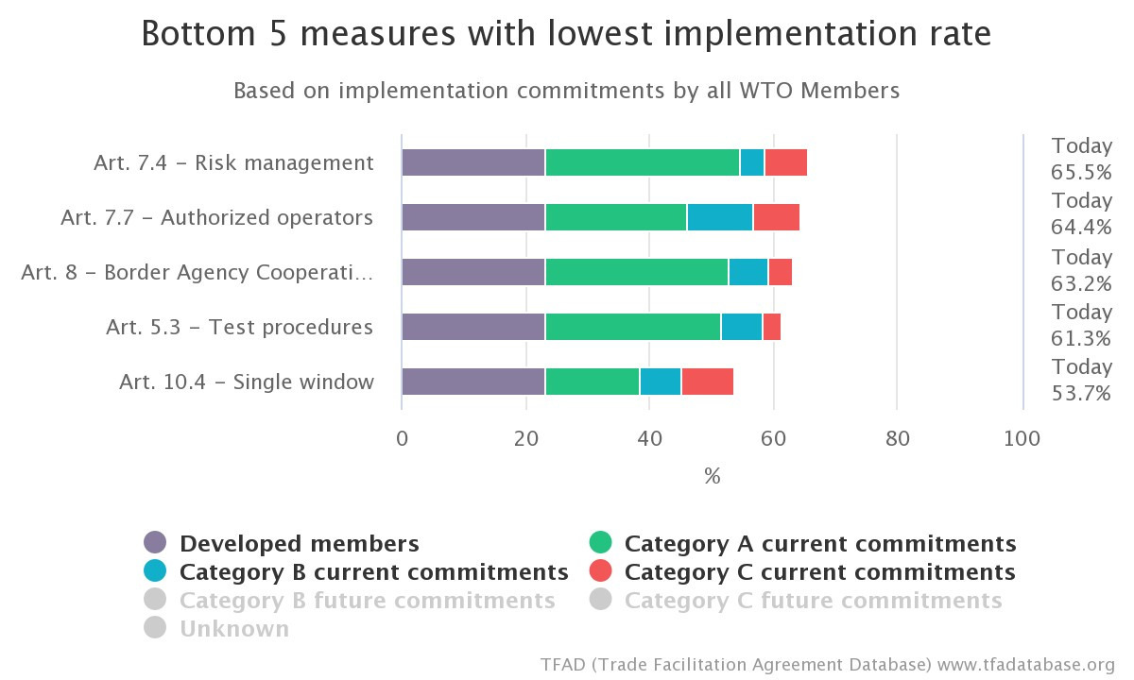

*Source: WTO Trade Facilitation Agreement Database (TFAD) [Accessed: 31 October 2023]*

## Have TFSP interventions been aligned to the objectives of national governments?

**The TFSP’s objective is focused on alignment and effective implementation of the WTO’s TFA**. By committing to implement the TFA, countries make a clear statement of their national objectives regarding trade facilitation. Since TFSP assistance is demand-driven, interventions are very much aligned to the objectives of national governments.

**TFSP activities are focused on TA as well as knowledge management and learning activities.** Regarding TA, TFSP uses a “whole-of-government approach,” which takes into account country priorities, available resources and local implementation capacities. This approach also leverages strong political and financial commitment from the highest level of government to drive the reform process[15], ensuring alignment with objectives of national governments. Reform priorities identified through technical assistance activities are also validated with public stakeholders to ensure alignment with national objectives. This aids in obtaining commitment at all levels. Importantly, high-level political commitment may fast-track the legal reforms required and source financing for heavy-cost projects. Commitment by different government agencies and private sector entities is required for achieving results that benefit a wide range of stakeholders. By deeply involving the government and private sector in the development of activities from start to finish, this can help ensure that client has a good understanding of the process and feels ready to carry out the work on their own going forward once TFSP support is completed.

**During the pandemic, TFSP adapted its support to national priorities by focusing on trade facilitation reforms.** This led to improved border processes and procedures to facilitate the secure and expeditious movement of perishable food products, medical supplies, personal protective equipment, and various types of cargo. In Tonga, for example, TFSP assisted with the development of a formal procedure for the expedited release of medicines and medical supplies, facilitating the clearance of COVID-19 vaccines[16]. As a result, Tonga is better prepared for any future emergencies or shocks by having an emergency preparedness and response framework agreed by all government agencies and in place that can be activated immediately as a crisis emerges.

## How and where has a gender lens been included in TFSP activities/projects?

The original conception of TFSP did not include a gender-specific component. However, the program has evolved to integrate a gender lens in its activities/projects even if both the TFA itself and the TFSP Theory of Change (TOC) do not include specific gender components. This is in recognition that gender equality is central to the WBG’s goals of ending extreme poverty and boosting shared prosperity in a sustainable manner.

**TFSP has funded the design and implementation of the Trade and Gender Study**. The study comprised a survey and stakeholder consultations to collect data on specific trade facilitation obstacles that men and women traders and customs clearing agents encounter. The study was conducted in 4 Pacific Island countries (Fiji, Samoa, Papua New Guinea, and Vanuatu) and Timor Leste, leading to the publication of individual country reports as well as a regional comparative report. An intensive communication campaign was implemented to disseminate the reports. A video summarizing the main findings was disseminated to a wide range of stakeholders, including governments, the private sector, and civil society in and beyond the countries covered by the study.[17]

**Leveraging the implementation of the TFSP-supported Trade and Gender Study in the Pacific region, the methodology was replicated in other countries**, namely Brazil, the Philippines, South Africa, and Tajikistan, through other funding sources. Information collected through these studies has been key to addressing the gap in data on how trade facilitation interventions impact traders by gender and informing the mainstreaming of gender in policy decisions. It should be noted that a common set of recommendations emerged from these surveys, which showed that women-led firms are less likely to have access to information, less likely to become part of the Authorized Economic Operator (AEO) scheme and are less likely to participate in NTFCs. The roll-out of the survey in other countries, such as Lesotho and Eswatini, is being planned at the time of writing this report.

**TFSP also provides assistance for WBG engagement with the WTO Gender Research Hub, which is a platform for knowledge-sharing on the impact of international trade on women and gender inequality**. The Hub provides the WBG with the opportunity to share gender-related trade research and to remain actively involved in discussions on trade and gender issues. For example, the WB participated in a session organized by the WTO Gender Research Hub in July 2022, that brought together government, development agencies, and statistical experts to discuss the lack of data on women in trade. Discussants highlighted that collaboration between stakeholders, particularly government agencies and statistical experts, is essential for filing this gap, and that this statistical need would help governments better target their trade policies that support gender equality. The WB presented learnings and findings from the TFSP-support Trade and Gender Surveys. One of the donors interviewed for the stocktake highlighted that while “gender mainstreaming is important, it is also essential not to lose focus of the main aim of the program, which is to help countries accelerate reforms in the context of the TFA.” Another stakeholder highlighted that the gender lens may not be a priority in certain countries such as Lesotho, where women are viewed as already leading many companies engaged in in trade and where the NTFC may not see this as a pressing issue. Nonetheless, gender equality is a cross-cutting priority for most donors’ ODA programs; and therefore should be integrated into a revised Theory of Change.

# Coherence

## Key Findings

* The WBG collaborates with multiple donors on a country-level basis to prevent duplication, promote consistency, and explore potential cooperation regarding existing projects. Semi-annual consultative committee meetings involving all donor partners are convened to share updates on ongoing TFSP activities and gather input and feedback from the donors.
* Donors, however, called for enhanced coordination using the WBG’s global and in-country teams to proactively inform missions and embassies about TFSP activities being implemented to ensure coherence with ongoing donor-supported efforts in those countries.
* Stakeholders highlighted that the shift of TFSP from IFC to the Bank’s portfolio has facilitated stronger linkages with other departments in the WBG, leading to funding from other WBG programs. According to an estimate provided by the WBG, TFSP interventions have led to USD 770 million of subsequent investment loans and Development Policy Operations (see Table 2).

## Have TFSP interventions been designed and implemented in ways that promote partnership and coordination with other multilateral organizations/donors around trade facilitation?

**Partnerships and collaboration with relevant multilateral organizations and donors play a crucial role in the governance of the TFSP.** The donors ensure that a global program like the TFSP is delivered effectively and that related technical support is deployed in a coordinated manner across the different countries to avoid wastage, conflicting trajectories, and client fatigue. To this end, TFSP works with a wide range of organizations, including the WTO, WCO, SDTF, International Trade Center (ITC), UNCTAD, United Nations Economic Commission for Europe (UNECE), United States Agency for International Development (USAID), Enhanced Integrated Framework (EIF) among others, to ensure coherence and identify opportunities for complementary assistance.

**The TFSP program is funded by nine donor partners: Australia, Canada, the European Commission, the Netherlands, Norway, Sweden, Switzerland, the United Kingdom, and the United States**. The WBG coordinates with the various donors at the country-level to prevent overlap, ensure coherence and potentially collaborate on ongoing initiatives. Consultative committee meetings involving all donor partners are also held every few months to provide updates on ongoing TFSP work and obtain feedback from donors.

* Box 1 Leveraging Partnerships to ensure CoherenceIn the **Western Balkans**, the local WBG team ensured regular contact with other trade-related projects, including USAID’s Enterprises for Development, Growth and Empowerment (EDGE) project and Gesellschaft für Internationale Zusammenarbeit’s (GIZ) trade facilitation project. In November 2020, the TFSP and USAID EDGE collaborated to organize online trainings for SPS agencies on risk management in international trade. The WBG team also maintained contact with the Central European Free Trade Agreement (CEFTA) Secretariat.
* The WBG works closely with the STDF to ensure that synergies between projects are effectively tapped into and that WTO TFA objectives are reflected in projects. In particular, experts supported by TFSP have actively participated in several STDF-led webinars to explore and promote solutions to SPS measures and trade issues, thereby advancing the trade facilitation agenda.
* The WBG also partners with the WCO to ensure complementarity and coherence. In **Sierra Leone**, for example, TFSP and the WCO jointly implemented the Time Release Study (TRS) and capacity-building for customs officials. TFSP support to **Bolivia**, which led to the creation of the NTFC, was complemented by WCO assistance to align border management processes and procedures with the WTO TFA.
* The **Georgia** Revenue Service had an established relationship with USAID to create the AEO program concept. Once the regulatory framework was established, TFSP offered additional support to operate the program.
* In **Vietnam**, TFSP provided support in collaboration with the Australian Department of Foreign Affairs and Trade’s (DFAT) bilateral assistance for the Vietnam Free Trade Agreement Portal (FTAP), ensuring coherence of TFSP work with the latter project.
* In the **Kyrgyz Republic**, a more formal mechanism for coordinated development assistance has been established through a working group of donors focusing on trade facilitation. The working group meets virtually every few months, allowing for important information sharing to avoid duplication of work and ensure coherence of the different projects.

**However, consultations revealed that coordination with donors could be improved**. While donors are kept informed of the progress through regular reports, stakeholders suggested additional efforts could be made to regularly share information on interventions, which would allow them to be kept updated on TFSP activities. Examples of additional information suggested by donors related to the outcomes of diagnostic work carried out by TFSP, how resources are used, what has been accomplished and what is left, and how the TFSP is achieving sustainability and results. Stakeholders recommended that the WBG make better use of its Global and in-country teams to inform the different missions/embassies of TFSP activities funded by donors in advance and to ensure coherence with ongoing work being carried out by donors in those countries.

## Have TFSP interventions led to funding from other World Bank programs or funds?

**The TFSP transitioned from the IFC portfolio to the Bank portfolio in 2018, and consultations revealed that being part of the Bank has allowed for a stronger link with other departments for leveraging existing WBG programs or funds**. According to a conservative estimate provided by the WBG, TFSP interventions have led to USD 770 million of additional investment (loans primarily) as of October 2023. This calculation on leverage is based only on amounts related to the trade facilitation components of additional investments that are linked to the initial TFSP technical assistance. (Areas and countries are listed in Table 2).

Table 2 TFSP contribution to new funding instruments

|  |  |  |
| --- | --- | --- |
| TFSP Country Intervention | Instrument | Areas covered by Instrument |
| Ethiopia | IPF | One-Stop Border Posts (OSBP) |
| Lesotho | IPF | National Single Window (NSW) |
| Malawi | IPF | OSBP |
| Ghana | IPF | Trade Facilitation Agreement (TFA) |
| Liberia | IPF | NSW |
| Bangladesh | IPF | NSW |
| Nepal | IPF | NSW |
| Central America Regional | DPO | Budget Support |
| Central America Regional | IPF | Customs & Border Agency Modernization |
| W/Balkans (phase 1 & 2) | IPF | NSW |
| W/Balkans (phase 1 & 2) | IPF | NSW |
| Tonga | DPL | Budget Support |
| Lao PDR | IPF | NTFC, TIP; integration with SW |
| Egypt | DPL | Budget Support |

*Source: TFSP*

**TFSP work undertaken in several countries has also been leveraged for projects implemented by both the WBG and other development partners**. In Nepal, a TFSP-funded advisory project led to a World Bank Nepal-India Regional Trade and Transport initiative, including supporting the creation of a National Single Window (NSW) and the Nepal Trade Portal. In Vanuatu, the Enhanced Integrated Framework Tier 2 project built on previous TFSP work and provided funding for the establishment of an Electronic Single Window system (for which TFSP supported preparations and process re-engineering). In Lesotho, TFSP-funded work informed a WBG loan for the implementation of the Lesotho NSW through the World Bank Private Sector Competitiveness and Development Project.

**Fiji is a good case example of what the WB can leverage from the TFSP with other work from the Bank**. Fiji is also the best example in the Pacific of TFSP interventions crossing over into other areas of the Bank’s activities. The team has worked with 6 WTO members and 4 non-WTO members in the Pacific. One of the key successes has been to promote regional dialogue through the NTFCs, for example. Getting key players in the regional to discuss common issues of interest on trade facilitation through policy dialogue has been one of the positive outcomes for the TFSP, starting with the 10 assessments the WBG did at a national level – common challenges being faced by island nations across the region. The Regional Trade Facilitation Strategy recently signed off by Ministers in the Pacific is another example of the great work TFSP has done on coordination with the recent placement of an advisor to focus on Strategy implementation. Tonga received budgetary support funding for some areas of trade facilitation implementation.

# Effectiveness

## Key Findings

* TFSP defines output indicators but does not set achievement targets, so it is not possible to assess achievement against target.
* Selected output indicators:
  + A total of 11 new countries have been added to the TFSP portfolio since the mid-term stocktake**;**
  + The TFSP is currently focusing on supporting governments to align with 25 TFA measures, leaving 22 measures on which TFSP has not provided support due to other development partners, or similar, providing complementary support to the TFSP, or the measure might be a Cat A or B in that particular country.
  + 47 gap analysis reports have been conducted since the start of TFSP in 2014.
  + Female participants in events have increased from 31% in 2018 to over 51% in 2023.
  + TFSP reports producing two implementation guides or toolkits.
  + TFSP has produced program brochures, factsheets, animation podcasts and 360° virtual reality films, which show significantly higher outreach of over 1 million views each.
* Outcomes – Lesotho. The WTO TFA Gap assessment in June 2022 showed that, since 2016, Lesotho significantly improved its level of alignment with respect to six TFA measures, which were also the focus of technical assistance provided by the TFSP.
* Outcomes – Fiji. TFSP supported a cargo manifest process, including customs, biosecurity and health, connected with e-Phyto and ASYCUDA World, which has dramatically improved processing times. More broadly, TFSP has helped border agencies to work together and laid the foundations for cooperation on a NSW. In addition, an NTFC Risk Management Working Group in Fiji,which receives TFSP support through an initiative to improve collaboration between port users, resulted in Fiji Ports Terminal Limited (FPTL) providing FRCS and BAF with access to the port operators container delivery system to allow improved planning for inspections and container delivery.
* TFSP carried out Trade and Gender studies in four Pacific Island countries and Timor Leste between 2019 and 2020, interviewing over 1,500 firms. Implementation of recommendations from the studies has so far been limited, but the methodology has been replicated by other programs.

## To what extent has TFSP achieved its output objectives?

**At the program level, TFSP defines output indicators but does not set achievement targets, so it is not possible to assess achievement against target.** However, progress since the mid-term stocktake in 2018 are presented in Table 3 above, with annual report figures for FY 2022 and FY 2023.

Table 3 Achievement of output indicators FY 2018, 2022 and 2023

**Output: 1.1 Technical assistance to reform trade facilitation laws, procedures, processes, systems, and consultative mechanisms within the context of the WTO TFA**

| Indicator | Achievement end FY 2018 | Achievement end FY 2022 | Achievement end FY 2023 |
| --- | --- | --- | --- |
| 1.1.1 No. countries receiving advisory services from TFSP (cumulative) | 45 | 48 | 56 |
| 1.1.2 No. WTO TFA measures supported in TFSP countries (cumulative) | 22 | 25 | 25 |
| 1.1.3 Number of WTO TFA gaps analysis reports completed (cumulative) | 50+[18] | 44 | 47 |
| 1.1.4 No. new laws/regulations/  amendments/  codes/government policies drafted, or contributed to the drafting (cumulative) | 93 laws and regs. | 161 laws  and regs | 177 laws and regs |
| 1.1.5 No. procedures/firm-level policies/practices/ standards recommended for improvement or elimination | 517 | 557 | 564 |

**Output: 2.1 Knowledge, learning and measurement products and indicators are generated**

| Indicator | Achievement end FY 2018 | Achievement end FY 2022 | Achievement end FY 2023 |
| --- | --- | --- | --- |
| 2.1.1 No. global and regional events delivered or facilitated by TFSP (e.g. peer-to-peer, learning events, Smart Lessons competition/event) | 12 | 134 | 164 |
| 2.1.2 No. country-level events delivered and/or facilitated by the TFSP | 42 | 358 | 398 |
| 2.1.3 % female participants in events | 31% | 36% | 51% |
| 2.1.4 No. implementation guides/toolkits created | 1 | 2 | 2 |
| 2.1.5 No. communications materials developed (e.g., videos, blogs, brochures, newsletters, etc.) | 77 | 533 | 707 |
| 2.1.6 No. in-country gender assessments undertaken | 3 | 6 | 6 |
| 2.1.7 No. completed in-country validation scoring sheets, in accordance with WTO TFA tracking tool methodology | 24 | 38 | 38 |

TFSP output achievements are discussed below under both of the two TFSP outcomes relating to technical assistance and knowledge management.

**Outcome 1: Technical Assistance**

**A total of 11 new countries have been added to the TFSP portfolio since the mid-term stocktake.** Only three countries were added in the four years from FY 2018 to FY 2022 (Bolivia and Lebanon in 2019 and Tonga in 2021). However, a further 8 countries were added in FY 2023 (Angola, Antigua and Barbuda, Egypt, Indonesia, Mozambique, Peru, South Africa, St. Kitts & Nevis). Requests for support from new countries tend to be channelled through the WTO’s Trade Facilitation Agreement Facility and shared with all Annex D support organizations and donors, including USAID and ITC, who may express preference to meet certain demands and provide support. TFSP is part of this process and selects requests that it is best placed to respond to effectively.

**The TFSP is currently focusing on supporting governments to align with 25 TFA measures, leaving 22 measures on which TFSP has not provided support.** This constitutes an increase in measures of 3 measures since 2018 (articles 2.1, 2.2 and 6.2), though these are addressed only in one country. The breadth of program support in terms of TFA measures covered has, therefore, remained stable. The 2022 Annual Report explains that TFSP focuses on measures which are more difficult to implement and on measures in which the World Bank Group has particular expertise, such as TIPs and NSWs.

**A total of 47 gap assessment reports have been conducted since the start of TFSP in 2014.** Three were conducted between 2022 and 2023. Additionally, in-country validation scoresheets are reported to have been conducted in 38 countries. There are baseline figures for 37 countries reported in the TFA Tracking Tool, with updated scores for 22 of these countries.

**Outcome 2: Knowledge, learning and measurement**

**TFSP reports 'delivering or facilitating’ a cumulative total of 164 global and regional events since the program began in 2014, of which 152 were organised since the mid-term stocktake in 2018.** Of these, 30 events took place in FY 2023. Events include peer-to-peer learning and policy dialogue events. The 2023 Annual Report includes 36 examples, some of which are actually national-level events. Most of these events involved TFSP participation but were not necessarily organised by TFSP. Some examples are presented in Box 2.

**The number of female participants in events has increased from 31% reported in 2018 to 36% in 2022 and over 51% in 2023**. This indicator is not cumulative, so the figures only represent attendance at events during the year in question. Achieving over half female participation at events is a significant achievement.

**TFSP reports led to the production of two implementation guides or toolkits.** These are the TFA tracking tool and the SPS guide published in 2020 under the TFSP Europe and Central Asia programme.

Box 2 Examples of TFSP global and regional events from TFSP 2023 Annual Report

* **WTO Aid for Trade Global Review** in Geneva, July 2022. TFSP co-organised or participated in several events at this meeting. These included ‘Aid for Trade: creating an enabling environment to increase women’s participation In trade’, a panel discussion organised by WBG, ITC and the UK government at which results of TFSP-supported gender and trade reviews were discussed. The event was attended by 326 participants from 59 countries. The WBG was involved in a session organised by the WTO Gender Research Hub, focusing particularly on data related to women and trade, and organised a session on ‘Enhancing TFA implementation in the Pacific through connectivity and inclusiveness’, focusing particularly on experience from Fiji and Tonga.
* **Launch Event on implementation of Advance Customs Declarations at the Guatemala El Salvador border**, Guatemala City, August 2023.
* **International Standards Organization (ISO) Annual Meeting** in Abu Dhabi; September 2022, including participation in a panel discussion on ‘Building Trust – trade in the age of digitization’.
* **WTO Public Forum and Annex D Meeting**, Geneva, September 2022.
* **Asia Pacific Trade Facilitation Forum**, Singapore, August 2022, organized by ADB and UNESCAP on the theme: “Next Generation Trade Facilitation for Sustainable Development”.
* **Central America Regional Trade Facilitation Event**, Guatemala, November 2022, organized by the World Bank Group.

*Source: TFSP Annual Reports 2021 and 2022*

**TFSP reports produced a cumulative total of 707 communication materials and used a wide variety of different formats, including reports, blogs, animations, videos, and podcasts.** There has been an especially large increase in communications materials produced in FY 2023 (Figure 4). The TFSP webpage, hosted within the World Bank Group website, is the main channel of communication. The 2023 annual report states that “the number of website visitors has continued to grow steadily since the launch of the website: from 1,500-page visitors at the end of FY17 to 16,544 on June 30, 2023.” There has been a steady increase in webpage visitors, with a particularly large increase in FY 2021 and FY 2022 (Figure 5)

Figure 4 TFSP Communication materials developed per year

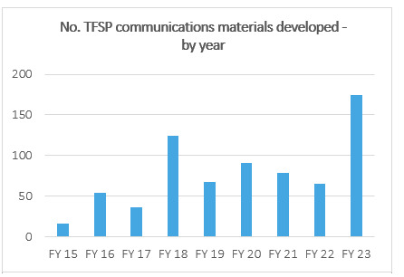

Figure 5 TFSP webpage visits

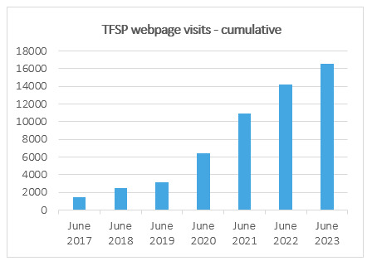

**The 2023 Annual Report lists seven blogposts published by the World Bank during the year**. These include:

* Timor-Leste moves toward WTO membership with new biosecurity legislation (June 2023);
* Gender dimensions in Tajikistan (May 2023);
* Helping Lao PDR businesses trade — the Authorized Economic Operator Programme (April 2023);
* Bananas and Blight – An Illustration in The Complexity of Global Trade (April 2023)

**TFSP has produced program brochures, factsheets, animation podcasts and 360° virtual reality films, with the 360° virtual reality films showing significantly higher outreach of over 1 million views each**. The ‘Trade Tips’ podcast has attracted 3,127 listeners and 1,700 subscribers. TFSP produced two 360° virtual reality films: Trading across borders in Guatemala and Honduras’ (with over 1.8 million views in Spanish) and ‘Making trade faster, cheaper and easier in Sierra Leone’ (with over 1 million views in English). A third 360° virtual reality film has been developed to illustrate trade facilitation reforms in Fiji.

## To what extent have TFSP’s outcome objectives been achieved, and what evidence is there to suggest that this is due to TFSP’s contribution?

**Reported achievements against TFSP outcome indicators are presented in Table 4 below**. While the overall programme indicators give an impression of the scale and rate of implementation by TFSP globally, understanding effectiveness is best examined at the country or regional level through the three case studies carried out for the stocktaking exercise. For each case study country, quantitative achievement of TFSP outcome indicators is presented, along with qualitative evidence based on interviews with relevant World Bank staff, government partners and private sector representatives.

Table 4 Achievement of outcome indicators FY 2018, 2022 and 2023.

**Outcome: 1. Regional and country-level trade procedures and practices simplified, modernized and/or harmonized and made transparent**

|  |  |  |  |
| --- | --- | --- | --- |
| Indicator | Achievement to end FY 2018 | Achievement to end FY 2022 | Achievement to end FY 2023 |
| 1.1 No. entities that implemented recommended changes | 56 | 107 | 115 |
| 1.2 No. recommended laws/regulations/amendments/codes enacted or government policies adopted | 54 | 114 | 121 |
| 1.3 No. recommended procedures/firm-level policies/practices/  standards that were improved or eliminated | 130 | 205 | 218 |
| 1.4 No. trade portals implemented | 6 | 11 | 11 |
| 1.5 No. Time Release Studies (TRS) published | 10 | 15 | 15 |

**Outcome: 2. Enhanced Collaboration and co-ordination between domestic and neighbouring border agencies and the private sector**

|  |  |  |  |
| --- | --- | --- | --- |
| Indicator | Achievement to end FY 2018 | Achievement to end FY 2022 | Achievement to end FY 2023 |
| 2.1 No. National Trade Facilitation Committees (NTFCs) established per the WTO TFA | 28 | 34 | 36 |
| 2.2 No. agreements completed to improve trade facilitation | 4 | 16 | 18 |

**Outcome: 3. Risk-based approaches integrated into border inspections and clearance processes**

|  |  |  |  |
| --- | --- | --- | --- |
| Indicator | Achievement to end FY 2018 | Achievement to end FY 2022 | Achievement to end FY 2023 |
| 3.1 No. risk management approaches supported in customs and/or other agencies | 22 | 31 | 31 |
| 3.2 No. countries that reduced the number of cargo inspections by border clearance agencies | 4 | 11 | 13 |

**Case Study 1: Fiji**

**TFSP work in Fiji has contributed to overall programme outcome indicators as follows:**

|  |  |  |
| --- | --- | --- |
| **Outcome indicator** | **Actual** | **Description** |
| 1.1 No. entities that implemented recommended changes | 1 | Fiji Customs |
| 1.2 No. recommended laws/ regulations/amendments/codes enacted or government policies adopted | 1 | The Stamp Duty Act was repealed, effective August 1, 2020, removing the requirement to pay a stamp duty of USD10 (per export bill of lading stamped at the Fiji Revenue and Customs Services (FRCS) office prior to export. Abolition of stamp duties reduced the cost and time to trade. This reform was supported by a review of fees and duties as part of the TFA Gap Assessment and follow-up by various NTFC working groups. |
| 1.3 Number of recommended procedures/firm-level policies/ practices/standards that were improved or eliminated | 1 | SPS certificates have been automated in response to COVID-19. In addition to that, in FY 22 Phase 2 of the GeNS implementation was started. This additional module allows exporters to commence the phytosanitary treatment and certification process within GeNS. Phase 2 also includes training for industry. |
| 1.4 No. trade portals implemented | - | - |
| 1.5 No. TRS published | - | - |
| 2.1 No. NTFCs established under WTO TFA | 1 | NTFC in Fiji was not established by TFSP but supported by TFSP. |
| 2.2 No. agreements completed to improve trade facilitation | 1 | MOU on data sharing was signed between FRCS and the Ministry of Fisheries in October 2020 allowing the Ministry to access the ASYCUDA World system. |
| 3.1 No. risk management approaches supported in customs and/or other agencies | 1 | Risk management system established in Fiji. |

**The TFSP started work in Fiji and Pacific with a TFA Gap Assessment for all 6 WTO countries in 2015.** One of the main recommendations was the establishment of an NTFC and support to the NTFC to develop a Fiji TFA Roadmap and National TFA Action Plan. Activities and priorities identified for implementation included: a) assistance to harmonise multi-agency border processes, to streamline processes and requirements, and to harmonize data; b) assistance in preparation to implement a Single Window system, including collaboration and coordination; and c) assistance in developing the trusted trader programme and related risk profiling.

Outcome 1: Simplified and harmonised trade procedures

**In 2019, a cargo manifest process was piloted based on process mapping by all agencies, including customs, biosecurity and health.** The manifest is connected with e-Phyto and the ASYCUDA world. Global Alliance for Trade Facilitation (GATF) liaised with the private sector on e-Phyto. TFSP supported the connection with ASYCUDA and worked with the biosecurity agency on process mapping.

**TFSP is supporting the NTFC to liaise with the government’s ‘DigitalFIJI’ project**, led by the Ministry of Communications on issues related to the National Single Window. TFSP carried out a Border Agency Digitalization Gap Analysis, which built on the UNCTAD blueprint. It also supported discussion on merging processes related to the International Maritime Organization Single Window and the National Single Window. TFSP works collaboratively with regional assistance projects, including UNCTAD, which completed a blueprint for a National Single Window in October 2023. This collaboration is an example of the added value TFSP can bring from a whole of government approach to digitalization.

**TFSP also supported the Trade and Gender Survey in Fiji to identify the main challenges that cross-border traders face related to trade facilitation at the firm level.** Key recommendations included: i) improve access to information on border-related processes and procedures; ii) strengthen the role of the NTFC and traders’ knowledge of and participation in the Committee; iii) strengthen formal grievance procedures; iv) promote pre-declaration practises; v) expand the Authorized Economic Operator (AEO) scheme, including to women traders; vi) explore reasons for detention and seizure of goods; and vii) Strengthen the system for on-line payment and encourage traders to pay on-line.

**Increased speed of processing cargo manifests has helped businesses such as Ben’s Trading,** a leading exporter of cassava, taro and other vegetables, which buys vegetables from 70,000 farmers and now employs 200 people**.** Co-owner Maria Moi told the World Bank that the manifest can now be processed in a matter of minutes, whereas it used to take 3-4 days[19]. This, in turn, has reduced costs and helped to grow the business.

Outcome 2: Enhanced collaboration between domestic and neighboring border agencies and the private sector**.**

**The TFSP assisted the NTFC in Fiji to set up Technical Working Groups on National Single Window (NSW), transparency of information, risk management, and test procedures**. The Chief Customers Officer at Fiji Revenue and Customs Service commented that TFSP has “a whole of government approach – while some of the other donors only focused on customs. The TFSP has been a catalyst to work with other border agencies. For example, through TFSP we now have a joint approach to risk management.”

**TFSP has supported the NTFC to improve collaboration between port users and the authorities.** As a result, Fiji Ports Terminal Limited (FPTL) provided the Fiji Revenue and Customs Service (FRCS) and the Biosecurity Authority of Fiji (BAF) with access to their container delivery system to allow for improved planning of inspections and container delivery.

**Private sector representatives have observed improved collaboration between government and port users.** The Customer Success Manager of Swire Shipping commented that: “One of the main benefits of TFSP is bringing all the main stakeholders involved in trade facilitation together and to make alignment of objectives easier. Prior to that, everyone was in their silos. Government processes are easier to change now. Post-COVID, there seems to be a permanent shift to electronic paperless trade.”

Outcome 3: Risk-based approaches integrated into border inspections and clearance processes

**Digitization of trade processes has enabled customs to more effectively manage risks and increase efficiency of clearance processes.** The Chief Customs Officer of the Fiji Revenue and Customs Services stated, “With automation, we were able to save time in terms of our effective profiling and targeting. We were able to mitigate most of the risks.”

**The Ministry of Health has also seen the benefits from the cargo manifest in terms of risk management**. The manifest gives the Ministry more time to review and address food safety risks. According to the Chief Health Inspector, Fiji Ministry of Health, “The automated import systems also make trade facilitation and food safety requirements much easier and efficient. Together with our colleagues and partners in Biosecurity, in Customs, and in Fisheries, we continue to build on the momentum to use this automated system for the benefit of the citizens of Fiji”.

**Case Study 2: “Deep Integration” Customs Union of Guatemala, Honduras, El Salvador**

| **Outcome indicator** | **Actual** | **Description** |
| --- | --- | --- |
| 1.1 No. entities that implemented recommended changes | 3 | Guatemala Customs; El Salvador Airport authority of El Salvador (CEPA); Honduras Customs |
| 1.2 No. recommended laws/ regulations/amendments/codes enacted or government policies adopted | 1 | In December 2018, a new regulation was issued for the management of the land border at the Tecun Uman II crossing between Guatemala and Mexico. |
| 1.3 Number of recommended procedures/firm-level policies/ practices/standards that were improved or eliminated | 7 | Central America Phase 1 Project (pre-2019)   1. El Salvador Air cargo clearance procedure 2. Honduras and Guatemala Customs Union and the use of FYDUCA. 3. El Salvador improved the publication of easily accessible information on import, export and transit procedures, fees, regulations and other items relevant to trade. 4. The Airport Authority of El Salvador (CEPA) improved air cargo clearance procedures e.g. eliminating the re-weighing process, harmonizing working hours of the agencies at the airport, and improving interconnection with customs to exchange information on air cargo documents. 5. Guatemala implemented measures to receive the required information, including manifests, prior to arrival of the goods. 6. Customs in Guatemala implemented risk management tools and post-clearance audit, and an Authorized Operator program to facilitate the movement of goods.   Central America phase 2 project:   1. El Salvador: The TFSP team developed an IT application (cargo tracker) to facilitate the air cargo process for the private sector to track their cargo once it arrives at the airport. It also provides important information about the cargo, which is required to start the customs clearance process. This was launched in FY23. |
| 1.4 No. trade portals implemented | - | - |
| 1.5 No. TRS published | - | - |
| 2.1 No. NTFCs established under WTO TFA | - | - |
| 2.2 No. agreements completed to improve trade facilitation | 2 | * Guatemala & Honduras: Legal Agreement between Guatemala and Honduras for the Customs Union. * El Salvador joining Guatemala & Honduras Agreement: Protocol of Accession of El Salvador to the Enabling Protocol for the Deep Integration Process between Guatemala and Honduras. |
| 3.1 No. of risk management approaches supported in customs and/or other agencies | 1 | Risk management system established in Guatemala. |

**Following the formal agreement of a customs union between Guatemala and Honduras in December 2014, the customs union was officially operational at selected border points by June 2016.** Instead of duplicate customs procedures and paperwork on both sides of the border, and as a result of implementing the customs union, trade between Honduras and Guatemala replaced these border controls only with tax, health and security controls, which required only a single online instrument called “FYDUCA” (Factura y Declaración Única Centroamericana – Central American Invoice and Declaration). Starting in March 2018, both countries made the use of FYDUCA mandatory. FYDUCA was reported to cut the time for traders to cross the border between Guatemala and Honduras from 10 hours to 15 minutes[20]. TFSP’s Regional Central America Project Phase 1 supported this process.

**Phase 1 TFSP activities began in Guatemala with an assessment of bottlenecks and inefficiencies in the trade environment and prioritised modernization of customs operations and streamlining border processes**. The electronic single window system allowed traders to submit necessary documentation online, drastically reducing waiting times. In Honduras, with its unique maritime trade potential through Puerto Cortés, TFSP focused on port efficiency and customs processes. Honduras saw intensified efforts to harmonise customs operations with neighbouring countries, particularly Guatemala, as they transitioned to their customs union together. In El Salvador, TFSP focused on legislative reforms to ensure alignment with the TFA, prioritising risk management systems.

**Phase II of the Regional Central America Project began in 2019 and falls within the scope of this TFSP stocktake**. Phase 2 includes four pillars, of which only Pillar 2 relating to the customs union is the focus of the case study on “Deep Integration”:

* Pillar 1 Support to Improve Regional Trade Regulations and Procedures, including work on a regional legal and procedural framework for electronic transactions, providing greater transparency and increased efficiency.
* Pillar 2 Support Guatemala and Honduras to help them consolidate their customs union and help El Salvador in its effort to integrate with this customs union.
* Pillar 3 Support for the National Implementation of the Trade Facilitation Agreement, focusing on continued technical assistance for national activities started in Phase 1.
* Pillar 4 - Technical assistance to Central American countries with the implementation of assessments for the TFA Tracking Tool developed in Phase I.

**Implementation of Phase 2 TFSP activities was initially affected negatively by the COVID-19 pandemic during FY 2021.** At the regional level, TFSP engaged with the Council of Ministers of Economic Integration (COMIECO) and the Secretariat for Integration (SIECO) and presented initiatives on five priority reforms during the last formal session of COMIECO in June 2021. In FY 2022, the World Bank team presented a Concept Note on Trade Facilitation as a means of accelerating economic recovery in Central America at the Council’s meeting in November 2021, focusing on advance declarations at land border crossings and expedited e-commerce shipments. In November 2022, the project held a seminar with COMIECO, including representatives from six countries, to build on these three areas. The meeting included a wide range of private sector representatives, including airlines, logistics, and manufacturing companies. TFSP support to ‘Deep Integration Guatemala-Honduras-El Salvador’ – the Customs Union - was also evaluated. Integration of El Salvador into the Customs Union was also addressed, and El Salvador agreed to a road map for the initiation of FYDUCA. This included work to implement the Advance Customs Declaration between El Salvador and Guatemala.

**During this second phase, political factors have limited the effectiveness of reforms, including disagreements and internal politics, which have led to month-long border closures.** A recent example occurred during the government change after the June and August 2023 elections in Guatemala, which led to an almost one-month-long border closure and ongoing blockages and closures as of the writing of this report, and the region is in turmoil.

**While TFSP focuses specifically on national implementation of the WTO Trade Facilitation Agreement to streamline and simplify trade procedures between countries, the Customs Union between Guatemala, Honduras and eventually El Salvador pushes integration much further.** The aim of the Customs Union is ultimately to remove customs from internal borders between member countries. TFA alignment is relevant for trade between the Customs Union and third parties but not within the Customs Union. NTFCs in these customs union settings should ultimately be replaced by a regional Customs Union Trade Facilitation Committee to regulate relations with other markets and to further enhance trade within the customs union.

**Case Study 3 Lesotho**

| **Outcome indicator** | **Actual** | **Description** |
| --- | --- | --- |
| 1.1 No. entities that implemented recommended changes | 12 | Lesotho Revenue Authority; Ministry of Agriculture (Animals and Plants); Ministry of Health (Port Health); Ministry of Home Affairs (Department of Immigration); Ministry of Police; Ministry of Transport (Weighbridge); Ministry of Finance (Road Fund); Ministry of Trade and Industry; Lesotho National Development Corporation (LNDC); National Security Services (NSS); Ministry of Small Business Development; Ministry of Development and Planning |
| 1.2 No. recommended laws/ regulations/amendments/codes enacted or government policies adopted | 4 | 1. Establishment of NTFC as per IFC Advisory Agreement and a Cabinet Decision (note: this outcome is based on the recommendation on establishment of NTFC legal mandate in the TFA report and support its establishment via input into the NTFC TOR as well as continuous support to the NTFC)  2. Passage of revised Customs, Excise Bill by Senate to amend the Customs and Excise Act No. 10 of 1982  3. National Single Window Blueprint adopted on Feb 2, 2022  4. New Customs and Excise Amendment Regulations 2022 on AEO entered into force on Aug 5, 2022 |
| 1.3 No. of recommended procedures/firm-level policies/ practices/standards that were improved or eliminated | 11 | 1. Compliance Risk Management (Prohibited and Restricted Goods List) adopted (based on a report delivered); 2. Support for setup of the disaster recovery site at Lesotho Revenue Authority; 3. Exit Gate Management to deal with Exit Notes 4. Client Call Centre for both internal and external enquiries 5. Separation of business traffic from passenger traffic 6. Lesotho Trade Portal was re-launched on Dec 9, 2020 improving transparency of information. 7. Expansion of PTP program in Maseru as of Jan 2020 8. Elimination of usage of document copies 9. Change of process of “notice to proceed” 10. Lesotho National Single Window pilot roll-out in 2 agencies covering 2 processes on June 29, 2022. 11. LNSW Steering Committee, LNSW Legal Working Group were set-up LNSW Steering Committee was set-up in May 20, 2021 and LNSW Working Group established at Steering Committee meeting in October 2021. |
| 1.4 No. trade portals implemented | 1 | - |
| 1.5 No. TRS published | - | - |
| 2.1 No. NTFCs established under WTO TFA | 1 | - |
| 2.2 No. agreements completed to improve trade facilitation | 2 | * Agreement with South African Revenue Service and Lesotho Revenue Authority on automatic exchange of information (Sept 2019) * MOU on Implementation of Lesotho National Single Window signed on June 10-20, 2022 |
| 3.1 No. of risk management approaches supported in customs and/or other agencies | 1 | Risk management framework established in Lesotho |

**In Lesotho, TFSP has focused on the following trade facilitation issues**: revising customs and electronic transactions legislation, setting up a National Trade Facilitation Committee, enhancing the implementation of ASYCUDA World, enhancing the Trade Information Portal, creating a National Single Window and improving co-ordinated border management[21].

Outcome 1: Simplified and harmonised trade procedures

**TFSP provided support to gain government approval for the National Single Window and to develop an appropriate legal framework.** An ICT needs assessment was conducted, with recommendations to develop a Light National Single Window initially with 5-6 agencies. Subsequently, TFSP supported the development of an LNSW blueprint and the procurement process. The LNSW was piloted in 2021 and completed in 2022. The TFSP conducted a private sector survey, which showed that LTIP use had increased since the launch of the new version. The project has supported over 12 border and cross-border trade regulatory agencies to streamline processes for permits and certificates.

**A Co-ordinated Border Management Report was drafted in 2020.** The report included recommendations which have been instrumental in enhancing border processes to facilitate clearance of essential goods during the pandemic. For example, COVID-19-related medicinal products and donations were excluded from import duty.

**TFSP supported the improvement of the Trade Information Portal.** This included support for an online workshop and training for the new version of the portal in 2020 as well as the drafting of a stakeholder analysis. The launch of the new portal, which contains over 260 regulations and procedures from 22 government agencies, was reported in the TFSP 2021 Annual Report.

**TFSP also provided technical assistance to develop Lesotho’s Preferred Trader Program (PTP)**, with the goal of expanding the program into a holistic AEO program aligned with the WCO SAFE Framework of Standards and the South African AEO program. The AEO program in Lesotho currently has 10 traders with certification, mostly South African corporates. The government wants to grow this number to 50 in the future. It is not clear how many are led by women.

**A Time Release Study is mentioned in the TFSP Annual Report 2017, with recommendations to improve efficiency**. Another Time Release Study was also conducted in Autumn 2022.

Outcome 2: Enhanced collaboration between domestic and neighboring border agencies and the private sector**.**

**The NTFC was formally launched in September 2017, and overall, stakeholders report that engagement with the NTFC in Lesotho was effective and frequent.** The NTFC has a clear vision and a well-articulated plan to implement its vision and has benefited from institutional stability. However, the COVID-19 pandemic led to a fragmentation of relationship management between the different agencies in the NTFC. Higher level decision-making by the Lesotho Coordinating Committee on Trade (LCCT) on the National Single Window has also been slower as the body does not meet frequently.

**TFSP provided support for consultations on the 2018 Draft Customs** **Bill**. The Customs and Excise (Amendment) Act was passed in 2021.

**Stakeholders also commented that co-operation between border agencies has not always been successful in Lesotho**. The Authorized Economic Operator project could not be implemented as not all government agencies were ready to sign up. However, when moved to the regional level, the AEO scheme has since progressed.

Outcome 3: Risk-based approaches integrated into border inspections and clearance processes

**In 2021, TFSP provided support for the review of the LRA’s risk management processes** and for evaluating the readiness of the organization to implement a holistic customs border management (CBM) approach.

**As a result of a new funding allocation in FY 2023, a range of further activities are current in preparation or early implementation**: A terms of reference to help Lesotho significantly grow the involvement of the private sector in the AEO; a survey on non-tariff barriers and trade facilitation constraints in the horticulture sector; a Trade and Gender Study; an end-to-end Time Release Study at Maseru Bridge border, including Lesotho and South Africa stakeholders under the joint guidance of a WCO capacity building support.

## To what extent have TFSP assumptions relating to the achievement of outcomes proved valid?

**TFSP’s Theory of Change has not changed since the Mid Term stocktake.** The TOC is premised on the theory that technical assistance provided to government partners, together with knowledge creation and dissemination, will result in improved trade policies and procedures. Improvement is envisaged in terms of simplification and harmonization of procedures, improved co-ordination between border agencies and improved risk management, equating with full alignment with the Trade Facilitation Agreement.

However, the assumption that technical assistance, training or improved knowledge can lead countries to make some fundamental changes to their trade facilitation policies may be optimistic. In fact, due to a number of political economy constraints, vested interests, individual incentives, and organizational weaknesses, technical assistance does not always result in desired outcomes.

**Political commitment has also not always been strong**. While this remains a challenge for most Aid for Trade programs, this has explained, in some instances, the divergence in results across TFSP countries. The WBG is aware of this risk and the problems that result from low levels of political support, including delays, low levels of ownership, and weak adoption of recommendations. A political economy analysis is integrated into TFSP diagnostics to identify constraints to reform. The identified constraints form part of the work plan for the NTFC to ensure consultations are undertaken with both public and private stakeholders. Despite this, some sustainability risks have arisen in this area.

**The TOC also assumes that levels of donor coordination are adequate.**  Donor coordination is usually described as being aligned, open, and able to leverage the contributions of different donors in order to have a wider impact. This assumption may not hold in reality. While donor coordination at the country level is mainstreamed into several phases of a TFSP project, including due diligence during the gap analysis and diagnostic phase, and the establishment of the NTFC and the sustainability support. In some cases, communication about their activities by donors can be limited. This is not unusual in Aid for Trade Interventions, but it should be considered and better documented, as it can lead to a weakening of this assumption.

## How effective was TFSP’s application of a gender lens?

**TFSP does not have any impact or outcome-level objectives relating to gender. However, it does have two output objectives relating to gender on the percentage of female participants in TFSP events and number of in-country gender assessment studies conducted.** Women’s participation in TFSP events has increased from 31% in 2018 to 36% in 2022 and 51% in 2023. Three gender assessment studies had been completed by 2018, with a further three added by 2022.

**TFSP carried out Trade and Gender studies in four Pacific Island countries[22] and Timor Leste between 2019 and 2020, interviewing over 1,500 firms[23].** The survey was based on initial design work in Africa through TFSP. The main survey findings included limited government consultation with women traders and lower levels of awareness of trade procedures (such as electronic submission of customs declarations and pre-declaration of shipments prior to arrival) among women traders. The Pacific Island studies helped inform the Pacific Regional Trade Facilitation Strategy, which will be launched in June 2024 at the Global Aid for Trade review. The World Bank has also been active in disseminating findings from the studies through the reports, an animation and a podcast.

**Implementation of recommendations from the studies has so far been limited.** The Timor Leste Trade and Gender Study has led the government of Timor Leste to consider the inclusion of the Association of Women Entrepreneurs as a non-executive member of the revamped National Trade Facilitation Committee. The NTFC also planned to organize several talk shows on national TV to raise awareness about border processes and procedures for women traders[24]. In December 2023, the recommendations from the Fiji Trade and Gender Study were discussed with stakeholders, and priority actions were agreed upon for implementation.

**However, the trade and gender survey methodology has been replicated in other programs.** The methodology, developed with TFSP resources, has been used by other programs across the WB in other countries, including Brazil, Philippines, South Africa,[25] and Tajikistan,[26] with surveys in Eswatini, Lesotho, Jordan [27]and India[28] also under preparation. TFSP's work on trade and gender has helped to inform a new USAID project on women and trade facilitation in the Dominican Republic. Looking ahead, TFSP aims to continue supporting accelerated TFA implementation while addressing gender and inclusion.

# Efficiency

## Key Findings

* TFSP has continued to focus on a number of areas highlighted through the Mid-Term stocktake, such as the Trade and Gender Studies and ongoing work, which is likely to have particular benefits for women traders and SMEs such as Trade Information Portals and National Single Windows.
* Limited progress has been made in implementing some of the mid-term stocktake recommendations, including revising the level of ambition and including indicators for impact on the private sector in the program results framework, increasing sensitivity to political economy analysis and reinforcing donor coordination at the country level.
* Various agencies interviewed for this stocktaking exercise commented on the TFSP’s excellent performance in adapting quickly to COVID-19 restrictions. The example in Central America showed that TFSP is also assisting the six countries in the common market there and their Secretariat to adapt to COVID-19.
* Examples from the Fiji case study show that TFSP was able to support border agencies to effectively anticipate and address COVID-related trade issues while, in turn, COVID helped to speed up the move away from paper towards digital processes.
* Outstanding issues relating to monitoring and evaluation include limited systematic measurement of impact on the private sector at the program level other than aggregating project savings to the private sector from project results; lack of output, outcome, and impact targets; infrequent tracking of TFA alignment; focus on cumulative achievement figures since the start of TFSP in 2014.
* TFSP reports that its activities have led to additional World Bank Group funding for trade facilitation work in 12 countries and regions, totaling USD 770 million.
* Various stakeholders commented that while leverage of additional funds from the World Bank Group may enable further investment in trade facilitation improvement, funding is largely in the form of debt, although often in the form of preferential, low-interest loans or no-interest loans to LDCs.

## Has TFSP implemented recommendations from the mid-term stocktaking exercise?

**Few recommendations from the mid-term stocktaking exercise were implemented**. The TFSP Secretariat welcomed the findings from the mid-term stocktaking and while the Secretariat was committed to addressing the recommendations made, it also received comments from donors that the scope of TFSP should not be changed. Nonetheless, it was agreed that TFSP would prioritize recommendations to integrate gender, better engage the private sector, and to increase its convening power at the country level to ensure coordination. The list of recommendations from the mid-term stocktaking included in below is derived from the WBG management response to the exercise:

| **Recommendation** | **WBG agreed action to be taken** | **Action since mid-term stocktake** |
| --- | --- | --- |
| 1. Increase awareness and sensitivity to the political economy situation of the recipient country prior to engagement; integrate lessons on political commitment during early implementation. | The WBG appreciates the recommendation and will ensure that the political economy in countries continues to be carefully considered before any support is provided. | No specific additional actions were agreed in the management response. However, the team continued utilizing existing approaches and have mainstreamed political economy analysis into the baseline diagnostics undertaken in each project, including the TFA gap analysis, to identify constraints to reform. The identified constraints form part of the workplan for the NTFC to ensure consultations are undertaken with both public and private stakeholders. |
| 2. Focus the country selection process. Criteria to include: demonstrated political commitment based on stakeholder analysis; income status; and poor alignment with TFA. | With current resources, the TFSP is close to max capacity in terms of the number of countries that are receiving support (47). Going forward, limited resources should prioritize least developed countries that cannot access other sources of support. Support will be subject to a TFA gap analysis to ensure political commitment and that TFSP funds are focused in areas where the respective government is committed to reform. | 11 new countries added since 2018: Bolivia and Lebanon (2019); Tonga (2021); Angola, Antigua and Barbuda, Egypt, Indonesia, Mozambique, Peru, South Africa, St. Kitts & Nevis (2023). Of these 11, one is ranked as low income by the World Bank in 2023 (Bolivia), 4 as lower middle income, 4 upper middle and 2 high income.  Selection has been based on: demand expressed by the government concerned, commitment to reform implementation, with prioritization of low-income countries, fragile states and those with limited access to donor resources, as well as middle income countries which act as gateways to low-income countries. |
| 3. Revise the level of ambition in the programme’s Theory of Change (TOC). | The WBG recognizes the level of ambition of the current program TOC to be adequate given the stage of implementation of TFSP activities and the current lifetime of the Trust Fund.  The RF will be updated (populated) on an annual basis to measure progress and determine if any need for course correction in the Program’s activities and outputs during the current lifetime of the Trust Fund. | Essentially, this recommendation was not accepted in totality by the programme and the Program TOC has not been revised. The programme has continued to update the existing results framework annually and detailed indicators for outputs, outcomes and impact are included at the project level.  The M&E framework will be updated and revised for phase 2 of TFSP to integrate the program and project results frameworks to better reflect results and data collection. |
| 4. Extend the range of interventions in countries with more mature trade facilitation systems, e.g., deepening assistance to agencies needing to improve capacity to address trade facilitation, focusing on single window implementation, and assisting the private sector in understanding and engaging relevant processes | The WBG agrees with donors in that the scope of the TFSP should not be extended at this point. Some of the activities that the consultants suggested to broaden, however, are already being implemented - or are in the process of being implemented -by the TFSP - including the NTFC capacity building, all border agencies focus and enhancing private sector engagement.  Increased visibility on private sector engagement, NTFC capacity building and the whole of government approach. | This recommendation was also not accepted by the WBG for reasons explained in the management response.  Agreed action focused on increasing visibility of certain existing activities: private sector engagement. NTFC capacity building, etc., but not to widen scope to new activities.  Donor response to this recommendation was to emphasize deeper engagement at the national and regional level rather than widening the scope with more narrow interventions. |
| 5. Understand gender and SME gaps in trade facilitation, and designing activities to address these gaps (e.g. women’s trader concerns in diagnostic assessments; gender balanced stakeholder participation, Charters for Cross-Border Traders (CCBTs); digital training for women traders. | Ensure that SMEs and the private sector overall is better targeted, potentially trough piloting certain interventions with entities like the Global Alliance and ITC. | TFSP has made clear progress in understanding gender gaps in trade facilitation through the 6 Trade and Gender Studies. Progress on addressing these gaps has been more limited. No specific initiatives on facilitating trade by SMEs were initiated. However, TFSP’s work in many areas such as Trade Information Portals and National Single Windows should have particular benefit for women traders and SMEs. |
| 6. Reinforce the in-country donor coordination efforts, not only through a continuation of the already effective communication efforts of the World Bank activities but by attempting to carry out joint activities with other international implementing agencies, and leverage the work of others | The WBG to include enhanced donor efforts in the country dialogue to fill the coordination gap where possible. | Co-ordination and formal communication channels to report on activities was reported by some donors as remaining an issue, though not by all.  Enhanced communication with donor partners in Capitals will be included in phase 2 of TFSP. |
| 7. Improve the World Bank’s system on financial reporting more generally (which goes beyond the powers of TFSP), which is poorly outdated in a world which demands ever greater transparency and accountability. | The recommendation goes beyond the TFSP, but WBG is continually looking at how reporting to donors can be optimized, including through the ongoing trust fund reform process. | The TFSP has partly been moved within the Umbrella Facility for Trade as a separate and distinct entity. There has been no change to reporting processes or formats. |

## How efficiently did the program respond to the challenges of the COVID-19 pandemic? What lessons can be learned?

**Various agencies interviewed for this stocktaking exercise commented on the TFSP’s excellent performance in adapting quickly to COVID-19 restrictions.** One donor member of the Consultative Committee commented on the speed of adaption in working methods, the rapid call to expedite transport of medical equipment and support for vaccination efforts. Another key international trade organization representative commented on the rapid adaptation by the World Bank and the role of regional managers in responding to the crisis, particularly through the adoption of digital training and meetings.

**Assistance was provided to Tonga for formal procedures to expedite the import of medicines and vaccines, including consultation with private sector representatives in 2021 and 2022[29]**. The project developed Fact Sheets for importers on expedited clearance procedures which were published in September 2021.

**In the Pacific region, a guidance note on “Expedited Release Guidelines for the Clearance of COVID-19 Vaccines and Associated Medical Equipment” was produced and shared with regional governments.** The guidance note was designed to help countries to assess their health ministries and frontline border agencies’ capabilities and preparedness to deliver expedited border clearances, storage, distribution, and any necessary re-export of COVID-19 vaccines and associated medical equipment.

**In Malawi, the WBG and TradeMark East Africa jointly assisted with profiling products needed for the COVID-19 response**—along with their associated importers—and designated these for expedited clearance and release in ASYCUDA World[30].

**Examples from the Fiji case study show that TFSP was able to support border agencies to effectively anticipate and address COVID-related trade issues** **while, in turn, COVID helped to speed up the move away from paper towards digital processes**. According to an official at the Ministry of Trade, Co-operatives and SMEs, “TFSP helped us to prepare and anticipate issues during the pandemic. We were already working on digitization, for example, through the shipping manifest. During COVID, we received a lot of consignments at the port for COVID-related equipment and protective clothing. The work of TFSP assisted us to clear this very quickly”. According to the Imports Station Coordinator, Biosecurity Fiji, “There was a mindset that we need this manual documentation, but COVID-19 has changed our mindset, and it has brought positiveness in the way that we are working”.

**Important lessons under the TFSP have also been learned around trade facilitation measures for emergency preparedness.** In going forward: i) Expedited clearance procedures should be in place before there is a disaster or emergency; ii) Procedures should be aligned with international guidelines, standards and agreements; iii) Developing standard operating procedures for processing relief consignments are required; iv) Sharing of best practices across all border agencies is essential on a continuous basis. Furthermore, “Expedited clearance procedures piloted during the pandemic reduced the time to import vaccines, priority food products and emergency-related cargo[31]”. In Tonga, for example - expediated clearance (from 3 days to 3 hours). As it happened, it was introduced just before the COVID vaccines arrived. Also, with the eruption of the Hunga Haʻapai volcano, it allowed for the relief consignments to get in quickly.

## Is the logical framework and M&E system fit for purpose and does it contain the right targets?

**The TFSP monitoring and evaluation system involves the collection of a wide range of output and outcome indicator information on a global scale**. The program collates a large quantity of detailed information which provide a very comprehensive overview of what the program has achieved. However, the following characteristics of the Monitoring and Evaluation system reduce its utility as both an accountability and learning tool:

* Limited systematic measurement of impact on the private sector. The impact level of the program results framework reflects only changes in law, policy, procedures and their implementation from government agencies responsible for trade facilitation. There is no systematic measurement of the impact this has on the private sector in terms of reducing time and cost of trading across borders. However, we acknowledge this measurement is undertaken at the project level and aggregated across the portfolio, resulting in an estimated USD 98 Million in savings to the private sector since the start of the TFSP.
* Some Time Release Studies have been conducted on an ad hoc basis, and figures for Private Sector Savings are included in the Annual Report. However, neither of the studies/reports is part of the formal program results framework for TFSP. The need for TFSP to report more on the impacts of its work on private sector trade was voiced by a wide range of Consultative Committee members and partner organizations during this stocktaking exercise and should be integrated into the program results framework in the next phase of TFSP.
* No targets. The TFSP program level results framework does not include targets at output, outcome and impact levels. This makes assessment of progress against objectives difficult.
* Cumulative results reporting. Most of the indicators reported in the results framework are reported on a cumulative basis since the beginning of the programme. This makes it more difficult to see progress on an annual basis, for example, in the annual report, and to see whether progress is accelerating or stalling year on year.
* Infrequent tracking of TFA alignment. Detailed assessment of alignment with TFA measures has only been conducted for 7 countries since 2019. The impact of COVID has had an effect on the ability to carry out gap assessments, but only one assessment took place in 2022 and two, to date, in 2023. This makes it difficult to assess the increase in alignment across the whole portfolio.
* Measurement of improvement in TFA alignment. As a measurement of its impact, TFSP reports an average increase in alignment scores for those countries where a baseline and follow-up assessment has been conducted. This figure is difficult to interpret because the number of countries included in the average figure varies, the dates of the baselines vary and most of the follow-up assessments took place sometime before the average figure is reported. In 2023, for example, of the 37 countries on the tracker, 22 have had both a baseline and update assessment, of which 15 updates were conducted before 2019.
* TFA alignment tracking results are not made public as there can be a potential discrepancy with alignment achievements reported by governments to the WTO, and the tool isn’t designed to rank countries given the variance in income level and development. Non-disclosure of alignment scores reduces the power of these results to provoke external pressure on governments from the private sector to push for more active reform and accurate reporting. Publication in the future, in some form or another, could be considered by the team.

## How efficiently has the TFSP leveraged additional financing?

**TFSP reports that its activities have led to additional World Bank Group funding for trade facilitation work in 12 countries and regions, totaling USD 770 million.** This figure includes 11 World Bank projects financed and 3 Development Policy Operations. This constitutes a significant increase in the USD332 million of leveraged World Bank lending reported in the 2018 mid-term stocktake report. The additional financing since 2018 has included projects in Lesotho (USD 4.8 million), Ghana (USD 11.6 million), Liberia (USD 7 million), Central America (USD 61.09 million), Lao PDR (USD 7.56 million), as well as the three DPOs in Central America (USD 50 million), Tonga (USD 2.47 million) and Egypt (USD 36 million).

**The largest project financed reported to have been leveraged by TFSP is USD 307.8 million in Malawi, relating to investment in One-Stop Border Posts**. The Malawi work was leveraged into the Southern Africa Trade and Connectivity Project, which includes USD 150 million for Malawi and USD 230 million for Mozambique. The trade facilitation component of this project totals approximately USD 307.8 million. TFSP support in Lesotho has also been complemented by funding for the Lesotho National Single Window pilot as part of the World Bank USD 15 million “Second Private Sector Competitiveness and Economic Diversification Project”, which was completed in FY22.

**Various stakeholders commented that while leverage of additional funds from the World Bank Group may enable further investment in trade facilitation improvement, funding is largely in the form of debt.** Though World Bank loans may be extended in the form of preferential, low-interest loans or no-interest loans to LDCs, some recipient countries feel that Category C requests should be met through grant funds and are reluctant to borrow for this purpose.

# Sustainability

## Key Findings

* Where local ownership and commitment are strong, such as in the case study countries, this can provide a strong basis for the rapid and effective uptake of TFSP-supported technical solutions, which can radically reduce time and cost of trading across borders. However, if there is an issue, very often, the lack of coordination is not at a donor level *per se* but between, for example, ministries of trade and customs and border agencies in-country or between the public sector and private sector. It can also depend on the country’s political will in relation to the reform agenda and its specific commitments under the WTO TFA. A gap between the reality on the ground versus the numbers being reported on the WTO TFA Categories A, B and C by individual countries is also a perceived risk for sustainability. This suggests a lot of work on the ground is needed to make implementation of the TFA sustainable and impactful.
* There are indications that TF reforms done in a regional setting take on a momentum and status that provides an additional element of sustainability than what occurs in the purely national context. From the Central America example of trade facilitation conducted in Guatemala/Honduras/El Salvador in the broader context of not only their national regimes but also a customs union, there are solid indications that regional influences are another force for sustainability since they provide additional rules, resources and accountability. While Central America also shows that regional structures might add the prospect of another level of tension, overall, functional regional bodies seem to be a stabilizing factor.
* According to the 2022 TFSP Annual Report, “Looking ahead, TFSP will continue to support accelerated TFA implementation while also continuing to respond to emerging issues, including climate, cross-border emergency preparedness, e-commerce, and gender and inclusion. The current capacity of TFSP to provide support, however, is limited”[32]. The TFSP going forward may also consider being more selective as it doesn’t make sense to be involved in everything, but understanding what the necessary building blocks for sustainability are in going forward is essential.

## To what extent has local ownership of program objective and activities been achieved under TFSP?

**The TFSP has several examples of generating local ownership through its interventions**. An example is in Botswana, where the Ministry of Trade through the NTFC took on the hosting, maintenance, and support of the trade information portal. According to the 2023 Annual Report, the “TFSP was able to foster ownership of the project within the government of Botswana by building a culture of transparency, local capacity, and financial responsibility”. The same report states that “to ensure the sustainability of the advance declaration reform in Guatemala and El Salvador (in pursuit of the deep integration initiative between Guatemala, Honduras, and El Salvador), the WB team provided training and capacity building for traders on how to use advance declaration”. The outcome of these efforts is to also build local ownership and capacity to sustain results over time.

**The TFSP has been a catalyst in Fiji for significant trade facilitation reforms**. The government has not only embraced with enthusiasm but has also created a demand for more reforms to take place, reforms which are driven by the Government of Fiji, with the support of this partnership between the World Bank and the Government of Fiji using the NTFC as the focal leadership mechanisim. According to one official at the Ministry of Trade, Co-operatives and SMEs that we interviewed, “TFSP has been a savior for us as we have very limited expertise. One area we can leverage is to have more in-country presence of the TFSP team. The physical presence is really a very positive thing and very effective as we can bring all the stakeholders into a room, discuss issues and come to an agreed plan/next step – so more of that, please. We’ve had a lot of intended and unintended benefits from TFSP. Previously, a lot of the border agencies were very territorial and not cooperating. TFSP acted as a catalyst to change that and to find solutions. Also, because of the collaboration that was instilled under TFSP – we are also benefitting from getting things done with public and private sector stakeholders in other areas not related to TF, such as starting a business, regulatory reform, etc. So, a much more collaborative environment overall”.

**Since 2019, the Botswana Trade and Investment Centre (BITC) has taken-on hosting, maintenance, and support of the TFSP-supported Trade Information Portal (TIP).** The local ownership includes absorbing all the costs and no longer requiring support from TFSP. TFSP was able to foster ownership of the project within the government of Botswana by building a culture of transparency, local capacity, and financial responsibility. This allowed BITC to take the TIP in-house and sustain its operations in the long term. BITC continues to regularly update the portal, providing timely information announcements, news updates, and publications.

**“Local ownership” takes on another dimension when considering it in the context of the customs union formed between Guatemala, Honduras and, most recently El Salvador**. In interviewing the Secretariat of the Customs Union there was a clear sense of ownership from the Secretariat’s standpoint, even bearing in mind that the SIECA Secretariat is more of a coordinator and service provider than an enforcer. SIECA is member-driven, but SIECA coordinates and encourages. It is involved in all the interfaces at the borders and between agencies. This provides a communication vessel and transparency that demonstrates that the three countries as well as SIECA, plan on the system working longer term.

In Central America is the new Trade Facilitation strategy being developed with all six NFTCs, including the three countries within the customs union and the three which are not. According to SIECA, all six of the National Committees have been improved because of this process. This “Trade Facilitation Strategy 2.0” was paid for by the IDB with the help of a WB consultant. This type of regional cooperation with the guidance of SIECA and the support of several donors is another example of a new type of “local ownership”.

**Another example is in Lesotho, where the introduction of the AEO scheme has produced a demonstration effect for other applicants**. As such, the AEO is currently being scaled up to include three new operators. In Lesotho, the NSWL was also used to demonstrate to Eswatini the benefits of the ‘lighter’ infrastructure to yield significant results in a more efficient manner for smaller land-locked countries. The interventions in Lesotho, through the empowerment of the NTFC, which has been driven by the TFSP and other implementing partners, has led to significant reforms, alignment across border agencies and scaled up to regional initiatives, all of which will drive up sustainability.

**In many countries, from Nepal to Lesotho, many border agencies face severe constraints to human and financial resources, including digital infrastructure**. This is especially true of the Ministry of Agricultural or Health in many countries, which have a pivotal role in administering and enforcing SPS measures. The TFSP support has focused much of its efforts since the mid-term stocktake to furthering its existing capacities, driving change management, and streamlining and aligning processes across agencies through a ‘whole of government’ approach. The ownership by other border agencies (together with the change in mindset) has been pivotal for accepting the reforms, digitalizing processes, and creating ownership of trade facilitation measures outside of the traditional ministry of trade/customs agencies. The successful advancement in piloting e-phyto (and adoption of e-phyto in the PACER Plus) is an example of the success of sustainable engagement of border agencies to sustain the impactful results made in other areas of trade facilitation.

## To what extent has additional financing leveraged by TFSP contributed to program sustainability?

**The World Bank has some distinct advantages over other implementing agencies in that it can bring all its various instruments together to impact policy and assist with change, including lending**. Fiji is a good case example of what we can leverage from the TFSP with other work from the Bank. Following a sequence of economic shocks, the Kingdom of Tonga is currently undergoing an economic recovery. The World Bank Group played a crucial role through prior resilience projects and recent assistance to Tonga's emergency response and recovery endeavors. This support, including a development policy operation exceeding USD18 million, proved instrumental in enhancing the country's resilience to these calamities and facilitating a prompt response. The assistance also extended to mitigating pandemic-related trade risks and aligning Tonga's trade practices with the World Trade Organization's Trade Facilitation Agreement (WTO TFA)[33].

**New funding for a regional program was also achieved in Central America**. As noted in this report, an example of multiple donor agencies boosting the process in Central America is through the IDB, with the help of a World Bank consultant, funding a new “Trade Facilitation Strategy 2.0” for all six countries of SIECA. Another example in Central America would be “FYDUCA” (an online single form for invoices and applications for clearance). According to SIECA, FYDUCA “has been a major gamechanger”. The important FYDUCA was grown by Millennium/USAID, and the TFSP finished the FYDUCA process in coordination with the IDB and the Spanish Cooperation and Development Agency. It has made a huge difference – from 1-2 days for border crossings to 8 seconds. FYDUCA started being utilized in 2017 in Guatemala. In March 2018, Guatemala and Honduras integrated trade procedures requiring only this FYDUCA single online instrument. El Salvador joined the Customs Union in November 2018. All countries now use it since 2019. This collaboration illustrates the multiplicative benefits of working with different implementing agencies.

# Impact

## Key Findings

* TFA Tracking Tool information on alignment with individual TFA measures has been analysed for the seven countries for which information has been updated since 2018. On average, alignment scores for these seven countries improved from 43% at baseline (2014-7) to 64% at the time of update (2019-23).
* The greatest average improvements in these seven countries were in Articles 7.6 (Average release times - 64% average improvement), Article 7.7 (Authorized operator scheme - 48% average improvement) and Article 23 (National Trade Facilitation Committee - 44% average improvement). These were also measures where TFSP also had a significant focus.
* Sub-articles on which TFSP also focused its support but which did not lead to a major average increase in alignment included Article 7.4 (Risk Management) and Article 10.1 (Formalities and Documentation Requirements) due to the critical need for sequencing many TFA measures to achieve full implementation of Article 7.4 across all border agencies.
* Comparison of components of the Logistics Performance Index suggests that border clearance times on average improved slightly between 2018 and 2023 across the board, in 21 TFSP countries for which data is available and in 110 non-TFSP countries
* At the project level, TFSP reports USD 98 million in savings to the private sector from the implementation of TFA reforms across the program.

## What are the early results of impact arising from the TFSP? In relation to which articles have the most significant reduction in alignment gaps been achieved that can be credited partially or fully to TFSP?

**TFA Tracking Tool information on alignment with individual TFA measures has been analyzed for the seven countries for which information has been updated since 2018**. As this stocktaking exercise focuses particularly on progress since the mid-term stocktake in 2018, only the results from these 7 countries can be considered relevant. The updated information enables comparison with baseline data collected for these countries between 2014 and 2017. The period between baseline and updated information ranges from 4 to 8 years.

**On average, alignment scores for these seven countries improved from 43% at baseline (2014-7) to 64% at the time of update (2019-23)**. This compares with an average increase from 41% to 53% for all countries for which there is any baseline and updated information, as reported in the 2023 annual report. For individual country performance, the rate of improvement ranges from 12% to 33%. The two countries with the lowest baseline alignment score achieved the highest increase in alignment within the shortest timeframe between baseline and update. While clearly a very small sample, the results do not tend to show better performance in higher-income countries or in countries with longer exposure to TFSP support during this period, hinting that performance is related to specific context in individual countries, which may include political commitment, human resource capacity, financial resources or other factors.

**To assess progress in alignment with specific TFA articles, improvements in alignment scores for each of the 13 overall TFA articles have been averaged for the seven countries.** Average improvements from baseline to update by article, from greatest to least, are presented in Table 5 below. The greatest progress has been on improving institutional arrangements through the establishment and strengthening of National Trade Facilitation Committees. Article 2 on transparency and consultation with the private sector and Article 7 on improving processes for the release and clearance of goods saw the next biggest average improvement.

Table 5 TFA articles with greatest progress in alignment

|  |  |  |
| --- | --- | --- |
| **Article No.** | **Article** | **Average increase in score** |
| 23 | Institutional arrangements | 0.44 |
| 2 | Opportunity to comment; information before entry into force; consultation | 0.29 |
| 7 | Release and clearance of goods | 0.29 |
| 1 | Publication and availability of information | 0.29 |
| 5 | Other measures to enhance impartiality, non-discrimination and transparency | 0.25 |
| 8 | Border agency co-operation | 0.19 |
| 3 | Advance rulings | 0.18 |
| 6 | Disciplines on fees and charges imposed on, or in connection with, import and export, and penalties | 0.18 |
| 10 | Formalities connected with importation, exportation and transit | 0.14 |
| 12 | Customs co-operation | 0.11 |
| 11 | Freedom of transit | 0.11 |
| 4 | Procedures for appeal or review | 0.10 |
| 9 | Movement of goods intended for import under customs control | 0.10 |

**More detailed analysis was conducted of improvement in alignment scores for the 37 specific sub-articles of the TFA, averaged over the 7 countries.** The 10 sub-articles with an improvement of at least 25% are listed in Table 6. The number of countries where the 2023 Annual Report suggest that TFSP support was provided is also listed for each of these sub-articles. The greatest average improvements were in Articles 7.6 (Average release times: 64% average improvement), Article 7.7 (Authorized operator scheme 48% average improvement) and Article 23 (National Trade Facilitation Committee) improved by 44%.

Table 6 TFA Sub-articles with greatest average increase in alignment

| **Article No.** | **Article** | **Average improvement in alignment score** | **No. countries with ≥33% increase**  **(out of 7)** | **No. of countries with TFSP support on this article**  **(out of 7)** |
| --- | --- | --- | --- | --- |
| 7.6 | Establishment and Publication of Average Release Times | 64% | 6 | 5 |
| 7.7 | Trade facilitation measures for authorized operatives | 48% | 5 | 4 |
| 23 | National Committee on Trade Facilitation | 44% | 3 | 6 |
| 5.1 | Notification for enhanced controls or inspections | 42% | 4 | 0 |
| 1.3 | National enquiry point | 35% | 3 | 1 |
| 2.2 | Consultations | 35% | 3 | 0 |
| 7.2 | Electronic payment | 33% | 4 | 0 |
| 1.2 | Information available through the internet | 33% | 3 | 1 |
| 6.3 | Penalty disciplines | 32% | 2 | 0 |
| 10.2 | Acceptance of copies | 26% | 2 | 0 |

**The three measures which saw the greatest improvement in alignment were also measures where TFSP also had a significant focus.** It is reasonable to conclude that TFSP support made a significant contribution to improved alignment for these measures.

**However, there are also sub-articles on which TFSP particularly focused its support but which did not lead to a major average increase in alignment, notably Article 7.4 (Risk Management) and Article 10.1 (Formalities and Documentation Requirements)**. TFSP has supported all seven partner governments in improving risk management but with a relatively low average increase in alignment score. This may result from the complexity of risk management and its dependence on alignment with a range of other TFA articles. The sub-articles on which TFSP focused the most attention within the 7 countries are presented in Table 7 below, along with the average increase in alignment score.

Table 7 TFA measures on which TFSP focused most attention

|  |  |  |  |
| --- | --- | --- | --- |
| **Article No.** | **Article** | **No. of countries where TFSP provided support (out of 7)** | **Average increase in alignment score** |
| 7.4 | Risk management | 7 | 21% |
| 23 | National Committee on Trade Facilitation | 6 | 44% |
| 7.6 | Establishment and Publication of Average Release Times | 5 | 64% |
| 7.7 | Trade facilitation measures for authorized operatives | 4 | 48% |
| 10.1 | Formalities and Documentation Requirements | 4 | 23% |
| 7.5 | Post Clearance Audit | 3 | 19% |
| 6.1 | General Disciplines on fees and charges | 3 | 13% |
| 10.4 | Single Window | 3 | 1% |

**While the TFA tracker tool covers only 7 countries that have data updated since 2019, the Logistics Performance Index (LPI) provides consistent and comparable data for a wider range of TFSP countries on a range of logistics-related indicators for both 2018 and 2023.** The LPI is based on survey data with logistics professionals in the private sector with actual experience of cross-border trading procedures and times. . One of these indicators is directly relevant to TFSP:

* Efficiency of the clearance process (i.e., speed, simplicity and predictability of formalities) by border control agencies, including customs.

**Comparison of data for this indicator between 2018 and 2023 may provide an independent benchmark of improved trade facilitation in TFSP countries and inform assessment of TFSP impact.** LPI data is available for 21 TFSP countries in both 2018 and 2023 and is presented in **Error! Not a valid bookmark self-reference.** below. On average, the customs score for the 21 TFSP countries increased slightly from 2.42 to 2.46 between 2018 and 2023, with 13 countries improving their score.

Table 8 LPI scores for 21 TFSP countries on trade facilitation-related criteria 2018 and 2023

| **Economy** | **Customs score 2018** | **Customs Score 2023** | **Improvement in customs score** |
| --- | --- | --- | --- |
| Philippines | 2.53 | 2.8 | 0.27 |
| Papua New Guinea | 2.32 | 2.4 | 0.08 |
| Sri Lanka | 2.58 | 2.5 | -0.08 |
| Honduras | 2.24 | 2.8 | 0.56 |
| El Salvador | 2.30 | 2.4 | 0.10 |
| Solomon Islands | 2.77 | 2.4 | -0.37 |
| Bangladesh | 2.30 | 2.3 | 0.00 |
| Serbia | 2.60 | 2.2 | -0.40 |
| Costa Rica | 2.63 | 2.8 | 0.17 |
| Nigeria | 1.97 | 2.4 | 0.43 |
| Brazil | 2.41 | 2.9 | 0.49 |
| Bosnia Herzegovina | 2.63 | 2.7 | 0.07 |
| Montenegro | 2.56 | 2.6 | 0.04 |
| Madagascar | 2.32 | 1.8 | -0.52 |
| Panama | 2.87 | 3.0 | 0.13 |
| Fiji | 2.41 | 2.3 | -0.11 |
| Rwanda | 2.67 | 2.5 | -0.17 |
| Bolivia | 2.32 | 2.1 | -0.22 |
| Guatemala | 2.16 | 2.3 | 0.14 |
| Albania | 2.35 | 2.4 | 0.05 |
| Liberia | 1.91 | 2.1 | 0.19 |
| **Average** | **2.42** | **2.46** | **0.04** |

Source: [World Bank Logistics Performance Index webpage](https://lpi.worldbank.org/)

# Recommendations

**Recommendation 1. Improve sustainability of the NTFCs and interventions in general by increasing private sector engagement**

The success of the NTFCs is contingent on effective coordination not only with border agencies but also with the private sector. The primary focus of the TFSP in-country is with public sector stakeholders – border agencies. The private sector needs to be more involved at an NTFC level. Even when it is already involved, it often lacks the capacity in most countries to be a driver and key player.

There is a call for a more robust and focused approach to operationalizing this coordination, emphasizing by actively involving the private sector as key decision makers in the NTFC processes.

The recommendation is to have a well-structured plan that not only formalizes private sector participation but also enhances their involvement in decision-making processes. Drawing from successful instances where the TFSP effectively leveraged the Global Alliance for Trade Facilitation (GATF) for private sector engagement, there is a recognition that such practices should become more standard rather than exceptional.

In essence, the NTFCs should be transformed into a proactive and inclusive platform where private sector entities are integral contributors, ensuring that their perspectives and needs are systematically integrated into the trade facilitation initiatives. This approach requires stronger investment of resources, training and capacity building to strengthen the private sector’s capacity to participate effectively in NTFCs and aligns with the overarching goal of fostering a collaborative environment that optimizes the synergies between government bodies and the private sector for more effective and sustainable trade facilitation outcomes.

**Recommendation 2. Monitoring and evaluation function should be enhanced.**

Going forward into the new phase of the Trade Facilitation Support Program, the Bank should revisit the TOC and undertake a mid-term stocktake as TFSP phase 2 progresses.

It is recommended that the TFSP monitoring and evaluation framework be enhanced in the following ways:

* Revise the TFSP Program impact objectives in the theory of change and results framework to replicate the indicators used at the project level where relevant and explicitly include impact on the private sector in terms of reduced time and cost of trading across borders.
* Agree on targets for all indicators in the program level results framework, including output, outcome and impact level.
* Report achievement against all indicators in the results framework on an annual basis, as well as cumulative over the life of the program.
* Build in routine gap assessment/tracking of alignment to TFA periodically to ensure comprehensive tracking of progress. Include support for NTFCs to be able to also track progress through self-assessment after project support has ended.
* Consider how individual country level TFA Tracking Tool data can be made available publicly, particularly to private sector operators in the relevant countries, while protecting the sensitivity of the data.

These changes should be be instituted in phase 2 of the program.

**Recommendation 3. Implement more specific activities around trade and sustainability**

The imperative for more inclusive trade facilitation is underscored by the recognition that certain recommendations, particularly those pertaining to trade and gender, have yet to be implemented. The attributed delay, citing COVID-19 as a contributing factor, prompts a renewed call for action for a broader scope, building on current initiatives encompassing not only gender but also digitalization of trade, e-commerce, climate and greening trade facilitation, disability access, and MSME inclusiveness.

While acknowledging that the TFSP has identified gender characteristics, the call for translating these insights into concrete actions underscores the importance of turning rhetoric into tangible advancements. The recognition that certain initiatives, such as Authorized Economic Operator (AEO) programs and trade portals, can positively impact women is encouraging. However, the overarching theme is a commitment to ensuring that inclusivity is not merely a concept but a tangible reality in trade facilitation efforts.

Addressing environmental impacts at a cross-cutting level reflects an understanding of the interconnectedness between trade facilitation and sustainable practices. The emphasis on gender equality, specifically on providing equal access to paperless trade, aligns with the broader goal of ensuring that trade benefits all segments of society. Additionally, the consideration of disability access, particularly in digital trade and trade information portals, reflects a commitment to accessibility and inclusivity.

**Recommendation 4. Furthering the utilization of digital tools across a whole of government approach.**

The TFSP’s commitment to accelerating digital transformation reflects an acknowledgement of the transformative potential technology holds for trade operations. The collaborative approach required from border agencies, involving partnerships with the private sector, aligns with a recognition that successful digitalization often requires expertise and collaboration from industry stakeholders. To keep up with the accelerated volumes of trade requires a coordinated digital infrastructure. While Customs tends to have strong capacity in this area, the TFSP should continue and intensify its work with other agencies to adopt the tools, introduce change management and become more efficient and transparent.

The TFSP should also consider introducing in the program’s approach to digitization and preparation for the implementation of National Single Windows the integration of artificial intelligence (AI) into various areas, with a specific focus on data-gathering processes. For example, some of the TFSP offerings - such as TIPs and NSW Blueprints - are at risk of being out of date in the coming years, as they rely on 'old technology' such as databases. One can already consider what back-end and front-end platforms could make these tools easier to maintain, upgrade, and ultimately be more user-friendly. TFSP can emphasize the importance of not losing sight of the core goal (TFA implementation) while considering additional enhancements through AI.

However, the country's readiness to use AI needs to be determined before deploying such tools. There will be variations in the speed of adaptation, including differences between Developing and Least Developed country adaptation and differences in the private sector between local and global companies, which might be anticipated to adapt AI the earliest of all participants in the process. One path could include incorporating AI technologies into the data-gathering processes of the activities around trade portals, national single windows, etc. This could involve using machine learning algorithms to collect, process, and analyze data more efficiently than traditional methods. Just as one example, in questionnaire-type forms, it is relatively easy to use AI to gather data and educate/inform both the agency and the applicant more about the process while also aggregating intelligent data-usage to make overall implements and highlight areas of need and areas of improvement. The aim is to leverage AI to enhance the quality, accuracy, and speed of data collection, ensuring that the information gathered is more reliable for decision-making. The expected outcome from integrating such support tools is in improving risk management, finding efficiency gaps in current processes, identifying areas for automating repetitive tasks, reducing delays, optimizing workflows, enhancing efficiency with limited resources in border agencies, cleaning up noise in data, and estimating missing data, improving the overall quality of data used in decision-making processes.

**Recommendation 5. Introduce more formal channels for communicating activities and results**

Effective information sharing with donors is pivotal for aligning objectives and garnering support. Several donors of the TFSP have highlighted the need for enhanced communication both at a centralized and regional/local level. They believe that the TFSP, through its affiliation with the World Bank, is well-positioned to facilitate coordination meetings among donors. To address this, the TFSP webpage could be more informative to donors on what is being done with regard to activities. For example, updating an accessible web page or excel sheet with the planned missions/countries and topics that TFSP will address for the upcoming 1-3 months, or email communication to donor focal points to inform them of key missions where it would be useful for the team to touch base with local teams.

Amongst implementing agencies, more formal communication has been suggested. Strengthening communication mechanisms facilitates better collaboration and synergy among partners involved in the TFSP. The TFSP will demonstrate good practice by ensuring documented and transparent communications with Annex D organizations (UNCTAD, ITC, WCO, OECD & WTO) prior to starting new in-country activities/initiatives, and should continue to strive for a synchronized approach to building coordination through the TFAF and in-country. This could include regional facilities like Trade Mark Africa and other regional organizations like the ADB and IDB. A dedicated dialogue between these entities is imperative to ensure a harmonized and complementary approach, maximizing the benefits of their collective expertise and resources.

Another means of ensuring more communication is at the level of national or regional projects. Perhaps from a project leadership template or a set of KPIs, the suggested inclusion of monthly or quarterly lunches or briefings with the various other project leaders from the various donors in a country is one example of having an informative coordinating function built naturally into project workflows.

# Case Studies

Case Study 1: Fiji

### Context and Background

Fiji, an archipelago comprising 333 islands, is classified as an upper-middle income country. The country is highly exposed to the effects of climate change and frequent extreme weather episodes. Fiji’s exports are highly concentrated in petroleum, water, sugar, and fish. Fiji’s imports are led by petroleum oils, nuclear reactors, electrical machinery, and vehicles, among others[34]. The country has a structural trade deficit that has been growing in recent years.

Fiji has five regional trade agreements in force: (i) South Pacific Regional Trade and Economic Cooperation Agreement (SPARTECA); (ii) Melanesian Spearhead Group (MSG); (iii) Pacific Island Countries Trade Agreement (PICTA); (iv) Interim Economic Partnership Agreement (IEPA) EU–Pacific States. On 14 March 2019, Fiji signed an Interim Economic Partnership with the United Kingdom to replicate the IEPA with the European Union (EU). Fiji is also a member of the Pacific Islands Forum (PIF), which aims to increase sustainable regional trade and investment to promote economic growth by lowering trade barriers among members. On November 16, 2023, Fiji, as one of the 14 Indo-Pacific Economic Framework for Prosperity (IPEF) partners[35], signed the IPEF Supply Chain Agreement and announced the substantial conclusion of the negotiations for the IPEF Clean Economy Agreement, IPEF Fair Economy Agreement, and the Agreement on the Indo-Pacific Economic Framework for Prosperity.

The multi-island country is “an economic, transportation, and academic hub of the South Pacific islands, making it an attractive trade and investment option for businesses looking to establish a presence in the region.” Trade facilitation, therefore, plays a vital role in enhancing Fiji’s trade efficiency, promoting economic growth, and supporting its integration into the global economy. The Trade Policy Review of Fiji (July 2023) recognized Fiji’s efforts in trade facilitation in different areas, including customs modernization reforms and the digital organizational transformation of the Fiji Revenue and Customs Service (FRCS). The review also noted that Fiji had fulfilled 97% of its implementation commitments under the WTO TFA. Trade-related challenges highlighted in the review include the country’s vulnerability to climate change as well as the impact of recent exogenous shocks on Fiji’s economy, including COVID-19 and multiple devastating natural disasters.

The Fijian Trade Policy Framework 2015-2025[36] serves as the guiding framework to ensure a coordinated and consistent approach to maximizing development gains by enhancing Fijian industries, investments, and trade. Trade facilitation is an important component of the framework which aims to achieve full compliance with the WTO TFA, to implement the single window system and reduce the maximum time taken to clear sea cargo from 5 days to 3 days. According to the IFC’s *Creating Markets in Fiji: Country Private Sector (May 2022)[37]*, “Despite significant recent reforms as well as investment steadily increasing over the decade, Fiji’s legal and regulatory trade and investment framework can be further improved as it largely disincentivizes efficiency-seeking investment.”

### Relevance

TFSP interventions in Fiji are highly relevant, especially as Pacific islands face unique trade challenges owing to their detachment from major world markets and their vulnerability to climate change. In 2014, Fiji ranked 111th out of 189 countries in the Trading Across Borders category in the World Bank’s Ease of Doing Business Report. By 2020, the last year during which the report was published, Fiji’s Trading Across Borders ranking improved to 79th out of 190 economies. The TFA is considered to have significantly contributed towards this improvement.

Fiji ratified the TFA in May 2017 following TFSP work that helped put the WTO TFA on the country’s political agenda. TFSP also assisted with categorization and support for the ratification and notification process[38]. According to TFAF, institutional procedures and human resources and training were the top two types of technical assistance sought, each accounting for 9 requests. Legislative and regulatory framework support, followed by ICT support, were the third and fourth most requested areas of assistance[39]. 29% of the TFA commitments are categorized as C commitments.

Figure 6 Timeline of implementation of TFA commitments (Fiji)

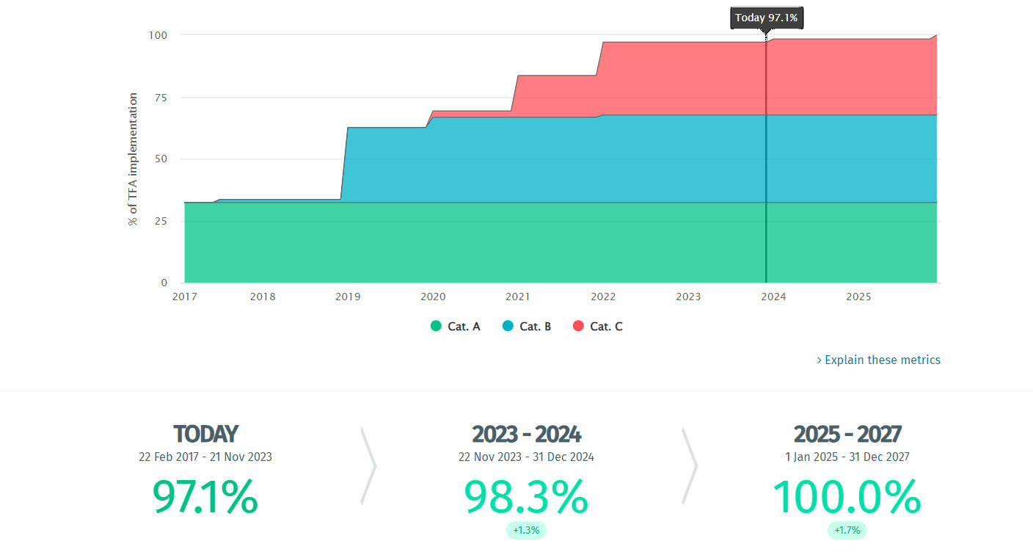

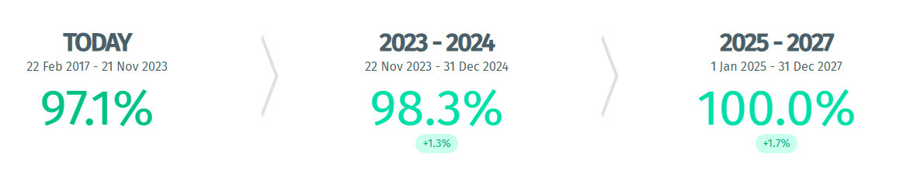

*Source: TFAF Database. Accessed on 21 Nov 2023*

By September 2022, Fiji had fulfilled 97.1% of its TFA implementation commitments. The two remaining commitments concern test procedures for goods declared for importation (definitive implementation date: 31 December 2023) and the establishment of a Single Window (implementation date: 31 December 2025)[40]. Fiji requires both technical assistance and funding to implement an integrated National Single Window (NSW) system. The authorities state that while the development of a Single Window Blueprint is currently in progress with the assistance of UNCTAD, further financial and technical assistance (TA) is required to roll out the implementation of the NSW in Fiji.

TFSP is also aligned to the recently signed Pacific Islands Forum regional trade facilitation strategy and has helped to promote regional integration. One stakeholder highlighted that a regional trade information portal would be very helpful to increase transparency on trade regulations applied by the different islands and added that a regional testing laboratory would also help to reduce costs and increase efficiency. The stakeholder noted that a Pacific-wide AEO program would also help to increase intra-regional trade.

TFSP support has also been relevant during the pandemic as the digitalized processes in place helped to quickly clear essential consignments.

### Activities

The TFSP started in Fiji and Pacific with a TFA Gap Analysis for the six WTO countries in 2015 with one of the main recommendations being the establishment of an NTFC. It supported the NTFC with the development of the Fiji TFA Roadmap and National TFA Action Plan. Activities and priorities identified for implementation include (A) assistance to harmonize multi-agency border processes, to streamline processes and requirements, and to harmonize data; (B) assistance in preparation to implement a Single Window system, including collaboration and coordination; and (C) assistance in developing the trusted trader program and related risk profiling.

In 2019, there was a pilot cargo manifest process, which was done as an initiative to demonstrate the value of the NTFC. This was done by organizing a work-through of process by all agencies. FRCS developed a module so other agencies (biosecurity and quarantine/health) could see benefits. Small digitalization initiatives took place: manifest, connectivity with e-Phyto, to link with ASYCUDA world. The Global Alliance for Trade Facilitation (GATF) undertook the private sector piece for e-Phyto, and the WBG, through the TFSP, did the connection with ASYCUDA and worked with the biosecurity agency (BAF) to map out processes. It also reviewed and finalized the draft laws and implementing regulations by BAF.

The TFSP assisted the NTFC in Fiji in setting up Technical Working Groups (TWGs), such as National Single Window (NSW), transparency of information, risk management and test procedures and assisted with the identification of new electronic initiatives and procedures that will enable border agencies to take further advantage of the recent upgrade of ASYCUDA World and installation of the Biosecurity Authority of Fiji (BAF) GeNS which will further enhance border collaboration. According to the 2023 TFSP Annual Report[41] – the main areas of technical assistance (TFA work priorities) that have been provided over the years primarily focused on:

*6.1 General Disciplines on Fees and Charges Imposed on or in Connection with Importation and Exportation*

*7.1 Pre-arrival Processing*

*7.4 Risk Management*

*8 Border Agency Cooperation*

*10.1 Formalities and Documentation Requirements*

*10.2 Acceptance of Copies*

*10.4 Single Window*

*23.2 National Committee on Trade Facilitation (NTFC)*

In May 2022, the WBG conducted an in-person mission to assist with the re-evaluation of all TFA-related changes that had been implemented swiftly during the response. Among the activities that were initiated through the NTFC working groups - TFSP support was used to provide advice and guidance on some of the following key initiatives and activities:

* The NTFC Secretariat requested support from TFSP to undertake a review of the status of border agencies’ capabilities to meet TFA requirements for “electronic reporting and clearance” of goods as well as the publication of information for the public and traders. This review’s objective was to ensure the Secretariat has a stock-take of all new initiatives implemented during 2019–2021 and would inform the NTFC’s considerations on options to implement a NSW and to focus its efforts.
* At the request of the NTFC Secretariat, the Word Bank Group recently undertook a “Digitization Gap Analysis to inform the design and guide the implementation of the Fiji National Single Window”, which includes a comprehensive analysis of the Border Clearance processes. This report was recently presented to key stakeholders and the Ministry of Trade.
* In October 2023, the Fiji NSW Blueprint was completed by UNCTAD and handed over to the Deputy Prime Minister and Minister for Trade, Co-operatives, Small and Medium Enterprises and Communications, Manoa Kamikamica[42] , who said the Single Window “The blueprint is a road map to developing the system which recognizes the need for different agencies involved in the trade clearance process and outlines their roles and responsibilities in the interconnectedness approach through this platform”.
* An NTFC Risk Management Working Group - which receives TFSP support through an initiative to improve collaboration between port users resulted in Fiji Ports Terminal Limited (FPTL) providing FRCS and BAF with access to the port operators’ container delivery system to allow improved planning for inspections and container delivery.
* The Ministry of Communications (MOC) is implementing a project, “DigitalFIJI,” which is the government’s digital transformation program aimed at creating the necessary infrastructure and applications to enable more government services to be conducted online and via apps. The NTFC Secretariat, with support from TFSP, is collaborating with MOC as some of these services intersect with services that also come under the scope of any future NSW developments.
* FRCS, BAF, and port users requested further training to develop a Time Release Study (TRS), and the TFSP provided support to commence preparations for the TRS with the intention of conducting a survey in late 2023.

### Effectiveness

Stakeholders reported that TFSP has been effective in achieving its outcomes. The TFSP benefitted from having a consultancy team physically on the ground during regular missions, which facilitated dialogue and ensured that consensus around decisions between the different stakeholders were reached during these missions. According to government stakeholders, the physical presence of the TFSP team has been key to the effectiveness of the program.

Interviewees highlighted several examples of the effectiveness of the TFSP. According to a government official, “Transparency is increased around initiatives such as trade information portals (TIPs) which support and save women and MSMEs time looking for information.” Regarding agricultural trade, which makes up more than 60% of Fiji’s exports, TFSP support has helped facilitate agricultural imports and exports. It is reported that cargo manifests are now delivered within minutes in comparison to 3-4 days prior to the implementation of TFSP initiatives. Companies like Ben Trading, one of the country’s leading exporters of cassava, taro, and seasonal vegetables, have benefited from such initiatives. The owner reported that trade facilitation is important not only for business growth but to support local people[43].

Indicators such as the OECD Trade Facilitation Indicators[44] also show that significant progress has been made since 2017 in several areas, including automation, information availability and procedures. However, there is scope for improvement in all areas. Advanced rulings have not yet been implemented.

Figure 7 Fiji’s Trade Facilitation Performance (2017 and 2022)

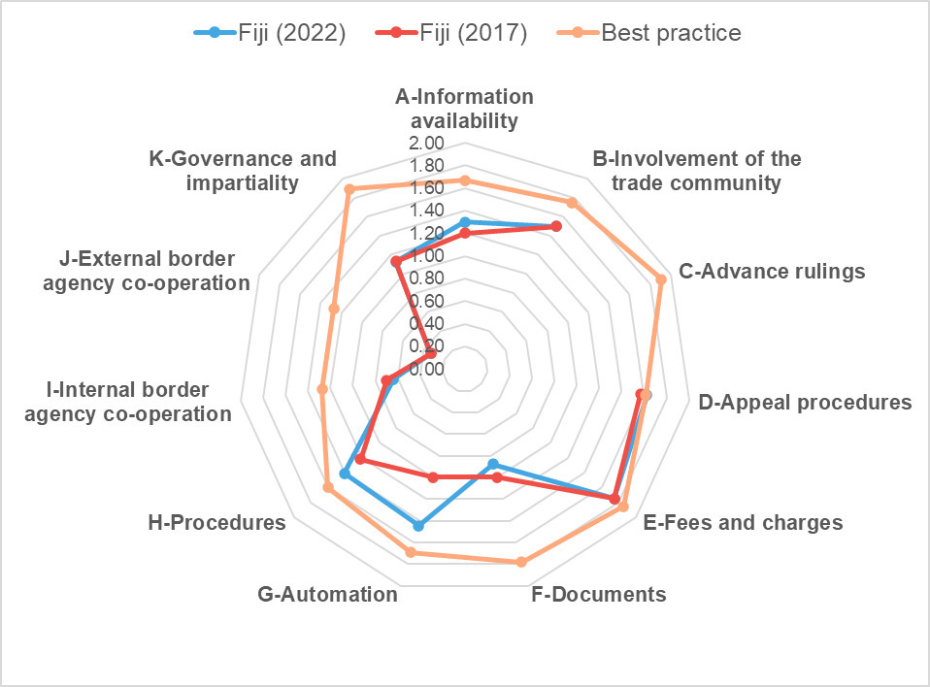

Source: OECD Trade Facilitation Indicators 2017 and 2022

Regarding the Logistics Performance Index (LPI), no major improvements have been noted in the different areas since 2016.

Figure 8 Fiji LPI, 2016 and 2023

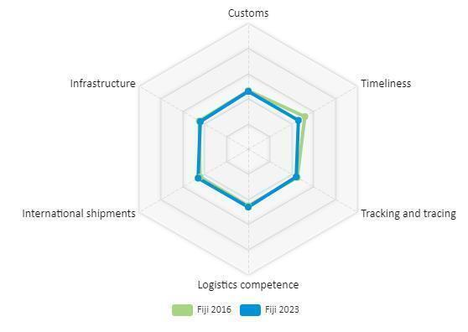

Source: Author’s elaboration based on World Bank LPI Data

Government stakeholders reported that the TFSP helped policymakers think ahead about the reforms that are needed in the country, adding that the program introduced a culture of collaboration between different departments in government and between government and the private sector.

The Fijian Ministry of Health underscored that TFSP reforms have allowed them to better manage health risks, especially around food safety. “The automated import systems also make trade facilitation and food safety requirements much easier and efficient. Together with our colleagues and partners in Biosecurity, in Customs, and as well in Fisheries, we continue to build on the momentum to use this automated system for the benefit of the citizens of Fiji,” said an interviewee from the Ministry.

Private sector stakeholders underscored that “Replacing the manual and paper-based manifest has helped speed up our day-to-day operations, saving us time and money.” Paperless cargo manifests have built confidence in digitalization. The next step, the implementation of the NSW, is expected to spur trade, especially in agricultural products.

The major factor mentioned in the interviews which constrained technical assistance provided by the WBG was the lack of human resources within their departments to continue moving ahead with the trade facilitation agenda.

### Efficiency

*Coordination.* Interviewees indicated that the TFSP has played a key role in bringing the public and private sectors together to work on trade facilitation issues. Examples of successful public-private coordination were seen in the implementation of the National Single Window and Single Manifest. However, stakeholders also highlighted that more private sector involvement in the NTFC should be considered. Furthermore, the whole of government approach used by the TFSP program has resulted in better coordination between different government agencies involved in the trade facilitation environment. A Customs stakeholder said, “The TFSP has been a catalyst to work with other border agencies, e.g., we were doing many the same things on risk management as other border agencies and through TFSP, we now have a joint approach to risk management.”

*Leverage*. One of the results of TFSP support in Fiji has been to provide continuity to WBG trade facilitation activities. This is described internally as leveraging additional funds. Fiji is a good case example of what can be leveraged from the TFSP with other work from the Bank. The TFSP team has worked with the 6 WTO members and 4 non-WTO members in the Pacific. One of the key successes has been to promote regional dialogue through the NTFCs, for example. Getting key players in the region to discuss common issues of interest on TF through policy dialogue has been one of the positive outcomes for the TFSP, starting with the 10 assessments we completed at a national level – there are obvious common challenges being faced by island nations across the region.

*COVID-19*. Important lessons have been learned around trade facilitation measures for emergency preparedness, such as: i) Expedited clearance procedures should be in place before there is a disaster or emergency; ii) Procedures should be aligned with international guidelines, standards and agreements; iii) Developing standard operating procedures for processing relief consignments are required; iv) Sharing of best practices across all border agencies is essential on a continuous basis. Furthermore, “Expedited clearance procedures piloted during the pandemic reduced the time to import vaccines, priority food products and emergency-related cargo”. In Tonga, for example - expedited clearance fell from 3 days to 3 hours. As it happened, it was introduced just before the COVID vaccines arrived. Also, with the eruption of the Hunga Haʻapai volcano, it allowed for the relief consignments to get in quickly. A guide was produced by the TFSP to help countries put in place critical processes for times of crises.

### Conclusion

The World Bank's Trade Facilitation Support Program (TFSP) in Fiji has been considered highly relevant in addressing the country's specific challenges, including detachment from major markets and climate change vulnerability. The TFSP played a pivotal role in putting the WTO TFA on Fiji's political agenda, leading to its ratification in 2017. By September 2022, Fiji had fulfilled 97.1% of its TFA implementation commitments, with two remaining commitments related to importation test procedures and the establishment of a Single Window system. The TFSP has also provided crucial support in areas supporting harmonizing border processes, preparation to implement the National Single Window, and the development of a trusted trader program.

The effectiveness of TFSP is evident in increased transparency, streamlined processes, and improved cargo manifest delivery times. Stakeholders commended the program for fostering collaboration between government departments and the private sector, ultimately enhancing trade facilitation. The TFSP's efficiency is underscored by its coordination efforts, bringing together diverse stakeholders to work on trade facilitation issues.

The program's leverage extends beyond Fiji, promoting regional dialogue through National Trade Facilitation Committees (NTFCs) and addressing common challenges faced by Pacific Island nations. Lessons learned during the COVID-19 pandemic emphasize the importance of expedited clearance procedures and standardized protocols for emergency preparedness. While progress is notable, challenges persist, including the need for additional human resources to sustain momentum. Overall, the TFSP has significantly contributed to Fiji's trade facilitation efforts, fostering economic growth and resilience in the face of global challenges.

Case Study 2: Lesotho

### Context and Background

Lesotho is landlocked, with exports highly concentrated in textiles and diamonds, which account for 43% and 19% of exports, respectively in 2022. The country’s main imports are mineral fuels (17%), cotton (7%), fabrics (5%) and electrical machinery (5%), among others[45]. Lesotho’s trade balance is structurally in deficit, and this trend is expected to continue.

Lesotho benefits from increased market access through various unilateral and bilateral trade agreements and memberships in regional trade blocs. The country is a member of the Southern African Customs Union (SACU) and enjoys duty-free trade with other SACU members which include Botswana, Namibia, South Africa, and Eswatini. As a Member of SACU, Lesotho also benefits from increased market access to international markets through the trade agreements signed by the bloc. Lesotho is a member of the Southern African Development Community and a beneficiary of the African Growth and Opportunity Act program. Classified as a least developed country under the Cotonou Agreement, Lesotho also benefits from the EU’s Everything But Arms (EBA) initiative, which provides duty-free and quota-free access to the EU for all products except arms. Furthermore, the country has ratified the African Continental Free Trade Agreement (AfCFTA), which aims to create a single continental market for goods and services.

Trade facilitation is instrumental in Lesotho’s economic growth and development. Despite notable progress made in enhancing the trade facilitation environment, trade costs remain high in Lesotho. The landlocked country is highly reliant on South Africa for transit to third-country markets, and while significant investments have been made to increase efficiency at the border through customs management systems, there is scope to improve cross-border transport and transit bond operations further. Moreover, the harmonization of regulations governing transport services is crucial to reduce the time and costs associated with international export transport services[46].

The National Strategic Development Plan (NSDP) 2017/18 - 2022/23 serves as the main framework to advance the country’s development goals and aims to transform Lesotho from a consumer-based economy to an export-oriented economy led by the private sector. Trade facilitation is an important component of the NSDP, whose lifespan was extended by the current government. The execution of the trade component of the NSDP is directed by the National Trade Policy Framework for 2021-2025[47]. Significant progress has been made on business environment reforms, but challenges persist, and the political and security environment provides an extremely challenging backdrop for efforts to improve the country’s trade facilitation regime.

### Relevance

TFSP interventions in Lesotho are considered to be highly relevant. Overall, the trade reforms have underpinned the country’s positive progress in improving its trade-enabling environment. In 2014, Lesotho ranked 147th out of 189 countries in the Trading Across Borders category in the World Bank’s Ease of Doing Business Report. By 2020, the last year during which the report was published, Lesotho’s Trading Across Borders ranking improved to 40th out of 190 economies. The TFA is viewed as one of the significant reforms which has contributed towards this improvement.

Lesotho ratified the TFA in January 2016. The WBG conducted a validation assessment mission, which assessed the trade facilitation regime in the country and collected feedback from the business community regarding the alignment of country processes with the TFA in June 2016. This exercise led to the elaboration of a plan of action, which was validated with stakeholders in a national TFA validation workshop[48]. According to TFAF, the lion's share of requested assistance has been in the regulatory area, representing 19 requests. Skills and capacity building of institutions, followed by ICT support, were the second and third most requested areas of assistance[49]. 63% of the TFA commitments are categorized as C commitments.

The WCO and UNCTAD, as well as the WBG, have been supporting Lesotho with implementing its commitments in the TFA. The WCO supported Lesotho under its Accelerate Trade Facilitation Programme in April 2023 to further enhance Coordinated Border Management, in line with Article 8 of the WTO Trade Facilitation Agreement (TFA), through Lesotho Border Management Services (LBMS)[50]. The WCO supports Lesotho under the multi-year Mercator partnership with Revenue Services Lesotho (RSL). It also delivered a data analytics workshop for the senior management of the Lesotho Revenue Authority (LRA)[51]. In June 2022, a new electronic tariff platform, developed by the LRA in partnership with the EU-WCO Programme for Harmonized System in Africa (HS-Africa Programme), funded by the European Union, was launched[52]. The WCO’s Accelerate Trade Facilitation Program, funded by the United Kingdom’s HM Revenue & Customs (HMRC), also delivered workshops on best practices and modern techniques in specific areas of Customs Project Management over 2021 and 2022.

UNCTAD was heavily involved in capacity building and preparing a roadmap of activities for the NTFC in Lesotho through the HMRC-WCO-UNCTAD Capacity Building Program for the Implementation of the WTO Trade Facilitation Agreement[53].

The activities supporting the LRS were part of the Customs Modernization Program[54] under the Trade Partnership program with the South Africa Revenue Service (SARS), which was initiated in 2012 as a bilateral arrangement with the SARS but which faced challenges, especially with elements of the AEO scheme.

Figure 9 Timeline of implementation of TFA commitments (Lesotho)

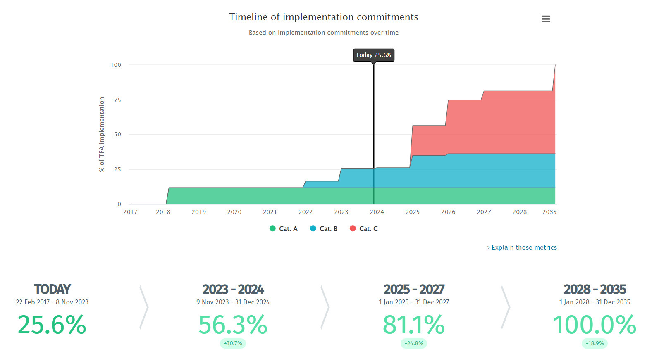

Source: TFAF Database. Accessed on 1 Nov 2023

In June 2022, the WBG updated Lesotho’s WTO TFA Gap Assessment. Stakeholders highlighted that there has been strategic continuity in TFSP implementation from 2016. Since the mid-term stocktaking exercise of the TFSP in 2019, a strong link has developed between the TFSP, loan funding and government strategy and investments. The TFSP has also improved regional integration and border management efforts, building strong links between Lesotho, South Africa and the region, which are instrumental for trade facilitation since trade from Lesotho transits through South Africa.

### Activities

The 2017 TFSP Annual Report stated that “The TFSP is supporting Lesotho in revising legislation (customs and electronic-transaction legislation that will support the single window), in enhancing the implementation of ASYCUDAWorld, in creating a trade single window and enhancing the trade information portal, setting up a National Trade Facilitation Committee, and in improving coordinated border management.” ASYCUDAWorld was implemented before the TFSP in 2015 under the Customs Modernization Program. Legislative review was done in a second phase, which included upgrading the modules in ASYCUDAWorld, but the legislative process had gotten stuck in parliament.

The 2018 TFSP Annual Report indicated that the WBG continued the work started in the previous year and was successful in (i) obtaining government support for the implementation of the single window, (ii) supporting over 12 border and cross-border trade regulatory agencies to streamline processes for permits and certificates, (iii) developing a legal framework concept paper for the single window; (iv) developing technical Terms of Reference for the upgrade of the ASYCUDA customs processing system and the development of a disaster recovery system and site, (v) conducting a time release study which also included specific recommendations on enhancing efficiency of agencies involved, (vi) providing support in creating the NTFC which was formally launched in September 2017. Furthermore, the TFSP provided support with consultations on the draft 2018 Customs Bill and offered advisory services to the government of Lesotho on enhancing its trade portal, resulting in a formal request by the government to upgrade the portal.

The 2019 TFSP Annual Report highlighted that a national single window information and communications technology (ICT) needs assessment was carried out and validated by both public and private sector actors. The needs assessment also provided recommendations to facilitate the smooth implementation of a light version of a national single window (LNSW). The aim of the LNSW is to capture around 80-90% of transactions for Lesotho, which are processed by up to 5-6 agencies. Furthermore, upgrades of the payment system were developed and tested to ensure compatibility with the latest version of the ASYCUDA. The Lesotho Revenue Authority (LRA) - South African Revenue Service (SARS) Connect Project, which aims to share information on import and export matters, was also kickstarted in May 2019.

The 2020 TFSP Annual Report underscored the support provided by the TFSP with the drafting of a coordinated border management report, including recommendations which have been instrumental in enhancing border processes to facilitate clearance of essential goods during the pandemic. Notably, all medicinal products crucial to the fight against COVID-19 as well as donations, were exempted from duties and import tax. TFSP also continued to facilitate the connectivity of LRA and SARS, which were in the testing phase of the single declaration. Furthermore, TFSP offered support to LRA for three regional workshops aimed at increasing awareness of prohibited and restricted goods entering or exiting Lesotho. TFSP continued to work with the government to enhance the Lesotho Trade Information Portal (LTIP), providing support for an online workshop and training for the new version of LTIP as well as the drafting of a stakeholder analysis for the LTIP.

The 2021 TFSP Annual Report highlighted the re-launch of the new and improved LTIP, which includes over 260 regulations and procedures from 22 government agencies and enhances access to and transparency in the country’s trading laws and processes. Technical assistance was also provided to the NTFC Secretariat and technical working group to notify addendums to Category C commitments to the WTO. TFSP also offered support for the review of the LRA’s risk management processes and for evaluating the readiness of the organization to implement a holistic customs border management (CBM) approach. TFSP subsequently supported CBM reforms, which had been delayed due to the pandemic. Additionally, TFSP provided technical assistance to develop Lesotho’s Preferred Trader Program (PTP), specifically ensuring alignment with international standards. TFSP also continued to support the implementation of the Lesotho National Single Window Lite (LNSW) by providing support to the procurement process, development of the LNSW blueprint, which was adopted by the NTFC and the formation of a transitional steering committee within the NTFC to work with suppliers.

The 2022 TFSP Annual Report indicated that continued TFSP support led to the enactment of the Customs and Excise (Amendment) Act 2021 and the roll-out of the pilot phase of the LNSW. The TFSP team also provided support to the LRA Customs to revive the PTP with the goal of expanding the program into a holistic AEO program in alignment with the WCO SAFE Framework of Standards and the South African AEO program. A consultant was engaged to assist with incorporating AEO provisions into the law. Following the LTIP re-launch and the roll-out of the LNSW, the TFSP conducted a private sector survey, which showed that LTIP use had increased since the launch of the new version. The team also conducted an updated assessment of Lesotho’s alignment with the WTO TFA.

The 2023 TFSP Annual Report highlighted that following the support provided in the previous reporting period, the Customs and Excise Amendment Regulations 2022 was issued in a Gazette Notice. A time release study (TRS), measuring export and import processes and covering time taken by agencies such as the Revenue Service of Lesotho (RSL) as well as other cross-border regulatory agencies involved in the issuance of licenses, permits and certificates, was also delivered. Additionally, Lesotho received a new allocation of funding as part of the Sothern Africa Regional program under TFSP. WBG, therefore, worked closely with government stakeholders to review the country’s trade facilitation priorities and identify reform opportunities to define implementation support for priority TFA measures. The TFA Gap Assessment report prepared in the previous reporting period was finalized and presented to the NTFC. TFSP support also assisted with the development of Terms of Reference for enhancing private sector participation in the AEO program and for a horticulture survey that will be completed in 2024. The survey aims to assess non-tariff barriers and trade facilitation constraints for horticulture exports, and recommendations based on WTO TFA measures will be proposed to address these barriers. Furthermore, initial preparations were made for the Trade and Gender Study in Lesotho. This included refining the survey methodology and tools and engaging with government counterparts to gather necessary information. The study is scheduled for completion in the upcoming reporting period. Support is also planned for an end-to-end TRS at the Maseru Bridge border, involving collaboration between Lesotho stakeholders and South Africa under the joint guidance of the World Customs Organization's capacity building.

There have been no specific activities, including a gender focus, up until recently. However, many of the mainstream TFA alignment activities carried out would have had a positive impact on women traders. Activities that are likely to have benefited women include the availability of information on regulations, procedures, and fees through the LTIP, the LRA-SARS Connect project, which ultimately decreases trade costs, the PTP, which simplifies customs procedures and the LNSW which increases efficiency at the border. The TFSP has paid attention to gender balance for participation in meetings. A gender dimension survey is about to start at the time of writing (end-2023).

A total of 42 events took place in Lesotho under the TFSP since the start, as shown in Table 9.

Table 9 TFSP events held for Lesotho

| **No.** | **Date** | **Name of Workshop** |
| --- | --- | --- |
| 1 | October 2016 | Workshop with senior management of the LRA to present the ASYCUDA World Automation Report |
| 2 | Nov 28 – Dec 2, 2016 | Heads of Border Agencies workshop |
| 3 | April 2017 | Workshop on strategic planning workshop for border agencies and enhancements to ASYCUDA World |
| 4 | April 2017 | Workshop to discuss the Single Window |
| 5 | July 2017 | WTO Aid-For-Trade Review and a trade facilitation peer-to-peer learning event in Geneva, co-organized by the WBG and the WTO. |
| 6 | 01 August 2017 | LNSW Visioning Workshop |
| 7 | 12 & 13 September 2017 | LNSW BPR workshop |
| 8 | 15 September 2017 | TRS workshop for Heads of Border Agencies |
| 9 | 24 October 2017 | First sitting of the National Trade facilitation Committee |
| 10 | 15 January 2018 | Workshop on SW business process approval and functional requirements |
| 11 | 15 May 2018 | Workshop on SW system requirements |
| 12 | 16-18 May 2018 | Workshop on consolidated prohibitions and restrictions list |
| 13 | 08 May 2019 | Workshop on ICT Assessment Validation Report for NSW |
| 14 | 11 September 2019 | NTFC Workshop |
| 15-28 | 07 Mar 2017 – 17 Oct 2019 | 14 trainings on Preferred Traders Programme |
| 29 | October 2019 | Training on Prohibited Goods – Central Region |
| 30 | October 2019 | Training on Prohibited Goods – Northern Region |
| 31 | 23 October 2019 | NTFC Workshop |
| 32 | Oct 24, 2019 | Introductory TIP meeting |
| 33 | 5 Nov 2019 | Demonstration of TIP Workshop |
| 34 | November 2019 | Training on Prohibited Goods – Southern Region |
| 35 | 02 December 2019 | NTFC Workshop |
| 36 | 23 January 2020 | NTFC Workshop |
| 37 | June 30, 2020 | Workshop with LRA risk, processing centre, audit, and anti-smuggling personnel in a collective discussion |
| 38 | 09 December 2020 | Physical and Virtual Official launch of the Lesotho TIP |
| 40 | June 8, 2022 | Risk and Compliance |
| 41 | June 14, 2022 | AEO Security |
| 42 | June 29, 2022 | AEO Legal Workshop |

### Effectiveness

The updated TFA Gap Assessment provides an excellent way of assessing progress and achievements in terms of expected TFSP outcomes.

Other indicators, such as the OECD Trade Facilitation Indicators[55] , also show that significant progress has been made since 2017 in several areas, including information availability, simplification and harmonization of documents, internal border agency cooperation, governance, and impartiality. However, there is scope for improvement in all areas.

Figure 10 Lesotho's Trade Facilitation Performance (2022)

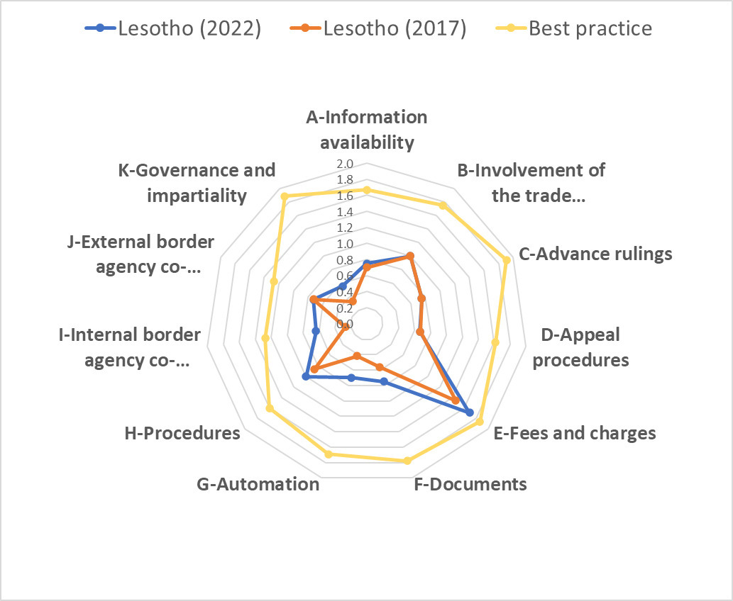

Source: OECD Trade Facilitation Indicators 2022

Regarding the Logistics Performance Index (LPI), updated data for Lesotho was not available. As shown in the radar chart below, between 2014 and 2018, progress was limited across the different indicators.

Figure 11 Lesotho LPI, 2014 and 2018

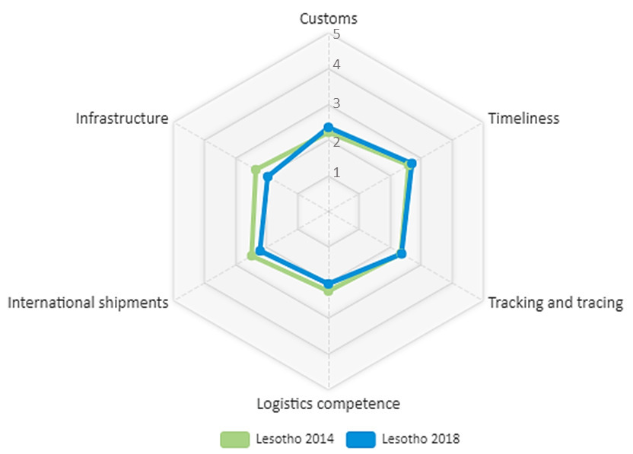

Source: Author’s elaboration based on World Bank LPI Data

Stakeholders reported that the level of engagement with the NTFC in Lesotho was effective and frequent and that the NTFC has a clear vision and a well-articulated plan to implement its vision. The initial set-up, dynamism and capacity of the NTFC were a driving force, especially in the initial stages of implementing the roadmap and the NTFC was progressive in edging progress forward. The NTFC in Lesotho also benefits from institutional stability as there has been no significant change of personnel in its member institutions, which provides stability and retains capacity.

As the NTFC roadmap moved towards the implementation of larger areas, such as the decision to finance the LNSW, final decisions were made by the Lesotho Coordinating Committee on Trade (LCCT). The LCCT was significantly less nimble, being headed by senior officials, which slowed down the decision-making process. While not compromising the results, this structure reduced the efficiency and speed of implementation. It was also highlighted that the COVID-19 pandemic led to a fragmentation of relationship management between the different agencies in the NTFC and that the lack of alignment reflects poorly on the leadership role that the NTFC is meant to play.

Interviewees pointed out that the whole of government approach was complex in Lesotho and further faced hurdles due to the limited capacity constraints. The Authorized Economic Operator project, which followed this approach, could not be implemented as not all government agencies were ready to sign up. However, the AEO project was moved to the regional level, and it has since progressed with agreement on the whole of government approach at that level. While the result was not compromised, it has taken longer to implement this reform.

While the AEO implementation was successful, it recorded 10 compliant exporters in 2020 in the program. Two companies have since merged, so there are now just 9 compliant AEOs in Lesotho. Three new applications are in the system as of the time of the stocktaking exercise. Most of the AEO operators are retailers. In May 2023, a SACU AEO scheme was completed, which will facilitate the movement of goods transiting in South Africa to the port.

The following factors which constrained technical assistance provided by the WBG were mentioned in the interviews:

* The software development for the LNSW took quite long, primarily as it was difficult to find a regional service provider for the coding that would use open-source software that would enable the maintenance and update of software by LRS. Once a service provider was on-boarded, the development went smoothly.
* While the speed of implementation of the LSNW, was considered fast, at just 13 months, a little delay was caused by the LRS’s IT department scheduling and other commitments, which some stakeholders estimated to have added around 15% delays in time to the project.
* As mentioned above, although the NTFC is functional and meets regularly, it is not capacitated to take decisions as it falls under the purview of the LCCT. The LCCT does not meet regularly, limiting the NTFC’s actions and making it a more prescriptive body. Nevertheless, the NTFC was helpful in endorsing actions to gain legitimacy.
* Some of the other border agencies were very slow to adapt to technological improvements leading to resource-based challenges for some of the border agencies. Some of the slow uptake also reflected low willingness to adopt to institutional changes amongst some agencies, despite the significant capacity-building efforts to improve efficiency.

### Efficiency

*Coordination*. Interviewees indicated that there was good private sector engagement in the initiatives undertaken by TFSP, especially the LTIP. On the other hand, several stakeholders highlighted that coordination and management of the program locally could be improved, adding that WBG has too few resources to manage this global program. Regarding coordination with other development partners working in Lesotho, stakeholder consultations showed that coordination was generally good, with no overlaps and a good rhythm of delivery. Active development partners in trade facilitation in Lesotho comprise UNCTAD and the WCO. The Accelerate Trade Facilitation program, jointly implemented by the WCO, UNCTAD and HMRC, delivered several interventions for Lesotho, including recent training on coordinated border management for the Southern African region, to strengthen the capacity of officials in charge of national trade facilitation committees (NTFCs) across Botswana, Eswatini, Lesotho, Malawi, Namibia, South Africa, Zambia and Zimbabwe.[56]

Delays in certain areas of implementation of NTFC activities were also underlined by some stakeholders. Since Lesotho lacked regulations governing e-transactions and e-signatures, it was necessary to have them in place to accommodate such recognition by the customs code. This process takes, on average two years or more, for legislative changes. The legislation Working Group worked at a slower pace than other areas of the implementation of NTFC activities. An earlier start of the process would have expedited reform activities led by NTFC.

*Leverage.* One of the results of TFSP support in Lesotho has been to provide continuity to WBG trade facilitation activities. This is described internally as leveraging additional funds. In Lesotho, TFSP has supported the development of the LNSW since 2017, including a blueprint that consisted of a business model, legal and regulatory framework, information technology infrastructure, and business process analysis. The LNSW blueprint was approved for adoption by the LCCT in February 2022 and is now being used to guide the implementation of the LNSW. The groundwork led by the TFSP was leveraged for a USD 15 million WBG loan to fund the implementation of the LNSW through the World Bank Private Sector Competitiveness and Development Project. TFSP support also led to further advisory work under consideration through a Southern Africa Regional Trade Facilitation project.

### Conclusion

Trade facilitation is instrumental for landlocked Lesotho’s economic growth and development even though the volume and complexity of transactions are relatively small in Lesotho in comparison to other countries. TFSP support in Lesotho has been highly relevant to both the public and private sectors. According to the TFAF, 63% of TFA commitments are Category C, and the top requests for assistance from Lesotho were in the regulatory area, skills and capacity building of institutions and ICT support. Overall, it is considered that TFSP has contributed to a better trade environment in Lesotho, building capacity and increasing the adoption of technology by trade-related institutions through leveraging broader and complementary instruments.

One of the major achievements of the program includes the roll-out of the pilot phase of the LNSW in 2022. After a year of implementation, it is a little early to measure results, but stakeholders suggest that revenue capture is likely to increase, and clearance times at most points should drop by a few hours. Nevertheless, trade is often pre-cleared through license or permit holders before reaching the border. The launch of the enhanced LTIP portal has also been a welcome development, especially by the private sector which now has easy access to regulations, processes and fees related to import and export.

Furthermore, TFSP support has been critical to the establishment and functioning of the NTFC, a key player in the trade facilitation agenda for Lesotho. The institutional stability that the NTFC benefits from has been important for Lesotho’s progress in aligning with the TFA. Nevertheless, challenges remain as the NTFC falls under the LCCT and is limited in its decision-making role. Better leadership of the NTFC is also needed to enhance collaboration between agencies involved. Additionally, TFSP-funded activities in Lesotho also leveraged new projects for WBG. The groundwork done by TFSP for the LNSW led to a USD 15 million WBG loan for implementation of the LNSW through the World Bank Private Sector Competitiveness Program.

The main challenges that constrained technical assistance provided by TFSP include coordination and delays in the implementation of NTFC activities. While there was good private sector involvement in TFSP-funded initiatives, consultations showed that coordination and management of the program can be improved through the provision of more WBG resources to the project. Coordination with other development partners was generally good. The lack of a regulatory framework in certain areas also led to delays in the implementation of NTFC activities. With legislative changes taking up to 2 years to materialize, the reform process took longer than expected. A prior assessment of the regulatory framework would have increased efficiency of TFSP.

Despite these constraints, the continued support of WBG and international development partners in pushing for reform is welcomed by both the public and private sectors. The TFSP’s contributions are recognized as essential outcomes for further reducing trade barriers and costs.

Case Study 3: “Deep Integration” Customs Union of Guatemala, Honduras and El Salvador

### Context and Background

Facilitating cross-border trade in Central America has presented numerous challenges. In 2017, cargo trucks still used to spend 10 hours to traverse less than a kilometer at the Guatemala-Honduras borders. These prolonged delays at border points contributed to a sluggish and costly regional trade environment.

Trade facilitation is at the foundation of Central America’s regional economic integration process and in 2015, Guatemala and Honduras initiated a Customs Union project aimed at streamlining trade through the elimination of customs procedures at shared borders. Following consultations with the private sector and governmental entities, El Salvador's Legislative Assembly sanctioned the Customs Union adhesion protocol to the "Northern Triangle Customs Union" in July 2018. Subsequently, in December 2021, the three nations approved a roadmap for El Salvador's inclusion in what is known as “the Deep Integration Process.” The inclusion of El Salvador is still a work in progress.

Given the shared borders and economic interests among these three countries, trade facilitation is of paramount importance to streamline cross-border transactions, reduce trade costs, and bolster economic growth. The “Deep Integration” Project goes well beyond the TFA, but it is an example of how to accomplish much more than the TFA requires, using regional development and regional structures, in this case, a customs union.[57] The “Deep Integration” customs union is a project within the TFSP’s Regional Central America Project. While the team leader estimates that “Deep integration” is perhaps 10% of the wider Regional Central America Project, it has great importance.

Central America has benefited from the Central American Integration System (SICA – Sistema de Integracion Centroamericana), which developed from the General Treaty on Central American Integration, signed in 1960 which was intended to form a common market.[58] SICA was established in 1991 in a common market form as the primary framework for regional integration in Central America. SICA is similar to other common market models covering economic, political, security and related areas. For most areas related to the “Deep Integration” customs union - which is the focus here, the relevant area for trade facilitation is the economic pillar of SICA[59], which has its own Secretariat for Regional Economic Integration (SIECA).[60]

In the political economy landscape of Guatemala, Honduras, and El Salvador, trade facilitation reforms are intrinsically linked with broader goals of economic rejuvenation, stability, and regional integration. These countries, each grappling with their unique challenges — from political unrest and corruption to economic disparities and security concerns — view trade as a lever for growth and stability.[61]

Implementation of trade facilitation reforms often meets hurdles stemming from national political dynamics. In Guatemala, indigenous rights and land use conflicts intersect with trade policies, while Honduras grapples with institutional weaknesses and governance issues. El Salvador, transitioning through various political phases, faces challenges in aligning its domestic reforms with regional commitments. Despite these complexities, the shared economic goals working with SIECA provide a foundation for these nations to pursue trade facilitation and integration through the customs union process known as “Deep Integration”, leveraging the collective strength of the region.[62] The project leader for the “Deep Integration” Project relating to the Customs Union summarized the two stages of the project as firstly integrating Guatemala and Honduras as a customs union, and secondly, the process of starting to add El Salvador.[63]

### Relevance

TFSP interventions are highly relevant in the context of the “Northern Triangle” countries of Guatemala, Honduras, and El Salvador.

In 2014, Guatemala, Honduras and El Salvador ranked 116th, 84th and 64th, respectively, out of 189 countries in the Trading Across Borders category in the World Bank’s Ease of Doing Business Report. By 2020, the last year during which the report was published, the Trading Across Borders ranking for Guatemala and El Salvador improved to 82nd and 46th out of 190 economies. The TFA is considered to have significantly contributed towards this improvement. However, Honduras slipped to 130th out of 190 economies for the trading across borders indicator.

Guatemala ratified the TFA in March 2017. According to TFAF, ICT support and infrastructure and equipment support were the top two types of technical assistance sought, accounting for 7 and 6 requests, respectively. Human resources and training, followed by legislative and regulatory framework support, were the third and fourth most requested areas of assistance[64]. 27.3% of the TFA commitments are categorized as C commitments. By August 2020, Guatemala had fulfilled 98.3% of its TFA implementation commitments.

Figure 12 Timeline of implementation of TFA commitments (Guatemala)

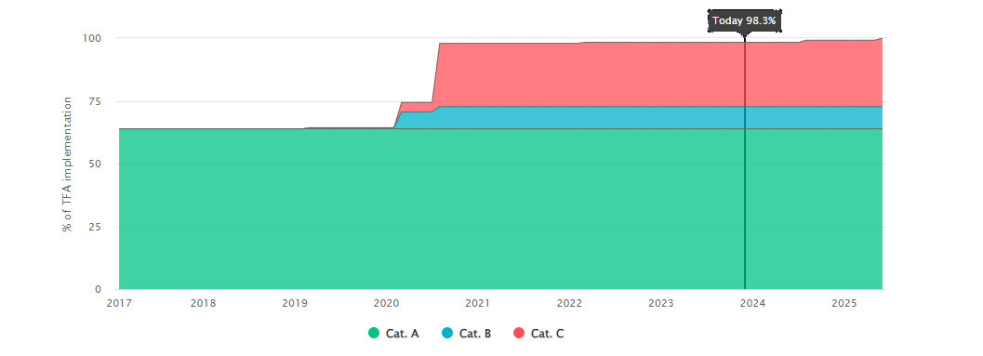

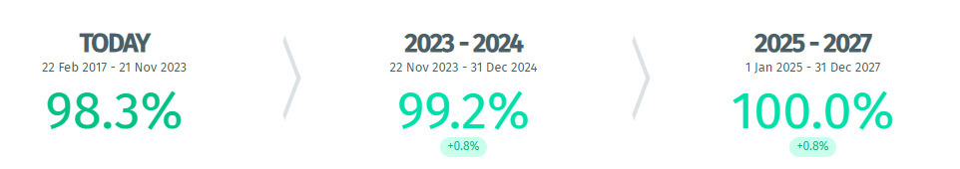

Source: TFAF Database. Accessed on 21 Nov 2023

Honduras ratified the TFA in July 2016. According to TFAF, human resources and training was the most requested area of technical assistance with 11 requests followed by legislative and regulatory framework support with 10 requests[65]. Institutional procedures followed by ICT support, were the third and fourth most requested areas of assistance. 39.1% of the TFA commitments are categorized as C commitments. By April 2023, Honduras had fulfilled 70.6% of its TFA implementation commitments.

Figure 13 Timeline of implementation of TFA commitments (Honduras)

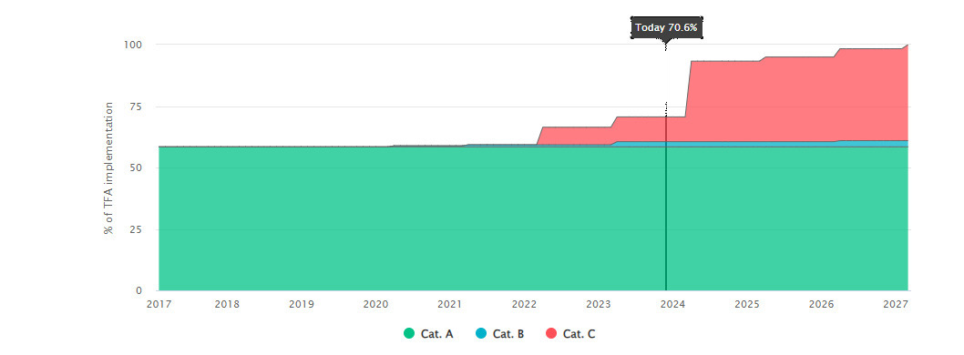

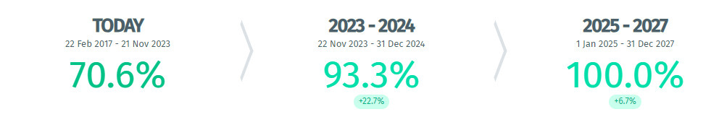

Source: TFAF Database. Accessed on 21 Nov 2023

El Salvador also ratified the TFA in July 2016. According to TFAF, ICT support, legislative and regulatory framework support and diagnostic and needs assessment were the top 3 technical assistance sought, with 6 requests each[66]. 22.7% of the TFA commitments are categorized as C commitments. By January 2023, El Salvador had fulfilled 98.3% of its TFA implementation commitments.

Figure 14 Timeline of implementation of TFA commitments (El Salvador)

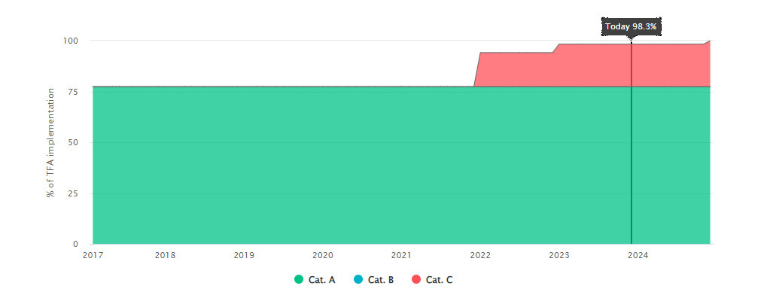

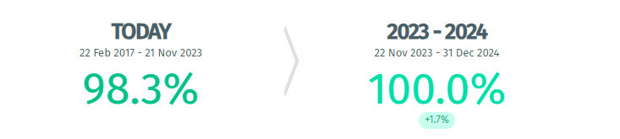

Source: TFAF Database. Accessed on 21 Nov 2023

### Activities

The activities for the “Deep Integration” Project relating to the Customs Union can be broken into two categories: 1. Activities supporting the integration of Guatemala and Honduras as a customs union and SIECA as secretariat; and 2. Activities supporting the process of adding El Salvador to the existing customs union.

1. Activities to support the governments of Honduras and Guatemala and SIECA:

* A baseline study which included border crossing times and processes at the three integrated land posts between Guatemala and Honduras.
* Development of 6 IT modules of FYDUCA (Central American Single Invoice and Declaration).
* Training more than 150 companies on how to use FYDUCA, and pilot exercises with three regional companies.
* Measurement of border crossing times once FYDUCA was operating.
* Assessment of the operations between Guatemala and Honduras at the Corinto border post using FYDUCA, identification of the main bottlenecks for the effective operation at the border, and proposed solutions for improvement of times in the short and medium term.

1. Activities to support the government of El Salvador in activating its accession to the customs union:

* Implementation of the road map for the country to join the deep integration, by working with the General Directorate of Internal Taxes of El Salvador in identifying the requirements in terms of developments and tests needed for the implementation of the FYDUCA.
* Supporting the Ministry of Finance to develop, modify and adapt its IT systems to be able to use FYDUCA.
* Preparation and dissemination of a training program, prior to the implementation of the Advance Declaration between Guatemala and El Salvador.
* Official launch of advance declaration at the “La Hachadura” land border in August 2022, with news outlets, public and private sector representatives.

In its FY2023 Annual Report, TFSP summarizes its Central America work in the final reporting year: “In this reporting period, the WB helped to deliver a high-level regional event and continued to support work on multimodal transport, expedited shipment, agile border crossings and deep integration (particularly with advance declarations between countries). Building on the ongoing rich and fluid policy dialogue, the WB engaged with the outgoing and incoming presidency pro-tempore of COMIECO (Costa Rica and Guatemala) respectively, as well as SIECA, to help craft a set of policy reforms that could be implemented in the short term and can result in tangible improvements for regional trade conditions.”[67]

### Effectiveness

The Deep Integration Project’s effectiveness in the Central American nations of Guatemala, Honduras, and El Salvador can be gauged by the tangible outcomes observed since the program's inception. Across all three nations, there's an evident uptick in trade volume, a reduction in trade barriers, and an improvement in stakeholder satisfaction, especially among the trading community.[68] According to a report by the World Bank, after the use of the FYDUCA since March 2018, about 75% of trade enjoys free movement.[69] Border crossings have averaged six minutes. Bilateral trade between Guatemala and Honduras increased 10.9% from 2017 to 2018.[70]

As the former Secretary General of SIECA shared: “Deep Integration” was many steps forward, well beyond those of the broader six country process. As an example, he cited SPS. Electronic handling of SPS transmissions started with the 2 countries of Guatemala and Honduras, but all of the six countries are watching.

A pivotal factor contributing to the program's effectiveness is its synergy with regional bodies, notably the engagement by SIECA. By aligning the Deep Integration Project's goals with SIECA's regional integration objectives, the Regional Central America Project ensured that reforms in individual countries were harmonized with broader regional standards. This integration has amplified the Deep Integration Program’s impact, as trade facilitation efforts in one country have a ripple effect across the region. The bi-national and regional projects under the Regional Central America Project have fostered a spirit of collaboration, ensuring that countries don't just improve their trade processes in isolation but move forward in tandem, benefiting the entire Central American trade ecosystem. Having said that, many of the broader outcomes cannot be directly linked to the Deep Integration project.[71]

This kind of learning and adjusting has enhanced the utility of the technical assistance being provided. The first phase of the Regional Central America Program, including Deep Integration, ended in May 2019, and Phase II was launched (P171021).[72]

A more limited number of activities were carried out during the COVID-19 period, and then in FY22 things began to open further to localized work. In its December 2022 report, the WB team self-assessed that their progress towards their Development Objective ranked as “Satisfactory (5)”.[73]

Indicators such as the OECD Trade Facilitation Indicators[74] also show that significant progress has been made since 2017 in several areas in the different countries.

Figure 15 Guatemala’s Trade Facilitation Performance (2017 and 2022)

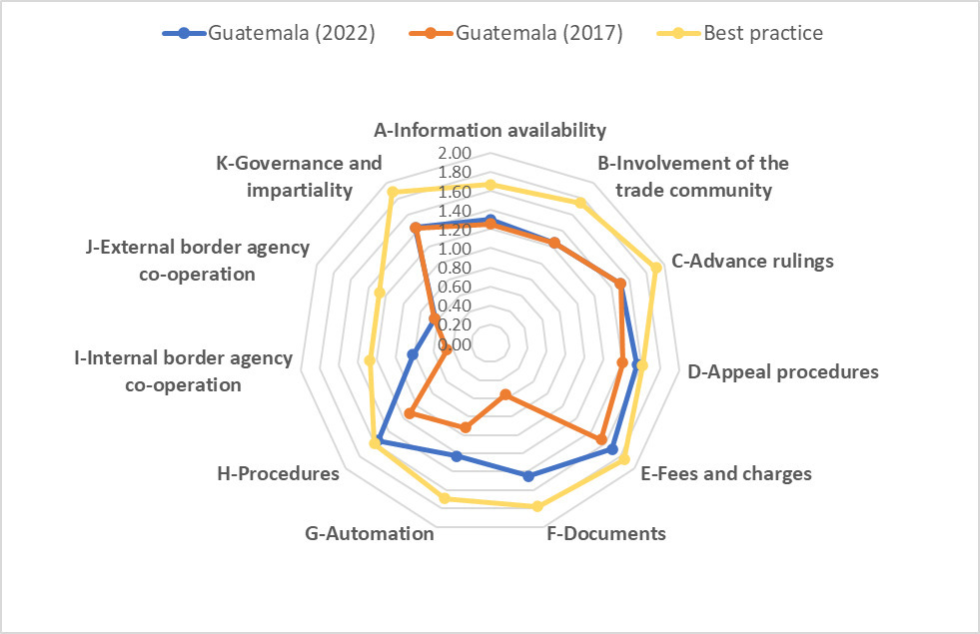

Source: OECD Trade Facilitation Indicators 2017 and 2022

Figure 16 Honduras’ Trade Facilitation Performance (2017 and 2022)

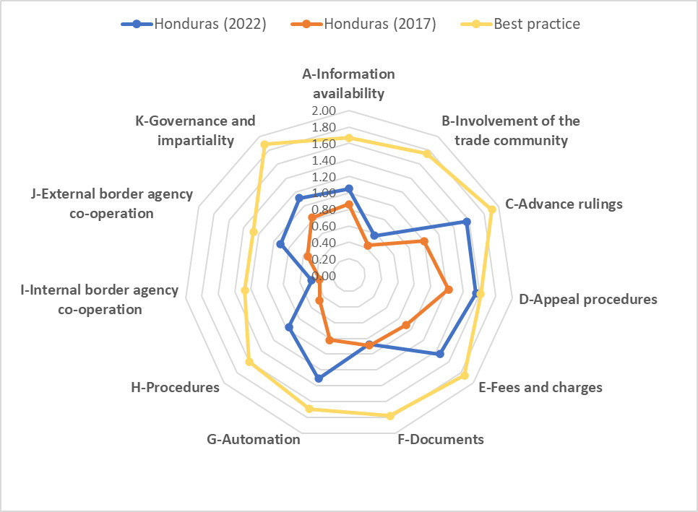

Source: OECD Trade Facilitation Indicators 2017 and 2022

Figure 17 El Salvador’s Trade Facilitation Performance (2017 and 2022)

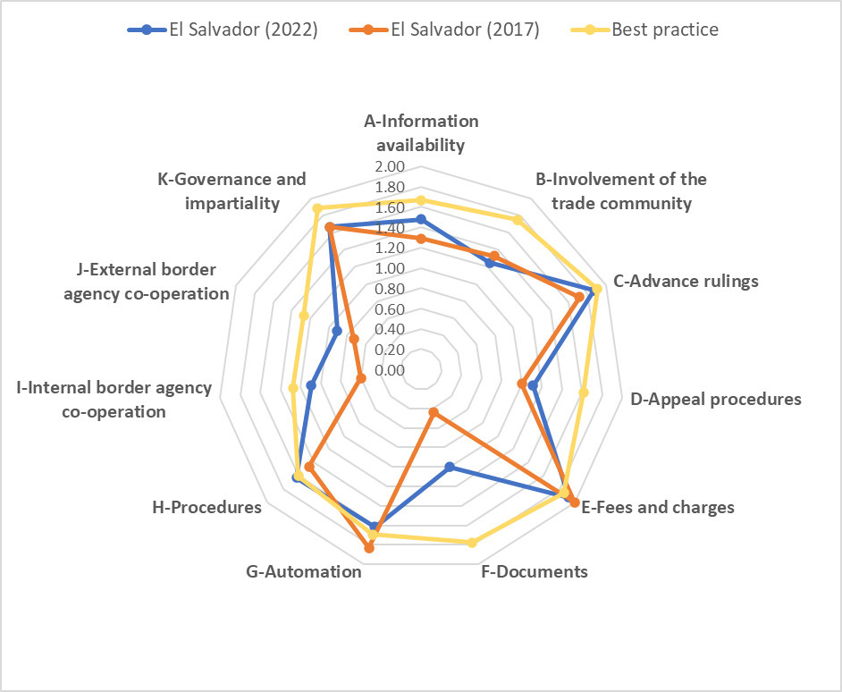

Source: OECD Trade Facilitation Indicators 2017 and 2022

Regarding the Logistics Performance Index (LPI), it can be observed that Guatemala shows improvements across most indicators from 2016 to 2023 except Customs and Timeliness. Honduras also improved across all indicators except tracking and tracing. On the other hand, El Salvador showed no improvements across the different indicators, even regressing slightly on the International Shipments indicator.

Figure 18 Guatemala LPI, 2016 and 2023

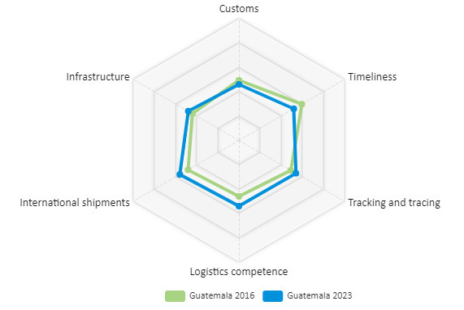

Figure 19 Honduras LPI, 2016 and 2023

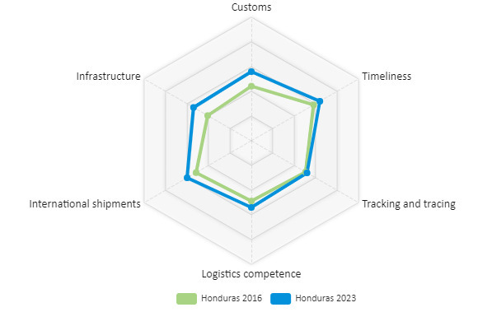

Figure 20 El Salvador LPI, 2016 and 2023

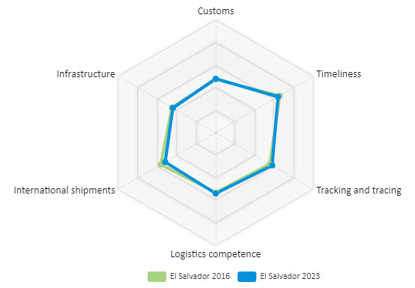

Source: Author’s elaboration based on World Bank LPI Data

The stocktaking team was not able to identify data that isolates the trade facilitation impacts of “Deep Integration” [75]. However, the noticeable decline in cross-border transit times in the Regional Central America Program data stands out as one of the most tangible outcomes. Freight forwarding and transport companies have reported more predictable and streamlined customs clearances, resulting in reduced operational costs, and increased efficiency.

Progress is not always even. According to our interview with CCIE, from the standpoint of the private sector, with many changes in government, the continuity and momentum of integration processes is slowed or even lost. Governments only remember that there is an integration process when there are problems. Changes of political will, and the regular rotation of officials and resultant learning curves are real factors.

The success witnessed in these countries is not merely a consequence of isolated interventions but rather a synergy of various change mechanisms. Stakeholder engagement has been pivotal. One key feature of the Deep Integration Project has been its emphasis on training. Direct interactions with traders, NGOs, and governmental agencies ensured that the initiatives weren’t just top-down but were rooted in ground realities and immediate needs.

Moreover, capacity-building initiatives, such as training modules and workshops, played a significant role in ensuring that reforms were not just implemented but also understood and owned by the local stakeholders. These interventions acted as catalysts for change, empowering local entities to drive the reforms themselves, and ensuring their sustainability.

Establishing common systems that are harmonized is important. There is a new common “Trade Facilitation Strategy 2.0” being developed for all six NFTCs, which is paid for by the IDB with a WB consultant. According to the SIECA Secretariat, all six national Committees have been improved because of this process. Again, this NFTC enhancement process is part of the Regional Central America Project rather than the Deep Integration sub-project, but it serves to illustrate the power of a regional model.

A further factor is that, in this regional setting, there is no NTFC. The mechanisms called for in the TFA are not a fit for a customs union, where customs officials are removed from the border and the focus shifts from customs clearance to tax payment, with a risk assessment. As the former Secretary General highlighted “Deep Integration” is much more than a “TFA+” process, because in a customs union, the internal borders no longer function in the same way, as all of the customs processes are removed. “Trade facilitation” within “Deep Integration” has transformed well beyond TFA parameters.

Delving deeper into the outcomes achieved, certain activities stand out as primary change mechanisms. In interviews with government partner agencies, a recurrent theme is the importance of the “Deep Integration” and Regional Central America Program's emphasis on knowledge dissemination and its adaptability.

Success often begets more requests for help, and this is the case for SIECA, but its challenge now is that SIECA funds the work at the border crossings and is the connecting data point, but now as it is being asked to increase from 3 to 9 border crossings in the larger customs union, it needs much more funding, and it needs a yet-to-be-determined financial sustainability model.

As the 2022 World Bank Report stresses, the initial Protocol to establish the Deep Integration Process established a “Structural and Investment Fund” which was critical to the reforms. According to the former Secretary General of SIECA, those USD10 million of funds jointly contributed are now exhausted. It needs to be replenished, and it needs further support, as well as infrastructure funding. This funding needs updating and provisioning. [76]

The sustainability of Deep Integration has a wider context. The Northern Triangle countries of El Salvador, Guatemala and Honduras have had turbulent years of issues of mass migration in the midst of violence, crime and poverty.[77]

Observers point to corruption, violence, and poor governance, and ask serious questions that are relevant to sustainability.[78] A recent study from August 2023 concludes:

“Given the entrenched nature of many of Central America’s problems, radical improvement on the political or social fronts is unlikely… The most likely scenario in the short term is that countries maintain their political trajectories, whether positive or negative.” [79]

In Guatemala, civil unrest continues[80] following the June and August 2023 elections.[81] This included a nearly month-long closure of the Guatemalan borders after the elections and other closures or threats of closures since that time.[82] It has further spiked since October 2023.[83]

In Honduras, one of the three pilot border crossings with Guatemala, El Florido, has closed regularly and has warnings, as does the Agua Caliente border crossing.[84]

A 2018 study by ECLAC relating to the Deep Integration project and trade facilitation finds:

“Finally, the amount of the benefits to be received upon the implementation of TF policies will depend on the degree of ambition the authorities of the countries involved put into the promotion of work aimed at achieving free circulation at border crossings with trade facilitation, as well as the competition and monitoring of the regulatory convergence associated with the process.” [85]

To truly understand the achievements of the TFSP’s “Deep Integration” Project in Guatemala, Honduras, and El Salvador, one must consider the intricate web of change mechanisms and interventions at play. Its sustainability is clearly influenced by strong and sometimes destructive political economy issues.

The following factors which constrained technical assistance provided by the WBG were mentioned in the interviews:

* In the context of the “Deep Integration” project of customs union development, there is need to identify the border issues that are peculiar to a customs union. For trade within the 2-3 countries of the Deep Integration, customs documents are now replaced by the FYDUCA document, whereas for trade outside the Deep Integration, traders should be using a Single Window system. For all of the benefits of the customs union, this has been an unintended consequence that traders now have two different sets of documents, depending on the destination within or outside the customs union.
* There have been political irregularities that limit the effectiveness of this work, including borders being closed for as much as a month. This was recently the case with Guatemala, where border crossings were stopped for nearly a month during the government change after the June and August 2023 elections. Trade was disrupted considerably.[86]

### Efficiency

*Adaptability.* One of the hallmarks of the TFSP's operation in these countries has been its adaptability, especially in the face of unforeseen challenges. The COVID-19 pandemic posed a significant threat to trade processes, but the Deep Integration Program showcased commendable flexibility in its responses. From introducing virtual training modules to adapting trade processes to fit the pandemic's constraints, the program proved that it wasn't rigidly bound to its initial framework. This adaptability was particularly evident in El Salvador, where community-based trade centers, though not part of the initial plan, were integrated to suit the changing landscape. Also noteworthy were the recommendations provided by the WB team in FY2020 as a response to SIECA’s request for advice on COVID-19 responses.[87]

*Coordination.* The strength of coordination between the Deep Integration Project and regional bodies, especially SIECA, played a pivotal role in ensuring the program's efficiency. By aligning their objectives and harmonizing their operations, they managed to avoid duplication of efforts and resource wastage. Stakeholders, especially from the private sector and NGOs, have also appreciated the program's transparency in its operations. Regular updates, open forums for discussion, and feedback mechanisms ensured that the program remained accountable to its beneficiaries.[88]

Having said that, while there is a story of regionalization being an important tool in trade facilitation, despite the announcement of El Salvador deciding to join the “Deep Integration” of Guatemala and Honduras, the progress since then, even accounting for COVID, is slow. Years after the initial commitment by El Salvador, the Deep Integration Project is working still with the El Salvador Tax Department to implement the basic FYDUCA system.[89]

According to our interview with the SIECA Secretariat, FYDUCA works well for those who use it, and it is mandatory to use the “fast lane” which is part of the process, but the private sector needs to step up and utilize the fast lane more. A pilot project measuring border crossing times for El Salvador saw a reduction of 18 minutes to 10 minutes – but that is vastly different than times of less than 1 minute in the two-country customs union.[90] Progress has been made, but geopolitical tensions has caused frictions which lead to a slowdown in trade processes. In terms of the M&E framework, these elements need to be better captured and prioritized over other metrics, such as number of meetings and video productions. Reports for the Regional Central America Project activities in Guatemala and Honduras on “deep integration” were limited in FY23 to assisting Guatemalan Customs in identifying the bottlenecks preventing effective operations.[91]

The former Secretary General of SIECA reminded us that sometimes a project needs to slow down before it can speed up again, referring to the process of adding El Salvador. He advises that the “Deep Integration” and the Regional Central America Project need to be closer to the Trade Ministers in terms of the agenda for the next years. The WB also needs to coordinate with other donors, especially with the IDB and USAID including coordination of areas for each donor. He also believes that the system needs a meeting organized by the donors, where they can share together how the donors would help the governments. This could start bilaterally, and then after feedback move into a larger meeting of the 3 countries, and how the donors as a team could help Deep Integration.

*Leverage.* One of the results of TFSP support in the region is that because of the innovative custom union processes and the shifts TFSP has helped SIECA, and the countries make already, ECLAC – Economic Commission of the United Nations for Latin America has indicated that is willing to step in and provide a new form of aid. ECLAC may assist with a new type of risk management training.

### Conclusion

For many years, trading across borders in Central America, particularly between Guatemala and Honduras, was mired in inefficiencies. These procedural bottlenecks made trade cumbersome, slow, and expensive.

Recognizing these impediments, the governments of Guatemala and Honduras, in tandem with SIECA, embarked on a transformative "Customs Union" initiative in 2015. A cornerstone of this project was the introduction of the “FYDUCA” system. The system reduced the bureaucratic encumbrances by mandating a singular online document, eradicating much of the erstwhile dual paperwork and processes that exporters and importers faced at both sides of the border.

The “Deep Integration” Project played a pivotal role in this series of changes. This assistance was not confined to mere strategizing; the “Deep Integration” Project actively facilitated the training of over 150 companies, ensuring they could adeptly navigate the new systems.

The immediate outcomes were palpable. El Salvador noticed and applied. Trade became quicker, costs were reduced, and business opportunities burgeoned. The feedback from the private sector was positive, with testimonials from corporate stakeholders underscoring the difference the Customs Union and FYDUCA made. One lesson is that the private sector needs to be more involved, as well as trained. [92]

Nonetheless, the journey isn't devoid of challenges. There remains a need for further training, infrastructure enhancements, system integrations, and the widespread dissemination of the revamped procedures. But as the data suggests, the strides made between 2015 and 2018 and then between 2018 and 2023 were noteworthy.

Wide-ranging work on technical subjects are ongoing. Gathering and publishing average release times brings transparency. Border agency cooperation is growing. Infrastructure enhancements are needed as are other important keys. But real progress is being made.

The two key lessons on the Deep Integration customs union from 2019 remain valid. First, regional integration is a driving force for trade facilitation.[93] Second, leveraging regional institutions is useful in garnering support and guiding the reforms.[94]

As the former Secretary General of SIECA said, “Deep Integration” has become greater than the national issues that have dogged progress in the past. Overall Guatemala has increased trade since the Deep Integration process began late in 2014, and it grows faster than pre-Deep Integration. Guatemala trades the most now with Honduras, whereas before Deep Integration, it traded most with El Salvador.

There is good reason to believe that if these “Deep Integration” reforms continue, the national and regional economies will continue to see incrementally important gains with the aim of removing the borders for customs purposes.[95] In the eight years from 2015 to 2023, trade flows have shifted in ways that sixty years of earlier efforts have been unable to accomplish. It is evident that improvements at the border from a trade facilitation standpoint are aiding in the removal of border constraints. While COVID has slowed progress, and while political and security upheaval is threatening the progress, both of which are outside the control of the WB, the model linking the customs union with trade facilitation has proven its merit.

Bibliography

Administrative Agreements between Governments and the Word Bank Group (Various) [Provided by the World Bank Group]

BBC News (2023), Guatemala paralysed as pro-democracy protests run into second week, Available at: <https://www.bbc.com/news/world-latin-america-67064814.amp>

Council on Foreign Relations (2023), Central America’s Turbulent Northern Triangle, Available at: <https://www.cfr.org/backgrounder/central-americas-turbulent-northern-triangle>

Crisis24 (2023), Guatemala: Indigenous activists to block multiple roads, borders and ports nationwide starting 05:30 Oct. 2, Available at: <https://crisis24.garda.com/alerts/2023/09/guatemala-indigenous-activists-to-block-multiple-roads-borders-and-ports-nationwide-starting-0530-oct-2>

Department of Foreign Affairs (2023), Guatemala, Available at: <https://www.dfa.ie/travel/travel-advice/a-z-list-of-countries/guatemala>

Economic Commission for Latin America and the Caribbean (ECLAC) (2018), The Central American Customs Union: Potential economic and social impacts, Available at: <https://www.cepal.org/sites/default/files/events/files/the_central_american_customs_union_potential_economic_and_social_impacts_1.pdf>

European Commission (20230, Echo Flash, Available at: <https://erccportal.jrc.ec.europa.eu/ECHO-Products/Echo-Flash#/daily-flash-archive/4914>

Geopolitical Intelligence Services (2023), Central America’s dysfunction grinds on, Available at: <https://www.gisreportsonline.com/r/central-america-dysfunction>

Government of Canada (2023). Honduras Travel Advice, Available at: <https://travel.gc.ca/destinations/honduras>

International Trade Centre, TradeMap Statistics, Available at: <https://www.trademap.org/>

Ministry of Industry, Trade and Tourism (2015), Fijian Trade Policy Framework (2015-2020), Available at: <https://www.mitt.gov.fj/wp-content/uploads/2018/10/Fijian-Trade-Policy-Framework-min.pdf>

Ministry of Trade and Industry (2021), Lesotho National Trade Policy Framework, Available at: <https://www.lesothotradeportal.org.ls/kcfinder/upload/files/Legal_1626769469.pdf>

OECD (2022), Trade Facilitation Indicators 2022, Available at: <https://compareyourcountry.org/trade-facilitation/en/1>

Leverage regional institutions to garner support and guide the reforms, Pages 17-18, Activity Completion Summary, Regional Central American Project to support the implementation of the Trade Facilitation Agreement (ID: 156050), May 17, 2019 [provided by the World Bank Group]

Progress Review (PR – Regional Support of the Implementation of the World Trade Organization – Trade Facilitation Agreement in Central America – Phase II (ID: P171021), July 17, 2020 [provided by the World Bank Group]

Progress Review (PR), Regional Support for the Implementation of the World Trade Organization – Trade Facilitation Agreement in Central America, Phase II (ID: P171021), December 05, 2022 [Provided by the World Bank Group]

Terms of Reference: Stocktaking/Assessment & Learning Review of the Trade Facilitation Support Program (TFSP)

TFSP Consultative Committee Meeting Notes (FY 19 – FY 23) [Provided by the World Bank Group]

The Fiji Times (2023), National single window system to improve ease of doing business, Available at: <https://www.fijitimes.com/national-single-window-system-to-improve-ease-of-doing-business/>

U.S. Embassy in Guatemala (2023), Demonstration Alert: Ongoing Demonstrations and Roadblocks (October 6, 2023), Available at: <https://gt.usembassy.gov/demonstration-alert-ongoing-demonstrations-and-roadblocks-october-6-2023>

UNCTAD (2018), UNCTAD's trade facilitation work boosted by new UK funding, Available at: <https://unctad.org/news/unctads-trade-facilitation-work-boosted-new-uk-funding>

UNCTAD (2023), UNCTAD training bolsters trade facilitation in Southern Africa, Available at: <https://unctad.org/news/unctad-training-bolsters-trade-facilitation-southern-africa>

US Department of Commerce (2023), Joint Statement From Indo-Pacific Economic Framework For Prosperity Partner Nations, Available at: <https://www.commerce.gov/news/press-releases/2023/11/joint-statement-indo-pacific-economic-framework-prosperity-partner>

Wall Street Journal (2023),Protests in Guatemala Close Roads, Choke Exports, Available at: <https://www.wsj.com/world/americas/protests-in-guatemala-close-roads-choke-exports-cab9923d>

World Bank (2023), TRADE FACILITATION MEASURES FOR EMERGENCY PREPAREDNESS, Effecting the flow of critical goods and trade during crises and disasters, presentation by Willian Gain, Geneva.

World Bank Blogs (2018), Customs Union between Guatemala and Honduras, from 10 hours to 15 minutes!, Available at: <https://blogs.worldbank.org/latinamerica/customs-union-between-guatemala-and-honduras-10-hours-15-minutes>

World Bank Blogs (2019), Leave your hammocks at home: How a customs union between Guatemala and Honduras cut trade times from 10 hours to 15 minute, Available at: <https://blogs.worldbank.org/trade/leave-your-hammocks-home-how-customs-union-between-guatemala-and-honduras-cut-trade-times-10-hours>

World Bank Blogs (2022), Public-private collaboration facilitates the import of vaccines in Tonga, Available at: <https://blogs.worldbank.org/trade/public-private-collaboration-facilitates-import-vaccines-tonga>

World Bank Group (2022), Country Private Sector Diagnostic – Creating Markets in Fiji, Available at: <https://www.ifc.org/content/dam/ifc/doc/mgrt/cpsd-fiji-summary.pdf>

World Bank Group (2022), Deep Trade Agreements: Anchoring Value Chains in Latin America and the Caribbean, Available at: <http://documents1.worldbank.org/curated/en/099441307192229437/pdf/IDU06a4342500006704e190be65003f8ee328f63.pdf>

World Bank Group (2023), Connecting to Compete 2023: Trade Logistics in the Global Economy, The Logistics Performance Index and Its Indicators, Available at: <https://lpi.worldbank.org/sites/default/files/2023-04/LPI_2023_report_with_layout.pdf>

World Bank Group (2023), Logistics Performance Index, Available at: <https://lpi.worldbank.org/>

World Bank Group (2023), TFSP Brochure, Available at: <https://thedocs.worldbank.org/en/doc/5bbf6a2cf673541f8a9f78c59f9bb13b-0430012022/related/TFSPBrochure2023Sept.pdf>

World Bank Group (2023), Trade Facilitation Challenges for Women Traders in the Pacific Islands and Timor-Leste, Available at: <https://www.worldbank.org/en/programs/trade-facilitation-support-program/publication/trade-facilitation-challenges-for-women-traders-in-the-pacific-region>

World Bank Group, Lesotho Competitiveness and Financial Inclusion Project, Project Information Document

World Bank Group, TFSP Website, Available at: <http://www.worldbank.org/tfsp>

World Bank Group, Trade Facilitation Support Program Annual Reports (FY 15 to FY 23) [Provided by the World Bank Group]

World Bank, Trade Facilitation Agreement Tracking Tool, Available at: <https://www.tfacountrytrackingtool.org/>

World Customs Organization (2022), Electronic tariff platform goes live in Lesotho, Available at: <https://www.wcoomd.org/en/media/newsroom/2022/june/electronic-tariff-platform-goes-live-in-lesotho.aspx>

World Customs Organization (2023), WCO Data Analytics capacity building for Lesotho Revenue Authority, Available at: <https://www.wcoomd.org/en/media/newsroom/2022/may/wco-data-analytics-capacity-building-for-lesotho-revenue-authority.aspx>

World Customs Organization (2023), WCO provides support to Lesotho to enhance Coordinated Border Management, Available at: <https://www.wcoomd.org/en/media/newsroom/2023/may/wco-provides-support-to-lesotho-to-enhance-coordinated-border-management.aspx>

World Trade Organization, TFAF Trade Facilitation Agreement Database, Available at: <https://www.tfadatabase.org/en>

World Trade Organization (2023), Trade Policy Review of Fiji, Available at: <https://www.wto.org/english/tratop_e/tpr_e/s444_e.pdf>

World Trade Organization and OECD, Private Sector Case Study Template, Available at: <https://www.tfafacility.org/sites/default/files/2022-01/21._lesotho_customs_modernisation_programme.pdf>

1. Terms of Reference

**TFSP Overview**

1. The Trade Facilitation Support Program (TFSP), a flagship technical assistance program administered by the World Bank Group (WBG), supports countries in aligning their trade practices and procedures with the WTO Trade Facilitation Agreement (TFA). Trade facilitation plays an important role in a country’s economic development as it enhances competitiveness by reducing time and cost to import and export. Simplified, transparent trade procedures are key components of good trade policy and vital for economic growth. This is particularly important for developing countries as they strive to connect to the global economy and to strengthen domestic economic activity. Additionally, trade facilitation in middle-income countries can act as gateways for LDCs, affecting the performance of regional LDCs and small-island developing states.
2. Recognizing the important roles of both the public and private sectors in trade facilitation, TFSP draws on the unique expertise of both the World Bank and International Finance Corporation. TFSP is a multi-donor trust fund that brings together diverse World Bank and IFC Advisory units around a common vision: sustained economic growth, productivity gains, job creation, and rising incomes for developing countries to eradicate poverty and boost shared prosperity. The WBG’s mission is to serve as a trusted partner for countries that seek to develop dynamic and resilient economies, expand market opportunities, and enable private initiative by offering integrated solutions to macroeconomic and private sector-focused structural reform programs.
3. TFSP assists client countries in identifying existing constraints and bottlenecks, designing and planning for implementation of reforms, and increasing predictability, transparency, and harmonization of systems and procedures in line with international standards covering import, export, and transit activities. TFSP funding supports activities through two main components:
   1. the provision of technical assistance (TA), where the WBG assists developing countries to reform their trade facilitation laws, procedures, processes, systems, and consultative mechanisms within the context of the provisions of the WTO TFA; and,
   2. facilitation of knowledge sharing, peer-to-peer learning, and the measurement of progress and results.
4. TFSP complements the work of other departments in the World Bank and IFC operating in the trade space. Externally, TFSP coordinates closely on the ground with international financial institutions, multilateral organizations, and other partners.
5. TFSP is financed by Australia, Canada, the European Union, the Netherlands, Norway, Switzerland, Sweden, the United Kingdom, and the USA.
6. More information about TFSP can be found at: <http://www.worldbank.org/tfsp>

**TFSP Stocktaking/Assessment**

1. Since inception in 2014, there has been high demand for support through TFSP, receiving over 60 formal requests for assistance. Implementation support has started in 56 countries.
2. A “mid-term” stock-take was undertaken in 2019, covering June 2014 – June 2018. This mid-term stock-take aimed to assess TFSP’s performance, identify lessons learned, and areas where improvements can be made. The mid-term stocktaking took a formative approach and focused on assessing TFSP’s performance up until June 2018, identifying strengths and weaknesses of TFSP’s approach to supporting WTO TFA alignment in client countries, as well as emerging lessons learned from WTO TFA implementation.
3. In summary, the mid-term stock-take found that TFSP was highly relevant to meeting donor partners’ policy objectives, it has strong alignment to TFA objectives, and is demand-driven. TFSP was also effective in building the capacity and knowledge of individual countries in implementing trade facilitation reforms and the TFA. Main recommendations from the mid-term stock-take were to: remain sensitive and vigilant to the political economy situation of countries, ensure stricter criteria for accessing support, consider extending the range of interventions in countries, address gender issues, increase focus on SMEs, and improve coordination at the national level as well as with partners at the global/HQ level.
4. TFSP is now seeking to complete a follow-up stock-take/assessment & learning review that picks up from the mid-term, covering July 2018 – June 2023. The main objectives of the follow-up stocktaking/assessment are to:
   1. Provide an independent, updated assessment of TFSP’s performance and results achieved from July 2018 to date to the TFSP’s stakeholders, including how TFSP has progressed in integrating the recommendations made during the mid-term stock-take;
   2. identify lessons learned and areas to improve the TFSP’s effectiveness; and
   3. assess how TFSP has complemented other trade facilitation programs particularly during the COVID-19 pandemic, including building partnerships and coordinating with other organizations/ donors in-country as well as at the global level.

***Scope of Work***

1. The stocktaking/assessment & learning review will be conducted following the OECD‐Development Assistance Committee (DAC) criteria for development effectiveness (relevance, efficiency, effectiveness, impact and sustainability) and the OECD DAC Standards for Development Evaluations[96]. Employing the DAC evaluation criteria, it is expected that this formative stocktaking will focus primarily on TFSP’s relevance, efficiency, effectiveness, sustainability as well as assess any early impacts. The stocktaking should review a selection of portfolio activities conducted under the TFSP across several regions.
2. The stocktaking/assessment team is expected to:
3. Assess the continuing validity of the Theory of Change / results framework of TFSP, including the underpinning assumptions of TFSP.
4. Conduct a selected, yet geographically representative, portfolio review and collect the data needed to assess and analyze TFSP’s performance and results achieved to date against its Logical Framework, analyzing the benefits of the program for participating countries, as well as for the private sector in these countries.
5. Answer the relevant stocktaking questions (see Stocktaking Questions section, below).
6. Where possible and relevant, undertake an assessment of TFSP’s impacts on supporting countries in aligning their trade facilitation practices with the WTO TFA.[97]
7. Capture and compile lessons learned and best practices that could be used to inform future WTO TFA implementation activities.
8. Review TFSP’s program management functions, including monitoring, communications, developing partnerships and reporting to donors.
9. Provide actionable recommendations for the TFSP management team.

***Stocktaking/Assessment Period***

1. The stocktaking/assessment will cover the period from July 2018 to June 2023.

***Audience***

1. The stocktaking is of interest to TFSP contributors (see para. 5), the World Bank Group Management, and the broader community who support WTO TFA implementation (see list of relevant stakeholders in Annex 1). The feedback and recommendations resulting from this formative stocktaking will be considered in TFSP’s future activities; to ensure this, there will be a formal Bank management response to the recommendations of the assessment, specifying actions to be taken. The stocktaking/assessment will also inform the next phase of TFSP (where applicable).

***Methodology***

1. The assessment team is expected to formulate a detailed methodology and design for the stocktaking/assessment and make it available to the TFSP for feedback. The consultant will be expected to gather and analyze data and deliver aggregate qualitative (and quantitative, where relevant) conclusions on the basis of diverse materials collected.
2. In collecting and analyzing data and drawing conclusions and recommendations, the stocktaking/assessment methodology should be based on a wide variety of sources of information and utilize methods that will result in a valid, credible, and evidence-based report. Among the methodological approaches, the assessment team could consider including, for example, a portfolio review,[98] interviews, and stakeholder surveys. The team is expected to develop an approach that allows for continuous incorporation of feedback in real-time during the review period*.*

**Determining Key Stocktaking/Assessment Questions**

1. The stocktaking/assessment will offer a broad and representative perspective on the achievements and challenges of TFSP. Key overview evaluative questions include:
   1. How relevant has the TFSP’s contribution been, to date, to full and effective implementation of the WTO TFA and, where relevant, related trade facilitation reforms, taking into account that trade facilitation reform at country-level is likely to be an on-going process?

* Include assessment of effectiveness of TFSP’s  main technical assistance and capacity building contributions, namely: revision of draft trade laws and implementing regulations; simplifying, streamlining, and harmonizing  trade procedures/documents to reduce time and cost to trade; reviewing and establishing inventories of fees and charges related to cross-border trade; establishing/publishing average release times; integrating risk-based management systems and other contemporary border management approaches into border inspections and clearance processes; designing and implementing automated and innovative technology to facilitate trade; and more broadly institutional capacity building.
* Include a country-level perspective, providing a view on TFSP’s impact in specific countries, not just at the global or regional level. This will include drawing on data provided by the TFA Tracking Tool under strict data access requirements.
  1. Relatedly, under which TFA articles have there been the most TFSP interventions? Was it where there have been the biggest gaps in TFA alignment, and have these gaps been reduced as a result of TFSP? In relation to which article(s) have there been the most significant changes that can be credited (fully/ partially) to TFSP in TFSP Projects
  2. Is TFSP’s focus on provision of technical assistance and creation of knowledge and learning (including trade and gender survey) helping countries design practical reform strategies to implement the TFA and related trade-facilitation reforms?
  3. The previous evaluation suggested a revision of the Theory of Change to make impact-level objectives more ambitious: alignment with the TFA is more of an **outcome** which should lead to the **impact** level objectives of, for example, Private Sector Savings. Have these impact-level objectives been set? How successful has TFSP been in achieving them?
  4. In considering the relevance of TFSP, how effective is its building block approach and what are the challenges and any lessons learned for each block?
  5. Is the logical framework fit for purpose? Does it contain the right targets? Is progress on TFSP outcomes as per the Logical Framework on track?
  6. Related to program sustainability, what and how effective have the TFSP’s approaches been on understanding and accommodating for the political economy aspects of trade facilitation reform, given the role of political considerations in border coordination (including regional cooperation), the functioning/ effectiveness of NTFCs, attention to gender-related inequalities, engaging the private sector?
  7. How effectively has TFSP increased transparency and harmonization of trade procedures in line with WTO TFA guidelines in TFSP-supported countries?
  8. Given the age of the program, it has now had time to implement support in a phased approach. How effective has it been in its prioritization and sequencing of reforms?
  9. How, where, and to what effect has a gender lens been included in TFSP activities/projects. How could gender equality be further mainstreamed in the program?
  10. How effectively has the TFSP leveraged additional financing, World Bank or otherwise, and with what impact/ result? Has this built program sustainability for TFSP?
  11. Have TFSP interventions been designed and implemented in ways that promote partnership and coordination with other multilateral organizations/donors around trade facilitation?

1. The stocktaking team is expected to provide a full set of questions in its Inception Report as well as the data collection strategy. The final list of questions will be agreed upon with the TFSP Secretariat. Deliverables expected from the Stocktaking Team
2. It is expected that the assessment team will:
   1. Prepare an Inception Report that includes a proposed Stocktaking Methodology (including overall approach and choice of design, key criteria, indicators, data collection strategy for the stocktaking (questions), a set of stocktaking questions, and a timeline to meet the Nov 30 deadline
   2. Data collection:Implement and independently undertake the necessary evaluative work. Evaluate relevant sources of information through desk reviews and literature studies, conduct stakeholder interviews (representative list in Annex 1), as laid out in the proposed Stocktaking Methodology, and interact with the TFSP Secretariat;
   3. Prepare a draft Report and accompanying draft Powerpoint that includes interim findings and emerging recommendations;
   4. Prepare a final Report and final Powerpoint that reflects feedback received from the TFSP Secretariat gathered during the drafting process.

**Stocktaking Governance**

1. The TFSP Secretariat will be available to provide guidance and feedback to the assessment team, including clarification on expectations and deliverables for the Inception Report, Methodology, and finalization of the Stocktaking. The TFSP Secretariat will also serve as the primary point of contact to the team and will facilitate access to necessary data and background documents.

**Tentative Delivery Schedule**

1. The desired timeline for the stocktaking is as follows. Prospective teams should keep in view the following milestones and timeline in submitting their proposals. A final timeline would be negotiated with the selected assessment team.

|  |  |
| --- | --- |
| ***Activity*** | ***Timeline*** |
| ***Select Stocktaking Team; contract signing*** | ***July*** |
| ***Inception Report; Methodology review; refining of TOR*** | ***August*** |
| ***Data collection*** | ***August - October*** |
| ***Analysis; prepare draft Stocktaking Report*** | ***November*** |
| ***Stocktaking Report Feedback Process (inc. w/TFSP Consultative Group)*** | ***November*** |
| ***Delivery of Final Report*** | ***November*** |

**Team Qualifications**

1. The stocktaking team is expected to have the following expertise:
   * Experience monitoring and evaluating large, global partnerships, and technical assistance programs in international development context;
   * Excellent knowledge of the content and implementation of the WTO Trade Facilitation Agreement;
   * Extensive expertise in trade supply chain processes, including those of customs administration and other border agencies, and the private sector, particularly in developing country contexts;
   * Strong analytical skills, including designing and conducting quantitative and qualitative data collection, analysis and triangulation of data;
   * Excellent skills in communication, report-writing in English, and delivering quality products on time;
   * Ability to interact with diverse groups of stakeholders (including representatives from private sector, civil society, government, and the World Bank Group); and
   * Experience in evaluating programs for their contribution to poverty reduction and gender equality.

**Recipient**

1. The stocktaking/assessment & learning review is being commissioned by the TFSP Secretariat, which is hosted by the World Bank Group.

**Contacts**

1. Please direct questions regarding these Terms of Reference to the TFSP Secretariat: Aileen Yang (ayang3@worldbank.org), cc Bill Gain ([wgain@worldbank.org](mailto:wgain@worldbank.org))
2. Results Framework/TOC

Impact: TFSP-supported countries' trad facilitation practices are aligned with the WTA Trade Facilitation Agreement (TFA).
Outcomes: Regional and country-level trade procedures and practices simplified, modernized and/or harmonized and made transparent in TFSP-supported countries; Collaboration and coordination between domestic and neighbouring border agencies and the private sector enhanced in TFSP-supported countries; Risk-based approaches integrated into border inspection and clearance processes in TFSP-supported countries.
Outputs: Technical assistance to reform facilitation laws, procedures, processes, systems, and consultative mechanisms within the context of the WTA TFA is provided; Knowledge, learning and measurement products and indicators are generated.

|  |  |  |  |
| --- | --- | --- | --- |
| **Impact** | **Indicators** | **Verification Sources** | **Assumption** |
| **TFSP-supported countries' trade facilitation practices are aligned with the WTO Trade Facilitation Agreement (TFA)** | 1. Increase in alignment with WTO TFA above the baseline  2. Number of firms that benefit from improved customs/border services | World Bank Group project appraisal, supervision and completion reports  Government data  (including ASYCUDA) | Public and private sector stakeholders implement recommended reforms |

| **Outcomes** | **Indicators** | **Verification Sources** | **Assumptions** |
| --- | --- | --- | --- |
| **1. Regional and country-level trade procedures and practices are simplified, modernized and/or harmonized, and made transparent** | 1.1 Number of entities that implemented recommended changes  1.2 Number of recommended laws/regulations/amendments/codes enacted or government policies adopted  1.3 Number of recommended procedures/firm-level policies/practices/standards that were improved or eliminated  1.4 Number of trade portals implemented  1.5 Number of Time Release Studies (TRS) published | World Bank Group project appraisal, supervision and completion reports | Project activities build capacity of relevant stakeholders to implement and operationalize  recommended reforms,  practices and/or standards  Public and private stakeholders engage in project activities and commit to cross-border collaboration |
| **2. Collaboration and coordination**  **between domestic and**  **neighboring border agencies and**  **the private sector are enhanced** | 2.1 Number of National Trade Facilitation Committees  (NTFCs) established per the WTO TFA  2.2 Number of agreements completed to improve trade facilitation | World Bank Group  project appraisal, supervision and completion reports | Government agencies are  willing to share information,  related to trade, including with cross-border partners |
| **3. Risk-based approaches are**  **integrated into border inspections**  **and clearance processes** | 3.1 Number of risk management frameworks established  in customs and/or other agencies  3.2 Number of countries that reduced the number of  cargo inspections by border clearance agencies | World Bank Group  project appraisal, supervision and completion reports | Relevant stakeholders are able  to access online resources,  including web-based trade portals and/or other IT systems |

| **Outputs** | **Indicators** | | **Verification Sources** | **Assumptions** |
| --- | --- | --- | --- | --- |
| **1.1 Technical assistance to reform trade facilitation laws, procedures, processes, systems, and consultative mechanisms within the context of the WTO TFA is provided** | 1.1.1 Number of countries receiving advisory services from TFSP  1.1.2 Number of WTO TFA measures supported in TFSP  countries (cumulative)  1.1.3 Number of WTO TFA gaps analysis reports completed  1.1.4 Number of new laws/regulations/amendments/codes /government policies drafted, or contributed to the drafting  1.1.5 Number of procedures/firm-level policies/practices/standards recommended for improvement or elimination | World Bank Group project appraisal, supervision and completion reports | | Technical assistance provided is of high quality, demand- driven and delivered on-time |
| **2.1 Knowledge, learning and**  **measurement products and indicators are generated** | 2.1.1 Number of global and regional events delivered (e.g.  peer-to-peer, learning events, Smart Lessons competition)  2.1.2 Number of country-level events delivered and/or facilitated by TFSP  2.1.3 Percentage of female participants in events  2.1.4 Number of implementation guides/toolkits created  2.1.5 Number of communications materials developed  (e.g., videos, blogs, brochures, newsletters, etc.)  2.1.6 Number of in-country gender assessments undertaken to inform future projects  2.1.7 Number of completed in-country validation scoring sheets, in accordance with the WTO TFA tracking tool methodology | World Bank Group  project appraisal, supervision and completion reports | | Knowledge, learning and  measurement products generated are of high quality and relevant to clients and stakeholders’ efforts to align trade measures with the TFA  Relevant stakeholders are actively engaged and share their experience and lessons learned with the broader trade community |

1. Interview Guidelines

These interview guides have been drafted mainly as a checklist for use during stakeholder interviews. They will be used flexibly depending on the role of the person interviewed to reflect their areas of responsibility. The aim of these guidelines is to ensure that the stocktaking questions are all addressed during the interview process.

1. **TFSP Management and Staff; World Bank Task Team Leader**

| **No.** | **Question** | **Focus** |
| --- | --- | --- |
| 1 | What is your involvement in the TFSP? | - |
| 2 | Can you explain what the TFSP set out to achieve and how?  [*Team to explore the TOC and intermediate outcomes during the interview and find out if the assumptions and pathways are valid and well-founded*] | Relevance |
| 3 | To what extent so far have the different initiatives under the overall umbrella of the TFSP been consistent with the objectives of the program? | Relevance |
| 4 | To what extent is the program ensuring that the interest of and impact on women and girls has been adequately addressed in initiatives supported? | Relevance |
| 5 | How does the program coordinate and cooperate with other relevant sources of TA and support of TFA alignment? Are there any formal or informal mechanisms used to communicate or coordinate with other projects? | Coherence |
| 6 | Are the objectives and outcomes of the program on track to be achieved? What factors explain the results achieved? *[Team to explore the different causal mechanisms from TOC – TA, knowledge management, etc.]* | Effectiveness |
| 7 | How has the effectiveness of different interventions varied, and what factors have affected the relative success of interventions? | Effectiveness |
| 8 | What are some of the constraints (e.g., political economy factors in focus countries) impacting on the implementation of the program? | Effectiveness |
| 9 | What were the main recommendations from the TFSP mid-term stocktaking? To what extent have they been implemented? | Efficiency |
| 10 | How did the program respond to the challenges of the COVID-19 pandemic? What changes were made? | Efficiency |
| 11 | What are the main difficulties and constraints faced by TFSP in implementation? How best can these be addressed or mitigated? | Efficiency |
| 12 | What examples can you share of how TFSP work has leveraged other resources to support TFA alignment. How is this best achieved? | Efficiency |
| 13 | Can you identify areas where the efficiency of TFSP implementation could be improved? | Efficiency |
| 14 | To what extent has TFSP focused upon the development and functioning of the National Trade Facilitation Committees (NTFCs) or other means of building national ownership? To what extent have they been effective in domestic coordination? What can be done to enhance their effectiveness in the future? | Sustainability/ Effectiveness |
| 15 | In individual countries, to what extent do you observe national customs administrations effectively implementing their part of TFA obligations, as compared to the implementation and cooperation needed by other ministries or departments of national governments? | Sustainability/ Effectiveness |
| 16 | Can you provide examples of TFSP’s wider impact, both intended and unintended? | Impact |

1. **Donors and International Organisations**

| **No.** | **Question** | **Focus** |
| --- | --- | --- |
| 1 | What has been the involvement of your organization with the TFSP? | - |
| 2 | How relevant are the objectives of the TFSP to those of your organization? In what ways? | Relevance |
| 3 | How is the TFSP focusing on gender issues and how do you think it could focus more effectively in this area? | Relevance |
| 4 | In your opinion, what are the key areas that should be tackled for improving customs and other border procedures and trade? | Relevance |
| 5 | Do you fund/implement similar projects to the TFSP? How do they compare and how are activities are coordinated? | Coherence |
| 6 | How effective has TFSP been in coordinating with other relevant sources of TA for TFA alignment? | Coherence |
| 7 | Are the objectives and outcomes of the program on track to be achieved? What factors explain the results achieved? | Effectiveness |
| 8 | What are the most important contributing factors to achievement of these outcomes? *[Team to explore the different causal mechanisms from TOC – TA, knowledge management etc.]* | Effectiveness |
| 9 | What are the main constraints and bottlenecks (e.g., political economy factors) faced by programs of this type? | Effectiveness |
| 10 | From your perspective how efficiently run is the TFSP? Do you see any areas where efficiency could be improved? | Efficiency |
| 11 | How did the program respond to the challenges of the COVID-19 pandemic? What changes were made? | Efficiency |
| 12 | What were the main recommendations from the TFSP mid-term stocktaking exercise? To what extent have they been implemented | Efficiency |
| 13 | How has work supported by TFSP influenced your own work or other work that your organization funds? Can you provide examples of specific examples where work supported by TFSP has made a concrete contribution to leveraging other resources from your organization for work on TFA alignment? | Efficiency |
| 14 | To what extent have partner countries developed a sense of ownership of the TFA alignment process and to what extent are National Trade Facilitation Committees effectively taking up their responsibility for domestic coordination and implementation of the TFA? | Sustainability/ Effectiveness |
| 15 | In individual countries, to what extent do you observe national customs administrations and other border agencies effectively implementing their part of TFA obligations, as compared to the implementation and cooperation needed by other ministries or departments of national governments? | Sustainability/ Effectiveness |
| 16 | Can you provide examples of TFSP’s wider impact, both intended and unintended? | Impact |

1. Case study approach
2. **Objective**

As part of the stocktaking exercise, the team will carry out three case studies of countries where TFSP has been present and contributed to the countries’ preparedness and implementation of the Trade Facilitation Agreement. The purpose of the case studies is to provide a more detailed assessment and data collection to answer the evaluation questions. The case studies will not involve country visits. The case studies form the main channel through which primary data will be collected in interviews to complement and triangulate secondary data from project reports, project statistics, and publicly available statistics.

1. **Selection criteria**

The criteria for selection of case study countries are as follows:

* If possible, at least one landlocked and one small island development state (SIDS).
* At least one cross-border intervention between two countries.
* At least one LDC.
* All countries should have baseline data collected under the tracking tool and updated data to measure progress.
* All countries should have a sufficient critical mass of interventions from TFSP to make it possible to have any meaningful analysis of results.
* Excluding conflict countries.

In addition, in the mid-term stock-take, the TFSP suggested the following additional criteria:

* Projects where the client – task team leader relationship has not had recent turnover and where clients should be able to talk specifically around the TFSP support;
* Countries which have not been subject to recent onerous requests on clients, to avoid survey fatigue.

Of the 37 countries included, 7 have baseline tracker TFA tracker data with an update within the time period of the evaluation (i.e. between 2019 and 2023). These are:

| **Country** | **Assessment Dates** | **Region** | **Economy** | **Geography** |
| --- | --- | --- | --- | --- |
| Albania | 2014-2020 | Europe and C. Asia | Upper middle | Coastal |
| Bangladesh | 2015-2019 | South Asia | Lower middle | Coastal |
| Liberia | 2016-2023 | Africa | Low | Coastal |
| Montenegro | 2014-2020 | Europe and C. Asia | Upper middle | Coastal |
| Nepal | 2015-2019 | South Asia | Low | Landlocked |
| Serbia | 2014-2022 | Europe and C. Asia | Upper middle | Landlocked |
| Sierra Leone | 2017-2023 | Africa | Low | Coastal |

In order to meet the selection, the following case study countries are suggested:

* **Liberia or Sierra Leone** (low income countries in Africa)
* **Nepal or Serbia** (landlocked)

None of the Small Island States have TFA tracker data available after 2018.**Vanuatu** may be the best choice as it is a lower middle income country which has ratified the TFA (in 2020) and has baseline and update information available (from 2015 and 2018).

In terms of cross-border initiatives, the team is aware of work with the Guatemala and Honduras customs union and notes reference in the 2022 Annual Report to regional work in Pacific Islands, Europe and Central Asia and Central America. Further discussion will be needed, however, on whether to include a cross-border initiative as a case study.

1. **The Case Studies**

The three case studies are suggested as follows:

1. Country 1: Fiji

Fiji, an archipelago comprising 333 islands, is classified as an upper-middle income country. The country is highly exposed to the effects of climate change and frequent extreme weather episodes. Fiji’s exports are highly concentrated in petroleum, water, sugar, and fish. Fiji’s imports are led by petroleum oils, nuclear reactors, electrical machinery, and vehicles among others[99].

The multi-island country is “an economic, transportation, and academic hub of the South Pacific islands, making it an attractive trade and investment option for businesses looking to establish a presence in the region.” Trade facilitation therefore plays a vital role in enhancing Fiji’s trade efficiency, promoting economic growth, and supporting its integration into the global economy.

In 2014, Fiji ranked 111th out of 189 countries in the Trading Across Borders category in the World Bank’s Ease of Doing Business Report. By 2020, the last year during which the report was published, Fiji’s Trading Across Borders ranking improved to 79th out of 190 economies. The TFA is considered to have significantly contributed towards this improvement.

Fiji ratified the TFA in May 2017 following TFSP work that helped put the WTO TFA on the country’s political agenda. TFSP also assisted with categorization and support for the ratification and notification process[100]. According to TFAF, institutional procedures and human resources and training were the top two types of technical assistance sought, each accounting for 9 requests. Legislative and regulatory framework support, followed by ICT support, were the third and fourth most requested areas of assistance[101]. 29% of the TFA commitments are categorized as C commitments.

1. Country 2: Lesotho

Lesotho is landlocked with exports highly concentrated in textiles and diamonds which account for 43% and 19% of exports respectively in 2022 The country’s main imports are mineral fuels (17%), cotton (7%), fabrics (5%) and electrical machinery (5%) among others[102].

Trade facilitation is instrumental for Lesotho’s economic growth and development. Despite notable progress made in enhancing the trade facilitation environment, trade costs remain high in Lesotho. The landlocked country is highly reliant on South Africa for transit to third country markets, and while significant investments have been made to increase efficiency at the border through customs management systems, there is scope to further improve cross-border transport and transit bond operations. Moreover, the harmonization of regulations governing transport services is crucial to reduce time and costs associated with international export transport services[103].

Overall, the trade reforms have underpinned the country’s positive progress in improving its trade enabling environment. In 2014, Lesotho ranked 147th out of 189 countries in the Trading Across Borders category in the World Bank’s Ease of Doing Business Report. By 2020, the last year during which the report was published, Lesotho’s Trading Across Borders ranking improved to 40th out of 190 economies. The TFA is viewed as one of the significant reforms which has contributed towards this improvement.

Lesotho ratified the TFA in January 2016. The WBG conducted a validation assessment mission which assessed the trade facilitation regime in the country and collected feedback from the business community regarding alignment of country processes with the TFA in June 2016. This exercise led to the elaboration of a plan of action which was validated with stakeholders in a national TFA validation workshop[104]. According to TFAF, the lion share of requested assistance has been in the regulatory area, representing 19 requests. Skills and capacity building of institutions, followed by ICT support, were the second and third most requested areas of assistance[105]. 63% of the TFA commitments are categorized as C commitments.

Country 3: Guatemala/Honduras

Facilitating cross-border trade in Central America has presented numerous challenges. In 2017, cargo trucks still used to spend 10 hours to traverse less than a kilometer at the Guatemala-Honduras borders. These prolonged delays at border points contributed to a sluggish and costly regional trade environment.

Trade facilitation is at the foundation of Central America’s regional economic integration process and in 2015, Guatemala and Honduras initiated a Customs Union project aimed at streamlining trade through the elimination of customs procedures at shared borders. Following consultations with the private sector and governmental entities, El Salvador's Legislative Assembly sanctioned the Customs Union adhesion protocol to the "Northern Triangle Customs Union" in July 2018. Subsequently, in December 2021, the three nations approved a roadmap for El Salvador's inclusion in what is known as “the Deep Integration Process.” The inclusion of El Salvador is still a work in progress.

Given the shared borders and economic interests among these three countries, trade facilitation is of paramount importance to streamline cross-border transactions, reduce trade costs, and bolster economic growth. The “Deep Integration” Project goes well beyond the TFA, but it is an example of how to accomplish much more than the TFA requires, using regional development and regional structures, in this case, a customs union.[106]

In 2014, Guatemala, Honduras and El Salvador ranked 116th, 84th and 64th respectively out of 189 countries in the Trading Across Borders category in the World Bank’s Ease of Doing Business Report. By 2020, the last year during which the report was published, the Trading Across Borders ranking for Guatemala and El Salvador improved to 82nd and 46th out of 190 economies. The TFA is considered to have significantly contributed towards this improvement. However, Honduras slipped to 130th out of 190 economies for the trading across borders indicator.

Guatemala ratified the TFA in March 2017. According to TFAF, ICT support as well as infrastructure and equipment support were the top two types of technical assistance sought, each accounting for 7 and 6 requests respectively. Human resources and training followed by legislative and regulatory framework support, were the third and fourth most requested areas of assistance[107]. 27.3% of the TFA commitments are categorized as C commitments. By August 2020, Guatemala had fulfilled 98.3% of its TFA implementation commitments.

**iv) Case study structure**

The case studies will be presented as annexes in the report. They will also form an important source of data to help answer the evaluation questions in the main sections of the report.

Each case study should be structured in 5 sections:

**Background / Context on trade facilitation in the country**

This section will provide statistics on the state of play with respect to ratification, notification, implementation, and other indicators publicly available (and possibly non-public if approval is given). It will examine the role trade plays in the economy of the countries concerned and provide context on the characteristics of this trade. It will also examine the political economy context in which trade facilitation reforms are being implemented.

**Relevance and coherence**

This section should consider the wider context of how program interventions have addressed trade facilitation needs in the country concerned and how they fit into the landscape of government efforts and donor interventions in this area. The program’s relevance will be considered from the point of view of donors, private sector, public sector and NGOs. Consideration of gender and poverty reduction elements into the project design will be probed in this section.

**Activities**

This should cover what the program has done in country and will cover such areas as sequencing of activities, prioritization, adaptation to the country context, choice of activities and delivery channels. This will be carried out through ‘output mapping’ – based on categories outlined in the results framework. Attention should also be paid to activities which were not included in the original results framework but were added to help achieve the program’s objectives.

**Efficiency**

This section will look at the cost of activities carried out (if data is available) and cover views of various stakeholders on how efficiently the program has been managed in country e.g. speed of response, strength of co-ordination, transparency, flexibility to changed circumstances etc., particularly with regard to response to the COVID-19 pandemic.

**Results: outcomes and change mechanisms**

Evidence on results should be collected from project reports and through interviews with IFI implementing partners and government partner agencies. In some limited cases, evidence can be triangulated against data collected from third parties (e.g. on cross border transit times from interviews with freight forwarding and transport companies). This exercise also requires examination of the extent to which activities supported under the project contributed to the outcomes realized and which activities were most significant as a change mechanism contributing to achievement of outcomes. In some cases, this will require some more in-depth probing in interviews: e.g. Examining with government partner agencies what were the range of factors which led to a change in border agency cooperation, or change in customs policy or procedure?

**To ensure brevity and utility of information provided, the maximum length should be 8 pages for each case study.**

1. **Sources of data**

Data collection for the case studies would involve primarily remote interviews with relevant stakeholders and review of relevant project documents and other literature:

* In depth review of program documentation available, including the initial TFA Gap assessment report, TFA tracking tool data, and project supervision reports or equivalent.
* Review of non-program related literature on trade facilitation issues in the target country, including from government sources, grey literature, media sources.
* Discussion with Task Team leaders in Washington DC – or in country offices where relevant.
* Discussion with World Bank teams in country.
* Discussions with government counterparts in relevant trade ministry, customs authority, etc.
* Discussions with private sector representatives, e.g., freight forwarders associations.
* Discussion with other trade facilitation programs/supporters in country – to establish areas of synergy, duplication etc.

1. List of Interviewees

### Consultative Committee Members

| **Organization** | **Name** | **Title** |
| --- | --- | --- |
| Netherlands | Esther Droppers | Senior Policy Advisor |
| Sweden (Sida) | Sven Olander | Senior Program Officer, Unit for Globally Sustainable Economic Development |
| Switzerland (SECO) | Monica Rubiolo | Head Trade Promotion, SECO Economic Cooperation and Development |
| World Australia (DFAT) | Shannon White | Director, Multilateral Economic Cooperation Section, FTA Policy and Economic Cooperation Branch, Free Trade Agreements and Stakeholder Engagement Division |
| World Australia (DFAT) | Sabrina Varma | Aid for Trade Adviser, Multilateral Economic Cooperation Section, FTA Policy and Economic Cooperation Branch, Free Trade Agreements and Stakeholder Engagement Division |
| World Customs Organization (WCO) | Özlem SOYSANLI | Technical Officer, Facilitation |
| USA | Paul Feteke | Senior International Trade Advisor and Trade Team Lead, USAID |
| EC | Martijn Boelen | Head of Trade at the Directorate-General for International Partnerships |
| EC | Paz Velasco Velazquez | Head of Sector Investment Climate and Trade |
| UK (FCDO) | Agnes Steil | Lead for Standards and Trade Facilitation | Trade for Development |
| UK (FCDO) | Alan Chalk | Senior Responsible Officer for Standards Partnership Program, Trade 4 Development department |
| UK (FCDO) | Awo Mahad | Policy Officer, Trade 4 Development dept |
| TFAF | Sheri Rosenow | Senior Counsellor, WTO Secretariat |
| STDF | Melvin Sprej | STDF Executive Secretary |
| Global Alliance for Trade Facilitation | Philippe Isler | Executive Director for GATF |

### World Bank Group Staff and Management

|  |  |  |
| --- | --- | --- |
| **Organization/Unit** | **Name** | **Title** |
| The World Bank | Mona Haddad | Global Director for Trade, Investment and Competitiveness in the Equitable Growth, Finance, and Institutions Practice Group (EFI) |
| The World Bank | Sebastien Dessus | Practice Manager for Global Trade and Regional Integration Unit |
| TFSP | William Gain | Program Manager for TFSP |
| TFSP | Aileen Yang | Consultant |
| TFSP STC | Marisa Zawacki | STC - Communications Specialist (K&M Component) |
| TFSP | Mayra Del Carmen Alfaro De Moran | Senior Operations Officer |
| TFSP | Ernani Argolo Checcucci Filho | Senior Trade Facilitation Specialist |
| TFSP | Shane Sela | Senior Trade Facilitation Specialist |
| The World Bank | Heidi Stensland | Senior Private Sector Specialist |
| The World Bank | Chris Miller | Senior Private Sector Specialist, South Pacific at The World Bank, Sydney Office |

### Fiji Case Study

| **Organization** | **Name** | **Title** |
| --- | --- | --- |
| Ministry of Trade, Co-operatives and SMEs, Suva, Fiji | Deepika Singh | Principal Trade Economist, Trade Unit |
| Fiji Revenue and Customs Services (FRCS) | Nausad Ali | Chief Customs Officer |
| SWIRE Shipping, Suva, Fiji | Anilesh Sharma | Customer Success Manager |

### Lesotho Case study

|  |  |  |
| --- | --- | --- |
| **Organization** | **Name** | **Title** |
| World Bank | Paul Schmidt | TFSP Consultant |
| World Bank | Bruce Ellison | TFSP Consultant |
| World Bank | Ian Thomas | TFSP Consultant |
| World Bank | Ziyaad Butler | TFSP Consultant |
| Lesotho Revenue Service | Mamakoala Pitso | Manager Trade Regimes |

### Central America Case Study

|  |  |  |
| --- | --- | --- |
| **Organization** | **Name** | **Title** |
| SIECA (Secretariat of Economic Integration of Central America) | Geraldine Guth | Executive Director |
| CCIE (Central American Economic Integration Advisory Committee) | Ana Morales | Executive Director |
| Ministry of Economy, El Salvador | Raquel Martinez | Director of Trade Policy |
| Ministry for Economic Development, Honduras | Melvin Redondo | Vice-Minister of International Trade and Economic Development; former Secretary General of SIECA |
| National Trade Facilitation Committee of Guatemala | Estuardo Arriaga | National Association of Exporters, Guatemala |

1. Based on available data at the time of undertaking this stocktake in 2023.
2. Two countries and one regional project were chosen for in-depth analysis. Fiji representing TFSP work in Small Island Developing States; Lesotho, an LDC in Africa and an example of the innovative Ditgital work supported by TFSP; and Central America, an example of the regional approach for TFA implementation.
3. Out of which five (9% of the total portfolio) are Pacific countries.
4. The list of countries that have been supported by TFSP are: Albania, Angola, Antigua & Barbuda, Bangladesh, Bolivia, Bosnia and Herzegovina, Botswana, Burundi, Cambodia, Costa Rica, Egypt, El Salvador, Eswatini, Ethiopia, Fiji, Georgia, Grenada, Guatemala, Honduras, Indonesia, Jamaica, Kazakhstan, Kosovo, Kyrgyz Republic, Lao PDR, Lebanon, Lesotho, Liberia, Madagascar, Malawi, Moldova, Mongolia, Montenegro, Mozambique, Myanmar, Nepal, Nicaragua, Panama, Papua New Guinea, Peru, Republic of North Macedonia, Samoa, São Tomé and Príncipe, Serbia, Sierra Leone, South Africa, Sri Lanka, St. Kitts & Nevis, St. Lucia, Tajikistan, Timor-Leste, Togo, Tonga, Vanuatu, Vietnam, and Zambia
5. Semi-Annual Consultative Committee Meeting, February 2023, p.2
6. TFSP Brochure, September 2023, <https://thedocs.worldbank.org/en/doc/5bbf6a2cf673541f8a9f78c59f9bb13b-0430012022/related/TFSPBrochure2023Sept.pdf>
7. Out of which five (9% of the total portfolio) are Pacific countries.
8. Funding for TFA Gap Assessments and ad hoc rapid response to countries before country-specific projects are created for implementation support.
9. Knowledge management and development (including global/regional events, peer-to-peer learning, gender analytics, impact evaluations, multimedia production, dissemination, etc.).
10. Out of the total allocations, 7 percent was specifically allocated to the Pacific region.
11. Trade Facilitation Support Program, World Bank, <https://www.worldbank.org/en/programs/trade-facilitation-support-program>
12. TFSP Theory of Change and Logical Framework FY 2022, p. 3
13. These scores have been obtained from the TFA tracking tool, which at the time of writing of this report, covered 37 countries of the 56 TFSP recipients: <https://www.tfacountrytrackingtool.org/>.
14. The score was available for Article 23 as a whole.
15. TFSP Annual Report, p. 7
16. TFSP Annual Report, FY 22, p. 14
17. TFSP Annual Reports FY 21 and FY 22
18. It is reported by WBG that this figure refers to number of Gap Assessment missions rather than number of reports completed, which is the value reported in FY 2022 and FY 2023.
19. <https://blogs.worldbank.org/trade/fiji-digitalizing-trade-processes-helping-firms-expand-new-markets-and-hire-more-workers?cid=SHR_BlogSiteShare_EN_EXT>
20. https://blogs.worldbank.org/latinamerica/customs-union-between-guatemala-and-honduras-10-hours-15-minutes written by Mayra Alfaro de Morán on April 02, 2018, entitled "Customs Union between Guatemala and Honduras, from 10 hours to 15 minutes!"
21. TFSP Annual Report 2017
22. Fiji, Papua New Guinea, Samoa and Vanuatu
23. TFSP Annual Report 2023
24. TFSP Annual Report 2022
25. Surveys in Brazil, Philippines, and South Africa were funded by the WB Trade Facilitation Program in Middle Income Countries (TFMICs), which was supported by the UK.
26. The Trade and Gender Study undertaken in Tajikistan was financed by the government of Japan through the Quality Infrastructure Investment Project. TFSP-funded WB subject matter experts provided advice and guidance on the work.
27. The survey in Jordan was financed by the World Bank’s Jordan Growth Multi-Donor Trust Fund, which is co-chaired by the government of Jordan and supported by the United Kingdom’s Foreign, Commonwealth and Development Office, the Kingdom of The Netherlands, Canada, Norway, and Germany. TFSP-funded WB subject matter experts provided advice and guidance on the work.
28. Early preparations from the Trade Facilitation and Gender Study in India was provided by TFSP, including support from WB experts to participate in private sector consultations with the Confederation of Indian Industry (CII) to roll-out of the study in India. The survey work – including data collection and reporting – was funded by through another source.
29. TFSP Annual Report 2022
30. TFSP Annual Report 2021
31. TRADE FACILITATION MEASURES FOR EMERGENCY PREPAREDNESS, Effecting the flow of critical goods and trade during crises and disasters, presentation by Willian Gain, World Bank, October 2023, Geneva.
32. 16371-WBG-TFSP-AnnRep-2022-WEB.pdf, page 33
33. https://blogs.worldbank.org/trade/public-private-collaboration-facilitates-import-vaccines-tonga
34. TradeMap Statistics, International Trade Centre
35. https://www.commerce.gov/news/press-releases/2023/11/joint-statement-indo-pacific-economic-framework-prosperity-partner
36. <https://www.mitt.gov.fj/wp-content/uploads/2018/10/Fijian-Trade-Policy-Framework-min.pdf>
37. https://www.ifc.org/content/dam/ifc/doc/mgrt/cpsd-fiji-summary.pdf
38. TFSP Annual Report 2016
39. TFAF Trade Facilitation Agreement Database, accessed 21 November 2023. Available at https://www.tfadatabase.org/en/members/fiji
40. https://www.wto.org/english/tratop_e/tpr_e/s444_e.pdf
41. TRADE FACILTATION SUPPORT PROGRAM – Annual Report, July, 1 2021 – June 30, 2022, pages 42-43
42. <https://www.fijitimes.com/national-single-window-system-to-improve-ease-of-doing-business/>
43. World Bank Blog, October 2023, <https://www.worldbank.org/en/programs/trade-facilitation-support-program/publication/trade-facilitation-challenges-for-women-traders-in-the-pacific-region>
44. OECD Trade Facilitation Indicators 2022, <https://compareyourcountry.org/trade-facilitation/en/1/LSO/LSO/default>
45. ITC Trade Map, <https://www.trademap.org/Index.aspx>
46. Lesotho Competitiveness and Financial Inclusion Project, Project Information Document, WBG
47. <https://www.lesothotradeportal.org.ls/kcfinder/upload/files/Legal_1626769469.pdf>
48. TFSP Annual Report 2016
49. TFAF Trade Facilitation Agreement Database, accessed 1 November 2023. Available at https://tfadatabase.org/en/members/lesotho
50. https://www.wcoomd.org/en/media/newsroom/2023/may/wco-provides-support-to-lesotho-to-enhance-coordinated-border-management.aspx
51. https://www.wcoomd.org/en/media/newsroom/2022/may/wco-data-analytics-capacity-building-for-lesotho-revenue-authority.aspx
52. https://www.wcoomd.org/en/media/newsroom/2022/june/electronic-tariff-platform-goes-live-in-lesotho.aspx
53. https://unctad.org/news/unctads-trade-facilitation-work-boosted-new-uk-funding
54. <https://www.tfafacility.org/sites/default/files/2022-1/21._lesotho_customs_modernisation_programme.pdf>
55. OECD Trade Facilitation Indicators 2022, <https://compareyourcountry.org/trade-facilitation/en/1/LSO/LSO/default>
56. <https://www.wcoomd.org/en/media/newsroom/2023/may/wco-provides-support-to-lesotho-to-enhance-coordinated-border-management.aspx> and <https://unctad.org/news/unctad-training-bolsters-trade-facilitation-southern-africa>
57. Reference can be made to this broader study which covers this theme in the context of global value chains. While there is not necessarily a direct correlation between impacts on global value chains as compared to completion of the TFA, TFSP strongly supported this work: “Deep Trade Agreements: Anchoring Value Chains in Latin America and the Caribbean”. World Bank Group study, 2022. Note that the study’s reference to “deep trade agreements” is broader than the “Deep Integration” customs union examined in this Central America case study.
58. “Deep Trade Agreements: Anchoring Value Chains in Latin America and the Caribbean”. World Bank Group study, 2022, page 119.
59. There could also be areas involved from other pillars such as security, immigration, etc at the border, but it is dealt with via SIECA.
60. SIECA is the Spanish acronym for “SIECA – Secretaria de Integracion Economica Centroamericana”.
61. “Central America’s Turbulent Northern Triangle”, https://www.cfr.org/backgrounder/central-americas-turbulent-northern-triangle
62. The volatility of the political environment is a factor in this region as elsewhere: “Deep Trade Agreements: Anchoring Value Chains in Latin America and the Caribbean”. World Bank Group study, 2022, page 96.
63. “Leave your hammocks at home: How a customs union between Guatemala and Honduras cut trade times from 10 hours to 15 minutes”, found at: https://blogs.worldbank.org/trade/leave-your-hammocks-home-how-customs-union-between-guatemala-and-honduras-cut-trade-times-10-hours
64. TFAF Trade Facilitation Agreement Database, accessed 21 November 2023. Available at <https://www.tfadatabase.org/en/members/guatemala>
65. TFAF Trade Facilitation Agreement Database, accessed 21 November 2023. Available at <https://www.tfadatabase.org/en/members/honduras>
66. TFAF Trade Facilitation Agreement Database, accessed 21 November 2023. Available at <https://www.tfadatabase.org/en/members/el-salvador>
67. FY2023 TFSP Annual Report, p. 78. (emphasis supplied)
68. While most of the reforms from the Regional Central America Project are not related directly to the customs union *per se*, they impact the overall trade facilitation environment.
69. “Deep Trade Agreements: Anchoring Value Chains in Latin America and the Caribbean”. World Bank Group study, 2022, page 121.
70. “Deep Trade Agreements: Anchoring Value Chains in Latin America and the Caribbean”. World Bank Group study, 2022, page 121.
71. As noted in 2019, among many lessons learned, it is useful to recall these two in the context of “Deep Integration”:

    ###### “Regional integration is a driving force for trade facilitation, and those ready for deeper integration should be encouraged to advance and showcase results for others.”

    ###### “Leverage regional institutions to garner support and guide the reforms.”

    Pages 17-18, Activity Completion Summary, Regional Central American Project to support the implementation of the Trade Facilitation Agreement (ID: 156050), May 17, 2019.
72. Progress Review (PR – Regional Support of the Implementation of the World Trade Organization – Trade Facilitation Agreement in Central America – Phase II (ID: P171021). July 17, 2020. P 3.
73. Progress Review (PR), Regional Support for the Implementation of the World Trade Organization – Trade Facilitation Agreement in Central America, Phase II (ID: P171021), December 05, 2022, pages 8-9.
74. OECD Trade Facilitation Indicators 2022, <https://compareyourcountry.org/trade-facilitation/en/1/LSO/LSO/default>
75. There is limited data in this 2022 WB Report as to 76% of bilateral trade enjoying free movement, but the report recognizes that “not enough data are yet available for a thorough impact evaluation.“ Deep Trade Agreements: Anchoring Value Chains in Latin America and the Caribbean”. World Bank Group study, 2022, page 121.
76. “Deep Trade Agreements: Anchoring Value Chains in Latin America and the Caribbean”. World Bank Group study, 2022, page 123.
77. “Central America’s Turbulent Northern Triangle”, https://www.cfr.org/backgrounder/central-americas-turbulent-northern-triangle
78. “Central America’s dysfunction grinds on”, Geopolitical Intelligence Services, August 30, 2023, found at: https://www.gisreportsonline.com/r/central-america-dysfunction
79. “Central America’s dysfunction grinds on”, Geopolitical Intelligence Services, August 30, 2023, found at: https://www.gisreportsonline.com/r/central-america-dysfunction
80. “ Guatemala- Civil unrest (DG ECHO, media) (ECHO Daily Flash of 19 October 2023)”, https://reliefweb.int/report/guatemala/guatemala-civil-unrest-dg-echo-media-echo-daily-flash-19-october-2023
81. “Guatemala paralysed as pro-democracy protests run into second week”, BBC News, 10 October 2023, found at: https://www.bbc.com/news/world-latin-america-67064814.amp
82. “Guatemala: Indigenous activists to block multiple roads, borders and ports nationwide starting 05:30 Oct. 2”, https://crisis24.garda.com/alerts/2023/09/guatemala-indigenous-activists-to-block-multiple-roads-borders-and-ports-nationwide-starting-0530-oct-2
83. “A high degree of caution issued to travellers”: *E.g.,* https://gt.usembassy.gov/demonstration-alert-ongoing-demonstrations-and-roadblocks-october-6-2023 ; and https://www.dfa.ie/travel/travel-advice/a-z-list-of-countries/guatemala
84. November 14, 2023 Notice: https://travel.gc.ca/destinations/honduras
85. “The Central American Customs Union: Potential economic and social impacts”, Economic Commission for Latin America and the Caribbean (ECLAC), November 2018, page 31, found at: https://www.cepal.org/sites/default/files/events/files/the_central_american_customs_union_potential_economic_and_social_impacts_1.pdf
86. “Protests in Guatemala Close Roads, Choke Exports”, Wall Street Journal, October 17, 2023, found at: https://www.wsj.com/world/americas/protests-in-guatemala-close-roads-choke-exports-cab9923d
87. Progress Review (PR), Regional Support for the Implementation of the World Trade Organization – Trade Facilitation Agreement in Central America, Phase 11 (ID: P171021), July 17, 2020, pages 12-13.
88. FY2023 TFSP Annual Report, p. 79.
89. FY2023 TFSP Annual Report, p. 82.
90. FY2023 TFSP Annual Report, p. 82.
91. FY2023 TFSP Annual Report, p. 83-4.
92. “Deep Trade Agreements: Anchoring Value Chains in Latin America and the Caribbean”. World Bank Group study, 2022, page 123.
93. “Deep Trade Agreements: Anchoring Value Chains in Latin America and the Caribbean”. World Bank Group study, 2022, page 123.
94. Pages 17-18, Activity Completion Summary, Regional Central American Project to support the implementation of the Trade Facilitation Agreement (ID: 156050), May 17, 2019.
95. “The Central American Customs Union: Potential economic and social impacts”, Economic Commission for Latin America and the Caribbean (ECLAC), November 2018, pages 16-21, found at: <https://www.cepal.org/sites/default/files/events/files/the_central_american_customs_union_potential_economic_and_social_impacts_1.pdf>
96. [The World Bank’s Internal Evaluation Group (IEG)](http://siteresources.worldbank.org/EXTGLOREGPARPROG/Resources/sourcebook.pdf) has adapted these OECD/DAC criteria to meet the needs of evaluation of WBG global programs (including trust funds).
97. TFSP Logical Framework defines TFSP’s impact as “TFSP-supported countries' trade facilitation practices are aligned with the WTO Trade Facilitation Agreement (TFA)”.
98. List of relevant documents will be provided to the selected firm.
99. TradeMap Statistics, International Trade Centre
100. TFSP Annual Report 2016
101. TFAF Trade Facilitation Agreement Database, accessed 21 November 2023. Available at https://www.tfadatabase.org/en/members/fiji
102. ITC Trade Map, <https://www.trademap.org/Index.aspx>
103. Lesotho Competitiveness and Financial Inclusion Project, Project Information Document, WBG
104. TFSP Annual Report 2016
105. TFAF Trade Facilitation Agreement Database, accessed 1 November 2023. Available at https://tfadatabase.org/en/members/lesotho
106. Reference can be made to this broader study which covers this theme in the context of global value chains. While there is not necessarily a direct correlation between impacts on global value chains as compared to completion of the TFA, TFSP strongly supported this work: “Deep Trade Agreements: Anchoring Value Chains in Latin America and the Caribbean”. World Bank Group study, 2022. Note that the study’s reference to “deep trade agreements” is broader than the “Deep Integration” customs union examined in this Central America case study.
107. TFAF Trade Facilitation Agreement Database, accessed 21 November 2023. Available at <https://www.tfadatabase.org/en/members/guatemala>