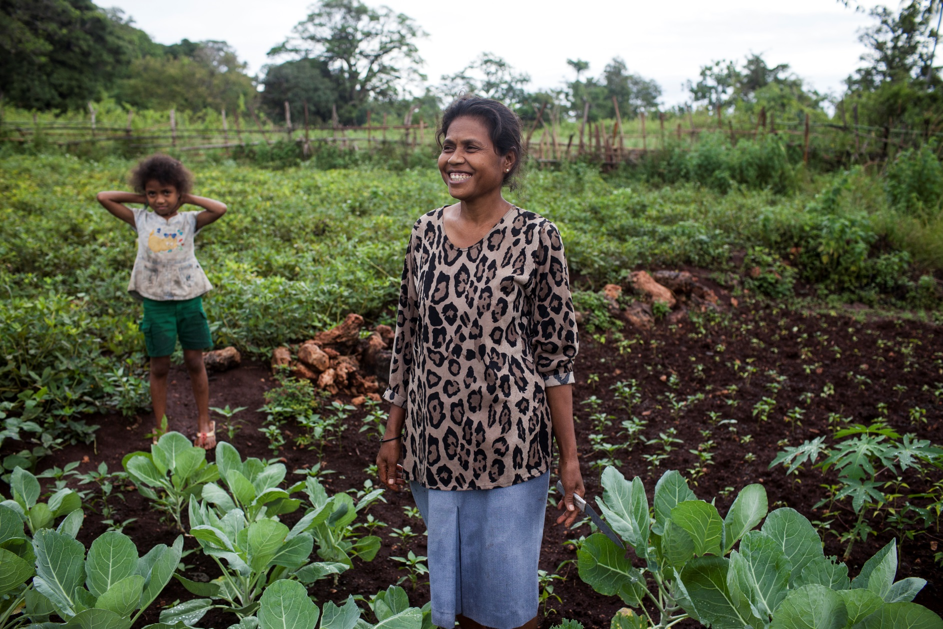Evaluation of Australian aid to Timor-Leste

Office of Development Effectiveness

June 2014

© Commonwealth of Australia 2014

**ISBN** 978-0-9874848-1-9

With the exception of the Commonwealth Coat of Arms and where otherwise noted all material presented in this document is provided under a Creative Commons Attribution 3.0 Australia (<http://creativecommons.org/licenses/by/3.0/au/>) licence. The details of the relevant licence conditions are available on the Creative Commons website (accessible using the links provided) as is the full legal code for the CC BY 3.0 AU licence (<http://creativecommons.org/licenses/by/3.0/au/legalcode>). The document must be attributed as Office of Development Effectiveness, *Evaluation of Australian aid to Timor-Leste,* ODE, Canberra, 2014.

Published by the Department of Foreign Affairs and Trade, Canberra, 2014.

This document is online at [www.ode.dfat.gov.au](http://www.ode.dfat.gov.au)

**Disclaimer**: The views contained in this report do not necessarily represent those of the Australian Government.

For further information, contact:

Office of Development Effectiveness  
Department of Foreign Affairs and Trade   
GPO Box 887  
Canberra ACT 2601  
Phone (02) 6178 4000  
Facsimile (02) 6178 6076  
Internet www.ode.dfat.gov.au

Cover: Isabella Dacavarhlo maintains her family’s peanut and sweet potato crop while her husband in away in Dili. Isabella is joined by her daughter Elvita Bendita Da Seus Soares who is 7 years old and studies in class 1. Isabella is part of a Seeds of Life support group who received training in effective methods of planting, maintenance and post-harvest. Isabella lives in Salary village, Laga SubDistrict, with her husband and their 6 children. *Photo: Conor Ashleigh, Australian Centre for International Agricultural Research.*

Office of Development Effectiveness

The Office of Development Effectiveness (ODE) at the Department of Foreign Affairs and Trade builds stronger evidence for more effective aid. ODE monitors the performance of the Australian aid program, evaluates its impact and contributes to international evidence and debate about aid and development effectiveness.

Visit ODE at [www.ode.dfat.gov.au](http://www.ode.dfat.gov.au)

Independent Evaluation Committee

The Independent Evaluation Committee (IEC) was established in mid-2012 to strengthen the independence and credibility of the work of the ODE. It provides independent expert evaluation advice to improve ODE’s work in planning, commissioning, managing and delivering a high-quality evaluation program.

Foreword

As chair of the committee that oversees the Office of Development Effectiveness, I have a direct interest in all their evaluations, but I had a particular interest in this one. When I was Vice President for East Asia and the Pacific with the World Bank from 2007 to 2012, I was responsible for the bank’s program in Timor-Leste, and worked closely with Australia.

I am pleased to say that the story told by the evaluation about Australia’s assistance to Timor-Leste resonated strongly with my own experience during the period it covered.

First, the report correctly underlines the unique challenges faced by Australia. As a close neighbour and the largest aid donor, Australia was bound to be the ‘go-to’ source for help. The need to build a functioning government was urgent, so I was not surprised that staff tried to be as responsive as possible. Unfortunately, the by-product of this responsiveness was that staff became involved in too many different things; this subsequently became a management problem for Australia. This was also a problem for Timor-Leste, which had to deal with a large number of donors. In the words of Minister for Finance Emilia Pires: ‘there were many cooks in the kitchen, all baking different kinds of cakes’.

Second, the report captures the implications of the resource boom in Timor-Leste and the challenge the Timor-Leste Government faced in managing it. I can personally attest to the critical role Australia played in helping the Timor-Leste Government to manage the budget implications of this boom.

Finally, and consistent with the Timor-Leste Government’s improved budget position, the report captures the increasing confidence and capacity of the Timor-Leste Government to communicate its aims and expectations and effectively lead the international donor effort. In my mind, this has played no small role in the increasingly mature relationship between the Australian aid program and the Timor-Leste Government over the period covered by the report. The lead role Timor-Leste has taken in g7+, driving the New Deal for Engagement in Fragile States (a grouping it does not have to be part of) reflects this new confidence.

In my 40-year career in international development I have not encountered many development challenges greater than the one faced by Timor-Leste at its independence. It is gratifying that such significant progress has been made, in spite of the setbacks. Credit for this rests substantially with the Timor-Leste Government and its population. However, the international community played an important and effective role as well. The evaluation’s account of Australia’s role should be of value to people with an interest in Timor-Leste, but particularly for those seeking to understand and learn from the strengths, weaknesses and limitations of international assistance in post-conflict settings.



Jim Adams, Chair of the Independent Evaluation Committee

Contents

Foreword iii

Acknowledgments vi

Executive summary 1

1 Introduction 9

1.1 Context 9

1.2 Aid and the economy 10

1.3 Australia’s relationship with Timor-Leste 11

1.4 Evaluation objectives and scope 15

1.5 Methodology 15

1.6 Report structure 16

2 Country strategy development 17

2.1 Introduction 17

2.2 Quality of planning for aid to Timor-Leste 17

2.3 Operationalising aid policies 21

2.4 Conclusion 23

3 Country strategy implementation 25

3.1 Introduction 25

3.2 Increasing selectivity of aid 25

3.3 Improving coordination and harmonisation 28

3.4 Improving alignment 33

3.5 Conclusion 37

4 Resourcing country strategy development and implementation 39

4.1 Introduction 39

4.2 Adequacy of resourcing 39

4.3 Corporate planning and supervision 41

4.4 Conclusion 43

5 Results of Australian aid in Timor-Leste 45

5.1 Introduction 45

5.2 Strengthening service delivery 45

5.3 Increasing agricultural productivity and employment 50

5.4 Improving government accountability, transparency and integrity 56

5.5 Building the foundations for a safer community 58

Acronyms and abbreviations 62

References 63

Acknowledgments

The evaluation was conducted by a team from Sustineo Pty Ltd and staff from ODE. It was led by David Carpenter (Sustineo) and David Slattery (ODE). Louisa Dow (ODE) was the evaluation manager and Debbie Bowman (ODE) provided oversight.

The evaluation team would like to thank the Timor-Leste Government, past and present Timor-Leste program and other staff, the Australian Federal Police, and the Australian Centre for International Agricultural Research.

Authors

(in alphabetical order)

David Carpenter (Sustineo)

Louisa Dow (ODE)

Stewart Norup (Sustineo)

David Slattery (ODE)

# Executive summary

Introduction

On 30 August 1999, 78.5 per cent of the Timorese population voted for independence from Indonesia in a national referendum. The result sparked violence on the part of pro-Indonesian militias, supported by elements of the Indonesian military and police. By the time international assistance arrived, an estimated 250 000 people (one-third of the population) were refugees in West Timor, and 2000 people had died. The conflict destroyed 70 per cent of public infrastructure, including public buildings, government records, and communication, electricity and water supply infrastructure. Indonesians had governed for 24 years and held most of the senior positions in the state administration. Their departure left large gaps in public sector capacity.

Growth in petroleum revenues from 2005–06 onwards has led to Timor-Leste’s qualification as a lower middle income country according to the World Bank’s classification method. However, its United Nations classification as a least developed country (which takes into account factors other than per capita income that impede sustainable development), provides a more accurate characterisation of its status. There is a strong development rationale for Australian support to Timor-Leste, which is one of the poorest countries in the world. Australia also has an abiding national interest in Timor-Leste’s prosperity and peace as one of its nearest neighbours.

Reflecting these interests, Australia has played a prominent role in an independent Timor-Leste’s short history. Australia has been the largest development partner for Timor-Leste over the last decade, and it is the seventh-largest recipient of Australian aid. Australian overseas development assistance has amounted to more than $1.5 billion since Timor-Leste’s referendum on independence. This figure does not include the generous contributions made by a range of Australian community groups and charities. In 2013 alone, members of the Australian Council for International Development (the peak body for Australian not-for-profit aid) provided some $21.9 million in Timor-Leste. Australia has also played a leading role in maintaining stability in the country through a number of military-led peacekeeping missions, and defence spending has exceeded $5.9 billion since 1999.

The Department of Foreign Affairs and Trade (DFAT) leads aid policy development and implementation and whole-of-government coordination in Timor-Leste.[1] Australia’s national interest in Timor-Leste’s prosperity is reflected in strong whole-of-government engagement in the aid program, with the Australian Federal Police (AFP) and the Australian Centre for International Agricultural Research (ACIAR) playing particularly significant roles. The Timor-Leste Police Development Program (TLPDP), administered by the AFP, is Australia’s largest single aid project at over $110 million from 2005–06 to 2012–13. ACIAR has been an important player in the agricultural sector, managing the long-running Seeds of Life project.

The evaluation

This evaluation by the Office of Development Effectiveness (ODE) focuses on the planning and implementation of aid to Timor-Leste from 2009 to the present, which is the period covered by the current Australia–Timor-Leste country strategy (2009–14). The evaluation’s objectives were to:

* assess the Australian aid program’s performance in developing and implementing strategies for aid to Timor-Leste that are selective and focused, represent whole-of-government interests, facilitate effective management of the aid program, and produce results

identify lessons learned from the Timor-Leste country program over the review period, as a means of informing future directions for the program, as well as guidance for country strategy development and execution across the aid program.

The evaluation was guided by three questions:

1. To what extent was Australia’s country strategy for Timor-Leste appropriately developed?

2. To what extent did DFAT (then AusAID) effectively manage its assistance program?

3. What results were achieved by Australia’s program of assistance between 2006 and 2012?

ODE’s analysis drew on internal working documents, program documentation, independent completion reports and annual performance reviews; publications from external bodies, academics and other donors; 95 staff and stakeholder interviews; and quantitative data from the aid program’s information management system, AidWorks.

Findings by chapter

Country strategy development

For the first 10 years of Australia’s assistance to Timor-Leste, the country program operated without an agreed policy position on its scope and focus, despite several attempts. This was not without consequences. Without such a position, it was difficult to maintain focus in the face of external demands. Activities proliferated, and resources were spread too thinly. This highlights how conventional development planning approaches must be adapted in countries facing, or in transition from, conflict. The evaluation considers that less ambitious, shorter term and more flexible country assistance plans could have supported more effective prioritising and sequencing of aid to Timor-Leste over the first decade of Australia’s assistance.

Although this would have been difficult to foresee when the 2009 country strategy was developed, the political stability since that time suggests the time was right for a traditional long-term plan. The 2009–14 Australia–Timor-Leste Country Strategy provided a starting point for a maturing partnership with Timor-Leste, marked by a ministerial-level Strategic Planning Agreement for Development (‘planning agreement’) in 2011. The government-to-government focus of the agreement was a departure from the country strategy’s emphasis on delivering aid through key partners and demonstrated Australia’s commitment to the principles of the g7+ and New Deal for Engagement in Fragile States. This was particularly apparent in its commitment to incrementally strengthen and use Timorese systems.

The focus of both the country strategy and the planning agreement were mostly sound. However, both lacked detail; neither was comprehensive in explaining the scope of planned assistance or clear about how priorities would be reflected in resource allocations. The evaluation considers that aid could be more rigorously prioritised by including targets for consolidating country programs and reducing the number of sectors to which aid is provided and/or initiatives under management. This should be complemented by appropriately detailed long-term estimates of assistance. This would help to promote mutual accountability and more predictable support.

Greater certainty about long-term financing would also assist in bridging the gap between the commitments in country-level policies, and the resources and actions required to realise them. This gap is evident in the failure of conventional corporate planning to adequately cater for the administrative costs required to expand and manage aid to Timor-Leste in a disciplined manner. It is also evident in the continuing experimentation with methods to address this problem. The evidence from Timor-Leste about the effectiveness of one such experiment—delivery strategies—suggests its recent removal from DFAT’s country strategy architecture was sensible. However, the evaluation considers that there is a continuing need to strengthen operational planning so that resource needs are matched to expected outcomes.

Country strategy implementation

The country program has made steady—albeit uneven—progress in implementing several of the country strategy’s central commitments. One of these commitments was to increase the selectivity of Australian aid. In the context of Timor-Leste’s wide-ranging and urgent needs, and Australia’s status as the largest donor, Australia’s flexibility and responsiveness was understandable. However, as was noted by the country strategy, this had ‘*pulled the program in many different directions*’.[2]

Progress on improving selectivity was initially limited by the large number of funding commitments made prior to the strategy. This included three multi-donor trust funds supervised by the World Bank and executed by the Timor-Leste Government ministries, as well as another six funding arrangements with multilateral institutions. The response to the humanitarian crisis in 2006 further increased the number of initiatives active in Timor-Leste. As the amount of aid administered by the then AusAID doubled between 2005–06 and 2008–09, so did the number of activities it managed. This limited efficiencies that could have been realised in scaling up assistance, and resulted in loss of oversight and engagement in some investments.

The evaluation suggests a more cautious approach to funding multilateral partners was warranted, taking into account their past performance and capacity on the ground. While the intent to harmonise assistance with other donors was sound, funding multiple projects managed by multilaterals, often in the same sector, may have actually exacerbated the problems with fragmentation and complexity that they were (in part) designed to address. The progressive finalisation of pre-existing commitments from 2011–12 onwards has enabled the program to start shaping a more coherent and manageable portfolio, including by substantially reducing the number of active initiatives, albeit not to 2005–06 levels. This has included a refinement of support through multilateral organisations, taking into account their local capacities and comparative advantages. However, progress is more apparent in some sectors than in others: programs in health and education are still relatively fragmented, and not strongly integrated with Timor-Leste Government systems. For this reason, further rationalisation and stronger alignment of investments is needed to ensure Australia is in the best position to assist the Timor-Leste Government to achieve its objectives.

Improved clarity in Timor-Leste Government policies and in their capacity to implement and coordinate donor efforts has helped Australia to more closely align its support with these policies. This is most evident in the program’s use of advisers. Responding to concerns from the Timor-Leste Government and in the Pacific about the overreliance on and value for money of advisers (relative to other options of support), the aid program acted decisively to reduce its reliance on advisers and improve how they are managed. Increases in Timor-Leste Government capacity, and the diminishing importance of aid as a source of finance, has also led to a stronger focus on strengthening and incrementally increasing use of government systems. However, given continued weaknesses in these systems (and the consequential risks of using them), it is not clear whether their use will increase as a vehicle for Australian aid. That said, the focus on using government systems has helped the program to take a more informed and consistent position on Timor-Leste’s reform challenges and how Australian aid can best assist.

Whole-of-government collaboration with the AFP and ACIAR has matured. Further strengthening these relationships beyond transactional-level information sharing and consultation will be a key challenge and opportunity over the next country strategy period.

Resourcing country strategy development and implementation

Developing strategies, designing interventions, overseeing implementing partners and engaging in policy dialogue is resource-intensive, especially in low-capacity, conflict-affected settings such as Timor-Leste. When the difficulties of scaling up aid are added to this equation, it is clear that administrative resources allocated to Timor-Leste were not adequate in the lead-up to the country strategy and the early years of its implementation. With limited staff resources being spread too thinly across too many projects, the country program was unable to exercise strong and consistent leadership over its investments, some of which drifted in focus when decisive intervention was required. A lack of adequate administrative resources encouraged a business model built on working through multilateral organisations, which collectively underperformed.

Regular business unit planning did not manage this situation well, failing to deliver any increase in administrative resources (beyond a short-term response to the 2006 crisis) during a period of rapid growth between 2006 and 2009. From 2009 onwards, increased senior attention has helped to ensure that resource allocations ultimately reflected program needs. In particular, a first-ever program ‘health check’ carried out by senior managers in 2010 identified areas in need of improvement and support, and focused senior management attention on the particular needs of the program. This, and subsequent measures, resulted in an upgrading of in-country leadership, strengthened access to knowledge and technical expertise, increases in and improved use of locally engaged staff, and better collaboration between Post and Canberra. This has delivered a staffing profile that is better suited to the needs of the program, and which provides a basis for more effective management of aid to Timor-Leste.

Results of assistance

Unsurprisingly, given the difficult context, the results of Australia’s development assistance have been uneven. The best results from Australia’s development assistance to Timor-Leste have been achieved in cases where assistance has been sustained over long timeframes, allowing it to evolve in ways that are sympathetic to, and supportive of, Timor-Leste Government policies. For example, the aid program’s long-running program of support for water and sanitation has significantly increased the number of rural people with access to improved water (estimated at 222 909 over the most recently completed phase) and has made a pivotal contribution to Timor-Leste’s likely achievement of its Millennium Development Goal target for rural water supply by 2015. Similarly, the joint DFAT–ACIAR Seeds of Life program, which began in 2000, has developed improved crop varieties that deliver between 20 and 89 per cent more yield than local varieties. Dissemination of these varieties to increasing numbers of farming households will increase yields, and significantly reduce the cost of importing foreign seed. Australia’s support to the Ministry of Finance through the World Bank was instrumental in building its capacity to manage the exponential expansion of Timor-Leste’s national budget. Long-running assistance from the AFP has helped to maintain law and order, and to substantively restore the functionality of the Timor-Leste police force after it collapsed in the 2006 crisis and (at least on some measures) improve its professionalism.

Results have been less compelling in cases where Australia has been unable to stay the course, where objectives have been vague or unrealistic, or where resources have been spread too thinly across too many projects. Health and education have not benefited from long-term support: the support that has been provided has suffered from fragmentation and the results thus far have been modest. Work to strengthen public administration (with the exception of support for public financial management) and justice services suffered from unclear and overly ambitious objectives. Improving justice services was correctly envisaged as requiring a long-term approach. However, this was downgraded in the context of developing the 2009 country strategy, and support ceased after only one phase. Generation of employment through labour-intensive infrastructure development, technical and vocational training and private sector development (microfinance) has provided some tangible direct and indirect benefits, but on a small scale. Similarly, targeted efforts to address gender inequality have been small in scale, and not positioned within a coherent long-term approach about how to most effectively address one of Timor-Leste’s most intractable problems. As a result, it does not appear that the results achieved from the individual components of this work were equal to the sum of its parts.

Overall conclusion

The combination of extreme poverty at Timor-Leste’s independence, the destruction and flight of human capital that accompanied the Indonesian exit, and recurrence of conflict within its first decade of nationhood presented one of the most difficult development challenges in recent history. From the 1999 referendum on independence, Australia has led efforts to achieve a level of security that lies at the foundation of Timor-Leste’s development aspirations. This was acknowledged by the World Bank’s 2011 World Development Report, which observed that ‘*it is difficult to imagine how committed leaders in … Timor-Leste [among other countries] would have stabilised their country without help from abroad*’. The path to this point has not been even. However, as the biggest and lead provider of international assistance—through both aid (including policing assistance) and non-aid (defence spending) efforts—Australia has been pivotal to achieving the relative stability that exists today in Timor-Leste.

This evaluation concludes that, from the evidence from Timor-Leste, that there is a continuing need to build coherent long-term and appropriately resourced programs that address a limited set of clear and compelling development objectives. Doing so will require better discipline around investment decisions, supported by more authoritative long-term plans that thoroughly consider the resources required to implement them. In countries affected by or transitioning from conflict, shorter-term, more flexible planning approaches which focus on prioritising and sequencing efforts will be required. However, these should pay much stronger attention to resourcing requirements than in contexts where business-as-usual approaches may be adequate.

The evaluation has made five recommendations aimed at strengthening the effectiveness of assistance to Timor-Leste, and the effectiveness of DFAT’s country program aid elsewhere.

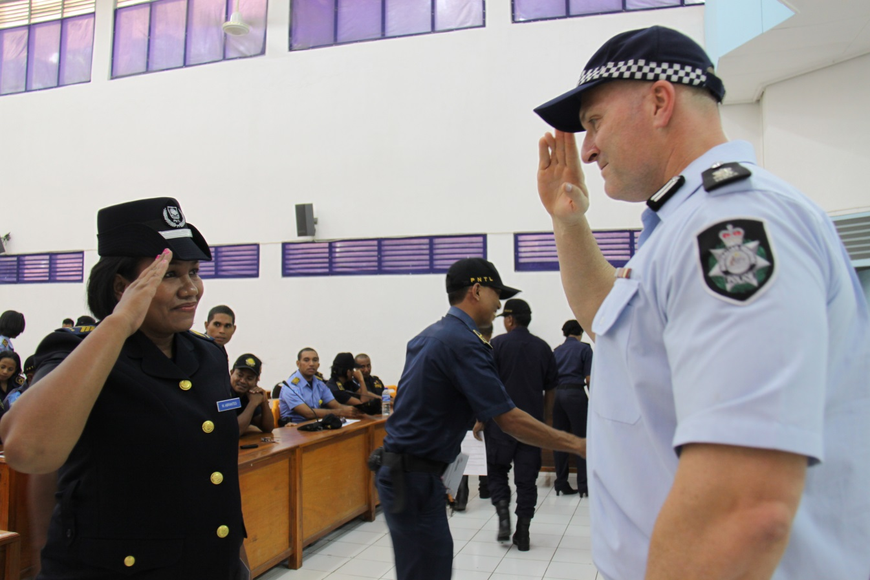

Policia Nacional de Timor-Leste Sergeant Maria Laura Abrantes being congratulated on completion of English language training by Superintendent Rod Kruger, Coordinator Training and Evaluation, Timor-Leste Police Development Program. *Photo: Timor-Leste Police Development Program.*

Recommendations and management response

The evaluation’s recommendations and management response to them are listed in Table 1. The response will form the basis of an implementation plan to address the recommendations.

Table 1 Recommendations and management response

|  |  |  |
| --- | --- | --- |
| Recommendation |  | Management response |
| 1 To strengthen the predictability of aid, and effectiveness of aid planning, DFAT’s revised country planning architecture should include provision for:   1. shorter term and more flexible country assistance policies for countries affected by, or in transition from, conflict 2. agreement on long-term financing commitments and their inclusion in country assistance policies 3. clear targets for consolidating country programs by reducing the number of sectors to which aid is provided and/or initiatives under management. | Agree | The Australian Government is developing a streamlined aid management system and a new performance framework for the aid program. This aid management system will strengthen aid planning in the integrated department.  The system requires all country and regional programs to produce an Aid Investment Plan (AIP). The AIP will provide a basis for agreement on long-term financing in country and regional planning documents that will be influenced in practice by program and partner performance. These AIPs will generally cover a four-year period and identify potential forward funding allocation for this timeframe. AIPs can have a shorter timeframe if required, including if they are for countries affected by or in transition from conflict.  As part of the new performance framework for the Australian aid program, a target has been established to consolidate the number of investments managed by DFAT by 20% by 2016–17. |
| 2. DFAT should establish a more structured process for collaborating with major whole-of-government partners where their work intersects with its development efforts, including by:   1. identifying and supporting AFP participation in the conception, design and (where appropriate) implementation of initiatives that intersect with its security sector work 2. identifying and supporting ACIAR participation in the conception, design and (where appropriate) implementation of agricultural development efforts. | Agree | Australian Government agencies are independently accountable for management of their own appropriations, including for overseas aid assistance. Consultation across whole-of-government partners is an important step in the DFAT aid investment design process.  DFAT and the AFP support efforts to end violence against women as part of the Australian aid program to Timor-Leste. DFAT and the AFP have regular meetings to discuss progress on these efforts, and the AFP’s TLPDP gender adviser participates in monthly DFAT gender working group meetings to promote gender equality linkages across the aid portfolio. In April 2014, DFAT will commence a new Ending Violence Against Women initiative in Timor-Leste. This was designed in 2013 in consultation with the AFP, and senior AFP officers participated in the design peer review. DFAT and the AFP have committed to regular meetings at the working level to facilitate collaboration throughout the initiative. DFAT will continue to include the AFP’s own assessment of the effectiveness of the TLPDP in the DFAT Aid Program Performance Reports for Timor-Leste.  The Seeds of Life initiative is co-managed by ACIAR and DFAT, and this current phase is scheduled to end in 2015. DFAT is consulting closely with and encouraging the participation of ACIAR, including in analysis and discussions with the Timor-Leste Government, in planning for Australia’s next phase of support to agricultural development in Timor-Leste, due to commence in 2015–16. DFAT will continue to collaborate with ACIAR in annual performance and quality assessments of major initiatives, such as Seeds of Life. |
| 3. To ensure a match between resource needs and delivery expectations, DFAT should strengthen resource planning by:   1. codifying the different resource requirements for different types of country or regional programs in operation, and including this in annual business unit planning 2. articulating principles for adequate health check coverage of country programs over time, and according priority to programs that are scaling up, and/or operating in particularly difficult or conflict-affected settings. | Agree | DFAT is in the process of preparing an interim business planning process for the integrated department. This will aim to support more effective resource planning.  DFAT is continuing the aid health check process for all country and regional programs. A schedule of six health checks is set each year, which will ensure over three years all major programs will receive this in-depth assessment. An aid health check for Timor-Leste is currently scheduled for mid-2014. |
| 4. To support a coherent long-term approach to addressing unemployment, DFAT should conduct a thorough analysis of the opportunities and challenges for private sector development in Timor-Leste, and the adequacy of its existing strategies in this context. | Agree | The following outlines how DFAT is supporting long-term approaches to employment and skills training, and agribusiness and private sector development:   * DFAT works with the Timor-Leste Government Secretariat of State for Vocational Training and Employment Policy to develop formal training systems so people can find gainful employment, increase productivity and support diversification of the economy. This has included support for the 2010 and 2013 Timor-Leste Labour Force Survey, which will contribute to greater analysis of key employment issues such as vulnerable employment, underemployment, youth unemployment and productivity.  We will continue to assist Timor-Leste to address employability issues with the development of a new skills development and employment program, due to commence in 2015. The program draws on thorough analysis and will help youth, workers and the unemployed improve their skills, knowledge and competencies to successfully enter the labour market, including self-employment. * As 70% of Timorese are subsistence farmers, there needs to be greater support for farm productivity and agribusinesses as significant agents of job creation and income creation. DFAT funds the multicountry Market Development Facility, which began in Timor-Leste in 2012. The facility supports businesses with innovative ideas to increase performance, stimulate economic growth and provide benefits for the poor, as workers, producers and consumers. It has undertaken extensive analysis of private sector opportunities, especially in ‘greenfields’ industries (construction, manufacturing and tourism). |
| 5. To strengthen the focus on, and effectiveness of work to address, gender inequality, including gender-based violence, DFAT should:   1. include a clear statement about how the program will address gender equality in the next Timor-Leste country strategy and indicators that enable progress in this area to be tracked 2. develop a long-term plan for how it will address gender inequality across the program, including, but not limited to how it will address the issue of gender-based violence. | Agree | DFAT will provide a clear outline of how the Australian aid program will address gender equality in the pending Timor-Leste Aid Investment Plan. This plan will cover multiple years and will include performance indicators, including on addressing gender equality, which will be assessed annually.  In 2013, the Timor-Leste program established a monthly gender working group to promote better gender equality outcomes across our aid portfolio. As part of this working group and the aid investment planning process, we are developing a gender action plan that will identify opportunities to improve gender equality outcomes across the Australian aid program to Timor-Leste. This will build on existing gender equality outcomes already being achieved in our roads, water and sanitation, agriculture, health and education initiatives.  As noted in Recommendation 2, in April 2014 DFAT will commence a new long-term Ending Violence Against Women initiative in Timor-Leste ($20 million over 4 years). This initiative will also collaborate across sectoral programs and the work of the AFP. |

ACIAR = Australian Centre for International Agricultural Research; AFP = Australian Federal Police; DFAT = Australian Government Department of Foreign Affairs and Trade; TLPDP = Timor-Leste Police Development Program

# 1 Introduction

## 1.1 Context

On 30 August 1999, 78.5 per cent of the Timorese population voted for independence from Indonesia in a national referendum. The announcement of this result was followed by violence on the part of pro-Indonesian militias supported by elements of the Indonesian military and police.[3] By the time international assistance arrived, an estimated 250 000 people (one-third of the population) were refugees in West Timor, and 2000 people had died.[4] The conflict destroyed 70 per cent of public infrastructure, including public buildings, government records, and communication, electricity, and water supply infrastructure.[5] Indonesians had governed the country for 24 years and held most of the high-level positions in the state administration, and their departure left large gaps in public sector capacity.[6]

The United Nations mission that oversaw the international response was widely regarded as a success at the time of Timor-Leste’s independence in 2002.[7] However, in 2006, hundreds of dissident soldiers from the Timorese defence force went on strike, protests occurred with increasing frequency in the capital, and the police force used heavy-handed tactics to disperse crowds, resulting in numerous deaths.[8] The conflict escalated, and within two months, 148 000 people had left their homes for camps on the outskirts of Dili.[9] The ‘rice crisis’[10] in 2007 and the attempted assassination of President Ramos-Horta and Prime Minister Gusmāo in 2008 were further reminders of the new nation’s fragility.[11]

In spite of these upheavals, in little over a decade Timor-Leste has established a democracy, saved over US$15.7 billion of petroleum revenue in a sovereign wealth fund,[12] and avoided a protracted civil conflict. Relative stability since 2008 has enabled the Timor-Leste Government to develop and release its long-term development vision (after several years of consultation). The Timor-Leste National Strategic Development Plan 2011–2030 seeks to transition Timor-Leste to an upper middle income country by 2030, and includes short, medium and long-term policies for social capital, infrastructure and economic development.[13] The Timor-Leste Government has taken over more and more of the day-to-day responsibility of managing security and delivering services. After 13 years, five missions and three elections, United Nations peacekeepers (including a 1000-strong UN Police contingent) withdrew from Timor-Leste in December 2012, marking a new phase in Timor-Leste’s development.[14]

Like all post-conflict fragile states, Timor-Leste is at risk of returning to conflict.[15] However, the recent period of stability, combined with the release of the Timor-Leste Government’s strategic development plan—which is indicative of improved government capacity—provides some basis for optimism that the country’s transition from fragile state to stability and growth is under way.

## 1.2 Aid and the economy

With its rapid growth in petroleum revenues, Timor-Leste qualifies as a lower middle income country according to the World Bank’s classification method, with a gross national income of US$3620 per person in 2012.[16] However, it is more accurately described by its United Nations classification as a least developed country, which takes into account factors other than per capita income that impede sustainable development, including the level of human capital and economic vulnerability.

Oil dependence is central to these factors. Timor-Leste is one of the most oil-dependent countries in the world, with petroleum income accounting for 80 per cent of gross domestic product in 2011.[17] In fact, Timor-Leste’s oil dependence is even more acute than this statistic suggests, given that government expenditure—which accounts for around half of the non-oil economy—is overwhelmingly dependent on oil revenue.[18] Oil revenue is deposited into a sovereign wealth fund that aims to provide long-term government funding through a conservative offshore investment strategy. The fund operates in a transparent manner: Timor-Leste is a signatory to the Extractive Industries Transparency Initiative and compliant with its standards.[19][20]

While oil and petroleum resources are a critical source of revenue, the sector generates few employment opportunities. The public sector dominates the economy and transfers through government investment and programs are the major driver of nonpetroleum growth.[21] Over 58 per cent of Timor-Leste’s 627 000 working-age population is not in the labour force, and of the remainder, around 70 per cent are either not employed, or in ‘vulnerable employment’ without any guaranteed salary or job security. For those 71 000 that were in salaried employment in 2010, 55 per cent were government employees.[22]

These factors place significant pressure on the Timor-Leste Government to diversify its economy, broaden its revenue base, and develop more sustainable sources of economic growth. This is particularly important given the expected decline in petroleum revenues from 2012 onwards, and that by some estimates, established oil and gas resources will be exhausted by 2025 at existing rates of production.[23]

On the back of the oil-driven growth in Timor-Leste’s national budget, the importance of aid funding as a driver of growth has decreased, although it remains a significant source of revenue (Figure 1). Reflecting improvements in government capacity, Timor-Leste has been an increasingly active participant in international aid forums. The Minister of Finance, Her Excellency Emilia Pires, chairs the g7+, the international grouping of fragile states driving the New Deal for Engagement in Fragile States. The New Deal agreement signed by Timor-Leste and 18 other fragile and conflict-affected states and development partners (including Australia) at the 4th High Level Forum on Aid Effectiveness at Busan in 2011 aims to reform aid to make it better suited to the challenges facing fragile and conflict-affected states.[24] Australia has provided significant financial support (amounting to $1.7 million between 2010–11 and 2013–14)[25] and technical support for the g7+ secretariat in Dili, and has agreed to be the lead donor piloting the initiative in Timor-Leste.[26]

Figure 1 Timor-Leste Government expenditure and overseas development assistance,   
2008–12

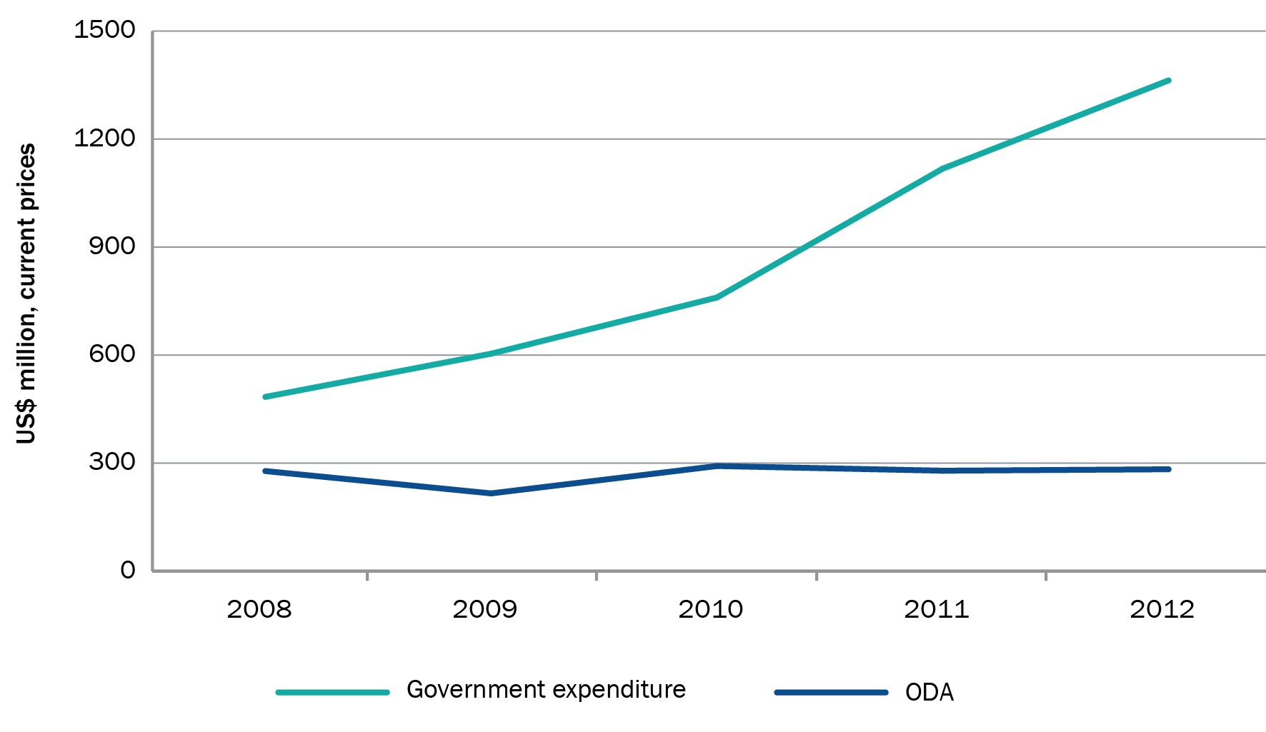

ODA = overseas development assistance

Source: Government expenditure statistics from Timor-Leste Budget Transparency Portal, [www.mof.gov.tl/budget-spending/budget-transparency-portal/?lang=en](http://www.mof.gov.tl/budget-spending/budget-transparency-portal/?lang=en). ODA statistics from Organisation for Economic Co-operation and Development, Development Assistance Committee, <http://stats.oecd.org/qwids/>

Notes: Government expenditure statistics include commitments and obligations. ODA figures are for all donors.

## 1.3 Australia’s relationship with Timor-Leste

Timor-Leste is one of the poorest countries in the world, and there is therefore a strong development rationale for Australian support to the country. Timor-Leste ranks 134 out of 187 countries in the United Nations Human Development Index.[27] The overall poverty headcount was 49.9 per cent in 2007, up from 39.7 per cent in 2001.[28] During the ‘hungry season’ before the harvest, the majority of people outside Dili regularly go without meals.[29] Average life expectancy at birth is 62.5 years.[30] For every 1000 babies born, 55 will die before their fifth birthday. Wasting affects 19 per cent of Timorese children and 58 per cent are stunted.[31] The maternal mortality rate (300/100 000 live births) is the second-highest in Asia; a woman’s lifetime risk of maternal death is one in 55.[32]

As one of our nearest neighbours, Australia also has a strong national interest in Timor-Leste’s prosperity and peace. In particular, Australia has a significant stake in the rich natural oil and gas resources in the Timor Sea, negotiation over which has at times been a defining issue of the Australia–Timor-Leste relationship.

Reflecting these interests, Australia has played a prominent role in Timor-Leste’s short history. Australia has been the largest development partner for Timor-Leste over the last decade. At an estimated $125.7 million in 2013–14, Timor-Leste is the seventh-largest recipient of Australian aid.[33]

While it is outside of the scope of this evaluation, Australia has also played a leading role in maintaining stability in the country through a number of military and peacekeeping missions since 1999. Aid, while very significant, has been outstripped in financial terms by Australian Defence Force spending in most years since independence (Figure 2). While overseas development assistance has amounted to more than $1.5 billion since independence, defence spending has exceeded $5.9 billion (both figures in constant 2011–12 prices).[34]

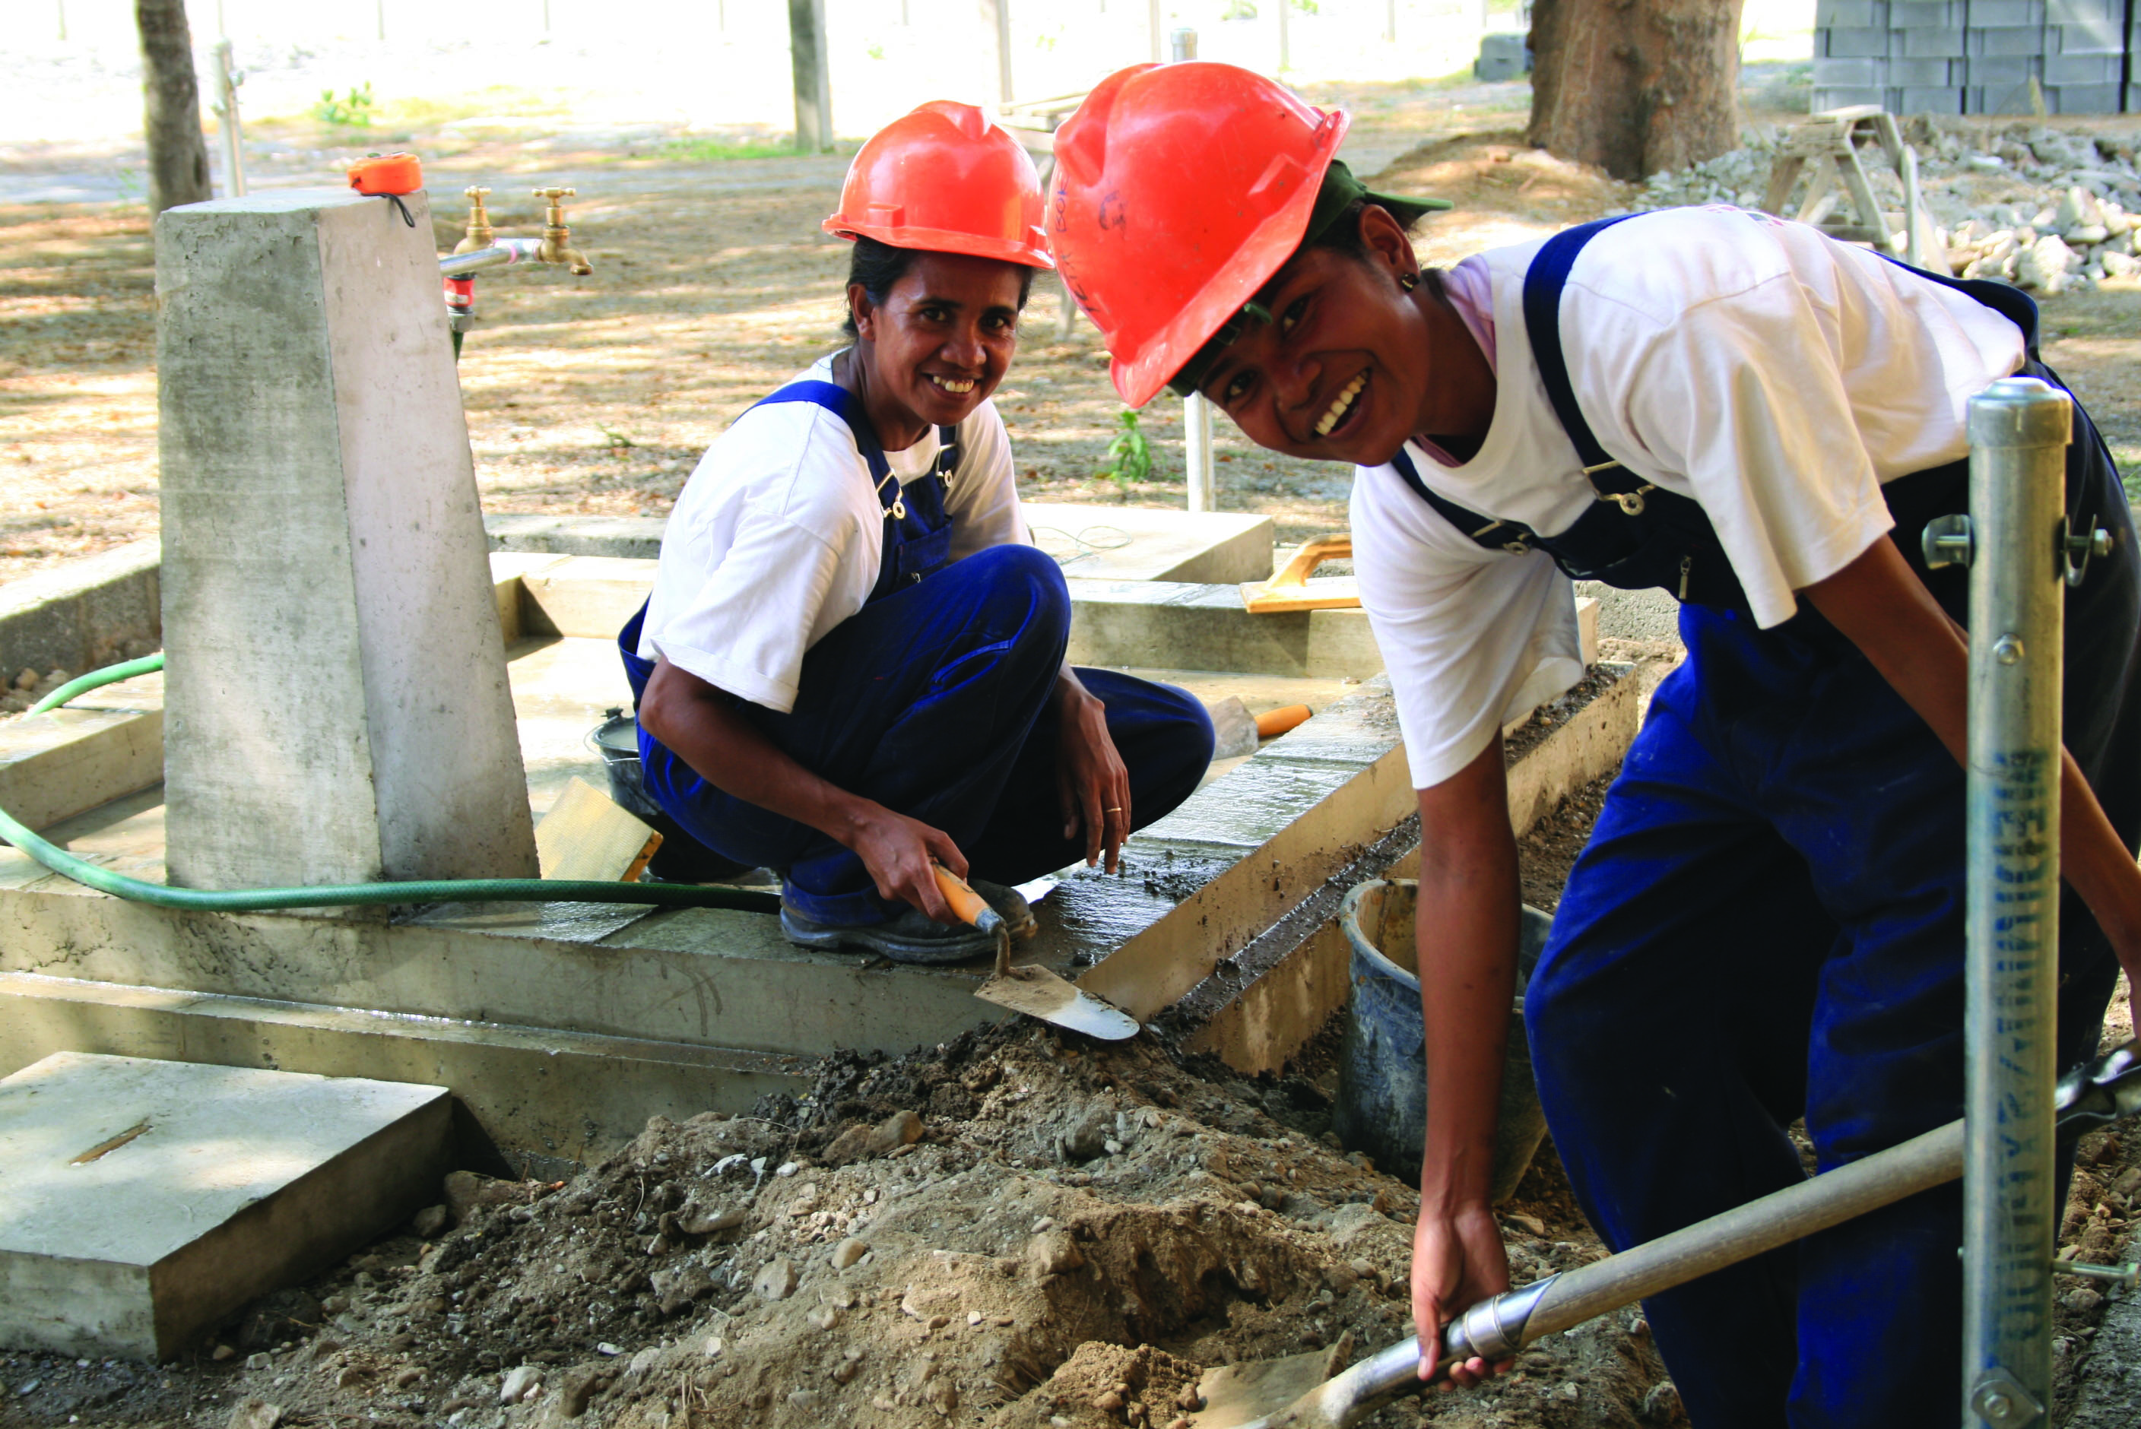

Julmira Da Silva and Ana Da Cruz undertake plumbing training at Timor-Leste's National Centre for Employment and Vocational Training, 2008. *Photo: AusAID.*

Figure 2 Australian overseas development assistance and defence force spending in Timor-Leste, and major events,   
1999–2000 to 2012–13

Defence force spending peaked at around $1200 million in 2000–01, then declined rapidly to around $50 million in 2004–05. Since then, spending increased and remained relatively stable at around $150–200 million between 2006–07 and 2012–13.
Australian overseas development assistance was just over $200 million in 1999–2000, but has been stable at around $100–150 million between 2000–01 and 2012–13.
Major events:
August 1999: 78% of Timorese vote for independence in referendum.
September 1999: Anti-independence violence increases. Security Council authorises deployment of an international force led by Australia. UN Transitional Administration in East Timor (UNTAET) established.
May 2002: Timor-Leste achieves independence. Timor Sea Treaty signed by Australia and Timor-Leste.
August 2005: Petroleum fund established. First receipt of petroleum revenues received by fund.
2006: Outbreak of violence culminating in displacement of 148 000 people. Defence leads international stabilisation force in response to a request from the Timor-Leste Government.
August 2006: Security Council establishes UN Integrated Mission in Timor-Leste.
February 2008: Attempted assassination of President Jose Ramos-Horta and Prime Minister Xanana Gusmao.
2009: Australia–Timor-Leste Country Strategy 2009–14 established.
November 2011: Government of Australia and Timor-Leste sign Strategic Planning Agreement for Development, aligned to the Timor-Leste Government’s Strategic Development Plan 2011–2030.
December 2012: United Nations peacekeepers withdraw, handing over responsibility for managing security to the Timor-Leste Government.


ODA = overseas development assistance

Note: Price deflator derived from *Budget 2013–14 Australia’s International Development Assistance Program,* Statement by Senator the Hon Bob Carr, Minister for Foreign Affairs, 14 May 2013, Table 7. Australian defence force spending figures do not cover the full costs of operations, as government seeks only to supplement defence funding for the ‘net additional’ cost of conducting an operation. Spending figures have been compiled from a number of sources.

Source: Data for 1999--00 to 2005–06 is from Table 1.11, Net additional cost of operations, 2005--06, Australian Government Department of Defence, *Annual report 2005–2006*, DoD, Canberra, 2006; data for 2006–07 and 2007–08 is from Australian Government Department of Defence, *Annual report 2008–09,* DoD, Canberra, 2009; data for 2008--09 to 2012–13 is from Australian Government Department of Defence, *Portfolio additional estimates statements 2012–13,* DoD, Canberra, 2012.

In line with Australia’s strong interest in Timor-Leste, the delivery of aid is a whole-of-government concern (Figure 3). The Timor-Leste Police Development Program, administered by the Australian Federal Police (AFP), is Australia’s largest single aid project: over $110 million between 2005–06 and 2012–13. The Australian Centre for International Agricultural Research (ACIAR) has been an important partner in the agricultural sector, managing the long-running Seeds of Life project.[35] Various other Australian Government departments and agencies have also been active in Timor-Leste, including the Australian Defence Force (as discussed above), Immigration and Citizenship, Infrastructure and Regional Development, Australian Electoral Commission, and state and territory governments (particularly Northern Territory, Australian Capital Territory, Tasmania, Victoria and South Australia).

Reflecting the Australian community’s strong support for Timor-Leste, Australian non-government organisations (NGOs) have also provided significant support to Timor-Leste since its independence, both as vehicles for delivering Australian Government assistance (over $67 million between 2005–06 and 2012–13)[36] and through their own revenues. In 2011-12, members of the Australian Council for International Development (the peak body for Australian not-for-profit aid) provided some $21.9 million in Timor-Leste from their own revenues, in addition to the $9 million they provided from aid program grants.[37]

Figure 3 Whole-of-government involvement in aid to Timor-Leste (current prices)

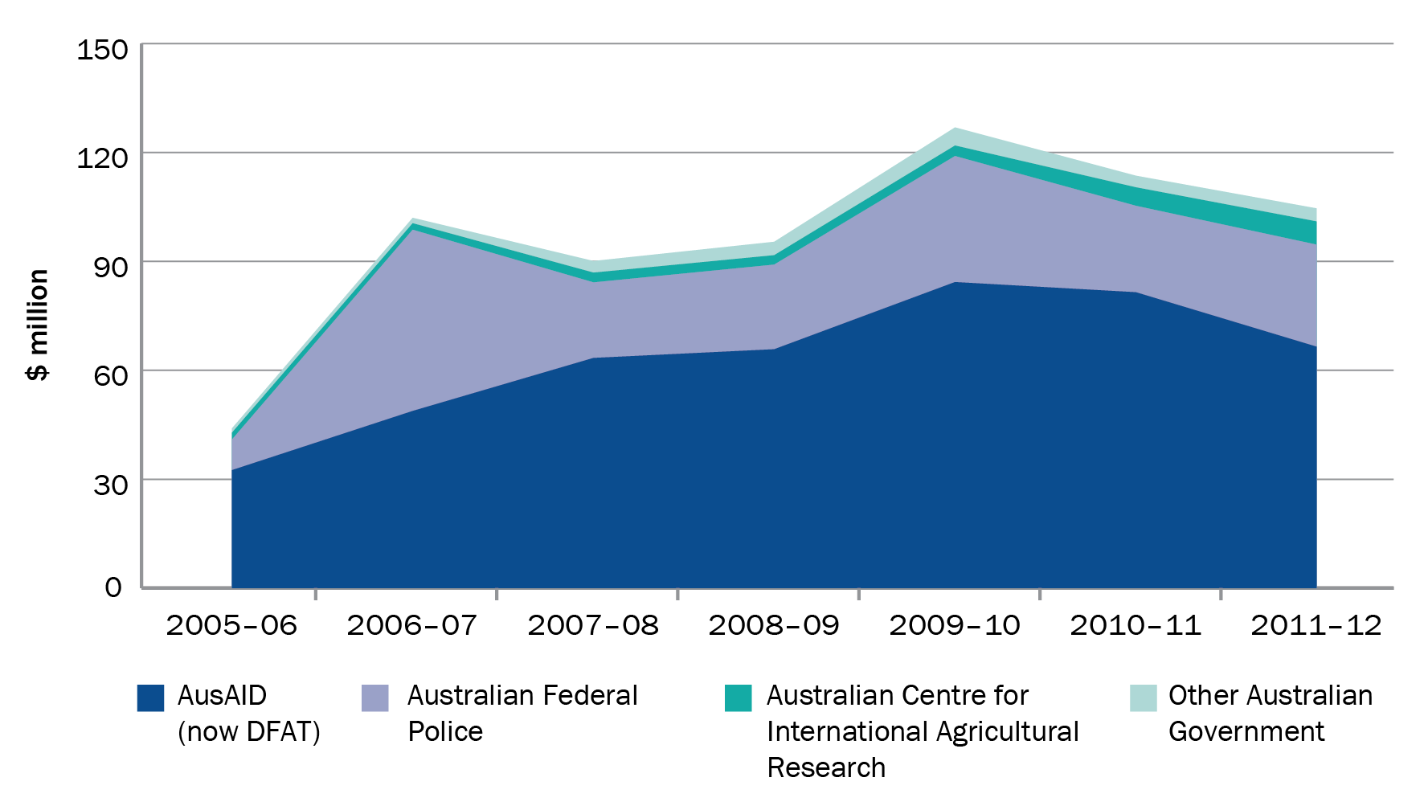

DFAT = Australian Government Department of Foreign Affairs and Trade

Note: Includes other government department expenditure sourced through DFAT’s appropriation.

Aid policy development and implementation and whole-of-government coordination are led by the Australian Government Department of Foreign Affairs and Trade (DFAT).[38] To provide a policy framework for development assistance, a number of interim and draft country strategies covering Australian aid to Timor-Leste were developed between 2001 and 2009, but none were finalised until the Australia–Timor-Leste Country Strategy 2009–14 (‘country strategy’) was approved in late 2009.[39] Following the 2011 release of the Timor-Leste Government Strategic Development Plan 2011–2030 (‘development plan’), the Australian Minister for Foreign Affairs and Timor-Leste Minister for Finance signed a Strategic Planning Agreement for Development (‘planning agreement’), confirming Australia’s commitment to align its aid program with Timor-Leste’s policies.[40]

## 1.4 Evaluation objectives and scope

The objectives of this evaluation were to:

* assess the Australian aid program’s performance in developing and implementing strategies for aid to Timor-Leste that are selective and focused, represent whole-of-government interests, facilitate effective management of the aid program, and produce results

identify lessons learned from the Timor-Leste country program to inform future directions for the program, and provide guidance on country strategy development and execution across the aid program. In particular, the evaluation sought to identify lessons of relevance to other parts of the aid program that are operating in fragile or post-conflict settings.

The evaluation was guided by three key evaluation questions:

1. To what extent was Australia’s country strategy for Timor-Leste appropriately developed?

2. To what extent did DFAT (then AusAID) effectively manage its assistance program?

3. What results were achieved by Australia’s program of assistance between 2006 and 2012?

The evaluation focuses on the delivery of aid to Timor-Leste from the development of the 2009 country strategy to the present, in particular examining the aid program’s internal strategy development, planning and implementation that have affected reported results. As the assessment of results covers a wide spectrum of assistance to Timor-Leste over the evaluation period, it relies primarily on secondary source material. The reliability of the assessment therefore depends heavily on the quality of work conducted by other parties, although efforts were made to triangulate this information with other sources of evidence.

## 1.5 Methodology

The evaluation used a mix of qualitative and quantitative methods. Qualitative analysis drew on internal working documents, program documentation, independent completion reports, annual performance reviews, and 95 staff and stakeholder interviews.[41]

During a scoping phase from November 2012 to February 2013, the evaluation team consulted past and present Timor-Leste country program staff, members of the Timor-Leste Government, other Australian Government stakeholders, and representatives from multilateral donors. Interviews with staff and stakeholders in Canberra and Dili and a preliminary review of documentation contributed to a desk study report and evaluation plan.[42] During the main data collection phase (February to May 2013), the evaluation team spent two-and-a-half weeks in Dili and conducted interviews with program staff directly involved in country strategy development and implementation, senior officials from the aid program and other Australian Government departments, Timor-Leste Government officials, non-government actors directly or indirectly involved in the program, and independent experts.

Quantitative data from the aid program’s information management system (AidWorks), the Organisation for Economic Co-operation and Development (OECD), World Bank, and the   
Timor-Leste Government were used to explore the country program’s results, and whether the program had a disciplined focus on its major objectives. Table 2 summarises these methods, the analytical issues and the credibility of data sources.

Table 2 Summary of methods used

|  |  |  |  |
| --- | --- | --- | --- |
| Method | Data source | Analysis | Credibility of data source |
| Staff and stakeholder interviews | Timor-Leste country program staff past and present (n = 33); senior aid program officials (n = 7); other Australian Government agencies (n = 12); Timor-Leste Government (n = 16); multilateral organisations (n = 7); non-government organisations (n = 4); consultants (n = 21); experts (n = 6). Total: 95 | Investigator triangulation. Systematic review of transcribed interviews using NVivo qualitative software by three investigators each coding all data and comparing codes. | **Good**  Interviewed majority of senior aid program staff involved in country strategy development and implementation since 2006. Interviewed key senior whole-of-government counterparts, Timor-Leste Government officials, and long-term consultants engaged by the aid program. |
| Document analysis | Program documentation (program performance reports, mid-term reviews, independent completion reports, other independent evaluations), Timor-Leste Government documents, whole-of-government reports, journal articles, multilateral donor reports | Review of over 200 references. | **Good**  Access to internal aid program documents relevant to Timor-Leste country program since 2002. Access to relevant internal (unpublished) policy documents. |
| Quantitative analysis | AidWorks data pertaining to all Timor-Leste initiatives, and OECD DAC Creditor Reporting System activity data from 2002–12 | Descriptive analysis of aid flows, and proliferation and fragmentation analysis of activity data. | **Good**  Duplication of aid program activity reporting to OECD DAC Creditor Reporting System created some data integrity problems. Duplicate activities were removed using array functions in Microsoft Excel. |

OECD DAC = Organisation for Economic Co-operation and Development, Development Assistance Committee

Note: AidWorks is the information system used to manage Australia’s aid investments.

## 1.6 Report structure

This chapter provided an overview of the context in which the country strategy was developed and implemented, the evaluation’s objectives and questions, and the evaluation methodology.

Chapter 2 addresses evaluation question 1: *To what extent was Australia’s Timor-Leste country strategy appropriately developed?*

Chapters 3 and 4 address evaluation question 2: *To what extent was Australian aid to Timor-Leste effectively managed?* Chapter 3 assesses whether the strategy was effectively implemented. Chapter 4 considers the adequacy of resources provided to support strategy development and implementation.

Chapter 5 addresses evaluation question 3: *What were the results of Australia’s program of assistance between 2006 and 2012?*

# 2 Country strategy development

## 2.1 Introduction

The focus of aid to specific countries should be grounded in robust analysis of the likely costs and benefits of possible investments, be aligned with Australian whole-of-government objectives and recipient government priorities, and be provided in a predictable manner to aid recipients. So that this occurs, aid policies have mandated the development of country strategies for the larger recipients of Australian aid. These strategies are intended to set out a country program’s rationale, approach and objectives over a specific period (usually five years), and which are agreed at appropriate levels by the Australian Government and its partners.

The Australian aid program has experimented with different approaches to country strategies to improve their coverage,[43] form and influence on decision-making.[44] This chapter examines the effectiveness of these approaches in providing a sound foundation for aid to Timor-Leste.

## 2.2 Quality of planning for aid to Timor-Leste

### Adapting policy requirements to fragile contexts

The period leading up to and following Timor-Leste’s independence was a time of instability and political change, during which its institutional and human capacities were stretched. This was exacerbated by the need to coordinate the activities of large numbers of aid donors.[45]

The fluidity of the environment made it difficult to establish a formal, long-term policy position on the focus of Australian aid to Timor-Leste until 2009. Australia attempted to define its strategy a number of times between 2000 and 2009, but these were not finalised or made public. None reflected a whole-of-government position on Australian aid, focusing only on the component managed by the Australian Agency for International Development (AusAID), now the Australian Government Department of Foreign Affairs and Trade (DFAT).[46]

In this, Australia was not alone.[47] However, it was not without consequences. As was observed by a 2009 review of service delivery conducted by the Office of Development Effectiveness (ODE), the absence of a strategy:

… made it difficult for AusAID staff to resist requests for support and maintain a clear focus on strategic areas of support. Demands on staff time and the urgent need for support to many areas in East Timor… tended to make decision-making reactive rather than planned and rational.[48]

Without a strategy, the aid program’s 2008 performance report for Timor-Leste noted that Australia had become the ‘*donor of first and last resort’* and ‘*the flexibility to respond became the [program’s] guiding force’.* Activities proliferated, and resources were spread too thinly.[49]

Finalising a strategy after almost a decade without one signalled a shift from a flexible emergency response for a country in crisis to a longer-term development partnership with the Timor-Leste Government. This evaluation recognises that the fluid and rapidly changing environment in Timor-Leste up until 2009 made it difficult, and probably counterproductive, to attempt to establish a comprehensive agreement with Timor-Leste about Australia’s long-term aid commitments and objectives. However, completion of shorter term and more flexible strategies could have provided a more disciplined framework for prioritising and sequencing of aid. This would have helped to avoid the drift in focus that occurred after the initial phase of assistance was complete.

### Aligning policies with Timor-Leste and whole-of-government priorities

Consultation on the country strategy with Australian Government departments resulted in some significant changes in focus and emphasis. In particular, feedback from the Department of Prime Minister and Cabinet resulted in the adoption of a focus on education service delivery. It also expanded the proposed focus on rural development and infrastructure into increasing employment, which included additional objectives for vocational education and private sector development (through microfinance). This process of consultation, and the response to feedback from it, helped to ensure the resulting strategy reflected a whole-of-government position on aid to Timor-Leste.[50]

Senior officials involved in developing the strategy noted to the evaluation that a concerted effort was made to align with Timor-Leste’s policy priorities, insofar as they were clear at that time. The Timor-Leste Government was consulted multiple times and through a range of avenues before the Australian strategy was ultimately endorsed by its Prime Minister. [51] The Timorese Prime Minister, Minister of Finance and Minister of Foreign Affairs were consulted on the strategy’s high-level objectives and the Ministry of Finance provided written feedback.[52] Operational consultation was more difficult. Country program staff reported to the evaluation that it was not always clear which Timor-Leste Government department or official was responsible for different elements of the strategy, and centralised decision-making hindered meaningful consultation. As is discussed in Chapter 4, these problems, as well as those encountered in previous attempts to develop country strategies for Timor-Leste, were compounded by difficulties in ensuring strong senior leadership and appropriate resourcing of strategy development.

On balance, the evaluation considers efforts to consult with the Timor-Leste Government and align with its priorities were reasonable, given the context. These efforts also paved the way for more mature discussions on the aid partnership and progressively higher levels of   
Timor-Leste Government ownership over the aid program in recent years. This was marked by the 2011 release of the Timor-Leste Government’s Strategic Development Plan 2011–2030 (‘development plan’), the first comprehensive statement of its long-term development priorities since 2002.[53] This provided the opportunity to reinvigorate the aid relationship.[54] Soon after the development plan’s release, AusAID’s Director-General met with senior   
Timor-Leste Government officials in Dili, and a Strategic Planning Agreement for Development (‘planning agreement’) between the two countries was signed in November 2011.[55] The development plan and planning agreement provided a new reference point for Australia’s aid to Timor-Leste. Officially, both the country strategy and the planning agreement provide a policy framework for the aid program. However, in practice, the planning agreement, signed at the ministerial level by both countries, superseded the country strategy.

### Framing how aid will be delivered

The country strategy emphasised the importance of working closely with bilateral and multilateral donors and non-government organisations (NGOs) to reduce the Timor-Leste Government’s administrative burden. In the context of low capacity and with the spectre of potential future civil and political disorder, the program’s focus on working through a broad range of actors was understandable, and consistent with principles for operating in low-capacity environments where governments may be overwhelmed and non-state actors are necessary to support fledgling institutions and provide accountability. In hindsight, the focus on working through other actors rather than forging deeper ties with the Timor-Leste Government appears overly tentative. It failed (understandably) to foresee the improvements in government capacity and development policies that occurred subsequently. In a marked departure from the country strategy’s focus on working through other donors and civil society, the 2011 planning agreement has a much stronger emphasis on working directly with the Timor-Leste Government. This is particularly evident in its commitment to incrementally strengthen and use Timorese systems, which was not included in the country strategy.

### Determining the focus and scope of assistance

The focus of assistance outlined by the country strategy was sound. Its high-level objectives—strengthening health and education services, increasing employment, securing community safety, and improving government accountability and transparency—are as important in 2014 as they were 2009.

The strategy’s commitment to improving service delivery recognised that lack of services was a fundamental constraint to development and poverty reduction. The inclusion of education in the strategy was particularly significant. There had been some earlier hesitancy about the level of support that Australia would provide, in part because of the status of Portuguese as the language of instruction and Portugal’s leading role in the sector. Australia’s commitment to support education has been made all the more important with the significant decline in Portuguese aid to Timor-Leste over the last five years.[56] The strengthened focus on service delivery directly responded to criticisms by ODE’s 2007 program effectiveness review that *‘[t]o finance [improved service delivery], either country program aid should have been increased, or funds taken from [elsewhere]*’.[57]

The commitment to increasing employment, incorporating a focus on vocational education and microfinance, was broader than that initially envisaged by the country program when it first drafted the strategy. The issue of unemployment in Timor-Leste is undeniably important, and is perhaps its greatest development challenge.[58] The major elements of the country strategy’s proposed response to this issue—a focus on agricultural productivity, labour-intensive road works, and technical and vocational training—are logical. The evaluation considers the private sector development component of this objective, which comprised a modest investment (US$2.5 million) in a UN-implemented microfinance project that has not been continued, would have benefited from a tighter consideration of the program’s capacity to provide support over a sufficient timeframe for substantive results to be achieved.

The country strategy described managing oil funds and translating resources into service delivery outcomes as ‘*[t]he key policy challenge*’ in Timor-Leste. Its commitment to improve budget execution and management implicitly recognised this as a keystone issue. However, beyond the focus on budget execution, the commitment to improving government accountability and transparency was vague.

The country strategy should have been more comprehensive in explaining the scope of assistance: three major multiyear initiatives lay wholly outside its stated focus. The justice sector was not mentioned in the strategy document, even though the five-year, $25 million Justice Sector Support Facility (JSSF) program had begun in June 2008, just over a year before the strategy was released. Also not mentioned were the funding to assist with petroleum resource development ($8 million annually over the country strategy period) and the large scholarships program ($23.5 million between 2007 and 2013).

While the planning agreement outlines priorities that accord with the country strategy, it does not specifically reference the country strategy. Rather, it reflects the content and language of the development plan, which it acknowledges as ‘*the overarching framework for all project and program creation and implementation*’.[59] Like the country strategy, the planning agreement has some notable gaps. Australia’s large scholarships program and assistance for petroleum resource development are again absent, as are a focus on gender equality and support for civil society, which was prominent in the country strategy.[60]

Though the planning agreement is lacking in detail, both Timor-Leste Government and Australian aid officials emphasised to the evaluation its importance in demonstrating and reinforcing Australia’s commitment to aligning with the Timor-Leste Government. The planning agreement’s status as a ministerial agreement adds weight to its commitments. However, its silence on the importance of gender equality and civil society suggests there is a risk that the stronger intergovernmental focus of the agreement will result in a retreat from issues that can only be resolved through the substantive involvement of non-state actors. The evaluation considers these omissions should be remedied in any future versions of the agreement.

### Providing a predictable basis for assistance

The country strategy provided an indicative financial commitment of $600 million between 2009 and 2014, but it did not explain how this would be allocated by sector: to different investments or through different aid instruments. This limited the strategy’s utility for the country program as a source of firm direction and discipline for investment decisions, and a means of improving the predictability of support.

Unlike the country strategy, the planning agreement does commit to the provision of multiyear financial estimates, although these estimates are not included in the agreement itself.[61] The evaluation considers inclusion of this detail, along with concrete commitments on consolidation, would help to ensure that aid was more rigorously prioritised, more predictable and more mutually accountable.

Recommendation 1

To strengthen the predictability of aid, and effectiveness of aid planning, DFAT’s revised country planning architecture should include provision for:

i shorter term and more flexible country assistance policies for countries affected by, or in transition from, conflict

ii agreement on long-term financing commitments and their inclusion in country assistance policies

iii clear targets for consolidating country programs by reducing the number of sectors to which aid is provided, and/or initiatives under management.

## 2.3 Operationalising aid policies

### Preparing delivery strategies

Country-level aid policies are necessarily high-level documents under which many different programming decisions might be made. In 2008, delivery strategies were introduced to strengthen the line of sight between individual investments, sectoral outcomes and country strategy objectives. Aid program guidance introduced at that time stated that country strategies *‘are not complete without delivery strategy/ies needed to guide implementation*’. Delivery strategy guidelines described them as *‘a key means of managing program scale (up or down) and consolidation towards fewer, larger programs to maximise aid effectiveness, efficiency and impact*’.[62]

From 2010–11 onwards, the program began work on as many as 10 delivery strategies covering discrete outcome areas. This was slow and time consuming. The first completed delivery strategy was for the water, sanitation and hygiene (WASH) sector, which consists of only one development investment and is therefore arguably the least in need of a delivery strategy for the reasons identified in corporate guidelines.[63] A delivery strategy for the health sector was completed in 2013, but no other was finalised,[64],[65] with much of the work on them overtaken by the need to develop the investment designs that are required to allocate and disburse funds. Country program staff also noted that changes in Timor-Leste Government staffing and leadership could bring about abrupt shifts in policy and sectoral organisation and, in some cases, the dissolution of entire ministries and agencies. This meant that program staff were understandably reluctant to invest in strategies that might soon be out of date.

Unfortunately, one area that would have benefited from more substantive consideration in a delivery strategy form—gender equality—did not receive it. This ran contrary to the country strategy’s commitment to developing a gender action plan that would identify specific measures to improve gender equality. Gender has remained absent from program policy development, including the planning agreement and internal policies developed to support implementation of the country strategy (see below). With some notable exceptions,[66] the program’s performance in promoting gender equality has been weak (see Chapter 5). This suggests the program would have benefited (and would continue to benefit) from a long-term plan for promoting gender equality.[67]

The intended purpose of delivery strategies has been fulfilled in part by internal planning work in the form of a 2011 Strategic Directions Paper and the draft policy enabling delivery strategy which builds on it. These address gaps in the country strategy and planning agreement by attempting to clarify the links between program objectives, organisational capacity and resourcing, how assessed priorities should be translated into resource allocations, and how the program can strengthen its relationships with and policy support for the Timor-Leste Government.

Taking into account the well-established need for DFAT to streamline its business model,[68] and slow progress in completing outcome-level delivery strategies across the aid program, delivery strategies have recently been removed from the country strategy architecture. The evidence from Timor-Leste—that investment in delivery strategies was not commensurate with returns from it—suggests this decision was sensible.

However, this evaluation found that there is a continuing need to strengthen links between the objectives in country-level aid policies and the identification of the resources and actions required to achieve them. This is evident in the initiative taken by the country program to develop internal policies that had no formal status (and were not required by aid program policies), but which senior Australian aid officials considered necessary for the effective implementation of the country program. It is also evident in the failure of regular corporate planning to match operational resources with delivery expectations (see Chapter 4). This finding is supported by other authoritative commentators, such as the Australian National Audit Office, which has pointed to the need for better up-front identification of, and planning for, the internal capacity and resources needed to achieve agreed aid objectives.[69]

### Monitoring and reporting progress

Country strategies should contain clear objectives that provide a basis for assessing progress and results. However, continual change has meant that the program has been unable to establish a clear set of objectives and framework for assessing progress, making it difficult for the program to create a clear narrative about its performance. Initially, the program struggled to reconcile the ‘gap’ between its individual initiatives’ intended outcomes and the high-level objectives set out in the country strategy. To overcome this, the program defined a set of outcomes in its 2010 program performance report, for which both Australia and the   
Timor-Leste Government could share responsibility, and set out the case for how Australia had contributed to their achievement. The 2011 development plan and planning agreement presented new challenges. Rather than continuing to report in terms of shared outcomes, the program then measured itself against the very long-term objectives in the development plan and planning agreement. The gap between initiative objectives and the higher level objectives remained. The 2012–13 program performance report reported against yet another set of objectives.[70]

In spite of these issues, since 2011 the country program has increased its focus on results. It has developed an interim performance assessment framework that draws together Australia’s and Timor-Leste’s shared goals under the 2011 planning agreement, the country strategy outcomes, and short-term development plan targets. It has also joined the Evaluation Capacity Building Program—an initiative to improve evaluation-related skills, knowledge and practice—which has resulted in a marked improvement in the quality of project monitoring and evaluation plans, including how these are planned for in project design documents.[71] This has been made possible in part by an increase in performance and quality capacity, including training and guidance in monitoring and evaluation put in place following an internal program health check in 2010. The program now has three officers working on monitoring and evaluation: two in Canberra and one at Post.[72]

## 2.4 Conclusion

Over the first 10 years of assistance to Timor-Leste, the country program operated without the ballast of an agreed policy position on its scope and focus. While to some extent this was understandable, it was not without its consequences. Without such a position, it was difficult to maintain a disciplined focus in the face of external demands: activities proliferated and resources were spread too thinly. The program’s inability to establish a clear policy position prior to 2009, despite several attempts, highlights how conventional development planning approaches must be adapted in the case of countries in, or in transition from, conflict. The evaluation considers less ambitious, shorter term and more flexible country assistance plans could have provided a more disciplined framework for prioritising and sequencing of aid to Timor-Leste over the first decade of Australia’s assistance.

Although this would have been difficult to foresee when the country strategy was developed, the political stability since 2009 suggests the time was right for a traditional long-term planning approach to be adopted. Appropriate effort was made to ensure that the strategy reflected a whole-of-government position on Timor-Leste Government priorities and that the strategy was aligned with these priorities. This provided a starting point for a maturing partnership with Timor-Leste, marked by the establishment of a ministerial-level planning agreement on aid in 2011. The strong government-to-government focus of the agreement marked a departure from the country strategy’s emphasis on delivering aid through other actors and demonstrated Australia’s commitment to the principles of the g7+ and New Deal for Engagement in Fragile States. This was particularly apparent in its commitment to incrementally strengthen and use Timorese systems.

The focus of both the country strategy and the planning agreement was broadly sound, although both lacked detail: neither was comprehensive in explaining the scope of planned assistance, or clear about how priorities would be translated into financing decisions. The evaluation considers that inclusion of targets to support more focused and disciplined assistance in future strategies and agreements would support a more rigorous prioritisation of aid. This should be complemented by appropriately detailed long-term estimates of assistance, to provide a stronger basis for mutual accountability over and predictability of support.

Greater certainty over long-term financing intentions would help to bridge the gap between the high-level commitments in country-level policies, and the resources and actions required to meet them. This gap is evident in the failure of business-as-usual corporate planning to adequately cater for the administrative costs required for a disciplined expansion and management of aid in Timor-Leste (see Chapter 4). It is also evident in the continuing experimentation with alternative methods to address this problem. The evidence from   
Timor-Leste about the effectiveness of one such experiment—delivery strategies—suggests its recent removal from DFAT’s country strategy architecture was sensible. However, the evaluation considers there is a continued need to strengthen operational planning, to match resource needs with expected outcomes, and ensure a tighter discipline over, and accounting for, programming decisions.

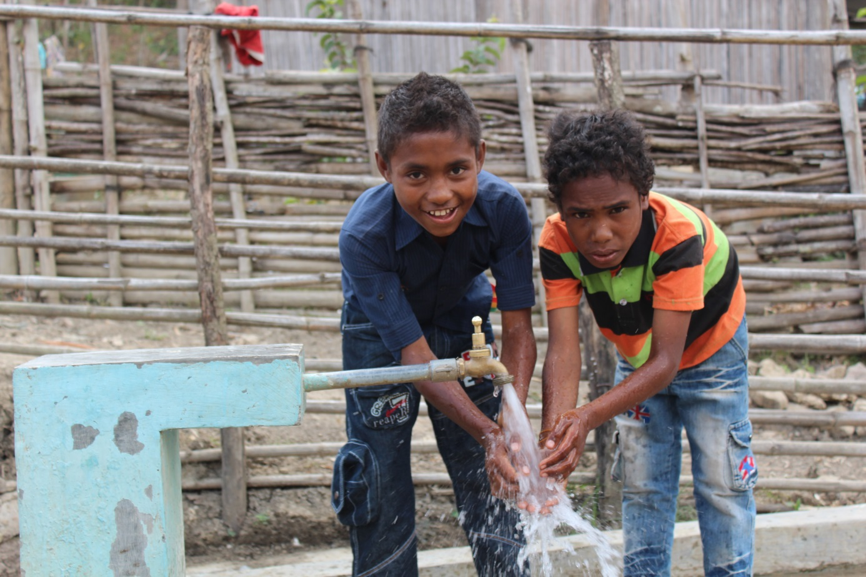

Natalino de Araujo (left) and Nofianus Amaral (right) wash their hands at a newly built water tap in Foholulik village in Suai of Cavalima district. *Photo: Arlindo Soares, Australian Embassy.*

# 3 Country strategy implementation

## 3.1 Introduction

The 2009 Australia–Timor-Leste country strategy was established at a critical point in the country’s short history. Outbreaks of conflict in 2006 and 2008 provided reminders of the unresolved divisions within Timor-Leste’s political leadership and community frustration about a lack of progress in improving services and economic opportunities—particularly in the context of exponential growth in government revenues from 2007 onwards.[73] A lack of harmonisation imposed a significant donor-management burden on the Timor-Leste Government, which, combined with the internal conflict, reduced its capacity to lead the development agenda.[74] In addition, there was increasing dissatisfaction within Timor-Leste with what was perceived to be a Dili-centric, adviser-driven, technocratic focus of aid donors.[75] These factors required donors, including Australia, to rethink how they could best support development in Timor-Leste and demonstrate that progress was being made.

Building on analyses of this context,[76] the country strategy made a number of commitments about how Australian aid would be reformed in order to more effectively support Timor-Leste. This chapter examines Australia’s progress in implementing three commitments that were central to the country strategy. These commitments were to:

* increase the selectivity of aid, by consolidating and focusing support in areas where success is most likely to be achieved
* strengthen coordination and harmonisation of its aid

improve alignment with Timor-Leste’s development policies and priorities.

## 3.2 Increasing selectivity of aid

Given the breadth of the challenges facing developing countries, it is tempting for aid donors to support a large number of activities spread across many sectors. However, if spread too thinly, this can reduce the impact of the support provided, increase fragmentation and complexity, and overwhelm aid recipients. Following independence, Timor-Leste had wide-ranging and urgent needs for assistance from aid donors, and little capacity to coordinate them. As the largest donor, Australia was often the first port of call for these needs, which placed it under significant pressure to widen the focus of its support. It is not surprising then, that the focus of the program suffered—a situation acknowledged by the country strategy, which noted that Australia’s flexibility and responsiveness in the post-conflict period had ‘*pulled the program in many different directions*’.[77]

The 2006 white paper precipitated the start of a major increase in Australian aid, which was allocated to country programs through thematically conceived new policy proposals from 2007–08 onwards. As a result, the country program entered into a significant number of multiyear funding commitments during the lead-up to the approval of the country strategy, locking it into a portfolio of activities that could not quickly be rationalised. Pressure to start new activities, including in response to the 2006 crisis, saw over $150 million of new programming just prior to the release of the strategy.[78] As a result, expenditure on activities approved between 2007–08 and 2009–10 grew to over 30 per cent of Australia’s aid portfolio by the time the country strategy was approved (Figure 4). By 2010–11, budget measure funding accounted for over 50 per cent of aid program expenditure in Timor-Leste.

Figure 4 Impact of programming decisions in the lead-up to country strategy approval

Long-term investment represented the majority of investment, from around $25 million in 2005–06, then remaining between $50 million and $80 million from 2006–07 to 2012–13. Expenditure on programs established between 2007–08 and 2009–10 took the total expenditure from around $65 million in 2007–08 to around $120 million in 2009–10. As a proportion of overseas development assistance, programs established between 2007–08 and 2009–10 from around 10% in 2006–07 to almost 35% in 2012–13, then decreased to around 15% in 2011–12 and around 20% in 2012–13.
Expenditure on programs established during the country strategy period began contributing to overall expenditure in 2011–12 (around $10 million) and 2012–13 (around $20 million).


ODA = overseas development assistance

Source: AidWorks data

While the strategy committed to refocusing efforts on a smaller number of activities and results, these decisions in the lead-up to its establishment meant the commitment came too late to have an immediate impact. Opportunities to consolidate began to appear in 2011–12 as a number of initiatives approached their conclusions. As the minister-counsellor noted in 2012:

… the [p]rogram is designing or redesigning 75% of our activities in the next 12 to 18 months which means we have the opportunity to reshape where we want to be out to 2015–16.[79]

This latest phase of the program has focused on consolidation, backed by policy commitments from successive Australian governments[80] and consequential corporate focus on selectivity, as well as the specific commitment of the country strategy. For example, in 2012, the program decided to end support for the Asian Development Bank’s Infrastructure Technical Assistance Program, which sought to develop infrastructure project management capacity within the Ministry of Infrastructure. At the same time, the country program decided to continue and expand funding to an existing project implemented by the International Labour Organization that applied labour-intensive road construction methods to generate employment.[81] Consistent with earlier decisions taken in the development of the country strategy, a second phase of the Justice Sector Support Facility was not pursued and was finalised in 2014. The country program ceased its management role in providing policing assistance and consolidated this support with the Australian Federal Police (AFP; see below). Investments in humanitarian aid in response to the 2006 crisis were finalised.

These decisions have increased the program’s coherence and manageability with a focus on shared priorities of the Timor-Leste and Australian governments. While the period between 2005–06 and 2008–09 saw the number of Australian initiatives active in Timor-Leste double (Figure 5), there has been a steady decrease in initiative numbers since this time, with consequential increases in the average size of initiatives.

Figure 5 Number of active initiatives and their average annual spend, 2005–06 to 2011–12

Of initiatives with expenditure greater than $100 000, the average spend was around $1.5 million from 2005–06 to 2008–09. This rapidly increased to $2.5 million in 2010–11, and $2.25 million in 2011–12.
The number of initiatives with expenditure greater than $100 000 increased from around 25 in 2005–06 to a peak of around 45 in 2008–09, before decreasing to around 32 in 2011–12.


Source: AidWorks data

This progress is more apparent in some sectors than in others, with programs in health and education still relatively fragmented, and not strongly aligned with partner government systems.[82] Further rationalisation and stronger alignment of investments will be critical to ensuring Australia is in the best position to assist the Timor-Leste Government to achieve its short-term targets, and realise the long-term vision outlined in its development plan.[83]

## 3.3 Improving coordination and harmonisation

### Coordination with other donors

A 2008 Office of Development Effectiveness (ODE) report on the implementation of the Paris Declaration in Timor-Leste characterised coordination and harmonisation as uneven and halting, observing:

Timor-Leste has a crowded donor environment in which donors have sometimes jostled for influence, while the sheer number of donors and NGOs—all with different agendas, programs, operating modalities and requirements—has created an enormous burden on the government. Given this, it is not surprising that there is a substantial body of evidence to suggest that harmonisation is yet to deliver at the operational level. For example, a recent stocktake undertaken as part of the State of the Nation report found that since 2002 over 300 donor reports had been produced in the infrastructure sector alone—a sobering statistic for such a small country.[84]

The country strategy recognised the crowded donor environment and the need to work in a coordinated way with other donors. It noted that working through multilateral organisations and other donors ‘*provide[s] scope for Australia to better coordinate and harmonise its aid and policy dialogue efforts*’.[85] Although experience with multi-donor trust funds has often been more mixed (particularly in fragile states), they are recognised for their strengths as a means to swiftly channel funds and improve coherence, predictability, risk management and alignment with national priorities.[86] Australia’s entry into multi-donor arrangements thus responded to the real risks of donor crowding, fragmentation of donor support and loss of Timor-Leste Government ownership. While the desire to harmonise assistance with other donors and encourage a broad base of donor support for Timor-Leste were significant factors in the program’s use of multilaterals, this was also driven by more pragmatic considerations. In particular, as discussed in Chapter 4, inadequate administrative resourcing and lack of human resources encouraged a business model that relied on multilateral partnerships, which implied a less intensive role for the country program.

As a result, the program increased funding of multilateral organisations significantly in the years preceding the country strategy (Figure 6). This included entry into several multi-donor trust funds supervised by the World Bank and executed by the relevant Timor-Leste Government ministries, including in public financial management (2008–09 onwards), health (2007–08 onwards) and education (2007–08 onwards). It also included six projects managed by multilateral institutions in four areas: infrastructure, through the International Labour Organization (roads) and the Asian Development Bank (infrastructure); health (emerging infectious diseases), through the Food and Agriculture Organization of the United Nations; education, through UNICEF and the International Labour Organization; and access to financial services through the United Nations Capital Development Fund.[87]

Figure 6 Spending through multilateral organisations as a proportion of country program aid, 2005–06 to 2011–12

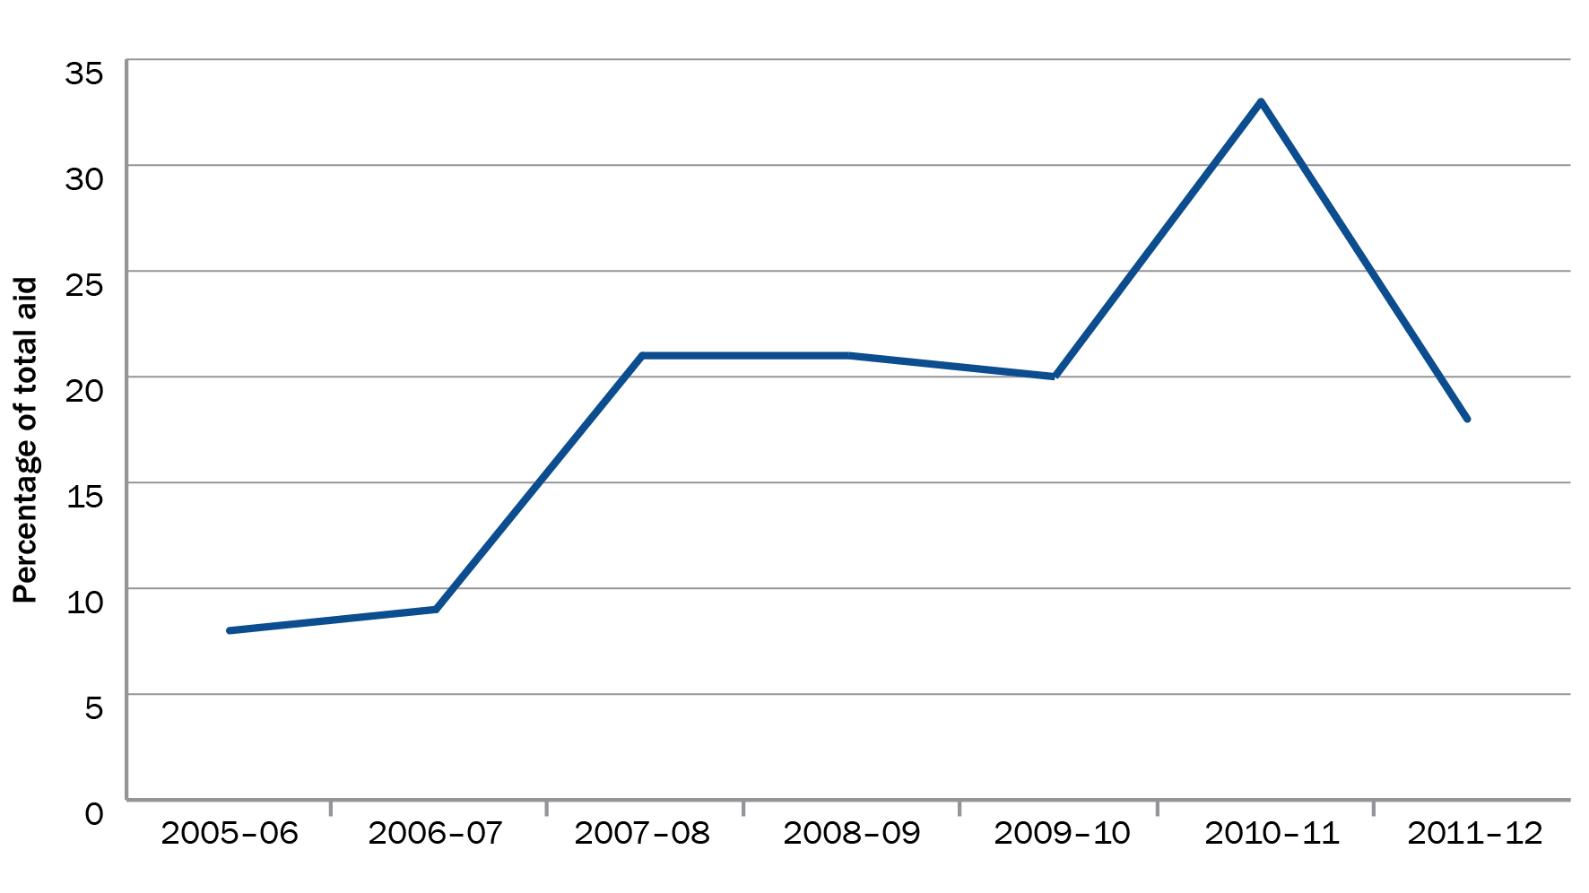

Source: AidWorks data

As discussed in Chapter 5, these arrangements had mixed but generally poor results. The World Bank-led multi-donor trust funds were recipient-executed programs and their performance tended to reflect the capacity of the Timorese ministries they worked with. The World Bank has struggled to maintain effective oversight and engagement with these funds.[88] These problems were exacerbated by the lack of flexibility and responsiveness associated with the application of World Bank procurement and financial management procedures—a weakness highlighted by a recent World Bank evaluation of assistance to Timor-Leste.[89] The Asian Development Bank’s infrastructure project was identified in the aid program’s 2011 program performance report as one of the country program’s worst performing initiatives. An earlier project performance report observed that *‘it probably would have been more efficient … to manage the contractor and relationship with the government directly*’. The 2011 program performance report raised early concerns about UNICEF’s management of its relationship with the Ministry of Education. These issues led the aid program to question:

… the relevance and effectiveness of supporting large recipient-executed trust funds in fragile states like Timor-Leste, unless there is a bigger commitment from the donors and the multilateral development banks to put more resources on the ground to support government implementation.[90]

With its limited resources consumed by the administrative tasks associated with the agreements it had entered into, the country program struggled to maintain effective oversight of its portfolio. In some cases, the country program was able to intervene with positive results. For example, pressure from the country program on the World Bank about the underperformance of its public financial management support was instrumental to changes that led to a marked improvement in its performance. However, weaknesses in human resourcing (see Chapter 4), affected the country program’s ability to provide effective oversight to all of its multilateral investments or to take decisive action in cases where they were underperforming, particularly early in the country strategy period.[91]

Funding multiple projects managed by multilaterals and other partners, often in the same sector, may have exacerbated problems with the fragmentation and complexity that they were (in part) designed to address. The recent design for a new education program, for example, observes that the large number of partners in the education sector, three of whom operated with financial contributions from Australia, had ‘*created a complex, time-consuming environment’* for the Timor-Leste Government, and contributed to the Ministry of Education’s frustration about the poor alignment of support to it.[92]

Given the Timor-Leste Government’s policy against taking on loans, it is important to recognise that Australia’s support for the multilateral development banks has had a positive impact in securing their active presence in country (see Box 1). The World Bank in particular was heavily reliant on Australian aid for their funding. In this way, Australia helped to maintain a diverse international community with expertise in the issues that Timor-Leste was facing.[93]

Box 1 Importance of Australian support for World Bank operations in Timor-Leste

Support to multilateral organisations has been a major component of Australia’s assistance to Timor-Leste, and has supported the continued involvement of these organisations in the country.

In the early stages of the country program, Australia participated in all of the World Bank and Asian Development Bank’s major multi-donor initiatives. This included the Trust Fund for East Timor, jointly managed by the Asian Development Bank and World Bank and established in 1999, and the World Bank’s Transitional Support Program and Consolidation Support Program, which was the main instrument used by donors and the Timor-Leste Government to engage on policy between 2003–06.

From around 2002 onwards, as transitional arrangements including the joint Asian Development Bank and World Bank Trust Fund for East Timor were scaled back, the World Bank’s inability to directly finance projects became pronounced. Largely as a result of the Timor-Leste Government policy against taking on foreign debt, the World Bank’s reliance on co-financing from bilateral donors increased from 7 per cent of its project costs in 2000–2002 to 60 per cent by 2008–10.

In this context, Australia’s contribution of over $55 million between 2005–06 and 2012–13 has been pivotal to ensuring the World Bank was able to maintain a presence in Timor-Leste.

Sources: World Bank Independent Evaluation Group, *Timor-Leste country program evaluation, 2000–2010,* World Bank IEG, 2011; Australia’s contribution estimate from AidWorks.

However, the evaluation suggests a more cautious approach to funding of multilateral partners was warranted. Discrete improvements in human resourcing, and the recent conclusion of many of these agreements, have created space for the country program to better target its support through multilateral organisations, taking into account their roles and strengths, including their past performance and demonstrated capacity on the ground.[94] Interviewees noted the program has taken targeted action to offset some of the observed weaknesses of multilateral operations; for example, by negotiating a direct funding agreement to provide technical assistance to the Ministry of Finance, supplementing support provided through the World Bank. The country program decided not to proceed with a second phase of the World Bank’s Public Sector Capacity Development Program, instead continuing support for public financial management under the bilateral Governance for Development Program. To offset this change, and to provide more flexible access to the World Bank’s knowledge and experience across the country program, the Australian Government Department of Foreign Affairs and Trade (DFAT) has also recently established a $13.6-million partnership with the World Bank to provide technical and advisory support services in areas of mutual interest.[95]

### Coordination with other Australian Government departments

Two Australian Government agencies have played important roles in aid to Timor-Leste: the AFP, through its assistance to the Timor-Leste National Police and participation in several United Nations missions; and the Australian Centre for International Agricultural Research (ACIAR) through Seeds of Life (SoL)—Australia’s major initiative in agriculture.

The AFP has supported Timor-Leste since the first United Nations mission (United Nations Mission in East Timor) began in 1999 and has managed the Timor-Leste Police Development Program (TLPDP) since 2004. Establishing effective working relationships between AusAID (now DFAT) and the AFP has been challenging. Initially, assistance to the National Police was provided through an unnecessarily complicated co-management arrangement by the AFP (directly) and AusAID (through a managing contractor), which made it difficult to ensure policing assistance was guided by, and reflected, a whole-of-government policy agenda.[96] Agreement by whole-of-government partners in 2008 to provide all policing assistance through the AFP helped to resolve the tensions this caused.

Tensions also arose between the two agencies in the early years of the country strategy from a failure to regularly consult on areas of mutual interest. For example, the TLPDP might have provided useful input on the design of the Incident Information Management System developed for the justice sector institutions under the Justice Sector Support Facility (JSSF), because it had direct implications for the police. In other cases, consultation between the two agencies has had significant benefits. For example, the TLPDP’s strong focus on addressing violence against women can in part be attributed to AusAID’s advocacy for the AFP to strengthen its focus on the problem.[97]

Unsurprisingly, a large number of interviewees reported that tensions between the AFP and AusAID in these early years also arose from differing views on how to build policing capacity. As documented elsewhere, expansion of the AFP’s international operations over the past decade has posed significant challenges to its capabilities in recruiting and preparing staff for international policing roles, particularly those focused on capacity development.[98]

Over time and with experience from missions in Solomon Islands, Timor-Leste and elsewhere, the AFP’s capabilities in, and approach to, capacity-building has matured.[99] As a result, there is now a much greater commonality of philosophy and approach to capacity-building between the AFP and the aid program, and earlier tensions are mostly resolved. Interviewees reported that consultation between the two agencies has also improved, with more regular meetings between the commander of TLPDP and the head of Post. However, these tend to be focused on information sharing and consultation, rather than more substantive collaboration on issues of mutual interest. In line with the recommendations in ODE’s 2012 evaluation of Australian law and justice assistance,[100] increasing substantive engagement between DFAT and the AFP would be worthwhile in policy and priority setting as well as program design and delivery in areas where the AFP has expertise. This would be particularly valuable in the design and implementation of the planned program to address gender-based violence, which, to be effective, will depend on resolution of both demand and supply issues. However, it should not be limited to this. With the cessation of Australia’s support in the justice sector, the AFP’s insight into, and understanding of, the supply-side dimensions of the problem of gender-based violence will become even more central to the effectiveness of the planned approach than has been the case previously. In addition, the capacity-building and policy dialogue work undertaken by the AFP would benefit from more structured engagement from DFAT to ensure it captures a broader development perspective.

The Timor-Leste program has benefited from the experience and expertise of other Australian Government departments through its collaboration with ACIAR in the agricultural sector. As discussed in Chapter 5, the long-running SoL program, which is jointly managed and funded by the country program ($22 million) and ACIAR ($3 million), has been successful in developing and disseminating improved seed varieties, helping to improve agricultural productivity and food security. On the back of stronger dialogue between the country program and ACIAR (aided by the appointment of an aid program agriculture specialist at Post), and similar to the relationship between the AFP and the country program, there is an opportunity to build on the strengths of the relationship between the two agencies. In designing its expanded program of assistance in agriculture, DFAT should ensure that the country program takes advantage of ACIAR’s knowledge and expertise in the sector and in Timor-Leste. It should build on ACIAR’s credible research base when designing interventions, while acknowledging the complexity of real-world agricultural development. This is consistent with the findings of the recent independent review of ACIAR, that ‘*ODA [overseas development assistance] arrangements could be implemented in ways which better allow for the inclusion of agencies utilising ODA, like ACIAR, in areas such as the development of whole-of-ODA country strategies’* and which made a number of recommendations to this effect.[101]

Recommendation 2

DFAT should establish a more structured process for collaborating with major whole-of-government partners where their work intersects with its development efforts, including by:

i identifying and supporting AFP participation in the conception, design and (where appropriate) implementation of initiatives that intersect with its security sector work

ii identifying and supporting ACIAR participation in the conception, design and (where appropriate) implementation of agricultural development efforts.

## 3.4 Improving alignment

The 2008 joint Australia–Timor-Leste review of the implementation of the Paris Declaration highlighted slow progress in aligning aid with government priorities and systems. Alignment efforts were hindered by a weakness in institutional capacity and policy frameworks, changes in the machinery of government, and the absence of a strong home for aid coordination.[102] Donors did not always respect Timor-Leste Government priorities, and their reluctance to use government systems reduced the scope for substantive alignment. The heavy reliance on international technical assistance to fill capacity gaps was not always well targeted or coordinated, and demand for qualified Timorese nationals to fill translation and support roles in donor agencies increased wages for Timorese nationals, undermining the Timor-Leste Government’s ability to recruit qualified staff.[103] These factors resulted in strong criticism of the Australian aid program. In 2009, then President Dr Jose Ramos-Horta criticised aid’s failure to adequately support service delivery.[104]

As discussed in Chapter 2, the country program made a concerted effort to align the country strategy with national development priorities in Timor-Leste as far as they were clear at the time; the strategy’s high-level objectives match the national objectives in the Timor-Leste Government’s 2009 Statement of National Priorities. Responding to concerns about the high costs and effectiveness of, and overreliance on, technical advisers, the strategy acknowledged that ‘*often donors fall back on simplistic models of change which revolve around the use of international expertise’* and committed to progressively reduce reliance on advisers. While it committed to strengthen government systems, the country strategy was silent on whether Australia could—or should—aim to continue using them.[105]

### Alignment of advisory support

As part of wider reforms of the use and cost of advisers in the aid program, the Timor-Leste program took decisive action to improve its use of technical advisers early in the country strategy period. As part of reforms to adviser management across the aid program,[106] in 2010 Timor-Leste and a small number of Pacific Island countries were selected for a review of the use of advisers, The review confirmed the importance of advisers in Australian assistance to Timor-Leste, highlighting advisers’ work in helping Timor-Leste build and administer a public service and modern institutions from a low base. However, the review also confirmed that concerns about the use of advisers in the aid program were warranted, observing that:

It was difficult to determine what adviser positions ‘add up to’ and whether they are contributing to the achievement of overall program objectives. This was due to the fact that expected results were often ill-defined and the assumptions about how change was expected to occur were questionable.[107]

Although they have been crucial in assisting Timor-Leste to deal with skills shortages across the public sector (including in functionally in-line roles), the country program’s reliance on external advisers without effective oversight essentially contracted out substantive policy engagement with the Timor-Leste Government. Combined with its limited inhouse advisory capacity, this constrained the country program’s ability to understand and engage on policy issues or to ensure support provided by advisers was relevant and consistent with established policies.[108]

Since the country strategy began, the country program—aided by the appointment of inhouse sectoral advisers—has progressively taken a more hands-on role in design and implementation and policy dialogue. This includes, in some cases, taking on direct roles in management of programs by inhouse specialists,[109] as well as increased direct involvement from staff in designing future investments.[110]

The joint Australia–Timor-Leste review in late 2010 recommended a 35 per cent reduction in adviser positions, among other recommendations to improve adviser effectiveness.[111] In addition, the introduction of a policy on adviser remuneration across the aid program further regulated and contained their costs.[112]

A reduction in adviser numbers, strengthened articulation of principles to govern their use, and an increase in inhouse advisory capabilities have provided a basis for stronger alignment with Timor-Leste Government priorities, and a more disciplined approach to the challenges it faces.

### Alignment with government systems

The program’s understanding and use of government systems as a vehicle for support has increased, albeit slowly. As mentioned above, the country strategy did not address the extent to which the aid program could, or should, aim to increase its use of government systems. The Timor-Leste Government has progressively strengthened its articulation of its policy positions and ability to coordinate donor efforts since the country strategy was finalised. The 2011 development plan is a comprehensive statement of the priorities of the fourth Constitutional Government.[113] The country program has demonstrated its commitment to align with the Timor-Leste Government’s plans through the planning agreement, which included, among other things, a commitment to incrementally strengthen and use partner government systems.[114] The Timor-Leste Government’s leadership role in the New Deal for Engagement in Fragile States further strengthened articulation of a set of operating principles for development cooperation in fragile and conflict-affected settings.[115]

While the strong statement of intent to incrementally strengthen and use partner government systems in the planning agreement is new in the context of Australia’s relationship with Timor-Leste, this focus has been an important part of Australian aid. For example, Australian aid has helped the Timor-Leste Government to establish a coherent tax system, improve revenue collection capacity and implement basic public expenditure management and treasury operations.[116] Even stand-alone projects, conceived completely outside of government systems (such as BESIK; see Box 2) have progressively and substantively integrated with the Timor-Leste Government.

Box 2 Rural water supply and sanitation (BESIK program)

Australia’s support for improved water supply and sanitation began as a response to postcrisis needs prior to independence. Now in its second phase, the BESIK program—known by the acronym for its Tetum name Bee, Saneamentu no Ijene iha Komunidade—works with communities to stimulate demand for water and sanitation services, and with civil society and government to improve how they provide these services.

When BESIK was established, public sector capacity was extremely low and much of the administrative architecture of the Timor-Leste Government was not yet defined. There was little alternative to using an externally contracted organisation. Though it is currently still administered by a managing contractor, BESIK has evolved over time, progressively integrating with, and being subsumed by, the Timor-Leste Government.

After developing district plans (now an established part of the sector planning process), the program recruited, trained and mobilised 88 subdistrict facilitators (23 of whom were women) to provide a link between communities and district water and sanitation service managers. Transferring these roles to the government payroll in 2011 was a significant milestone. BESIK also worked with the National Water Services Department and the Ministry of Public Works to establish a water and sanitation information system, which allows the Water Services Department to extract and use information about water system locations and functionalities, improving confidence that they are able to effectively manage increased budgetary allocations.

The Timor-Leste Government’s investments in the water and sanitation sector increased from US$3.5 million in 2009 to US$20 million in 2012, and they now exceed donor funding in the sector. Systems funded by BESIK and the Timor-Leste Government have resulted in significant increases in the number of rural people with access to improved water, estimated at 222 909 over phase two. Assuming this momentum is maintained, and sufficient emphasis is placed on repairs, operations and maintenance, Timor-Leste is now on track to achieve its Millennium Development Goal for rural water supply by 2015 (that 75 per cent of Timor-Leste’s rural population will have access to safe, reliable and sustainable water, increased from 57.1 per cent in 2010).

Sources: Timor-Leste Government, *Sanitation and water for all: statement of commitment,* Government of the Democratic Republic of Timor-Leste, 2012; Australian Agency for International Development, *BESIK delivery strategy,* AusAID, Canberra, 2012; P Crawford & J Willetts, *Past reflections, future plans: an independent evaluation of AusAID’s support to rural WASH in Timor-Leste,* AusAID, 2012; Timor-Leste MDG indicators, available at [www.undp.org/content/dam/timorleste/docs/library/MDGReport2009Englishv.1.pdf](http://www.undp.org/content/dam/timorleste/docs/library/MDGReport2009Englishv.1.pdf).

Increases in Timor-Leste Government capacity and the diminishing importance of aid in dollar terms have led the country program to focus more strongly on identifying opportunities to use partner government systems. Since 2012, the choice of delivery modalities for new initiatives has reflected this intention. The most significant example of this for Australia is the Direct Funding Agreement negotiated with the Ministry of Finance in early 2013. Other major new initiatives, such as the National Program for Village Development (a Timor-Leste Government program that provides grants for infrastructure to every village) and a new health program centred on maternal and child health, are being designed with a view to using government systems more intensively.[117] Although implemented by the International Labour Organization as a stand-alone project, the Roads for Development (R4D) Program design includes a plan to gradually transition towards greater use of government systems.[118]

Given continued weaknesses in Timor-Leste Government systems and the consequential risks of using them, it is not clear whether their use as a vehicle for Australian aid will increase. Nor are there strong grounds for expecting that their adoption will necessarily result in a marked improvement in development results. However, the more explicit focus on using government systems has required a much stronger understanding of the Timor-Leste Government’s strengths and weaknesses. This has helped the program to take a more informed and consistent position on its reform challenges and how aid can best assist in addressing these.[119]

## 3.5 Conclusion

The country program has made steady—albeit uneven—progress in implementing several of the country strategy’s central commitments. Progress on improving selectivity was initially limited by the large number of funding commitments made prior to the strategy, including three multi-donor trust funds supervised by the World Bank and executed by Timor-Leste Government ministries, and another six funding arrangements with multilateral institutions. The response to the humanitarian crisis in 2006 further increased the number of initiatives in Timor-Leste: as a result, they doubled from 2005–06.

While the intent to harmonise assistance with other donors was sound, funding multiple projects managed by multilaterals, often in the same sector, may have actually exacerbated the problems with fragmentation and complexity they were (in part) designed to address. The progressive finalisation of pre-existing commitments from 2011–12 onwards has enabled the program to start shaping a more coherent and manageable portfolio, including by substantially reducing the number of active initiatives, albeit not to 2005–06 levels. This has included a refinement of support through multilateral organisations, taking into account their local capacities and comparative advantages. Progress is more apparent in some sectors than in others: programs in health and education are still relatively fragmented, and not strongly integrated with Timor-Leste Government systems. Further rationalisation and stronger alignment of investments will be critical to ensuring Australia is in the best position to assist the Timor-Leste Government to achieve its policy objectives.

Improved clarity in Timor-Leste Government policies, capacity to implement and ability to coordinate external assistance has helped Australia to more closely align its support. This is most evident in the program’s use of advisers. Responding to concerns from the Timor-Leste Government and in the Pacific about the overreliance on and value for money of advisers (relative to other options of support), the country program acted decisively to reduce its reliance on them and improve how they are managed. Increases in Timor-Leste Government capacity, and the diminishing importance of aid as a source of finance, has also led to a stronger focus on strengthening and incrementally increasing use of government systems. Given continued weaknesses in Timor-Leste Government systems and the consequential risks of using them, it is not clear whether their use will increase significantly as a vehicle for Australian aid. However, the more explicit focus on them has required a much stronger understanding of the Timor-Leste Government strengths and weaknesses, which has helped the program to take a more informed and consistent position on its reform challenges and how Australian aid can best assist.

Whole-of-government collaboration with the AFP and ACIAR has matured. Further strengthening these relationships beyond transactional-level information sharing and consultation, through to more substantive engagement in policy and priority setting, as well as program design and delivery in areas of mutual interest, will be a challenge and opportunity over the next country strategy period.

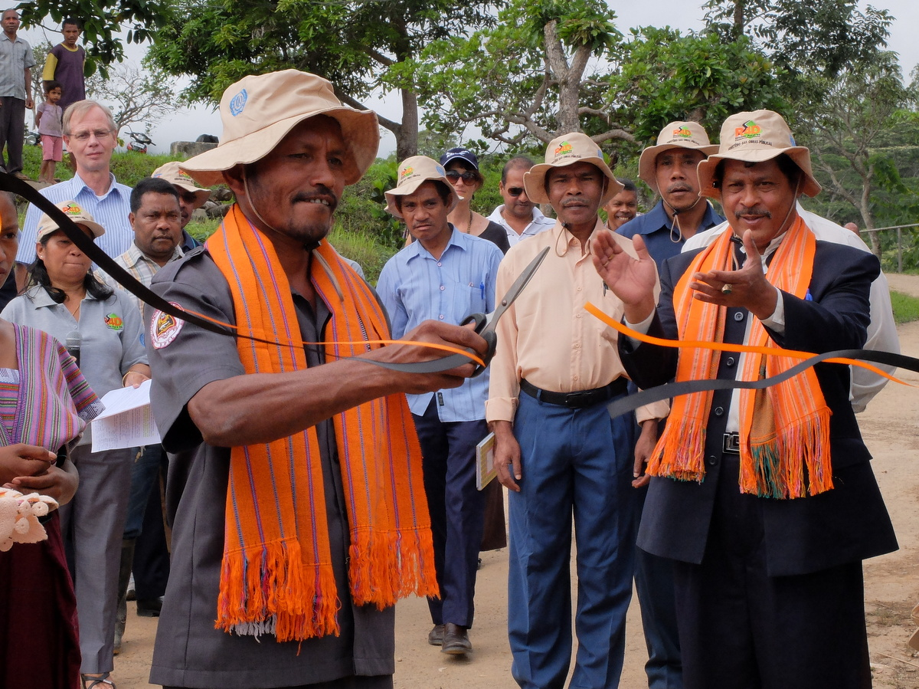

Chief of Village of Laulara cuts the ribbon for the launch of the Roads for Development (R4D) program. *Photo: International Labour Organization.*

# 4 Resourcing country strategy development and implementation

## 4.1 Introduction

The quality of an aid program depends in large part on its ability to recruit and retain skilled staff, and to manage them effectively. Human resources need to be matched to different programs’ needs based on the breadth and complexity of the work they are expected to undertake. This chapter examines the Timor-Leste program’s human resource management, including:

* the adequacy of resources provided to support strong leadership, knowledge and technical expertise; and to ensure the effective use of local staff and effective internal collaboration

the effectiveness of corporate supervision and support in ensuring human resources matched delivery expectations.

## 4.2 Adequacy of resourcing

### Strengthening leadership and specialist expertise

A country program’s ability to play an active and constructive role in shaping and influencing partner government policies depends in large part on effective leadership from staff with a solid grasp of both technical issues and the operating environment, including political dynamics.[120] This is particularly important in complex, shifting environments.

Aid program staff at all levels, consultants, experts and partner government representatives cited strong leadership as fundamental to the provision of high-quality aid to Timor-Leste. However, the Timor-Leste program was hampered by a lack of sufficient people to provide the necessary leadership; until 2009, Dili Post was headed by a counsellor (Executive Level 2)—the same level of representation accorded at the time to much smaller posts such as Dhaka, Islamabad and Vientiane. Those involved in the program prior to 2009 commented that a lack of clear and consistent guidance from the executive and other senior staff had created indecision at lower levels, and contributed to a lack of strategic direction and increasing fragmentation within the country program. Consistent with other analysis of strategy development in the aid program, interviewees attributed a sense of indecision about the program’s direction until 2009 to a lack of senior engagement in country strategy development, observing that it was only when senior executives took responsibility for strategy development that the situational analysis and strategy was finalised.[121]

In 2008, recognising the program’s status and the challenges inherent in the complex environment, the aid program upgraded the head of Post position to minister-counsellor, a Senior Executive Service-level position then in common with other important posts such as Manila, Honiara and Port Moresby. Leadership capacity at Post was further boosted in 2011 with the recruitment of a second counsellor,[122] and a further two in 2012–13. This has been pivotal to the development of a much clearer articulation of how the program would operate, and the resources it would require to be effective. It has also helped to significantly improve relationships and dialogue with the Timor-Leste Government. Since 2011, senior advisers in education, public finance, health, and water, sanitation and hygiene (WASH) have been recruited, increasing the program’s capacity to engage in strategic design and decision-making at Post.[123] These changes have taken place alongside a shift towards developing strong aid management, and technical, country-specific and thematic expertise throughout the Australian aid program.[124]

### Strengthening local staff capacity and utilisation

As observed in independent reviews conducted by the Organisation for Economic Co-operation and Development (OECD) in 2004 and 2008,[125] and the Australian National Audit Office (ANAO) in 2009, overseas-based (also known as locally engaged) staff are fundamental to the Australian aid program’s success. They often have extensive networks and understanding of the political economy, and play an important role in ensuring continuity as Australian-based officers rotate in and out of postings. The importance of locally engaged staff is reflected in successive aid program workforce plans, which have attributed some of the significant progress made in Indonesia, Philippines and Papua New Guinea to their high-quality, in-country technical advice and expertise, and imaginative locally engaged recruitment. These note that the Australian aid program needs to make better use of locally engaged staff capabilities and invest in building them further.[126]

Until 2011, locally engaged program staff in Timor-Leste were primarily placed in and limited to support roles. Senior staff cited locally engaged officers’ low level of engagement in country strategy development, limited training opportunities and absence of career pathways as a significant problem for the program. In early 2011, the First Assistant Director-General (Corporate) visited Dili, and later made recommendations about locally engaged resourcing to the executive. The country program has since provided a career structure and greater responsibilities for Timorese staff, and increased the number of locally engaged officers by 79 per cent: from 19 in 2010 to 34 in 2013.[127] Long-term locally engaged staff interviewed in Dili commented on how these changes have positively affected their work satisfaction and professional development.

### Strengthening internal collaboration

Managing a program from two locations requires strong communication, clarity and appropriate division of roles and responsibilities. The Australian aid program has historically managed country program teams in various ways. What these have in common is a clear distinction between the roles and responsibilities of officers based at Desk and Post. Reforms from the early 2000s onwards have progressively devolved responsibility for management of the program cycle to Post, with Desk fulfilling strategy and policy development, and performance and quality functions, and managing relationships with the minister, other government partners and Australian stakeholders. While noting that this had supported stronger on-the-ground management and knowledge accumulation, ANAO’s 2009 review of the aid program found there was ‘room for improvement’ in collaboration between Desk and Post teams.[128]

Driven by the need to better use resources and skills across its portfolio, in 2011 the program began implementing an integrated ‘one-team’ approach. In a step unique within the aid program, budgets were integrated, travel by Desk staff increased significantly, reporting lines were modified, and historically prescribed division of responsibilities between Canberra and Dili was removed. Some staff at Desk began reporting to managers in Dili and vice versa, with strategic decisions made by a whole-of-program management team.[129] In contrast to the largely Desk-driven 2009 strategy development, in 2013 the program began developing a new country situational analysis and country strategy with roundtable discussions jointly run via videolink between Canberra and Dili.

The one-team model was established at a time when there was strong senior in-country leadership, the operating environment had stabilised and the program’s direction was well established and understood. It has been effective in fostering strong internal collaboration within a large and new team during an intense period of strategy development and design of new programs. While there is no one model that can be applied to the diversity of program settings, the evaluation considers that the one-team model may also be effective in other country programs where similar conditions exist. As such, the Australian Government Department of Foreign Affairs and Trade (DFAT) could consider the potential applicability and efficacy of the Timor-Leste program’s one-team model to operations in other countries and regions across the aid program.

## 4.3 Corporate planning and supervision

### Business unit planning

The aid program uses different Post management and staffing arrangements depending on the size, kind, complexity and perceived importance of the relevant country program. Decisions about workforce size and makeup are made by senior management in annual business unit plans. The extent to which a program’s staffing profile accords with its needs is therefore affected by how well they are articulated in business unit plans, as well as the quality of senior management decisions about them, relative to other agency priorities.

As discussed above, the program’s operating costs and the cost of scaling up were significantly underestimated in Timor-Leste. A doubling of aid administered by the country program between 2005–06 and 2008–09 also resulted in a doubling of the number of aid initiatives, limiting any economies of scale that might have been possible. There was a gradual increase in staffing at Post during this time, but it did not relieve the increasing administrative burden on program staff (Figure 7).

Figure 7 Number of initiatives administered by the country program and number of staff in Dili

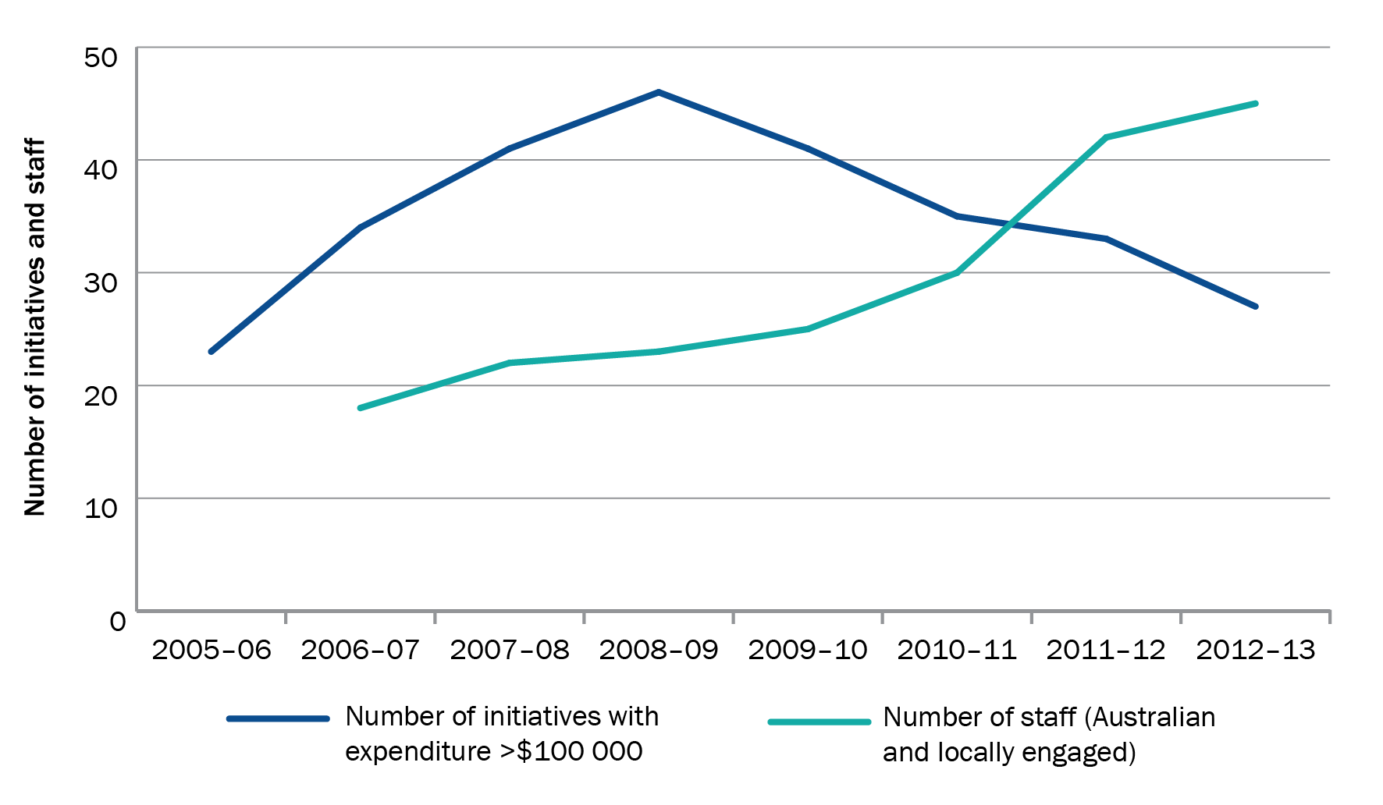

Note: Human resources data not available for 2005–06.

Source: DFAT AidWorks data, human resources and country program data

Rapid growth without an adequate staffing profile limited the program’s capacity to effectively manage its growing portfolio of work. Staff based in Dili between 2006 and 2009 reported that they were too busy with administrative work to engage in either country strategy development or policy dialogue with the Timor-Leste Government. Staff working in Canberra at the time also noted the heavy workload associated with the 2006 and 2008 crises. Australian non-government organisations (NGOs), community groups, and local and state governments showed a high level of interest in Timor-Leste, also placing a significant burden on Canberra-based staff that competed with strategy development. Staff consulted by the evaluation that were involved in the program from 2006 to 2009 suggested that a lack of human resources encouraged a business model reliant on multilateral partnerships, which implied a less intensive role for the country program. While directing funds through multilateral partners and managing contractors may require less intensive management by aid program staff at Post, the program remains responsible for engaging effectively and consistently with these initiatives to oversee their implementation. These challenges were compounded by a high rate of staff turnover. Internal analyses conducted in the lead-up to the country strategy noted as many as 14 changes of Desk leadership and five assistant directors general in the two years prior to strategy implementation.

This situation was not well managed through regular business unit planning, which did not result in any significant increase in resources for the program, between 2006 and 2009. For both co-financing and contracted arrangements, staff were spread too thinly to exercise strong leadership in policy dialogue and setting the direction of some of its programs—as one interviewee stated, ‘*we contracted out our policy engagement*’. While it runs counter to the principle of harmonisation to expect Australia to engage intensively on policy issues across the breadth of its programs, its status as the largest bilateral donor in Timor-Leste suggests it should have had access to adequate resources to engage in effective policy dialogue in at least some of the areas it funded.

### Corporate supervision

From 2009 onwards, these problems were progressively rectified through measures instigated outside the established business unit planning process. In particular, a first-ever program health check carried out by senior managers in 2010 was instrumental in identifying areas in need of improvement and support, and focusing senior management attention on the needs of the program.[130] Though the health check did not address staffing, the issues identified and recommendations for change underlined unmet human resource needs and marked a turning point for the program.[131] Subsequent visits by the head of the corporate division focused on the program’s human resource requirements and resulted in additional staffing allocations from 2011. As the program made headway in consolidating its activities, focusing on larger initiatives in a smaller number of sectors, space opened up for managers to spend more time engaging with implementing partners and the Timor-Leste Government.

The evaluation considers the aid program would benefit from better planning and continued corporate supervision of country and regional program resourcing. In particular, business unit planning should more thoroughly assess the expected administrative resource requirements of different types of programs. At one extreme, some programs have a very high level of whole-of-government interest, the operating environment is particularly difficult, and Australian aid is expected to provide wide-ranging support (Timor-Leste is one such program). At the other, there are programs with a lower level of whole-of-government interest, where Australian aid can play more of a niche role working through other donors with larger, more established presences. This evaluation suggests these differences, as well as potential changes to the operating context (such as conflict risk and expectations of scaling up), could be better anticipated and accounted for in resource planning. Corporate supervision resources (such as those allocated to program health checks) should be prioritised to ensure programs are adequately resourced for what they are expected to do.

Recommendation 3

To ensure a match between resource needs and delivery expectations, DFAT should strengthen resource planning by:

i codifying the different resource requirements for different types of country or regional programs in operation, and including this in annual business unit planning

ii articulating principles for adequate health check coverage of country programs over time, and according priority to programs that are scaling up, and/or operating in particularly difficult or conflict-affected settings.

## 4.4 Conclusion

Developing strategies, designing interventions, overseeing implementing partners, and actively and constructively shaping and influencing partner government policies are resource-intensive activities. This is especially so in low-capacity, conflict-affected settings such as Timor-Leste, where Australia has a significant national interest and plays a large role. When the difficulties of scaling up aid are added to this equation, it is clear that administrative resources allocated to Timor-Leste were not adequate in the lead-up to, and early years of, the country strategy. Staff were spread too thinly to exercise strong leadership and oversight of some of its programs.

Regular business unit planning did not manage this situation well. Costs were significantly underestimated, and there was no significant increase in administrative resources (beyond a short-term response to the 2006 crisis) during a period of rapid growth between 2006 and 2009. From 2009 onwards, increased senior attention was instrumental in ensuring resource allocations ultimately reflect program needs. In particular, a first-ever program health check carried out by senior managers in 2010 identified areas in need of improvement and support, and focused senior management attention on the particular needs of the program. This and subsequent measures resulted in an upgrading of in-country leadership, strengthened access to knowledge and technical expertise, increases in and improved use of overseas-based staff, and experimentation with a ‘one-team’ approach to improving collaboration between Post and Canberra. These changes have resulted in a staffing profile better suited to the needs of the program, and a basis for more effective management of aid to Timor-Leste.

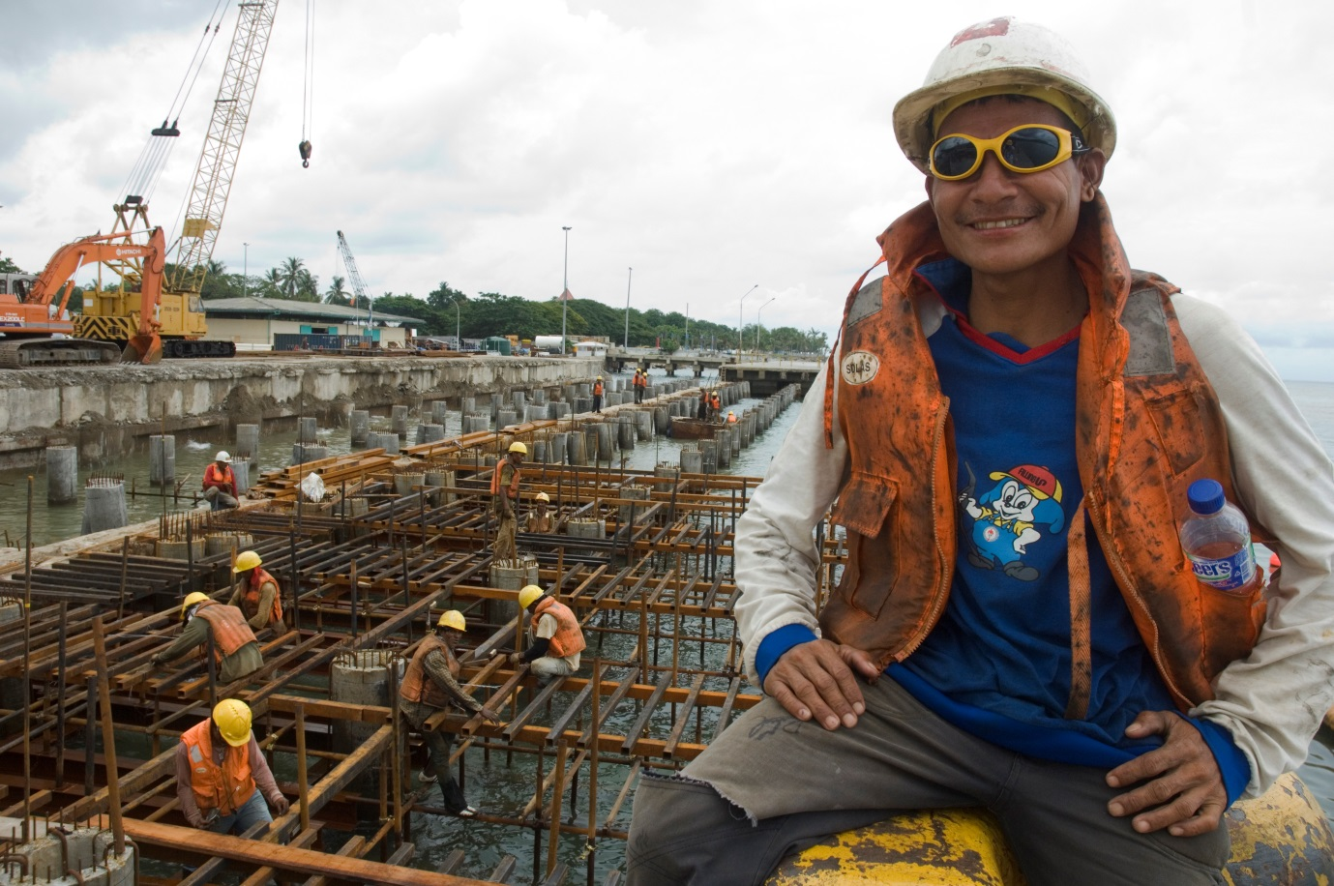

Port construction in Dili, 2008. *Photo: Lorrie Graham, AusAID.*

# 5 Results of Australian aid in Timor-Leste

## 5.1 Introduction

To identify lessons about what works and what does not, particularly in fragile and conflict-affected settings such as Timor-Leste, this chapter examines the results obtained from the major investments in nine sectors: health, basic education, WASH (water, sanitation and hygiene), agriculture, infrastructure, technical and vocational training, governance and capacity-building, policing, and justice (including efforts to address violence against women). Recognising the time required for results to be obtained and to be verifiable, the scope of the assessment extends to 2006, and earlier in some sectors where support has been longer standing. For each sector, the evaluation analysed secondary source material including Timor-Leste Government documents and national statistics, program performance reports, mid-term reviews and evaluations produced by the Australian Agency for International Development (AusAID; now the Australian Government Department of Foreign Affairs and Trade [DFAT]) and implementing partners, as well as academic literature. Interpretation of the evidence in these sources was augmented by data obtained from interviews.

This chapter is organised around an adapted version of the strategic goals in the country strategy, which are to:

* strengthen service delivery in the education, health, and water and sanitation sectors
* increase agricultural productivity and employment by improving infrastructure, promoting vocational education and promoting private sector development
* improve government accountability, transparency and integrity

build the foundations for a safer community.

Where possible, the development context of sectors supported by Australia in or around 2006 is discussed and then compared to the present situation. Effort was made to take into account external influences and contextual factors that affect the consideration of results, leading to an assessment of Australia’s contribution to underlying trends in each sector.

## 5.2 Strengthening service delivery

### Health

A range of statistical assessments of human development in Timor-Leste highlight long-term improvements in headline health indicators. According to the World Bank, life expectancy increased from 59 years in 1999 to 66 years in 2011.[132] Both infant and under-five mortality were cut by more than half (88 to 44 and 125 to 64 per thousand, respectively)[133] between 2002 and 2009, when Timor-Leste’s demographic and health survey was conducted. Although neonatal mortality is still very high,[134] Timor-Leste has met the 2015 Millennium Development Goal (MDG) target for reducing the mortality rate of infants and children under five years old. The World Health Organization has also estimated that the maternal mortality rate also fell from 410 deaths per 100 000 live births in 2005 to 300 in 2010 (MDG 5). Though the lack of precision in these estimates suggests they need to be interpreted cautiously, they are consistent with a longer-term downward trend in maternal mortality in Timor-Leste.[135]

These trends are positive, but the population’s health remains poor. Maternal mortality is significantly higher than in neighbouring Indonesia.[136] There has been little progress in reducing child malnutrition. According to the United Nations, the proportion of stunted children under five increased from 54 per cent in 2007 to 58 per cent in 2009–10.[137] Strong population growth during this period (around 3 per cent, among the highest in the world) means this equates to a large increase in underweight children.

Timor-Leste Government investment in health has increased substantially, from US$25.7 million[138] in 2006–07 to US$48 million (estimated) in 2012.[139] Donor contributions remain significant at around US$19 million in 2012–13.[140] Australia was the largest bilateral donor in the health sector between 2006–07 and 2011–12, contributing $65.6 million.[141]

The principal vehicle of Australia’s support ($23 million in 2007–13) was the Health Sector Strategic Plan–Support Project (HSSP-SP), a multi-donor trust fund administered by the World Bank and executed by the Ministry of Health. HSSP-SP has supported mobile health clinics, procurement of medical equipment and pharmaceuticals, scholarships and staff training, and provided technical assistance, including a twinning arrangement with the Institute of Health Sciences and Menzies Research Institute in Australia.

Progress has been slow due to a number of factors. Concerns about a lack of flexibility in World Bank procurement procedures, and a lack of effective oversight and management (see Chapter 4) led to the restructure of World Bank support in 2011 following a mid-term review.[142] Since this time performance has improved. Training of community nurses commenced, while mobile community outreach clinics—referred to by their Tetum acronym as ‘SISCas’—were activated in all 13 districts with the support of local and international non-government organisations (NGOs). Australian funding has enabled 475 SISCas to provide prenatal care, malnutrition screening, health promotion, hygiene education and curative services to more than 300 000 people, mostly mothers and children.[143] The program has also improved the storage, supply and distribution of pharmaceuticals and medical supplies by installing a warehouse management system.[144]

In contrast to HSSP–SP’s systems-strengthening approach, Australia’s other large health investment emphasised provision of direct services. The $12.6 million Australia–Timor-Leste Assistance to Specialised Services project (ATLASS) project, delivered by the Australian Royal College of Surgeons, began in 2006. Now in its second phase, ATLASS supports skilled Australian health professionals to conduct surgical procedures in the National Hospital and trains Timorese medical professionals to manage treatable surgical conditions throughout the country. An independent review in 2010 concluded the program had provided a high quality of clinical support. Australian specialists conducted 1577 operations in six subspecialty areas at the National Hospital, accounting for around 70 per cent of general surgeries performed and 40 per cent of anaesthetics administered between 2007 and 2009.Twenty-one nurse anaesthetists were trained (at least one for each hospital in the country); 50 doctors, nurses and surgeons undertook health studies; and 54 midwives and 6 surgeons were trained and working throughout Timor-Leste.[145]

Given the dearth of qualified medical specialists when it commenced in 2006, ATLASS’s direct approach was clearly relevant to Timor-Leste’s needs. However, this has started to change with the return of significant numbers of Cuban Government-trained Timorese medical practitioners from 2010 onwards.[146] The 2010 review also pointed to misalignment between ATLASS’s focus on specialist services and the country strategy and development plan’s concentration on improving maternal, neonatal and child health outcomes at the district level. It also suggested that through direct service delivery, ATLASS may have unintentionally undermined local capacity.[147] To address these problems, the review recommended that the program transition from direct service provision to develop the capacity of medical professionals in priority secondary surgical procedures, and to focus on child and maternal health through obstetric and paediatric services. Subsequent performance reporting has acknowledged the further work required to ensure that the project aligns to the priorities of the Timorese Ministry of Health.[148]

In addition to these large programs, Australia also provided over $22 million to support eight activities focused on family planning and reproductive health, pandemic preparedness, undernutrition, and addressing food shortages in response to the 2006 humanitarian crisis. In part because of their small scale, it is difficult to assess the results of these investments. An evaluation of the $5.6 million pandemic preparedness project instigated by the country program using finances allocated under its Pandemics and Emerging Infectious Diseases Strategy, and implemented by the Food and Agriculture Organization of the United Nations, found its objective—a measurable improvement in livestock health and husbandry—was unrealistic. While some positive results were noted in improved veterinary staff capacity and the establishment of disease surveillance and reporting systems, the evaluation concluded these outcomes would not be sustained without continued external support.[149] With no incursions of avian influenza (concerns over which had driven the conception of the project) and a resultant downwards revision of the risk posed by it, the country program decided not to continue its support for the project.[150]

The quality of monitoring and evaluation presents another constraint. A World Food Program evaluation of its nutrition program, which received $2.7 million from Australia, observed that a failure to collect data against basic indicators was alarming, made it ‘*impossible to accurately quantify the effectiveness of the programme*,’ and ‘*implied inadequate technical support and supervision from either the Regional Bureau or HQ*’.[151] The evaluation further observed that widespread sharing of food supplements by intended beneficiaries was likely undermining the program’s effectiveness in treating and preventing malnutrition. Results from a one-off $5 million investment in the USAID-led Health Improvement Project (using funds made available from the aid program’s health and HIV unit in Canberra) have also been limited by delays in implementation.[152]

Investments in family planning and reproductive health services produced stronger results. A 2012 independent review of three activities in this area confirmed that they had significantly increased access to family planning and reproductive health services.[153] According to national health statistics, funding of Marie Stopes International and Health Alliance International is supporting between one-quarter and one-half of contraceptive use across the country. Marie Stopes International had achieved significant coverage in eight districts with over 50 000 young women and men accessing family planning services, and over 55 000 accessing clinical services between 2009 and 2012. This resulted in 42 186 ‘couple years of protection,’[154] which, according to a standard impact estimator, may have averted 45 child and 6 maternal deaths and allowed Timorese women to avoid 3343 unplanned pregnancies by using contraception. Pointing to these activities’ reliance on donor funding, the evaluation suggested that a new phase should improve sustainability by working more closely with the Ministry of Health.[155]

### Education

Up to 70 per cent of public infrastructure, including a large number of schools, was destroyed after Indonesian forces departed in 1999.[156] The Timor-Leste Government continues to rebuild, but many schools remain in poor condition. There have also been significant cultural and policy-related challenges in the education sector, including poor quality of teaching and the role of Portuguese (alongside Tetum) as an official language of instruction.[157] A high proportion of children do not speak either of the official languages when they first enrol in school.[158] Human resource constraints within the Ministry of Education mean it struggles to effectively manage finances, procurement and logistics.[159]

Net primary enrolment grew from 65.6 per cent in 2007 to 87.9 per cent in 2009, the latest year for which data is available.[160] Retention within the school system has increased at a slower rate, from 47 per cent in 2001 to 65.9 per cent in 2009.[161] Despite this positive trajectory, Timor-Leste will not achieve its MDG target of 100 per cent net primary enrolment and completion of fifth grade by 2015.

With increases in revenue, Timor-Leste Government allocations to education have increased from US$35 million in 2006–07[162] to $US95 million in 2012.[163] Between 2006–07 and 2011–12, Australia invested $43.1 millionin the education sector, making it one of the largest contributors outside the Timor-Leste Government. Its biggest investment ($11.6 million in 2007–12, approximately 40 per cent of total funds) was in the Education Sector Support Program (ESSP), which seeks to strengthen the capacity of the Ministry of Education in policy development, resource management and innovation, and which is supervised by the World Bank and executed by the ministry. Most activities supported capacity-building at the national level, with a smaller number focused on direct service delivery.[164]

Performance reports from Australia and the World Bank have rated ESSP implementation progress as adequate. The reports note results such as the performance of economic efficiency analysis to underpin the revision of the National Education Strategic Plan; development of training manuals and training of 178 cluster school directors to implement the Timor-Leste Government Escola Basica program; building or rehabilitating 2100 classrooms; procurement of school furniture; completion of literacy and numeracy training for 3464 teachers; and provision of Tetum and Portuguese supplementary learning materials to every schoolchild in Timor-Leste.[165]

Despite these outputs, concerns about capacity-building and sustainability of outcomes—particularly important given increases in the Timor-Leste Government education budget—are prominent in performance reports. A 2010 review of the project suggested many of its achievements were built on capacity substitution, rather than capacity-building, with a resultant lack of buy-in from the Ministry of Education to the project’s analytical work.[166][167] For example, while the project successfully improved the Education Management Information System, there was marked reluctance within the ministry to use this system and the data it generates.[168] Further, there was some concern the ministry would not take responsibility for ESSP-funded positions at the end of the project.[169]

While it is too early to assess results for Australia’s other major investment in basic education—the UNICEF Education Quality Improvement in Timor-Leste Project—it provides further evidence of delivery against its country strategy commitment to increase focus on service delivery.[170]

### Rural water, sanitation and hygiene

Inadequate access to safe water and poor hygiene practices have significant health ramifications, particularly in children. In 2010, a national survey in Timor-Leste found that 16 per cent of all children had suffered from diarrhoea in the preceding two weeks.[171] It has been estimated that 12 per cent of infant deaths in Timor-Leste are WASH-related.[172] A 2008 WHO–UNICEF report found that only 63 per cent of people in rural areas had access to improved water sources, 40 per cent had access to improved sanitation and 52 per cent practised open defecation.[173]

Australia is the main donor in WASH and has been active in the sector since 2002.[174] Australian support for WASH is primarily delivered through the Australia East Timor Rural Water Supply and Sanitation Program, known locally as ‘Bee, Saneamentu no Ijene iha Komunidade’, or BESIK, which is now in its second phase.

Internal reviews and independent evaluations have consistently rated BESIK positively. A 2012 independent review highlighted strong capacity-building outcomes that had been achieved through scholarships, structured training and mentoring from technical advisers. It found that sanitation policies developed by the project and adopted by the Timor-Leste Government had played an important role in working with Ministry of Infrastructure and Ministry of Health directorates and NGOs to better plan and coordinate their work.[175] Creation of a water and sanitation information system improved the quality of information on system function and location, contributing to better planning and maintenance. The transfer of 88 subdistrict facilitators from BESIK to the government payroll was seen as a strong indicator of government ownership.[176] Systems funded by BESIK and the Timor-Leste Government have significantly increased the number of rural people with access to improved water, estimated at 222 909 over phase two.[177] If this momentum is maintained, and sufficient emphasis is placed on repairs, operations and maintenance, Timor-Leste is now on track to achieve its MDG target for rural water supply by 2015.

BESIK’s gender equality outcomes were also strong. With support from BESIK, the recruitment of women in government roles has increased: 53 per cent of sanitation program officers; 25 per cent of WASH facilitators; and 31 per cent of water and sanitation committee members are now women. Recent reporting has also quantified some of the nonhealth benefits of improved access to water. Water collection is time consuming in rural areas and the task usually falls to women and children. Prior to BESIK, 72 per cent of communities took longer than 30 minutes to collect water, whereas all communities reached by BESIK now take less than 30 minutes to collect water.[178]

Progress in improving sanitation has been slower, and Timor-Leste is unlikely to meet its MDG target of 55 per cent access to sanitation in rural areas. Through BESIK, 67 068 people (7 per cent of the rural population) gained access to basic sanitation (of which 35 955 people gained access to *improved sanitation* using the MDG measure) and 258 rural communities (165 BESIK supported) were declared free of open defecation. Reporting from the project estimates it has resulted in 5751 additional households in which hand-washing is practised, and sanitation promotion activities have reached 387 292 people.[179] While these figures are impressive, there is a need to ensure that community-based asset management—carried forward by water management*—*can sustain existing systems and expand services.[180]

### Conclusion—strengthening service delivery

Building from a low base, headline indicators show Timor-Leste has made progress in improving access to health, education, and water and sanitation services. Australia’s support for service delivery has been most effective in water and sanitation. Significant achievements in institutional strengthening have occurred along with substantial improvements in access to clean water. In combination with increasing Timor-Leste resources allocations, aid funding has provided access to improved water for over 220 000 people over the most recent phase of assistance. As observed by a 2010 Independent Progress Report, BESIK has made a ‘pivotal and significant’ contribution to Timor-Leste’s progress towards its MDG target for improved water supply.[181] Solid, albeit slower, progress has been made against the MDG target for improved sanitation, which Timor-Leste is unlikely to achieve.

With the exception of these WASH investments, it is difficult to attribute positive underlying trends to other service delivery sectors supported by Australian aid. Australia’s largest health investment, HSSP-SP, was not operational in time to have made a significant contribution to progressive reductions in child and maternal mortality. More modest investments through the Australian Royal College of Surgeons, United Nations agencies and NGOs have produced some valuable outcomes, although the broad focus of this assistance, combined with the weak implementation and small scale of some activities likely reduced its impact on core health indicators. The country program has actively reformed and rationalised its health portfolio, including by strengthening ATLASS’s focus on secondary health, scaling back work on pandemic preparedness and discontinuing ineffective activities. As a result, Australia’s health sector support has become more focused around shared Timor-Leste and Australian priorities, and the most crucial human development areas of child and maternal health.

The results of Australia’s support for basic education have also been modest. ESSP’s inability to mainstream technical functions and build human resource capacity within the Ministry of Education to fulfil its mandate has reduced the sustainability of its outcomes. The slow start to Australia’s other major investment in basic education through UNICEF means there are limited results to report at this stage.

## 5.3 Increasing agricultural productivity and employment

### Agriculture

Agriculture is vitally important for the majority of Timorese people’s livelihoods, and for the country’s economy. Farming is the main source of income for 80 per cent of households, and agriculture accounts for 30 per cent of non-oil gross domestic product.[182] However, the majority of arable land in Timor-Leste is not conducive to high-production agriculture: land holdings are very small, and yields of rice and maize (the staple crops) are very low at approximately 1.5 and 1 tonne per hectare, respectively.[183] Low-quality seed, variable water supply, pests and diseases, and low fertility contribute to low yields, resulting in a prolonged ‘hungry season’ which can extend from September to March, during which crops are growing but not ready to harvest.[184]

Timor-Leste Government investment in agriculture has increased slowly despite significant increases in revenue. The Ministry of Agriculture and Fisheries budget increased from US$14 million in 2006–07[185], to US$16.8 million in 2012, and is expected to reach US$25.1 million in 2013.[186] Donor funds are expected to total US$17.5 million in 2013.[187] Australia’s Seeds of Life (SoL) is the largest donor-funded program, accounting for approximately 30 per cent of donor funding in 2013.[188]

SoL began in 2000 as an Australian Centre for International Agricultural Research (ACIAR)-funded research project that aimed to improve farmers’ access to high-yielding crop varieties adapted to local environments.[189] Initially, the project focused on conducting scientific trials and rehabilitating research stations. With aid program funding from 2005 onwards, SoL expanded its focus to include on-farm trials throughout the country and strengthening the scientific and organisational capacity of the Ministry of Agriculture and Fisheries. In 2011, the five-year phase three commenced, supported by $22 million from the country program, $3 million from ACIAR and $2 million from the ministry. SoL is co-managed by the country program and ACIAR, with country program staff providing in-country oversight.

SoL has made a solid contribution to improving agricultural productivity in Timor-Leste. The improved crop varieties it developed demonstrate yield advantages of between 20 and 89 per cent over local varieties. It released 10 improved crop varieties to more than 43 000 farming households between 2008–09 and 2010–11. The involvement of farmers in on-farm trials and the participatory ranking of improved varieties have resulted in high levels of local acceptance, replanting and adoption.[190] As of 2013, 700 informal seed groups (each containing between 10 and 20 people), have been established and are producing an average of 159 kilograms of high-quality maize seed each season. The 46 tonnes produced by these groups in 2012 is approximately 10 per cent of the country’s maize seed requirement. ACIAR advised the evaluation that, by 2015, the program aims to meet 67 per cent of maize seed and 90 per cent of rice seed requirements. The significant yield difference between improved seeds and poor-quality local and imported seeds will increase yields while reducing seed import costs for the government.

The program’s long history and that it has long been considered ‘the ministry’s program’ is very important. A number of senior ministry staff commented that they had been involved in SoL for many years and could recount the different phases of the program and their achievements. SoL staff work closely with ministry senior staff to improve various organisational and human resource issues, including strategic planning. These activities are valued by ministry senior staff who reported significant improvements in organisational capability over time.The ministry’s strengths have helped to justify increased budget allocations. Factors crucial to the success of the program are outlined in Box 3.

Box 3 Why has Seeds of Life generated such good results?

Seeds of Life (SoL) has a simple, logical agronomic focus that is linked to a tangible developmental outcome (better seeds = higher yields = more food security). SoL has never lost sight of its original focus on seeds, which is simple and indisputable from an agronomic perspective. For example, improved plant genetic material can address approximately 19 per cent of the yield gap in maize in Timor-Leste.[191] Unlike many other agricultural programs, the program lends itself to quantitative measurement (e.g. number of varieties, number of trials, number of seeds disseminated, number of farmers receiving seeds and number of farmer groups).

The technological solution was well disseminated and not implemented technocratically. An anthropological comparison of SoL with the much less successful Indonesian-funded Tapo-Memo project underlines the importance of socialising technologies:

*Because SoL’s approach was delinked from a technological package, relied minimally on outside expertise, availed itself of existing networks, sought not to create new groups, offered no incentives, and presented no more than a few square metres of risk to farmers, there was considerably less scope for conflict, untoward appropriation, or subsequent discontent.*

Source: C Shepherd & A McWilliam, Ethnography, agency, and materiality: anthropological perspectives on rice development in East Timor, *East Asian Science, Technology and Society: An International Journal* 5:189–215, 2011.

However, the program has not yet resulted in large increases in agricultural productivity or food security. The provision of high-quality plant genetic material was a logical first step, but its long-term contribution—and improvements in agricultural productivity more generally—will depend on other agronomic factors. Critically, soil fertility is recognised as having potentially the biggest impact on maize yields in Timor-Leste (up to 42 per cent of the yield gap can be addressed by better soil fertility),[192] but this is much more challenging to address than improving seeds.[193]

Recognising the importance of agriculture in Timor-Leste, and the limitations of its focus on seeds, the country program is considering the feasibility of expanding its assistance in the sector. While SoL is a flagship program and it is still early days in the sector, there are likely complementary activities that could be developed. The evaluation considers that any new approach should give due consideration to the conditions that have led to success in the past (see Box 4).

Box 4 A proposed approach to new programming in the rural development sector in Timor-Leste

Any approach to new agriculture, horticulture or fisheries programming in Timor-Leste should:

* be simple and measurable, and based on analysis of the most important factors contributing to increased productivity and food security in Timor-Leste (e.g. improving soil nutrition, reducing post-harvest losses in crops, improving livestock genetics or improving pest management)
* disseminate the proposed technologies through participatory decision-making with farmers, fishermen, non-government organisations and the government
* be developed jointly with the Ministry of Agriculture and Fisheries, and further build the capacity of ministry staff to conduct research and develop support systems
* link its high-level objectives to the development goals of the Timor-Leste Government as outlined in the development plan and other development priorities (e.g. nutrition, self-sufficiency, etc.)
* where possible, seek to achieve quick results to galvanise political and community support, without compromising the program’s integrity.

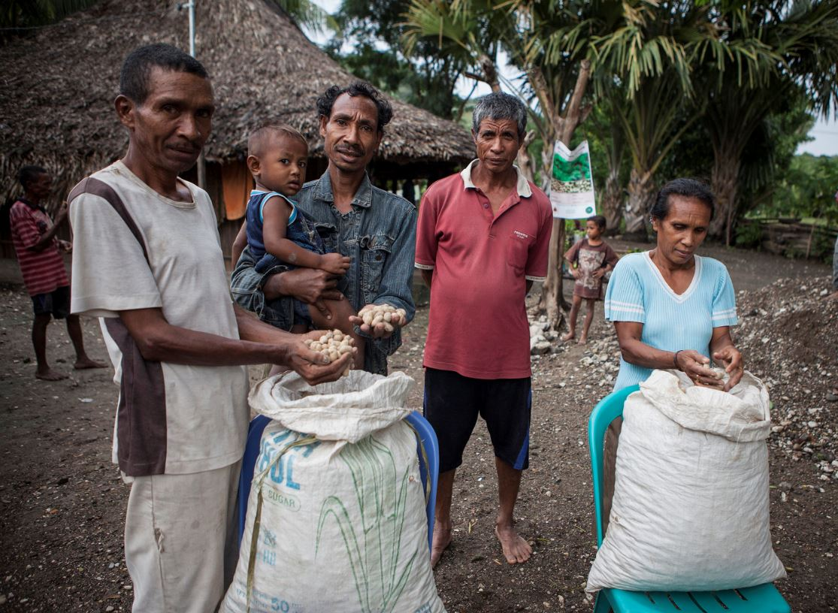

Members of the seed harvesting group display their peanut harvest in Tequinomata, Laga Sub-District. *Photo: ACIAR.*

### Infrastructure

Timor-Leste’s infrastructure is in poor repair. The condition of roads isolates rural people from services and economic opportunities.[194] Infrastructure is a high priority in the Timor-Leste Government’s development plan, and the government is the largest investor in infrastructure. It has established an Infrastructure Fund to support improved electricity generation, sanitation, roads and transport, water, telecommunications and ports. In 2012, the Infrastructure Fund was US$800 million.[195]

Australia’s biggest investment in infrastructure was a $12.6-million contribution to the Asian Development Bank-implemented Infrastructure Technical Assistance program (2007–11), which included a small US$3-million top-up from the bank. The project employed a managing contractor to work with the Ministry of Infrastructure to improve the implementation of capital development projects and build project management capacity—a logical focus given the scale of the Infrastructure Fund.

The project’s 2012 evaluation concluded that the program has helped to improve the Ministry of Infrastructure’s capital budget execution and to develop capacity in the ministry at the individual and organisational levels through training, scholarships and the technical upgrade program. However, it noted that the quality of advisers and their relationships with counterparts was variable, and pointed to weaknesses in the monitoring and evaluation system and program governance, which were seen as incapable of dealing with stakeholders’ concerns in a timely manner. Some of the technical products developed by the program were not being used because ministry staff lacked confidence in them, with the result that sustainability was classified as weak and the need for ongoing technical support was classified as high.[196] The country program’s annual performance report in 2011 identified it as one of the worst performing initiatives.[197]

Support for infrastructure also included rehabilitation and maintenance of rural roads through the International Labour Organization, including $3.3 million for its US$12.3-million multi-donor rural roads project.[198] This support was provided through a discrete component of its broader technical and vocational training-focused Youth Employment Promotion Program (discussed below). The evaluation of the rural roads project found it had operated well within its limited scale and met its project objectives, rehabilitating 300 kilometres of rural roads, generating over 1.3 million days of employment and injecting US$3 million into rural communities.[199] Program reporting rated the project as successful, but on a limited scale, and observed that larger projects would be needed to spur growth and generate significant employment opportunities for rural people.[200]

### Technical and vocational training

In addition to support for basic education (see above), Australia was also active in technical and vocational training. Its main investment in this area was US$8 million for the US$18-million Youth Employment Promotion Program (YEPP), also conducted by the International Labour Organization. YEPP’s aim of increasing employment and skills is particularly salient in Timor-Leste, given that there are an estimated 262 000 youth aged between 15 and 29—almost a quarter of the population—of which about 80 per cent are either economically inactive or unemployed.[201]

A mid-term evaluation concluded that YEPP was on track to achieve its objectives, and that the capacity of Timor-Leste Government youth-related institutions was improving. Skills enhancement and counselling programs had been successful, and available employment opportunities were being filled by adequately skilled young people.[202] The country program estimated that its contribution in 2012—helping 1923 students (almost half of whom were girls) enrol in vocational training—was almost a quarter of the national target for that year.[203] Unsurprisingly given the state of the economy, vocational training mostly did not result in jobs—of the 24 494 youth registered by employment centres supported by the project, only 4.7 per cent could be successfully linked to employment opportunities. However, the labour-intensive public works component provided temporary employment, averaging one month, for 78 000 young people (less than 30 years), 27 per cent of whom were women.[204]

On the policy side, YEPP activities have helped to regulate a sector that has been highly informal. Qualification frameworks were developed in areas such as hospitality, tourism and office management, and a legal framework for vocational education and training was established.[205] These outcomes will be built on through the recently announced $12.2 million Training and Employment Support Program, which will reach over 5000 youths between 2013 and 2015.[206]

Australia has also provided more discrete support for vocational training through the $4.1 million English Language program. Conceived in response to a request from Timor-Leste’s Prime Minister, the project aims to improve the standard of English language in Timor-Leste as a means of improving access to further education opportunities in country and regionally. As such, the project has important synergies with other investments. Notably, Australia’s program of scholarships to study in Australia has struggled to achieve its target for scholarships allocated to Timor-Leste, because of English language barriers faced by applicants, reducing the administrative efficiency of the program.[207]

### Private sector development

The country strategy prominently featured private sector development as a vehicle for increasing employment, and explicitly mentioned microfinance as part of the program’s intended approach. However, the main response was a modest $2.5 million contribution to the US$5 million United Nations Development Program–United Nations Capital Development Fund joint Inclusive Finance for Under-Served Economy project. While the 2011 review of the project endorsed its relevance to Timor-Leste’s needs and identified some modest (albeit uneven) progress in strengthening the finance sector,[208] the scale of this investment does not reflect its prominence in the country strategy, particularly when compared to the several much larger investments not mentioned in the strategy. There would be merit in reviewing the priority accorded to microfinance in the context of other possible approaches to promoting private sector development and employment. A thorough analysis of the opportunities and challenges for private sector development should inform the new country strategy, and preface further investments in the sector.

Recommendation 4

To support a coherent long-term approach to addressing unemployment, DFAT should conduct a thorough analysis of the opportunities and challenges for private sector development in Timor-Leste, and the adequacy of its existing strategies in this context.

### Conclusion—increasing agricultural productivity and employment

Australia’s support in the agriculture sector through the SoL program has laid the foundation for improved agricultural productivity through the provision of high-quality plant genetic material. The improved crop varieties it developed demonstrate yield advantages of between 20 and 89 per cent over local varieties, and these have been disseminated to large and ever increasing numbers of farming households. The significant yield difference between improved seeds and poor-quality local and imported seeds will increase yields and, as the stock of high-quality seed increases, the cost of importing foreign seed is expected to reduce significantly.

Australia’s focus on employment-generating activities through infrastructure, technical and vocational training and private sector development (microfinance) has been small relative to total overseas development assistance and its investment in other sectors. The success of infrastructure investments through multilateral institutions has been patchy: weak on the institutional strengthening side managed by the Asian Development Bank; better on road rehabilitation and maintenance works carried out through the International Labour Organization, which have directly generated short-term employment for large numbers of Timorese while improving the quality of road infrastructure. Building on this experience, the country program is now funding a larger four-year rural roads project valued at $30 million between 2012 and 2016 through the International Labour Organization.[209]

Australia’s involvement in vocational training has yielded some reasonable results in the form of an improved regulatory environment and direct training and support for Timorese youth. However, the weakness of the economy severely limits the number of youth (trained or not) that can access employment. While support for private sector development through microfinance was prominent in the country strategy, actual financing of it has been too modest to reasonably expect significant changes in access to finance and private sector activity.

## 5.4 Improving government accountability, transparency and integrity

The Timorese national budget almost doubled between 2005–06 and 2006–07, placing extreme pressure on the Timor-Leste Government to manage its expanding resources well.[210] Australia has provided significant support ($13 million) for public financial management reforms through the US$31 millionPlanning and Financial Management Capacity Building Program (PFMCBP; 2007–13), which was supervised by the World Bank and executed by the Ministry of Finance.

PFMCBP’s results have been mainly positive. Internal reviews have consistently rated it as highly effective, despite some tension between the country program and the World Bank over the management of the program (see Chapter 3).[211] A recent Australian and Ministry of Finance fiduciary risk review concluded that planning and financial management performance had improved markedly between 2007 and 2010, with overall fiduciary risk decreasing from high to moderate during that period.[212] This finding is also corroborated by other actors, such as the International Monetary Fund.[213] As the main source of external support for the ministry from 2007–10, PFMCBP was central to these improvements.

Australia also made a large investment in improving public administration through the $42.8-million Public Sector Capacity Development Program (2006–11). The program provided 125 short- and long-term consultants to play advisory and (effectively) in-line roles to (mostly) central government agencies, including the Civil Service Commission, the National Institute for Public Administration (INAP), the Office of the Prime Minister, and the National Directorate of Aid Effectiveness in the Ministry of Planning and Finance. Assistance included support for policy development, training and curriculum development (especially in INAP), and the development of personnel management systems and corporate policies.[214]

The country program’s 2012 evaluation of the project paints a mixed picture of its success. It highlighted a range of problems with the way the project used technical advisers, reflecting problems documented by the joint Australia–Timor-Leste Adviser Review in 2010 and discussed in Chapter 3.[215] This, combined with the breadth and lack of clarity of its objectives, meant it was unable to consistently provide long-term and carefully programmed support to its partners. The project’s breadth of focus, in turn, made it hard for aid program staff to provide strong oversight and management of the project and engagement with its partners.[216]

Australia also provided $8 million to the Timor-Leste Government each year between 2006–07 and 2012–13 as part of a commitment to assist with petroleum resource development.[217] However, this investment fell outside the scope of the evaluation and was not assessed by the Office of Development Effectiveness (ODE).

### Scholarships and volunteers

Approximately $23.5 million was spent between 2007 and 2013 on scholarships for Timorese nationals to study in Australia. These aim to develop capacity and leadership skills so that individuals can contribute to development in their home country. They also aim to build people-to-people linkages at the individual, institutional and country levels. The program has supported 364 Timorese nationals to undertake short- and long-term study in Australia in a field relevant to Timor‑Leste’s development priorities (Table 3). The aid program has made some progress in aligning its scholarships program with Timor-Leste Government needs, including by developing a harmonised approach with the New Zealand aid program to avoid duplication and gaps.[218]

Table 3 Awards for Timor-Leste nationals to study in Australia, 2007–13

|  |  |  |  |  |  |  |  |  |
| --- | --- | --- | --- | --- | --- | --- | --- | --- |
| Awards | Intake years | | | | | | | |
| **2007** | **2008** | **2009** | **2010** | **2011** | **2012** | **2013** | **Total** |
| Long-term awards | 14 | 12 | 23 | 23 | 30 | 34 | 22 | 158 |
| Short-term awards | 21 | 19 | 18 | 15 | 45 | 31 | 22 | 171 |
| Total | 35 | 31 | 41 | 38 | 75 | 65 | 44 | 329 |

Source: DFAT Scholarships Section

The scholarships program has, for a variety of reasons, had difficulty in achieving gender equality. Between 2007 and 2013 around 60 per cent of scholarships went to men. The discrepancy between men and women benefiting from the program can be improved, particularly in the case of short-term awards. For long-term awards, there has been a marked improvement recently; in 2014, 19 awards were offered to men and 16 to women.

The completion rate is high, with low numbers having scholarships terminated and all short-term scholars completing their courses. Until very recently, no analysis had been undertaken of the impact of the scholarship program in Timor-Leste. However, a recent tracer study of returned scholars suggests that scholarships improve development outcomes for Timor-Leste, at the very least, for individuals. Most of the benefits seem to favour public sector organisations that are based in Dili. Alumni generally do not return to their previous jobs, but if they do they are usually promoted.[219]

In addition to scholarships, approximately $10.5 million (2006–07 to 2012–13) has been provided for 281 Australian volunteers to work with and support a range of government and non-government organisations. Reflecting broader deficiencies in the monitoring and evaluation of the volunteer program,[220] and the lack of any targeted evaluation of it in Timor-Leste, it is difficult to assess the outcomes from this investment. However, in the context of concerns about the overreliance on mainstream technical assistance (discussed above), the value of volunteers as an alternative has been publicly recognised at the highest level of the Timor-Leste Government.[221] The value of the contribution that volunteers make to the aid program has recently been affirmed by ODE’s evaluation of the volunteers program.[222]

### Conclusion—improving government accountability, transparency and integrity

Australia was the largest aid donor in the governance sector between 2006 and 2012. Australian support was strongest in the public financial management, which focused on building capacity in specific administrative competencies. These demonstrably improved over time and have been critical to enabling the Timor-Leste Government to manage rapid revenue increases.

Australia’s support was weakest in pursuing the broader objectives of improved public sector capacity development. A lack of clarity of objectives resulted in a diffuse focus, and an inability to provide consistent well-planned support to, and engagement with, the project partners.[223] The results of scholarships and volunteer activities are difficult to assess, although recent evidence suggests that successful scholars benefit through promotions and skills development, while volunteer contributions have been commended at the highest levels of the Timor-Leste Government as a valuable and useful alternative to mainstream technical assistance.

## 5.5 Building the foundations for a safer community

### Policing and security

Support to policing and security has been delivered by the Australian Federal Police (AFP) through the Timor-Leste Police Development Program (TLPDP), which focuses on developing the capacity of the Timorese police force (Policia Nacional de Timor-Leste; PNTL). Spending over $110 million between 2005–06 and 2012–13, TLPDP is the largest Australian-funded aid initiative in Timor-Leste.[224]

The role of the police in the 2006 crisis led to a fracturing and disintegration of the PNTL. Contracted TLPDP advisers, several AFP team members and local staff were evacuated to Australia during the violence, and all TLPDP activities were suspended. Some members of the AFP’s TLPDP team joined Operation Serene, the police contingent mobilised from Australia to support stabilisation. The AFP work on training, investigations, forensics and operations began again in late 2006.[225] Since that time, the TLPDP has provided support through a range of activities, including training of police and law and order officials in management, investigations, community policing, discipline, intelligence, elections and English language; significantly renovating the police training centre in Dili; developing a nationally accredited curriculum and courses for delivery at the police training centre; and increasing the availability of nationally accredited staff.[226]

With the support of Australia and the United Nations, the functionality of the PNTL has been substantively restored. The improved situation was marked by the handover from the United Nations of policing powers to the PNTL in late 2012 and peaceful presidential elections in the same year.[227] It is now six years since the last serious security issue (the attempted presidential assassination in 2008).

While data from the TLPDP suggests that application of training in the workplace remains low (reflecting much international experience with training as a method of capacity development), there is some evidence that TLPDP is making a difference to technical policing skills, management and administrative competence.[228] There is also some evidence that the PNTL’s capacity and professionalism have increased over time. The 2013 Asia Foundation Community-Police Perception Survey reports improvements in citizen perceptions of the PNTL since 2008, when the first national survey was conducted, including that 74 per cent of respondents are satisfied with requests for assistance from the PNTL, up from 63 per cent in 2008. Further, only 3.7 per cent of citizens reported being subject to verbal abuse and intimidation, and 1.4 per cent to physical abuse from the PNTL, down from 15 per cent and 19 per cent, respectively.[229]

The stabilising influence of a visible international policing presence is hard to measure, but it is likely to have been significant. Nevertheless, the vast majority of Timorese people do not consider the PNTL to be primarily responsible for security in their localities and believe that the role is fulfilled by local leaders and informal institutions.[230] Underreporting of crime was still high in 2008—only 58 per cent of people subject to a crime reported it to the police.[231] In this context, it is important to note that building policing capability and establishing rule of law is a long-term exercise. Analysis in the World Bank’s 2011 World Development Report suggests that the average time required by the fastest 20 performers in institutional transformation was 40 years for the establishment of basic rule of law, with the quickest of these requiring 17 years. Consequently, the small gains since independence will not amount to much in the absence of long-term reforms of policing institutions.[232]

### Justice

The $28.2-million Justice Sector Support Facility (JSSF; 2007–13) aimed to provide equal and timely access to justice for men, women and children by building the capacity of the justice sector. It focused on strengthening the administration of justice institutions and managed a small program of grants to civil society organisations.

While noting some discrete achievements,[233] the final evaluation of the project concluded that it had provided some foundational building blocks for, but had not demonstrably improved, justice services. The design was considered overly ambitious and unwieldy, which contributed to poor decision-making. Mirroring criticisms in ODE’s 2012 evaluation of Australian law and justice assistance,[234] the evaluation characterised the project’s normative institutional capacity development model (evident in its reliance on and unfocused use of advisers)[235] as unimaginative. While the project design noted that the foundations of success would require the adoption of a long-term perspective (10 years +), ‘*recognising that development of institutional capacity will be an ongoing process over many years*’, the deprioritisation of aid to the sector in the development of the 2009 country strategy meant this could not be realised.[236] Perhaps because it was not part of the country program’s long-term plans, management was characterised as substandard, and lacking in strong consistent engagement.[237]

### Violence against women

As the JSSF evaluation found, addressing violence against women is crucial not just as a stand-alone issue, but also because of its wider impacts in Timor-Leste:

Donor support for improved health and education delivery cannot produce significant ‘value for money,’ let alone be effective and productive, if roughly 25 per cent of the Timorese population is partially excluded from full participation in and the benefits of development support because of the violence inflicted upon them.[238]

Though it is not the only issue confronting Timorese women, violence is the touchstone of concerns about their position in society. A 2010 demographic and health survey found that over one-third (38 per cent) of women aged 15–49 in Timor-Leste have experienced physical violence.[239] A 2003 United Nations Population Fund (UNFPA)/International Rescue Committee study found that 51 per cent of married women reported feeling unsafe in their relationship in the last 12 months.[240] Despite a comprehensive 2010 law against domestic violence, the belief that violence against women is acceptable is widespread. The 2010 survey found that 86.2 per cent of women respondents aged 15–49 considered that husbands could be justified in hitting or beating their wives for at least one of five specified reasons.[241]

The country program has carried out a variety of activities aimed at reducing gender-based violence. For example, the JSSF provided 32 grants to Timorese NGOs for activities focused on increasing access to justice and ending violence against women, including construction of a safe house, counselling and other support services, and community and legal education.[242] It also contributed to the 2010 passage of the Law Against Domestic Violence (addressing a recommendation in ODE’s 2008 report on approaches to violence against women in Timor-Leste and Melanesia).[243] The AFP has, through the TLPDP, supported 16 projects addressing gender inequality and gender-based violence between 2010 and 2012, including a domestic violence investigation training program for Timorese police officers. [244] It has worked with UNFPA to design and implement a medical protocol for collecting evidence in cases of sexual assault, rape and domestic violence; supported development of one long-term and two short-term safe houses with UN Women; and partnered with UN Women, UNFPA, UNICEF and UN Police to invest in and train PNTL staff for Vulnerable Persons Units in all 13 districts.[245] An AFP adviser to the TLPDP works primarily with the Vulnerable Persons Units to support efforts to end violence against women.[246]

Outside these efforts, and some other discrete successes, the performance of the program in promoting gender equality has not been strong. In three rounds of performance reporting between 2010 and 2012, around 45 per cent of the initiatives assessed for their performance in promoting gender equality were judged to be unsatisfactory.[247] While the challenging context goes some way to explaining poor performance, it has not been helped by the absence of a clear strategy for addressing gender inequality. The country strategy committed the program to developing a gender action plan that would identify specific measures to improve gender equality, but the plan was not completed. Strategic documents subsequent to the country strategy have touched only briefly on gender and violence against women.[248]

### Conclusion—building the foundations for a safer community

Australia has provided support to policing and security, and justice—including violence against women—during a very volatile and difficult period in Timor-Leste. The PNTL essentially disintegrated as an institution in 2006. Since donor support re-commenced, Australia has had some success developing technical and administrative capacity within the PNTL, and there is good evidence from community perceptions surveys that its capacity and professionalism has improved. The lack of direct relevance of formal justice systems, including police, in the resolution of crimes experienced by Timorese means it is difficult to attribute this to the improved security situation that has existed since the last major security incident in 2008. Continued entrenchment of stable conditions, including by progressively increasing the role and effectiveness of the police in maintaining rule of law, will depend on continued incremental and generational reform.

On the justice side, effectiveness was limited by a lack of clarity over objectives and an inability to provide the long-term support envisaged at the time Australia’s major investment in the sector—the JSSF—commenced. As a result, the independent evaluation of the project characterised it as having established some foundational building blocks for, but not demonstrably improving, justice services.

Australia’s support for eliminating violence against women in Timor-Leste has yielded some positive results, but the discrete scale of its activities and the lack of a clear and coherent statement of intent and strategic plan for addressing this issue have prevented the country program from investing the resources and attention that it deserves. This affected performance, with some 45 per cent of initiatives implemented between 2010 and 2012 assessed as unsatisfactory for their performance in promoting gender equality. The country program has indicated that it will increase efforts to mainstream gender equality across all of Australia’s development investments, while also implementing a new program to address violence against women in early 2014.[249] A review of all Australian programs from a gender perspective would help establish a strong, strategic, long-term approach to addressing gender inequality as part of the next country strategy.

Recommendation 5

To strengthen the focus on, and effectiveness of work to address, gender inequality, including gender-based violence, DFAT should:

i include a clear statement about how the program will address gender equality in the next Timor-Leste country strategy and indicators that enable progress in this area to be tracked

ii develop a long-term plan for how it will address gender inequality across the program, including, but not limited to how it will address the issue of gender-based violence.

# Acronyms and abbreviations

ACIAR Australian Centre for International Agricultural Research

AFP Australian Federal Police

AusAID Australian Agency for International Development (integrated into the Australian Government Department of Foreign Affairs and Trade in November 2013)

development plan Timor-Leste Government, *Timor-Leste National Strategic Development Plan 2011–2030*, Timor-Leste Government, 2011

DFAT Australian Government Department of Foreign Affairs and Trade

JSSF Justice Sector Support Facility

MDG Millennium Development Goal

NGO non-government organisation

ODE Office of Development Effectiveness

planning agreement Australian Agency for International Development, *Strategic Planning Agreement for Development between the Government of Timor-Leste and the Government of Australia*, AusAID, Canberra, 2011

SoL Seeds of Life

TLPDP Timor-Leste Police Development Program

UN United Nations

WASH water, sanitation and hygiene

# References

1. For most of the period covered by the evaluation, this role was played by the Australian Agency for International Development (AusAID). The former AusAID was integrated with the Department of Foreign Affairs and Trade (DFAT) in machinery of government changes on 18 September 2013. Throughout this report, DFAT has been used interchangeably with ‘aid program’ or ‘country program’ where there is a clear continuation of AusAID’s prior role within the integrated DFAT. References to AusAID have been retained in cases that are primarily historical in nature, such as those that refer to its authorship of publications or of specific decisions.
2. Australian Agency for International Development, *Australia–Timor-Leste Country Strategy, 2009–2014,* AusAID, Canberra, 2009.
3. S Ingram, *Building the wrong peace: re-viewing the United Nations transitional administration in East Timor through a political settlement lens*, State, Society & Governance in Melanesia (SSGM) discussion paper 2012/4, 2012; V Harris & A Goldsmith, The struggle for independence was just the beginning, in: V Harris & A Goldsmith (eds), *Security, development and nation-building in Timor-Leste: a cross-sectoral assessment*, Routledge, London, 2011.
4. J Chopra, Building state failure in East Timor. *Development and Change* 33(5):979–1000, 2002.
5. S Ingram, 2012.
6. Government of Timor-Leste and Australian Agency for International Development, *Bilateral program review of public service capacity in Timor-Leste,* AusAID, Canberra, 2008.
7. S Ingram, 2012.
8. R Curtain, *Crisis in Timor-Leste: looking beyond the surface reality for causes and solutions,* State, Society & Governance in Melanesia (SSGM) working paper 2006/1, 2006.
9. R Curtain, 2006.
10. In February 2007, a shortage of rice led to new waves of violence in Dili where angry mobs looted government buildings, stealing over 700 tonnes of rice. (D Kammen, Sovereignty and food politics in East Timor., *Philippine Journal of Third World Studies* 26(1–2):264–273, 2011.)
11. Scanteam, *Review of development cooperation in Timor-Leste: final report,* Norwegian Agency for Development Cooperation, Oslo, 2007.
12. Central Bank of Timor-Leste, *Petroleum fund of Timor-Leste quarterly report,* 10(XXIV), 2014.
13. Timor-Leste Government, *Timor-Leste National Strategic Development Plan 2011–2030*, Timor-Leste Government, Dili, 2011.
14. United Nations, *Drawing down—the end of a UN peacekeeping mission in Timor-Leste*, UN News Centre, 2013.
15. World Bank, *World development report 2011: conflict, security and development,* International Bank for Reconstruction and Development, World Bank, Washington DC, 2011.
16. World Bank. *How we classify countries*, World Bank, <http://data.worldbank.org/about/country-classifications>, 2014; World Bank, *Data: Timor-Leste,* World Bank, <http://data.worldbank.org/country/timor-leste>, 2013.
17. Table 1.1 *Key national accounts aggregates*, in: Timor-Leste Ministry of Finance, General Directorate of Statistics, *Timor-Leste National Accounts, 2000–11*, Timor-Leste Ministry of Finance, Dili, <http://dne.mof.gov.tl/national_accounts>, 2013.
18. Out of 58 countries assessed by the Resource Watch Institute, Timor-Leste ranked second for its dependence on oil and gas revenues as a source of government revenue. (Resource Watch Institute, *Resource Governance Index*, RWI, <http://index.revenuewatch.org/rgi/data-explore>, 2013.)
19. Extractive Industries Transparency Initiative, *EITI fact sheet,* EITI, Oslo, <http://eiti.org/files/EITI-fact-sheet-English.pdf>, 2013
20. Timor-Leste ranks 13 out of 58 countries assessed by the Resource Watch Institute in its resource governance index, which measures the quality of governance in the oil, mining and gas sectors in resource-rich countries.
21. Asian Development Bank, *Asian development outlook, 2013 update: governance and public service delivery,* ADB, Manila, 2013.
22. Timor-Leste Secretariat of State for Vocational Training and Employment & National Statistics Directorate, *Timor-Leste Labour Force Survey 2010*, SSVT & NSD, Dili, 2010.
23. S Scheiner, *How long will the Petroleum Fund carry Timor-Leste?,* La'o Hamutuk,[www.laohamutuk.org/econ/model/ScheinerPetrolFund21Oct2013.pdf](http://www.laohamutuk.org/econ/model/ScheinerPetrolFund21Oct2013.pdf), 2013.
24. g7+, *A new deal for engagement in fragile states,* 4th High Level Forum on Aid Effectiveness, 29 November — 1 December 2011, Busan, South Korea.
25. DFAT advice to ODE.
26. Australian Government Department of Foreign Affairs and Trade, *Fragility and conflict,* DFAT, Canberra, <http://aid.dfat.gov.au/aidissues/fragility-conflict/Pages/new-deal.aspx>, 2013.
27. United Nations Development Programme, *Human Development Report 2013,* UNDP, New York, 2013.
28. World Bank, *Data: Timor-Leste,* 2013.
29. D Kingsbury, *The price of liberty,* Palgrave MacMillan, 2009.
30. Timor-Leste Government, *Millennium Development Goals 2010: Where are we now? Where do we want to be in 2015?* Timor-Leste Government, Dili, 2010.
31. A forthcoming ODE evaluation of Australia’s support for child undernutrition will consider this issue.
32. UNICEF, *Improving child nutrition: the achievable imperative for global progress,* United Nations, 2013.
33. Australian Government, *Budget: Australia’s international development assistance program 2013–14,* Commonwealth of Australia, Canberra, 2013.
34. Department of Defence annual reports and estimates statements, see sources cited in Figure 2.
35. Australian Centre for International Agricultural Research, *Annual report: Seeds of Life phase three,* ACIAR, Canberra, 2011.
36. AidWorks data.
37. Advice from the Australian Council for International Development.
38. For most of the period covered by the evaluation, this role was played by the Australian Agency for International Development (AusAID). The former AusAID was integrated with DFAT in machinery of government changes on 18 September 2013. Throughout this report, DFAT has been used interchangeably with ‘aid program’ or ‘country program’ where there is a clear continuation of AusAID’s prior role within the integrated DFAT. References to AusAID have been retained in cases that are primarily historical in nature, such as those that refer to its authorship of publications or of specific decisions.
39. AusAID, *Australia–Timor-Leste Country Strategy, 2009–14,* 2009.
40. Australian Agency for International Development, *Strategic Planning Agreement for Development between the Government of Timor-Leste and the Government of Australia*, AusAID, Canberra, 2011.
41. Key interviewees were selected in cooperation with aid program staff familiar with the Timor-Leste Program. A snowballing technique, involving the referral from one key interviewee to another, was used to identify key aid program staff, other Australian Government staff, NGO and other donor staff, private contractors, experts and counterparts from the Timor-Leste Government.
42. The evaluation plan is available on the ODE website: www.ode.dfat.gov.au.
43. The Australian National Audit Office found in 2009 that, contrary to policy requirements, only 11 of the 20 largest country programs had a strategy in place. By late 2012, this situation had improved, with 17 of the largest 20 country programs covered by strategies. However, of the 36 programs that were required to have a country strategy, only 21 had one in place. (Australian National Audit Office, *AusAID’s management of the expanding aid program,* ANAO, Canberra, 2009.)
44. Highlighting a lack of ‘*clear line[s] of sight between the inputs, outputs and intended outcomes of country program aid’,* the ANAO (2009) found that country strategies were of variable quality, and not consistently used as the basis for decision-making.
45. Office of Development Effectiveness, *A balancing act: implementation of the Paris Declaration in Timor-Leste,* ODE, Canberra, 2008.
46. These included attempts in 2000–01, 2005, 2006 and 2007.
47. The World Bank, for example, relied on a series of year-long strategy documents, before completing its first multiyear strategy in 2005. This was subsequently set aside when the 2006 crisis struck. The Bank then waited until 2013 before finalising its next multiyear strategy. (World Bank Independent Evaluation Group, *Timor-Leste country program evaluation, 2000–2010,* World Bank IEG, Washington DC, 2011.)
48. Australian Agency for International Development, *Improving the provision of basic services for the poor: water and sanitation sector evaluation: East Timor background report,* AusAID, Canberra, 2009, cited in: Australian National Audit Office, *AusAID’s management of the expanding Australian aid program,* ANAO, Canberra, 2009.
49. Australian Agency for International Development, *Annual program performance report for Timor-Leste Program,* AusAID, Canberra, 2008.
50. The country program also conducted consultations with other Australian Government departments, representatives from all state and territory governments, a large number of Australian and international NGOs, and friendship groups and academics from Australian universities. While some written comments and feedback on the draft strategy were received from several of these parties, the evaluation was unable to identify any substantive changes to it, or assess the level of ownership of it that resulted from this approach.
51. Letter from Prime Minister Gusmao to Prime Minister Rudd, 14 December 2009.
52. Letter from the Ministry of Finance Aid Effectiveness Team to Minister-Counsellor Ali Gillies, 27 July 2009.
53. Timor-Leste Government, *Timor-Leste National Strategic Development Plan 2011–2030*, 2011.
54. AusAID, *Annual program performance report for Timor-Leste Program,* 2008.
55. AusAID, *Strategic Planning Agreement*, 2011.
56. Portuguese aid to Timor-Leste fell from US$46.64 million in 2007 to US$27.65 million in 2011 (constant prices)—a decline of 40 per cent. (OECD International Statistics Online Database: www.oecd.org/dac/stats/idsonline.html.)
57. Office of Development Effectiveness, *East Timor Program effectiveness review,* unpublished, ODE, Canberra, 2007.
58. Described by the country strategy as follows: ‘*Employment opportunities are scarce. With approximately 16 000 young people entering the labour market each year, the rate of youth unemployment is over 40 per cent. Less than half as many women as men participate in the paid labour force*’.
59. AusAID, *Strategic Planning Agreement*, 2011.
60. The strategy noted that although Timor-Leste had been stable since 2008, before then the country had ‘*experienced bouts of conflict or instability on average every two years since the independence vote in 1999’*, and recognised that conflict was a key risk to the country program. To mitigate this risk, the strategy also paid particular attention to the value of working with civil society (in addition to its commitment to supporting the Timorese police force).
61. This was carried out through Post staff liaison with Timor-Leste Government counterparts following the announcement of the annual Australian aid budget in 2012 and 2013. The proposed budgets of major investments were also discussed with the government during the process of designing sectoral investments.
62. Australian Agency for International Development, *Guidance: how to approach the delivery strategy,* AusAID, Canberra, 2008.
63. Program staff also informed the evaluation that the usefulness of this delivery strategy was subsequently diminished by the project design for BESIK (see Box 2), which differed from it in many important respects.
64. Australian Agency for International Development internal management document, unpublished, 2013.
65. AusAID (2013) internal management document (unpublished). The Timor-Leste program was not alone in finding this policy requirement challenging. By the end of 2012, only 10 delivery strategies had been completed across the aid program, and 29 were in draft form. Together, these 39 delivery strategies represent just 28 per cent of an estimated 138 required to cover the key outcomes identified by each country and regional program.
66. Such as providing grants focused on ending violence against women to Timorese NGOs through the Justice Sector Support Facility, providing vocational training to a large number of girls and women, and recruiting women into key positions through BESIK performance on gender equality (see further discussion in Chapter 5).
67. The planning agreement references gender only briefly, with mention of maternal and child health targets in 2015. The program’s internal policy enabling delivery strategy considers the additional burdens of poverty for women and girls, but does not specify measures that the program will take to address them.
68. See, for example, Australian Government, *Independent review of aid effectiveness*, Australian Government, Canberra, 2011.
69. Australian National Audit Office, *AusAID’s management of infrastructure aid to Indonesia*, ANAO, Canberra, 2013.
70. Australian Agency for International Development, *Annual program performance report: Timor,* AusAID, Canberra, 2009.
71. Data provided by the country program assessing the quality of designs and monitoring and evaluation (M&E) plans against the aid program’s M&E Standards before and after establishment of the evaluation capacity building program.
72. Two officers in Canberra are assigned 20 per cent and 70 per cent, and an officer at Post is assigned 70 per cent, to performance and quality management.
73. United States Aid, *The crisis in Timor-Leste: causes, consequences and options for conflict management and mitigation,* USAID, Washington DC, 2006.
74. For example, ODE’s 2008 report on the implementation of the Paris Declaration observed that ‘*far too much of the Timor-Leste Government’s time and energy is still taken up with donor management, rather than the more important business of running the country*’. (Office of Development Effectiveness, *A balancing act: implementation of the Paris Declaration in Timor-Leste*, Australian Agency for International Development, Canberra, 2008.)
75. D De Tray, *Capacity stripping: how the international community contributes to capacity problems in fragile states, and what to do about it,* Results for Development Institute, Washington DC, 2011.
76. Notably, Office of Development Effectiveness, *Annual review of development effectiveness,* ODE, Canberra, 2007; ODE, *East Timor Country Program effectiveness review,* 2007; ODE, *A balancing act: implementation of the Paris Declaration in Timor-Leste,* ODE, Canberra, 2008; Australian Agency for International Development, *Country situational analysis,* unpublished, AusAID, Canberra, 2009.
77. AusAID, *Australia–Timor-Leste Country Strategy 2009–2014,* 2009*.*
78. One interviewee characterised the situation as a ‘logjam’ that ‘locked down’ the country program.
79. Australian Agency for International Development, *Timor-Leste: strategic directions for the aid program,* unpublished, AusAID, Canberra, 2009.
80. The two major policy statements on the aid program produced in the last decade, the Howard Government’s 2006 white paper and the Gillard Government’s 2011 Effective Aid policies, both emphasised the importance of selectivity to the effectiveness of Australian aid.
81. A new four-year rural roads program (called the Roads for Development Program, or ‘R4D’) commenced in March 2012 with a planned country program contribution of US$30 million.
82. As noted in recent designs of the aid program’s new initiative to strengthen education systems.
83. Timor-Leste Government, *Timor-Leste National Strategic Development Plan 2011–2030*, 2011.
84. ODE, *A balancing act: implementation of the Paris Declaration in Timor-Leste,* 2008.
85. AusAID, *Australia–Timor-Leste Country Strategy 2009–2014,* 2009*.*
86. H Tilley & H Tavakoli, *Better aid modalities: are we risking the results?* Overseas Development Institute, London, 2012.
87. Analysis of AidWorks data.
88. This weakness is a consistent theme of AusAID reporting on the performance of the three World Bank-led multi-donor trust funds (Health Sector Strategic Plan–Support Project, Education Sector Support Program, and Planning and Financial Management Capacity Building Program; PFMCBP). For example, the most recent quality at implementation report for the PFMCBP noted only minimal program oversight and engagement in the program from the World Bank. Quality at implementation reports for the education and health projects document concerns over the country strategy period about the lack of consistent oversight, management, and monitoring and reporting from the World Bank.
89. The evaluation noted that ‘*Procurement procedures, however, have been a key constraint to development effectiveness and to effective service delivery. The Bank has focused on its own procurement guidelines and the ring-fencing of its own funds, but has not devoted sufficient attention to helping improve government procurement requirements and practices. It has therefore not contributed much to the development of a strong procurement system or requisite national capacity in the government. Overall, this has weakened the results of the development effort in Timor-Leste*’. (World Bank Independent Evaluation Group, *Timor-Leste country program evaluation, 2000–2010,* World Bank IEG, Washington DC, 2011.)
90. Australian Agency for International Development, *Republica Democratica de Timor-Leste annual program performance report 2011,* AusAID, Canberra, 2012.
91. For example, reflecting on the performance of the Education Sector Support Program, judged by AusAID to be less than satisfactory on a range of fronts, the final quality at implementation report for the project observed that: *‘AusAID was not actively involved in the design or in the implementation and was not part of the policy dialogue with the Government. Also, the education team did not have sufficient human resources to adequately manage such a large program. This led to AusAID not analysing project plans and reports in detail or demanding rigorous evidence based reporting*..

    The design for the new eight-year education program characterised the nature of AusAID’s education support as follows: *‘AusAID has tended to be a ‘silent partner’ and was not directly engaged in policy dialogue or quality assurance. This approach resulted in weak oversight of the quality and progress of the programs, a lack of knowledge on important issues in the sector, and weak relationships with key government stakeholders*’. (Australian Agency for International Development, *The Timor-Leste/Australian Program for Enhancing the National Development of Education (APRENDE), 2013–2021,* investment design document (redacted), AusAID, Canberra, 2013.)
92. Australian Agency for International Development, *APRENDE investment design document,* AusAID, Canberra, 2013.
93. AusAID, *Timor-Leste: strategic directions for the aid program,* 2012.
94. One example of this has been the initiation of a $2.2 million direct funding agreement with the Ministry of Finance, which has been able to provide quicker and more flexible support than the Planning and Financial Management Capacity Building Program, which is constrained by World Bank procurement processes.
95. Administration agreement between the Commonwealth of Australia and the World Bank.
96. Australian Government, *Strategic review of the AusAID components of the Timor-Leste Police Development Program,* unpublished document, Australian Government, Canberra, 2007.
97. Key staff and stakeholder interviews.
98. R Beale, *New realities: national policing in the 21st Century—federal audit of police capabilities,* Attorney-General's Department, Canberra, 2009.
99. As reflected in ODE’s 2012 evaluation of Australian law and justice assistance, which noted that *‘the creation of the [Australian Federal Police’s International Deployment Group] has … been a major institution-building challenge in its own right. In its early years of operation, it was focused mainly on providing personnel for in-line policing work in Solomon Islands, only shifting to capacity building from around 2005–06. Since then, it has been on a steep learning curve, gradually developing a small core of sworn and unsworn staff skilled in capacity building (a very different skill set than policing), together with program design and monitoring support*’. (Office of Development Effectiveness, *Building on local strengths: evaluation of Australian law and justice assistance,* ODE, Canberra, 2013.)
100. ODE’s 2012 evaluation of Australian law and justice assistance recommended that the Australian Government agencies involved in law and justice assistance make greater investments in harmonising their activities, including *‘agreement on overarching goals and approaches, aid effectiveness principles, joint indicators of progress and a clear division of labour’.*
101. Review Panel, *Independent review of the Australian Centre for International Agricultural Research (ACIAR),* Australian Government, Canberra, 2013.
102. ODE, *A balancing act: implementation of the Paris Declaration in Timor-Leste,* 2008.
103. D De Tray, 2011.
104. Radio Australia, *Australian foreign aid to Pacific 'wasted' on consultants*, Radio Australia, [www.radioaustralia.net.au/international/radio/onairhighlights/australian-foreign-aid-to-pacific-wasted-on-consultants](http://www.radioaustralia.net.au/international/radio/onairhighlights/australian-foreign-aid-to-pacific-wasted-on-consultants), 2009; La’o Hamutuk *How much money have international donors spent on and in Timor‐Leste?* La’o Hamutuk, 2009.
105. AusAID, *Australia–Timor-Leste Country Strategy 2009–2014,* 2009*.*
106. Australian Government, *Budget: Australia’s international development assistance—a good international citizen,* statement by the Honourable Stephen Smith MP, Minister for Foreign Affairs, and the Honourable Bob McMullan MP, Parliamentary Secretary for International Development Assistance, 11 May 2010 .
107. Australian Agency for International Development, *Timor-Leste Country Program report: joint review of adviser positions funded by the Australian aid program,* AusAID, Canberra, 2010.
108. This point is raised in a thoughtful discussion of the facility modality in the final evaluation of the Public Sector Capacity Development Project, which observed that: *‘several advisers expressed amazement that AusAID had not engaged them in any discussions to understand the context and commented how strange it felt to be implementing an AusAID program without knowing what the policy or strategy was. Partners in both CSC [Civil Service Commission] and INAP [National Institute of Public Administration] also commented that they rarely saw AusAID*’. (S Emmott & B Wilson, *The Public Sector Capacity Development Program in East Timor: final evaluation report,* AusAID, Canberra, 2012, p. 25.)
109. For example, the BESIK Program—the major investment in the rural water, sanitation and hygiene sector—was led for a time by a technical director from the country program with significant experience in the sector in Timor-Leste. A similar role exists in the Governance for Development (G4D) Program and a new community-driven development initiative called the National Suco Development Program (PNDS) that is expected to become operational in 2013. (Australian Agency for International Development, *PNDS draft design document,* unpublished, AusAID, Canberra, 2012.)
110. Australian Agency for International Development, *Timor branch: the in-house facilitated design approach—guidelines for design managers and their facilitators,* unpublished, AusAID, Canberra, 2012.
111. Including to: (a) clearly define and agree on the mix of functions in an adviser position (b) clearly define and track progress towards expected outcomes (c) stop using the adviser-counterpart model for capacity development (d) improve adviser management practices; and (e) jointly and more meaningfully explore alternative approaches to adviser positions. (Australian Agency for International Development, *Timor-Leste country program report: joint review of adviser positions funded by the Australian aid program,* AusAID, Canberra, 2010.)
112. Australian Government Department of Foreign Affairs and Trade, *Adviser Remuneration Framework version 3*, DFAT, Canberra, 2014.
113. Timor-Leste Government, *Timor-Leste National Strategic Development Plan 2011–2030*, 2011.
114. AusAID, *Strategic Planning Agreement*, 2011.
115. g7+, *A new deal for engagement in fragile states,* 2011.
116. Australian Agency for International Development, *Planning and Financial Management Capacity Building Program* *quality at implementation reports,* AusAID, Canberra, 2009, 2010, 2011.
117. DFAT advised ODE that the final decision on the use of government decisions in health would depend on the results of an independent review planned for 2014, and (as is the case for all programs intending to use government systems ) a fiduciary risk assessment. (AusAID, *PNDS draft design document*; Australian Agency for International Development, *Health delivery strategy draft document,* unpublished, AusAID, Canberra, 2012; Australian Agency for International Development, *Timor-Leste: strategic directions for the aid program,* unpublished, AusAID, Canberra, 2012.) STILL INCONSISTENT IN USE OF AUSAID/UNPUBLISHED ETC, PLS REVIEW.
118. Australian Agency for International Development & International Labour Organization, *Roads for development: project document,* unpublished AusAID/ILO, 2011.
119. For example, AusAID’s *Draft policy enabling delivery strategy* (AusAID, Canberra, 2011) provides an astute commentary on several facets of Timor-Leste Government policies where a consistent position is required from the Australian aid program.
120. Office of Development Effectiveness, *Thinking and working politically: evaluation of policy dialogue in AusAID,* ODE, Canberra, 2013.
121. Internal analyses of the aid program’s country program architecture have recognised the importance of fostering substantive involvement of senior management in country strategy development, providing strategic guidance, and resourcing and incentivising high-quality analysis and contestability.
122. AusAID, *Timor-Leste: strategic directions for the aid program,* 2012.
123. AusAID, *Timor-Leste: strategic directions for the aid program,* 2012.
124. Phase One of AusAID’s Workforce Plan included a commitment to place staff in positions that *‘best use their skills and experience*’. Phase Two set out a plan to increase the proportion of staff in specialist roles, and allow divisions to determine the staff profile that meets their needs.
125. Organisation for Economic Co-operation and Development, Development Assistance Committee, *Australia Development Assistance Committee peer review,* OECD DAC, 2005, 2009; ANAO, *AusAID’s management of the expanding aid program,* 2009.
126. Australian Agency for International Development, *AusAID Workforce Plan Phase One,* AusAID, Canberra, 2011; AusAID, *AusAID Workforce Plan Phase Two*, AusAID, Canberra, 2011.
127. DFAT human resources and Dili Post data.
128. ANAO, *AusAID’s management of the expanding aid program,* 2009.
129. AusAID, *Timor-Leste: strategic directions for the aid program,* 2012.
130. The health check has since been institutionalised as a core part of the work program for DFAT’s aid management team, and is conducted for a number of programs annually. The basic metrics for the health check analysis have also been included, since 2012, in an agency operations report, which produces agency-wide performance data at regular intervals and a basis for comparing the health of different programs.
131. The health check’s primary focus was on manageability, including fragmentation and proliferation; pipeline planning; program quality; delivery organisation performance; and data quality. Noting that a significant number of initiatives were due to end and that program and data quality was variable, it identified a range of support needs, including support and training in pipeline planning, program design and evaluation.
132. World Bank, *Data: Timor-Leste,* 2013.
133. Timor-Leste Government, *Millennium Development Goals 2010,* 2010.
134. Improvements in under-five mortality is largely attributable to fewer deaths after the first months of life, with neonatal mortality essentially unchanged since 2003, and accounting for one-third of child deaths under five.
135. The World Health Organization calculates that the 2005 figure of 410 deaths per 100 000 live births in 2005 could be anywhere between 220 and 780, while the figure of 300 deaths per 100 000 live births in 2010 could be anywhere between 160 and 560. (WHO statistics, [www.who.int/gho/maternal_health/countries/en/](http://www.who.int/gho/maternal_health/countries/en/).)
136. UNICEF (2013). *At a glance: Timor-Leste,* UNICEF, Geneva, [www.unicef.org/infobycountry/Timorleste_statistics.html](http://www.unicef.org/infobycountry/Timorleste_statistics.html).
137. UNICEF, *Improving child nutrition: the achievable imperative for global progress,* 2013.
138. Timor-Leste Government, *General Budget of the State 2006–07,* Budget Paper No 2, Ministry of Finance, Dili, 2006.
139. Timor-Leste Government, *A citizens guide to the 2012 State Budget,* Ministry of Finance, Dili, 2012.
140. Timor-Leste Government, *A citizens guide to the 2012 State Budget,* 2012.
141. Based on AidWorks data supplied to the evaluation team.
142. JO Da Silva, *Health Sector Strategic Plan–Support Project mid term review,* AusAID, Canberra, 2010.
143. Australian Agency for International Development, *Annual program performance report: Timor-Leste,* AusAID, Canberra, 2013.
144. Australian Agency for International Development, *Health Sector Strategic Plan–Support Project: quality at implementation report,* unpublished, AusAID, Canberra, 2012.
145. Australian Agency for International Development, *Annual program performance review: Timor-Leste,* AusAID, Canberra, 2011.
146. The 2010 review estimated that 700 Timorese medical graduates would begin to return from Cuba from September 2010.
147. On this issue the evaluation notes that: ‘*the dominance of ATLASS in general surgery is at odds with the number of surgeons operating; ATLASS currently accounts for only 1-2 of up to 5 general surgeons based at the National Hospital. It is likely the very high quality of ATLASS service delivery is having the unintended effect of displacing other national and international efforts to appropriately share the workload—explained to occur as patients ‘vote with their feet’. The implications of this are twofold: it undermines the cost effectiveness of other surgeons and reinforces a dependence on ATLASS to provide the majority of surgical service (despite MoH recruiting other international specialists for this purpose). In doing so, it potentially impacts on ATLASS ability to devote sufficient time to its core function: capacity development of trainees*’. (P Deutschmann & A Whyatt, *Australia Timor-Leste Program of Assistance for Specialised Services (ATLASS)*, independent progress report, AusAID, Canberra, 2010, p. 8.)
148. AusAID, *Annual program performance report: Timor-Leste,* 2013.
149. East Timor Program, *Independent evaluation of Biosecurity Strengthening Project in Timor-Leste, management response,* AusAID, 2011.
150. Australian Agency for International Development, *Quality at implementation report for Biosecurity project,* unpublished, AusAID, Canberra, 2012.
151. World Food Programme Office of Evaluation, *Country portfolio evaluation Timor-Leste: an evaluation of WFP’s portfolio (2008–2012),* WFP, Rome, 2013.
152. Australian Agency for International Development, *Minute to exempt an activity from a quality process for Health Improvement Project,* unpublished, AusAID, Canberra, 2011.
153. Australian Agency for International Development Health Resource Facility, *AusAID East Timor family planning and reproductive health service support*, independent completion report, unpublished, AusAID, Canberra, 2012.
154. ‘Couple years of protection’ is calculated by multiplying the quantity of each contraceptive method distributed to clients by a conversion factor, to yield an estimate of the duration of contraceptive protection provided per unit of that method.
155. AusAID Health Resource Facility, 2012.
156. S Ingram, 2012.
157. AusAID, *Republica Democratica de Timor-Leste annual program performance report 2011,* 2012.
158. R Shah, *Perceptions, practices and policies about teaching and learning in Timor-Leste*, University of Auckland, New Zealand, 2011.
159. C Hall, *Ministry of Education review of financial management processes,* report prepared as part of the ESSP Mid Term Review, Australian Agency for International Development, Canberra, 2010.
160. Timor-Leste Government, *Millennium Development Goals 2010,* 2010.
161. Timor-Leste Government, *Millennium Development Goals 2010,* 2010.
162. Timor-Leste Government, *General Budget of the State 2006–07,* 2006.
163. Timor-Leste Government, *A citizens guide to the 2012 State Budget,* 2012.
164. Australian Agency for International Development, *Education Sector Support Program quality at implementation report,* unpublished, AusAID, Canberra, 2012.
165. AusAID, *Education Sector Support Program quality at implementation report,* 2012; World Bank, *Education Sector Support Project: annual progress report for 2010,* World Bank, Washington DC, 2010.
166. C Hall, 2010.
167. AusAID, *Education Sector Support Program quality at implementation report,* 2012.
168. C Hall, 2010*.* 
169. AusAID, *Education Sector Support Program quality at implementation report,* 2012.
170. While Australia’s $5.2 million commitment to project was disbursed in 2010–11 (approximately 30 per cent of total funding), commencement of the project was delayed until 2012. (Australian Agency for International Development, *UNICEF Education Quality Improvement in Timor-Leste Project quality at implementation report,* AusAID, Canberra, 2012.)
171. Timor-Leste Government, *Highlights of the 2010 census, main results in Timor-Leste*, Timor-Leste Government, Dili, 2011.
172. Institute for Sustainable Futures, *Timor-Leste: WASH brief,* AusAID, Canberra, & Institute for Sustainable Futures, Sydney, 2010.
173. World Health Organization & UNICEF, *Progress on sanitation and drinking water, 2010 updates,* WHO & UNICEF, 2010.
174. USAID has also provided significant assistance including US$16 million in support to rural water supply through NGO activities in two districts. (P Crawford & J Willetts, *Past reflections, future plans: an independent evaluation of AusAID support in rural WASH in Timor Leste,* AusAID Independent Completion Report, AusAID, Canberra, 2012.)
175. P Crawford & J Willets, 2012.
176. P Crawford & J Willets, 2012.
177. P Crawford & J Willets, 2012.
178. AusAID, *Annual program performance report: Timor-Leste,* 2013.
179. AusAID, *Annual program performance report: Timor-Leste,* 2013.
180. These groups’ effectiveness being currently constrained by difficulty raising the revenue to maintain systems, technical and management weaknesses and bottlenecks in accessing government support. (P Crawford & J Willetts,2012.)
181. P Bazeley, P Dutton, S Giltner, E Moniz, T de Souza, M Edwardes, M Prime & J Perreira, *Australia–Timor-Leste Rural Water Supply & Sanitation Program, Be, Saneamento no Igiene iha Komunidade: report of the mid-term independent progress review,* AusAID, Canberra, 2010.
182. MF Rola-Rubzen, JA Janes, VP Correia, & F Dias, *Challenges and constraints in production and marketing horticultural products in Timor Leste*. Acta Horticulturae. 895:245–253, 2011.
183. Timor-Leste Government Ministry of Agriculture and Fisheries, synopsis, http://gov.east-timor.org/MAFF/English/plant_production.htm.
184. M Lopes & H Nesbitt, Improving food security in East Timor with higher yielding crop varieties, in: D Templeton (ed), *Food security in East Timor, Papua New Guinea and Pacific Island countries and territories*, Australian Centre for International Agricultural Research, Canberra, 2012.
185. Timor-Leste Government, *General Budget of the State 2006­–07,* 2006.
186. Timor-Leste Government, *General Budget of the State 2006–07,* 2006.
187. Timor-Leste Government, *General Budget of the State 2006–07,* 2006.
188. Timor-Leste Government, *Budget Paper No. 5,* Timor-Leste Government, Dili, 2013.
189. ACIAR, 2011.
190. M Lopes & H Nesbitt, 2012.
191. Australian Agency for International Development, *Seeds of Life quality at implementation report*, unpublished AusAID, Canberra, 2012.
192. Australian Agency for International Development, *Seeds of Life (Phase 3) Technical Advisory Group report*, AusAID, Canberra, 2011.
193. Carpenter, DB *The agroecological adaptations of resource-poor farmers from a Philippines Barangay,* unpublished PhD thesis, Australian National University, Canberra, 2005.
194. Australian Agency for International Development, *Roads for Development concept note,* unpublished, AusAID, Canberra, 2011.
195. Timor-Leste Government, *A citizen’s guide to the 2012 State Budget,* 2012.
196. R Renneberg & C Melhuish, *Timor-Leste Asian Development Bank Infrastructure Program Management/Infrastructure Technical Assistance Project, independent completion report,* AusAID, Canberra, 2012.
197. AusAID, *Republica Democratica de Timor-Leste annual program performance report 2011,* 2012.
198. This included contributions from Norway (US$2.5 million), the European Commission (US$2.3 million), Ireland (US$1.3 million), Timor-Leste Government (US$2.8 million), and a small (US$0.2 million) contribution from the International Labour Organization.
199. Sergeant, Martin & dos Reis , Casimero, *TIM-Works final evaluation report,* Australian Agency for International Development, Canberra, 2012.
200. Australian Agency for International Development, *TIM-Works quality at implementation report,* unpublished, AusAID, Canberra, 2012.
201. Timor-Leste Secretariat of State for Vocational Training and Employment and National Statistics Directorate, 2010.
202. M Wheelan, *Youth Employment Promotion Program mid term review,* unpublished, AusAID, Canberra, 2010.
203. AusAID, *Annual program performance report: Timor-Leste,* 2013.
204. M Wheelan, 2010.
205. AusAID, *Annual program performance report: Timor-Leste,* 2013.
206. International Labour Organization, *Australia and ILO announce new programme of training support to Secretariat of State for Vocational Training and Employment (SEPFOPE) of Timor-Leste,* ILO, Geneva, 2013.
207. In the 2012 intake, only 22 of the available 40 places could be filled, in large part because otherwise suitable applicants could not achieve the required score under the International English Language Testing System.
208. M De Sousa Shields & P Kelekis, *UNCDF special projects implementation review exercise: inclusive finance for the underserved economy—Timor-Leste,* United Nations Development Programme, New York, 2012.
209. Titled ‘Roads for Development’
210. Timor-Leste Government, *General Budget of the State 2006–07,* 2006.
211. Australian Agency for International Development, *PFMCBP quality at implementation reports,* unpublished, AusAID, Canberra, 2009, 2010 and 2011.
212. Particular improvements noted by the internal review include: reductions in fiduciary risk in many system elements, with risks falling from high to moderate between 2007 and 2010 (the most significant improvement came in treasury disbursement; accounting, recording and reporting of nontax revenue; anti-corruption, procurement and nonsalary expenditure control; budget execution; and the implementation of a financial management to channel funds to schools, health clinics and communities.
213. International Monetary Fund, *Democratic Republic of Timor-Leste, public financial management performance report,* IMF Country Report No. 10/341, IMF, Washington DC, 2010.
214. Australian Agency for International Development, *Public Sector Capacity Development Program quality at implementation report,* unpublished, AusAID, Canberra, 2011.
215. AusAID, *Timor-Leste Country Program report: joint review of adviser positions funded by the Australian aid program,* 2010.
216. S Emmott & B Wilson, *The Public Sector Capacity Development Program in East Timor: final evaluation report,* AusAID, Canberra, 2012.
217. Australian Minister for Foreign Affairs, Alexander Downer; Minister for Industry, Science and Resources, Senator Minchin; & the Attorney-General, Daryl Williams, *Australia, East Timor and the United Nations agree on new resources deal for the Timor Sea,* joint media release, [www.foreignminister.gov.au/releases/2001/fa097a_01.html](http://www.foreignminister.gov.au/releases/2001/fa097a_01.html), 3 July 2001.
218. Australian Agency for International Development, *Quality at implementation report for management of scholarships in Timor-Leste*, unpublished, AusAID, Canberra, 2012.
219. Australian Government Department of Foreign Affairs and Trade, *Australia and New Zealand Tracer Study, draft report*, AusAID, Canberra, 2013.
220. Office of Development Effectiveness, *Evaluation of the Australian Volunteers for International Development (AVID) program*, ODE, Canberra, 2014.
221. In an article by the then President, Dr Jose Ramos-Horta, on the focus of the Australian aid program, he explicitly recognised the importance of volunteers as part of the response to the dependence on highly paid technical advisers, stating that ‘*[s]ome of our best advisers, including Australians, have been volunteers*’. (J Ramos-Horta, Focusing aid brings forward the day we can do without it. *The Sydney Morning Herald*, 11 July 2011.)
222. ODE, *Evaluation of the Australian Volunteers for International Development (AVID) program,* 2014.
223. Reflecting this, measures of governance and transparency improved only marginally between 2006 and 2012, and, in some areas, receded. For example, as reported by the World Bank, measures of government effectiveness decreased relative to other nations on the World Governance Indicators during this period. In 2012, just over 10 per cent of countries had less effective government systems than Timor-Leste. Other measures including ‘voice and accountability’ and ‘control of corruption’ improved only marginally between 2006 and 2012 but from higher bases, while ‘regulatory quality’ improved threefold from five per cent to 15 per cent of countries with poorer regulatory quality. (World Bank Institute, *Worldwide governance indicators: country data report for Timor-Leste 1996–2012,* World Bank, Washington DC, 2012.)
224. AidWorks data.
225. Advice from the Australian Federal Police.
226. Australian Federal Police, *2011 Headline Results Calculation Sheet: East Timor,* AFP Timor-Leste Police Development Program internal document, AFP, Canberra, 2011.
227. S Everingham & staff, *UN hands power back to East Timor police,* ABC News, [www.abc.net.au/news/2012-10-31/an-un-to-accelarate-withdrawal-from-un/4343480](http://www.abc.net.au/news/2012-10-31/an-un-to-accelarate-withdrawal-from-un/4343480), 2012.
228. In particular, the use of some investigation techniques and operational methods—two areas of particular TLPDP focus—appear to be improving.
229. Submission No. 82 provided to Inquiry into Australia’s relationship with Timor-Leste, Joint Standing Committee on Foreign Affairs, Defence and Trade, [www.aph.gov.au/parliamentary_business/committees/house_of_representatives_committees?url=jfadt/timor_leste_2013/subs.htm](http://www.aph.gov.au/parliamentary_business/committees/house_of_representatives_committees?url=jfadt\timor_leste_2013\subs.htm), 2013.
230. See S Everett, *Law and justice in Timor-Leste: a survey of citizen awareness and attitudes regarding law and justice,* Asia Foundation, San Francisco, 2009. This report highlights the primary role of the traditional and informal justice system in dealing with law and justice issues. Only 5 per cent of respondents reported that the PNTL would be their first point of call to address a crime or dispute.
231. L Chinn & S Everett, *A survey of community-police perceptions, Timor-Leste in 2008,* Asia Foundation, San Francisco, 2008.
232. On this, informed commentators have observed that the PNTL remains substantively unreformed, and a range of institutional, legal, and political uncertainties surrounding the PNTL are yet to be addressed. See for instance B Wilson, To 2012 and beyond: international assistance to police and security sector development in Timor-Leste. *Asian Politics & Policy*, 4(1):73–88, 2012.
233. In particular, it commended the JSSF’s grants program as notable and innovative, and commented favourably on the establishment of an integrated information management system, and improvements in budgeting and planning support in justice institutions. (E Scheye, G Peake, B Pearce & R Perry*. Independent evaluation of the East Timor Justice Sector Support Facility*, Australian Agency for International Development, Canberra, 2012.*)*
234. Office of Development Effectiveness, *Building on local strengths: evaluation of Australian law and justice assistance,* ODE, Canberra, 2012.
235. The services of which were rationalised after the joint Australia–Timor-Leste Adviser Review in 2010 (see Chapter 3).
236. Australian Agency for International Development, *East Timor justice sector support facility: design framework for GoA assistance 2007–2012*, AusAID, Canberra, 2007.
237. E Scheye, G Peake, B Pearce, & R Perry, *Independent evaluation of the East Timor Justice Sector Support Facility,* Australian Agency for International Development, Canberra, 2012.
238. E Scheye, G Peake, B Pearce & R Perry, 2012.
239. National Statistics Directorate, Ministry of Finance, *Timor-Leste demographic and health survey 2009–10*, Timor-Leste Government, Dili, 2010.
240. United Nations Population Fund, *Gender-based violence in East Timor,* UNFPA, New York, 2003.
241. The options were: burns the food; argues with him; goes out without telling him; neglects the children; or refuses to have sexual intercourse with him. (National Statistics Directorate, Ministry of Finance*, Timor-Leste demographic and health survey 2009–10,* Democratic Republic of Timor-Leste, 2010.)
242. E Scheye, G Peake, B Pearce & R Perry, 2012.
243. Office of Development Effectiveness, *Violence against women in Melanesia and East Timor,* ODE, Canberra, 2008.
244. Australian Government, *Independent evaluation of the Timor-Leste Justice Sector Support Facility,* Australian Government, Canberra, 2012.
245. United Nations Development Programme, *Project document: capacity building support to Policia National da Timor Leste,* UNDP, New York, 2013.
246. Australian Government, *Independent evaluation of the Timor-Leste Justice Sector Support Facility,* 2012.
247. AidWorks data.
248. The planning agreement references gender only briefly, with mention of maternal and child health targets in 2015. The program’s policy enabling delivery strategy considers the additional burdens of poverty for women and girls, but does not specify measures that the program will take to address them.
249. Country program advice.