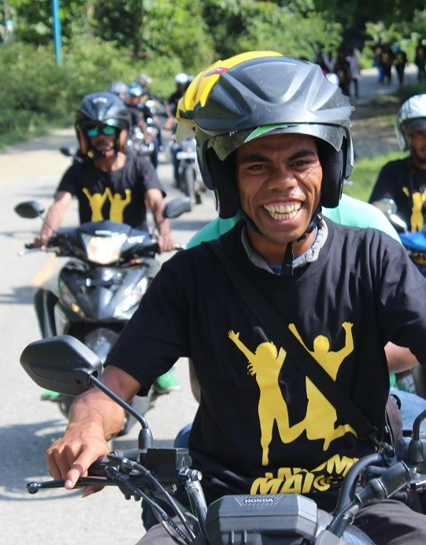

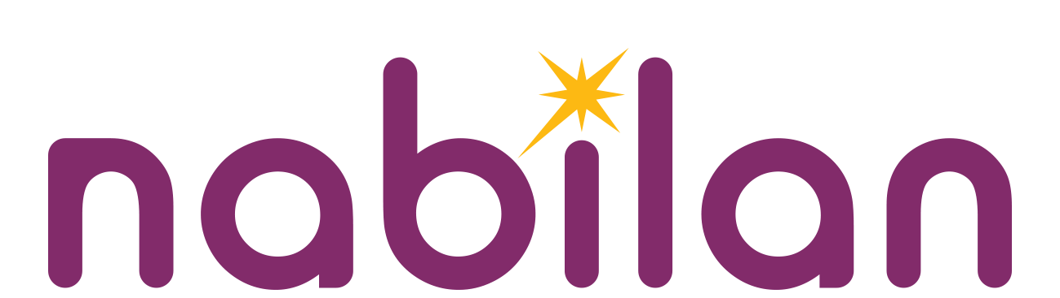
Nabilan: Ending Violence Against Women Program
Annual Report (Volume 1)
1 January 2018—31 December 2018
Supported by the Australian Government
Submitted February 2019

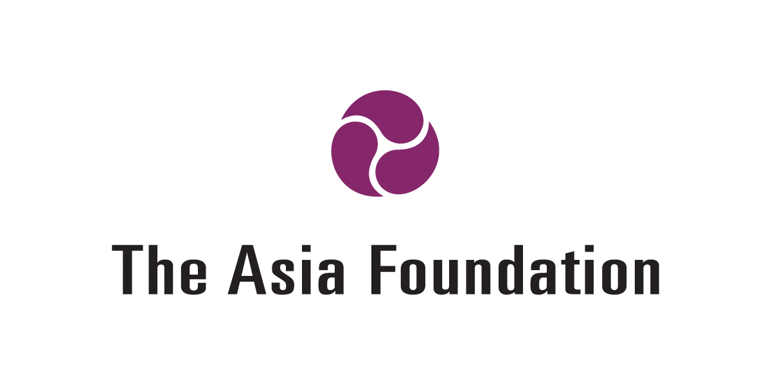

Abbreviations and Acronyms
ADTL | Asosiasaun Defisiente Timor-Leste (Disability Association of Timor-Leste)
ALFeLa | Asisténsia Legál ba Feto no Labarik (Women and Children’s Legal Aid)
CAN | Change Ambassadors’ Network
CBA | Community-based approaches
CM | Community Mobilisers
CODIVA | Coalition for Diversity and Action
CSO | Civil Society Organisation
DFAT | Department of Foreign Affairs and Trade
DPO | Disabled People’s Organisation
EOPO | End of Program Outcomes
EVAW | Ending Violence Against Women
FGD | Focus Group Discussion
FMDC | Fundasaun Media Development Centre
GoTL | Government of Timor-Leste
INS | Instituto Nacional de Saúde (National Institute for Health)
JSMP | Judicial System Monitoring Programme
KEQ | Key Evaluation Question
LGBTI | Lesbian, Gay, Bisexual, Transgender and Intersex
M&E | Monitoring and Evaluation
MELP | Monitoring, Evaluation and Learning Plan
MHVF | Mane Ho Vizaun Foun (Men With a New Vision)
MO | Municipal Officer
MSSI | Ministry of Social Solidarity and Inclusion
NAP-GBV | National Action Plan Against Gender-Based Violence
ODE | Office of Development Effectiveness (DFAT)
OIS | Organisational and institutional strengthening
PDC | Personal Development Courses
PNDS | Programa Nasional Dezenvolvimentu Suku (National Suku Development Program)
PRADET | Psychosocial Recovery and Development in East Timor
RAS | Rapid Assessment Survey
SECOM | Secretary of State for Social Communications
SEII | Secretary of State for Equality and Inclusion
SOGIESC | Sexual Orientation, Gender Identity and Expression, and Sex Characteristics
SSC | Stories of Significant Change
ToC | Theory of Change
UMS | Uma Mahon Salele (Shelter for Women and Children)
VAWC | Violence against women and children
WGQ | Washington Group Questions

Table of Contents
Contents

Abbreviations and Acronyms i
Executive Summary 1
1. Introduction 3
2. Progress towards outcomes: Services 9
3. Progress towards outcomes: Behaviour change 18
4. Sustainability and appropriateness across the program 23
5. Learning & Management Responses 24
Annexes 26

Annex 1 Key Evaluation Questions and sub-questions
Annex 2 Progress Against Indicators
Annex 3 Grant Summary Table
Annex 4 Management Responses

Executive Summary
The Nabilan (Ending Violence Against Women and Children) Program is an 8-year Australian Aid initiative implemented by The Asia Foundation in Timor-Leste on behalf of the Australian Government. Nabilan commenced in April 2014, with Phase 2 continuing from April 2018 until June 2022, with a budget of $A14.2m over four years. The goal of Phase 2 of Nabilan is that “Women and children live free from violence and can enjoy their rights”. To contribute to this goal, Phase 2 has two End of Program Outcomes (EOPOs). EOPO1 is “women and children who experience violence have access to quality and inclusive services”; and EOPO 2 is “individuals, communities and institutions take action to reduce violence against women and children”.
This Annual Report for 2018 outlines our work and progress towards these EOPOs. Nabilan’s new Theory of Change (ToC) and Monitoring, Evaluation and Learning Plan (MELP) for Phase 2 was developed during this reporting period, and this report responds to that MELP. During this period Nabilan moved from six-monthly written progress reporting, to an annual progress report and six-monthly verbal progress briefing. In 2018 Nabilan also contributed to the Australia-Timor-Leste Bilateral Development Cooperation Program Performance Assessment Framework (PAF), reporting against nine out of 19 indicators, and submitting four Stories of Significant Change (SSC). Three SSCs were verified as highly significant. Progress against PAF indicators is included in this report.
During 2018 the Nabilan team was reduced and national staff took over leadership of the main program areas. Nabilan has limited M&E resources in Phase 2: an M&E Adviser will be contracted on a Short Term Adviser basis as required, and an internal M&E Officer for limited days per month. M&E is led principally by the Team Leader and all Nabilan staff are engaged in M&E activities.
Nabilan remains highly relevant to the agenda of Government of Timor-Leste (GoTL), supporting it to achieve the goals in the Strategic Development Plan, the program of the 8th Constitutional Government, the National Action Plan against Gender Based Violence (NAP-GBV) and the Sustainable Development Goals. Nabilan also remains relevant to the objectives of the Government of Australia’s (GoA) foreign aid program—as expressed in Australia’s Foreign Policy White Paper, DFAT’s Gender equality and women’s empowerment strategy 2016, and DFAT’s aid investment plan for Timor-Leste 2015/16–2018/19. Additionally, DFAT’s Office of Development Effectiveness (ODE) strategic evaluation of Australia’s development assistance to end violence against women and girls found that the Australian aid program’s focus on support for services and prevention activities, primarily through Nabilan, is appropriate and contextually relevant, and should be continued. The evaluation found that Nabilan represents global best practice in its integrated approach to prevention and Violence Against Women and Children (VAWC) services. The subsidiary agreement between the GoA and GoTL regarding the Nabilan Program lapsed in April 2018. Negotiations between the GoA and GoTL have progressed throughout the year with a new subsidiary agreement likely by mid 2019.
Services: Progress towards EOPO1 is mostly on track. In the transition from Phase 1 to Phase 2, Nabilan supported continuity of essential VAWC services through grants to services partners, while leading efforts to improve quality and inclusiveness of those services through training and technical assistance. Nabilan’s services partners have national coverage, reaching all municipalities and supported 1,343 new clients in 2018, compared with 1,092 new clients in 2017 (representing a 23 percent increase). Of all new clients, 36 had a disability (2.6%). A total of 10,038 individual services were provided to new and existing clients in 2018, compared with 7,599 services in 2017 (representing a 32 percent increase). Both new clients and services numbers greatly exceeded our targets.
Nabilan continues to support strengthened referral pathways through provision of ongoing support to partners, improving monitoring data, and supporting design of a referral app called ‘Hamahon’. There was a significant increase in referrals between partners in 2018, compared with the previous reporting period.
Nabilan contributed to improved quality of service delivery. Notably, 21 staff from a wide range of Civil Society Organisations (CSO) graduated with their Certificate III in Social Services, and 12 new medical forensic examiners successfully completed their training. An external evaluation of the Certificate III in Social Services, and review of course materials, was conducted in 2018. The evaluation found that key service provider staff have improved knowledge and skills, and service providers are using those increased skills, knowledge and sensitivity to deliver services. An external review of Nabilan’s Case Management and Assessment Tools was also undertaken in 2018. In response to the review, Nabilan adjusted the case audit process to focus on key minimum standards, and other standards which indicate ‘high’ quality case management. Further work with partners is required to support case management.
Nabilan contributed significantly to inclusive service delivery. The December 2018 ODE Evaluation—Development for All: Evaluation of progress made in strengthening disability inclusion in Australian aid cites Nabilan very positively, including for “establish[ing] good working relationships with local DPOs [Disabled Peoples Organisations], which have been mutually beneficial”, “modelling inclusion by leading and managing work to make facilities accessible”, inclusion of DPO members in the Certificate III in Social Services training, and assisting DPOs on Convention on the Rights of People with Disabilities (CRPD) reporting. During this period Nabilan also supported service partners to identify and support clients with a disability and clients from other vulnerable groups; and improved data collection on Lesbian, Gay, Bisexual, Transsexual and Intersex (LGBTI) clients.
Nabilan continued to support improved justice sector response to VAWC by funding key justice sector partners ALFeLa (Women and Children’s Legal Aid) and Judicial System Monitoring Programme (JSMP). The number of cases of VAWC monitored by JSMP during 2018 has increased compared with the previous reporting period. This exceeds the target of the number of cases monitored holding steady. Nabilan’s approach to justice sector programming will be reviewed in 2019 to ensure advocacy is targeted and achieving results.
Social norms change: There is some delay in progress towards EOPO2. During 2018 we reoriented our prevention work towards a broader social norms change approach, primarily through the community-based approaches (CBA) work in Suku Letefoho, Manufahi; and the newly formed Change Ambassadors’ Network (CAN). Due to budget cuts, grants to prevention partners were delayed until 2019.
Nabilan is directly supporting communities and institutions to take action to prevent VAWC. Our CBA prevention work (KOKOSA!) in Suku Letefoho, Manufahi, moved into Phase II during 2018, and Phase II is scheduled for completion by June 2019. Thirteen mobilisers are actively raising awareness about VAWC in their communities, and six new community action groups have been identified. However, baseline data on existing community awareness collected in 2018 suggests there is considerable work to be done. There are already positive examples of Nabilan’s KOKOSA! training modules being used by other agencies, and this is a significant achievement at this early stage.
At the institutional level, Nabilan established the CAN with representatives from Australian Aid Investment Partners and key CSOs. CAN members were actively engaged throughout 2018, and continued to increase their skills and knowledge on effective violence prevention methods. There are already positive examples of CAN members using their learnings to promote gender equality in their programs, laying the foundation for future integration of quality prevention approaches. Nabilan completed baseline research for the CAN, which will allow us to monitor progress, and adapt our programming as required.
At the societal level, Nabilan intensified support to the independent feminist movement, through Grupu Feminista and other activists. Nabilan supported successful social media campaigns through Facebook, with Nabilan’s boosting of Grupu Feminista’s Facebook posts leading to an 8-fold increase in the number of users reached, and a 10-fold increase in positive engagement with the posts. Alumni from the Certificate III in Social Services course are active in this movement, applying their learnings and skills to push for a change in social norms in Timor-Leste.
Nabilan has made progress on influencing increased government dialogue and action on preventing VAWC. This has occurred through a strengthened relationship with the Secretary of State for Equality and Inclusion (SEII), and joint activities at both national and Manufahi level. Nabilan worked with the GoTL on media training to improve reporting standards on gender and VAWC. There is opportunity to work with SEII going forward to strengthen their approach to effective prevention.
Sustainability and appropriateness (EOPO3 and 4) will be the focus of the mid-term review of Nabilan, although progress has been made already in sustainability of Nabilan program outcomes by working through and enhancing local systems and structures; and building the capacity of service providers, communities and institutions. Further work is required with GoTL, in particular the Ministry of Social Solidarity and Inclusion (MSSI), and service providers to address the issue of sustainable funding for essential VAWC services. The delays in passing the State Budgets in 2017 and 2018 meant that no progress was possible in terms of advocating for increased percentage of government funding for these services.

1. Introduction

Nabilan Overview
The Nabilan (Ending Violence Against Women and Children) Program is an 8-year Australian aid initiative implemented by The Asia Foundation in Timor-Leste on behalf of the Government of Australia (GoA). The program commenced in April 2014, with Phase 2 continuing from April 2018 until June 2022. The goal of Phase 2 of Nabilan is that “Women and children live free from violence and can enjoy their rights”. To contribute to this goal, Phase 2 has two End of Program Outcomes (EOPO): EOPO1 (Services): Women and children who experience violence have access to quality and inclusive services; and EOPO2 (Social Norms Change): Individuals, communities and institutions take action to reduce violence against women and children.
Nabilan’s Phase 2 goal reflects the goal of the Timor-Leste National Action Plan Against Gender Based Violence (NAP-GBV) 2017-21 which is reducing and ultimately eliminating gender-based violence (GBV) through a multi-sectoral coordinated approach. Nabilan EOPO 1 aligns with NAP-GBV Pillars 2 & 3 on Services and Access to Justice, and EOPO 2 aligns with NAP-GBV Pillar 1 on Prevention. Nabilan Phase 2 also continues its extensive engagement with civil society organisations (CSO), with an intensified emphasis supporting local feminists and movements.
The budget for Nabilan Phase 2 is $A14.2m over four years. Nabilan Phase 2 was officially launched on 31 July 2018 by the Australian Minister for Foreign Affairs.

Nabilan Operating Context
Nabilan transitioned into Phase 2 in April 2018. The team was reduced, to correspond with programming changes and budget. National staff took over leadership of the main program areas. The subsidiary agreement between the Governments of Australia and Timor-Leste regarding the Nabilan Program lapsed in April 2018.
In 2018, Nabilan and partner CSOs operated in a context of political change. The 7th Constitutional Government of Timor-Leste (GoTL) was unable to pass the State Budget. This meant CSO service providers received intermittent support under the emergency duodecimo system. On 22 June 2018, the 8th Constitutional Government of Prime Minister HE Jose (Taur Matan Ruak) Vasconcelos commenced with an absolute majority with 34 seats in the 65-seat legislature. The 2018 rectification budget was finally passed in August 2018, meaning that CSO service providers were able to receive their funding from the Ministry of Social Solidarity and Inclusion (MSSI).
Under the 8th Constitutional Government, the Secretary of State for Gender Equality and Social Inclusion (the gender equality ministry), became the Secretary of State for Equality and Inclusion (SEII). The allocation for MSSI was $US52.23 million of which $US2.029 million was allocated for services and victims of natural disasters, and for SEII $US684,000, most of which was for operational and salary costs. The Ministry of Health is, on a transitional basis, under the leadership of the Deputy Minister of Health. The 2019 State Budget was promulgated on 7 February 2019. The Gender Budget Statement for 2019 states that 40% of the budget was allocated for principally women’s programs; and 30% was allocated for specific women’s programs. However, none of the ministries responsible for implementing the NAP-GBV 2017-21 have allocated any funding to NAP-GBV activities.
Throughout 2018, there was growing feminist activism by individuals and groups such as the Grupu Feminista. Young Timorese women and men, many who are graduates of Nabilan’s Certificate III in Social Services Course, are increasingly taking public action to promote gender equality and end discrimination against all marginalised groups. Using social media and public events, including over the 16 Days of Activism Against Gender-Based Violence, these individuals and groups are contributing to a change in social norms in Timor-Leste.

Relevance of Nabilan
Nabilan remains extremely relevant to the agenda of GoTL, supporting it to achieve the goals in the Strategic Development Plan 2011-2030, through its focus on gender equality, combating domestic violence, vulnerable people and families, and vulnerable children. Nabilan is also relevant to the program of the 8th Constitutional Government, the NAP-GBV 2017-2021, and the Sustainable Development Goals. Nabilan remains relevant to the objectives of Australia’s aid program, as expressed in Australia’s Foreign Policy White Paper, which emphasises advancing human rights and gender equality. It is also aligned with DFAT’s gender equality and women’s empowerment strategy; and DFAT’s aid investment plan for Timor-Leste 2015/16–2018/19, in particular Objective 2: Advancing Human Development, and the multi-sectoral issue of “Empowering women and girls”.

Additionally, DFAT’s Office of Development Effectiveness (ODE) strategic evaluation of Australia’s development assistance to end violence against women and girls found that the Australian aid program’s focus on support for services and prevention activities, primarily through Nabilan, is appropriate and contextually relevant, and should be continued. The ODE evaluation found that there has been substantial progress in services, and Nabilan represents global best practice in its integrated approach to prevention and violence against women and children (VAWC) services.

Violence against women and children remains one of the biggest development challenges in Timor-Leste. In their lifetimes, most women in Timor-Leste experience some form of physical, sexual, emotional, or economic violence by an intimate partner. Women’s experiences of intimate partner violence are frequent and severe, and women rarely leave these violent relationships. The GoTL remains committed to reducing violence against women, through the NAP-GBV 2017-21, and has a strong legislative and policy framework for addressing violence against women and children.

Nabilan remains the single biggest gender program in Timor-Leste. It funds half of all shelters, the only women’s legal aid organisation, and one-stop crisis centres for victims of violence. Nabilan has also been leading primary prevention activities, and the push for a broader social norms change approach to violence prevention. Nabilan’s pilot community-based intervention in Suku Letefoho, Manufahi, is the first adaptation of SASA! in Timor-Leste. Nabilan’s evidence-based approach to prevention has already been adopted by other agencies.

Monitoring and Evaluation (M&E)
Nabilan’s new Theory of Change (ToC) and Monitoring, Evaluation and Learning Plan (MELP) for Phase 2 were developed during this reporting period. The MELP documents the system that Nabilan will use to provide evidence, learning and improvements to its program. The MELP will also assist Nabilan to contribute to the Australia Timor-Leste Bilateral Development Program Performance Assessment Framework and to report against nine out of 19 indicators, as detailed below.
Strategic Themes | Outcome | PAF Indicator # | Indicator
People | Higher quality frontline services | 8 | Instances of improved systems for service delivery
 |  | 9 | Number of people who applied improved skills to deliver better quality services
 |  | 10 | Number of service delivery improvements
 | More people benefit from services | 12 | Number of services provided
 | More women and girls are safe and empowered | 13 | Number of people that demonstrate improved attitudes to women and girls
 |  | 14 | Instances of women’s leadership opportunities and empowerment
 |  | 15 | Number of women and girls who experience violence accessing essential services
Society | Better decision-making and evidence-based policy | 20 | Instances of improved policy and implementation
 |  | 21 | Instances of evidence available for decision-making

Nabilan moved from six-monthly written progress reporting, to an annual progress report and six-monthly verbal progress briefing. Learning dialogues were held with Nabilan, the Australian Embassy, and M&E House on 9 August 2018 and 29 January 2019 in preparation for the verbal briefing and this annual report. The Key Evaluation Questions (KEQ) and sub-questions that guide these processes can be found at Annex 1.

An external evaluation of the Certificate III in Social Services was conducted by Ruth Hugo over 9 April–1 June 2018. The consultant interviewed 33 people and reviewed the course materials. The final evaluation report with 18 recommendations was submitted on 1 June 2018. Nabilan is continuing to implement most of these recommendations. Nabilan also engaged Ben Larke to review Nabilan’s Case Management and Assessment Tools. The review was conducted over 10 days, between 22 May and 13 July 2018. In response to the review, Nabilan adjusted the case audit process to focus on key minimum standards, and other standards which indicate ‘high’ quality case management.

Four Stories of Significant Change (SSC) were submitted in 2018, covering the July–December 2017 and January–June 2018 reporting periods. Three SSCs were verified as highly significant. Nabilan has limited M&E resources in Phase 2: an M&E Adviser who will be contracted on a Short Term Adviser basis as required, and an internal M&E Officer for limited days per month. M&E is led principally by the Team Leader and all Nabilan staff are engaged in M&E activities.

About this report

This 2018 Annual Progress Report covers the period 1 January–31 December 2018. The report has been written in accordance with DFAT Monitoring and Evaluation Standards, April 2017; and is informed by M&E House’s Good Practice Note: Progress Reporting.

This Chapter introduced the Nabilan Program including an overview, operating context, relevance, M&E, and ToC. Chapters 2 and 3 outline the effectiveness of progress towards EOPO1 (services) and EOPO2 (behaviour change). Chapter 4 discusses EOPO3 (sustainability) and EOPO4 (appropriateness). Annex 1 covers Key Evaluation Questions and sub-questions, Annex 2 details progress against indicators, Annex 3 provides a Grants Summary Table, and Annex 4 outlines Management Responses (to previous recommendations).

A separately submitted volume includes revised Risk and Mitigation Measures, the Financial Report with explanation of deviations, and the Evidence Matrix.
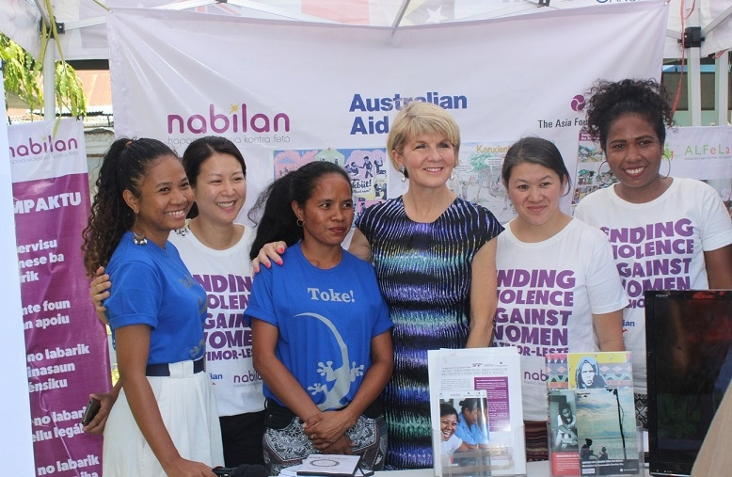
Launch of Nabilan Phase 2 on 31 July 2018.

Design session for the ‘Hamahon’ referral app by Catalpa International, 27 October 2018

2. Progress towards outcomes: Services

What Nabilan did
In 2018, Nabilan provided a total of $US1,476,042.07 in grants to essential violence against women services and advocacy partners: Asisténsia Legal ba Feto no Labarik (ALFeLa–legal aid for women and children), Casa Vida (shelter for children), FOKUPERS (shelter for women), Judicial System Monitoring Programme (JSMP–court monitoring and advocacy), Psychosocial Recovery and Development in East Timor (PRADET–one-stop crisis centre for victims of violence), and Uma Mahon Salele (UMS–shelter for women and children). All grants were awarded after a competitive call for proposals; and evaluation by a selection committee comprising representatives from SEII, the Australian Embassy, WaterAid and a prevention expert nominated by Nabilan.
Key training interventions (Certificate III in Social Services, 4R training on recognising and responding to non-accidental injuries, and medical forensic examination training) were implemented according to the work plan in 2018. Twenty-one students from the second round graduated with their Certificate III in Social Services; 98 health workers completed PRADET’s 4R training; and 12 new medical forensic examiners successfully completed their theory and practicum.
Nabilan facilitated make-up sessions for eight students from the second round of the Certificate III course, ensuring that they could graduate. Course materials were updated throughout 2018 in response to the recommendations from the evaluation of the course. Nabilan also supported six Certificate III alumni to undertake their Certificate III in Training and Assessment so that they can join as facilitators in the next round of the social services course.
Nabilan partner PRADET focused on improving identification and referral of victims by health providers. PRADET, with Dr Margaret Gibbons and Instituto Nacional de Saúde (INS), trained 12 doctors, midwives and nurses, to become accredited medical forensic examiners. PRADET also delivered three rounds of 4R training on recognising and responding to non-accidental injuries. Other work in the health sector included training for Health Alliance International staff on gender, child protection and the legal framework.
ALFeLa worked with MSSI to deliver training to referral network partners on the Nabilan-supported MSSI standard operating procedures on referrals and case management. ALFeLa also partnered with Nabilan to train the Polícia Nacional Timor-Leste (PNTL—National Police of East Timor) in Manufahi on legal frameworks and mandatory reporting obligations. This was in response to findings from Nabilan’s community-based prevention work in Suku Letefoho, Manufahi.
Ensuring inclusive service delivery is a key focus of Nabilan’s work with partners. With Asosiasaun Defisiente Timor-Leste (ADTL–Disability Association of Timor-Leste), Nabilan funded accessibility modifications for PRADET’s Fatin Hakmatek Baucau building. ADTL also provided Washington Group Questions (WGQ) training to Nabilan partners. Nabilan partnered with Marie Stopes Timor-Leste and Hivos to fund Sexual Orientation, Gender Identity and Expression, and Sex Characteristics (SOGIESC) training for service providers. Nabilan also provided child protection training to Casa Vida and FOKUPERS to ensure that child residents are protected from abuse within these institutions.

EOPO 1—Women and children who experience violence have access to quality and inclusive services
KEQ 1: How effective was the Nabilan program in ensuring women and children who experience violence have access to adequate and responsive services?
Findings—EOPO1 is mostly on track.
- Nabilan has exceeded its target for the reporting period for the number of new clients and the number of services provided by Nabilan partners.
- Key provider staff have improved knowledge and skills. Nabilan has exceeded its target for 2018 for the number of Nabilan partners completing the Certificate III in Social Services and is well on track to meet or exceed the target for new Medical Forensic Examiners trained by the end of 2019.
- Twenty-one out of 26 CSO staff who commenced the Certificate III in Social Services course successfully completed the qualification (three dropouts, two did not pass). All 12 health professionals completing Medical Forensic Examiner training were deemed able to conduct examinations by Dr Margaret Gibbons. Pre- and post-testing of partners completing the Certificate III in Social Services and Medical Forensic Examiner Training was not undertaken as continuous assessments were built into the training.
- Nabilan has contributed to improved quality service delivery through the Certificate III in Social Services course, and ongoing technical assistance and other training. The recent evaluation of the Certificate III in Social Services provides clear evidence of staff improving the way they support clients as a result of completing the course. However, the case management audit of services partners (the primary method of assessing improvements in the service quality of Nabilan CSO partners) found that Nabilan is unlikely to meet service quality targets in 2019 due to issues with a new partner’s poor case management systems. In response to this finding, Nabilan will need to intensify its efforts to improve partner case management.
- Nabilan contributed to inclusive service delivery by supporting services partners to identify and support clients with a disability and clients from other vulnerable groups, and improving data collection on Lesbian, Gay, Bisexual, Transsexual and Intersex (LGBTI) clients. Vulnerable clients, such as clients with a disability, are accessing VAWC services. In 2018, partners supported an increased number of clients with a disability compared with the 2014 baseline. The December 2018 ODE Evaluation on strengthening disability inclusion in Australian aid cites Nabilan very positively for a number of aspects of its disability inclusive work.
- Nabilan continues to support strengthened referral pathways through provision of ongoing support to partners, improving monitoring data, and supporting design of a referral app called ‘Hamahon’. There was an increase in referrals between service providers, compared with 2017.
- Nabilan continued to support improved justice sector response to VAWC by providing funding to key justice sector partners ALFeLa and JSMP. The number of cases of VAWC monitored by JSMP during 2018 has increased compared with the previous reporting period, due to JSMP increasing its court monitoring activities. This exceeds the target of the number of cases monitored holding steady.
- However, there has been no progress in improving charging and sentencing of domestic violence cases, and Nabilan’s targets in this area have not been met. Nabilan will review our approach to justice sector programming in 2019.
- Nabilan’s services partners have national coverage, reaching all municipalities, and increasing numbers of women and children. Nabilan funding support allows continuity of essential VAWC services, such as the only dedicated women and children’s legal aid service, one-stop crisis centre, and shelters in four municipalities.

Evidence

Numbers of new clients supported by Nabilan partners
Nabilan services partners are helping increasing numbers of women and children clients. Partners supported 1,343 new clients in 2018, compared with 1,092 new clients in 2017. Half of the new clients were victims of domestic violence, 19% of cases involved sexual violence (non-domestic violence), 9% civil cases (including abandonment), 7% multiple forms of domestic violence, and 5% sexual violence within a family context. Of all new clients, 1,264 were female and 49 were male. Most new clients came from Dili (37%), followed by Baucau (13%) and Oecusse (12%). As shown in Chart 1 below, Nabilan partners have national coverage. Nabilan partners continued to support children, as well as vulnerable women.

Of all new clients, 28% were children. Eighteen percent of new female clients had never attended formal schooling; 3% have a disability; 14% are heads of their households; and 11% do not speak Tetum. (See below charts 3-6.)

Number of services provided by Nabilan partners
Nabilan services partners provided a wide range of VAWC services. A total of 10,038 individual services were provided to new and existing clients in 2018, compared with 7,599 services in 2017. These services respond to women and children’s needs in the immediate aftermath of violence, as well as ongoing support required such longer-term shelter, access to education and training, and follow-up. There was an increase in referrals made by partners and follow-up of clients’ cases.

Table 2. Services provided in 2018 | Total
Referrals made | 1,266
Legal assistance | 2,623
Medical treatment | 494
MFP | 698
Temporary accommodation (Fatin Hakmatek) | 192
Shelter | 324
Counselling | 1,174
Life-skills training | 403
Access to formal education | 142
Family visits | 95
Reintegration support | 647
Financial / material support | 566
Follow-up visits | 1,414
Total | 10,038

Quality of service delivery
Key service provider staff have improved knowledge and skills, and service providers are using those increased skills, knowledge and sensitivity to deliver services. Twenty-one students from the second round graduated with their Certificate III in Social Services, with evidence of improvements in service quality as a result. The external evaluation of the course conducted between 9 April – 1 June 2018 concluded there was strong level of student satisfaction with the training; and employer feedback has been positive, with specific examples such as staff having better communication and leadership skills, better referral skills, and a reduction in victim-blaming attitudes. Importantly, according to stakeholder interviews conducted during the evaluation of the course, the Certificate III in Social Services has led to the emergence of ‘social services’ as a profession in Timor-Leste. Prior to the course, staff providing frontline services did not label themselves as a ‘social worker’. They didn’t view the commonalities between their roles and did not always consider themselves as part of the same valuable profession, sector or industry. Through course design and two rounds of course delivery, a social service profession was created in Timor-Leste.
PRADET trained 12 new medical forensic examiners, all who are ready to be accredited by the INS. These examiners will work from municipal referral hospitals, strengthening the link between the public health sector and VAWC services. The exit report by the trainer, Dr Margaret Gibbons, states that the examiners have the required skills and confidence to undertake examinations and all passed the three-hour long theory examination. There were mixed results from PRADET’s 4R training on recognising and responding to non-accidental injuries. While the pre and post-training assessments showed that the training generally improved participants’ knowledge of Fatin Hakmatek services, and confidence about managing cases of VAWC, there were no clear improvement in specific clinical practices. Use of English in the pre-and post-testing could explain the mixed results.
Dr Gibbons also audited 151 medical forensic protocols to assess the quality of current examiners. She found that 40 protocols (26%) had one or more major issues, mostly incorrect completion of the client consent field. This is a minor technical error, however has consequences for the legality of the evidence collected. In 2017, the same audit found a similar number of protocols (22%) had one or more major issues. Nabilan will update the protocol to simplify the consent page and continue supporting refresher training for examiners.
Nabilan did not administer routine pre- and post-training assessments for training directly facilitated by Nabilan (gender, child protection, legal frameworks and mandatory reporting obligations). Eighty percent of those who enrolled in the Certificate III in Social Services course, and 100% of trainees who attended the medical forensic examination course, successfully completed the training. M&E will be strengthened with support from M&E House and the Nabilan M&E adviser. Follow-up is required to collect better information about how participants are using their skills for improving service delivery.
Recommendation: Develop monitoring tools to better assess impact of Nabilan supported training and 4R training, including post-training survey tool, and routine pre- and post-training assessments. Update the medical forensic protocol and continue supporting refresher training for examiners.
Nabilan has contributed to high quality service delivery through the Certificate III in Social Services course, and ongoing technical assistance and other training. The case management audit of services partners is the primary method of assessing improvements in the service quality of Nabilan CSO partners. In 2018, a consultant reviewed the case audit tools and recommended changes, which were then implemented.
Subsequently, Nabilan audited 207 case files from Casa Vida, five PRADET Fatin Hakmatek, FOKUPERS in Dili, Suai and Maliana, and UMS. Thirty-two percent of cases audited met minimum standards, and a further 21% met high standards, meaning a total of 53% of cases met at least the minimum standards. The mid-term target for July 2019 is that 70% of cases meet at least minimum standards. Minimum standards are basic case management standards such as: each client having one case file; files are kept in a secure location; there is an intake form; and there is evidence that the client consented to receive the services. None of the audited cases from FOKUPERS met minimum standards in this round. Nabilan will work continue to work with partners to improve the minimum standards of their case management, with a particular emphasis on FOKUPERS
Recommendation: Continue to support service providers to improve their case management, with a particular emphasis on FOKUPERS.

Inclusive service delivery
Nabilan contributed significantly to inclusive service delivery. The December 2018 ODE Evaluation—Development for All: Evaluation of progress made in strengthening disability inclusion in Australian aid cites Nabilan very positively, including for “establish[ing] good working relationships with local DPOs [Disabled Peoples Organisations], which have been mutually beneficial”, “modelling inclusion by leading and managing work to make facilities accessible”, inclusion of DPO members in the Certificate III in Social Services training, and assisting DPOs on Convention on the Rights of People with Disabilities (CRPD) reporting.
During this reporting period Nabilan contributed to inclusive service delivery by supporting service partners to identify and support clients with a disability and clients from other vulnerable groups and improving data collection on LGBTI clients. In 2018, partners supported a total of 36 clients with a disability (2.6% of all new clients). This is holding steady compared with 2017, when 2% of new clients had a disability. It is an increase compared with the 2014 baseline of five out of 302 (1.6%) new clients with a disability. Partners referred 14 new clients to a disabled people’s organisation (DPO), however no referrals were recorded from DPOs to Nabilan partners. Nabilan invited DPOs to attend the bi-monthly partners meetings to strengthen the relationships between the sectors. Partners are providing increasingly detailed information in their narrative reports about the situation of clients with disabilities, evidencing the impact of Nabilan’s training sessions and the Certificate III in Social Services course.
Nabilan also started collecting information about LGBTI clients in 2018. ALFeLa supported one transgender male client in a discrimination complaint and worked with Hatutan (a youth advocacy group) to raise awareness about discrimination against the LGBTI community in Timor-Leste.
Recommendation: Support partners to use WGQ during client intake - this will take training and support, and should be delivered in coordination with DPOs.
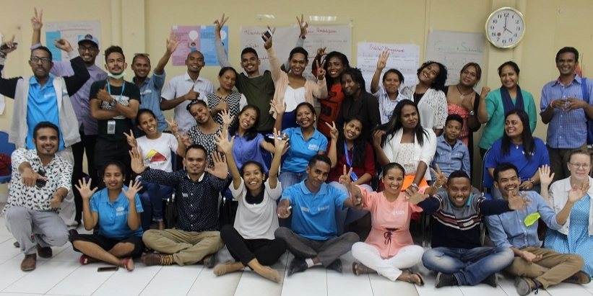
Participants from the SOGIESC training held with Marie Stopes and Hivos, 17–18 October 2018

Referral pathways
Nabilan continues to support strengthened referral pathways through provision of ongoing support to partners, improving monitoring data, and supporting design of a referral app called ‘Hamahon’. Compared with 2017, there was an increase in referrals overall. In 2018, Nabilan partners received a total of 1,343 new clients. Of those new clients, 1,111 (83%) were referred from other organisations within the referral network (police, VAWC service providers, MSSI), and 232 (17%) were referred from organisations outside the referral network (self-referred, family, other NGOs, DPOs, health providers, community leaders). Partners made a total of 1,266 referrals: a total of 937 (74%) were to organisations within the referral network and 329 (26%) referrals were made to organisations outside of the referral network. In 2017, partners received a total of 1,092 referral and made a total of 820 referrals. Nabilan updated the partner reporting templates for the July-December 2018 period to more accurately collect information on referrals. ALFeLa and FOKUPERS require ongoing support to accurately record referrals.

Nabilan also supported SEII and referral network partners to design a referral app called ‘Hamahon’ (www.hamahon.tl), to ease referrals. Network members will be able to easily update their phone numbers when staff change and notify each other when phone numbers are inactive. The app will also help organisations outside the referral network to refer women and children to VAWC service providers. Since the launch on 6 December 2018, the site has had 109 visits per month. Half of all visitors are linking through to the contact pages (with phone numbers of partners), showing that the app is being used. Uma Paz Baucau, a shelter organisation not funded by Nabilan, has logged into the app, showing its use outside of Nabilan partners. The app is available for free download from the Google Play store.
Recommendation: Work with ALFeLa and FOKUPERS to improve referral data, including possible update to ALFeLa’s case management database.

Justice sector response
Nabilan continued to support improved justice sector response to VAWC by providing funding to key justice sector partners ALFeLa and JSMP. In 2015, Nabilan funded ALFeLa to lodge an individual communication to the Committee on the Elimination of Discrimination on behalf of a client who had been sentenced for killing her husband while acting in self-defence. On 26 February 2018, the Committee made its recommendations to the GoTL, finding that there have been systemic failures in preventing domestic violence in this case and that the client had been discriminated against by the justice sector. This was a highly significant decision, and the first time Timor-Leste has used the individual communications mechanism. The Committee’s recommendations have implications for how the police, community leaders, and the justice sector must respond to domestic violence. ALFeLa continued advocacy on adoption of these recommendations with the Prime Minister’s Office and SEII.
JSMP continued to monitor the courts and advocate on key issues. In 2018, JSMP monitored a total of 1,008 cases (644 domestic violence cases; 55 sexual violence cases, 409 other cases), an increase from 836 cases monitored in 2017 (403 domestic violence cases; 29 sexual violence cases, 404 other cases).
There has been no progress in improving charging and sentencing in domestic violence cases. There has been no increase in the number of domestic violence cases resulting in a conditional suspended sentence. In 2017 and 2018, the percentage of domestic violence cases monitored resulting in a conditional suspended sentence has remained steady at 5%. The application of the more serious charge of mistreatment of a spouse or serious assault in domestic violence cases has marginally decreased (9% in 2018 compared with 10% in 2017). The use of fines has increased (14% in 2018 compared with 11% in 2017). While JSMP is continuing to advocate within its sphere of influence, progress against these three indicators are not on track. Nabilan will review its programming in the justice sector in 2019.
JSMP is continuing to develop a guide to the Penal Code, which aims to improve the understanding of key provisions in the Penal Code on physical assault and sexual assault, as well as the Law Against Domestic Violence. There is now support from the Legal Training Centre and Ministry of Justice for this project.
Recommendation: Review Nabilan’s programming in the justice sector, particularly the balance between JSMP’s court monitoring work versus its advocacy work. A change in advocacy goals should be considered, for example moving away from the focus on charging and sentencing, and more on practical monitoring mechanisms for those on suspended sentences.
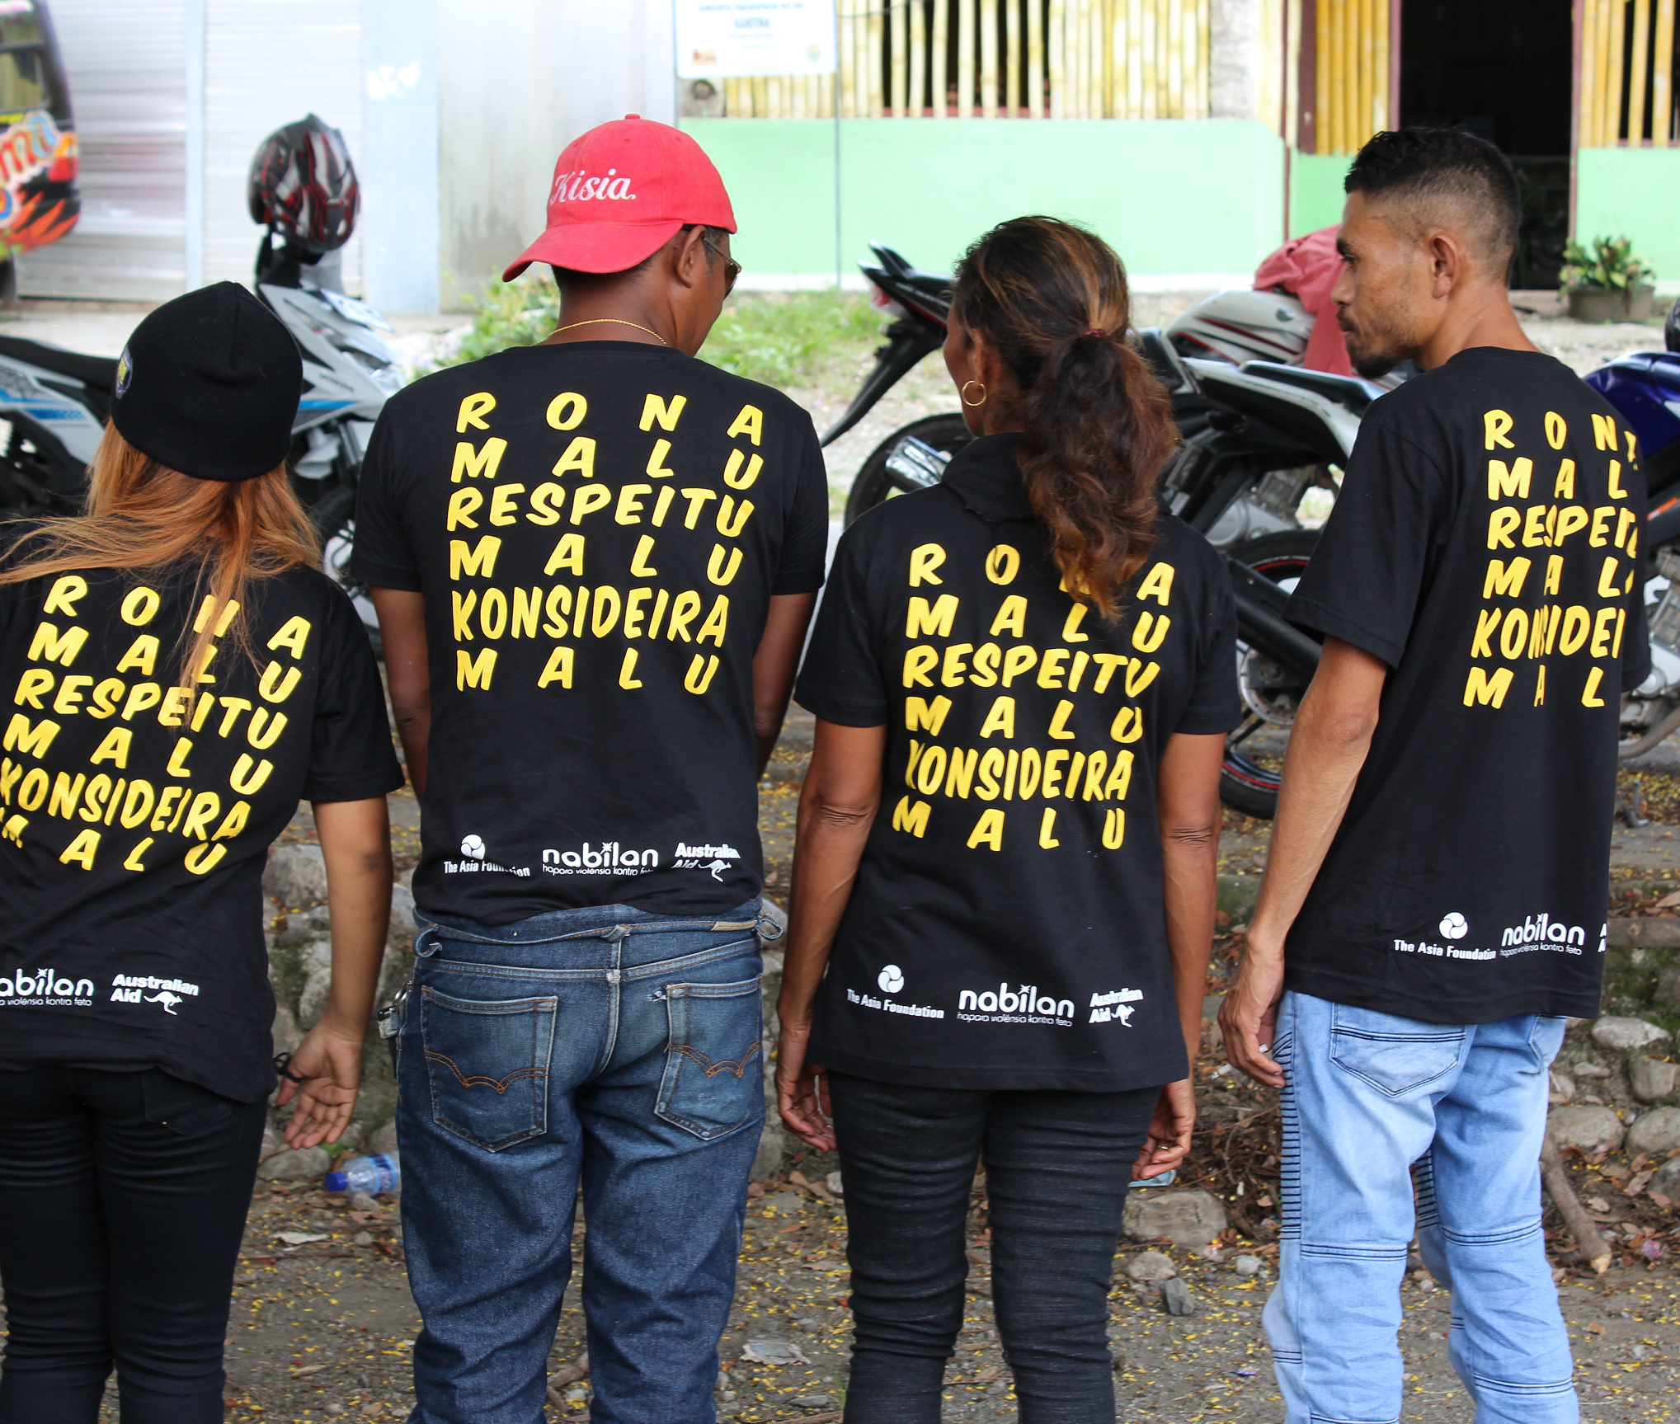
Community events in Suku Letefoho to celebrate the 16 Days of Activism Against Gender-Based Violence, 10 December 2018

Community march in Suku Letefoho to celebrate the 16 Days of Activism Against Gender-Based Violence, 10 December 2018

3. Progress towards outcomes: Behaviour change

What Nabilan did
Prevention partners were selected by Nabilan after a competitive call for proposals, however disbursement of grants was delayed until January 2019 due to the reduction in Nabilan’s budget. Grant agreements were signed with: PRADET’s Personal Development Course (PRADET-PDC); Mane Ho Vizaun Foun (MHFV–Men With a New Vision) for their Suku Protection Group program; Fundasaun Media Development Centre (FMDC) for their TekiToke radio shows and youth listening groups; and Coalition for Diversity and Action (CODIVA) to contribute to social inclusiveness in Timor-Leste. These partners will reach the individual, families/relationship, community, and societal levels of the ecological framework. During the last six months of 2018, Nabilan reviewed all partner materials and provided training to implementing staff to improve their readiness to deliver high-quality prevention activities.
Nabilan continued the community-based prevention work in Suku Letefoho, adapted from the SASA! methodology developed by Raising Voices in Uganda. Nabilan’s adaptation is called KOKOSA! which stands for each of the four phases of SASA!: Start (Komesa); Awareness (Konxiénsia); Support (Suporta); and Action (Asaun). We completed Phase I and supported the community mobilisers (CM) to move into the second phase (Awareness) with training on the new tools. We identified and trained six community action groups (two women’s groups, two agriculture groups, one art group, and one youth drama group), as well as other key groups such as community healthcare workers, Community Policing Council, and religious leaders. A new Municipal Officer was assigned to Manufahi at the beginning of 2018, and this has greatly motivated the CMs and the community. We also signed MoUs with two new mobilisers. As part of ongoing monitoring and programming, we conducted the first rapid assessment survey (RAS) and focus group discussions (FGD) in May 2018. The RAS and FGD results provide the baseline for KOKOSA! in Suku Letefoho.
Nabilan created the Change Ambassadors’ Network (CAN) in January 2018 to support the mainstreaming of violence against women prevention work across GoA funded programs in Timor-Leste. Nabilan held five one-day workshops in 2018, two make-up sessions and two meetings with CAN members. Using a transformative approach, Nabilan is supporting voluntary members with the skills and mutual support required to influence change in their organisations, and to integrate quality prevention approaches into their own work. Nabilan also developed a CAN training package with the members, which can be integrated into their own programming.
Nabilan continued to support the local feminist movement, Grupu Feminista, and other women leaders with funding for events and technical support. Nabilan supported the Grupu Feminista fun run for International Women’s Day 2018, a public event against sexual harassment, a youth debate on child abandonment and victim-blaming, a “male allies for gender equity” campaign, and a silent march over 16 days. Nabilan helped Grupu Feminista to boost their Facebook posts and held a series of meetings on effective advocacy approaches.
Nabilan focused on improving media reporting of VAWC through media monitoring and developing a positive media kit which was launched during the 16 Days of Activism Against Gender-Based Violence. Nabilan published five ‘advertorials’ in two national newspapers (STL and Timor Post) to spread positive prevention messages in the community. During the16 Days of Activism Against Gender-Based Violence, Nabilan also launched two SASA!-adapted radio plays on GMN Radio and Manufahi local radio, and three Nabilan public service announcements from 2017 and coffee-consent films were played on GMN TV.
Nabilan also conducted a joint media training workshop with SEII, JSMP, the Secretary of State for Social Communication (SECOM) and the Press Council. This was the first joint prevention activity with SEII, and sets the foundation for closer cooperation in Phase II.
Nabilan completed baseline research for both the community-based work in Suku Letefoho and the CAN. This will allow us to monitor progress and adapt our programming as required.

EOPO 2—Individuals, communities and institutions take action to reduce VAWC

KEQ 2: To what extent are individuals, communities and institutions taking action to reduce VAWC?

Findings—Some aspects of EOPO 2 are delayed.
- Nabilan has selected prevention partners but grant disbursements were delayed until January 2019 due to the reduction in Nabilan’s budget. This provided time for Nabilan to improve partner materials and provide staff with capacity-building. An intensive monitoring schedule of partner activities was also developed. This work is continuing.
- Nabilan continued to support communities to take independent action to prevent VAWC. The KOKOSA! program in Suku Letefoho transitioned from Phase 1(Komesa/Start) to Phase II (Konxiénsia/Awareness) during 2018. We are progressing toward the target of completing Phase II by June 2019. However, baseline data on existing community awareness collected in 2018, suggests there is considerable work to be done. Comparing this baseline with data to be collected in 2019 will allow us to assess whether the intervention remains on track and inform a decision on whether to progress to Phase III (Action) in 2020.
- There are already positive examples of Nabilan’s KOKOSA! training modules, informed by the Community-based approaches (CBA) pilot, being used by other agencies, and this is a significant achievement at this early stage. Examples have been provided of CAN members using their learnings to promote gender equality in their programs, laying the foundation for future integration of quality prevention approaches. Nabilan continues to support Change Ambassadors to influence their programs on quality prevention approaches. During 2018 Nabilan completed baseline research for the CAN, which will allow us to monitor progress, and adapt our programming as required. More time is required to fully assess impact.
- Nabilan has continued to contribute to the independent women’s movement through supporting increased reach and effectiveness of the independent feminist movement, Grupu Feminista, and some alumni of the Certificate III in Social Services, who are mobilising to promote gender equity and ending violence against women.
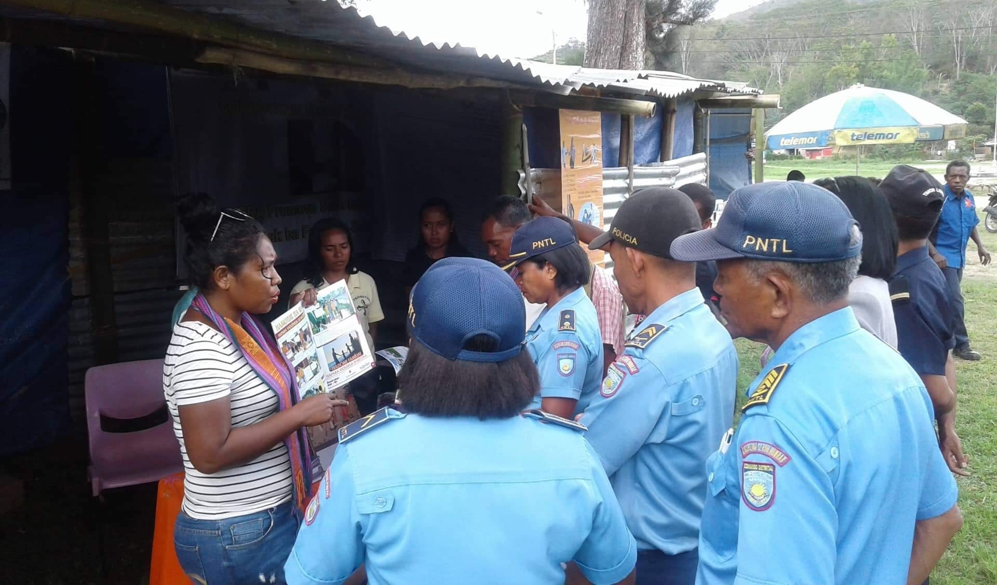
- Nabilan has made progress on influencing increased government dialogue and action on preventing VAWC. This has occurred through a strengthened relationship with SEII, and joint activities at both national and Manufahi level. There is opportunity to work with SEII going forward to strengthen their approach to effective prevention.
Nabilan prevention team at the Aileu Expo, 26 November 2018

Evidence

Prevention partners
Nabilan selected four prevention partners (CODIVA, FMDC, MHFV and PRADET-PDC), however there was no other progress in 2018 due to the delay in these grants. The new grants will commence in January 2019. Nabilan used this gap to support the partners with feedback on their prevention approaches.

KOKOSA!
Nabilan continued to support communities to take independent action to prevent VAWC. The KOKOSA! program in Suku Letefoho transitioned from Phase I (Komesa/Start) to Phase II (Konxiénsia/ Awareness) during 2018. Thirteen CMs continued to take action in Suku Letefoho as part of KOKOSA!, conducting 126 documented activities over 2018 and referring four cases to the police and a DPO. The Nabilan Municipal officer also identified a case of domestic violence which had not been registered by the police. Nabilan responded with training support for the police officers during the 16 Days of Activism Against Gender-Based Violence. While CMs are not yet completing four activities per month, they have increased their activities since the new Municipal Officer started working more closely to motivate and monitor their activities.
The Suku Letofoho community was actively engaged in the 16 Days of Activism. The youth drama group rehearsed and performed a KOKOSA! play at the market and on International Human Rights Day. The municipal hospital took part in a press conference on International AIDS day, highlighting the link between HIV/AIDS and VAW. The community also held a march to mark International Human Rights Day. These activities are all examples of collective action taken by the Suku Letefoho community, with Nabilan support.
Despite these positive developments in Suku Letefoho, the 2018 baseline (derived from the RAS and FGDs) indicates that there is considerable work to be done:
- 50% of women and 40% of men think VAW is normal in a relationship;
- 90% of women and 100% of men believe when men discipline their wives it makes their family stronger;
- 43% of women and 34% of men believe women are to blame for violence against them;
- 57% of women and 53% of men report having supported someone experiencing or using violence in the last 12 months; and
- 40% of women and 49% of men reported having being involved with others in promoting non-violence relationships.
Nabilan presented these findings to the community, as an essential step towards increased awareness of the extent of the problem.
Recommendation: Finish adaptation/translation of SASA! toolkit.

Adoption of KOKOSA! Approaches
Even at this early stage, there are positive examples of Nabilan’s community-based approach being adopted by other agencies. Components of the KOKOSA! training materials have been incorporated into Community Policing training manuals, the Certificate III in Social Services curriculum (comprising members from 10 civil society organisations), the CAN training package, Assosiasaun Chega Ba Ita (ACBIT)/Asia Justice and Rights’ (AJAR) work with women survivors, UN Women’s training package being developed for the Civil Service Commission, and Community Based Rehabilitation Network Timor-Leste (CBRNTL) to adapt specifically for preventing violence against women with disabilities.

Change Ambassador’s Network
Nabilan continues to effectively support Change Ambassadors to influence their programs on quality prevention approaches. Members of the CAN were actively engaged throughout 2018 and continued to increase their skills and knowledge. Between 13 and 36 members participated in each of the five one-day workshops, two make-up sessions and two meetings held in 2018. Attendance fluctuated throughout 2018, due to competing work commitments. Nabilan held two make-up sessions to ensure everyone benefitted from all the sessions held to date. Nabilan conducted a baseline survey with the members to assess their level of understanding and training needs. Of the 19 respondents of the self-assessed questionnaire, around half of all members said that they either had some or good understanding of each of the topics. However, very few thought they knew the topics well enough to teach others. Nabilan will work with the members to improve their understanding and confidence, so that they can integrate their learnings into their programs.
Already, we are receiving positive feedback from some participating organisations. Nabilan received positive feedback from Australia’s Support Program to theNational Suku Development Program (PNDS) on the impact of the CAN training on their ambassadors, and examples of how the ambassadors have integrated their learnings in their work: “I am impressed with what [our change ambassadors] are learning through the network and how it is motivating them to lead change and dialogue with their peers” –Team Leader of PNDS-SP. CAN members from PNDS-SP have already developed an anti-domestic violence policy for their team and conducted sexual harassment training. Nabilan has developed a draft training package with 1, 2 and 3-day options, which will be adapted by the members in 2019. Sections of the package have already been used by CARE International.

Independent women’s movement
Nabilan continues to support Grupu Feminista and alumni from the Certificate III in Social Services course, who have intensified their activism both online and in public. Grupu Feminista’s “male allies for gender equity” social media campaign for National Women’s Day reached 119,769 users and had 18,098 engagements (likes, shared, comments). Nabilan’s Social Norms Change Adviser was added as an administrator to the Grupu Feminista Facebook page (Feminismu Iha Timor Leste) and supported core members to develop effective advocacy strategies and use positive messaging.
During October–December 2018, their Facebook page saw an 116% increase in followers. The page now has 6,959 followers (as of 5/02/2019), of which 6,108 are from Timor-Leste (88%). A Nabilan-boosted post from November 2018 on HIV prevention & condom use reached 50.9K users and got 2.1K clicks and 4.4K likes/comments/shares. In comparison, a non-boosted post from September 2018 on the cause of rape reached 6.4K users and got 726 clicks and 440 likes/comments/shares. Boosting has led to an almost 8-fold increase in the users reached, and 10-fold increase in positive engagement with the posts. At the same time, Nabilan supported Grupu Feminista to develop community guidelines for the Facebook page, including how to engage in heathy discussions and dealing with online abuse.

Grupu Feminista also organised numerous other well-attended advocacy events, including a fun run for International Women’s Day 2018, a public event against sexual harassment, a youth debate on child abandonment and victim-blaming (attended by approximately 700 people), and a silent march over 16 days (more than 400 people).
Grupu Feminista Fun Run on IWD 2018, 8 March 2018

Government of Timor-Leste (GoTL) dialogue and action on VAWC
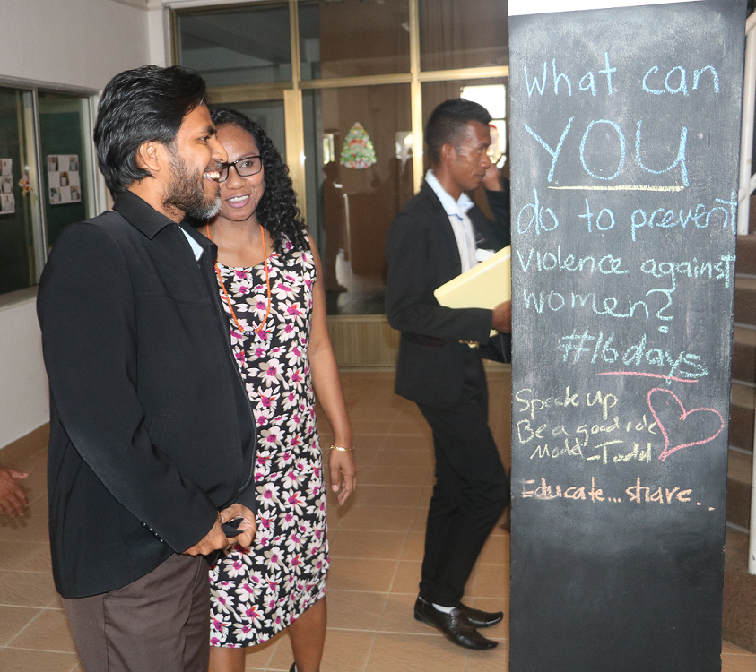
Nabilan has made progress on influencing increased GoTL dialogue and action on preventing VAWC. This has occurred through a strengthened relationship with SEII, and joint activities at both national and Manufahi level.
In October 2018, Nabilan conducted a joint media training workshop with SEII, JSMP, SECOM and the Press Council. This was the first joint prevention activity with SEII. Nabilan was able to observe SEII’s training and share our approach with the training directorate of SEII. At least 33 members of the media attended the training. Nabilan received positive feedback from SEII and the media, providing an entry point for future work with SEII. Based on the findings from the training, Nabilan developed a “positive media kit” to improve standards of reporting. The SECOM launched the package on 6 December 2018. Nabilan continues to conduct media monitoring to assess impact from the training and positive media kit.
Secretary of State for Social Communication at the launch of the positive media kit, 6 December 2018.
In Manufahi, Nabilan has developed a much closer relationship with the municipal administration through the KOKOSA! work. SEII was an equal partner in the organisation and implementation of all 16 days activities in Suku Letefoho, and the municipal hospital administration has supported KOKOSA! training for healthcare workers and the press conference on the links between HIV/AIDS and VAW.
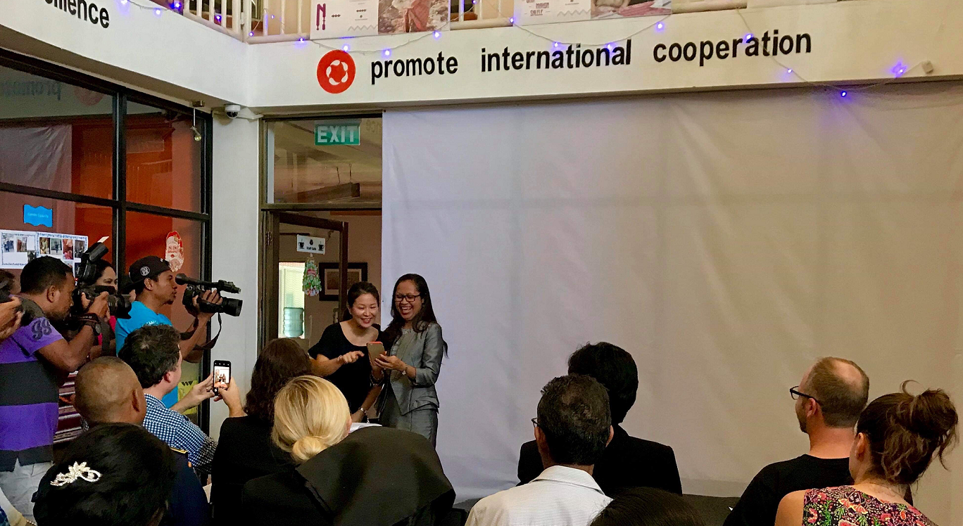
Secretary of State for Equality and Inclusion at the Hamahon launch, 6 December 2018.

4. Sustainability and appropriateness across the program
KEQ 3 and 4 on sustainability and appropriateness will be the focus of the mid-term review of Nabilan. Progress has been made already in sustainability of Nabilan program outcomes, as summarised below. Further work is required with the GoTL, in particular MSSI, and service providers to address the issue of sustainable funding for essential VAWC services. The delays in passing the State Budgets in 2017 and 2018 meant that no progress was possible in terms of advocating for increased percentage of government funding for these services.

Key achievements
- Nabilan continued to support partners through organisational and institutional strengthening (OIS). All long-standing Nabilan partners continues to show improvement in their OIS assessments.
- Nabilan supported PRADET with advocacy on allocation of government land for Fatin Hakmatek Dili services. As a result, advocacy was taken up on behalf of PRADET by SEII, members of parliament, and the umbrella civil society organisation FONGTIL. The Prime Minister’s Office intervened with the Ministry of Health and there are positive signs that PRADET will be given a long-term government lease on appropriate land to relocate Fatin Hakmatek Dili.
- As addressed under KEQ1, Nabilan’s Certificate III in Social Services has created a new social worker profession in Timor and will have lasting impact on service quality.
- As addressed under KEQ 2, Nabilan’s work to support a broader social norms change is starting to have impact with leaders, institutions and communities. The alumni from Nabilan’s Certificate III in Social Services course are emerging as strong leaders in the feminist movement.
- Nabilan’s baseline methodology is being used by Plan for their Reference Baseline Study of the Say No to Gender Based Violence in Timor-Leste Project, Year 2018 to 2020 (in Aileu).
- Nabilan and the Australian Embassy held a workshop on a government engagement strategy for Phase II. The strategy will be submitted in 2019.
Recommendation: Develop a government engagement strategy.

5. Learning & Management Responses
We identified the following key learnings from 2018.
- While client and services numbers were expected to hold steady compared with 2017, there was continuing increase in both numbers. Services partners are operating at beyond maximum capacity. Stress on service providers will be monitored going forward.
- Nabilan continues to contribute to quality training. Demand for Nabilan-supported training, particularly the Certificate III in Social Services training, remains high. Nabilan will remain responsive to demand.
- Nabilan’s investment in the Certificate III in Social Services course had an unexpected positive impact on the growing feminist movement in Timor-Leste. Alumni of the course are the most active leaders in this movement, strengthened by the knowledge and networks formed during the course.
- Nabilan’s support for Grupu Feminista and other leaders is having a noticeable impact, with minimal direct resourcing.
The recommendations from this report are as follows:
- Develop monitoring tools within the first six months of 2019 to better assess impact of Nabilan supported training and 4R training, including post-training survey tool, and routine pre- and post-training assessments. Update the medical forensic protocol and continue supporting refresher training for examiners. Nabilan will work with the M&E Adviser and M&E House as required.
- Continue to support service providers to improve their case management, with a particular emphasis on FOKUPERS in 2019. Nabilan’s Services Manager will lead this work.
- Support partners to use WGQ during client intake - this will take training and support, and should be delivered in coordination with DPOs. Nabilan’s Partnerships Manager will work with partners and ADTL to implement this recommendation throughout 2019.
- Work with ALFeLa and FOKUPERS to improve referral data, including possible update to ALFeLa’s case management database in the second half of 2019. Nabilan’s Services Manager will lead this work.
- Review Nabilan’s programming in the justice sector, particularly the balance between JSMP’s court monitoring work versus its advocacy work. A change in advocacy goals should be considered, for example moving away from the focus on charging and sentencing, and more on practical monitoring mechanisms for those on suspended sentences. The Nabilan Team Leader will undertake this review with JSMP and other partners in the first six months of 2019.
- Finish adaptation/translation of the SASA! toolkit and clearly define the knowledge to policy strategy for KOKSA!. Nabilan’s Social Norms Change Adviser will work with external experts in the second half of 2019 to finalise this strategy.
- Develop a government engagement strategy.
The key management response to these learnings and recommendations will be:
- Improve monitoring of training impact for Certificate III in Social Services Course, 4R training, and other Nabilan supported training (child protection, legal frameworks, gender).
- Identify specific plan to improve case management and OIS with FOKUPERS.
- Potentially pilot use of WGQ during client intake for PRADET, with support from ADTL and CBM.
- Cost requested updates to ALFeLa’s client management database.
- Conduct an independent review of JSMP’s VAWC work (update to 2015 audit) and ALFeLa case file audit (conducted 2015 and 2017).
- Continue adapting and sharing the SASA!/KOKOSA! materials.
- Clearly define the knowledge to policy strategy for KOKSA!
- Finalise the government engagement strategy.

Annexes
Annex 1 Key Evaluation Questions and sub-questions
Annex 2 Progress Against Indicators
Annex 3 Grant Summary Table
Annex 4 Management Responses

Annex 1 Key Evaluation Questions and sub-questions
KEQ1 How effective was the Nabilan program in guaranteeing women and children victims access to adequate and responsive services?
  - To what extent are service provider staff using their knowledge and skills for improved service delivery?
  - To what extent did Nabilan contribute to high quality service delivery?
  - To what extent did Nabilan contribute to inclusive service delivery?
  - How has Nabilan strengthened referral pathways?
  - How has Nabilan contributed to improving the justice sector response to VAWC?
KEQ 2 To what extent are individuals, communities and institutions taking action to reduce violence against women?
  - Is Nabilan effectively supporting partner agencies to undertake quality prevention programming?
  - How has Nabilan contributed to the independent women's movement’s advocacy on gender equity and ending VAWC?
  - To what extent has Nabilan influenced increased GOTL dialogue and action on preventing VAWC?
  - Is Nabilan effectively supporting Change Ambassadors to influence their programs on quality prevention approaches?
  - To what extent has Nabilan supported individuals, communities and institutions to recognise VAWC as a problem?
  - To what extent has Nabilan supported communities to take independent action to prevent VAWC?
  - To what extent has the evidence from the CBA pilot influenced prevention programming by other agencies?
KEQ 3 What key factors will contribute to the sustainability of the Nabilan program outcomes beyond the end of the program?
- To what extent is GOTL resourcing prevention activities and essential services for women and children impacted by violence? How did Nabilan contribute to this?
- Is there evidence of change of community attitudes and practices relating to VAWC?
- Is there evidence of strengthened local capacity and systems to continue implementation of quality services and prevention approaches?
- To what extent is the CBA approach likely to be replicable in the context of Timor-Leste?
KEQ 4 Are there indications that the Nabilan programming model has contributed, or could contribute, to changing social norms relating to GBV in Timor-Leste?
  - In Nabilan and partners supported focal areas, what evidence is there of change in community members’ and leaders’ attitudes to VAWC??
  - Was the approach taken appropriate to contribute to changes in social norms?

Annex 2 Progress Against Indicators
Rating | Description
On track | Our progress towards achieving this EOPO/KEQ is on track, at this stage of the program.
Some delay | There are some delays and challenges, but we expect to be back on track in the next reporting period.
Major delay | There have been significant delays and/or barrier to progress in this EOPO/KEQ. Management actions are proposed or being taken to address the delays/barriers.
Too early to tell | It is too early to tell if we are on track or not. Possibly the activities have not yet commenced, or only just commenced.

KEQ and Sub-Questions | Relevant outcome | Indicators | # | Corresponding PAF Indicator (Aug 2018) | # | Target | Status
KEQ1 How effective was the Nabilan program in guaranteeing women and children who experience violence have access to adequate and responsive services? | EOPO1: Women and children who experience violence have access to quality and inclusive services | - Number of new clients supported by Nabilan partners. Disaggregation: gender, age, municipality, disability, type of case | 1,343 | PAF Indicator 15: Number of women and girls who experience violence accessing essential services | 1,092 | Number of new clients steady compared with 2017 levels | On track
 |  | - Number of services provided by Nabilan partners  Disaggregation: type of service | 10,038 | PAF Indicator 12: Number of services provided | 7,599 | Number of services provided steady compared with 2017 levels | On track
1.1 To what extent are service provider staff using their knowledge and skills for improved service delivery? | IO1.1: Service providers use increased skills, knowledge and sensitivity to deliver services  ImO1.1 Key service provider staff have improved knowledge and skills | - Number of Nabilan partner and non-partner staff completing training (Certificate III in Social Services, Medical Forensic Examiner Training, 4R). Disaggregation: gender, disability, service. | Cert III: 21  MFE: 12  4R:98  Other training -  WGQ: 21  SOGIESC: 9  PNTL: 25  HAI: 17  CV: 56  FOKUPERS: 32 |  |  | - Certificate III: 20 in 2018; 20 in 2019; 20 in 2020; 20 in 2021  - 4R: 30 in 2018; 45 in 2019; 45 in 2020; 45 in 2021  - Medical forensic examiner training: 15 new examiners by end of 2019 | On track.
 |  | - Proportion of Nabilan-trained participants who demonstrate improved knowledge/skills.  Disaggregation: gender, disability, service | Cert III: 80% passed (21 out of 26)  MFE: 100% passed (12 out of 12) | PAF Indicator 9: Number of people who applied improved skills to deliver better quality services |  | At least 50% of participants in each training demonstrate improved knowledge/skills at end of training | On track against Cert III and MEF.  Insufficient data available for 4R and other Nabilan training.
1.2 To what extent did Nabilan contribute to high quality service delivery? | IO1.1: Service providers use increased skills, knowledge and sensitivity to deliver services  ImO1.1 Key service provider staff have improved knowledge and skills | - Case reviews showing increase in quality at service provider-level | 46% did not meet minimum standards  32% met minimum standards  21% high quality | PAF Indicator 10: Number of service delivery improvements |  | - By June 2019, at least 70% of cases meet minimum standards.  - By June 2021, at least 70% cases demonstrate high quality. | Major delay.
 |  | - Instances of Nabilan contributing to improved quality of support and legal services | See narrative report. | PAF Indicator 8: Instances of improved systems for service delivery |  | N/A | Some delay.
1.3 To what extent did Nabilan contribute to inclusive service delivery? | IO1.1: Service providers use increased skills, knowledge and sensitivity to deliver services | - Instances of Nabilan contributing to partners delivering inclusive services for marginalized clients | See narrative report. | PAF Indicator 8: Instances of improved systems for service delivery |  | N/A | On track.
 |  | - Proportion of clients supported by Nabilan partners that are vulnerable | 36 (2.6%) clients with disability  14% FFH  18% no schooling  11% does not speak Tetum |  | 5 (1.6%) clients with disability | Maintain or increase in proportion of clients with disabilities (and other vulnerable clients) compared with 2014 baseline | On track.
1.4 How has Nabilan strengthened referral pathways? | IO1.2: Women and children experiencing violence are referred to appropriate services  ImO1.2 Non-referral network service providers have knowledge and skills to respond appropriately to women and children who experience violence | - Number of women and children being referred to partner services. Disaggregation: referral source (from referral-network partners or outside the referral network (DPOs; health workers; community leaders; self-referred)) | Total 1,343 referred:  1,111 (83%) from within referral network;  232 (17%) from outside.  Total 1,266 referrals made:  937 (74%) within referral network;  329 (26%) to outside. |  | 2017:  Total 1,090 referrals received  Total 820 referrals made.  Did not disaggregate by within/ outside referral network. | - 5% increase in referrals from outside the referral network by 2020  - 10% increase in number of referrals made between service providers | On track.
1.5 How has Nabilan contributed to improving the justice sector response to VAWC? | IO1.4: The justice sector improves its response to VAWC  ImO1.4 Partners and service providers advocate for improved justice sector response to VAWC | - Evidence of appropriate charging and sentencing in the formal justice system:  - number of DV cases resulting in suspended sentence with monitoring obligation;  - number of DV cases being charged as serious assault or mistreatment of a spouse;  - number of DV cases resulting in fine | Suspended sentence with monitoring obligation: 26 (5%)  Charged as serious assault or mistreatment of a spouse: 48 (9%)  Fine: 74 (14%) |  | 2017:  Suspended sentence with monitoring obligation: 20 (5%)  Charged as serious assault or mistreatment of a spouse: 39 (10%)  Fine: 37 (11%) | Compared against 2017 baseline:  - increase in number of DV cases resulting in suspended sentence with monitoring obligation;  - increase in number of DV cases being charged as serious assault or mistreatment of a spouse;  - decrease in number of DV cases resulting in fine | Major delay.
 |  | - Number of cases of VAWC reaching the courts monitored by JSMP  Disaggregation: case type; special features such as defendant has disability, use of medical evidence; represented by ALFeLa | 1,008 total cases:  644 DV cases  55 sexual violence cases  409 other cases |  | 836 total cases:  403 DV cases  29 sexual violence cases  404 other cases | Number of cases holding steady against 2017 | On track.
 |  | - Evidence of Nabilan partners and service providers advocating for improved justice sector response to VAWC | See narrative report. |  |  | N/A | On track
KEQ 2 To what extent are individuals, communities and institutions taking action to reduce violence against women? | EOPO2: Individuals, communities and institutions take action to reduce violence against women and children | - Selected members at each level of the ecological model (individuals, communities, institutions) can demonstrate examples of action taken to reduce violence |  | PAF Indicator 13: Number of people that demonstrate improved attitudes to women and girls |  | 20% of respondents to Change Ambassador Survey and CBA monitoring survey can demonstrate appropriate examples of action taken to reduce violence | On track.
2.1 Is Nabilan effectively supporting partner agencies to undertake quality prevention programming? | IO2.1 Quality VAWC prevention initiatives which target individuals, communities and institutions are implemented  ImO2.2 Partner staff have knowledge & skills to implement effective prevention approaches | - Number of Nabilan-supported prevention activities reaching: individuals, families/relationship level, communities, institutions, society  - Number of people reached by each prevention activity. Disaggregation: gender, disability, location (when available) | 1 x community intervention (CBA/KOKOSA!)  1 x media training (society/media level)  Newspaper advertorials – continuing (society level)  Grupu Feminista social media campaigns – continuing (society level)  Prevention grants delayed to 2019. |  |  | At least one activity at each level. | Some delay.
 |  | - Effectiveness score for partner prevention programming |  |  |  | Each partner has an annual score increase of at least 5%, or reaches score of 28 by 2022. | Some delay.
2.2 How has Nabilan contributed to independent women's movement's advocacy on gender equity and ending VAWC? | ImO2.1 The Independent women’s movement is supported to promote gender equity and is empowered to advocate for social change | - Instances of Nabilan support to the independent women's movement to advocate on preventing VAWC | See narrative report. | PAF Indicator 14: Instances of women’s leadership opportunities and empowerment |  | N/A | On track.
2.3 To what extent has Nabilan influenced increased GOTL dialogue and action on preventing VAWC? | ImO2.3 Selected GoTL agencies have improved knowledge to implement effective prevention approaches | - Instances of Nabilan supporting Government agencies to integrate effective prevention messaging in their own programs | See narrative report. | PAF Indicator 20: Instances of improved policy and implementation; PAF Indicator 21: Instances of evidence available for decision-making |  | N/A | On track.
2.4 Is Nabilan effectively supporting Change Ambassadors to influence their programs to integrate quality prevention approaches? | ImO2.4 Change Ambassadors have the knowledge and are supported to influence the integration of quality prevention approaches | - Examples of Change Ambassadors integrating quality prevention approaches into their own programs | See narrative report. |  |  | N/A | On track.
 |  | - Number of Change Ambassadors who continue to participate in the network | 13 – 26 for each session |  |  | 20 by end 2019 have continued to participate in the network. | On track.
 |  | - Proportion of Change Ambassadors with improved knowledge and confidence to advocate for the integration of effective prevention messaging into their own programs |  |  |  | At least 70% of Change Ambassadors have improved knowledge and feel confident about integrating effective prevention messaging into their programs. | On track.
2.5 To what extent has Nabilan supported individuals, communities and institutions to recognise VAWC as a problem? | IO2.2 Individuals, communities and institutions recognise VAWC as a problem | - Proportion of participants displaying improved knowledge and attitudes related about VAWC Disaggregation: gender  Reported separately for:  * Participants in primary prevention initiatives  * Target groups of other Nabilan-supported prevention activities |  | PAF Indicator 13: Number of people that demonstrate improved attitudes to women and girls |  | TBC | Some delay.
2.6 To what extent has Nabilan supported communities to take independent action to prevent VAWC? | IO2.3 Communities in Suku Letefoho and other focus areas are taking independent action to prevent VAWC | - Completion of all four phases of SASA! in Suku Letefoho by July 2020.  Note: SASA! methodology requires community members to reach a threshold of knowledge, attitudes, skills, and behaviour before moving onto each phase. This will be assessed through qualitative and quantitative CBA monitoring tools, FGDs and Rapid Assessment Surveys (RAS), deployed at the beginning and end of each of the four phases of the CBA work in Manufahi. | See narrative report.  Moved into Phase II in July 2018; Phase II to be completed by end June 2019. |  |  | Completion of Phase II (Awareness) between July 2018 – June 2019;  Completion of Phase III (Support) between July – December 2019;  Completion of Phase III (Action) between Jan – July 2020.  Target will combine analysis of both quantitative and qualitative data and decision made by Nabilan team on if there is sufficient change in the community to progress to the next phase of SASA!. | On track.
 |  | - Number of activities conducted by community mobilisers to prevent VAWC in suku Letefoho. | 126 activities completed by mobilisers:  41 in Phase I  85 activities in Phase II |  |  | Phase 1: minimum 2 activities per CM per month  Phase 2: minimum 4 activities per CM per month;  Phase 3 & 4: TBC | Some delay.
 |  | - Number of collective actions taken by community members in Suku Letefoho to prevent VAWC. | 4 (2 drama performances; 1 press conference; 1 community march) | PAF Indicator 13: Number of people that demonstrate improved attitudes to women and girls |  | At least 3 instances of collective action taken by 2020 | On track.
2.7 To what extent has the evidence from the CBA pilot influenced prevention programming by other agencies? | ImO2.5 Learning from the Community Based Approach in Suku Letefoho is documented analysed and used by Nabilan and other organisations. | - Instances where other agencies have adopted the key approaches and learning from the CBA pilot. | See narrative report. |  |  | N/A | On track.
KEQ 3 What key factors will contribute to the sustainability of the Nabilan program outcomes beyond the end of the program? | Principle: Sustainability | Addressing KEQ3 and its sub-questions will be a key focus of the mid-term review. To answer these questions, the mid-term review will synthesise data from a range of sources, including key informant interviews, reviews of existing documents and literature, existing data collected to answer KEQs 1 and 2. |  |  |  | N/A
3.1 To what extent is GOTL resourcing prevention activities and essential services for women and children impacted by violence? How has Nabilan influenced this? | IO1.3: Relevant Ministries use evidence to allocate funding of essential services  ImO1.3 Partners advocate for increased GoTL funding of essential VAWC services | - Instances that reflect GoTL recognition of the need for sustainable funding for services |  |  |  | 1 MoU with MoH signed; 1 PRPF held each year; funding discussed at coordination meetings with UN agencies, government and other donors | Some delay.
 |  | - Evidence of changed funding portfolio (%) provided by Nabilan/other donors/government to for Nabilan partners |  |  |  | N/A | Some delay.
 |  | - Evidence of Nabilan partners advocating to GoTL for increased funding |  |  |  | N/A | Some delay.
3.2 Is there evidence of changes in community attitudes and practices relating to VAWC? |  | Refer to Indicators 13 and 23 above |  |  |  | Refer to Indicators 13 and 23 above | Too early to tell.
3.3 Is there evidence of strengthened local capacity and systems to continue implementation of quality services and prevention approaches? |  | - Organisational Institutional Strengthening assessment ratings |  |  |  | By 2022 each organisation is meeting at least 80% of all OIS milestones across all nine categories | Too early to tell.
 |  | Refer to Indicators 5-8 above |  |  |  | Refer to Indicators 5-8 above
3.4 To what extent is the CBA approach likely to be replicable in the context of Timor-Leste? |  | - Stakeholder perceptions of appropriateness of the CBA approach in the context of Timor-Leste |  |  |  | N/A | Too early to tell.
KEQ 4 Are there indications that the Nabilan programming model has contributed, or could contribute, to changing social norms relating to VAWC in Timor-Leste? | Principle: Appropriateness | Addressing KEQ4 and its sub-questions will be a key focus of the mid-term review. To answer these questions, the mid-term review will synthesise data from a range of sources, including key informant interviews, reviews of existing documents and literature, existing data collected to answer KEQs 1 and 2. The Nabilan Endline survey will provide additional data against this KEQ. |  |  |  | N/A | Too early to tell.

Annex 3 Grant Summary Table
Partner |  | Actual Grant Disbursed in $US
 | Jan - June 2018 |  | July - Dec 2018 | Total: Jan – Dec 2018
ALFeLa | $78,777.17 |  | $110,468.02 | $189,245.19
Casa Vida | $77,058.48 |  | $91,259.98 | $168,318.46
FOKUPERS |  |  | $33,600.00 | $33,600.00
PRADET – Fatin Hakmatek | $181,405.04 |  | $234,626.66 | $416,031.70
PRADET – Medical forensic training |  |  | $27,568.05 | $27,568.05
Uma Mahon Salele | $47,935.79 |  | $46,550.00 | $94,485.79
JSMP | $69,136.05 |  | $84,239.28 | $153,375.33
JSMP – Penal Code Guide |  |  | $26,136.00 | $26,136.00
Total | $454,312.53 |  | $654,447.99 | $1,108,760.52

Annex 4 Management responses
Previous report recommendations and management response – action and progress (from August 2018)
Key Area | Recommendations | Management response | Responsibility | Progress
Services | Client data to be disaggregated by LGBTI/ other vulnerable groups. | Update partner narrative reporting template. | Team Leader  Partnerships Manager | Completed.
 | For referrals in Manufahi, develop mechanism to track whether they are related to CBA work. | Trace referrals from Manufahi, where possible, including referrals from CMs and new Uma Mahon. | Services Manager  Municipal Officer | No progress. Issues with client confidentiality. 4 referrals were made by CMs (based on CBA monitoring).
 | The referrals sources need to be further clarified e.g. define who are ‘community leaders’, be more specific in list of ‘other NGOs’. | Update partner narrative reporting template. | Team Leader  Partnerships Manager | Completed.
 | Monitor what is happening with the new Uma Mahon in Letefoho, and if required provide TA through services team & Cert III. | Municipal Officer and Services Manager to visit Uma Mahon and assess capacity and needs. | Services Manager  Municipal Officer | Completed. Visit undertaken, and two staff enrolled in the Certificate III course starting January 2019.
 | There are currently no tools assessing women’s suicide risk, and limited support pathways for women at risk of suicide. We need to explore this further. | Engage consultant to develop these tools. | Team Leader  Services Manager | On hold. Existing tools could be adapted. Dr. Margaret Gibbons will share the tool being introduced to PRADET.
 | Need to consider how to deliver counselling training to people in municipalities. | Engage consultant to develop counselling course which could be delivered by national staff.  Change structure of Certificate III course to allow greater participation from staff in the municipalities. | Team Leader  Services Manager | In progress. Five-day counselling training course being developed.  Fourteen out of 25 students in the 3rd round of the Certificate III course are from the municipalities.
 | Need to develop tools to track how Certificate III graduates apply their skills to improve service delivery. | M&E Adviser to develop appropriate tool. Seek support from M&E House. | Team Leader | In progress. M&E Adviser developed post-training survey tool (February 2019). M&E House will support with other tools.
 | Need to strengthen pre-post assessment of PRADET 4R training participants. | Seek support from M&E House. | Team Leader | In progress. M&E House will provide support in 2019.
 | Be clear on attribution vs contribution of Nabilan. | Improve in evidence matrix. | Team Leader | In progress.
 | Need to revise case management tools & review process in light of the evaluation findings. | Update case management audit tools. | Team Leader  Services Manager | Completed. New audit criteria developed in September–October 2018. Audit completed for 207 sample cases.
 | Strengthen referral pathways to partners from DPOs, LGBTI community and Estrela. | Invite DPOs and other groups to Nabilan bi-monthly partner meetings. Continue gender, disability & SOGIESC training for partners. Strengthen Certificate III course content on vulnerable groups. | Services Manager  Partnerships Manager  Training & TA Manager | In progress. ADTL and RHTO invited to bi-monthly partner meetings. SOGIESC training delivered once in 2018 and once in 2019. Certificate III course materials are being updated to focus more on marginalised groups, including inviting guest facilitators.
 | Need to do more to increase referrals from outside the referral network – e.g. working with church, DPOs. | Training for DPOs on referral network. Work with church groups in Manufahi. | Training & TA Manager  Municipal Officer | In progress. Nabilan began working with church groups in Manufahi as part of KOKOSA!.  Will look for opportunities to provide training for DPOs, possibly through a services partner.
 | Increase awareness of referral network by engaging with healthcare workers, INS and DPOs | Training for DPOs on referral network.  Training for healthcare workers.  Continue 4R training. | Training & TA Manager | In progress. Conducted training for HAI. Marie Stopes has 3 students in the 3rd round of the Certificate III course. PRADET continued 4R training.  Will look for opportunities to provide training for DPOs, possibly through a services partner.
 | Need to understand how clients are being referred by collecting more specific information on referral sources.  Need to clarify how referrals by family are captured in the data. | Update partner narrative reporting template. | Team Leader  Partnerships Manager | Completed.
 | Need to engage with PHD on their teenage pregnancy work (manual and church engagement). | Meet with PHD to discuss their strategy. | Team Leader | No progress. Unclear if PHD is continuing this work.
 | Need to strategically engage with church leaders.  Identify entry points and linkages with other programs working with the church. | Look for opportunities in Manufahi through CBA work. | Municipal Officer | In progress. Nabilan began working with church groups in Manufahi as part of KOKOSA!.
Justice | Need to identify strategies to reduce the use of fines (thorough advocacy, resources & training to judges, etc.). | Review Nabilan’s programming in justice sector. | Team Leader | In progress. Limited funding means direct training for judges is not possible. The guide to the Penal Code will provide better explanation of the relevant provisions.
 | Need to look at how JSMP media releases link to Nabilan priorities and how these releases are taken up/used by other agencies. | Monitor JSMP media release and conduct media monitoring. | Social Norms Change Program Officer | In progress. Media monitoring is being conducted and JSMP press releases are checked regularly.
Social Norms Change | Work with JSMP, SEII and FMDC to develop media training based on Nabilan media monitoring findings. | Conduct joint training for media to improve gender sensitive reporting. | Training & TA Manager  Municipal Officer | Completed in October – joint training for media with SEII, SECOM, JSMP and Press Council.
 | Declining participation in CAN: Work with Embassy on invitations, set-up Facebook group, and set meeting schedule. | Work with Embassy on invitations, set-up Facebook group, and set meeting schedule. | Social Norms Change Program Officer | Completed. All invitations now sent from Embassy; have meeting schedule for 2019; held two make-up sessions.
 | MELP – review indicator 13. | Update MELP. | Team Leader | Completed.
 | Identify ways to work more with SEII in 2019. Involve embassy in the discussion. | Hold meeting with SEII to identify joint-activities and workplan. Invite embassy to all meetings at DG level or higher. | Team Leader  Social Norms Change Adviser | In progress. Several meetings with SEII held in 2018 and draft workplan submitted. Meeting held in January 2019 to identify joint activities for Phase II.
 | MELP - merge indicators 19 and 20 and make it into a narrative indicator or SSC. | Update MELP. | Team Leader  M&E House | Completed.
 | Write up results of CAN baseline (consultations & survey). | Write up results of CAN baseline (consultations & survey). | Social Norms Change Adviser | Completed.
 | Explore CAN additional funding opportunities with embassy. | Request additional funding for the make-up sessions. | Social Norms Change Adviser | Completed.
 | MELP - need to set specific targets for CBA work & better articulate the process. | Update the MELP with more specific targets. | Team Leader  Social Norms Change Adviser | Completed.
 | Individual mentoring of CMs. | Municipal Officer to closely accompany and mentor CMs. | Municipal Officer | Ongoing.
 | Finish adaptation/translation of SASA! Toolkit. | Continue adaptation and translation as we progress through the 3 stages. | Social Norms Change Adviser | Continuing. Adaptations for phase 2 (Awareness) completed. Additional materials (health chats etc.) also translated.
 | Revise community mobilising tools/ activities based on baseline findings related to sexual violence. | Revise tools. | Social Norms Change Adviser | Continuing.
 | MELP – need to revise indicator 23 (remove reference to CBA) and review other CBA indicators. | Update MELP. | M&E House | Completed.
 | MELP – change indicator 24 to “number (or instances) of discrete community actions taken in Suku Letefoho to prevent VAWC” and set targets. | Update MELP. | M&E House | Completed.
 | MELP – set target dates for moving to Phase 3 and 4 of CBA program. | Update MELP. | M&E House | Completed.
Sustainability | Revise Question 2.7 to “To what extent has evidence generated by Nabilan influenced programming by other agencies?” – to broaden the question so it’s not just about CBA evidence. | Update MELP. | M&E House | Completed.
 | Finalise strategy for government and community engagement. | Hold workshop with Embassy, and draft strategy. | Team Leader | In progress. Workshops held in December 2018, strategy being drafted.
 | Seek opportunities to raise issues with GoTL through high level representation (e.g. HOM) |  | Team Leader | Continuing. Support for PRADET was advanced through HOM.
 | Need PRPF meetings and LoG signed for higher level engagement. |  | Embassy | In progress. Amendments to LoG submitted to MSSI and SEII.
 | Work with GfD to look at government gender expenditure data. Need to clarify what is counted as “gender expenditure” in this data. | Analyse the gender budget statement. | Team Leader  Director of Public Policy | Completed. Budget expenditure statement for 2019 showed much higher allocation (70%) towards gender equality than expected.
 | DFAT to explore potential for volunteer to be placed with MS  SI. |  | Embassy | Completed.

‘Duodecimo’: every month public institutions can only expend 1/12th of their annual budget on every budget line based on the actual expenditure of the previous year.
As of 7 February 2019.
Aide Memoire: Timor-Leste Country Visit, to end violence against women and girls evaluation. September 2018.
The Asia Foundation. 2016. Understanding Violence against Women and Children in Timor-Leste: Findings from the Nabilan Baseline Study – Main Report. The Asia Foundation: Dili.
SASA! (Start, Awareness, Support, Action) is a model of primary prevention developed by Raising Voices Uganda. Its effectiveness in preventing intimate partner violence within programmatic timeframes has been verified by randomised control trials conducted by the Center for Domestic Violence Prevention, London School of Hygiene and Tropical Medicine and Makerere University.

