**Publication**

Partnership for Human Development

First Six-Monthly Progress Report: Volume I

July–December 2016

Issued February 2017

© 2017

Cover photo: Junior doctor completing medical training through the Royal Australian College of Surgeons

Credit: Sara Hudson, Royal Australian College of Surgeons

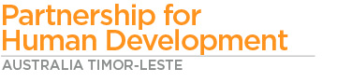

CONTENTS

Acronyms and Abbreviations 3

Executive Summary 4

Introduction 5

Achieving Greater Development Impacts 6

Health 7

Education 10

Water and Sanitation 13

Nutrition 15

Social Protection 17

Gender 18

Disability 19

Conclusion 20

# Acronyms and Abbreviations

|  |  |
| --- | --- |
| ATLASS II | Australia-Timor-Leste Program of Assistance for Secondary Services Phase II |
| AUD | Australian dollars |
| BESIK | Programa Bee, Saneamentu no Ijiene iha Komunidade [Water, Sanitation and Hygiene in Communities Program] |
| BdM | *Bolsa da Mãe* [Conditional Cash Transfer Program] |
| HAI | Health Alliance International |
| INFORDEPE | Instituto Nacional de Formação de Docentes e Profissionais da Educação [National Institute for the Training of Teachers and Educational Professionals] |
| MSTL | Marie Stopes Timor-Leste |
| NGO | Non-Government Organisation |
| ODF | Open Defecation Free |
| PHD | Australia Timor-Leste Partnership for Human Development |
| PLMP | Professional Learning and Mentoring Program |
| PRADET | Psychosocial Recovery and Development in East Timor |
| RHTO | Ra’es Hadomi Timor Oan |
| SDG | Sustainable Development Goals |
| SRH | Sexual Reproductive Health |
| TLNAS | Timor-Leste National Ambulance Service |
| UNESCO | United Nations Education, Scientific and Cultural Organization |
| WHO | World Health Organization |

# Executive Summary

The Australia Timor-Leste Partnership for Human Development (PHD) has in its first six months successfully transitioned multiple activities under one program whilst establishing its corporate operations backbone. Programs have continued with minimal interruption, while a major strategic planning exercise has commenced to deliver collaborative and innovative programming for the next five years. PHD has also maintained long-term relationships with key stakeholders, by working closely with the Australian Embassy to ensure the program supports the Australian Government’s engagement with the Government of Timor-Leste.

Moving forward, PHD is focused on finalising and implementing its Five Year Strategic Plan, in cooperation with both governments. This will be underpinned by a robust Monitoring, Evaluation and Learning Framework to ensure: **accountability** for the outcomes achieved with the resources provided; attention to opportunities for **learning and knowledge generation**; and **effective communication** about PHD activities and outcomes for stakeholders to support evidence-based decision-making.

This report summarises the establishment and progress of PHD for the period July 2016 to December 2016, in relation to its efforts to enhance human development in Timor-Leste.

Key activities delivered include:

* Successful transition and ongoing delivery of existing programs, including the transition of over 44 former program personnel to ensure continuity of relationships and program knowledge.
* Establishment and nurturing of relationships with key stakeholders required to take the program forward.
* Support to the Ministry of Education to distribute new curriculum materials for Grade 3 and Grade 4 to 307 preschools and 1,334 Ensino Basico schools.
* Assistance to Ministry of Social Solidarity *Bolsa da Mãe* systems to support and strengthen public financial management.
* Launched the PHD Facebook page, which has attracted over 9,800 followers.
* Supported the launch of the Hamutuk program in September 2016.

# Introduction

PHD supports the Government of Timor-Leste’s *Strategic Development Plan 2011–2030* and reflects Australia’s commitment to work in partnership with the Government of Timor-Leste to enhance human development in Timor-Leste over the next 10 years. The investment (AUD 120 million over the first phase, July 2016 to May 2021), works towards Strategic Objective 2 of Australia’s Timor-Leste Aid Investment Plan: *Enhancing Human Development*.

PHD brings together, under one program, what were previously eight separate Australian Government investments in health, education, sanitation, water, nutrition, gender equality, disability and social protection. By bringing them together, the Government of Australia hopes to maximise the effectiveness, relevance, and performance of Australia’s human development aid portfolio to better support the Government of Timor-Leste.

PHD’s Five Year Strategic Plan, due in April 2017, will deliver greater coherence in PHD programming, enabling enhanced support for the Government of Timor-Leste to meet its development challenges. PHD’s Monitoring and Evaluation Learning Framework will support these efforts, providing a firm evidence base for innovative interventions and ongoing support. Furthermore, the Framework will give PHD the ability to determine which of its programs and activities are working and which need to be modified.

PHD’s role is to ensure that coming generations of Timorese people are better able to lead, contribute to and benefit from their nation’s economic and social development.

Working together under one program will enable these investments to deliver on the objectives identified in Figure 1 below.

Education

Health

Water

Nutrition

Disability

Gender Equality

Social Protection

Sanitation

**Investment:** to Improve Human Development in Timor-Leste.

**Outcome:**

Coming generations of Timorese can lead, contribute to, and benefit from their nation’s economic and social development.

**Through Partnership:** Government of Australia in partnership with Government of Timor-Leste.

**Strategic Alignment:**

Government of Timor-Leste’s *Strategic Development Plan 2011–2030*

Australia’s Timor-Leste Aid Investment Plan, Strategic Objective 2: *Enhancing Human Development*

**Program Objectives, better achieved through a collaborative, cross-sectoral approach:**

* Improved maternal and newborn health.
* Available and accessible family planning services and commodities.
* Strengthened high impact health system investments.
* Improved water and sanitation:
  + Improved toilets and hygiene.
  + Sustainable access to safe rural water.
* Improved education outcomes focusing on basic literacy and numeracy for primary school children, including those with disabilities.
* Address nutrition as a cross-cutting theme and promote heathy eating.
* Mainstream gender and social inclusion:
  + Women and girls are empowered and have access to improved services.
  + People with disabilities are “included”.
  + Poor and vulnerable people have safeguards.

Figure 1: PHD’s overarching framework.

# Achieving Greater Development Impacts

A key aim of the PHD design is to achieve better human development outcomes – those that directly impact on the people of Timor-Leste – through being able to offer a more complete response to complex development problems. Ways of working more effectively in partnership with the Government of Timor-Leste, other donors, and non-government organisations (NGOs) through a comprehensive and cross-sectoral program have been discussed through a series of strategic programming meetings and continue to be developed. This approach will be trialled in coming years, and linked to a robust monitoring, evaluation and learning framework, to ensure that the most appropriate and effective modalities are being applied for delivering development impacts.

The design for PHD provided a good rationale for why individual sectors should fall under the one program. PHD will now pilot ways in which the program can best achieve positive impact on peoples’ wellbeing.

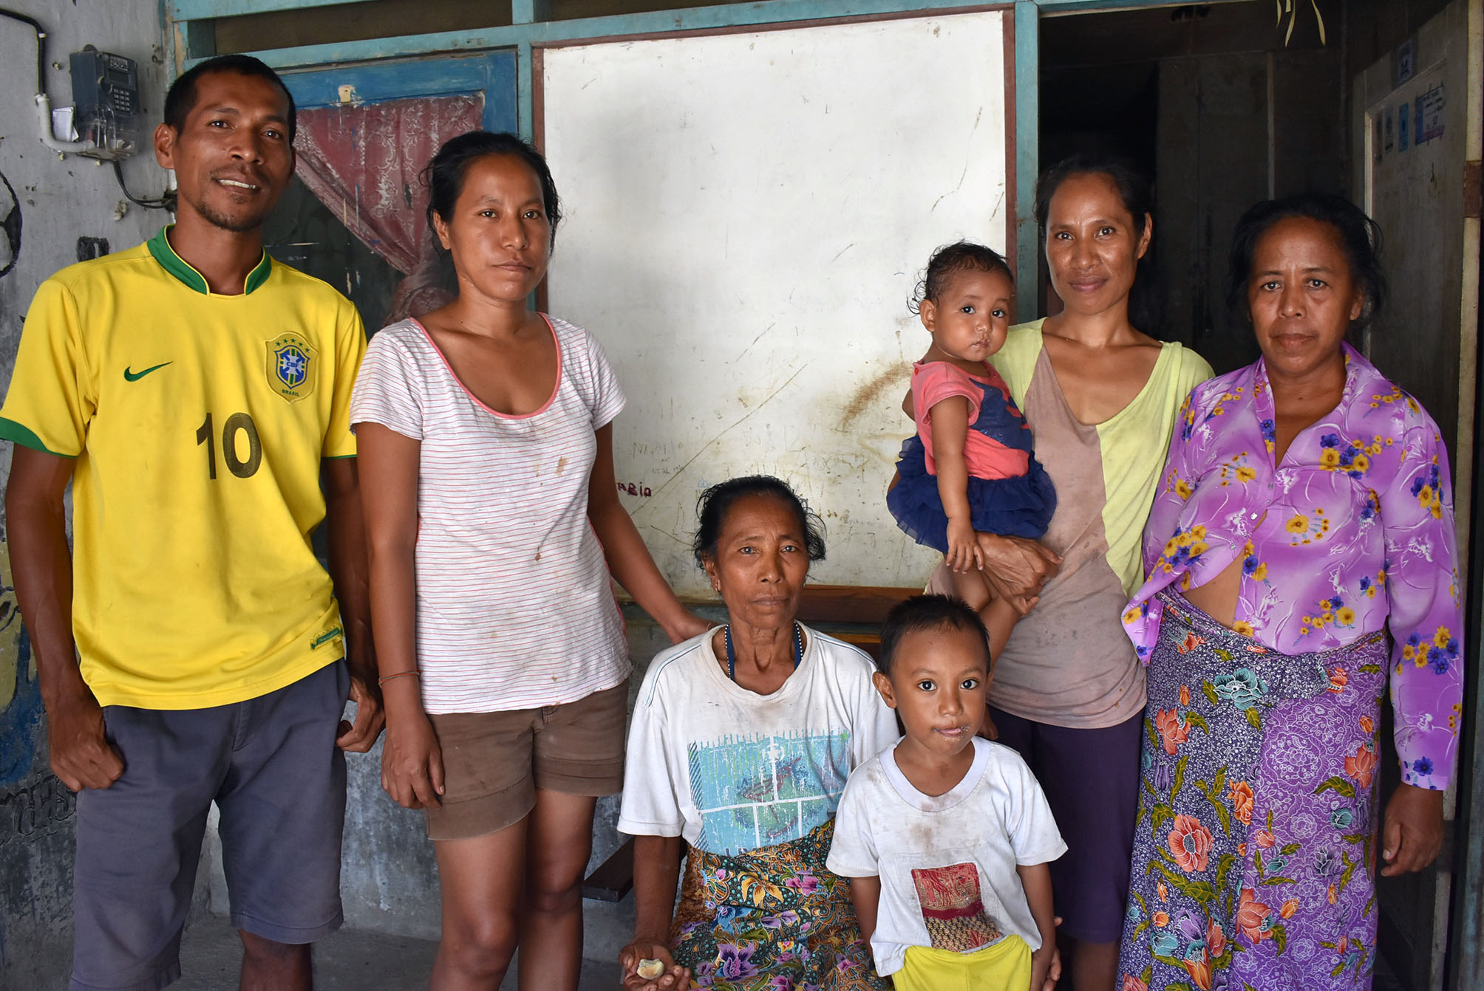

# Health

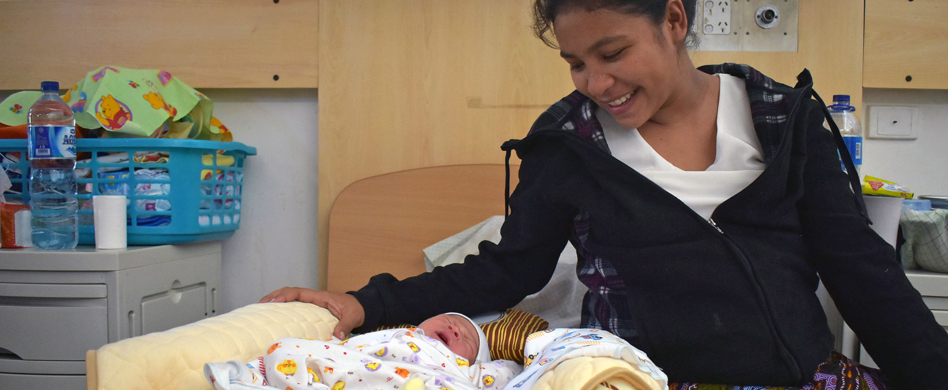

|  |  |
| --- | --- |
| 2016-17 Budget: | AUD 7,575,000 |
| Sector Goal: | Improve access to health services for the people of Timor-Leste and promote better health, sanitation, and hygiene practices, so that they adopt these. |
| Focus: | Maternal and newborn health. |

PHD’s program partners in Health have continued to deliver support to improve maternal and newborn health, with some support provided directly through PHD to the Ministry of Health.

## Highlights

* 153 midwives and 2 doctors completed a full Learning Laboratory cycle. This includes 59 providers for safe and clean delivery, and 23 providers for essential newborn care.
* 22 Timorese doctors were trained in anaesthesia, paediatrics, and surgery, and 24 first year Diploma and 8 Postgraduate Diploma trainees in Family Medicine successfully completed their rotations and exams.
* Over 14,000 expectant mothers are registered through the Liga Inan program, which means they will have regular interaction with health providers during their pregnancy period.
* 85 percent of Marie-Stopes Timor-Leste’s (MSTL) clients reported being satisfied with the family planning, and sexual and reproductive health services received through the MSTL team.
* Through their family planning work, MSTL attended more than 12,400 client visits, and averted an estimated 1,743 unintended pregnancies.

## Scale up of Liga Inan Program

Implemented in partnership with Catalpa International and Health Alliance International (HAI), the Liga Inan program continues to use simple mobile phone technology to facilitate communication between expectant mothers and health workers.

In the reporting period, Liga Inan scaled-up and now operates in Ainaro and Covalima municipalities, and preliminary work to launch in Baucau has been initiated. Additionally, the management for Liquica municipality was handed over to the Ministry of Health in November 2016. By December 2016, over 14,000 women were registered across 6 municipalities, with a plan to start in Baucau in mid-2017. Registration at a community health centre means that expectant mothers are more likely to benefit from the relevant care during pregnancy and after delivery of their babies, and it also increases the likelihood of mothers having an assisted birth. A Liga Inan mother is twice as likely to deliver with a skilled birth attendant and seven times more likely to go for follow-up care.

## Family Planning

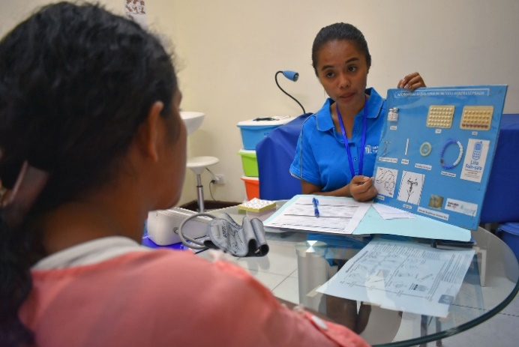MSTL continues to support the provision of family planning to 11 municipalities in Timor-Leste. MSTL operates in every sub-municipality of these 11 municipalities, supporting more than 140 community health centres and health posts to deliver a range of high quality family planning and sexual reproductive health (SRH) training and services.

During the reporting period, MSTL provided small group education sessions on family planning and SRH, and received and answered 12,469 calls through the youth hotline (*Lina Foin-sa’e*), with an increase of 52 percent in female callers. The MSTL clinic and outreach teams attended more than 12,400 client visits, and averted an estimated 1,743 unintended pregnancies through their work. An increased proportion (42 percent increase) of Timorese women are using family planning methods.

In interviews with 498 MSTL clients, it was found that 85 percent of clients were satisfied with services and responsiveness. According to the World Health Organization, family planning helps prevent closely spaced and ill-timed pregnancies and births, which are directly linked to infant mortality rates. Their evidence also suggests that women who have more than 4 children are at increased risk of maternal mortality[1].

## Health System Strengthening

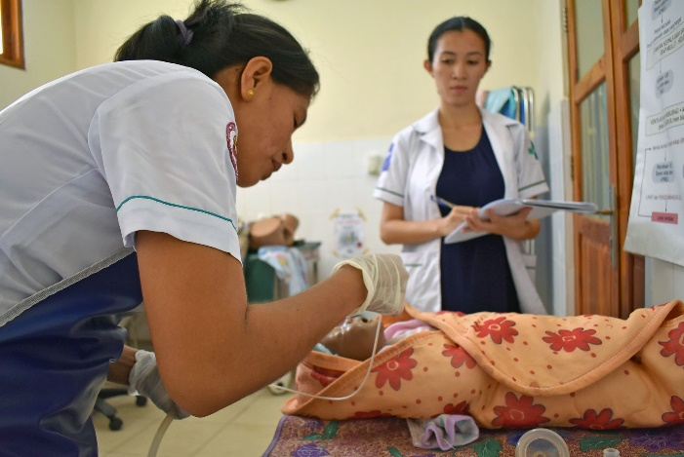MSTL and HAI have been working closely with the Ministry of Health to strengthen the competencies of Ministry of Health service providers in family planning services, safe and clean delivery, and essential newborn care, through Learning Laboratories and coaching and mentoring of providers and their supervisors.

**MSTL** supports clinical providers to deliver high quality, broad ranging family planning services through improved knowledge, skills, and attitudes.

**HAI’s** Learning Laboratories, implemented in partnership with the Instituto Nacional de Saúde, are a practical way of strengthening health providers’ core competencies in life saving, safe and clean deliveries, newborn care, and provider–client communications.

During the reporting period, a total of 153 midwives and 2 doctors completed a full Learning Laboratory cycle. This includes 59 providers for safe and clean delivery, and 23 providers for essential newborn care. All health providers completed their Laboratory cycle. Another 61 providers started a Laboratory cycle during the period to be completed in 2017.

Further evidence through the World Health Organization (WHO) indicates that postnatal care is critical to both maternal and child mortality, but is one of the most neglected periods for care[2]. With greater competency in government midwives, the quality of family planning and SRH services is improving, more families are aware of the benefits of and are using family planning and SRH services, and more midwives are delivering safe and clean births and essential newborn care services.

Seven municipalities have made improvements to their Timor-Leste Health Management Information System (HMIS), with the Ministry of Health Monitoring and Evaluation Department better able to analyse and use health information. Feedback from the improvements process was shared at the Joint Annual Health Sector Review and is being used by the WHO to feed into the HMIS strategic plan and program registers for maternal and child health, immunisation, family planning, outpatients, laboratory, and surveillance. Plans for strengthening the public financial management within the Ministry of Health were reviewed, and research to identify and map issues affecting hygiene and sanitation at health facilities was conducted. Stronger health systems provide scope for improving both access and health practices.

## Hospital Based Education and Training

The Royal Australasian College of Surgeons provides secondary assistance services (ATLASS II) in partnership with the Ministry of Health, the Guido Valadares National Hospital, and the National University. In the reporting period, 22 Timorese doctors were trained in anaesthesia, paediatrics, and surgery, and 24 first year Diploma and 8 Postgraduate Diploma trainees in Family Medicine successfully completed their rotations and exams. Through the College’s initiatives, more junior doctors expect to have increased basic clinical competencies, including in maternal and reproductive health, family planning, and paediatric services, which will contribute to improving maternal and child health services in Timor-Leste.

## Improved Access to Sexual Reproductive Health Services for People with Disabilities

The Christian Blind Mission Australia has been providing services to ensure health programs are inclusive of and benefit people with disabilities, particularly women and children. The Mission completed the research report, *Knowledge, Attitudes and Practices of Maternal and Child Health Providers to Women with Disabilities*, and disseminated the findings, which have been used to plan future positive action. They have been advocates of disability awareness by providing training to key providers and NGOs in the health sector. Improved disability awareness in the health sector provides greater scope for everyone to access services.

|  |
| --- |
| Box 1 – Timor-Leste’s Ambulance Service provides midwifery support for on-road retrievals in Dili and aeromedical transfers to the districts  TLNAS’s first on-road midwife, Felismina dos Santos, delivered a healthy baby in Hera after being called to the home when the mother went into labour and there was not enough time to reach the nearest health facility.  This life-saving service is supported by the Ambulance and Transport Project, which works with the Ministry of Health to reduce maternal morbidity and mortality. Over a third of ambulance call-outs are obstetric-related.  The project also provides clinical support to the TLNAS, which includes an Australian paramedic adviser, a Timorese-trained midwife, and now 8 Emergency Medical Dispatchers provided in collaboration with Cruz Vermelha Timor-Leste. Every year over 200 Timorese nurses and doctors are trained in emergency ambulance care. This is delivered through professional development, as well as formal training provided by program partners. |

## Service Delivery

The Timor-Leste National Ambulance Service (TLNAS) is a free, government-run service providing emergency response across all 13 municipalities in Timor-Leste. TLNAS has a fleet of 56 active vehicles (with a further 77 multi-function vehicles) and approximately 85 staff, including paramedics, doctors, and ambulance officers. The team at the Ambulance and Transport Project (who support the TLNAS continue, on average, to undertake 9 service events per week, and 35 percent of these are conducted in the municipalities by the project’s mobile mechanic team. The project has consistently maintained high-quality and low-cost maintenance services, through the mobile mechanic model. Workshops in Dili continue to function at a high level with a quality rating close to 99 percent, indicating that faults are being accurately diagnosed and repaired.

In October 2016, TLNAS team members travelled to Darwin, Australia, to gain exposure to a variety of aspects of emergency services. They participated in the World Health Organization emergency medical team verification event, attended a disaster logistics course, and learnt from professionals at the St John Ambulance Operations Centre.

Then in November 2016, the team travelled to Victoria, Australia, to the Victorian Ambulance Service to learn about clinical leadership models on-road with David Natoli, a Mobile Intensive Care paramedic and senior clinician. In exchange, Mr Natoli flew back to Dili to provide technical advice on the implementation of Clinical Practice Guidelines within the TLNAS.

The TLNAS is actively seeking to improve clinical outcomes and transport times for vulnerable and ill Timorese patients. The project and TLNAS work together collaboratively to maintain resource availability and staff competency.

# Education

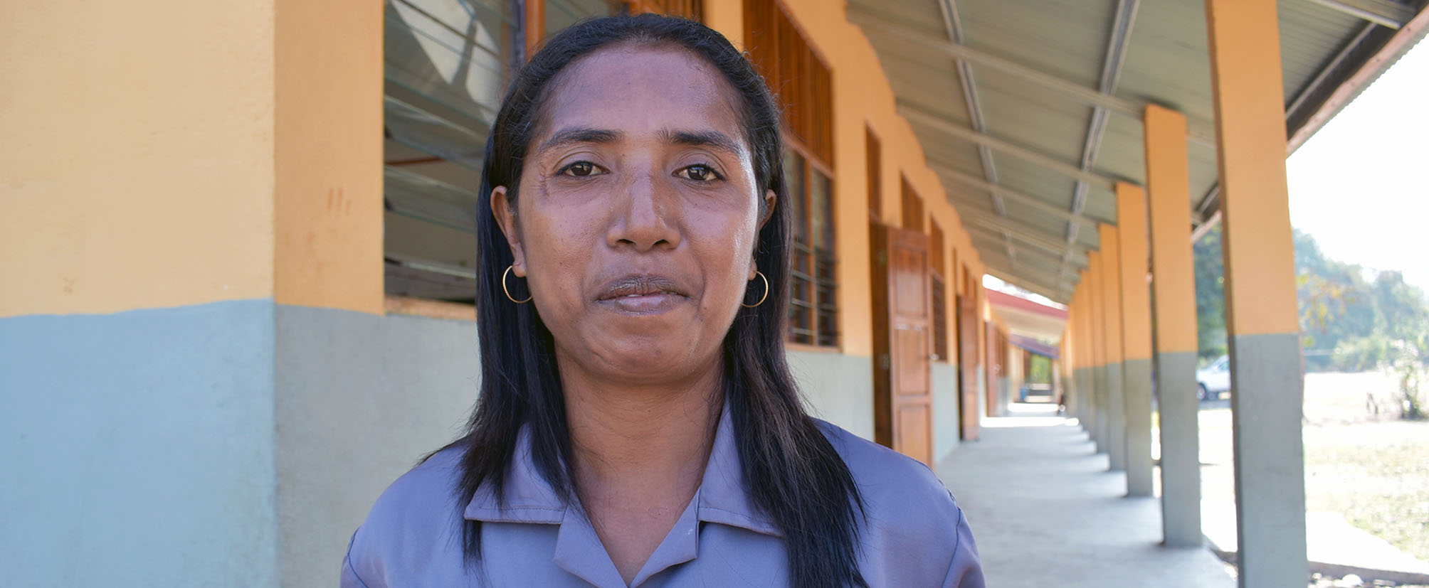

|  |  |
| --- | --- |
| 2016-17 Budget: | AUD 3,443,677 |
| Sector Goal: | Improved basic education for all Timorese children for improved literacy and numeracy skills. |
| Focus: | Children in Grades 1 to 6. |

## Highlights

* Distribution of Ministry of Education’s national curriculum materials for Grade 3 and Grade 4 to 307 preschools and 1,334 Ensino Basico schools.
* Teacher training to approximately 200 school leaders to effectively deliver the Professional Learning and Mentoring Program (PLMP), with another 65 new enrolments in pre-service teacher training, and 52 graduations from the pre-service program.
* Design of interactive training materials, which included:
  + Set-up and delivery of training materials on tablets.
  + Design and development of mobile application for peer learning.
  + Design and deployment of data collection and assessment tool.
  + Design and development of mobile application for teacher classroom observations.
  + Creation of real-time program monitoring dashboard.
* Preparation for the monitoring and evaluation of PLMP and specialised teacher training.

During the reporting period, the PHD Education sector worked collaboratively and consultatively with the Ministry of Education and the National Institute for the Training of Teachers and Educational Professionals (INFORDEPE) to deliver basic education activities in line with the priorities of the Government of Timor-Leste.

The PHD Education sector ensured uninterrupted and ongoing support to improved literacy and numeracy in the early years and holistic learning outcomes through building school leadership capacity. The program also worked to improve Grades 1 to 4 teacher practice and education sector policy and systems. A key focus in the reporting period was to support the implementation of the Ministry of Education’s new child-centred basic education curriculum and training of teachers.

## Professional Learning and Mentoring Program

PLMP, partnered with Ministry of Education, INFORDEPE, and the Australian Embassy, aims to improve student achievement and learning by building the capacity of teachers and school leaders to support the new curriculum and its pedagogies. This has been achieved through:

* **Leadership events** for leaders involved in Grades 1 to 6, so far including 3 events, usually for 2 days each time.
* **Mentoring**: international and national accompanier mentors working closely with school leaders and teachers through classroom observations and feedback.
* **Peer learning groups** occur at least monthly within clusters.
* **IT tablets** for record-keeping about classroom observations, student literacy/numeracy results, and peer learning.

|  |  |  |
| --- | --- | --- |
| **Phase of PLMP** | **Locations** | **Scope** |
| Phase 1  (Apr 2016–Dec 2016) | Liquica and Manatuto | 62 schools, 90 school leaders |
| Phase 2  (Aug 2016–Mar 2017) | Dili (including Atauro), Aileu, and one cluster in Lacluta, Viqueque | 90 schools, 110 school leaders |
| Phase 3  (Feb 2017–Sep 2017) | Baucau and Viqueque (25 percent of each municipality) and Bobonaro |  |
| Phase 4  (Apr 2017–Dec 2017) | TBC |  |

PLMP aims to cover 50 percent of schools in each municipality within each phase, with nationwide coverage within 5 years. The improvements in teacher classroom practice have resulted in increased student literacy and numeracy test results by varying degrees, but usually by around 15–20 percent over a 4 month period. The World Bank plans to verify these results through testing in early 2017.

An observation checklist, used in Liquica and Manatuto, has indicated an increase in teacher lesson preparation from 75 to 90 percent in the reporting period. Similarly it has shown improvements in lesson planning, classroom management, pedagogical skills, and participation, from 60 to 80–90 percent in the reporting period. It is expected that through improvements in teacher preparation, management, and participation skills, higher student engagement will result and lead to improved literacy and numeracy outcomes.

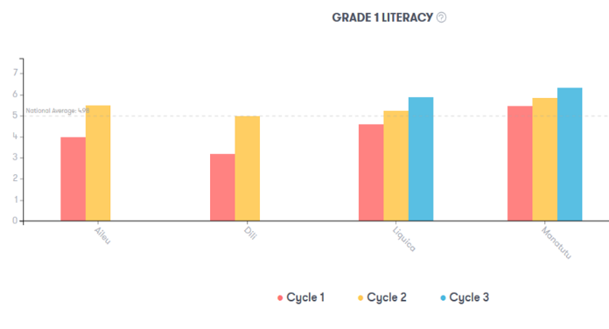

Figure 2: Grade 1 Literacy Improvement across Municipalities

Interviews were carried out with inspectors, directors, adjuntos, and coordinators of filial schools, which gave clear indication of improvements in teacher practices. Correlated improvements included:

* Teachers remaining at school after hours to prepare lessons.
* Teachers being creative in using various resources to engage students better in the learning process.
* Better use of group work.
* Teacher use of an individual lesson plan reflecting the new curriculum; increased punctuality of teachers and leaders.
* Greater use of active learning processes and more child-centred learning.

An education infrastructure analysis report was developed to project demand and supply of schooling from 2015–2030 to support Ministry planning. The report maps the changing demand for schooling (primary and secondary school) and maps the classroom and teacher supply requirements. It provides the Ministry with evidence to support the aim to secure future funds for school facilities and supply of teachers. The report findings have been used in political party discussions in the lead-up to the elections and during the budget process. The report has also been submitted to the Ministry of Education’s Global Partnership for Education Secretariat to inform the Ministry of Education’s next sector analysis.

## Mother-Tongue Based Multilingual Education

There has been a move towards teaching children in their mother tongue as the instructional language to better prepare students to learn the official languages, which are Tetum and Portuguese. The results of this have shown considerable improvement in student literacy rates, as demonstrated by End-line Assessment carried out by UNESCO National Commission through the Mother-Tongue Based Multilingual Education Program.

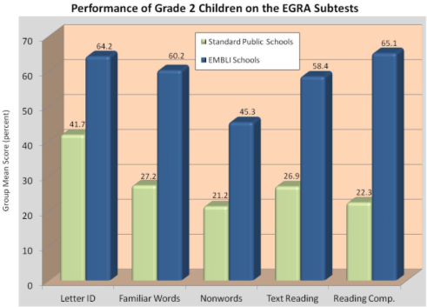Comparison studies indicate that the Mother-Tongue Program preschool students are now achieving Grade 1 and Grade 2 results, indicating an acceleration in children’s academic development by 1.5 to 2 years.

## Distribution of the Ministry of Education’s National Curriculum Materials

In partnership with the Ministry of Education, the national curriculum materials for Grades 3 and 4 were distributed to 307 preschools and 1,334 Ensino Basico schools across Timor-Leste. PHD provided technical support for improved warehouse management, packing, distribution, monitoring, reporting, and cross learning. Distribution was followed by monitoring of 13 preschools and 140 Ensino Basico schools, by the Ministry of Education, INFORDEPE, and PHD/PLMP, to review the availability of learning materials, such as lesson plans, and the use of the materials at schools after the INFORDEPE teacher training. This monitoring will feed into Ministry planning for 2017 curriculum distribution.

Figure 3: Performance of Grade 2 Children on the EGRA Subtests.

## Scholarships

A ‘Girls Education Award’ through the Alola Foundation, has supported university access to Timorese women through the continuation of 49 university scholarships at local institutions, employment training, and mentoring. In the reporting period 4 students have graduated.

After graduating, students are given the opportunity to join job-readiness training, with the objectives of improving their capacity and encouraging them to determine their future goals, as well as learning how to write a resume and apply for relevant positions. Five students completed the training in the reporting period.

“This training has provided me valuable information and guides me to searching for my future career; and this is as a reference for me in order to find a job.”

Students are very welcome to do an internship at Alola and work as a volunteer to improve their knowledge. Alola approaches NGOs and institutions to locate job opportunities. The scholarship has an impact on literacy, as the financial support allows girls to stay in school.

## Teacher Training

Improvements in the quality of teaching to primary students are being achieved through the provision of a Bachelor of Teaching (primary) at the Baucau Catholic Teachers College. The ability for Timorese to access quality teacher training is significantly improving, with up to 60 students graduating annually, the provision of third-year specialist courses in English, science, and mathematics, as well as an expansion to a fourth-year course for gaining a Licensiatura. This is complemented by further professional development through a Masters of Education program, financial management skills training, Portuguese language training, and leadership and management training. In the reporting period there were 52 graduates.

The impact of improvements to teaching quality for primary students is that a child-centred teaching approach is becoming more widely used within Timor-Leste. This approach enthuses students to learn, resulting in higher attendance numbers, and leading to higher literacy and numeracy rates.

# Water and Sanitation

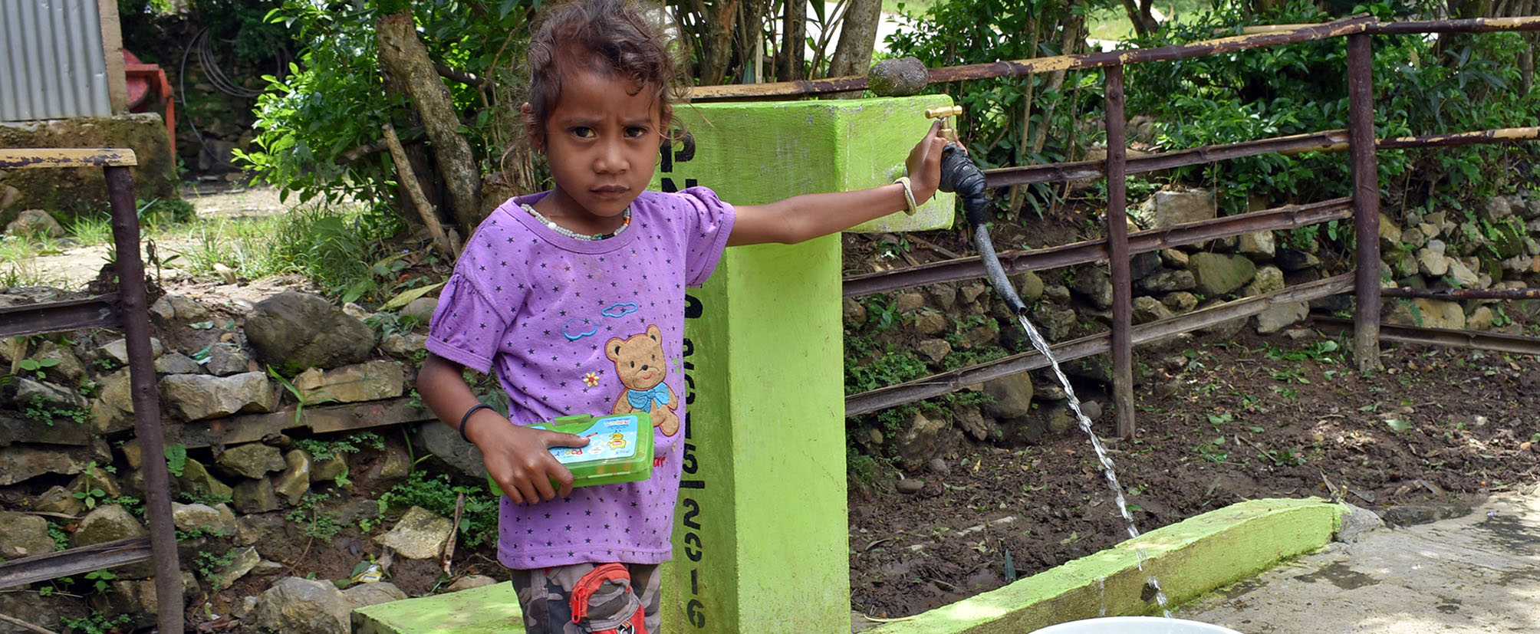

## SANITATION

|  |  |
| --- | --- |
| 2016-17 Budget: | AUD 890,000 |
| Sector Goal: | Improve sanitation through mobilising community action to end open defecation and supporting Open Defecation Free communities to advance to ‘Hygienic’ status. |
| Focus: | Increased toilet access and improved toilet conditions to maximise the practice of hygienic behaviours. |

## Highlights

* Municipal leadership commitment to the Open Defecation Free (ODF) Initiative in Aileu, Ainaro, Bobonaro, and Liquica; with requests from Manufahi and Viqueque municipality to the Ministry of Health to implement the ODF Initiative.
* Development of the Sanitation Improvement Roadmap, with Ministry of Health and NGO partner commitment to its achievement.
* Draft design for the Hygienic Initiative, with Bobonaro Municipality and Atabae Administrative Post leadership interest in its implementation.
* National Hospital and National Institute for Health ownership of PHD-supported Global Handwashing Day and World Toilet Day.
* Hand Washing with Soap behaviour change campaign packages ready for use.
* Sanitation improvement indicators finalised with Ministry of Health and implementing partners.

## An Open Defecation Free Timor-Leste

Planning for implementation of the ODF Initiative in Aileu, Ainaro, and Liquica Municipalities has begun with municipal commitment and NGO partner implementation strategies being drafted. Results from the ODF Sustainability Study have fed into improvements in the ODF Initiative. As part of the Sanitation sector strategy development process, an assessment of risks for implementation of ODF Initiative during the next year of changes has also been carried out. The PHD Sanitation sector also actively collaborated with the Ministry of Health on the design of the sanitation sector strategy and initiated visits to three municipalities to engage municipal and administrative post governments in the ODF Initiative, and in Bobonaro Municipality to discuss actions needed to move from 94 percent coverage to 100 percent. Institutional triggering[3] in the target locations has been prepared.

The ODF Initiative works towards increasing demand and community ownership over household building of toilets, and improving sanitation practices through the eradication of open defecation. ODF status is achieved through a municipality-led strategy that accelerates community action to end open defecation. This municipality-led approach is successful through motivational leadership and an institutional triggering process, complemented by triggering community action and follow-up. Together these create a new social norm for sanitation to achieve ODF in Timor-Leste.

The Ministry of Health, with support from PHD, has developed a National Sanitation Roadmap to achieve the National Basic Sanitation Policy goals. In discussions with sectoral agencies through the Government’s Sanitation Working Group, partners were identified in each of Timor-Leste’s municipalities for implementation of the Roadmap activities.

## Hygienic Status Initiative

A Hygienic Initiative concept design has been developed for trial in Atabae Administrative Post (Bobonaro), through consultation with relevant government and partner stakeholders, including the Ministry of Health, Ministry of Public Works, Ministry of Social Solidarity, municipal and administrative post leadership, the National Program for Suco Development, the Market Development Facility, and relevant NGOs. Results from the ODF Sustainability Study have also fed the concept design. Market research into community access to sanitation supplies through the private sector in Atabae Administrative Post to enable toilet upgrades is planned for early 2017.

The Hygienic Initiative, targeted at Atabae Administrative Post (which has achieved ODF status in 2016), is aimed at supporting communities to upgrade their sanitation to advance the community from ODF to Hygienic. Hygienic status requires that ODF status is maintained in the community, all houses have improved toilets, all toilets have handwashing facilities that are equipped with water and soap, and all schools and health facilities have improved sanitation. The goal of Hygienic status is based on the ODF Sustainability Study finding that approximately 18 percent of houses in ODF communities revert to open defecation, because they could not access desired sanitation supplies to upgrade their toilet, ensuring that all households can access appropriate supplies, both logistically and financially. Proposed market research aims to account for this in the design of the Hygienic Initiative. The private sector will be assessed for appropriate sanitation supplies and engaged in a voucher scheme to support houses to upgrade their household sanitation. Improving toilets will reduce faeces exposure in the environment and optimise the sustainability and use of the toilets, thus contributing to better and more sustainable health outcomes.

## WATER

|  |  |
| --- | --- |
| 2016-17 Budget: | AUD 1,000,000 |
| Sector Goal: | Build on achievements of previous investments in the water sector through working in partnership with the Government of Timor-Leste, other donors, and NGOs. |
| Focus: | Improving management of established water systems. |

The Ministry of Infrastructure, in partnership with the BESIK program, has implemented a number of water systems throughout Timor-Leste. To build on these achievements, PHD is now targeting work in Bobonaro Municipality and proposing to improve service delivery through a two-pronged approach: (1) improving community management of water systems; and (2) strengthening the responsiveness of municipal leadership to operations and maintenance needs. The pilot of this approach will be integrated with the Hygienic Initiative and contribute to the achievement of Hygienic status.

PHD has been investigating the benefits of a more holistic approach across sectors, by bringing together water, sanitation, and hygiene. A rapid assessment, carried out in the reporting period, is providing recommendations for the various actors in the water and sanitation sectors to collaborate for maximum effectiveness to advance water sustainability and access, as well as sanitation to achieve greater hygiene levels at the household and community level. It also considers integration at the municipal and national levels across key education and health facilities. This will be progressed to begin implementation in 2017.

# Nutrition

|  |  |
| --- | --- |
| 2016-17 Budget: | AUD 1,200,000 |
| Sector Goal: | Reduce stunting among children aged 0–23 months in Timor-Leste. |
| Focus: | The health and nutritional status of mothers and children. |

## Highlights

* Hamutuk Launch in September 2016.
* Regional Launch Big Think was held October 2016.
* Facilitated the President’s Nutrition Awards on Independence Day (28 November 2016) by the President in Los Palos.

|  |
| --- |
| **Box 2 – Working together to improve nutrition outcomes in Timor-Leste**  The Australian Embassy’s Hamutuk program aims to reduce the prevalence of stunting in children under 2 years in Timor-Leste through collective action across sectors. Through innovative thinking, Hamutuk is:   * Strengthening nutrition capacity across partners. * Working to improve a range of nutrition-promoting behaviours. * Using innovative technology to foster multi-sector collaboration.   Hamutuk commenced work in Holarua, Manufahi. Holarua consists of 13 hamlets, half of which are not accessible from the main road. The total population is approximately 7,000 people.  Over the next 5 years, Hamutuk plans to expand to other villages in Timor-Leste.    https://hamutuk.tl/static/img/Logos/HAMUTUK_LOGO.png |

## Nutrition Awareness

The Regional Launch Big Think hosted a regional nutrition and food security dialogue. It included participation in World Food Day activities, and a seminar and field trips to expand that dialogue. Through it potential innovators in the sector and from the region were supported to submit applications to the Launch Food Revolution Challenge. It was attended by 12 Pacific Island representatives and colleagues from Second Muse and the Australian Government Innovation Exchange. Opening dialogue in the sector expands information flow and allows avenues for communication that set the groundwork for nutrition awareness in Timor-Leste.

The President’s Nutrition Award was granted on Independence Day by the President. This award raises awareness of the nutrition situation in Timor-Leste, motivates and inspires more Timorese to become involved in evidence-based nutrition practices, educates and raises awareness on improved practices, while also recognising and rewarding leaders and achievers in Timor-Leste communities. Evidence through the Food and Agriculture Organization of the United Nations and the World Health Organization indicates that nutrition awareness, particularly amongst women, contributes to better maternal health and lower child mortality rates[4].

In the reporting period, the President’s Nutrition Program book was drafted to complement the award, along with a President’s Nutrition and Food Security round-table dialogue report. These documents indicate dedication at the national level to nutrition and food security, and also actively work towards increasing awareness throughout the country.

## Strengthening Nutrition Capacity and Behaviour

Hamutuk is a pilot strategy for collective nutrition impact in selected Timor-Leste villages. It looks at trialling communication tools and resources for targeted social behaviour change, and measuring impact on nutrition status. Hamutuk is led by the National Council for Food Security, Sovereignty and Nutrition in Timor-Leste, the Australian Embassy in Timor-Leste, and a Technical Support Hub. The Hamutuk Launch was attended by the Australian Ambassador, the President’s Office, District Administrator, and all PHD partners, to increase its prevalence in the sector.

## Improving Maternal and Newborn Health

Implemented by the Alola Foundation, the Maternal and Child Health Program included ongoing cooking demonstrations, infant and young child feeding counselling, community discussion groups, counselling services and home visits for pregnant and lactating women in Manufahi Municipality with a focus on Holarua. Members of the Mothers Support Groups in Holarua also participated in Hamutuk multi-sector nutrition training. The impact of this was timely referrals to health facilities and supported breastfeeding and complementary feeding for children under 2 years.

# Social Protection

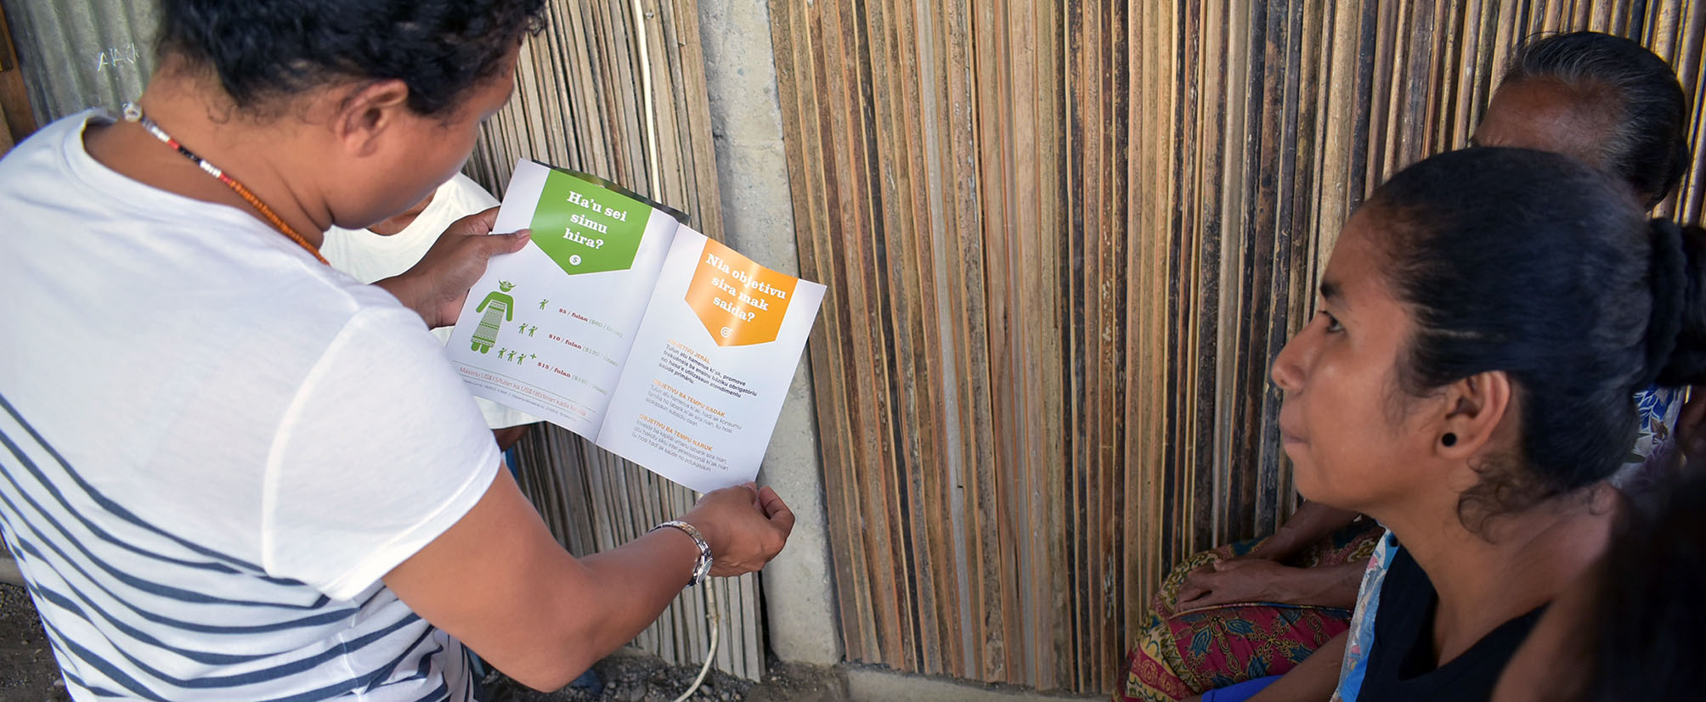

|  |  |
| --- | --- |
| 2016-17 Budget: | AUD 390,000 |
| Sector Goal: | Contribute towards building a solid social protection base for all Timorese people. |
| Focus: | Supporting the Government of Timor-Leste’s *Bolsa da Mãe* social protection transfer system. |

## Highlights

* Assistance to the Minister of Social Solidarity in policy making, policy reform advocacy, research, planning, and monitoring and evaluation.
* Assistance to the Ministry of Social Solidarity *Bolsa da Mãe* (*BdM*) department for system and payments improvements.

## Ministry Policy and Planning

To build a social protection base for the people of Timor-Leste, contributions to Ministry policy were given, including advocacy on reforming *BdM* program design and also collaboration on drafting the first National Social Protection Strategy, a work in process being led by the International Labour Organization, with the Ministry of Social Solidarity.

A Social Protection Costing Tool was developed to capture the broader benefits of social protection transfers and feed into policy design and budget decision-making. This has led into discussions on the Timor-Leste Social Protection Framework and how transfer expenditures can be improved. A concept paper on the priorities for social protection investment, with a review of existing programs, was drafted and provided to the Minister of Social Solidarity and the Prime Minister’s Office.

Staff from PHD, the Embassy, the Prime Minister’s Office, and the Ministry of Social Solidarity attended training in Chiang Mai in October 2016 on Designing and Implementing Social Transfer Programmes. This has led to a Ministry request for training of their staff to improve efficiency in the design and implementation of social benefits programs.

Three staff in the Ministry of Social Solidarity have been provided with English language lessons, with the aim of widening their training options and access to policy information across the world.

## *Bolsa da Mãe* Systems Improvements

Systems support in the *BdM* department has led to improvements and efficiencies. Following a quality review of the Social Assistance Information and Management System, the *BdM* module was improved and the Ministry staff were trained in using the system and quality data input. Data input timelines were set and old data for *BdM* registrations was cross-checked against other sources to confirm accuracy, leading to a clean-up of data. This contributed to smoother *BdM* payments during the December 2016 and January 2017 period.

Information sharing with frontline staff and beneficiaries was improved with a number of *BdM* information brochures and posters disseminated to Ministry of Social Solidarity Social Technicians, health centres and health posts, PLMP target schools, and civil society organisations. This in turn allowed these actors to better inform poor households, especially the ones with disability-affected children, about their entitlements when registering for *BdM*.

# Gender

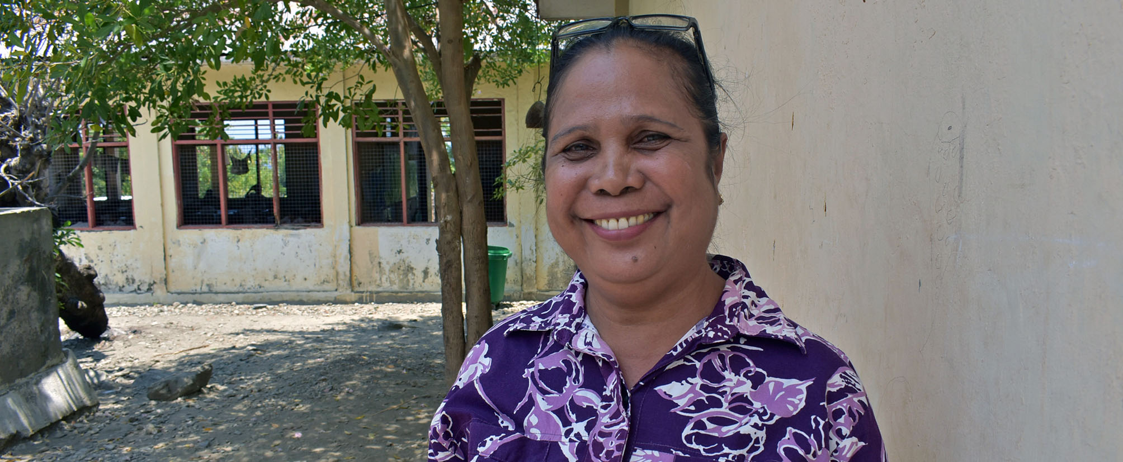

|  |  |
| --- | --- |
| 2016-17 Budget: | AUD 312,492 |
| Sector Goal: | Mainstream gender equality through all PHD programming, so that women and girls are more empowered and have better access to improved services. |
| Focus: | Mainstreaming gender equality across all Australian Embassy investments. |

## Highlights

* Introductory training workshop on the Care International Gender Empowerment Framework.
* Reviews and updates of the Gender Action Plan.

Key events included International Women’s Day and the Ending Violence Against Women Campaign, both of which had a significant turn-out promoting gender awareness throughout Timor-Leste.

## Gender Empowerment Framework

PHD have been engaging with Care International about their Gender Empowerment Framework, which looks at overlapping three important dimensions in empowerment: the individual’s agency (aspirations and capabilities); their relations (power relations through which paths are navigated); and the structures (environment that surrounds and conditions choice); as well as engaging men and boys to challenge social norms and stereotypes. While the Framework is global, based on a variety of studies, it is a starting point for stakeholders to begin exploring power relations and how change can come about in the Timor-Leste context. It allows partners to link women’s own definition and priorities for empowerment to key dimensions of social change.

The training workshop, held in October 2016, allowed partners to gain understanding of the Framework and provide them with markers to rank their own projects to determine where gender mainstreaming improvements may lie.

## Gender Action Plan

The Australian Embassy’s Gender Action Plan aims to ensure all sectors are accountable for gender mainstreaming and to plan their activities with a gender-appropriate lens. The Action Plan has been reviewed and updated, with key priorities set out and agreed. The review included collaborative discussions across a range of Embassy programs, including the Market Development Facility, Governance for Development, National Program for Suco Development, and Farming for Prosperity Timor-Leste, to achieve consistency in approach across Timor-Leste investments.

The priorities in the Gender Action Plan focus on ensuring all sectors incorporate gender-focused activities for which they will be held accountable to safeguard their implementation.

# Disability

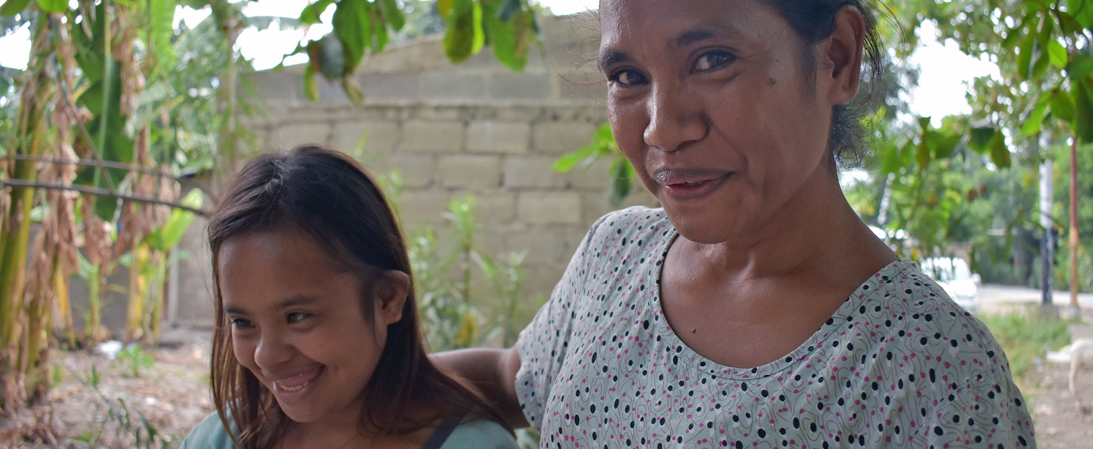

|  |  |
| --- | --- |
| 2016-17 Budget: | AUD 1,053,079 |
| Sector Goal: | Improve disability-inclusive mainstreaming in development, so that people living with disabilities benefit from improved opportunities and access to services, and increase their participation in leadership. |
| Focus: | Advocacy for people living with disabilities, in particular with regard to livelihood and employment. |

## Highlights

* Disability awareness advocacy and increased access to education, health, and justice services for people with disability through Ra’es Hadomi Timor Oan and Asosiasaun Defisiensia Timor-Leste.
* Mental health service access for clients, families, and prisoners through visitations, counselling, and education/recreation programs, with improved empowerment through skills training.

## Advocacy and Improved Access

A number of training and advocacy events through Ra’es Hadomi Timor Oan have led to increased awareness for disability inclusiveness in Timor-Leste, lending a voice to people with disability. It provided a space for people with different type of disability to learn. Thirteen schools and vocational training centres were also given training and a number of self-help groups initiated to improve opportunity and access to educational services. Thirteen people with disability were also provided with referrals to health and rehabilitation services to improve their access to health.

The Asosiasaun Defisiensia Timor-Leste is also leading the way in advocacy and access by identifying 9 home-based jobs for people with disability to increase their access to opportunity, as well as conducting Community Based Rehabilitation Diploma 1 courses to improve the quality of disability services, enabling people with disability to attend secondary school equivalency exams in Indonesia and access internships to increase access to education services, and also providing publications to increase awareness. The International Day of People with Disability (3 December 2016) was held through the organisation in 13 municipalities, increasing the awareness of disability and visibility of people with disability.

## Support in Mental Health

The Psychosocial Recovery and Development organisation has been working closely with Timorese facing mental health issues to improve their opportunities and determine avenues for access to service and family support. Access to mental health services has improved through visits and individual counselling to around 160 clients. In Dili a Psychosocial Rehabilitation Service was provided, which conducted skills training in cooking, hygiene, and daily living. Opportunities for dissemination of information on mental health and referral options were taken through mental health case managers, and through a public forum to advocate for the rights of the mentally ill and their families.

# Conclusion

PHD, in its initial phase, has successfully brought together stakeholders from a variety of sectors to work together towards enhancing human development in Timor-Leste. Partners are actively engaged and implementing a variety of strong initiatives to support Timorese to better lead and contribute to Timor-Leste’s economic and social development.

With pilots trialling the most effective way to improve a collaborative cross-sectoral approach, complex problems to key services are improving. More Timorese are also receiving information on available key services and have improved access to them.

The Program’s forward priorities include:

* Be responsive to the Government of Timor-Leste’s human development priorities.
* Address development challenges that require collaborative interventions across sectors.
* Contribute to sustainable and holistic development outcomes.
* Share lessons, analyse, plan, and implement approaches across sectors.

The PHD Five-Year Strategic Plan and MELF are close to being finalised and PHD will finalise its governance structure in the first half of 2017. These key aspects are fundamental to bedding down PHD’s foundations. Once resolved, together with the foundational work done during the first six months, PHD will be well placed to provide successful support to the Government of Timor-Leste in the years ahead.

1. See http://who.int/mediacentre/factsheets/fs351/en/.
2. See http://apps.who.int/iris/bitstream/10665/97603/1/9789241506649_eng.pdf
3. Institutional triggering is mobilising municipality administrations, health services and local authorities to prioritise their commitment to ending ODF through raising awareness with the community leaders about the sanitation problems in their communities and talk about ways to solve them, garnering support and commitment from the community leaders to bring about change in the community with regard to the sanitation situation, and developing an action plan for community-led total sanitation activities in their community.
4. See <http://www.fao.org/ag/humannutrition/nutritioneducation/en> and <http://www.who.int/nutrition/EB128_18_backgroundpaper2_A_reviewofhealthinterven tionswithaneffectonnutrition.pdf>.