Mission Performance Report

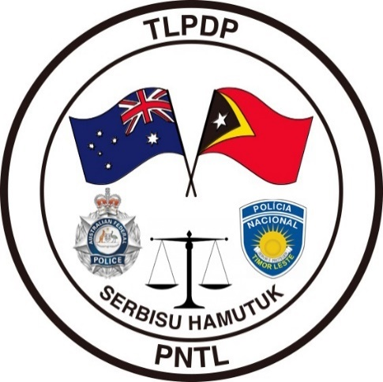
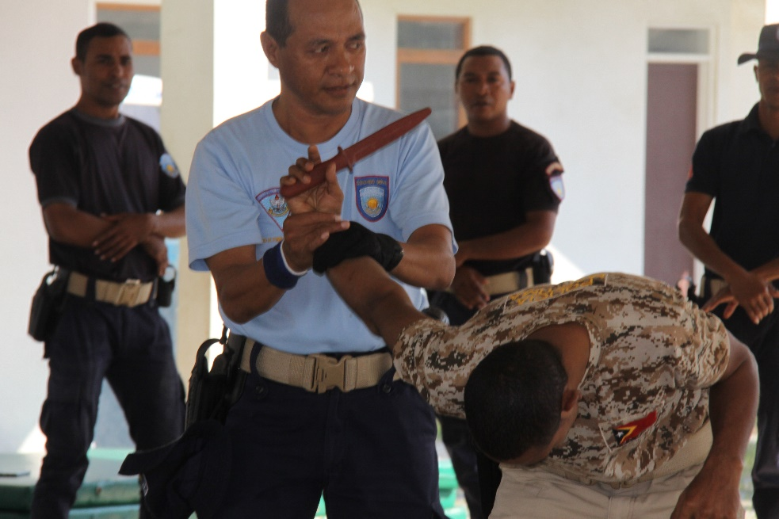
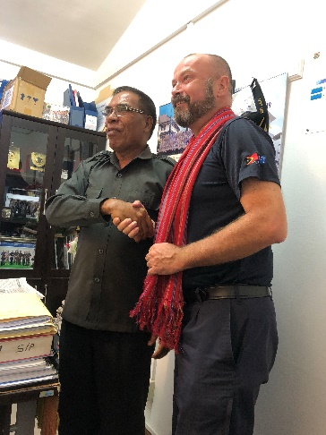
January – June 2019

TLPDP

Overview
The primary audience for this report is the AFP-IO Executive and IO-Strategy, Development & Training (SD&T). Information provided in this MPR will be used by SD&T to develop a summary report (Development Performance Report) for the IO-Executive on the overall performance of programs across the portfolio. Other uses for the MPR include informing evaluations and other reporting requirements including senate estimates, talking points and external request for information.
MPR guidance note is available from IO-Strategy&Development@afp.gov.au and is designed to help programs complete this template.
The TLPDP is a bi-lateral capacity building program providing assistance to the PNTL and is supported by the RDTL and the Government of Australia. The objective of the TLPDP has been to assist the PNTL to build the foundations of an effective and accountable police service. The design builds on three previous phases of support in developing the PNTL.
The overarching objective of the Program is for the PNTL to deliver skilled and professional policing services which respond effectively to community needs and contribute to a stable and secure Timor - Leste.
Three core components contribute to the achievement of those goals;
- Sustainability, Self-improvement and Organisational Leadership
- Operational Effectiveness, and
- Responsive Policing Services.

The TLPDP uses a bi-lateral approach under a joint management agreement through a Project Coordination Board (PCB). The PCB meets quarterly to discuss progress to date, monitors outcomes and provides a forum for the introduction or modification of new and existing programs or projects.
The focus for the Program moving forward into FY 2019/20 are;
- Executive Leadership and Management Training,
- PNTL attachment and secondments to Australian Policing jurisdictions – AFP and NTP,
- The establishment of a TNC Unit within PNTL – including infrastructure,
- An investigations and intelligence training continuum,
- Gender as a thematic across all programs,
- English Language Training,
- Governance and institutional strengthening,
- Technical and financial support to the Information Management System,
- Continued support to establish a UN Policing Capacity within PNTL,
- Capacity and capability development of the Vulnerable Persons Unit, and
- Projects as agreed to through the Project Coordination Board.

Effectiveness
OFFICER SAFETY – Use of Force Training
Following an unlawful Police Shooting in November 2018, by off-duty PNTL officers, the Commander General of the PNTL requested the assistance of TLPDP to formulate a training package to assist in lessening the risk of this type of incident reoccurring. TLPDP are leading a project with International partners including the New Zealand Police and United Nations and have developed a human rights focused Officer Safety Course for delivery to all PNTL members.
In April 2019, 41 PNTL members were selected to become OST instructors and undertook a four-week Certificate IV in Workplace Training and Assessment Course, followed by a six-week instructors’ course which graduated in June 2019. The PNTL now have certified trainers and an approved OST curriculum. In addition, the Norms of Operations Procedures (NOP’s) have been authorized and the district trainers are now included as part of the Police Training Centre as opposed to coming under the command of individual districts.
The PNTL executive have agreed that this will form the basis of a compulsory Use of Force (UoF) permit system for all members and all members are to undertake OST training for five days, delivered by PNTL certified trainers with TLPDP guidance. On completion, all PNTL members are required to undertake an annual two-day recertification program.
TLPDP have shown the flexibility to react to emerging issues highlighted by the PNTL through the import of a specialist tactical advisor to lead this project and ensure a professional outcome.
VULNERABLE PERSONS UNITS (VPU)
Gender and Family based violence is unfortunately prevalent in Timor-Leste. TLPDP have supported the PNTL in the provision of quality victim care and investigation of such crimes through their support to the Vulnerable Person’s Unit of the PNTL. This support includes:
- The planned refurbishment of Vulnerable Persons Unit Facilities in the Districts which provide a safe reception area for the victims of Family and Gender based Violence and sexual assault,
- Provision of Investigative tools and I.T equipment,
- Support to the Training of VPU Investigators,
- Assistance with socialization of Gender Based Violence Issues in the communities, and
- Early prevention activities through school visits and talking with children.
The vast majority of these type of offences occur in Dili (largely due to population density) and TLPDP have recently commenced construction of a fit for purpose Vulnerable Persons Unit facility in Dili Police District. This facility has been designed as a modern reception, care provision and interview facility to assist the victims of crime and enhance investigations. The facility is expected to open in August or September 2019.

A new Gender Advisor has commenced work in TLPDP and has an excellent skill set in this field. An agreement in place between TLPDP and the PNTL will see the gender advisor provide additional skills set training, including how to take victim-based statements and the statements of vulnerable people – in particular children.
ASSISTANCE WITH TRANS-NATIONAL CRIME INVESTIGATIONS
The PNTL are aware of their exposure to Trans-National Crime Issues due to their geographical location and difficulties in policing their borders. TLPDP continue to focus on this area with the PNTL and have identified 40 Investigators to undergo extensive Investigations training to form the nucleus of a Trans-National Crime Unit. Twenty-Two of these Investigators have recently completed a Certificate IV in Investigations and will continue on with diploma level training in the near future.
In conjunction with PNTL a major new Trans-National Crime Centre has been planned and designed with construction to begin as soon as possible. To support this facility TLPDP will work to upskill the PNTL’s forensic capabilities through expert advisor support and a supporting facility is planned for construction in the future. The TNC building has been communicated with the Minister of Home Affairs through AFP International Operations as part of the Pacific Step-Up.
The focus of TLPDP for the reporting period has been to introduce organisational change, some of which has been foundational (UoF training) aimed at changing poor behaviour and standards. The new Commander General has been given a mandate by government to reform the PNTL to a more community-based police force.
TLPDP and the New Zealand Police Program (Timor Leste Community Police Support Program -TLCPSP) have commenced a program with the 2nd CG to look at what needs to be done, identified areas of improvement and have been asked to facilitate a high-level delegation to Australia to meet with the senior executive of the AFP and ACT Police to visualise the PNTL of the future.
TLPDP and TLCPSP have provided a comprehensive dot point document to the Reform Team within PNTL which consists of the 2nd CG, National Operations Commander, Commander TLPDP and Commander TLCPSP. This body of work is ongoing and once a position has been reached, the CG will be briefed. He will then take his reform program to the Minister of Interior and The Council of Ministers. The current Prime Minister is driving this change.

Efficiency
The TLPDP has delivered some significant projects during the reporting period, in particular the completion of the Sustainable District Training Model (SDTM), qualification of certified district trainers and the delivery on time and on budget of the District Training Buildings. This has enabled the PNTL to deliver core policing skills and courses to the PNTL in all the districts. This has included PNTL delivery of C3, first responders’ course and basic investigations and intelligence programs within the districts.
The SDTM has provided a significant increase in female participation rates and enabled the PNTL to deliver more programs, to more districts and at no cost. The associated travel and per diem costs have been negated as a result of locally delivered training.
TLPDP has entered into several strategic partnerships for the joint development of programs, particularly with the UoF project and the agreement between UNDP and the NZ Police to develop this program under the auspices on the UN Use of Force Model. TLPDP has endeavoured to develop partnerships with the Department of Home Affairs through the Embassy based ABF Officer, with TLPDP and ABF co-funding the Border Control Course at JCLEC.
Further efficiencies have been met through the in-principle agreement with the Northern Territory Police Force to commence an observation/embedded program with selected officers of the PNTL in Darwin. This program also includes the ACT Police and wider AFP in Darwin, Sydney and Canberra. It is envisaged that this program will commence in the first half of FY 2019/20.
Partnership challenges do exist between TLPDP and Portugal, although a formal meeting is to take place in August 2019 on the return to country of the senior Portuguese police officer based in the Embassy. This officer is from PSP (the Portuguese National Police) and not GNR. GNR continue to be involved in the development of the PNTL but our views are not always similar, and this remains a challenge. Japan and China both provide assistance to the PNTL but on a Fly-in-fly-out model. Japans involvement is very much based on the community constable in the Succo and China is often involved in the provision of target specific training and technical equipment. Indonesia is represented by a police liaison officer based in the Indonesian Embassy.
A joint feasibility study is to commence on the development of a detector dog program in the PNTL and this is only in the early stages and will rely on the donation of suitable dogs through the ABF dog detector program. The PNTL have sourced $25,000 USD to assist the TLPDP in this program. This program is not a simple one to implement and may not yet be possible. The NZ Police have a pacific wide dog program but deliver this capability on a cost recovery basis. The program delivered to the Royal Fijian Police cost $600,000 and is beyond the capacity of both the PNTL and TLPDP.
Adherence to budget has been a challenge as TLPDP has to deal with a fluctuating US dollar for projects and associated costs in Timor-Leste. TLPDP has incurred a 1.3% overspend for FY 2018/19.

Sustainability
Sustainability within Timor-Leste is a challenge as the budgets of organisations are small and predominantly service the salary costs of staff and minor administrative budgets. The RDTL are looking to implement a new budget and donor system which will see Aid Agencies and Whole of Government Programs have to adhere to full disclosure of funding and projects. The Australian Embassy and other embassies are working through these requirements. The proposal has met heavy criticism by both Embassy’s and NGO’s and potentially looks to roll Aid Budgets into the State Budget.

TLPDP utilises the PCB to agree on priorities but also puts in place the necessary governance through NOPs and an understanding that the ultimate aim is for PNTL sustainability and responsibility. The SDTM is a good example of a program which has required significant administrative support and change but has realised a centrally controlled, district delivered training regimen under the auspices of the Police Training Centre. The SDTM, UoF program and TLPDP funded training is operationally sustainable but still relies on donor support.

Gender Equality

IO Gender Strategy Theme: Lead and Role Model
As at June 2019, TLPDP comprises of 11 members including one contracted through Coffey International seven males and four females.
To ensure continuous improvement, TLPDP has developed a Gender Mainstreaming Checklist which is applied to all TLPDP training courses and programs. The checklist is completed by the event/ program manager together with the Gender Advisor. It is a living document that is amended if required as the program develops. A measuring tool has also been created to record and track the qualitative or quantitative information. The information is used to report on and improve future training and programs.
To reinforce gender mainstreaming considerations, a poster has been developed that is in line with the checklist. The poster is hung in all TLPDPD offices in both English and Tetun with a view to producing a simplified version for PNTL to use.
TLPDP Gender Advisors attended the inaugural AFP IO Gender Advisor’s Workshop in Canberra from 1 to 4 July 2019. TLPDP was selected as part of a discussion panel to speak about AFP efforts to promote gender equality offshore as it is acknowledged that TLPDP is successfully incorporating gender mainstreaming into all its programs and projects.

IO Gender Strategy Theme: Build Capability
The current disaggregated breakdown of PNTL members as at May 2019 is:
Total 4149 Females 624 = 15%
Constable ranks 2730 - Females 401 = 14.56%
Sergeant ranks 1073 - Females 190 = 17.7%
Inspector rank 283 - Females 30 = 10.6%
Superintendent rank 55 - Females 3 = 5.45%

This breakdown shows a good balance of females, relatively speaking within the sergeant ranks. However, more work needs to be done to provide pathways and to encourage females to aspire to the perform at the executive level, so they can help shape the strategic direction of the PNTL.
PNTL celebrate significant anniversaries and events that highlight women’s achievements and challenges. This includes national days such as Rural Women’s Day and the National Day for Timorese Women. On the international front events include International Day for the Elimination of Violence against Women and International Women’s Day. TLPDP provides support for these events. The theme for IWD was “think equal, be equal for the same opportunities” and this was highlighted in keynote speeches made by the Minister of Interior and the Administrator of Oecusse.
As part of IWD celebrations, a two-day PNTL gender mainstreaming conference was conducted (6-7 March) in conjunction with UN Women. The conference focused on gender equality and equity considerations, human rights training and domestic and gender-based violence involving PNTL and external presenters. Significantly, more than half the participants were males. Presentations were delivered by both males and females with good representation from PNTL and external partner agencies. Participants, mostly PNTL, engaged well with presenters and each other, questioning legal provisions against cultural norms.
Significantly, PNTL, TLPDP and UN Women worked collaboratively to organise and deliver a high-quality product that benefitted all parties within organisational budgets.
As of June 2019, the PNTL Gender Strategy has still not been finalised or approved by PNTL. TLPDP are currently assisting PNTL with minor amendments to make the document more comprehensive before its presented to the CG for final endorsement.

TLPDP has developed whole of program initiates that support all PNTL officers including providing English language training, leadership development training and developing highly skilled investigators who can manage and investigate transnational crimes which include human trafficking and sexual servitude.
On 24 May 2019, the PNTL National VPU delivered the first School Visits Program (SVP) for early prevention of Family and Gender Based Violence (GBV) to approximately 700 secondary school students (equal ratio male to female) at Saint Michael School, Dili. The Program was developed in partnership with TLPDP and focuses on the laws and impacts of GBV in Timor-Leste, sexual consent and safe use of social media (ThinkUknow).
The Minister of Education, Minister of Interior, and PNTL General Commander as well as TLPDP Gender Advisor delivered keynote speeches to the audience. Essential messages included that the dangers and pitfalls of social media is a growing problem in TL and the important role that the youth need to play as the future of TL, in eliminating family and GBV. Significantly, the Minister for Education expressed a desire for this program to be rolled out at all secondary schools in Timor Leste.
The entire Program including opening ceremony was broadcasted live on television using the school’s own network channel as well as its Facebook site; so far there has been more than 5000 views (hits). Furthermore, the program was featured as a news item on the national TV station.
The PNTL’s delivery of the presentation was very well received by students, teachers and other invited guests; they (PNTL) were professional, energetic and confident. The Program will be delivered to other schools in Dili and surrounding districts in the near future.
Following on from the Aboriginal Family Violence Policing Conference held in the NT in June 2018, Gender Advisors Sandy Allan and Leesa Alexander accompanied by two PNTL National VPU officers travelled to Australia to attend the 3rd Australasian Indigenous Family Violence Policing Conference hosted by the Queensland Police Service (QPS) in Cairns, Qld (19 to 21 June 2019). PNTL’s attendance at the conference was acknowledged by the Commissioner of Police, Ian Stewart APM.
Due of PNLT’s attendance at last year’s conference, AIFVPC management offered PNTL an invitation to present at this year’s event. Consequently, PNTL supported by TLPDP showcased the newly developed SVP for early prevention of Family and GBV. This was a significant opportunity for PNTL at an international forum and the presentation was well received by the audience.
Whilst in Cairns, TLPDP took the opportunity to visit the QPS Sexual Assault Unit to show PNTL how a modern policing service investigate and manage crimes of GBV, especially against children. Both PNTL and TLPDP benefited greatly from attending the conference and various initiatives to improve PNTL’s response to Family and GBV will be progressed in the near future.

IO Gender Strategy Theme: Engagement & Collaboration
During the reporting period TLPDP continued to support the PNTL Gender Working Group which is the PNTL’s primary coordination platform for engagement with government agencies, aid partners and NGO’s. These quarterly meetings have developed into an outcome focused forum with key stakeholders working together on a number of projects to enhance PNTL capabilities. An outcome arising from a recent meeting (June 2019) led to the concept of the creation of a subcommittee to develop a PNTL Violence against women training curriculum. The team will be steered by PNTL with support from TLPDP and will also involve other stakeholders including The Asia Foundation and UN Women.
The TLPDP Gender Advisors continue to attend DFAT led gender and disability forums including program gender the Gender and Disability Workshops as well as regular informal with DFAT. Outcomes include enhanced network contacts and information sharing about achievements, challenges and current programs which allows the TLPDP to have a holistic appreciation of Australian aide programs in Timor Leste.

Risk Management
Normal AFP Fraud control and accountability mechanisms are in place. The requirements of the PGPA Act 2013 are adhered to and all expenditure for LVSP and HVSP is administered and checked through AFP Contracts and Procurement. Monthly financial updates and meetings are held to sense check expenditure and appropriate and authorised delegations are also adhered to.
The greatest risk to the Program financially relates to the fluctuating USD and the exchange rate. Payments are administered through DFAT under the terms of the current Service Level Agreement. Oversight is conducted by IO Finance.

Checklist
Please submit to IO-Strategy&Development@afp.gov.au by 15 January or July for each period.
☐ Up-to-date project work plan or project register or guiding is included
☐ ODA training statistics spreadsheet is completed and included
Author/s | Detective Superintendent Geoff Turner
Cleared By | Detective Superintendent Geoff Turner C-TLPDP

Case Studies/Other Supporting Material

